State of Florida |  | Public Service Commission  Capital Circle Office Center ● 2540 Shumard Oak Boulevard  Tallahassee, Florida 32399-0850  -M-E-M-O-R-A-N-D-U-M-
DATE: | April 21, 2017
TO: | Office of Commission Clerk (Stauffer)
FROM: | Office of the General Counsel (Harper)  Division of Accounting and Finance (Golden)  Division of Economics (Rome)
RE: | Docket No. 160246-WS – Proposed adoption of Rule 25-30.444, F.A.C., Utility Reserve Fund, and 25-30.4445, F.A.C., Notice of Application for Utility Reserve Fund.
AGENDA: | 05/04/17 – Regular Agenda – Interested Persons May Participate
COMMISSIONERS ASSIGNED: |  |  | All Commissioners
PREHEARING OFFICER: |  |  | Polmann
RULE STATUS: |  |  | May Not Be Deferred. Rules must be filed for adoption by June 7, 2017
SPECIAL INSTRUCTIONS: |  |  | None

Case Background
During the 2016 Legislative Session, the Florida Legislature enacted House Bill 491, which modified Section 367.081(2)(c), F.S., and required the Commission to adopt rules to implement a utility reserve fund for water and wastewater utilities. The Commission proposed the adoption of Rule 25-30.444, F.A.C., Utility Reserve Fund, and Rule 25-30.4445, F.A.C., Notice of Application for Utility Reserve Fund, at its March 7, 2017, agenda conference. Pursuant to Section 120.54, Florida Statutes, the notice of proposal of Rules 25-30.444 and 25-30.4445, F.AC., was published in the March 9, 2017, edition of the Florida Administrative Register.

On March 22, 2017, the Joint Administrative Procedures Committee (JAPC), sent a letter with comments for Rule 25-30.444, F.A.C, which is appended hereto as Attachment A. JAPC did not have any comments or recommended changes for Rule 25-30.4445, F.A.C.
This recommendation addresses whether the Commission should change the proposed Rule 25-30.444, F.A.C., based on JAPC’s comments. The Commission has jurisdiction pursuant to Sections 120.54, 350.127(2)(c), 367.081, and 367.121, F.S.

Discussion of Issues

Issue 1:
Should the Commission change proposed Rule 25-30.444, F.A.C., based on JAPC’s comments? (Harper)

Recommendation:
Yes. Staff recommends changing proposed Rule 25-30.444, F.A.C., as set forth in Attachment B.

Staff Analysis:
In its March 22, 2017 letter, JAPC commented that Subsection (1) of Rule 25-30.444, F.A.C., should be clarified to state that the utility reserve fund could be used only for repairs to existing distribution and collection infrastructure. JAPC suggested that the statutory language, “existing distribution and collection infrastructure that is nearing the end of its useful life or is detrimental to water quality or reliability of service” be added to the proposed rule as shown in Attachment B to clarify that the utility reserve fund would not apply to future new construction. Therefore, staff recommends that this language be added. The additional rule language is simply for clarification and has no effect on the scope or intent of the rule proposed by the Commission.

In addition, JAPC suggested that the statutory language “existing distribution and collection infrastructure that is nearing the end of its useful life or is detrimental to water quality or reliability of service” also be added to Subsection 25-30.444(4)(f), to clarify that the rule would apply to repairs of existing infrastructure only. Therefore, staff recommends that this language be added as shown in Attachment B. Again, the additional rule language is simply for clarification and has no effect on the scope or intent of the rule proposed by the Commission.

Staff has contacted JAPC staff regarding the rule language set forth in Attachment B. JAPC staff stated that if the proposed rule is changed as set forth in Attachment B, JAPC staff will not have any further issues or comments on the rule and the rule may be filed for adoption with the Department of State 21 days after a Notice of Change is published in the Florida Administrative Register.
.

Issue 2:
Should this docket be closed?

Recommendation:
Yes. If the Commission approves staff’s recommendation in Issue 1, a Notice of Change will be published in the Florida Administrative Register. The rules may be then filed for adoption with the Department of State 21 days after the Notice of Change is published in Florida Administrative Register, and this docket should be closed. (Harper)

Staff Analysis:
If the Commission approves staff’s recommendation in Issue 1, a Notice of Change will be published in the Florida Administrative Register. The rules may be then filed for adoption with the Department of State 21 days after the Notice of Change is published in Florida Administrative Register, and this docket should be closed.

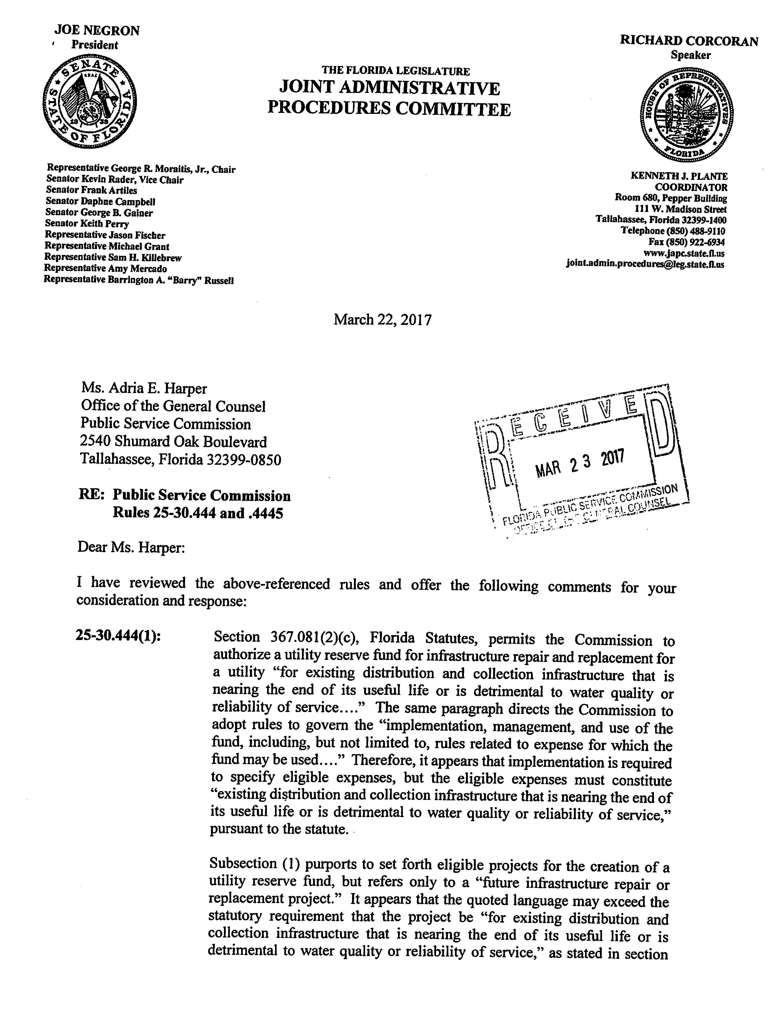

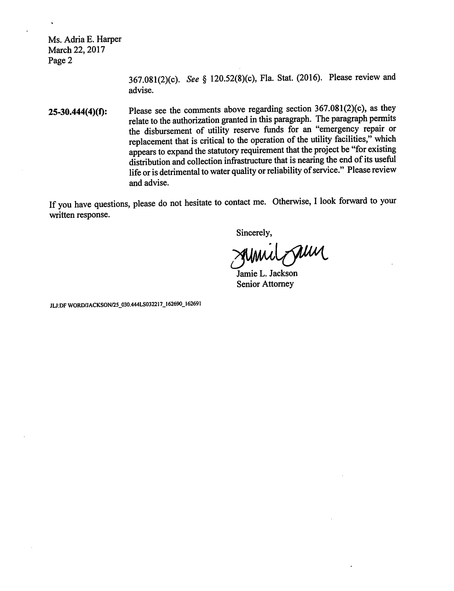

25-30.444 Utility Reserve Fund
(1) PROJECT ELIGIBILITY. The following considerations shall be applied in determining whether a future infrastructure repair or replacement project of existing distribution and collection infrastructure that is nearing the end of its useful life or is detrimental to water quality or reliability of service is eligible for advance funding through a utility reserve fund and whether a utility reserve fund is the most appropriate methodology to address the requested project.
(a) The following projects shall be eligible for a utility reserve fund:
1. Projects to repair or replace existing utility infrastructure that is nearing the end of its useful life or is detrimental to water quality or reliability of service that is recorded in the National Association of Regulatory Utility Commissioners’ Uniform System of Accounts (NARUC USOA) water utility plant account numbers 304, 305, 306, 307, 308, 309, 310, 311, 320, 330, 331, 333, 334, 335, 336, and 339, and wastewater utility plant account numbers 354, 355, 360, 361, 362, 363, 364, 365, 366, 367, 370, 371, 374, 375, 380, 381, 382, and 389;
2. Future expenditures related to land or land rights recorded in NARUC USOA water utility plant account number 303 or wastewater utility plant account number 353 if the expenditure is necessary to the successful completion of an eligible repair or replacement project;
3. Upgrades or enhancements of existing facilities if it can be demonstrated that the upgrade or enhancement is necessary to comply with federal, state, or local regulatory requirements, or provides a more cost-effective or more reliable alternative than an identical replacement, and that the upgrade or enhancement is not designed solely to address future customer growth;
4. Repair projects that may be expensed rather than capitalized, as prescribed by Rule 25-30.140(1)(g)(3), F.A.C., if it can be demonstrated that the repair expense is not already reflected in the utility’s current rates as an annual or amortized annual expense, or that the annual repair and maintenance expense allowance reflected in the utility’s current rates is insufficient to cover the projected costs of the proposed repair project; or
5. If a project includes both the repair or replacement of existing infrastructure and the expansion or improvement of facilities to meet future customer growth, the portion of the project that is related to the repair and replacement of existing infrastructure is eligible if those costs can be identified and segregated from the portion of the project related to the expansion or improvements designed to meet future customer growth.
(b) The following projects shall not be eligible for a utility reserve fund:
1. Projects to repair or replace general plant that is not directly associated with the physical operation of the utility’s water or wastewater systems that are recorded in NARUC USOA water utility plant account numbers 340, 341,342, 343, 344, 345, 346, 347, and 348, and wastewater utility plant account numbers 390, 391, 392, 393, 394, 395, 396, 397, and 398;
2. Expenditures related to NARUC USOA water utility plant accounts 301 and 302, and wastewater utility plant accounts 351 and 352, which cover organization and franchise related expenditures;
3. Expenditures related to land or land rights recorded in NARUC USOA water utility plant account number 303 or wastewater utility plant account number 353 if the expenditure is necessary solely to meet future customer growth; or
4. Capital improvement projects to expand existing facilities or construct new facilities solely to meet future customer growth.
(c) When evaluating whether the utility’s request to create a utility reserve fund is the most appropriate methodology to address the utility’s eligible future infrastructure repair and replacement projects, the following additional factors will be considered:
1. Whether the anticipated completion date of the project allows sufficient time to accumulate the funds necessary to fund the project;
2. Whether the anticipated completion date is within 24 months of the end of the historic test year used in a jointly filed rate application, if applicable, thereby making the project eligible for consideration as a pro forma project in the rate proceeding pursuant to Section 367.081(2)(a)2., F.S.;
3. Whether the contributions-in-aid-of-construction that will result from the utility reserve fund will cause the utility to exceed the service availability policy guidelines provided in Rule 25-30.580, F.A.C.;
4. Whether any of the eligible projects included in the utility reserve fund will result in the complete elimination of either the water or wastewater treatment process;
5. Whether it has been more than seven years since the utility’s last rate case, if the request is filed as a stand-alone application or in conjunction with a limited proceeding; or
6. Whether the total increase resulting from implementation of the utility reserve fund surcharge will exceed the utility’s annual revenues for the most recent 12-month period or test year by more than 30 percent.
(2) UTILITY RESERVE FUND FILING REQUIREMENTS. Each applicant that requests approval to create a utility reserve fund shall provide the following information to the Commission. The request may be filed as a stand-alone application or in conjunction with an application for rate increase filed pursuant to Sections 367.081(2)(a), 367.0814, or 367.0822, F.S. If the request is filed in conjunction with an application for rate increase that also requires the applicant’s general information, paragraphs (2)(a), (b), and (c) may be omitted from the utility reserve fund portion of the joint application. A utility that qualifies for staff assistance as provided by Rule 25-30.455(1), F.A.C., may also request assistance with the utility reserve fund process.
(a) The utility’s name as it appears on the utility’s certificate, address, telephone number, and, if available, email address and fax number.
(b) The name(s), address(es), and telephone number(s) of the person(s) that should be contacted regarding this application.
(c) The address within the service area where the application is available for customer inspection during the time the rate application is pending.
(d) A statement of the reason(s) why the utility is requesting approval of a utility reserve fund.
(e) A capital improvement plan that includes: a general description of the age and condition of the utility’s facilities; a description of all infrastructure repair or replacement projects that the utility anticipates will be necessary within the next five years, at a minimum, even if some projects will not be included in the utility reserve fund; and the following information for each infrastructure repair or replacement project that the utility requests be included in the utility reserve fund:
1. A description of each plant asset that will be repaired or replaced, including the NARUC USOA account number for each asset;
2. The date each asset was originally placed into service or an estimate of the age of the plant asset(s) as reflected in the utility’s depreciation records if the original service date is unknown;
3. A detailed description of the reason(s) each repair or replacement project is necessary to maintain or improve the quality or reliability of the water or wastewater service, including whether any asset will be replaced prior to the end of its average service life as provided by Rule 25-30.140, F.A.C.;
4. If the repair or replacement project is required by a governmental or regulatory agency, include a copy of the rule, regulation, order, or other regulatory directive that requires the repair or replacement;
5. The projected cost to repair or replace each asset, and documentation that supports the utility’s calculation of the projected cost. The utility shall make all reasonable efforts to obtain at least three comparative cost estimates for each requested project. Acceptable forms of projected cost documentation are: an estimate by a professional engineer or other person knowledgeable in design and construction of water and wastewater plants; a bid from a vendor or service provider that includes a description of all work to be completed and an itemized list of all costs associated with the project; vendor information regarding the purchase price of plant components that will be purchased directly by the utility and labor estimates for work that will be performed on the project by a utility employee or contractual service provider, along with a statement that confirms that the employee’s or contractual service provider’s work on the project is not included in their normal duties; or other information that shows a detailed and verifiable estimate of the projected cost. If the utility is unable to obtain three cost estimates for each project, the utility shall provide a statement explaining what steps the utility took to obtain the estimates, why the utility was unable to obtain three estimates, and any responses received from any contractors solicited.
6. Detailed specifications for each asset that can be used to verify the projected repair or replacement cost, such as type, size, quantity, or quality of the materials used to complete the repair or replacement of the asset. If the type, size, quantity, or quality of the components used to make the repair or replacement will be materially different than the plant asset(s) being repaired or replaced, describe the specific differences and why the change is either necessary or provides a better resolution for the repair or replacement;
7. If the repair or replacement will change the design of the system, include a statement explaining how the design of the system will change and why the change is either necessary or will provide a better resolution for the repair or replacement;
8. A description of any alternatives to the proposed infrastructure repair or replacement project that the utility considered, such as new technologies or interconnection with another utility system, and why the proposed project was determined to be the most cost-effective option or will provide a better resolution for the repair or replacement;
9. If the infrastructure that is being replaced was subject to a non-used and useful adjustment in the utility’s last rate proceeding, include a statement explaining whether the utility considered reducing the size of the replacement infrastructure to better match the utility’s capacity needs and the results of that analysis;
10. A description of any expense increases or decreases that the utility anticipates will occur following completion of the infrastructure repair or replacement project; and
11. The projected timeline and anticipated completion date for the repair or replacement project, including a detailed description of any target dates and significant milestones if the project will be completed in multiple phases. If the repair or replacement project is required by a governmental or regulatory agency, include any specific deadlines that have been imposed by that agency, and describe any penalties that will be incurred by the utility if the deadlines are not met.
(f) A description of any other funding sources that may be used for the project, including a breakdown of the estimated project costs that will be funded with the utility reserve fund, utility investment, and each available external funding source, such as a bank loan, government loan, or government grant, as applicable.
(g) A schedule showing the calculation of the annualized revenues for the most recent 12-month period using the rates in effect at the time the utility files its application for approval to create a utility reserve fund, broken down by customer class and meter size. This schedule may be omitted from the utility reserve fund portion of the application if filed in conjunction with an application for a rate proceeding that also requires an annualized revenue calculation.
(h) A schedule showing the calculation of the proposed utility reserve fund surcharge based on the number of bills by customer class and meter size for the most recent 12-month period, or test year if filed in conjunction with an application for a rate proceeding.
(i) Revised tariff sheets incorporating the utility reserve fund surcharge into the tariff. The utility shall show the utility reserve fund surcharge as a separate charge in its tariff and on its customer bills.
(j) A statement indicating whether the applicant will secure the utility reserve fund through an interest-bearing escrow account or an irrevocable letter of credit. If the utility’s request to create a utility reserve account is approved by the Commission, the utility will be required to provide documentation showing that the escrow account has been established or the irrevocable letter of credit has been obtained prior to implementation of the utility reserve fund surcharge.
(k) A description of the procedures that the utility will implement to segregate the monies collected from the utility reserve fund surcharge on the utility’s books and records. Separate accounting records must be maintained to record all transactions associated with the collection, deposit, and use of monies designated for the utility reserve fund. A separate bank account may be used to segregate the utility reserve fund monies that are secured through an irrevocable letter of credit but is not required.
(l) A statement signed by an officer of the utility that the utility will comply with the noticing requirements in Rule 25-30.4445, F.A.C., if the request is filed as a stand-alone application, Rule 25-22.0407, F.A.C., if the request is filed in conjunction with an application for a rate increase filed pursuant to Sections 367.081(2)(a) or 367.0814, F.S., or Rule 25-30.446, F.A.C., if the request if filed in conjunction with a limited proceeding filed pursuant to Section 367.0822, F.S.
(m) An Asset Management Plan prepared by the Florida Rural Water Association may be provided in lieu of a capital improvement plan in paragraph (2)(e).
(3) Reporting Requirements. Any utility that receives approval from or is required by the Commission to create a utility reserve fund must keep an accurate and detailed account of all monies and report to the Commission all monies it receives from the utility reserve fund surcharge. The reporting requirement shall begin when the utility’s reserve fund surcharge tariff becomes effective. The utility must file periodic reports as follows:
(a) The utility shall file a report with the Commission Clerk’s office no later than the 20th of every month indicating the monthly and total amount of money deposited into, and monthly and total amount of disbursements made from the utility reserve fund as of the end of the preceding month. If the utility bills its customers less frequently than once a month, this reporting requirement may be modified to match the utility’s normal billing frequency. A copy of a bank statement that separately identifies the utility reserve fund deposits and disbursements may serve as the monthly report.
(b) At least once every six months, the utility shall also report the status of all eligible projects included in the utility reserve fund for which work was performed during the last six months including the actual start date, the estimated or actual completion date, the costs incurred during the last six months, and the total cost for any projects completed during the last six months.
(c) The reports shall continue as long as the utility reserve fund is in effect and until all funds have been disbursed either to pay for completed eligible projects or as refunds to customers.
(d) A request for disbursement from the utility reserve fund escrow account or authorization to use funds secured by an irrevocable letter of credit may be filed in conjunction with the utility’s monthly or quarterly reports.
(e) The utility shall also separately identify the utility reserve fund in its annual report filed with the Commission each year pursuant to Rule 25-30.110, F.A.C.
(f) The utility shall file an updated capital improvement plan with the Commission at least once every three years for as long as the utility reserve fund remains active.
(4) DISBURSEMENT OF FUNDS. A utility requesting disbursement of funds from an escrow account or authorization to use funds secured by an irrevocable letter of credit shall file the following information and supporting documentation:
(a) A statement explaining why the disbursement is needed, including a description of the completed project, or if a partial disbursement of funds is necessary prior to completion of the full project, a description of the completed phase of the project, purchase of materials, payments to contractors or vendors, or construction draws, as applicable;
(b) The date the project or phase of the project was completed and the replacement asset(s) was placed in service, as applicable;
(c) Documentation supporting the amount of the requested disbursement. Acceptable forms of documentation are: invoices, receipts, contractor application and request for payment forms, loan documents, documents showing proof of payment, and other information that shows detailed and verifiable project costs and payments;
(d) Documentation showing that the completed work was inspected or approved by the governmental or regulatory authority that required the repair or replacement project, if applicable; and
(e) Other documentation that demonstrates the project was completed, such as photographs of the completed work, may be submitted but is not required.
(f) A utility may request the disbursement of funds from a utility reserve fund to assist with making an emergency repair or replacement of existing distribution and collection infrastructure that is nearing the end of its useful life or is detrimental to water quality or reliability of service that is critical to the operation of the utility facilities and resulted from events that were out of the utility’s control, such as weather related damage, accidents, or defective parts. The utility’s request for an emergency disbursement must include the following information:
1. The information required in paragraphs (4)(a) through (e) above;
2. A description of any future funding sources that may be available to assist the utility with the emergency repair or replacement costs, such as government assistance for weather damage, insurance benefits, or manufacturer warranties for defective parts;
3. A statement explaining how the utility will reimburse the utility reserve fund for the emergency disbursement through future funding sources, such as, government assistance, insurance benefits, manufacturer warranties, bank loans, or utility investment. If no funding sources will be available for reimbursement of the utility reserve fund, the utility shall either provide a statement describing how the utility reserve fund project(s) or timeline may be modified to address the project funding needs without modifying the amount of the utility reserve fund surcharge, or provide the information required in subsection (5) below to request a modification of the utility reserve fund surcharge.
(5) UTILITY RESERVE FUND MODIFICATIONS. A utility that must undertake a project that was not anticipated when the utility reserve fund was created or that must make significant modifications to a previously approved project may request a modification of the utility reserve fund at any time following creation of the fund or in the utility’s next rate proceeding by filing the following information:
(a) A statement describing why the new project or modification of a previously approved project is necessary, and whether the utility is requesting a change in the utility reserve fund surcharge or only acknowledgement of the project modifications. If the new project or project modification is required by a governmental or regulatory agency, include a copy of the rule, regulation, order, or other regulatory directive that requires the new project or project modification; and
(b) The information required in paragraphs (2)(e) or (m), and (f), (g), (h), and (i) if the utility is requesting a change in the utility reserve fund surcharge. Also, if the utility reserve fund is secured through an irrevocable letter of credit, the utility shall provide an updated irrevocable letter of credit prior to implementation of the utility reserve fund surcharge increase.
(6) FINAL DISPOSITION OF UTILITY RESERVE FUND.
(a) The utility reserve fund surcharge shall be discontinued after all approved eligible projects(s) have been completed, sufficient funds have been collected in the utility reserve fund to cover the cost of the approved eligible project(s), and the final disbursement has been made from the utility reserve fund. During the utility’s next rate proceeding, the utility’s rate base, capital structure, operating expenses, and rates shall be adjusted as needed to reflect the completed projects. The amount of the new plant assets that are funded through a utility reserve fund shall be offset with an equal addition to contributions-in-aid-of-construction.
(b) Any monies that remain in the utility reserve fund following the last disbursement for the completed eligible project(s) shall be refunded to the customers with interest in accordance with Rule 25-30.360, F.A.C.
(c) All monies collected and held in the utility reserve fund should remain with the utility regardless of any changes in utility ownership. If a utility’s ownership changes through a transfer or abandonment, the Commission shall determine whether the utility reserve fund should be continued as follows:
1. In the event that the utility’s ownership changes through a transfer as provided in Rule 25-30.037, F.A.C., the transfer agreement shall include provisions that state: that the utility reserve fund shall remain with the utility following the close of the sale; that the seller shall provide copies of all documents related to the utility reserve fund to the buyer, including the approved capital improvement plan, financial records, and status reports; whether the buyer requests to continue the utility reserve fund following the transfer; and whether the buyer will assume responsibility for the escrow account or obtain an irrevocable letter of credit to secure the utility reserve fund. If the buyer does not request to continue the utility reserve fund or does not provide sufficient documentation to guarantee the continued security of the utility reserve fund and compliance with the provisions set forth in this rule, all monies held in the utility reserve fund shall be refunded to the customers with interest in accordance with Rule 25-30.360, F.A.C., and the utility reserve fund surcharge and utility reserve fund shall be discontinued. However, if the transfer of ownership is requested pursuant to Rule 25-30.037(5), F.A.C., and will result in the transfer of ownership to an exempt entity other than a governmental utility, the buyer shall not be required to obtain an escrow account or an irrevocable letter of credit.
2. In the event that the utility is abandoned as provided in Rule 25-30.090, F.A.C., all monies held in the utility reserve fund and all documents related to the utility reserve fund shall remain with the utility and be turned over to the court-appointed receiver. If the utility remains under Commission jurisdiction following the abandonment, the court-appointed receiver shall be responsible for managing the utility reserve fund in accordance with this rule and all applicable Commission Orders.
(d) If the utility fails to follow through with the eligible project(s) covered by the utility reserve fund or comply with the security, fund maintenance, or reporting requirements set forth in this rule, the Commission shall initiate a review of the utility reserve fund and surcharge to determine whether the utility reserve fund and surcharge should be discontinued and whether all monies in the reserve fund should be refunded to the customers with interest in accordance with Rule 25-30.360, F.A.C.
Rulemaking Authority 350.127(2), 367.081(2)(c), 367.121 FS. Law Implemented 367.081(2)(c) FS. History–New __________.

