State of Florida |  | Public Service Commission  Capital Circle Office Center ● 2540 Shumard Oak Boulevard  Tallahassee, Florida 32399-0850  -M-E-M-O-R-A-N-D-U-M-
DATE: | April 21, 2017
TO: | Office of Commission Clerk (Stauffer)
FROM: | Division of Economics (Rome)  Office of the General Counsel (Janjic)
RE: | Docket No. 170071-GU – Petition for approval of tariff modifications relating to relocation or modification of gas service facilities, by Peoples Gas System.
AGENDA: | 05/04/17 – Regular Agenda – Tariff Filing – Interested Persons May Participate
COMMISSIONERS ASSIGNED: |  |  | All Commissioners
PREHEARING OFFICER: |  |  | Administrative
CRITICAL DATES: |  |  | 05/29/17 (60-Day Suspension Date)
SPECIAL INSTRUCTIONS: |  |  | None

Case Background
On March 30, 2017, Peoples Gas System (Peoples or Company) filed a petition requesting Commission approval of amendments to the relocation of gas service facilities provision in the Company’s tariff. The Commission approved Peoples’ original gas service facilities tariff in 1982. Peoples is a natural gas distribution utility subject to the Commission’s regulatory jurisdiction under Chapter 366, Florida Statutes (F.S.).
Effective April 14, 2017, a federal pipeline safety rule (49 C.F.R. § 192.383 (2017)) with which Peoples must comply was amended by the Pipeline and Hazardous Materials Safety Administration (PHMSA). Staff placed the relevant rulemaking record as published in the Federal Register in the docket file for informational purposes. As a result of PHMSA’s revisions to the federal rule, Peoples is seeking permission to modify Tariff Sheet Nos. 5.000-1 and 5.601-1. The proposed tariff sheets are included as Attachment A to this recommendation. The Commission has jurisdiction in this matter pursuant to Sections 366.03, 366.05, and 366.06, F.S.

Discussion of Issues

Issue 1:
Should the Commission approve Peoples' proposed modifications relating to the Company’s gas service facilities tariff?

Recommendation:
Yes, the Commission should approve Peoples’ proposed modifications relating to the Company’s gas service facilities tariff, as reflected in Attachment A, effective May 4, 2017. (Rome)

Staff Analysis:
The current wording of Peoples’ Tariff Sheet No. 5.601-1 does not allow the Company to seek reimbursement for customer-requested modifications to the Company’s gas service facilities. The proposed tariff revisions would allow Peoples to be reimbursed by customers who request modifications to the Company’s gas service facilities, including those customers who request the installation of an excess flow valve (EFV) on an existing service line pursuant to the new PHMSA rule discussed below.

PHMSA Changes to Pipeline Safety Rules
Peoples is required by PHMSA to comply with federal Rule 49 C.F.R. § 192.383 (2017). As originally adopted, the rule required the installation of an EFV on any new or replaced service line serving a single-family residence after February 12, 2010, subject to certain exceptions. An EFV is a device designed to shut off automatically when the natural gas flow exceeds certain limits, such as when a service line is damaged due to excavation or other activities. Thus, the EFV provides safety benefits by limiting the risk of escaping gas due to third party damage or a pipe failure. EFVs do not protect against gas leaks occurring in piping behind the customer’s gas meter. Most service lines serving non-residential customers deliver in excess of 1,000 standard cubic feet per hour and are fitted with curb valves that are shut off manually.
PHMSA adopted amendments to 49 C.F.R. § 192.383 (2017), which took effect on April 14, 2017. Among other things, the rule revisions, subject to certain exceptions, provide for the following: (a) “operators” such as Peoples are required to notify customers of their right to request installation of an EFV, (b) if a service line customer requests an EFV installation, Peoples must install the EFV at a mutually agreeable date, and (c) the question of who bears the cost of the requested EFV installation is left to the “operator’s rate-setter”. These three key elements are discussed individually below.
Regarding customer notification, PHMSA determined that notification through broad electronic means, including website postings, was acceptable. In Peoples’ petition, the Company asserted that it is prepared to provide such notification as is required by the amended rule. In response to a staff inquiry, Peoples provided staff with a draft of the information to be posted on the Company’s website. The website posting will include information such as the function and benefits of an EFV and answers to “Frequently Asked Questions” regarding EFVs, including potential cost estimates for EFV installations and a point of contact for interested customers.
Regarding EFV installation, Peoples represented in its petition that the Company has been installing EFVs on new and replaced service lines since February 2010 and will continue to do so. Peoples stated that for a new service line, the average cost of the EFV itself is approximately $30 and is included in the calculation of the Maximum Allowable Construction Cost (MACC) for purposes of determining whether a contribution-in-aid-of-construction would be required of the customer for the installation of the service line and other appurtenances necessary to provide gas service.
However, Peoples represented that the situation is considerably different in the case of an existing customer that requests an EFV installation on a line that may have been installed many years before, and that may require extensive excavation and restoration. Peoples estimated that in most cases, the cost of retrofitting an EFV on a typical existing service line would be between $1,200 and $1,800, depending on the excavation and restoration required in connection with the installation. According to the rulemaking record published in the Federal Register, PHMSA opined that customer-initiated EFV installations on existing lines would not be a circumstance with which operators would be dealing in significant numbers; however, PHMSA opted to retain the right for existing customers to request an EFV installation with the recognition that some individual households might have a high willingness-to-pay for EFVs due to risk aversion and other factors.
Peoples suggested that it would be inappropriate for existing customers, who either already have an EFV installed on their service lines or who do not request that an EFV be installed, to subsidize the installations of EFVs for customers who request them. Peoples further stated that the costs of installing EFVs on existing service lines would not be incurred by Peoples but for the customers’ requests, and such costs should be borne by the affected customers.
The rulemaking record published in the Federal Register also devoted considerable discussion to the appropriate regulatory entities which would be responsible for determining who should pay for the costs of EFV installations on existing service lines. PHMSA considered stakeholder comments and ultimately “left the question of who bears the cost of installing EFVs on service lines not being newly installed or replaced to the operator’s rate-setter.”

Conclusion
Based upon the information provided by Peoples and a review of the PHMSA rulemaking record published in the Federal Register, staff agrees with Peoples’ assertion that the Commission is Peoples’ “rate-setter” for purposes of the federal rule. Staff also believes that it is appropriate for customers who request modifications to gas service facilities, such as the installation of EFVs on existing service lines, to bear the cost of the modifications and that such costs should not be subsidized by the general body of ratepayers. Therefore, staff recommends that the Commission approve Peoples’ proposed modifications relating to the Company’s gas service facilities tariff, as reflected in Attachment A, effective May 4, 2017.

Issue 2:
Should this docket be closed?

Recommendation:
If Issue 1 is approved and a protest is filed within 21 days of the issuance of the order, the tariffs should remain in effect, with any revenues held subject to refund, pending resolution of the protest. If no timely protest is filed, this docket should be closed upon the issuance of a consummating order. (Janjic)

Staff Analysis:
If Issue 1 is approved and a protest is filed within 21 days of the issuance of the order, the tariffs should remain in effect, with any revenues held subject to refund, pending resolution of the protest. If no timely protest is filed, this docket should be closed upon the issuance of a consummating order.

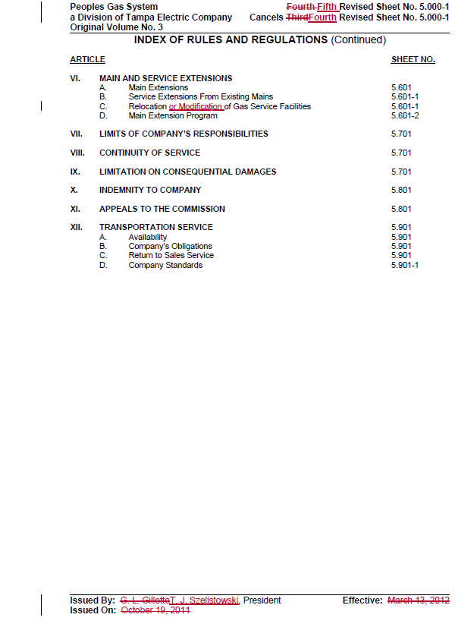
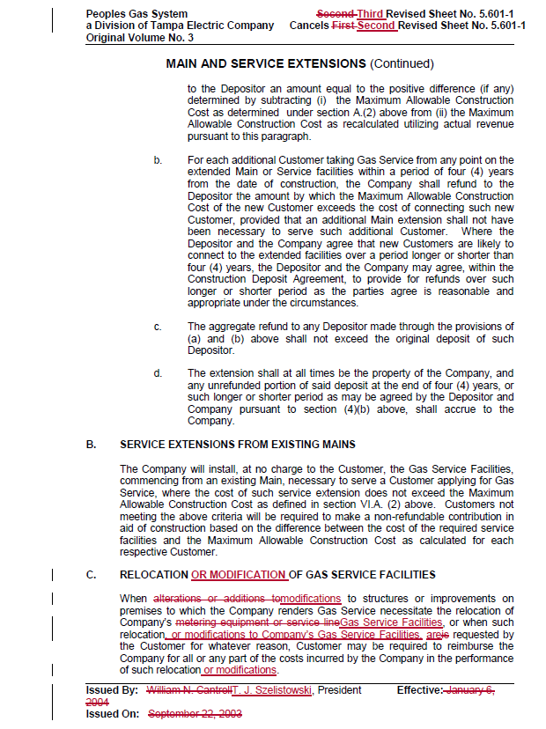

Order No. 10656, issued March 17, 1982, in Docket No. 810302-GU, In re: Petition of Peoples Gas System, Inc. for an increase in rates and charges.
Docket No. PHMSA-2011-0009; Amendment No. 192-121, Federal Register / Vol. 81, No. 199 / Friday, October 14, 2016, pp. 70987-71002.
The PHMSA rulemaking record published in the Federal Register contains the purpose for promulgating the rule, pertinent noticing requirements for the rule, a summary of the rulemaking process including stakeholder comments and PHMSA’s responses thereto, and the final rule language.
Federal Register / Vol. 81, No. 199 / Friday, October 14, 2016; pp. 70987-71002.
Id., pp. 70990, 70993-70994.
Peoples also anticipated that depending upon site-specific conditions, the costs could be less than the bottom of this estimated range, as well as above the top of the range. Petition, paragraph 6.
Federal Register / Vol. 81, No. 199 / Friday, October 14, 2016; p. 70996.
Id., p. 70987.

