State of Florida  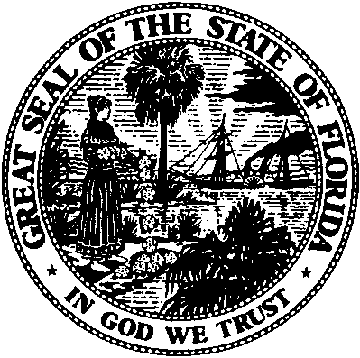 |  | Public Service Commission  Capital Circle Office Center ● 2540 Shumard Oak Boulevard  Tallahassee, Florida 32399-0850  -M-E-M-O-R-A-N-D-U-M-
DATE: | April 21, 2017
TO: | Office of Commission Clerk (Stauffer)
FROM: | Division of Economics (Ollila)  Office of the General Counsel (Taylor)
RE: | Docket No. 170036-GU – Joint petition for approval of territorial agreement in DeSoto County by Florida Division of Chesapeake Utilities Corporation and Sebring Gas System, Inc.
AGENDA: | 05/04/17 – Regular Agenda – Proposed Agency Action – Interested Persons May Participate
COMMISSIONERS ASSIGNED: |  |  | All Commissioners
PREHEARING OFFICER: |  |  | Graham
CRITICAL DATES: |  |  | None
SPECIAL INSTRUCTIONS: |  |  | None

Case Background
On February 16, 2017, the Florida Division of Chesapeake Utilities Corporation (Chesapeake) and Sebring Gas System, Inc., (Sebring) filed a joint petition for approval of a territorial agreement in DeSoto County. On April 3, 2017, the petitioners filed an amended joint petition with a corrected proposed territorial agreement (proposed agreement) and map. The proposed agreement corrects an inaccurate description of the Sebring service area contained in the February 16, 2017 filing. The proposed agreement is Attachment A to the petition and the map is Attachment B to the petition (due to the voluminous nature of the exhibits, they have not been attached to this recommendation).
The joint petitioners responded to staff’s data request on March 2, 2017. The Commission has jurisdiction over this matter pursuant to Section 366.04, Florida Statutes (F.S.).

Discussion of Issues

Issue 1:
Should the Commission approve the proposed agreement between Chesapeake and Sebring?

Recommendation:
Yes, the Commission should approve the proposed agreement between Chesapeake and Sebring. (Ollila)

Staff Analysis:
Pursuant to Section 366.04(3)(a), F.S., and Rule 25-7.0471, Florida Administrative Code (F.A.C.), the Commission has jurisdiction to approve territorial agreements between and among natural gas utilities. Unless the Commission determines that the agreement will cause a detriment to the public interest, the agreement should be approved.
The joint petitioners stated that over the past year they have independently pursued plans to extend service in DeSoto County, specifically to customers in and around the City of Arcadia. The joint petitioners stated that without the proposed agreement the joint petitioners’ extension plans would likely result in the uneconomic duplication of facilities and, potentially, a territorial dispute. The joint petitioners assert that approval of the proposed agreement will enable as many customers as possible to receive natural gas service.
Currently, Chesapeake and Sebring both have customers in DeSoto County; however, neither petitioner has facilities capable of serving the City of Arcadia. Under the proposed agreement, the joint petitioners have agreed that Chesapeake’s service territory will be defined as all of DeSoto County, except for customers within Arcadia’s municipal boundary and two specifically identified customers who are located just outside the Arcadia city limits and are currently served by Sebring. Sebring’s service area will include customers within Arcadia’s municipal boundaries and the two specifically identified customers outside Arcadia’s municipal limits. The two customers are identified in the proposed agreement and in the map.
There are no customers or facilities to be transferred. The proposed agreement includes a provision that provides Chesapeake with a right of first refusal if Sebring decides to sell any portion of its natural gas or propane facilities. The proposed agreement states that prior to the second anniversary of the effective date (the date the Commission’s decision becomes final), Sebring and Chesapeake will meet to review the status of the proposed agreement and will submit a status report to the Commission. After the second anniversary, the parties will meet no more than every fifth anniversary to review the status of the proposed agreement and provide a status report to the Commission.
The joint petitioners represent that the proposed agreement will not cause a decrease in the availability or reliability of natural gas service provided by Chesapeake or Sebring to existing or future ratepayers of either company. The joint petitioners represent that the Commission’s approval of the proposed agreement will be consistent with Section 366.04, F.S., and Rule 25-7.0471, F.A.C. Further, the joint petitioners attest that the proposed agreement is in the public interest, will not adversely impact any customers, and will facilitate expansion by facilitating service to new customers and areas in an efficient manner.
After review of the petition, the proposed agreement, and the joint petitioners’ responses to staff’s data request, staff believes that the proposed agreement is in the public interest, that it eliminates any potential uneconomic duplication of facilities and will not cause a decrease in the reliability of gas service. As such, staff believes that the proposed agreement creates no detriment and is in the public interest and recommends that the Commission approve it.

Issue 2:
Should this docket be closed?

Recommendation:
If no protest is filed by a person whose substantial interests are affected within 21 days of the issuance of the Order, this docket should be closed upon the issuance of a Consummating Order. (Taylor)

Staff Analysis:
If no protest is filed by a person whose substantial interests are affected within 21 days of the issuance of the Order, this docket should be closed upon the issuance of a Consummating Order.

Utilities Commission of the City of New Smyrna Beach v. Florida Public Service Commission, 469 So. 2d 731 (Fla. 1985).

