State of Florida |  | Public Service Commission  Capital Circle Office Center ● 2540 Shumard Oak Boulevard  Tallahassee, Florida 32399-0850  -M-E-M-O-R-A-N-D-U-M-
DATE: | May 24, 2017
TO: | Office of Commission Clerk (Stauffer)
FROM: | Office of the General Counsel (Page)  Division of Economics (Rome)  Division of Engineering (Moses)
RE: | Docket No. 170034-EU – Proposed amendment of Rule 25-6.0345, F.A.C., Safety Standards for Construction of New Transmission and Distribution Facilities.
AGENDA: | 06/05/17 – Regular Agenda – Interested Persons May Participate
COMMISSIONERS ASSIGNED: |  |  | All Commissioners
PREHEARING OFFICER: |  |  | Graham
RULE STATUS: |  |  | Proposal May Be Deferred
SPECIAL INSTRUCTIONS: |  |  | None

Case Background
Rule 25-6.0345, Florida Administrative Code (F.A.C.), Safety Standards for Construction of New Transmission and Distribution Facilities, sets forth the current version of the National Electrical Safety Code (NESC) as the safety standards to be used by electric utilities when constructing transmission and distribution systems. The rules implement Sections 366.04(2) and (6), Florida Statutes (F.S.).
Section 366.04(2), F.S., sets forth the Commission’s jurisdiction over electric utilities to prescribe a uniform classification of accounts, a rate structure, and to require electric power conservation and reliability through a coordinated grid. Section 366.04(6), F.S., grants the Commission exclusive jurisdiction to prescribe and enforce safety standards for transmission and distribution facilities of all public electric utilities, cooperatives organized under the Rural Electric Cooperative Law, and electric utilities owned and operated by municipalities. Section 366.04(6)(b), F.S., states that in adopting safety standards, the Commission shall, at a minimum, adopt after review any new edition of the NESC.
Staff initiated this rulemaking to update Rule 25-6.0345, F.A.C., so that the 2017 edition, which is the most current edition of the NESC, is incorporated by reference into the rule. The Commission’s Notice of Development of Rulemaking was published in the Florida Administrative Register on December 16, 2016, in Volume 42, No. 243. There were no requests for a rule development workshop, and no workshops were held. No comments from interested parties were received.
This recommendation addresses whether the Commission should propose the amendment of Rule 25-6.0345, F.A.C. The Commission has jurisdiction pursuant to Section 120.54, F.S., Section 366.04, F.S., and Section 366.05, F.S.

Discussion of Issues

Issue 1:
Should the Commission propose the amendment of Rule 25-6.0345, F.A.C.?

Recommendation:
Yes. The Commission should propose the amendment of Rule 25-6.0345, F.A.C., as set forth in Attachment A.

Staff Analysis: The NESC was introduced in 1914 as the product of a congressional mandate for the National Bureau of Standards to investigate the hazards of electrical work, contemporary engineering theory and generally accepted good industry practices. The NESC is a consensus standard that has been prepared by the NESC Committee under procedures approved by the American National Standards Institute.
The NESC sets the ground rules and guidelines for practical safeguarding of utility workers and the public during the installation, operation, and maintenance of electric supply, communication lines and associated equipment, and is revised every five years so that the code is up-to-date with changes in the industry and technology. Some of the changes for the 2017 Edition include revising and reorganizing the guy insulator placement rules, and revising the substation impenetrable fence requirements. Clearances of overhead lines from aboveground swimming pools without decks were added to Rule 234E1. Staff recommends that the Commission should amend Rule 25-6.0345, F.A.C., to incorporate by reference the 2017 Edition of the NESC.

Minor Rules Certification
Currently, Rule 25-6.0345, F.A.C., is not on the Commission’s list of minor violation rules. Pursuant to Section 120.695, F.S., beginning July 1, 2017, for each rule filed for adoption the agency head shall certify whether any part of the rule is designated as a rule the violation of which would be a minor violation. Rule 25-6.0345, F.A.C., is a rule for which a violation would not be a minor violation because the violation of the rule would result in economic or physical harm to a person or an adverse effect on the public health, safety, or welfare or create a significant threat of such harm. Since a violation of Rule 25-6.0345, F.A.C., would continue to be a major violation, no statutory certification is required and no change to the Commission’s current list of minor violation rules published on the Commission’s website is necessary.

Statement of Estimated Regulatory Costs
Pursuant to Section 120.54, F.S., agencies are encouraged to prepare a statement of estimated regulatory costs (SERC) before the adoption, amendment, or repeal of any rule. The SERC is appended as Attachment B to this recommendation. The SERC analysis also includes whether the rule amendment is likely to have an adverse impact on growth, private sector job creation or employment, or private sector investment in excess of $1 million in the aggregate within five years of implementation.
The SERC concludes that the rule amendment will not likely directly or indirectly increase regulatory costs in excess of $200,000 in the aggregate in Florida within one year after implementation. Further, the SERC concludes that the rule amendment will not likely have an adverse impact on economic growth, private sector job creation or employment, private sector investment, business competitiveness, productivity, or innovation in excess of $1 million in the aggregate within five years of implementation. Thus, the rule amendment does not require legislative ratification pursuant to Section 120.541(3), F.S. In addition, the SERC states that the rule amendment will not have an adverse impact on small business and will have no impact on small cities or counties. No regulatory alternatives were submitted pursuant to paragraph 120.541(1)(a), F.S. None of the impact/cost criteria established in paragraph 120.541(2)(a), F.S., will be exceeded as a result of the recommended revision.

Conclusion
Based on the foregoing, staff recommends the Commission propose the amendment of Rule 25-6.0345, F.A.C.

Issue 2:
Should this docket be closed?

Recommendation:
Yes. If no requests for hearing or comments are filed, the rule may be filed with the Department of State, and this docket should be closed. (Page)

Staff Analysis:
If no requests for hearing or comments are filed, the rule may be filed with the Department of State, and this docket should be closed.

25-6.0345 Safety Standards for Construction of New Transmission and Distribution Facilities.
The Commission adopts and incorporates by reference the 2012 edition of the 2017 National Electrical Safety Code (NESC) C2-2017 ANSI C-2 [NESC], as the applicable safety standards for transmission and distribution facilities subject to the Commission’s safety jurisdiction. Each investor-owned electric utility, rural electric cooperative, and municipal electric system shall, at a minimum, comply with the standards in these provisions. A copy of the NESC C2-2017 may be obtained from the Institute of Electric and Electronic Engineers, Inc. (IEEE), 3 Park Avenue, New York, NY 10016-5997.
Rulemaking Authority 350.127(2), 366.05(1) FS. Law Implemented 366.04(2), (6) FS. History–New 8-13-87, Amended 2-18-90, 11-10-93, 8-17-97, 7-16-02, 2-1-07, 12-16-12, ________.
h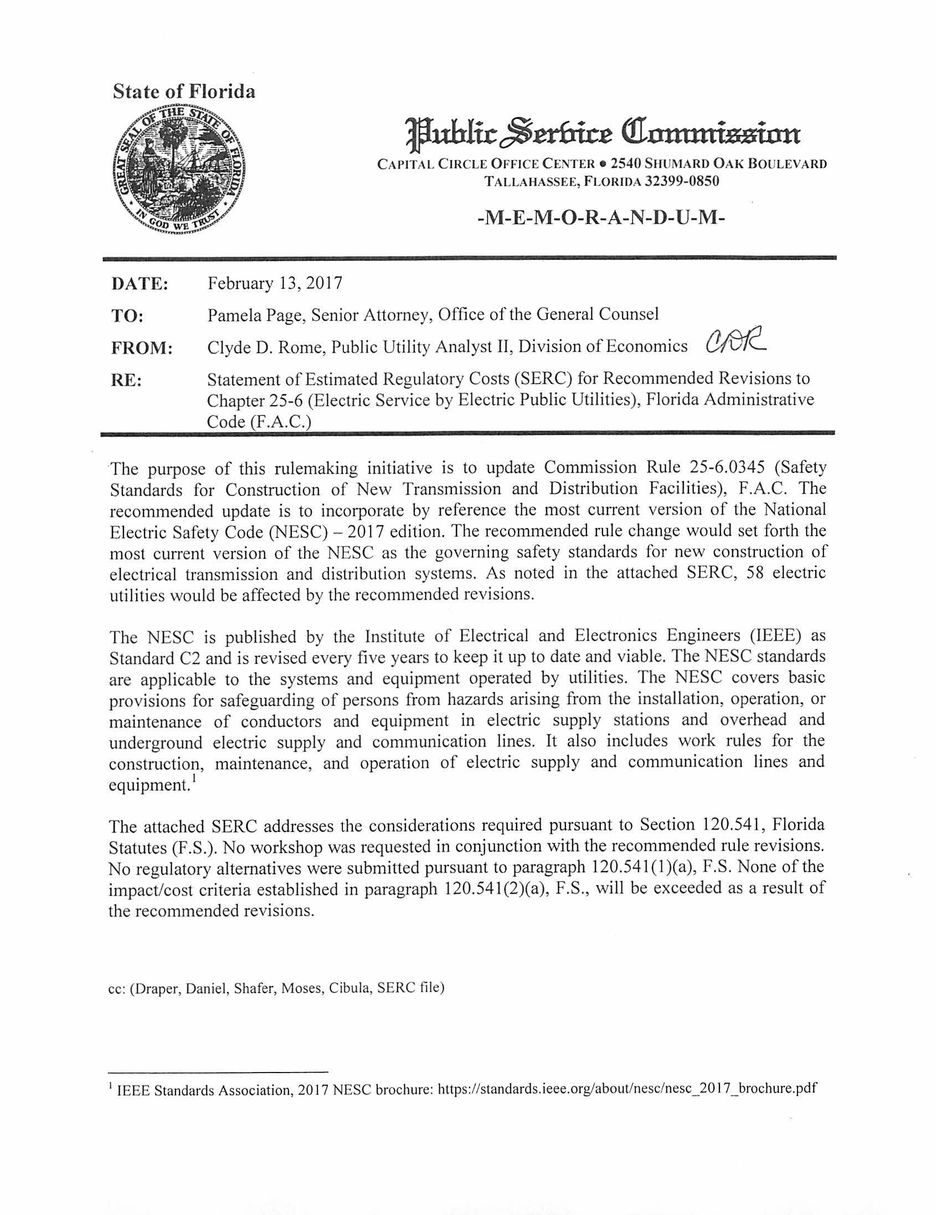

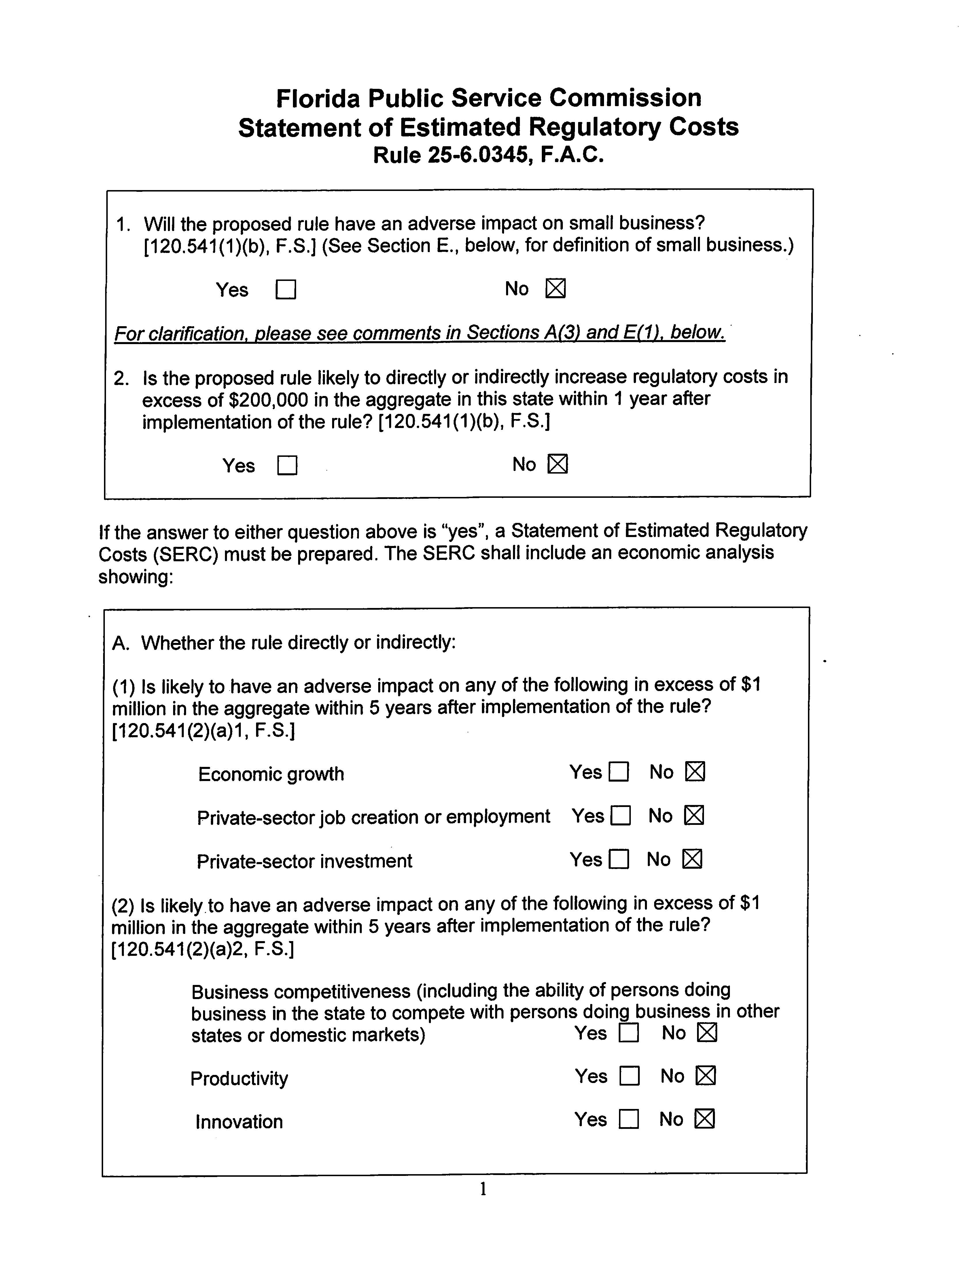

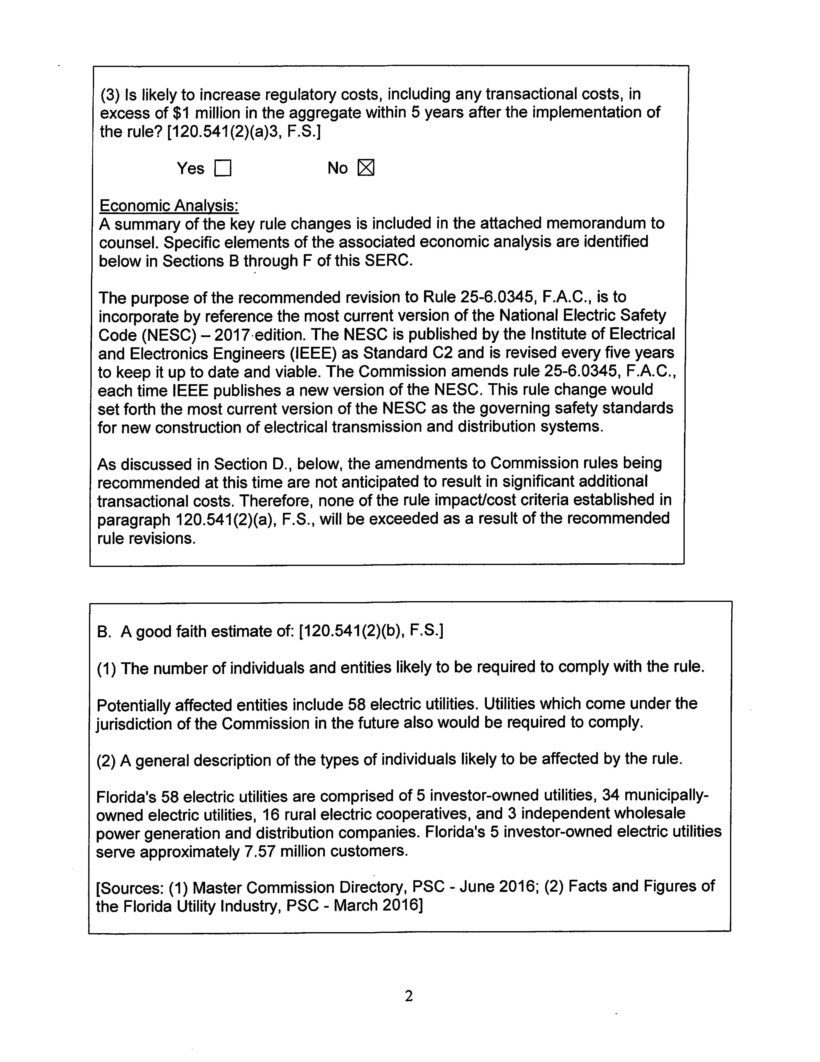

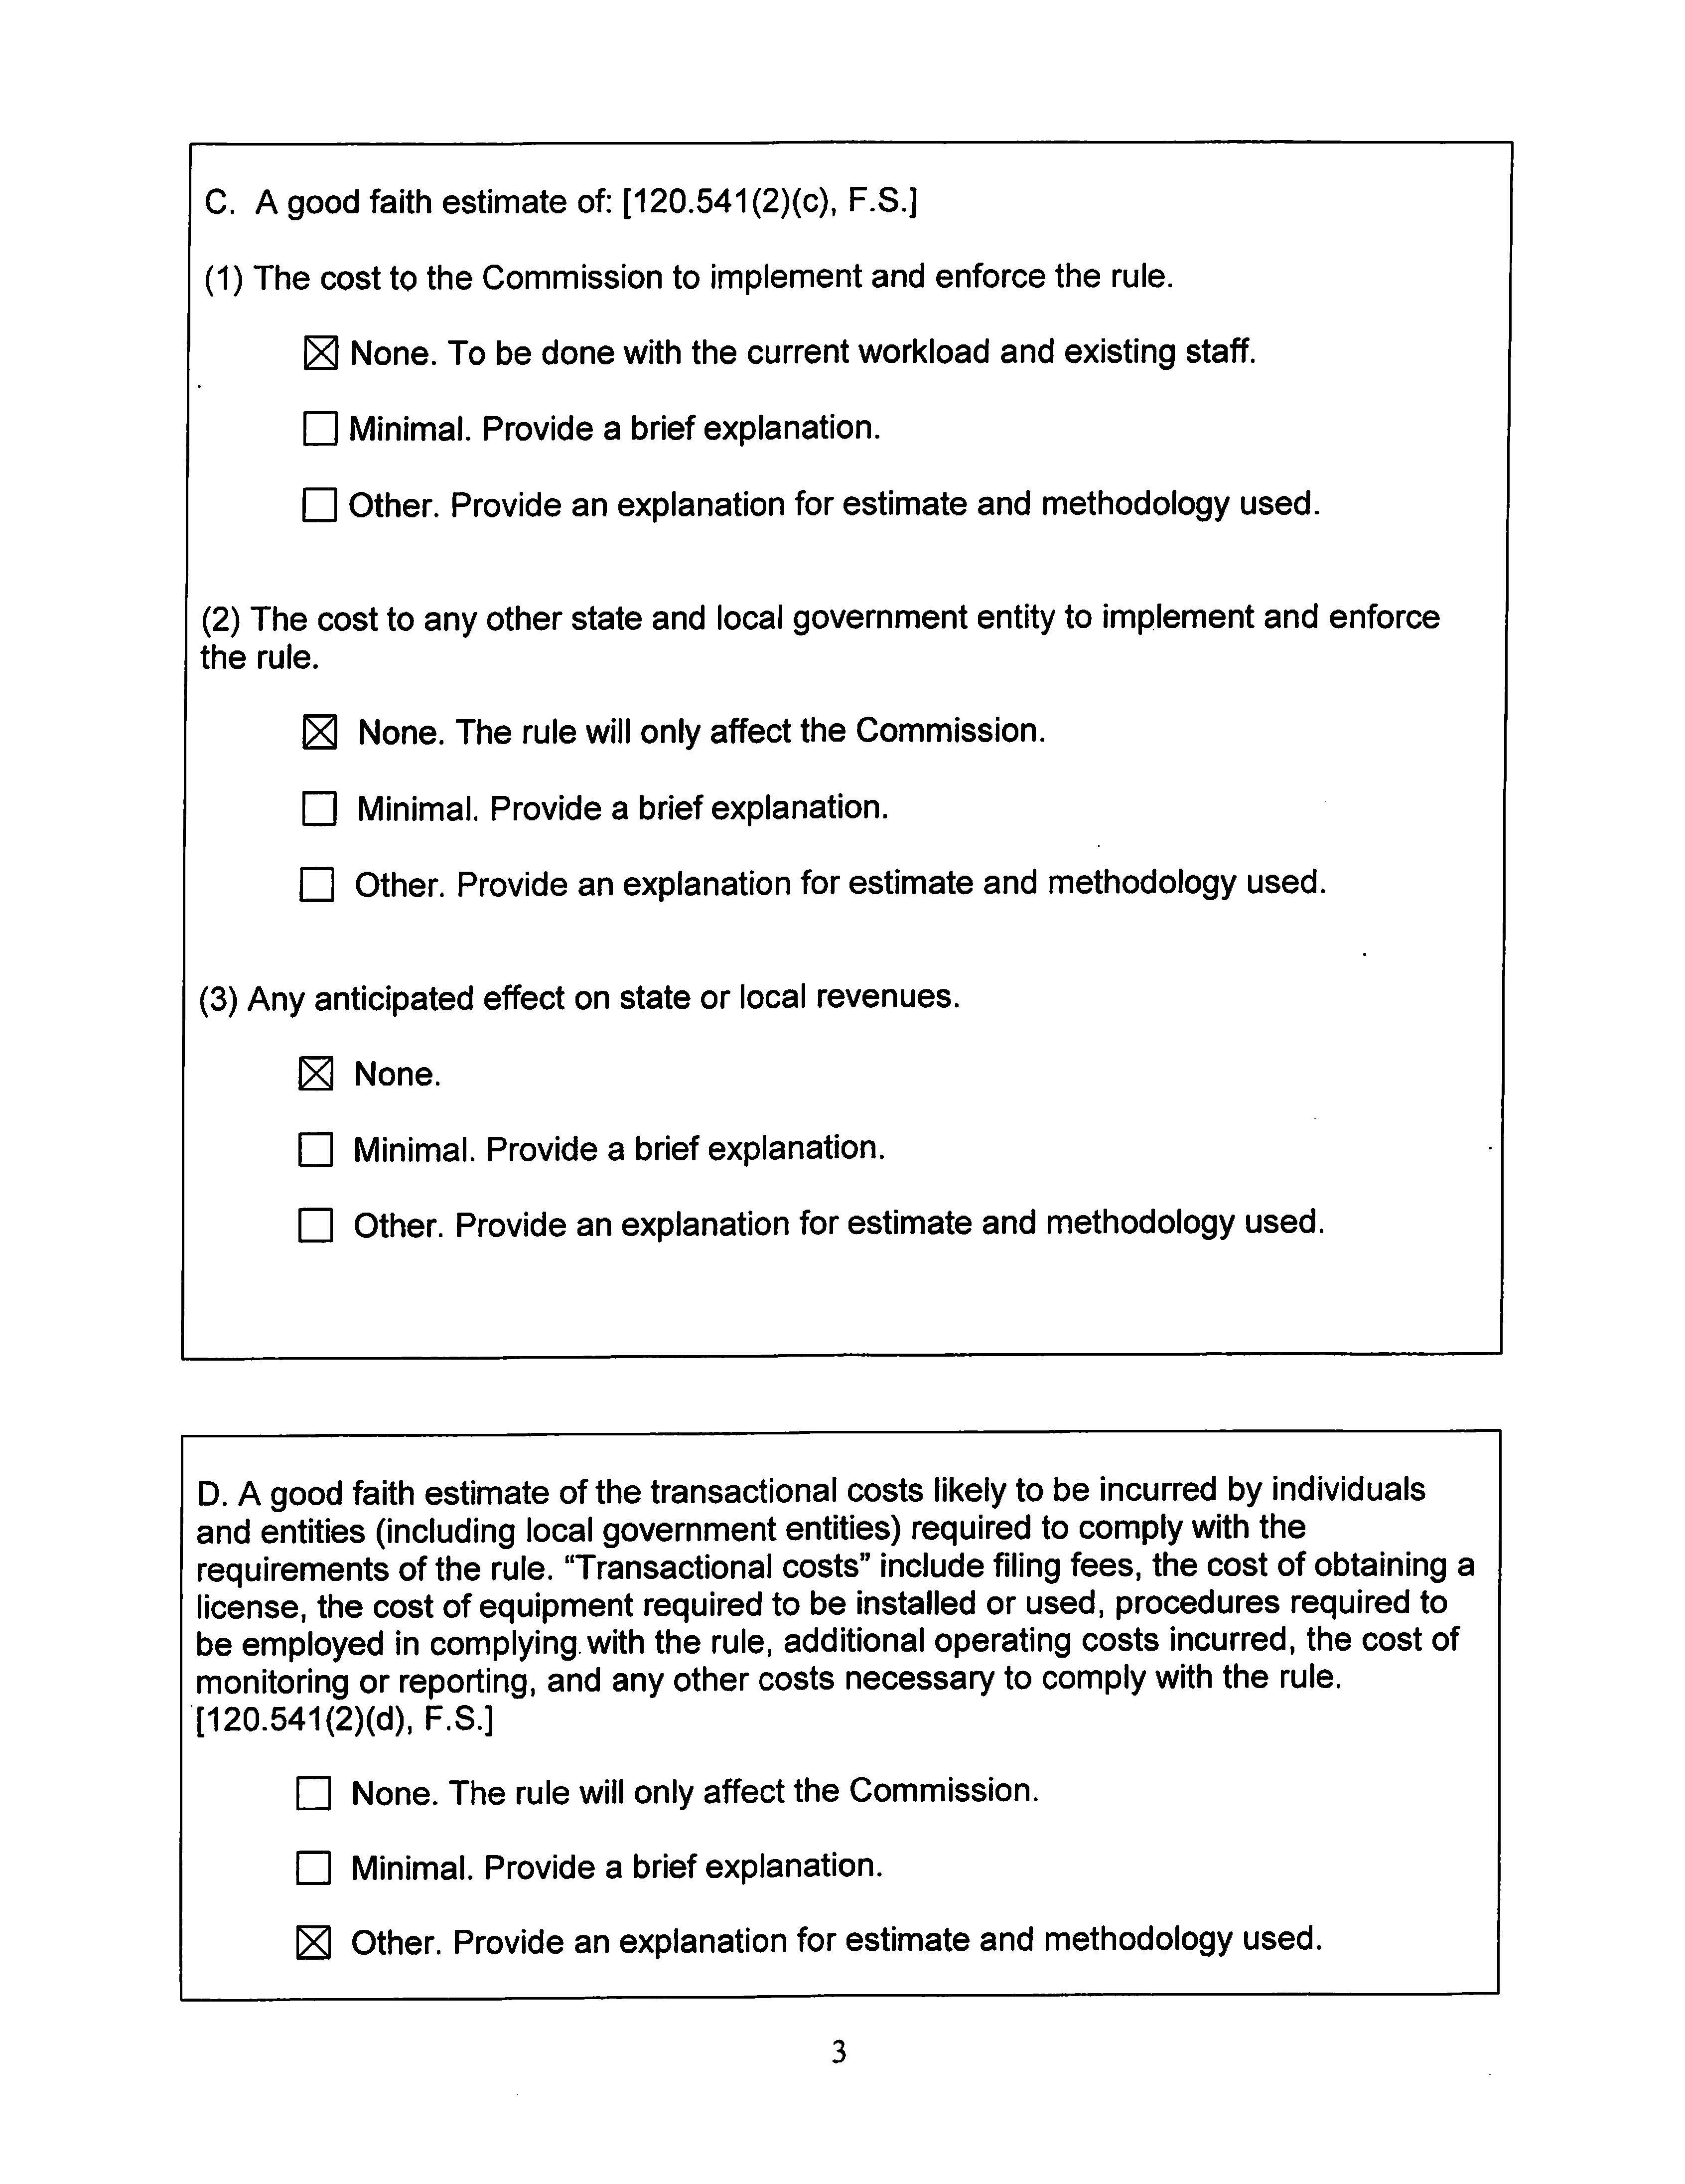

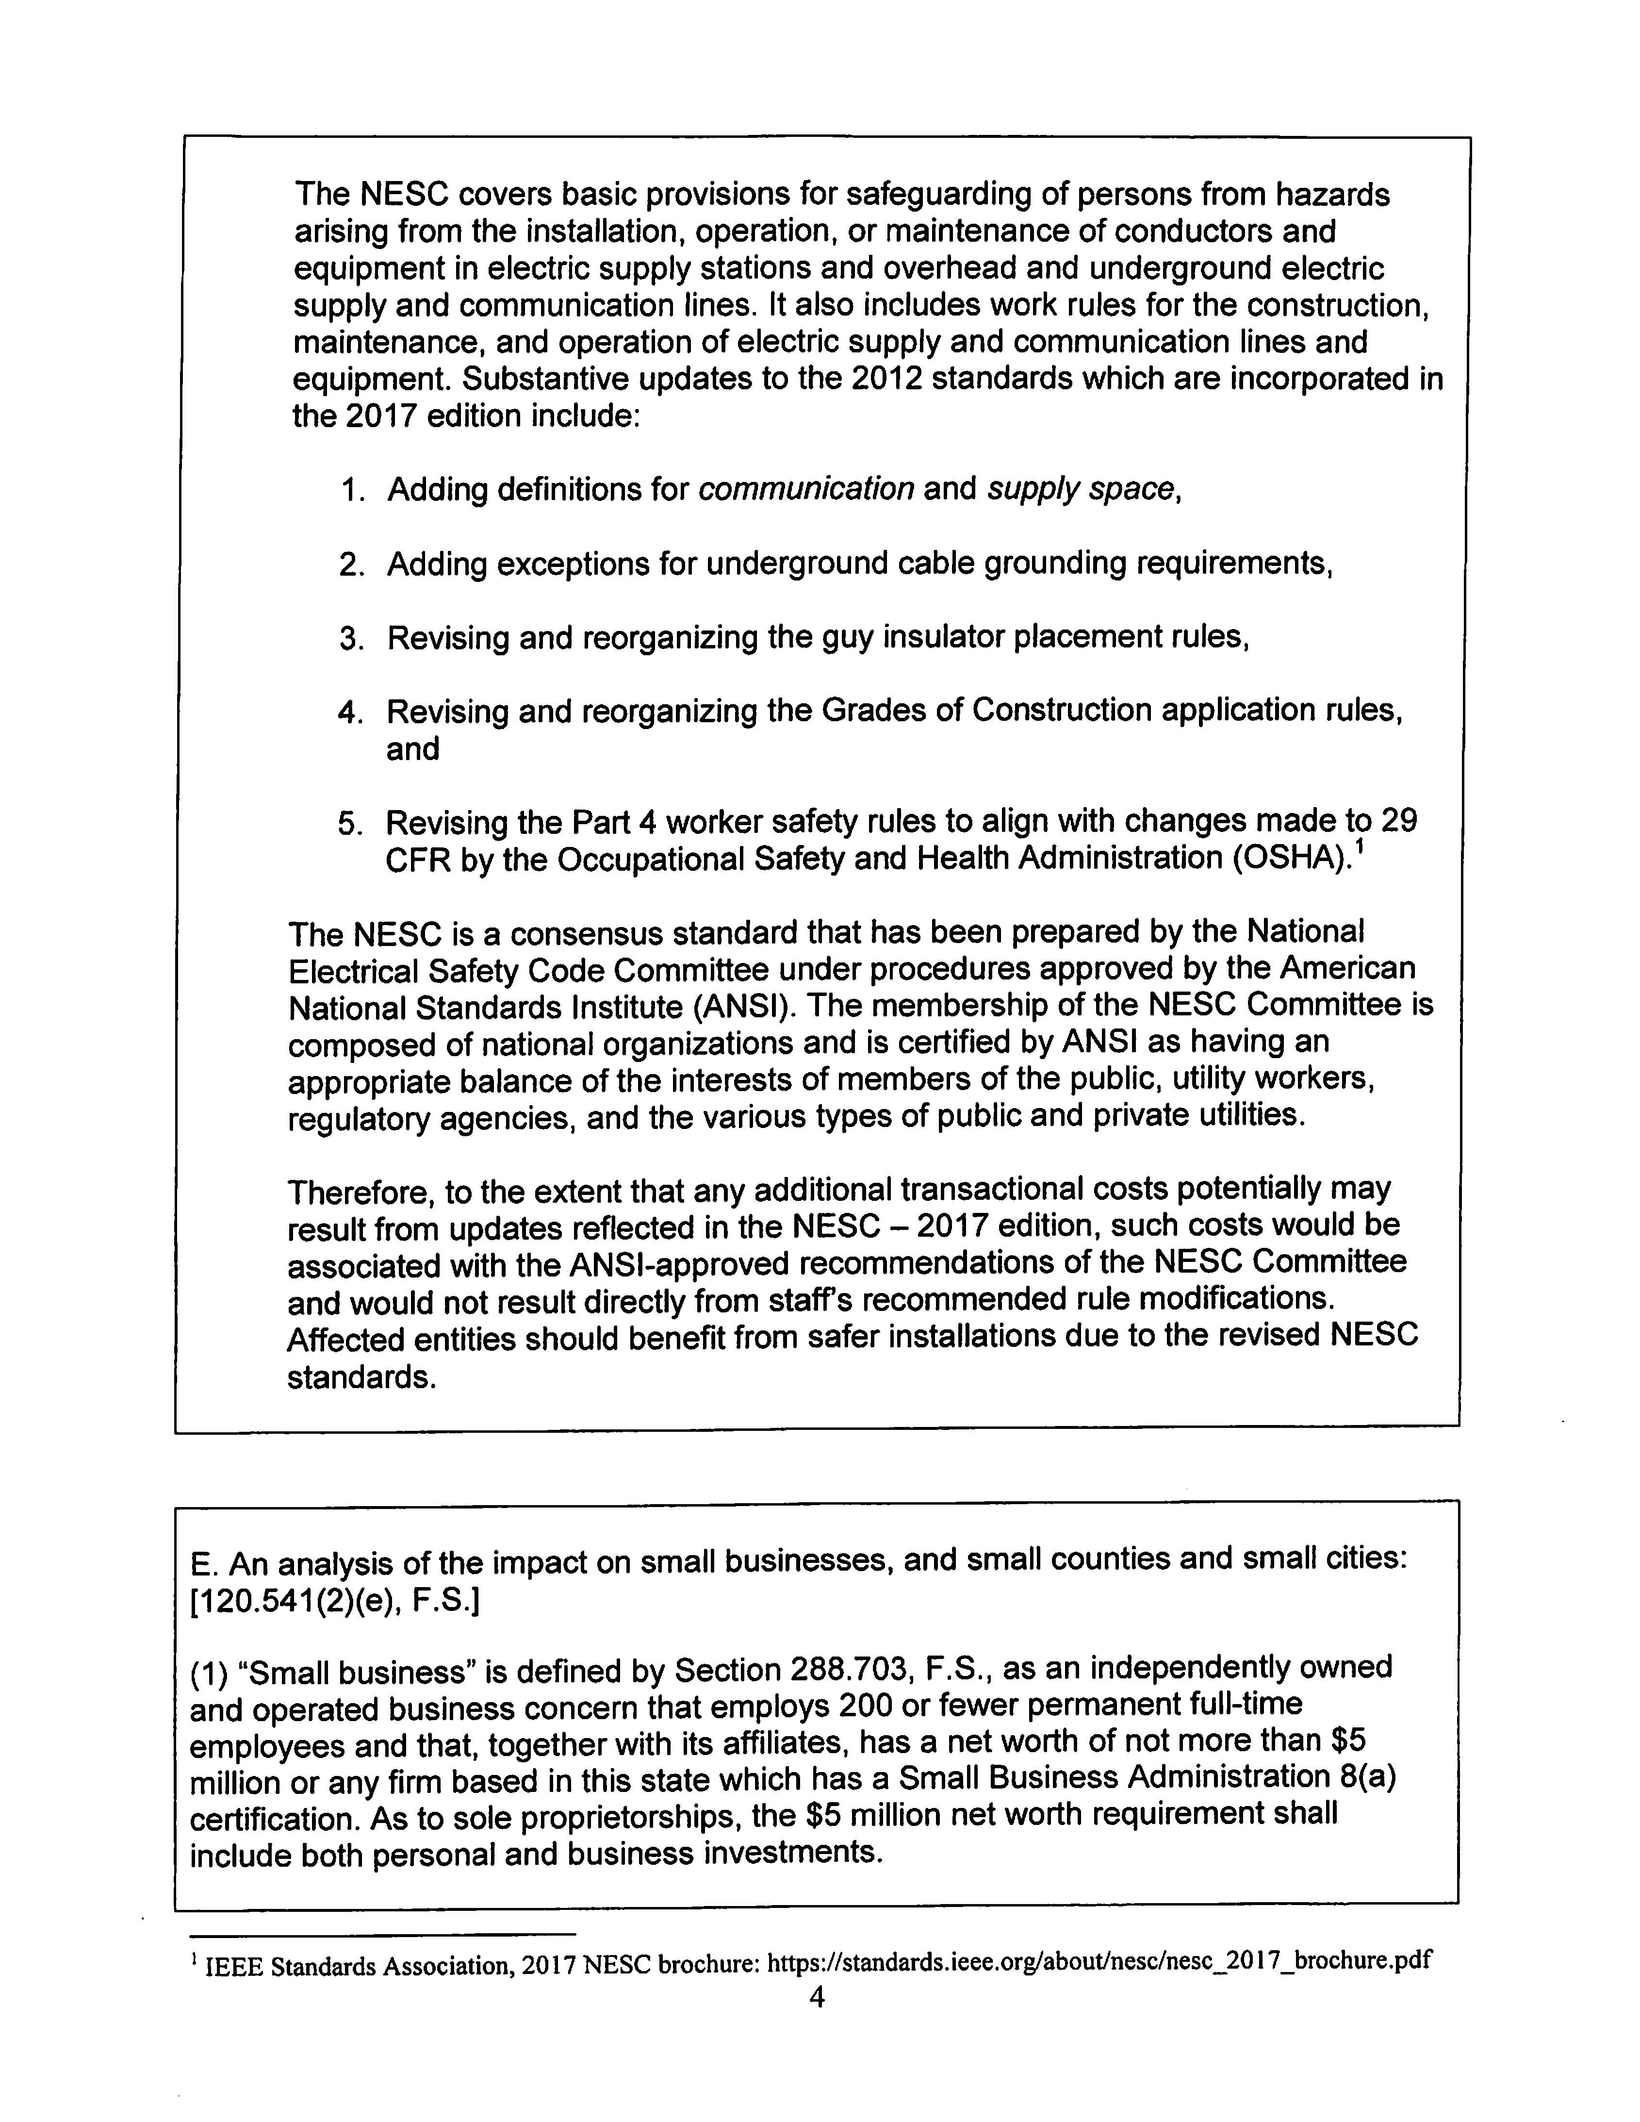

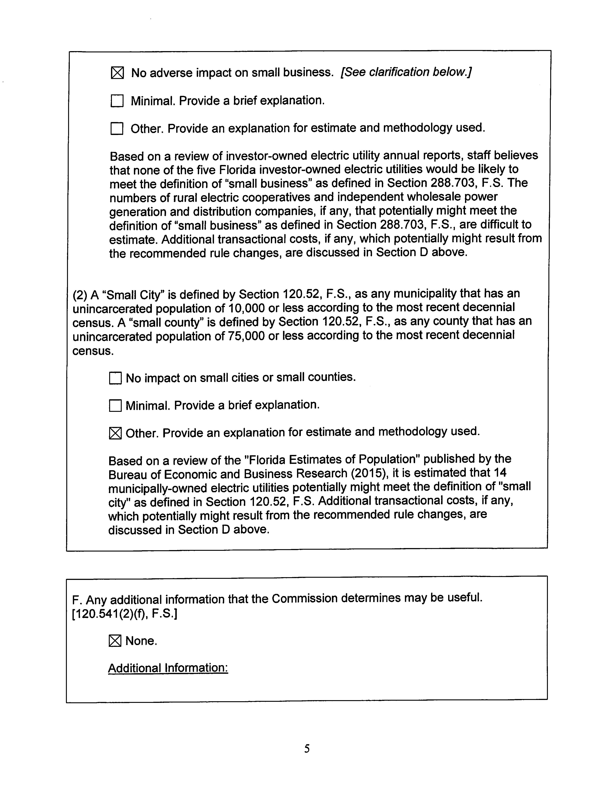

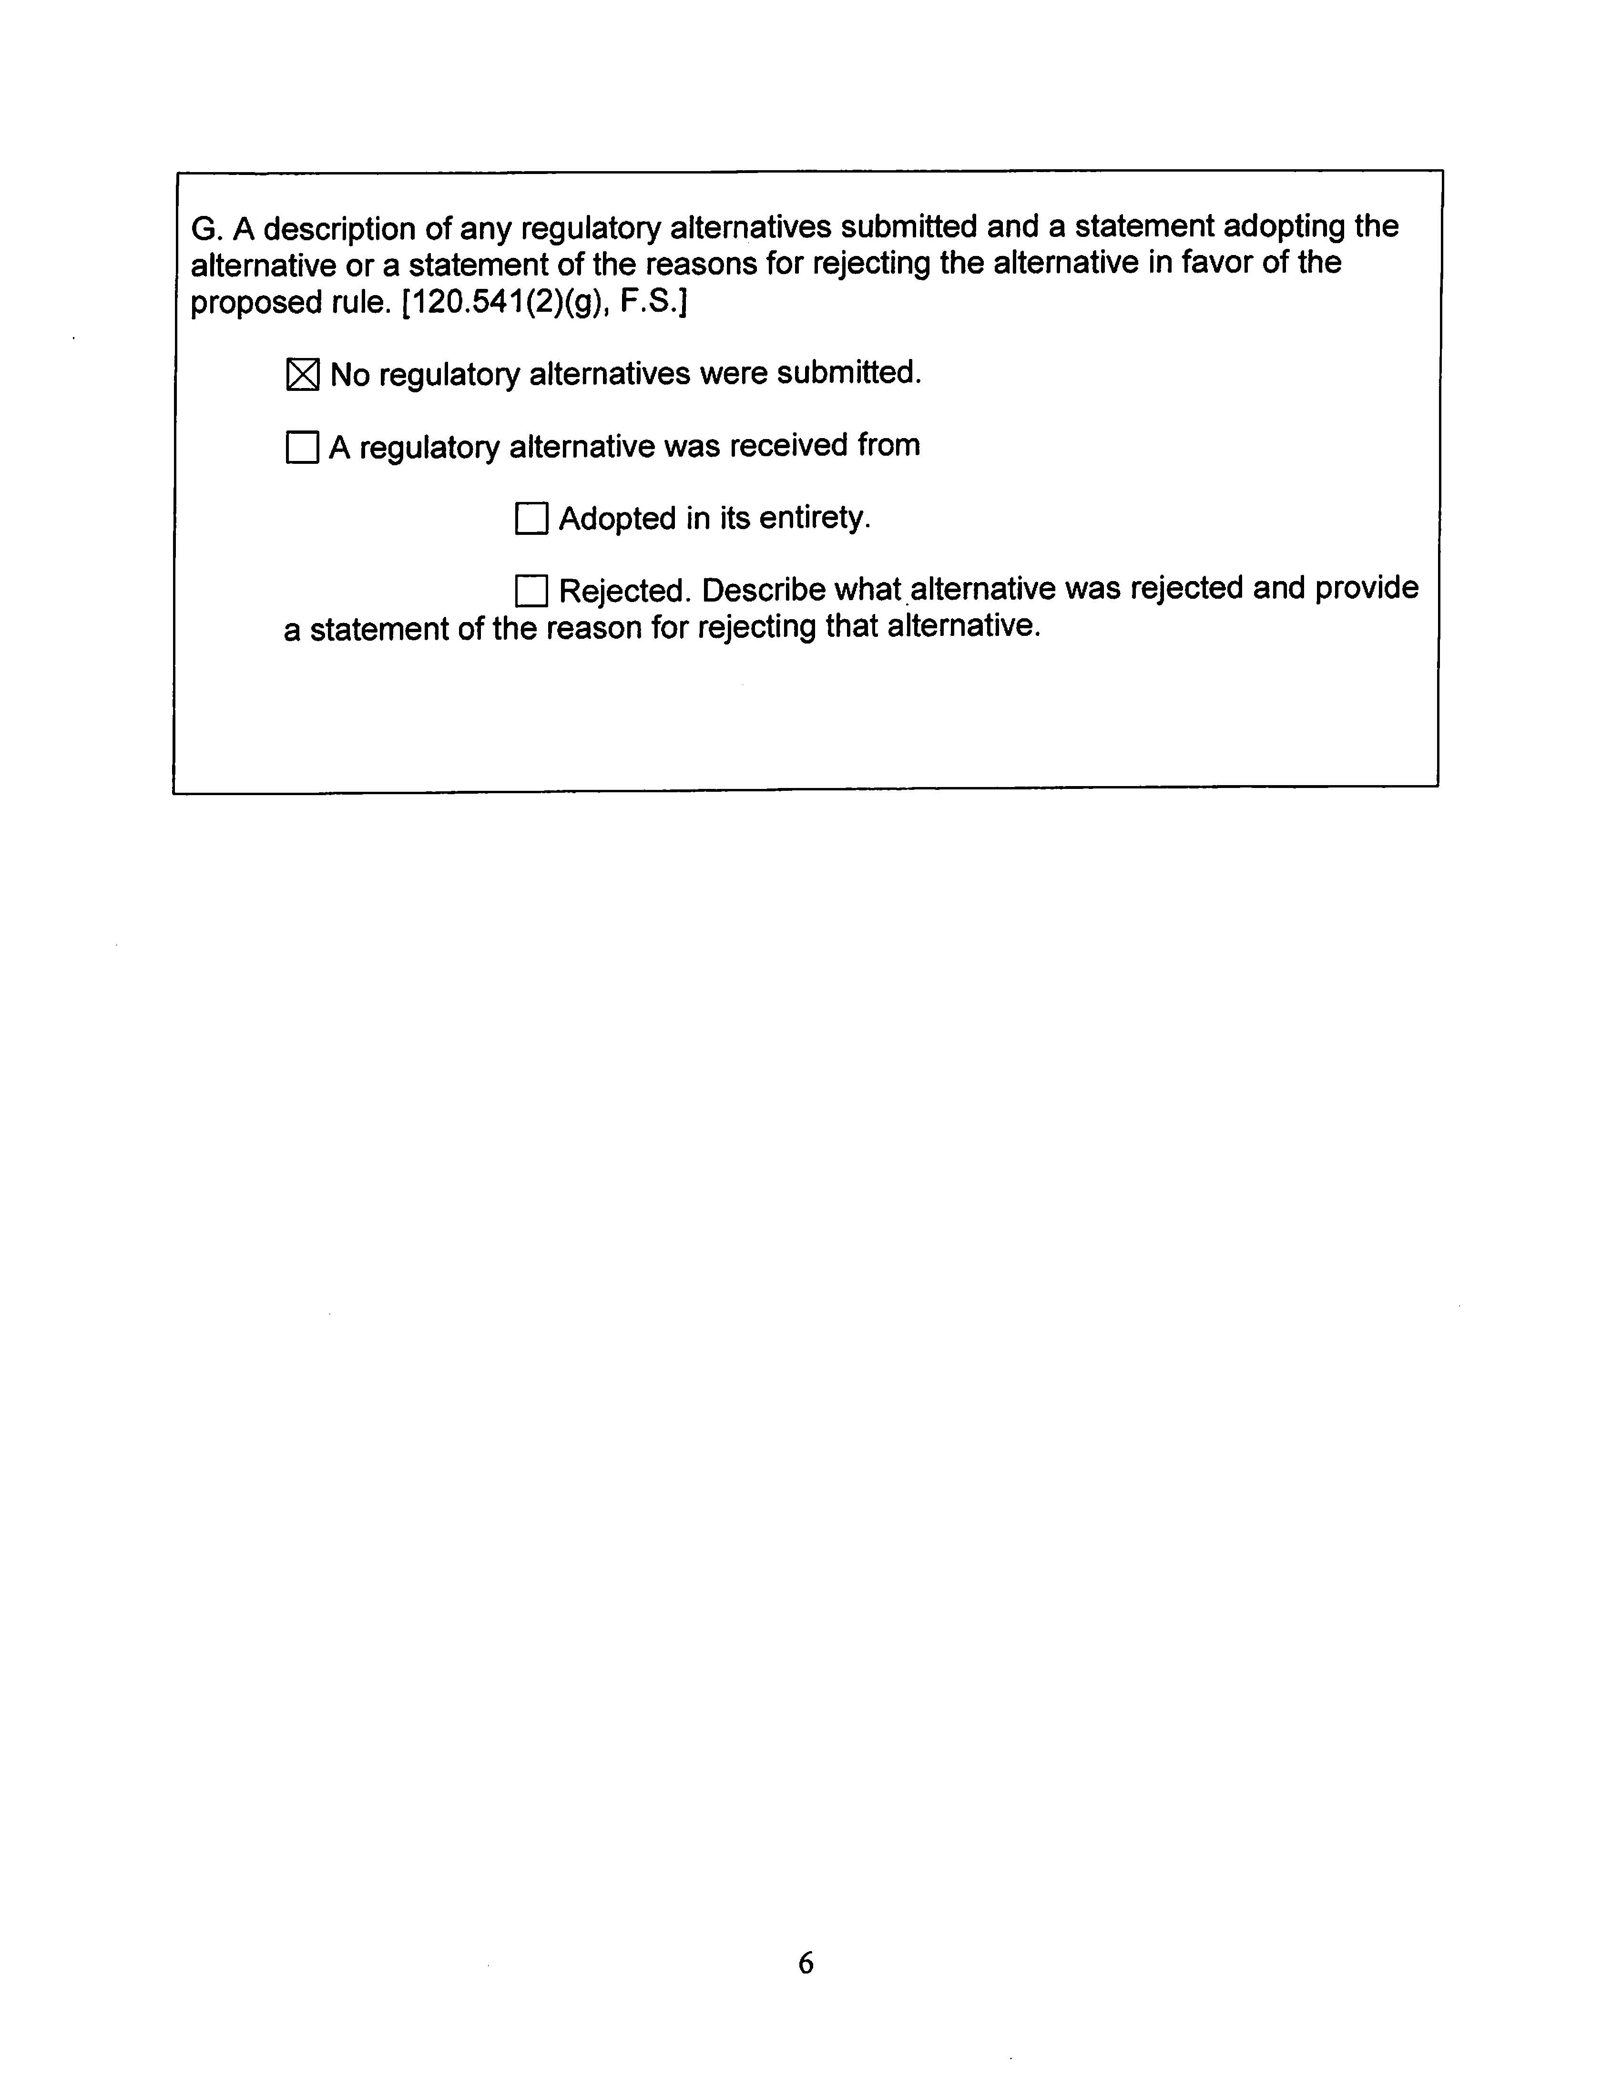

IEEE Standards Association, 2017 NESC brochure: https//standards.ieee.org/about/nesc/nesc_2017_brochure.pdf.
Id.
Id.
Id.
2017 National Electrical Safety Code (NESC) C2-2017.
Section 120.541(2), F.S.

