State of Florida |  | Public Service Commission  Capital Circle Office Center ● 2540 Shumard Oak Boulevard  Tallahassee, Florida 32399-0850  -M-E-M-O-R-A-N-D-U-M-
DATE: | May 24, 2017
TO: | Office of Commission Clerk (Stauffer)
FROM: | Division of Economics (Guffey)  Office of the General Counsel (Taylor)
RE: | Docket No. 170068-EU – Joint petition for approval of amendment to territorial agreement, by Tampa Electric Company and Withlacoochee River Electric Cooperative, Inc.
AGENDA: | 06/05/17 – Regular Agenda – Proposed Agency Action - Interested Persons May Participate
COMMISSIONERS ASSIGNED: |  |  | All Commissioners
PREHEARING OFFICER: |  |  | Polmann
CRITICAL DATES: |  |  | None
SPECIAL INSTRUCTIONS: |  |  | None

Case Background
On March 29, 2017, Tampa Electric Company (TECO or the Company) and Withlacoochee River Electric Cooperative, Inc. (WREC) filed a joint petition for approval of an amendment to their current territorial agreement in Pasco County (territorial amendment). TECO serves retail customers in Hillsborough County and in portions of Polk, Pinellas, and Pasco Counties. WREC serves retail customers in portions of Hernando, Citrus, Sumter, Pasco, and Polk Counties.

The original electric service boundary between TECO and WREC was approved by the Commission in 1974 in Order No. 6281. The boundary was amended in 1990 in Order No. 23905 and further amended in 2006 in Order No. PSC-06-0128-PAA-EU (2006 Order). The 1990 territorial agreement approved in Order No. 23905 has been placed in the docket file and attached as Attachment A to this recommendation for informational purposes.

The 2006 Order amended the TECO and WREC territorial agreement approved in 1990 in Order No. 23905 in three limited geographic areas: the Meadow Pointe Subdivision, the Belle Chase Subdivision, and the Cannon Ranch Subdivision. The 2006 Order is included as Exhibit A to the petition. Page 7 of the 2006 Order includes a map showing the agreed upon service boundary modifications relative to the Cannon Ranch Subdivision in Pasco County. The 2006 Order did not approve a new territorial agreement and only amended the 1990 territorial agreement with respect to the three subdivisions listed above.

The Cannon Ranch subdivision was never developed and in 2016 a new developer acquired the development rights of the Cannon Ranch subdivision. The new developer renamed the subdivision Mirada Subdivision and has proposed a different development plan from the Canon Ranch Subdivision. The instant petition seeks to only amend the territorial boundaries in the proposed Mirada Subdivision to accommodate the new development plans (as shown in Attachment B). All other aspects of the territorial agreement approved in 1990 and amended in 2006 remain the same.

Staff issued its first data request on April 21, 2017, to which the responses were received on May 8, 2017. The Commission has jurisdiction over this matter pursuant to Section 366.04, Florida Statues, (F.S.).

Discussion of Issues

Issue 1:
Should the Commission approve the joint petition by TECO and WREC to amend their territorial agreement related to the Mirada Subdivision, f/k/a Cannon Ranch Subdivision, in Pasco County?

Recommendation:
Yes. The Commission should approve the joint petition by TECO and WREC to amend their territorial agreement related to the Mirada Subdivision, f/k/a Cannon Ranch Subdivision, in Pasco County. (Guffey)

Staff Analysis:
In 2016, the new developer who acquired the former Cannon Ranch Subdivision discussed with TECO and WREC the provision of electric service to the proposed Mirada Subdivision. Those discussions led to a mutual agreement among TECO, WREC, and the developer regarding the most efficient, reliable provision of electricity to the new subdivision.

As required by Rule 25-6.0440(1)(f), Florida Administrative Code, the parties provided three large scale maps: a Florida Department of Transportation General County map of Pasco county, the general area of the Mirada Subdivision, and an expanded view of the current and proposed boundary lines specific to the Mirada Subdivision. The specific Mirada Subdivision map is shown in Attachment B to this recommendation.

The proposed territorial amendment is to accommodate the proposed new subdivision. Essentially, the centerline of Mirada Boulevard will serve as the revised territorial boundary between TECO and WREC as it relates to the Mirada Subdivision. The petitioners assert that this proposal would allow both utilities to have sufficient access to the areas to be served and it will facilitate the orderly provision of electricity by the two utilities. The petitioners further assert that the proposed territorial amendment will not cause a decrease in the reliability of electric service to the existing and future ratepayers of either utility and will prevent the uneconomic duplication of facilities.

The Mirada Subdivision covers 2,350 acres and will have a total of 4,520 customers when developed. TECO will serve 2,420 customers and WREC will serve 2,100 customers. As this subdivision has not been developed yet, there are no customers to be transferred as a result of the proposed territorial amendment. Similarly, there are no affected customers to be notified. The petitioners represented that the developer of the Mirada Subdivision has agreed with TECO and WREC that the new boundary line through the development is appropriate and acceptable to the developer.

Conclusion
After review of the petition, the proposed territorial amendment, and the joint petitioners’ responses to its data request, staff believes that the proposed territorial amendment is in the public interest and will enable TECO and WREC to better serve the future customers in the Mirada Subdivision in Pasco County. It appears that the proposed territorial amendment eliminates any potential uneconomic duplication of facilities and will not cause a decrease in the reliability of electric service. As such, staff believes that the proposed territorial amendment between TECO and WREC will not cause a detriment to the public interest and recommends that the Commission approve it.

Issue 2:
Should this docket be closed?

Recommendation:
If no protest is filed by a person whose substantial interests are affected within 21 days of the issuance of the Order, this docket should be closed upon the issuance of a Consummating Order. (Taylor)

Staff Analysis:
If no protest is filed by a person whose substantial interests are affected within 21 days of the issuance of the Order, this docket should be closed upon the issuance of a Consummating Order.

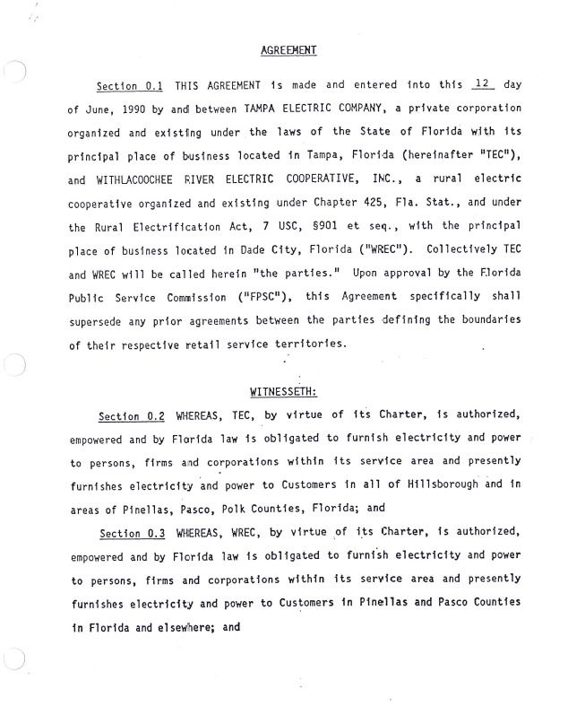

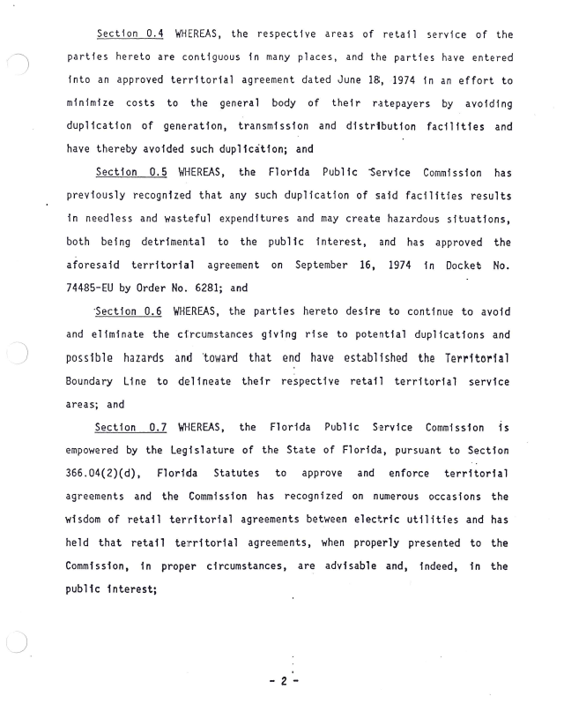
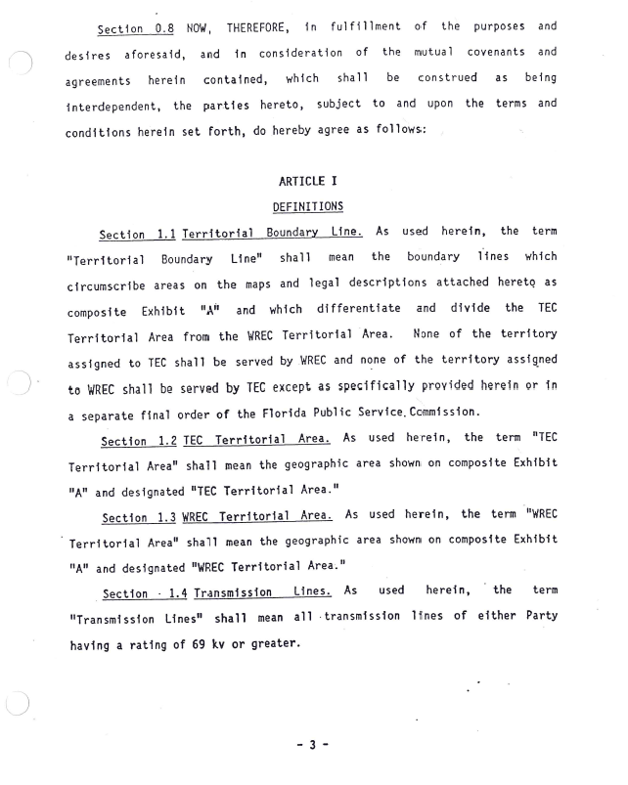
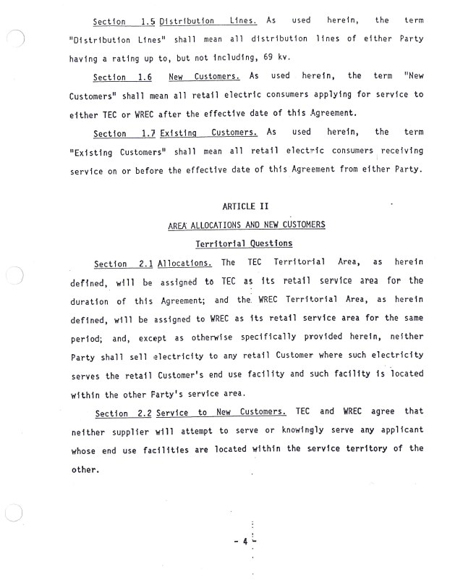
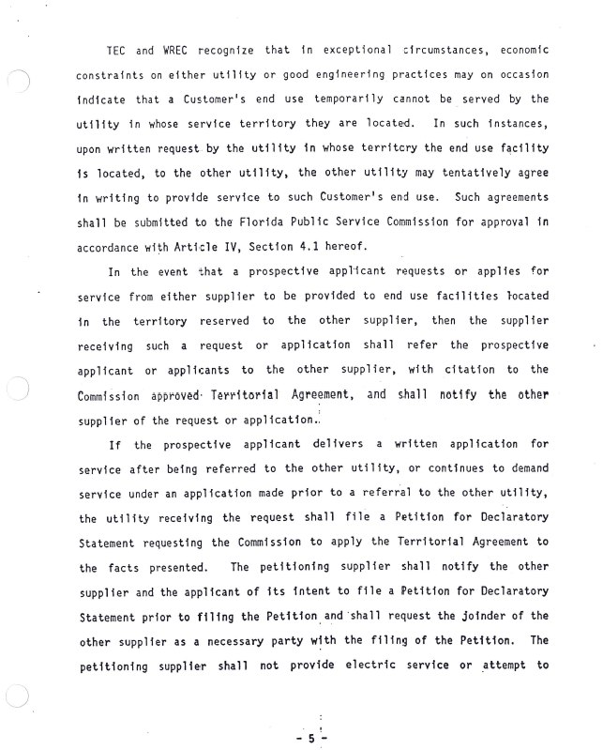
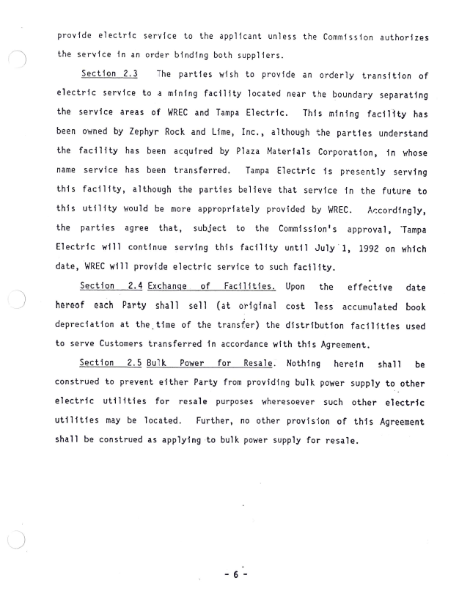
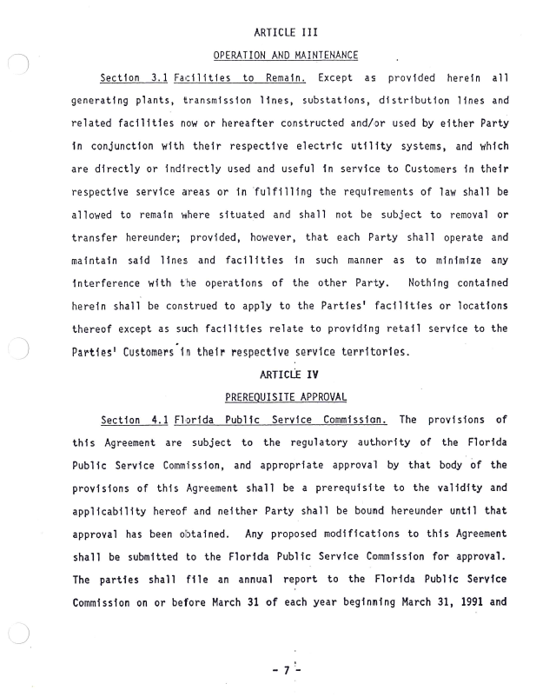
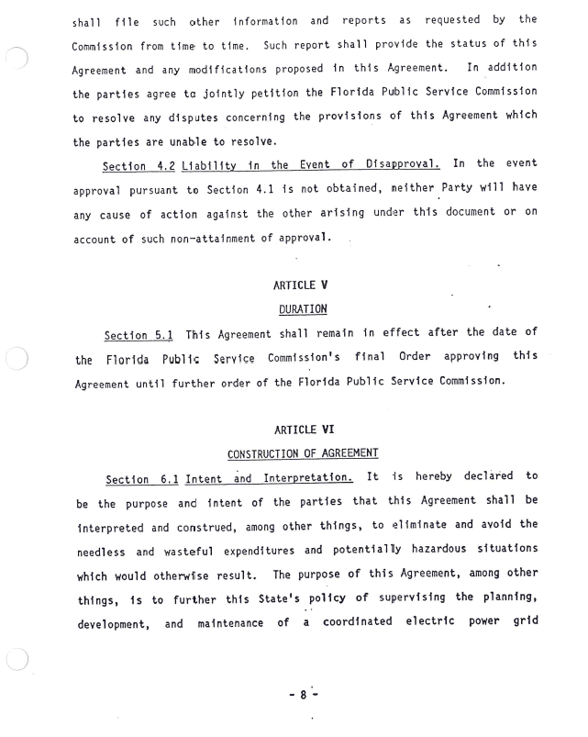
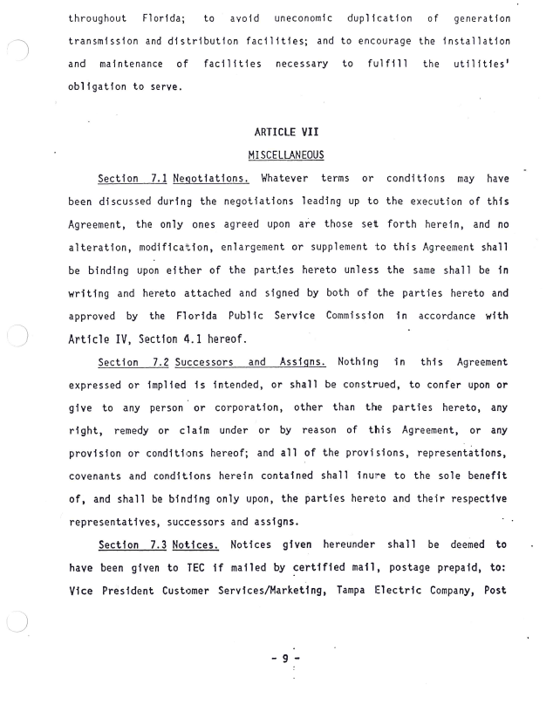
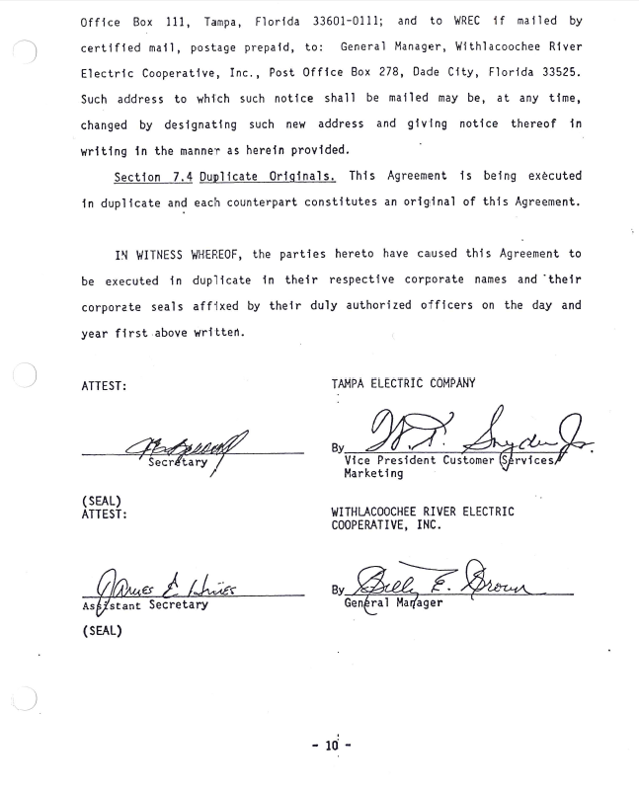
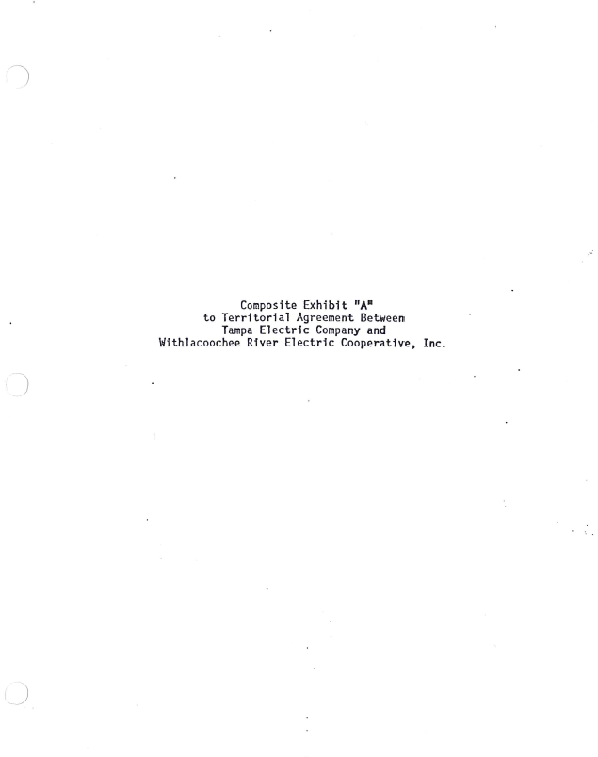
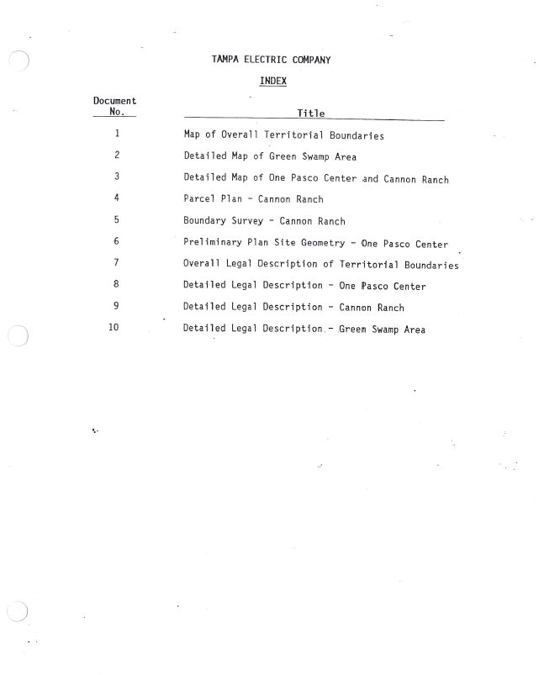
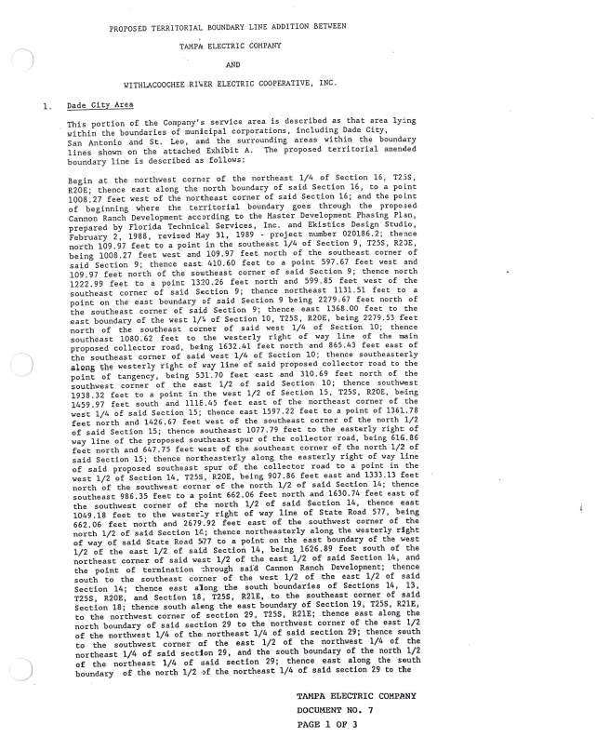
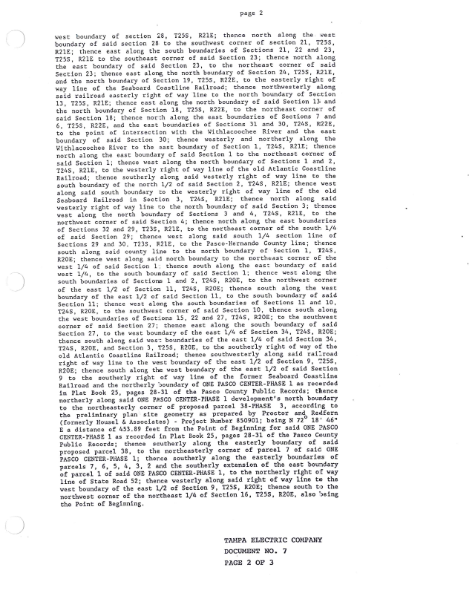
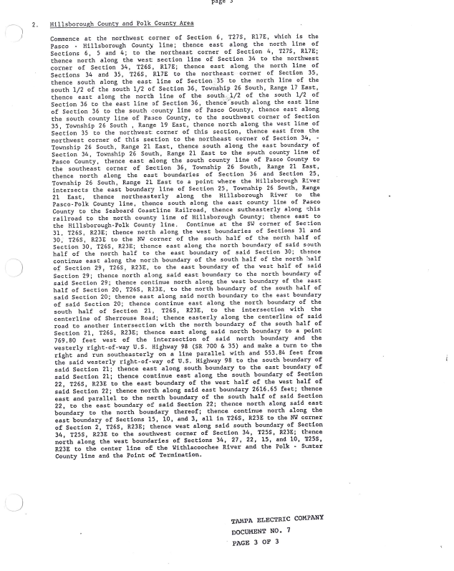
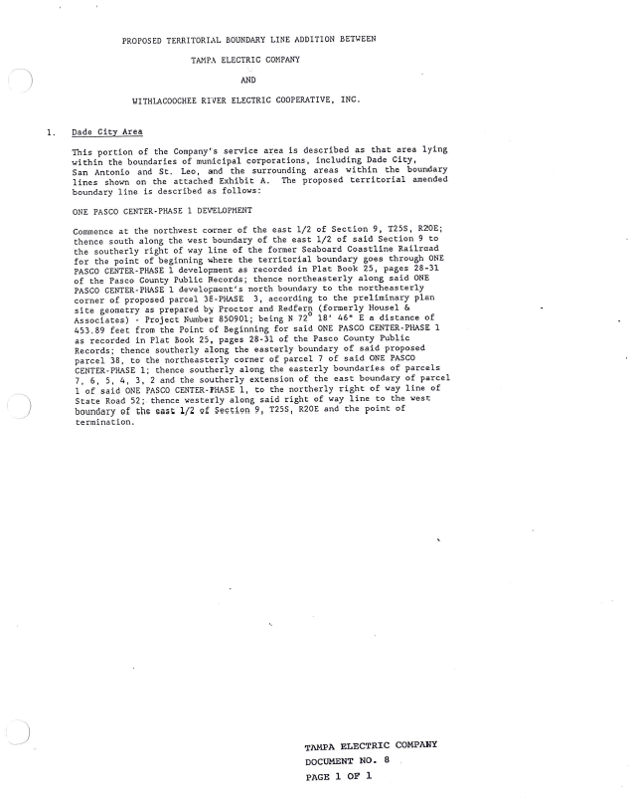
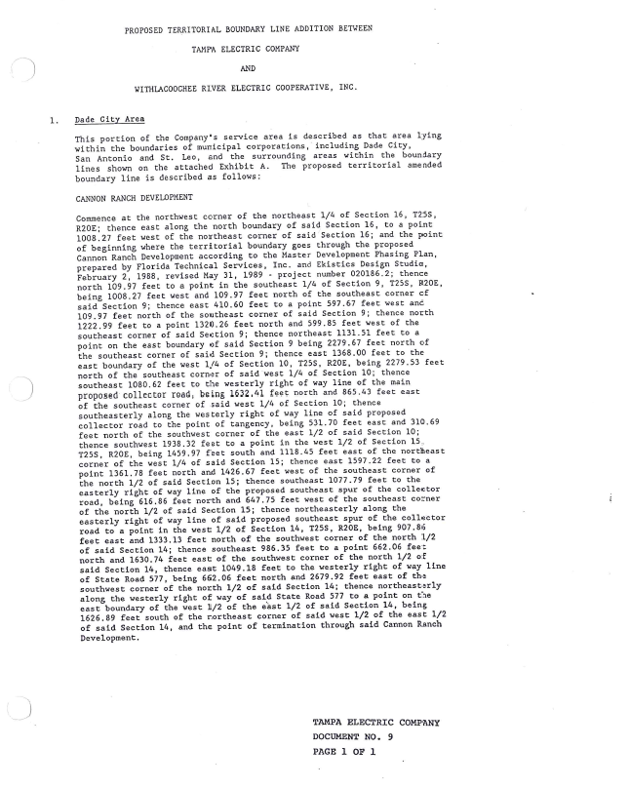
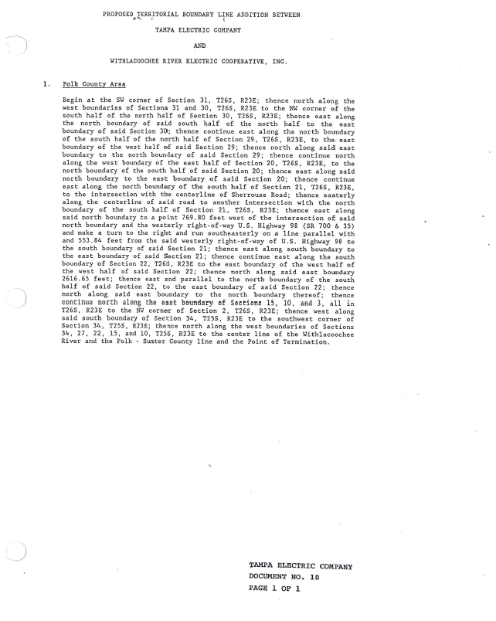
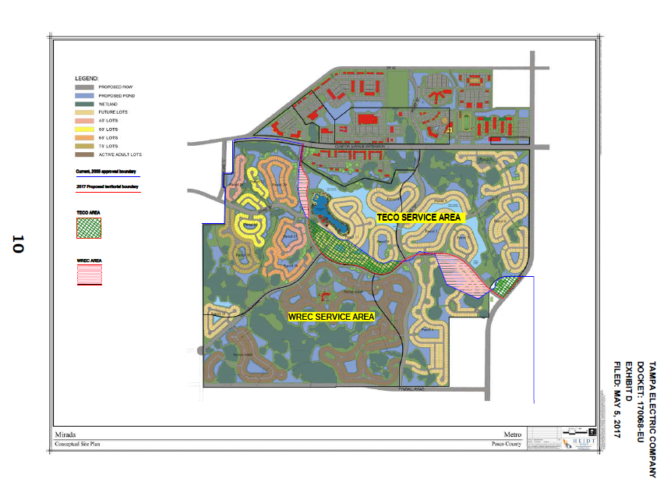

Order No. 6281, issued on September 16, 1974, in docket No. 74485-EU, In re: Application of Tampa Electric Company for approval of territorial agreement with Withlacoochee River Electric Cooperative, Inc., relative to respective retail electric systems and service areas.
Order No. 23905, issued December 20, 1990, in Docket No 900752-EU, In re: Joint Petition for Approval of 1990 Amendment to Territorial Agreement by Tampa Electric Company and Withlacoochee River Electric Cooperative, Inc.
Order No.PSC-06-0128-PAA-EU, issued February 16, 2006, in Docket No. 041408-EU, In re: Joint petition of Tampa Electric Company and Withlacoochee River Electric Cooperative, Inc. for expedited interim approval of customer transfers pending consideration of joint application for permanent relocation of territorial boundaries.
Document No. 04984-17.

