State of Florida |  | Public Service Commission  Capital Circle Office Center ● 2540 Shumard Oak Boulevard  Tallahassee, Florida 32399-0850  -M-E-M-O-R-A-N-D-U-M-
DATE: | May 24, 2017
TO: | Office of Commission Clerk (Stauffer)
FROM: | Division of Economics (Guffey)  Office of the General Counsel (DuVal)
RE: | Docket No. 170085-GU – Request for approval of tariff modifications applicable to address installation of excess flow valves, by Florida City Gas.
AGENDA: | 06/05/17 – Regular Agenda – Tariff Filing – Interested Persons May Participate
COMMISSIONERS ASSIGNED: |  |  | All Commissioners
PREHEARING OFFICER: |  |  | Administrative
CRITICAL DATES: |  |  | 06/12/17 (60-Day Suspension Date)
SPECIAL INSTRUCTIONS: |  |  | None

Case Background
On April 12, 2017, Florida City Gas (FCG or Company) filed a petition requesting Commission approval of tariff modifications to address the installation of excess flow valves (EFVs) in order to comply with new federal guidelines. FCG is a natural gas local distribution company subject to the Commission’s regulatory jurisdiction under Chapter 366, Florida Statutes (F.S.).

Effective April 14, 2017, a federal pipeline safety rule (49 C.F.R. § 192.383 (2017)) with which FCG must comply was amended by the Pipeline and Hazardous Materials Safety Administration (PHMSA). As a result of PHMSA’s revisions to the federal rule, FCG is seeking to modify Tariff Sheet Nos. 1A and 22B. The proposed tariff sheets are included as Attachment A to this recommendation. Staff issued a data request to the Company for which the responses were received on May 4, 2017. Staff received the Company’s responses to follow-up questions on May 11, 2017, which staff placed in the docket file.
The Commission approved a similar petition by Peoples Gas System at its May 4, 2017 Agenda Conference (Docket No. 170071-GU). Staff placed the relevant rulemaking record as published in the Federal Register in the Docket No. 170071-GU file for informational purposes. The Commission has jurisdiction in this matter pursuant to Sections 366.03, 366.04, 366.05, and 366.06, F.S.

Discussion of Issues

Issue 1:
Should the Commission approve FCG's proposed modification to Tariff Sheet Nos. 1A and 22B relating to the Company's Excess Flow Valves tariff?

Recommendation:
Yes, the Commission should approve FCG’s proposed modification to Tariff Sheet Nos. 1A and 22B relating to the Company’s Excess Flow Valves tariff, as reflected in Attachment A, effective June 5, 2017. (Guffey)

Staff Analysis:
The proposed tariff revision would allow FCG to be reimbursed by customers who request the installation of an EFV on an existing service line pursuant to the new PHMSA rule discussed below.

PHMSA Changes and Pipeline Safety Rules
FCG is required by PHMSA to comply with Federal Rule 49 C.F.R. § 192.383 (2017). As originally adopted, the rule required the installation of an EFV on any new or replaced service line serving a single family residence after February 12, 2010, subject to certain exceptions. An EFV is a device designed to shut off automatically when the natural gas flow exceeds certain limits, such as when a service line is damaged due to excavation or other activities. Thus the EFV provides safety benefits by limiting the risk of escaping gas due to third party damage or a pipe failure. EFVs do not protect against gas leaks occurring in piping behind the customer’s gas meter. Most service lines serving non-residential customers deliver in excess of 1,000 standard cubic feet per hour and are fitted with curb valves that are shut off manually.

PHMSA adopted an amendment to 49 C.F.R. § 192.383 (2017), which took effect on April 14, 2017. Among other things, the rule revisions, subject to certain exceptions, provide for the following: (a) “operators” such as FCG are required to notify customers of their right to request installation of an EFV, (b) if a service line customer requests an EFV installation, FCG must install the EFV at a mutually agreeable date, and (c) the question of who bears the cost of the requested EFV installation is left to the “operator’s rate-setter.” These three key elements are discussed individually below.

Regarding customer notification, PHMSA determined that notification through broad electronic means, including website postings, was acceptable. In response to staff’s data request, FCG provided the information that was posted on the Company’s website and a copy of the bill insert containing EFV information. The website posting includes information related to the function and benefits of an EFV and answers to “Frequently Asked Questions” regarding EFVs, including potential cost estimates for EFV installations and a point of contact for interested customers.

Regarding EFV installation, FCG stated that the Company installs EFVs on new service lines at a cost of approximately $13 to $137. However, FCG stated that it is considerably different in the case of an existing customer who requests an EFV installation on a line that may have been installed many years before. FCG stated that the cost to have an EFV installed on an existing line is between $2,300 and $4,000. This general estimated range includes the cost of crew members, hours, excavator, other equipment and materials, landscaping, service upsize and taxes. The actual cost will be determined after a site visit and it could be less or more than the above stated general estimated cost.

The rulemaking record published in the Federal Register also devoted considerable discussion to the appropriate regulatory entities which would be responsible for determining who should pay for the costs of EFV installation on existing service lines. PHMSA considered stakeholder comments and ultimately “left the question of who bears the cost of installing EFVs on service lines not being newly installed or replaced to the operator’s rate-setter.” FCG states that the Commission is the Company’s rate-setter.

Conclusion
Based upon the information provided by FCG and a review of the PHMSA rulemaking record published in the Federal Register, staff agrees with FCG’s assertion that the Commission is FCG’s “rate-setter” for purposes of the federal rule. Staff also believes that it is appropriate for customers who request the installation of EFVs on existing service lines to bear the cost of the modifications and that such costs should not be subsidized by the general body of ratepayers. Therefore, staff recommends that the Commission approve FCG’s proposed tariff modifications to Tariff Sheet Nos. 1A and 22B relating to the Company’s EFVs tariff, as reflected in Attachment A, effective June 5, 2017.

Issue 2:
Should this docket be closed?

Recommendation:
If Issue 1 is approved and a protest is filed within 21 days of the issuance of the order, the tariffs should remain in effect, with any revenues held subject to refund, pending resolution of the protest. If no timely protest is filed, this docket should be closed upon the issuance of a consummating order. (DuVal)

Staff Analysis:
If Issue 1 is approved and a protest is filed within 21 days of the issuance of the order, the tariffs should remain in effect, with any revenues held subject to refund, pending resolution of the protest. If no timely protest is filed, this docket should be closed upon the issuance of a consummating order.

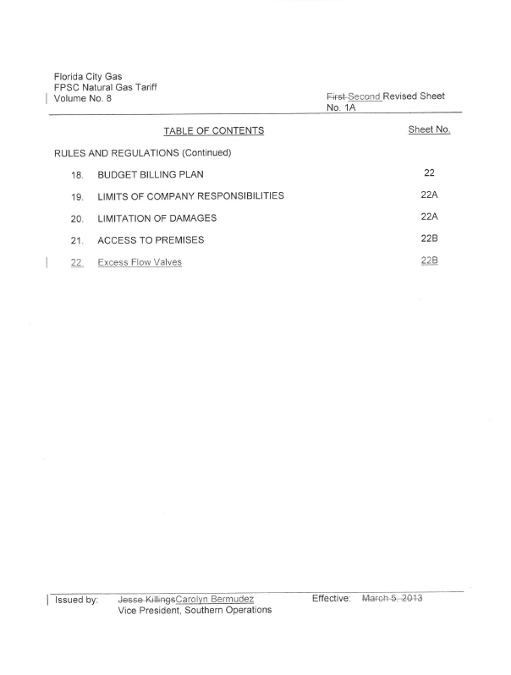
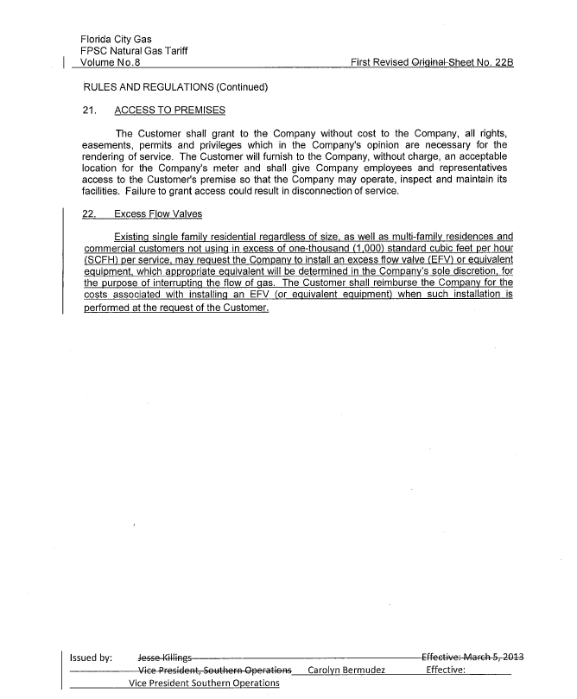

Docket No. PHMSA-2011-0009; Amendment No 192-121, Federal Register / Vol. 81, No. 199 / Friday, October 14, 2016, pp. 70987-71002.
Docket No. 170071-GU – Petition for approval of tariff modifications relating to relocation or modification of gas service facilities, by Peoples Gas System.
The PHMSA rulemaking record published in the Federal Register contains the purpose for promulgating the rule, pertinent noticing requirements for the rule, a summary of the rulemaking process including stakeholder comments and PHMSA’s responses thereto, and the final rule language.
Federal Register / Vol. 81, No. 199 / Friday, October 14, 2016; pp. 70987-71002.
Id., pp. 70990, 70993-70994.
FCG stated that the actual cost could be less than the bottom of this estimated range, as well as above top of the range. Response to follow-up question 2.
Id., p. 70987.

