State of Florida |  | Public Service Commission  Capital Circle Office Center ● 2540 Shumard Oak Boulevard  Tallahassee, Florida 32399-0850  -M-E-M-O-R-A-N-D-U-M-
DATE: | June 29, 2017
TO: | Office of Commission Clerk (Stauffer)
FROM: | Division of Economics (Rome, Draper)  Office of the General Counsel (Mapp)
RE: | Docket No. 170073-EI – Petition for approval of revised underground residential distribution tariffs, by Tampa Electric Company.
AGENDA: | 07/13/17 – Regular Agenda – Tariff Filing – Interested Persons May Participate
COMMISSIONERS ASSIGNED: |  |  | All Commissioners
PREHEARING OFFICER: |  |  | Administrative
CRITICAL DATES: |  |  | 11/30/17 (8-Month Effective Date)
SPECIAL INSTRUCTIONS: |  |  | None

Case Background
On March 31, 2017, Tampa Electric Company (TECO or Company) filed a petition for approval of its revised underground residential distribution (URD) tariffs. The proposed tariffs and associated charges are shown in Attachment A. TECO’s current charges were approved in Order No. PSC-15-0273A-TRF-EI. The Commission suspended TECO’s proposed tariffs in Order No. PSC-17-0176-PCO-EI. On May 12 and June 1, 2017, TECO provided responses to staff’s data requests. On June 15, 2017, TECO responded to a staff follow-up inquiry, which has been placed in the docket file. The Commission has jurisdiction over this matter pursuant to Sections 366.03, 366.04, 366.05, and 366.06, Florida Statutes (F.S.).

Discussion of Issues

Issue 1:
Should the Commission approve TECO's proposed URD tariffs and associated charges?

Recommendation:
Yes, the Commission should approve TECO’s proposed URD tariffs and other associated charges as shown in Attachment A, effective July 13, 2017. (Draper, Rome)

Staff Analysis:
Rule 25-6.078 Florida Administrative Code (F.A.C.), defines investor-owned utilities’ (IOU) responsibilities for filing updated URD tariffs. TECO has filed the instant petition pursuant to subsection (3) of the rule, which requires IOUs to seek Commission approval of updated URD tariff charges if the utility’s per-lot cost differentials between overhead and underground service based on current material and labor costs vary by more than 10 percent from the existing Commission-approved differentials. All IOUs are required to file supporting data and analyses for URD tariffs at least once every three years.
The URD tariffs provide standard charges for underground service in new residential subdivisions and represent the additional costs the utility incurs to provide underground service in place of overhead service. The cost of standard overhead construction is recovered through base rates from all ratepayers. In lieu of overhead construction, customers have the option of requesting underground facilities. Costs for underground construction have historically been higher than for standard overhead construction and the additional cost is paid by the customer as a contribution-in-aid-of-construction (CIAC). Typically, the URD customer is the developer of the subdivision.
TECO’s URD charges are based on two standard model subdivisions: (1) a 210-lot low density (LD) subdivision, and (2) a 176-lot high density (HD) subdivision. While actual construction may differ from the model subdivisions, the model subdivisions are designed to reflect average overhead and underground subdivisions. TECO does not utilize a model HD subdivision where dwelling units take service at ganged meter pedestals (groups of meters at the same physical location).
In response to a staff data request, TECO stated that the designs used for the LD and HD underground subdivisions in this docket were the same as those used in the Company’s 2015 docket. However, TECO identified two changes to the designs for the LD and HD overhead subdivisions: (a) substitution of 35-foot Class 4 wooden poles for 30-foot Class 6 wooden poles to meet wind-loading/clearance guidelines, and (b) addition of more lightning arrester stations to address a deficiency in the prior design. The impacts of these design changes are discussed later in this recommendation.
Table 1-1 presents a comparison between the currently approved and proposed URD differentials for the LD and HD subdivisions. The charges shown are per-lot charges.

Table 1-1
Comparison of URD Differential per Lot
 | Current Differential | Proposed Differential
Low Density | $373.86 | $247.69
High Density | $47.64 | $0.00
Source: Petition page 2; paragraphs 6 and 7
As shown in Table 1-1 above, the differentials per lot have decreased for both subdivisions. Two primary factors impacted the calculation of TECO’s proposed URD charges and are discussed in greater detail below: (1) updated labor and material costs, and (2) calculation of operational costs.

Updated Labor and Material Costs
The installation costs of both underground and overhead facilities include the labor and material costs to provide primary, secondary, and service distribution lines as well as transformers. The costs of poles are specific to overhead service while the costs of trenching and backfilling are specific to underground service. TECO’s current URD charges are based on 2015 labor and material costs, and the proposed charges are based on 2017 costs. Table 1-2 compares the per-lot 2015 and 2017 underground and overhead labor and material costs (rounded to whole dollars) for the two subdivisions.
Table 1-2
Labor and Material Costs per Lot
 | 2015 Costs | 2017 Costs | Difference
Low Density
Underground labor/material costs | $2,127 | $2,156 | $29
Overhead labor/material costs | $1,269 | $1,379 | $110
Per lot differential | $858 | $777 | ($81)
High Density
Underground labor/material costs | $1,638 | $1,640 | $2
Overhead labor/material costs | $979 | $1,001 | $22
Per lot differential | $659 | $639 | ($20)
Source: Petition Exhibit pages LD 1 and HD 1
As indicated in Table 1-2 above, the total labor and material cost differentials decreased for both the LD and HD model subdivisions because the costs of overhead construction increased at a greater rate than the costs of underground construction. Documentation provided by TECO indicated that the two design changes noted earlier in this recommendation pertaining to the model subdivisions with overhead service affected the associated construction costs for overhead service.
The materials cost for overhead construction increased due to the substitution of more expensive 35-foot Class 4 wooden poles for 30-foot Class 6 wooden poles in order to meet wind-loading/clearance guidelines. Materials costs for overhead service also increased due to the addition of more lightning arrester stations to address a deficiency in the design used in the 2015 docket. The additional labor hours necessary to install the additional lightning arrester stations and the larger poles also increased the associated labor cost portion of overhead construction.
TECO provided other relevant documentation to show that the Company decreased its material handling factor from 23.38 percent to 15.31 percent. The recalculation of the factor to reflect current material handling practices had the effect of mitigating the increases to construction costs for both the LD and HD model subdivisions.
TECO also provided information to show that contractor overhead adder rates increased from 21.85 percent to 34.83 percent. TECO represented that the increase in adder rates was based on prior year actual costs associated with all projects using contract labor. Some of the more common activities typically performed by contractors include trenching, transformer pad site preparation, and splice box installation. These contractor services are performed in association with underground construction; therefore, the increase in contractor overhead adder rates had a greater effect on underground construction costs than on the construction costs for overhead service. However, increases in labor costs associated with underground construction were mitigated by decreases in material costs.

Updated Operational Costs
Rule 25-6.078(4), F.A.C., provides that the differences in Net Present Value (NPV) of operational costs between overhead and underground systems, including average historical storm restoration costs over the life of the facilities, be included in the URD charge. Operational costs include operations and maintenance (O&M) costs and capital costs. The inclusion of the operational costs is intended to capture longer term costs and benefits of undergrounding.
TECO used its actual historical O&M and capital expenses for the period 2014 through 2016 to calculate the operational cost difference for overhead and underground facilities. Table 1-3 below compares the 2015 and 2017 NPV calculations of operational cost differentials (rounded to whole dollars) between overhead and underground systems on a per-lot basis.
Table 1-3
NPV of Operational Costs Differential per Lot
 | 2015 Calculation | 2017 Calculation | Difference
Low Density
Underground NPV - Operational Costs | $906 | $1,025 | $119
Overhead NPV - Operational Costs | $1,390 | $1,554 | $164
Per lot Differential | ($484) | ($529) | ($45)
High Density
Underground NPV - Operational Costs | $432 | $484 | $52
Overhead NPV - Operational Costs | $1,044 | $1,157 | $113
Per lot Differential | ($612) | ($673) | ($61)
Source: Petition Exhibit pages LD 1 and HD 1
Table 1-3 shows that the NPV of operational costs for overhead service is higher than the NPV for underground service. This reflects the inclusion of storm restoration costs in the NPV calculations; storm restoration costs are higher for overhead service than for underground service. This has the effect of reducing the differential in the per-lot calculations.
The methodology used by TECO in its 2015 filing for calculating the NPV of operational costs was approved in Order No. PSC-09-0784-TRF-EI. In response to a staff data request, TECO stated that it used the same approved methodology in the instant docket with the exception of the period over which storm restoration costs were averaged. The storm restoration costs in the current filing are based on the previous three-year average of hurricane recovery costs for the distribution system; the value used in the 2015 docket was based on the average of hurricane recovery costs for the period 2004 through 2008 inclusive (five years).
TECO represented that the use of the most recent three-year average is consistent with the methodology used in the NPV calculations for non-storm operating costs. The Company also asserted that the most recent three-year period is more representative of current and future costs of restoration and better reflects storm activity in TECO’s service territory than the older data used in the Company’s prior URD filing. Using the most recent three-year period had the effect of mitigating the increase in the NPV of operational costs associated with overhead construction.
TECO’s NPV calculation used a 35-year life of the facilities and a 6.61 percent discount rate. Staff notes that operational costs may vary among IOUs as a result of differences in size of service territory, miles of coastline, regions subject to extreme winds, age of the distribution system, or construction standards.

Other Proposed Tariff Changes
In addition to the proposed tariff changes discussed above, TECO proposed to revise its non-refundable deposits for estimates of CIAC for conversion of existing overhead distribution facilities to underground facilities. To develop the proposed deposits, TECO adjusted its current deposit amounts by the Consumer Price Index (CPI) factors published by the United States Department of Labor Bureau of Labor Statistics in Table 24 of the CPI Detailed Report.
TECO also proposed modifications to the charges and credits for customers requesting new underground service laterals from overhead distribution systems, and for the conversion of existing service laterals from overhead to underground. Factors which contributed to the Company’s requested modifications included the shift to using 35-foot poles for clearance reasons and the increases in contractor labor costs associated with conversions to underground service.

Conclusion
Documentation provided by TECO supports the Company’s assertion that the per-lot cost differentials for the model LD and HD subdivisions have decreased. A significant factor contributing to the decrease in the differentials is that the costs of overhead construction increased at a greater rate than the costs of underground construction. The increases in the cost of overhead construction may be attributed in part to the Company’s design changes to subdivisions with overhead service to better reflect actual construction practices.
Staff has reviewed TECO’s proposed changes to its URD tariffs and associated charges, the accompanying work papers, and responses to staff’s data requests. Staff believes TECO’s proposed URD tariffs and other associated charges are reasonable; staff recommends approval of the tariffs shown in Attachment A, effective July 13, 2017.

Issue 2:
Should this docket be closed?

Recommendation:
If Issue 1 is approved and a protest is filed within 21 days of the issuance of the order, the tariffs should remain in effect, with any revenues held subject to refund, pending resolution of the protest. If no timely protest is filed, this docket should be closed upon the issuance of a consummating order. (Mapp)

Staff Analysis:
If Issue 1 is approved and a protest is filed within 21 days of the issuance of the order, the tariffs should remain in effect, with any revenues held subject to refund, pending resolution of the protest. If no timely protest is filed, this docket should be closed upon the issuance of a consummating order.

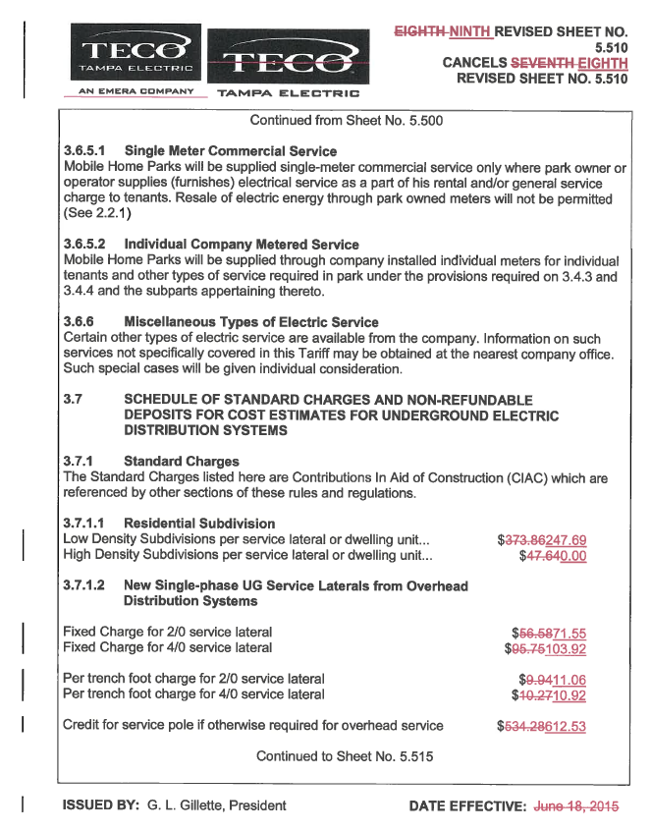
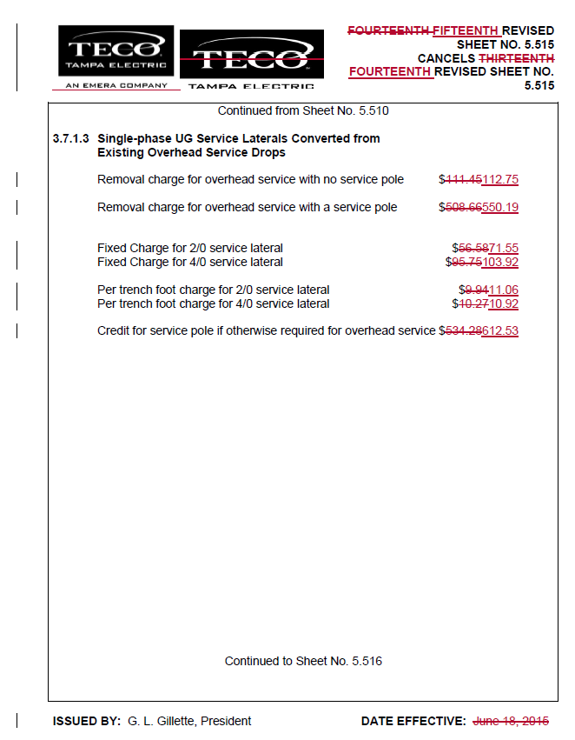
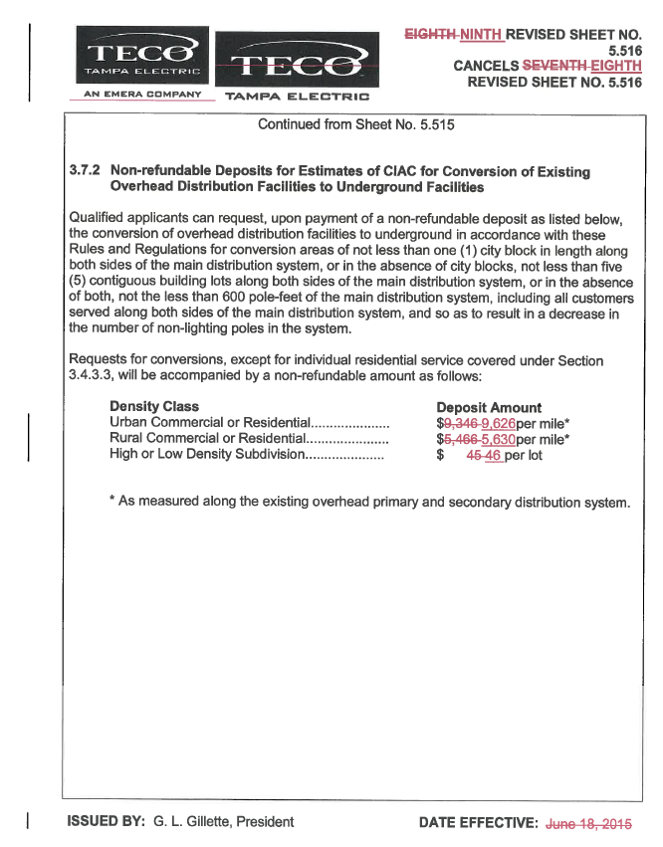

Order No. PSC-15-0273A-TRF-EI, issued July 6, 2015, in Docket No. 150103-EI, In re: Petition for approval of revised underground residential distribution tariff, by Tampa Electric Company.
Order No. PSC-17-0176-PCO-EI, issued May 16, 2017, in Docket No. 170073-EI, In re: Petition for approval of revised underground residential distribution tariffs, by Tampa Electric Company.
$248 (rounded) is calculated as follows: $777 (Table 1-2) - $529 (Table 1-3) = $248.
Order No. PSC-09-0784-TRF-EI, issued November 19, 2009, in Docket No. 090164-EI, In re: Petition for approval of revised tariff sheets for underground residential distribution service, by Tampa Electric Company.

