State of Florida |  | Public Service Commission  Capital Circle Office Center ● 2540 Shumard Oak Boulevard  Tallahassee, Florida 32399-0850  -M-E-M-O-R-A-N-D-U-M-
DATE: | June 29, 2017
TO: | Office of Commission Clerk (Stauffer)
FROM: | Division of Engineering (Matthews, Thompson)  Office of the General Counsel (Corbari)
RE: | Docket No. 170070-EQ – Petition for approval of revised standard offer for energy purchase from cogenerators and renewable generating facilities and standard offer contract for purchases of firm capacity and energy, by Florida Public Utilities Company.
AGENDA: | 07/13/17 – Regular Agenda – Proposed Agency Action – Interested Persons May Participate
COMMISSIONERS ASSIGNED: |  |  | All Commissioners
PREHEARING OFFICER: |  |  | Administrative
CRITICAL DATES: |  |  | None
SPECIAL INSTRUCTIONS: |  |  | Staff recommends the Commission simultaneously consider Docket Nos. 170072-EQ, 170075-EQ, 170076-EQ, and 170077-EQ.

Case Background
Section 366.91(3), Florida Statutes (F.S.) requires that each investor-owned utility (IOU) continuously offers to purchase capacity and energy from renewable energy generators and small qualifying facilities. Florida Public Service Commission (Commission) Rules 25-17.200 through 25-17.310, Florida Administrative Code (F.A.C.), implement the statute and require each IOU to file with the Commission, by April 1 of each year, a standard offer contract based on the next avoidable fossil fueled generating unit of each technology type identified in the utility’s current Ten-Year Site Plan. On March 30, 2017, Florida Public Utilities Company (FPUC) filed a petition for approval of its revised standard offer rate schedule and standard offer contract, in accordance with the rules cited above and Rules 25-9.003, 25-17.0825, and 25-17.0832, F.A.C.
Because FPUC, an IOU, does not own or operate any electric generating units, it does not have any avoidable units on which to base its standard offer contract. Rule 25-17.250(1), F.A.C., requires that, under these circumstances, the standard offer contract be based on avoiding or deferring a planned purchase. FPUC currently purchases all of its electric power through purchased power agreements in its Northeast Division from Jacksonville Electric Authority (JEA), and in its Northwest Division from Gulf Power Company (Gulf). FPUC is currently in negotiations with Florida Power & Light (FPL) to become the full requirements supplier for the Northeast Division once the contract with JEA expires on December 31, 2017.
The Commission has jurisdiction over this standard offer contract pursuant to Sections 366.04 through 366.06, and 366.91, F.S.

Discussion of Issues

Issue 1:
Should the Commission approve the revisions to the standard offer rate schedule and standard offer contract filed by Florida Public Utilities Company?

Recommendation:
Yes. FPUC’s revised standard offer rate schedule and standard offer contract conform to all the requirements of Rule 25-17.0825, and Rules 25-17.200 through 25-17.310, F.A.C., and reflect the avoidable costs associated with FPUC’s power purchase agreements. Staff recommends that the revisions to the rate schedule and standard offer contract filed by FPUC be approved as filed. (Thompson)

Staff Analysis:
Pursuant to Rule 25-17.250, F.A.C., an IOU must continuously make available a standard offer contract for the purchase of firm capacity and energy from renewable generating facilities (RF) and small qualifying facilities (QF) with a design capacity of 100 kilowatt (kW) or less. FPUC does not own or operate any of its own electric generating facilities and thus does not file a Ten-Year Site Plan. Instead, FPUC purchases its electric energy under long-term, full requirements contracts with wholesale providers.
The standard offer rate schedule consists of three components: (1) the Standard Offer-As Available schedule (SOA); (2) the Standard Offer- Firm Schedule (SOF); and (3) the Standard Offer Contract. The SOA and SOF consolidate FPUC's previous REN and COG tariffs, as approved by this Commission in Order No. PSC-16-0531-PAA-EQ, issued November 22, 2016. Revisions to FPUC’s standard offer contract and rate schedule, in type-and-strike format, are included as Attachment A to this recommendation. The capacity and energy payments under the proposed rate schedule depend on the terms of FPUC’s wholesale contracts with its suppliers for FPUC's Northeast Division and Northwest Division.

Northeast Division
At present, JEA is the full requirements supplier for FPUC's Northeast Division, which consists of Fernandina Beach and Amelia Island. FPUC is currently in negotiations with FPL to become the full requirements supplier for the Northeast Division once the contract with JEA expires on December 31, 2017. In response to Staff’s First Data Request, FPUC provided estimates of the annual payments to an operator with a 10 MW facility, operating at a capacity factor of 80 percent, for a RF/QF operator located inside the service territory with FPL as the full requirements supplier.

Northwest Division
At present, Gulf is the full requirements supplier for FPUC's Northwest Division, which consists of portions of Jackson, Calhoun, and Liberty counties. In response to Staff’s First Data Request, FPUC provided estimates of the annual payments to an operator with a 10 MW facility, operating at a capacity factor of 80 percent, for a RF/QF operator located inside the service territory.

Conclusion
FPUC’s standard offer contract and related rate schedule conform to all the requirements of Rule 25-17.0825, and Rules 25-17.200 through 25-17.310, F.A.C., and reflect the avoidable costs associated with FPUC’s purchased power agreements. Staff recommends that the revisions to the rate schedule and standard offer contract filed by FPUC be approved as filed.

Issue 2:
Should this docket be closed?

Recommendation:
Yes. This docket should be closed upon issuance of a consummating order, unless a person whose substantial interests are affected by the Commission’s decision files a protest within 21 days of the issuance of the Commission’s Proposed Agency Action Order. Potential signatories should be aware that, if a timely protest is filed, FPUC’s standard offer contract may subsequently be revised. (Corbari)

Staff Analysis:
This docket should be closed upon the issuance of a consummating order, unless a person whose substantial interests are affected by the Commission’s decision files a protest within 21 days of the issuance of the Commission’s Proposed Agency Action Order. Potential signatories should be aware that, if a timely protest is filed, FPUC’s standard offer contract may subsequently be revised.

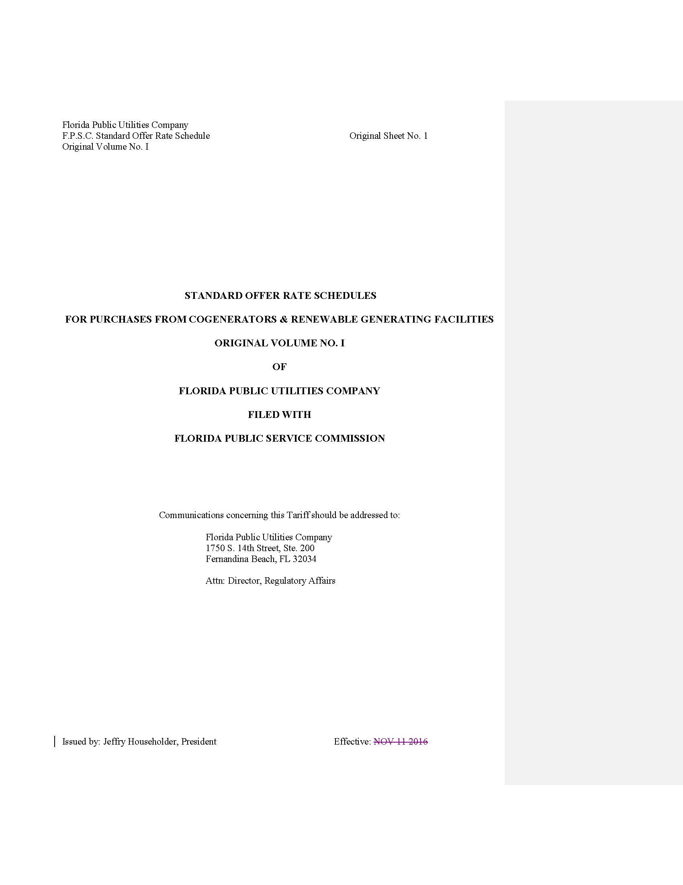

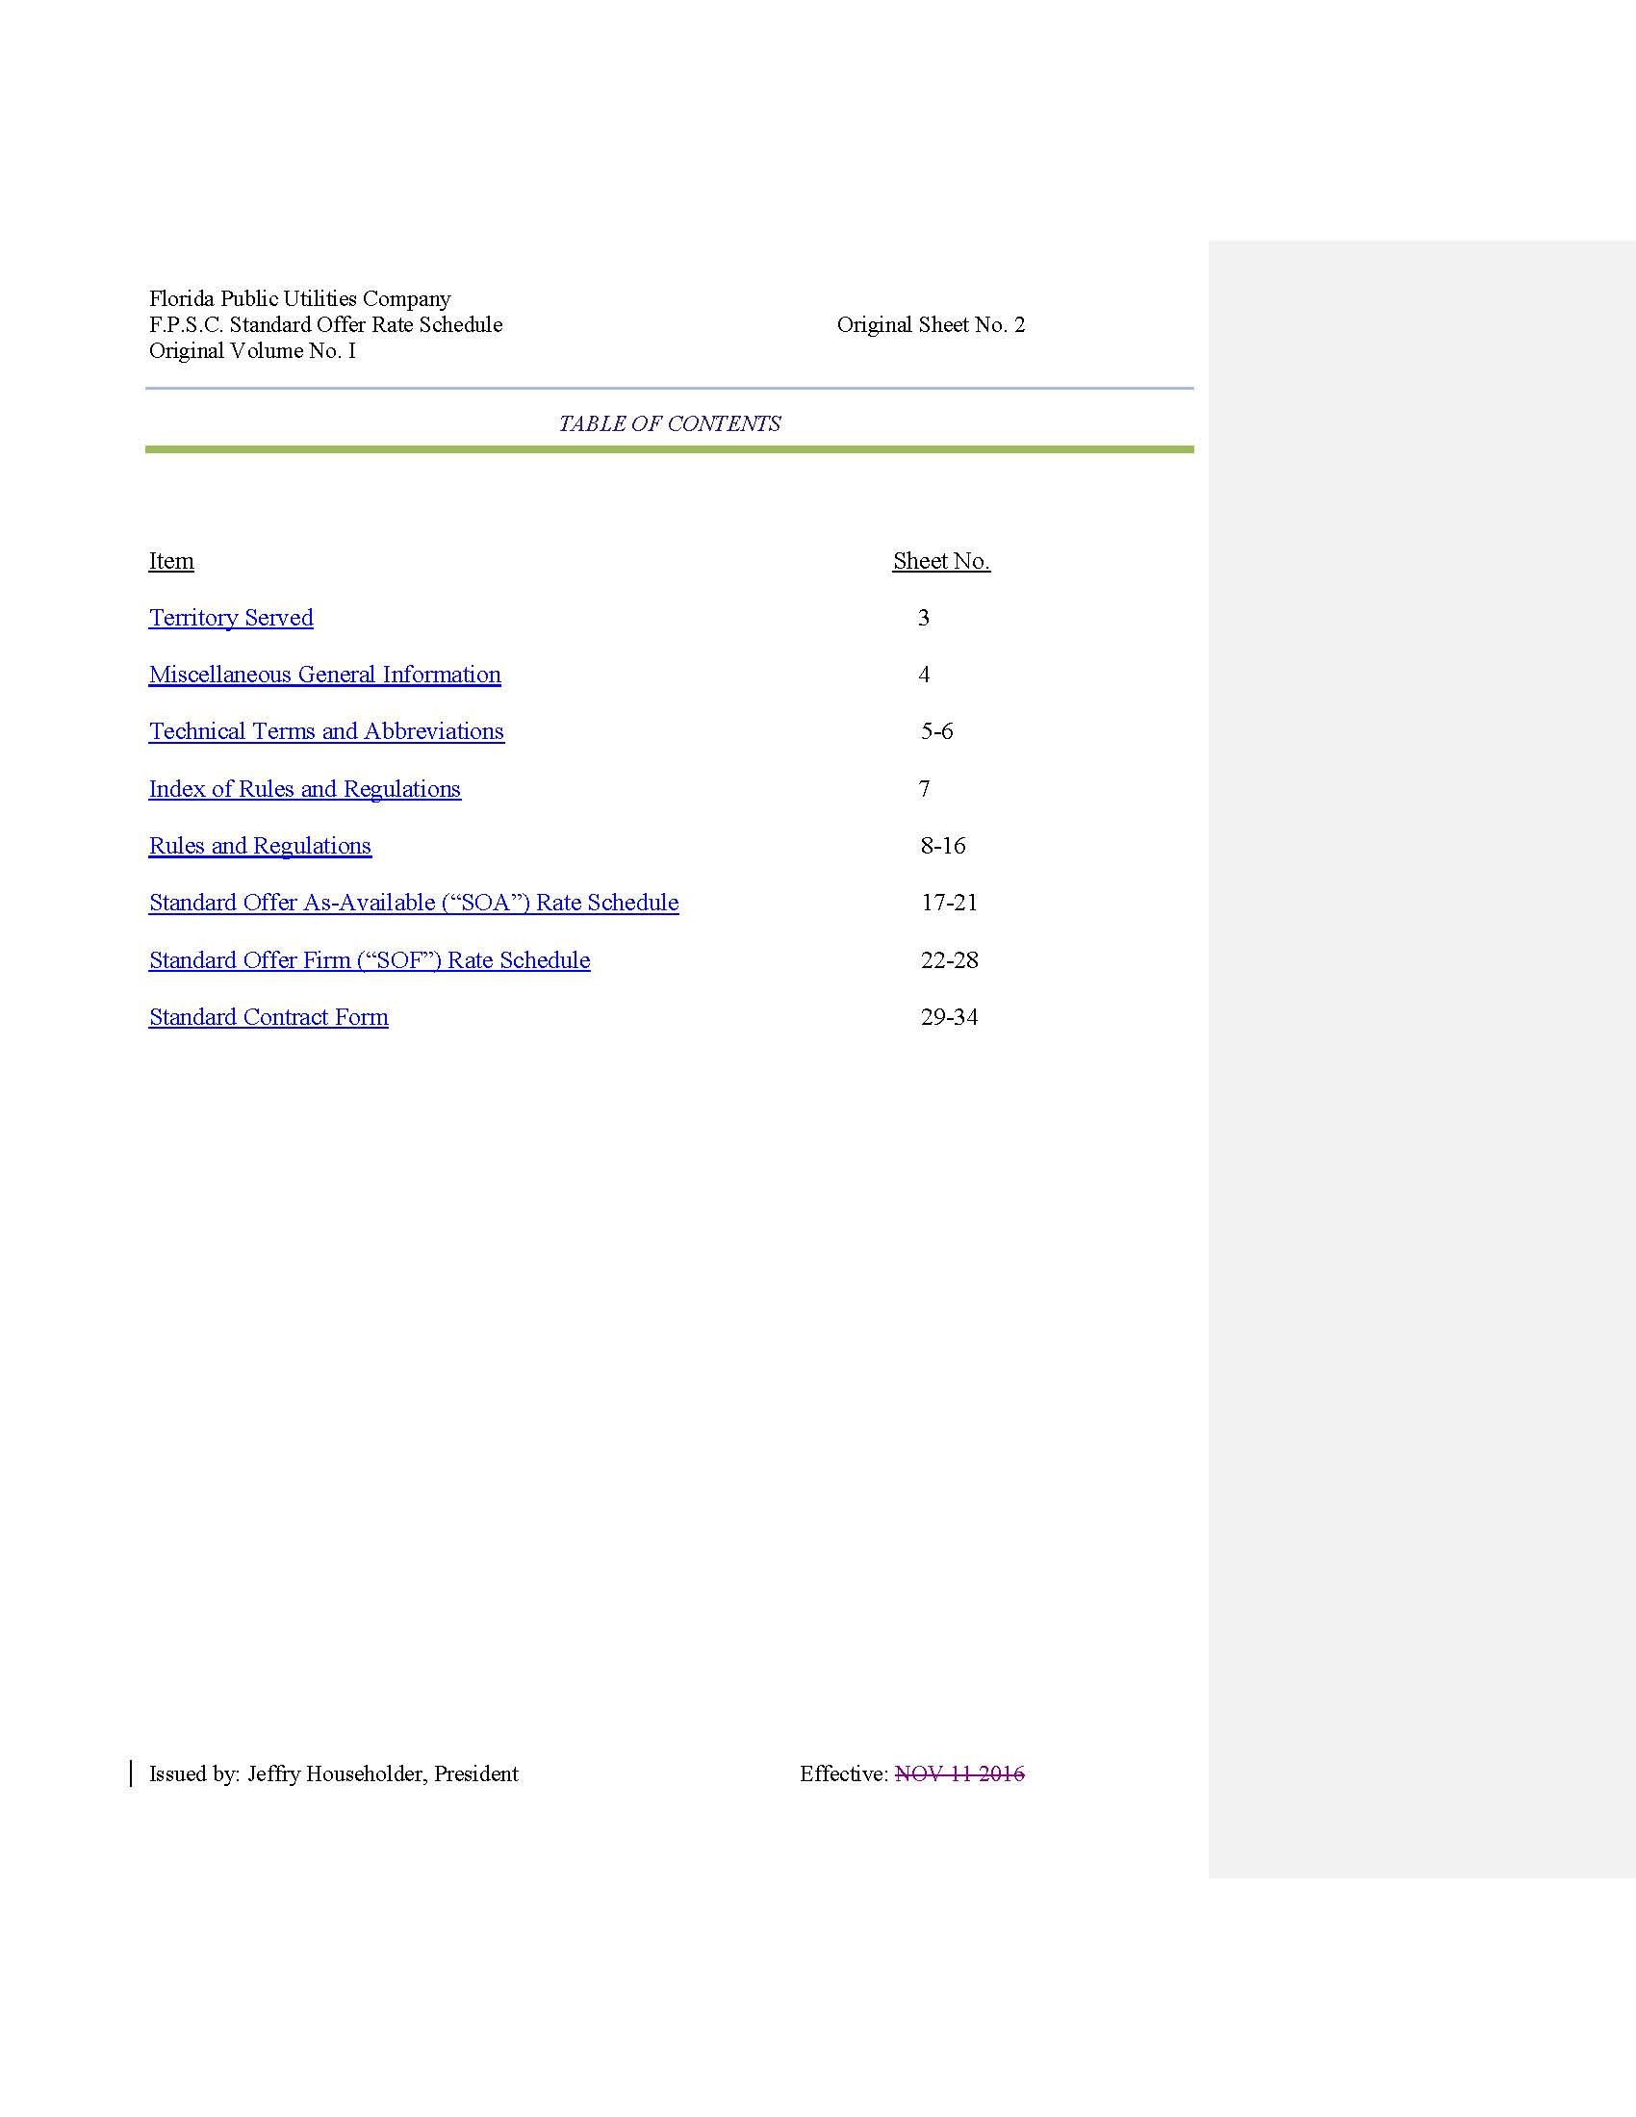

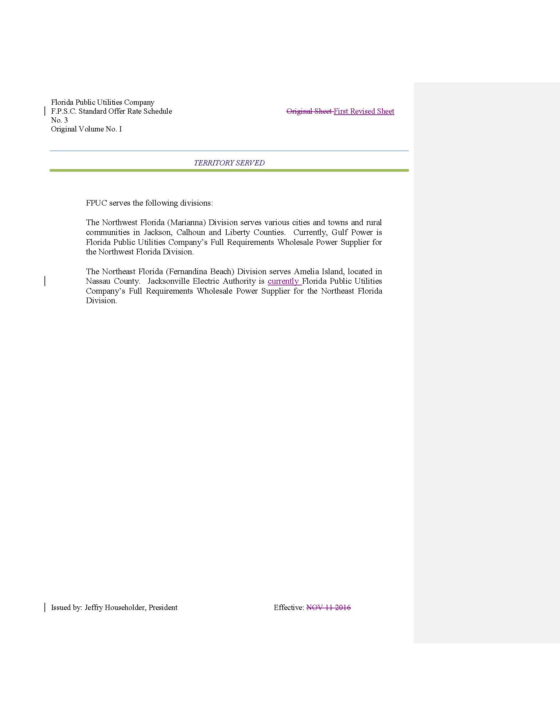

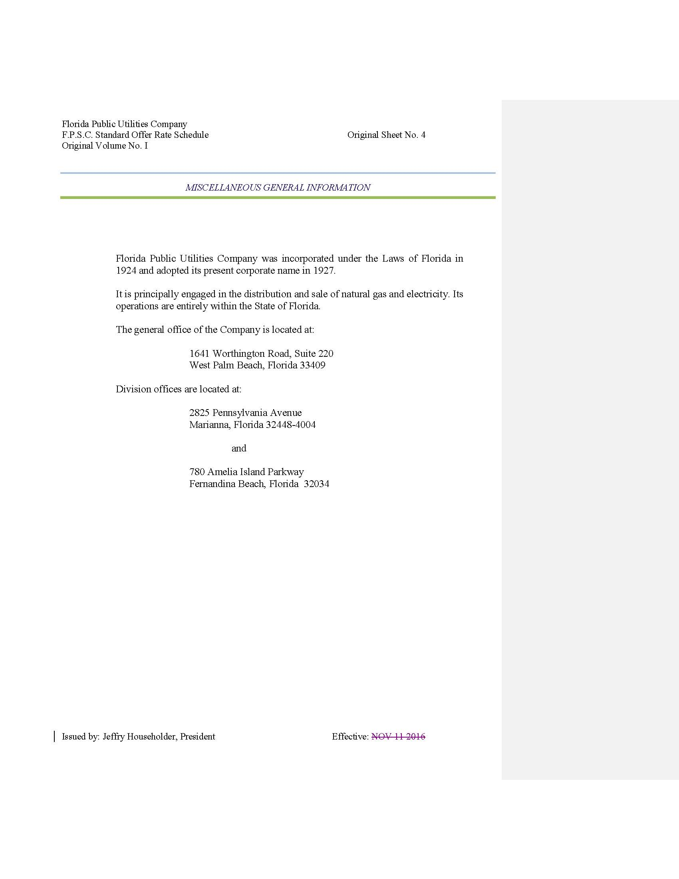

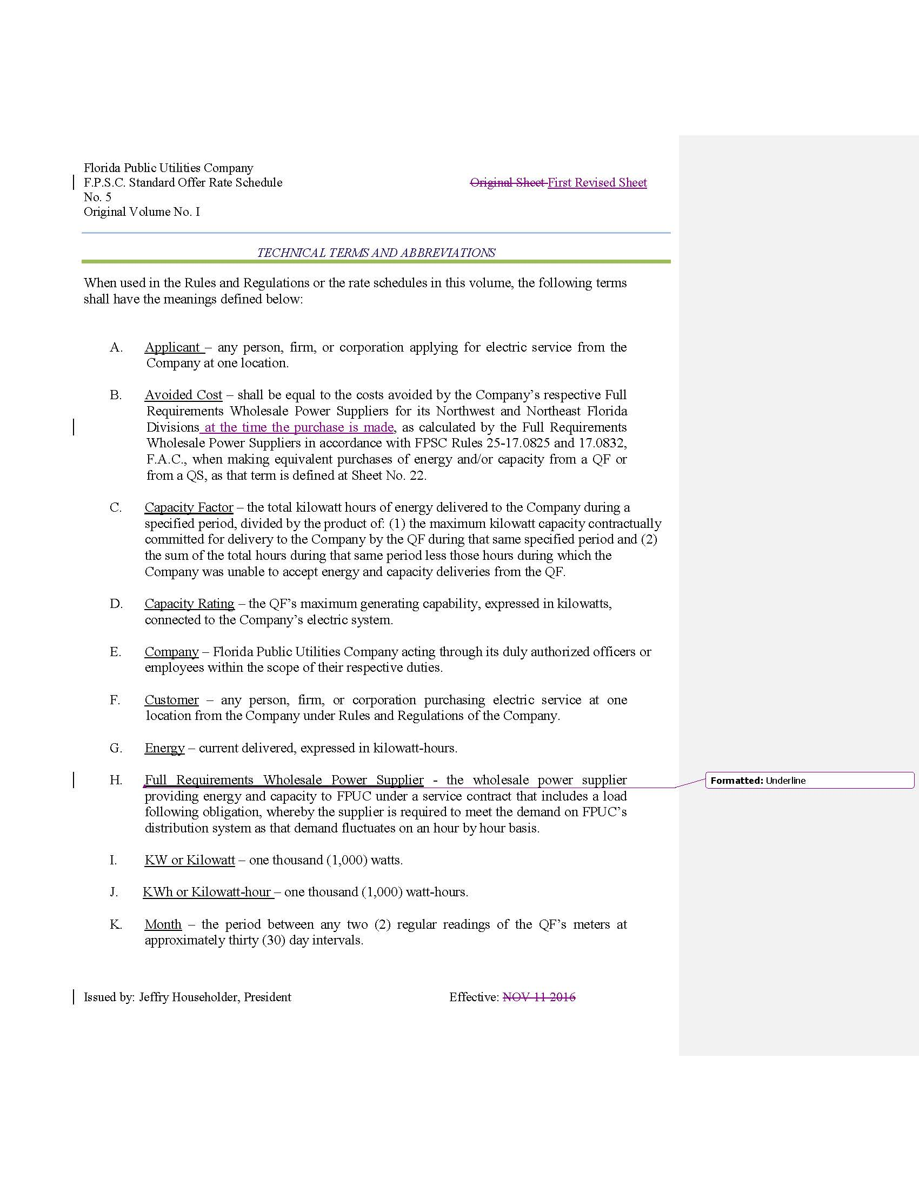

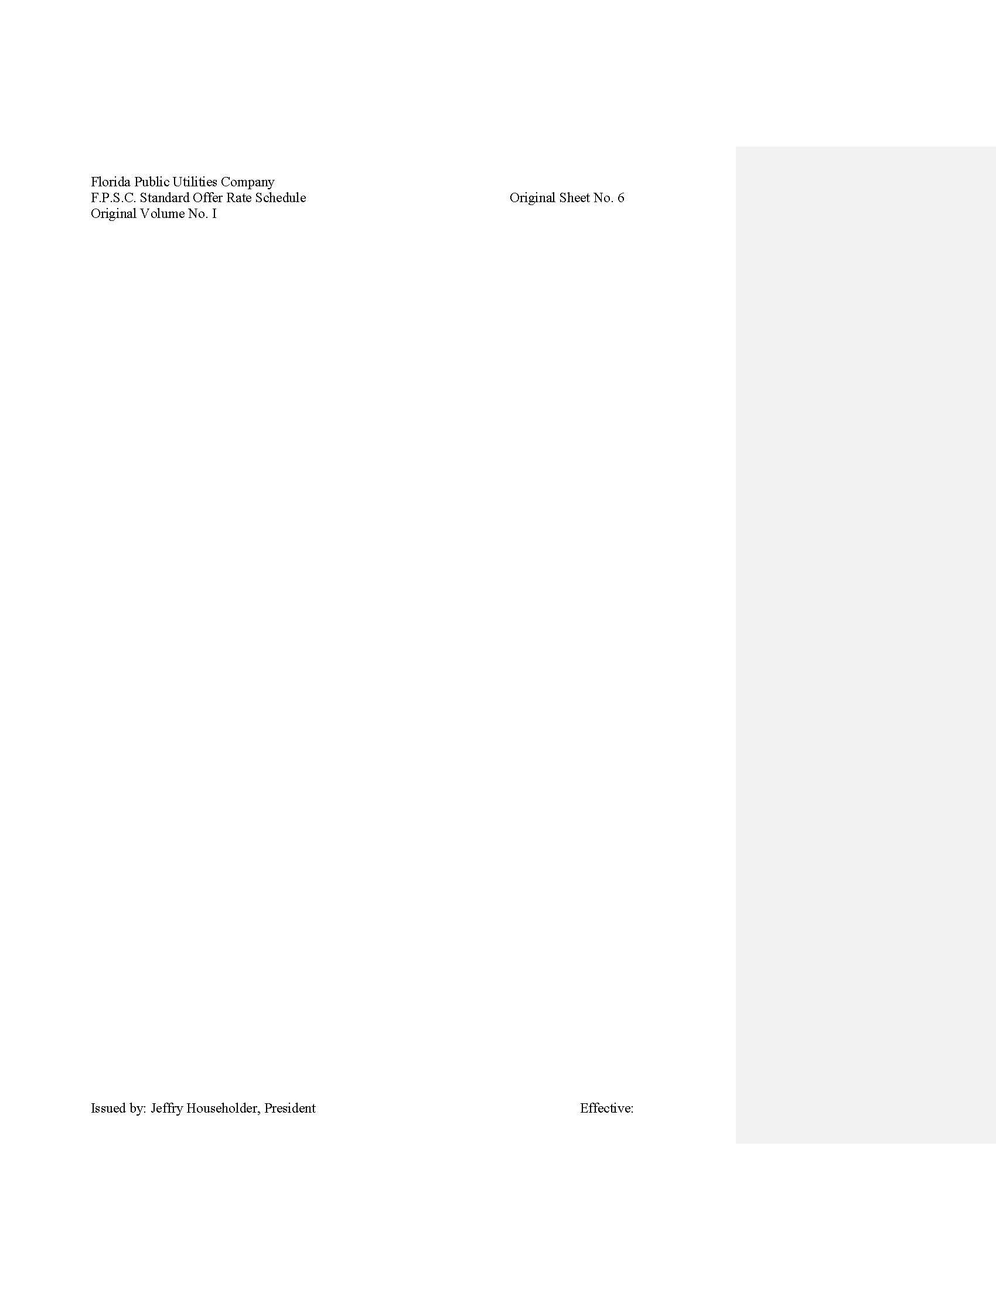

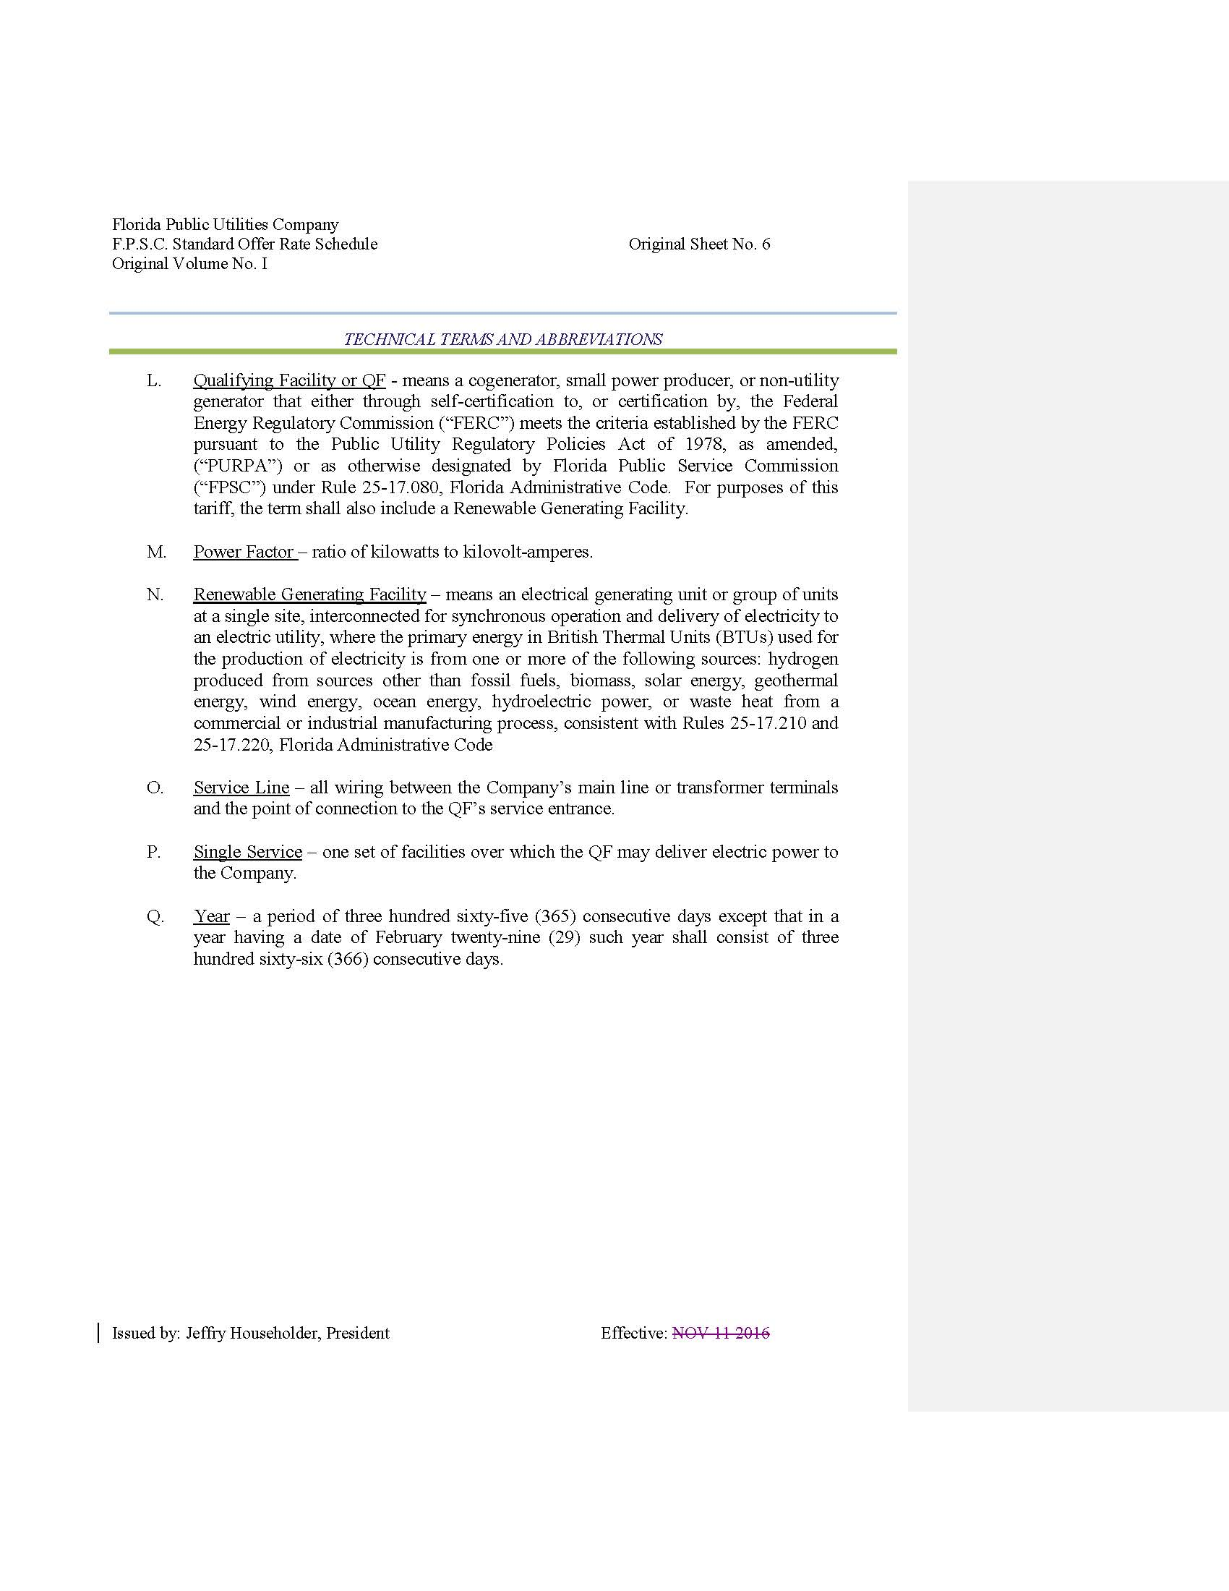

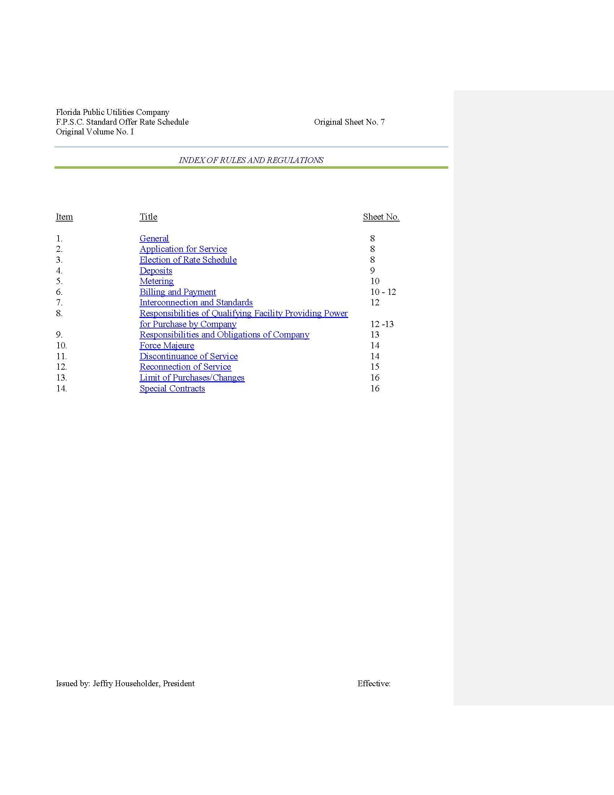

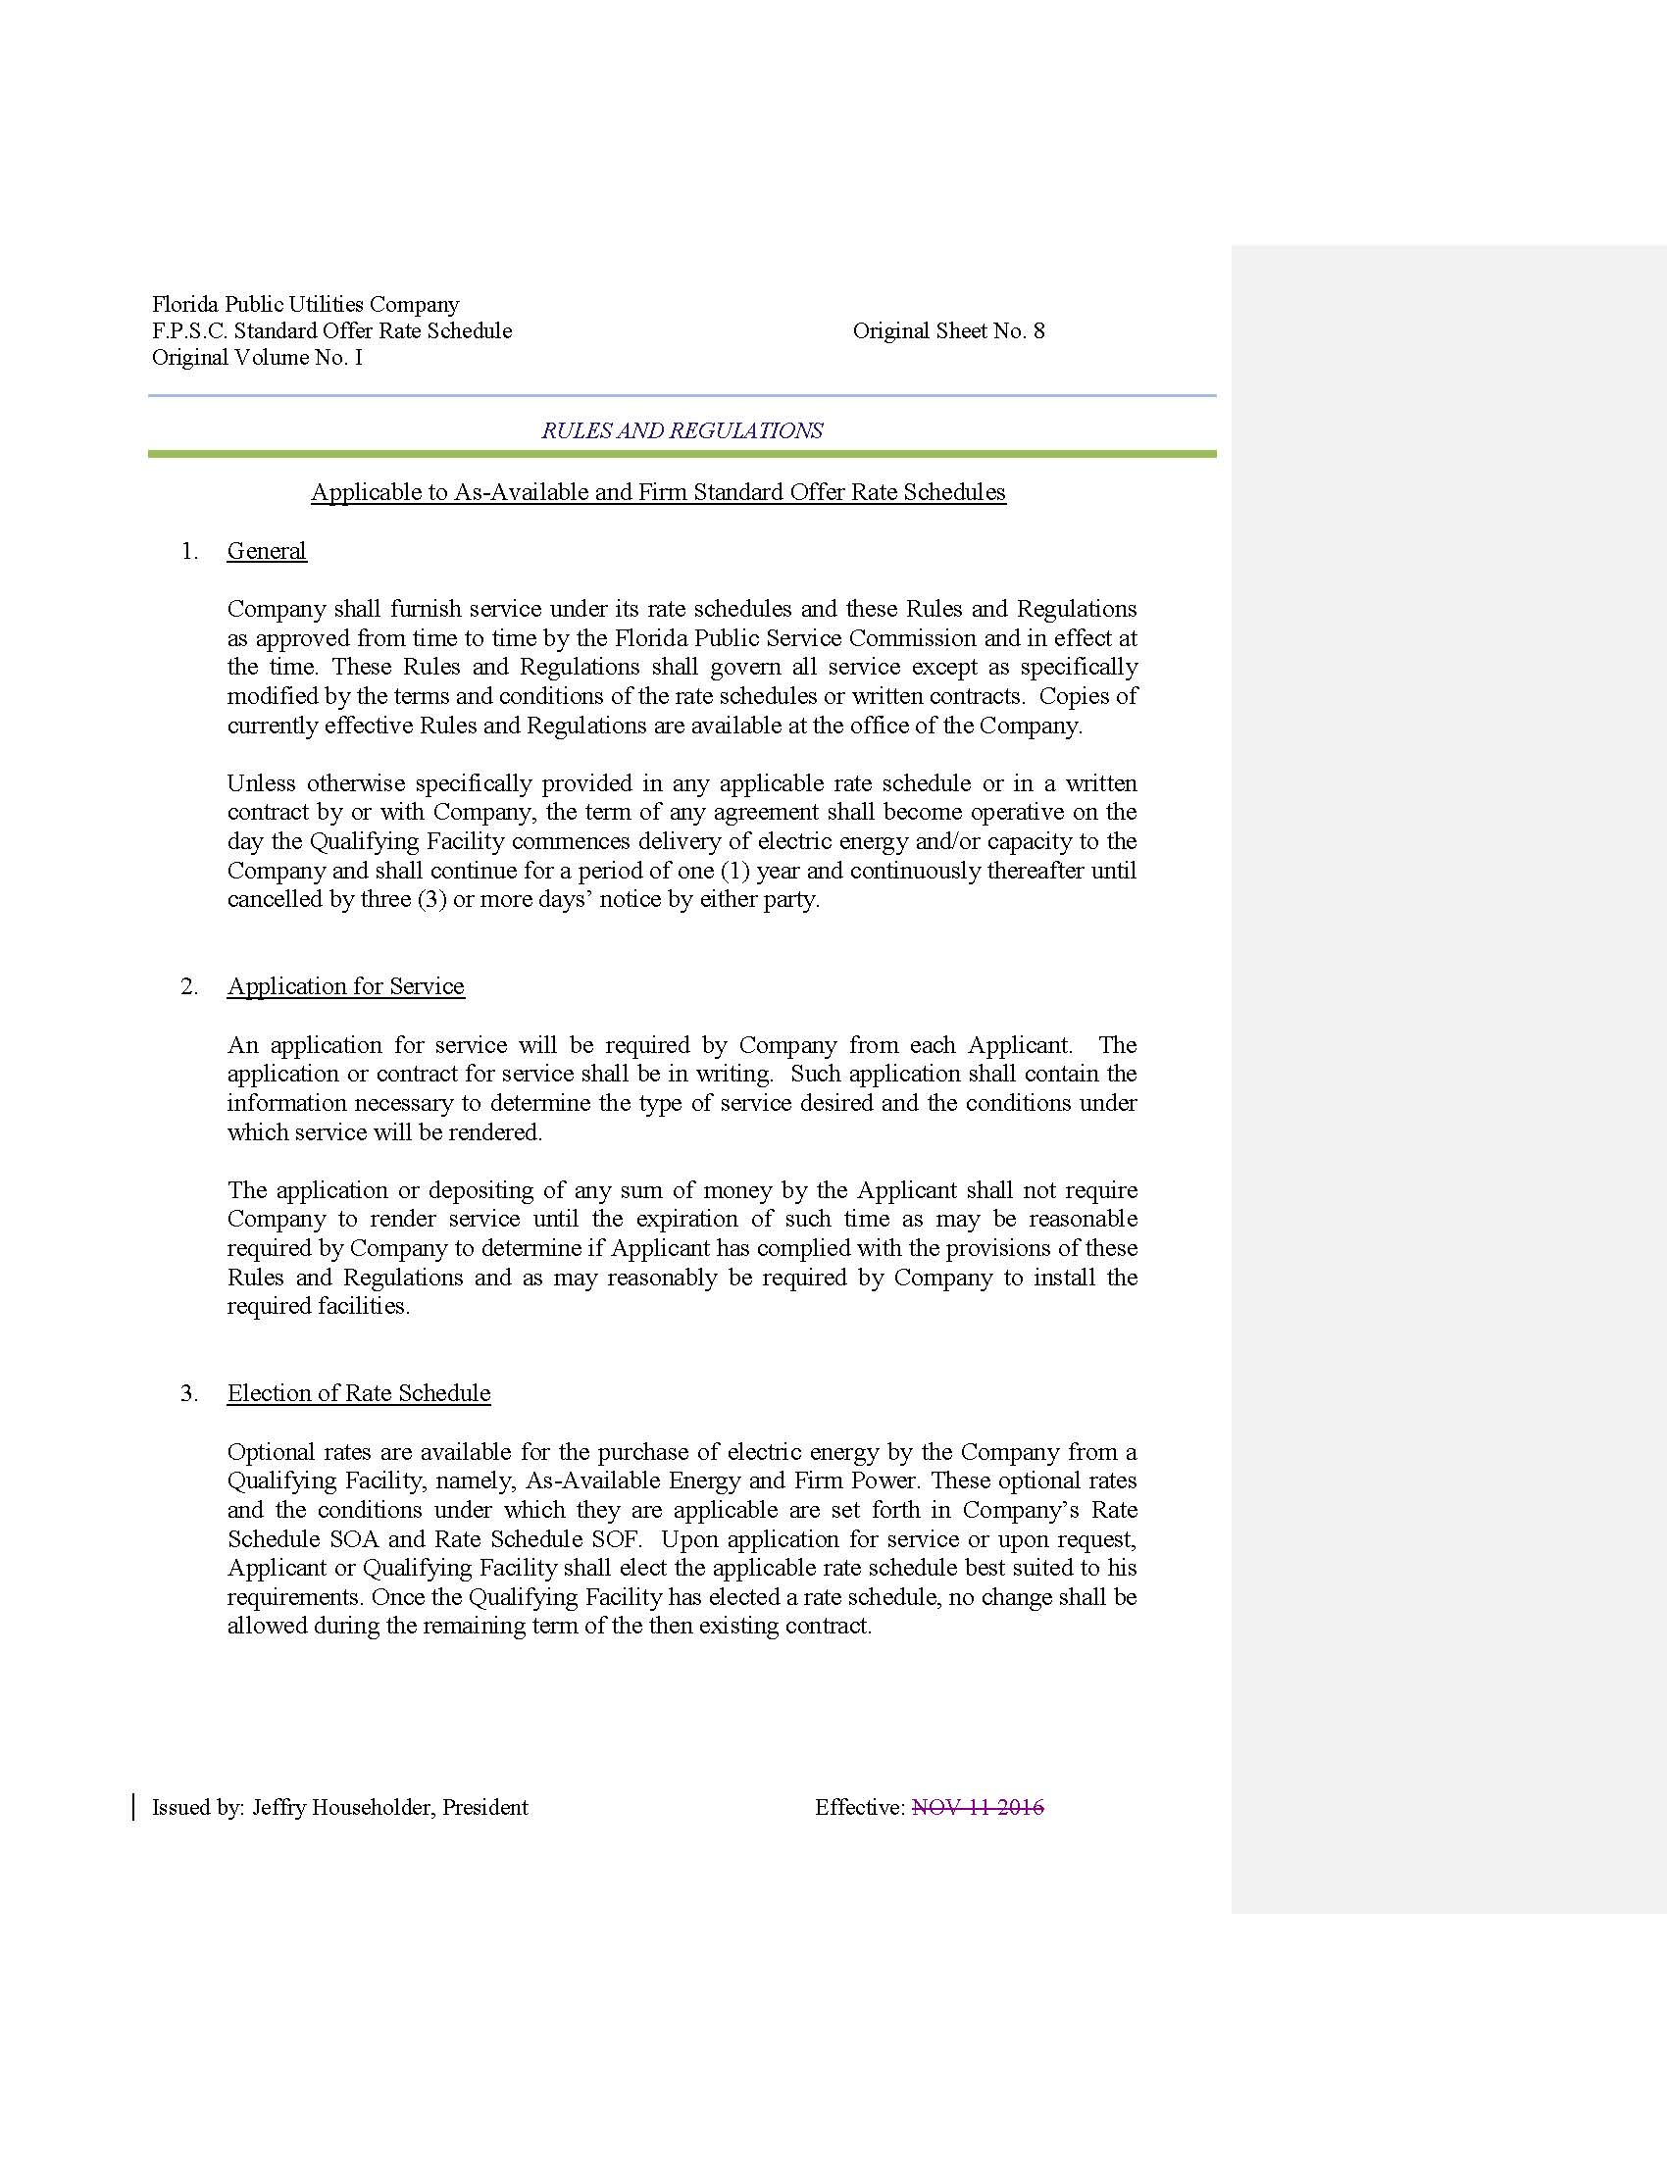

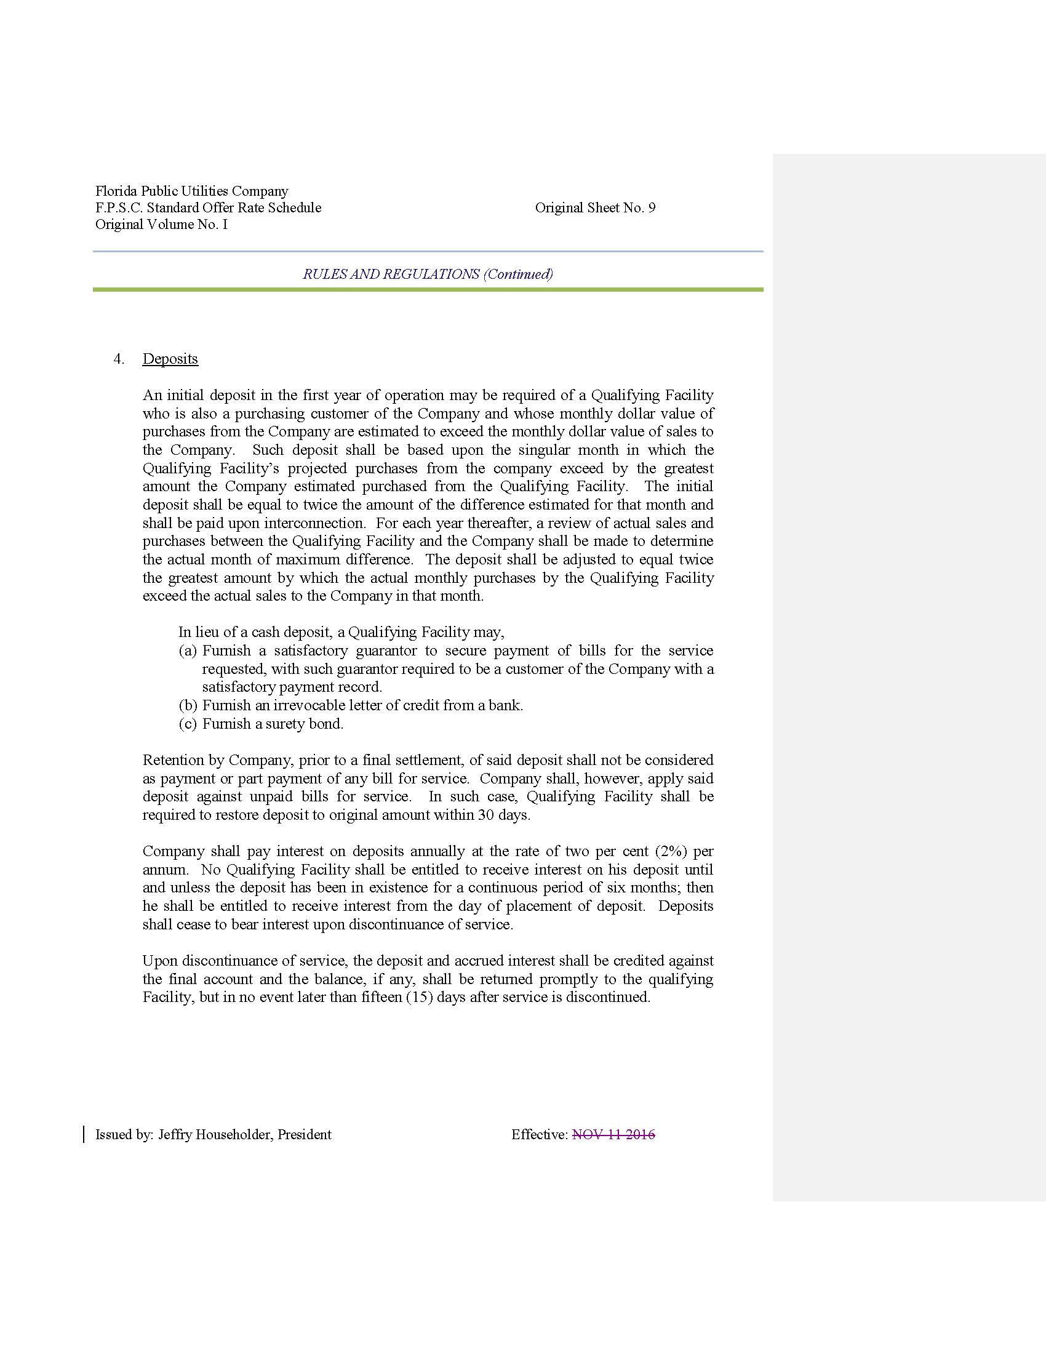

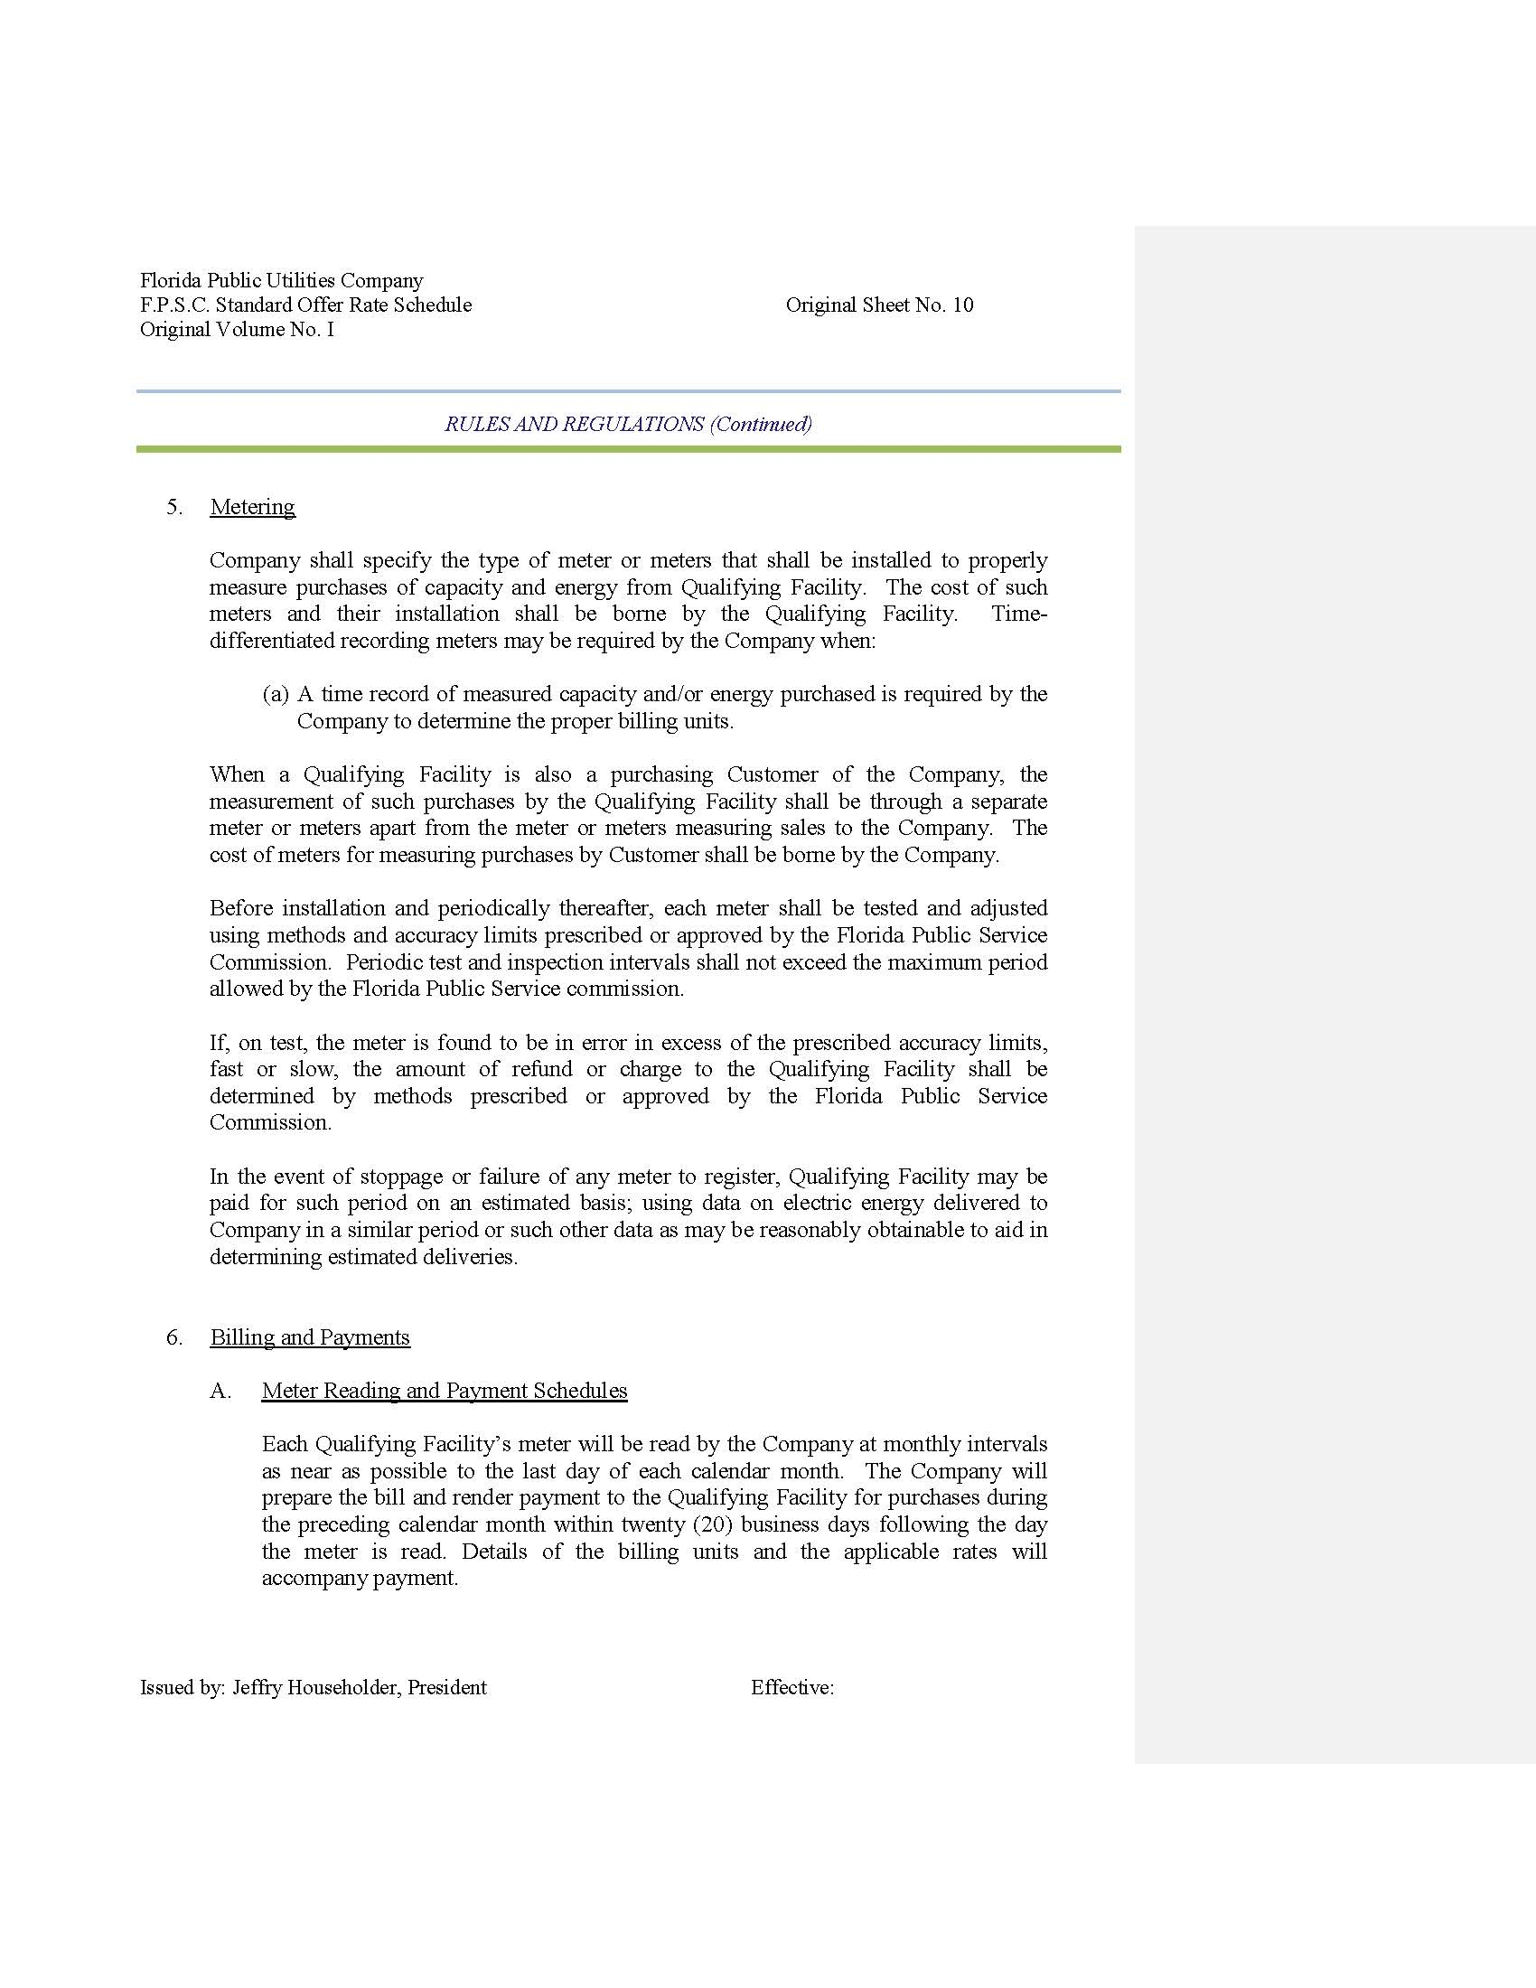

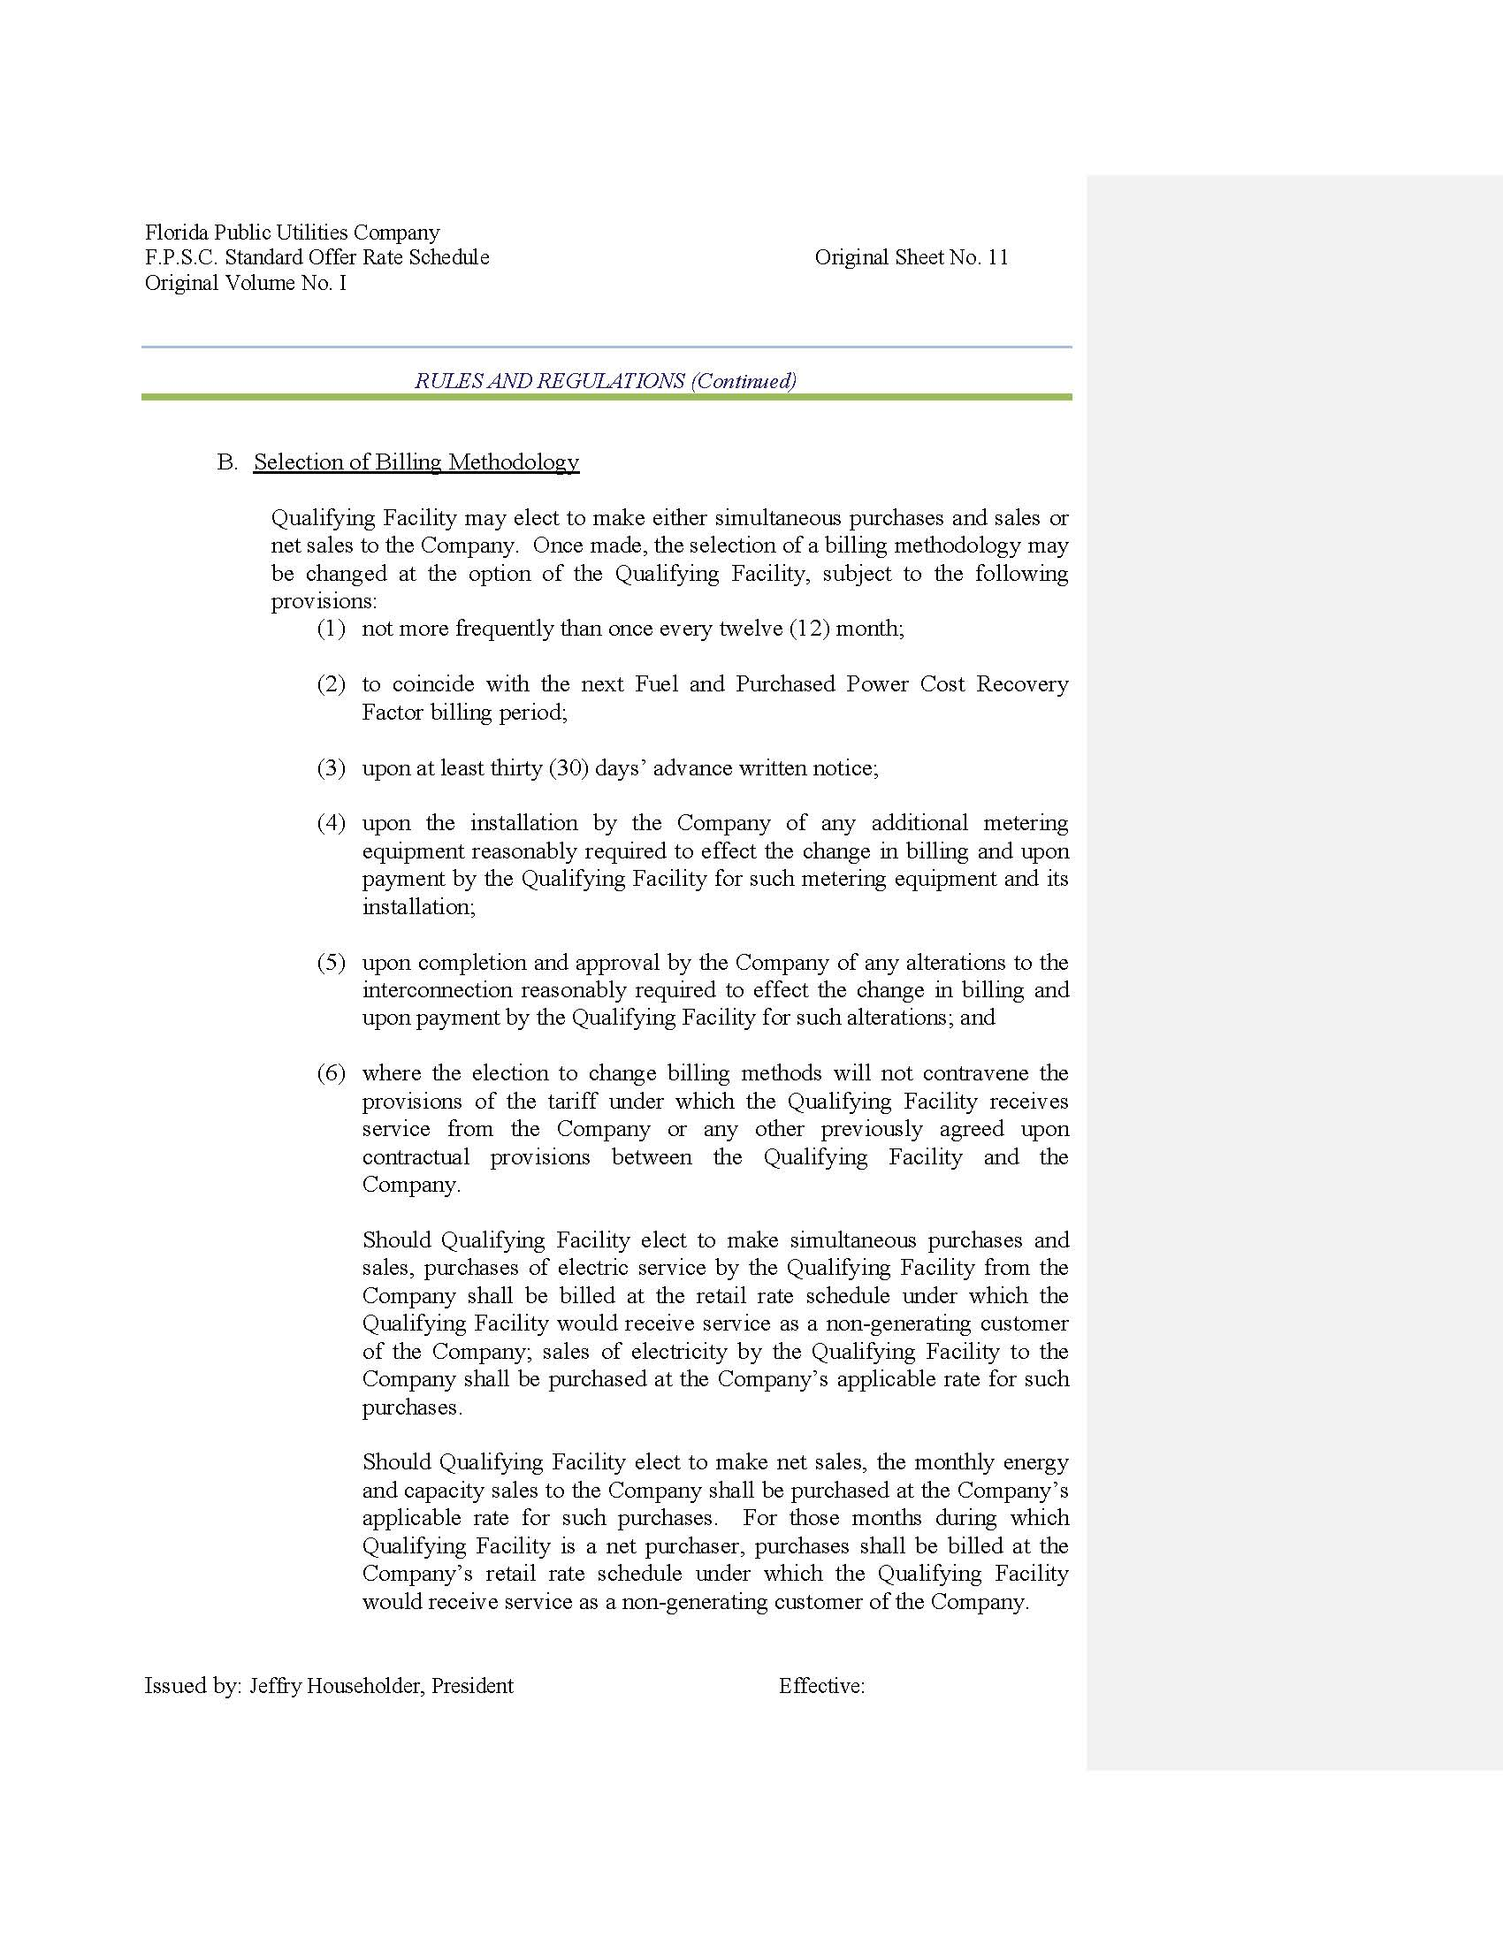

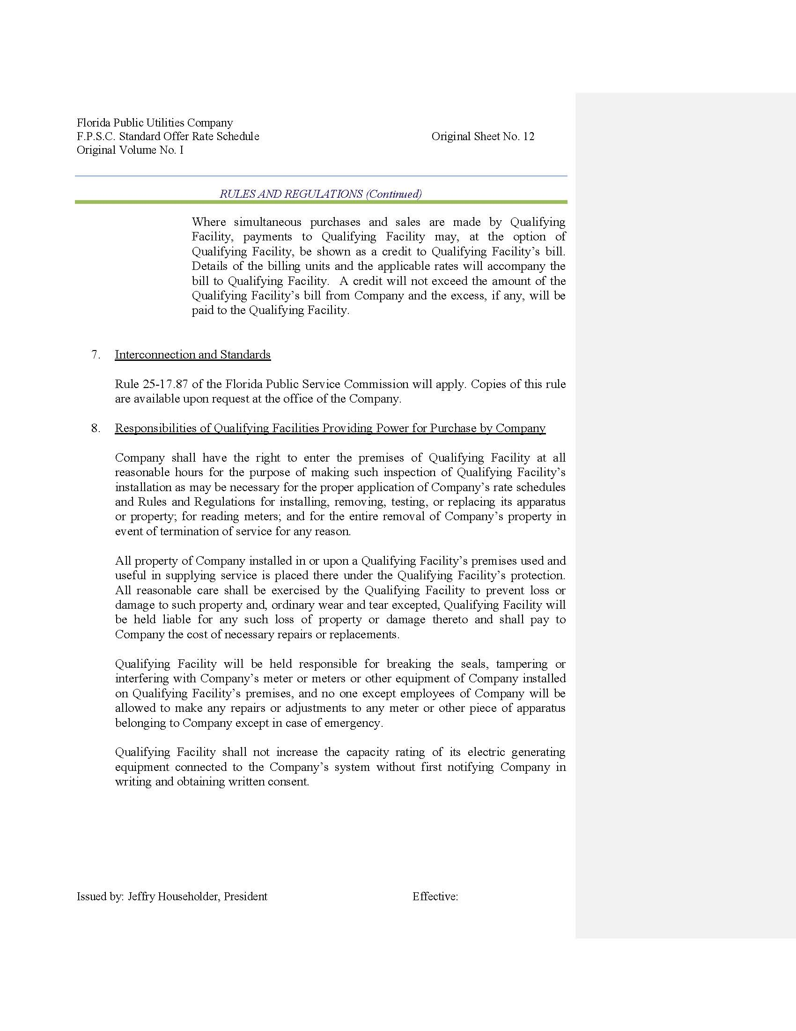

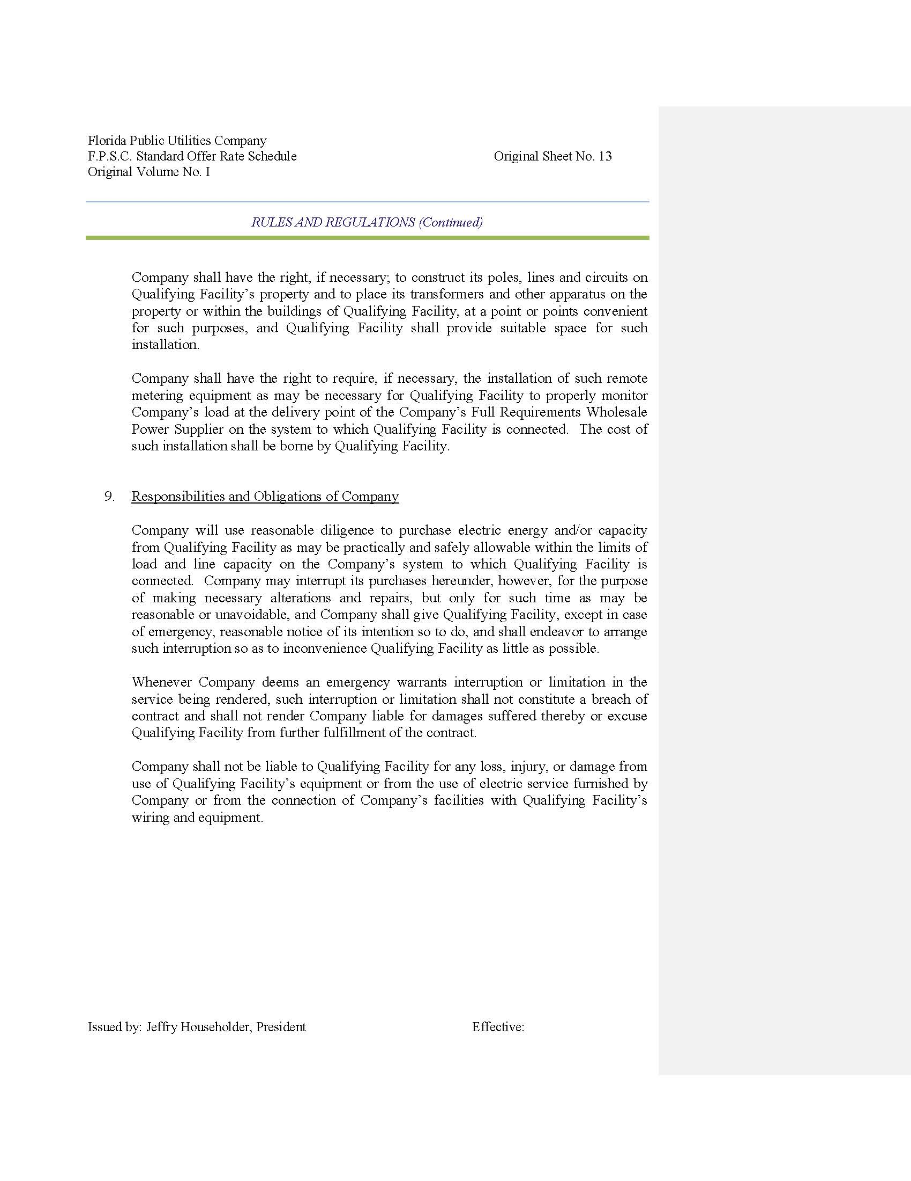

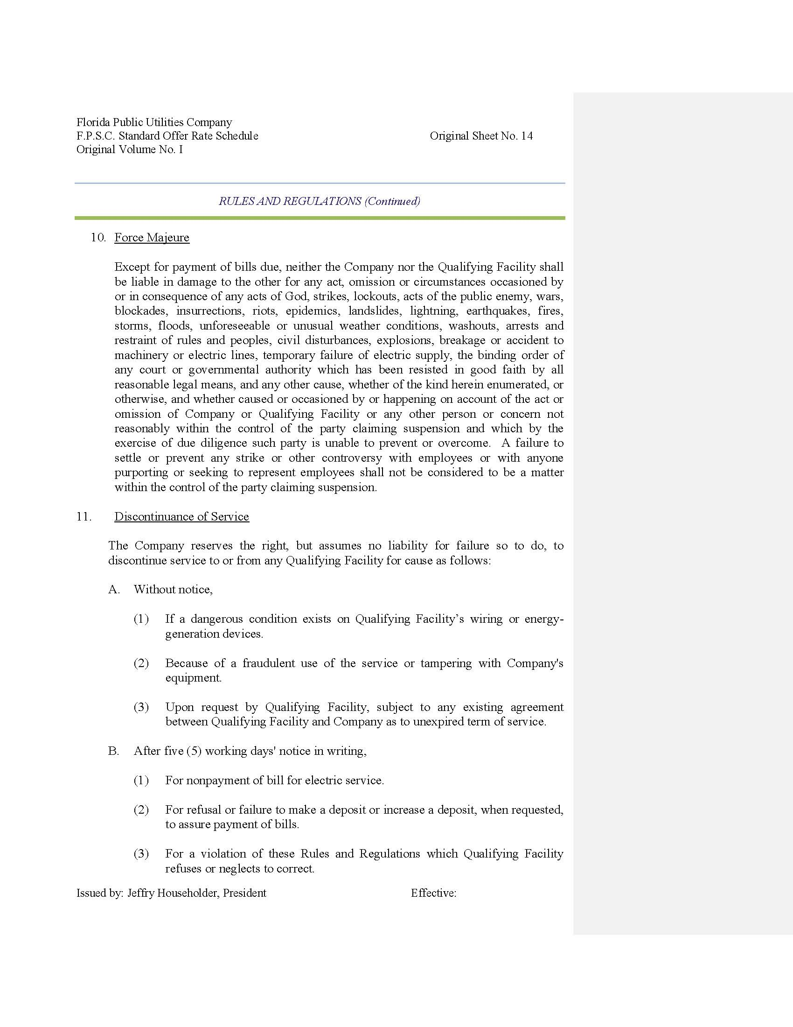

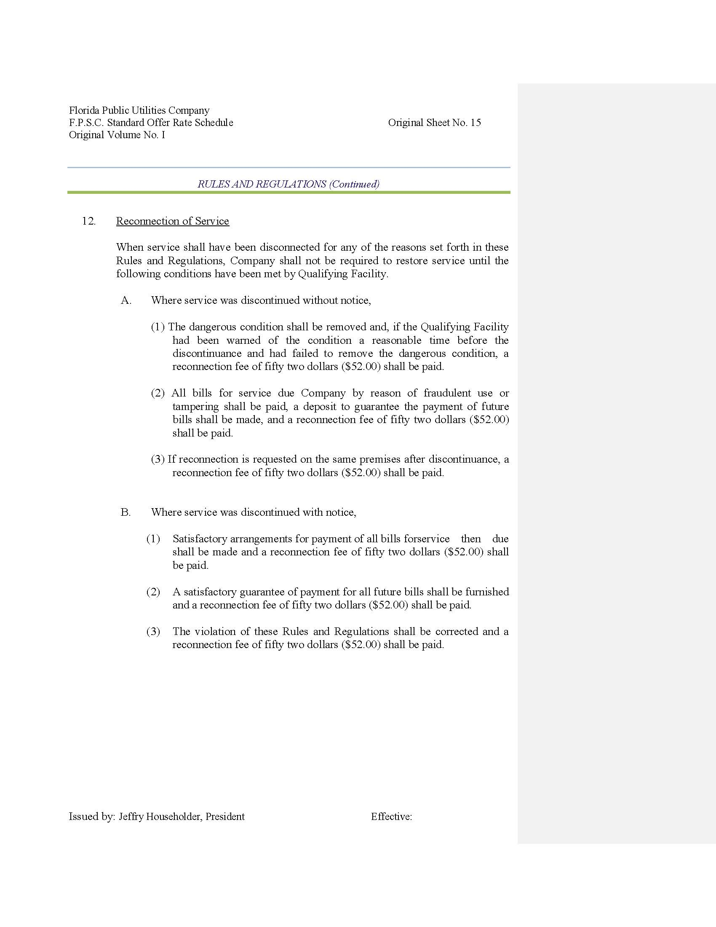

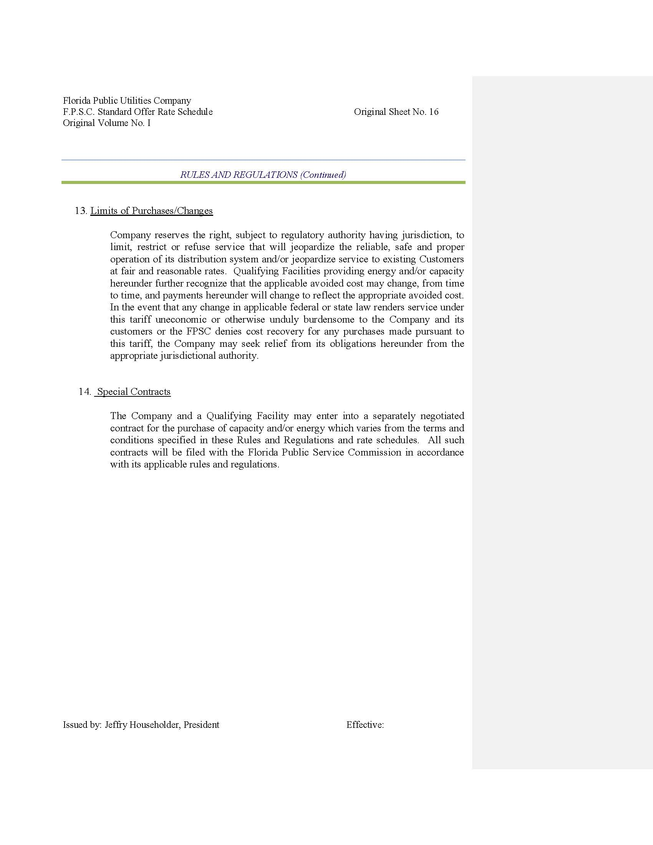

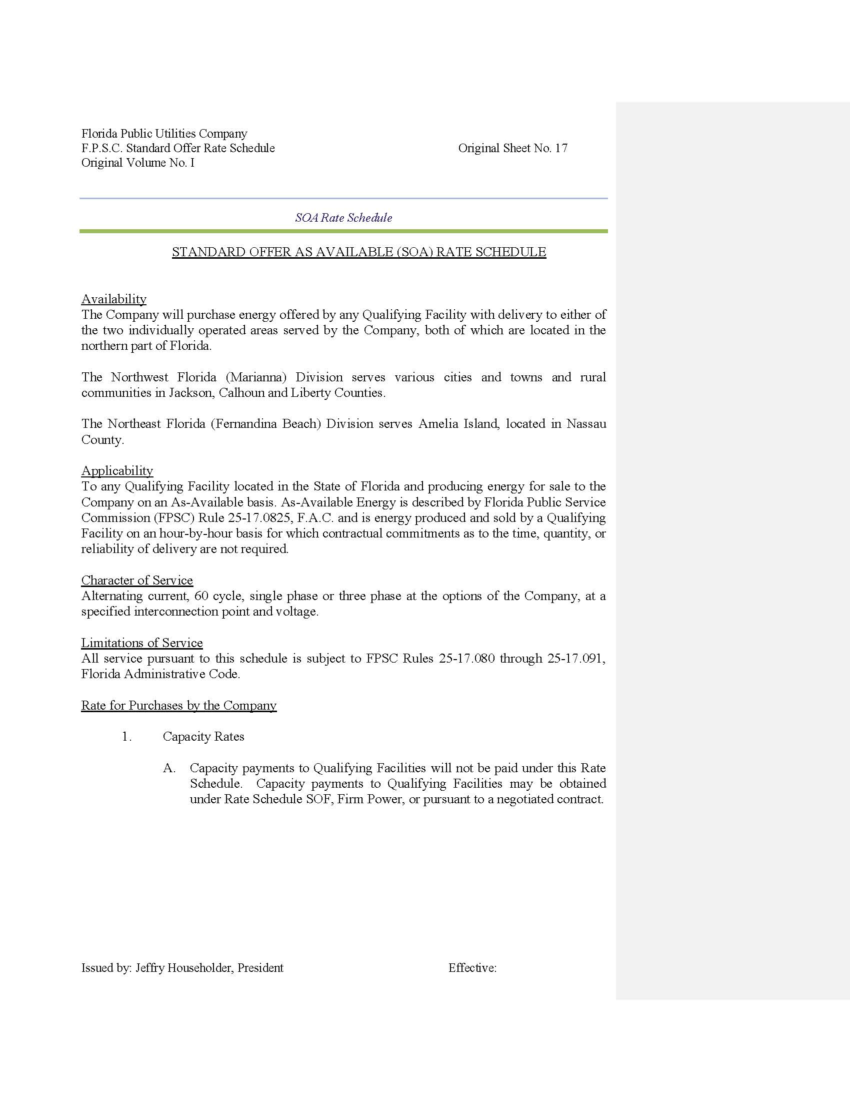

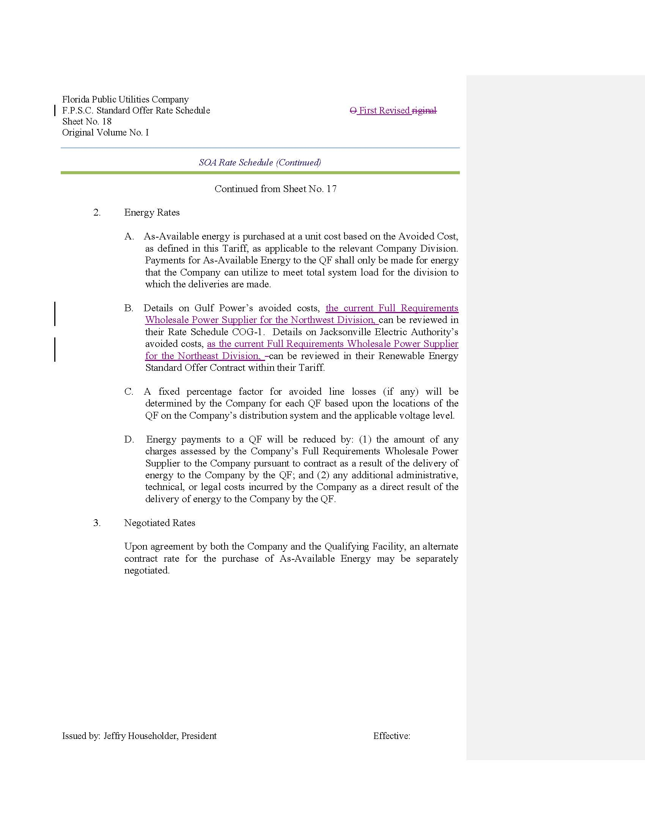

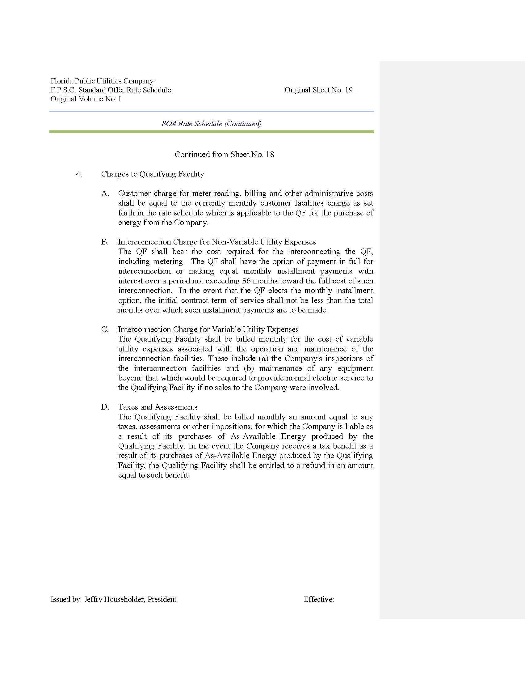

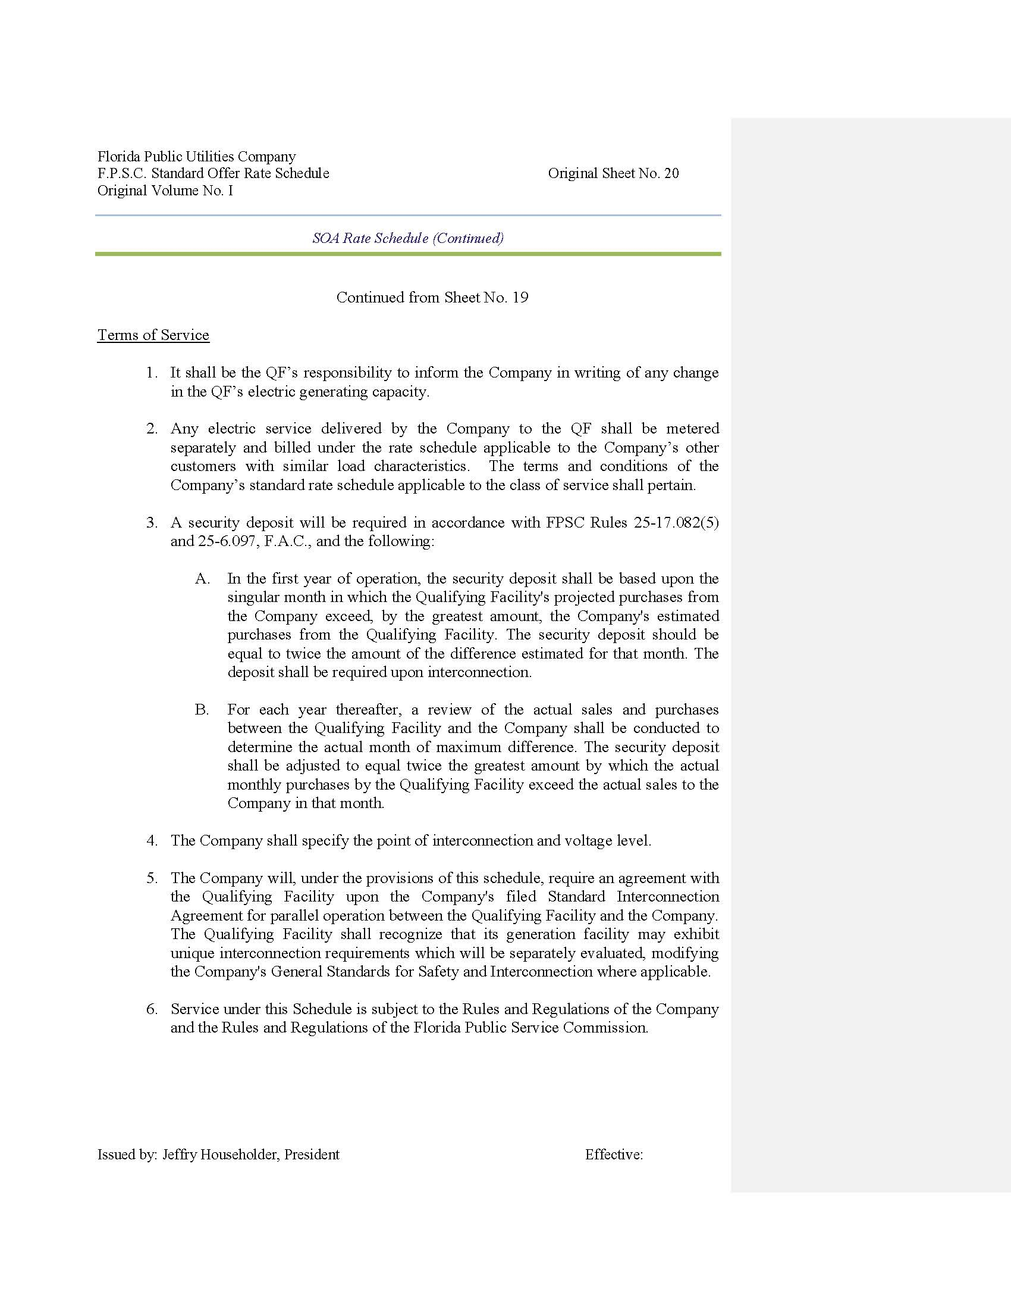

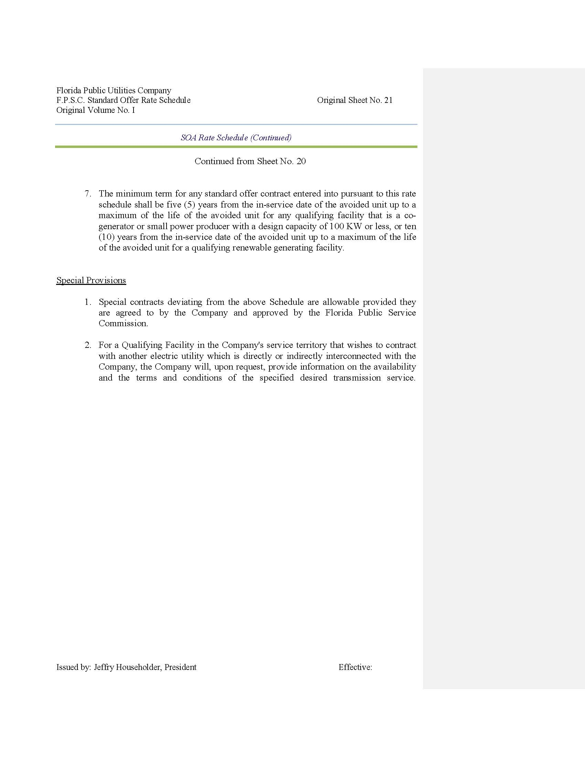

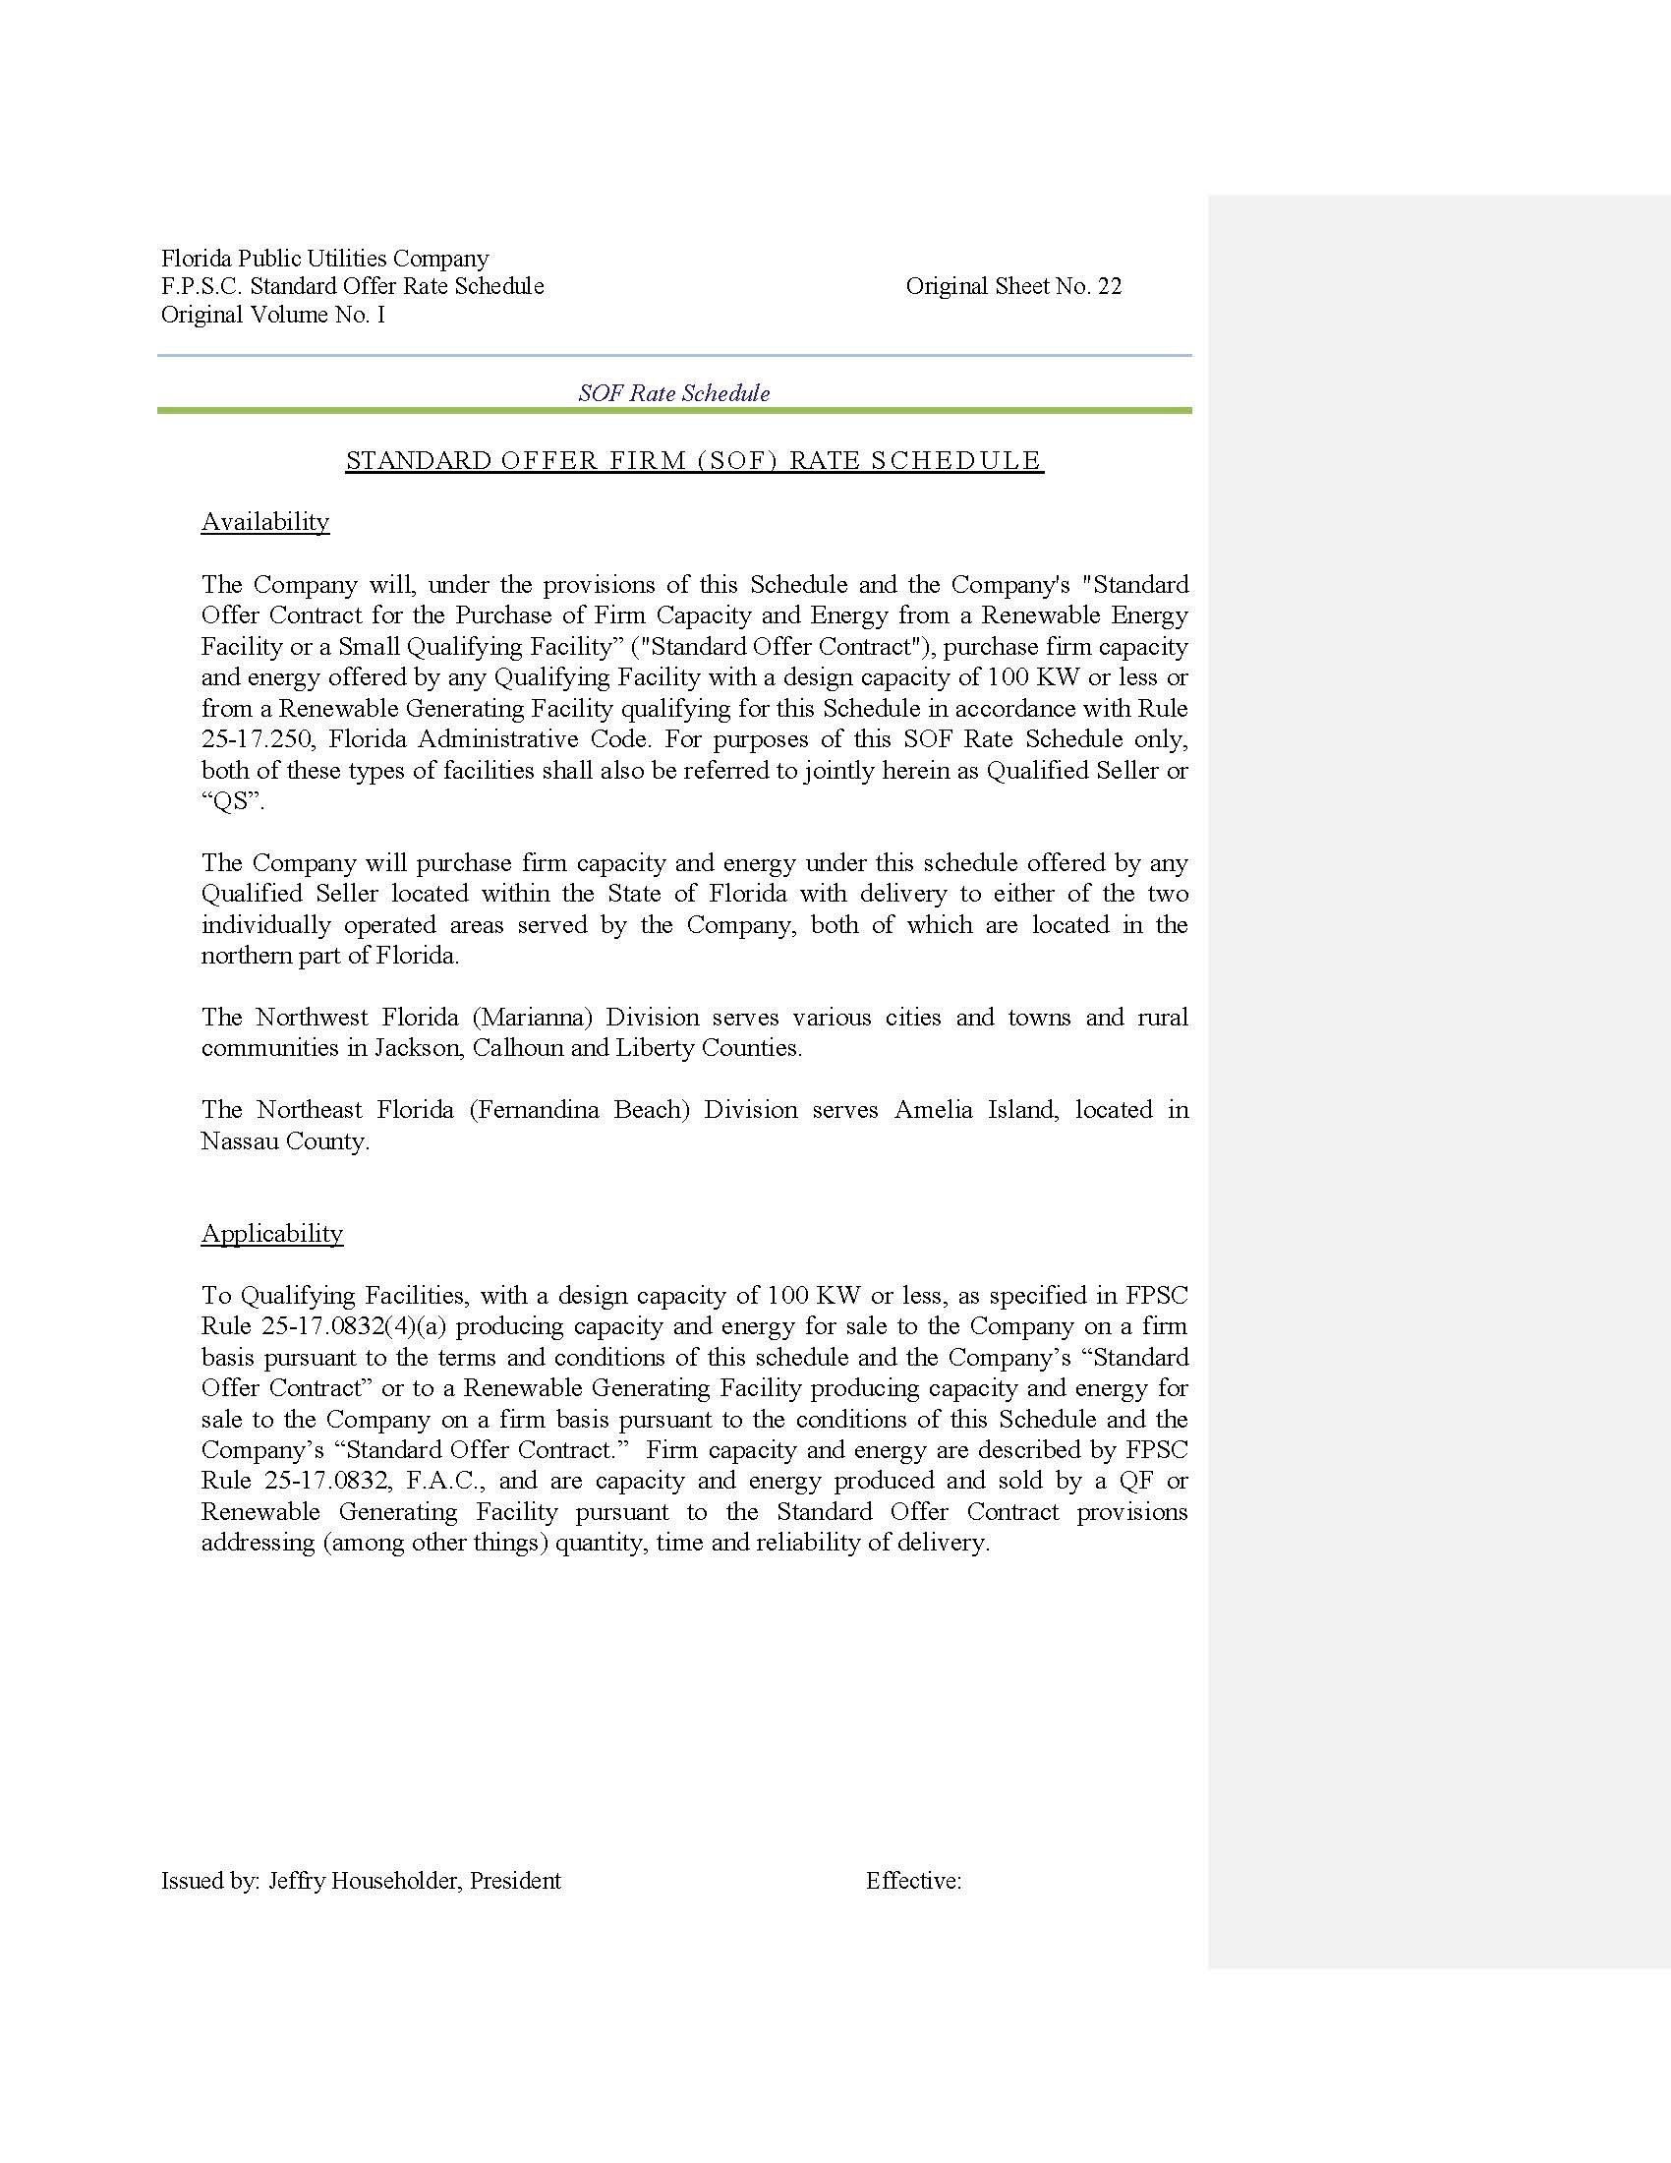

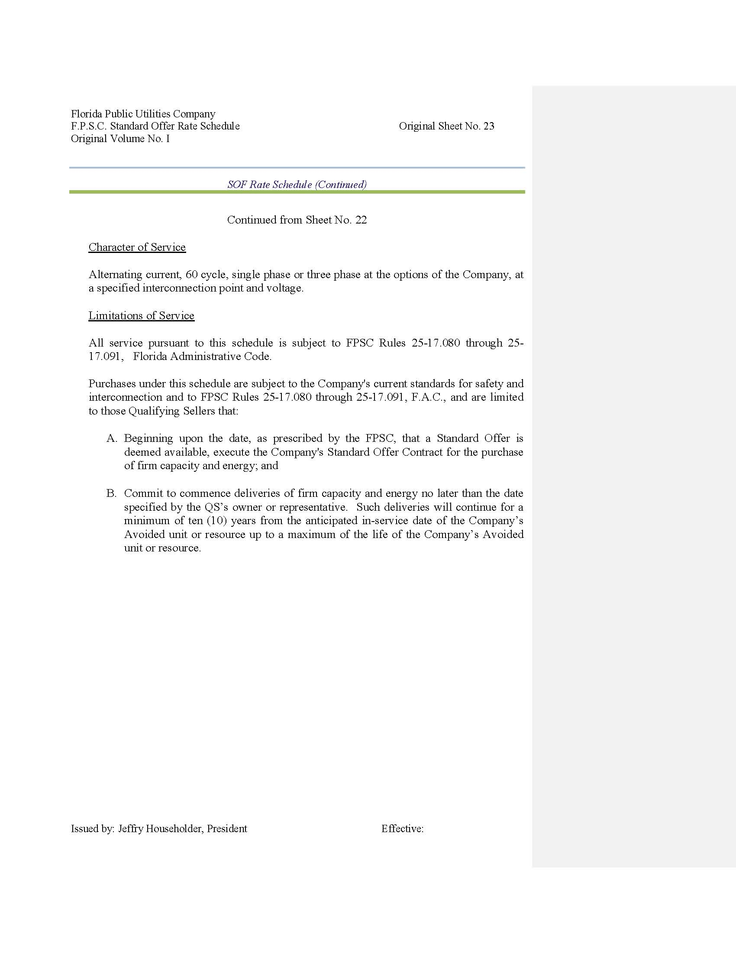

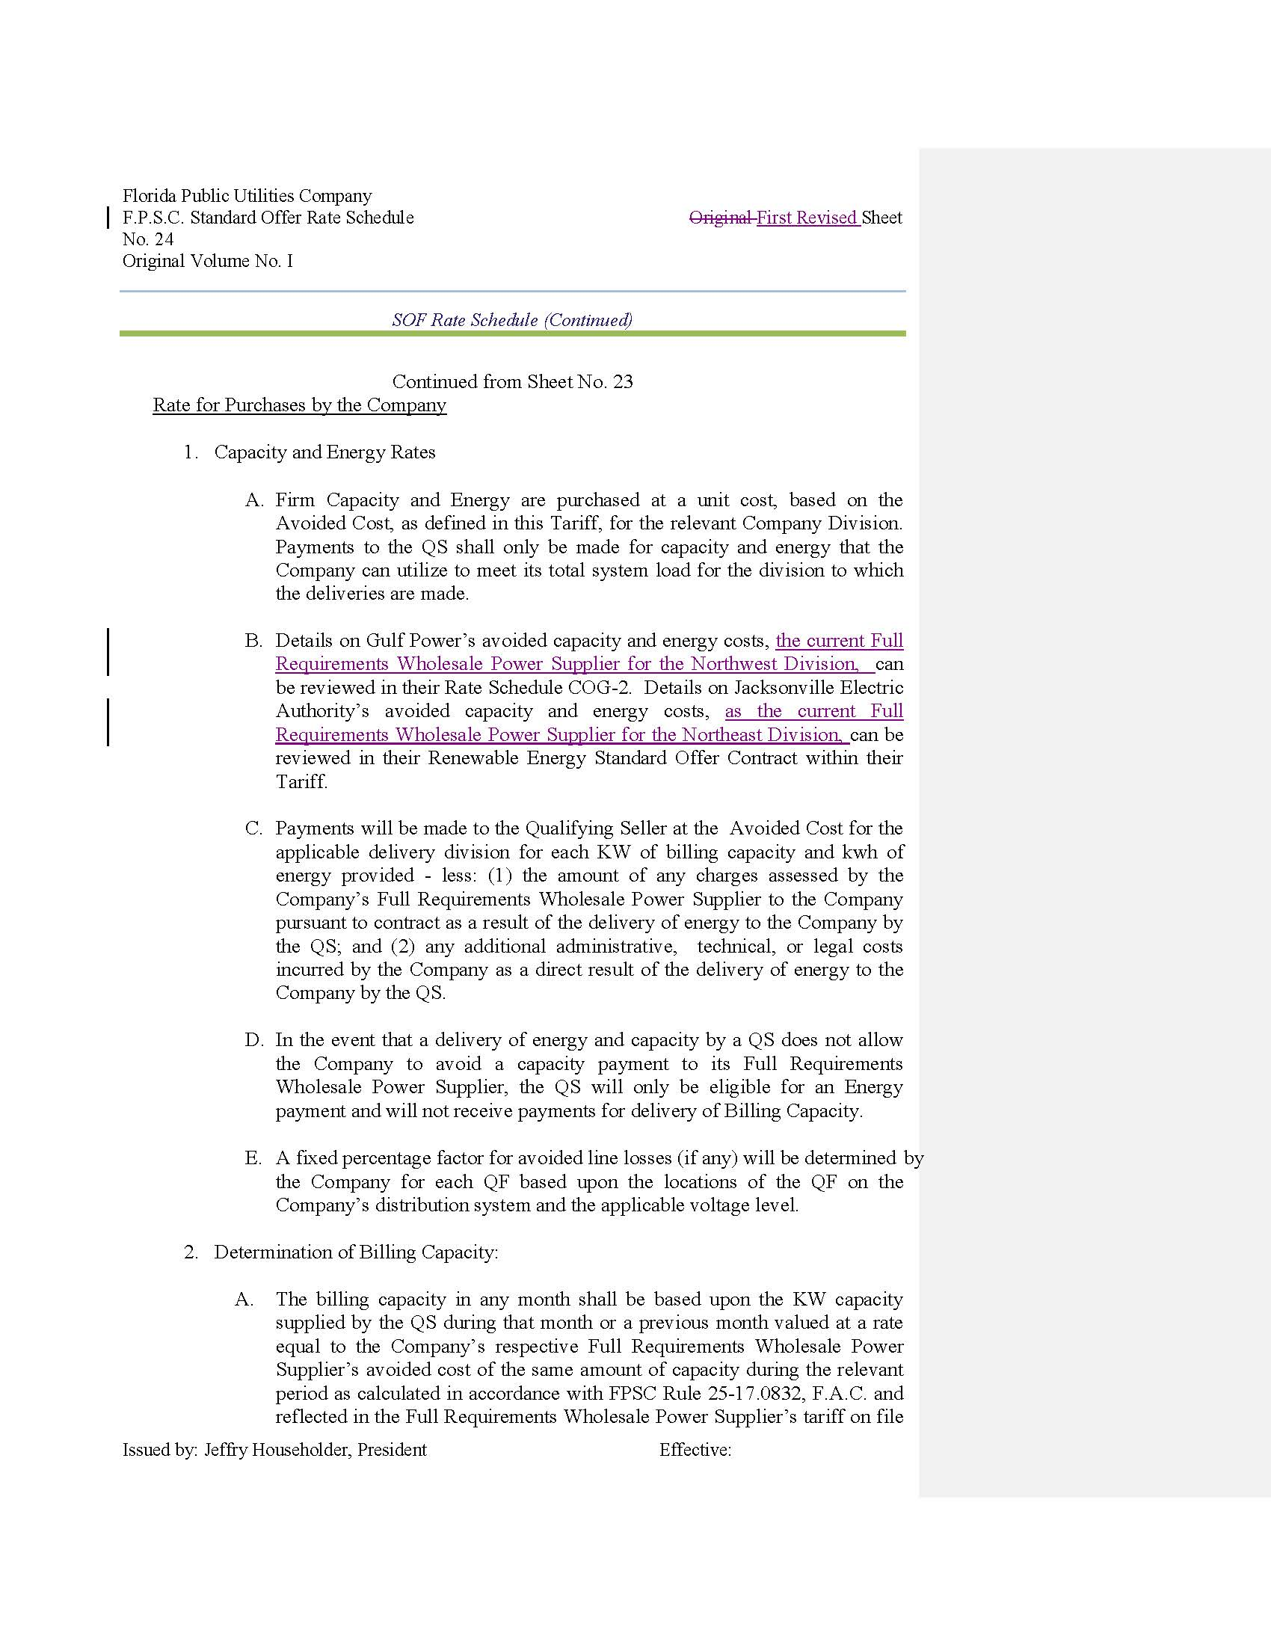

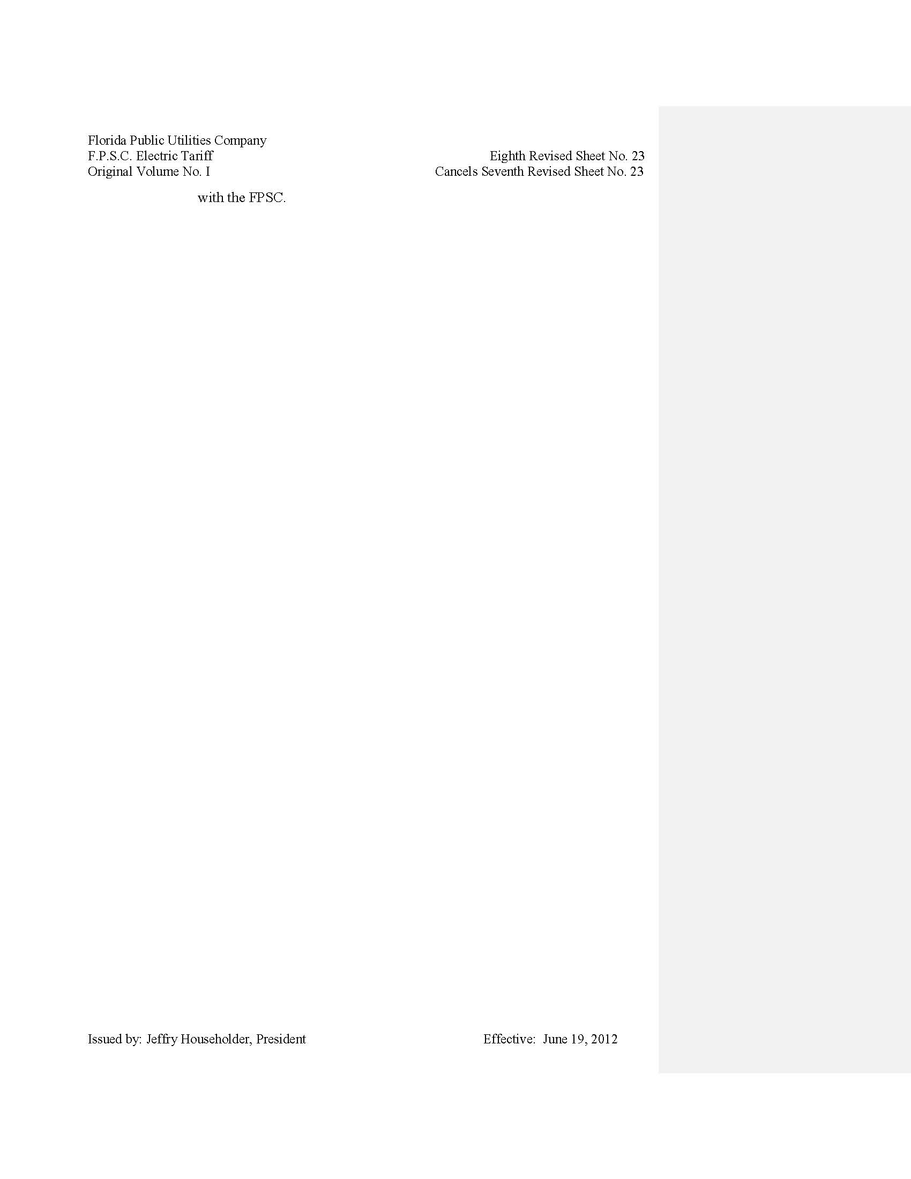

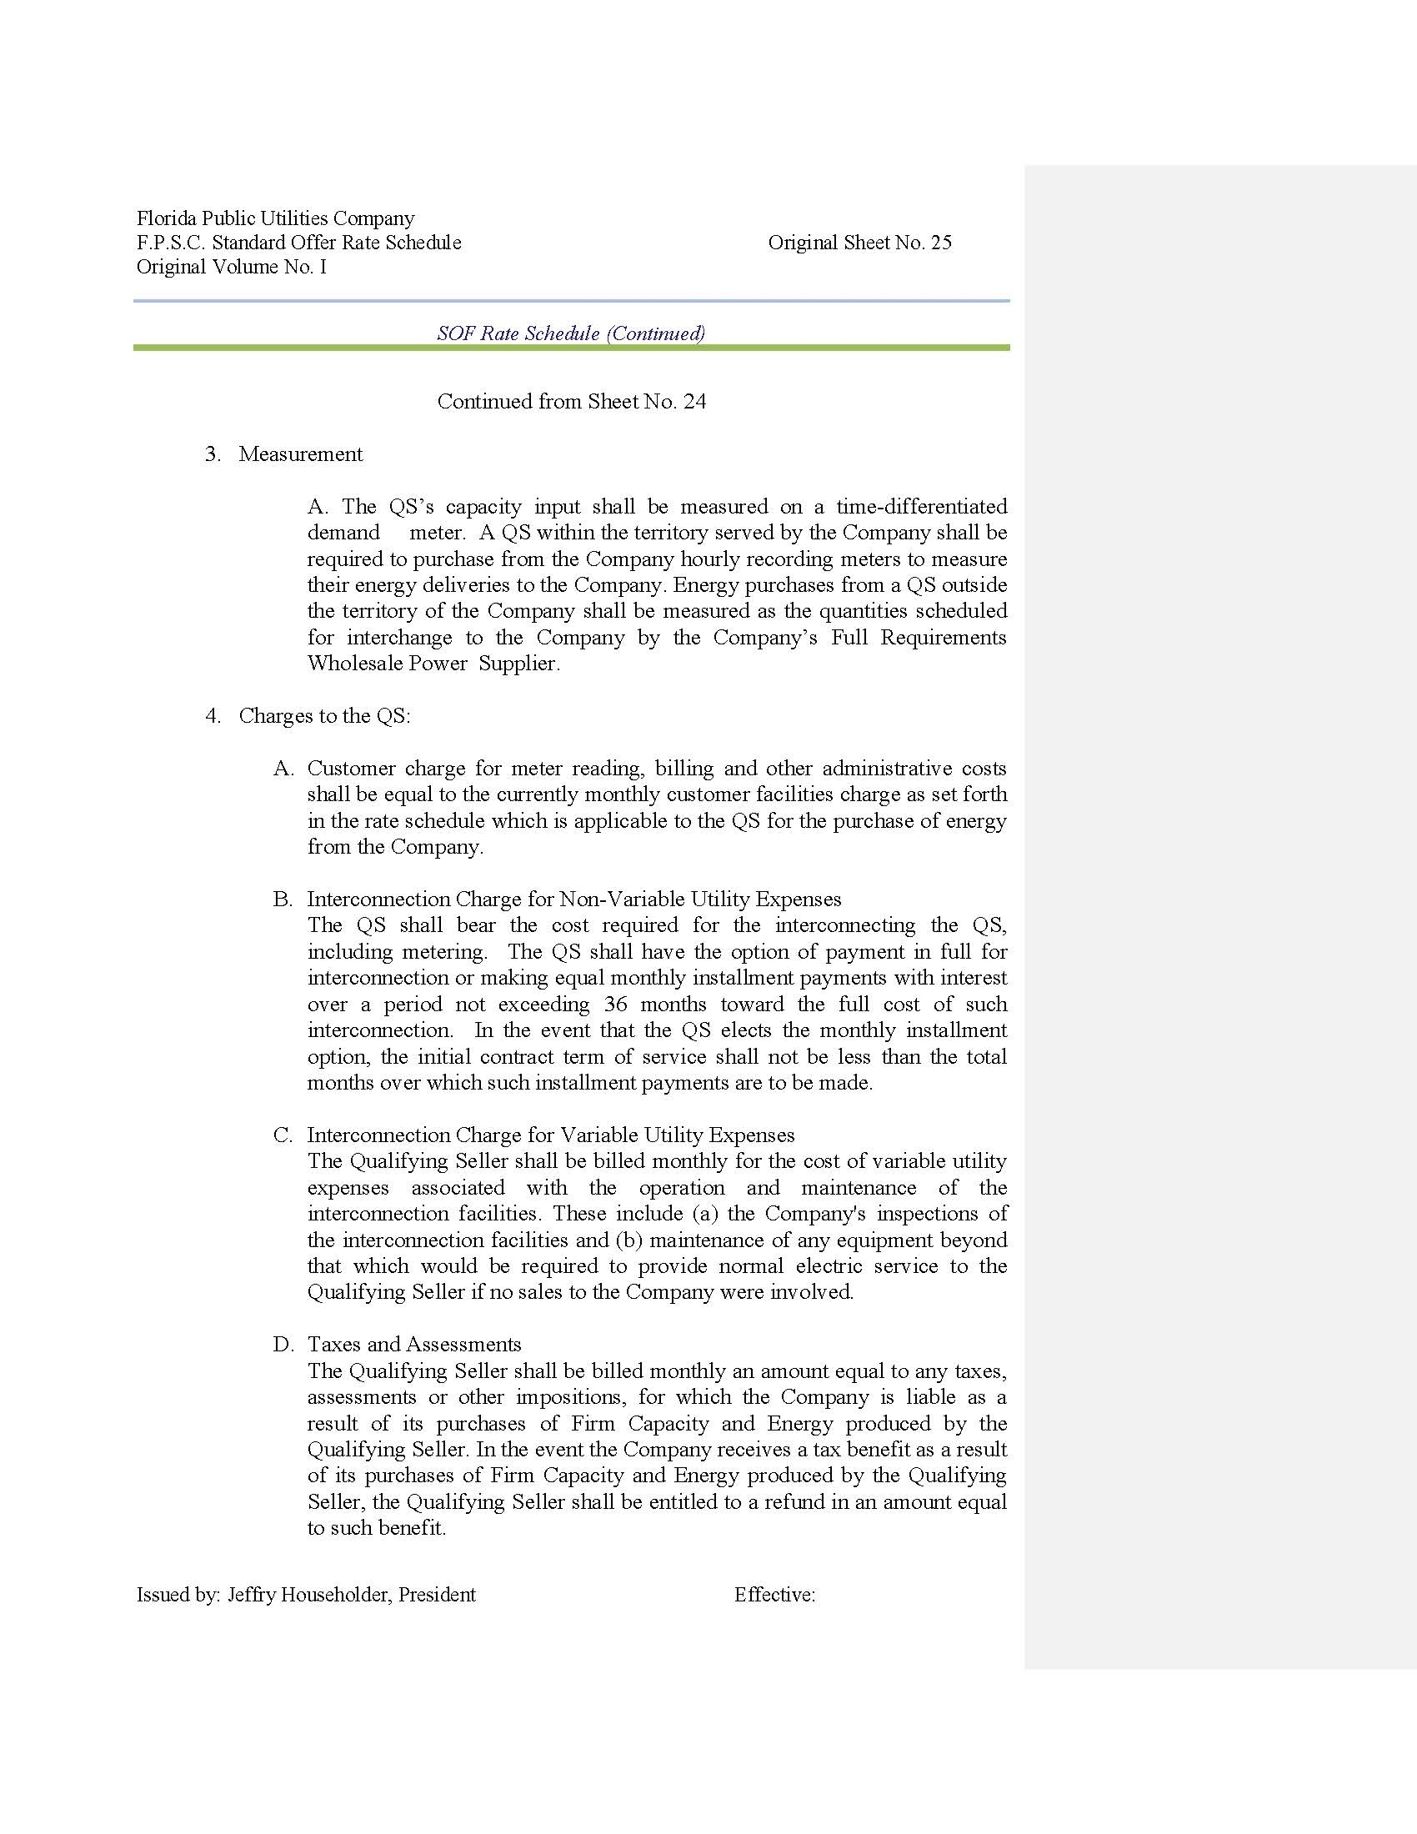

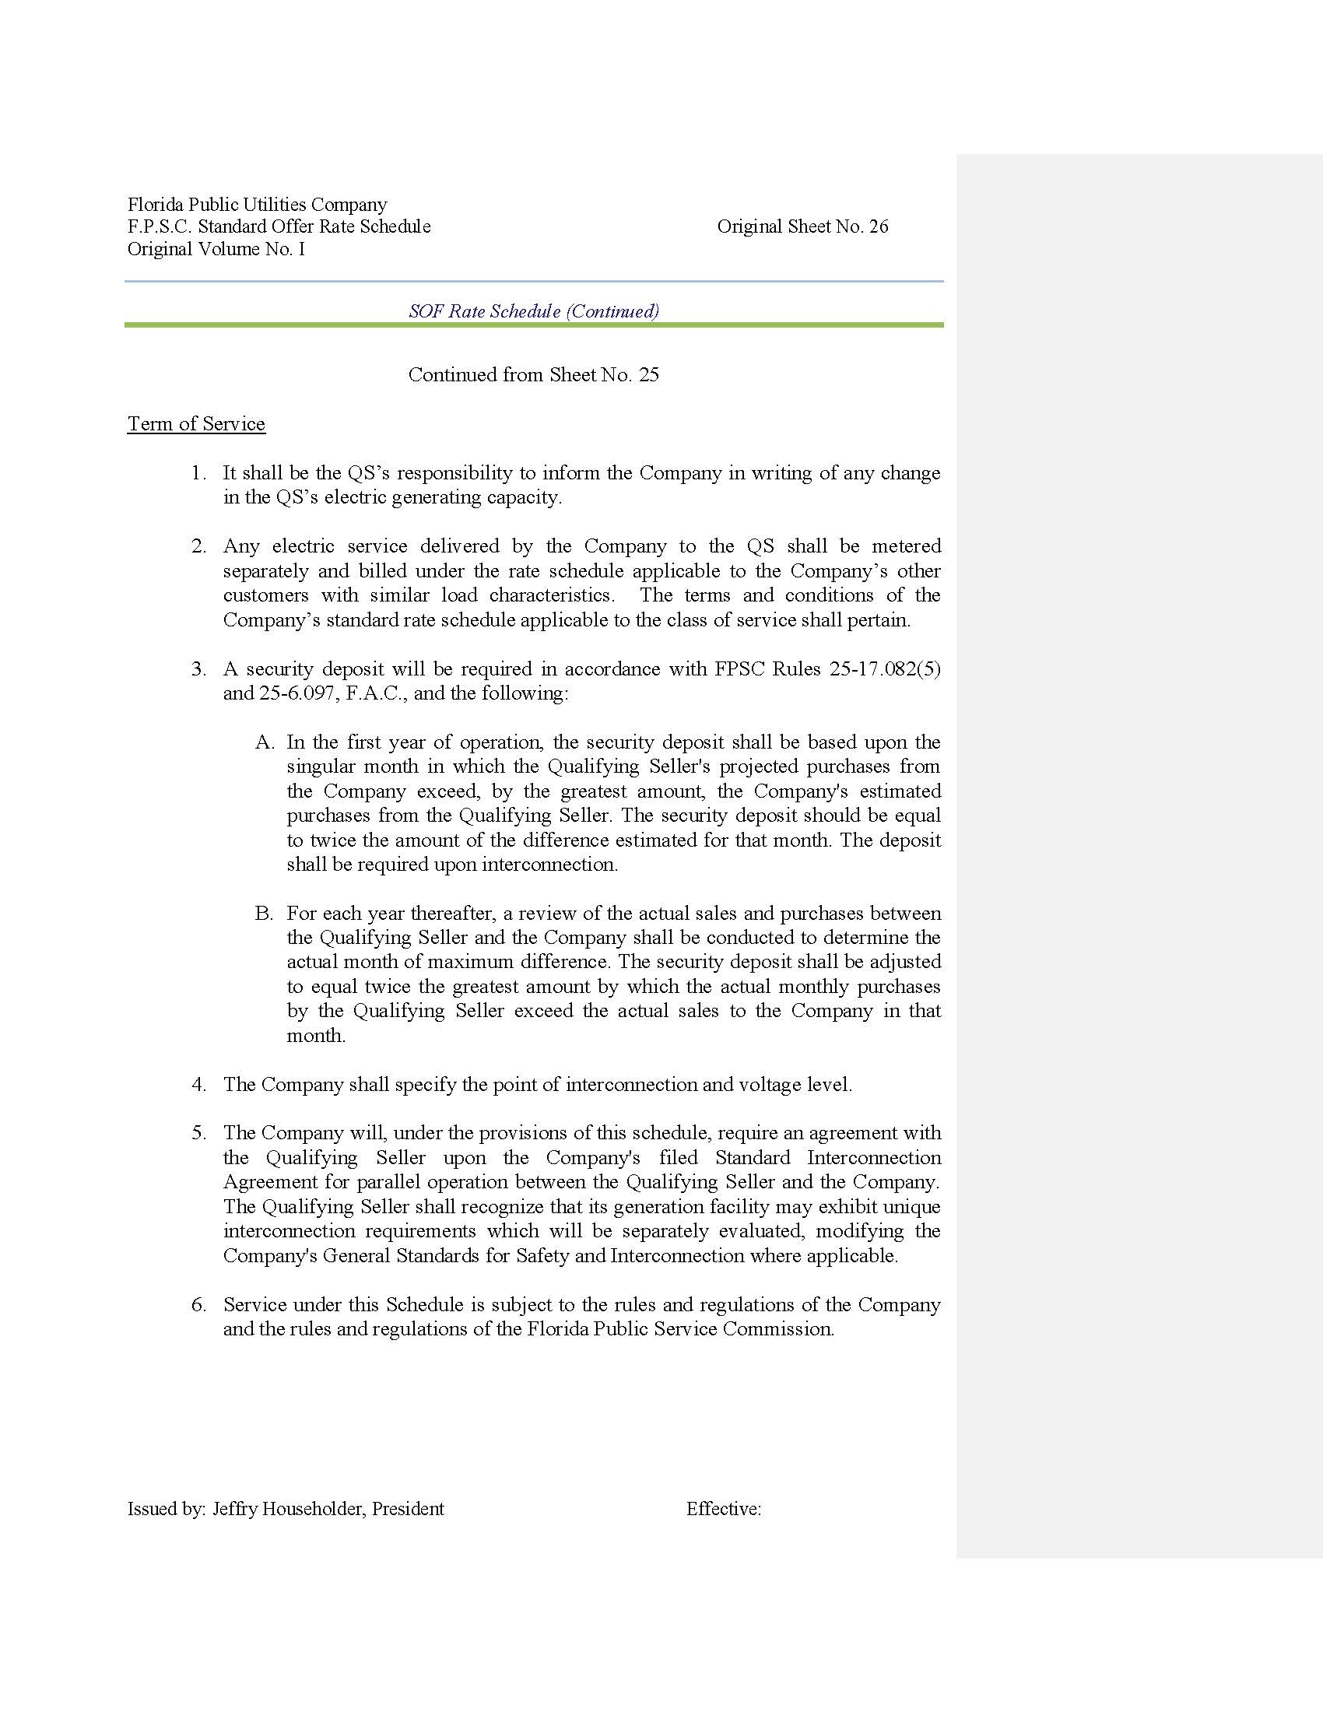

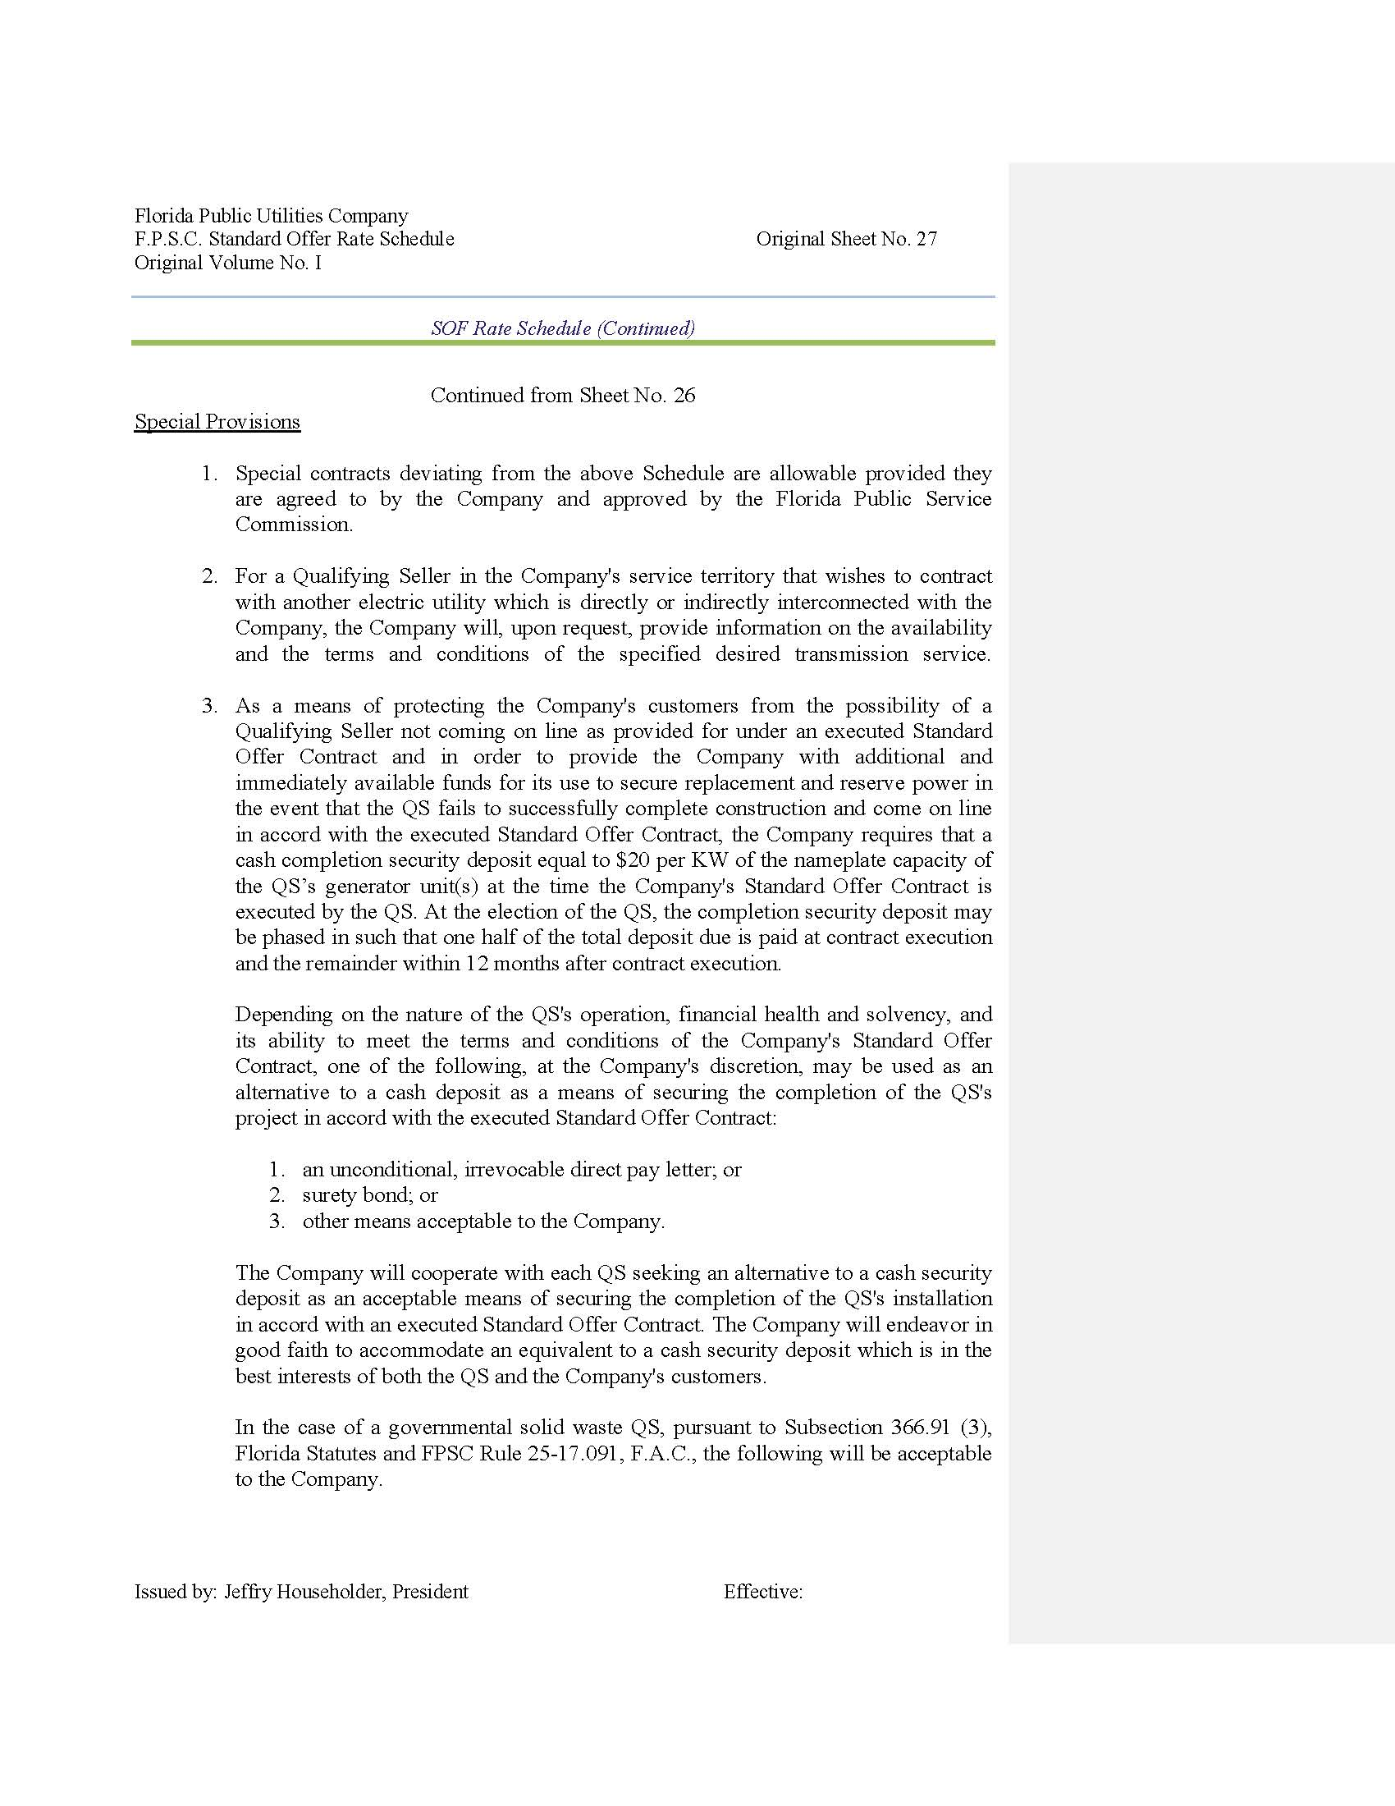

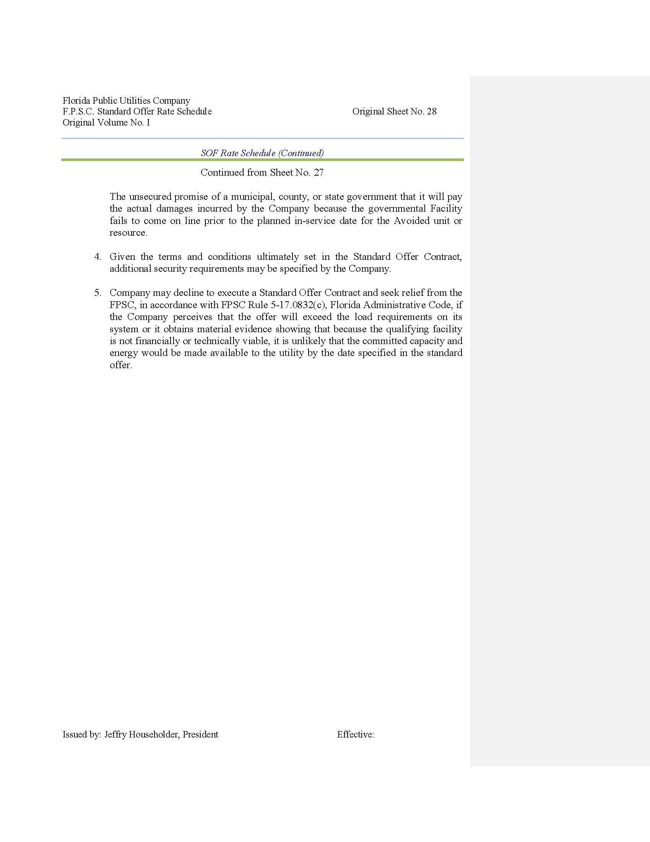

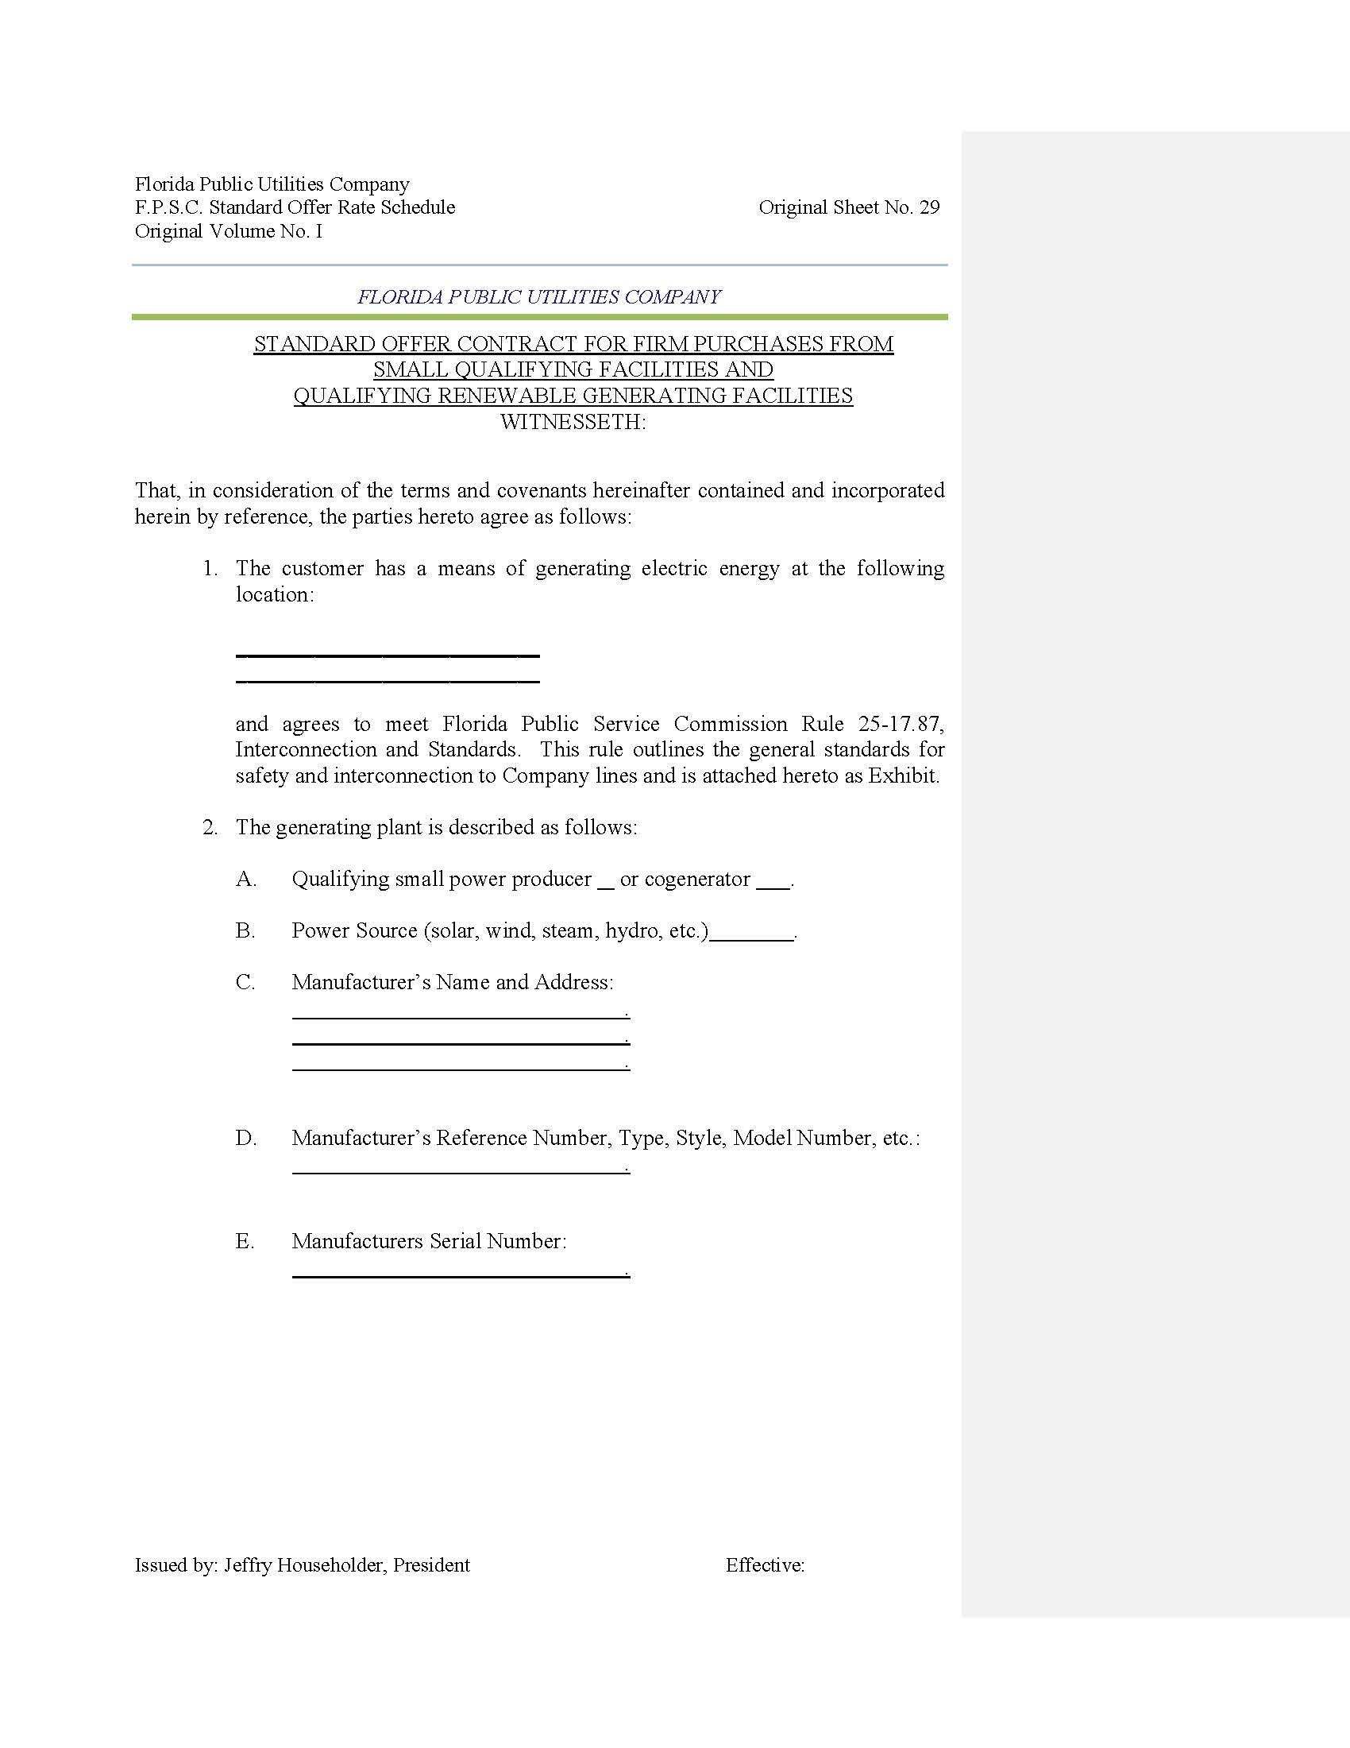

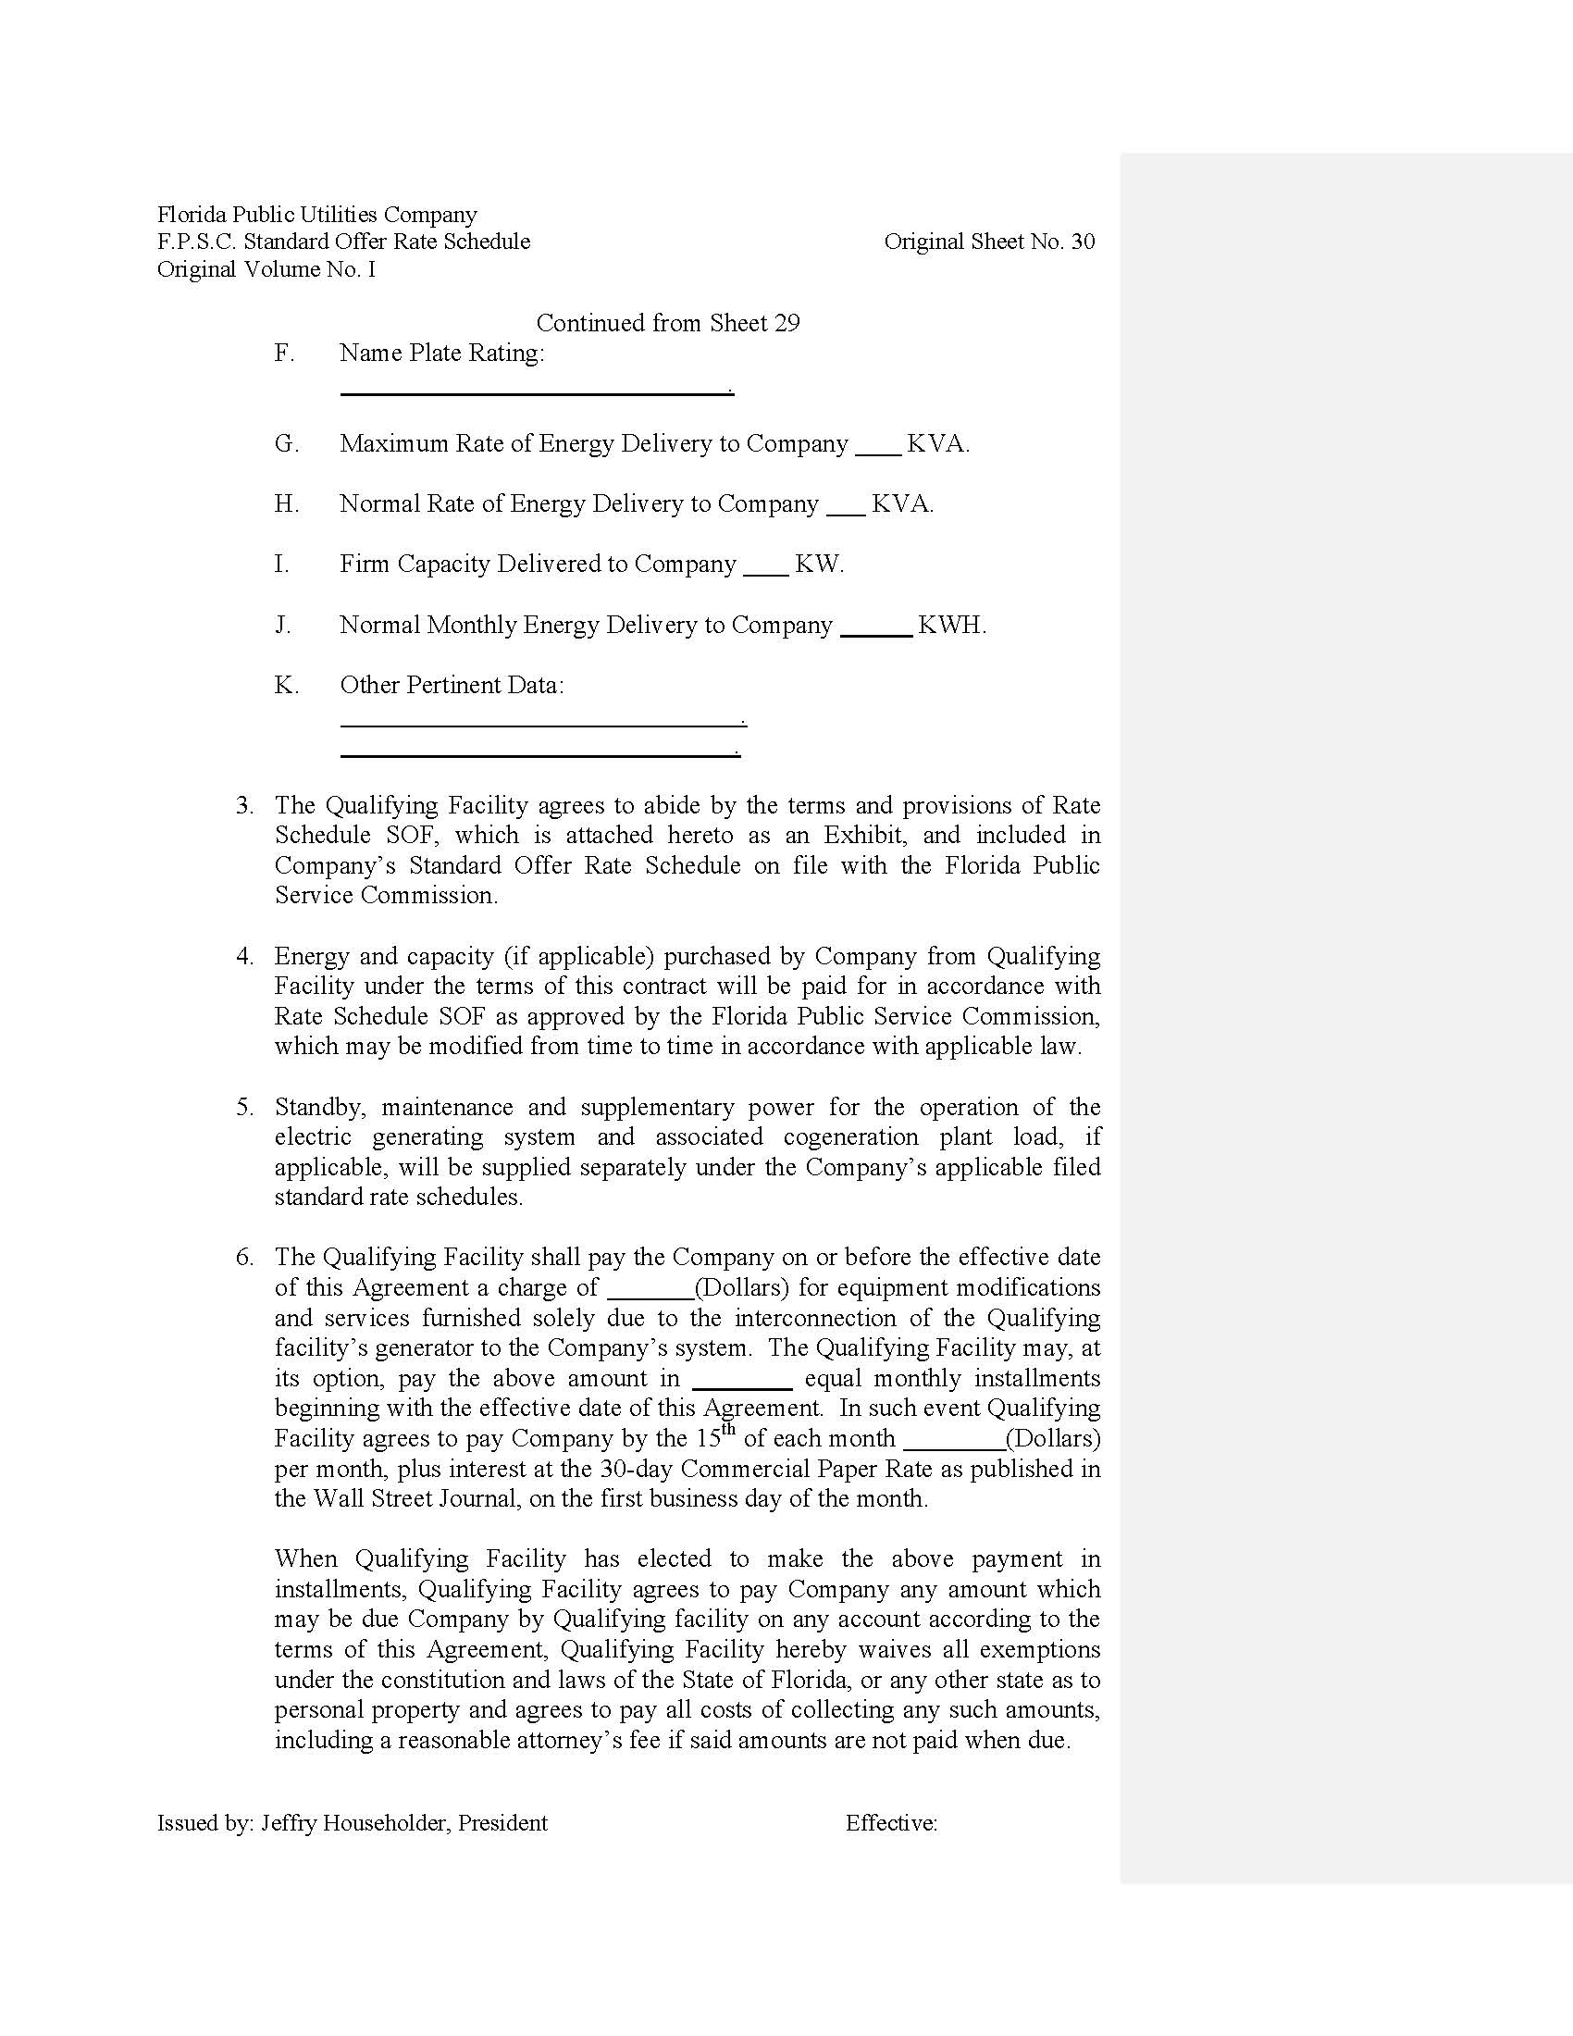

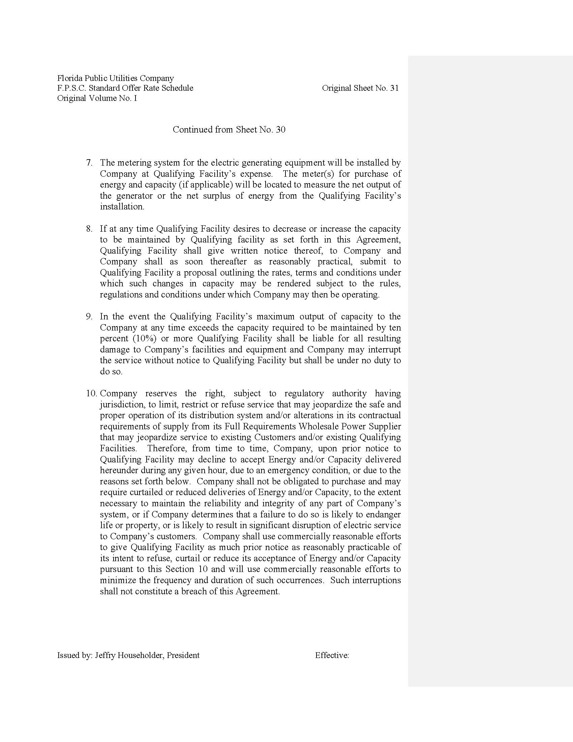

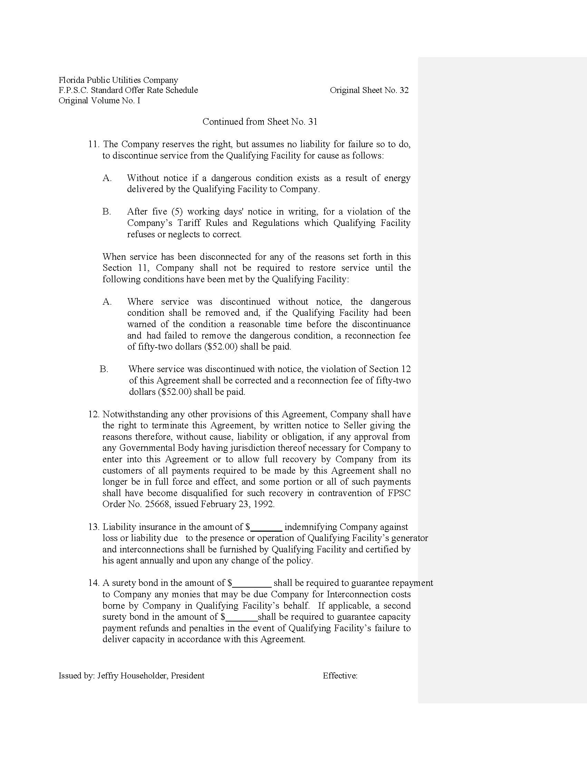

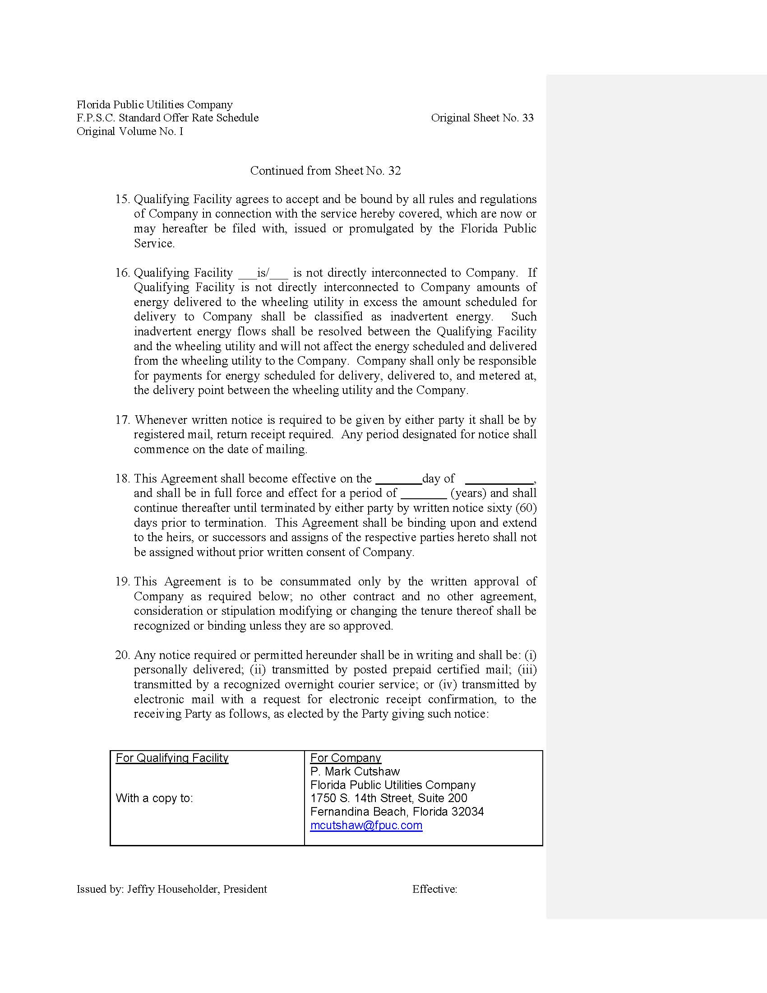

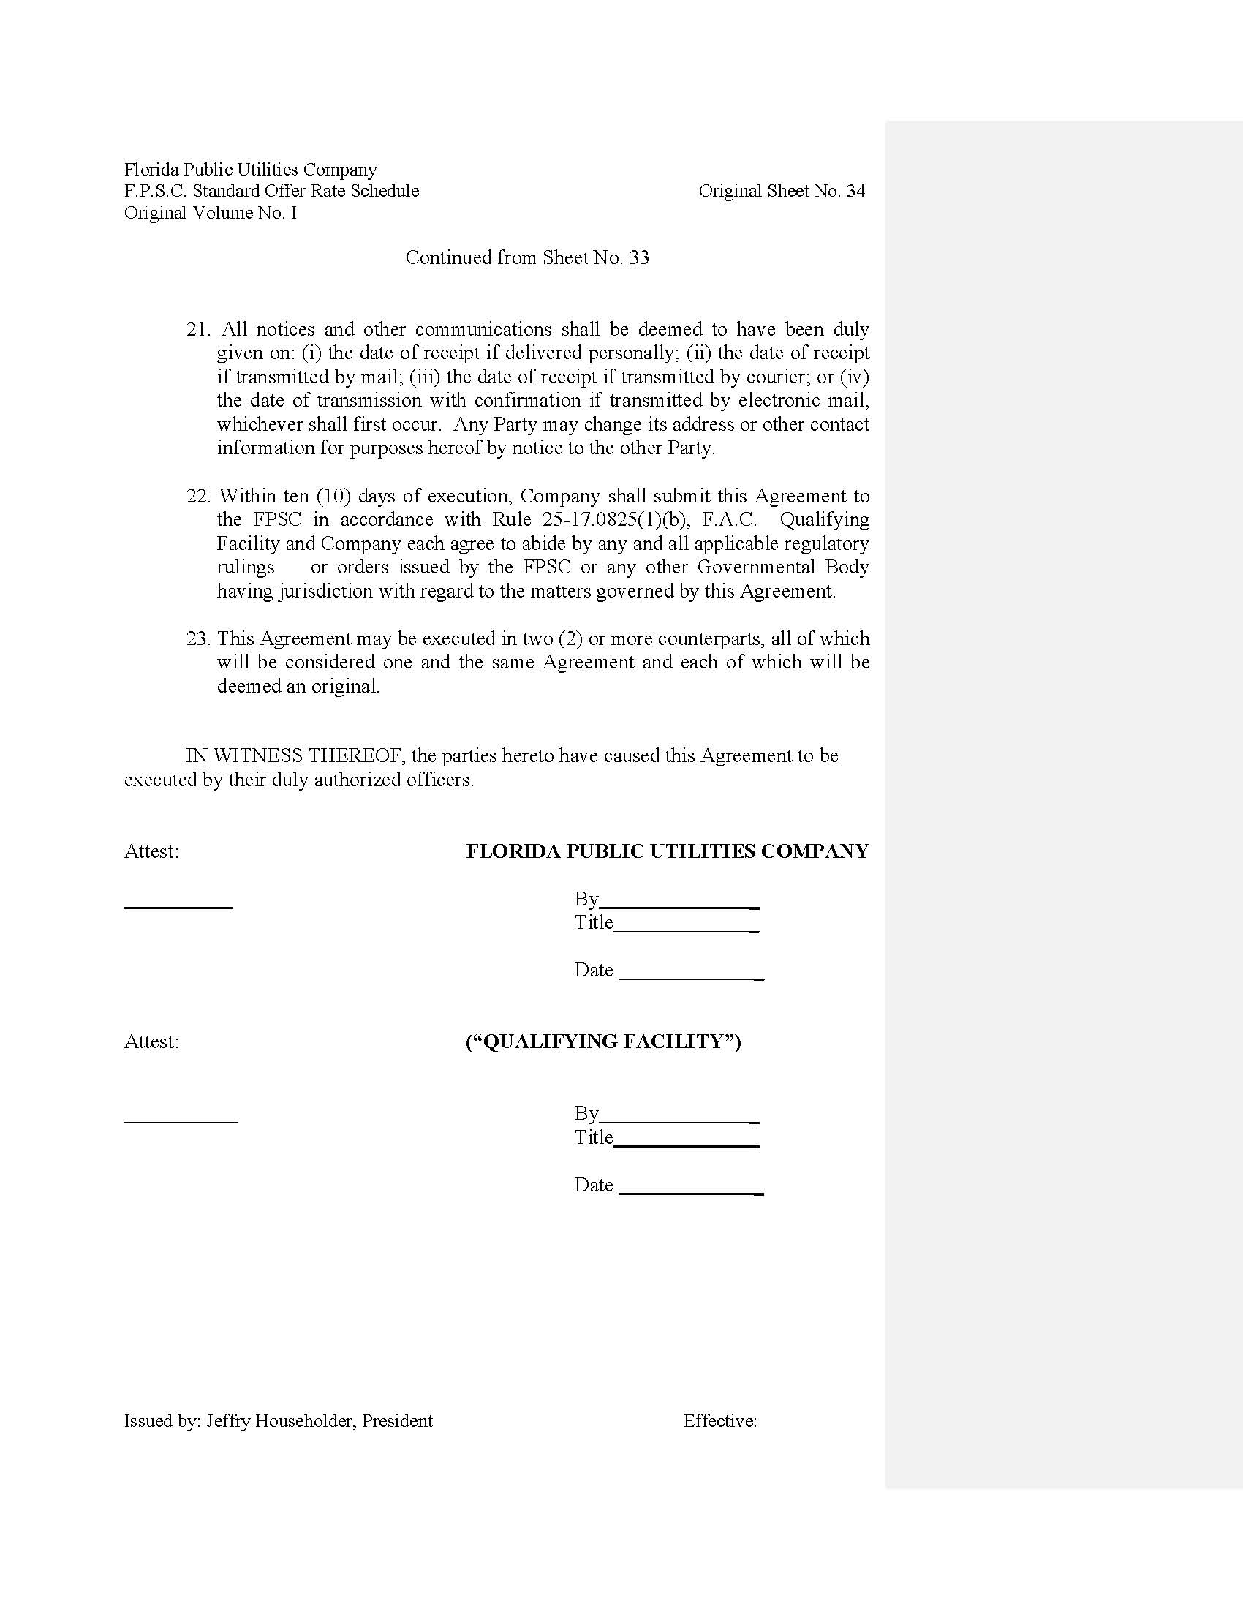

Order No. PSC-16-0531-PAA-EQ, issued November 22, 2016, in Docket No. 160074-EQ, In re: Petition for approval of new standard offer rate schedule for energy purchases from cogenerators and renewable facilities and for approval of standard offer contract for purchased of firm capacity and energy, by Florida Public Utilities Company.
Document No. 05135-17, dated May 31, 2017, in Docket No. 170070-EQ.
Document No. 05135-17, dated May 31, 2017, in Docket No. 170070-EQ.

