BEFORE THE FLORIDA PUBLIC SERVICE COMMISSION

In re: Joint petition for approval of modifications to customer deposit tariff sheets, by Florida Public Utilities Company, Florida Public Utilities Company - Fort Meade, Florida Public Utilities Company - Indiantown Division, and Florida Division of Chesapeake Utilities Corporation. | DOCKET NO. 20170110-GU  ORDER NO. PSC-2017-0289-TRF-GU  ISSUED: July 24, 2017

The following Commissioners participated in the disposition of this matter:

JULIE I. BROWN, Chairman
ART GRAHAM
RONALD A. BRISÉ
DONALD J. POLMANN

ORDER MODIFYING FLORIDA PUBLIC UTILITIES COMPANY’S TARIFFS

BY THE COMMISSION:
BACKGROUND

On May 9, 2017, Florida Public Utilities Company (FPUC electric and gas divisions), Florida Public Utilities Company-Fort Meade, Florida Public Utilities Company-Indiantown Division, and the Florida Division of Chesapeake Utilities Corporation (Joint Petitioners or Companies) filed a joint petition requesting Commission approval of modifications to tariff sheets regarding customer deposits. On June 23, 2017, the joint petitioners filed an additional tariff revision to the FPUC electric tariff. The Joint Petitioners operate under the Chesapeake Utilities Corporation, a Delaware-based energy company.
During the 2015 session, the Florida Legislature enacted House Bill 7109 which was incorporated into Chapter 2015-129, Laws of Florida. Among other things, the legislation created Section 366.05(1)(b) and (c), Florida Statutes (F.S.). Subsection (1)(b) addresses billing periods and Subsection (1)(c) addresses customer deposits. These laws became effective on July 1, 2015. We adopted amendments to Rules 25-6.097 (Customer Deposits) and 25-6.100 (Customer Billings) for the electric utilities; and amendments to Rules 25-7.083 (Customer Deposits) and 25-7.085 (Customer Billing) for the gas utilities, Florida Administrative Code (F.A.C.), to implement the laws enacted in July 2015.
The Joint Petitioners are requesting tariff modifications at this time to ensure that the Companies’ tariff language continues to conform to the applicable statutes and Commission rules. The Companies’ waived the 60-day suspension date until July 13, 2017. We have jurisdiction in this matter pursuant to Sections 366.03, 366.05, and 366.06, F.S.
DECISION
The Joint Petitioners’ proposed tariff modifications are designed to conform their tariffs to applicable statutes and Commission rules. At this time, the FPUC gas division, FPUC-Fort Meade, FPUC-Indiantown, and the Florida Division of Chesapeake Utilities Corporation do not have tiered rate schedules; therefore, these gas companies are not proposing any changes to their tariffs as a result of changes to Section 366.05(1)(b), F.S., and Rule 25-7.085, F.A.C. The Joint Petitioners’ proposed tariff modifications are addressed below.
Customer Deposits
Section 366.05(1)(c), F.S., provides that for an existing account, the total deposit may not exceed two months of average actual charges. For a new service request, the total deposit may not exceed two months of projected charges. Once a new customer has had continuous service for a 12-month period, the amount of the deposit shall be recalculated using actual data. Any difference between the projected and actual amounts must be resolved by the customer paying the additional amount that may be billed by the utility or the utility returning any overcharge.
We amended Rules 25-6.097(1), and 25-7.083, F.A.C., to state that the utility’s methodology for determining customer deposits for existing and new accounts shall conform to Section 366.05(1)(c), F.S. The prior rule language already required that the total amount of a deposit not exceed twice the average monthly bill. The Joint Petitioners’ proposed amendments to the electric and gas tariffs conform to the new statutory language regarding the recalculation of the deposit after 12-months.
Billing Period for FPUC Electric Tariff
Section 366.05(1)(b), F.S., provides that if the Commission authorizes a public utility to charge tiered rates based upon levels of usage and to vary its regular billing period, the utility may not charge a customer a higher rate because of an increase in usage attributable to an extension of the billing period; however, the regular meter reading date may not be advanced or postponed more than five days for routine operating reasons without prorating the billing for the period. We amended Rule 25-6.100, F.A.C., to implement the statutory changes. The prior rule specified that the regular meter reading date may be advanced or postponed not more than 5 days without a proration of the billing for the period, but did not address the application of tiered rates to extended billing periods. Tiered rates, such as FPUC’s residential energy charges, apply a higher energy charge to usage above 1,000 kilowatt-hours.
FPUC-Electric proposed new language to Tariff Sheet No. 28 to reflect the Section 366.05(1)(b), F.S., statutory requirements and to include the Company’s current billing practices in its tariff. The revised tariff sheet addresses both the proration of charges when billing periods are varied by more than five days, as well as the prohibition against charging higher tiered rates if the extension of a billing period of more than five days causes a customer’s energy consumption to exceed the Company’s tier threshold of 1,000 kilowatt-hours.

Upon review of the applicable statutes, Commission rules, and proposed tariffs filed by FPUC (electric and gas divisions), FPUC-Fort Meade, FPUC-Indiantown Division, and the Florida Division of Chesapeake Utilities Corporation, we find that the tariff sheet revisions conform to the applicable statutes and Commission rules. Therefore, we approve the requested modifications to tariff sheets, as reflected in Attachment A, effective July 13, 2017.
Based on the foregoing, it is
ORDERED by the Florida Public Service Commission that the Florida Public Utilities Company’s modifications to its tariffs as reflected in Attachment A, are hereby approved effective July 13, 2017. It is further
ORDERED that if a protest is filed within 21 days of issuance of the Order, the tariff shall remain in effect with any charges held subject to refund pending resolution of the protest. It is further
ORDERED that if no timely protest is filed, this docket shall be closed upon the issuance of a Consummating Order.
By ORDER of the Florida Public Service Commission this 24th day of July, 2017.

/s/ Carlotta S. Stauffer
CARLOTTA S. STAUFFER
Commission Clerk
Florida Public Service Commission
2540 Shumard Oak Boulevard
Tallahassee, Florida 32399
(850) 413-6770
www.floridapsc.com

Copies furnished: A copy of this document is provided to the parties of record at the time of issuance and, if applicable, interested persons.

SBR

NOTICE OF FURTHER PROCEEDINGS

The Florida Public Service Commission is required by Section 120.569(1), Florida Statutes, to notify parties of any administrative hearing or judicial review of Commission orders that is available under Sections 120.57 or 120.68, Florida Statutes, as well as the procedures and time limits that apply. This notice should not be construed to mean all requests for an administrative hearing or judicial review will be granted or result in the relief sought.

Mediation may be available on a case-by-case basis. If mediation is conducted, it does not affect a substantially interested person's right to a hearing.

The Commission's decision on this tariff is interim in nature and will become final, unless a person whose substantial interests are affected by the proposed action files a petition for a formal proceeding, in the form provided by Rule 28-106.201, Florida Administrative Code. This petition must be received by the Office of Commission Clerk, 2540 Shumard Oak Boulevard, Tallahassee, Florida 32399-0850, by the close of business on August 14, 2017.

In the absence of such a petition, this Order shall become final and effective upon the issuance of a Consummating Order.

Any objection or protest filed in this docket before the issuance date of this order is considered abandoned unless it satisfies the foregoing conditions and is renewed within the specified protest period.

FPUC-Electric
First Revised Sheet No. 12
First Revised Sheet No. 14
First Revised Sheet No. 28

FPUC-Natural Gas
Seventh Revised Sheet No. 13
First Revised Sheet No. 13.1

Florida Division of Chesapeake Utilities Corporation
Second Revised Sheet No. 12
Fifth Revised Sheet No. 32
Third Revised Sheet No. 33

Florida Public Utilities Company-Indiantown Division
Third Revised Sheet No. 47
Third Revised Sheet No. 48
First Revised Sheet No. 49

Florida Public Utilities Company-Fort Meade
Second Revised Sheet No. 11
First Revised Sheet No. 14
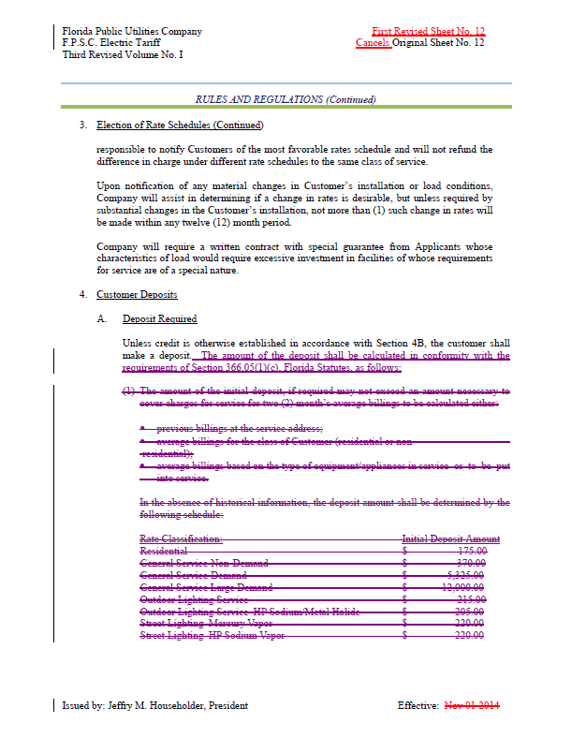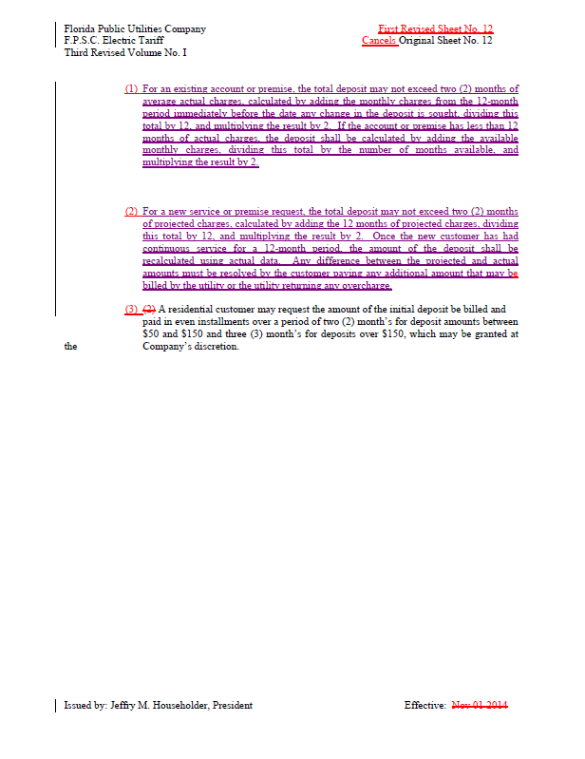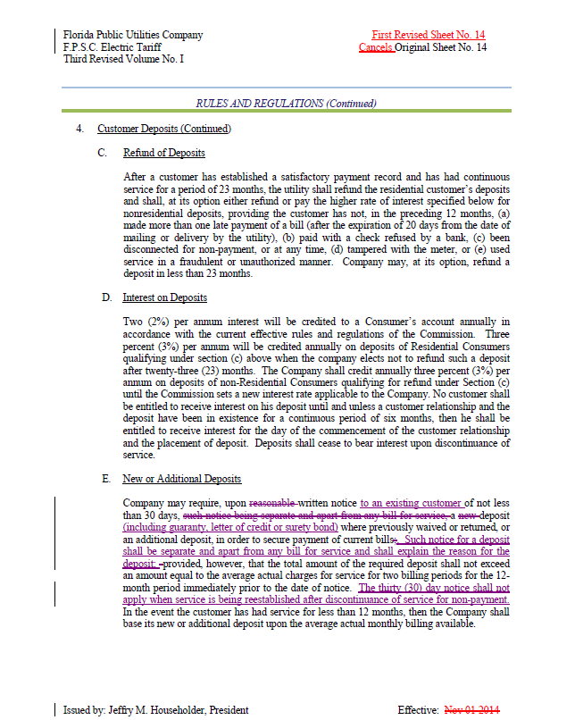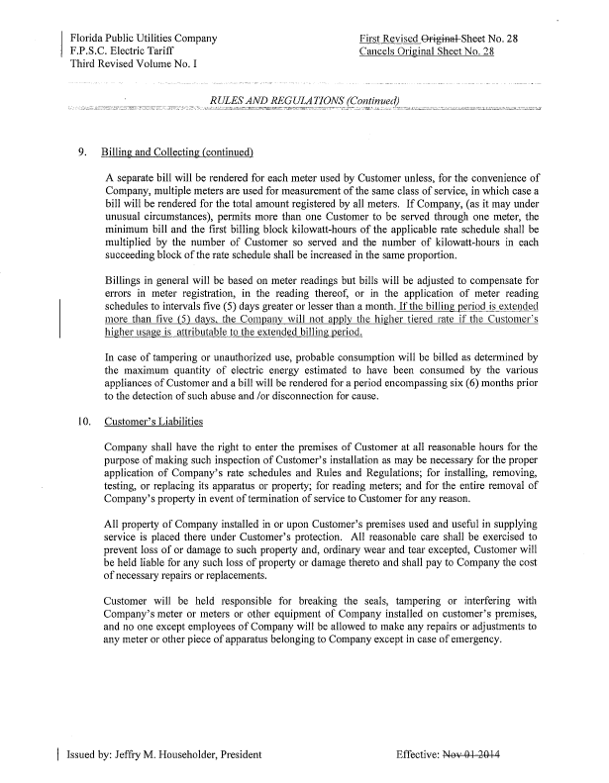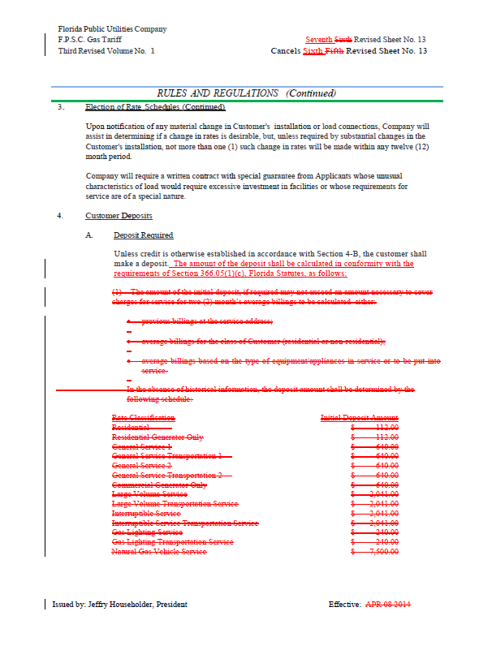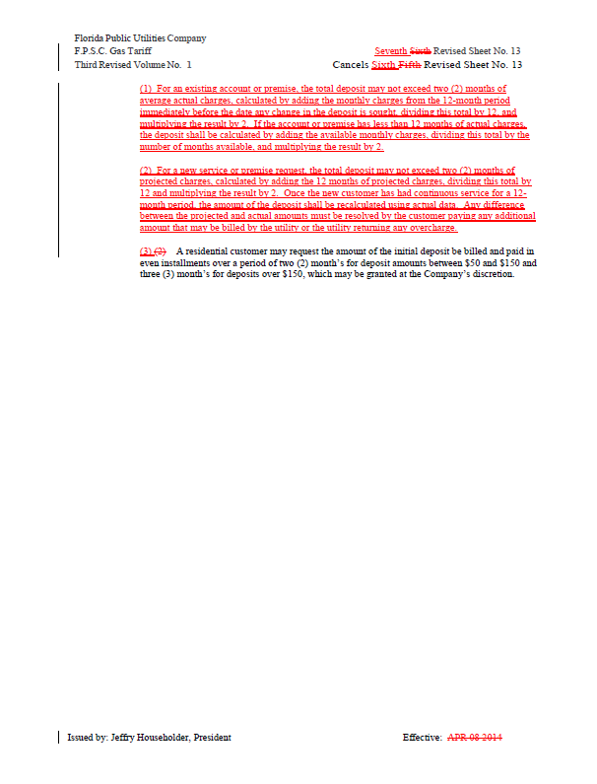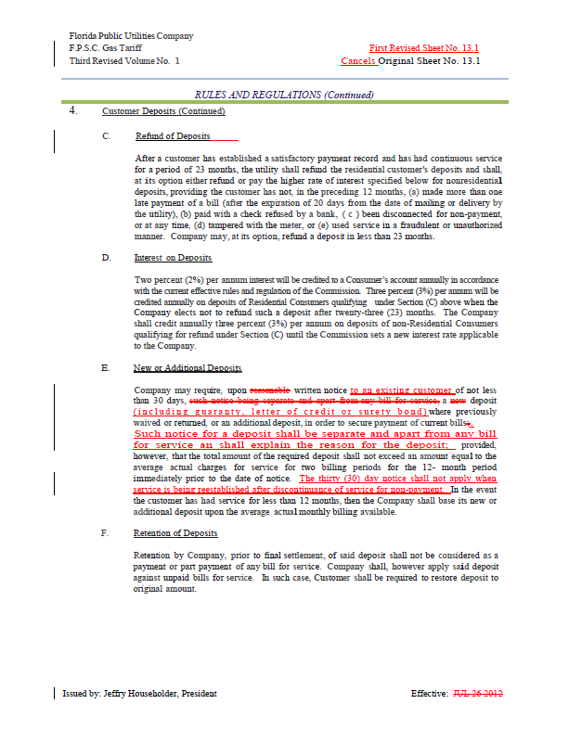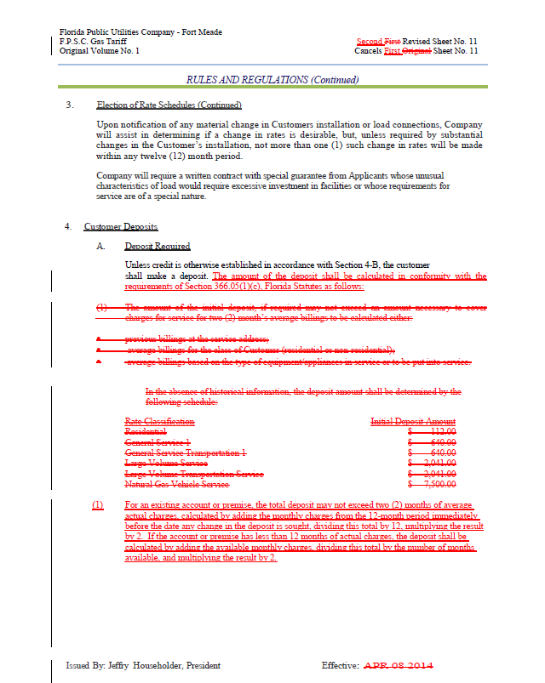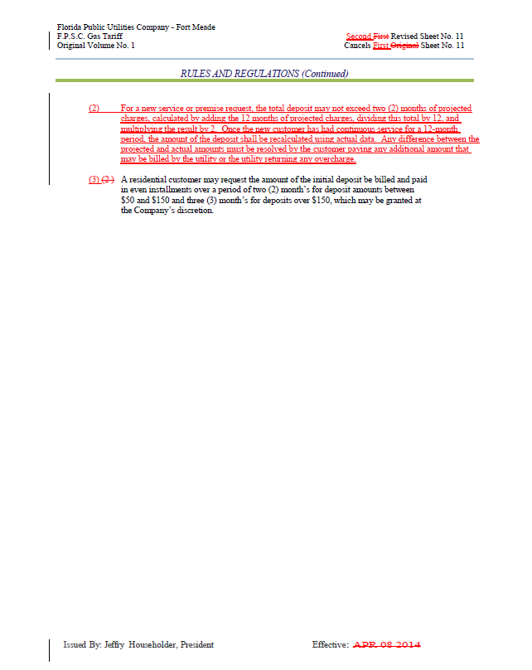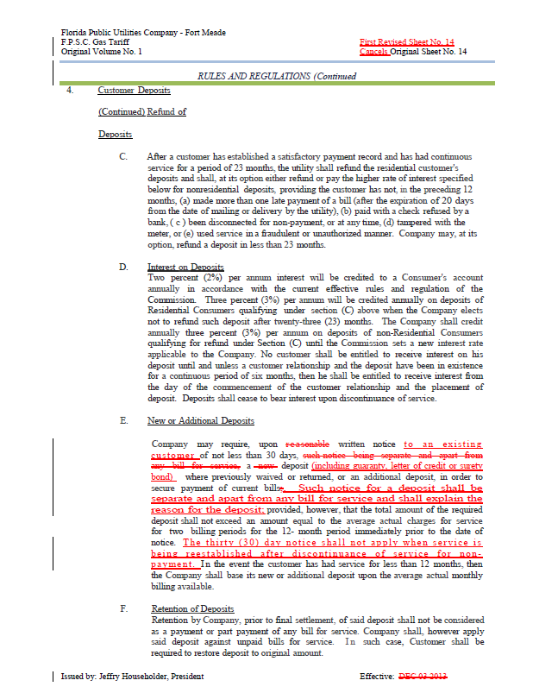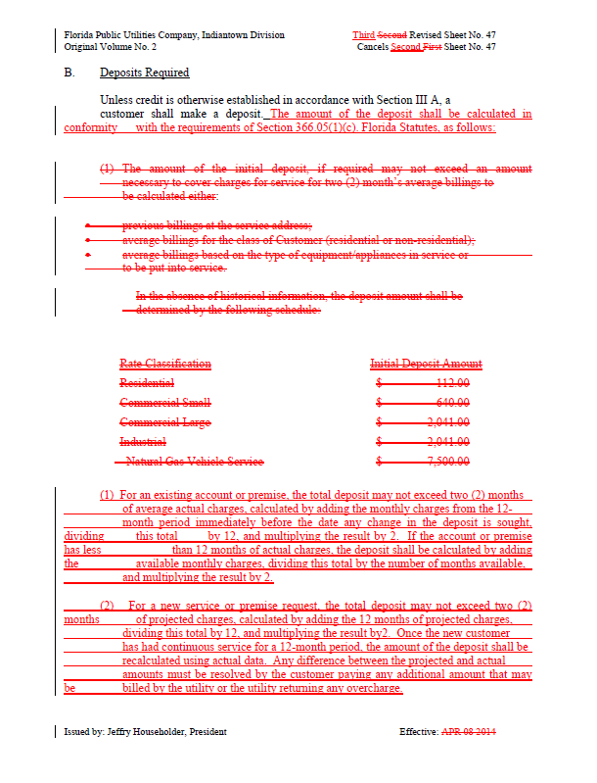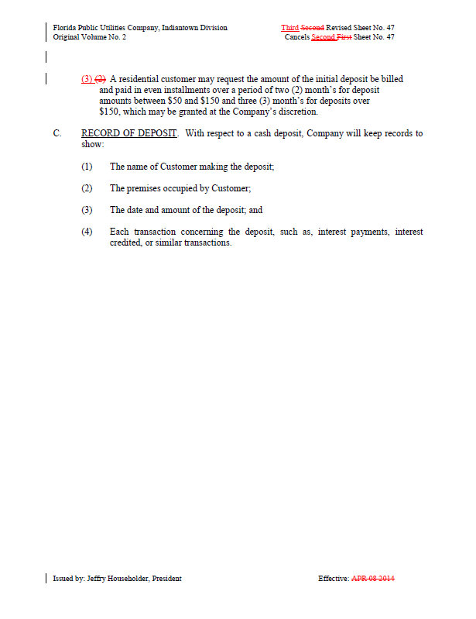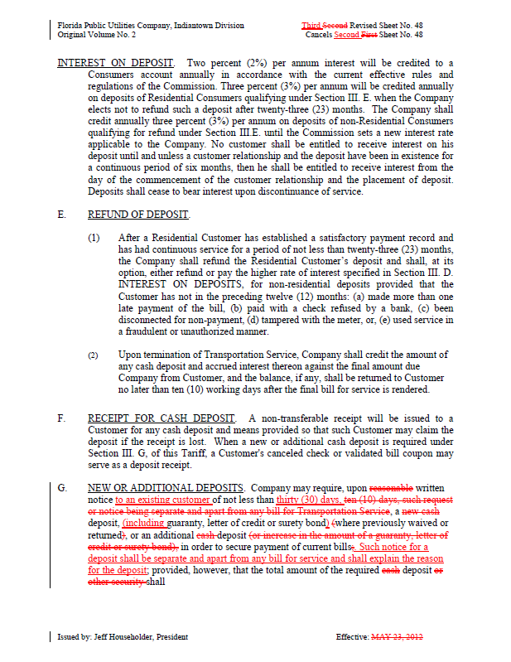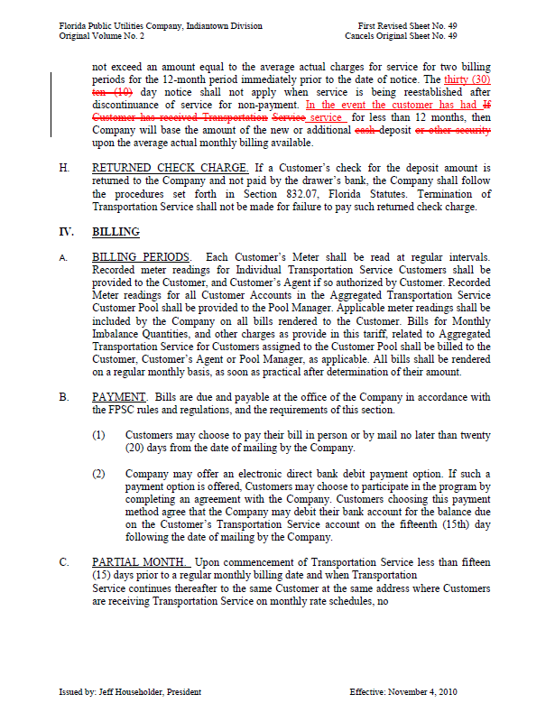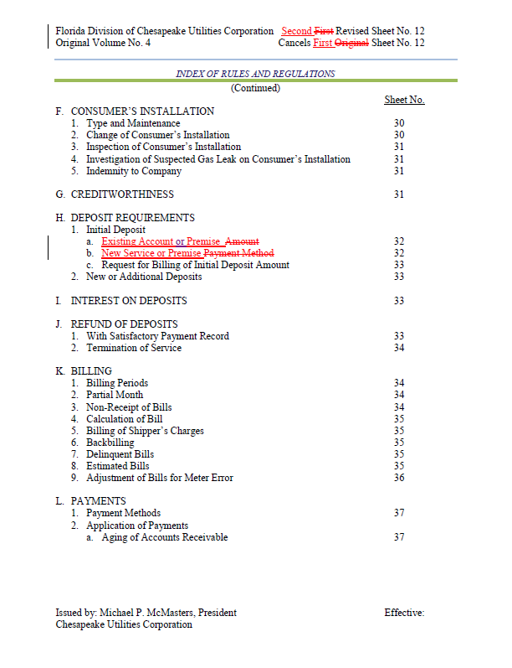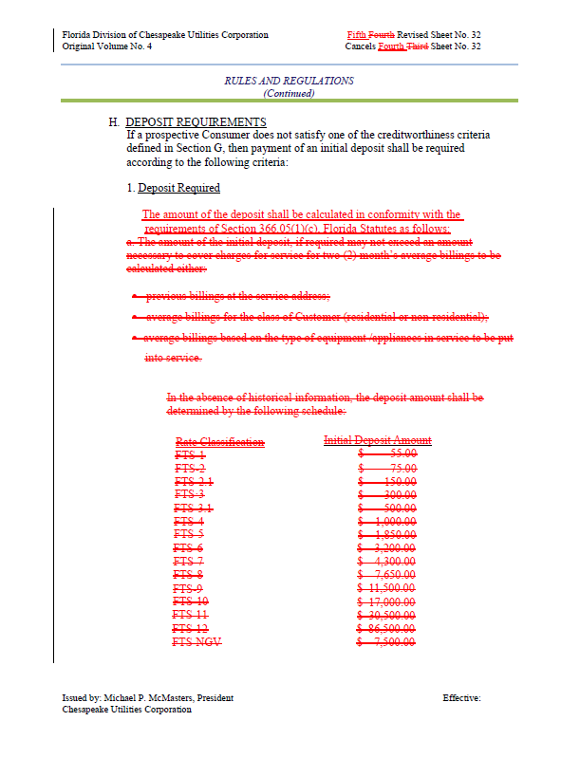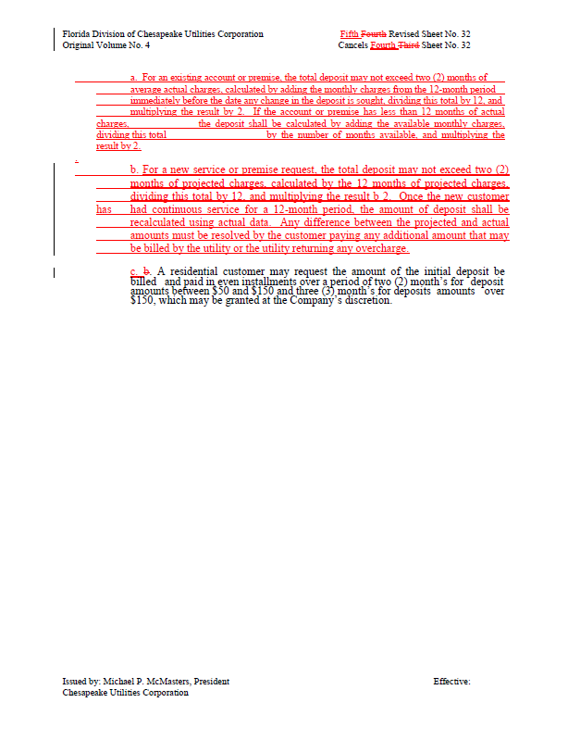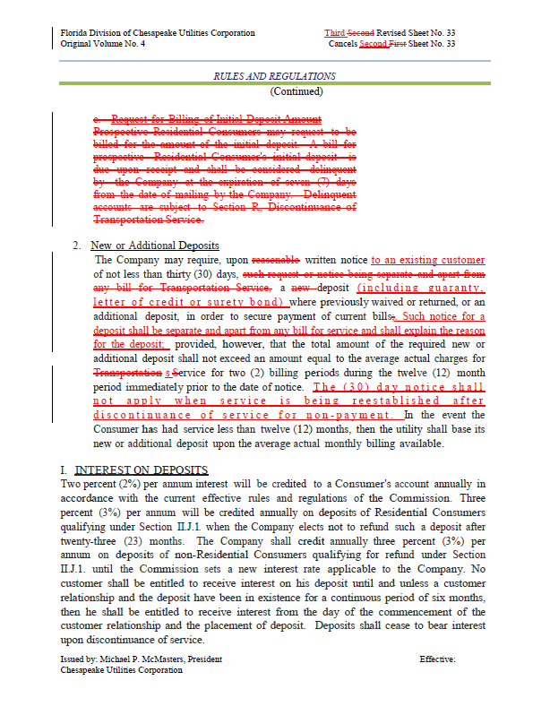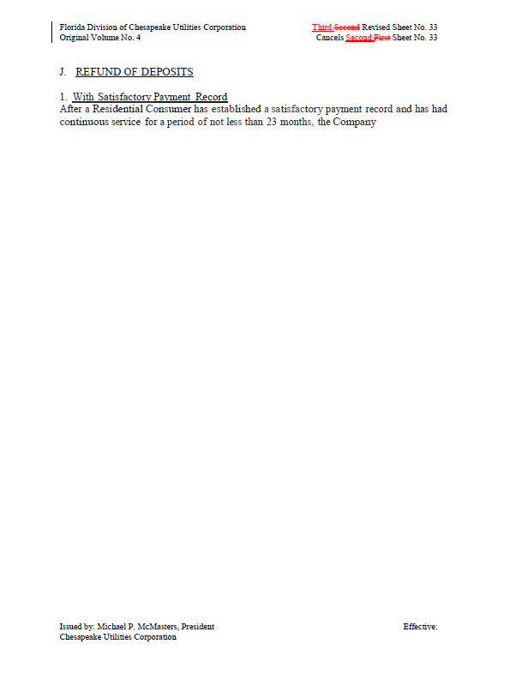

Order No. PSC-16-0024-FOF-PU, issued January 12, 2016, in Docket No. 150241-PU, In re: Proposed amendments to Rules 25-6.093, Information to Customers; 25-6.097, Customer Deposits; 25-6.100, Customer Billings; 25-7.079, Information to Customers; 25-7.083, Customer Deposits; and 25-7.085, Customer Billing, F.A.C.
Id.
Id.

