State of Florida |  | Public Service Commission  Capital Circle Office Center ● 2540 Shumard Oak Boulevard  Tallahassee, Florida 32399-0850  -M-E-M-O-R-A-N-D-U-M-
DATE: | August 24, 2017
TO: | Office of Commission Clerk (Stauffer)
FROM: | Division of Economics (Ollila)  Office of the General Counsel (Janjic)
RE: | Docket No. 20170074-EI – Petition for approval of 2017 revisions to underground residential distribution tariffs, by Gulf Power Company.
AGENDA: | 09/07/17 – Regular Agenda – Tariff Filing – Interested Persons May Participate
COMMISSIONERS ASSIGNED: |  |  | All Commissioners
PREHEARING OFFICER: |  |  | Administrative
CRITICAL DATES: |  |  | 11/30/17 (8-Month Effective Date)
SPECIAL INSTRUCTIONS: |  |  | None

Case Background
On March 31, 2017, Gulf Power Company (Gulf or Company) filed a petition for approval of 2017 revisions to its underground residential distribution (URD) tariffs. The URD tariffs apply to new residential subdivisions and represent the additional costs Gulf incurs to provide underground distribution service in place of overhead service. The proposed (legislative version) URD tariffs are contained in Attachment A to the recommendation. Gulf’s current charges were approved in Order No. PSC-15-0274-TRF-EI (2015 Order).
The Commission suspended Gulf’s proposed tariffs in Order No. PSC-17-0193-PCO-EI. Gulf responded to staff’s first data request on June 2, 2017, and to staff’s second data request on July 14, 2017. The Commission has jurisdiction over this matter pursuant to Sections 366.03, 366.04, 366.05, and 366.06, Florida Statutes (F.S.).

Discussion of Issues

Issue 1:
Should the Commission approve Gulf's proposed URD tariffs and associated charges?

Recommendation:
Yes, the Commission should approve Gulf’s proposed URD tariffs and associated charges, as shown in Attachment A, effective September 7, 2017. (Ollila)

Staff Analysis:
Rule 25-6.078, Florida Administrative Code (F.A.C.), defines investor-owned utilities’ (IOU) responsibilities for filing updated URD tariffs. Gulf filed the instant petition pursuant to subsection (3) of the rule, which requires IOUs to seek Commission approval of updated URD tariff charges if the utility’s per-lot cost differentials between overhead and underground service based on current material and labor costs, vary by more than 10 percent from the existing Commission-approved differentials. All IOUs are required to file supporting data and analyses for URD tariffs at least once every three years.
The URD tariffs provide standard charges for underground service in new residential subdivisions and represent the additional costs, if any, the utility incurs to provide underground service in place of standard overhead service. The cost of standard overhead construction is recovered through base rates from all ratepayers. In lieu of overhead construction, customers have the option of requesting underground facilities. Any additional cost is paid by the customer as contribution-in-aid-of construction (CIAC). Typically, the URD customer is the developer of a subdivision.
Gulf’s URD charges are based on two standard model subdivisions: a 210-lot low density subdivision and a 176-lot high density subdivision. While actual construction may differ from the model subdivisions, the model subdivisions are designed to reflect average overhead and underground subdivisions.
Table 1-1 shows the current and proposed URD differentials for the low and high density subdivisions. The charges shown are per-lot charges. Gulf’s URD tariffs also provide for reduced charges if the customer chooses to supply and/or install the primary and secondary trench and duct system.
Table 1-1
Comparison of URD Differential per Lot
 | Current Differential | Proposed Differential
Low Density | $402 | $498
High Density | $521 | $562
Source: 2015 Order and 2017 Petition
As shown in Table 1-1, the proposed URD differentials show an increase for both model subdivisions. The calculations of the proposed URD charges include updated labor and material costs, as well as updated operational costs.

Updated Labor and Material Costs
The installation costs of both overhead and underground facilities include the labor and material costs to provide primary, secondary, and service distribution lines, as well as transformers. The cost to provide overhead service also includes poles. The cost to provide underground service includes the cost of trenching and backfilling.
Gulf stated, in response to staff’s data request, that there have not been any design changes to either the low or high density subdivision since 2015. The mix of Gulf employee and contractor labor remains the same as it was in 2015. Gulf employees perform most overhead construction activities while contractor labor is used for underground construction. Both Gulf and contractor labor rates increase as specified in their respective contracts.
Total labor and material costs increased from 2015 to 2017 by a larger amount for underground construction than for overhead construction, resulting in an increase in the differential. The driver of the increase is material cost. Gulf explained in its response to staff’s data request that since 2015 the cost of underground material outpaced the cost of material used in overhead construction. As an example, Gulf stated that the cost of underground padmount transformers increased while the cost of overhead transformers remained stable.
Loading factors increased from 2015 to 2017. The Stores Handling loading factor increased from 4 percent in 2015 to 17 percent in this filing because of a higher volume of transmission material purchases. The Stores Handling factor includes supervision, labor, and expenses incurred for stores-related activities such as the operation of general storerooms. Gulf explained that the increase in the Engineering loading factor from 48 to 52 percent is due to increases in its engineering labor rate.
Table 1-2 below compares total 2015 and 2017 per-lot labor and material costs for the two subdivisions.
Table 1-2
Labor and Material Costs per Lot
 | 2015 Costs | 2017 Costs | Difference
Low Density
Underground Labor/Material Costs | $2,307 | $2,460 | $153
Overhead Labor/Material Costs | $1,715 | $1,740 | $25
Per lot Differential | $592 | $720 | $128
High Density
Underground Labor/Material Costs | $1,895 | $1,976 | $81
Overhead Labor/Material Costs | $1,331 | $1,352 | $21
Per lot Differential | $564 | $624 | $60
Source: 2015 Order and 2017 Petition

Updated Operational Costs
Rule 25-6.078(4), F.A.C., requires that the differences in net present value (NPV) of operational costs between overhead and underground systems, including average historical storm restoration costs over the life of the facilities, be included in the URD charge. The inclusion of the operational cost is intended to capture longer term costs and benefits of undergrounding.
Operational costs include operations and maintenance costs and capital costs and represent the cost differential between maintaining and operating an underground versus an overhead system over the life of the facilities. The inclusion of the storm restoration cost in the URD differential lowers the differential, since an underground distribution system generally incurs less damage than an overhead system as a result of a storm and, therefore, less restoration costs when compared to an overhead system. Gulf’s operational costs, last updated for the 2015 filing, represent a five-year average (2012 – 2016). The methodology used by Gulf in this filing for calculating the NPV of operational costs was approved in Order No. PSC-12-0531-TRF-EI.
Gulf’s NPV calculation used a 32-year life of the facilities and a 6.69 percent discount rate. Staff notes that operational costs may vary among IOUs as a result of differences in size of service territory, miles of coastline, regions subject to extreme winds, age of the distribution system, or construction standards.
Table 1-3 below compares the 2015 and 2017 NPV calculations of operational and storm restoration cost differentials between overhead and underground systems on a per lot basis. As Table 1-3 shows, there are small differences in the differentials from 2015 to 2017.
Table 1-3
NPV of Operational Costs Differential per Lot
 | 2015 Calculation | 2017 Calculation | Difference
Low Density
Underground NPV – Operational Costs | $436 | $416 | ($20)
Overhead NPV- Operational Costs | $626 | $638 | $12
Per lot Differential | ($190) | ($222) | ($32)
High Density
Underground NPV – Operational Costs | $274 | $261 | ($13)
Overhead NPV – Operational Costs | $317 | $323 | $6
Per lot Differential | ($43) | ($62) | ($19)
Source: 2015 Order and 2017 Petition

Other Proposed Tariff Changes
In addition to the proposed tariff changes discussed above, Gulf proposed modifications to the reduced URD charges paid by customers who either supply and install the primary and secondary trench and duct system (system) or who only install the system. In addition, Gulf proposed modifications to the charges that apply when a three-phase lift station for sewage is requested in a new residential subdivision. Finally, Gulf proposed modifications to binding cost estimates for URD conversions.

Conclusion
Staff has reviewed Gulf’s proposed URD tariffs and associated charges, its accompanying work papers, and responses to staff’s data requests. Staff believes the proposed URD tariffs and associated charges are reasonable. Staff recommends approval of Gulf’s proposed URD tariffs and associated charges, as shown in Attachment A, effective September 7, 2017.

Issue 2:
Should this docket be closed?

Recommendation:
If Issue 1 is approved and a protest is filed within 21 days of the issuance of the order, the tariffs should remain in effect, with any revenues held subject to refund, pending resolution of the protest. If no timely protest is filed, this docket should be closed upon the issuance of a consummating order. (Janjic)

Staff Analysis:
If Issue 1 is approved and a protest is filed within 21 days of the issuance of the order, the tariffs should remain in effect, with any revenues held subject to refund, pending resolution of the protest. If no timely protest is filed, this docket should be closed upon the issuance of a consummating order.

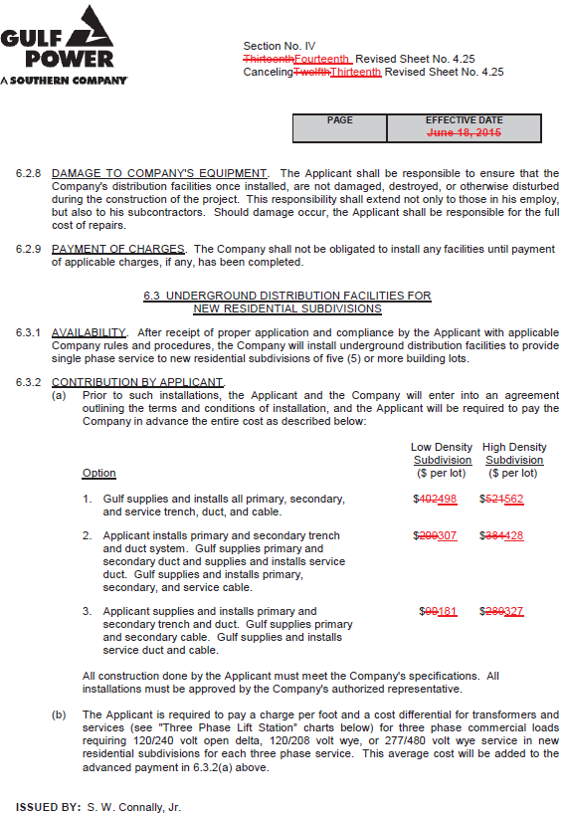
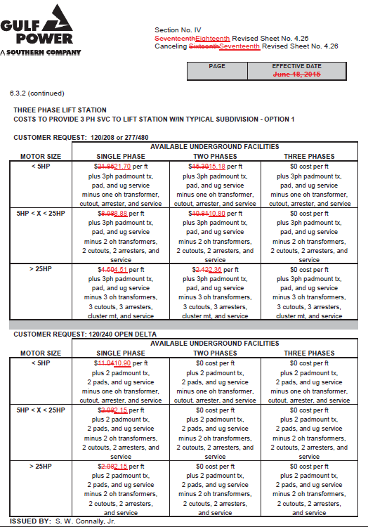
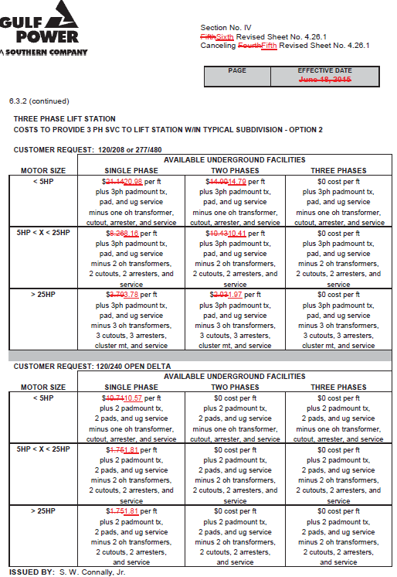
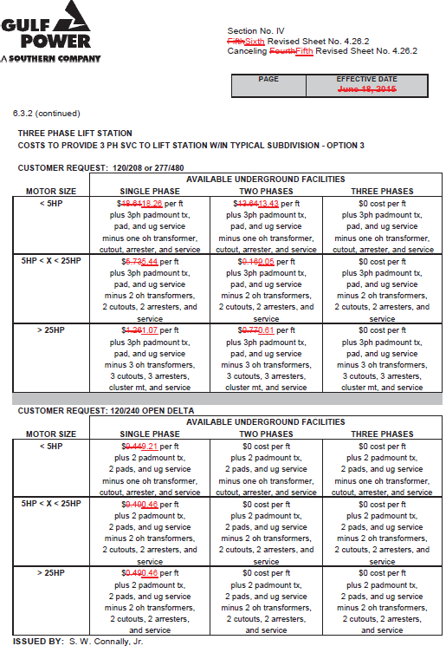
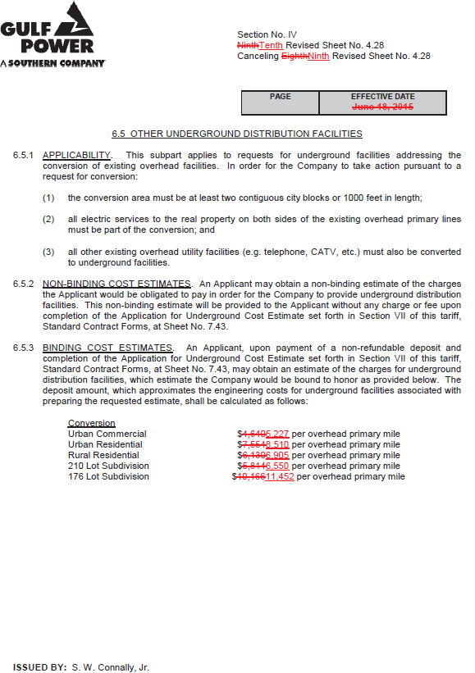

Order No. PSC-15-0274-TRF-EI, issued July 6, 2015, in Docket No. 150112-EI, In re: Request by Gulf Power Company to modify its underground residential differential tariffs.
Order No. PSC-17-0193-PCO-EI, issued May 19, 2017, in Docket No. 170074-EI, In re: Petition for approval of 2017 revisions to underground residential distribution tariffs, by Gulf Power Company.
$498 is calculated as follows: $720 (Table 1-2) - $222 (Table 1-3) = $498.
Order No. PSC-12-0531-TRF-EI, issued October 4, 2012, in Docket No. 120075-EI, In re: Request by Gulf Power Company to modify its underground residential differential tariffs.

