BEFORE THE FLORIDA PUBLIC SERVICE COMMISSION

Notice of RULE DEVELOPMENT

TO

ALL INTERESTED PERSONS

UNDOCKETED

IN RE: INITIATION OF RULEMAKING TO AMEND RULE 25-4.0665, FLORIDA ADMINISTRATIVE CODE, LIFELINE SERVICE, AND TO REPEAL RULE 25-4.113, FLORIDA ADMINISTRATIVE CODE, REFUSAL OR DISCONTINUANCE OF SERVICE BY COMPANY

ISSUED: August 29, 2017

NOTICE is hereby given that the Commission staff has made certain changes to the preliminary draft rule language to amend Rule 25-4.0665, F.A.C., Lifeline Service, that was attached to the Notice of Staff Rule Development Workshop dated July 25, 2017. Those draft rule changes include: 1) clarifying in newly numbered paragraph (7) that an eligible telecommunications carrier must provide written notice within 20 calendar days of rejecting a Lifeline application; 2) clarifying in newly numbered paragraph (8) that an eligible telecommunications carrier or its designee must provide written notice prior to the termination of Lifeline service; and 3) rewording newly numbered paragraph (10) to clarify eligible telecommunications carrier responsibilities regarding advertising the availability and charges of Lifeline service. Consistent with the 2011 changes made to Ch. 364, F.S., Rule 25-4.113 would be repealed.

If requested in writing and not deemed unnecessary by the agency head, a rule development workshop will be scheduled and noticed in the next available Florida Administrative Register. Any further written comments or suggestions regarding the draft rule language or requests for a rule development workshop must be submitted to Rosanne Gervasi, Office of the General Counsel, 2540 Shumard Oak Blvd., Tallahassee, FL 32399-0850 at (850) 413-6224 by September 12, 2017. Copies of the preliminary draft rules are attached, including the updated draft changes to the Lifeline rule.

By DIRECTION of the Florida Public Service Commission this 29th day of August, 2017.

/s/ Carlotta S. Stauffer
CARLOTTA S. STAUFFER
Commission Clerk
Florida Public Service Commission
2540 Shumard Oak Boulevard
Tallahassee, Florida 32399
(850) 413-6770
www.floridapsc.com

Copies furnished: A copy of this document is provided to the parties of record at the time of issuance and, if applicable, interested persons.

RG

25-4.0665 Lifeline Assistance Service.
(1) Eligible Telecommunications Companies must offer Lifeline Assistance as prescribed by the Federal Communications Commission in Title 47, Code of Federal Regulations, Part 54, Subpart E, Universal Service Support for Low-Income Consumers, Sections 54.400 through 54.417, as amended October 1, 2016, which are hereby incorporated into this rule by reference, and which is available at [hyperlink]. A subscriber is eligible for Lifeline service if:
(a) The subscriber is a participant in one of the following federal assistance programs:
1. Medicaid;
2. Food Stamps;
3. Supplemental Security Income (SSI);
4. Temporary Assistance for Needy Families/Temporary Cash Assistance;
5. “Section 8” Federal Public Housing Assistance;
6. Low-Income Home Energy Assistance Program; or
7. The National School Lunch Program – Free Lunch; or
(b) The subscriber’s eligible telecommunications carrier has more than one million access lines and the subscriber’s household income is at or below 150 percent of the federal poverty income guidelines.
(2) A subscriber living on federally recognized Tribal lands who does not satisfy the eligibility requirements for Lifeline service in subsection (1) of this rule is nevertheless eligible for Lifeline service if the subscriber receives benefits from one of the following Bureau of Indian Affairs programs:
(a) Tribal temporary assistance for needy families (TANF);
(b) NSL Program – Free Lunch; or
(c) Head Start.
(3) Eligible telecommunications carriers with less than one million access lines are not required to enroll Lifeline applicants through the income eligibility test of 150 percent or less of the federal poverty income guidelines, but may do so voluntarily.
(4) Eligible telecommunications carriers that charge an initial connection charge must offer Link-Up service to subscribers who are eligible for Lifeline service pursuant to this rule.
(2)(5) When enrolling customers in the Lifeline service program under paragraph (1)(a) of this rule, eligible Eligible telecommunications carriers shall accept Form PSC/TEL 157 (xx/xx 6/10), entitled “Application for Link-Up Florida and Lifeline Assistance,” which is incorporated into this rule by reference and which is available at [hyperlink] or can be accessed from the Commission’s website at http://www.floridapsc.com/ConsumerAssistance/LifelineAssistance under “Lifeline Application Form.” www.floridapsc.com, by selecting “Link-Up Florida and Lifeline Assistance,” then selecting “Need Discounted Phone Service?,” and then selecting “English Link-Up and Lifeline Certification Form” (also available in Spanish and Creole).
(3)(6) Eligible telecommunications carriers shall enroll customers for Lifeline service who electronically submit Form PSC/TEL 158 (xx/xx 6/10), entitled “Lifeline and Link-Up Florida On-line Self Certification Form,” which is incorporated into this rule by reference and which is available at [hyperlink] or can be accessed from the Commission’s website at https://secure.floridapsc.com/Lifeline/Application. www.floridapsc.com, by selecting “Link-Up Florida and Lifeline,” then selecting “Apply On-line.”
(7) For Lifeline applicants who do not use On-line enrollment or simplified certification enrollment, the eligible telecommunications carrier must accept Public Assistance eligibility determination letters, including those provided for food stamps, Medicaid, and public housing lease agreements, as proof of eligibility for Link-Up and Lifeline enrollment.
(4)(8) Eligible telecommunications carriers must allow customers the option to submit Link-Up or Lifeline applications via U.S. Mail or facsimile, and may allow applications to be submitted electronically. Eligible telecommunications carriers must also allow customers the option to submit copies of supporting documents via U.S. Mail or facsimile.
(9) Eligible telecommunications carriers shall only require a customer to provide the last four digits of the customer’s social security number for application for Lifeline and Link-Up service and to verify continued eligibility for the programs as part of the annual verification process.
(5)(10) All eligible telecommunications carriers shall participate in the Lifeline service Simplified Automatic Enrollment Process. For purposes of this rule, the Lifeline service Simplified Automatic Enrollment Process is an electronic interface between the Department of Children and Family Services, the Commission, and the eligible telecommunications carrier that allows low-income individuals to automatically enroll in Lifeline following enrollment in a qualifying public assistance program.
(a) The Commission shall send an e-mail to the eligible telecommunications carrier informing the eligible telecommunications carrier that Lifeline service applications are available for retrieval for processing.
(b) The eligible telecommunications carrier shall enroll the subscriber in the Lifeline service program as soon as practicable, but no later than 60 days from the receipt of the e-mail notification. Upon completion of initial enrollment, the eligible telecommunications carrier shall credit the subscriber’s bill for Lifeline service as of the date the eligible telecommunications carrier received the e-mail notification from the Commission.
(b)(c) The eligible telecommunications carrier shall maintain at least one a current e-mail address with the Commission, which the Commission will use to inform the eligible telecommunications carrier of the Commission’s Lifeline secure website address and that new Lifeline service applications are available for retrieval for processing.
(c)(d) The eligible telecommunications carrier shall maintain with the Commission the names, e-mail addresses and telephone numbers of at least one primary and one secondary company representative who will manage the user accounts on the Commission’s Lifeline secure website.
(d)(e) Within 20 calendar days of receiving the Commission’s e-mail notification that the Lifeline service application is available for retrieval, the eligible telecommunications carrier shall provide a facsimile response to the Commission via the Commission’s dedicated Lifeline service facsimile telephone line at (850) 717-0108 413-7142, or an electronic response via the Commission’s Lifeline secure website, identifying the customer name, address, telephone number, and date of the application for:
1. Misdirected Lifeline service applications; or
2. Applications for customers currently receiving Lifeline service.; and
3. Rejected applicants, which shall include the reason(s) why the applicants were rejected.
In lieu of a facsimile or electronic submission, the eligible telecommunications carrier may file the information with the Office of Commission Clerk.
(e)(f) Pursuant to Section 364.107(1), F.S., information filed by the eligible telecommunications carrier in accordance with paragraph (5)(d) (9)(e) of this rule is confidential and exempt from Section 119.07(1), F.S. However, the eligible telecommunications carrier may disclose such information consistent with the criteria in Section 364.107(3)(a), F.S. For purposes of this rule, the information filed by the eligible telecommunications carrier will be presumed necessary for disclosure to the Commission pursuant to the criteria in Section 364.107(3)(a)4., F.S.
(6)(11) An eligible telecommunications carrier shall not impose additional verification requirements on subscribers beyond those which are required by this rule.
(12) If the Office of Public Counsel certifies a subscriber eligible to receive Lifeline service under the income test set forth in Section 364.10(3)(a), F.S., an eligible telecommunications carrier shall not impose any additional verification requirements on the subscriber.
(7)(13) Within 20 calendar days of rejecting a Lifeline application, an An eligible telecommunications carrier must provide written notice to the a customer within 30 days of receipt of the application providing the reason for rejecting the a rejected Lifeline application, and providing contact information for the customer to get information regarding the application denial. Rejected applications received via the Simplified Enrollment Process under paragraph (5) must also be reported to the Commission by the same methods as in paragraph 5(d) of this rule, with the reason why the application was rejected.
(8)(14) An eligible telecommunications carrier or its designee must provide 60 days written notice prior to the termination of Lifeline service pursuant to Title 47, Code of Federal Regulations, Part 54, Subpart E, Section 54.405 Carrier obligation to offer Lifeline, as amended October 1, 2016. The notice of impending pending termination shall contain the telephone number at which the subscriber can obtain information about the subscriber’s Lifeline service from the eligible telecommunications carrier. The notice shall also inform the subscriber of the availability, pursuant to Section 364.105, F.S., of discounted residential basic local telecommunications service.
(15) If a subscriber’s Lifeline service is terminated and the subscriber subsequently presents proof of Lifeline eligibility, the eligible telecommunications carrier shall reinstate the subscriber’s Lifeline service as soon as practicable, but no later than 60 days following receipt of proof of eligibility. Irrespective of the date on which the eligible telecommunications carrier reinstates the subscriber’s Lifeline service, the subscriber’s bill shall be credited for Lifeline service as of the date the eligible telecommunications carrier received the proof of continued Lifeline eligibility.
(9)(16) All eligible telecommunications carriers shall provide current Lifeline service company information to the Universal Service Administrative Company at www.lifelinesupport.org so that the information can be posted on the Universal Service Administrative Company’s consumer website.
(10)(17) Eligible telecommunications carriers must advertise the availability of Lifeline service. Pursuant to Title 47, Code of Federal Regulations, Part 54, Subpart E, Section 54.405(b), all eligible telecommunications carriers are obligated to publicize the availability of Lifeline service in a manner reasonably designed to reach those likely to qualify for the service. Only posting the availability of Lifeline service on an eligible telecommunications carrier’s website is insufficient to meet this requirement. Advertising the availability of Lifeline service can be achieved by using any of the following media: flyers, local newspaper ads, local TV ads, mail, e-mail, web advertisements, bill inserts and other text-based methods of advertisement or a combination of such media. Pursuant to Title 47 of the United States Code, Section 214(e)(1)(B), charges must also be included in the Lifeline advertisement. The company may redirect consumers to a 1-800 customer service number and website to see applicable charges and fees in lieu of listing all charges in an advertisement. to those who may be eligible for the service. At a minimum, if the eligible telecommunications carrier publishes a directory, the eligible telecommunications carrier must include in the index of the directory a notice of the availability of Lifeline service. If the eligible telecommunications carrier generates customer bills, the eligible telecommunications carrier must also place an insert in the subscriber’s bill or a message on the subscriber’s bill at least once each calendar year advising subscribers of the availability of Lifeline service.
(11)(18) Eligible telecommunications carriers must file all reports with the Commission in accordance with Title 47, Code of Federal Regulations, Part 54, Subpart E, Section 54.422(c), Annual reporting for eligible telecommunications carriers that receive low-income support, as amended October 1, 2016. may not charge a service deposit in order to initiate Lifeline service if the subscriber voluntarily elects toll blocking or toll control. If the subscriber elects not to place toll blocking or toll control on the line, an eligible telecommunications carrier may charge a service deposit.
(19) Eligible telecommunications carriers may not charge Lifeline subscribers a monthly number-portability charge.
(20) Eligible telecommunications carriers offering Link-Up and Lifeline service must submit quarterly reports to the Commission no later than 30 days following the ending of each quarter as follows: First Quarter (January 1 through March 31); Second Quarter (April 1 through June 30); Third Quarter (July 1 through September 30); Fourth Quarter (October 1 through December 31). The quarterly reports shall include the following data:
(a) The number of Lifeline subscribers, excluding resold Lifeline subscribers, for each month during the quarter;
(b) The number of subscribers who received Link-Up for each month during the quarter;
(c) The number of new Lifeline subscribers added each month during the quarter;
(d) The number of transitional Lifeline subscribers who received discounted service for each month during the quarter; and
(e) The number of residential access lines with Lifeline service that were resold to other carriers each month during the quarter.
Rulemaking Authority 120.80(13)(d), 350.127(2), 364.10(3)(j) FS. Law Implemented 364.10, 364.105, 364.183(1) FS. History–New 1-2-07, Amended 12-6-07, 6-23-10.________.

25-4.113 Refusal or Discontinuance of Service by Company.
(1) As applicable, the company may refuse or discontinue telephone service under the following conditions provided that, unless otherwise stated, the customer shall be given notice and allowed a reasonable time to comply with any rule or remedy any deficiency:
(a) For non-compliance with or violation of any state or municipal law, ordinance, or regulation pertaining to telephone service.
(b) For the use of telephone service for any other property or purpose than that described in the application.
(c) For failure or refusal to provide the company with a deposit to insure payment of bills in accordance with the company’s regulations.
(d) For neglect or refusal to provide reasonable access to the company for the purpose of inspection and maintenance of equipment owned by the company.
(e) For noncompliance with or violation of the Commission’s regulations or the company’s rules and regulations on file with the Commission, provided 5 working days’ written notice is given before termination.
(f) For nonpayment of bills for telephone service, including the telecommunications access system surcharge referred to in subsection 25-4.160(3), F.A.C., provided that suspension or termination of service shall not be made without 5 working days’ written notice to the customer, except in extreme cases. The written notice shall be separate and apart from the regular monthly bill for service. A company shall not, however, refuse or discontinue service for nonpayment of a dishonored check service charge imposed by the company, nor discontinue a customer’s Lifeline local service if the charges, taxes, and fees applicable to dial tone, local usage, dual tone multifrequency dialing, emergency services such as “911,” and relay service are paid. No company shall discontinue service to any customer for the initial nonpayment of the current bill on a day the company’s business office is closed or on a day preceding a day the business office is closed.
(g) For purposes of paragraphs (e) and (f), “working day” means any day on which the company’s business office is open and the U.S. Mail is delivered.
(h) Without notice in the event of customer use of equipment in such manner as to adversely affect the company’s equipment or the company’s service to others.
(i) Without notice in the event of hazardous conditions or tampering with the equipment furnished and owned by the company.
(j) Without notice in the event of unauthorized or fraudulent use of service. Whenever service is discontinued for fraudulent use of service, the company may, before restoring service, require the customer to make, at his own expense, all changes in facilities or equipment necessary to eliminate illegal use and to pay an amount reasonably estimated as the loss in revenues resulting from such fraudulent use.
(2) In case of refusal to establish service, or whenever service is discontinued, the company shall notify the applicant or customer in writing of the reason for such refusal or discontinuance.
(3) Service shall be initiated or restored when the cause for refusal or discontinuance has been satisfactorily adjusted.
(4) The following shall not constitute sufficient cause for refusal or discontinuance of service to an applicant or customer:
(a) Delinquency in payment for service by a previous occupant of the premises, unless the current applicant or customer occupied the premises at the time the delinquency occurred and the previous customer continues to occupy the premises and such previous customer shall benefit from such new service.
(b) Delinquency in payment for service by a present occupant who was delinquent at another address and subsequently joined the household of the customer in good standing.
(c) Delinquency in payment for separate telephone service of another customer in the same residence.
(d) Failure to pay for business service at a different location and a different telephone number shall not constitute sufficient cause for refusal of residence service or vice versa.
(e) Failure to pay for a service rendered by the company which is not regulated by the Commission.
(f) Failure to pay the bill of another customer as guarantor thereof.
(g) Failure to pay a dishonored check service charge imposed by the company.
(5) When service has been discontinued for proper cause, the company may charge a reasonable fee to defray the cost of restoring service, provided such charge is set out in its approved tariff on file with the Commission.
Rulemaking Authority 350.127, 427.704(8) FS. Law Implemented 427.704 FS. History–New 12-1-68, Amended 3-31-76, 10-25-84, 10-30-86, 1-1-91, 9-16-92, 1-7-93, 1-25-95, 7-5-00, Repealed________.

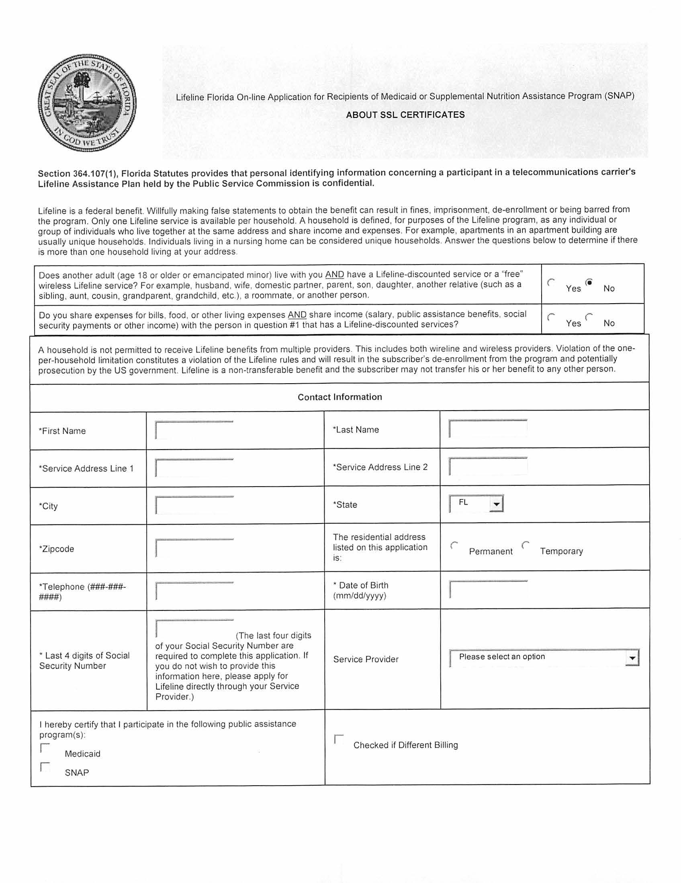

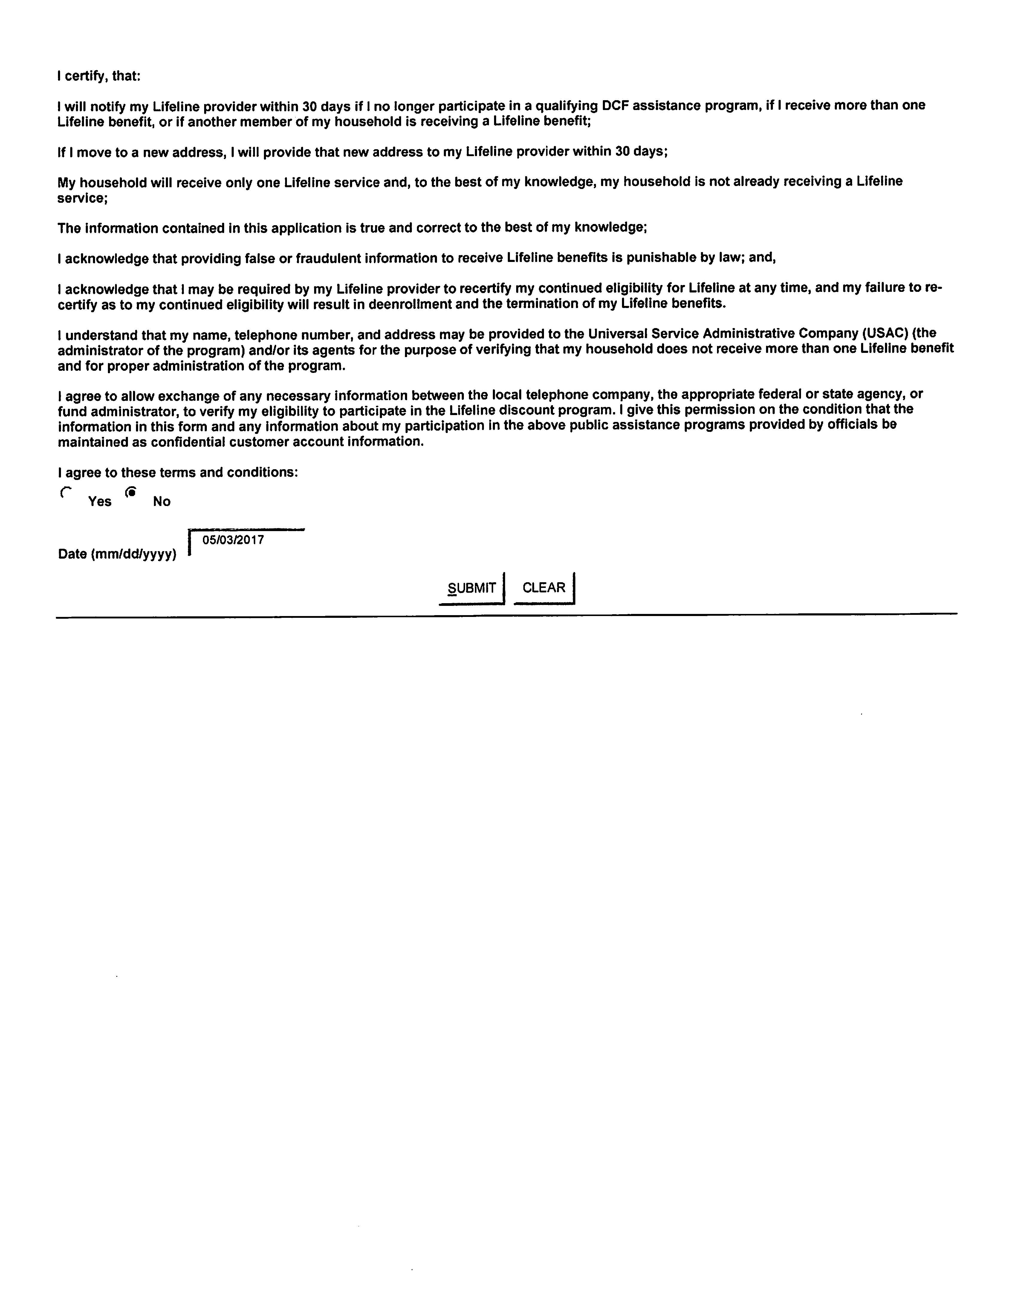
Application for
Lifeline Assistance

Billing Name___________________________________________________________________________

Service Address_________________________________________________________________________

City ___________________________________ State ______________________ Zip Code ___________

Is your service address temporary? Check One: ________ YES ________ NO

Last Four Digits of Social Security Number____________ Date of Birth___________________________

Billing Address (if different from Service Address)_____________________________________________

City ___________________________________ State ______________________ Zip Code ___________

Telephone Number ( )__________________________ (NOTE: If you do not currently have local phone service, please contact a local phone provider in your area to establish service.)

Lifeline is a federal benefit. Willfully making false statements to obtain the benefit can result in fines, imprisonment, de-enrollment or being barred from the program.

Only one Lifeline benefit is available per household. A household is not permitted to receive Lifeline benefits from multiple providers. This includes wireline and wireless providers.

Violation of the one-per-household limitation constitutes a violation of the Lifeline rules and will result in the subscriber’s de-enrollment from the program.

Lifeline is a non-transferable benefit and the subscriber may not transfer his or her benefit to any other person.

I hereby certify that I participate in the following public assistance program(s): (Check all that apply)

Supplemental Nutrition Assistance Program (SNAP)/Food Stamps

Medicaid

Supplemental Security Income (SSI)

Federal Public Housing Assistance (Section 8)

Veteran’s Pension and Survivor’s Pension Program

Bureau of Indian Affairs Programs (Tribal Temporary Assistance for Needy Families,
Head Start Subsidy, NSLP) – Tribal Land Residents only

(OVER)

1-800-540-7039.

A household is defined, for purposes of the Lifeline program, as any individual or group of individuals who live together at the same address and share income and expenses. For example, apartments in an apartment building are usually unique households. Individuals living in a nursing home can be considered unique households. Answer the questions below to determine if there is more than one household living at your address.

- Does another adult (age 18 or older or emancipated minor) live with you AND have a Lifeline-discounted service or a “free” wireless Lifeline service? For example, husband, wife, domestic partner, parent, son, daughter, another relative (such as a sibling, aunt, cousin, grandparent, grandchild, etc.), a roommate, or another person.
____ No. You are ELIGIBLE for Lifeline because no one in your household has Lifeline. Please certify and sign below. | ____ Yes. Please answer question 2 below.

- Do you share expenses for bills, food, or other living expenses AND share income (salary, public assistance benefits, social security payments or other income) with the person in question #1 that has a Lifeline-discounted services?
____ No. You are ELIGIBLE for Lifeline because no one in your household has Lifeline. Please certify and sign below. | ____ Yes. STOP. Do not sign the form. You are NOT ELIGIBLE because someone in your household already has Lifeline.

Please initial each line to certify, that:

______ I will notify my Lifeline provider within 30 days if I no longer participate in a qualifying DCF assistance program, if I receive more than one Lifeline benefit, or if another member of my household is receiving a Lifeline benefit;

______ If I move to a new address, I will provide that new address to my Lifeline provider within 30 days;

______ My household will receive only one Lifeline benefit and, to the best of my knowledge, my household is not already receiving a Lifeline benefit;

______ The information contained in this application is true and correct to the best of my knowledge;

______ I acknowledge that providing false or fraudulent information to receive Lifeline benefits is punishable by law; and,

______ I acknowledge that I may be required by my Lifeline provider to recertify my continued eligibility for Lifeline at any time, and my failure to re-certify as to my continued eligibility will result in deenrollment and the termination of my Lifeline benefits.

______ I understand that my name, telephone number, and address may be provided to the Universal Service Administrative Company (USAC) (the administrator of the program) and/or its agents for the purpose of verifying that my household does not receive more than one Lifeline benefit.

______ I agree to allow exchange of any necessary information between the local telephone company, the appropriate federal or state agency, or fund administrator, to verify my eligibility to participate in the Lifeline discount program. I give this permission on the condition that the information in this form and any information about my participation in the above public assistance programs provided by officials be maintained as confidential customer account information.

______________________________________________________________________ _____________________________
Customer’s signature Date

Please mail or fax this application to the telephone company that provides your service along with acceptable copies of documentation of program participation. Acceptable documentation of program eligibility would include: (1) the current or prior year’s statement of benefits from a qualifying state, federal or Tribal program; (2) a notice letter of participation in a qualifying state, federal or Tribal program; (3) program participation documents (e.g., the consumer’s Supplemental Nutrition Assistance Program (SNAP) electronic benefit transfer card or Medicaid participation card (or copy thereof); or (4) another official document evidencing the consumer’s participation in a qualifying state, federal or Tribal program.

Access Wireless  One Levee Way, Ste. 3104  Newport, KY 41071  Fax: 888-594-4473  Phone: 513-550-2755 | AT&T  Florida Lifeline  PO Box 4600  Waterloo, IA 50704  Fax: (800)295-7495  Phone: (855)301-0355 | CenturyLink  CenturyLink Data Services  555 Lake Border Drive  Apopka, FL 32703  Fax: (866)810-7530  Phone: (855)954-6546 | Cox Communications  Attn: Lifeline Services  PO Box 620  Charleston, IL 61920-9905  Fax: (855)981-5433
FairPoint Communications  Offline Services Group  30 East Main Street  Westfield, NY 14787  Fax: (877) 321-3166  Phone: (800) 400-5568 | Frontier Lifeline  1398 South Woodland Blvd.  Suite A  Deland, FL 32720  Fax: (844)452-6399 | Global Connection Inc. of America  P.O. Box 48269  Atlanta, GA 30362  Fax: 1-888-878-9323  (877)511-3009  www.realhomephone.com | ITS Telecommunications  Attn: Customer Service  P. O. Box 277  Indiantown, FL 34956  Fax: (772) 597-4155  Phone: (772) 597-2111
(Bay County Address)  WOW! Internet, Cable & Phone  235 W. 15th Street  Panama City, FL 32401  Fax: (850) 215-5800  Phone: (850) 215-2161 | (Pinellas County Address)  WOW! Internet, Cable & Phone  3001 Gandy Boulevard North  Pinellas Park, FL 33782  Fax: (727) 576-4800  Phone: (727) 239-0234 | NEFCOM  P. O. Box 485  Macclenny, FL 32063  Fax: (904) 259-1200  Phone: (904) 259-2261 or  (877)838-5695 | Phone Club Corporation  Ms. Priscila Wolff, President  P.O. Box 908  Flagler Beach, FL 32136-0908  Phone: (786)777-0079  www.phoneclub.us
SafeLink Wireless/TracFone  Lifeline/Free Cell Phone Dept.  P. O. Box 220009  Milwaukie, OR 97269-0009  Fax: (800) 834-7713  Phone: (800) 977-3768 | Smart City Telecom  Attn: Customer Care  P. O. Box 22555  Lake Buena Vista, FL 32830  Fax: (407) 828-6701  Phone: (407) 828-6700 | TDS Telecom - Lifeline  P. O. Box 608  Lancaster, WI 53813  Fax: (877) 271-2861  Phone: (888) 225-5837 | Tele Circuit Network  Tele Circuit Network Corp.  1815 Satellite Blvd Suite 504  Duluth, GA 30097  Fax: (877) 835-3788  Phone: (877) 835-3247
T-Mobile  Lifeline Support  PO Box 37380  Albuquerque, NM 87176-7380  Fax: (813) 348-5724  Phone: (800) 937-8997 | Virgin Mobile d/b/a Assurance Wireless  P.O. Box 686  Parsippany, NJ 07054  Fax: (877) 732-3018  Phone: (888) 898-4888 | Windstream Florida  1720 Galleria Blvd.  Charlotte, NC 28270  Fax: (704) 849-7000  Phone: (800)347-1991
1-800-540-7039.
PSC/TEL 157 (REV 4/17)

