State of Florida |  | Public Service Commission  Capital Circle Office Center ● 2540 Shumard Oak Boulevard  Tallahassee, Florida 32399-0850  -M-E-M-O-R-A-N-D-U-M-
DATE: | September 21, 2017
TO: | Office of Commission Clerk (Stauffer)
FROM: | Office of the General Counsel (Cowdery)  Division of Economics (Ollila)
RE: | Docket No. 20170163-OT – Proposed repeal of Rules 25-22.017, F.A.C., Rulemaking Proceeding – Adoption, and 25-22.039, F.A.C., Intervention, and proposed amendment of Rules 25-22.060, F.A.C., Motion for Reconsideration of Final Orders, and 25-40.001, F.A.C., Exceptions to the Uniform Rules of Procedure.
AGENDA: | 10/03/17 – Regular Agenda – Interested Persons May Participate
COMMISSIONERS ASSIGNED: |  |  | All Commissioners
PREHEARING OFFICER: |  |  | Polmann
CRITICAL DATES: |  |  | None
SPECIAL INSTRUCTIONS: |  |  | None

Case Background
This rulemaking addresses certain rules in Chapter 25-22, Florida Administrative Code (F.A.C), governing practice and procedure. In 1998, the Administration Commission pursuant to Section 120.54(5), Florida Statutes (F.S.), enacted Uniform Rules of Procedure (Uniform Rules). The Uniform Rules are the rules of procedure for each agency subject to Chapter 120, F.S., including the Commission, unless the Administration Commission grants an exception to the agency. Because of the adoption of the Uniform Rules, many of the Commission’s procedural rules contained in Chapter 25-22, F.A.C., were rendered unnecessary and were repealed in 1998.
Pursuant to Section 120.54, F.S., the Commission in 1998 filed a Petition for Exceptions to the Uniform Rules of Procedure for some of its rules (1998 Petition for Exceptions). In its 1998 Petition for Exceptions, the Commission raised concerns that customer participation in hearings might be limited by requiring intervention petitions to be filed at least 20 days prior to a final hearing, as required by Uniform Rule on Intervention, because customers might not have sufficient notice of the final hearing date. The Commission recognized that the Uniform Rule on Intervention allows for intervention after expiration of the 20-day time period “for good cause shown,” but was concerned that many lay persons might not intervene because they would not understand the meaning of that language. The Commission’s 1998 Petition for Exceptions noted that the “take the case as they find it” language of the Commission’s intervention rule eliminates any confusion over the impact an intervenor can have on an ongoing proceeding. The Administration Commission granted the Commission an exception to the Uniform Rule on Intervention. The Commission appears to be the only agency using an exception to the Uniform Rule on Intervention.

The Administration Commission granted an exception to Uniform Rule Chapter 28-103, F.A.C., Rulemaking, for Commission Rule 25-22.017, F.A.C., Rulemaking Proceeding – Adoption, on the basis that the Commission’s rule was required for the most efficient operation of the Commission. However, because Uniform Rule Chapter 28-103, F.A.C., was repealed on December 4, 2012, Rule 25-22.017, F.A.C., is no longer an exception to the Uniform Rules. The Administration Commission also granted an exception to Uniform Rule Chapter 28-106, Decisions Determining Substantial Interests, for the Commission’s Motion for Reconsideration rule, Rule 25-22.060, F.A.C.

Section 120.54(5)(a)3., F.S., requires each agency to maintain a chapter listing its rules that are exceptions to the Uniform Rules of Procedure. Rule 25-40.001, F.A.C., identifies in table format the Commission rules that are exceptions to the Uniform Rules.

This recommendation addresses whether the Commission should propose the repeal of Rules 25-22.017 and 25-22.039, F.A.C., and the amendment of Rules 25-22.060 and 25-40.001, F.A.C. Notices of rule development appeared in the June 28, 2017, edition of the Florida Administrative Register. No rule development workshop was requested, and thus a workshop was not held. Comments on the proposed repeal of Rule 25-22.039, F.A.C., were provided by Florida Power & Light (FPL), Duke Energy Florida, LLC (DEF), Tampa Electric Company (TECO), and Gulf Power Company (Gulf). The Commission has jurisdiction pursuant to Sections 120.54, 120.569, 120.57, and 350.127(2), F.S.

Discussion of Issues

Issue 1:
Should the Commission propose the repeal of Rules 25-22.017, Rulemaking Proceeding – Adoptions, and 25-22.039, F.A.C., Intervention, and the amendment of Rules 25-22.060, Motion for Reconsideration of Final Orders, and 25-40.001, F.A.C., Exceptions to the Uniform Rules of Procedure?

Recommendation:
Yes, the Commission should propose the repeal of Rules 25-22.017 and 25-22.039, F.A.C., and the amendment of Rules 25-22.060 and 25-40.001, F.A.C., as set forth in Attachment A. Staff recommends that the Commission certify proposed amended Rules 25-22.060 and 25-40.001, F.A.C., as minor violation rules. Staff also recommends that the Notice of Rulemaking issued by the Commission should state that in repealing Rule 25-22.039, F.A.C., Intervention, and thus becoming subject to Uniform Rule 28-106.205, F.A.C., Intervention, it is the Commission’s intent to continue to require intervenors to take the case as they find it. (Cowdery, Ollila)

Staff Analysis:
Staff is recommending the repeal of Rules 25-22.017 and 25-22.039, F.A.C., and the amendment of Rules 25-22.060 and 25-40.001, F.A.C., as set forth in Attachment A. Below is staff’s analysis for the recommended rule repeals and amendments.

Repeal of Rule 25-22.017, F.A.C., Rulemaking Proceeding – Adoption
Section (1) of Rule 25-22.017, F.A.C., states that the Commission, at a public meeting, shall consider the record, the proposed rule, timely exceptions to the presiding officer’s final recommended version, if permitted, and the recommendation of the presiding officer, and may question staff and other persons as part of its deliberations prior to adopting, rejecting or modifying the proposed rule. The Commission follows the detailed adoption procedures set forth in Section 120.54(3), F.S. Section 120.54(3)(c), F.S., addresses the procedures to be followed in the event a hearing is requested on a proposed rule. Rulemaking proceedings are governed solely by the provisions of Section 120.54(3)(c), F.S., unless a separate proceeding is convened under Sections 120.569 and 120.57, F.S. Staff believes that Rule 25-22.017, F.A.C., is unnecessary to implementation of Section 120.54(3), F.S.

Section (2) of Rule 25-22.017, F.A.C., explains that oral argument and petitions for reconsideration are not appropriate to the rulemaking process, but that any interested person may file a petition for initiation of rulemaking proceedings pursuant to Rule 28-103.006, F.A.C., Rulemaking, to amend or otherwise modify an adopted rule or amendment. A statement that oral argument is not appropriate in rulemaking is unnecessary because paragraph (7)(a) of the Commission’s Oral Argument Rule states that oral argument at an Agenda Conference is limited to recommended orders and dispositive motions, which would not include rulemaking orders. In addition, as discussed in detail below, the language in Section (2) concerning reconsideration in rulemaking should be moved to the Commission’s motion for reconsideration rule, Rule 25-22.060, F.A.C., so that it is consolidated with other rule provisions relating to motions for reconsideration.

Finally, the statement in Section (2) that a petition to initiate rulemaking is filed pursuant to Uniform Rule 28-103.006, F.A.C., is obsolete because Uniform Rule Chapter 28-103, F.A.C., was repealed December 4, 2012. For the reasons explained above, staff recommends that the Commission propose the repeal of Rule 25-22.017, F.A.C., as set forth in Attachment A.

Repeal of Rule 25-22.039, F.A.C., Intervention
As discussed below, staff is recommending the repeal of its exception to the Uniform Rule on Intervention, Rule 25-22.039, F.A.C. If the Commission’s intervention rule is repealed, the Commission would follow the Uniform Rule on Intervention, Rule 28-106.205, F.A.C.

The Commission’s Intervention Rule
The Commission’s intervention rule, Rule 25-22.039, F.A.C., states as follows:

Persons, other than the original parties to a pending proceeding, who have a substantial interest in the proceeding, and who desire to become parties may petition the presiding officer for leave to intervene. Petitions for leave to intervene must be filed at least five (5) days before the final hearing, must conform with Uniform subsection 28-106.201(2), F.A.C., and must include allegations sufficient to demonstrate that the intervenor is entitle to participate in the proceeding as a matter of constitutional or statutory right or pursuant to Commission rule, or that the substantial interests of the intervenor are subject to determination or will be affected through the proceeding. Intervenors take the case as they find it.

Section (2) of Uniform Rule 28-106.201, F.A.C., Initiation of Proceedings, referenced in the Commission’s intervention rule, states as follows:

(2) All petitions filed under these rules shall contain:
(a) The name and address of each agency affected and each agency’s file or identification number, if known;
(b) The name, address, any e-mail address, any facsimile number, and telephone number of the petitioner, if the petitioner is not represented by an attorney or a qualified representative; the name, address, and telephone number of the petitioner’s representative, if any, which shall be the address for service purposes during the course of the proceeding; and an explanation of how the petitioner’s substantial interests will be affected by the agency determination;
(c) A statement of when and how the petitioner received notice of the agency decision;
(d) A statement of all disputed issues of material fact. If there are none, the petition must so indicate;
(e) A concise statement of the ultimate facts alleged, including the specific facts the petitioner contends warrant reversal of modification of the agency’s proposed action;
(f) A statement of the relief sought by the petitioner, stating precisely the action petitioner wishes the agency to take with respect to the agency’s proposed action.

The Uniform Rule on Intervention
The Uniform Rule on Intervention, Rule 28-106.205, F.A.C., (Attachment B) states:

- Persons other than the original parties to a pending proceeding whose substantial interest will be affected by the proceeding and who desire to become parties may move the presiding officer for leave to intervene. Except for good cause shown, motions for leave to intervene must be filed at least 20 days before the final hearing unless otherwise provided by law. The parties may, within 7 days of service of the motion, file a response in opposition. The presiding officer may impose terms and conditions on the intervenor to limit prejudice to other parties.
- The motion to intervene shall contain the following information:
(a) The name, address, e-mail address, telephone number, and any facsimile number of the intervener, if the intervener is not represented by an attorney or qualified representative; and
(b) The name, address, e-mail address, telephone number, and any facsimile number of the intervenor’s attorney or qualified representative; and
(c) Allegations sufficient to demonstrate that the intervenor is entitled to participate in the proceeding as a matter of constitutional or statutory right or pursuant to agency rule, or that the substantial interests of the intervenor are subject to determination or will be affected by the proceeding; and
(d) A statement as to whether the intervenor supports or opposes the preliminary agency action; and
(e) The statement required by subsection 28-106.204(3); and
(f) The signature of the intervenor or intervenor’s attorney or qualified representative; and
(g) The date.
(3) Specifically-named persons, whose substantial interests are being determined in the proceeding, may become a party by entering an appearance and need not request leave to intervene.
Section (3) of Uniform Rule 28-106.204, Motions, F.A.C., referenced in the Uniform Rule on Intervention, states:
(3) All motions, other than a motion to dismiss, shall include a statement that the movant has conferred with all other parties of record and shall state as to each party whether the party has any objection to the motion. Any statement that the movant was unable to contact the other party or parties before filing the motion must provide information regarding the date(s) and method(s) by which contact was attempted.

Comments from FPL, TECO, DEF, and Gulf
FPL filed comments on the proposed repeal of the Commission’s intervention rule, Rule 25-22.039, F.A.C., stating that, for the most part, it concurs that the procedure for intervening in administrative proceedings is adequately covered by Uniform Rule on Intervention. However, FPL wants to preserve the “take the case as they find it” principle as essential for the expeditious and efficient prosecution of complex matters before the Commission. FPL states that deleting the sentence that intervenors take the case as they find it would make it unclear whether future intervenors would be required to take cases as they find them; that parties would have to argue whether or not prior Commission precedent remains viable; and Commission proceedings could be unnecessarily convoluted and delayed by intervenors seeking to interject last-minute changes to the substantive issues and/or agreed procedures for this resolution.

FPL offered two possible solutions to address its concern. FPL’s first choice would be for the Commission to amend the Commission’s intervention rule to state: “Intervention in pending proceedings shall be governed by Rule 28-106.205, F.A.C. Intervenors take the case as they find it.” Alternatively, FPL suggested that the final order approving the repeal should state clearly that future intervenors will continue to take cases as they find them. DEF, TECO, and Gulf all filed letters in agreement with the comments filed by FPL.

Discussion
As discussed in the Case Background, the primary reason the Commission in 1998 requested an exception to the Uniform Rule on Intervention was that it was concerned that there could be a chilling effect on customer intervention in Commission proceedings if customers were to get notice of the hearing date fewer than 20 days before the hearing. The concern was that lay people might not understand that they could still intervene by showing good cause, which could include an argument of insufficient notice. However, this has not turned out to be a problem during the almost 20 years since the exception was granted to the Uniform Rule.

Lack of notice of hearing dates has not been a problem in Commission proceedings. Commission practice and Rule 25-22.0405, F.A.C., Notices of Hearings, allow the prehearing officer to assure that customers get sufficient notice of the final hearing date. The Notices of Hearings rule provides that the Commission will require a public utility to publish additional notices of hearing in newspapers of general circulation in the area affected and to give notice to its customers by mail, if the Commission finds that it is necessary in order to afford adequate notice to the customers. In addition, hearing dates are generally set well in advance of the hearing and identified in an Order Establishing Procedure, which gives affected persons notice of the date of the hearing well in advance of 20 days before the final hearing.

In addition, experience shows that allowing intervention a mere five days before hearing has resulted in intervenors receiving less than the meaningful participation that they would be afforded if they intervened earlier in the proceeding. This is because at a point five days before the hearing, all prefiled testimony has been filed, discovery has been concluded, the prehearing conference has occurred, and all parties’ positions on issues in the case have been identified in prefiled testimony and in the prehearing order. Requiring intervention to be at least 20 days before the hearing, as required by the Uniform Rule, would in most cases be prior to the prehearing conference and would allow intervenors to participate in issue identification. This earlier intervention allows intervenors’ involvement to be more meaningful and is less disruptive of the hearing process. Further, if an interested person seeks to intervene fewer than 20 days before hearing, the Uniform Rule on Intervention allows the presiding officer to grant the motion to intervene for good cause shown.

The maxim that intervenors take the case as they find it is preserved in the Uniform Rule on Intervention. Administrative and court decisions since enactment of the Uniform Rules show this to be the case. The phrase “take the case as they find it” generally means that the rights of the intervenor are subordinate to and dependent on the principal issues raised by the original parties to an action, and the intervening party is limited to litigating only its interest as affected by the principal issues. The Florida Supreme Court stated that the Commission’s intervention rule requirement that intervenors take the case as they find it is similar to Florida Rules of Civil Procedure Rule 1.230, Intervention, stating:

“Anyone claiming an interest in pending litigation may at any time be permitted to assert a right by intervention, but the intervention shall be in subordination to, and in recognition of, the propriety of the main proceeding, unless otherwise ordered by the court in its discretion.” Fla. R. Civ. P. 1230. See Coast Cities Coaches, Inc. v. Dade County, 178 So. 2d 703, 706 (Fla. 1965)(“it is settled law, however, that an intervening defendant is bound by the record made at the time he intervenes and must take the suit as he finds it unless the court, in its discretion, otherwise orders”).

Panda Energy International v. Jacobs, 813 So. 2d 46, 50 fn. 4 (Fla. 2002). See also State Trust Realty, LLC v. Deutcshe Bank National Trust Company Americas, 207 So. 3d 923, 925-26 (Fla. 4th DCA 2016)(stating that Fla. R. Civ. Pro. 1.230 has consistently been interpreted to mean that interveners are bound by the record made at the time they intervene and must take the suit as they find it).

The principle that intervenors must take the case as they find it applies in administrative proceedings under both the Commission’s intervention rule and the Uniform Rule on Intervention. In Humana of Florida, Inc. v. Department of Health and Rehabilitative Services, 500 So. 2d 186, 188 (Fla. 1st DCA 1986), rev. denied, 506 So. 2d 1041 (Fla. 1987), the Florida Supreme Court found that an intervenor in a formal administrative proceeding before the Division of Administrative Hearings joined the proceeding subject to the action of the original petitioner. See also Environmental Confederation of Southwest Florida, Inc. v. IMC Phosphates, Inc., 857 So. 2d 207, 210-11 (Fla. 1st DCA 2003) (relying on Humana in recognizing the applicability in administrative proceedings of the Fla. R. Civ. Pro. 1.230 principle that an intervenor’s rights are subordinate to the parties’ rights), and Broward Children’s Center, Inc. v. Plantation Nursing and Rehabilitation Center, 66 So. 3d 1063, 1064 (Fla. 1st DCA 2011).

The Department of Environmental Regulation (DEP), in addressing intervention requested in an administrative hearing under the Uniform Rule on Intervention, stated:

Case law is clear, that when the ALJ allowed intervention, the MACLA Intervenors' rights were subordinate to the propriety of the main proceeding and they were bound by the issues and matters in the record and by the pleadings as they existed at the time of intervention. See, e.g., Riviera Club v. Belle Mead Development Corp., 141 Fla. 538, 194 So. 783, 784 (Fla. 1940)(reflecting that intervention is a well founded principle of law and that the courts “have always striven to maintain the integrity of the issues raised by the original pleadings, and to keep newly admitted parties within the scope of the original suit.”) [also citing Environmental Confederation and Humana]

Sherry et al. v. Okaloosa Co. et al., Consolidated Final Order, issued August 29, 2011, 2011 WL 4350413 (Fla. Dept. Env. Prot). DEP specified that the issues that intervenors were allowed to argue can be limited by the Administrative Law Judge under the Uniform Rule on Intervention “and in accordance with applicable intervention case law.” Id. at *12. Thus, even though neither Fla. R. Civ. P. 1.230 nor the Uniform Rule on Intervention specifically state that an intervenor must “take the case as it finds it,” that principle is applied in administrative cases by Administrative Law Judges and the courts by requiring that intervention be in subordination to, and in recognition of, the propriety of the main proceeding, subject to the discretion of the judge or presiding officer. Staff believes that the law is clear that intervenors take the case as they find it under the Uniform Rule on Intervention. However, staff believes that for purposes of clarity, the Notice of Rulemaking should state that in repealing Rule 25-22.039, F.A.C., Intervention, and thus becoming subject to Uniform Rule 28-106.205, F.A.C., Intervention, it is the Commission’s intent to continue to require intervenors to take the case as they find it.

Unlike the Uniform Rule on Intervention, the Commission’s intervention rule does not specify that the presiding officer may impose terms and conditions on the intervenor to limit prejudice to other parties. However, this provision of the Uniform Rule would merely codify existing agency practice because Commission prehearing officers routinely exercise their discretion to impose terms and conditions on intervenors. In Panda, for example, the Commission prehearing officer denied the intervenor’s request to extend the discovery cutoff date by one day, allowed the intervenor to take the depositions it requested, and required the utility to provide immediate access to all confidential information. On appeal, the Florida Supreme Court held that the discovery limitations placed on the intervenor by the Commission were not an abuse of discretion. Panda, 813 So. 2d at 50. Commission prehearing officer orders granting intervention routinely state that the intervenor takes the case as it finds it. If a motion to intervene is filed and granted after the Order Establishing Procedure has been issued, an intervenor must, like any other party, file a motion with the prehearing officer to request any changes to the scheduled dates. These principles will not change under the Uniform Rule on Intervention.

Adopting the Uniform Rule as the intervention rule for the Commission is advantageous in that the requirements for what must be alleged in a motion to intervene are specifically intended to apply to motions to intervene. The Commission’s intervention rule, on the other hand, requires petitions to intervene to conform with Uniform Rule Section 28-106.201(2), F.A.C., which applies to parties filing a petition to challenge final agency action and is not specifically meant for motions to intervene. The Commission’s intervention rule requires petitions to intervene to include allegations sufficient to demonstrate that the intervenor is entitled to participate in the proceedings. This requirement will not change because the same language is in the Uniform Rule on Intervention.

Section (3) of the Uniform Rule on Intervention states that specifically-named persons, whose substantial interests are being determined in the proceeding, may become a party by entering an appearance and need not request leave to intervene. The Commission does not have a similar rule provision. The Section (3) Uniform Rule provision is beneficial to parties and the Commission because it saves resources by allowing specifically-named persons whose substantial interests are being determined to become a party by filing a fairly simple notice of appearance instead of a much more involved petition to intervene.

For the reasons explained above, staff recommends that the Commission propose the repeal of the Commission’s intervention rule, Rule 25-22.039, F.A.C., as set forth in Attachment A. Staff further recommends that the Notice of Rulemaking should state that in repealing Rule 25-22.039, F.A.C., Intervention, and thus becoming subject to Uniform Rule 28-106.205, F.A.C., Intervention, it is the Commission’s intent to continue to require intervenors to take the case as they find it.

Amendment of Rule 25-22.060, F.A.C., Motion for Reconsideration of Final Orders
Staff is recommending that the Commission propose the amendment of Rule 25-22.060, F.A.C., to delete paragraph (1)(e), which states:

A motion for reconsideration of an order adopting, repealing, or amending a rule shall be treated by the Commission as a petition to adopt, repeal, or amend a rule under Section 120.54(7), F.S. and Rule 28-103.106, F.A.C.

Unlike the other provisions of Rule 25-22.060, F.A.C., paragraph (1)(e) specifically addresses rulemaking procedure. The Commission’s Petition and the Administration Commission’s 1998 final order that granted an exception for Rule 25-22.060, F.A.C., did not specifically address paragraph (1)(e). Reference in paragraph (1)(e) to Uniform Rule 28-103.106, F.A.C., is obsolete because, as previously stated, Uniform Rule Chapter 28-103, F.A.C., is repealed.

The apparent purpose of paragraph (1)(e) is to recognize that a motion for reconsideration is not appropriate in rulemaking under Section 120.54, F.S., and, further, to treat a motion for reconsideration of a rule adoption, repeal, or amendment as a petition to initiate rulemaking under Section 120.54(7), F.S. Section 120.54(7), F.S., gives the specific requirements for a person to petition an agency to adopt, amend, or repeal a rule. There does not appear to be any benefit to treating a motion for reconsideration of a rule adoption, repeal, or amendment as a petition to initiate rulemaking. If a person were to file such a motion for reconsideration, it would be denied as unauthorized under Section 120.54, F.S., but that denial would not interfere with the person’s ability to file a Section 120.54(7), F.S., petition to initiate rulemaking. For these reasons, staff believes paragraph (1)(e) of the Commission’s Motion for Reconsideration of Final Orders rule should be deleted.

In addition, as explained above, staff believes that the provision of Section (2) in Rule 25-22.017, F.A.C., that states that reconsideration is not appropriate in rulemaking, should be updated and, because its subject matter is reconsideration, it should be moved to Rule 25-22.060, F.A.C. For the reasons explained above, staff recommends that the Commission propose the amendment of Rule 25-22.060, F.A.C., Motion for Reconsideration of Final Orders, as set forth in Attachment A.

Amendment of Rule 25-40.001, F.A.C., Exceptions to the Uniform Rules of Procedure
As discussed in the Case Background, Rule 25-40.001, F.A.C., identifies in table format the Commission rules that are exceptions to the Uniform Rules. As previously explained, Uniform Rule Chapter 28-103, F.A.C., is repealed. Likewise, Uniform Rule Chapter 28-107, Licensing, F.A.C., was repealed on January 15, 2007. These two Uniform Rule chapters should thus be deleted from Rule 25-40.001, F.A.C. Additionally, if the Commission proposes the repeal of the Commission’s intervention rule, Rule 25-22.039, F.A.C., it should be deleted from the list of the Commission’s exceptions to the Uniform Rules. Finally, the title of Rule 25-22.060, F.A.C., should be amended to state the rule’s complete title: Motion for Reconsideration of Final Orders. For these reasons, staff recommends that the Commission should propose the amendment of Rule 25-40.001, F.A.C., as set forth in Attachment A.
Statement of Estimated Regulatory Costs
Pursuant to Section 120.54(3)(b)1., F.S., agencies are encouraged to prepare a statement of estimated regulatory costs (SERC) before the adoption, amendment, or repeal of any rule. A SERC was prepared for this rulemaking and is appended as Attachment C. As required by Section 120.541(2)(a), F.S., the SERC analysis includes whether the rule repeals and amendments are likely to have an adverse impact on economic growth, private sector job creation or employment, or private sector investment in excess of $1 million in the aggregate within five years after implementation. None of the impact cost/criteria established will be exceeded as a result of the recommended revisions.

The SERC concludes that the rule repeals and amendments will likely not directly or indirectly increase regulatory costs in excess of $200,000 in the aggregate in Florida within one year after implementation. Further, the SERC concludes that the rule repeals and amendments will not likely increase regulatory costs, including any transactional costs or have an adverse impact on business competitiveness, productivity, or innovation in excess of $1 million in the aggregate within five years of implementation. Thus, the rule repeals and amendments do not require legislative ratification pursuant to Section 120.541(3), F.S. In addition, the SERC states that the rule repeals and amendments would not have an adverse impact on small businesses, would have no implementation or enforcement cost on the Commission or any other state and local government entity, and would have no impact on small cities or small counties.

Minor Violation Rules Certification
Pursuant to Section 120.695, F.S., beginning July 1, 2017, for each rule filed for adoption, the Commission is required to certify whether any part of the rule is designated as a rule the violation of which would be a minor violation. A list of the Commission rules designated as minor violation rules is published on the Commission’s website, as required by Section 120.695(2), F.S. Currently, Rules 25-22.017, 25-22.039, 25-22.060, and 25-40.001, F.A.C., are on the Commission’s list of rules designated as minor violations. If the Commission proposes the repeal of Rules 25-22.017 and 25-22.039, F.A.C., once the repeals become effective, these rules should be deleted from the Commission’s published list of minor violation rules.
If the Commission proposes the amendment of Rules 25-22.060 and 25-40.001, F.A.C., the rules would continue to be considered minor violation rules. Therefore, for purposes of filing the amended rules for adoption with the Department of State, staff recommends that the Commission certify proposed amended Rules 25-22.060 and 25-40.001, F.A.C., as minor violation rules.
Conclusion
For the reasons described above, staff recommends that the Commission should propose the repeal of Rules 25-22.017 and 25-22.039, F.A.C., and the amendment of Rules 25-22.060 and 25-40.001, F.A.C., as set forth in Attachment A. Staff recommends that the Commission certify the proposed amended Rules 25-22.060 and 25-40.001, F.A.C., as minor violation rules. Staff also recommends that the Notice of Rulemaking should state that in repealing Rule 25-22.039, F.A.C., Intervention, and thus becoming subject to Uniform Rule 28-106.205, F.A.C., Intervention, it is the Commission’s intent to continue to require intervenors to take the case as they find it.

Issue 2:
Should this docket be closed?

Recommendation:
Yes. If no requests for hearing or comments are filed the rules should be filed with the Department of State, and the docket should be closed. (Cowdery)

Staff Analysis:
If no requests for hearing or comments are filed by affected persons, the rules should be filed with the Department of State, and the docket should be closed.

25-22.017 Rulemaking Proceeding - Adoption.
(1) At a public meeting, the Commission shall consider the record, the proposed rule, timely exceptions to the presiding officer’s final recommended version, if permitted, and the recommendation of the presiding officer. The Commission may also question staff and other persons as part of its deliberations prior to adopting, rejecting or modifying the proposed rule.
(2) Oral argument and petitions for reconsideration are not appropriate to the rulemaking process. However, any interested person may petition the Commission after a rule is adopted or amended, for initiation of rulemaking proceedings pursuant to Rule 28-103.006, F.A.C., to amend or otherwise modify the adopted rule or amendment.
Rulemaking Authority 350.127(2) FS. Law Implemented 120.525, 120.54(3) FS. History–New 12-21-81, Amended 10-25-83, Formerly 25-22.17, Amended 5-3-99. Repealed _________.

25-22.039 Intervention.
Persons, other than the original parties to a pending proceeding, who have a substantial interest in the proceeding, and who desire to become parties may petition the presiding officer for leave to intervene. Petitions for leave to intervene must be filed at least five (5) days before the final hearing, must conform with Uniform subsection 28-106.201(2), F.A.C., and must include allegations sufficient to demonstrate that the intervenor is entitled to participate in the proceeding as a matter of constitutional or statutory right or pursuant to Commission rule, or that the substantial interests of the intervenor are subject to determination or will be affected through the proceeding. Intervenors take the case as they find it.
Rulemaking Authority 350.01(7), 350.127(2) FS. Law Implemented 120.569, 120.57 FS. History–Formerly 25-2.34, Amended 12-21-81, Formerly 25-22.39, Repealed_________.

25-22.060 Motion for Reconsideration of Final Orders.
(1) Scope and General Provisions.
(a) Any party to a proceeding who is adversely affected by an order of the Commission may file a motion for reconsideration of that order. The Commission will not entertain any motion for reconsideration of any order that disposes of a motion for reconsideration. Petitions for reconsideration are not authorized in the rulemaking process, and the Commission will not entertain any motion for reconsideration on the adoption, repeal, or amendment of a rule.
(b) A party may file a response to a motion for reconsideration and may file a cross motion for reconsideration. A party may file a response to a cross motion for reconsideration.
(c) A final order shall not be deemed rendered for the purpose of judicial review until the Commission disposes of any motion and cross motion for reconsideration of that order, but this provision does not serve automatically to stay the effectiveness of any such final order. The time period for filing a motion for reconsideration is not tolled by the filing of any other motion for reconsideration.
(d) Failure to file a timely motion for reconsideration, cross motion for reconsideration, or response, shall constitute waiver of the right to do so.
(e) A motion for reconsideration of an order adopting, repealing, or amending a rule shall be treated by the Commission as a petition to adopt, repeal, or amend a rule under Section 120.54(7), F.S. and Rule 28-103.006, F.A.C.
(2) Contents. Any motion or response filed pursuant to this rule shall contain a concise statement of the grounds for reconsideration, and the signature of counsel, if any.
(3) Time. A motion for reconsideration of a final order shall be filed within 15 days after issuance of the order. A response to a motion for reconsideration or a cross motion for reconsideration shall be served within 7 days of service of the motion for reconsideration to which the response or cross motion is directed. A response to a cross motion for reconsideration shall be served within 7 days of service of the cross motion.
Rulemaking Authority 350.01(7), 350.127(2) FS. Law Implemented 120.569, 120.57 FS. History–New 12-21-81, Amended 10-4-84, Formerly 25-22.60, Amended 7-11-96, 1-1-07,_____________.

25-40.001 Exceptions to the Uniform Rules of Procedure.
The following provisions of the Commission’s rules are exceptions to the uniform rules of procedure:
UNIFORM RULE | COMMISSION RULE THAT IS AN EXCEPTION
CHAPTER 28-102, F.A.C.  AGENDA AND SCHEDULING OF MEETINGS AND  WORKSHOPS | Rule 25-22.0021, F.A.C.  Agenda Conference Participation.
CHAPTER 28-102, F.A.C. – AGENDA AND SCHEDULING  OF MEETINGS AND WORKSHOPS AND CHAPTER 28-106,  F.A.C. – DECISIONS DETERMINING SUBSTANTIAL  INTERESTS | Rule 25-22.0022, F.A.C.  Oral Argument Rule.
Rule 28-102.001, F.A.C.  Notice of Public Meeting, Hearing, or Workshop. | Rule 25-22.001, F.A.C.  Notice of Meeting or Workshop.
Subsection 28-102.002(2), F.A.C.  Agenda of Meetings, Hearings, and Workshops. | Rule 25-22.002, F.A.C.  Agenda of Meetings.
CHAPTER 28-103, F.A.C.  RULEMAKING | Rule 25-22.017, F.A.C.  Rulemaking Proceeding – Adoption.
CHAPTER 28-106, F.A.C.  DECISIONS DETERMINING SUBSTANTIAL INTERESTS | Rule 25-22.006, F.A.C.  Confidential Information.  Rule 25-22.029, F.A.C.  Point of Entry Into Proposed Agency Action Proceedings.  Rule 25-22.0376, F.A.C.  Reconsideration of Non-Final Orders.  Subsections 25-22.0406(7)-(8) , F.A.C.  Notice and Public Information on General Rate Increase  Requests by Electric, Gas and Telephone Companies.  Subsections 25-22.0407(8) and (10) , F.A.C.  Notice of and Public Information for General Rate  Increase Requests by Water and Wastewater Utilities.  Rule 25-22.060, F.A.C.  Motion for Reconsideration of Final Orders.
Rule 28-106.205, F.A.C.  Intervention. | Rule 25-22.039, F.A.C.  Intervention.
Rule 28-106.208, F.A.C.  Notice of Hearing. | Rule 25-22.029, F.A.C.  Point of Entry into PAA Proceeding.  Rule 25-22.0405, F.A.C.  Notices of Hearings.
Rule 28-106.212, F.A.C.  Subpoenas. | Rule 25-22.045, F.A.C.  Subpoenas.
CHAPTER 28-107, F.A.C.  LICENSING | Rule 25-22.075, F.A.C.  Transmission Line Permitting Proceedings.  Rule 25-22.080, F.A.C.  Electrical Power Plant Permitting Proceedings.
Rulemaking Authority 120.54(5)(a)3. FS. Law Implemented 120.54(5)(a)3. FS. History–New 4-28-99, Amended 3-28-07, 9-28-15, ________.

28-106.205 Intervention.
(1) Persons other than the original parties to a pending proceeding whose substantial interest will be affected by the proceeding and who desire to become parties may move the presiding officer for leave to intervene. Except for good cause shown, motions for leave to intervene must be filed at least 20 days before the final hearing unless otherwise provided by law. The parties may, within 7 days of service of the motion, file a response in opposition. The presiding officer may impose terms and conditions on the intervenor to limit prejudice to other parties.
(2) The motion to intervene shall contain the following information:
(a) The name, address, e-mail address, telephone number, and any facsimile number of the intervener, if the intervener is not represented by an attorney or qualified representative; and
(b) The name, address, e-mail address, telephone number, and any facsimile number of the intervenor’s attorney or qualified representative; and
(c) Allegations sufficient to demonstrate that the intervenor is entitled to participate in the proceeding as a matter of constitutional or statutory right or pursuant to agency rule, or that the substantial interests of the intervenor are subject to determination or will be affected by the proceeding; and
(d) A statement as to whether the intervenor supports or opposes the preliminary agency action; and
(e) The statement required by subsection 28-106.204(3); and
(f) The signature of the intervenor or intervenor’s attorney or qualified representative; and
(g) The date.
(3) Specifically-named persons, whose substantial interests are being determined in the proceeding, may become a party by entering an appearance and need not request leave to intervene.
Rulemaking Authority 14.202, 120.54(5) FS. Law Implemented 120.54(5) FS. History–New 4-1-97, Amended 1-15-07, 2-5-13.

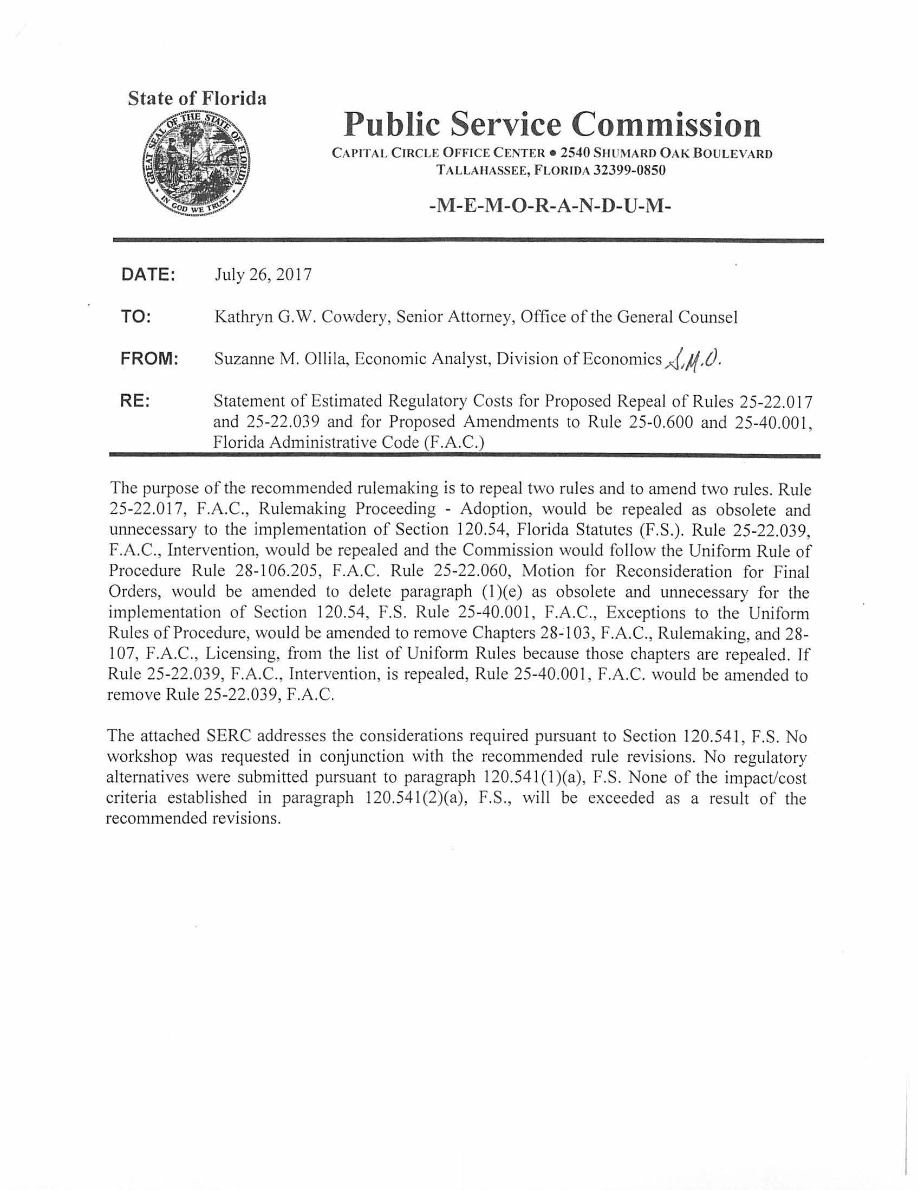

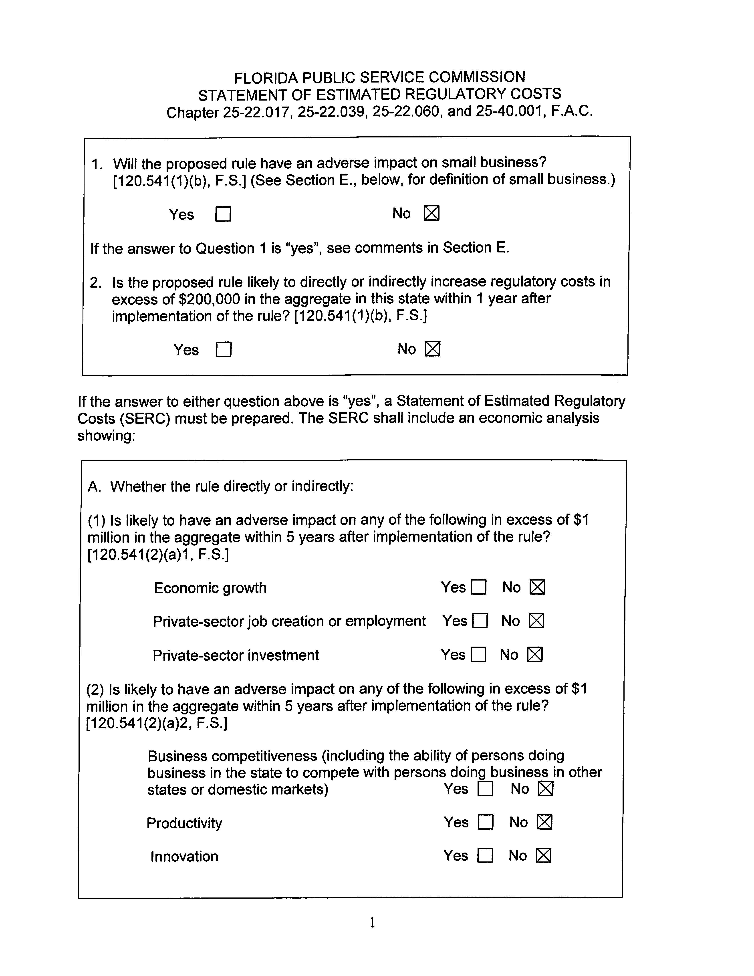

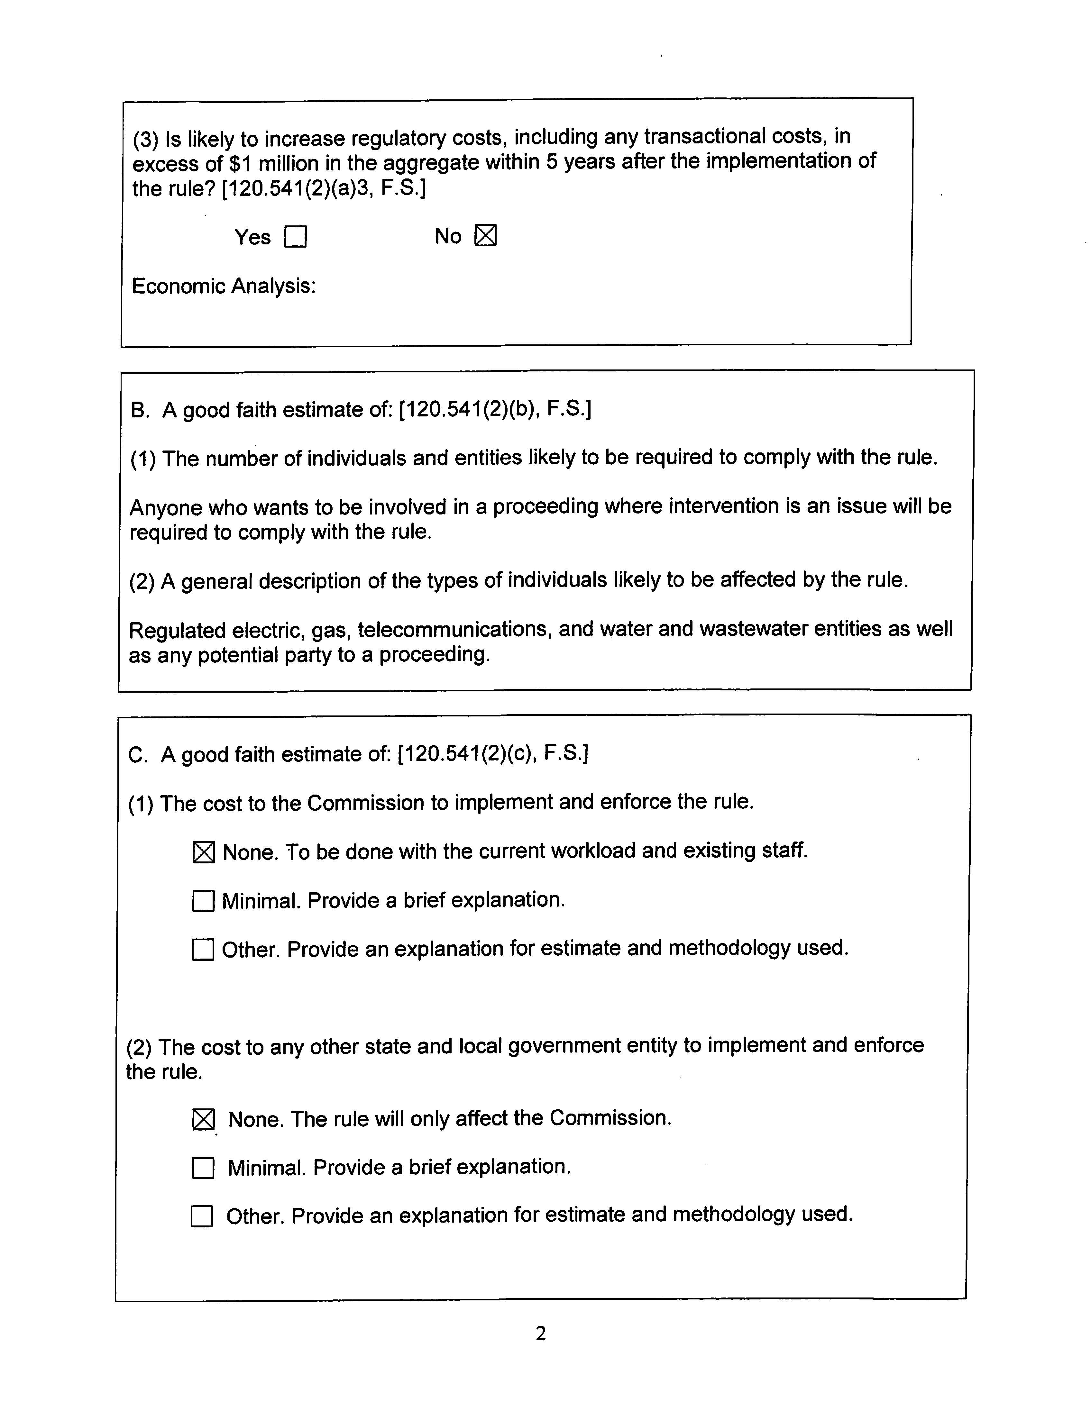

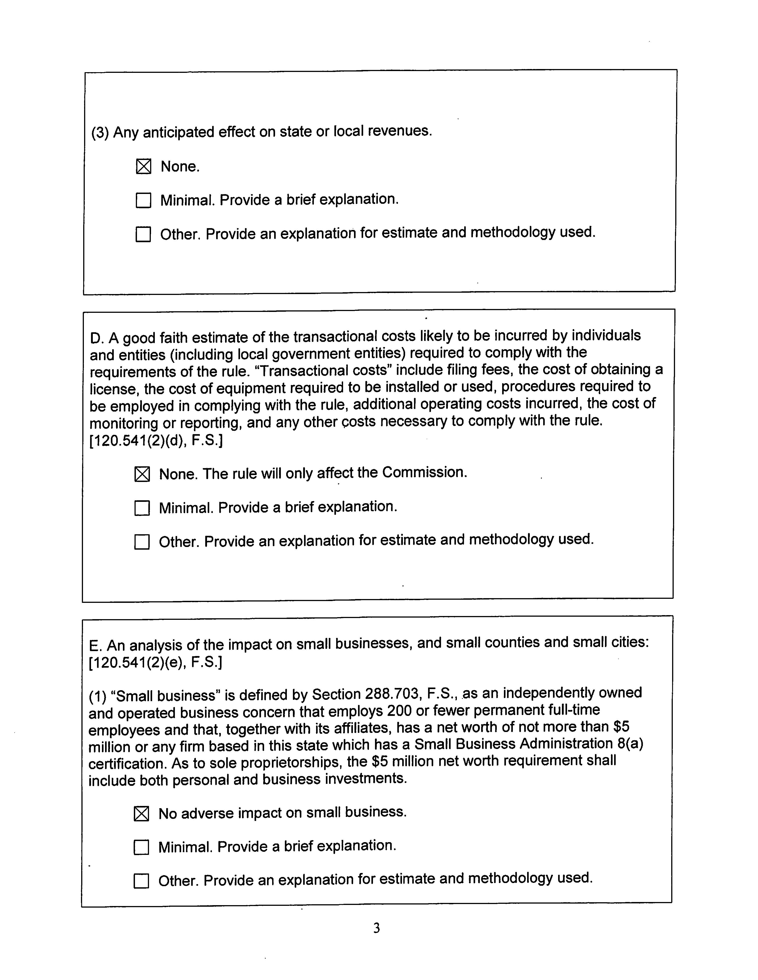

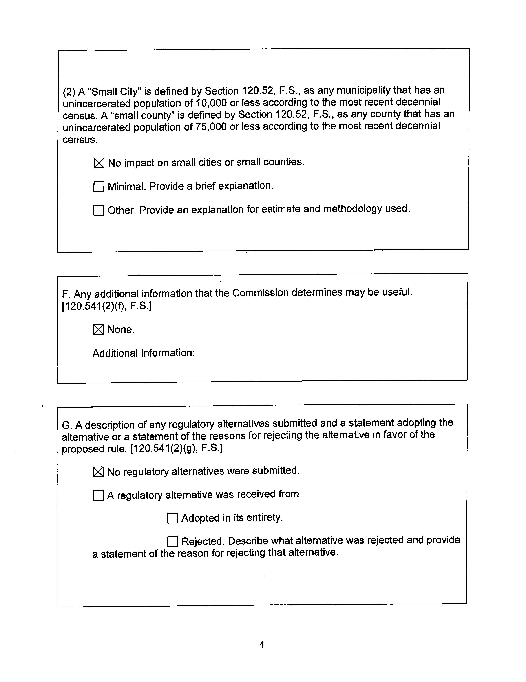

Pursuant to Section 14.202, F.S., the Administration Commission was created as part of the Executive Office of the Governor and is composed of the Governor and Cabinet.
Florida Public Service Commission’s Petition for Exceptions to the Uniform Rules of Procedure, filed April 15, 1998, and Florida Public Service Commission’s Supplement to its Petition for Exceptions to Uniform Rules of Procedure, filed May 29, 1998 in Administration Commission Case No. APA-98-007, In Re: Petition for Exceptions from the Uniform Rules of Procedure, Florida Public Service Commission, filed in Docket No. 980500-PU, In Re: Repeal of certain rules in Chapter 25-21, and Chapter 25-22, F.A.C., amendment of certain rules in Chapter 25-22, F.A.C., and adoption of new Rule 25-40.001, F.A.C.
However, informal participation in rulemaking proceedings is allowed at Agenda Conferences pursuant to Rule 25-22.0021, F.A.C., unless there has been a hearing pursuant to Section 120.54(3)(c), F.S., and the record has been closed.
Under Section 120.54(3)(a)1., F.S., after the Commission approves adoption, amendment, or repeal of a rule at an Agenda Conference, a Notice of Proposed Rules is published in the Florida Administrative Register. The Commission also notifies affected utilities and persons by issuing a Notice of Rulemaking. A final order is not part of Section 120.54, F.S., rulemaking procedure.
Administrative Law Judge.
To staff’s knowledge, no one has filed a motion for reconsideration in a rulemaking docket.

