State of Florida |  | Public Service Commission  Capital Circle Office Center ● 2540 Shumard Oak Boulevard  Tallahassee, Florida 32399-0850  -M-E-M-O-R-A-N-D-U-M-
DATE: | September 21, 2017
TO: | Office of Commission Clerk (Stauffer)
FROM: | Division of Economics (Ollila)  Office of the General Counsel (Janjic)
RE: | Docket No. 20170175-EU – Joint petition for approval of amended territorial agreement in Orange and Osceola Counties, by Duke Energy Florida, LLC and Reedy Creek Improvement District.
AGENDA: | 10/03/17 – Regular Agenda – Proposed Agency Action - Interested Persons May Participate
COMMISSIONERS ASSIGNED: |  |  | All Commissioners
PREHEARING OFFICER: |  |  | Polmann
CRITICAL DATES: |  |  | None
SPECIAL INSTRUCTIONS: |  |  | None

Case Background
On August 14, 2017, Duke Energy Florida, LLC (Duke) and the Reedy Creek Improvement District (Reedy Creek) filed a joint petition for approval of an amended territorial agreement (proposed agreement) in Orange and Osceola Counties. The proposed agreement is contained in Attachment A. The maps and written descriptions delineating the area to be served by the proposed agreement are provided in the petition as Exhibits A and B, respectively. Additional maps are contained in the joint petitioners’ response to staff’s data request filed in this docket on August 31, 2017. Due to the voluminous nature of Exhibits A and B and the maps provided in the data request response, they have not been attached to this recommendation.
The joint petitioners’ territorial agreement was approved by the Commission in 1994 and amended in 2010 (existing agreement). The expiration date of the existing agreement is September 30, 2017. The joint petitioners stated that they will abide by the existing agreement until the Commission approves the proposed agreement. The Commission has jurisdiction over this matter pursuant to Section 366.04, Florida Statutes (F.S.).

Discussion of Issues

Issue 1:
Should the Commission approve the proposed agreement between Duke and Reedy Creek?

Recommendation:
Yes, the Commission should approve the proposed agreement between Duke and Reedy Creek. (Ollila)

Staff Analysis:
Pursuant to Section 366.04(2)(d), F.S., and Rule 25-6.0440(2), Florida Administrative Code (F.A.C.), the Commission has jurisdiction to approve territorial agreements between and among rural electric cooperatives, municipal electric utilities, and other electric utilities. Unless the Commission determines that the agreement will cause a detriment to the public interest, the agreement should be approved.

Reedy Creek is a special taxing district created by the Florida legislature. Reedy Creek operates like a municipality in that it is authorized to furnish electric service to areas within its defined legal boundary; however, pursuant to its charter, Reedy Creek cannot furnish retail electric power outside of its boundary. Reedy Creek is authorized to furnish electric power to areas in Orange and Osceola Counties.

There are three differences between the existing and proposed agreements, as explained by the joint petitioners in their response to staff’s data request. First, the proposed agreement includes modified territorial boundaries. Second, the territorial boundary maps in the proposed agreement have been updated to a geographic information system (GIS) format, thus displaying the boundary lines in greater detail. Third, the term of the existing agreement is 23 years and the term of the proposed agreement is 30 years. After the expiration of the 30-year term of the proposed agreement in 2047, the agreement would remain in effect until and unless either party provides written notice of termination no less than 12 months prior to the termination date.

The proposed territorial boundary changes involve three areas. The boundary changes include two areas, which have been de-annexed by Reedy Creek and will be served by Duke under the proposed agreement: the Black Lake parcel and an area in the vicinity of I-4 and Osceola Parkway. The third boundary modification, an area in the vicinity of County Road (CR) 535 and Apopka Vineland Road, is in the Reedy Creek political boundary and is served by Reedy Creek; however, the area was previously shown as served by Duke. The three boundary changes are detailed in the joint petitioners’ response to staff’s data request. There are no customer transfers and no facilities will be purchased or transferred; therefore, no noticing was required pursuant to Rule 25-6.0440(1)(d), F.A.C.
The joint petitioners assert that the proposed agreement will avoid duplication of service and wasteful expenditures, it will protect the health and safety of the public from potentially hazardous conditions, and it will not cause a decrease in the reliability of electric service. The joint petitioners believe and represent that the Commission’s approval of the proposed agreement is in the public interest.

Conclusion
After review of the petition, the proposed agreement, and the joint petitioners’ response to staff’s data request, staff believes that the proposed agreement is in the public interest and will enable Duke and Reedy Creek to better serve their current and future customers. It appears that the proposed agreement eliminates any potential uneconomic duplication of facilities and will not cause a decrease in the reliability of electric service. As such, staff believes that the proposed agreement between Duke and Reedy Creek will not cause a detriment to the public interest and recommends that the Commission approve it.

Issue 2:
Should this docket be closed?

Recommendation:
If no protest is filed by a person whose substantial interests are affected within 21 days of the issuance of the Order, this docket should be closed upon the issuance of a Consummating Order. (Janjic)

Staff Analysis:
If no protest is filed by a person whose substantial interests are affected within 21 days of the issuance of the Order, this docket should be closed upon the issuance of a Consummating Order.

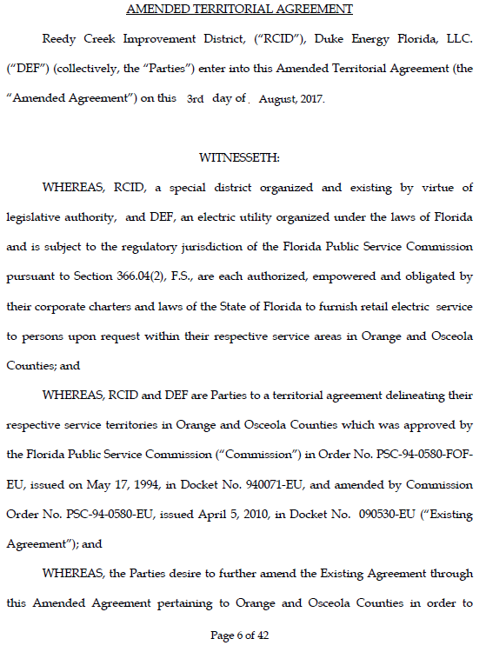
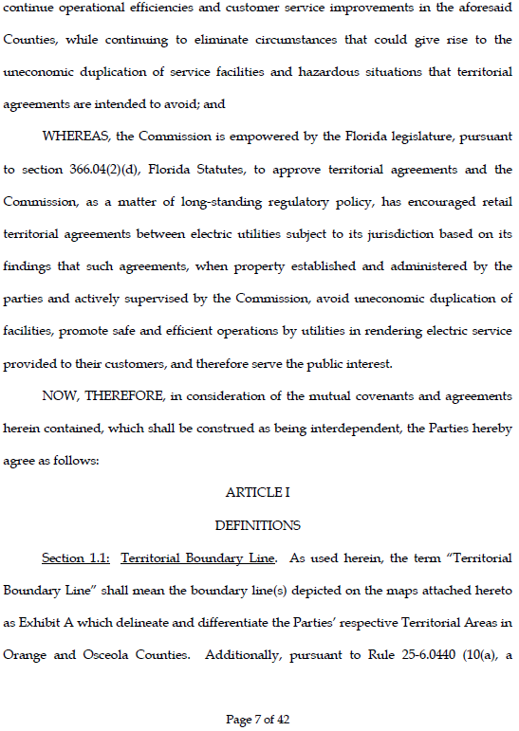
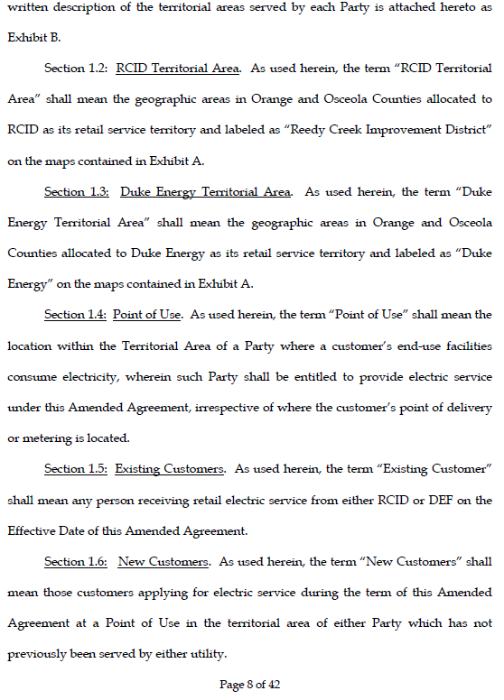
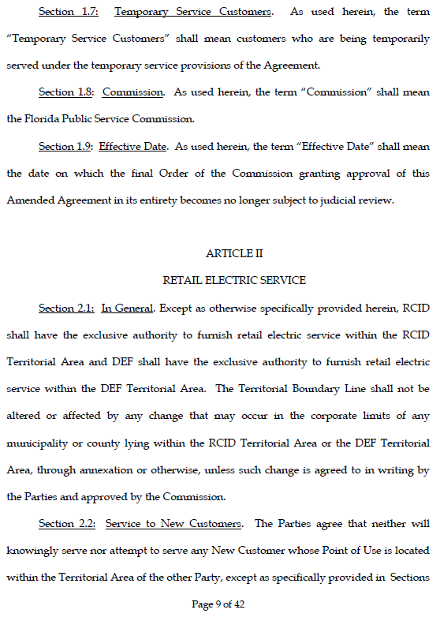
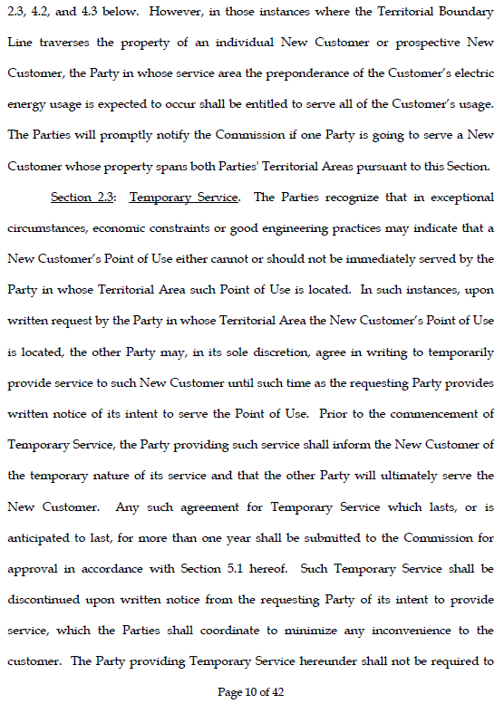
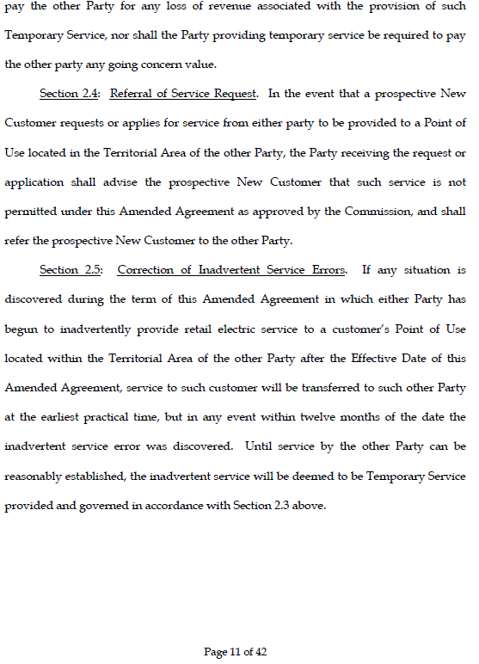
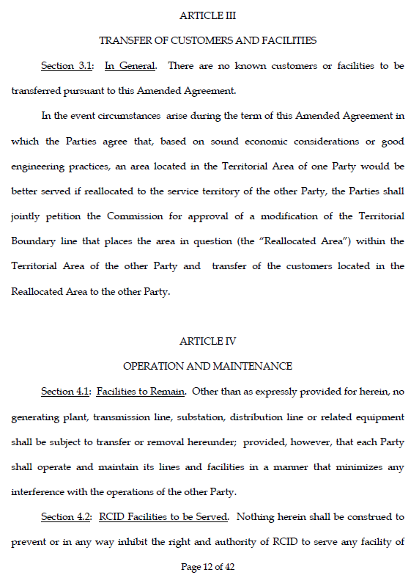
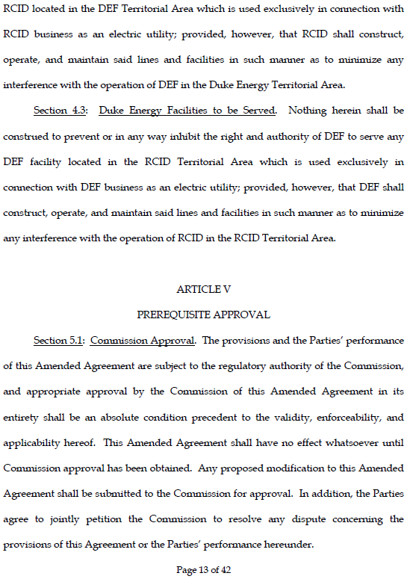
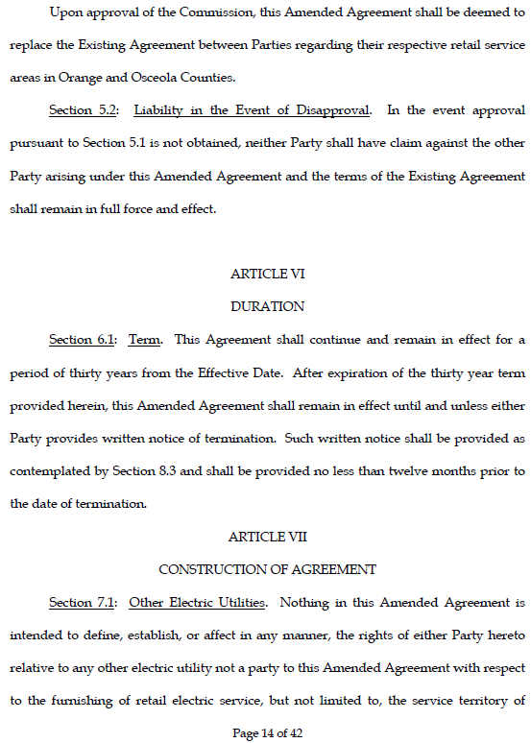
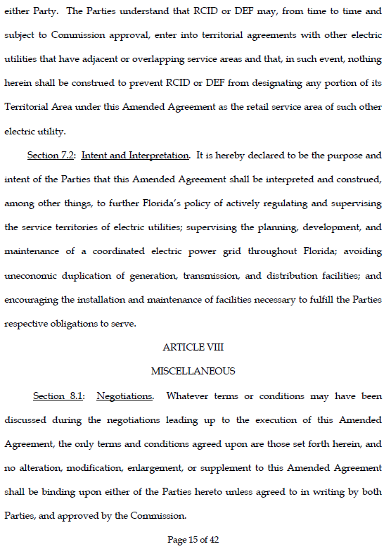
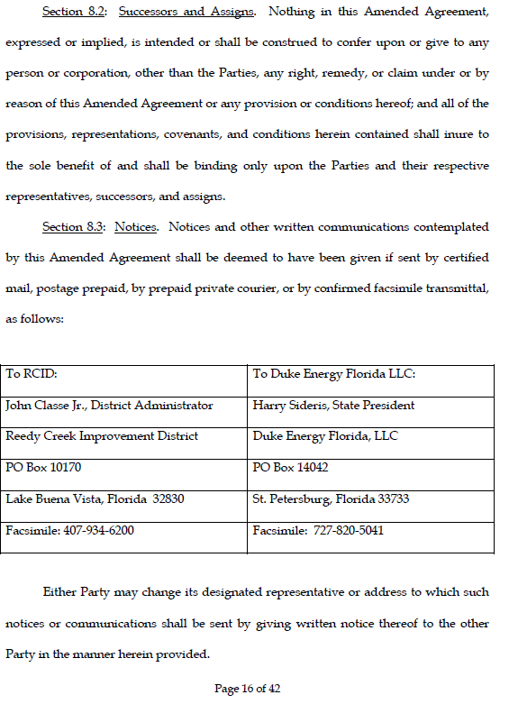
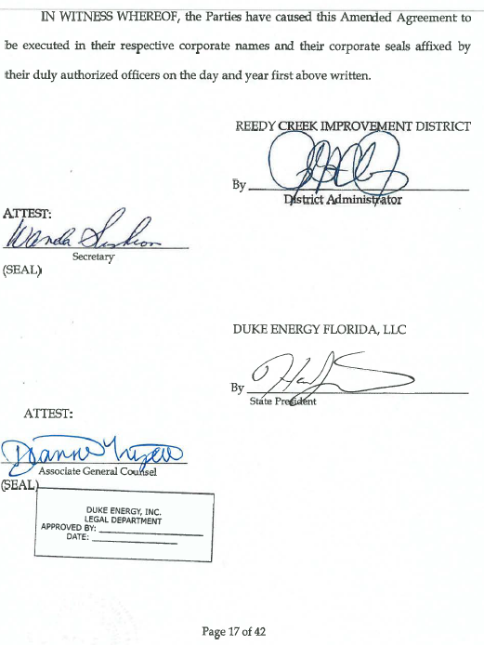

Order No. PSC-94-0580-FOF-EU, issued May 17, 1994, in Docket No. 940071-EU, In re: Joint Petition for approval of territorial agreement between Florida Power Corporation and Reedy Creek Improvement District; Order No. PSC-10-0206-PAA-EU, issued April 5, 2010, in Docket No. 090530-EU, In re: Joint Petition for approval to amend territorial agreement by Progress Energy Florida, Inc. and Reedy Creek Improvement District.
Utilities Commission of the City of New Smyrna Beach v. Florida Public Service Commission, 469 So. 2d 731 (Fla. 1985).

