BEFORE THE FLORIDA PUBLIC SERVICE COMMISSION

|  |  |
| --- | --- |
| In re: Application for increase in water and wastewater rates in Charlotte, Highlands, Lake, Lee, Marion, Orange, Pasco, Pinellas, Polk, and Seminole Counties by Utilities, Inc. of Florida. | DOCKET NO. 20160101-WS  ORDER NO. PSC-2017-0361-FOF-WS  ISSUED: September 25, 2017 |

The following Commissioners participated in the disposition of this matter:

JULIE I. BROWN, Chairman

ART GRAHAM

RONALD A. BRISÉ

DONALD J. POLMANN

ORDER APPROVING IN PART REQUESTED INCREASE IN WATER AND

WASTEWATER RATES AND REQUIRING REFUNDS WITH INTEREST

BY THE COMMISSION:

APPEARANCES:

MARTIN S. FRIEDMAN, ESQUIRE, Friedman & Friedman, P.A., 766 North Sun Drive, Suite 4030, Lake Mary, FL 32746

On behalf of Utilities, Inc. of Florida (UIF).

J. R. KELLY, ERIK L. SAYLER, PATRICIA A. CHRISTENSEN, and VIRGINIA PONDER, ESQUIRES, 111 West Madison Street, Room 812, Tallahassee, FL 32399-1400

On behalf of Office of Public Counsel (OPC).

BRIAN ARMSTRONG, ESQUIRE, Law Office of Brian Armstrong, PPLC, P.O. Box 5055, Tallahassee, Florida 32314-2055

On behalf of Summertree Water Alliance (Summertree) and Ann Marie Ryan.

WILLIAM S. BILENKY, ESQUIRE, Manson Bolves Donaldson Varn, P.A., 1101 West Swann Avenue, Tampa, Florida 33606

On behalf of Seminole County.

WALT TRIERWEILER, JENNIFER CRAWFORD, DANIJELA JANJIC, KYESHA MAPP, and WESLEY TAYLOR, ESQUIRES, Florida Public Service Commission, 2540 Shumard Oak Boulevard, Tallahassee, Florida 32399-0850

On behalf of the Florida Public Service Commission (Staff).

KEITH HETRICK, Esquire, General Counsel, and MARY ANNE HELTON, Esquire, Deputy General Counsel, Florida Public Service Commission, 2540 Shumard Oak Boulevard, Tallahassee, Florida 32399-0850

Advisors to the Florida Public Service Commission.

TABLE OF CONTENTS

Abbreviations and Technical Terms 5

I. BACKGROUND 7

II. QUALITY OF SERVICE 10

III. ALLOCATION THRESHOLD ISSUE 25

A. ERC COUNT 25

IV. RATE BASE 28

A. AUDIT ADJUSTMENTS TO RATE BASE 28

B. PROJECT PHOENIX REGULATORY ASSETS 32

C. TEST YEAR PLANT-IN SERVICE 36

D. SUMMERTREE WATER SUPPLY ASSETS 37

E. PRO FORMA PLANT ADDITIONS 38

F. PLANT RETIREMENTS 81

G. EXCESSIVE UNACCOUNTED FOR WATER 88

H. EXCESSIVE INFILTRATION AND INFLOW 89

I. USED AND USEFUL FOR WATER TREATMENT 92

J. USED AND USEFUL FOR WATER STORAGE 92

K. USED AND USEFUL FOR WATER FOR WATER DISTRIBUTION 92

L. USED AND USEFUL FOR WASTEWATER TREATMENT 92

M. USED AND USEFUL FOR WASTEWATER COLLECTION 100

N. TEST YEAR ADJUSTMENTS 100

O. TEST YEAR CIAC 101

P. TEST YEAR ACCUMULATED AMORTIZATION OF CIAC 104

Q. WORKING CAPITAL ALLOWANCE 105

R. TEST YEAR RATE BASE 112

V. COST OF CAPITAL 113

A. TAP FEES POST 2000 113

B. ACCUMULATED DEFERRED TAXES 119

C. CUSTOMER DEPOSITS 121

D. COST RATE FOR CUSTOMER DEPOSITS 122

E. COST RATE FOR SHORT-TERM DEBT 122

F. COST RATE FOR LONG-TERM DEBT 122

G. CAPITAL STRUCTURE FOR RATE SETTING 123

H. RETURN ON EQUITY FOR RATE SETTING 124

I. WEIGHTED AVERAGE COST OF CAPITAL 127

VI. NET OPERATING INCOME 129

A. TEST YEAR REVENUES 129

B. AUDIT ADJUSTMENTS TO NET OPERATING INCOME 132

C. SALARIES AND WAGE EXPENSE 136

D. EMPLOYEE PENSION AND BENEFITS EXPENSE 138

E. COST ALLOCATED FROM WSC 140

F. PURCHASED WATER EXPENSE 144

G. PURCHASED SEWER EXPENSE 146

H. SLUDGE REMOVAL EXPENSE 147

I. PURCHASED POWER EXPENSE 150

J. CHEMICAL EXPENSE 152

K. MATERIALS AND SUPPLIES EXPENSE 154

L. CONTRACTUAL SERVICES – ENGINEERING EXPENSE 156

M. CONTRACTUAL SERVICES – LEGAL EXPENSE 157

N. CONTRACTUAL SERVICES – TESTING EXPENSE 158

O. CONTRACTUAL SERVICES – OTHER EXPENSE 158

P. EQUIPMENT RENTAL EXPENSE 161

Q. TRANSPORTATION EXPENSE 162

R. RATE CASE EXPENSE 163

S. TREATMENT OF UNAMORTIZED RATE CASE EXPENSE 169

T. MISCELLANEOUS EXPENSE 173

U. COST SAVINGS 177

V. TEST YEAR AND PRO FORMA O&M EXPENSE 178

W. TEST YEAR DEPRECIATION EXPENSE 179

X. TEST YEAR AMORTIZATION OF CIAC 180

Y. SUMMERTREE DECOMMISSIONING NOI ADJUSTMENTS 181

Z. SANDALHAVEN SALVAGE VALUE 184

AA. TAXES OTHER THAN INCOME 184

VII. REVENUE REQUIREMENT 185

VIII. RATE STRUCTURE 186

A. SUBSIDY VALUE LIMITS 186

B. RATE STRUCTURE 193

C. RATES AND RATE STRUCTURE-WATER 198

D. PRIVATE FIRE PROTECTION CHARGES 203

E. RATES AND RATE STRUCTURE – WASTEWATER 203

IX. OTHER ISSUES 207

A. MISCELLANEOUS SERVICE CHARGES 207

B. LATE PAYMENT CHARGE 210

C. REUSE RATES 213

D. CUSTOMER DEPOSITS 213

E. METER INSTALLATION CHARGES 213

F. CUSTOMER CONNECTION, MAIN CONNECTION CHARGES 213

G. GUARANTEED REVENUE CHARGES 217

H. ALLOWANCE FOR FUNDS PRUDENTLY INVESTED 217

I. INTERIM REFUNDS 220

J. REMOVAL OF CURRENT RATE CASE EXPENSE 222

K. MECHANISM TO ADDRESS PRIOR RATE CASE EXPENSE 223

L. INDEX AND PASS THROUGH FILINGS 225

M. FPSC-REGULATED ACCOUNTING, FILING, AND REPORTING 226

N. COMMISSION ORDERED ADJUSTMENTS 226

O. POOL VEHICLES AND SPECIAL EQUIPMENT 228

P. COMMISSION ORDERED ADJUSTMENTS NOTIFICATION 230

Table of Schedules 235

**SCHEDULES 238-348**

Abbreviations and Technical Terms

The following abbreviations used herein are listed below for reference purposes:

AA Accumulated Amortization

AC Asbestos Cement

ADIT Accumulated Deferred Income Tax

AFPI Allowance for Funds Prudently Invested

ASME American Society of Mechanical Engineers

AUF Aqua Utilities Florida, Inc.

AWT Advanced Wastewater Treatment

BFC Base Facility Charge

BR Brief

CAD Computer-Aided Design

CAO Compliance Assistance Offer

CIAC Contributions in Aid of Construction

CIPP Cured-in-place Pipe

COA Commission Ordered Adjustments

DEP Department of Environmental Protection

EDU Equivalent Development Unit

ERC Equivalent Residential Connection

EUW Excessive Unaccounted for Water

EWD Englewood Water District

EXH Exhibit

F.A.C. Florida Administrative Code

FDOT Florida Department of Transportation

F.S. Florida Statutes

GAC Granular Activated Carbon

GIS Geographic Information System

GL General Ledger

GPD Gallons Per Day

GPM Gallons Per Minute

HAA5 Haloacetic Acids

HDPE High Density Poyethylene

I&I Infiltration and/or Inflow

IRS Internal Revenue Service

LUSI Lake Utility Services, Inc.

M&R M&R Consultants

MCL Maximum Contaminant Level

MFRs Minimum Filing Requirements

MSA Milian, Swain & Associates

NARUC National Association of Regulatory Utility Commissioners

NEC National Electric Code

NSF Non-Sufficient Funds

O&M Operation and Maintenance

OPC Office of Public Counsel

PAA Proposed Agency Action

PATH Act Protecting Americans from Tax Hikes Act

PVC Polyvinyl Chloride

RIBs Rapid Infiltration Basin Systems

ROE Return on Equity

RTU Remote Terminal Unit

SCADA Supervisory Control & Data Acquisition

SECO Sumter Electric Cooperative

SWFWMD Southwest Florida Water Management District

TOTI Taxes Other than Income

TR Transcript

TTHM Total Trihalomethanes

U&U Used and Useful

UI Utilities, Inc.

UIF Utilities, Inc. of Florida

USOA Uniform System of Accounts

WACC Weighted Average Cost of Capital

WM Water Mains

WSC Water Service Corp.

WTP Water Treatment Plant

WWTP Wastewater Treatment Plant

# **I. BACKGROUND**

Utilities, Inc. of Florida (UIF or Utility) is a Class A utility providing water and wastewater service to 27 systems in the following counties: Charlotte, Highlands, Lake, Lee, Marion, Orange, Pasco, Pinellas, Polk, and Seminole. As the result of a recent corporate reorganization and name change, UIF is the sole surviving corporation that owns and operates the water and wastewater systems that are the subject of this rate case application. UIF is a wholly-owned subsidiary of Utilities, Inc. (UI).[1]

For 2015, the Utility recorded total company operating revenues of $13,336,372 and $15,094,296 for water and wastewater, respectively. UIF reported net operating income for 2015 of $1,682,158 for water and $3,222,388 for wastewater. In 2015, UIF had 34,022 and 32,524 respective water and wastewater customers for its combined systems. The following table reflects the rate proceeding in which rates were last established for UIF’s respective systems.

Last Proceedings Establishing Rates for UIF Systems

| **Former Utility Name** | **Order** | **Issuance Date** |
| --- | --- | --- |
| Tierra Verde Utilities, Inc. | PSC-09-0372-PAA-SU | May 27, 2009 |
| Utilities, Inc. of Longwood | PSC-10-0407-PAA-SU | June 21, 2010 |
| Lake Utility Services, Inc. | PSC-11-0514-PAA-WS | November 3, 2011 |
| Utilities, Inc. of Eagle Ridge | PSC-11-0587-PAA-SU | December 21, 2011 |
| Mid-County Services, Inc. | PSC-12-0389-PAA-SU | July 27, 2012 |
| Utilities, Inc. of Pennbrooke | PSC-12-0667-PAA-WS | December 26, 2012 |
| Utilities Inc. of Florida (Orange and Pinellas Counties) | PSC-14-0025-PAA-WS | January 10, 2014 |
| Cypress Lakes Utilities, Inc. | PSC-14-0283-PAA-WS | May 30, 2014 |
| Lake Placid Utilities, Inc. | PSC-14-0335-PAA-WS | June 30, 2014 |
| Labrador Utilities, Inc. | PSC-15-0208-PAA-WS | May 26, 2015 |
| Sanlando Utilities Corporation | PSC-15-0233-PAA-WS | June 3, 2015 |
| Utilities, Inc. of Sandalhaven | PSC-16-0013-PAA-SU | January 6, 2016 |
| Utilities Inc., of Florida (Marion and Seminole Counties) | PSC-16-0296-PAA-WS | June 27, 2016 |
| Utilities Inc., of Florida (Pasco County) | PSC-16-0505-PAA-WS | October 31, 2016 |

On November 2, 2015, Cypress Lake Utilities, Inc. (Cypress Lakes), Utilities, Inc. of Eagle Ridge (Eagle Ridge), Labrador Utilities, Inc. (Labrador), Lake Placid Utilities, Inc. (Lake Placid), LUSI, Utilities, Inc. of Longwood (Longwood), Mid-County Services, Inc. (Mid-County), Utilities, Inc. of Pennbrooke (Pennbrooke), Utilities Inc. of Sandalhaven (Sandalhaven), Sanlando Utilities Corporation (Sanlando), Tierra Verde Utilities, Inc. (Tierra Verde), and UIF (UIF-Marion, UIF-Pinellas, UIF-Orange, UIF-Pasco, and UIF-Seminole) filed a joint application for acknowledgement of corporate reorganization and approval of name change. By Order No. PSC-16-0143-FOF-WS, issued April 12, 2016, we acknowledged the corporate reorganization and name change of UI’s 12 subsidiaries in Florida.[2]

On December 30, 2015, the Utility requested a limited proceeding water rate increase for UIF-Marion, UIF-Pasco, and UIF-Seminole in Docket No. 150269-WS. As the request was filed prior to our recognition of UIF’s corporate reorganization, the limited proceeding applied only to the former UIF systems and did not include Longwood and Sanlando in Seminole County. Driving the limited proceeding were (1) galvanized service line replacement costs in Marion County, (2) loss of irrigation customers, plant additions, and purchased water costs in Pasco County, and (3) interconnection plant addition costs in Seminole County. UIF requested to bifurcate its request for UIF-Pasco, and ultimately deferred its requested increase for lost irrigation revenues for consideration in the instant docket. As a result of the bifurcation, rate increases for UIF-Marion and UIF-Seminole were addressed by Order No. PSC-16-0296-PAA-WS, issued July 27, 2016.[3] The remaining issues for UIF-Pasco were addressed by Order No. PSC-16-0505-PAA-WS, issued October 31, 2016.[4]

On April 28, 2016, UIF filed a request for test year approval and also requested that we process its petition for rate relief using the proposed agency action (PAA) procedure.[5] On May 10, 2016, OPC filed a petition to intervene, and an Order was issued acknowledging OPC’s intervention the same day.[6] By letter dated May 13, 2017, OPC objected to using PAA procedure to process the Utility’s rate case due to the size and complicated nature of the expected rate case proceeding.[7] In a subsequent letter filed on May 23, 2016, the Utility requested to forego the PAA procedure and proceed directly to hearing.

On August 31, 2016, UIF filed its application for approval of interim and final water and wastewater rate increases. By letter dated September 29, 2016, Commission staff advised the Utility that its Minimum Filing Requirements (MFRs) had deficiencies. The Utility filed its responses on October 31, 2016. A second deficiency letter was issued on November 18, 2016. The Utility filed a response to Commission staff’s second deficiency letter on November 22, 2016, correcting its remaining deficiencies, and thus, November 22, 2016, became the official filing date pursuant to Sections 376.081 and 367.083, Florida Statutes (F.S.). The test year established for interim and final rates is the historical 13-month average period ended December 31, 2015, with requested adjustments for pro forma projects. UIF requested a final revenue increase of $2,721,001 for water and $4,194,453 for wastewater.

The Utility requested a single, consolidated rate structure. Prior to our decision regarding consolidation, the Utility’s requested rate relief was evaluated using the cost structures in effect at the time of filing. Each UIF system will be referred to by the name of the former utility it belonged to prior to the corporate reorganization.

By Order No. PSC-16-0526-PCO-WS, issued November 22, 2016, we authorized the collection of interim water and wastewater rates, subject to refund pursuant to Section 367.082, F.S. The approved interim revenue requirements represented an increase of $348,309 for water and $209,440 for wastewater operations.[8] Additionally, we ordered the collection of revenues totaling $530,900 held subject to refund for systems that appeared to be earning above their maximum return on equity (ROE).[9]

We held eight customer service hearings January 10-11 and February 1-2, 2017, throughout UIF’s service territory. We held a ninth customer service hearing before the beginning of the evidentiary hearing on May 8, 2017, in Tallahassee.

On April 19, 2017, Summertree Water Alliance (Summertree) filed a petition to intervene.[10] The petition was amended April 27, 2017 to also seek intervention for Ann Marie Ryan. On May 4, 2017, the Prehearing Officer granted intervention to Summertree.[11] A separate order was issued on May 5, 2017, granting intervention with limitations to Ms. Ryan.[12] In our analysis herein, we analyzed the post-hearing position for Ms. Ryan with Summertree, because Ms. Ryan and Summertree filed a combined brief. On April 26, 2017, Seminole County filed a petition to intervene.[13] On May 2, 2017, the Prehearing Officer granted intervention with limitations to Seminole County.[14]

On April 20, 2017, OPC filed a motion to strike portions of the rebuttal testimony and exhibits of UIF witness Patrick Flynn. The Prehearing Officer issued an order on May 2, 2017, denying the motion to strike.[15] On May 10, 2017, OPC filed a motion for reconsideration before the full Commission and requested oral argument on its motion. On June 23, 2017, we granted oral argument and denied OPC’s motion for reconsideration.[16]

A formal evidentiary hearing was held on May 8-10, 2017. At the hearing, we approved category 2 stipulations for Used and Useful (U&U) – Water Treatment, U&U – Storage, U&U – Water Distribution, U&U - Wastewater Collection, Customer Deposits in both Parts V and IX, Cost Rate for Customer Deposits, Cost Rate for Short Term Debt, Contractual Services – Legal, Transportation Expense, Sandalhaven Salvage Value, Private Fire Protection Charge, Reuse Rates, Meter Installation Charges, Guaranteed Revenue Charges, and Index and Pass Through, as reflected herein. The Parties filed briefs on June 20, 2017.

This order addresses the Utility’s final requested rates and refunds with interest. We have jurisdiction pursuant to Section 367.081, F.S.

**DECISION**

# **II. QUALITY OF SERVICE**

Pursuant to Rule 25-30.433(1), F.A.C., in a rate proceeding we must determine the overall quality of service provided by a utility based on an evaluation of the utility’s product, the operational conditions of the utility’s plant and facilities, and the utility’s attempt to address customer satisfaction.

PARTIES’ ARGUMENTS

**UIF**

UIF argued the quality of service for all of its systems is satisfactory based on the quality of its product, operating conditions, and attempts to address customer satisfaction. UIF asserted that the Utility’s water and wastewater facilities are in compliance with the applicable Florida Department of Environmental Protection (DEP) standards for all of its systems, except one, as demonstrated by the testimony of the Commission staff-sponsored DEP witness. While there were instances of non-compliance issues during the years evaluated, UIF argued that the issues were not considered unusual or excessive as testified to by DEP’s witness. The Utility asserted that the only wastewater system with outstanding compliance issues is Eagle Ridge. For the Eagle Ridge system, UIF articulated that it hopes to resolve the issues by means of a pro forma project requested in this proceeding.

Additionally, the Utility stated that all of its 23 water systems were meeting primary and secondary water standards. At the time of the technical hearing, the LUSI water system was under a DEP consent order for disinfection byproduct exceedances; however, UIF has continued to meet the milestones required by DEP, and the problem is also the subject of a pro forma project. The Utility further summarized its actions taken in regards to Cypress Lakes, Labrador, Pennbrooke, Sanlando, UIF - Seminole, and UIF- Pasco/Summertree, where quality of service concerns had been raised. The Utility argued that though it was not included in this rate case, an asset management system would be implemented in the near future to improve the operation, maintenance, and management of its assets.

UIF argued that OPC provided all customer comments and letters filed in the docket, as well as customer communications that were not required by Commission rule, in order “to elevate the number of comments.” Furthermore, some of the documented customer communications were outside of the required time period and had no demonstrative value. The Utility argued that only secondary water quality complaints over the past five years should be considered. UIF also asserted that OPC did not use an accepted Commission methodology in its evaluation of complaints, but instead, OPC’s witness used an “arbitrary 1% customer complaint threshold” to identify systems with areas of concern. In her evaluation, OPC’s witness did not take into consideration the rise in customer complaints for systems that had a rate case during the past five years. The Utility argued OPC’s evaluation is based upon admitted flaws, and has no probative value and the recommendation should be disregarded.

**OPC**

OPC evaluated several documents addressing UIF’s quality of service, including testimony, exhibits, MFRs, DEP records, customer correspondence, and testimony from eight service hearings. From this information, OPC argued the Utility has had a number of DEP issues, such as water and wastewater deficiencies, incidents of non-compliance, and consent orders that occurred prior to and during the test year. OPC stated that under cross-examination, DEP’s witness acknowledged that while these problems were not unusual or excessive, she did not personally analyze the non-compliance and enforcement issue reports; therefore, some aspects could have been missed. OPC argued that all of these issues, both during and outside the test year, should be considered to determine if there is a history of non-compliance.

OPC also argued that UIF does not have a preventative or predictive maintenance program in place to identify future capital improvements. Instead, the Utility’s improvements are “sporadic” and reactive to “overdue maintenance,” which could affect service reliability and result in higher future costs. While UIF’s parent company, Corix Group of Companies, aims to implement a preventative program, any such program was not addressed in this rate case. Due to its failure to implement any maintenance plans in the past, OPC argued we should find UIF’s maintenance practices unsatisfactory and reduce its ROE by a minimum of 50 basis points.

OPC argued that a review of the customer complaints demonstrated several common issues with regards to water aesthetics and the frequency of rate increases for some systems. In response to UIF’s assertion that its quality of service should be based on current conditions and not on past customer complaints, OPC stated quality of service is evaluated in part on the Utility’s “attempts” to address customer satisfaction. OPC further asserted that due to the number of recurring complaints raised by customers, UIF does not appear to be competently addressing customers’ concerns. Additionally, complaints made during and before the test year are relevant in establishing if there is a pattern or history of problems. OPC identified several systems with a complaint rate higher than one percent, including Cypress Lakes, Labrador, LUSI, Mid-County, Pennbrooke, Sandalhaven, Sanlando, UIF-Pasco/Summertree, and UIF-Seminole. OPC also reviewed the customer complaints logged in our complaint system and found a multitude of complaints related to water quality that had been previously considered. Based on the number and type of complaints by customers, OPC argued we should find UIF’s quality of service to be unsatisfactory and reduce its ROE by a minimum of 50 basis points.

Using the information collected, OPC identified nine systems where it argued we should find the quality of service to be unsatisfactory: Cypress Lakes, Labrador, LUSI, Mid-County, Pennbrooke, Sandalhaven, Sanlando, UIF-Pasco/Summertree, and UIF-Seminole. These nine systems were selected based on DEP consent orders, prior Commission orders, DEP records, and customer complaints. Based on the history of issues for these nine systems, OPC contends we should reduce the ROE for unsatisfactory systems by a minimum of 50 basis points. In sum, OPC argued the overall quality for UIF should be considered unsatisfactory and its ROE should be reduced by a minimum of 150 basis points.

**Summertree**

Summertree stated that it adopts the positions and arguments of OPC regarding UIF’s quality of service, specifically a finding of unsatisfactory for the UIF-Pasco/Summertree system’s quality of service. Summertree asserted that the Utility’s lack of a preventative and predictive maintenance program demonstrated a practice of reactive maintenance, and resulted in higher costs. In particular, the UIF-Pasco/Summertree system has experienced a history of water issues, as well as a dismissive nature by UIF towards customers’ concerns. Summertree argued that UIF-Pasco/Summertree customers have received water that was not in compliance with all DEP water standards, and the Utility has made poor attempts to communicate with its customers. In review of the evidence, Summertree argued UIF’s quality of service should be considered unsatisfactory and we should reduce its ROE by 150 basis points.

ANALYSIS

Pursuant to Rule 25-30.433(1), Florida Administrative Code (F.A.C.), in water and wastewater rate cases we shall determine the overall quality of service provided by a utility. This is derived from an evaluation of three separate components of a utility’s operations. These components are: (1) the quality of the utility’s product; (2) the operational conditions of the utility’s plant and facilities; and (3) the utility’s attempt to address customer satisfaction. The rule further states that sanitary surveys, outstanding citations, violations, and consent orders on file with the DEP and the county health department over the preceding three-year period shall be considered.

Section 367.0812(1), F.S., additionally requires that we consider the extent to which the utility provides water service that meets secondary water quality standards when fixing rates. Established by DEP rule, primary water quality standards relate to the safety of the water, while secondary standards relate to the aesthetics of the water like taste, color, odor, and sediment.

Rule 25-30.433(1), F.A.C., requires that the testimony of a utility’s customers be considered in a rate case proceeding. Eight service hearings were held in the Utility’s service territory. We traveled to New Port Richey, Zephyrhills, Port Charlotte, Lake Placid, Leesburg, Clermont, Altamonte Springs, and Lakeland. A total of 163 customers provided sworn testimony at the noticed hearings, and approximately 51 percent of these customers spoke on quality of service. Local legislators and county officials also attended several of the service hearings and provided comments. We conducted a ninth service hearing in Tallahassee prior to the technical hearing on May 8, 2017, where 10 speakers provided testimony, including a Florida Legislator, a Pasco County Commissioner, and the Assistant County Administrator for Utility Services in Pasco County. Seven of the ten speakers discussed the Summertree system. The remaining three speakers were representatives of the Cypress Lakes, Labrador, and Sanlando systems.

Commission staff-sponsored DEP witness Kleinfelter provided testimony to address the compliance status, from 2014 to 2016, for UIF’s water and wastewater systems. Witness Kleinfelter’s testimony also included DEP enforcement actions taken against UIF during the same timeframe. Witness Kleinfelter testified that, based on her experience at DEP, the non-compliance issues presented in her testimony were not unusual or excessive. At the time of the technical hearing, all of the Utility’s systems were in compliance, except for two wastewater systems: Eagle Ridge and Cross Creek.

OPC witness Vandiver testified that she reviewed DEP records and documentation relating to quality of service for the Utility’s water and wastewater systems. Witness Vandiver expressed concerns regarding UIF’s quality of service, specifically three consent orders, deficiencies relating to nine systems, main breaks, boil water notices, sewage spills, phosphorus exceedances, and chlorine residuals. Witness Vandiver asserted that deficiencies that have been corrected should still be taken into consideration since customers were still paying rates, under the assumption UIF was in compliance, during these circumstances. UIF witness Hoy stated that the quality of service should be based on the current state of the Utility’s environmental compliance with DEP, rather than instances of past non-compliance, which does not accurately reflect the work that UIF has done to address those issues.

In addition to the testimony received at the customer service hearings, witness Kleinfelter testified to the number of customer complaints received by DEP, and Commission staff witness Hicks testified about customer complaints received by us over the past five years. DEP logged 17 water and 20 wastewater related complaints, which mainly consisted of concerns with color, odor, and taste, though a few complaints involved water pressure and sewage overflow. We received a total of 218 complaints from January 1, 2010 through December 31, 2016, with 68 percent of the complaints concerning billing issues, and the remaining 32 percent concerning quality of service issues. OPC witness Vandiver provided a summary of all customer correspondence received by us from September 2016 through March 2017, which included over 750 letters and comments. Approximately 99 percent of the letters and comments were on the subject of rates; however, approximately 54 percent of customers also expressed dissatisfaction with the quality of service.

Witness Vandiver also testified that she reviewed customer complaints provided by UIF. Using tabulated quality of service complaints over the past five years, witness Vandiver identified eight systems that had an average annual complaint rate greater than one percent. These systems are Cypress Lakes, Labrador, Lake Placid, LUSI, UIF-Marion, UIF-Pasco, UIF-Pinellas, and UIF-Seminole. For the systems that met this one percent complaint rate, witness Vandiver stated that there were several issues that were common between the systems that were related to secondary water standards and water pressure. Witness Hoy testified that witness Vandiver’s utilization of a one percent average annual complaint rate was an arbitrary measure for evaluating the Utility’s quality of service. Witness Hoy testified that one indicator for the current service provided by the Utility is the number of customers in attendance at the eight service hearings and the subject of their comments. Witness Hoy also stated that the number of complaints can be impacted by the filing of a rate case. When it comes to secondary standards, the Utility stated in its brief, that the number of complaints that are received may vary for many reasons, including factors outside of UIF’s control, like the conditions of a customer’s plumbing or vacancy of a residence.

In its brief, OPC argued that all UIF systems should be considered unsatisfactory. OPC witness Vandiver specifically testified that nine systems should have a quality of service designation of marginal or unsatisfactory. These nine systems are Cypress Lakes, Labrador, LUSI, Mid-County, Pennbrooke, Sandalhaven, Sanlando, UIF-Pasco – Summertree, and UIF-Seminole. For the remaining systems, witness Vandiver did not provide a recommendation regarding quality of service. Following the filing of witness Vandiver’s testimony, no new information regarding quality of service was entered into the record other than customer testimony made at the ninth service hearing, held in Tallahassee. The customers that provided testimony at the Tallahassee service hearing represented customers from four systems that witness Vandiver identified in her testimony.

Each of UIF’s systems and our findings concerning their quality of service ratings are discussed below.

Table 1

Summary of Commission Approved Quality of Service

|  |  |  |  |  |
| --- | --- | --- | --- | --- |
| **System** | **UIF** | **OPC** | **Commission Decision** | **ROE Reduction** |
| Cross Creek/Eagle Ridge | Satisfactory | Unsatisfactory* | Satisfactory | None |
| Lake Placid | Satisfactory | Unsatisfactory* | Satisfactory | None |
| Longwood | Satisfactory | Unsatisfactory* | Satisfactory | None |
| Sandalhaven | Satisfactory | Unsatisfactory | Satisfactory | None |
| Sanlando | Satisfactory | Unsatisfactory | Satisfactory | None |
| Tierra Verde | Satisfactory | Unsatisfactory* | Satisfactory | None |
| UIF-Marion | Satisfactory | Unsatisfactory* | Satisfactory | None |
| UIF-Orange | Satisfactory | Unsatisfactory* | Satisfactory | None |
| UIF-Pasco-Orangewood | Satisfactory | Unsatisfactory* | Satisfactory | None |
| UIF-Pinellas | Satisfactory | Unsatisfactory* | Satisfactory | None |
| Cypress Lakes | Satisfactory | Unsatisfactory | Marginal | 50 basis points |
| Labrador | Satisfactory | Unsatisfactory | Marginal | None |
| LUSI | Satisfactory | Unsatisfactory | Marginal | None |
| Mid-County | Satisfactory | Unsatisfactory | Marginal | 50 basis points |
| Pennbrooke | Satisfactory | Unsatisfactory | Marginal | 50 basis points |
| UIF-Seminole | Satisfactory | Unsatisfactory | Marginal | None |
| UIF-Pasco - Summertree | Satisfactory | Unsatisfactory | Unsatisfactory | 100 basis points |

*OPC argued in its brief that these systems were unsatisfactory, but these systems were not identified in OPC witness Vandiver’s testimony as having marginal or unsatisfactory quality of service.

**Systems with Satisfactory Quality of Service**

As illustrated by Table 1 above, OPC witness Vandiver identified nine systems with quality of service concerns. For the remaining systems, witness Vandiver did not address quality related issues and did not indicate that we should find the quality of service to be less than satisfactory. The systems not identified by witness Vandiver are Cross Creek, Eagle Ridge, Lake Placid, Longwood, Tierra Verde, UIF-Marion, UIF-Orange, UIF-Pasco – Orangewood, and UIF - Pinellas. All of these systems, except Cross Creek/Eagle Ridge, were in compliance with DEP requirements, had low customer turn-out at service hearings, received few quality related complaints, and were found to have satisfactory quality of service in past Commission orders.

For the Sandalhaven and Sanlando systems, OPC specified in its brief that we should find the quality of service to be unsatisfactory and UIF’s ROE should be reduced by a minimum of 150 basis points. However, OPC witness Vandiver testified that UIF’s ROE should be reduced by at least 25 basis points or 50 basis points if the system has a history of issues. The Utility maintained that the quality of service for all of these systems should be satisfactory. Our evaluation of these systems, as well as Cross Creek and Eagle Ridge, is discussed in greater detail below.

***Cross Creek/Eagle Ridge***

For the Eagle Ridge WWTP, witness Kleinfelter testified that following a compliance evaluation inspection on June 2, 2016, the wastewater facility was found to be out of compliance, noting several deficiencies. The deficiencies included corrosion on the equalization tanks, leaking valve, non-operational flow chart recorder, unsafe walkways, no traceable thermometer, and no standard information on daily calibration sheets. UIF provided a letter to DEP that all deficiencies would be cured by the end of 2016. On January 17, 2017, UIF stated that an in-house permit for the equalization basins corrections was obtained and the walkway construction was scheduled to be completed by February 2017. On March 14, 2017, DEP conducted a site visit and noted that not all corrective action had been completed.

Witness Kleinfelter testified at the technical hearing that subsequent to her filed testimony, Cross Creek was found to be out-of-compliance by DEP. Following DEP’s determination of non-compliance for the Cross Creek system, a Compliance Assistance Offer (CAO) letter was issued by DEP. However, the Utility showed prompt response to deficiencies identified by DEP during Cross Creek’s last inspection on May 23, 2016.

Six customers spoke at the service hearing in Punta Gorda, near Cross Creek’s and Eagle Ridge’s service territory. Of the six customers, two customers provided testimony on quality of service, specifically the Utility’s customer service. The number of complaints received by UIF was low with only two over the past five years. Witness Kleinfelter testified that DEP did not receive any customer complaints concerning Cross Creek or Eagle Ridge during the period of 2012-2016.

***Sandalhaven***

OPC argued that Sandalhaven’s quality of service should be considered unsatisfactory based upon a consent order with DEP. DEP witness Kleinfelter testified that as a result of a complaint, an inspection by DEP of the Sandalhaven WWTP was completed and DEP issued a CAO letter to UIF on May 5, 2014. The inspection revealed that the pond berms appeared to be leaching, and subsequently the Utility entered into a consent order with DEP. All conditions set by DEP were met and the consent order was closed on December 7, 2015. On November 3, 2015, DEP received confirmation from UIF that all flows to the WWTP were diverted and the facility was permanently offline. As of December 1, 2015, the Utility completed the decommissioning of the Sandalhaven WWTP and the system is in compliance with DEP.

Six customers provided testimony at the Punta Gorda service hearing near Sandalhaven’s service territory, two of which provided comments on customer service. Of the other four customers, three discussed high rates and one discussed U&U concerns. Over the past five years, seven complaints were received by the Utility for the Sandalhaven system, involving issues with odor and sewage backup. Witness Kleinfelter testified that over the past five years, DEP received one complaint related to leaching of percolation ponds, which led to the consent order discussed above.

***Sanlando***

OPC argued that Sanlando’s quality of service should be considered unsatisfactory based upon a consent order with DEP and customer complaints made at the Altamonte Springs service hearing. Witness Kleinfelter testified that on April 7, 2015, UIF signed a consent order for unauthorized discharges and rapid infiltration basin (RIBs) failures at the Wekiva Hunt Club WWTP. According to a records review conducted by DEP on December 2, 2015, the Utility had completed all requirements outlined in the consent order, and consequently DEP sent a letter notifying UIF that the enforcement case regarding Sanlando was closed. On August 15, 2016, DEP identified two minor deficiencies at the Sanlando WTP, which the Utility addressed and DEP subsequently issued a Compliance Letter on November 17, 2016. Witness Kleinfelter testified that both Sanlando’s water and wastewater facilities were in compliance with DEP requirements.

At the Altamonte Springs service hearing near Sanlando’s service territory, customers expressed concern about the large rate increase that had been proposed. During the technical hearing in Tallahassee, witness Hoy testified that compared to all other UIF systems, Sanlando currently has the lowest rates, as well as the highest average consumption per customer. Witness Hoy affirmed that the consolidated rates would be competitive with other utilities in the area, and would be beneficial to all of UIF’s customers.

Customers at the Altamonte Springs service hearing also commented on the number of water main breaks. Customers testified that water main breaks had occurred frequently and UIF did not appear to be making the proper repairs as breaks continued to persist, particularly in reference to Autumn Drive. The Utility stated that it had responded promptly to any occurrence of a water main break and the necessary repairs had been made, along with restoring pressure, flushing the lines, and issuing precautionary boil water advisories to affected customers. Specific to Autumn Drive, UIF replaced 900 feet of the water main in January 2017, and no further water main breaks have occurred on that street. Additionally, at the service hearing in Tallahassee, a customer from Sanlando testified to the poor water quality experienced by customers. The customer echoed some of the same concerns raised by customers at the Altamonte Springs service hearing, such as the poor aesthetics of the water.

Witness Hoy testified that the number of complaints by customers can be greatly impacted by filing for a rate increase. Citing Sandalhaven and Labrador as examples, witness Hoy stated that for the previous rate cases, these systems had a high turnout at customer meetings. However, in this rate proceeding where customers would see a reduction in rates, the turnout of customers was very low. Witness Hoy stated that the opposite was true for Sanlando in this rate case. Witness Hoy also suggested that for systems where customer turnout decreased from previous rate cases, the quality of service and/or rate issues have been addressed.

Over the past five years, the number of customer complaints received for the Sanlando system was low relative to its large customer base. Witness Vandiver testified that Sanlando had a less than one percent average annual complaint rate for 2015, with the highest number of quality of service complaints regarding low pressure. Witness Kleinfelter testified that DEP did not receive any water complaints for 2012-2016, but two wastewater complaints were reported regarding odor and RIBs flooding at the WWTP. The complaint involving the RIBs flooding resulted in UIF entering a consent order with DEP, as discussed above.

**Conclusion of Systems with Satisfactory Quality of Service**

We find that the evidence presented by OPC does not demonstrate that there are systemic problems that the Utility is failing to address in the systems within this category. When comparing the average annual complaint rates, most of the systems are below two percent and the overall average complaint rate for all of the systems is one percent. At the hearing, witness Vandiver acknowledged the use of a one percent threshold is not a recognized standard for evaluating quality of service. If used as an analytical tool as witness Vandiver suggests, we consider an overall average complaint rate of one percent to be relatively low and does not indicate that UIF is failing to address customers’ concerns. UIF is also upgrading its existing infrastructure, in addition to new projects that have the potential to improve water quality. Therefore, we find for the Cross Creek/Eagle Ridge, Lake Placid, Longwood, Sandalhaven, Sanlando, Tierra Verde, UIF-Marion, UIF-Orange, UIF-Pasco – Orangewood, and UIF-Pinellas systems, the quality of service shall be satisfactory.

**Systems with Marginal Quality of Service**

As shown in Table 1, OPC recommended that we find the quality of service to be unsatisfactory for LUSI, while UIF’s position that the quality of service for LUSI is satisfactory. Based on an open consent order for LUSI, we find its quality of service marginal. Additionally, we find Cypress Lakes, Labrador, Mid-County, Pennbrooke, and UIF-Seminole systems marginal for the reasons provided below.

***LUSI***

OPC argued that LUSI’s quality of service should be considered unsatisfactory based upon a consent order with DEP. Witness Kleinfelter testified that on September 6, 2016, UIF signed a consent order for disinfection byproducts exceedances at the LUSI WTP. According to the milestones laid out in the consent order, within 30 days of the effective date, the Utility was required to submit an engineering analysis report identifying treatment upgrades. UIF met this milestone by submitting the engineering report on October 12, 2016. On December 19, 2016, the second milestone was met with the hiring of an engineering consultant. UIF was required to also submit Quarterly Reports, the first of which was submitted on January 5, 2017. At the time of the technical hearing, the Utility has met all required milestones and the next milestone was due on June 22, 2017. Based on the fourth quarter samples taken in 2016, the disinfection byproducts were below the Maximum Contaminant Level (MCL). However, the consent order remains open and will not be closed until all conditions of the order are met by the Utility. We agree with OPC that because of the consent order, the quality of service provided by LUSI is marginal.

From 2012-2016, DEP received three complaints concerning taste, odor, color, disinfection byproducts, and the rate increase. A complaint made on September 26, 2014, involved concern over blue water that had a metallic odor and felt sticky. The Utility responded that during maintenance on the stripping towers, dried media had entered the distribution system after an air bag gave way. Many other customers made similar water quality complaints to UIF following the incident, so the system was flushed and improvements in the water quality were seen. The Utility followed up with the customer and the complaint was closed on September 26, 2014. On October 16, 2015, a customer made a complaint with DEP regarding a notice of disinfection byproducts that he received in the mail, as well as the proposed rate increase. The Utility followed up with the customer and the complaint was closed on October 27, 2015. On January 5, 2016, an odor complaint was received by DEP that was associated with a WWTP, where an odor control system was in place. UIF responded to the customer, and the complaint was considered resolved on January 5, 2016. UIF has been working cooperatively with DEP to address these issues.

We find that UIF is taking adequate steps to meet the milestones set out in the consent order for disinfection byproducts at its LUSI WTP to avoid a penalty, but not a marginal rating. In a previous decision, we recognized the efforts of a utility to correct water quality issues and did not require a penalty.[17] The Utility has demonstrated that it is working with DEP, and witness Kleinfelter testified that the system is considered to be in compliance, despite the open consent order concerning disinfection byproducts exceedances. Nonetheless, since LUSI has an open consent order with DEP for a water quality standard violation, the quality of service is found to be marginal with no penalty imposed at this time.

***Cypress Lakes***

OPC argued that Cypress Lakes’ quality of service should be considered unsatisfactory based on DEP deficiencies, an average complaint rate over one percent, and a past history of customer complaints. Witness Vandiver testified that Cypress Lakes has had a history of quality of service issues, which were addressed in a prior Commission proceeding. In Cypress Lakes’ 2007 rate case proceeding, the quality of service was determined to be marginally satisfactory by us due in part to the Utility’s inability to manage the water quality issues.[18] In 2010, while acknowledging the concerns of Cypress Lakes’ customers, we found the quality of service to be satisfactory as customers’ complaints were related to the aesthetics of the water, and were not associated with the safety of the water.[19] Staff-sponsored DEP witness Kleinfelter testified that Cypress Lakes was in compliance during all of 2015 and 2016.

Over the past five years, customers made 100 complaints to Cypress Lakes about taste and odor with a few related to discoloration. The number of complaints has generally been trending downward since 2011. At the Lakeland service hearing in Cypress Lakes’ service territory, eight customers provided testimony. Five of those customers discussed quality of service issues, remarking on the use of filtration systems to treat the water in their homes, low water pressure, sulfur odor, and a residue on their dishes. At the ninth service hearing, conducted in Tallahassee, one Cypress Lakes customer expressed dissatisfaction with consolidated rates and wastewater charges, but did not discuss issues with quality of service.

Witness Kleinfelter testified that DEP received four complaints about the Cypress Lakes system, two in 2013 and two in 2014. The complaints in 2013 involved low pressure and a possible E. Coli infection from the water, which resulted in a bacteriological analysis sample being taken. The water sample came back negative for bacteria and operational changes were made by the Utility to remedy the issue with low pressure. Both complaints in 2014 related to odor, which were addressed by flushing the system and a free chlorine burn.

Based upon the number of complaints, complaints about the quality of the product with DEP, and other quality of service issues, we find that this system deserves a marginal rating with a 50 basis point penalty. Not only does it appear the quality of the product has not significantly improved in recent years, the Utility has failed to take steps to address these issues. A marginal rating with a 50 basis point penalty should encourage the Utility to make some improvements and encourage it to engage those customers on these secondary water quality issues.

***Labrador***

OPC argued that Labrador’s quality of service should be considered unsatisfactory based on prior Commission orders and an average complaint rate over one percent. In Labrador’s last rate case, we found the quality of water service to be marginal and wastewater service to be satisfactory.[20] Since that rate case, UIF engaged a consultant to complete a study on the source water quality and other factors related to the water quality complaints. The Utility presented the results of the study to the Forest Lake Estates Homeowners Association; however, customers were opposed to the rate increase that could result from the capital investments needed to improve the water quality.

Alternatively, UIF verified with its chemical suppliers that the amount of sequestrant being added to reduce the amount of iron precipitation was at optimum levels, and UIF also modified the operational use of its wells. The findings from the source water quality study indicated that one of Labrador’s wells had water quality issues, specifically iron. Therefore, the use of Labrador’s other well has been maximized to alleviate the amount of iron customers experience in the water. Witness Kleinfelter testified that Labrador has been in compliance with all DEP standards for the period of 2014-2016.

The chemical analysis results for Labrador on February 4, 2015, showed manganese exceeded the MCL. The Utility noted in the report that the manganese result provided was incorrect, and was re-evaluated by the lab. Through the discovery process, UIF provided the subsequent report containing the re-evaluated results, which were completed on March 4, 2015. The report showed that the amount of manganese in the water sample was below the MCL, and consequently, no additional follow-up action was required by the Utility.

No customers from Labrador’s service territory provided testimony at the Zephyrhills service hearing. At the service hearing in Tallahassee, a customer from Labrador testified to the poor water quality in their community. Of the quality of service complaints received by UIF over the past five years, 41 complaints were related to low pressure and sewer odor, with less than 20 related to water aesthetics, such as odor, color, and taste. From witness Kleinfelter’s testimony, DEP received two complaints for Labrador, one in 2013, and one in 2016. On January 1, 2013, a complaint was made with DEP on equipment being offline due to electrical issues. The Utility responded that it was installing the necessary equipment and the issue was resolved on April 16, 2013. On September 30, 2016, a complaint was made regarding a boil water notice. The notice was lifted on October 1, 2016, and the customer confirmed a rescinded notice had been received.

UIF has been working cooperatively with DEP to address the issues associated with Labrador. For the above reasons, we find that the quality of service to be marginal with no ROE reduction.

***Mid-County***

OPC argued that Mid-County’s quality of service should be considered unsatisfactory based on prior Commission orders and DEP customer complaints. In Mid-County’s 2006 rate case proceeding,[21] quality of service was determined to be marginal due to its non-compliance status regarding the quality of its product. However, in Mid-County’s last rate case proceeding in 2008,[22] we found the system’s quality of service to be satisfactory.

Witness Kleinfelter testified that Mid-County was in compliance with DEP requirements during 2014, 2015, and 2016. On Mid-County’s Wastewater Compliance Inspection Report dated August 17, 2015, two minor out-of-compliance deficiencies were listed. The deficiencies were resolved, and on September 21, 2015, DEP issued a Compliance Letter to the Utility.

Witness Vandiver testified that several Wastewater Treatment Plants (WWTP) had experienced sewage spills during and following the test year. Mid-County had the highest number of sewage spills with 22 spills from January 2015 to September 2016. Eight of the incidents were the result of high amounts of rainfall from a tropical storm. For these incidents, the Utility added lime to the affected areas and all debris was cleared. For the 14 sewage spills unrelated to a tropical storm, UIF identified the cause for 12 of the spills and outlined the steps that were taken to correct the problem. For the other two spills, UIF reported to DEP that the causes were unknown, but the Utility was working with the community where the spills occurred in order to address the problem.

Over the past five years, UIF received 20 quality of service related complaints for the Mid-County system, which were largely regarding odor or sewer backup. Witness Kleinfelter testified that DEP received nine odor complaints for Mid-County from May 2015 to November 2016, along with one sewage overflow from a manhole in September 2016. The witness testified that follow-up action was taken and all complaints have been closed. For the above reasons, including the large number of sewer spills and odor complaints, we find it appropriate to impose a marginal rating with a 50 basis point ROE reduction penalty.

***Pennbrooke***

OPC argued that Pennbrooke’s quality of service should be considered unsatisfactory based upon current and past customer complaints. Witness Vandiver testified that Pennbrooke has had prior quality of service issues. In Pennbrooke’s last rate case, the system was found to be satisfactory; however, we directed UIF to work with its customers to address concerns regarding the high iron levels in the water.[23] The Utility acquired an engineering analysis of alternative treatment options, and presented a recommended treatment method to its customers. Witness Hoy testified that customers decided against implementing the recommended option due to the rate impact on customers. However, witness Hoy noted that an alternative treatment method could be explored if the consolidation was approved, as the rate impact on Pennbrooke’s customers would be much lower.

The chemical analysis results for Pennbrooke on February 10, 2015, showed an iron exceedance over the MCL. However, a sequestrant was added to the water supply at the Pennbrooke plant in conformance with DEP regulations. Pursuant to DEP Rule 62-550.325, F.A.C., if a sequestrant is added, the sum of the iron and manganese must not exceed 1.00 milligrams per liter. Therefore, since the sum of the iron and manganese results from February 10, 2015, did not exceed 1.00 milligrams per liter, the system is fully compliant with DEP Rules and Regulations. Additionally, witness Kleinfelter testified that the Pennbrooke system was in compliance with the DEP requirement for the 2014-2016 period, during which one complaint for low pressure was received.

Complaints received by the Utility demonstrate that customers have issues with discolored water, sediment, and low pressure. Pennbrooke customers at the Leesburg service hearing also raised issues with the high amount of iron in their water. A marginal rating and penalty would encourage the Utility to address these problems and return to prove to us that these water quality issues have been fixed. In recognition of these issues, we find the quality of service for this system is marginal and we impose a 50 basis point ROE reduction.

***UIF-Seminole***

OPC argued that UIF-Seminole’s quality of service should be considered unsatisfactory based on an average complaint rate over one percent. Excluding Sanlando and Longwood, which were discussed previously, the majority of UIF-Seminole’s WTPs were in compliance with DEP from 2014-2016. Three systems, Ravenna Park, Phillips, and Little Wekiva, had violations for Total Dissolved Solids in April 2015, bacteriological reporting in June 2015, and inadequate chlorine residuals in July 2016, which resulted in the issuance of a public notice to customers. However, witness Kleinfelter testified that all three systems have since returned to compliance with DEP.

A total of 40 customers spoke at the Altamonte Springs service hearing, located near UIF-Seminole’s service territory. However, the majority of the speakers were Sanlando customers, and none of the customers spoke directly to issues with the UIF-Seminole systems. UIF received a total of 144 complaints in 2015, with a large number of complaints related to odor, color, and low pressure. In regard to odor, a partially closed valve was discovered in 2015, which was preventing water flow, particularly during flushing of the system. After the valve was opened, there were improvements to the aesthetics of the water and the number of odor complaints decreased. In addition, UIF has included a pro forma project for water main replacements in Seminole County to address occurrences of tuberculation, which can result in low pressure problems for customers.From 2012-2016, DEP received only two complaints in connection to UIF-Seminole’s nine systems, excluding Sanlando and Longwood. Both complaints involved water aesthetics for the Ravenna Park system, and were subsequently resolved and closed by DEP.

UIF has been working cooperatively with DEP to address the issues associated with UIF-Seminole. There have been ongoing secondary water quality standard issues with this product and the system requires capital intensive upgrades. For these reasons, we find the quality of service for UIF – Seminole is marginal, and we shall impose no ROE reduction.

**Conclusion of Systems with Marginal Quality of Service**

As marginally performing systems that have been making strides toward improving customer service and compliance, LUSI, Labrador, and UIF – Seminole shall be rated as marginal, with no reduction to the systems’ ROE. Cypress Lakes, Mid-County and Pennbrooke are problematic systems with recurring marginal quality of service issues that require the Utility’s immediate attention and are therefore assessed a 50 basis point reduction on ROE in order to encourage the Utility to make the required improvements and to report back to us with proof that these problems have been addressed. To accomplish this, the Utility shall file, with the Division of Engineering, a report on the status of compliance with DEP requirements for each marginal system within six months of the issuance of our Order in this rate proceeding. The quality of service for these six systems will remain marginal until the Utility comes before us in a future proceeding in which quality of service shall be considered.

**System with Unsatisfactory Quality of Service**

As shown in Table 1 above, OPC witness Vandiver recommended that we find the quality of service of the UIF-Pasco/Summertree system to be unsatisfactory. Additionally, in its brief, Summertree agreed with OPC that the quality of service is unsatisfactory. UIF’s position is that Summertree system’s quality of service is satisfactory. By Order No. PSC-14-0025-PAA-WS,[24] we found the quality of water in the Summertree water system to be unsatisfactory, and we ordered that the ROE for the Summertree water system be subject to a 100 basis point reduction. UIF was ordered to engage in discussions with Summertree customers and present suitable options to address the quality issues related to secondary water standards. The customers were surveyed on the options presented, and customers voted to interconnect with Pasco County. When approving the interconnection cost, the Commission required testing and reports every six months:

While the interconnection with Pasco County should improve water quality, the final impact on water quality can be determined only after the completion of the interconnection and the implementation of a flushing protocol. Therefore, the Utility shall be directed to provide secondary water quality results for portions of its Summertree distribution system at least every six months until this Commission finds the water quality to be satisfactory. Samples shall be taken from the same sites labeled “nearby system site” shown in Appendix A of the CPH Report for consistency purposes. Such results shall be filed with this Commission for informational purposes. The first report shall be filed no later than 30 days after the completion of the interconnection with Pasco County. Pursuant to the 2014 Order, the 100-basis point reduction in ROE shall remain in place until the water quality is deemed satisfactory by this Commission.

Order No. PSC-16-0505-PAA-WS at page 5. The interconnection with Pasco County was complete in December 2016. Witness Hoy testified that as of the hearing, UIF had only submitted one set of secondary water quality results since the interconnection.

Witness Flynn was asked when UIF may come to us to address the quality of service associated with the interconnection. He testified that the Utility was planning to initiate a “burn” of its distribution system. Witness Flynn elaborated that after the burn the Utility would have a better understanding of the water quality it delivers to the Summertree customers and it would have a better understanding of its flushing regimen.

We order that UIF undertake, at a minimum, continued sampling necessary to demonstrate that it is able to maintain all secondary water quality standards and has implemented a satisfactory flushing protocol as discussed in Order PSC-16-0505-PAA-WS.[25] Until such time that we approve a separate petition with this information, we find that the quality of water in the Summertree water system shall remain unsatisfactory, and the 100 basis point reduction in ROE shall remain in place for the Summertree system.

CONCLUSION

Based on the record evidence and the Parties’ arguments, UIF is investing in water quality improvement projects and is taking steps to reach a resolution to customers’ concerns. We find that the quality of the Utility’s product, the operating condition of the Utility’s plant and facilities, and its attempts to address customer complaints shall be considered satisfactory for Cross Creek/Eagle Ridge, Lake Placid, Longwood, Sandalhaven, Sanlando, Tierra Verde, UIF-Marion, UIF-Orange, UIF-Pasco–Orangewood, and UIF-Pinellas. For Labrador, LUSI, and UIF-Seminole, we find the quality of service shall be deemed marginal with no ROE deduction in recognition of the Utility’s cooperative efforts in working towards compliance with DEP. Additionally, for Cypress Lakes, Mid-County, and Pennbrooke, we find the quality of service shall be deemed marginal with a 50 basis point reduction in ROE for those systems in order to encourage the Utility to address the quality of service issues in these systems and to return to us with proof that these problems have been adequately addressed. We find the quality of service for UIF-Pasco–Summertree shall remain unsatisfactory and the 100-basis point reduction in ROE shall remain in place for the Summertree system until such time that we approve a separate petition that the system has demonstrated that it has maintained all secondary water quality standards and has implementing the required flushing protocol. Therefore, apart from the systems listed in Table 2 below, we find that UIF’s overall quality of service shall be deemed satisfactory.

Table 2

Quality of Service Summary Table

|  |  |  |
| --- | --- | --- |
| **System** | **Quality of Service** | **Penalty** |
| Cypress Lakes | Marginal | 50 basis point |
| Labrador | Marginal | None |
| Mid-County | Marginal | 50 basis point |
| Pennbrooke | Marginal | 50 basis point |
| UIF-Seminole | Marginal | None |
| LUSI | Marginal | None |
| UIF–Pasco–Summertree | Unsatisfactory | 100 basis point |

# 

# **III. ALLOCATION THRESHOLD ISSUE**

## A. ERC COUNT

We must determine the total ERCs applicable to the Utility, by county, and by system as of December 31, 2015, for allocation purposes.

PARTIES’ ARGUMENTS

**UIF**

UIF asserted that costs shall be allocated to each system based on the number of customers, measured in ERCs with a total of 70,208.7 ERCs. UIF stated that it provided the appropriate test year allocations to Commission staff auditors, and that no modifications have occurred to change them.

**OPC**

OPC stated that UIF has provided two sets of ERC values in response to Commission staff auditor requests and discovery responses to OPC, for ERC totals of 71,049.7 and 64,183.9 customers for water and wastewater, respectively. OPC noted however that even for the 71,049.7 customer count, the allocation factors are not constant between responses. Specifically, the 71,049.7 customer count allocation factors for Sanlando varied from 33.29 percent to 35.61 percent, while the 64,183.9 count used 33.22 percent. OPC argued that UIF did not provide an adequate explanation for these inconsistencies and that the count that appears in the MFR B-12 Schedules should be adopted, for a total customer count of 64,183.9

ANALYSIS

Some costs, such as those for Project Phoenix and Water Services Corp. (WSC), an entity used by UI to allocate shared services such as accounting, billing, and customer services, are shared among the UIF systems and may be shared with non-UIF systems that are part of UI. As in prior rate cases, after removing all non-UIF costs, the appropriate costs shall be allocated to each system based on the number of customers, measured in ERCs. UIF consolidated the ERCs for its operations in Marion, Orange, Pasco, Pinellas, and Seminole into a single entry labeled UIF, with 6,870.4 for water and 2,796.1 for wastewater. The accounting of certain costs resulted in different allocated costs for certain systems. The accounting adjustments are addressed in sections Cost Allocated from WSC, Transportation Expense, Pool Vehicles and Special Equipment of this order.[26]

**ERCs by UIF Systems for Allocation**

Commission staff audit finding 10 noted that there is a difference between the total ERCs for each system and the values used to allocate some O&M expenses. There is also some disparity between the Utility’s initial response to OPC and the updated ERC response to discovery by Commission staff. UIF’s updated response utilizes the same methodology to identify the total ERCs by system as that of OPC witness Ramas. We support Ramas’ findings for total ERCs for each of the 16 systems within UIF as reflected in Table 3 as consistent with the allocation method used by us. It is worth noting that in its post trial brief, OPC retreated from the position taken by witness Ramas and adopted its earlier position based upon the Utility’s MFRs and first discovery response.

Table 3

ERCs by UIF Systems for Allocation

|  |  |  |  |
| --- | --- | --- | --- |
| **UIF System** | **Water** | **Wastewater** | **Total** |
| Cypress Lakes | 1,266.3 | 1,204.5 | 2,470.8 |
| Eagle Ridge | - | 2,527.6 | 2,527.6 |
| Labrador | 762.7 | 756.7 | 1,519.4 |
| Lake Placid | 141.1 | 143.1 | 284.2 |
| Longwood | - | 1,695.5 | 1,695.5 |
| LUSI | 11,739.9 | 3,630.8 | 15,370.7 |
| Mid-County | - | 5,622.2 | 5,622.2 |
| Pennbrooke | 1,488.0 | 1,240.0 | 2,728.0 |
| Sandalhaven | - | 1,229.0 | 1,229.0 |
| Sanlando | 13,853.9 | 11,145.7 | 24,999.6 |
| Tierra Verde | - | 2,095.2 | 2,095.2 |
| UIF-Marion | 548.8 | 76.4 | 625.2 |
| UIF-Orange | 310.5 | - | 310.5 |
| UIF-Pasco | 2869.5 | 1245.2 | 4,114.7 |
| UIF-Pinellas | 430.1 | - | 430.1 |
| UIF-Seminole | 2711.5 | 1474.5 | 4,186.0 |
| **Total** | **36,122.3** | **34,086.4** | **70,208.7** |

Source: UIF and OPC data, EXH 133

**ACME Allocation**

UIF’s total ERC count did not include the 841 ERCs associated with an unregulated company, ACME, which would increase the total to 71,049.7 ERCs. As discussed earlier, neither UIF nor OPC’s witness Ramas included the ERC count for ACME. The method discussed above for allocation can also be used to adjust the shared costs in question. Including the 841 ERCs associated with ACME has the effect of removing 1.184 percent (841 / 71,049.7) of the total shared costs. For costs shared by ACME that were not removed by UIF, 841 ERCs shall be used to allocate the ACME costs.

CONCLUSION

The total ERCs by system, as shown in Table 3 above, are hereby approved and were used to allocate costs among the UIF systems after all appropriate adjustments, including the removal of non-UIF costs, were made. For costs shared by ACME that were not removed by UIF, 841 water ERCs were used for allocation purposes.

# **IV. RATE BASE**

## A. AUDIT ADJUSTMENTS TO RATE BASE

This section addresses the audit adjustments to be made to rate base, both stipulated and contested.

PARTIES’ ARGUMENTS

**UIF**

In its brief, UIF stated that rate base should be adjusted to reflect Audit Findings 1-5 and 9, along with the inclusion of a calculation correction to Audit Finding 1. UIF witness Deason stated that the audit adjustments in Audit Finding 1 excluded debits of $39,791 and $797 from accumulated depreciation. In its brief, UIF included another correction to Audit Finding 1 to decrease plant by $37,500. In total, UIF reflected a $400,922 reduction to rate base for the audit findings.

**OPC**

In its brief, OPC agreed with rate base adjustments to reflect Audit Findings 1-4 and 9, along with the corrections to Audit Findings 1 and 3. OPC agreed with UIF witness Deason’s corrections to Audit Finding 1 and stated that another excluded adjustment, to decrease plant by $37,500, should also be included in the total audit adjustment. OPC contended that further corrections are needed to decrease Audit Finding 3 based on the MFR balance of AA of CIAC in UIF-Orange and the prior Commission-approved plant balance for UIF-Pasco, resulting in a total decrease of $298,144 to Audit Finding 3.

**Summertree**

In its brief, Summertree agreed with OPC.

ANALYSIS

The audit adjustments agreed upon by the Utility, OPC, and Summertree are set forth in Table 4 below.

Table 4

Description of Rate Base Audit Adjustments

|  |  |
| --- | --- |
| **Audit Finding** | **Description of Adjustments** |
| **1** | To reflect the appropriate prior Commission-ordered adjustments for Cypress Lakes. |
| **2** | To reflect the appropriate prior Commission-ordered adjustments for LUSI. |
| **3** | To reflect the appropriate prior Commission-ordered adjustments for UIF-Marion, Orange, Pasco, Pinellas, & Seminole. |
| **4** | To correct Accumulated Amortization of CIAC balances for Pennbrooke. |
| **9** | To correct corporate and regional allocations of plant, accumulated depreciation, and depreciation expense. |

However, UIF, OPC, and Summertree agreed in their post-hearing briefs that the following corrections should be made to the calculation of Audit Findings 1 and 3. We agree.

**Audit Finding 1**

Commission staff witness Dobiac testified that Cypress Lakes’ rate base should be increased by $13,362 for water and decreased by $135,012 for wastewater to reflect the appropriate prior Commission-ordered adjustments. However, UIF witness Deason contended that a reduction of $39,791 to water and $797 to wastewater were not made to accumulated depreciation in the final calculation reflected in staff witness Dobiac’s testimony. In its brief, OPC agreed with witness Deason’s corrections to Audit Finding 1 and suggested to decrease plant by $37,500, in the total audit adjustment. Although not reflected in witness Deason’s testimony, UIF’s total adjustment to Audit Finding 1, as reflected in its brief, included the same additional reduction to plant. Using the audit work papers, Commission staff verified the three adjustments proposed by UIF and OPC. Based on the inclusion of these additional adjustments, as agreed upon by all Parties, the net adjustments to Cypress Lakes’ rate base shall be an increase of $15,652 for water and a decrease of $134,213 to wastewater.

**Audit Finding 3**

Audit Finding 3, as reflected in witness Dobiac’s testimony, addressed adjustments necessary to reflect the appropriate prior Commission-ordered adjustments for UIF-Marion, Orange, Pasco, Pinellas, and Seminole. Witness Dobiac testified that the total rate base for the currently consolidated systems should be decreased by $481,461 for water and $244,129 for wastewater. As detailed in her testimony, these total adjustments are comprised of rate base adjustments for each of the five counties.

As reflected in witness Dobiac’s testimony, the net adjustment to rate base for UIF-Seminole’s water and wastewater systems are ($1,022,818) and $391,303, respectively. While using the audit work papers to apply the specific adjustments for Audit Finding 3, we determined that the calculation of the accumulated depreciation adjustment for water and wastewater did not include all test year adjustments. As such, the net rate base adjustment to UIF-Seminole’s water and wastewater systems shall be ($1,062,776) and $371,660 for water and wastewater, respectively.

As reflected in witness Dobiac’s testimony, the net adjustment to rate base for UIF-Orange’s water system is an increase of $39,630. In its brief, OPC stated that the audit adjustment made to Accumulated Amortization of Contributions in Aid of Construction (AA of CIAC) for UIF-Orange was erroneously based on a negative balance of $12,404. In the Utility’s original filing, MFR Schedule A-1 of UIF-Orange reflected a positive balance of $12,404. OPC asserted that the audit adjustment should be reduced to properly reflect the positive balance. We agree with OPC’s assertion. As such, the net adjustment to rate base for UIF-Orange shall be a net increase of $14,822.

In regards to UIF-Pasco’s wastewater system, OPC contended that the beginning balance auditors used for total plant does not reconcile with the last order for this wastewater system.[27] As such, OPC recommended a decrease of $273,336 to the audit adjustment. The record does not support OPC’s recommended adjustment, as the basis for the adjustment is the 13-month average balances from the last order. Staff witness Dobiac’s beginning balances are appropriately based on the ending balances for the previous test year, not the average balances relied upon in OPC’s recommended adjustment.

CONCLUSION

Tables 5 and 6 below summarize our approved audit adjustments for water and wastewater, respectively. Additional detail for Audit Findings 3 and 9 is also provided in Tables 7 through 10 below.

Table 5

Audit Adjustments to Rate Base – Water

|  |  |  |  |  |
| --- | --- | --- | --- | --- |
| **Audit Finding** | **Plant** | **Accumulated Depreciation** | **CIAC** | **Accumulated Amortization of CIAC** |
| 1 | ($13,585) | $23,127 | ($3,625) | $9,735 |
| 2 | 24,235 | 146,639 | (20,200) | (108,597) |
| 3 | 1,485,795 | (2,149,922) | 282,972 | (165,073) |
| 9 | 379,310 | 0 | 0 | 0 |
| **Total** | **$1,875,745** | **($1,980,156)** | **$259,147** | **($263,935)** |

Table 6

Audit Adjustments to Rate Base – Wastewater

|  |  |  |  |  |
| --- | --- | --- | --- | --- |
| **Audit Finding** | **Plant** | **Accumulated Depreciation** | **CIAC** | **Accumulated Amortization of CIAC** |
| 1 | $197,346 | ($355,242) | $0 | $23,683 |
| 2 | 2,579 | 8,499 | 32,579 | (8,642) |
| 3 | 1,889,544 | (2,467,050) | 273,168 | 40,567 |
| 4 | 0 | 0 | 0 | (239,460) |
| 9 | 223,199 | 0 | 0 | 0 |
| **Total** | **$2,312,679** | **($2,813,793)** | **$305,747** | **($183,852)** |

Table 7

Audit Finding 3 – Water

|  |  |  |  |  |
| --- | --- | --- | --- | --- |
| **System** | **Plant** | **Accumulated Depreciation** | **CIAC** | **Accumulated Amortization of CIAC** |
| UIF-Marion | $66,296 | $93,584 | $23,668 | ($16,529) |
| UIF-Orange | 16,722 | 681 | (28,844) | 26,264 |
| UIF-Pasco | 741,722 | (567,821) | 111,100 | 39,924 |
| UIF-Pinellas | 101,538 | (72,884) | 18,546 | (37,418) |
| UIF-Seminole | 559,517 | (1,603,482) | 158,502 | (177,314) |
| **Total** | **$1,485,795** | **($2,149,922)** | **$282,972** | **($165,073)** |

Table 8

Audit Finding 3 – Wastewater

|  |  |  |  |  |
| --- | --- | --- | --- | --- |
| **System** | **Plant** | **Accumulated Depreciation** | **CIAC** | **Accumulated Amortization of CIAC** |
| UIF-Marion | $28,777 | ($3,524) | $0 | ($59) |
| UIF-Pasco | 666,675 | (1,393,033) | 46,517 | 19,216 |
| UIF-Seminole | 1,194,092 | (1,070,493) | 226,651 | 21,410 |
| **Total** | **$1,889,544** | **($2,467,050)** | **$273,168** | **$40,567** |

Table 9

Audit Finding 9 – Net Plant

|  |  |  |
| --- | --- | --- |
| **System** | **Water** | **Wastewater** |
| Cypress Lakes | $6,317 | $6,008 |
| Eagle Ridge | 0 | (15,149) |
| Labrador | 3,742 | 3,713 |
| Lake Placid | 967 | 980 |
| LUSI | 65,940 | 20,392 |
| Longwood | 0 | (12,551) |
| Mid-County | 0 | 63,653 |
| Pennbrooke | 7,002 | 5,834 |
| Sandalhaven | 0 | (5,254) |
| Sanlando | 128,910 | 103,695 |
| Tierra Verde | 0 | (15,856) |
| UIF | 166,432 | 67,734 |
| **Total** | **$379,310** | **$223,199** |

Table 10

Audit Finding 9 – UIF Counties

|  |  |  |
| --- | --- | --- |
| **System** | **Water** | **Wastewater** |
| UIF-Marion | $13,294 | $1,851 |
| UIF-Orange | 7,522 | 0 |
| UIF-Pasco | 69,512 | 30,164 |
| UIF-Pinellas | 10,419 | 0 |
| UIF-Seminole | 65,685 | 35,719 |
| **Total** | **$166,432** | **$67,734** |

## B. PROJECT PHOENIX REGULATORY ASSETS

We next address the appropriate amounts of regulatory assets for each system that is associated with the Utility’s Project Phoenix Financial/Customer Care Billing System.

PARTIES’ ARGUMENTS

**UIF**

In response to Commission staff’s discovery, UIF reflected the amounts, by system, it calculated for the regulatory assets associated with the Utility’s Project Phoenix. The Utility stressed that the compulsory language of Commission Order No. PSC-14-0521-FOF-WS mandates the determination of the regulatory asset in the next rate case of the affected systems, regardless of the Utility’s request. UIF acknowledged that although the inclusion of the regulatory asset could not result in the Utility exceeding the revenue requirement requested in its MFRs, it could be used to offset any disallowed revenue.

**OPC**

In its brief, OPC argued that UIF did not include any regulatory assets associated with the Project Phoenix Financial/Customer Care Billing system in its MFRs. OPC contended that the Utility attempted to include the assets by providing a schedule of a calculation of such assets, although UIF witness Hoy had previously confirmed that those assets were not included in the Utility’s testimony and exhibits. OPC asserted that Commission Order No. PSC-14-0521-FOF-WS, addressed the creation of regulatory assets for the Project Phoenix Financial/Customer Care Billing System, and authorized the Utility to create a regulatory asset or liability, but did not require it. OPC stated that the Utility did not provide evidence in its filings, audit, or discovery regarding the creation of these assets, and provided the schedule of assets via email well after the discovery deadline had passed. OPC argued that, by rule, it is the Utility’s burden to support its case, and UIF has not met this burden regarding the regulatory assets. OPC further argued that these assets should not be included in rate base.

**Summertree**

In its brief, Summertree agreed with OPC.

ANALYSIS

The purpose of the Utility’s Project Phoenix was to improve accounting, customer service, customer billing, and financial and regulatory reporting functions of UI and its subsidiaries. UI’s Project Phoenix became operational in December 2008. In the Miles Grant Water and Sewer Company case, we determined that recovery of Project Phoenix costs would be allocated on the basis of Equivalent Residential Connections (ERCs).[28] Beginning with Pennbrooke’s 2009 rate case, and in subsequent dockets, we removed the ERCs of systems divested by UI from total company ERCs when determining the net investment in Project Phoenix, and did not include the ERCs of systems acquired by UI after the original allocation of the investment.[29]

In Docket No. 110153-SU, as part of a proposed settlement of PAA protests, Eagle Ridge, with the consent and support of OPC, petitioned us to open a generic docket to address protested issues relating to the Utility’s Project Phoenix.[30] These protested issues were subsequently addressed by Order No. PSC-14-0521-FOF-WS, issued in Docket No. 120161-WS (UI Generic Docket).[31] Additionally, the Parties agreed, and we subsequently ordered, that if there is an upward or downward adjustment to the previously approved revenue requirement resulting from a final Commission decision in the UI Generic Docket, Eagle Ridge shall be authorized to create a regulatory asset or liability, accruing interest at the 30-day commercial paper rate, and further specified that the regulatory asset or liability shall be amortized over four years in Eagle Ridge’s next rate proceeding.[32] We ordered this same treatment for Cypress Lakes, Lake Placid, Pennbrooke, Sanlando, UIF-Marion, UIF-Orange, UIF-Pasco, UIF-Pinellas, and UIF-Seminole.[33] We determined the regulatory assets for Sanlando in its most recent rate proceeding, Docket No. 140060-WS.[34]

The Utility’s MFRs did not include its calculation of the regulatory assets in its original request, nor did it include Sanlando’s previously determined regulatory asset. In its brief, OPC stressed that UIF did not include the assets in its testimony or exhibits and argued that the Utility did not provide evidence in its filings, audit, or discovery regarding the creation of these assets. Further, OPC contended that although we authorized the creation of a regulatory asset or liability for the systems, it ultimately did not require it. As such, OPC argued that UIF should not be given recovery of regulatory assets associated with Project Phoenix because the Utility had failed to meet its burden to support the inclusion. However, we clearly specified in the UI Generic Docket that the regulatory assets or liabilities shall be determined in the next rate case of the affected UI systems in Florida.[35] Therefore, all of our adjustments associated with Project Phoenix are appropriate.

In the UI Generic Docket, we clarified its treatment of divestitures going forward and found that they shall be net of any acquisitions.[36] Specifically, we ordered that the net investment for Project Phoenix shall be determined using a modified U&U analysis that incorporated ERCs associated with both UI divestitures and acquisitions.[37] We calculated the total revenue impact of our decisions for each of the affected systems, except Sanlando, by applying the methodology described in the UI Generic Docket Order (i.e. recalculate adjustments to computer maintenance expense, depreciation expense, and incremental return using information contained within our orders that authorized the creation of a regulatory asset or liability for each of the systems). The regulatory assets and liabilities represent the total revenue impact since the implementation of rates in each of those rate proceedings, including interest.

In response to Commission staff’s discovery, UIF calculated regulatory assets for the appropriate systems associated with the Utility’s Project Phoenix. UIF’s determination of the regulatory asset balances did not reflect our approved methodology; UIF’s calculation eliminated the divestiture adjustment completely. Therefore, UIF’s balances were greater than the balances consistent with the UI Generic Docket Order.

As such, the balances for Sanlando shall be increased by $832 for water and $649 for wastewater to reflect the annual amortization of the regulatory asset previously authorized by us.[38] For all but one system, the current adjustment is less than the adjustment calculated in the last rate case, therefore necessitating the creation of a regulatory asset pursuant to the UI Generic Docket. Pennbrooke is the one system with a current adjustment that is more than the adjustment calculated in the last rate case, therefore necessitating the creation of a regulatory liability pursuant to the UI Generic Docket. The regulatory assets and liability calculated for each system, as well as the annual amortization, are reflected in Table 11 below.[39]

CONCLUSION

Consistent with our previous decisions, UIF shall be authorized to create regulatory assets and a regulatory liability as reflected in Table 11 below. The balances for Sanlando shall be increased by $832 for water and $649 for wastewater to reflect the annual amortization of the regulatory asset previously authorized by us.

Table 11

Project Phoenix Regulatory Assets/Liabilities & Annual Amortization

|  |  |  |  |  |
| --- | --- | --- | --- | --- |
| **System** | **Regulatory Asset/Liability** | | **Annual Amortization** | |
| **Water** | **Wastewater** | **Water** | **Wastewater** |
| Cypress Lakes | $7,173 | $6,587 | $1,793 | $1,647 |
| Eagle Ridge | 0 | 3,421 | 0 | 855 |
| Lake Placid | 689 | 769 | 172 | 192 |
| Pennbrooke | (1,113) | (892) | (278) | (223) |
| UIF-Orange | 368 | 0 | 92 | 0 |
| UIF-Pasco | 3,401 | 1,476 | 850 | 369 |
| UIF-Pinellas | 510 | 0 | 127 | 0 |
| UIF-Seminole | 3,214 | 1,748 | 803 | 437 |
| **Total** | **$14,242** | **$13,109** | **$3,554** | **$3,277** |

## C. TEST YEAR PLANT-IN SERVICE

We next address whether adjustments should be made to test year plant-in-service balances.

PARTIES’ ARGUMENTS

**UIF**

The Utility argued that adjustments should be made to test year plant in service balances based on the decommissioning of the Summertree water plant in Pasco County and the wastewater plants in Sandalhaven and Longwood. UIF stated that the effect of these decommissioned plants will be discussed in later issues.

**OPC**

OPC witness Ramas contended that four plant accounts for Lake Placid and two plant accounts for UIF-Marion were fully depreciated. Witness Ramas stated that since the accounts were fully depreciated, the balance should be completely removed from the Utility’s books. OPC discussed engineering invoices totaling $3,821 that should be capitalized in Sandalhaven, consistent with the discussion in Part VI, Section L: Contractual Services – Engineering Expense below. OPC also discussed other reductions pertaining to pro forma projects; these will be discussed in Part IV, Section E - Pro forma Plant Additions below.

**Summertree**

In its brief, Summertree agreed with OPC.

ANALYSIS

In OPC witness Ramas’ testimony, she discussed plant accounts that were fully depreciated at the start of the test year that UIF continued to depreciate. Witness Ramas suggested removal of the test year depreciation expense as well as complete removal of the fully recovered assets and associated accumulated depreciation from the books to prevent the possibility of over depreciation from reoccurring. UIF witness Swain agreed that test year depreciation expense in association with these accounts should be removed; however, witness Swain did not agree that the assets and accumulated depreciation should be written off. Witness Swain argued that even though those accounts are fully depreciated, the plant items are still in service so they should not be removed from the books. We agree with UIF witness Swain that there is no adjustment to test year plant and we agree with both OPC witness Ramas and UIF witness Swain regarding the removal of test year depreciation expense for these accounts and limiting accumulated depreciation to the account balance.

The discussion of fully depreciated plant accounts and the appropriate methodology for these accounts is discussed below when determining the appropriate adjustments to test year accumulated depreciation. The discussion of inclusion or removal of various pro forma projects is below in the section under that name. OPC reclassified Engineering fees in the amount of $3,821 for the Sandalhaven wastewater system. Both UIF witnesses Flynn and Deason agreed that these engineering fees should be capitalized, as these fees were associated with a capital project and were nonrecurring. As such, $3,821 associated with engineering fees shall be capitalized. In addition, a corresponding adjustment to increase accumulated depreciation and depreciation expense by $116 is also necessary.

CONCLUSION

Based on the above, we order that Engineering fees in the amount of $3,821 for the Sandalhaven wastewater system be capitalized and included in the appropriate plant account. We approve a corresponding adjustment to increase accumulated depreciation and depreciation expense by $116.

## D. SUMMERTREE WATER SUPPLY ASSETS

This section addresses the appropriate adjustments to rate base to reflect assets for the UIF – Pasco – Summertree system.

PARTIES’ ARGUMENTS

**UIF**

UIF witness Swain agreed with witness Ramas that the retirements made for the Summertree water system in Pasco County should be consistent with our decision in Order No. PSC-16-0505-PAA-WS, with an update to replace the estimated cost of decommissioning with the actual costs incurred. UIF stated that the total loss on abandonment should be amortized pursuant to Rule 25-30.433(9), F.A.C.

**OPC**

OPC witness Ramas stated that the retirement made for the Summertree water system in Pasco County should be consistent with our prior order. OPC Witness Woodcock testified there was insufficient supporting documentation for the updated cost of decommissioning; thus, these costs should not be included.

**Summertree**

In its brief, Summertree stated the Utility's adjusted test year rate base should be decreased by $535,690.

ANALYSIS

In its filing, the Utility did not provide an assignment of specific plant balances between the Summertree and Orangewood systems. UIF retired the full balance for multiple accounts associated with the water treatment plant and wells in UIF-Pasco water as listed below in Table 12.

By Order No. PSC-16-0505-PAA-WS, we established a net book value of $363,697 for the water treatment plant and wells in the Summertree system.[40] The Utility acknowledged that retirements should be made in agreement with our previous order. Our approved adjustments to the components of rate base are listed in Table 12 below.

Table 12

Adjustments to Rate Base in UIF-Pasco

|  |  |  |  |
| --- | --- | --- | --- |
| **Component of Rate Base** | **MFR retirement** | **Order retirement** | **Adjustments** |
| Plant in Service | ($1,786,610) | ($715,518) | $1,071,092 |
| Accumulated Depreciation | 1,786,610 | 275,034 | (1,511,576) |
| Contributions in Aid of Construction (CIAC) | 156,827 | 160,460 | 3,633 |
| Accumulated Amortization of CIAC (AA of CIAC) | (156,827) | (83,673) | 73,154 |
| **Total** | **$0** | **($363,697)** | **($363,697)** |

Source: Order No. PSC-16-0505-PAA-WS

CONCLUSION

To reflect the appropriate retirement adjustments for UIF-Pasco water, we order plant and accumulated depreciation be increased by $1,071,092 and $1,511,576, respectively. Also, CIAC shall be decreased by $3,633 and AA of CIAC shall be increased by $73,154.

## E. PRO FORMA PLANT ADDITIONS

UIF proposed 47 pro forma plant addition projects; however, one project, PCF-28 (Blower replacement at the Wekiva facilities), was deferred and recovery for the project is not being requested in this rate case. In this section, we examine whether any adjustments are required to address the Utility’s pro forma plant additions.

PARTIES’ ARGUMENTS

**UIF**

The Utility asserted that our policy, which OPC acknowledged, has been that proper documentation of pro forma projects is to provide actual invoices for the projects that have been completed and signed contracts supported by three bids for the projects not completed.

The Utility argued that pursuant to Section 367.081(2)(a)2, F.S., such projects must be completed within 24 months after the end of the test year. The Utility explained pro forma projects, by their nature, are not always completed at the time of filing and hard numbers as to their cost are not available at filing either. As documentation became available throughout the discovery process, as it has been done in every case with pro forma plant adjustments, UIF provided updated documentation.

UIF argued that OPC witness Woodcock had an opportunity to visit all of its water and wastewater systems and to evaluate the pro forma projects. The witness did not question the reasonableness or necessity of any of the pro forma projects, but recommended that projects be excluded because he did not have enough time to review the cost justification for all pro forma projects. The Utility stated that OPC’s witness amended his testimony at the hearing when it was advantageous for him to do so, but did not seek to change his testimony to comment on the pro forma projects he claimed he did not have sufficient time to review. Further, UIF argued, for those projects whose cost exceeded the original estimate, OPC’s witness recommended that only the original estimate be allowed, but at the same time, if the project cost was actually less than the estimate, he recommended the actual cost be allowed. UIF argued that the witness was clearly trying to establish a double standard. The Utility also noted that OPC sought to exclude 11 projects from Commission consideration, which included a project its own witness acknowledged at the hearing was reasonable.

UIF stated that Summertree, through its cross-examination of UIF witness Flynn, implied that there was something sinister with coordinating capital projects with cost recovery in a rate case. The Utility explained doing so was good utility practice as it reduced the regulatory lag that was inherent in capital expenditures by utilities.

Last, UIF argued that all of the pro forma projects were fully supported with either invoices or signed contracts and would be completed by December 31, 2017, which is within the 24-month statutory deadline. A summary of the current project costs and completion dates were set forth in EXH 248 and totaled $36,850,000.

**OPC**

In its brief, OPC began by providing a chronology and description of the filings supporting and opposing the proposed pro forma projects. OPC argued that UIF submitted an inadequate initial filing and an inadequate revised filing that failed to support its request for rate relief. OPC asserted that UIF had enough time and expertise to provide support for projects OPC contested in this case. OPC argued that UIF, and not staff or any other party, has the burden of proof to support the Utility’s rate request. OPC argued that during cross-examination of witness Woodcock, UIF asked numerous questions which attempted to shift the burden to OPC.

OPC identified the non-contested pro forma projects with sufficient cost justification and argued that where there is a difference between OPC witness Woodcock’s testimony and UIF witness Flynn’s rebuttal testimony, greater weight should be given to witness Woodcock’s recommendation. OPC argued this is because witness Woodcock physically inspected a number of UIF’s proposed pro forma projects.

OPC next identified the contested projects, breaking them down into four categories:

* Category 1 – Pro Forma Projects Initially with Adequate Cost Justification
* Category 2 – Pro Forma Projects with Cost Justification Supporting Less than Requested
* Category 3 – Pro Forma Projects Lacking Adequate Cost Justification
* Category 4 – Pro Forma Projects Without any Cost Justification

OPC argued that documented cost support for projects in all of these categories was either insufficient, inadequate, omitted, increased significantly, or provided unreasonably late through witness Flynn’s rebuttal testimony. OPC asserted that some projects witness Woodcock initially agreed to in his testimony are now in dispute because of the increases included in witness Flynn’s rebuttal testimony and exhibits. Once again, OPC asserted that greater weight should be given to witness Woodcock’s recommendation because he physically inspected some of the proposed pro forma projects in dispute.

In conclusion, OPC argued that UIF has the burden to prove the prudence and reasonableness for all pro forma projects it requested be included in rates. Moreover, UIF should not be allowed to substantively enlarge its rate request in rebuttal and we should disallow cost recovery for all pro forma projects where UIF failed to meet its burden.

**Summertree**

In its brief, Summertree noted that UIF requested nearly $37 million of pro forma adjustments to be included in rate base and rates, although UIF identified only $30.8 million of pro forma projects in its MFRs. Summertree argued that UIF seeks to take advantage of the two-year pro forma test period authorized by Florida law. Summertree asserted that even where the prudence of a project and the reasonableness of a projected cost could be established, a project should not be included in rate base if UIF failed to produce credible evidence that it will complete the project by December 31, 2017. Therefore, the analysis of OPC witness Woodcock suggesting that a portion of the projected projects appeared prudent and the projected costs appeared reasonable is not sufficient for us to include the projects and associated investments in rate base. Summertree stated credible evidence must be presented in the record to establish that the projects will be completed and in service prior to December 31, 2017.

Summertree next argued that UIF’s capital planning program principally revolved around the goal of spending as much capital during the two-year pro forma period as possible to maximize UIF’s rate increase. Summertree asserted that statements in the justification documentation identified rate recovery as a principal factor in identifying the pro forma projects to get prompt recovery of UIF’s investment. In addition, Summertree noted that UIF’s justification documentation included information regarding each pro forma projects’ anticipated ROE, cost of debt, after tax return on rate base, and pre-tax return on rate base. Summertree argued this information has no relationship to the justification of any individual project.

Summertree adopted the arguments proffered by OPC in opposition to the inclusion of other pro forma projects in rate base, particularly those projects which were not completed and in service on the day the evidentiary hearing was initiated. Summertree did not provide testimony on this issue.

ANALYSIS

Section 367.081, F.S., provides that this Commission, in fixing rates, shall consider facilities to be constructed within a reasonable time in the future, not to exceed 24 months after the end of the historic base year used to set final rates, unless a longer period is approved by this Commission, to be U&U if such property is needed to serve current customers. Eighteen pro forma plant items discussed in this section have been completed and the remaining projects are projected to be completed within 24 months of the test year (December 31, 2017).

The direct testimony of witness Flynn and the Utility’s MFRs identified 47 pro forma plant additions totaling approximately $31 million.[41] For many of the pro forma projects, witness Flynn provided bids or invoices as well as internal Utility documents (add-change forms) providing a description, including the justification and benefits, of a respective project.

UIF originally requested cost recovery to replace a blower at the Wekiva facilities in the Sanlando service area (PCF-28) and to replace a blower at the Mid-County South facilities in the Mid-County service area (not a PCF EXH). Since the start of the case, UIF has postponed both projects to a later date. Because UIF postponed both projects, these projects are not addressed below.

OPC witness Woodcock provided testimony identifying the pro forma costs that he considered appropriate for inclusion in rate base as well as the costs that he determined should not be included in rate base. Witness Woodcock’s analysis and recommended adjustments relied on the information presented in the direct testimony of UIF witness Flynn. Additionally, witness Woodcock conducted field visits to observe the progress of some pro forma projects.

In total, OPC witness Woodcock testified that approximately $21.3 million of the Utility’s requested pro forma additions appear to be reasonable and adequately supported by documentation. The $21.3 million acknowledged by witness Woodcock represents 38 projects.

Witness Woodcock testified that much of the supporting documentation provided by witness Flynn did not sufficiently support the Utility’s request. Witness Woodcock testified that invoices documenting the full scope of a project and final installed costs represent the best documentation to support additions to rate base. Witness Woodcock additionally testified that a competitive bid plus a signed contract for a defined project scope could be considered to support additions to rate base. We agree that invoices and bids provide a rational basis for determining that the cost of a pro forma addition is reasonable.

In his rebuttal testimony, UIF witness Flynn provided information to address the concerns expressed in the testimony of witness Woodcock. The information provided by witness Flynn included new and updated bids, invoices, and add-change forms. Based on the updated information, UIF’s resulting pro forma plant request totaled $36,850,000 of capital investment.

No party challenged or questioned the necessity of the pro forma projects as being needed to provide adequate and reliable service. The disputed issues are over the cost justification provided for several projects.

Our analyses of UIF’s pro forma projects consist of: (1) pro forma additions that are agreed upon by the Parties and (2) pro forma additions that are not agreed upon. Within each section is a description of the individual pro forma additions and the associated costs requested by UIF.

**Pro-Forma Additions Agreed to by the Parties**

For each project in this section, we reviewed the documentation in the record, including bids and invoices, to determine the reasonable cost for each respective addition. We then compared the supported cost to the cost proffered by UIF and OPC for each individual project. Based on this comparison, we identified 18 pro forma additions, totaling approximately $13 million that appear to be agreed upon by UIF and OPC. Table 13 below summarizes the pro forma additions that are agreed upon.

Table 13

Pro Forma Additions Agreed to by the Parties

| **Pro Forma Project** | **UIF Requested Amount** | **OPC Recommended Amount** | **Commission Approved Amount** |
| --- | --- | --- | --- |
| PCF-1 Cypress Lakes Hydro Tank Replacement | $26,000 | $25,732 | $25,732 |
| PCF-6 Oswalt Rd. Water Mains (WM) Relocates | $181,000 | $181,400 | $181,400 |
| PCF-7 LUSI SCADA System | $459,000 | $458,902 | $458,056 |
| PCF-8 LUSI TTHM & HAA5 Analysis | $79,000 | $79,250 | $79,250 |
| PCF-9 Engineering Lake Groves Water Treatment Plant (WTP) Upgrades | $331,000 | $330,832 | $330,832 |
| PCF-10 Eng-LUSI US 27 Ph.3 Utility Relocates, and PCF-10a LUSI US 27 Ph. 3 Utility Relocates | $1,734,000 | $1,806,000 | $1,734,320 |
| PCF-12 Longwood Groves I&I Study | $50,000 | $50,000 | $49,315 |
| PCF-22 Sanlando Autumn Drive WM Replacement | $99,000 | $98,970 | $98,970 |
| PCF-24 Sanlando Markham Woods Rd. WM Relocates | $66,000 | $65,900 | $65,900 |
| PCF-29 Sanlando Well 2A & Lift Station A1 Electrical Improvements | $344,000 | $343,437 | $343,437 |
| PCF-31 Tierra Verde 401 8th Street GSM Replacement | $85,000 | $84,673 | $84,673 |
| PCF-32 UIF Crescent Heights WM Replacement | $1,806,000 | $1,806,000 | $1,805,518 |
| PCF-39 UIF Crystal Lake WM Replacement | $1,586,000 | $1,585,933 | $1,585,933 |
| PCF-40 UIF Little Wekiva WM Replacement | $522,000 | $521,681 | $521,681 |
| PCF-42 UIF Oakland Shores WM Replacement | $1,572,000 | $1,571,701 | $1,571,701 |
| PCF-43 UIF Phillips WM Replacement | $1,188,000 | $1,188,247 | $1,188,247 |
| PCF-44 UIF Ravenna Park WM Replacement | $2,161,000 | $2,160,808 | $2,160,808 |
| PCF-47 UIF Global – Geographic Information System (GIS) Mapping Services | $244,000 | $244,321 | $244,321 |
| **Pro Forma Projects Totals** | **$12,533,000** | **$12,603,787** | **$12,530,094** |

***PCF-1 Cypress Lakes Hydropneumatic Tank Replacement***

In its filing, UIF requested cost recovery to install the 10,000-gallon hydropneumatic tank that is being removed from Summertree and relocated at the Cypress Lakes Water Treatment Plant (WTP). UIF explained that the existing tank to Cypress Lakes is a non-American Society of Mechanical Engineers (ASME) tank and was installed in 1987. A 2014 tank inspection, which was submitted to the Polk County Health Department, indicated that the tank is in less than ideal condition and even though the tank has not failed, it is in a state of degradation that will likely result in failure in the near future. The Polk County Health Department directed the Utility to either refurbish or replace the tank. UIF believes it is prudent to replace a 30-year old non-ASME tank with a 4-year old ASME tank of similar size and configuration.

The project also includes construction of a concrete support for the tank and connecting the tank to the existing yard piping. The tank is to be cleaned, disinfected, and sampled before placed in service. The existing tank at Cypress Lakes will be disconnected and removed. This project was completed prior to the May 8, 2017 hearing.

In UIF witness Flynn’s direct testimony, filed August 31, 2016, the requested amount for this project was $30,000. OPC witness Woodcock testified that the Utility provided sufficient documentation to support $25,732. In his rebuttal testimony, UIF witness Flynn provided a quote for $25,732. Based on the documentation provided by the Utility, as well as the testimony of witnesses Flynn and Woodcock, $25,732 is reasonable for the proposed project.

***PCF-6 Oswalt Road Water Main Relocation***

In its filing, UIF requested cost recovery to relocate distribution system facilities on Oswalt Road in advance of a Lake County road and drainage improvement project in the LUSI service area. UIF explained that as part of the project it was necessary to directionally drill through heavily treed portions of the right-of-way to complete the project. UIF was going to use the open cut installation method but due to a change in Lake County’s plan, the Utility was forced to change the path of its water mains (WM) which caused costs to increase. This project was completed on January 31, 2017.

In UIF witness Flynn’s direct testimony, the requested amount for this project was $50,000 based on initial bids. In his rebuttal testimony, UIF witness Flynn provided actual invoices and requested $181,000. OPC witness Woodcock testified that the Utility invoices actually reflect $181,400. Based on the documentation provided by the Utility, as well as the testimony of witnesses Flynn and Woodcock, $181,400 is reasonable for this project.

***PCF-7 LUSI SCADA System***

UIF requested cost recovery for design services, bidding, and installation of a Supervisory Control and Data Acquisition (SCADA) system for the LUSI service area to remotely monitor eleven WTPs, one reclaimed water plant, one WWTP, five well sites, and eighteen lift stations. The WTPs historically operated according to system pressure differential by switches that offer little control over the operation. The WTPs tend to compete against one another and cause facilities to continue to run exceeding the maximum day design capacity. A solution to this issue is the implementation of a SCADA system wherein the facilities can be better controlled and monitored to avoid future exceedances. The project was completed on July 1, 2016.

The use of the SCADA system should improve response to alarms, eliminating the need for an external alarm company. The SCADA system should also improve the collection of pumping data. Lift station operating reports can be evaluated each morning to check for problems allowing the technician to prioritize the route. In addition, commercial power glitches that create false alarms would be recognized by the SCADA system.

In UIF witness Flynn’s direct testimony, the requested amount for this project was $470,000. The supporting documentation provided with witness Flynn’s direct testimony includes invoices totaling $458,056. OPC witness Woodcock testified that the Utility provided sufficient documentation to support $458,902. In his rebuttal testimony, UIF witness Flynn rounded the amount requested for this project to $459,000. Based on the documentation provided by the Utility, as well as the testimony of witnesses Flynn and Woodcock, $458,056 is reasonable for this project.

***PCF-8 LUSI TTHM & HAA5***

UIF requested cost recovery to investigate options available to determine a long-term solution to reduce the Total Trihalomethanes (TTHM)/Five Haloacetic Acids (HAA5), which are disinfection byproducts, in the LUSI service area. UIF explained that the LUSI systems had challenges meeting the TTHM/HAA5 limits over the last several years. The Utility commissioned an engineering study in 2014 and it was determined bi-directional flushing would help reduce the HAA5. Bi-directional flushing was the least costly and complicated solution when compared to Chloramines, Granular Activated Carbon (GAC), Ion Exchange, or RO. UIF reported that the bi-directional flushing was successful, particularly in the cooler weather when formation potential was less likely due to lower water temperature. However, higher temperatures are lasting longer and water temperatures have been altogether higher on average accelerating TTHM/HAA5 formation, indicating that UIF needed to find an alternate solution.

The project also included testing at the eight wells in LUSI North and the three wells in LUSI South. The samples were evaluated to develop a basic TTHM formation curve and HAA5 formation potential. The hydraulic Water CAD model was updated to evaluate the water age within the system. UIF explained that the water age will need to be developed to determine the correlation between the existing sampling points and the model water age. This project was completed on November 19, 2016.

In UIF witness Flynn’s direct testimony, the requested amount for this project was identified as $79,250. The supporting documentation provided with witness Flynn’s direct testimony include invoices totaling $79,250. OPC witness Woodcock testified that the Utility provided sufficient documentation to support the $79,250 cost. In his rebuttal testimony, UIF witness Flynn rounded the amount requested for this project to $79,000. Based on the documentation provided by the Utility, as well as the testimony of witnesses Flynn and Woodcock, $79,250 is reasonable for this project.

***PCF-9 Engineering Lake Groves WTP Upgrades***

UIF requested cost recovery for design services, permitting, and pilot testing of the complete membrane treatment system as discussed in PCF-8 for the Lake Groves WTP in the LUSI service area to reduce TTHM/HAA5 values. UIF explained that on September 12, 2016, DEP issued a consent order for the LUSI service area for exceeding the TTHM/HAA5 limits. Under the terms of the consent order, the Utility was required to conduct a treatment study. The alternative treatment study is discussed above under PCF-8. The final engineering report identified four treatment technologies that would reduce the TTHM/HAA5 values: ozone, GAC, ion exchange, and membrane filtration. The membrane filtration technology was selected based upon effectiveness, capital cost, maintenance costs, complexity, consistency, reliability, ease of future expansion, safety, and required operator skill set. During the design phase, a pilot test will be conducted to insure that the membrane filtration can in fact achieve the required TTHM/HAA5 reduction. This project was projected to be completed by June 1, 2017.

Based on the information provided by the Utility, UIF must meet two deadlines within the consent order: (1) the 60-day requirement to select a design engineer and (2) the 180-day design and permitting deadline. Conducting a pilot test would verify the chosen treatment technology best suits the needs of the Utility and the risk associated with selecting the membrane technology will be avoided up front.

In UIF witness Flynn’s direct testimony, the requested amount for this project was identified as $450,000. OPC witness Woodcock testified in his direct testimony that the Utility did not provide any supporting documentation and that this project should be excluded from the rate case. In his rebuttal testimony, UIF witness Flynn provided updated supporting documentation and decreased the total requested amount of the project to $331,000. The supporting documentation included two quotes: one for $330,832 and one for $352,606. In response to discovery, OPC witness Woodcock acknowledged that he reviewed the supporting documentation and agreed $330,832 is reasonable for this project. Based on the documentation provided by the Utility, as well as the testimony of witnesses Flynn and Woodcock, $330,832 is reasonable for this project.

***PCF-10 Engineering LUSI US 27 Phase 3 Utility Relocates and PCF 10a LUSI US 27 Phase 3 Utility Relocates***

UIF requested cost recovery for the engineering design and the removal and replacement of WM, reclaimed WM, and force mains located within the Florida Department of Transportation (FDOT) right-of way along US Highway 27. The Utility explained that its facilities are located within the FDOT right-of-way and subject to the FDOT permitting requirements that include the requirement to relocate and adjust facilities. Failure to comply with FDOT permit conditions will result in the issuance of a Notice to Vacate the right-of-way. UIF asserts this would negatively impact the quality and availability of service to existing customers. The Utility believes it is important to insure that its facilities are relocated efficiently and effectively. UIF asserts that to do this, it will require the use of engineering services that are coordinated with FDOT’s consultants and contractors. Failure to relocate the facilities may result in delays to FDOT’s contractor and claims for damages.

This project includes engineering design and the relocation of approximately 9,915 linear feet of 16-inchWM, 142 linear feet of 8-inchWM, 2,460 linear feet of 12-inch force mains, 40 linear feet of 8-inch reclaimed WM, and 602 linear feet of 12-inch reclaimed WM. These quantities of pipes are based upon FDOT roadway plans with limited information provided regarding actual vertical and horizontal locations. As such, the contractor selected for the engineering design was tasked with verifying the vertical and horizontal locations of UIF’s facilities, mapping the facilities, and comparing them to existing locations in the FDOT plan set. This project was projected to be completed by June 30, 2017.

In UIF witness Flynn’s direct testimony, the requested amount for this project was $1,869,000. OPC witness Woodcock testified that the Utility provided sufficient documentation to support $1,806,000. In his rebuttal testimony, UIF witness Flynn provided updated supporting documentation and decreased the total requested amount to $1,734,000. Based on the documentation provided by the Utility, as well as the testimony of witnesses Flynn and Woodcock, $1,734,320 is reasonable for the proposed project.

***PCF-12 Longwood Groves I&I Study***

UIF has requested cost recovery to clean and video inspect 30,000 linear feet of gravity sewer main to identify the locations of significant deficiencies in the Longwood collection system. After measuring each sewer tangent, it was determined the actual lineal footage for this project totaled approximately 26,300 linear feet. This project was completed on January 31, 2017.

In UIF witness Flynn’s direct testimony, the requested amount for this project was identified as $50,000. OPC witness Woodcock testified that the Utility provided documentation to support a project cost of $50,000. In his rebuttal testimony, UIF witness Flynn provided updated invoices totaling $49,315. Based on the documentation provided by the Utility, as well as the testimony of witnesses Flynn and Woodcock, $49,315 is reasonable for the project.

***PCF-22 Sanlando Autumn Drive Water Main Replacement***

UIF requested to replace approximately 900 linear feet of 6-inch PVC WM in the Sanlando service area. UIF explained there has been at least five water main breaks in this area since 2015. In addition, in this area, the stormwater conveyance system is overland flow. UIF explained that during the water main breaks, the extra water would cause damage to residential homes and property resulting in liability insurance claims. The existing PVC material was installed in mid to late 1970 and has much thinner wall thickness than what is installed today. The Utility staff, when making repairs, observed a great degree of deflection in the pipe making the repair activity difficult when realigning the pipe. UIF believes the breaks in this area appear to be related to stress caused by over-deflected water main sections when it was originally installed. This project was completed on January 31, 2017.

In UIF witness Flynn’s direct testimony, the requested amount for this project was identified as $98,970. OPC witness Woodcock testified that the Utility provided documentation to support a project cost of $98,970. In his rebuttal testimony, UIF witness Flynn provided updated supporting documentation and rounded the total requested amount to $99,000. The supporting documentation includes three quotes for $98,970, $103,020, and $109,130. Based on the documentation provided by the Utility, as well as the testimony of witnesses Flynn and Woodcock, $98,970 is reasonable for the project.

***PCF-24 Sanlando Markham Woods Road Water Mains Relocations***

UIF has requested cost recovery to relocate WM and valves in the Sanlando service area in advance of a Seminole County road improvement project at the intersection of Markham Woods Drive and State Road 434. This project was completed on July 31, 2016.

In UIF witness Flynn’s direct testimony, the requested amount for this project was identified as $65,900. OPC witness Woodcock testified that the Utility provided invoices to support a project cost of $65,900. In his rebuttal testimony, UIF witness Flynn rounded the amount of the project to $66,000. Based on testimony of witnesses Flynn and Woodcock, $65,900 is reasonable for the project.

***PCF-29 Sanlando Well 2A & Lift Station A1 Electrical Improvements***

UIF requested cost recovery to design and install an emergency generator at the Des Pinar Well 2A and Lift Station A-1 in the Sanlando service area. The generator will provide backup power to the well and lift station during power outages to avoid sanitary sewer overflows or low water pressure. The project also includes improvements to the electrical equipment to meet National Electric Code (NEC) specifications. This project was projected to be completed by April 30, 2017.

In UIF witness Flynn’s direct testimony, the requested amount for this project was $343,437. OPC witness Woodcock testified that the Utility provided documentation to support a project cost of $343,437. In his rebuttal testimony, UIF witness Flynn rounded the amount of the project to $344,000. Based on testimony of witnesses Flynn and Woodcock, $343,437 is reasonable for the project.

***PCF-31 Tierra Verde 401 8th Street Gravity Sewer Mains Replacement***

UIF requested cost recovery to replace approximately 83 linear feet of gravity sewer mains in the Tierra Verde service area. UIF explained that in February 2015, approximately 28 linear feet of gravity sewer main failed and required replacement. Upon excavation and installation of the new pipe, it was found that an additional 15 linear feet of pipe needed replacement. Further issues were found with the gravity sewer main and it was determined an additional 40 linear feet of the pipe would need replacement. This project was broken down into two phases. The project also included dewatering the site, the removal and replacement of a customer’s driveway, and restoration of the affected customer’s landscaping materials. This project was completed on March 3, 2016.

In UIF witness Flynn’s direct testimony, the requested amount for this project was identified as $84,673. The supporting documentation provided with witness Flynn’s direct testimony included two invoices totaling $84,673. OPC witness Woodcock testified that the Utility provided documentation to support a project cost of $84,673. Based on the documentation provided by the Utility, as well as the testimony of witnesses Flynn and Woodcock, $84,673 is reasonable for the project.

***PCF-32 UIF-Orange County - Crescent Heights Water Mains Replacements***

UIF requested cost recovery to replace approximately 14,100 linear feet of WM in the Crescent Heights service area within the UIF Orange County territory. UIF explained that the Crescent Heights water system is comprised of Asbestos Cement (AC) and galvanized iron pipes, which are estimated to be 57 years old, with few valves to isolate sections of the system when water main breaks occur. The existing valves are double disc valves that do not fully seat and bronze body wheel handle valves that are damaged and difficult to operate. The AC pipes are failing frequently due to but not limited to fatigue, loss of hoop strength due to high water table, gasket failures, ground settling, and excess deflection of pipe joints. The galvanized pipes over time have organic growth that contributes to water quality complaints. UIF explained there are no fire hydrants or significant flushing points to adequately maintain the system.

Orange County requires the Utility remove all existing WM located within the right-of-way except mains under county roads that can be grouted in place. UIF explains that all AC pipe must be removed and disposed of by a certified asbestos contractor in a Class I landfill. This project includes replacing valves, blows offs, water services, driveway sections, and sidewalks. This project was projected to be completed by November 30, 2017.

In UIF witness Flynn’s direct testimony, the requested amount for this project was $1,806,000. The supporting documentation provided with witness Flynn’s direct testimony included three quotes for the majority of the work and a quote for right-of-way permitting, production of as-built drawings, field inspections during construction, and contract bidding services. OPC witness Woodcock testified that the Utility provided documentation to support a project cost of $1,806,000. Based on the documentation provided by the Utility, as well as the testimony of witnesses Flynn and Woodcock, $1,805,518 is reasonable for the project.

***PCF-39 UIF-Seminole County- Crystal Lake Water Main Replacements***

UIF requested cost recovery to replace approximately 18,500 linear feet of WM in the Crystal Lake service area within the UIF Seminole County territory. UIF explained that the Crystal Lake water system is comprised of AC and galvanized iron pipes, which are estimated to be 61 years old, with few valves to isolate sections of the system when water main breaks occur. The existing valves are double disc valves that do not fully seat and bronze body wheel handle valves that are damaged and difficult to operate. The AC pipes are failing frequently due to but not limited to fatigue, loss of hoop strength due to high water table, gasket failures, ground settling, and excess deflection of pipe joints. Over time organic growth in the distribution system contributes to water quality complaints. UIF explained there are no fire hydrants or significant flushing points to adequately maintain the system. UIF explained that some galvanized mains are located in a rear easement with water meters being inaccessible for reading and maintenance purposes.

Seminole County requires the Utility to remove all existing WM located within the right-of-way except mains under county roads that can be grouted in place. UIF explains that all AC pipe must be removed and disposed of by a certified asbestos contractor in a Class I landfill. This project includes replacing valves, blows offs, water services, and driveway sections. This project was projected to be completed by September 30, 2017.

In UIF witness Flynn’s direct testimony, the requested amount for this project was $1,585,933. The supporting documentation provided with witness Flynn’s direct testimony included three quotes for the majority of work, and a quote for right-of-way permitting, production of as-built drawings field inspections during construction, and contract bidding services. OPC witness Woodcock testified that the Utility provided documentation to support a project cost of $1,585,933. In his rebuttal testimony, UIF witness Flynn rounded the amount of the project to $1,586,000. Based on the documentation provided by the Utility, as well as the testimony of witnesses Flynn and Woodcock, $1,585,933 is reasonable for the project.

***PCF-40 UIF-Seminole County – Little Wekiva Water Main Replacements***

UIF requested cost recovery to replace approximately 4,100 linear feet of WM in the Little Wekiva service area within the UIF Seminole County territory. UIF explained that the Little Wekiva water system is comprised of AC and galvanized iron pipes, which are estimated to be 58 years old, with few valves to isolate sections of the system when water main breaks occur. The existing valves are double disc valves that do not fully seat and bronze body wheel handle valves that are damaged and difficult to operate. The AC pipes are failing frequently due to but not limited to fatigue, loss of hoop strength due to high water table, gasket failures, ground settling, and excess deflection of pipe joints. Over time, organic growth in the distribution system contributes to water quality complaints. UIF explained there are no fire hydrants or significant flushing points to adequately maintain the system.

Seminole County requires the Utility to remove all existing WM located within the right-of-way except mains under county roads that can be grouted in place. UIF explains that all AC pipe must be removed and disposed of by a certified asbestos contractor in a Class I landfill. This project includes replacing valves, blows offs, water services, and driveway sections. This project was completed prior to the hearing on May 8, 2017.

In UIF witness Flynn’s direct testimony, the requested amount for this project was $521,681. The supporting documentation provided with witness Flynn’s direct testimony included three quotes for the majority of work and a quote for right-of-way permitting, production of as-built drawings field inspections during construction, and contract bidding services. OPC witness Woodcock testified that the Utility provided documentation to support a project cost of $521,681. In his rebuttal testimony, UIF witness Flynn rounded the amount of the project to $522,000. Based on the documentation provided by the Utility, as well as the testimony of witnesses Flynn and Woodcock, $521,681 is reasonable for the project.

***PCF-42 UIF Seminole County-Oakland Shores Water Main Replacements***

UIF requested cost recovery to replace approximately 16,900 linear feet of WM in the Oakland Shores service area within the UIF Seminole County territory. UIF explained that the Oakland Shores water system is comprised of AC and galvanized iron pipes, which are estimated to be 55 years old, with few valves to isolate sections of the system when water main breaks occur. The existing valves are double disc valves that do not fully seat and bronze body wheel handle valves that are damaged and difficult to operate. The AC pipes are failing frequently due to but not limited to fatigue, loss of hoop strength due to high water table, gasket failures, ground settling, and excess deflection of pipe joints. Over time organic growth in the distribution system contributes to water quality complaints and elevated TTHM/HAA5 levels.

Seminole County requires the Utility to remove all existing WM located within the right-of-way except mains under county roads that can be grouted in place. UIF explains that all AC pipe must be removed and disposed of by a certified asbestos contractor in a Class I landfill. This project includes replacing valves, blows offs, water services, driveway sections, and sidewalks. This project was projected to be completed by June 30, 2017.

In UIF witness Flynn’s direct testimony, the requested amount for this project was $1,571,701. The supporting documentation provided with witness Flynn’s direct testimony included three quotes for the majority of work and a quote for right-of-way permitting, production of as-built drawings field inspections during construction, and contract bidding services. OPC witness Woodcock testified that the Utility provided documentation to support a project cost of $1,571,701. In his rebuttal testimony, UIF witness Flynn rounded the amount of the project to $1,572,000. Based on the documentation provided by the Utility, as well as the testimony of witnesses Flynn and Woodcock, $1,571,701 is reasonable for the project.

***PCF-43 UIF Seminole County – Phillips Water Main Replacements***

UIF requested cost recovery to replace approximately 9,350 linear feet of WM in the Phillips service area within the UIF Seminole County territory. UIF explained that the Phillips water system is comprised of AC and galvanized iron pipes, which are estimated to be 53 years old, with few valves to isolate sections of the system when water main breaks occur. The existing valves are double disc valves that do not fully seat and bronze body wheel handle valves that are damaged and difficult to operate. The AC pipes are failing frequently due to but not limited to fatigue, loss of hoop strength due to high water table, gasket failures, ground settling, and excess deflection of pipe joints. The galvanized pipes over time have organic growth that contributes to water quality complaints. UIF explained there are no fire hydrants or significant flushing points to adequately maintain the system.

Seminole County requires the Utility to remove all existing WM located within the right-of-way except mains under county roads that can be grouted in place. UIF explains that all AC pipe must be removed and disposed of by a certified asbestos contractor in a Class I landfill. This project includes replacing valves, blows offs, water services, and driveway sections. This project was projected to be completed by November 30, 2017.

In UIF witness Flynn’s direct testimony, the requested amount for this project was $1,188,247. The supporting documentation provided with witness Flynn’s direct testimony included three quotes for the majority of work and a quote for right-of-way permitting, production of as-built drawings field inspections during construction, and contract bidding services. OPC witness Woodcock testified that the Utility provided documentation to support a project cost of $1,188,247. In his rebuttal testimony, UIF witness Flynn rounded the amount of the project to $1,188,000. Based on the documentation provided by the Utility, as well as the testimony of witnesses Flynn and Woodcock, $1,188,247 is reasonable for the project.

***PCF-44 UIF Seminole County – Ravenna Park Water Main Replacements***

UIF requested cost recovery to replace approximately 23,400 linear feet of WM in the Ravenna Park service area within the UIF Seminole County territory. UIF explained that the Ravenna Park water system is comprised of AC and galvanized iron pipes, which are estimated to be 51 to 59 years old, with few valves to isolate sections of the system when water main breaks occur. The existing valves are double disc valves that do not fully seat and bronze body wheel handle valves that are damaged and difficult to operate. The AC pipes are failing frequently due to but not limited to fatigue, loss of hoop strength due to high water table, gasket failures, ground settling, and excess deflection of pipe joints. The galvanized pipes over time have organic growth that contributes to water quality complaints. UIF explained there are no fire hydrants or significant flushing points to adequately maintain the system.

Seminole County requires the Utility to remove all existing WM located within the right-of-way except mains under county roads that can be grouted in place. UIF explains that all AC pipe must be removed and disposed of by a certified asbestos contractor in a Class I landfill. This project includes replacing valves, blows offs, water services, driveway sections, and sidewalks. This project was projected to be completed by June 30, 2017.

In UIF witness Flynn’s direct testimony, the requested amount for this project was $2,160,808. The supporting documentation provided with witness Flynn’s direct testimony included three quotes for the majority of work and a quote for right-of-way permitting, production of as-built drawings field inspections during construction, and contract bidding services. OPC witness Woodcock testified that the Utility provided documentation to support a project cost of $2,160,808. In his rebuttal testimony, UIF witness Flynn rounded the amount of the project to $2,161,000. Based on the documentation provided by the Utility, as well as the testimony of witnesses Flynn and Woodcock, $2,160,808 is reasonable for the project.

***PCF-47 UIF Global – Geographic Information System (GIS) Mapping Services***

UIF requested cost recovery for a GIS database mapping system. UIF explained that this project would be broken down into two phases. Phase one involved updating the system maps for each service area. The maps were needed for support in this rate case as well as providing current information to the field staff. The maps depict water and sewer facilities including size of pipe, location of treatment facilities and lift stations, and customers served by class type. This phase has been completed.

Phase two is comprised of conversion of the system maps into a GIS database mapping system. This tool will provide a means of collecting up-to-date information of the Utility’s linear assets in a network accessible by all employees. UIF explained this upgrade in technology would improve workflow management, accurately identify and locate linear assets, track and trend data to better forecast renewals and replacements, guide expenditure decisions, and improve level of service to the customers. The GIS database mapping system will produce a consolidated geodatabase with descriptive attribute data to support daily operations and the continued maintenance and development of the GIS database locally. This phase of the project was projected to be completed by June 30, 2017.

In UIF witness Flynn’s direct testimony, the requested amount for this project was $350,000. The supporting documentation provided with witness Flynn’s direct testimony included a quote for phase one of $60,880 and phase two of $183,441. Phase two was awarded to the same contractor who performed the phase one work.[42] UIF explained additional bidders were not sought for phase two because the contractor was familiar with UIF’s systems due to performing phase one. In addition, using the same contractor who developed the maps would make the conversion of the maps into the GIS database mapping system seamless. OPC witness Woodcock testified that the Utility provided documentation to support a project cost of $244,321. In his rebuttal testimony, UIF witness Flynn rounded the amount of the project to $244,000. Based on the documentation provided by the Utility, as well as the testimony of witnesses Flynn and Woodcock, $244,321 ($183,441 + $60,880) is reasonable for the project.

**Pro Forma Additions Disagreed to by the Parties**

The remaining 28 pro forma additions account for approximately $24 million of the Utility’s pro forma request.[43] UIF Witness Woodcock testified in support of approximately $8 million of the requested amount for these projects should be included in rate base and stated that an inadequacy or lack of documentation and lack of time to review late arriving information were the basis for excluding the balance of the Utility’s requested costs. Witness Woodcock did not provide specific testimony opposing UIF’s rationale for pursuing the pro forma projects. Witness Woodcock objected to the timing and amount of information he received for the remaining projects. He did not object to their prudence or necessity.

Similar to the previous section, we reviewed the documentation in the record, including bids and invoices, to determine the reasonable cost for each respective addition. Table 14 summarizes the pro forma additions to which OPC objects to UIF receiving cost recovery at this time.

Table 14

Pro Forma Additions Disagreed to by Parties

| **Pro Forma Project** | **UIF Requested Amount** | **OPC Recommended Amount[44]** | **Commission Approved Amount** |
| --- | --- | --- | --- |
| PCF-3 Eagle Ridge Surge Tank & Plant Improvements | $938,000 | $106,388 | $937,445 |
| PCF-5 Lake Groves Sludge Dewatering Equipment | $249,000 | $240,000 | $244,295 |
| PCF-11 Longwood Church Ave. Force Main (FM) Relocates | $254,000 | $193,880 | $253,524 |
| PCF-13 Longwood Groves I&I Remediation | $274,000 | $0 | $273,745 |
| PCF-14 Mid-County Electrical Improvements | $1,139,000 | $0 | $1,158,120 |
| PCF-15 Mid-County Field Office Replacement | $65,000 | $65,000 | $78,429 |
| PCF-16 Mid-County Flow Monitoring & Analysis | $77,000 | $76,704 | $62,760 |
| PCF-17 Mid-County I&I Remediation | $148,000 | $0 | $118,031 |
| PCF-18 Mid-County Methanol Pumps & Instrumentation | $102,000 | $92,576 | $101,833 |
| PCF-19 Mid-County US 19 FM Relocation & Gravity Sewer Main (GSM) Rehab | $230,000 | $172,879 | $194,271 |
| PCF-20 Pennbrooke WTP Electrical | $421,000 | $0 | $436,617 |
| PCF-21 Sandalhaven Placida Road Utility Relocation | $267,000 | $217,034 | $200,557 |
| PCF-23 Sanlando Lift Station Remote Terminal Unit (RTU) | $591,000 | $353,200 | $591,200 |
| PCF-25 Sanlando Myrtle Lake Hills WM | $695,000 | $684,271 | $60,000 |
| PCF-26 Sanlando I&I Study and Remediation, Ph.2 | $1,727,000 | $1,573,884 | $1,820,225 |
| PCF-27 Sanlando Shadow Hills Diversion | $8,090,000 | $0 | $7,361,078 |
| PCF-30 Sanlando Wekiva Wastewater Treatment Plant (WWTP) Rehabilitation | $1,837,000 | $1,729,034 | $1,826,204 |
| PCF-33 UIF-Buena Vista/Orangewood WM Replacement | $2,174,000 | $0 | $2,161,993 |
| PCF-35 Lake Tarpon WM Replacement | $1,218,000 | $800,000 | $1,218,146 |
| PCF-36 UIF Electrical Improvements at Little Wekiva & Jansen WTPs. | $282,000 | $268,830 | $221,495 |
| PCF-37 UIF Eng WM Replacement | $57,000 | $0 | $57,047 |
| PCF-38 UIF Bear Lake WM Replacement | $1,495,000 | $1,485,270 | $1,495,127 |
| PCF-41 UIF Northwestern FM Relocation | $689,000 | $120,000 | $0 |
| PCF-45 UIF Ravenna Park/Crystal Lake Interconnection | $647,000 | $646,000 | $707,320 |
| PCF-46 C4500 Kodiak Truck Upgrade | $46,000 | $44,000 | $46,157 |
| Vehicle Replacement Program for 2016 | $175,000 |  | $175,000 |
| Boom Truck | $61,000 |  | $61,000 |
| LUSI Lake Groves WWTP Splitter Box Replacement | $83,000 |  | $83,460 |
| **Pro Forma Projects Totals** | **$24,031,000** | **$8,865,950** | **$21,945,138** |

***PCF-3 Eagle Ridge WWTP Surge Tank and Headworks***

UIF requested cost recovery for replacing and upgrading the surge tanks at the Eagle Ridge WWTP and performing plant improvements. UIF explained that one of the tanks at the WWTP ruptured due to structural failure caused by erosion in 2010. A DEP inspection in 2016 showed that the remaining tanks were badly corroded and the facility was determined to be out of compliance. The DEP inspection also identified other plant improvements needed to avoid degradation of plant performance.

Based on information provided by UIF, the existing surge tanks are subject to corrosion due to the presence of hydrogen sulfide gasses in spite of the use of an air scrubber on a continuous basis. The tanks are covered to provide odor control as mandated by DEP, which causes preventative maintenance to be insufficient to extend the life of the tank. UIF explained the existing bar screen is insufficient in removing grit, rags, and debris from the influent flow resulting in a buildup of inert or inorganic materials in the tanks and airbays of the treatment trains. UIF proposes to replace the tanks with a single glass-fused steel tank of larger capacity.

This project also includes replacing the existing 40-year old wooden chemical storage building. UIF explained that the chemical building is at the end of its service life and is at risk of collapsing. According to UIF, the cost to replace the building is less than the cost to repair the building. Additionally, the original aluminum splitter box leaked from holes caused by corrosive gasses. UIF is requesting to remove and replace the splitter box. The project includes upgrading the chlorination system and plant process equipment to include SCADA controls. UIF is also replacing the weathered wooden decking, rails, and steps at the membrane filter with aluminum decking, rails and steps. DEP noted in its inspection that the walkways do not appear safe. UIF explained that the field office has been in continuous use for over 20 years, is at the end of its service life, and no longer provides an adequate work area for UIF’s field staff. This project also includes removing non-native trees along the perimeter fence and improvements to the plant entrance as requested by the home owner association. It appears that the proposed project will address the deficiencies identified by DEP. This project was projected to be completed by September 30, 2017.

In UIF witness Flynn’s direct testimony, the requested amount for this project was $350,000. Witness Flynn’s direct testimony included an agreement dated March 15, 2016, with Excel Engineering to perform a feasibility analysis of replacing the two existing surge tanks. OPC witness Woodcock testified that the Utility only provided documentation to support a project cost of $106,388 because there was an agreement with a contractor, which was unsigned. However, OPC argued that the appropriate amount to approve for this project is $350,000, based on the Utility’s initial estimate. In his rebuttal testimony, UIF witness Flynn provided updated documentation supporting the increased amount of $938,140. Witness Flynn explained that the initial estimate of $350,000 was before the engineering design had been completed and bid out. Based on the results of the previously discussed feasibility analysis, Excel Engineering submitted bid packages to qualified contractors. The described bid process resulted in a signed agreement, dated March 8, 2017, for the majority of the work. The following summarizes the documentation provided by witness Flynn:

* Invoices to replace the splitter box totaling $28,618 dated March 16, 2016, May 27, 2016, and June 15, 2016
* Invoices for engineering of the project for $45,919 dated May 25, 2016, August 30, 2016, September 7, 2016, October 24, 2016, November 30, 2016, January 23, 2017, and March 1, 2017
* A quote for driveway improvements for $20,263 dated June 15, 2016
* Two quotes for the installation of the SCADA equipment for $23,013 dated August 2, 2016 and February 24, 2017
* A quote to replace the field office for $52,665 dated September 2, 2016
* Invoices to remove trees for $40,850 dated October 3, 2016 and October 10, 2016
* A quote for replacement of the decking and stairs for $8,850 dated January 24, 2017
* A quote for replacement of the catwalk deck for $13,478 dated February 6, 2017
* A quote to replace the field office furnishing for $3,427 dated February 24, 2017
* Two quotes for the majority of work for $700,363 and $1,639,841 dated March 8, 2017

Based on the documentation provided in this case, $937,445 ($700,363 + $45,919 + $20,263 + $23,013 + $13,478 + $8,850 + $52,665 + $3,427 + $28,618 + $40,850) is reasonable for the proposed project.

***PCF-5 Lake Groves Sludge Dewatering Equipment***

In its filing, UIF requested cost recovery to construct a 20-inch by 60-inch concrete Pre-processing and Pasteurization chamber with an odor control system. UIF explained that using the pilot technology would avoid increases in sludge hauling expense. The proposed process passes sludge through a dewatering box and then pours the sludge into the pre-processing chamber of the drying unit. After a day in the pre-processing chamber, the sludge will then be pushed into the pasteurization chamber where the biosolids will be converted to a Class A product. The reduced biosolids will then be swept up and disposed of in a Class 1 landfill. UIF also noted that DEP backs the development and application of this technology due to its potential as a viable means of achieving Class A solids and reducing the need for land application.

The project also includes a second Flo Trend box to be used in dewatering and tipping of residuals into the processing chamber. The second box will not hamper the existing operation of the wastewater treatment process. UIF explains there is continued growth in the Lake Groves service area and influent flows have been increasing, which increases the sludge production. A small odor control unit with a blower is also included in the scope of this project. This project was projected to be completed by May 30, 2017.

In UIF witness Flynn’s direct testimony, the requested amount for this project was identified as $245,000. OPC witness Woodcock testified that the Utility provided sufficient documentation to support $240,000. In his rebuttal testimony, UIF witness Flynn provided updated supporting documentation and increased the total requested amount of this project to $249,000. Witness Flynn explained the increase reflects the purchase of a Kubota tractor loader and rake attachment. The following summarizes the documentation provided by witness Flynn:

* $160,000 for the SolarOrganite Pilot project dated May 28, 2015
* $4,295 for Kubota tractor loader and rake dated June 17, 2015
* $40,000 for the concrete and asphalt used for the SolarOrganite system dated July 13, 2015
* $40,000 for the Flo Trend Sludge Mate with Tarp dated May 30, 2016

Based on the documentation provided in this case, $244,295 ($160,000 + $40,000 + $40,000 + $4,295) is reasonable for the proposed project.

***PCF-11 Longwood Church Ave. Force Main Relocation***

UIF requested cost recovery for removing and relocating 1,885 linear feet of 6-inch force main and 415 linear feet of 4-inch force main on Church Avenue. UIF explained that its existing force main is in direct conflict with the City of Longwood’s new storm water pipe. This project will relocate the force main away from the storm water excavation so that the force main is not damaged during construction and thus avoids a sanitary sewer spill. The existing PVC force main will be removed after the new High Density Polyethylene (HDPE) force main is placed in service. The PVC force main cannot be abandoned in place.

UIF explained that there are two parallel force mains along Church Avenue. Initially, it was determined that only the existing 6-inch force main would need to be removed and the existing 4-inch force main would not be in conflict with the City’s plans. When the contractor began the relocation work, it was determined that the 4-inch force main was in conflict with the City’s project. The 4-inch force main will be relocated to the south side of Church Avenue and connected to the new force main being installed from a lift station. To match the new force mains, approximately 485 linear feet of the new 4-inch force main will be upsized to 6-inch, which requires the lift station pumps to be upgraded from 5 horsepower to 10 horsepower. It was also determined that the amount of pipe removal increased by 1,367 linear feet. This project was projected to be completed by March 30, 2017.

In UIF witness Flynn’s direct testimony, the requested amount for this project was identified as $193,880. OPC witness Woodcock testified that the Utility provided documentation to support a project cost of $193,880. In his rebuttal testimony, UIF witness Flynn provided updated supporting documentation and increased the total requested amount of the project to $253,324. Witness Flynn explained the increase reflects additional project cost driven by the City of Longwood, which made unilateral changes to the original scope of the project. The following summarizes the documentation provided by witness Flynn:

* Invoices totaling $24,000 for the design and permitting services dated April 30, 2016, May 31, 2016, and June 30, 2016
* Three quotes for the majority of work for $144,770, $168,505, and $169,450 dated June 30, 2016
* A quote for $25,110 for the pipe removal dated August 16, 2016
* Quotes totaling $39,038 for the relocation of the 4-inch force main dated October 15, 2016
* A quote for $7,766 for modifications to the lift station dated October 27, 2016
* A quote for $12,840 for the pumps for the lift station dated November 3, 2016

Based on the documentation provided in this case, $253,524 ($144,770 + $25,110 + $24,000 + $12,840 + $7,766 + $39,038) is reasonable for the proposed project.

***PCF-13 Longwood Groves Inflow and Infiltration (I&I) Remediation***

UIF requested cost recovery to correct deficiencies found during the cleaning and videoing of the gravity sewer mains in Longwood Groves, PCF-12. The corrections will address excessive I&I that currently increases the flows. UIF explained that the vast majority of the collection system is located under paved areas where a catastrophic failure of a gravity main could lead to the collapse of a paved roadway.

The project includes:

* Installing a Cured-In-Place Pipe (CIPP) liner and one four-foot sectional liner
* Reinstating and grouting 15 sanitary laterals and rehabilitating 4 sanitary manholes
* Removing roots and applying root killer to 469 linear feet of gravity sewer main
* Excavating and repairing gravity sewer mains at three locations to repair significant pipe sagging and offset joints

Based on the information provided by UIF, this project will repair damaged gravity sewer mains that if not addressed would continue to be a source of significant I&I, which would elevate the treatment costs. By addressing the deficiencies in the collection system, groundwater intrusion shall be reduced, improving the plant’s performance. This project was projected to be completed by May 30, 2017.

In UIF witness Flynn’s direct testimony, the requested amount for this project was $450,000. OPC witness Woodcock testified in his direct testimony that UIF did not provide any supporting documentation and this project shall be excluded from this rate case. In his rebuttal testimony, UIF witness Flynn provided supporting documentation and decreased the total requested amount of this project to $274,000. The supporting documentation included two quotes. One quote was from Traverse Group, Inc. for the majority of the work for $180,913 dated February 13, 2017. The second quote was from Inistuform for installing CIPP liners and root removals for $92,832 dated February 20, 2017. It appears the original cost of $450,000 included the I&I study, which is accounted for in PCF-12. Based on the documentation provided in this case, $273,745 ($180,913 + $92,832) is reasonable for the project.

***PCF-14 Mid-County Electrical Improvements***

UIF requested cost recovery to upgrade the electrical equipment at the Mid-County WWTP. UIF explained that a design engineer determined the existing electrical distribution equipment fails to meet current electrical code. To obtain a Pinellas County electrical permit, all deficient components of the electrical system must be replaced and upgraded. The existing 1978 generator and primary transfer switch were bought used and installed in 1993. This equipment is frequently under repair, parts are difficult to obtain on short notice, and has reached the end of its service life.

Based on the information provided by the Utility, the current generator unit’s performance history indicates that it could fail at any time. If the generator fails, UIF must rent a 500KW unit on short notice with very high daily/weekly rental charges. In addition, the failure would put the facility at risk of not meeting effluent water quality limits.

The project includes replacing and upgrading new transfer switches, motor controls, distribution panels, conduits, cables, and ancillary equipment. Also included is a change from 230V service to 480V service in order to provide cleaner incoming power with fewer outages and negative impacts to motors and pumps. Three 230V, 3 phase pole-mounted transformers will be replaced with a single pad-mounted 480V transformer. The transformer will feed a new motor control center through a single automatic transfer switch. This project was projected to be completed by September 30, 2017.

In UIF witness Flynn’s direct testimony, the requested amount for this project was $900,000. OPC witness Woodcock testified that the Utility did not provide documentation to support the cost. The documentation that witness Woodcock reviewed included a bid that was un-dated and un-signed and did not contain the detailed information that should have been included as compared to other bids. For this reason, witness Woodcock recommends the project not be included in this rate case. In his rebuttal testimony, UIF witness Flynn provided updated supporting documentation and increased the total requested amount of the project to $1,139,000. Witness Flynn explained the initial project scope and estimated cost was focused on replacing the 500KW diesel generator and transfer switches. Further investigation identified the need to replace the existing electrical equipment. The following summarizes the documentation provided by witness Flynn:

* Invoices for the engineering services totaling $27,420 dated February 25, 2015, March 7, 2016, September 29, 2016, October 25, 2016, December 22, 2016, and January 30, 2017
* A quote for the site survey for $15,300 dated March 8, 2016
* A quote for project management for $98,400 dated August 23, 2016
* Two bids for the majority of the work; one for $1,017,000 and the other for $1,110,000 dated January 25, 2017

Based on the documentation provided in this case, $1,158,120 ($1,017,000 + $98,400 + $27,420 + $15,300) is reasonable for the proposed project.

***PCF-15 Mid-County Field Office Replacement***

UIF requested cost recovery to remove and replace the Mid-County field office trailer. UIF explained that the existing office trailer is approximately 20 years old and is in need of replacement due to structural degradation. The existing facility has experienced frequent repairs to its heating, ventilation, and air conditioning unit, its roof due to leaks, and its floor. UIF explained the electrical service is undersized for current operational needs and the trailer layout is inadequate to meet the current and future needs of the operations staff. The wear and tear after many years of use indicates the trailer will require a major investment in capital improvement in order to extend its useful life.

UIF explained that the new facility would provide additional room to support the requirements of the Area Manager, plant operators, and field staff at the Mid-County WWTP. The new building will also house the treatment plant’s SCADA system, the process control lab facilities, storage lockers, offices, and storage space for files, plans and drawings. UIF believes that the new facility would also provide adequate space to conduct safety-training activities. This project was completed on July 8, 2016.

In UIF witness Flynn’s direct testimony, the requested amount for this project was identified as $65,000. However, the supporting documentation provided with witness Flynn’s direct testimony included invoices totaling $78,429. The following summarizes the documentation provided by witness Flynn:

* Two invoices for the modular building totaling $43,797 dated November 24, 2015 and May 2, 2016
* Seven invoices for furniture and process lab cabinets totaling $6,962 with five dated March 31, 2016 and the other two dated April 19, 2016 and May 5, 2016
* Two invoices for the site work and demolition of the existing trailer totaling $27,670 dated April 25, 2016 and August 30, 2016

OPC witness Woodcock testified that the Utility provided documentation to support a project cost of $65,000. It appears witness Flynn estimated the project costs lower than what the actual invoices provided totaled. Witness Woodcock recommended the costs identified in witness Flynn’s written direct testimony be accepted even if the supporting invoices are higher. Based on the documentation provided by the Utility, $78,429 ($43,797 + $27,670 + $6,962) is reasonable for the project.

***PCF-16 Mid-County Flow Monitoring & Analysis***

UIF requested cost recovery to collect gravity flow data at 16 discrete manhole locations in the Mid-County collection system over two months. The manhole sites include locations where flows from mobile home parks enter the Utility’s collection system. UIF explained the purpose of this project is to determine the location and severity of excessive I&I that occurs during severe wet weather conditions. Locating and then fixing the sources of excessive inflow and infiltration will allow for optimal use of existing permitted treatment capacity instead of investing capital to expand the plant’s current capacity. This project will allow the Utility to make timely and prudent improvements to the facilities where appropriate and beneficial in order to maintain an adequate level of service, avoid sanitary sewer overflows, and operate efficiently.

This project includes ten Hach FloDar open channel flow meters with wireless data transmission and six Hach Sub AV open channel flow meters with wireless data transmission. The flow meters are on a three-month lease. Also, included are digital rain gauges at each site. This project was projected to be completed by April 1, 2017.

In UIF witness Flynn’s direct testimony, the requested amount for this project was identified as $80,000. OPC witness Woodcock testified that the Utility provided documentation to support a project cost of $80,000. In his rebuttal testimony, UIF witness Flynn provided updated supporting documentation and decreased the total requested amount to $77,000. However, the supporting documentation includes three invoices for the 16 flow meter leases totaling $62,760 dated October 1, 2015, November 1, 2015, and December 22, 2015. Based on the documentation provided by the Utility, $62,760 for the flow meter leases is reasonable for the project

***PCF-17 Mid-County I&I Remediation***

UIF requested cost recovery to evaluate and address I&I throughout Mid-County’s sanitary sewer collection system. UIF explained a large percentage of the collection system is made of clay pipe that is greater than 40 years old. The pipes are subject to root intrusion as well as pipe and gasket failures that provide pathways for groundwater infiltration. During extended wet weather when the water table is elevated, the additional plant flow can tax the plant’s performance as well as generate sanitary sewer overflows.

Included in the project are two open channel flow meters. These meters will collect data from multiple locations to determine where excess I&I is occurring. Also included is an emergency investigation of a trunk line to determine the cause of sewer backups and the remediation of an offset pipe under a creek bed that was discovered by the emergency investigation. A smoke testing of specific sub-basins as indicated from analysis of previously collected flow data and the purchase of a push camera system to investigate gravity mains and laterals are included in this project. This project was projected to be completed by October 31, 2017.

In UIF witness Flynn’s direct testimony, the requested amount for this project was $600,000. OPC witness Woodcock testified that the Utility did not provide documentation to support the cost and the project should not be included in this rate case. In his rebuttal testimony, UIF witness Flynn provided updated supporting documentation and reduced the total requested amount of the project to $148,000. The following summarizes the documentation provided by witness Flynn:

* Invoices for manhole pins totaling $7,519 dated November 29, 2016
* Invoices for the cleaning and video inspecting of the collection system totaling $24,716, both dated November 30, 2016
* An invoice for an emergency investigation for $17,550 dated November 30, 2016
* A quote for a relay pipe totaling $14,755 dated January 26, 2017
* A quote for the open channel flow meters totaling $44,777 dated March 6, 2017
* A quote for a push camera recorder and locator for $8,714 dated March 14, 2017

Based on the documentation provided in this case, $118,031 ($24,716 + $44,777 + $14,755 + $7,519 + $8,714 + $17,550) is reasonable for the proposed project.

***PCF-18 Mid-County Methanol Pumps & Instrumentation***

UIF requested cost recovery for replacing two existing methanol feed pumps and installing instrumentation to flow pace the methanol feed rates. UIF explained that the Mid-County WWTP is a surface water discharge facility with limits in its National Pollutant Discharge Elimination System operating permit. The permit includes deep bed denitrification filters that utilize methanol to reduce total nitrogen levels. The methanol pumps, associated pump controls, and piping components are approximately 24 years old and at the end of their service lives. UIF explained that the pumps are frequently under repair and some of the pump parts are obsolete.

Based on the information provided, the WWTP could suffer a catastrophic failure due to obsolete pumping equipment. This would result in higher costs for emergency procurement of scarce parts, shipping, and installation. The upgrades would eliminate these concerns and monitoring would be enhanced and improved. This project was projected to be completed by March 31, 2017.

In UIF witness Flynn’s direct testimony, the requested amount for this project was $102,000. The supporting documentation provided with witness Flynn’s direct testimony includes:

* An invoice for the methanol pumps for $38,609 dated July 22, 2016
* A quote for the labor and material to install the pumps and equipment for $12,500 dated July 25, 2016
* A quote for the chemical analyzer equipment for $41,467 dated August 24, 2016
* Added contingency for a change in prices for $9,257

OPC witness Woodcock testified that the Utility provided documentation to support a project cost of $92,576. It appears that witness Woodcock did not include the added contingency for a change in price. We included the contingency since there are two quotes, which are not firm costs like those contained in the invoices. Based on the documentation provided in this case, $101,833 ($41,467 + $38,609 + $12,500 + $9,257) is reasonable for the proposed project.

***PCF-19 Mid-County US 19 Force Main Relocation and Gravity Sewer Main Rehabilitation***

UIF requested cost recovery to replace approximately 525 linear feet of 6-inch force main and to redirect flows to a different manhole and gravity artery into the Mid-County WWTP. UIF explained that this project is in coordination with the widening of US 19. The Utility will relocate the existing 6-inch force main by redirecting the flow from a lift station to across US 19 south of the lift station and then discharge into another gravity artery that flows into the WWTP. The existing flows cross US 19 through an 8-inch cast iron pipe. That pipe is so tuberculated that it restricts flow during major rain events resulting in sanitary sewer overflows at the manhole. UIF believes that by redirecting the force main flow away from the manhole through an alternate path, the risk of sanitary sewer overflows would be significantly reduced.

The project would also give UIF an opportunity to clean and line 190 linear feet of 8-inch gravity main crossing under US 19. This project was projected to be completed by May 31, 2017.

In UIF witness Flynn’s direct testimony, the requested amount for this project was $230,000. OPC witness Woodcock testified that the Utility provided documentation to support a project cost of $172,879. Witness Woodcock indicated that the remainder of the cost is unsupported. In his rebuttal testimony, UIF witness Flynn provided updated supporting documentation for the same amount as requested in his direct testimony. Witness Flynn also explained the engineering design of this project was initiated in 2013 and was delayed while the county revised the road widening plans. The following summarizes the documentation provided by witness Flynn:

* An invoice for preliminary engineering evaluation for $15,000 dated July 9, 2014
* A quote to clean and line 190 linear feet of 8-inch gravity sewer line for $16,125 dated July 5, 2016
* A quote to remove and replace 75 linear feet of damaged sewer gravity line for $49,700 dated August 10, 2016
* Invoices for the engineering of the project totaling $4,265 dated August 30, 2016 and September 30, 2016
* An invoice to replace 525 linear feet of 6-inch force main for $107,054 dated December 20, 2016
* Added contingency for a change in prices for $2,127

Based on the documentation provided in this case, $194,271 ($107,054 + $4,265 + $16,125 + $15,000 + $49,700 + $2,127) is reasonable for the proposed project.

***PCF-20 Pennbrooke WTP Electrical Improvements***

UIF requested cost recovery to design, construct, and permit new electrical components at the Pennbrooke WTP. UIF explained that the WTP was constructed in 1987 and has been expanded to accommodate growth. Much of the electrical equipment was phased-in to include additional high service capacity without regard for upgrading the main electrical service to the building. The existing main service is not sized so that both wells and high service pumps can function together during periods of peak demands. In addition, most of the electrical panels do not comply with the 2016 NEC and represent a safety hazard when troubleshooting.

UIF explained that prolonging the upgrades would subject the facility to current and future failure that will impact the level of service. The new panels will meet all current codes and provide for a safe working environment when troubleshooting or making adjustments. This project was projected to be completed by July 1, 2017.

In UIF witness Flynn’s direct testimony, the requested amount for this project was $270,000. OPC witness Woodcock testified that the Utility did not provide documentation to support the cost and the project should not be included in this rate case. In his rebuttal testimony, UIF witness Flynn provided updated supporting documentation and increased the total requested amount of the project to $421,000. UIF explained the scope of the project changed to include installation of isolation valves on each of the three ground storage tanks’ outlet ports. The valves are needed in order to remove any of the tanks individually in order to inspect, maintain and repair the tanks as needed. The following summarizes the documentation provided by witness Flynn:

* Invoices for the engineering services for the project totaling $19,900 dated June 7, 2016, August 2, 2016, and September 7, 2016
* Three quotes for the majority of the work with the lowest quote being $311,453 dated December 9, 2016
* A quote for the pump control panel, pressure monitoring panel and filed instruments for $69,584 dated December 9, 2016
* A quote for isolation valves, as explained above, for $25,630 dated January 11, 2017
* A quote for underground electric service for $10,050 dated April 10, 2017

Based on the documentation provided in this case, $436,617 ($311,453 + $19,900 + $69,584 + $25,630 + $10,050) is reasonable for the proposed project.

***PCF-21 Sandalhaven Placida Road Utility Relocation***

UIF requested cost recovery to relocate approximately 2,295 linear feet of force mains in the Sandalhaven service area. UIF explained that Charlotte County intends to modify its stormwater system along Placida Road. Besides widening the drainage swale, the County plans to install sidewalks. As a result, UIF must relocate multiple segments of 4-inch and 6-inch PVC force mains. The force main segments must be moved before the County’s contractor begins the work to avoid incurring a damage claim from the County contractor for delays to the production schedule. This project was projected to be completed by June 30, 2017.

The project includes:

* Relocating 1,880 linear feet of 6-inch PVC force main
* Relocating 415 linear feet of 4-inch PVC force main
* Installing 4 6-inch valves
* Installing 1 4-inch valve
* Making 11 force main connections
* Adjusting 6 valves
* Completing all restoration activities

In UIF witness Flynn’s direct testimony, the requested amount for this project was $250,000. OPC witness Woodcock testified that the Utility provided documentation to support a project cost of $217,034. Witness Woodcock indicated the remainder of the $32,966 ($250,000 - $217,034) for the project cost was unsupported. In his rebuttal testimony, UIF witness Flynn provided updated supporting documentation and increased the total requested amount of the project to $267,000. The following summarizes the documentation provided by witness Flynn:

* A quote for the majority of the work for $174,088 dated July 22, 2011
* Invoices for professional services totaling $7,300 dated October 3, 2011, November 1, 2011, April 11, 2012, and August 8, 2012
* A quote for the engineering of the project for $19,169 dated March 21, 2016

Based on the documentation provided in this case, $200,557 ($19,169 + $7,300 + $174,088) is reasonable for the proposed project.

***PCF-23 Sanlando Lift Station Remote Terminal Unit (RTU)***

UIF requested cost recovery to procure and install 55 RTUs at each lift station in the Sanlando service area. UIF explained that 42 lift station are currently monitored by an alarm company and 13 lift stations are monitored by audio/visual alarms only. In 2016, UIF installed the SCADA at the Wekiva WTP and WWTP. With the use of SCADA, the response time for the field technicians has been reduced by 5 to 10 minutes. UIF believes installing RTUs at the lift stations, so the SCADA can monitor the lift stations, will reduce sanitary sewer overflows and potential backups in the systems. In addition, the field technicians will be able to pull reports from SCADA about the lift stations and enter data into the SCADA about repairs completed to the lift stations.

UIF explained that in 2016, the DEP issued an emergency rule that requires stringent sanitary sewer overflow reporting procedures. These procedures include notifying DEP, Central District DEP, and the media within 24 hours of the spill, regardless of the volume. The new procedures also call for notification to any affected property owners within 48 hours if the spill creates a threat to the public health and/or Florida’s air and water resources. UIF believes this project will improve response times for alarm events and further reduce sanitary sewer overflows. This project was projected to be completed by June 30, 2017.

In UIF witness Flynn’s direct testimony, the requested amount for this project was $353,200. OPC witness Woodcock testified that the Utility provided documentation to support a project cost of $353,200. In his rebuttal testimony, UIF witness Flynn provided updated supporting documentation and increased the total requested amount of the project to $591,000. Witness Flynn explained the increase reflects the lower of two bids received after soliciting bids from four qualified electrical contractors. The following summarizes the documentation provided by witness Flynn:

* A quote for the engineering service for $26,200 dated April 25, 2016
* Two quotes for electrical work and stands for the RTUs for $217,250 and $258,500, both dated November 18, 2016
* A quote for the RTUs for $341,320 dated November 18, 2016
* A permit fee for $6,430

Based on the documentation provided in this case, $591,200 ($217,250 + $341,320 + $26,200 + $6,430) is reasonable for the proposed project.

***PCF-25 Sanlando Myrtle Lake Hills Water Mains***

UIF requested cost recovery to provide water service to 116 home sites within the existing Myrtle Lake Hills subdivision in the Sanlando service area. Myrtle Lake Hills is a subdivision recently added to the Sanlando service area.[45] The project was completed on January 31, 2017. The project includes legal fees, legal description, revised service area map, design, permitting and construction to provide potable water service and fire protection to the Myrtle Lake Hills subdivision.

In UIF witness Flynn’s direct testimony, the requested amount for this project was $695,450. OPC witness Woodcock testified that the Utility provided documentation to support a project cost of $684,271. Witness Woodcock indicated the remainder of the $11,179 ($695,450 - $684,271) for the project cost was unsupported. However, OPC witness Ramas testified this pro forma project should not be included because Commission Order No. PSC-16-0107-PAA-WU[46] made it clear the project would not affect the existing Sanlando customers and that the costs of the project would be reimbursed by the main extension charge. In his rebuttal testimony, UIF witness Flynn testified that the construction of the Myrtle Lake Hills water main extension did impact the existing Sanlando customers. The project brought benefits to the existing customers by having a hydrant in close proximity to their homes and a looped connection resulting in lower head loss during peak demand, enhanced fire flows, and reduced risk of water outages by having a second connection.

We agree with OPC that our Order for the Myrtle Lake Hill territory amendment stated that the existing customers of Sanlando would not be affected by this project. The amount included in our order in Docket No. 150230-WU for the project was $641,000. However, we agree with UIF that the existing customers in Sanlando did indeed benefit from this project. Since the customers of Myrtle Lake Hill are paying a main extension charge for connections based on the project amount of $641,000, it is appropriate to reduce the amount of this project to $54,000 ($695,000[47] - $641,000). However, there was an invoice related to this pro forma project that was expensed and not capitalized. UIF agreed that the amount of the invoice, $6,000, should be capitalized and part of this project. Therefore, $60,000 ($54,000 + $6,000) is reasonable for this project.

***PCF-26 Sanlando I&I Study and Remediation, Phase 2***

UIF requested cost recovery to inspect and clean approximately 98,190 linear feet of gravity sewer mains in the Sanlando service area. The Sanlando service area has a history of excessive I&I. UIF explained that lift station elapsed time readings were analyzed to determine the most likely sources of I&I. In 2014, approximately 49,900 linear feet of gravity sewer main were inspected and cleaned under Phase 1. Damaged pipes were either lined or excavated as needed to address the deficiencies. Under Phase 2, approximately 83,190 linear feet of gravity sewer mains will be inspected so UIF will be able to identify other sources of I&I and make corrections or improvements.

There was a Change Order to this project that increased the amount of gravity sewer mains to be inspected. Actual field quantities were found and it was determined that there was an additional 15,000 linear feet to be inspected. The total amount of gravity sewer mains to be inspected is now 98,190 linear feet. The investigation portion of this project was completed on July 1, 2016 and the deficiency correction portion was completed on January 31, 2017.

In UIF witness Flynn’s direct testimony, the requested amount for this project was $1,726,384. OPC witness Woodcock testified that the Utility provided documentation to support a project cost of $1,573,884. It appears that witness Woodcock did not include the documentation for the inspection phase of this project. In its brief, OPC asserts there is no evidence to support increasing this project cost beyond what witness Woodcock recommended. In his rebuttal testimony, UIF witness Flynn provided supporting documentation and rounded the total requested amount to $1,727,000. The following summarizes the documentation provided by witness Flynn:

* Invoices for the inspections totaling $138,784 dated June 22 and 26, 2015, July 30, 2015, August 31, 2015, September 30, 2015, November 30, 2015, December 31, 2015, and January 5 and 14, 2016
* Invoices for the excavation and repairs totaling $954,113 dated August 26, 2016, September 28, 2016, November 30, 2016, December 14, 2016, and January 31, 2017
* Invoices for the majority of work totaling $727,328 dated September 13, 2016, October 4, 2016, November 29, 2016, December 13, 2016, and January 1, 2017

Although UIF initially requested $1,727,000 for this project, as a result of the Change Order, the final invoices totaled $1,820,225. Based on the final invoices, $1,820,225 ($138,784 + $727,328 + $954,113) is reasonable for the proposed project.

***PCF-27 Sanlando Shadow Hills Diversion***

UIF requested cost recovery to divert wastewater flows from the Shadow Hills WWTP to the Wekiva WWTP. We find that the decommissioning of the Shadow Hills WWTP, which serves approximately 1,726 connections, is prudent. The Shadow Hills WWTP is a stand alone plant with no alternative means, currently, to redirect flow.

The Utility contracted with Kimley-Horn and Associates (Kimley-Horn) to evaluate the most cost-effective means to address the situation described above. At the conclusion of the evaluation, the following options were identified:

1. Build a new plant at Shadow Hills and decommission the old plant.
2. Build a master pump station at the Shadow Hills plant site, demolish the plant and redirect the flow to Des Pinar for treatment at the Wekiva WWTP.
3. Build an equalization tank at Des Pinar to allow the Shadow Hills flow to be pumped as evenly as possible across 24 hours so as not to hydraulically or organically overload the Wekiva WWTP.

Each option listed above was evaluated giving consideration to associated capital costs as well as O&M costs, which were estimated over a 20-year operational period. Based on the economic analysis performed by Kimley-Horn, Option 3 was approximately $114,000 less than Option 2 and approximately $5,700,000 less than Option 1. Kimley-Horn recommended Option 3 as the favored alternative for treating flows from Shadow Hills. The analysis performed by Kimley-Horn reasonably demonstrates that Option 3 is the best alternative for diverting wastewater flows from Shadow Hills WWTP.

The project includes replacement of a lift station, the installation and upsizing of the force mains, tank and pumping station improvements, construction of a new operations building and equipment storage building, and decommissioning of the Shadow Hills WWTP. In his direct testimony, UIF witness Flynn testified that the total cost of the project would be $4,243,423. Witness Flynn also testified that this project would include the construction of a field office and equipment storage shed.

OPC witness Woodcock testified that the support originally provided by UIF was basically an engineering-design report, which is not sufficient documentation. Witness Woodcock additionally reviewed the information provided subsequent to the Utility’s initial filing. Based on his review, witness Woodcock testified that the cost of the project appeared to increase more than $3.6 million. Witness Woodcock, citing specifically to a generator and the field office, further argued that the scope of the project expanded significantly. Given the described changes, witness Woodcock recommended that all costs associated with this project should be excluded from the current rate case, as there was insufficient time for him to render a thorough review.

In his rebuttal testimony, UIF witness Flynn provided updated documentation to support the Utility’s request. Based on the updated documentation, the total cost of the project increased from $4.2 million to $8.1 million. Regarding the cost increase, witness Flynn explained that the field office and storage building identified in his direct testimony were not included in the original cost estimate. Witness Flynn added that witness Woodcock did not question the prudence of the project despite having visited the facilities.

UIF also provided a Post-Bid Update, performed by Kimley-Horn, to explore the reasons for the increase in the project costs and to determine if Option 3 remained the best option. Based on the Post-Bid Update, there were multiple factors that contributed to the cost differential including increases in labor and material costs. Kimley-Horn ultimately concluded that Option 3 remained the most cost-effective option to pursue. Based on the information contained in the Post-Bid Update, it appears the cost increase impacting this project was not a result of imprudent actions on the Utility’s part.

UIF explained several components of the project must be completed in order to achieve adequate performance of the existing system. These components include the replacement or modification of several force mains and pumping station improvements. UIF indicated that the new operations building and storage building could be eliminated. It was noted, however, that the headcount working out of the current building, which was built in 1973, has grown over time and the existing building does not adequately support the staff. In addition, the existing 40 year old storage barn, which is made of wood and galvanized metal, has rotted, and is in need of replacement. This project is projected to be completed by December 31, 2017.

UIF indicated that all bids received for the project were competitive and from vendors that the Utility has worked with in the past. It was also noted that the bid for the storage building was from a vendor that had previously performed similar work at a similar price for UIF. The following summarizes the quotes provided by UIF:

* One quote for the alternatives analysis for $23,500 dated January 20, 2015
* Three quotes for majority of the engineering work for $236,923, $549,966 and $239,801 dated April 7 and 8, 2016
* One quote for the office design for $47,750 dated October 7, 2016
* Three quotes for the Springs Blvd force main for $925,350, $1,082,398, and $1,096,790 dated December 22, 2016
* Three quotes for the Devonshire force main for $1,488,184, $1,598,003, and $1,443,049 dated December 22, 2016
* Two quotes for the Des Pinar improvements (which included the operation building) for $3,325,829 and $3,012,273 dated January 9, 2017
* Two quotes for the Sabal Palm Master Pump station for $2,473,433 and $2,244,445 dated January 11, 2017
* Three quotes for different parts of the Shadow Hills WWTP demolition totaling $35,786 ($29,750 – six different tasks, $600 – for disconnection of power, and $5,436 – abandon and monitoring well testing dated January 18, 2017, January 20, 2017, and January 26, 2017)
* One quote for the Des Pinar storage building for $106,659 dated February 17, 2017

We further agree with UIF that the new operations building and storage building could be eliminated, which reduces the amount of this project by $714,657. Based on the documentation provided in this case, $7,361,078 ($236,923 + $23,500 + $2,452,025 + $2,244,445 + $925,350 + $1,443,049 + $35,786) is reasonable for the proposed project.

***PCF-30 Sanlando Wekiva Wastewater Treatment Plant Rehabilitation***

UIF requested cost recovery to empty, clean, and completely rehabilitate each of the three WWTPs at the Wekiva Hunt Club facility. UIF explained the Wekiva WWTP is comprised of three circular wastewater treatment trains. Each of the three treatment trains have been in service for over twenty years without any comprehensive rehabilitation work being performed. There are two baffle walls separating air bays from aerobic digesters that have become significantly deteriorated and are flexing under the hydrostatic pressure of the contents. Repairing the baffle walls will prevent failure and maintain the integrity of the structure. Debris has accumulated throughout each of the plant’s airbays reducing the overall treatment efficiency. By removing the debris additional treatment capacity will be reestablished. In addition, many areas near walkways are significantly deteriorated and lighting atop each plant is inadequate creating a potential safety hazard. When diffusers fail, the replacement drop pipe must be shortened by two to three feet before the diffusers can be reinstalled due to the mass of grit and sand that has accumulated on the bottom of the tanks. The existing clarifier drives on two of the plants are past the end of their service life and repair parts are no longer available. UIF explained by replacing the drives, future maintenance and repair can be performed quickly and efficiently.

There were two Change Orders to this project. The first Change Order increased the expense by delaying the cleaning of plant number 3. UIF explained that in preparation of the plant number 3 rehabilitation, the plant was taken off line and the flows were sent to plants number 1 and number 2 for treatment. This created plant upset conditions resulting in solids being sent to the filters, binding of the media, and increasing backwash frequency. The treated water in excess of what the filters could process was sent to Rapid Infiltration Basin Systems 2, 3, and 4. Due to these circumstances, plant number 3 had to be placed back in service until an alternative approach could be developed.

The second Change Order includes adding sludge removal to the project. UIF explained a complete sludge removal from the digesters is required to complete the rehabilitation process. The monies required to complete sludge removal were not included in the original project amount, as it was believed that the sludge could be transferred from one plant to the next. Transferring the sludge from one plant to another would upset the treatment process and become unmanageable. This project was projected to be completed by November 30, 2017.

In UIF witness Flynn’s direct testimony, the requested amount for this project was $1,803,000. OPC witness Woodcock testified that the Utility provided documentation to support a project cost of $1,729,034. Witness Woodcock indicated that he disagrees with UIF’s estimate for the sales tax. Witness Woodcock testified that 7 percent sales tax that UIF used to estimate the cost of the project was overestimated and he used 6 percent sales tax instead. In his rebuttal testimony, UIF witness Flynn provided updated supporting documentation and increased the requested amount to $1,837,000. Witness Flynn also explained that Seminole County levies a 1 percent sales tax, which is in addition to the state sales tax rate of 6 percent. The following summarizes the documentation provided by witness Flynn:

* Three quotes for the majority of the work for $1,526,000, $1,704,000, and $1,695,555 dated March 28, 2016
* One bid for the cleaning of each tank for $158,850 dated September 20, 2016
* One bid for Change Order 1 for $10,534 dated September 20, 2016
* Invoices for Change Order 2 totaling $24,000 dated December 22, 2016 and January 3 and 4, 2017
* Estimated 7 percent sales tax for $117,940

Based on the testimony and documentation provided in this case, $1,826,204 ($1,526,000 + $158,850 + $106,820 + $10,534 + $24,000) is reasonable for the proposed project. We calculated the sales tax, using 7 percent, as $106,820, not the $117,940 that UIF estimated.

***PCF-33 UIF-Pasco County – Buena Vista/Orangewood Water Mains Replacement***

UIF requested cost recovery to replace approximately 60,069 linear feet of WM in the Buena Vista/Orangewood service area within the UIF Pasco County territory. UIF explained that the Buena Vista/Orangewood water system is comprised of AC and galvanized iron pipes, which are estimated to be 50 years old, with few valves to isolate sections of the system when water main breaks occur. The existing valves are double disc valves that do not fully seat. The AC pipes are failing frequently due to but not limited to fatigue, loss of hoop strength due to high water table, gasket failures, ground settling, and excess deflection of pipe joints. This project was projected to be completed by June 30, 2017.

There were two Change Orders to this project. The first Change Order increased the expense to reestablish residential service connections to 600 residences. This is required because UIF will be relocating the WM from the back lot utility easement to the front of the property along the roadway.

The second Change Order increased the project budget to include the following four items:

* Additional 820 linear feet of AC pipe replacement
* Construct an additional 26 short side residential services
* Additional mobilization/demobilization due to Pasco County requiring a ROW use permit
* Bond processing fee to obtain Pasco County ROW permit

In UIF witness Flynn’s direct testimony, the requested amount for this project was $1,200,000. We note that Kimley-Horn, which UIF signed an agreement with for design, permitting, and oversight services, provided the Utility with a preliminary opinion of probable cost totaling $1,200,000. The signed agreement identified bidding and construction services as a task that would be performed by Kimley-Horn. OPC witness Woodcock testified that the Utility did not provide documentation to support the cost and the project should not be included in this rate case. In his rebuttal testimony, UIF witness Flynn provided updated supporting documentation and increased the requested amount to $2,174,000. The following summarizes the documentation provided by witness Flynn:

* Invoices for the engineering totaling $53,125 provided in March 2016 through February 2017
* Three quotes for the majority of the work for $4,464,401, $2,675,851, and $2,066,888 dated December 12, 2016
* Invoices for the Change Orders totaling $41,980 dated February 9 and 28, 2017

Based on the documentation provided in this case, we find $2,161,993 ($2,066,888 + $53,125 + $41,980) is reasonable for the proposed project.

***PCF-35 Lake Tarpon Water Main Replacements***

UIF requested cost recovery to replace approximately 17,400 linear feet of WM in the Lake Tarpon service area within the UIF Pinellas County territory. UIF explained that the Lake Tarpon water system is comprised of AC pipes, which are estimated to be 50 years old, with few valves to isolate sections of the system when water main breaks occur. The existing valves are double disc valves that do not fully seat. The AC pipes are failing frequently due to but not limited to fatigue, loss of hoop strength due to high water table, gasket failures, ground settling, and excess deflection of pipe joints. This project was projected to be completed by March 31, 2017.

There was a Change Order to this project. The Change Order increased the expense to reestablish residential services connections to 260 residences. This is required because UIF will be relocating the WM from the backyards to the front of the property.

In UIF witness Flynn’s direct testimony, the requested amount for this project was $800,000. OPC witness Woodcock testified that the Utility provided documentation to support a project cost of $800,000. In his rebuttal testimony, UIF witness Flynn provided updated supporting documentation and increased the requested amount to $1,218,000. Witness Flynn explained the increase in project costs reflects the additional cost to replace 260 service lines that was not included in the original bid package and is part of the Change Order. The following summarizes the documentation provided by witness Flynn:

* A quote for the engineering services for $41,125 dated February 1, 2016
* Two quotes for the majority of the work for $1,048,321 and $1,673,583 September 14, 2016
* A quote for the Change Order for $128,700 dated December 12, 2016

Based on the documentation provided in this case, $1,218,146 ($1,048,321 + $41,125 + $128,700) is reasonable for the proposed project.

***PCF-36 UIF Seminole County Electrical Improvements at Little Wekiva and Jansen WTPs***

UIF requested cost recovery to make electrical improvements at the Jansen and Little Wekiva WTPs. Included in this project is the installation of RTUs at six other Seminole County systems, which will be networked through the Wekiva SCADA system to allow remote monitoring of all eight Seminole County WTPs. UIF explained that both electrical components at the Little Wekiva and Jansen WTPs were originally installed in 1970 and have out lived their service life. The new control panel at the Little Wekiva WTP will provide a long service life, meet current electrical codes, and improve the functionally and reliability of the facility. The new water pressure-monitoring panel at the Jansen WTP will include a pressure transducer to capture operating pressure at the facility. There will be a new 6-inch flow meter installed at the Jansen WTP as a meter at one of the wells failed its meter accuracy test.

Included in this project are meter register heads that will be installed at four locations. This will allow the existing flow meters at those locations to provide run conditions and flow totals. This information will be captured by the Wekiva SCADA system for use in producing the Monthly Operating Reports for FDEP.

There was one Change Order to this project. UIF explained that the existing water meters at Jansen Well #1 and Bear Lake well cannot be retrofitted to accommodate the meter register head. This is due to the meters age and manufacturer. The register meter head provides input to the new RTUs. Therefore, complete new meter assemblies must be purchased.

In UIF witness Flynn’s direct testimony, the requested amount for this project was $323,000. OPC witness Woodcock testified that the Utility provided documentation to support a project cost of $268,830 and the remaining amount is unsupported. In his rebuttal testimony, UIF witness Flynn provided updated supporting documentation and decreased the requested amount to $281,181. The following summarizes the documentation provided by witness Flynn:

* Invoices for 100 percent of the deign services completed and 70 percent of the construction services completed dated October 1, 2015 through November 2, 2016. Included on the invoices is the total contract price of $38,600
* Invoices for 50 percent of work completed dated July 27, 2016, September 12, 2016 and November 15, 2016, including the total contract price of $83,750
* Invoices for the RTU installations totaling $86,794 dated September 21, 2016 and October 18, 2016
* Invoices for the meters and meter registers totaling $12,351 dated October 25, 2016 and November 1 and 7, 2016

Based on the invoices provided in this case, $221,495 ($38,600 + $83,750 + $86,794 + $12,351) is reasonable for the proposed project.

***PCF-37 UIF Seminole and Orange Counties Engineering Water Mains Replacements***

UIF requested cost recovery to provide design bid level plans and permitting of construction through FDEP for the seven water systems where the Utility will replace the WM. UIF explained the seven systems have been in service for 40 plus years and are combinations of AC and galvanized WM. The AC WM have approached the end of their service life. The galvanized WM have reduced capacity resulting in a reduction in pressure and volume at the tap due to mineral deposits. UIF also explained that galvanized WM contribute to water quality issues related to color from iron deposits. This project was completed on September 1, 2016.

In UIF witness Flynn’s direct testimony, the requested amount for this project was $57,000. OPC witness Woodcock testified that he believed the documentation provided supports engineering costs for a number of different water systems that are also included in the individual system projects. Witness Woodcock recommends removing the cost of the project to avoid double counting. UIF witness Flynn explained in his rebuttal testimony, the $57,000 in this project reflects the cost of designing seven separate water main replacement projects. The contractor also provided support for permitting and bidding tasks and made periodic visits to the job sites while construction was under way, which was included in the individual projects. These are two separate components of the engineering services. The supporting documentation included invoices totaling $57,047. Based on the testimony and documentation provided in this case, $57,047 is reasonable for the project.

***PCF-38 UIF Seminole County - Bear Lake Water Mains Replacements***

UIF requested cost recovery to replace approximately 16,400 linear feet of WM in the Bear Lake service area within the UIF Seminole County territory. UIF explained that the Bear Lake water system is comprised of AC and galvanized iron pipes, which are estimated to be 58 years old, with few valves to isolate sections of the system when water main breaks occur. The existing valves are double disc valves that do not fully seat and bronze body wheel handle valves that are damaged and difficult to operate. The AC pipes are failing frequently due to but not limited to fatigue, loss of hoop strength due to high water table, gasket failures, ground settling, and excess deflection of pipe joints. The galvanized pipes over time have organic growth that contributes to water quality complaints. UIF explained there are no fire hydrants or significant flushing points to adequately maintain the system.

Seminole County requires the Utility to remove all existing WM located within the right-of-way except mains under county roads that can be grouted in place. UIF explains that all AC pipe must be removed and disposed of by a certified asbestos contractor in a Class I landfill. This project includes replacing valves, blow offs, water services, and driveway sections. This project was projected to be completed by November 30, 2017.

In UIF witness Flynn’s direct testimony, the requested amount for this project was $1,485,270. The supporting documentation provided with witness Flynn’s direct testimony includes:

* A quote for the engineering services for $9,857 dated August 24, 2016
* Three quotes for the majority of the work for $1,485,269, $1,707,721 and $1,570,182 September 26, 2016

OPC witness Woodcock testified that the Utility provided documentation to support a project cost of $1,485,270. Witness Woodcock recommended the costs identified in witness Flynn’s written direct testimony should be accepted even if the supporting documentation is higher. In his rebuttal testimony, UIF witness Flynn increased the requested amount to $1,495,000. Based on the documentation provided in this case, $1,495,127 ($1,485,269 + $9,858) is reasonable for the proposed project.

***PCF-41 UIF Seminole County Northwestern Force Main Relocation***

UIF requested cost recovery to remove approximately 158 linear feet of AC force main pipes and install approximately 4,497 linear feet of HDPE and PVC pipes in the Trailwoods subdivision in the UIF Seminole County service territory. UIF explained that a portion of the force main was installed, approximately in 1970, along a private road. One of the property owners has requested compensation from UIF for use of the private road. UIF negotiated with the property owner; however, an agreeable value for the easement was not reached.

UIF explained another portion of the force main is severely deteriorated. The force main is pumped to a gravity manhole and the pipe drains with every lift station pump cycle. This allows gasses to accumulate in the pipe causing deterioration and corrosion. UIF indicated the original force main is 10-inch in diameter exceeding the pipe size that is needed to convey the flow to the manholes. UIF will downsize the pipe to 6-inch diameter, which is the correct size to fit the hydraulic profile of the lift station. This project was projected to be completed by April 30, 2017.

In UIF witness Flynn’s direct testimony, the requested amount for this project was $120,000. OPC witness Woodcock testified that the Utility provided documentation to support a project cost of $120,000. In his rebuttal testimony, UIF witness Flynn provided updated supporting documentation and increased the requested amount to $689,000. Witness Flynn explained the increase in cost of the project was due to a change in the plan route. Originally, UIF planned the route using the shortest available distance between the lift station and the City of Altamonte Springs’ force main on Highway 434. However, the City staff required UIF to utilize a specific point of connection, which significantly increased the length of pipe. In addition, Seminole County requires the excavation and removal of the existing pipe from the right-of-way instead of abandoning the pipe. The following summarizes the documentation provided by witness Flynn:

* A quote for the engineering service for $19,500 dated April 4, 2016
* Two quotes for the majority of the work for $681,100 and $669,131 dated April 11, 2016

There was insufficient documentation supporting UIF’s claims about the City of Altamonte Springs changing the route. Based on insufficient supporting documentation, this project was eliminated from the pro forma plant addition amounts.

***PCF-45 UIF Seminole County Ravenna Park/Crystal Lake Interconnection***

UIF requested cost recovery to construct an interconnection between the Ravenna Park and Crystal Lake water distribution systems in the Seminole County service territory. UIF explained that the Crystal Lake WTP was originally constructed in the late 1950s and included a single well, chlorination equipment, and a hydropneumatic tank. In the early 1990s, the Utility entered into an emergency interconnect with the City of Sanford to have an auxiliary water source in the event of a plant outage and to maintain compliance with FDEP regulations. Over the last several years, the well at Crystal Lake has been producing sand that was first resolved by adding a sand filter with an automatic backwash feature. However, the increased sand production has damaged the pumps and caused the sand filter not to work as efficiently as it should. This causes a low-pressure event that activates the automatic interconnect and elevates the purchased water expense.

The Utility met with the City of Sanford to determine if it was willing to provide a permanent wholesale interconnect water supply to service the area. The City was not opposed and provided UIF with the connection fee cost per customer and the consumption rates both of which included a 25 percent surcharge, as the system is located outside the City limits. An analysis was performed to determine what would be more cost effective: interconnect with the City of Sanford or interconnect with Ravenna Park. The analysis revealed that it would be more prudent to interconnect Crystal Lake with Ravenna Park.

Included in this project is the demolition of the existing 20,000-gallon ground storage tank at the Ravenna Park WTP and improvements to a 103,000-gallon ground storage tank. Improvements will be made to the 560 gallons per minute cascade aerator adjacent to the tank. The project includes relocation of the existing high service pumps, 3,000-gallon hydropneumatic tank, and associated appurtenances such as piping valves. The contractor will demolish the existing facilities at the Crystal Lake WTP and abandon the potable well.

There was one Change Order to this project. The Utility needed to install a temporary interconnect with the City of Sanford that included a 4-inch meter, 6-inch reduced pressure zone backflow preventer, and piping. This project was completed October 1, 2016.

In UIF witness Flynn’s direct testimony, the requested amount for this project was $646,000. The supporting documentation provided with witness Flynn’s direct testimony includes:

* Three quotes for the majority of work for $595,935, $631,499, and $656,200 dated March 19, 2015
* A quote for the engineering services $22,000 dated April 13, 2015
* A quote for the Crystal Lake well abandonment for $10,000 dated September 3, 2015
* A quote for the Change Order for $17,900 dated March 10, 2016

OPC witness Woodcock testified that the Utility provided documentation to support a project cost of $646,000. OPC witness Ramas testified that $61,485 of the test year purchase water for Seminole County should be removed. In his rebuttal testimony, UIF witness Flynn rounded the requested amount to $647,000. Witness Flynn also testified that it was appropriate to include the cost to purchase bulk water from the City in the pro forma project cost. Based on the testimony and documentation provided in this case and including the purchased water amount, $707,320 ($595,935 + $22,000 + $10,000 + $17,900 + $61,485) is reasonable for the proposed project.

***PCF-46 C4500 Kodiak Truck Upgrade***

UIF requested cost recovery to upgrade its Kodiak truck. UIF explained that the service truck is 10 years old. The project includes installing a properly sized and configured utility body, a larger crane with a 20-foot boom extension and 25,000 feet per pound moment rating, twin outriggers, work lights, safety strobe lights, rooftop beacon, power inverter, and a 12-volt outlet. The contractor will reinstall the welding unit. This project was completed September 16, 2016.

In UIF witness Flynn’s direct testimony, the requested amount for this project was $44,000. The supporting documentation provided with witness Flynn’s direct testimony include invoices totaling $46,157 dated September 20, 2016, and November 7, 2016. OPC witness Woodcock testified that the Utility provided documentation to support a project cost of $44,000. Witness Woodcock testified that even though the documentation costs were higher than what witness Flynn requested, he is recommending what witness Flynn requested in his direct testimony stating that the request was supported. In his rebuttal testimony, UIF witness Flynn rounded the requested amount to $46,000. Based on the actual invoices provided in this case, $46,157 is reasonable for the proposed project.

***Vehicle Replacement Program and Boom Truck***

UIF requested approximately $900,000 for a Vehicle Replacement program. UIF explained that the Utility cycles out vehicles that have been fully depreciated and amortized, that are at the end of their service life, that are likely to incur significant increases in maintenance and repair costs in the near term due to age, mileage, condition, reliability, and factory recall activity. UIF explained that it has an ongoing history of prudently replacing worn out vehicles on an annual basis. Based on review of information provided in a discovery response, it appears that the Utility’s requested amount included costs over multiple years. In response to discovery by Commission staff, UIF clarified that the total cost for this pro forma project is $175,000.

OPC witness Woodcock did not address this project. In UIF witness Flynn’s rebuttal testimony, he indicated that the requested amount for the Vehicle Replacement program was $175,000, which was based on five vehicles that were replaced in 2016. The Utility also requested $61,000 for the purchase of a Boom Truck. The vehicle replacement program was completed July 22, 2016 and the Boom Truck purchase was completed September 27, 2016. Based on the documentation provided in this case, $175,000 is reasonable for the vehicle replacement program and $61,000 is reasonable for the Boom Truck purchase.

***LUSI Lake Groves WWTP Splitter Box Replacement***

UIF requested cost recovery to replace a splitter box in the Lake Groves WWTP in the LUSI service area. UIF explained that the existing splitter box is designed to divide the influent flow to each of the two treatment plants and allow excess flow to be diverted to each of the surge tanks. The baffle wall inside the splitter box has deteriorated to the point that the influent flow can no longer be evenly divided between the two treatment plants. UIF explained that the maximum permitted nitrate levels have been exceeded from time to time. UIF believes the splitter box deterioration is a contributing factor to the exceedances. This project was completed January 29, 2016.

OPC witness Woodcock did not address this project as it was not addressed in witness Flynn’s direct testimony. Supporting documentation provided through discovery included:

* Two quotes for the majority of the work for $83,504 and $78,000 dated March 24, 2015
* An invoice from the selected contractor for $78,000 dated May 4, 2015
* UIF included 7 percent sale tax of $5,460, as the quotes stated taxes were not included.

In his rebuttal testimony, UIF witness Flynn rounded the requested amount to $83,000. In its brief, OPC asserts that UIF provided no testimony and no supporting documentation with testimony for this project. However, OPC asserts that UIF provided an invoice supporting $78,000. OPC argues that only $78,000 should be included. Based on the testimony and documentation provided in this case, $83,460, which includes the sales tax and the invoiced amount ($5,460 + $78,000), is reasonable and shall be included for the project.

**Total Adjustments to Pro Forma Additions by System**

In addition to the adjustments to pro forma plant, we also calculated adjustments for accumulated depreciation, depreciation expense, and property taxes in TOTI. Table 15 below summarizes the total adjustments of pro forma additions to plant, accumulated depreciation, depreciation expense, and TOTI by system.

Table 15

Adjustments for Pro Forma Additions

|  |  |  |  |  |
| --- | --- | --- | --- | --- |
| **System** | **Plant** | **Accumulated Depreciation** | **Depreciation Expense** | **TOTI**  **Prop. Tax** |
| Cypress Lakes – Water | ($10,144) | $620 | ($3,211) | $6,096 |
| Cypress Lakes – Wastewater | (15,101) | 994 | (3,200) | (7,164) |
| Eagle Ridge – Wastewater | 535,755 | (38,513) | 23,911 | 6,325 |
| Labrador – Water | (5,885) | 324 | (1,414) | (179) |
| Labrador - Wastewater | (5,837) | 322 | (1,403) | (177) |
| Lake Placid - Water | (1,768) | 116 | (375) | 0 |
| Lake Placid - Wastewater | (1,795) | 118 | (380) | 0 |
| LUSI – Water | 183,534 | (41,959) | (16,654) | 95,121 |
| LUSI – Wastewater | 700,530 | (33,660) | 7,317 | (98,231) |
| Longwood – Wastewater | (54,675) | (10,077) | (749) | 184 |
| Mid County – Wastewater | (353,644) | (40,616) | (12,631) | (4,800) |
| Pennbrooke – Water | (114,201) | (6,589) | (10,150) | (2,502) |
| Pennbrooke – Wastewater | (17,979) | 1,226 | (3,699) | (1,124) |
| Sandalhaven - Wastewater | (69,852) | (1,413) | (5,087) | 1,562 |
| Sanlando – Water | (772,505) | 3,729 | (39,123) | (13,693) |
| Sanlando – Wastewater | 640,637 | 339,772 | 150,648 | 24,382 |
| Tierra Verde – Wastewater | 11,106 | 374 | (4,738) | 401 |
| UIF-Marion – Water | (6,880) | 183 | (920) | (203) |
| UIF-Marion – Wastewater | (957) | 26 | (128) | (33) |
| UIF-Orange – Water | (8,624) | (23,468) | 2,060 | (2,528) |
| UIF-Pasco – Water | 626,016 | (31,937) | 10,614 | 7,677 |
| UIF-Pasco – Wastewater | (15,612) | 417 | (2,088) | (396) |
| UIF-Pinellas – Water | 212,753 | (16,588) | 4,362 | 1,936 |
| UIF-Seminole – Water | 27,480 | (113,641) | (1,721) | (10,070) |
| UIF-Seminole – Wastewater | (318,487) | 5,489 | (12,463) | (4,987) |
| **Total** | **$3,163,865** | **($684,296)** | **$78,777** | **($2,403)** |

Note: Accounting Method shown = there is an inverse relationship for accumulated depreciation only, which means that a positive adjustment reflected above indicates a reduction to the system and a negative adjustment indicates an increase to the system.

CONCLUSION

Based on the discussion above, the total adjustment for pro forma plant additions are $3,163,865 resulting in a total balance of pro forma additions of $34,475,232. As shown in Table 15 above, the total plant additions for water shall be increased by $129,776, and increased by $3,034,089 for wastewater. By March 31, 2018, UIF shall file a report with us stating the completion date for all pro forma projects approved herein, along with the supporting documentation showing that the projects have been completed.

## F. PLANT RETIREMENTS

Next we address the appropriate plant retirements and associated adjustments to be made for water and wastewater.

PARTIES’ ARGUMENTS

**UIF**

UIF witness Swain testified that plant retirements should include the decommissioning of the two WWTPs in Longwood and Sandalhaven. UIF asserted that the loss on assets should be amortized according to Rule 25-30.433(9), F.A.C. In its brief, the Utility also addressed the decommissioning of the Summertree water treatment plant in UIF-Pasco.

The Utility stated that for assets being replaced by pro forma projects, the retirement should equal 75 percent of the replacement cost. UIF witness Swain added that using a different method to estimate original cost would have an impact on the calculation of depreciation expense. UIF witness Swain agreed with OPC witness Ramas that in the event the 75 percent of replacement cost resulted in removal of an amount greater than the test year balance for a fixed asset account, the retirement should be limited to the test year balance. Additionally, the Utility indicated that, in specific situations, the amount of the retirement should be altered if the books show a negligible balance for the fixed asset being retired and replaced.

**OPC**

OPC witness Ramas discussed the Utility’s application of a 75 percent factor to the pro forma plant additions to determine the cost of retirement for the items being replaced. Witness Ramas showed that UIF applied a 75 percent factor because it is established by us as acceptable when original cost is unknown, and has been used numerous times by UIF in past rate cases.

OPC witness Ramas argued that while the application of the 75 percent factor may be appropriate, it is not appropriate in instances where the 75 percent factor exceeds the entire balance of the plant account. Witness Ramas further argued that the application of the 75 percent factor results in negative accumulated depreciation balances. OPC witness Ramas stated negative accumulated depreciation is an increase to rate base which can be caused by retiring plant before it is fully depreciated without early retirement loss recovery provisions. Witness Ramas stated it is not normal to have on-going negative accumulated depreciation balances.

OPC stated that for each pro forma project with a replacement, the retirement should be capped at the year-end balance of the plant account affected. Additionally, OPC witness Ramas stated an amount lower than the test year balance may be warranted. UIF agreed that a more appropriate estimate should be used and agreed that retirements should be capped at the year-end plant balances.

OPC based its retirements on 75 percent of replacement cost in the majority of the projects. However, specific instances of less than 75 percent are discussed below.

***Longwood***

The Church Avenue relocation project should be capped at the balance in account 360.2 of $23,870. Thus, OPC witness Ramas contended plant should be increased by $103,630 and corresponding adjustments should be made to increase accumulated depreciation by $101,903 and depreciation expense by $3,454. Utility witness Swain agreed with this adjustment.

***UIF-Orange***

The Crescent Heights water main replacement project should be capped at the balance in account 331.4 of $199,193. Thus, OPC witness Ramas asserted plant and accumulated depreciation should be increased by $1,153,967 and depreciation expense by $26,827. UIF Witness Swain agreed with this adjustment.

***UIF-Pinellas***

Due to the age of the system, the assets associated with the Lake Tarpon water main replacement project should be fully depreciated and should not have a retirement associated with it. Thus, OPC witness Ramas recommended plant and accumulated depreciation be increased by $750,000 and depreciation expense by $17,442. UIF Witness Swain agreed with this adjustment.

***UIF-Seminole***

Due to previous replacement projects in the system, the assets associated with the Seminole County water main replacement project should be capped at the December 2000 balance of account 334.1 of $886,000. OPC witness Ramas stated plant should be increased by $5,489,669, accumulated depreciation by $5,516,978 and depreciation expense by $127,572. UIF witness Swain agreed with this adjustment.

Also, the Northwestern force main replacement project should be capped at the balance in account 360.2 of $28,207. OPC witness Ramas asserted plant in service should be increased by $16,793, accumulated depreciation by $193,329, and depreciation expense by $563. UIF witness Swain agreed with this adjustment.

**Summertree**

In its brief, Summertree agreed with OPC.

ANALYSIS

**75 Percent of Pro Forma Plant Additions**

In its filing, UIF used the 75 percent of pro forma addition methodology to determine the retirement amount of the asset being replaced by all pro forma projects. UIF explained that it is our practice that a factor of 75 percent of replacement cost be used for retirements. OPC agreed that this method is acceptable in the event that the Utility does not know the original cost of the asset being retired. Table 17 below reflects the 75 percent retirement of pro forma plant by system.

Throughout the discovery period, Commission staff and OPC sent multiple interrogatories and production of documents requests asking for the original cost of the retirements associated with pro forma replacement projects. The Utility responded that either this information was not available, or if documentation was provided, it did not contain the information requested. However, in UIF witness Swain’s opening statement at the hearing, she explained that the Utility does not book retirements using the 75 percent method. Witness Swain further stated that UIF either uses original cost, if available, or the Handy-Whitman Guide.

**Capped Plant Retirements**

OPC witness Ramas recommended that for each of the pro forma plant additions associated with the replacement of existing plant, a corresponding adjustment to reduce plant and accumulated depreciation associated with the retirement of the plant being replaced is made. Witness Ramas argued the amount should be capped at the test year-end balance of the impacted plant account. In its brief, OPC argued, “Clearly, it is not appropriate to remove a larger amount of plant from UIF’s books associated with the replacement and retirement of an existing asset than what was actually recorded to begin with.” On rebuttal, UIF witness Swain agreed with OPC witness Ramas on this matter.

We agree that the amount of retirement to plant in service and accumulated depreciation reflected in the adjusted test year shall be calculated based on either the 75 percent methodology used by the Utility or on the actual balance in the impacted plant in service account as of December 31, 2015, if that balance would be negative as a result of the 75 percent methodology. Therefore, when a retirement results in a negative plant balance, the retirement amount is limited to the test year plant balance so that there would be no negative plant. This situation occurred six times, as reflected in Table 16 below.

Table 16

Capped Plant Retirements

|  |  |  |  |
| --- | --- | --- | --- |
| **System** | **PCF/Description** | **Account Number** | **Amount** |
| Longwood | PCF-11: Collection System – Force (relocation) | 360.2 | ($23,800) |
| Pennbrooke | PCF-20: Electrical Improvements | 311.3 | ($157,313) |
| Sanlando | PCF-27: Shadow Hills Diversion | 360.2 | ($363,073) |
| UIF – Orange | PCF-32: Crescent Heights Water Main Replacement | 331.4 | ($199,271) |
| UIF – Orange | PCF-32: Crescent Heights Water Main Replacement | 333.4 | ($25,106) |
| UIF – Seminole | PCF-36: Electrical improvements at Little Wekiva & Jansen WTP | 304.3 | ($128,797) |

**Agreed Upon Account Treatment**

OPC witness Ramas identified multiple accounts that should be capped due to special situations.

***UIF-Pasco***

Witness Ramas’ direct testimony discussed the retirement in association with the Orangewood/Buena Vista water main replacement project. Witness Ramas stated that due to the low amount of accumulated depreciation compared to the plant balance, no retirement should be recorded for this project. On rebuttal, UIF witness Swain agreed with this adjustment. Therefore, account No. 331.4 shall be increased by $1,125,000 for this project.

***UIF-Pinellas***

Witness Ramas discussed the retirement associated with the Lake Tarpon water main replacement project. Witness Ramas stated that due to the age of the water system, any WM being replaced have likely already been fully depreciated and removed from the books in previous cases; therefore, the retirement should be removed for this project. In her rebuttal testimony, witness Swain agreed with this adjustment. As such, account No. 331.4 shall be increased by $750,000 for this project.

***UIF-Seminole***

OPC witness Ramas discussed the retirements associated with the water main replacement projects. Ms. Ramas stated that due to past replacement projects and retirements, only $885,984 should be associated with the current project. In her rebuttal testimony, witness Swain agreed with this adjustment. Account No. 331.4 shall be increased by $5,527,913 for this project.

Witness Ramas also discussed removing the retirement for the Northwestern Force Main replacement. On rebuttal, witness Swain agreed with this adjustment. Therefore, we shall increase account No. 360.2 by $139,990.

Table 17 summarizes our adjustments to pro forma addition retirements for plant, accumulated depreciation, and depreciation expense.

Table 17

Pro Forma Plant Additions Retirements

|  |  |  |  |  |
| --- | --- | --- | --- | --- |
| **System** | **MFR - Pro Forma Plant Retirements** | **Comm. Approved - Pro Forma Plant Retirements** | **Comm. Approved – Plant/ accumulated depreciation adjustment** | **Comm. Approved - Depreciation expense adjustment** |
| Cypress Lakes – Water | $24,036 | $21,638 | $2,398 | $1,110 |
| Cypress Lakes - Wastewater | 8,595 | 2,225 | 6,370 | 1,348 |
| Eagle Ridge – Wastewater | 295,537 | 707,753 | (412,216) | (29,724) |
| Labrador – Water | 5,443 | 1,409 | 4,034 | 854 |
| Labrador – Wastewater | 5,399 | 1,398 | 4,001 | 847 |
| Lake Placid – Water | 1,007 | 261 | 746 | 157 |
| Lake Placid – Wastewater | 1,022 | 264 | 758 | 160 |
| LUSI – Water | 985,043 | 951,188 | 33,855 | 12,442 |
| LUSI – Wastewater | 617,180 | 1,177,369 | (560,189) | (9,185) |
| *Longwood – Wastewater | 139,599 | 26,932 | 112,667 | 5,355 |
| Mid County – Wastewater | 892,944 | 740,372 | 152,572 | 5,312 |
| *Pennbrooke – Water | 400,619 | 160,062 | 240,557 | 2,488 |
| Pennbrooke – Wastewater | 8,849 | 2,291 | 6,559 | 503 |
| Sandalhaven – Wastewater | 200,020 | 152,688 | 47,332 | 2,742 |
| Sanlando – Water | 222,157 | 149,245 | 72,912 | 15,442 |
| *Sanlando – Wastewater | 1,999,867 | 383,663 | 1,616,204 | 74,812 |
| Tierra Verde – Wastewater | 50,426 | 67,376 | (16,950) | 1,723 |
| UIF-Marion – Water | 3,917 | 1,014 | 2,903 | 614 |
| UIF-Marion – Wastewater | 545 | 141 | 404 | 85 |
| *UIF-Orange – Water | 1,359,903 | 224,951 | 1,134,952 | 26,565 |
| *UIF-Pasco – Water | 1,145,477 | 5,301 | 1,140,167 | 29,424 |
| UIF-Pasco – Wastewater | 8,886 | 2,300 | 6,586 | 1,394 |
| *UIF-Pinellas – Water | 753,069 | 794 | 752,275 | 17,957 |
| *UIF-Seminole – Water | 6,557,012 | 1,019,806 | 5,537,206 | 130,898 |
| *UIF-Seminole – Wastewater | 235,552 | 87,734 | 147,818 | 6,312 |
| **Total** | **$15,922,104** | **$5,803,166** | **$10,118,938** | **$296,574** |

*These systems have capped plant retirements or Parties agreed upon treatment of retirement.

**Early Loss on Retirements**

In response to discovery, UIF identified early loss on abandonment calculations that were appropriate for UIF-Pasco, Longwood, and Sandalhaven. Below is the discussion regarding loss on abandonment for Longwood and Sandalhaven. We will take up the matter of UIF - Pasco decommissioning in Part VI, Section Y.

***Longwood***

UIF requested cost recovery for the decommissioning of its Shadow Hills WWTP in the Longwood service area. UIF explained that the Shadow Hills WWTP was constructed in the early 1980s and has never been rehabilitated. Additionally, the equalization tank at the Shadow Hills WWTP has passed its useful service life and the treatment train and aerobic digesters are in need of rehabilitation. A failure of the tank at Shadow Hills WWTP would have a negative environmental impact, as there would be no means to treat the incoming waste stream. Based on the deteriorated state of the facility and the potential impact of a failure. UIF reviewed options to remedy the situation. Based on an economic analysis, decommissioning the Shadow Hills WWTP and diverting the flows to the Des Pinar WWTP in the Sanlando service area was the favored solution.

Rule 25-30.433(9), F.A.C., prescribes the calculation for determining the appropriate amortization period for forced abandonment or the prudent retirement of plant assets prior to the end of their depreciable life. We have calculated the amortization period and expense as established in the Rule. The annual amortization expense is $193,294 over 9.00 years. Our calculations are summarized in Table 18 below.

Table 18

Longwood WWTP Loss on Decommissioning

|  |  |
| --- | --- |
|  | **Comm. Approved Calculations** |
| Net Book Value | $1,689,498 |
| Salvage Value | (50,361) |
| Cost of Removal | 50,923 |
| Total Cost | $1,690,060 |
|  |  |
| Rate of Return | 7.09% |
|  |  |
| Return on Net Book Value | $116,235 |
| Depreciation Expense | 77,059 |
| Annual Amortization Expense | $193,294 |
|  |  |
| Amortization Period | 9.00 Years |

In addition to this calculation, we also corrected the adjustment to accumulated depreciation the Utility made in its original filing. We zeroed out accumulated depreciation for the corresponding plant accounts that were retired. This results in an addition of $1,639,137 to accumulated depreciation for Longwood. We also made an adjustment to property tax to recognize the retired plant. We find that a decrease of $29,552 to TOTI is appropriate.

***Sandalhaven***

In October 2014, DEP issued a Consent Order that required the Utility to divert all flows from Sandalhaven’s WWTP to the Englewood Water District, and decommission the WWTP.[48] Pursuant to Order No. PSC-16-0013-PAA-SU, we approved the retirement of Sandalhaven’s WWTP and a net loss on the forced abandonment in the amount of $97,696. OPC witness Ramas testified that in the prior docket, the Order indicated the Utility provided revised calculations for the retirement after several inquiries from Commission. These revised calculations removed the same amount from both plant in service and accumulated depreciation for the WWTP. OPC witness Ramas stated because the accumulated depreciation accounts were apparently reduced by the full balance in the associated plant in service account, a negative accumulated depreciation resulted, and will continue to increase rate base in perpetuity unless corrected. In its brief, the Utility stated that “a correction to Sandalhaven’s MFRs is necessary to properly reflect a loss on the retirement.”

UIF witness Swain agreed with OPC witness Ramas, but suggested similar adjustments should be made to depreciation expense and AA of CIAC. UIF witness Swain also suggested deferring and amortizing the net balance of the loss and including an amount in working capital (1/2 year amount).

In order to correct this situation, the accumulated depreciation balances for the WWTP were adjusted by removing the negative balances. We also recalculated the net loss and fall out adjustments to depreciation expense and AA of CIAC. Additionally, the amortization period was recalculated pursuant to Rule 25-30.433(9), F.A.C. These adjustments are shown in Table 19.

Table 19

Sandalhaven WWTP Loss on Decommissioning

|  |  |
| --- | --- |
|  | **Comm. Calculations** |
| Net Plant  Net CIAC  Net Loss to Rate Base  Plus Removal Cost from prior Order  Total Net Loss  Rate of Return  Return on Net Loss to Rate Base  Depreciation Expense  Amortization of CIAC  Annual Amortization Expense  Amortization Period | $200,347  19,273  $181,074  97,696  $278,770  7.09%  $12,840 42,745 (25,074)  $30,511  9.14 years |

As a result of these calculations, the adjustment to accumulated depreciation the Utility made in its original filing has been corrected. Accumulated depreciation for the corresponding plant accounts that were retired have been zeroed out. This results in a decrease of $200,347 to accumulated depreciation for Sandalhaven.

Further, with respect to the Sandalhaven decommissioning, UIF witness Flynn testified there was no salvage value associated with the decommissioning of the Sandalhaven WWTP. UIF witness Swain also testified that for Sandalhaven, the loss on retirement was net of salvage value. We agree that the loss on retirement was net of salvage value.

We therefore make an adjustment to property tax has been made to recognize the retired plant. This results in a decrease of $3,151 to TOTI.

CONCLUSION

Plant retirements shall be $2,535,669 for water and $3,267,497 for wastewater. As such, plant shall be increased by $8,922,014 for water and $1,196,924 for wastewater. Accumulated depreciation shall be increased by $8,922,014 for water and $2,635,714 for wastewater. Depreciation expense shall be increased by $237,951 for water and $58,623 for wastewater. TOTI shall be decreased by $29,552 for wastewater. In addition, increases of $193,294 and $30,511 to amortization expense have been made for Longwood and Sandalhaven respectively, to recognize the loss on retirement of the WWTPs.

## G. EXCESSIVE UNACCOUNTED FOR WATER

There are nine water systems that have excessive unaccounted for water (EUW). Our adjustments to purchased water, purchased power, and chemical expenses are discussed below.

PARTIES’ ARGUMENTS

**UIF**

UIF agrees with OPC that nine systems have EUW, as shown in Table 20, below. UIF witness Seidman disagrees with OPC witness Woodcock that the Ravenna Park system had EUW. UIF asserts that as Ravenna Park was interconnected with Crystal Lake during the test year, it is appropriate to consider them together, which produces no EUW.

**OPC**

OPC witness Woodcock stated he found ten of UIF’s water systems had more than ten percent of the water pumped or purchased for which UIF could not account. The only disputed system is Ravenna Park, which OPC argues should be 0.95 percent EUW.

**Summertree**

Summertree agreed with OPC’s position and adopted its arguments.

ANALYSIS

Rule 25-30.4325, F.A.C., defines EUW as unaccounted for water in excess of 10 percent of the amount produced. After performing the EUW calculations for all water systems, we have determined for all systems, except UIF Seminole Ravenna Park, the percentages of EUW agreed upon by UIF and OPC shall be applied to adjust the purchased power and chemicals costs. We recalculated the EUW for Ravenna Park using the updated MFR for that system, and find that no adjustment shall be made for that system.

CONCLUSION

Table 20 below illustrates the parties’ recommended percentages of EUW, along with our approved percentages of EUW and adjustments for each system. There are nine water systems that have EUW. Our adjustments to purchased water, purchased power, and chemical expenses are shown in the table below.

Table 20

Percentages of EUW

|  |  |  |  |  |
| --- | --- | --- | --- | --- |
| **System Name** | **EUW (%)** | | | **Comm. Approved Adjustment ($)** |
| **OPC** | **UIF** | **Comm.** |
| Labrador | 4.6 | 4.6 | 4.6 | ($460) |
| Lake Placid | 3.06 | 3.06 | 3.06 | ($108) |
| Pasco Orangewood | 7.66 | 7.66 | 7.66 | ($1,234) |
| Marion | 1.35 | 1.35 | 1.35 | ($203) |
| Pinellas Lake Tarpon | 10.2 | 10.2 | 10.2 | ($415) |
| Seminole Little Wekiva | 4.81 | 4.81 | 4.81 | ($66) |
| Seminole Oakland Shores | 2.23 | 2.23 | 2.23 | ($282) |
| Seminole Phillips | 1.56 | 1.56 | 1.56 | ($28) |
| Seminole Weathersfield | 1.31 | 1.31 | 1.31 | ($338) |
| Seminole Ravenna Park | 0.95 | 0 | 0 | $0 |

## H. EXCESSIVE INFILTRATION AND INFLOW

As discussed below, we find that three wastewater systems have excessive infiltration and/or inflow (I&I).

PARTIES’ ARGUMENTS

**UIF**

UIF agreed with OPC that there is excessive I&I in three wastewater systems, although it disagreed with the calculated percentages for two of those systems. UIF witness Seidman agreed with OPC on the excessive I&I amount for UIF Pasco Wis Bar, but disagreed with the excessive I&I amounts for Sandalhaven and UIF Seminole Lincoln Heights. UIF asserted that for both systems, it is reasonable to utilize values higher than the standard values utilized by us for expected return flows in calculating the percentages of I&I. UIF witness Seidman pointed out that, in his calculation of infiltration for Seminole Lincoln Heights, OPC witness Woodcock utilized an incorrect total length of gravity main pipe, which should be 6,018 feet for the 8 inch pipe.

**OPC**

OPC agreed with UIF that for the UIF Pasco Wis Bar system, the amount of excessive I&I is 17.22 percent. OPC stated that it does not agree with UIF’s use of an alternative methodology to calculate I&I because the Utility provided no additional evidence or support that such methodology is reliable. OPC witness Woodcock’s analysis used the standard Commission practice of 80 percent return for residential and 90 percent return for general service customers, resulting in excessive I&I for Sandalhaven of 8.37 percent and for Seminole Lincoln Heights of 37.41 percent. In addition, OPC witness Ramas recommended adjustments based on witness Woodcock’s assessments.

**Summertree**

Summertree agreed with OPC’s positions and arguments concerning excessive I&I.

ANALYSIS

UIF and OPC agree that the UIF Pasco Wis Bar system has 17.22 percent excessive I&I. However, the Parties disagree on the percentages of excessive I&I for the Sandalhaven and UIF Seminole Lincoln Heights systems. The systems and respective percentages of excessive I&I and our approved adjustments to O&M expense are as follows:

Table 21

Summary of Excessive I&I

|  |  |  |  |  |
| --- | --- | --- | --- | --- |
| **System Name** | **Excessive I&I (%)** | | | **Commission Adjustment** |
| **OPC** | **UIF** | **Commission** |
| Pasco Wis Bar | 17.22 | 17.22 | 17.22 | ($35,616) |
| Sandalhaven | 8.37 | 1.76 | 8.37 | ($30,452) |
| Seminole Lincoln Heights | 37.41 | 32.62 | 32.9 | ($61,068) |

**UIF Seminole Lincoln Heights**

In calculating I&I, the actual amount of treated wastewater is compared to the amount that is expected to be returned to the WWTP. In the calculation, we have historically utilized 80 percent of the water used by residential customers and 90 percent of the water used by general service customers to obtain the expected amount returned to the WWTP. However, for the Seminole Lincoln Heights system, UIF witness Seidman stated that, because the lots are small and some have their own irrigation systems, higher expected flows of 84 percent for residential and 96 percent for general service customers should be utilized. In support of these values, witness Seidman cites Order No. PSC-07-0505-SC-WS in Docket No. 060243-WS, wherein we allowed identical values for expected return flow at the Ravenna Park system.[49]

The amount of excessive I&I calculated by OPC utilized the standard values of 80 percent and 90 percent. Although we accepted higher values for expected return flows at the Ravenna Park system in a previous rate case, we are not persuaded that UIF’s justification for a similar adjustment at Seminole Lincoln Heights is reasonable. UIF has provided no analysis to support its percentages for estimated return flows of 84 percent for residential and 96 percent for general service, other than the fact that those values were utilized in a previous rate case for a different system. We agree with OPC that the appropriate values for estimated return flow are 80 and 90 percent for residential and general service, respectively.

We performed a calculation of the infiltration allowance for Seminole Lincoln Heights utilizing 6,018 feet of 8 inch pipe, which is the correct length contained in the Utility’s MFRs. The calculation resulted in 32.9 percent excessive I&I; therefore, we find that a 32.9 percent adjustment to purchased power and chemicals at Seminole Lincoln Heights.

**Sandalhaven**

In the case of Sandalhaven, UIF witness Seidman made a general statement that we have made exceptions when the Utility provided a reasonable explanation for using different percent return flows. Witness Seidman went on to explain that based on their knowledge of the system, UIF personnel have determined that a 90 percent return for residential use and a 96 percent return for general service are more appropriate for this utility. Witness Seidman stated that there is very little irrigation utilized by the residential customers at Sandalhaven, and that the flows from the multi-family units with common irrigation systems are not returned to the WWTP. The witness also cites the Utility’s calculation of I&I in its previous rate case for Sandalhaven, in which the higher values for return flows were utilized.[50]

Witness Seidman stated that in Docket No. 060285-SU, staff did a calculation of I&I which was virtually identical to that presented by the Utility. In Order No. PSC-07-0865-PAA-SU, it is unclear what values for the expected return flows were used, since the calculation shown is for the U&U percentage and only shows the total amount of I&I with no excess. Witness Seidman also stated that we accepted the Utility’s higher values for expected return flows, and that he has not seen any information to lead him to vary from that precedence.

In addition, witness Seidman did not offer any numerical or analytical basis for using the particular values for expected return flows of 90 percent for residential and 96 percent for general service in either the previous case or the instant case. We are not persuaded that values higher than our standard of 80 percent for residential return flow and 90 percent for general service return flow should be utilized for the UIF Seminole Lincoln Heights and Sandalhaven systems, because the Utility did not provide a reasonable justification for using the higher values.

CONCLUSION

Three wastewater systems have I&I. UIF Pasco Wis Bar has 17.22 percent I&I, Sandalhaven has 8.37 percent I&I, and UIF Seminole Lincoln Heights has 32.9 percent I&I. O&M expense, based on these percentages for the three systems, is decreased by $35,616, $30,452, and $61,068, respectively.

## I. USED AND USEFUL FOR WATER TREATMENT

Pursuant to the stipulation approved by us at the May 8, 2017 hearing, all water treatment and related facilities shall be 100 percent U&U.

## J. USED AND USEFUL FOR WATER STORAGE

Pursuant to the stipulation approved by us at the May 8, 2017 hearing, all water storage and related facilities shall be 100 percent U&U.

## K. USED AND USEFUL FOR WATER FOR WATER DISTRIBUTION

Pursuant to the stipulation approved by us at the May 8, 2017 hearing, all water distribution and related facilities shall be 100 percent U&U.

## L. USED AND USEFUL FOR WASTEWATER TREATMENT

We next address the appropriate U&U percentages and fall-out adjustments for wastewater treatment.

PARTIES’ ARGUMENTS

**UIF**

UIF noted that both the Utility and OPC agree that Eagle Ridge is 100 percent U&U. All systems except Labrador, Lake Placid, LUSI, Mid-County, Sandalhaven, and UIF-Marion’s Crownwood have been determined to be 100 percent U&U by us in prior Orders.

For Labrador and UIF-Marion’s Crownwood WWTP, UIF asserted that both facilities are built-out, regardless of OPC’s mathematical calculation, and should therefore be considered 100 percent U&U. For Labrador, UIF argued that the only developable land within the service area is an 11.6 acre parcel that the residents use as a storage area for their RV’s and boat trailers, and that OPC did not present evidence that this usage would change. UIF stated that adjacent land outside the Utility’s certified territory should not be considered in the determination of U&U as Rule 25-30.432, F.A.C., does not contemplate expansion of the service territory as a factor to be considered and OPC has not provided evidence to support that this is possible.

For Lake Placid, UIF asserted the system should be considered 100 percent U&U. The service area is built-out despite some growth potential, as environmental regulations in the service territory prevent further development.

For Mid-County, UIF argued that the situation is unique, and that it has little, if any room for growth within the service area. While there will continue to be some growth in ERCs as more mobile home parks are redeveloped and some parcels become available for new construction, the new growth in customers has not resulted in increased flows due to lower density and improvements in I&I. Despite the calculation of 91.75 percent U&U, UIF suggested that it would not have a great impact to allow 100 percent U&U given the circumstances discussed above.

For LUSI and Sandalhaven, UIF asserted that prepaid connections should be considered in U&U calculations, as an obligation has been placed on the Utility to be ready to service these customers, causing them to plan and commit resources. Witness Seidman argued that ignoring these connections would penalize UIF for being prudent by incurring the obligation based on non-refundable prepayments from developers. For LUSI, UIF stated that a 59 percent U&U is appropriate using the flow rates reserved by developers, instead of the average system flow proposed by OPC. A similar treatment was proposed for Sandalhaven by UIF witness Seidman.

For Sandalhaven, UIF argued that our Rule 25-30.432, F.A.C., applies only to WWTP, and does not apply to other components of a wastewater system. UIF asserted that OPC’s proposed approach to each individual component, such as the force main, master lift station, and the pumping plant, ignores economies of scale and simple logic, and is inconsistent with our prior practice. For example, UIF argued that both the force main and master lift station were sized based upon the ultimate flow to avoid future expansions, equipment failure, or damage. UIF witness Seidman stated that weight must be given to our consideration in Order PSC-16-0013-PAA-SU, by which we found that U&U for the Englewood Water District (EWD) purchase and the force main/lift station were 91.4 percent and 93 percent. While witness Seidman agreed that the issue of U&U would have no precedential value based on the settlement agreement in that case, witness Seidman maintained that no underlying engineering aspects, such as the sizing of the force main to meet the expected peak flows, had changed to support U&U lower than the values considered in that order. Further, UIF asserted that our rules do not specify how to determine U&U for force mains or lift stations. While not disputing that the flow method used by OPC was also used in Order No. PSC-07-0865-PAA-SU for the force main and lift station, UIF argued that the method was based on U&U rules intended for treatment plants.

For the EWD capacity, UIF asserted that while OPC and UIF’s methodology are the same, OPC’s application fails to account for factors such as prepaid connections, growth, or an appropriate amount of I&I. For Sandalhaven, UIF’s MFR schedule F-6 cited Commission Order No. PSC-07-0865-PAA-SU to support that the Utility acted prudently in its decision to interconnect with and purchase 300,000 GPD blocks of capacity for treatment and disposal from EWD in 2006, and eventually retire the onsite WWTP, which was taken off line on November 6, 2015.

For the force main, UIF classified it as the manifold main through which all wastewater flows are delivered for treatment, and asserted that it should be found to be 100 percent U&U pursuant to Order No. PSC-96-1338-FOF-WS.[51] UIF argued that given that 45 percent of the force main is outside of the service territory, it cannot collect flows from connections along that length.

For the master lift station, UIF asserted that the sizing of the master lift station concrete structure was prudent and should be considered 100 percent U&U, as it is unreasonable to expect UIF to build a smaller well initially to house two pumps, and then enlarge it for the third pump.

For the pumping plant, UIF argued that it is sized to address current and expected flows based upon a peaking factor. UIF asserted that consideration of a peaking factor is appropriate, and conforms with prior Commission precedence as a peaking factor was used to determine the U&U calculation of pumping plant in Order No. PSC-96-1338-FOF-WS.

**OPC**

OPC asserted that both UIF and OPC’s respective witnesses used the same methodology, but differ in choice of inputs, with OPC selecting traditional inputs. OPC noted that it considers Eagle Ridge to be built-out and therefore 100 percent used & useful. Furthermore, OPC stated that its analysis focused on Labrador, Lake Placid, LUSI, Mid-County, Sandalhaven, and UIF-Marion’s Crownwood, none of which have been determined to be 100 percent by us in prior Orders.

For Labrador, OPC asserted that the system is 40.59 percent U&U, as the 11.6 acre parcel currently used by residents to store RVs and boats may be developed in the future. Also, there is extensive undeveloped land surrounding the service territory. Similarly, for UIF-Marion’s Crownwood system, OPC argued that the system is 53.20 percent U&U as adjacent land is available for development and that in the future, UIF-Marion’s Crownwood system may expand to serve more customers. However, witness Woodcock recognized that the Crownwood system was previously set at 68.65 percent U&U by Order No. PSC-03-1440-FOF-WS.[52]

For Lake Placid, OPC asserted that the system is 29.79 percent U&U as it has been experiencing growth since its last rate case. In addition, OPC stated that since UIF has failed to provide documentation of the purported environmental restrictions, it should not be considered unavailable for development. Similarly, for Mid-County, OPC argued that the system is 93.67 percent U&U as it has been experiencing growth since its last rate case, including an increase in flows since the test year used in this rate case.

Regarding prepaid connections used in LUSI and Sandalhaven, OPC witness Woodcock stated that the U&U statute and rules are silent regarding the use of prepaid connections. OPC argued that the inclusion of the prepaid connections by UIF for LUSI and Sandalhaven was based on speculative assumptions and extended the growth period beyond the five years provided in Section 367.081(2), F.S. Usage of prepaid connections further risks double-counting growth of new customers. In addition, OPC argued that if prepaid connections are considered by us, they should be based upon flow data during the test year, instead of estimates of prepaid commitments. Further, prepaid connections should be reduced by those future customers that will never connect due to changes in developments. Based on these factors, for LUSI, OPC asserted that the system is 53.55 percent U&U based on the removal of prepaid connections.

For Sandalhaven, OPC agreed that the decision to purchase capacity and interconnect with EWD appeared to be prudent at the time the decision was made. OPC witness Woodcock agreed that in Order No. PSC-16-0013-PAA-SU, we recognized UIF’s argument for economies of scale in prudently sizing the facilities to meet the long term needs of the service area. However, OPC witness Woodcock stated there were not any U&U adjustments due to economies of scale and he cited prior Commission orders, including Order No. PSC-07-0865-PAA-SU for the force main and master lift station, for his similar approach to evaluate each component separately. Last, OPC witness Woodcock argued that it is more appropriate to use average flow instead of the peak flow method used by UIF. OPC witness Woodcock asserted that he followed the same method he used in the 2012 rate case under the jurisdiction of Charlotte County and calculated U&U of the components of the transmission system. Combining these factors and those discussed above, OPC argued that Sandalhaven’s EWD capacity should be considered 42.24 percent U&U, the force main 13.55 percent U&U, the master lift station 11.27 percent U&U, and the pumping plant 27.25 percent U&U.

**Summertree**

Summertree adopted OPC’s positions and arguments for this issue.

ANALYSIS

There is no dispute that Rules 25-30.431 and 25-30.432, F.A.C., must be followed for U&U evaluation of WWTP. The rules set forth provisions for flow data and capacity to be used in the equation and other factors for consideration such as inflow and infiltration, growth, the extent to which the area served by the plant is built-out, and decrease in flow due to conservation or reduction in customers. In addition to WWTP, the U&U for Sandalhaven’s purchased capacity and transmission system is discussed separately, as Parties disagree on the method and applicable provisions.

**U&U for WWTP**

Table 22 is a summary of the U&U percentages for the ten WWTP systems proposed by UIF, along with OPC’s recommendations, and our approved values. OPC did not dispute UIF on the U&U for Cypress Lakes, Eagle Ridge, Longwood, Pennbrooke, and Sanlando, as we previously determined the U&U to be 100 percent and there is no dispute regarding the flow data, capacity, and other factors for consideration pursuant to Rules 25-30.431 and 25-30.432, F.A.C. Therefore, these WWTP systems shall be considered 100 percent U&U.

Table 22

UIF, OPC, and Commission Approved for WWTP U&U Percent Value

|  |  |  |  |
| --- | --- | --- | --- |
| **WWTP System** | **UIF** | **OPC** | **Comm. Approved** |
| Cypress Lakes | 100.00 | No Dispute | 100.00 |
| Eagle Ridge | 100.00 | No Dispute | 100.00 |
| Labrador | 100.00 | 40.59 | 79.94 |
| Lake Placid | 100.00 | 29.79 | 29.79 |
| Longwood | 100.00 | No Dispute | 100.00 |
| LUSI | 58.78 | 53.55 | 58.78 |
| Mid-County | 100.00 | 93.67 | 93.67 |
| Pennbrooke | 100.00 | No Dispute | 100.00 |
| Sanlando | 100.00 | No Dispute | 100.00 |
| UIF-Marion | 100.00 | 53.20 | 68.65 |

Of the remaining five systems in dispute, the differences can be attributed to the treatment of prepaid connections and the system build-out status.

***Prepaid Connections***

The treatment of prepaid connections affects the U&U for LUSI and Sandalhaven. UIF argued that prepaid commitment should be considered in U&U, as the payment placed an obligation on the Utility to be ready to serve, and ignoring it would penalize UIF for being prudent by incurring the obligation based on non-refundable prepayments from developers. OPC argued that the U&U statute and rules are silent regarding the use of prepaid connections and the inclusion of the prepaid connections was based on speculative assumptions.

Using hindsight, the prepaid connections, now cancelled, may appear to be based on the speculative demand from the developers, but that shall not be the basis for a U&U adjustment. Rather, the practice of commitment of capacity based on non-refundable prepayments from developers is reasonable and the CIAC reduces the investment on which the utility may earn a return. After weighing the Parties’ arguments, we have determined that UIF’s arguments in this case support the inclusion of the prepaid connections for determination of U&U.

For LUSI, the only difference between OPC and UIF’s U&U values is the treatment of prepaid connections. OPC’s position of 53.55 percent did not include any consideration of prepaid commitment. UIF included 52,360 GPD commitment due to prepaid connections. This equates to approximately 5.24 percent of additional U&U after dividing that commitment by the 999,000 GPD of capacity. As discussed above, we included the 5.24 percent due to prepaid connections and approve a 58.78 percent U&U for LUSI.

***System Build-Out Status***

UIF’s position that Lake Placid, Mid-County, Labrador, and UIF-Marion are 100 percent U&U, was based on the Utility’s argument that those systems are built-out because there has been no growth in flows within the service areas. OPC argued that these systems are not built-out because of the potential for expansion. Based on our review of the record, UIF has not demonstrated that its built-out argument is any different than that considered by us in prior orders. There is no dispute regarding the calculated U&U percentages, as they are based on the same flow data, capacity, and method. Therefore, we evaluated the U&U based on the comparison of the established U&U determined in prior orders and the calculated U&U percentages.

For Lake Placid and Mid-County, we agree with OPC and approves 29.79 percent and 93.67 percent based on the calculated U&U percentages. They are slightly higher in comparison with the U&U percentages established by prior orders, indicating growth. For Labrador and UIF-Marion, we find 79.94 percent and 68.65 percent based on the higher U&U percentages established by prior orders, as the calculated values are lower due to lower flows while capacities remain the same. This is consistent with Commission practice in consideration of the conservation factor, which reduces the flows below the level that we used to set U&U.[53]

**U&U for Sandalhaven Purchased Capacity and Transmission System**

For the EWD capacity purchased by Sandalhaven, UIF and OPC agreed on the use of 300,000 GPD for EWD capacity and 138,285 gpd for test year flows. The difference is in prepaid connections and an adjustment due to excess I&I. We have determined an annual I&I adjustment of 4,225,529 gallons, or 11,577 gpd, which reduces the flow to 126,708 gpd. Regarding prepaid connections, for the reason discussed above, we find it appropriate to include the prepaid capacity of 160,930 gpd. Dividing the 287,638 gpd total flow by the 300,000 gpd capacity results in a U&U of 95.88 percent for EWD capacity.

While recognizing that the U&U method used in Order No. PSC-16-0013-PAA-SU would have no precedential value based on the settlement agreement, UIF witness Seidman argued that weight must be given to our consideration in that order, which found that U&U for the EWD purchase, and the force main/lift station were 91.4 percent and 93 percent. OPC witness Woodcock agreed with UIF that we recognized UIF’s argument for economies of scale in prudently sizing the facilities to meet the long term needs of the service area. However, witness Woodcock calculated U&U of the facilities as 11.27 percent for the master lift station structure, 27.25 percent for the pumping plant, and 13.55 percent for the force main.

We find that U&U percentages calculated by witness Woodcock using the flow method for these components produces unreasonable results and are inconsistent with the economies of scale argument. As expressed by UIF witness Seidman, the sizing of the master lift station concrete structure for three pumps was economical compared with building a smaller well initially to house two pumps, and then enlarging it for the third pump.

The approach OPC witness Woodcock used for these components is similar to the method used by us in Order No. PSC-07-0865-PAA-SU. We note, however, the special circumstances in that case under which we made adjustments as part of evaluating the pro forma construction of the transmission system for the EWD interconnection. The order states on page 11, “…until the WWTP is retired, a non-U&U adjustment is necessary for the interconnection costs, including the impact fees paid to the EWD.”

The approach we took was only intended until retirement of the WWTP. Before Sandalhaven completed its interconnection to EWD, its WWTP was the sole means of treating its wastewater effluent and was determined to be 100 percent U&U. Now that the WWTP has been decommissioned and the transmission system, which includes the force main, master lift station structure, and pumps, is the sole means of delivering flows to EWD for treatment, the transmission system shall be evaluated as a whole and be considered 100 percent U&U. This is also supported by the evaluation by the flow method as discussed below.

Based on the opinion expressed in the letter of engineering firm CPH Engineers, Inc. (CPH) dated June 26, 2006, the transmission system was expected to handle a daily average flow of 275,000 gpd with installed pumping capacity of 760 gallons per minutes, or approximately 1,000,000 gpd peak flow. Because the daily average flow is used for the U&U evaluation by the flow method, it is appropriate to use the 275,000 gpd as the capacity of the transmission system for consistency. Based on the calculation with this capacity and the same 287,638 gpd total flow for the U&U evaluation of the EWD capacity, we find 100 percent U&U for the transmission system.

**Prepaid CIAC**

OPC witness Ramas argued that the non-U&U adjustment should only be applied to prepaid CIAC. Witness Ramas cites the procedure established in the previous order issued for LUSI.[54] We do not agree with this adjustment. It is our practice to apply non-U&U to CIAC, including any prepaid CIAC.[55] Application of a U&U adjustment to total CIAC is needed to determine proper cost of service. Order No. PSC-95-0748-FOF-WU states:

The cost of service is based on U&U assets which are devoted to providing service to the customer base served. [non-U&U] plant, [non-U&U] and the useful investment in taxes are excluded from cost of service and rates.[56]

We agree with UIF that Non-U&U shall be applied to total CIAC, including the prepaid portion.

**Adjustments to Rate Base and Net Operating Income**

Using the U&U percentages established above, we calculated adjustments to rate base, Depreciation Expense (net of CIAC), and TOTI. Table 24 below summarizes the adjustments in each of the applicable systems.

CONCLUSION

The appropriate U&U percentages based on our discussion above are shown in Table 23 below.

Table 23

Commission Approved WWTP U&U Percent Value

| **System** | **Facilities** | **U&U (Percent)** |
| --- | --- | --- |
| Cypress Lakes | WWTP | 100.00 |
| Eagle Ridge | WWTP | 100.00 |
| Labrador | WWTP | 79.94 |
| Lake Placid | WWTP | 29.79 |
| Longwood | WWTP | 100.00 |
| LUSI | WWTP | 58.78 |
| Mid-County | WWTP | 93.67 |
| Pennbrooke | WWTP | 100.00 |
| Sandalhaven | EWD Capacity | 95.88 |
| Sandalhaven | Transmission | 100.00 |
| Sanlando | WWTP | 100.00 |
| UIF-Marion | WWTP | 68.65 |

The appropriate fall-out adjustments are shown in Table 24 below.

Table 24

U&U Adjustments to Rate Base and Net Operating Income

|  |  |  |  |
| --- | --- | --- | --- |
| **System - WWTP** | **Rate Base** | **Depreciation Expense (Net)** | **TOTI** |
| Labrador | ($289,404) | ($14,181) | ($2,180) |
| Lake Placid | (89,807) | (7,418) | (816) |
| LUSI | (727,208) | (39,964) | (1,742) |
| Mid-County | (67,761) | (5,926) | (460) |
| Sandalhaven | (17,533) | (598) | (1,050) |
| UIF-Marion | (16,641) | (2,011) | (140) |
| **Total** | **($1,208,354)** | **($70,098)** | **($6,388)** |

## M. USED AND USEFUL FOR WASTEWATER COLLECTION

Pursuant to the stipulation approved by us at the May 8, 2017 hearing, all collection lines shall be 100 percent U&U.

## N. TEST YEAR ADJUSTMENTS

The appropriate adjustments to test year accumulated depreciation are discussed below.

PARTIES’ ARGUMENTS

**UIF**

The Utility stated that an increase of $4,928,573 should be made to the adjusted test year balances in association with audit adjustments, updates to pro forma projects, and a correction to the decommissioning of the Sandalhaven WWTP.

**OPC**

In its brief, OPC stated that this issue is a fall-out issue from the adjustments made in Part IV, Section C above.

**Summertree**

In its brief, Summertree agreed with OPC.

ANALYSIS

In their briefs, UIF and OPC discussed adjustments that are presented in other issues. Audit adjustments to test year accumulated depreciation is discussed in section Part IV, Section A of this order. OPC witness Ramas argued that fully depreciated accounts and associated accumulated depreciation should be removed from the books to prevent future incidences of over depreciation in Part IV, Section C. UIF witness Swain disagreed contending that assets that are still in use should not be removed from the books. We agree with UIF witness Swain that assets still in use shall not be removed from the books; however, the continued depreciation of fully recovered assets shall be reversed.

We applied UIF’s proposed adjustments and our approved audit adjustments, as well as our pro forma adjustments. We analyzed the updated balance of plant, accumulated depreciation, and depreciation expense and have made adjustments to limit accumulated depreciation to plant balances and to remove depreciation expense from fully depreciated assets.

CONCLUSION

Table 25 below summarizes our approved adjustments for each system.

Table 25

Over Depreciation Corrections

|  |  |  |
| --- | --- | --- |
| **System** | **Accumulated Depreciation** | **Depreciation Expense** |
| Cypress Lakes – Water | $354,032 | ($1,131) |
| Cypress Lakes – Wastewater | 357 | 0 |
| Eagle Ridge – Wastewater | 64,783 | (9,097) |
| Labrador – Wastewater | 3,520 | (198) |
| Lake Placid – Water | 2,754 | (525) |
| Lake Placid – Wastewater | 7,208 | 1,290 |
| Longwood – Wastewater | 9,150 | (1,708) |
| Mid County – Wastewater | 82,281 | 0 |
| Pennbrooke – Wastewater | 91 | 0 |
| Sandalhaven – Wastewater | 33,696 | (6,944) |
| Sanlando – Wastewater | 53,216 | (26,258) |
| Tierra Verde – Wastewater | 8,649 | (191) |
| UIF-Marion – Water | 13,617 | (8,477) |
| UIF-Marion – Wastewater | 1,934 | (414) |
| UIF-Orange – Water | 11,656 | (2,696) |
| UIF-Pasco – Water | 52,687 | (12,650) |
| UIF-Pasco – Wastewater | 20,460 | (11,165) |
| UIF-Pinellas – Water | 5,900 | (3,945) |
| UIF-Seminole – Water | 491,079 | (42,196) |
| UIF-Seminole – Wastewater | 50,215 | (12,985) |
| **Total** | **$1,267,285** | **($139,290)** |

## O. TEST YEAR CIAC

We next address whether further adjustments to test year CIAC are appropriate.

PARTIES’ ARGUMENTS

**UIF**

In its brief, UIF stated that test year adjustments should be made as a result of the audit findings impacting CIAC, which are Audit Findings 1, 2, and 3.

Audit Findings

Finding 1 – Cypress Lakes (3,625)

Finding 2 – LUSI 12,379

Finding 3 – UIF Counties 556,140

The Utility also argued that pro forma adjustments should be made regarding the decommissioning of the UIF-Pasco Summertree system. UIF stated that CIAC should be reduced by $3,633 to properly record the decommissioning of the Summertree plant. Regarding Sanlando – Myrtle Lake Hills Water Main addition, UIF stated that until CIAC is collected, the costs are incurred by the Utility. UIF argued that, consistent with Commission practice, the Utility will construct the water main extension in Myrtle Lake Hills, and the customers will pay a service availability fee at the time of connection. The Utility further argued that because the plant addition has been paid for by UIF, only the CIAC collected to date should be added. According to UIF, the amount of CIAC collected in connection with the Myrtle Lake Hills extension is $5,526 per connection for forty connections.

**OPC**

***LUSI***

According to OPC, the LUSI wastewater CIAC balance should not be reduced through the application of a non-used and useful percentage (non-U&U) as proposed in UIF’s initial filing. Removal of the Company’s application of non-U&U percentage to the LUSI wastewater CIAC increases CIAC by $1,656,177. OPC witness Ramas referred to the last rate case where the Utility made a similar adjustment.[57] Citing this Order, OPC witness Ramas testified that we rejected the non-U&U adjustments to CIAC, finding that they were not appropriate or justified. OPC argued that the Commission firmly stated:

We find that the Utility’s non-U&U adjustments to the CIAC accounts are not appropriate or justified . . . U&U adjustments apply only to prepaid CIAC and it is the utility‘s burden to prove that those adjustments relate to prepaid CIAC. We find that LUSI did not provide documentation supporting any prepaid CIAC. Prepaid CIAC for treatment plant is typically associated with Refundable Advance Agreements which the utility admitted that it does not have. Consistent with our practice, all CIAC associated with existing customers is considered 100 percent U&U, and as such, no U&U adjustment shall be made to CIAC.[58]

OPC argued that, as in the last case, UIF is attempting to reclassify CIAC in order to qualify it for a U&U calculation. OPC further argued that UIF has provided no evidence to support its argument. OPC agreed with our prior Order and argued that the Utility has the burden to demonstrate that it has appropriately included CIAC. OPC argued that UIF has not met its burden on this issue.

***Sanlando***

A pro forma addition was included by UIF to design and construct water facilities in the Myrtle Lake Hills subdivision. OPC argued that this project should not be included in rate base because its intent is to serve future customers. OPC argued that if we include this project in rate base, the related revenue impacts should also be included. In its brief, OPC argued that witness Flynn testified that the revenues associated with these future customers were not included in its filing. According to OPC, UIF witness Flynn also testified that the service availability charges for this project should be included in rate base if the project is included. According to OPC, if the project is allowed in rate base, $241,542 should be included in CIAC.

**Summertree**

In its brief, Summertree adopted OPC’s arguments and did not repeat them in its brief for brevity.

ANALYSIS

In its brief, UIF presented adjustments to CIAC associated with Audit Findings 1, 2, and 3. The Utility also included an adjustment for the decommissioning of the UIF-Pasco Summertree treatment plant. To properly record the decommissioning of the Summertree plant, UIF stated that CIAC should be reduced by $3,633. During the course of the hearing, testimony was presented regarding the application of U&U to CIAC and AA of CIAC. OPC argued the application of the U&U adjustment to CIAC should follow the treatment established in the last order issued for LUSI.

OPC also argued that the Myrtle Lake Hills expansion project, within the Sanlando system, should not be included in rate base because it is intended to serve future customers. However, OPC offered that if this project is included, the related revenue impact should also be recognized, including an adjustment to CIAC. We have already determined that the Myrtle Lake Hills project cost shall be reduced from UIF’s requested $695,000 to $60,000. No adjustments were necessary for CIAC associated with the Sanlando system.

CONCLUSION

Based upon the record and the parties’ arguments, we find that no additional adjustments to test year CIAC are necessary.

## P. TEST YEAR ACCUMULATED AMORTIZATION OF CIAC

We next address the appropriate adjustments to test year AA of CIAC.

PARTIES’ ARGUMENTS

**UIF**

UIF witness Swain testified that adjustments should be made to the Sandalhaven retirement which took place in the test year to remove the balance of AA of CIAC related to the CIAC removed as a result of the decommissioning, as reflected in EXH 249. The Utility also argued that test year adjustments should be made as a result of the audit findings impacting AA, which were Audit Findings 1, 2, 3, and 4, as reflected in the table below.

UIF - Audit Findings Adjustments

|  |  |
| --- | --- |
| **Audit Findings** |  |
| Finding 1 – Cypress Lakes | $33,418 |
| Finding 2 – LUSI | ($117,239) |
| Finding 3 – UIF Counties | ($ 99,698) |
| Finding 4 – Pennbrooke | ($239,460) |

**OPC**

OPC only addressed the LUSI wastewater AA of CIAC in its brief. OPC argued that LUSI’s wastewater AA of CIAC balance should not be reduced through the application of a non-U&U percentage as proposed in UIF’s initial filing. OPC witness Ramas testified that removal of the Utility’s application of a non-U&U percentage to the LUSI wastewater AA of CIAC increases the AA of CIAC by $573,138. OPC argued the non-U&U adjustment should not be applied to the CIAC balance for the same argument set forth in that issue, and no related adjustment should be made to the AA account.

**Summertree**

In its brief, Summertree adopted OPC’s arguments.

ANALYSIS

In its brief, UIF discussed adjustments that should be made as a result of Audit Findings 1, 2, 3, and 4. The Utility also discussed the adjustment to AA of CIAC for the UIF-Pasco Summertree decommissioning. In its brief, OPC argued for a change in the application of the U&U adjustment to AA of CIAC for LUSI. With regard to the Sandalhaven retirement, in order to correct a negative accumulated depreciation for the WWTP account balances, we recalculated the net loss. This resulted in an adjustment reducing amortization of CIAC by $19,273. Several systems reflected AA of CIAC in excess of the CIAC total balance. For these systems, we made adjustments to limit the AA of CIAC to the CIAC balance. These adjustments are found in Table 26.

CONCLUSION

We find the appropriate adjustments are as follows:

Table 26

Accumulated Amortization of CIAC Test Year Adjustments

|  |  |  |
| --- | --- | --- |
| **System** | **Water** | **Wastewater** |
| Lake Placid | ($722) | ($25,258) |
| Mid-County | 0 | (123,809) |
| Sanlando | 0 | (13,749) |
| **Total** | **($722)** | **($162,816)** |

The Utility shall make a net reduction to test year AA of CIAC of $722 for water and $162,816 for wastewater.

## Q. WORKING CAPITAL ALLOWANCE

We next discuss the appropriate working capital allowance for water and wastewater.

PARTIES’ ARGUMENTS

**UIF**

In its brief, UIF stated that working capital per the MFRs was $2,234,901 and adjustments to working capital totaled $3,265,168:

|  | Federal Tax Receivable/Payable reversed (DDS-4) | Misc. Deferred Debits to be included | Water Analysis | Steel Tank Removal | Allocation Correction | Loss on decommissioning + removal |
| --- | --- | --- | --- | --- | --- | --- |
| Cypress Lakes | 35,343 |  |  |  |  |  |
| Eagle Ridge | (82,809) | 8,233 |  |  |  |  |
| Labrador | 15,131 |  | 9,000 |  |  |  |
| Lake Placid | (761) | 58 |  |  |  |  |
| Longwood | 43,703 |  |  |  |  | 1,519,618 |
| LUSI | 602,382 |  |  |  |  |  |
| Mid-County | 75,556 | 9,533 |  |  |  |  |
| Pennbrooke | (25,448) | 126,949 |  |  |  |  |
| Sandalhaven | (389,275) | 51,332 |  |  |  | 462,270 |
| Sanlando | 218,520 | 45,833 |  | 11,699 |  |  |
| Tierra Verde | 39,342 |  |  |  |  |  |
| UIF | (29,957) |  |  |  | (3,924) | 518,443 |
| Total | 501,727 | 241,938 | 9,000 | 11,699 | (3,924) | 2,500,331 |

UIF stated that corrections to working capital adjustments should be made to reflect the calculation of loss on decommissioning for Longwood and Sandalhaven, per Rule 25-30.433(9), F.A.C. For UIF-Pasco, working capital should reflect the findings in Order No. PSC-16-0505-PAA-WS.

**OPC**

In its brief, OPC argued that several adjustments to miscellaneous deferred debits should be made. For Cypress Lakes, OPC contended that a reduction to working capital of $720 is necessary to reflect the cost of $50,200 for the pro forma Sediment Removal project (PCF-2). As reflected on MFR Schedule A-3 of Cypress Lakes, the Utility based its pro forma adjustment to working capital on a total project cost of $51,000. For Labrador, OPC stated that working capital should be increased by $9,000 for the water system to reflect the amortization of a water system alternatives analysis, which was agreed upon by the Utility. OPC also argued that the $180,000 UIF included in working capital for the abandonment and decommissioning of the Summertree water supply assets should be removed. The final adjustment to miscellaneous deferred debits proposed by OPC was to reduce LUSI’s working capital by $119,000 to reflect the revised amount associated with the pro forma TTHM/HAA5 Remediation project (PCF-9).

OPC also argued that additional adjustments to accrued taxes are required. The first was an adjustment to decrease working capital by $3,924, correcting an allocation error of accrued taxes in UIF-Pinellas, as agreed upon by the Utility. OPC stated that $82,809 should be removed from Eagle Ridge’s working capital because its negative accrued tax balance was associated with income tax overpayments for which refunds have been requested, and the Utility is in agreement. OPC highlighted its concern with the negative accrued tax balance in Sandalhaven, as emphasized by OPC witness Ramas. OPC contended that UIF agreed that the balance associated with the federal income tax amounts should be removed from the Sandalhaven working capital as the balance was written-off by the Utility.

Additionally, OPC stated that in response to its recommended removal of the negative accrued income tax balances for the Eagle Ridge and Sandalhaven systems, UIF witness Swain testified that the Utility made a correcting entry after the end of the test year to remove the balances from its books, and that a similar adjustment was made to all of the UIF systems. As a result, UIF included adjustments for all systems in its rebuttal testimony filing. OPC argued that its recommended adjustments for the Eagle Ridge and Sandalhaven systems should be adopted by us as the issue was discovered early enough to allow for a more detailed review of the accrued income tax balances through the discovery process, but OPC contended that it did not have enough information to evaluate the appropriateness or reasonableness of the remaining adjustments in UIF’s rebuttal filing and incorporated in EXH 250.

**Summertree**

In its brief, Summertree agreed with OPC.

ANALYSIS

Rule 25-30.433(2), F.A.C., requires that Class A utilities use the balance sheet method to calculate the working capital allowance. In its MFRs, UIF reflected a total working capital allowance of $963,526 for water and $1,130,915 for wastewater. We have determined that additional adjustments are necessary.

**Regulatory Assets**

We addressed the Project Phoenix regulatory assets in Part IV, Section B above, but did not include an adjustment to working capital. We have adjusted working capital to reflect the unamortized balance of the regulatory assets approved in the UI Generic Docket. [59] Accordingly, working capital shall be increased based on the net amounts reflected in Table 27 below.

Table 27

Adjustments for Regulatory Assets/Liability

|  |  |  |
| --- | --- | --- |
| **System** | **Water** | **Wastewater** |
| Cypress Lakes | $5,380 | $4,941 |
| Eagle Ridge | 0 | 2,565 |
| Lake Placid | 517 | 577 |
| Pennbrooke | (835) | (669) |
| Sanlando | 2,496 | 1,947 |
| UIF-Orange | 276 | 0 |
| UIF-Pasco | 2,551 | 1,107 |
| UIF-Pinellas | 382 | 0 |
| UIF-Seminole | 2,410 | 1,311 |
| **Total** | **$13,177** | **$11,779** |

**Deferred Rate Case Expense**

In its MFRs, the Utility reflected no deferred rate case expense for any systems. The July 1, 2016 implementation of Section 367.081(9), F.S., prohibits a utility from earning a return on the unamortized balance of rate case expense. Prior to that implementation, it was our practice to include in working capital one-half of the approved amounts of rate case expense from prior cases that had not been fully amortized under the balance sheet method. UIF witness Swain testified that in the preparation of this case, she applied the current statute as it pertains to working capital and did not include the unamortized portion of rate case expense associated with prior dockets. However, the current statute does not apply to rate case expense previously authorized by us prior to the 2016 implementation of Section 367.081(9), F.S. As acknowledged by witness Swain, all unamortized rate case expense included in the instant docket is the result of rate case proceedings that occurred prior to the 2016 implementation of Section 367.081(9), F.S. Therefore, adjustments are necessary to reflect the unamortized balance of rate case expense associated with our previous decisions, as discussed below.

We find that it is appropriate to surcharge systems with unamortized rate case expense from prior dockets based on the annual four-year rate reduction amount set by our previous orders. Prior to the implementation of Section 367.081(9), F.S., the annual four-year rate reduction amount included the associated return on deferred rate case expense included in working capital. As such, no working capital adjustments are necessary for these systems.

However, an adjustment to working capital is necessary for systems that have not begun amortizing rate case expense previously approved in the UI Generic Docket. Pursuant to the UI Generic Docket Order, recovery of the approved expense shall be included as part of each systems’ next rate proceeding.[60] An adjustment shall be made to include the unamortized balance of the UI Generic Docket rate case expense in the working capital of each system commencing recovery. The surcharges, as previously discussed, address the systems that have previously started recovery of rate case expense associated with the UI Generic Docket, and no working capital adjustment is necessary for these systems. Working capital shall be increased based on the amounts reflected in Table 28 below.

Table 28

Adjustments for Deferred Rate Case Expense

|  |  |  |
| --- | --- | --- |
| **System** | **Water** | **Wastewater** |
| Cypress Lakes | $1,304 | $1,241 |
| Eagle Ridge | 0 | 2,634 |
| Lake Placid | 137 | 139 |
| LUSI | 11,131 | 3,442 |
| Longwood | 0 | 1,820 |
| Mid-County | 0 | 3,513 |
| Pennbrooke | 1,544 | 1,287 |
| Tierra Verde | 0 | 2,192 |
| UIF-Marion | 566 | 79 |
| UIF-Orange | 320 | 0 |
| UIF-Pasco | 2,960 | 1,284 |
| UIF-Pinellas | 444 | 0 |
| UIF-Seminole | 2,797 | 1,521 |
| **Total** | **$21,203** | **$19,152** |

**Miscellaneous Deferred Debits**

***MFR Corrections***

Several adjustments are necessary to correct errors reflected in the Utility’s MFRs. In its original filing, UIF included $450,000 associated with PCF-9, a project for engineering design and permitting services to address elevated TTHM and HAA5 values, as a pro forma adjustment to miscellaneous deferred debits for LUSI’s water system. This project was capitalized to a plant account. Thus, working capital for LUSI’s water system shall be decreased by $450,000.

Additionally, the Utility’s original filing included an error in the allocation of miscellaneous deferred debits for UIF-Pinellas. In its original filing, UIF allocated working capital to each of the UIF systems currently consolidated, based on each system’s respective ERCs.[61] All consolidated systems reflected $71,595 of miscellaneous deferred debits prior to allocation except UIF-Pinellas. UIF should have allocated miscellaneous deferred debits to UIF-Pinellas. Based on an ERC allocation of 4.449 percent, working capital shall be increased by $3,186 (4.449 percent x $71,595) for UIF-Pinellas to correct the allocation error.

Additionally, UIF witness Swain identified adjustments to correct the exclusion of miscellaneous deferred debits from Schedule A-17 for several systems in her rebuttal testimony. We verified all of witness Swain’s adjustments, and each one corresponded to the amount included on Schedule A-18 for each system. These adjustments are set forth in Table 29 below.

Table 29

Adjustments to Correct Schedule A-17

|  |  |  |
| --- | --- | --- |
| **System** | **Water** | **Wastewater** |
| Eagle Ridge | $0 | $8,233 |
| Lake Placid | 29 | 29 |
| Mid-County | 0 | 9,533 |
| Pennbrooke | 69,245 | 57,704 |
| Sandalhaven | 0 | 51,332 |
| Sanlando | 25,399 | 20,434 |
| **Total** | **$94,673** | **$147,265** |

***Fall-Out Adjustments***

The final area of adjustments to miscellaneous deferred debits results from the amortization of expenses or the loss on early retirements. Table 30 below summarizes the adjustments to include the unamortized portion of each item, less one year of amortization.

Table 30

Fall-Out Adjustments to Miscellaneous Deferred Debits

|  |  |  |
| --- | --- | --- |
| **System** | **Water** | **Wastewater** |
| Cypress Lakes | $0 | ($720) |
| Labrador | 8,000 | 0 |
| Lake Placid | 0 | 4,369 |
| Longwood | 0 | 1,547,265 |
| Mid-County | 0 | 21,602 |
| Mid-County | 0 | 4,000 |
| Mid-County | 0 | 1,904 |
| Mid-County | 0 | 4,700 |
| Pennbrooke | 0 | 2,700 |
| Sandalhaven | 0 | 186,539 |
| Sanlando | 0 | 7,799 |
| Sanlando | 1,960 | 1,577 |
| UIF-Marion | 2,827 | 0 |
| UIF-Pasco | 298,672 | 0 |
| **Total** | **$311,460** | **$1,781,735** |

**Accrued Taxes**

OPC witness Ramas’ testimony addressed several concerns associated with negative balances of accrued taxes in UIF’s original filing. As testified by witness Ramas, liabilities typically reduce the working capital allowance under the balance sheet methodology, unless the balance of the liability is negative.

As addressed by witness Ramas, the working capital for UIF-Pinellas reflected a negative accrued tax balance in the amount of $79,890 prior to allocation. As previously discussed, the allocation is derived from a consolidated working capital shared with the currently consolidated UIF systems. The working capital of each of the consolidated systems reflected a positive accrued tax balance of $78,890, prior to allocation, except UIF-Pinellas. UIF-Pinellas’ accrued tax balance prior to allocation was a negative $78,890. Accordingly, accrued taxes shall be increased by $159,780 for UIF-Pinellas to change the negative balance into a positive balance of $79,890 (-$79,890 + $159,780). Since liabilities reduce working capital, the correction actually decreases working capital by $159,780. Based on an ERC allocation of 4.449 percent, working capital shall be decreased by $7,109 (4.449 percent x $159,780) for UIF-Pinellas to correct the allocation.

Witness Ramas stated that working capital for UIF-Pinellas needed to be reduced by $3,924 to correct the erroneous balance of accrued taxes allocated to the system, and UIF agreed with the correction. However, the amount agreed upon by both Parties also included the adjustment amount to correct miscellaneous deferred debits, as previously identified, resulting in a net adjustment that decreased working capital by $3,924 ($3,186 - $7,109).

The final adjustment to accrued taxes stems from OPC witness Ramas’ testimony regarding negative balances of accrued taxes for Eagle Ridge and Sandalhaven. In her rebuttal testimony, UIF witness Swain indicated that the Utility made correcting entries after the test year to remove balances associated with federal income tax and included the associated adjustments. Witness Ramas testified that for rate-making purposes, the accrued tax component of working capital represents a current liability. We analyzed the adjustments proposed by witness Swain using the Utility’s GLs and verified that all but one adjustment was associated with federal income tax balances brought forward from previous years. The one adjustment that could not be confirmed was a decrease of $602,382 to the accrued taxes for LUSI. As such, the adjustments to accrued taxes as set forth on Table 31 below to remove federal income tax balances brought forward from previous years.

Table 31

Accrued Taxes

|  |  |  |
| --- | --- | --- |
| **System** | **Water** | **Wastewater** |
| Cypress Lakes | $18,113 | $17,230 |
| Eagle Ridge | 0 | (82,809) |
| Labrador | 7,595 | 7,536 |
| Lake Placid | 378 | 383 |
| Longwood | 0 | 43,703 |
| Mid-County | 0 | 75,556 |
| Pennbrooke | (13,881) | (11,567) |
| Sandalhaven | 0 | (389,275) |
| Sanlando | 121,096 | 97,424 |
| Tierra Verde | 0 | 39,342 |
| UIF-Marion | (1,701) | (237) |
| UIF-Orange | (962) | 0 |
| UIF-Pasco | (8,893) | (3,859) |
| UIF-Pinellas | (1,333) | 0 |
| UIF-Seminole | (8,403) | (4,570) |
| **Total** | **$112,009** | **($211,143)** |

**Accumulated Deferred Income Taxes**

The Utility’s original filing reflected an Accumulated Deferred Income Taxes (ADITs) debit test-year balance of $95,909 for Mid-County and an additional pro forma adjustment to decrease the balance by $1,683. ADITs are addressed on a consolidated basis. Thus, working capital for Mid-County shall be decreased by $94,226 ($95,909 - $1,683) to remove ADITs included in Mid-County’s working capital.

**Negative Working Capital**

Our adjustments to LUSI’s working capital results in a negative working capital for the water system. Commission practice is to set a negative working capital balance at zero.[62]

CONCLUSION

The appropriate working capital allowance is $1,130,422 for water and $3,030,342 for wastewater. As such, the working capital allowance shall be increased by $166,896 for water and $1,654,561 for wastewater. Table 32 below summarizes our approved adjustments and working capital allowance for each system.

Table 32

Working Capital Allowance

|  |  |  |  |  |  |
| --- | --- | --- | --- | --- | --- |
| **System** | **Adjustments** | | | **Working Capital Allowance** | |
| **Water** | **Wastewater** | **Water** | | **Wastewater** |
| Cypress Lakes | $24,798 | $22,691 | $6,860 | | $85,561 |
| Eagle Ridge | 0 | (69,376) | 0 | | 123,249 |
| Labrador | 15,595 | 7,536 | 42,589 | | 117,473 |
| Lake Placid | 1,060 | 5,496 | 7,374 | | 12,842 |
| LUSI | (370,572) | 3,442 | 0 | | 53,358 |
| Longwood | 0 | 1,592,788 | 0 | | 1,592,801 |
| Mid-County | 0 | 26,582 | 0 | | 211,457 |
| Pennbrooke | 56,073 | 49,455 | 80,599 | | 88,298 |
| Sandalhaven | 0 | (151,404) | 0 | | 325,277 |
| Sanlando | 150,952 | 129,181 | 322,563 | | 331,244 |
| Tierra Verde | 0 | 41,534 | 0 | | 11,759 |
| UIF-Marion | 1,693 | (158) | 17,471 | | 2,038 |
| UIF-Orange | (366) | 0 | 8,561 | | 0 |
| UIF-Pasco | 295,290 | (1,468) | 557,788 | | 34,331 |
| UIF-Pinellas | (4,431) | 0 | 11,858 | | 0 |
| UIF-Seminole | (3,196) | (1,738) | 74,759 | | 40,654 |
| **Total** | **$166,896** | **$1,654,561** | **$1,130,422** | | **$3,030,342** |

## R. TEST YEAR RATE BASE

We were also asked to determine the appropriate test year rate base for UIF’s water and wastewater systems.

PARTIES’ ARGUMENTS

**UIF**

$114,815,110.

**OPC**

The water rate base should be $48,172,804 and the wastewater rate base should be $43,687,931.

**Summertree**

Summertree agrees with Public Counsel.

ANALYSIS

This is a fallout issue. Based upon the Utility’s adjusted 13-month average test year balances and our approved adjustments, the appropriate 13-month average rate base is $52,396,017 for the water systems and $59,302,005 for the wastewater systems. Schedule Nos. 3-A and 3-B attached to this order reflect rate base calculations for each system. Our approved adjustments to rate base for each system are shown on Schedule No. 3-C, which is also attached.

# **V.** **COST OF CAPITAL**

## A. TAP FEES POST 2000

In this section, we evaluate whether the Utility paid taxes on Tap Fees Post 2000 to determine what adjustments are required to be made as a result of these payments.

PARTIES’ ARGUMENTS

**UIF**

UIF maintained that it correctly paid taxes on the Tap Fees Post 2000 based on the advice of its outside tax consultants. The Utility argued that taxes paid on Tap Fees after the year 2000 was not “thrown-away” money and considers it to be a prepayment of taxes that should have been amortized over 25 years. The Utility argued that the unamortized balance of ADITs associated with Post 2000 Tap Fees should have been amortized at the same rate as the corresponding CIAC balance as of the time the CIAC was collected from the developers, and the remaining unamortized balance should be removed from the MFR balance. UIF agreed that the deferred tax balance on the Post 2000 Tap Fees should be removed, but only the amount that should have been on the books had the Utility been correctly accounting for the deferred tax balances as reflected in EXH 249.

Witness Swain explained that in the prior Sandalhaven rate case, UIF argued to support the inclusion of ADITs associated with Post 2000 Tap Fees and did not focus on the proper amortization of the deferred taxes. The taxes paid on Tap Fees after the year 2000 was not money thrown away, it was a prepayment of taxes and allowed the company to take the full depreciation expense deduction without making a corresponding reduction to CIAC. UIF argued that it should be amortizing the Post 2000 Tap Fees ADITs with the offset against ADITs for depreciation. UIF further argued the unamortized balance should be disallowed and the ADIT depreciation should be increased by the amount of the amortization of the Post 2000 Tap Fees ADITs. UIF argued the appropriate amortization period to use is 25 years which is the period allowed for depreciation. The calculation of the amortization of Post 2000 Tap Fees ADITs that should be included as an ADIT, and the corresponding unamortized balance that should be disallowed is reflected in EXH 343 and is based on the balances reflected in prior rate cases.

**OPC**

OPC argued that we have clearly and concisely addressed the inclusion of the Post 2000 Tap Fees ADITs in Sandalhaven’s prior rate cases. OPC opined that in Order No. PSC-16-0013-PAA-SU, we explicitly determined that the deferred tax debit item should be excluded. OPC argued that in the Sandalhaven case, we determined that Post 2000 Tap Fees ADITs, which were generated from plant capacity charges collected from developers by the Utility, were non-taxable according to IRS Treasury Regulation 1.118-2(b)(4)(i). OPC further argued that the Post 2000 Tap Fees ADITs balance of $2,750,256 identified in Audit Finding 5 of the Staff Audit Report should be removed from the ADIT balance in the capital structure. OPC argued that up until April 20, 2017, UIF agreed to remove the Post 2000 Tap Fees ADITs from the capital structure and chose not to provide any supporting documentation for the calculations or origination of the Post 2000 Tap Fees ADITs. OPC also argued that UIF witness Swain conceded the Utility changed its position three days after indicating it agreed to remove the Post 2000 Tap Fee ADITs and subsequent to the filing of UIF’s rebuttal testimony. OPC contended that this issue is not whether UIF either has or should have been amortizing the deferred debit balance from the Post 2000 Tap Fees ADITs; the issue is that we have previously determined the Utility should not have paid the income taxes on the plant capacity fees collected from developers after 2000. OPC argued that since we determined that the income taxes should not have been paid, ratepayers should not be penalized by a reduction to the ADIT credit balance which results from the inclusion of the debit deferred tax from the Post 2000 Tap Fees, and, therefore, the full amount of the Post 2000 Tap Fees ADITs should be removed.

**Summertree**

In its brief, Summertree agreed with OPC.

ANALYSIS

In Finding 5 included in the Commission Staff Audit Report, the balances for Post 2000 Tap Fees ADITs for each of the systems included in UIF’s rate case filing were reviewed. The ADIT balances resulted from plant capacity fees paid by developers to UIF which is recorded as CIAC. In Order No. PSC-16-0013-PAA-SU, we determined that according to IRS Treasury Regulation 1.118-2, the plant capacity fees collected from developers after calendar year 2000 were not taxable. However, UIF argued that it correctly paid income tax on Post 2000 Tap Fees and only the unamortized balance should be removed. This question was previously resolved in Docket No. 150102-SU regarding Utilities, Inc. of Sandalhaven’s application for an increase in wastewater rates.[63] In Order No. PSC-16-013-PSS-SU, we stated:

Paragraph (b)(3) of IRS Treasury Regulation 1.118-2 states that a customer connection fee is not a contribution in aid of construction under paragraph (b) and generally is included in taxable income. The Utility classified the CIAC received from developers as Tap Fees, or service line or meter fees. Based on the Utility’s classification, it is understandable that a reasonable person could conclude that the CIAC is taxable under the Utility’s interpretation of IRS Treasury Regulation 1.118-2. However, we find that the CIAC collected from developers does not meet the definition of a customer connection fee as defined by Paragraph (b)(3)(i) of IRS Treasury Regulation 1.118-2, which states:

The term *customer connection fee* includes any amount of money or other property transferred to the Utility representing the cost of installing a connection or service line (including the cost of meters and piping) from the Utility’s main water or sewer lines to the line owned by the customer or potential customer.

The CIAC in question consists mostly of payments from multiple developers from 1995 through 2006 to the utility to reserve capacity from the utility to service potential residents in the planned developments. The amount of the plant capacity fee collected from the developers was based upon our approved plant capacity fee of $1,250 per ERC listed in Sandalhaven’s tariff. The amount of CIAC received was $1,573,581 which resulted in deferred taxes of approximately $592,138.

IRS Treasury Regulation 1.118-2 clearly demonstrates that Sandalhaven’s plant capacity charges are non-taxable CIAC. The characteristics to meet the definition of non-taxable CIAC are: (1) the money must be contributed to a regulated public utility that provides either water or sewer disposal services; (2) the contribution must provide for the expansion, improvement, or replacement of the utility’s facilities; and (3) the contribution cannot be included in the utility’ rate base for rate-making purposes. The CIAC collected by the utility meets all of these characteristics.

Further, if the CIAC received from the developers is considered a customer connection fee, subparagraph (b)(4)(i) of IRS Treasury Regulation 1.118-2 clearly demonstrates that Sandalhaven’s plant capacity charges meet the exception whereby the CIAC is non-taxable if the charges were approved within 8 1/2 months from the in-service date of the WWTP.

[Emphasis supplied]

In our Order, we found that the debit ADITs from taxes paid on plant capacity charges should be disallowed for ratemaking purposes.[64] This same issue was addressed by us in October 2007 in Docket No. 060285-WS, and in that case, we also disallowed the inclusion of the debit ADITs.[65]

OPC and UIF protested Order No. PSC-16-0013-PAA-SU, issued in Docket No. 150102-SU. A settlement to the protest was filed by OPC and UIF and approved by us by Order No. PSC-16-0151-FOF-SU, issued April 18, 2016 (Settlement Order). In the Settlement Order, all of the issues protested by the Parties in the PAA Order were set forth in the respective Parties’ Petition and Cross-Petition. The protested issues could be raised in a subsequent rate case by either Party. The Parties agreed that all issues decided by the PAA Order, except for those preserved subject to the terms of the Stipulation and Settlement Agreement would become final upon the acceptance and approval of the Stipulation and Settlement Agreement. The disallowance of the Post 2000 Tap Fees ADIT adjustment was not one of the issues included in either OPC’s Petition or UIF’s Cross-Petition, therefore, our decision on the ADITs was a final action.[66]

During cross examination, witness Swain agreed that the Order disallowed fully the inclusion of the debit ADIT balance, but testified that she believed the ADIT issue in Order No. PSC-16-0013-PAA-SU was not one of the issues that were included as finally decided. However, Commission Order No. PSC-16-0151-FOF-SU approving the Stipulation and Settlement Agreement is clear on its face that the ADIT issue was not protested and was deemed final.[67]

In its filing in the instant case, UIF recognized our previously ordered adjustment for Sandalhaven and removed the Post 2000 Tap Fee ADIT debit balance of $618,138 from the capital structure. However, UIF did not make the same adjustment for the other systems in its filing as reported in Audit Finding 5. Through discovery, Commission staff requested that UIF provide supporting documentation and information regarding the Post 2000 Tap Fees ADITs. The requested information included three interrogatories to explain: (1) from what sources the ADITs were generated; (2) if there was any corresponding CIAC balance associated with the Tap Fees; and (3) why the amounts were not being amortized to reduce the ADIT debit balance. Our staff also requested UIF to provide any documents associated with the collection of tap fees that gave rise to the Post 2000 Tap Fees ADITs, and documentation that demonstrated the Utility paid income tax on the income from the Post 2000 Tap Fees.

On April 17, 2017, UIF responded to our staff’s discovery regarding the ADITS, stating that taxes were correctly paid on Post 2000 Tap Fees, and the Company was in agreement to remove ADITs associated with Post 2000 Tap Fees from the determination of revenue requirement.

During cross examination, witness Swain admitted that UIF did not provide any of the information or documents requested by Commission staff in its interrogatories and requests for production of documents regarding the ADITs. Witness Swain explained that the information was not provided because at that point in time the Utility was not going to defend having the Tap Fees included in the MFRs. On cross examination, witness Swain admitted that in UIF’s last two Sandalhaven rate cases, the Post 2000 Tap Fee ADITs were disallowed by us because we determined the payment of the income taxes was not justified. Witness Swain testified that UIF chose not to defend its position because it had already lost in two prior rate cases.[68] Witness Swain explained that after the Utility’s incomplete response on April 17, 2017, UIF determined that there was a portion of the ADITs that should be included.

In UIF’s response to Commission Staff’s Interrogatory No. 307, filed on April 20, 2017, identified as EXH 170, the Utility agreed with Audit Finding 5 that an adjustment should be made to remove the deferred debit balance for the Post 2000 Tap Fees ADITs for all of the systems, but only to remove the unamortized balance. In its response, UIF indicated that the ADITs should be amortized over the tax life of the related CIAC, with the debit to ADIT depreciation. In witness Swain’s original rebuttal testimony, she incorrectly stated that the Utility had removed all the deferred taxes associated with Post 2000 Tap Fees, when in fact, it did not. During witness Swain’s deposition on April 28, 2017, she changed her rebuttal testimony to remove a statement regarding other corrections to the MFRs that related to the removal of the Post 2000 Tap Fees ADITs. According to witness Swain, there were taxes paid on Tap Fees after the law had changed so they were no longer taxable; the Utility maintains that it was correct to pay the tax because that is what their tax accountants, and outside tax accountants told them to do.

Witness Swain testified that after responding to discovery, the Utility realized that the taxes paid should have been recovered over time at the same rate as the related CIAC is amortized. Witness Swain agreed that the unamortized portion of the Post 2000 Tap Fee ADITs should not be included in the ADIT balance, and explained that the proper treatment is to reduce the ADIT credit on depreciation expense by an amount equal to the amortization of the ADIT on CIAC. The deferred tax for depreciation expense is created by a timing difference (book life of the asset verses tax life of the asset) of the depreciation life of the CIAC asset. UIF argued that had it not paid the income tax on Tap Fees, the proper treatment would have been to reduce the deduction for depreciation expense by the amount of the amortization of the corresponding CIAC, and therefore, the deferred tax associated with depreciation would have been a credit equal to the amortization of the ADIT on CIAC. However, witness Swain admitted that UIF has not actually amortized the Post 2000 Tap Fee ADITs on its books in the past and, as of May 10, 2017, the Utility has not worked out all the calculation details.

In support of UIF’s position, witness Swain provided a late-filed deposition exhibit (EXH 205) reflecting calculation of the amortization of the Post 2000 Tap Fee ADITs which the Utility argued should be included, and the unamortized balance which should be disallowed. However, during cross examination, witness Swain admitted that the Utility did not produce any additional documentation supporting or explaining from where the balances in the schedule were obtained, only that witness Swain pulled them from prior rate cases.

CONCLUSION

We agree with OPC that the Post 2000 Tap Fee ADITs shall be removed from the ADIT component of the capital structure consistent with our findings in Order No. PSC-16-0013-PAA-SU. The Utility had an opportunity to protest our decision in Order No. PSC-16-0013-PAA-SU, but chose not to.

Audit Finding 5 included in Commission staff’s audit report listed the debit balances of the Post 2000 Tap Fee ADITs that were in question and our staff followed up with discovery to inquire about the Utility’s position. The Utility initially agreed, on April 17, 2017, that the amounts should be removed from the determination of revenue requirement, but three days later, UIF changed its position. It was not until April 28, 2017, one week before the start of the hearing, that witness Swain changed her rebuttal testimony on the treatment of the Post 2000 Tap Fee ADITs. In addition, the Utility has not provided any convincing record evidence in this proceeding to support its position.

We agree with OPC that the issue is not whether the Utility either has or should have been amortizing the deferred tax debits associated with Post 2000 Tap Fees, but that we have previously determined that the taxes should not have been paid. We have previously determined that income taxes should not have been paid in the first place, and as a result, ratepayers shall not be penalized by the reduction to the zero cost ADIT balance in the capital structure that results from the Utility’s proposal to include the amortized portion in the ADIT balance.

Therefore, the full amount of Deferred Tax Debits – Post 2000 Tap Fees shall be removed from the ADIT balance in the MFRs. This results in an adjustment to increase the credit balance of ADITs in the capital structure by $2,750,246 on a UIF consolidated basis.

## B. ACCUMULATED DEFERRED TAXES

Next we determine the appropriate amount of ADITs income taxes to include in the capital structure.

PARTIES’ ARGUMENTS

**UIF**

UIF opined that bonus depreciation on pro forma water and wastewater utility plant should be included in the calculation of ADIT. The Utility argued that the unamortized balance of ADITs for Post 2000 Tap Fees should also be made in accordance with adjustments made to Deferred Tax Debits – Post 2000 Tap Fees. The total adjustment to the MFRs is $7,981,898, resulting in a balance of $15,462,793.

**OPC**

OPC argued that in the Utility’s filing, UIF included the impacts of its proposed post-test year plant additions on the ADIT balance in the capital structure, but failed to include the impacts of the 50 percent bonus depreciation allowed under current tax law in determining the ADIT impacts of the post-test year plant additions. OPC argued that the impacts of bonus depreciation on the ADIT balance in the capital structure should be included for any post-test year plant additions we ultimately approve for inclusion in rate base, with the exception of pro forma land and buildings additions. The electronic ADIT work papers provided by the Utility in response to OPC’s discovery request were modified by witness Swain to include the impacts of the 50 percent bonus depreciation calculations. The use of the modified work paper version resulted in a $3,524,927 increase in the ADIT balance associated with OPC’s adjusted pro forma plant additions. As a result of removing the impacts of the Deferred Tax Debit – Post 2000 Tap Fees and including the impacts of the bonus depreciation on OPC’s recommended plant additions, the ADIT balance included in UIF’s filing of $7,585,272 on a consolidated UIF basis should be increased to $13,756,149.

**Summertree**

In its brief, Summertree agreed with the arguments made by OPC.

ANALYSIS

Both UIF and OPC agree that an adjustment should be made to reflect the 50 percent bonus depreciation on new plant additions permitted by the Protecting Americans from Tax Hikes (PATH) Act and current IRS tax law. The PATH Act, signed into law on December 18, 2015, extended the bonus deprecation allowed by Section 179 of the Internal Revenue (IRS) Code from 2015 through 2017. We agree with OPC witness Ramas that the impacts of the 50 percent bonus depreciation should be included in determining the amount of ADITs to include in the capital structure for pro forma plant placed in service from 2015 through 2017.

Section 179 of the U.S. Code permits a tax deduction of 50 percent of the cost of certain qualified new property placed in service during the tax year.[69] Qualified utility property is listed in Sections 168(e)(5) and 168(i)(10) of the U.S. Code and includes both water and wastewater property used predominantly in the trade or business of the furnishing or sale of water or sewage disposal services.[70]

UIF admitted that it did not include bonus depreciation on pro forma plant additions in its MFRs. During cross examination, UIF witness Swain agreed that water utility property and reuse property qualify for bonus depreciation and also agreed that UI claims bonus depreciation on its wastewater utility property on its income tax returns. Witness Swain testified that for that reason the bonus depreciation should be calculated on all of the plant (water and wastewater) that is included on UI’s tax returns.

To make the adjustments for the pro forma plant additions, OPC witness Ramas used the electronic ADIT work papers provided by the Utility in its supplemental response to OPC’s POD No. 4 (EXH172). To calculate the appropriate balance, the electronic work papers were modified to replace UIF’s plant balances with OPC’s recommended pro forma plant balances, and revised the tax depreciation formulas to include the calculation for the 50 percent bonus depreciation.

We used the same electronic work sheets included in OPC’s and UIF’s electronic work papers to calculate the ADITs associated with the pro forma plant additions. We used the pro forma plant addition amounts and calculated the associated ADITs using the same methodology contained in OPC’s and UIF’s electronic work sheets. The only exception was that, in an abundance of caution, we did not include 50 percent bonus depreciation for the Kodiak Truck Upgrade since it was not a “new” plant addition as required by the IRS code for qualified plant.[71] The amount of the ADITs associated with the addition of the pro forma plant amounts are delineated in Table 33 below.

Table 33

ADIT Balances

Pro Forma Plant Additions

| **System** | **Amount** |
| --- | --- |
| Cypress Lakes | $8,365 |
| Eagle Ridge | 162,027 |
| Labrador | 2,797 |
| Lake Placid | 523 |
| Longwood | 108,399 |
| LUSI | 728,648 |
| Mid-County | 285,813 |
| Pennbrooke | 78,179 |
| Sandalhaven | 38,763 |
| Sanlando | 2,185,250 |
| Tierre Verde | 18,549 |
| Marion County | 802 |
| Orange County | 273,819 |
| Pasco County | 399,480 |
| Pinellas County | 288,254 |
| Seminole County | 1,781,124 |
| **Total Consolidated UIF Basis** | **$6,300,792** |

We find that the total amount of ADITs from pro forma plant additions is a credit balance of $6,300,792 on a consolidated UIF basis that shall be added to the ADIT balance in capital structure.

In addition, we calculated corresponding adjustments to ADITs to reflect the reduction of plant due to our earlier U&U adjustment. The total corresponding adjustment related to the U&U adjustment is a credit of $608 on a consolidated UIF basis that shall be added to the ADIT balance in the capital structure.

CONCLUSION

In its MFRs, the Utility included a 13-month average balance of $7,339,011 for ADITs in its capital structure. We approve a total adjustment increase of $9,051,646 ($6,300,792 + $2,750,246 + $608) to the credit ADIT balance included in the capital structure. Accordingly, the appropriate amount of ADITs to include in the capital structure is $16,390,657 ($7,339,011 + $9,051,646).

## C. CUSTOMER DEPOSITS

Pursuant to the stipulation approved by us at the May 8, 2017 hearing, $232,022 is the appropriate amount of customer deposits to be included in the capital structure.

## D. COST RATE FOR CUSTOMER DEPOSITS

Pursuant to the stipulation approved by us at the May 8, 2017 hearing, consistent with Rule 25-30.311, F.A.C., the customer deposit cost rate shall be 2.0 percent. The customer deposit cost rate contained in the capital structure for the Lake Placid system shall be reduced to 2.0 percent.

## E. COST RATE FOR SHORT-TERM DEBT

Pursuant to the stipulation approved by us at the May 8, 2017 hearing, the appropriate cost rate for the short-term debt for the test year shall be 2.32 percent.

## F. COST RATE FOR LONG-TERM DEBT

Next we evaluate the appropriate cost rate for long-term debt for the test year that ended on December 31, 2015.

PARTIES’ ARGUMENTS

**UIF**

In its MFRs, UIF included a cost rate of long-term debt of 6.70 percent and opined that subsequent documentation was provided in EXHs 147 and 172. UIF argued that although Summertree asserted a vague position without asserting any particular cost of long-term debt, it did not produce any evidence or cross-examination, and therefore, the 6.70 percent cost rate for long-term debt is unrefuted.

**OPC**

OPC took the position that the appropriate cost rate for long-term debt for the test year should be 6.70%, but provided no additional argument for its position.

**Summertree**

In its brief, Summertree argued that UIF failed to produce any evidence to establish that UIF has diligently pursued low cost and no cost funding available to UIF from state agencies. The cost rate for long-term debt for the test year should be reduced to penalize UIF for failing to prove it has made any efforts to secure available low cost loans such as state revolving loan funds available to UIF.

ANALYSIS

OPC and UIF agreed that 6.70 percent is the appropriate cost rate for long-term debt for the test year ended December 31, 2015. The cost rate for long-term debt is the actual cost of long-term debt for its parent company, UI. UIF provided documentation supporting its cost rate for long-term debt, filed confidentially. We reviewed the documentation and confirmed that the cost rate for long term debt of 6.70 percent is based on UI’s actual cost rate for long term debt. Summertree sponsored no witnesses and provided no testimony, nor did Summertree provide any record evidence in this case to support its position.

CONCLUSION

Based on the evidence in the record, the appropriate cost rate for long-term debt for the test year that ended December 31, 2015, is 6.70 percent.

## G. CAPITAL STRUCTURE FOR RATE SETTING

Next we examine the appropriate capital structure for rate setting for the consolidated systems.

PARTIES’ ARGUMENTS

**UIF**

In its brief, UIF argued that consistent with the Utility’s request for consolidated rates, UIF maintains that the appropriate capital structure is as filed in the MFRs consolidated filing, adjusted.

**OPC**

OPC maintained that the impact of the 50 percent bonus depreciation allowance on its adjusted pro forma water and wastewater plant additions should be included in determining the amount of ADITs to include in the capital structure at zero cost. Further, OPC argued that the capital structure for each system should be synchronized with OPC’s recommended adjusted rate base balances for each system.

**Summertree**

Summertree agreed with and adopted the arguments made by OPC.

ANALYSIS

In its original MFRs, UIF requested a consolidated capital structure based on a 13-month average as of December 31, 2015, consisting of common equity in the amount of $50,417,549 (49.27 percent), long-term debt in the amount of $47,409,074 (46.33 percent), and short-term debt in the amount of $4,502,481 (4.40 percent) as the sources of investor supplied capital. The ratios of UIF’s investor supplied capital is based on the actual capital structure of the Utility’s parent company, UI. Witness Hoy testified that his parent company's subsidiaries do not have their own loan facilities and “that all happens at the UI umbrella.” The Utility appropriately used the 13-month average to determine the capital structure for class A utilities as required by Rule 25-30.433(4), F.A.C. UIF reconciled the capital structure to the consolidated UIF rate base using only its investor sources of capital.

OPC proposed to use a separate capital structure of each system to determine the rate of return and revenue requirement on a system by system basis. OPC adjusted the capital structure for each system in order to synchronize OPC’s recommended adjusted rate base balances with the capital structure. OPC also adjusted the ADIT balance in each system’s capital structure to reflect OPC’s proposed adjustments to ADITs as a result of the impacts of OPC’s revisions to the proposed pro forma plant additions and inclusion of the 50 percent bonus depreciation. OPC witness Ramas applied a different capital structure to each system to determine the rate of return on an individual system basis. The resulting adjusted rate of return for each system was carried forward to the calculation of OPC’s recommended revenue requirement.

When determining rate structure for this Utility, as discussed below, we determined that the rates shall be consolidated into a single rate structure for all water systems and all wastewater systems. UIF receives all of its capital from its parent company, UI, which is used to invest in each of UIF’s water and wastewater systems. As a consolidated singular company, the capital that the Utility receives from its parent is fungible and shared by all water and wastewater systems operating under the UIF umbrella.

Therefore, we agree with UIF that use of a consolidated capital structure is appropriate to determine a uniform rate of return for all systems for rate setting purposes. This methodology is consistent with our decision in the Aqua Utilities Florida, Inc. (AUF) rate case in Docket No. 080121-WS.[72] In the instant docket, we determined the appropriate capital structure by reconciling combined water and wastewater rate base to the investor sources of capital. We made a specific adjustment to increase the ADIT balance in the capital structure. The resulting capital structure is provided in Schedule No. 1 attached to this order.

CONCLUSION

We find that a consolidated capital structure consisting of 49.27 percent common equity, 46.33 percent long-term debt, and 4.40 percent short-term debt as a percentage of investor sources shall be used for rate setting purposes to correspond to the consolidated rates. The consolidated water and wastewater rate bases shall be reconciled to investor sources of capital only, and specific adjustments shall be made to increase the ADIT balance to $16,390,657, and increase the customer deposit balance to $232,022, as stipulated by the Parties and approved by us.

## H. RETURN ON EQUITY FOR RATE SETTING

Within this section, we determine UIF’s ROE at the time of our vote.

PARTIES’ ARGUMENTS

**UIF**

In its brief, UIF argued that while it has been our long-standing policy in PAA cases to use the leverage formula in effect when it makes its decision, in a case that is going directly to hearing, the leverage formula at the time of filing should be used. UIF argued that the use of the leverage formula is an option the Utility can choose in lieu of presenting evidence on the appropriate rate of return on common equity. UIF argued that since the Utility had to make the choice of using the leverage formula or presenting evidence at the time of its filing the rate case, the leverage formula in place at the time of filing must control. However, in Docket No. 170006-WS at the June 5, 2017 Agenda, we retained the current leverage formula, thus, the appropriate ROE is 10.40 percent as set forth in the MFRs.

**OPC**

In its brief, OPC argued that we should utilize the leverage formula in effect at the time of our vote to calculate the ROE. OPC agreed that at the time of the hearing, the leverage formula produced an ROE for UIF of 10.40 percent. OPC pointed out in its brief that UIF witness Swain argued in her rebuttal that the appropriate ROE for the Longwood system was 11.61 percent, but during cross examination, she conceded that all UIF systems should have the same ROE, and that she calculated the Longwood ROE incorrectly. OPC argued that the ROE should be reduced by 150 basis points due to UIF’s failure to provide satisfactory quality of service. OPC also opined that additional factors may also require further reductions to ROE based upon evidence adduced at the hearing.

**Summertree**

In its brief, Summertree argued that our use of the leverage formula in this proceeding would result in an excessive ROE and excessive rates. Summertree argued that water and wastewater utilities are the beneficiaries of a number of rate-setting mechanisms which facilitate rate increases and render the operation of a water and wastewater utility much less risky than a natural gas utility. Summertree argued that natural gas utilities do not have access to annual indexing, staff assisted rate cases, pass-through of standard operating expenses, AFPI, guaranteed revenue charges, and rules requiring minimum CIAC from customers. Summertree argued that each of these favorable rate-setting devices is available to water and wastewater utilities in Florida, and as such, UIF’s authorized ROE should be reduced by 300 basis points to reflect this significantly lower risk.

ANALYSIS

Both OPC and UIF agree that the appropriate return on common equity to use for rate setting purposes is 10.40 percent and should be based on our approved leverage formula. OPC argued that the approved leverage formula at the time of our vote on this matter should be used. UIF argued that the approved leverage formula at the time of filing its rate case should be used. At the June 6, 2017 Commission Conference, we voted to continue to use the same leverage formula that was approved in 2016.[73] The same leverage formula was in effect at the time of UIF filing this rate case that will be in effect at the time of our decision on this matter. Therefore, the specific leverage formula to use for determining the appropriate ROE for rate setting purposes is not in dispute by OPC or UIF.

Florida law allows UIF, in lieu of presenting evidence and filing testimony on the appropriate rate of return on common equity, to request that we adopt the range of rates of return on common equity that has been established by us through a leverage formula. Section 367.081(4)(f), F. S., states:

This commission may regularly, not less often than once each year, establish by order a leverage formula or formulae that reasonably reflect the range of returns on common equity for an average water or wastewater utility and which, for purposes of this section, shall be used to calculate the last authorized rate of return on equity for any utility which otherwise would have no established rate of return on equity. In any other proceeding in which an authorized rate of return on equity is to be established, a utility, in lieu of presenting evidence on its rate of return on common equity, may move the commission to adopt the range of rates of return on common equity that has been established under this paragraph.

We approved the following leverage formula in effect throughout the duration of this rate case: ROE = 7.13% + (1.610 ÷ Equity Ratio).[74]

The cost rate of common equity derived from our approved leverage formula is dependent upon the equity ratio of the Utility. Both OPC and UIF agree that the appropriate equity ratio to use in our approved leverage formula is 49.27 percent. The equity ratio was based on UIF’s investor sources of capital only. The appropriate return on equity derived from our approved leverage formula is 10.40 percent. For illustrative purposes, the derivation is as follows: 10.40% = 7.13% + (1.610 ÷ 49.27%).

OPC argued that the ROE should be reduced by 150 basis points to penalize the Utility for failure to provide satisfactory quality of service. However, the only reductions to the ROE for UIF’s quality of service are specific adjustments for the Summertree, Cypress Lakes, Mid-County, and Pennbrooke systems. By Order No. PSC-0025-PAA-WS in Docket No. 120209-WS, we made a specific adjustment to reduce the ROE for the Summertree system by 100 basis points as a result of unsatisfactory quality of service. The resulting ROE for the Summertree system is 9.40 percent. Therefore Cypress Lakes, Mid-County and Pennbrooke shall be reduced by 50 basis points due to marginal quality of service. The resulting ROE for the Cypress Lakes, Mid-County, and Pennbrooke systems is 9.90 percent.

Summertree opined that UIF’s ROE should be reduced by 300 basis points to reflect the Utility’s significantly lower risk. Summertree argued that since our approved leverage formula is based on natural gas utilities, and whereas water and wastewater utilities have favorable rate setting devices not available to natural gas utilities, the resulting ROE is excessive. Summertree’s arguments are misplaced and more appropriate for our annual docket regarding the reestablishment of authorized range of return on common equity for water and wastewater utilities pursuant to Section 367.081(4)(f), F.S. Further, Summertree’s arguments are unsupported by any testimony or competent record evidence.

CONCLUSION

We find that the appropriate ROE for rate setting purposes is 10.40 percent for all systems except for the Summertree, Cypress Lakes, Mid-County, and Pennbrooke systems. This calculation is based on our approved leverage formula and an equity ratio of 49.27 percent based on investor sources of capital. The ROE applicable for the Summertree system is 9.40 percent, with the 100-basis point reduction for unsatisfactory quality of service. The appropriate ROE for the Cypress Lakes, Mid-County, and Pennbrooke systems is 9.90 percent, as a result of a 50 basis point reduction for marginal quality of service.

## 

## I. WEIGHTED AVERAGE COST OF CAPITAL

We next examine the appropriate weighted average cost of capital (WACC) on a consolidated basis for UIF for purposes of setting rates in this proceeding.

PARTIES’ ARGUMENTS

**UIF**

In its brief, UIF argued the appropriate WACC is 7.21 percent based on the capital structure in its MFRs and the additional ADIT adjustment and reconciliation to the Utility’s adjusted rate base.

**OPC**

In its brief, OPC suggested the following argument regarding the appropriate cost rates: long-term debt – 6.70%; short-term debt – 2.32%; Common Equity – 10.40%; and customer deposits – 2.0%. The appropriate cost rates should reflect the most current leverage formula and any ROE reductions.

OPC used a separate capital structure for each system to determine the WACC based on its proposed adjustments to rate base and the amount of ADITs to include in the capital structure.

**Summertree**

In its brief, Summertree argued that the appropriate cost rates are the result of Commission decisions regarding prior issues relating to cost of capital; however, as to ROE we should establish a 5.9% ROE (a 450 basis point reduction); as to long-term debt cost, we should reduce UIF’s debt costs to reflect the fact that UIF has produced no evidence to identify any efforts to obtain available low cost or no cost funds.

ANALYSIS

In its initial filing, UIF requested a WACC of 7.75 percent. In its brief, the Utility changed its request and argued the appropriate WACC is now 7.21 percent. The lower WACC is due to the increase of ADITs from the adjustments discussed earlier. In its brief, UIF proposed the following capital structure and WACC:

Table 34

UIF Proposed Weighted Average Cost of Capital

|  |  |  |  |  |
| --- | --- | --- | --- | --- |
| **Capital Component** | **Amount** | **Percentage** | **Cost Rate** | **Weighted Cost** |
| Long-Term Debt | $45,901,027 | 39.98% | 6.70% | 2.69% |
| Short-Term Debt | 4,359,260 | 3.80% | 2.32% | 0.10% |
| Common Equity | 48,813,805 | 42.52% | 10.40% | 4.42% |
| Customer Deposits | 232,022 | 0.20% | 2.00% | 0.004% |
| Tax Credits – Zero Cost | 46,232 | 0.04% | 0.00% |  |
| ADITs | $15,462,763 | 13.47% | 0.00% |  |
| **Total Weighted Average Cost of Capital** | | **100%** |  | **7.21%** |

OPC did not propose to use a consolidated WACC and instead calculated the rate of return for each individual system to determine the revenue requirement and then aggregated the individual system revenue requirements into a total UIF revenue requirement.

As we discuss below, we are consolidating rates into a single rate structure for all water systems and a single rate structure for all wastewater systems. Accordingly, the same rate of return shall be applied to all water and wastewater systems on a consolidated basis. UIF receives all of its capital from its parent company, UI, which is invested in each of UIF’s water and wastewater systems. As a consolidated singular company, UIF’s capital it receives from its parent is fungible and shared by all water and wastewater systems operating under the UIF umbrella.

The WACC is a fallout issue that combines the cost rates and amounts of the capital components into a final rate of return. The record established that the cost rates for common equity (10.40 percent), long-term debt (6.70 percent), short-term debt (2.32 percent), and customer deposits (2.0 percent) is not in material dispute. Only Summertree disputes the cost rate of long-term debt and common equity, but Summertree did not provide or cite to any record evidence or testimony to support its position.

The net effect of the adjustment to the ADITs is a decrease in the overall cost of capital from UIF’s revised requested rate of return of 7.21 percent to 7.09 percent. Schedule 1 attached to this order shows the new capital structure and WACC. The WACC is summarized below in Table 35.

There is a 100 basis point reduction to the ROE for the Summertree system due to unsatisfactory quality of service. We made a 50 basis point reduction for marginal quality of service for these systems: Cypress Lakes, Mid-County and Pennbrooke. The resulting WACC for Summertree is 6.67 percent. The resulting WACC for Cypress Lakes, Mid-County and Pennbrooke is 6.88.

Table 35

Weighted Average Cost of Capital

|  |  |  |  |  |
| --- | --- | --- | --- | --- |
| **Capital Component** | **Amount** | **Percentage** | **Cost Rate** | **Weighted Cost** |
| Long-Term Debt | $44,025,192 | 39.41  % | 6.70% | 2.64% |
| Short-Term Debt | 4,182,393 | 3.74% | 2.32% | 0.09% |
| Common Equity | 46,821,526 | 41.92% | 10.40% | 4.36% |
| Customer Deposits | 232,022 | 0.21% | 2.00% | 0.00% |
| Tax Credits – Zero Cost | 46,232 | 0.04% | 0.00% |  |
| ADITs | $16,390,657 | 14.67% | 0.00% |  |
| **Total Weighted Average Cost of Capital** | | **100%** |  | **7.09%** |

CONCLUSION

We find that on the proper components, amounts, and cost rates associated with the capital structure for the test year ending December 31, 2015, the appropriate WACC on a consolidated basis for UIF for purposes of setting rates in this proceeding is 7.09 percent for all systems except Summertree, Cypress Lakes, Mid-County, and Pennbrooke. With the Commission-approved 100 basis point reduction for the Summertree system, the appropriate WACC for the Summertree system is 6.67 percent. Because Cypress Lakes, Mid-County, and Pennbrooke received a 50 basis point reduction for marginal quality of service, the appropriate WACC for them is 6.88 percent.

# **VI. NET OPERATING INCOME**

## A. TEST YEAR REVENUES

Next we review the appropriate amount of test year revenues for UIF’s water and wastewater systems.

PARTIES’ ARGUMENTS

**UIF**

UIF argued the appropriate test year revenues are $28,430,668, as set forth in the Utility’s MFRs.

**OPC**

OPC argued the appropriate test year revenues are $29,279,888 for water and wastewater. Furthermore, OPC contended that test year revenues should be increased by $13,972 if the Myrtle Lake Hills project is included in rate base. In support of its argument, OPC noted UIF witness Flynn testified that the revenues associated with Myrtle Lake Hills were not included in the Utility’s MFRs. Additionally, witness Flynn testified that if this project is included, the service availability charges should be included in rate base. In turn, if this project is included in rate base, OPC asserted that the associated billing determinants and revenues should be included in test year revenues.

The Utility did not have an approved late payment fee in place for all of its systems during the test year. OPC argued that regardless of the late payment charge approved during this proceeding, the charge should be multiplied by the number of late payment occurrences in 2015 of 21,491 and imputed into test year revenues.

**Summertree**

Summertree argued that this is a fall-out issue based on our adjustments supported by OPC and Summertree. Therefore, Summertree adopted the arguments of OPC for this issue.

ANALYSIS

In its MFRs, the Utility reflected test year revenues of $13,649,614 for water and $15,629,963 for wastewater. In order to calculate the appropriate test year revenues, we evaluated the billing determinants from each respective system's E-14 Schedules, identified as EXH 32 at hearing, which included revisions to cure deficiencies of the initial filing. The appropriate billing determinants of each respective system were multiplied by the rates in effect prior to filing (except Eagle Ridge, Sandalhaven, Mid-County, and Pennbrooke); subsequent to the test year, four-year rate reductions, index and pass-throughs, or limited proceedings affected the remaining systems’ existing rates at the time of filing. We find the total test year revenues are $13,737,592 and $15,551,992 for water and wastewater, respectively. The test year revenues are composed of $13,607,252 and $15,496,096 of service revenues and $130,340 and $55,896 of miscellaneous revenues for UIF’s water and wastewater systems, respectively. We made adjustments to UIF’s miscellaneous revenues if a particular system included county taxes in its recorded miscellaneous revenues. UIF shall collect county taxes on behalf of the county and UIF is allowed to keep a portion of the taxes to help cover the administrative costs of collecting the taxes before remitting to the county. However, the revenues associated with administration of county taxes shall be removed and recorded below the line, because the revenues are not associated with the provision of utility service. Additionally, on an individual system basis, Commission-ordered adjustments to the miscellaneous revenues shall reflect the appropriate allocation between water and wastewater based on ERCs.

We considered OPC’s argument for the inclusion of the billing determinants of Myrtle Lake Hills in test year revenues. However, it is appropriate to impute these billing determinants into test year revenues because the corresponding expenses were not included in operation and maintenance expenses.

The Utility’s requested and Commission approved test year revenues, by system, are shown below in Tables 36 for water and Table 37 for wastewater.

Table 36

Test Year Water Revenues by System

|  |  |  |  |  |  |
| --- | --- | --- | --- | --- | --- |
| **System** | **Comm. Approved Service Revenues** | **Comm. Approved Miscellaneous Revenues** | **Comm. Approved Total Test Year Revenues** | **Utility Adjusted**  **Test Year Revenues** | **Comm. Approved Adjustment** |
| Cypress Lakes | $355,650 | $2,225 | $357,875 | $358,028 | ($153) |
| Labrador | $303,918 | $1,323 | $305,241 | $305,241 | $0 |
| Lake Placid | $69,282 | $231 | $69,513 | $69,370 | $143 |
| LUSI | $5,422,420 | $62,234 | $5,484,654 | $5,484,612 | $42 |
| Pennbrooke | $375,133 | $1,729 | $376,862 | $382,225 | ($5,363) |
| Sanlando | $4,594,779 | $24,561 | $4,619,340 | $4,632,114 | ($12,774) |
| UIF-Marion | $206,120 | $2,295 | $208,415 | $208,417 | ($2) |
| UIF-Orange | $114,317 | $2,775 | $117,092 | $117,093 | ($1) |
| UIF-Pasco | $993,892 | $14,782 | $1,008,674 | $902,828 | $105,846 |
| UIF-Pinellas | $156,867 | $1,248 | $158,115 | $158,115 | $0 |
| UIF- Seminole | $1,014,874 | $16,937 | $1,031,811 | $1,031,571 | $240 |
| **TOTAL** | **$13,607,252** | **$130,340** | **$13,737,592** | **$13,649,614** | **$87,978** |

Table 37

Test Year Wastewater Revenues by System

|  |  |  |  |  |  |
| --- | --- | --- | --- | --- | --- |
| **System** | **Comm. Approved Service Revenues** | **Comm. Approved Miscellaneous Revenues** | **Comm. Approved Total Test Year Revenues** | **Utility Adjusted Test Year Revenues** | **Comm. Approved Adjustment** |
| Cypress Lakes | $657,692 | $2,756 | $660,448 | $660,639 | ($191) |
| Eagle Ridge | $1,148,868 | $1,735 | $1,150,603 | $1,168,925 | ($18,322) |
| Labrador | $633,312 | $966 | $634,278 | $639,372 | ($5,094) |
| Lake Placid | $72,621 | $210 | $72,831 | $72,690 | $141 |
| Longwood | $799,122 | $9,691 | $808,813 | $808,813 | $0 |
| LUSI | $2,296,655 | $9,073 | $2,305,728 | $2,305,688 | $40 |
| Mid-County | $1,787,087 | $2,121 | $1,789,208 | $1,790,020 | ($812) |
| Pennbrooke | $511,099 | $1,440 | $512,539 | $518,121 | ($5,582) |
| Sandalhaven | $1,158,784 | $3,313 | $1,162,097 | $1,196,788 | ($34,691) |
| Sanlando | $4,039,708 | $18,954 | $4,058,662 | $4,075,542 | ($16,880) |
| Tierra Verde | $996,212 | $0 | $996,212 | $996,212 | $0 |
| UIF-Seminole | $840,387 | $3,176 | $843,563 | $840,136 | $3,427 |
| UIF-Pasco | $506,565 | $2,166 | $508,731 | $508,738 | ($7) |
| UIF- Marion | $47,984 | $295 | $48,279 | $48,279 | $0 |
| **TOTAL** | **$15,496,096** | **$55,896** | **$15,551,992** | **$15,629,963** | **($77,971)** |

CONCLUSION

Based on the above, we find the appropriate test year revenues for UIF’s water and wastewater systems are $13,737,592 and $15,551,992, respectively.

## B. AUDIT ADJUSTMENTS TO NET OPERATING INCOME

We next review whether adjustments are appropriate to the Utility’s operating expense to account for the audit adjustments related to net operating income.

PARTIES’ ARGUMENTS

**UIF**

In its brief, UIF accepted Audit Findings 2, 4, 9, and 10, as reflected in the testimony of UIF witness Deason. Witness Deason stated that he agreed with each of the findings and took no exception with the calculation of the adjustments. Based on witness Deason’s testimony, UIF agreed with a total adjustment increasing depreciation expense by $72,776 to reflect Audit Findings 2, 3, 4, and 9, and increasing O&M expense by $71,662 to reflect Audit Finding 10. Additionally, witness Deason stated that he agreed with Audit Finding 7, but further asserted that the adjustment was immaterial.

**OPC**

In its brief, OPC detailed its recommendations on Audit Finding 6, 7, and 10, as follows:

***Audit Finding 6***

OPC argued that according to Commission staff witness Dobiac’s testimony, $12,999 should be removed from Materials and Supplies expense, as it fell outside the test year and was extraordinary. OPC pointed out that Commission staff witness Dobiac also testified that this expense was the result of a steel tank that was demolished, and that the Utility did not respond to staff’s request for supporting documentation of the original cost of the steel tank. OPC contended that the Utility provided invoices totaling $12,999 for sand and grit removal that were originally for services in 2014, but were reclassified to 2015 on September 30, 2015. The expense should be reduced by $10,399 to reflect the $2,600 annual amortization. OPC stated that since the charges were incurred in May of 2015, deferred debits included in working capital should reflect amortization of one year and seven months, for a 13-month average adjustment of $10,813.

***Audit Finding 7***

OPC stated that Commission staff witness Dobiac and UIF witness Deason agreed that there was a 2006 delinquent tax bill of $1,695 and a tax bill of $110 that was duplicative in Pennbrooke test year Taxes Other than Income (TOTI). As such, OPC contended that test year taxes should be reduced by $985 for water and $820 for wastewater.

***Audit Finding 10***

OPC stated that Commission staff witness Dobiac recommended an increase of $70,000 to allocated expenses pending the outcome of the conflicting ERC schedules that the Utility provided to the auditors. OPC argued that this adjustment should not be made because the Utility did not meet the burden of proof to support its allocation methodology concerning the ERC schedules. OPC indicated that since UIF did not support the allocation, no adjustment is appropriate.

**Summertree**

In its brief, Summertree agreed with OPC.

ANALYSIS

Based on the testimony of UIF witness Deason, audit adjustments agreed upon by the Utility are set forth in Table 38 below. OPC agreed with all of the adjustments in Table 38, except for Audit Finding 10. In its brief, OPC also argued for the inclusion of adjustments reflected in Audit Finding 6. We review whether adjustments are necessary due to Audit Finding 6 in Part IV, Section K.

Table 38

Description of NOI Audit Adjustments

|  |  |
| --- | --- |
| **Audit Finding** | **Description of Adjustments** |
| 2 | To reflect the appropriate prior Commission-ordered adjustments for LUSI. |
| 3 | To reflect the appropriate prior Commission-ordered adjustments for UIF-Marion, Orange, Pasco, Pinellas, & Seminole. |
| 4 | To correct Accumulated Amortization of CIAC balances for Pennbrooke. |
| 7 | To remove TOTI incorrectly booked for Pennbrooke. |
| 9 | To correct corporate and regional allocations of plant, accumulated depreciation, and depreciation expense for all UIF systems. |
| 10 | To correct corporate and regional allocations of O&M expense for all UIF systems. |

**Audit Finding 2**

Commission staff witness Dobiac testified that the net depreciation expense for LUSI should be increased by $8,261 and $3,117 for water and wastewater, respectively. While using the audit work papers to apply the specific adjustments for Audit Finding 2, Commission staff determined that the net depreciation expense adjustment for water included the depreciation expense adjustment twice. As such, the net depreciation adjustment to LUSI’s water system shall be increased by $3,420 to reflect a total increase of $11,681 ($8,261 + $3,420).

**Audit Finding 3**

Commission staff witness Dobiac testified that the net depreciation expense for UIF-Seminole should be increased by $26,599 and $72,343 for water and wastewater, respectively. While using the audit work papers to apply the specific adjustments for Audit Finding 3, Commission staff determined that the calculation of the net depreciation expense adjustment for water and wastewater did not include all test year adjustments. As such, the net depreciation adjustments to UIF-Seminole’s water and wastewater systems shall be increased by $32,059 and $75,313, respectively.

**Audit Finding 10**

Commission staff witness Dobiac testified that allocated corporate and regional expenses were reviewed and reconciled to the GL for each UIF system. Additionally, witness Dobiac noted that calculating the effect on each system’s O&M expense based on ERCs produced material increases to O&M expense for Mid-County and Sanlando. In an effort to clarify the allocations, UIF provided an additional ERC schedule, but did not provide any further support for the allocations.

Ultimately, as testified by Commission staff witness Dobiac, the issue of the correct ERC allocation was deferred for further review. In its brief, OPC argued that the audit adjustment should not be made because the Utility did not meet the burden of proof to support its allocation methodology concerning the ERC schedules.

The ERC allocation is the same count reflected in the adjustments set forth in Commission staff witness Dobiac’s testimony. Therefore, no further adjustments are necessary for Audit Finding 10. O&M expense shall be increased for water and wastewater by $10,517 and $61,141, respectively.

CONCLUSION

Based on the above, the appropriate adjustments to net operating income are reflected in the Tables 39 and 40. Additional detail of Audit Findings 3, 9, and 10 is also provided in Tables 41 through 43.

Table 39

Audit Adjustments to NOI – Water

|  |  |  |  |
| --- | --- | --- | --- |
| **Audit Finding** | **Depreciation Exp. Net of CIAC Amortization** | **O&M Exp.** | **TOTI** |
| 2 | $11,681 | $0 | $0 |
| 3 | 2,241 | 0 | 0 |
| 7 | 0 | 0 | (985) |
| 9 | (46,772) | 0 | 0 |
| 10 | 0 | 10,517 | 0 |
| **Total** | **($32,850)** | **$10,517** | **($985)** |

Table 40

Audit Adjustments to NOI – Wastewater

|  |  |  |  |
| --- | --- | --- | --- |
| **Audit Finding** | **Depreciation Exp. Net of CIAC Amortization** | **O&M Exp.** | **TOTI** |
| 2 | $3,117 | $0 | $0 |
| 3 | 49,941 | 0 | 0 |
| 4 | 68,031 | 0 | 0 |
| 7 | 0 | 0 | (820) |
| 9 | (3,664) | 0 | 0 |
| 10 | 0 | $61,141 | 0 |
| **Total** | **$117,425** | **$61,141** | **($820)** |

Table 41

Audit Finding 3 – Net Depreciation Expense

|  |  |  |
| --- | --- | --- |
| **System** | **Water** | **Wastewater** |
| UIF-Marion | ($16,245) | ($20,482) |
| UIF-Orange | (1,854) | 0 |
| UIF-Pasco | (9,103) | (4,890) |
| UIF-Pinellas | (2,616) | 0 |
| UIF-Seminole | 32,059 | 75,313 |
| **Total** | **$2,241** | **$49,941** |

Table 42

Audit Finding 9 – Net Depreciation Expense

|  |  |  |
| --- | --- | --- |
| **System** | **Water** | **Wastewater** |
| Cypress Lakes | $14,048 | $13,336 |
| Eagle Ridge | 0 | (3,073) |
| Labrador | (2,068) | (2,051) |
| Lake Placid | (184) | (187) |
| LUSI | (28,849) | (8,921) |
| Longwood | 0 | (2,264) |
| Mid-County | 0 | 19,610 |
| Pennbrooke | (3,545) | (2,953) |
| Sandalhaven | 0 | (1,294) |
| Sanlando | (7,879) | (6,338) |
| Tierra Verde | 0 | (2,514) |
| UIF-Marion | (1,696) | (236) |
| UIF-Orange | (1,031) | 0 |
| UIF-Pasco | (7,858) | (3,410) |
| UIF-Pinellas | (1,463) | 0 |
| UIF-Seminole | (6,197) | (3,369) |
| **Total** | **($46,722)** | **($3,664)** |

Table 43

Audit Finding 10 – O&M Expense

|  |  |  |
| --- | --- | --- |
| **System** | **Water** | **Wastewater** |
| Cypress Lakes | ($1,852) | ($1,758) |
| Eagle Ridge | 0 | (4,345) |
| Labrador | (1,152) | (1,143) |
| Lake Placid | 41 | 42 |
| LUSI | (10,862) | (3,359) |
| Longwood | 0 | (3,525) |
| Mid-County | 0 | 57,334 |
| Pennbrooke | (2,502) | (2,085) |
| Sandalhaven | 0 | (1,908) |
| Sanlando | 35,968 | 28,933 |
| Tierra Verde | 0 | (3,674) |
| UIF-Marion | (981) | (137) |
| UIF-Orange | (570) | 0 |
| UIF-Pasco | (4,420) | (1,918) |
| UIF-Pinellas | (732) | 0 |
| UIF-Seminole | (2,421) | (1,316) |
| **Total** | **$10,517** | **$61,141** |

## C. SALARIES AND WAGE EXPENSE

Next we examine the salaries and wages expense for appropriate adjustments.

PARTIES’ ARGUMENTS

**UIF**

UIF requested a 3.75 percent increase to annualize salaries and wages expense. UIF also requested additional employees. UIF witness Flynn asserted that the addition of three field technicians in Mid-County, LUSI, and Sanlando reflects the critical need to address preventative and predictive maintenance activities in these systems in order to improve the delivery of water and sewer service, extend the life of existing assets, comply with regulatory requirements, and reduce service interruptions caused by equipment failures. Further, UIF detailed the tasks the additional field technicians will complete including flushing of dead end lines on a cyclical basis, performing drawdown tests of lift stations, and testing of pressure relief valves on hydropneumatic tanks on an annual basis. UIF stated that the preventative and predictive maintenance activities will reduce the need for reactive maintenance, which negatively impacts the delivery of water and sewer service in a reliable way. UIF argued that although the process of filling these technician positions is not complete, the inclusion of salary and benefits associated with these positions is appropriate for reliable water and sewer service.

**OPC**

OPC witness Ramas argued that the three new positions, for which the costs are applied entirely to the Mid-County, LUSI, and Sanlando systems, should be excluded. Ms. Ramas asserted that the Utility has not filled these positions, has not demonstrated that it needs to increase its employee complement directly assigned to these three systems, and has failed to meet its burden demonstrating that the expenses associated with these proposed new positions are prudent and reasonable. OPC asserted that UIF failed to demonstrate that it filled a position for Mid-County or that the number of employees assigned to the Mid-County system increased after the test year.

OPC argued that as a result of the recent decommissioning of the Sandalhaven WWTP, we determined in Order No. PSC-16-0013-PAA-SU, at pages 21-22, that salary and wage expense should be reduced by $45,778; benefit expense should be reduced by $13,284; and payroll taxes should be reduced by $3,947 to reflect the reduction in WWTP operators needed after decommissioning of the plant. OPC argued that after considering the 3.75 percent gross-up factor applied by the Company, the Sandalhaven salary and wage expenses should be reduced by $47,495 to reflect the reduced WWTP operator staffing needs, consistent with our prior Order.

**Summertree**

Summertree argued against the requested increase for the three new maintenance employees that would be hired outside of the test year. Summertree argued that given UIF’s refusal to identify or present facts which would suggest reductions in UIF costs or investments outside the 2015 test year, the Commission should refuse to make any pro forma adjustments requested by UIF to increase its revenue requirements such as the additional salaries and wages for three additional maintenance employees. Summertree further asserted that UIF has not filled these positions and has not demonstrated that it needs to increase the number of employees.

ANALYSIS

The Utility requested an adjustment to increase salaries and wages expense by 3.75 percent. This includes two parts: (1) a 3.00 percent pro forma increase for the year after the test year; and (2) a 0.75 percent increase to annualize test year salaries that were increased by three percent in April of the test year. OPC witness Ramas did not challenge the application of the 3.75 percent increase in salaries and wages expense. Using the Commission’s 2016 Price Index of 1.29 percent, salaries and wages expense shall reduced by $48,580 for water and $48,315 for wastewater. Corresponding adjustments shall be made to reduce payroll taxes by $3,777 for water and $3,870 for wastewater. Further, salaries and wages expense for Sandalhaven shall be decreased by $47,495.

OPC and Summertree contended that UIF did not justify three new positions. However, UIF witness Flynn stated in his rebuttal testimony that “the addition of three field technicians in Mid-County, LUSI, and Sanlando reflects the critical need to address preventative and predictive maintenance activities in these systems in order to improve the delivery of water and sewer service, extend the life of existing assets, comply with regulatory requirements, and reduce service interruptions caused by equipment failures.” We concur with the premise of providing preventative maintenance and therefore approve no adjustment for these positions.

CONCLUSION

Based on the adjustments to salaries and wages expense, salaries and wages expense shall be reduced by $48,580 for water and $48,315 for wastewater. Corresponding adjustments shall be made to reduce payroll taxes by $3,777 for water and $3,870 for wastewater. Further, the appropriate level of O&M expenses to reflect the retirement of the WWTP, as ordered by Order No. PSC-16-0013-PAA-SU is $98,504.[75] Accordingly, salaries and wages expense shall be decreased further by $47,495 for Sandalhaven.

## D. EMPLOYEE PENSION AND BENEFITS EXPENSE

We next turn to employee pension and benefits expense.

PARTIES’ ARGUMENTS

**UIF**

UIF reiterated the need for three additional field technicians and therefore argued the need to include employee pensions and benefits expense related to those positions. In regards to the remaining employee pensions and benefits expense, UIF argued that OPC’s witness did not attempt to refute that the health insurance reserve expense was recurring, merely that the expense was “not reflective of a normal annual expense level.” UIF argued that since the health care cost is directly related to the number of claims filed in a year, it would not be uncommon for the level of expense to vary from year to year. The Utility reasserted this fact by pointing out that this expense was $926,599 in 2014, $1,153,840 in 2015, and $1,034,444 in 2016. UIF reasserted the legitimacy of this expense, and that it would make no sense to exclude it in its entirety merely because the amount may vary from year to year.

**OPC**

OPC argued that the Utility’s proposed pro forma adjustments to the Mid-County, LUSI, and Sanlando systems to include costs associated with three additional new positions should be rejected for the reasons set forth in its discussion of adjustments to salaries and wage expense. In addition to the salary and wage expense impacts, the removal of these positions results in reductions to employee pension and benefits expense.

OPC also argued that the Sandalhaven employee benefits expense should be reduced by $13,284 to reflect the impacts of the COA from Order No. PSC-16-0013-PAA-SU, grossed up by the 3.75 percent increase applied to the test year labor expenses by the Company.

OPC further argued that a health insurance reserve adjustment of $110,000 to the health insurance reserve expense subaccount, booked on the last day of the year, was not supported by the Utility and had a significant impact on the test year expenses. In addition, OPC asserted that the adjustment resulted in the test year expenses being inconsistent with the surrounding years’ expense levels. OPC further argued that in order to calculate the test year expense level that is reflective of a normal on-going expense level, the impacts of the $110,000 reserve adjustment should be removed.

**Summertree**

In its brief, Summertree agreed with OPC.

ANALYSIS

UIF requested an adjustment to increase pensions and benefits expense by 3.75 percent. This includes two parts: (1) a 3.00 percent pro forma increase for the year after the test year; and (2) a 0.75 percent increase to annualize test year salaries that were increased by three percent in April of the test year. Consistent with the adjustment discussed in Part VI, Section C, this adjustment annualizes the 2015 pensions and benefits expense and reflects an increase in pensions and benefits expense for 2016. OPC witness Ramas did not challenge the application of the 3.75 percent increase in pensions and benefits expense. However, the Commission approved a 1.29 percent increase in pensions and benefits expense based on our 2016 Price Index. Using the Commission’s 2016 Price Index of 1.29 percent, pensions and benefits expense shall be reduced by $18,959 for water and $16,732 for wastewater.

In accordance with Order No. PSC-16-0013-PAA-SU, we made an adjustment to Sandalhaven to reflect the reduced operating staff needed as a result of the retired WWTP. This results in a reduction of $13,284. In addition, we adjusted this amount to reflect the 3.75 percent increase included by UIF. This results in a further reduction of $498 ($13,284 x 0.0375). Therefore, pensions and benefits shall be reduced by $13,782 ($13,284 + $498).

UIF had a health insurance reimbursements expense of $926,599 for 2014, $1,153,840 for 2015, and $1,034,444 for 2016. In order to normalize the test year with the previous and following years, and consistent with the methodology used to adjust Eagle Ridge’s materials and supplies expense, we calculated a three year average for UIF’s pensions and benefits expense. The three-year average is $1,038,294. This results in a reduction to pensions and benefits expense of $115,546 ($1,153,840 - $1,038,294). In addition, we removed $4,333 ($115,546 x 0.0375) to account for the 3.75 percent increase. This results in a total adjustment of $119,878 ($115,546 + $4,333). We allocated this adjustment to all UIF systems using the ERC allocations.

CONCLUSION

Based on the above, pension and benefits expense shall be reduced by $18,959 for water and $16,732 for wastewater. Additionally, pension and benefits expense for Sandalhaven shall be reduced by $13,782. This expense shall be further reduced by $119,878 allocated across all systems, as reflected in Table 44 below.

Table 44

Three-Year Average Adjustment

| **System** | **Total Adj.** | **Water Adj.** | **Wastewater Adj.** |
| --- | --- | --- | --- |
| Cypress Lakes | ($4,219) | ($2,162) | ($2,057) |
| Eagle Ridge | (4,316) | 0 | (4,316) |
| Labrador | (2,594) | (1,302) | (1,292) |
| Lake Placid | (485) | (241) | (244) |
| Longwood | (2,895) | 0 | (2,895) |
| LUSI | (26,245) | (20,045) | (6,199) |
| Mid-County | (9,600) | 0 | (9,600) |
| Pennbrooke | (4,658) | (2,541) | (2,117) |
| Sandalhaven | (2,098) | 0 | (2,098) |
| Sanlando | (42,686) | (23,655) | (19,031) |
| Tierra Verde | (3,577) | 0 | (3,577) |
| UIF-Marion | (1,068) | (937) | (130) |
| UIF-Orange | (530) | (530) | 0 |
| UIF-Pasco | (7,026) | (4,900) | (2,126) |
| UIF-Pinellas | (734) | (734) | 0 |
| UIF-Seminole | (7,147) | (4,630) | (2,518) |
| **Total** | **($119,878)** | **($61,677)** | **($58,201)** |

## E. COST ALLOCATED FROM WSC

We now turn to the costs and allocation factors from Water Service Corp. (WSC) to determine appropriate adjustments.

PARTIES’ ARGUMENTS

**UIF**

In its brief, UIF maintained that WSC is a part of UI and was created to allocate the services that are shared among all of UI’s subsidiaries throughout the country. Allocated costs include services for human resources, accounting, and all employee related costs. UIF stated that these expenses are allocated among all UI subsidiaries based upon ERC counts, and that the Commission audits the allocations in every rate case, including the instant docket. UIF concurred with OPC’s position to remove the adjustment associated with a non-recurring entry for a Fixed Asset Clean Up.

**OPC**

In its brief, OPC stated that UIF did not present a case in its direct testimony to support its allocations or allocation methodology. OPC argued that UIF failed to meet the burden of proof to demonstrate that costs allocated from WSC were reasonable or that the allocation factors were appropriate going forward. OPC recommended that the following adjustments be made:

***Allocation Factors***

OPC argued that the corrected ERC count of 64,183.9 should be applied. The allocated expenses should be reduced by $104,985.

***Leadership Training***

OPC explained in its brief that, according to Commission staff auditor’s testimony, the audit identified leadership training expense that work paper 47 traced to the Leadership Team Meeting cost source documentation. OPC stated that the audit work papers indicate a total cost to UI of $32,069. We stated in Order No. PSC-15-0233-PAA-WS that, while the expense of leadership training is not impermissible, the failure to provide support documentation warrants an adjustment.[76] OPC pointed out that in that Order, the Commission stated that UIF was put on notice to submit support of the expense, but failed to do so.[77] Therefore, the costs were disallowed.[78] OPC argued that while the Utility did provide the auditor with the necessary invoices in this case, it did not justify the necessity of those expenses for the provision of water and wastewater to the customers. OPC maintained that costs of $7,047 should be removed.

***Fixed Asset Clean Up***

OPC witness Ramas testified that depreciation expense from “Water Service Corp. Allocated State Expenses” was much higher in March 2015 as compared to the rest of the year for all systems. The Utility explained that this increase was due to a Fixed Asset Clean Up adjustment, and UIF witness Swain agreed with the removal of the out of period adjustment. OPC stated that the document that the Utility provided showed a Fixed Asset Clean Up entry of $87,296 that was booked to the Florida depreciation expenses that are allocated to the systems. OPC witness Ramas maintained that the $86,222 (87,296 - $1,074 for non-regulated) recorded to the Florida regulated systems should be removed.

**Summertree**

Summertree stated in its brief that UIF's only witness to justify UIF's payment of more than $2 million annually to its affiliate, WSC, was UIF witness Deason. Summertree maintained that witness Deason testified that costs from WSC are allocated to UIF based upon the number of ERCs served by UIF in Florida and that annual allocated costs for the 2015 test year were $1,843,658. Allocated depreciation cost for common plant was $406,630.

Summertree stated that UIF witness Deason could not agree that an annual expenditure of more than $2 million was a significant amount, and suggested that it was a matter of opinion. Summertree argued that witness Deason did not know if the $2 million affiliate cost was audited by anyone, and did not know if these costs were ever audited by UIF's independent auditors.

Summertree argued that UIF witness Deason was aware of third parties capable of performing the same type of services that are currently being provided by UIF's affiliate, but that it was not his responsibility to ensure that the costs being incurred by UIF, and allocated to UIF by its affiliate, were the lowest cost possible. Summertree maintained that witness Deason could not identify an entity or person who reviews the $2 million of costs on behalf of UIF or evaluates the quality of the services being provided. Summertree argued that there was an absence of any diligence on UIF's part to evaluate such services, their quality, and their costs. Summertree stated that it was troubling that we also have not audited these costs or the quality of the services provided.

Summertree stated that the record indicates that UIF and WSC failed to properly book Commission Ordered Adjustments (COA’s) despite repeated orders to do so and failed to properly record costs and identify assets upon acquisition. Summertree indicated that the Utility has made a number of mistakes in its utility accounting and that the quality of services being provided to UIF by WSC is suspect.

Summertree argued that UIF presented a confused representation of the affiliate relationship between WSC and UIF. Summertree maintained that it is the Utility’s burden to identify and explain that relationship, the scope of services provided by its affiliate on UIF's behalf, and the reasonableness of the costs being allocated by its affiliate. Summertree stated that UIF has failed to meet that burden, and its request to recover more than $2 million of payments made to its affiliate, WSC, should be denied.

Additionally, Summertree agreed with and adopted the arguments of OPC regarding allocation factors.

ANALYSIS

**Allocation Factors**

The Utility’s allocation factors, based on ERCs, have been previously addressed in Part VI, Section E. and no further allocation factor adjustments are necessary.

**WSC Allocated Costs**

As testified by UIF witness Hoy, WSC is comprised of all UI shared services, such as IT, accounting, and human resources, for all of its systems across the country. UIF witness Deason further described the entity as an accounting mechanism for costs associated with the shared services. Witness Hoy echoed this description when he testified that WSC was set up to control the shared costs, including proper allocations, by having them flow through one organization, especially since costs are shared by UI subsidiaries across the country. Although each subsidiary has an individual agreement with WSC, the purpose of the agreement is to specify the services that are provided and the allocation methodology associated with those services. Both UIF witnesses Hoy and Flynn asserted that WSC does not fulfill the role of a contractor. Witness Flynn also clarified that all employees that provide service to UI systems at any level are considered WSC employees.

Summertree questioned the reasonableness of all affiliate costs allocated to UIF from WSC. Through cross examination of UIF witness Deason, Summertree attempted to establish that costs allocated from WSC were not audited by UIF or Commission auditors. Allocations from UIF’s affiliate, WSC, have been audited in all previous rate cases and in the instant docket, as testified by Commission staff witness Dobiac. Audit Findings 9 and 10 reflect witness Dobiac’s recommended adjustment to allocated costs. Similar adjustments were often made to allocated costs approved by us in previous UIF rate cases, but allocated costs were never completely disallowed.

In addition, Summertree suggested that the Utility did not perform its due diligence to ensure that there were not more reasonable costs offered by third parties for performing the types of services currently being provided by WSC. These services referred to by Summertree in its cross-examination of witness Deason, such as accounting, customer service and billing, are all reflected in the WSC salaries and wages expense allocated to each of the UIF systems. Salaries and wages expense is routinely examined for reasonableness in each of UIF’s rate cases, including the instant docket. The Utility’s burden of proof for costs associated with shared services provided by WSC is met in the reasonableness of salaries and wages expense. All parties had the ability to challenge the reasonableness of existing levels of the expense.

**Leadership Training**

In its brief, OPC argued for the exclusion of costs associated with Leadership Training, as set forth in our two prior Orders.[79] As cited in OPC’s brief, we found that the leadership training was not necessarily impermissible, but that UIF shall submit detailed support for the expense.[80] The Utility provided invoices to auditors in the instant docket, and the auditors did not make an adjustment to remove these costs. Additionally, since the two prior Orders by us were issued removing the expense, we have not made an adjustment to disallow the expense of the leadership training in a subsequent UIF rate case.[81]

**Fixed Asset Clean Up**

OPC witness Ramas testified that MFR Schedule B-12 (EXH DDS-1) for each of the systems shows the “Water Service Corp. Allocated State Expenses” in account 403 - Depreciation Expense, was much higher in March 2015 than in the other months of the test year. The Utility explained that this increase was due to a Fixed Asset Clean Up adjustment. The Utility stated that in the past, depreciation was calculated for fixed assets but not recorded in the GL. Therefore, UIF had to do an adjusting entry to reconcile the GL and fixed assets. OPC witness Ramas testified that $86,222 recorded to the Florida regulated systems should be removed. Witness Ramas provided an allocation schedule for the removal of this expense from each system. UIF witness Swain agreed that the adjustment applies to a period outside of the test year and should be removed. Our calculation of the adjustment differs slightly in regard to the ERC count, which is consistent with our determination of the total ERCs. Our adjustments to remove the Fixed Asset Clean Up Adjustment are reflected in Table 45 below.

CONCLUSION

We find the costs and allocation factors from WSC are appropriate, with the exception of allocated depreciation expense associated with a Fixed Asset Clean Up adjustment. Depreciation expense shall be decreased by $86,263 to remove the Fixed Asset Clean Up adjustment. The specific system adjustments are reflected in Table 45 below.

Table 45

Adjustment to Remove Fixed Asset Clean Up Adjustment

| **System** | **% Allocation** | **Water** | **Wastewater** | **Total** |
| --- | --- | --- | --- | --- |
| Cypress Lakes | 3.48% | ($1,556) | ($1,480) | ($3,036) |
| Eagle Ridge | 3.56% | 0 | (3,106) | (3,106) |
| Labrador | 2.14% | (937) | (930) | (1,867) |
| Lake Placid | 0.40% | (173) | (176) | (349) |
| LUSI | 21.63% | (14,424) | (4,461) | (18,885) |
| Longwood | 2.39% | 0 | (2,083) | (2,083) |
| Mid-County | 7.91% | 0 | (6,908) | (6,908) |
| Pennbrooke | 3.84% | (1,828) | (1,524) | (3,352) |
| Sandalhaven | 1.73% | 0 | (1,510) | (1,510) |
| Sanlando | 35.19% | (17,022) | (13,694) | (30,716) |
| Tierra Verde | 2.95% | 0 | (2,574) | (2,574) |
| UIF-Seminole | 5.89% | (3,332) | (1,812) | (5,143) |
| UIF-Orange | 0.44% | (381) | 0 | (381) |
| UIF-Pasco | 5.79% | (3,526) | (1,530) | (5,056) |
| UIF-Pinellas | 0.61% | (528) | 0 | (528) |
| UIF-Marion | 0.88% | (674) | (94) | (768) |
| **Total** |  | **($44,382)** | **($41,881)** | **($86,263)** |

## F. PURCHASED WATER EXPENSE

We next examine whether any purchased water expense adjustments should be made for individual systems.

PARTIES’ ARGUMENTS

**UIF**

While UIF concurred with the purchased water expense increase for Summertree of $117,206, it argued that this assumes adequate chlorine residual in the water delivered by Pasco County. With respect to Ravenna Park, the Utility argued that the proposed adjustment to remove purchased water expense clearly ignores the reality that UIF will incur additional operating and maintenance costs associated with the additional demand on the Ravenna Park system and that water is likely to still be purchased on an emergency basis if needed. The Utility asserted that it is fair to say that the purchased power and chemical expense will increase at Ravenna Park in proportion to the increase in water demand generated by the Crystal Lake customer base on an annual basis. UIF adjusted out the purchased water expense in both years and both systems because that expense is not expected to recur. Crystal Lake expenses decreased by $1,657 while Ravenna Park expenses increased by $4,356, which is a difference of $2,699.

**OPC**

OPC argued that the Utility did not include the cost of purchased water expense resulting from the post test year interconnection of the Summertree system to Pasco County. OPC witness Ramas testified that the adjustment to include this expense should be consistent with the methodology used in Order No. PSC-16-0505-PAA-WS, Docket No. 150269-WS. Witness Ramas also testified that, because the interconnection project in UIF-Seminole is complete and Crystal Lake is being supplied by UIF’s Ravenna Park wells, purchased water expense should be discontinued. These changes resulted in the Crystal Lake expenses decreasing by $1,657 and the Ravenna Park expenses increasing by $3,256, a difference of $2,699. While this is a net of multiple accounts, the amount is minimal, so an adjustment to the removal of the purchased water expense is a reasonable estimate. Therefore, OPC argued that $58,786 ($61,485 - $2,699) should be removed as a non-recurring expense.

**Summertree**

In its brief, Summertree referenced Section 3 of the Operations Management System Project Brief entitled, “Project Justification,” in order to demonstrate that using the Operations Management System could produce year-over-year cost savings of five to ten percent. Summertree argued that UIF neglected to reflect any such savings in its request for rate relief, yet its cost-benefit analysis of whether or not to utilize the Operations Management System likely included these potential savings. Summertree stated that UIF should not only record savings it experiences for future rate proceedings, but should also remove those savings from its 2015 test year revenue requirement, as those costs will be avoided as a result of implementing the new systems. Summertree argued that we should reject UIF’s assertion that it is unable to quantify the savings associated with the Operations Management System, and should reduce UIF’s operating costs by ten percent. This same argument was presented in Part VI, Sections G – Purchased Sewer Expense, J – Chemical Expense, O – Contractual Services, P – Equipment Rental Expense, T – Miscellaneous Expense, and V – Test Year and Pro Forma O&M Expense.

ANALYSIS

Based on its review of purchased water expense, we approve the two adjustments to the Utility’s purchased water expense as summarized below.

**UIF – Pasco**

OPC witness Ramas testified that purchased water expense for UIF-Pasco should be increased by $117,206 pursuant to Order No. PSC-16-0505-PAA-WS, Docket No. 150269-WS. Witness Ramas calculated this adjustment by projecting gallons to be sold to the Summertree system grossed up by 10 percent for flushing and another 10 percent for other losses. UIF witness Swain testified that this adjustment should be made, subject to any revisions provided by Mr. Flynn. UIF witness Flynn provided no further testimony on this issue. Therefore, we agree with this adjustment and approve increasing purchased water expense by $117,206 in accordance with Order No. PSC-16-0505-PAA-WS.

**UIF – Seminole**

UIF requested cost recovery to construct an interconnection between the Ravenna Park and Crystal Lake water distribution systems in Seminole County’s service territory, identified as pro forma project PCF-45, which is addressed in witness Flynn’s direct testimony. Witness Ramas testified that $61,485 of the test year purchased water for Seminole County should be removed. Witness Flynn agreed and testified that it was appropriate to include this cost in the pro forma project cost. As such, we reduced purchased water expense by $61,485 to capitalize it as part of the pro forma cost.

CONCLUSION

Summertree stated in its brief that we should reduce the Utility’s operating expenses for Part VI, Sections G – Purchased Sewer Expense, J – Chemical Expense, O – Contractual Services, P – Equipment Rental Expense, T – Miscellaneous Expense, and V – Test Year and Pro Forma O&M Expense, by ten percent based on the Project Justification Section of the Operations Management System Project Brief. We disagree and find that no other adjustments shall be made to O&M expense based on the Operations Management System Project Brief.

Based on the above, we find that purchased water expense shall be increased by $117,206 for UIF-Pasco and decreased by $61,485 for UIF-Seminole.

## G. PURCHASED SEWER EXPENSE

Now we turn to whether adjustments should be made to account for purchased sewage expense.

PARTIES’ ARGUMENTS

**UIF**

In response to OPC’s suggested reduction in purchased sewage for Sandalhaven, UIF witness Flynn testified that OPC witness Ramas misunderstood the Utility’s calculation of purchased sewage. UIF witness Flynn asserted that the calculation of purchased sewage reflects the sum of the total gallons treated in the test year at the Sandalhaven WWTP plus the total gallons treated at EWD in the test year multiplied by the unit cost of treatment and disposal at EWD.

**OPC**

OPC argued that two invoices totaling $11,088 for UIF-Pasco should be removed from the test year because they are out of period. In response to further discovery, UIF explained that the December 2015 invoices did not hit the GL until January 2016 and were therefore not included in the test year. However, OPC argued that a review of the GL and the schedule from EXH 142 indicated that the December 2015 invoices were included in the test year as well as the December 2014 invoices.

**Summertree**

Summertree argued that a reduction of ten percent should be made to UIF’s operating costs due to UIF’s assertion that it is unable to quantify savings associated with the Operations Management System. See Part VI, Section F – Purchased Water Expense for Summertree’s full argument and our ruling.

ANALYSIS

Based on our review of purchased sewage expense, we find it appropriate to make one adjustment to the Utility’s purchased sewage expense. In its MFRs for UIF-Pasco, UIF reflected an expense of $217,919 for purchased sewage treatment. In response to discovery, the Utility indicated that two invoices totaling $11,088 were included in the test year that were for services provided in 2014 and should be removed from the test year.

CONCLUSION

Based on the above, we find that UIF’s purchased sewage expense for UIF-Pasco wastewater shall be decreased to $11,088.

## H. SLUDGE REMOVAL EXPENSE

We next examine the Utility’s sludge removal projects to determine if adjustments are appropriate.

PARTIES’ ARGUMENTS

**UIF**

UIF asserted that the only necessary adjustment for sludge removal is for LUSI due to the pilot test of the sludge dewatering project at the Lake Groves subsystem. The data indicated that only half of the maximum savings to expense, or $1,750 per month, could be obtained from the project and therefore, the adjustment should be a reduction of $21,000 per year. UIF witness Swain disagreed with OPC witness Ramas’ recommended adjustment of $3,600 for Mid County. UIF witness Flynn stated that although the retirement of the WWTP at Sandalhaven eliminated the need for sludge hauling, $2,000 of expense should be included in the revenue requirement for cleaning lift stations.

**OPC**

OPC asserted that adjustments should be made to Mid-County, Sandalhaven, and LUSI. In each instance, OPC argued that UIF failed to provide documentation to support the Utility’s proposed adjustments.

For Mid-County, OPC stated that invoices for $3,600 provided by the Utility showed the services were provided outside the test year and recommended removing them from expense. For Sandalhaven, OPC witness Ramas stated that a reduction of $13,455 was appropriate for Sandalhaven based on the decommissioning of the WWTP which eliminates the need for sludge hauling. For LUSI, OPC witness Ramas referred to UIF’s indication in discovery that the sludge dewatering project in the Lake Groves subsystem of LUSI could result in a $3,500 per month reduction in sludge hauling expense, and recommended an annual adjustment of $42,000.

**Summertree**

Summertree stated that UIF and Corix participated in the decision to implement the Operations Management System at a cost of $4 million. Because Corix’s utility operation at the University of Oklahoma experienced a year-after-year O&M cost savings of five to ten percent, Summertree stated that UIF should reduce its operating costs by ten percent as a result of the implementation of the Operations Management System.

ANALYSIS

UIF and OPC disagreed on adjustments for the LUSI, Mid County, and Sandalhaven systems. While Summertree argues for a reduction in O&M costs between five to ten percent, it provided no testimony to support these adjustments. The parties’ proposed and our approved adjustments are shown in Table 46 below.

**Table 46**

**Adjustments for Sludge Removal Expense**

|  |  |  |  |
| --- | --- | --- | --- |
| **System** | **Adjustments** | | |
| **UIF** | **OPC** | **Comm.** |
| LUSI | ($21,000) | ($42,000) | ($21,000) |
| Mid County | $0 | ($3,600) | ($3,600) |
| Sandalhaven | ($11,455) | ($13,455) | ($13,455) |

**LUSI Pro Forma Project**

As one of its pro forma projects, UIF proposed to install a sludge dewatering system at its LUSI wastewater plant. The system is designed to use solar energy to reduce the water content of sludge from the plant thereby reducing its volume, which in turn would reduce sludge hauling expense. In response to discovery, the Utility estimated a maximum amount of O&M savings resulting from the project to be $3,500 each month. Based on that response, OPC witness Ramas recommended a reduction to annual sludge hauling expense at LUSI of $42,000.

UIF witness Flynn stated in his rebuttal testimony that, based on the actual performance of the installed equipment, the estimated full savings of $42,000 stemming from the project cannot be achieved. Witness Flynn explained that the dewatering facility will operate satisfactorily only if the loading rate is reduced to half of the full design rate, and therefore, only half of the anticipated $3,500 per month in sludge hauling expense savings is possible. Witness Flynn stated that an adjustment to O&M expense for sludge hauling at LUSI should be calculated to be $21,000 per year. We find that a reduction of $21,000 for sludge hauling expense is appropriate, based on the actual performance of the dewatering equipment.

**Mid County**

OPC witness Ramas also recommended a reduction of $3,600 to sludge hauling expense at Mid County. Ms. Ramas stated that two of the three accruals to sludge removal made on December 31, 2015, were for services rendered in January of 2016, which is outside the established test year. UIF witness Swain stated in rebuttal testimony that she did not agree with OPC witness Ramas’ adjustment, but provided no reason or justification for her opinion, and did not dispute that the services were provided outside the test year. We find that OPC’s recommended adjustment is appropriate as the services were provided outside the test year.

**Sandalhaven**

OPC witness Ramas recommended a reduction of $13,455 to sludge hauling expense at Sandalhaven, based on the decommissioning of the WWTP. By Order No. PSC-16-0013-PAA-SU, issued January 6, 2016, we ordered UIF to remove 100 percent of the test year sludge hauling expense.[82] Ms. Ramas also pointed to UIF’s response to discovery in which it stated that a portion of the sludge hauling expense is related to lift station cleaning. However, witness Ramas stated that the Utility did not quantify the amount of sludge hauling expense related to lift station cleaning in its test year expenses, nor did it provide an ongoing level of expense.

UIF witness Flynn did not rebut OPC witness Ramas’ argument in favor of reducing sludge hauling expense at Sandalhaven due to the decommissioning of the WWTP; however, he explained that the O&M expense also included an amount for cleaning lift stations of $2,000, and stated that it is appropriate to include that amount in the revenue requirement. However, no explanation of how the $2,000 figure was obtained nor was any additional information provided to support the amount. Thus, we find that sludge handling shall not be included, as further detailed in Part VI, Section H.

Summertree stated in its brief that we should reduce the Utility’s operating expenses by ten percent based on the Project Justification Section of the Operations Management System Project Brief. We find that no other adjustments shall be made to O&M expense based on the Operations Management System Project Brief.

CONCLUSION

Based on the above, we find that adjustments shall be made to reduce sludge removal expense by $21,000 for LUSI to account for savings due to the sludge dewatering project; by $3,600 for Mid County to remove costs for services received outside the test year; and by $13,455 for Sandalhaven to remove expenses for the decommissioned WWTP.

## I. PURCHASED POWER EXPENSE

Now we turn to whether adjustments are necessary for purchased power expenses.

PARTIES’ ARGUMENTS

**UIF**

UIF witness Flynn stated that since Duke Energy Florida, LLC’s (Duke) requirements for remaining on an interruptible tariff have changed, in order to meet the new requirements to receive power under the interruptible tariffs, UIF asserted it would need to replace its existing generators which supply power to the plant when the power from Duke is interrupted. UIF Witness Flynn explained that replacing the generators is not a viable option for UIF’s customers as it would not be operationally feasible or economical. As a result, the expense for purchased power at Sanlando increased by $16,982 for water and $31,111 for wastewater.

Witness Flynn also stated that the cancellation of a purchased power agreement with Sumter Electric Cooperative (SECO) has caused an increase in water expense at LUSI. UIF Witness Flynn explained that the load-shedding tariff agreement with SECO was also cancelled at LUSI due to the requirement that load be shed no more than thirty minutes after SECO’s request, increasing frequency of such requests, and SECO’s unwillingness to install equipment allowing for automated response to requests, and other factors. Although the cancellation of the tariff at SECO was not related to the new Federal Environmental Protection Agency requirements, to remain on the tariff, UIF would need to incur expenses to enhance or replace equipment used to control the system, in addition to increases in other related costs. UIF Witness Flynn stated that the interruptible power agreement with SECO actually resulted in increased power costs at the LUSI wastewater plant due to penalties levied by SECO because the power was not shut off quickly enough.

**OPC**

OPC witness Ramas testified that in discovery responses, UIF explained that the pro forma increases to purchased power were due to the termination of interruptible power tariffs by Duke and SECO. Witness Ramas stated that for each of the adjustments, no supporting information was provided by UIF for the cancellation of interruptible power tariffs by Duke at Longwood and Sanlando, or by SECO at LUSI. Witness Ramas recommended reductions of ($7,147) for Longwood, ($21,866) for LUSI [($14,209) for water and ($7,657) for wastewater], and ($48,093) for Sanlando [($26,653) for water and ($21,440) for wastewater].

In addition, OPC recommended two adjustments at Sandalhaven. The first adjustment was for ($3,637) due to an out-of-test year expense. OPC stated that this expense was for a customer Guarantee Deposit Certificate which UIF agreed should be removed from the purchased power expense. The second adjustment was for ($5,111), which OPC stated was an additional reduction from the purchased power expense included in the MFRs due to the decommissioning of the WWTP at Sandalhaven and diverting flows to EWD’s treatment and disposal facilities.

**Summertree**

Summertree stated that UIF and Corix participated in the decision to implement the Operations Management System at a cost of $4 million. Because Corix’s utility operation at the University of Oklahoma experienced a year-after-year O&M cost savings of five to ten percent, Summertree stated that UIF should reduce its operating costs by ten percent as a result of the implementation of the Operations Management System.

ANALYSIS

Three systems are impacted by the cancellation of interruptible power tariffs: LUSI, Longwood, and Sanlando. The interruptible tariffs provide a credit on the power bill in exchange for the customer shutting off its power from the electric utility upon request. Because UIF requires a continuous source of electric power to operate its facilities, standby generators must be available. The difference between any savings from credits due to an interruptible tariff and increased costs to upgrade generators and related equipment must be balanced.

UIF witness Flynn stated that, according to an analysis undertaken by UIF, the cost of upgrading equipment is greater than credits offered by the electric companies. In addition to equipment costs, witness Flynn stated that remaining on the interruptible tariff creates higher costs for employees who must work extra hours in order to operate the generators at LUSI. The facilities will still have generators available in the event of a general power outage. We obtained the adjustments for LUSI and Sanlando by netting out the increase in purchased power costs due to the cancellation of interruptible tariffs with the total test year expense listed in the MFRs.

UIF witness Deason agreed with OPC that an adjustment of $3,637 should be made to reduce purchased power expense at Sandalhaven. The amount was related to a Customer Guarantee Deposit Certificate that was recorded in November, 2015, which is outside the established test year. In addition, the expense for purchased power at the WWTP shall reflect the average monthly expense during the test year.

The increased cost of purchased power due to the cancellation of interruptible power agreements is reasonable due to the higher cost of replacing equipment, along with increases in related costs. We agree with OPC that adjustments at Sandalhaven for an out-of-test-year expense and for reduced purchased power expense due to the decommissioning of the WWTP are appropriate.

Summertree stated in its brief that we should reduce the Utility’s operating expenses by ten percent based on the Project Justification section of the Operations Management System Project Brief. However, we find that no other adjustments shall be made to O&M expense based on the Operations Management System Project Brief.

CONCLUSION

In addition to adjustments to purchased power expense addressed in Part VI, Section I, we find the adjustments identified in Table 47 below are appropriate.

Table 47

Purchased Power Adjustments

|  |  |  |
| --- | --- | --- |
| **UIF System** | **Comm. Approved Adjustment ($)** | |
| **Water** | **Wastewater** |
| LUSI | 3,631 | (9,831) |
| Longwood | - | (7,147) |
| Sandalhaven | - | (3,637) |
| Sanlando | (9,671) | 9,671 |

## J. CHEMICAL EXPENSE

We next decide whether adjustments should be made to chemical expenses.

PARTIES’ ARGUMENTS

**UIF**

UIF admitted that an error included in the MFRs for Eagle Ridgeshould be corrected requiring a decrease of $7,266 in chemical expense. UIF witness Swain stated that the Utility does not agree with OPC that chemical expense at Mid County should be adjusted by $4,220, based on the Company’s statement that a decrease of “as much as” ten percent of the test year expense for purchased methanol was expected due to the pro forma project to replace methanol pumps and install in-line nutrient analyzers. UIF witness Swain testified that OPC witness Ramas had made the adjustment based on the Utility’s statement that it expected as much as a ten percent reduction. UIF argued that up to 10 percent may result in values from zero to ten percent, and therefore no adjustment should be made at this time.

**OPC**

OPC argued that adjustments are necessary at Eagle Ridge, Sandalhaven, and Mid-County. OPC agreed with UIF’s adjustment for Eagle Ridge of $7,266. For Sandalhaven, OPC witness Ramas recommended an adjustment of $3,145 based on the fact that chemicals are no longer required due to the decommissioning of the WWTP. For Mid County, OPC witness Ramas testified that UIF’s proposed pro forma project to add in-line nutrient analyzers and to replace methanol pumps should result in a $4,220 reduction to purchased methanol expense. OPC witness Ramas referred to a response to discovery in which the Utility stated it expected the expense to decrease by as much as ten percent of the $42,222 test year expense.

**Summertree**

Summertree stated that UIF and Corix participated in the decision to implement the Operations Management System at a cost of $4 million. Because Corix’s utility operation at the University of Oklahoma experienced a year-after-year O&M cost savings of five to ten percent, Summertree stated that UIF should reduce its operating costs by ten percent as a result of the implementation of the Operations Management System.

ANALYSIS

We agree with UIF witness Swain, who stated that the MFRs contained an error in the chemicals expense for UIF’s Eagle Ridge system and that there should have been a reduction to the test year amount of $37,241. This correction results in a decrease of $7,266. Accordingly, the chemicals expense at Eagle Ridge shall be reduced by $7,266.

Mid County is the only system for which OPC and UIF dispute an adjustment. However, OPC recommended an adjustment at Sandalhaven which UIF did not rebut. While Summertree argues for a reduction in O&M costs between five to ten percent, it provided no testimony to support the adjustments.

We find that it is reasonable to adjust expenses by $4,220 at Mid County, based on UIF’s statement in discovery that it expected to achieve as much as ten percent in savings to chemical expenses. UIF’s argument that a lower level of savings should be reflected without offering an alternative figure is rejected. UIF did not adequately rebut OPC’s recommended adjustment of $3,145 in chemical expense at Sandalhaven. We find that consistent with our adjustment due to the closure of the WWTP at Sandalhaven, OPC’s recommended adjustment is reasonable.

Summertree stated in its brief that we should reduce the Utility’s operating expenses by ten percent based on the Project Justification Section of the Operations Management System Project Brief. We find that no other adjustments shall be made to O&M expense based on the Operations Management System Project Brief.

CONCLUSION

Based on the above, in addition to the adjustments for chemical expense addressed in Part IV, Section G, we approve reductions of $7,266 for Eagle Ridge, $4,220 for Mid County, and $3,145 for Sandalhaven.

## K. MATERIALS AND SUPPLIES EXPENSE

We now review the materials and supplies expenses to determine whether adjustments are appropriate.

PARTIES’ ARGUMENTS

**UIF**

UIF argued that the $10,000 charge for the Labrador water quality analysis should have been charged only to the water system and, because it is a non-recurring cost, should be deferred and amortized over five years. In regard to Eagle Ridge, Utility witness Flynn argued that the test year level of materials and supplies expense reflects the trend of increasing expenses, the aging of the infrastructure, and price increases. UIF Witness Flynn testified that a linear regression analysis is a more accurate method to determine the appropriateness of the test year level materials and supplies expense, and would result in an amount in excess of the actual test year amount of $74,992.

**OPC**

OPC stated that schedule B-8 of the MFRs for the Eagle Ridge system showed a 145.80 percent variance above the prior test year benchmark. OPC witness Ramas testified that, given the large variance between the test year expense and expenses incurred in prior years, coupled with UIF’s failure to demonstrate that the significant increase realized in the test year is reflective of on-going cost expectations, the test year materials and supplies expense should be adjusted to appropriately reflect the most recent three-year average expense level. The Utility provided the expense levels for the years 2011-2015. Applying these amounts, witness Ramas calculated a three-year average of $58,475. OPC Witness Ramas argued that materials and supplies expense should be reduced by $16,517 to reflect the $58,475 from the three year average.

In regard to Sandalhaven, OPC stated that UIF indicated that a series of invoices totaling $6,074 are not recurring costs. Utility witness Deason also agreed that the $6,074 should be removed from the test year’s materials and supplies expense. OPC argued that Sandalhaven’s materials and supplies expense should be reduced by $6,074.

In regard to Mid-County, OPC stated that UIF provided an invoice for $32,404 related to the removal of grit and sediment from the Equalization Tank. The Utility further agreed that this expense should be deferred and amortized over three years as that is the frequency with which this maintenance activity occurs. Therefore, OPC argued that the materials and supplies expense for Mid-County should be reduced by $21,603 to reflect one year of amortization.

**Summertree**

Summertree argued that a reduction of ten percent should be made to UIF’s operating costs due to UIF’s assertion that it is unable to quantify savings associated with the Operations Management System. See Part VI, Section F – Purchased Water Expense for Summertree’s full argument and our ruling.

ANALYSIS

Based on its review of materials and supplies expense, we find that several adjustments to UIF’s materials and supplies expense shall be made as summarized below.

**Eagle Ridge**

In its Eagle Ridge MFRs, the Utility reflected an expense of $74,992 for test year materials and supplies. UIF recorded test year materials and supplies expense of $51,659 in 2014, $48,774 in 2013, $42,784 in 2012, and $47,876 in 2011. Because there has been a low variance in materials and supplies expense in the previous four years, the 2015 expense appears to be an anomaly and a three year average using 2013-2015 to normalize the test year shall be applied. A three-year average using the 2013-2015 expenses results in $58,475 ($74,992 + $51,659 + $48,774 / 3). Therefore, we approve reducing materials and supplies expense by $16,517 ($74,992 - $58,475).

**Mid-County**

In its Mid-County MFRs, UIF included a payment of $32,404 for removal of grit and sediment from the Equalization Tank. The Utility stated that this expense should be deferred and amortized over three years as that is the frequency with which this maintenance activity occurs. We agree it is appropriate to amortize this expense over three years. As such, materials and supplies expense shall be reduced by $21,602 ($32,404 / 3 x 2).

**Pennbrooke**

In its Pennbrooke MFRs, UIF included a payment of $3,000 related to the WWTP permit renewal. The Utility stated that the permit renewal was for ten years. Accordingly, the Utility shall amortize this expense over the life of the permit. Thus, materials and supplies expense shall be reduced by $2,700.

**Sandalhaven**

In its Sandalhaven MFRs, UIF included several invoices for non-recurring services totaling $6,074 ($2,890 + $460 + $544 + $1,380 + $800) in its test year materials and supplies expense. UIF Witness Deason agreed that these expenses will be discontinued because the ponds are gone. Therefore, materials and supplies expense shall be reduced by $6,074.

**Sanlando**

In its Sanlando MFRs, the Utility included a journal entry for $2,318 that was incorrectly accrued in its materials and supplies expense. The invoice was included only in water and has a 2016 order date. Witness Deason agreed that this expense should be removed from test year materials and supplies expense. In response to discovery and UIF witness Swain’s rebuttal testimony, the Utility indicated that $12,999 was included in test year materials and supplies expense for wastewater associated with the demolition and removal of a steel tank. Witness Swain testified that, as an extraordinary expense, it should be deferred and amortized over five years. We agree with witness Swain in accordance with Rule 25-30.433(8), F.A.C., and materials and supplies expense shall be reduced by $10,399. In total, we order a reduction of $12,717 ($2,318 for water and $10,399 for wastewater).

CONCLUSION

As discussed above, we find that the total rate case expense shall be reduced by $59,610 as shown in Table 48 below.

Table 48

Materials and Supplies Adjustments

|  |  |  |
| --- | --- | --- |
| **System** | **Water** | **Wastewater** |
| Eagle Ridge | $0 | ($16,517) |
| Mid-County | 0 | (21,602) |
| Pennbrooke | 0 | (2,700) |
| Sandalhaven | 0 | (6,074) |
| Sanlando | (2,318) | (10,399 |
| **Total** | **($2,318)** | **($46,893)** |

## L. CONTRACTUAL SERVICES – ENGINEERING EXPENSE

We next review engineering expenses to determine if any adjustments are appropriate.

PARTIES’ ARGUMENTS

**UIF**

UIF witness Deason agreed that $3,321 should be removed from the test year expenses for contractual services – engineering for the Sandalhaven system, and that the amount should be capitalized. Witness Deason testified that the costs for consulting work related to the wastewater permit renewal at Lake Placid should be charged to wastewater and not split between water and wastewater. Witness Deason testified that the cost should be recorded as an expense; however, only the amortized portion of the permit renewal is included in expense rather than the entire amount. Witness Deason also agreed that $6,000 in engineering expense booked to Sanlando associated with the Myrtle Lake project should in fact be capitalized. The amount is split between the Sanlando water and wastewater operations with $3,324 to water and $2,676 to wastewater.

**OPC**

OPC stated that an adjustment of $2,380 should be made to Mid County and amortized over five years. For Sandalhaven, OPC stated that two invoices from CPH Engineering for $504 and $2,817 should be removed from expense and capitalized. For Lake Placid, OPC argued that two invoices from Excel Engineering for $2,979 and $875 should be amortized over a ten-year period in order to properly represent the cost of permitting. OPC also stated that an invoice for $6,000 from Kimley Horn for the Myrtle Lake project should be capitalized.

**Summertree**

Summertree stated that UIF and Corix participated in the decision to implement the Operations Management System at a cost of $4 million. Because Corix’s utility operation at the University of Oklahoma experienced a year-after-year O&M cost savings of five to ten percent, Summertree stated that UIF should reduce its operating costs by ten percent as a result of the implementation of the Operations Management System.

ANALYSIS

OPC’s recommended adjustments are reasonable to reflect the frequency of permitting. The adjustments were also deemed appropriate by UIF witness Deason. For Lake Placid, the permit related expense shall be amortized and applied to wastewater only. For Sandalhaven and Sanlando, these expenses, $3,321 and $6,000 respectively, shall be removed as they are included in pro forma.

For Mid-County contractual services – engineering, the Utility in response to discovery indicated that $2,380 was from Excel Engineering for WWTP permit renewal. In response to additional discovery, UIF indicated that the WWTP permit for Mid-County has a five-year renewal period. These expenses shall be amortized over the life of the permit. Therefore, contractual services – engineering expense for Mid-County shall be reduced by $1,904.

Summertree stated in its brief that we should reduce the Utility’s operating expenses by ten percent based on the Project Justification section of the Operations Management System Project Brief. We disagree. We find that no other adjustments are required to be made to O&M expense based on the Operations Management System Project Brief.

CONCLUSION

We find, and UIF and OPC agree, that reductions of $1,920 to water and $1,549 to wastewater shall be made to Lake Placid to remove and amortize the cost of permit renewal. Reductions of $1,904 shall be made to Mid-County to remove and amortize costs related to permit renewal. Decreases of $3,321 to Sandalhaven and $6,000 ($3,325 for water and $2,675 for wastewater) to Sanlando shall be made due to the inclusion of the costs for pro forma expenses.

## M. CONTRACTUAL SERVICES – LEGAL EXPENSE

Pursuant to the stipulation approved by us at the May 8, 2017 hearing, additional legal expenses associated with the prior rate case shall not be included in the adjusted test year in this case. Therefore, Labrador water expenses shall be reduced by $505 and Labrador wastewater expenses shall be reduced by $501.

## N. CONTRACTUAL SERVICES – TESTING EXPENSE

We next review testing expense to determine if any adjustments are appropriate.

PARTIES’ ARGUMENTS

**UIF**

UIF agreed that the LUSI system was billed $905 for testing expenses incurred in 2014, which is outside the established test year, and should therefore be removed from expense. UIF stated that $2,280.25 in testing expenses for Cypress Lakes also occurred in 2014 and should be removed from test year expense.

**OPC**

OPC argued that testing expense for LUSI included $905 for work performed in 2014. In addition, OPC stated that Sanlando testing expense included four invoices totaling $3,364 for work performed in 2014 that should be removed from test year expense.

**Summertree**

Summertree agreed with OPC’s position.

ANALYSIS

In its MFRs for LUSI, the Utility included several invoices for services provided by Eurofins Eaton Analytical that were outside the test year totaling $905 in its contractual services - testing expenses for water. UIF also included several invoices from Tri-Tech Labs, Inc. for services provided outside the test year totaling $520 in its contractual services – testing expenses for water. We agree; therefore, we order the removal of $1,425 ($905 + $520) from contractual services – testing expense for the LUSI water system.

Summertree stated in its brief that we should reduce the Utility’s operating expenses by ten percent based on the Project Justification Section of the Operations Management System Project Brief. However, we find that no other adjustments are required to O&M expense based on the Operations Management System Project Brief.

CONCLUSION

Thus, we find an adjustment to reduce the LUSI water system by $1,425 shall be made due to invoices being outside the established test year.

## O. CONTRACTUAL SERVICES – OTHER EXPENSE

Contractual services – other expenses were also reviewed by us to determine if adjustments should be made.

PARTIES’ ARGUMENTS

**UIF**

UIF argued that in the test year, the Labrador system incurred $10,000 for a water quality analysis performed by Gaydos Hydro Services, LLC. Because this is a non-recurring expense, the Utility argued it should be amortized over five years in accordance with Rule 25-30.433(8), F.A.C.

**OPC**

OPC argued that the Utility recorded $10,000 to the Labrador system to perform a water system alternatives analysis which OPC witness Ramas testified should be amortized over five years. UIF witness Swain testified that she agreed with this adjustment. OPC argued that this expense should be reduced by $8,000 to reflect the amortization over five years.

In regards to Sandalhaven, OPC argued that a December 1, 2015, journal entry to accrue $864 should be removed. The invoice for the $864 payment is dated January 5, 2016, and is a 13th payment in the test year. Utility witness Deason agreed that this should be removed from the test year expense. Therefore, OPC argued that this amount should be removed from test year expenses.

OPC also argued that test year contractual services – other expense for Mid-County should be reduced by $4,700 to amortize a non-recurring cost over five years pursuant to Rule 25-30.433(8), F.A.C. OPC stated that contractual services - other included an invoice from Pinellas Tree Service for $5,875. This tree trimming activity is performed approximately every five years. UIF witness Deason testified that this is a non-recurring expense, and that non-recurring expenses should be amortized over three to five years.

OPC argued that test year contractual services – other expense for UIF-Marion should be reduced by $2,827 to amortize a non-recurring cost over five years pursuant to Rule 25-30.433(8), F.A.C. OPC stated that contractual services – other included an invoice from Utility Services Associates for $3,533. The Utility stated that the vendor has provided this service in 2015, 2016, and 2017. However, OPC argued that UIF did not provide any documentation to support that this is a recurring expense for this system. Furthermore, OPC argued that the UIF-Marion GL did not include any expenses from this vendor for the years 2013 and 2014. The 2012 GL includes an invoice for $1,678; however, there is no description for the services provided. Since UIF provided conflicting statements and the documentation did not support the statement that this service was a recurring cost, OPC argued that the Utility failed to meet its burden for this expense.

**Summertree**

Summertree argued that a reduction of ten percent should be made to UIF’s operating costs due to UIF’s assertion that it is unable to quantify savings associated with the Operations Management System. See Part VI, Section F – Purchased Water Expense for Summertree’s full argument and our ruling.

ANALYSIS

Based on its review of contractual services – other expense, we find that several adjustments are required to be made to UIF’s contractual services – other expense as summarized below.

**Labrador**

In its MFRs for Labrador, the Utility included $10,000 for a water quality analysis that is non-recurring in its test year contractual services - other expenses. In its MFRs, this expense was allocated to water and wastewater based on ERCs ($5,020 to water and $4,980 to wastewater). Because this expense is a water quality analysis, we find it appropriate to allocate it entirely to water. This expense shall be amortized over five years in accordance with Rule 25-30.433(8), F.A.C. Therefore, Labrador contractual services - other expense shall be reduced by $8,000 ($3,020 for water and $4,980 for wastewater).

**Mid-County**

In its MFRs for Mid-County, UIF included a payment of $5,875 for tree trimming and removal services. In response to discovery, the Utility stated that this activity occurs approximately every five years. This expense shall be amortized over five years. Therefore, contractual services - other expense shall be reduced by $4,700.

**Sandalhaven**

In its MFRs for Sandalhaven, UIF included an invoice for $864 dated January 5, 2016, that was a 13th payment in test year contractual services - other expense. Witness Deason agreed that this invoice was outside the test year and should be removed. Therefore, contractual services - other expense shall be reduced by $864.

**UIF-Marion**

The Utility included an invoice for $3,534 for UIF Marion in test year contractual services – other expense which included the description “survey for and pinpoint leaks in the water distribution system.” In response to discovery, UIF stated that “this is not an annually scheduled service, but usually occurs every year. This vendor has provided this service in 2015, 2016 and 2017.” However, we agree with OPC that the Utility did not provide any documentation to support that the vendor provided services in 2016 or 2017. Further, the GL does not include any expense from this vendor for 2013 and 2014. There is an invoice from this vendor for $1,678 in 2012; however, there is no description for the services provided. We find that UIF did not meet its burden of proof that this is an annually recurring expense and, therefore, this expense shall be amortized over five years. This results in a reduction of $2,827 to miscellaneous expense for UIF-Marion’s water system.

CONCLUSION

Based on the above, contractual services, we find that other expense shall be reduced by $3,020 for Labrador’s water system, by $4,980 for Labrador’s wastewater system, by $4,700 for Mid-County, by $864 for Sandalhaven, and by $2,827 for UIF-Marion’s water system.

## P. EQUIPMENT RENTAL EXPENSE

We also evaluated equipment rental expense to determine if there were adjustments we should make.

PARTIES’ ARGUMENTS

**UIF**

UIF stated in its brief that its witness Swain disagreed with OPC’s recommendation to remove $5,593 in equipment rental expense.

**OPC**

In its brief, OPC stated that the amount of equipment rental expense reported by UIF in Schedule B-8 of the MFRs for Sanlando is considerably larger than the prior test year benchmark. OPC witness Ramas testified that the $5,593 recorded for equipment rental expense in January 2015 was for equipment rented in 2014 and should be removed as it is outside the test year. OPC argued that, while UIF’s witness Swain disagreed with the removal of this amount, she gave no support for her opinion. OPC stated that witness Ramas had originally split the amount between water and wastewater, but further review found the entire amount should be removed solely from wastewater.

**Summertree**

Summertree argued that a reduction of ten percent should be made to UIF’s operating costs due to UIF’s assertion that it is unable to quantify savings associated with the Operations Management System. See Part VI, Section F – Purchased Water Expense for Summertree’s full argument and our ruling.

ANALYSIS

UIF reported equipment rental expense of $5,593 in Schedules B-6 and B-7 of the Utility’s MFRs for the Sanlando wastewater system. OPC witness Ramas testified that UIF provided invoices from Walker Miller Equipment Co., Inc. in response to Commission staff’s request for information. OPC Witness Ramas stated that the invoices provided by the Utility for January 2015, were for equipment rented in 2014, and recommended a reduction to equipment rental expense of $3,100 for water and $2,493 for wastewater. Upon further review of the Utility’s MFRs, witness Ramas amended her recommendation to reduce equipment rental expense by $5,593 for wastewater only. While UIF witness Swain stated in her rebuttal testimony that she disagreed with the removal of the equipment rental expense for January 2015, no support was provided by the Utility.

We reviewed the invoices provided by the Utility and determined that two of the invoices from Walker Miller Equipment Co., Inc., which were included in the amounts listed in the MFRs, were for equipment rented prior to the 2015 test year. While the two invoices from Walker Miller that were prior to the test year totaled $6,393, UIF only reported $5,593 in its MFRs for January 2015. Therefore, the reduction of equipment rental expense for the Sanlando wastewater system shall be limited to $5,593 for the amount reflected in the Utility’s MFRs.

CONCLUSION

Based on the above, we find that equipment rental expense for the Sanlando wastewater system shall be reduced by $5,593.

## Q. TRANSPORTATION EXPENSE

Pursuant to the stipulation approved by us at the May 8, 2017 hearing, we find that the Utility included in the Tierra Verde system a posting of fuel and fleet repairs that should have been allocated across all Florida systems. Since the Utility did not have consolidated rates at the time of the hearing, the allocations shall be adjusted as follows:

Table 49

Transportation Adjustments

|  |  |
| --- | --- |
| Cypress Lakes – Water | $107 |
| Cypress Lakes – Wastewater | 101 |
| Eagle Ridge – Wastewater | 212 |
| Labrador – Water | 64 |
| Labrador – Wastewater | 64 |
| Lake Placid – Water | 12 |
| Lake Placid – Wastewater | 12 |
| Longwood – Wastewater | 142 |
| LUSI – Water | 986 |
| LUSI – Wastewater | 305 |
| Mid-County – Wastewater | 472 |
| Pennbrooke – Water | 125 |
| Pennbrooke – Wastewater | 104 |
| Sandalhaven – Wastewater | 103 |
| Sanlando – Water | 1,164 |
| Sanlando – Wastewater | 936 |
| Tierra Verde – Wastewater | ($5,723) |

## R. RATE CASE EXPENSE

Section 367.081(7), F.S., requires us to review rate case expense and disallow all rate case expense determined by us to be unreasonable. Our review of rate case expense follows.

PARTIES’ ARGUMENTS

**UIF**

UIF stated that rate case expense excludes the time incurred to correct deficiencies. UIF also stated that witness Deason testified that when he prepared EXH 168, he excluded the time the consultants spent in correcting deficiencies.

UIF witness Hoy testified that neither UIF nor WSC has full-time media relations/communications personnel in-house. Witness Hoy stated that because this is a complex case and after learning that there would be eight service hearings, it was important that UIF engage a firm specializing in communications. Witness Hoy stated that one of the purposes of engaging Tucker Hall was to assist UIF in putting together an informative cover letter to accompany the more formal Commission notices. UIF asserted that in lieu of hiring full-time communications personnel, UIF retains communication specialists on an as needed basis, as it does for legal services. UIF argued that if having a communications employee is a reasonable business expense, certainly reengaging Tucker Hall for the instant rate case in lieu of adding a full-time employee is a reasonable rate case expense. Lastly, UIF stated that the $35,874 in rate case expense for Tucker Hall is only about three percent of the total rate case expense.

**OPC**

OPC argued that the updated rate case expense is $271,937 less than the rate case expense in the MFRs; therefore, the MFR expense should be reduced to the amount of the updated rate expense, along with further adjustments.

OPC stated that UIF identified costs related to Mr. Seidman ($4,537) and Mr. Friedman ($1,404) related to deficiency correction, and these were not removed from JD-4. Thus, an additional $5,941 should be removed from rate case expense.

OPC asserted that due to the unusual and excessive levels of revisions and supplementation required by UIF to make its responses complete, any costs incurred by the Utility to revise, complete, or supplement responses should also be disallowed. OPC stated that a review of the billing information for Attorney Friedman showed 12 days where there was an e-mail and/or Notice of Filing referencing revised or supplemental discovery and while the specific tasks each day were not detailed by time spent, taking the total amount and dividing it by the number of tasks results in an approximate reduction of $3,969. OPC suggested that in the alternative, an extremely conservative reduction based on an estimated .2 hours for each notice plus .4 hours to review revisions would result in a $2,592 (12 x (.4 + .2) x $360) reduction.

OPC contended several adjustments related to travel should be made, such as, removing unnecessary hearing travel for Mr. Friedman who resides in Tallahassee and removing deposition travel for Mr. Flynn and Mr. Hoy because the depositions were telephonic. In addition, the hearing concluded two days early. Therefore, only half of the Utility’s travel should be allowed. OPC asserted that costs for WSC employees should be disallowed; otherwise, UIF customers are paying these employees twice for their work.

Finally, OPC argued that the Commission has a general policy that advertising considered to be institutional, goodwill, promotional or image-enhancing is not allowed for revenue requirement purposes, while informational or instructional materials related to health and safety have been allowed. OPC argued that witness Hoy could not articulate a benefit that customers received from the use of this public relations/crisis management firm for customer communications. OPC asserted that the description of the letter included with the customer notices appears to be an attempt to promote UIF’s rate request, not explain the impact. Thus, it is readily apparent that Tucker Hall was engaged more specifically for the purpose of enhancing and/or managing UIF’s image during and after this rate case. OPC argued that all of the Tucker Hall costs of $24,541 should be disallowed. OPC stated that these adjustments total $58,358 and should serve to further reduce the rate case expense included in the MFRs.

**Summertree**

In its brief, Summertree agreed with OPC.

ANALYSIS

Pursuant to Section 367.081(7), F.S., we shall determine the reasonableness of rate case expense and shall disallow all rate case expense determined to be unreasonable. We have examined the requested actual expenses, supporting documentation, and estimated expenses as listed and described below for the current rate case.

In its MFRs, UIF requested $1,352,294 for current rate case expense. The Utility also included $420,105 in unamortized rate case expense. Our staff requested updates of actual rate case expense incurred, with supporting documentation, as well as the estimated amounts to complete the case. The Utility’s last revised update of actual and estimated rate case expense, through completion of the hearing process, totaled $1,122,308. A breakdown of the Utility’s requested rate case expense is as follows:

Table 50

UIF’s Revised Rate Case Expense Request

|  | **Actual** | **Additional**  **Estimated** | **Revised**  **Total** |
| --- | --- | --- | --- |
| Friedman & Friedman P.A. | $121,393 | $104,370 | $225,763 |
| Milian, Swain, & Associates | 419,943 | 52,800 | 427,743 |
| M&R Consultants | 88,226 | 25,650 | 113,876 |
| Guastella Associates, LLC | 108,379 | 8,930 | 117,309 |
| Tucker Hall | 23,499 | 12,375 | 35,874 |
| PSC Filing Fee | 9,000 | 0 | 9,000 |
| WSC Employees | 16,774 | 0 | 16,774 |
| WSC Travel | 1,068 | 13,500 | 14,568 |
| Consultant Travel | 0 | 0 | 0 |
| Noticing & Supplies | 76,797 | 39,606 | 116,403 |
| **Total** | **$865,077** | **$257,231** | **$1,122,308** |

**Friedman & Friedman, P.A.**

UIF witness Deason provided documentation detailing rate case expense for the law firm Friedman & Friedman, P.A. (Mr. Friedman). The actual fees and costs totaled $121,393 with an estimated additional $104,370 to complete the rate case, totaling $225,763 ($121,393 + $104,370).

Mr. Friedman’s expenses included $9,000 for the rate case filing fee. UIF also included a line item for the $9,000 filing fee in its MFRs. However, the Utility did not include the $9,000 filing fee in its requested legal costs. Therefore, there was no duplicative filing fee expense.

According to invoices, the law firm of Mr. Friedman identified and billed the Utility $1,404 related to the correction of MFR deficiencies. The $1,404 for deficiency related work was not included in the Utility’s updated request for rate case expense. However, we further identified $216 in expense that contained legal work related to the correction of deficiencies. We have previously disallowed rate case expense associated with correcting MFR deficiencies because of duplicate filing costs.[83] Consequently, we find that an adjustment to reduce Mr. Friedman’s legal fees by $216 is appropriate.

Mr. Friedman’s last estimate to complete the rate case included fees for 283.5 hours at $360/hr. and additional costs for photocopies and attending the August 3, 2017 Agenda Conference, totaling $2,310. Mr. Friedman’s fees included 128 hours to travel to and from Tallahassee for Final Hearing, and five days of Final Hearing preparation. Based on hearing transcripts, the calculated length of the hearing was 36 hours. In addition, we calculated five full working days of hearing preparation to be 40 hours (5 days x 8 hours). In total, we calculated 76 hours (36 hours + 40 hours) for hearing preparation and hearing attendance. As mentioned in OPC’s brief, Mr. Friedman resides in Tallahassee; therefore, we did not include any time for travel. Similarly, $1,760 in estimated costs for hearing travel (i.e. meals and hotel) were removed. Accordingly, we find that Mr. Friedman’s legal fees shall be reduced by $20,696 ($216 + $18,720 + $1,760).

**Milian, Swain & Associates**

UIF witness Deason provided documentation detailing rate case expense for the accounting firm Milian, Swain, & Associates (MSA). The actual fees and costs totaled $419,943 with an estimated $52,800 to complete the rate case, totaling $472,743 ($419,943 + $52,800).

In regard to MSA’s actual expenses, we reviewed the supporting documentation and verified that there were no hours related to correcting deficiencies or amending annual reports included in the Utility’s requested recovery of accounting fees.

MSA’s last estimate to complete the rate case included fees related to discovery and preparation for the hearing totaling $49,800 and travel costs totaling $3,000. The estimated hours to complete include 186 hours for Ms. Swain and 84 hours for Ms. Yapp. The estimated hours for Ms. Swain are reasonable because in addition to responding to discovery, she is a witness providing testimony in this case. However, we find that the estimated time for Ms. Yapp to respond to discovery was excessive. The estimated time for Ms. Yapp to respond shall be reduced to reflect the average monthly hours spent responding to discovery. Based on the invoices provided by witness Deason, Ms. Yapp’s average monthly hours related to discovery responses since the filing of the MFRs is 35.5 hours. Therefore, MSA’s estimated hours shall be reduced by 48.5 hours (84 hours - 35.5 hours) to reflect the average time in a month spent responding to discovery. This results in a reduction of $7,276 (48 hours x $150).

UIF also estimated $3,000 in travel costs for witness Swain to attend the technical hearing. While it is reasonable to include some travel expense for Ms. Swain, no support for the $3,000 in travel costs was provided. In order to determine a reasonable cost for witness Swain’s travel; we determined that only $1,268 is appropriate, which is consistent with half of the combined hearing travel costs for witnesses Hoy and Flynn. This results in a reduction of $1,732 ($3,000 - $1,268) to MSA’s estimate to complete. In summary, MSA rate case expense shall be reduced by $9,008 ($7,276 + $1,732).

**M&R Consultants**

UIF witness Deason provided documentation detailing rate case expense for the engineering firm M&R Consultants (M&R). The actual fees and costs totaled $88,226 with an estimated $25,650 to complete the rate case, totaling $113,876 ($88,226 + $25,650). The invoices included consulting services for reviewing engineering-related schedules, responding to staff’s data requests, reviewing staff recommendations, responding to discovery, and preparing testimony. We identified $1,425 for work related to amending UIF’s annual reports, which shall be treated as deficiency-related work. Therefore, M&R fees shall be reduced by $1,425.

M&R’s last estimate to complete the rate case included fees related to discovery and preparation for the hearing totaling $23,250 and travel costs totaling $1,650. M&R’s estimated hours included 35 hours for responding to discovery and 120 hours for hearing-related rebuttal preparation and to attend the hearing. The estimated time for M&R to respond to discovery is excessive. Similar to our arguments regarding the adjustment for Ms. Yapp’s estimate to complete, we calculated an average of hours per month for responding to discovery of 12 hours per month. M&R’s estimated hours for responding to discovery shall be reduced by 23 hours (35 hours - 12 hours) to reflect this average. This results in a reduction of $3,431 (23 hours x $150). In addition, M&R’s estimate to complete shall be reduced by 5 hours, $750, to reflect the difference between the invoice from M&R and witness Deason’s schedule. In total, we reduced M&R rate case expense by $5,606 ($1,425 + $3,431 + $750).

**Guastella Associates, LLC**

UIF witness Deason provided documentation detailing rate case expense for the consulting firm Guastella Associates, LLC (Guastella). The actual fees and costs totaled $108,379 with an estimated $8,930 to complete the rate case, totaling $117,309 ($108,379 + $8,930). Guastella’s actual fees did not include any time for work related to the correction of deficiencies. We reviewed the invoices provided and find the actual fees are reasonable and therefore made no adjustment.

Guastella’s last estimate to complete the rate case was included in witness Deason’s updated schedule of rate case expense. The estimate included fees related to discovery and preparation for the hearing totaling $8,330 and travel costs totaling $600. Guastella’s estimate to complete is also reasonable.

**Tucker Hall**

UIF witness Deason provided documentation detailing rate case expense for communications firm Tucker Hall totaling $35,874. When witness Hoy was asked to explain the benefit or value of the firm’s services, he explained that this is a large case with a lot of moving parts and a lot of communication issues. When asked to further elaborate, he described a letter from Tucker Hall included with UIF’s formal customer notice that explained the rate impact of this rate case. However, this letter was not entered into the record for our review. Further, UIF did not provide any additional support of the work performed by Tucker Hall for this proceeding.

In addition, witness Hoy acknowledged that we have routinely disallowed expenses related to public relations and image enhancing. We were unable to determine that the services performed by Tucker Hall were strictly for communications and not for the purpose of enhancing and/or managing UIF’s image during and after this rate case.

In conclusion, we find the Utility did not provide sufficient justification that services provided by Tucker Hall were reasonable and prudent. Therefore, we reduced rate case expense by $35,874.

**Filing Fee**

The Utility included $9,000 in its MFR Schedule B-10 for the filing fee. We have verified that this is the correct amount for the filing fee.

**WSC Employees**

UIF witness Deason provided documentation detailing rate case expense for WSC employees totaling $16,774. UIF did not provide any estimate to complete. The provided documentation detailed work related to the rate case for three WSC employees. We reviewed the documentation and find that $16,774 is a reasonable amount when compared to the total requested rate case expense and that it is reasonable for WSC employees to assist UIF considering the number of consultants and magnitude of work involved to process the case.

**WSC Travel**

UIF witness Deason provided documentation detailing rate case expense for WSC employee travel. The actual travel costs totaled $1,068 with an estimated $13,500 to complete the rate case, totaling $14,568 ($1,068 + $13,500). Actual costs included $1,068 for WSC employee travel for the customer service hearings. We have reviewed the invoices and find these costs are reasonable.

UIF’s estimate for WSC travel costs totaled $13,500. This included $720 for witness Hoy to attend a settlement meeting in Tallahassee and $2,536 for witnesses Hoy and Flynn to attend the final hearing. We have reviewed the estimate breakdown for travel, lodging, meals, and miscellaneous, and we find these costs are reasonable. However, a total of $10,244 in estimated costs were not supported. Therefore, WSC travel has been decreased by $10,244.

**Consultant Travel**

In its MFRs, UIF included $13,501 for consultant travel. UIF witness Deason provided documentation detailing estimated consultant travel for Mr. Friedman, witness Guastella, witness Seidman, and witness Swain. Each consultant listed has included travel costs in their respective invoices or estimates to complete. As such, we did not include any consultant travel costs to avoid double recovery.

**Noticing & Supplies**

UIF witness Deason provided documentation detailing rate case expense for noticing and MFR copies totaling $116,403. This includes $71,735 for actual noticing costs. We reviewed the supporting documentation for noticing and found that $777 in total costs occurred before the UIF test year letter was filed. UIF did not provide any documentation to support that the $777 that occurred prior to the test year letter being filed was related to the current rate proceeding. Therefore, we reduced the noticing expense by $777. UIF provided an estimate to complete for technical hearing notices and final notices totaling $39,606. This estimate included a breakdown of the costs per notice page totaling $0.50 per two page notice. UIF serves 39,606 premises that require noticing. Therefore, we find the estimated noticing costs of $39,606 (39,606 premises x $0.50 x 2 notices) is reasonable and approve no adjustment.

UIF also provided invoices and a breakdown of costs for MFR copies totaling $5,062. We verified the breakdown of costs with supporting invoices and removed $65 due to lack of support. In total, noticing has been reduced by $842 ($777 + $65).

CONCLUSION

Based upon the adjustments discussed above, we find that UIF’s revised rate case expense of $1,122,308 shall be decreased by $82,270 to reflect our adjustments, for a total of $1,040,038. A breakdown of our approved rate case expense is in Table 51 below.

Table 51

Commission Approved Rate Case Expense

|  |  |  |  |
| --- | --- | --- | --- |
| **Description** | **Utility**  **Revised Act.**  **& Est.** | **Comm. Approved**  **Adjustments** | **Total** |
| Legal Consulting Fees | $225,762 | ($20,696) | $205,067 |
| Accounting Consulting Fees | 472,743 | 9,008 | 463,734 |
| Engineering Consulting Fees | 113,876 | 5,606 | 108,269 |
| Rate Consulting Fees | 117,309 | 0 | 117,309 |
| Tucker Hall | 35,874 | (35,874) | 0 |
| Filing Fee | 9,000 | 0 | 9,000 |
| WSC Fees & WSC Travel | 31,342 | (10,244) | 21,098 |
| Travel | 0 | 0 | 0 |
| Noticing & Supplies | 116,403 | (842) | 115,562 |
| **Total** | **$1,122,308** | **($82,270)** | **$1,040,038** |

We find that the total rate case expense is $1,040,038. Pursuant to Section 367.081(8), F.S., rate case expense shall be amortized over four years unless a longer period can be justified and is in the public interest. A longer period was neither requested by the Utility, nor was it proposed by any of the intervenors. As such, this represents an annual expense of $260,010. As stated previously, in its updated filing, the Utility requested $1,352,294 for current rate case expense, with an annual amortization amount of $338,074. Based on the Utility’s original filing, the annual amortization of rate case expense shall be decreased by $78,064 ($260,010 - $338,074). The specific system adjustments are reflected on the respective 3-C schedules attached.

## S. TREATMENT OF UNAMORTIZED RATE CASE EXPENSE

We now turn to what treatment is necessary for unamortized rate case expense.

PARTIES’ ARGUMENTS

**UIF**

UIF witness Swain testified that the unamortized portion of rate case expense from prior rate cases should be included in the rate case expense for the current rate case to be amortized over four years. Witness Swain argued that extending the amortization period from prior cases over a period longer than four years is a benefit to the customers in lower rates and, therefore, the Utility should waive the four year amortization period.

**OPC**

OPC witness Ramas outlined several problems with the Utility’s proposed treatment of the unamortized rate case expense from prior rate cases. OPC argued that if a rate case is filed before the expiration of the amortization period and this prior rate case expense is included as part of test year expenses, nothing further would need to be adjusted.

Witness Ramas asserted that UIF included unamortized balances as of the end of the December 31, 2015, test year. She argued that assuming new rates will take effect August 1, 2017, UIF will have collected an additional 19 months for this unamortized rate case expense, resulting in double counting over this period.

Witness Ramas also argued that the Utility’s proposed methodology would result in an amortization period of more than four years. OPC argued that prior to 2016, Section 367.0816, F.S., addressed recovery of rate case expense and provided only a four-year recovery period with no discretion for the Commission to approve a longer period. OPC went on to argue that all rate case expense was approved pursuant to Section 367.0816, F.S., as opposed to Section 367.081(8), F.S., which witness Swain used to defend extending the amortization period.

Lastly, OPC witness Ramas argued that UIF did not remove the amortization expense that was recorded during the test year when it added in the new amortization expense, resulting in double counting.

**Summertree**

In its brief, Summertree agreed with OPC.

ANALYSIS

In its original filing, UIF reflected amortization of rate case expense in the test year for nearly all systems with unamortized rate case expense from prior dockets, including the UI Generic Docket for systems that have begun recovery.[84] The only exceptions were LUSI, UIF-Orange, UIF-Pasco, and UIF-Pinellas. Each of these systems reflected no amortization of rate case expense in the test year despite still recovering rate case expense from prior dockets. The error in the latter three systems is the result of UIF not allocating the total annual amortization of rate case expense from Docket No. 120209-WS and including it only in UIF-Seminole.[85]

UIF’s original filing also included a pro forma adjustment to include additional amortization of rate case expense for each system. The Utility’s adjustments, detailed on MFR Schedule B-10 of each system, were calculated by combining the unamortized balance of rate case expense from prior rate cases, as of the end of the test year, with the estimated total rate case expense from the current docket and amortizing the combined total over four years. As noted by OPC witness Ramas, UIF’s adjustments result in the inclusion of additional amortization of rate case expense for prior cases already reflecting recovery in the test year.

As discussed in Part IX, Section K, we are approving surcharges to recover unamortized rate case expense and removing unamortized rate case expense associated with prior dockets. Therefore, the systems with unamortized rate case expense shall not recover the annual amortization through O&M expense, as the surcharge is designed to recover the annual amortization of rate case expense embedded in rates for each respective system. Therefore, unamortized rate case expense and any corresponding amortization of the expense shall be removed from the Utility’s filing. The only exception to this adjustment is applicable to systems that have not begun recovery of unamortized rate case expense associated with the UI Generic Docket, as the expense has not been previously embedded in rates.

The surcharge for unamortized rate case expenses is based on the annual four-year rate reduction amount set by our prior orders and not calculated as a corresponding adjustment to the removal of unamortized rate case expense and corresponding amortization of the expense. As previously discussed, the Utility’s filing included errors in the test year and in its adjustments to rate case expense. However, these concerns are rendered moot by the removal of all unamortized rate case expense, except for amounts associated with the UI Generic Docket that have yet to commence being recovered. As such, unamortized rate case expense reflected in the Utility’s filing shall be decreased by $993,504 and $1,044,872 for water and wastewater, respectively. A corresponding adjustment is necessary to decrease amortization of rate case expense by $248,376 and $261,218 for water and wastewater, respectively. The adjustments for each specific system are detailed below in Table 52.

Table 52

Adjustments to UIF’s Pro Forma Rate Case Expense

| **System** | **Unamortized Rate Case Expense** | | **Amortization of Rate Case Expense** | |
| --- | --- | --- | --- | --- |
| **Water** | **Wastewater** | **Water** | **Wastewater** |
| Cypress Lakes | ($92,048) | ($87,444) | ($23,012) | ($21,861) |
| Eagle Ridge | 0 | (44,172) | 0 | (11,043) |
| Labrador | (110,228) | (109,352) | (27,557) | (27,338) |
| Lake Placid | (14,388) | (14,524) | (3,597) | (3,631) |
| Pennbrooke | (34,056) | (28,376) | (8,514) | (7,094) |
| Sandalhaven | 0 | (309,932) | 0 | (77,483) |
| Sanlando | (294,088) | (236,564) | (73,522) | (59,141) |
| UIF-Marion | (19,348) | (1,756) | (4,837) | (439) |
| UIF-Orange | (7,136) | 0 | (1,784) | 0 |
| UIF-Pasco | (65,952) | (28,616) | (16,488) | (7,154) |
| UIF-Pinellas | (9,884) | 0 | (2,471) | 0 |
| UIF-Seminole | (346,376) | (184,136) | (86,594) | (46,034) |
| **Total** | **($993,504)** | **($1,044,872)** | **($248,376)** | **($261,218)** |

As previously discussed, the unamortized rate case expense associated with the UI Generic Docket is appropriate to include in the annual amortization of rate case expense for systems that have not begun recovery, as reflected in UIF’s adjustments. However, additional adjustments are necessary to reflect the correct amount of the unamortized rate case expense. Pursuant to Order No. PSC-14-0521-FOF-WS, recovery of the approved rate case expense shall be included as part of each systems’ next rate proceeding, and accrue interest at the 30-day commercial paper rate.[86] The Utility reflected the correct amount of approved rate case expense for all but one system, Mid-County, but it did not include accrued interest. As such, we find that unamortized rate case expense shall be increased by $6,986 for Mid-County to correct the Commission-approved amount and include accrued interest, based on the 30-day commercial paper rate.[87] These adjustments shall include interest in each of the other systems. The Commission approved adjustments to unamortized rate case expense associated with the UIF Generic Docket are detailed in Table 53 below, along with the corresponding adjustment to amortization of rate case expense.

Table 53

Adjustments to UI Generic Docket Rate Case Expense

|  |  |  |  |  |  |
| --- | --- | --- | --- | --- | --- |
| **System** | **Unamortized Rate Case Expense** | | **Amortization of Rate Case Expense** | | |
| **Water** | **Wastewater** | | **Water** | **Wastewater** |
| Cypress Lakes | $30 | $29 | | $8 | $7 |
| Eagle Ridge | 0 | 61 | | 0 | 15 |
| Lake Placid | 3 | 3 | | 1 | 1 |
| LUSI | 260 | 80 | | 65 | 20 |
| Longwood | 0 | 42 | | 0 | 11 |
| Mid-County | 0 | 6,986 | | 0 | 1,747 |
| Pennbrooke | 36 | 30 | | 9 | 8 |
| Tierra Verde | 0 | 51 | | 0 | 13 |
| UIF-Marion | 13 | 2 | | 3 | 1 |
| UIF-Orange | 7 | 0 | | 2 | 0 |
| UIF-Pasco | 69 | 0 | | 17 | 0 |
| UIF-Pinellas | 30 | 10 | | 8 | 3 |
| UIF-Seminole | 65 | 35 | | 4 | 2 |
| **Total** | **$513** | **$7,329** | | **$117** | **$1,828** |

CONCLUSION

Unamortized rate case expense shall be removed for all prior dockets for each respective system, with the exception of unamortized rate case expense associated with the UI Generic Docket that has yet to commence recovery. As such, the unamortized rate case expense reflected in the Utility’s original filing shall be decreased by $997,991 (-$993,504 + $513) and $1,037,543 (-$1,044,872 + $7,329) for water and wastewater, respectively. A corresponding adjustment shall be made to decrease the amortization of rate case expense by $248,259 (-$248,376 + $117) and $259,390 (-$261,218 + $1,828) for water and wastewater, respectively.

## T. MISCELLANEOUS EXPENSE

In this section we examine whether adjustments should be made to miscellaneous expense.

PARTIES’ ARGUMENTS

**UIF**

UIF argued that $5,000 should not be removed from Mid-County in connection with its sewer permit. Utility witness Deason argued that costs associated with permit renewals are booked as expenses in the year in which they occur. He went on to argue that if test year permit renewals are amortized, other permit renewals occurring outside the test year would need to be treated the same way. During OPC’s cross examination, Witness Deason was questioned about the nature of various test year expenses, and he could not affirm whether they were non-recurring. However, if we find them to be non-recurring, UIF argued that they should be amortized over five years.

**OPC**

OPC argued that a cost related to a WWTP permit renewal for Lake Placid should be amortized over ten years. OPC contended that the Utility stated that the $1,000 permit renewal was for ten years.

OPC argued that three invoices totaling $6,816 should be removed from test year miscellaneous expense for Cypress Lakes. Test year expense included an invoice of $2,280 received in 2014. UIF witness Deason admitted that this expense was incurred outside the test year. Additionally, through discovery, the Utility provided two invoices for services provided outside the test year in the amounts of $1,620 and $2,916.

In regard to Mid-County, OPC asserted that $4,000 should be removed from miscellaneous expense for a five-year operating permit that was booked for $5,000.

OPC contended that Sanlando’s test year miscellaneous expense should be reduced by $4,657. Test year expense included two December 31, 2015, journal entries in the amounts of $603 and $417 which represent the 13th set of monthly payments for garbage removal service. UIF Witness Deason agreed that these invoices should be removed from the test year. In addition, miscellaneous expense included an invoice for $4,422 for landscaping that UIF witness Deason testified was not a recurring cost. OPC argued that this cost should be removed and amortized over five years.

OPC argued that Labrador’s test year miscellaneous expense should be reduced by $8,243. OPC argued that miscellaneous expense included an invoice from Gaydos for $10,000. OPC witness Ramas testified that this charge was not an annual recurring event and was specific to the water system. Therefore, OPC witness Ramas recommended that $10,000 be amortized over five years and charged only to the water system and UIF witness Swain agreed. In addition, the Utility included two invoices of $81 and $162 for services provided outside the test year in test year miscellaneous expense. OPC argued that these expenses should be removed.

OPC asserted that Sandalhaven’s test year miscellaneous expense should be reduced by $500. OPC stated that miscellaneous expense included an invoice for $500 from CPH Engineering for services provided outside the test year and should, therefore, be removed.

**Summertree**

Summertree argued that a reduction of ten percent should be made to UIF’s operating costs due to UIF’s assertion that it is unable to quantify savings associated with the Operations Management System. See Part VI, Section F – Purchased Water Expense for Summertree’s full argument and our ruling.

ANALYSIS

Based on our review of miscellaneous expense, we make several adjustments to UIF’s miscellaneous expense as summarized below.

**Cypress Lakes**

In its Cypress Lakes MFRs, the Utility reflected an expense of $33,751 for water and $54,351 for wastewater. A total of $6,816 ($2,325 from water and $4,491 from wastewater) shall be removed from test year expenses related to invoices for services provided outside the test year.

In its filing, UIF requested cost recovery to remove and dispose of accumulated grit and sand in the Cypress Lakes WWTP. UIF explained that the plant performance has already been impaired due to the accumulation of grit and delays in removing the material could lead to non-compliance with the treatment plant’s operating permit.

The project also included replacement of failed diffusers and the replacement of all Polyvinyl Chloride (PVC) connecting pipe with stainless steel connecting pipe. UIF indicated that pipe failures have impaired plant performance and caused emergency repairs. The stainless steel connecting pipe will be stronger and more durable than the PVC connecting pipe and is expected to reduce the number of failures. This project was completed on August 31, 2016.

Based on the information provided by the Utility, the proposed project is expected to improve the operational reliability as well as effluent water quality of the Cypress Lakes WWTP. The WWTP provides reclaimed water to a golf course for irrigation purposes.

In UIF witness Flynn’s direct testimony, the requested amount for this project was $50,200. OPC witness Woodcock testified that the Utility provided sufficient documentation to support the $50,200 cost. Based on documentation provided by the Utility, as well as the testimony of witnesses Flynn and Woodcock, we have determined that $50,200 is reasonable for the proposed project.

In its MFRs, UIF requested $5,100 to amortize this project over ten years. Miscellaneous expense shall be reduced by $80 for wastewater to reflect $50,200 amortized over ten years ($5,100 - $80 = $5,020). In total, we approve a reduction of $6,896 ($6,816 + $80).

**Labrador**

In its filing, UIF requested cost recovery to remove and dispose of accumulated grit and sand in Labrador’s WWTP. UIF explained that delay in removing the material could lead to non-compliance with the treatment plant’s operating permit, and plant performance has already been impaired due to the accumulation of grit.

The project also included removing and replacing failed diffusers. Project documentation indicated that all nine tanks will be cleaned. Based on the information provided by the Utility, the proposed project is expected to improve effluent quality and also reduce the current maintenance required to clean irrigation spray heads on the spray field. This project was completed on September 23, 2016.

In UIF witness Flynn’s direct testimony, the requested amount for this project was identified as $61,137. OPC witness Woodcock testified that the Utility provided sufficient documentation to support the $61,137 cost. Based on documentation provided by the Utility, as well as the testimony of witnesses Flynn and Woodcock, $61,137 is reasonable for the proposed project.

The Utility included two invoices that were allocated to water and wastewater for services provided outside the test year for $81 and $162 in miscellaneous expenses. Therefore, Labrador’s miscellaneous expense shall be reduced by $243 ($122 for water and $121 for wastewater).

**Lake Placid**

In its MFRs, UIF included a payment of $1,000 related to Lake Placid’s WWTP permit renewal. The Utility stated that the permit renewal was for ten years. We have determined that it is appropriate to amortize this payment over the life of the permit. Therefore, miscellaneous expense shall be reduced by $900.

**Mid-County**

In its MFRs, UIF included a payment of $5,000 to renew Mid-County’s operating permit. The Utility stated that the permit renewal was for five years. This payment shall also be amortized over the life of the permit. Therefore, miscellaneous expense shall be reduced by $4,000.

**Sandalhaven**

UIF included an invoice for services provided outside the test year for $500 in Sandalhaven’s test year miscellaneous expenses. Witness Flynn agreed that this invoice was before the test year and should be capitalized. Therefore, we approve reducing miscellaneous expense by $500.

We determined that $9,770 shall be removed from miscellaneous expense for Sandalhaven for incorrectly booked amortization expense.

**Sanlando**

The Utility included two invoices which represent the 13th set of monthly payments ($603 and $417) in its test year miscellaneous expenses for Sanlando. UIF also included an invoice for $4,422 in miscellaneous expense. UIF Witness Deason testified that this invoice was not a recurring cost. Therefore, we approve removing and amortizing this cost over five years, which reduces miscellaneous expense by $3,538. In total, we approved a reduction of $4,558 ($603 + $417 + $3,538). This reduction is allocated as $2,526 for water and $2,032 for wastewater.

CONCLUSION

Based on the above, we find miscellaneous expense shall be reduced by $6,896 for Cypress Lakes, by $122 for Labrador water and $121 for Labrador wastewater, by $900 for Lake Placid wastewater, by $4,000 for Mid-County, by $10,270 for Sandalhaven, and by $2,526 for Sanlando water and $2,032 for Sanlando wastewater.

## U. COST SAVINGS

We examined the evidence in the record to determine if any adjustments should be made in the current rate proceeding to reflect cost savings, if any, resulting from the proposed consolidation of tariffs and accounting records.

PARTIES’ ARGUMENTS

**UIF**

UIF explained in its brief that the consolidation of the multiple operating companies into one company was a “paper consolidation” that had no impact on the operations of its systems. The Utility maintained that systems, departments, and job duties were not combined. UIF acknowledged the potential for experiencing efficiencies in regulatory matters with the Commission and the Florida Secretary of State, such as filing one annual report or one filing fee, but it maintained that the effect would be considered immaterial in the instant docket. The Utility stated that the majority of cost savings would be realized in future rate cases if the Commission approves rate consolidation, as the time and expense associated with preparing MFRs would be significantly reduced from prior cases.

**OPC**

OPC stressed the importance of taking into account anticipated cost-savings that were not included in UIF’s filing. Specifically, OPC argued that we should include a five percent O&M savings resulting from consolidation and UIF’s infrastructure replacement projects, and another five percent O&M savings resulting from the implementation of the Operations Management System. Additionally, OPC asserted that we should make the other cost reduction adjustments recommended by OPC in other issues.

**Summertree**

In its brief, Summertree agreed with OPC.

ANALYSIS

In its brief, OPC argued for adjustments to represent cost savings associated with “consolidation,” UIF’s infrastructure replacement projects, and the implementation of the Operations Management System. Summertree agreed with OPC. However, neither party presented evidence specifying how any of those factors would result in cost savings directly associated with the actual consolidation of tariffs and accounting records. Further, OPC provided no evidence to support how it quantified the adjustment of five percent related to “consolidation and UIF’s infrastructure replacement projects,” as proposed in its brief.

As discussed in Part IX, Section M, we find that the Utility shall maintain separate plant and CIAC subsidiary ledgers for its individual systems for Commission purposes. Therefore, no adjustments shall be made for cost-savings associated with the consolidation of accounting records. Based on the Utility’s assessment of cost savings expected through its proposed consolidation of tariffs and accounting records, the majority of any cost savings would be realized in future rate cases, as the time and expense associated with preparing MFRs would be significantly reduced from prior cases. Because cost savings from consolidation will likely materialize in the preparation of future rate cases, no further adjustments are warranted in the current rate proceeding.

CONCLUSION

Based on evidence in the record, we have determined that no cost savings adjustment shall be made in the current rate proceeding.

## V. TEST YEAR AND PRO FORMA O&M EXPENSE

Next we evaluate whether adjustments should be made because of the decommissioning of plants.

PARTIES’ ARGUMENTS

**UIF**

UIF argued that as a result of decommissioning plants in Longwood, Sandalhaven, and UIF-Pasco, the Utility incurred losses which should be amortized over the period of time prescribed in Rule 25-30.433(9), F.A.C.

**OPC**

OPC stated that UIF is proposing to implement an Operations Management System which should lead to O&M savings in the range of five to ten percent per year. As a proxy for anticipated cost savings from this system, we should make the other cost reduction adjustments recommended by OPC in other issues.

**Summertree**

Summertree argued that a reduction of ten percent should be made to UIF’s operating costs due to UIF’s assertion that it is unable to quantify savings associated with the Operations Management System. See Part VI, Section F – Purchased Water Expense for Summertree’s full argument and our ruling.

ANALYSIS

Both OPC and Summertree argued for adjustments to O&M expense to reflect cost savings of five to ten percent that could be realized by the Utility’s implementation of the Operations Management System (OMS). However, neither party proffered testimony reflecting the adjustment or detailing the reasons for making it. Utility witness Flynn’s rebuttal testimony detailed that a similar operations system used at the University of Oklahoma experienced year-over-year costs saving in the range of five to ten percent. However, in reference directly to UIF, witness Flynn asserted that it would be difficult to quantify the savings that will accrue as the asset-management program rolls out.

Additionally, Utility witness Hoy stressed that UIF is in the very preliminary stages of implementation, and moreover, the Utility is not seeking recovery of the costs associated with the OMS in the current rate case. Based on the information above, no adjustments shall be made related to the Operations Management System. Cost savings realized by the OMS will be addressed in future rate cases. Additionally, cost reduction adjustments recommended by OPC in other issues are due to independent projects and are unrelated to the OMS.

CONCLUSION

Based on the above, no further adjustments as a result of decommissioning plants in Longwood, Sandalhaven, and UIF-Pasco, are required or shall be made to the Utility's test year and pro forma O&M expense.

## W. TEST YEAR DEPRECIATION EXPENSE

In this section, we analyze whether further adjustments are necessary to depreciation expense.

PARTIES’ ARGUMENTS

**UIF**

UIF restated its acceptance of Audit Findings 2 and 4 which impact net depreciation expense. UIF also agreed with adjustments proposed by OPC witness Ramas to remove prior period depreciation expense allocated to all systems and depreciation expense associated with plant accounts that were fully depreciated. Additionally, UIF asserted that depreciation expense should be increased to reflect limiting plant retirements and the additional cost of pro forma plant projects. In total, UIF stated that depreciation expense should be increased by $309,279.

**OPC**

OPC acknowledged the fall-out adjustments to depreciation expense resulting from other issues. In total, OPC stated that depreciation expense should be increased by $139,109 for the water systems and decreased by $412,981 for the wastewater systems to reflect adjustments for the GIS system, pro forma plant adjustments, non-U&U plant adjustments, audit adjustments, depreciation on fully depreciated assets, and to adjust for the Summertree Decommissioning.

**Summertree**

In its brief, Summertree agreed with OPC.

ANALYSIS

All adjustments to test year depreciation expense are reflected as corresponding adjustments in previous issues: adjustments based on engineering expenses being capitalized in the test year, adjustments to reflect our approved pro forma plant, adjustments for the decommissioning of the Longwood and Sandalhaven WWTP, adjustments associated with non-U&U, adjustments resulting from the correction of over-depreciated plant, adjustments to depreciation expense, and adjustments for the decommissioning of the Summertree WTP in UIF-Pasco.

CONCLUSION

All adjustments to test year depreciation expense are reflected as corresponding adjustments that we have approved elsewhere in this order. No further adjustments are necessary or shall be made.

## X. TEST YEAR AMORTIZATION OF CIAC

We now analyze whether further adjustments are required to amortize CIAC.

PARTIES’ ARGUMENTS

**UIF**

UIF restated its acceptance of Audit Findings 2 and 4, which impact net depreciation expense. Specifically, the Utility identified Audit Finding 4 as an increase of $68,031 to CIAC amortization expense.

**OPC**

As discussed by OPC Witness Ramas, OPC removed the Utility’s application of a non-U&U adjustment to CIAC for LUSI’s wastewater system based on Commission Order PSC-11-0514-PAA-WS. OPC reflected the corresponding adjustment to remove the Utility’s non- U&U adjustment to CIAC amortization, resulting in an increase of $49,890.

**Summertree**

In its brief, Summertree agreed with OPC.

ANALYSIS

All adjustments to test year amortization of CIAC expense are reflected as corresponding adjustments in previous issues: adjustments for the decommissioning of the Sandalhaven WWTP, adjustments associated with non-U&U, adjustments resulting from the correction of over-amortized CIAC, audit adjustments to CIAC amortization expense, and adjustments for the decommissioning of the Summertree WTP in UIF-Pasco.

CONCLUSION

All adjustments to test year amortization of CIAC expense are reflected as corresponding adjustments in previous issues. As such, the required adjustments have already been approved and no further adjustments are necessary.

## Y. SUMMERTREE DECOMMISSIONING NOI ADJUSTMENTS

We now evaluate the impacts of the abandonment and decommissioning of the Summertree water supply assets to determine if adjustments are required to be made to the NOI.

PARTIES’ ARGUMENTS

**UIF**

UIF witness Swain stated that amortization expense should be calculated per Order No. PSC-16-0505-PAA-WS, in Docket No. 150269-WS, with an update to the actual cost of removal. In its brief, the Utility calculated its amortization expense by dividing the loss and the updated cost of removal (363,697+176,826=540,523) by the amortization period established in the previous order of 12.24 years. The updated cost of removal was established by UIF witness Flynn.

**OPC**

OPC argued that in UIF’s initial filing, the Utility only included an increase of $20,000 to O&M expense for the amortization of $200,000. OPC witness Ramas stated that Order No. PSC-16-0505-PAA-WS established the proper retirements and amortization for the decommissioning of the Summertree WTP. OPC continued that we should determine proper amortization expense, O&M expense, depreciation expense, and TOTI.

OPC witness Woodcock testified that UIF did not provide sufficient documentation to support either the projected or updated cost of removal. As such, OPC stated that the cost of removal should be disallowed for recovery.

OPC witness Ramas discussed updating the accumulated depreciation to recognize the additional 13 months of depreciation between the time the Order was issued and when the plant was officially decommissioned.

**Summertree**

In its brief, Summertree agreed with OPC.

ANALYSIS

**Loss on Decommissioning Amortization Expense**

UIF requested recovery of costs associated with the abandonment of four water supply wells and the decommissioning of those well sites at the Summertree WTP. This project is in response to the interconnection with Pasco County, which was approved by Order No. PSC-16-0505-PAA-WS (Interconnection Order).[88] The interconnection has been completed and placed into service.

UIF provided a list of tasks that will be performed for the Summertree Well Abandonment project. The tasks include, but are not limited to, the removal of all chemicals, tanks, pumps, generators, electrical equipment, buildings, fencing, and other improvements from each well site. UIF indicated that a 10,000-gallon hydropneumatic tank, a prefabricated equipment shed, and SCADA equipment at the well sites would be used at other UIF systems. This project is estimated to be complete by May 31, 2017.

In UIF witness Flynn’s direct testimony, the requested amount for this project was estimated to be $200,000. UIF explained that the estimated decommissioning costs are net of the three reusable items described above. OPC witness Woodcock testified that the $200,000 for this project should be excluded from the current rate case because the Utility failed to provide necessary support for the reasonableness of the project at the time of its initial filing.

In his rebuttal testimony, UIF witness Flynn provided supporting documentation for this project. The supporting documentation included two quotes for the decommissioning of the wells as well as a quote for engineering services. The lower of the two quotes, provided by Environmental Equipment Sales, Inc., identified a total project cost of $175,226. The higher quote identified an estimated cost of $198,438. UIF did solicit a bid from a third company for the decommissioning of the wells, but that company chose not to submit a bid. UIF’s documentation also included a quote of $5,700 for engineering service from Excel Engineering and one quote from E & R Mechanical to remove the SCADA equipment for $800. The documentation provided by witness Flynn adequately supports a project cost of $181,726 ($175,226 + $5,700 + $800) for the Summertree Well Abandonment project.

UIF indicated that it would request reimbursement of well abandonment costs from the South West Florida Water Management District (SWFWMD) per its well abandonment program. The Utility did not provide an estimate of the reimbursement; however, in the Interconnection Order, $20,000 of anticipated funds from the SWFWMD was recognized and deducted from the cost of removal.[89] Therefore, we approve a total cost of removal of $161,726 ($181,726 - $20,000).

Rule 25-30.433(9), F.A.C., prescribes the calculation for determining the appropriate amortization period for forced abandonment or the prudent retirement of plant assets prior to the end of their depreciable life. We have recalculated the amortization period and expense as established in the Rule. We find an annual amortization expense of $46,750 over 11.24 years. Calculations from the Interconnection Order, UIF, OPC, and this Commission are summarized in Table 54 below.

Table 54

Loss on Decommissioning Amortization Expense

|  | **Order No. PSC-16-0505-PAA-WS** | **UIF[90]** | **OPC** | **Comm. Approved** |
| --- | --- | --- | --- | --- |
| Net Book Value | $363,697 | $363,697 | $363,697 | 363,697 |
| Tank Salvage Value | (5,000) | 0 | (5,000) | 0 |
| Cost of Removal | 200,000 | 176,826 | 0 | 181,726 |
| SWFWMD Grant Money | 0 | 0 | 0 | (20,000) |
| Additional Depreciation Expense | 0 | 0 | (23,803) | 0 |
| Total Cost | $558,697 | $540,523 | $334,894 | $525,423 |
|  |  |  |  |  |
| Rate of Return | 7.22% | 7.22% | 7.22% | 7.22% |
|  |  |  |  |  |
| Return on Net Book Value | $25,898 | N/A | $24,179 | $26,259 |
| Depreciation Expense | 19,735 | N/A | 19,735 | 19,735 |
| Annual Amortization Expense | $45,633 | $44,160 | $43,914 | $46,750 |
|  |  |  |  |  |
| Amortization Period | 12.24 Years | 12.24 Years | 7.63 Years | 11.24 Years |

**Loss on Decommissioning O&M Expense**

In its initial filing, UIF incorrectly included an adjustment to O&M expense of $20,000 associated with the amortization of the removal costs. In the Interconnection Order on page eight, we determined O&M expense shall be reduced by $48,609. As such, we approve the removal of the incorrectly booked amortization costs and a reduction in O&M expense of $48,609 in accordance with the Interconnection Order.

**Taxes Other than Income**

In its filing, UIF did not make adjustments to TOTI for the decreases in property tax and salary expense. In the Interconnection Order on page 10, a reduction to TOTI of $9,493 for property tax and $440 for salary expense was established. Therefore, a reduction of $9,933 ($9,493 + $440) to TOTI shall be taken.

CONCLUSION

Based on the above, we find that amortization expense shall be increased by $46,750, and O&M expense shall be decreased by $68,609. Further, TOTI shall be reduced by $9,933.

## Z. SANDALHAVEN SALVAGE VALUE

Pursuant to the stipulation approved by us at the May 8, 2017 hearing, we find that no adjustment is appropriate because no salvage value was received by the Utility as a result of decommissioning the Sandalhaven WWTP and related assets. The cost of removal was net of any potential salvage.

## AA. TAXES OTHER THAN INCOME

In this section, we determine the appropriate amount of TOTI to be used in setting rates.

ANALYSIS

Based on this our approved adjustments to test year revenues and to remove the Utility’s requested increase, regulatory assessment fees (RAFs) shall be reduced by $118,486 for the water systems and $192,259 for the wastewater systems. To reflect our approved total revenue increase, RAFs shall be increased by $86,610 for the water systems and $147,960 for the wastewater systems. In total, TOTI shall be decreased by $31,876 (-$118,486 + $86,610) for the water systems and $44,299 (-$192,259 + $147,960) for the wastewater systems. Adjustments to property and payroll taxes related to pro forma plant, plant retirements, non-U&U adjustments, and salaries and wages expense are reflected as corresponding TOTI adjustments in respective issues. Additionally, a test year adjustment to property taxes is reflected our approved audit adjustments.

CONCLUSION

Based on our approved adjustments to test year revenues and to remove the Utility’s requested increase, RAFs shall be reduced by $118,486 for the water systems and $192,259 for the wastewater systems. To reflect our approved total revenue increase, RAFs shall be increased by $86,610 for the water systems and $147,960 for the wastewater systems. In total, TOTI shall be decreased by $31,876 (-$118,486 + $86,610) for the water systems and $33,857 (-$192,259 + $147,960) for the wastewater systems.

# **VII. REVENUE REQUIREMENT**

ANALYSIS

When a utility files an application for increased rates, it must show an increase to its overall revenue requirement is necessary to be afforded an opportunity to earn a fair rate of return. The burden of proof is on the utility seeking an increase. See South Fla. Natural Gas Co. v. FPUC, 534 So. 2d 695, 697 (Fla. 1988) (finding that under the Commission's rate-setting authority, a utility seeking a change must demonstrate that the present rates are unreasonable and show by a preponderance of the evidence that the rates fail to compensate the utility for its prudently incurred expenses and fail to produce a reasonable return on its investment); FloridaPower Corp. v. Cresse, 413 So. 2d 1187, 1191 (Fla. 1982) (finding that the burden of proof is always on a utility seeking a rate change, and upon other parties seeking to change established rates); and Sunshine Utils. v. FPUC, 577 So. 2d 663, 666 (Fla. 1st DCA 1991) (finding that Section 367.081, F.S., provides that “in determining whether a rate is reasonable, the Commission must consider, among other things, a fair return on investment. To do so, the Commission must have authority to require proper evidence as to the utility's investment.”).

In every rate proceeding after considering the testimony and exhibits presented, we must evaluate whether any of the rate base, cost of capital, and net operating income requests require adjustments. As discussed in the previous issues, when considering the record evidence, the revenue requirements for some individual cost categories may increase, while others may decrease. Our typical practice is to limit the revenue requirement increase to the total amount sought in the utility’s petition. Thus, for a single system utility, we do not set rates at a revenue requirement higher than initially requested by the utility.[91] When setting county-wide rates for multiple systems within a county, we have not singled out the revenue requirement for each individual system, but instead grouped the systems in each county to determine revenue requirements.[92] Where warranted, we have also allowed the revenue requirement to exceed a utility’s request when necessary to conform to mitigating circumstances.[93]

In its MFR Schedules B-1 and B-2, UIF sought an overall revenue requirement of $16,370,621 for water and $19,824,720 for wastewater. Our overall approved revenue requirement is less than the total amount sought by UIF - $15,662,276 for water and $18,840,298 for wastewater. If these adjustments for each system were viewed on a stand alone system basis, the revenue requirement for some systems would be higher than stated in the MFRs, and for some it would be less. However, when the systems are aggregated, the overall requirement is consistent with our practice of not exceeding the total revenue requirement requested by the utility.

When we set interim rates in this case by Order No. PSC-16-0526-PCO-WS, we capped each system at the revenue requirement stated in the MFRs and set interim rates for each individual system to be consistent with the prescriptive requirements of Section 367.082, F.S. Because we have approved consolidated rates as requested by the Utility pursuant to Section 367.081, F.S., looking at the revenue requirements on a consolidated basis is the approach that should be followed when setting final water and wastewater rates.

CONCLUSION

Consistent with the approved rate base, cost of capital, and net operating income adjustments discussed here, we have approved a total revenue requirement of $15,662,276 for water and $18,840,298 for wastewater. Additionally, the revenue requirement impact associated with an ROE reduction for Summertree customers is $38,650. Further, the revenue requirement impacts associated with the 50 basis point ROE reductions for Cypress Lakes-Water, Cypress Lakes-Wastewater, Mid-County, Pennbrooke-Water, and Pennbrooke-Wastewater are $2,344, $7,475, $18,431, $3,837, and $3,993, respectively. The revenue requirements for each of the Utility’s systems are reflected in Schedule Nos. 3-A, and 3-B, as well as in Attachment A attached to this order.

# **VIII. RATE STRUCTURE**

## A. SUBSIDY VALUE LIMITS

PARTIES’ ARGUMENTS

**UIF**

UIF asserted that a consolidated rate structure simply reflects an averaging of costs to accomplish the goal of customers paying the same rates for the same service. UIF believed consolidated rates would achieve more affordable rates for all customers, mitigate the rate impact of future capital improvements, and save costs. UIF claimed that there are no subsidies in this case because the rates are not unduly discriminatory and they merely reflect an acceptable difference between consolidated rates and individually calculated rates. UIF argued that subsidy values should not play any part in the determination of consolidated rates. Further, it should be recognized that the differences between single tariff rates and rates calculated for individual systems do not reflect an accurate comparison between consolidated single tariff rates and rates for stand alone systems. UIF pointed out that staff witness Daniel testified that subsidies are inherent in ratemaking even within a single system. In addition, UIF emphasized that UIF currently has water systems that are not interconnected but still have consolidated rates. UIF agreed with witness Daniel that subsidies should be measured as an amount instead of a percentage because percentages can be very misleading.

UIF noted that, in prior cases, we have consolidated rates such that water bills at 7,000 gallons were capped at $68.30 and wastewater bills at 6,000 gallons were capped at $87.55.[94] UIF emphasized that its proposed consolidated rates, at those same consumption levels, resulted in substantially lower bills of $25.33 for water and $54.93 for wastewater. UIF acknowledged witness Daniel’s calculations that UIF’s proposed consolidated rates would result in a $13.74 water subsidy from Sanlando. In addition, UIF indicated that witness Daniel calculated a wastewater subsidy of $14.99 from Pennbrooke, $12.83 from Sanlando, and $9.14 from Mid-County. UIF asserted that these subsidy amounts are only slightly higher than the $12.50 subsidy discussed by witness Daniel and if an inflation factor was added, they would be within the previously approved amount.

UIF attested that all customers would benefit from a consolidated rate structure, so it is important that a single tariff rate be approved now. However, UIF stressed that if we have any hesitation in approving a fully consolidated rate, a phase-in to fully consolidated rates should be approved. UIF explained that a phase-in result would partially reduce the decrease in rates for those systems receiving a decrease and moderately reduce the increase to those systems receiving an increase. Under a phased-in approach, UIF asserted that full consolidation should be implemented after 12 months.

**OPC**

OPC submitted that if consolidated rates are approved, it is imperative that the customers know the subsidy values imposed.

**Seminole County**

Seminole County asserted that there is no evidence in the record to support any level of subsidy by any system. Seminole County believed that any subsidy must be established through cost of service studies absent a rule that establishes appropriate subsidy levels. Seminole County argued that no party has put forward any evidence establishing a cost of service for any of UIF’s systems. Seminole County further argued that no party evaluated the parity, variability, or range of costs of service for groups of like-cost systems.

ANALYSIS

Seminole County takes the position that a consolidated, single tariff rate across the same customer classes in distinctly separate and operationally independent utilities creates an illegal subsidy that is based upon an averaging of the costs of service and not the actual cost of service. The County also contends that such a rate is unfairly discriminatory in penalizing customers in low cost utilities and unjustifiably benefitting customers in high cost utilities, in contravention of Section 367.081(2)(a)1., F.S. In support of its position, Seminole County cites to Southern States Utilities v. Florida Public Service Commission, 714 So. 2d 1046, 1052 [sic] (Fla. 1st DCA 1998), stating that the Court emphasized:

Utilities should be prudent and efficient in their business operations.... The most efficient way to ensure accountability is to force a utility to look at these decisions as they relate to the cost and benefits of the particular service area rather than on a total company basis where the individual investment decisions often appear immaterial.

Id*.* at 1053. The quoted language; however, is from the Commission Order under review by the First District Court of Appeal, offered for the proposition that we must determine the extent of a utility’s investment reasonably dedicated to providing the public service and examine carefully expenses the utility incurs in the process.

Indeed, the Court’s decision in Southern States is quite different than represented by Seminole County, that a uniform rate is per se illegal and unfairly discriminatory. In Southern States, we implemented a cap band rate structure for the first time.[95] “Instead of setting a different rate within each of Florida Water’s service areas solely on the basis of the cost of service there, the PSC grouped service areas by cost of service, then set rates uniformly within each group.” Id*.* at 1048.

In affirming our use of the cap band rate structure, the Court noted that Section 367.081, F.S., is drawn broadly to include ratemaking criteria such as “the value and quality of the service” as well as “the cost of providing the service.” Id*.* at 1051. The Court noted that “the statute makes no explicit reference to a utility company’s owning more than one utility system and is silent as to what bearing, if any, ownership of multiple systems should have in setting rates.” Id*.* The Court found that:

Nothing inherent in the cap band methodology runs afoul of the statute. The order under review sets rates so that no ratepayer's rates for wastewater exceed by more than seven percent what they would have been if each system's rates had been set on a stand alone, cost of service basis. This modest deviation from a pure cost of service basis for individual rates pales by comparison to the magnitude of inevitable intra-system subsidization. *Nor is a pure cost of service basis as to each individual ratepayer mandated by a statute which directs that “the commission shall consider the value and quality of service and the cost of providing service.*” § 367.081(2), Fla. Stat. (1997). . . . A shift in the direction of “affordability” takes the value of service into account. *Although using stepped rates or “cap bands” requires offsetting increases and does not spread offsets perfectly evenly among households paying less than maximum rates, such use need not lead to unfairly discriminatory rates.*

Id*.* at 1053 (emphasis added). Finally, the Court noted that:

[a]s the PSC itself recognizes, the use of cap bands *or uniform rates* in no way diminishes the force of the statutory requirement that rates be reasonable. Before setting rates for separate classes of customers, the utility must establish and the PSC must approve a determination of the utility’s overall revenue requirements.

Id*.* (emphasis added).

We have approved consolidated rates for water and wastewater systems in the past, based on criteria unique to those systems. For example, in a rate case for Sunshine Utilities, Inc., we approved consolidated rates for 16 separate water systems. Prior to approval of the uniform rates, the utility’s rates differed from system to system and included flat rates, declining block rates, and a base facility charge (BFC) with a uniform gallonage charge. We found that consolidated rates with a BFC and a uniform gallonage charge should be used uniformly throughout the company, and that the uniform rate structure would provide customers with greater control of their water bills and provide the utility with a less complicated and expensive billing procedure.[96]

As noted by staff witness Daniel, in most of those cases, the service areas were smaller and the customers less diverse than those for which UIF is currently seeking rate consolidation. However, we have also considered consolidated rates for several large water and wastewater utilities. Cap band rates were approved for Southern States Utilities, Inc. in 1999 following a series of proceedings.[97] Approximately 90 water systems were grouped into eight bands and 37 wastewater systems were grouped into six bands. We found that the cap band rates represented a significant move toward a long-term goal of uniform rates and minimized the amount of subsidies paid by customers.[98]

Witness Daniel further noted that the most recent examples when we consolidated rates was for AUF.[99] In these cases, we ultimately approved cap band rates for approximately 57 water and 25 wastewater systems.

In the instant case, UIF witness Guastella provided the majority of testimony on the benefits of consolidated rates. He testified that: (1) all customers were entitled to a reasonably equal level of service at equal rates; (2) rate-making is an averaging process; (3) consolidated rates would mitigate the rate impact of future capital improvements for each system; and (4) consolidated rates would encourage the acquisition of smaller utilities by larger utilities. In addition, witness Guastella testified that consolidated rates would produce cost savings in relation to regulatory rate proceedings. In cross examination, witness Guastella defined an unduly discriminatory rate as one that creates a subsidy. He further testified that there are no subsidies in this case because the rates are not unduly discriminatory and reflect a regulatory policy that is in the best interest of the customers.

Witness Daniel testified that we have approved consolidated rates for water and wastewater systems in the past. Commission witness Daniel further testified that the most important benefit of consolidated rates for customers is that the cost of system upgrades or repairs could be spread over a large number of customers to mitigate the impact of those costs on customers. Witness Daniel also addressed concerns associated with UIF’s request for consolidated rates, stating, “For customers in lower cost systems, consolidated rates will result in a disproportionate share of the revenue requirements being included in their rates in the short term, although as previously mentioned, this may be offset in the future if significant capital improvements are needed in the lower cost systems.” However, Tables 55 and 56 show that several systems will also receive immediate benefits from rate consolidation.

When setting water and wastewater rates, we are charged with fixing rates that are just, reasonable, compensatory, and not unfairly discriminatory pursuant to Section 367.081(2)(a)1, F.S. As Commission witness Daniel testified, our authority has not barred us from approving consolidated or cap band rates in the past. UIF Witness Guastella testified that the entitlement to a reasonably equal level of service at similar rates among all customers, existing and new, regardless of location, has been well established by regulatory agencies regarding utility services such as electric, gas, and telecommunications. We agree with witness Guastella that the concept of reasonably similar service for the same rates should also be applicable to water and wastewater services.

The subject of the fairness of rate consolidation was discussed thoroughly during cross examination. On the topic of fairness, UIF witness Guastella stated that, “In terms of just a concept, I believe if you ask the customers, do you believe it is fair to pay the same rate for the same service, I don’t think you get a customer saying no. If you start to talk about price increases, well customers don’t like price increases no matter what they are or where they are.” Witness Guastella further testified that the proposed single tariff rate structure meets all the rate setting policies and it accomplishes the Utility’s goal of having the customers of all systems paying the same rates for the same service. On cross examination, Commission witness Daniel testified that fairness should be measured by the question, “are you paying a fair price for the service you are receiving?” We recognize that fairness is subjective in nature and must be measured by us from all perspectives. The rates that constitute fairness for one party could easily be viewed as unfairness for other parties and vice versa.

With subsidies inherent in all utility ratemaking, the question was brought forth during the hearing of, “where do we draw the line?” Utility witness Guastella testified that there is no regulatory requirement that rates must reflect the precise cost of providing service to each and every group of customers at different locations. Commission witness Daniel also testified that we have approved consolidated rates for water and wastewater systems that were previously interconnected.

By Order No. PSC-09-0385-FOF-WS, issued in Docket No. 080121-WS, we set a subsidy limit of $12.50 at 7,000 gallons for the water systems and 6,000 gallons for the wastewater systems. At the time, AUF had approximately 57 water and 25 wastewater systems. The water subsidy level was evaluated at 7,000 gallons because it was the average residential demand of all of AUF’s water systems. The wastewater subsidy level was evaluated at 6,000 gallons based on the utility proposed wastewater cap of 6,000 gallons. To put the $12.50 AUF subsidy limit in perspective, if it is indexed from 2009 through 2017, using our approved indexes,[100] it results in a subsidy limit of $14.38.

UIF’s average residential water demand is 10,000 gallons of water a month. The only system within UIF to use on average more than 10,000 gallons a month is Sanlando at 15,600 gallons a month. Sanlando is an outlier that skews the actual average residential water demand of UIF’s water systems. Therefore, we find it is appropriate to use UIF’s average residential water usage, excluding Sanlando, which is 7,000 gallons a month. We find that a subsidy limit of $14.38 at 7,000 gallons of water is appropriate.

We find it is more appropriate to compare UIF’s wastewater subsidy levels at the Utility proposed wastewater cap of 8,000 gallons instead of the 6,000 gallons cap used in AUF. The indexed subsidy limit of $14.38 (which was based on 6,000 gallons), shall be increased by $4.79 to incorporate the additional 2,000 gallons. Therefore, we have determined that a wastewater subsidy limit of $19.17 at 8,000 gallons of usage is appropriate. Tables 55 and 56 below show the subsidies payed and received by UIF’s water and wastewater systems, respectively.

Table 55

Residential Water Bill Comparison

|  |  |  |  |
| --- | --- | --- | --- |
| **Based on 7,000 Gallons a Month** | | | |
| **System** | **Bill at Stand Alone Rate** | **Bill at Consolidated Rate** | **Subsidy Paid (Received)** |
| Sanlando | $10.52 | $22.99 | $12.47 |
| Pennbrooke | $24.82 | $22.99 | ($1.83) |
| LUSI | $26.17 | $22.99 | ($3.18) |
| UIF – Marion | $30.02 | $22.99 | ($7.03) |
| Cypress Lakes | $44.67 | $22.99 | ($21.68) |
| Lake Placid | $67.36 | $22.99 | ($44.37) |
| Summertree | $73.40 | $22.99 | ($50.41) |
| Orangewood | $77.44 | $22.99 | ($54.45) |
| Labrador | $77.95 | $22.99 | ($54.96) |
| UIF – Seminole | $79.92 | $22.99 | ($56.93) |
| UIF – Orange | $103.43 | $22.99 | ($80.44) |
| UIF – Pinellas | $119.95 | $22.99 | ($96.96) |

*Based on pre-repression rates

Table 56

Residential Wastewater Bill Comparison

|  |  |  |  |
| --- | --- | --- | --- |
| **Based on 8,000 Gallons a Month** | | | |
| **Systems** | **Bill at Stand Alone Rate** | **Bill at Consolidated Rate** | **Subsidy Paid (Received)** |
| Lake Placid | $41.01 | $57.51 | $16.50 |
| Pennbrooke | $41.21 | $57.51 | $16.30 |
| Longwood | $45.39 | $45.45 | $0.06 |
| Mid-County | $48.90 | $57.51 | $8.61 |
| Sanlando | $49.10 | $57.51 | $8.41 |
| Orangewood | $51.15 | $57.51 | $6.36 |
| Tierre Verde | $52.47 | $45.45 | ($7.02) |
| UIF – Marion | $61.75 | $57.51 | ($4.24) |
| LUSI | $62.40 | $57.51 | ($4.89) |
| Cypress Lakes | $65.62 | $57.51 | ($8.11) |
| UIF – Seminole | $66.63 | $57.51 | ($9.12) |
| Eagle Ridge | $71.03 | $57.51 | ($13.52) |
| Summertree | $74.36 | $57.51 | ($16.85) |
| Labrador | $112.54 | $57.51 | ($55.03) |
| Sandalhaven | $148.55 | $57.51 | ($91.04) |

*Based on pre-repression rates.

CONCLUSION

In AUF, discussed above, we approved a subsidy limit of $12.50 at 7,000 gallons for the water systems and 6,000 gallons for the wastewater systems. Since the AUF subsidy was approved in a 2009 Commission order, we indexed the $12.50 water subsidy limit to $14.38 using our approved indexes from 2009 through 2017. In addition, based on UIF’s proposed wastewater cap of 8,000 gallons, we utilized the wastewater subsidy limit for comparison at 8,000 gallons instead of 6,000 gallons, as previously used in AUF. As a result, the wastewater subsidy limit increased by $4.79 to incorporate the additional 2,000 gallons. Therefore, we find that the appropriate water subsidy limit is $14.38 at 7,000 gallons, and the appropriate wastewater subsidy limit is $19.17 at 8,000 gallons.

## B. RATE STRUCTURE

PARTIES’ ARGUMENTS

**UIF**

UIF witness Guastella provided analysis in support of consolidated rates and single tariff pricing. Witness Guastella pointed out that the primary objective of utilities is to provide safe and adequate service, which all customers are entitled to receive, and utility regulatory agencies assure utilities are doing so, at just and reasonable rates. Additionally, witness Guastella argued that we have recognized that single tariff pricing is appropriate for functionally integrated systems regardless of whether they are physically connected. He also testified that the water and wastewater industry is increasingly providing the opportunity for all customers of a multi-operational Utility to receive an equal level of service at equal rates.

Witness Guastella explained single tariff pricing as an averaging process, in which all components of the revenue requirement are totaled for all operations and are applied to the total bills or units of consumption. This process, as suggested by witness Guastella, results in rates that represent an average rate per unit of service among all of the operations. Furthermore, witness Guastella identified when similar averaging processes are apparent in traditional rate setting principles. For example, utilities must charge the same rate to customers regardless of the location, despite whether the customer is new or existing. In support of single tariff pricing, UIF witness Guastella stated consolidated rates are not unduly discriminatory and are not subsidies; they represent a sound regulatory policy for the benefit of all customers. Witness Guastella argued that economies of scale are attributable to large utilities with respect to combined operations, personnel, purchasing, and cost of capital. He argued this in conjunction with the challenges utilities face such as increasing environmental requirements and necessary capital improvements. Other benefits alleged by witness Guastella include cost savings associated with rate filings and rate case savings.

Lastly, witness Guastella testified that single tariff pricing creates rate stability. In addition, witness Guastella stated that eventually, all operations will require significant capital improvement either to install new plant for new environmental requirements or to replace existing lower cost assets with newer higher-cost assets. For this reason, he argued that on an individual system basis, those swings in capital requirements would require significant rate changes. Further, witness Guastella contended customers who might object to single tariff pricing due to their rates not being low on an individual system basis may in the future appreciate single tariff pricing when the system serving them is the one requiring major capital improvements. In support of its argument, UIF also acknowledged Commission staff witness Daniel’s direct testimony as she pointed out that single tariff pricing mitigates the impact of cost increases associated with additional Utility investment in response to aging infrastructure repair or replacement, and quality of service issues.

**OPC**

If stand alone rates are consolidated, OPC argued the customers should have knowledge of the subsidy values imposed by us.

**Seminole County**

Seminole County argued that no water or wastewater systems should be consolidated because there is no evidence in the record to support any level of subsidy. Seminole County contended that no party has put forward any testimony or evidence establishing a cost of service for any of UIF’s systems. Additionally, Seminole County asserted none of the participating parties in this proceeding evaluated the variability or range of costs of service for groups of like-cost systems.

Seminole County defended its position by pointing out three faulty suppositions to single tariff pricing. These suppositions were that a single tariff rate structure will produce additional revenue for investment, decrease the number of rate cases filed by the Utility, and result in savings in financing costs. In support of the first supposition, Seminole County argued that witness Daniel agreed whether the rate structure is stand alone or consolidated, both should produce the same amount of revenues. Seminole County did not believe that UIF’s frequency of rate cases would decrease because rate cases are driven by market-driven costs and not by UIF’s costs of providing service. Lastly, Seminole County contended that there is no evidence in the record indicating that single tariff pricing would produce savings in financing costs; in support of its argument, Seminole County argued that witness Guastella was unable to identify when this benefit may accrue. In conclusion, Seminole County argued a stand alone rate structure for each system is the most appropriate option.

ANALYSIS

In its MFRs, UIF requested that the current rate structures and rates for all of its water and wastewater systems be consolidated into a single rate structure and rates. The Utility is currently composed of 12 water systems with stand alone rates. BFCs for those systems range from $4.49 to $15.94. Six of the systems have a uniform gallonage charge and the remaining systems have tiered inclining block rates with various consumption levels. UIF’s 15 wastewater systems have 13 residential rate schedules based on water demand and 7 flat rate schedules for those customers where water demand information is not available.

UIF Witness Guastella stated that the benefits of consolidated rates included that it would: (1) encourage large utilities to acquire small utilities; (2) recognize economies of scale attributable to large utilities with respect to combined operations; (3) result in cost savings associated with regulatory rate filings; and (4) produce rate stability across all systems. UIF Witness Hoy also concurred with witness Guastella that consolidated rates would encourage and mitigate the impact of system specific investment, and may permit certain system specific improvements that would otherwise be determined to be cost prohibitive by customers of those systems. Witness Hoy identified the Pennbrooke water system as an example of this type of situation. Pennbrooke’s customers have expressed concerns over iron in the water, but thus far, have been unwilling to bear the cost to address the issue on a stand alone basis.

Commission witness Daniel also identified benefits for both customers and UIF associated with consolidated rates or single tariff pricing. First, the costs of system upgrades could be spread over a large number of customers which would mitigate the impact of these costs to customers. Witness Daniel also noted that UIF would benefit from the simplification of billing and accounting functions resulting from consolidated rates.

Regarding rate stability, witness Guastella testified that single tariff pricing would protect customers from the impact of severe rate shock and provide stabilized earnings and the ability to attract lower cost of capital. A key difference between true stand alone rates and single tariff pricing is that single tariff pricing allows UIF, a multi-system utility, to share corporate costs such as administrative staff, engineers, or accountants. Whereas, if the individual systems were truly stand alone, their costs would be higher and the adequacy of service would be at a lower standard. UIF witness Guastella stated that these shared costs are generating economies of scale that benefit all customers. He further elaborated that financing, in particular, is significant. He also opined that internally generated funds from retained earnings are greater at the corporate level, resulting in a lesser need to borrow funds. However, Seminole County contended that there is no evidence in the record indicating that single tariff pricing will produce savings in financing costs. Seminole County argued that witness Guastella was unable to identify when this benefit may accrue.

We agree with the benefits identified by witness Guastella and witness Daniel, and there was no opposing testimony offered in contravention by any party. Even though no evidence quantifying the value of the alleged benefits was presented, it is intuitively reasonable to accept that the enumerated benefits are persuasive, especially in the areas of rate stability and finance. We accept witness Guastella’s testimony that the ability to share corporate costs is a favorable benefit for all UIF customers.

We have carefully considered the concerns associated with UIF’s request for consolidated rates. A primary concern is how the revenue requirement will be disproportionately shared and included in rates, especially for customers in lower cost systems. However, Commission staff witness Daniel testified that even though in the short-term consolidated rates would result in customers of low-cost systems subsidizing the customers of high-cost systems, all customers could benefit over time; the impact of any cost increases would be spread over a greater number of customers, lowering the impact on rates. Additionally, UIF witness Guastella pointed out that there are already averaging processes present when there are differentials in the costs of serving a customer in relation to their physical distance from the water supply or treatment facility. We accept witness Guastella’s observation that there are already averaging processes contained within ratemaking and agree with witness Daniel that over time the benefits would accrue to customers of all systems, including Sanlando.

Seminole County vigorously complained about the magnitude of the percentage increase that Sanlando customers would experience as a result of a consolidated rate structure. However, UIF witnesses Guastella and Hoy testified that while Sanlando could experience a significant rate increase under the proposed consolidated rates in the short term, in the future, improvements would be necessary for the Sanlando system that can be spread across all UIF customers, hence benefitting the Sanlando customers. The corollary to the Sanlando situation is best represented by the UIF-Pinellas and UIF-Orange water systems. As shown on Table 57, below, a customer’s bill based on stand alone rates for these systems results in typical bills in excess of $100 per month compared to a consolidated bill for Sanlando at 16,000 gallons of $48.06. The UIF-Pinellas and UIF-Orange systems would experience increases of 113 percent and 215 percent, respectively, on typical consumption of 7,000 gallons under a stand alone rate structure.

We have also evaluated the arguments brought forth by Seminole County oppose single tariff pricing. Seminole County argued that there is no record evidence or rule to support any level of subsidy. However, witness Guastella testified that there are differences in costs to provide service to all customers, and he argued that these cost differences should not be defined as subsidies.

As discussed above in Part VIII, Section A, we approved a water subsidy limit of $14.38 at the 7,000 gallon consumption level and a wastewater subsidy limit of $19.17 at the 8,000 gallon consumption level for consolidation of rates.  We performed a of detailed analysis in order to determine which water and wastewater systems, if any, should be consolidated. The consolidated revenue requirement, excluding miscellaneous revenues for all systems, was used to calculate consolidated rates for the analysis.  In the previous section of this Order, on a fully consolidated basis, we found that the highest paid monthly subsidy for water would be $12.50 at the 7,000 gallon consumption level by the Sanlando system and $16.50 at the 8,000 gallon consumption level by the Lake Placid system. As shown below in Tables 57 and 58, we find it appropriate to consolidate the water and wastewater rates and rate structure of all UIF systems because the highest water and wastewater subsidies provided by an individual system are less than the subsidy limits approved, and this would best achieve the benefits identified by witnesses Guastella and Daniel.

We have been faced in the past with requests from other utilities to consolidate rates and rate structures, as mentioned by witness Daniel. The most recent of these requests was the AUF case, in which ultimately cap band rates were approved for 57 water and 25 wastewater systems. Witness Daniel testified that although cap band rates are different from fully consolidated rates, we found that in the AUF case that cap band rates represented a significant move toward a long-term goal of uniform rates and minimized the amount of subsidies paid by customers.

In past considerations of rate consolidation, we have approved other methodologies such as the cap band or banded methodology. The banded methodology groups similar costs with systems together to minimize subsidies within the groups. In this case, we first examined a rate structure in which the systems were grouped following the methodology used in AUF, which was adjusted for the consumption levels.[101] As shown in Table 57, we examined a rate structure based upon three groups (A-C) with similar costs. The 7,000 gallon consumption level represents the average consumption excluding Sanlando. Sanlando’s high average consumption distorted the overall consolidated system average. Groupings were determined by the resulting break points in the amounts of the bills at 7,000 gallons of consumption. The highest subsidy among the groups was approximately $11.05; however, the third group contained two systems with the highest stand alone revenue requirements. The customers’ bills were significantly higher than the maximum bill of $65.24 approved in AUF’s consolidated rate case. The systems in the third group would not benefit from a band rate structure.

As shown in Table 58, we developed three groups or bands based on similar costs in order to perform a comparison of consolidated rate and banded rates for wastewater at the 8,000 gallon consumption level, consistent with the methodology used in the AUF case. The breaks between the groups were determined based on breaks in the amounts of the bills at the 8,000 gallon consumption level. The results of this analysis are in Table 58. As discussed in Part VIII, Section A of this order, at the 8,000 residential wastewater cap, we approved a wastewater subsidy limit of $19.17. The highest subsidy under a consolidated rate structure is $16.50, whereas the highest subsidy amongst banded groups is $18.00. The third group contains two systems with the highest stand alone rates. The bills in this group were significantly higher than the maximum bill of $82.25 approved in AUF’s consolidated rate case. As was true with the water systems analyzed above, the wastewater systems in the third group would not benefit from a band rate structure.

Table 57

Consolidated Versus Banded Rates - Water

|  |  |  |  |  |  |  |
| --- | --- | --- | --- | --- | --- | --- |
| **Groups** | **UIF**  **Systems** | **Stand-Alone Rates** | **Consolidated Rates** | **Subsidy** | **Banded Rates** | **Subsidy** |
| A | Sanlando | $10.52 | $22.99 | $12.47 | $18.17 | $7.65 |
| Pennbrooke | $24.82 | $22.99 | ($1.83) | $18.17 | ($6.65) |
| LUSI | $26.17 | $22.99 | ($3.18) | $18.17 | ($8.00) |
| UIF- Marion | $30.02 | $22.99 | ($7.03) | $18.17 | ($11.85) |
| Cypress Lakes | $44.67 | $22.99 | ($21.68) | $18.17 | ($26.50) |
| B | Lake Placid | $67.36 | $22.99 | ($44.37) | $78.41 | $11.05 |
| Pasco- Summertree | $73.40 | $22.99 | ($50.41) | $78.41 | $5.01 |
| Pasco- Orangewood | $77.44 | $22.99 | ($54.45) | $78.41 | $0.97 |
| Labrador | $77.95 | $22.99 | ($54.96) | $78.41 | $0.46 |
| Seminole | $79.92 | $22.99 | ($56.93) | $78.41 | ($1.51) |
| C | Orange | $103.43 | $22.99 | ($80.44) | $108.63 | $5.20 |
| Pinellas | $119.95 | $22.99 | ($96.96) | $108.63 | ($11.32) |

Source: Calculations based on the approved revenue requirement

Table 58

Consolidated vs. Banded Rates - Wastewater

|  |  |  |  |  |  |  |
| --- | --- | --- | --- | --- | --- | --- |
| **Groups** | **System Name** | **Stand-Alone Rates** | **Consolidated Rate** | **Consolidated Rate**  **Subsidy** | **Banded**  **Rate** | **Banded Rate Subsidy** |
| A | Lake Placid | $41.01 | $57.51 | $16.50 | $47.37 | $6.36 |
| Pennbrooke | $41.21 | $57.51 | $16.30 | $47.37 | $6.16 |
| Longwood | $45.39 | $45.45 | $0.06 | $43.47 | ($1.92) |
| Mid-County | $48.90 | $57.51 | $8.61 | $47.37 | ($1.53) |
| Sanlando | $49.10 | $57.51 | $8.41 | $47.37 | ($1.73) |
| B | UIF-Pasco  (Orangewood) | $51.15 | $57.51 | $6.36 | $55.51 | $4.36 |
| Tierra Verde | $52.47 | $45.45 | ($7.02) | $50.15 | ($2.32) |
| UIF-Marion | $61.75 | $57.51 | ($4.24) | $55.51 | $6.24 |
| LUSI | $62.40 | $57.51 | ($4.89) | $55.51 | $6.89 |
| Cypress Lakes | $65.62 | $57.51 | ($8.11) | $55.51 | ($10.11) |
| Eagle Ridge | $71.03 | $57.51 | ($13.52) | $55.51 | ($15.52) |
| UIF-Pasco  (Summertree) | $74.36 | $57.51 | ($16.85) | $55.51 | ($18.85) |
| UIF-Seminole | $66.63 | $57.51 | ($9.12) | $55.51 | ($11.12) |
| C | Labrador | $112.54 | $57.51 | ($55.03) | $130.54 | $18.00 |
| Sandalhaven | $148.55 | $57.51 | ($91.04) | $130.54 | ($18.01) |

Source: Calculations based on the approved revenue requirement

CONCLUSION

We agree with the benefits of single tariff pricing as enumerated by witnesses Guastella and Daniel, including (1) encouragement of large utilities to acquire small utilities, (2) recognition of economies of scale attributable to large utilities with respect to combined operations, (3) cost savings associated with regulatory rate filings, and (4) resulting rate stability across all systems. As such, we find that it is appropriate to consolidate all water systems and all wastewater systems into single rate structures.

## C. RATES AND RATE STRUCTURE-WATER

PARTIES’ ARGUMENTS

**UIF**

UIF contended that its BFC is designed to recover 35 percent of the water revenue requirement. UIF noted that Commission staff witness Daniel testified that the requested recovery through the BFC is consistent with those approved in prior UIF rate cases; however, we typically use 40 percent. UIF asserted that recovery of 40 percent of the revenue requirement through the BFC is acceptable and it would provide further improvement to revenue stability. UIF indicated that its proposed BFC of $11.54 for a 5/8” x 3/4” meter would increase at a 40 percent allocation, with other meter sizes calculated in accordance with Rule 25-30.055, F.A.C. Absent a change to the BFC allocation, UIF expressed that the appropriate gallonage charge for general service customers is $2.98 per 1,000 gallons. The gallonage charges for residential customers should include a three-tiered inclining block rate structure with usage blocks of: (1) 0-8,000 gallons; (2) 8,000-16,000 gallons; and (3) over 16,000 gallons, with gallonage charges of $1.97, $2.95, and $3.93, respectively, for each tier.

UIF recognized that customers would reduce consumption in response to an increase in price. UIF indicated that, over the past ten years, we have typically estimated a reduction in water consumption at four percent of discretionary consumption for every ten percent increase in price. UIF stated that evidence in the record showed what has happened with repression over the last five years. UIF explained that the repression adjustment results in an increase in final rates and a lower elasticity of demand assumption that would mitigate against the rate impact. However, UIF stated the result may be that the utility does not achieve its authorized rate of return. UIF professed that its proposed repression adjustment is significantly less than that used by us, but it is advantageous to the customers. Although UIF has proposed a repression adjustment of two percent of discretionary consumption, UIF stated that it would be acceptable for us to approve a level within the range of two to four percent in order to give weight to historical findings.

**Seminole County**

In its brief, Seminole County stated that water rates should be discrete to the respective water utility and not through a consolidated single tariff rate that creates a discriminatory cross- subsidy imposed upon a large number of low-cost service customers. Seminole County argued the rates should be designed to recover the actual cost of service and provide an opportunity to earn a reasonable return, while at the same time encouraging conservation through inclining block rates to reduce demand and the volume of water sold. Seminole County claimed that subsidizing high-cost utility customers’ rates sends inappropriate cost signals and is contrary to encouraging conservation. Further, Seminole County contended that the cheapest form of extending existing capacity is through demand management.

ANALYSIS

The Utility’s water system is composed of 12 systems and consists of various rate structures. For residential customers, one-half of the Utility’s water systems have a uniform gallonage charge while the other systems have tiered block rate structures which contain various consumption levels included within the tiers. General service customers are billed based on a BFC and uniform gallonage charge.

Our charge is to set rates that are just, reasonable, compensatory, and not unfairly discriminatory, considering the value, quality, and cost of the service pursuant to Section 367.081(2)(a)1., F.S.

Our practice is to select the rate design parameters that: (1) produce the approved revenue requirement; (2) reasonably distribute cost recovery among the Utility’s customers; (3) establish the appropriate non-discretionary usage threshold for restricting repression; and (4) implement, where appropriate, water conserving rate structures.[102]

After conducting a detailed analysis, we found no support for Seminole County’s contention that uniform rates are illegal or per se discriminatory. We also analyzed the usage characteristics of current residential water customers.

**Base Facility Charge/Gallonage Allocation**

In her testimony, Commission staff witness Daniel testified that we typically allocate approximately 40 percent of the revenue requirement of a water system to the BFC. In its brief, the Utility agreed with witness Daniel indicating that 40 percent of the revenue requirement through the BFC is acceptable and would provide further improvement to revenue stability. However, when a customer base is seasonal in nature, we typically assign a higher allocation to the BFC, which provides greater revenue stability. Our analysis of the Utility’s aggregated billing data illustrates a non-seasonal customer base. We also performed various allocations to the BFC and determined that a 35 percent revenue allocation provides sufficient revenues to design gallonage charges that will send pricing signals to customers who are using above the non-discretionary levels of consumption. Furthermore, the BFC allocation is consistent with those approved in prior cases. Therefore, we agree with witness Guastella’s proposal in the MFRs, and find that 35 percent of the revenue requirement shall be recovered from the BFC.

**Residential Rate Blocks**

In its brief, the Utility asserted that the rate structure should include a three-tier inclining block rate structure with usage blocks of: (1) 0-8,000 gallons; (2) 8,000-16,000 gallons; and (3) over 16,000 gallons. In addition, UIF witness Guastella also proposed usage block rate factors of 1.00, 1.50, and 2.00 for the residential usage rate factors, and a usage rate factor of 1.50 for the general service class. In his testimony, witness Guastella asserted that the Utility’s proposed rate structure is based on Sanlando’s current rate structure. UIF Witness Guastella further asserted that Sanlando’s current rate structure was used as the basis for the proposed rate structure because it has the second highest number of customers, the highest water consumption, and will have the greatest impact by the single tariff rates. The Utility’s proposed rate structure is not a reflection of Sanlando’s current stand alone current rate structure, but instead reflects the existing rate structure of UIF-Seminole. In her testimony, Commission staff witness Daniel asserted that a three-tiered rate structure recognizes non-discretionary consumption as well as discretionary consumption, for which a modest pricing signal can be provided, and higher levels of discretionary consumption for which a more significant pricing signal is desired.

In designing tiered rates, witness Daniel states that a goal is to establish the appropriate non-discretionary usage threshold in an effort to minimize any necessary rate increases for non-discretionary usage. Customers’ usage in the first tier should be shielded from repression adjustment to rates.[103] In response to discovery, the Utility indicated that its proposed rate structure does not account for estimates made for non-discretionary demand, including average household size for each system. Since the Utility’s proposed rate structure did not consider a non-discretionary threshold, we do not agree with the Utility’s proposed tiers.

In her testimony, Commission staff witness Daniel asserted that the demarcation between discretionary and non-discretionary consumption is based on demographic characteristics. Witness Daniel testified that the number of gallons included in a first tier consumption threshold for residential customers is estimated at 50 gallons per person per day for each person in the household. Witness Daniel sponsored Exhibit 139, which illustrates customer demographics for the Utility’s residential water customers, which includes the number of customers, average monthly residential consumption, average household size, and seasonality percentage by system. The average number of people per household served by UIF’s water systems is 2.3. Therefore, based on the number of people per household the non-discretionary usage threshold shall be 4,000 gallons (2.3 x 50 x 30).

As discussed above, the Utility proposed a third threshold of 16,000 gallons. In this case, the Sanlando system had test year average consumption level of 15,600 gallons per month. As witness Daniel stated, “factors used to develop the relationship in prices among the tiers can provide pricing signals to customers that are designed to encourage water conservation at higher levels of consumption.” We find that the tiers as proposed by the Utility would not result in a sufficient incentive to reduce average consumption in the Sanlando system. Instead, a third tier set at 12,000 gallons per month would capture 63 percent of Sanlando’s demand and establish a stronger pricing signal to encourage conservation.

Accordingly, we find that the Utility’s proposed three tier rate blocks shall be adjusted to minimize the impact on essential or non-discretionary usage at 4,000 gallons or below. In addition, the proposed third tier threshold of 16,000 gallons shall be reduced to 12,000 gallons to ensure that an appropriate price incentive is provided for users above that level. These adjustments produce residential usage block rate factors of 1.00, 1.50, and 2.50. Our approved rate factors for the residential class promote conservation for those customers with higher levels of consumption. The resulting approved residential rate blocks are: (1) 0-4,000 gallons; (2) 4,000-12,000 gallons; and (3) all usage in excess of 12,000 gallons per month

**General Service**

Commission staff Witness Daniel testified that a tiered gallonage charge for the general service class is not effective in promoting water conservation because their consumption is typically inelastic. We agree that usage tiers for the general service are not appropriate and we find that the general service water customers shall be billed a BFC and uniform gallonage charge, which is based on all gallons absent a tiered rate structure.

**LUSI Multi-Residential Customers**

The LUSI water system has a multi-residential class, which consists of customers with 5/8” and 8” meter sizes. The Utility’s existing rate structure for the multi-residential class is a three-tier inclining block rate structure that is the same as the residential customer class. Typically, the multi-residential customer class has the same rate structure as the general service customer class. We set rates for the multi-residential class in LUSI’s last rate case. However, in this case, the Utility indicated that the 5/8” multi-residential customers are single family homes and the 8” multi-residential customers are apartment complexes. Therefore, we find that it is appropriate to classify the 5/8” multi-residential customers as residential and the 8” multi-residential customers as general service on a going-forward basis. This change is reflected on Schedule No. 4-A for the LUSI water system.

**Repression**

A water repression adjustment quantifies changes in consumption patterns in response to an increase in price. Commission staff witness Daniel also testified that over the past ten years we estimated that the rate by which residential customers will reduce their water consumption in response to an increase in price, elasticity of demand, is four percent of discretionary usage for every ten percent increase in price. As mentioned earlier, we typically restrict repression for non-discretionary consumption.

In his testimony, UIF witness Guastella asserted that LUSI and Sanlando are the larger systems and the only systems in which volumetric rates (repression adjustment) were applied. Exhibit 28, Schedule W-6 illustrates an elasticity of demand at two percent of discretionary usage for every ten percent increase in price. Sanlando represented an overall reduction of 11.67 percent and LUSI represented a de minimus reduction of .83 percent. Witness Daniel testified that a lower discretionary elasticity of demand would mitigate the impact of a rate increase. Therefore, we agree with witness Guastella that discretionary elasticity of demand shall reflect two percent of discretionary usage for every ten percent in price.

Sanlando is the only water system that pays a subsidy under consolidated rates. The consumption pattern indicates that Sanlando’s average consumption is 15,600 gallons per month. This is an indication that there is a considerable amount of discretionary or non-essential water demand. Based on our analysis, the residential discretionary consumption can be expected to decline by an overall reduction of 212,207,160 gallons, which results in a 12 percent reduction to Sanlando’s consumption. Other corresponding reductions are $48,710 for purchased power, $23,136 for chemicals, and $3,385 for RAFs. Furthermore, the anticipated repression results in a post repression revenue requirement of $15,306,318.

**ROE Penalties**

We previously imposed a penalty for unsatisfactory quality of service in the Summertree system by Order No. PSC-14-0025-PAA-WS and that penalty shall be maintained pending the outcome of further testing by the Utility. The penalty amount per year, based on the stand alone revenue requirement for Summertree is $35,696. Since the penalty is imposed on the basis of the Summertree system alone, it is appropriate that the credit flow back exclusively to the benefit of the customers of the Summertree system. We have calculated the appropriate BFC and gallonage credits based on the test year billing determinants for the Summertree system. The appropriate credits are contained in Schedule No. 4-A – UIF Pasco – Summertree.

As discussed in Part II, we imposed quality of service penalties on UIF's Cypress Lakes, Mid-County and Pennbrooke for marginal quality of service. The penalty amounts per year, based on the stand alone revenue requirement, are $2,344 for Cypress water and $3,837 for Pennbrooke water. It is likewise appropriate that the credits flow back to the benefit of the customers of those systems. We have calculated the appropriate BFC and gallonage credits based on the test year billing determinants for each respective system. The appropriate credits are reflected in Schedule Nos. 4, 4-A and 4-B of each respective system attached to this order.

CONCLUSION

We have approved water rates, including the Summertree, Cypress Lakes and Pennbrooke ROE penalty credits, as shown on the attached Schedule Nos. 4 and 4-A. The Utility shall file revised tariff sheets and proposed customer notices to reflect the Commission-approved rates. These approved rates shall be effective for service rendered on or after the stamped approval date on the tariff sheets pursuant to Rule 25-30.475(1), F.A.C. In addition, the approved rates shall not be implemented until our staff has approved the proposed customer notices and the notice has been received by the customers. The Utility shall provide proof of the date notice was given within 10 days of the date of the notice.

## D. PRIVATE FIRE PROTECTION CHARGES

Pursuant to the stipulation approved by us at the May 8, 2017 hearing, the appropriate fire protection rate shall be established pursuant to Rule 25-30.465, F.A.C.

## E. RATES AND RATE STRUCTURE – WASTEWATER

PARTIES’ ARGUMENTS

**UIF**

UIF contended that its BFC is designed to recover 51.8 percent of the wastewater revenue requirement. UIF noted that Commission staff witness Daniel testified that the requested recovery through the BFC is consistent with those approved in prior UIF rate cases. UIF agreed with witness Daniel that the wastewater gallonage cap mitigates the swing that happens when water gallonage is used to calculate wastewater rates; therefore, UIF’s requested gallonage cap of 8,000 gallons is appropriate. Additionally, UIF argued the appropriate BFC is $25.47 for a 5/8” x 3/4” meter, a residential gallonage charge of $4.91 per thousand gallons, and a general service gallonage charge of $5.65 per thousand gallons for wastewater service.

**Seminole County**

Seminole County argued that single tariff pricing exacerbates the discriminatory subsidy in the single tariff water rate with respect to wastewater rates being based upon water rates. Seminole County contended that the wastewater cap should be based on the gallons treated by each respective system. Additionally, wastewater rates should be constructed based on the cost of service and the opportunity to earn a reasonable return on its U&U investment in the provision of that service. Seminole County opposed averaging costs across Utility providers or cross-Utility subsidies in determining wastewater rates.

ANALYSIS

We are charged with setting rates that are just, reasonable, compensatory, and not unfairly discriminatory, considering the value, quality, and cost of the service pursuant to Section 367.081(2)(a)1, F.S. The traditional wastewater rate structure set by us consists of a BFC and gallonage charge for residential customers. For general service customers, the rate structure typically consists of a BFC based on meter size and a gallonage charge 1.2 times the corresponding residential gallonage charge.[104]

When designing wastewater rates, Commission staff witness Daniel testified that our practice is to allocate 50 percent of the revenue or greater to the BFC to reflect the capital intensive nature of wastewater utilities. UIF Witness Guastella’s argument for the appropriate allocation of revenues to the BFC is in line with witness Daniel’s argument. Witness Guastella argued that 51.8 percent of revenues should be allocated to the BFC. No other intervenors presented an argument on the appropriate percentage of revenues to be allocated to the BFC. Considering the information presented by witnesses Guastella and Daniel, we constructed the consolidated BFC with a 51.8 percent revenue allocation.

UIF requested an 8,000 gallon cap for its consolidated residential wastewater rates. Witness Daniel testified that the wastewater cap on residential bills aims to capture approximately 80 percent of the residential customers’ water consumption; this recognizes that not all water consumption is returned to the wastewater system.[105] Currently, UIF’s wastewater systems currently have varying caps ranging from 6,000 to 10,000 gallons. UIF agreed with Commission staff witness Daniel that if wastewater rates were consolidated and the cap was left at 8,000, it would mitigate the swing that would occur when gallons are considered to calculate the wastewater gallonage charge. Additionally, witness Daniel testified that a higher gallonage cap would result in more gallons included in the calculation of the residential wastewater gallonage charge (and a lower gallonage charge) than a lower gallonage cap. We agree and therefore find an 8,000 gallon cap shall be applied to UIF’s residential wastewater rates.

Our volumetric and flat rates for wastewater service take into account the gallonage demand of all UIF wastewater customers. Select systems bill a flat rate for wastewater service where water demand is not easily accessible to the Utility or if there are wastewater only customers who may rely on their own private well for water. We have approximated the average demand of these flat rate customers on an individual system basis. As suggested by witness Daniel, the rates for flat rate customers shall be approximately equal to the rates of the average consumption-based customer; in other words, the flat rate shall be equal to the BFC plus the average gallonage for consumption-based rates. We utilized this methodology to determine the approximate flat rate demand if the system billed volumetric residential rates in addition to a flat rate. However, some of UIF’s wastewater systems do not have volumetric residential wastewater rates. With this in mind, we have determined the approximate wastewater demand for those systems without volumetric residential rates by analyzing the engineering schedules in UIF’s MFRs, which display the total gallons of treated wastewater. We removed the amount of general service gallons displayed on the rate schedules of the MFRs from the total treated wastewater gallons, resulting in an approximate amount of wastewater gallons attributable to the residential flat rate customers.

We analyzed the consolidated wastewater flat rates proposed by the Utility. However, the consolidated wastewater flat rates do not take into account any approximation of gallonage demand. Witness Guastella calculated his proposed flat rates by the total number of bills and a meter factor of 1.40 for the residential and 1.75 for the general service flat rates. We agree with Commission staff witness Daniel that to the extent possible, the approximate wastewater demand should be incorporated when calculating wastewater flat rates. UIF Witness Guastella did not offer any further explanation on the calculation of wastewater flat rates other than the Sewer Rate Development exhibit.

We averaged the gallons consumed across all UIF systems in order to determine the approximate wastewater consumption per month relative to customer class. The average demand of a residential flat rate customer is approximately 4,978 gallons per month. That is similar to the overall residential demand of all volumetric wastewater customers of approximately 4,651 gallons per month. Sanlando is the only UIF system that currently bills a general service flat rate. We determined the average demand per general service flat rate customer to be approximately 4,862 gallons per month. In order to determine this average demand unique to Sanlando, we used the average consumption incorporated in its flat rate from Sanlando’s most recent stand alone rate case.[106] Based on the above, we established a single flat rate for both residential and general service customers of UIF based on an average demand of 5,000 gallons per month as shown in Schedule No. 4-B. Furthermore, the Utility indicated that water data for its current flat rate customers was either not readily available or would cause the Utility to incur additional costs. Therefore, the Utility shall maintain flat rates for those systems that currently have flat rates in place.

**Bi-Monthly Billing Frequency**

All UIF wastewater systems with the exception of Mid-County and Tierra Verde follow a monthly billing frequency. Mid-County and Tierra Verde bill their customers bi-monthly because the billing for these systems is done by Pinellas County at no additional charge. Pinellas County follows a bi-monthly billing frequency and bills Mid-County and Tierra Verde for its wastewater services in the same manor. Therefore, we find that these two systems shall maintain a bi-monthly billing schedule since Pinellas County provides this service at no extra cost.

**Cross Creek Community Association**

Eagle Ridge provides service to the Cross Creek Community Association (Cross Creek). Cross Creek is a multi-story condo building, consisting of approximately 905 residential units and is currently billed a flat rate for each unit. The Cross Creek Homeowner’s association is billed for these residential customers. Lee County provides the water data for the volumetric wastewater customers of Eagle Ridge. However, the Utility does not know whether Cross Creek is individually metered, billed through master meters at each building, or a combination of the two. With this in mind, we find that these residential customers shall continue to be billed a flat rate. On a prospective basis, a unique general service flat rate for Cross Creek shall be stablished, which consists of our approved flat rate multiplied by Cross Creek’s 905 units. The general service rate for Cross Creek is shown on Schedule No. 4 attached.

**DeeAnn Estates**

Lake Placid has one bulk service customer, DeeAnn Estates Homeowners Association (DeeAnn). DeeAnn consists of condominium buildings totaling approximately 72 units behind its two inch master meter. In a previous rate case, a unique BFC was established based on 80 percent of DeeAnn’s ERCs or approximately 58 ERCs; a 20 percent reduction was applied to account for the savings to the utility of billing, bookkeeping, and maintenance of the mains on the discharged side of the meter. Additionally, DeeAnn’s gallonage charge was designed to be 80 percent of the general service gallonage charge to reflect the fact that DeeAnn pays for all costs associated with its lift station.[107] We approve a BFC of $1,470.56 and a gallonage charge of $4.05 for DeeAnn to maintain these components.

**Wastewater Repression**

In addition, based on the expected reduction in water demand, we find that a repression adjustment shall be also be made for wastewater. Because wastewater rates are calculated based on customers’ water demand, if those customers’ water demand is expected to decline, then the billing determinants used to calculate wastewater rates shall also be adjusted. Based on the billing analysis for the wastewater system, we find a repression adjustment of 27,355,976 gallons to reflect the anticipated reduction in water demand used to calculate wastewater rates. We find a 2.3 percent reduction in total residential consumption and corresponding reductions of $27,905 for purchased power, $10,411 for chemicals, $10,102 for sludge removal, and $2,179 for RAFs to reflect the anticipated repression, which results in a post-repression revenue requirement of $18,374,905.

**ROE Penalties**

As discussed in Part II, we imposed quality of service penalties on UIF's Cypress Lakes, Mid-County and Pennbrooke for marginal quality of service. The penalty amounts per year, based on the stand alone revenue requirement, are $7,475 for Cypress wastewater, $18,431 for Mid-County wastewater, and $3,993 for Pennbrooke wastewater. It is likewise appropriate that the credits flow back to the benefit of the customers of those systems. We have calculated the appropriate BFC and gallonage credits based on the test year billing determinants for each respective system. The appropriate credits are reflected in Schedule Nos. 4, 4-A and 4-B of each respective system attached to this order.

CONCLUSION

We have approved water rates, including the Cypress Lakes, Mid-County and Pennbrooke ROE penalty credits, as shown on Schedule Nos. 4 and 4-A. Our approved wastewater rates are shown on Schedule Nos. 4 and 4-B attached to this order. The Utility shall file revised tariff sheets and a proposed customer notice to reflect the Commission-approved rates. The approved rates shall be effective for service rendered on or after the stamped approval date on the tariff sheets provided customers have received notice pursuant to Rule 25-30.475, F.A.C. The Utility shall provide proof of noticing within 10 days of rendering its approved notice.

# **IX. OTHER ISSUES**

## A. MISCELLANEOUS SERVICE CHARGES

In this section, we evaluate UIF’s request for miscellaneous service charges.

PARTIES’ ARGUMENTS

**UIF**

UIF provided supporting documentation justifying its requested miscellaneous service charges. UIF asserted that no evidence was presented to refute the requested miscellaneous service charges.

**OPC**

OPC put forth no argument in its post hearing brief.

**Summertree**

Summertree put forth no argument in its post hearing brief.

ANALYSIS

Miscellaneous service charges are defined as initial connection, normal reconnection, violation reconnection, and premises visit charges according to Rule 25-30.460, F.A.C. We are authorized to establish, increase, or change a rate or charge other than monthly rates or service availability charges pursuant to Section 367.091, F.S. The Utility’s request to revise its miscellaneous charges was accompanied by its reason for requesting the charge, as well as the cost justification required by Section 367.091(6), F.S. UIF’s cost justification for all miscellaneous charges is reflected below on Table 59.

Table 59

Miscellaneous Service Charges Cost Justification

|  |  |  |  |
| --- | --- | --- | --- |
| **Activity** | **Normal Hours Cost** | **Activity** | **After Hours Cost** |
| Administrative Labor | $7.75 | Administrative Labor | $7.45 |
| Field Labor | $16.51 | Field Labor | $24.76 |
| Transportation | $10.11 | Transportation | $10.11 |
| Paper and Ink | $0.20 | Paper and Ink | $0.20 |
| Postage | $0.49 | Postage | $0.49 |
| Total | $35.06 | Total | $43.00* |
| Expansion Factor for RAFs | 0.955 | Expansion Factor for RAFs | 0.955 |
| Requested Charge | $36.71 | Requested Charge | $45.03 |

*Reflects amount requested by Utility, actual total is $43.01

The purpose of miscellaneous service charges is to place the cost burden of the miscellaneous service strictly on the cost causer. We evaluated the costs reported in the Utility’s cost justification for its requested miscellaneous service charges and find them reasonable. The Utility’s requested miscellaneous service charges include expected costs for administrative labor, field labor, transportation, printing, and postage. UIF’s cost justification for its miscellaneous service charges also included an expansion factor for RAFs.

We find that it is not appropriate to recover paper, ink, and postage costs through miscellaneous service charges because these activities do not require noticing.[108] In addition, we find that the administrative labor for the after hours cost was miscalculated and shall be the same as the normal hours cost. Furthermore, we find the violation reconnection charge for wastewater shall be the Utility’s actual cost to administer and process the charge pursuant to Rule 25-30.460(1)(c), F.A.C. Calculations for our approved miscellaneous service charges are shown below in Table 60. We rounded the calculated miscellaneous service charges to the nearest tenth.

Table 60

Miscellaneous Service Charges Calculation

|  |  |  |  |
| --- | --- | --- | --- |
| **Activity** | **Normal Hours Cost** | **Activity** | **After Hours Cost** |
| Administrative Labor | $7.75 | Administrative Labor | $7.75 |
| Field Labor | $16.51 | Field Labor | $24.76 |
| Transportation | $10.11 | Transportation | $10.11 |
| **Total** | **$34.37** | **Total** | **$42.62** |
| Expansion Factor for RAFs | 0.955 | Expansion Factor for RAFs | 0.955 |
| Approved Charge | $36.00 | Approved Charge | $44.60 |

CONCLUSION

We approve the miscellaneous service charges shown below in Table 61 for all of UIF’s systems. The Utility shall be required to file a proposed customer notice and tariff to reflect our approved charges. The approved charges shall be effective on or after the stamped approval date on the tariff sheets pursuant to Rule 25-30.475(1), F.A.C. In addition, the approved charges shall not be implemented until our staff has approved the proposed customer notice. UIF shall provide proof of the date notice was given no less than ten days after the date of the notice.

Table 61

Commission Approved Miscellaneous Charges

|  |  |  |  |  |
| --- | --- | --- | --- | --- |
| **Charge** | **Utility’s Proposed**  **Charges** | | **Commission Approved**  **Charges** | |
|  | Normal Hours | After Hours | Normal Hours | After Hours |
| Initial Connection | $36.71 | $45.03 | $36.00 | $44.60 |
| Normal Reconnection | $36.71 | $45.03 | $36.00 | $44.60 |
| Violation Reconnection – Water | $36.71 | $45.03 | $36.00 | $44.60 |
| Violation Reconnection - Wastewater | $36.71 | $45.03 | Actual Cost | |
| Premises  Visit | $36.71 | $45.03 | $36.00 | $44.60 |

## B. LATE PAYMENT CHARGE

In this section, we evaluate the appropriate late payment charge for UIF.

PARTIES’ ARGUMENTS

**UIF**

In its MFRs, the Utility requested a late payment charge of $8.84 and provided the necessary cost justification pursuant to Section 367.091(6), F.S. UIF’s cost justification for its late payment charge requested recovery of the costs of clerical and administrative labor of $7.75, computer and copier costs of $0.20, and postage of $0.49 associated with processing a delinquent bill. Additionally, UIF requested to recover an expansion factor for RAFs in its late payment charge.

UIF witness Deason testified to the hourly salaries of the billing specialist and assistant billing manager of $18.36 and $28.16 utilized by the Utility in the labor calculations for its requested late payment charge. UIF based its late payment calculations on Docket 070377-WU, in which the labor component accounted for the work of the billing specialist and assistant billing manager while processing an average of six late payments per hour. Additionally, in an interrogatory response, the Utility provided the late payment occurrences for all systems in 2016.

**OPC**

OPC argued that the late payment charge should be based on a reasonable allocation of labor costs and actual expenses required to process and mail the late payment notices. OPC asserted that only one person would be necessary to research or do the required “legwork” for this task if it is performed by hand. The Utility was questioned about the amount of time it should take two employees to prepare late payment charges by hand and why this labor is not performed by the billing system.

Additionally, OPC contended that test year revenues did not include any late payment charge revenues; therefore, the impact of any late payment charge approved by us in this proceeding should be included as a pro forma increase in test year revenues. OPC stated that the anticipated revenues to be generated from the approved late payment charge should be removed from the revenues used to determine the service rates. OPC asserted that UIF’s requested late payment charge of $8.84, if approved, would result in $190,033 in late payment charge revenues.

ANALYSIS

UIF’s current late payment charge of $5.25 was implemented for all of its systems in 2016 following the consolidation of the Utility’s systems in Docket No. 150235-WS.[109] Prior to our approval of a statewide late payment charge for UIF, the only systems with a late payment charge were formerly known as Lake Placid Utilities, Inc. and Cypress Lakes Utilities, Inc. In its MFRs, the Utility requested a late payment charge of $8.84 for all systems and provided cost justification in support of its request as required by Section 367.091, F.S.

The purpose of this charge is not only to provide an incentive for customers to make timely payment, thereby reducing the number of delinquent accounts, but also to place the cost burden of processing delinquent accounts solely upon those who are cost causers. UIF’s requested late payment charge includes labor, computer, copier, and postage costs. UIF’s cost justification for its late payment charge also included an expansion factor for RAFs.

UIF’s labor component of $7.75 was calculated by using an hourly salary of $18.36 for the billing specialist and $28.16 for the assistant billing manager. UIF witness Deason testified that he based the Utility’s labor calculations on a prior docketed case, in which we determined that six late payments processed each hour was appropriate.[110] The Utility indicated its billing process was modified to automate the process as much as possible. UIF’s automated billing process calculates the late payment charge if the bill was received two days past the due date and adds the late payment charge to the customer’s next bill. During this automated process, the billing specialist checks the accuracy of dates at which bills are received and recorded in the billing system. The role of the assistant billing manager is to review the work of the billing specialist, monitor late payment reports, and review late payment activity for trends and correctness. In addition to the labor component, the Utility included the cost for its computer and copier of $0.20, postage of $0.49, and an expansion factor for RAFs of 0.955.

The Utility indicated that it processed a total of 21,810 late payments in 2016 for all UIF systems. However, UIF expects the total amount of late payments to decrease over time since many UIF customers were not previously subject to a late payment charge even if their bill was delinquent. UIF believes the amount of late payments will go down over time as customers adapt to the intended pricing signals of the late payment charge.

We accept the Utility’s request to recover the costs for its computer, copier, postage, and expansion factor for RAFs as reasonable. However, we disagree with the labor costs associated with the assistant billing manager of UIF’s requested late payment charge. UIF derived the costs of the labor component based on the assertion that the Utility processes an average of six late payments per hour or spends approximately 10 minutes processing a single late payment. It is our practice to allow 10-15 minutes per account per month for clerical and administrative labor to research, review, and prepare the notice.[111] Therefore, we accept UIF’s cost justification for its billing specialist and the billing specialist’s responsibilities, as well as the requested time spent to perform them of 10 minutes. However, we disagree with UIF’s request to allot the same amount of time to the assistant billing manager, considering the main responsibility of this particular employee is to verify the correctness of the billing specialist.

We question the amount of time it should take two employees to process a single late payment charge by hand considering the Utility uses an automated system to assist in this process. We find that the labor costs of the assistant billing manager shall be reduced to reflect a more accurate account of this employee’s responsibilities associated with late payment charges. Consistent with our practice, we find that the assistant billing manager’s time spent reviewing a single late payment charge shall be reduced from 10 to 5 minutes, which shall reduce the allowance of labor necessary to process a delinquent account of 20 minutes to 15 minutes. The Utility’s requested and our approved late payment charges are shown below in Table 62. We find that the calculated late payment charge of $6.39 should be rounded up to the nearest tenth; therefore, we approve a late payment charge of $6.40 for UIF.

In its brief, OPC stated that if the Utility’s requested late payment charge of $8.82 was approved it would result in $190,033 of late payment revenues. OPC based this calculation on 21,497 occurrences during 2015, as provided by the Utility. However, when calculating late payment revenues using our approved late payment charge of $6.40 and 21,810 occurrences in 2016, this results in $139,584 of late payment revenues that shall be excluded from the revenues used in determining service rates. The Utility indicated that 2016 is when the late payment charge was approved for all UIF systems. We find that the 2016 late payment data is a more accurate representation of occurrences because during 2016, the late payment charge had already been implemented system wide.

Table 62

Late Payment Charge

|  |  |  |
| --- | --- | --- |
| **Activity** | **Utility Proposed** | **Comm. Approved** |
| Clerical & Administrative Labor  Billing Specialist  Assistant Billing Manager | $18.36/6 = 3.06  $28.16/6 = $4.69 | $18.36 *(10/60) = $3.06  $28.16 * (5/60) = $2.35 |
| Computer/ Copier | $0.20 | $0.20 |
| Postage | $0.49 | $0.49 |
| Sub Total | $8.44 | $6.10 |
| Expansion Factor for RAFs | 0.955 | 0.955 |
| **Total** | **$8.84** | **$6.40** |

CONCLUSION

Based on the above, the appropriate late payment charge for UIF is $6.40. The Utility shall file a revised tariff sheet and a proposed customer notice to reflect the late payment charge approved by us. This charge shall be effective for service rendered on or after the stamped approval date on the tariff sheets provided customers have received notice. The tariff sheets shall be approved upon our staff’s verification that the tariffs are consistent with our decision and that the proposed customer notice is adequate pursuant to Rule 25-30.475, F.A.C. The Utility shall provide proof of its noticing within 10 days of rendering its approved notice.

## C. REUSE RATES

Pursuant to the stipulation approved at the May 8, 2017 hearing, we find the appropriate reuse rates as  $7.64 BFC plus $1.45 per thousand gallons.

## D. CUSTOMER DEPOSITS

Pursuant to stipulation approved by us at the May 8, 2017 hearing, we find that the appropriate  amount of customer deposits shall be established pursuant to Commission Rule 25-30.311, F.A.C.

## E. METER INSTALLATION CHARGES

Pursuant to stipulation approved by us at the May 8, 2017 hearing, we find that the appropriate uniform meter installation charge of $208 shall be approved, with all other meter sizes at actual cost.

## F. CUSTOMER CONNECTION, MAIN CONNECTION CHARGES

In this section, we analyze the customer connection and main connection charges requested by UIF.

PARTIES’ ARGUMENTS

**UIF**

UIF stated that it did not request any changes in its service availability charges, and no evidence was presented at the hearing to serve as a basis to make any such charges. Thus, UIF asserted that existing customer connection, main extension, plant capacity, and system capacity charges would remain unchanged.

ANALYSIS

Service availability charges are one-time charges applicable to new connections, which allow customers to pay their pro rata share of the facilities and plant costs. Pursuant to Rule 25-30.580, F.A.C., a utility’s service availability policy should be designed in accordance with the following guidelines: (1) the maximum amount of contributions-in-aid-of construction, net of amortization, should not exceed 75 percent of the total original cost, net of accumulated depreciation, of the utility’s facilities and plant when the facilities and plant are at their designed capacity; and (2) the minimum amount of contributions-in-aid-of-construction should not be less than the percentage of such facilities and plant that is represented by the water transmission and distribution and sewage collection systems. Currently, UIF’s tariffs contain service availability charges, which include connection, main extension, system capacity, and plant capacity charges for its water and wastewater systems. The Utility’s current service availability charges and contribution levels for its water and wastewater systems are shown on Table 63 below.

In her testimony, Commission staff witness Daniel asserted that the Utility’s contribution levels should be reviewed to ensure that the levels fall within the range indicated in our guidelines.

Table 63

Service Availability Charges and Contribution Levels For Water and Wastewater

|  |  |  |  |  |  |  |
| --- | --- | --- | --- | --- | --- | --- |
|  |  | **System** | **Main** |  | **Minimum** | **Overall** |
|  | **Connection** | **Capacity** | **Extension** | **Plant** | **Contribution** | **Contribution** |
|  | **Charges** | **Charges** | **Charges** | **Capacity** | **Levels** | **Levels** |
| Systems |  |  |  |  |  |  |
| Cypress Lakes Water |  |  |  | $750 | 46% | 35% |
| Cypress Lakes Wastewater |  |  |  | $1,275 | 34% | 29% |
| Labrador Water |  |  |  |  | 27% | 0% |
| Labrador Wastewater |  |  |  |  | 15% | 0% |
| Lake Placid Water | $383 |  |  |  | 41% | 51% |
| Lake Placid Wastewater | $817 |  |  |  | 27% | 67% |
| LUSI Water |  |  | $1,426 | $1,157 | 47% | 46% |
| LUSI Wastewater |  |  | $1,243 | $558 | 20% | 41% |
| Pennbrooke Water |  |  |  |  | 29% | 30% |
| Pennbrooke Wastewater |  |  |  |  | 36% | 35% |
| Sanlando Water |  |  | $5,526 | $225 | 40% | 13% |
| Sanlando-Wastewater |  |  |  | $225 | 28% | 8% |
| UIF – Marion Water | *$350 |  |  |  | 55% | 7% |
| UIF – Marion Wastewater | $450 |  |  |  | 25% | 4% |
| UIF – Orange | $200 |  |  |  | 94% | 0% |
| UIF – Pasco Water | $65 |  |  |  | 62% | 3% |
| UIF – Pasco Wastewater | $570 |  |  |  | 44% | 21% |
| UIF – Seminole Water | $200 |  |  |  | 72% | 1% |
| UIF – Seminole Wastewater | *$570 |  |  | $2,125 | 65% | 6% |
| Mid-County |  |  |  | $1,235 | 32% | 15% |
| Sandalhaven |  |  |  | $3,270 | 46% | 34% |
| Tierra Verde |  | $450 |  |  | 33% | 18% |
| Eagle Ridge |  |  |  | $692 | 20% | 18% |
| Longwood |  |  |  | $65 | 0% | 5% |

As shown above in Table 63, the majority of the water and wastewater systems do not meet the minimum contribution level. Based on our prior orders and our U&U percentages approved herein, the majority of the water and wastewater systems are 100 percent U&U, built out, or distribution and collection lines have been fully contributed. Therefore, uniform service availability charges would have minimal impact on the utility’s overall CIAC level. In addition, the current service availability charges for some systems are a result of stipulated agreements and specific municipal charges, as described below. As a result, system specific service availability charges shall be maintained for the main extension and plant capacity charges. Witness Daniel testified that, for systems experiencing growth, additional CIAC can help mitigate the Utility’s investment in that system as new customers connect.

**Connection Charges**

A connection charge is designed to recover the cost to connect a customer’s property to the utility’s distribution or collection system. As shown in Table 63, several of UIF’s systems have connection charges ranging from $65 to $383 for water and $65 to $570 for wastewater.[112] In UIF’s existing tariff, the $2,125 reflected as a connection charge for Seminole County Ravenna Park/Lincoln Heights was approved as a plant capacity charge, which is collected and remitted to the City of Sanford in accordance with a bulk wastewater agreement.[113] UIF’s tariff shall be revised to reflect the $2,125 as a plant capacity charge as described above.

Pursuant to Rule 25-30.515, F.A.C., a connection charge may include the meter installation cost. As shown in Part IX, Section E. of this Order, the parties stipulated to a uniform meter installation charge of $208.21. The majority of the existing water connection charges include the meter installation cost. These water connection charges shall be revised to reflect only the cost of connecting the customer’s property to the water main. In response to an interrogatory, the Utility indicated that this can vary depending on where the water main is located. UIF indicated that the installation may include, but not be limited to, boring under the road or excavating depending upon the depth of the main. If the stipulated meter installation charge were removed from the existing connection charge, we do not believe that the remaining amount would cover the installation of the piping as described by the Utility in its interrogatory response. Therefore, we find that the water connection charge for new connections shall be reflected at actual cost for all of UIF’s water systems. For wastewater, the connection of the wastewater main to the customer’s property includes, but is not limited to, locating all underground lines, tapping the main, and excavating the sewer main. The existing connection charges do not adequately reflect current cost of connecting the wastewater main to the customer’s property. Therefore, we find that new connection charges for UIF’s wastewater systems shall be at actual cost.

**System Capacity Charges**

A system capacity charge is a single service availability charge that includes the cost of both plant (plant capacity charges) and lines (main extension charges).[114] As shown in Table 63, Tierra Verde is the only system that currently has a system capacity charge. This charge was established in Docket No. 8104353-S.[115] Typically, we separate the system capacity charge into plant capacity and main extension charges. However, although the charge is specified as a system capacity charge, the Order that established the system capacity charge indicated the charge was developed to recover the cost of an interconnection with the City of St. Petersburg for the treatment of wastewater. Further, at that time, the Utility’s collection lines were considered 100 percent U&U and largely contributed. Therefore, we find that the system capacity charge for Tierra Verde shall be reflected as a plant capacity charge in the Utility’s tariff.

**Main Extension Charges**

A main extension charge is a service availability charge designed to reflect the average cost per customer of the utility’s distribution or collection systems. Currently, LUSI’s water and wastewater system and Sanlando’s water systems are the only systems with main extension charges. Based on the contribution level for LUSI, we find that the existing main extension charges for both water and wastewater shall remain unchanged. For Sanlando’s water system, the main extension charge is for the Myrtle Hills subdivision, as a result of an extension of service due to failure of wells. This charge is exclusively for the Myrtle Hills subdivision and was not to be borne by the other customers of the Sanlando system.[116] In her testimony, Commission staff witness Daniel testified that the UIF’s systems should have main extension charges or policies wherein the Utility will recover the cost of each new customer’s pro rata share of the lines. The Utility identified LUSI systems other than Lake Groves, Lake Groves wastewater, and Sandalhaven wastewater as systems that have distribution or collection lines that have not been fully contributed and have vacant lots fronting existing mains. For water and wastewater systems that will require additional facilities to serve new customers, we find that developers shall be required to donate or contribute the lines and facilities to the Utility consistent with the existing service availability policy.

**Plant Capacity Charges**

A plant capacity charge represents a portion of the cost of the production, treatment, and disposal systems. Cypress Lakes’ water and wastewater plant capacity charges are a result of a stipulated agreement.[117] As mentioned previously, the plant capacity charge for UIF-Seminole is collected from the customers of Ravenna Park/Lincoln Heights and remitted to City of Sanford. These charges shall remain unchanged. The plant capacity charges for the remaining systems shall also remain unchanged. We recognize that maintaining the plant capacity charges will have minimal impact on the investment in the individual system and the Utility as a whole because the majority of the systems are built-out or will require additional development.

CONCLUSION

The customer connection charge shall be at actual cost for all water and wastewater systems. The existing main extension and plant capacity charges shall remain unchanged. The system capacity charge for Tierra Verde shall be reflected as a plant capacity charge in the Utility’s tariff. The connection charge for UIF-Seminole shall be reflected as a plant capacity charge in the Utility’s tariff. For water and wastewater systems that will require additional facilities to serve new customers, developers shall be required to donate or contribute the lines and facilities to the Utility consistent with the existing service availability policy. The Utility shall file revised tariff sheets and a proposed customer notice. UIF shall provide notice to customers who have requested service within the 12 calendar months prior to the month the application was filed to the present. The approved charges shall be effective for connections made on or after the stamped approval date on the tariff sheets. The Utility shall provide proof of noticing within 10 days of rendering its approved notice.

## G. GUARANTEED REVENUE CHARGES

Pursuant to stipulation approved by us at the May 8, 2017 hearing, we find that the appropriate guaranteed revenue charge for the Sandalhaven system shall be equal to the respective BFC for Sandalhaven.

## H. ALLOWANCE FOR FUNDS PRUDENTLY INVESTED

In this section we determine the appropriate AFPI charges for each system.

PARTIES’ ARGUMENTS

**UIF**

UIF indicated that it did not request any changes in its service availability charges, and no evidence was presented at the hearing to serve as a basis to make any changes. UIF asserted that the AFPI charges currently in effect should remain unchanged. UIF specified that the current respective water AFPI charges should apply to future connections of 491 ERCs for LUSI’s Lake Groves and 1,241 ERCs for LUSI systems other than Lake Groves (LUSI – Others). In addition, the Utility stated that the current respective wastewater AFPI charges should apply to new ERCs of 3,966 for Lake Groves, 862 for Sandalhaven, and 493 for Longwood. UIF asserted that the number of ERCs would change if there is any change in the U&U.

ANALYSIS

The Utility’s tariffs include AFPI charges for the LUSI water system and the Longwood, LUSI, and Sandalhaven wastewater systems. Pursuant to Rule 25-30.434(1), F.A.C., an AFPI charge is a mechanism designed to allow a Utility to earn a fair rate of return on prudently constructed plant held for future use from the future customers that will be served by that plant, in the form of a charge paid by those customers. Subparagraph 6 of Rule 25-30.434, F.A.C. further specifies that the Utility can continue to collect AFPI until all projected ERCs included in the calculation of the charge have been added. AFPI charges are typically allowed to accrue for five years from the date they are approved. The Rule further states that the Utility can continue to collect the constant charge until all ERCs projected in the calculation have been added. Therefore, if all ERCs have been met for a particular system, the AFPI charge shall be discontinued.

UIF did not propose to revise its AFPI charges for its water and wastewater systems; however, the charges should be clarified. Commission staff witness Daniel testified that some of the tariffs should be clarified as to the number of future connections to which the charges apply.

**LUSI – Lake Groves**

We established an AFPI charge in a certificate case for Lake Groves Utilities, which is now part of LUSI; the Utility was projected to serve approximately 545 ERCs at buildout.[118] In response to an interrogatory, the Utility indicated that the remaining ERCs for the Lake Groves water and wastewater systems are 491 and 3,966, respectively. In addition, the Utility indicated that, at the end of the test year, Lakes Groves’ system was serving 4,362 ERCs and 3,629 ERCs for water and wastewater, respectively. The Utility’s water and wastewater tariffs for Lake Groves do not reflect the number of remaining ERCs to which the AFPI would apply. When the AFPI charge was designed for Lake Groves, the AFPI charge was intended for no more than 545 ERCs. We find the Utility has exceeded the number of ERCs upon which the AFPI charged were based, and the AFPI charge shall be discontinued for LUSI – Lake Grove.

**LUSI - Others**

AFPI charge was established in 1997 for the LUSI – Others systems and was designed to be collected from future ERCs of 1,080 and 977 for the WTP and distribution system, respectively.[119] The Utility, in response to an interrogatory, stated that the LUSI – Others system, at the end of the test year, was serving 7,378 ERCs for water and had remaining ERCs of 1,241. UIF made no distinction between the WTP and distribution system as to the number of remaining ERCs. Based on the above, we find the Utility has exceeded the number of ERCs authorized for the AFPI charge for LUSI - Other’s WTP and distribution system. Therefore, the AFPI charge for both the WTP and distribution system shall be discontinued.

**Longwood**

Longwood’s AFPI charges were approved by a stipulation in 1989.[120] The Order approving the stipulation did not specify the number of applicable ERCs. The approved tariff, at that time, had the only reference of the number ERCs, which was 2,128. In response to an interrogatory, the Utility indicated there are 493 ERCs remaining. As of the end of the test year, Longwood was serving 1,695.5 ERCs. As a result, there are only 432 applicable ERCs remaining. UIF’s tariff for Longwood shall reflect that the remaining number of ERCs is 432 as of December 31, 2015.

**Sandalhaven**

For the Sandalhaven wastewater system, the Utility has maintained the AFPI charges that were in effect when we obtained jurisdiction from Charlotte County.[121] In response to an interrogatory, the Utility indicated that the number of ERCs to which the AFPI charges apply for Sandalhaven is 862. The remaining ERCs provided by the Utility include 68 ERCs for Eagles Preserve. The property owners of Eagles Preserve pay a guaranteed revenue charge. Therefore, those customers shall not be required to pay the AFPI charge because the guaranteed revenue charge reimbursed the Utility for cost of operation, maintenance, depreciation, taxes, and return on investment for their share of the Utility’s facilities. Therefore, the remaining ERCs for which the AFPI charges apply for Sandalhaven shall be 794 (862-68).

Based on the above, UIF has collected AFPI charges from more ERCs than what the charges were designed for in the LUSI’s Lake Groves water and wastewater systems and LUSI - Others. Accordingly, we find that a new docket shall be opened with a full audit in order to determine the amount of overcollection of AFPI charges and the appropriate disposition of the overcollection.

CONCLUSION

The appropriate AFPI charges are the existing charges for each respective system, which have not exceeded the number of applicable ERCs. The tariffs shall be revised to reflect the number of remaining ERCs to which AFPI charges apply. For Longwood and Sandalhaven, the tariffs shall be revised to reflect remaining ERCs of 432 and 794, respectively, as of December 31, 2015. The AFPI charges for LUSI’s Lake Groves’ water and wastewater systems and LUSI - Others shall be discontinued. In addition, we find that a new docket shall be opened to conduct a full audit in order to determine the amount of overcollection of AFPI charges, and the disposition of any overcollection.

## I. INTERIM REFUNDS

PARTIES’ ARGUMENTS

**UIF**

In its brief, UIF cited the requirements contained in Section 367.082, F.S., for calculating refunds. However, the Utility stated that no refunds were appropriate. UIF further cited Rule 25-30.360(4),(7), and (8), F.A.C., for implementing refunds, and stated that the Corporate Undertaking of UIF and the Corporate Guarantee of UI should be released upon the verification of any required refunds by Commission staff, or, if no refunds were required, upon the issuance of the Final Order.

**OPC**

OPC acknowledged that the refund calculation should be a fall-out. However, OPC stated that all customers should receive a refund for the 3-month period of time when the MFRs were deemed deficient. Additionally, OPC maintained that the interim rate refund should be calculated according to Commission policy and determined for each system on a stand alone basis. OPC added that if statewide or banded rates are implemented, systems receiving a rate decrease should receive a refund of the difference between prior authorized rates and interim rates.

**Summertree**

In its brief, Summertree agreed with OPC.

ANALYSIS

We authorized UIF to collect interim water and wastewater rates, subject to refund, pursuant to Section 367.082, F.S., by Order No. PSC-16-0526-PCO-WS. The approved interim revenue requirement for water of $2,653,047 represented an increase of $348,309. The approved interim revenue requirement for wastewater of $1,828,090 represented an increase of $209,440.[122]

In its brief, OPC argued that customers should receive a refund for the time period when the MFRs were deficient. However, in accordance with Section 367.082 F.S., if a utility makes a prima facie showing that it is earning outside the range of reasonableness of its rate of return, we must authorize, within 60 days of filing, the collection of rates sufficient to earn the minimum of the rate of return. UIF made a prima facie showing that it was earning outside the range of reasonableness on rate of return; therefore, we approved interim rates for UIF. As such, UIF appropriately charged interim rates during the time period in which the MFRs were deficient, and no additional refunds are required in relation to the period for which MFRs were deficient.

To establish the proper refund amounts, we calculated interim period revenue requirements by using the same data used to establish final rates. Current rate case expense and incomplete pro forma projects were removed because these items are prospective in nature and did not occur during the interim collection period. This resulted in a refund for Lake Placid, UIF-Marion (wastewater), and UIF-Pasco (wastewater) as detailed in Table 64 below.

In addition, we conducted a review of all systems to identify whether any system was potentially earning above its maximum ROE.[123] Four systems are earning above their maximum ROE, Eagle Ridge Labrador (wastewater), and Pennbrooke and Seminole County (wastewater). This also resulted in a refund for these systems as detailed in the Table 64 below.

CONCLUSION

Based on the above, we find the following refunds are appropriate:

Table 64

Interim Refunds

|  |  |  |  |  |
| --- | --- | --- | --- | --- |
| **System** | **Interim Revenue Requirement** | **Adjusted Interim Revenue Requirement** | **Refund Amount** | **Refund Percentage** |
| Lake Placid – Water | $79,206 | $76,777 | $2,429 | 3.70% |
| Lake Placid – Wastewater | $72,952 | $68,934 | $4,018 | 5.51% |
| UIF-Marion – Wastewater | $79,264 | $61,401 | $17,863 | 22.54% |
| UIF-Pasco – Wastewater | $614,260 | $517,098 | $97,162 | 15.82% |
| Eagle Ridge – Wastewater | ($24,112) | N/A | $19,250 | 1.67% |
| Labrador – Wastewater | ($134,838) | N/A | $114,329 | 18.03% |
| Pennbrooke – Wastewater | ($47,924) | N/A | $768 | 0.15% |
| Seminole – Wastewater | ($138,594) | N/A | $77,646 | 9.20% |

Source: Order No. PSC-16-0526-PCO-WS

The refunds shall be made with interest in accordance with Rule 25-30.360(4), F.A.C. The Utility shall be required to submit proper refund reports pursuant to Rule 25-30.360(7), F.A.C. The Utility shall treat any unclaimed refunds as CIAC pursuant to Rule 25-30.360(8), F.A.C. Further, the corporate undertaking shall be released upon Commission staff’s verification that the required refunds have been made.

## J. REMOVAL OF CURRENT RATE CASE EXPENSE

PARTIES’ ARGUMENTS

**UIF**

Pursuant to Section 367.081(8), F.S., rate case expense is recovered over four years unless a longer period is justified and is in the public interest. UIF asserted that there was no evidence presented to warrant a variance of the four year amortization period. UIF submitted that rates should be reduced based upon the total determined rate case expense.

**OPC**

OPC stated that rates should be reduced pursuant to Rule 25-30.4705, F.A.C.

**Summertree**

Summertree agreed with OPC’s arguments.

ANALYSIS

Section 367.081(8), F.S., requires that rates be reduced immediately following the expiration of the determined amortization period by the amount of the rate case expense previously included in rates. After weighing the evidence in the record, we determined that a four year amortization period is appropriate. The reduction shall reflect the removal of revenue associated with the amortization of rate case expense, the associated return on deferred rate case expense included in working capital, and the gross up for RAFs. This results in a reduction of $174,414 for water and $143,414 for wastewater. Using our approved operating revenues, expenses, capital structure, and billing determinants, the reduction in revenues shall result in the rate decrease as shown on Schedule Nos. 4-A and 4-B attached to this order.

CONCLUSION

UIF’s water and wastewater rates shall be reduced as shown on Schedule Nos 4-A and 4-B respectively. This is to remove rate case expense, grossed up for RAFs, which is being amortized over a four-year period and will result in a reduction of $174,414 for water and $143,414 for wastewater. The decrease in rates shall become effective immediately following the expiration of the four-year rate case expense recovery period pursuant to Section 367.081(8), F.S. UIF shall be required to file revised tariff sheets no later than one month prior to the actual date of the required rate reduction. The Utility shall also be required to file a proposed customer notice setting forth the lower rates and the reason for the reduction. If UIF files this reduction in conjunction with a price index or pass-through rate adjustment, separate data shall be filed for the price index and/or pass-through increase, and the reduction in the rates due to the amortized rate case expense.

## K. MECHANISM TO ADDRESS PRIOR RATE CASE EXPENSE

PARTIES’ ARGUMENTS

**UIF**

UIF stated that the unamortized rate case expense from prior dockets and the generic docket totaled $386,766 as of July 2017. UIF added that subsequent to the test year, we determined rate case expense by Order No. PSC-16-0296-PAA-WS in the amount of $17,968, and by Order No. PSC-16-0505-PAA-WS in the amount of $25,090, and the unamortized amounts for those dockets are $13,476 and $19,863 respectively. UIF asserted that total unamortized rate case expense should be $420,105. The Utility acknowledged that Section 367.081(8), F.S., requires rate case expense be apportioned for recovery over four years unless a longer period can be justified and is in the public interest. UIF argued that if unamortized rate case expense was added to the rate case expense in this docket and amortized over four years, it would lessen impact on rates to customers than OPC’s proposed separate surcharge. Further, UIF proclaimed that reducing rate impact to customers is in the public interest.

**OPC**

OPC asserted that if consolidated rates are not approved, then prior unamortized rate case expense should be treated in accordance with our prior orders for specific systems. However, OPC emphasized that if any form of consolidated rates were approved, then the unamortized rate case expense should be separated for each system, recovered through surcharges, and removed at the respective systems’ expiration of the amortization period from prior rate cases, which is in accordance with the requirements of Section 367.081(8), F.S. Further, OPC argued that any prior rate case expense included in the test year expenses for any of UIF’s specific systems should be removed to avoid customers paying for the expense twice. OPC emphasized that they do not agree with UIF witness Swain’s method of combining prior rate case expense with current rate case expense and spreading it among all systems. OPC attested that witness Swain failed to address the fairness of requiring systems to pay for prior rate case expense of other systems and the requirement to comply with prior applicable statutory provisions.

**Summertree**

Summertree agreed with OPC’s arguments.

ANALYSIS

Section 367.0816, F.S., was repealed by Ch. 2016-226, Laws of Florida, effective July 1, 2016, and replaced with Section 367.081(8), F.S. Section 367.0816, F.S., was in effect when UIF’s previous rate cases were filed and therefore is the applicable statute for the Utility’s unamortized rate case expense. Table 65 lists the systems that have unamortized rate case expenses and their expected date of rate reduction.

Table 65

UIF’s Upcoming First Year Rate of Reductions

|  |  |  |  |  |  |
| --- | --- | --- | --- | --- | --- |
| **System** | **Docket** | **Order** | **Order Issued** | **Tariff Effective Date** | **Rate Reduction**  **Date** |
| UIF | 120209-WS | PSC-14-0025-PAA-WS | 01/10/14 | 02/16/14 | 02/15/18 |
| Lake Placid | 130243-WS | PSC-14-0335-PAA-WS | 06/30/14 | 07/28/14 | 07/27/18 |
| Cypress Lakes | 130212-WS | PSC-14-0508-AS-WS | 09/24/14 | 10/11/14 | 10/10/18 |
| Labrador | 140135-WS | PSC-15-0208-PAA-WS | 05/26/15 | 06/24/15 | 06/23/19 |
| Sanlando | 140060-WS | PSC-15-0233-PAA-WS | 06/03/15 | 07/01/15 | 06/30/19 |
| Sandalhaven | 150102-SU | PSC-16-0013-PAA-SU | 01/06/16 | 02/10/16 | 02/09/20 |
| UIF – Marion and Seminole County | 150269-WS | PSC-16-0296-PAA-WS | 07/27/16 | 08/18/16 | 08/18/20 |
| UIF – Pasco County | 150269-WS | PSC-16-0505-PAA-WS | 10/31/16 | 02/07/17 | 02/07/21 |

Source: UIF’s Prior Commission Orders

As outlined above in the Parties’ arguments, UIF asserted that unamortized rate case expense from prior cases should be included with current rate case expense and amortized over four years. The Utility further argued that it should be allowed to waive the four-year amortization period of the prior rate cases because it would lessen the rate impact to customers and would therefore be in the customers’ best interest.

As OPC witness Ramas testified, UIF’s methodology would result in an amortization period of more than four years, which is inconsistent with Section 367.0816, F.S. We agree with OPC’s methodology of creating surcharges for each system carrying unamortized rate case expense and removing the surcharge at the Rate Reduction Dates in Table 65. Each system’s rate case expense is embedded in its current rates and is currently being collected as part of its monthly rates. To ensure no rate case expense is double collected, we find it is appropriate to create rates based on the annual four-year rate reduction amount set by prior Commission orders. Table 66 shows the rate case expense associated with prior orders for each system that will be removed at the end of the ordered four-year amortization period. Using the approved test year billing determinants and the associated unamortized rate case expense, we calculated the surcharges for each system shown on Schedules 4-A and 4-B attached to this order.

Table 66

Previous Rate Case Expense Amounts by System

|  |  |  |
| --- | --- | --- |
| **System** | **Amount** | **Reduction Date** |
| UIF – Orange County Water | $4,385 | 02/15/18 |
| UIF – Seminole County Water | $38,087 | 02/15/18 |
| UIF – Seminole County Wastewater | $20,208 | 02/15/18 |
| UIF – Pasco County Water | $42,354 | 02/15/18 |
| UIF – Pasco County Wastewater | $16,704 | 02/15/18 |
| UIF – Pinellas County Water | $6,319 | 02/15/18 |
| Lake Placid Water | $1,717 | 07/27/18 |
| Lake Placid Wastewater | $1,729 | 07/27/18 |
| Cypress Lakes Water | $23,252 | 10/10/18 |
| Labrador Water | $11,568 | 06/23/19 |
| Labrador Wastewater | $11,372 | 06/23/19 |
| Sanlando Water | $30,361 | 06/30/19 |
| Sanlando Wastewater | $23,962 | 06/30/19 |
| Sandalhaven Wastewater | $32,203 | 02/09/20 |
| UIF – Marion County Water | $2,416 | 08/18/20 |
| UIF – Seminole County Water | $2,278 | 08/18/20 |
| UIF – Pasco County Water | $6,555 | 02/07/21 |

Source: UIF’s Prior Commission Orders

CONCLUSION

UIF’s unamortized rate case expense as shown on Table 66 shall be recovered through surcharges and removed at the respective systems’ expiration date of the amortization period in accordance with Section 367.0816, F.S. The applicable surcharge for each system is shown on Schedules 4-A and 4-B. UIF shall be required to remove the surcharge for each system immediately following the expiration of the four year rate case expense recovery period established in previous orders and shown on Table 66. UIF shall be required to file revised tariffs and a proposed customer notice setting forth the lower rates and the reason for the reduction no later than one month prior to the actual date of the required rate reduction. If UIF files this reduction in conjunction with a price index or pass-through rate adjustment, separate data shall be filed for the price index and/or pass-through increase or decrease and the reduction in the rates due to the amortized rate case expense.

## L. INDEX AND PASS THROUGH FILINGS

Pursuant to stipulation approved by us at the May 8, 2017 hearing, UIF shall file its future index and pass through filings in the same manner as the approved consolidation, one consolidated water rate and one consolidated wastewater rate.

## M. FPSC-REGULATED ACCOUNTING, FILING, AND REPORTING REQUIREMENTS

PARTIES’ ARGUMENTS

**UIF**

UIF maintained that it should file its FPSC-regulated accounting, filing, and reporting requirements in the same manner as the approved consolidation.

**OPC**

OPC highlighted rate case issues such as EUW, I&I, and U&U that support the necessity of maintaining all records on a system basis for accounting, filing, and reporting requirements. Additionally, OPC cited the importance of maintaining system records for future retirements.

**Summertree**

In its brief, Summertree agreed with OPC.

ANALYSIS

Utility witness Deason testified that UIF keeps records to show which counties each system is associated with and the information could be used to easily aggregate the systems. Additionally, witness Deason agreed that in subsequent cases, the Utility could provide Commission staff auditors detail to support Commission-ordered adjustments in Excel, or a format that is easily sorted. UIF also acknowledged that it intends to continue to maintain books and records for each individual system as it has in the past.

CONCLUSION

We find that UIF shall consolidate its in-state FPSC-regulated accounting, filing, and reporting requirements in the same manner as the consolidation is approved. For Commission purposes, UIF shall maintain separate plant and approved CIAC subsidiary ledgers for its individual systems. Further, UIF shall maintain the ability to ungroup accounting records in the same manner as it is easily able to aggregate information, as testified by UIF witness Deason.

## N. COMMISSION ORDERED ADJUSTMENTS

PARTIES’ ARGUMENTS

**UIF**

The previous thirteen rate cases undertaken by the companies, now consolidated into UIF, were identified within the Audit conducted by Commission staff. UIF argued that the Audit did not identify a single instance in which the Utility had not made Commission Ordered Adjustments (COAs). UIF did note. however, that the adjustments relating to Cypress Lakes were made approximately three months late and that Commission audit staff believed the adjustments were not correctly recorded as they were not carried forward from the test year to the time the adjustments were made. UIF also stated that the LUSI adjustments were timely made, but according to audit staff, should have been made to different accounts. These specific instances, the Utility argued, were mere differences of opinion as to how some of the adjustments should have been booked. UIF stated that of the thirteen orders with COAs, audit staff identified only three issues, and in every instance, the COAs were in fact made. UIF concluded by stating that it had substantially complied with the requirement to book COAs within 90 days of the effective date of each respective order, and that no action by us is necessary.

**OPC**

OPC argued that there were three instances in this case, Docket Nos. 140060-WS, 120209-WS, and 040316-WS, where the Utility failed to make COAs. Specifically in Docket No. 040316-WS, OPC argued that the Utility entered a stipulation initiated after a show cause order regarding the number of accounting issues, including the making of timely adjustments to rate base to reflect our orders, and still failed to make the required adjustments. OPC stated that staff witness Dobiac testified that UIF had failed to make adjustments to its books as required by our prior orders, and that Cypress Lakes either did not record or incorrectly recorded plant adjustments and depreciation and amortization to reflect the current impact of plant adjustments.

OPC asserted that OPC witness Ramas testified that problems regarding negative plant balances and erroneous accumulated depreciation balances related to UIF’s failure to appropriately make COAs. Additionally, OPC stated that witness Ramas also testified that based on Commission staff’s audit, the issues for the Pasco and Seminole county systems were the result of accounting errors.

In order to ensure UIF’s compliance with COAs in the future, OPC argued that we should require UIF to provide an Excel version of the adjusting entry to be sorted and analyzed by staff to verify compliance with the order, the GL reflecting the date that the entry was booked, and schedules and workpapers that reconcile the specific numbers in our order to the specific numbers in the accounting journal entries.

**Summertree**

Summertree agreed with OPC’s arguments.

ANALYSIS

Based upon comments within our staff’s audit, OPC alleged that UIF failed to make the COAs for many systems. The evidence does not support this finding. Our audit staff made adjustments to COAs applicable to UIF’s original five county systems plus LUSI and Cypress Lakes. In a number of instances, UIF disagreed with the audit staff’s adjustments. These differences were all addressed in the rate base adjustments. Ultimately, the Utility booked all COAs prior to the submission of the MFRs for this instant rate proceeding.

CONCLUSION

We find that UIF booked all COAs prior to the submission of the MFRs, and our audit staff made adjustments to those applicable systems as appropriate. Accordingly, no further action is required.

## O. POOL VEHICLES AND SPECIAL EQUIPMENT

PARTIES’ ARGUMENTS

**UIF**

UIF asserted our staff auditor in prior rate cases had received transportation expense documentation in a particular format; however, the format in which the documentation was provided in this rate case did not allow her to make a recommendation on transportation expenses and thus she deferred that issue to the analyst. The Utility argued, however, that it did provide to the auditors sufficient information from which to make the required calculation, and at no time was UIF advised that the auditors did not have the information to do so. Although the auditor did not believe the salary documentation provided facilitated making proper adjustments and thus deferred that issue to the analyst, the Utility contended it provided the documentation that should have been sufficient for the auditors to make any salary adjustments. UIF argued that in such cases where audit staff is not able to get information or complete answers by the deadline, it is routine to defer to the Commission technical staff to follow-up, and that is particularly true of this case where Commission audit staff was essentially completing 12 audits in the time frame of one audit. The Utility asserted that in virtually every rate case there are audit findings in which matters are deferred to technical staff for follow-up, that this case is no different, and UIF substantially complied with the auditors’ requests.

**OPC**

OPC noted staff witness Dobiac testified that in prior rate cases, UIF included in its MFRs adjustments for allocating plant vehicles, the associated accumulated depreciation, depreciation expense, and transportation costs from the Utility’s regional office to each Florida system as well as employees’ salaries, benefits and payroll taxes from the corporate and regional offices. However, OPC asserted that in this case, the auditors could not determine these adjustments because the supporting documentation for UIF’s current filing for vehicle transportation balances did not include the support for pool vehicles and special equipment, or the calculation for determining transportation expense per vehicle. In addition, OPC asserted the Utility did not provide the payroll information necessary to allow the audit staff to verify the allocated salaries.

OPC has also argued UIF failed to meet the requirements of Rule 25-30.450, F.A.C. OPC stated that none of the documentation appears to follow the requirement that the data be organized to enable verification of the MFR expenses in an expedient manner. OPC also contended that the documents do not trace the financial records to the amounts provided in the MFRs as required by the Rule. OPC maintained the Utility carries the burden to support its filing and has failed to do so, and the burden should not be shifted to the staff auditors or intervenors to determine the basis for the expenses not included in the MFRs. As such, OPC asserted that UIF’s expense could be disallowed in its entirety as it has not been appropriately supported by the Utility. However, OPC does recognize that UIF has incurred expenses for salary, benefits and transportation, and thus, asserted a more reasonable option is to penalize the Utility three percent of the salary and benefits expense, as well as transportation expense. This represents only 2.66 percent of the requested revenue increase and OPC believes it would be effective as an incentive for UIF to comply in the future.

**Summertree**

Summertree adopted the arguments of OPC.

ANALYSIS

The record shows that UIF failed to provide sufficient information concerning its transportation expenses and salaries for further adjustments to be made by our audit staff. The transportation expense documentation UIF provided was insufficient for audit staff to make a recommendation and the matter was deferred to our technical staff. The salary documentation submitted by UIF was similarly deficient and the matter was also deferred to our technical staff. If the transportation or salary documentation would have been sufficient, audit staff would have included it and made the appropriate adjustments.

In cases where audit staff does not have access to sufficient information in order to make proper adjustments and recommendations, the matters are typically deferred to technical staff for follow-up. OPC’s witness Ramas provided testimony on UIF’s proposed additional employees for Mid-County, LUSI, and Sanlando, and did not challenge the Utility’s application of the 3.75 percent increase in salaries and wages and employee benefits. The record includes six UIF responses to staff interrogatories concerning salary and wages expenses and eight Utility responses to staff interrogatories concerning transportation expenses. However, these matters were later addressed and the record was substantially augmented by 12 UIF responses to OPC interrogatories concerning salary and wages expenses, and two Utility responses to OPC interrogatories concerning transportation expenses.

CONCLUSION

Based on the above, we find the record evidence in this docket does not support a finding that there were substantive impairments to fully evaluate salaries, wages, and transportation expenses. Accordingly, no further action is required.

## P. COMMISSION ORDERED ADJUSTMENTS NOTIFICATION

PARTIES’ ARGUMENTS

**UIF**

UIF stated in its brief that it should make Commission approved adjustments, and notify us within 90 days of the effective date of the final order, as is consistent with our policy.

**OPC**

In its brief, OPC stated that UIF should notify us in writing that it has made the necessary adjustments to its books. OPC argued that if UIF fails to comply with any COAs, we should require the Utility to show cause for its lack of compliance.

**Summertree**

In its brief, Summertree stated that we should hold UIF to the highest standard of compliance with our rules. Summertree argued that, in past instances, UIF has repeatedly failed to comply with such rules and practices. Summertree asserted that, as the largest regulated water and wastewater utility in Florida, UIF’s lack of compliance is inexcusable.

ANALYSIS

The Utility shall notify us, in writing, that it has adjusted its books in accordance with any adjustments ordered herein. UIF shall submit a letter within 90 days of the issuance of the final order in this docket, confirming that the adjustments to all the applicable NARUC USOA accounts have been made to the Utility’s books and records. In the event the Utility needs additional time to complete the adjustments, notice shall be provided within seven days prior to the deadline. Upon proving good cause, Commission staff shall be given administrative authority to grant an extension of up to 60 days for the Utility to adjust its books and records. This protocol is similar to our practice in recent cases.[124]

Based on the foregoing, it is

ORDERED by the Florida Public Service Commission that Utilities, Inc. of Florida’s application for an increase in water and wastewater rates is hereby approved as set forth in the body of this Order. It is further

ORDERED that all matters contained in the attached schedules and appendices are incorporated herein by reference. It is further

ORDERED that the quality of service for all systems except for UIF - Summertree, Cypress Lakes, Labrador, Mid-County, Pennbrooke, LUSI, and UIF – Seminole shall be deemed satisfactory. The quality of service for the Cypress Lakes, Labrador, Mid-County, Pennbrooke, LUSI, and UIF – Seminole systems shall be deemed marginal. Cypress Lakes, Mid-County, and Pennbrooke shall have a 50 basis point reduction in return on equity. The Utility shall file, with the Division of Engineering, a report on the status of compliance with DEP requirements for each marginal system within six months of the issuance of the Commission's Order in this rate proceeding. Those with findings will remain as marginal until the Utility comes before us at a future proceeding seeking quality of service to be considered. We find the quality of service remains unsatisfactory and a 100-basis point reduction applied to return on equity for the Summertree system. It is further

ORDERED that UIF’s authorized return on equity for rate setting purposes is 10.40 percent for all systems except for the Summertree, Cypress Lakes, Mid-County, and Pennbrooke systems based on our approved leverage formula and an equity ratio of 49.27 based on investor sources of capital. The ROE applicable for the Summertree system is 9.40 percent. The ROE for Cypress Lakes, Mid-County and Pennbrooke systems is 9.90 percent. It is further

ORDERED that as set forth herein, we find that all water and wastewater systems shall be consolidated into a single rate structure. It is further

ORDERED that the approved rate structures and monthly water and wastewater rates, including the Summertree, Cypress Lakes, Mid-County and Pennbrooke ROE penalty credits, are included in Schedule Nos. 4, 4-A, and 4-B attached to this Order. The Utility shall file revised tariff sheets and proposed customer notices to reflect the Commission approved rates. The approved rates shall be effective for service rendered on or after the stamped approval date on the tariff sheets, pursuant to Rule 25-30.475(1) F.A.C. The approved rates shall not be implemented until Commission staff has approved the proposed customer notices and the notices have been received by the customers. The Utility shall provide proof of the date notice was given within 10 days of the notice. It is further

ORDERED that the miscellaneous service charges approved herein shall be approved for all of UIF's systems. The Utility shall be required to file a proposed customer notice and tariff to reflect the Commission approved charges. The approved charges shall be effective on or after the stamped approval date on the tariff sheets, pursuant to Rule 25-30.475(1),F.A.C. The approved charges shall not be implemented until Commission staff has approved the proposed customer notice. UIF shall provide proof of the date notice was given no less than 10 days after the date of the notice. It is further

ORDERED that the appropriate reuse rates are $7.64 BFC plus $1.45 per thousand gallons. It is further

ORDERED that the appropriate late payment charge for UIF is $6.40. The Utility shall file a revised tariff sheet and a proposed customer notice to reflect the Commission approved late payment charge. This approved charge shall be effective for service rendered on or after the stamped approval date on the tariff sheets provided customers have received notice. The tariff sheets shall be approved upon Commission staff’s verification that the tariffs are consistent with our decision and that the proposed customer notice is adequate, pursuant to Rule 25-30.475, F.A.C. The Utility shall provide proof of its noticing within 10 days of rendering its approved notice. It is further

ORDERED that the amount of customer deposits shall be established pursuant to Commission Rule 25-30.311, F.A.C. It is further

ORDERED that a uniform meter installation charge of $208 shall be approved, with all other meter sizes at actual cost. It is further

ORDERED that the customer connection charge shall be at actual cost for all water and wastewater systems. The existing main extension and plant capacity charges shall remain unchanged. The system capacity charge for Tierra Verde shall be reflected as a plant capacity charge in the Utility's tariff. The connection charge for UIF-Seminole shall also be reflected as a plant capacity charge in the Utility's tariff. For water and wastewater systems that will require additional facilities to serve new customers, developers shall donate or contribute the lines and facilities to the Utility consistent with the existing service availability policy. The Utility shall file revised tariff sheets and a proposed customer notice. UIF shall provide notice to customers who have requested service within the 12 calendar months prior to the month the application was filed to the present. The approved charges shall be effective for connections made on or after the stamped approval date on the tariff sheets. The Utility shall provide proof of noticing within 10 days of rendering its approved notice. It is further

ORDERED that the appropriate Allowance for Funds Prudently Invested (AFPI) charges are the existing charges for each respective system, which do not exceed the number of applicable equivalent residential connections (ERCs). The tariffs shall be revised to reflect the number of remaining ERCs to which AFPI charges apply. For Longwood and Sandalhaven, the tariffs shall be revised to reflect the remaining ERCs of 432 and 794, respectively, as of December 31, 2015. The AFPI charges for LUSI's Lake Groves' water and wastewater systems and LUSI - Others shall be discontinued. Commission staff is directed to open a new docket and conduct a full audit in order to determine the amount of overcollection of AFPI charges and the disposition of the overcollection. It is further

ORDERED that interim refunds shall be made as set forth herein. The refunds shall be made with interest in accordance with Rule 25-30.360(4), F.A.C. The Utility shall be required to submit proper refund reports, pursuant to Rule 25-30.360(7), F.A.C. The Utility shall treat any unclaimed refunds as Contributions in Aid of Construction, pursuant to Rule 25-30.360(8), F.A.C. The corporate undertaking shall be released upon staff’s verification that the required refunds have been made. It is further

ORDERED that UIF's water and wastewater rates shall be reduced as shown on Schedule Nos. 4, 4-A, and 4-B, respectively. The decrease in rates shall become effective immediately following the expiration of the four-year rate case expense recovery period, pursuant to Section 367.081(8), F.S. UIF shall be required to file revised tariff sheets no later than one month prior to the actual date of the required rate reduction. The Utility shall also be required to file a proposed customer notice setting forth the lower rates and the reason for the reduction. If UIF files this reduction in conjunction with a price index or pass-through rate adjustment, separate data shall be filed for the price index and/or pass-through increase, and the reduction in the rates due to the amortized rate case expense. It is further

ORDERED that UIF's unamortized rate case expense approved herein shall be recovered through surcharges and removed at the respective systems' expiration date of the amortization period in accordance with Section 367.0816, F.S. The applicable surcharge for each system is shown on Schedule Nos. 4-A and 4-B of this Order. UIF shall remove the surcharge for each system immediately following the expiration of the four year rate case expense recovery period established in previous orders and as provided herein. UIF shall be required to file revised tariffs and a proposed customer notice setting forth the lower rates and the reason for the reduction no later than one month prior to the actual date of the required rate reduction. If UIF files this reduction in conjunction with a price index or pass-through rate adjustment, separate data shall be filed for the price index and/or pass-through increase or decrease and the reduction in the rates due to the amortized rate case expense. It is further

ORDERED that UIF shall file its future index and pass through filings in the same manner as the consolidation was approved. It is further

ORDERED that UIF shall be allowed to consolidate its in-state Commission-regulated accounting, filing, and reporting requirements in the same manner as the consolidation is approved. For Commission purposes, UIF shall maintain separate plant and CIAC subsidiary ledgers for its individual systems. It is further

ORDERED that the Utility shall notify the Commission, in writing, that it has adjusted its books in accordance with any Commission ordered adjustments. UIF shall submit a letter within 90 days of the final order in this docket, confirming that the adjustments to all applicable NARUC USOA accounts have been made to the Utility's books and records. In the event the Utility needs additional time to complete the adjustments, notice shall be provided within seven days prior to deadline. Upon proving good cause, Commission staff shall have administrative authority to grant an extension of up to 60 days for the Utility to adjust its books and records. It is further

ORDERED that this docket shall remain open for staff's verification that the Utility has completed the approved refunds, that the revised tariff sheets and customer notices have been filed by UIF, and that the Utility has notified us in writing that the adjustments for all applicable NARUC USOA primary accounts have been made. Once these actions are complete, this docket shall be closed administratively.

By ORDER of the Florida Public Service Commission this 25th day of September, 2017.

|  |  |
| --- | --- |
|  | /s/ Carlotta S. Stauffer |
|  | CARLOTTA S. STAUFFER  Commission Clerk |

Florida Public Service Commission

2540 Shumard Oak Boulevard

Tallahassee, Florida 32399

(850) 413‑6770

www.floridapsc.com

Copies furnished: A copy of this document is provided to the parties of record at the time of issuance and, if applicable, interested persons.

WLT

NOTICE OF FURTHER PROCEEDINGS OR JUDICIAL REVIEW

The Florida Public Service Commission is required by Section 120.569(1), Florida Statutes, to notify parties of any administrative hearing or judicial review of Commission orders that is available under Sections 120.57 or 120.68, Florida Statutes, as well as the procedures and time limits that apply. This notice should not be construed to mean all requests for an administrative hearing or judicial review will be granted or result in the relief sought.

Any party adversely affected by the Commission's final action in this matter may request: 1) reconsideration of the decision by filing a motion for reconsideration with the Office of Commission Clerk, 2540 Shumard Oak Boulevard, Tallahassee, Florida 32399-0850, within fifteen (15) days of the issuance of this order in the form prescribed by Rule 25-22.060, Florida Administrative Code; or 2) judicial review by the Florida Supreme Court in the case of an electric, gas or telephone utility or the First District Court of Appeal in the case of a water and/or wastewater utility by filing a notice of appeal with the Office of Commission Clerk, and filing a copy of the notice of appeal and the filing fee with the appropriate court. This filing must be completed within thirty (30) days after the issuance of this order, pursuant to Rule 9.110, Florida Rules of Appellate Procedure. The notice of appeal must be in the form specified in Rule 9.900(a), Florida Rules of Appellate Procedure.

# **Table of Schedules**

Attachment A 238

Consolidated Schedule No. 1 239

Cypress Lakes Schedule No. 2-A 240

Cypress Lakes Schedule No. 2-B 241

Cypress Lakes Schedule No. 2-C 242

Cypress Lakes Schedule No. 3-A 243

Cypress Lakes Schedule No. 3-B 244

Cypress Lakes Schedule No. 3-C 245

Cypress Lakes Schedule No. 4-A 246

Cypress Lakes Schedule No. 4-B 247

Eagle Ridge Schedule No. 2-A 248

Eagle Ridge Schedule No. 2-B 249

Eagle Ridge Schedule No. 3-A 250

Eagle Ridge Schedule No. 3-B 251

Eagle Ridge Schedule No. 4 252

Labrador Schedule No. 2-A 253

Labrador Schedule No. 2-B 254

Labrador Schedule No. 2-C 255

Labrador Schedule No. 3-A 256

Labrador Schedule No. 3-B 257

Labrador Schedule No. 3-C 258

Labrador Schedule No. 4-A 259

Labrador Schedule No. 4-B 260

Lake Placid Schedule No. 2-A 261

Lake Placid Schedule No. 2-B 262

Lake Placid Schedule No. 2-C 263

Lake Placid Schedule No. 3-A 264

Lake Placid Schedule No. 3-B 265

Lake Placid Schedule No. 3-C 266

Lake Placid Schedule No. 4-A 267

Lake Placid Schedule No. 4-B 268

LUSI Schedule No. 2-A 269

LUSI Schedule No. 2-B 270

LUSI Schedule No. 2-C 271

LUSI Schedule No. 3-A 272

LUSI Schedule No. 3-B 273

LUSI Schedule No. 3-C 274

LUSI Schedule No. 4-A 275

LUSI Schedule No. 4-B 276

Longwood Schedule No. 2-A 277

Longwood Schedule No. 2-B 278

Longwood Schedule No. 3-A 279

Longwood Schedule No. 3-B 280

Longwood Schedule No. 4 281

Mid-County Schedule No. 2-A 282

Mid-County Schedule No. 2-B 283

Mid-County Schedule No. 3-A 284

Mid-County Schedule No. 3-B 285

Mid-County Schedule No. 4 286

Pennbrooke Schedule No. 2-A 287

Pennbrooke Schedule No. 2-B 288

Pennbrooke Schedule No. 2-C 289

Pennbrooke Schedule No. 3-A 290

Pennbrooke Schedule No. 3-B 291

Pennbrooke Schedule No. 3-C 292

Pennbrooke Schedule No. 4-A 293

Pennbrooke Schedule No. 4-B 294

Sandalhaven Schedule No. 2-A 295

Sandalhaven Schedule No. 2-B 296

Sandalhaven Schedule No. 3-A 297

Sandalhaven Schedule No. 3-B 298

Sandalhaven Schedule No. 4 299

Sanlando Schedule No. 2-A 300

Sanlando Schedule No. 2-B 301

Sanlando Schedule No. 2-C 302

Sanlando Schedule No. 3-A 303

Sanlando Schedule No. 3-B 304

Sanlando Schedule No. 3-C 305

Sanlando Schedule No. 4-A 306

Sanlando Schedule No. 4-B 307

Tierra Verde Schedule No. 2-A 308

Tierra Verde Schedule No. 2-B 309

Tierra Verde Schedule No. 3-A 310

Tierra Verde Schedule No. 3-B 311

Tierra Verde Schedule No. 4 312

UIF-Marion Schedule No. 2-A 313

UIF-Marion Schedule No. 2-B 314

UIF-Marion Schedule No. 2-C 315

UIF-Marion Schedule No. 3-A 316

UIF-Marion Schedule No. 3-B 317

UIF-Marion Schedule No. 3-C 318

UIF-Marion Schedule No. 4-A 319

UIF-Marion Schedule No. 4-B 320

UIF-Orange Schedule No. 2-A 321

UIF-Orange Schedule No. 2-B 322

UIF-Orange Schedule No. 3-A 323

UIF-Orange Schedule No. 3-B 324

UIF-Orange Schedule No. 4 325

UIF-Pasco Schedule No. 2-A 326

UIF-Pasco Schedule No. 2-B 327

UIF-Pasco Schedule No. 2-C 328

UIF-Pasco Schedule No. 3-A 329

UIF-Pasco Schedule No. 3-B 330

UIF-Pasco Schedule No. 3-C 331

UIF-Pasco - Orangewood Schedule No. 4-A 332

UIF-Pasco - Summertree Schedule No. 4-A 333

UIF-Pasco - Orangewood Schedule No. 4-B 334

UIF-Pasco - Summertree Schedule No. 4-B 335

UIF-Pinellas Schedule No. 2-A 336

UIF-Pinellas Schedule No. 2-B 337

UIF-Pinellas Schedule No. 3-A 338

UIF-Pinellas Schedule No. 3-B 339

UIF-Pinellas Schedule No. 4 340

UIF-Seminole Schedule No. 2-A 341

UIF-Seminole Schedule No. 2-B 342

UIF-Seminole Schedule No. 2-C 343

UIF-Seminole Schedule No. 3-A 344

UIF-Seminole Schedule No. 3-B 345

UIF-Seminole Schedule No. 3-C 346

UIF-Seminole Schedule No. 4-A 347

UIF-Seminole Schedule No. 4-B 348



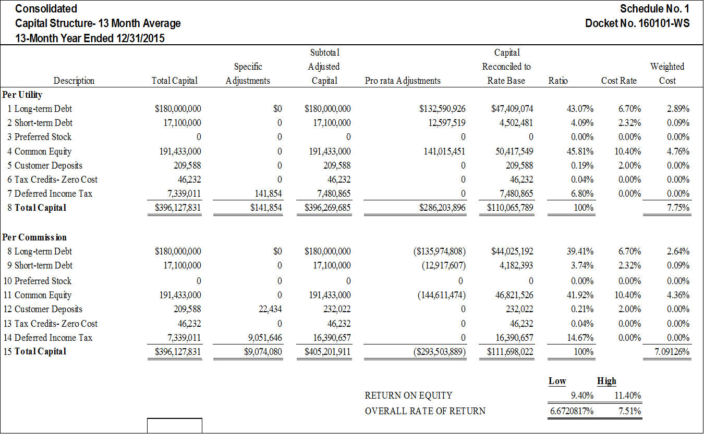

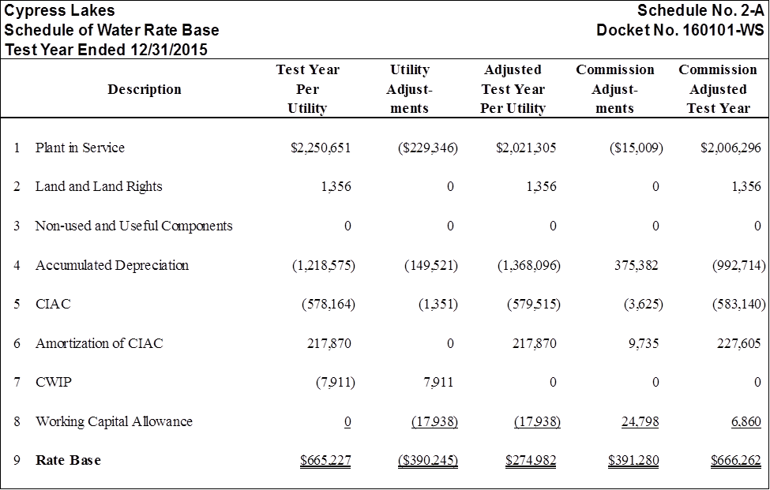

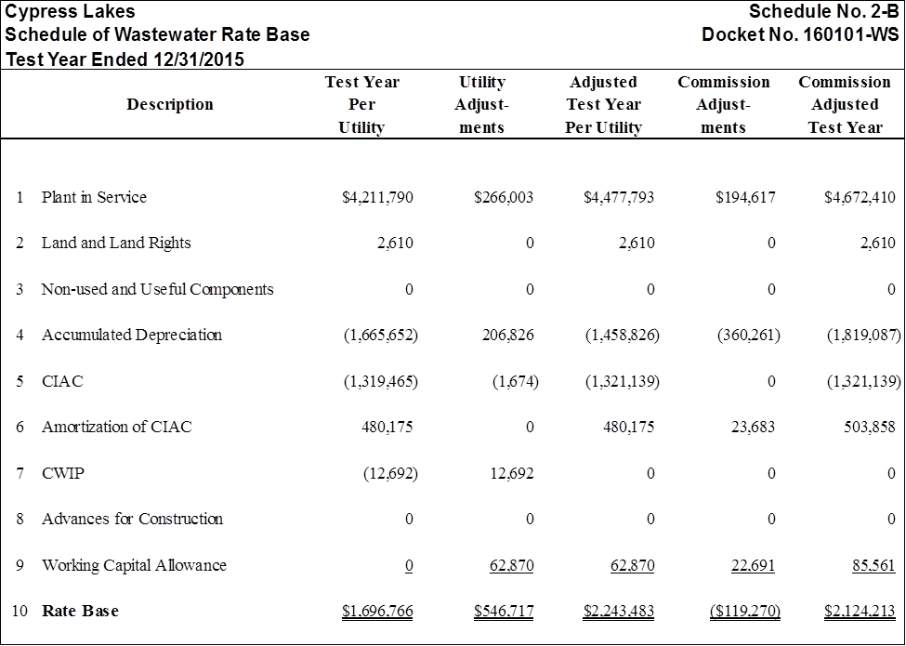

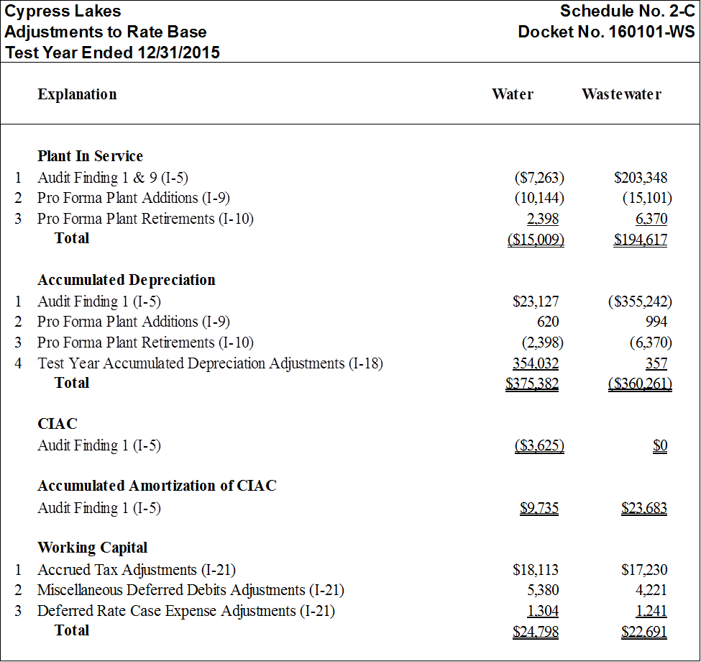

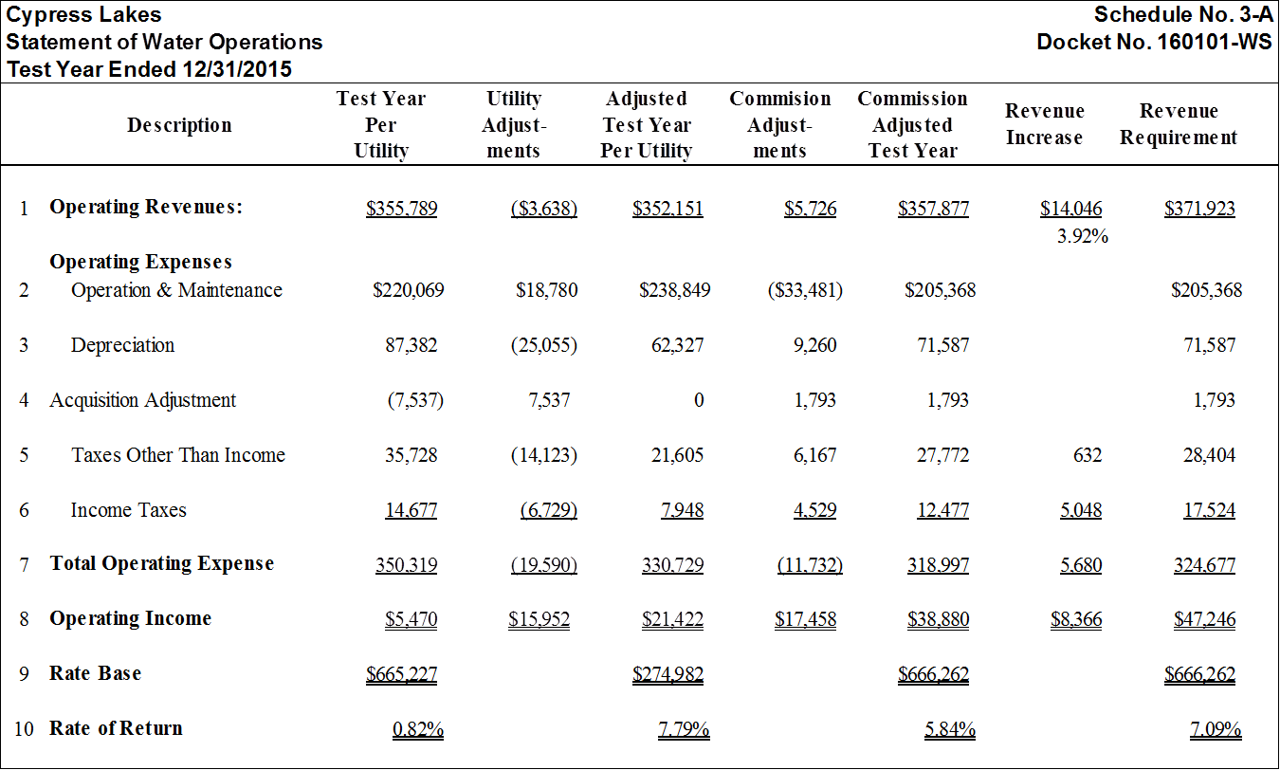

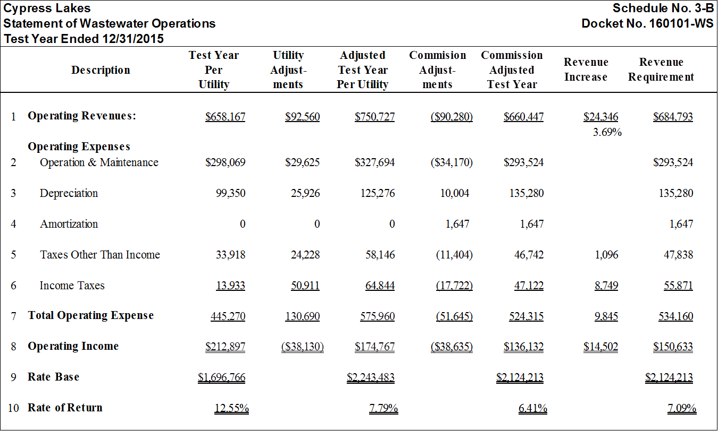

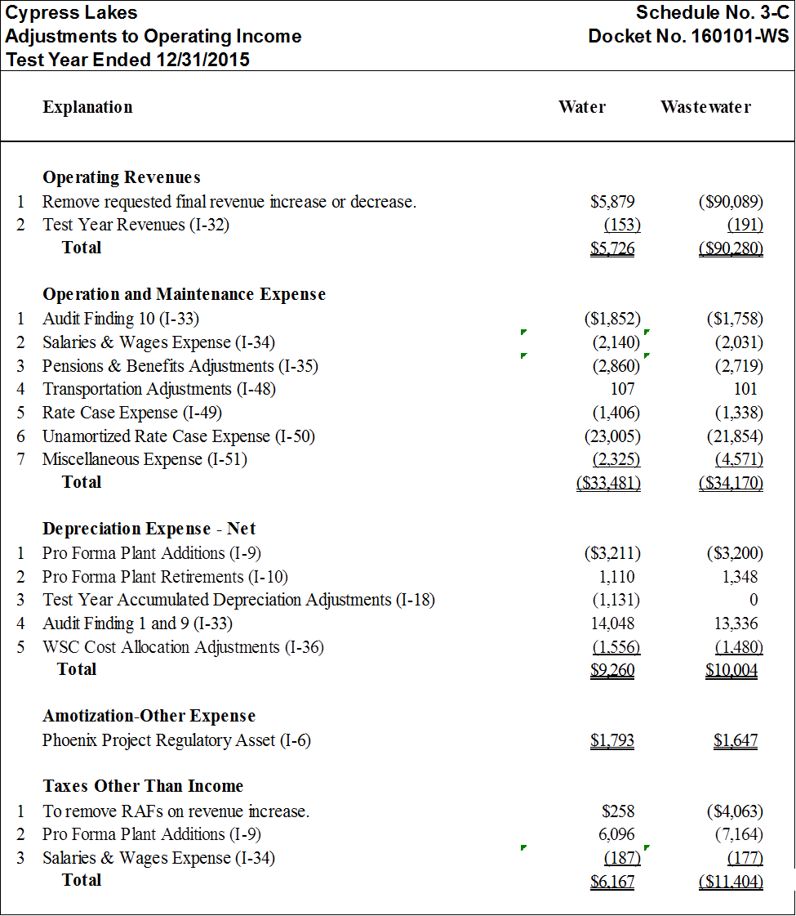

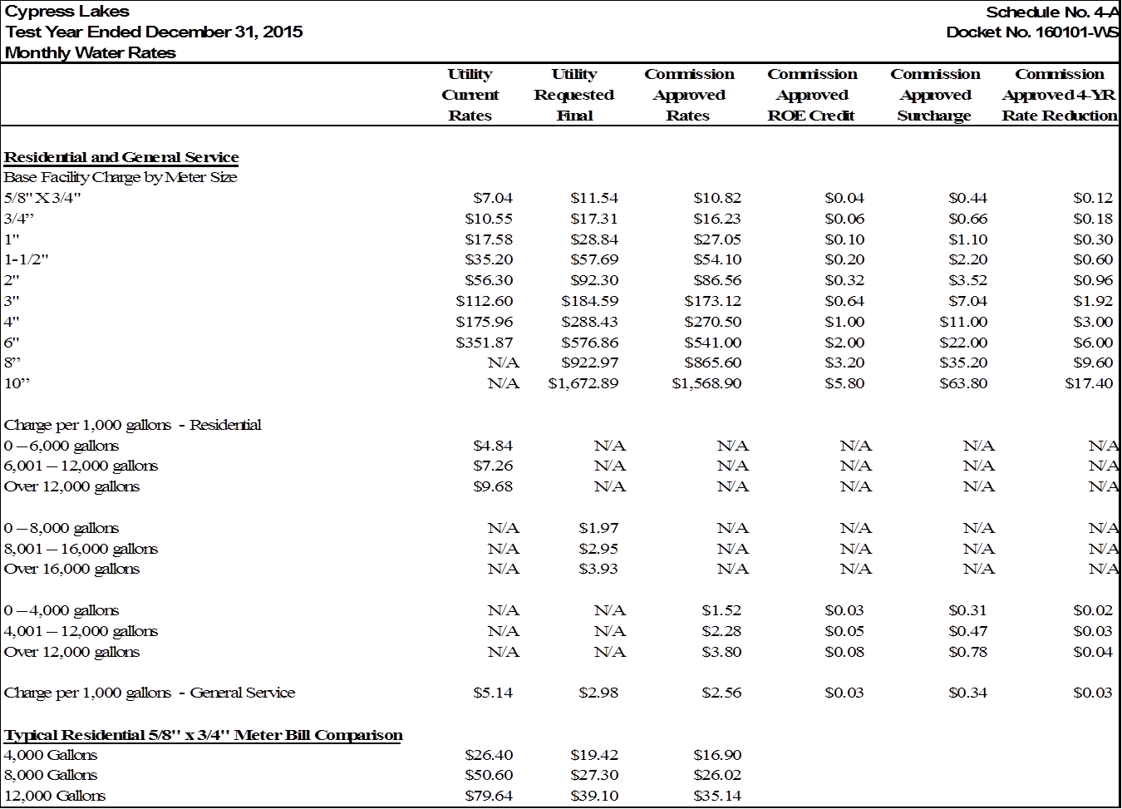

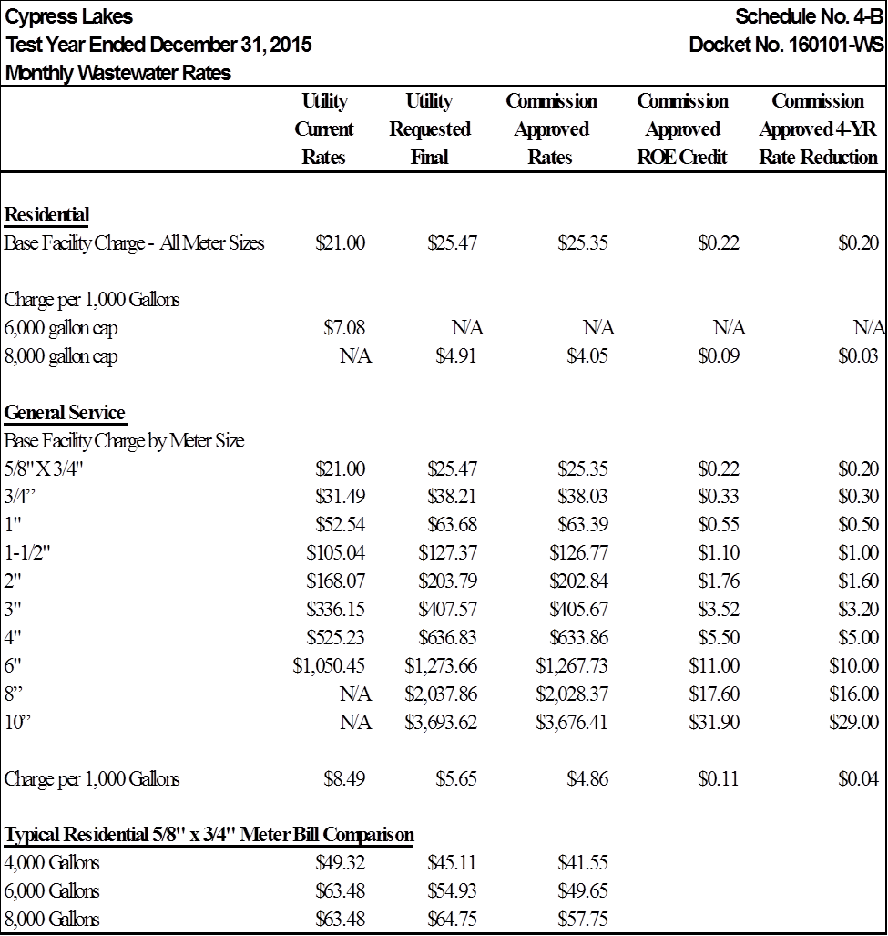

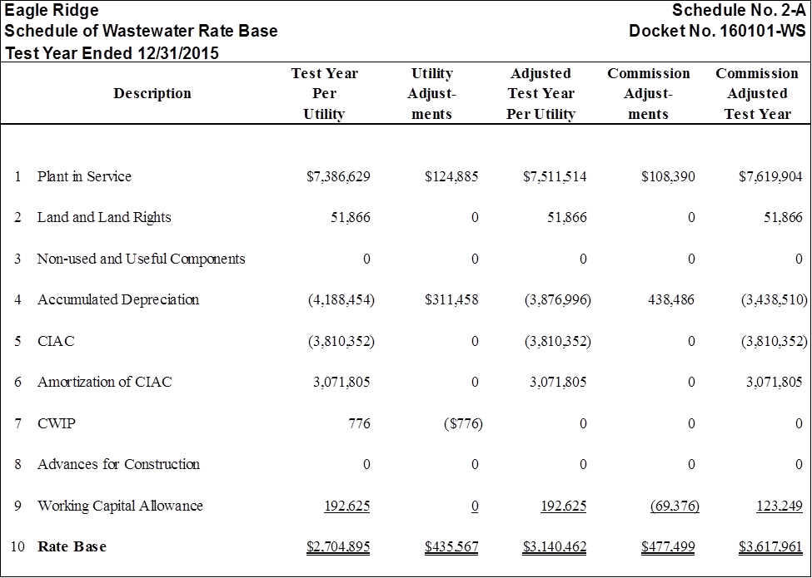

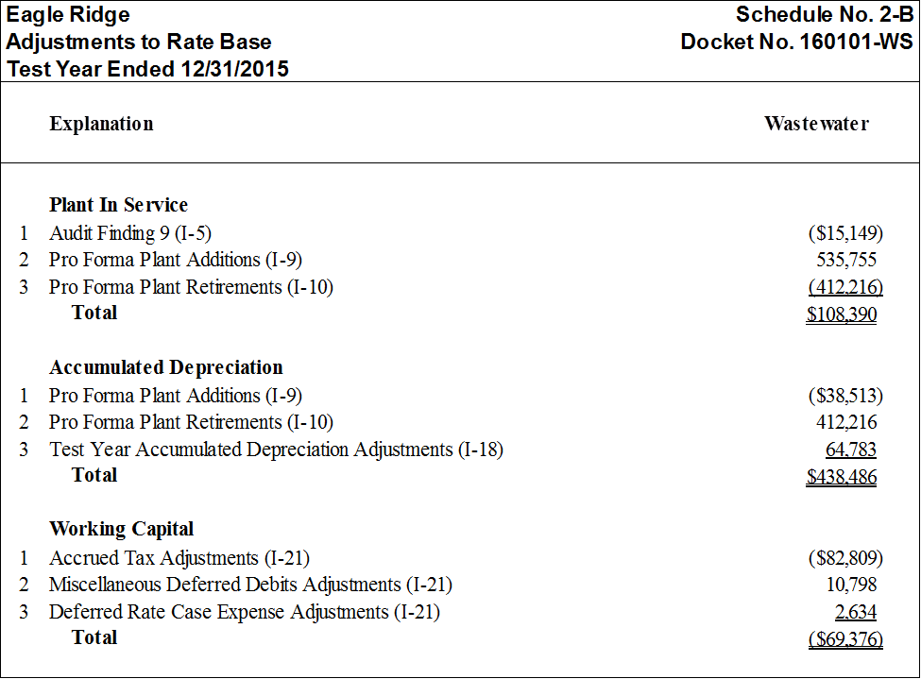

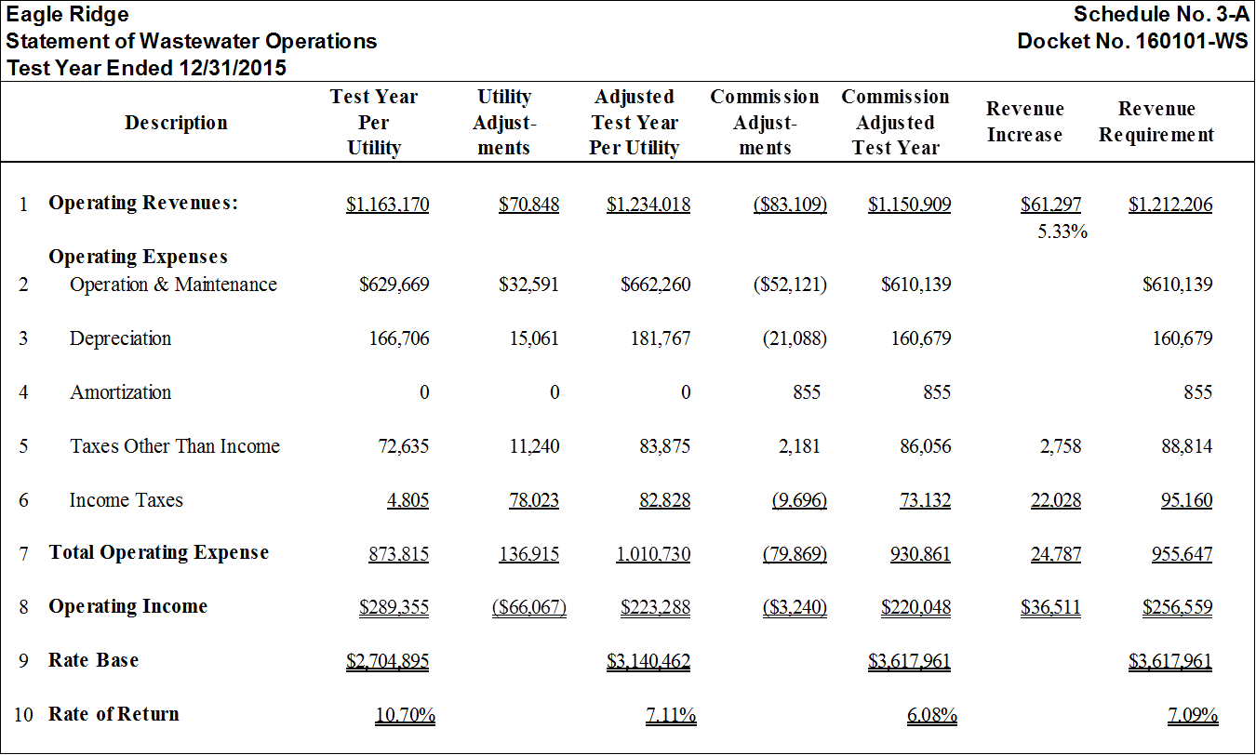

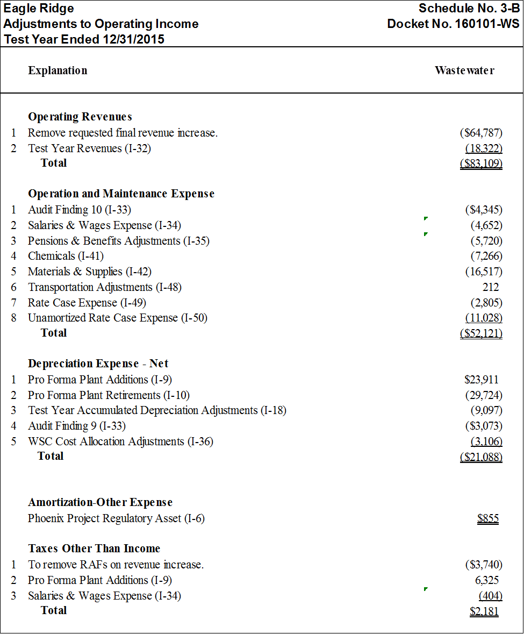



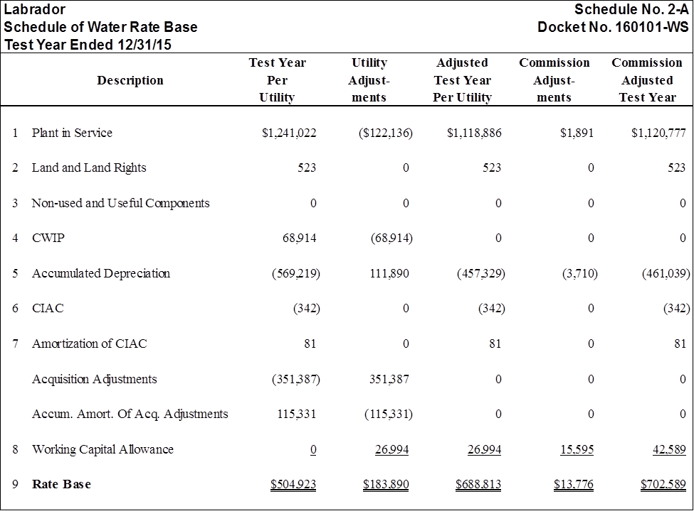

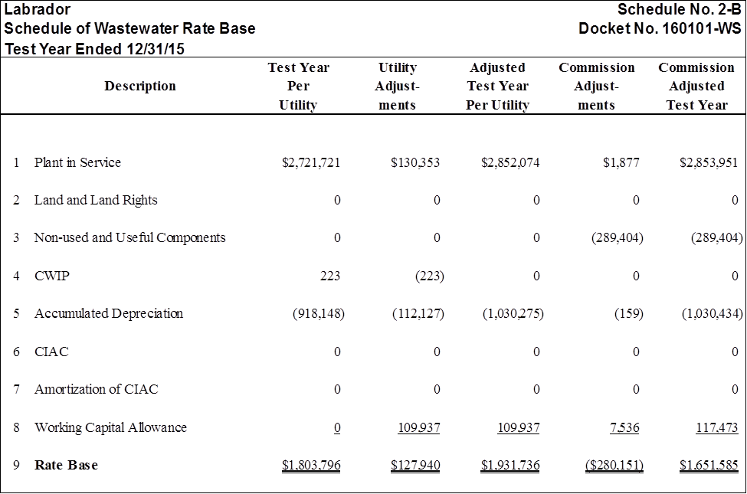

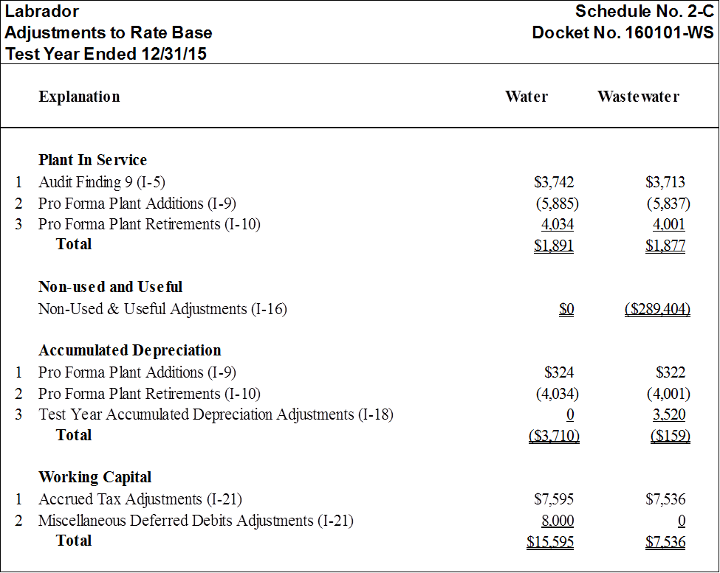

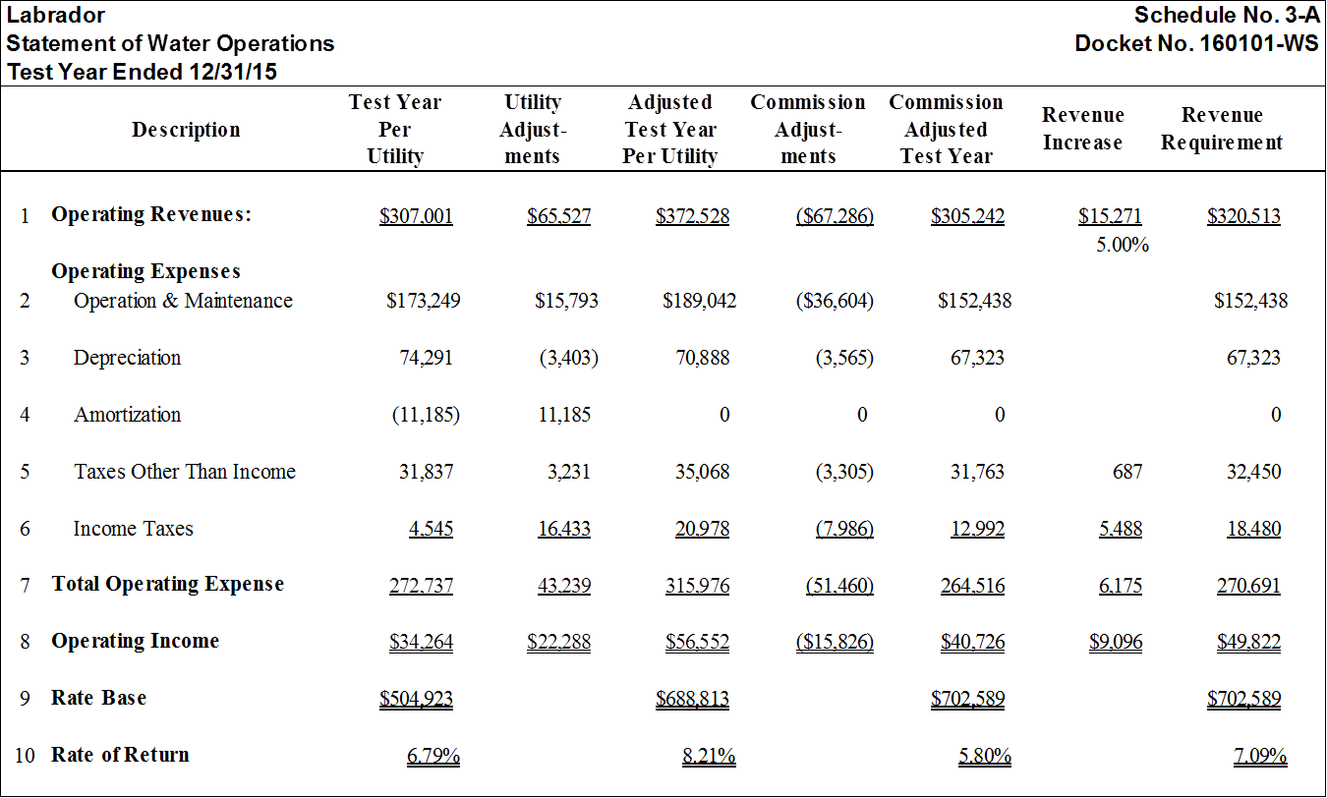

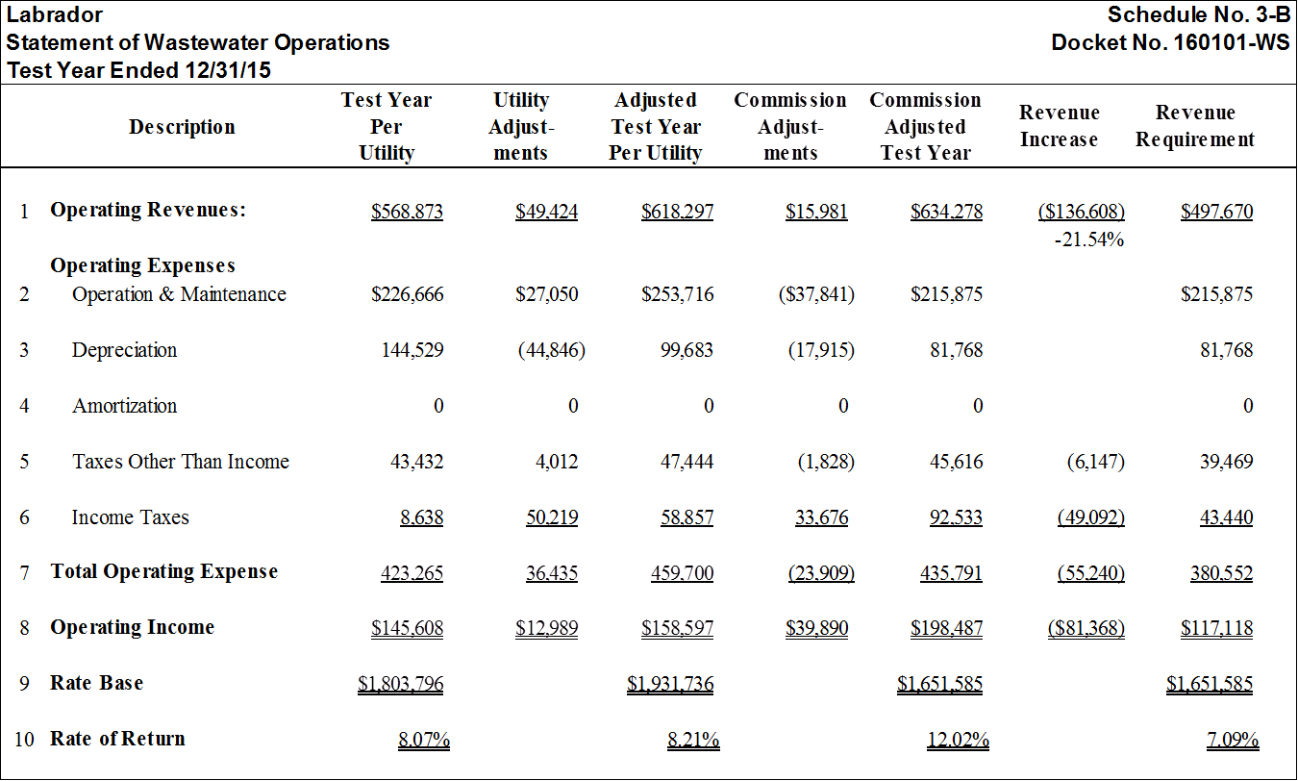

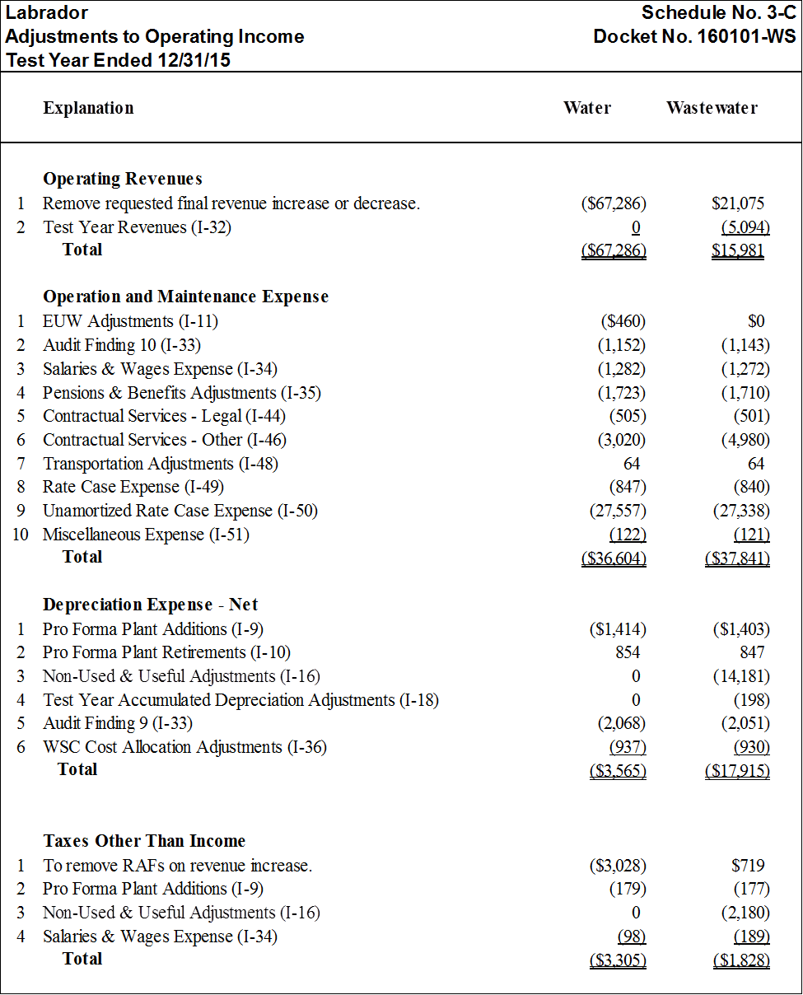

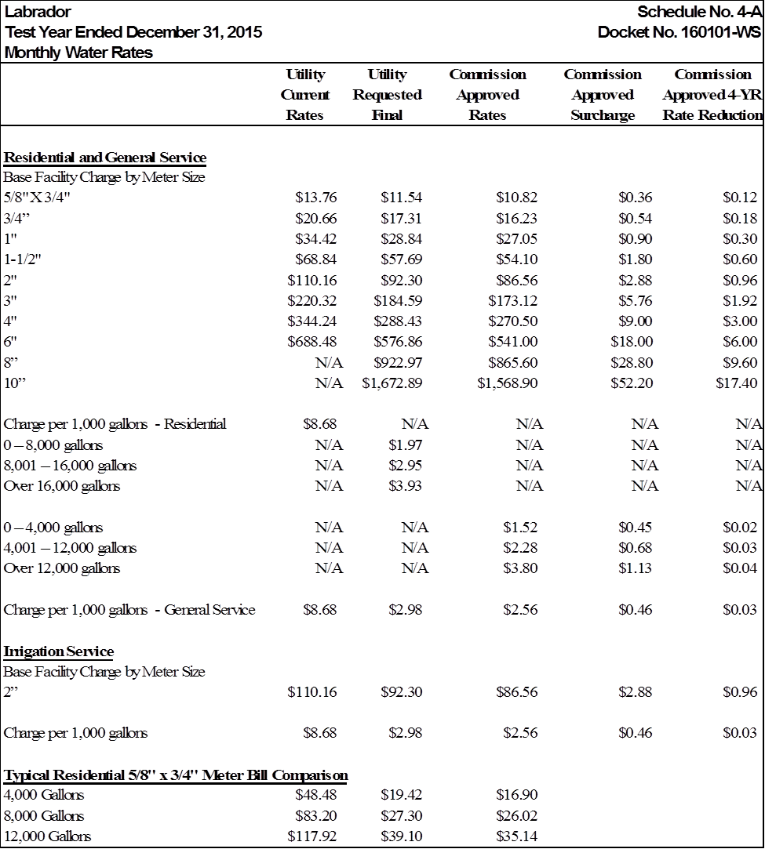

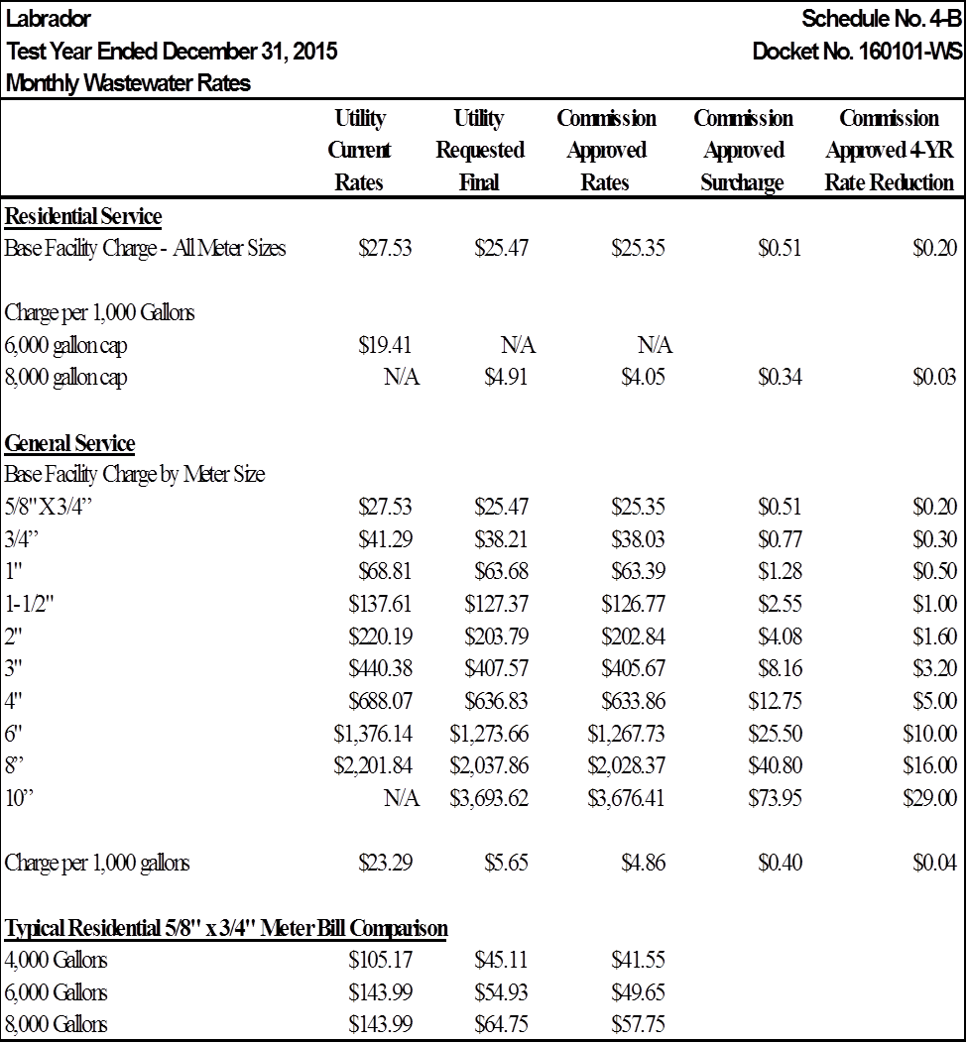

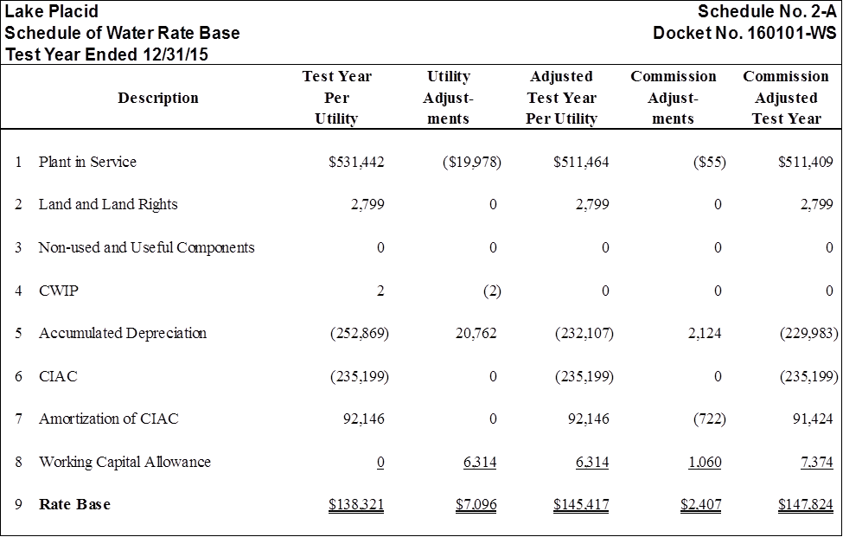

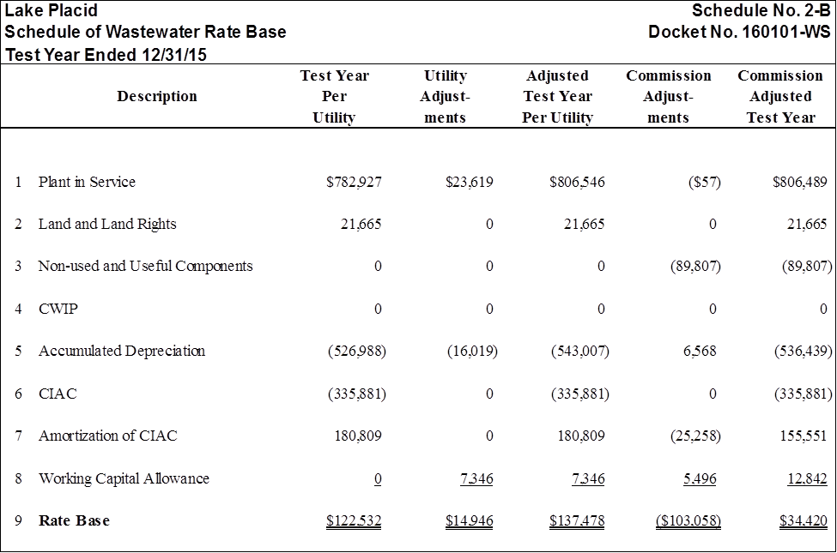

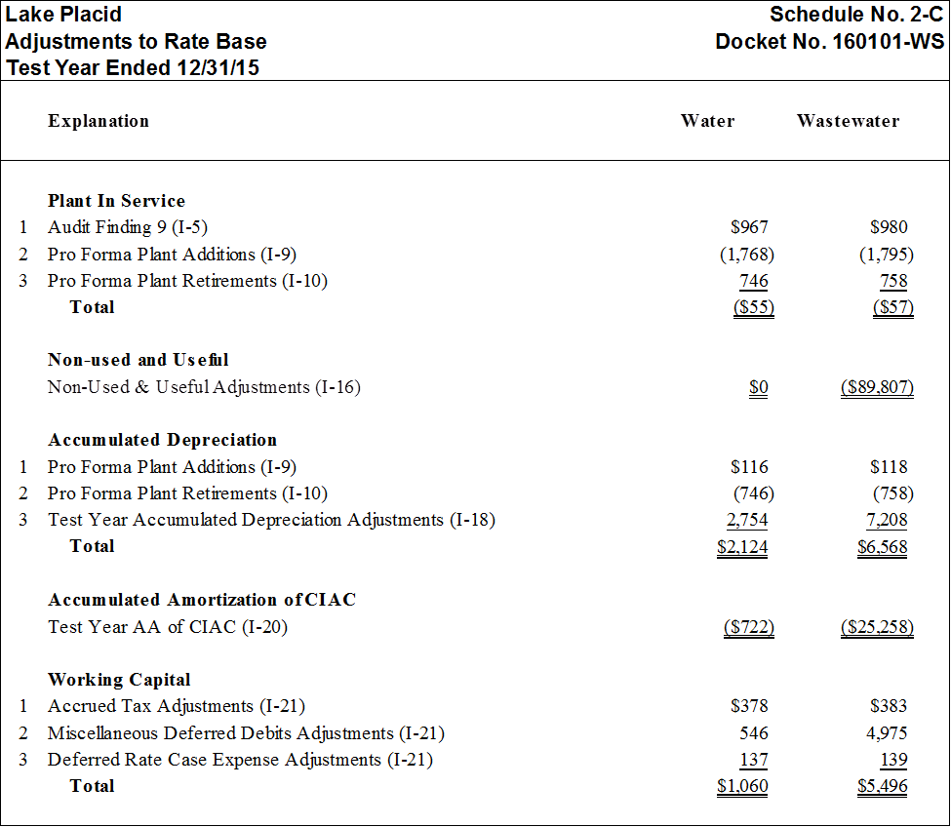

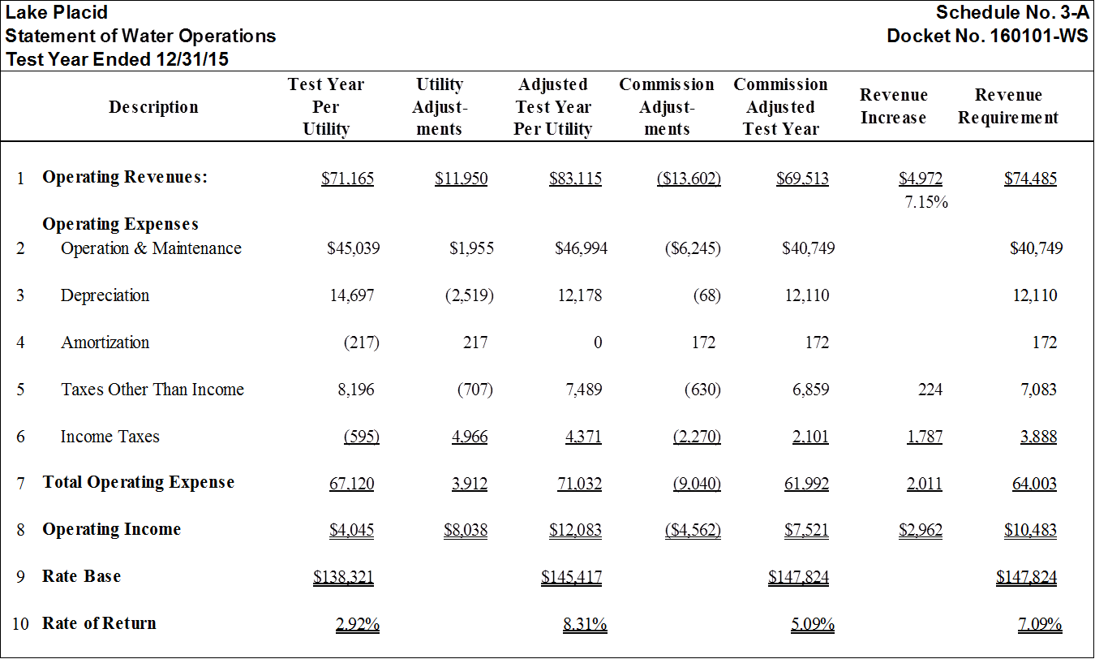

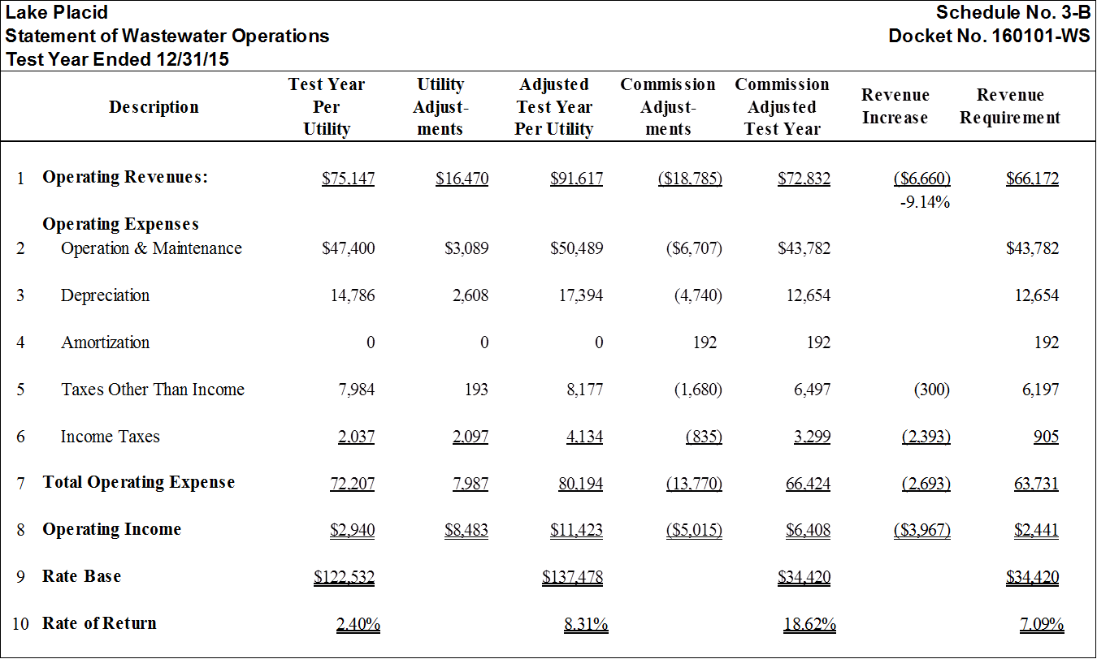

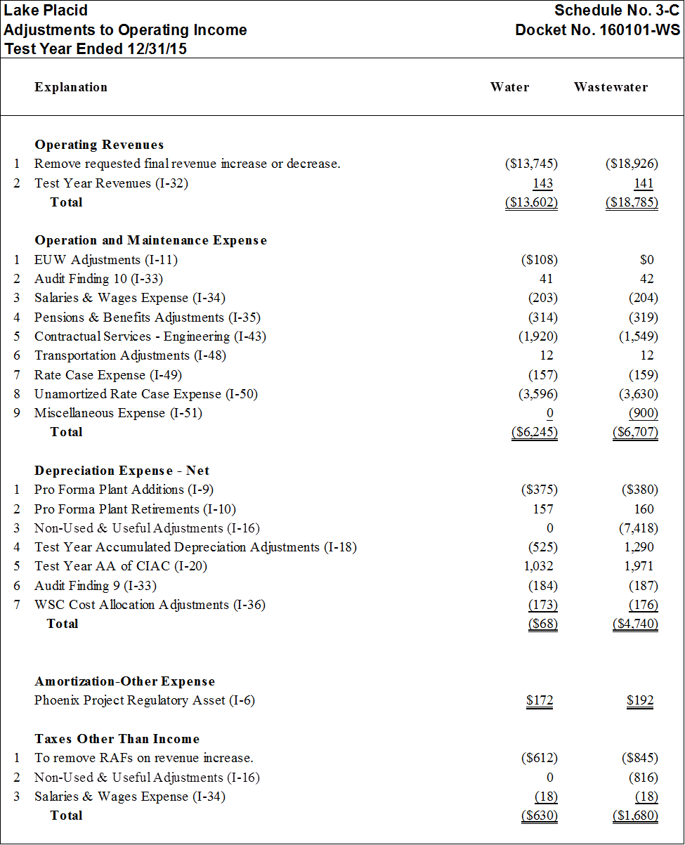

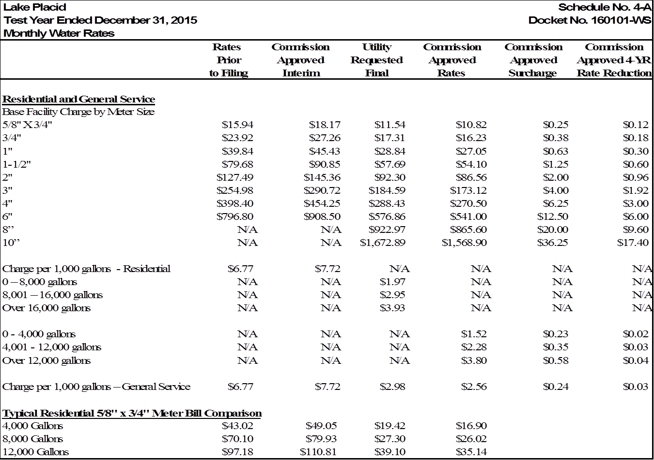



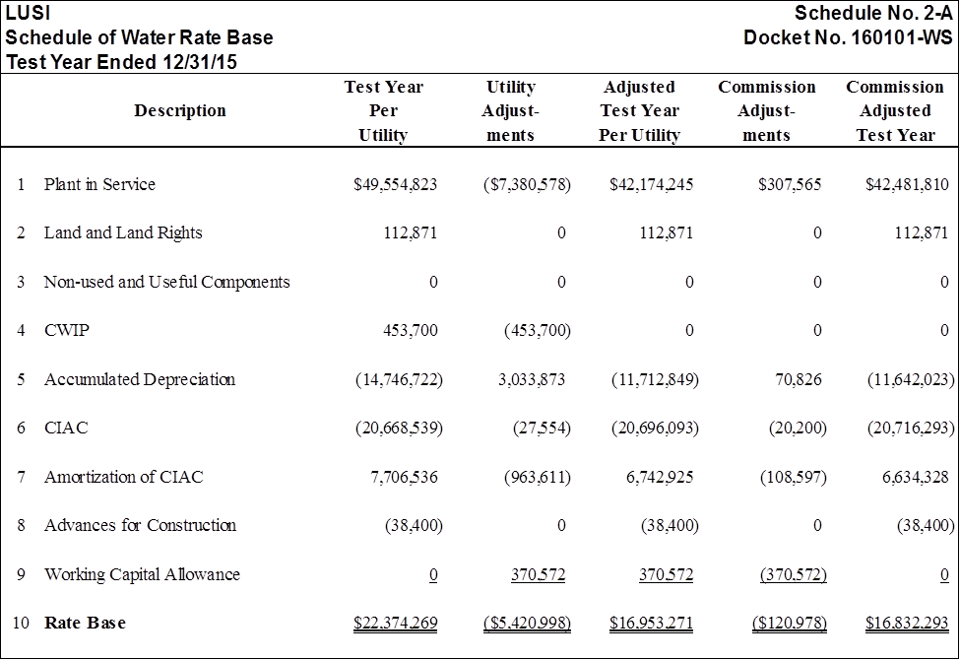

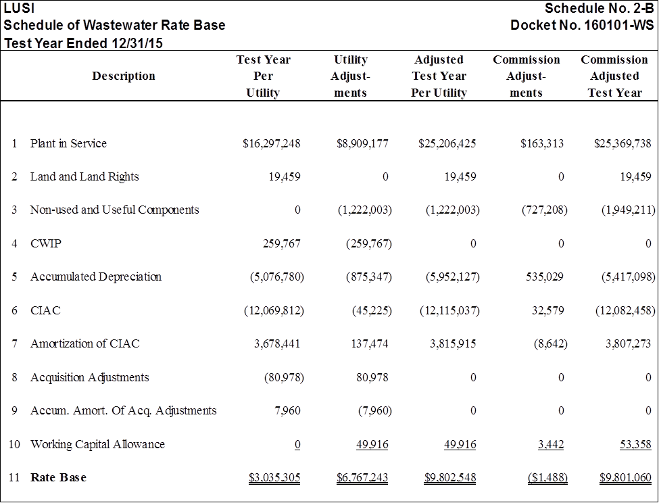

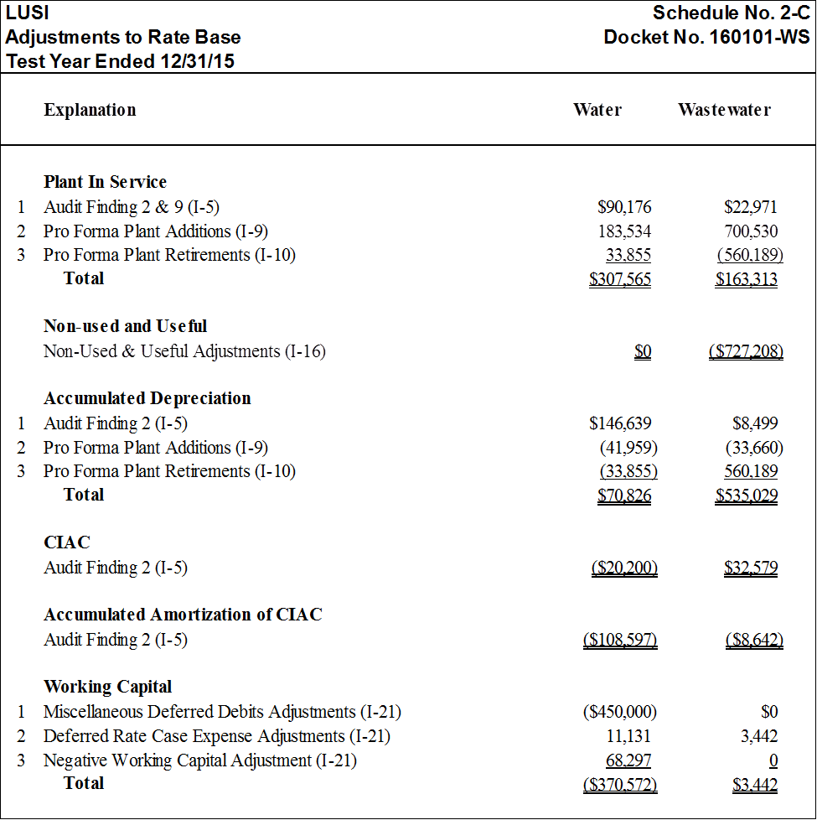

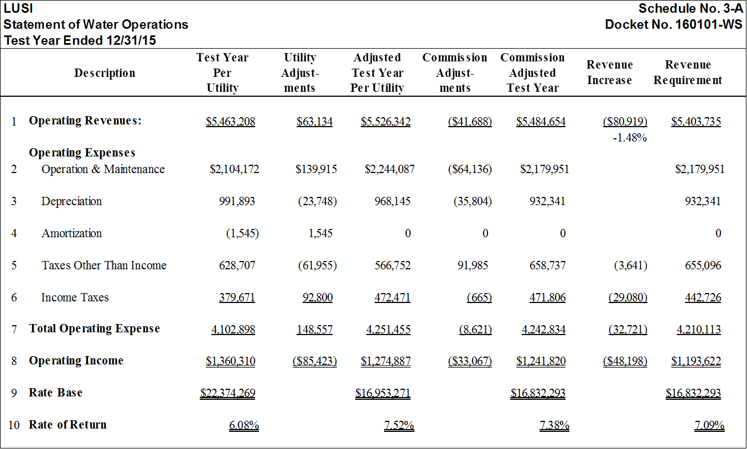

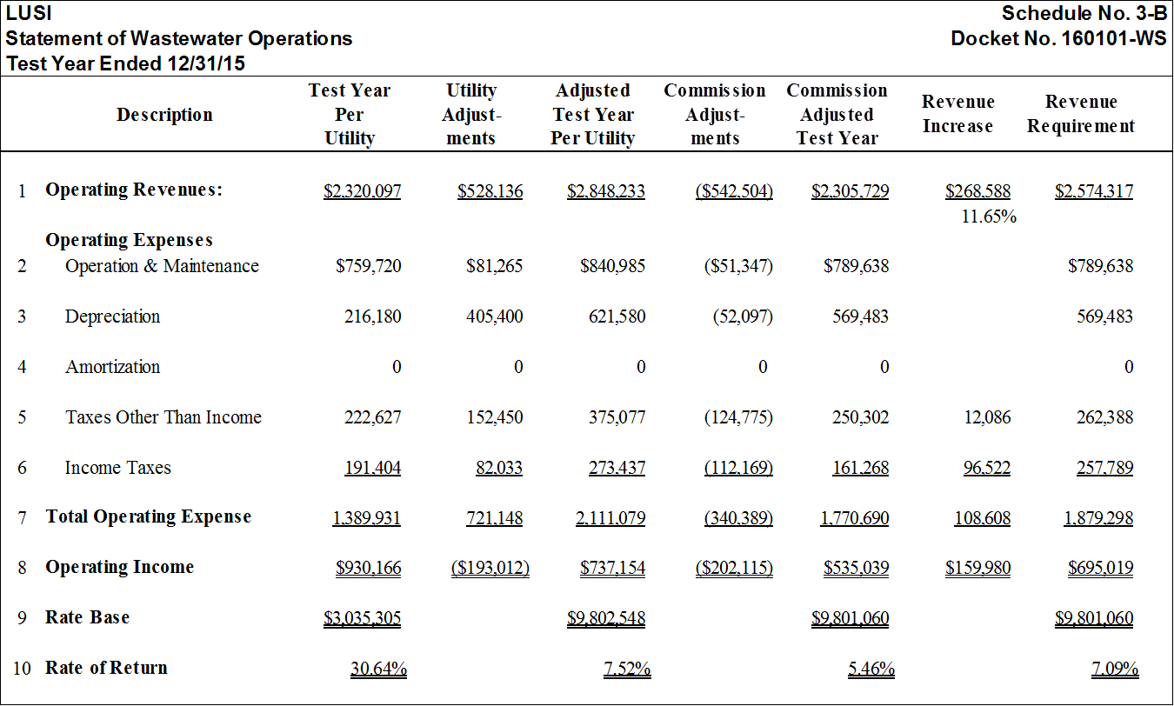

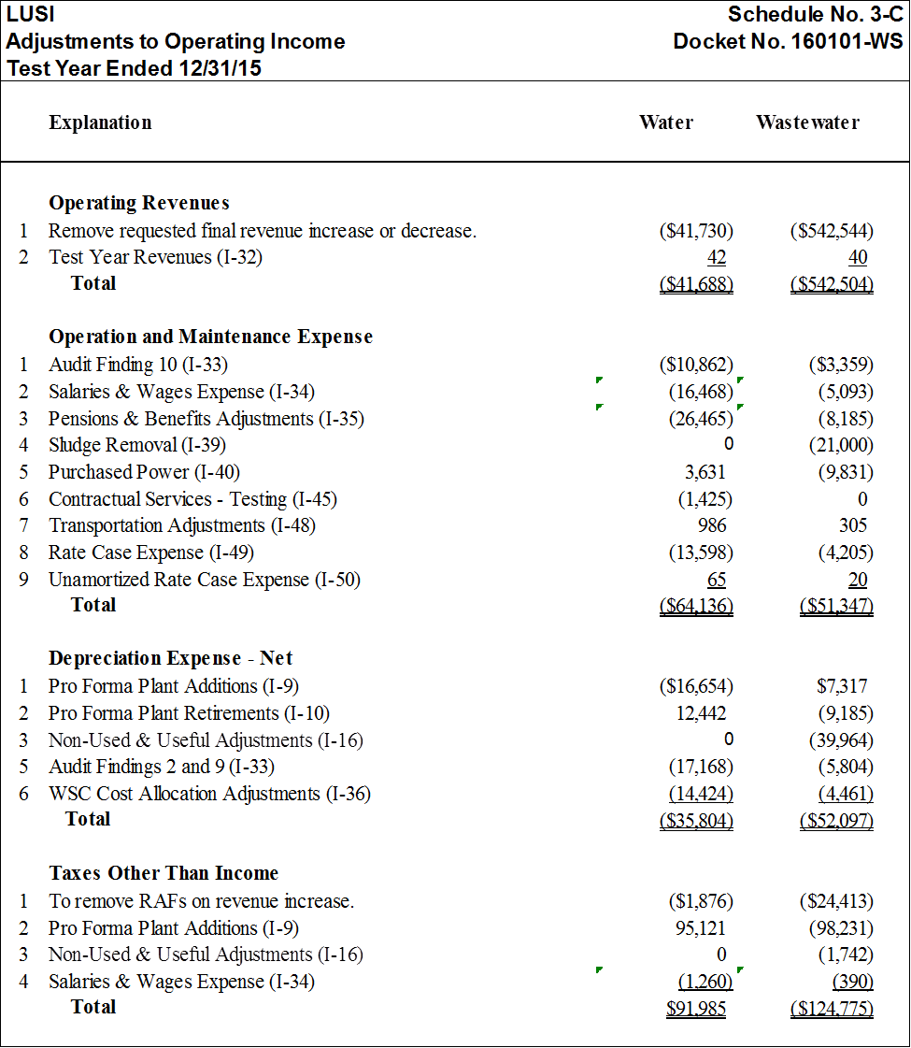

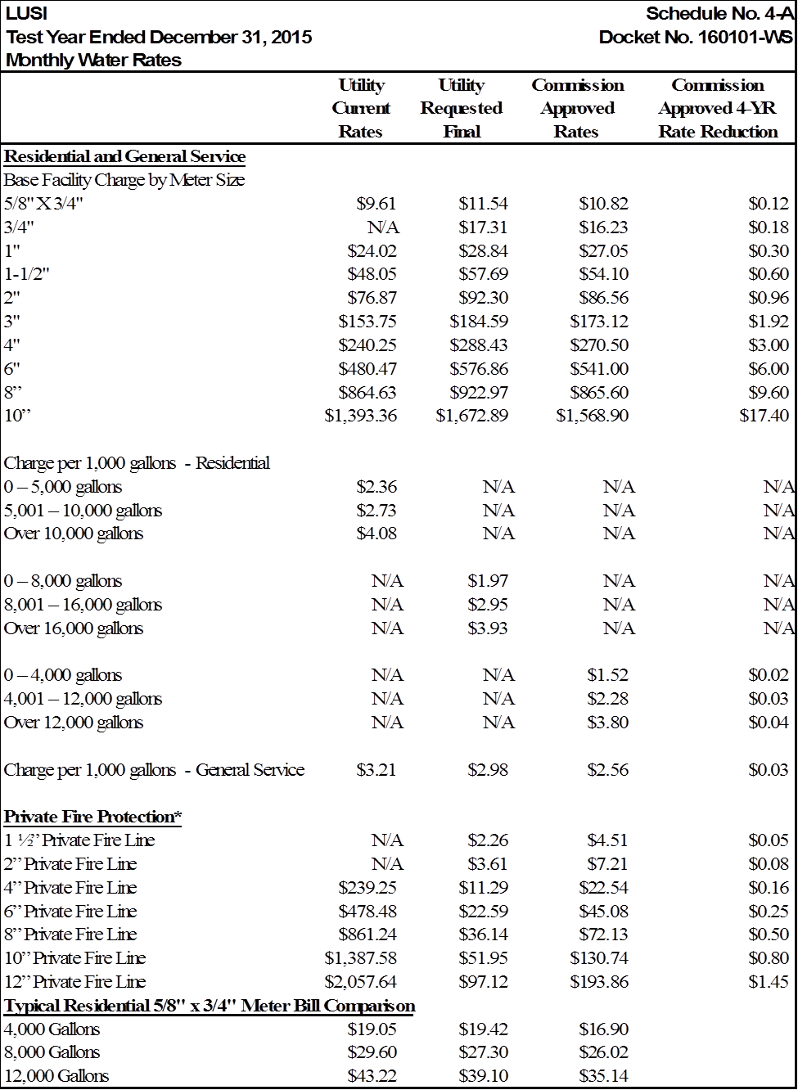

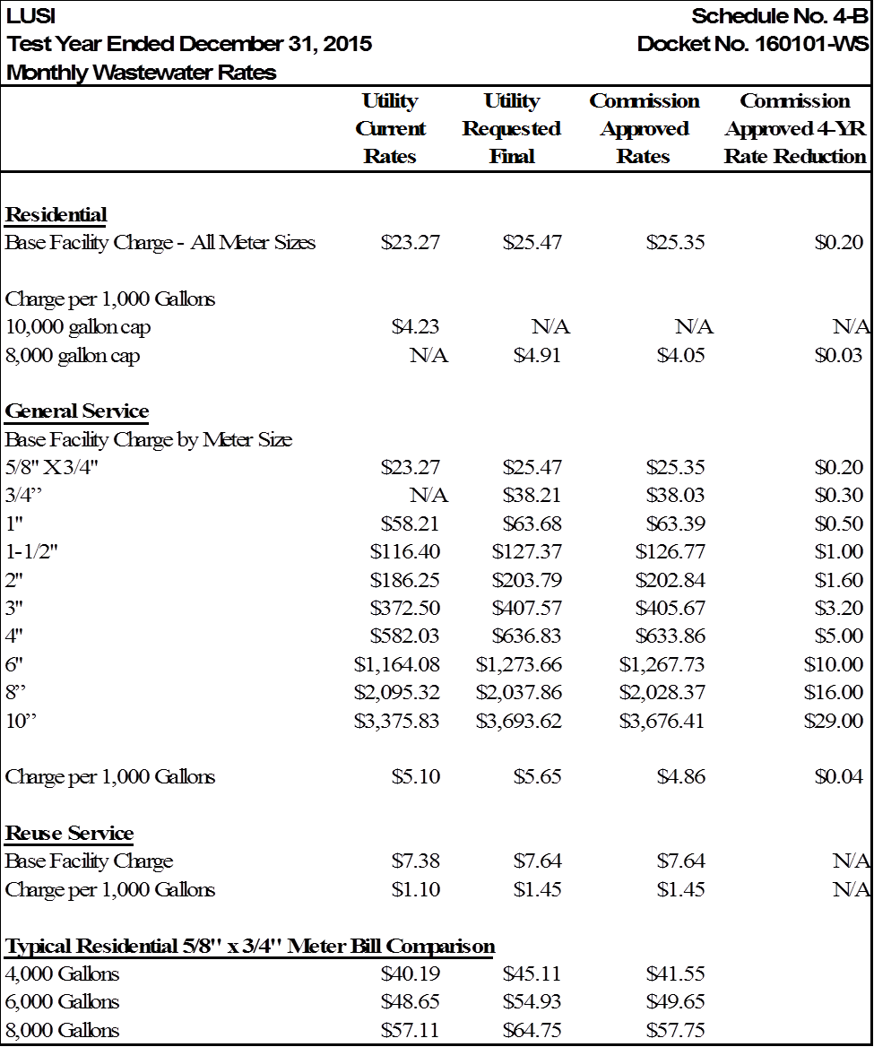

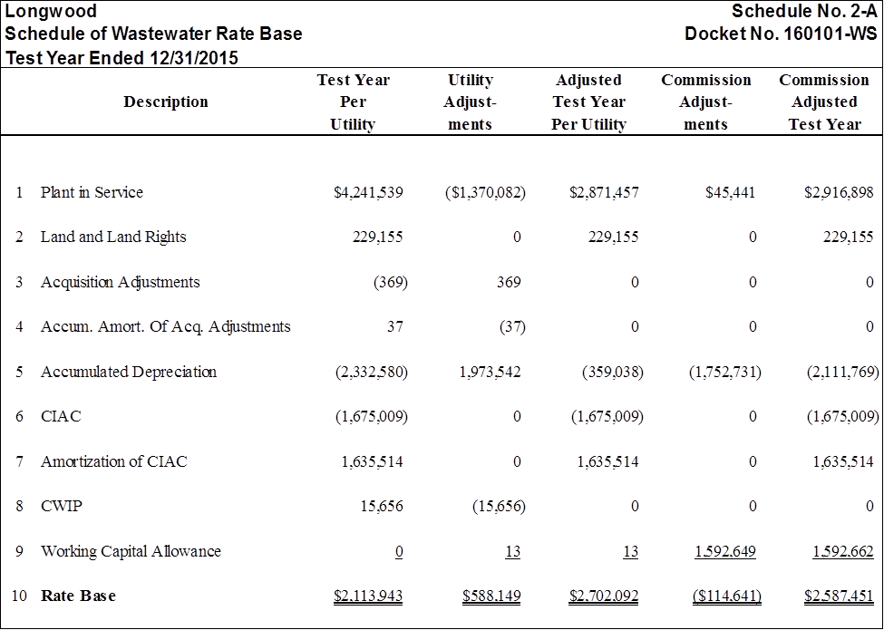

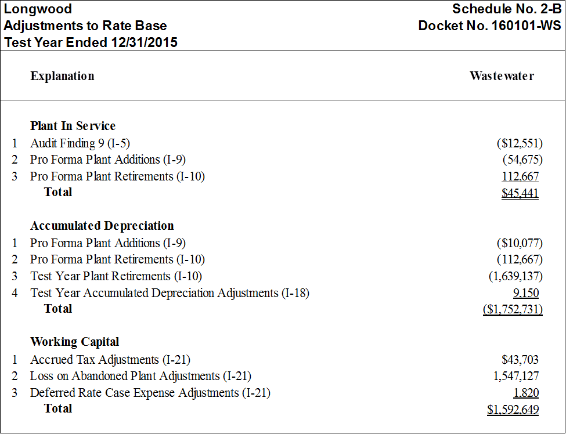

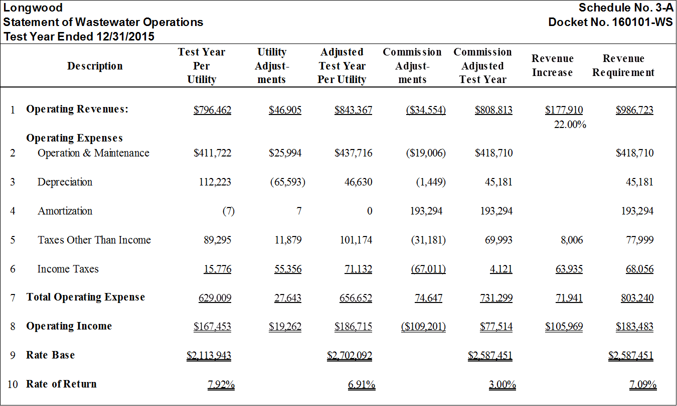

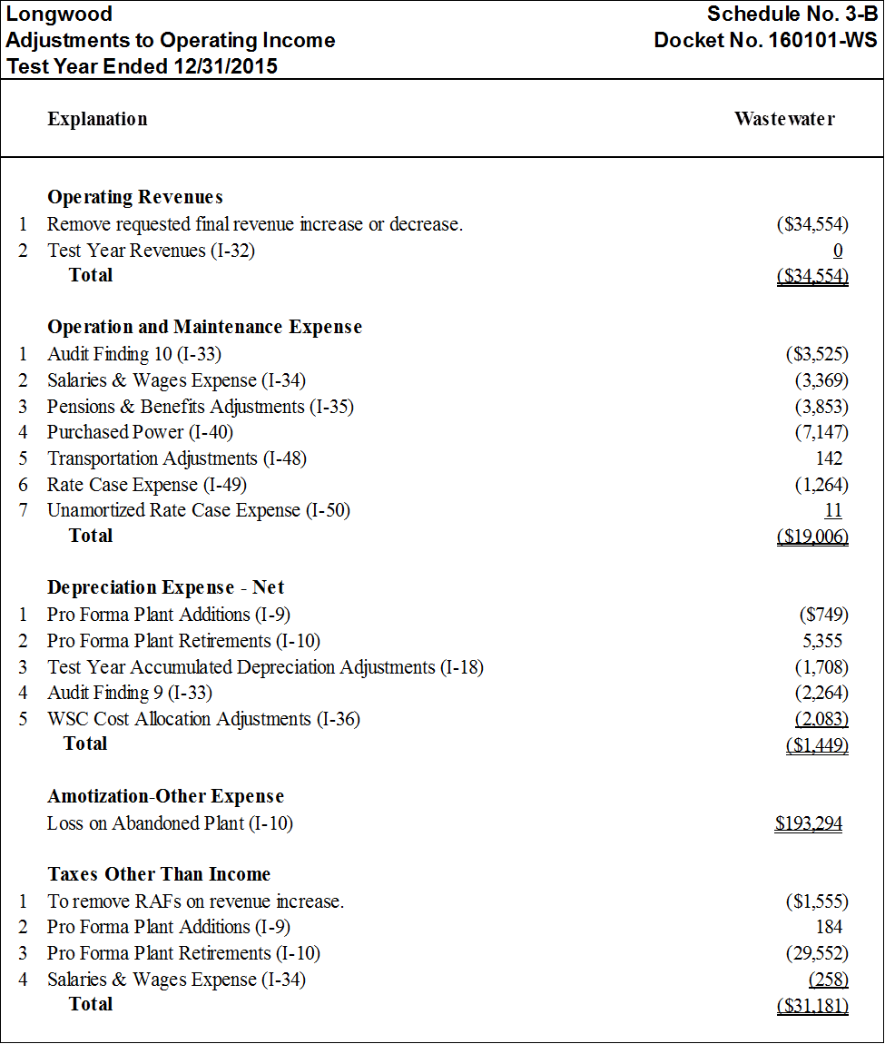



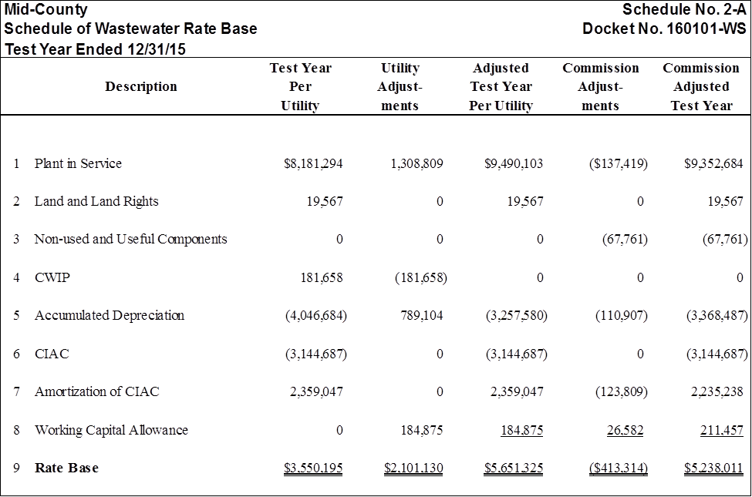

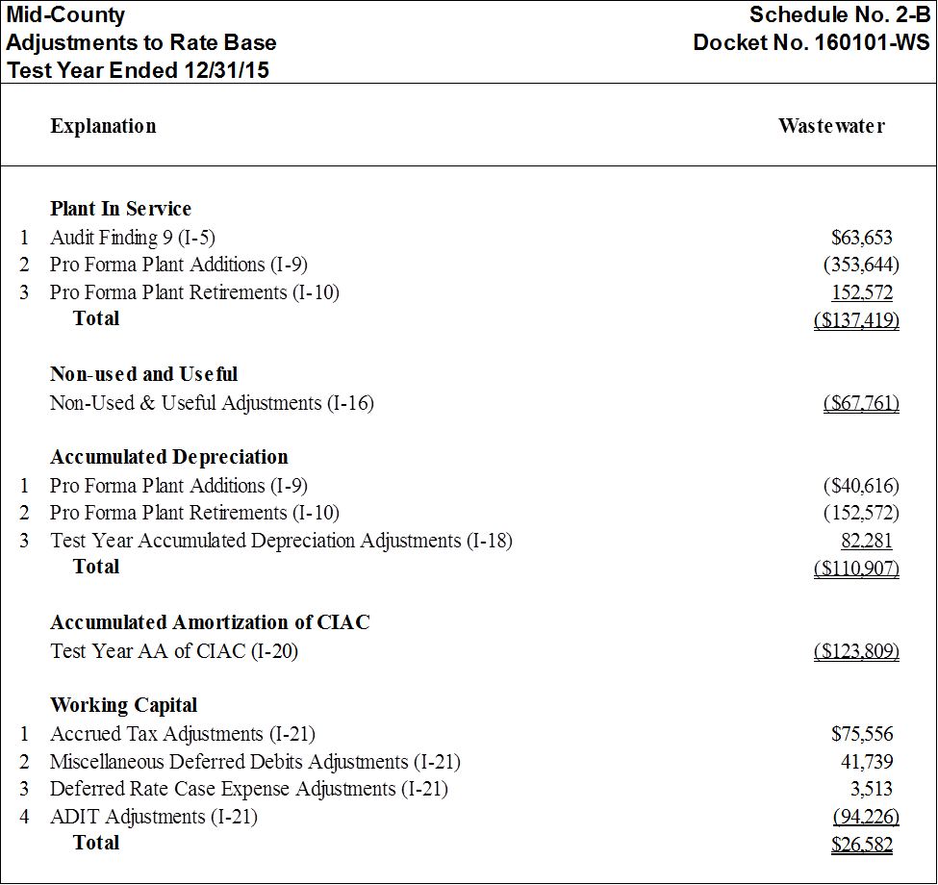

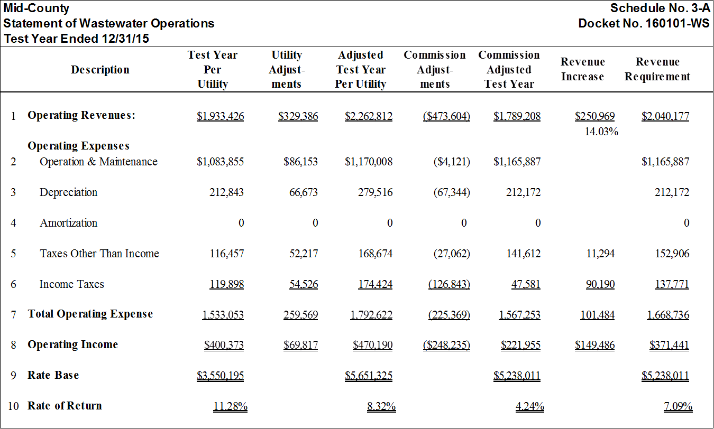

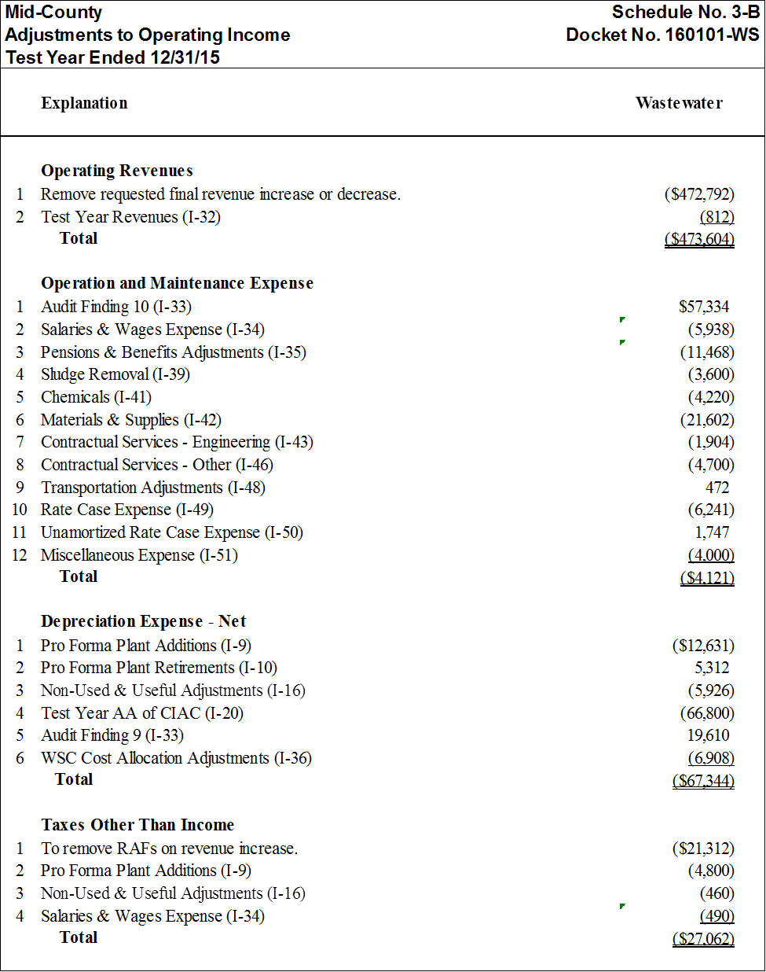

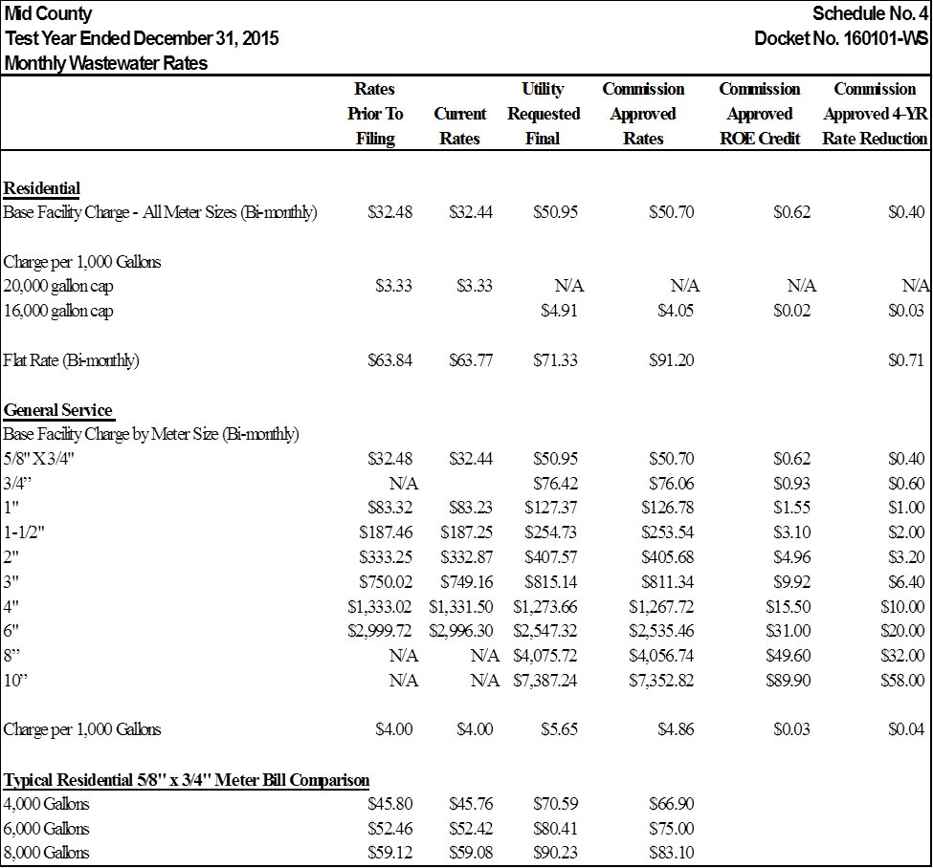













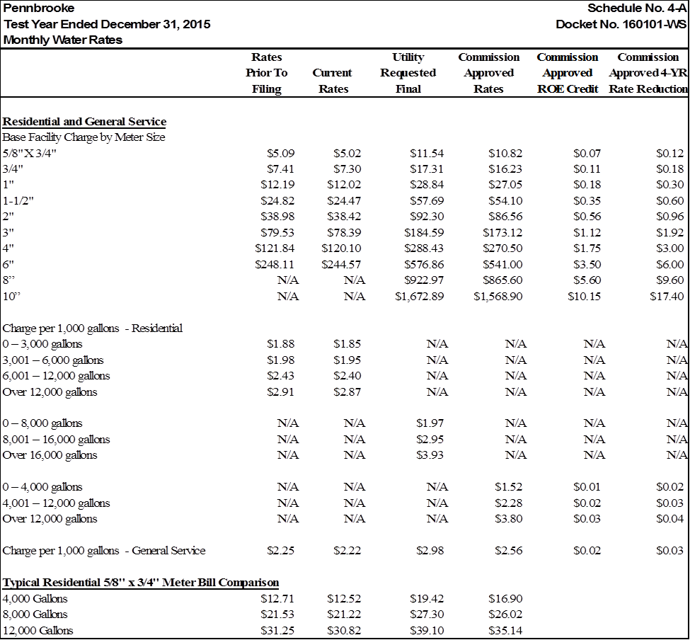

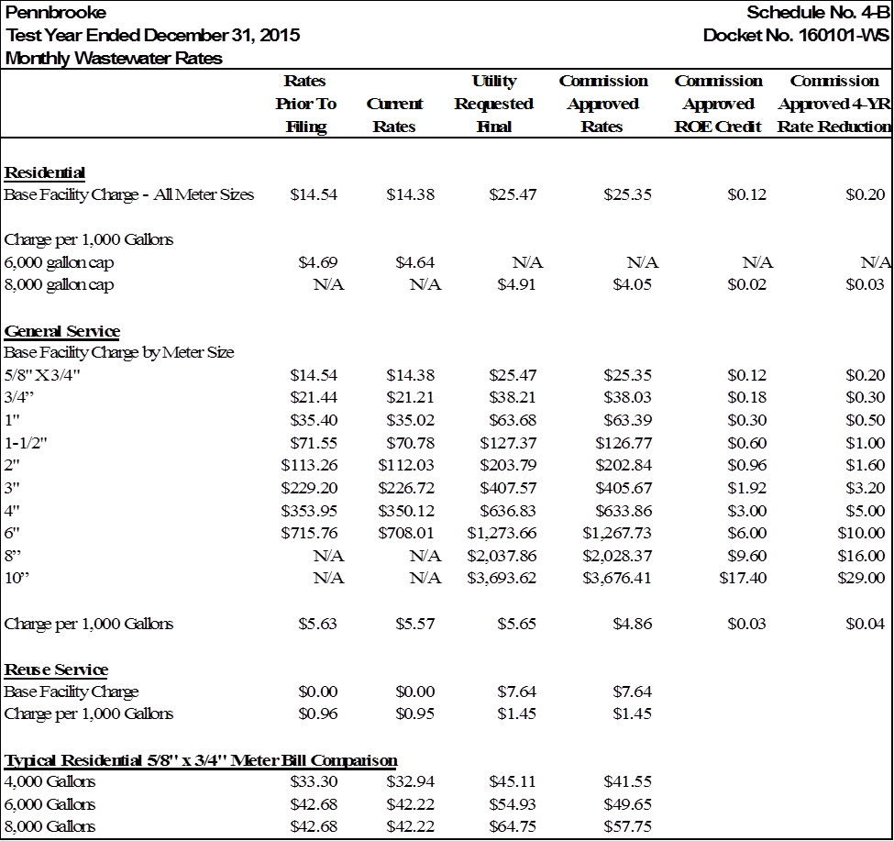









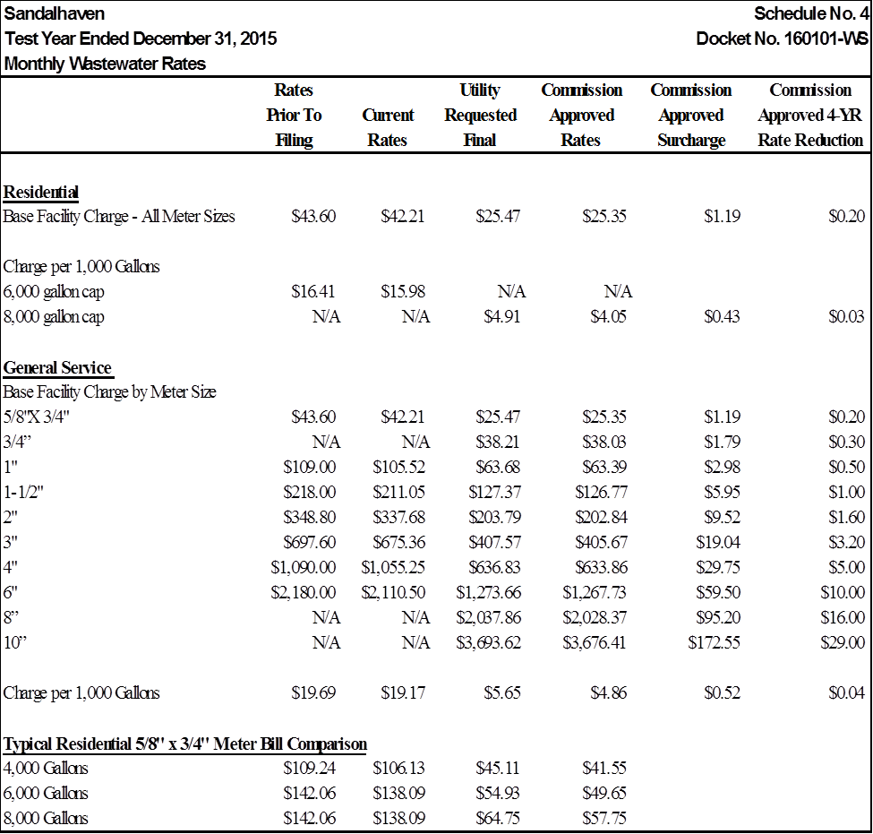













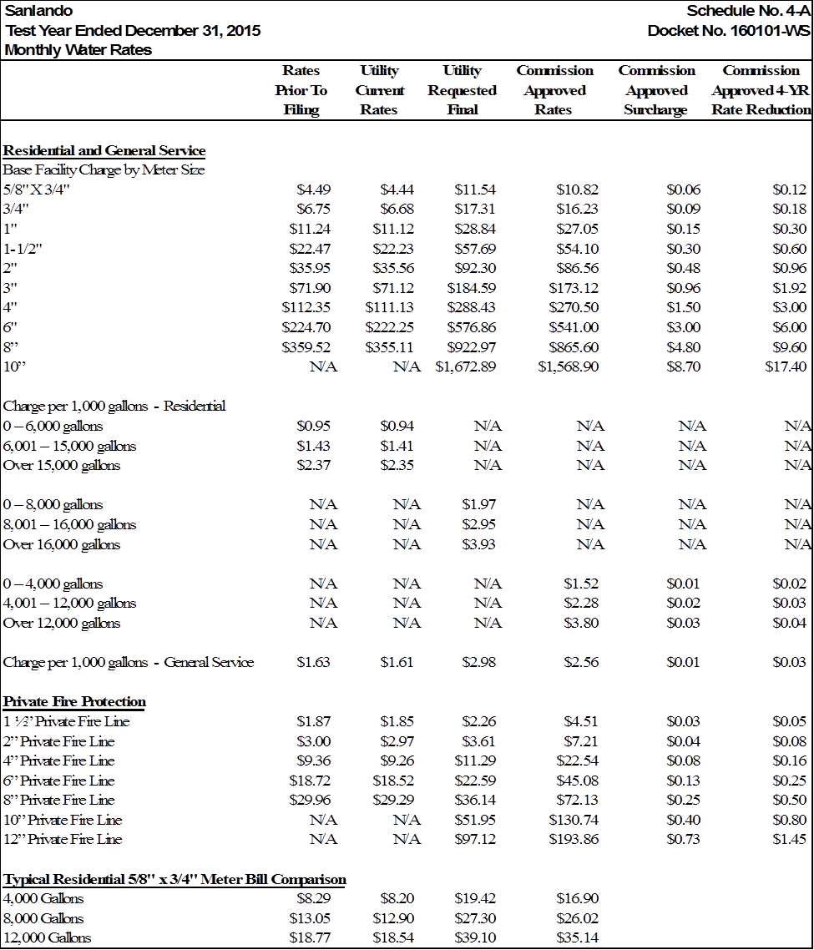

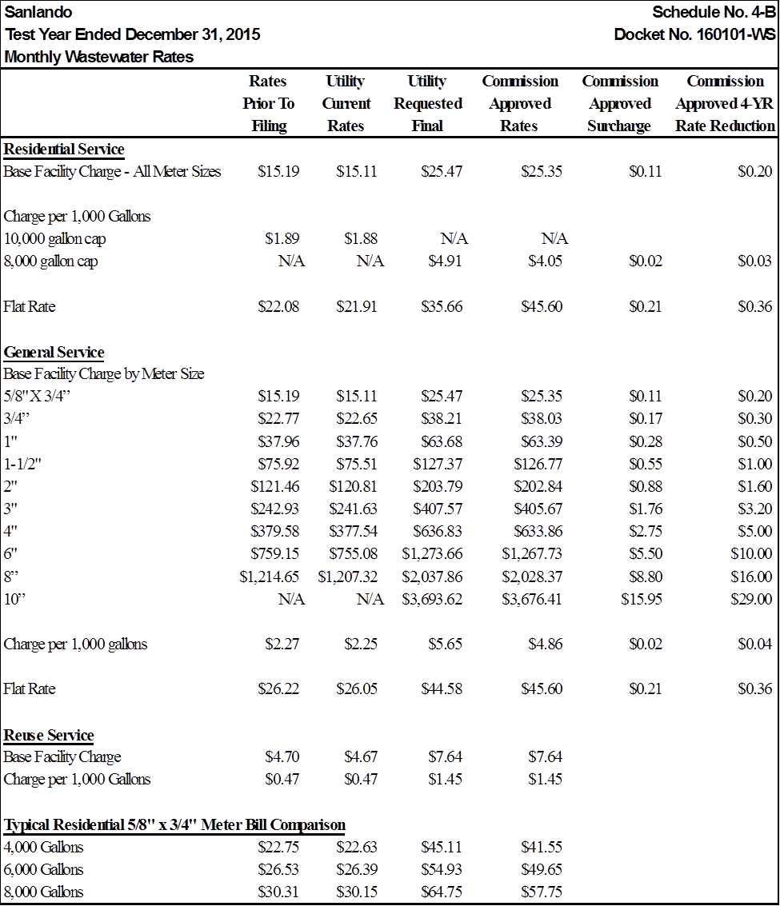









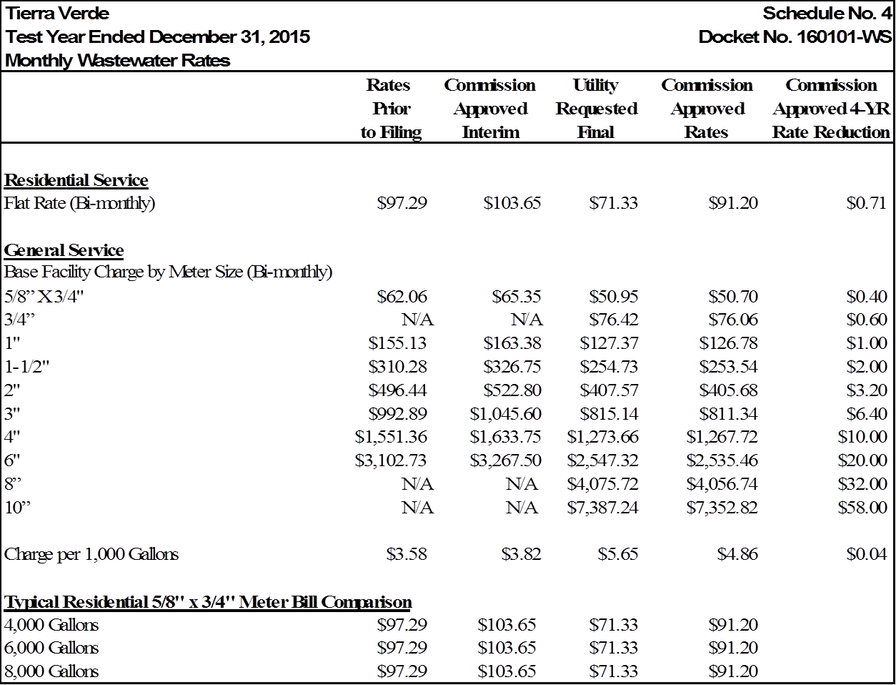













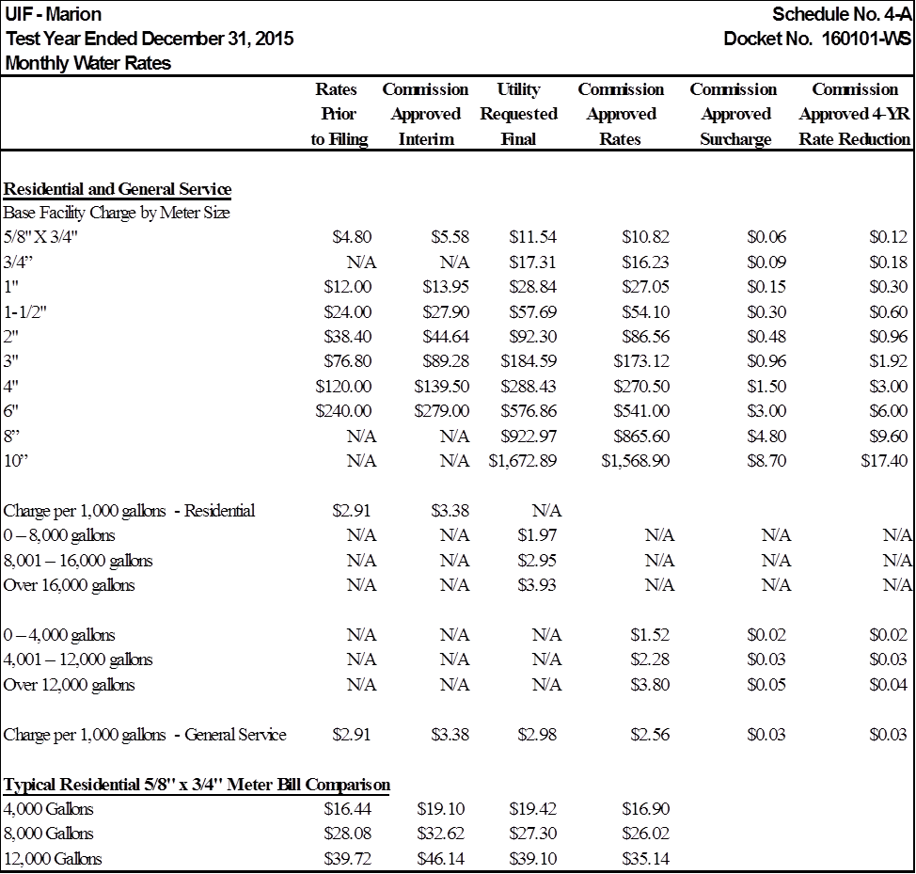

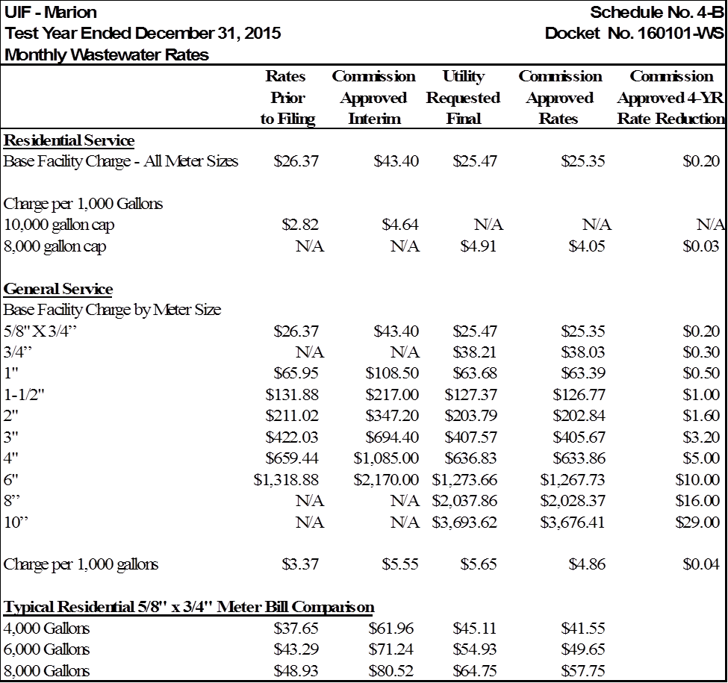









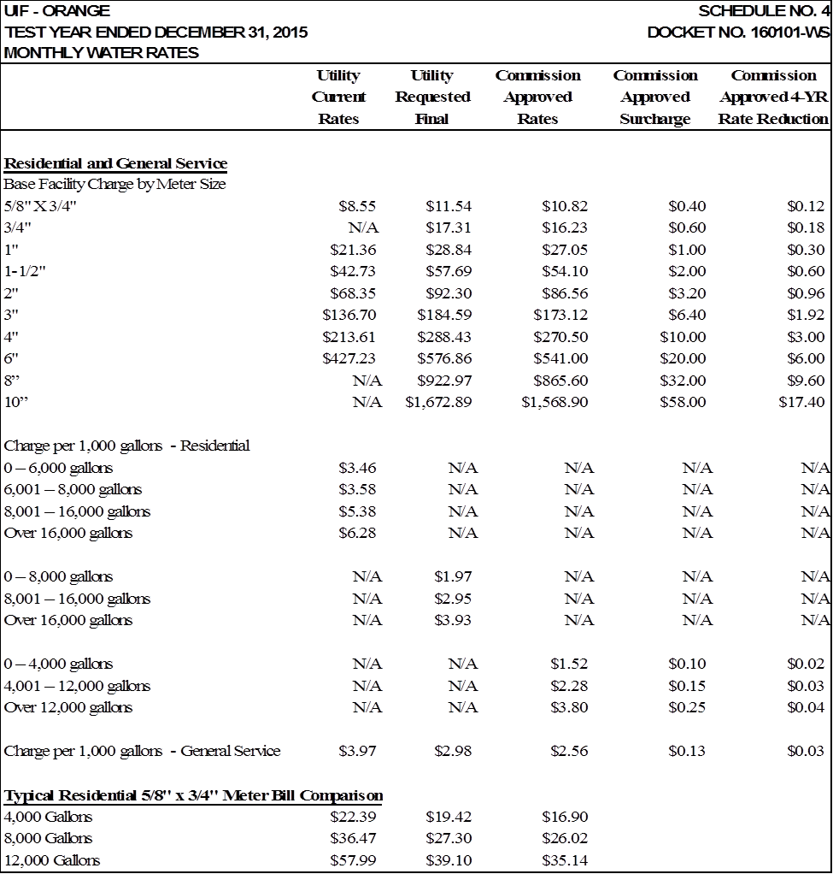













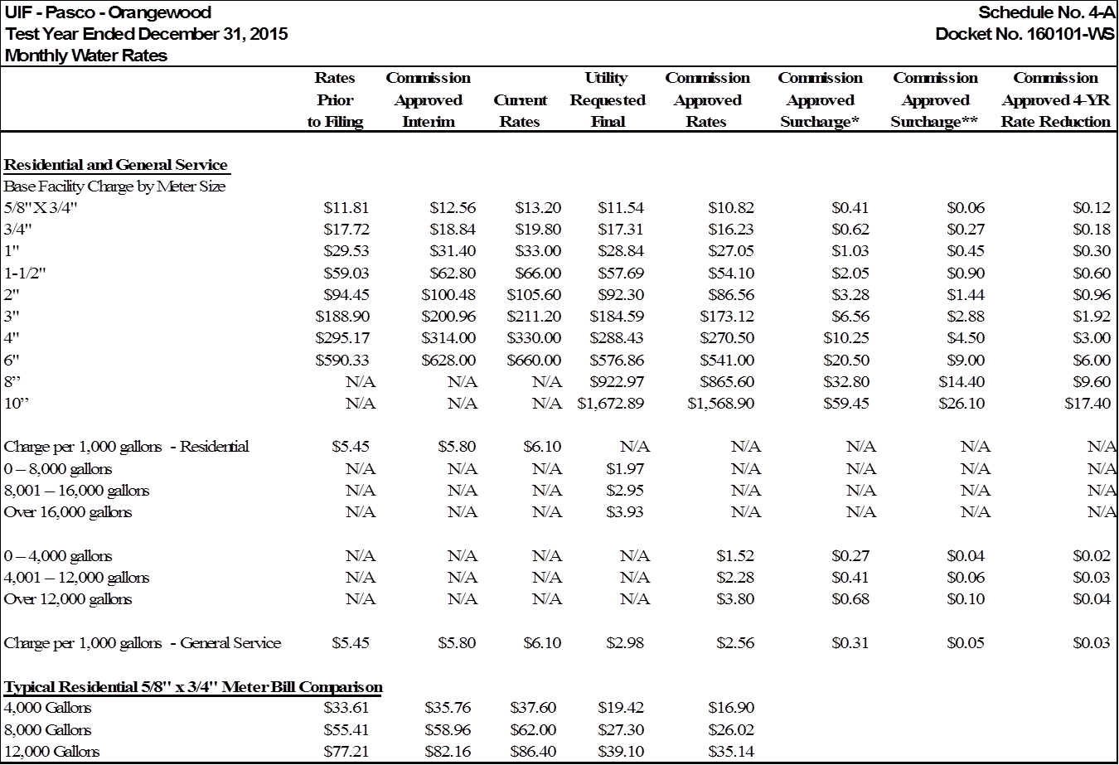

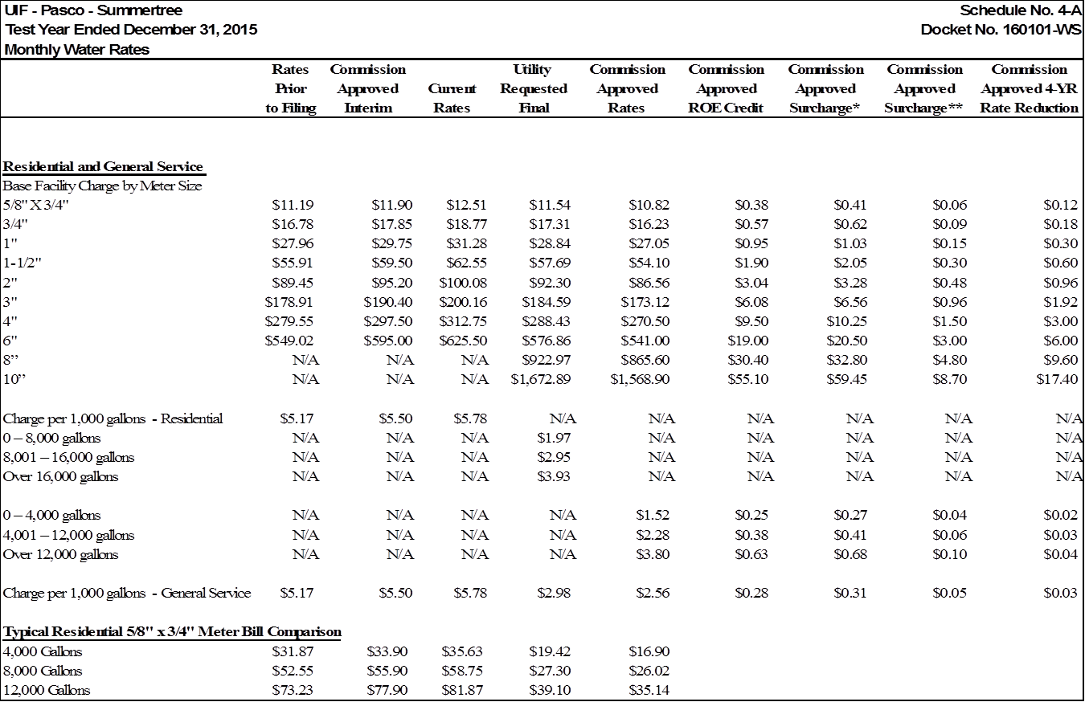

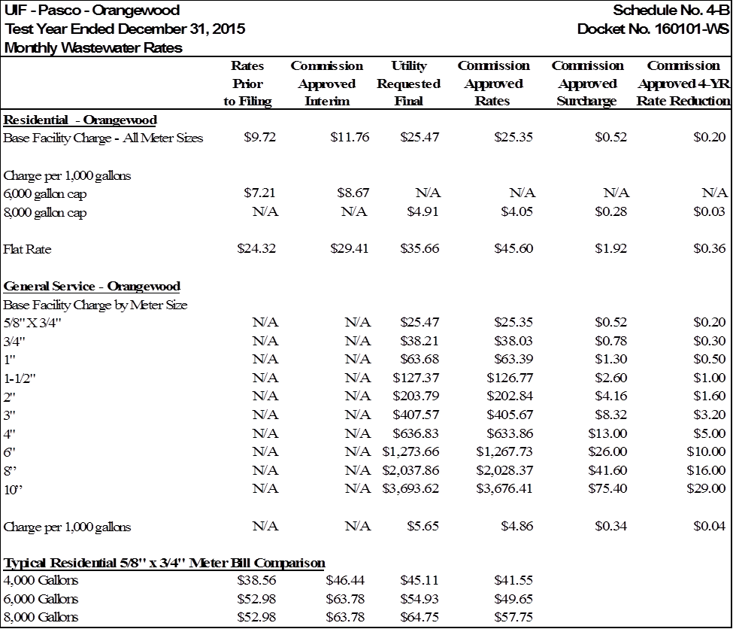

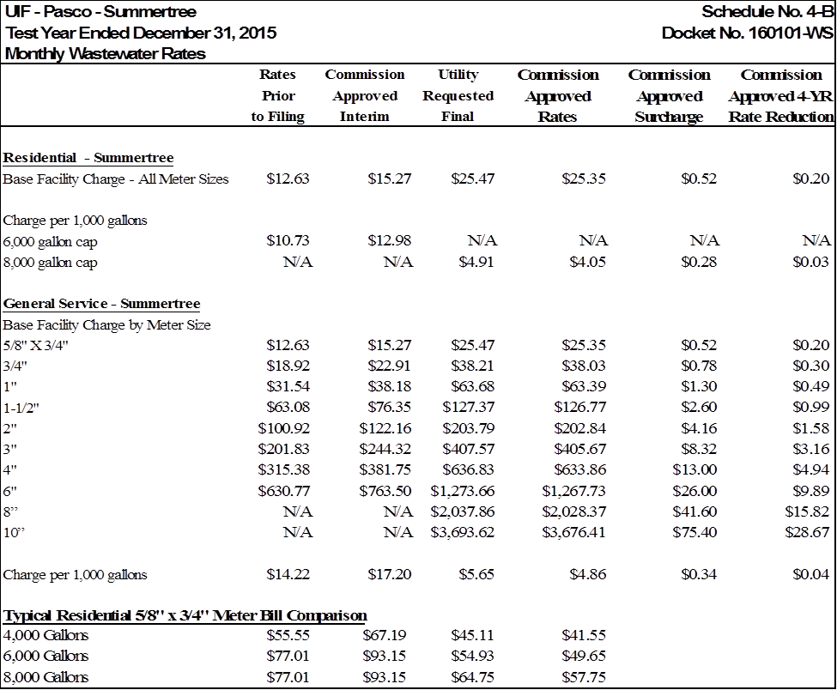









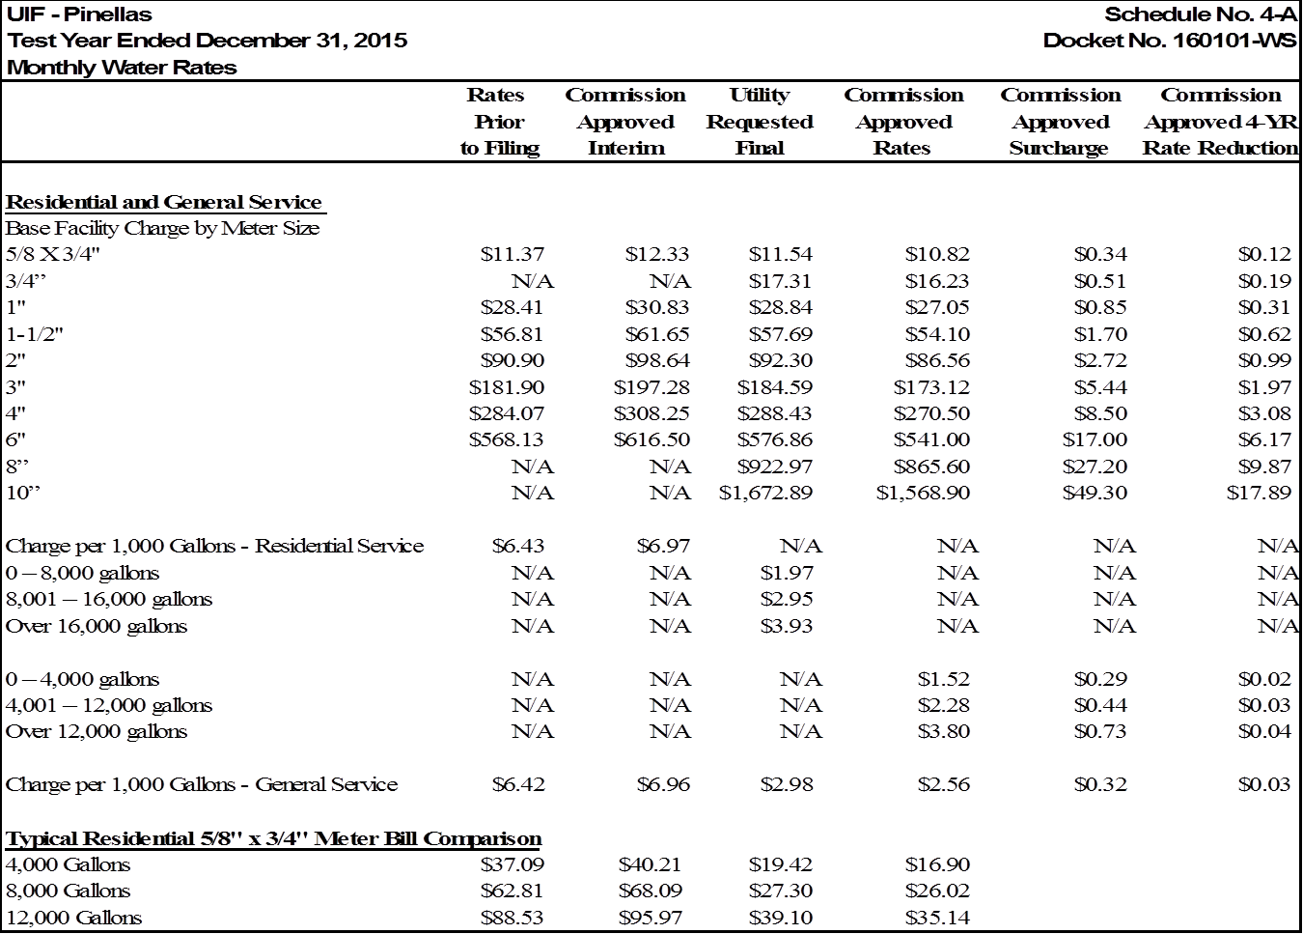













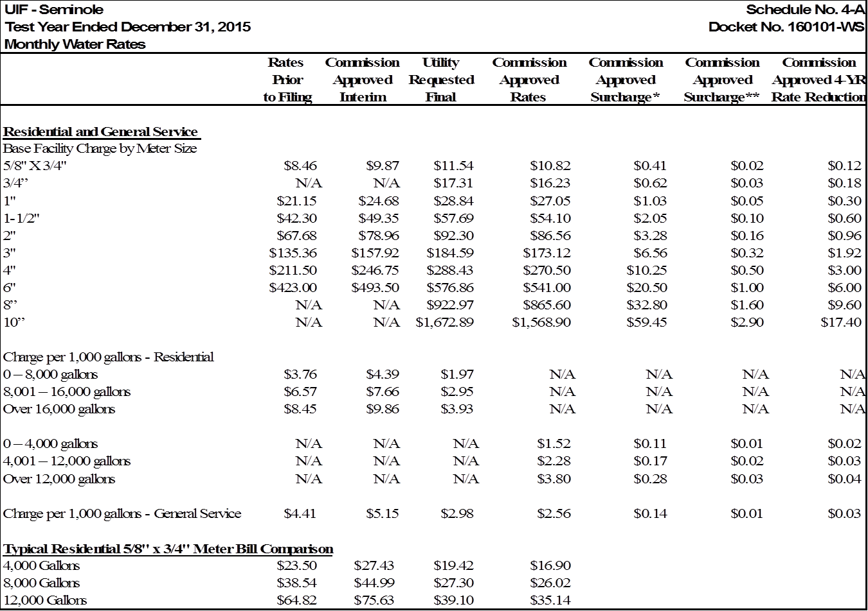

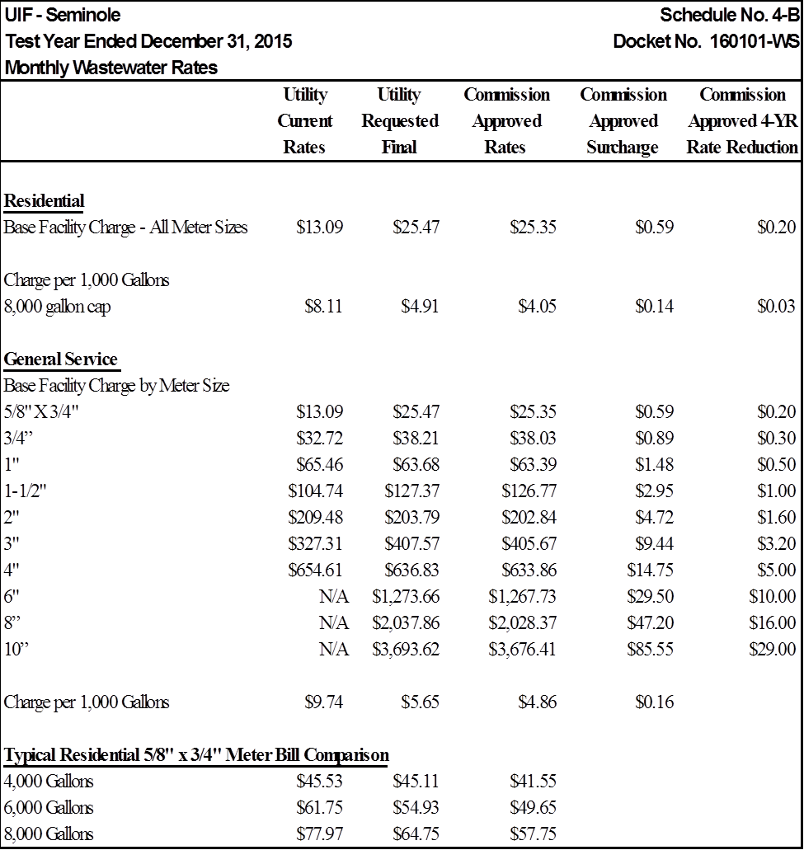

1. Order No. PSC-16-0143-FOF-WS, issued April 12, 2016, in Docket No. 150235-WS, In re: Joint application for acknowledgement of corporate reorganization and request for approval of name changes on water and/or wastewater certificates of Cypress Lakes Utilities, Inc. in Polk County; Utilities, Inc. of Eagle Ridge in Lee County; Utilities, Inc. of Florida in Marion, Orange, Pasco, Pinellas, and Seminole Counties; Labrador Utilities, Inc. in Pasco County; Lake Placid Utilities, Inc. in Highlands County; Lake Utility Services, Inc. in Lake County; Utilities, Inc. of Longwood in Seminole County; Mid-County Services, Inc. in Pinellas County; Utilities, Inc. of Pennbrooke in Lake County; Utilities, Inc. of Sandalhaven in Charlotte County; Sanlando Utilities Corporation in Seminole County; and Tierra Verde Utilities, Inc. in Pinellas County, to Utilities, Inc. of Florida.
2. Id. p.7
3. Order No. PSC-16-0296-PAA-WS, issued July 27, 2016, in Docket No. 150269-WS, In re: Application for limited proceeding water rate increase in Marion, Pasco, and Seminole Counties, by Utilities, Inc. of Florida.
4. Order No. PSC-16-0505-PAA-WS, issued October 31, 2016, in Docket No. 150269-WS, In re: Application for limited proceeding water rate increase in Marion, Pasco, and Seminole Counties, by Utilities, Inc. of Florida.
5. Document No. 02589-2016
6. Order No. PSC-16-0189-PCO-WS, issued May 10, 2016, in Docket No. 160101-WS, In re: Application for increase in water and wastewater rates in Charlotte, Highlands, Lake, Lee, Marion, Orange, Pasco, Pinellas, Polk, and Seminole Counties by Utilities, Inc. of Florida.
7. Document No. 02699-2016
8. Order No. PSC-16-0526-PCO-WS, issued November 22, 2016, in Docket No. 160101-WS, In re: Application for increase in water and wastewater rates in Charlotte, Highlands, Lake, Lee, Marion, Orange, Pasco, Pinellas, Polk, and Seminole Counties by Utilities, Inc. of Florida.
9. Id.
10. Document No. 04314-2017
11. Order No. PSC-17-0150-PCO-WS, issued May 4, 2017, in Docket No. 160101-WS, In re: Application for increase in water and wastewater rates in Charlotte, Highlands, Lake, Lee, Marion, Orange, Pasco, Pinellas, Polk, and Seminole Counties by Utilities, Inc. of Florida.
12. Order No. PSC-17-0155-PCO-WS, issued May 5, 2017, in Docket No. 160101-WS, In re: Application for increase in water and wastewater rates in Charlotte, Highlands, Lake, Lee, Marion, Orange, Pasco, Pinellas, Polk, and Seminole Counties by Utilities, Inc. of Florida.
13. Document No. 04440-2017
14. Order No. PSC-17-0146-PCO-WS, issued May 2, 2017, in Docket No. 160101-WS, In re: Application for increase in water and wastewater rates in Charlotte, Highlands, Lake, Lee, Marion, Orange, Pasco, Pinellas, Polk, and Seminole Counties by Utilities, Inc. of Florida.
15. Order No. PSC-17-0147-PCO-WS, issued May 2, 2017, in Docket No. 160101-WS, In re: Application for increase in water and wastewater rates in Charlotte, Highlands, Lake, Lee, Marion, Orange, Pasco, Pinellas, Polk, and Seminole Counties by Utilities, Inc. of Florida.
16. Order No. PSC-17-0243-FOF-WS, issued June 23, 2017, in Docket No. 160101-WS, In re: Application for increase in water and wastewater rates in Charlotte, Highlands, Lake, Lee, Marion, Orange, Pasco, Pinellas, Polk, and Seminole Counties by Utilities, Inc. of Florida.
17. Order No. PSC-14-0626-PAA-WU, issued October 29, 2014, in Docket No. 130265-WU, In re: Application for staff-assisted rate case in Charlotte county by Little Gasparilla Water Utility, Inc.
18. Order No. PSC-07-0199-PAA-WS, issued March 5, 2007, in Docket No. 060257-WS, In re: Application for increase in water and wastewater rates in Polk County by Cypress Lakes Utilities, Inc.
19. Order No. PSC-10-0682-PAA-WS, issued November 15, 2010, in Docket No. 090349-WS, In re: Application for limited proceeding rate increase in Polk County by Cypress Lakes Utilities, Inc.
20. Order No. PSC-15-0208-PAA-WS, issued May 26, 2015, in Docket No. 140135-WS, In re: Application for increase in water/wastewater rates in Pasco County by Labrador Utilities, Inc.
21. Order No. PSC-07-0134-PAA-SU, issued February 16, 2007, in Docket No. 060254-SU, In re: Application for increase in wastewater rates in Pinellas County by Mid-County Services, Inc.
22. Order No. PSC-09-0373-PAA-SU, issued May 27, 2009, in Docket No. 080250-SU, In re: Application for increase in wastewater rates in Pinellas County by Mid-County Services, Inc.
23. Order No. PSC-12-0667-PAA-WS, issued December 26, 2012, in Docket No. 120037-WS, In re: Application for increase in water and wastewater rates in Lake County by Utilities, Inc. of Pennbrooke.
24. Order No. PSC-14-0025-PAA-WS, issued January 10, 2014, in Docket No. 120209-WS, In re: Application for increase in water and wastewater rates in Marion, Orange, Pasco, Pinellas, and Seminole Counties by Utilities, Inc. of Florida.
25. Order No. PSC-16-0505-PAA-WS, issued October 31, 2016, in Docket No. 150269-WS, In re: Application for limited proceeding water rate increase in Marion, Pasco, and Seminole Counties by Utilities, Inc. of Florida.
26. While the issue as framed requests information on a county-basis, the Parties focused on a system-basis for the applicable ERCs.
27. Order No. PSC-14-0025-PAA-WS, issued January 10, 2014, in Docket No. 120209-WS, In re: Application for increase in water and wastewater rates in Marion, Orange, Pasco, Pinellas, and Seminole Counties by Utilities. Inc. of Florida.
28. Order No. PSC-08-0812-PAA-WS, issued December 16, 2008, in Docket No. 070695-WS, In re: Application for increase in water and wastewater rates in Martin County by Miles Grant Water and Sewer Company.
29. Order No. PSC-10-0400-PAA-WS, issued June 18, 2010, in Docket No. 090392-WS, In re: Application for increase in water and wastewater rates in Lake County by Utilities, Inc. of Pennbrooke.
30. Order No. PSC-12-0346-FOF-SU, issued July 5, 2012, in Docket No. 110153-SU, In re: Application for increase in wastewater rates in Lee County by Utilities, Inc. of Eagle Ridge.
31. Order No. PSC-14-0521-FOF-WS, issued September 30, 2014, in Docket No. 120161-WS, In re: Analysis of Utilities, Inc.'s financial accounting and customer service computer system.
32. Order No. PSC-12-0346-FOF-SU, pp. 2, 9.
33. Order Nos. PSC-14-0335-PAA-WS, issued June 30, 2014, in Docket No. 130243-WS, In re: Application for staff-assisted rate case in Highlands County by Lake Placid Utilities Inc.; PSC-14-0283-PAA-WS, issued May 30, 2014, in Docket No. 130212-WS, In re: Application for increase in water and wastewater rates in Polk County by Cypress Lakes Utilities, Inc.; PSC-14-0025-PAA-WS, issued January 10, 2014, in Docket No. 120209-WS, In. re: Application for increase in water and wastewater rates in Marion, Orange, Pasco, Pinellas, and Seminole Counties by Utilities, Inc. of Florida.; PSC-13-0085-PAA-WS, issued February 14, 2013, in Docket No. 110257-WS, In re: Application for increase in water and wastewater rates in Seminole County by Sanlando Utilities Corporation.; and PSC-12-0667-PAA-WS, issued December 26, 2012, in Docket No. 120037-WS, In re: Application for increase in water and wastewater rates in Lake County by Utilities, Inc. of Pennbrooke.
34. Order No. PSC-15-0233-PAA-WS, issued June 3, 2015, in Docket No. 140060-WS, In re: Application for increase in water and wastewater rates in Seminole County by Sanlando Utilities Corporation.
35. Order No. PSC-14-0521-FOF-WS, p. 10.
36. Id., pp. 8-9.
37. Id.
38. Order No. PSC-15-0233-PAA-WS, p. 10.
39. Order Nos. PSC-14-0335-PAA-WS; PSC-14-0283-PAA-WS; PSC-14-0025-PAA-WS; PSC-13-0085-PAA-WS; and PSC-12-0667-PAA-WS.
40. Order No. PSC-16-0505-PAA-WS, issued October 31, 2016, in Docket No. 150269-WS, In re: Application for limited proceeding water rate increase in Marion, Pasco, and Seminole Counties, by Utilities, Inc. of Florida.*,* p. 6*.*
41. Two of the pro forma projects (PCF-2 and PCF-4) are considered as expense items and are discussed in Section VI, T: Miscellaneous Expense. One pro forma project (PCF-34) relates to the abandonment and decommissioning of UIF’s Summertree water supply assets and is discussed in Part IV, Section D and Part VI, Section Y. In addition, the associated retirements for the pro forma projects will be discussed in Part IV, Section F.
42. UIF did not seek more than one bidder for phase one as the threshold to obtain three bids was not exceeded. UIF explained that its internal policy requires the solicitation of at least three bids for capital projects that are expected to exceed $50,000 in cost.
43. As noted earlier, PCF-28 was postponed.
44. In several instances, the numbers recommended in OPC’s post-hearing position and associated chart differ from those discussed in the text of OPC’s brief. In those instances, we used the amount ultimately cited in OPC’s post-hearing position and chart.
45. See Docket No. 150230-WU, In re: Application for amendment of Certificate of Authorization No. 247-W, to extend water service area to include land in Seminole County, by Sanlando Utilities Corporation.
46. See Order No. PSC-16-0107-PAA-WU, issued March 15, in Docket No. 150230-WU, In re: Application for amendment of Certificate of Authorization No. 247-W, to extend water service area to include land in Seminole County, by Sanlando Utilities Corporation.
47. We used the amount in EXH 248, which was rounded.
48. Order No. PSC-16-0013-PAA-SU, issued January 6, 2016, in Docket 150102-SU, In re: Application for increase in wastewater rates in Charlotte County by Utilities Inc. of Sandalhaven.
49. Order No. PSC-07-0505-SC-WS, issued June 13, 2007, in Docket No. 060243-WS, In re: Application for increase in water and wastewater rates in Marion, Orange, Pasco, Pinellas, and Seminole Counties by Utilities, Inc. of Florida, p. 51.
50. Order No. PSC-07-0865-PAA-SU, issued October 29, 2007, in Docket No. 060285-SU, In re: Application for increase in wastewater rates in Charlotte County by Utilities, Inc. of Sandalhaven.
51. Order No. PSC-96-1338-FOF-WS, issued November 7, 1996, in Docket No. 951056-WS, In re: Application for rate increase in Flagler County by Palm Coast Utility Corporation.
52. Order No. PSC-03-1440-FOF-WS, issued December 22, 2003, in Docket No. 020071-WS, In re: Application for rate increase in Marion, Orange, Pasco, Pinellas, and Seminole Counties by Utilities, Inc. of Florida.
53. Order No. PSC-03-1440-FOF-WS, issued December 22, 2003, in Docket No. 020071-WS, In re: Application for rate increase in Marion, Orange, Pasco, Pinellas, and Seminole Counties by Utilities, Inc. of Florida and Order No. PSC-15-0208-PAA-WS, issued May 26, 2015, in Docket No. 140135-WS, In re: Application for increase in water/wastewater rates in Pasco County by Labrador Utilities, Inc.
54. Order No. PSC-11-0514-PAA-WS, issued November 3, 2011, in Docket No. 100426-WS, In re: Application for increase in water and wastewater rates in Lake County by Lake Utility Services, Inc., pages 16-17.
55. Order No. PSC-02-1449-PAA-WS, issued October 21, 2002, in Docket No. 011451-WS, In re: Investigation of water and wastewater rates for possible overearnings by Plantation Bay Utility Co. in Volusia County. Order No. PSC-02-1739-PAA-WS, issued December 10, 2002, in Docket No. 990374-WS, In re: Application for staff- assisted rate case in Highlands County by The Woodlands of Lake Placid, L.P. Docket No. 020010-WS, Order No. PSC-96-0679-FOF-WU, issued May 23, 1996, in Docket No. 950697-WU, In re: Application for staff-assisted rate case in Highlands County by Placid Lakes Utilities, Inc., Order No. PSC-96-0869-FOF-WS, issued July 2, 1996, in Docket No. 950966-WS, In re: Application for a staff-assisted rate case in Highlands County by Sebring Ridge Utilities, Inc.
56. Order No. PSC-95-0748-FOF-WU, issued June 21, 1995, in Docket No. 940865-WU, In re: Application for Authority to Gross Up Contributions In Aid Of Construction (CIAC) in Escambia County by The Peoples Water Service Company, p. 8.
57. Order No. PSC-11-0514-PAA-WS, issued November 3, 2011, in Docket No. 100426-WS, In re: Application for increase in water and wastewater rates in Lake County by Lake Utility Services, Inc., pages 16-17.
58. Id.
59. Order No. PSC-14-0521-FOF-WS, p. 20.
60. Order No. PSC-14-0521-FOF-WS, p. 20.
61. The UIF systems currently consolidated are UIF-Marion, UIF-Orange, UIF-Pasco, UIF-Pinellas, and UIF-Seminole.
62. Order No. PSC-97-0076-FOF-WS, issued January 27, 1997, in Docket No. 961364-WS, In re: Investigation of rates of Lindrick Service Corporation in Pasco County for possible overearnings*,* p. 3.
63. Order No. PSC-16-0013-PAA-SU, issued January 6, 2016, in Docket No. 150102-SU, In re: Application for increase in wastewater rates in Charlotte County by Utilities, Inc. of Sandalhaven*,* p. 17–20.
64. Id.
65. Order No. PSC-07-0865-PAA-SU, issued October 29, 2007, in Docket No. 060285-SU, In re: Application for increase in wastewater rates in Charlotte County by Utilities, Inc. of Sandalhaven*,* pages 23-36*.*
66. Order No. PSC-16-0151-FOF-SU, issued April 28, 2016, in Docket No. 150102-SU, In re: Application for increase in wastewater rates in Charlotte County by Utilities, Inc. of Sandalhaven.
67. Id.
68. Order Nos. PSC-07-0865-PAA-SU, issued October 29, 2007, in Docket No. 060285-SU, In re: Application for increase in wastewater rates in Charlotte County by Utilities, Inc. of Sandalhaven; and PSC-16-0151-FOF-SU, issued April 28, 2016, in Docket No. 150102-SU, In re: Application for increase in wastewater rates in Charlotte County by Utilities, Inc. of Sandalhaven.
69. 26 U.S. Code § 179.
70. 26 U.S. Code § 168.
71. Id.
72. Order No. PSC-09-0385-FOF-WS, issued May 29, 2009, in Docket No. 080121-WS, In re: Application for increase in water and wastewater rates in Alachua, Brevard, DeSoto, Highlands, Lake, Lee, Marion, Orange, Palm Beach, Pasco, Polk, Putnam, Seminole, Sumter, Volusia, and Washington Counties by Aqua Utilities Florida, Inc.
73. Order No. PSC-17-0249-PAA-WS, issued June 26, 2017, in Docket No. 170006-WS, In re: Water and wastewater industry annual reestablishment of authorized range of return on common equity for water and wastewater utilities pursuant to Section 367.081(4)(f), F.S.
74. Order No. PSC-17-0249-PAA-WS, issued June 26, 2017, in Docket No. 170006-WS, In re: Water and wastewater industry annual reestablishment of authorized range of return on common equity for water and wastewater utilities pursuant to Section 367.081(4)(f), F.S.
75. Order No. PSC-16-0013-PAA-SU, issued January 6, 2016, in Docket No. 150102-SU, In re: Application for rate increase in wastewater rates in Charlotte County by Utilities, Inc. of Sandalhaven.
76. Order No. PSC-15-0233-PAA-WS.
77. Id.
78. Id.
79. Order Nos. PSC-15-0233-PAA-WS; and PSC-15-0208-PAA-WS, issued May 26, 2015, in Docket No. 140135-WS, In re: Application for increase in water and wastewater rates in Pasco County by Labrador Utilities, Inc.
80. Order No. PSC-15-0233-PAA-WS.
81. Order No. PSC-16-0013-PAA-SU, issued January 6, 2016, in Docket No. 150102-SU, In re: application for increase in wastewater rates in Charlotte County by Utilities, Inc. of Sandalhaven.
82. Order No. PSC-16-0013-PAA-SU, issued January 6, 2016, in Docket No. 150102-SU, In re: Application for increase in wastewater rates in Charlotte County by Utilities, Inc. of Sandalhaven.
83. Order Nos. PSC-05-0624-PAA-WS, issued June 7, 2005, in Docket No. 040450-WS, In re: Application for rate increase in Martin County by Indiantown Company, Inc.*;* and PSC-01-0326-FOF-SU, issued February 6, 2001, in Docket No. 991643-SU, In re: Application for increase in wastewater rates in Seven Springs System in Pasco County by Aloha Utilities, Inc.
84. Order No. PSC-14-0521-FOF-WS.
85. Order No. PSC-14-0025-PAA-WS.
86. Id., p. 20.
87. Id., p. 25.
88. See Order No. PSC-16-0505-PAA-WS, issued October 31, 2016, in Docket No. 150269-WS, In re: Application for limited proceeding water rate increase in Marion, Pasco, and Seminole Counties by Utilities, Inc. of Florida*,* p. 7*.*
89. Id.
90. UIF did not calculate a breakout of annual amortization expense.
91. Order Nos. PSC-13-0673-FOF-WS, issued December 19, 2013, in Docket No. 130212-WS, In re: Application for

    increase in water/wastewater rates in Polk County by Cypress Lakes Utilities, Inc.; PSC-08-0761-PCO-SU, issued November 17, 2008, in Docket No. 080247-SU, In re: Application for Wastewater Rate Increase by Utilities, Inc. of Eagle Ridge, PSC-06-0675-PCO-SU, issued August 7, 2006, in Docket No. 060255-SU, In re: Application for increase in wastewater rates in Pinellas County by Tierra Verde Utilities, Inc.; and PSC-05-0287-PAA-SU, issued March 17, 2005,and in Docket No. 040972-SU, In re: Application for rate increase in Pinellas County by Ranch Mobile WWTP, Inc.
92. Order No. PSC-95-0191-FOF-WS, issued February 9, 1995, in Docket No. 940917-WS, In re: Application for rate increase for increased water and wastewater rates in Seminole, Orange, and Pasco Counties by Utilities, Inc. of Florida (We established county-wide revenue requirements for: 11 systems in Seminole County, 3 systems in Orange County, and 1 system in Pasco County).
93. Order No. 24094, issued February 12, 1991, in Docket No. 900151-GU, In re: Application for natural gas rate increase by FPUC (Subsequent to utility’s filing of MFRs, we had approved higher O&M expenses and depreciation rates for FPUC in another document, and those changes increased the need for rate relief).
94. See Order Nos. PSC-09-0385-FOF-WS and PSC-11-0256-PAA-WS, in Docket No. 080121-WS,In re: Application for increase in water and wastewater rates in Alachua, Brevard, DeSoto, Highlands, Lake, Lee, Marion, Orange, Palm Beach, Pasco, Polk, Putnam, Seminole, Sumter, Volusia, and Washington Counties by Aqua utilities, Inc.
95. As noted in FN 6 of the Court’s order, in an earlier docket involving the same systems, Docket No. 920199-WS, we developed a “modified stand alone” rate structure, which it used as a starting point in the case on review. Id. at 1053.
96. Order No. 13014, issued February 20, 1984, in Docket No. 810386-W, In re: Request of Sunshine Utilities, Inc. for Staff Assistance on a Rate Increase to Customers in Marion County, Florida. See also Order Nos. PSC 97-0531-FOF-WU, issued May 9, 1997, and PSC-99-0635-FOF-WU, issued April 5, 1999, in Docket No. 960444-WU, In re. Application for rate increase and for increase in service availability charges in Lake County by Lake Utility Services, Inc.; Order No. PSC-03-1440-FOF-WS, issued December 22, 2003, in Docket No. 020071-WS, In re: Application for rate increase in Marion, Orange, Pasco, Pinellas, and Seminole Counties by Utilities, Inc. of Florida.
97. Order Nos. PSC-93-0423-FOF-WS, issued March 22, 1993, and PSC-95-1292-FOF-WS, issued October 19, 1995, in Docket No. 920199-WS, In re: Application for rate increase in Brevard, Charlotte/Lee, Citrus, Clay, Duval, Highlands, Lake, Marion, Martin, Nassau, Orange, Osceola, Pasco, Putnam, Seminole, Volusia, and Washington Counties by Southern States Utilities, Inc.; Collier County by Marco Shores Utilities (Deltona); Hernando County by Spring Hill Utilities (Deltona); and Volusia County by Deltona Lakes Utilities (Deltona); PSC-94-1123-FOF-WS, issued September 3, 1994, in Docket No. 930880-WS, In re: Investigation into the appropriate rate structure for Southern States Utilities, Inc. for all regulated systems in Bradford, Brevard, Citrus, Clay, Collier, Duval, Hernando, Highlands, Lake, Lee/Charlotte, Marion, Martin, Nassau, Orange, Osceola, Pasco, Putnam, Seminole, St. Johns, St. Lucie, Volusia, and Washington Counties; and PSC-96-0125-FOF-WS, issued January 25, 1996, and PSC-96-1320-FOF-WS, issued October 30, 1996, in Docket No. 950495-WS, In re: Application for rate increase and increase in service availability charges by Southern States Utilities, Inc. for Orange-Osceola Utilities, Inc. in Osceola County, and in Bradford, Brevard, Charlotte, Citrus, Clay, Collier, Duval, Highlands, Lake, Lee, Marion, Martin, Nassau, Orange, Osceola, Pasco, Putnam, Seminole, St. Johns, St. Lucie, Volusia, and Washington Counties.
98. Order No. PSC-96-1320-FOF-WS, p. 227.
99. Order Nos. PSC-09-0385-FOF-WS, issued May 29, 2009, in Docket No. 080121-WS, In re: Application for increase in water and wastewater rates in Alachua, Brevard, DeSoto, Highlands, Lake, Lee, Marion, Orange, Palm Beach, Pasco, Polk, Putnam, Seminole, Sumter, Volusia, and Washington Counties by Aqua Utilities Florida, Inc.; and PSC-12-0102-FOF-WS, issued March 5, 2012, in Docket No. 100330-WS, In re: Application for increase in water/wastewater rates in Alachua, Brevard, DeSoto, Hardee, Highlands, Lake, Lee, Marion, Orange, Palm Beach, Pasco, Polk, Putnam, Seminole, Sumter, Volusia, and Washington Counties by Aqua Utilities Florida, Inc.
100. See Order No. PSC-16-0552-PAA-WS, issued December 12, 2016, in Docket No. 160005-WS,In re: Annual reestablishment of price increase or decrease index of major categories of operating costs incurred by water and wastewater utilities pursuant to Section 367.081(4)(a), F.S.
101. Order No. PSC-09-0385-FOF-WS, issued May 29, 2009, in Docket No. 080121-WS, In re: Application for increase in water and wastewater rates in Alachua, Brevard, DeSoto, Highlands, Lake, Lee, Marion, Orange, Palm Beach, Pasco, Polk, Putnam, Seminole, Sumter, Volusia, and Washington Counties by Aqua Utilities Florida, Inc.
102. Order No. PSC-16-0525-PAA-WS, issued November 21, 2016, in Docket No. 160030-WS, In re: Application for increase in water rates in Lee County and wastewater rates in Pasco County by Ni Florida, LLC.; Order No. PSC-17-0107-PAA-WS, issued March 24, 2017, in Docket No. 150257-WS, In re: Application for staff-assisted rate case in Marion County, by East Marion Utilities, LLC.
103. Order No. PSC-10-0167-PAA-WU, issued March 23, 2010, in Docket No. 090346-WU, In re Application for staff-assisted rate case in Lake County by Brendenwood Water System, Inc.
104. Order Nos. PSC-12-0102-FOF-WS, issued March 5, 2012, in Docket No. 100330-WS, In re: Application for increase in water/wastewater rates in Alachua, Brevard, DeSoto, Hardee, Highlands, Lake, Lee, Marion, Orange, Palm Beach, Pasco, Polk, Putnam, Seminole, Sumter, Volusia, and Washington Counties by Aqua Utilities Florida, Inc.*;* PSC-15-0233-PAA-WS, issued June 3, 2015, in Docket No. 140060-WS, In re: Application for increase in water and wastewater rates in Seminole County by Sanlando Utilities Corporation.
105. Order Nos. PSC-15-0282-PAA-WS, issued July 8, 2015, in Docket No. 140158-WS, In re: Application for increase in water/wastewater rates in Highlands County by HC Waterworks, Inc.; PSC-16-0525-PAA-WS, issued November 21, 2016, in Docket No. 160030-WS, In re: Application for increase in water rates in Lee County and wastewater rates in Pasco County by Ni Florida, LLC.
106. Order No. PSC-15-0233-PAA-WS, issued June 3, 2015, in Docket No. 140060-WS, In re: Application for increase in water and wastewater rates in Seminole County by Sanlando Utilities Corporation.
107. Order No. PSC-07-0287-PAA-WS, issued April 3, 2007, in Docket No. 060260-WS, In re: Application for increase in water and wastewater rates in Highlands County by Lake Placid Utilities, Inc.
108. Order No. PSC-17-0091-FOF-SU, issued March 13, 2017, in Docket No. 150071-SU, In re: Application for increase in wastewater rates in Monroe County by K W Resort Utilities Corp.
109. Order No. PSC-16-0253-TRF-WS, issued June 29, 2016, in Docket No. 160104-WS, In re: Application for NSF and late payment charges in Charlotte, Highlands, Lake, Lee, Marion, Orange, Pasco, Pinellas, Polk, and Seminole Counties by Utilities Inc. of Florida.
110. Order No. PSC-08-0009-TRF-WU, issued January 2, 2008, in Docket No. 070377-WU, In re: Request for approval of change in meter installation customer deposits tariff and proposed changes in miscellaneous service charges in Marion County by Windstream Utilities Company.
111. Order Nos. PSC-11-0204-TRF-SU, issued April 25, 2011, in Docket No. 100413-SU, In re: Request for approval of tariff amendment to include a late fee of $14.00 in Polk County by West Lakeland Wastewater.; PSC-08-0255-PAA-WS, issued April 24, 2008, in Docket No. 070391-WS, In re: Application for certificates to provide water and wastewater service in Sumter County by Orange Blossom Utilities, Inc.; PSC-01-2101-TRF-WS, issued October 22, 2001, in Docket No. 011122-WS,In re: Tariff filing to establish a late payment charge in Highlands County by Damon Utilities, Inc.
112. Order No. 12447, issued September 6, 1983, in Docket No. 830141-WS, In re: Application of Lake Placid Utilities for certificates to operate water and sewer systems in Highlands County, pursuant to Section 367.171, Florida Statutes; Order No. 21555, issued July 17, 1989, in Docket No. 890335-WU, In re: Application of Utilities, Inc. of Florida for amendment of Certificate No. 383-W in Lake County; Order No. PSC-01-1655-PAA-WS, issued August 13, 2001, in Docket No. 000793-WS, In re: Application for transfer of facilities and Certificates Nos. 484-W and 421-S in Pasco County from Bartelt Enterprises, Inc. to Utilities, Inc. of Florida, holder of Certificates Nos. 107-W and 229-S; and for cancellation of Certificates Nos. 484-W and 421-S; Order No. 20779, issued February 20, 1989, in Docket No. 871059-SU, In re: Application by Longwood Utilities, Inc. for rate increase in Seminole County; Order No. 21554, issued July 17, 1989, in Docket No. 881324-WS, In re: Application of Crownwood of Ocala Utility Company, Inc., for staff assisted rate case in Marion County.
113. Order No. PSC-03-1244-TRF-SU, issued November 5, 2003, in Docket No. 030602-SU; In re: Application for approval of pass-through service availability charge for bulk wastewater service from City of Sanford, in Seminole County, by Utilities, Inc. of Florida.
114. Order No. PSC-17-0209-PAA-WU, issued May 30, 2017, in Docket No. 160065-WU, In re: Application for increase in water rates in Charlotte County by Bocilla Utilities, Inc.
115. Order No. 11949, issued May 20, 1983, in Docket No. 810453-S, In re: Application of Seagull Utility Company for increased rates to its customers in Pinellas County, Florida.
116. Order No. PSC-16-0107-PAA-WU, issued March 15, 2016, in Docket No. 150230-WU, In re: Application for amendment of Certificate of Authorization No. 247-W, to extend water service area to include land in Seminole County, by Sanlando Utilities Corporation.
117. Order No. PSC-07-0912-AS-WS, issued November 9, 2007, in Docket No. 060257-WS, In re: Application for increase in water and wastewater rates in Polk County by Cypress Lake Utilities, Inc.
118. Order No. 24283, issued March 25, 1991, in Docket No. 900957-WS, In re: Application of Lake Groves Utilities, Inc. for water and sewer certificates in Lake County.
119. Order No. PSC-97-0531-FOF-WU, issued May 9, 1997, in Docket No. 960444-WU, In re: Application for rate increase and for increase in service availability charges in Lake County by Lake Utility Services, Inc.
120. Order No. 20779, issued February 20, 1989.
121. Order No. PSC-16-0151-FOF-SU, issued April 18, 2016, in Docket No. 150102-SU, In re: Application for increase in wastewater rates in Charlotte County.
122. Order No. PSC-16-0526-PCO-WS, Issued November 22, 2016, in Docket No. 106101-WS, In re: Application for increase in water and wastewater rates in Charlotte, Highlands, Lake, Lee, Marion, Orange, Pasco, Pinellas, Polk, and Seminole Counties by Utilities, Inc. of Florida.
123. Id.
124. Order Nos. PSC-16-0525-PAA-WS, issued November 21, 2016, in Docket No. 160030-WS, In. re: Application for increase in water rates in Lee County and wastewater rates in Pasco County by Ni Florida, LLC; and Order No. PSC-17-0209-PAA-WS, issued May 30, 2017, in Docket No. 160065-WU, In re: Application for increase in water rates in Charlotte County by Bocilla Utilities, Inc.