BEFORE THE FLORIDA PUBLIC SERVICE COMMISSION

In re: Petition by Florida Division of Chesapeake Utilities Corporation for approval of special contract with Sebring Gas System, Inc. | DOCKET NO. 20170176-GU  ORDER NO. PSC-2017-0390-PAA-GU  ISSUED: October 13, 2017

The following Commissioners participated in the disposition of this matter:

JULIE I. BROWN, Chairman
ART GRAHAM
RONALD A. BRISÉ
DONALD J. POLMANN
GARY F. CLARK

NOTICE OF PROPOSED AGENCY ACTION
ORDER APPROVING THE FLORIDA DIVISION OF CHESAPEAKE UTILITIES CORPORATION’S SPECIAL CONTRACT WITH SEBRING GAS SYSTEM, INC.

BY THE COMMISSION:

NOTICE is hereby given by the Florida Public Service Commission (Commission) that the action discussed herein is preliminary in nature and will become final unless a person whose interests are substantially affected files a petition for a formal proceeding, pursuant to Rule 25-22.029, Florida Administrative Code (F.A.C.).

Background

On August 14, 2017, the Florida Division of Chesapeake Utilities Corporation (Chesapeake) filed a petition seeking Commission approval of a Special Contract (Contract) with Sebring Gas System, Inc. (Sebring). Pursuant to the Contract, Chesapeake will construct a gas pipeline in DeSoto County near the City of Arcadia. The pipeline is referred to as the Arcadia Pipeline on the map shown in Attachment A to the order and as the Sebring Pipeline in the Contract. Chesapeake and Sebring both own and operate natural gas distribution facilities in Florida and are subject to the regulatory jurisdiction of the Commission pursuant to Section 366.06, Florida Statutes (F.S.).
The Contract between Chesapeake and Sebring was executed on June 30, 2017, has an initial 20-year term, and can be extended for additional one year periods unless given notification by either party to terminate the Contract. The proposed Contract is shown in Attachment B to the order. During the evaluation of the petition, Commission staff issued two data requests to Chesapeake for which responses were received on August 28, 2017 and on September 5, 2017. The first data request was also forwarded to Sebring, for which responses were received on September 19, 2017. In its response to Commission staff’s first data request, Chesapeake filed certain revisions to the Cost of Service Study that was included in the petition. There have been no public comments regarding this petition. We have jurisdiction over this matter pursuant to Sections 366.04, 366.05, and 366.06, F.S.
Decision

At present, Chesapeake and Sebring both have customers in DeSoto County; however, neither utility has facilities capable of providing gas service to the City of Arcadia. In May 2017, by Order No. PSC-2017-0205-PAA-GU, the Commission approved a territorial agreement between Chesapeake and Sebring. Pursuant to the territorial agreement, Sebring’s service area includes customers within Arcadia’s municipal boundaries and two specifically identified customers just outside Arcadia’s municipal limits. Chesapeake’s service territory is defined as DeSoto County, except for customers within Arcadia’s municipal boundary and the two specifically identified customers who are located outside of the Arcadia municipal limits.
The proposed Contract is designed to allow Sebring to provide gas service to the City of Arcadia. Sebring will construct and own the distribution system to serve customers within the City of Arcadia and Chesapeake will construct, own, and maintain a pipeline connecting the Florida Gas Transmission (FGT) interstate transmission pipeline with Sebring’s distribution system. Chesapeake will provide transportation service only; the gas delivered to the City of Arcadia via FGT and the Sebring Pipeline is purchased by Sebring. The Contract contains the terms and conditions under which Chesapeake will provide transportation service and the negotiated rate allowing Chesapeake to recover its investment in the Sebring Pipeline. Rule 25-9.034, F.A.C., and Chesapeake’s tariff require that special contracts be approved by the Commission.
In accordance with the Contract, Chesapeake is constructing approximately one mile of four-inch coated steel pipeline extending from the FGT facilities in Hardee County to the interconnection point with Sebring’s distribution system. Chesapeake will connect the pipeline with FGT at the Arcadia gate station, an existing delivery point. Chesapeake will install a new custody transfer station at its interconnection point with Sebring’s distribution system that will serve the City of Arcadia. Chesapeake anticipates construction of the pipeline to be complete in October 2017. The Contract contains language stating that Sebring is relying upon Chesapeake’s expertise in operating and providing transportation service over the Sebring Pipeline.
Chesapeake stated that it has obtained approvals from the Department of Transportation and the Department of Environmental Protection for the pipeline. Additionally, Chesapeake stated it is currently working to receive approval from the Seminole Gulf Railroad for the railroad crossing.

Cost of Service Considerations
The cost of service study provided by Chesapeake in its response to Commission staff’s first data request shows total annual operating cost of $128,183 for the Sebring Pipeline. The cost of service includes a return on the investment, operation and maintenance cost, depreciation, and taxes. Chesapeake’s investment for the Sebring Pipeline totals $821,384 and includes the main installation, custody transfer meter, and skid mount (a prefabricated frame that holds the meter and pressure regulation equipment). The return included in the cost of service is 5.67 percent, based on the midpoint rate of return shown in Chesapeake’s December 2016 year-end surveillance report.
The negotiated annual fixed rate contained in the Contract of $136,812 is designed to enable Chesapeake to cover its cost of service. The contract amount is paid by Sebring to Chesapeake in monthly reservation charges. that are fixed and do not vary based on actual usage. The largest daily quantity of gas Chesapeake is obligated to transport to Sebring is 720 Dekatherms.
Based on the cost of service study provided, we find the monthly reservation charge recovers its cost of service and, therefore, will provide benefits to Chesapeake’s general body of ratepayers, as well as Sebring’s customers in the City of Arcadia.
Conclusion
Based on the review of the petition and responses to Commission staff’s data requests, we find Chesapeake’s representations to be reasonable and approve the Special Contract between Chesapeake and Sebring as shown in Attachment B. The Contract is effective as of the date of our vote, October 3, 2017.
Based on the foregoing, it is

ORDERED by the Florida Public Service Commission that the Florida Division of Chesapeake Utilities Corporation’s petition for approval of a special contract with Sebring Gas System, Inc., is hereby approved, effective October 3, 2017.

ORDERED that the provisions of this Order, issued as proposed agency action, shall become final and effective upon the issuance of a Consummating Order unless an appropriate petition, in the form provided by Rule 28-106.201, Florida Administrative Code, is received by the Commission Clerk, 2540 Shumard Oak Boulevard, Tallahassee, Florida 32399-0850, by the close of business on the date set forth in the “Notice of Further Proceedings” attached hereto. It is further

ORDERED that in the event this Order becomes final, this docket shall be closed.

By ORDER of the Florida Public Service Commission this 13th day of October, 2017.

/s/ Carlotta S. Stauffer
CARLOTTA S. STAUFFER
Commission Clerk
Florida Public Service Commission
2540 Shumard Oak Boulevard
Tallahassee, Florida 32399
(850) 413-6770
www.floridapsc.com

Copies furnished: A copy of this document is provided to the parties of record at the time of issuance and, if applicable, interested persons.

WDT

NOTICE OF FURTHER PROCEEDINGS OR JUDICIAL REVIEW

The Florida Public Service Commission is required by Section 120.569(1), Florida Statutes, to notify parties of any administrative hearing that is available under Section 120.57, Florida Statutes, as well as the procedures and time limits that apply. This notice should not be construed to mean all requests for an administrative hearing will be granted or result in the relief sought.

Mediation may be available on a case-by-case basis. If mediation is conducted, it does not affect a substantially interested person's right to a hearing.

The action proposed herein is preliminary in nature. Any person whose substantial interests are affected by the action proposed by this order may file a petition for a formal proceeding, in the form provided by Rule 28-106.201, Florida Administrative Code. This petition must be received by the Office of Commission Clerk, 2540 Shumard Oak Boulevard, Tallahassee, Florida 32399-0850, by the close of business on November 3, 2017.

In the absence of such a petition, this order shall become final and effective upon the issuance of a Consummating Order.

Any objection or protest filed in this/these docket(s) before the issuance date of this order is considered abandoned unless it satisfies the foregoing conditions and is renewed within the specified protest period.

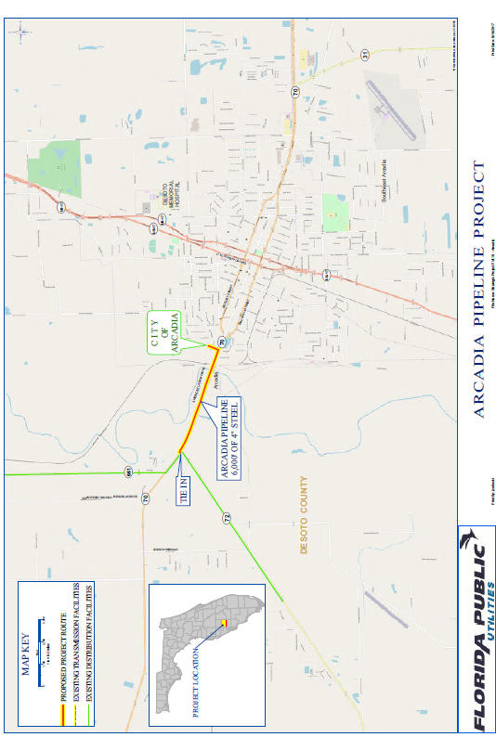
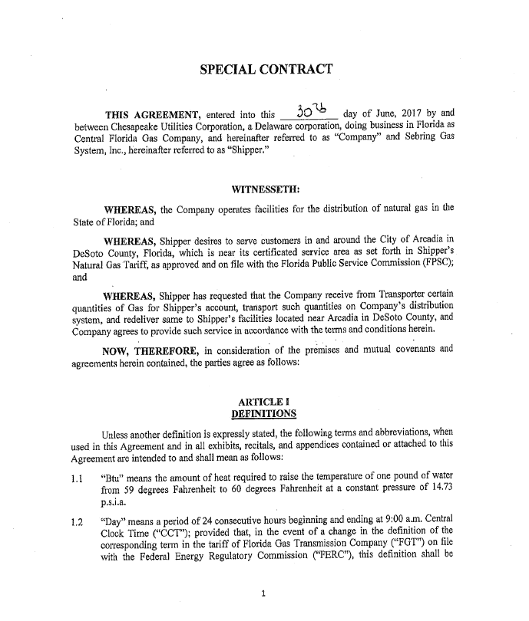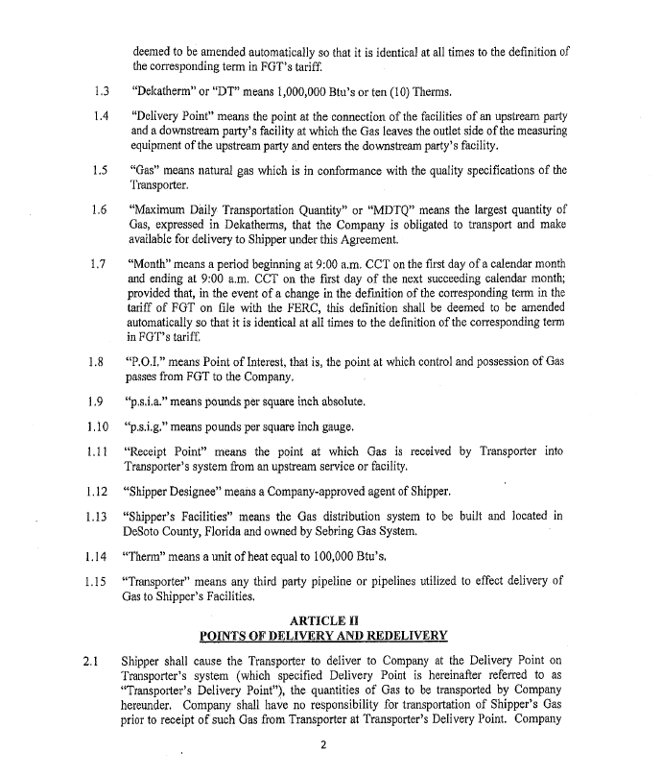

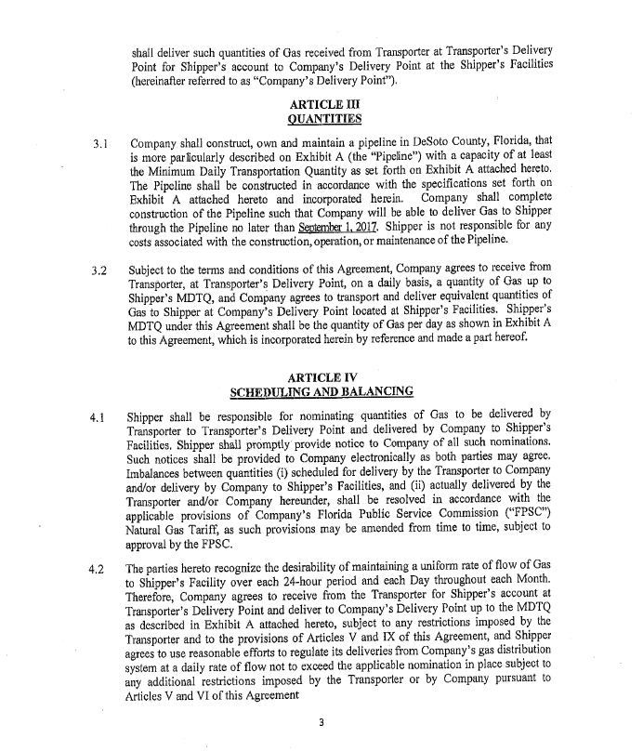

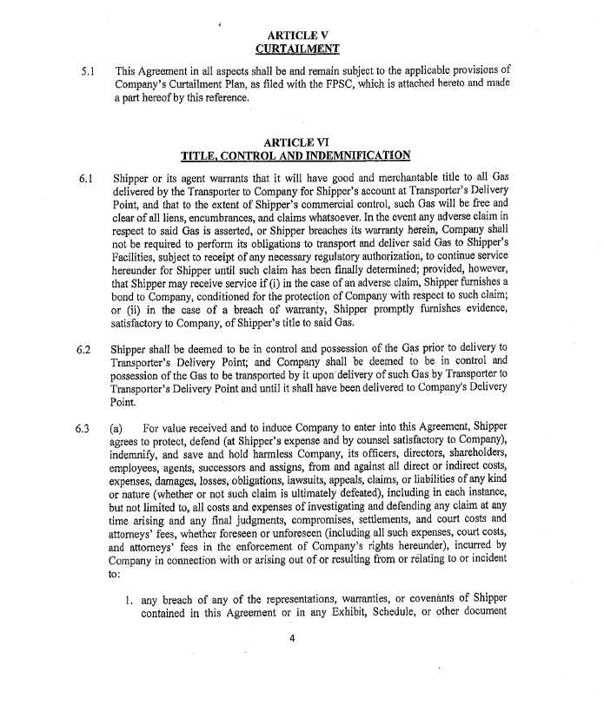

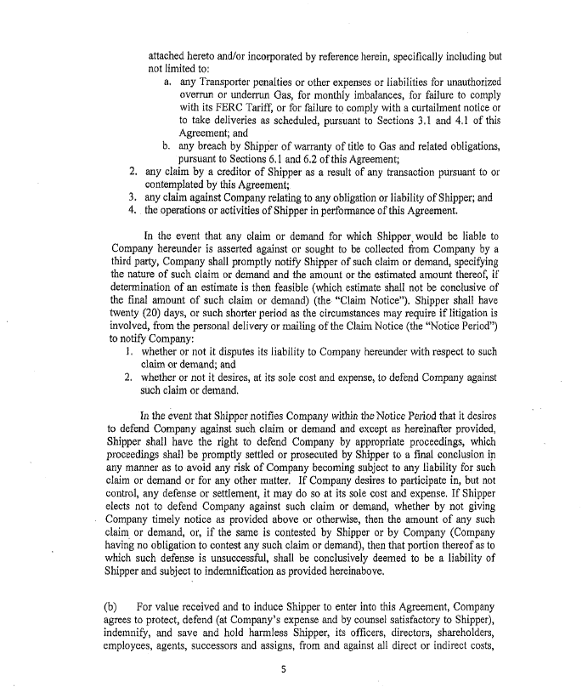

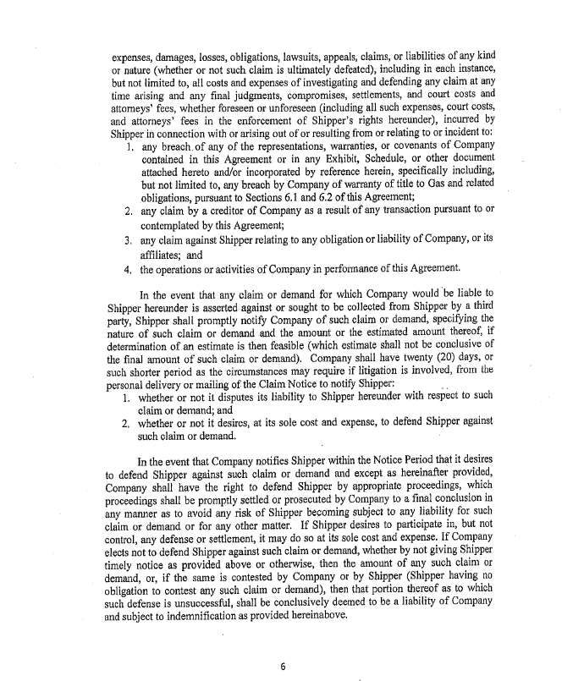

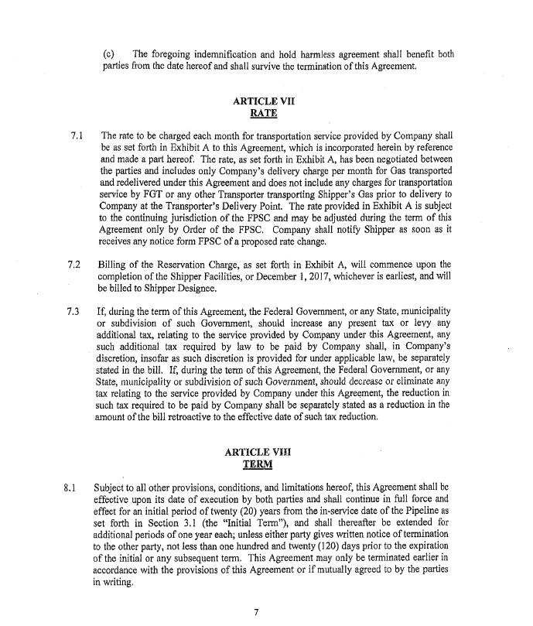

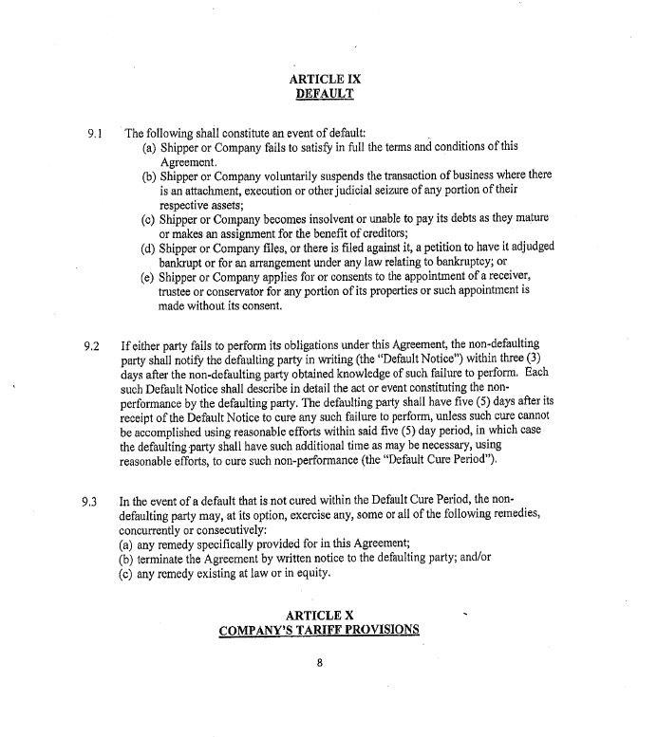

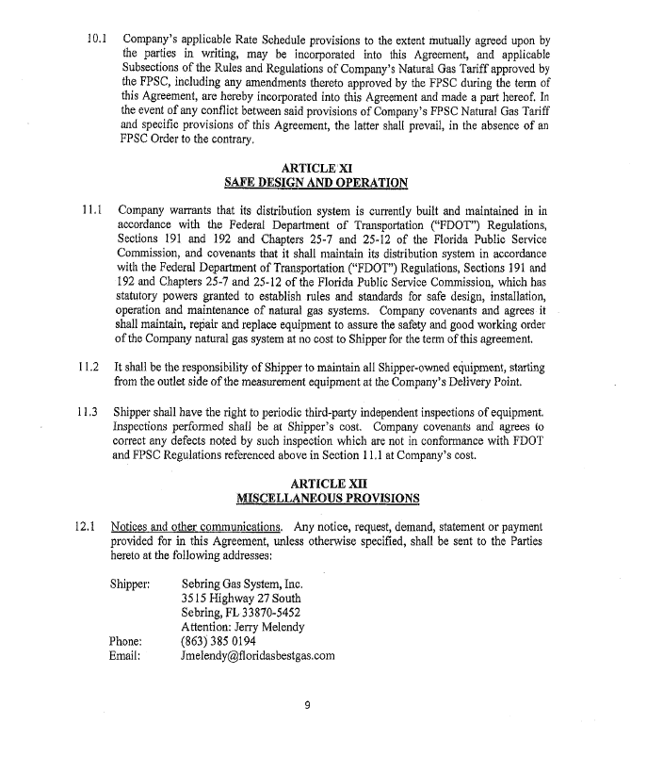

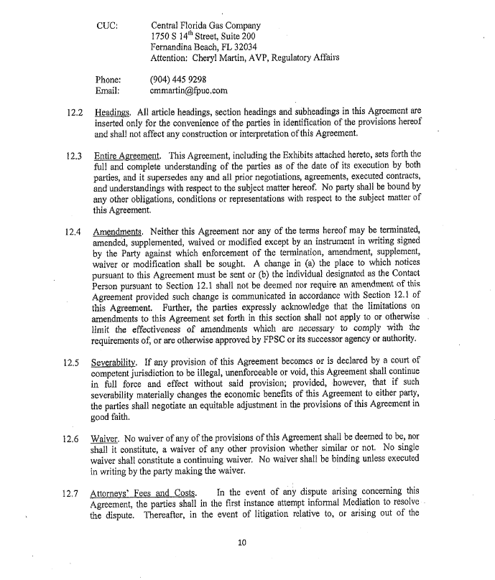

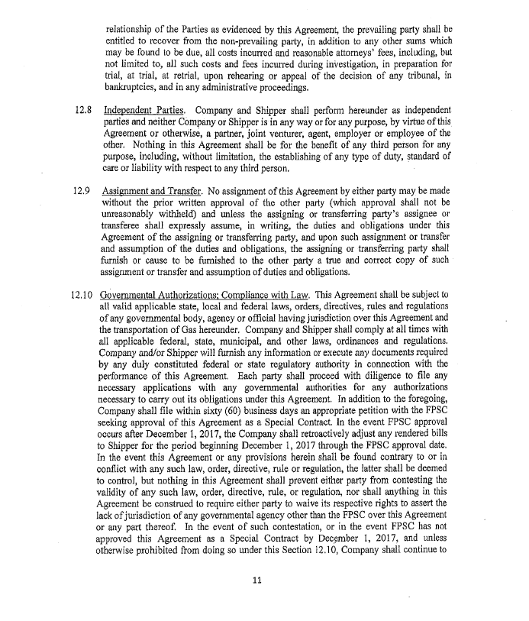

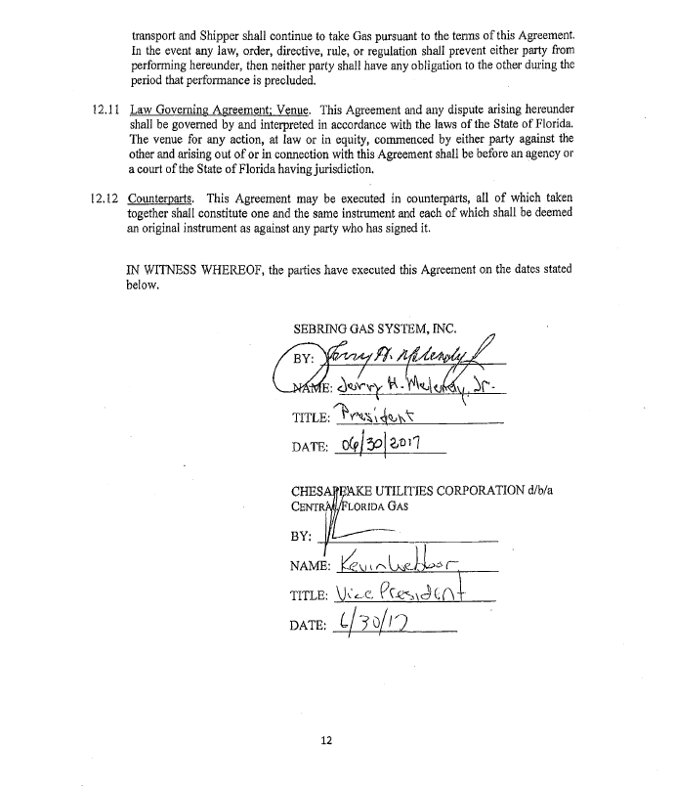

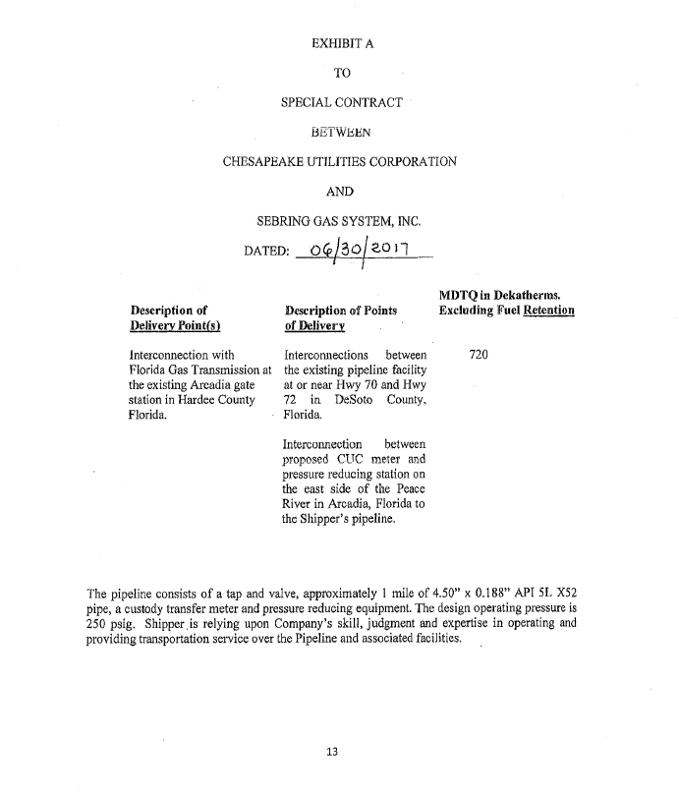

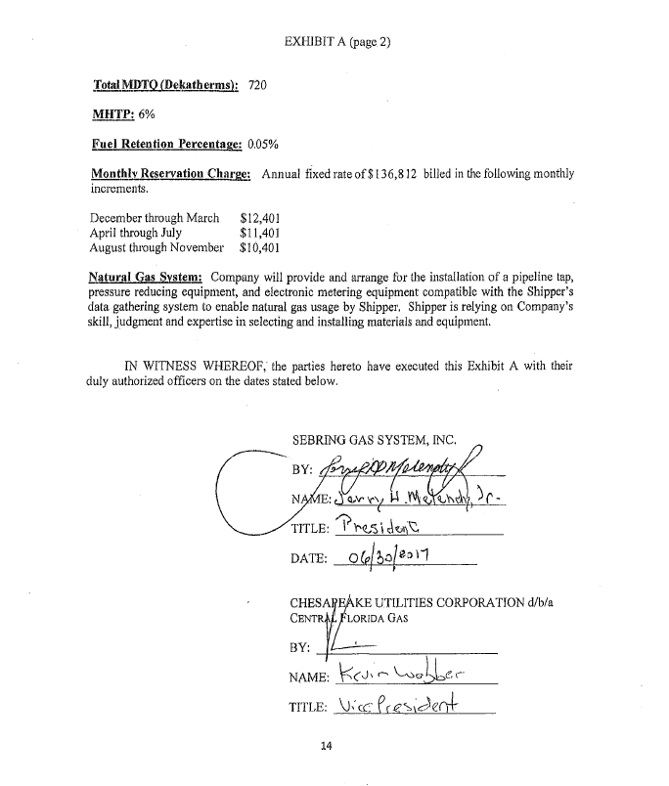

Order No. PSC-2017-0205-PAA-GU, issued May 23, 2017, in Docket No. 20170036-GU, In re: Joint petition for approval of territorial agreement in DeSoto County by Florida Division of Chesapeake Utilities Corporation and Sebring Gas System, Inc.
Monthly Reservation Charge: The annual fixed rate of $136,812 is billed in the following increments: December through March $12,401 April through July $11,401 August through November $10,401

