State of Florida |  | Public Service Commission  Capital Circle Office Center ● 2540 Shumard Oak Boulevard  Tallahassee, Florida 32399-0850  -M-E-M-O-R-A-N-D-U-M-
DATE: | October 26, 2017
TO: | Office of Commission Clerk (Stauffer)
FROM: | Division of Economics (Doherty, Draper)  Office of the General Counsel (Mapp)
RE: | Docket No. 20170180-GU – Petition by the Florida Division of Chesapeake Utilities Corporation for approval of special contract with Mosaic Fertilizer LLC.
AGENDA: | 11/07/17 – Regular Agenda – Proposed Agency Action – Interested Persons May Participate
COMMISSIONERS ASSIGNED: |  |  | All Commissioners
PREHEARING OFFICER: |  |  | Polmann
CRITICAL DATES: |  |  | None
SPECIAL INSTRUCTIONS: |  |  | None

Case Background
On August 23, 2017, the Florida Division of Chesapeake Utilities Corporation (Chesapeake or company) filed a petition for approval of a special contract with Mosaic Fertilizer, LLC (Mosaic). Chesapeake is a local distribution company subject to the regulatory jurisdiction of the Commission pursuant to Chapter 366, Florida Statues (F.S.). Mosaic is in the business of mining, processing phosphate, and manufacturing fertilizer. Mosaic purchases natural gas for its New Wales facility in Polk County, Florida, which is involved in the production of phosphate fertilizer.
During its evaluation of the petition, staff issued a data request to Chesapeake for which a response was received on September 19, 2017. The Commission has jurisdiction pursuant to Sections 366.04, 366.05, and 366.06, F.S.

Discussion of Issues

Issue 1:
Should the Commission approve the special contract between Chesapeake and Mosaic?

Recommendation:
Yes. The Commission should approve the special contract shown in Attachment A between Chesapeake and Mosaic. The contract should be effective as of the date of the Commission’s vote. (Doherty, Draper)

Staff Analysis:
To evaluate the proposed special contract, staff is providing some background information regarding Chesapeake’s transportation service provided to Mosaic.

Background
Mosaic is a large volume natural gas transportation customer and currently takes service under Chesapeake’s Firm Transportation Service - 13 (FTS-13) rate schedule. The FTS-13 rates were approved by the Commission in Chesapeake’s 2009 rate case. The FTS-13 rate schedule contains a flat monthly rate of $16,692.25 and no per therm usage charge. Mosaic continues to be the only customer on the FTS-13 rate schedule. In the 2009 rate case, the FTS-13 rate was designed based on Mosaic’s cost to bypass the company’s distribution system while also recovering Chesapeake’s cost to provide service to Mosaic. Mosaic has the ability to bypass Chesapeake’s distribution system since the Florida Gas Transmission (FGT) pipeline traverses Mosaic’s property and Mosaic could directly interconnect with FGT.
Chesapeake only provides transportation service to Mosaic as Chesapeake does not purchase the actual gas commodity for its customers; rather, customers purchase gas from third party marketers or shippers. The FTS-13 rate is available to customers whose annual transportation volume is greater than 12,500,000 therms.
In October 2014, the Commission closed the FTS-13 rate schedule to new customers and grandfathered Mosaic under the FTS-13 rate. Since the FTS-13 rate was designed based on Mosaic’s cost to serve, a new customer seeking service under the same tariff may not have the same cost profile as Mosaic, potentially resulting in the new customer being subsided by the general body of ratepayers.
Due to Mosaic’s current business requirements and processes, its gas transportation volumes have dropped below the 12,500,000 therms annual transportation requirement of the FTS-13 rate schedule. As a result of this reduced level of usage, Mosaic now qualifies for the FTS-12 rate schedule that is available to customers with annual therm usage between 2,500,000 and 12,500,000 therms. Under the current Commission approved FTS-12 charges, Mosaic would have to pay a firm transportation charge ($9,000) as well as a usage charge ($0.06123 per therm), resulting in a monthly bill of approximately $72,372.
Chesapeake explained in the petition that reclassifying Mosaic as an FTS-12 customer would significantly increase Mosaic’s monthly bill; therefore, Chesapeake identified the most practical step was to negotiate the proposed contract as requested by Mosaic. Rule 25-9.034, Florida Administrative Code, and Chesapeake’s tariff require that special contracts be approved by the Commission.

Proposed Contract
The cost of service study provided by Chesapeake shows current total annual operating costs of $102,316 for the Mosaic facilities. The cost of service includes operation and maintenance costs and taxes. Chesapeake explained that the facilities to serve Mosaic are fully depreciated. Therefore, there is no investment and no associated depreciation and return on investment included in the cost of service.
The negotiated annual fixed rate contained in the special contract (confidential) is designed to enable Chesapeake to cover its cost of service. The special contract amount is to be paid by Mosaic to Chesapeake in monthly reservation charges that are fixed and do not vary based on actual usage. The initial maximum daily quantity of gas Chesapeake is obligated to transport to Mosaic is 5,100 dekatherms, with the option for Mosaic to adjust the maximum daily quantity up to 6,100 dekatherms. The term of the special contract is five years and will be extended for additional periods of one year each unless either party gives written notice of termination.
Based on the cost of service study provided, staff agrees with Chesapeake’s assertion that the monthly reservation charge recovers Mosaic’s cost of service and, therefore, will provide benefits to Chesapeake’s general body of ratepayers.

Conclusion
Based on the review of the petition and responses to staff’s data requests, staff believes Chesapeake’s representations to be reasonable and recommends that the Commission approve the special contract between Chesapeake and Mosaic as shown in Attachment A. The special contract should be effective as of the date of the Commission’s vote.

Issue 2:
Should this docket be closed?

Recommendation:
If no protest is filed by a person whose substantial interests are affected within 21 days of the issuance of the Order, this docket should be closed upon the issuance of a Consummating Order. (Mapp)

Staff Analysis:
If no protest is filed by a person whose substantial interests are affected within 21 days of the issuance of the Order, this docket should be closed upon the issuance of the Consummating Order.

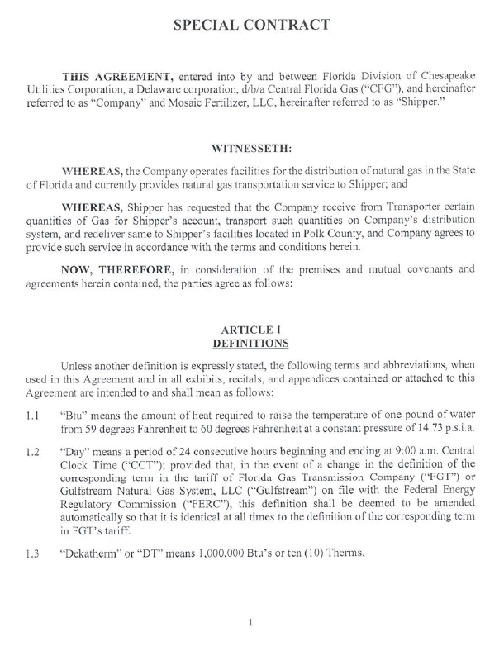
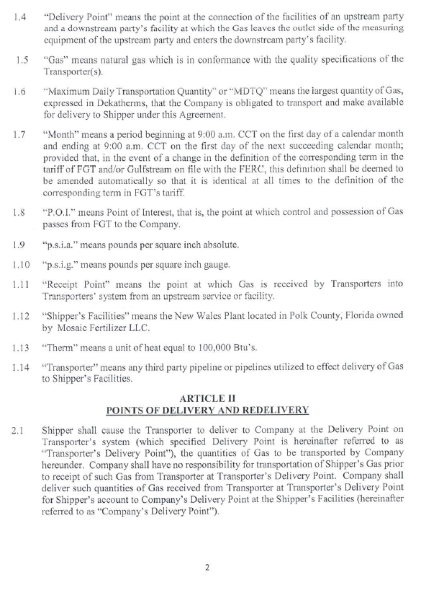
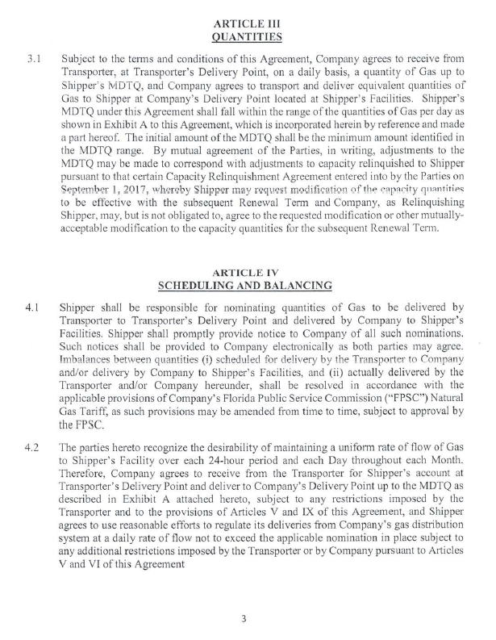

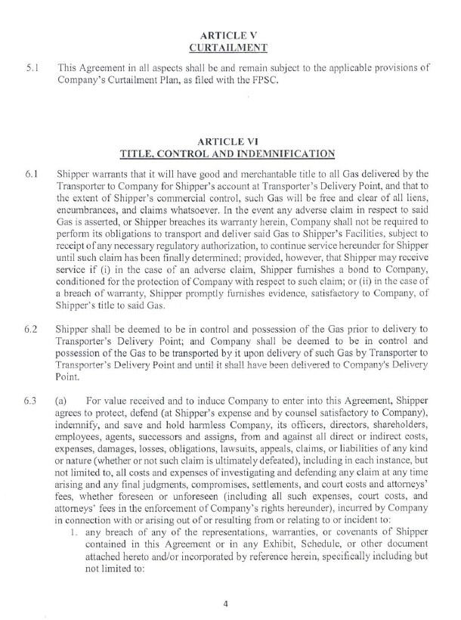

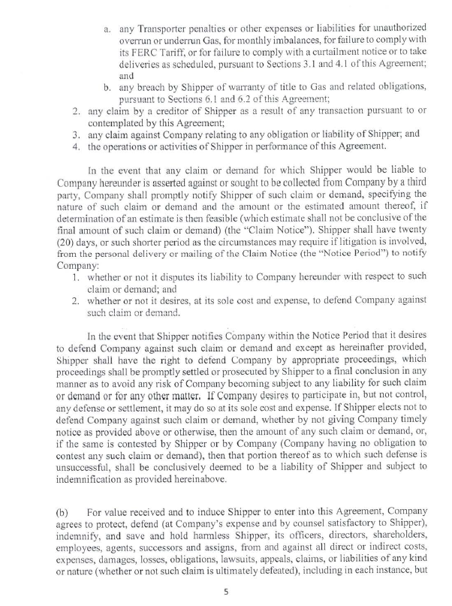

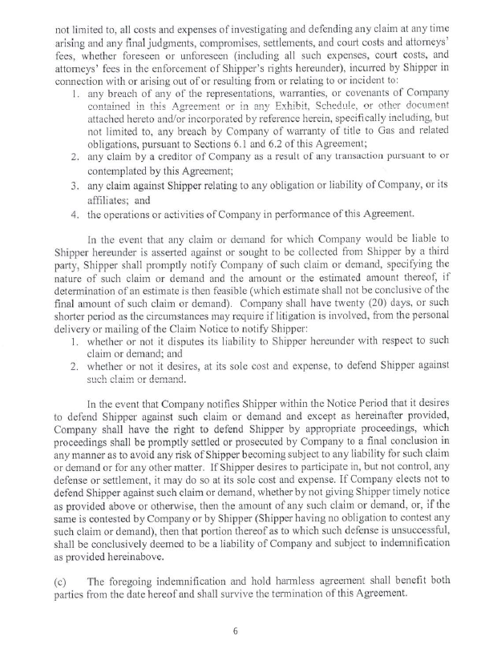

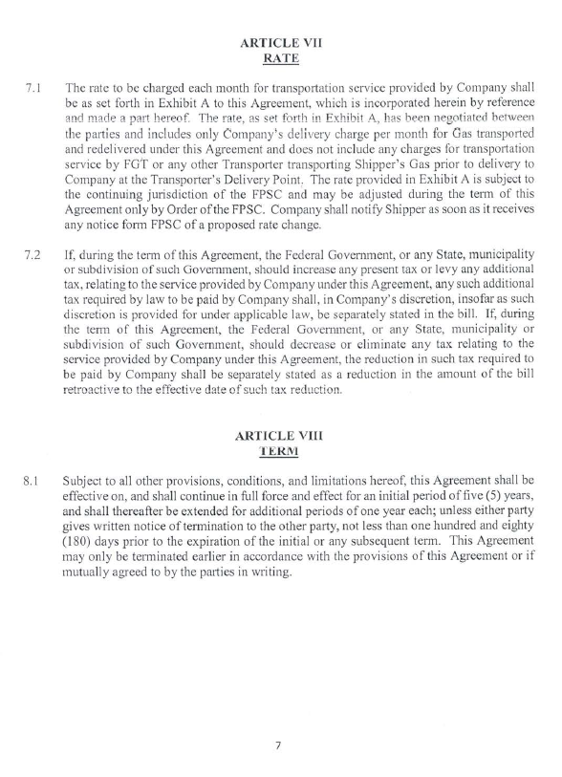

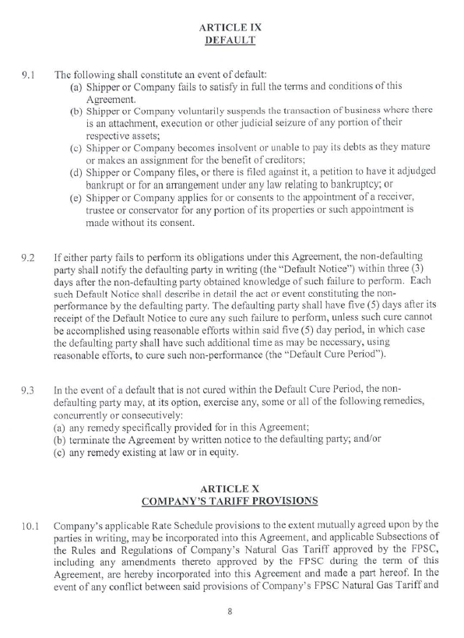
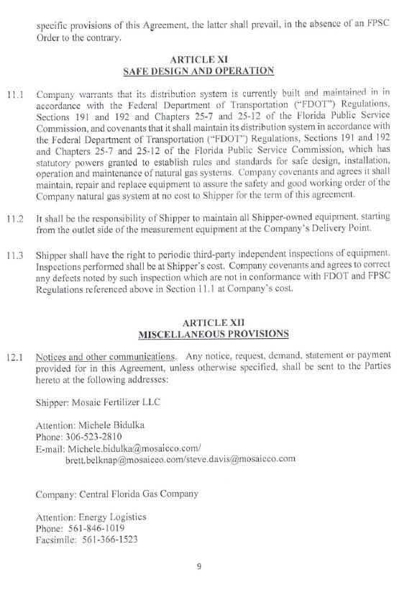
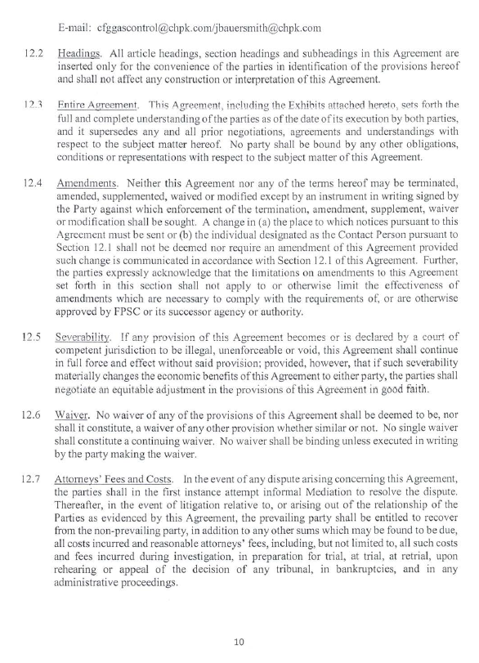
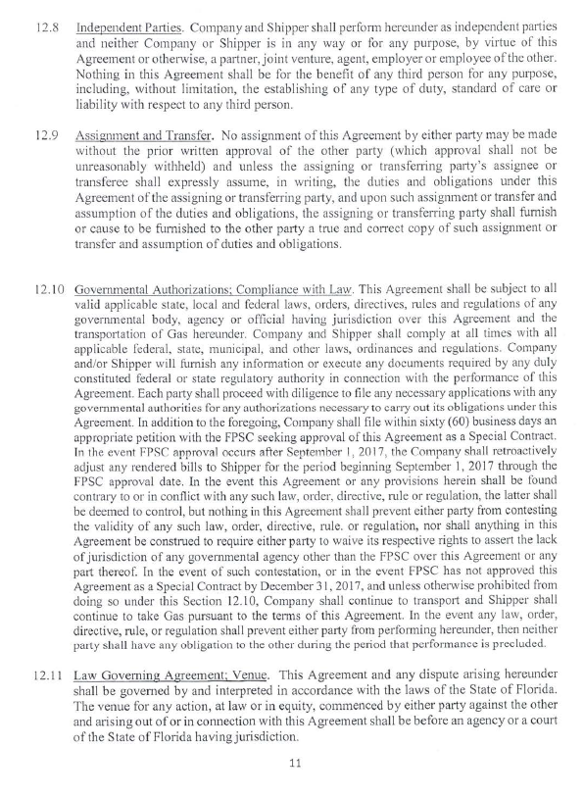
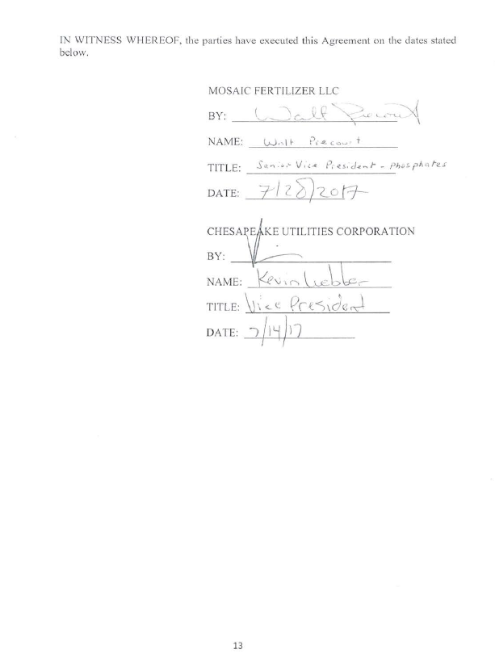

Order No. PSC-10-0029-PAA-GU, issued January 14, 2010, in Docket No. 090125-GU, In re: Petition for increase in rates by Florida Division of Chesapeake Utilities Corporation.
Order No. PSC-14-0592-TRF-GU, issued October 22, 2014, in Docket No. 140151-GU, In re: Petition of the Florida Division of Chesapeake Utilities Corporation to Close Rate Schedule Firm Transportation Service – 13 (FTS-13).

