State of Florida |  | Public Service Commission  Capital Circle Office Center ● 2540 Shumard Oak Boulevard  Tallahassee, Florida 32399-0850  -M-E-M-O-R-A-N-D-U-M-
DATE: | October 26, 2017
TO: | Office of Commission Clerk (Stauffer)
FROM: | Division of Economics (Guffey)  Office of the General Counsel (Janjic)
RE: | Docket No. 20170189-GU – Petition for approval of safety, access, and facility enhancement program (SAFE) true-up and associated cost recovery factors, by Florida City Gas.
AGENDA: | 11/07/17 – Regular Agenda – Tariff Filing – Interested Persons May Participate
COMMISSIONERS ASSIGNED: |  |  | All Commissioners
PREHEARING OFFICER: |  |  | Administrative
CRITICAL DATES: |  |  | 8-Month Effective Date: 04/30/18 (60-day suspension date waived by the utility)
SPECIAL INSTRUCTIONS: |  |  | None

Case Background
On August 31, 2017, Florida City Gas (City Gas or company) filed a petition for approval of its safety, access, and facility enhancement program (SAFE) true-up and associated 2018 cost recovery factors. The SAFE program was originally approved by the Commission in Order No. PSC-15-0390-TRF-GU (2015 order) to recover the cost of relocating on an expedited basis certain existing gas mains and associated facilities from rear lot easements to the street front. In the 2015 order, the Commission found that the relocation to the street front provides for more direct access to facilities and will enhance the level of service provided to all customers through improved safety and reliability. The SAFE factor is a surcharge on customers’ bills. The Commission ordered the company to file an annual petition, beginning in 2016, for a review and reset of the surcharge factors to true-up any prior over- or under-recovery and to set the surcharge for the coming year. City Gas’ current SAFE factors were approved in Order No. PSC-16-0517-TRF-GU (2016 order). The SAFE program is a 10-year program (2015 through 2025).
In its filing, City Gas waived the 60-day suspension deadline pursuant to Section 366.06(3), Florida Statutes (F.S.). City Gas filed its responses to staff’s first data request on September 21, 2017. The Office of the Public Counsel (OPC) filed a Notice of Intervention on October 4, 2017, which was acknowledged by Order PSC-2017-0413-PCO-GU, issued on October 24, 2017. The proposed tariff page is contained in Attachment 2 of this recommendation. The Commission has jurisdiction over this matter pursuant to Sections 366.03, 366.04, 366.05, 366.06, and 368, F.S.

Discussion of Issues

Issue 1:
Should the Commission approve City Gas' proposed SAFE factors effective January 2018?

Recommendation:
Yes. The Commission should approve City Gas’ proposed SAFE factors with an effective date of the first billing cycle of January 2018. (Guffey)

Staff Analysis:
Under the SAFE program, City Gas will relocate and replace 254.3 miles of mains and associated facilities from rear property easements to the street front over a 10-year period, ending in 2025. City Gas began its replacements at the end of 2015, as provided for in the 2015 order, and the surcharges have been in effect since January 2016.
The 2016 order approving the current surcharges states that “if City Gas files a rate case before 2025, the then-current SAFE surcharge program would be folded into any newly approved rate base, and the surcharge would begin anew.” On October 23, 2017, City Gas filed a petition for a rate increase and the Commission opened Docket No. 20170179-GU to address the rate case proceeding. In the rate case, City Gas witness Michael Morley testifies that City Gas proposes to incorporate the SAFE program revenue requirement ($3.5 million) in the requested base rate increase of $19.3 million and reset the SAFE surcharge to $0 at the time revised base rates will go into effect. Since the SAFE program is expected to continue until 2025, the SAFE surcharge would begin anew in 2019.

As stated in City Gas’ response to staff’s data request, the company's 2017 replacement plans include eight projects. Seven projects are in the Miami area (Cutler Bay, Hialeah, and South Miami Heights neighborhood). One project is in Brevard County (Merritt Island). The company’s projected 2018 replacement plans include nine projects. Eight projects will be in the Miami area (South Miami Heights neighborhood, Westchester neighborhood, Hialeah, and Miami Gardens) and one project will be in Brevard County (Merritt Island). Attachment 1 of this recommendation displays City Gas' mains and services replacement progress, both actual and forecasted.
City Gas stated that its replacement projects are generally prioritized based on the risk assessment model in its Distribution Integrity Management Program (DIMP). Prioritization factors include, but are not limited to, the location of the pipeline, pipeline material, leak incident rates, and rear lot pipelines with maintenance access complications and customer encroachments.

True-ups by Year
As required by the initial 2015 order, City Gas’ calculations for the 2018 revenue requirement and SAFE factors include a final true-up for 2016, an actual/estimated true-up for 2017, and projected cost for 2018. City Gas does not currently include interest on any over- or under-recoveries in its calculations.

Final True-up for 2016
City Gas stated that the revenues collected for 2016 were $931,973 compared to a revenue requirement of $749,325, resulting in over-recovery of $182,647.

Actual/Estimated 2017 True-up
City Gas provided actual revenues for January through July and forecast revenues for August through December of 2017, totaling $2,025,987, compared to an actual/estimated revenue requirement of $2,259,077, resulting in an under-recovery of $233,090. Adding the 2016 over-recovery of $182,647 to the 2017 under-recovery of $233,090, the resulting total 2017 true-up is an under-recovery of $50,443.

Projected 2018 Costs
The company projects investment of $30,634,858 for the relocation of gas mains from rear property easements to the street front in 2018. The corresponding revenue requirement, which includes return on investment, depreciation, and taxes, is $3,452,072. After adding the 2017 under-recovery of $50,443, the total 2018 revenue requirement is $3,502,515. Table 1-1 displays the 2018 revenue requirement calculation.
Table 1-1
2018 Revenue Requirement Calculation
2018 Projected Replacements | $30,634,858
Return on Investment | $2,315,506
Depreciation Expense | $905,272
Property Tax Expense | $231,294
2018 Revenue Requirement | $3,452,072
Plus 2017 Under-recovery | $50,443
Total 2018 Revenue Requirement | $3,502,515
Source: Exhibit B of the Petition

Proposed SAFE Factors
The SAFE factors are fixed monthly surcharges. The company's cost allocation method was approved in the 2015 order, and according to City Gas, used for the instant filing. The approved methodology allocates the current cost of a 2-inch pipe to all customers (other than those with pre-existing contracts) on a per customer basis and allocates the incremental cost of replacing a pipe larger than 2 inches to customers who use over 6,000 therms per year. For larger customers, the cost pool takes into account that the minimum pipe is insufficient to serve their demand, and therefore, allocates an incremental per foot cost in addition to the all-customer cost. The resulting allocation factors are applied to the 2018 total revenue requirement to develop the monthly customer SAFE factors.
Staff notes that the average residential customer uses approximately 240 therms per year. The proposed fixed monthly factor is $2.60 for customers using less than 6,000 therms per year, compared to the current factor of $1.53 per month. For customers using 6,000 therms or more per year, the proposed fixed monthly factor is $4.76, compared to the current factor of $2.77 per month.

Conclusion
Staff has reviewed City Gas’ filing and supporting documentation and believes that the calculations are consistent with the methodology and are reasonable and accurate. Therefore, staff recommends approval of City Gas' proposed 2018 SAFE surcharge factors with an effective date of the first billing cycle of January 2018.

Issue 2:
Should this docket be closed?

Recommendation:
If Issue 1 is approved and a protest is filed within 21 days of the issuance of the order, the tariffs should remain in effect, with any revenues held subject to refund, pending resolution of the protest. If no timely protest is filed, this docket should be closed upon the issuance of a consummating order. (Janjic)

Staff Analysis:
If Issue 1 is approved and a protest is filed within 21 days of the issuance of the order, the tariffs should remain in effect, with any revenues held subject to refund, pending resolution of the protest. If no timely protest is filed, this docket should be closed upon the issuance of a consummating order.

Table 1
Florida City Gas’ SAFE Program Progress
 | Main Replacements |  | Service Replacements
Year | Replaced Main (miles) | Total Miles Remaining | Replaced Services (No.) | Total Remaining Services
2014 | 0.0 | 254.3 | 0 | 12,719
2015 | 0.0 | 254.3 | 49 | 12,670
2016 | 17.1 | 237.2 | 1,433 | 11,237
2017 | 37.5 | 199.7 | 1,557 | 9,680
2018 | 27.6 | 172.1 | 1,698 | 7,982
2019 | 25.0 | 147.2 | 1,250 | 6,732
2020 | 25.0 | 122.2 | 1,250 | 5,481
2021 | 25.0 | 97.2 | 1,250 | 4,231
2022 | 25.0 | 72.2 | 1,250 | 2,981
2023 | 25.0 | 47.2 | 1,250 | 1,730
2024 | 25.0 | 22.2 | 1,250 | 480
2025 | 22.2 | 0.0 | 480 | 0
Source: FCG Response to Staff’s First Data Request

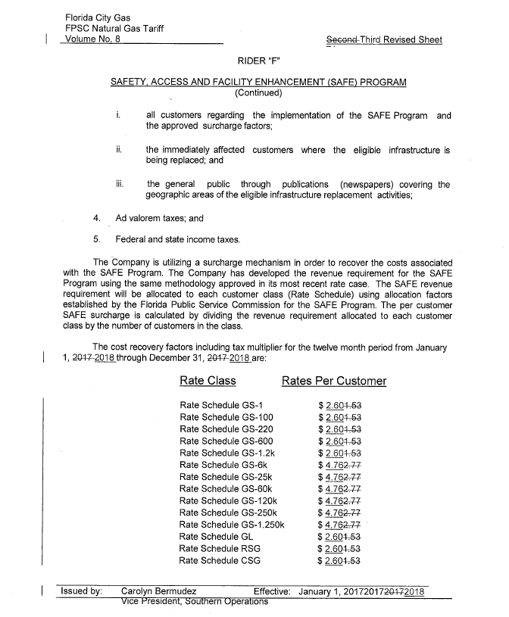

Order No. PSC-15-0390-TRF-GU, issued September 15, 2015, in Docket No. 150116-GU, In re: Petition for approval of safety, access, and facility enhancement program and associated cost recovery methodology, by Florida City Gas.
Order No. PSC-16-0517-TRF-GU, issued November 21, 2016, in Docket No. 160198-GU, In re: Petition for approval of safety, access, and facility enhancement program (SAFE) true-up and associated cost recovery factors, by Florida City Gas.

