State of Florida |  | Public Service Commission  Capital Circle Office Center ● 2540 Shumard Oak Boulevard  Tallahassee, Florida 32399-0850  -M-E-M-O-R-A-N-D-U-M-
DATE: | October 26, 2017
TO: | Office of Commission Clerk (Stauffer)
FROM: | Division of Economics (Ollila)  Office of the General Counsel (Brownless)
RE: | Docket No. 20170190-GU – Joint petition for approval of gas reliability infrastructure program (GRIP) by Florida Public Utilities Company, Florida Public Utilities Company-Fort Meade, and Florida Division of Chesapeake Utilities Corporation.
AGENDA: | 11/07/17 – Regular Agenda – Tariff Filing – Interested Persons May Participate
COMMISSIONERS ASSIGNED: |  |  | All Commissioners
PREHEARING OFFICER: |  |  | Administrative
CRITICAL DATES: |  |  | 8-Month Effective Date: 5/1/18 (60-day suspension date waived by the utility)
SPECIAL INSTRUCTIONS: |  |  | None

Case Background
On September 1, 2017, Florida Public Utilities Company (FPUC), FPUC-Fort Meade (Fort Meade), and the Florida Division of Chesapeake Utilities Corporation (Chesapeake), collectively the company, filed a joint petition for approval of their gas reliability infrastructure program (GRIP or program) cost recovery factors for the period January through December 2018. The GRIP for FPUC and Chesapeake was originally approved in Order No. PSC-12-0490-TRF-GU (2012 order) to recover the cost of accelerating the replacement of cast iron and bare steel distribution mains and services through a surcharge on customers’ bills. Order No. PSC-15-0578-TRF-GU established a GRIP for Fort Meade and required Fort Meade to file its petition for GRIP factors concurrently with FPUC and Chesapeake. The current GRIP surcharges were approved in Order No. PSC-16-0567-TRF-GU. In the 2012 order the Commission found that “Replacement of bare steel pipelines is in the public interest to improve the safety of Florida’s natural gas infrastructure, thereby reducing the risk to life and property.”
The Commission approved Chesapeake’s petition to amend the 2017 GRIP surcharge factor for commercial customers in rate class FTS-9 and to permit Chesapeake to issue refunds to the affected customers in Order No. PSC-17-0194-GU. After a customer inquiry about the factor, Chesapeake determined that the factor was overstated and that it was appropriate to refund the over-recovery of dollars to the affected customers. Rate class FTS-9 is for customers whose annual therm usage is between 400,000 and 700,000 (compared to about 240 therms per year for residential customers). Chesapeake reported that credits totaling $71,460.62, including interest, were applied to the six FTS-9 customer accounts on May 30, 2017.
In an email, the company waived the 60-day suspension deadline pursuant to Section 366.06(3), Florida Statutes, (F.S.). On September 29, 2017, the company filed responses to staff’s first data request, including a corrected Chesapeake tariff sheet No. 105.1. The Office of Public Counsel intervened in this docket on October 3, 2017, which was acknowledged by Order No. PSC-2017-0394-PCO-GU, issued October 17, 2017. The proposed tariff sheets are contained in Attachment B (FPUC), Attachment C (Chesapeake), and Attachment D (Fort Meade). The Commission has jurisdiction over this matter pursuant to Sections 366.03, 366.04, 366.05, and 366.06, F.S.

Discussion of Issues

Issue 1:
Should the Commission approve FPUC’s, Chesapeake’s, and Fort Meade’s proposed GRIP surcharges for 2018?

Recommendation:
Yes, the Commission should approve FPUC’s, Chesapeake’s, and Fort Meade’s proposed 2018 GRIP surcharge for each rate class effective for all meter readings for the period January – December 2018. (Ollila)

Staff Analysis:
The FPUC and Chesapeake GRIP surcharges have been in effect since January 2013, while Fort Meade’s surcharges were first implemented in January 2017. In response to staff’s data request, FPUC and Chesapeake stated that the replacement projects scheduled to be completed in 2017 are in Lake Worth, Palm Beach, Bartow, Lake Wales, and Winter Haven. Projects begun in 2017 and scheduled to be completed in early 2018 are in West Palm Beach and Lake Wales. Attachment A provides an update of mains and services replaced and replacement forecasts.
The GRIP replacement program for FPUC and Chesapeake is expected to be complete in 2022 as scheduled. In its response to staff’s data request, the company explained that in the early part of the program, based on their Distribution Integrity Management Program (DIMP), FPUC and Chesapeake aggressively replaced high risk qualifying facilities first, which increased capital expenditures. As a result, more than 50 percent of the mains and service projects have been completed with five years remaining in the GRIP. FPUC and Chesapeake stated that they are attempting to allocate the remaining projects over the five years left in the program. The company noted that the program may be accelerated if municipal roadway improvement projects arise where qualifying facilities are located, helping to reduce the replacement costs.
Fort Meade’s GRIP replacement program was originally expected to be complete by the end of 2018; the company stated that due to non-FPUC construction work in the area of its qualifying facilities and the lack of available contractor resources, Fort Meade has experienced delays and the replacement may extend beyond 2018.
FPUC agreed to report any depreciation and/or operations and maintenance savings as described in the 2012 order. In its response to staff’s data request, the company stated that there were no depreciation and/or operations and maintenance expense savings included as a reduction in expenses. The company stated that it had determined that if there were any depreciation expense savings, they would be offset by other factors, including increased cost of removal.

FPUC’s True-ups by Year
FPUC’s calculations for the 2018 GRIP revenue requirement and surcharges include a final true-up for 2016, an actual/estimated true-up for 2017, and projected costs for 2018. FPUC recovers $747,727 of annual GRIP expenses in base rates; therefore, the $747,727 is excluded from the GRIP surcharge calculations.

Final True-up for 2016
FPUC stated that the revenues collected for 2016 were $10,524,264, compared to a revenue requirement of $9,006,529, resulting in an over-recovery of $1,517,735. Adding the 2015 under-recovery of $2,967,684, the 2016 over-recovery of $1,517,735, and subtracting interest of $6,494 associated with any over- and under-recoveries, the final 2016 true-up is an under-recovery of $1,456,443.

Actual/Estimated 2017 True-up
FPUC provided actual revenues for January through July and estimated revenues for August through December 2017, totaling $12,397,877, compared to an actual/estimated revenue requirement for 2017 of $10,297,955, resulting in an over-recovery of $2,099,922. Adding the 2016 under-recovery of $1,456,443, the 2017 over-recovery of $2,099,922, and interest of $5,099, the resulting total 2017 over-recovery is $648,578.

Projected 2018 Costs
FPUC projects capital expenditures of $6,600,000 for the replacement of cast iron/bare steel infrastructure in 2018. This compares with final 2016 expenditures of $19,571,150 and actual/estimated 2017 expenditures of $6,071,766. The return on investment, depreciation expense, and property tax and customer notification expense associated with that investment are $11,640,975. Subtracting the revenue requirement for bare steel replacement investment included in base rates results in a 2018 revenue requirement of $10,893,248. After subtracting the total 2017 over-recovery of $648,578, the 2018 revenue requirement is $10,244,670. Table 1-1 shows FPUC’s 2018 revenue requirement calculation.
Table 1-1
FPUC 2018 Revenue Requirement Calculation
2018 Projected Expenditures | $6,600,000
Return on Investment | $7,669,444
Depreciation Expense | $2,308,044
Tax and Customer Notice Expense | $1,663,487
2018 Revenue Requirement | $11,640,975
Less Revenue Requirement in Base Rates | $747,727
2018 GRIP Revenue Requirement | $10,893,248
Less 2017 Over-recovery | $648,578
2018 Total Revenue Requirement | $10,244,670
Source: Cassel testimony, page 5 of 5 & Schedule C-2, page 4 of 15

Chesapeake’s True-ups by Year
Chesapeake’s calculations for the 2018 GRIP revenue requirement and surcharges include a final true-up for 2016, an actual/estimated true-up for 2017, and projected costs for 2018. Chesapeake does not have a replacement recovery amount embedded in base rates.

Final True-up for 2016
Chesapeake stated that the revenues collected for 2016 were $2,590,372 compared to a revenue requirement of $2,474,720, resulting in an over-recovery of $115,652. Adding the 2015 under-recovery amount of $125,419, the 2016 over-recovery of $115,652, and interest of $88 associated with any over- and under-recoveries, the final 2016 under-recovery is $9,679.

Actual/Estimated 2017 True-up
Chesapeake provided actual GRIP revenues for January through July and estimated revenues for August through December 2017, totaling $2,924,819, compared to an actual/estimated revenue requirement of $3,057,660, resulting in an under-recovery of $132,840. Adding the 2016 under-recovery amount of $9,679, the 2017 under-recovery of $132,840, and interest of $156, the total 2017 true-up is an under-recovery of $142,364.

Projected 2018 Costs
Chesapeake projects capital expenditures of $3,300,000 for the replacement of cast iron/bare steel infrastructure in 2018. This compares with final 2016 expenditures of $6,453,987 and actual/estimated 2017 expenditures of $2,852,772. The return on investment, depreciation expense, and property tax and customer notification expense to be recovered in 2018 totals $3,383,086. After adding the total 2017 under-recovery of $142,364, the total 2018 revenue requirement is $3,525,450. Table 1-2 shows Chesapeake’s 2018 revenue requirement calculation.
Table 1-2
Chesapeake 2018 Revenue Requirement Calculation
2018 Projected Expenditures | $3,300,000
Return on Investment | $2,190,536
Depreciation Expense | $694,550
Tax and Customer Notice Expense | $498,000
2018 Revenue Requirement | $3,383,086
Plus 2017 Under-recovery | $142,364
2018 Total Revenue Requirement | $3,525,450
Source: Cassel testimony, page 5 of 5 & Schedule C-2, page 9 of 15

Fort Meade’s True-ups by Year
Fort Meade started its replacement program in 2016 and first implemented GRIP surcharges in January 2017. Unlike FPUC and Chesapeake, only bare steel services (and no mains) require replacement in Fort Meade.

Final True-up for 2016
Since Fort Meade did not have a GRIP surcharge in 2016, the surcharge revenue for 2016 is $0. The revenue requirement for 2016 is $2,581. After adding interest associated with the under-recovery of $1, the total 2016 under-recovery is $2,582.

Actual/Estimated 2017 True-up
Fort Meade provided actual GRIP revenues for January through July and estimated revenues for August through December 2017, totaling $33,624, compared to an actual/estimated revenue requirement of $16,201, resulting in an over-recovery of $17,603. Adding the 2016 under-recovery of $2,582, the 2017 over-recovery of $17,603, and interest of $82, the resulting total 2017 true-up is an over-recovery of $15,103.

Projected 2018 Costs
Fort Meade projects capital expenditures of $100,000 for the replacement of cast iron/bare steel infrastructure in 2018. This compares with 2016 final expenditures of $104,346 and actual/estimated 2017 expenditures of $81,806. The return on investment, depreciation expense, and property tax expense to be recovered in 2018 totals $25,019. After subtracting the total 2017 over-recovery of $15,103, the total 2018 revenue requirement is $9,916. Table 1-3 shows Fort Meade’s 2018 revenue requirement calculation.
Table 1-3
Fort Meade 2018 Revenue Requirement Calculation
2018 Projected Expenditures | $100,000
Return on Investment | $16,718
Depreciation Expense | $5,313
Tax Expense | $2,988
2018 Revenue Requirement | $25,019
Less 2017 Over-recovery | $15,103
2018 Total Revenue Requirement | $9,916
Source: Cassel testimony, page 5 of 5 & Schedule C-2, page 14 of 15

Proposed Surcharges for FPUC, Chesapeake, and Fort Meade
As established in the 2012 order approving the GRIP, the total 2018 revenue requirement is allocated to the rate classes using the same methodology that was used for the allocation of mains and services in the cost of service study used in the companies’ most recent rate case. Fort Meade has the same rate schedules as FPUC; therefore, FPUC’s allocation factors are used to calculate the GRIP surcharges for Fort Meade. After calculating the percentage of total plant costs attributed to each rate class, the respective percentages were multiplied by the 2018 revenue requirement, resulting in the revenue requirement by rate class. Dividing each rate class’ revenue requirement by projected therm sales provides the GRIP surcharge for each rate class.
The proposed 2018 GRIP surcharge for FPUC’s residential customers on the RS Schedule is $0.24395 per therm (compared to the current surcharge of $0.34225 per therm). The decrease in the surcharge is a result of the decrease in capital expenditures and the 2017 over-recovery discussed earlier. The monthly bill impact is $4.88 for a residential customer using the typical 20 therms per month. The proposed FPUC tariff page is Attachment B.
The proposed 2018 GRIP surcharge for residential Chesapeake customers on the FTS-1 schedule is $0.11838 per therm (compared to the current surcharge of $0.10371 per therm). The monthly bill impact is $2.37 for a residential customer using the typical 20 therms per month. The proposed Chesapeake tariff pages are contained in Attachment C.
The proposed 2018 GRIP surcharge for residential Fort Meade customers on the RS Schedule is $0.08198 per them (compared to the current surcharge of $0.36931 per therm). The monthly bill impact is $1.64 for a residential customer using the typical 20 therms per month. The proposed Fort Meade tariff page is provided in Attachment D.

Conclusion
Staff believes the calculation of the 2018 GRIP surcharge revenue requirement and the proposed GRIP surcharges for FPUC, Chesapeake, and Fort Meade are reasonable and accurate. Staff recommends approval of FPUC’s, Chesapeake’s, and Fort Meade’s proposed 2018 GRIP surcharge for each rate class effective for all meter readings for the period January – December 2018.

Issue 2:
Should this docket be closed?

Recommendation:
If Issue 1 is approved and a protest is filed within 21 days of the issuance of the order, the tariffs should remain in effect, with any revenues held subject to refund, pending resolution of the protest. If no timely protest is filed, this docket should be closed upon the issuance of a consummating order. (Brownless)

Staff Analysis:
If Issue 1 is approved and a protest is filed within 21 days of the issuance of the order, the tariffs should remain in effect, with any revenues held subject to refund, pending resolution of the protest. If no timely protest is filed, this docket should be closed upon the issuance of a consummating order.

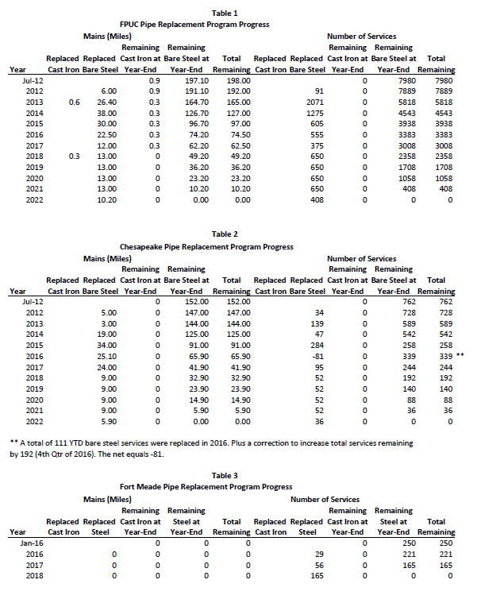
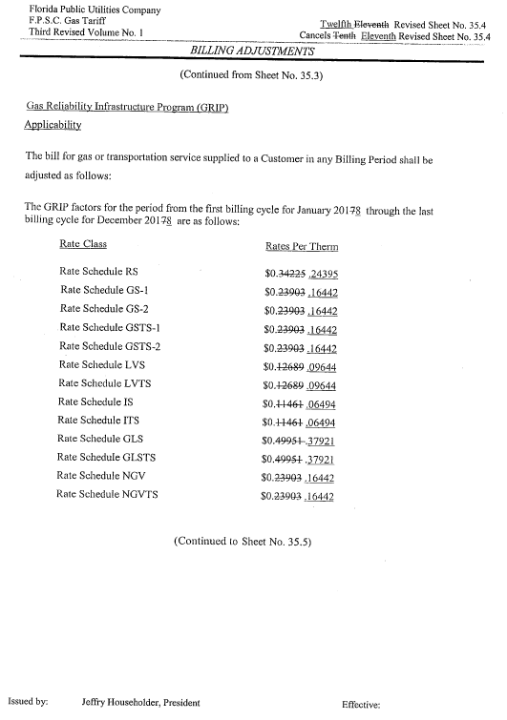
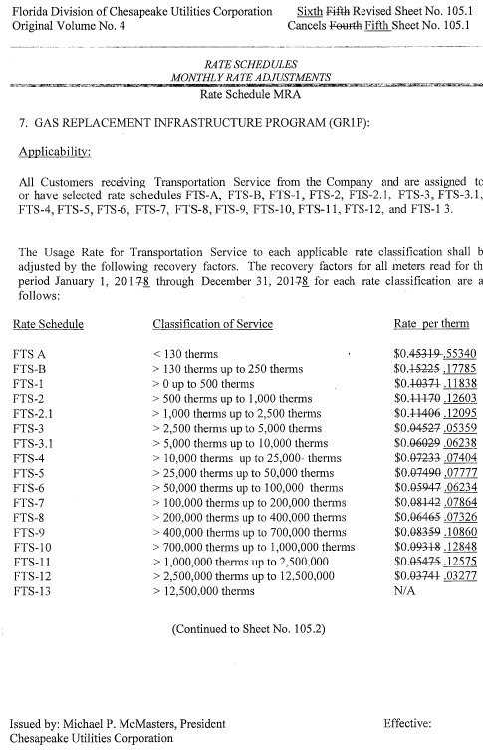
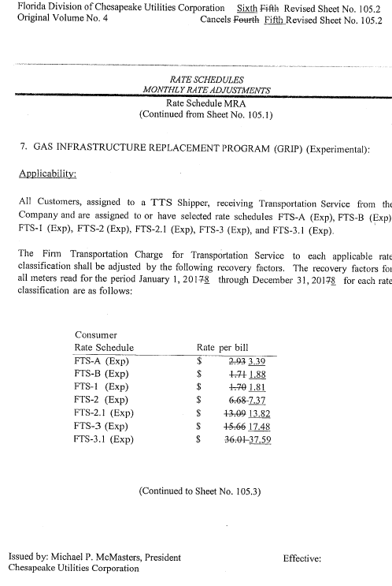
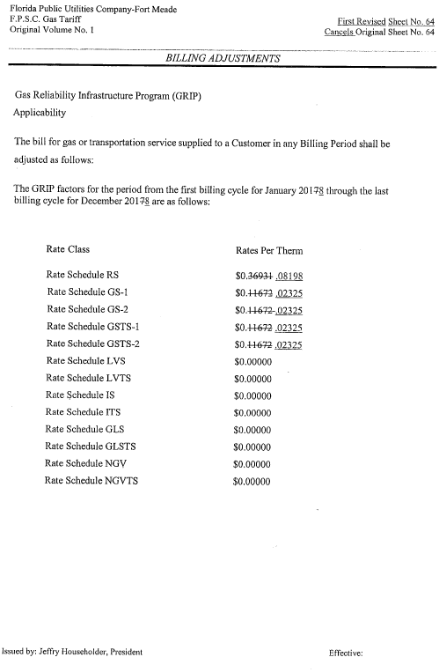

Order No. PSC-12-0490-TRF-GU, issued September 24, 2012, in Docket No. 120036-GU, In re: Joint petition for approval of Gas Reliability Infrastructure Program (GRIP) by Florida Public Utilities Company and the Florida Division of Chesapeake Utilities Corporation.
Order No. PSC-15-0578-TRF-GU, issued December 21, 2015, in Docket No. 150191-GU, In re: Joint petition for approval to implement gas reliability infrastructure program (GRIP) for Florida Public Utilities Company-Fort Meade and for approval of GRIP cost recovery factors by Florida Public Utilities Company, Florida Public Utilities Company-Fort Meade and the Florida Division of Chesapeake Utilities Corporation.
Order No. PSC-16-0567-TRF-GU, issued December 19, 2016, in Docket No. 160199-GU, In re: Joint petition for approval of gas reliability infrastructure program cost recovery factors by Florida Public Utilities Company, Florida Public Utilities Company-Fort Meade, and the Florida Division of Chesapeake Utilities Corporation.
Order No. PSC-17-0194-TRF-GU, issued May 19, 2017, in Docket No. 170062-GU, In re: Petition for approval to amend gas reliability infrastructure program (GRIP) cost recovery factor, by Florida Division of Chesapeake Utilities Corporation.

