State of Florida |  | Public Service Commission  Capital Circle Office Center ● 2540 Shumard Oak Boulevard  Tallahassee, Florida 32399-0850  -M-E-M-O-R-A-N-D-U-M-
DATE: | October 26, 2017
TO: | Office of Commission Clerk (Stauffer)
FROM: | Office of the General Counsel (DuVal, Cuello)  Division of Accounting and Finance (Mouring, Smith)  Office of Consumer Assistance and Outreach (Hicks)  Division of Economics (McCoy, McNulty)
RE: | Docket No. 20170200-WU – Initiation of show cause proceedings against Kincaid Hills Water Company, in Alachua County, for noncompliance with Sections 350.113, 350.117, 367.121, and 367.145, Florida Statutes, and Rules 25-30.110, 25-30.120, 25-30.355, and 25-22.032, Florida Administrative Code.
AGENDA: | 11/07/17 – Regular Agenda – Show Cause – Interested Persons May Participate
COMMISSIONERS ASSIGNED: |  |  | All Commissioners
PREHEARING OFFICER: |  |  | Graham
CRITICAL DATES: |  |  | None
SPECIAL INSTRUCTIONS: |  |  | None

Case Background
Commission staff opened the instant docket to initiate show cause proceedings against Kincaid Hills Water Company (Kincaid or Utility) for apparent violations of Florida Statutes (F.S.) and Commission rules for: (1) its failure to remit payment of its annual Regulatory Assessment Fees (RAFs) for the years 2008, 2009, 2012, 2013, and 2016; (2) its failure to submit its Annual Reports for the years 2009, 2010, 2011, 2012, and 2013; and (3) its failure to respond to customer complaints and to provide a written response to Commission staff regarding customer complaints.
Kincaid is a Class C water utility providing service in Alachua County. Kincaid became subject to Commission jurisdiction and was granted a grandfather water certificate in 1993. The following information provides a historical overview of the Commission’s activities related to Kincaid.
After failing to submit its Annual Reports for 1994 through 1996, an enforcement proceeding was initiated against Kincaid for violations of Rule 30.110, Florida Administrative Code (F.A.C.) (1997 Proceeding), and Kincaid was ordered to show cause why it should not be penalized $2,628 for failing to submit its Annual Reports. Kincaid failed to respond to the Commission’s Order, resulting in the Annual Report penalties being assessed by the Commission. After several failed attempts by Commission staff to contact Kincaid to collect the Annual Report penalty, the Commission submitted the penalty to the Florida Department of Financial Services (DFS) to be written-off as uncollectible.

In 2004, after failing to submit RAFs for the years 1995 through 2003 and failing to submit Annual Reports for the years 1998 through 2003, the Commission initiated an enforcement proceeding against Kincaid for violations of Section 350.113, F.S., and Rules 25-30.110 and 25-30.120, F.A.C. (2004 Proceeding). In an effort to work with Kincaid to resolve its non-compliance issues and because Kincaid made an effort to cooperate with Commission staff and submitted all of the delinquent Annual Reports for 1998-2003, the Commission declined to order Kincaid to show cause or assess fines against Kincaid for failing to submit RAFs and Annual Reports. Instead, the Commission approved a payment plan submitted by Kincaid to pay the RAFs, plus statutory penalty and interest, that it owed for the years 1995 to 2003. In addition, Kincaid was put on notice that failure to timely submit RAFs and Annual Reports in the future or comply with any Commission orders would result in further enforcement action by the Commission.

Kincaid again failed to submit RAFs and Annual Reports the year after the 2004 Proceeding, as well as the following two years. Kincaid made several payments toward the RAF amounts owed pursuant to the payment plan approved by Order No. PSC-04-0615-FOF-WU between June 2004 and January 2006, then ceased submitting payments. After failing to submit RAFs and Annual Reports for 2004, 2005, and 2006, failing to submit payments pursuant to the approved payment plan, and failing to respond to staff’s attempts to collect the amounts owed, the Commission initiated another enforcement proceeding against Kincaid in 2007 for violations of Section 350.113, F.S., and Rules 25-30.110 and 25-30.120, F.A.C., and Order No. PSC-04-0615-FOF-WU (2007 Proceeding).
At the time the Commission initiated the 2007 Proceeding, Kincaid had serious compliance issues with the Florida Department of Environmental Protection (DEP), as well as the United States Environmental Protection Agency (EPA). Despite finding “a continued pattern of disregard for the directions, orders, and rules of this Commission,” and “a continued pattern of disregard for the timely payment of RAFs,” the Commission again declined to order Kincaid to show cause, finding “exigent and mitigating circumstances” existed. At that time, the Commission reasoned that assessing additional penalties and requiring Kincaid to pay its delinquent RAFs and assessing Annual Report penalties would only further impair Kincaid’s financial viability and its ability to address the DEP and EPA compliance issues. Therefore, the Commission ordered that the outstanding RAFs amounts, including penalty and interest, owed by Kincaid for the years 1995 through 2006, be submitted to DFS to be written-off as uncollectible. Kincaid was put on notice that “failure to timely file future annual reports will subject it to the penalties authorized by Rule 25-30.110(7), F.A.C., and to show cause proceedings and fines of up to $5,000 per day per violation for each day the violation continues, as set forth in Section 367.161, F.S., or revocation proceedings pursuant to Section 367.161(2), F.S.” In addition, the Commission found Kincaid eligible for a Staff-Assisted Rate Case (SARC). Finally, the Commission ordered that the 2007 Proceeding remain open until Kincaid filed its SARC application, and that staff was to bring a recommendation to the Commission should Kincaid fail to timely submit RAFs during the pendency of its SARC.
In April 2008, Kincaid notified Commission staff that it would not pursue a SARC due to customer dissatisfaction expressed after Kincaid implemented recent rate increases. Between June 2007 and April 2008, Kincaid received two price-index increases, and a 4.5% pass-through increase, which allowed Kincaid to recover RAFs in its rates going forward. With the recent increases, Kincaid stated it could meet its obligations to pay RAFs and maintain Kincaid without a SARC. By Order No. PSC-08-0386-FOF-WU, the Commission ordered the 2007 Proceeding closed based on Kincaid submitting its 2007 RAFs and receiving the index and pass-through increases.
The year following the closure of the 2007 Proceeding, Kincaid again failed to submit its RAFs for 2008, as well as for the years 2009, 2010, 2011, 2012, and 2013. Kincaid again failed to submit its Annual Reports for the years 2009, 2010, 2011, 2012, and 2013. Kincaid also failed to respond to staff’s repeated attempts to contact Kincaid by telephone, mail, and email. In June 2014, Kincaid’s owner, Mr. Berdell Knowles, Sr., finally responded to staff regarding Kincaid’s outstanding RAFs, outstanding Annual Reports, and payment options. Mr. Knowles, Sr. agreed to submit Kincaid’s outstanding Annual Reports and RAF returns, along with an initial RAF payment by June 30, 2014. In addition, Mr. Knowles, Sr. was advised that the Commission may pursue further compliance action if Kincaid did not comply with a RAF payment plan. Mr. Knowles, Sr. failed to submit Kincaid’s 2008-2013 RAF returns or an initial RAF payment, and failed to submit Kincaid’s 2009-2013 Annual Reports, by June 30, 2014, as agreed and, again, failed to respond to staff’s attempts to contact Kincaid.
In October 2014, due to staff’s continued inability to contact Mr. Knowles, Sr., Commission staff communicated with the DEP staff assigned to Kincaid’s compliance issues and obtained the contact information for Mr. Berdell Knowles, Jr., a corporate officer of Kincaid. On October 20, 2014, staff spoke with Mr. Knowles, Jr. regarding Kincaid’s delinquent RAF and Annual Report status, the lack of cooperation by Mr. Knowles, Sr. to engage in discussions with staff, and Kincaid’s corporate and financial status. On October 23, 2014, staff held a conference call with Mr. Knowles, Jr., wherein Mr. Knowles, Jr. agreed to an initial compliance action plan to resolve Kincaid’s compliance issues. Mr. Knowles, Jr. agreed to submit all of Kincaid’s delinquent Annual Reports for years 2009-2013, as well as the RAF amounts owed for the years 2010 and 2011, plus penalty and interest, by November 7, 2014. As part of the initial compliance plan, Kincaid also agreed to continue working with staff regarding payment of the remaining RAF amounts owed, to consider pursing a SARC, and to submit future RAFs and Annual Reports timely.
On November 14, 2014, the Commission received Kincaid’s payment in the amount of $8,690.15, which satisfied the outstanding RAF amounts owed by Kincaid for 2010 and 2011. On November 14, 2014, the Commission received Kincaid’s Annual Reports for 2009-2013. On February 16, 2015, staff held a conference call with Kincaid (Mr. Knowles, Sr. and Mr. Knowles, Jr. both participated), wherein Kincaid agreed to resolve its compliance issues, including negotiation of payment options for its past due RAFs, to submit future RAFs and Annual Reports timely, to pursue a SARC, and to update its corporate status with the Florida Secretary of State, Division of Corporations Since submitting the $8,690.15 payment, however, Kincaid failed to meet the requirements of the initial compliance plan as agreed. Although Kincaid submitted its 2014, 2015, and 2016 Annual Reports timely, Kincaid failed to meet the other requirements of the initial compliance plan. Specifically, Kincaid has failed to: (1) submit additional payments toward its remaining years of delinquent RAFs; (2) continue to work with staff regarding repayment of its remaining years of delinquent RAFs; (3) update its corporate status with the Florida Secretary of State, Division of Corporations; (4) apply for a SARC; and (5) to submit its 2016 RAFs.
Commission staff received customer complaints regarding Kincaid on October 13, 2016, March 30, 2017, and May 8, 2017. To date, Kincaid has not responded to these customer complaints, nor has Kincaid provided a written response to Commission staff on each complaint.
By certified letter, dated July 31, 2017, Commission staff notified Kincaid of apparent violations of Sections 350.113, 350.117, 367.121, and 367.145, F.S., and Rules 25-30.110, 25-30.120, 25-30.355, and 25-22.032, F.A.C., and possible initiation of a show cause proceeding against the Utility for: (1) failing to remit payment of its annual RAFs for the years 2008, 2009, 2012, 2013, and 2016; (2) failing to timely submit its Annual Reports for the years 2009, 2010, 2011, 2012, and 2013; and (3) failing to respond to customer complaints and to provide a written response to Commission staff regarding customer complaints. Kincaid’s owner, Mr. Knowles, Sr., was informed in that letter that Section 367.161, F.S., provides in pertinent part:
(1) If any utility, by any authorized officer, agent, or employee, knowingly refuses to comply with, or willfully violates, any provision of this chapter or any lawful rule or order of the commission, such utility shall incur a penalty for each such offense of not more than $5,000, to be fixed, imposed, and collected by the commission . . . . Each day that such refusal or violation continues constitutes a separate offense. Each penalty shall be a lien upon the real and personal property of the utility, enforceable by the commission as statutory liens under chapter 85.
(2) The commission has the power to impose upon any entity that is subject to its jurisdiction under this chapter and that is found to have refused to comply with, or to have willfully violated, any lawful rule or order of the commission or any provision of this chapter a penalty for each offense of not more than $5,000, which penalty shall be fixed, imposed, and collected by the commission; or the commission may, for any such violation, amend, suspend, or revoke any certificate of authorization issued by it. Each day that such refusal or violation continues constitutes a separate offense. Each penalty shall be a lien upon the real and personal property of the entity, enforceable by the commission as a statutory lien under chapter 85.
Staff’s letter put Kincaid on notice that Commission staff would open a docket to initiate a show cause proceeding if Kincaid did not correct the violations by remitting payment of the delinquent RAFs, remitting payment for penalties for late-filed Annual Reports, and submitting written responses to the customer complaints by August 31, 2017. Commission staff further notified Kincaid that should the Utility ultimately be found in violation of Commission statutes, rules, or orders, the Commission may impose fines of up to $5,000 per violation, for each day each violation continues, including levying a statutory lien upon the real and personal property of the Utility, or the Commission may amend, suspend, or revoke Kincaid’s certificate, pursuant to Section 367.161, F.S. Additionally, Commission staff stated that, if necessary, the Commission may also seek injunctive or other appropriate relief in circuit court to compel Kincaid’s compliance, pursuant to Section 367.121, F.S. To date, Kincaid has not remitted payment of the delinquent RAFs, remitted payment for penalties for late-filed Annual Reports, or submitted written responses to the customer complaints, in response to staff’s letter.
By certified letter, dated September 28, 2017, the Commission’s Office of the General Counsel notified Kincaid that Commission staff opened a docket initiating a show cause proceeding for the Utility’s apparent statute and rule violations.
This recommendation addresses whether or not the Commission should order Kincaid to show cause why it is not obligated to submit the relevant payments and fines and bring itself into compliance with the Commission’s statutes and rules. Issue 1 is staff’s recommendation regarding Kincaid’s apparent violation of Sections 350.113 and 367.145, F.S., and Rule 25-30.120, F.A.C., for failure to submit RAFs for the years 2008, 2009, 2012, 2013, and 2016. Issue 2 is staff’s recommendation regarding Kincaid’s apparent violation of Section 367.121, F.S., and Rule 25-30.110, F.A.C., for failure to timely submit its Annual Reports for the years 2009, 2010, 2011, 2012, and 2013. Issue 3 is staff’s recommendation regarding Kincaid’s apparent violation of Rules 25-30.355 and 25-22.032, F.A.C., for failing to respond to customer complaints. Issue 4 discusses the closing of the docket and options for pursuing collection of the past due RAFs, Annual Report penalties, and penalties for failing to respond to customer complaints, along with the procedure for the option of initiating revocation proceedings.
When evaluating staff’s recommendation, a review of the Commission’s authority regarding a utility’s alleged violations of Commission rules, statutes, or orders is helpful.
Pursuant to Section 367.161(1), F.S., the Commission is authorized to impose upon any entity subject to its jurisdiction a penalty of not more than $5,000 for each such day a violation continues, if such entity is found to have refused to comply with or to have willfully violated any lawful rule or order of the Commission, or any provision of Chapter 367, F.S. Each day a violation continues is treated as a separate offense. Each penalty is a lien upon the real and personal property of the utility and is enforceable by the Commission as a statutory lien. If a penalty is also assessed by another state agency for the same violation, the Commission’s penalty will be reduced by the amount of the other agency’s penalty. As an alternative to the above remedies, Section 367.161(2), F.S., permits the Commission to amend, suspend, or revoke a utility’s certificate for any such violation. Part of the determination the Commission must make in evaluating whether to penalize a utility is whether the utility willfully violated the rule, statute, or order. Section 367.161, F.S., does not define what it is to “willfully violate” a rule or order.
Willfulness is a question of fact. The plain meaning of “willful” typically applied by the Courts in the absence of a statutory definition, is an act or omission that is done “voluntarily and intentionally” with specific intent and “purpose to violate or disregard the requirements of the law.” Fugate at 76.
The procedure followed by the Commission in dockets such as this is to consider the Commission staff’s recommendation and determine whether or not the facts warrant requiring the utility to respond. If the Commission finds that the facts warrant requiring the utility to respond, the Commission issues an Order to Show Cause (show cause order). A show cause order is considered an administrative complaint by the Commission against the utility. If the Commission issues a show cause order, the utility is required to file a written response, which response must contain specific allegations of disputed fact. If there are no disputed factual issues, the utility’s response should so indicate. The response must be filed within 21 days of service of the show cause order on the respondent.
In recommending a penalty, staff reviews prior Commission orders. While Section 367.161, F.S., treats each day of each violation as a separate offense with penalties of up to $5,000 per offense, staff believes that the general purpose of the show cause penalties is to obtain compliance with the Commission’s rules, statutes, and orders. If a utility has a pattern of noncompliance with a particular rule or set of rules, staff believes that a higher penalty is warranted. If the rule violation adversely impacts the public health, safety, or welfare, staff believes that the sanction should be the most severe.
The utility has two options if a show cause order is issued. The utility may respond and request a hearing pursuant to Sections 120.569 and 120.57, F.S. If the utility requests a hearing, a further proceeding will be scheduled before the Commission makes a final determination on the matter. The utility may respond to the show cause order by remitting the fine and bringing itself into compliance with the Commission’s statutes and rules. If the utility pays the fine and brings itself into compliance with the Commission’s statutes and rules, this show cause matter is considered resolved, and the docket closed.
In the event the utility fails to timely respond to the show cause order, the utility is deemed to have admitted the factual allegations contained in the show cause order. The utility’s failure to timely respond is also a waiver of its right to a hearing. If the utility does not timely respond, a final order will be issued imposing the sanctions set out in the show cause order. It should be noted that if the Commission commences revocation or suspension proceedings, the Commission must follow very specific noticing requirements set forth in Section 120.60, F.S., prior to revocation or suspension of a certificate.
The Commission has jurisdiction pursuant to Sections 350.113, 367.121, 367.145, and 367.161, F.S.

Discussion of Issues

Issue 1:
Should Kincaid Hills Water Company be ordered to show cause in writing, within 21 days, why it is not obligated to remit payment in the amount of $22,403.19, for delinquent Regulatory Assessment Fees, plus statutory penalties and interest, for the years 2008, 2009, 2012, 2013, and 2016?

Recommendation:

Alternative 1 Recommendation: Yes. Kincaid Hills Water Company should be ordered to show cause in writing, within 21 days, why it is not obligated to remit payment in the amount of $22,403.19, for delinquent Regulatory Assessment Fees, plus statutory penalties and interest, for the years 2008, 2009, 2012, 2013, and 2016. Specifically, staff recommends that the Utility be directed to pay its past due RAFs in the amount of $2,279.75 for 2008, $2,712.33 for 2009, $2,634.08 for 2012, $2,239.02 for 2013, and $2,006.69 for 2016, including statutory interest and penalties in the amounts of $2,963.68 for 2008, $3,200.55 for 2009, $2,159.95 for 2012, $1,544.93 for 2013, and $662.21 for 2016. (DuVal, Cuello, Hicks, McCoy, Smith)
Alternative 2 Recommendation: No. The Commission should direct staff to initiate certificate revocation proceedings against Kincaid Hills Water Company consistent with Chapter 120 and Section 367.161, F.S. (DuVal, Cuello, Hicks, McCoy, Smith)

Staff Analysis:

Applicable Law
Pursuant to Sections 350.113 and 367.145, F.S., and Rule 25-30.120, F.A.C., each regulated company under the jurisdiction of the Commission shall pay to the Commission a RAF based upon the gross operating revenues for the prior year operating period. Rule 25-30.120, F.A.C., requires that utilities pay a regulatory assessment fee of 4.5 percent of its gross revenues derived from intrastate business, or a minimum of $25.00 if there are no revenues or if revenues are insufficient to generate above the $25.00 minimum. Section 350.113(4), F.S., provides for a penalty of 5 percent for the first 30 days, and an additional penalty of “5 percent for each additional 30 days or fraction thereof during the time in which the failure continues, not to exceed a total penalty of 25 percent,” and states that “the commission shall collect the fee and penalty, plus interest and all costs of collection, from the regulated company.” Section 367.145(1)(b), F.S., states that, in addition to the penalties and interest otherwise provided, the Commission may impose a penalty upon a utility for failure to pay regulatory assessment fees in a timely manner in accordance with Section 367.161, F.S. Further, Rule 25-30.120(7)(b), F.A.C., provides that, in addition to statutory penalties and interest, the Commission may impose an additional penalty upon a utility for failing to pay RAFs timely, pursuant to Section 367.161, F.S.
Pursuant to Section 367.161, F.S., the commission has the power to impose upon any entity that is subject to its jurisdiction under this chapter and that is found to have refused to comply with, or to have willfully violated, any lawful rule or order of the commission or any provision of this chapter a penalty for each offense of not more than $5,000, for each such day a violation continues, which penalty shall be fixed, imposed, and collected by the commission; or the commission may, for any such violation, amend, suspend, or revoke any certificate of authorization issued by it.

Willfulness is a question of fact. Therefore, part of the determination the Commission must make in evaluating whether to penalize a utility is whether the utility willfully violated the rule, statute, or order. Section 367.161, F.S., does not define what it is to “willfully violate” a rule or order. The plain meaning of “willful” typically applied by the Courts in the absence of a statutory definition, is an act or omission that is done “voluntarily and intentionally” with specific intent and “purpose to violate or disregard the requirements of the law.” Fugate at 76.

Factual Allegations

Commission records indicate that Kincaid failed to submit RAFs for the years 2008, 2009, 2012, 2013, and 2016. Kincaid has a long history of failing to submit RAFs, and has had two enforcement proceedings brought by the Commission in 2004 and 2007 for failing to submit RAFs. In fact, since coming under the Commission’s jurisdiction in 1993, Kincaid has only submitted RAFs timely two times (2014 and 2015). Despite the numerous attempts by the Commission and staff over the last 13 years to work with Kincaid to resolve its RAF compliance issues, Kincaid has repeatedly failed to comply with its statutory and regulatory obligations.
Because Kincaid failed to submit its 2008, 2009, 2012, 2013, and 2016 RAFs timely, statutory penalties and interest are also due.
The total amount owed by Kincaid for 2008, 2009, 2012, 2013, and 2016 RAFs, plus associated penalties and interest, calculated through November 7, 2017, is $22,403.19. A breakdown of the amount is shown in the table below.

Year | Revenues | RAFs  (4.5%) | Penalty  (5% up to 25%)  (As of 11/7/17) | Interest  (1% through 08/31/17)  (As of 11/7/17) | Payments | Total  Due
2016 | $44,593.00 | $2,006.69 | $501.67 | $160.54 | $0.00 | $2,668.90
2013 | $49,756.00 | $2,239.02 | $559.76 | $985.17 | $0.00 | $3,739.17
2012 | $58,535.00 | $2,634.08 | $658.52 | $1,501.43 | $0.00 | $4,715.00
2009 | $60,274.00 | $2,712.33 | $678.08 | $2,522.47 | $0.00 | $5,858.63
2008 | $50,661.00 | $2,279.75 | $569.94 | $2,393.74 | $0.00 | $5,197.83
Totals | $263,819.00 | $11,871.87 | $2967.97 | $9,629.21 | $12,888.25 | $22,403.19
Alternative 1 Recommendation
By knowingly failing to comply with the provisions of Sections 350.113 and 367.145, F.S., and Rule 25-30.120, F.A.C., staff believes Kincaid’s acts were “willful” in the sense intended by Section 367.161, F.S., and contemplated by Fugate. Therefore, staff recommends that Kincaid Hills Water Company be ordered to show cause in writing, within 21 days, why it is not obligated to remit payment in the amount of $22,403.19, for delinquent Regulatory Assessment Fees, plus statutory penalties and interest, for the years 2008, 2009, 2012, 2013, and 2016. Specifically, staff recommends that the Utility be directed to pay its past due RAFs in the amount of $2,279.75 for 2008, $2,712.33 for 2009, $2,634.08 for 2012, $2,239.02 for 2013, and $2,006.69 for 2016, including statutory interest and penalties in the amounts of $2,963.68 for 2008, $3,200.55 for 2009, $2,159.95 for 2012, $1,544.93 for 2013, and $662.21 for 2016. Staff recommends that the show cause order incorporate the following conditions:
- This show cause order is an administrative complaint by the Florida Public Service Commission, as petitioner, against Kincaid Hills Water Company, as respondent.
- Kincaid shall respond to the show cause order within 21 days of service on the Utility, and the response shall reference Docket No. 20170200-WU, Initiation of show cause proceedings against Kincaid Hills Water Company, in Alachua County, for noncompliance with Sections 350.113, 350.117, 367.121, and 367.145, Florida Statutes, and Rules 25-30.110, 25-30.120, 25-30.355, and 25-22.032, Florida Administrative Code.
- Kincaid has the right to request a hearing to be conducted in accordance with Sections 120.569 and 120.57, F.S., and to be represented by counsel or other qualified representative.
- Requests for hearing shall comply with Rule 28-106.2015, F.A.C.
- Kincaid’s response to the show cause order shall identify those material facts that are in dispute. If there are none, the petition must so indicate.
- If Kincaid files a timely written response and makes a request for a hearing pursuant to Sections 120.569 and 120.57, F.S., a further proceeding will be scheduled before a final determination of this matter is made.
- A failure to file a timely written response to the show cause order will constitute an admission of the facts herein alleged and a waiver of the right to a hearing on this issue.
- In the event that Kincaid fails to file a timely response to the show cause order, the fine will be deemed assessed and a final order will be issued.
- If Kincaid responds to the show cause order by remitting the fine, this show cause matter will be considered resolved, and the docket closed.
Furthermore, the Utility should be warned and put on notice that continued failure to comply with Commission orders, rules, or statutes will again subject the Utility to show cause proceedings and fines of up to $5,000 per day per violation for each day the violation continues, or the Commission may amend, suspend, or revoke Kincaid’s certificate, as set forth in Section 367.161, F.S.
Alternative 2 Recommendation
In the alternative, Commission staff should be directed to send a letter to the Utility, giving the Utility 30 days notice that it intends to commence revocation proceedings. Revocation would be in lieu of the penalties set forth above. In evaluating this option, it would be important for the Commission to consider Kincaid’s management’s history, specifically, the fact that the Utility has a long history of noncompliance. Staff believes that Kincaid has a poor record of complying with applicable rules and statutes under Commission jurisdiction. Notably, this is the fourth time staff has opened a docket to initiate a show cause proceeding since Kincaid became subject to the Commission’s jurisdiction in 1993. The Commission similarly initiated revocation proceedings against St. George Island Utility Company, Ltd. in Franklin County as a result of that utility’s history of noncompliance with orders, rules, and statutory requirements.
Commission staff is concerned that Kincaid’s management does not understand how to and is not willing to commit the time to operate a utility within the meaning of Chapter 367, F.S. The operation of a utility under Chapter 367, F.S., if successful, allows a utility the opportunity to earn a return on its investment. If management is not willing to operate as a utility, the Utility’s certificate should be revoked, removing any opportunity the owner has to earn a return on its investment. If the certificate is revoked, a receiver must be appointed pursuant to Section 367.165, F.S., until a sale of the utility system has been approved pursuant to Section 367.071, F.S.

Issue 2:
Should Kincaid Hills Water Company be ordered to show cause in writing, within 21 days, why it is not obligated to remit payment in the amount of $14,376, in statutory penalties for failing to timely submit its Annual Reports for the years 2009, 2010, 2011, 2012, and 2013?

Recommendation:

Alternative 1 Recommendation: Yes. Kincaid Hills Water Company should be ordered to show cause in writing, within 21 days, why it is not obligated to remit payment in the amount of $14,376, in statutory penalties for failing to timely submit its Annual Reports for the years 2009, 2010, 2011, 2012, and 2013. (DuVal, Cuello, Hicks, McCoy, Smith)
Alternative 2 Recommendation: No. The Commission should direct staff to initiate certificate revocation proceedings against Kincaid Hills Water Company consistent with Chapter 120 and Section 367.161, F.S. (DuVal, Cuello, Hicks, McCoy, Smith)

Staff Analysis:

Applicable Law
Section 367.121(1)(c) and (i), F.S., authorizes the Commission to require utilities subject to its jurisdiction to file such regular financial reports it deems necessary. Rule 25-30.110(3)(a), F.A.C., provides that each utility under the jurisdiction of the Commission shall file an Annual Report on or before March 31st, for the preceding year ending December 31. The standard penalty for delinquent Annual Reports is $3 per day, pursuant to Rule 25-30.110(7), F.A.C.
Pursuant to Section 367.161, F.S., the commission has the power to impose upon any entity that is subject to its jurisdiction under this chapter and that is found to have refused to comply with, or to have willfully violated, any lawful rule or order of the commission or any provision of this chapter a penalty for each offense of not more than $5,000, for each such day a violation continues, which penalty shall be fixed, imposed, and collected by the commission; or the commission may, for any such violation, amend, suspend, or revoke any certificate of authorization issued by it.
Willfulness is a question of fact. Therefore, part of the determination the Commission must make in evaluating whether to penalize a utility is whether the utility willfully violated the rule, statute, or order. Section 367.161, F.S., does not define what it is to “willfully violate” a rule or order. The plain meaning of “willful” typically applied by the Courts in the absence of a statutory definition, is an act or omission that is done “voluntarily and intentionally” with specific intent and “purpose to violate or disregard the requirements of the law.” Fugate at 76.

Factual Allegations
A review of Commission records indicates that Kincaid has repeatedly failed to submit its Annual Reports. Since coming under Commission jurisdiction in 1993, Kincaid has only submitted five Annual Reports on time (1997, 2007, 2014, 2015, 2016).
Therefore, the total penalty amount owed by Kincaid for failing to timely submit its annual reports for the years 2009 to 2013 is $14,376. A breakdown of the amount is shown in the table below.
Year | Date Due | Date Submitted | Days Late | Penalty  ($3 per day)
2013 | 03/31/2014 | 11/14/2014 | 228 | $684.00
2012 | 04/01/2013 | 11/14/2014 | 593 | $1,779.00
2011 | 04/02/2012 | 11/14/2014 | 958 | $2,874.00
2010 | 03/31/2011 | 11/14/2014 | 1,324 | $3,972.00
2009 | 03/31/2010 | 11/14/2014 | 1,689 | $5,067.00
Total |  |  | 4,792 | $14,376.00
Alternative 1 Recommendation
By knowingly failing to comply with the provisions of Section 367.121, F.S., and Rule 25-30.110, F.A.C., staff believes Kincaid’s acts were “willful” in the sense intended by Section 367.161, F.S., and contemplated by Fugate. Therefore, staff recommends that Kincaid Hills Water Company should be ordered to show cause in writing, within 21 days, why it is not obligated to remit payment in the amount of $14,376, in statutory penalties for failing to submit its Annual Reports for the years 2009, 2010, 2011, 2012, and 2013. Staff recommends that the show cause order incorporate the following conditions:
- This show cause order is an administrative complaint by the Florida Public Service Commission, as petitioner, against Kincaid Hills Water Company, as respondent.
- Kincaid shall respond to the show cause order within 21 days of service on the Utility, and the response shall reference Docket No. 20170200-WU, Initiation of show cause proceedings against Kincaid Hills Water Company, in Alachua County, for noncompliance with Sections 350.113, 350.117, 367.121, and 367.145, Florida Statutes, and Rules 25-30.110, 25-30.120, 25-30.355, and 25-22.032, Florida Administrative Code.
- Kincaid has the right to request a hearing to be conducted in accordance with Sections 120.569 and 120.57, F.S., and to be represented by counsel or other qualified representative.
- Requests for hearing shall comply with Rule 28-106.2015, F.A.C.
- Kincaid’s response to the show cause order shall identify those material facts that are in dispute. If there are none, the petition must so indicate.
- If Kincaid files a timely written response and makes a request for a hearing pursuant to Sections 120.569 and 120.57, F.S., a further proceeding will be scheduled before a final determination of this matter is made.
- A failure to file a timely written response to the show cause order will constitute an admission of the facts herein alleged and a waiver of the right to a hearing on this issue.
- In the event that Kincaid fails to file a timely response to the show cause order, the fine will be deemed assessed and a final order will be issued.
- If Kincaid responds to the show cause order by remitting the fine, this show cause matter will be considered resolved, and the docket closed.
Furthermore, the Utility should be warned and put on notice that continued failure to comply with Commission orders, rules, or statutes will again subject the Utility to show cause proceedings and fines of up to $5,000 per day per violation for each day the violation continues, or the Commission may amend, suspend, or revoke Kincaid’s certificate, as set forth in Section 367.161, F.S.
Alternative 2 Recommendation
In the alternative, Commission staff should be directed to send a letter to the Utility, giving the Utility 30 days notice that it intends to commence revocation proceedings. Revocation would be in lieu of the penalties set forth above. In evaluating this option, it would be important for the Commission to consider Kincaid’s management’s history, specifically, the fact that the Utility has a long history of noncompliance. Staff believes that Kincaid has a poor record of complying with applicable rules and statutes under Commission jurisdiction. Notably, this is the fourth time staff has opened a docket to initiate a show cause proceeding since Kincaid became subject to the Commission’s jurisdiction in 1993. The Commission similarly initiated revocation proceedings against St. George Island Utility Company, Ltd. in Franklin County as a result of that utility’s history of noncompliance with orders, rules, and statutory requirements.
Commission staff is concerned that Kincaid’s management does not understand how to and is not willing to commit the time to operate a utility within the meaning of Chapter 367, F.S. The operation of a utility under Chapter 367, F.S., if successful, allows a utility the opportunity to earn a return on its investment. If management is not willing to operate as a utility, the Utility’s certificate should be revoked, removing any opportunity the owner has to earn a return on its investment. If the certificate is revoked, a receiver must be appointed pursuant to Section 367.165, F.S., until a sale of the utility system has been approved pursuant to Section 367.071, F.S.

Issue 3:
Should Kincaid Hills Water Company be ordered to show cause in writing, within 21 days, why it is not obligated to remit payment in the amount of $750 in statutory penalties, respond to the customer complaints submitted on October 13, 2016, March 30, 2017, and May 8, 2017, and to provide a written response to Commission staff on each complaint?

Recommendation:

Alternative 1 Recommendation: Yes. Kincaid Hills Water Company should be ordered to show cause in writing, within 21 days, why it is not obligated to remit payment in the amount of $750 in statutory penalties, respond to the customer complaints submitted on October 13, 2016, March 30, 2017, and May 8, 2017, and to provide a written response to Commission staff on each complaint. Specifically, staff recommends that the Utility be directed to pay a statutory penalty in the amount of $250 for failing to respond to a customer complaint dated October 13, 2016, a statutory penalty in the amount of $250 for failing to respond to a customer complaint dated March 30, 2017, and a statutory penalty in the amount of $250 for failing to respond to a customer complaint dated May 8, 2017. (DuVal, Cuello, Hicks, McCoy, Smith)
Alternative 2 Recommendation: No. The Commission should direct staff to initiate certificate revocation proceedings against Kincaid Hills Water Company consistent with Chapter 120 and Section 367.161, F.S. (DuVal, Cuello, Hicks, McCoy, Smith)

Staff Analysis:

Applicable Law

Rule 25-30.355, F.A.C., requires that a utility make a full and prompt acknowledgment and investigation of all customer complaints and respond fully and promptly to all customer requests. Finally, Rule 25-22.032(6)(b), F.A.C., requires that a utility respond to a customer complaint received by the Commission by contacting the customer within 15 working days after receiving the complaint from Commission staff and provide a written response to the complaint to Commission staff within 15 working days after receiving the complaint from Commission staff.

Pursuant to Section 367.161, F.S., the commission has the power to impose upon any entity that is subject to its jurisdiction under this chapter and that is found to have refused to comply with, or to have willfully violated, any lawful rule or order of the commission or any provision of this chapter a penalty for each offense of not more than $5,000, for each such day a violation continues, which penalty shall be fixed, imposed, and collected by the commission; or the commission may, for any such violation, amend, suspend, or revoke any certificate of authorization issued by it.

Willfulness is a question of fact. Therefore, part of the determination the Commission must make in evaluating whether to penalize a utility is whether the utility willfully violated the rule, statute, or order. Section 367.161, F.S., does not define what it is to “willfully violate” a rule or order. The plain meaning of “willful” typically applied by the Courts in the absence of a statutory definition, is an act or omission that is done “voluntarily and intentionally” with specific intent and “purpose to violate or disregard the requirements of the law.” Fugate at 76.

Factual Allegations

A review of Commission records shows that Kincaid is not timely responding to customer complaints. The Commission’s Consumer Activity Tracking System (CATS) shows three customer complaints in which Kincaid has failed to respond to both the customer and the Commission staff. Staff has compiled a list of customer complaints currently open with the Commission, along with a copy of each of the CATS complaint records for review. These complaints were submitted to the Commission on October 13, 2016, March 30, 2017, and May 8, 2017. The complaints show that customers reported regularly experiencing difficulty in reaching a Utility representative and reported Kincaid’s telephone number being out-of-service on occasions. Commission staff has experienced great difficulty in reaching Kincaid regarding the customer complaints. Furthermore, Kincaid has failed to adequately respond to Commission staff’s repeated attempts to contact Kincaid by telephone, mail, and e-mail in order to resolve the complaints. To date, Kincaid has not responded to these customer complaints and has not provided a written response to Commission staff on these complaints.

Alternative 1 Recommendation

Where available, staff looks to prior Commission Orders for guidance on the amount and type of fines for each violation. Order No. PSC-06-0349-SC-WS involved a similar rule violation. The Commission penalized Lindrick Service Corporation (Lindrick) for failure to properly handle customer complaints in violation of Rule 25-22.032, F.A.C. In the Lindrick docket, Commission staff conducted a study of Lindrick’s practices. Staff issued a report, referred to as the 2005 report. Based in part on the report, the Commission found that Lindrick did not properly track its customer complaints and inquiries. The Commission also found that Lindrick did not accurately monitor and trend its customer complaints. Furthermore, Lindrick did not timely respond to five complaints. In response, Lindrick argued that it did try to monitor and track the complaints, but then Lindrick agreed with the Commission that a more formal tracking system would be helpful. By the time of the issuance of the show cause order, Lindrick had taken several proactive steps to remedy the problems identified by staff in its 2005 report. Lindrick worked with staff to establish a tracking system to correct its deficiencies, for which the Commission reduced the recommended penalty from $250 to $125. Accordingly, the Commission fined Lindrick $125 for its violations of Rule 25-22.032, F.A.C., which was a reduction of the original staff recommendation of $250 for the violation.
Order No. PSC-11-0541-SC-WS also involved a similar rule violation. In that docket, the Commission penalized Four Points Utility Corporation (Four Points) for failure to fully and promptly acknowledge and investigate all customer complaints and furnish replies to inquiries by Commission staff within 15 days from the date of the inquiry, as required by Rule 25-30.355, F.A.C. Four Points did not timely respond to 38 complaints (over seven times the number of untimely responses as Lindrick). Unlike Lindrick, Four Points did not attempt to work with staff to correct its deficiencies. Accordingly, using prior Order No. PSC-06-0349-SC-WS, as a guide, the Commission ordered Four Points to show cause, in writing within 21 days, why it should not have been fined in the amount of $1,750 ($250 x 7) for failure to fully and promptly acknowledge and investigate all customer complaints and furnish replies to inquiries by Commission staff within 15 days from the date of the inquiry, as required by Rule 25-30.355, F.A.C.
Kincaid has not timely responded to three complaints. However, similar to Four Points, Kincaid has not attempted to work with staff to correct its deficiencies. Accordingly, using prior Order Nos. PSC-06-0349-SC-WS and PSC-11-0541-SC-WS, as a guide, Kincaid should be ordered to show cause, in writing within 21 days, why it should not be fined in the amount of $750 ($250 x 3) for failure to fully and promptly acknowledge and investigate all customer complaints and furnish replies to inquiries by Commission staff within 15 days from the date of the inquiry, as required by Rule 25-30.355, F.A.C.
By knowingly failing to comply with the provisions of Rules 25-22.032(6)(b) and 25-30.355, F.A.C., staff believes Kincaid’s acts were “willful” in the sense intended by Section 367.161, F.S., and contemplated by Fugate. Therefore, staff recommends that Kincaid Hills Water Company should be ordered to show cause in writing, within 21 days, why it is not obligated to remit payment in the amount of $750 in statutory penalties, respond to the three referenced customer complaints, and to provide a written response to Commission staff on each complaint. Specifically, staff recommends that the Utility be directed to pay a statutory penalty in the amount of $250 for failing to respond to a customer complaint dated October 13, 2016, a statutory penalty in the amount of $250 for failing to respond to a customer complaint dated March 30, 2017, and a statutory penalty in the amount of $250 for failing to respond to a customer complaint dated May 8, 2017. Staff recommends that the show cause order incorporate the following conditions:
- This show cause order is an administrative complaint by the Florida Public Service Commission, as petitioner, against Kincaid Hills Water Company, as respondent.
- Kincaid shall respond to the show cause order within 21 days of service on the Utility, and the response shall reference Docket No. 20170200-WU, Initiation of show cause proceedings against Kincaid Hills Water Company, in Alachua County, for noncompliance with Sections 350.113, 350.117, 367.121, and 367.145, Florida Statutes, and Rules 25-30.110, 25-30.120, 25-30.355, and 25-22.032, Florida Administrative Code.
- Kincaid has the right to request a hearing to be conducted in accordance with Sections 120.569 and 120.57, F.S., and to be represented by counsel or other qualified representative.
- Requests for hearing shall comply with Rule 28-106.2015, F.A.C.
- Kincaid’s response to the show cause order shall identify those material facts that are in dispute. If there are none, the petition must so indicate.
- If Kincaid files a timely written response and makes a request for a hearing pursuant to Sections 120.569 and 120.57, F.S., a further proceeding will be scheduled before a final determination of this matter is made.
- A failure to file a timely written response to the show cause order will constitute an admission of the facts herein alleged and a waiver of the right to a hearing on this issue.
- In the event that Kincaid fails to file a timely response to the show cause order, the fine will be deemed assessed and a final order will be issued.
- If Kincaid responds to the show cause order by remitting the fine, responding to the customer complaints, and providing a written response to Commission staff on each complaint, this show cause matter will be considered resolved, and the docket closed.
Furthermore, the Utility should be warned and put on notice that continued failure to comply with Commission orders, rules, or statutes will again subject the Utility to show cause proceedings and fines of up to $5,000 per day per violation for each day the violation continues, or the Commission may amend, suspend, or revoke Kincaid’s certificate, as set forth in Section 367.161, F.S.
Alternative 2 Recommendation
In the alternative, Commission staff should be directed to send a letter to the Utility, giving the Utility 30 days notice that it intends to commence revocation proceedings. Revocation would be in lieu of the penalties and required actions set forth above. In evaluating this option, it would be important for the Commission to consider Kincaid’s management’s history, specifically, the fact that the Utility has a long history of noncompliance. Staff believes that Kincaid has a poor record of complying with applicable rules and statutes under Commission jurisdiction. Notably, this is the fourth time staff has opened a docket to initiate a show cause proceeding since Kincaid became subject to the Commission’s jurisdiction in 1993. The Commission similarly initiated revocation proceedings against St. George Island Utility Company, Ltd. in Franklin County as a result of that utility’s history of noncompliance with orders, rules, and statutory requirements.
Commission staff is concerned that Kincaid’s management does not understand how to and is not willing to commit the time to operate a utility within the meaning of Chapter 367, F.S. The operation of a utility under Chapter 367, F.S., if successful, allows a utility the opportunity to earn a return on its investment. If management is not willing to operate as a utility, the Utility’s certificate should be revoked, removing any opportunity the owner has to earn a return on its investment. If the certificate is revoked, a receiver must be appointed pursuant to Section 367.165, F.S., until a sale of the utility system has been approved pursuant to Section 367.071, F.S.

Issue 4:
Should this docket be closed?

Recommendation:
If the Commission orders Kincaid to show cause as to Issues 1, 2, and 3, and Kincaid timely responds in writing to the Order to Show Cause, this docket should remain open to allow for the appropriate processing of the response. If the Commission orders Kincaid to show cause as to Issues 1, 2, and 3, and Kincaid responds to the show cause order by remitting the fines, responding to the customer complaints, and providing a written response to Commission staff on each complaint, this show cause matter will be considered resolved, and the docket should be closed administratively. If the Commission orders Kincaid to show cause as to Issues 1, 2, and 3, and Kincaid does not remit payment, or does not respond to the Order to Show Cause, this docket should remain open to allow the Commission to pursue collection of the amounts owed by the Utility. Alternatively, if the Commission orders that a proceeding to revoke Kincaid’s water certificate should be initiated, this docket should remain open until such a proceeding can be initiated. (DuVal, Cuello)

Staff Analysis:
If the Commission orders Kincaid to show cause as to Issues 1, 2, and 3, and Kincaid timely responds in writing to the Order to Show Cause, this docket should remain open to allow for the appropriate processing of the response. If the Commission orders Kincaid to show cause as to Issues 1, 2, and 3, and Kincaid responds to the show cause order by remitting the fines, responding to the customer complaints, and providing a written response to Commission staff on each complaint, this show cause matter will be considered resolved, and the docket should be closed administratively. If the Commission orders Kincaid to show cause as to Issues 1, 2, and 3, and Kincaid does not remit payment, or does not respond to the Order to Show Cause, this docket should remain open to allow the Commission to pursue collection of the amounts owed by the Utility. Alternatively, if the Commission orders that a proceeding to revoke Kincaid’s water certificate should be initiated, this docket should remain open until such a proceeding can be initiated.

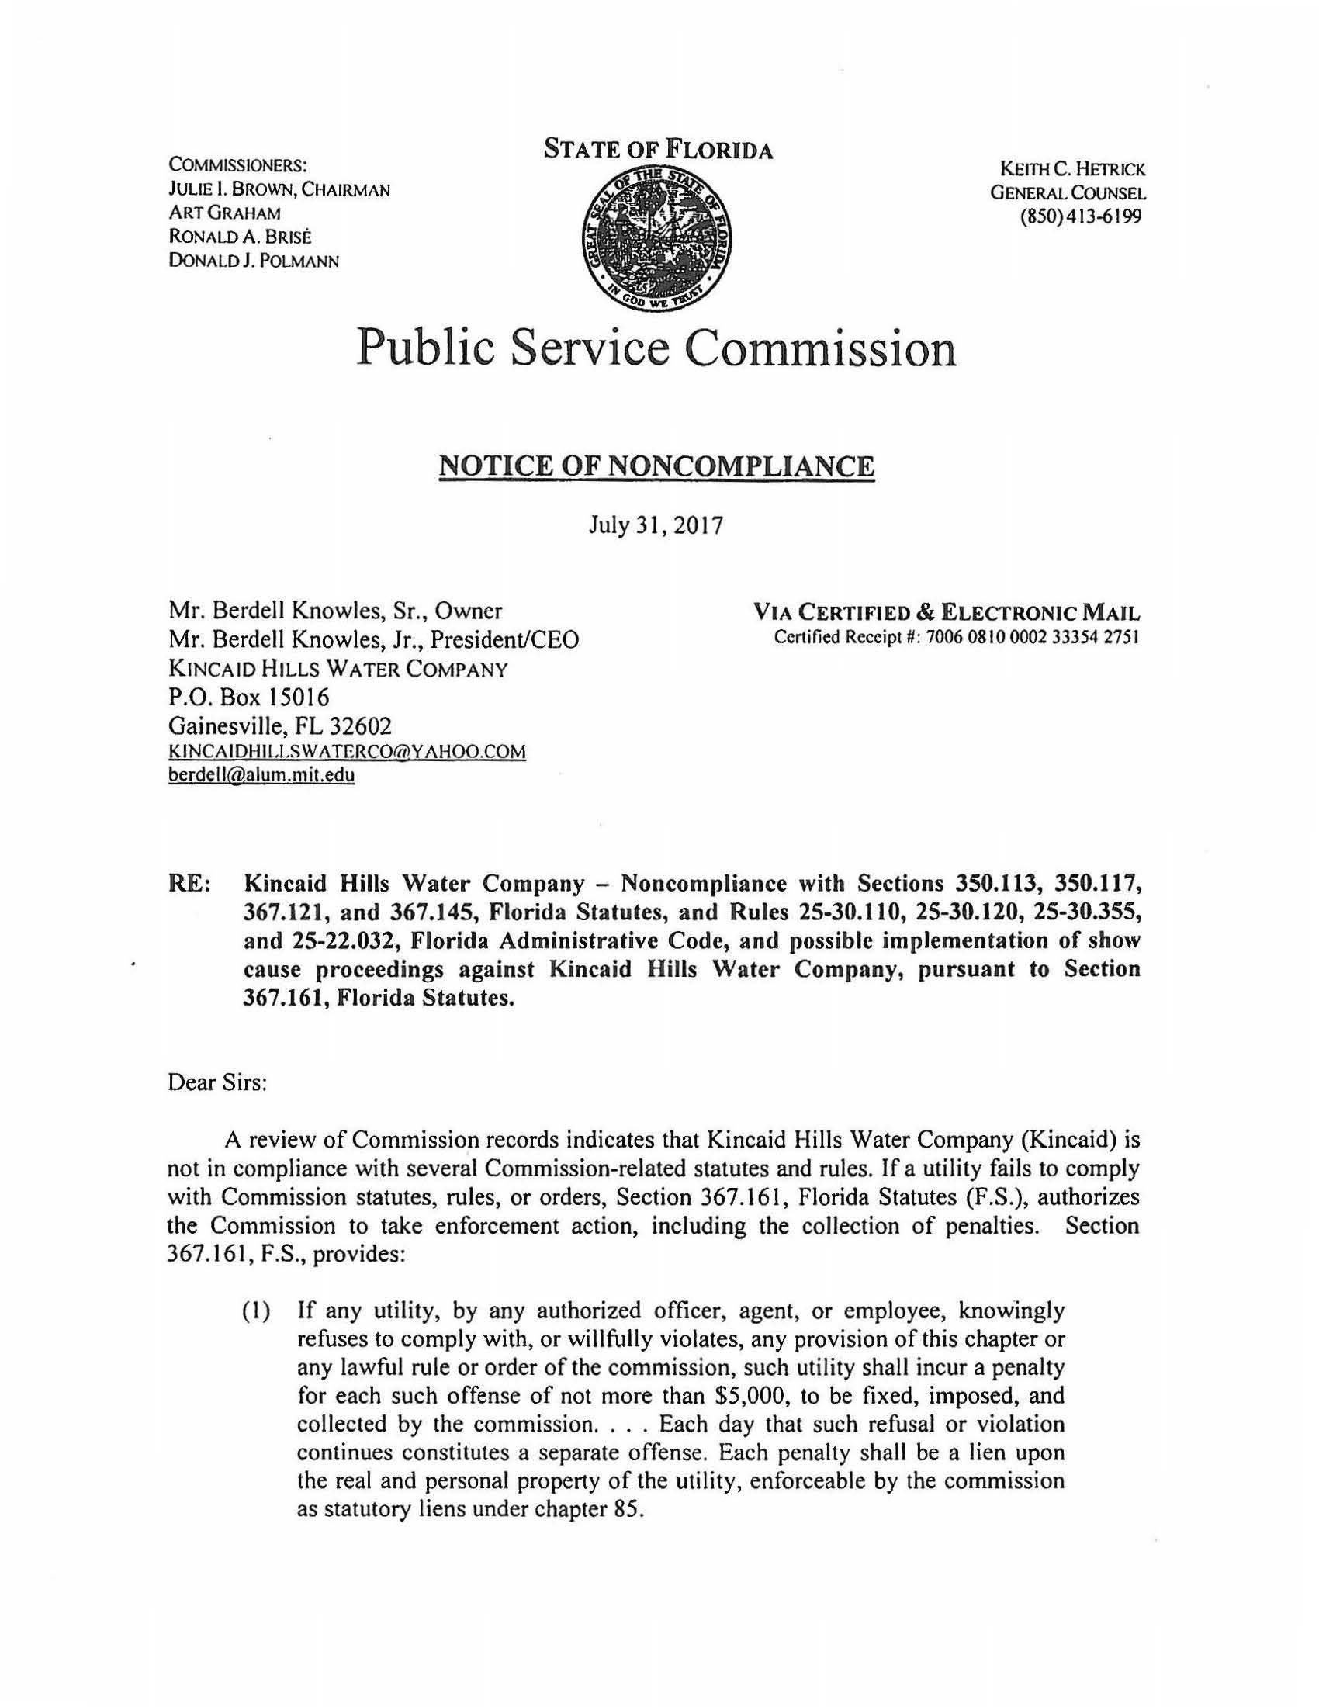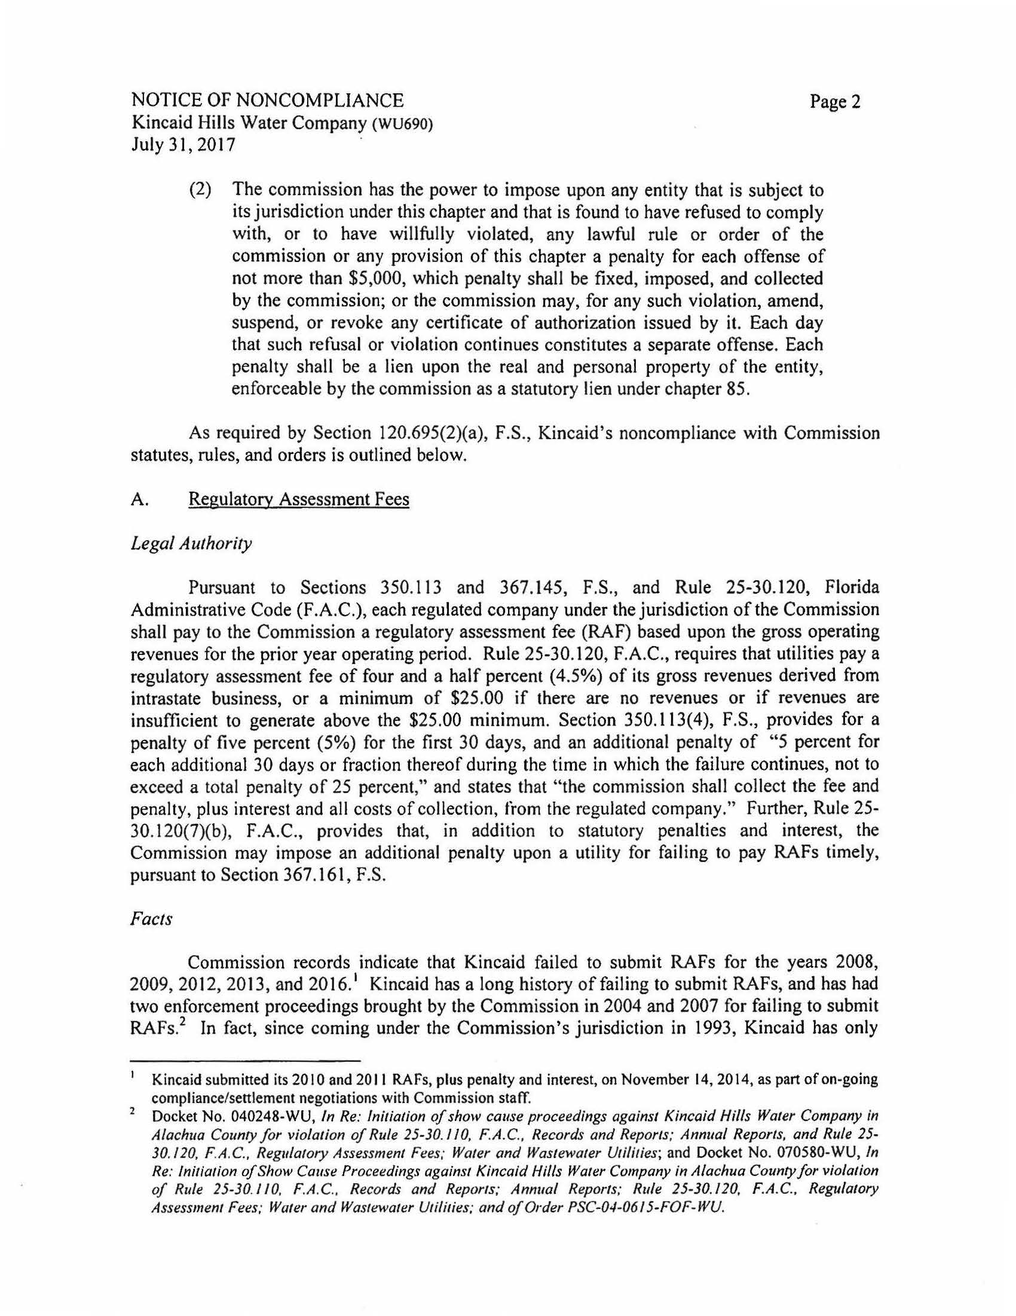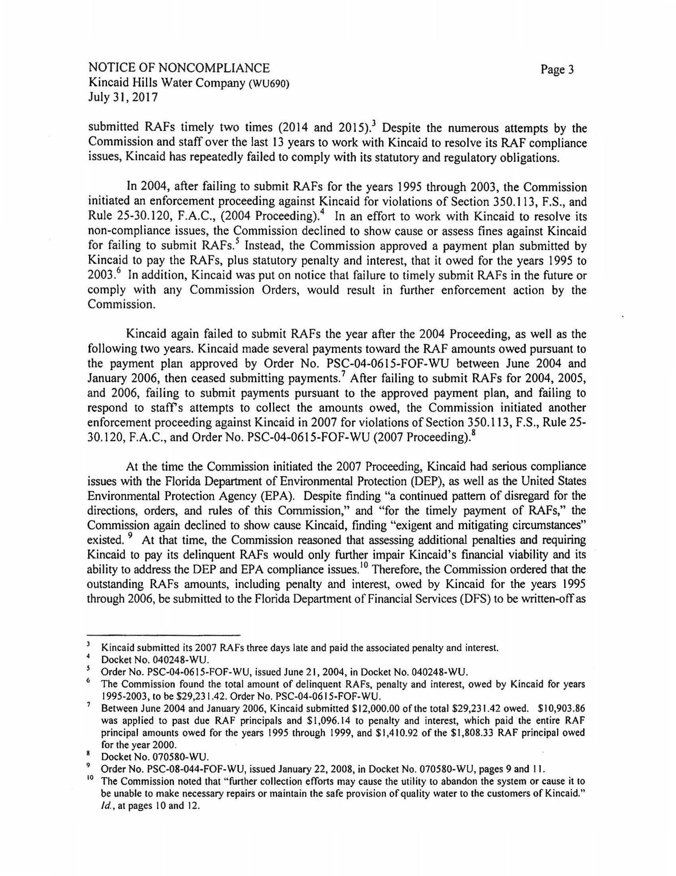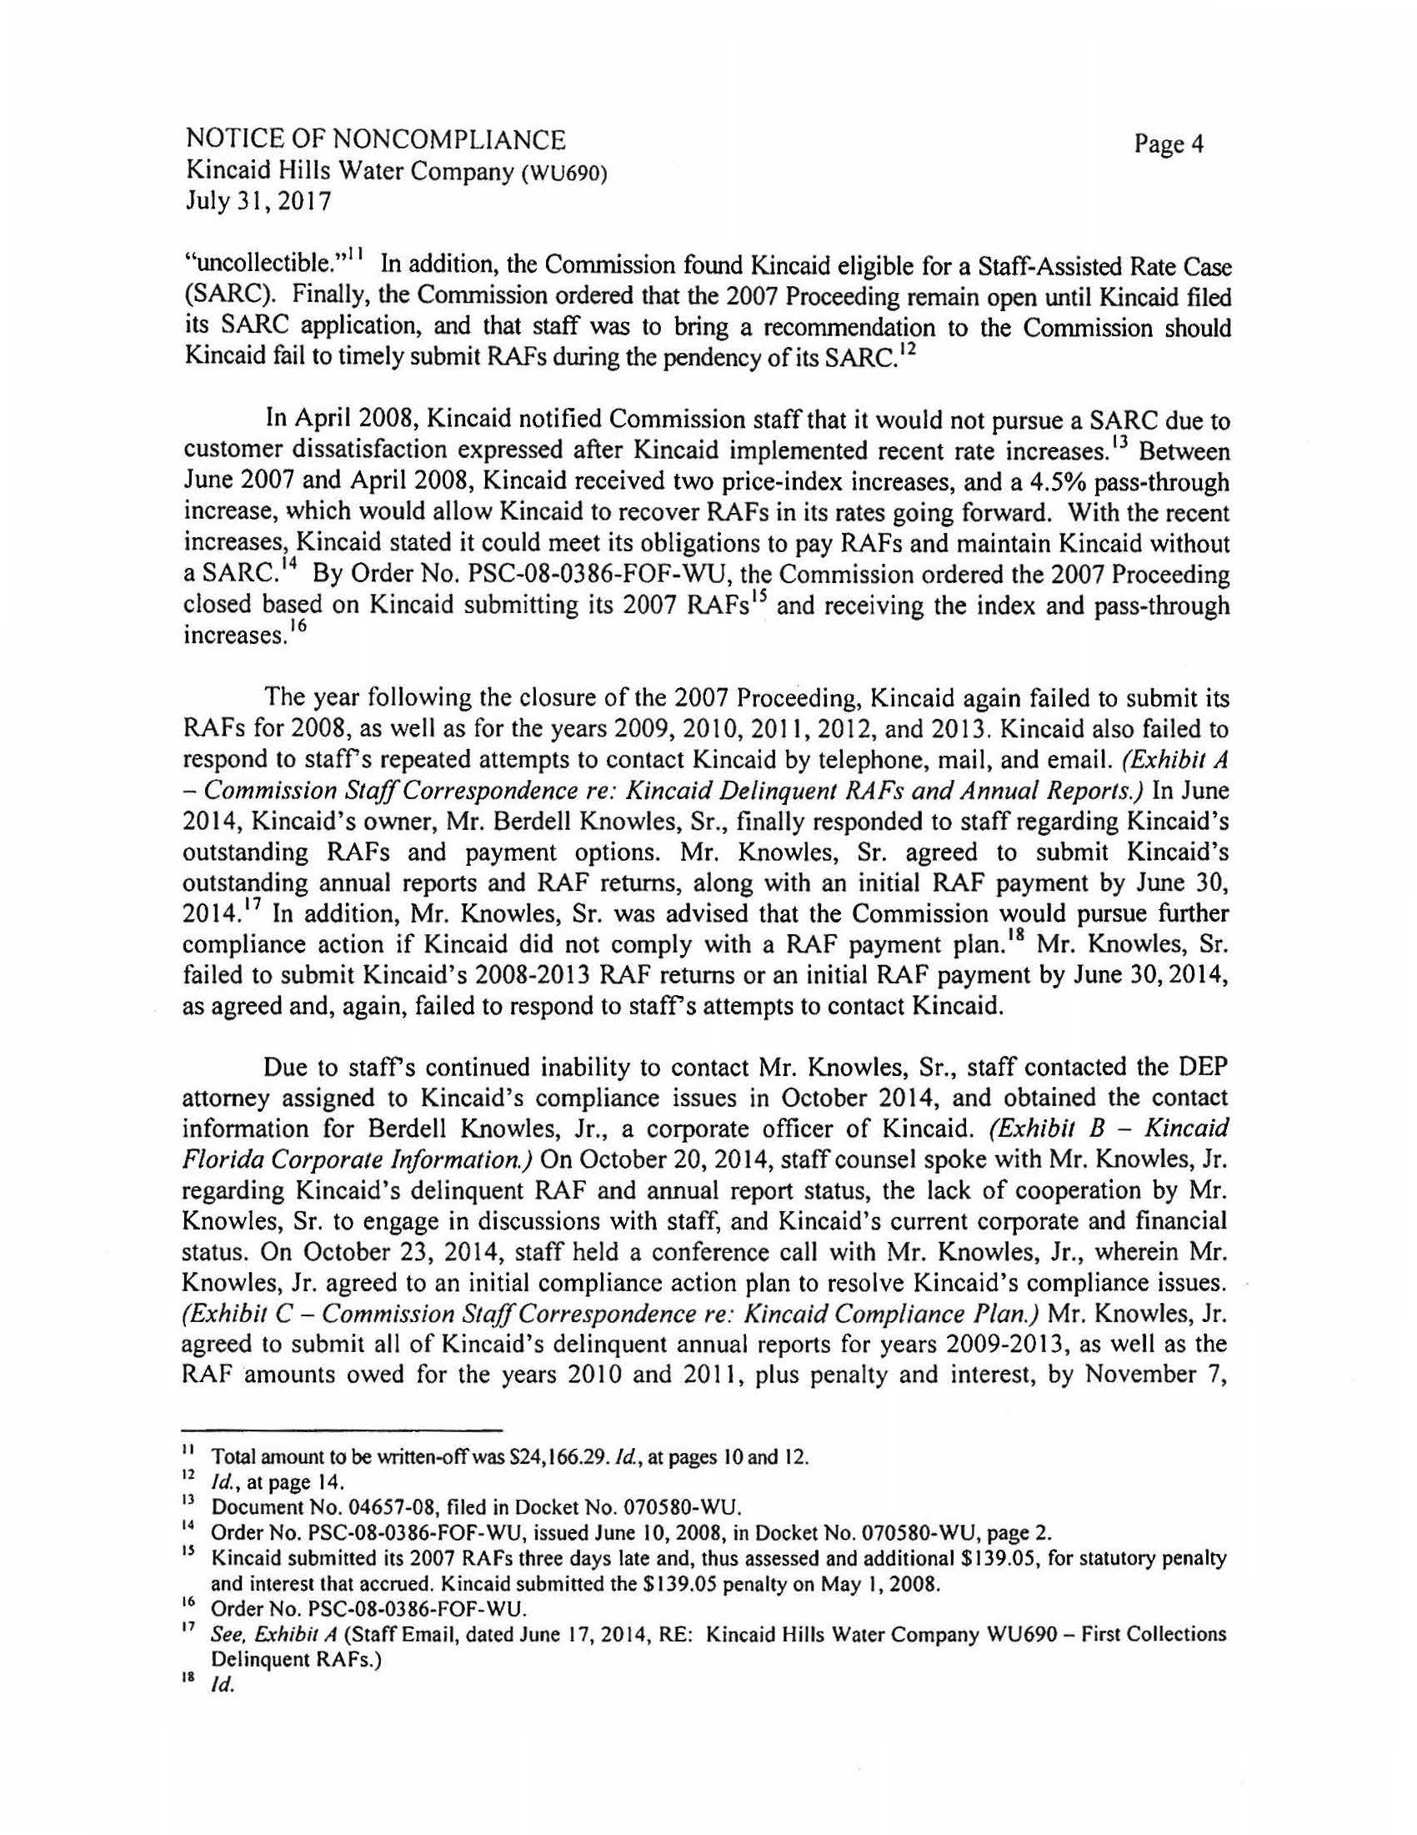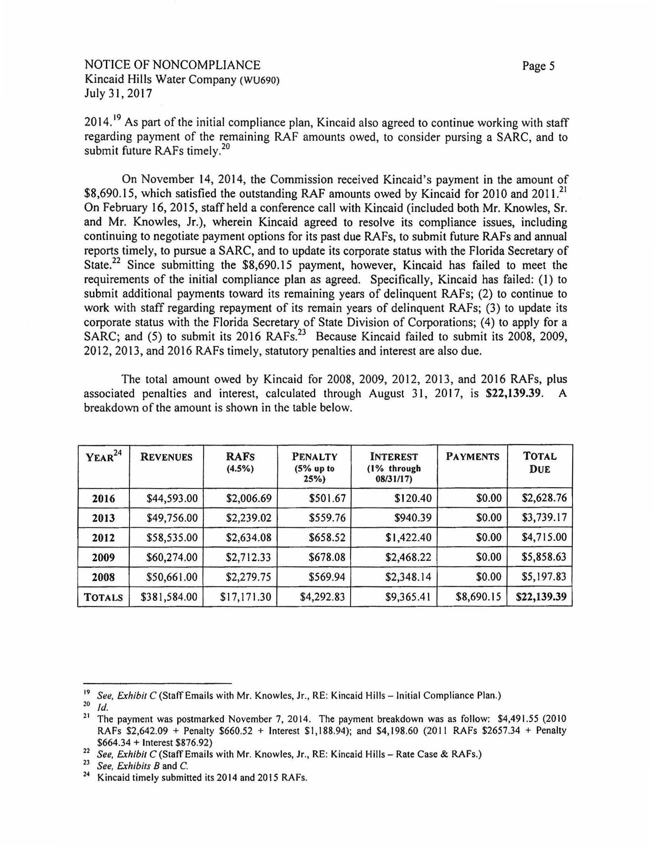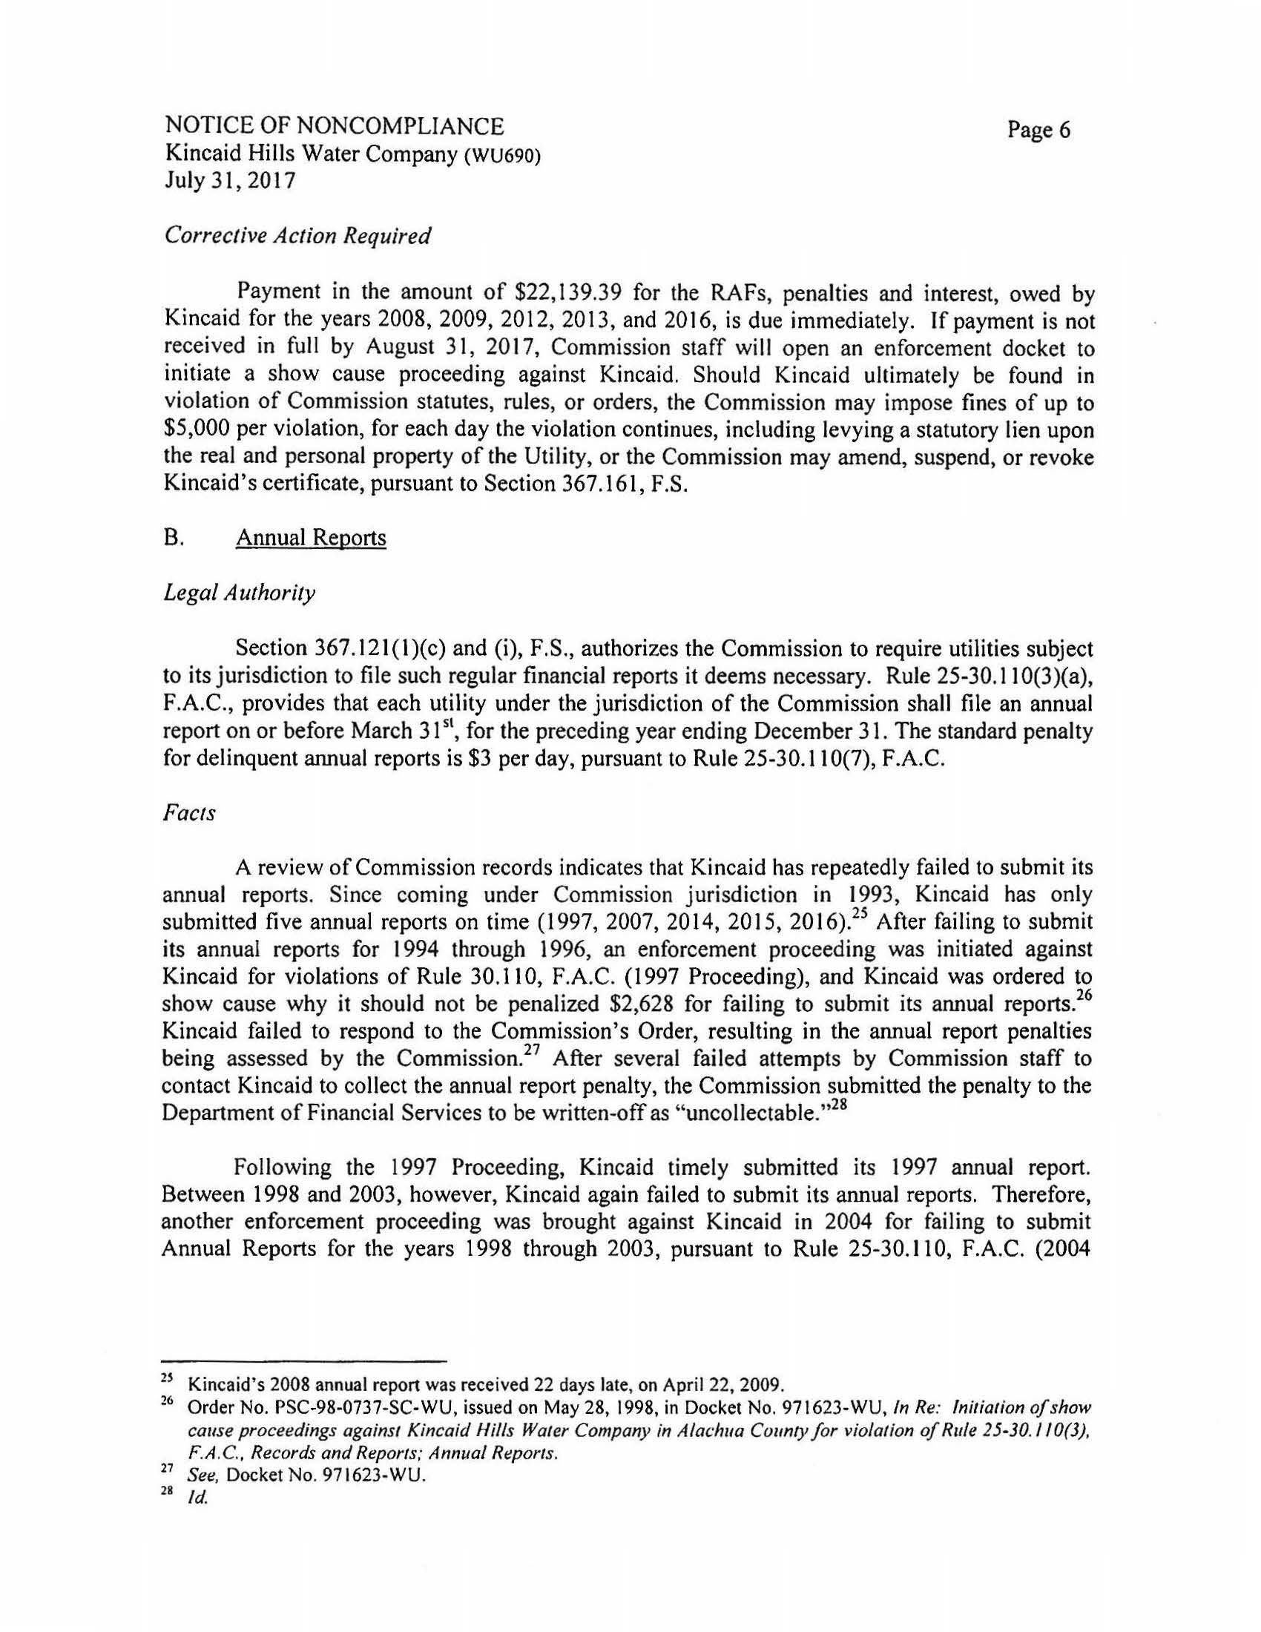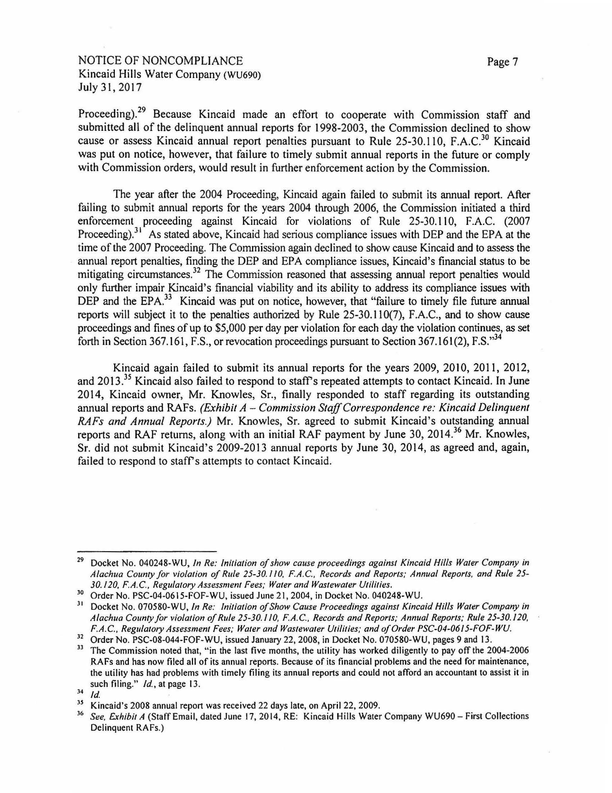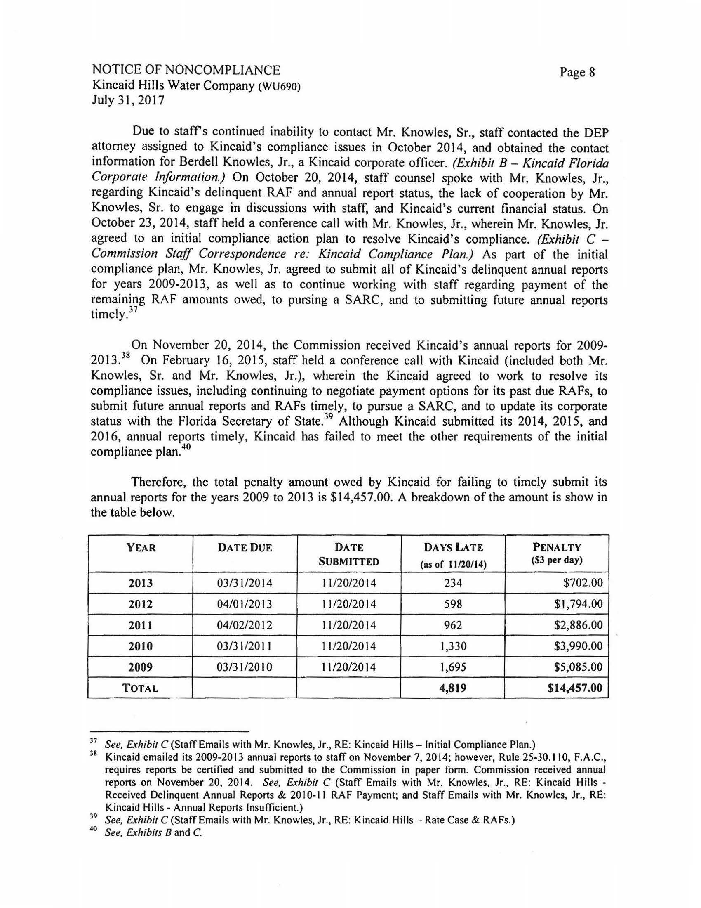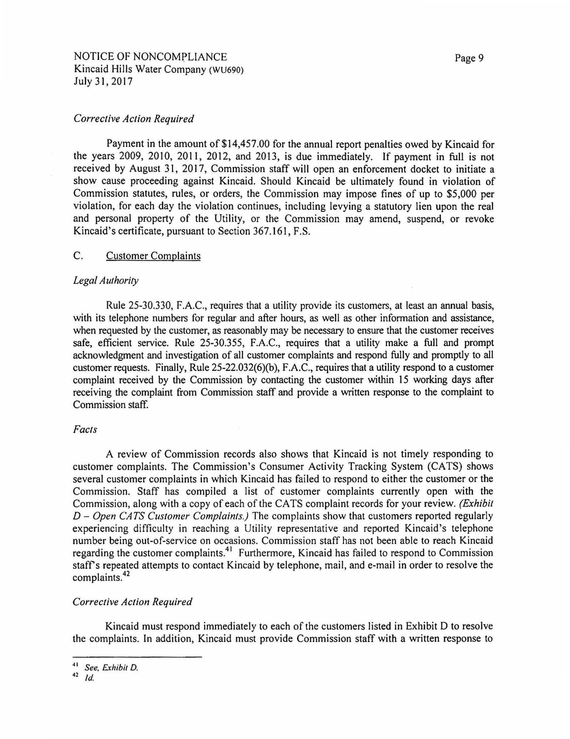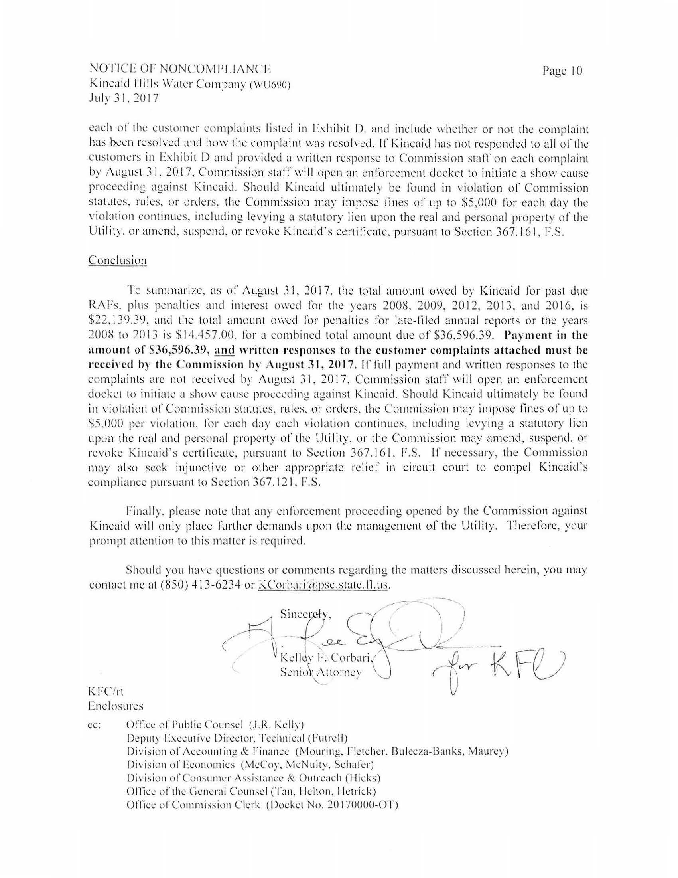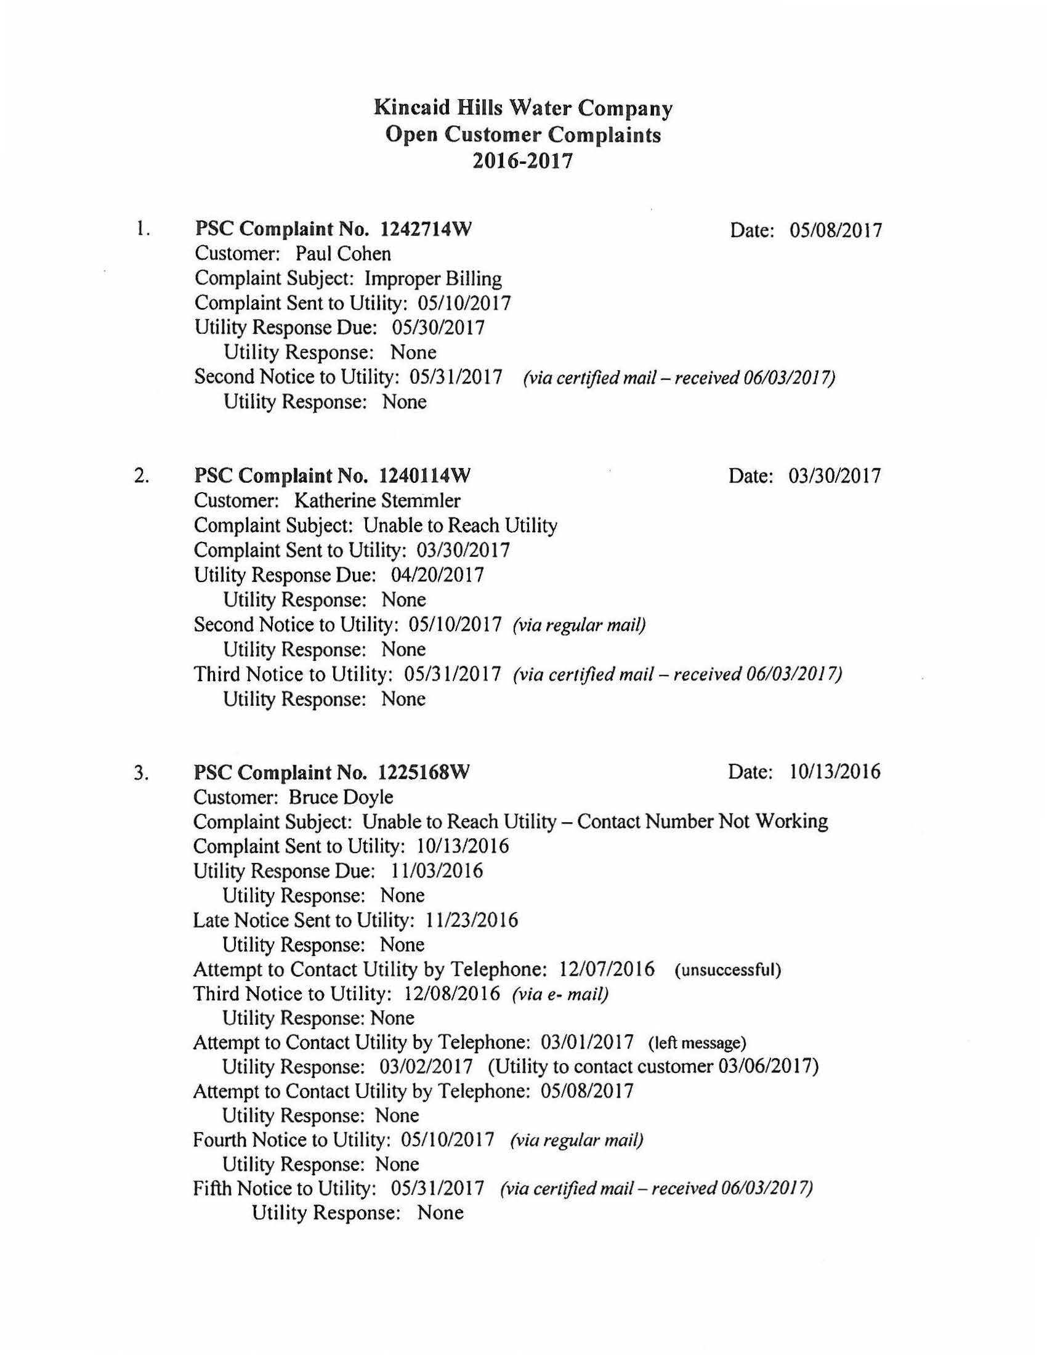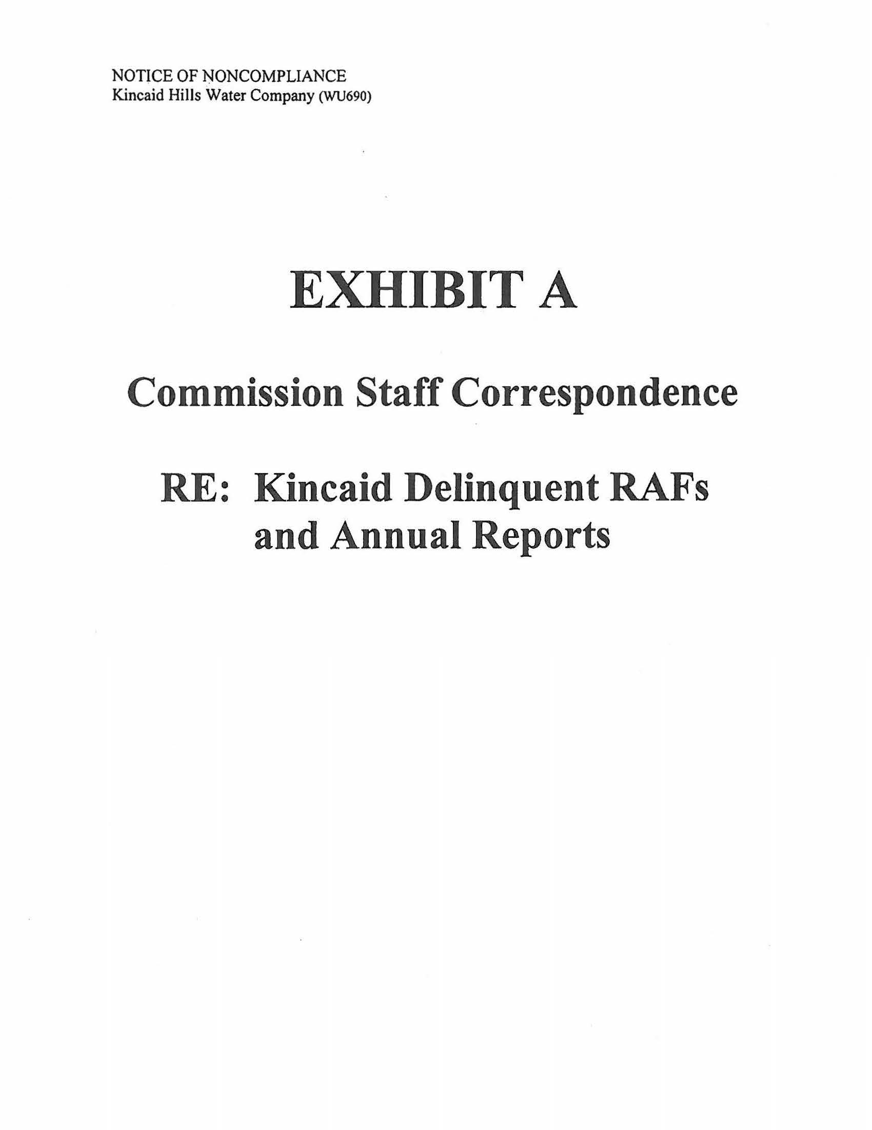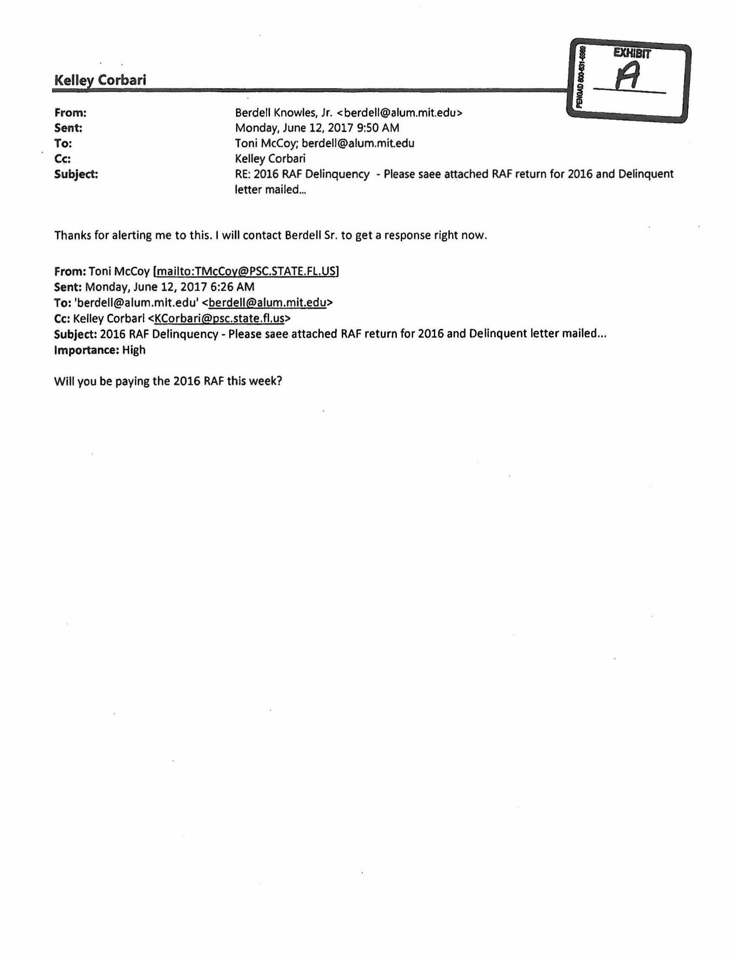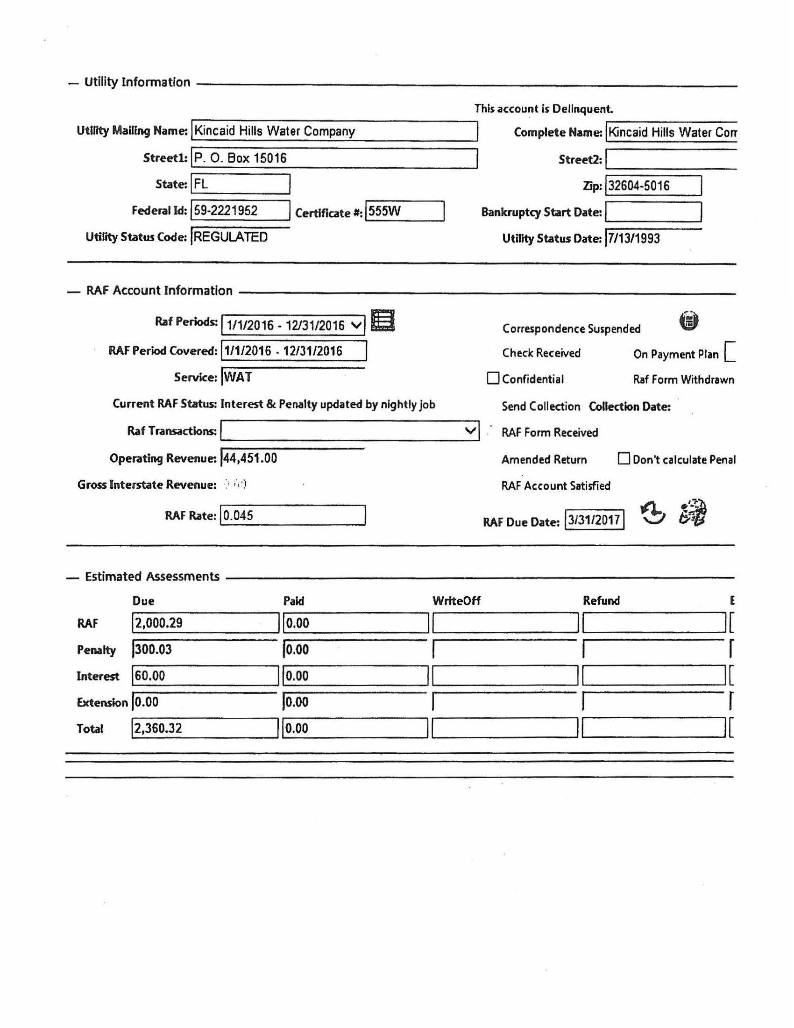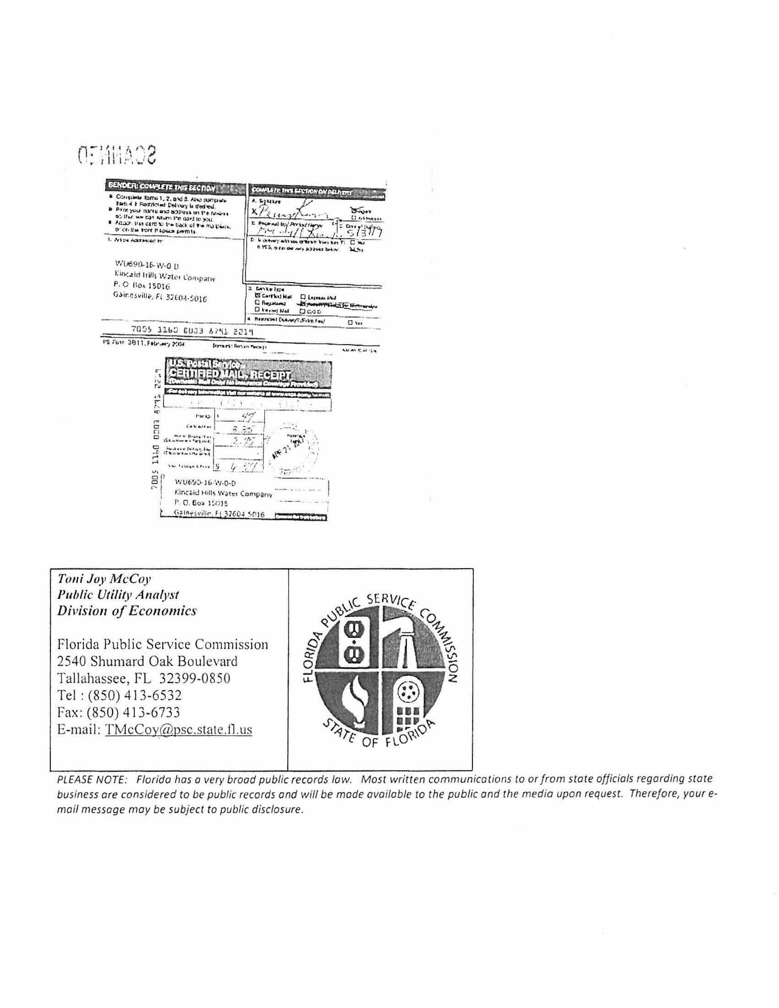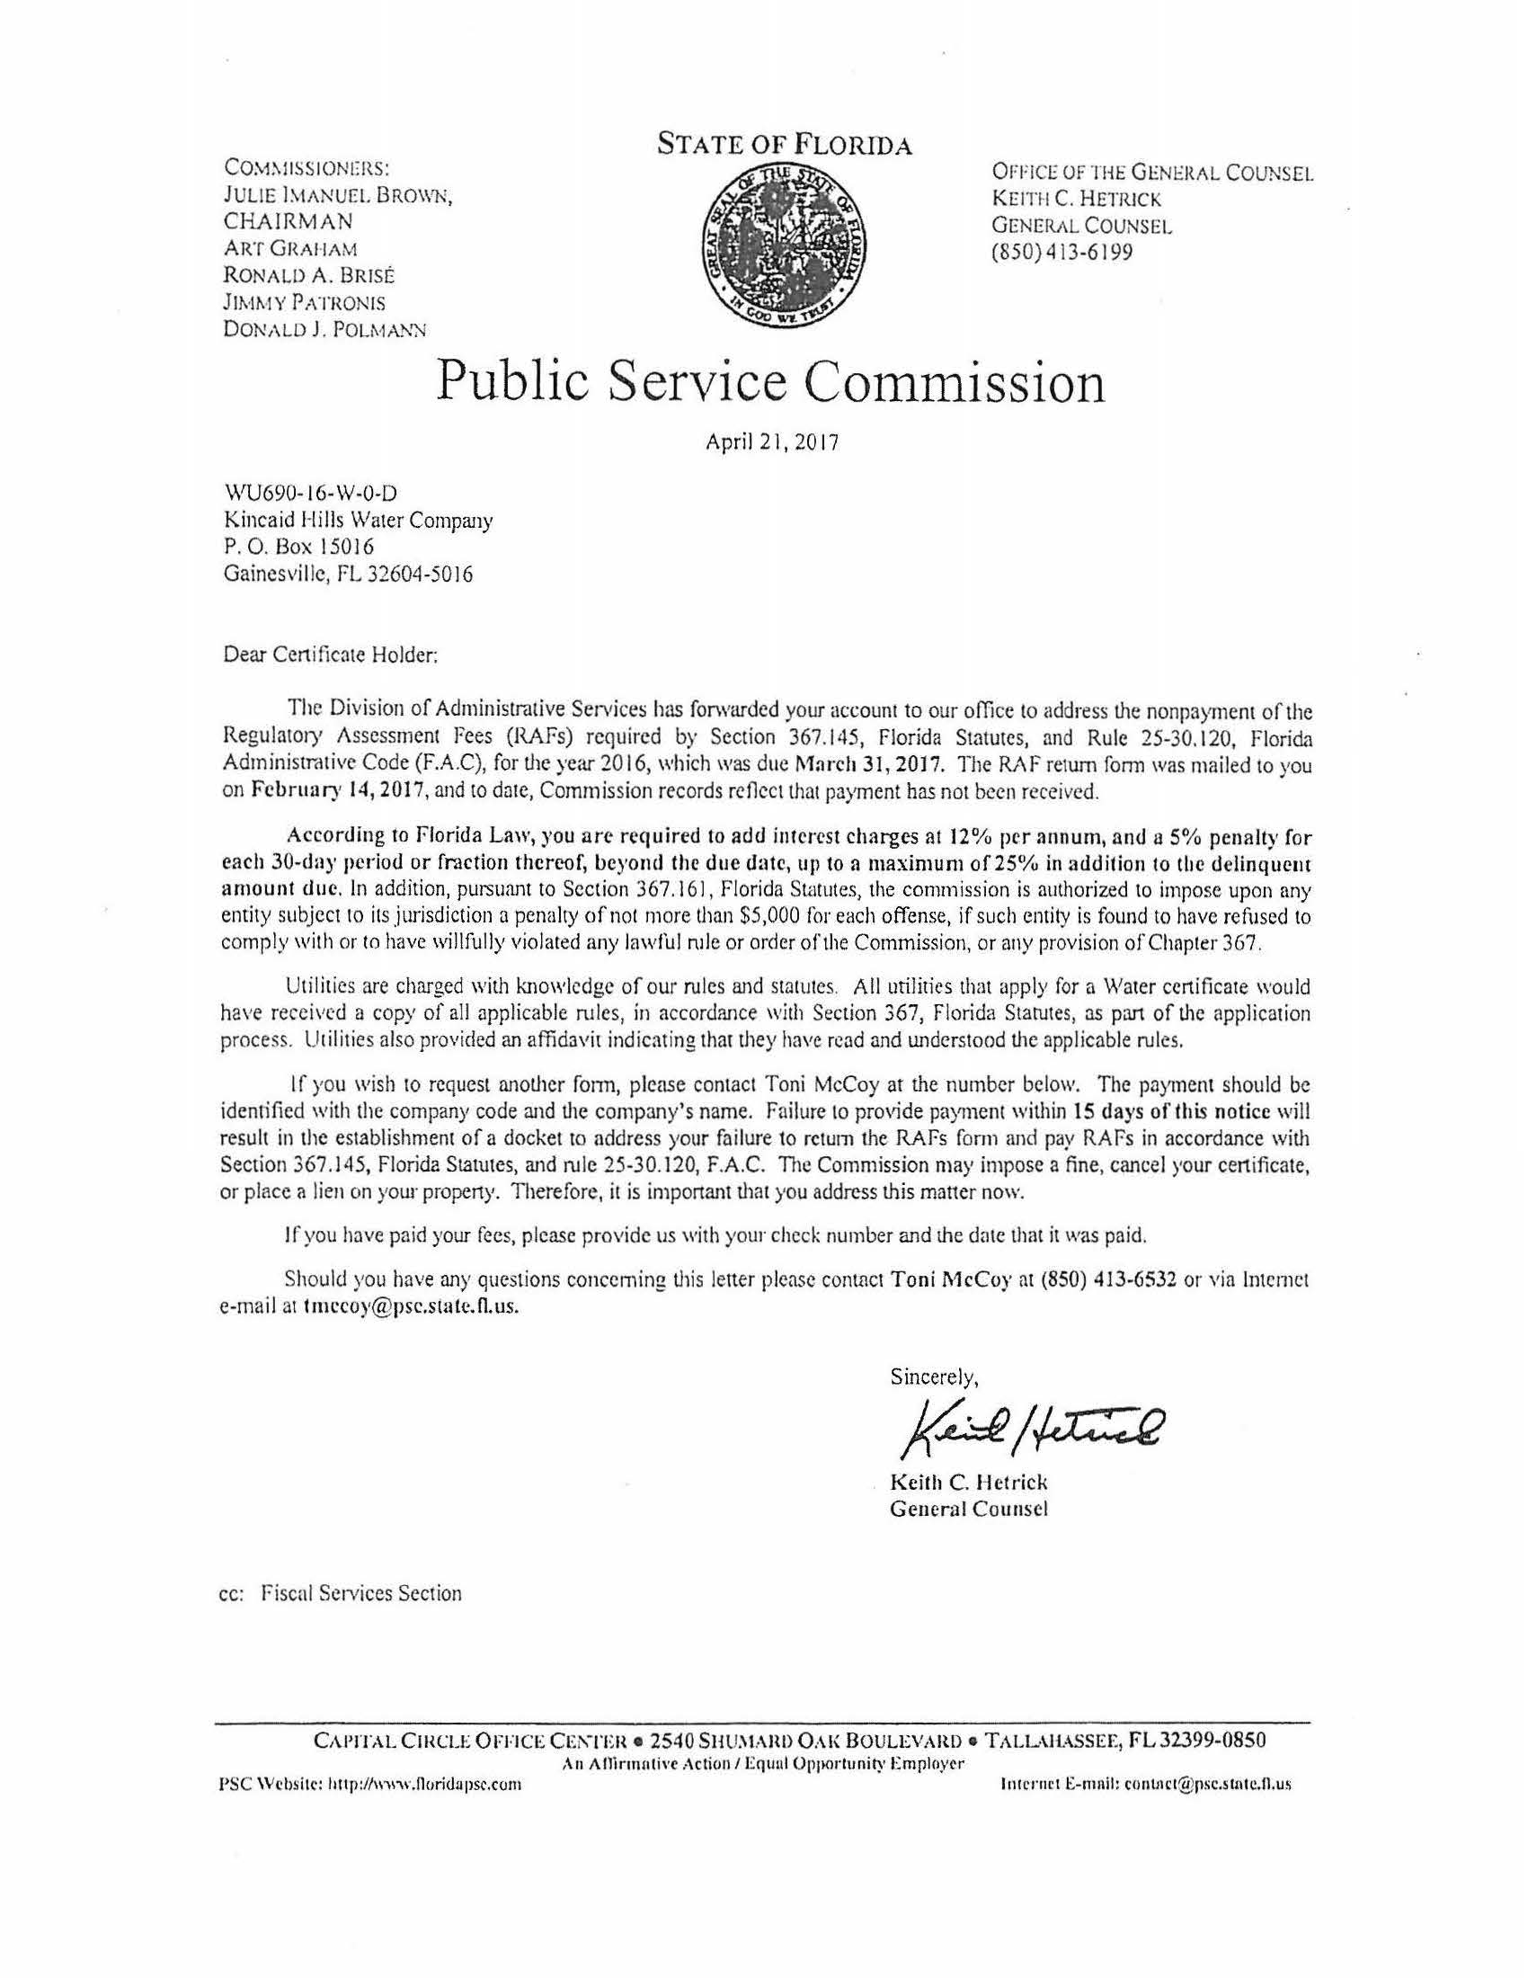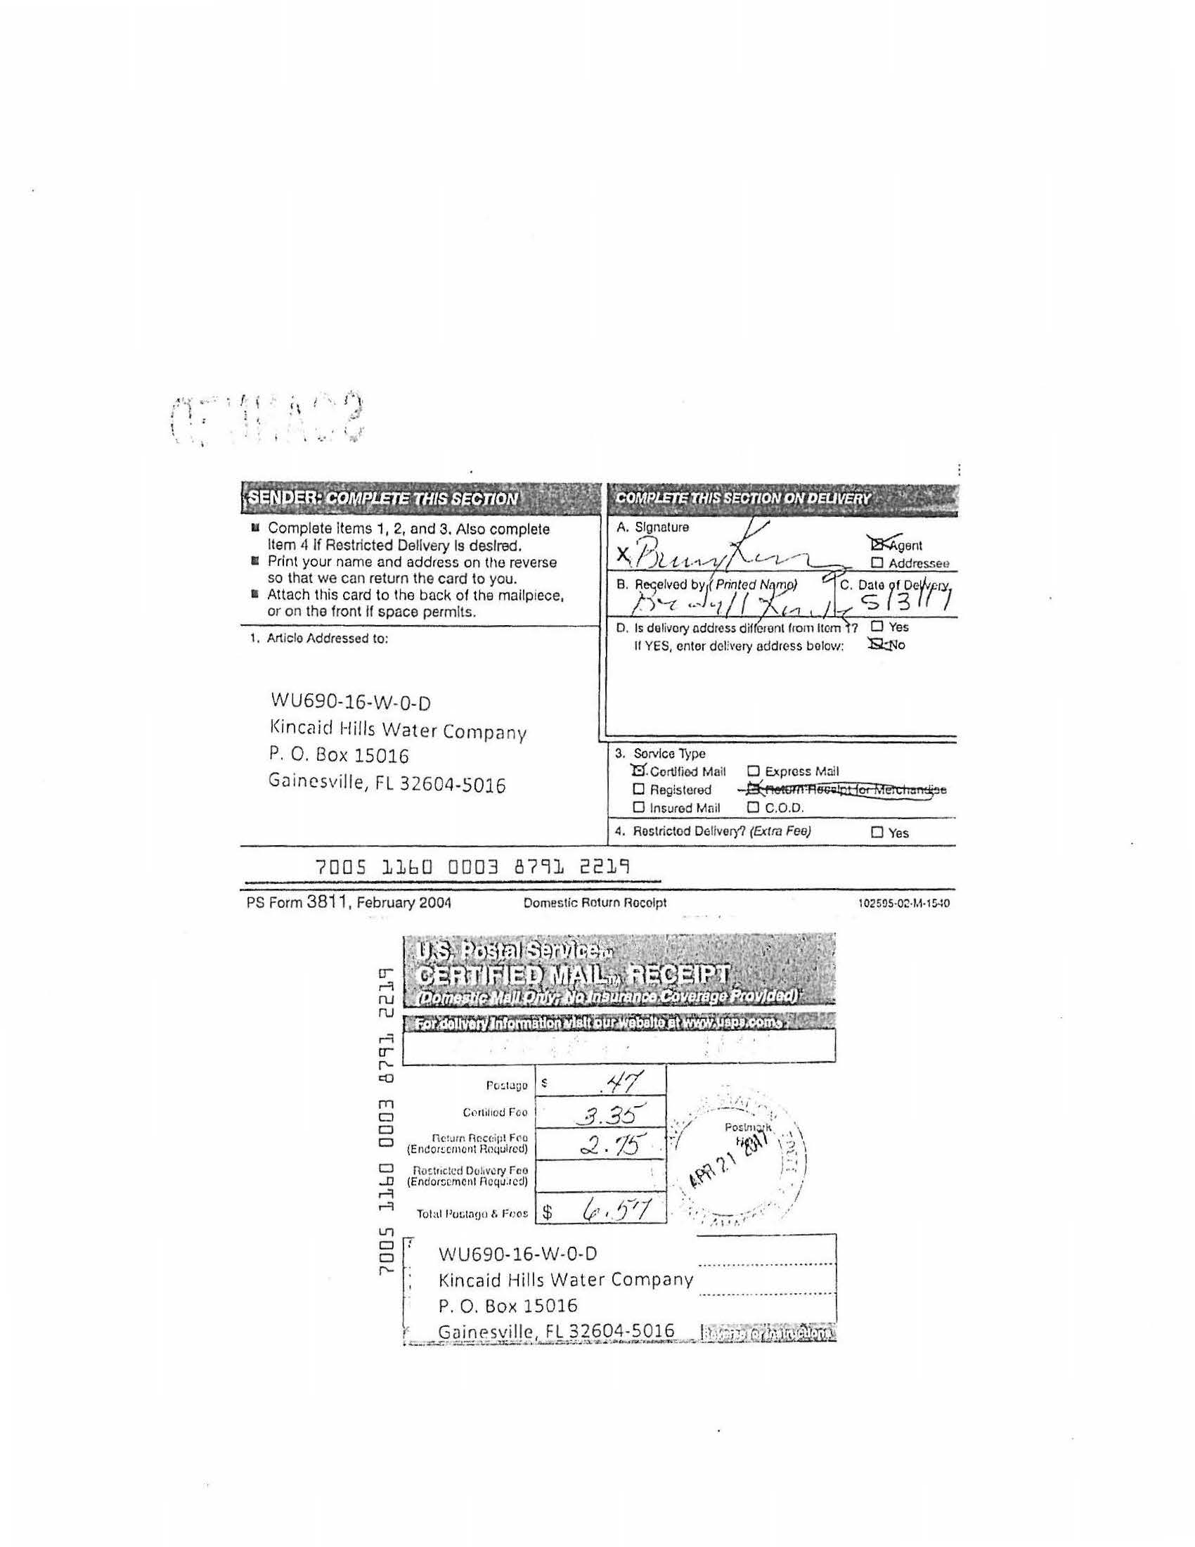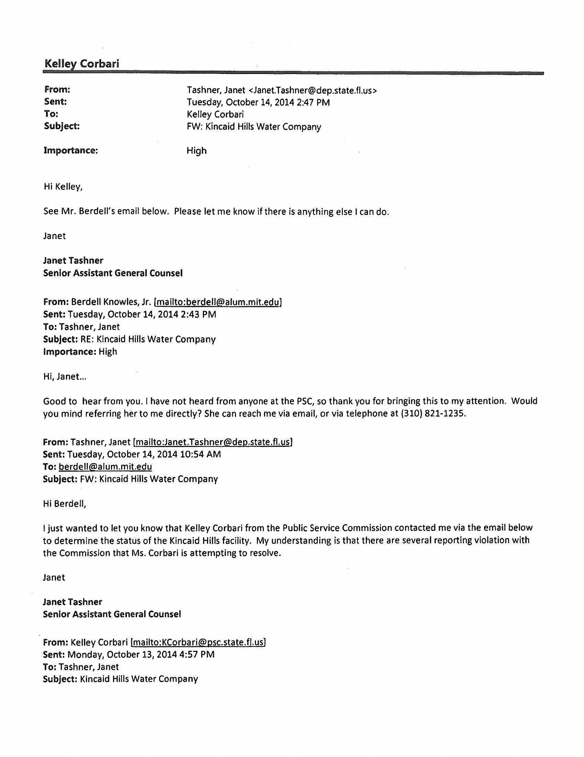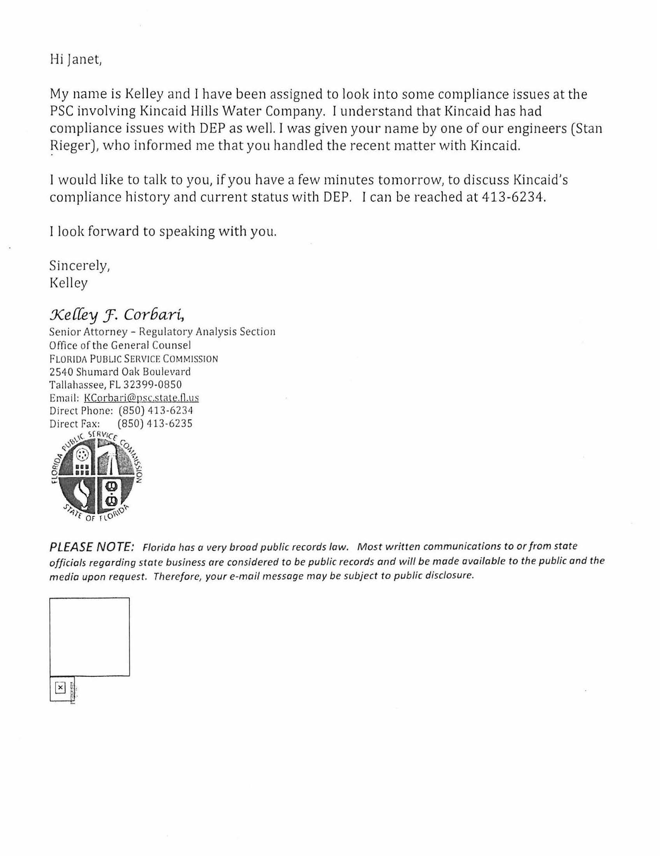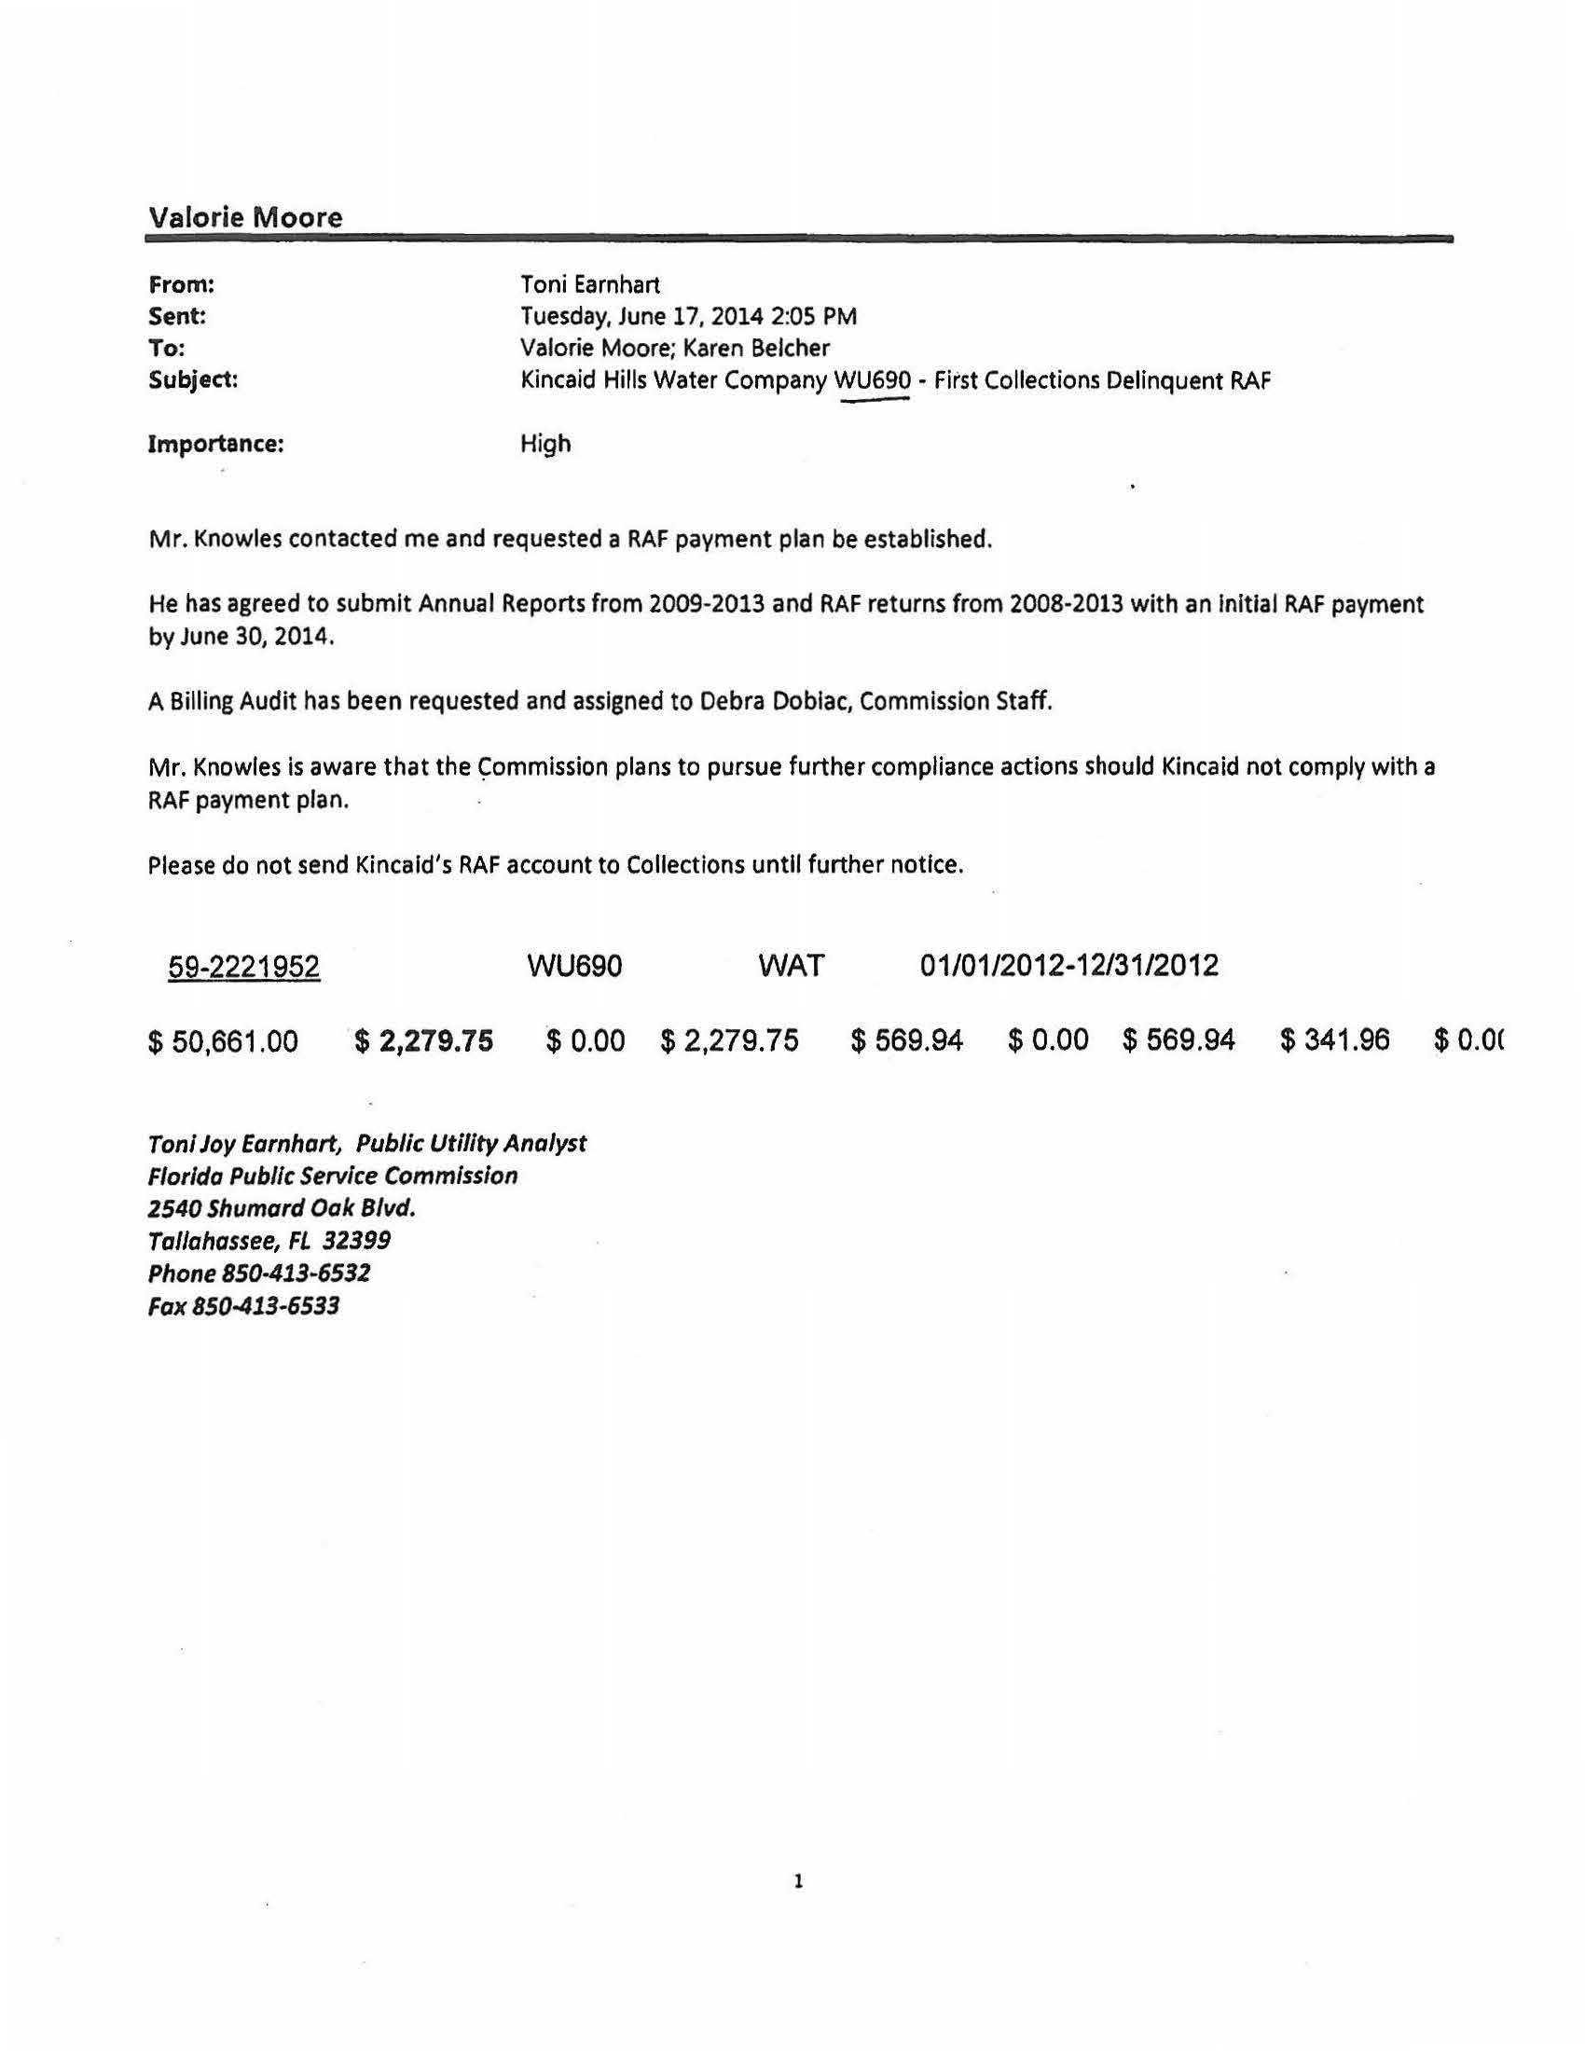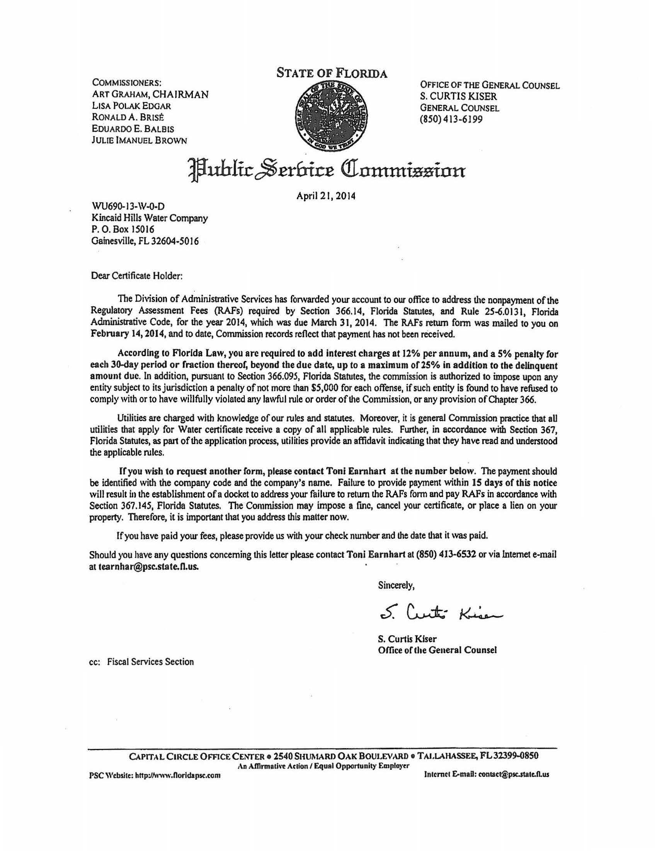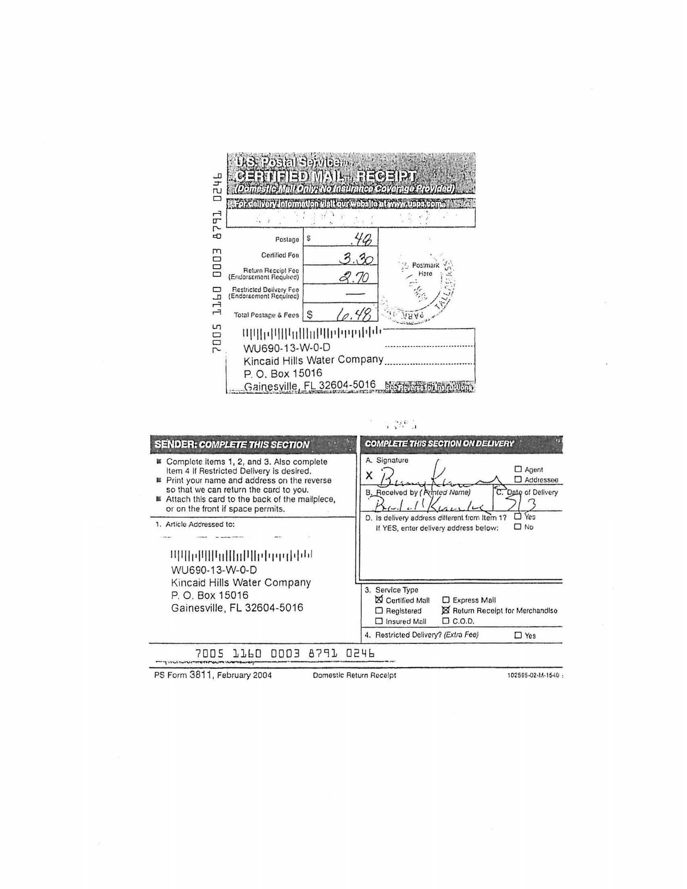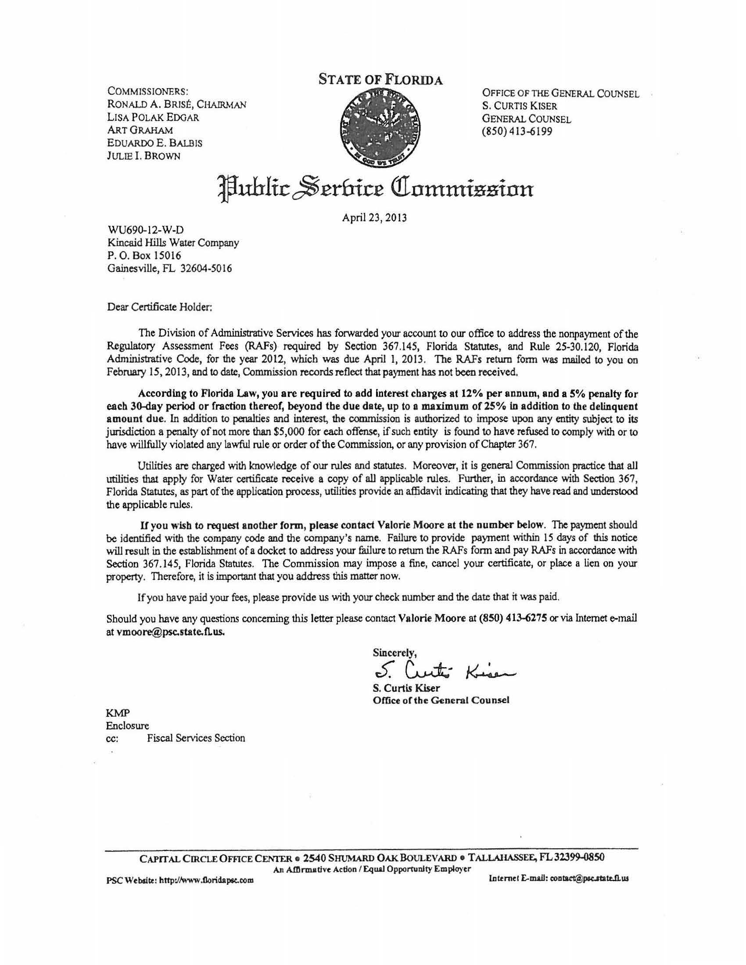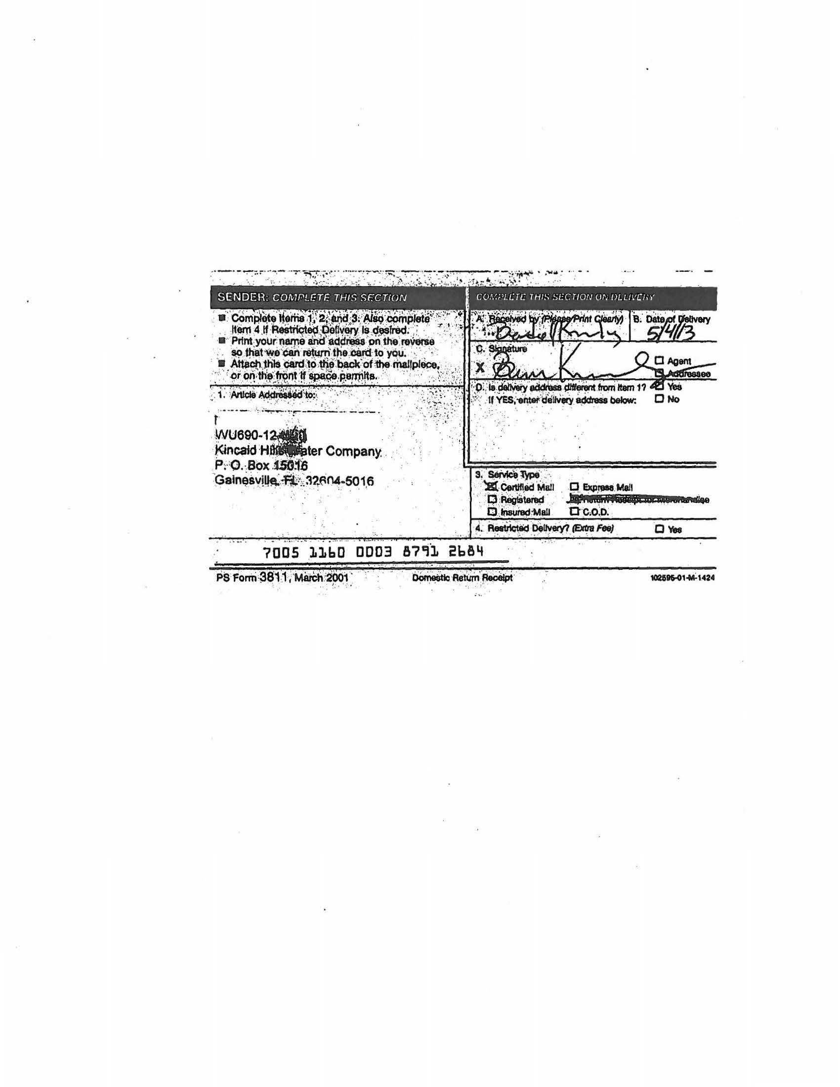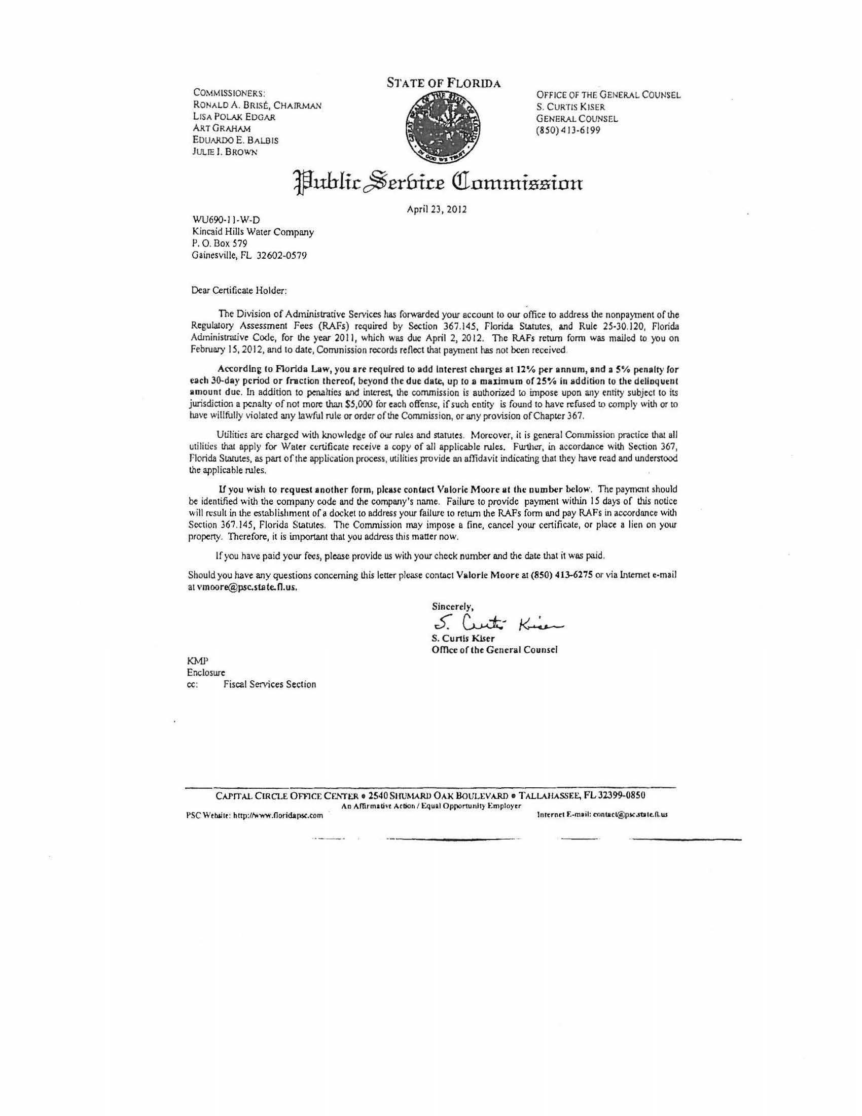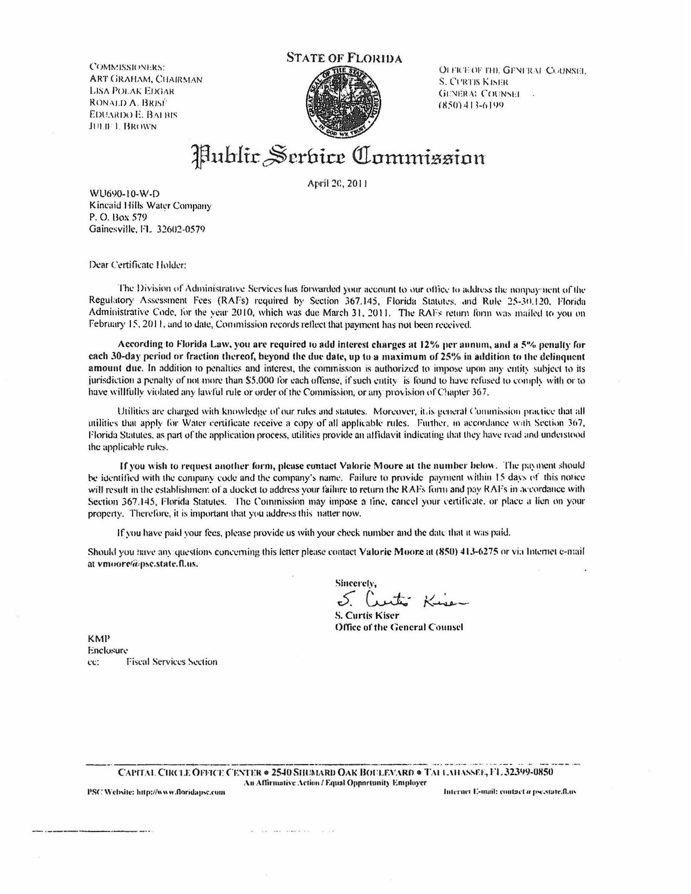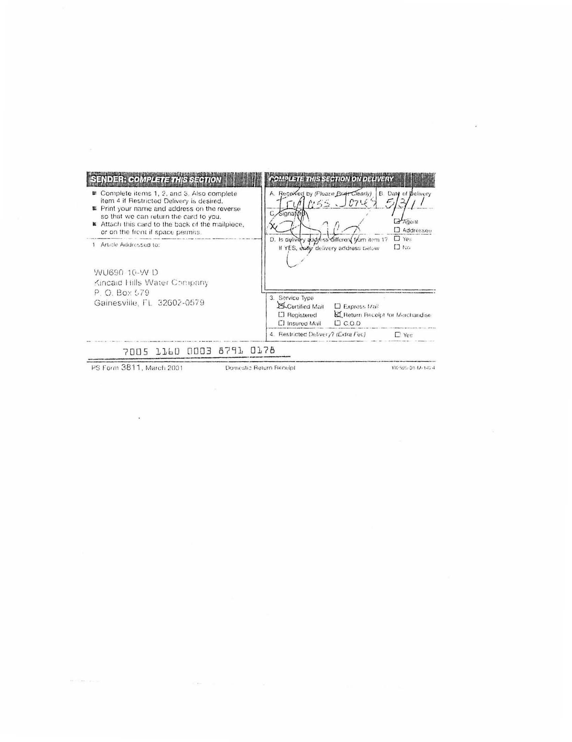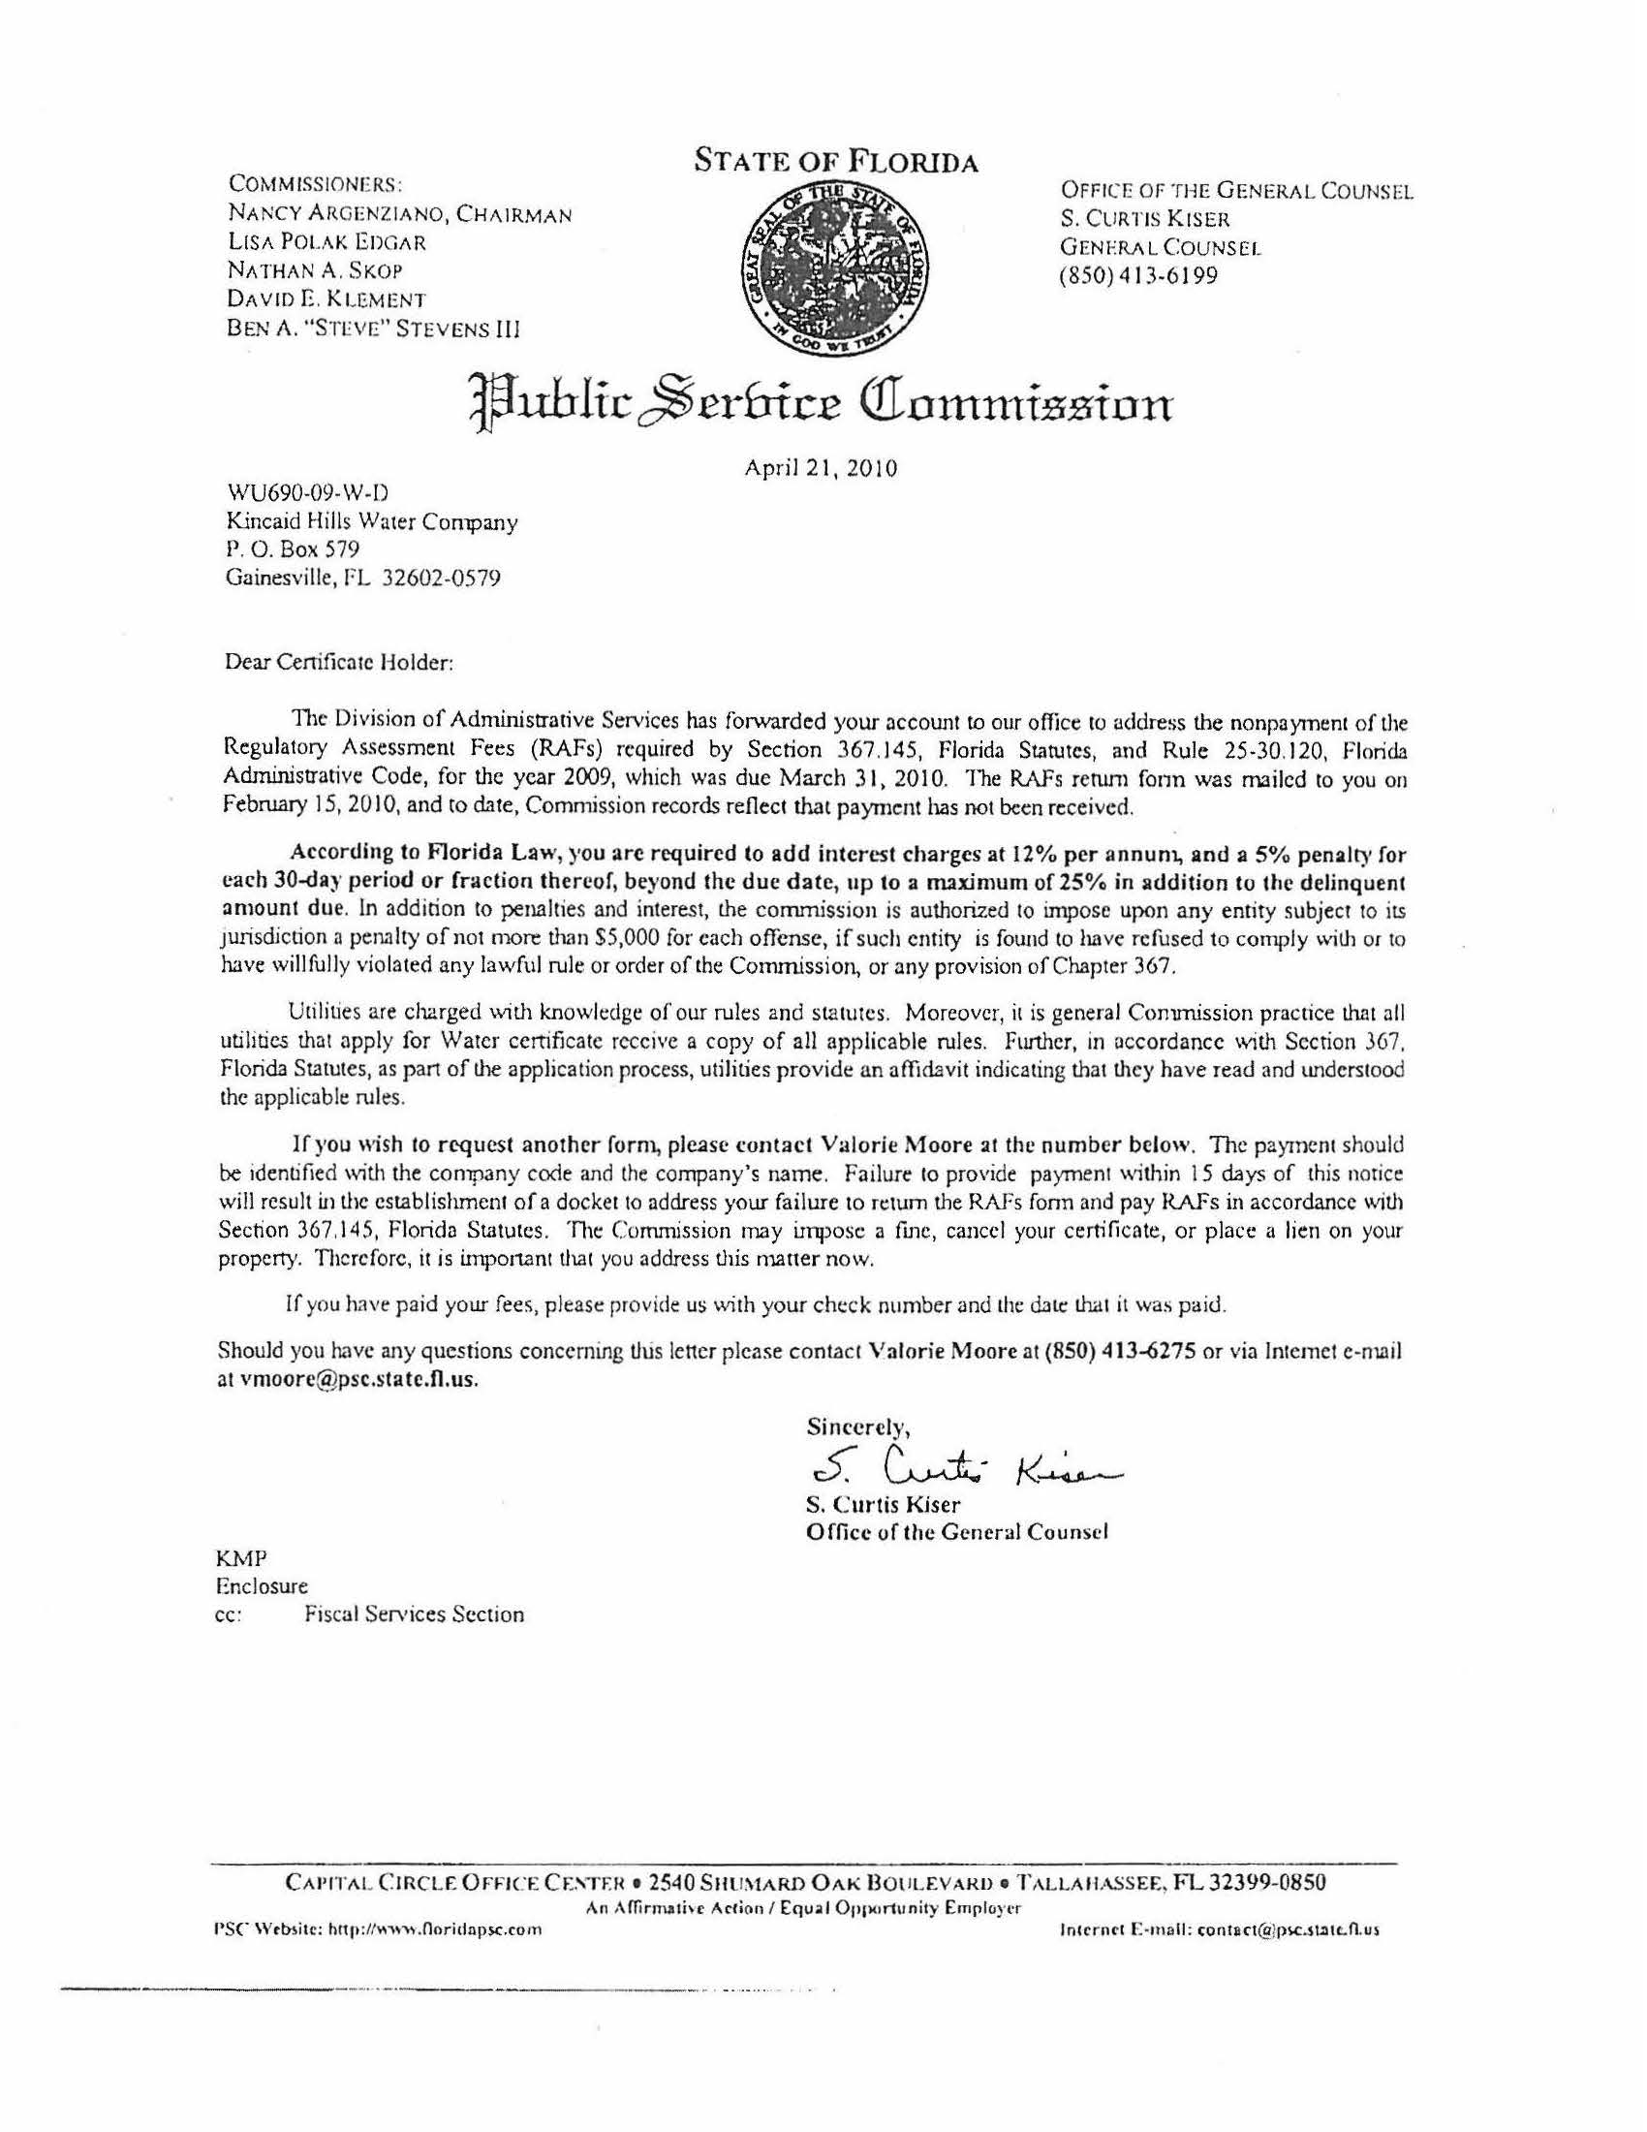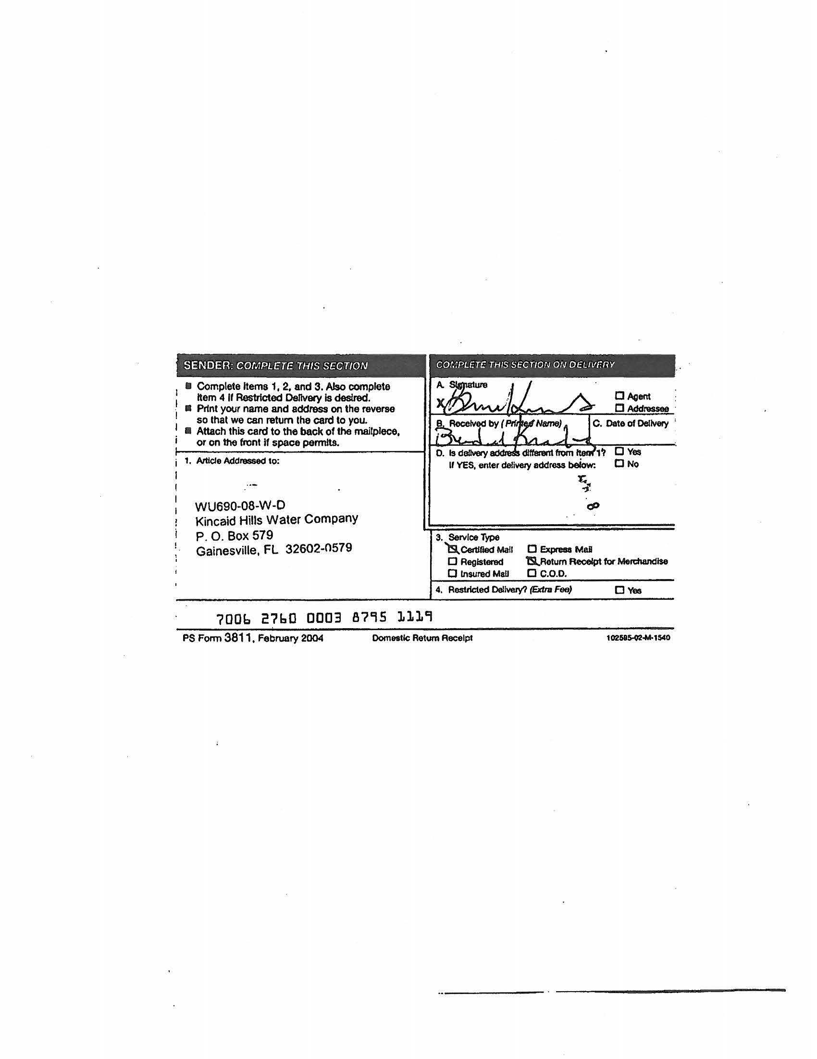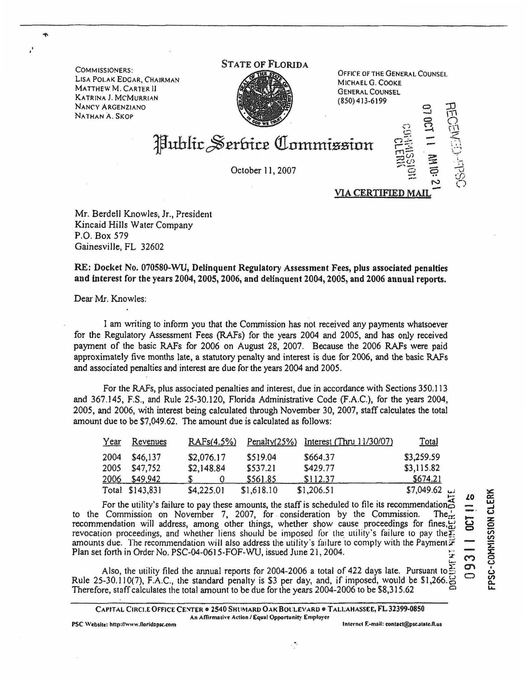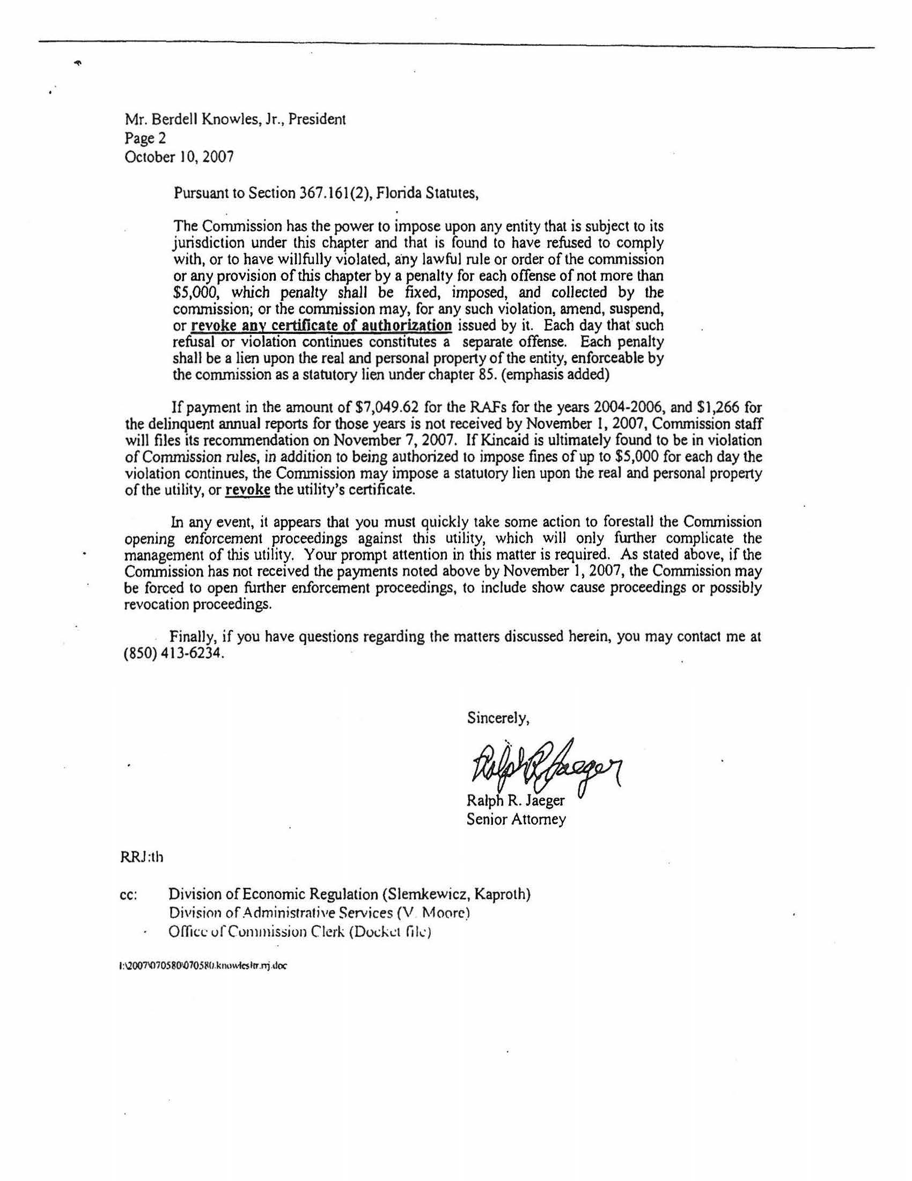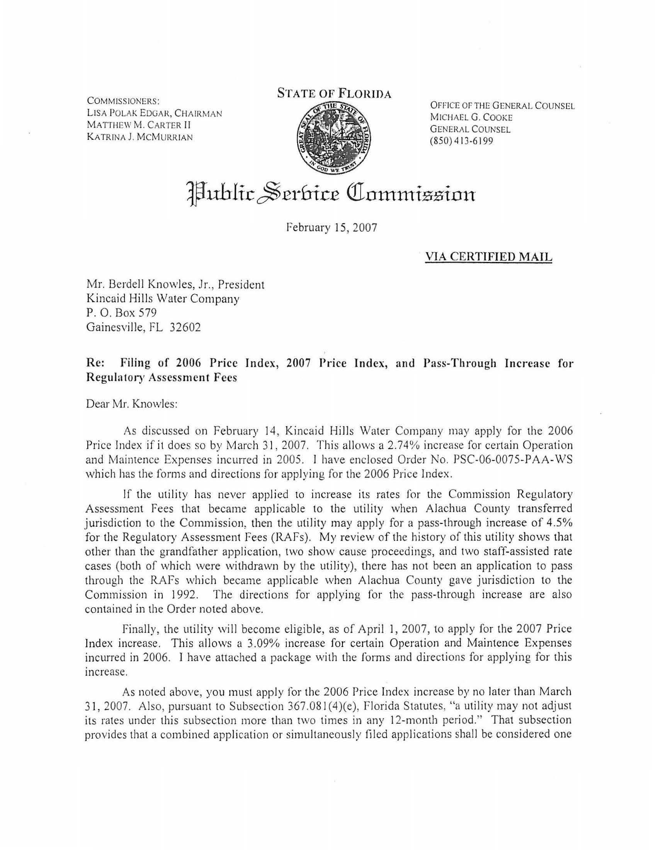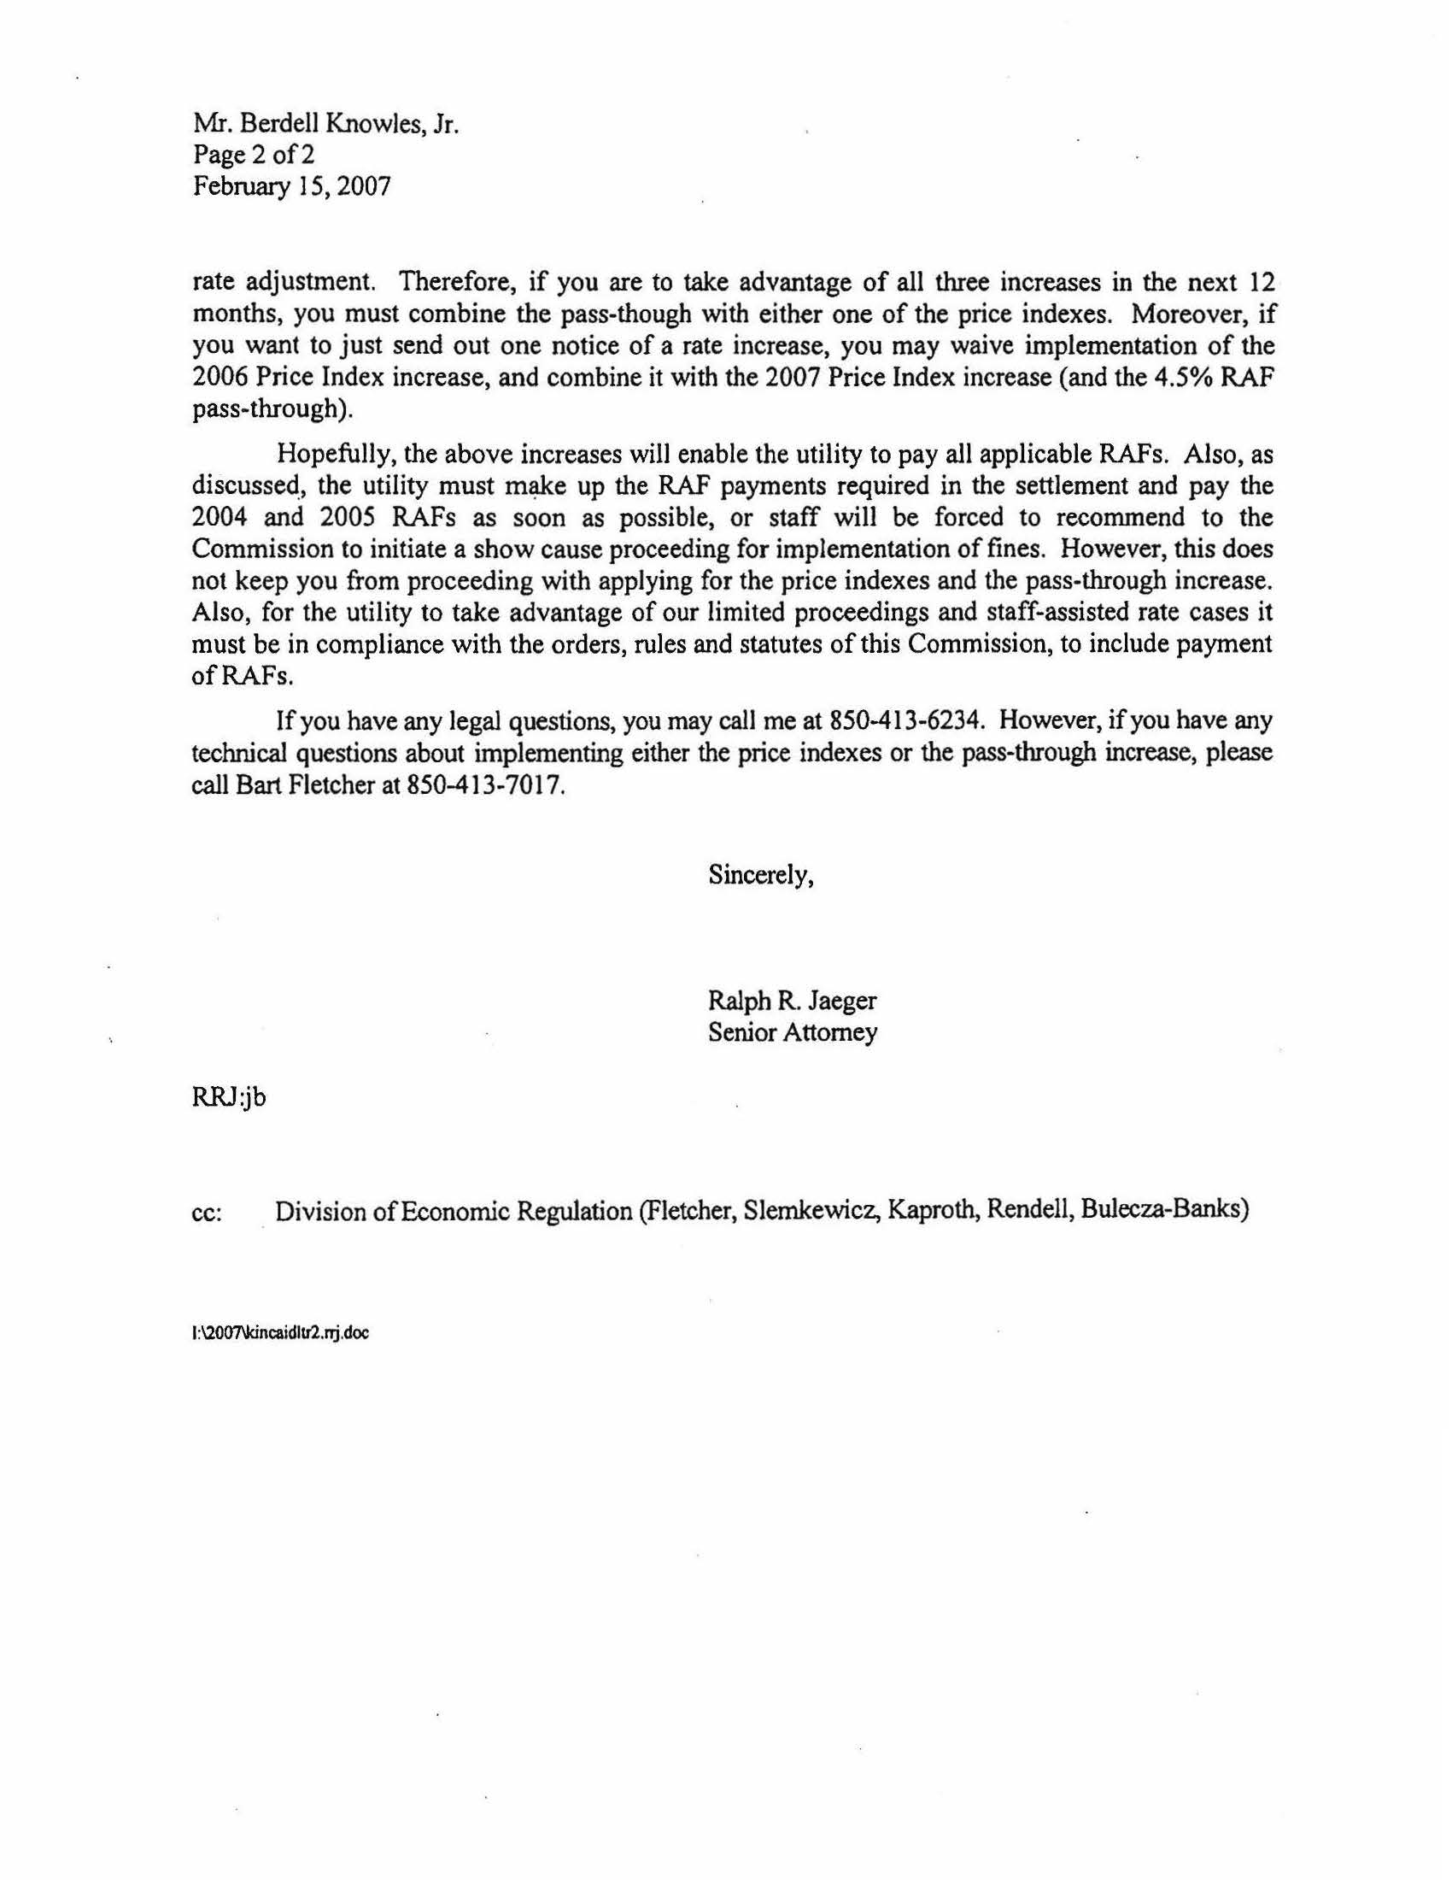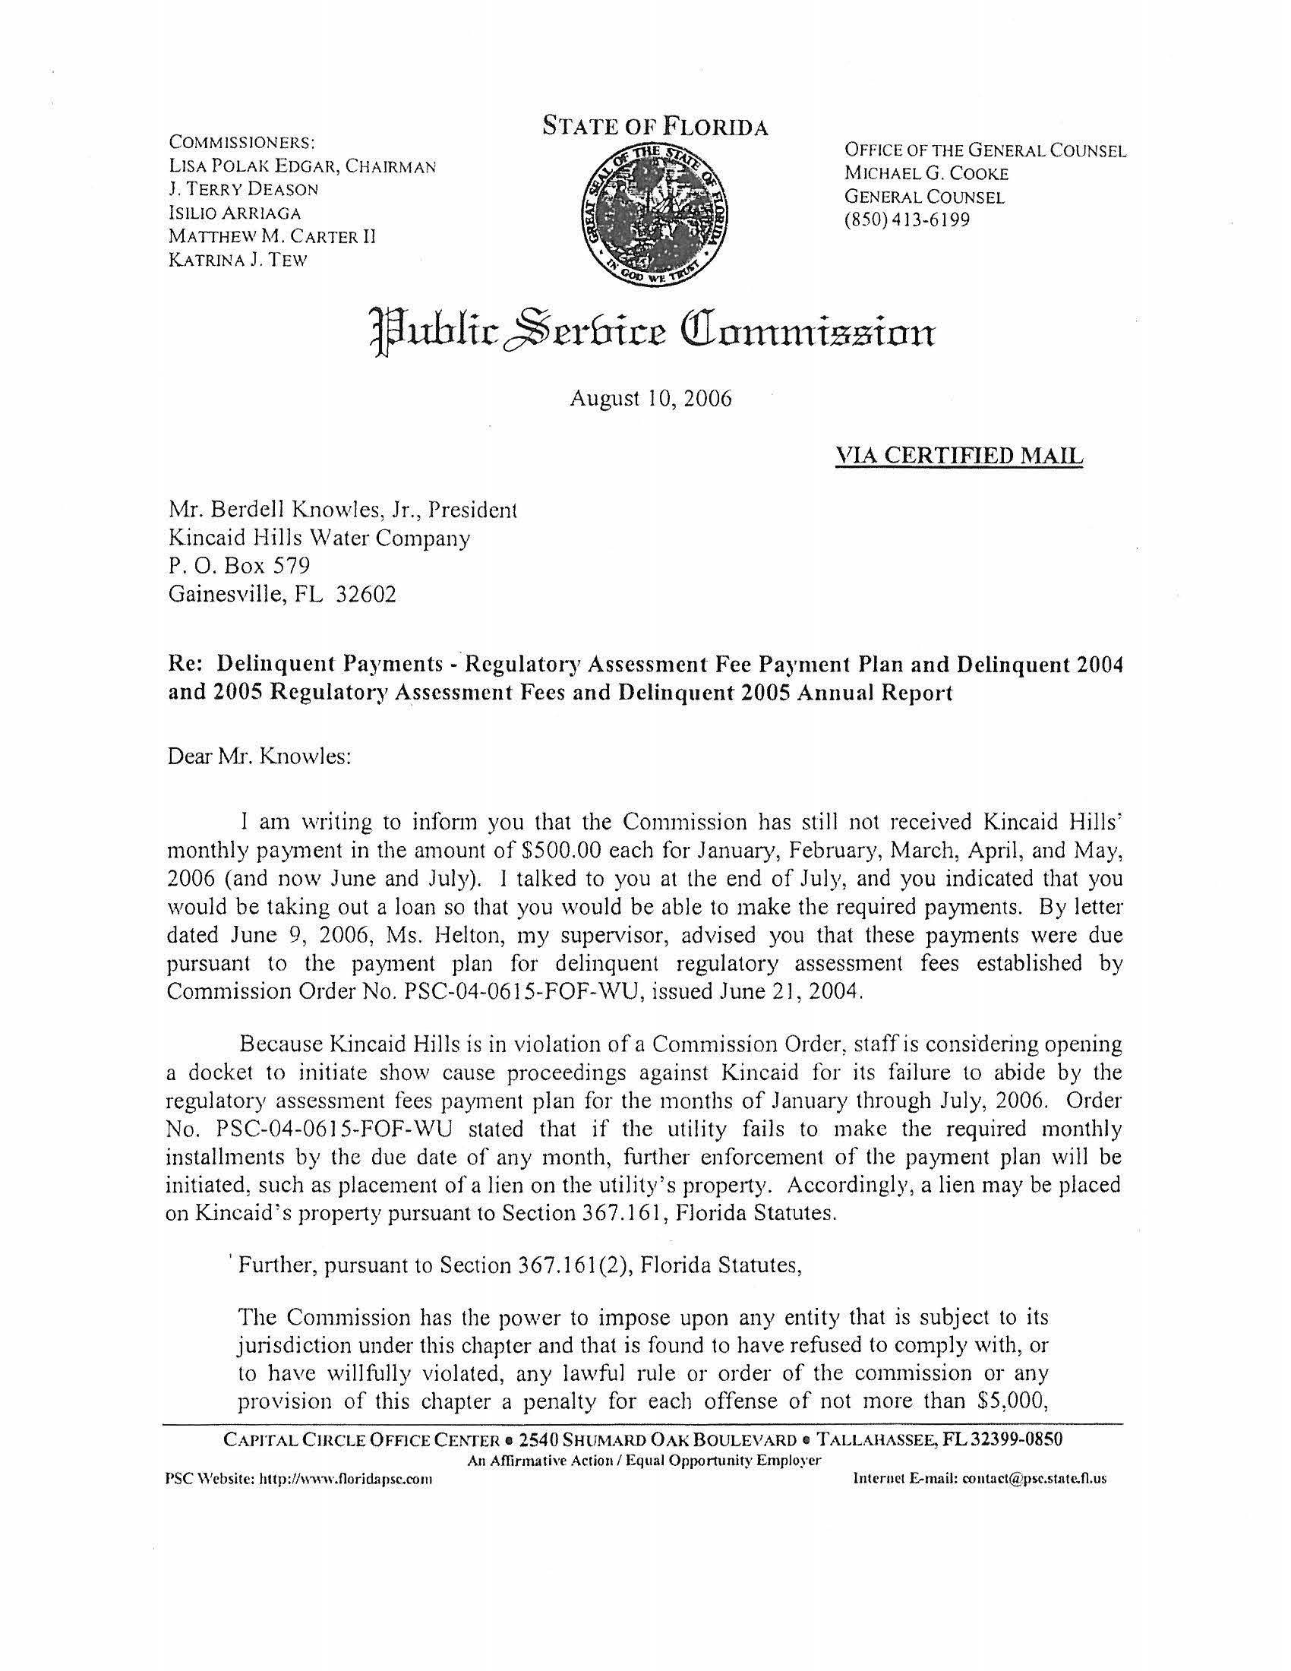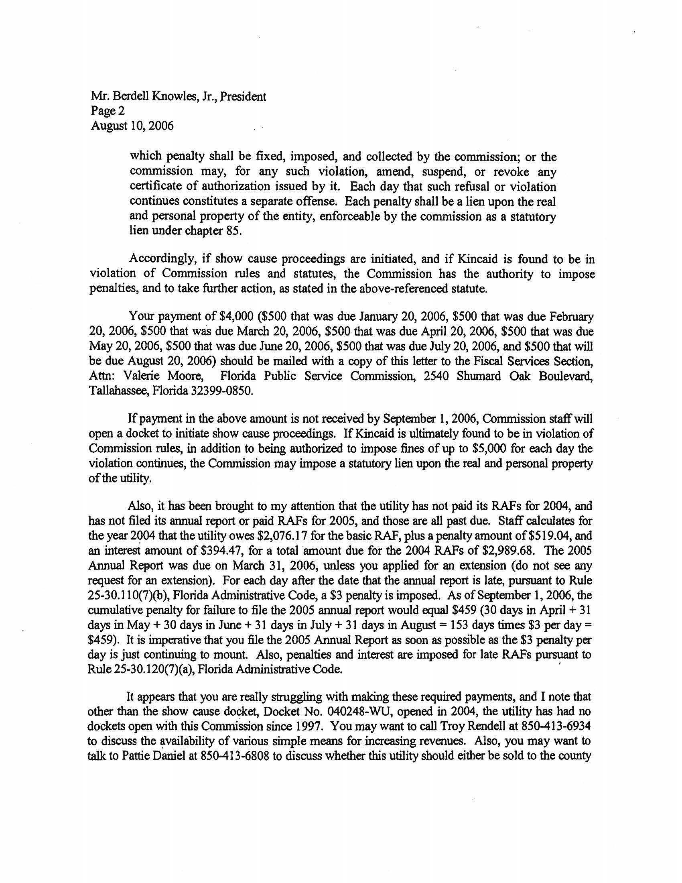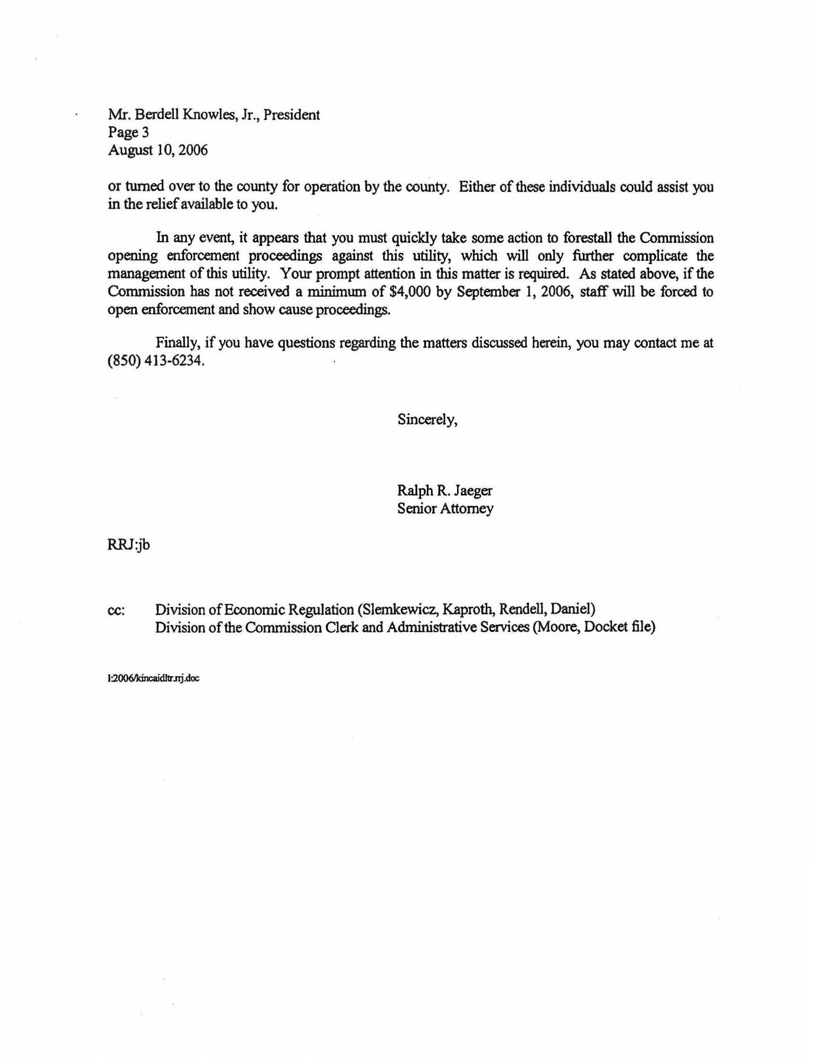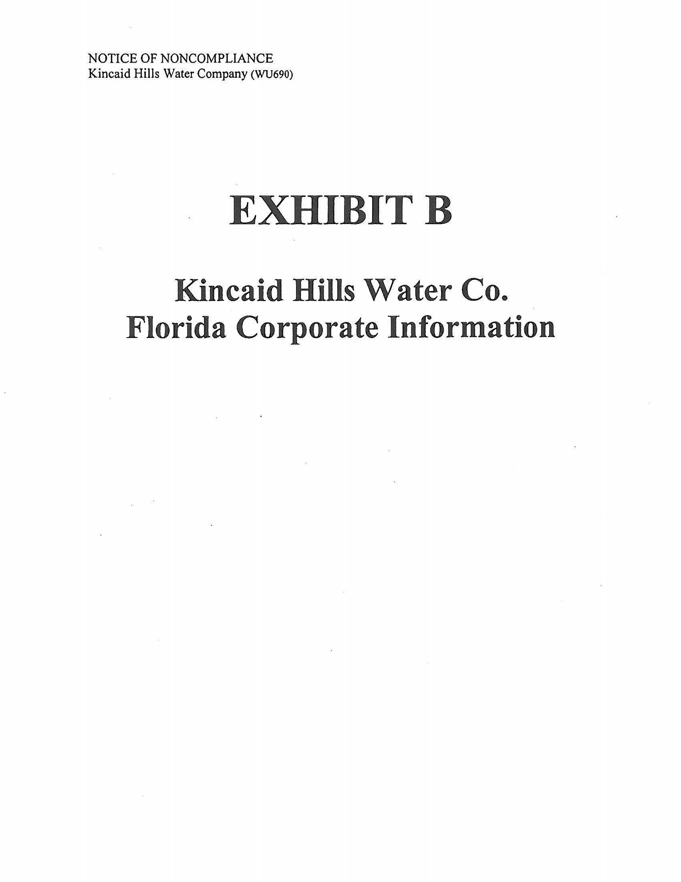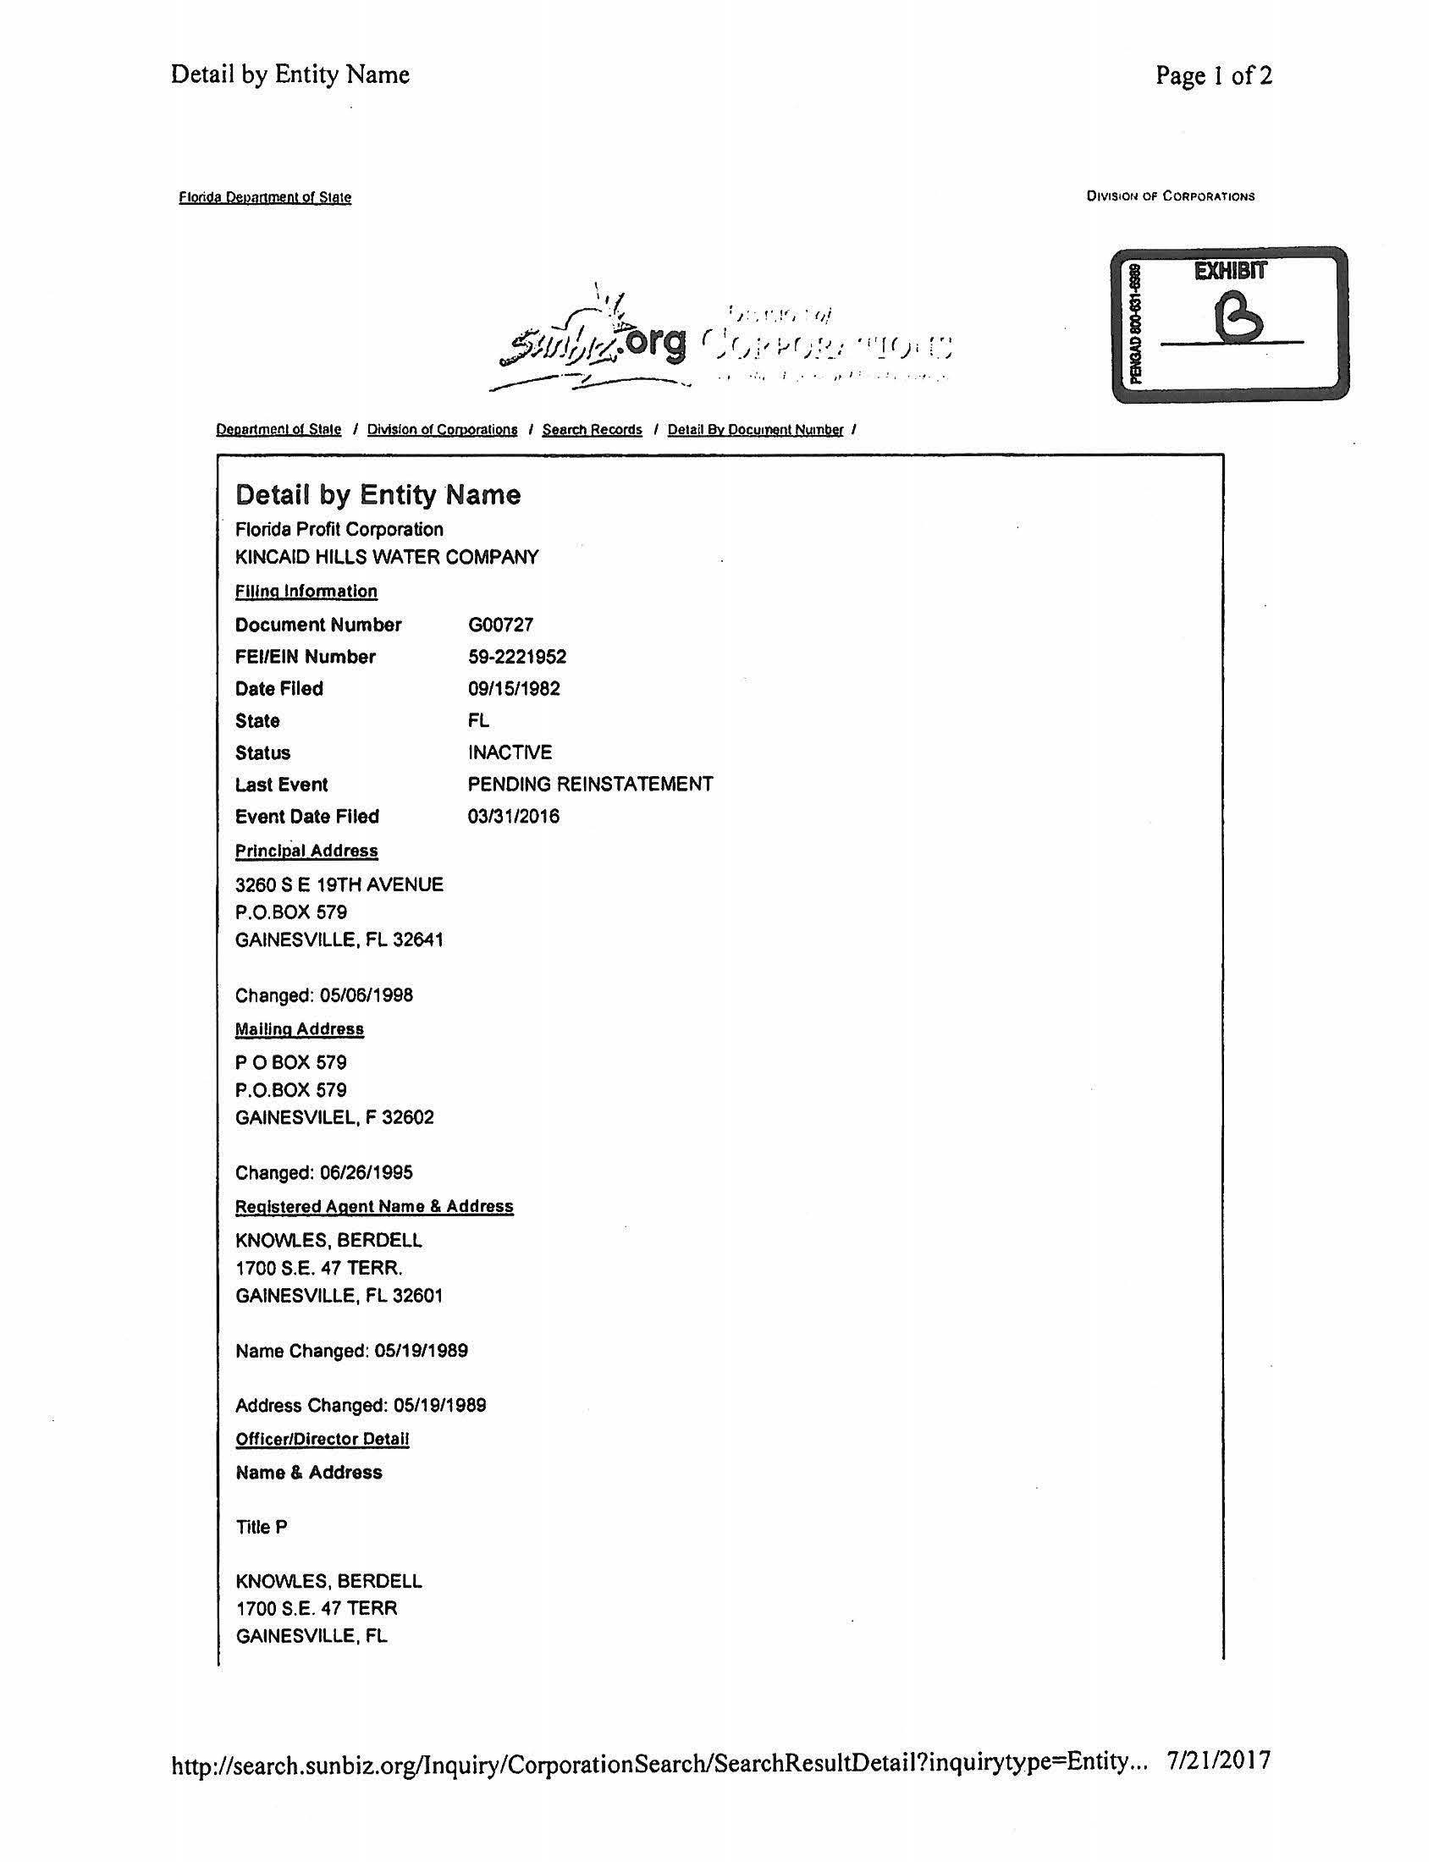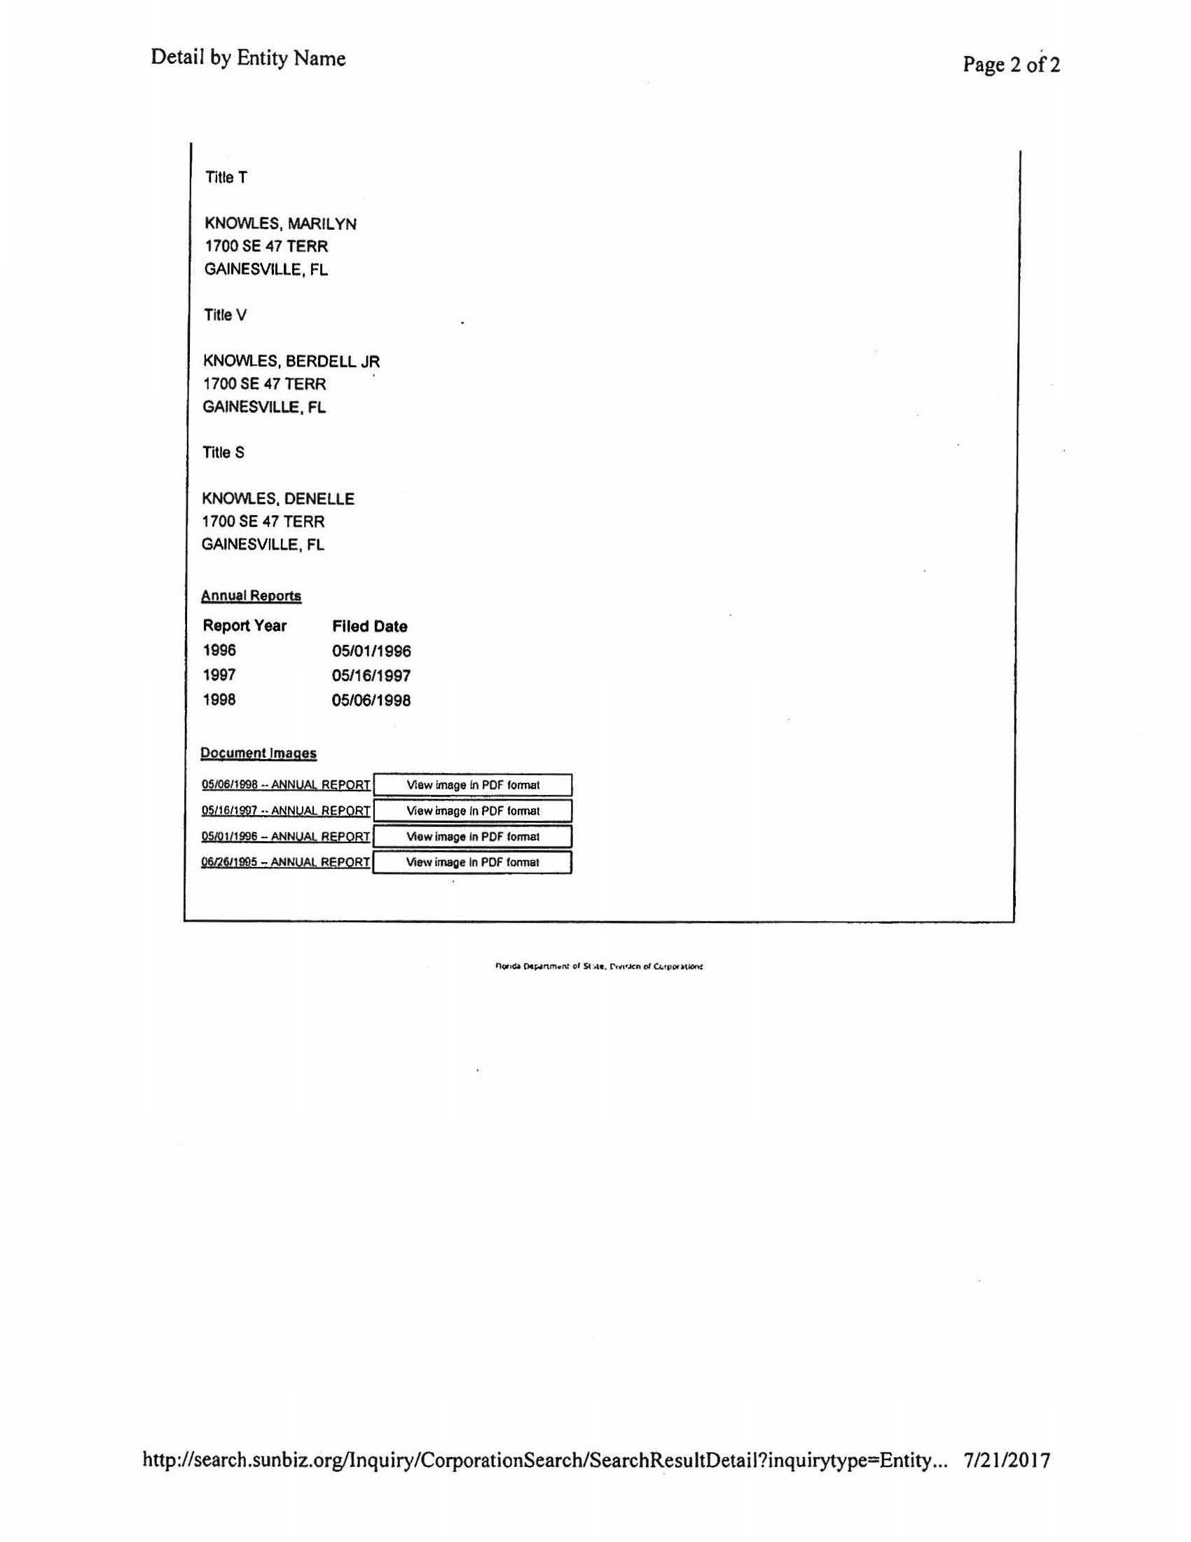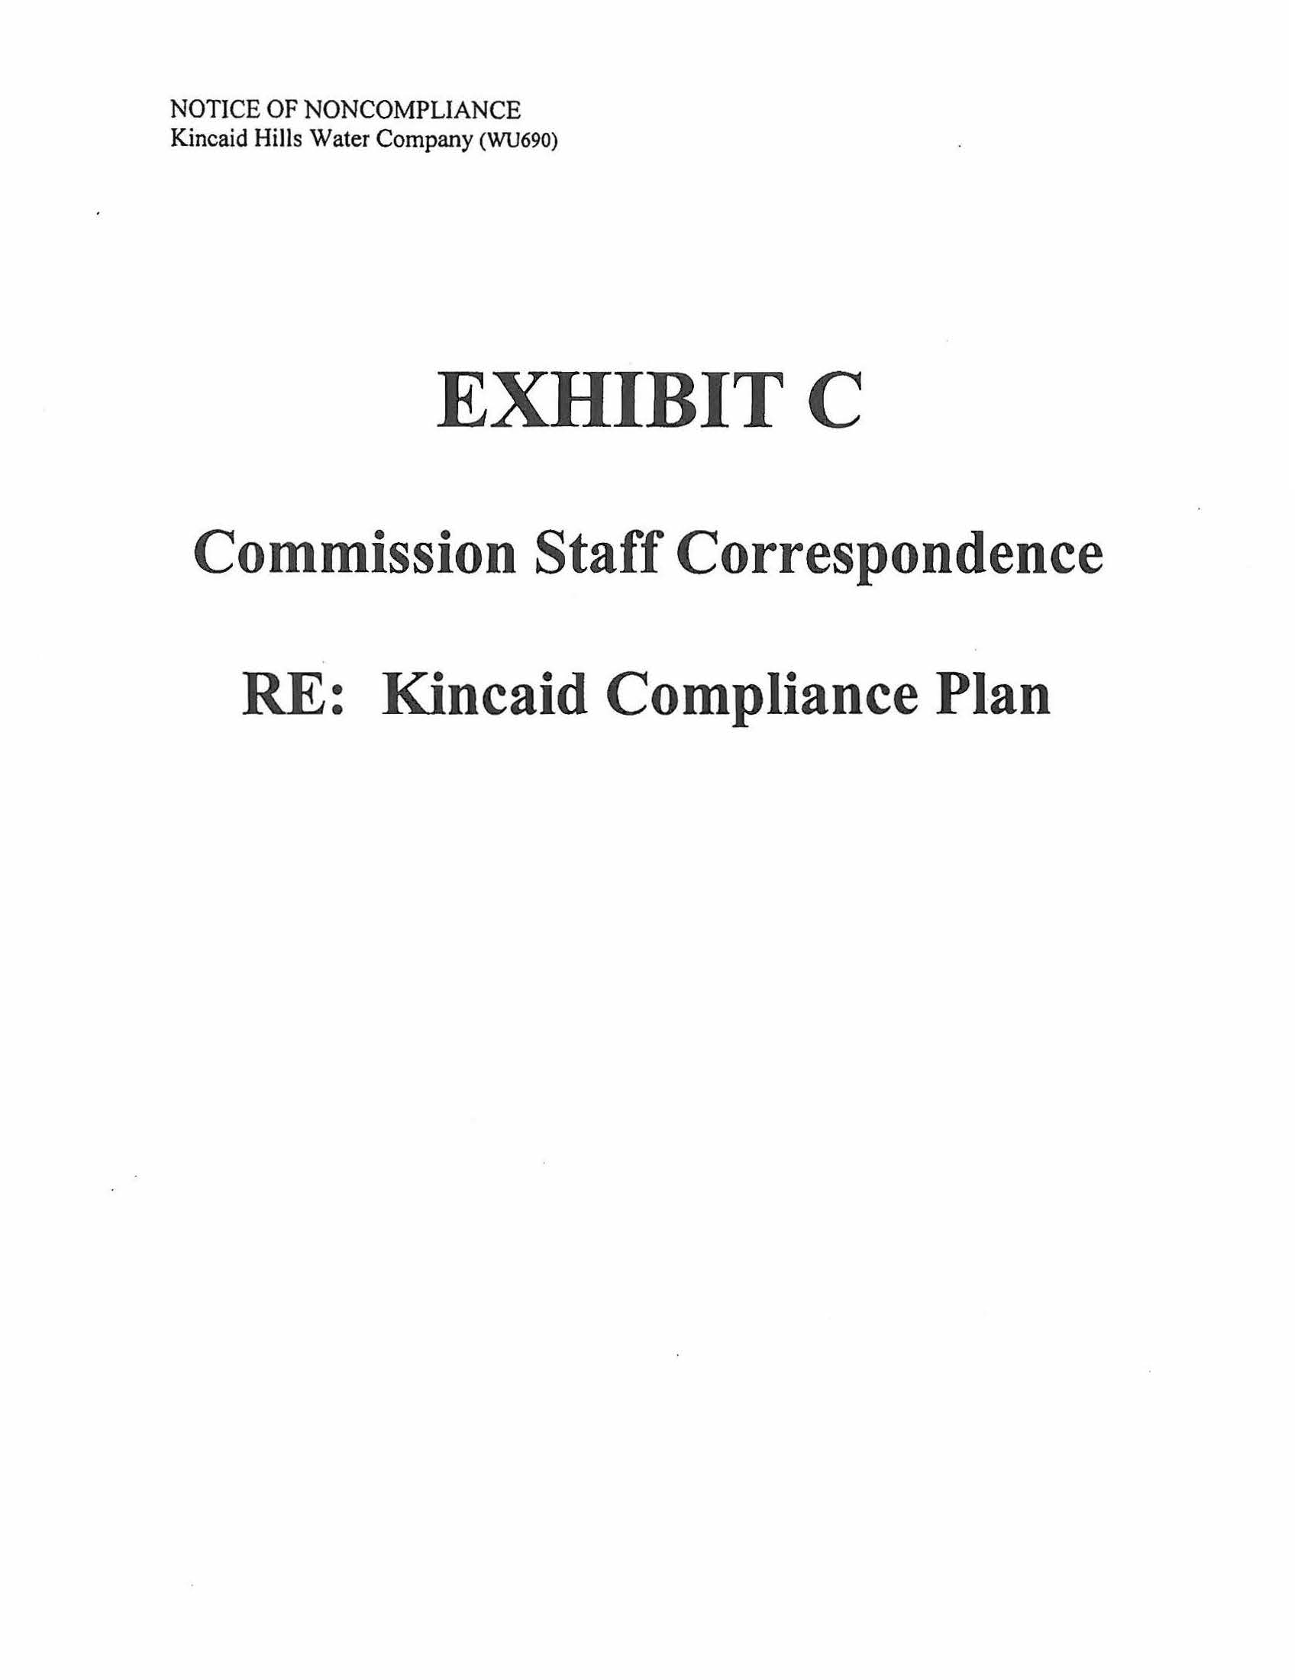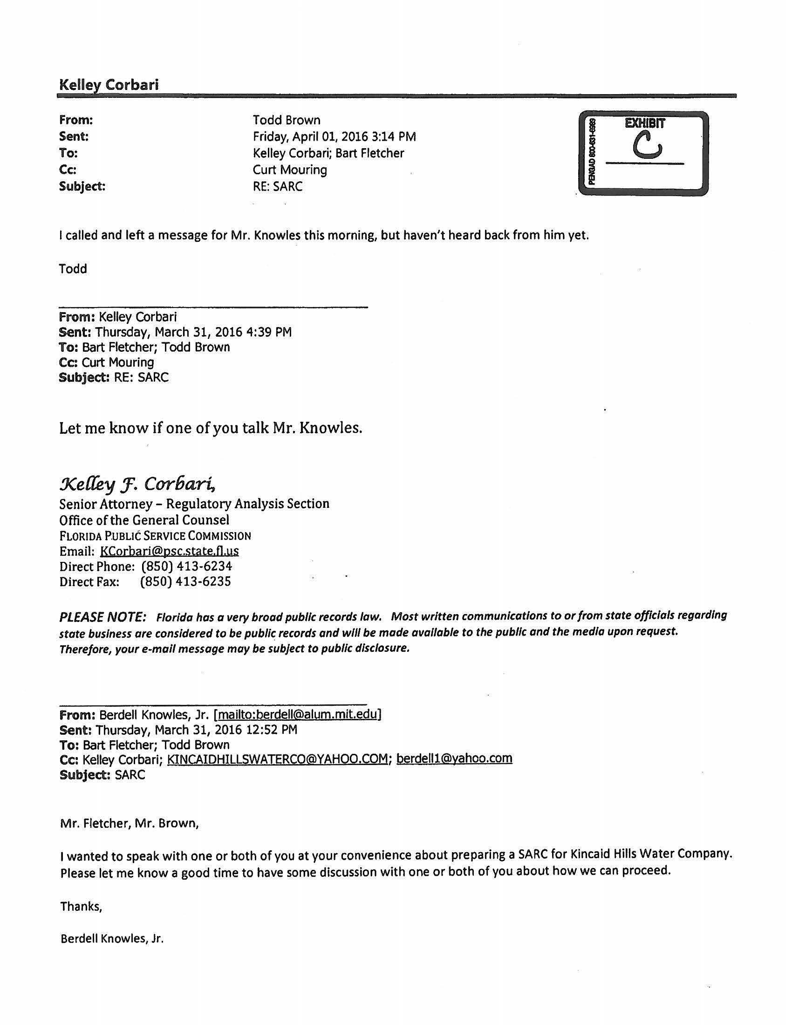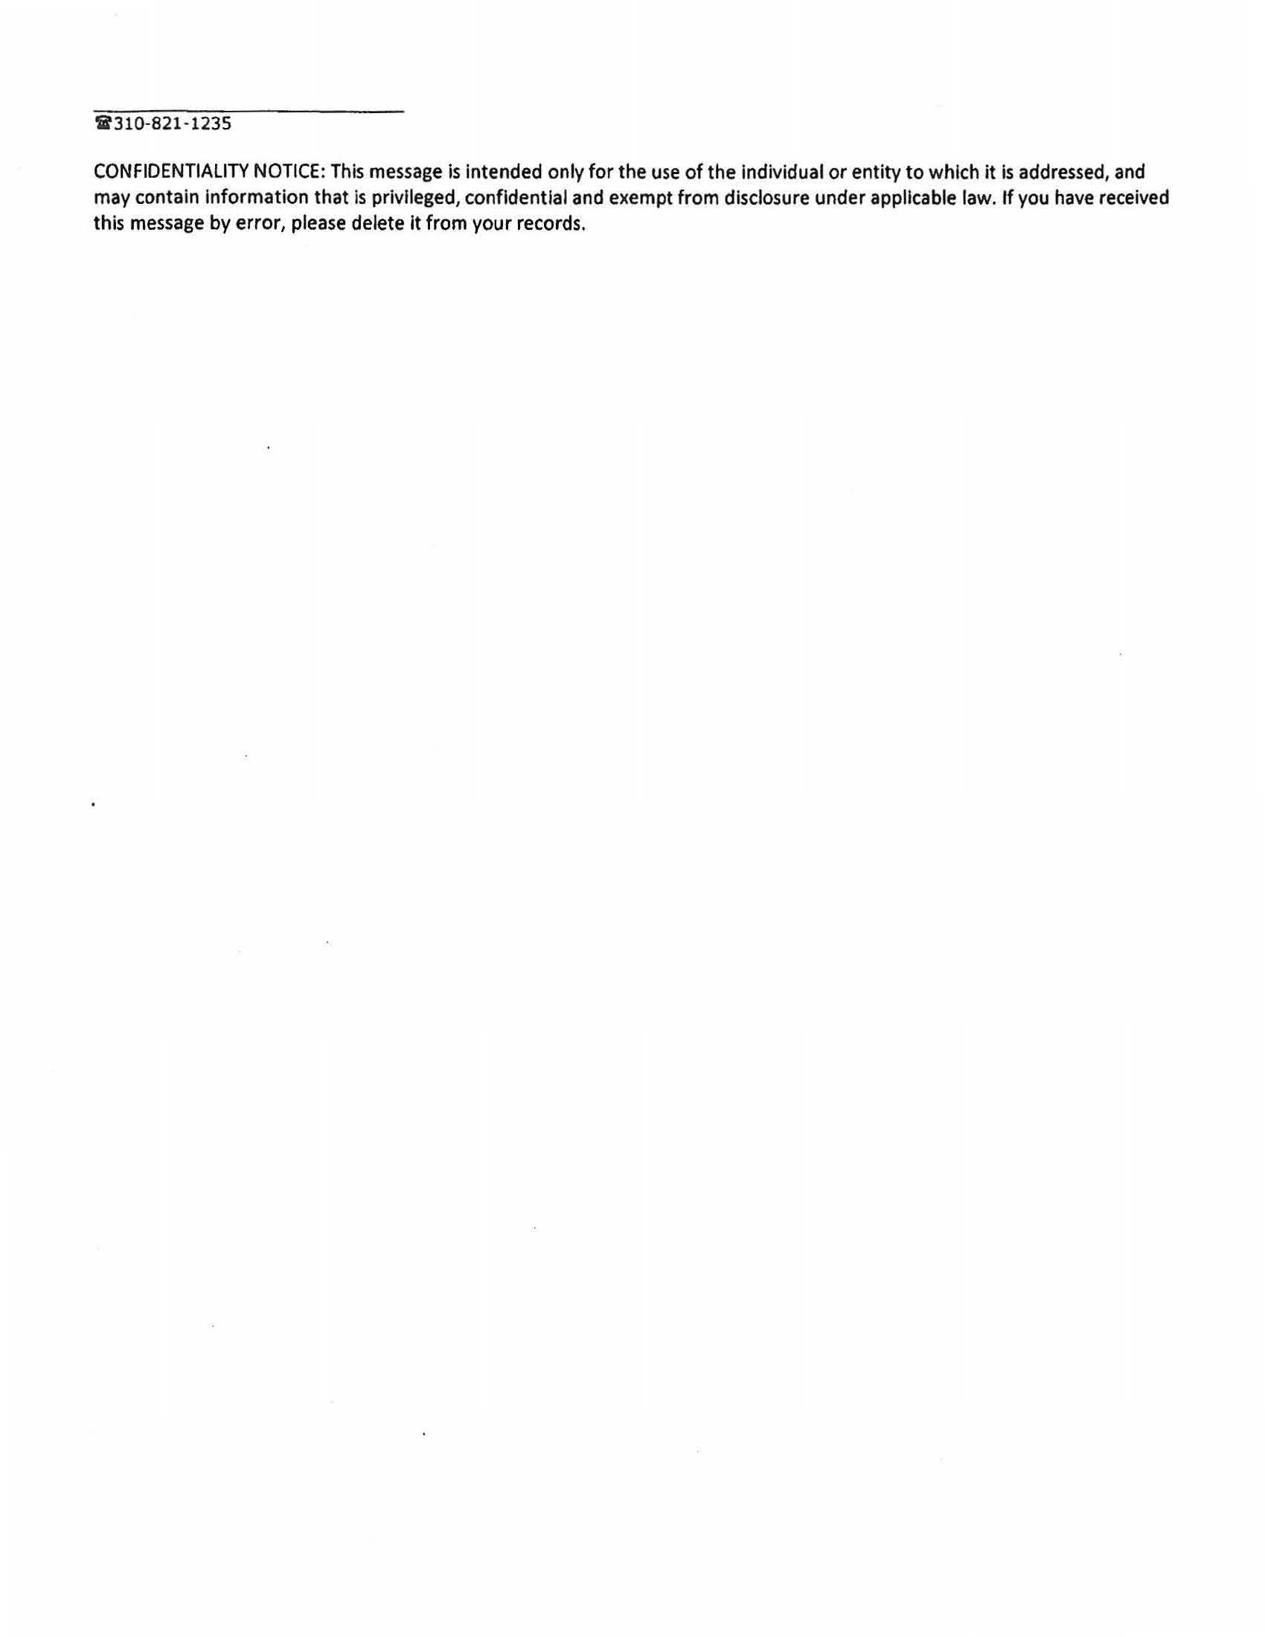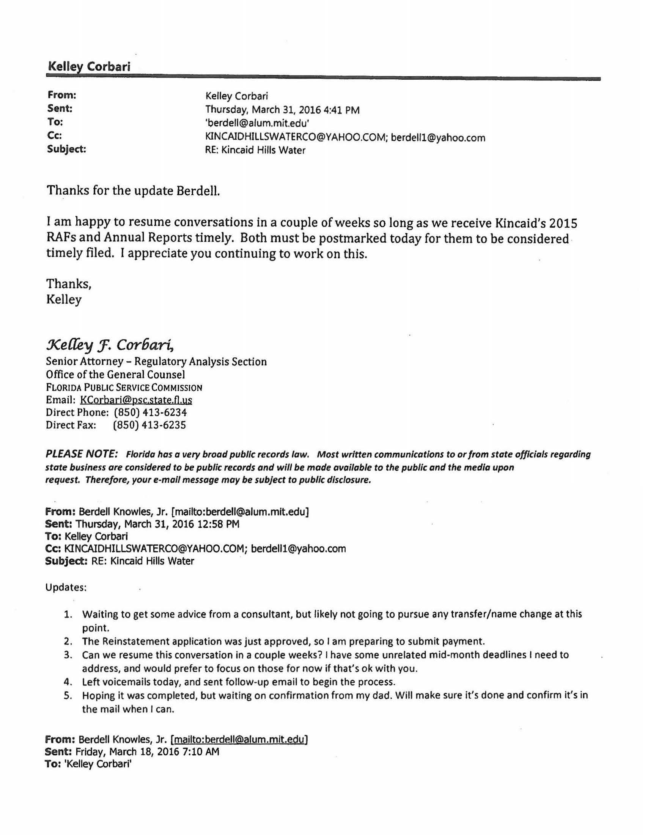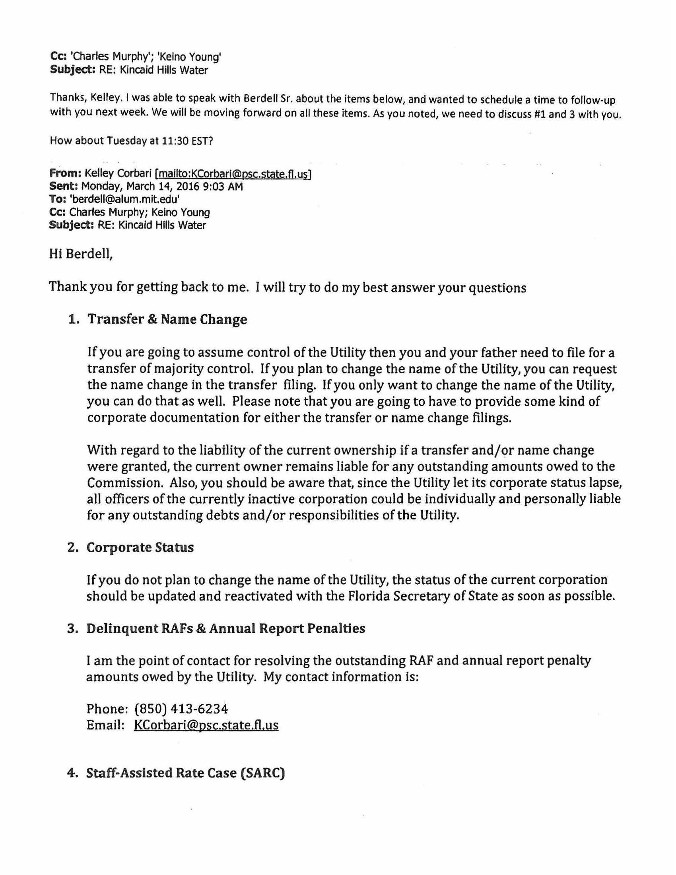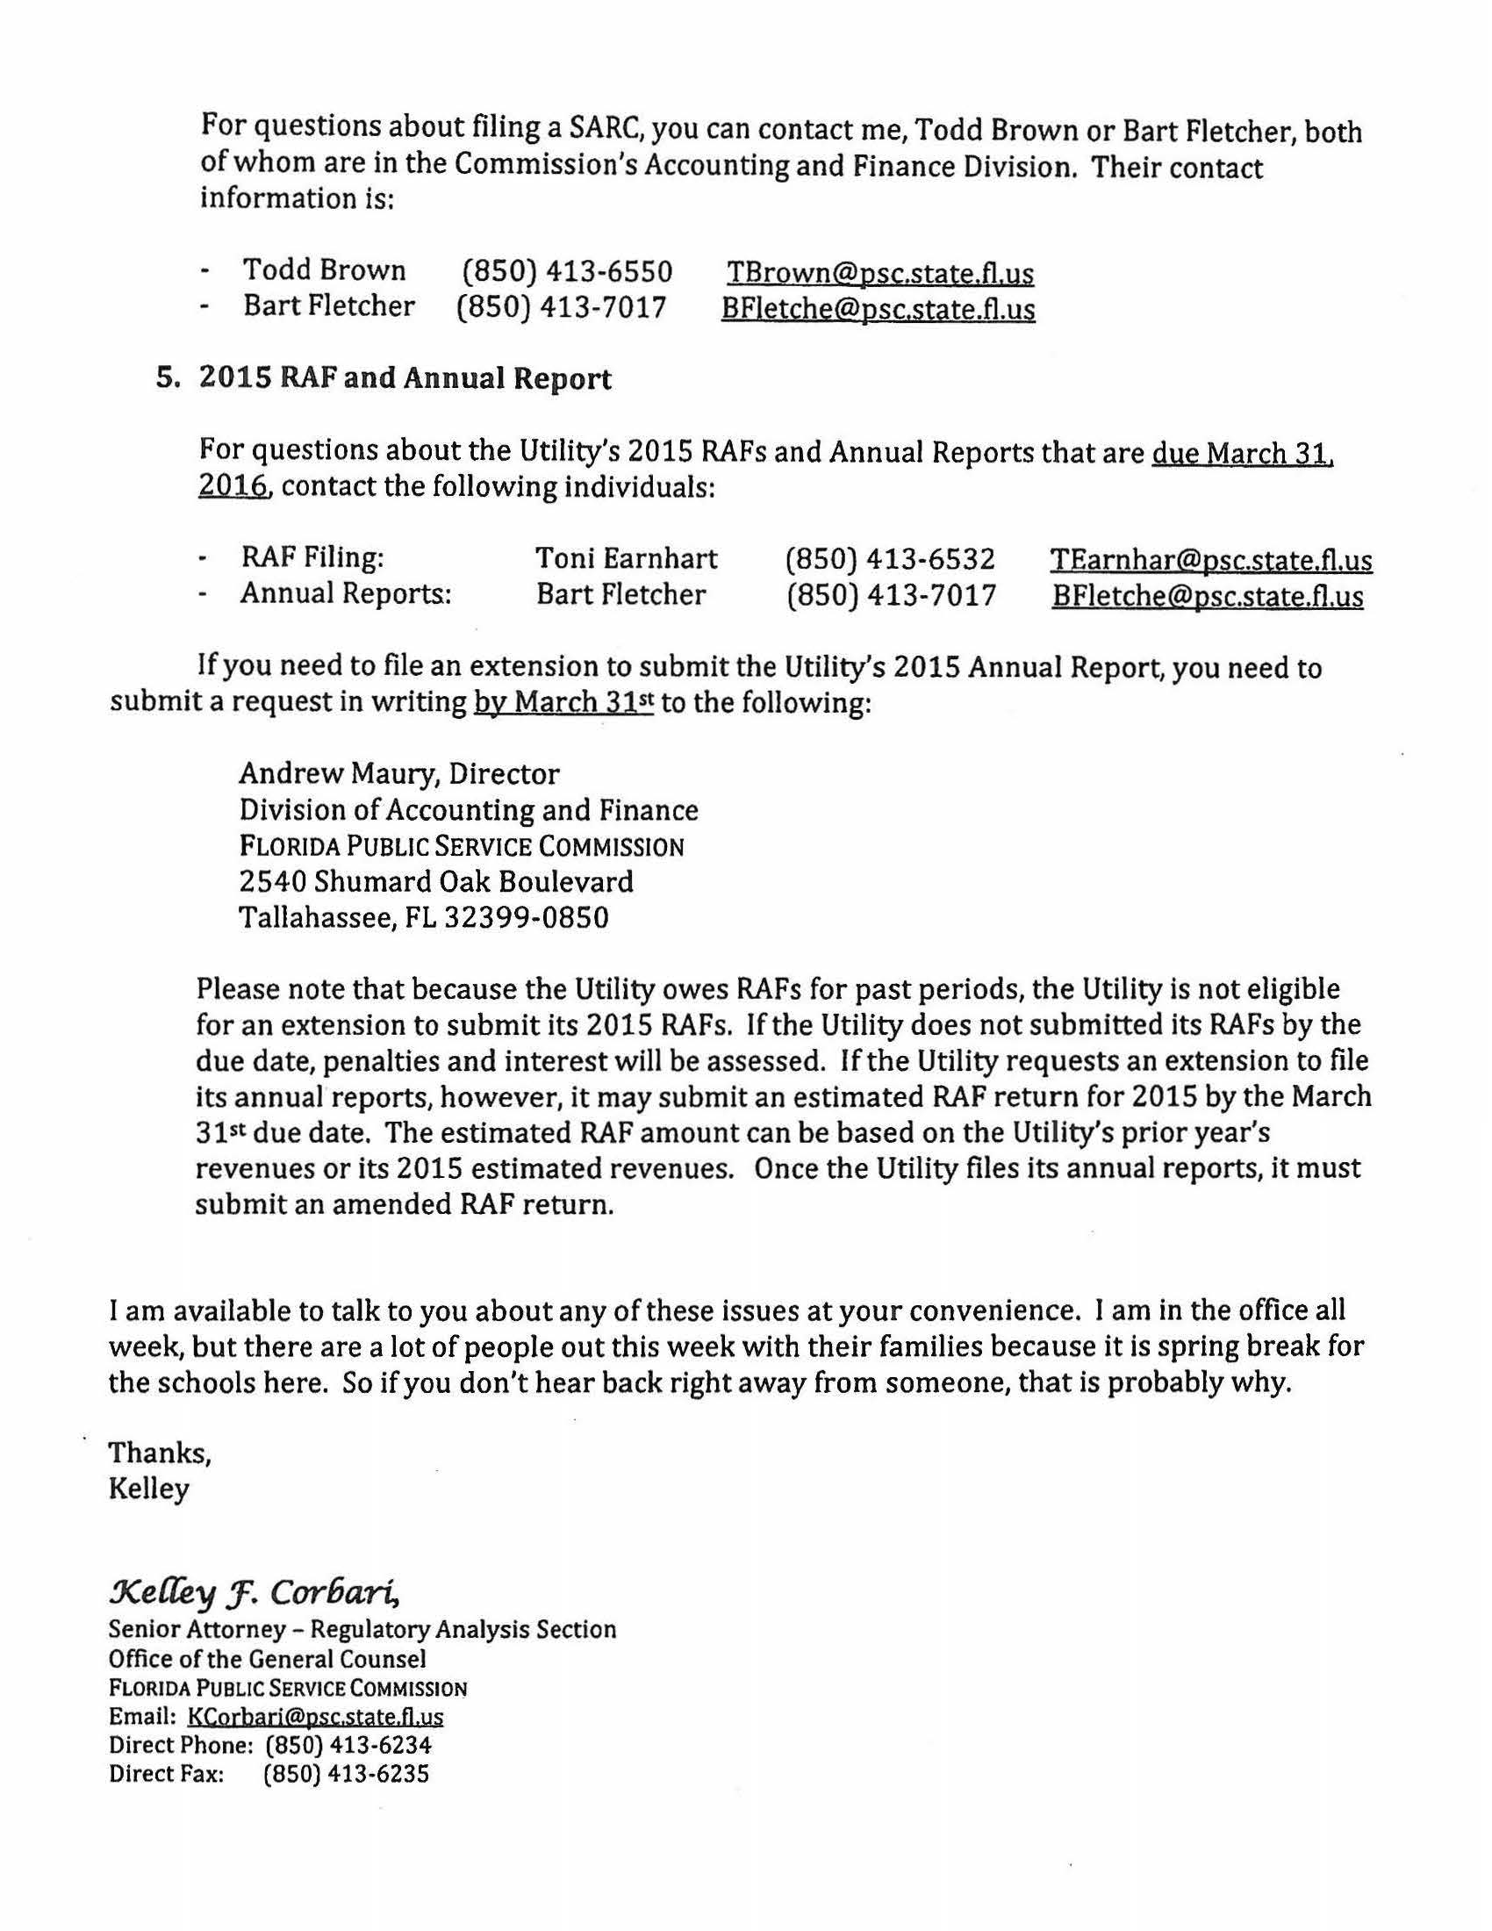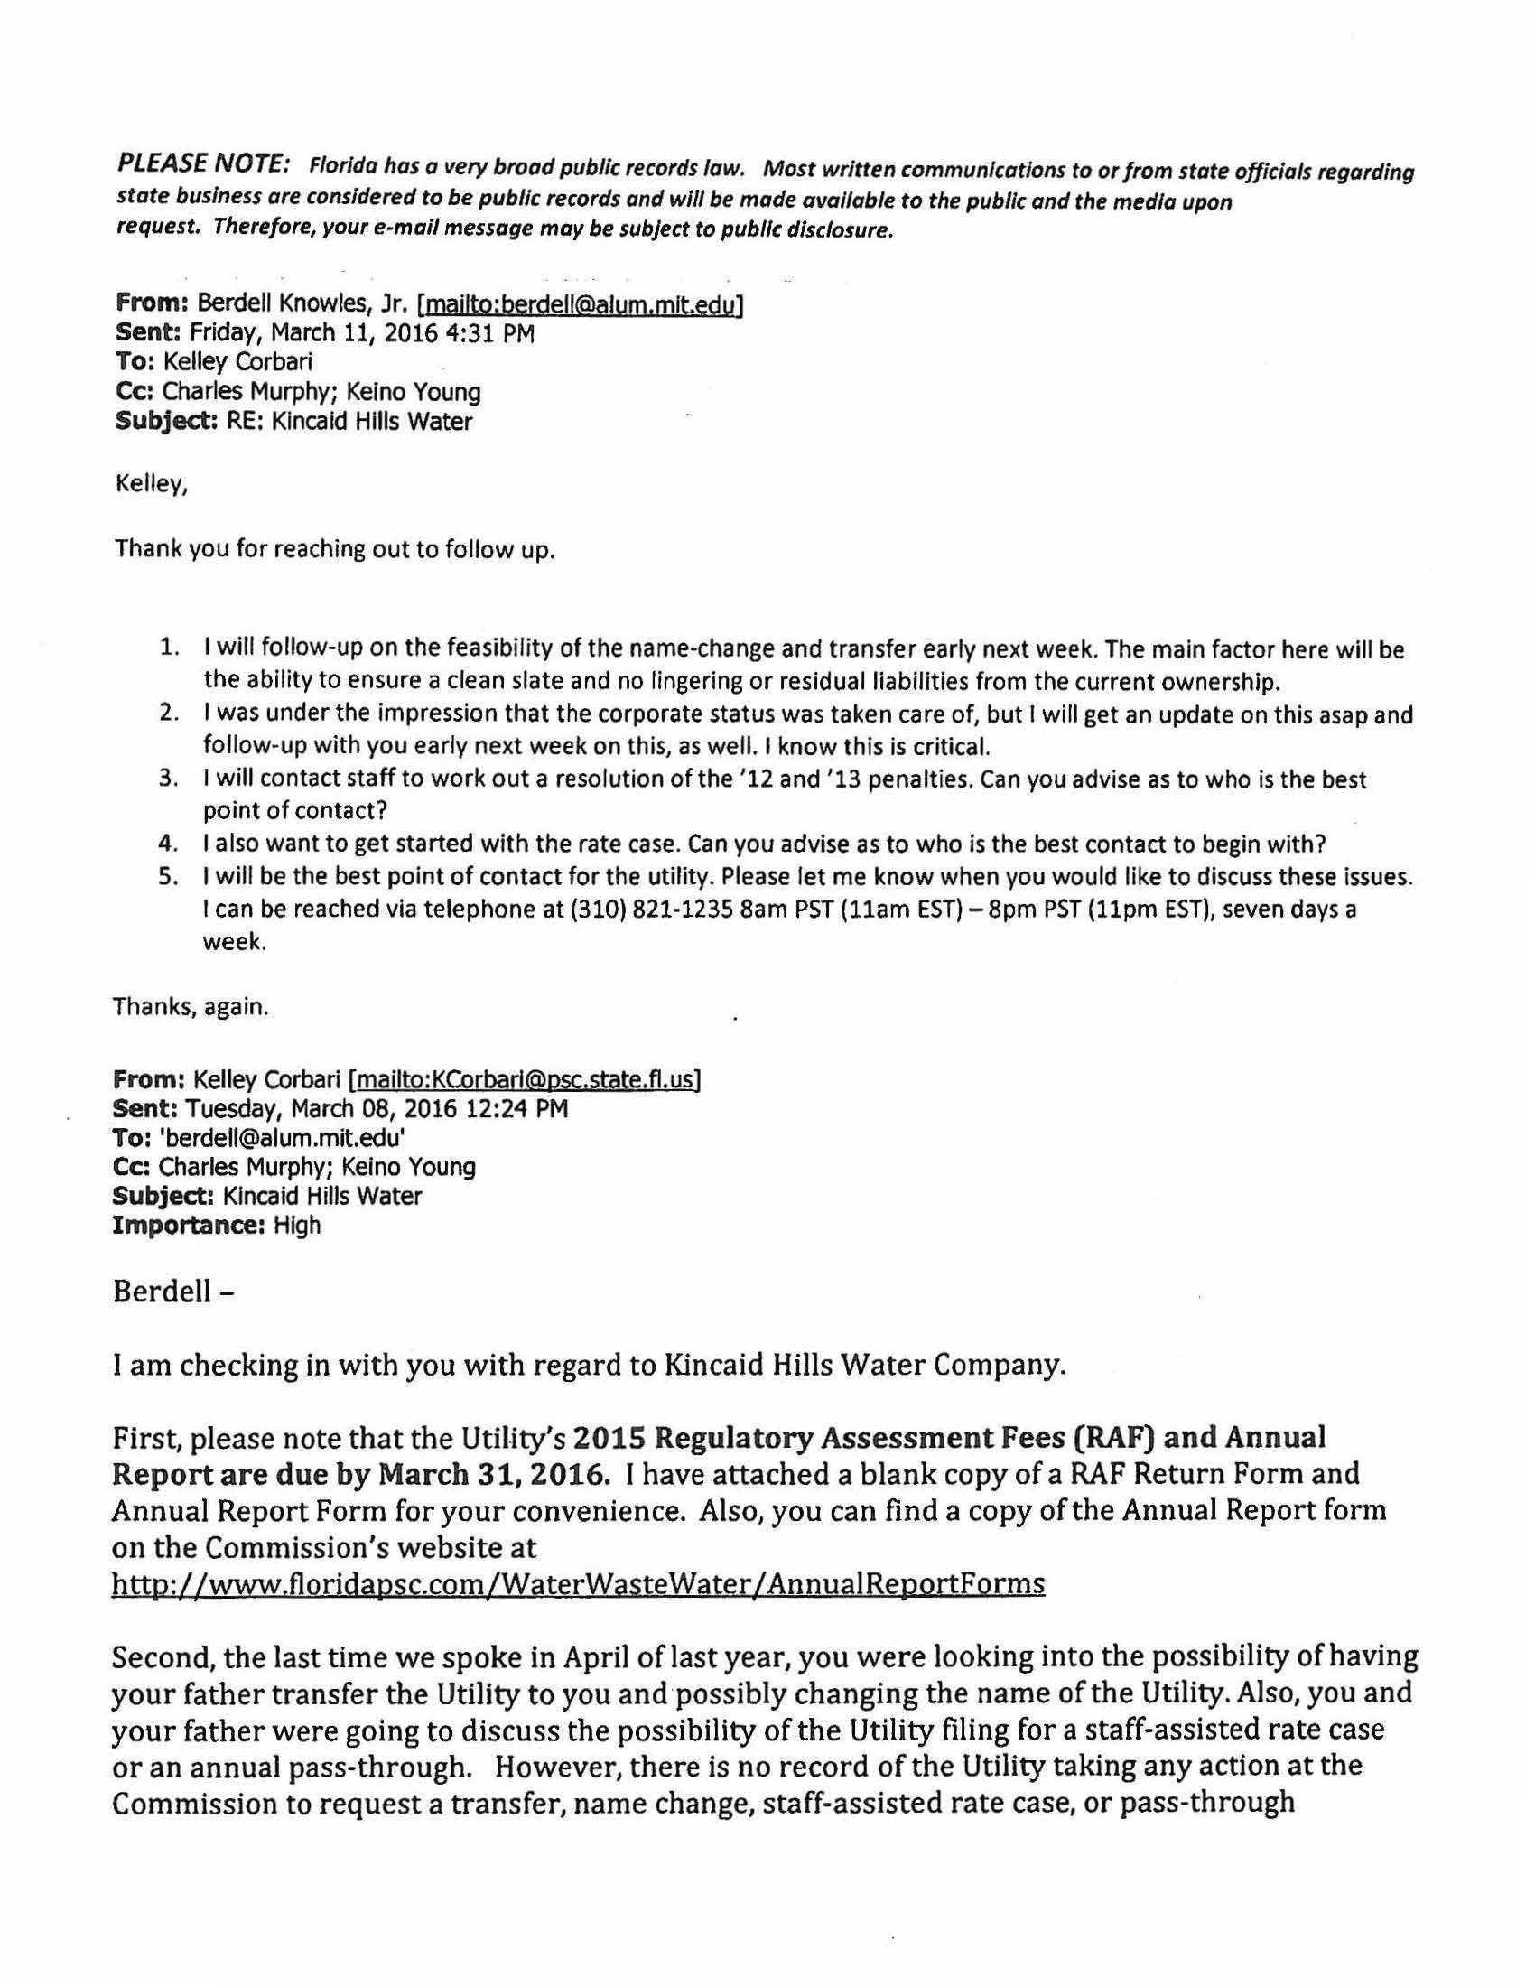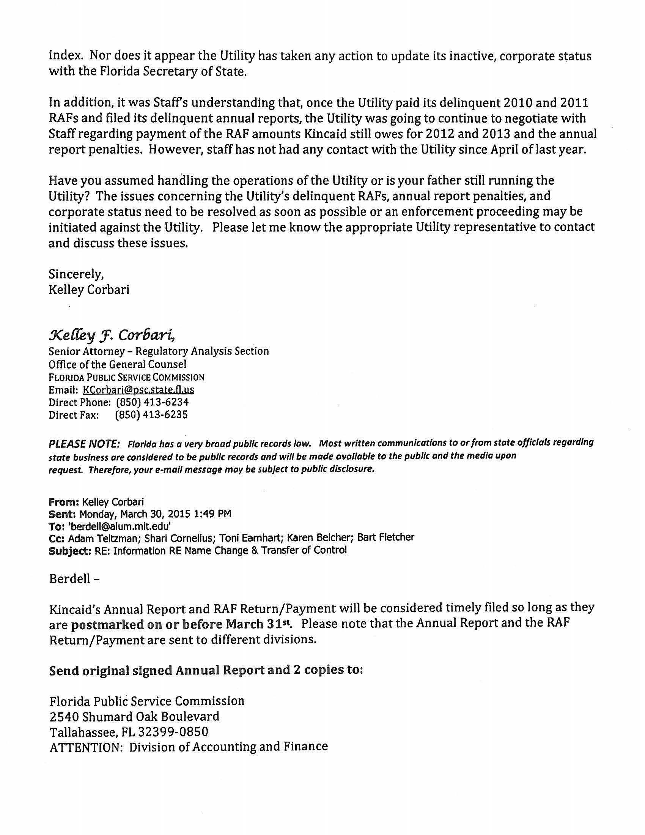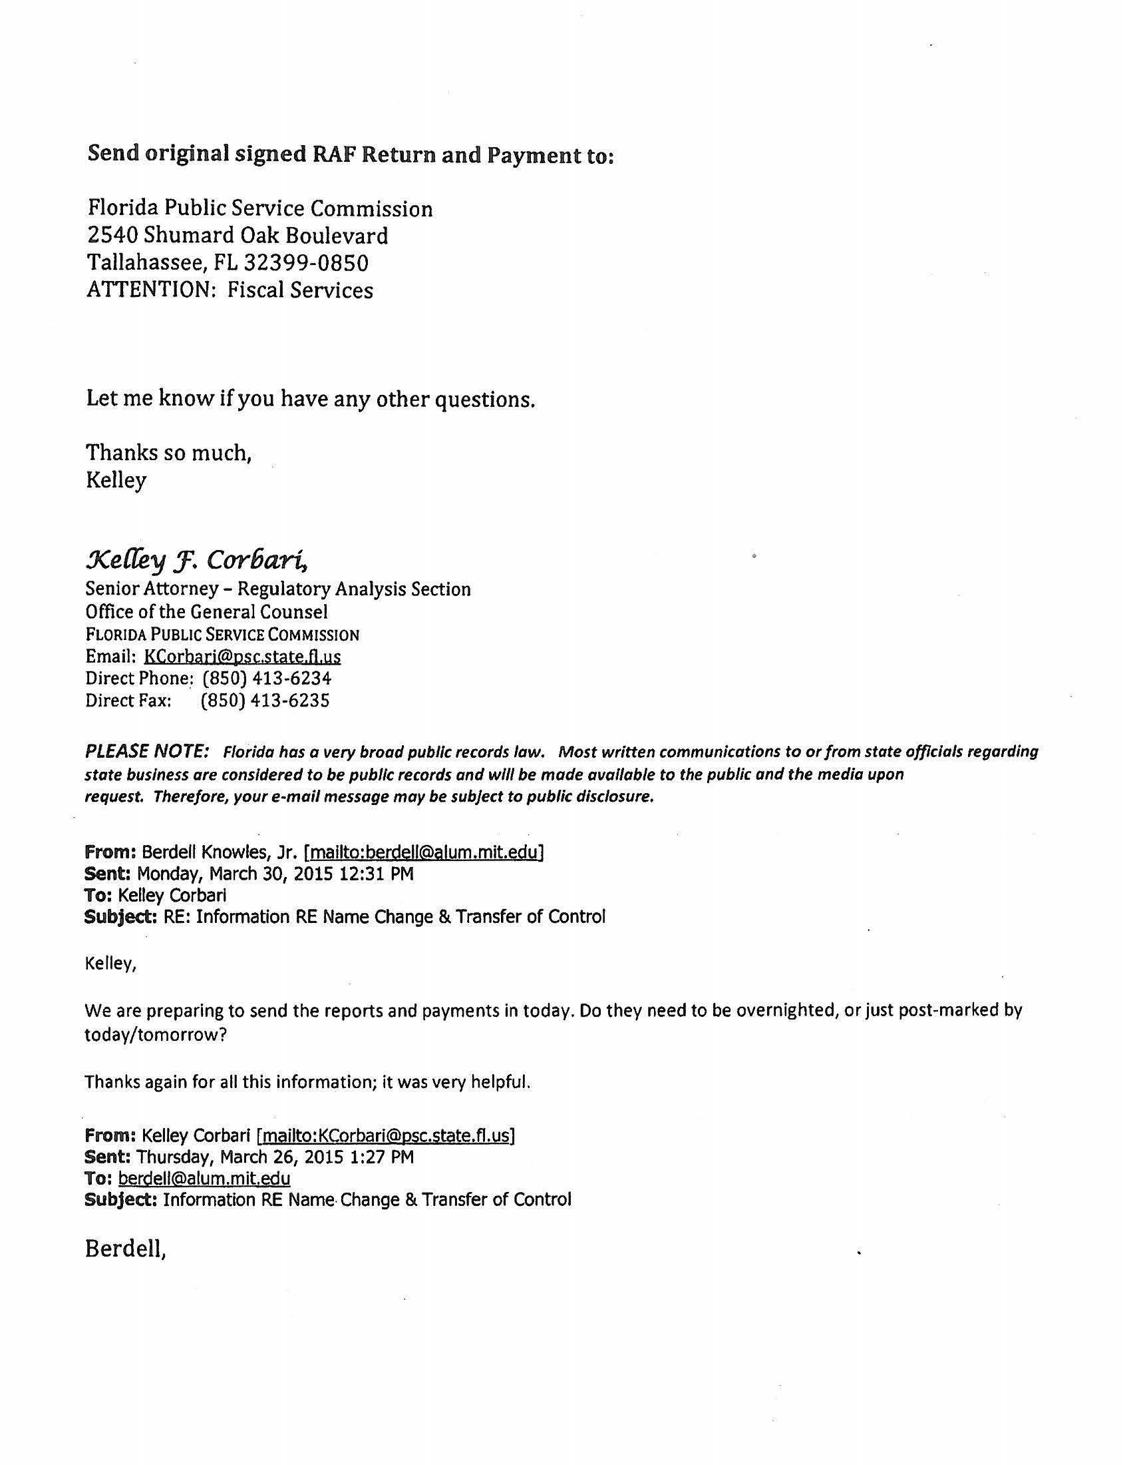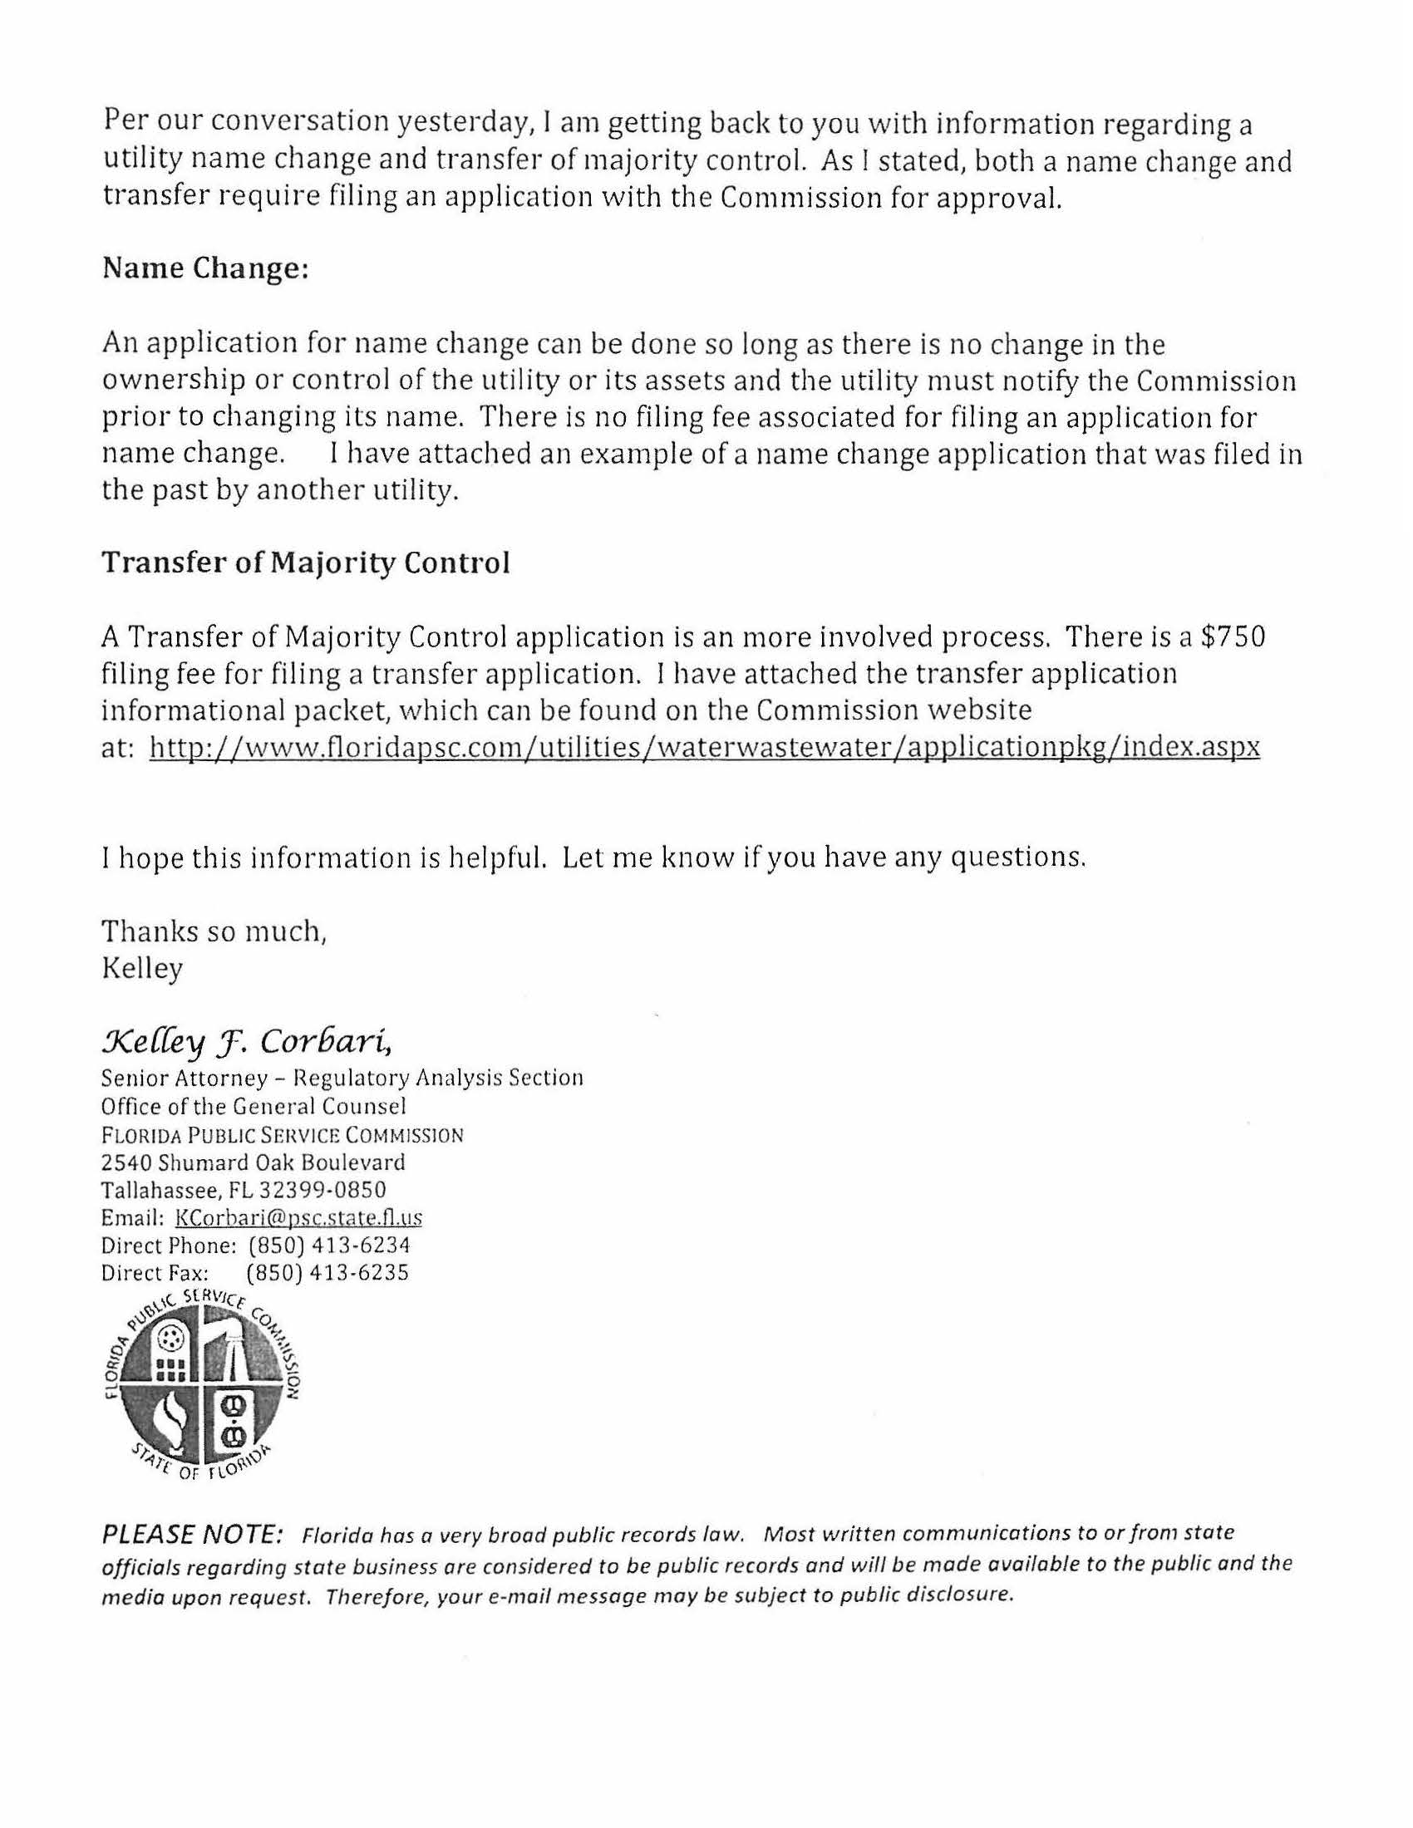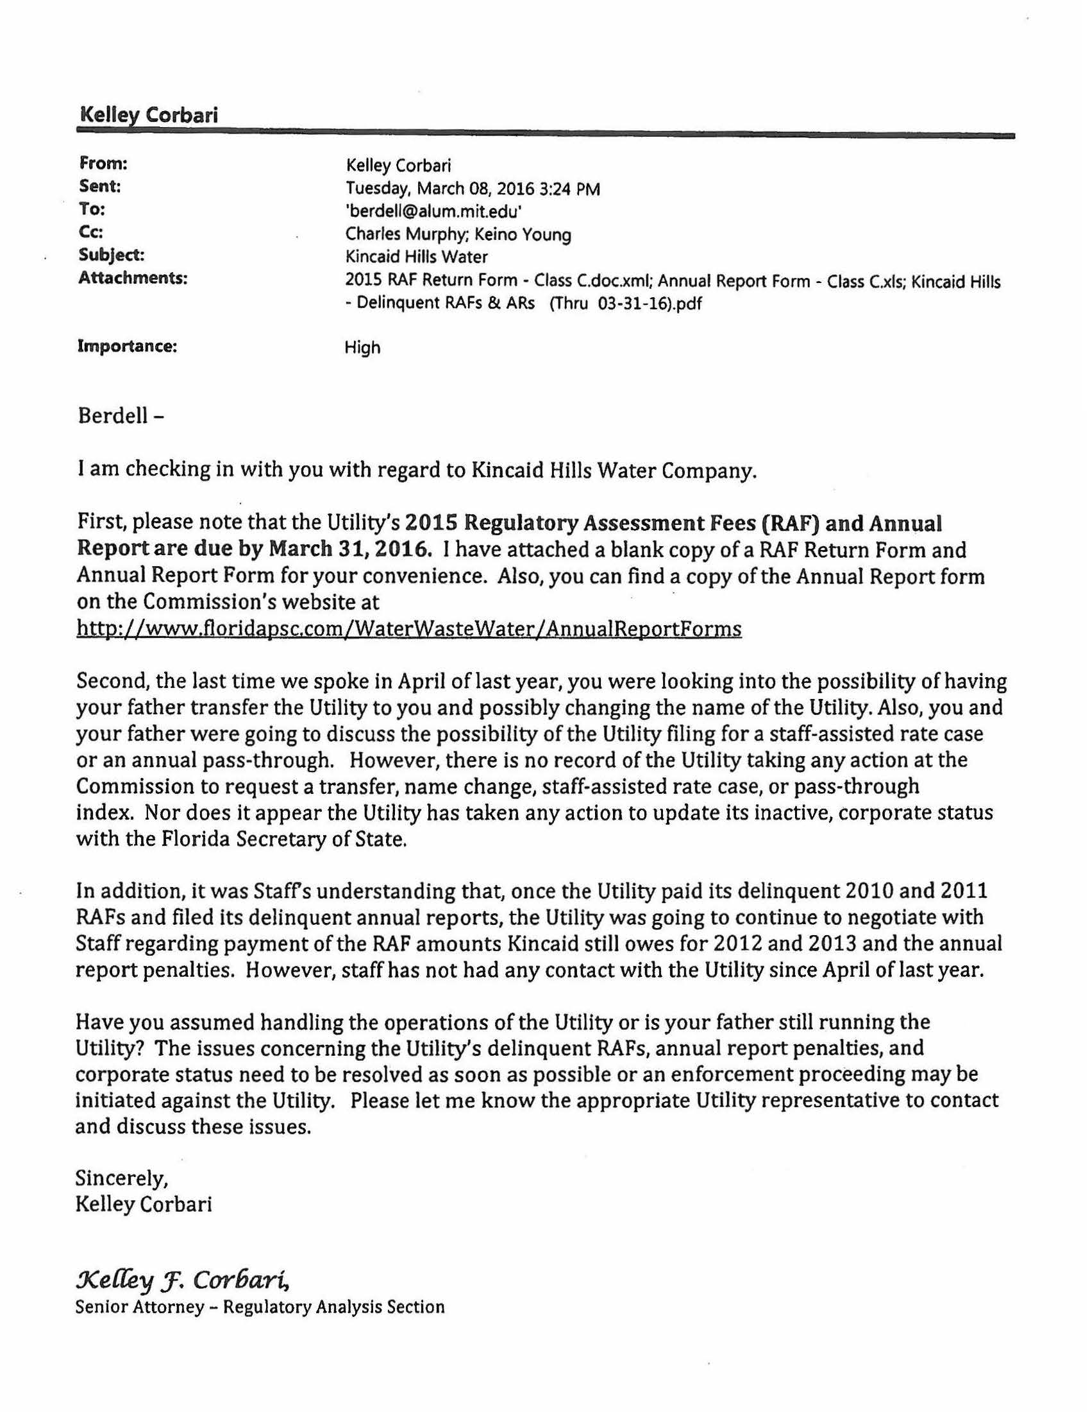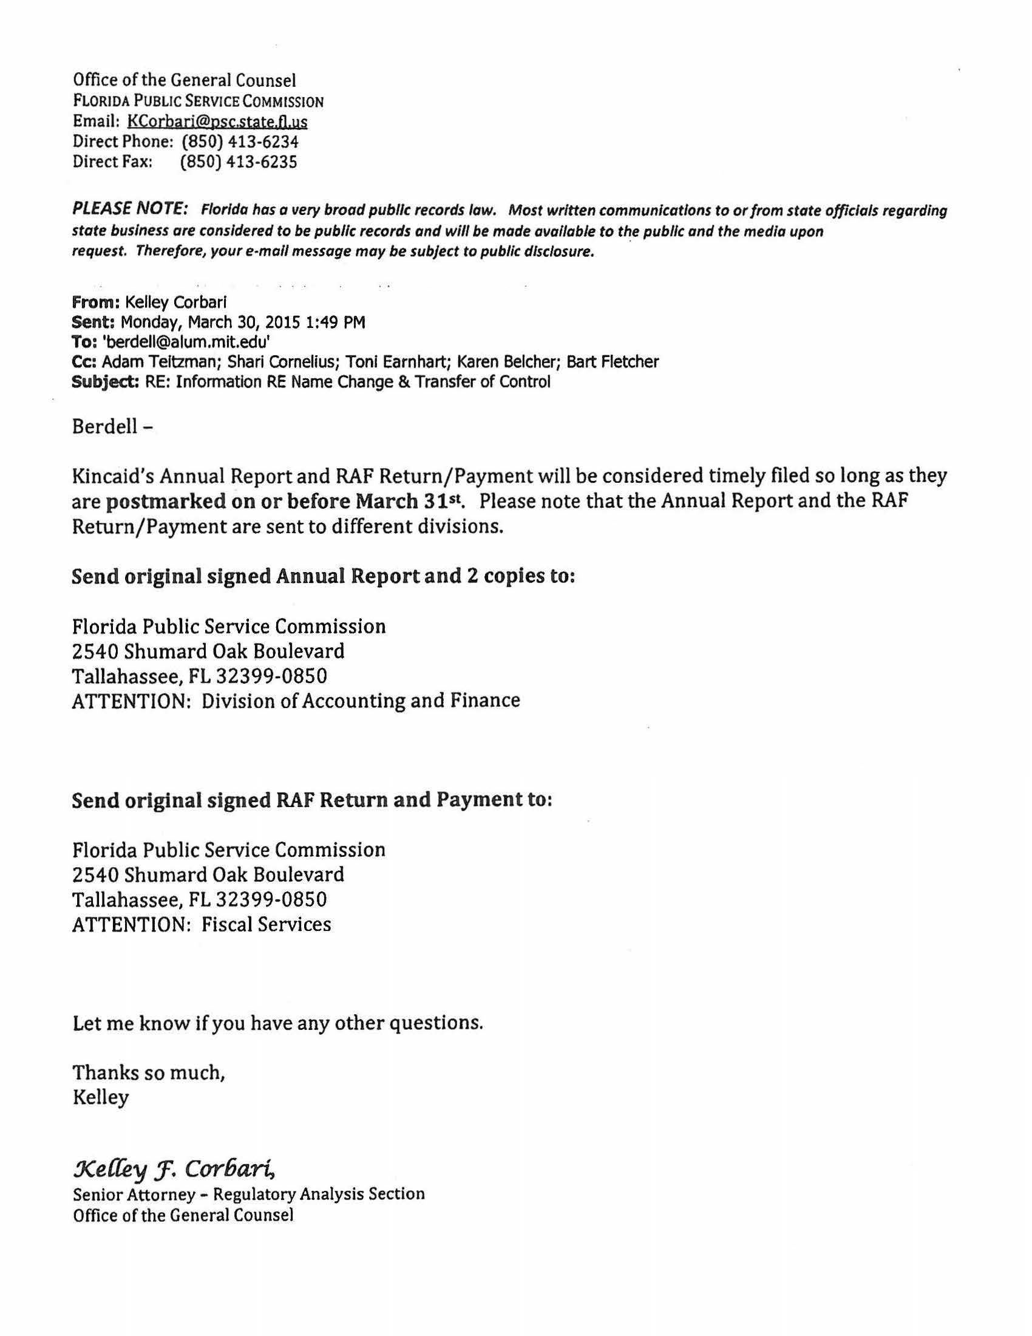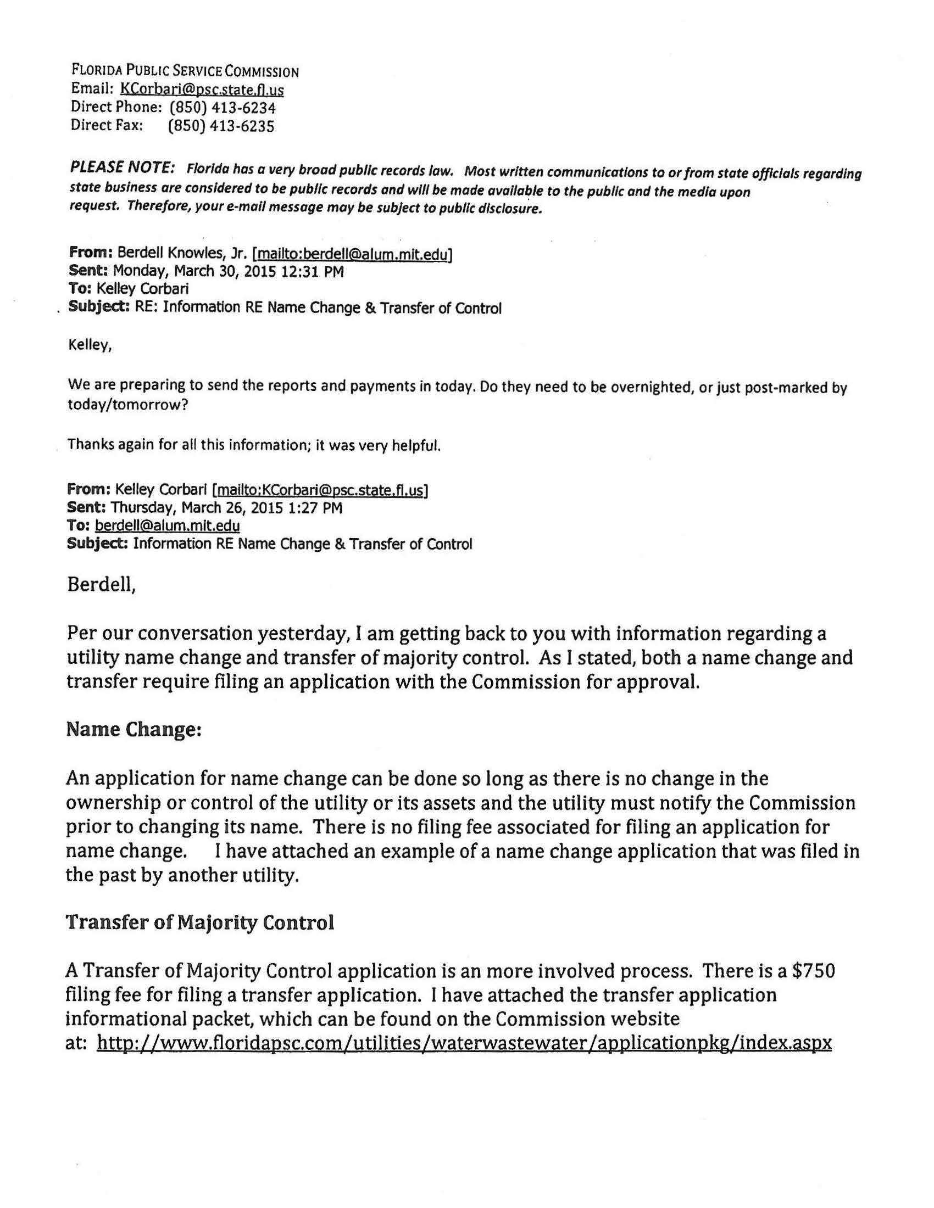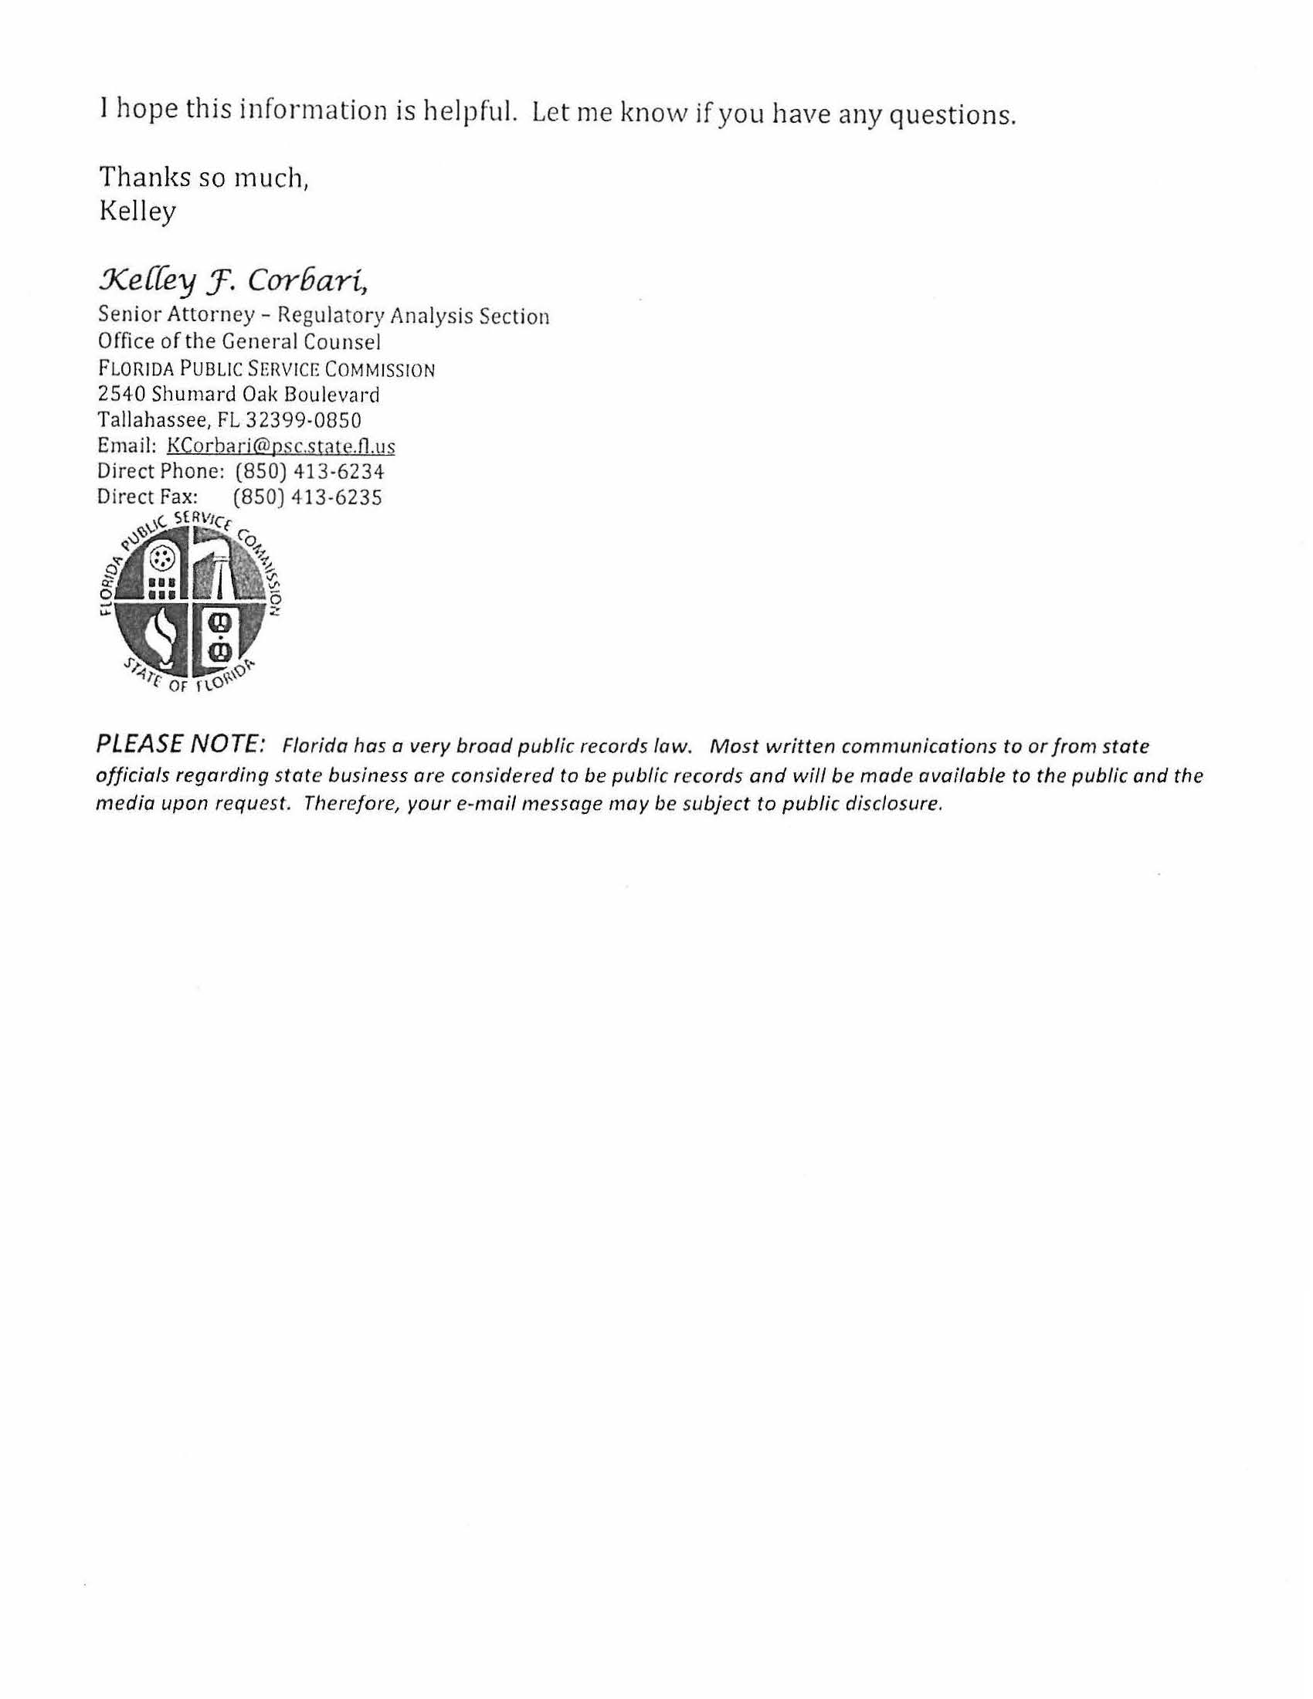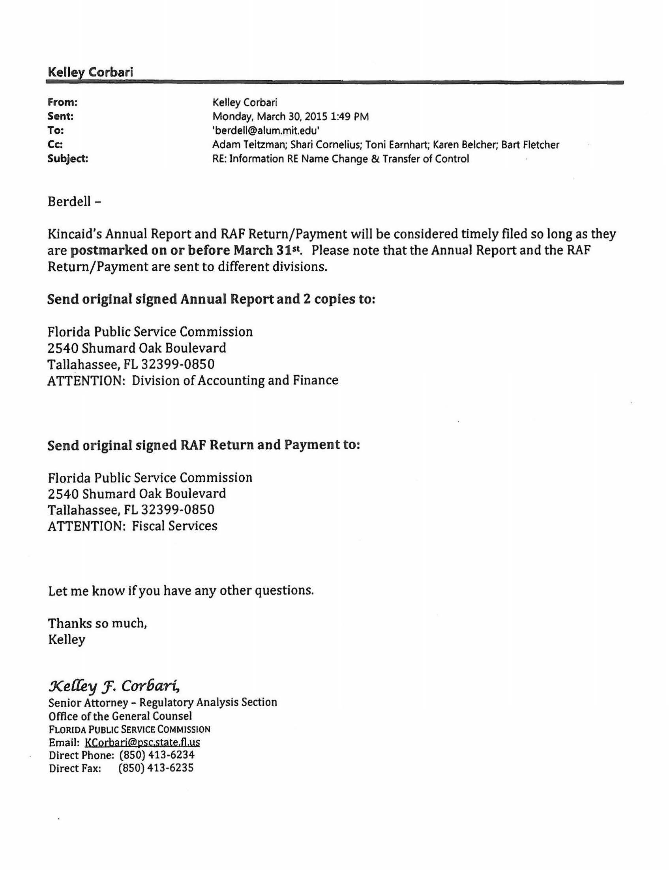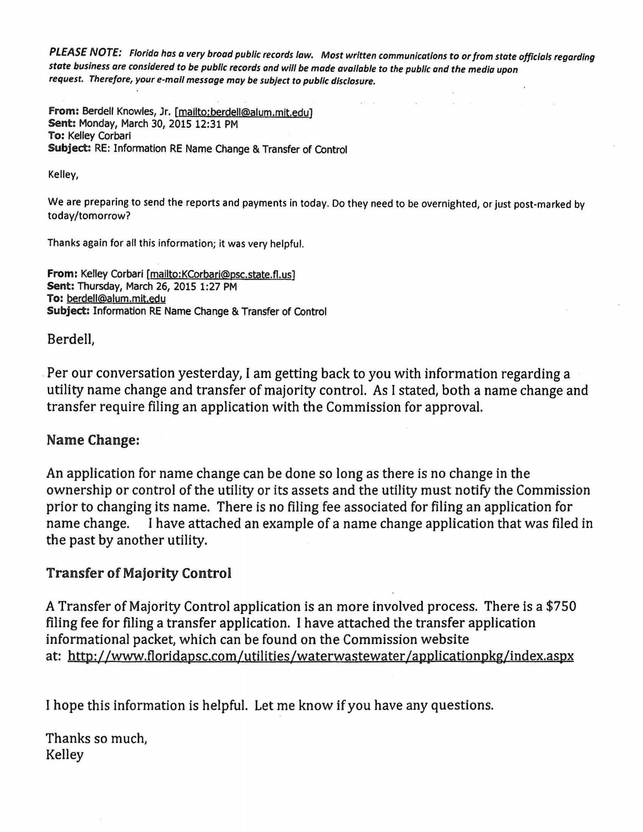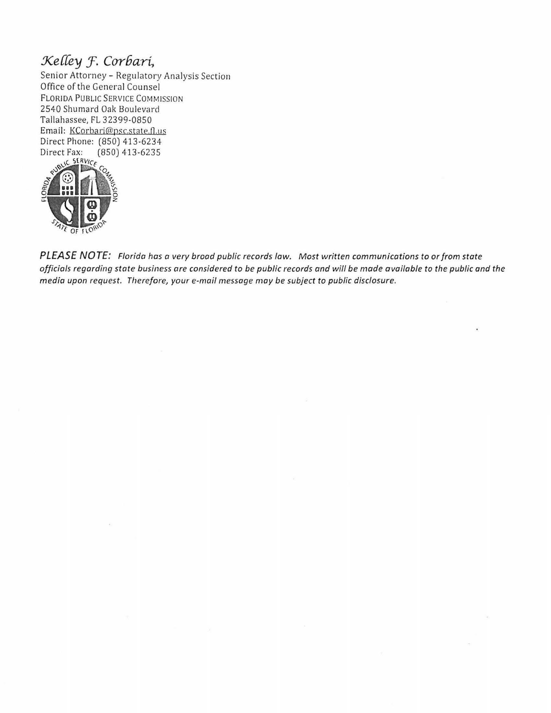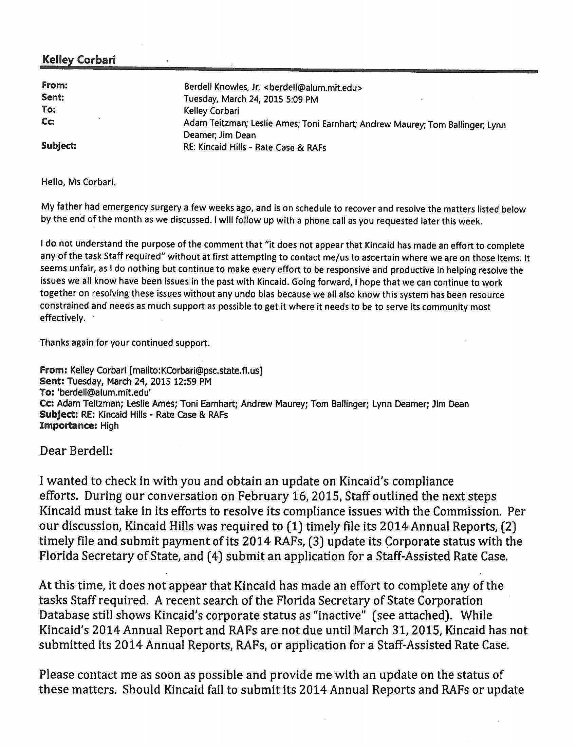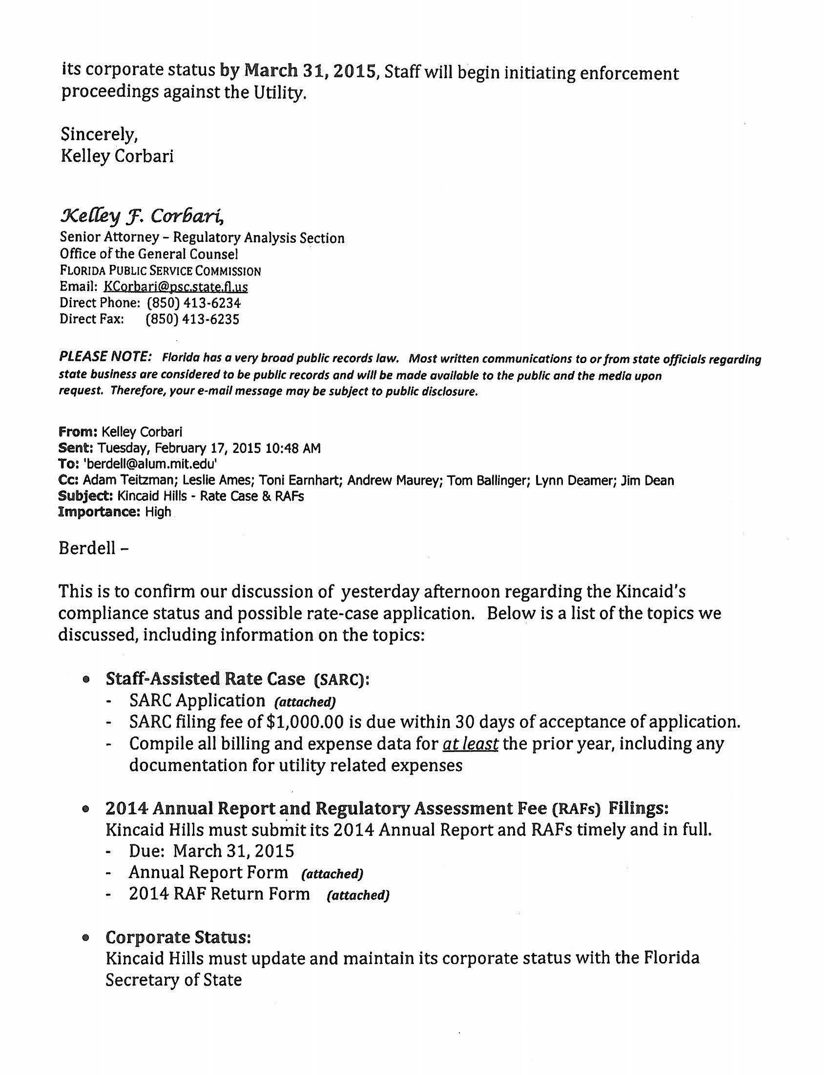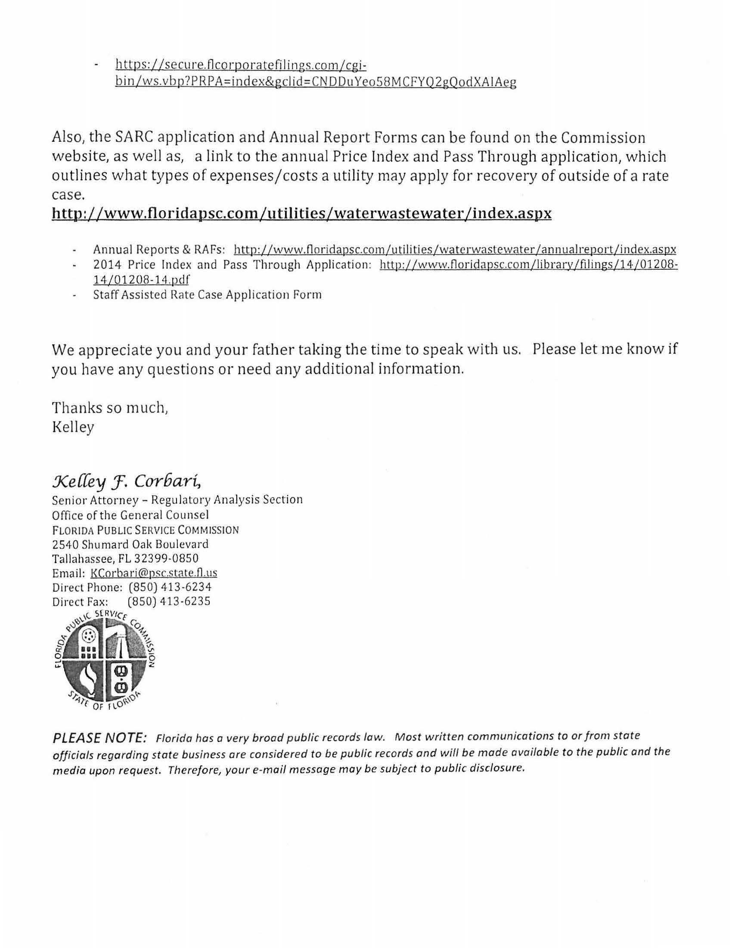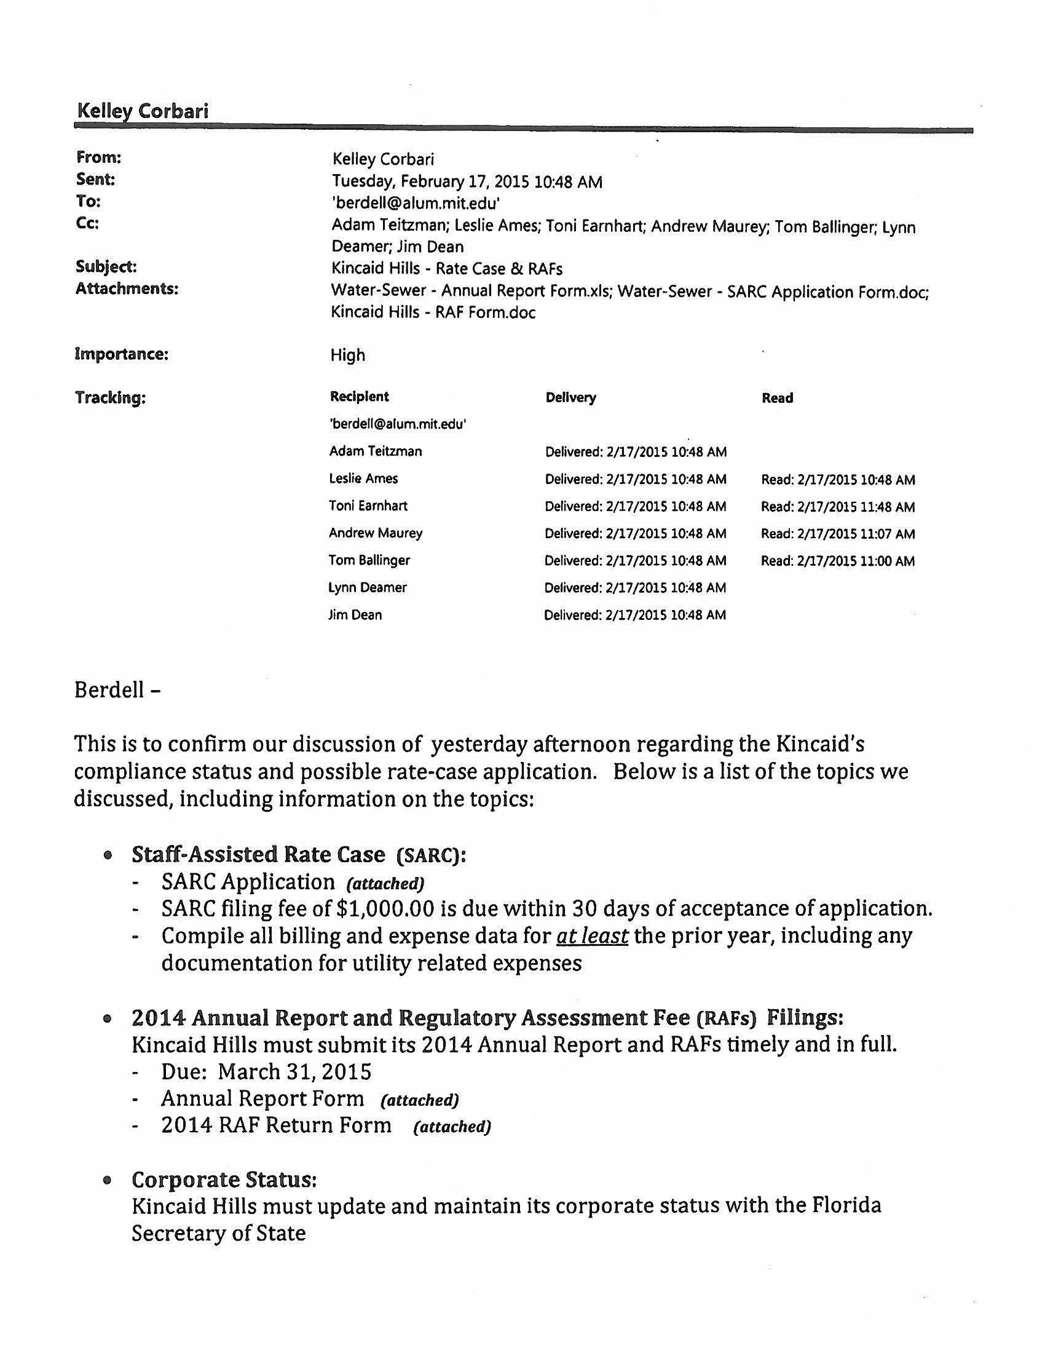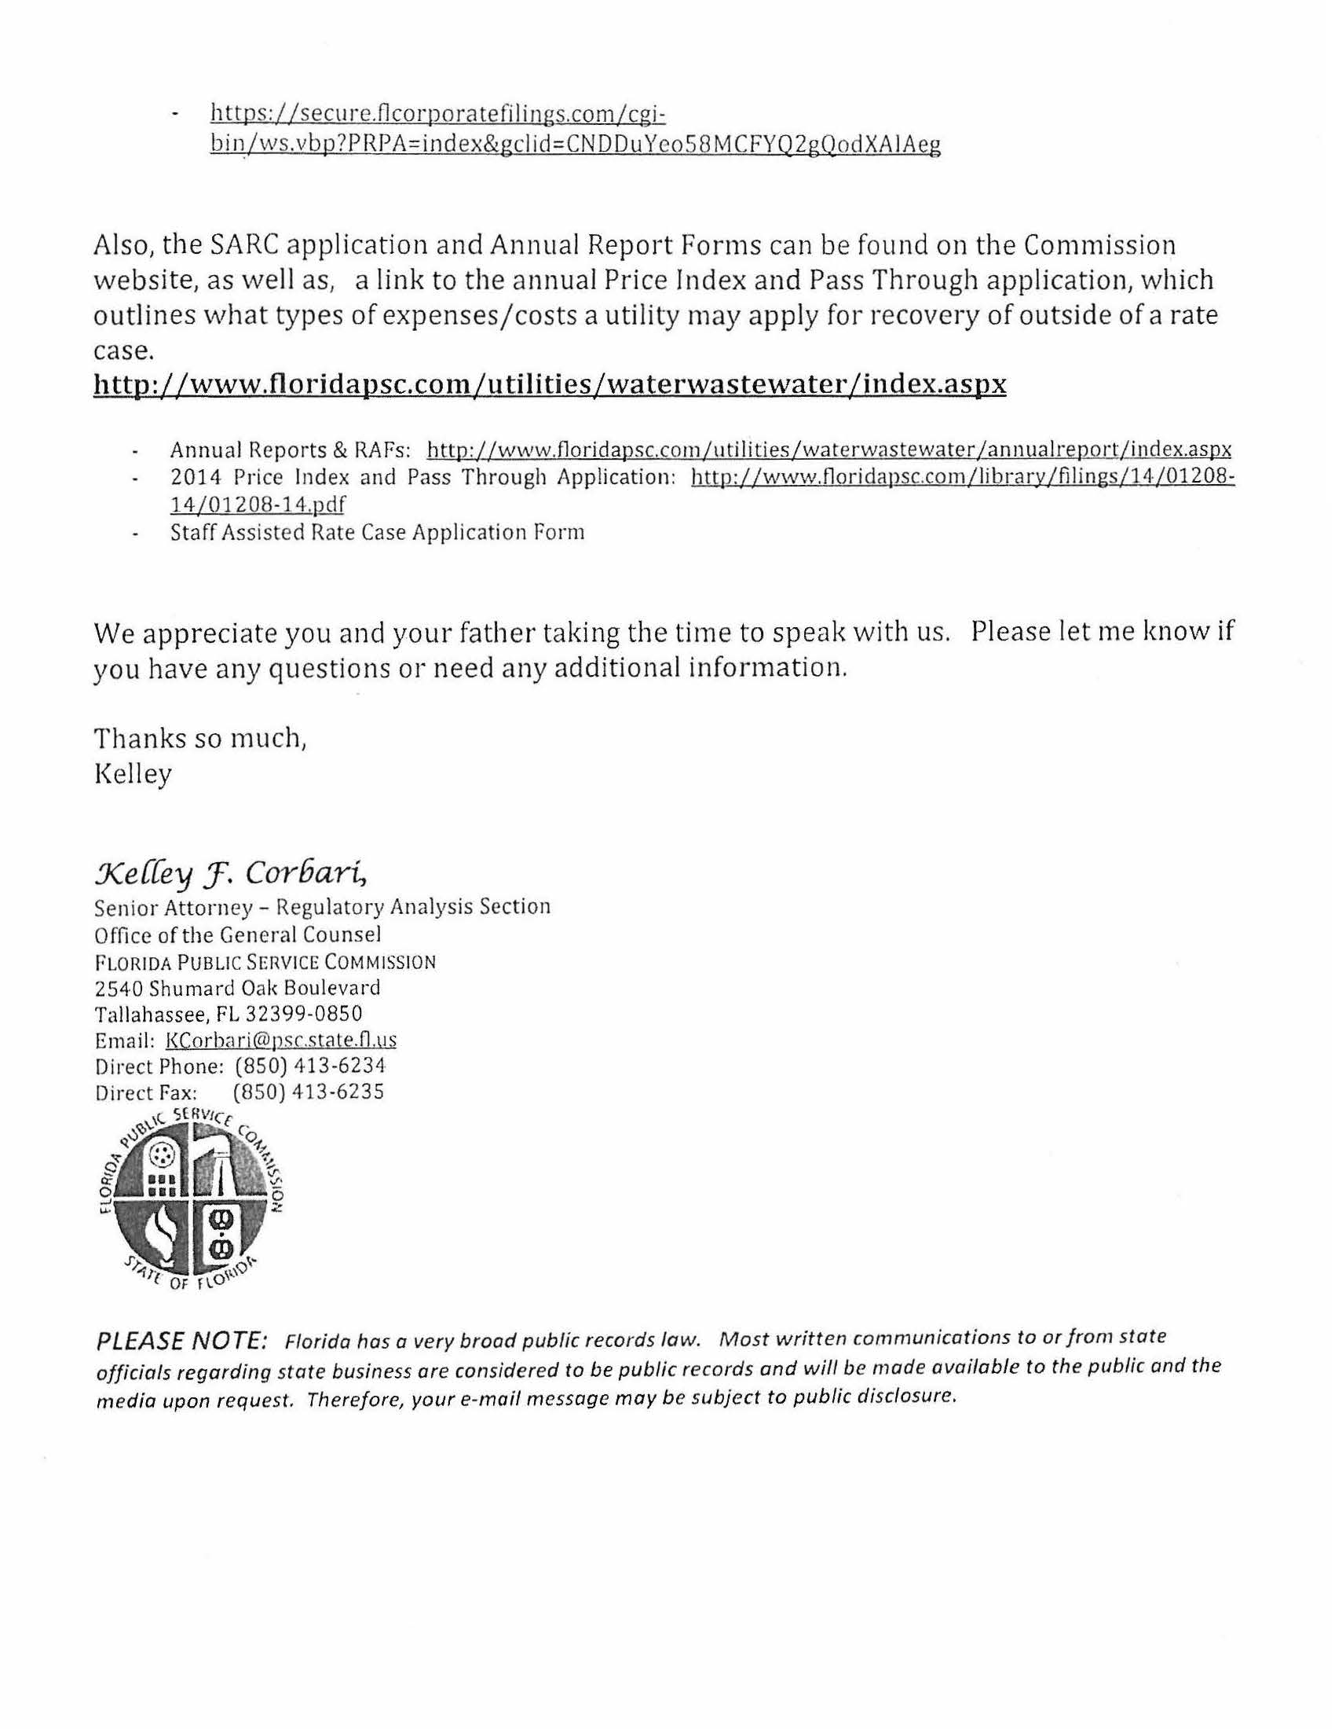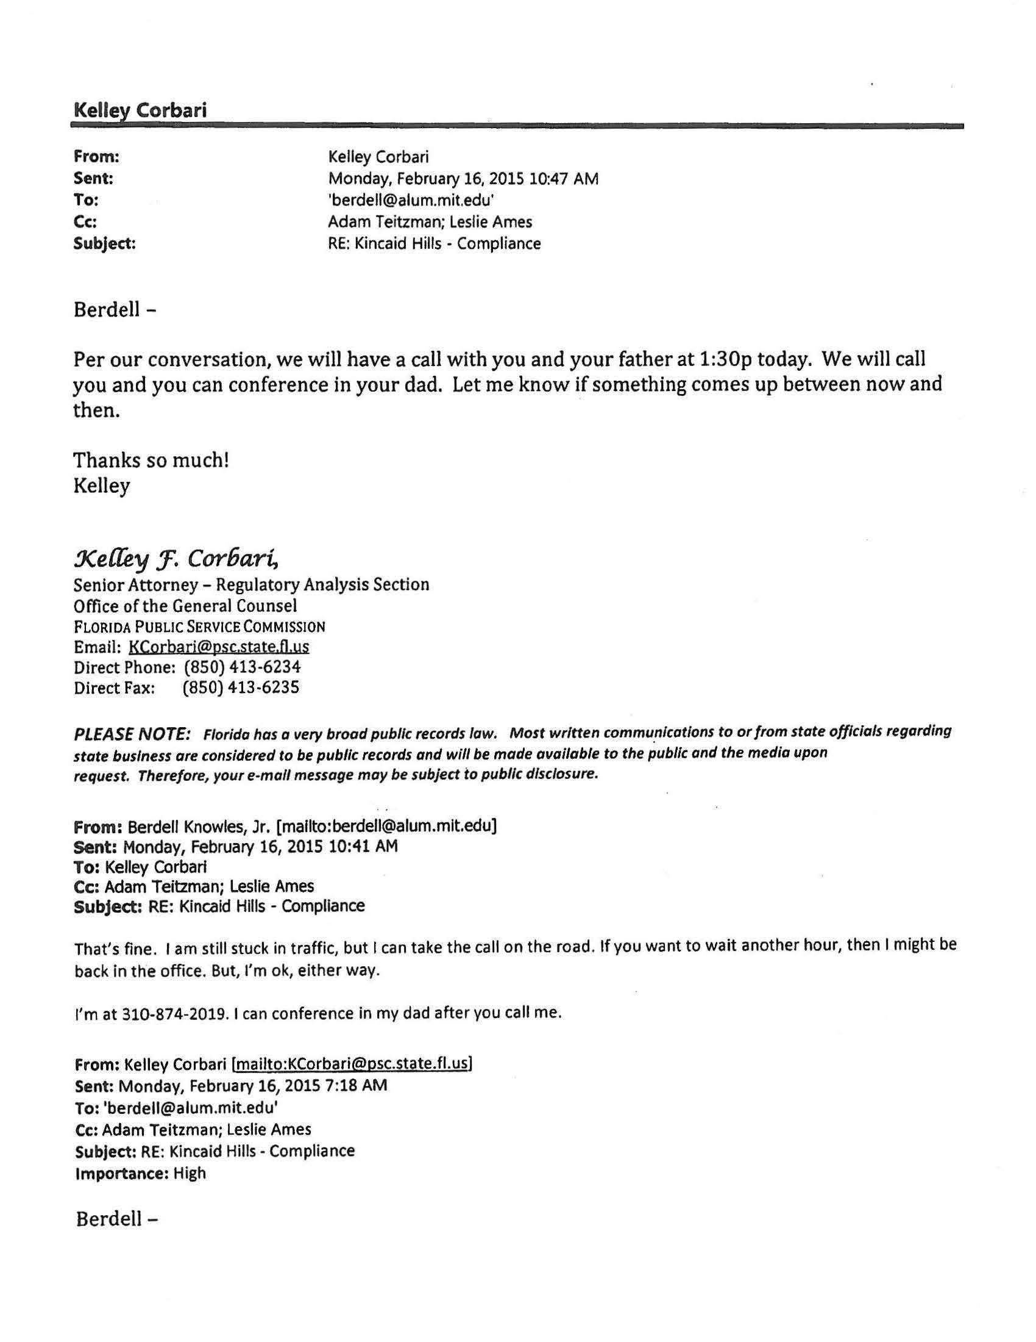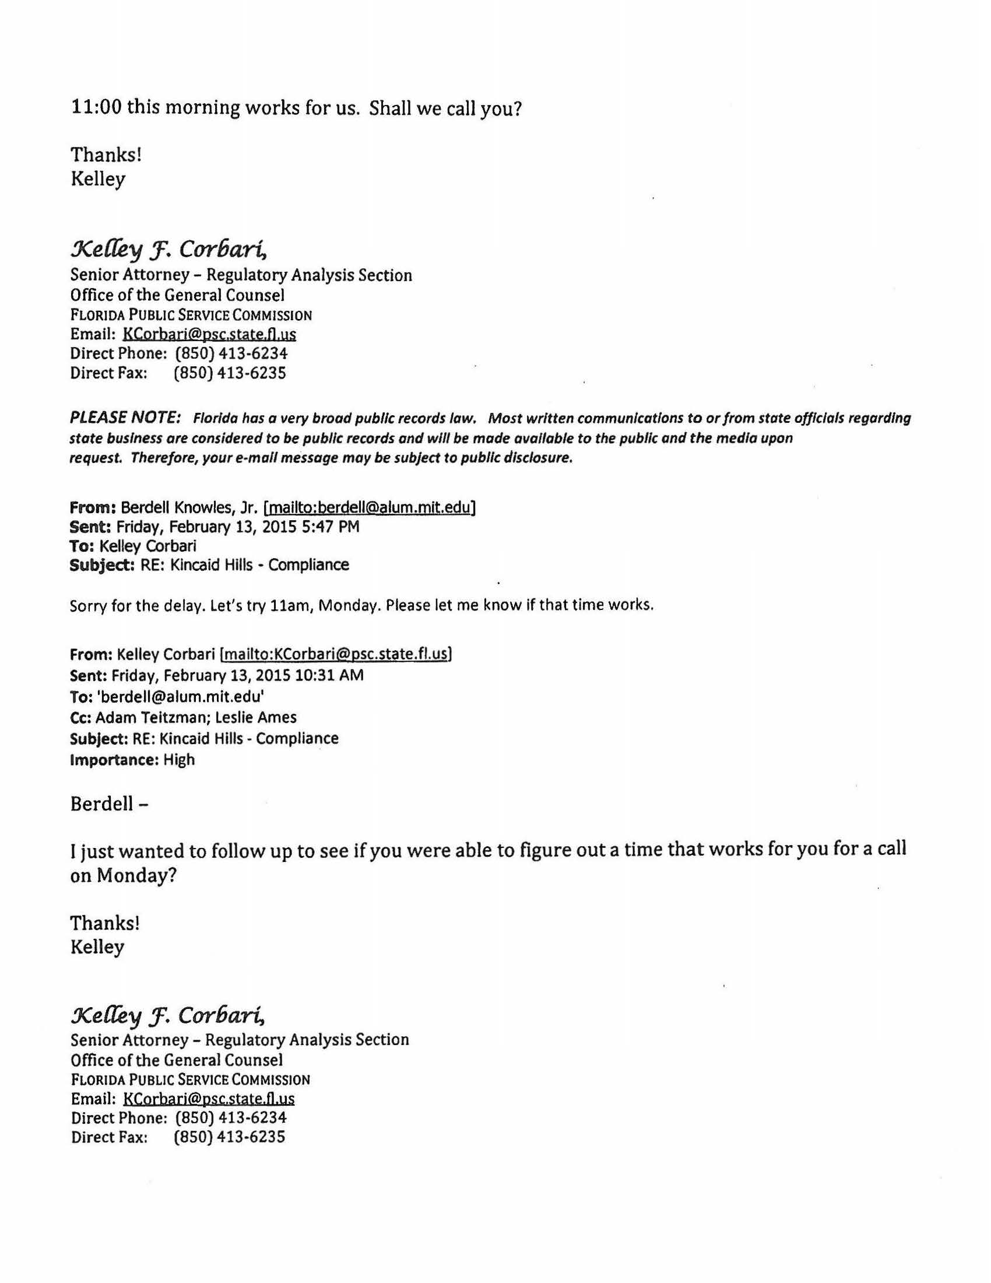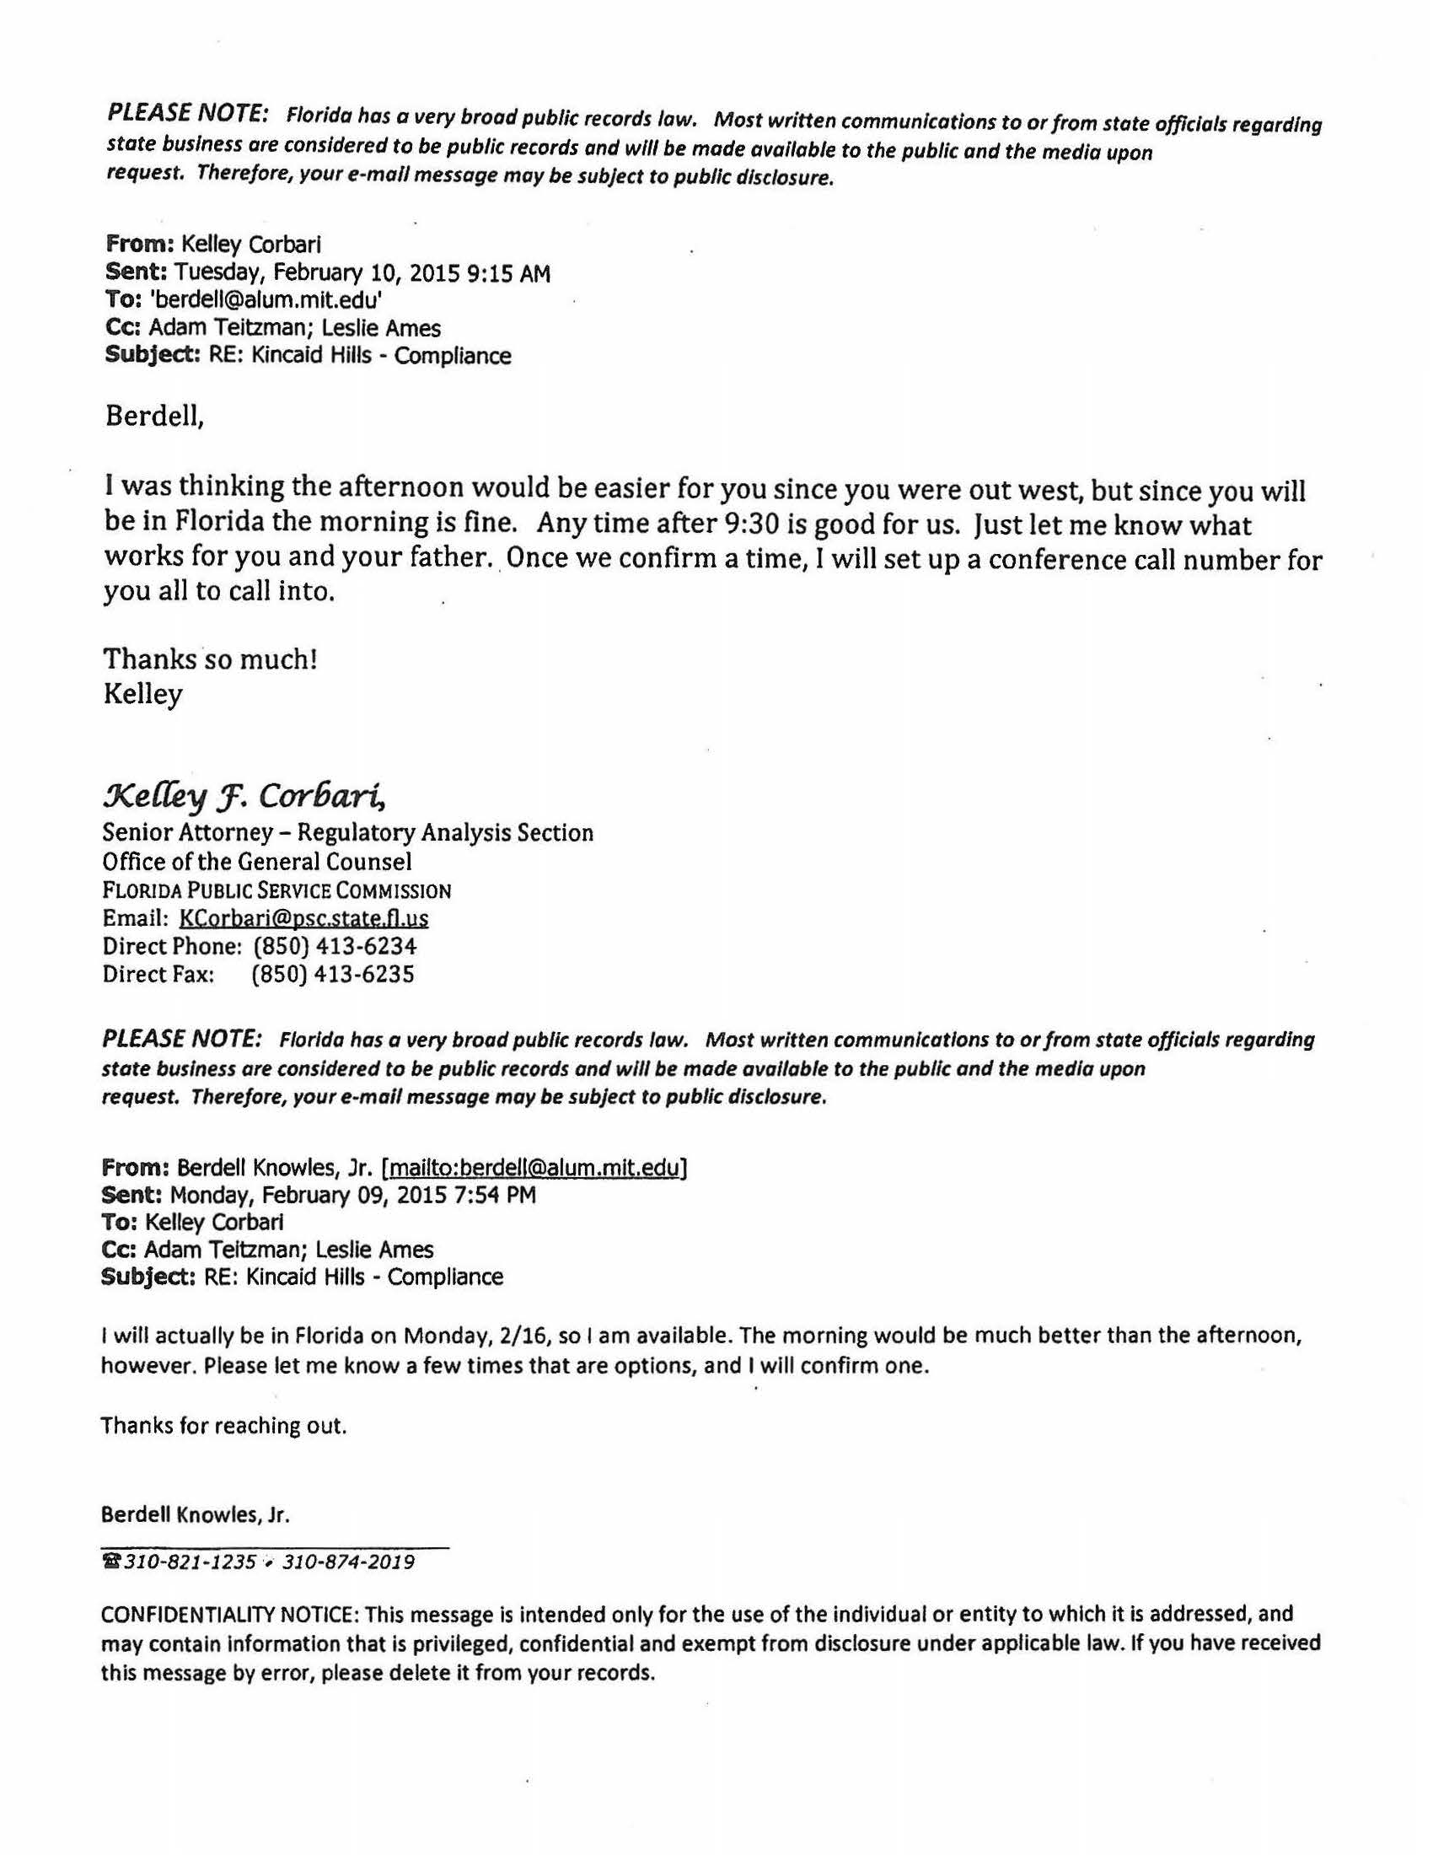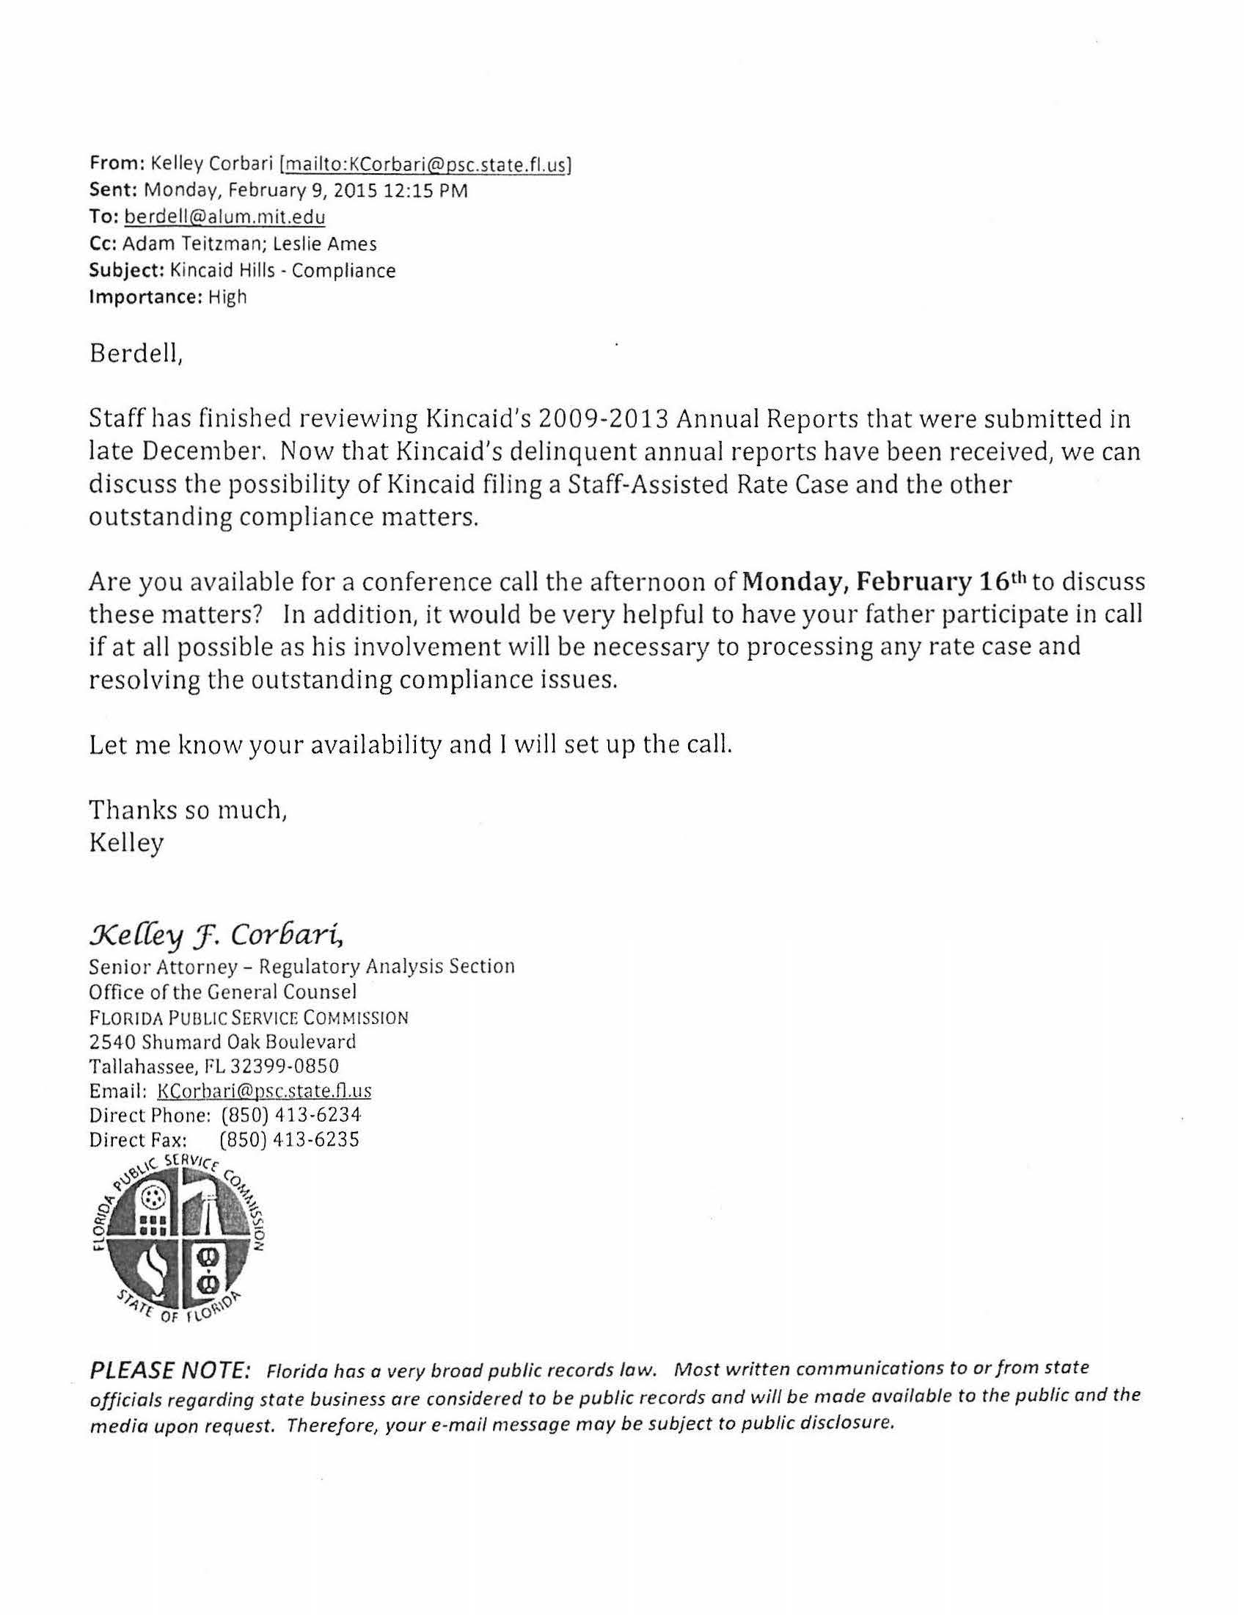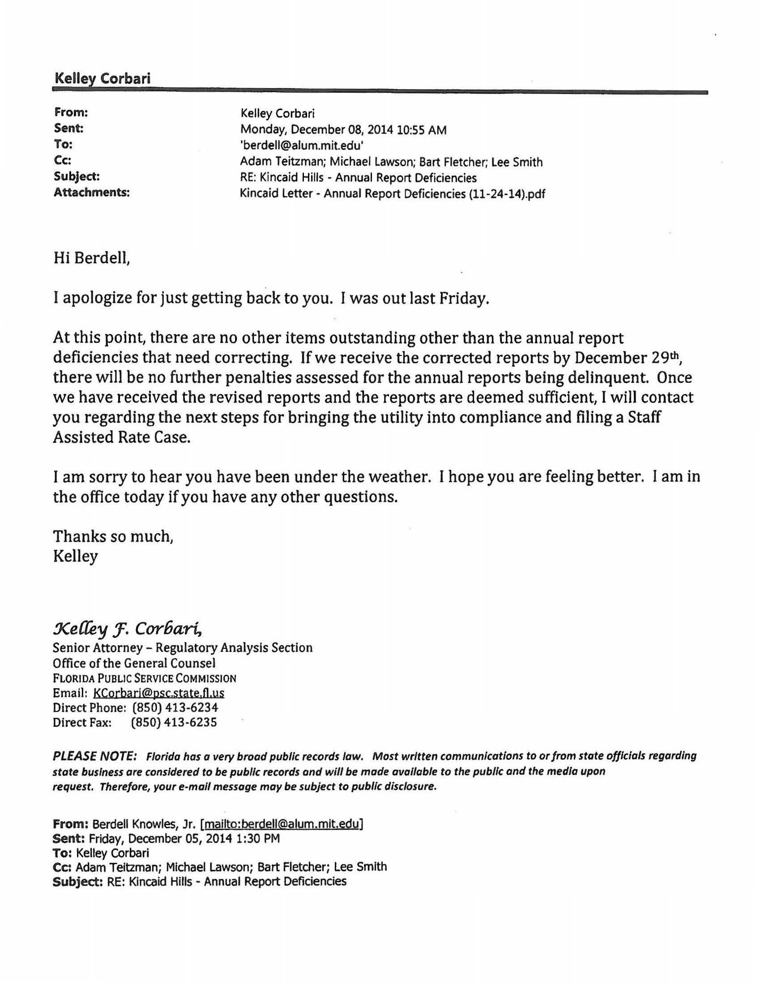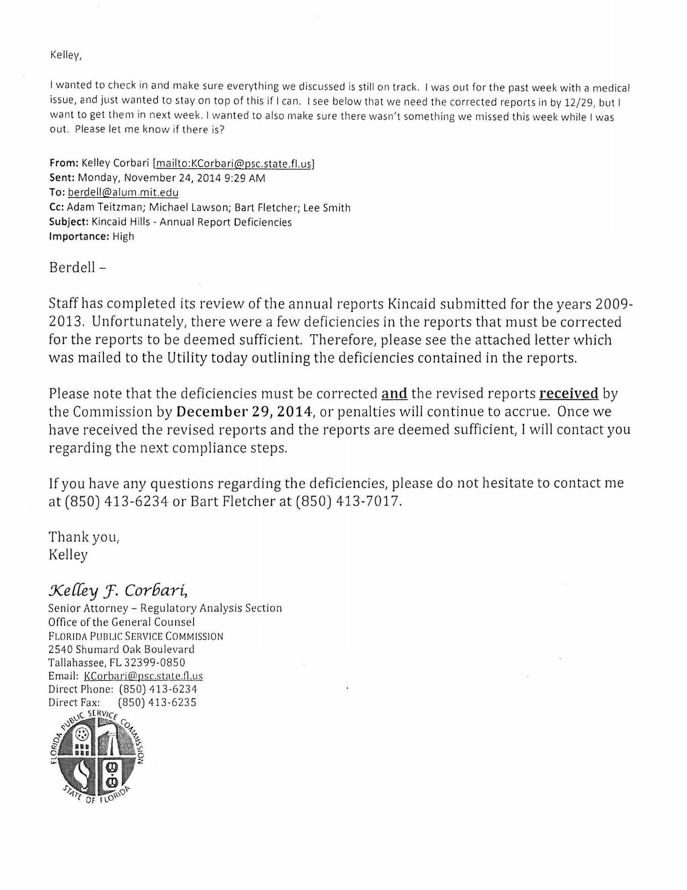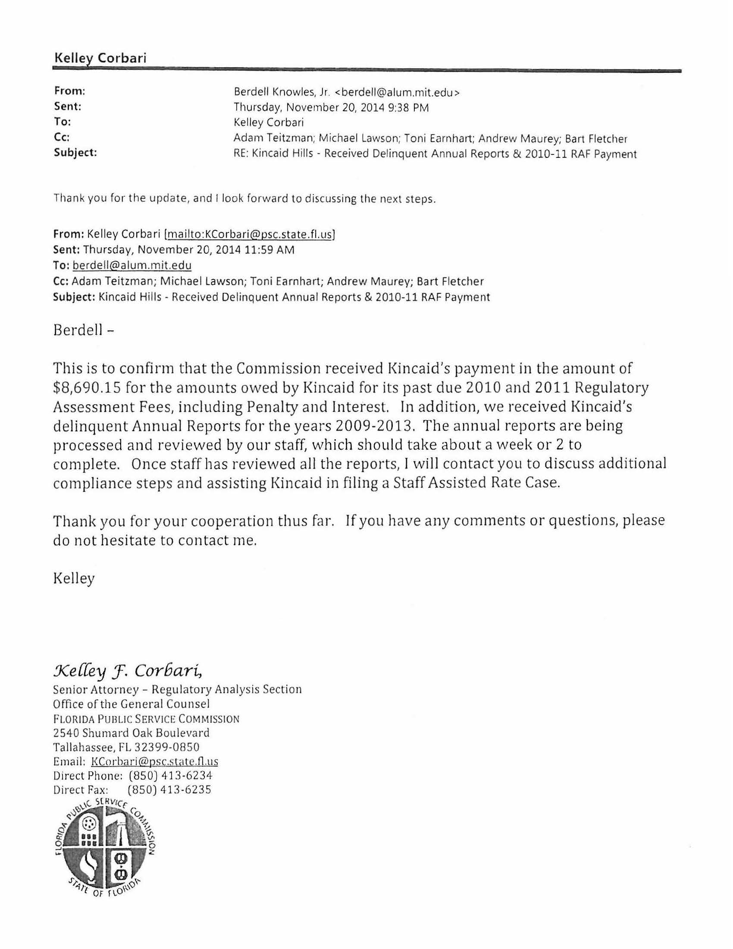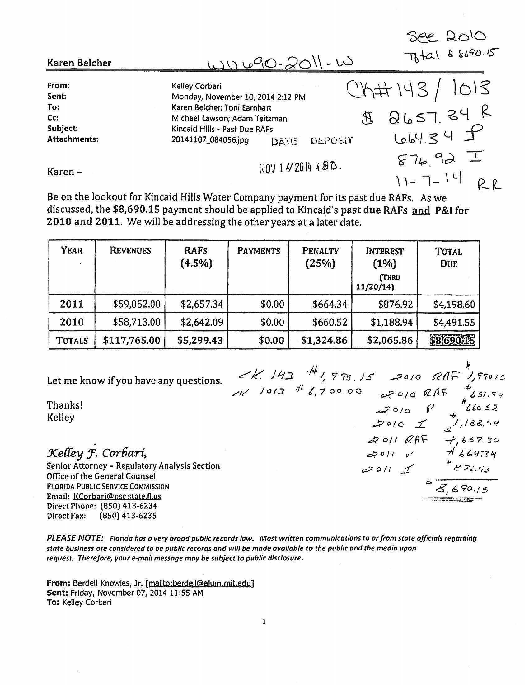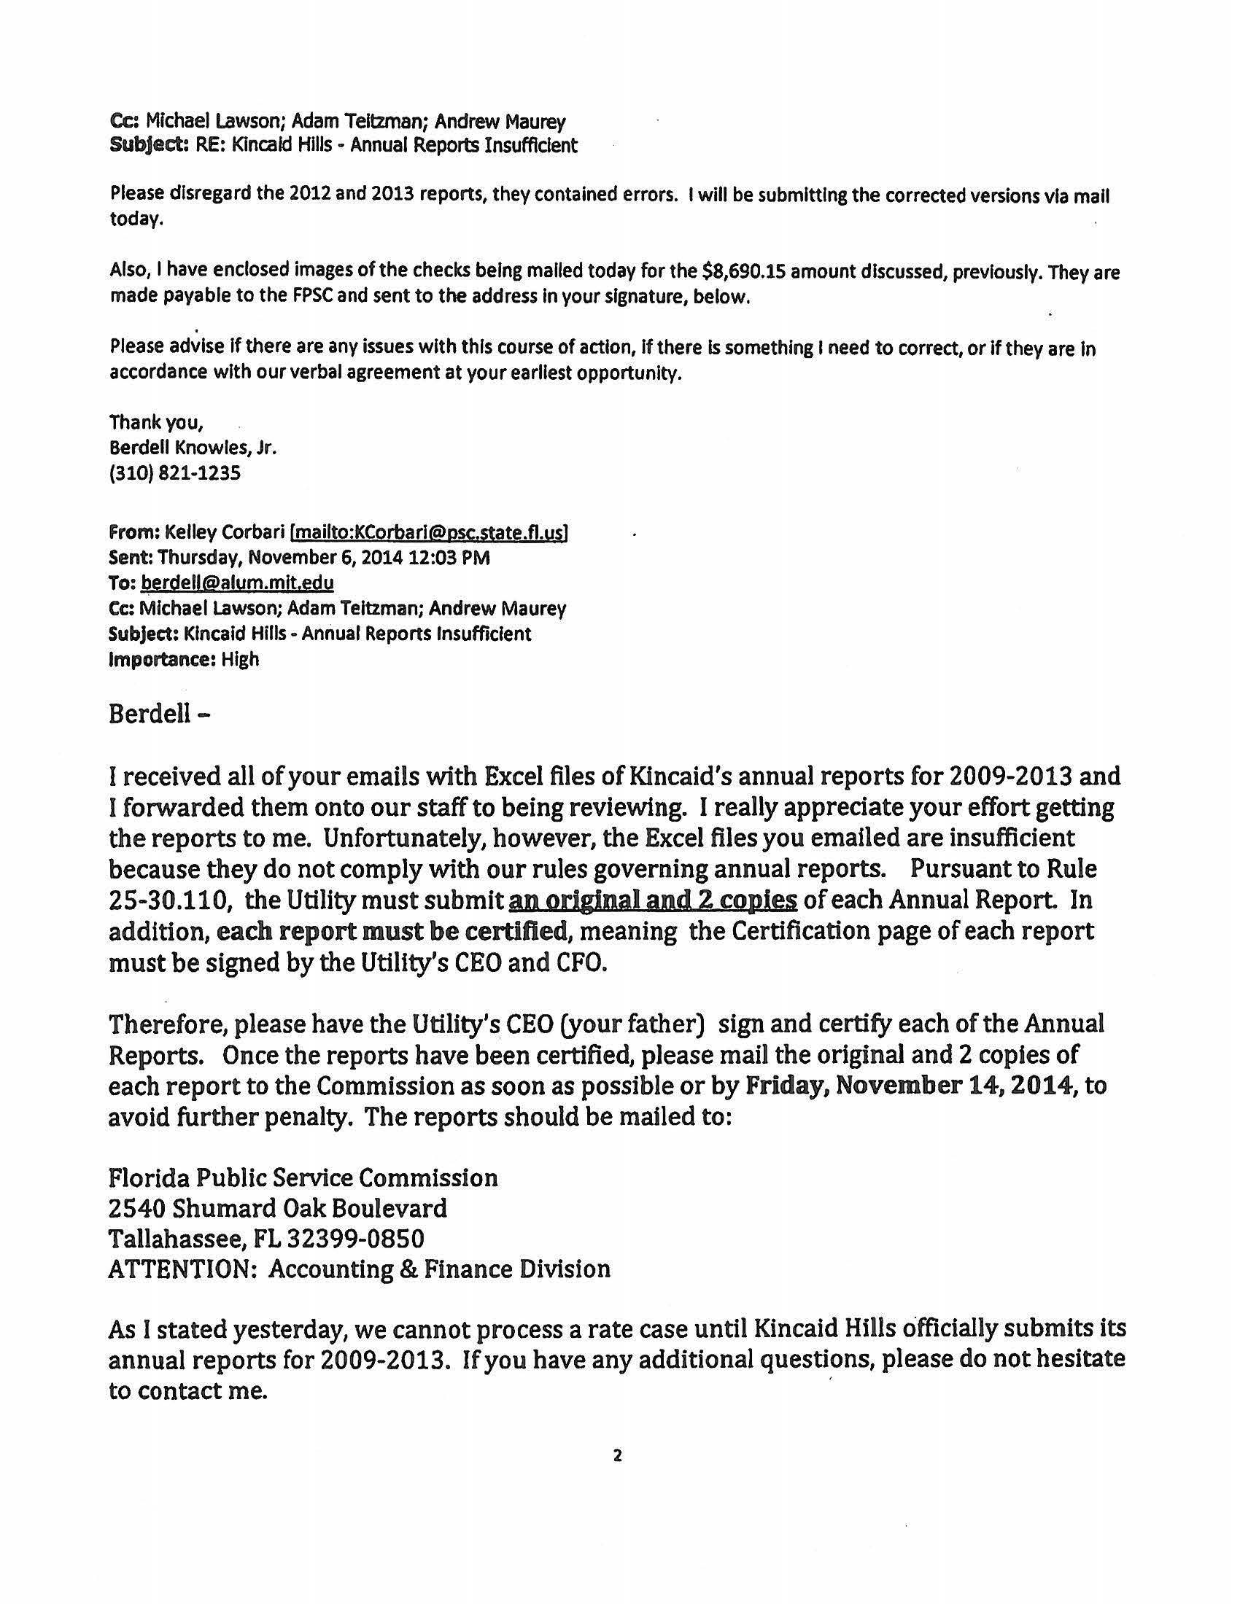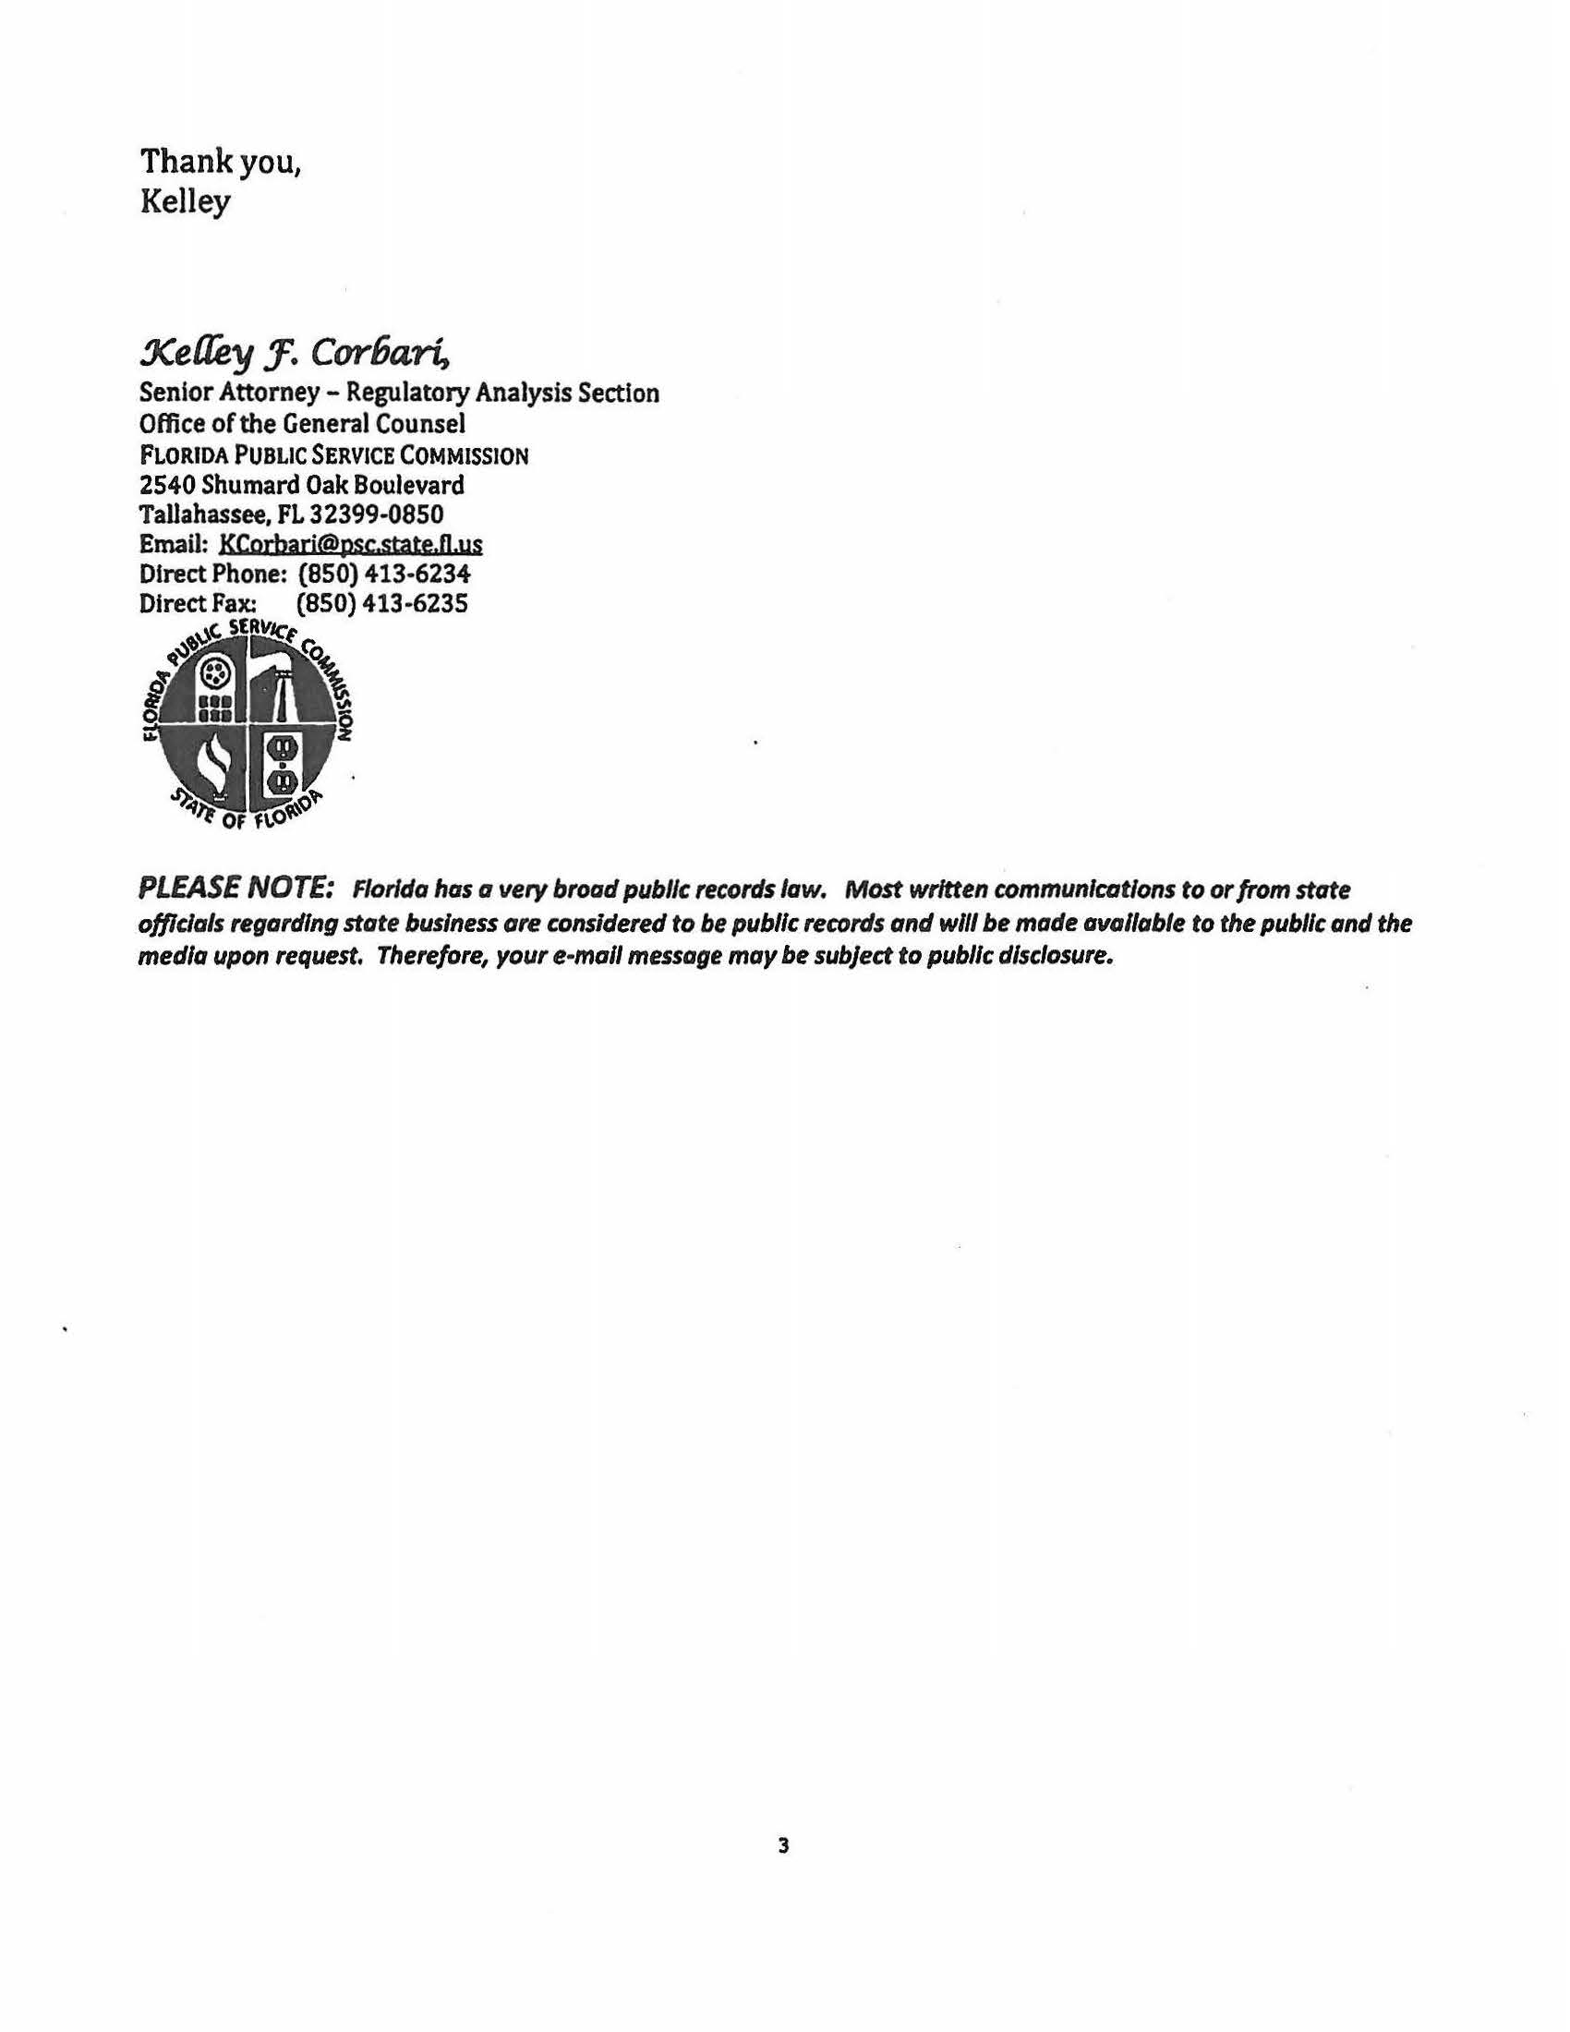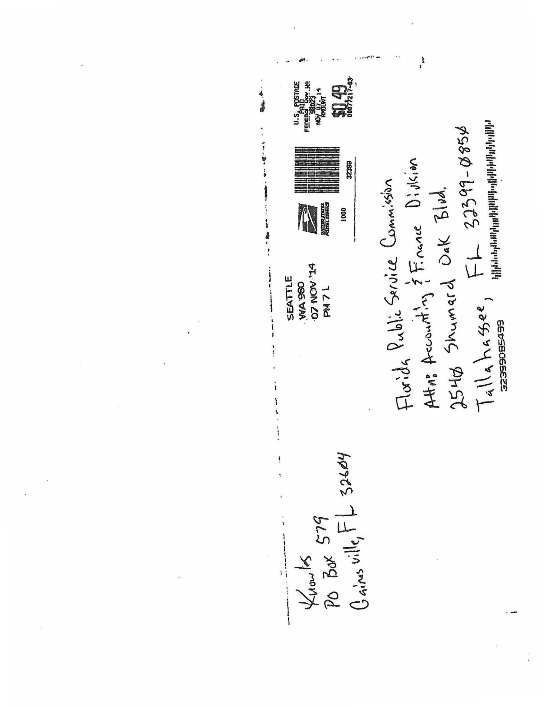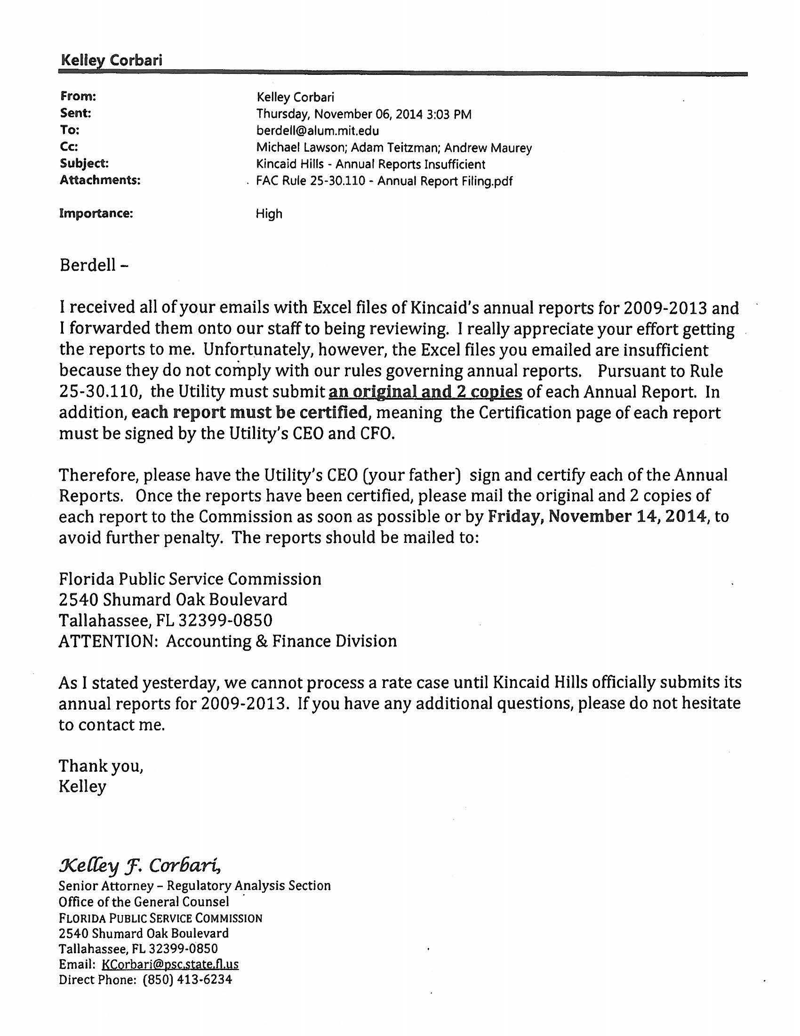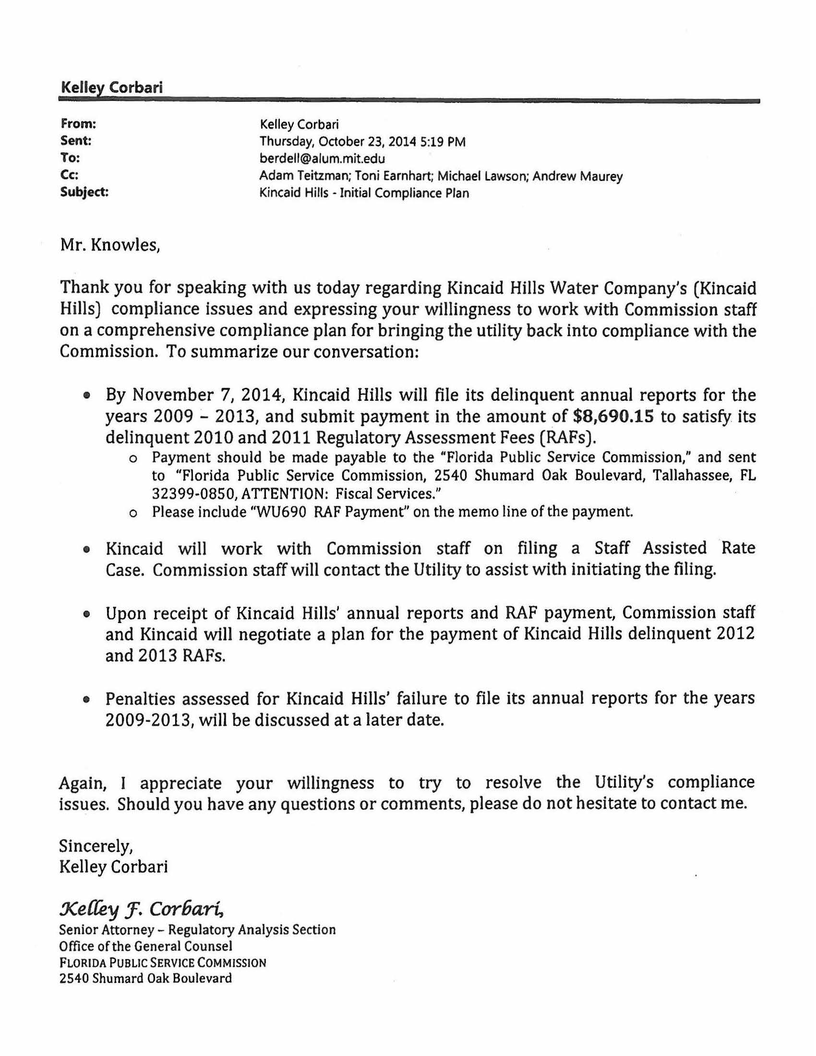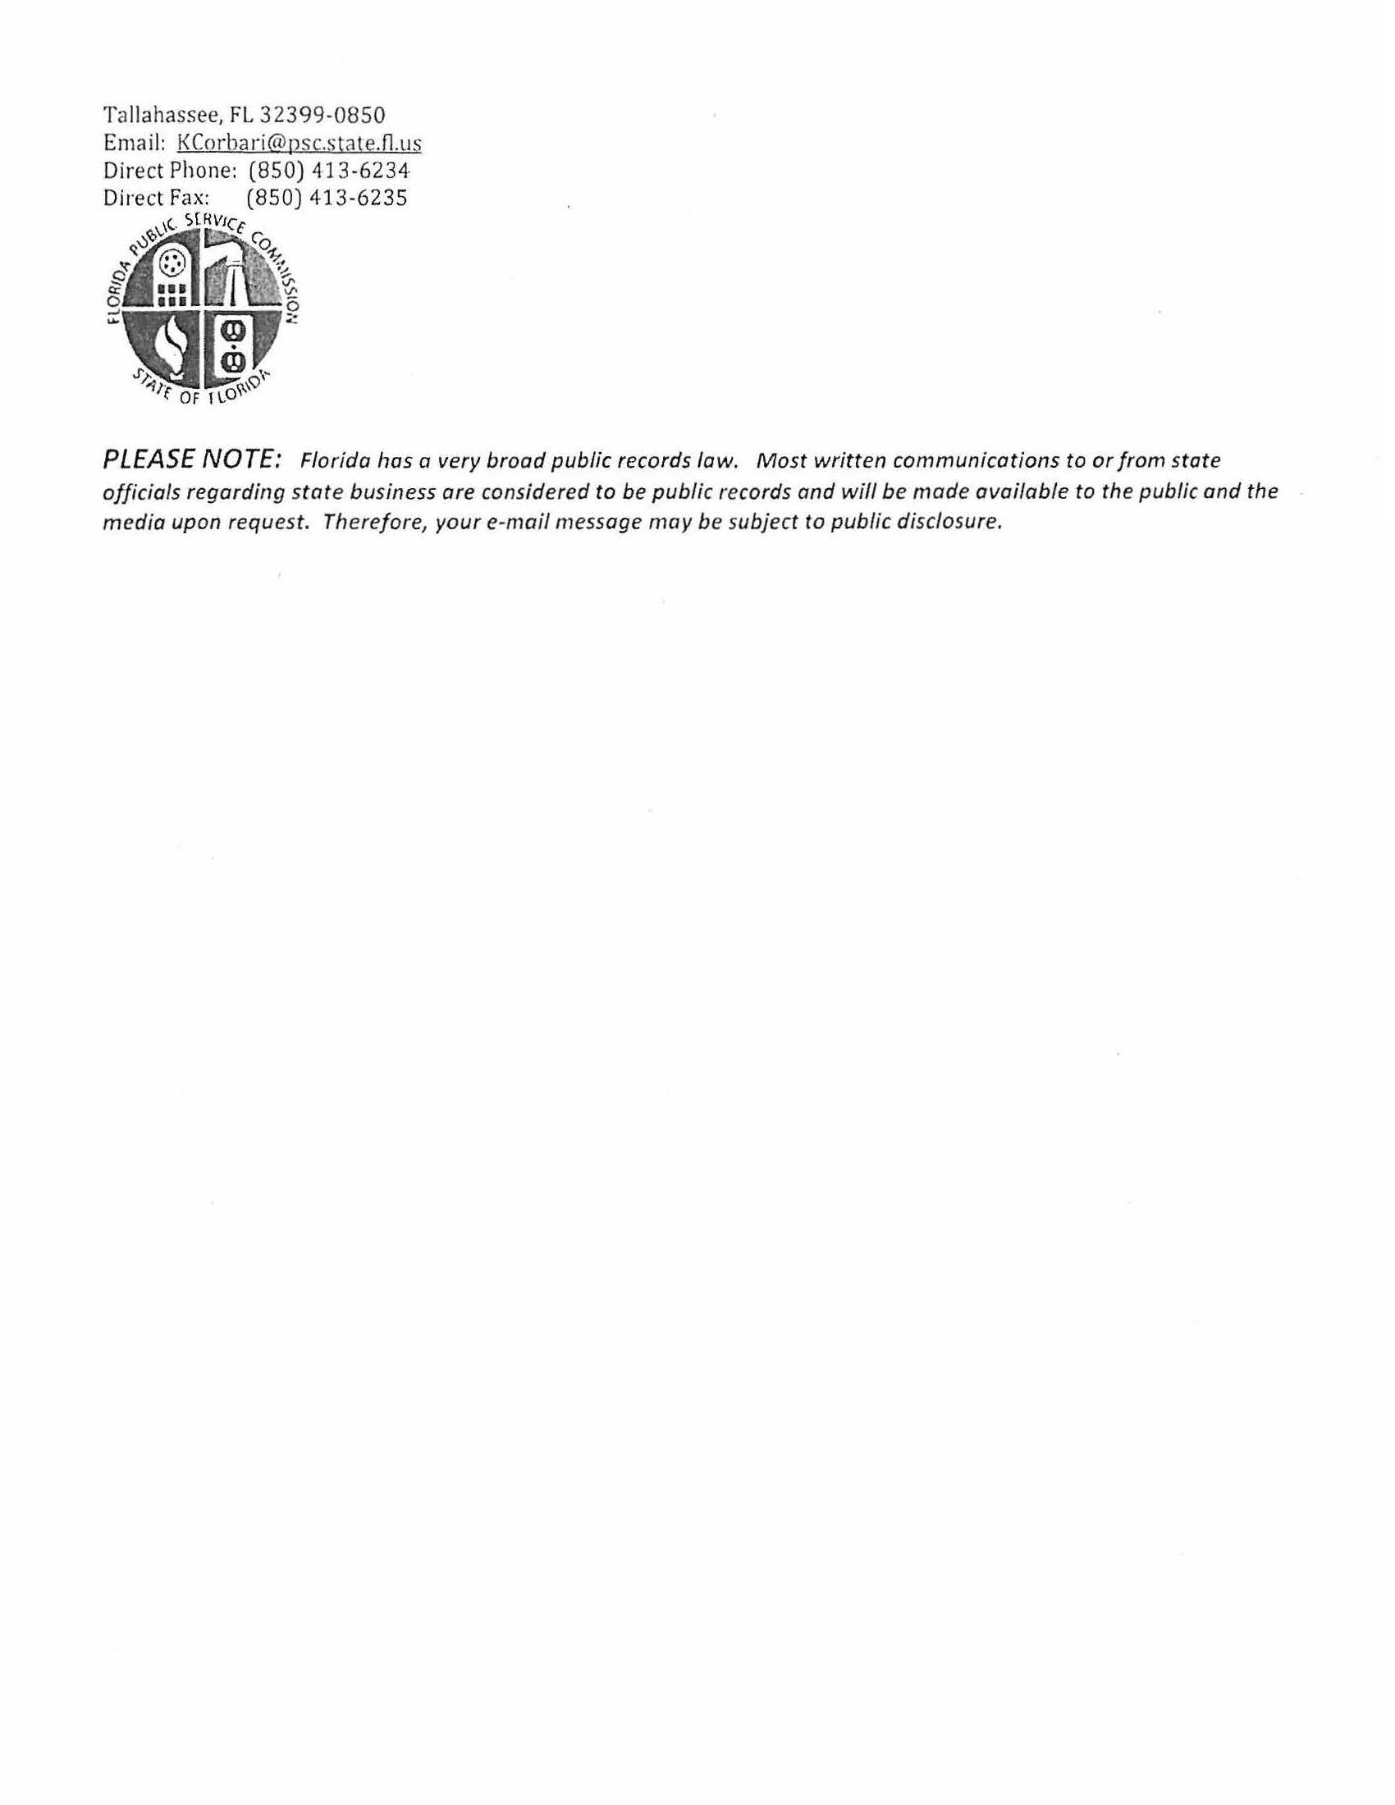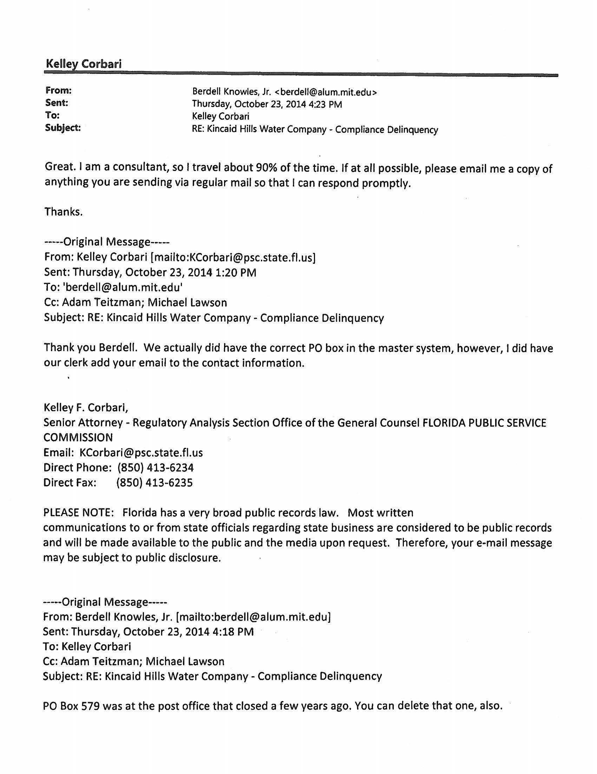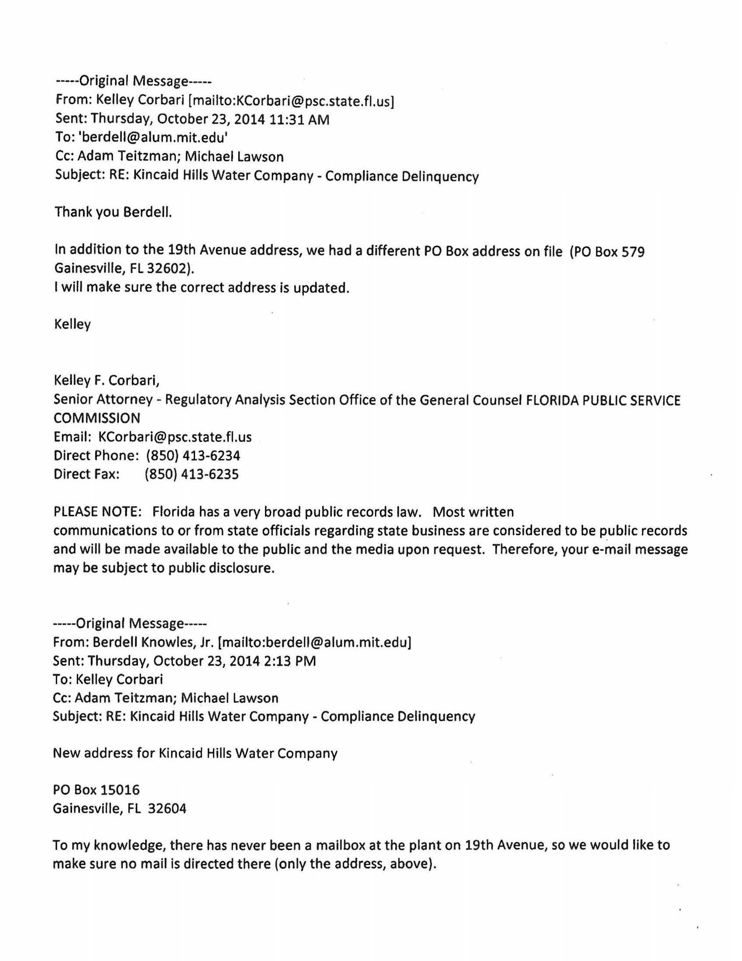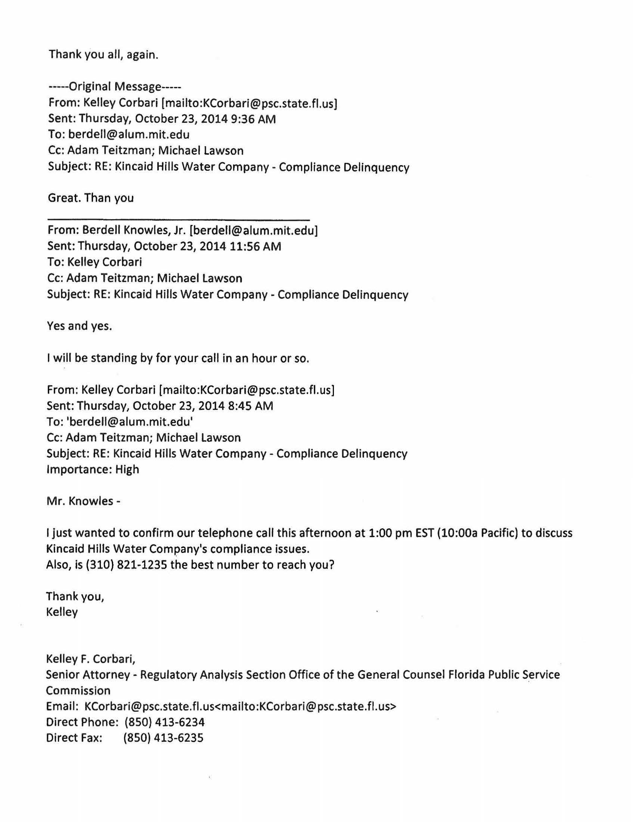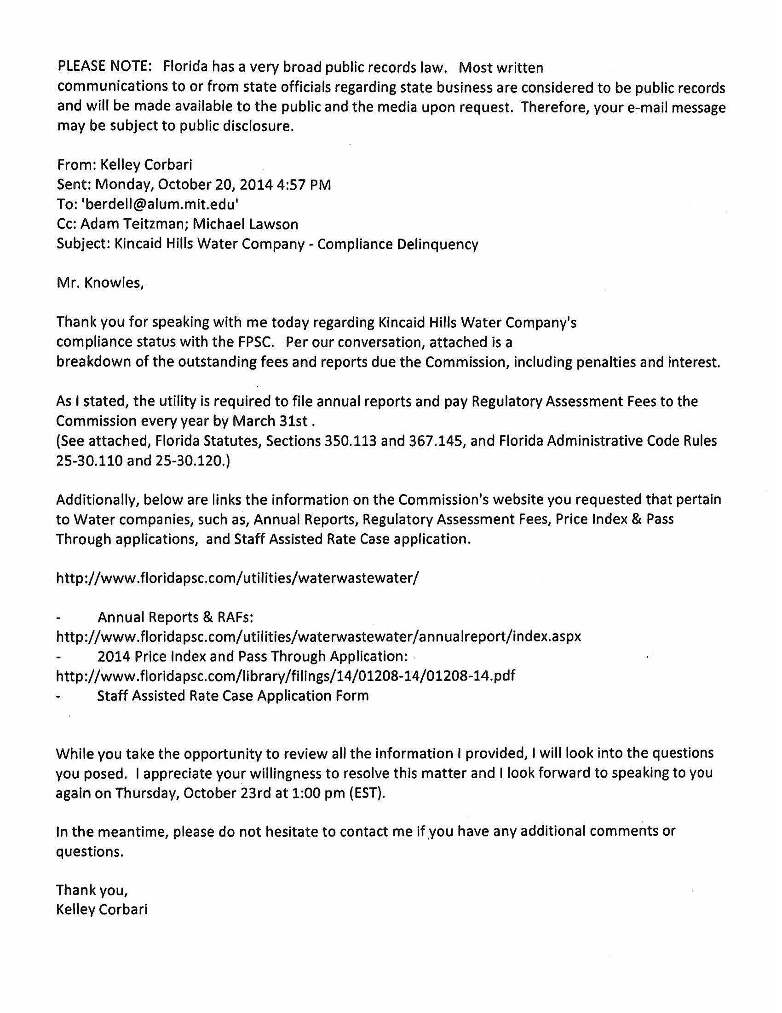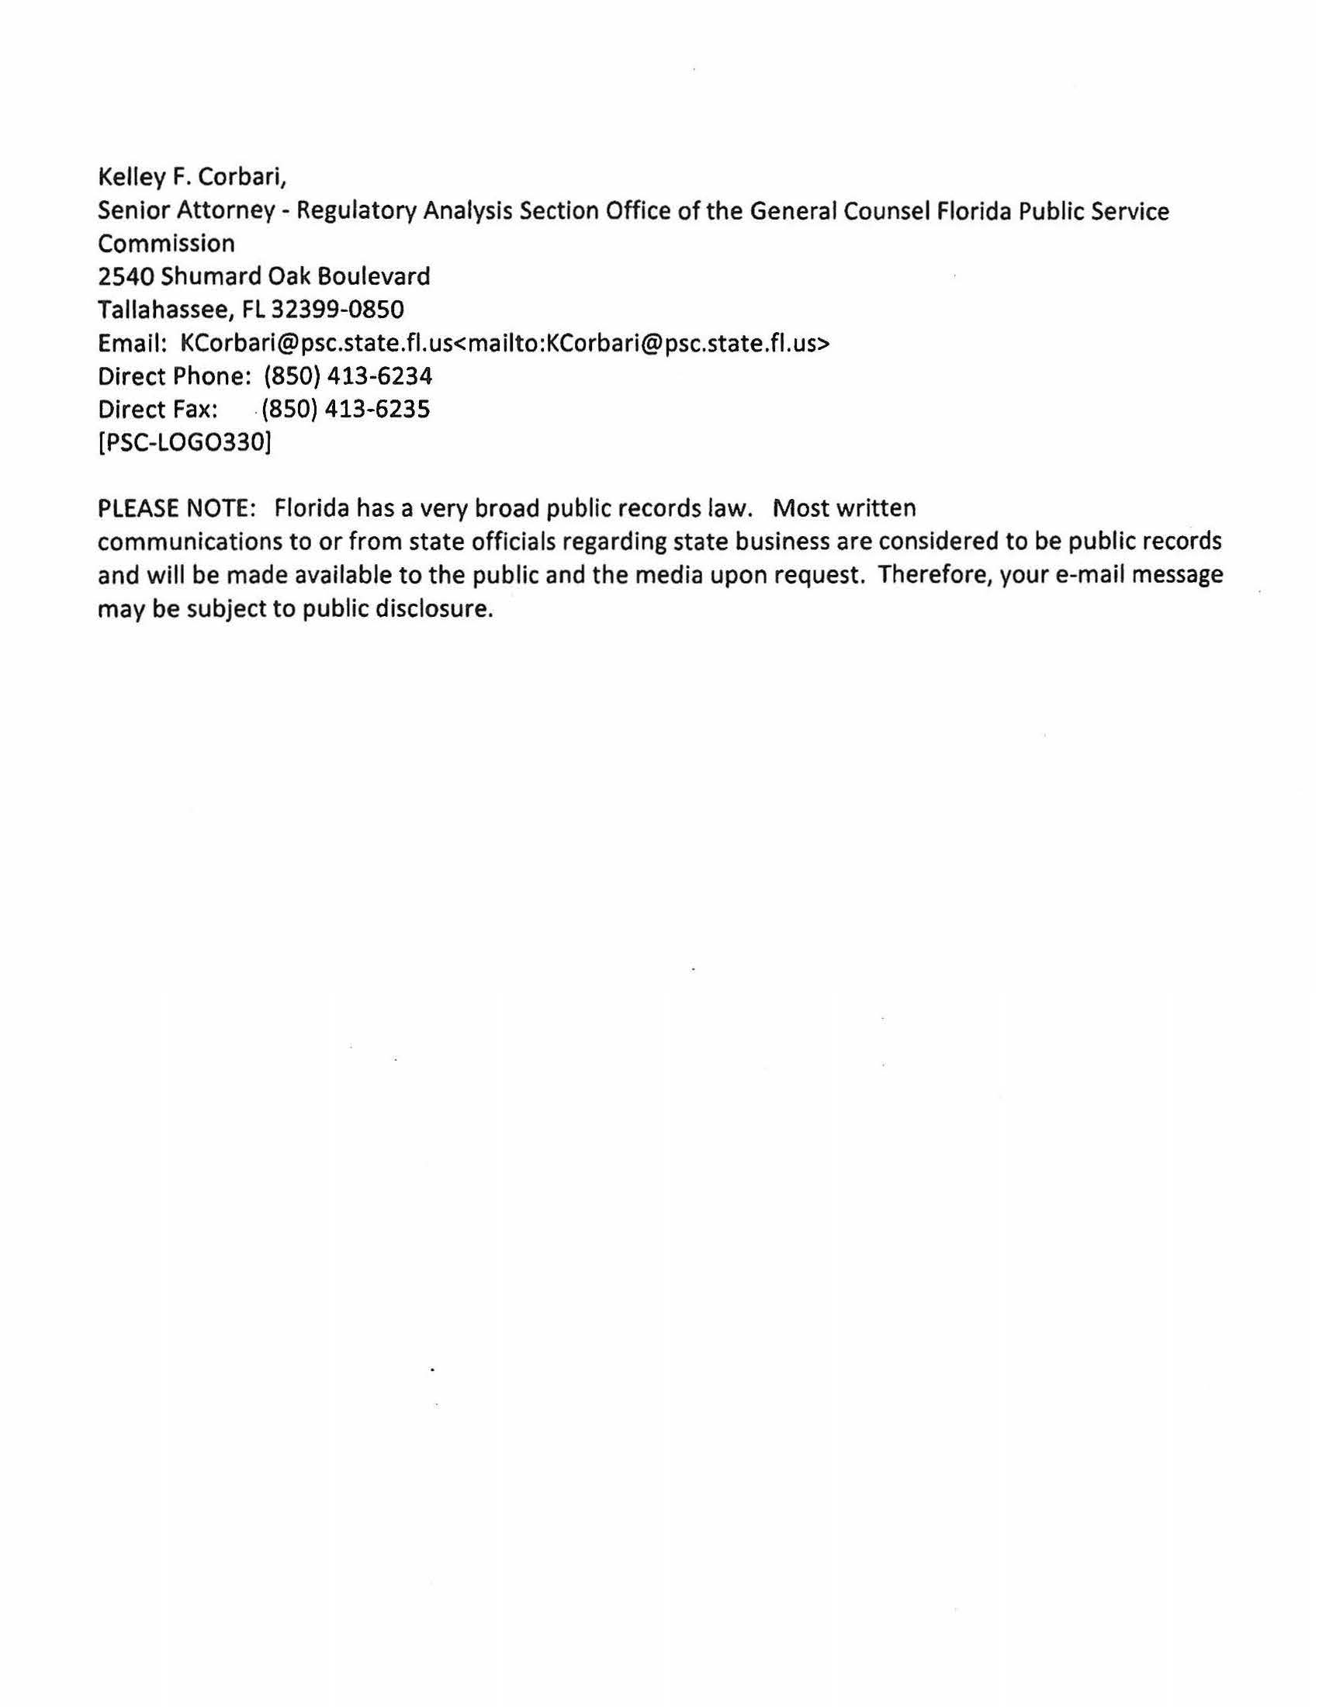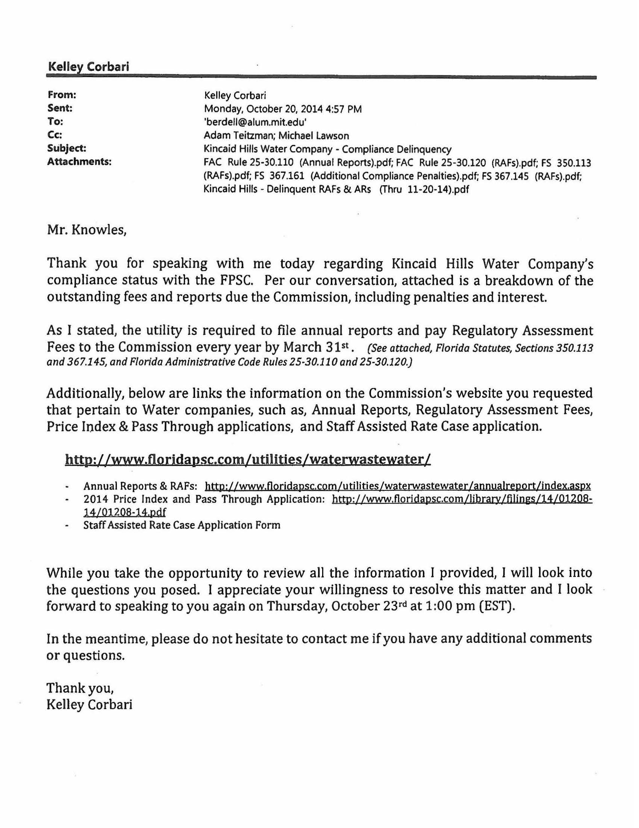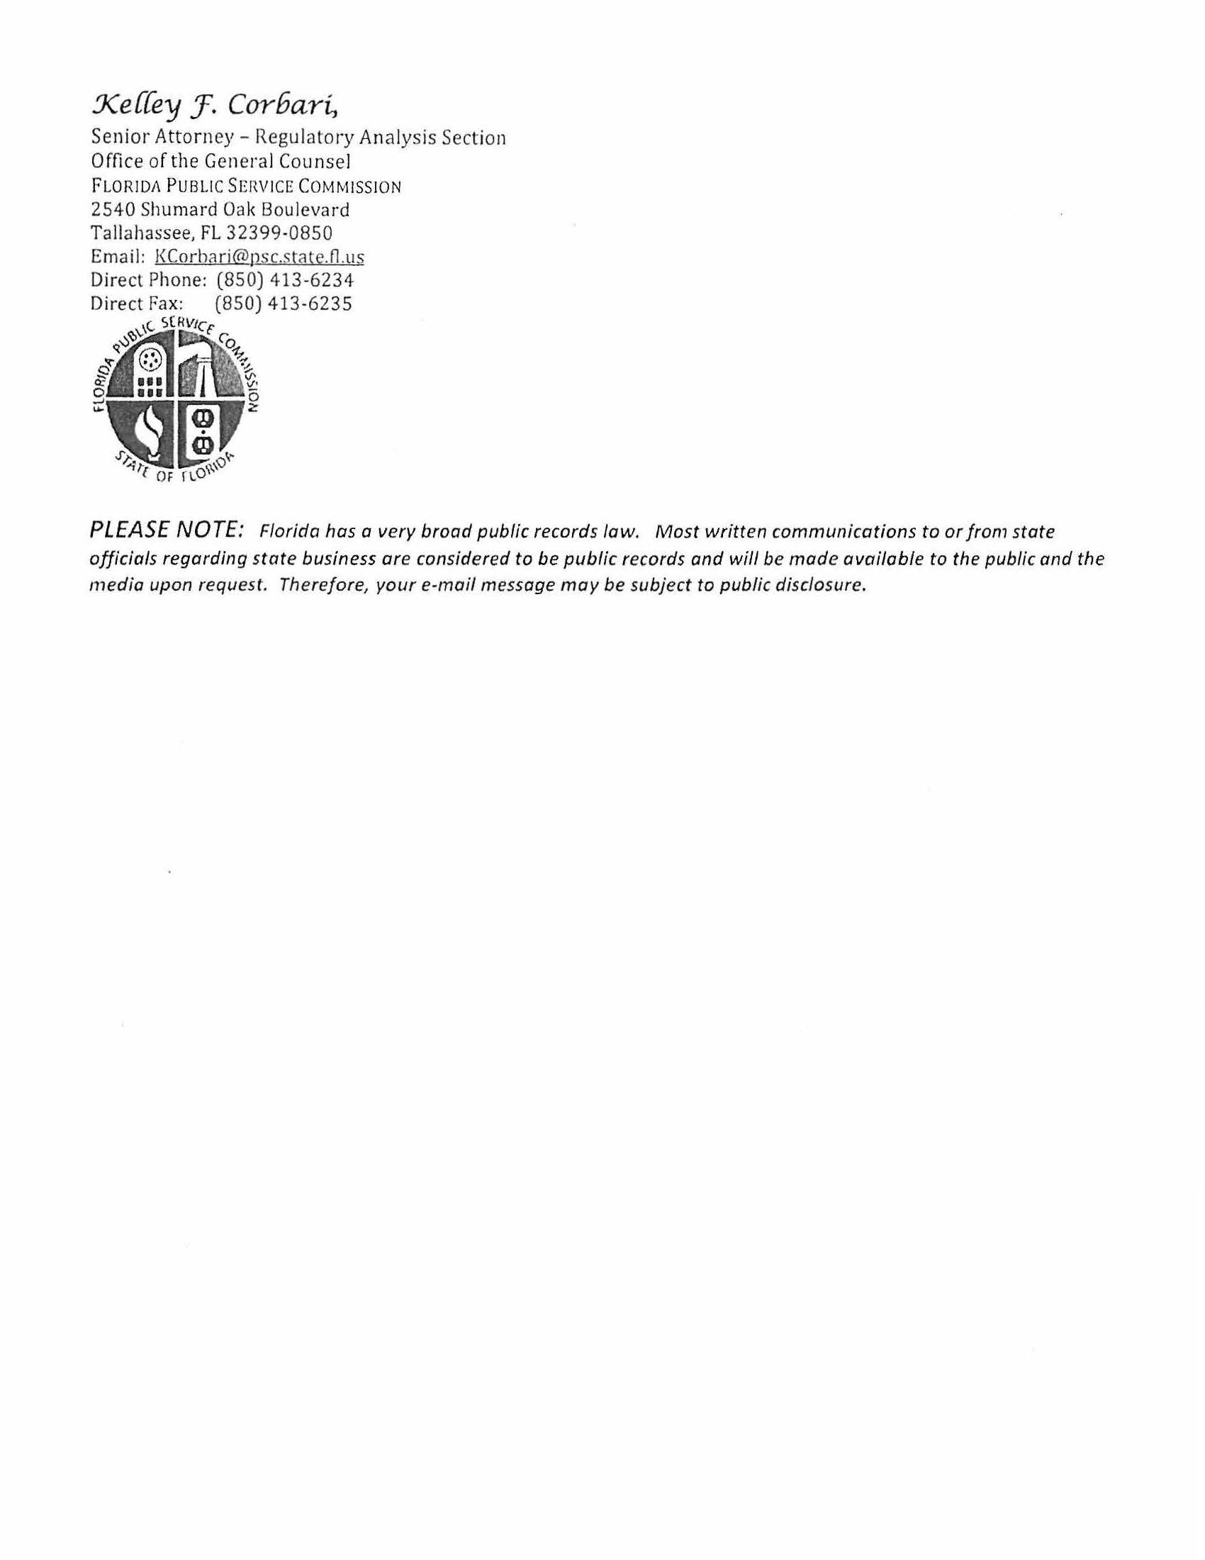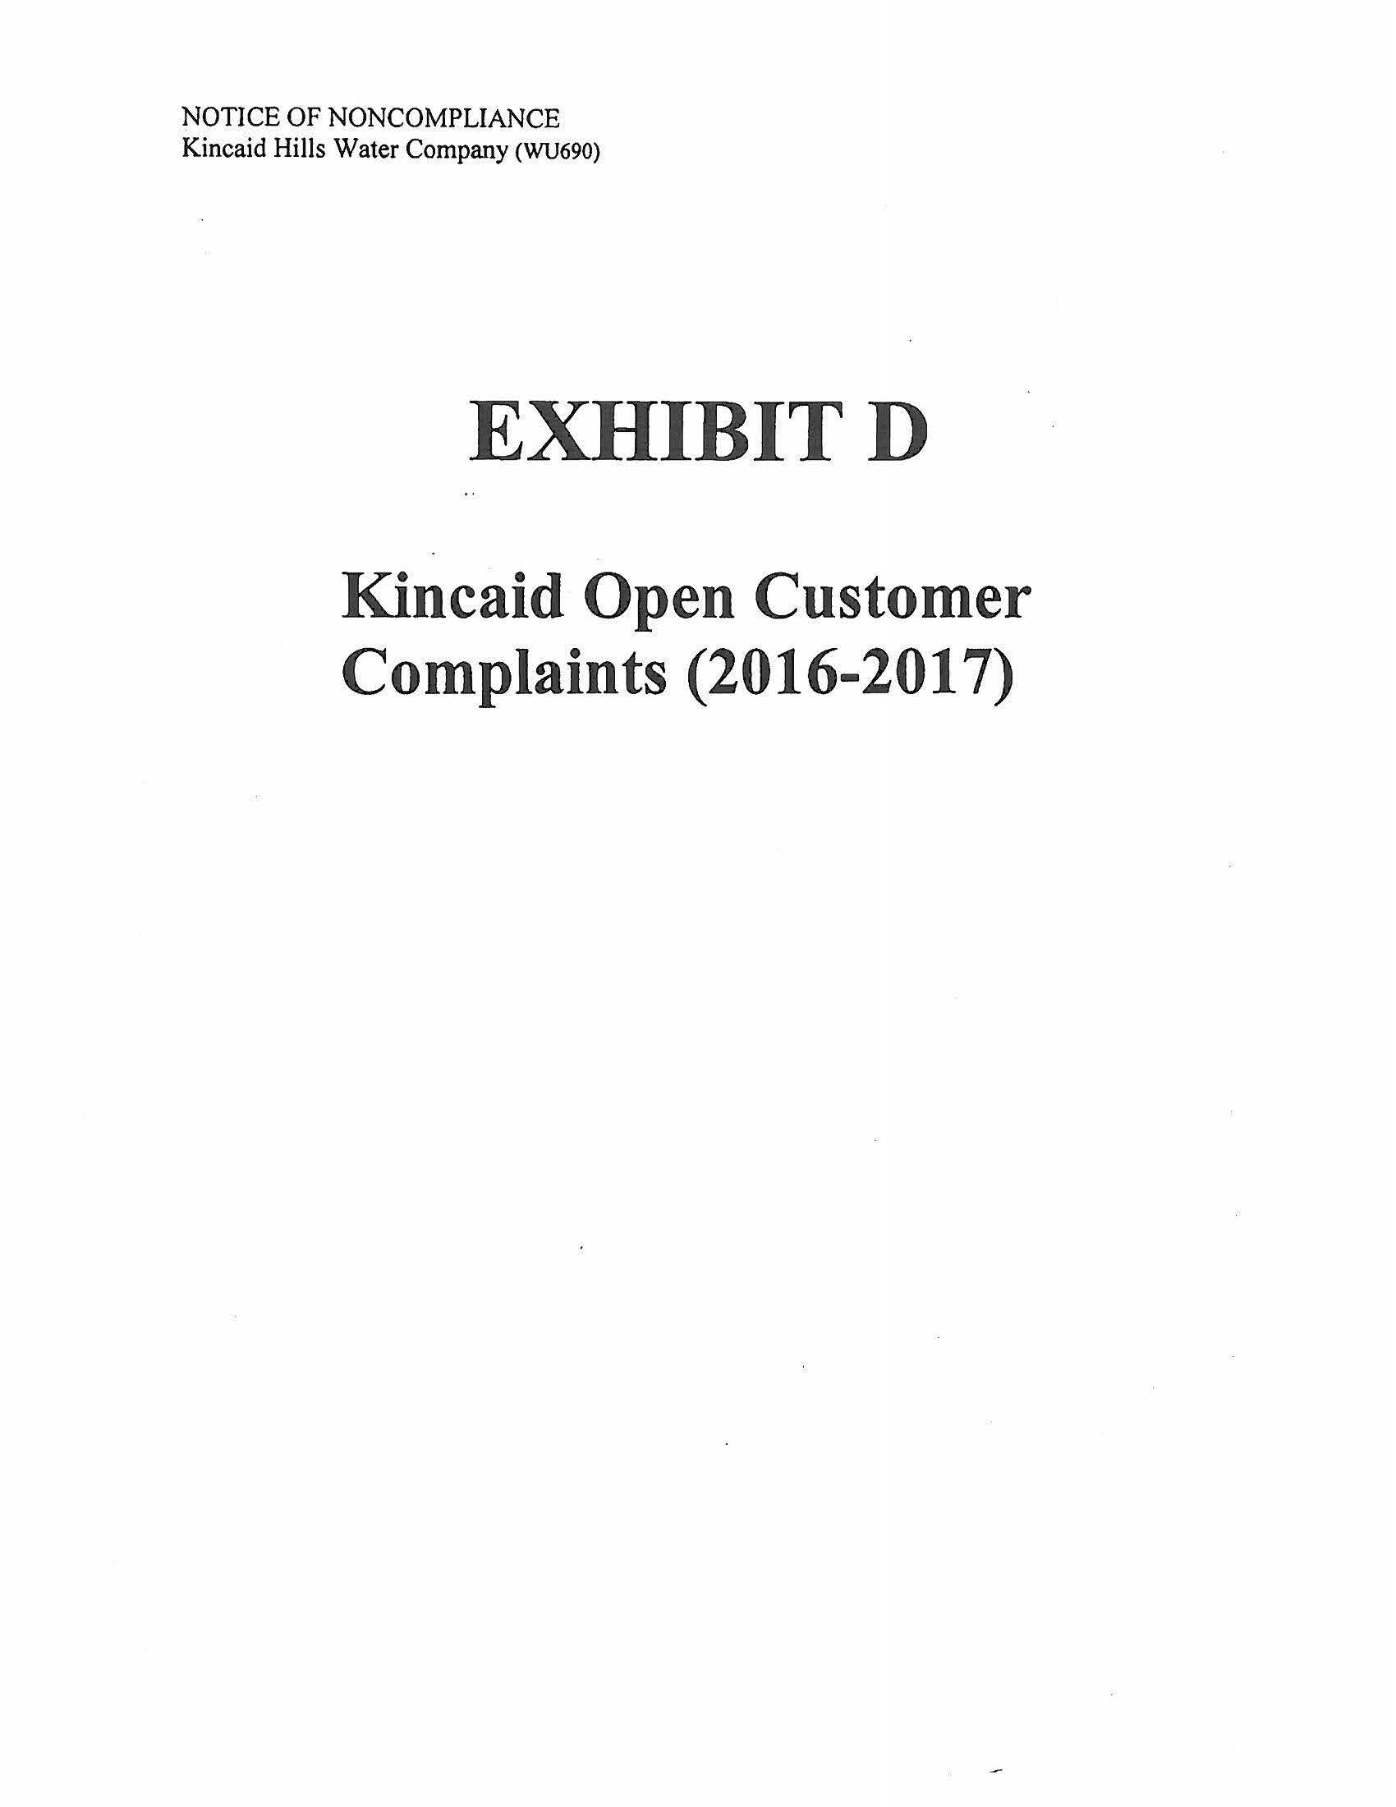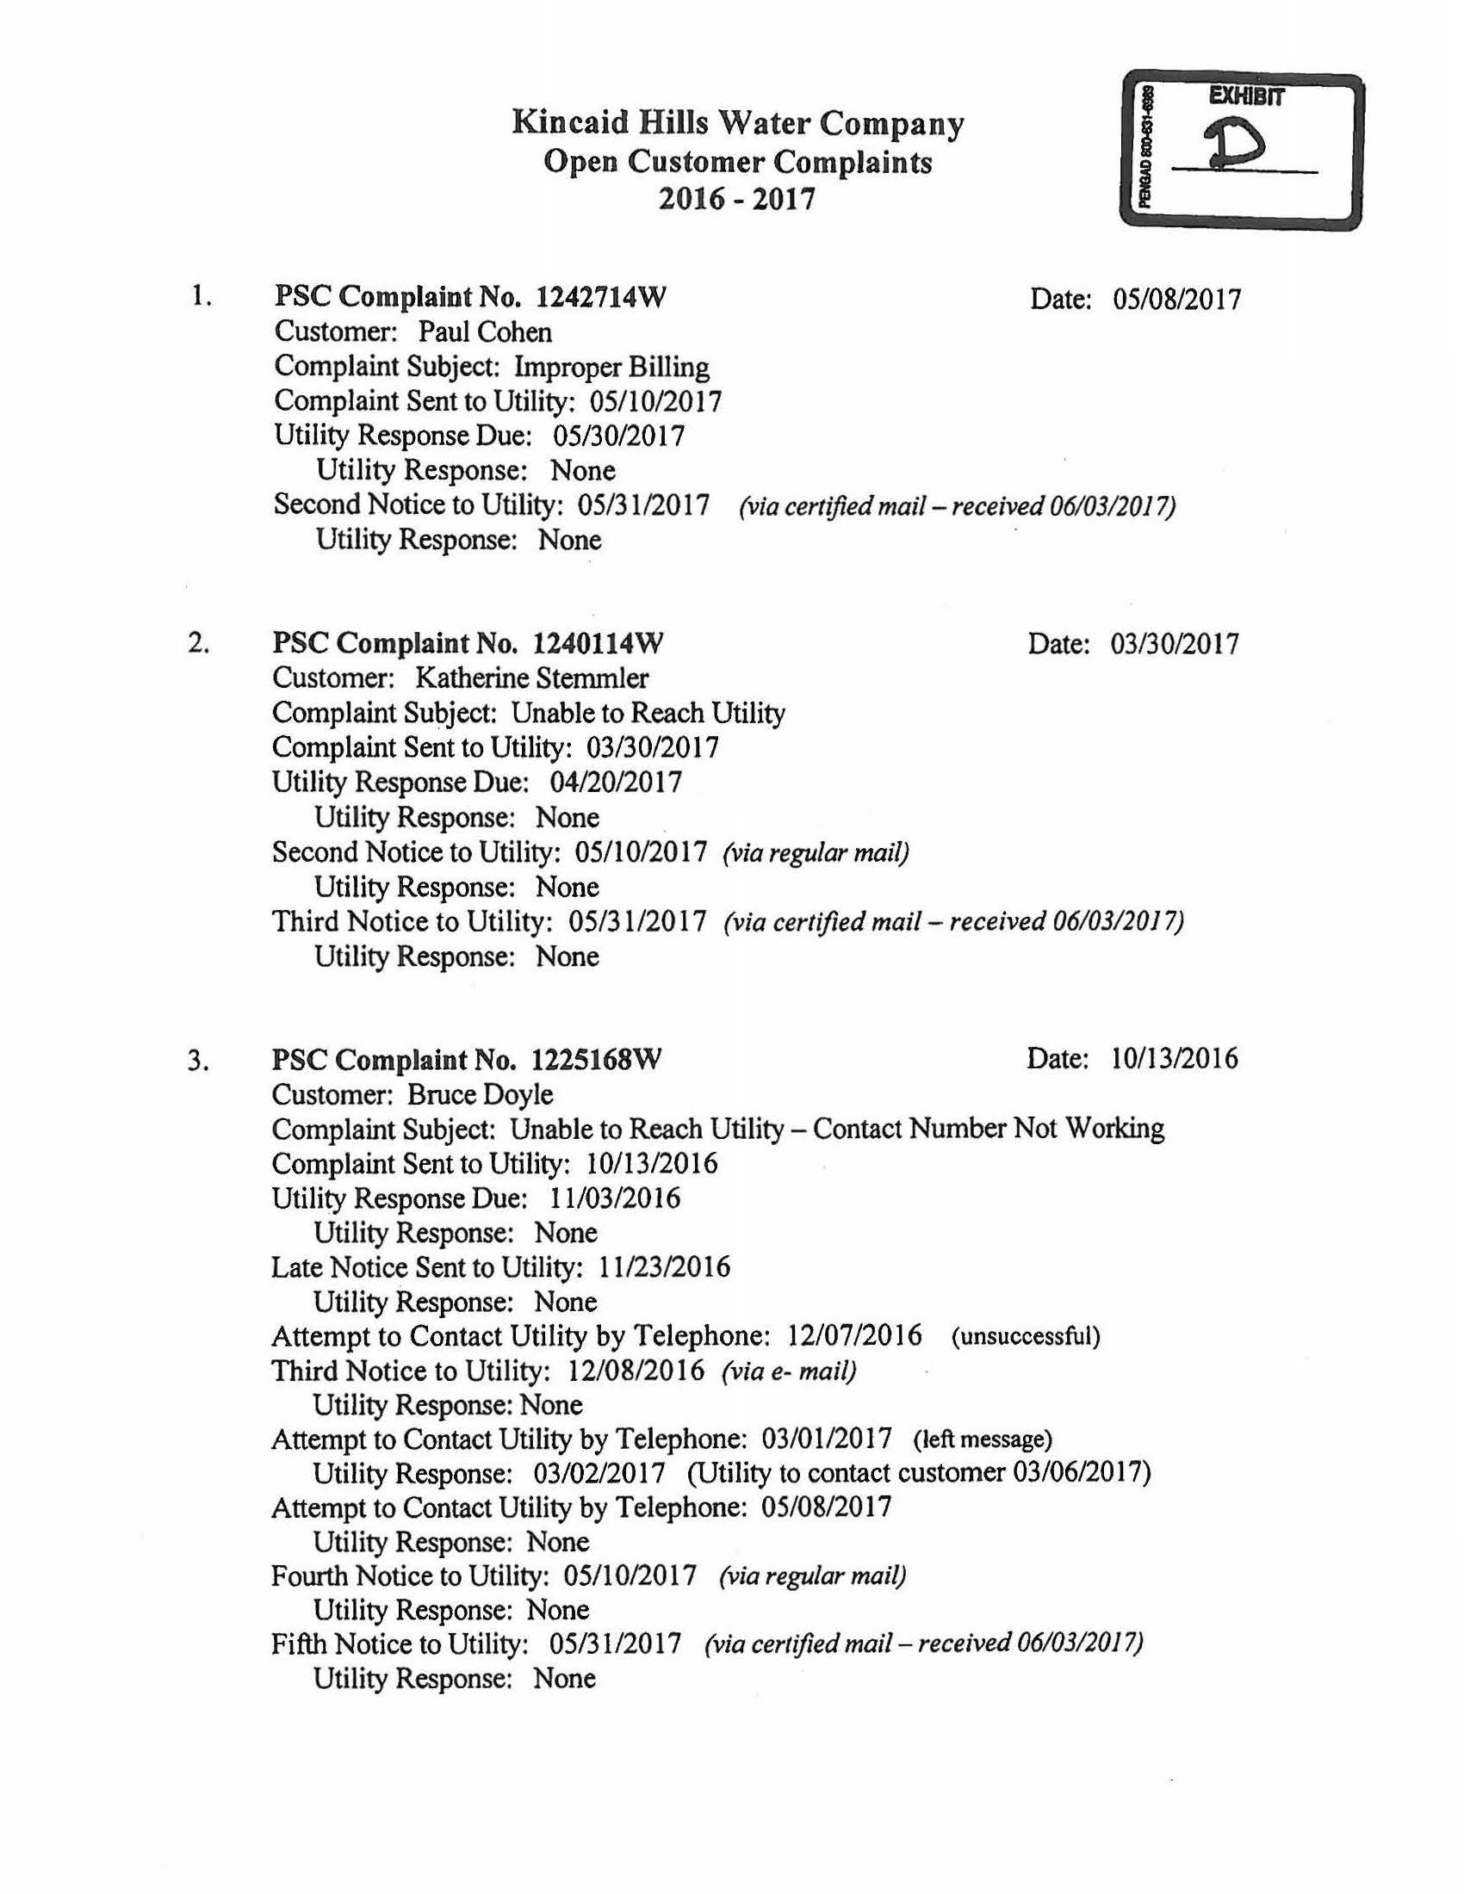
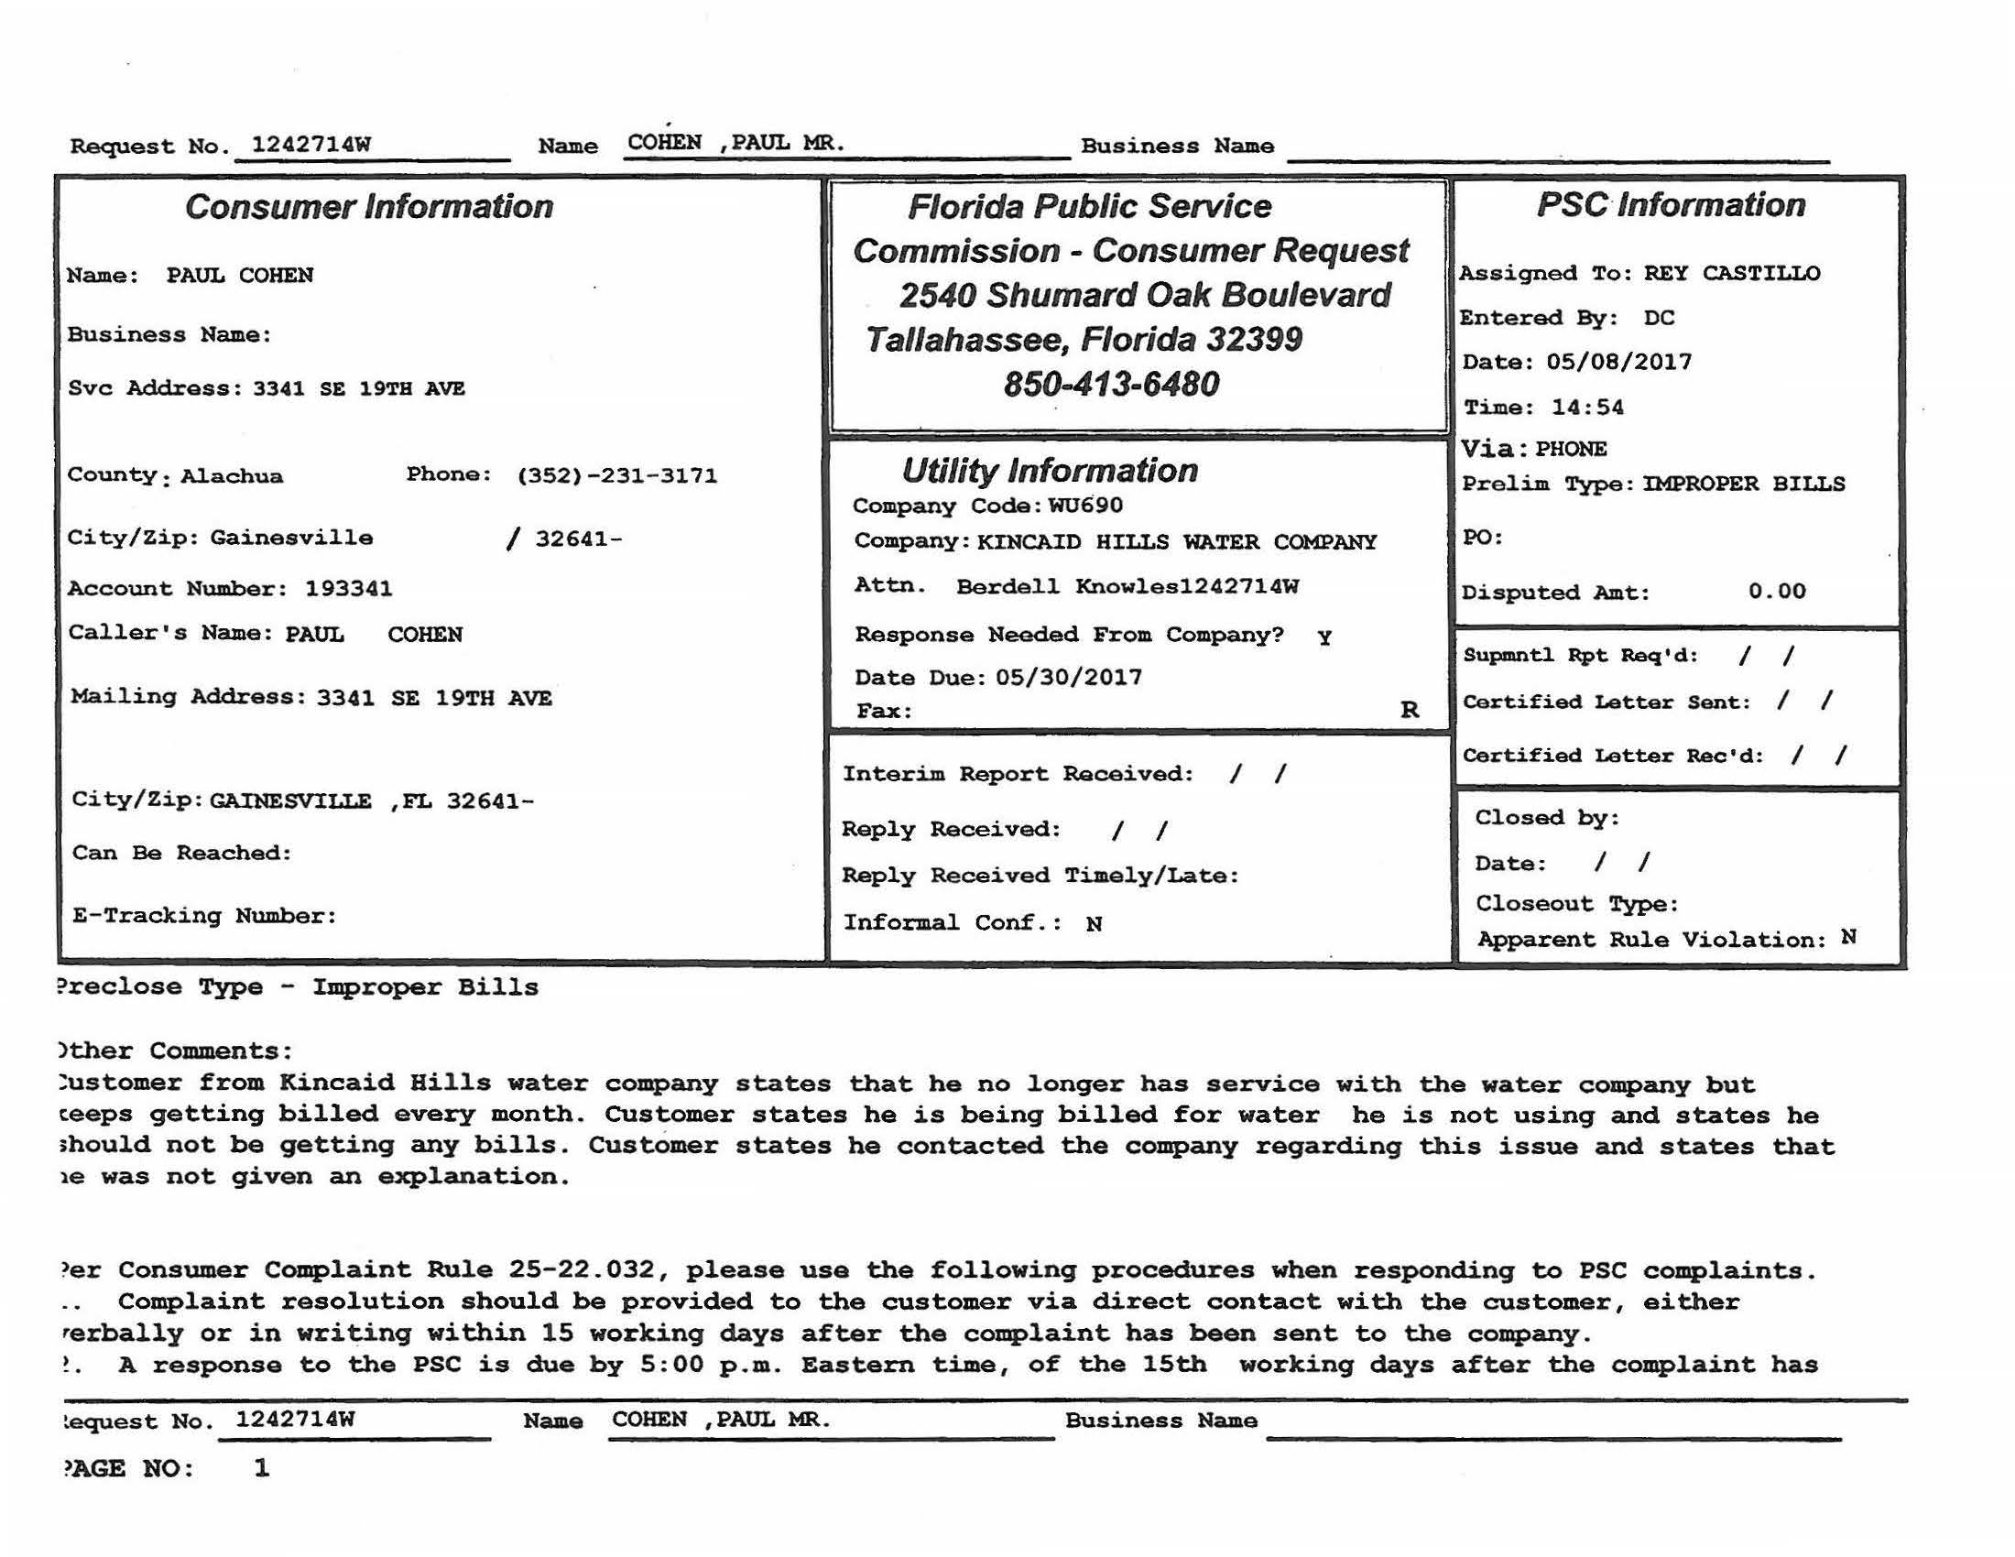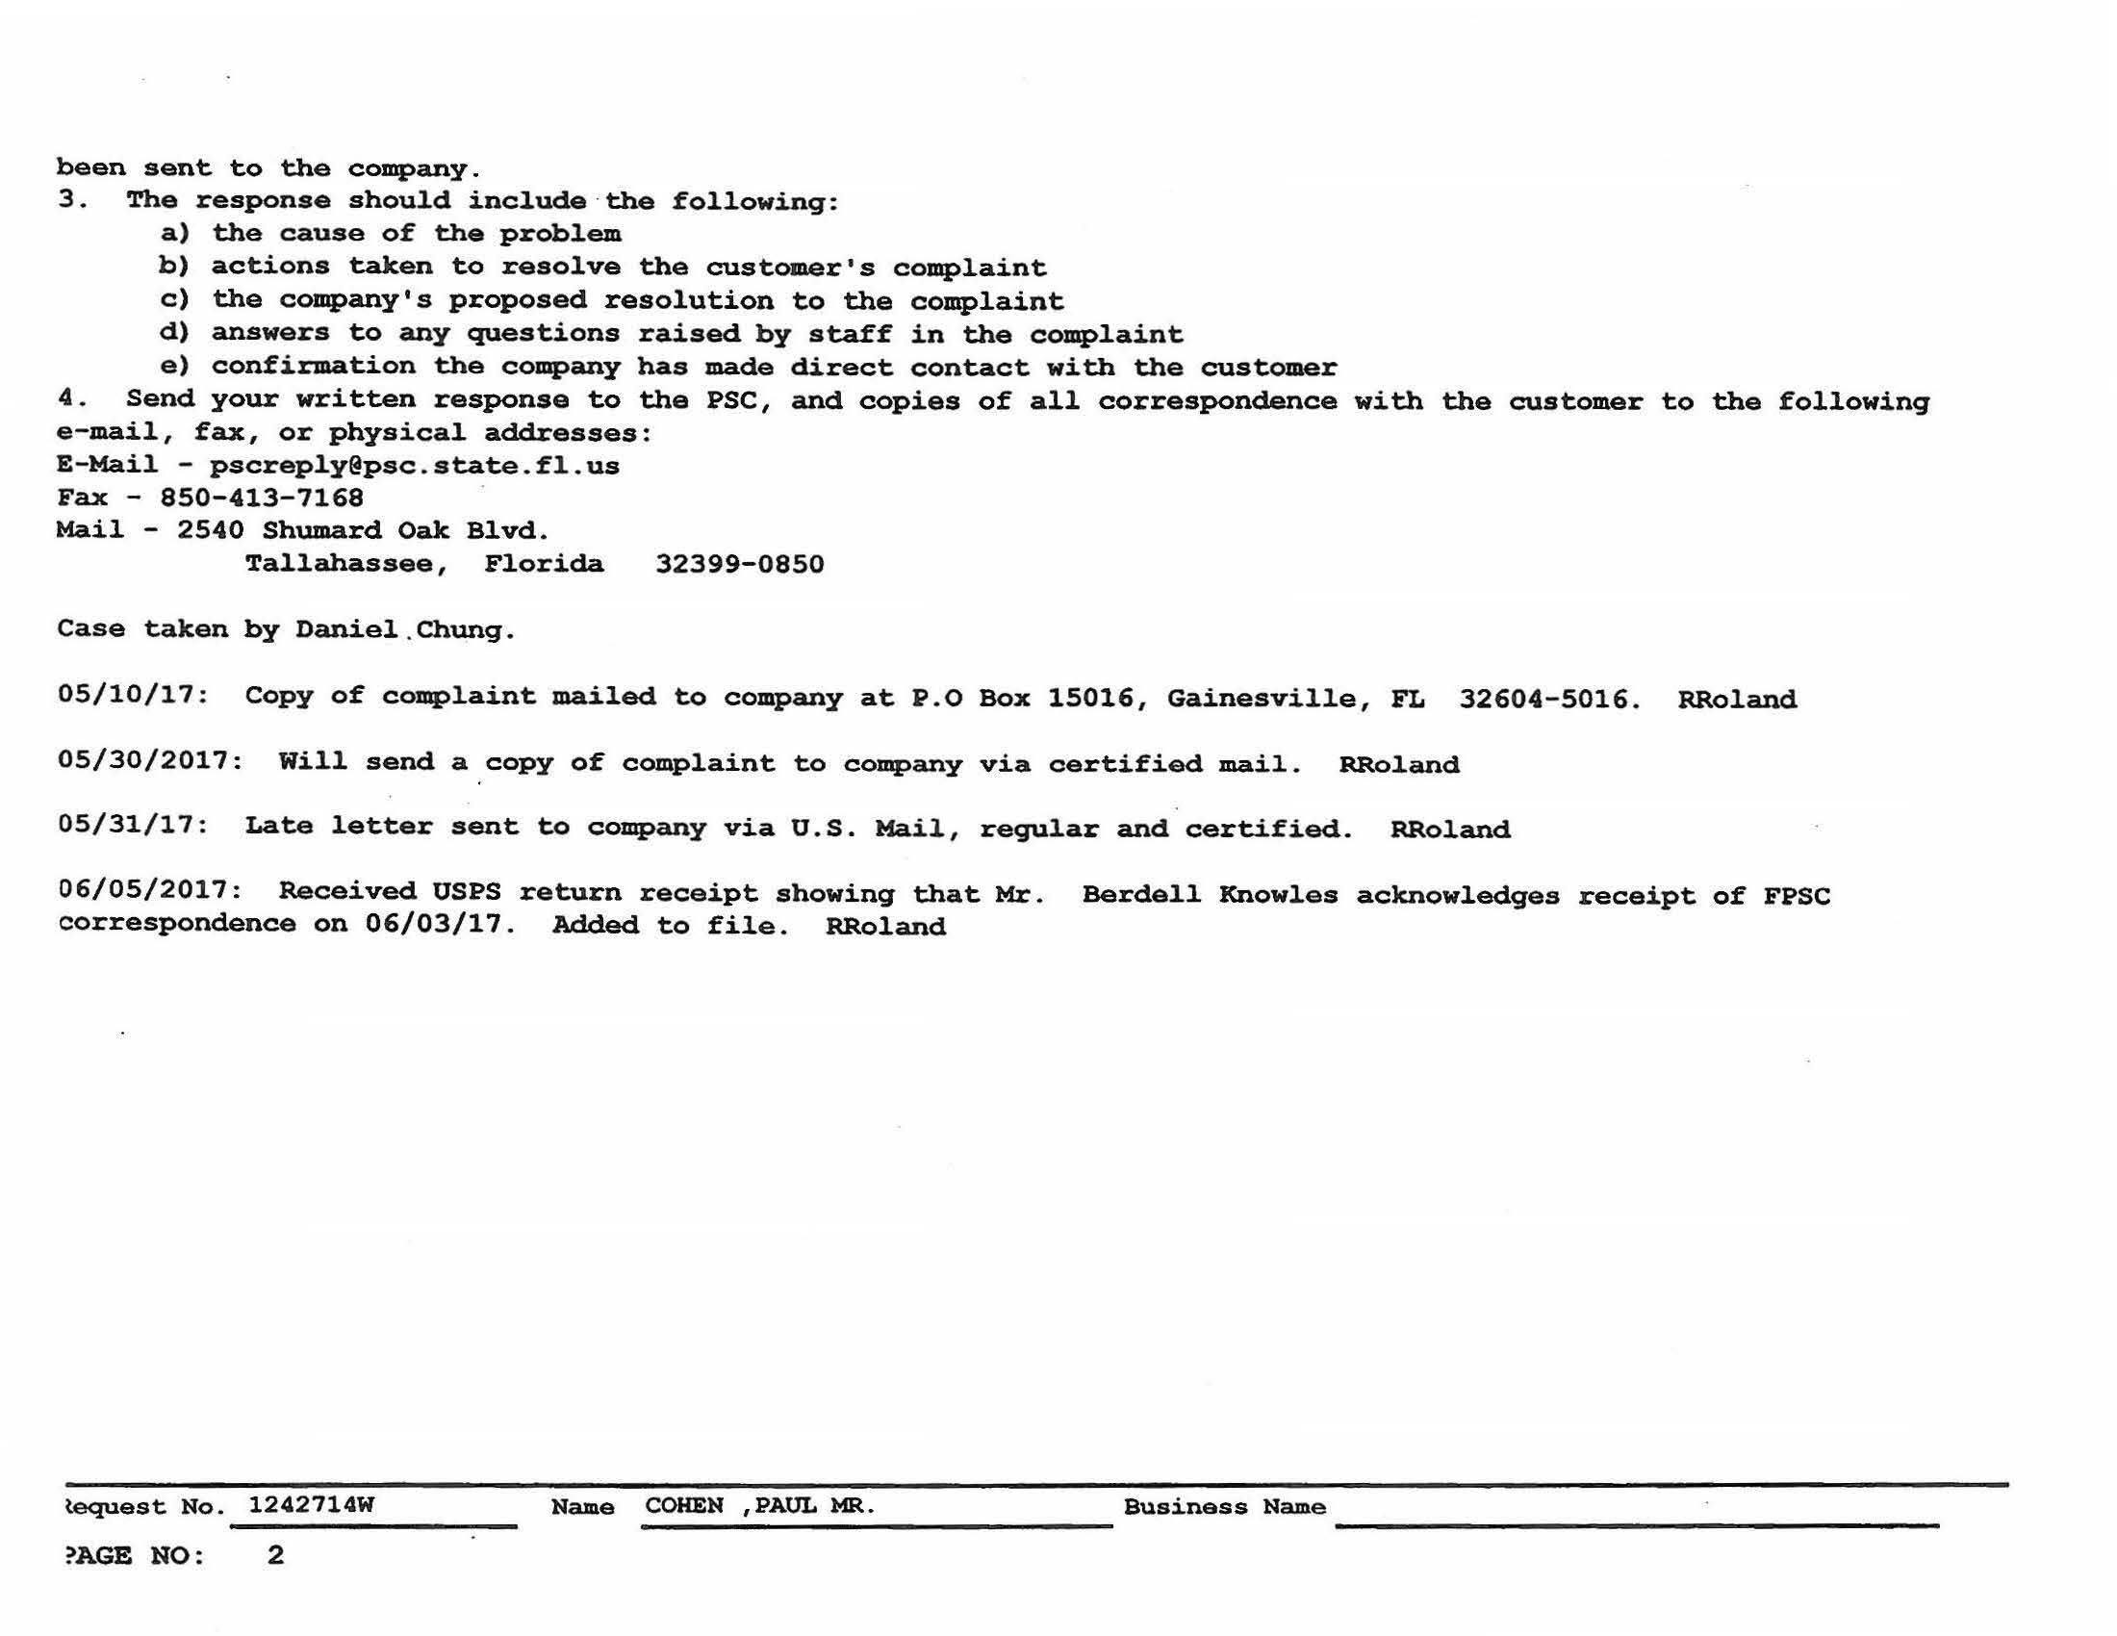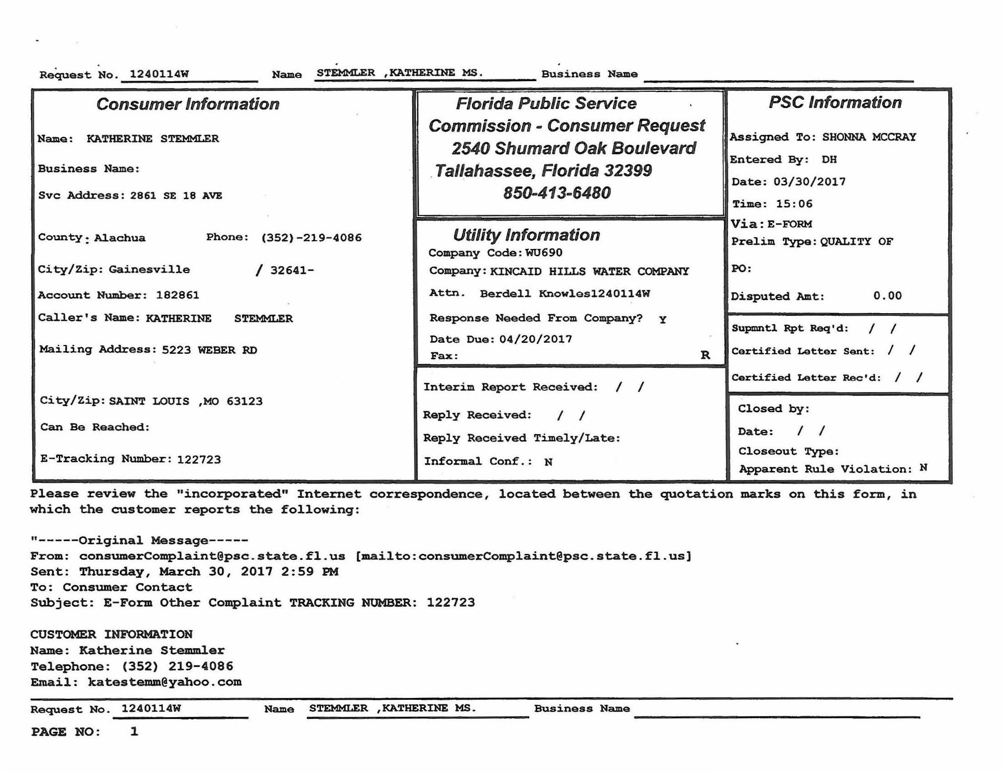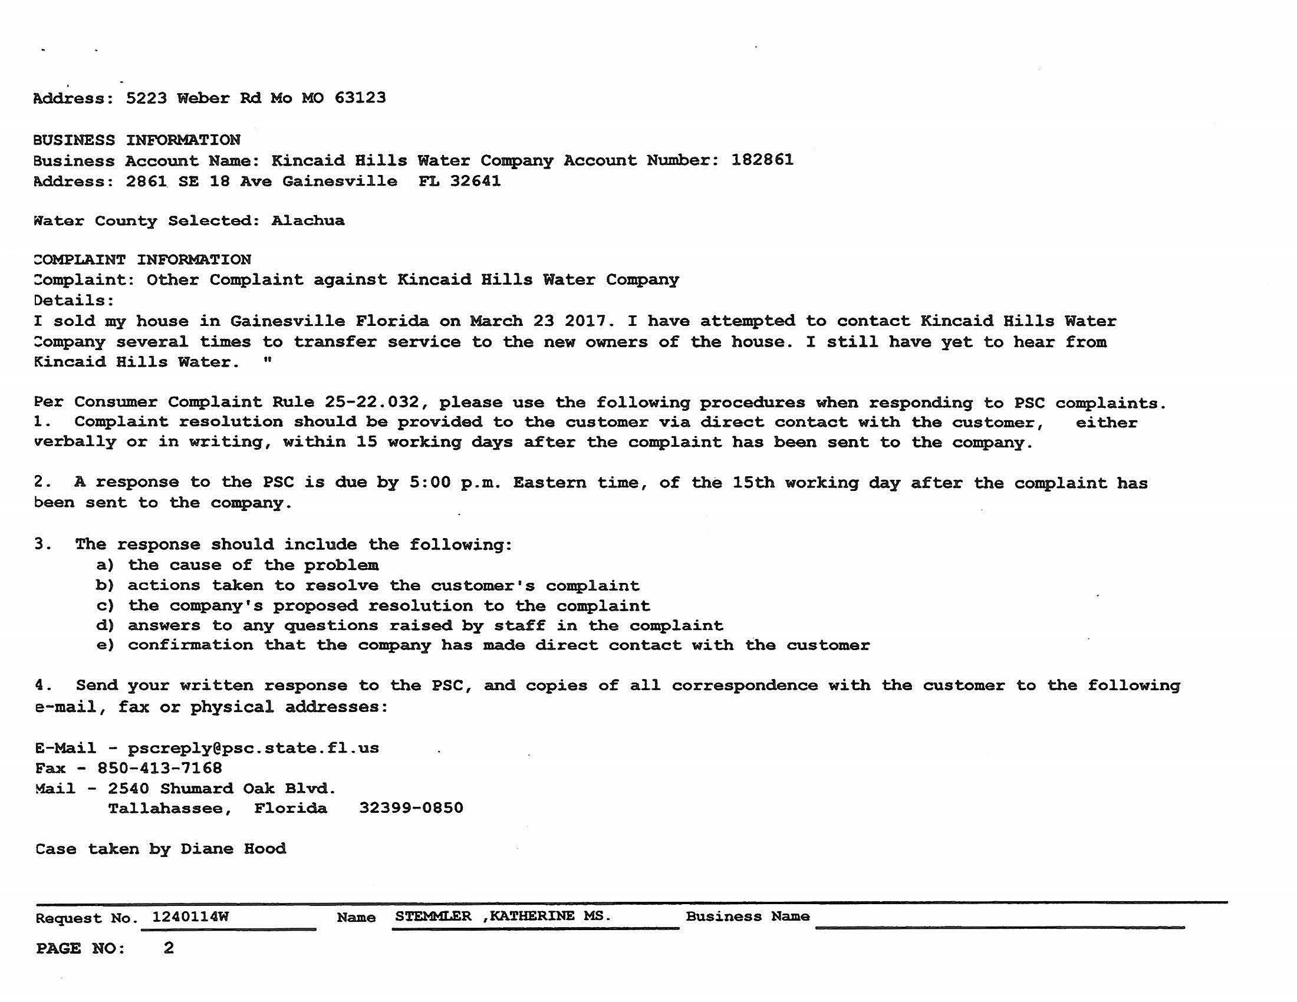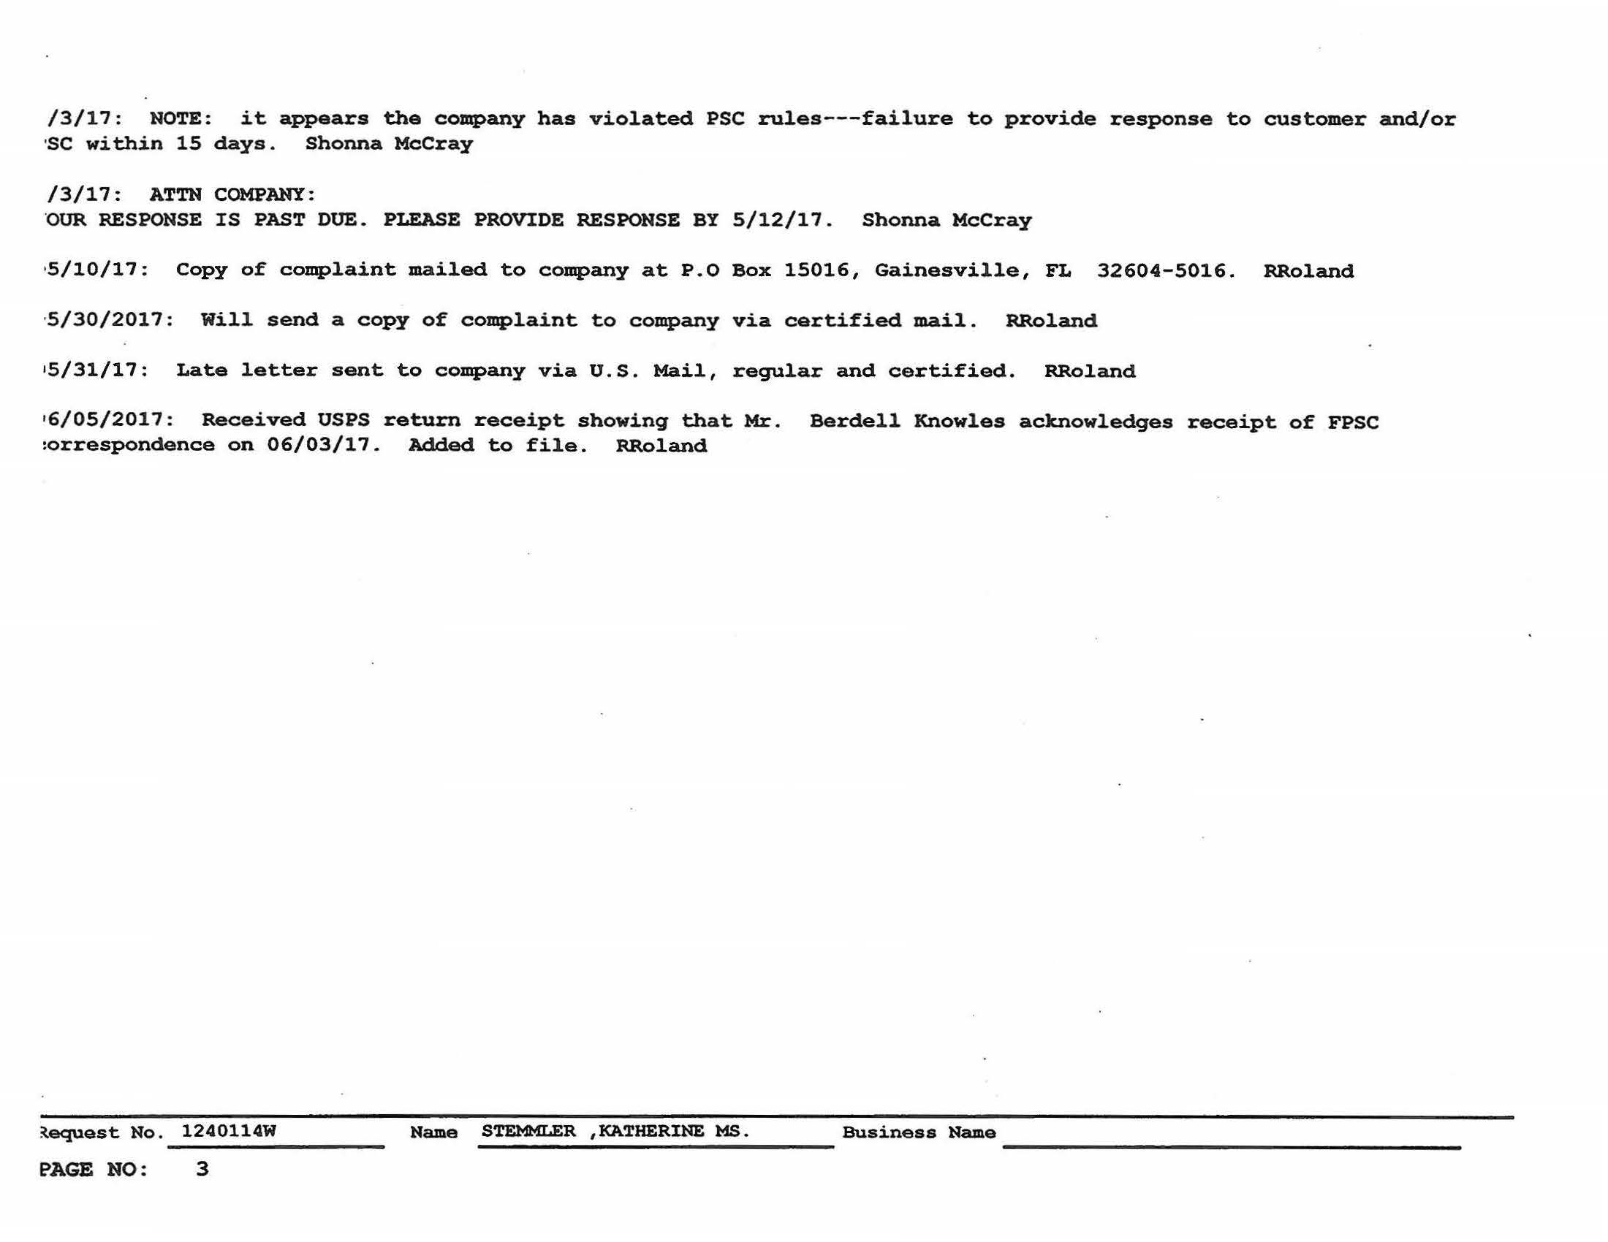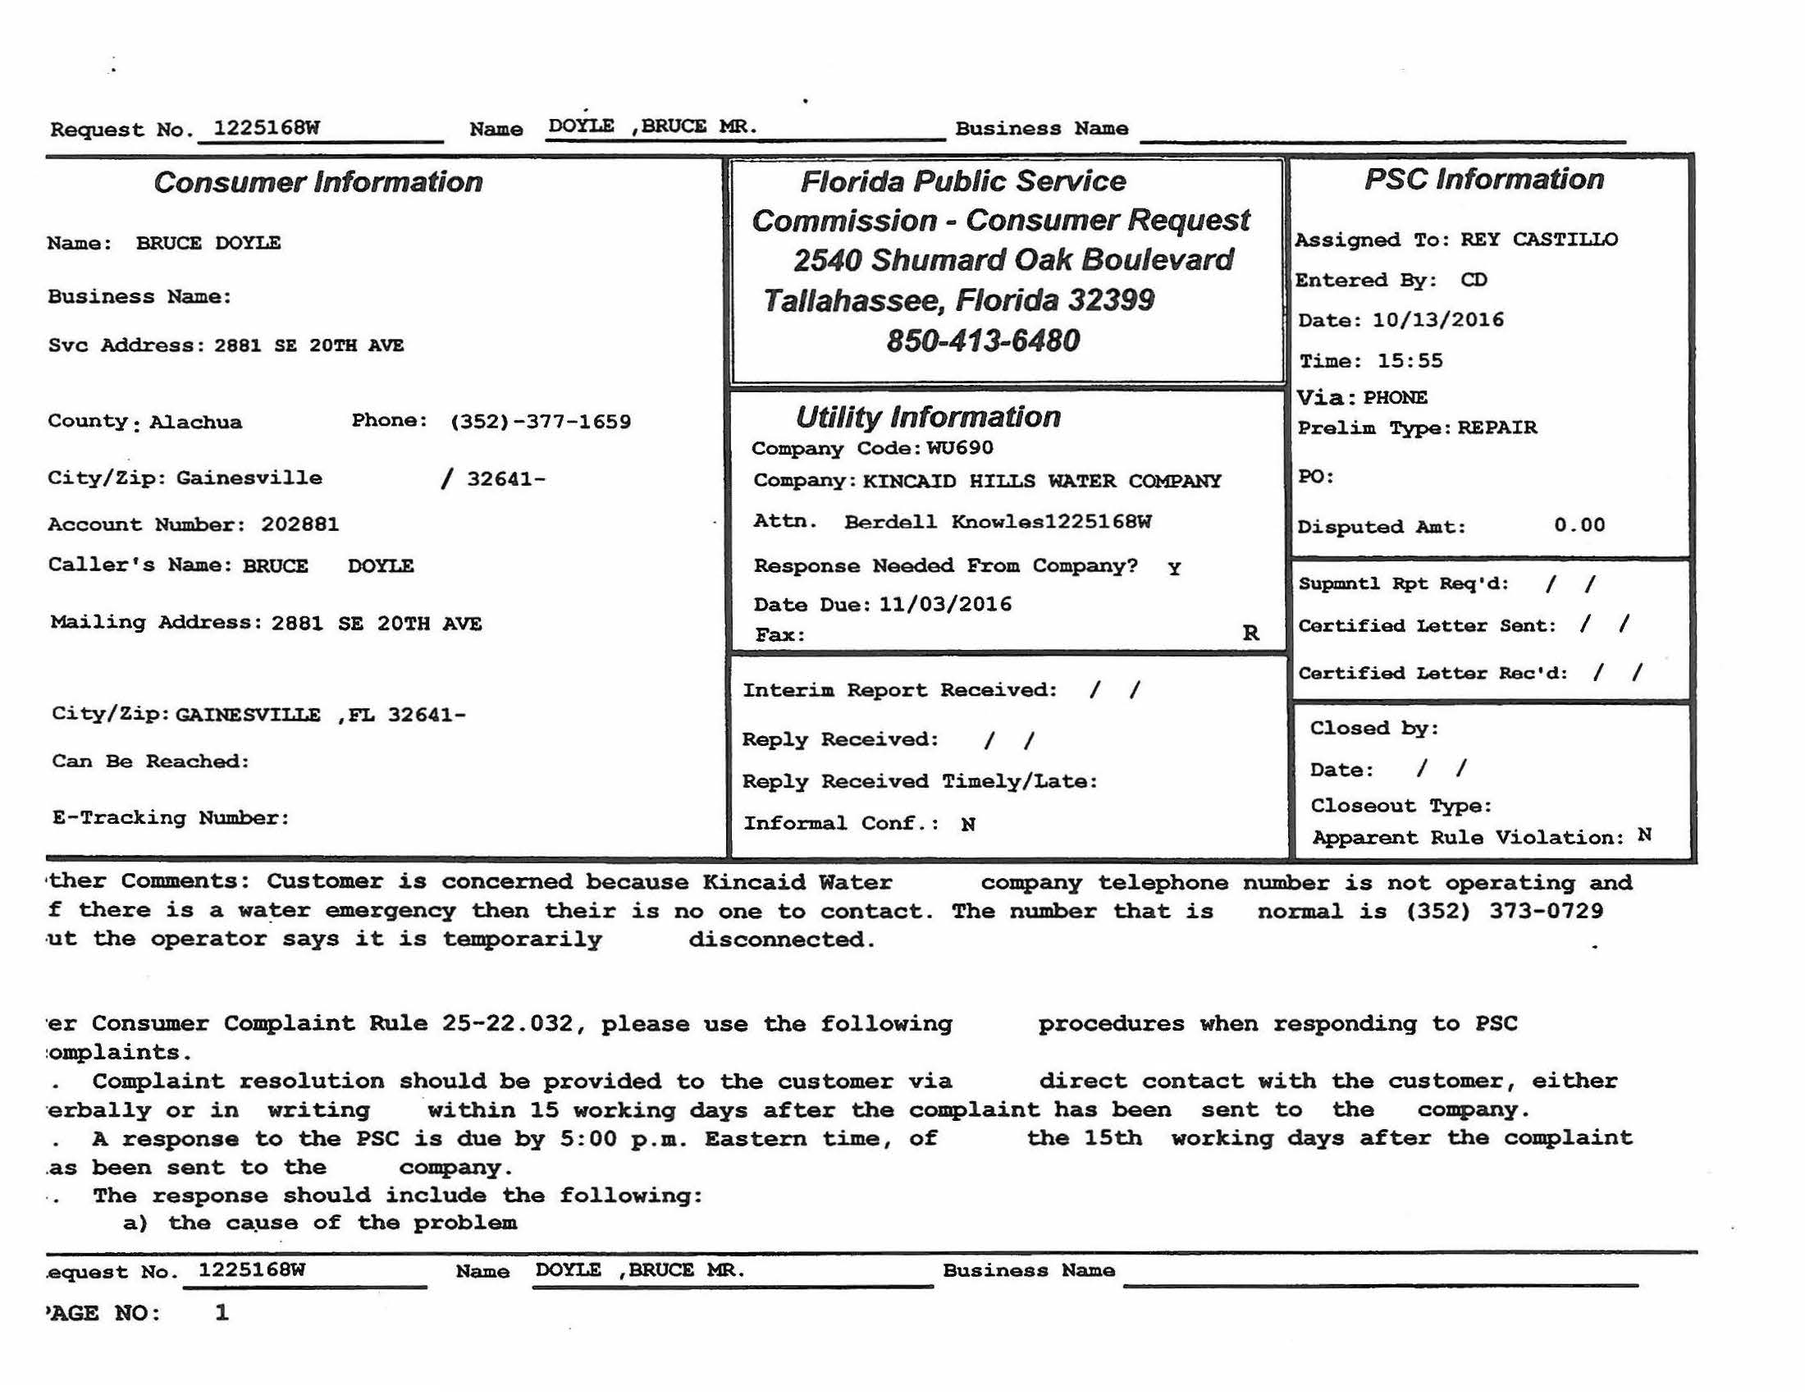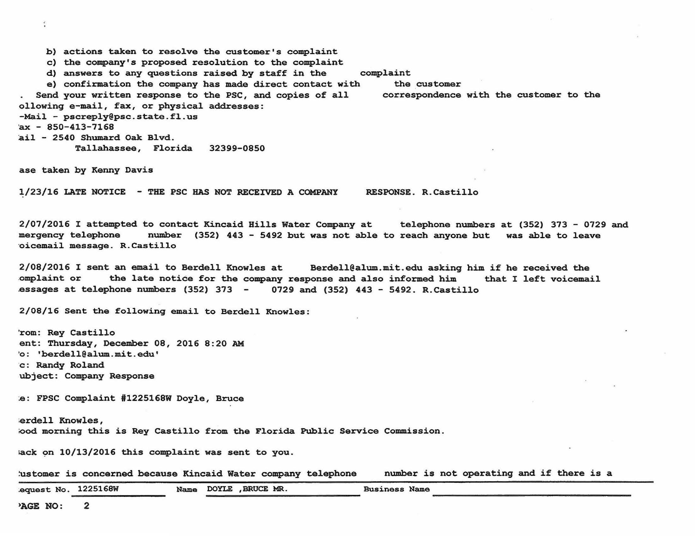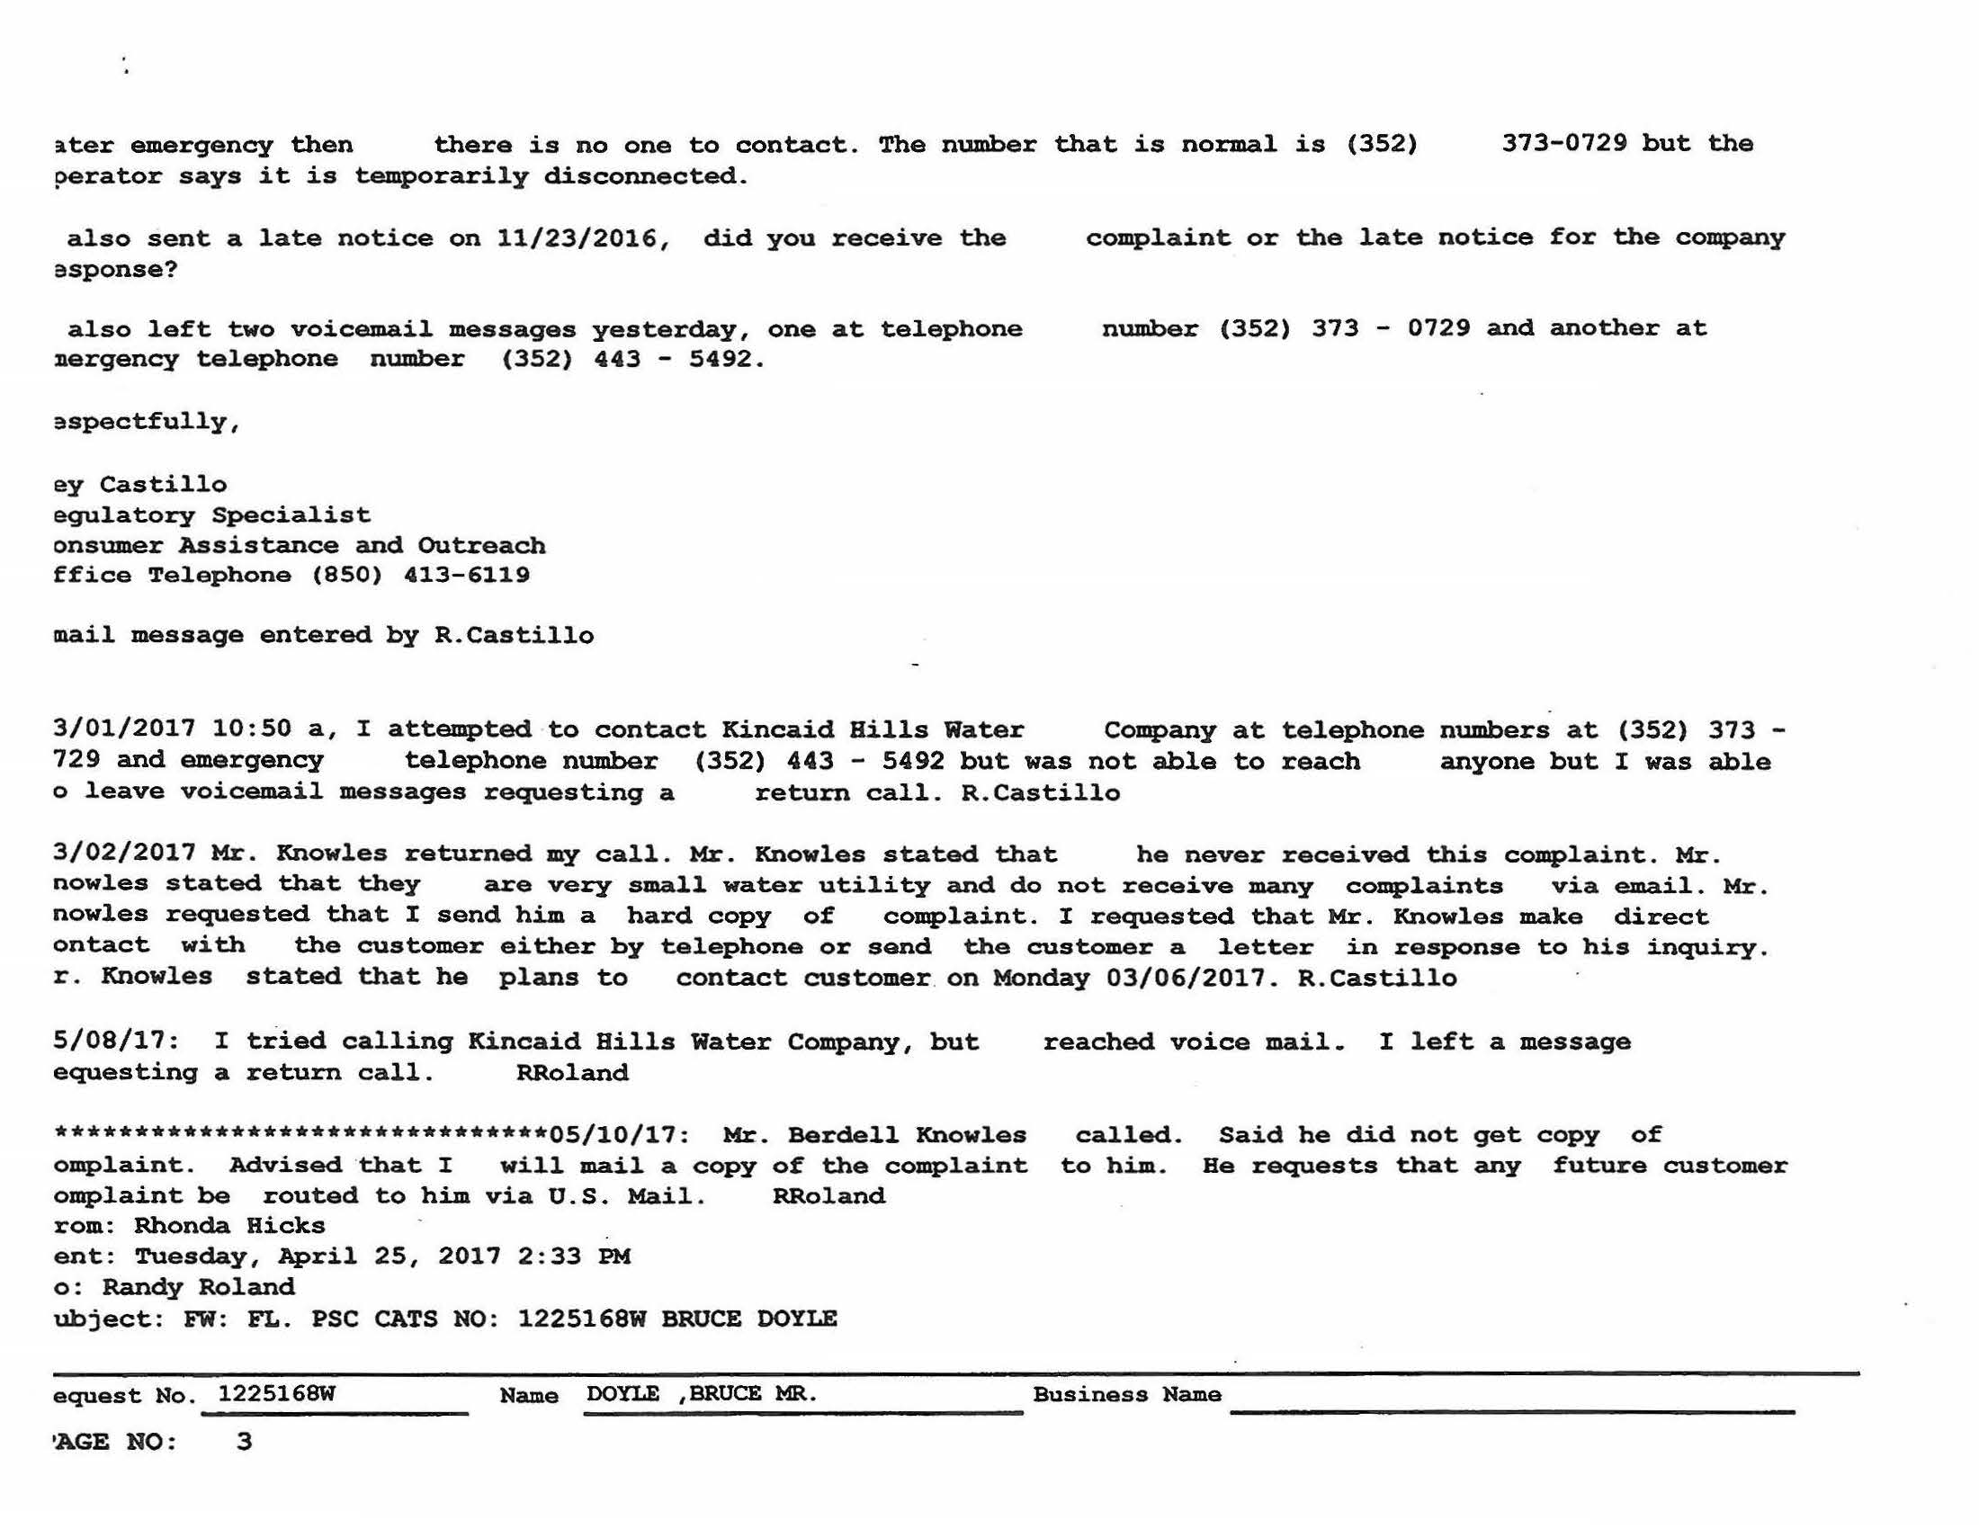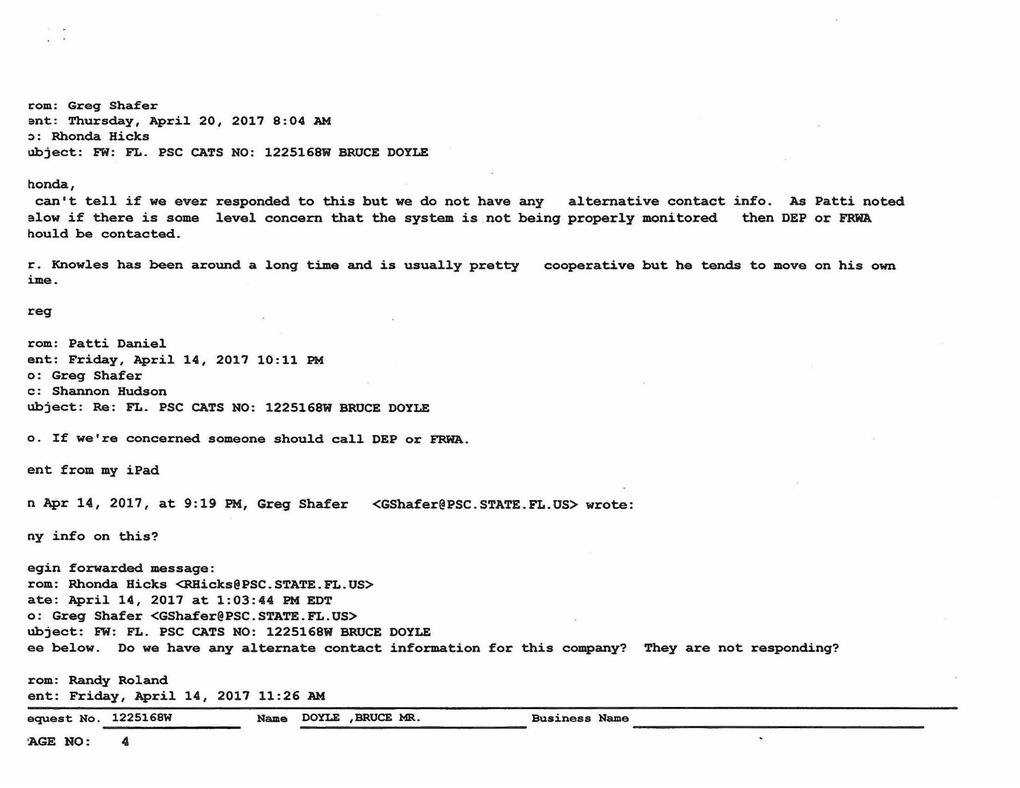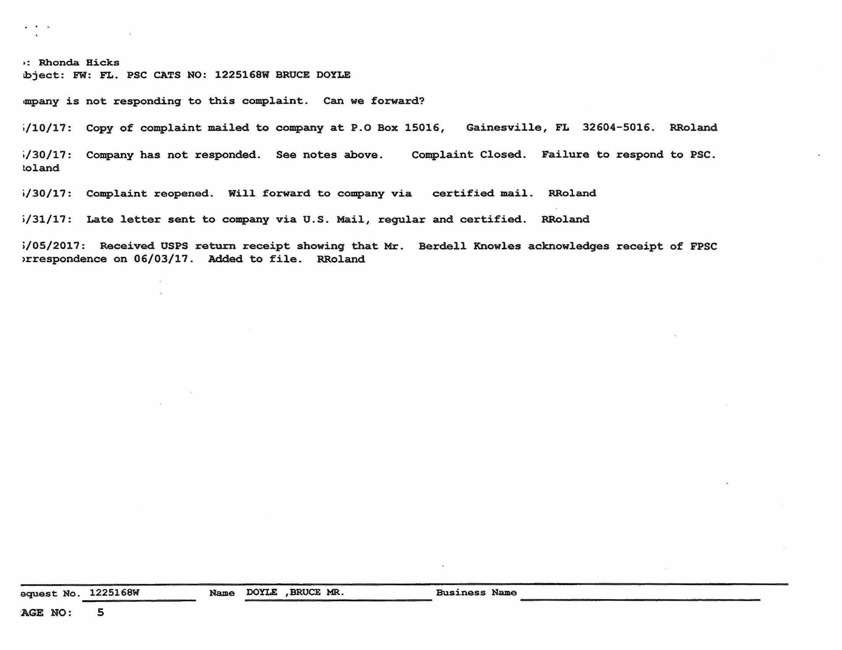

Order No. PSC-93-1027-FOF-WU, issued July 13, 1993, in Docket No. 921195-WU, In re: Application for certificate to provide water service in Alachua County under grandfather rights by Kincaid Hills Water Company.
Order No. PSC-98-0737-SC-WU, issued on May 28, 1998, in Docket No. 971623-WU, In Re: Initiation of show cause proceedings against Kincaid Hills Water Company in Alachua County for violation of Rule 25-30.110(3), F.A.C., Records and Reports; Annual Reports.
See, Docket No. 971623-WU.
See, Document No. 10810-98, in Docket No. 971623-WU.
Docket No. 040248-WU, In re: Initiation of show cause proceedings against Kincaid Hills Water Company in Alachua County for violation of Rule 25-30.110, F.A.C., Records and Reports; Annual Reports, and Rule 25-30.120, F.A.C., Regulatory Assessment Fees; Water and Wastewater Utilities.
Order No. PSC-04-0615-FOF-WU, issued June 21, 2004, in Docket No. 040248-WU, In re: Initiation of show cause proceedings against Kincaid Hills Water Company in Alachua County for violation of Rule 25-30.110, F.A.C., Records and Reports; Annual Reports, and Rule 25-30.120, F.A.C., Regulatory Assessment Fees; Water and Wastewater Utilities.
The Commission found the total amount of delinquent RAFs, penalty and interest, owed by Kincaid for years 1995-2003, to be $29,231.42. See Order No. PSC-04-0615-FOF-WU.
Between June 2004 and January 2006, Kincaid submitted $12,000.00 of the total $29,231.42 owed. $10,903.86 was applied to past due RAF principals and $1,096.14 to penalty and interest, which paid the entire RAF principal amounts owed for the years 1995 through 1999, and $1,410.92 of the $1,808.33 RAF principal owed for the year 2000.
Docket No. 070580-WU, In re: Initiation of Show Cause Proceedings against Kincaid Hills Water Company in Alachua County for violation of Rule 25-30.110, F.A.C., Records and Reports; Annual Reports; Rule 25-30.120, F.A.C., Regulatory Assessment Fees; Water and Wastewater Utilities; and of Order PSC-04-0615-FOF-WU.
Order No. PSC-08-0044-FOF-WU, issued January 22, 2008, in Docket No. 070580-WU, pages 9 and 11.
The Commission noted that “further collection efforts may cause the utility to abandon the system or cause it to be unable to make necessary repairs or maintain the safe provision of quality water to the customers of Kincaid.” Id., at pages 10 and 12; The Commission noted that, “in the last five months, the utility has worked diligently to pay off the 2004-2006 RAFs and has now filed all of its Annual Reports. Because of its financial problems and the need for maintenance, the utility has had problems with timely filing its Annual Reports and could not afford an accountant to assist it in such filing.” Id., at page 13.
Total amount to be written-off was $24,166.29. Id., at pages 10 and 12.
Id.
Id., at page 14.
Document No. 04657-08, filed in Docket No. 070580-WU.
Order No. PSC-08-0386-FOF-WU, issued June 10, 2008, in Docket No. 070580-WU, page 2.
Kincaid submitted its 2007 RAFs three days late and, was, therefore, assessed an additional $139.05, for statutory penalty and interest that accrued. Kincaid submitted the $139.05 penalty on May 1, 2008.
Order No. PSC-08-0386-FOF-WU.
Kincaid’s 2008 Annual Report was received 22 days late, on April 22, 2009.
Attachment A, Exhibit A (Commission Staff Correspondence re: Kincaid Delinquent RAFs and Annual Reports).
Attachment A, Exhibit A (Staff Email, dated June 17, 2014, RE: Kincaid Hills Water Company WU690 – First Collections Delinquent RAFs.)
Id.
Attachment A, Exhibit B (Kincaid Florida Corporate Information).
Attachment A, Exhibit C (Commission Staff Correspondence re: Kincaid Compliance Plan).
Attachment A, Exhibit C (Staff Emails with Mr. Knowles, Jr., RE: Kincaid Hills – Initial Compliance Plan.)
Id.
The payment was postmarked November 7, 2014. The payment breakdown was as follows: $4,491.55 (2010 RAFs $2,642.09 + Penalty $660.52 + Interest $1,188.94); and $4,198.60 (2011 RAFs $2657.34 + Penalty $664.34 + Interest $876.92)
Kincaid emailed its 2009-2013 Annual Reports to staff on November 7, 2014; however, Rule 25-30.110, F.A.C., requires reports be certified and submitted to the Commission in paper form. The Commission staff received the paper form of the Annual Reports on November 14, 2014. See Attachment A, Exhibit C (Staff Emails with Mr. Knowles, Jr., re: Kincaid Hills - Received Delinquent Annual Reports & 2010-11 RAF Payment; and Staff Emails with Mr. Knowles, Jr., re: Kincaid Hills - Annual Reports Insufficient.)
See Attachment A, Exhibit C (Staff Emails with Mr. Knowles, Jr., RE: Kincaid Hills – Rate Case & RAFs.)
See Attachment A, Exhibits B and C.
See Attachment A, Exhibits B and C.
See Attachment A.
See, Document No. 07952-2017, in Docket No. 20170200-WU.
Fugate v. Fla. Elections Comm’n, 924 So. 2d 74, 75 (Fla. 1st DCA 2006), citing, Metro. Dade County v. State Dep't of Envtl. Prot., 714 So. 2d 512, 517 (Fla. 3d DCA 1998).
Fugate, 924 So. 2d 74 at 75.
Kincaid submitted its 2010 and 2011 RAFs, plus penalty and interest, on November 14, 2014, as part of on-going compliance/settlement negotiations with Commission staff.
Docket No. 040248-WU, In Re: Initiation of show cause proceedings against Kincaid Hills Water Company in Alachua County for violation of Rule 25-30.110, F.A.C., Records and Reports; Annual Reports, and Rule 25-30.120, F.A.C., Regulatory Assessment Fees; Water and Wastewater Utilities; and Docket No. 070580-WU, In Re: Initiation of Show Cause Proceedings against Kincaid Hills Water Company in Alachua County for violation of Rule 25-30.110, F.A.C., Records and Reports; Annual Reports; Rule 25-30.120, F.A.C., Regulatory Assessment Fees; Water and Wastewater Utilities; and of Order PSC-04-0615-FOF-WU.
Kincaid submitted its 2007 RAFs three days late and paid the associated penalty and interest.
Kincaid timely submitted its 2014 and 2015 RAFs.
Order No. PSC-93-0370-AS-WU, issued March 9, 1993, in Docket No. 920782-WU, In re: Revocation by Florida Public Service Commission of Certificate No. 302-W issued to St. George Island Utility Company, Ltd. In Franklin County.
Fugate, 924 So. 2d 74 at 75.
Kincaid’s 2008 Annual Report was received 22 days late, on April 22, 2009.
Order No. PSC-93-0370-AS-WU, issued March 9, 1993, in Docket No. 920782-WU, In re: Revocation by Florida Public Service Commission of Certificate No. 302-W issued to St. George Island Utility Company, Ltd. In Franklin County.
Fugate, 924 So. 2d 74 at 75.
Attachment A, Exhibit D (Open CATS Customer Complaints).
Id.
Id.
Order No. PSC-06-0349-SC-WS, issued April 25, 2006, in Docket No. 060057-WS, In re: Investigation into whether Lindrick Service Corporation should be ordered to show cause.
Order No. PSC-11-0541-SC-WS, issued November 22, 2011, in Docket No. 110254-WS, In re: Initiation of show cause proceedings against Four Points Utility Corporation in Polk County for violation of Commission rules and regulations as outlined in the Florida Public Service Commission’s management audit for Four Points Utility Corporation and Bimini Bay Utilities Corporation issued June 2011.
Order No. PSC-93-0370-AS-WU, issued March 9, 1993, in Docket No. 920782-WU, In re: Revocation by Florida Public Service Commission of Certificate No. 302-W issued to St. George Island Utility Company, Ltd. In Franklin County.

