BEFORE THE FLORIDA PUBLIC SERVICE COMMISSION

In re: Application for limited proceeding to approve 2017 second revised and restated settlement agreement, including certain rate adjustments, by Duke Energy Florida, LLC. | DOCKET NO. 20170183-EI
In re: Examination of the outage and replacement fuel/power costs associated with the CR3 steam generator replacement project, by Progress Energy Florida, Inc. | DOCKET NO. 20100437-EI
In re: Petition for issuance of nuclear asset-recovery financing order, by Duke Energy Florida, Inc. d/b/a Duke Energy. | DOCKET NO. 20150171-EI
In re: Fuel and purchased power cost recovery clause with generating performance incentive factor. | DOCKET NO. 20170001-EI
In re: Energy conservation cost recovery clause. | DOCKET NO. 20170002-EG
In re: Nuclear cost recovery clause. | DOCKET NO. 20170009-EI  ORDER NO. PSC-2017-0451-AS-EU  ISSUED: November 20, 2017

The following Commissioners participated in the disposition of this matter:

JULIE I. BROWN, Chairman
ART GRAHAM
RONALD A. BRISÉ
DONALD J. POLMANN
GARY F. CLARK

APPEARANCES:

DIANNE M. TRIPLETT, ESQUIRE, 299 First Avenue North, St. Petersburg, Florida 33701
On behalf of Duke Energy Florida, LLC (DEF).

J.R. KELLY, and CHARLES REHWINKEL, ESQUIRES, Office of Public Counsel, c/o The Florida Legislature, 111 West Madison Street, Room 812, Tallahassee, Florida 32399-1400
On behalf of the Citizens of the State of Florida (OPC).

JON C. MOYLE, JR., ESQUIRE, Moyle Law Firm, PA, The Perkins House, 118 North Gadsden Street, Tallahassee, Florida 32301
On behalf of the Florida Industrial Power Users Group (FIPUG).

Robert Scheffel Wright and John T. LaVia, III, ESQUIRES, Gardner, Bist, Bowden, Bush, Dee, LaVia & Wright, P.A., 1300 Thomaswood Drive, Tallahassee, Florida 32308
On behalf of the Florida Retail Federation (FRF).

JAMES W. BREW, ESQUIRE, Stone Mattheis Xenopoulos & Brew, PC, 1025 Thomas Jefferson St., NW, Eighth Floor, West Tower, Washington, DC 20007
On behalf of White Springs Agricultural Chemicals, Inc. d/b/a PCS Phosphate – White Springs (PCS Phosphate).

GEORGE CAVROS, ESQUIRE, 120 E. Oakland Park Boulevard, Suite 105, Fort Lauderdale, Florida, 33334
On behalf of the Southern Alliance for Clean Energy (SACE).

KYESHA MAPP, MARGO DUVAL, and SUZANNE BROWNLESS, ESQUIRES, Florida Public Service Commission, 2540 Shumard Oak Boulevard, Tallahassee, Florida 32399-0850
On behalf of the Florida Public Service Commission (Staff).

MARY ANNE HELTON, ESQUIRE, Deputy General Counsel, Florida Public Service Commission, 2540 Shumard Oak Boulevard, Tallahassee, Florida 32399-0850
Advisor to the Florida Public Service Commission.

Keith hetrick, ESQUIRE, General Counsel, Florida Public Service Commission, 2540 Shumard Oak Boulevard, Tallahassee, Florida 32399-0850
Florida Public Service Commission General Counsel.

ORDER APPROVING 2017 SECOND REVISED AND RESTATED
SETTLEMENT AGREEMENT

BY THE COMMISSION:
BACKGROUND

On August 29, 2017, Duke Energy Florida, LLC (DEF) filed a Petition for a Limited Proceeding to approve its 2017 Second Revised and Restated Settlement Agreement (2017 Agreement), Including Certain Rate Adjustments (Petition). The 2017 Agreement, with noted exceptions, seeks to replace and supplant the 2013 Revised and Restated Stipulation and Settlement Agreement (2013 Agreement) we approved by Order No. PSC-13-0598-FOF-EI and its three subsequent stipulated amendments approved by, Order Nos. PSC-15-0465-S-EI, PSC-16-0138-FOF-EI, and PSC-16-0425-PAA-EI. The 2017 Agreement was signed and executed by DEF, the Office of Public Counsel (OPC), the Florida Industrial Power Users Group (FIPUG), the Florida Retail Federation (FRF), White Springs Agricultural Chemicals, Inc. d/b/a PCS Phosphate (PCS Phosphate), and the Southern Alliance for Clean Energy (SACE) (collectively, the Parties). The signatories to the 2017 Agreement are organizations that represent DEF’s major customer groups.

Pursuant to the Petition, the Parties requested that we hold a limited proceeding in accordance with Sections 366.06(3) and 366.076(1), and Chapter 120, Florida Statutes (F.S.), and Rule 25-28.301, Florida Administrative Code (F.A.C.), to consider the merits of the 2017 Agreement, which is appended to this Order in Attachment A. We held an administrative hearing on this matter on October 25, 2017. During the hearing, the Parties spoke in support of the 2017 Agreement. We provided DEF customers and interested persons with the opportunity to present public testimony and voice any concerns with the 2017 Agreement, and DEF sponsored witnesses who provided sworn testimony and answered questions pertaining to the 2017 Agreement.

SETTLEMENT AGREEMENT

The 2017 Agreement provides DEF with a multi-year increase to base rates beginning with the first billing cycle of January 2019, and resolves outstanding issues in existing, continuing, and prospective dockets before this Commission. This includes the fuel and purchased power cost recovery clause, Docket No. 20170001-EI; the energy conservation cost recovery clause, Docket No. 20170002-EG; the nuclear cost recovery clause, Docket No. 20170009-EI; the securitization of the Crystal River Unit 3 (CR3) regulatory asset, Docket No. 150171-EI; and the fuel/power costs associated with the CR3 outage, Docket No. 100437-EI.

With respect to Docket No. 20170009-EI, the 2017 Agreement resolves, in a comprehensive manner, all remaining issues regarding the Levy Nuclear Project (LNP). The 2017 Agreement provides that DEF will not seek future recovery from retail customers of any combined operating licensing costs and associated carrying costs. DEF will write off all remaining but yet unrecovered LNP costs, whether incurred as of the date of this Commission’s vote or to be incurred later. This includes $81,901,218 at issue in Docket No. 20170009-EI, and the $34 million termination fee ordered by the U.S. District Court for the Western District of North Carolina to be paid to Westinghouse, which is currently under appeal. As specifically stated in paragraph 11 of the 2017 Agreement, “To the extent DEF agrees to, or is obligated to pay or incur, any additional LNP-related costs of any type or nature whatsoever . . . DEF is forever barred from recovering said costs from retail customers . . . there will never be any LNP-related costs of any type or nature whatsoever recovered from DEF’s retail ratepayers.”

The 2017 Agreement also contains a provision whereby DEF may undertake the construction of approximately 175 megawatts (MW) per calendar year of solar generation projects, for a maximum of 700 MW throughout the term of the 2017 Agreement. These solar projects must reasonably be projected to go into service during the term of this agreement pending our approval of each project. DEF is also authorized to purchase, install, own, and support Electric Vehicle Service Equipment (EVSE) at DEF customer locations as part of a five year EVSE pilot program. The 2017 Agreement provides that DEF may incur up to $8 million plus reasonable operating expenses, with a minimum deployment of 530 EVSE ports. Of all the EVSE ports installed, the 2017 Agreement specifies that at least 10 percent of the EVSE ports must be installed in low income communities as that term is defined in Section 288.9913(3), F.S. Another pilot program provided for within the 2017 Agreement is the Battery Storage Pilot Program, which allows DEF to implement a 50 MW battery storage program designed to enhance service to retail customers or to enhance operations of existing or planned solar facilities.

DECISION

The standard for approval of a settlement agreement is whether it is in the public interest. A determination of public interest requires a case-specific analysis based on consideration of the proposed settlement taken as a whole.

The 2017 Second Revised and Restated Settlement Agreement is a comprehensive, balanced, and fair resolution of a complex and far-ranging set of circumstances, that provide rate stability and predictability for DEF customers. One of the largest benefits of the 2017 Agreement is that it resolves years of controversy, and ensures that DEF customers will never be required to pay any additional costs associated with the Levy Nuclear Project. This prohibition includes known costs related to obtaining the combined operating license and potential costs that could result from the pending litigation between DEF and WEC. The 2017 Agreement also provides benefits to DEF customers through the proposed Battery Storage Pilot Program and the Electric Vehicle Service Equipment Pilot Program.

Based on our review of the 2017 Agreement, the exhibits entered into the record, the support of the Parties, the testimony provided by DEF witnesses Javier Portuondo and Ben Borsch, and the benefits to DEF customers, we find that the 2017 Second Revised and Restated Settlement Agreement, as a whole, is in the public interest. Therefore, the 2017 Second Revised and Restated Settlement Agreement is hereby approved.

Based on the foregoing, it is

ORDERED by the Florida Public Service Commission that the 2017 Second Revised and Restated Settlement Agreement is approved. It is further

ORDERED that all matters contained in the Exhibits attached to the 2017 Second Revised and Restated Settlement Agreement, and incorporated by reference, are approved. It is further

ORDERED that the new and revised tariff sheets implementing the 2017 Second Revised and Restated Settlement Agreement and reflecting the approved final rates and charges are approved. It is further

ORDERED in the event that no timely appeal is filed, Docket No. 20170183-EI and 100437-EI shall be closed. Docket Nos. 150171-EI, 20170001-EI, 20170002-EI, and 20170009-EI shall remain open for future disposition by this Commission.

By ORDER of the Florida Public Service Commission this 20th day of November, 2017.

/s/ Carlotta S. Stauffer
CARLOTTA S. STAUFFER
Commission Clerk
Florida Public Service Commission
2540 Shumard Oak Boulevard
Tallahassee, Florida 32399
(850) 413-6770
www.floridapsc.com

Copies furnished: A copy of this document is provided to the parties of record at the time of issuance and, if applicable, interested persons.

KRM

NOTICE OF FURTHER PROCEEDINGS OR JUDICIAL REVIEW

The Florida Public Service Commission is required by Section 120.569(1), Florida Statutes, to notify parties of any administrative hearing or judicial review of Commission orders that is available under Sections 120.57 or 120.68, Florida Statutes, as well as the procedures and time limits that apply. This notice should not be construed to mean all requests for an administrative hearing or judicial review will be granted or result in the relief sought.

Any party adversely affected by the Commission's final action in this matter may request: 1) reconsideration of the decision by filing a motion for reconsideration with the Office of Commission Clerk, 2540 Shumard Oak Boulevard, Tallahassee, Florida 32399-0850, within fifteen (15) days of the issuance of this order in the form prescribed by Rule 25-22.060, Florida Administrative Code; or 2) judicial review by the Florida Supreme Court in the case of an electric, gas or telephone utility or the First District Court of Appeal in the case of a water and/or wastewater utility by filing a notice of appeal with the Office of Commission Clerk, and filing a copy of the notice of appeal and the filing fee with the appropriate court. This filing must be completed within thirty (30) days after the issuance of this order, pursuant to Rule 9.110, Florida Rules of Appellate Procedure. The notice of appeal must be in the form specified in Rule 9.900(a), Florida Rules of Appellate Procedure.

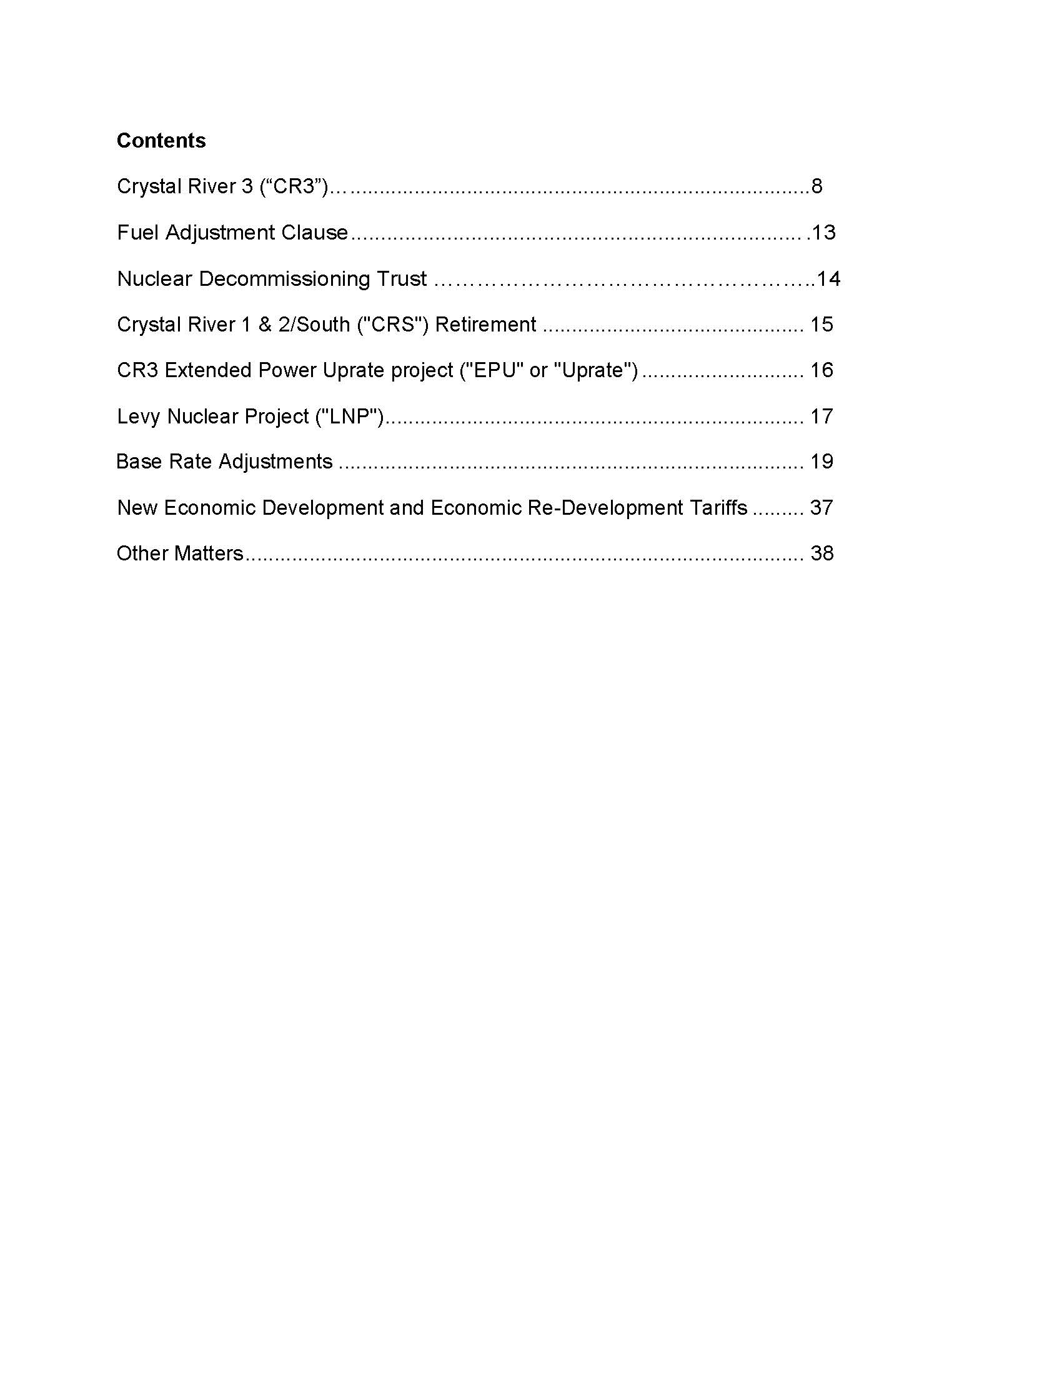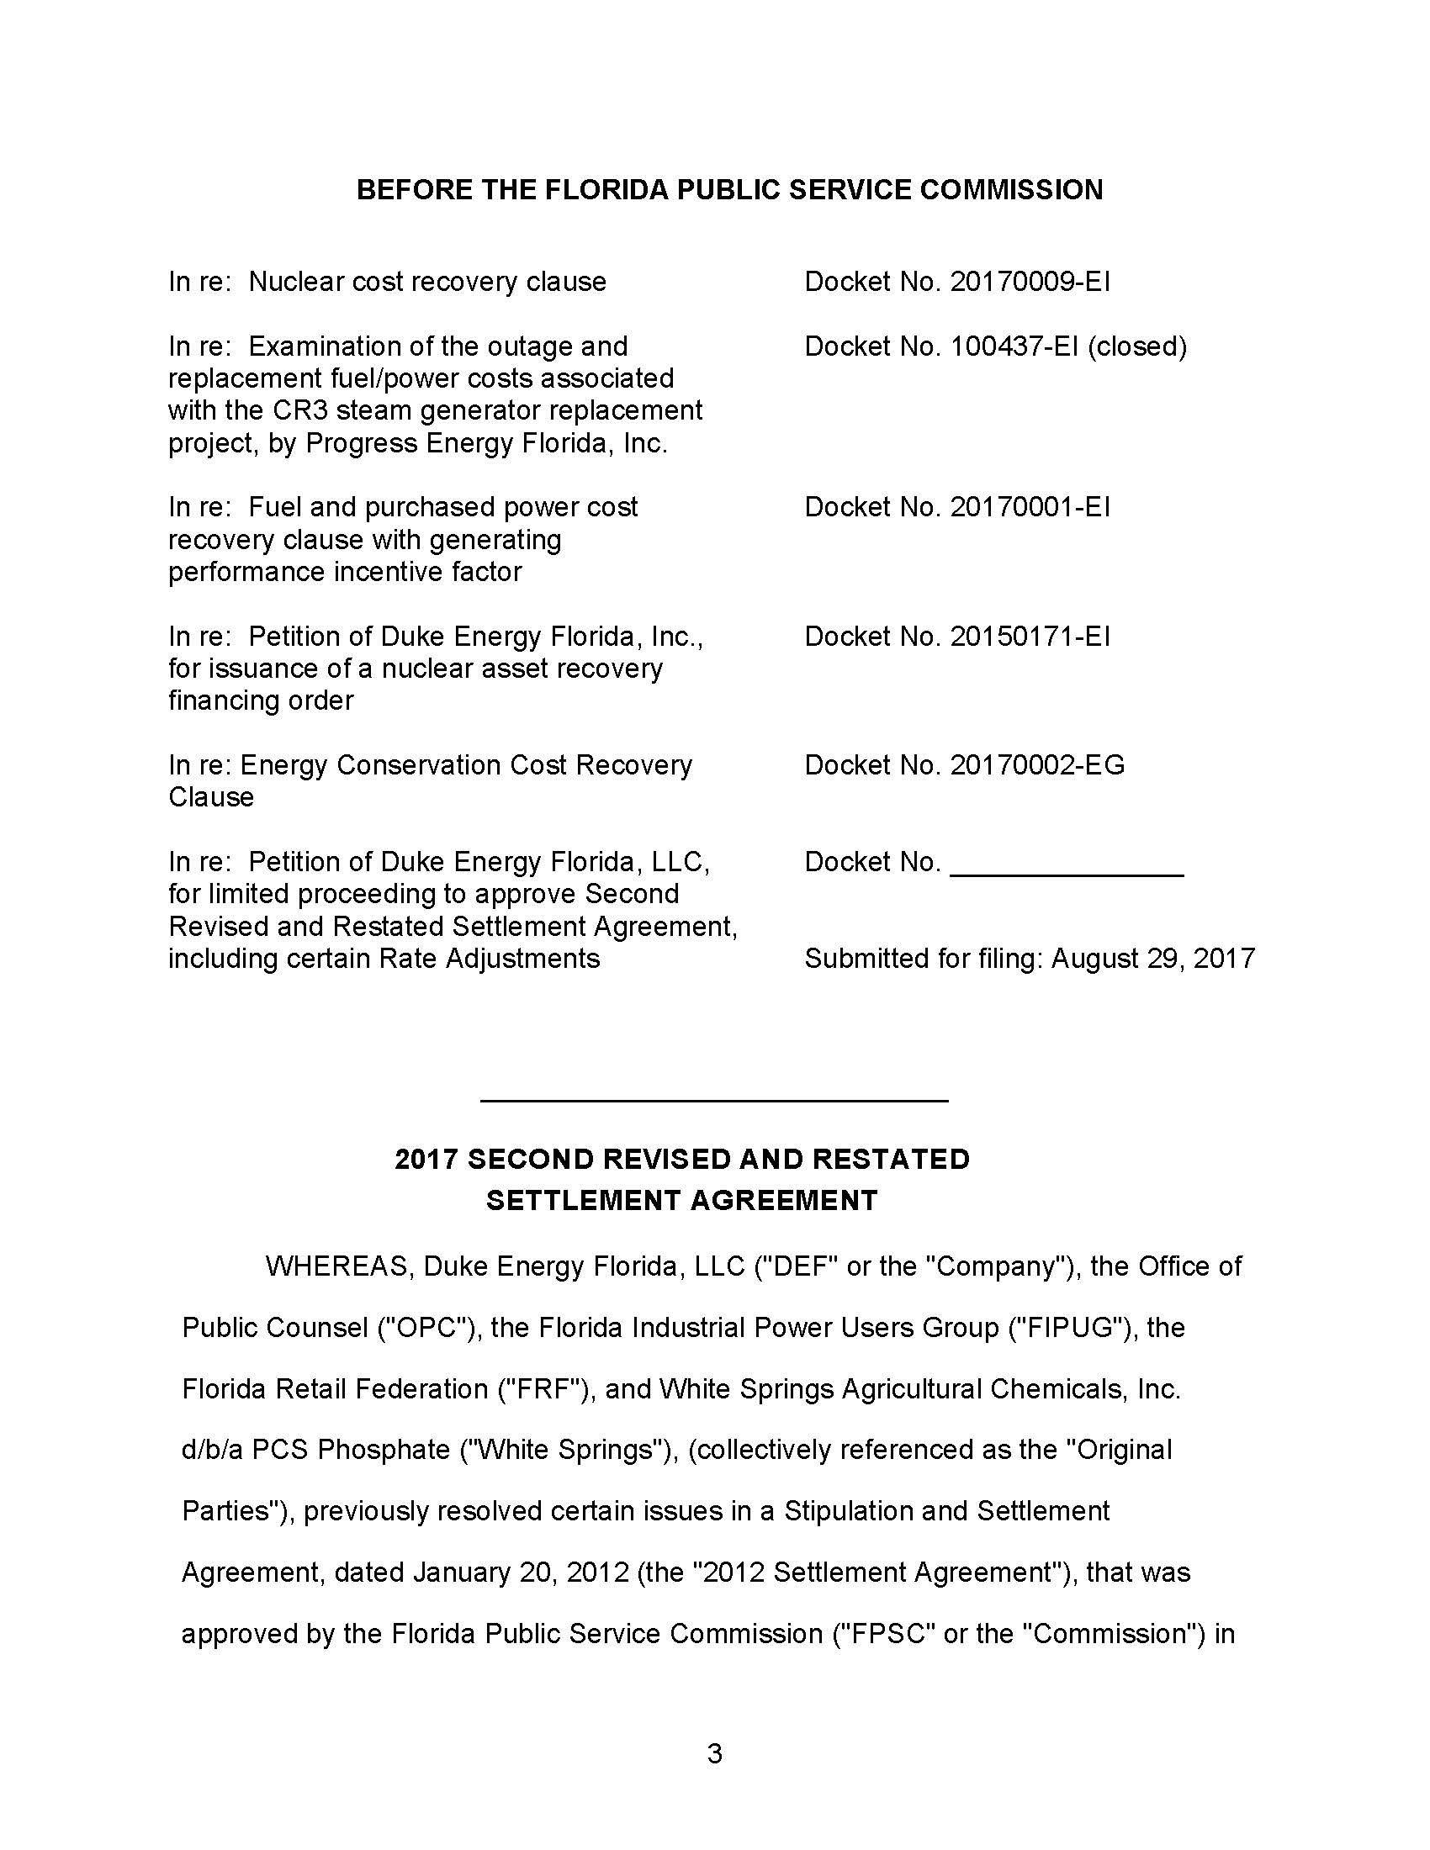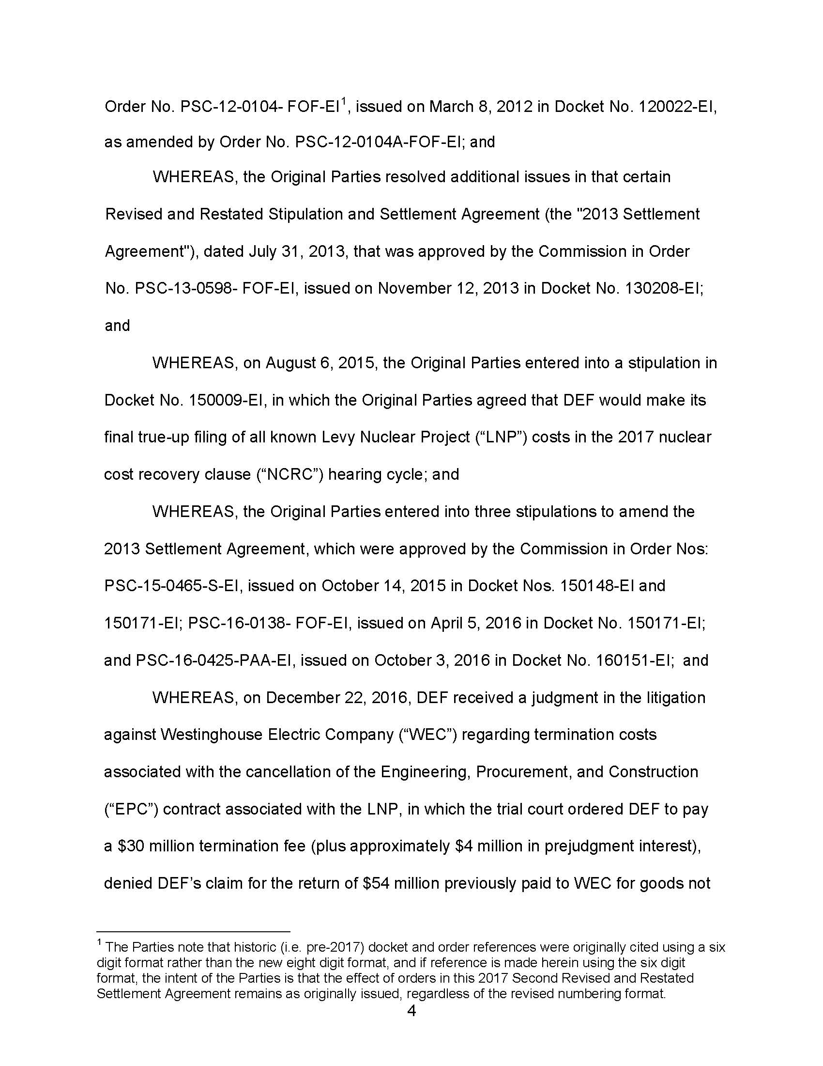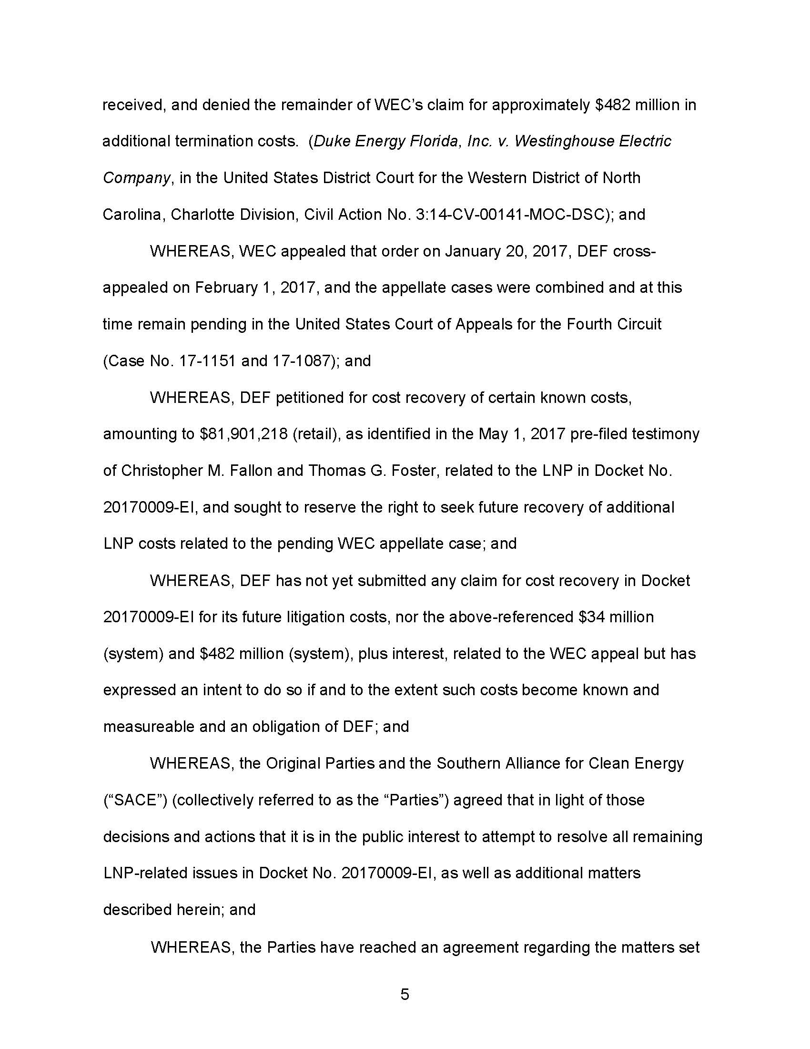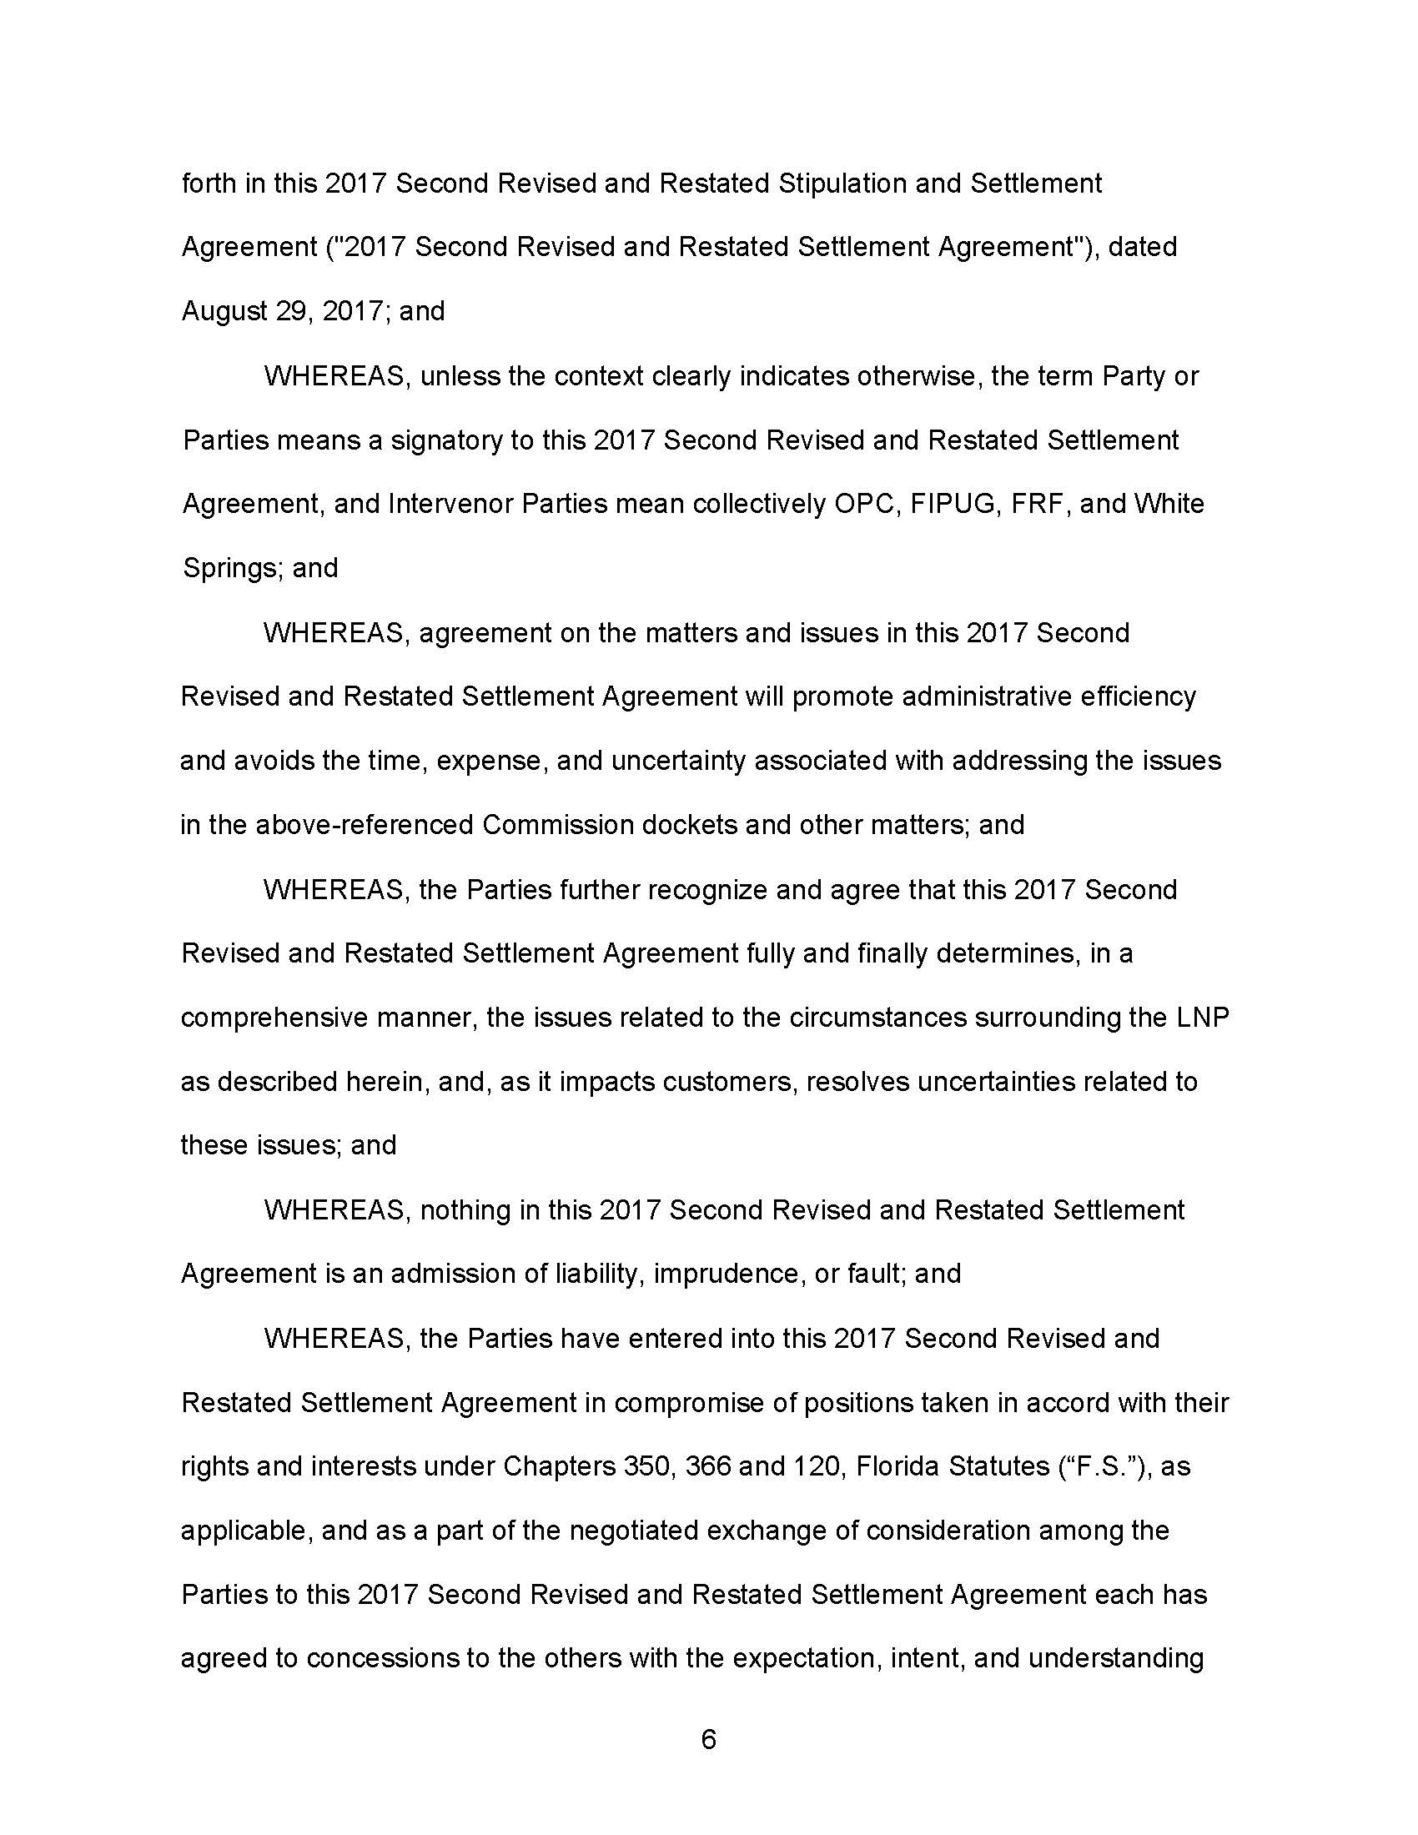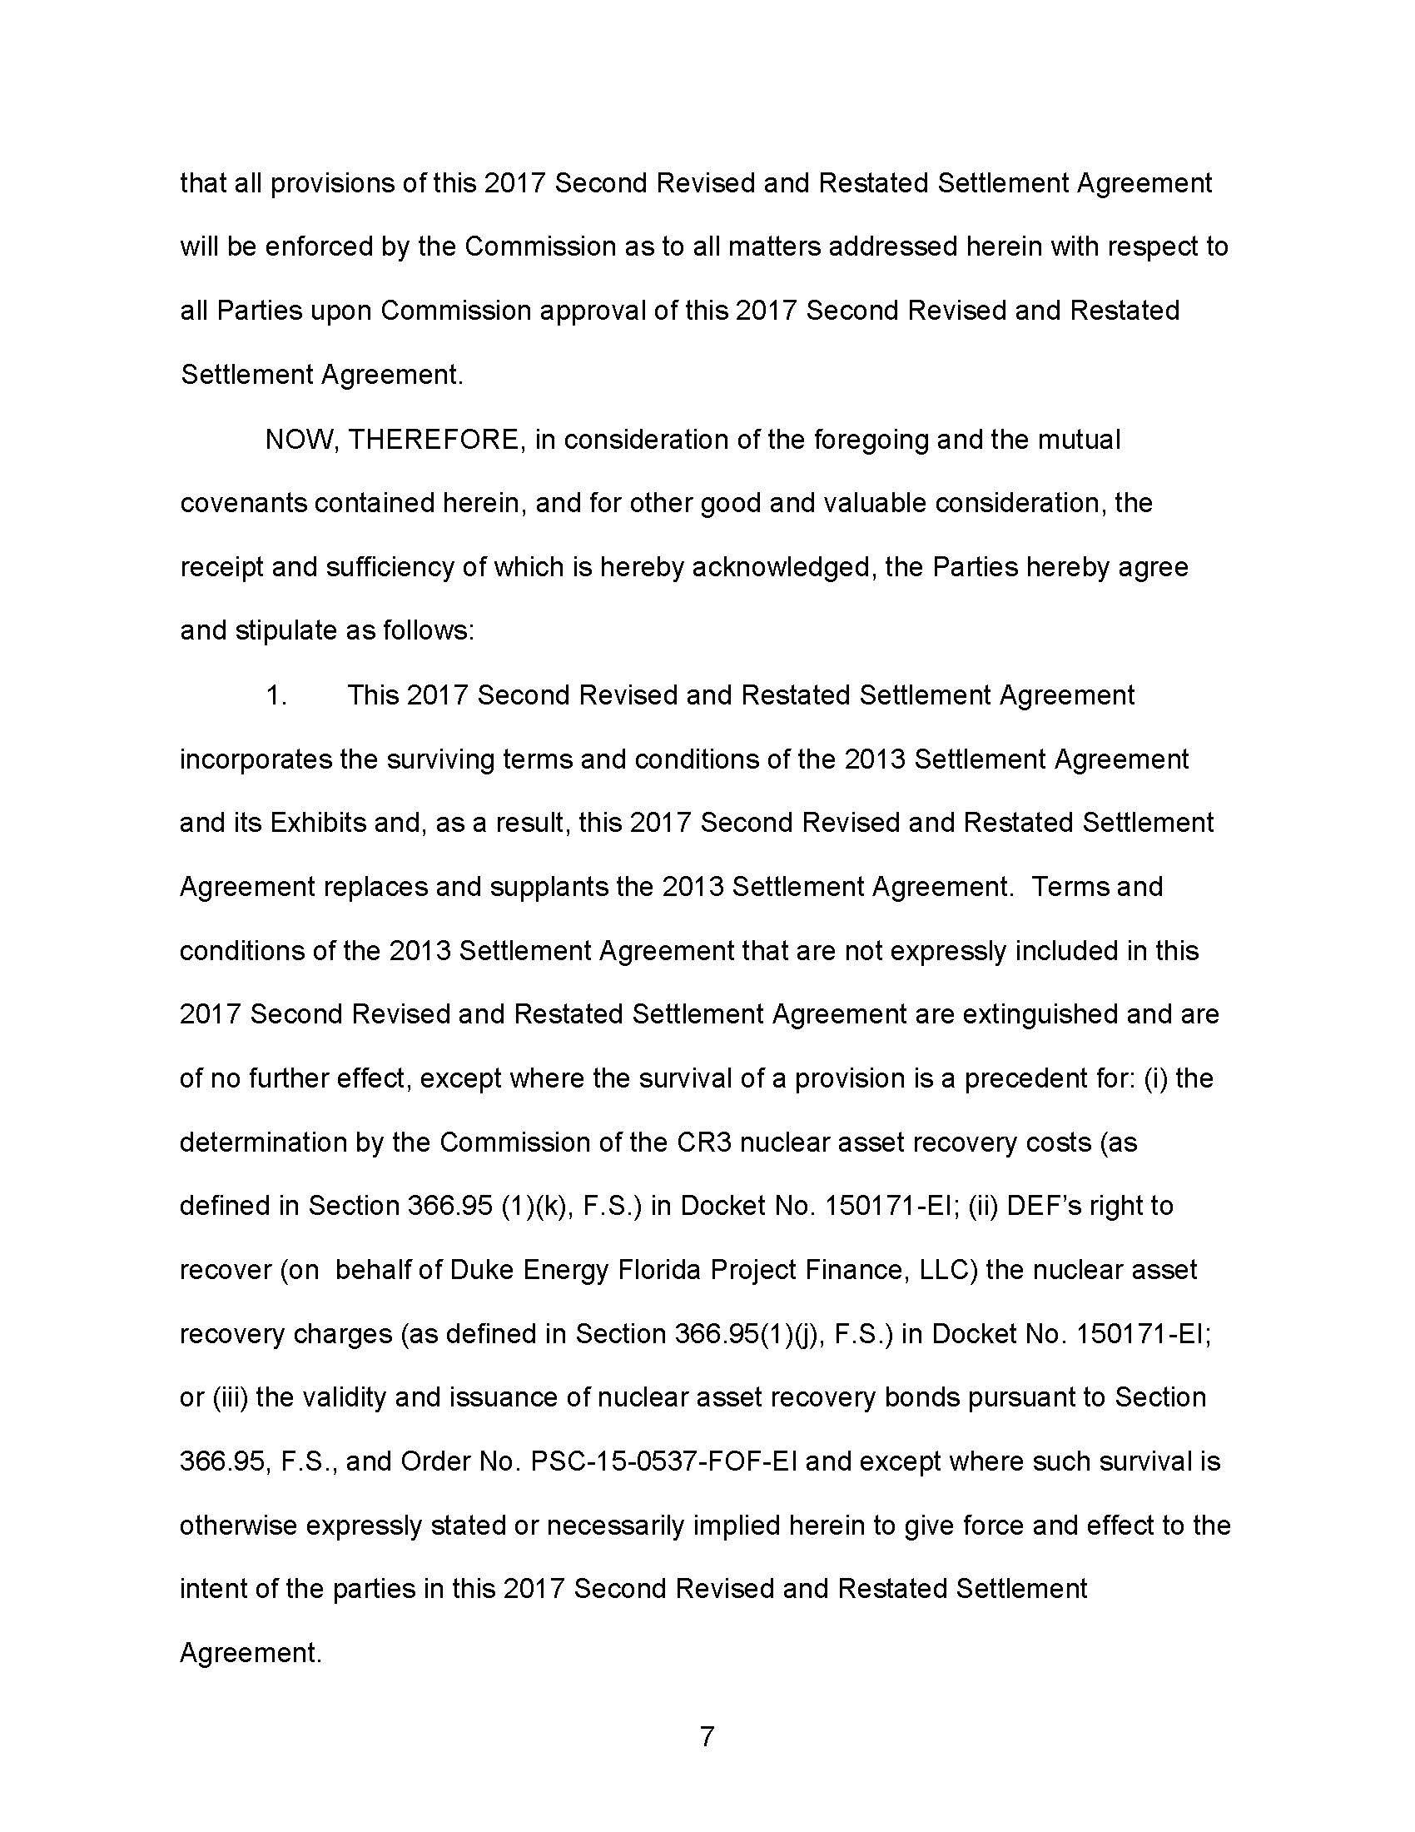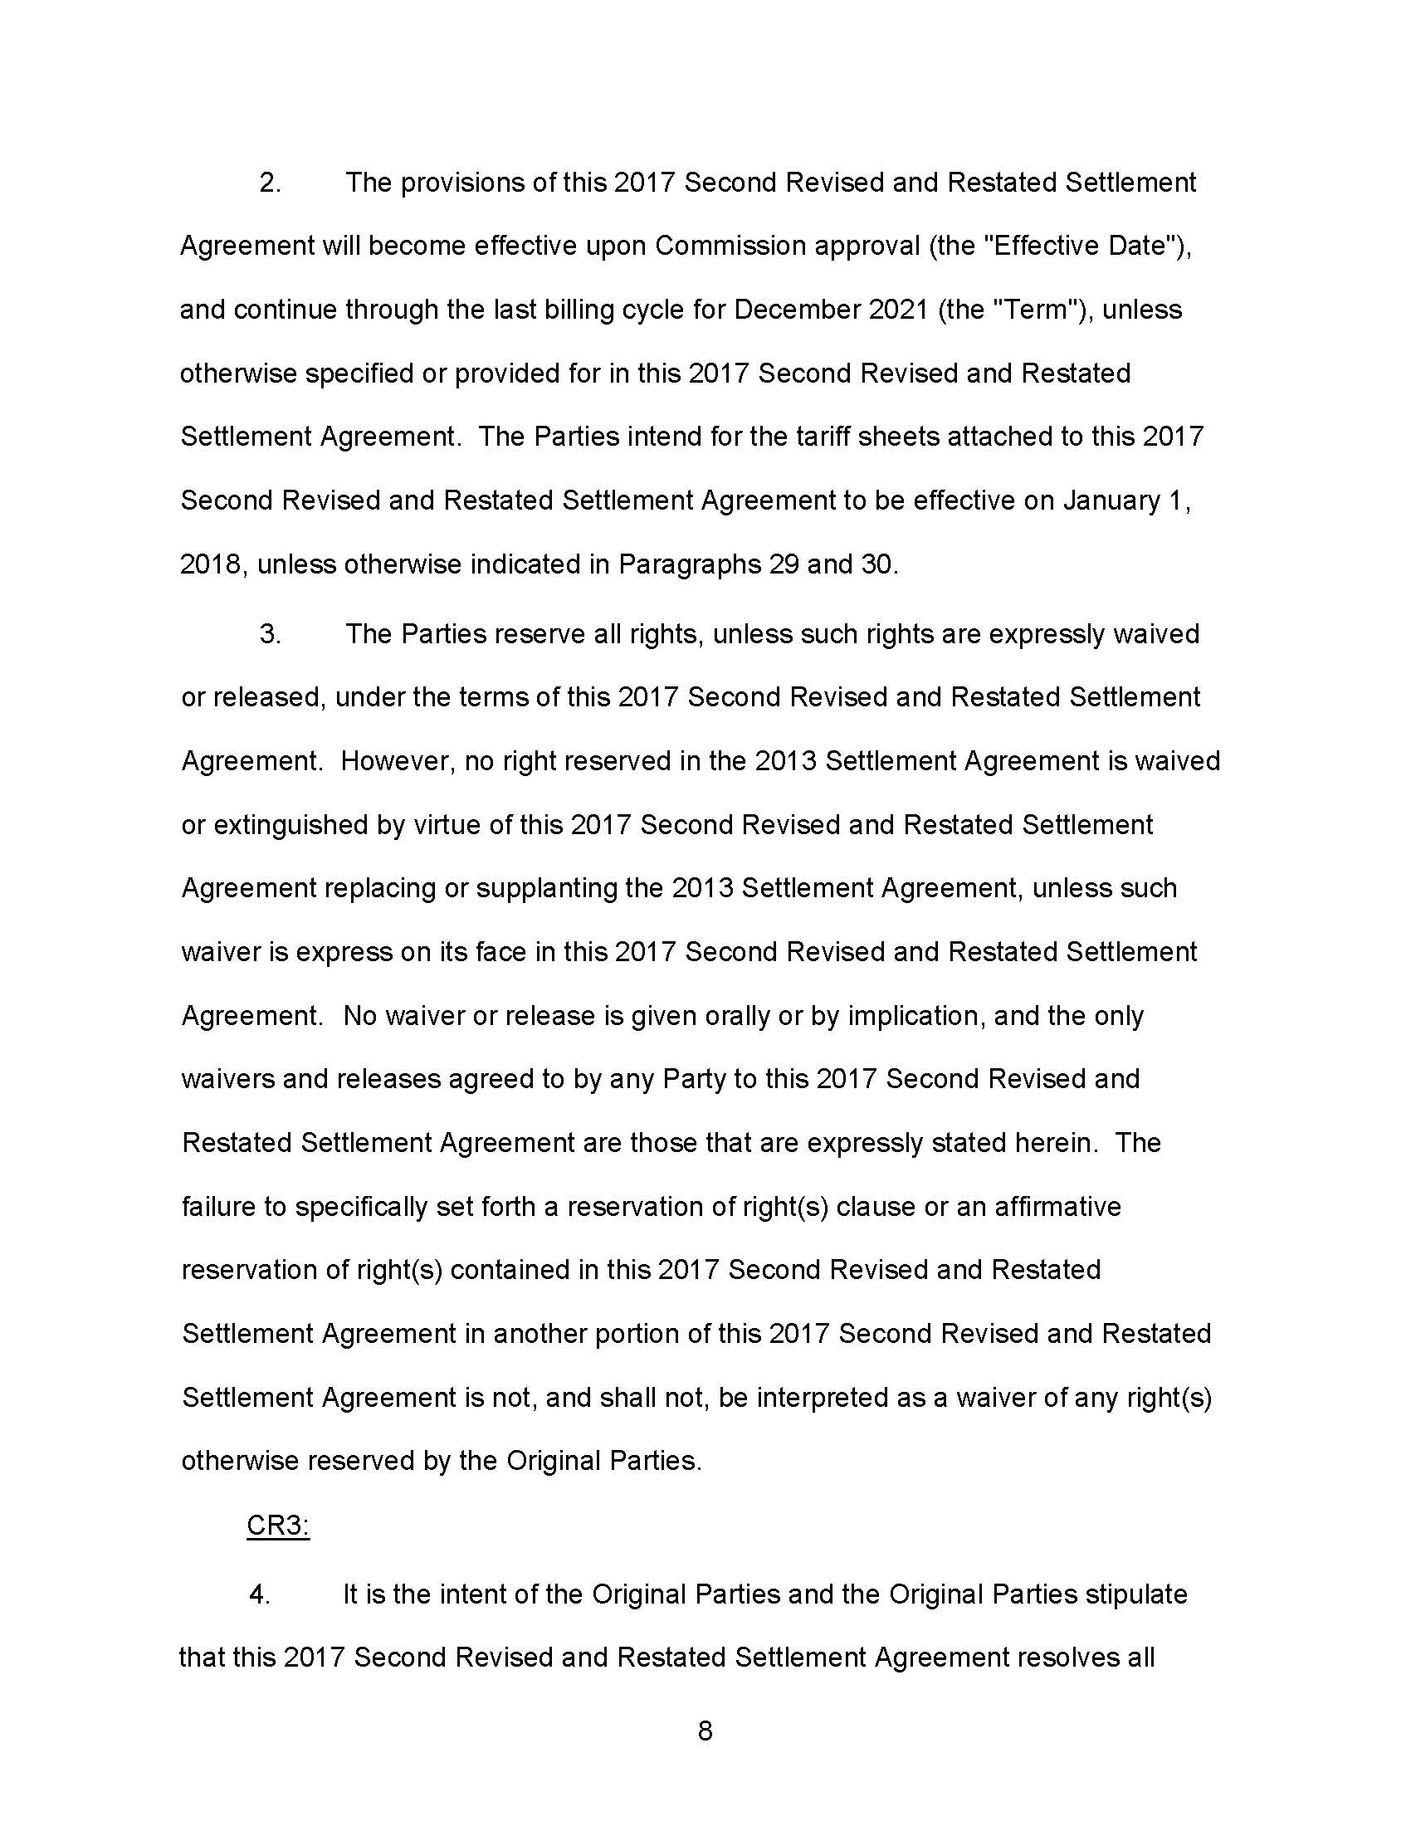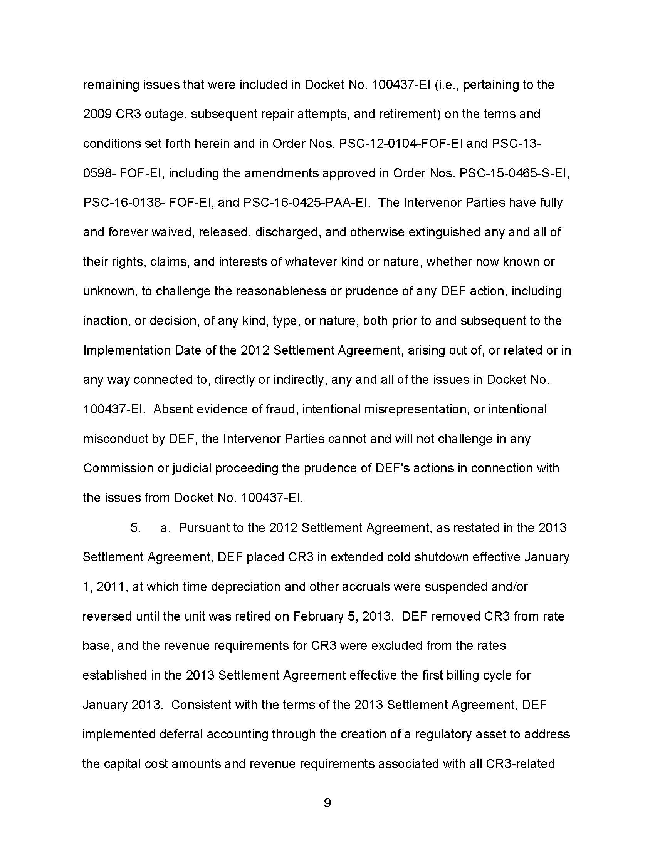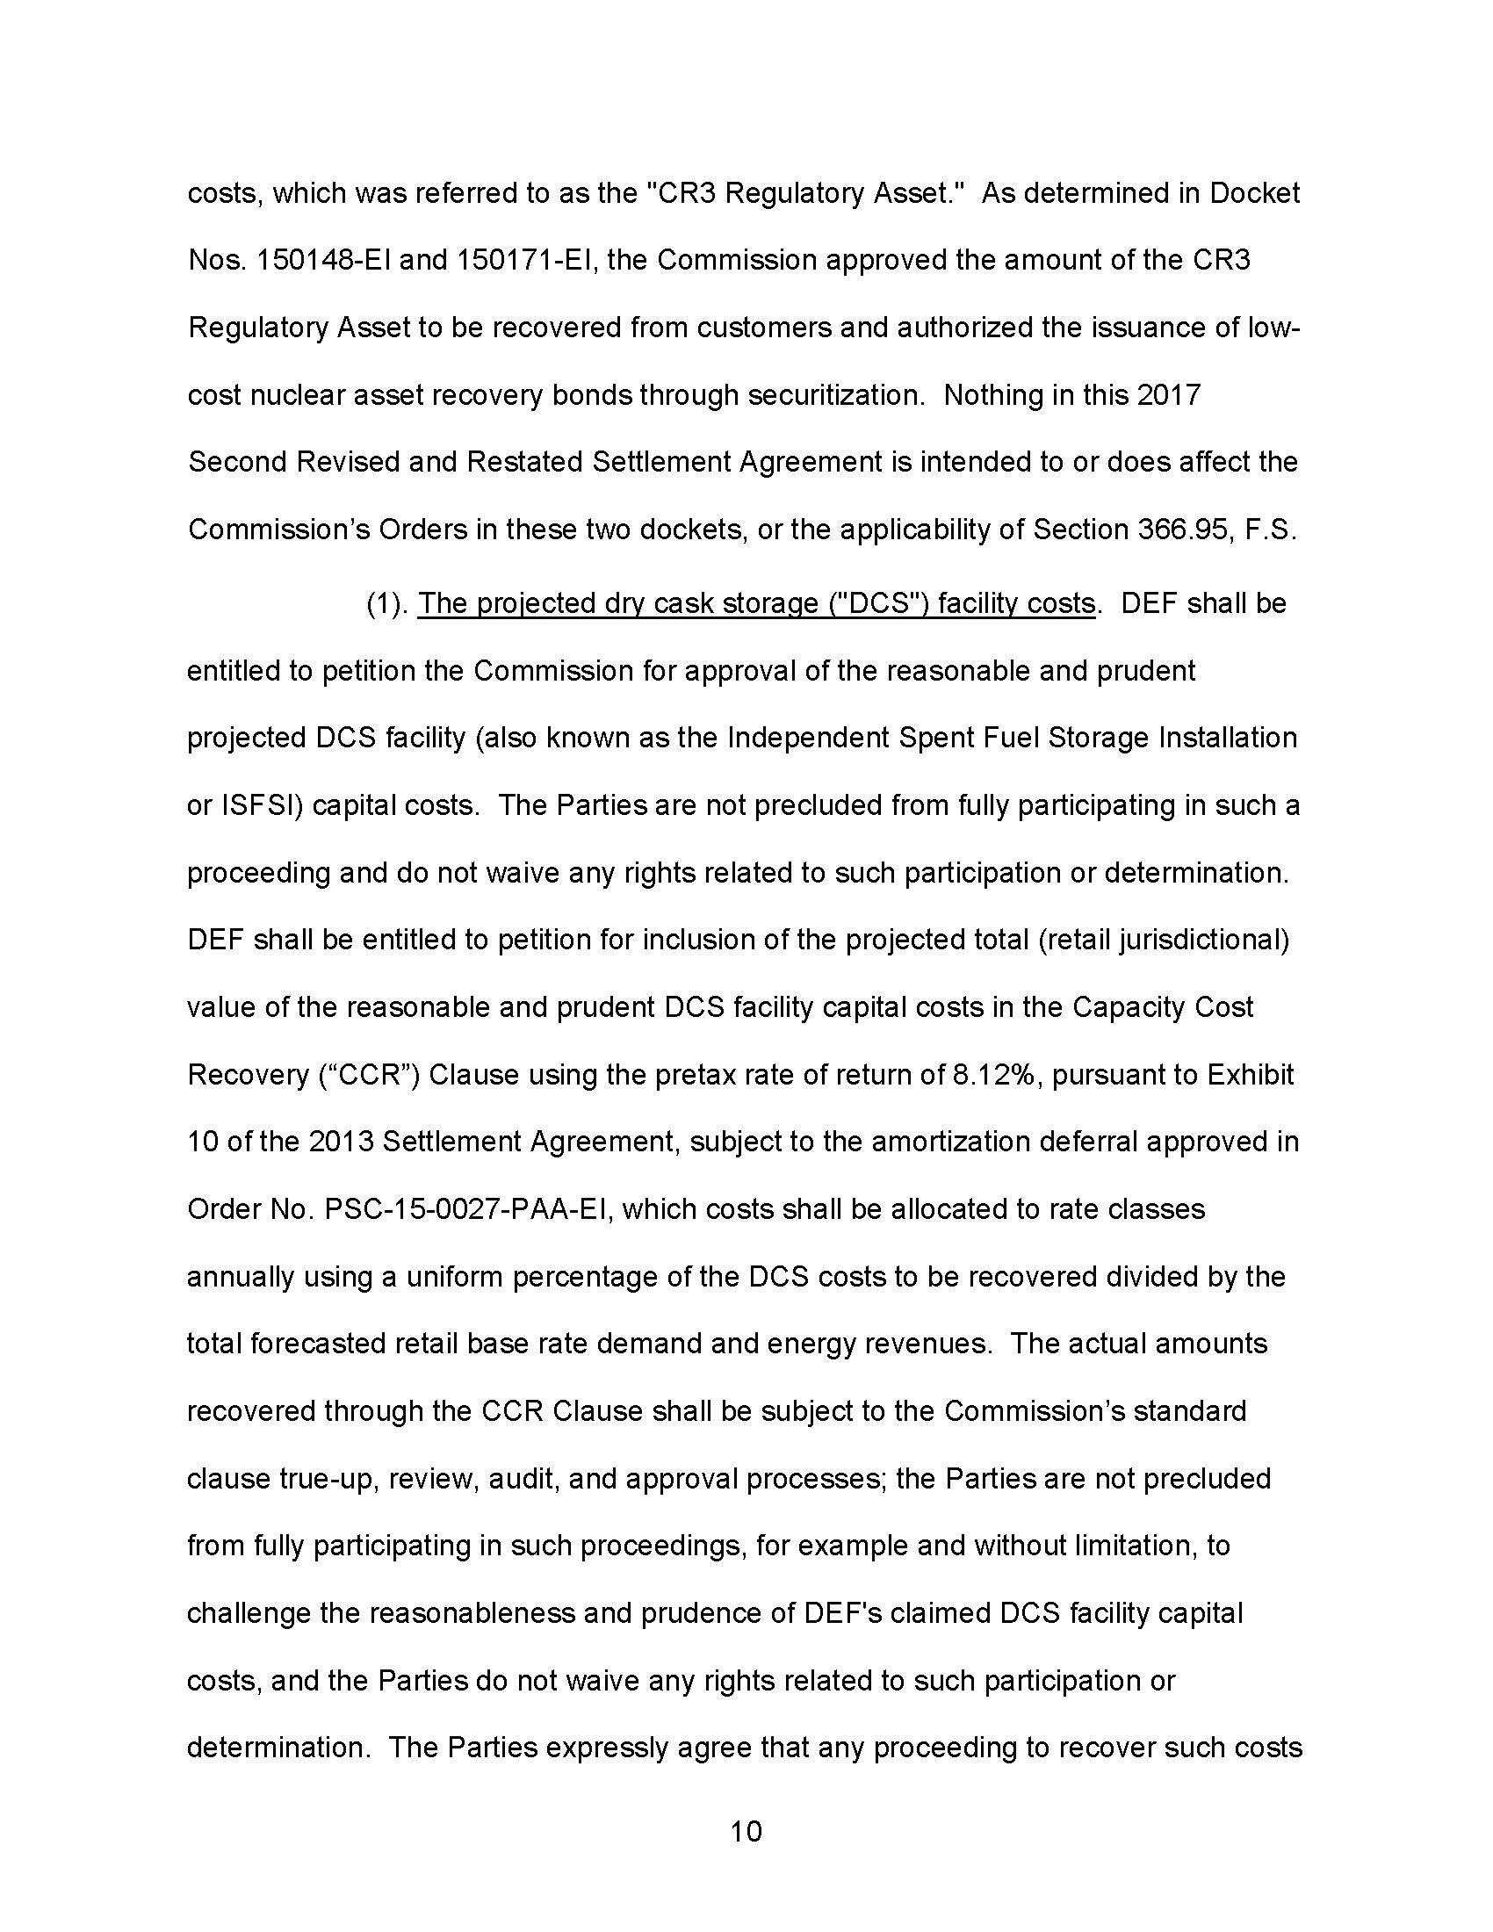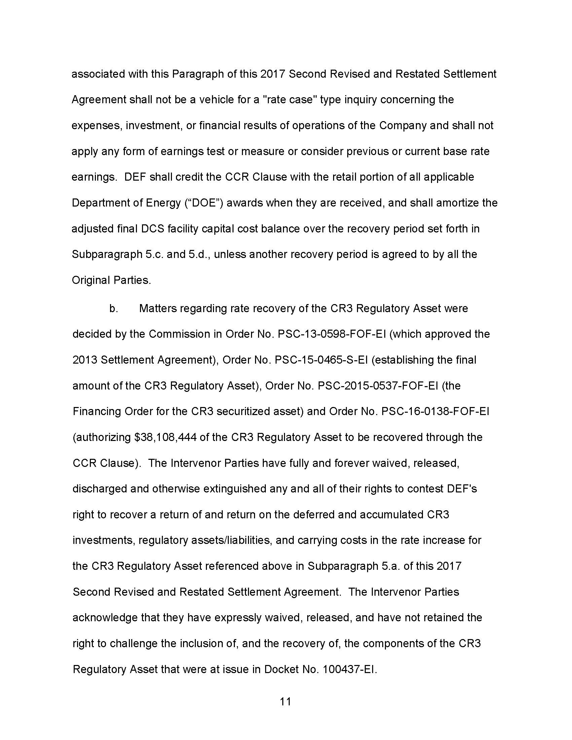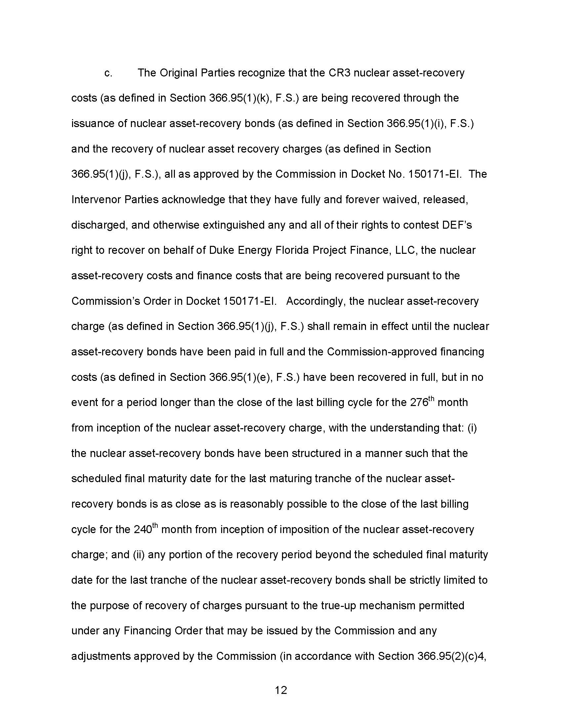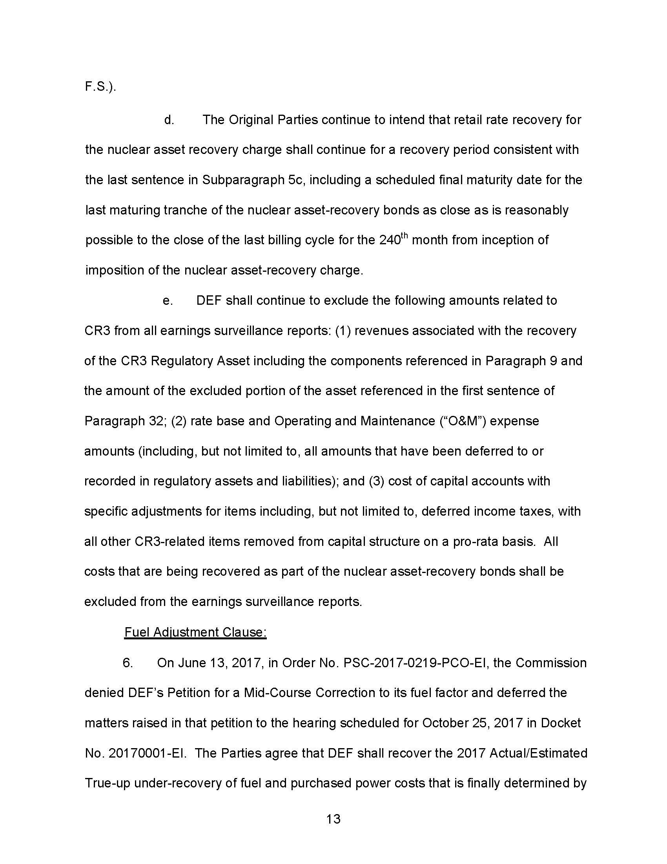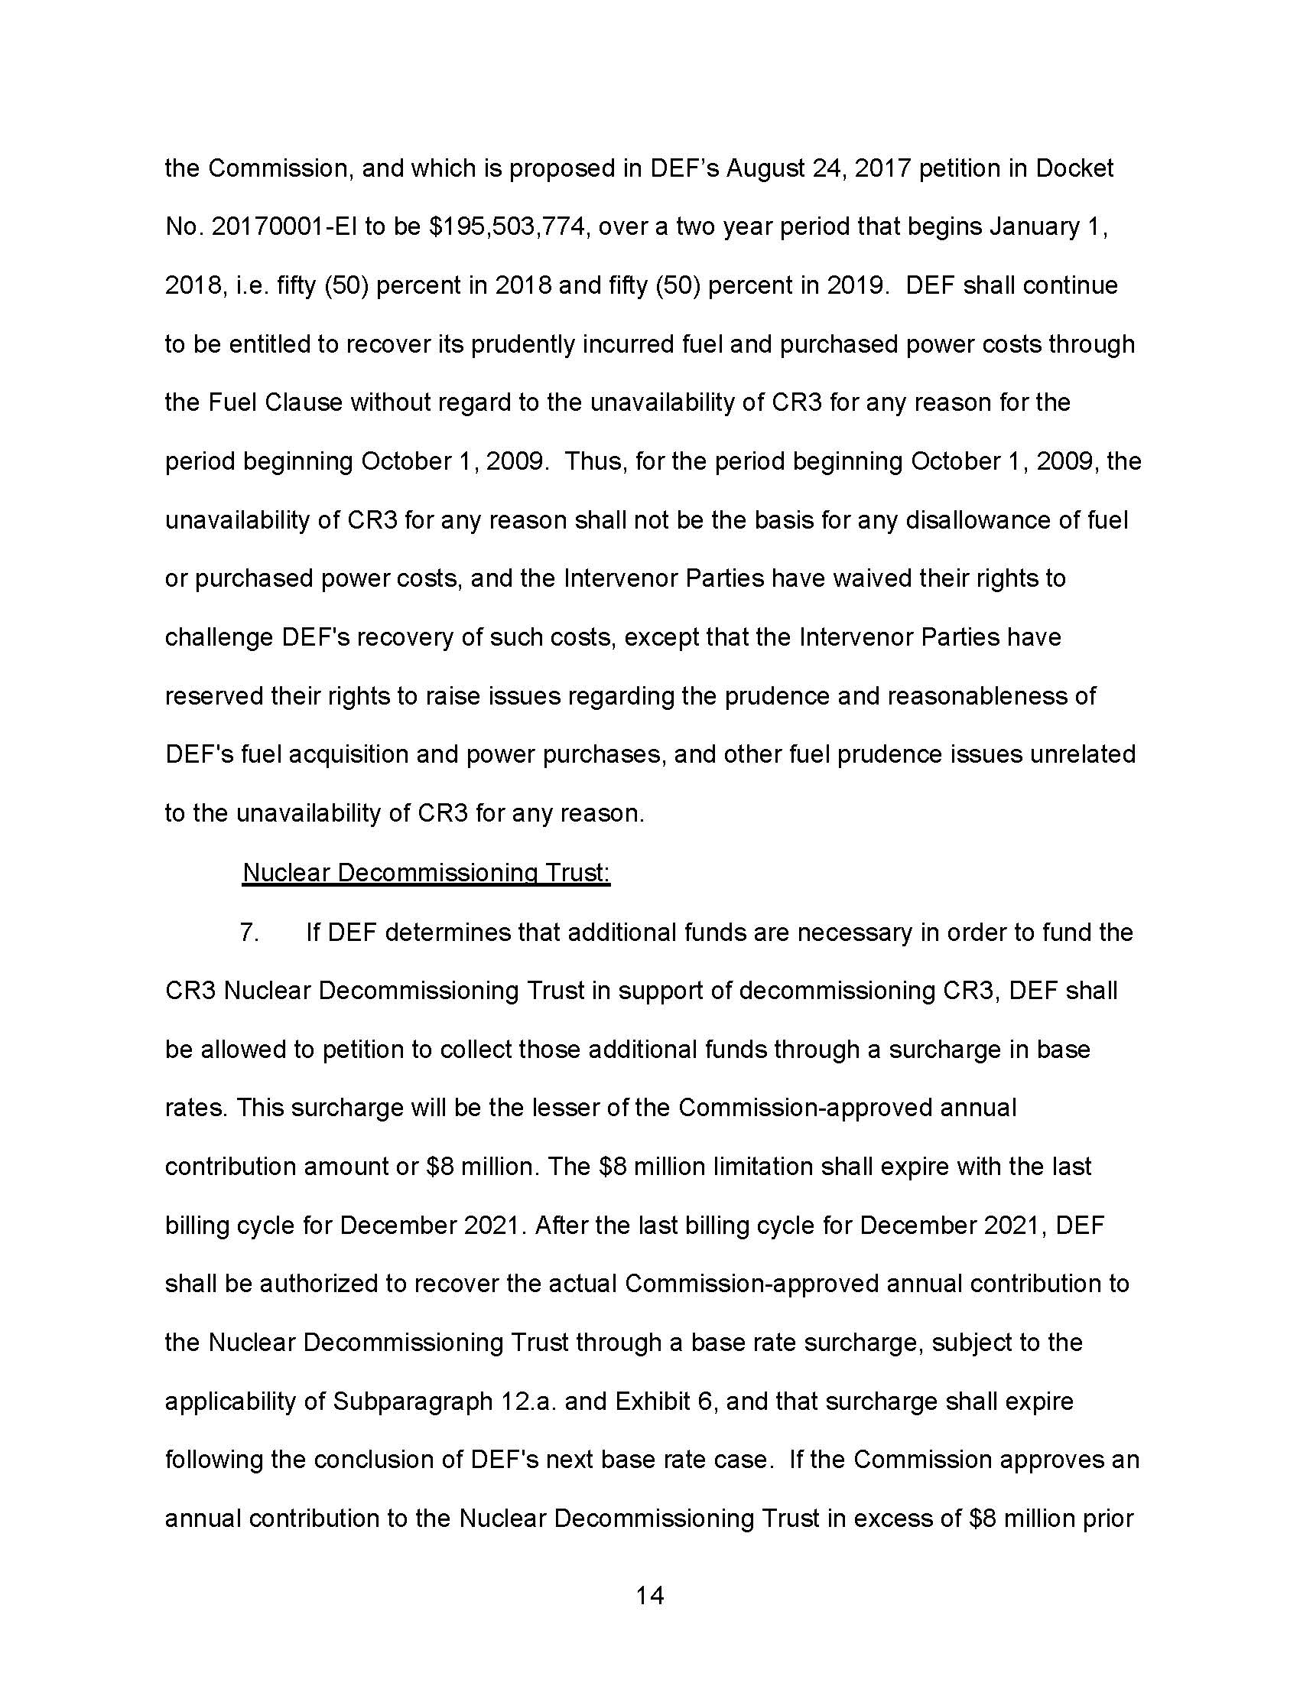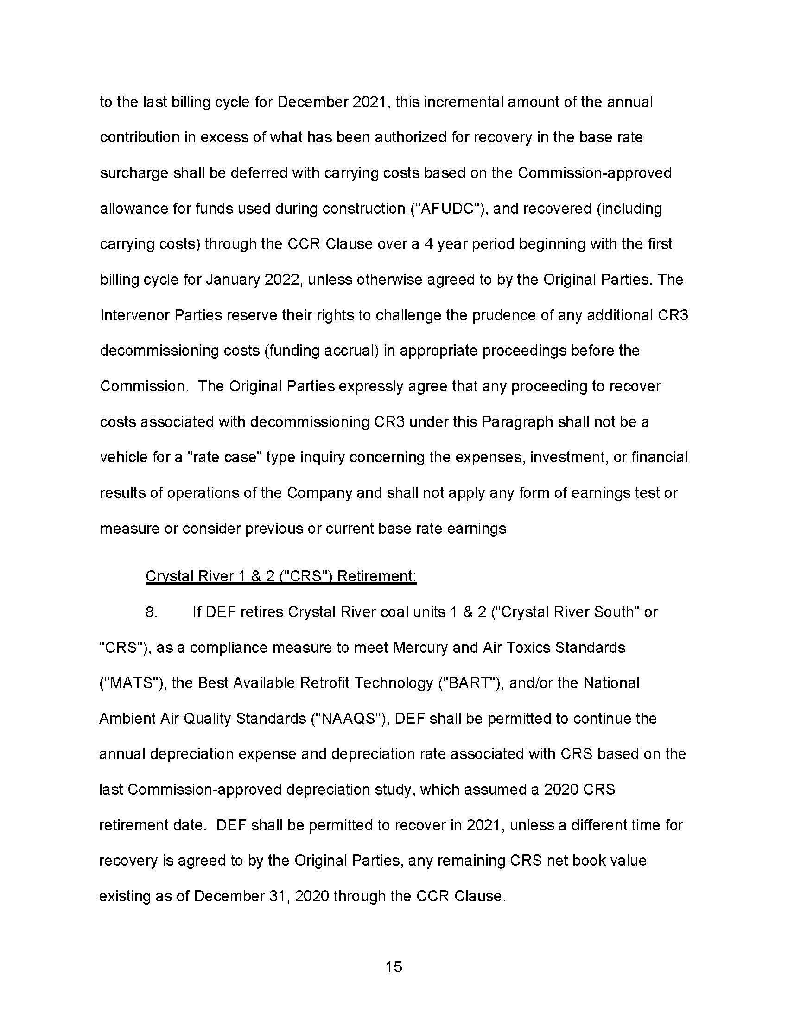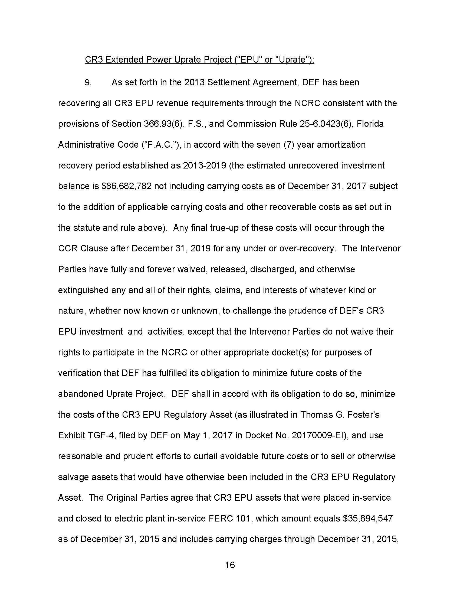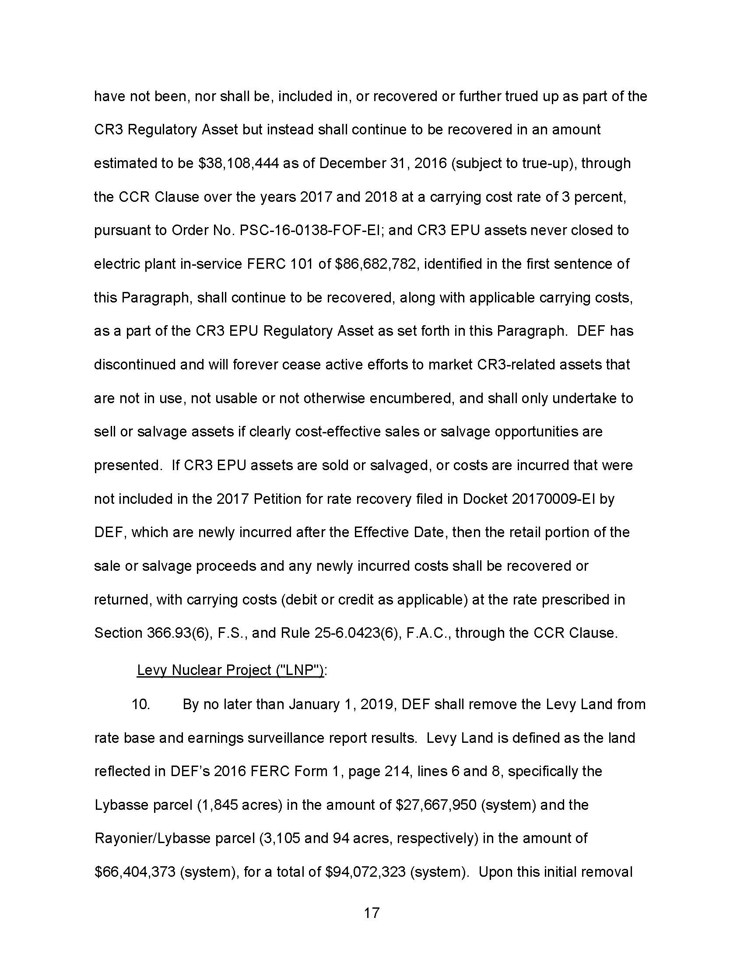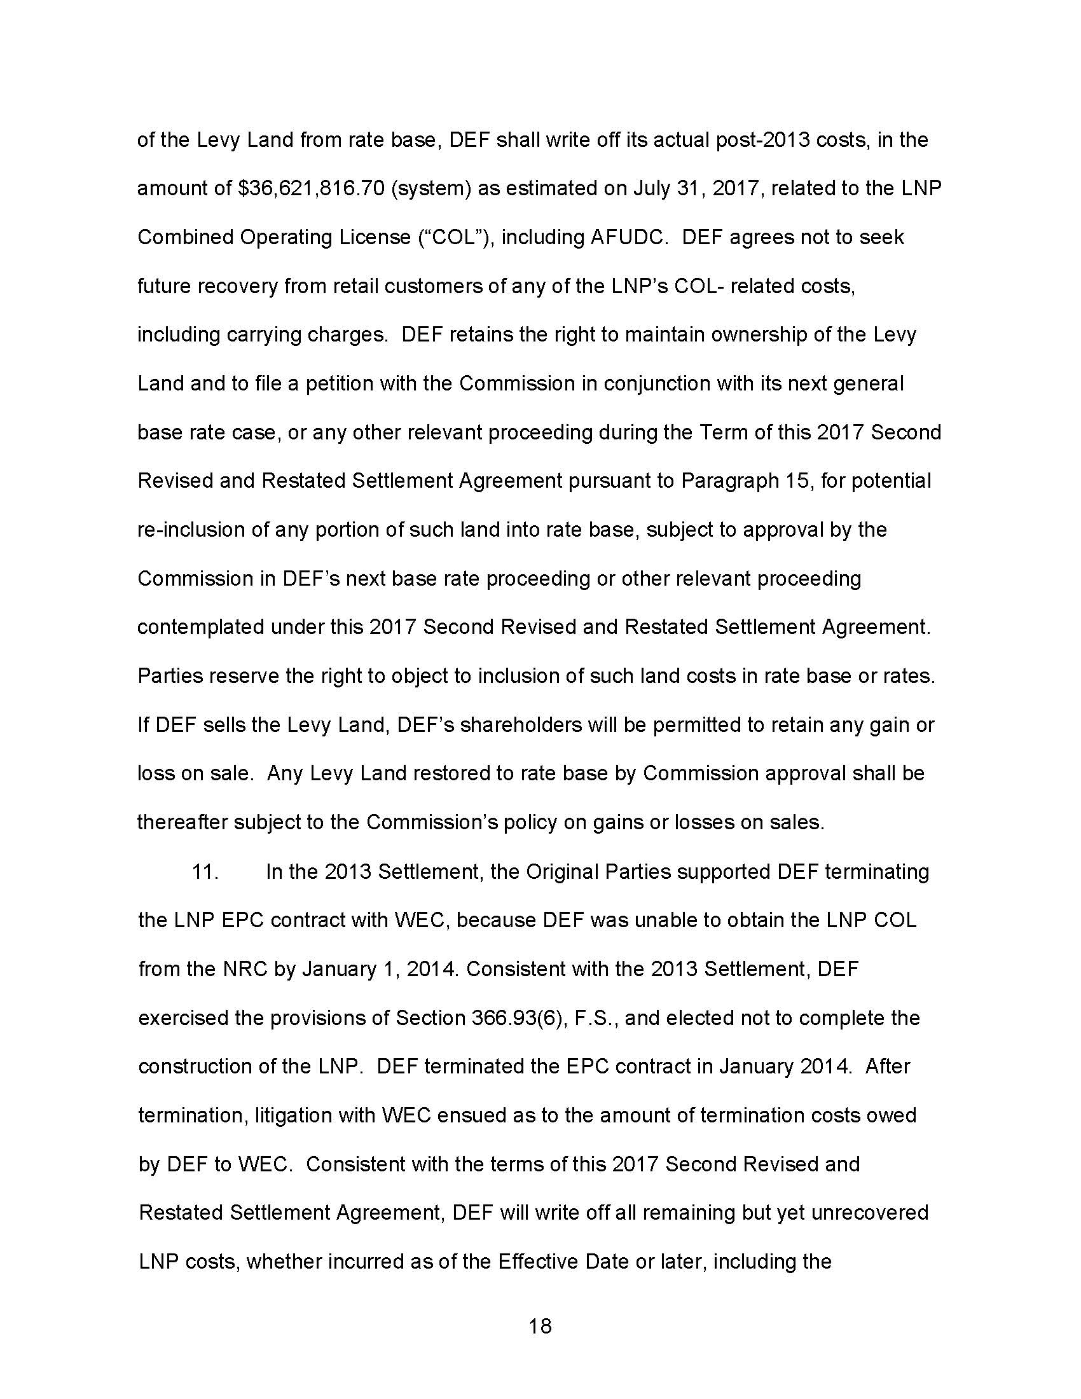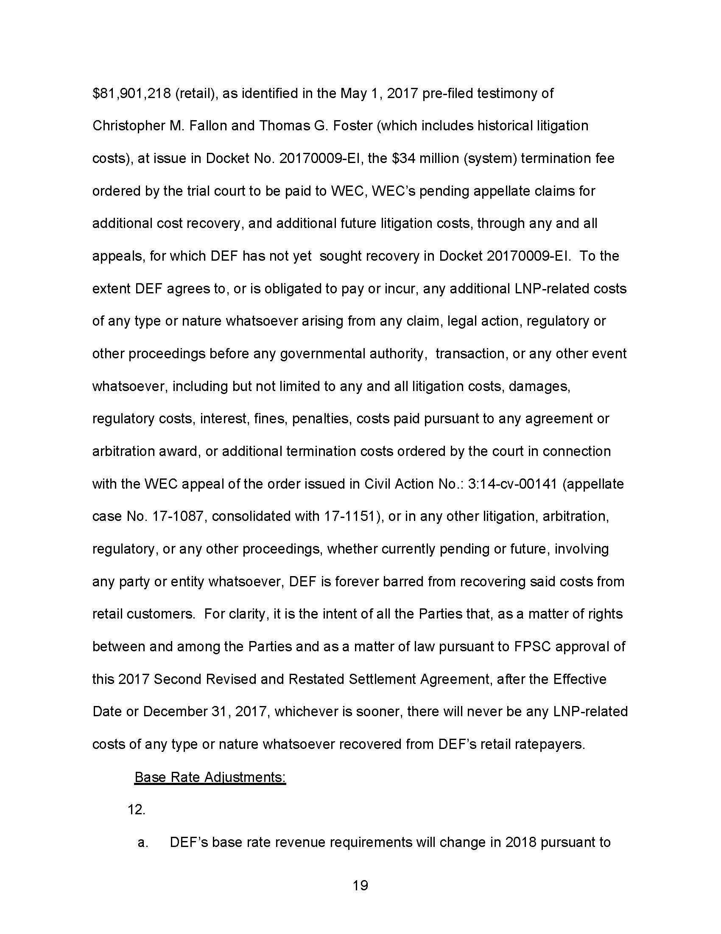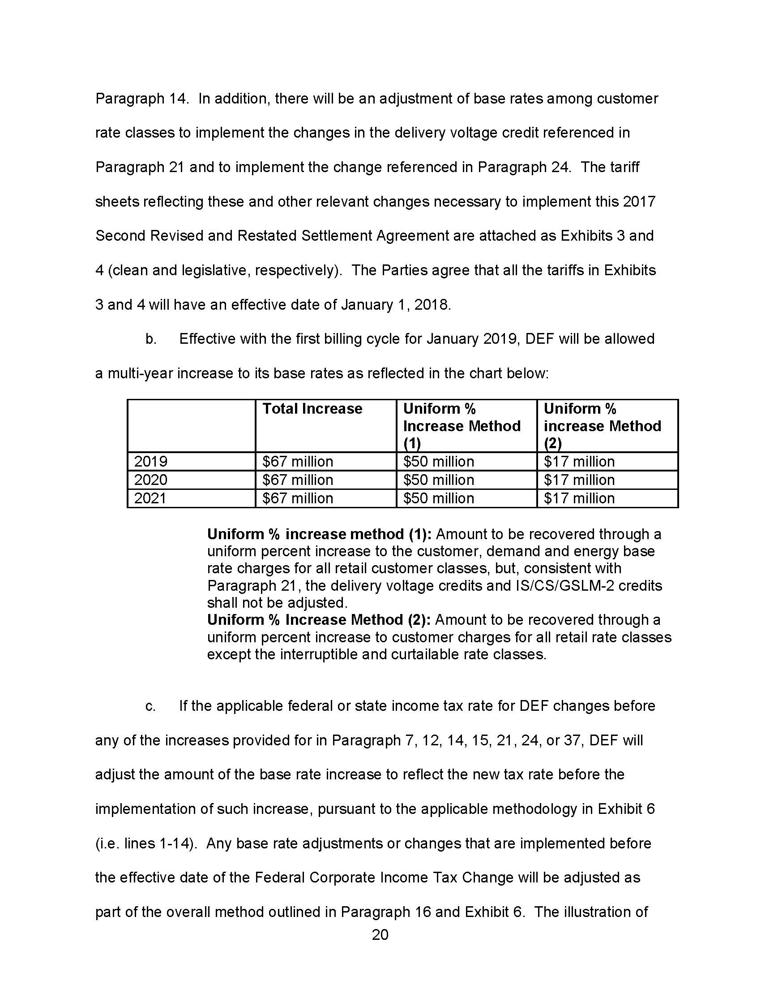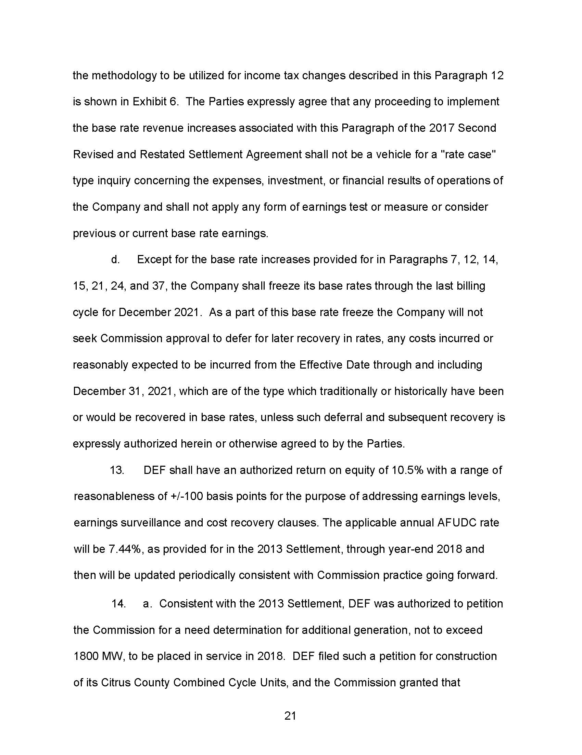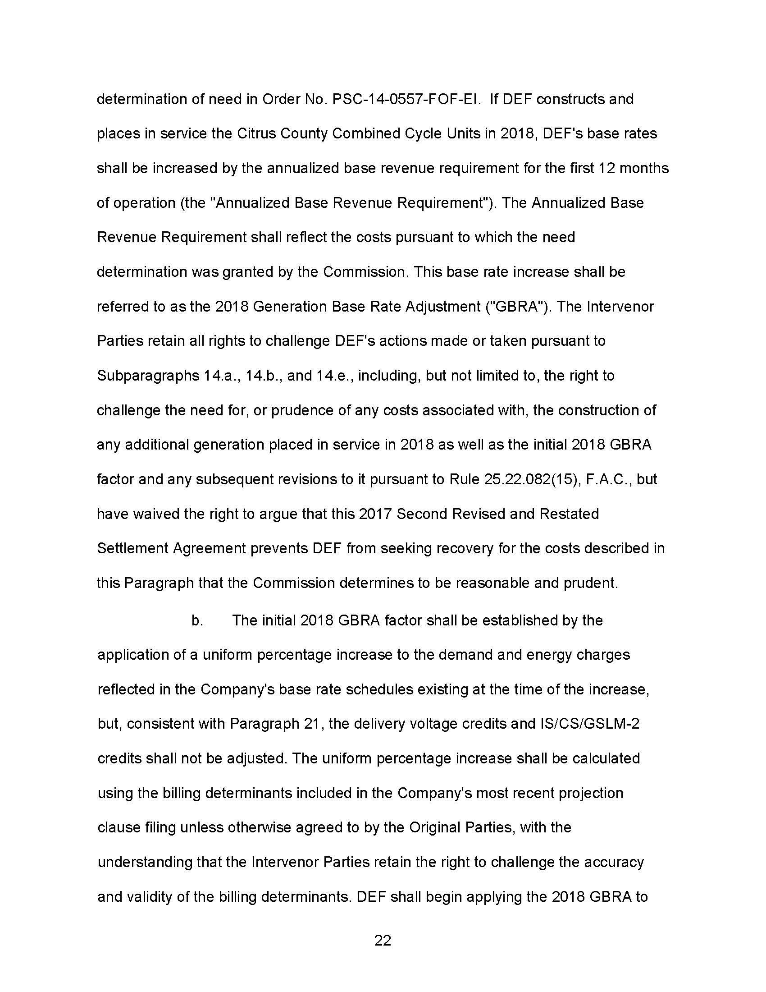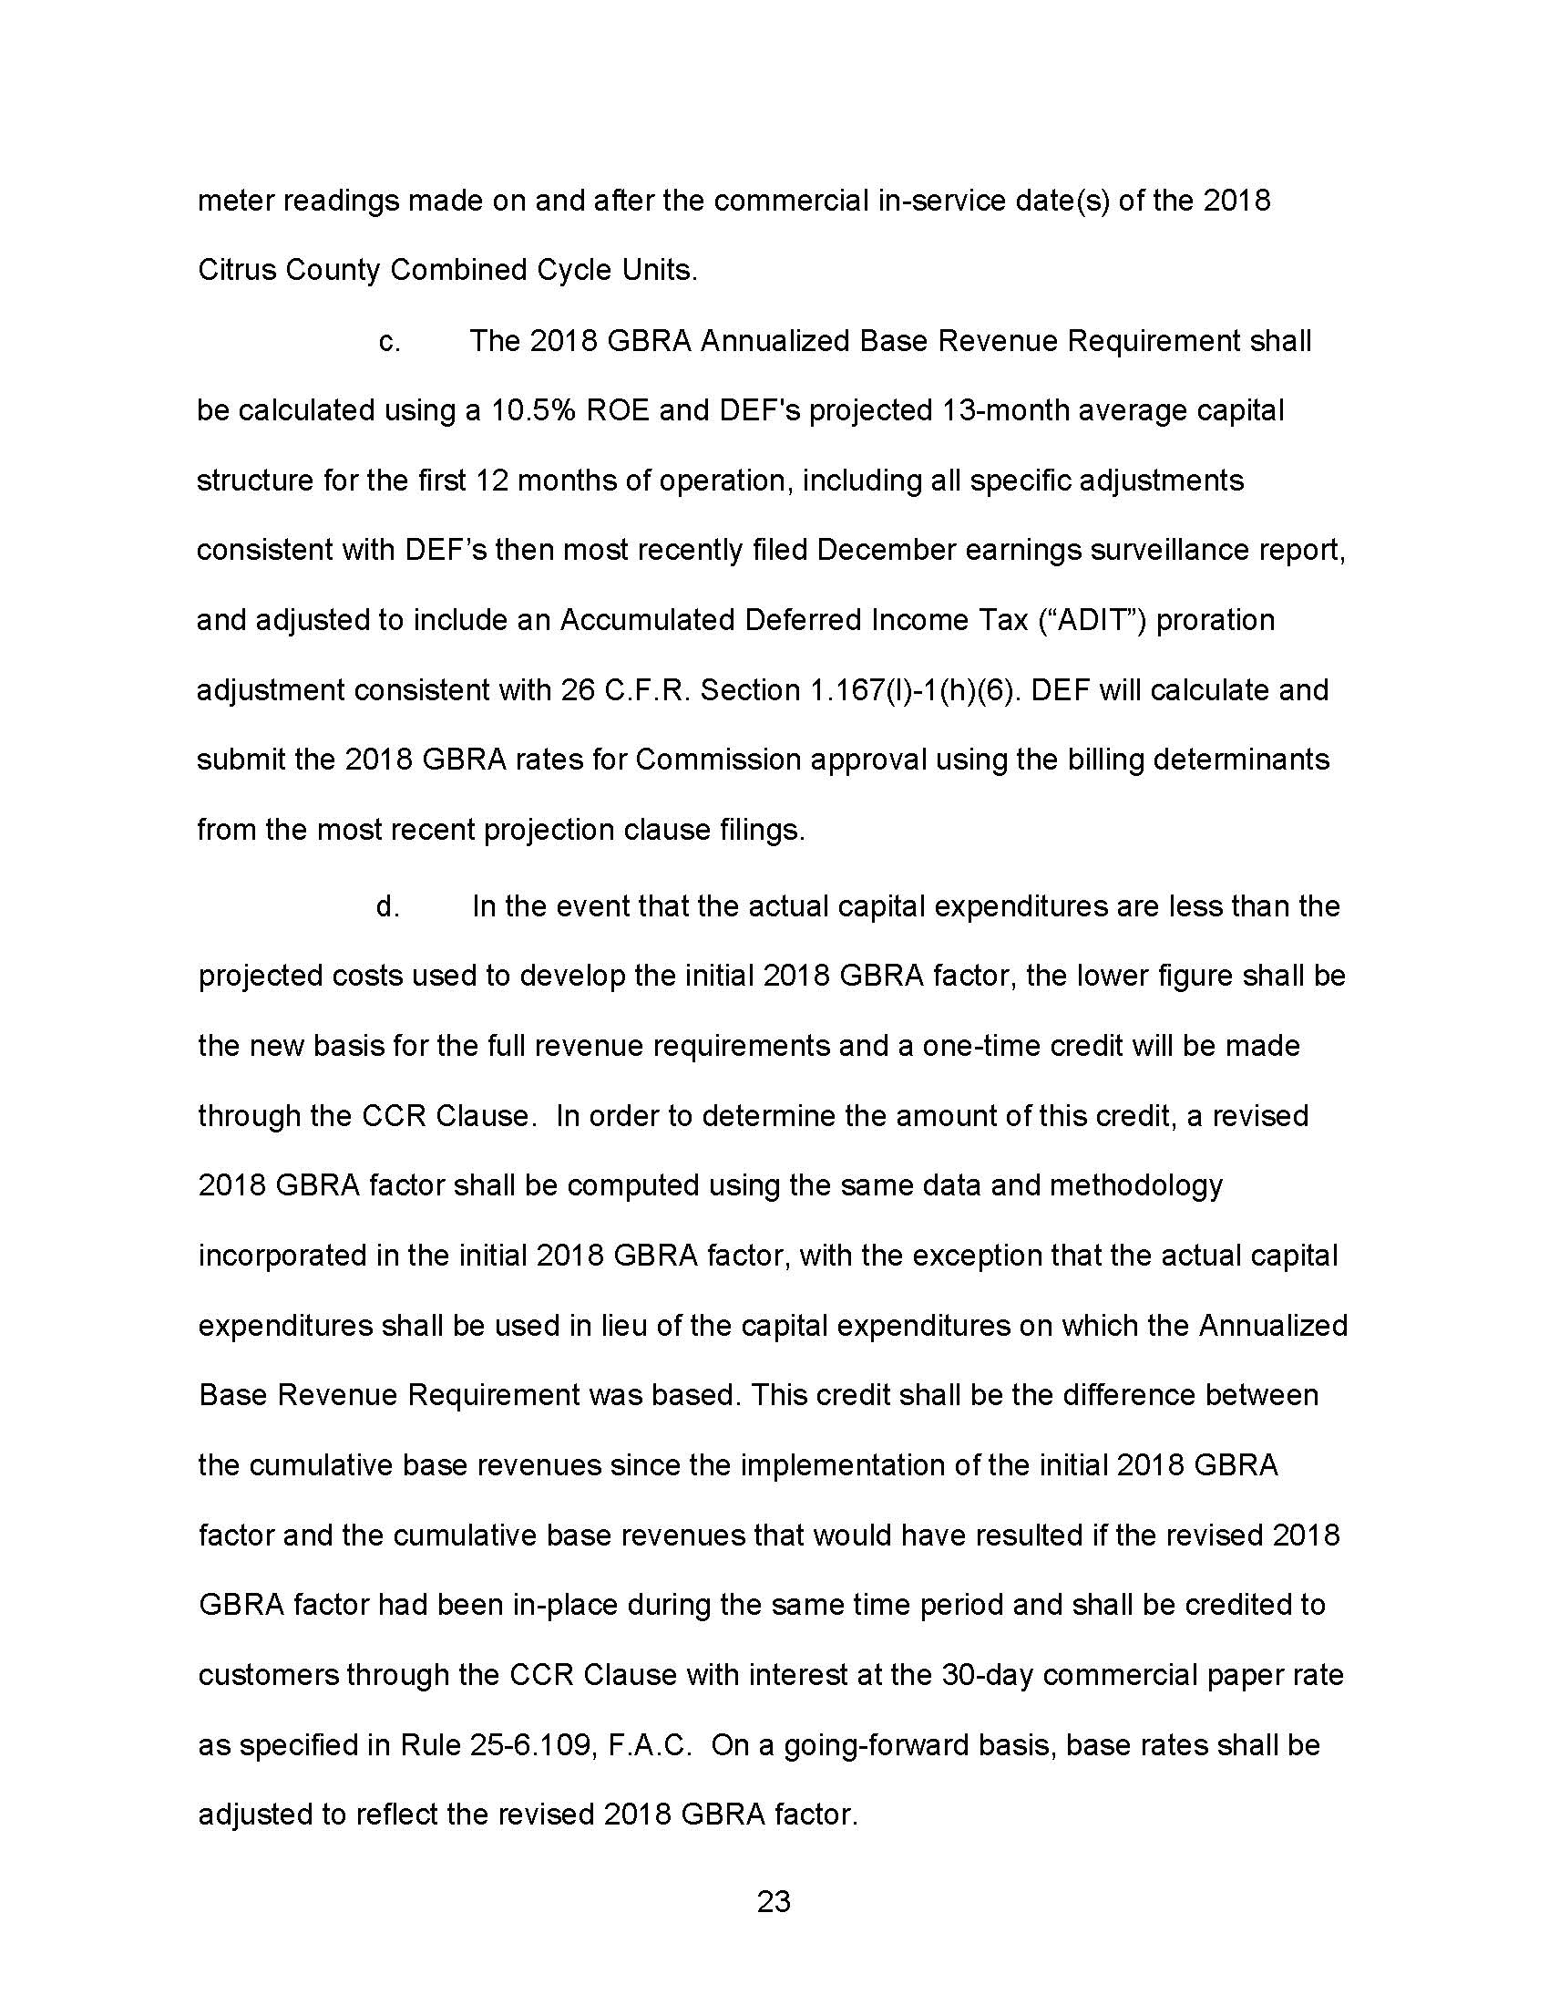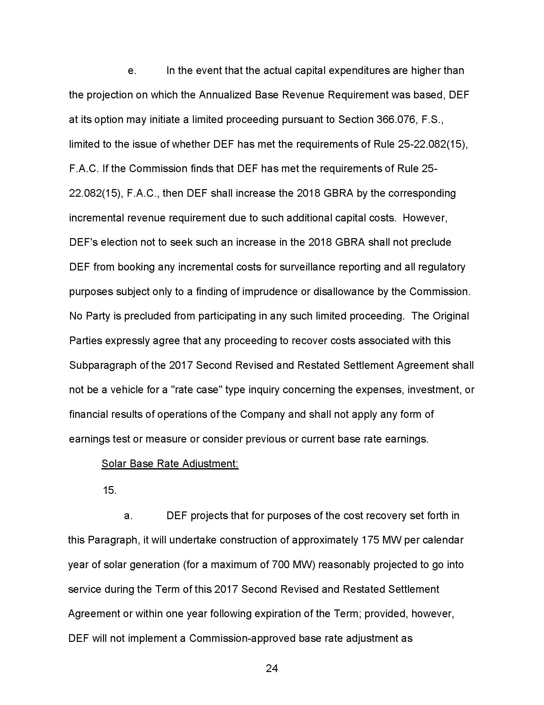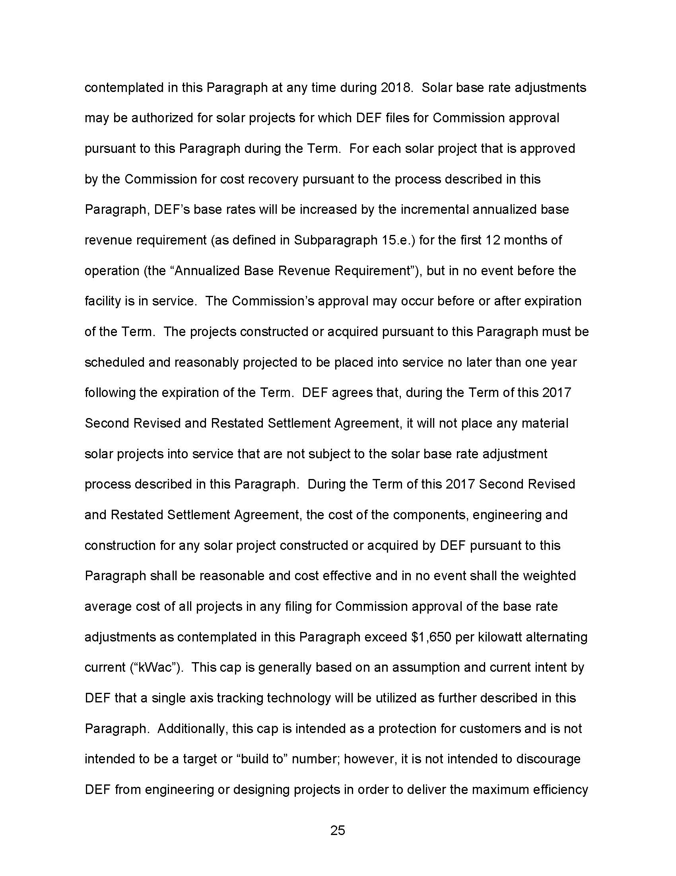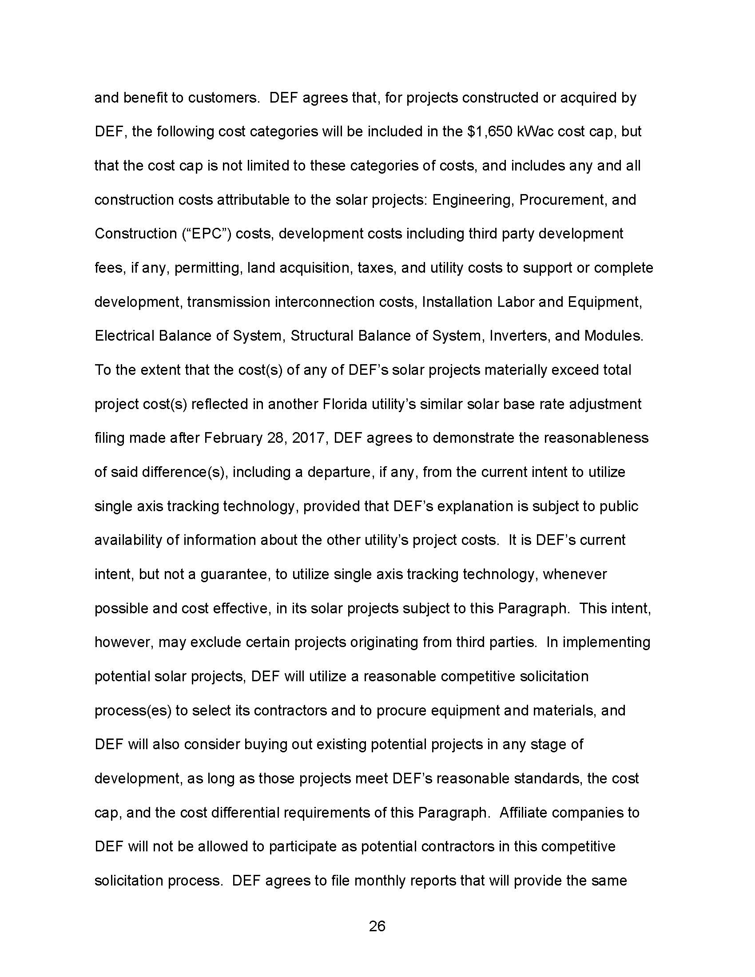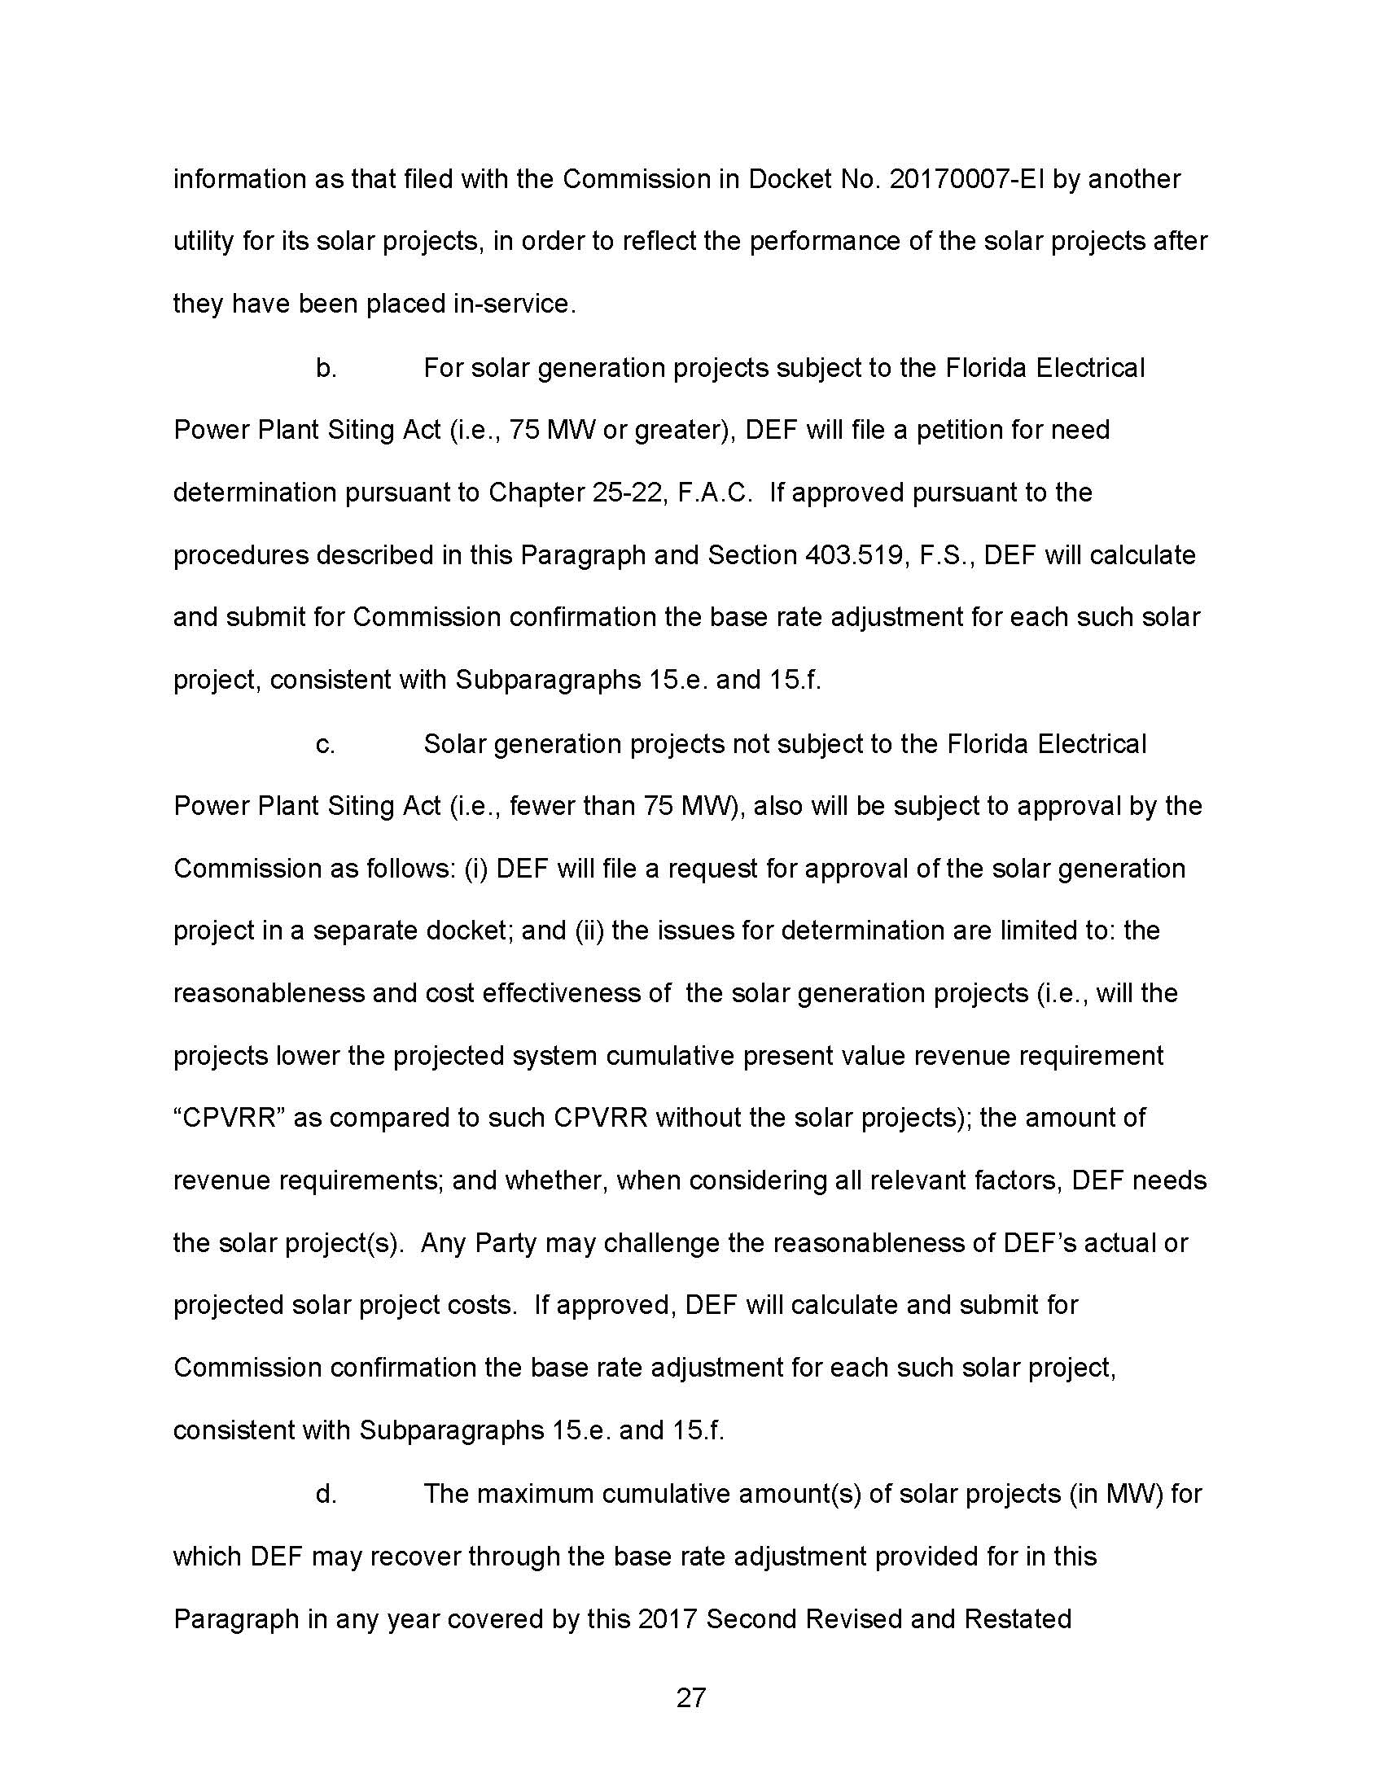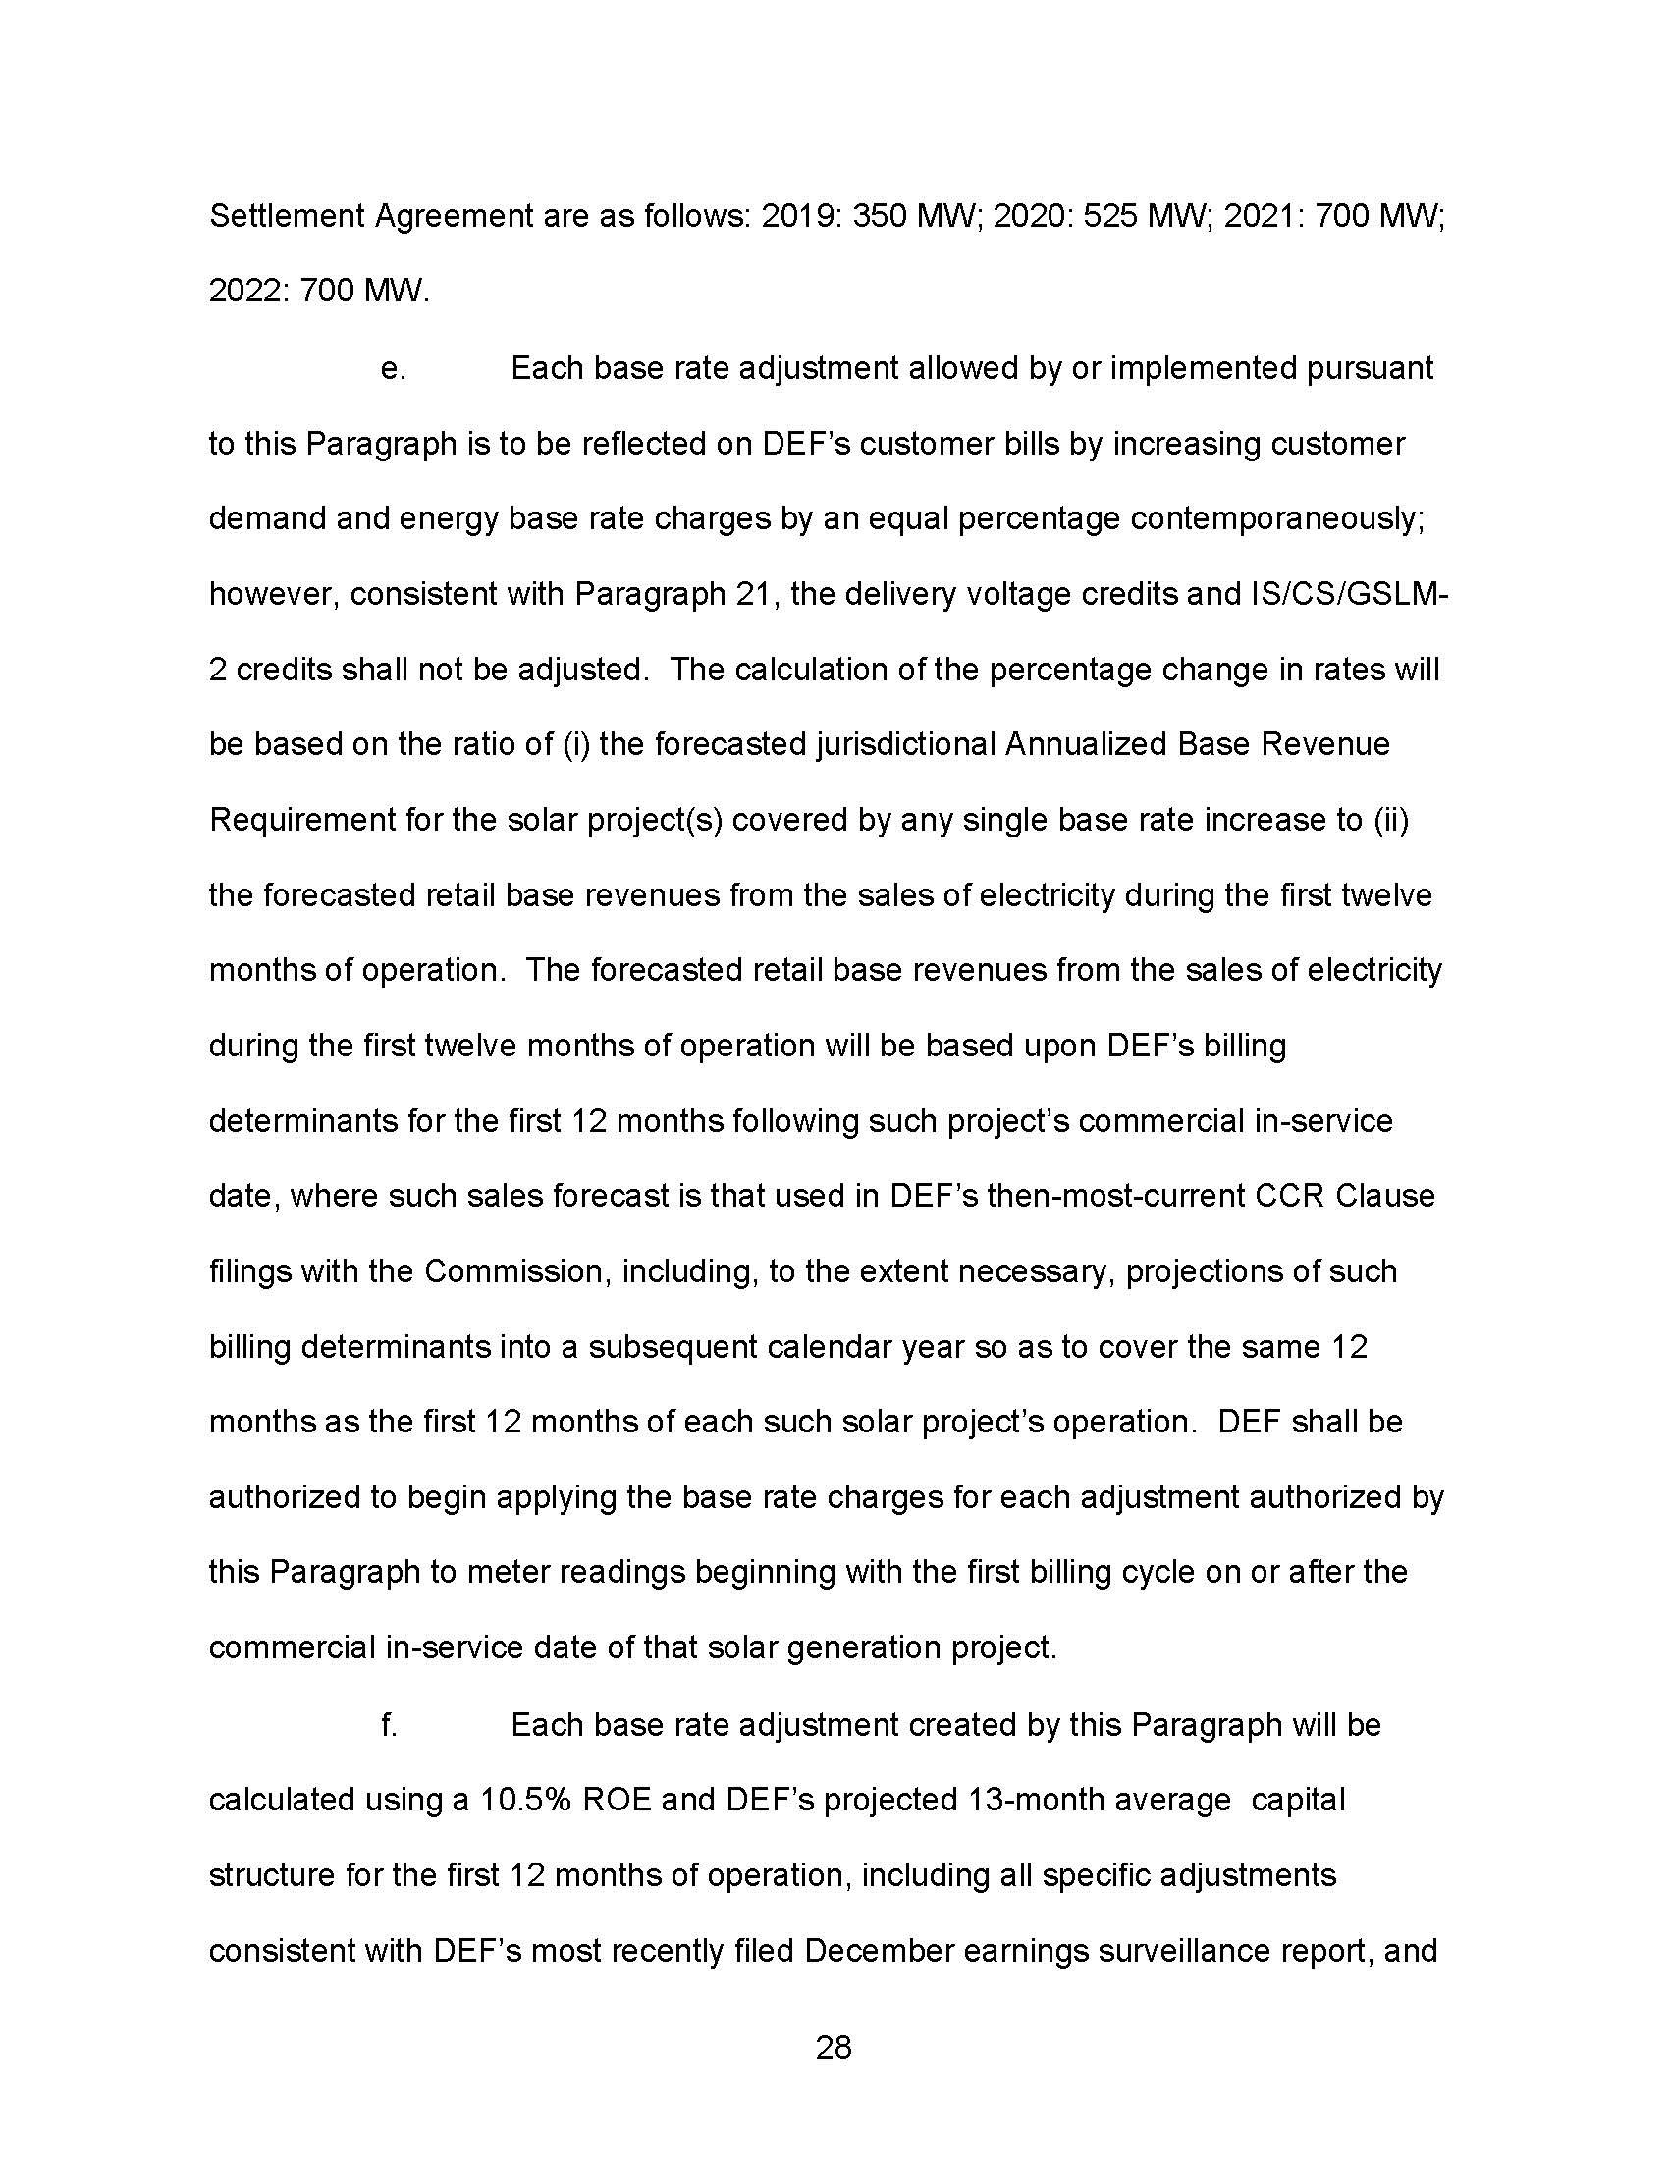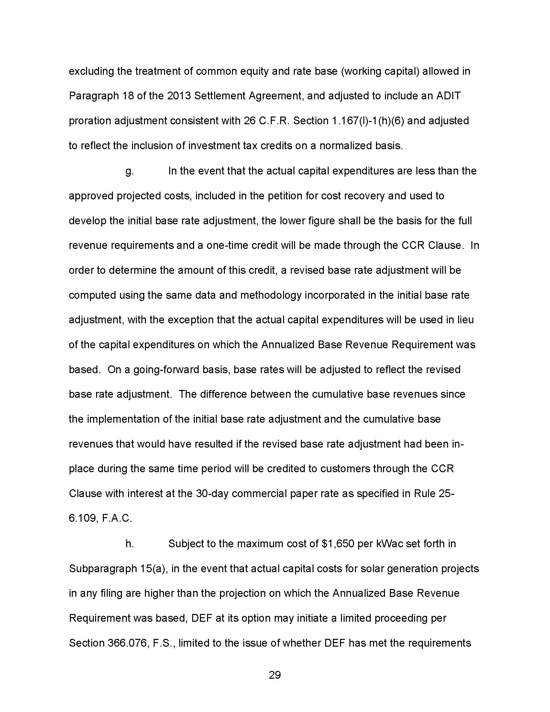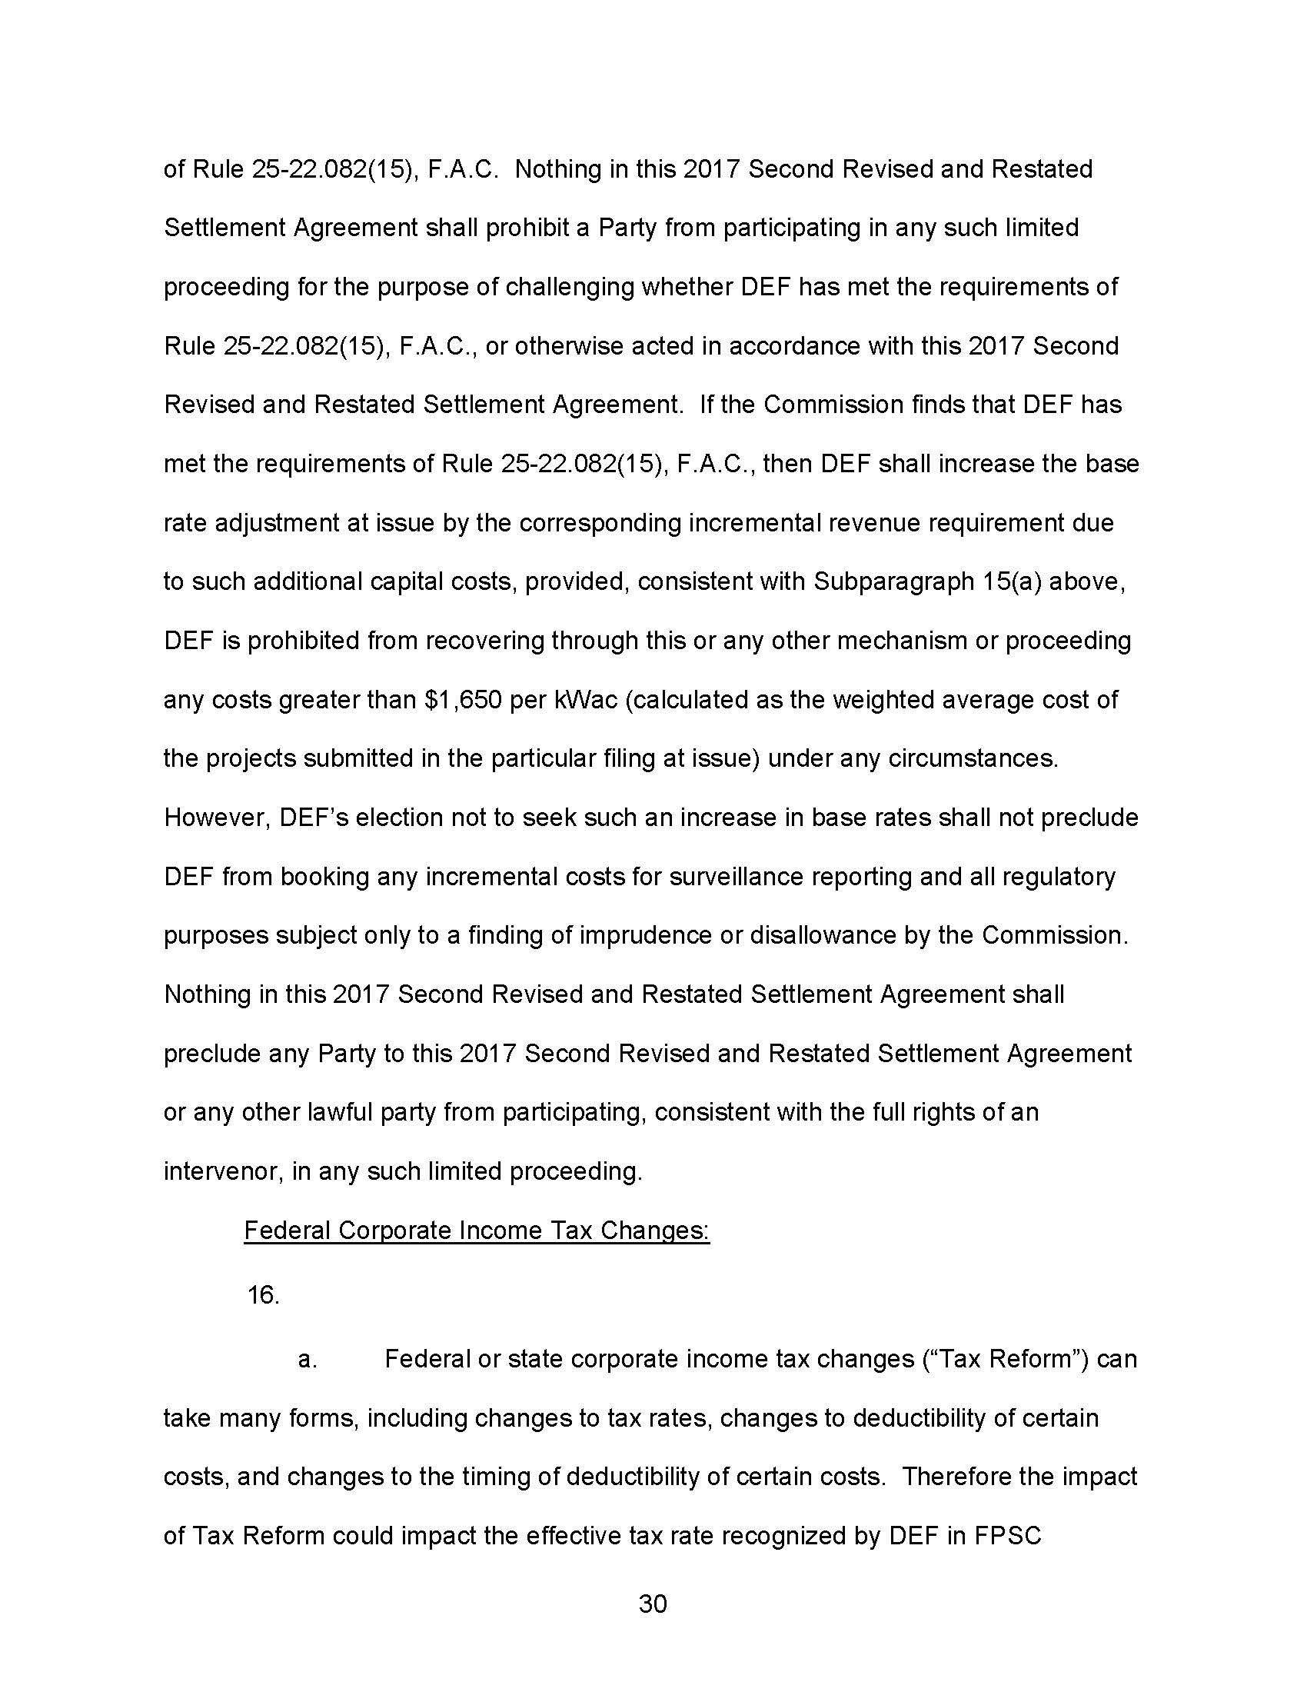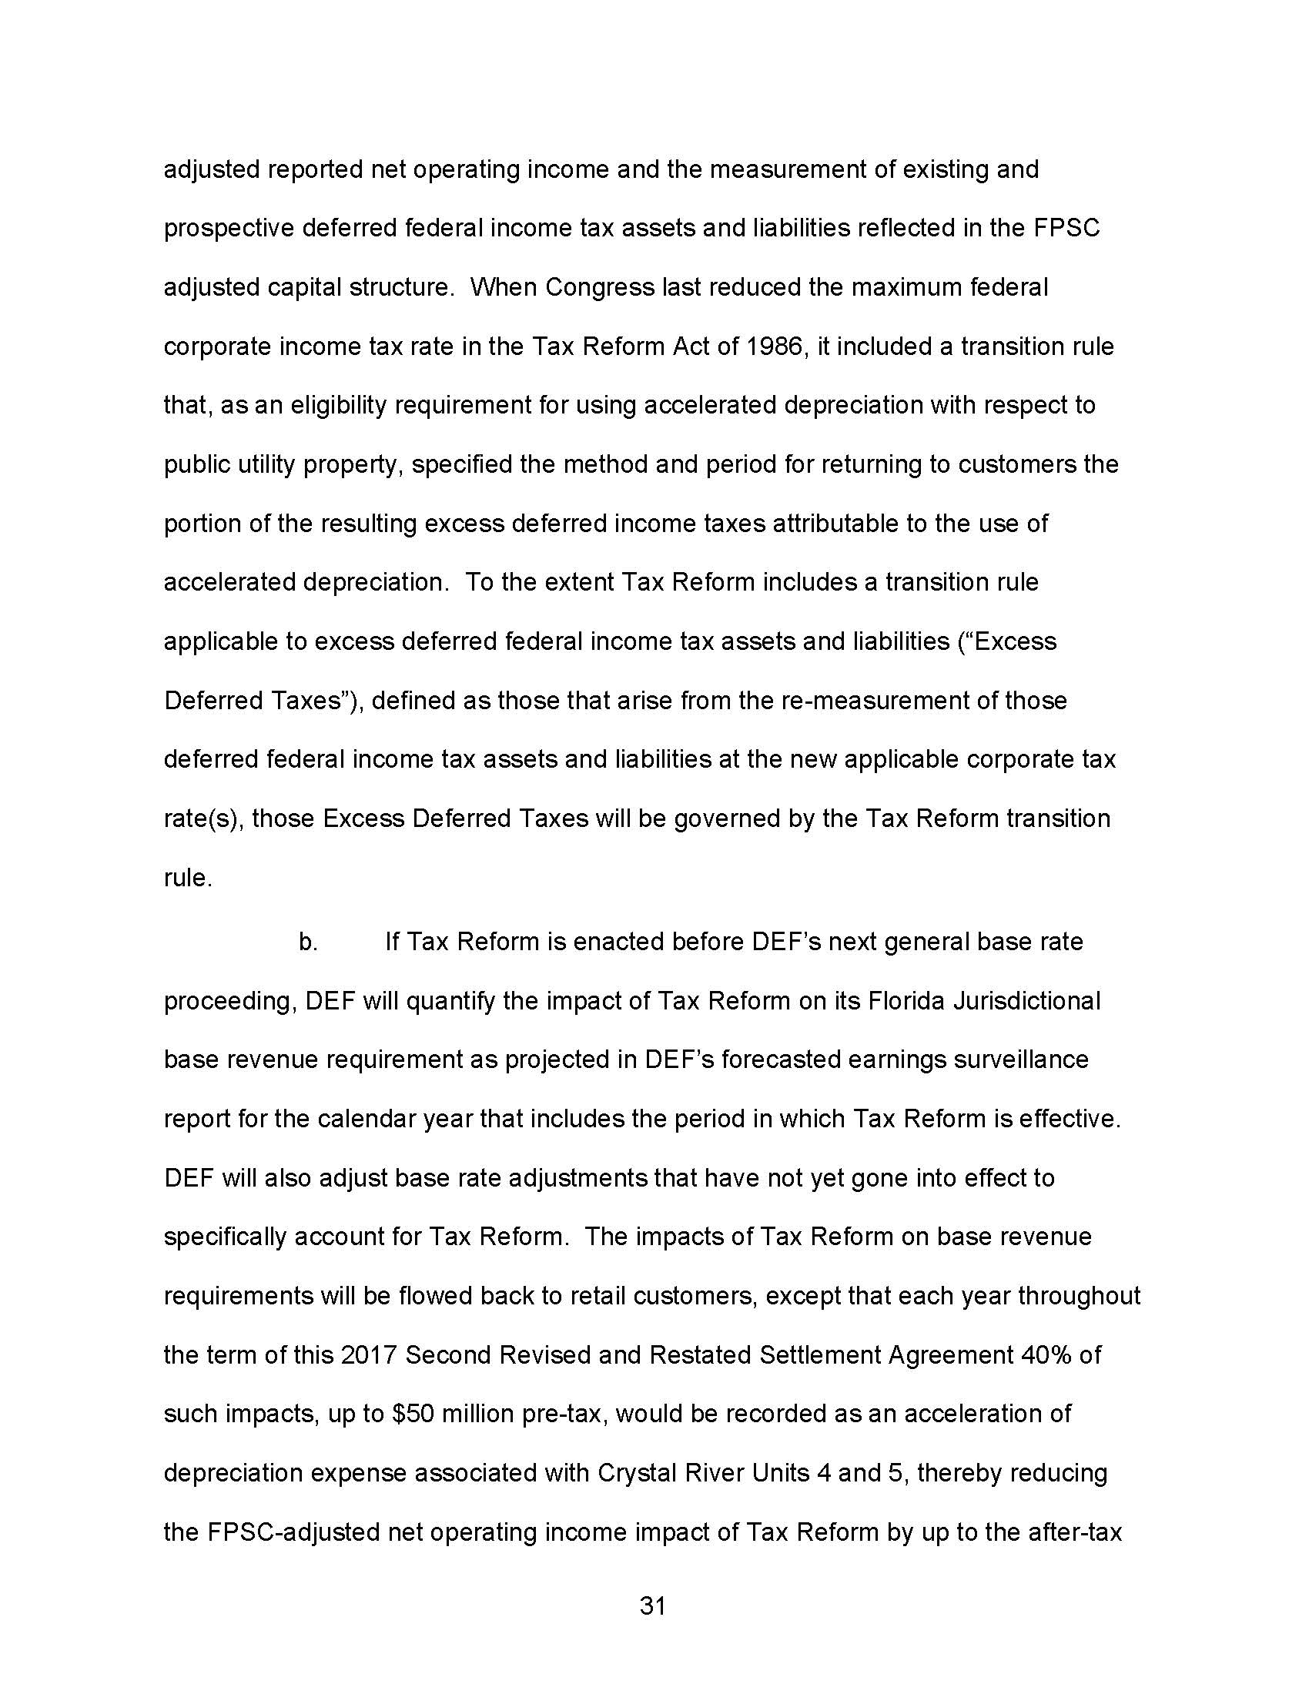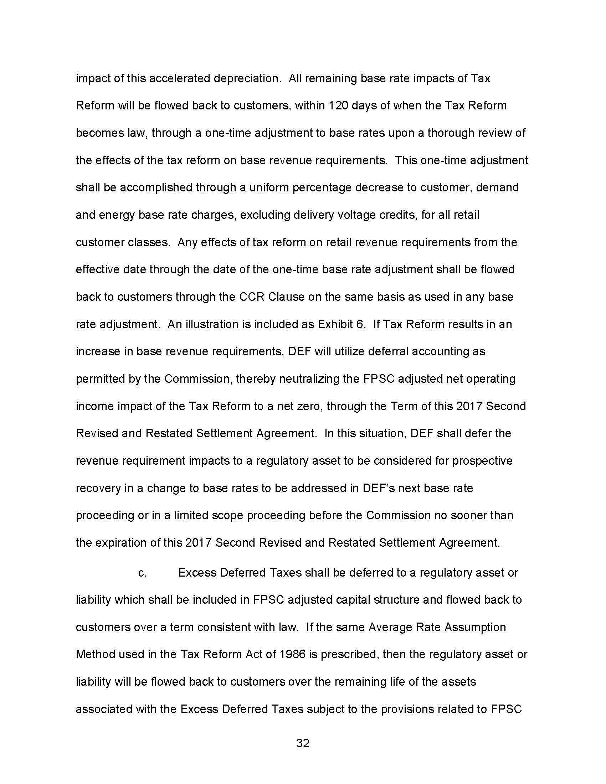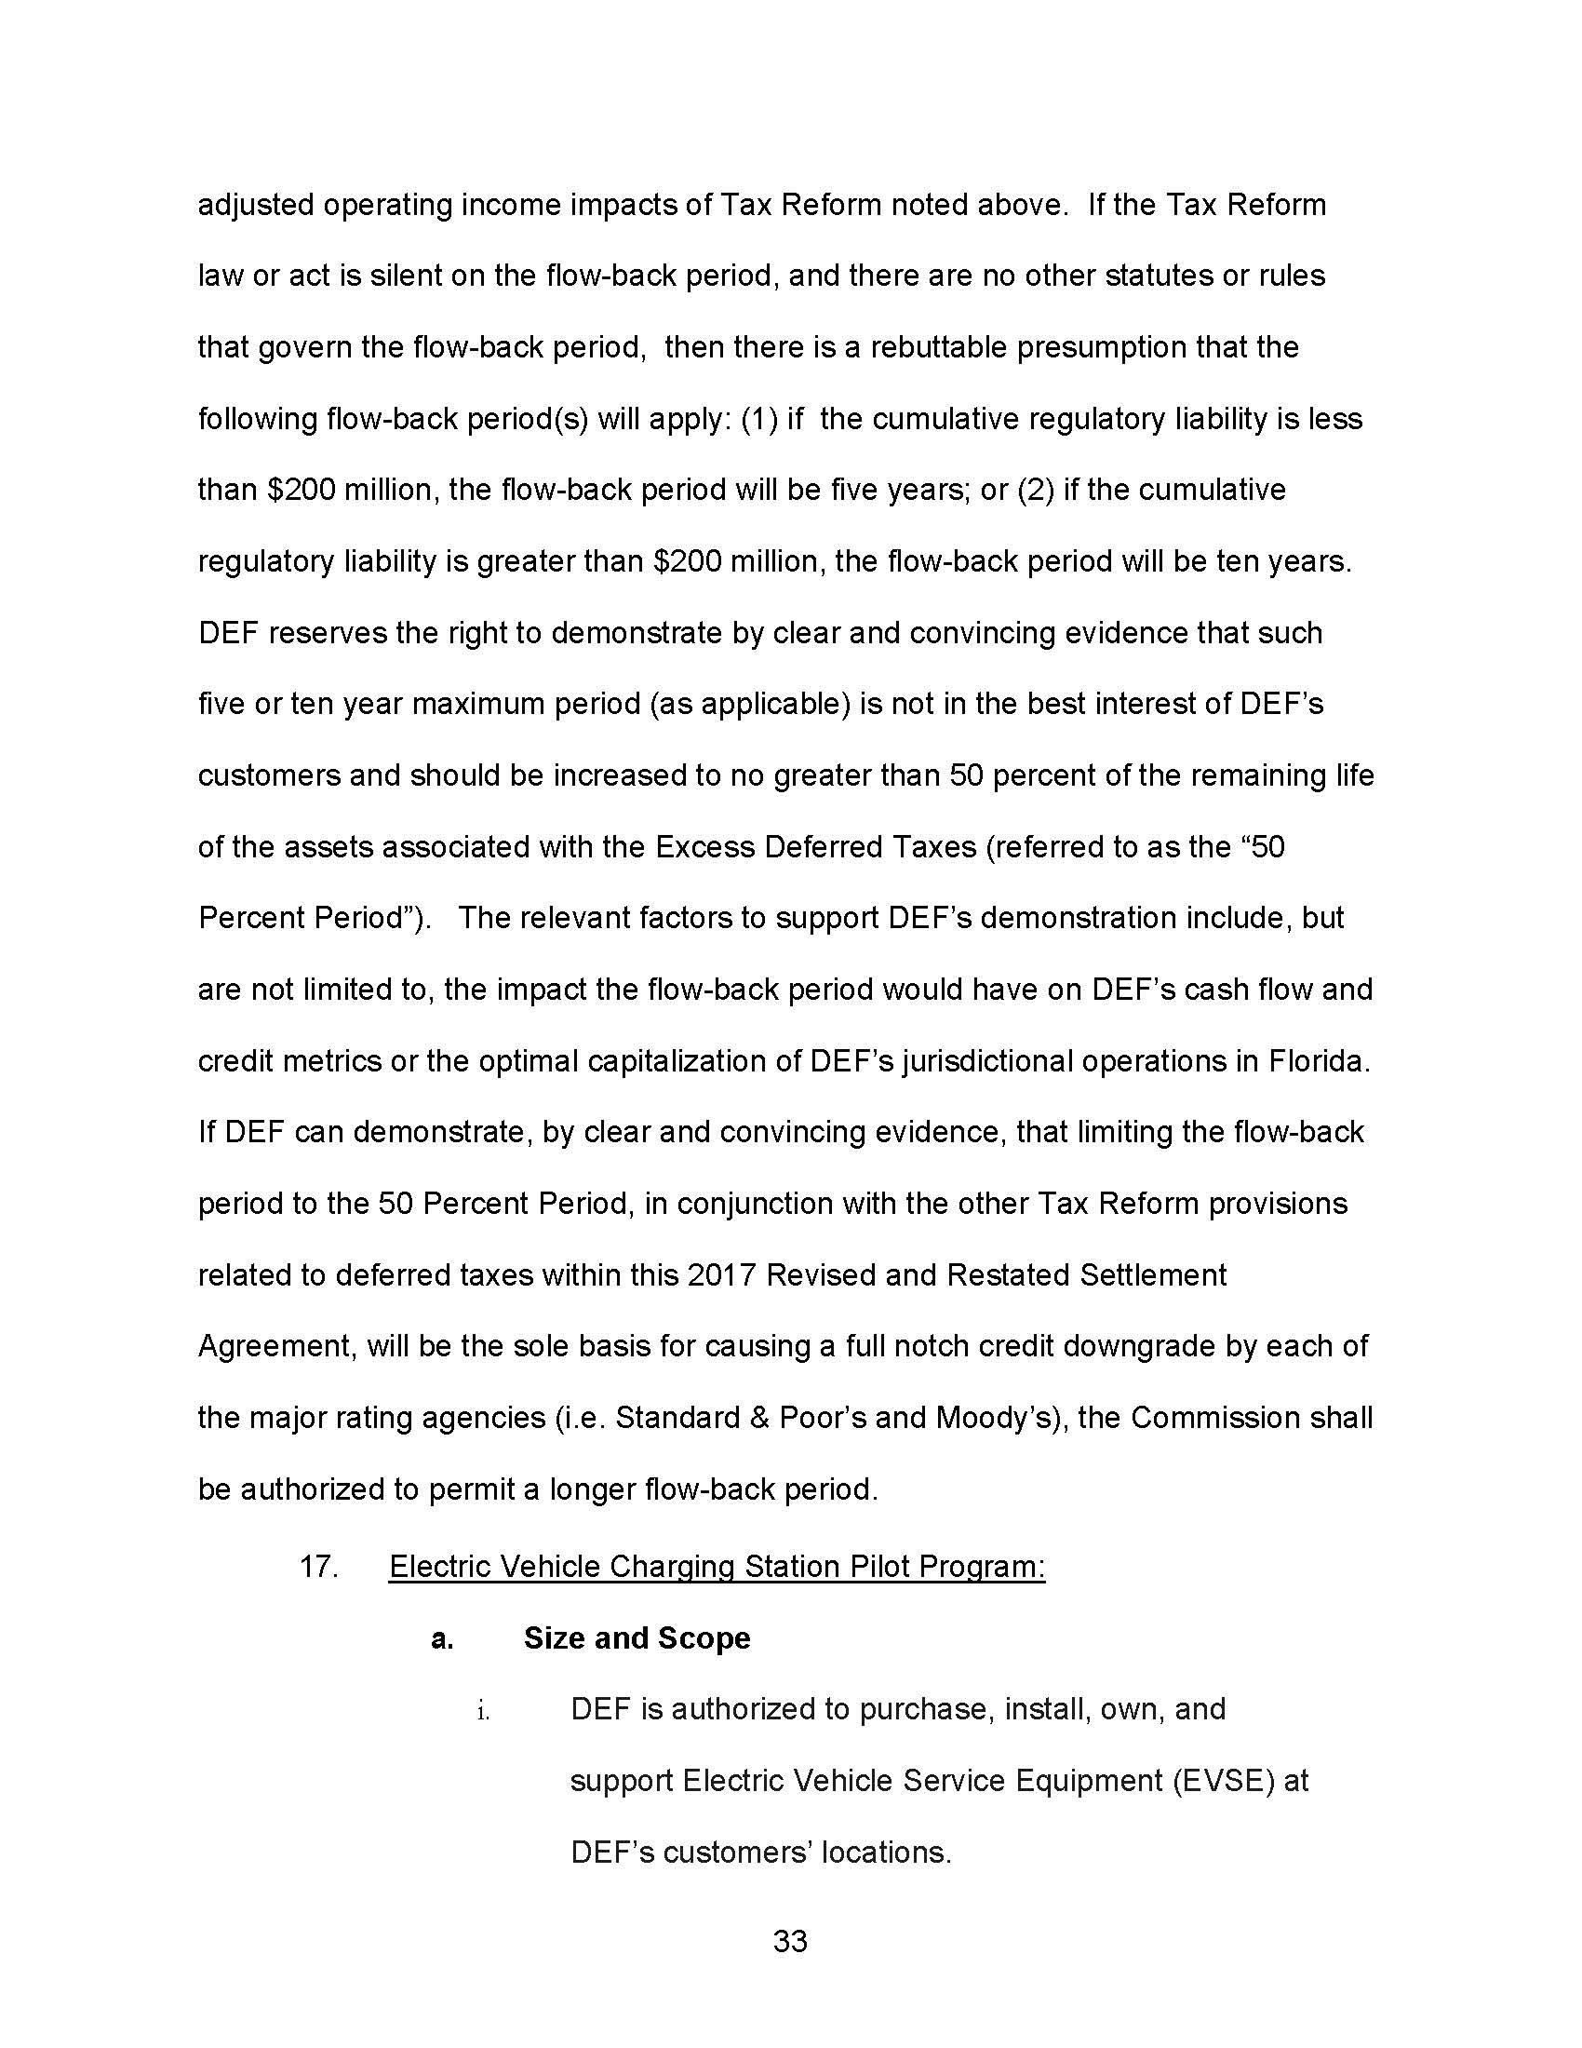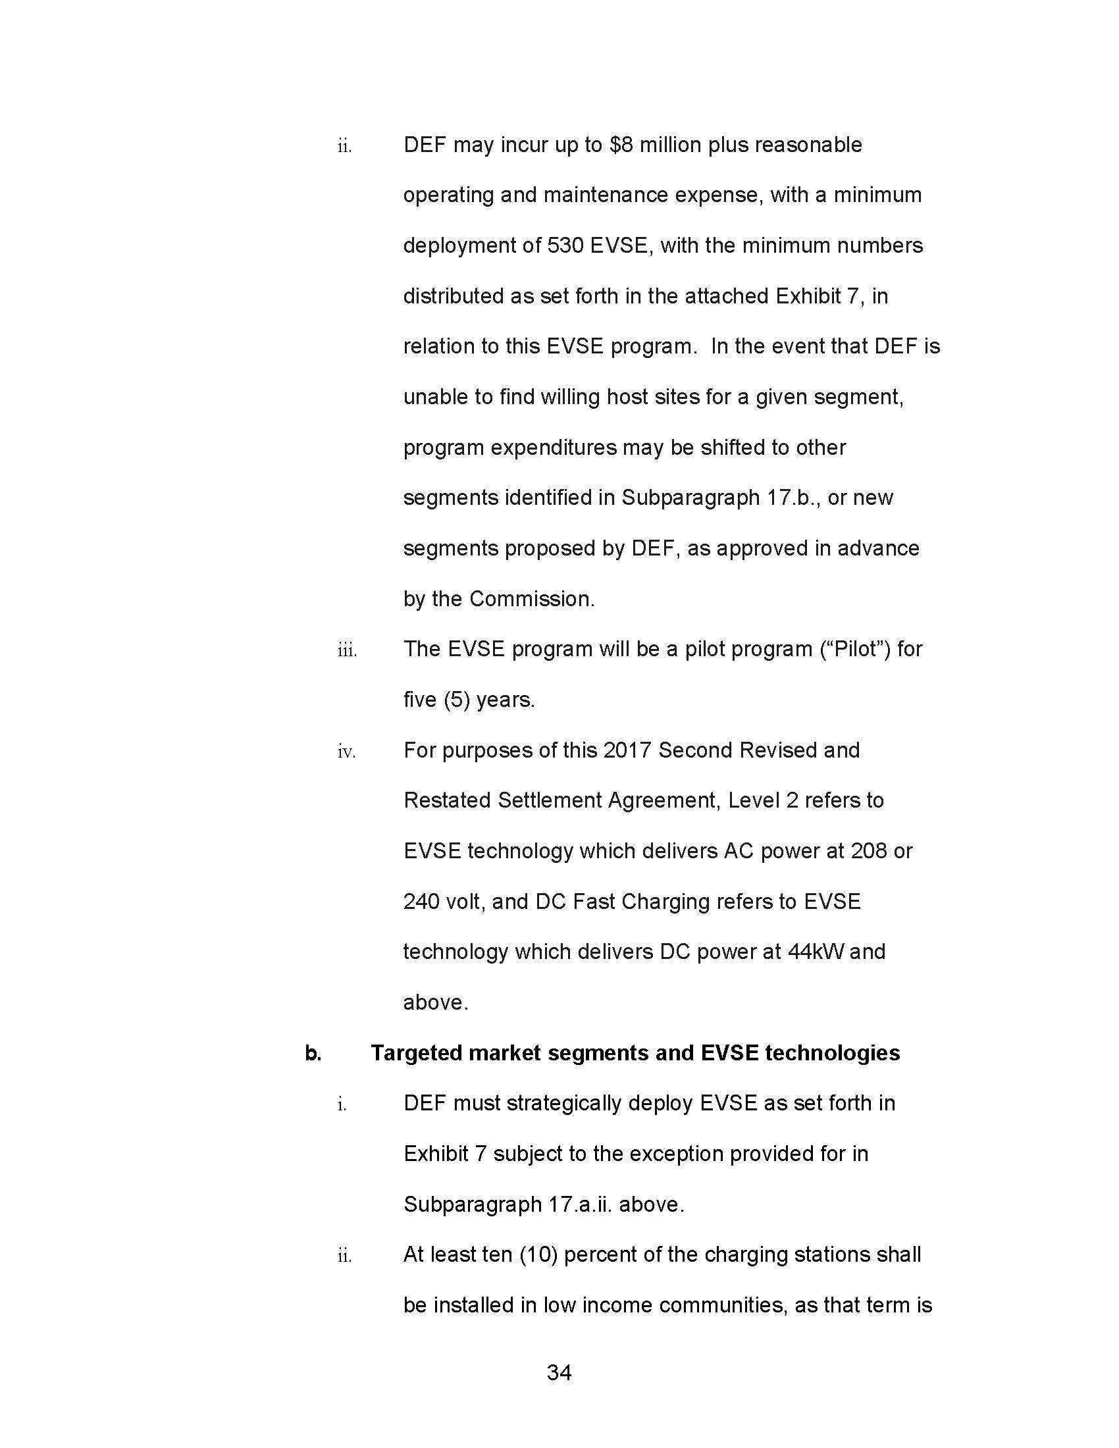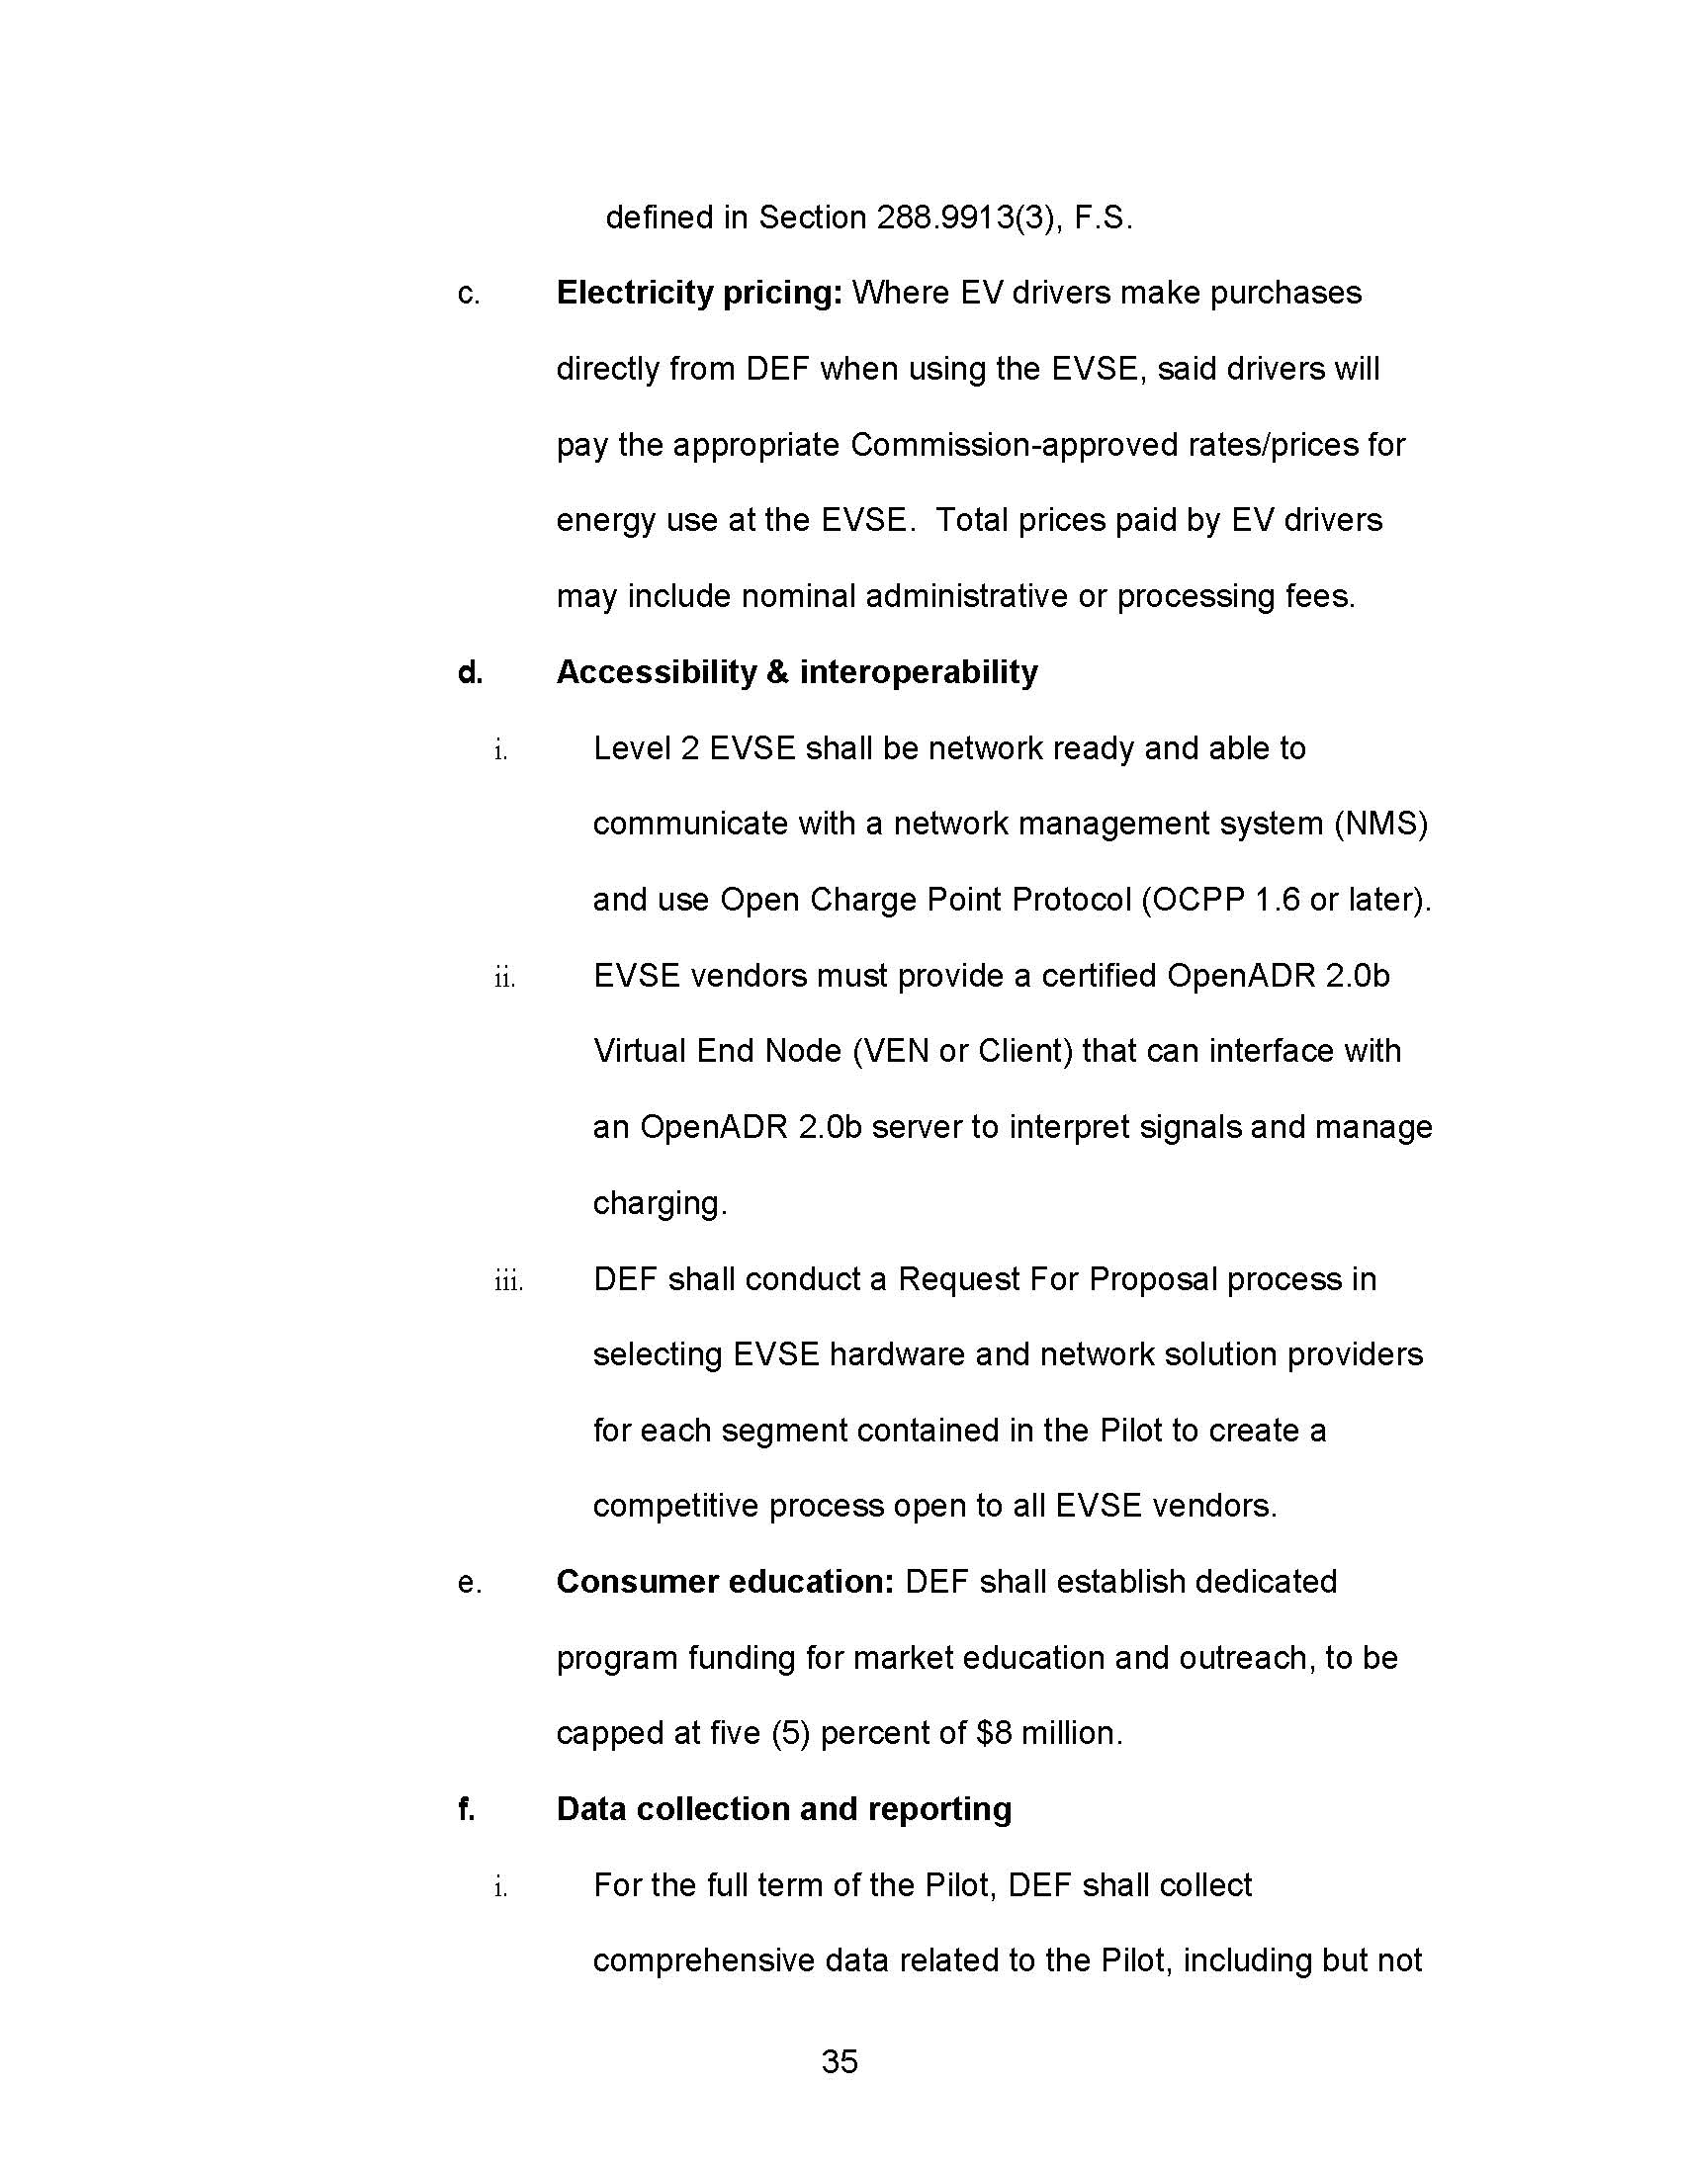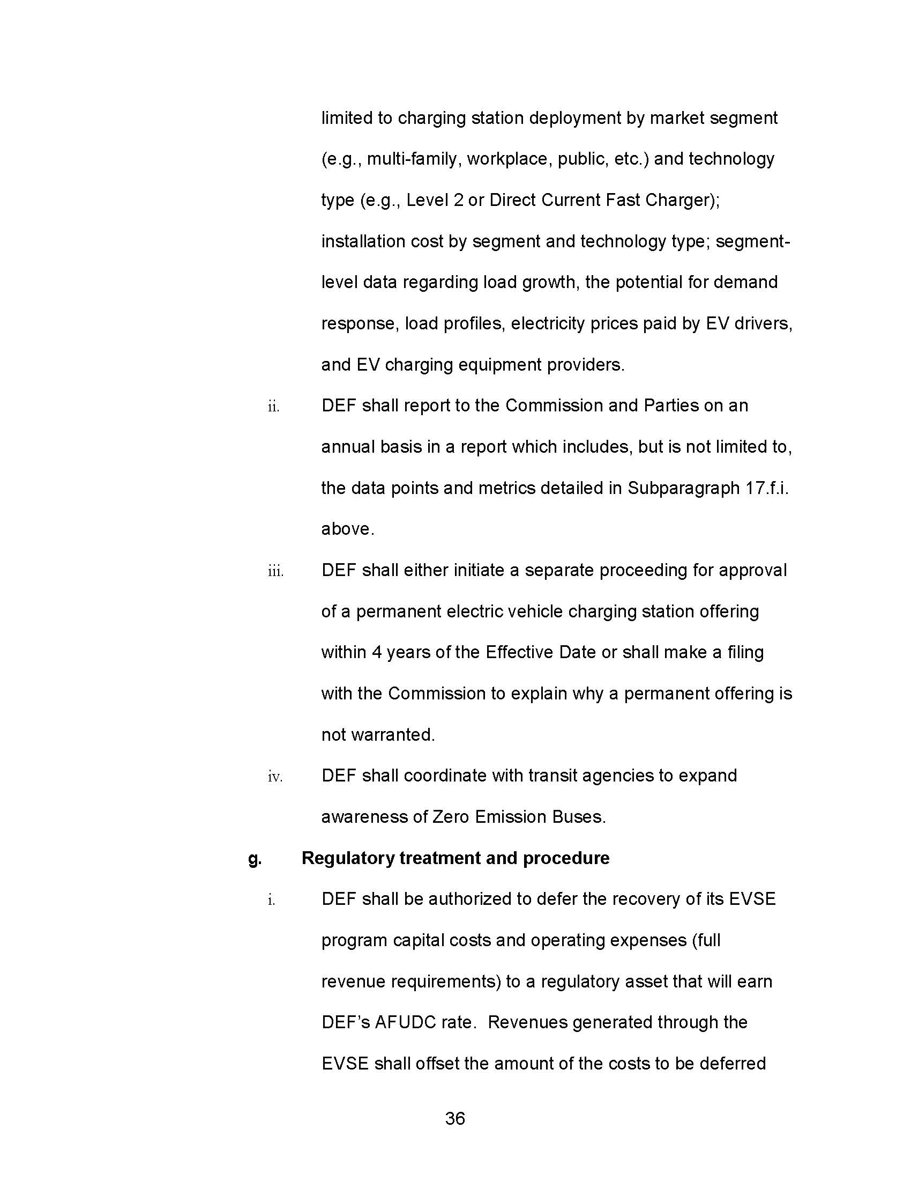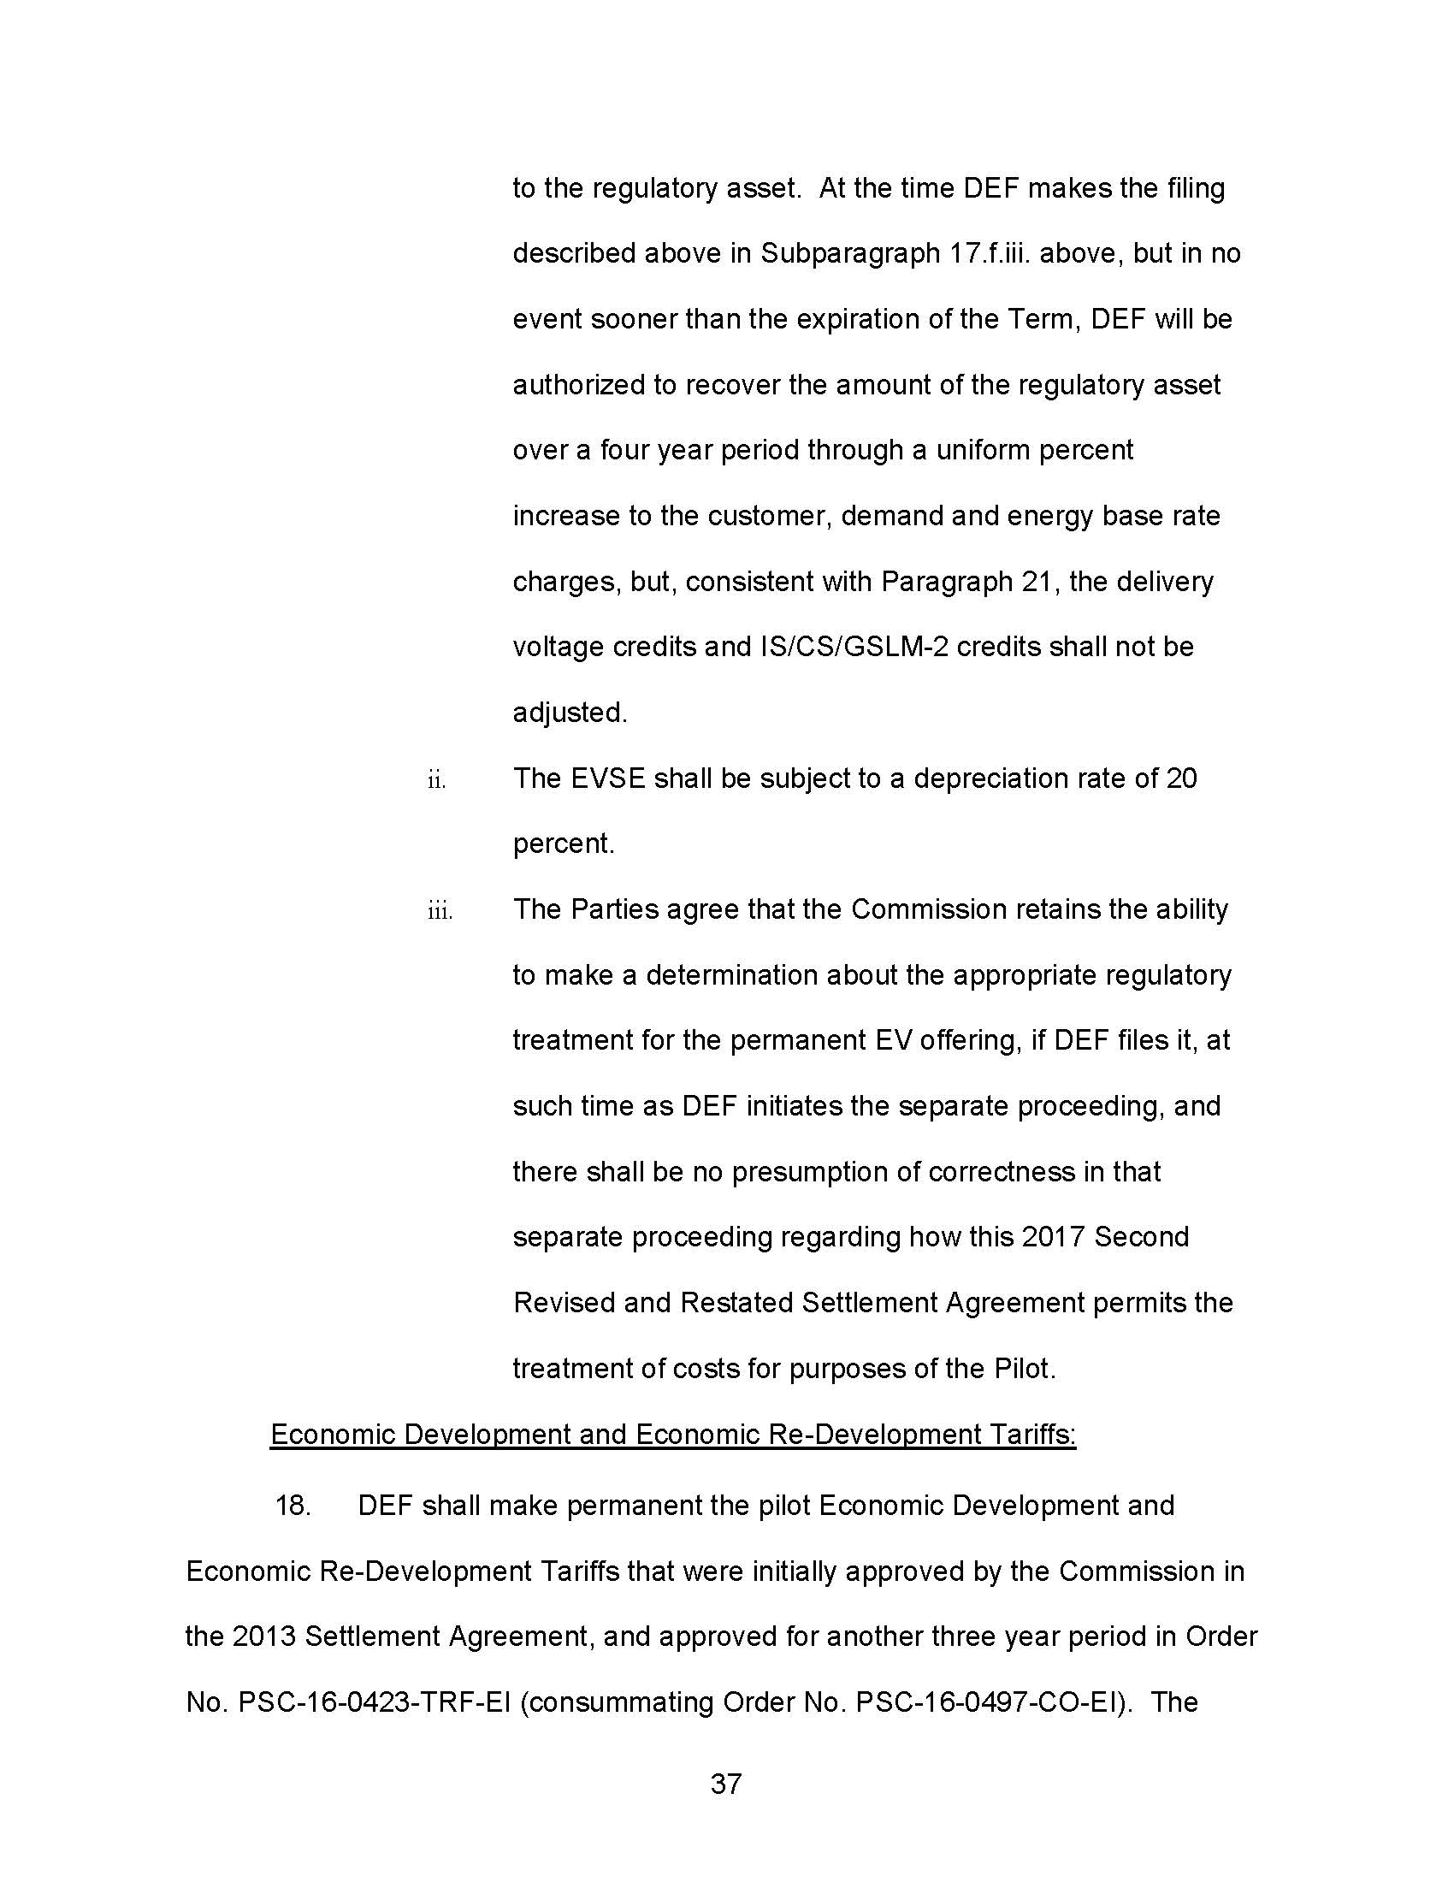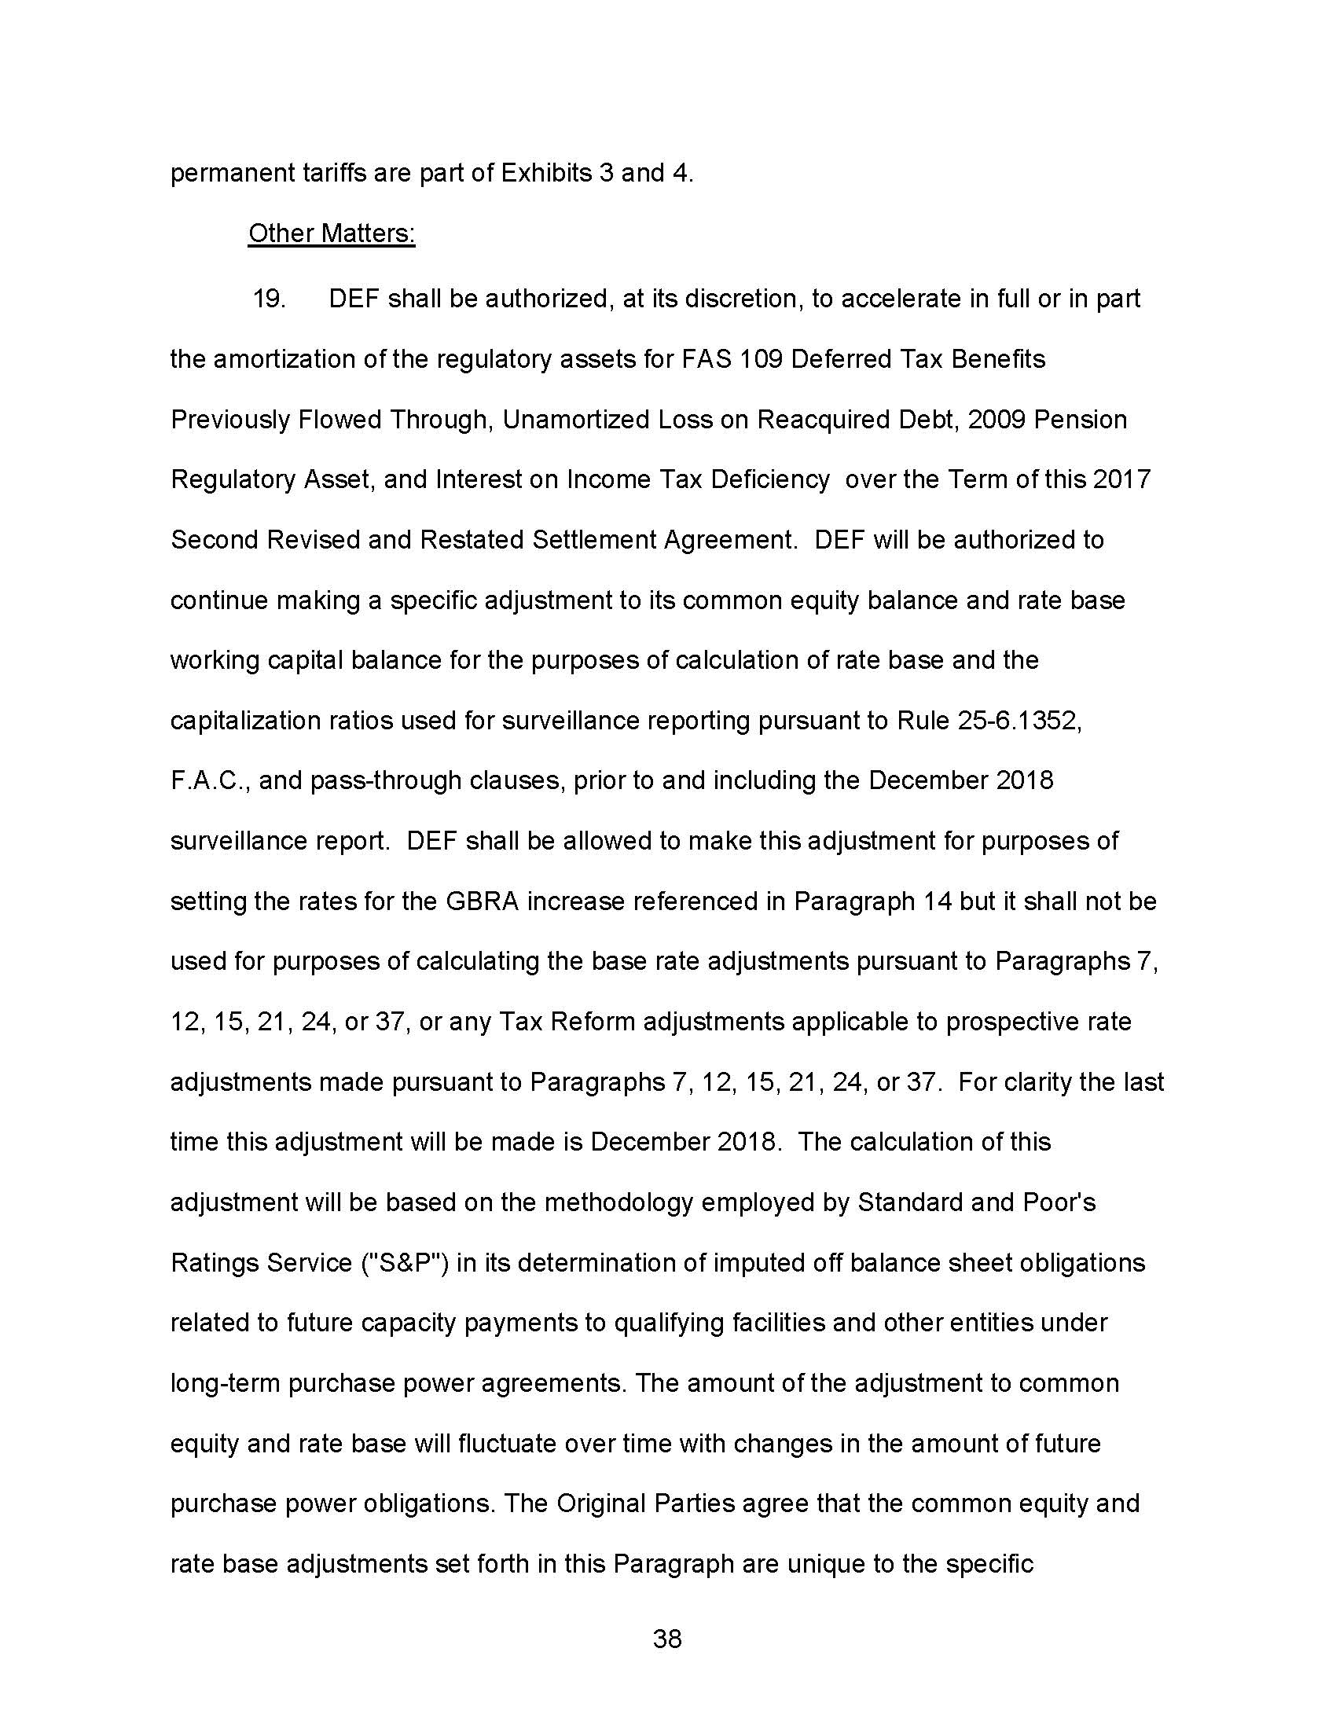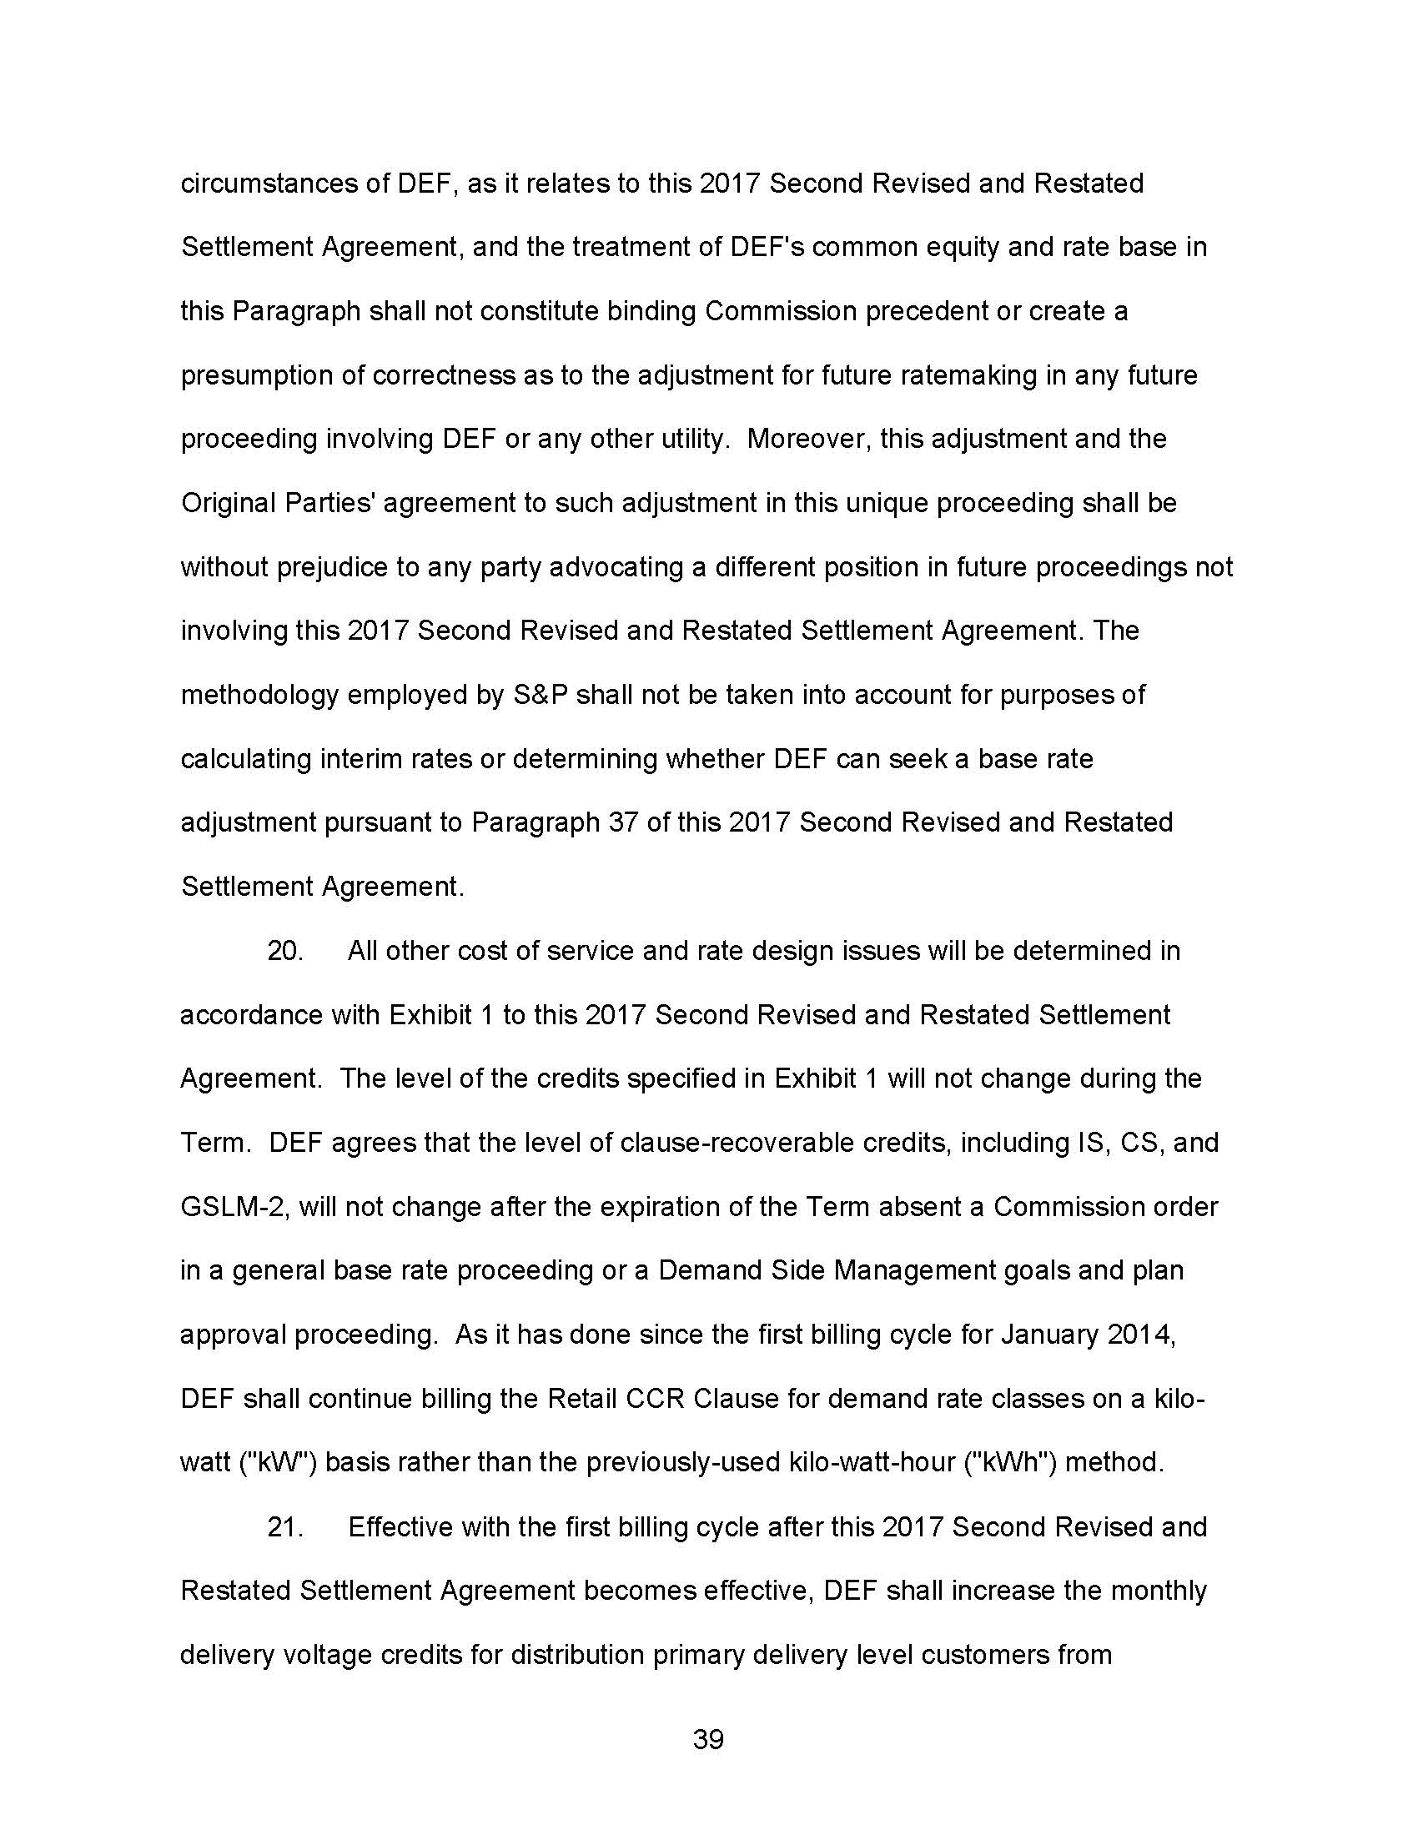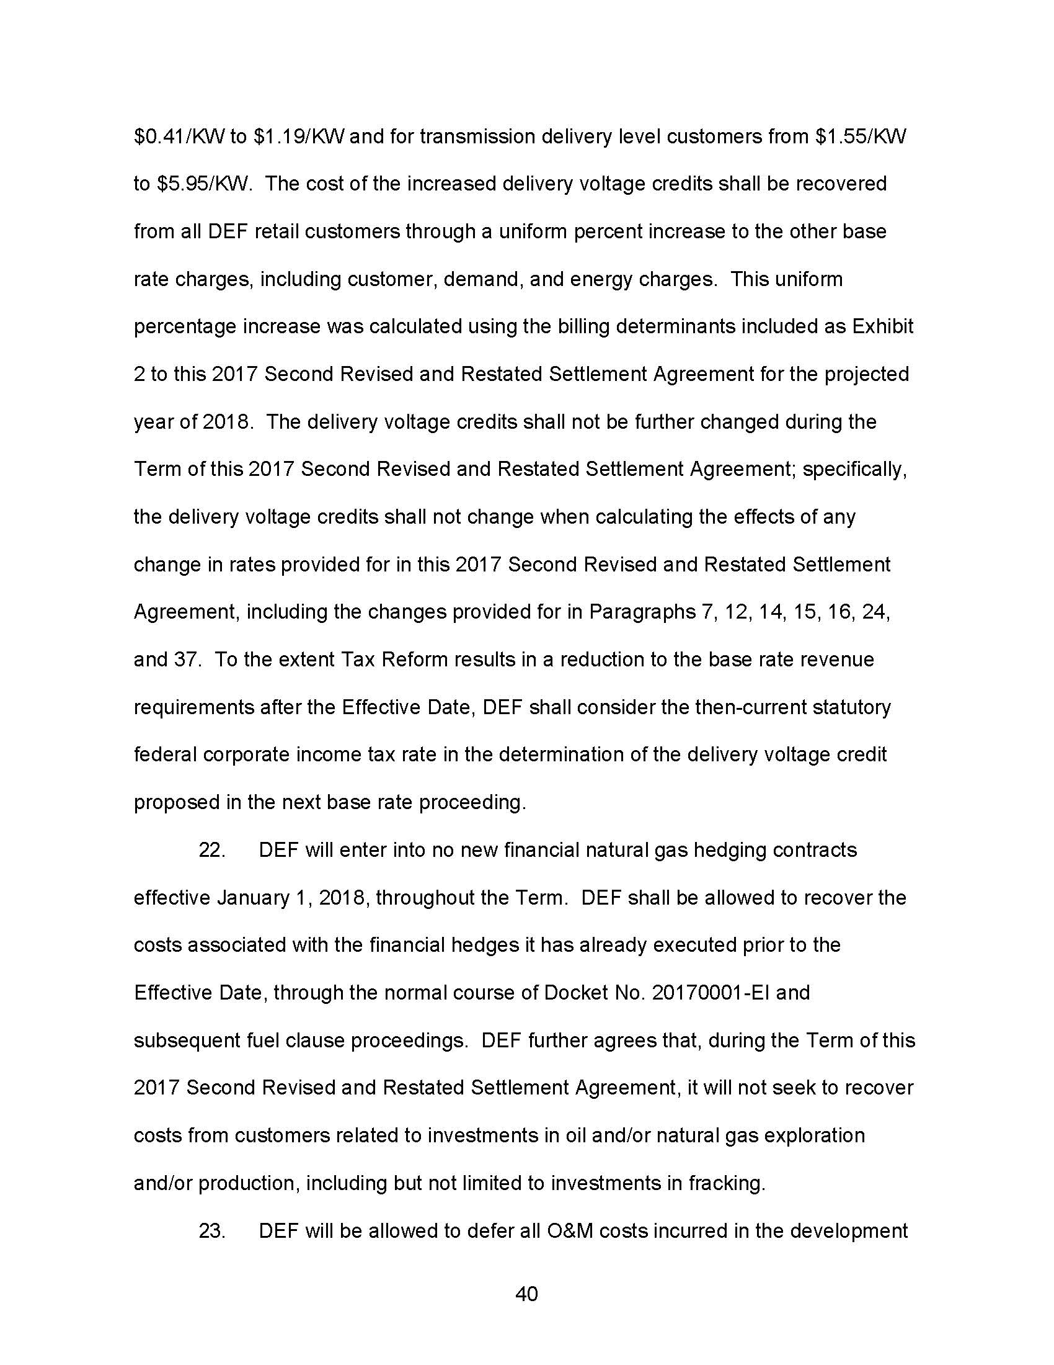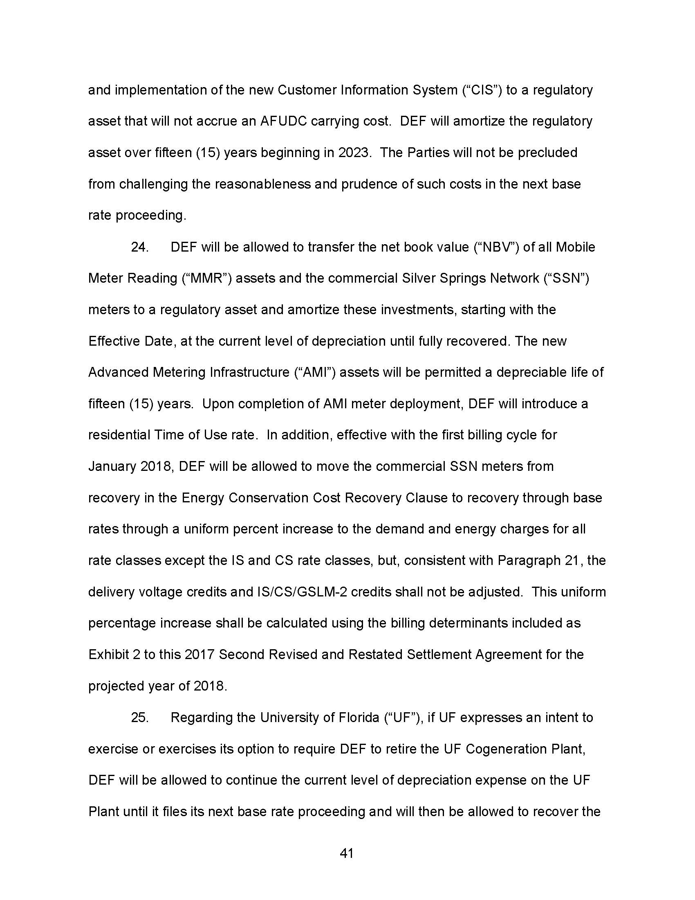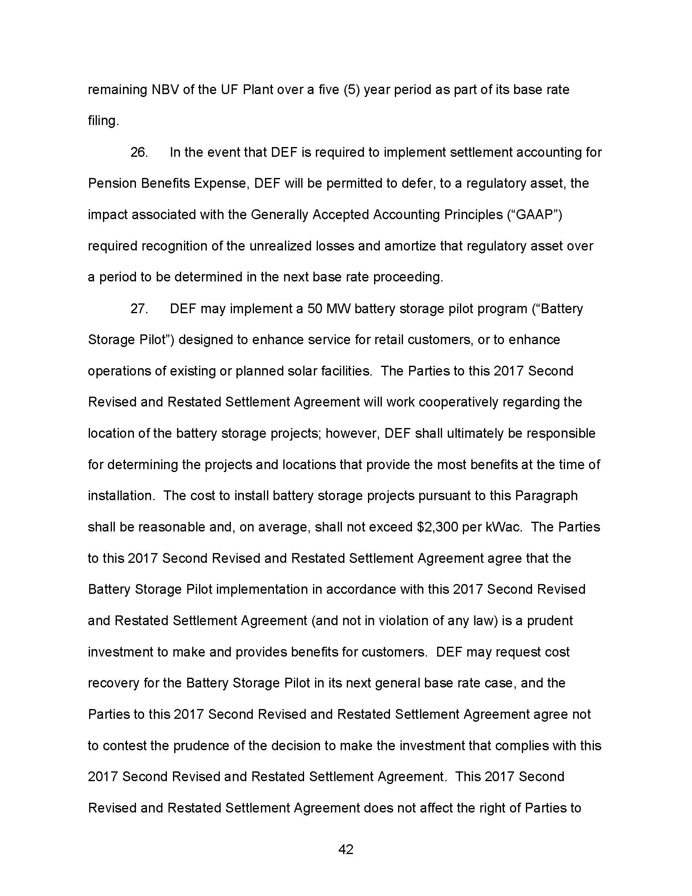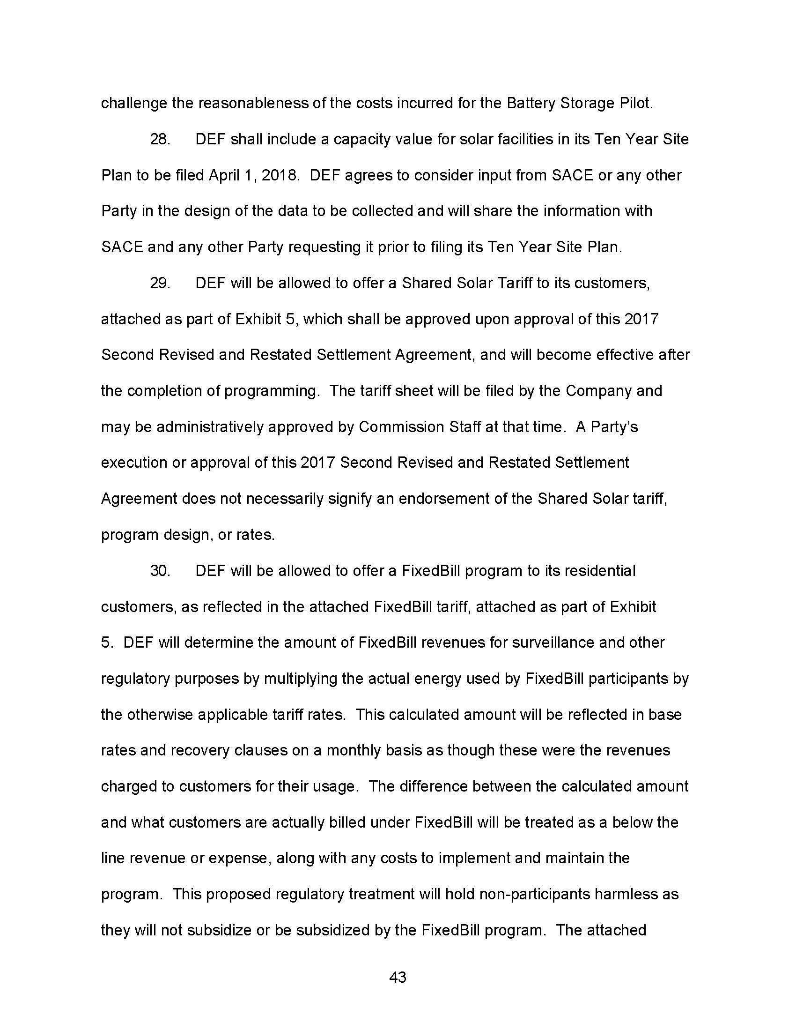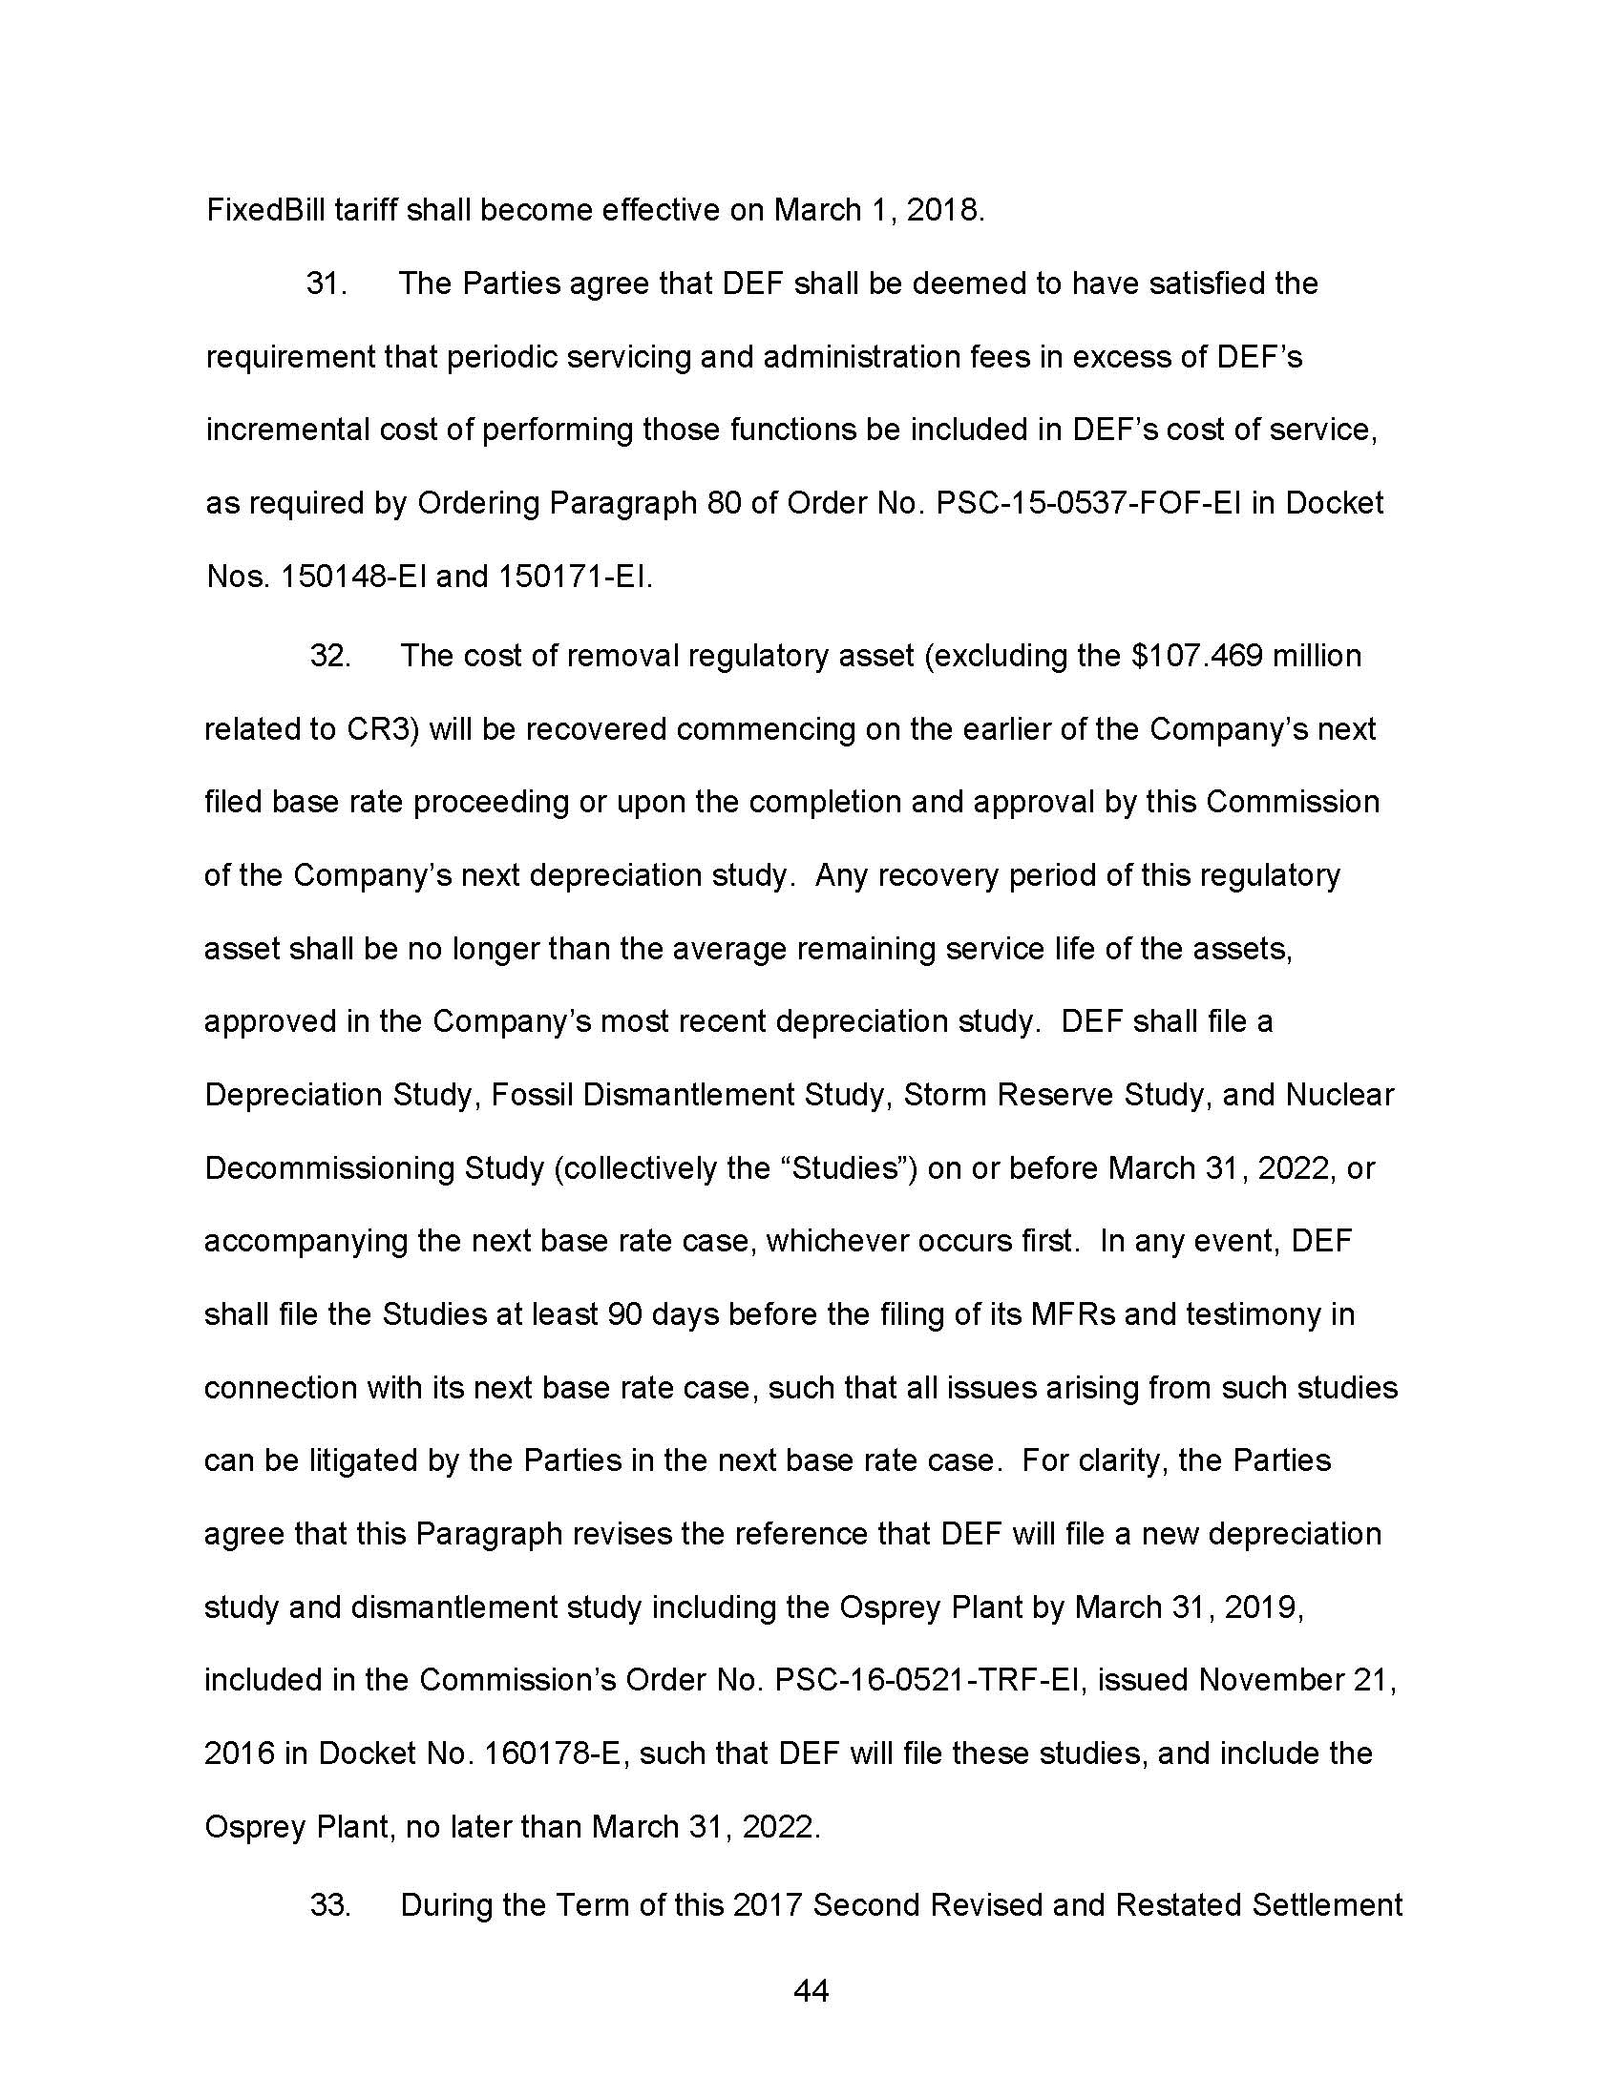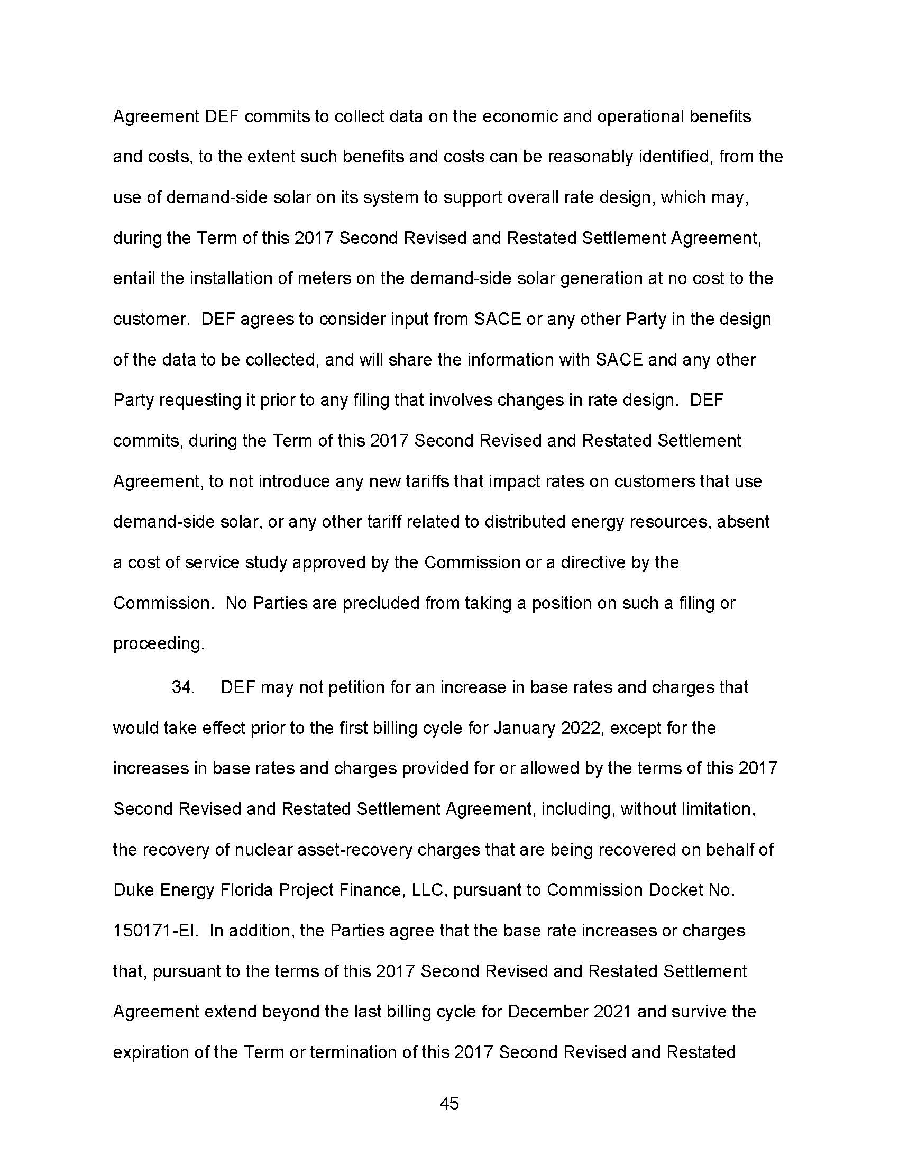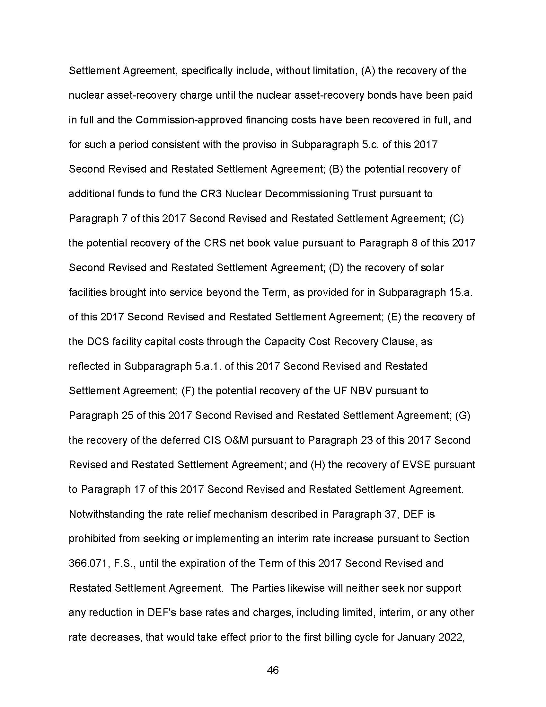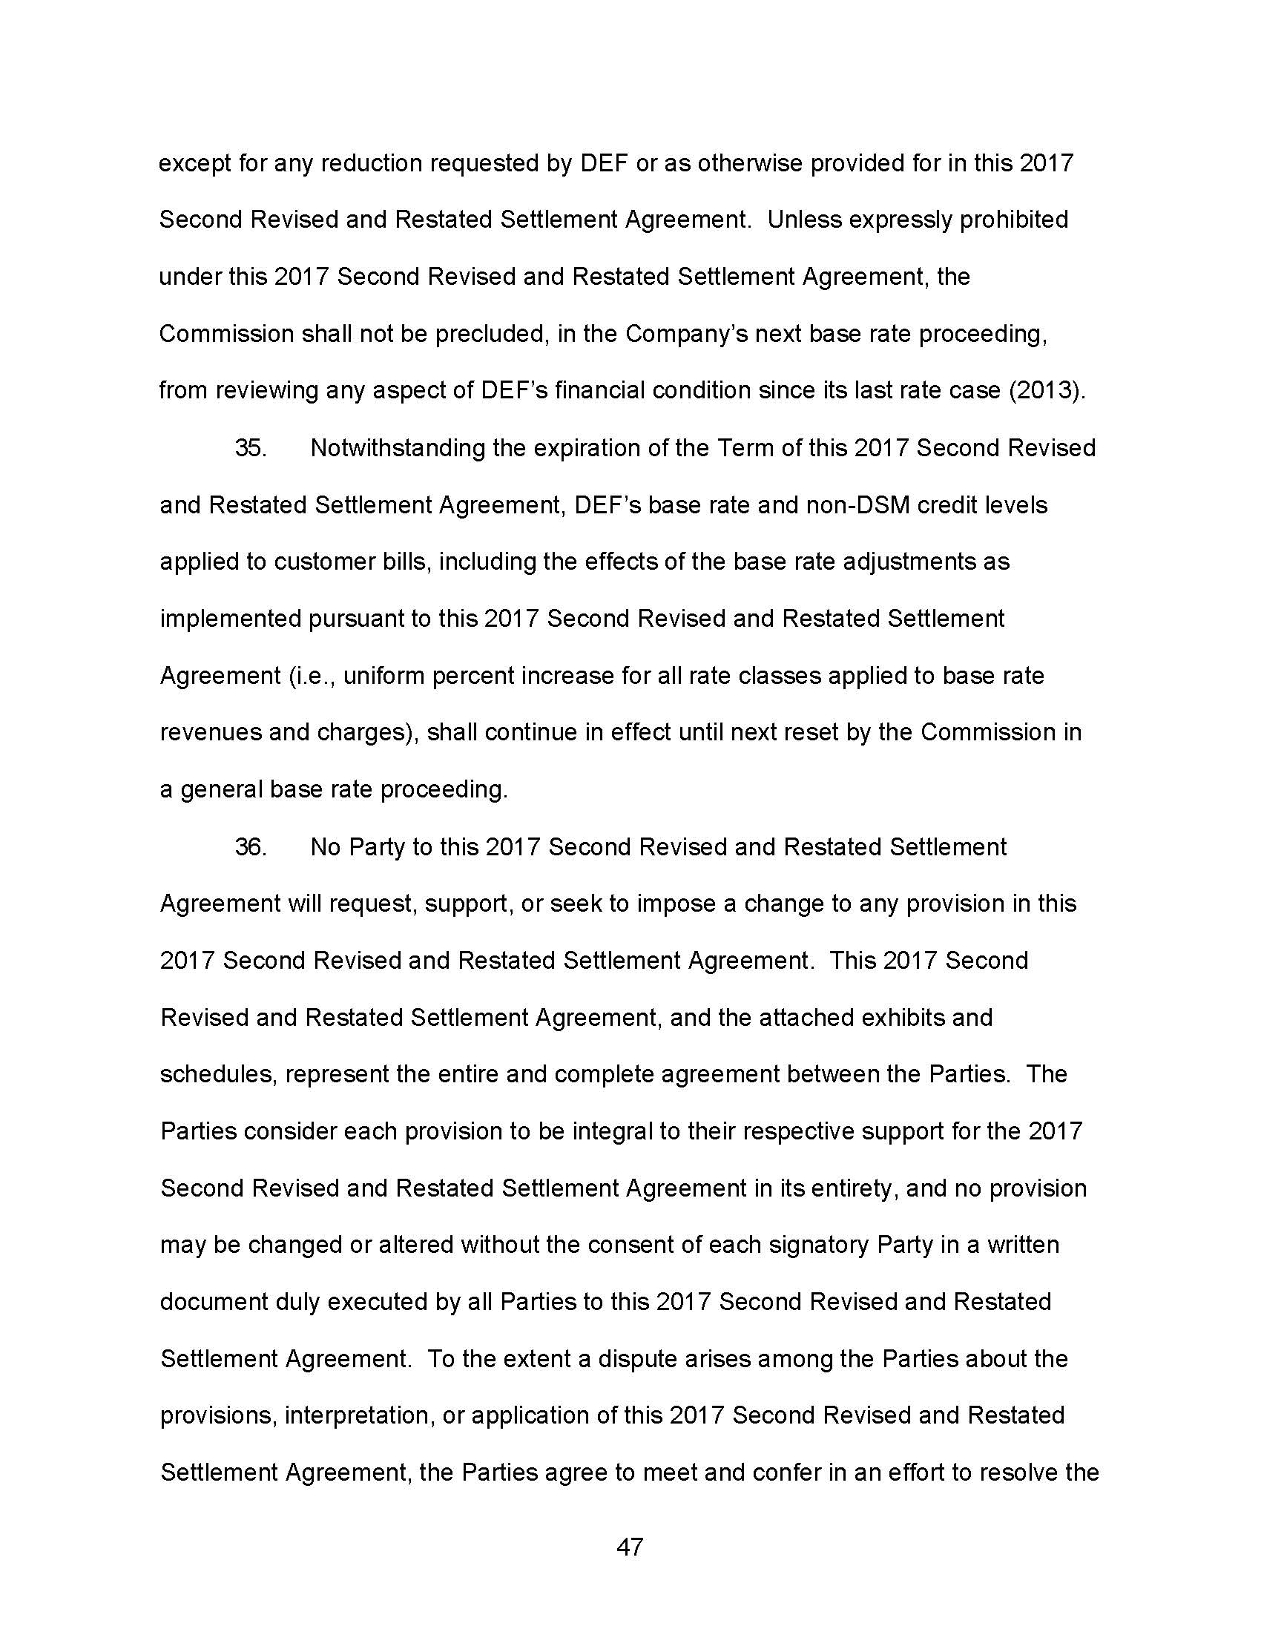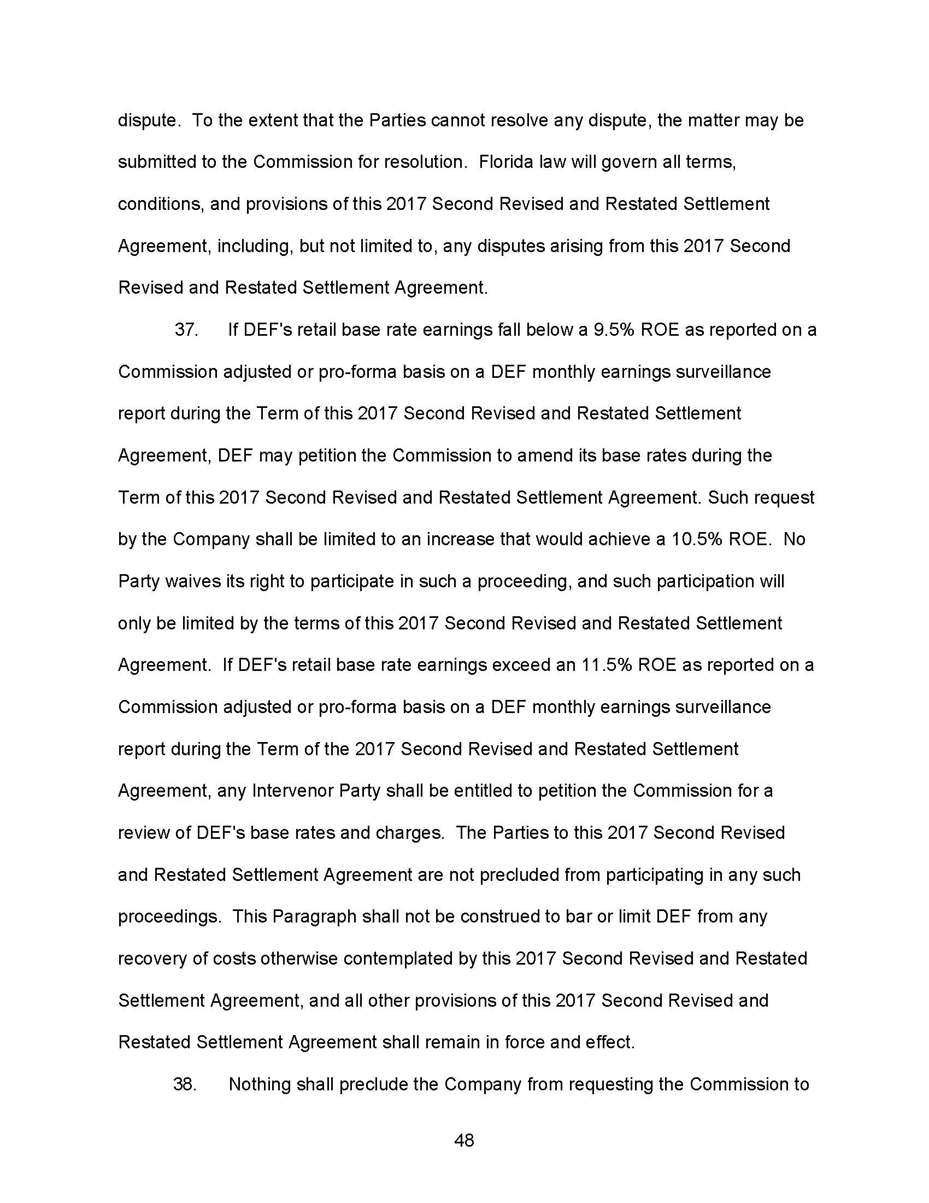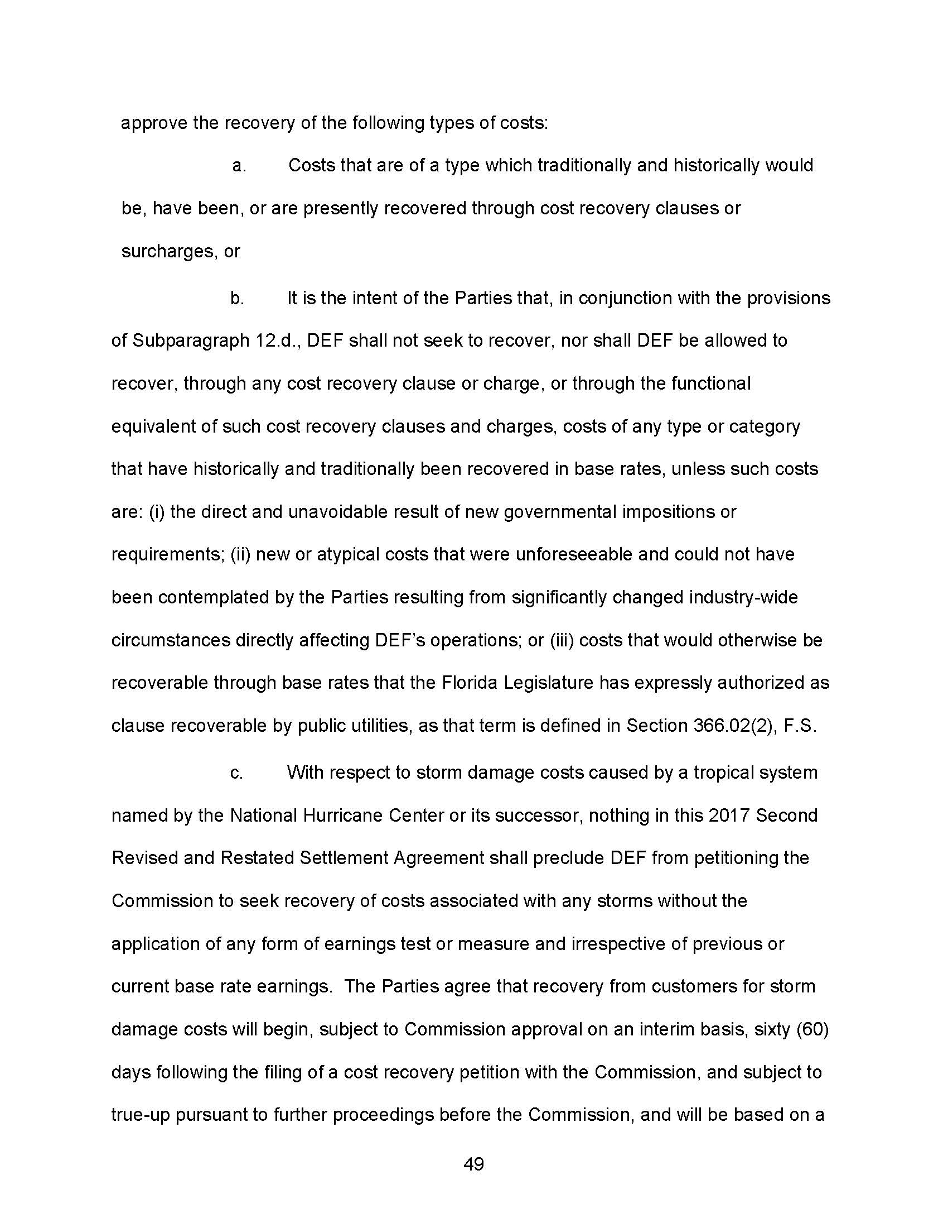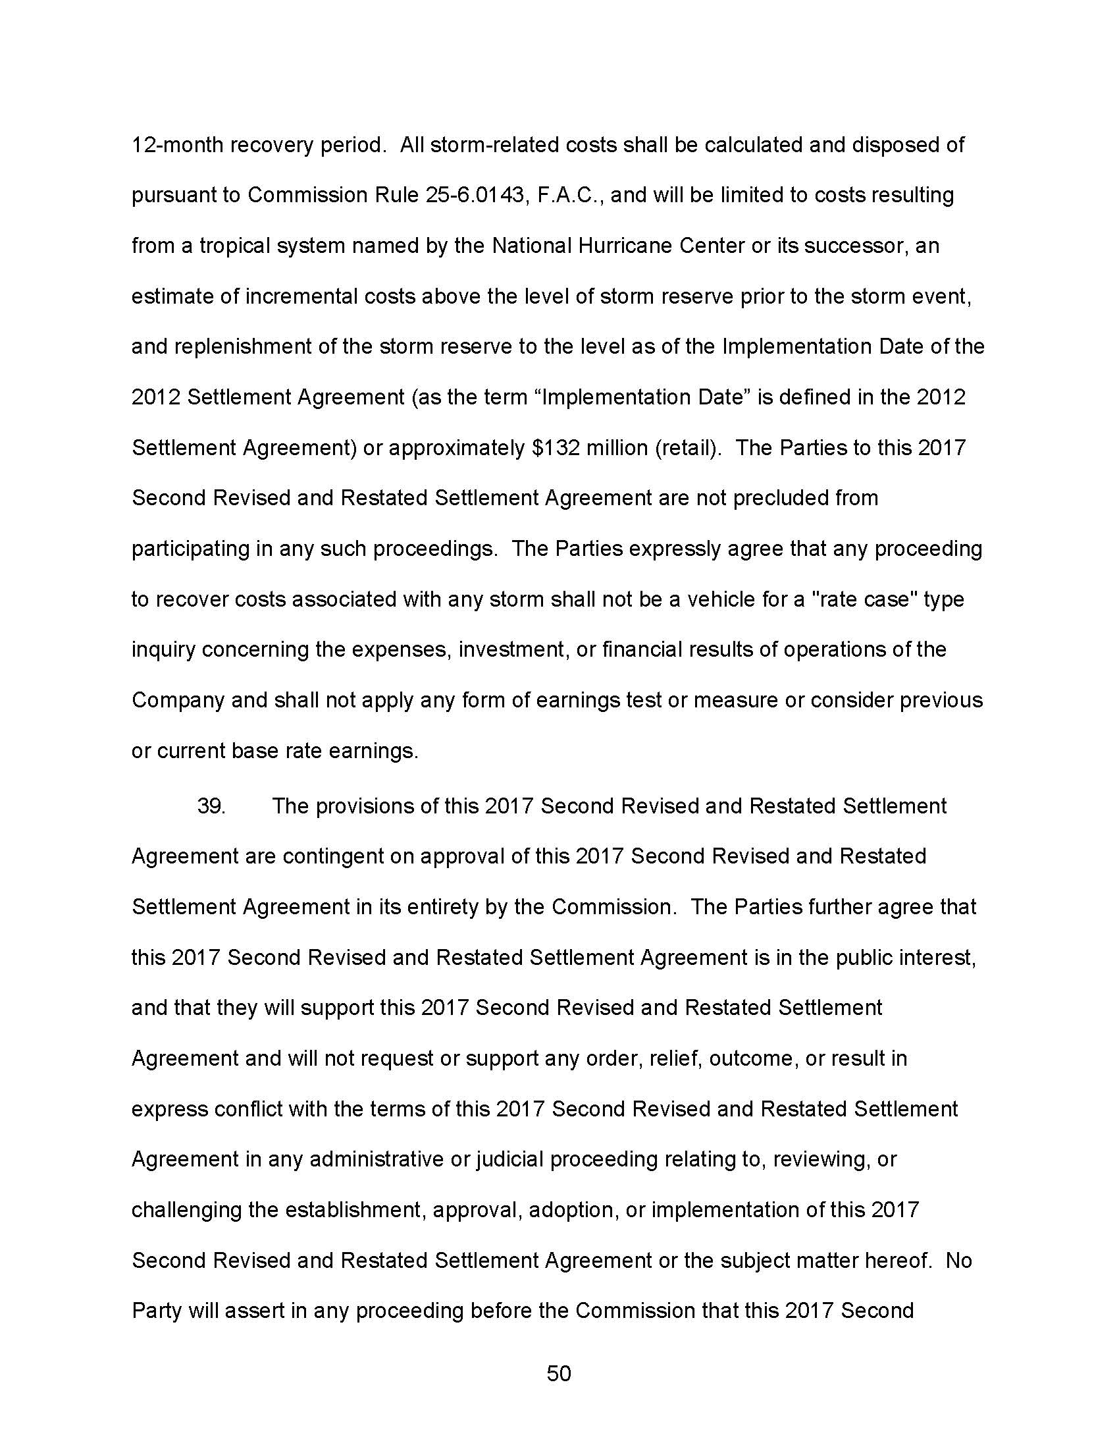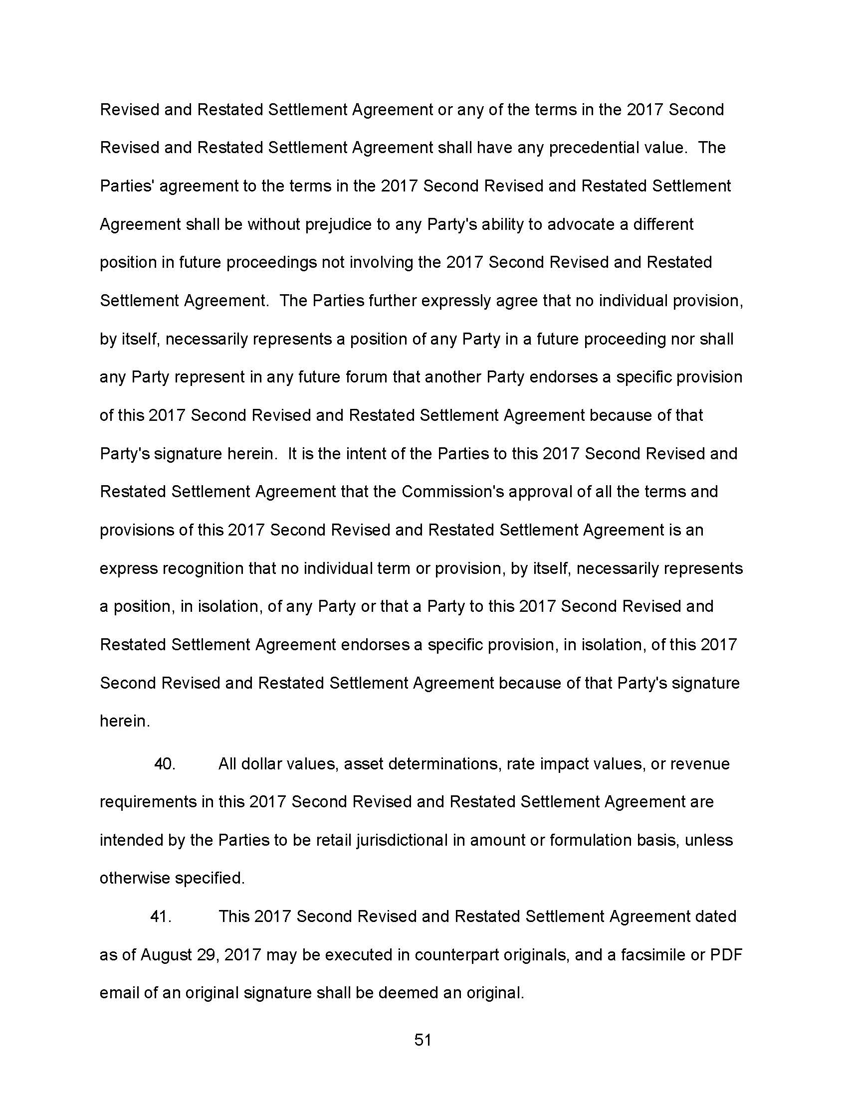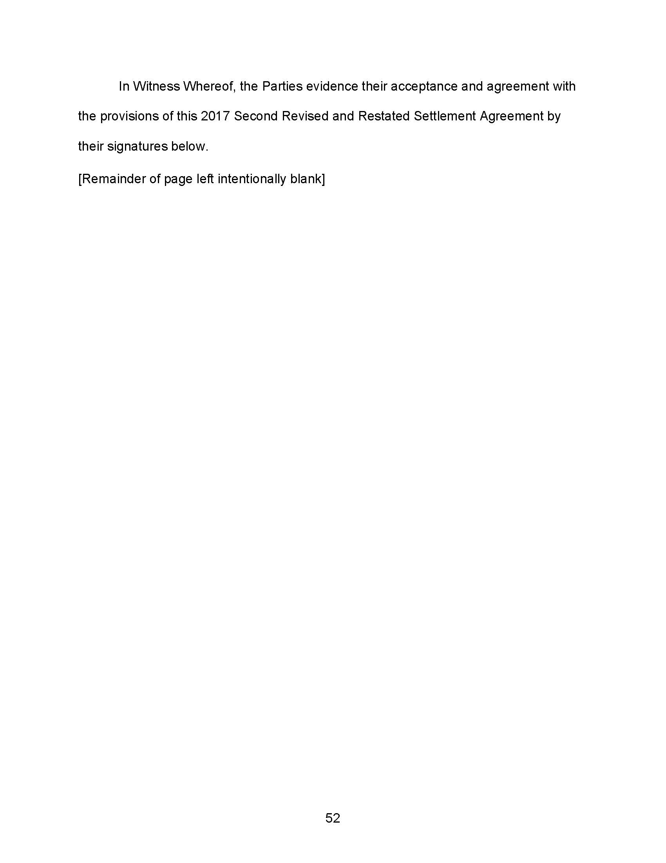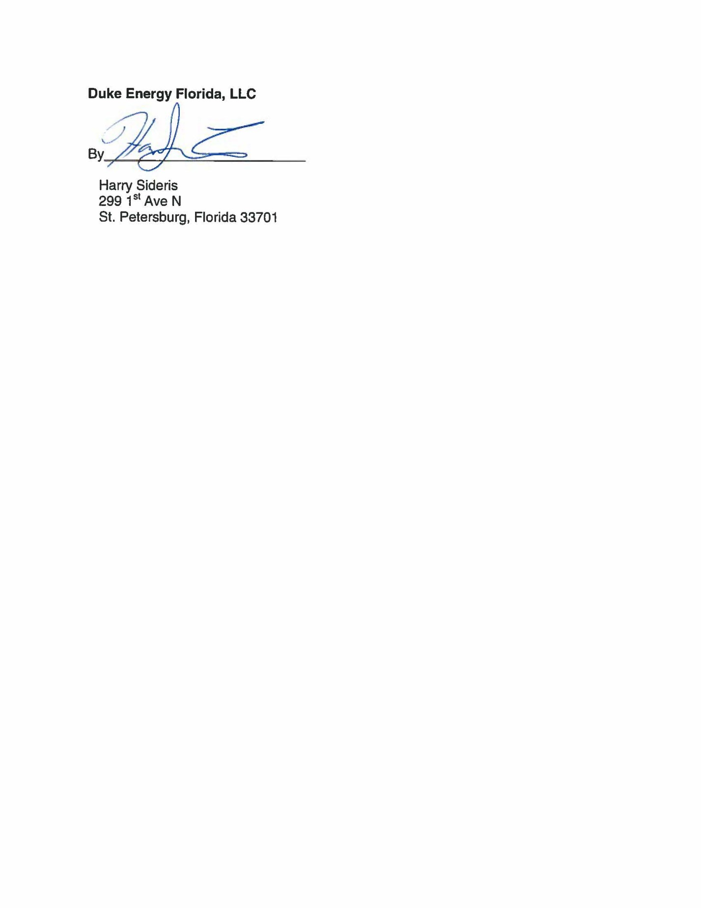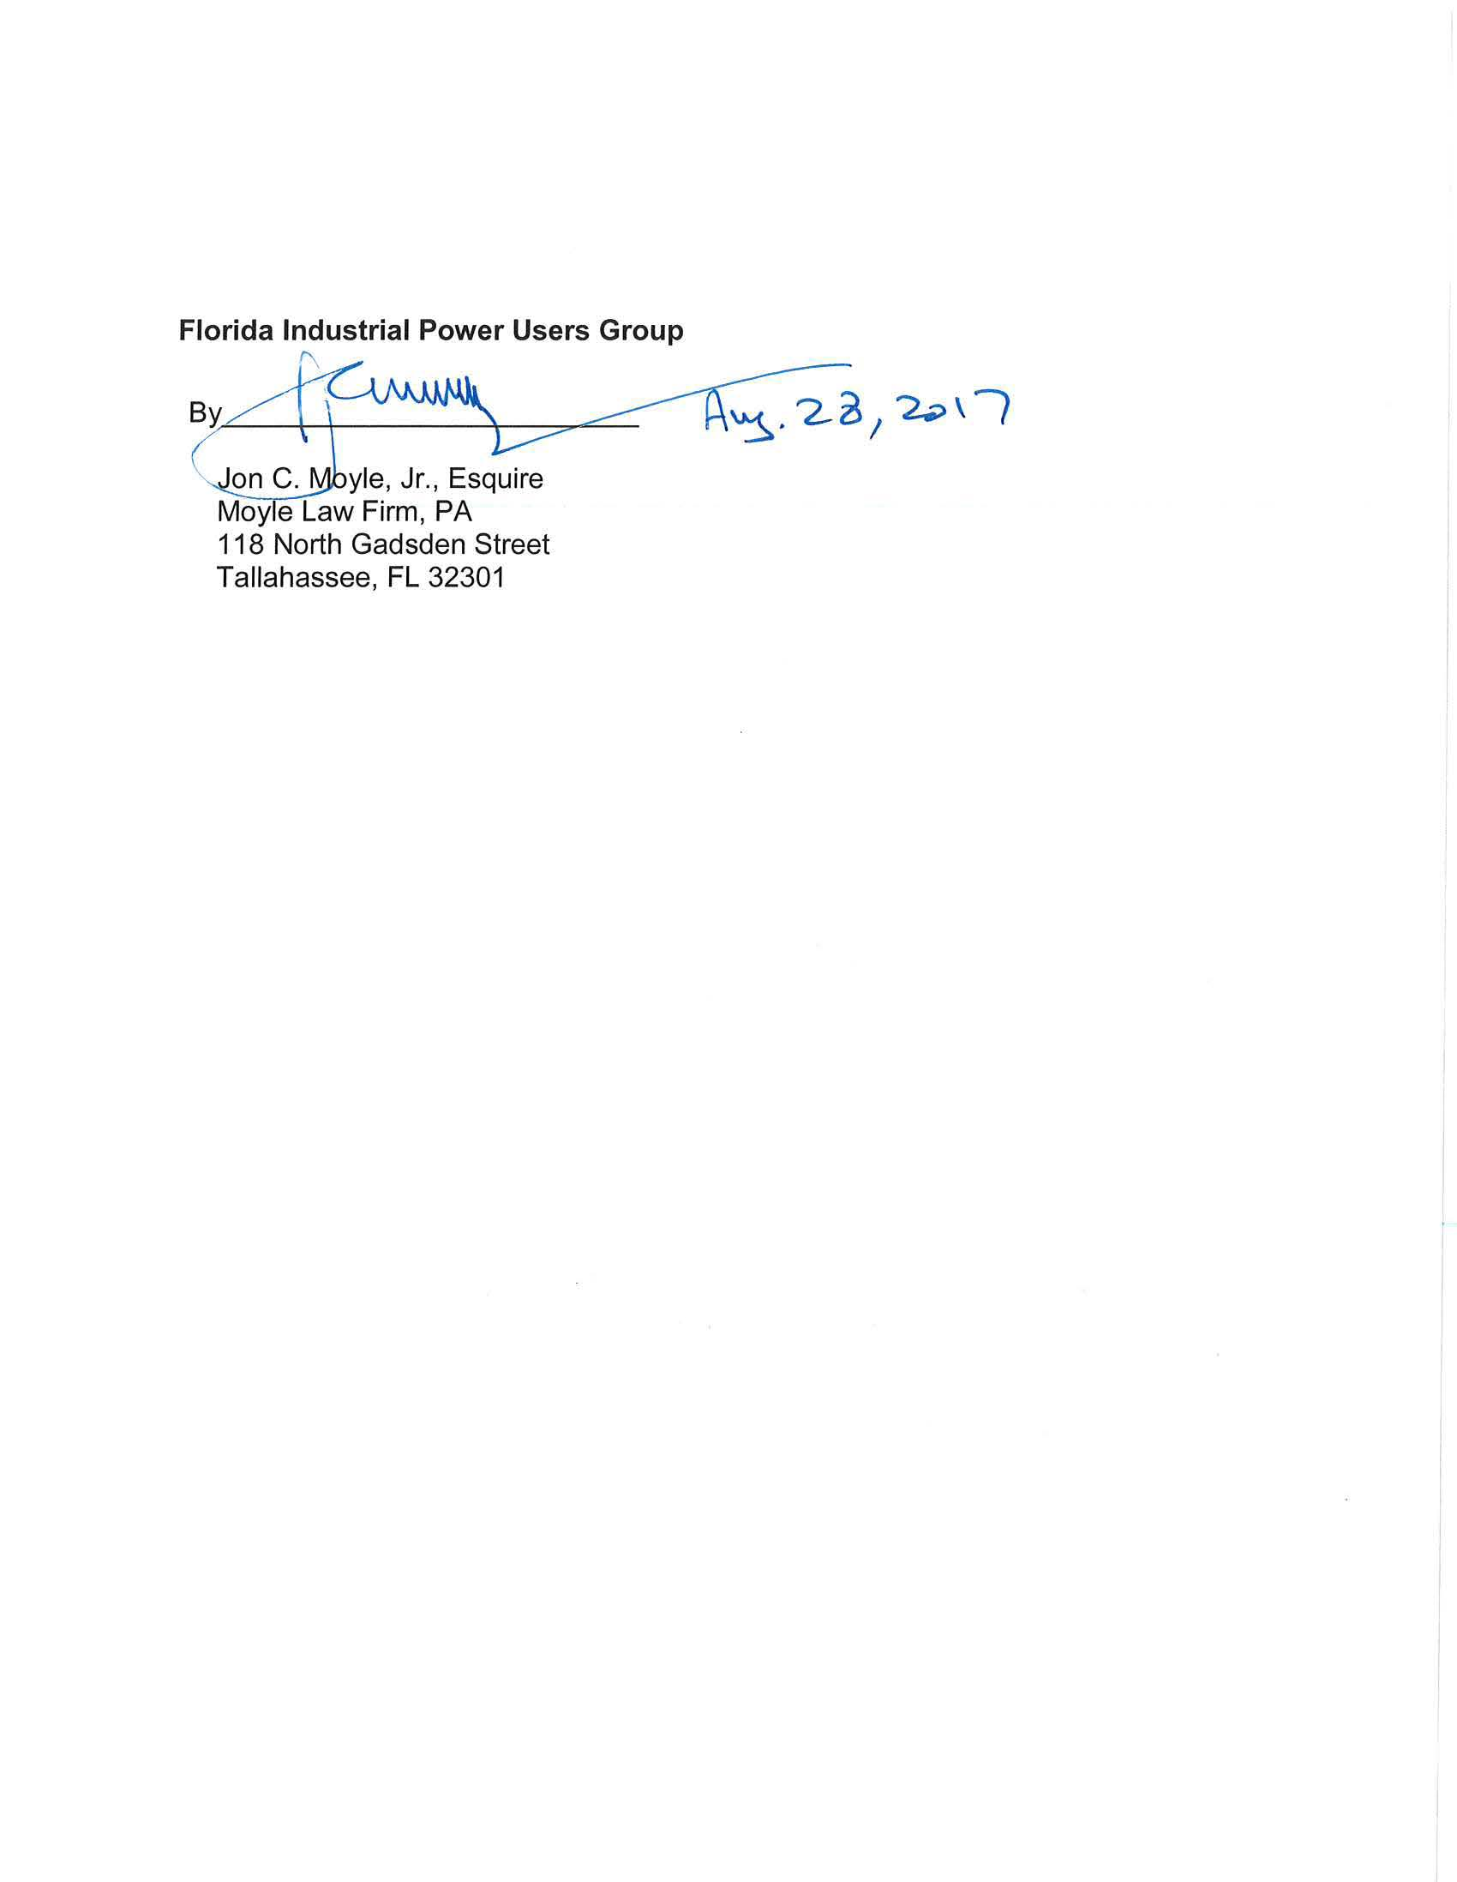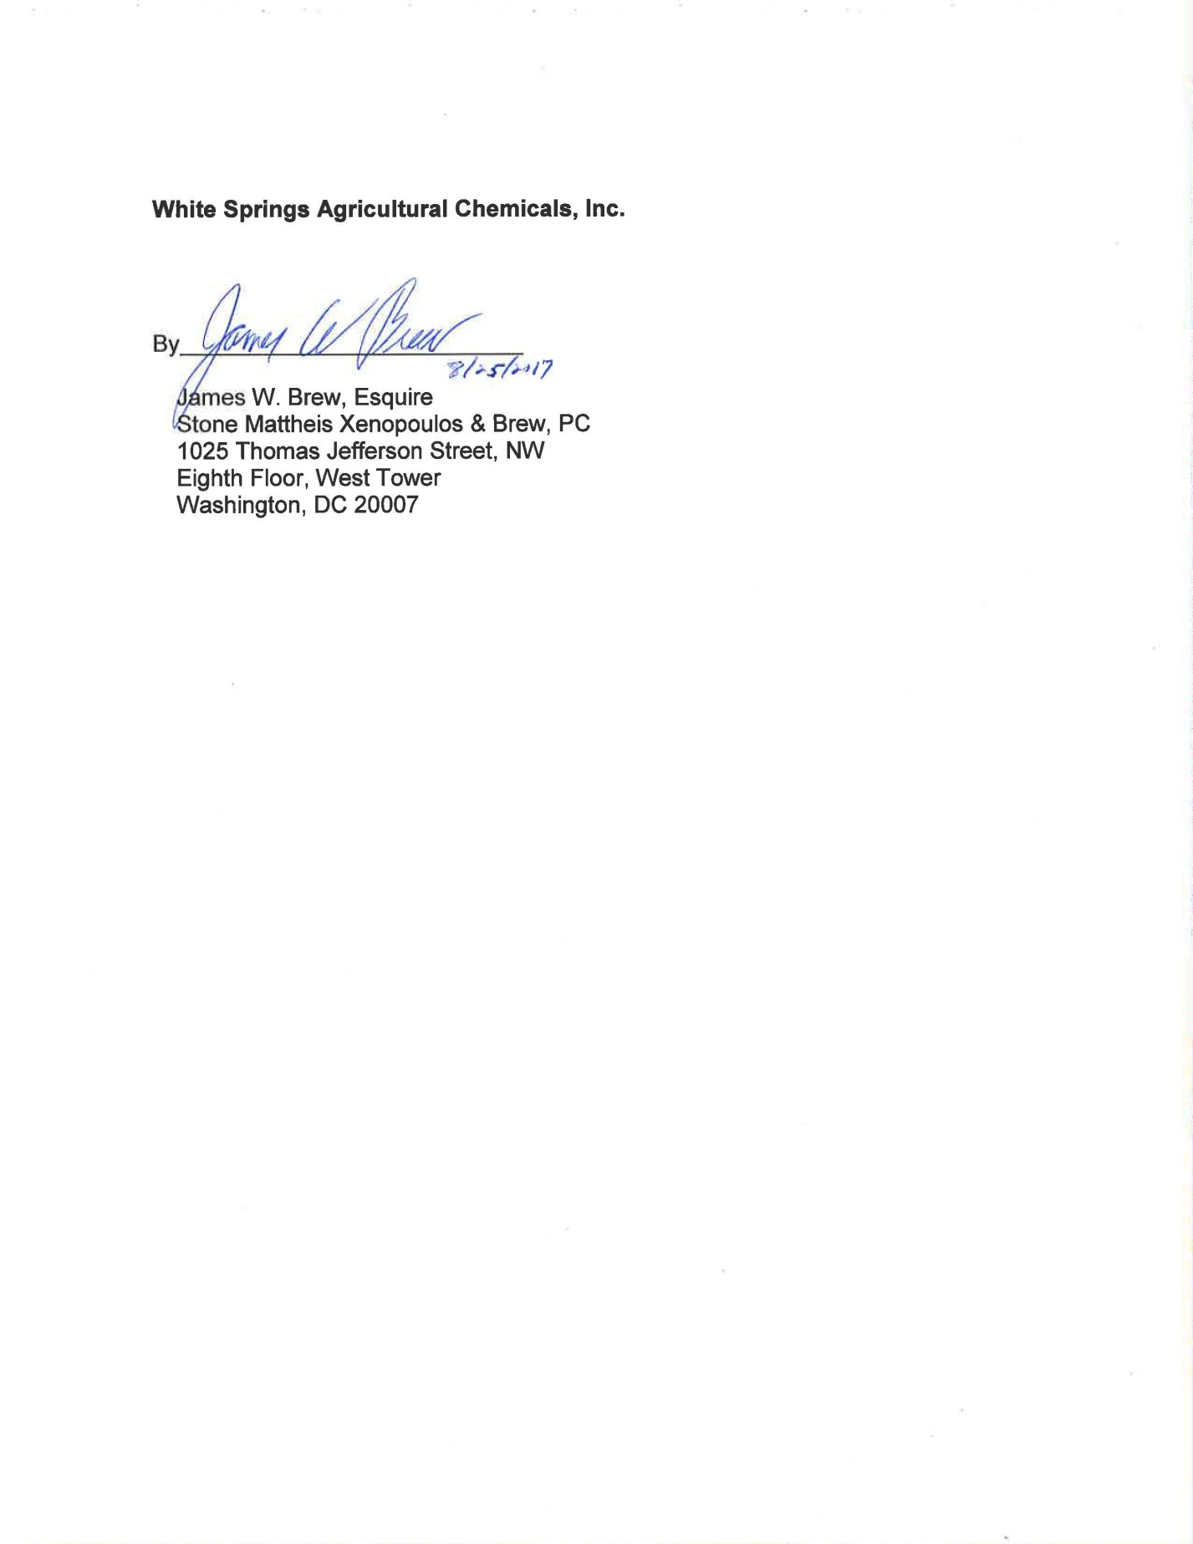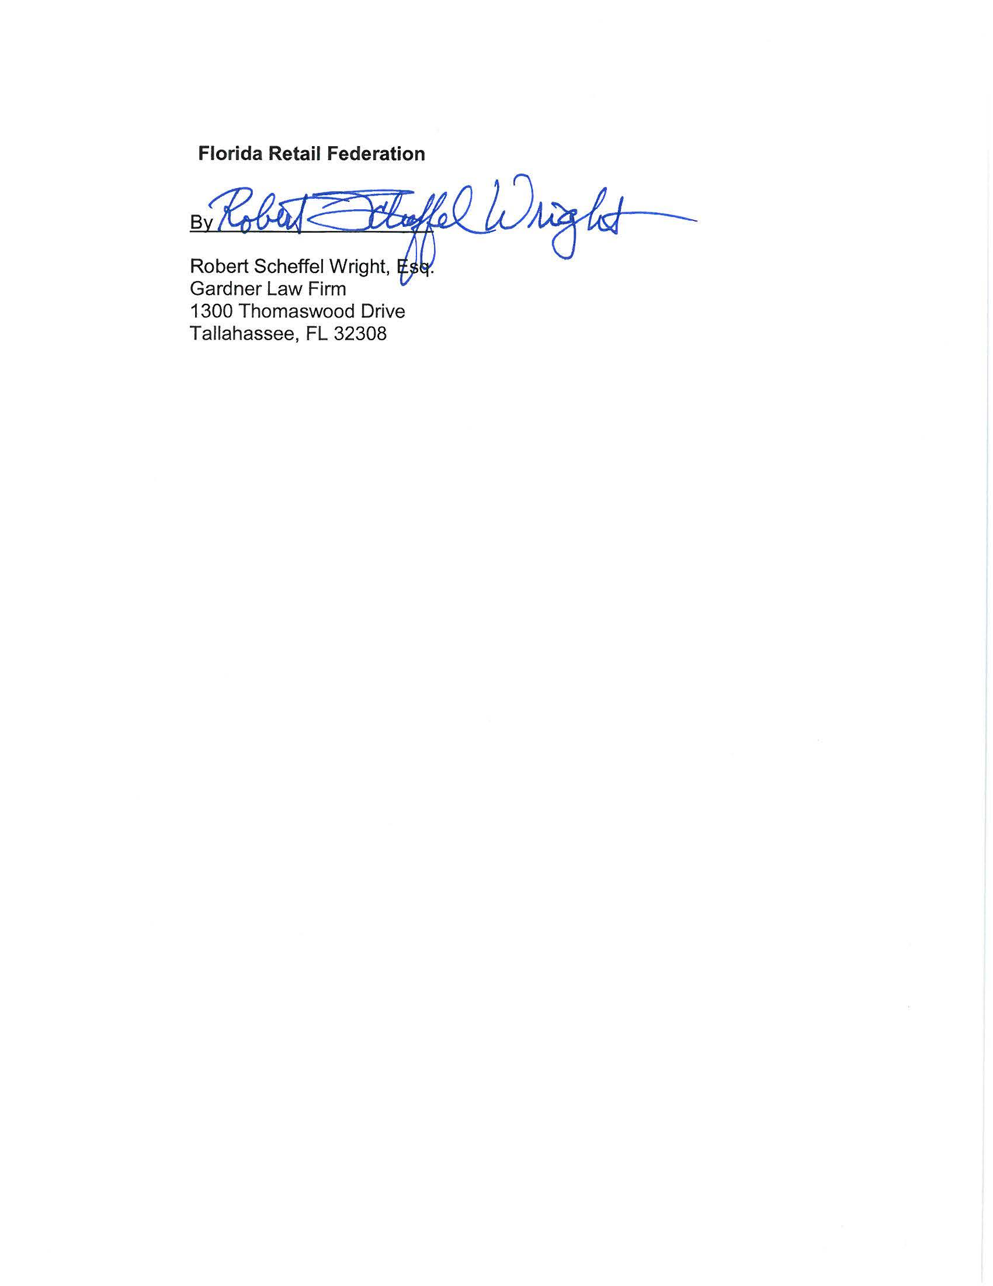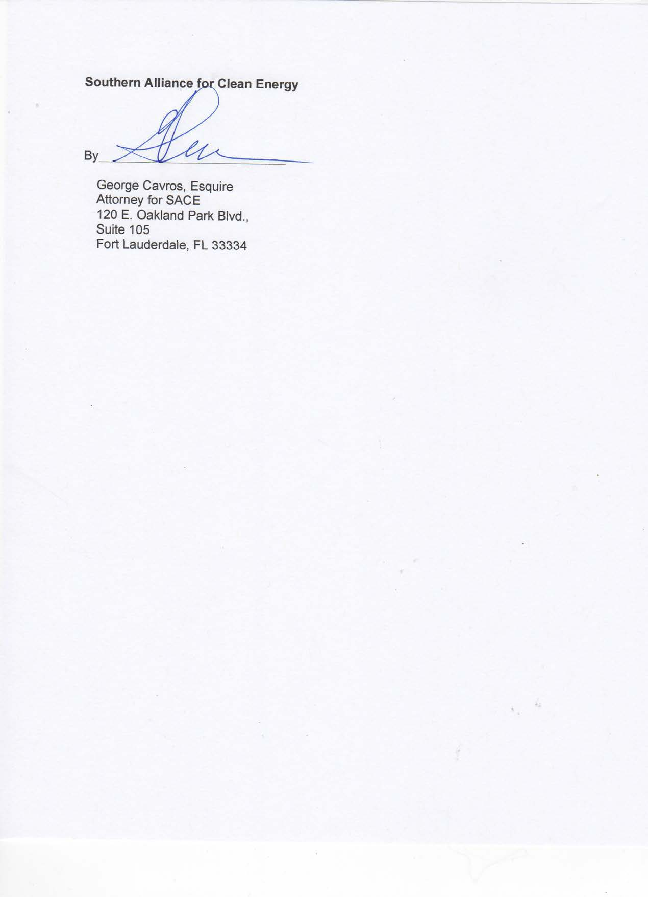

Order No. PSC-15-0465-S-EI, issued October 14, 2105, in Docket No. 15014-EI, In re: Petition for approval to include in base rates the revenue requirement for the CR3 regulatory asset, by Duke Energy Florida, Inc. and Docket No. 150171-EI, In re: Petition for issuance of nuclear asset-recovery financing order, by Duke Energy Florida, Inc. d/b/a Duke Energy; Order No. PSC-16-0138-FOF-EI, issued April 5, 2016, in Docket No. 15014-EI, In re: Petition for approval to include in base rates the revenue requirement for the CR3 regulatory asset, by Duke Energy Florida, Inc. and Docket No. 150171-EI, In re: Petition for issuance of nuclear asset-recovery financing order, by Duke Energy Florida, Inc. d/b/a Duke Energy; Order No. PSC-16-0425-PAA-EI, issued October 3, 2016, in Docket No. 160151-EI, In re: Petition for approval of stipulation to amend and revised and restated stipulation and settlement agreement by Duke Energy Florida, LLC.
Due to its length, the Exhibits to the 2017 Second Revised and Restated Settlement Agreement are not physically attached to this Order. However, all terms and conditions within those attachments are incorporated by reference herein. See Document No. 07346-2017, filed August 29, 2017, in Docket No. 20170183-EI, Application for limited proceeding to approve 2017 second revised and restated settlement agreement, including certain rate adjustments, by Duke Energy Florida, LLC.
Order No. PSC-13-0023-S-EI, issued January 14, 2013, in Docket No. 120015-EI, In re: Petition for increase in rates by Florida Power & Light Company; Order No. PSC-11-0089-S-EI, issued February 1, 2011, in Docket Nos. 080677 and 090130, In re: Petition for increase in rates by Florida Power & Light Company and In re: 2009 depreciation and dismantlement study by Florida Power & Light Company; Order No. PSC-13-0023-S-EI, issued January 14, 2013, in Docket No. 120015-EI, In re: Petition for increase in rates by Florida Power & Light Company; PSC-10-0398-S-EI, issued June 18, 2010, in Docket Nos. 090079-EI, 090144-EI, 090145-EI, 100136-EI, In re: Petition for increase in rates by Progress Energy Florida, Inc., In re: Petition for limited proceeding to include Bartow repowering project in base rates, by Progress Energy Florida, Inc., In re: Petition for expedited approval of the deferral of pension expenses, authorization to charge storm hardening expenses to the storm damage reserve, and variance from or waiver of Rule 25-6.0143(1)(c), (d), and (f), F.A.C., by Progress Energy Florida, Inc., and In re: Petition for approval of an accounting order to record a depreciation expense credit, by Progress Energy Florida, Inc.; Order No. PSC-05-0945-S-EI, issued September 28, 2005, in Docket No. 050078-EI, In re: Petition for rate increase by Progress Energy Florida, Inc.
Order No. PSC-13-0023-S-EI, at p. 7.

