BEFORE THE FLORIDA PUBLIC SERVICE COMMISSION

In re: Petition for approval of safety, access, and facility enhancement program (SAFE) true-up and associated cost recovery factors, by Florida City Gas. | DOCKET NO. 20170189-GU  ORDER NO. PSC-2017-0454-TRF-GU  ISSUED: November 22, 2017

The following Commissioners participated in the disposition of this matter:

JULIE I. BROWN, Chairman
ART GRAHAM
RONALD A. BRISÉ
DONALD J. POLMANN
GARY F. CLARK

ORDER APPROVING FLORIDA CITY GAS’ PETITION FOR APPROVAL OF SAFE TRUE-UP AND ASSOCIATED COST RECOVERY FACTORS

BY THE COMMISSION:

Background
On August 31, 2017, Florida City Gas (City Gas or company) filed a petition for approval of its safety, access, and facility enhancement program (SAFE) true-up and associated 2018 cost recovery factors. The SAFE program was originally approved by this Commission in Order No. PSC-15-0390-TRF-GU (2015 order) to recover the cost of relocating on an expedited basis certain existing gas mains and associated facilities from rear lot easements to the street front. In the 2015 order, we found that the relocation to the street front provides for more direct access to facilities and will enhance the level of service provided to all customers through improved safety and reliability. The SAFE factor is a surcharge on customers’ bills. We ordered the company to file an annual petition, beginning in 2016, for a review and reset of the surcharge factors to true-up any prior over- or under-recovery and to set the surcharge for the coming year. City Gas’ current SAFE factors were approved in Order No. PSC-16-0517-TRF-GU (2016 order). The SAFE program is a 10-year program (2015 through 2025).
In its filing, City Gas waived the 60-day suspension deadline pursuant to Section 366.06(3), Florida Statutes (F.S.). City Gas filed its responses to Commission staff’s first data request on September 21, 2017. The Office of the Public Counsel (OPC) filed a Notice of Intervention on October 4, 2017, which was acknowledged by Order PSC-2017-0413-PCO-GU, issued on October 24, 2017. The proposed tariff page is contained in Attachment 2 of this Order. We have jurisdiction over this matter pursuant to Sections 366.03, 366.04, 366.05, 366.06, and 368, F.S.
Decision
Under the SAFE program, City Gas will relocate and replace 254.3 miles of mains and associated facilities from rear property easements to the street front over a 10-year period, ending in 2025. City Gas began its replacements at the end of 2015, as provided for in the 2015 order, and the surcharges have been in effect since January 2016.
The 2016 order approving the current surcharges states that “if City Gas files a rate case before 2025, the then-current SAFE surcharge program would be folded into any newly approved rate base, and the surcharge would begin anew.” On October 23, 2017, City Gas filed a petition for a rate increase and Docket No. 20170179-GU was opened to address the rate case proceeding. In the rate case, City Gas witness Michael Morley testifies that City Gas proposes to incorporate the SAFE program revenue requirement ($3.5 million) in the requested base rate increase of $19.3 million and reset the SAFE surcharge to $0 at the time revised base rates will go into effect. Since the SAFE program is expected to continue until 2025, the SAFE surcharge would begin anew in 2019.
As stated in City Gas’ response to Commission staff’s data request, the company's 2017 replacement plans include eight projects. Seven projects are in the Miami area (Cutler Bay, Hialeah, and South Miami Heights neighborhood). One project is in Brevard County (Merritt Island). The company’s projected 2018 replacement plans include nine projects. Eight projects will be in the Miami area (South Miami Heights neighborhood, Westchester neighborhood, Hialeah, and Miami Gardens) and one project will be in Brevard County (Merritt Island). Attachment 1 of this Order displays City Gas' mains and services replacement progress, both actual and forecasted.
City Gas stated that its replacement projects are generally prioritized based on the risk assessment model in its Distribution Integrity Management Program (DIMP). Prioritization factors include, but are not limited to, the location of the pipeline, pipeline material, leak incident rates, and rear lot pipelines with maintenance access complications and customer encroachments.
True-ups by Year
As required by the initial 2015 order, City Gas’ calculations for the 2018 revenue requirement and SAFE factors include a final true-up for 2016, an actual/estimated true-up for 2017, and projected cost for 2018. City Gas does not currently include interest on any over- or under-recoveries in its calculations.

Final True-up for 2016
City Gas stated that the revenues collected for 2016 were $931,973 compared to a revenue requirement of $749,325, resulting in over-recovery of $182,647.
Actual/Estimated 2017 True-up
City Gas provided actual revenues for January through July and forecast revenues for August through December of 2017, totaling $2,025,987, compared to an actual/estimated revenue requirement of $2,259,077, resulting in an under-recovery of $233,090. Adding the 2016 over-recovery of $182,647 to the 2017 under-recovery of $233,090, the resulting total 2017 true-up is an under-recovery of $50,443.
Projected 2018 Costs
The company projects investment of $30,634,858 for the relocation of gas mains from rear property easements to the street front in 2018. The corresponding revenue requirement, which includes return on investment, depreciation, and taxes, is $3,452,072. After adding the 2017 under-recovery of $50,443, the total 2018 revenue requirement is $3,502,515. Table 1 displays the 2018 revenue requirement calculation.
Table 1
2018 Revenue Requirement Calculation
2018 Projected Replacements | $30,634,858
Return on Investment | $2,315,506
Depreciation Expense | $905,272
Property Tax Expense | $231,294
2018 Revenue Requirement | $3,452,072
Plus 2017 Under-recovery | $50,443
Total 2018 Revenue Requirement | $3,502,515
Source: Exhibit B of the Petition
Proposed SAFE Factors
The SAFE factors are fixed monthly surcharges. The company's cost allocation method was approved in the 2015 order, and according to City Gas, used for the instant filing. The approved methodology allocates the current cost of a 2-inch pipe to all customers (other than those with pre-existing contracts) on a per customer basis and allocates the incremental cost of replacing a pipe larger than 2 inches to customers who use over 6,000 therms per year. For larger customers, the cost pool takes into account that the minimum pipe is insufficient to serve their demand, and therefore, allocates an incremental per foot cost in addition to the all-customer cost. The resulting allocation factors are applied to the 2018 total revenue requirement to develop the monthly customer SAFE factors.
It is noted that the average residential customer uses approximately 240 therms per year. The proposed fixed monthly factor is $2.60 for customers using less than 6,000 therms per year, compared to the current factor of $1.53 per month. For customers using 6,000 therms or more per year, the proposed fixed monthly factor is $4.76, compared to the current factor of $2.77 per month.
Conclusion
We have reviewed City Gas’ filing and supporting documentation and find that the calculations are consistent with the methodology and are reasonable and accurate. Therefore, we approve Florida City Gas' proposed 2018 SAFE surcharge factors with an effective date of the first billing cycle of January 2018.
Based on the foregoing, it is

ORDERED by the Florida Public Service Commission that Florida City Gas’ petition for its Safety, Access and Facility Enhancement Program (SAFE) true-up and associated cost recovery factors is approved with effective date of the first billing cycle of January 2018. It is further

ORDERED that if a protest is filed within 21 days of issuance of the Order, the tariff shall remain in effect with any charges held subject to refund pending resolution of the protest. It is further

ORDERED that if no timely protest is filed, this docket shall be closed upon the issuance of a Consummating Order.

By ORDER of the Florida Public Service Commission this 22nd day of November, 2017.

/s/ Hong Wang
HONG WANG
Chief Deputy Commission Clerk
Florida Public Service Commission
2540 Shumard Oak Boulevard
Tallahassee, Florida 32399
(850) 413-6770
www.floridapsc.com

Copies furnished: A copy of this document is provided to the parties of record at the time of issuance and, if applicable, interested persons.

DJ

NOTICE OF FURTHER PROCEEDINGS

The Florida Public Service Commission is required by Section 120.569(1), Florida Statutes, to notify parties of any administrative hearing or judicial review of Commission orders that is available under Sections 120.57 or 120.68, Florida Statutes, as well as the procedures and time limits that apply. This notice should not be construed to mean all requests for an administrative hearing or judicial review will be granted or result in the relief sought.

Mediation may be available on a case-by-case basis. If mediation is conducted, it does not affect a substantially interested person's right to a hearing.

The Commission's decision on this tariff is interim in nature and will become final, unless a person whose substantial interests are affected by the proposed action files a petition for a formal proceeding, in the form provided by Rule 28-106.201, Florida Administrative Code. This petition must be received by the Office of Commission Clerk, 2540 Shumard Oak Boulevard, Tallahassee, Florida 32399-0850, by the close of business on December 13, 2017.

In the absence of such a petition, this Order shall become final and effective upon the issuance of a Consummating Order.

Any objection or protest filed in this docket before the issuance date of this order is considered abandoned unless it satisfies the foregoing conditions and is renewed within the specified protest period.

Table 1
Florida City Gas’ SAFE Program Progress
 | Main Replacements |  | Service Replacements
Year | Replaced Main (miles) | Total Miles Remaining | Replaced Services (No.) | Total Remaining Services
2014 | 0.0 | 254.3 | 0 | 12,719
2015 | 0.0 | 254.3 | 49 | 12,670
2016 | 17.1 | 237.2 | 1,433 | 11,237
2017 | 37.5 | 199.7 | 1,557 | 9,680
2018 | 27.6 | 172.1 | 1,698 | 7,982
2019 | 25.0 | 147.2 | 1,250 | 6,732
2020 | 25.0 | 122.2 | 1,250 | 5,481
2021 | 25.0 | 97.2 | 1,250 | 4,231
2022 | 25.0 | 72.2 | 1,250 | 2,981
2023 | 25.0 | 47.2 | 1,250 | 1,730
2024 | 25.0 | 22.2 | 1,250 | 480
2025 | 22.2 | 0.0 | 480 | 0
Source: FCG Response to Staff’s First Data Request

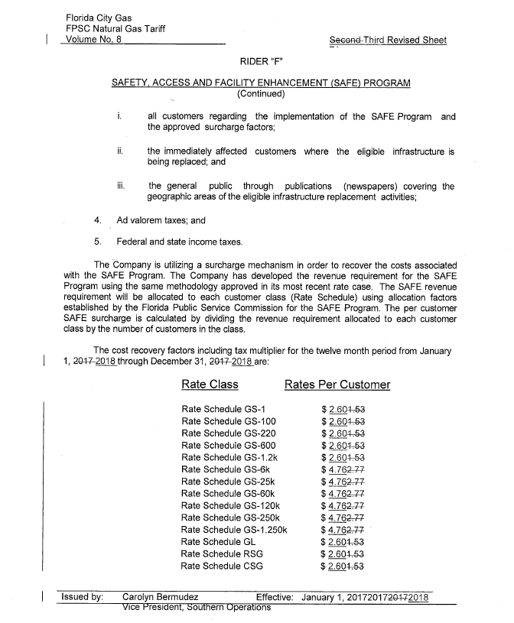

Order No. PSC-15-0390-TRF-GU, issued September 15, 2015, in Docket No. 150116-GU, In re: Petition for approval of safety, access, and facility enhancement program and associated cost recovery methodology, by Florida City Gas.
Order No. PSC-16-0517-TRF-GU, issued November 21, 2016, in Docket No. 160198-GU, In re: Petition for approval of safety, access, and facility enhancement program (SAFE) true-up and associated cost recovery factors, by Florida City Gas.

