BEFORE THE FLORIDA PUBLIC SERVICE COMMISSION

In re: Petition for limited proceeding to approve 2017 amended and restated stipulation and settlement agreement, by Tampa Electric Company. | DOCKET NO. 20170210-EI
In re: Petition for approval of energy transaction optimization mechanism, by Tampa Electric Company. | DOCKET NO. 20160160-EI  ORDER NO. PSC-2017-0456-S-EI  ISSUED: November 27, 2017

The following Commissioners participated in the disposition of this matter:

JULIE I. BROWN, Chairman
ART GRAHAM
RONALD A. BRISÉ
DONALD J. POLMANN
GARY F. CLARK
APPEARANCES:

JAMES D. BEASLEY and JEFFRY WAHLEN, ESQUIRES, Ausley McMullen Law Firm, P.O. Box 391, Tallahassee, Florida 32302
On behalf of Tampa Electric Company (TECO).

J.R. KELLY, VIRGINIA PONDER and CHARLES REHWINKEL, ESQUIRES, Office of Public Counsel, c/o The Florida Legislature, 111 West Madison Street, Room 812, Tallahassee, Florida 32399-1400
On behalf of the Citizens of the State of Florida (OPC).

KAREN PUTNAL and JON MOYLE, ESQUIRES, Moyle Law Firm, PA, The Perkins House, 118 North Gadsden Street, Tallahassee, Florida 32301
On behalf of the Florida Industrial Power Users Group (FIPUG).

Robert Scheffel Wright and John T. LaVia, III, ESQUIRES, Gardner, Bist, Bowden, Bush, Dee, LaVia & Wright, P.A., 1300 Thomaswood Drive, Tallahassee, Florida 32308
On behalf of the Florida Retail Federation (FRF).

SUZANNE BROWNLESS, ESQUIRE, Florida Public Service Commission, 2540 Shumard Oak Boulevard, Tallahassee, Florida 32399-0850
On behalf of the Florida Public Service Commission (Staff).

MARY ANNE HELTON, ESQUIRE, Deputy General Counsel, Florida Public Service Commission, 2540 Shumard Oak Boulevard, Tallahassee, Florida 32399-0850
Advisor to the Florida Public Service Commission.

Keith hetrick, ESQUIRE, General Counsel, Florida Public Service Commission, 2540 Shumard Oak Boulevard, Tallahassee, Florida 32399-0850
Florida Public Service Commission General Counsel.

FINAL ORDER APPROVING 2017 AMENDED AND RESTATED
STIPULATION AND SETTLEMENT AGREEMENT

BY THE COMMISSION:

BACKGROUND

On September 27, 2017, Tampa Electric Company (TECO) filed a petition for limited proceeding to approve its 2017 amended and restated stipulation and settlement agreement (Petition). In its Petition, TECO requested that the Florida Public Service Commission (Commission) hold a limited proceeding pursuant to Sections 366.076, 120.57(2) and 366.06(3), Florida Statutes (F.S.), and Rule 28-106.301, Florida Administrative Code (F.A.C.), to allow the Commission to review and approve the 2017 Amended and Restated Stipulation and Settlement Agreement (2017 Agreement) attached as an exhibit to the Petition.

The 2017 Agreement has been signed by TECO and the following: the Office of Public Counsel (OPC); Florida Industrial Power User’s Group (FIPUG); Florida Retail Federation (FRF); Federal Executive Agencies (FEA); and West Central Florida Hospital Utility Alliance (HUA). TECO alleges that the 2017 Agreement amends and extends the term of its 2013 Stipulation and Settlement Agreement (2013 Agreement), which resolved all outstanding issues in its last base rate case proceeding, approved by Order No. PSC-2013-0443-FOF-EI, issued September 30, 2013, in Docket No. 20130040-EI. The 2017 Agreement also includes the asset optimization mechanism originally requested in Docket No. 20160160-EI, and constitutes a full resolution of all issues raised in that docket. TECO and all other parties to the 2017 Agreement agree that there are no disputed issues of material fact that must be resolved for us to grant its Petition and approve the 2017 Settlement Agreement.

Based on these representations, we issued Order No. PSC-2017-0384-PCO-EI, on October 4, 2017, setting the Petition for a final hearing, which was held on November 6, 2017. FEA and HUA were excused from attending the final hearing. At the final hearing, TECO presented the testimony of four witnesses: Carlos Aldazabal, Mark Ward, James Rocha, and Bill Ashburn. A Comprehensive Exhibit List was admitted into the record as well as the exhibits identified thereon. The parties, supporting the 2017 Agreement, waived the right to file post-hearing briefs, and a bench vote was taken at the conclusion of the hearing.

Settlement Agreement

The major elements of the 2017 Agreement are as follows:

- The 2017 Agreement term (Term) is approximately four years in duration, from the Effective Date (date of vote) through 2021, and is, by and large, a four year extension of the 2013 Agreement.

- The 2017 Agreement retains the existing return on equity (ROE) of 10.25%, with a range of 9.25% to 11.25%, and features an equity ratio of 54% for the Solar Base Rate Adjustment (SoBRA) revenue requirement calculations and TECO’s actual equity ratio for surveillance reporting and setting clause rates.

- Base rates to remain at current levels initially, with solar generation cost recovery (SoBRA) included in tranches during the Term at the following dates and maximum cumulative amounts:
Year | Earliest Rate Change and In-Service Date | Maximum Cumulative  SoBRA MW | Maximum Cumulative Annualized SoBRA Revenue Requirement (millions) | Maximum Cumulative Impact on 1,000 KWH Residential Bill
2018 | September 1 | 150 | $30.6 ($10.2 collected over 4 months) | $1.95
2019 | January 1 | 400 | $81.5 | $3.33
2020 | January 1 | 550 | $112.1 | $4.47
2021 | January 1 | 600 | $122.3* | $4.87
* Cost recovery contingent on 2018-2019 tranches constructed at a maximum average capital cost of $1475/kW_{ac.}

- SoBRA total installed costs for purposes of cost recovery cannot exceed $1,500 per KWac (cap). Projects must be smaller than 75 MW and thus are not subject to the Power Plant Siting Act. Each tranche requires that a new petition for cost recovery be filed in a separate docket.

- SoBRA savings, where actual costs are below the $1,500 per KWac cap, are shared between customers and company on a 75%/25% basis. The full benefit of Renewable Energy Credits (RECs) will be flowed through to retail customers through the Environmental Cost Recovery Clause (ECRC).

- SoBRA costs are allocated equally among all rate classes with the exception of the lighting class. The lighting class is responsible for 40% of its SoBRA revenue requirement, with the remaining 60% of its revenue requirement allocated to the other customer classes.

- If federal or state tax reform is enacted before TECO’s next rate case, TECO will flow back to retail customers within 120 days any impacts to revenue requirements through a one-time adjustment to base rates, uniformly applied across customer classes and charges.

- Standby Generator Credits increase from $4.75/kW/month to $5.35/kW/month. Contracted Credit Value, or CCV Credit, is increased marginally for secondary, primary, and sub-transmission voltage customers.

- If TECO’s coal-fired generating assets and Automatic Meter Reading (AMR) meters are retired during the Term, the related assets will be depreciated using TECO’s then-existing depreciation rates.

- The parties consent to TECO’s petition to implement its proposed asset optimization/ incentive plan set forth in Docket No. 20160160-EI during the Term, but at modified percentage thresholds of achieved gains to be divided between customers and shareholders.

- TECO will enter into no new natural gas financial hedging contracts through December 31, 2022 and will file a request to close Docket No. 20170057-EI upon approval of the 2017 Agreement or as soon thereafter as practical.

- TECO will not seek recovery of any costs from its customers related to investments in oil and/or natural gas exploration, reserves, acreage and or production for a period of five years after the Effective Date.

- Carryover Provisions applicable from the 2013 Agreement include: named storm damage recovery; the Economic Development Rider; and deferral of depreciation and dismantlement studies until the year before TECO’s next rate case.

DECISION
The standard for approval of a settlement agreement is whether it is in the public interest. A determination of public interest requires a case-specific analysis based on consideration of the proposed settlement taken as a whole. The signatories to the 2017 Agreement represent a broad segment of FPL’s customer base including both residential and commercial classes. Many of the terms found in the 2017 Agreement were proposed by the signatories and are consistent with terms found in Florida Power & Light Company’s, Gulf Power Company’s, and Duke Energy Florida, LLC’s most recent rate case settlements, e.g., cessation of natural gas hedging, construction of cost-effective solar generation, implementation of an asset optimization program, implementation of a storm damage recovery mechanism, an economic development rider, and the deferral of depreciation studies until the utility’s next rate case. The 2017 Agreement essentially maintains the current base rates for another four years adjusted for additions to solar generating capacity spread over the same period. Thus, the 2017 Agreement increases TECO’s fuel diversity in a cost effective manner while providing rate predictability. Further, the 2017 Agreement allows ratepayers to receive the benefit of any revisions to the federal income tax code within 4 months of those benefits becoming available. Having carefully reviewed the 2017 Agreement, the exhibits entered into the record, and the testimony provided by TECO’s witnesses, we find that taken as a whole it provides a reasonable resolution of all the issues addressed. We find, therefore, that the 2017 Agreement, Attachment A hereto, establishes rates that are fair, just, and reasonable and is in the public interest, and hereby approve it.

Based on the foregoing, it is

ORDERED by the Florida Public Service Commission that Tampa Electric Company’s Petition for Limited Proceeding to approve 2017 Amended and Restated Stipulation and Settlement Agreement is hereby granted. It is further

ORDERED that the 2017 Amended and Restated Stipulation and Settlement Agreement, attached hereto as Attachment A, and incorporated by reference, is hereby approved. It is further

ORDERED that the tariff sheets, contained in Exhibit A attached to the 2017 Amended and Restated Stipulation and Settlement Agreement, are hereby approved with an effective date of the first billing cycle in January 2018. It is further

ORDERED that in the event no timely appeal is filed, Docket Nos. 20170210-EI and 20160160-EI shall be closed.

By ORDER of the Florida Public Service Commission this 27th day of November, 2017.

/s/ Carlotta S. Stauffer
CARLOTTA S. STAUFFER
Commission Clerk
Florida Public Service Commission
2540 Shumard Oak Boulevard
Tallahassee, Florida 32399
(850) 413-6770
www.floridapsc.com

Copies furnished: A copy of this document is provided to the parties of record at the time of issuance and, if applicable, interested persons.

SBr

NOTICE OF FURTHER PROCEEDINGS OR JUDICIAL REVIEW

The Florida Public Service Commission is required by Section 120.569(1), Florida Statutes, to notify parties of any administrative hearing or judicial review of Commission orders that is available under Sections 120.57 or 120.68, Florida Statutes, as well as the procedures and time limits that apply. This notice should not be construed to mean all requests for an administrative hearing or judicial review will be granted or result in the relief sought.

Any party adversely affected by the Commission's final action in this matter may request: 1) reconsideration of the decision by filing a motion for reconsideration with the Office of Commission Clerk, 2540 Shumard Oak Boulevard, Tallahassee, Florida 32399-0850, within fifteen (15) days of the issuance of this order in the form prescribed by Rule 25-22.060, Florida Administrative Code; or 2) judicial review by the Florida Supreme Court in the case of an electric, gas or telephone utility or the First District Court of Appeal in the case of a water and/or wastewater utility by filing a notice of appeal with the Office of Commission Clerk, and filing a copy of the notice of appeal and the filing fee with the appropriate court. This filing must be completed within thirty (30) days after the issuance of this order, pursuant to Rule 9.110, Florida Rules of Appellate Procedure. The notice of appeal must be in the form specified in Rule 9.900(a), Florida Rules of Appellate Procedure.

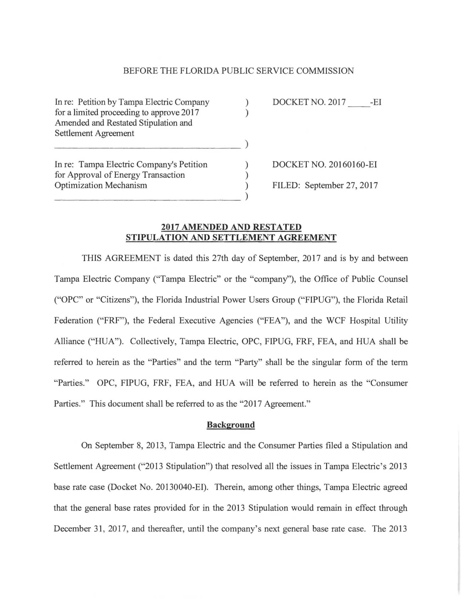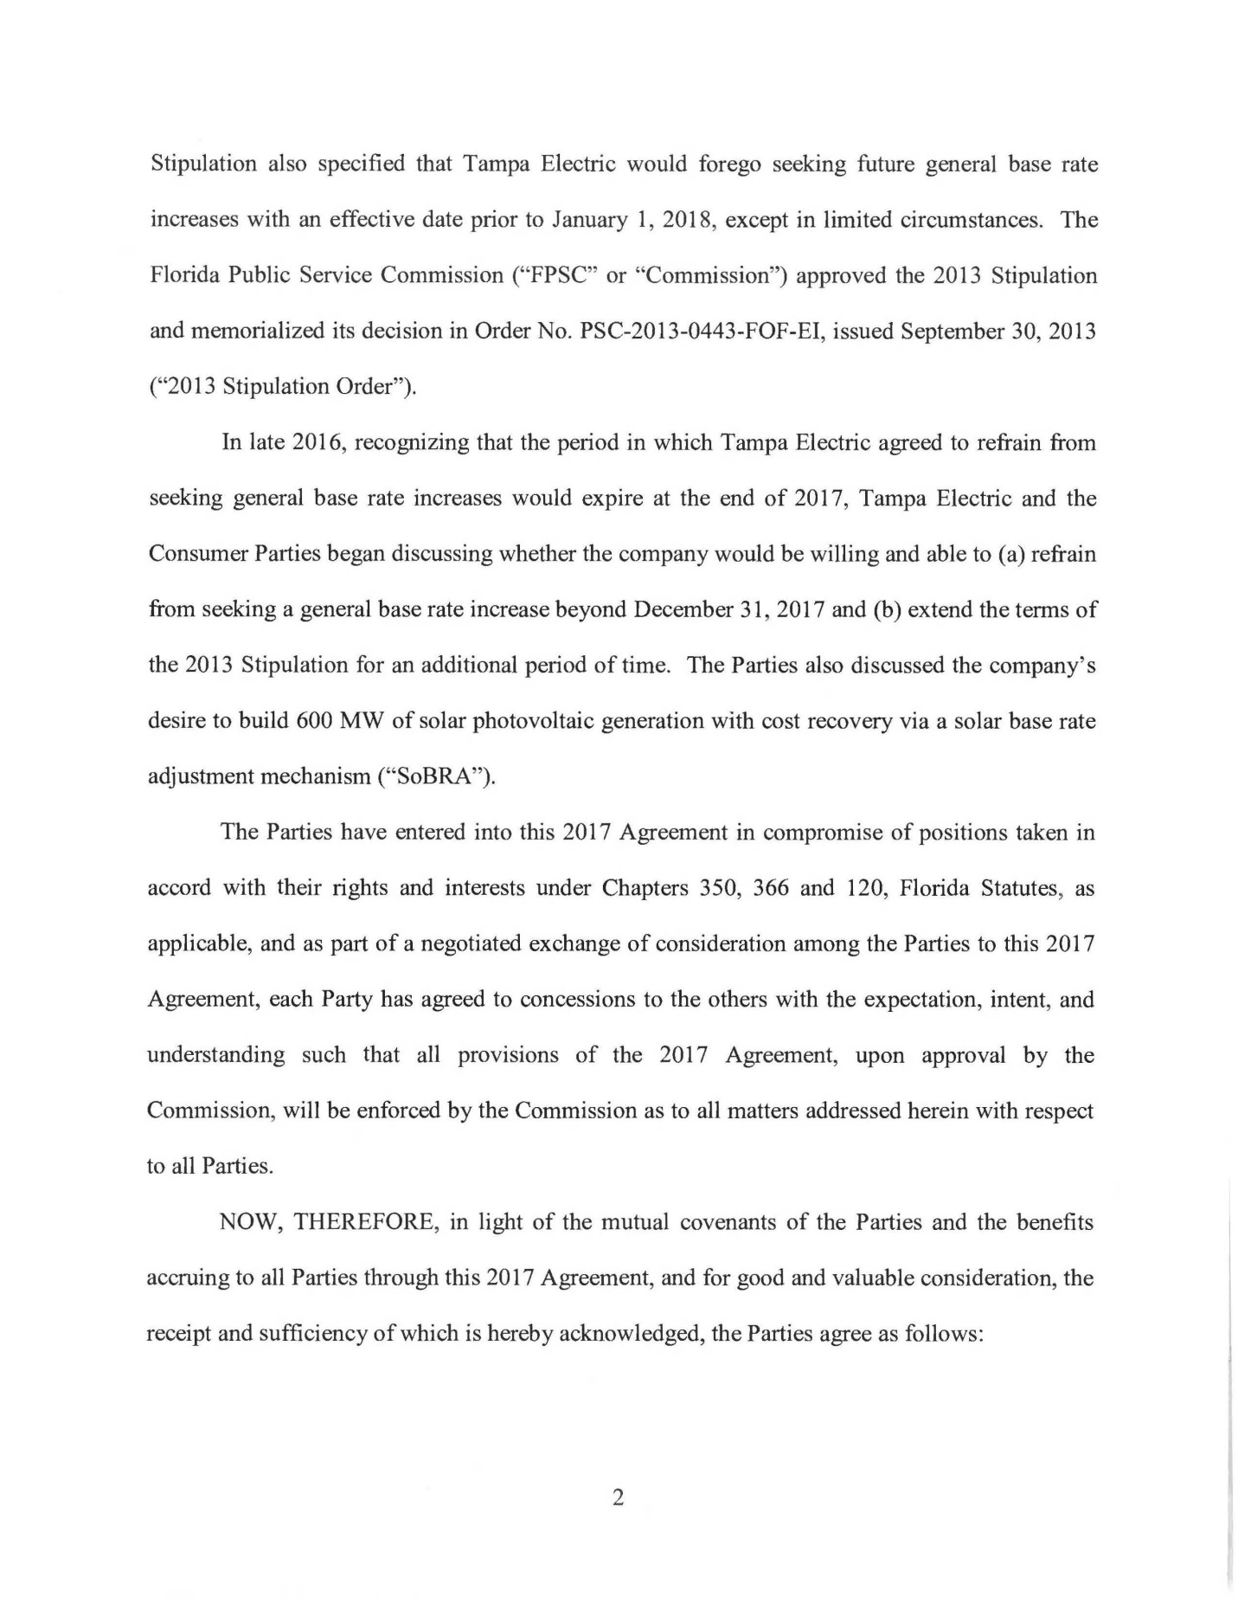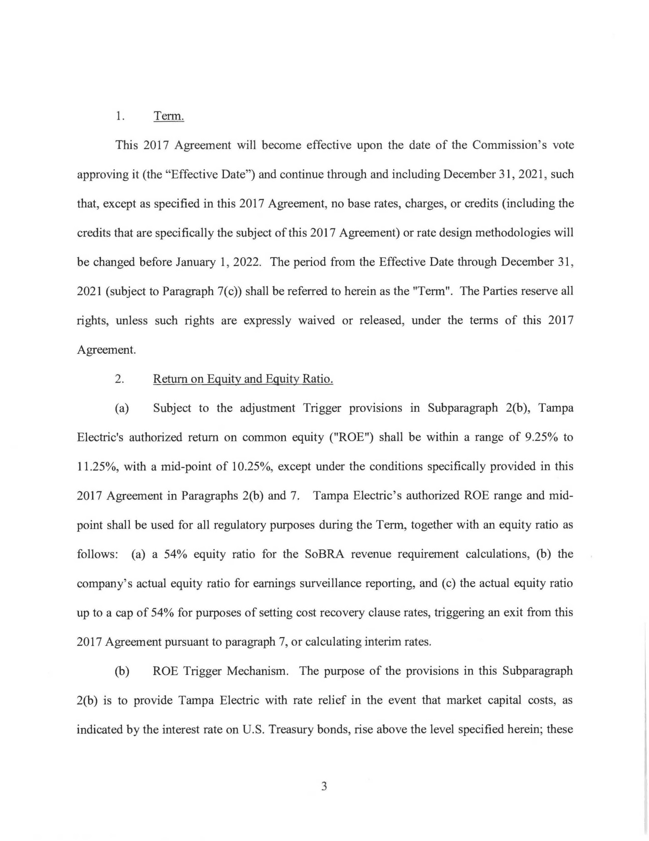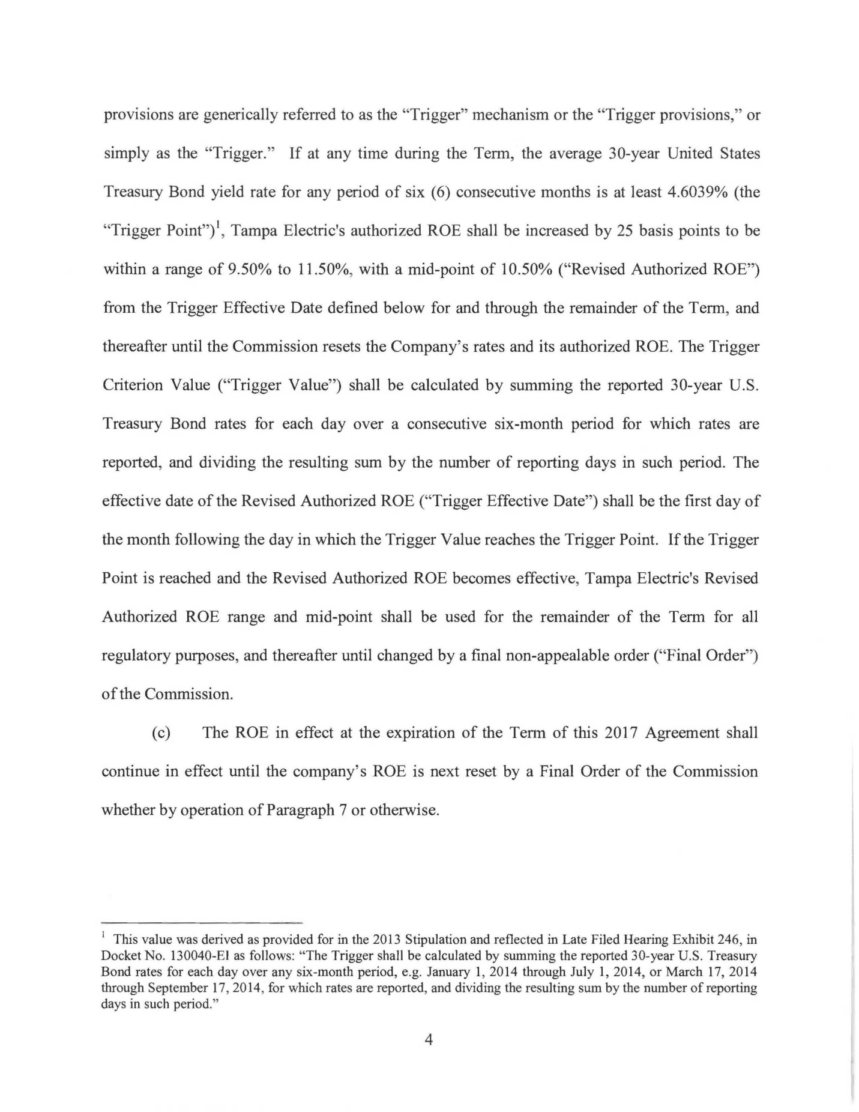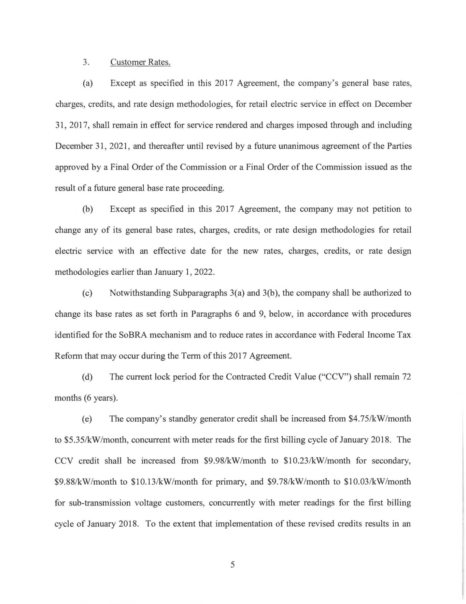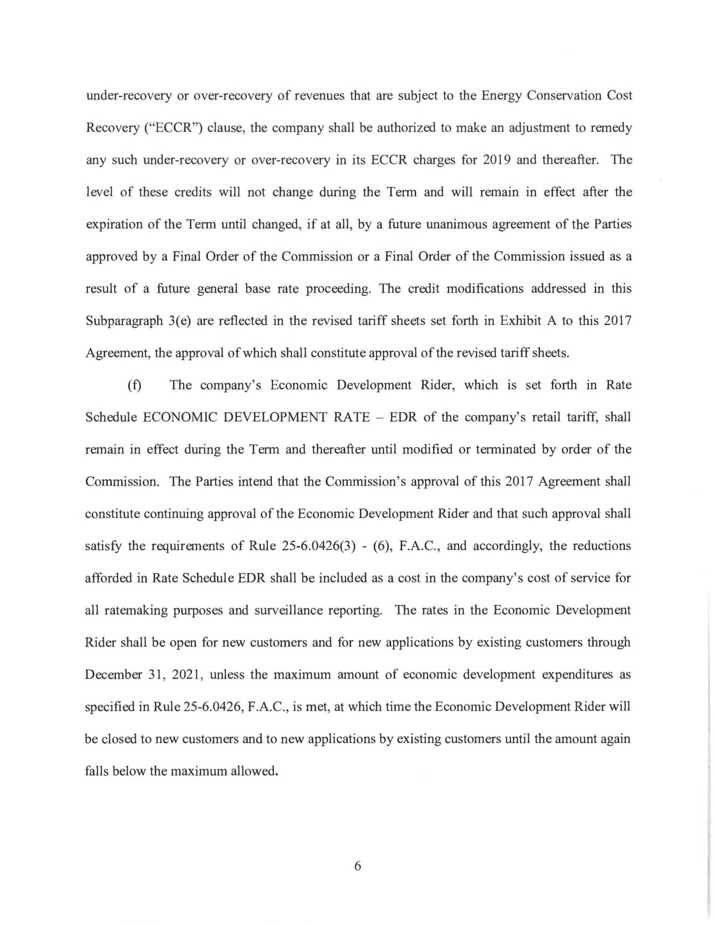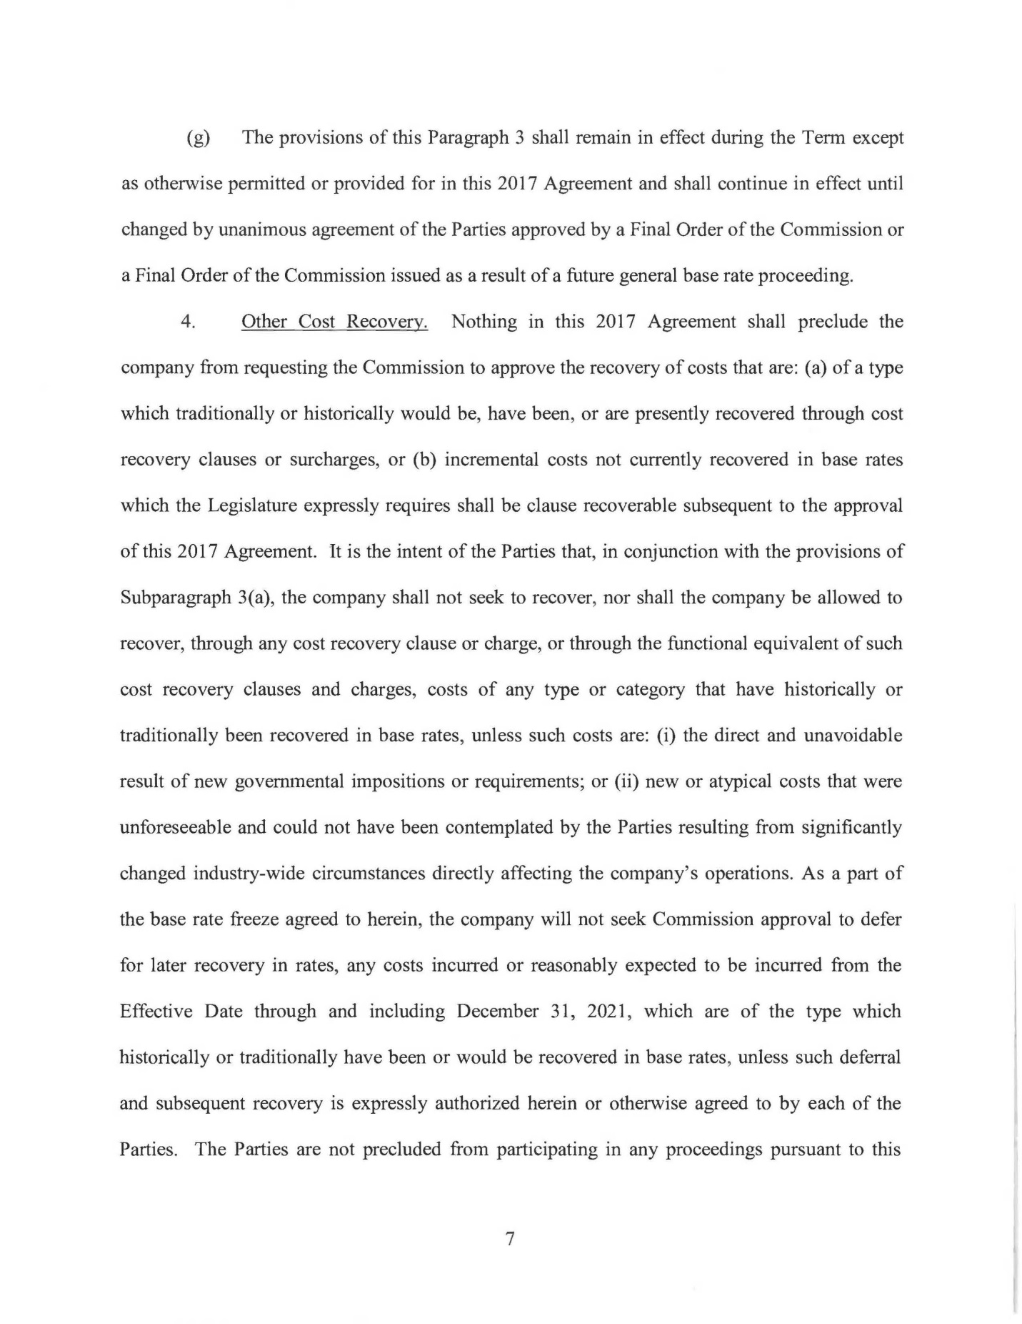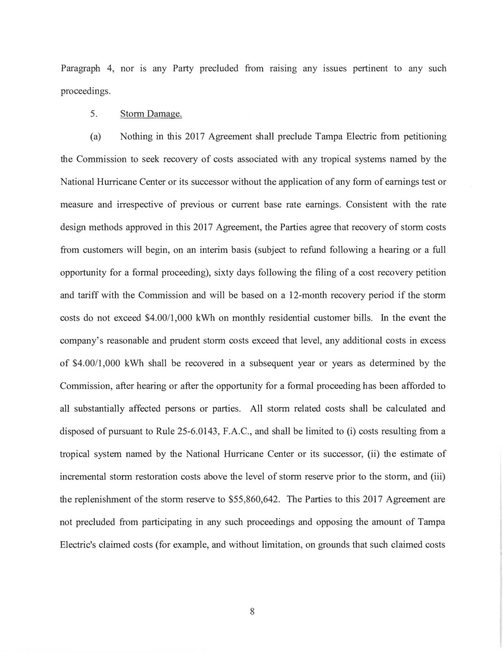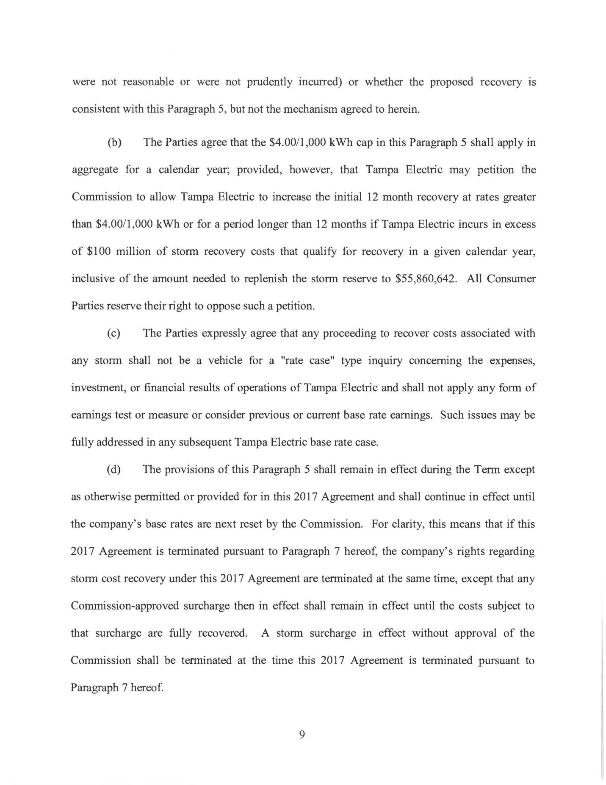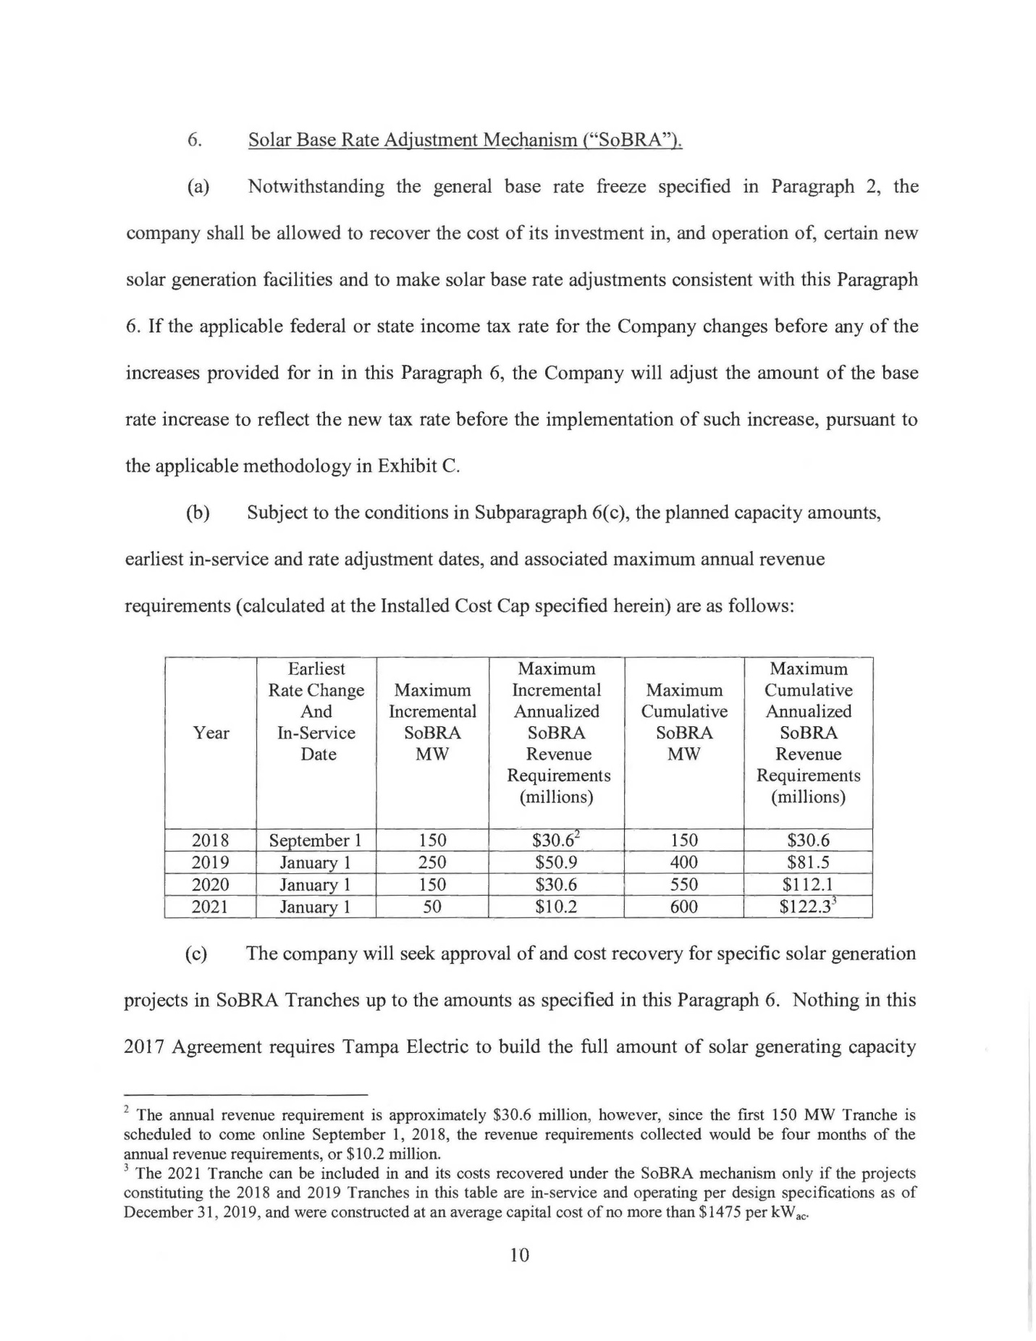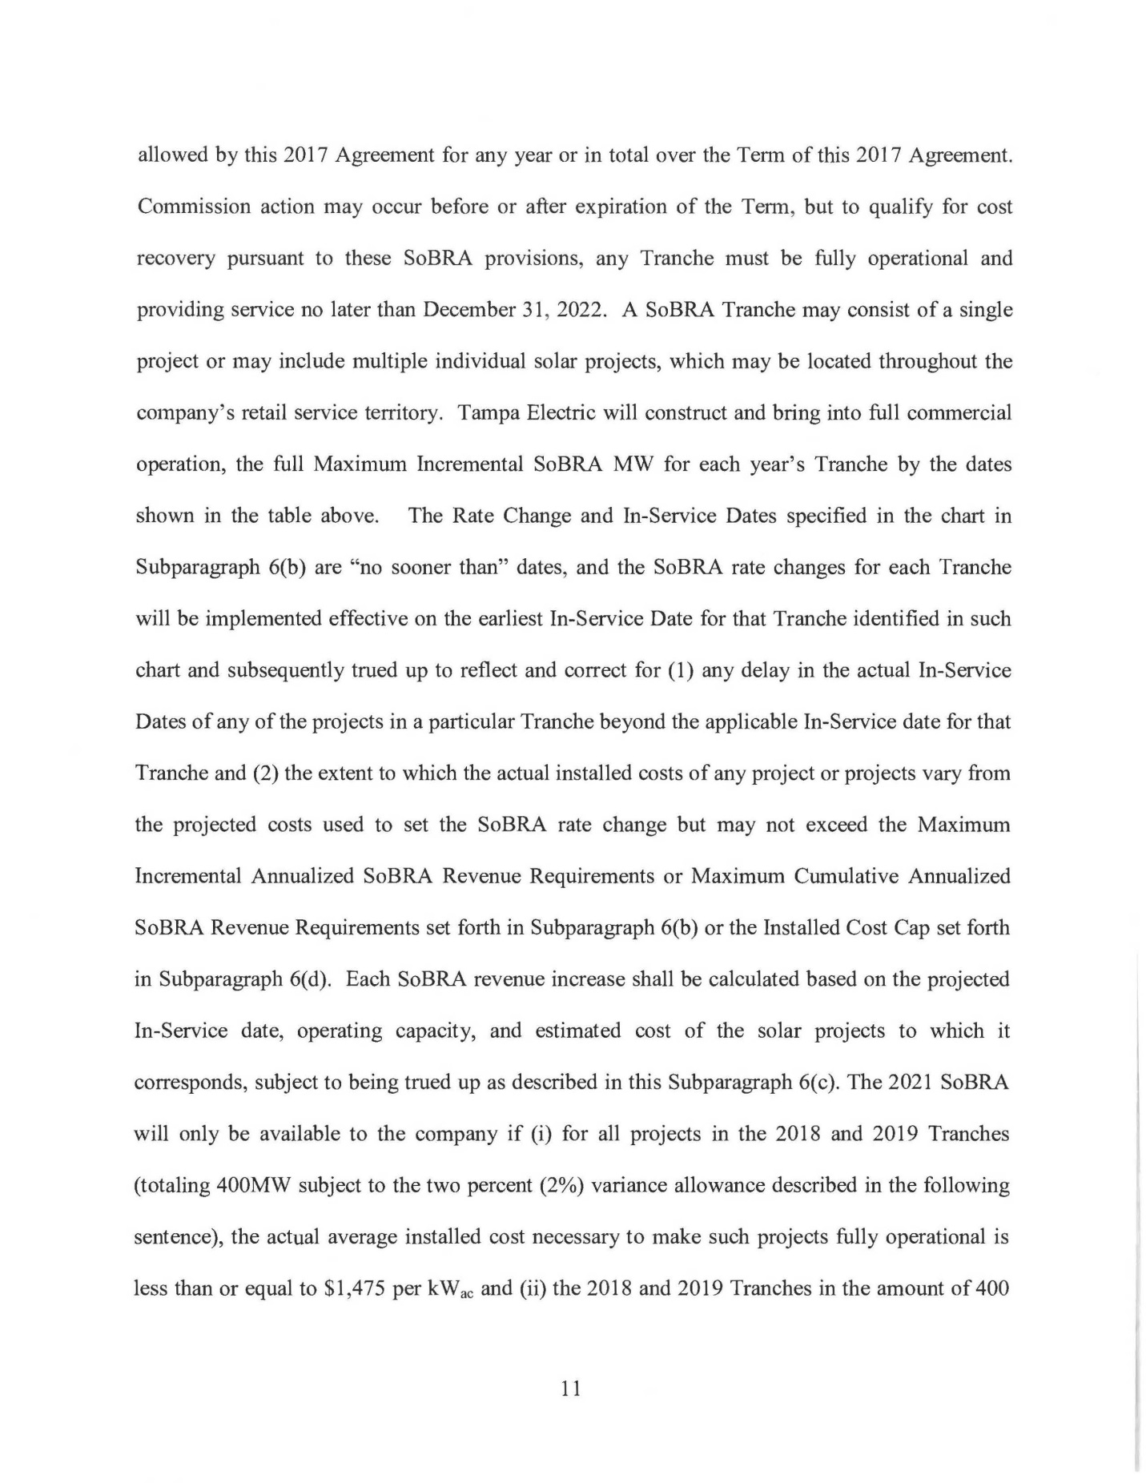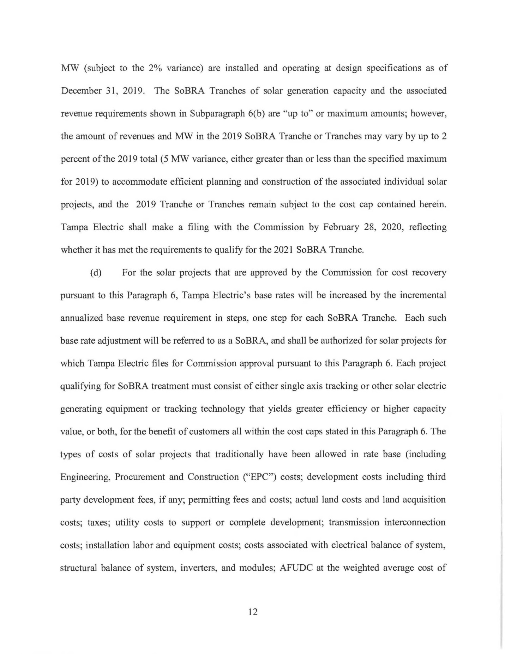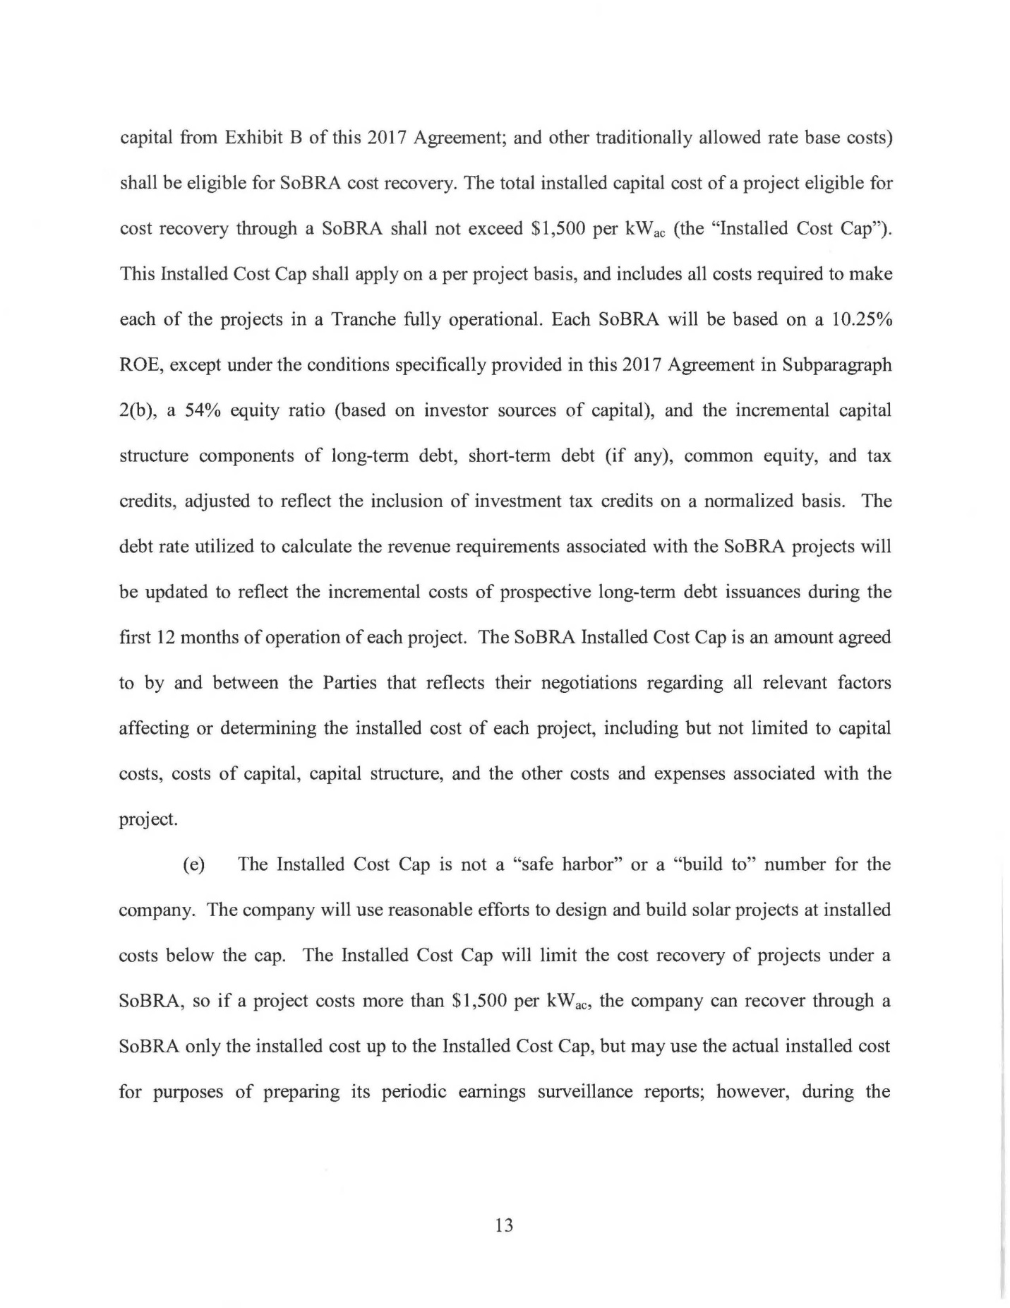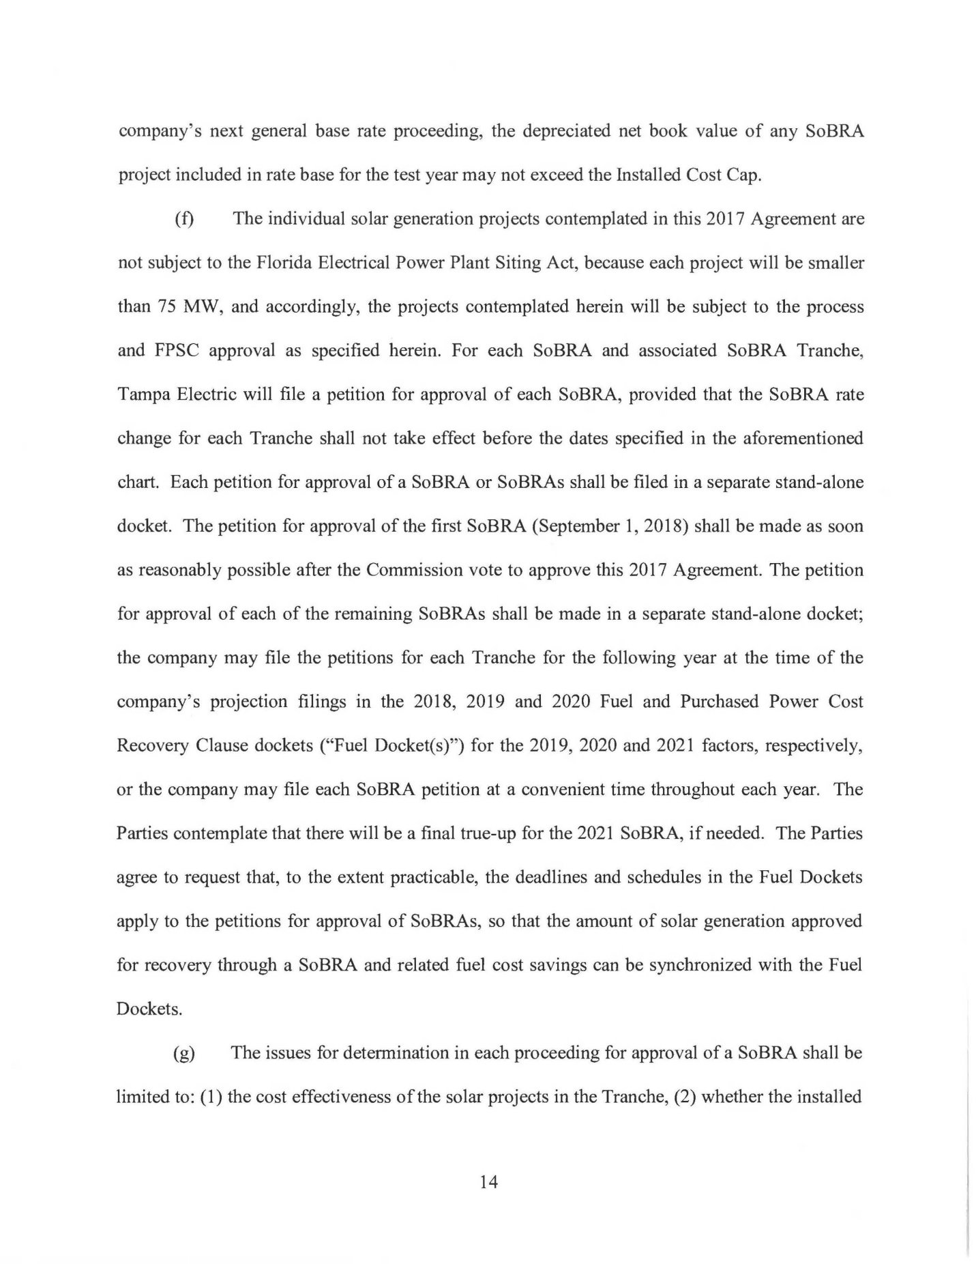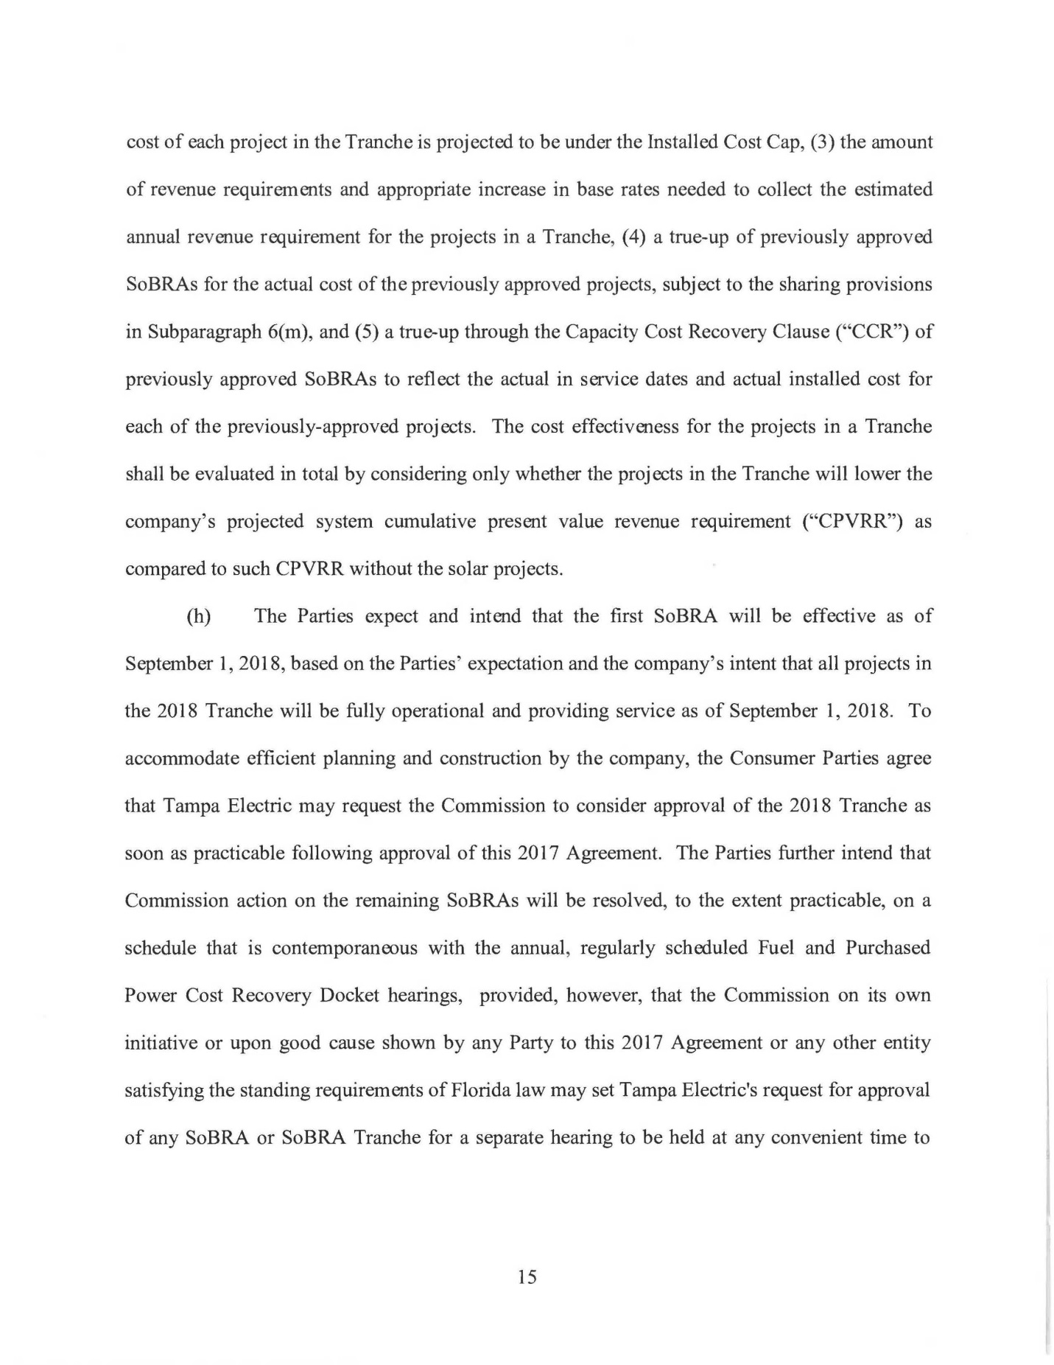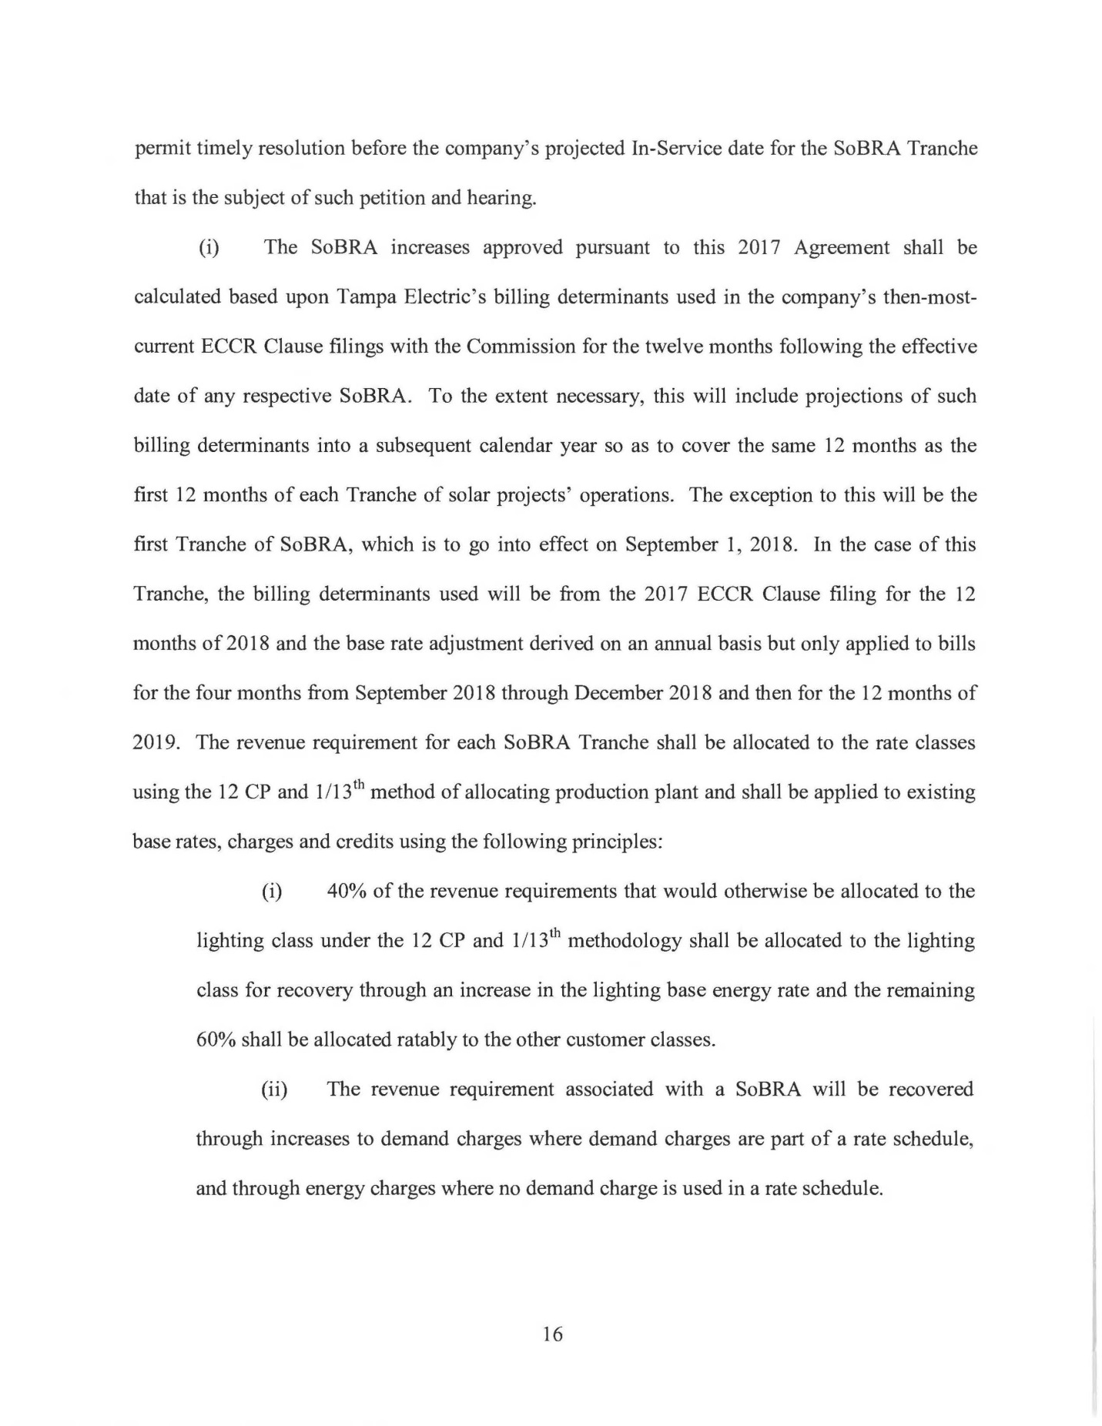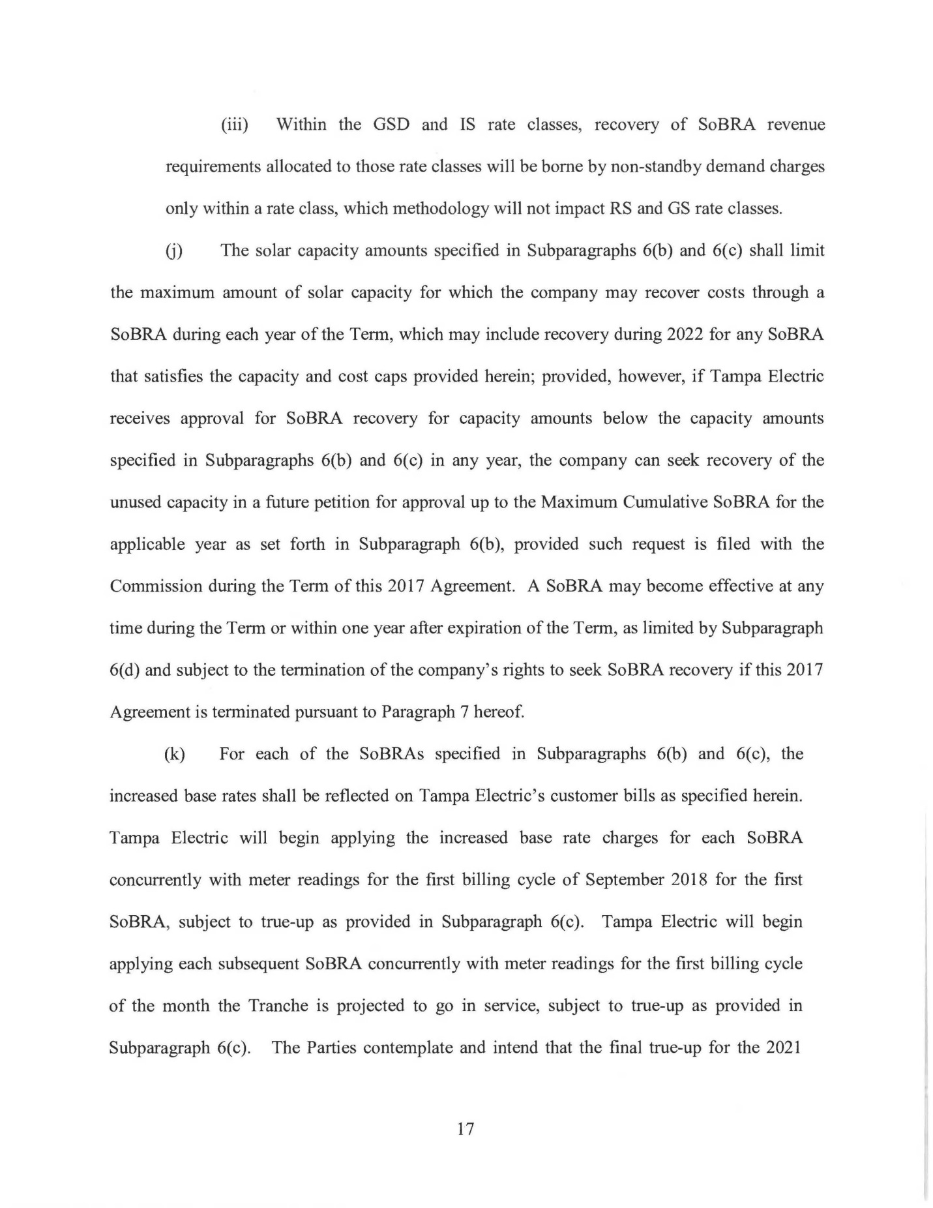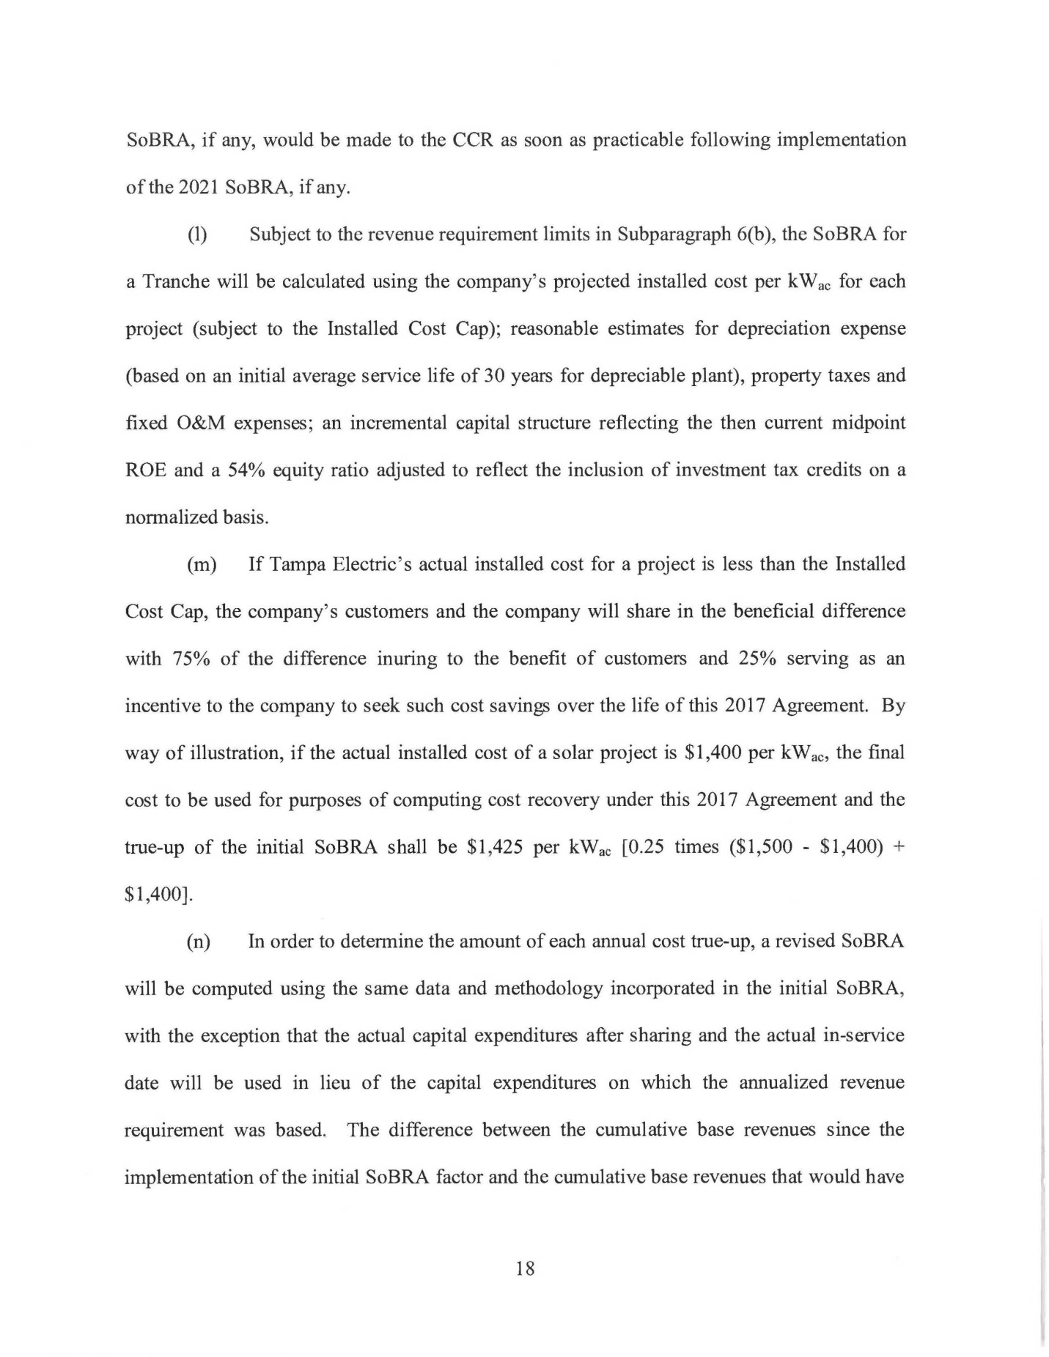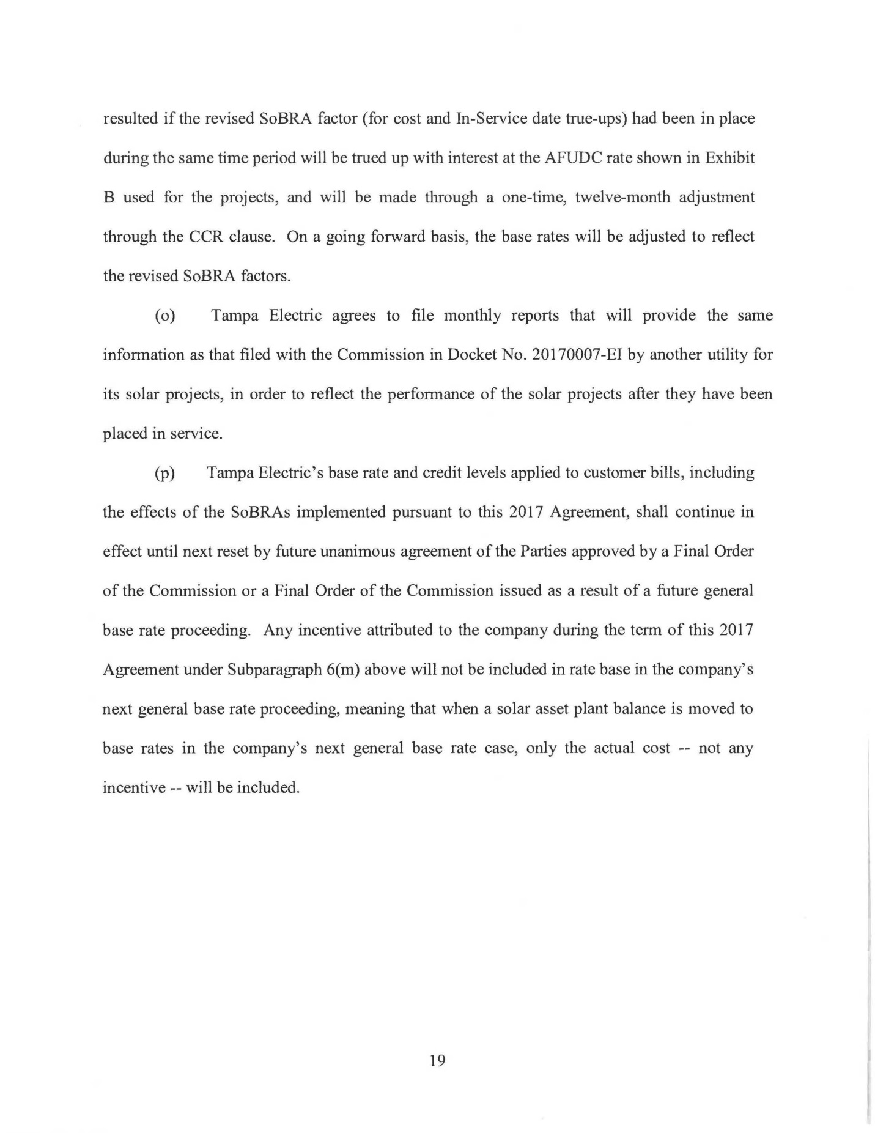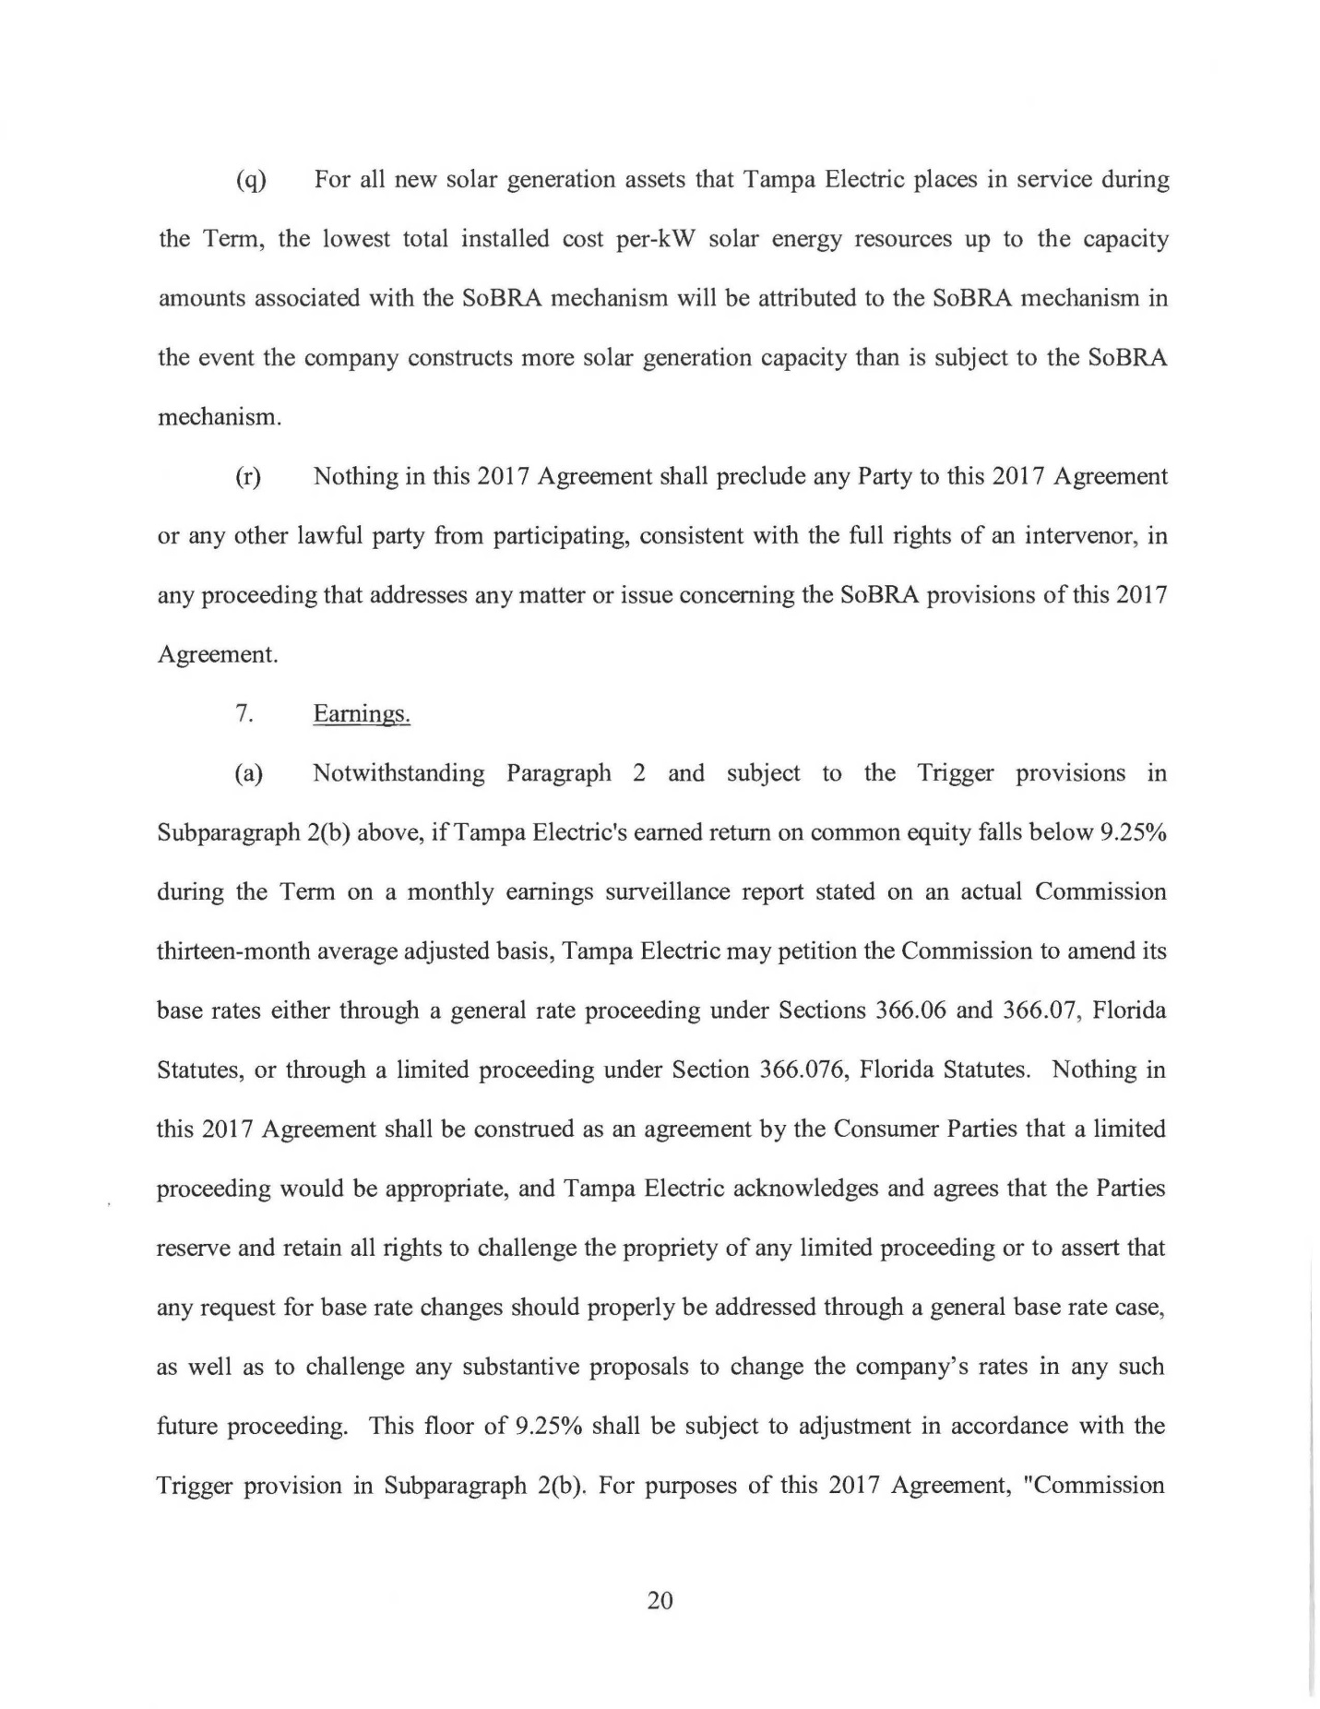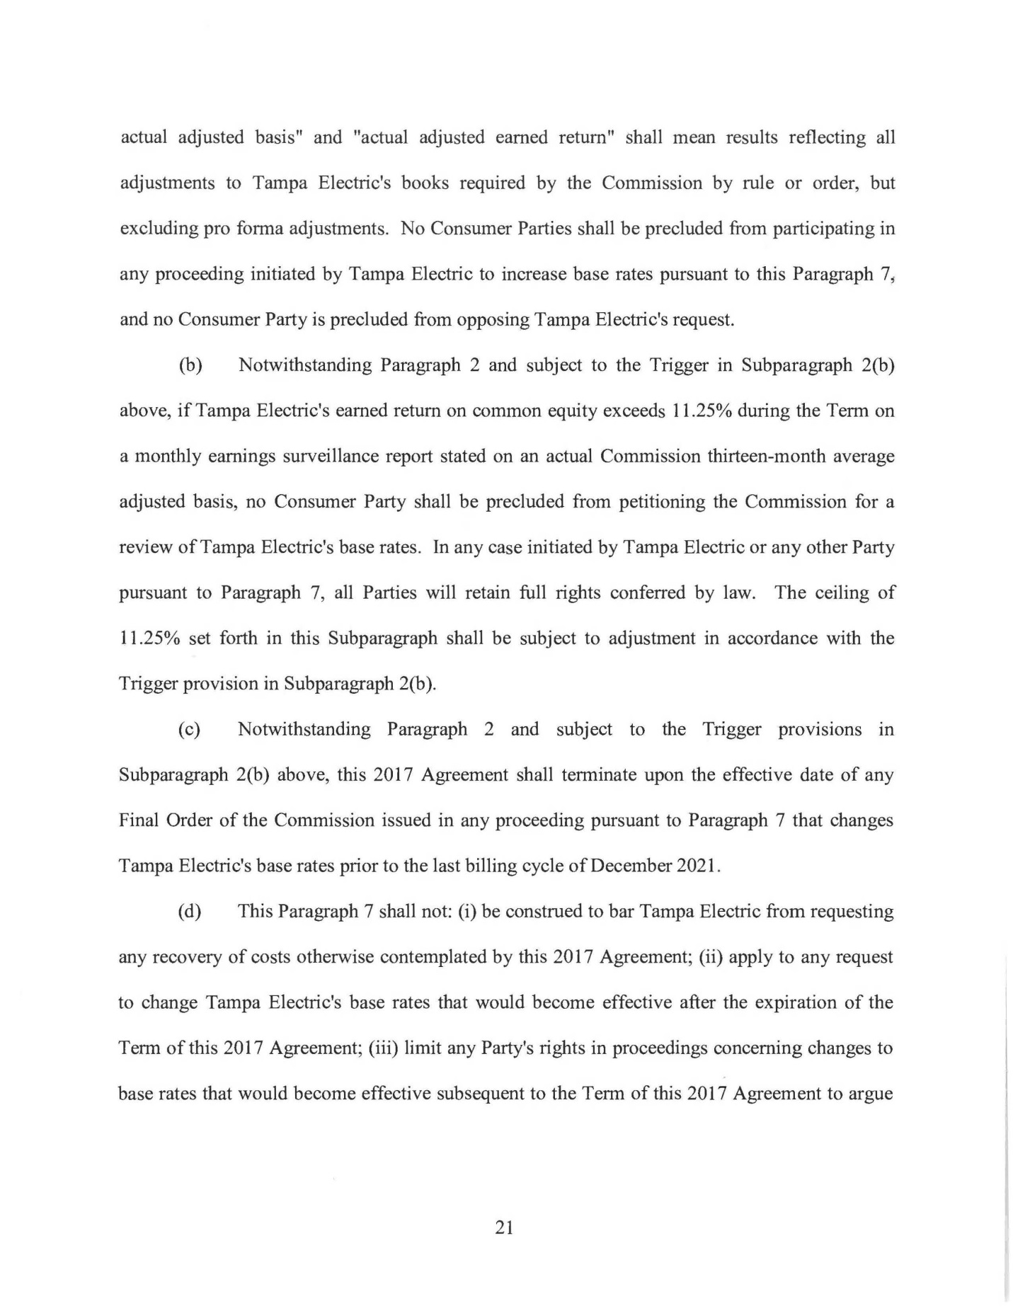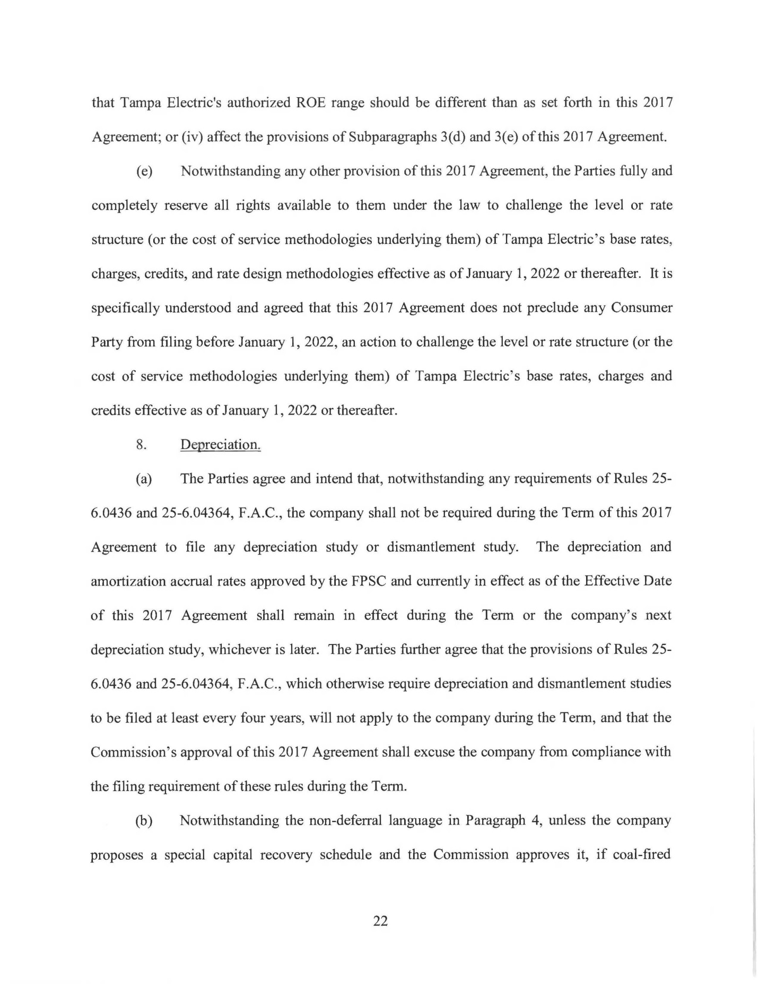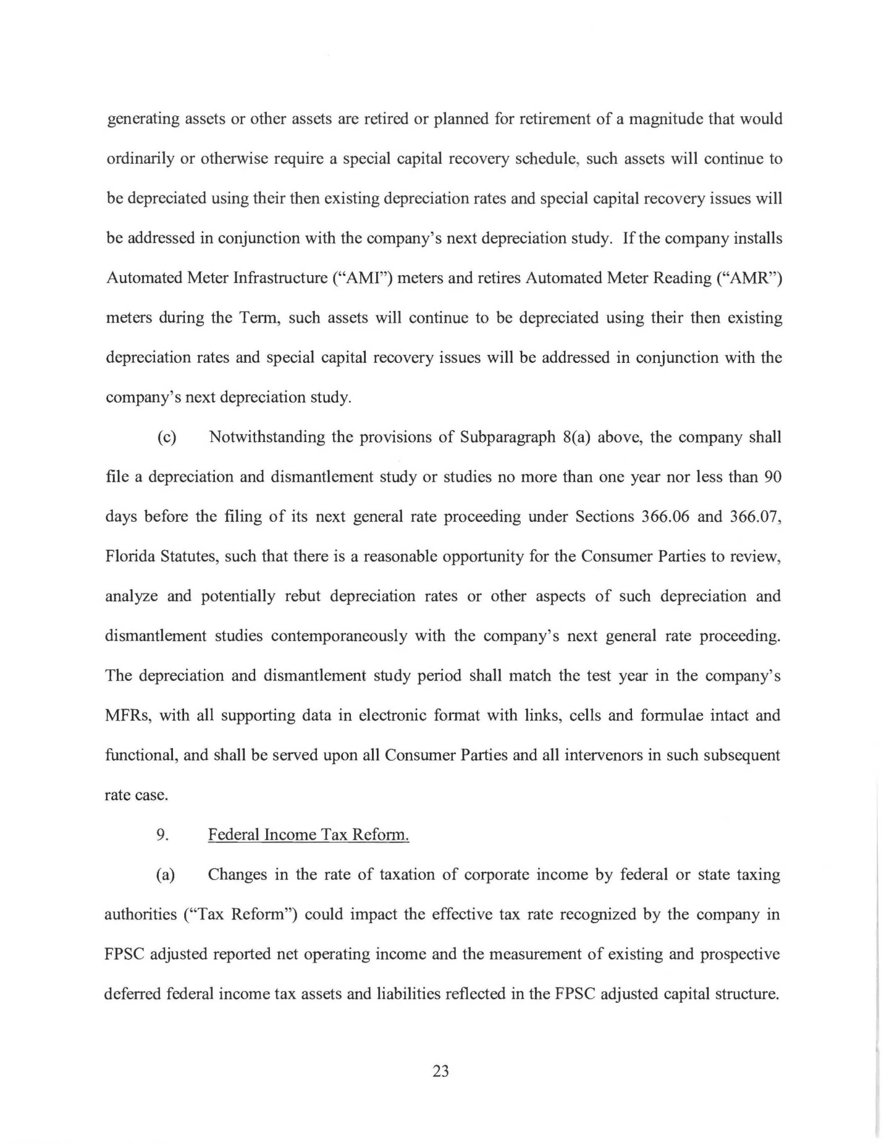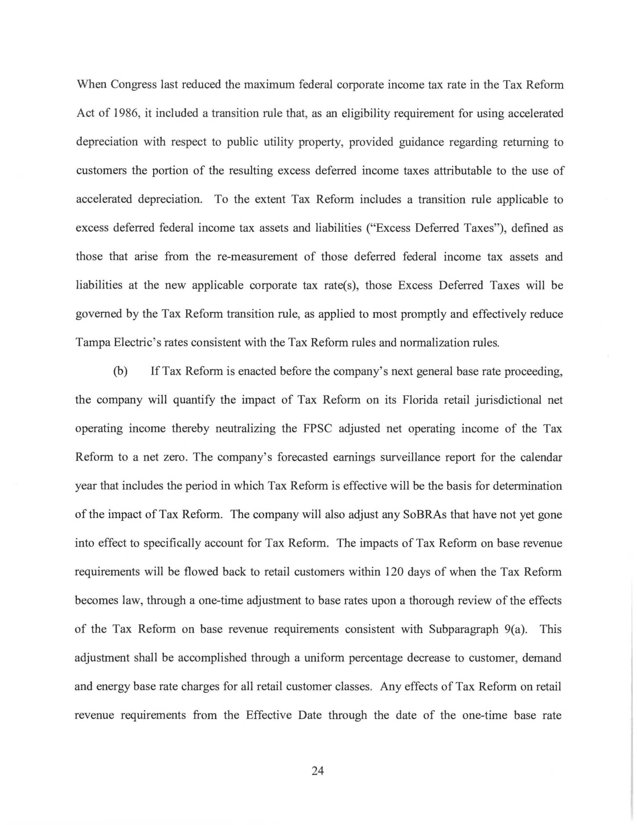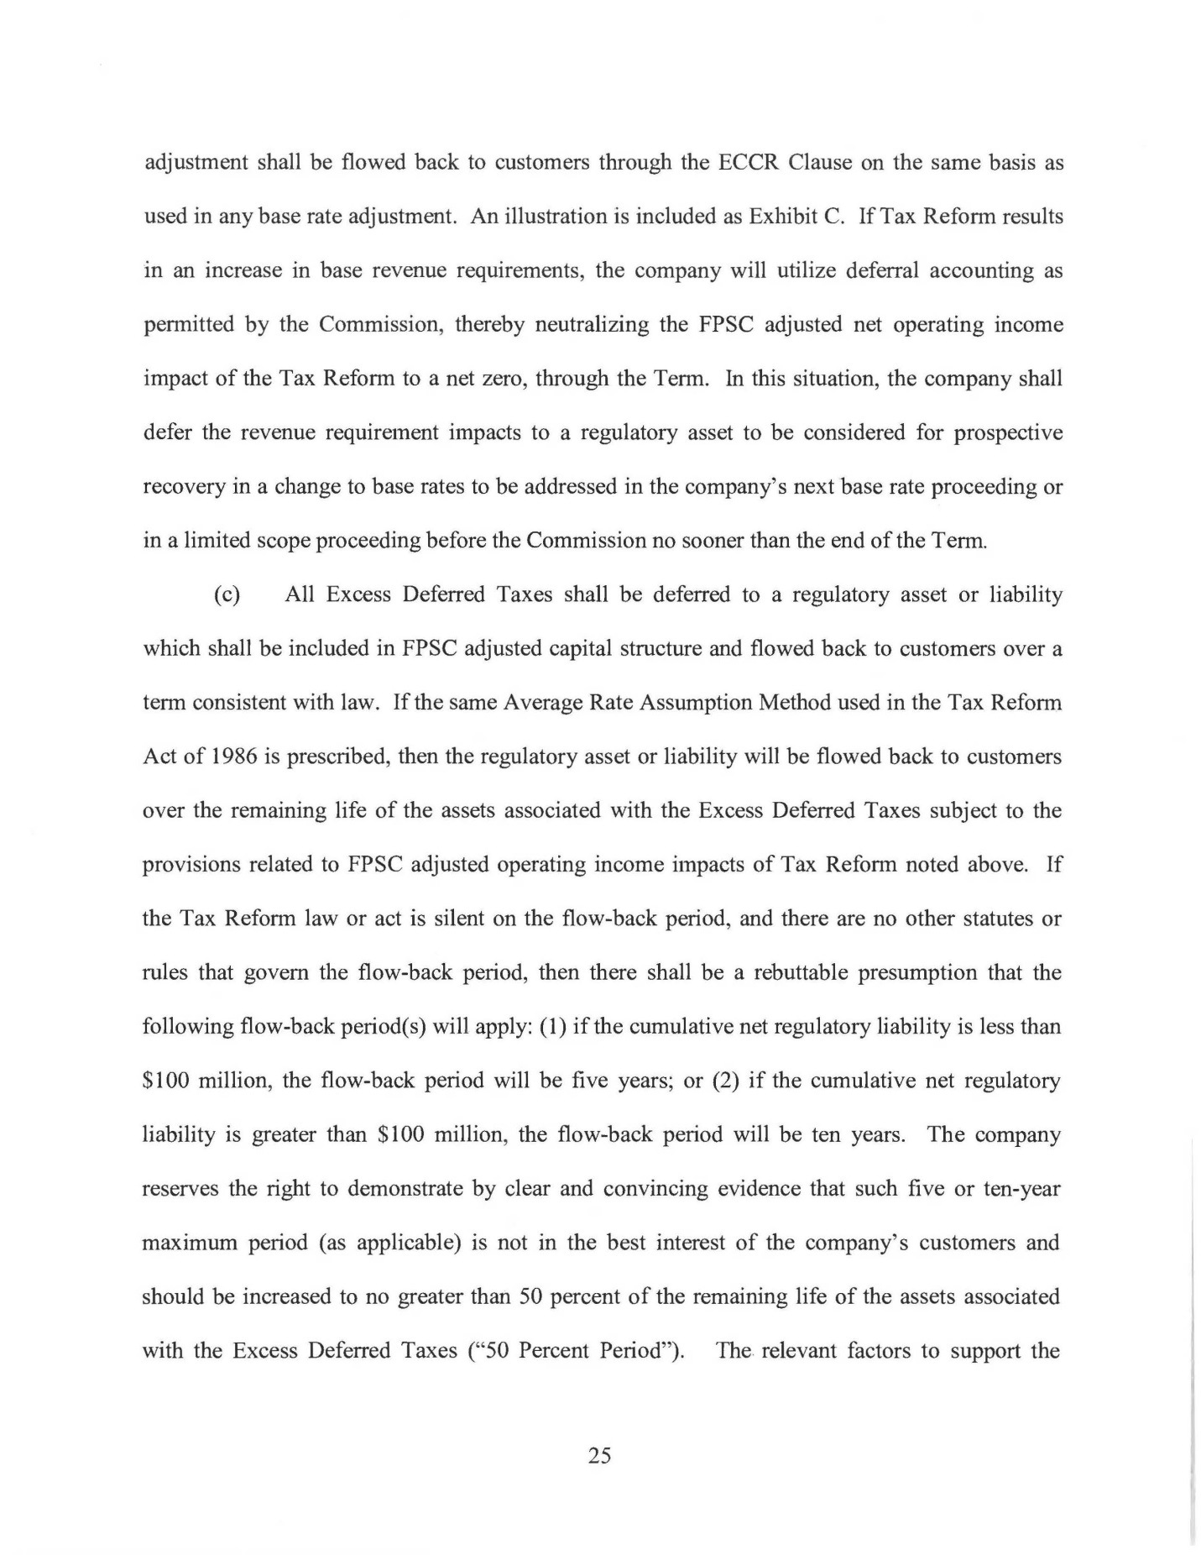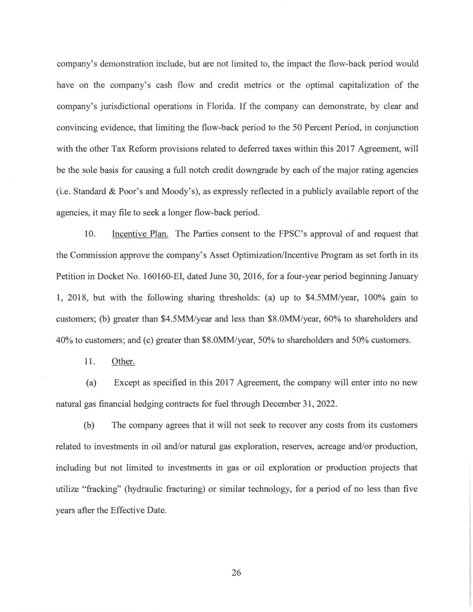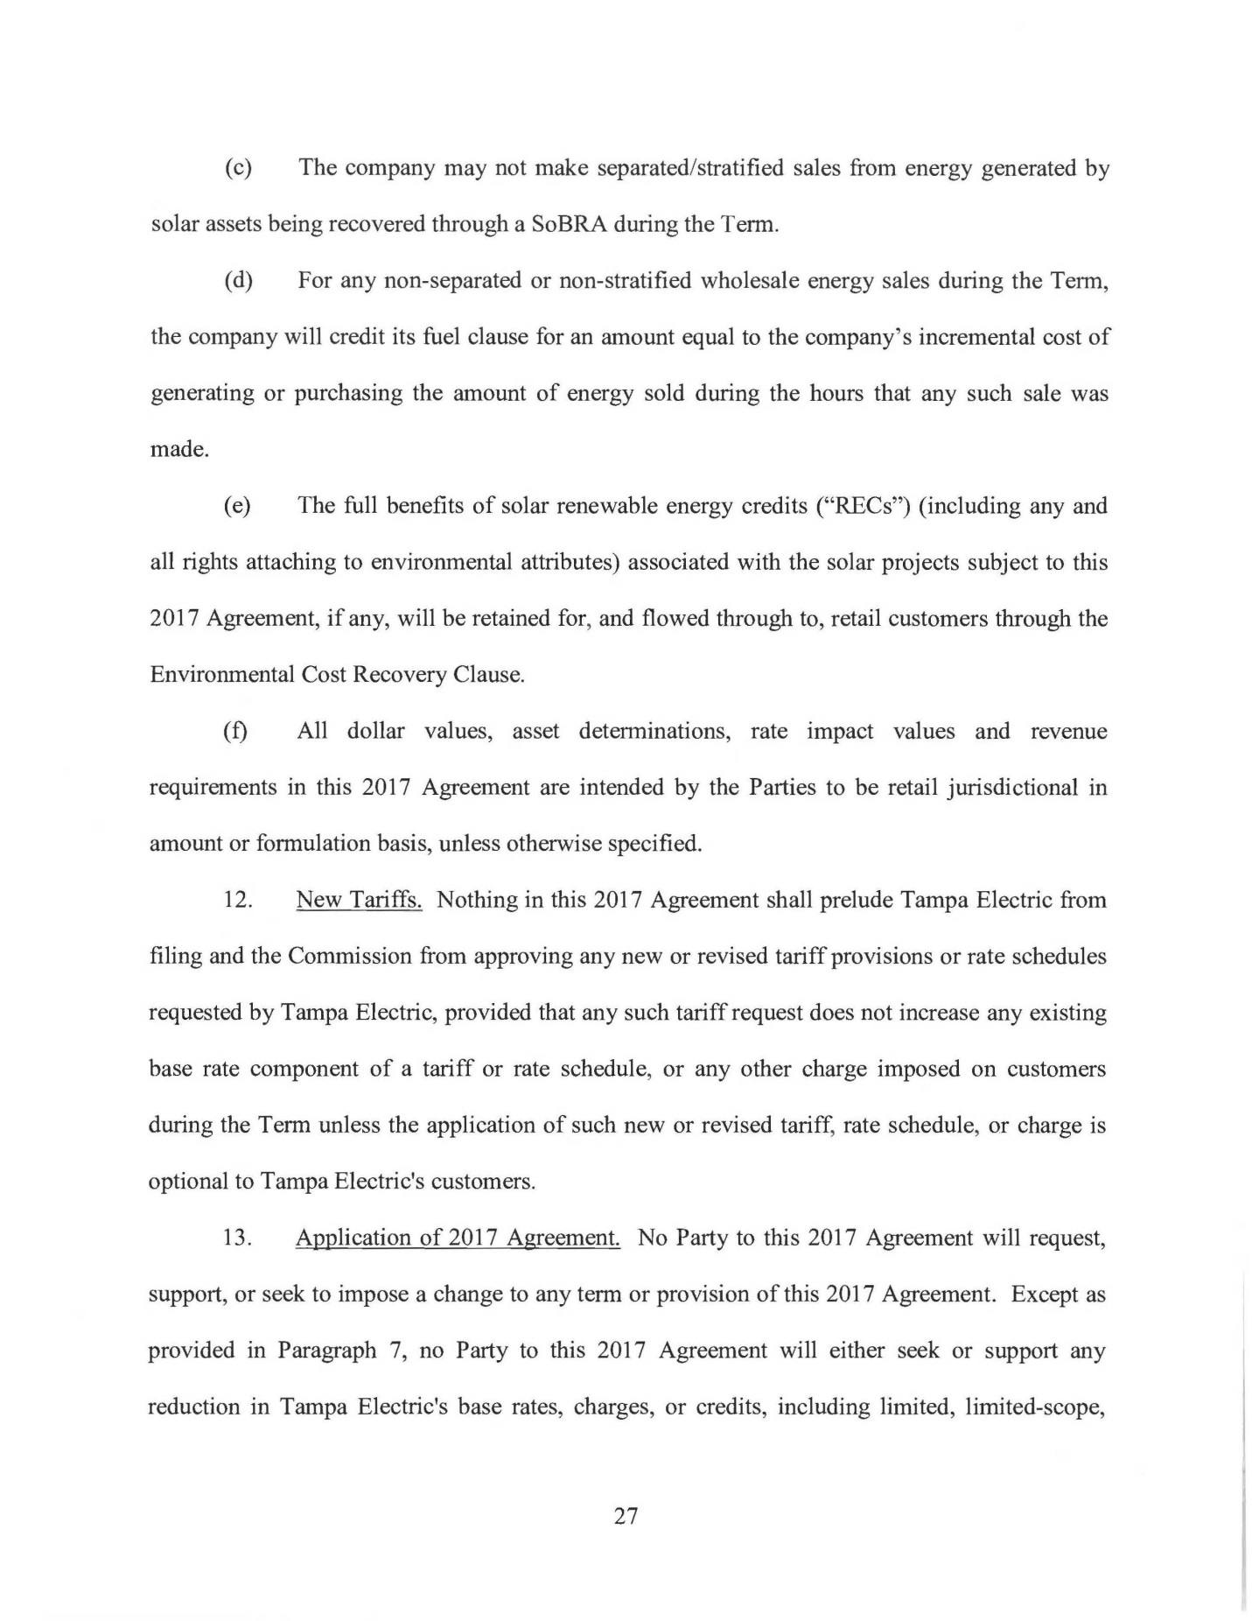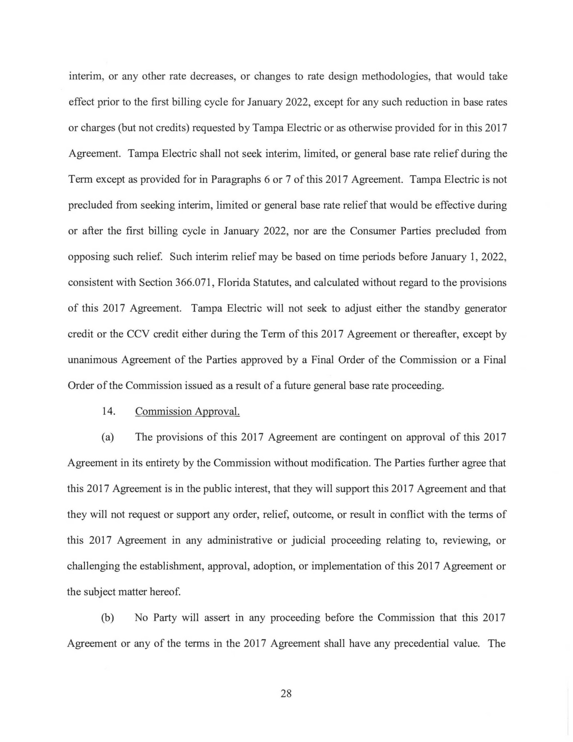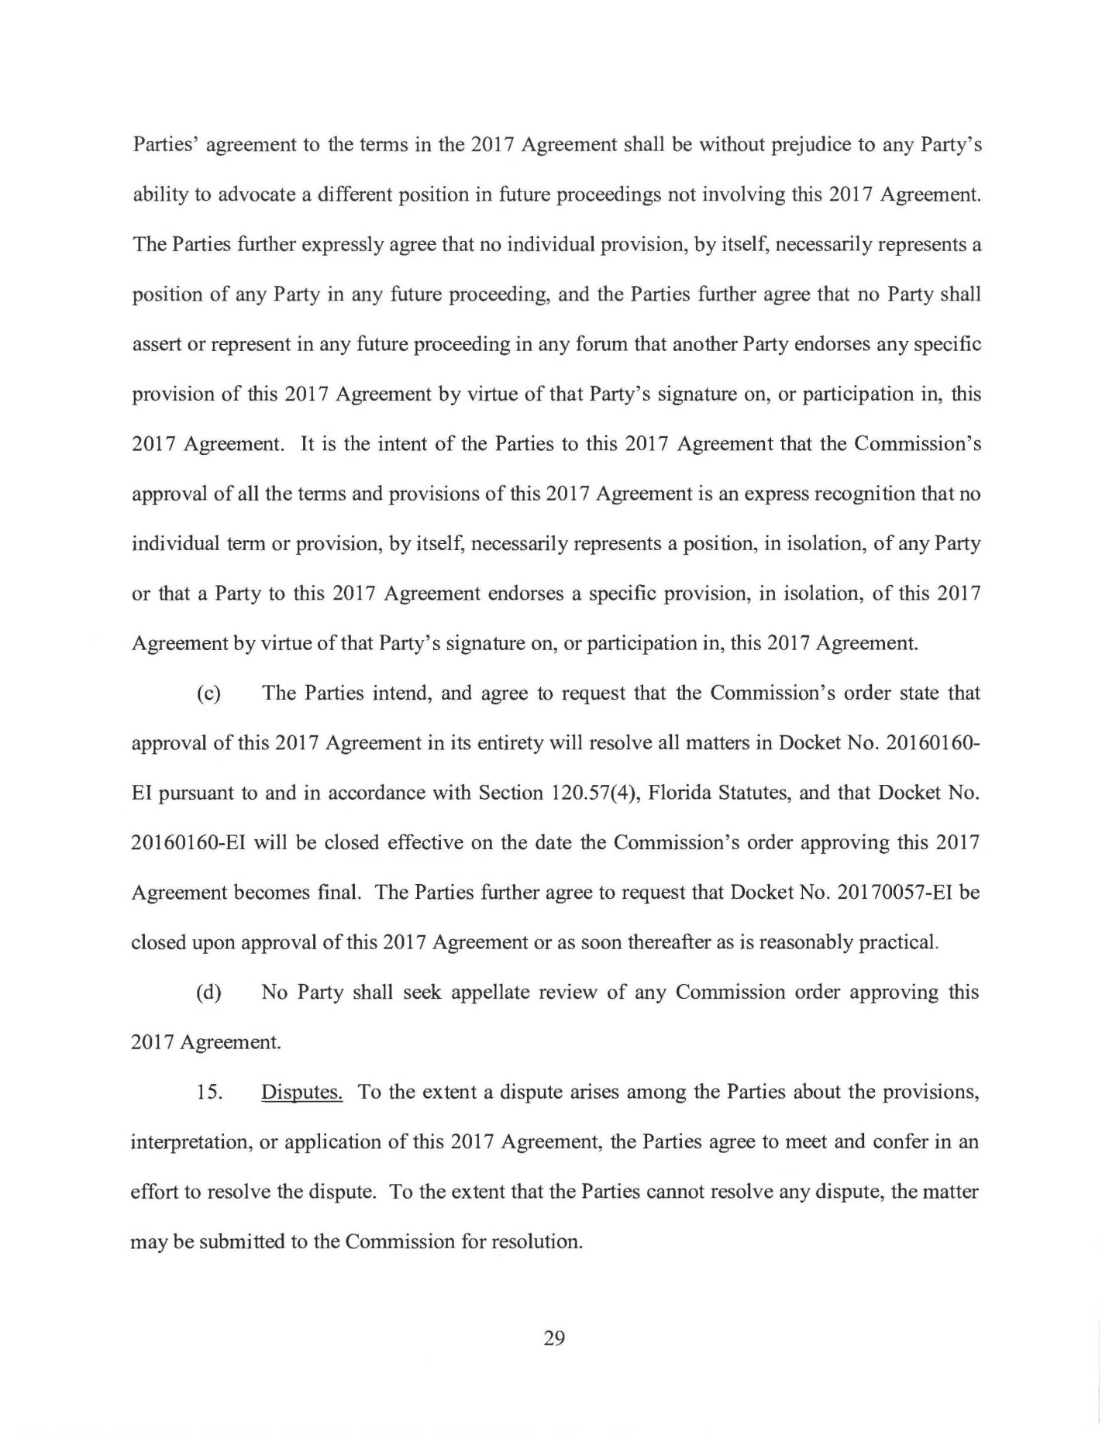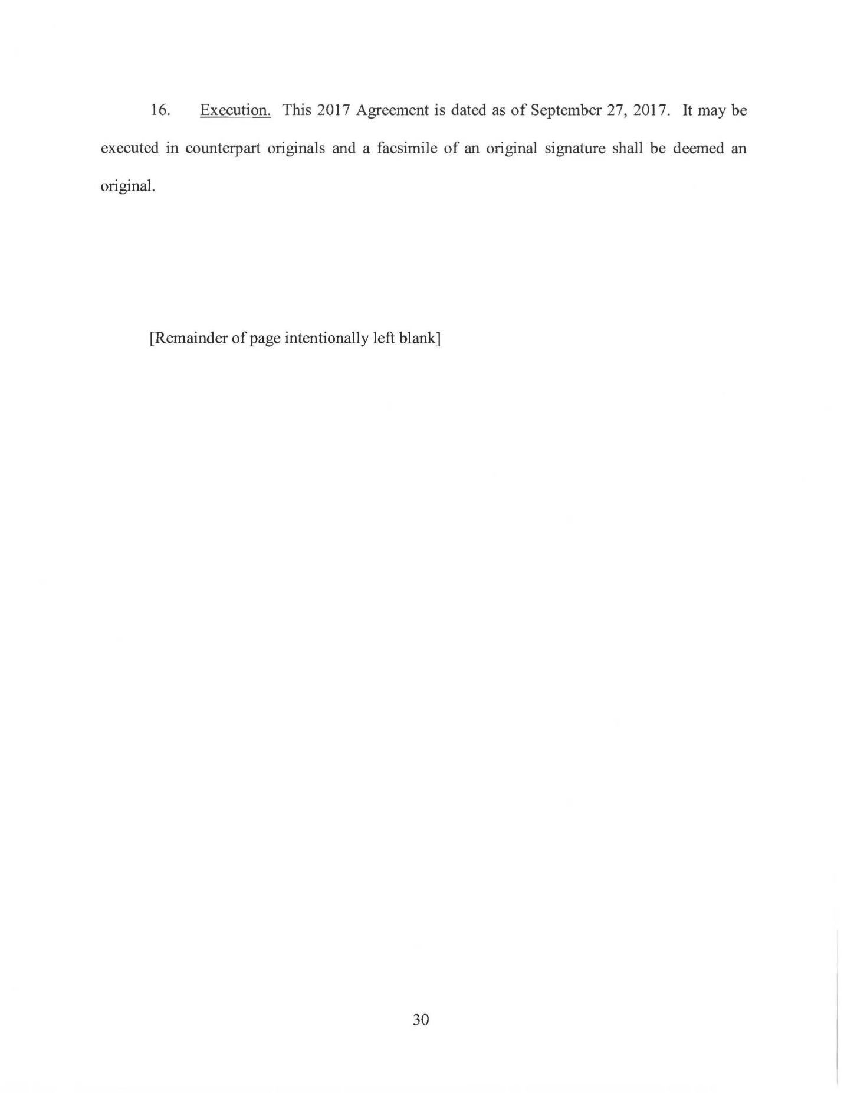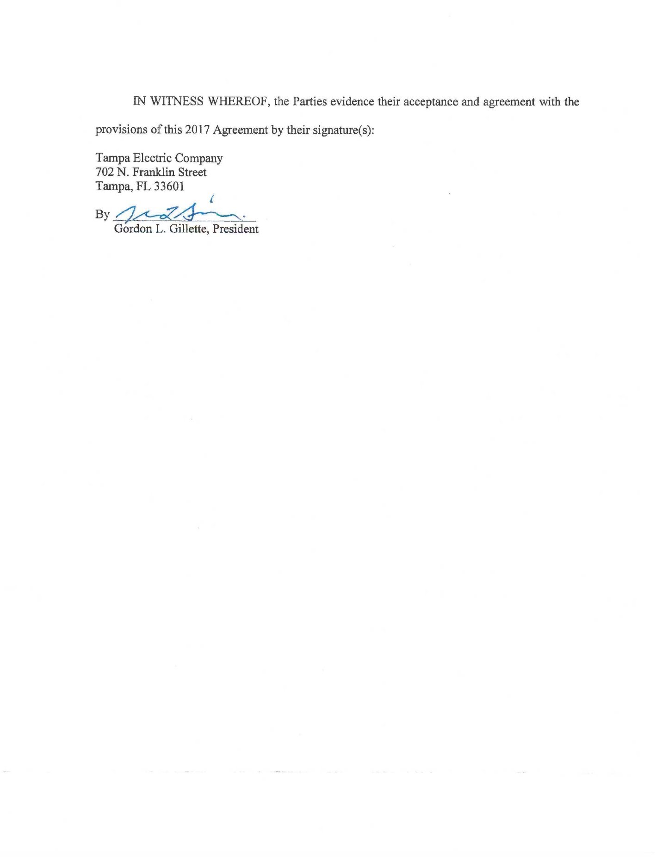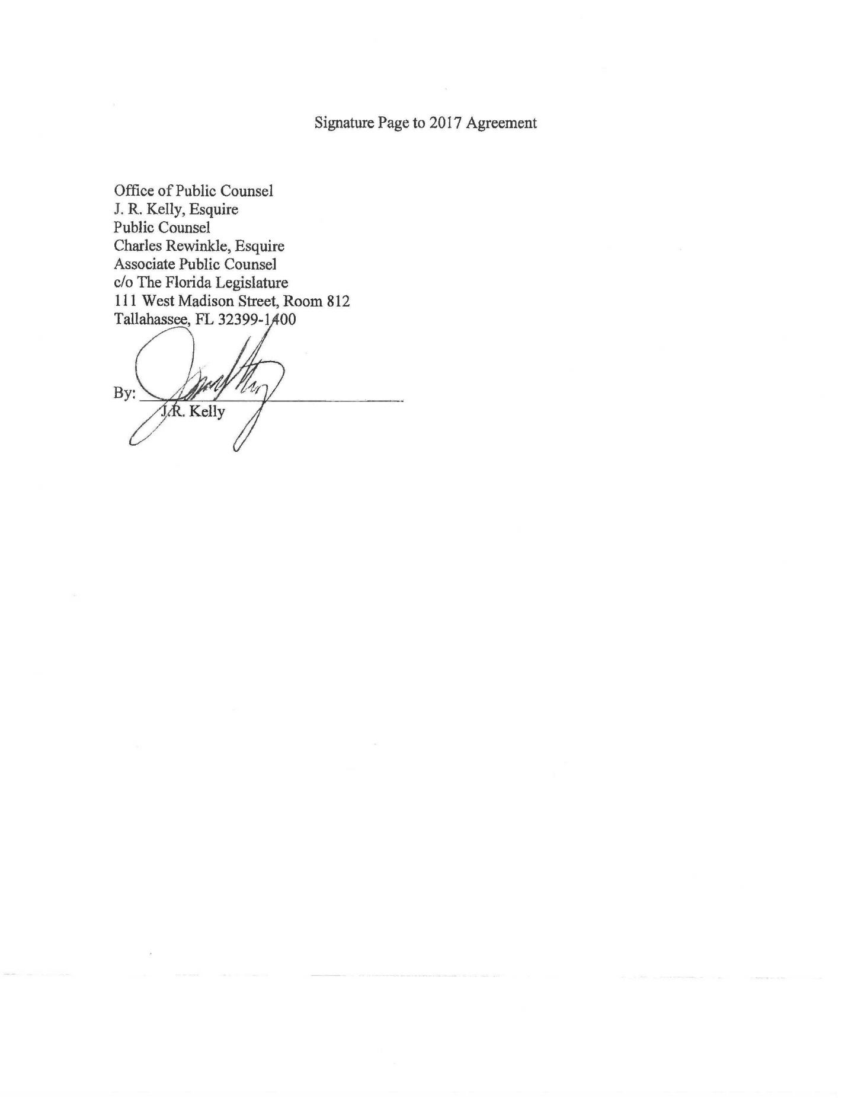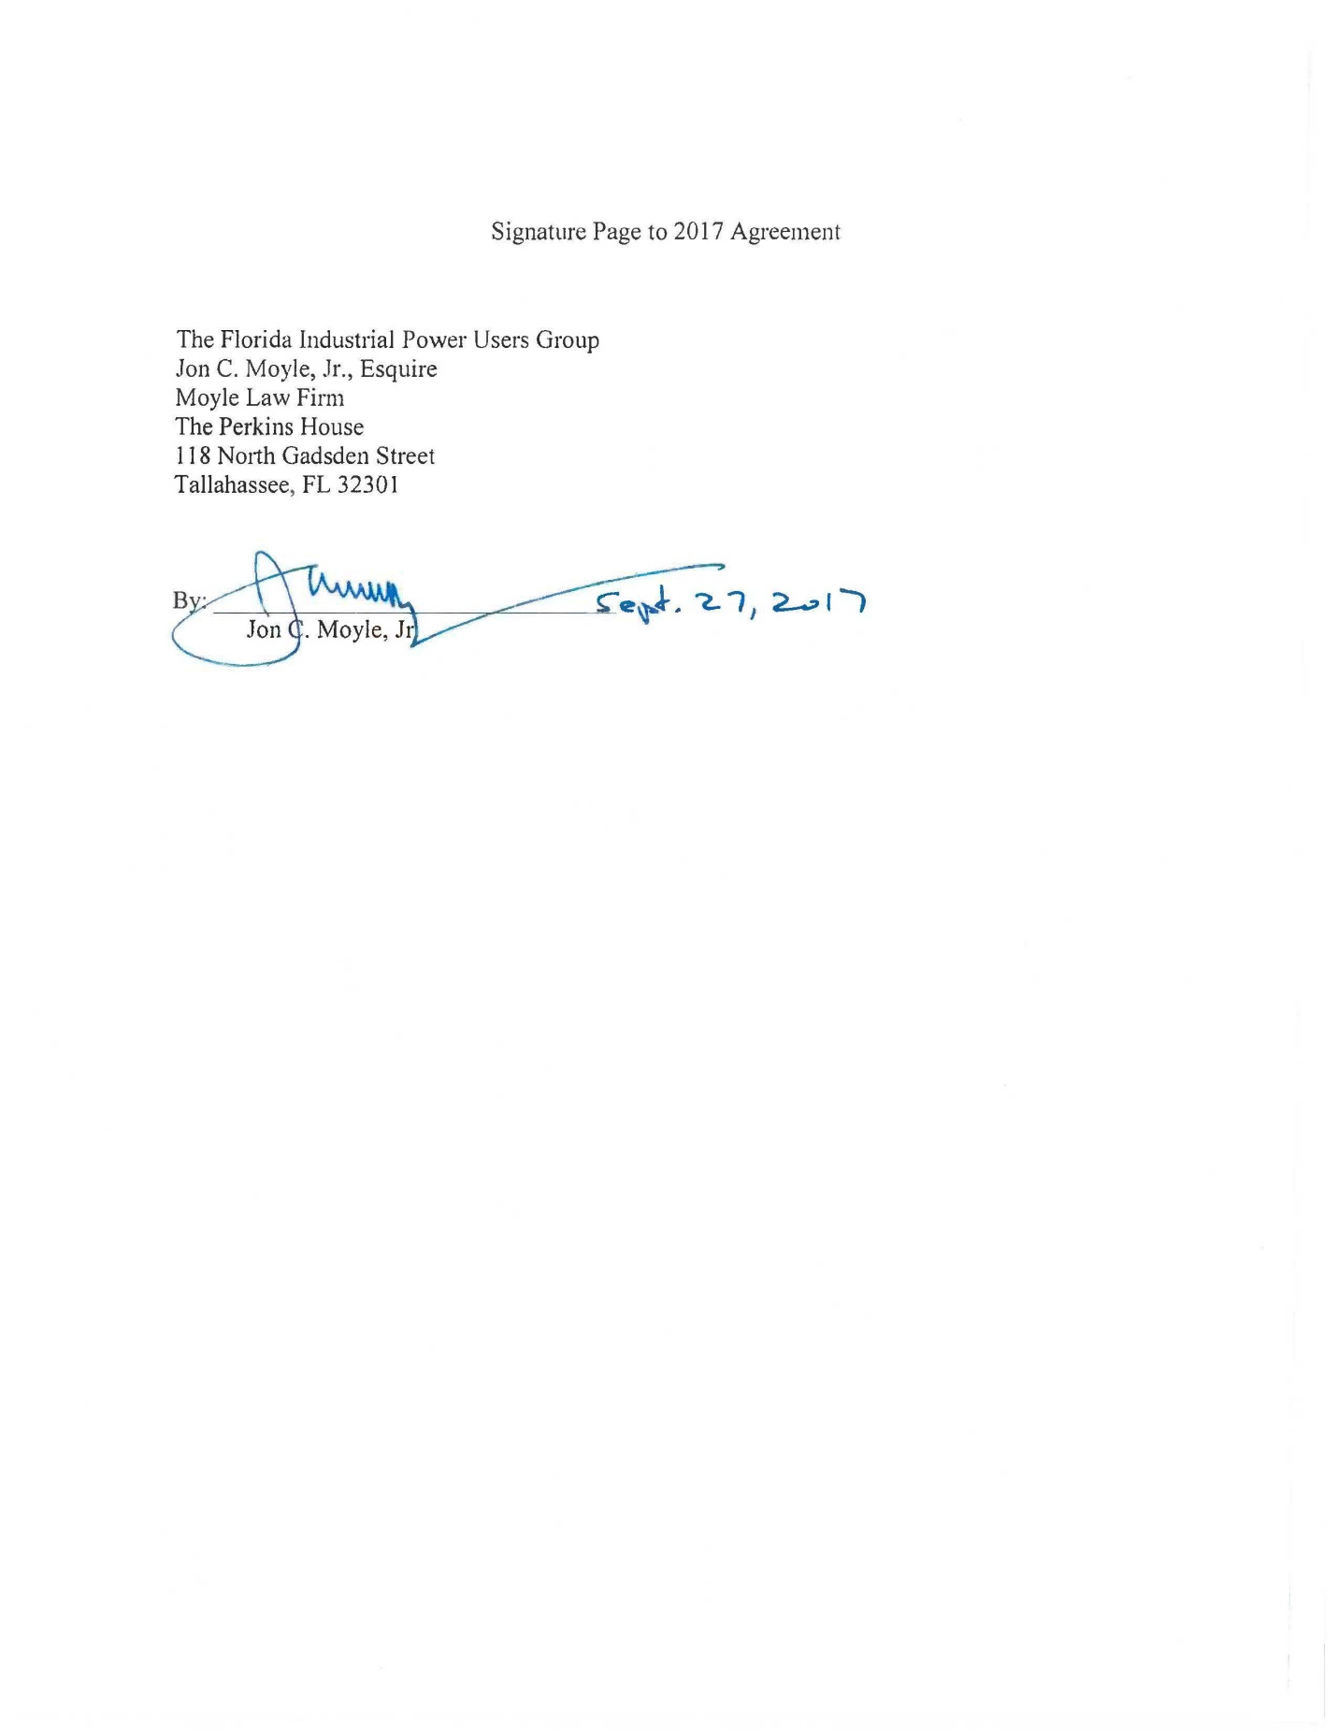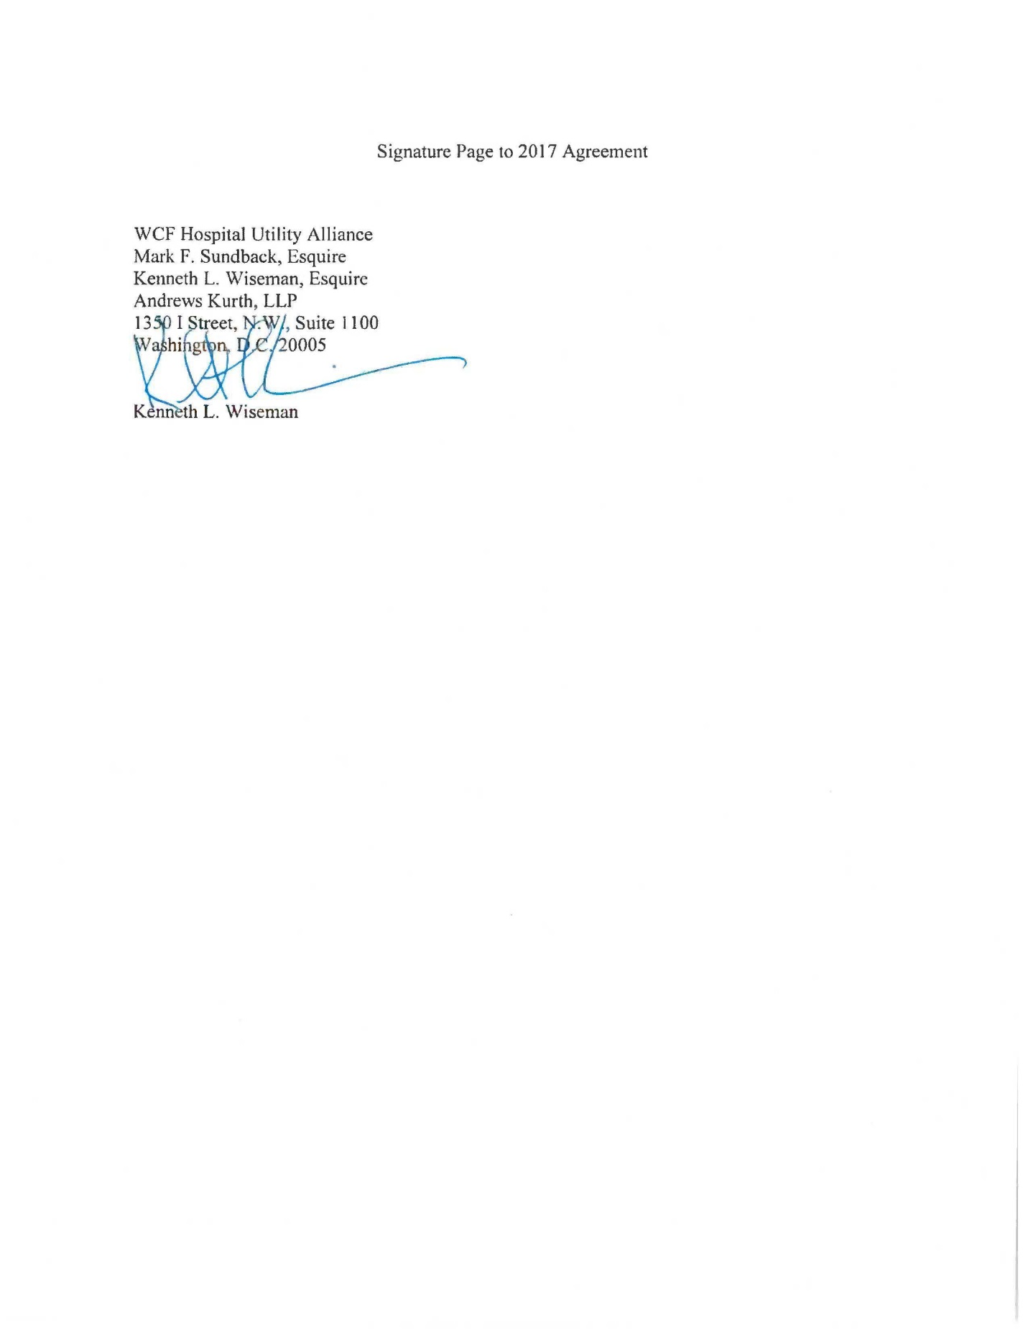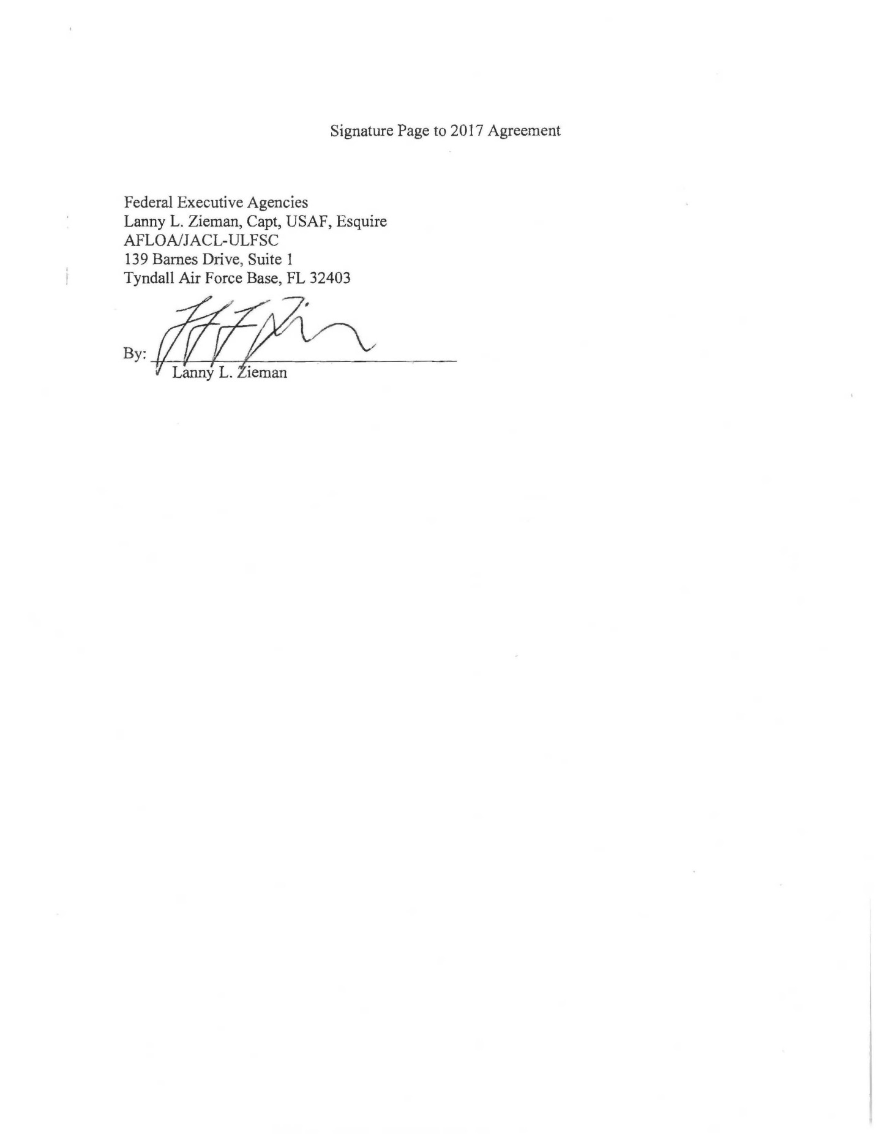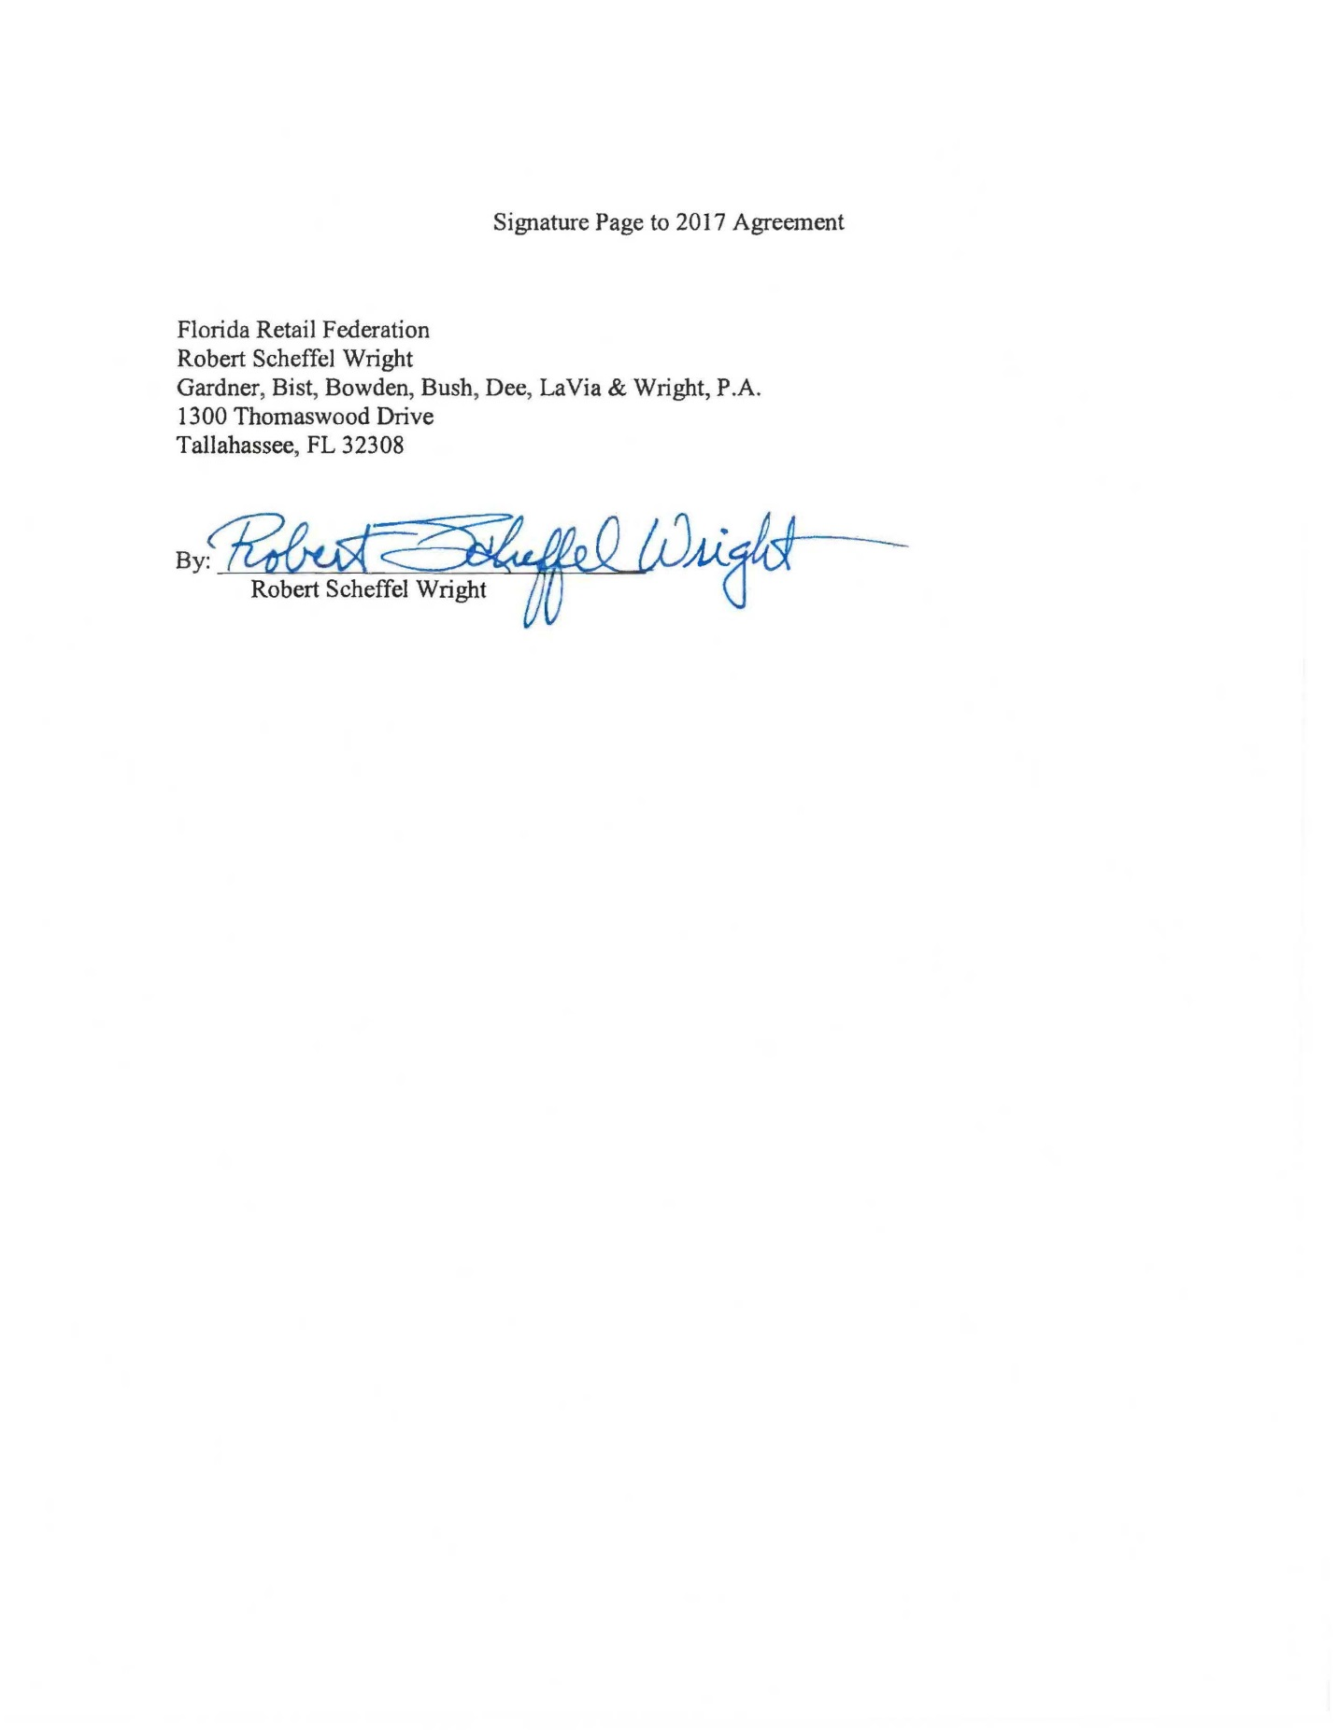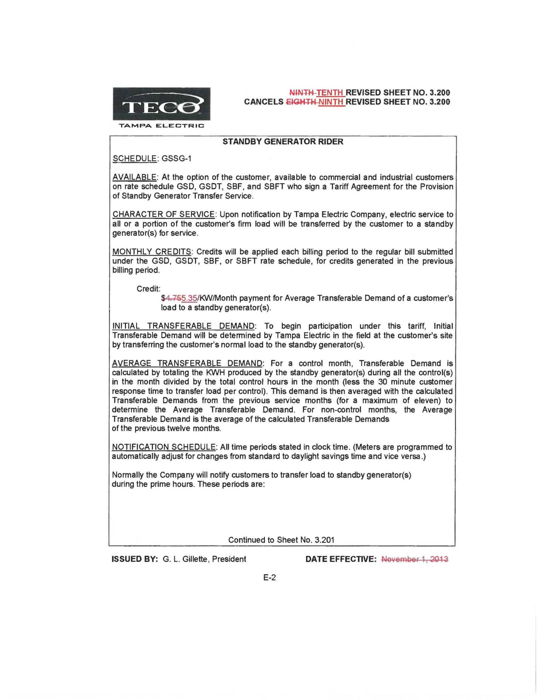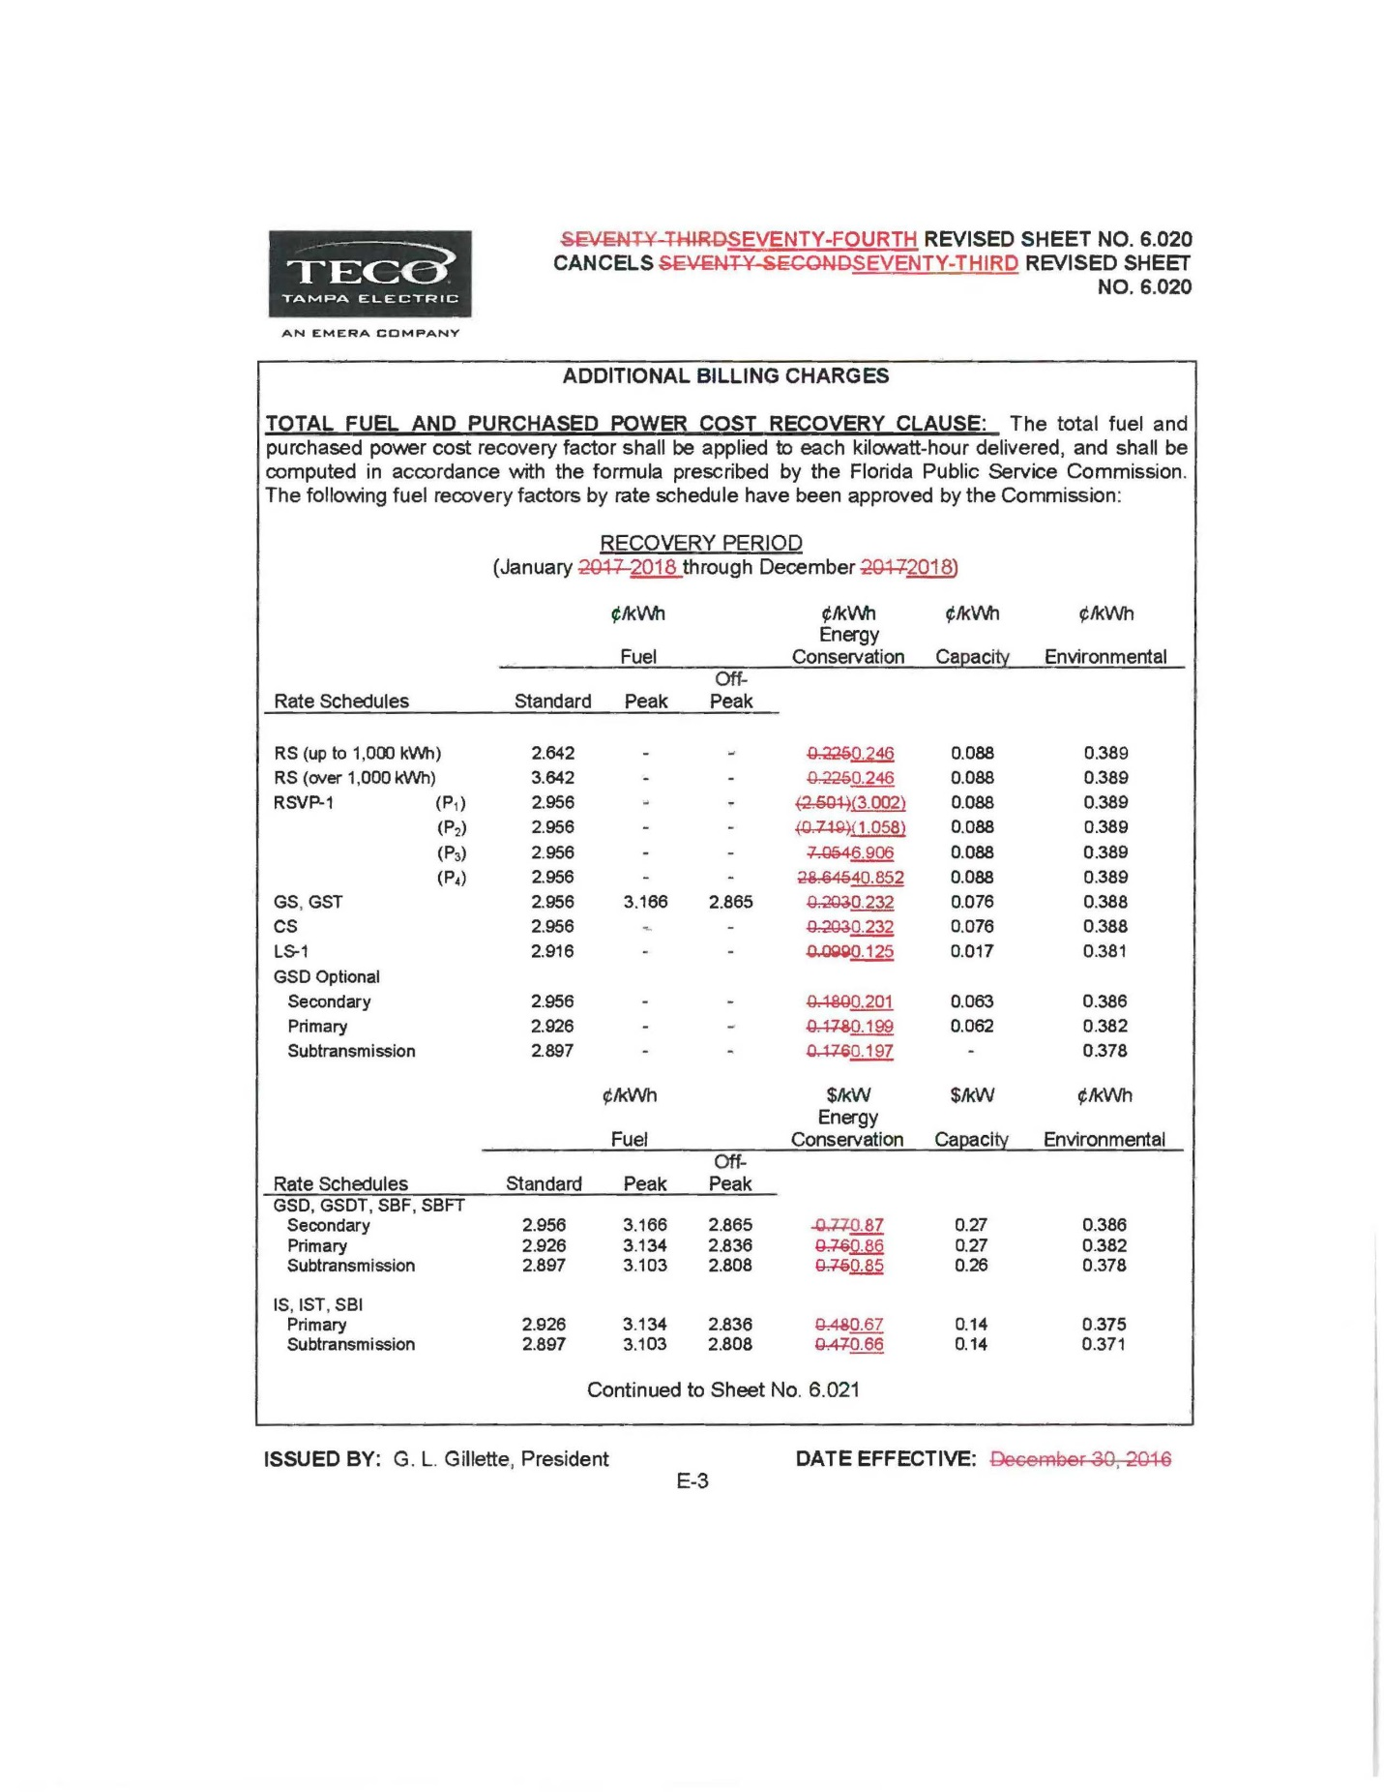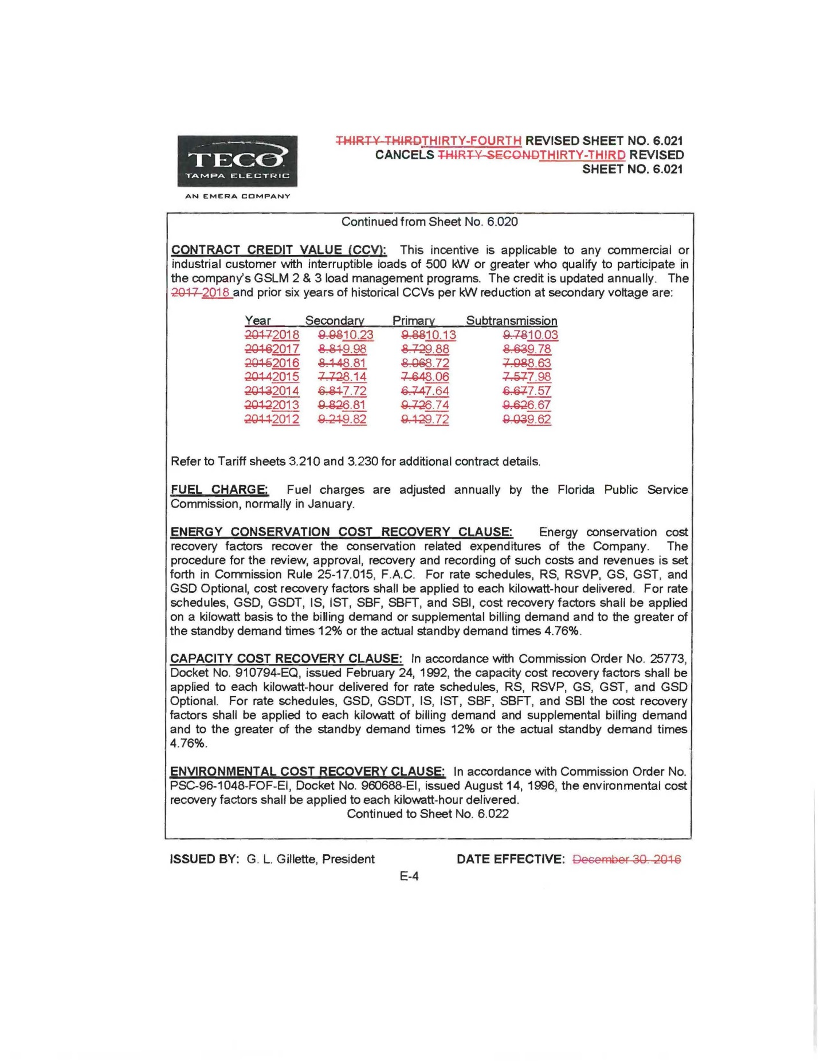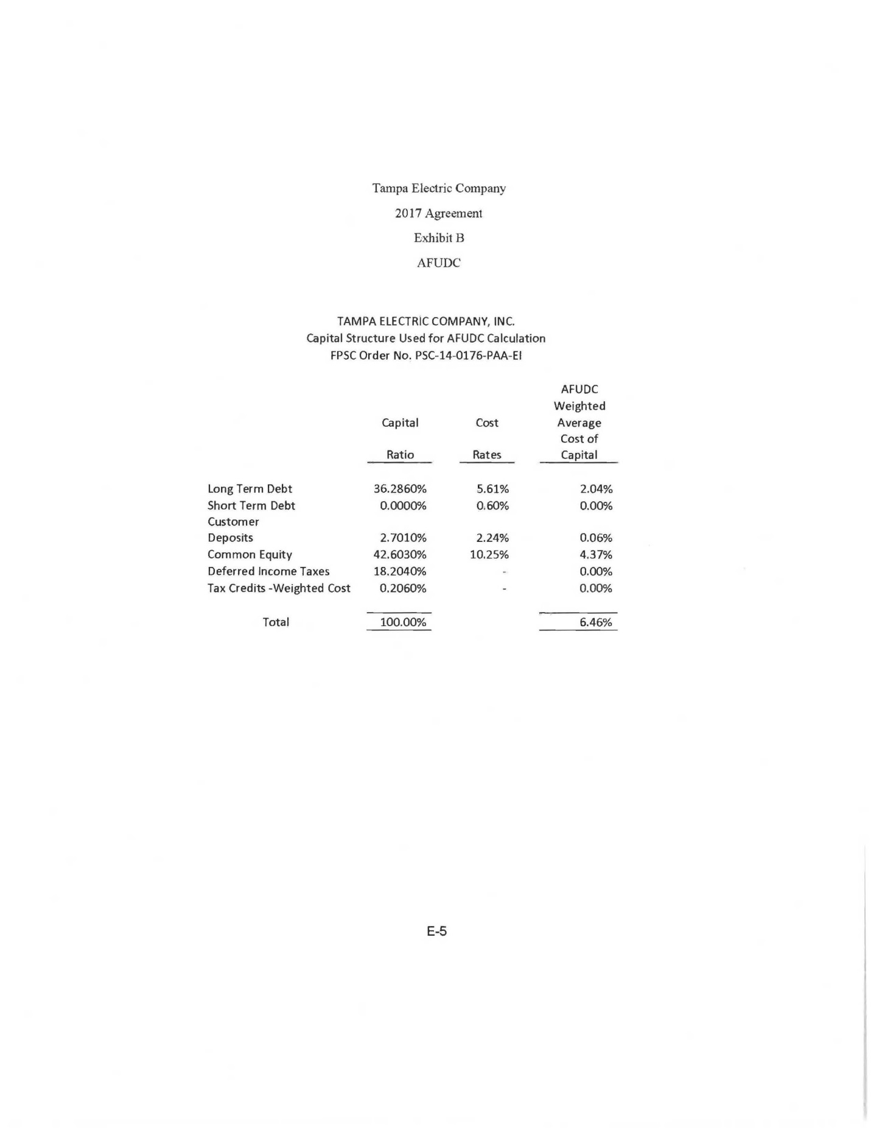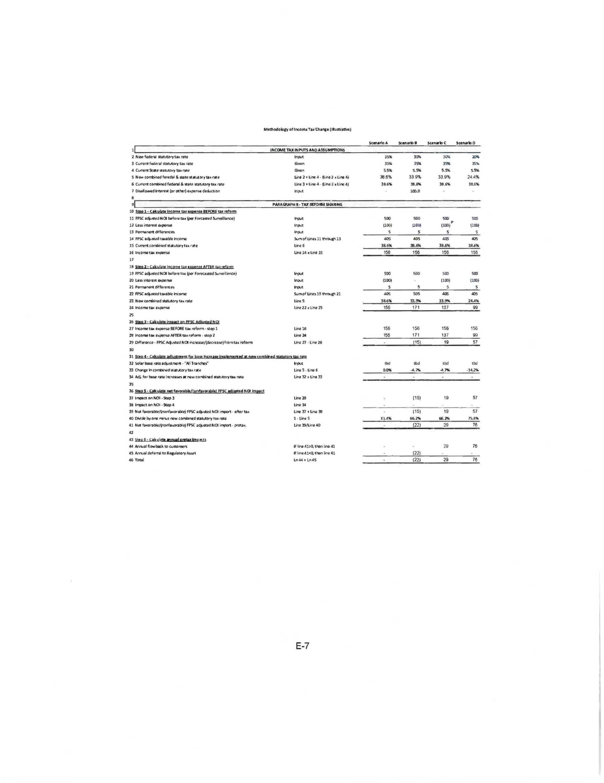

Docket No. 20160160, In re: Petition by Tampa Electric Company for approval of Energy Transaction Optimization Mechanism.
Order No. PSC-13-0023-S-EI, issued on January 14, 2013, in Docket No. 120015-EI, In re: Petition for increase in rates by Florida Power & Light Company; Order No. PSC-11-0089-S-EI, issued February 1, 2011, in Docket Nos. 080677 and 090130, In re: Petition for increase in rates by Florida Power & Light Company and In re: 2009 depreciation and dismantlement study by Florida Power & Light Company; Order No. PSC-13-0023-S-EIPSC-10-0398-S-EI, issued June 18, 2010, in Docket Nos. 090079-EI, 090144-EI, 090145-EI, 100136-EI, In re: Petition for increase in rates by Progress Energy Florida, Inc., In re: Petition for limited proceeding to include Bartow repowering project in base rates, by Progress Energy Florida, Inc., In re: Petition for expedited approval of the deferral of pension expenses, authorization to charge storm hardening expenses to the storm damage reserve, and variance from or waiver of Rule 25-6.0143(1)(c), (d), and (f), F.A.C., by Progress Energy Florida, Inc., and In re: Petition for approval of an accounting order to record a depreciation expense credit, by Progress Energy Florida, Inc.; Order No. PSC-05-0945-S-EI, issued September 28, 2005, in Docket No. 050078-EI, In re: Petition for rate increase by Progress Energy Florida, Inc.
Order No. PSC-13-0023-S-EI, at p. 7.
Order No. PSC-16-0560-AS-EI, issued on December 15, 2016, in Docket No. 160021-EI, In re: Petition for rate increase by Florida Power & Light Company; Order No. PSC-17-0178-S-EI, issued on May 16, 2017, in Docket No. 20160186-EI, In re: Petition for rate increase by Gulf Power Company; Order No. PSC-2017-0451-AS-EI, issued on November 20, 2017, in Docket No. 20170183-EI, In re: Application for limited proceeding to approve 2017 second revised and restated settlement agreement including certain rate adjustments by Duke Energy Florida LLC .

