State of Florida |  | Public Service Commission  Capital Circle Office Center ● 2540 Shumard Oak Boulevard  Tallahassee, Florida 32399-0850  -M-E-M-O-R-A-N-D-U-M-
DATE: | November 30, 2017
TO: | Office of Commission Clerk (Stauffer)
FROM: | Office of the General Counsel (Cowdery)  Office of Consumer Assistance and Outreach (Hicks)  Division of Economics (Guffey)  Division of Engineering (Graves, King)
RE: | Docket No. 20170222-WS – Proposed amendment of Rules 25-30.130, Record of Complaints, and 25-30.355, Complaints, F.A.C.
AGENDA: | 12/12/17 – Regular Agenda – Interested Persons May Participate
COMMISSIONERS ASSIGNED: |  |  | All Commissioners
PREHEARING OFFICER: |  |  | Graham
RULE STATUS: |  |  | Proposal May Be Deferred
SPECIAL INSTRUCTIONS: |  |  | None

Case Background
Rule 25-30.130, Record of Complaints, Florida Administrative Code (F.A.C.), requires each water and wastewater utility to keep a record of each signed, written customer complaint, and identifies the information that must be kept in the record. Rule 25-30.355, Complaints, F.A.C., requires a utility to make a full and prompt acknowledgement and investigation of all customer complaints, and defines the word “complaint.” Staff initiated this rulemaking to update language, delete obsolete requirements, edit to improve readability, and clarify the rules.

The Commission also has a rule addressing customer complaints that applies to all of the Commission’s regulated utilities, Rule 25-22.032, F.A.C., Customer Complaints. Under this rule, if a customer complaint is not resolved informally between a customer and the utility, the customer may file a complaint with the Commission. Staff is not recommending any amendments to this rule because the process set out in the rule works well. However, staff examined Rules 25-30.130 and 25-30.355, F.A.C., in light of the process described in Rule 25-22.032, F.A.C., to determine whether there was any duplication between the rules.

The notice of rule development for Rules 25-30.130 and 25-30.355, F.A.C., appeared in the February 8, 2017, edition of the Florida Administrative Register, volume 43, number 26. Staff rule development workshops were held on February 28, 2017, and on June 27, 2017. Although no water or wastewater utility representatives attended the workshops, Mr. Mike Smallridge provided comments that were considered in this rulemaking. The Office of Public Counsel participated in both workshops and provided comments that have been incorporated into the recommended rule amendments.
This recommendation addresses whether the Commission should propose the amendment of Rules 25-30.130 and 25-30.355, F.A.C. The Commission has jurisdiction pursuant to Sections 120.54, 350.127(2), 367.0812, 367.111, and 367.121(1), Florida Statutes (F.S.).

Discussion of Issues

Issue 1:
Should the Commission propose the amendment of Rules 25-30.130, Record of Complaints, and 25-30.355, Complaints, F.A.C.?

Recommendation:
Yes, the Commission should propose the amendment of Rules 25-30.130 and 25-30.355, F.A.C., as set forth in Attachment A. Staff recommends that the Commission certify proposed amended Rules 25-30.130 and 25-30.355, F.A.C., as minor violation rules. (Cowdery, King, Graves, Hicks, Guffey)

Staff Analysis:
Staff recommends that the Commission propose the amendment of Rules 25-30.130 and 25-30.355, F.A.C., as set forth in Attachment A. Staff’s analysis of how each rule should be amended is discussed in more detail below.

Rule 25-30.130, F.A.C., Record of Complaints

Requirement to maintain a record of all complaints
Under subsection (1) of Rule 25-30.130, F.A.C., water and wastewater utilities must maintain a record of all signed, written complaints. The requirement for a signed, written complaint pre-dates electronic communication and is technically obsolete. For this reason, staff recommends that the Commission propose the amendment of subsection (1) of Rule 25-30.130, F.A.C., to require water and wastewater utilities to maintain a record of all complaints.
Staff is further recommending that Rule 25-30.130(1), F.A.C., be amended to state that the word “complaint” is defined in Rule 25-30.355(1), F.A.C., as discussed below. Staff believes that this will assure that water and wastewater utilities are made aware of what customer contacts constitute complaints that are subject to the record keeping requirements of Rule 25-30.130, F.A.C.

Requirement to maintain a record of each complaint for five years
Staff is recommending that Rule 25-30.130, F.A.C., be amended to require water and wastewater utilities to keep a record of all customer complaints for five years. Currently, water and wastewater utilities are required to keep records and reports of customers’ service complaints for three years pursuant to Rule 25-30.110(1)(a), F.A.C., Records and Reports. However, staff believes that this three year retention period is obsolete because of recent changes to Section 367.0812(1)(c), F.S. These statutory changes require the Commission, in considering quality of service in rate cases, to consider complaints regarding applicable secondary water quality standards filed by customers with the Commission during the past five years. Because the Commission reviews five years of customer complaints concerning secondary water treatment standards, staff believes it is reasonable to require water and wastewater utilities to keep a record of all customer complaints for five years.
As mentioned in the Case Background, the Commission has a rule applicable to all industries with a procedure to resolve customer complaints that are not resolved informally between a customer and the utility, Rule 25-22.032, F.A.C., Customer Complaints. This Customer Complaints rule requires a utility to keep copies of documentation relating to each Commission complaint for two years after the date the complaint was closed by the Commission. This is a different recordkeeping requirement than the requirement that water and wastewater utilities retain a record of each complaint received by the utility for five years under Rule 25-30.130, F.A.C., addressed in this docket. Staff recommends that for clarity, the Commission should add language to Rule 25-30.130, F.A.C., specifying that documentation relating to customer complaints processed under the Commission’s Customer Complaints rule, Rule 25-22.032, F.A.C., shall be retained for the two year time period as required by Rule 25-22.032(10)(a), F.A.C.

Requirement for utilities to provide records of complaints to Commission staff upon request
Staff is recommending that Rule 25-30.130, F.A.C., be amended to include a requirement in subsection (2) that utilities provide records of complaints to Commission staff upon request. Staff believes that this is the intent of Rule 25-30.130, F.A.C. Water and wastewater utilities are required by Rule 25-30.110(1)(b), F.A.C., to maintain their records at their offices in Florida, unless otherwise authorized by the Commission, and they must keep those records open for inspection by Commission staff during business hours. However, there is no specific Commission rule requiring utilities to provide records of complaints to the Commission upon Commission staff’s request. Amending Rule 25-30.130, F.S., to specifically include this requirement will give clarity to assure that utilities keep their records of complaints in such a format or manner that the records are readily available to Commission staff when requested.

Rule 25-30.355, F.A.C., Complaints

Responding to customer complaints
Subsection (1) of Rule 25-30.355, F.A.C., requires water and wastewater utilities to make a full and prompt acknowledgement and investigation of all customer complaints. Staff recommends that this language should be amended to require a utility to investigate a customer complaint and give the customer a verbal or written response within 15 working days of the utility’s receipt of the complaint. A 15-day response requirement would give specificity and clarity as to what is considered an appropriate response time.
Subsection (1) of Rule 25-30.355, F.A.C., also requires water and wastewater utilities to “respond fully and promptly to all customer requests.” Staff is recommending that this requirement be deleted from Rule 25-30.355, F.A.C., because it is duplicative of other rule requirements that better explain the utilities’ responsibilities to promptly address customer service requests. In this regard, Rule 25-30.310(2), F.A.C., requires water and wastewater utilities to initiate service to a customer “without unreasonable delay”; Rule 25-30.250(1), F.A.C., requires water and wastewater utilities to re-establish service with the shortest possible delay consistent with the safety of its consumers and the general public; and Rule 25-30.320, F.A.C., addressing refusal or discontinuance of service, contains customer notification requirements. Additionally, Rule 25-30.266, F.A.C., contains provisions that apply when a customer requests the utility to test for meter error. Further, the requirement that customer service requests be promptly addressed is appropriately addressed in the rules described above instead of in the customer complaint rule because customer service requests are not complaints.

Definition of complaint
Rule 25-30.355, F.A.C., defines complaint, in part, as an objection made to the utility by the customer as to the utility’s charges, facilities, or service that requires action on the part of the utility. Staff believes that the rule should be amended to make clear that the customer may inform the utility of its complaint by telephone call, e-mail, letter, or utility’s web-site form. This specificity will mean that all such customer complaints will be recorded and retained as required in Rule 25-30.130, F.A.C., and will be responded to within 15 working days as required by subsection (2) of Rule 25-30.355, F.A.C.

Deletion of response to staff inquiry requirement
Subsection (3) of Rule 25-30.355, F.A.C., requires water and wastewater utilities to reply in writing to Commission staff inquiries within 15 days from the date of the inquiry. Staff recommends that this requirement should be deleted because this same requirement is already properly included in Commission Rule 25-22.032, F.A.C., Customer Complaints, and does not belong in Rule 25-30.355, F.A.C. The focus of Rule 25-30.355, F.A.C., Complaints, is on the utility’s responsibility to promptly investigate and respond to customer complaints and attempt to resolve those complaints without Commission staff’s involvement. If Commission staff has become involved and is requesting information from the utility, it means the complaint was not resolved by the utility and customer, and the customer has filed a complaint with the Office of Consumer Assistance and Outreach for resolution under Rule 25-22.032, F.A.C.

Utility response to emergency conditions
Staff recommends that subsection (3) of Rule 25-30.355, F.A.C., be amended to require each water and wastewater utility to have a procedure for receiving and promptly responding to emergency calls 24 hours a day. Staff believes this amendment is necessary because although another Commission rule, Rule 25-30.330(1), F.A.C., Information to Customers, requires water and wastewater utilities to provide their customers, at least annually, their telephone numbers for regular and after hours, the rule does not address emergency calls.

Staff also recommends that subsection (3) be amended to define emergencies as reports of water or wastewater main breaks or conditions caused by utility-owned facilities wherein property damage or personal injury is reasonably foreseeable. This language is similar to the electric utility definition of emergency in subsection (4) of Rule 25-6.094, F.A.C.

Statement of Estimated Regulatory Costs
Pursuant to Section 120.54(3)(b)1., F.S., agencies are encouraged to prepare a statement of estimated regulatory costs (SERC) before the adoption, amendment, or repeal of any rule. A SERC was prepared for this rulemaking and is appended as Attachment B. As required by Section 120.541(2)(a)1., F.S., the SERC analysis includes whether the rule amendments are likely to have an adverse impact on economic growth, private sector job creation or employment, or private sector investment in excess of $1 million in the aggregate within 5 years after implementation. Section 120.541(2)(a)1., F.S. None of the impact/cost criteria will be exceeded as a result of the recommended revisions.

The SERC concludes that the rule amendments will likely not directly or indirectly increase regulatory costs in excess of $200,000 in the aggregate in Florida within 1 year after implementation. Further, the SERC concludes that the rule amendments will not likely increase regulatory costs, including any transactional costs or have an adverse impact on business competitiveness, productivity, or innovation in excess of $1 million in the aggregate within 5 years of implementation. Thus, the rule amendments do not require legislative ratification, pursuant to Section 120.541(3), F.S. In addition, the SERC states that the rule amendments would not have an adverse impact on small businesses, would have no implementation or enforcement cost on the Commission or any other state and local government entity, and would have no impact on small cities or small counties. The SERC states that transactional costs on small businesses, if there are any, are expected to be minimal.

Minor Violation Rules Certification
Pursuant to Section 120.695, F.S., beginning July 1, 2017, for each rule filed for adoption, the Commission is required to certify whether any part of the rule is designated as a rule the violation of which would be a minor violation. A list of the Commission rules designated as minor violation rules is published on the Commission’s website, as required by Section 120.695(2), F.S. Currently, Rules 25-30.130 and 25-30.355, F.A.C., are on the Commission’s list of rules designated as minor violations. If the Commission proposes the amendment of Rules 25-30.130 and 25-30.355, F.A.C., the rules would continue to be considered minor violation rules. Therefore, for purposes of filing the amended rules for adoption with the Department of State, staff recommends that the Commission certify proposed amended Rules 25-30.130 and 25-30.355, F.A.C., as minor violation rules.

Conclusion
For the reasons described above, staff recommends that the Commission should propose the amendment of Rules 25-30.130 and 25-30.355, F.A.C., as set forth in Attachment A. Staff recommends that the Commission certify the proposed amended Rules 25-30.130 and 25-30.355, F.A.C., as minor violation rules.

Issue 2:
Should this docket be closed?

Recommendation:
Yes. If no requests for hearing or comments are filed, the rules should be filed with the Department of State, and the docket should be closed. (Cowdery)

Staff Analysis:
If no requests for hearing or comments are filed, the rules should be filed with the Department of State, and the docket should be closed.

25-30.130 Record of Complaints.
(1) Each utility shall maintain a record of all complaints each signed, written complaint received by the utility from any of that utility’s customers.
(2) Each The record shall show include the name and address of the complainant;, the nature of the complaint;, the date received;, the result of any the investigation;, the disposition of the complaint; and the date of the disposition of the complaint. The word “complaint” as used in this rule is defined in subsection 25-30.355(1), F.A.C.
(2) Notwithstanding the requirements of paragraph 25-30.110(1)(a), F.A.C., utilities shall maintain a record of each complaint for a minimum of five years from the date of receipt and shall provide a copy of records of complaints to the Commission upon Commission staff’s request. Documentation relating to customer complaints processed under Rule 25-22.032, F.A.C., shall be retained as set forth in paragraph 25-22.032(10)(a), F.A.C.
Rulemaking Authority 350.127(2), 367.0812(5), 367.121(1) FS. Law Implemented 367.0812(1), 367.111, 367.121(1) FS. History–New 9-12-74, Formerly 25-10.30, 25-10.030, Amended 11-10-86, ____________.

25-30.355 Complaints.
(1) A utility shall make a full and prompt acknowledgement and investigation of all customer complaints and shall respond fully and promptly to all customer requests.
(1)(2) For the purpose of this rule Tthe word “complaint” as used in this rule means shall mean an objection made to the utility by a the customer by telephone call, e-mail, letter, or the utility’s website form as to the utility’s charges, facilities, or service, that where the disposal of the complaint requires action by on the part of the utility.
(2) Within 15 working days of a utility’s receipt of a complaint, the utility shall investigate the complaint and give the customer a verbal or written response.
(3) Replies to inquiries by the Commission’s staff shall be furnished within fifteen (15) days from the date of the inquiry and shall be in writing, if requested. Each utility shall have a procedure for receiving and promptly responding to emergency calls 24 hours a day. Reports of water or wastewater main breaks or conditions caused by utility-owned facilities where property damage or personal injury is reasonably foreseeable shall be considered an emergency.
Rulemaking Authority 350.127(2), 367.0812(5), 367.121(1) FS. Law Implemented 367.0812(1), 367.111, 367.121(1) FS. History–New 9-12-74, Formerly 25-10.70, 25-10.070, Amended 11-10-86, _________.

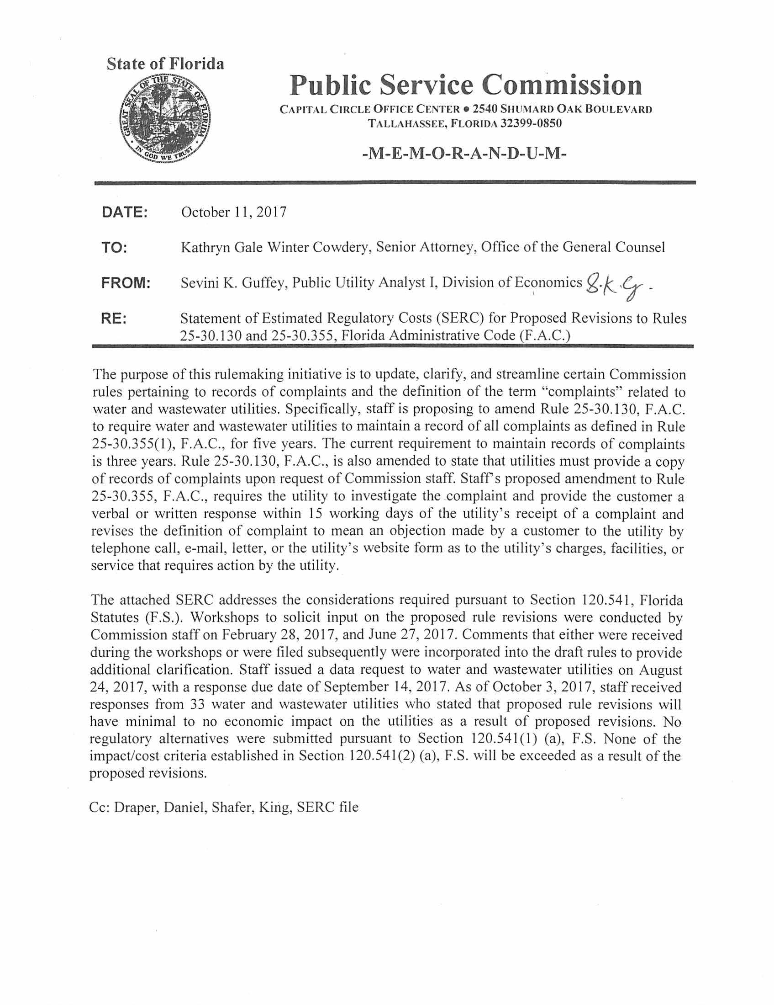

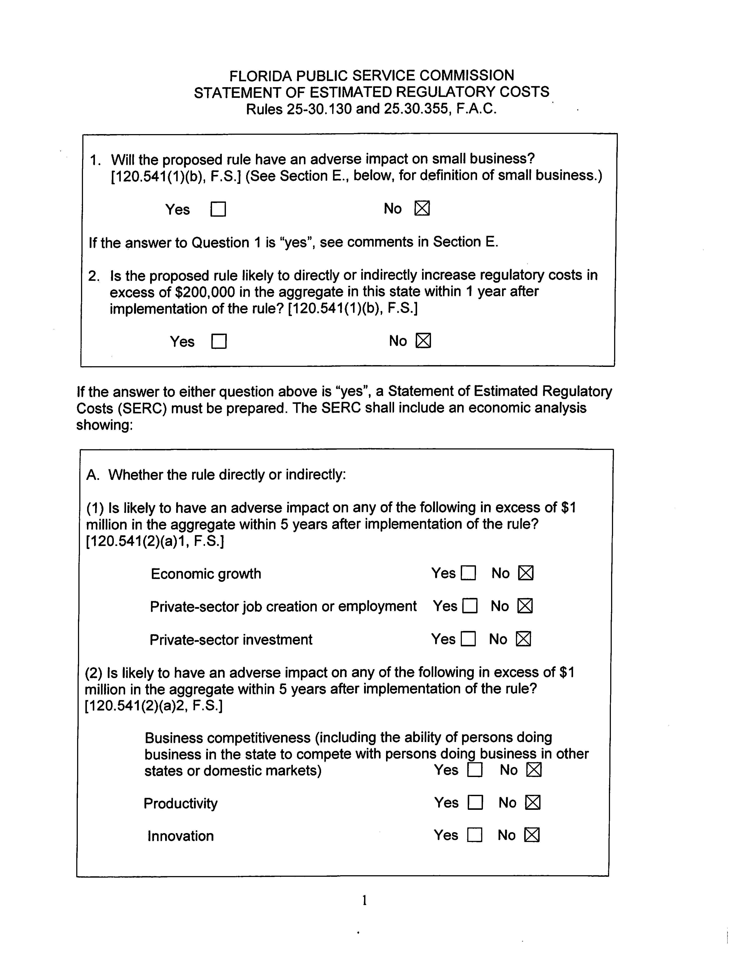

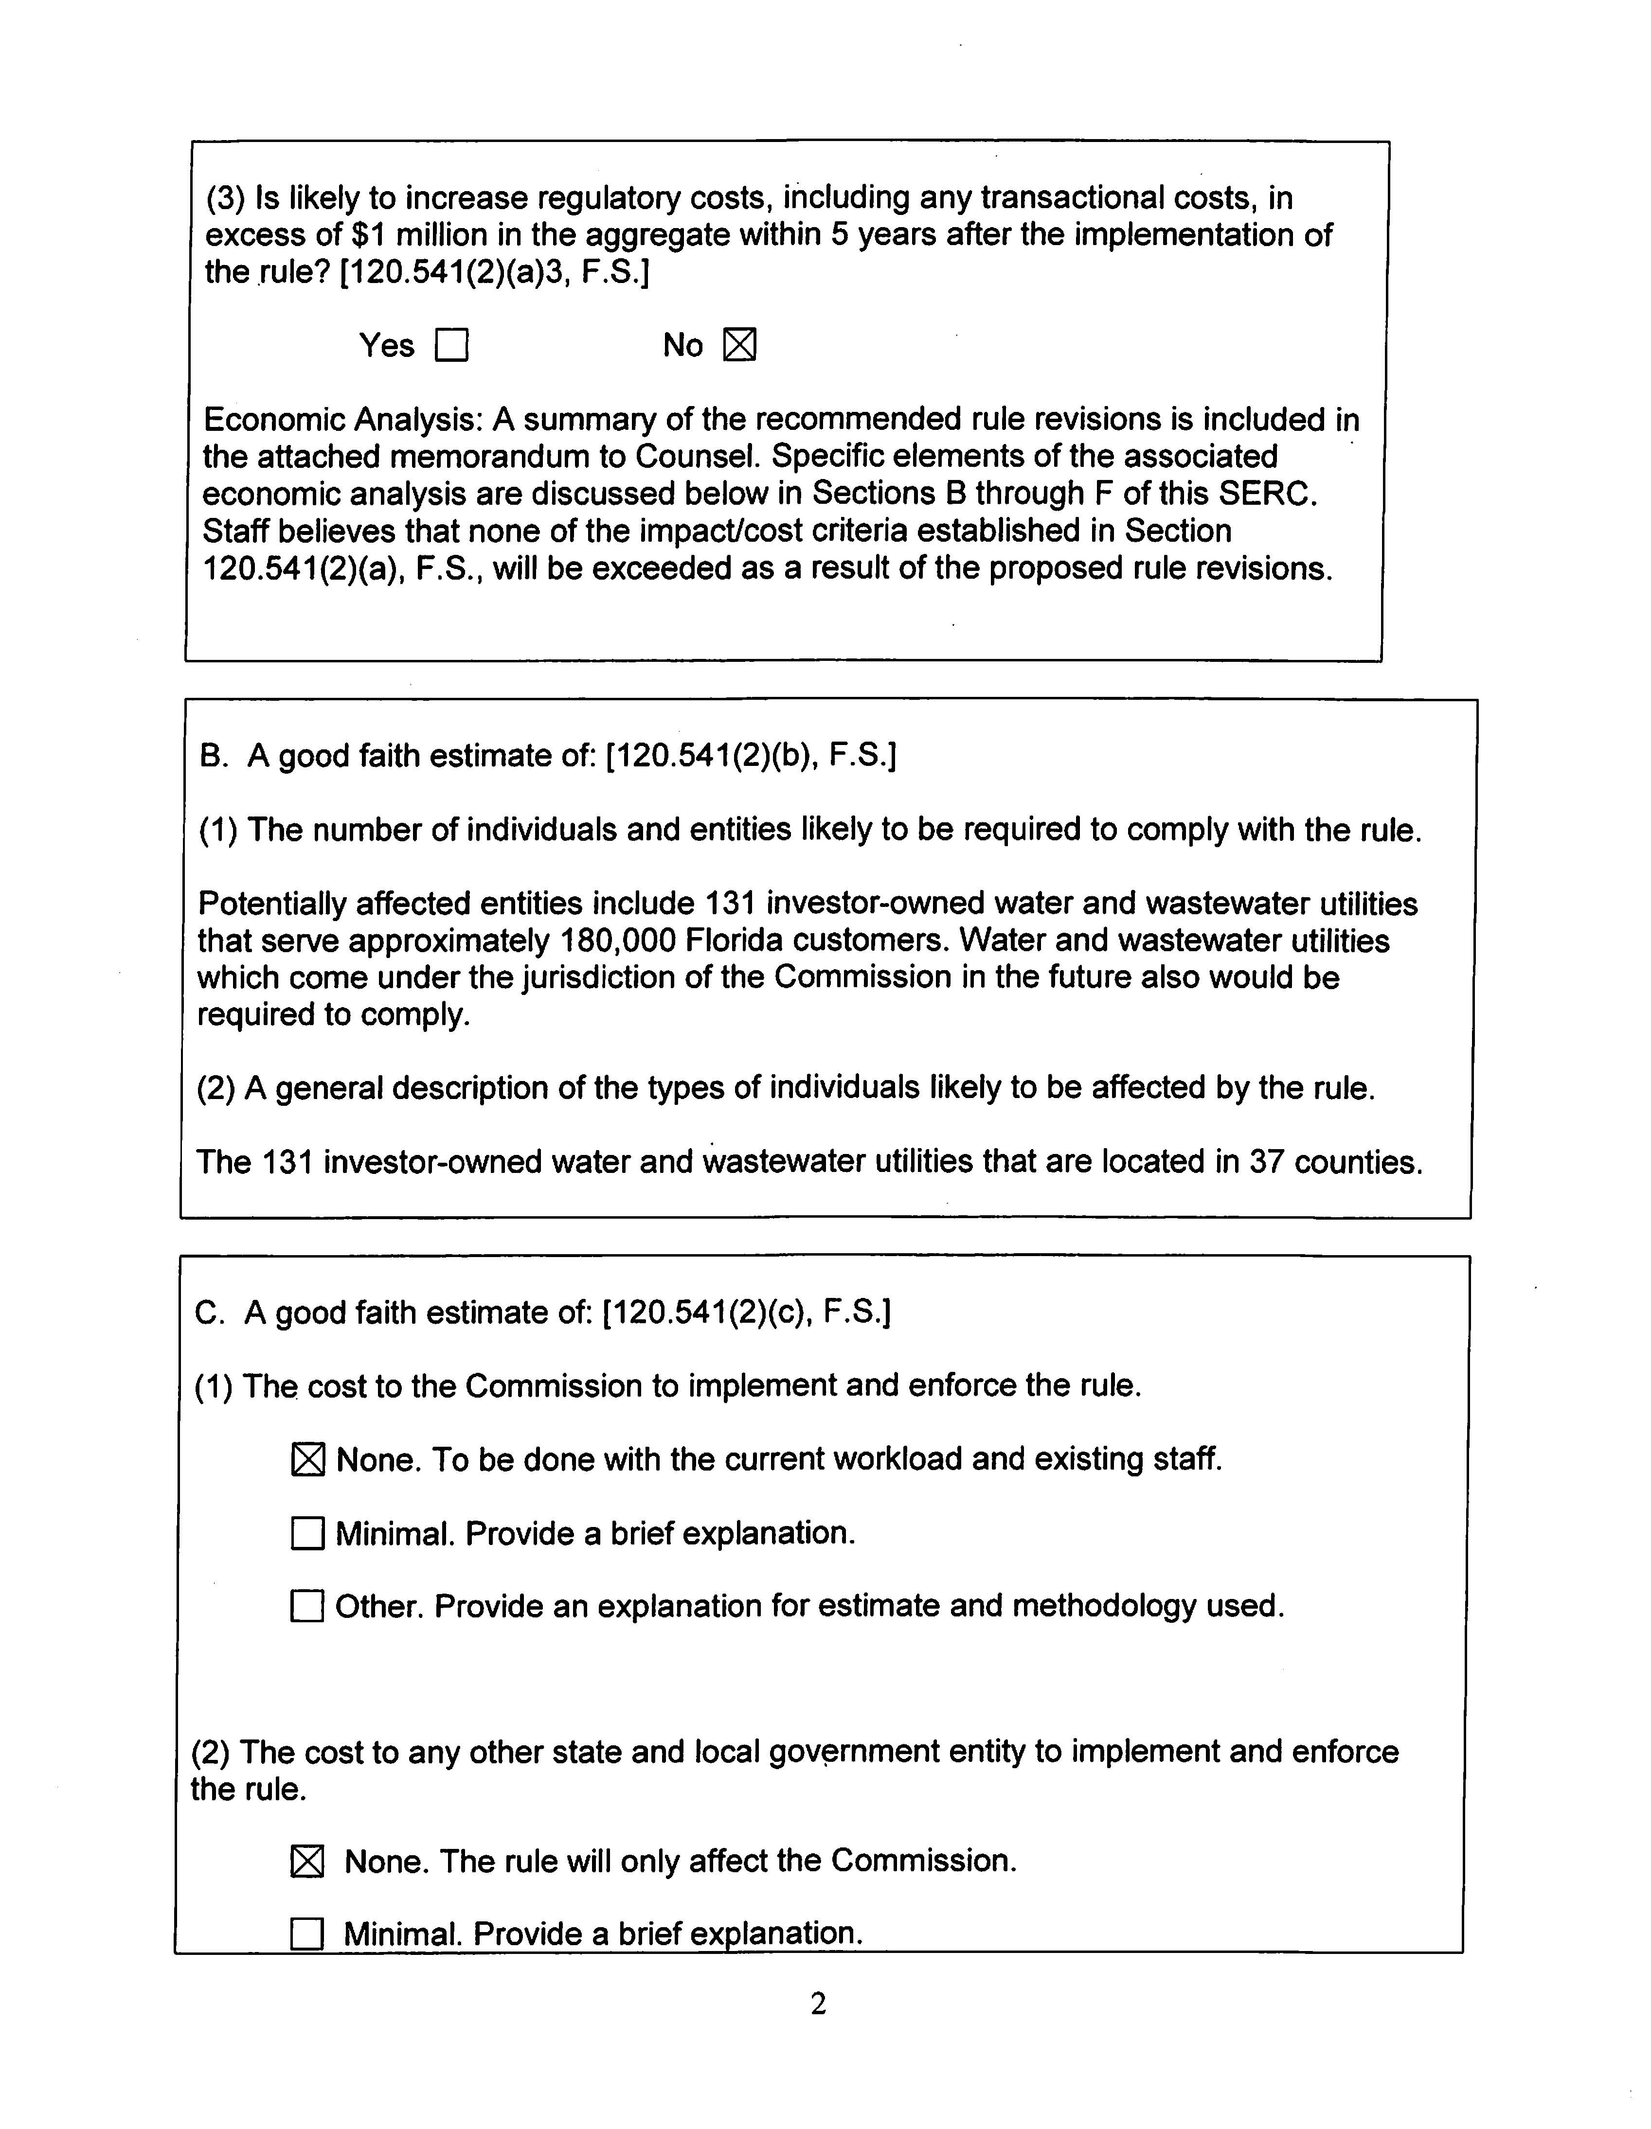

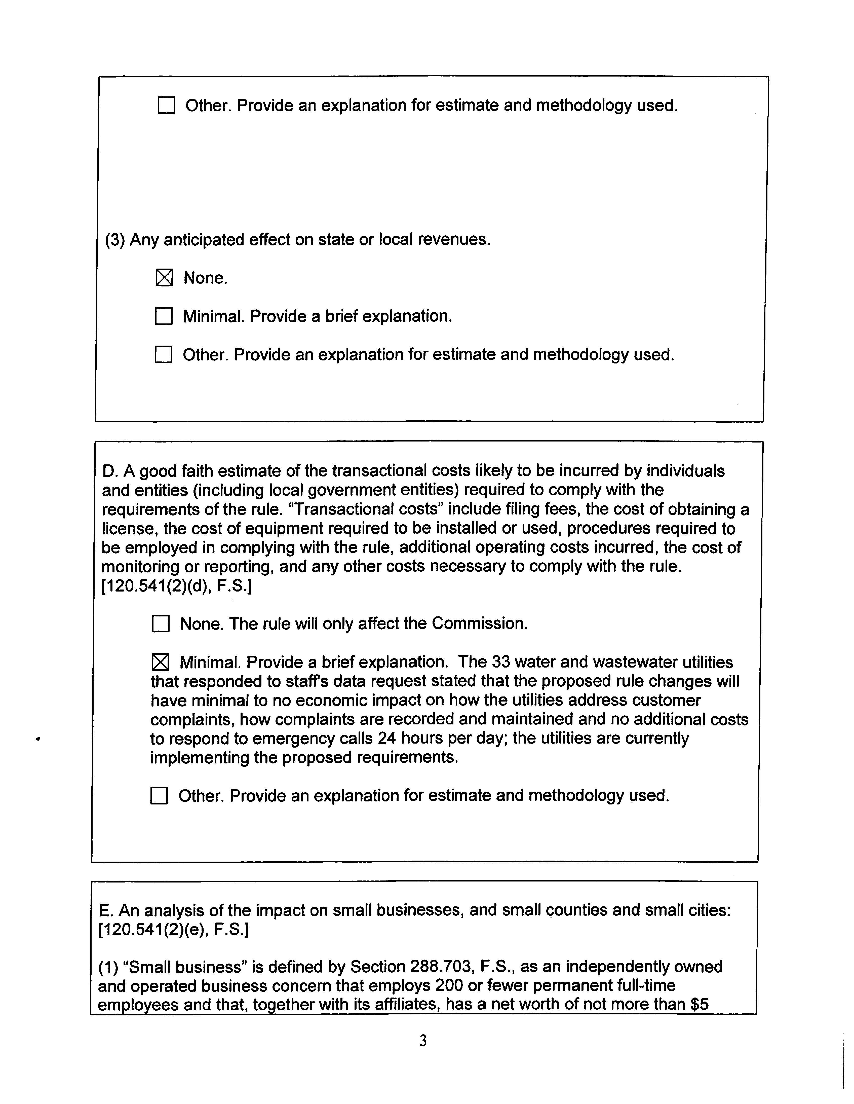

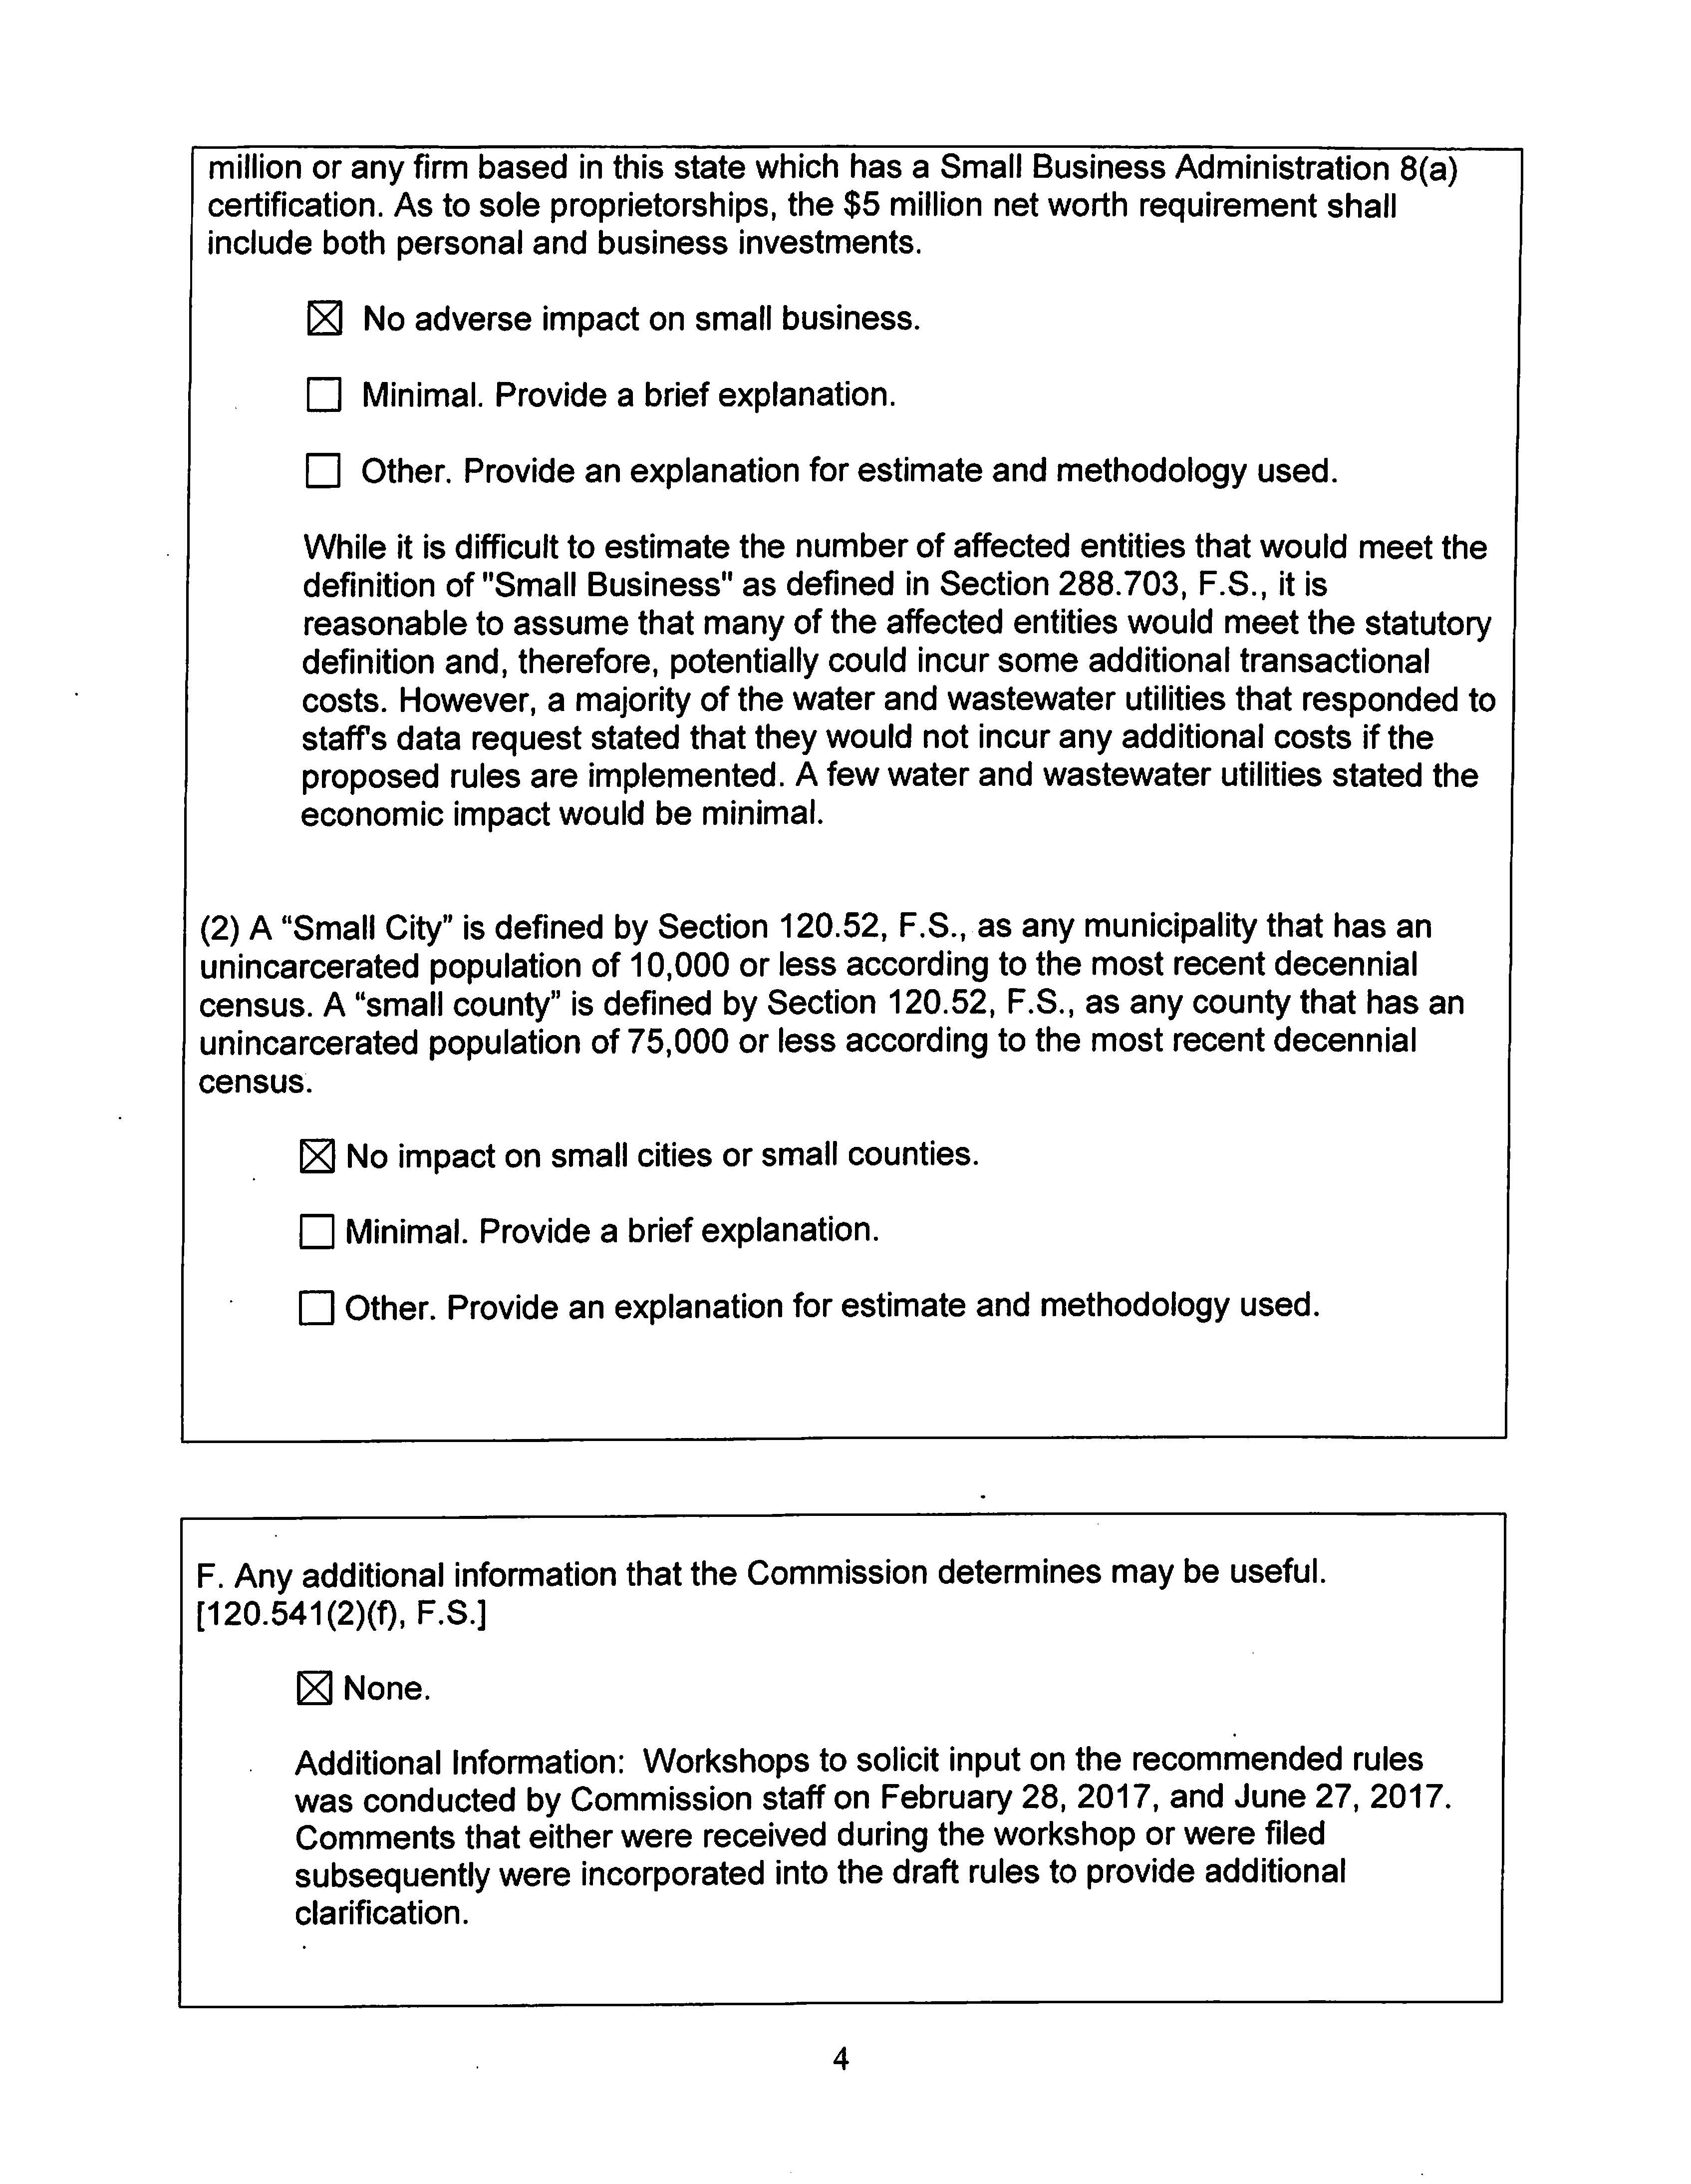

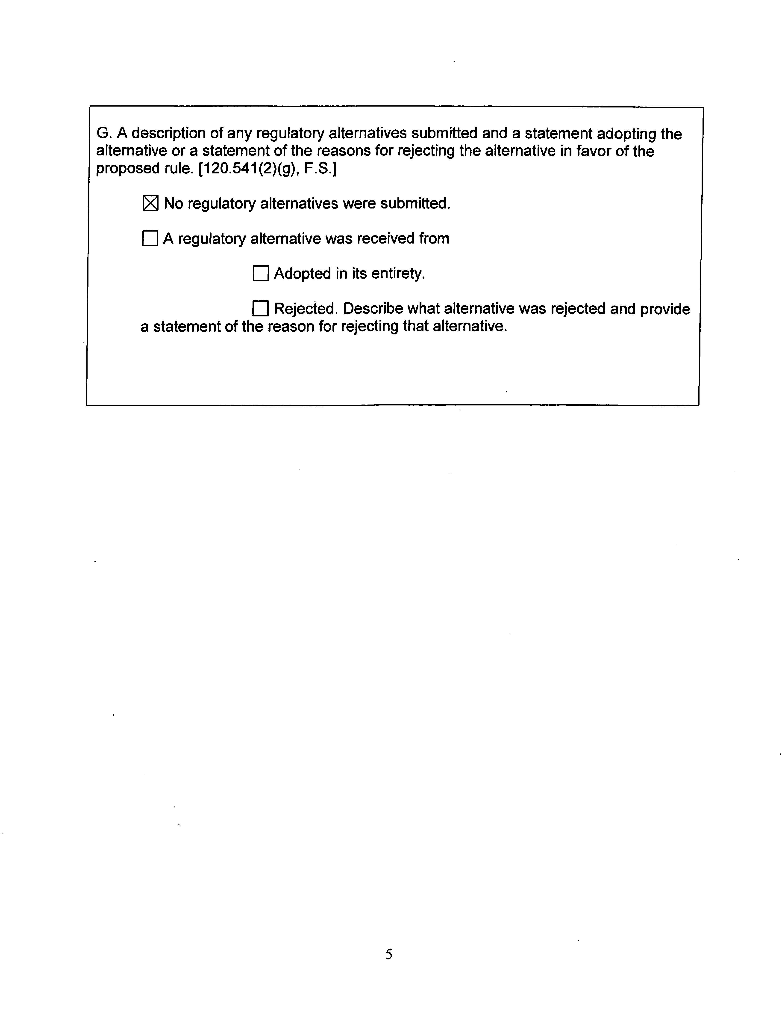

Because of these changes to Section 367.0812(1)(c), F.S., the Commission amended Rules 25-30.440 (11) and 25-30.037(1)(r)4, F.A.C., to require water and wastewater utilities’ rate case applications and applications for authority to transfer an existing water utility to include a copy of all customer complaints that the utility has received regarding DEP secondary water quality standards during the past five years. Order No. PSC-15-0567-FOF-WS, issued December 16, 2015, in Docket No. 150198-WS, In re: Proposed Adoption of Rules; Order No. PSC-15-0055-FOF-WS, issued January 21, 2015, in Docket No. 140205-WS, In re: Proposed Adoption of Rule.
The Commission has rules that specifically require utilities to provide other types of records upon staff’s request. For example, Rule 25-30.245(2), F.A.C., requires each water and wastewater utility to furnish its accident reports to the Commission upon request of Commission staff. Rule 25-22.032(6)(e), F.A.C., addressing unresolved customer complaints filed with Commission, states that Commission staff may request and the utility is required to provide copies of information necessary to resolve a dispute between the utility and the customer.
If a customer believes that its service request has not been addressed promptly as required by the Commission rules discussed above for service requests, the customer may make a complaint to the utility.
Commission rules require electric and gas public utility to have a procedure for receiving and promptly responding to emergency calls 24 hours a day. Rules 25-6.094, 25-7.080(2), 25-12.041 and 25-12.042, F.A.C.

