State of Florida |  | Public Service Commission  Capital Circle Office Center ● 2540 Shumard Oak Boulevard  Tallahassee, Florida 32399-0850  -M-E-M-O-R-A-N-D-U-M-
DATE: | November 30, 2017
TO: | Office of Commission Clerk (Stauffer)
FROM: | Division of Economics (Doherty, Draper)  Office of the General Counsel (Mapp)
RE: | Docket No. 20170193-GU – Petition for approval of transportation service agreement with Florida Public Utilities Company, by Peninsula Pipeline Company, Inc.
AGENDA: | 12/12/17 – Regular Agenda – Proposed Agency Action – Interested Persons May Participate
COMMISSIONERS ASSIGNED: |  |  | All Commissioners
PREHEARING OFFICER: |  |  | Brisé
CRITICAL DATES: |  |  | None
SPECIAL INSTRUCTIONS: |  |  | None

Case Background
On September 1, 2017, Peninsula Pipeline Company, Inc. (Peninsula) filed a petition seeking approval of a firm transportation service agreement (Agreement) between Peninsula and Florida Public Utilities Company (FPUC), collectively the parties, for an extension in New Smyrna Beach. Peninsula operates as a natural gas transmission company as defined by Section 368.103(4), Florida Statutes (F.S.). FPUC is a local distribution company (LDC) subject to the regulatory jurisdiction of the Commission pursuant to Chapter 366, F.S.
In Order No. PSC-07-1012-TRF-GP Peninsula received approval of an intrastate gas pipeline tariff that allows it to construct and operate intrastate pipeline facilities and to actively pursue agreements with gas customers. Peninsula provides transportation service only, and does not engage in the sale of natural gas. Pursuant to Order No. PSC-07-1012-TRF-GP Peninsula is allowed to enter into certain gas transmission agreements without prior Commission approval. However, Peninsula is requesting Commission approval of this Agreement as it does not fit any of the criteria enumerated in the tariff for which Commission approval would not be required. Both Peninsula and FPUC are subsidiaries of Chesapeake Utility Corporation (Chesapeake), and agreements between affiliated companies must be approved by the Commission pursuant to Section 368.105, F.S., and Order No. PSC-07-1012-TRF-GP.
Pursuant to the proposed Agreement (Attachment A to the petition), Peninsula will construct a new natural gas pipeline in the New Smyrna Beach area and relocate an existing gate station that is in a populated area. During its evaluation of the petition, staff issued a data request to both Peninsula and FPUC for which responses were received on October 2, 2017. The Commission has jurisdiction over this matter pursuant to Sections 366.05(1), 366.06, and 368.105. F.S.

Discussion of Issues

Issue 1:
Should the Commission approve the Agreement between Peninsula and FPUC?

Recommendation:
Yes. The Commission should approve the proposed Agreement between Peninsula and FPUC dated August 25, 2017. (Doherty, Draper)

Staff Analysis:
FPUC provides natural gas service to residential and commercial/industrial customers in the New Smyrna Beach area. As discussed in the petition, FPUC is currently experiencing operational pressure issues on its distribution system which have hindered FPUC’s ability to provide adequate service to the outer edges of New Smyrna Beach during peak periods. Peak periods occur typically in the winter and cold weather lowers the pressure of gas, causing delivery of gas issues. The pressure issues have also directly impacted economic growth development in both the large commercial and small industrial sectors. Finally, a current FPUC gate station is located inside an active RV park, raising safety concerns.
To address the issues discussed above, FPUC and Peninsula entered into the proposed Agreement. This Agreement will be in effect for an initial period of 20 years and shall be extended for additional 10-year increments. The Agreement will provide resolution to the pressure problems, improve the reliability, and relocate the gate station from the RV park. Specifically, pursuant to the Agreement, Peninsula will undertake two new projects discussed in more detail below.
First, Peninsula will relocate the gate station that is currently inside an RV park to a new site adjacent to the Highway 92 right-of-way just north of the current site. Peninsula provided photos of the gate station and adjacent RV park in Attachment B to the petition.
Second, Peninsula will construct and own a new pipeline, referred to as the New Smyrna Beach Line in the proposed Agreement. The new 14.7 mile pipeline will interconnect with the interstate Florida Gas Transmission (FGT) pipeline’s Daytona West gate station on US Highway 92, approximately one mile west of Interstate 95 in Volusia County. The pipeline will travel south where it will interconnect with FPUC’s existing pipeline in New Smyrna Beach. The New Smyrna Beach Line is shown in the map in Attachment A to this recommendation as the solid blue line. Peninsula stated that it is required to obtain approvals from the Florida Department of Transportation and the Florida Department of Environmental Protection for the pipeline, which Peninsula expects to receive soon. Construction is expected to be completed in early 2018.
FPUC’s existing 4 inch pipeline that has been serving the New Smyrna Beach area will remain in service as a distribution line. The New Smyrna Beach Line will be larger in diameter (8 inches) and will be located entirely within the public rights-of-way. The New Smyrna Beach Line will also operate at a higher delivery pressure than FPUC’s existing line to alleviate the existing pressure problems and support growth in the area.
The parties assert that the negotiated monthly reservation charge contained in the Agreement is consistent with a market rate in that they are within the ranges of rates set forth in similar agreements as required by Section 368.105(3)(b), F.S. In response to staff’s data request, Peninsula provided a comparison of construction costs (confidential) for other similar agreements entered into by Peninsula. While construction costs vary for each project due to pipe size, construction conditions, permitting, etc., staff believes that Peninsula’s construction and on-going maintenance costs for the proposed new line appear reasonable and comparable to other projects.
FPUC is proposing to recover the payments to Peninsula under the proposed Agreement from its customers through its Purchased Gas Adjustment (PGA) and Swing Service Rider mechanisms consistent with other gas transmission pipeline costs incurred by FPUC. FPUC provided information showing that the impact on the PGA will be minor ($0.042 per therm for 2018). While FPUC will incur costs associated with this service expansion, any new load will help spread the costs over a larger customer base.
The benefit of Peninsula, as opposed to FPUC, constructing the new pipeline, is primarily that Peninsula’s construction and ownership of the pipeline will avoid FPUC undertaking the costs and risks for this project, which in turn protects FPUC’s ratepayers. Prior to entering into an agreement with Peninsula, FPUC stated that it engaged in a conversation with FGT regarding the possibility of FGT building the new pipeline; however, the conversation did not produce an economically viable solution. In response to staff’s data request, FGT’s project estimate is higher than Peninsula’s cost.

Conclusion
Based on the petition and responses from Peninsula to staff’s data request, staff believes the proposed Agreement is cost effective, reasonable, meets the requirements of Section 368.105, F.S., and benefits FPUC’s customers. Staff therefore recommends approval of the proposed Agreement between Peninsula and FPUC dated August 25, 2017.

Issue 2:
Should this docket be closed?

Recommendation:
Yes. If no protest is filed by a person whose substantial interests are affected within 21 days of the issuance of the Order, this docket should be closed upon the issuance of a Consummating Order. (Mapp)

Staff Analysis:
If no protest is filed by a person whose substantial interests are affected within 21 days of the issuance of the Order, this docket should be closed upon the issuance of a Consummating Order.

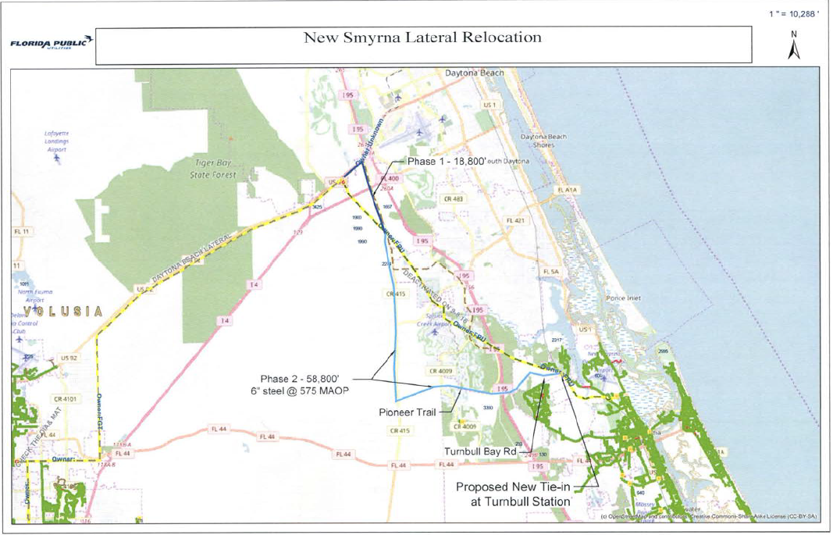

Order No. PSC-06-0023-DS-GP, issued January 9, 2006, in Docket No 050584-GP, In re: Petition for declaratory statement by Peninsula Pipeline Company, Inc. concerning recognition as a natural gas transmission company under Section 368.101, F.S., et seq.
Order No. PSC-07-1012-TRF-GP, issued December 21, 2007, in Docket No. 070570-GP, In re: Petition for approval of natural gas transmission pipeline tariff by Peninsula Pipeline Company, Inc.
Peninsula Pipeline Company, Inc., Intrastate Pipeline Tariff, Original Vol. 1, Sheet No. 12, Section 4.

