State of Florida |  | Public Service Commission  Capital Circle Office Center ● 2540 Shumard Oak Boulevard  Tallahassee, Florida 32399-0850  -M-E-M-O-R-A-N-D-U-M-
DATE: | January 25, 2018
TO: | Office of Commission Clerk (Stauffer)
FROM: | Division of Engineering (Thompson, Ellis, King, Wright)  Division of Economics (Higgins)  Office of the General Counsel (Cuello)
RE: | Docket No. 20170248-EI – Petition for approval of fuel cost proxy substitution to qualifying facility contract between Duke Energy Florida, LLC and CFR/Biogen (n/k/a Orange Cogeneration Limited Partners), Ridge Generating Station Limited Partnership, Mulberry Energy Company, Inc. (n/k/a Polk Power Partners), and Orlando Cogen Limited, L.P.
AGENDA: | 02/06/18 – Regular Agenda – Proposed Agency Action - Interested Persons May Participate
COMMISSIONERS ASSIGNED: |  |  | All Commissioners
PREHEARING OFFICER: |  |  | Administrative
CRITICAL DATES: |  |  | Duke is requesting a Consummating Order be filed by April 2018 because they are retiring Crystal River 1 and 2, the Avoided Unit Fuel Reference Plant for the contracts being modified, on this date.
SPECIAL INSTRUCTIONS: |  |  | None

Case Background
On July 1, 1991, the Florida Public Service Commission (Commission) approved a petition by Florida Power Corporation n/k/a Duke Energy Florida, LLC (Duke or Utility) requesting approval for cost recovery of negotiated contracts for purchase of firm capacity and energy with the following qualifying facilities: Ridge Generating Station Limited Partnership (Ridge), Mulberry Energy Company, Inc. n/k/a Polk Power Partners (Polk), and Orlando CoGen Limited, L.P. (Orlando), among others. Similarly, on March 31, 1992, the Commission approved a joint petition by another qualifying facility, CFR-Biogen Corp. n/k/a Orange Cogeneration Limited Partners (Orange), and Duke requesting approval for cost recovery of a negotiated contract for purchase of firm capacity and energy. (These contracts, as amended to date, are collectively referred to as the “QF PPAs”)
Pursuant to the QF PPAs, Duke’s coal-fired units Crystal River 1 and 2 (CR 1 and 2) comprise the avoided unit fuel reference plant that is used to calculate the energy payments for these qualifying facilities. This calculation includes the delivered price of coal burned at CR 1 and 2. However, Duke plans to retire these coal units in April 2018. Upon retirement of these units, the energy payments for these QF PPAs can no longer be calculated as previously called for.
Duke and the owners of the qualifying facilities have negotiated respective amendments to the QF PPAs to agree to substitute the delivered price of coal burned at CR 1 and 2 with a substitute index to act as a fuel cost proxy (Substitute Index), designed to approximate the delivered price of coal burned at CR 1 and 2. Each of the amendments utilizes the Substitute Index, with the index’s development methodology being identical among all amendments. On November 17, 2017, Duke filed a petition for approval of the amendments to the QF PPAs.
The Commission has jurisdiction over this matter pursuant to Sections 366.04 and 366.051, Florida Statutes (F.S.).

Discussion of Issues

Issue 1:
Should the Commission approve Duke Energy Florida, LLC’s petition for approval of the amendments to the negotiated contracts for purchase of firm capacity and energy between Ridge Generating Station Limited Partnership, Mulberry Energy Company, Inc. n/k/a Polk Power Partners, Orlando CoGen Limited, L.P., and CFR-Biogen Corp. n/k/a Orange Cogeneration Limited Partners?

Recommendation:
Yes. Duke currently plans to retire CR 1 and 2 in April 2018, coal units comprising the avoided unit fuel reference plant as defined in the QF PPAs. The amendments to the QF PPAs seek to substitute the delivered price of coal burned at CR 1 and 2 with the Substitute Index, a fuel cost proxy expected to approximate the delivered price of coal to CR 1 and 2. The remaining total annual payments under the modified QF PPAs are expected to remain approximately equivalent to those estimated prior to modification.
The amendments to the QF PPAs do not modify any other part of the respective contracts. Thus, the core provisions of the QF PPAs, including total energy delivery amounts, contract duration, reliability, security, and risk allocation remain unchanged. Therefore, staff recommends that the Commission approve Duke’s petition for approval of the amendments to the QF PPAs. (Wright)

Staff Analysis:
Duke’s petition requests approval of modifications to four existing contracts. The Utility has provided the information required in accordance with Rule 25-17.0836(1), Florida Administrative Code (F.A.C.). As required by Rule 25-17.0836(6), F.A.C., staff evaluated modifications and concessions of the Utility and developer against both the existing contract and the current value of the purchasing Utility’s avoided cost.
Three of the four negotiated contracts for the purchase of firm capacity and energy under consideration in this docket were originally approved for cost recovery in 1991, with the fourth contract receiving approval in 1992. Since the original approvals, the Mulberry Energy Company, Inc. contract has been assigned to Polk Power Partners, with the agreement of Duke. Likewise, Duke agreed to the assignment of the contract originally with CFR-Biogen Corp. to Orange Cogeneration Limited Partners. The Ridge and Orlando QF PPAs expire in December 2023. The Polk QF PPA expires in August 2024, while the Orange QF PPA expires in December 2025. For all of the contracts, CR 1 and 2 comprise the avoided unit fuel reference plant. That is, the delivered price of coal burned at CR 1 and 2 is used as a fuel proxy for energy payment calculation purposes of the avoided unit. Duke plans to retire CR 1 and 2 in April 2018. Thus, after this date energy payment calculations could not be calculated pursuant to the terms of the contracts. Duke and the parties to each QF PPA have negotiated respective amendments to the contracts, attached as Attachment A, that seek to substitute the delivered price of coal burned at CR 1 and 2 with the Substitute Index, an index designed to approximate the delivered price of coal burned at CR 1 and 2. Each of the amendments utilizes the Substitute Index, with the index’s development methodology being identical among all amendments.
The Substitute Index is designed as a composite index, calculated as the sum of a coal price index and a transportation cost index, unitized in $/MMBtu. The coal price index is the unweighted monthly average of the weekly SNL Physical Market Survey Prompt Year price for NYMEX Big Sandy River Barge coal in $/ton published by SNL and converted to $/MMBtu. This index was chosen by Duke and the qualifying facilities because the characteristics of the coal, including heat rate and sulfur content, best matched that of the coal burned at CR 1 and 2 and because the index was public, transparent, and had historic values that were readily available. Following selection, the historic values of the coal price index were compared to the actual comprehensive fuel costs of CR 1 and 2 found on Duke’s A4 Schedule, System Net Generation and Fuel Cost Report. A variable, yet persistent, difference was identified over the eight years of data reviewed and was calculated to be approximately $52/ton. This difference was used as the foundation for the transportation cost index used in the Substitute Index. To account for future transportation cost variability, and to arrive at the final transportation cost index, the $52/ton rate is multiplied by a Rail Cost Adjustment Factor index, which sensitizes the transportation cost to the rate of inflation in railroad inputs such as labor and fuel. Staff finds the Substitute Index is designed in a logical, fair, and robust manner and recognizes its use in the amendments to the QF PPAs as a good faith effort to maintain the cost-effectiveness of the QF PPAs as originally approved by the Commission.
Three years of historic monthly energy prices used to calculate payments to each of the qualifying facilities under current contractual obligations were compared to prices calculated utilizing the Substitute Index as a fuel cost proxy in order to evaluate the potential for future payment deviations. After removal of outliers, payments calculated utilizing the Substitute Index were on average 0.058 $/MMBtu higher than as-paid fuel prices, representing an average 1.49 percent increase. Duke determined that a 1 percent increase in the value of the Substitute Index would result in a $0.03/1000 kWh increase to customer bills. In light of this information, the use of the Substitute Index to approximate the delivered price of coal to CR 1 and 2 over the remaining durations of the contracts is expected to result in energy payments that would remain approximately equivalent to those that would have been made had CR 1 and 2 remained in-service. Furthermore, any potential payment deviations from use of the Substitute Index that ultimately reach the customer through cost recovery mechanisms were determined to have minimal impact to ratepayer’s bills. Therefore, staff recommends that the amendments to the QF PPAs are cost effective.
While each amendment seeks to modify its respective QF PPA and implement use of the Substitute Index, the language used in each amendment naturally differs as a consequence of the differences in language used in each individual QF PPA. As a result of this, the amendments were also evaluated for their ability to accurately incorporate the Substitute Index as a fuel cost proxy in their respective QF PPA. Those amendments modifying the Orange, Polk, and Orlando contracts were determined to contain appropriate language. The amendment modifying the Ridge contract was found to omit language necessary to identify the use of the Substitute Index as a factor in the calculation of energy payments while simultaneously replacing its predecessor. Duke was notified of this omission and has filed a letter agreement between Duke and Ridge detailing the necessary amendment modifications, attached as Attachment B.

Conclusion
Duke currently plans to retire CR 1 and 2 in April 2018, coal units comprising the avoided unit fuel reference plant as defined in the QF PPAs. The amendments to the QF PPAs seek to substitute the delivered price of coal burned at CR 1 and 2 with the Substitute Index, a fuel cost proxy expected to approximate the delivered price of coal to CR 1 and 2. The remaining total annual payments under the modified QF PPAs are expected to remain approximately equivalent to those estimated prior to modification.
The amendments to the QF PPAs do not modify any other part of their respective contracts. Thus, the core provisions of the QF PPAs, including total energy delivery amounts, contract duration, reliability, security, and risk allocation remain unchanged. Therefore, staff recommends that the Commission approve Duke’s petition for approval of the amendments to the QF PPAs.

Issue 2:
Should this docket be closed?

Recommendation:
Yes. If no person whose substantial interests are affected by the proposed agency action (PAA) files a protest within 21 days of the issuance of the PAA Order, a Consummating Order should be issued and the docket should be closed. (Cuello)

Staff Analysis:
If no person whose substantial interests are affected by the proposed agency action files a protest within 21 days of the issuance of the PAA Order, a Consummating Order should be issued and the docket should be closed.

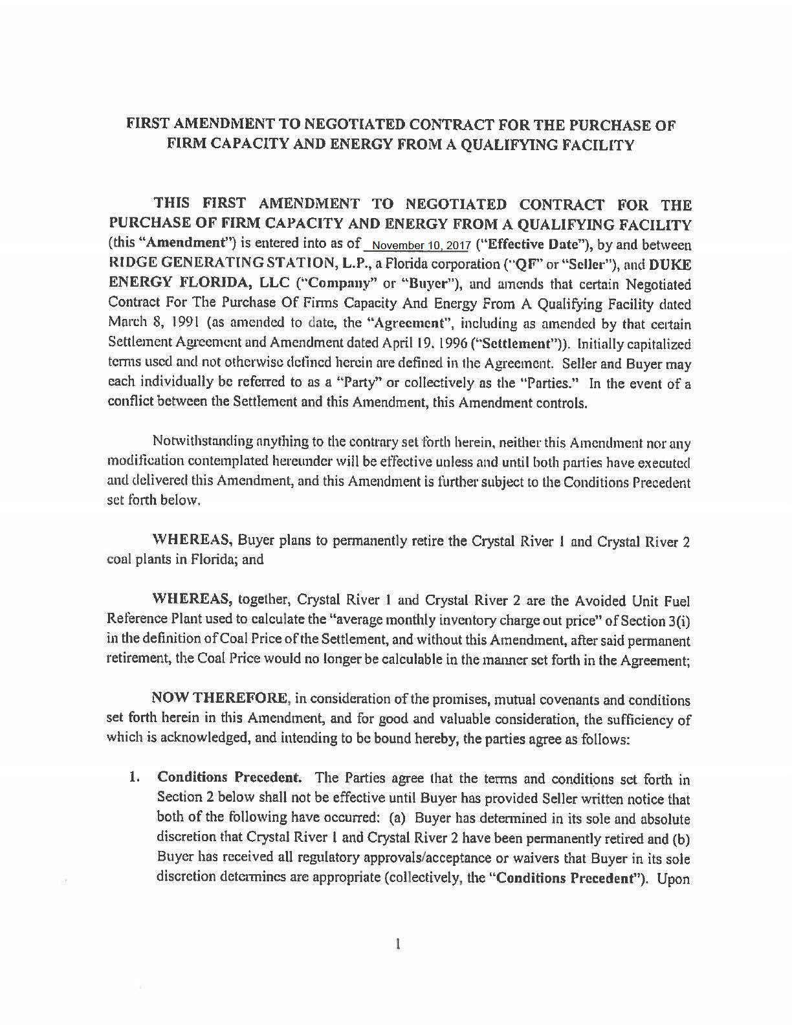

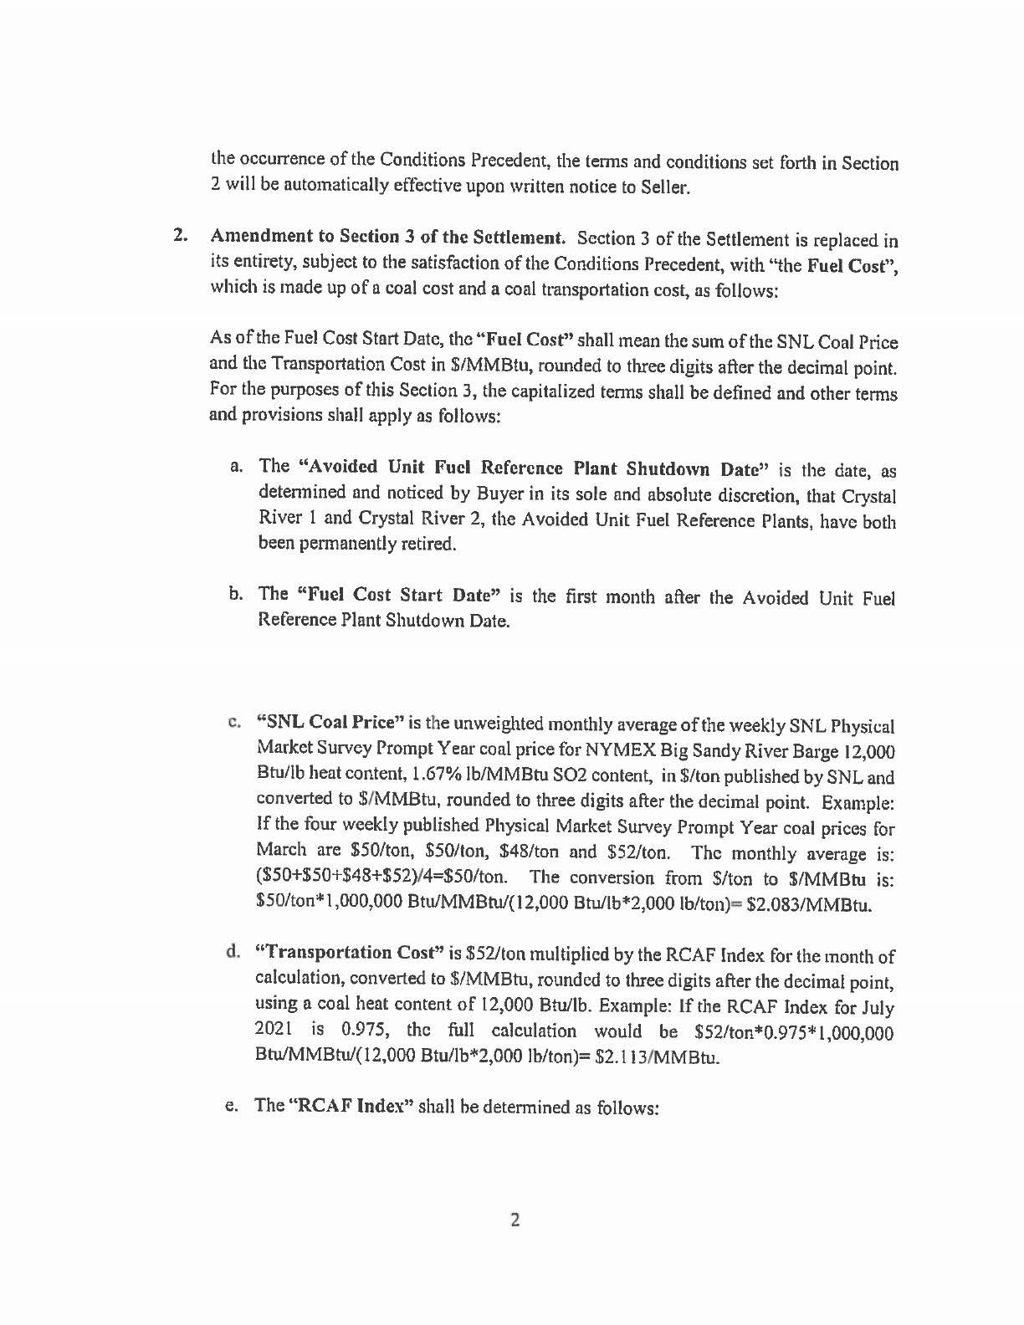

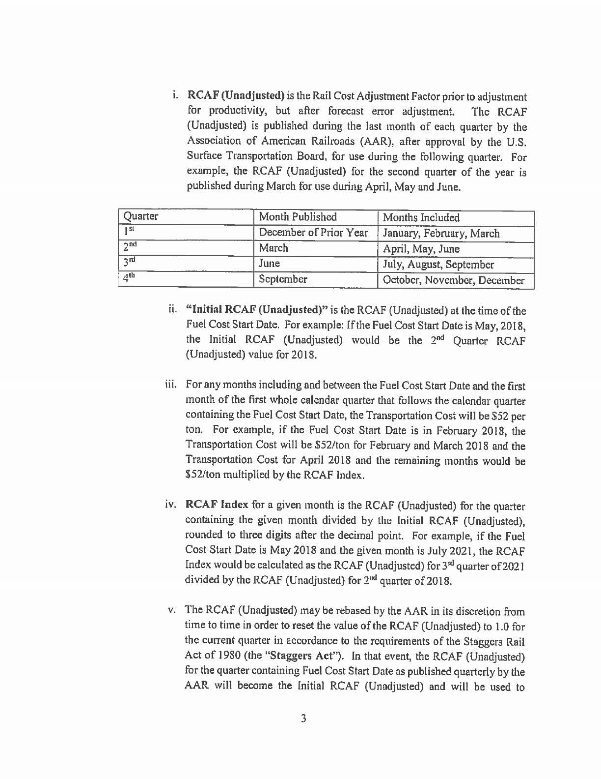

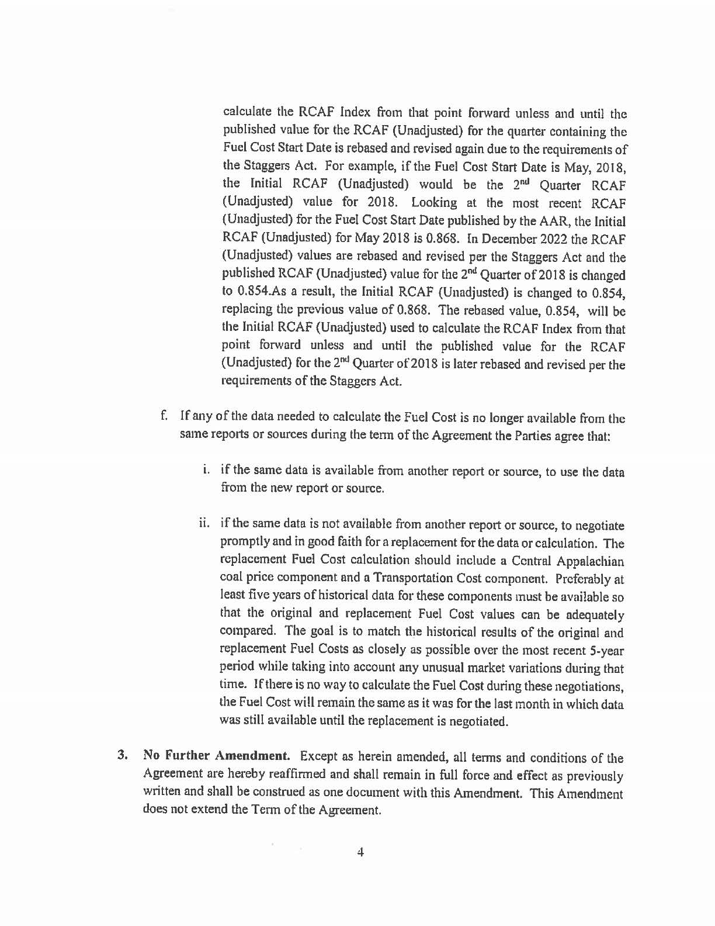

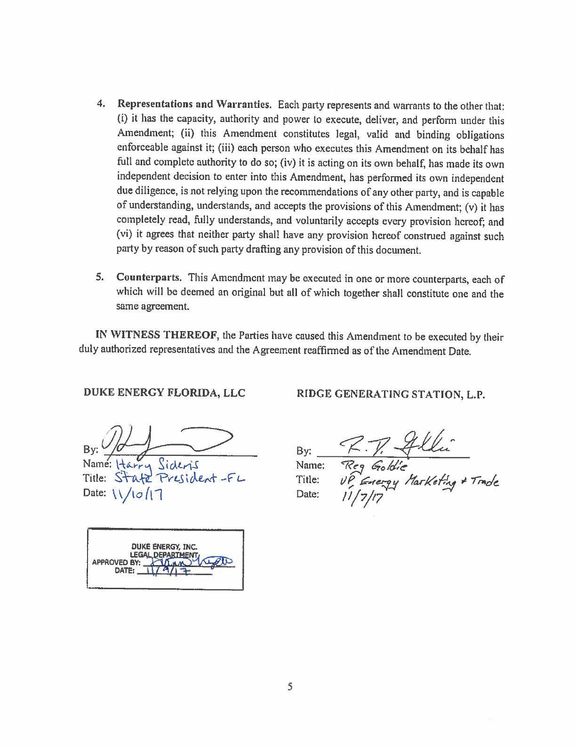

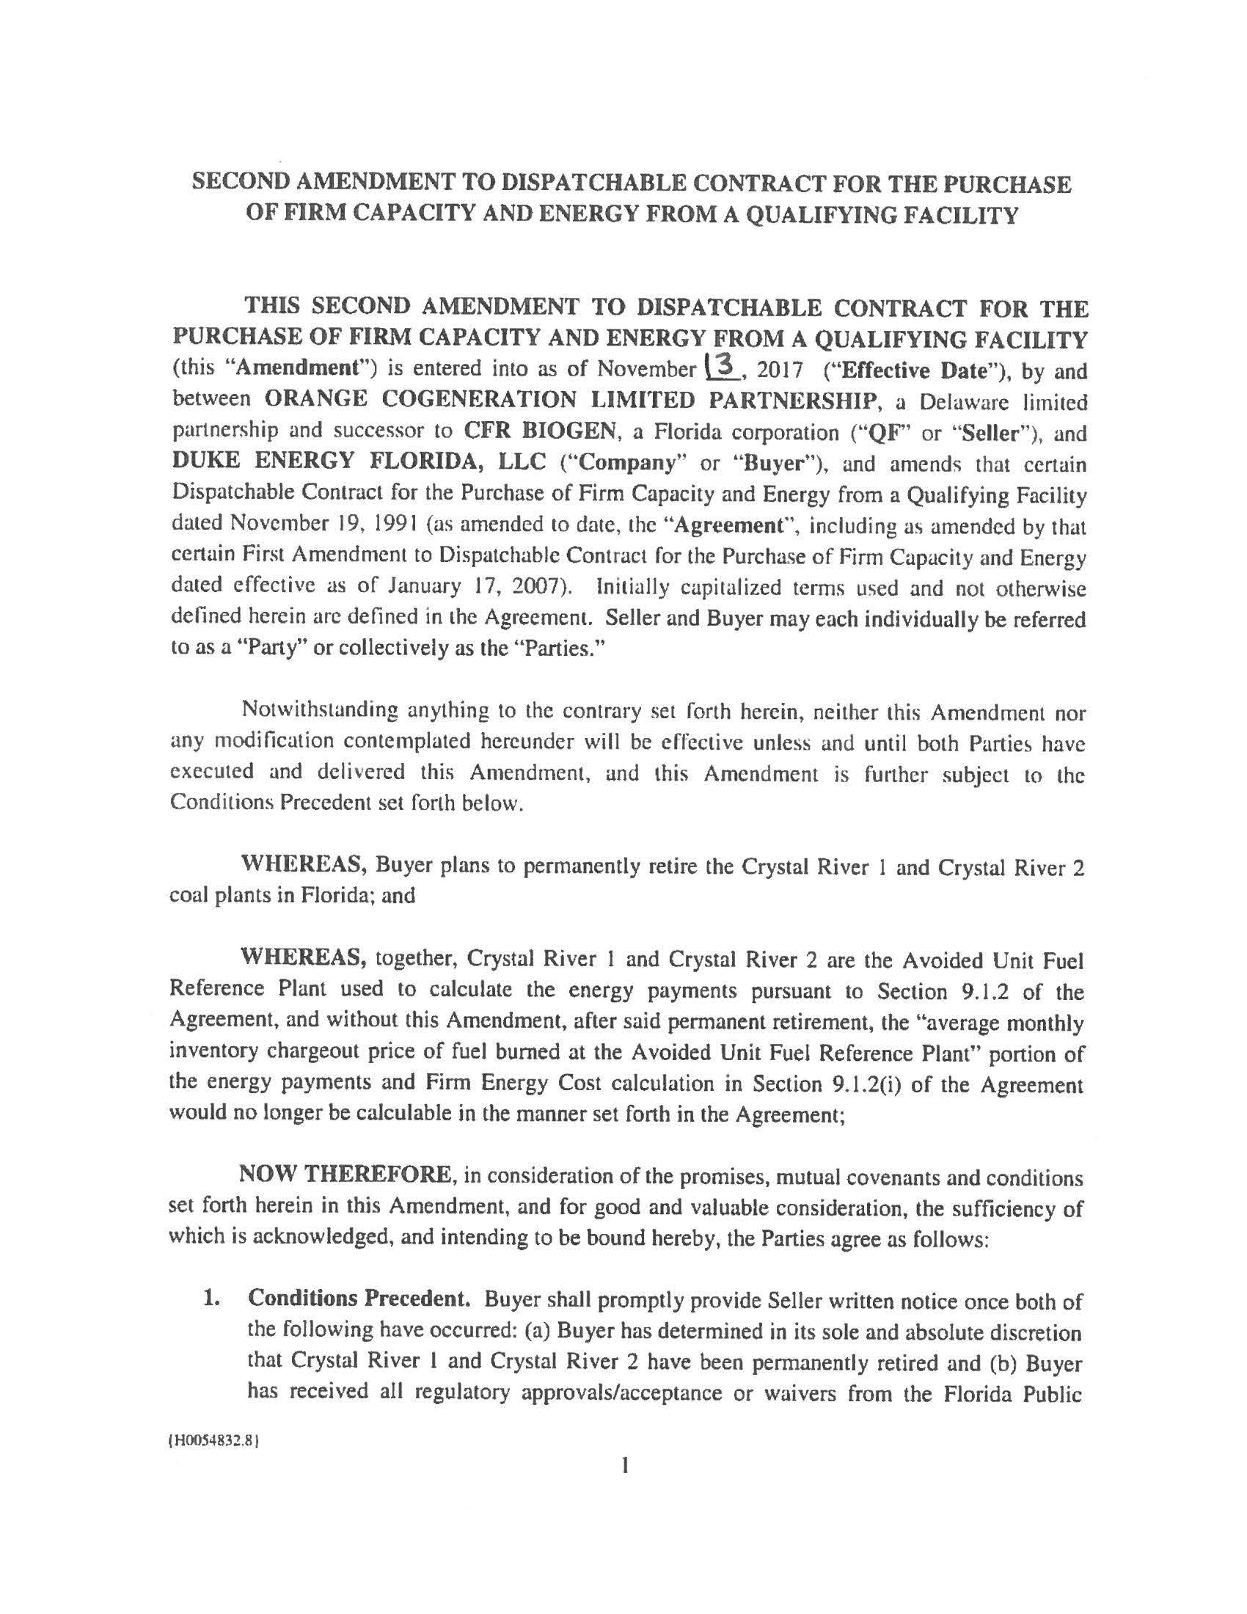

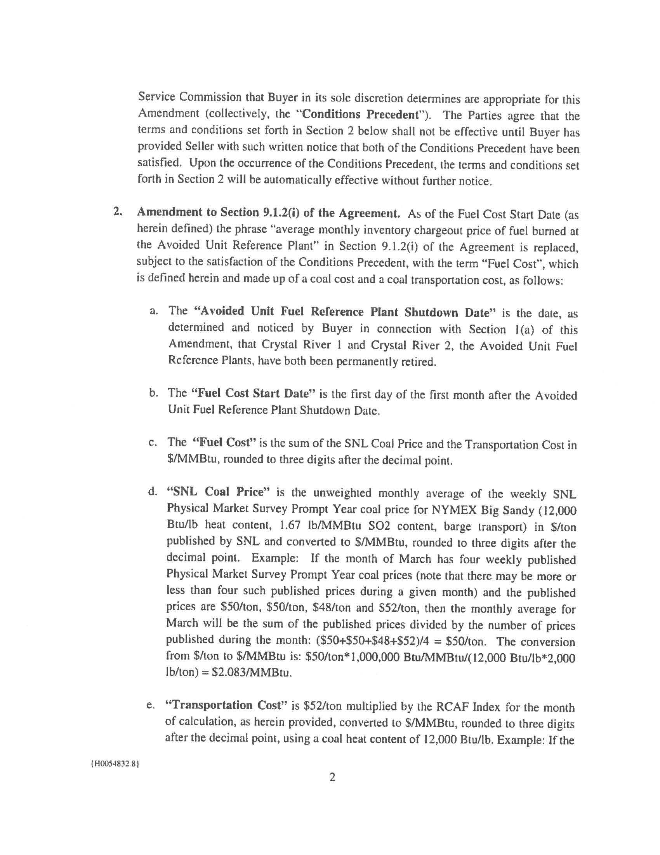

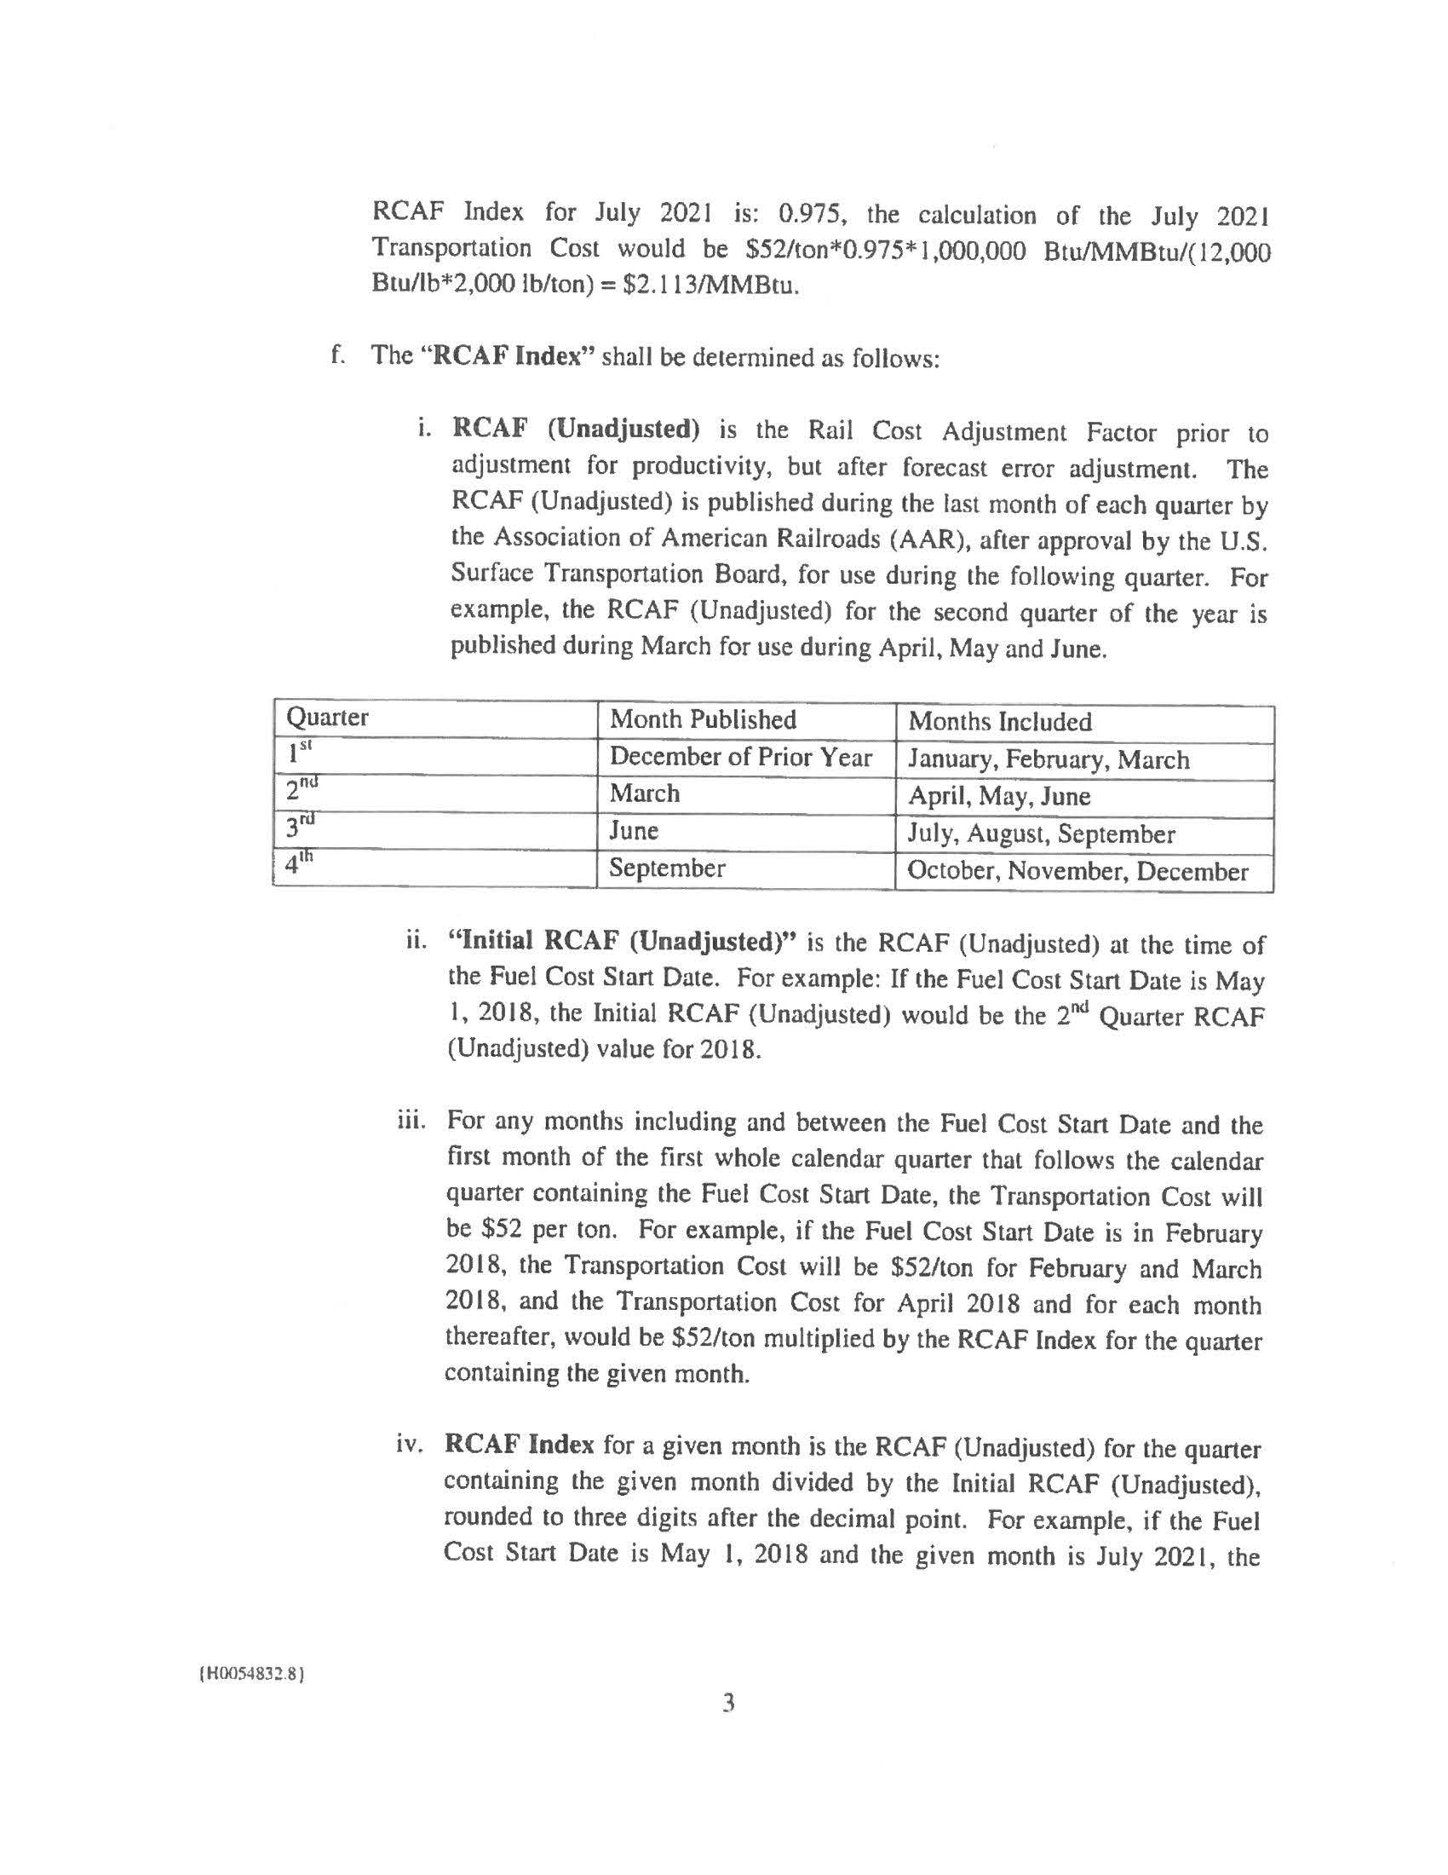

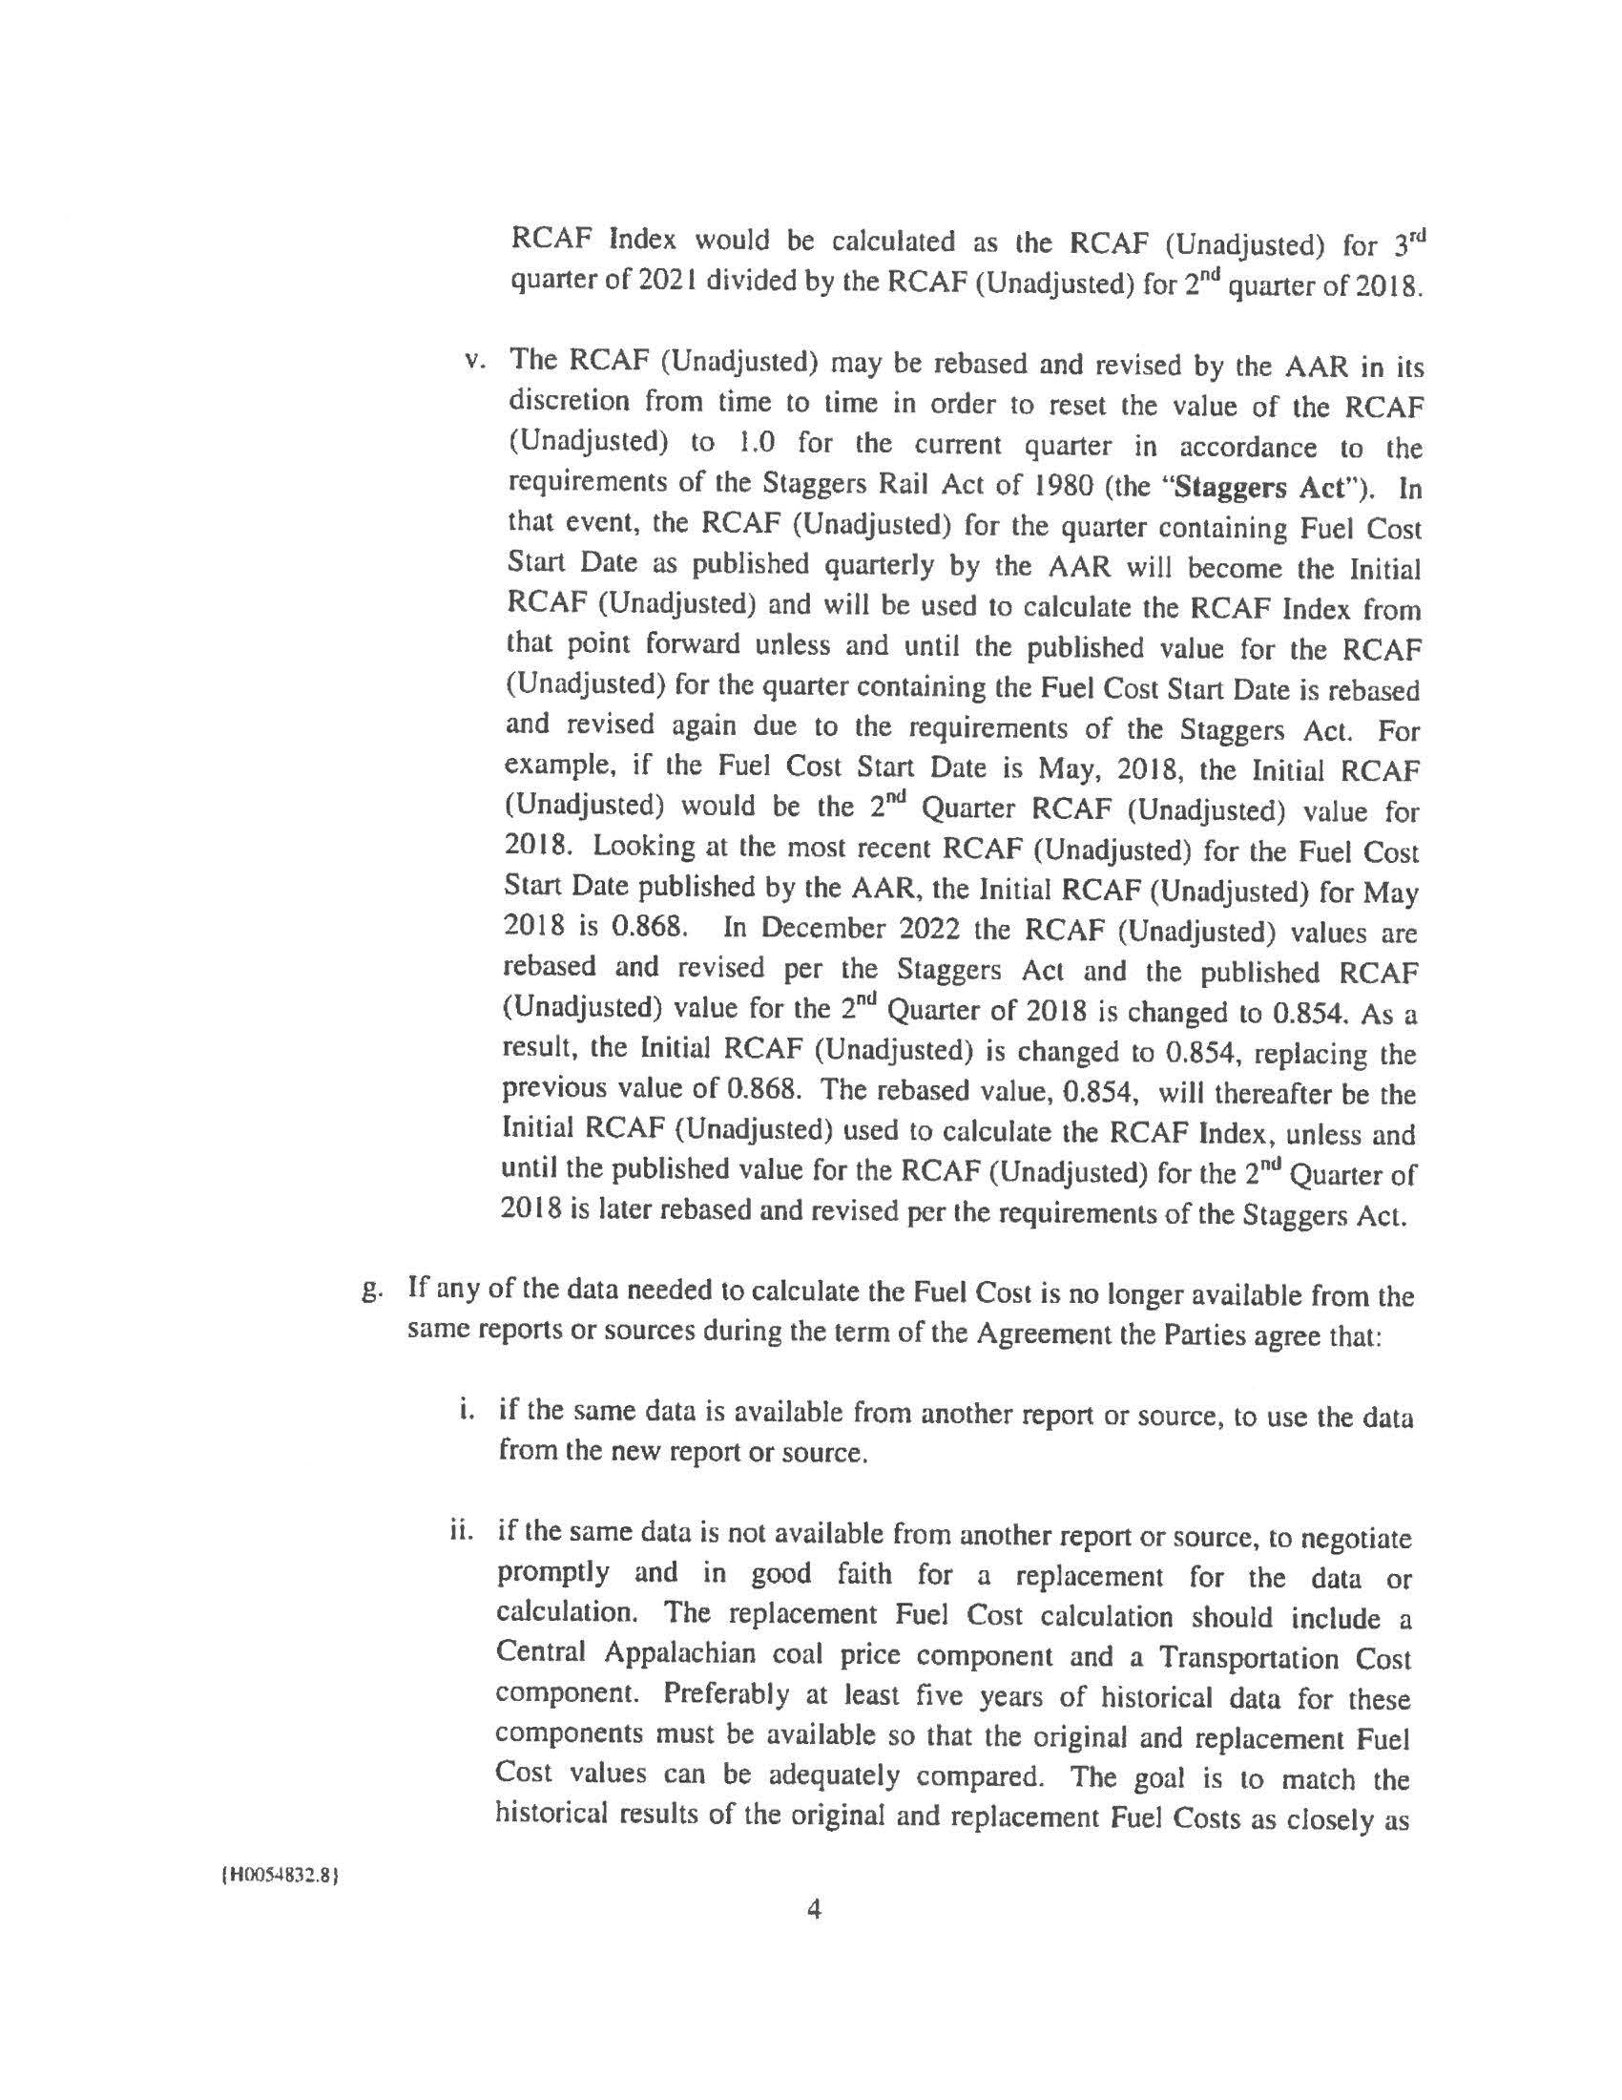

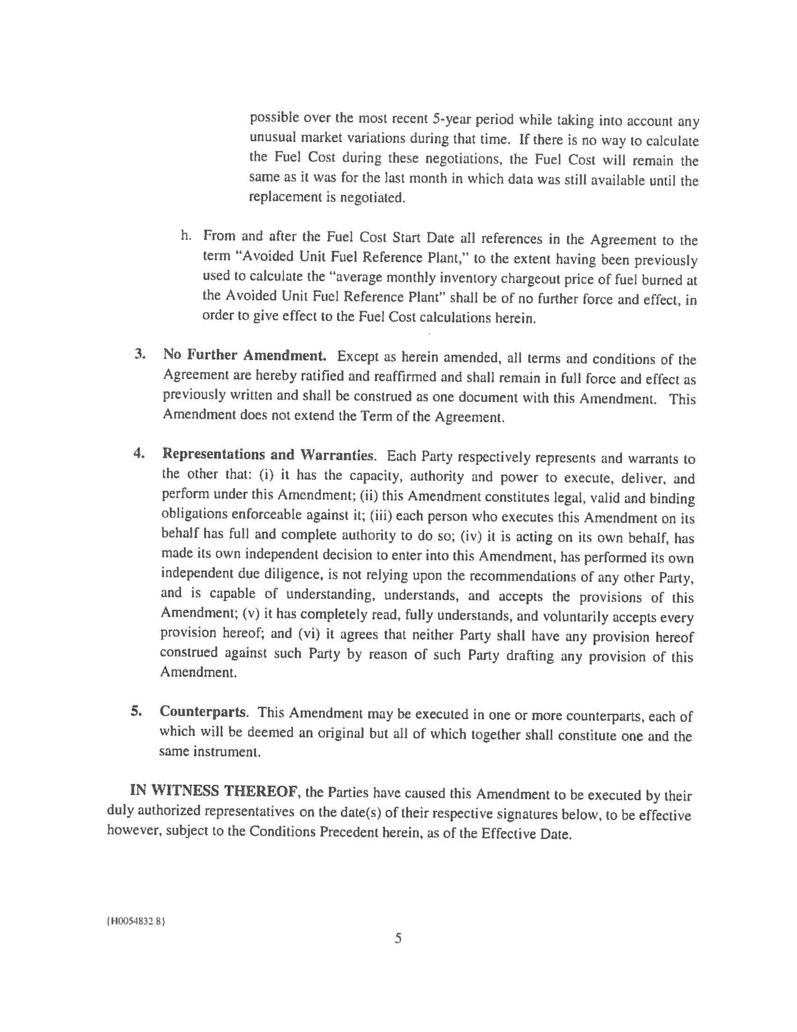

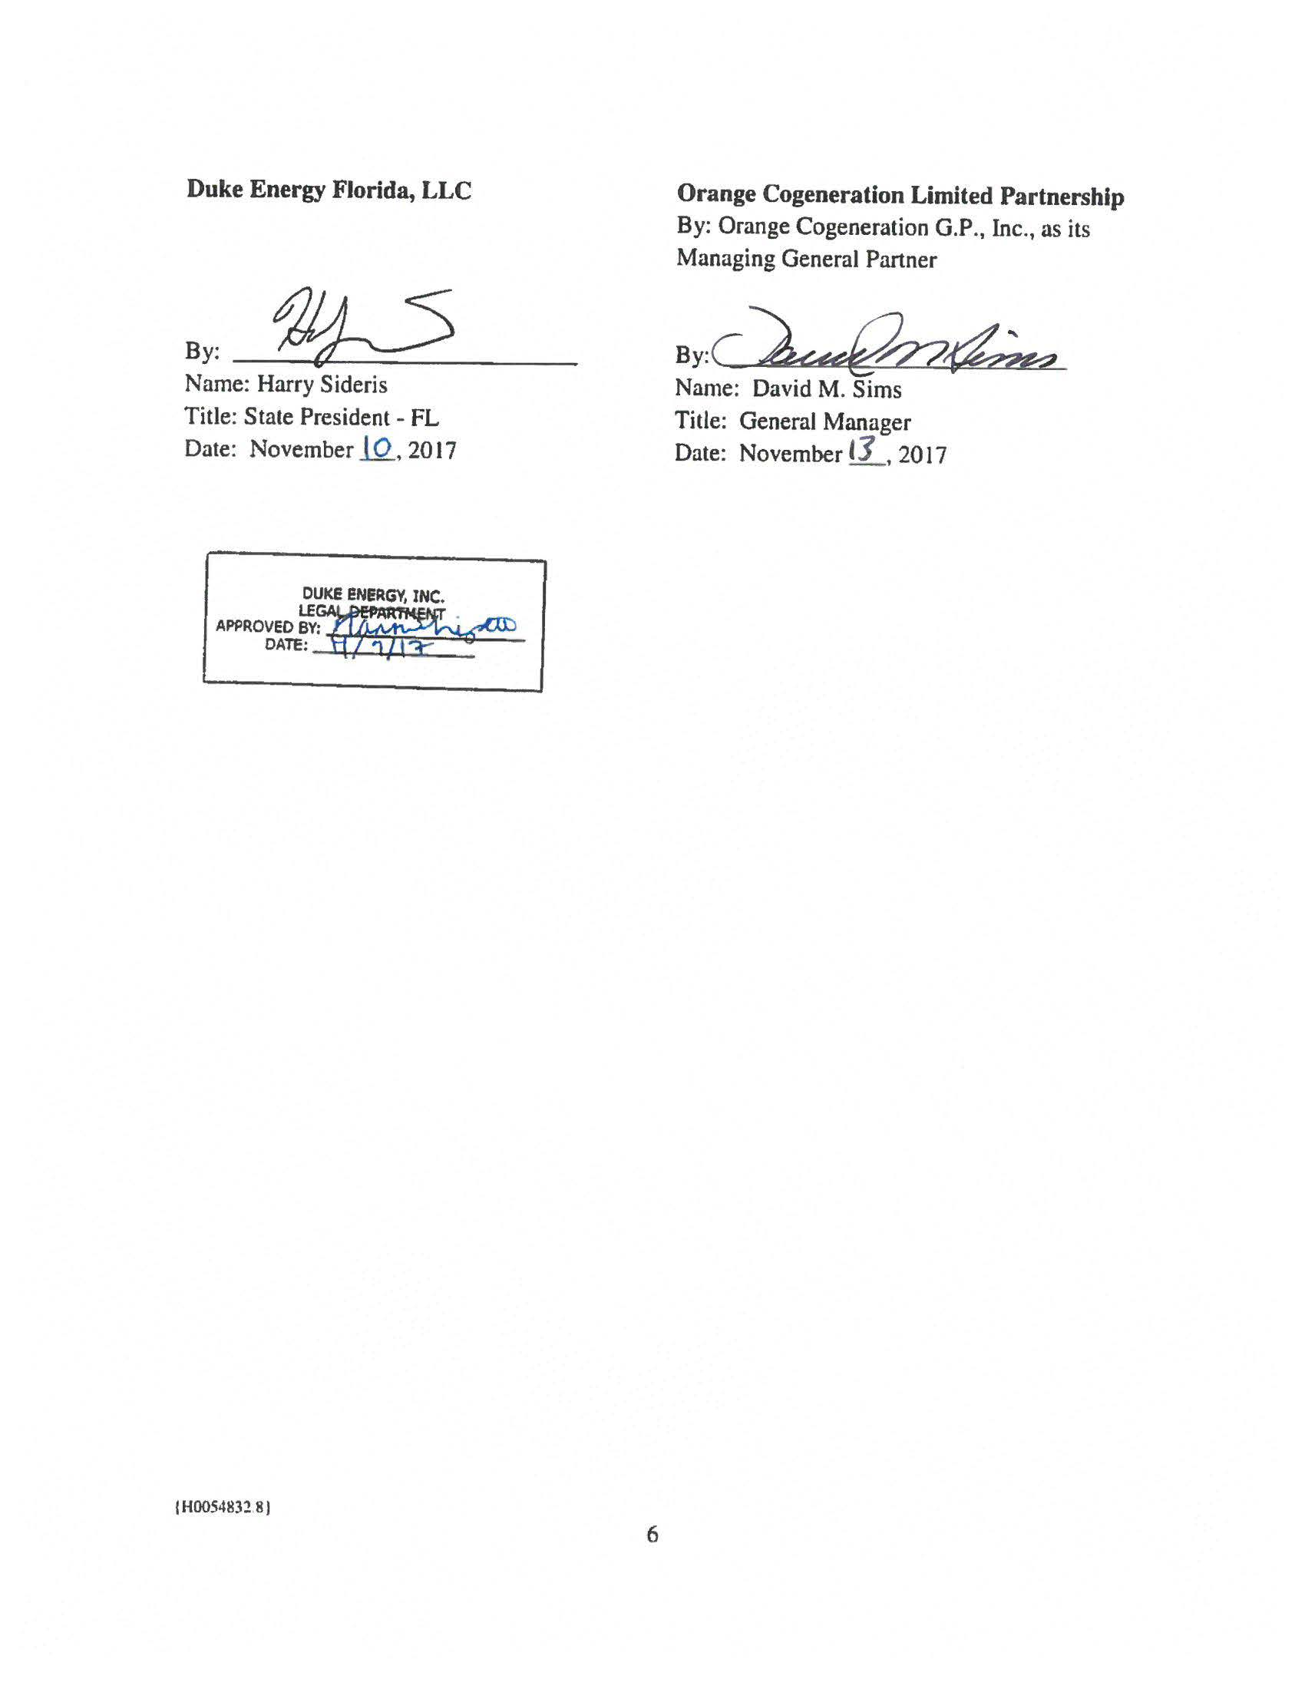

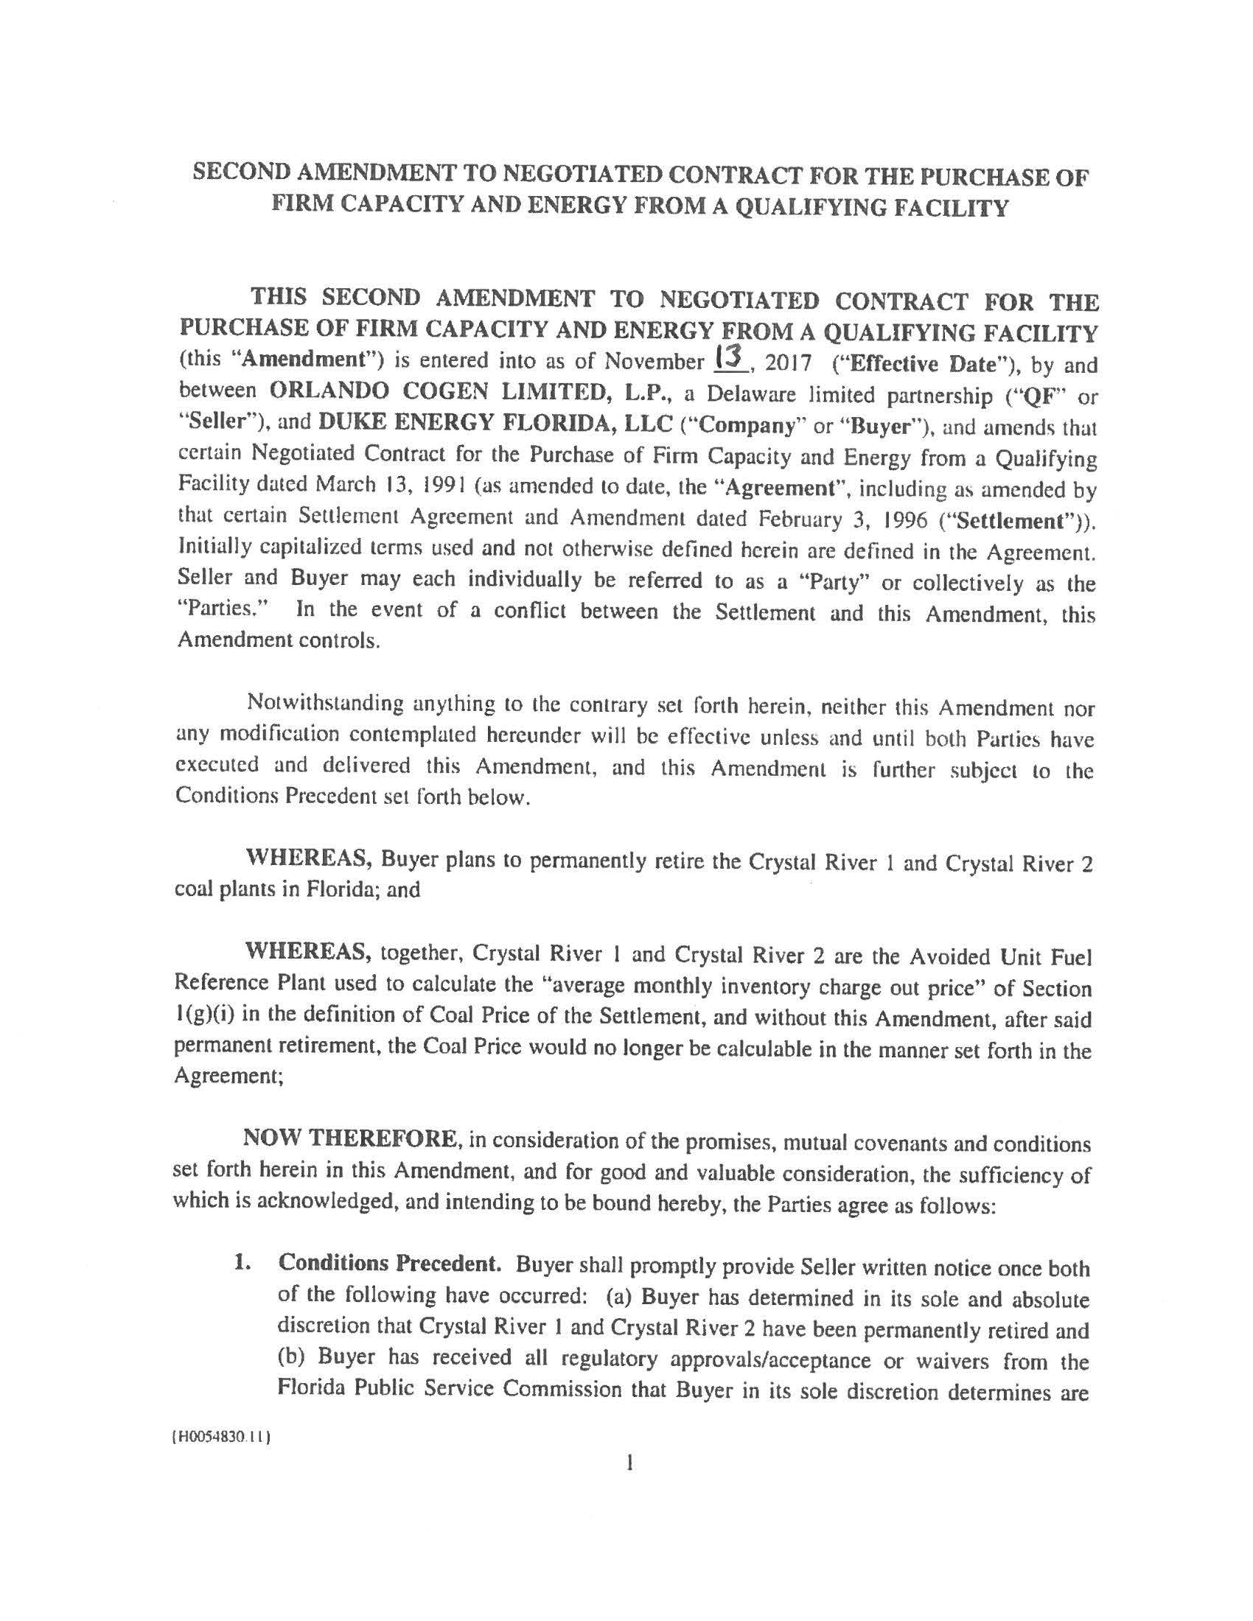

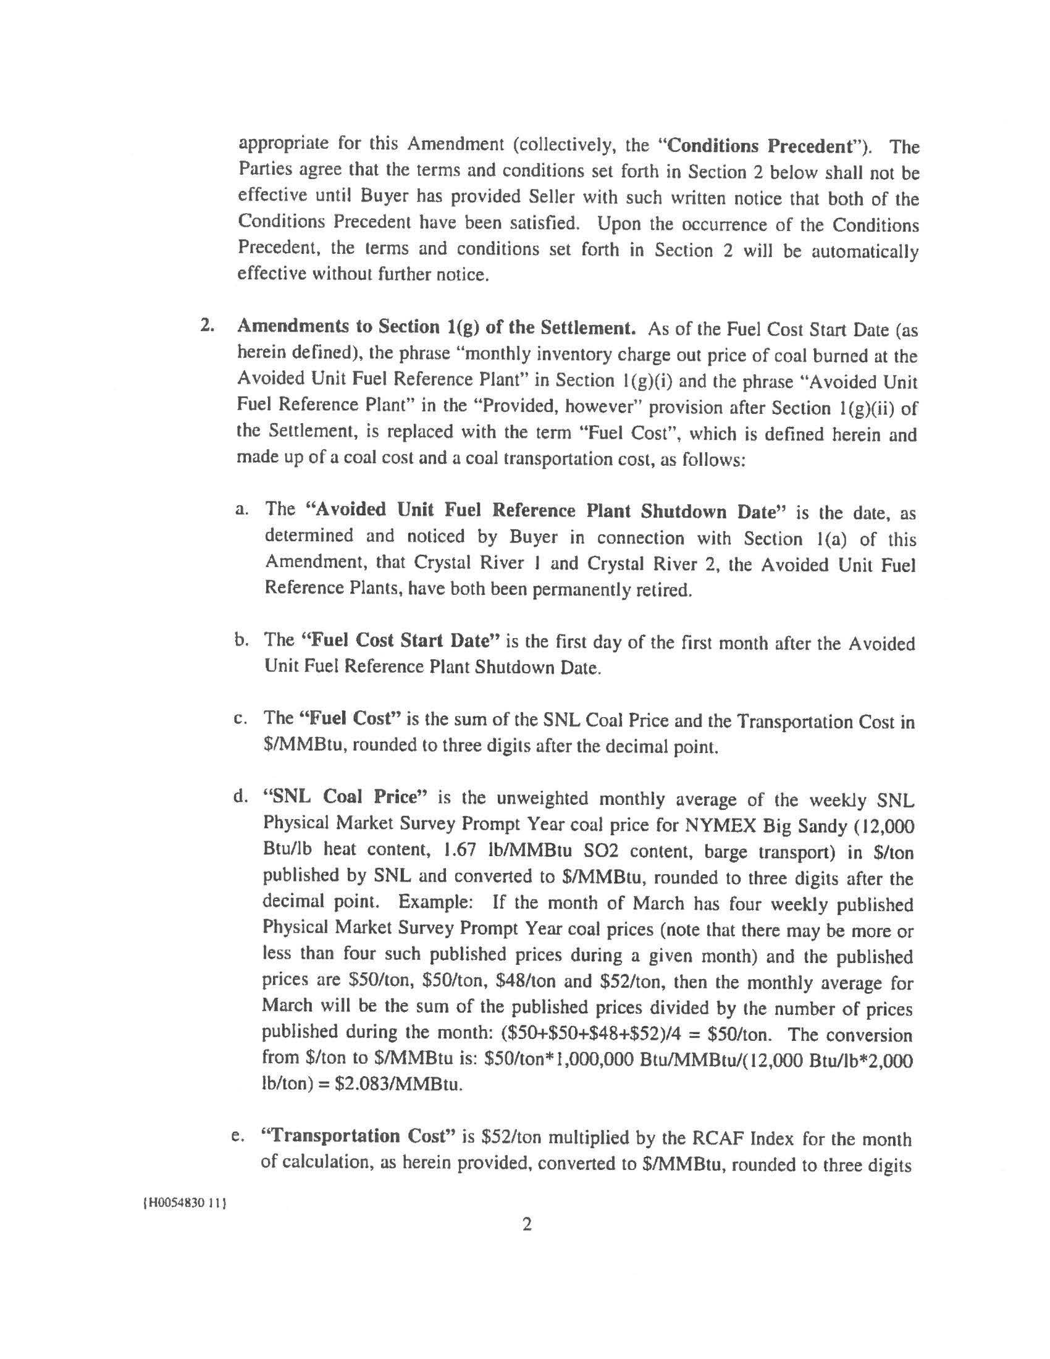

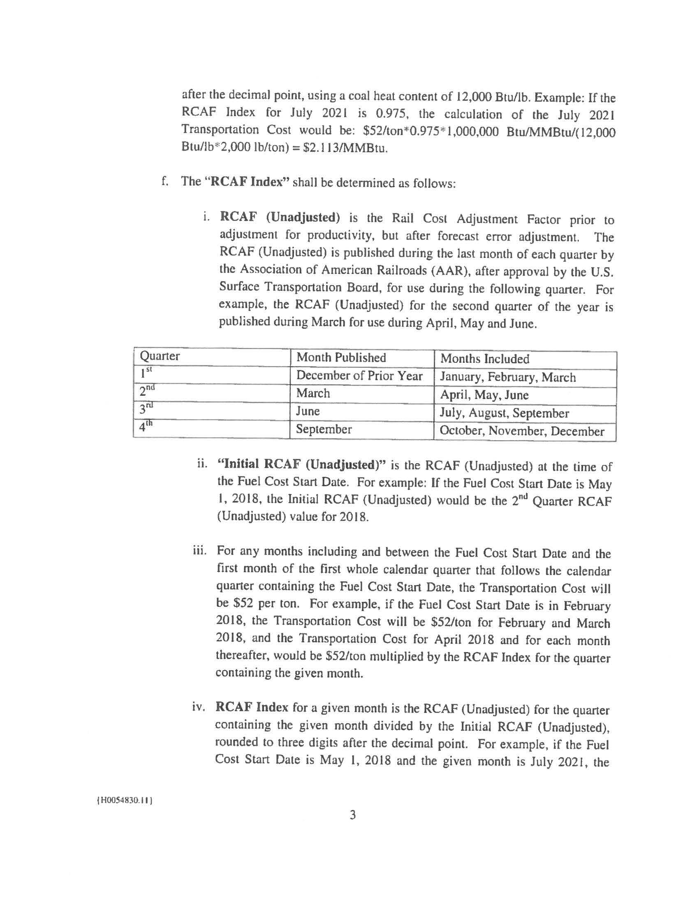

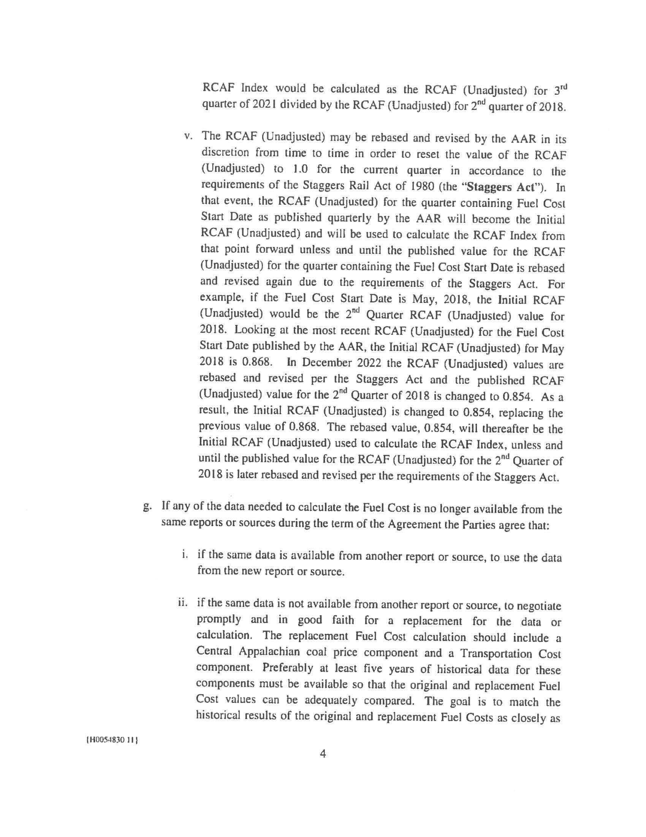

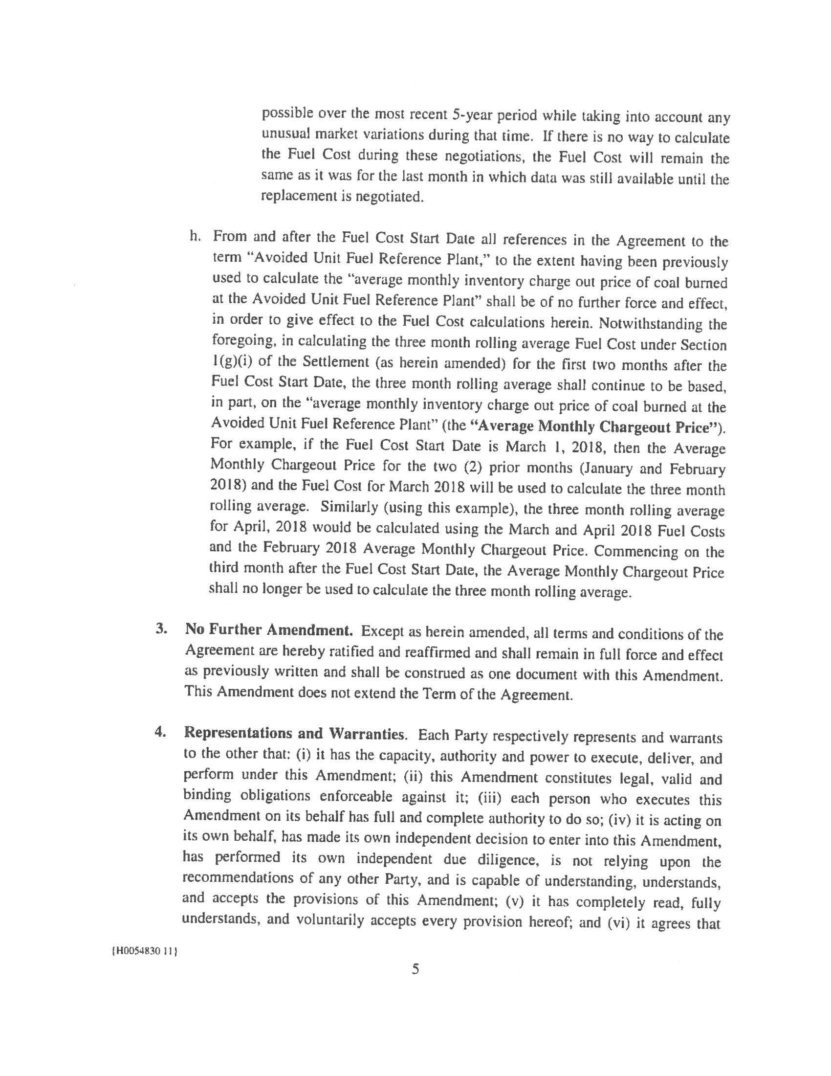

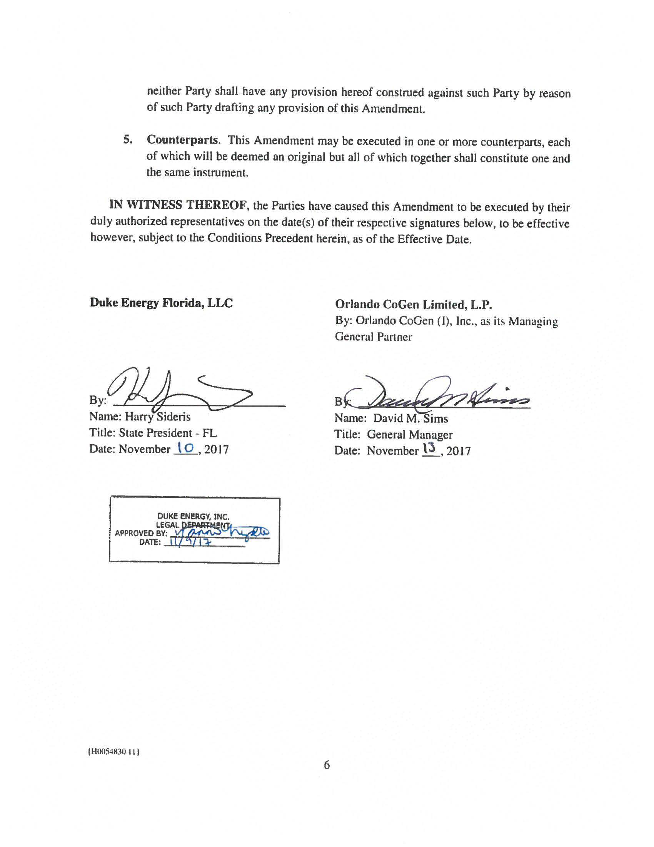

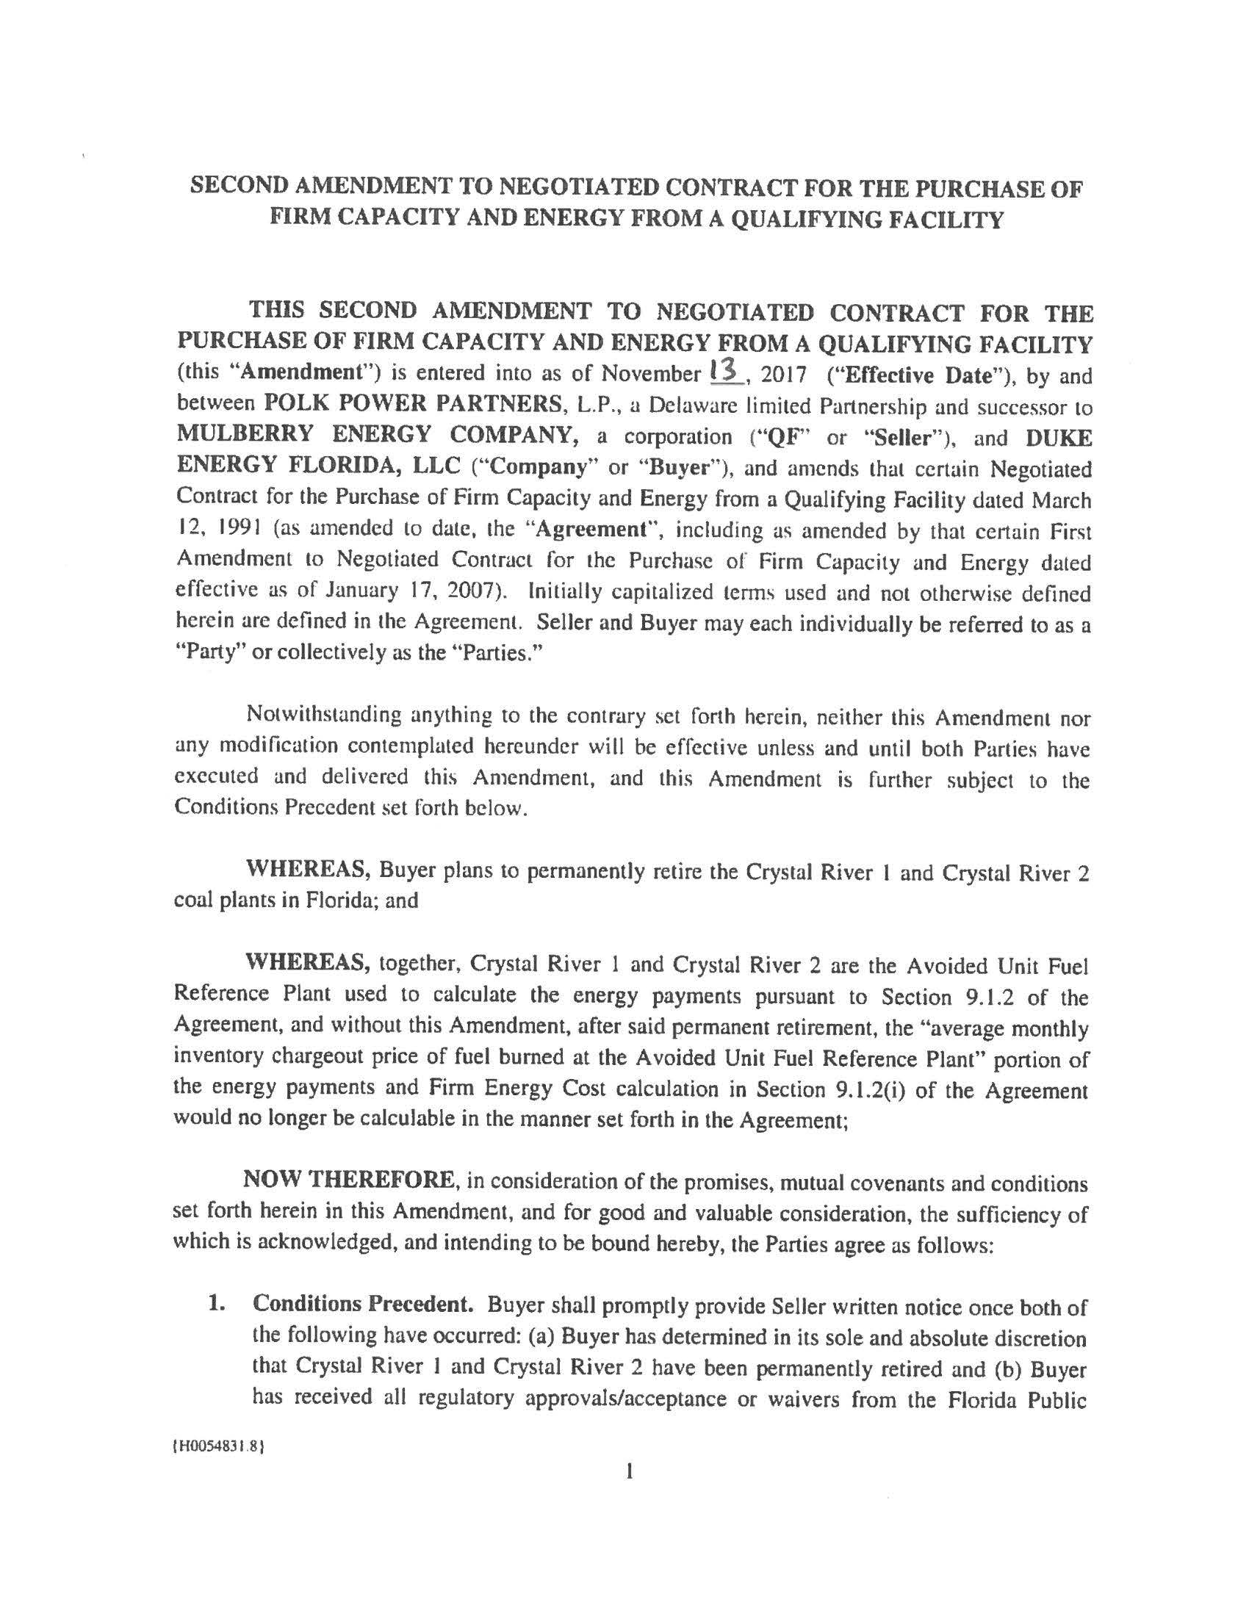

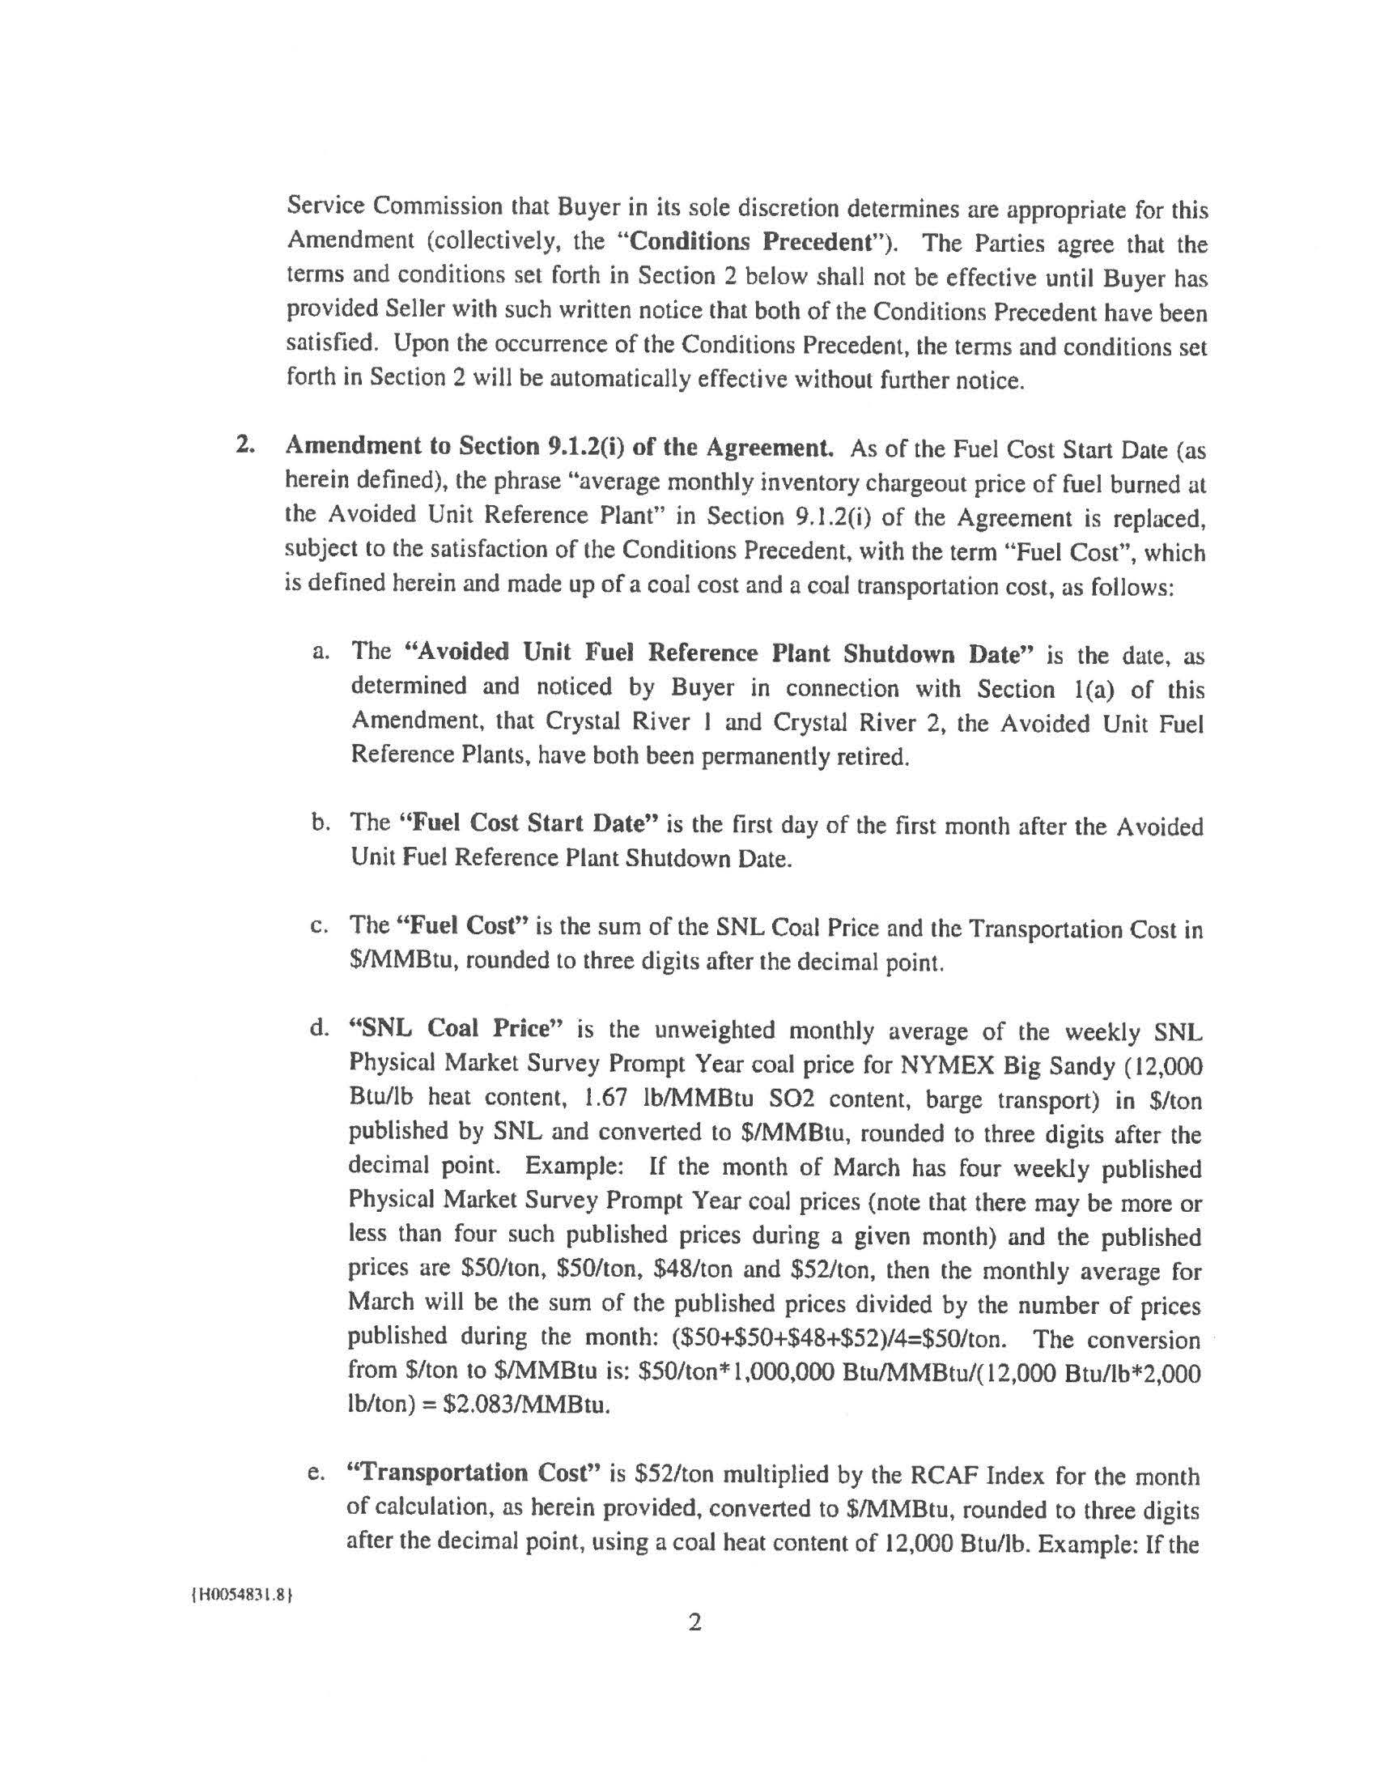

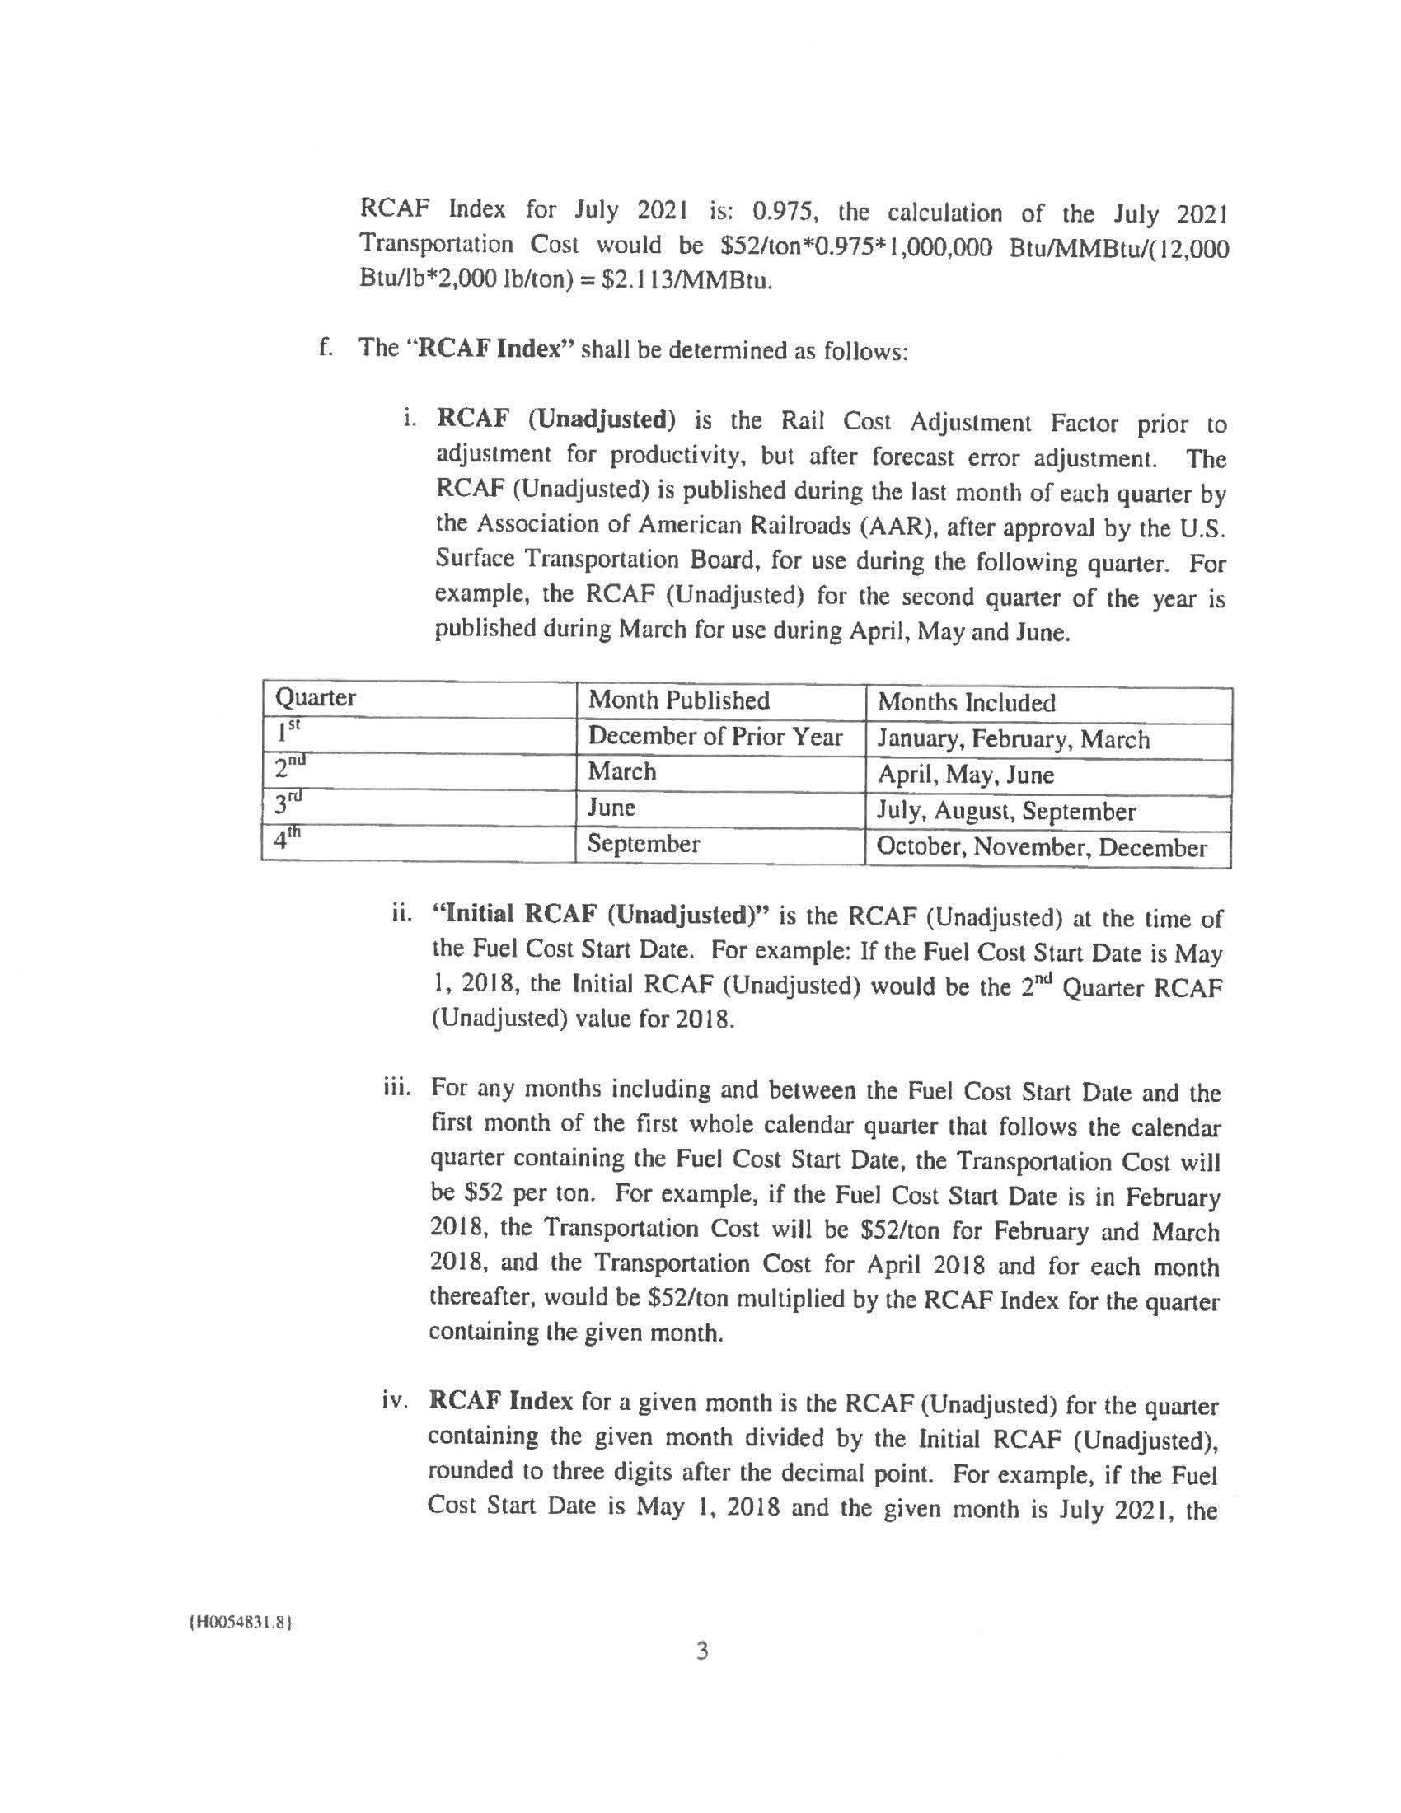

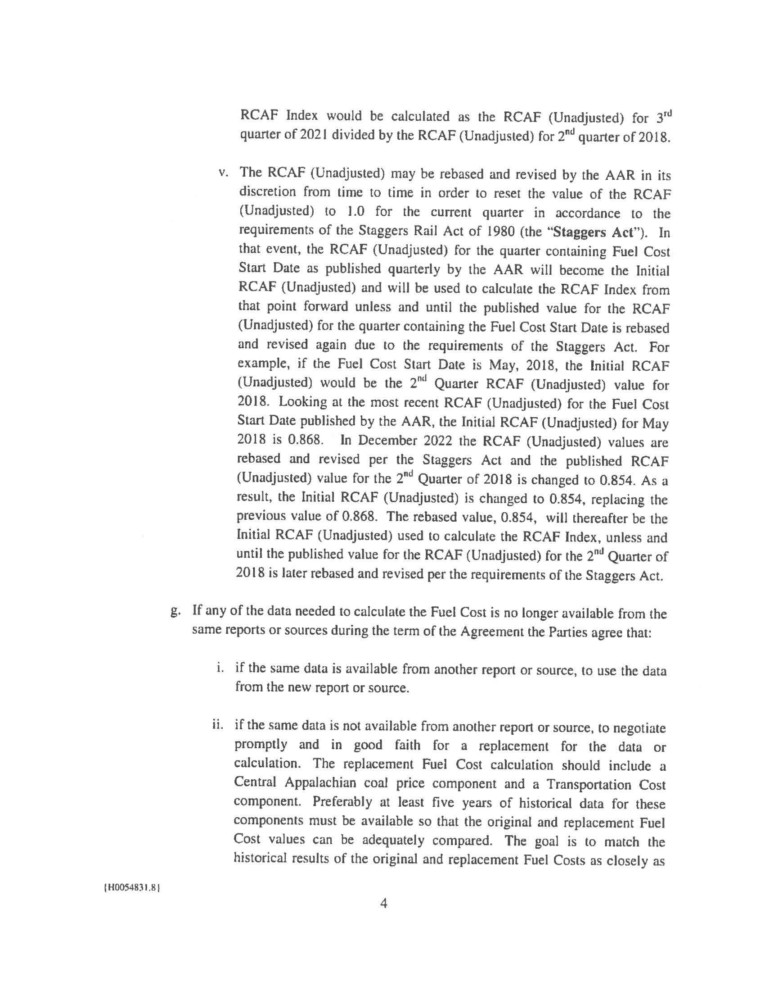

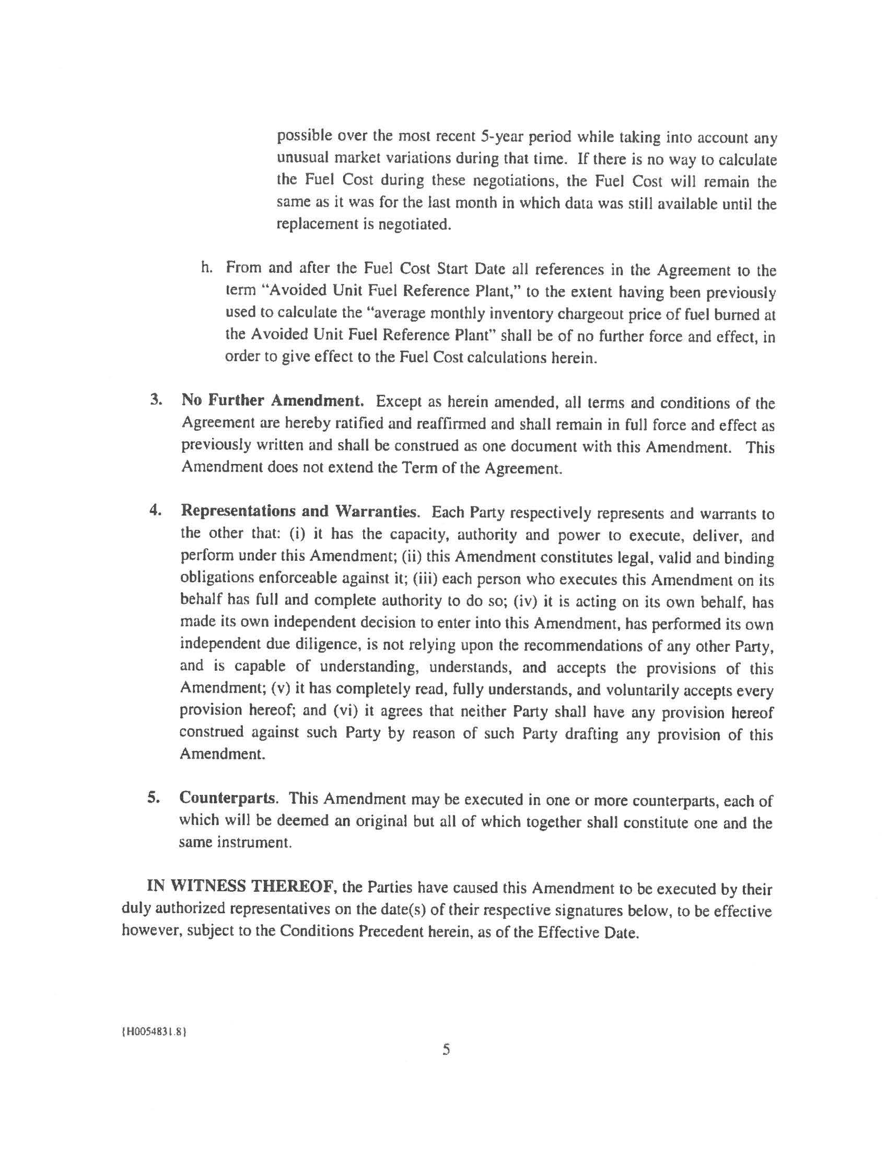

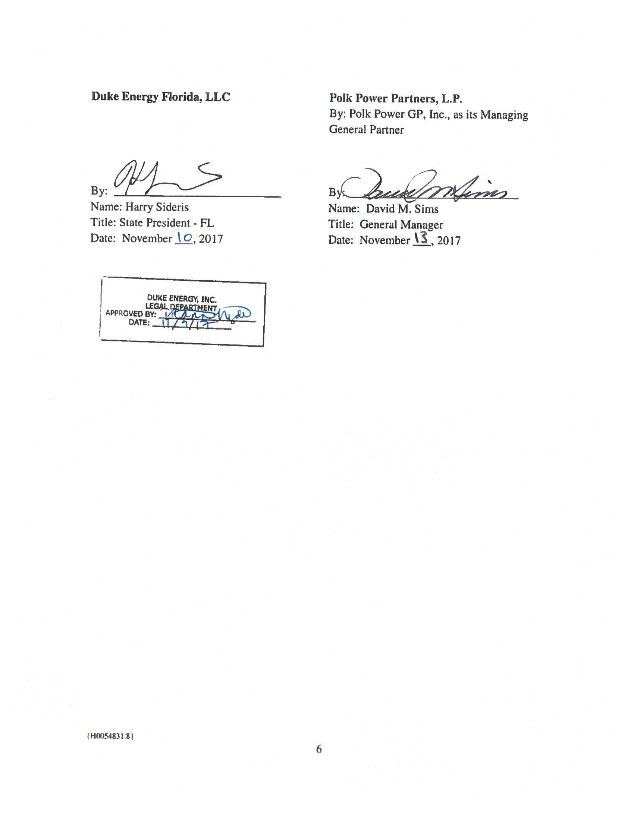
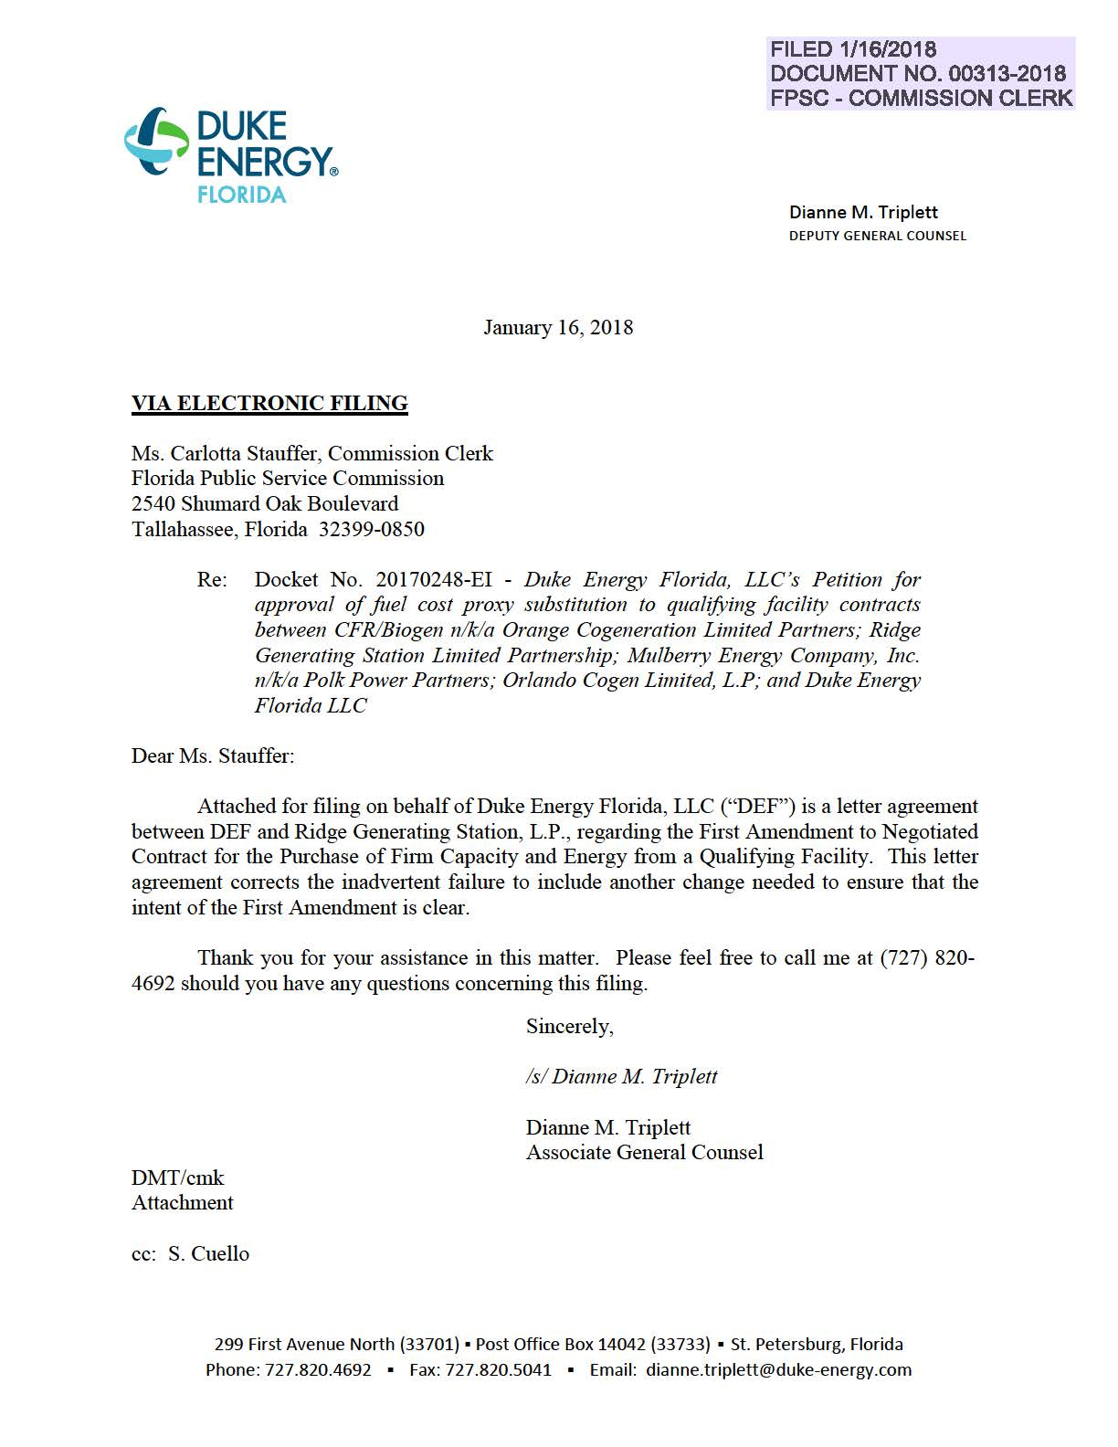

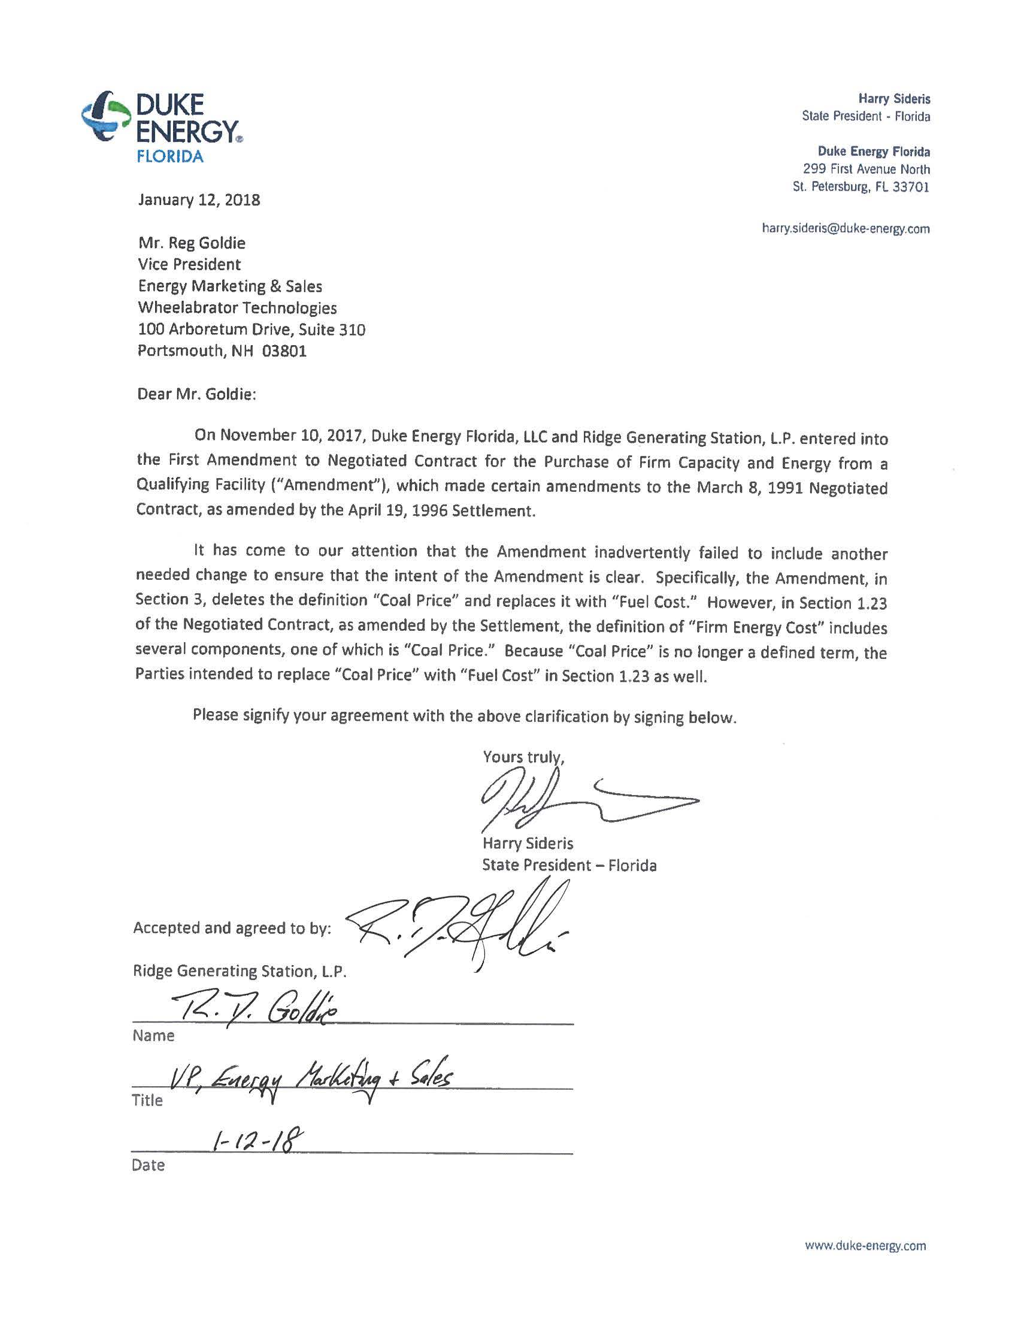

Order No. 24734, issued July 1, 1991, in Docket No. 910401-EQ, In re: Petition for approval of contracts for purchase of firm capacity and energy by Florida Power Corporation.
Order No. PSC-92-0129-FOF-EQ, issued March 31, 1992, in Docket No. 900383-EQ, In re: Complaint by CFR Bio-Gen Corporation against Florida Power Corporation for alleged violation of standard offer contract, and request for determination of substantial interests.

