State of Florida |  | Public Service Commission  Capital Circle Office Center ● 2540 Shumard Oak Boulevard  Tallahassee, Florida 32399-0850  -M-E-M-O-R-A-N-D-U-M-
DATE: | February 16, 2018
TO: | Office of Commission Clerk (Stauffer)
FROM: | Division of Accounting and Finance (Passett, Mouring, D. Buys)  Division of Economics (Draper, Guffey)  Division of Engineering (P. Buys, Graves)  Office of the General Counsel (Crawford, Mapp, Janjic)
RE: | Docket No. 20170271-EI – Petition for recovery of costs associated with named tropical systems during the 2015, 2016, and 2017 hurricane seasons and replenishment of storm reserve subject to final true-up, Tampa Electric Company.
AGENDA: | 03/01/18 – Regular Agenda – Preliminary Procedural -- Interested Persons May Participate
COMMISSIONERS ASSIGNED: |  |  | Brown, Polmann, Fay
PREHEARING OFFICER: |  |  | Brown
CRITICAL DATES: |  |  | None
SPECIAL INSTRUCTIONS: |  |  | None

Case Background
On December 28, 2017, Tampa Electric Company (Tampa Electric) filed a petition for a limited proceeding seeking authority to implement interim Storm Cost Recovery Charge factors to recover a total of $87.4 million for the incremental restoration costs related to tropical systems named by the National Hurricane Center (“NHC”) during the 2015, 2016, and 2017 hurricane seasons and to replenish its storm reserve subject to true-up.
On January 30, 2018, Tampa Electric filed an amended petition, updating the recovery amount to $102.5 million. In its amended petition, Tampa Electric asserts that as a result of Tropical Storms Erika and Colin, and Hurricanes Hermine, Matthew and Irma, Tampa Electric incurred total retail recoverable costs of approximately $102.5 million, less its pre-storm storm reserve balance of $55.9 million, resulting in net recoverable costs of $46.6 million. In addition, Tampa Electric proposes to replenish its storm reserve to the $55.9 million balance that existed on October 31, 2013. The regulatory assessment fee gross-up adds an additional $74,000 to the recoverable costs.
Tampa Electric filed its amended petition pursuant to the provisions of the Amended and Restated Stipulation and Settlement Agreement (ARSSA) approved by the Commission in Order No. PSC-2017-0456-S-EI. Pursuant to Paragraph 5 of the ARSSA, Tampa Electric may petition the Commission to allow the Company to increase the initial 12 month recovery at rates greater than $4.00/1,000 kWh or for a period longer than 12 months if Tampa Electric incurs in excess of $100 million of storm recovery costs that qualify for recovery in a given calendar year, inclusive of the amount needed to replenish the storm reserve. In its amended petition, Tampa Electric is seeking recovery through an interim Storm Cost Recovery Charge factor of $10.07/1,000 kWh beginning with the first billing cycle in April 2018 and concluding when the storm reserve has been replenished, which is estimated to be in December 2018.
The Florida Industrial Power Users Group petitioned to intervene in this docket on January 10, 2018.
The Commission has jurisdiction over this matter pursuant to Sections 366.04, 366.05, 366.06, and 366.076, Florida Statutes.

Discussion of Issues

Issue 1:
Should the Commission authorize Tampa Electric to implement interim Storm Cost Recovery Charge factors?

Recommendation:
Yes, the Commission should authorize Tampa Electric to implement interim Storm Cost Recovery Charge factors, subject to refund. Once the total actual storm costs are known, Tampa Electric should be required to file documentation of the storm costs for Commission review and true-up of any excess or shortfall.
The appropriate security to guarantee the funds collected subject to refund is a corporate undertaking. (Passett, D. Buys)
Staff Analysis: As stated in the case background, Tampa Electric filed an amended petition for a limited proceeding seeking authority to implement interim Storm Cost Recovery Charge factors to recover a total of $102.5 million for the incremental restoration costs related to named tropical storms and hurricanes during the 2015, 2016, and 2017 hurricane seasons and to replenish its storm reserve. The requested recovery of $102.5 million represents net retail recoverable costs of approximately $46.6 million, plus an additional $55.9 million to replenish the storm reserve to the balance that existed on October 31, 2013. In addition, the $102.5 million includes a regulatory assessment fee gross-up of $74,000. The amended petition was filed pursuant to the provisions of the ARSSA approved by the Commission in Order No. PSC-2017-0456-S-EI. Tampa Electric further asserts that this amount was calculated in accordance with the Incremental Cost and Capitalization Approach (ICCA) methodology prescribed in Rule 25-6.0143, Florida Administrative Code (F.A.C.).
Pursuant to Paragraph 5 of the ARSSA, Tampa Electric may petition the Commission to allow the Company to increase the initial 12 month recovery at rates greater than $4.00/1,000 kWh or for a period longer than 12 months if Tampa Electric incurs in excess of $100 million of storm recovery costs that qualify for recovery in a given calendar year, inclusive of the amount needed to replenish the storm reserve. Tampa Electric has requested an interim Storm Cost Recovery Charge factor of $10.07 on a monthly 1,000 kWh residential bill, effective from April 2018 through December 2018.
The approval of interim Storm Cost Recovery Charge factors is preliminary in nature and is subject to refund pending a further review once the total actual storm restoration costs are known. After the actual costs are reviewed for prudence and reasonableness, and are compared to the actual amount recovered through the interim storm charge, a determination will be made whether any over/under recovery has occurred. The disposition of any over/under recovery, and associated interest, would be considered by the Commission at a later date.

Based on a review of the information provided by Tampa Electric in its amended petition, staff recommends that the Commission authorize Tampa Electric to implement interim Storm Cost Recovery Charge factors, subject to refund. Once the total actual storm costs are known, Tampa Electric should be required to file documentation of the storm costs for Commission review and true-up of any excess or shortfall. It is important to emphasize that this recommendation is only for interim Storm Cost Recovery Charge factors, and is not a confirmation of prudence of costs nor an approval of Tampa Electric’s plans. This is merely a recommendation to allow the Company to begin recovery on an interim basis in accordance with the current ARSSA, subject to refund following a hearing or a full opportunity for a formal proceeding.
Staff recommends that all funds collected subject to refund be secured by a corporate undertaking. The criteria for a corporate undertaking include sufficient liquidity, ownership equity, profitability, and interest coverage to guarantee any potential refund. Staff believes TECO has adequate resources to support a corporate undertaking in the amount requested.

Issue 2:
Should the Commission approve Tampa Electric’s proposed tariffs and associated charges?

Recommendation:
Yes. The Commission should approve Tampa Electric’s tariffs as proposed in the amended petition to go into effect with the first billing cycle in April 2018. (Guffey)

Staff Analysis:
Tampa Electric is seeking approval of interim Storm Cost Recovery Charge factors as shown in proposed Fourth Revised Tariff Sheet No. 6.022 (Attachment A to this recommendation). Appendix F to the amended petition includes revisions to all tariffs reflecting the addition of the interim storm recovery charges as shown on Tariff Sheet No. 6.022. A residential customer who uses 1,000 kilowatt-hours will see a $10.07 increase on the monthly bill for the period beginning with the first billing cycle in April 2018.
In response to staff’s request for additional information, Tampa Electric stated that customers will be notified of the interim Storm Cost Recovery Charge factors via bill inserts on the first billing cycle in February 2018. The company has also prepared a FAQ document for Tampa Electric Customer Service Professionals to use for customer inquiries regarding the interim storm recovery charge. Tampa Electric also issued a news/press release which outlined the interim Storm Cost Recovery Charge factors on December 28, 2017 and provided customer notices for staff review.
Staff recommends that the Commission should approve Tampa Electric’s proposed tariffs to go into effect with the first billing cycle in April 2018.
Issue 3:
Should this docket be closed?

Recommendation:
No, this docket should remain open pending final reconciliation of actual recoverable storm costs with the amount collected pursuant to the interim Storm Cost Recovery Charge factors, and the calculation of a refund or additional charge if warranted. (Janjic)

Staff Analysis:
This docket should remain open pending final reconciliation of actual recoverable storm costs with the amount collected pursuant to the interim Storm Cost Recovery Charge factors, and the calculation of a refund or additional charge if warranted.

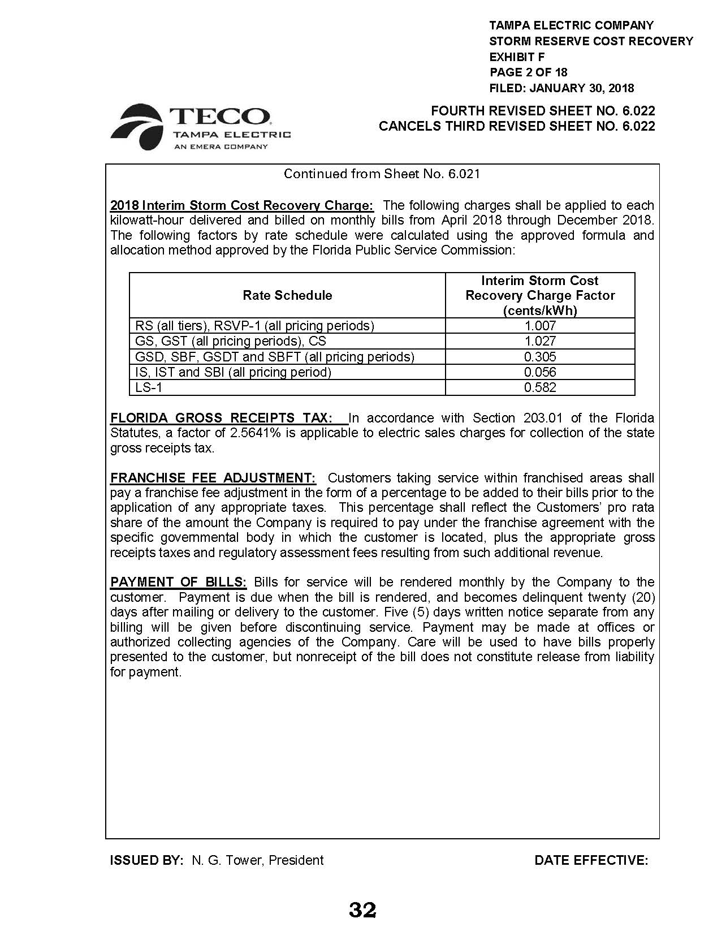

Order No. PSC-2017-0456-S-EI, Docket Nos. 20170210-EI, In re: Petition for limited proceeding to approve 2017 amended and restated stipulation and settlement agreement, by Tampa Electric Company and 20160160-EI, In re: Petition for approval of energy transaction optimization mechanism, by Tampa Electric Company, issued November 27, 2017.
Document No. 00222-2018, issued January 10, 2018, in Docket No. 20170271-EI, In re: Petition for recovery of costs associated with named tropical systems during the 2015, 2016, and 2017 hurricane seasons and replenishment of storm reserve subject to final true-up, by Tampa Electric Company.
See Document No. 00787-2018, Exhibit D, Page 2 of 2 (Tampa Electric Amended Petition).
Order No. PSC-2017-0456-S-EI, Docket Nos. 20170210-EI, In re: Petition for limited proceeding to approve 2017 amended and restated stipulation and settlement agreement, by Tampa Electric Company and 20160160-EI, In re: Petition for approval of energy transaction optimization mechanism, by Tampa Electric Company, issued November 27, 2017.

