BEFORE THE FLORIDA PUBLIC SERVICE COMMISSION

In re: Application for approval of tariff for the gross-up of CIAC in Charlotte, Highlands, Lake, Lee, Marion, Orange, Pasco, Pinellas, Polk, and Seminole Counties, by Utilities, Inc. of Florida. | DOCKET NO. 20180025-WS  ORDER NO. PSC-2018-0162-TRF-WS  ISSUED: March 26, 2018

The following Commissioners participated in the disposition of this matter:

ART GRAHAM, Chairman
JULIE I. BROWN
DONALD J. POLMANN
GARY F. CLARK
ANDREW GILES FAY

ORDER APPROVING TARIFF FOR GROSS-UP OF CIAC

BY THE COMMISSION:

Background
Utilities, Inc. of Florida (UIF or utility) is a Class A utility providing water and wastewater services to 27 systems in the following counties: Charlotte, Highlands, Lake, Lee, Marion, Orange, Pasco, Pinellas, Polk, and Seminole. The utility reported in its 2016 annual report, water operating revenues in the amount of $2,498,891 and $1,440,710 for wastewater.
On January 29, 2018, UIF filed an application for approval of a tariff to allow for gross-up of contributions in aid of construction (CIAC) in Charlotte, Highlands, Lake, Lee, Marion, Orange, Pasco, Pinellas, Polk and Seminole Counties. The utility indicated that a change in tax law may cause it to be at risk of the opportunity to earn a reasonable return on its used and useful property if it is not allowed to collect the impact on receipt of CIAC.
This order addresses the utility’s request for approval of a gross-up tariff. We have jurisdiction pursuant to Sections 367.081 and 367.091, Florida Statutes (F.S.).

Decision
Effective January 1, 2018, the Federal Tax Cuts and Jobs Act amended Section 118 of the Internal Revenue Code. Prior to the amendments, CIAC was exempt from taxable gross income for water and wastewater utilities. As a result of the amendments, both cash and property CIAC are now taxable gross income for water and wastewater utilities. In recognition of this change in the tax law, we opened Docket No. 20180013-PU, In re: Petition to establish a generic docket to investigate and adjust rates for 2018 tax savings by Office of Public Counsel, to address the potential rate impacts on regulated electric, gas, water, and wastewater utilities.
A similar law, the Tax Reform Act of 1986, became effective in 1987. In Docket No. 860184-PU, this Commission found that it was appropriate to allow water and wastewater utilities to recover the tax on CIAC from the contributor, including the tax associated with the additional tax that would also become taxable income. For those utilities that were approved to collect the gross-up on CIAC, the gross-up amounts collected were held subject to refund and were evaluated on a case-by-case basis as to whether any refunds were subsequently required.
In its petition, the utility included a proposed tariff (Attachment A, attached hereto) to gross-up cash service availability charges and property contributions to recover the federal and state corporate income taxes associated with those contributions. According to the utility, UIF could risk loss of its opportunity to earn a reasonable return on its property used and useful in the public service if it is not allowed to collect the tax impact on receipt of CIAC.

Based on the above, we find it appropriate to approve UIF’s proposed tariff. The gross-up amounts shall be collected subject to refund pending resolution of Docket No. 20180013-PU, and guaranteed by a corporate undertaking. UIF shall provide notice to property owners who have requested service during the 12 months prior to the month the request for gross-up of CIAC was filed. The approved gross-up charges shall be effective for connections made on or after the stamped approval date on the tariff sheets. The utility shall provide proof of noticing within 10 days of rendering its approved notice. In addition, UIF shall file with its Annual Report a calculation detailing: (1) the amounts of cash and property contributions received during the reporting year; (2) the calculation of the utility’s tax liability for the reporting year; and (3) the amount of taxes actually collected on CIAC for the reporting year. The reporting requirement shall begin with the 2018 Annual Report and continue each year thereafter.

Based on the foregoing, it is

ORDERED by the Florida Public Service Commission that Utilities, Inc. of Florida’s tariff for the gross-up of CIAC, attached hereto, is approved. It is further

ORDERED that the gross-up amounts shall be collected subject to refund pending resolution of Docket No. 20180013-PU and guaranteed by a corporate undertaking. UIF shall provide notice to property owners who have requested service during the 12 months prior to the month the request for gross-up of CIAC was filed. The approved gross-up charges shall be effective for connections made on or after the stamped approval date on the tariff sheets. The utility shall provide proof of noticing within 10 days of rendering its approved notice. It is further

ORDERED that UIF shall file with its Annual Report a calculation detailing: (1) the amounts of cash and property contributions received during the reporting year; (2) the calculation of the utility’s tax liability for the reporting year; and (3) the amount of taxes actually collected on CIAC for the reporting year. The reporting requirement shall begin with the 2018 Annual Report and continue each year thereafter. It is further

ORDERED that if a protest is filed within 21 days of issuance of the Order, the tariff shall remain in effect with any charges held subject to refund pending resolution of the protest. It is further

ORDERED that this docket shall remain open pending resolution of Docket No. 20180013-PU.

By ORDER of the Florida Public Service Commission this 26th day of March, 2018.

/s/ Carlotta S. Stauffer
CARLOTTA S. STAUFFER
Commission Clerk
Florida Public Service Commission
2540 Shumard Oak Boulevard
Tallahassee, Florida 32399
(850) 413-6770
www.floridapsc.com

Copies furnished: A copy of this document is provided to the parties of record at the time of issuance and, if applicable, interested persons.

JSC

NOTICE OF FURTHER PROCEEDINGS

The Florida Public Service Commission is required by Section 120.569(1), Florida Statutes, to notify parties of any administrative hearing or judicial review of Commission orders that is available under Sections 120.57 or 120.68, Florida Statutes, as well as the procedures and time limits that apply. This notice should not be construed to mean all requests for an administrative hearing or judicial review will be granted or result in the relief sought.

Mediation may be available on a case-by-case basis. If mediation is conducted, it does not affect a substantially interested person's right to a hearing.

The Commission's decision on this tariff is interim in nature and will become final, unless a person whose substantial interests are affected by the proposed action files a petition for a formal proceeding, in the form provided by Rule 28-106.201, Florida Administrative Code. This petition must be received by the Office of Commission Clerk, 2540 Shumard Oak Boulevard, Tallahassee, Florida 32399-0850, by the close of business on April 16, 2018.

In the absence of such a petition, this Order shall become final and effective upon the issuance of a Consummating Order.

Any objection or protest filed in this docket before the issuance date of this order is considered abandoned unless it satisfies the foregoing conditions and is renewed within the specified protest period.

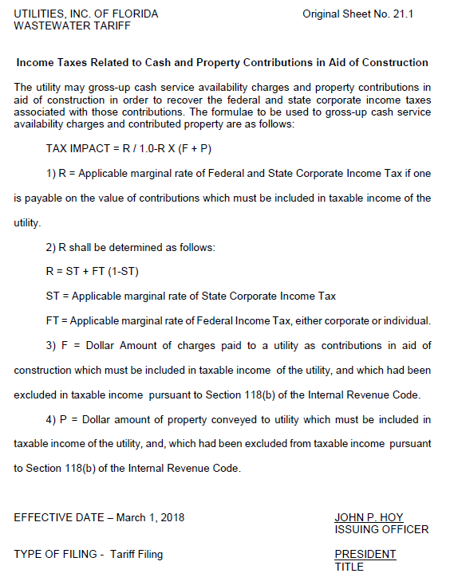

The amendment was repealed in 1996.
According to the 2016 Annual Report, UIF collected approximately $835,000 in cash and property CIAC.

