State of Florida |  | Public Service Commission  Capital Circle Office Center ● 2540 Shumard Oak Boulevard  Tallahassee, Florida 32399-0850  -M-E-M-O-R-A-N-D-U-M-
DATE: | April 26, 2018
TO: | Office of Commission Clerk (Stauffer)
FROM: | Division of Economics (Bethea, Hudson)  Division of Accounting and Finance (Cicchetti)  Office of the General Counsel (Crawford)
RE: | Docket No. 20180100-WS – Application for approval of tariff for the gross-up of CIAC for water rates in Lee County and wastewater rates in Pasco County, by Ni Florida, LLC.
AGENDA: | 05/08/18 – Regular Agenda – Tariff Filing – Interested Persons May Participate
COMMISSIONERS ASSIGNED: |  |  | All Commissioners
PREHEARING OFFICER: |  |  | Administrative
CRITICAL DATES: |  |  | 06/18/18 (60-Day Suspension Date)
SPECIAL INSTRUCTIONS: |  |  | None

Case Background
Ni Florida, LLC (Ni Florida or utility) is a Class A utility providing service to approximately 745 water connections in Lee County and 2,757 wastewater connections in Pasco County. The utility reported in its 2017 annual report operating revenues in the amount of $292,211 for water and $2,282,516 for wastewater. The utility did not collect any contributions in aid of construction (CIAC) for 2017.
On April 17, 2018, the utility filed an application for approval of a tariff to allow for gross-up of CIAC. As discussed in Issue 1 below, the utility indicated that the change in tax law may cause it to risk the loss of its opportunity to earn a reasonable return on its used and useful property if it is not allowed to collect the tax impact on receipt of CIAC. This recommendation addresses the utility's request for approval of gross-up tariffs related to 2018 changes in the federal tax code. Any potential refund related to the change in the federal tax rate currently embedded in the utility’s rates is outside of this recommendation and will be addressed in the generic Docket No. 20180013-PU. The Commission has jurisdiction pursuant to Sections 367.081 and 367.091, Florida Statutes (F.S.).

Discussion of Issues

Issue 1:
Should Ni Florida’s request for approval of a tariff to allow the gross-up of CIAC be approved?

Recommendation:
Yes, the tariffs filed on April 17, 2018 should be approved. The utility should provide notice to all persons in the service areas included in the application who have filed a written request for service or who have been provided a written estimate for service within the 12 calendar months prior to the month the application was filed. The approved gross-up charges should be effective for connections made on or after the stamped approval date on the tariff sheets. The utility should provide proof of noticing within 10 days of rendering its approved notice. (Bethea, Hudson, Cicchetti)

Staff Analysis:
Effective January 1, 2018, the Federal Tax Cuts and Jobs Act amended Section 118 of the Internal Revenue Code. Prior to the amendments, CIAC was exempt from taxable gross income for water and wastewater utilities. As a result of the amendments, both cash and property CIAC are now taxable gross income for water and wastewater utilities. In recognition of this change in the tax law, the Commission has opened Docket No. 20180013-PU, In re: Petition to establish a generic docket to investigate and adjust rates for 2018 tax savings by Office of Public Counsel to address the potential rate impacts on regulated electric, gas, water, and wastewater utilities.

A similar law, the Tax Reform Act of 1986, became effective in 1987. In Docket No. 19860184-PU, the Commission found that it was appropriate to allow water and wastewater utilities to recover the tax on CIAC from the contributor, including the tax associated with the additional tax that would also become taxable income. For those utilities that were approved to collect the gross-up on CIAC, the gross-up amounts collected were held subject to refund and were evaluated on a case-by-case basis as to whether any refunds were subsequently required.

On April 17, the utility filed a tariff (Attachment A) to gross-up cash service availability charges and property contributions to recover the federal and state corporate income taxes associated with those contributions. According to the utility, Ni Florida could risk loss of its opportunity to earn a reasonable return on its property used and useful in the public service if it is not allowed to collect the tax impact on receipt of CIAC.

The tariff recognizes that, for depreciable property, depreciation expense is tax deductible and the utility’s tax liability will be reduced by depreciation claimed for tax purposes. The proposed tariff is mathematically the same, regarding the gross-up for taxes, as the tariff approved by the Commission following the hearing in Docket No. 19860184-PU. Because the proposed tariff accurately depicts the utility’s expected tax expense associated with CIAC, staff believes no further Commission action would be required once the gross-up formula has been approved. Staff notes that in Order No. 23541 in Docket No. 19860184-PU, the Commission required a reconciliation of CIAC tax collected to taxes paid. Staff does not believe a reconciliation of tax collected on CIAC to taxes paid should be required for two reasons. First, the proposed formula more appropriately tracks the potential tax liability associated with the collection of CIAC. Second, expenses approved in base rates are not typically subject to reconciliation. For example, the utility’s revenue requirement is grossed-up for expected taxes and expected tax expense is included in rates but there is no after-the-fact proceeding to reconcile taxes actually paid with tax expense allowed in case the utility experienced a loss and paid no taxes. Consequently, staff believes no after-the-fact proceeding is warranted to compare allowed tax expense for CIAC to actual tax expense and, therefore, no corporate undertaking is necessary.

Based on the above, staff recommends that the tariffs should be approved. The approved gross-up charges should be effective for connections made on or after the stamped approval date on the tariff sheets. The utility should provide notice to all persons in the service areas included in the application who have filed a written request for service or who have been provided a written estimate for service within the 12 calendar months prior to the month the application was filed. The utility should provide proof of noticing within 10 days of rendering its approved notice.

Issue 2:
Should this docket be closed?

Recommendation:
If a protest is filed by a substantially affected person within 21 days of issuance of the order, the tariffs should remain in effect, with any revenues held subject to refund, pending resolution of the protest. If no timely protest is filed, the order should become final upon the issuance of a consummating order. However, the docket should remain open to allow staff to verify that the appropriate notice has been filed by the utility and approved by staff. Once the utility has provided proof of noticing, the docket should be closed administratively. (Crawford)

Staff Analysis:
If a protest is filed by a substantially affected person within 21 days of issuance of the order, the tariffs should remain in effect, with any revenues held subject to refund, pending resolution of the protest. If no timely protest is filed, the order should become final upon the issuance of a consummating order. However, the docket should remain open to allow staff to verify that the appropriate notice has been filed by the utility and approved by staff. Once the utility has provided proof of noticing, the docket should be closed administratively.

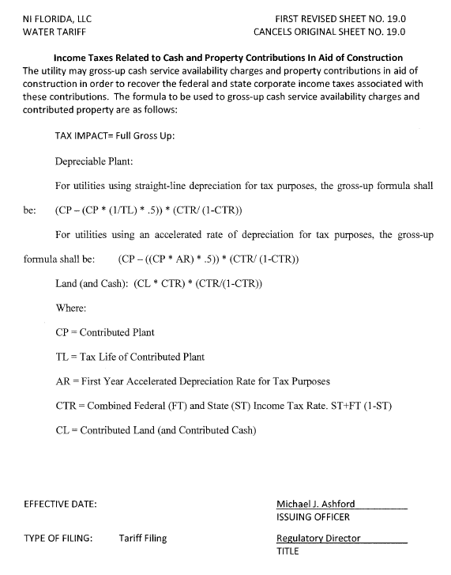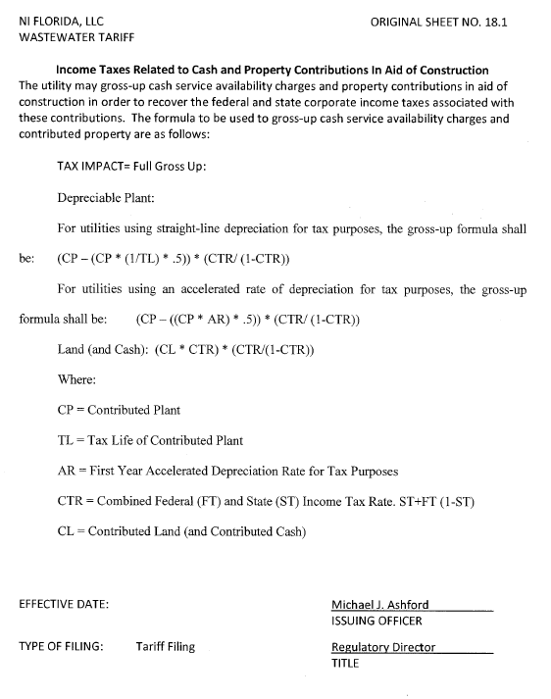

Docket No. 20180013-PU, In re: Petition to establish generic docket to investigate and adjust rates for 2018 tax savings, by Office of Public Counsel.
The amendment was repealed in 1996.
According to the 2017 Annual Report, Ni Florida collected approximately $1,453,329 in cash and property CIAC.
Order No. 23541, issued October 1, 1990, in Docket No. 860184-PU, In re: Request by Florida Waterworks Association for investigation of proposed repeal of Section 118(b), Internal Revenue Code [Contributions-in-aid-of-construction].
Staff’s recommendation is consistent with the Commission’s vote at the April 20,2018 Agenda Conference with respect to Docket No. 20180042-WS, In re: Application for approval of tariff for the gross-up of CIAC in Martin County, by Indiantown Company, Inc., and Docket No. 20180059-WS, In re: Application for approval of tariff for the gross-up of CIAC in Escambia County, by Peoples Water Service Company of Florida, Inc.

