BEFORE THE FLORIDA PUBLIC SERVICE COMMISSION

In re: Petition for approval of transportation service agreement with Florida Division of Chesapeake Utilities Corporation, by Peninsula Pipeline Company, Inc. | DOCKET NO. 20180015-GU  ORDER NO. PSC-2018-0233-PAA-GU  ISSUED: May 8, 2018

The following Commissioners participated in the disposition of this matter:

ART GRAHAM, Chairman
JULIE I. BROWN
DONALD J. POLMANN
GARY F. CLARK
ANDREW GILES FAY

NOTICE OF PROPOSED AGENCY ACTION
ORDER APPROVING TRANSPORTATION SERVICE AGREEMENT

BY THE COMMISSION:

NOTICE is hereby given by the Florida Public Service Commission that the action discussed herein is preliminary in nature and will become final unless a person whose interests are substantially affected files a petition for a formal proceeding, pursuant to Rule 25-22.029, Florida Administrative Code (F.A.C.).

BACKGROUND
On January 12, 2018, Peninsula Pipeline Company, Inc. (Peninsula) filed a petition seeking approval of a firm transportation service agreement (Agreement) between Peninsula and the Florida Division of Chesapeake Corporation d/b/a Central Florida Gas (CFG), collectively the parties, for the construction of a gas pipeline and two custody transfer stations in Escambia County, Florida. Peninsula operates as a natural gas transmission company as defined by Section 368.103(4), Florida Statues (F.S.). CFG is a local distribution company (LDC) subject to the regulatory jurisdiction of this Commission pursuant to Chapter 366, F.S.
By Order No. PSC-07-1012-TRF-GP, Peninsula received approval of an intrastate gas pipeline tariff that allows it to construct and operate intrastate pipeline facilities and to actively pursue agreements with natural gas customers. Peninsula provides transportation service only and does not engage in the sale of natural gas. Pursuant to Order No. PSC-07-1012-TRF-GP, Peninsula is allowed to enter into certain gas transmission agreements without prior Commission approval. However, Peninsula is requesting Commission approval of this Agreement as it does not fit any of the criteria enumerated in the tariff for which Commission approval would not be required. Both Peninsula and CFG are subsidiaries of Chesapeake Utility Corporation (Chesapeake), and agreements between affiliated companies must be approved by this Commission pursuant to Section 368.105, F.S., and Order No. PSC-07-1012-TRF-GP.
Pursuant to the proposed Agreement (Attachment B), Peninsula will construct and operate a natural gas pipeline and two custody transfer stations in Escambia County. During its evaluation of the petition, two data requests were issued to both Peninsula and CFG for which responses were received on February 26, 2018 and March 5, 2018. On March 29, 2018, Chesapeake filed revised Tariff Sheet Nos. 3 and 5 to reflect the addition of Escambia County to the description of territory served. This Commission has jurisdiction over this matter pursuant to Sections 366.05(1), 366.06, and 368.105. F.S.
DECISION
This petition is a jointly developed plan by the parties for the expansion of natural gas service in Escambia County. The parties stated in the petition that Escambia County has limited economic development and that the expansion of natural gas service will add growth and expansion in the Pensacola area market.
Pursuant to the proposed Agreement, Peninsula will construct an interconnection between Peninsula and Florida Gas Transmission’s (FGT) interstate pipeline at the northernmost edge of Escambia County. From that interconnection, Peninsula will construct a 33-mile, 12 inch steel pipeline southward to Old Chemstrand Road. From there, Peninsula will extend a 10 inch pipeline east for five miles. The Peninsula pipeline will terminate at two custody transfer stations to interconnect with CFG’s distribution system. Construction of the Peninsula pipeline and CFG’s distribution system is expected to be complete by the third quarter of 2018. A map of the FGT interconnection, the Peninsula pipeline, and the two customer transfer stations is shown in Attachment A. Once the Peninsula pipeline is in operation, Peninsula will provide transportation service to CFG.
No LDC currently provides natural gas service in Escambia County. Pensacola Energy, a municipal natural gas utility, provides natural gas service to the City of Pensacola and in certain other discrete areas in Escambia County. Pensacola Energy currently transports natural gas to serve its customers over the Gulf South interstate pipeline. CFG stated in the petition that its newly constructed distribution system will provide transportation service to an industrial customer and Pensacola Energy. CFG further explained that the expansion plans in Escambia County will provide CFG the opportunity to serve additional customers. Interconnecting with the Peninsula pipeline via CFG will provide Pensacola Energy with an additional supply source.
CFG is proposing to recover the payments to Peninsula from its customers under the proposed Agreement through its Purchased Gas Adjustment (PGA) and Swing Service Rider mechanisms consistent with other gas transmission pipeline costs incurred by CFG. CFG provided information showing that the impact on the PGA will be minor ($0.04693 per therm for 2019). While CFG will incur costs associated with this service expansion, any new load will help spread the costs over a larger customer base.
The parties assert that the negotiated monthly reservation charge contained in the Agreement is consistent with a market rate since they are within the ranges of rates set forth in similar agreements as required by Section 368.105(3)(b), F.S. CFG did not obtain a Request for Proposals (RFP) from other entities to construct the pipeline. Peninsula, however, engaged in a conversation with FGT about building the pipeline. FGT declined to bid the construction of the project because owning and operating laterals such as the one proposed in this petition are not a focus of their expansion activities.
The proposed Agreement between CFG and Peninsula will be in effect for an initial period of 30 years and will be extended for additional 10-year increments, unless either party gives written notice of termination. The benefit of Peninsula, as opposed to CFG, constructing the new pipeline, is primarily that Peninsula’s construction and ownership of the pipeline will avoid CFG undertaking the costs and risks for this project, which in turn protects CFG’s ratepayers.

CFG currently does not provide natural gas service in Escambia County. Therefore, on March 29, 2018, CFG filed revised Tariff Sheet Nos. 3 and 5 to reflect the addition of Escambia County to the description of territory served section of its tariff. CFG has also requested that Commission staff be given authority to administratively approve these tariffs consistent with our decision.

Upon review of the petition and responses to the data requests, we find that the proposed Agreement is cost effective, reasonable, meets the requirements of Section 368.105, F.S., and benefits CFG’s customers. For these reasons we hereby approve the proposed Agreement between Peninsula and CFG dated January 8, 2018.
Based on the foregoing, it is

ORDERED by the Florida Public Service Commission that Peninsula Pipeline Company’s request to approve a firm transportation service agreement dated January 8, 2018, between Peninsula and the Florida Division of Chesapeake Corporation, d/b/a Central Florida Gas, for the construction of a gas pipeline and two custody transfer stations in Escambia County, Florida is hereby approved. It is further

ORDERED that the provisions of this Order, issued as proposed agency action, shall become final and effective upon the issuance of a Consummating Order unless an appropriate petition, in the form provided by Rule 28-106.201, F.A.C., is received by the Office of the Commission Clerk, 2540 Shumard Oak Boulevard, Tallahassee, Florida 32399-0850, by the close of business on the date set forth in the “Notice of Further Proceedings” attached hereto. It is further

ORDERED that, if a protest is filed within 21 days of the issuance of the order, this docket shall remain open pending resolution of the protest. If no protest is timely filed, Commission staff is authorized to administratively approve Tariff Sheet Nos. 3 and 5 to reflect the addition of Escambia County to the description of territory served consistent with our decision and this docket shall be closed upon the issuance of a Consummating Order.

By ORDER of the Florida Public Service Commission this 8th day of May, 2018.

/s/ Carlotta S. Stauffer
CARLOTTA S. STAUFFER
Commission Clerk
Florida Public Service Commission
2540 Shumard Oak Boulevard
Tallahassee, Florida 32399
(850) 413-6770
www.floridapsc.com

Copies furnished: A copy of this document is provided to the parties of record at the time of issuance and, if applicable, interested persons.

SBr

NOTICE OF FURTHER PROCEEDINGS OR JUDICIAL REVIEW

The Florida Public Service Commission is required by Section 120.569(1), Florida Statutes, to notify parties of any administrative hearing that is available under Section 120.57, Florida Statutes, as well as the procedures and time limits that apply. This notice should not be construed to mean all requests for an administrative hearing will be granted or result in the relief sought.

Mediation may be available on a case-by-case basis. If mediation is conducted, it does not affect a substantially interested person's right to a hearing.

The action proposed herein is preliminary in nature. Any person whose substantial interests are affected by the action proposed by this order may file a petition for a formal proceeding, in the form provided by Rule 28-106.201, Florida Administrative Code. This petition must be received by the Office of Commission Clerk, 2540 Shumard Oak Boulevard, Tallahassee, Florida 32399-0850, by the close of business on May 29, 2018.

In the absence of such a petition, this order shall become final and effective upon the issuance of a Consummating Order.

Any objection or protest filed in this/these docket(s) before the issuance date of this order is considered abandoned unless it satisfies the foregoing conditions and is renewed within the specified protest period.

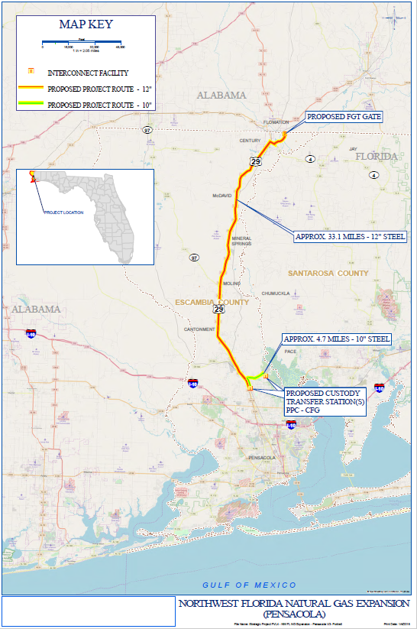

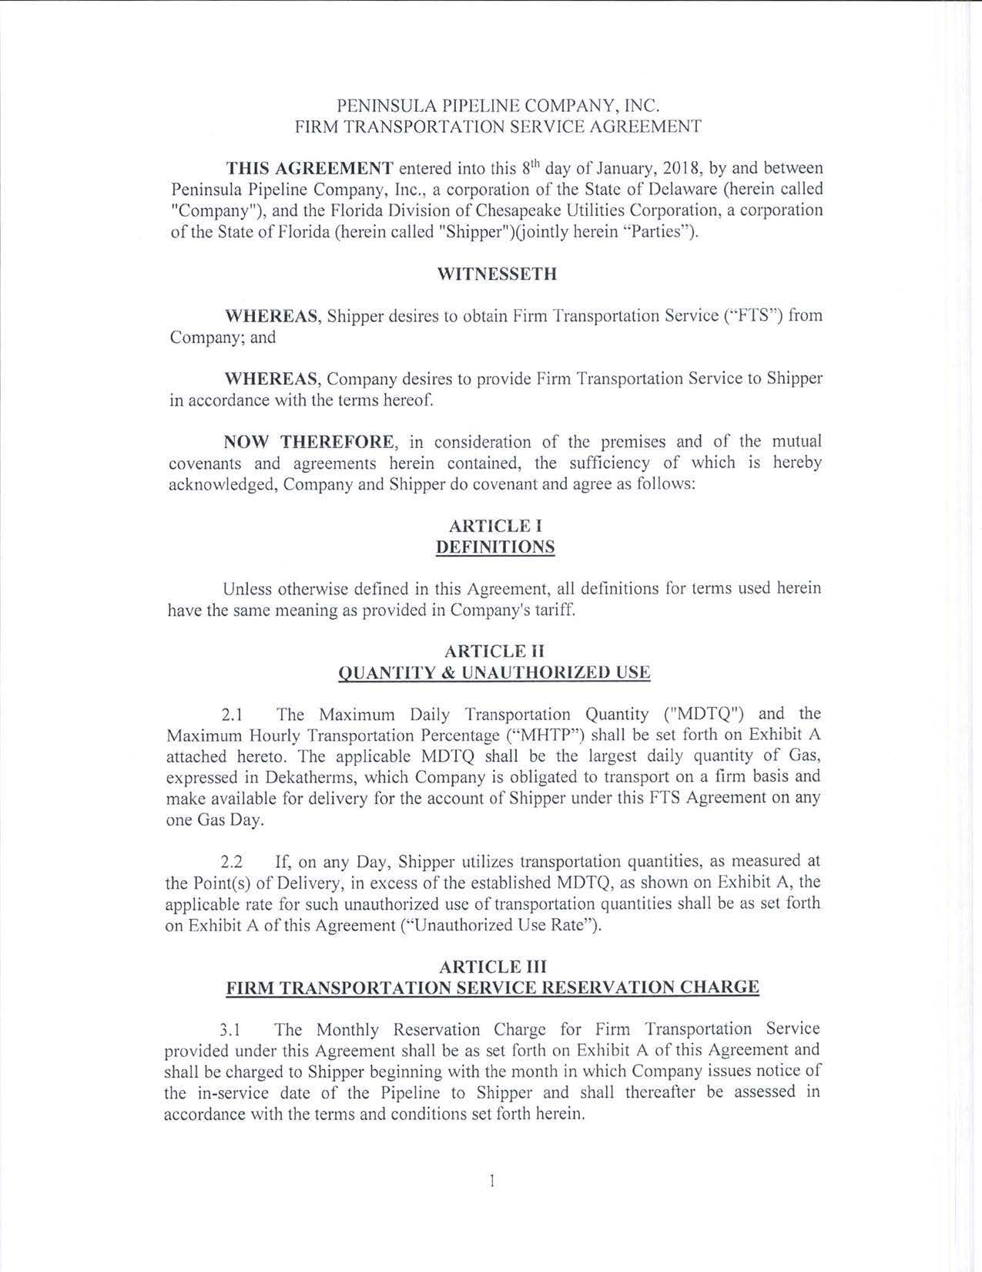
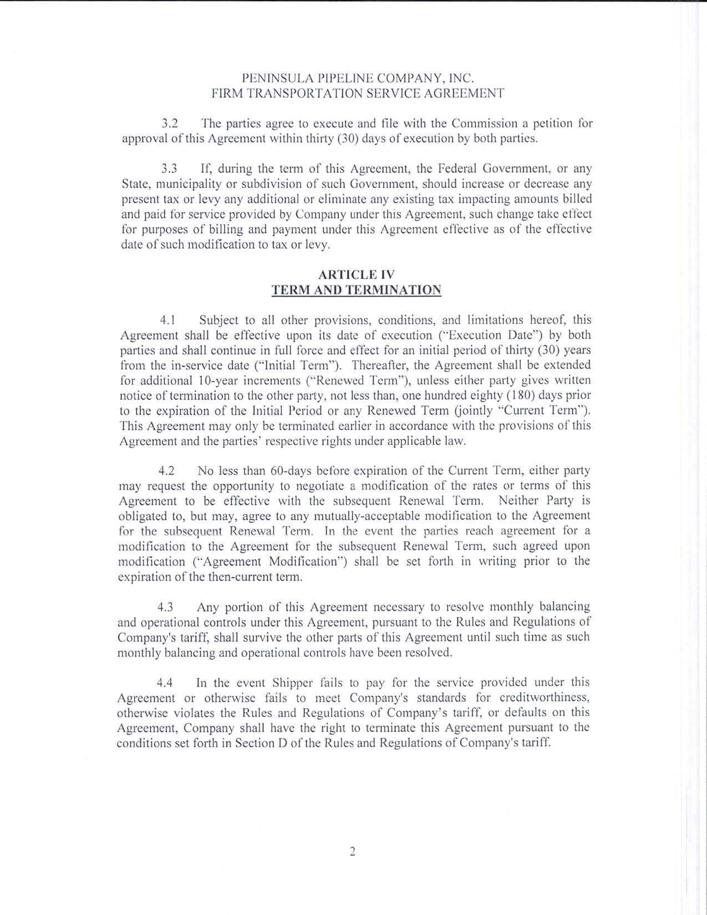

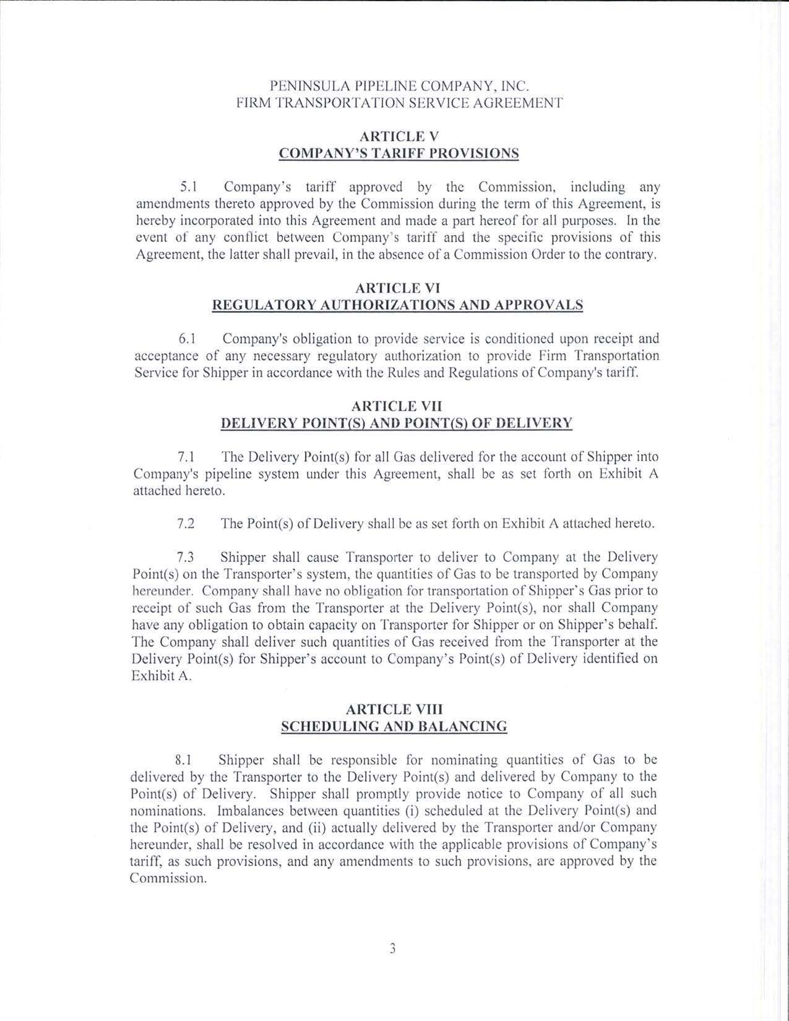

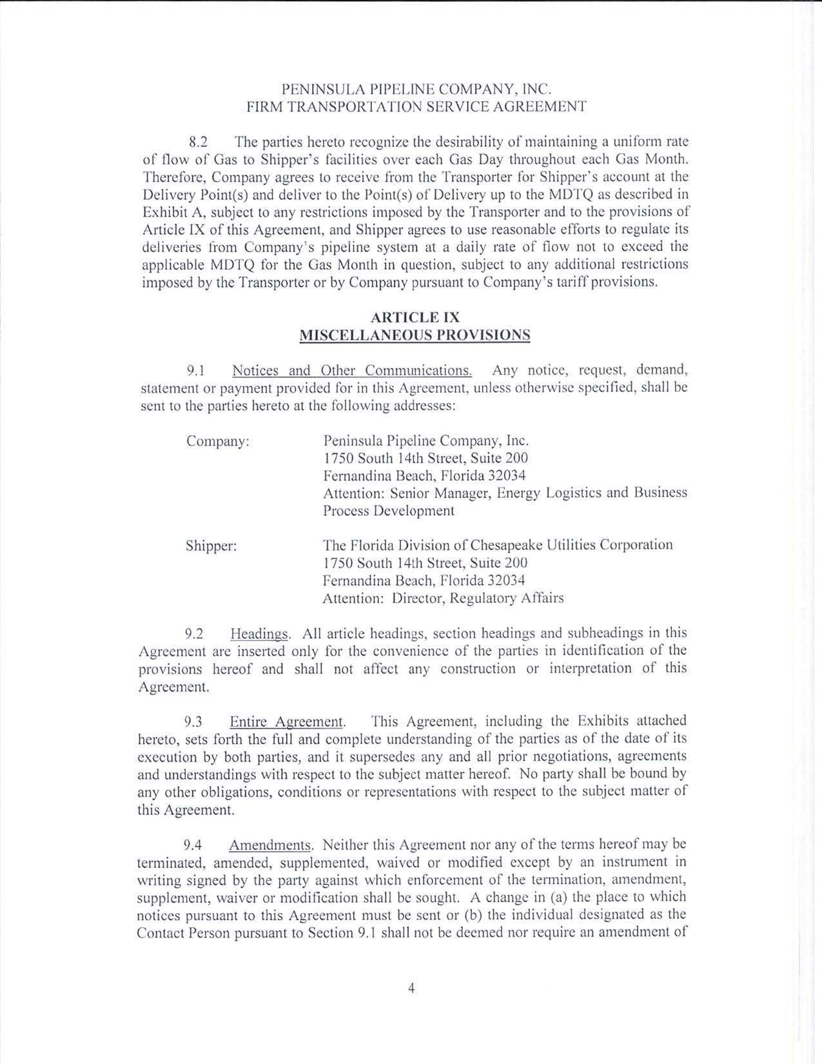

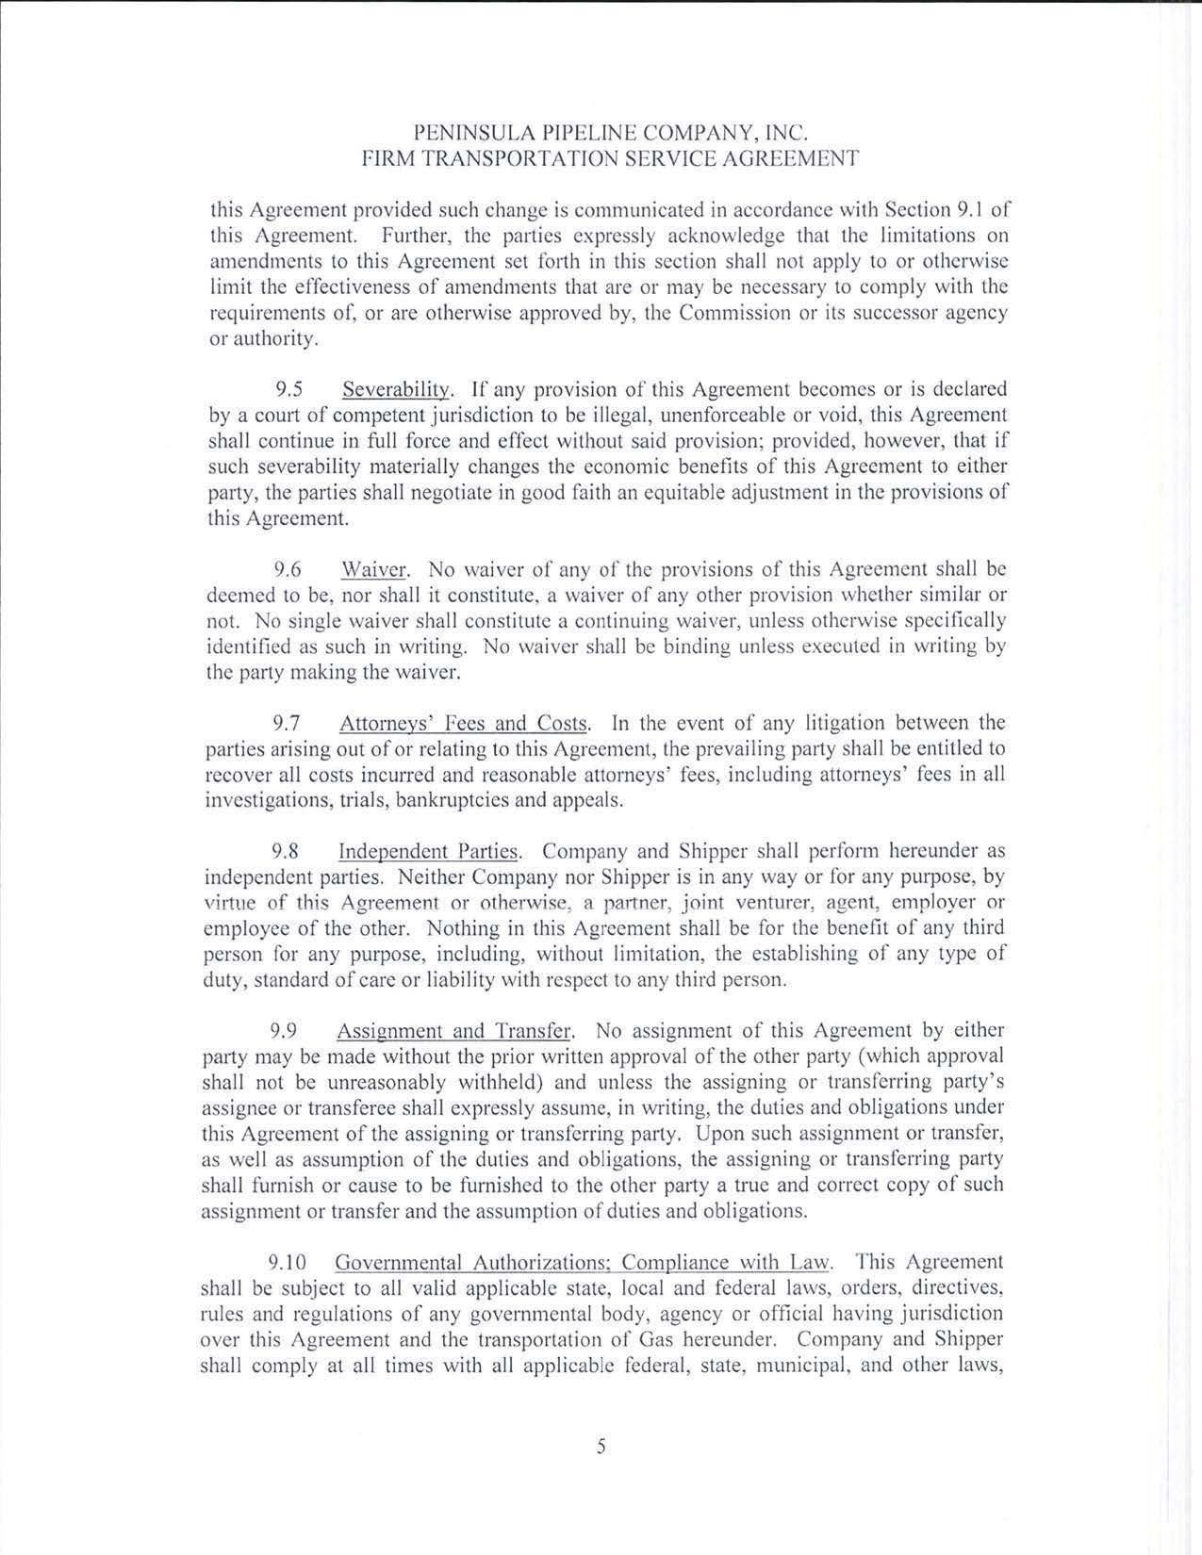

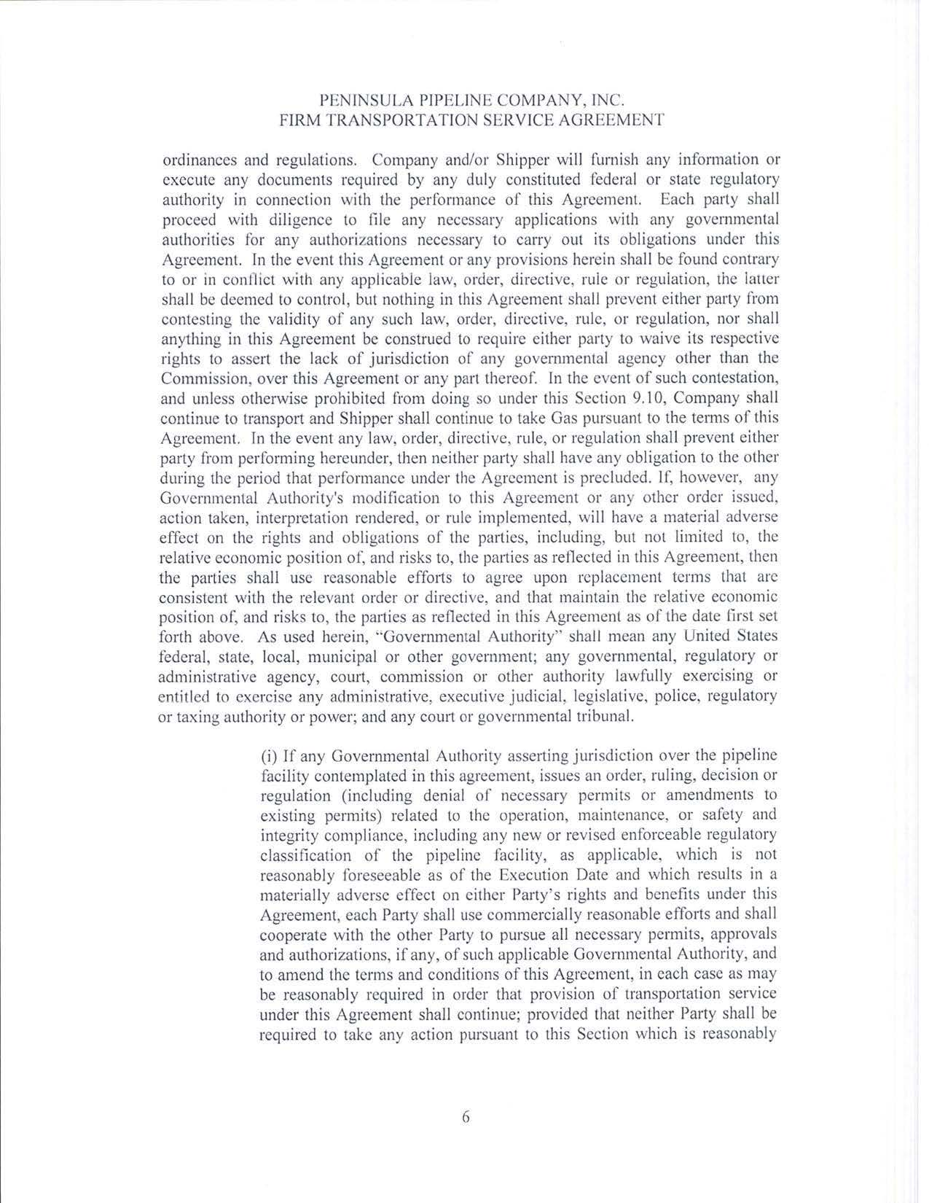
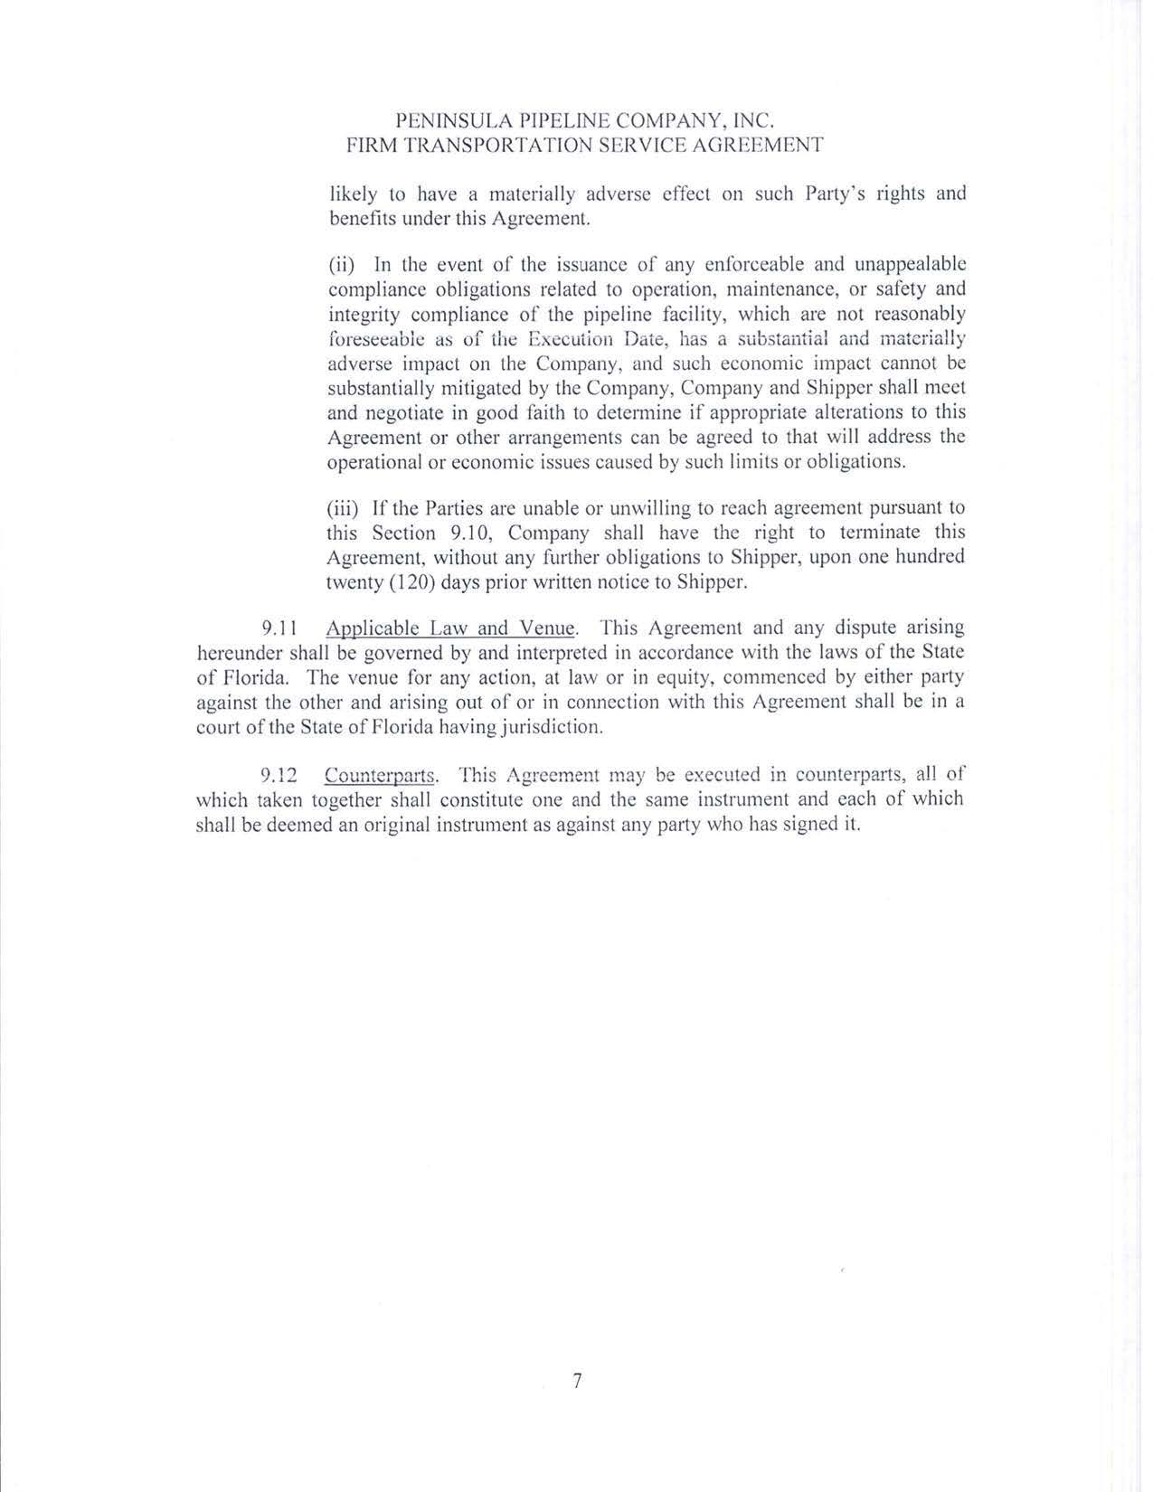

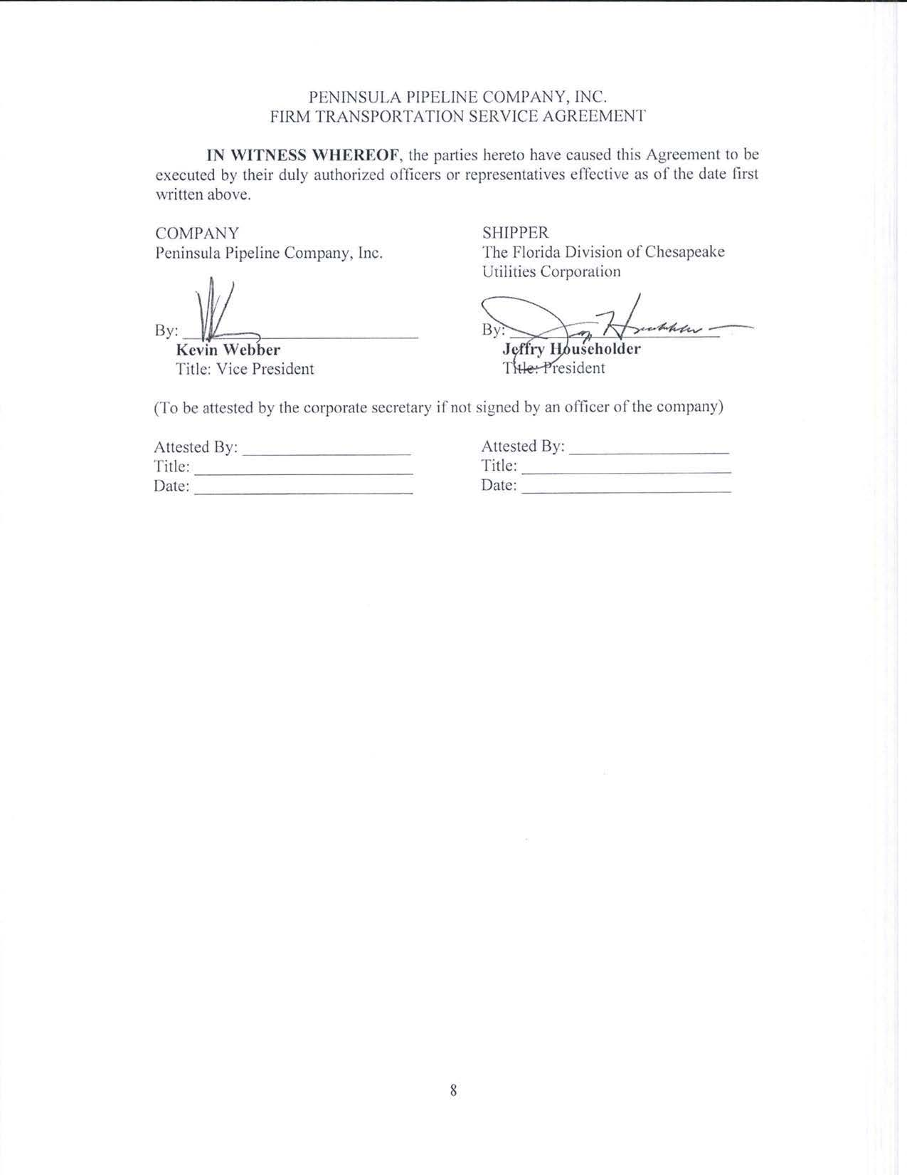

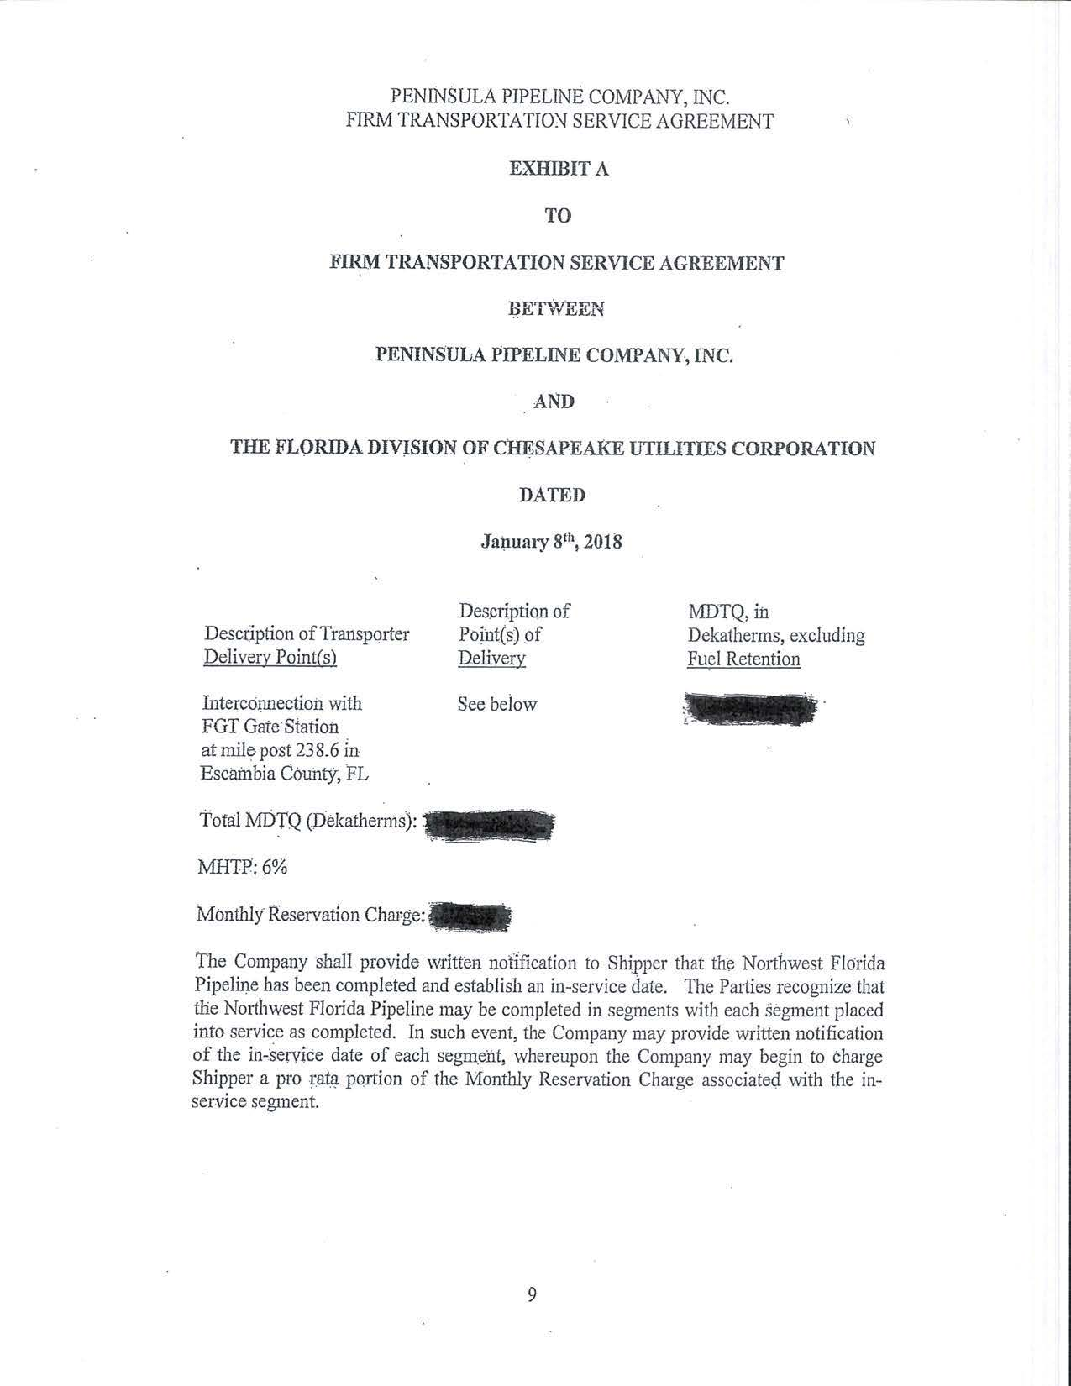

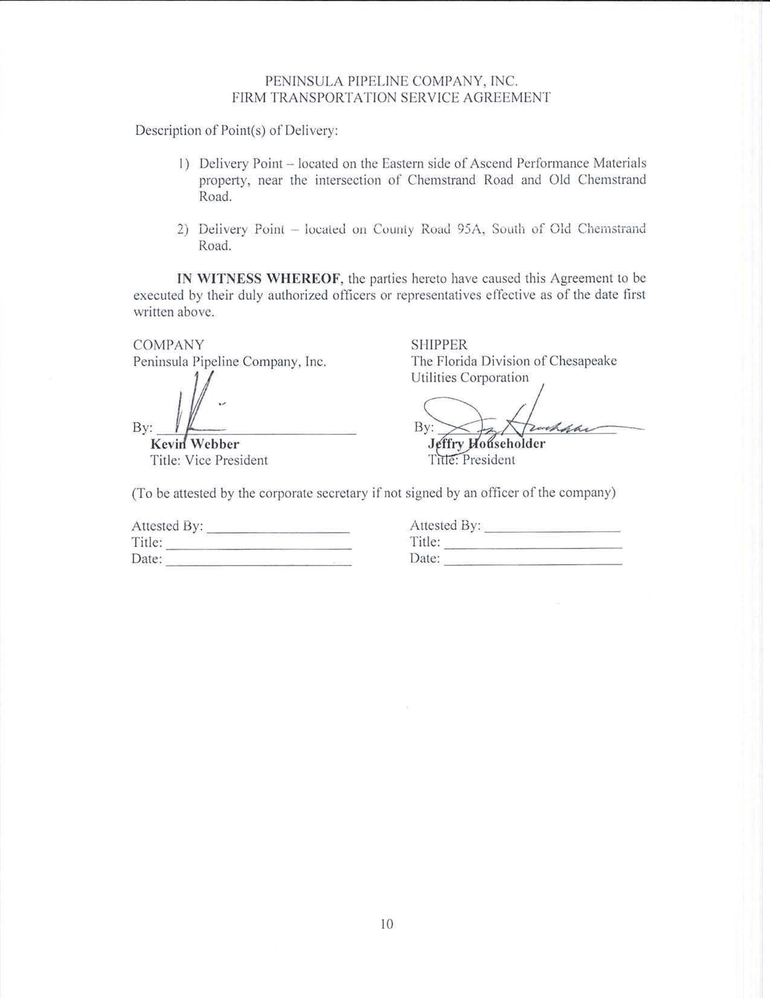

Order No. PSC-06-0023-DS-GP, issued January 9, 2006, in Docket No. 050584-GP, In re: Petition for declaratory statement by Peninsula Pipeline Company, Inc. concerning recognition as a natural gas transmission company under Section 368.101, F.S., et seq.
Order No. PSC-07-1012-TRF-GP, issued December 21, 2007, in Docket No. 070570-GP, In re: Petition for approval of natural gas transmission pipeline tariff by Peninsula Pipeline Company, Inc.
Peninsula Pipeline Company, Inc., Intrastate Pipeline Tariff, Original Vol. 1, Sheet No. 12, Section 4.
Order No. PSC-2017-0467-CO-GU, issued December 12, 2017, in Docket No. 170191-GU, In re: Joint petition for approval of revised swing service rider rates for the period January through December 2018, by Florida Public Utilities Company, Florida Public Utilities Company-Indiantown Division, Florida Public Utilities Company-Fort Meade and Florida Division of Chesapeake Utilities Corporation.

