BEFORE THE FLORIDA PUBLIC SERVICE COMMISSION

In re: Petition for approval of arrangement for totalized meter interconnection service, by Tampa Electric Company. | DOCKET NO. 20180092-EQ  ORDER NO. PSC-2018-0373-PAA-EQ  ISSUED: July 30, 2018

The following Commissioners participated in the disposition of this matter:

ART GRAHAM, Chairman
JULIE I. BROWN
DONALD J. POLMANN
GARY F. CLARK
ANDREW GILES FAY

NOTICE OF PROPOSED AGENCY ACTION ORDER
APPROVING PETITION FOR APPROVAL OF ARRANGEMENT
FOR TOTALIZED METER INTERCONNECTION SERVICE

BY THE COMMISSION:

NOTICE is hereby given by the Florida Public Service Commission that the action discussed herein approving the application for totalized metering interconnection service arrangement between Tampa Electric Company (TECO or utility) and MacDill Air Force Base (MacDill) is preliminary in nature and will become final unless a person whose interests are substantially affected files a petition for a formal proceeding, pursuant to Rule 25-22.029, Florida Administrative Code (F.A.C.).

Background
On April 9, 2018, TECO filed a petition for approval of an arrangement for totalized meter interconnection service (arrangement). The proposed arrangement is a special contract between TECO and MacDill. MacDill is a United States Air Force Base located in Tampa, Florida. Pursuant to Rule 25-9.034, F.A.C., special contracts must be approved by this Commission.
On May 1, 2018, Commission staff held a noticed informal meeting with TECO to discuss the proposed arrangement. The Office of the Public Counsel participated in the meeting. We have jurisdiction over this matter pursuant to Sections 366.04, 366.05, and 366.06, Florida Statutes.

Decision
The proposed arrangement between TECO and MacDill provides for the application for totalized metering, which is the summation of adjacent metering equipment readings serving the same property. Totalized metering is permissible under TECO’s current tariff; however, TECO’s tariff does not address MacDill’s unique circumstances. Therefore, TECO filed the instant petition for an arrangement. The proposed arrangement does not contain a special rate for MacDill; MacDill will continue to pay TECO’s tariffed charges.

MacDill
MacDill is located south of Tampa at the end of the Interbay peninsula in Hillsborough County and receives electric service from TECO at the MacDill substation (shown on the map in Attachment B to this order as MacDill – 23 D). MacDill is a federal enclave and owns and operates its distribution system behind the meter at the MacDill substation. TECO does not own any distribution system on the base and provides service to MacDill at primary voltage pursuant to rate schedule, General Service – Demand Time-of-Day.
The MacDill operations center operates continuously; therefore, reliability is a major concern. TECO explained that during hurricane season MacDill is at risk for storm surge and flooding due to being just four feet above sea level and at the end of a peninsula. MacDill owns a standby generator; however, the generator only has three days worth of diesel fuel as a reserve.
MacDill is planning to add new load which could exceed the existing MacDill substation’s capacity. To accommodate the incremental MacDill load as well as growth in the surrounding area, TECO is building a new substation (Interbay substation, shown on Attachment B). The Interbay substation is directly west 1.4 miles from the current MacDill 23 – D substation. Once the Interbay substation is constructed, MacDill will be served by both substations. TECO stated that the Interbay substation will be operational in July or August 2018.

Proposed Arrangement
TECO’s current tariff sheet No. 5.075 addresses totalized metering. Totalized metering can be provided by the utility when single circuit metering is impractical because the customer’s load exceeds the loading criteria of one standard transformer. To illustrate, a large warehouse’s demand cannot be served by one standard transformer. TECO, in accordance with the arrangement, shall install two transformers, and two metering circuits, and combine the readings from the two meters.
The tariff provides for certain criteria the customer must meet to qualify for totalized metering: (1) all the services totalized must be at the same voltage level; (2) the facility’s total demand load must exceed the loading criteria for the largest standard transformer; and (3) the facility must be comprised of one building containing a single business operated by one customer. In addition, the tariff states that totalized metering will normally be provided to a single geographical point.
MacDill’s circumstances vary from what is contemplated in TECO’s current tariff with respect to two criteria. First, the MacDill base, while it is on one unit of property, consists of multiple buildings. Second, MacDill will be served from two points of delivery (the two substations) which are 1.4 miles apart.
The application of totalized metering for the existing and the new interconnection, along with balancing of the MacDill load between the two substations, should provide more capacity and more reliable service to MacDill. In addition, the proposed arrangement should free up capacity at the MacDill substation allowing TECO to meet future capacity and energy needs outside the MacDill base. Currently, the MacDill substation only serves MacDill.
Under the totalized metering arrangement, MacDill would pay one customer charge and the kilowatt hours metered at the two substations would be added together. The demand billed would be the highest totalized (combined) demand registered at both substations.

Conclusion
We recently approved a special contract between Florida City Gas and U.S. Sugar, a large industrial customer who was facing unique challenges. Similar to the instant petition, we approved a variance from Florida City Gas’s tariff to address the challenges faced by U.S. Sugar through a special contract.
We have reviewed TECO and MacDill’s proposed arrangement, or special contract, and data provided during the informal meeting on Tuesday, May 1, 2018. We hereby approve the proposed arrangement between TECO and MacDill, as shown in Attachment A, effective July 10, 2018.
Based on the foregoing, it is
ORDERED by the Florida Public Service Commission that the proposed arrangement between Tampa Electric Company and MacDill Air Force Base, as shown in Attachment A, is approved with an effective date of July 10, 2018. It is further

ORDERED that the provisions of this Order, issued as proposed agency action, shall become final and effective upon the issuance of a Consummating Order unless an appropriate petition, in the form provided by Rule 28-106.201, Florida Administrative Code, is received by the Commission Clerk, 2540 Shumard Oak Boulevard, Tallahassee, Florida 32399-0850, by the close of business on the date set forth in the “Notice of Further Proceedings” attached hereto. It is further
ORDERED that in the event this Order becomes final, this docket shall be closed.

By ORDER of the Florida Public Service Commission this 30th day of July, 2018.

/s/ Carlotta S. Stauffer
CARLOTTA S. STAUFFER
Commission Clerk
Florida Public Service Commission
2540 Shumard Oak Boulevard
Tallahassee, Florida 32399
(850) 413-6770
www.floridapsc.com

Copies furnished: A copy of this document is provided to the parties of record at the time of issuance and, if applicable, interested persons.
WLT

NOTICE OF FURTHER PROCEEDINGS OR JUDICIAL REVIEW

The Florida Public Service Commission is required by Section 120.569(1), Florida Statutes, to notify parties of any administrative hearing that is available under Section 120.57, Florida Statutes, as well as the procedures and time limits that apply. This notice should not be construed to mean all requests for an administrative hearing will be granted or result in the relief sought.

Mediation may be available on a case-by-case basis. If mediation is conducted, it does not affect a substantially interested person's right to a hearing.

The action proposed herein is preliminary in nature. Any person whose substantial interests are affected by the action proposed by this order may file a petition for a formal proceeding, in the form provided by Rule 28-106.201, Florida Administrative Code. This petition must be received by the Office of Commission Clerk, 2540 Shumard Oak Boulevard, Tallahassee, Florida 32399-0850, by the close of business on August 20, 2018.

In the absence of such a petition, this order shall become final and effective upon the issuance of a Consummating Order.

Any objection or protest filed in this/these docket(s) before the issuance date of this order is considered abandoned unless it satisfies the foregoing conditions and is renewed within the specified protest period.

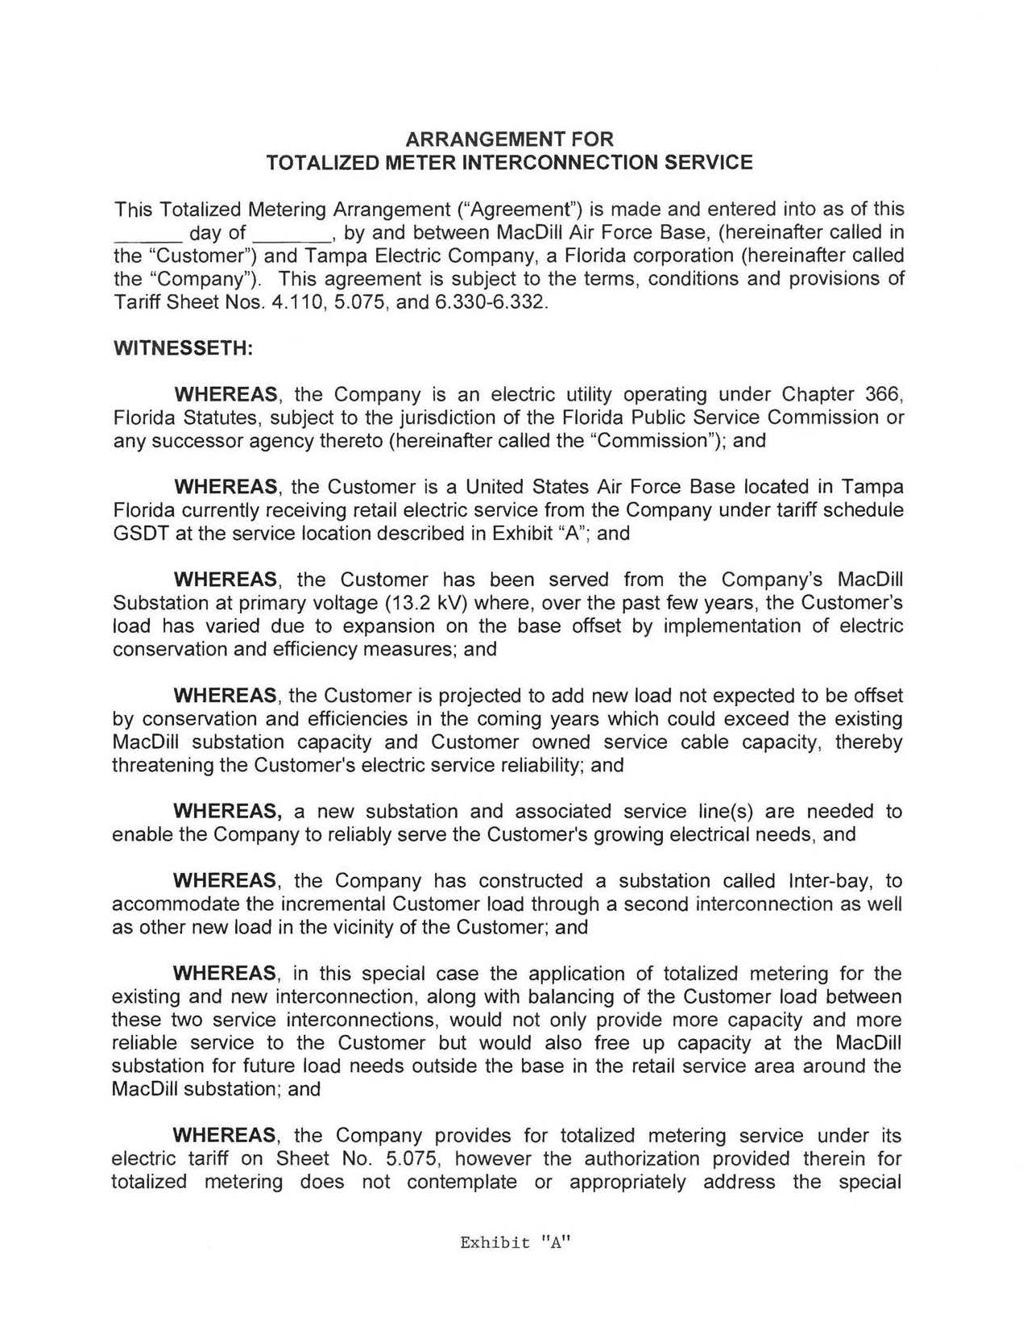
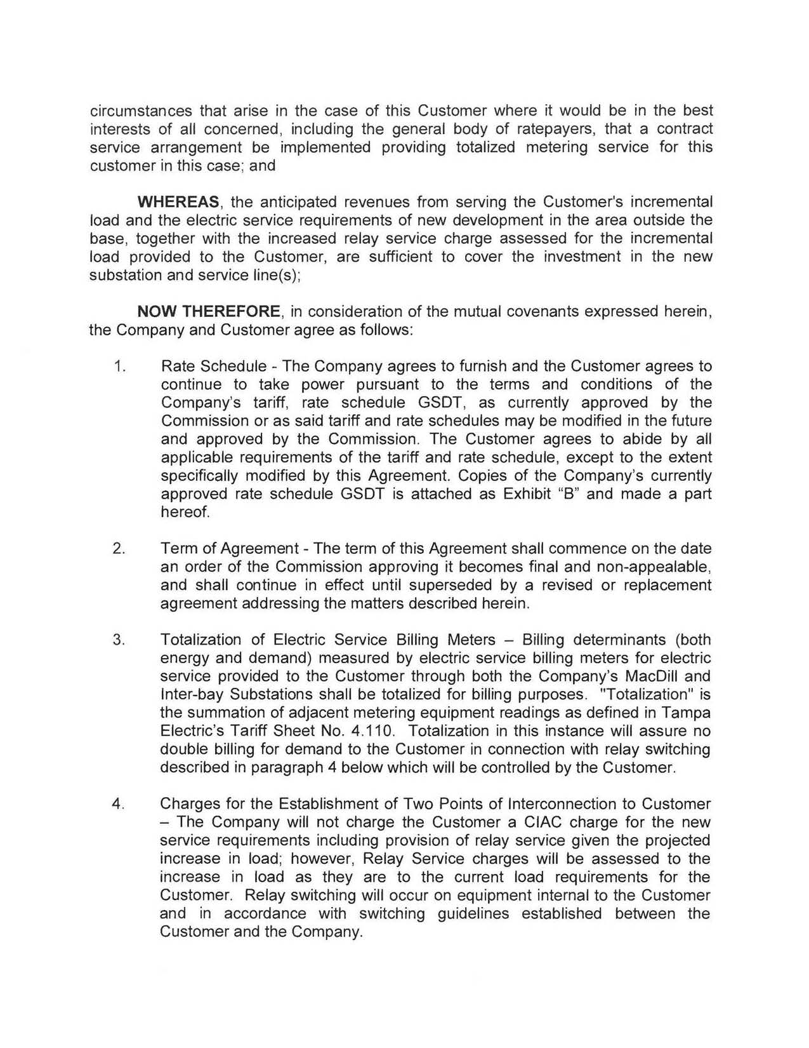
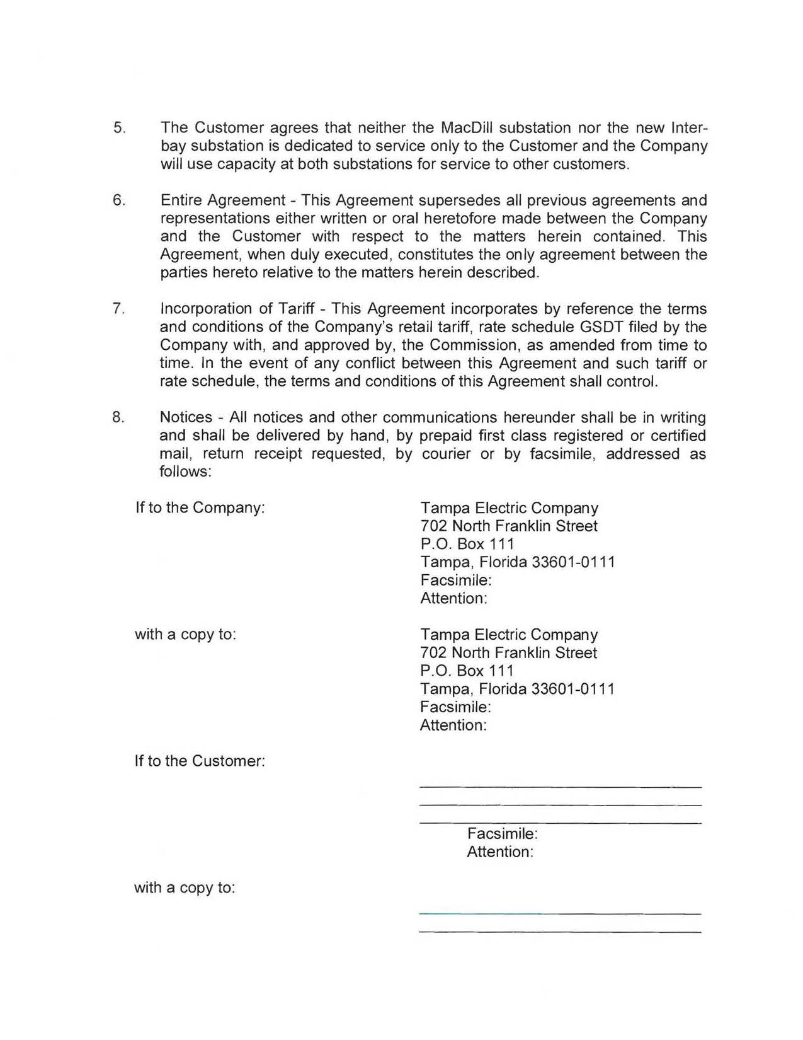
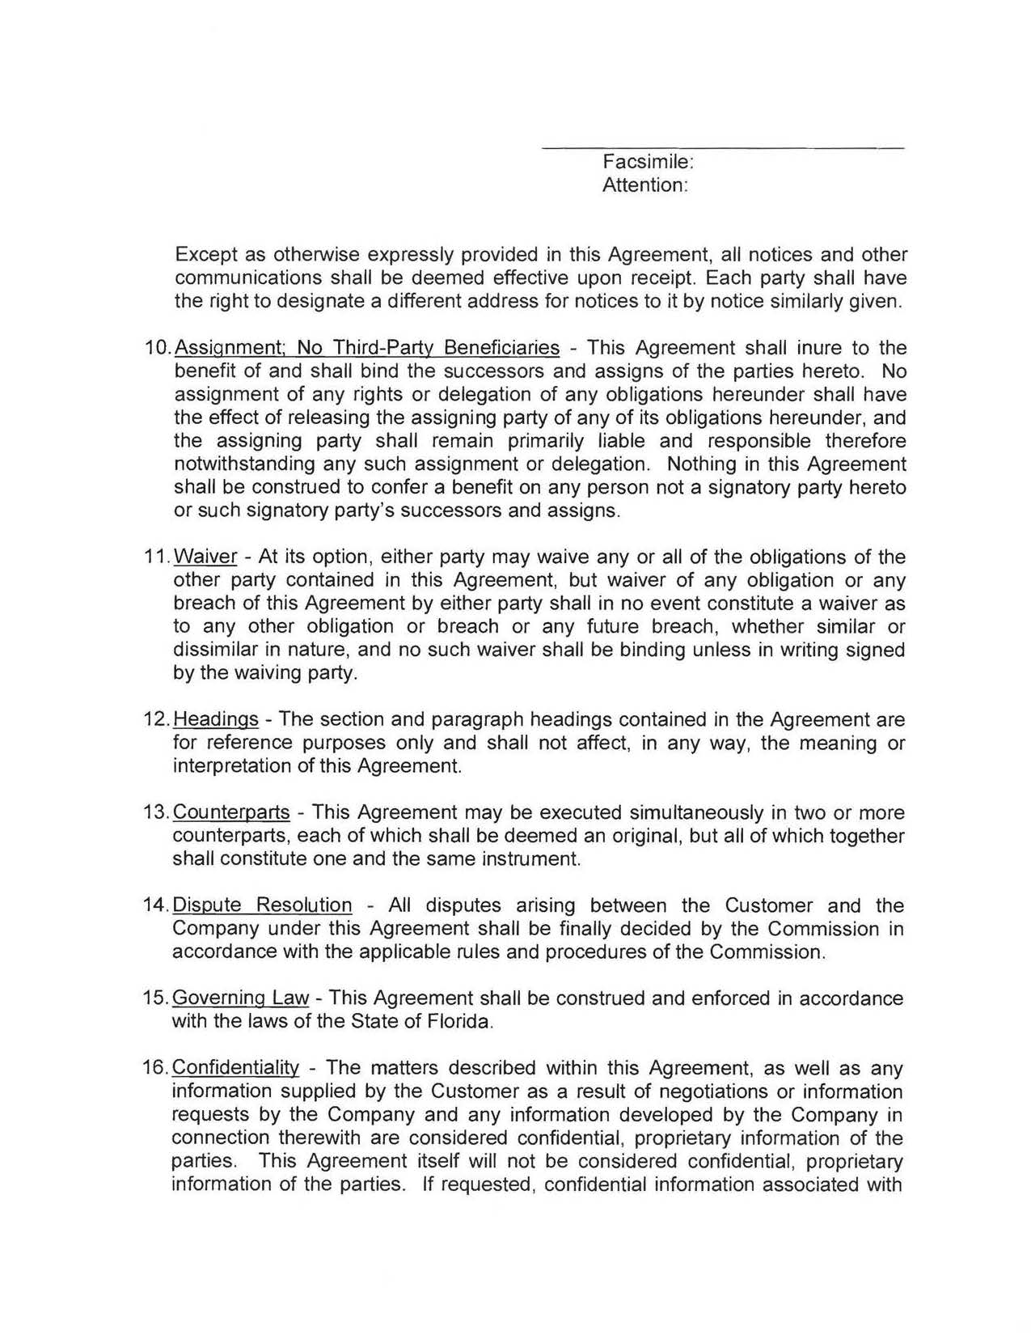

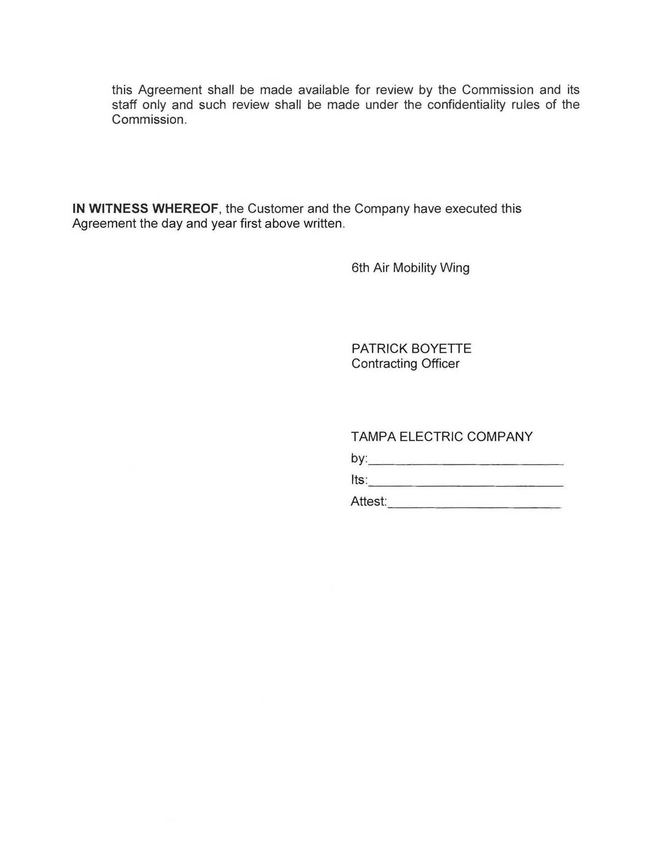

Map of MacDill Air Force Base
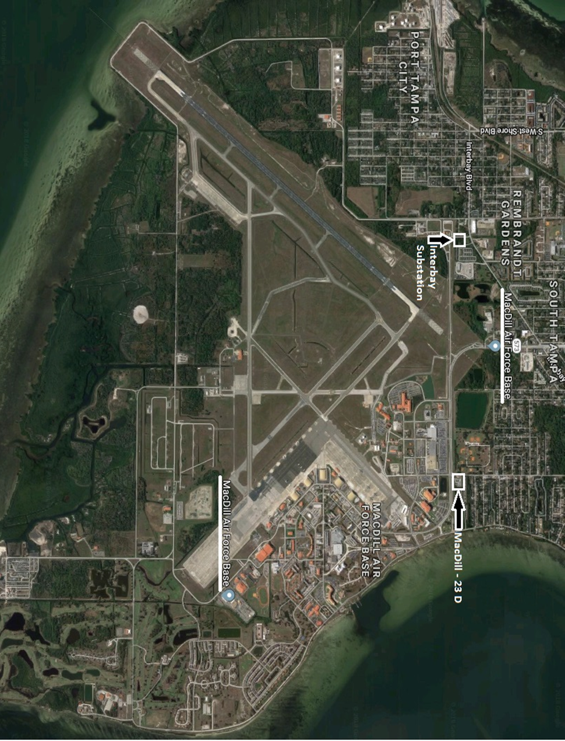

Order No. PSC-2018-0273-PAA-GU, issued May 31, 2018, in Docket No. 20180043-GU, In re: Petition for approval of area extension plan rate extension agreement with United States Sugar Corporation, by Florida City Gas.

