State of Florida |  | Public Service Commission  Capital Circle Office Center ● 2540 Shumard Oak Boulevard  Tallahassee, Florida 32399-0850  -M-E-M-O-R-A-N-D-U-M-
DATE: | August 17, 2018
TO: | Office of Commission Clerk (Stauffer)
FROM: | Office of the General Counsel (Gervasi)  Division of Economics (Draper)  Office of Industry Development and Market Analysis (Fogleman)
RE: | Docket No. 20170233-TP – Proposed amendment of Rule 25-4.0665, F.A.C., Lifeline Service, and Proposed Repeal of Rule 25-4.113, F.A.C., Refusal or Discontinuance of Service by Company.
AGENDA: | 08/29/18 – Regular Agenda – Rule Proposal – Interested Persons May Participate
COMMISSIONERS ASSIGNED: |  |  | All Commissioners
PREHEARING OFFICER: |  |  | Clark
RULE STATUS: |  |  | Proposal May Be Deferred
SPECIAL INSTRUCTIONS: |  |  | None

Case Background
On February 6, 2012, the Federal Communications Commission (FCC) released a Report and Order (Order FCC 12-11) and Further Notice of Proposed Rulemaking addressing Lifeline and Link Up Reform and Modernization. The stated purposes of Order FCC 12-11 were to strengthen protections against waste, fraud, and abuse; improve program administration and accountability; improve enrollment and consumer disclosures; initiate modernization of the Lifeline program to include broadband; and constrain the growth of the program in order to reduce the burden on all who contribute to the Federal Universal Service Fund. Many of the modifications contained in Order FCC 12-11 affected Florida’s Lifeline program. By Order No. PSC-12-0205-PAA-TP, issued April 17, 2012, in Docket No. 120052-TP, the Commission modified Florida’s Lifeline program accordingly and determined that Rule 25-4.0665, Florida Administrative Code (F.A.C.), the Commission’s Lifeline rule, would need to be amended in order to conform to the requirements of Order FCC 12-11.
Meanwhile, during the course of the Commission’s Lifeline rule development process, the FCC released a Notice of Proposed Rulemaking and Order seeking comments on restructuring the Lifeline program to include access to broadband. On April 27, 2016, the FCC released its Third Report and Order, Further Report and Order, and Order on Reconsideration (Order FCC 16-38), further addressing the modernization of the federal Lifeline program. The stated purpose of Order FCC 16-38 is to help low-income Americans afford access to the Internet. The Order reflects a transition of the FCC from primarily supporting voice services to targeting support at modern broadband services. Order FCC 16-38 encourages broadband providers to offer meaningful broadband services to Lifeline subscribers, streamlines Lifeline program rules, eliminates outdated program obligations, and makes several additional changes to combat waste, fraud, and abuse, including establishing a National Lifeline Eligibility Verifier that removes the responsibility of determining Lifeline subscriber eligibility from providers.
Many of the modifications contained in Order FCC 16-38 and the federal Lifeline rule amendments attached thereto affect Florida’s Lifeline program. This recommendation addresses whether the Commission should propose the amendment of Rule 25-4.0665, F.A.C., Lifeline Service (Lifeline rule), in order to conform the rule to the requirements of Order FCC 16-38. This recommendation also addresses whether the Commission should propose the repeal of Rule 25-4.113, F.A.C., Refusal or Discontinuance of Service by Company, consistent with the 2011 deregulatory changes made to Chapter 364, Florida Statutes (F.S.).
A Notice of Development of Rulemaking was published on June 23, 2017, in Volume 43, Number 122, of the Florida Administrative Register (FAR). FairPoint Communications and Cox Florida Telcom, L.P., submitted comments on the draft Lifeline rule and AT&T requested a rule workshop. A Notice of Rule Development Workshop was published on July 26, 2017, in Volume 43, Number 144, of the FAR. Upon consideration of the comments submitted and concerns expressed by AT&T, staff further revised the preliminary draft rule language and AT&T thereafter withdrew its request for a workshop. Therefore, no rule development workshop was held. On August 29, 2017, staff issued notice of the revisions made to the preliminary draft rule language and provided all interested persons a second opportunity to submit further written comments or to request a workshop. No further comments or requests for workshop were received. The Commission has jurisdiction pursuant to sections 120.54, 350.127(2), 364.10, 364.105, and 364.183(1), F.S.

Discussion of Issues

Issue 1:
Should the Commission propose the amendment of Rule 25-4.0665, F.A.C., Lifeline Service, and the repeal of Rule 25-4.113, F.A.C., Refusal or Discontinuance of Service by Company?

Recommendation:
Yes, the Commission should propose the amendment of Rule 25-4.0665, F.A.C., Lifeline Service, and the repeal of Rule 25-4.113, F.A.C., Refusal or Discontinuance of Service by Company, as set forth in Attachment A. Staff recommends that the Commission certify proposed amended Rule 25-4.0665, F.A.C., as a minor violation rule. (Gervasi, Fogleman, Draper)

Staff Analysis:
Staff recommends that the Commission propose the amendment of Rule 25-4.0665, F.A.C., and the repeal of Rule 25-4.113, F.A.C., as set forth in Attachment A. Staff’s rationale for the rule amendment and repeal is discussed in more detail below.
Amendment of Rule 25-4.0665, F.A.C., Lifeline Service
Rule 25-4.0665, F.A.C., Lifeline Service, establishes the requirements eligible telecommunications carriers (ETCs) must follow when they offer Lifeline service. The rule lists the eligibility criteria for applications, processes and procedures for accepting applications, procedures for rejecting applications, timeframes for enrolling applicants, advertising, and reporting requirements. Staff is recommending that the Commission propose the amendment of Rule 25-4.0665, F.A.C., in order to conform the rule to the requirements of Order FCC 16-38 and the federal Lifeline rule amendments attached thereto, specifically including FCC Rules 47 CFR §§ 54.400 - 54.417.

Eligibility Criteria
As shown on Attachment A, staff recommends that Paragraph (1) of the Rule 25-4.0665, F.A.C., should be amended to require ETCs to offer Lifeline assistance as prescribed by the FCC, and to incorporate the federal Lifeline rules into the rule by reference. Among other things, by Order FCC 16-38, the FCC amended Rule 47 CFR § 54.409(a) to remove state-specified eligibility criteria for Lifeline support in order to continue to prevent waste, fraud, and abuse. Therefore, the state-specified eligibility criteria contained in Paragraphs (1)-(3) and (7) should be deleted.

Staff notes that the FCC expressly removed the Low Income Home Energy Assistance Program, the National School Lunch Program, and Temporary Assistance for Needy Families as qualifying federal assistance programs for determining eligibility for Lifeline. This was due in part to low enrollment in Lifeline based on participation in those programs, as well as to a finding that those programs do not offer the same advantages in developing a federal eligibility database, preventing waste, fraud, and abuse, nor better targeting of the neediest low-income households as the Supplemental Nutrition Assistance Program, Medicaid, SSI, Federal Public Housing Assistance, and the Veterans Pension benefit.

Elimination of Link Up Service
Staff recommends that Paragraph (4) of Rule 25-4.0665, F.A.C., should be deleted, to eliminate the requirement that ETCs who charge an initial connection charge must offer Link Up service to subscribers who are eligible for Lifeline. Federal Link Up assistance is no longer available to subscribers who are eligible for Lifeline service. By Order FCC 12-11, the FCC eliminated Link Up support on non-Tribal lands for all ETCs, and Rule 47 CFR § 54.413 was amended to restrict Link Up assistance to eligible residents of Tribal lands seeking telecommunications service from a telecommunications carrier that is receiving high-cost support on Tribal lands. Therefore, by Order No. PSC-12-0205-PAA-TP, the Commission removed non-Tribal Link Up from the Florida Lifeline program.
Subscriber Certification Requirements
Paragraph (9) specifies that an ETC shall only require the last four digits of a customer’s social security number for continued eligibility for Lifeline and Link-Up as part of the annual verification process. That requirement is contained in Rule 47 CFR § 54.410, Subscriber eligibility determination and certification for Lifeline service, and should thus be deleted as unnecessary.

Paragraph (10)(b) contains a 60-day deadline for initial enrollment in the Lifeline program and requires an ETC to credit the subscriber’s bill for Lifeline service as of the date the ETC received the e-mail notification from the Commission. This paragraph should be deleted because it conflicts with the subscriber eligibility determination and certification requirements of Rule 47 CFR § 54.410, which do not contain a deadline for initial enrollment. It also conflicts with Rule 47 CFR § 54.407(a), which states that “Universal service support for providing Lifeline shall be provided directly to an [ETC] based on the number of actual qualifying low-income customers it serves directly as of the first day of the month.”

Paragraph (12) prohibits an ETC from imposing any additional verification requirements on a subscriber who is certified by the Office of Public Counsel (OPC) as being eligible to receive Lifeline service under the income test set forth in Section 364.10(2)(a), F.S. Section 364.10(2)(a), F.S., prescribes an income eligibility test of 150 percent or less of the federal poverty income guidelines for Lifeline customers. By Order FCC 16-38, the FCC continued to allow income-based eligibility for households with annual incomes of less than 135 percent of the federal poverty income guidelines. This paragraph should be deleted because it is inconsistent with the FCC’s eligibility criteria.
Paragraph (15) requires the reinstatement of a subscriber’s terminated Lifeline service no later than 60 days following receipt of proof of eligibility and requires that the subscriber’s bill must be credited for Lifeline service as of the date the ETC received the proof of continued Lifeline eligibility. That paragraph should be deleted because it conflicts with the subscriber eligibility determination and certification requirements of Rule 47 CFR § 54.410, which do not contain a deadline for reinstatement of a subscriber’s terminated Lifeline service. It also conflicts with Rule 47 CFR § 54.407(a), which states that “Universal service support for providing Lifeline shall be provided directly to an [ETC] based on the number of actual qualifying low-income customers it serves directly as of the first day of the month.”
Other Recommended Changes
The recommended changes to Paragraphs (14), (17), and (18) (newly numbered as Paragraphs (9), (11), and (12)) contained on Attachment A are self-explanatory. Staff recommends that Paragraph (19) be deleted as unnecessary because it is duplicative of Section 364.10(1)(d), F.S., which requires that an ETC may not charge Lifeline subscribers a monthly number-portability charge. Finally, staff recommends the deletion of Paragraph (20), which contains quarterly reporting requirements to the Commission. The quarterly reporting requirements are no longer necessary because, as reflected in newly numbered Paragraph (11), Rule 47 CFR § 54.422(c) requires ETCs to file detailed annual reports with the FCC, the program administrator, and with the relevant state commissions.

Moreover, the FCC has developed new national Lifeline application and recertification forms, as well as a worksheet to be used to determine whether a customer is eligible for Lifeline service in instances where the customer shares an address with another Lifeline recipient. Customers who are Medicaid or Supplemental Nutrition Assistance Program (SNAP) participants may also enroll in the Lifeline program in Florida by submitting the Commission’s on-line application form. These forms are referenced in newly numbered Paragraphs (2), (3), and (4) of the draft Lifeline rule and are attached to this recommendation as Attachment C.

Repeal of Rule 25-4.113, F.A.C., Refusal or Discontinuance of Service by Company
Rule 25-4.113, F.A.C., Refusal or Discontinuance of Service by Company, outlines the conditions under which a local exchange telecommunications company may discontinue or refuse to provide telephone service. Staff recommends that consistent with the 2011 changes made to Chapter 364, F.S., the Commission should propose to repeal Rule 25-4.113, F.A.C. The Regulatory Reform Act of 2011 amended Chapter 364, F.S., to remove Commission regulatory oversight of basic local telecommunications service and nonbasic service, including service quality and price regulation. Section 364.01(3), F.S., provides that “[t]he Legislature finds that the competitive provision of telecommunications services, including local exchange telecommunications service, is in the public interest and has provided customers with freedom of choice, encouraged the introduction of new telecommunications service, encouraged technological innovation, and encouraged investment in telecommunications infrastructure.” Sections 364.011(5) and 364.011(6), F.S., exempt basic and nonbasic service from Commission oversight, respectively, except to the extent delineated in Chapter 364, F.S. Rule 25-4.113, F.A.C., has thus been rendered obsolete.

Staff notes that this rulemaking docket was initiated to address Rules 25-4.113 and 25-4.0665, F.A.C., at the same time because Rule 25-4.113 specifically addresses Lifeline. Rule 25-4.113(1)(f) provides that a company shall not “discontinue a customer’s Lifeline local service if the charges, taxes, and fees applicable to dial tone, local usage, dual tone multifrequency dialing, emergency services such as ‘911,’ and relay service are paid.” Staff considered whether this language should be included in the Lifeline rule upon the repeal of Rule 25-4.113, under the authority of Section 364.10(2)(c), F.S., which states that “[a]n eligible telecommunications carrier may not discontinue basic local telecommunications service to a subscriber who receives Lifeline service because of nonpayment by the subscriber of charges for nonbasic services billed by the telecommunications company, including long-distance service.” However, staff is not recommending the inclusion of this language in the Lifeline rule because it would be inconsistent with Order FCC 16-38 and the federal Lifeline rules, which do not prohibit an ETC from discontinuing a customer’s Lifeline service for any of the reasons stated in Rule 25-4.113, F.A.C. Pursuant to Rule 47 CFR §54.405, de-enrollment from Lifeline service occurs when a subscriber no longer meets the criteria for eligibility for the service, for non-usage of the service for 30 consecutive days, for failure to re-certify for the service, or upon request by the subscriber.

Statement of Estimated Regulatory Costs
Pursuant to Section 120.54(3)(b)1., F.S., agencies are encouraged to prepare a statement of estimated regulatory costs (SERC) before the adoption, amendment, or repeal of any rule. A SERC was prepared for this rulemaking and is appended as Attachment B. As required by Section 120.541(2)(a), F.S., the SERC analysis includes whether the amendment of Rule 25-4.0665 and repeal of Rule 25-4.113, F.A.C. (rule amendment and repeal), are likely to have an adverse impact on economic growth, private sector job creation or employment, or private sector investment in excess of $1 million in the aggregate within five years after implementation. None of the impact cost/criteria established will be exceeded as a result of the recommended revisions.

The SERC concludes that the rule amendment and repeal will likely not directly or indirectly increase regulatory costs in excess of $200,000 in the aggregate in Florida within one year after implementation. The SERC concludes that the rule amendment and repeal will not likely increase regulatory costs, will have minimal transactional costs, and minimal impact on small businesses. Moreover, the rule amendment and repeal will not have an adverse impact on business competitiveness, productivity, or innovation in excess of $1 million in the aggregate within five years of implementation. Thus, the rule amendment and repeal do not require legislative ratification pursuant to Section 120.541(3), F.S. In addition, the SERC states that if any of the ETCs are small businesses, any impact from the rule amendment and repeal would be minimal. The SERC also states that the rule amendment and repeal would have no implementation or enforcement cost on the Commission or any other state and local government entity and would have no impact on small cities or small counties.

Minor Violation Rules Certification
Pursuant to Section 120.695, F.S., beginning July 1, 2017, for each rule filed for adoption, the Commission is required to certify whether any part of the rule is designated as a rule the violation of which would be a minor violation. A list of the Commission rules designated as minor violation rules is published on the Commission’s website, as required by Section 120.695(2), F.S. Currently, Rules 25-4.0665 and 25-4.113, F.A.C., are on the Commission’s list of rules designated as minor violations. If the Commission proposes the repeal of Rule 25-4.113, F.A.C., once the repeal becomes effective, the rule should be deleted from the Commission’s published list of minor violation rules.
If the Commission proposes the amendment of Rule 25-4.0665, F.A.C., the rule would continue to be considered a minor violation rule. Therefore, for purposes of filing the amended rule for adoption with the Department of State, staff recommends that the Commission certify proposed amended Rule 25-4.0665, F.A.C., as a minor violation rule.
Conclusion
For the above reasons, staff recommends that the Commission propose the amendment of Rule 25-4.0665 and the repeal of Rule 25-4.113, F.A.C., as set forth in Attachment A. Moreover, the Commission should certify proposed amended Rule 25-4.0665, F.A.C., as a minor violation rule.

Issue 2:
Should this docket be closed?

Recommendation:
Yes, if no requests for hearing or comments are filed, the rule amendment and repeal as proposed should be filed for adoption with the Secretary of State and the docket should be closed. (Gervasi)

Staff Analysis:
Unless comments or requests for hearing are filed, the rules as proposed may be filed with the Secretary of State without further Commission action. The docket may then be closed.

25-4.0665 Lifeline Assistance Service.
(1) Eligible Telecommunications Companies must offer Lifeline Assistance as prescribed by the Federal Communications Commission in Title 47, Code of Federal Regulations, Part 54, Subpart E, Universal Service Support for Low-Income Consumers, Sections 54.400 through 54.417, as amended October 1, 2017, which are hereby incorporated into this rule by reference, and which are available at [hyperlink]. A subscriber is eligible for Lifeline service if:
(a) The subscriber is a participant in one of the following federal assistance programs:
1. Medicaid;
2. Food Stamps;
3. Supplemental Security Income (SSI);
4. Temporary Assistance for Needy Families/Temporary Cash Assistance;
5. “Section 8” Federal Public Housing Assistance;
6. Low-Income Home Energy Assistance Program; or
7. The National School Lunch Program – Free Lunch; or
(b) The subscriber’s eligible telecommunications carrier has more than one million access lines and the subscriber’s household income is at or below 150 percent of the federal poverty income guidelines.
(2) A subscriber living on federally recognized Tribal lands who does not satisfy the eligibility requirements for Lifeline service in subsection (1) of this rule is nevertheless eligible for Lifeline service if the subscriber receives benefits from one of the following Bureau of Indian Affairs programs:
(a) Tribal temporary assistance for needy families (TANF);
(b) NSL Program – Free Lunch; or
(c) Head Start.
(3) Eligible telecommunications carriers with less than one million access lines are not required to enroll Lifeline applicants through the income eligibility test of 150 percent or less of the federal poverty income guidelines, but may do so voluntarily.
(4) Eligible telecommunications carriers that charge an initial connection charge must offer Link-Up service to subscribers who are eligible for Lifeline service pursuant to this rule.
(2)(5) When enrolling customers in the Lifeline service program under paragraph (1)(a) of this rule, eligible telecommunications carriers shall accept FCC Form 5629, OMB APPROVAL EDITION 3060-0819, PSC/TEL 157 (6/10), entitled “Lifeline Program Application Form,” “Application for Link-Up Florida and Lifeline Assistance,” which is incorporated into this rule by reference and which is available at [hyperlink] or can be accessed from the Universal Service Administrative Company’s Commission’s website at https://www.usac.org/_res/documents/li/pdf/nv/LI_Application_UniversalForm.pdf . www.floridapsc.com, by selecting “Link-Up Florida and Lifeline Assistance,” then selecting “Need Discounted Phone Service?,” and then selecting “English Link-Up and Lifeline Certification Form” (also available in Spanish and Creole). The Spanish version of this form is also incorporated into this rule by reference and is available at [hyperlink] or from the Universal Service Administrative Company’s website at https://www.usac.org/_res/documents/li/pdf/nv/LI-SP_Application_UniversalForms.pdf. Eligible telecommunications carriers shall also accept Form PSC 1023 (08/18), entitled “Lifeline Florida On-line Application for Recipients of Medicaid or Supplemental Nutrition Assistance Program (SNAP),” which is incorporated into this rule by reference and which is available at [hyperlink] or from the Commission’s website at www.floridapsc.com, by selecting “Lifeline Assistance,” then selecting “Public Service Commission Secure On-Line Application Form.”
(3)(6) When recertifying customers in the Lifeline service program, eligible telecommunications carriers shall accept FCC Form 5630, OMB APPROVAL EDITION 3060-0819, entitled “Lifeline Program Annual Recertification Form,” which is incorporated into this rule by reference and which is available at [hyperlink] or from the Universal Service Administrative Company’s website at https://www.usac.org/_res/documents/li/pdf/nv/LI_Recertification_UniversalForms.pdf. The Spanish version of this form is also incorporated into this rule by reference and is available at [hyperlink] or from the Universal Service Administrative Company’s website at https://www.usac.org/_res/documents/li/pdf/nv/LI-SP_Recertification_UniversalForms.pdf.
Eligible telecommunications carriers shall enroll customers for Lifeline service who electronically submit Form PSC/TEL 158 (6/10), entitled “Lifeline and Link-Up Florida On-line Self Certification Form,” which is incorporated into this rule by reference and can be accessed from the Commission’s website at www.floridapsc.com, by selecting “Link-Up Florida and Lifeline,” then selecting “Apply On-line.”
(7) For Lifeline applicants who do not use On-line enrollment or simplified certification enrollment, the eligible telecommunications carrier must accept Public Assistance eligibility determination letters, including those provided for food stamps, Medicaid, and public housing lease agreements, as proof of eligibility for Link-Up and Lifeline enrollment.
(4) To obtain information necessary to confirm whether a customer is eligible for Lifeline service in instances where the customer shares an address with another Lifeline recipient, eligible telecommunications carriers shall accept FCC Form 5631, OMB APPROVAL EDITION 3060-0819, entitled “Lifeline Program Household Worksheet,” which is incorporated into this rule by reference and which is available at [hyperlink] or from the Universal Service Administrative Company’s website at https://www.usac.org/_res/documents/li/pdf/nv/LI_Worksheet_UniversalForms.pdf. The Spanish version of this form is also incorporated into this rule by reference and is available at [hyperlink] or from the Universal Service Administrative Company’s website at https://www.usac.org/_res/documents/li/pdf/nv/LI-SP_Worksheet_UniversalForms.pdf.
(5)(8) Eligible telecommunications carriers must allow customers the option to submit Link-Up or Lifeline application and recertification forms applications via U.S. Mail or facsimile, and may allow applications to be submitted electronically. Eligible telecommunications carriers must also allow customers the option to submit copies of supporting documents via U.S. Mail or facsimile.
(9) Eligible telecommunications carriers shall only require a customer to provide the last four digits of the customer’s social security number for application for Lifeline and Link-Up service and to verify continued eligibility for the programs as part of the annual verification process.
(6)(10) All eligible telecommunications carriers shall participate in the Lifeline service Simplified Automatic Enrollment Process. For purposes of this rule, the Lifeline service Simplified Automatic Enrollment Process is an electronic interface between the Department of Children and Family Services, the Commission, and the eligible telecommunications carrier that allows low-income individuals to automatically enroll in Lifeline following enrollment in a qualifying public assistance program.
(a) The Commission shall send an e-mail to the eligible telecommunications carrier informing the eligible telecommunications carrier that Lifeline service applications are available for retrieval for processing.
(b) The eligible telecommunications carrier shall enroll the subscriber in the Lifeline service program as soon as practicable, but no later than 60 days from the receipt of the e-mail notification. Upon completion of initial enrollment, the eligible telecommunications carrier shall credit the subscriber’s bill for Lifeline service as of the date the eligible telecommunications carrier received the e-mail notification from the Commission.
(b)(c) The eligible telecommunications carrier shall maintain at least one a current e-mail address with the Commission, which the Commission will use to inform the eligible telecommunications carrier of the Commission’s Lifeline secure website address and that new Lifeline service applications are available for retrieval for processing.
(c)(d) The eligible telecommunications carrier shall maintain with the Commission the names, e-mail addresses and telephone numbers of at least one primary and one secondary company representative who will manage the user accounts on the Commission’s Lifeline secure website.
(d)(e) Within 20 calendar days of receiving the Commission’s e-mail notification that the Lifeline service application is available for retrieval, the eligible telecommunications carrier shall provide a facsimile response to the Commission via the Commission’s dedicated Lifeline service facsimile telephone line at (850) 717-0108 413-7142, or an electronic response via the Commission’s Lifeline secure website, identifying the customer name, address, telephone number, and date of the application for:
1. Misdirected Lifeline service applications; or
2. Applications for customers currently receiving Lifeline service.; and
3. Rejected applicants, which shall include the reason(s) why the applicants were rejected.
In lieu of a facsimile or electronic submission, the eligible telecommunications carrier may file the information with the Office of Commission Clerk.
(e)(f) Pursuant to Section 364.107(1), F.S., information filed by the eligible telecommunications carrier in accordance with paragraph (6)(d) (9)(e) of this rule is confidential and exempt from Section 119.07(1), F.S. However, the eligible telecommunications carrier may disclose such information consistent with the criteria in Section 364.107(3)(a), F.S. For purposes of this rule, the information filed by the eligible telecommunications carrier will be presumed necessary for disclosure to the Commission pursuant to the criteria in Section 364.107(3)(a)4., F.S.
(7)(11) An eligible telecommunications carrier shall not impose additional verification requirements on subscribers beyond those which are required by this rule.
(12) If the Office of Public Counsel certifies a subscriber eligible to receive Lifeline service under the income test set forth in Section 364.10(3)(a), F.S., an eligible telecommunications carrier shall not impose any additional verification requirements on the subscriber.
(8)(13) Within 20 calendar days of rejecting a Lifeline application, an An eligible telecommunications carrier must provide written notice to the a customer within 30 days of receipt of the application providing the reason for rejecting the a rejected Lifeline application, and providing contact information for the customer to get information regarding the application denial. Rejected applications received by way of the Simplified Enrollment Process under subsection (6) must also be reported to the Commission via the Commission’s dedicated Lifeline service facsimile telephone line at (850) 717-0108 or electronically via the Commission’s Lifeline secure website, with the reason why the application was rejected. In lieu of a facsimile or electronic submission, the eligible telecommunications carrier may file the information with the Office of Commission Clerk.
(9)(14) An eligible telecommunications carrier or its designee must provide 60 days written notice prior to the termination of Lifeline service pursuant to Title 47, Code of Federal Regulations, Part 54, Subpart E, Section 54.405 Carrier obligation to offer Lifeline, as amended October 1, 2017. The notice of impending pending termination shall contain the telephone number at which the subscriber can obtain information about the subscriber’s Lifeline service from the eligible telecommunications carrier. The notice shall also inform the subscriber of the availability, pursuant to Section 364.105, F.S., of discounted residential basic local telecommunications service.
(15) If a subscriber’s Lifeline service is terminated and the subscriber subsequently presents proof of Lifeline eligibility, the eligible telecommunications carrier shall reinstate the subscriber’s Lifeline service as soon as practicable, but no later than 60 days following receipt of proof of eligibility. Irrespective of the date on which the eligible telecommunications carrier reinstates the subscriber’s Lifeline service, the subscriber’s bill shall be credited for Lifeline service as of the date the eligible telecommunications carrier received the proof of continued Lifeline eligibility.
(10)(16) All eligible telecommunications carriers shall provide current Lifeline service company information to the Universal Service Administrative Company at www.lifelinesupport.org so that the information can be posted on the Universal Service Administrative Company’s consumer website.
(11)(17) Eligible telecommunications carriers must advertise the availability of Lifeline service. Pursuant to Title 47, Code of Federal Regulations, Part 54, Subpart E, Section 54.405(b), all eligible telecommunications carriers are obligated to publicize the availability of Lifeline service in a manner reasonably designed to reach those likely to qualify for the service. Only posting the availability of Lifeline service on an eligible telecommunications carrier’s website is insufficient to meet this requirement. Advertising the availability of Lifeline service can be achieved by using any of the following media: flyers, local newspaper ads, local TV ads, mail, e-mail, web advertisements, bill inserts and other text-based methods of advertisement or a combination of such media. Pursuant to Title 47 of the United States Code, Section 214(e)(1)(B), as amended December 1, 1997, which is hereby incorporated into this rule by reference, and which is available at [hyperlink], charges must also be included in the Lifeline advertisement. The company may redirect consumers to a 1-800 customer service number and website to see applicable charges and fees in lieu of listing all charges in an advertisement. to those who may be eligible for the service. At a minimum, if the eligible telecommunications carrier publishes a directory, the eligible telecommunications carrier must include in the index of the directory a notice of the availability of Lifeline service. If the eligible telecommunications carrier generates customer bills, the eligible telecommunications carrier must also place an insert in the subscriber’s bill or a message on the subscriber’s bill at least once each calendar year advising subscribers of the availability of Lifeline service.
(12)(18) Eligible telecommunications carriers must file all reports with the Commission in accordance with Title 47, Code of Federal Regulations, Part 54, Subpart E, Section 54.422(c), Annual reporting for eligible telecommunications carriers that receive low-income support, as amended October 1, 2017, which is hereby incorporated into this rule by reference, and which is available at [hyperlink]. may not charge a service deposit in order to initiate Lifeline service if the subscriber voluntarily elects toll blocking or toll control. If the subscriber elects not to place toll blocking or toll control on the line, an eligible telecommunications carrier may charge a service deposit.
(19) Eligible telecommunications carriers may not charge Lifeline subscribers a monthly number-portability charge.
(20) Eligible telecommunications carriers offering Link-Up and Lifeline service must submit quarterly reports to the Commission no later than 30 days following the ending of each quarter as follows: First Quarter (January 1 through March 31); Second Quarter (April 1 through June 30); Third Quarter (July 1 through September 30); Fourth Quarter (October 1 through December 31). The quarterly reports shall include the following data:
(a) The number of Lifeline subscribers, excluding resold Lifeline subscribers, for each month during the quarter;
(b) The number of subscribers who received Link-Up for each month during the quarter;
(c) The number of new Lifeline subscribers added each month during the quarter;
(d) The number of transitional Lifeline subscribers who received discounted service for each month during the quarter; and
(e) The number of residential access lines with Lifeline service that were resold to other carriers each month during the quarter.
Rulemaking Authority 120.80(13)(d), 350.127(2), 364.10(3)(j) FS. Law Implemented 364.10, 364.105, 364.183(1) FS. History–New 1-2-07, Amended 12-6-07, 6-23-10,________.

25-4.113 Refusal or Discontinuance of Service by Company.
(1) As applicable, the company may refuse or discontinue telephone service under the following conditions provided that, unless otherwise stated, the customer shall be given notice and allowed a reasonable time to comply with any rule or remedy any deficiency:
(a) For non-compliance with or violation of any state or municipal law, ordinance, or regulation pertaining to telephone service.
(b) For the use of telephone service for any other property or purpose than that described in the application.
(c) For failure or refusal to provide the company with a deposit to insure payment of bills in accordance with the company’s regulations.
(d) For neglect or refusal to provide reasonable access to the company for the purpose of inspection and maintenance of equipment owned by the company.
(e) For noncompliance with or violation of the Commission’s regulations or the company’s rules and regulations on file with the Commission, provided 5 working days’ written notice is given before termination.
(f) For nonpayment of bills for telephone service, including the telecommunications access system surcharge referred to in subsection 25-4.160(3), F.A.C., provided that suspension or termination of service shall not be made without 5 working days’ written notice to the customer, except in extreme cases. The written notice shall be separate and apart from the regular monthly bill for service. A company shall not, however, refuse or discontinue service for nonpayment of a dishonored check service charge imposed by the company, nor discontinue a customer’s Lifeline local service if the charges, taxes, and fees applicable to dial tone, local usage, dual tone multifrequency dialing, emergency services such as “911,” and relay service are paid. No company shall discontinue service to any customer for the initial nonpayment of the current bill on a day the company’s business office is closed or on a day preceding a day the business office is closed.
(g) For purposes of paragraphs (e) and (f), “working day” means any day on which the company’s business office is open and the U.S. Mail is delivered.
(h) Without notice in the event of customer use of equipment in such manner as to adversely affect the company’s equipment or the company’s service to others.
(i) Without notice in the event of hazardous conditions or tampering with the equipment furnished and owned by the company.
(j) Without notice in the event of unauthorized or fraudulent use of service. Whenever service is discontinued for fraudulent use of service, the company may, before restoring service, require the customer to make, at his own expense, all changes in facilities or equipment necessary to eliminate illegal use and to pay an amount reasonably estimated as the loss in revenues resulting from such fraudulent use.
(2) In case of refusal to establish service, or whenever service is discontinued, the company shall notify the applicant or customer in writing of the reason for such refusal or discontinuance.
(3) Service shall be initiated or restored when the cause for refusal or discontinuance has been satisfactorily adjusted.
(4) The following shall not constitute sufficient cause for refusal or discontinuance of service to an applicant or customer:
(a) Delinquency in payment for service by a previous occupant of the premises, unless the current applicant or customer occupied the premises at the time the delinquency occurred and the previous customer continues to occupy the premises and such previous customer shall benefit from such new service.
(b) Delinquency in payment for service by a present occupant who was delinquent at another address and subsequently joined the household of the customer in good standing.
(c) Delinquency in payment for separate telephone service of another customer in the same residence.
(d) Failure to pay for business service at a different location and a different telephone number shall not constitute sufficient cause for refusal of residence service or vice versa.
(e) Failure to pay for a service rendered by the company which is not regulated by the Commission.
(f) Failure to pay the bill of another customer as guarantor thereof.
(g) Failure to pay a dishonored check service charge imposed by the company.
(5) When service has been discontinued for proper cause, the company may charge a reasonable fee to defray the cost of restoring service, provided such charge is set out in its approved tariff on file with the Commission.
Rulemaking Authority 350.127, 427.704(8) FS. Law Implemented 427.704 FS. History–New 12-1-68, Amended 3-31-76, 10-25-84, 10-30-86, 1-1-91, 9-16-92, 1-7-93, 1-25-95, 7-5-00, Repealed________.

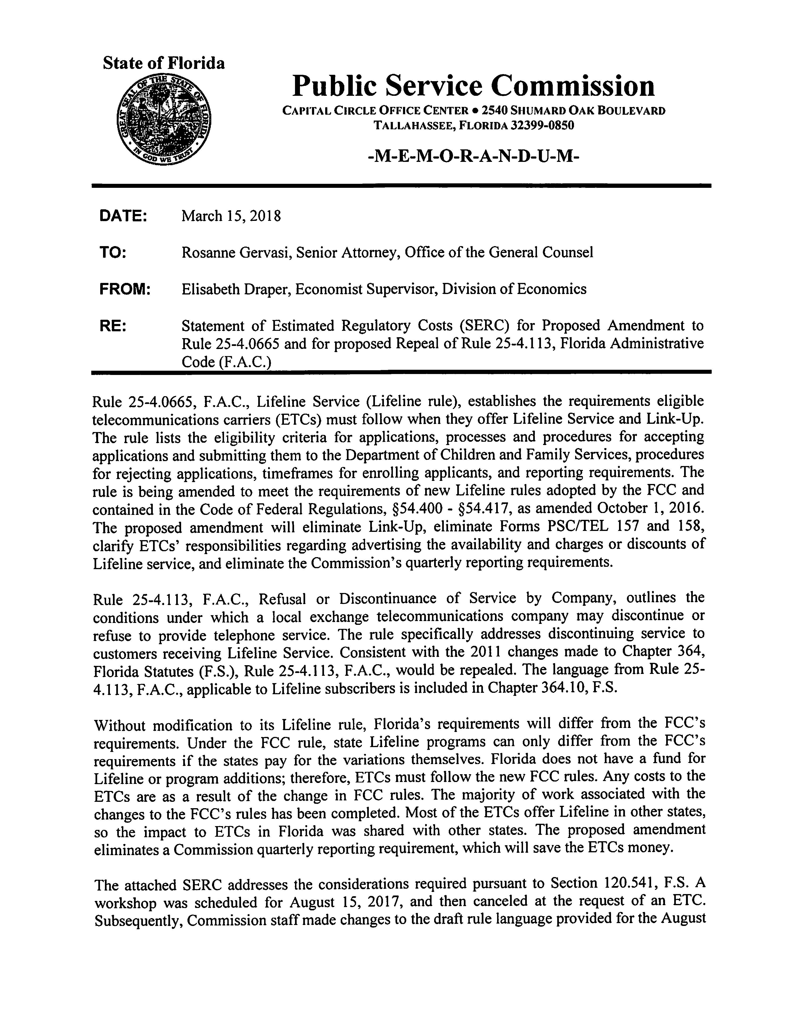

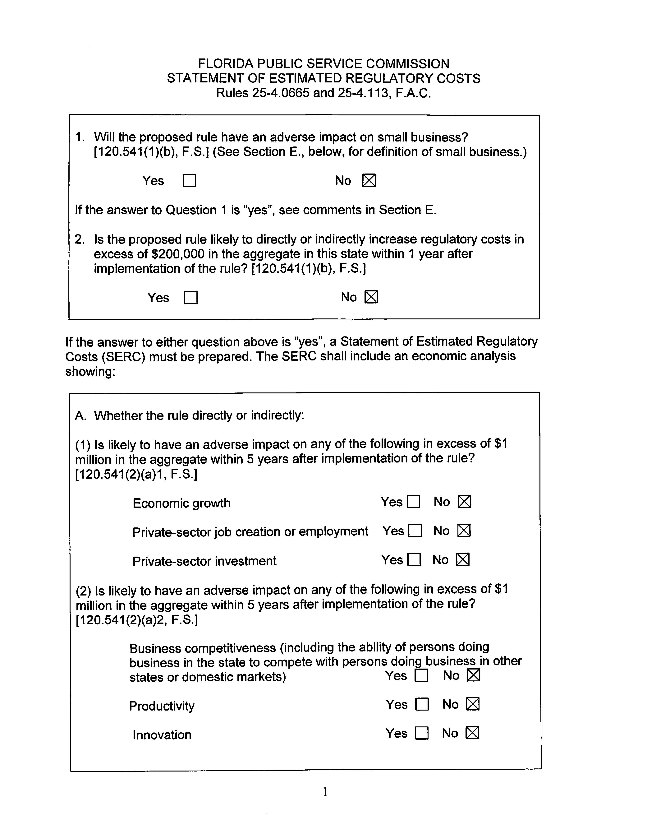

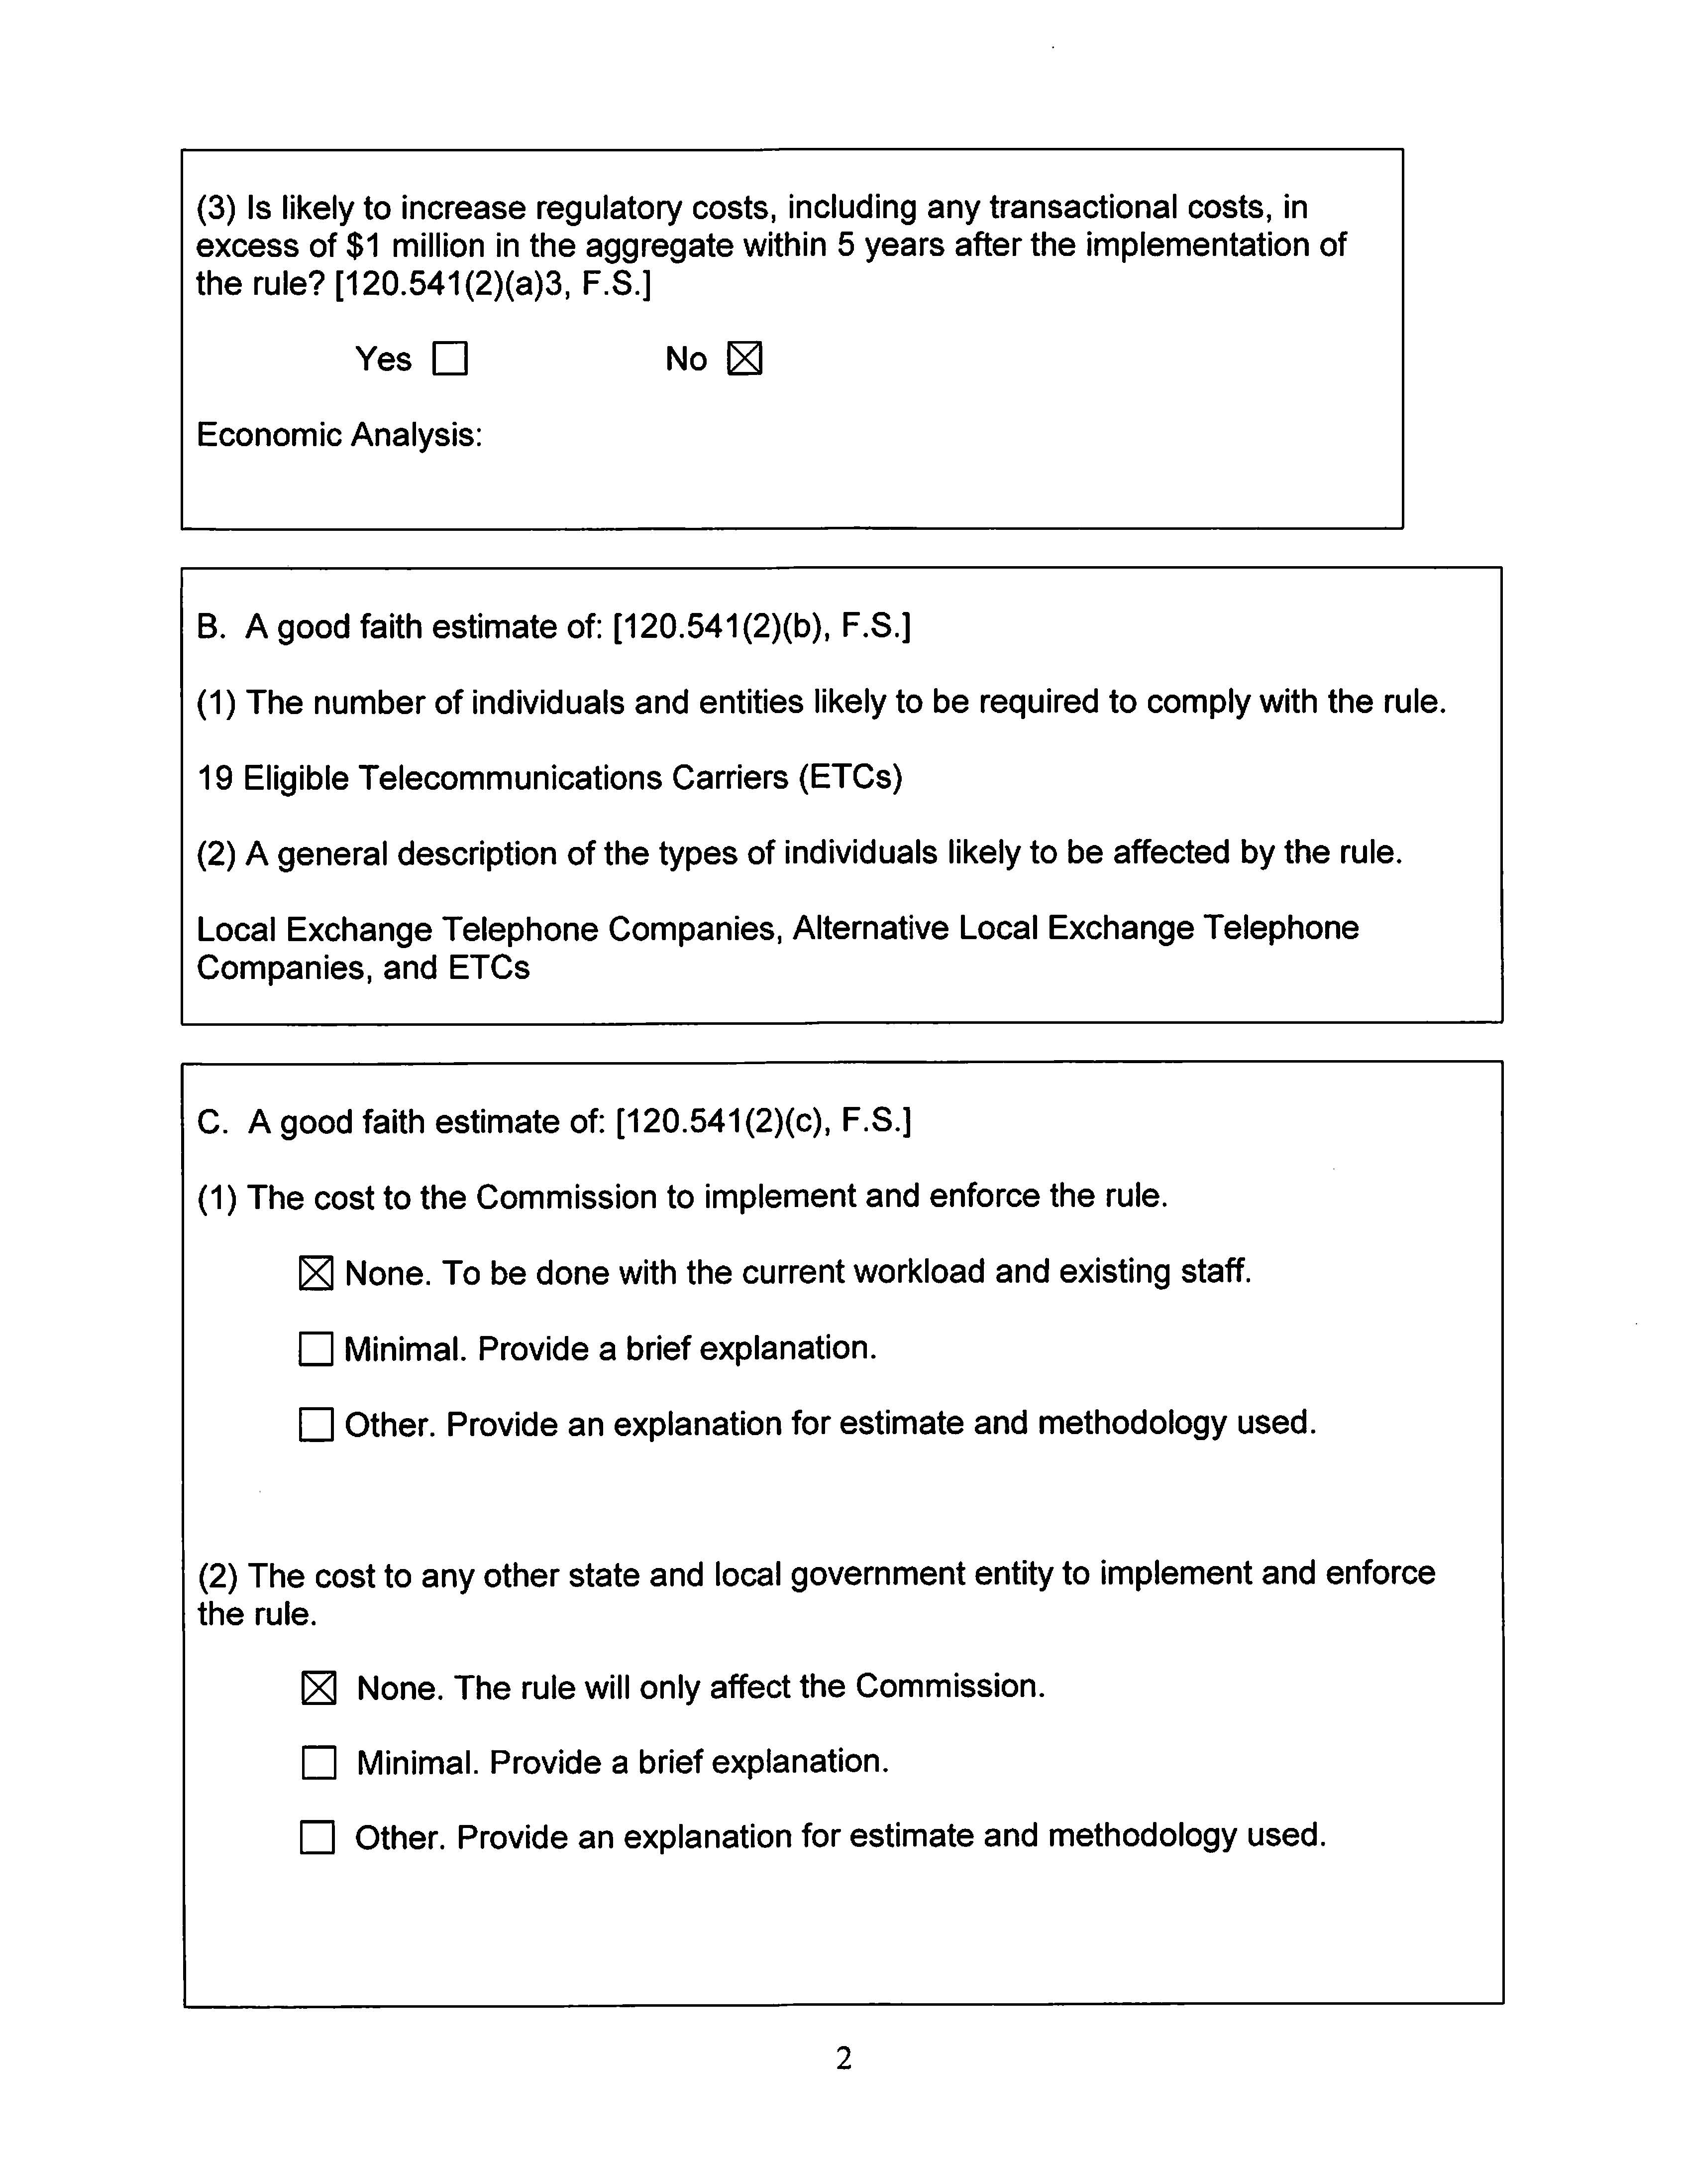

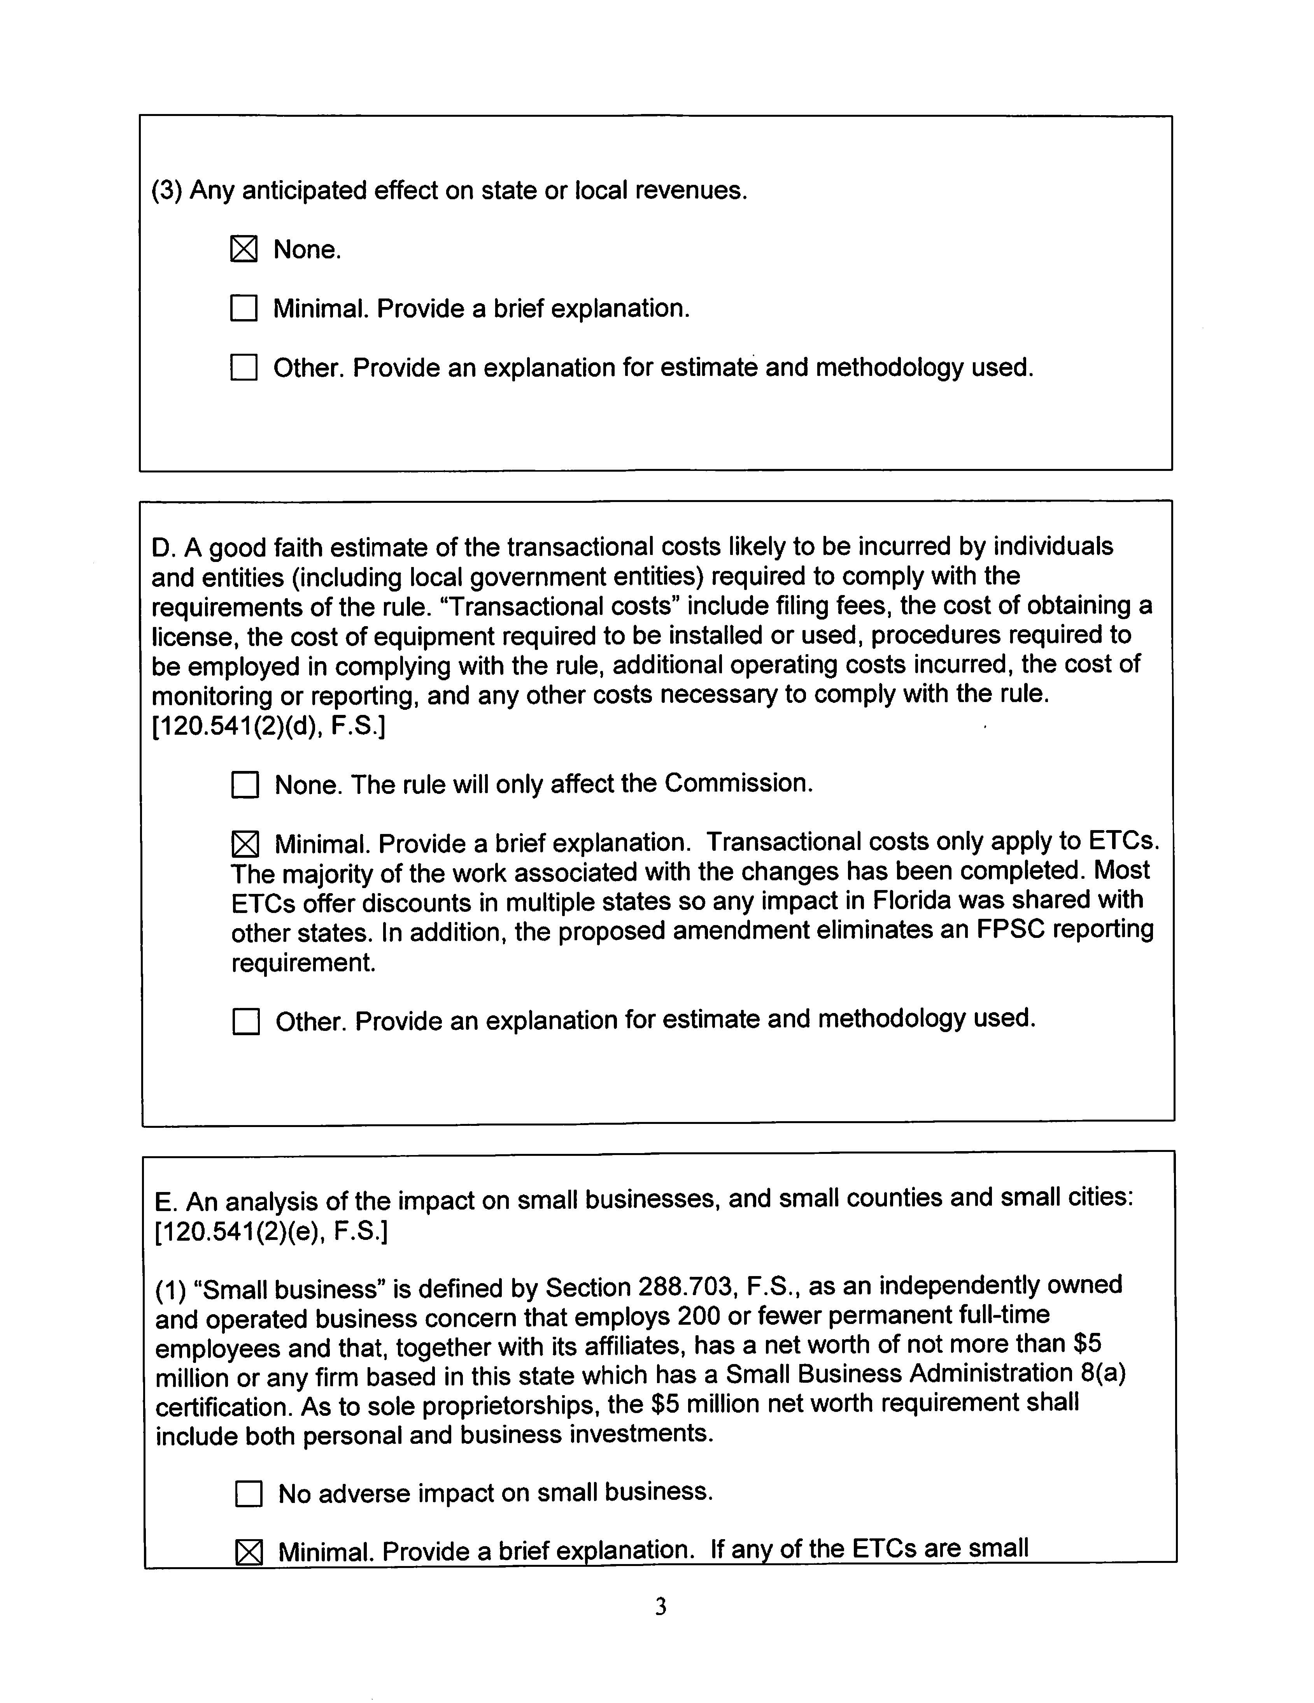

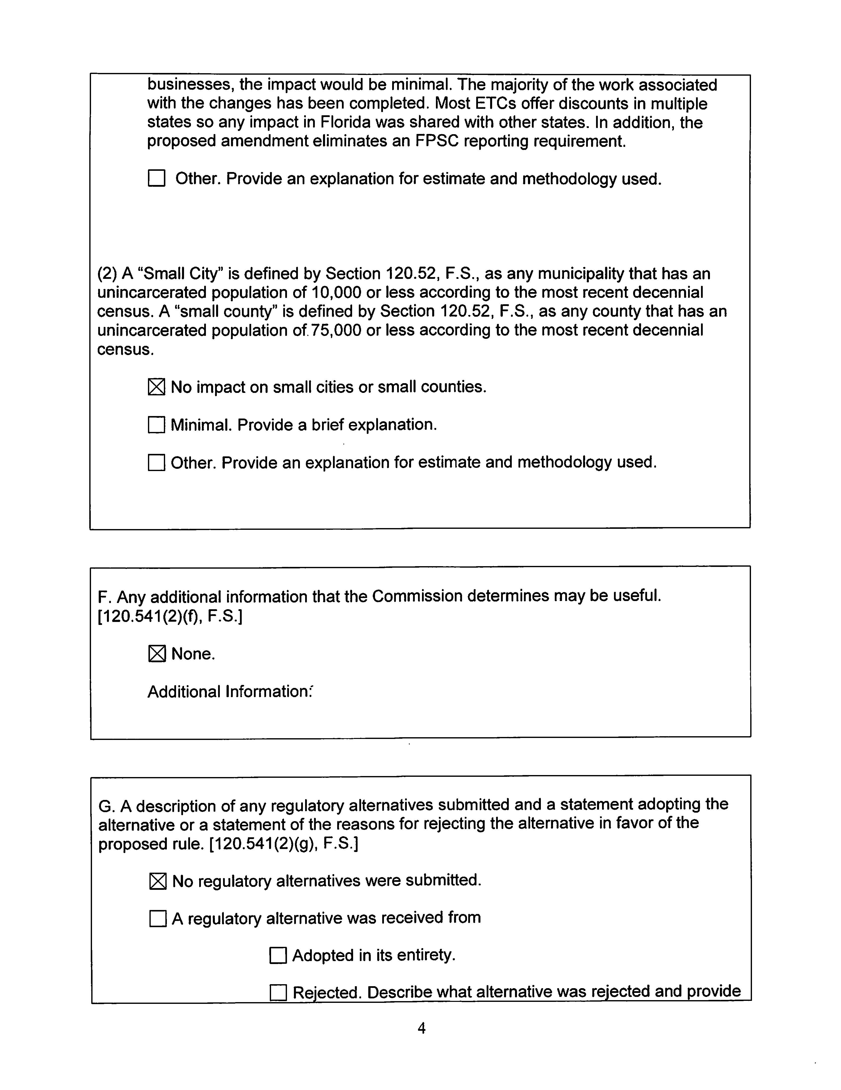

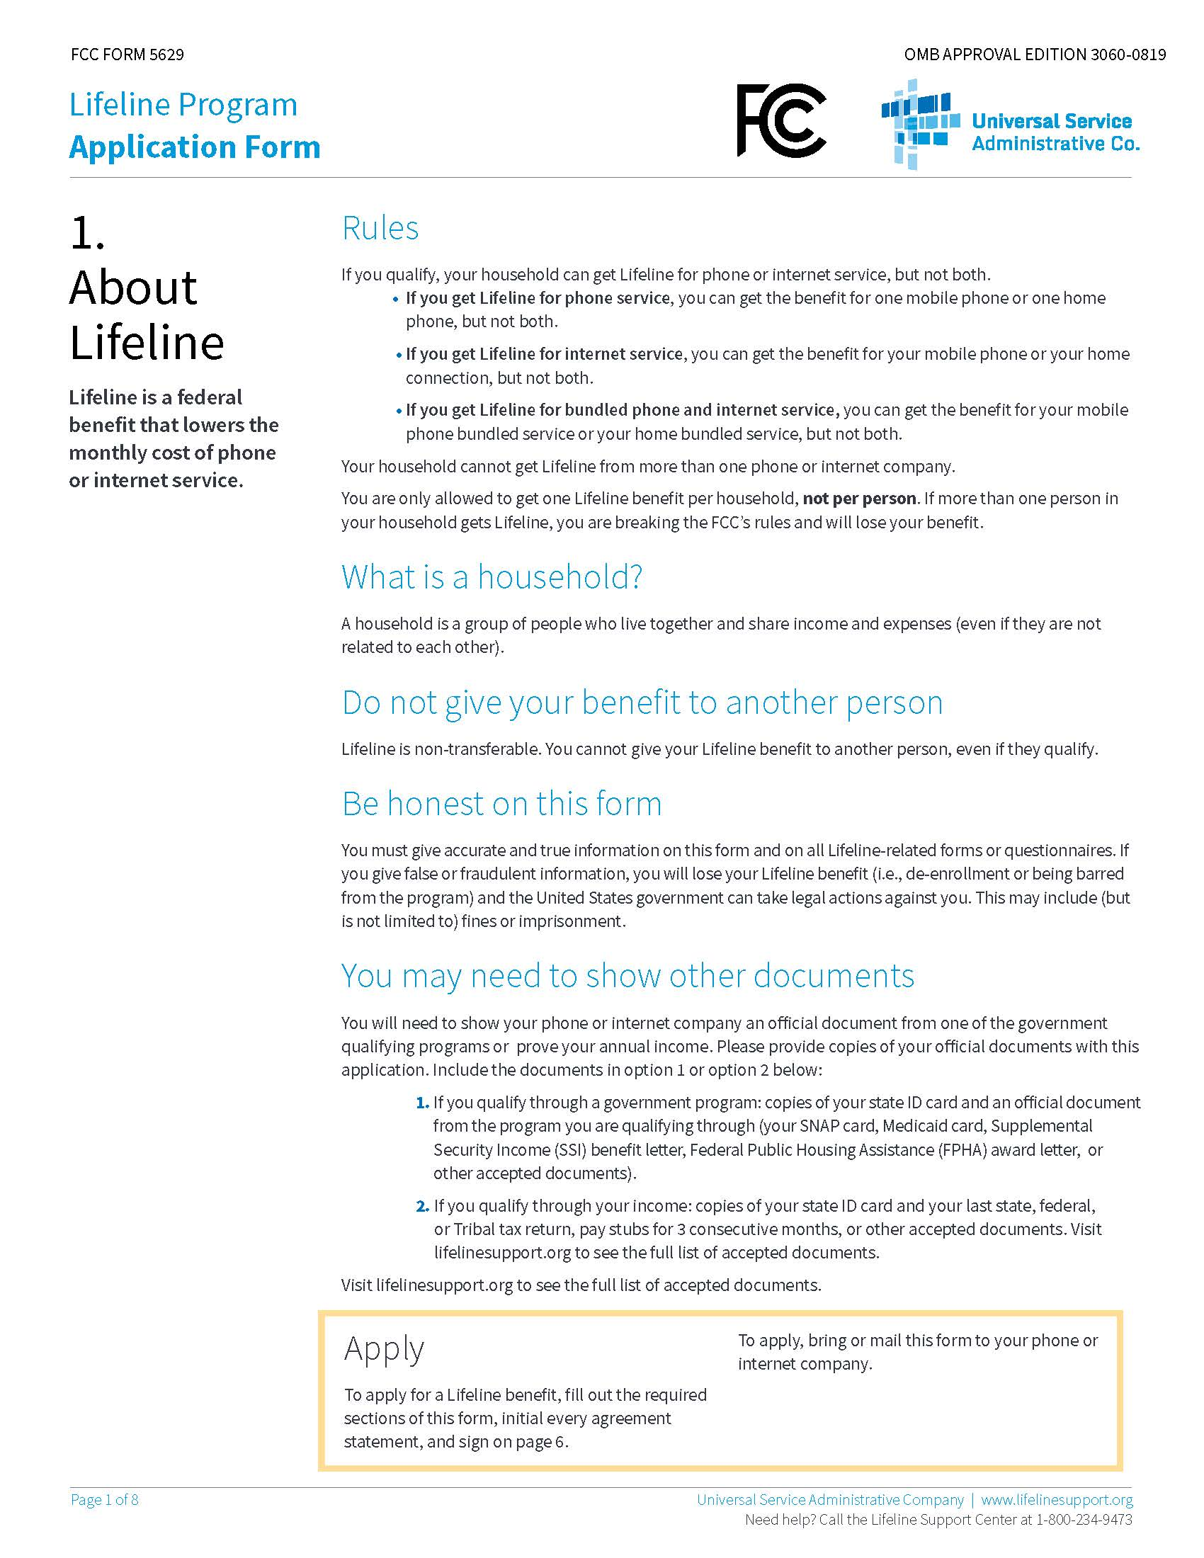
Rule No. 25-4.0665, F.A.C.
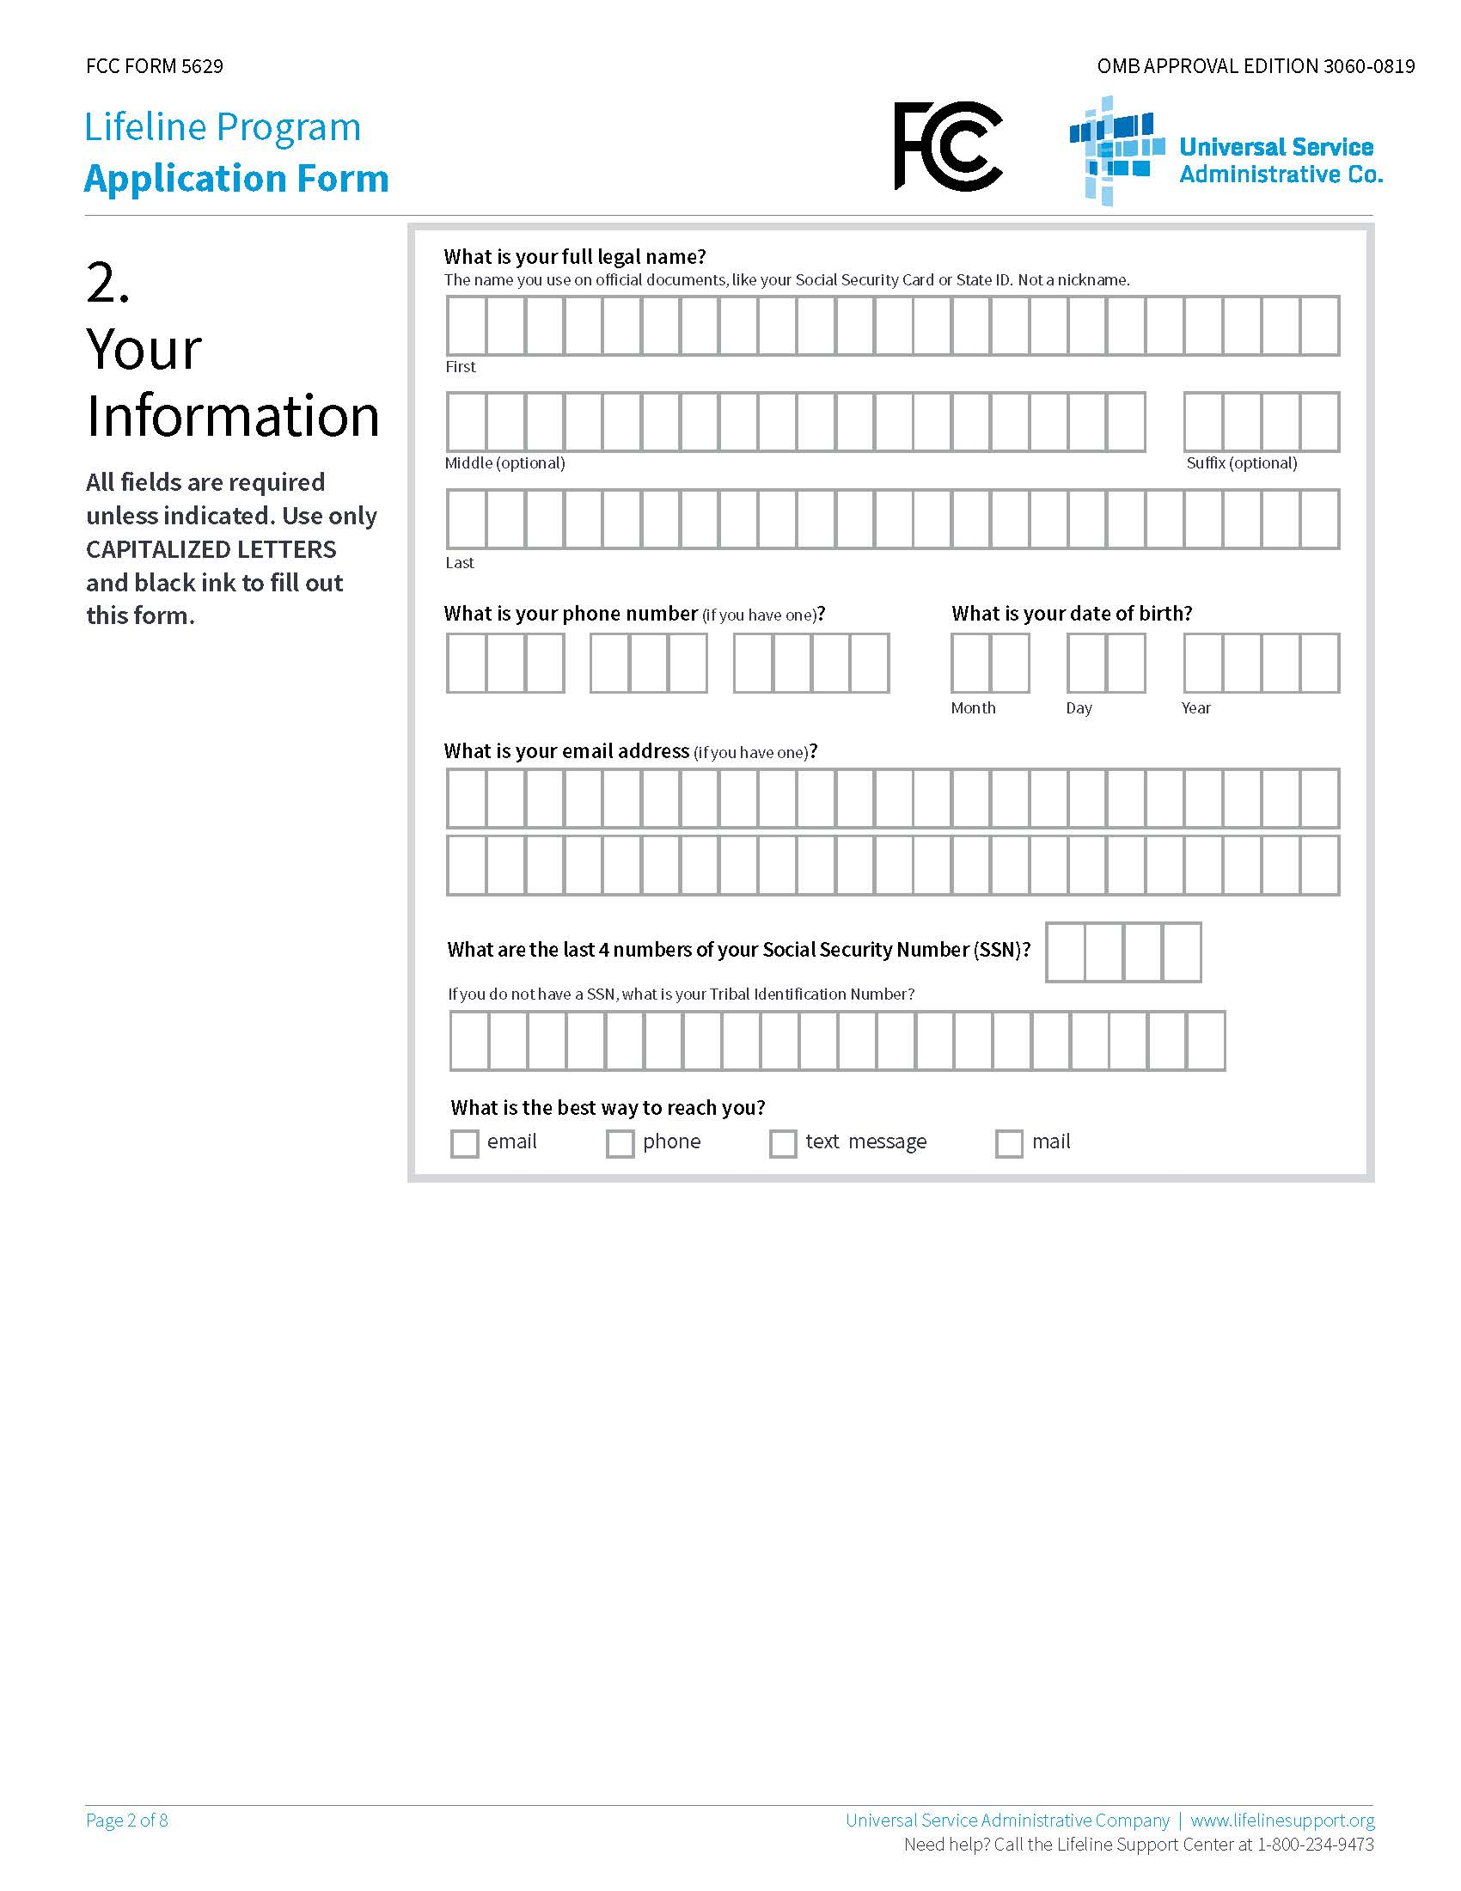

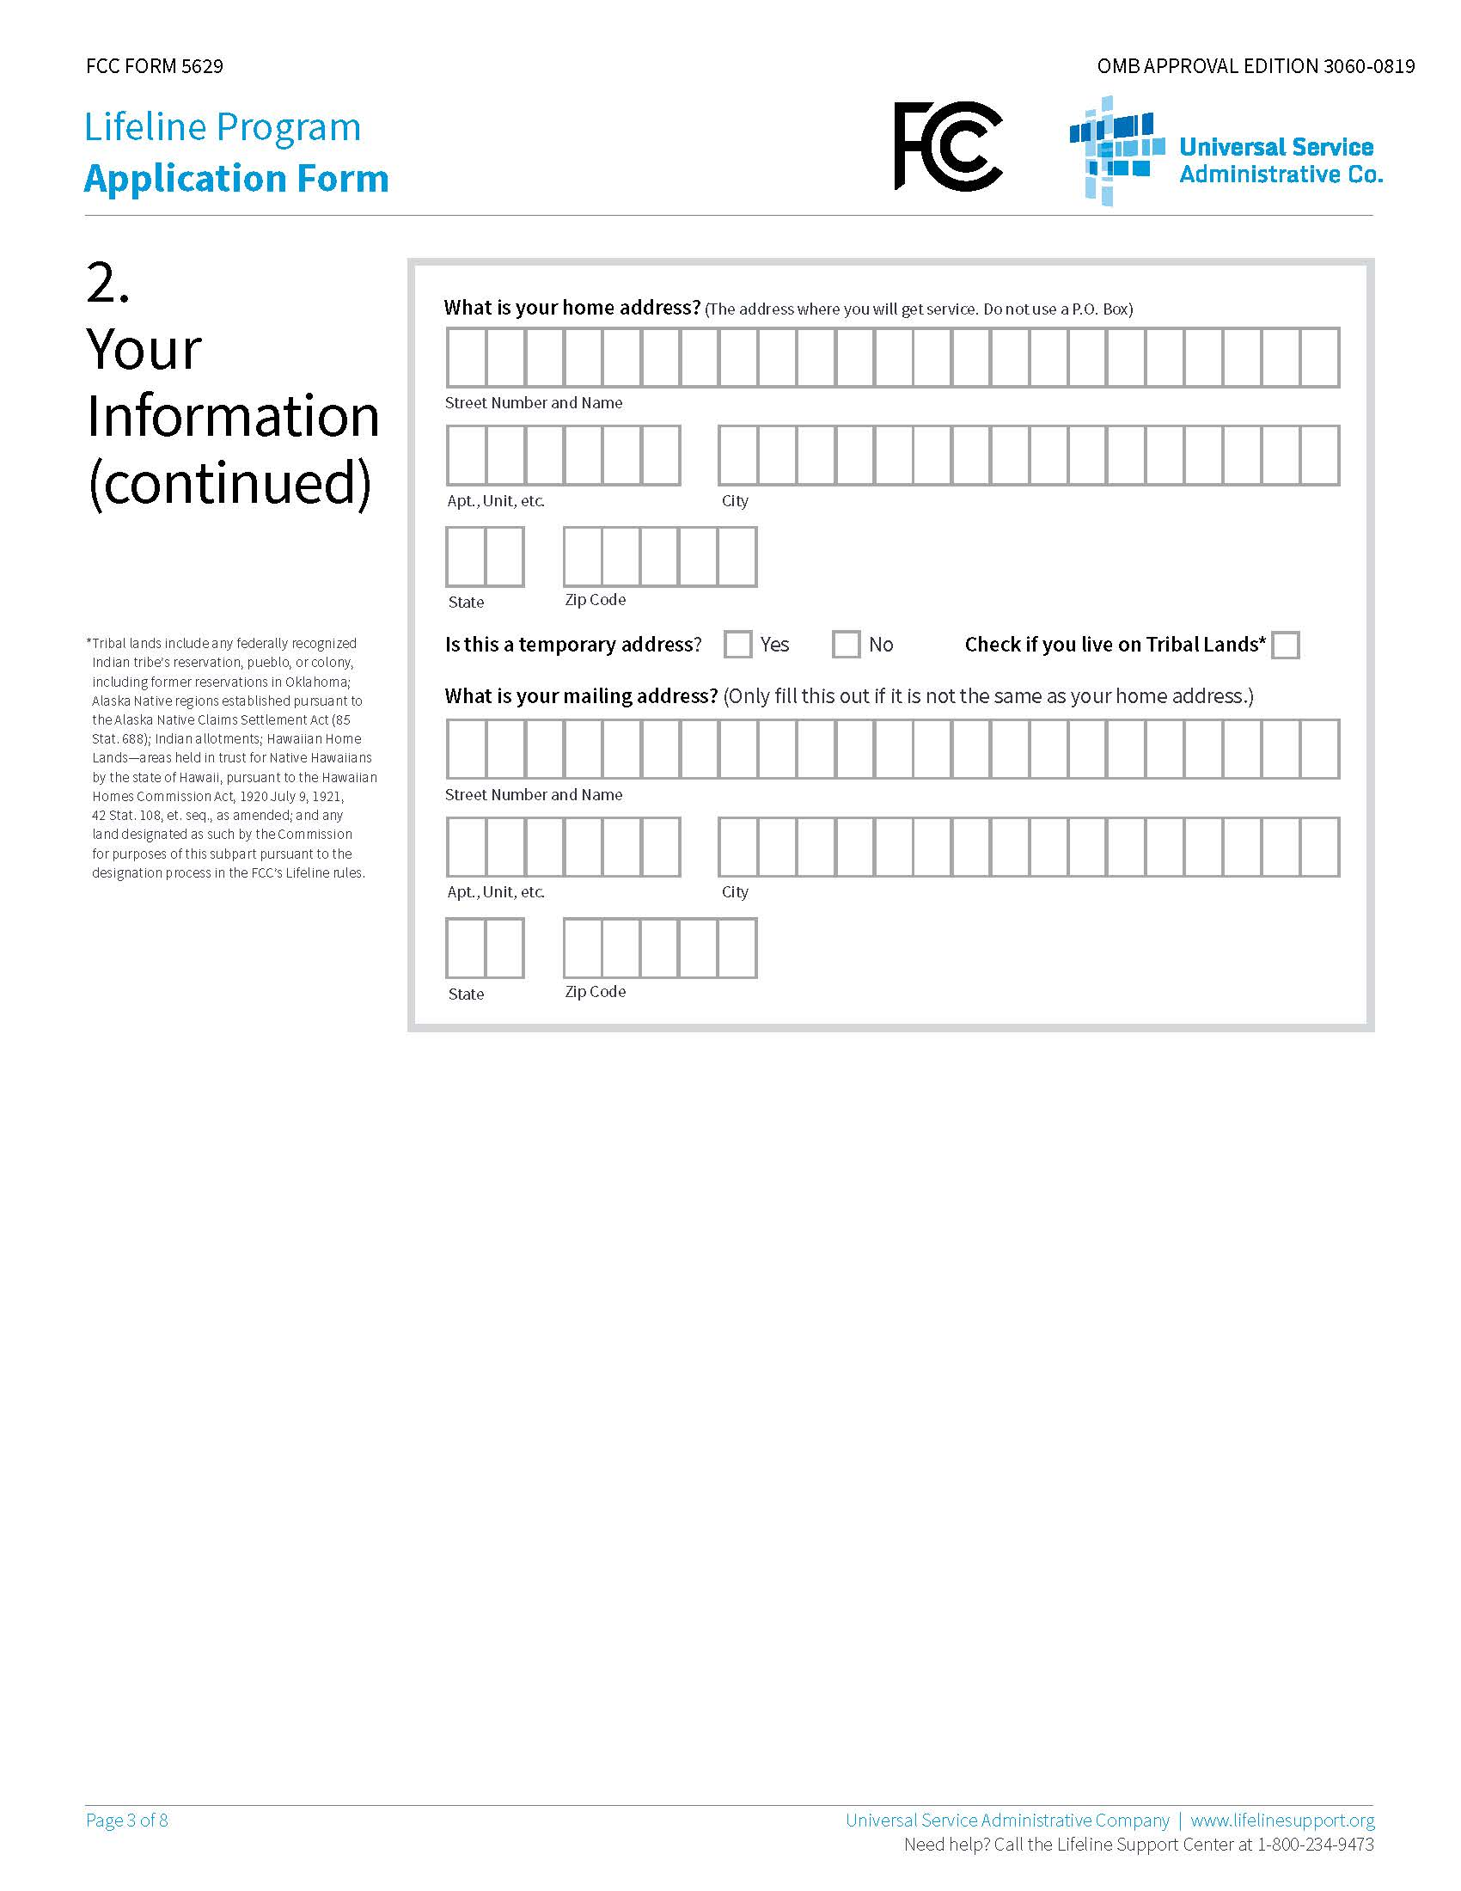

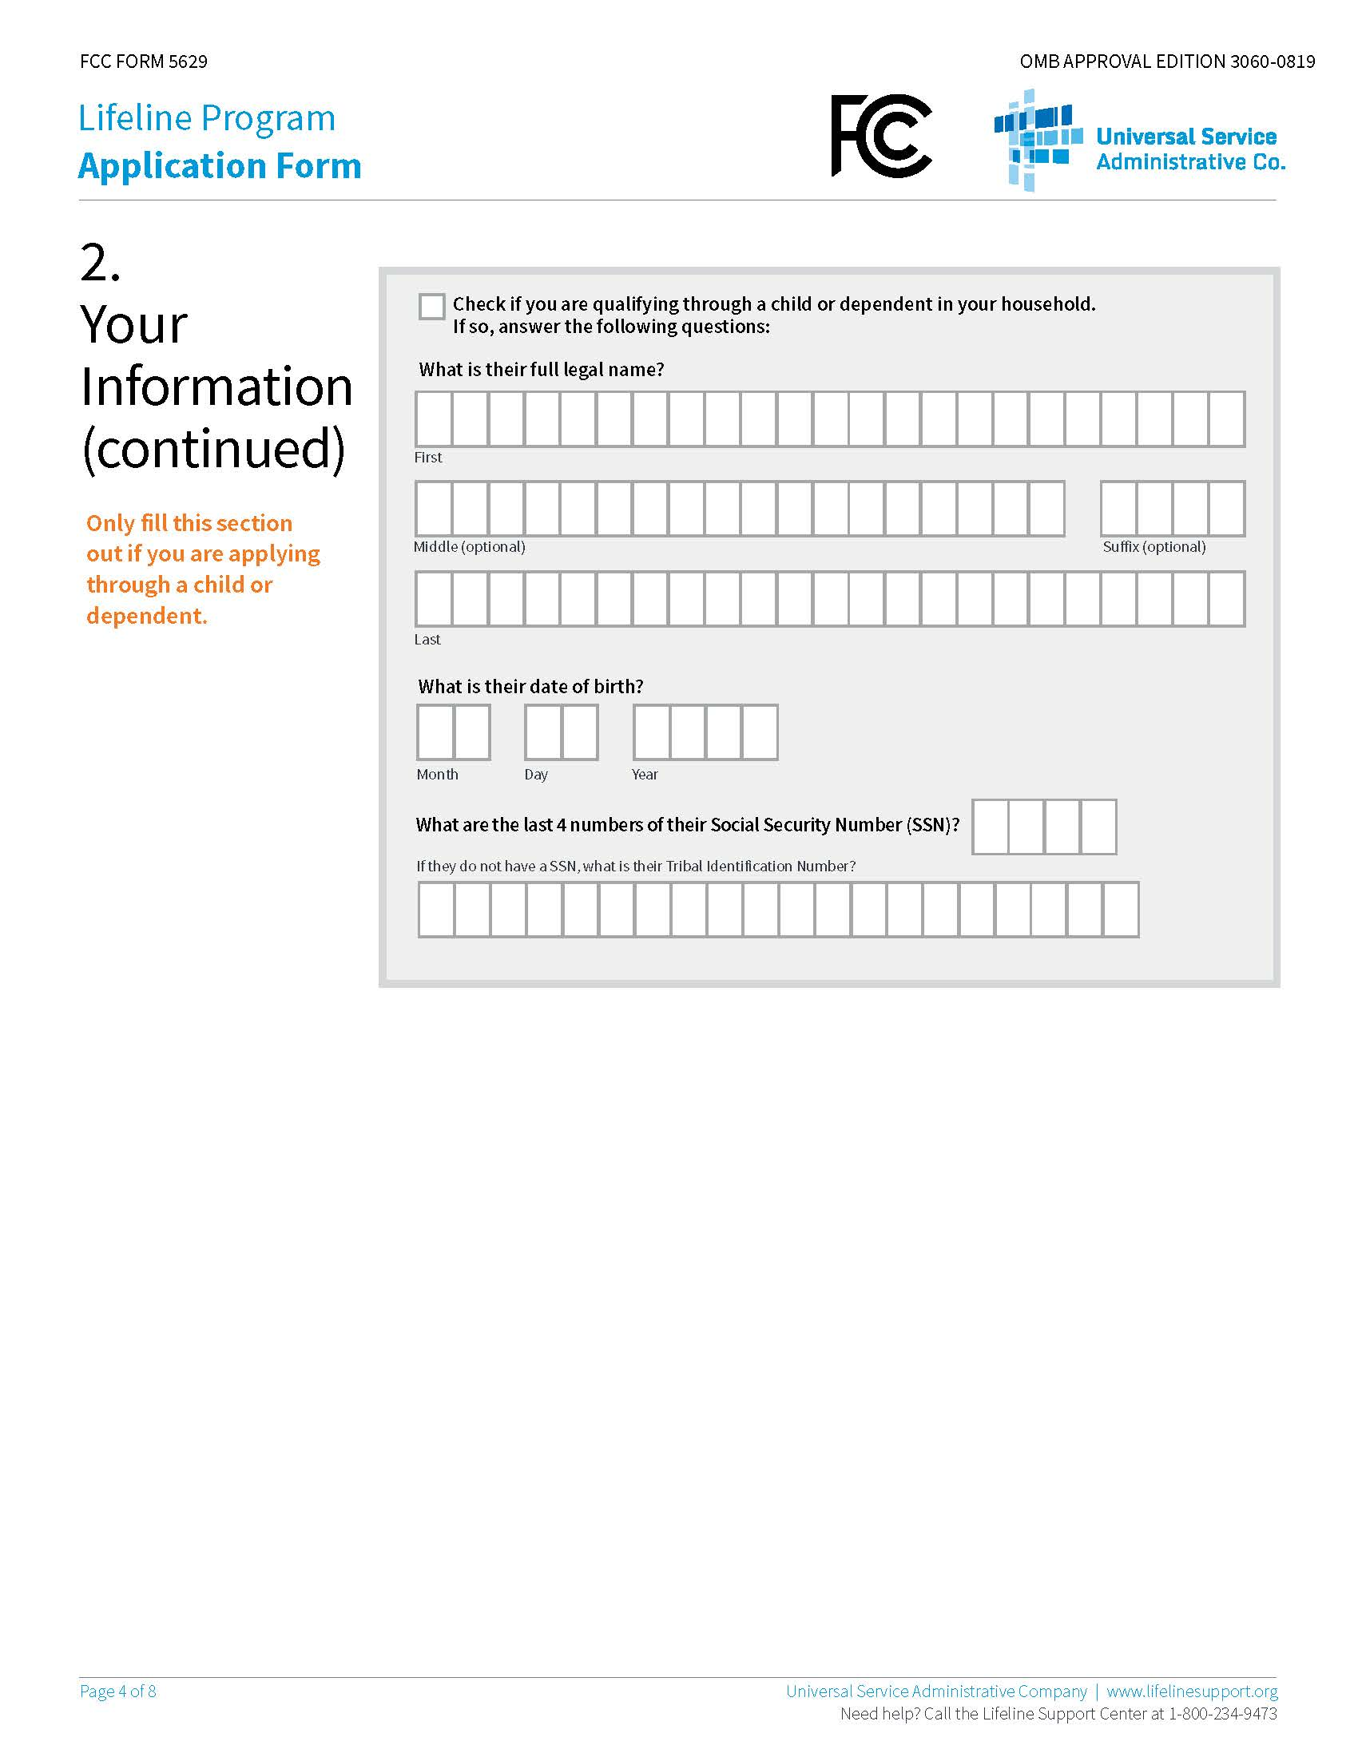

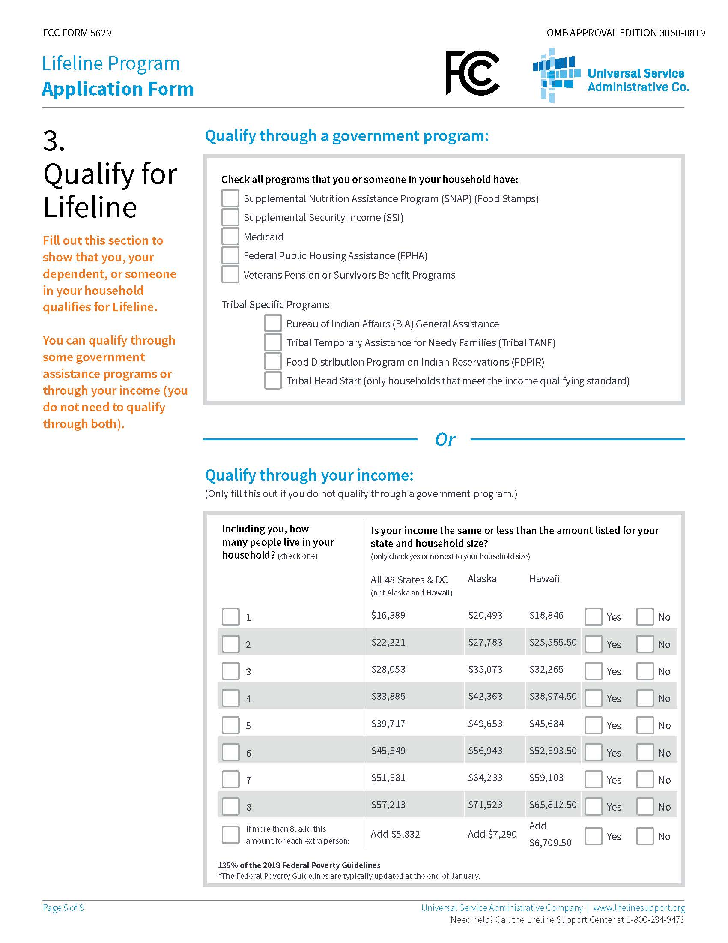

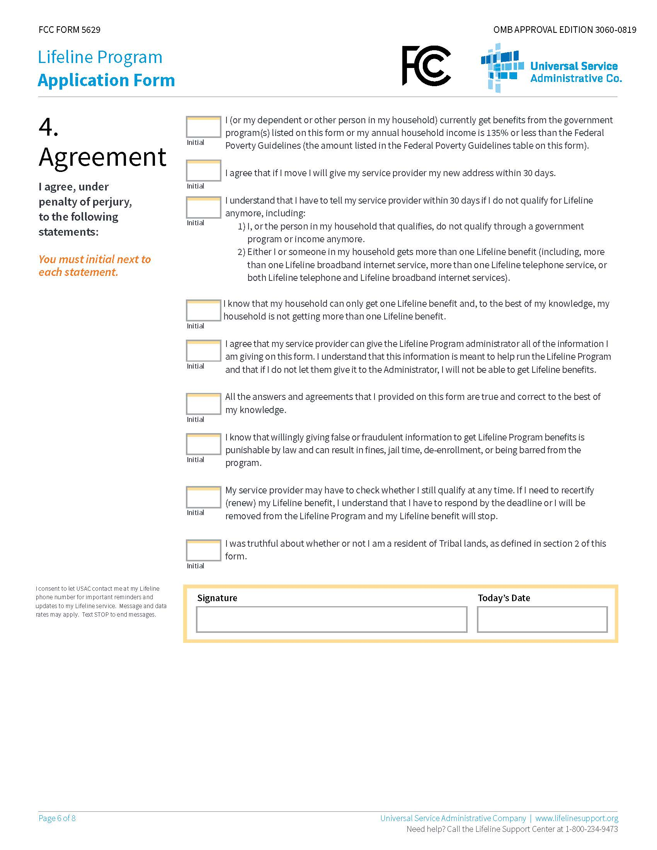

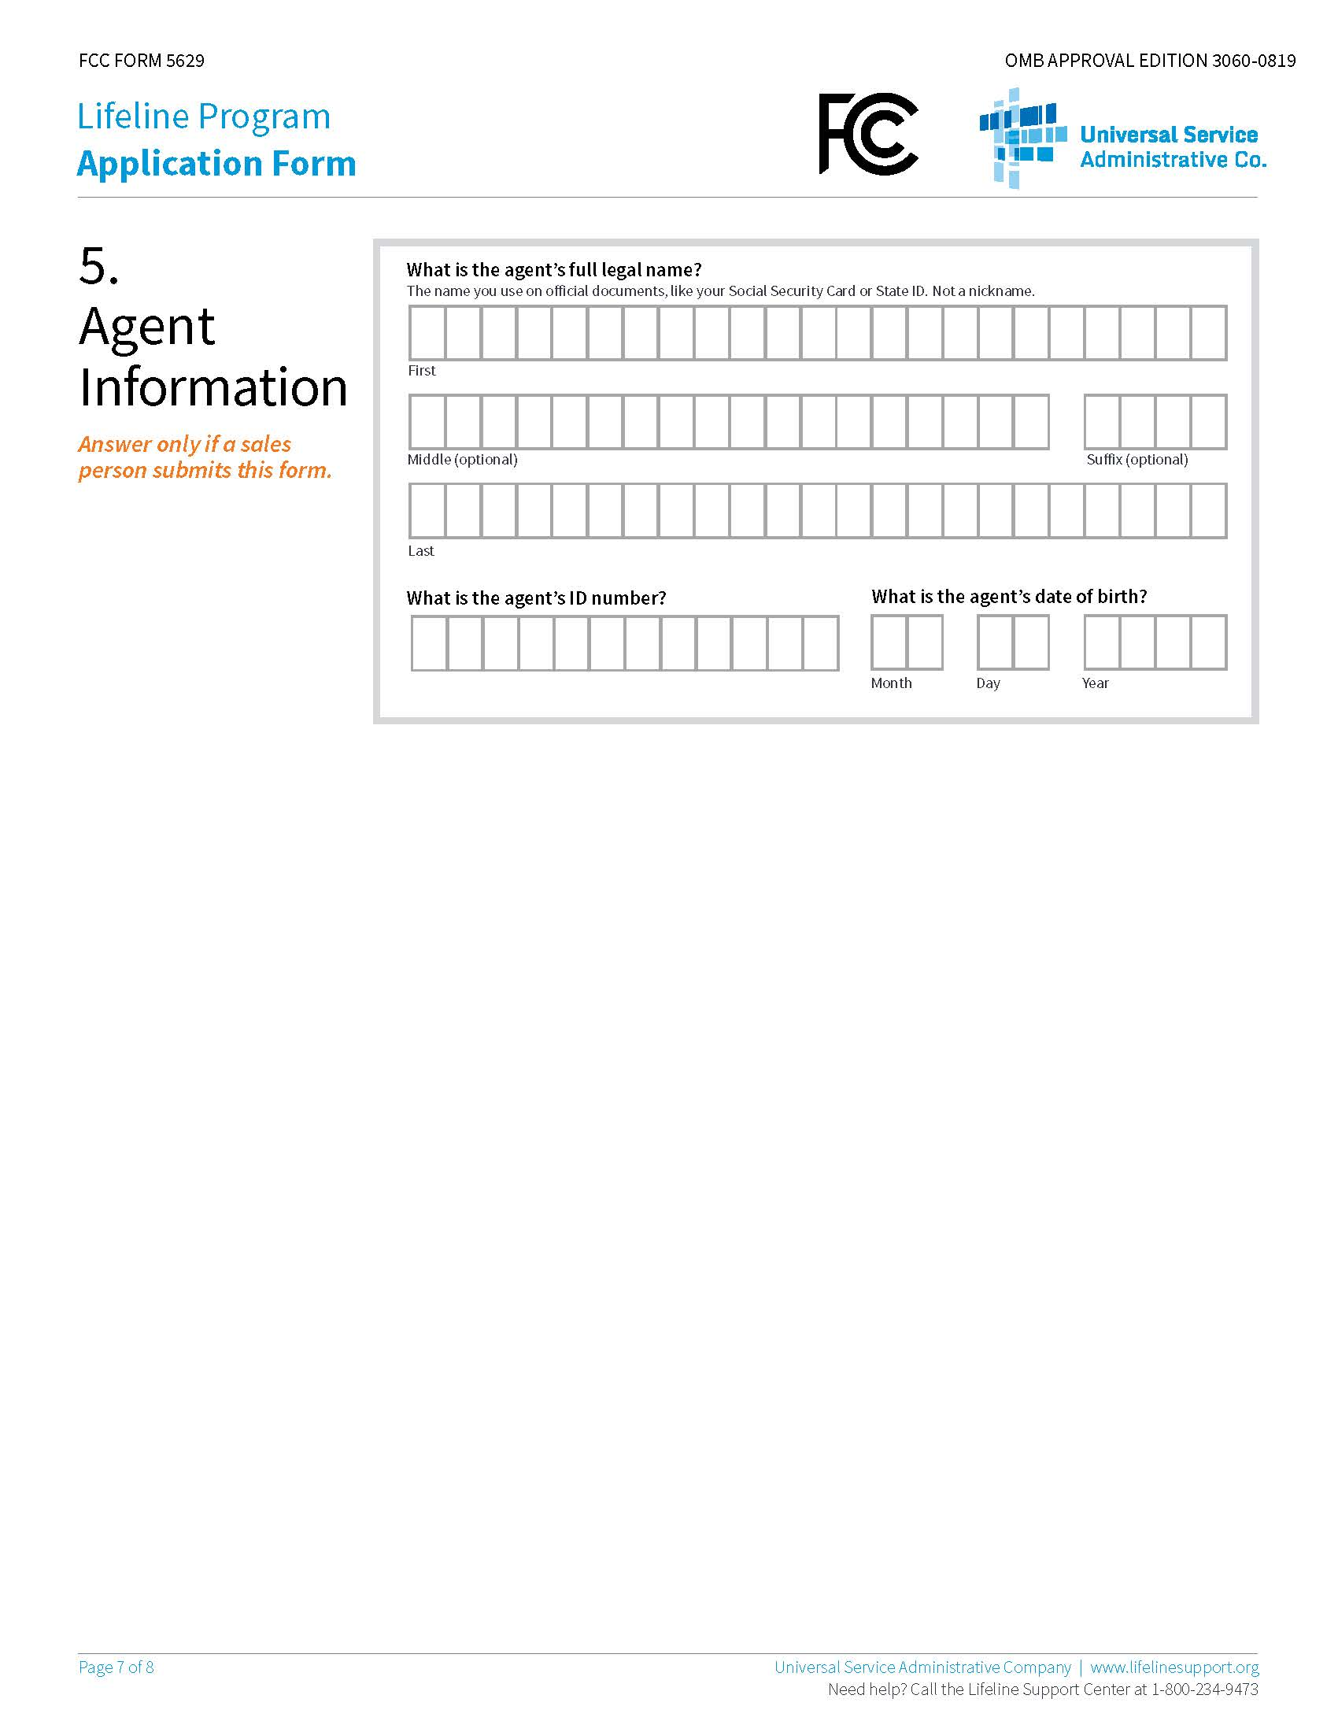

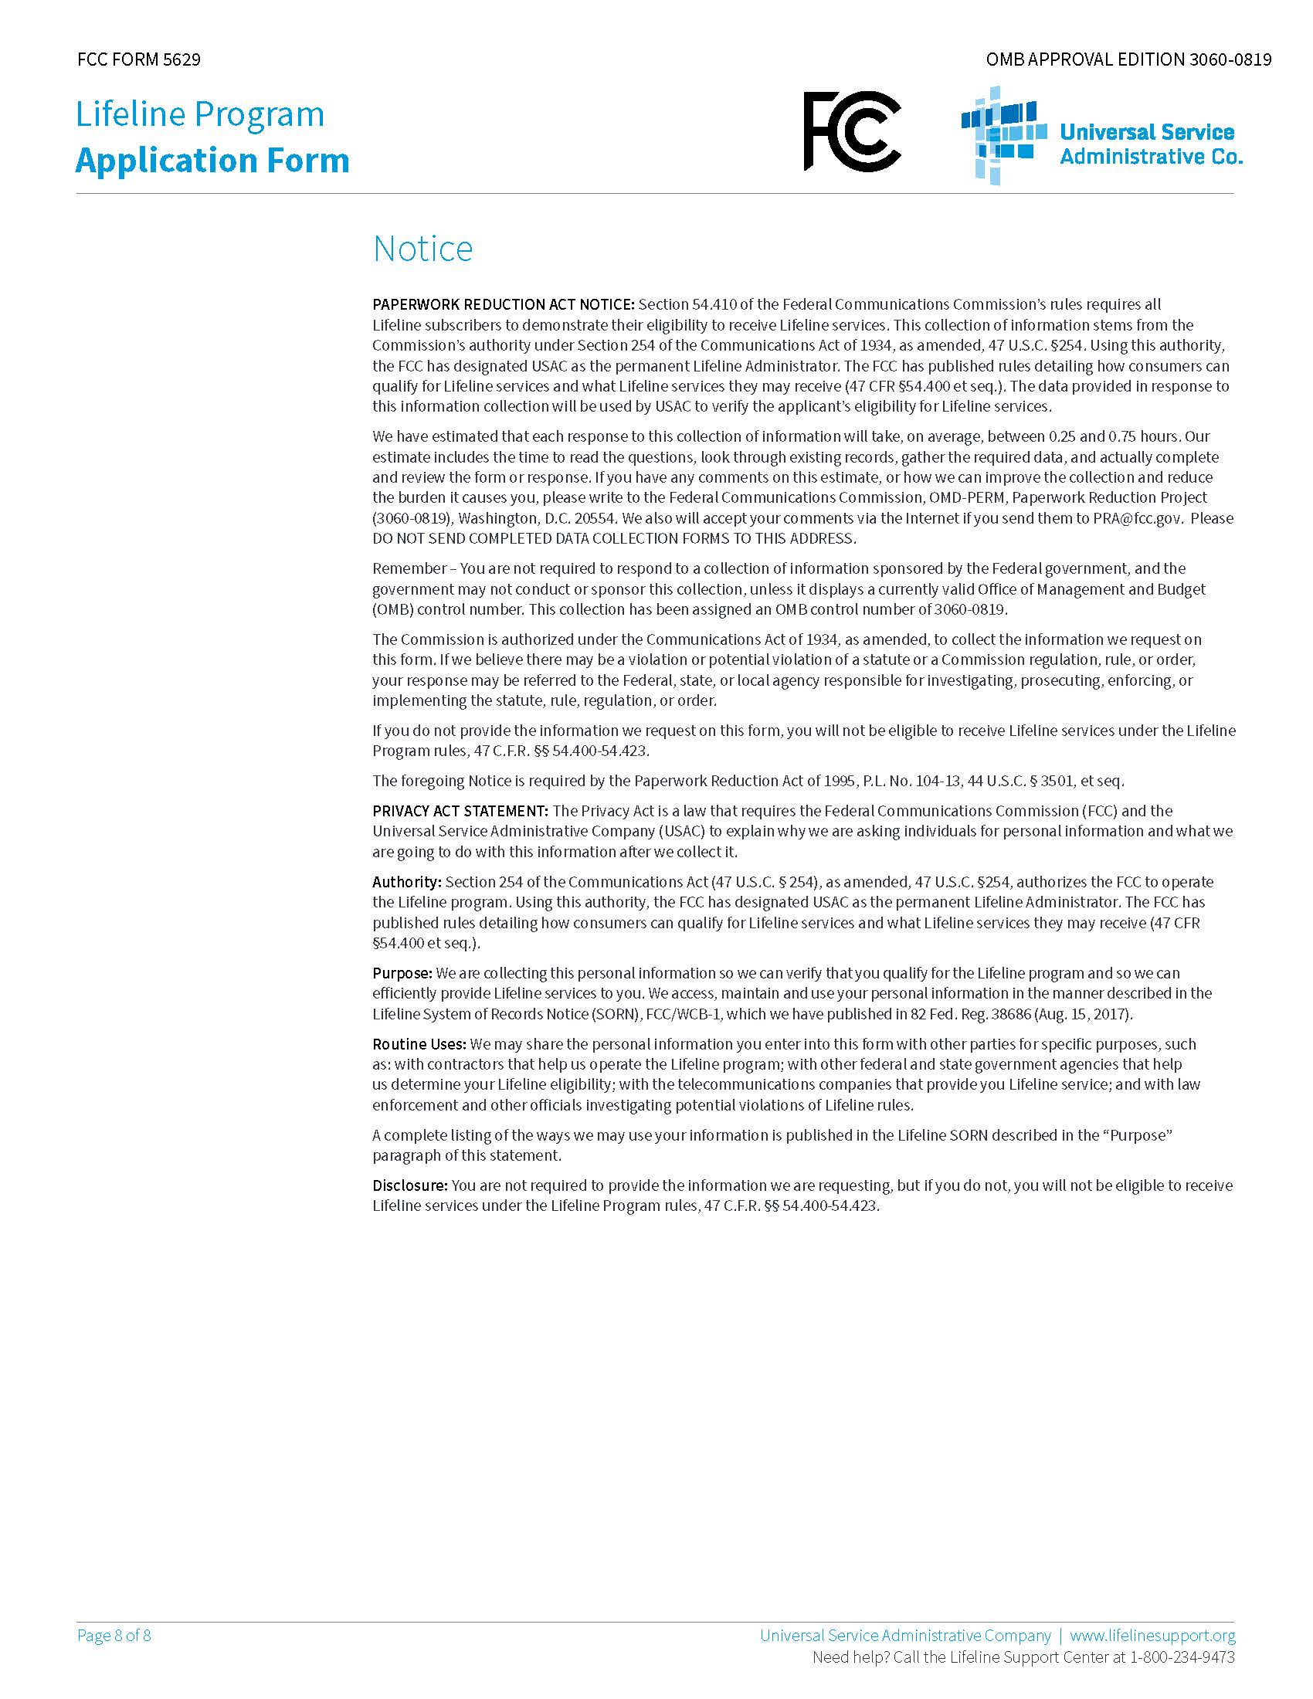

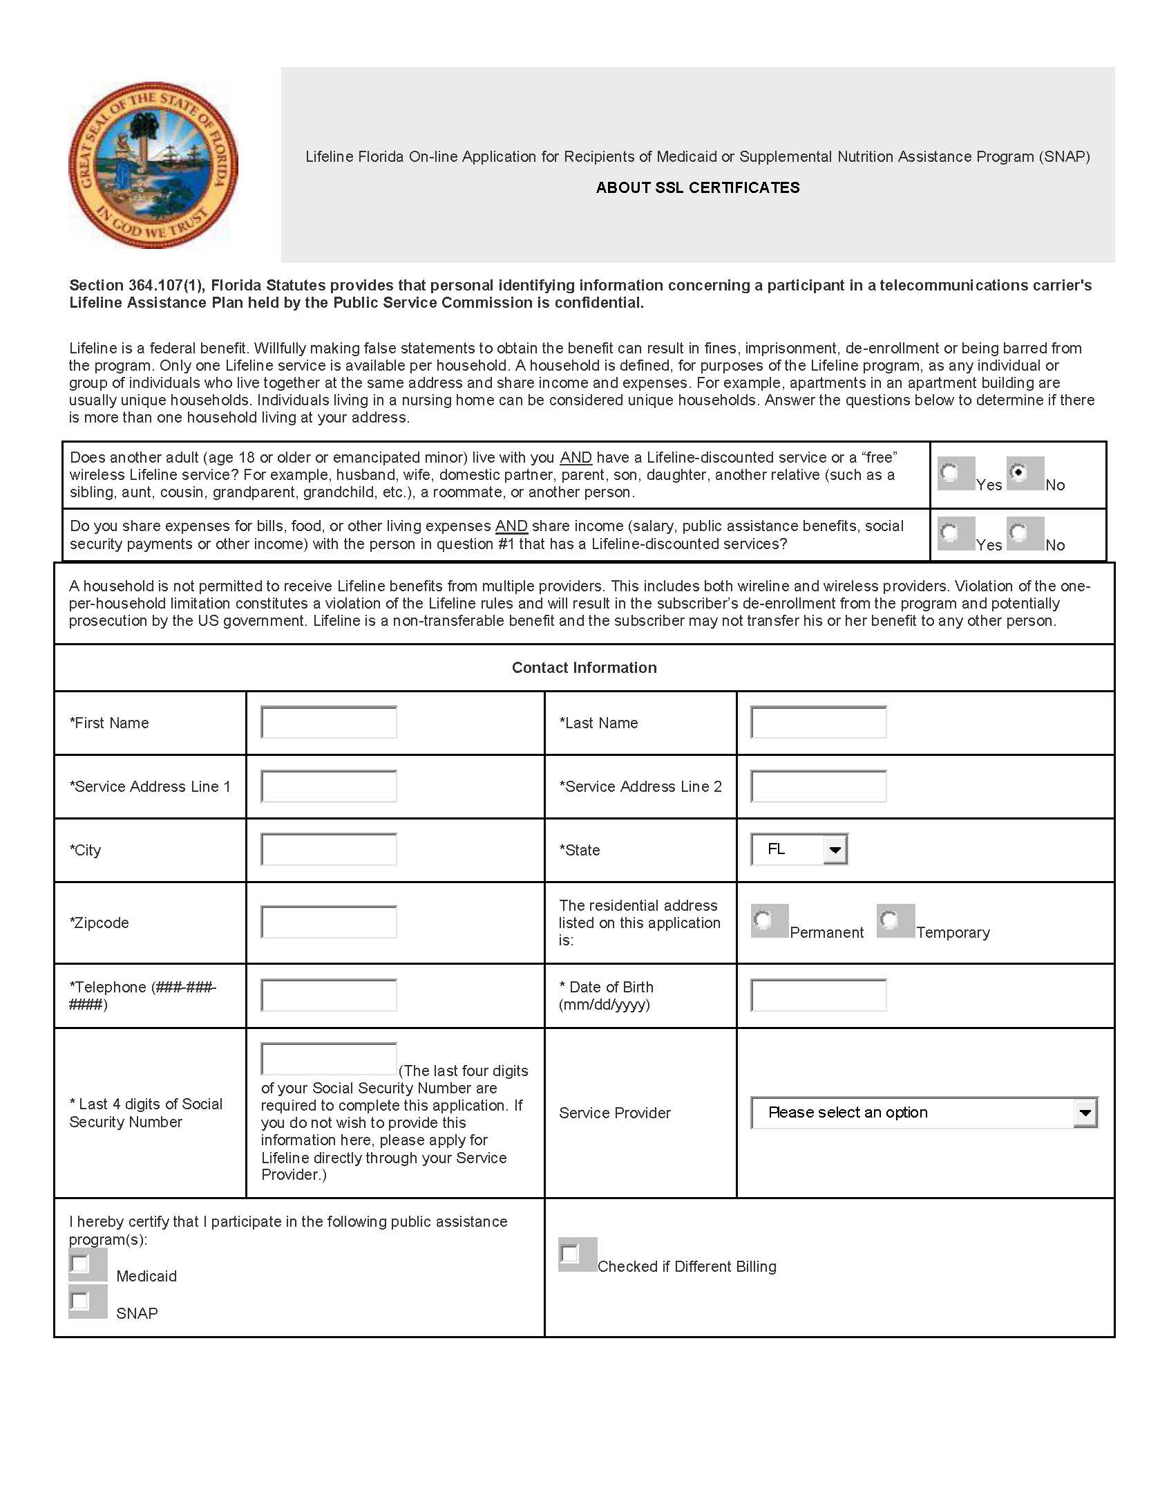
PSC 1023 (08/18)
Rule No. 25-4.0665, F.A.C.

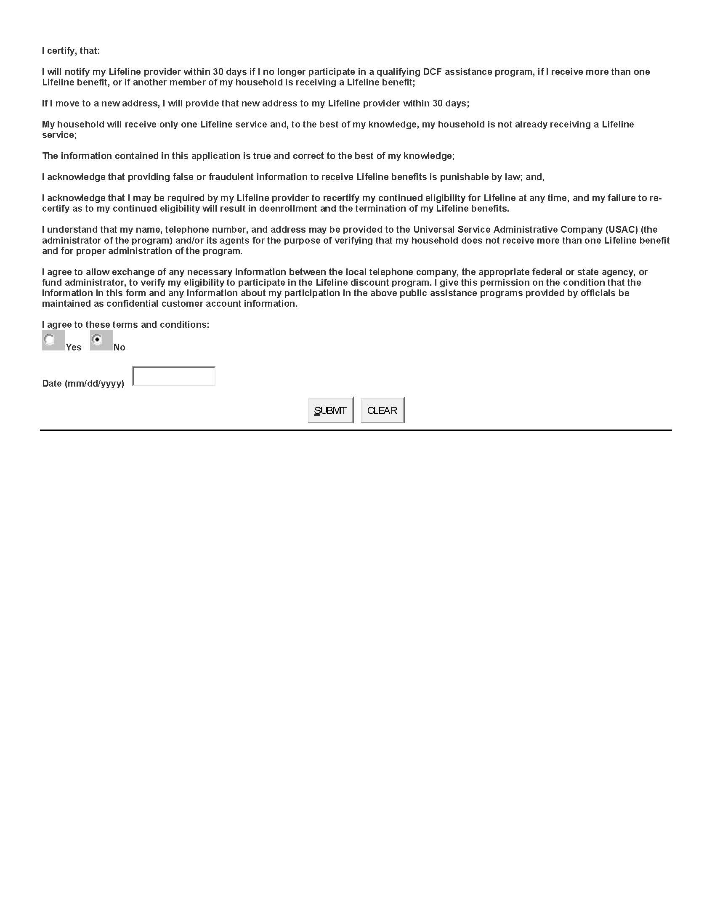

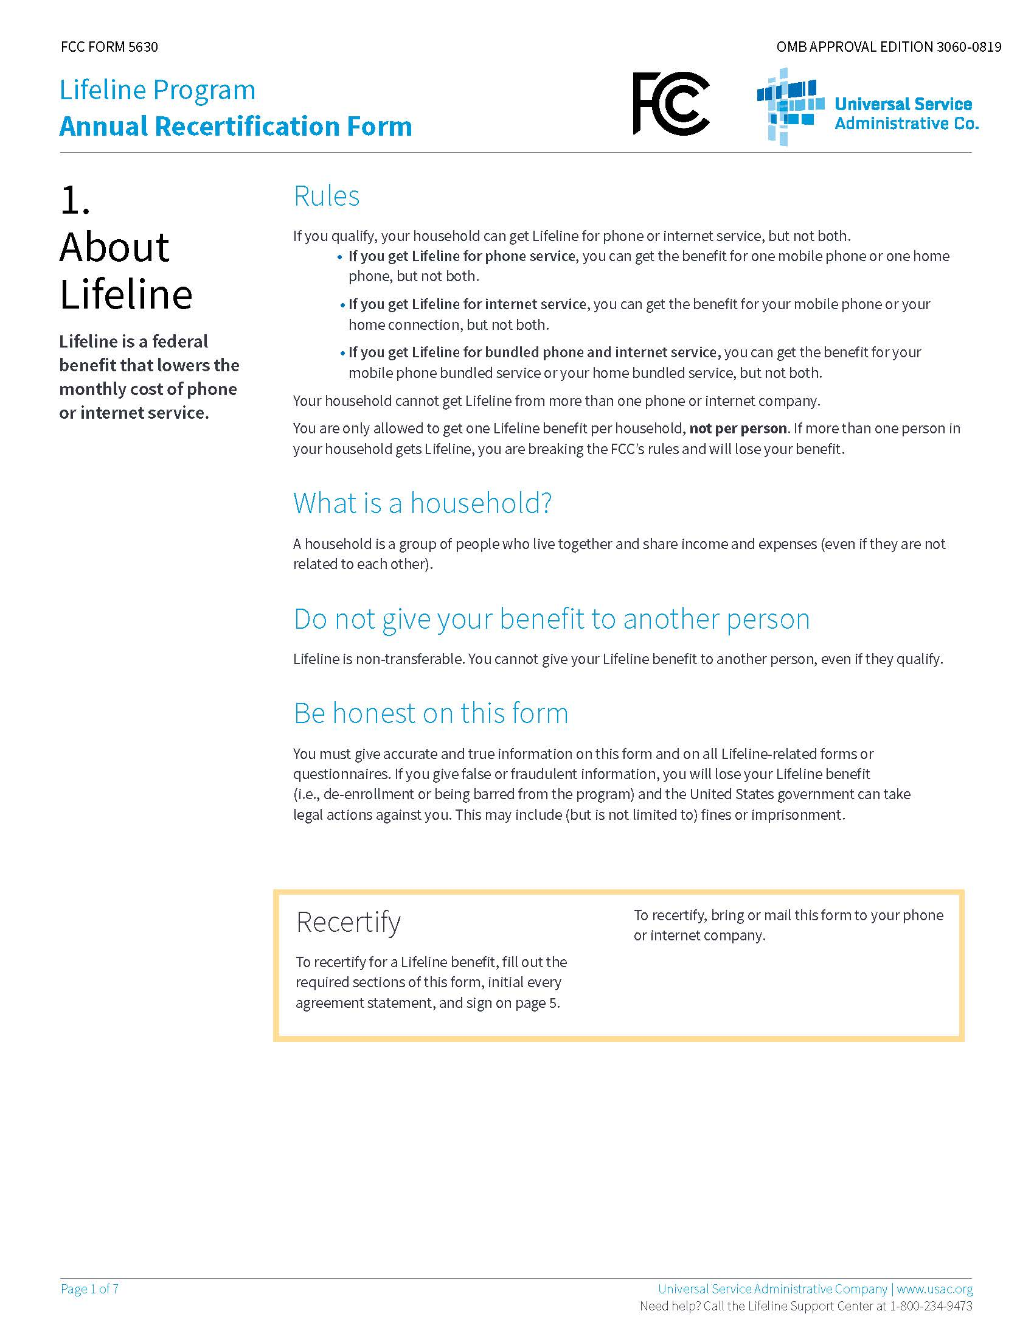
Rule No. 25-4.0665, F.A.C.

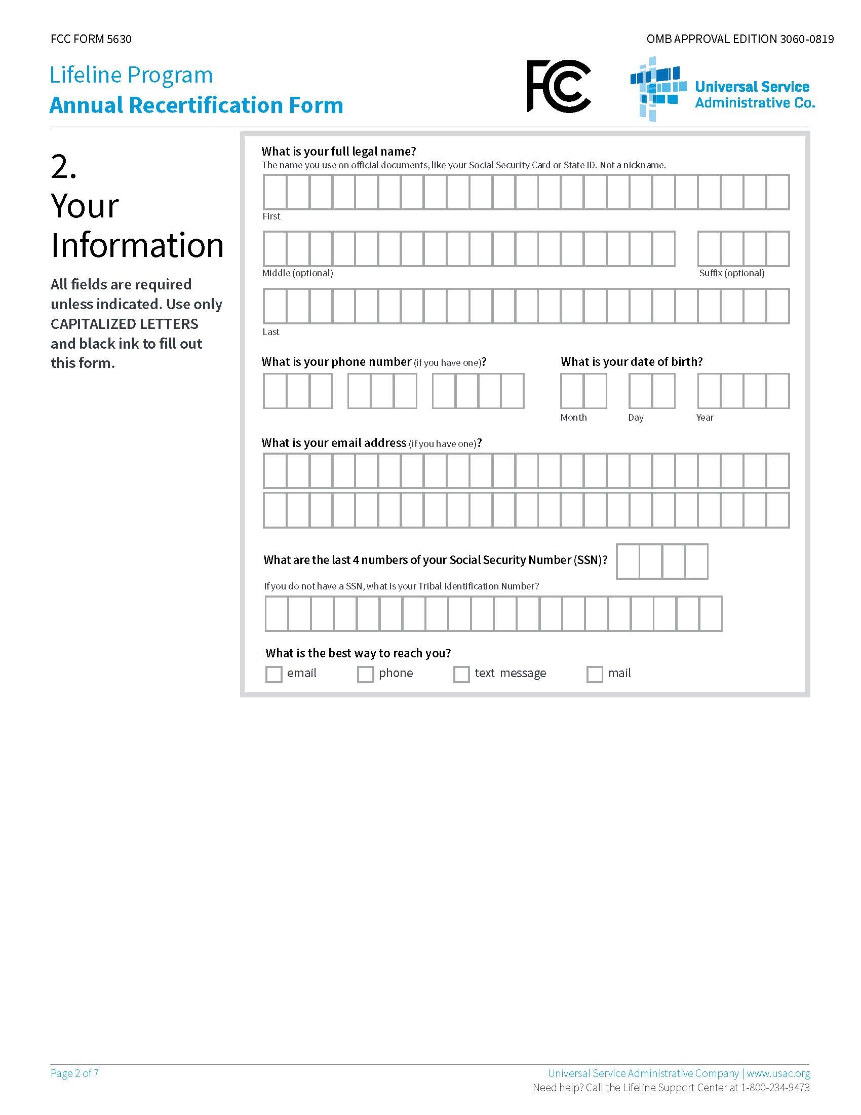

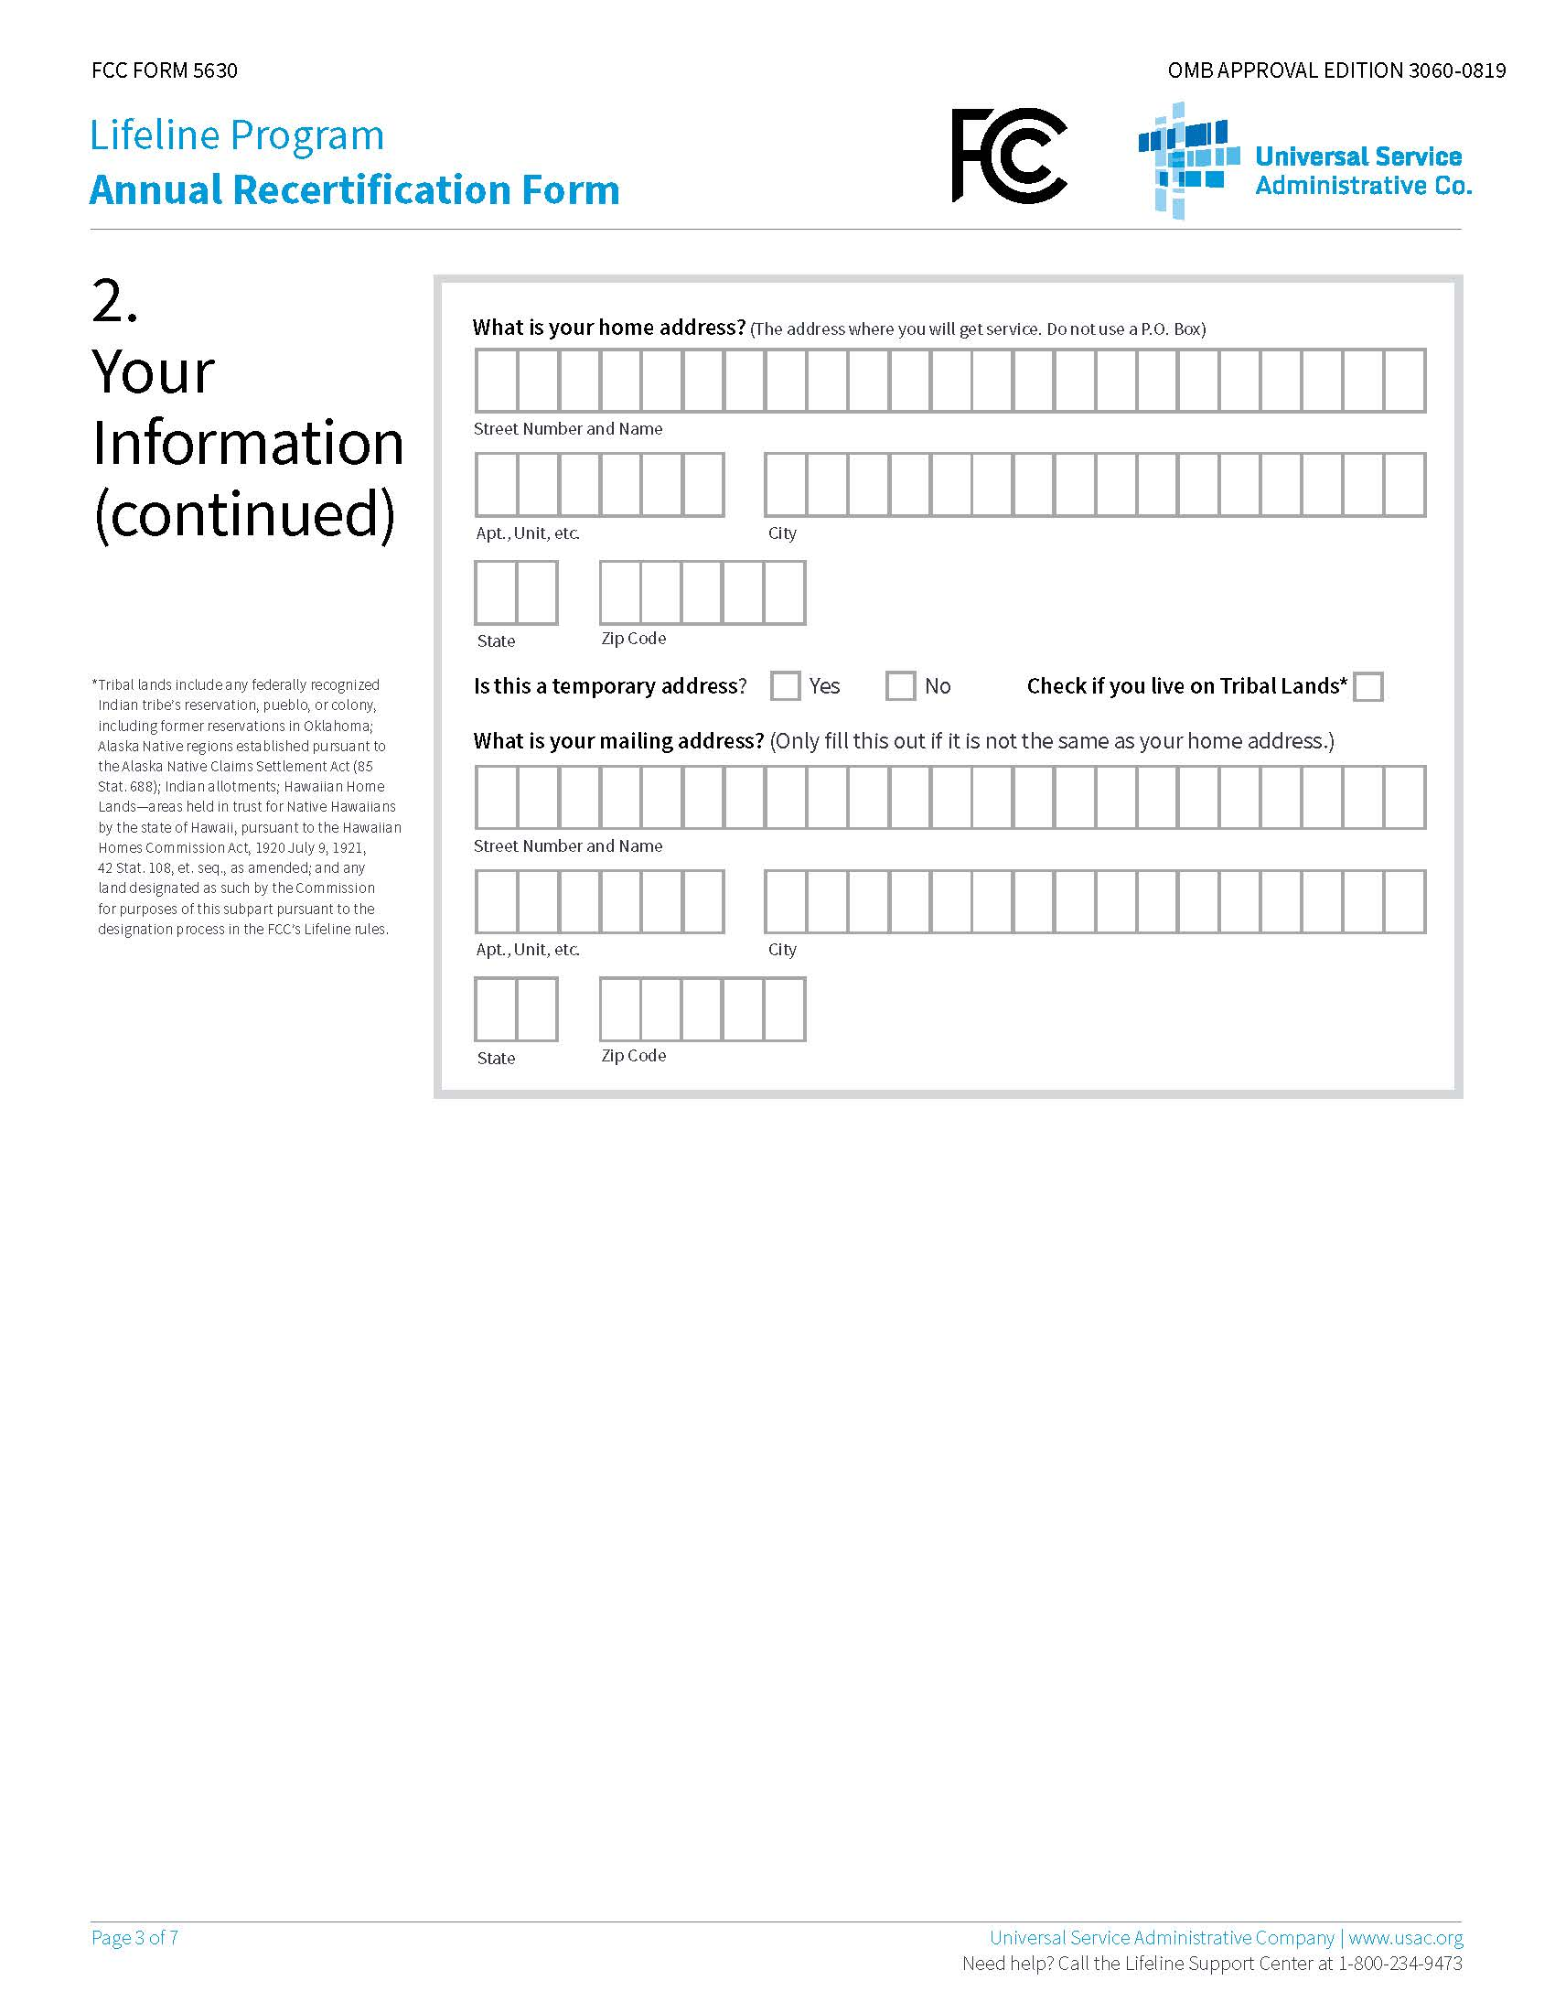

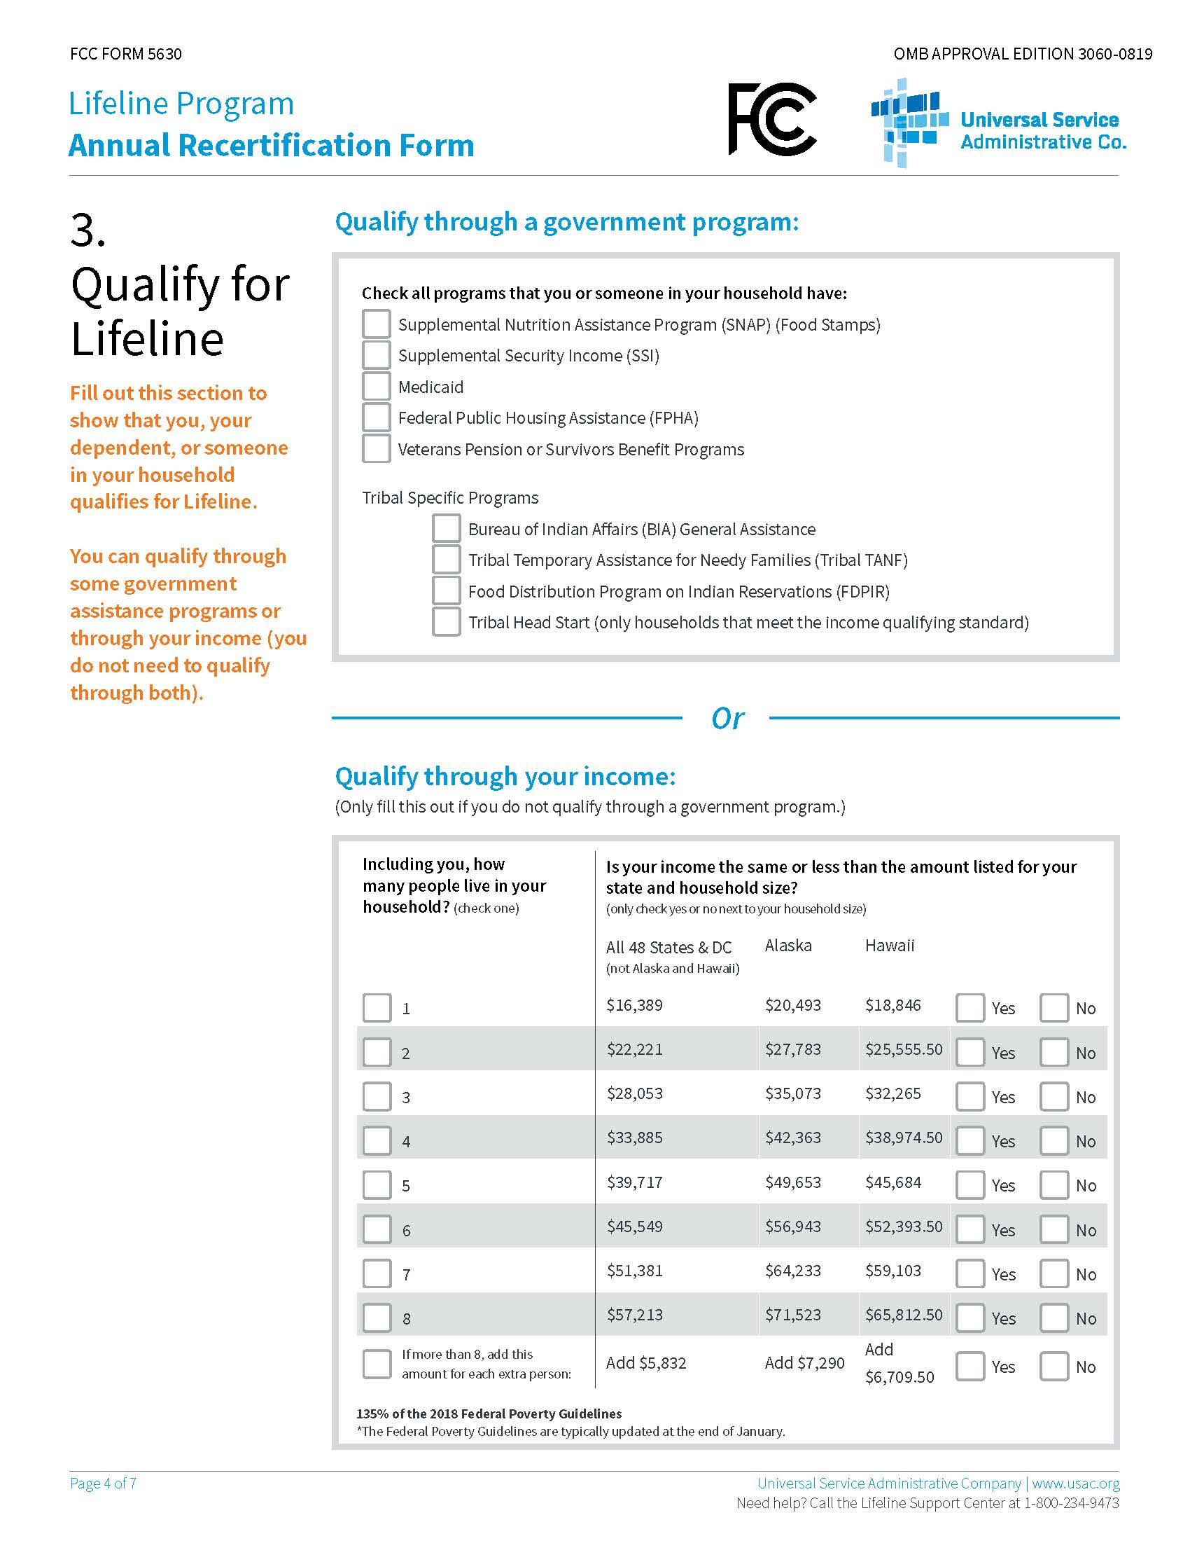

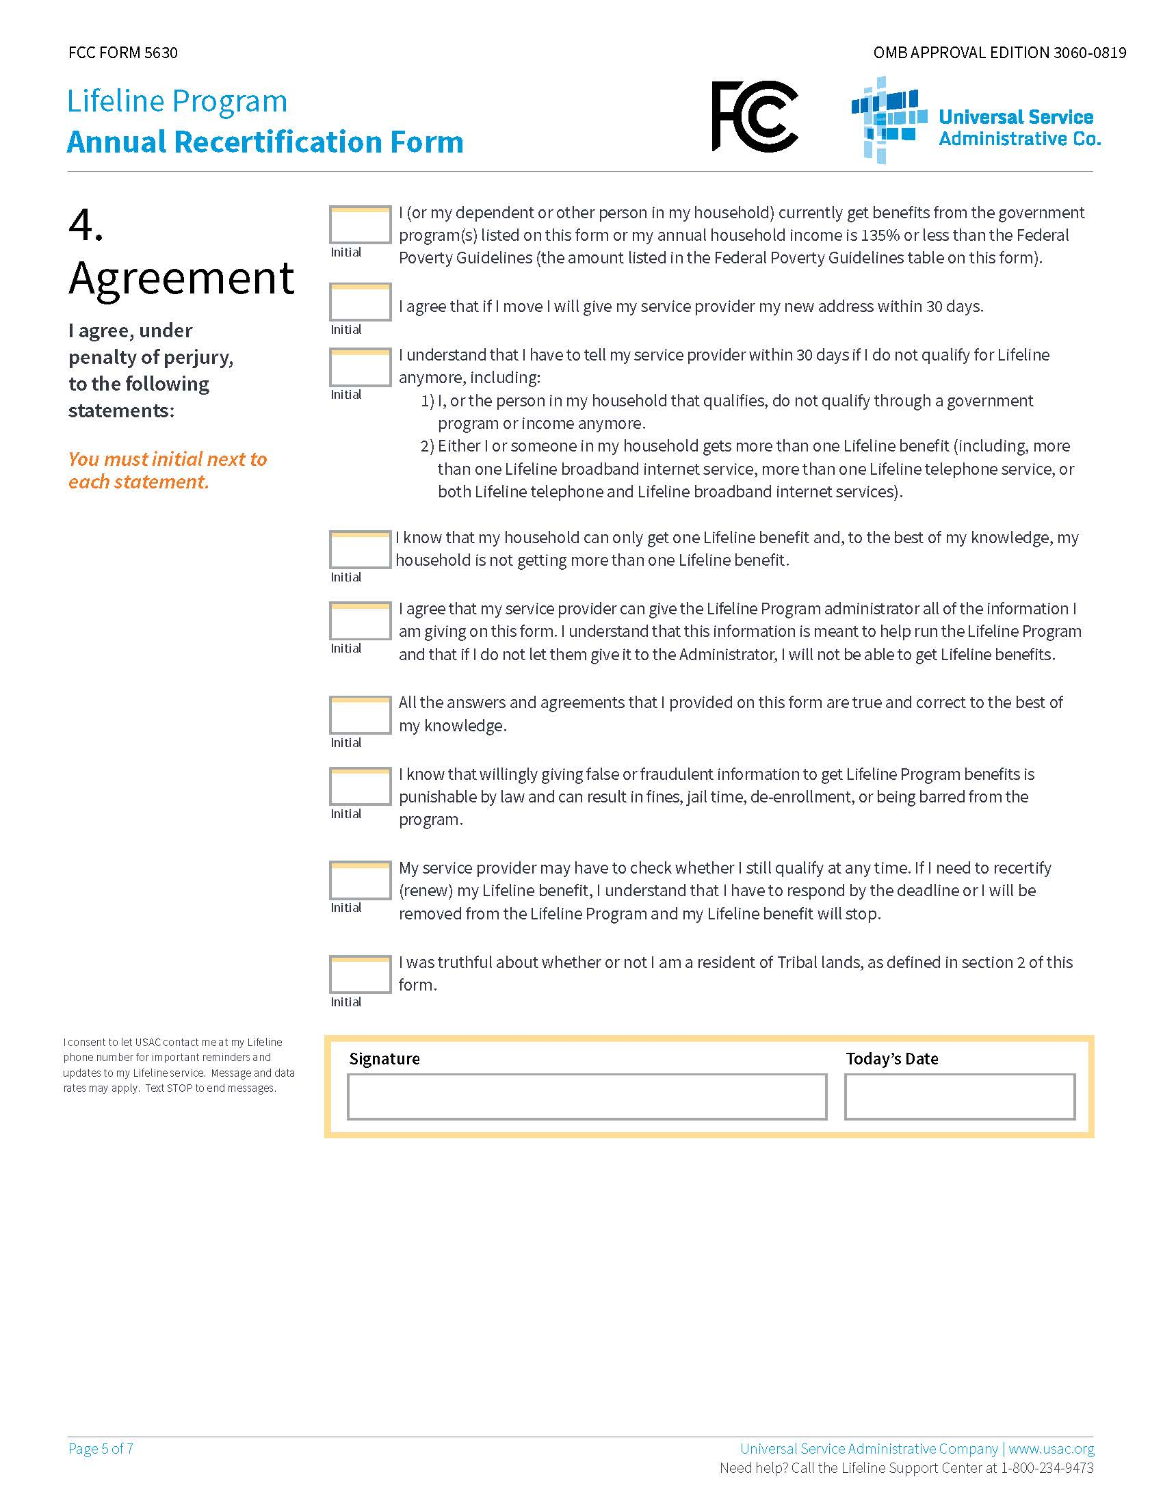

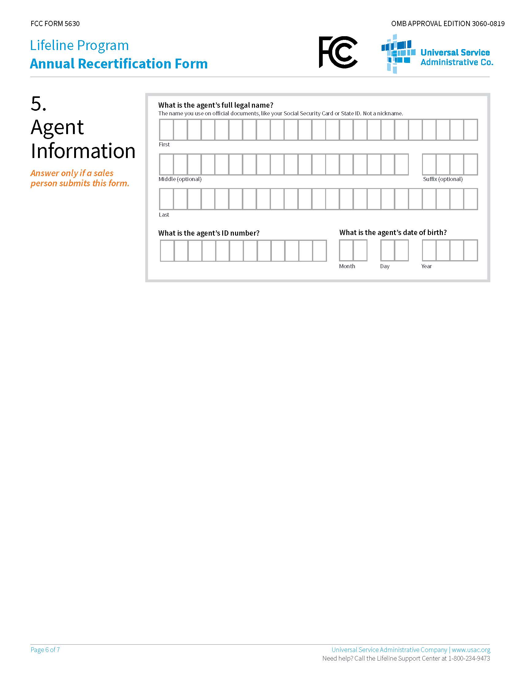

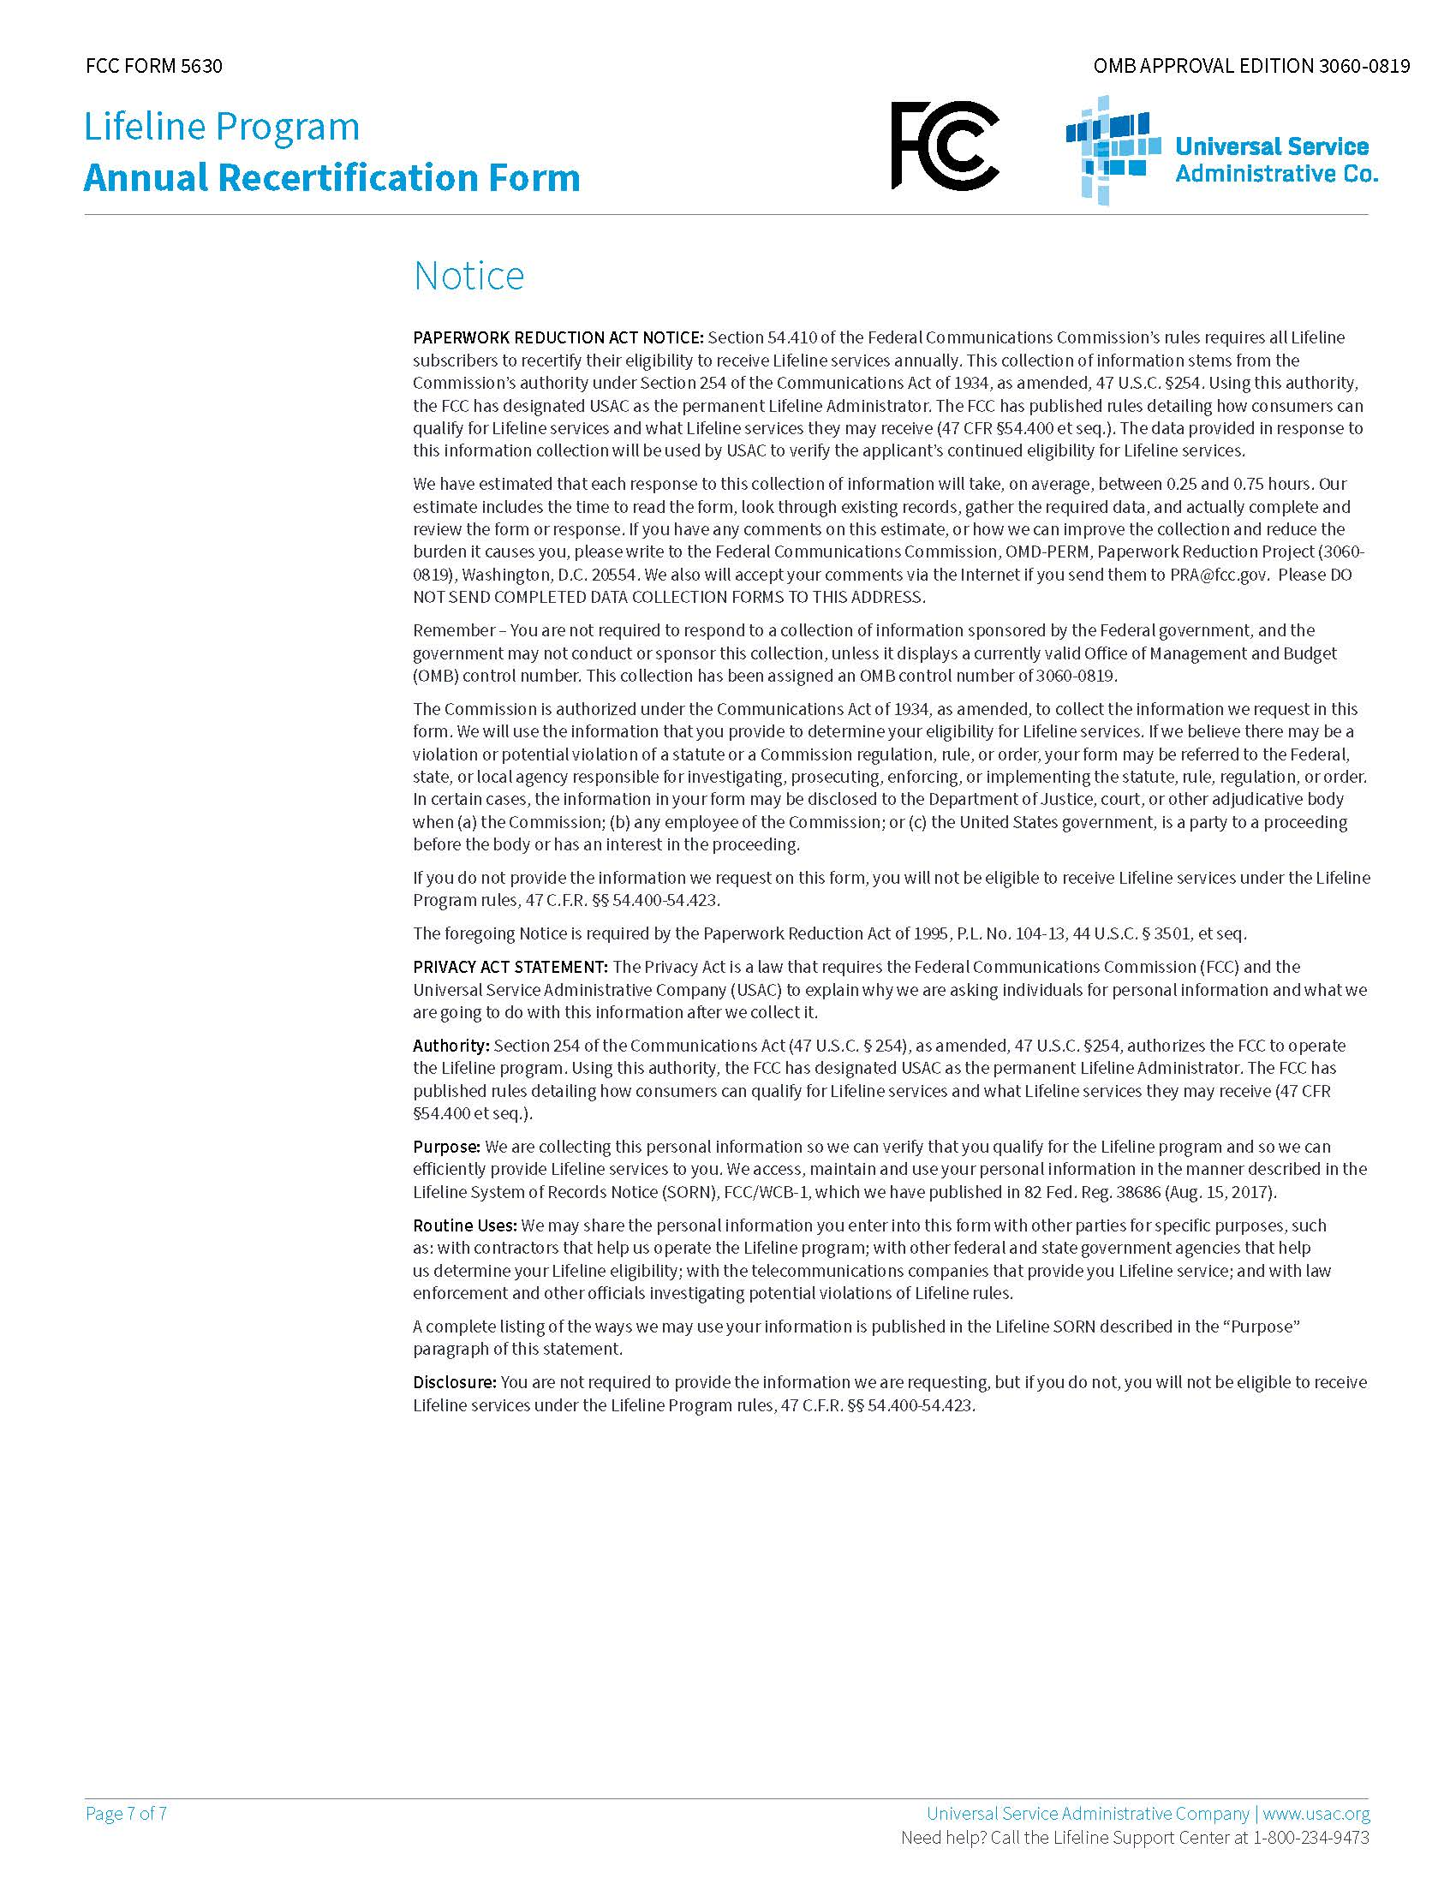

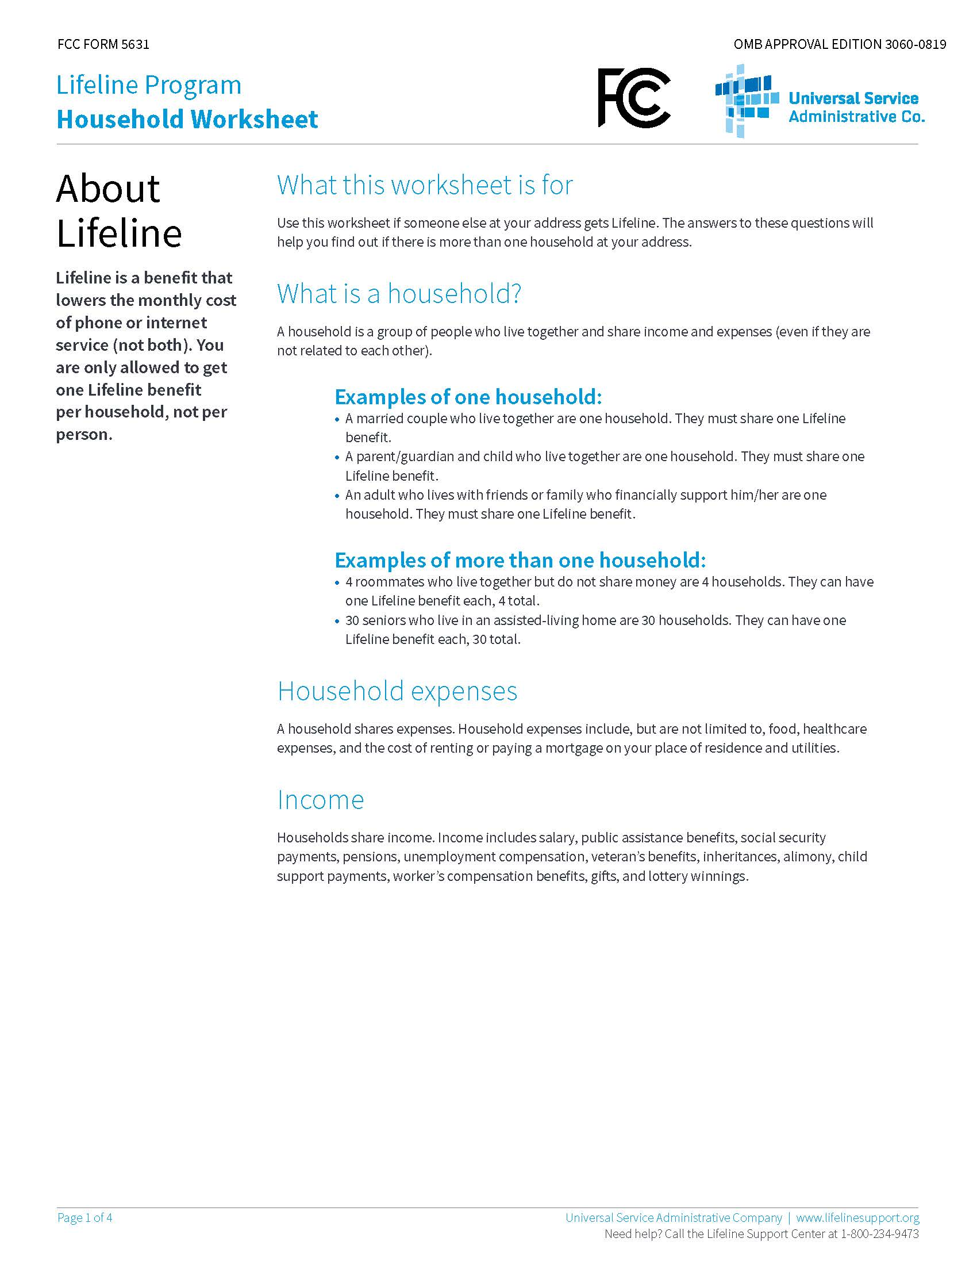
Rule No. 25-4.0665, F.A.C.

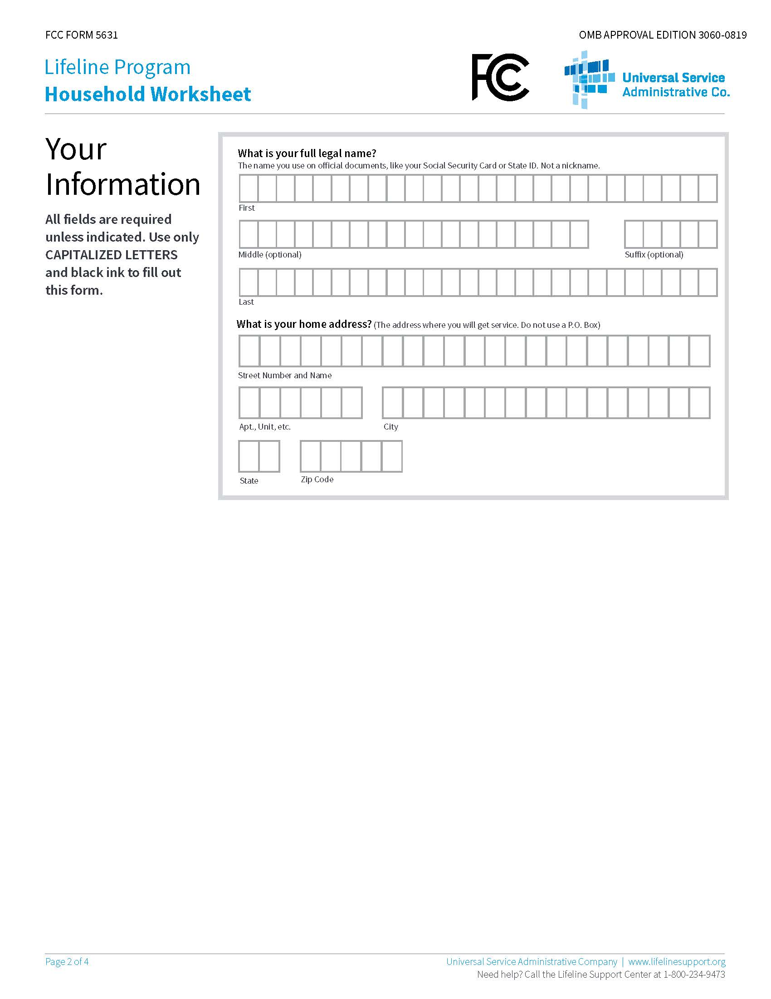

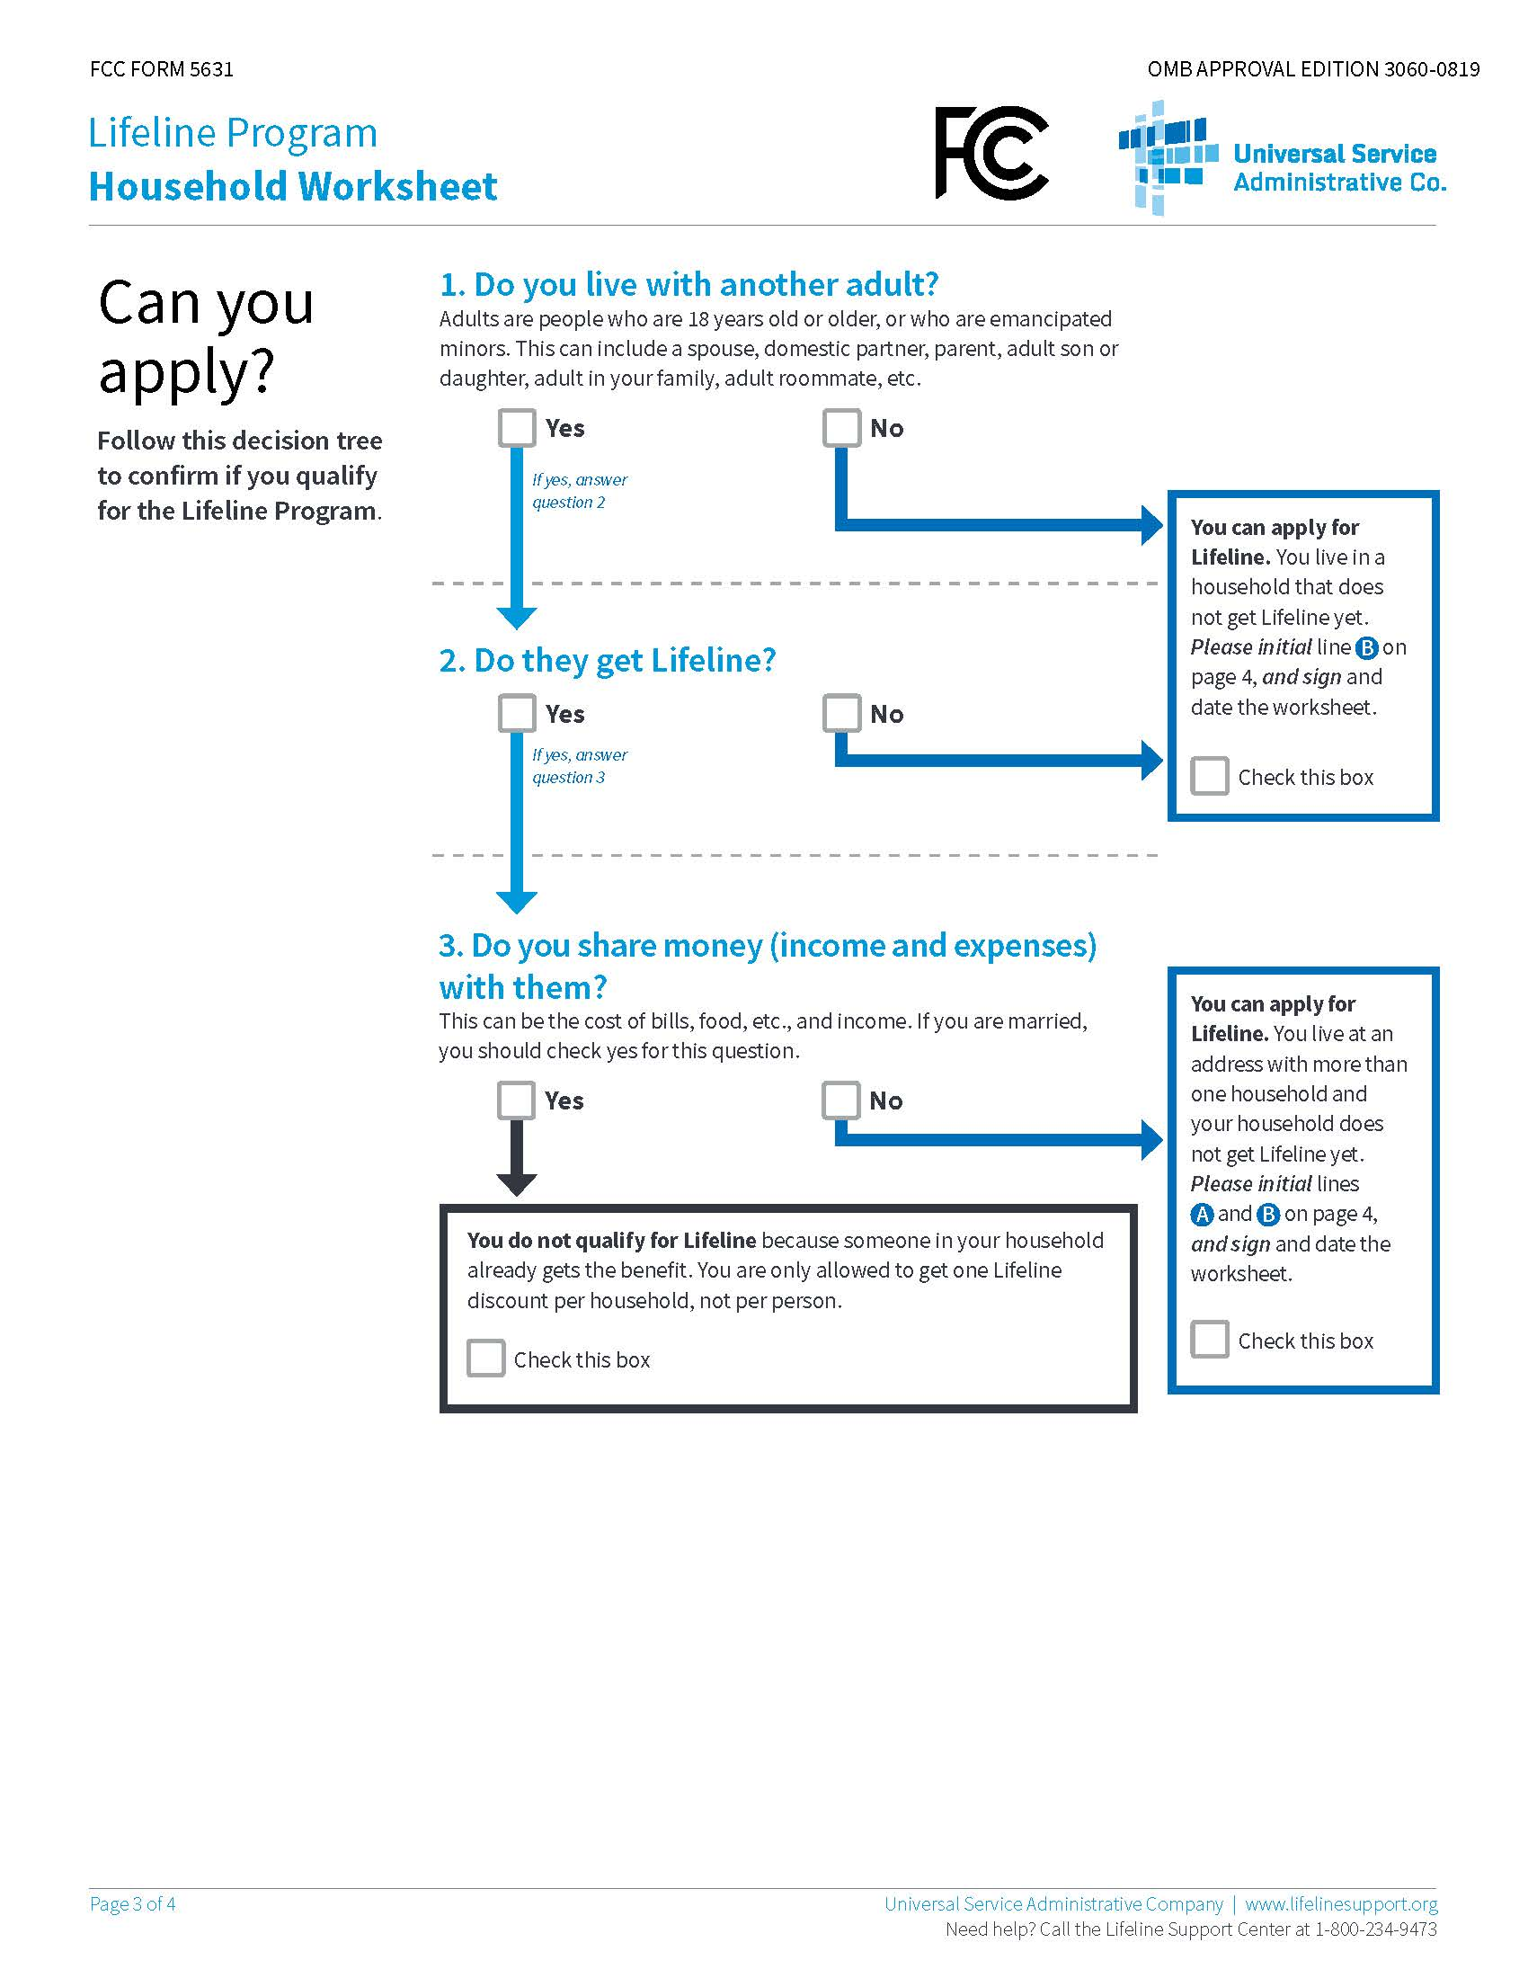

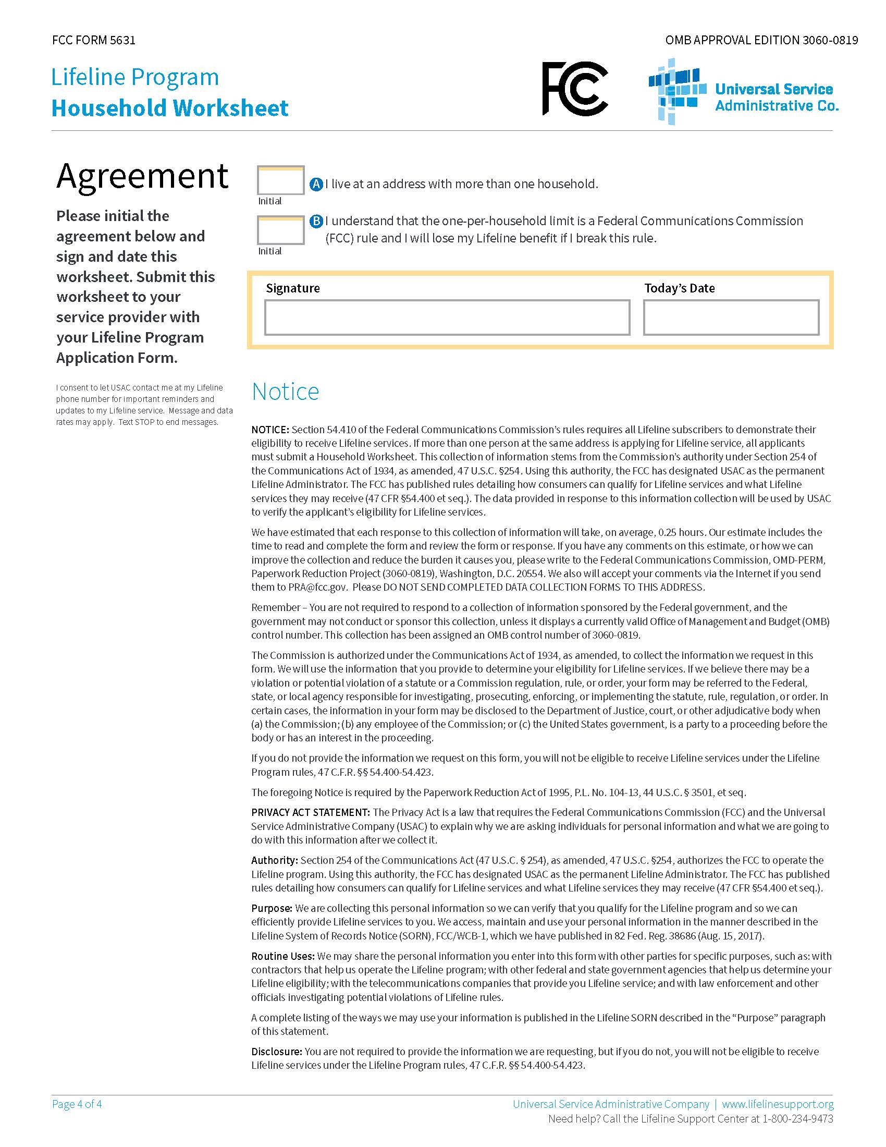

In the Matter of Lifeline and Link Up Reform and Modernization (WC Docket No. 11-42), Lifeline and Link Up (WC Docket No. 03-109), Federal-State Joint Board on Universal Service (CC Docket No. 96-45), Advancing Broadband Availability Through Digital Literacy Training (WC Docket No. 12-23), Report and Order and Further Notice of Proposed Rulemaking. Adopted: January 31, 2012, Released: February 6, 2012.
In Re: Florida Link-Up and Lifeline Program Modernization. The order was consummated by Order No. PSC-12-0239-CO-TP, issued May 14, 2012.
FCC 15-71, WC Docket No. 11-42, Lifeline and Link-Up Reform and Modernization, Second Further Notice of Proposed Rulemaking, Order on Reconsideration, Second Report and Order, and Memorandum Opinion and Order, released June 22, 2015. The Commission filed comments in that proceeding on August 31, 2015.
In the Matter of Lifeline and Link Up Reform and Modernization (WC Docket No. 11-42), Telecommunications Carriers Eligible for Universal Service Support (WC Docket No. 09-197), and Connect America Fund (WC Docket No. 10-90). Order No. FCC 12-11. Adopted: March 31, 2016, Released: April 27, 2016.
Section 364.10(1)(a), F.S., defines an ETC to mean “a telecommunications company, as defined by s. 364.02, which is designated as an eligible telecommunications carrier by the commission pursuant to 47 C.F.R. s. 54.201.” Pursuant to 47 U.S. Code § 214(e)(1), common carriers designated as ETCs must offer the services that are supported by Federal universal service support mechanisms under 47 U.S. Code § 254(c), either using their own facilities or a combination of their own facilities and resale of another carrier’s services. Order FCC 16-38 at 80, para. 223, requires that Lifeline providers must be designated as ETCs.
Order FCC 16-38 at 77, para. 212. The FCC noted that the changes to eligibility only apply to the federal Lifeline program, and that states that maintain their own Lifeline funds may still adopt any eligibility requirements that they deem necessary. Id. at 78, para. 215. Florida does not maintain state Lifeline funding.
Order FCC 16-38 at 68, para. 188.
Id.

