State of Florida |  | Public Service Commission  Capital Circle Office Center ● 2540 Shumard Oak Boulevard  Tallahassee, Florida 32399-0850  -M-E-M-O-R-A-N-D-U-M-
DATE: | October 18, 2018
TO: | Office of Commission Clerk (Stauffer)
FROM: | Division of Engineering (Mtenga, Ellis, King)  Division of Economics (Guffey, Draper)  Office of the General Counsel (Crawford, Davis, Nieves)
RE: | Docket No. 20180149-EI – Petition for a limited proceeding to approve first solar base rate adjustment, by Duke Energy Florida, LLC.
AGENDA: | 10/30/18 – Regular Agenda – Tariff Filing - Interested Persons May Participate
COMMISSIONERS ASSIGNED: |  |  | All Commissioners
PREHEARING OFFICER: |  |  | Fay
CRITICAL DATES: |  |  | 60-Day clock waived by Utility until 10/30/2018
SPECIAL INSTRUCTIONS: |  |  | None

Case Background
Duke Energy Florida, LLC’s (DEF) petition for a limited proceeding to approve its 2017 Second Revised and Restated Settlement Agreement (2017 Settlement) was approved by the Florida Public Service Commission (Commission) on November 20, 2017, by Order No. PSC-2017-0451-AS-EU. Paragraph 12 of the 2017 Settlement allows DEF to implement an increase to base rates effective January 2019, and paragraph 15 of the 2017 Settlement allows DEF to petition the Commission for cost recovery of up to 350 megawatts (MW) of solar generation in 2019. According to paragraph 15 of the 2017 Settlement, the cost of the solar projects shall be reasonable and cost-effective.
On July 31, 2018, DEF filed a petition for a limited proceeding to approve its first solar base rate adjustment, which includes both the Hamilton Solar Power Plant (Hamilton Project) and the Columbia Solar Power Plant (Columbia Project). The Hamilton Project is expected to go into service in late 2018 and the Columbia Project is expected to go into service in early 2020. Each project has a rating of 74.9 MW.
On August 24, 2018, DEF filed a petition, also in Docket No. 20180149-EI, for approval of tariff changes to implement the 2019 base rate increase approved in the 2017 Settlement and the proposed base rate adjustment for the Hamilton Project. The tariffs filed with this petition also include the base rate increase for the second Citrus County Combined Cycle Power Block (Citrus Unit 2) which was approved for inclusion in base rates by Order No. PSC-2018-0367-TRF-EI (Citrus Order). The decisions to increase rates for the Citrus Unit 2 and the step increase authorized by paragraph 12 of the 2017 Settlement Agreement are final. The recommendation below combines these previously approved increases with the solar base rate adjustment increase for administrative efficiency.
DEF requests that the tariffs filed on August 24, 2018, go into effect with the first billing cycle in January 2019; however, Duke acknowledges the tariff increases for the Hamilton Project and Citrus Unit 2 are contingent on DEF placing the units into service before the first billing cycle of January 2019. DEF has also requested that the rates for the Hamilton Project be subject to refund to allow the Commission to render a decision on the solar base rate adjustment petition. A hearing for the Hamilton and Columbia Projects is currently scheduled to be held in April 2019. A copy of the tariff to be approved is shown in Legislative format appended to this recommendation as Attachment A.
This recommendation addresses the tariffs DEF filed in its August 24, 2018, petition. DEF waived the 60-day file and suspend provision of Section 366.06(3), Florida Statutes (F.S.), until the October 30, 2018 Commission Conference. The Commission has jurisdiction pursuant to Sections 366.06 and 366.076, F.S.

Discussion of Issues

Issue 1:
Should the Commission approve DEF’s tariffs filed on August 24, 2018?

Recommendation:
Yes. The Commission should approve DEF’s tariffs filed on August 24, 2018, appended to this recommendation as Attachment A. The tariffs should go into effect with the first billing cycle in January 2019. The base rate increase associated with the Hamilton Project should be subject to refund, pending the Commissions’ final determination regarding the Hamilton and Columbia Projects following the April administrative hearing. If the in-service date of the Hamilton Project is delayed, then the tariffs reflecting the Hamilton Project should become effective, subject to refund, with the first billing cycle after the Hamilton Project is placed in commercial service and the Commission should provide staff authority to administratively approve the tariffs at the appropriate time. If the in-service date of the Hamilton Project and/or Citrus Unit 2 is delayed, DEF should notify staff of the delay(s) and file revised tariffs, for administrative approval by staff, effective with the first billing cycle of January 2019 to remove the portion of the base rate increase associated with those units. (Draper, Guffey)

Staff Analysis:
On August 24, 2018, DEF filed a petition and supplemental direct testimony of Marcia Olivier to support the calculations and proposed tariffs to go into effect with the first billing cycle in January 2019. The proposed tariffs reflect three base rate increases: (1) the Hamilton Project; (2) the base rate increase approved in the 2017 Settlement; and (3) the base rate increase to reflect Citrus Unit 2 approved in the Citrus Order. DEF explained that combining several rate increases into one tariff sheet filing smooths out the rate impact to customers and avoids the potential confusion of multiple tariff sheets. The three base rate changes are discussed in more detail below.

Hamilton Project
The proposed Hamilton Project is a 74.9 MW solar facility being constructed in Hamilton County and is at issue in the instant docket. DEF states that the Hamilton Project is expected to be in-service in December 2018. DEF requested to implement the base rate increase for the Hamilton Project with the first billing cycle in January 2019, subject to refund, pending the final Commission decision in this docket. DEF further stated that if the commercial in-service date of the Hamilton Project is delayed, then the tariff should become effective with the first billing cycle after the Hamilton Project is placed in commercial service and the Commission should provide staff authority to administratively approve the tariff sheets at the appropriate time.

The proposed annualized revenue requirement for the Hamilton Project is $15.2 million. Exhibit MO-2 of the supplemental direct testimony of Marcia Olivier shows the allocation of the $15.2 million revenue requirement to all rate classes. The uniform percentage increase to all rate classes is 0.69 percent. The residential base rate impact of the Hamilton Project is $0.46 on a 1,000 kWh bill.

Base Rate Increase approved in 2017 Settlement
Paragraph 12(b) of the 2017 Settlement provides for a $67 million base rate increase effective with the first billing cycle in January 2019. Paragraph 12(c) of the 2017 Settlement provides that if the applicable federal or state income tax rate for DEF changes, DEF will adjust the amount of the base increase to reflect the new tax rate before the implementation of such increase. DEF explained in the supplemental direct testimony of Marcia Oliver that DEF recalculated the base rate increase, in accordance with the 2017 Settlement, to reflect the new lower federal income tax rate resulting from the 2017 Tax Cuts and Jobs Act. Staff reviewed the calculation of the revised base rate increase and confirmed that DEF applied the tax changes in accordance with the 2017 settlement. The revised base rate increase is $55.1 million. The residential base rate impact of the 2017 Settlement is $1.84 on a 1,000 kWh bill.

Citrus Unit 2 Increase approved in Citrus Unit Order
The Citrus Order gave staff the administrative authority to approve tariffs and associated charges that implement the Commission’s approval regarding base rate inclusion of DEF’s Citrus Combined Cycle Project. As stated above, DEF’s tariff sheets filed on August 24, 2018, also reflect the Citrus Unit 2 increase. Citrus Unit 2 is scheduled to be placed in-service in December 2018. As provided for in the Citrus Order, in the event that Citrus Unit 2 is delayed, then the tariff should become effective with the first billing cycle after Citrus Unit 2 is placed in commercial service and staff has authority to administratively approve the tariff sheets at the appropriate time. The residential base rate impact of Citrus Unit 2 is $2.25 on a 1,000 kWh bill.

Conclusion
The impact on a residential 1,000 kWh bill of the three base rate changes discussed above effective with the first billing cycle in January 2019 is an increase of $4.55. Duke will notify its customers of the rate changes in their December bills.

The Commission should approve DEF’s tariffs filed on August 24, 2018, appended to this recommendation as Attachment A. The tariffs should go into effect with the first billing cycle in January 2019. The base rate increase associated with the Hamilton Project should be subject to refund, pending the Commissions’ final determination regarding the Hamilton and Columbia Projects following the April administrative hearing. If the in-service date of the Hamilton Project is delayed, then the tariffs reflecting the Hamilton Project should become effective, subject to refund, with the first billing cycle after the Hamilton Project is placed in commercial service and the Commission should provide staff authority to administratively approve the tariffs at the appropriate time. If the in-service date of the Hamilton Project and/or Citrus Unit 2 is delayed, DEF should notify staff of the delay(s) and file revised tariffs, for administrative approval by staff, effective with the first billing cycle of January 2019 to remove the portion of the base rate increase reflected with those units.

Issue 2:
Should this docket be closed?

Recommendation:
No. The docket should remain open pending the Commission’s final decision on DEF’s petition. (Crawford, Davis, Nieves)

Staff Analysis:
The docket should remain open pending the Commission’s final decision on DEF’s petition for limited proceeding with respect to the Hamilton and Columbia Projects.

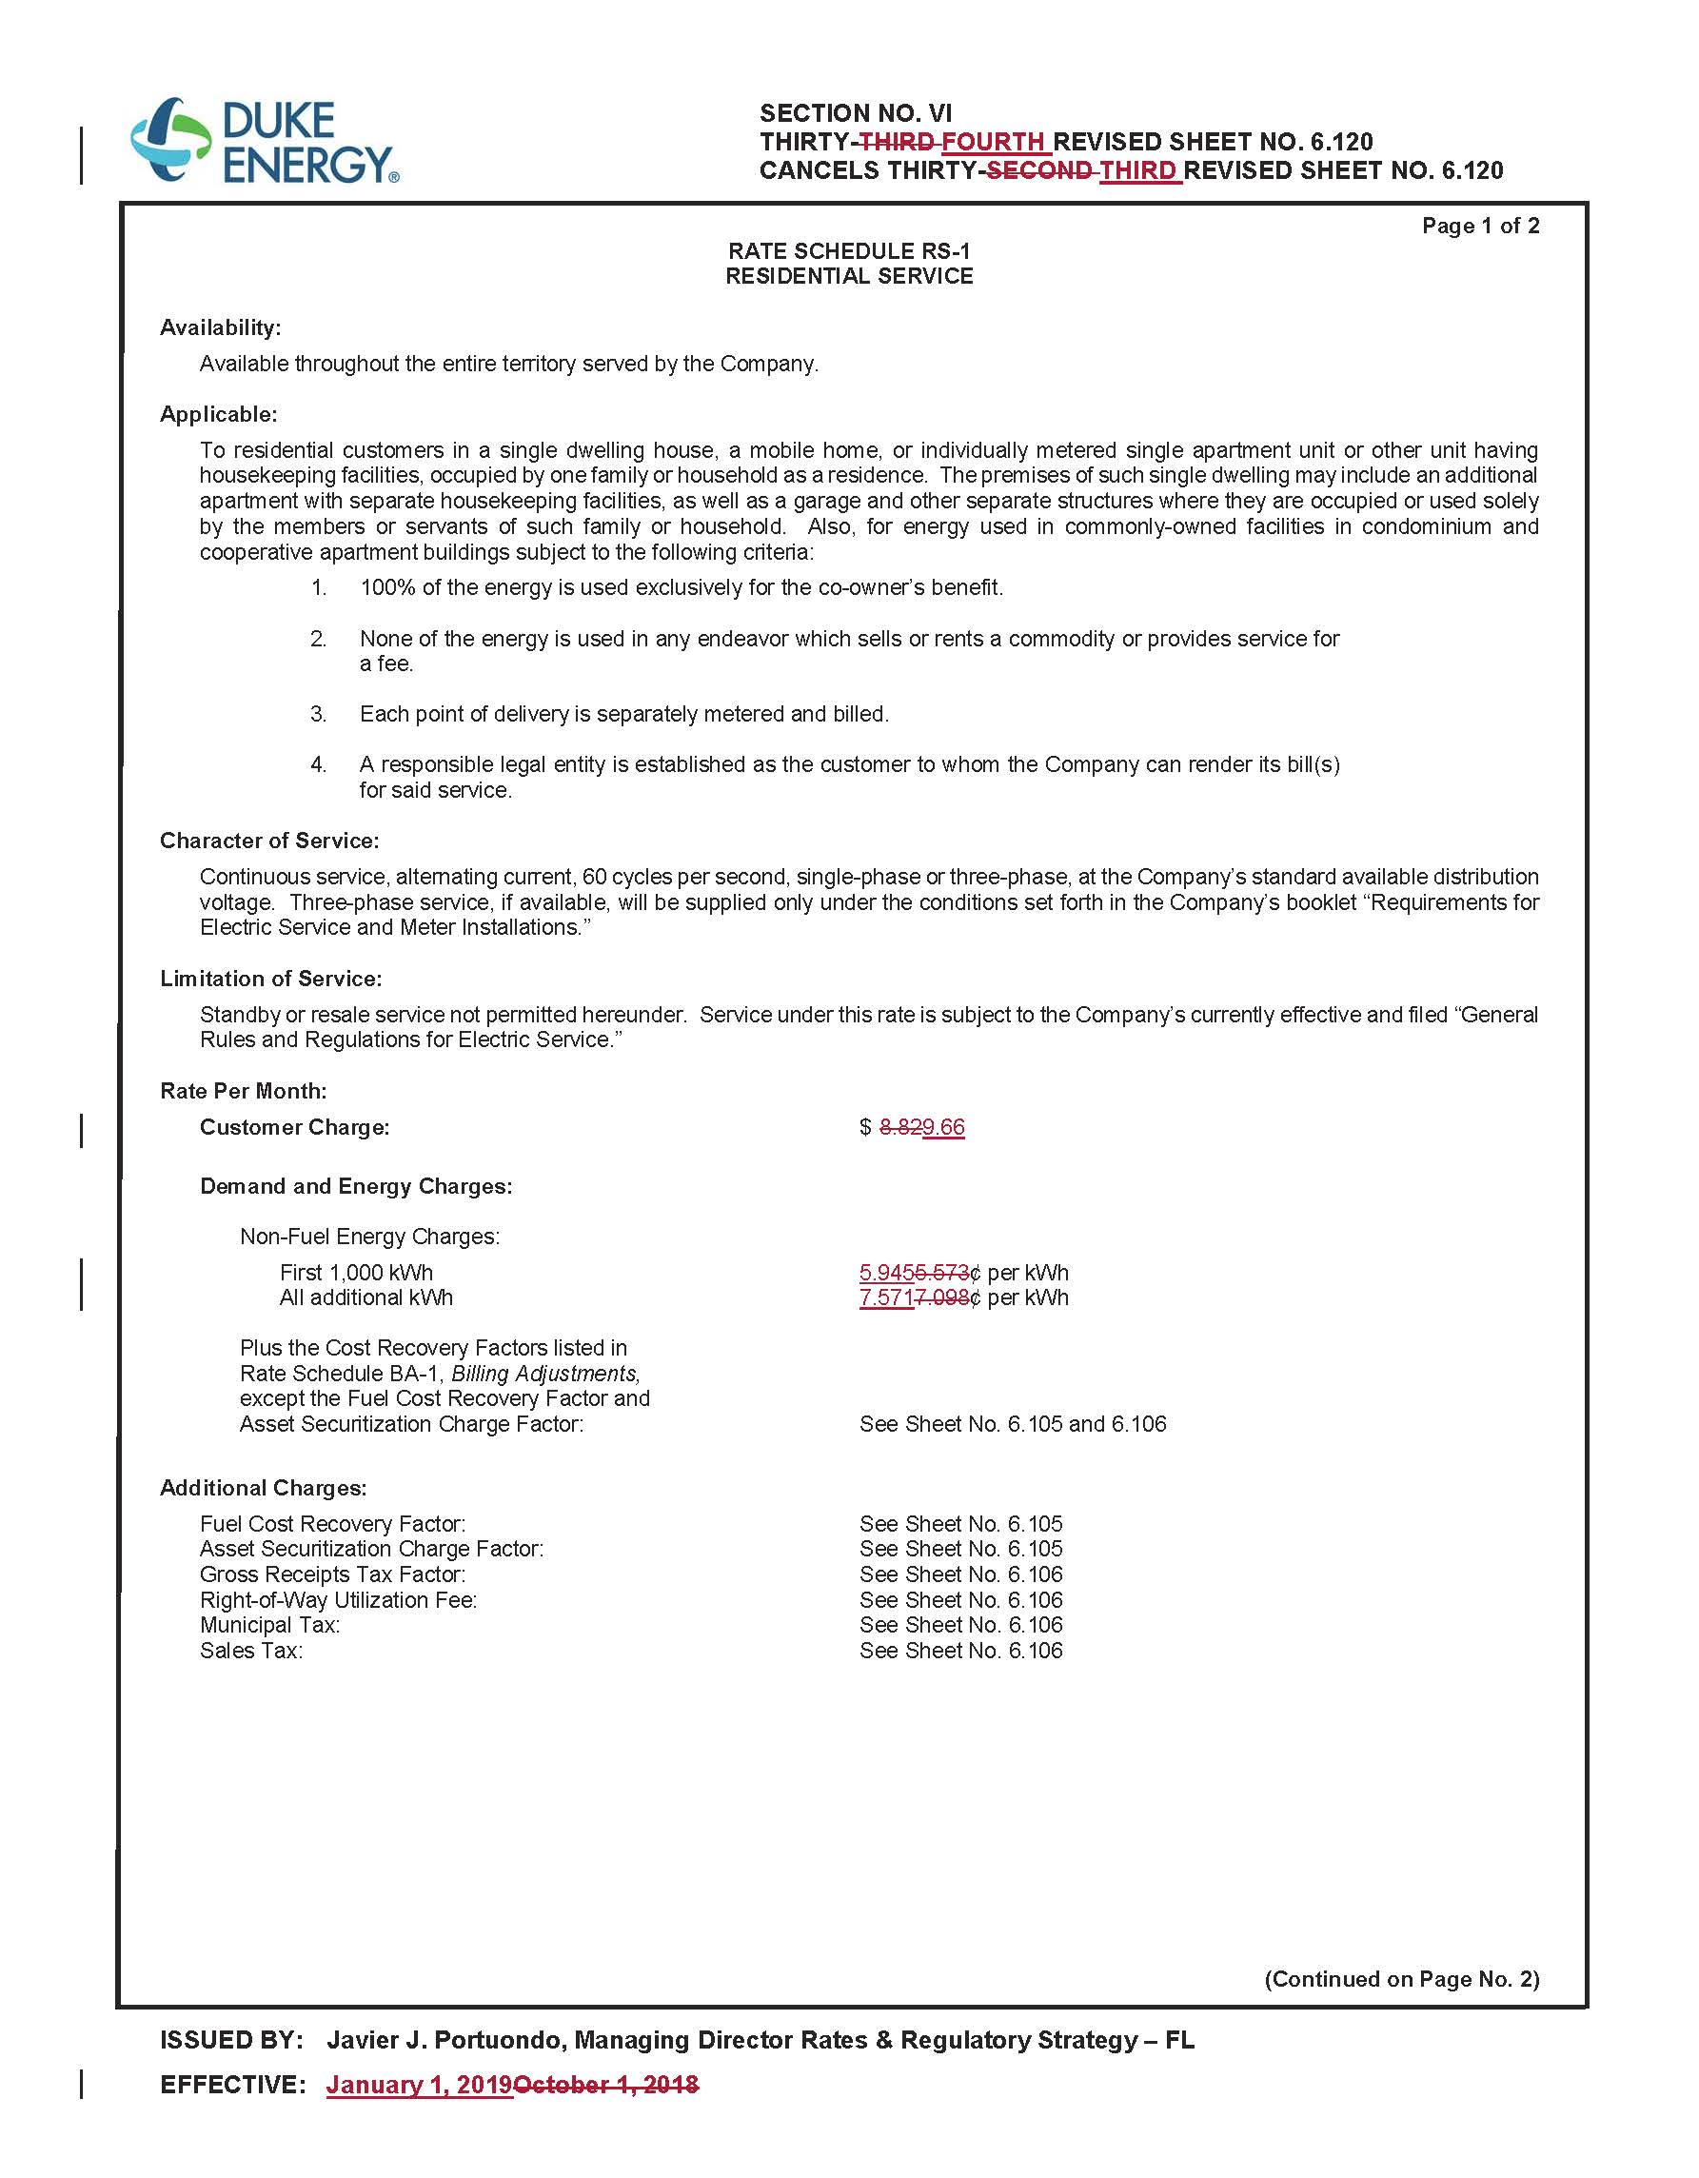
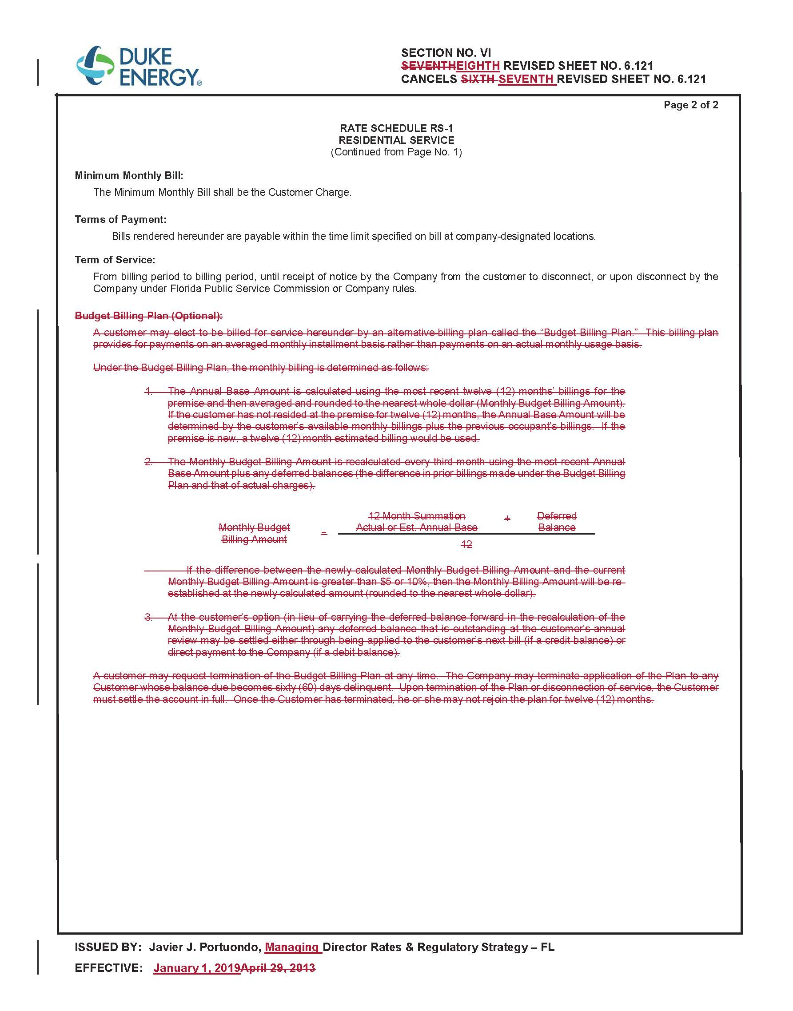
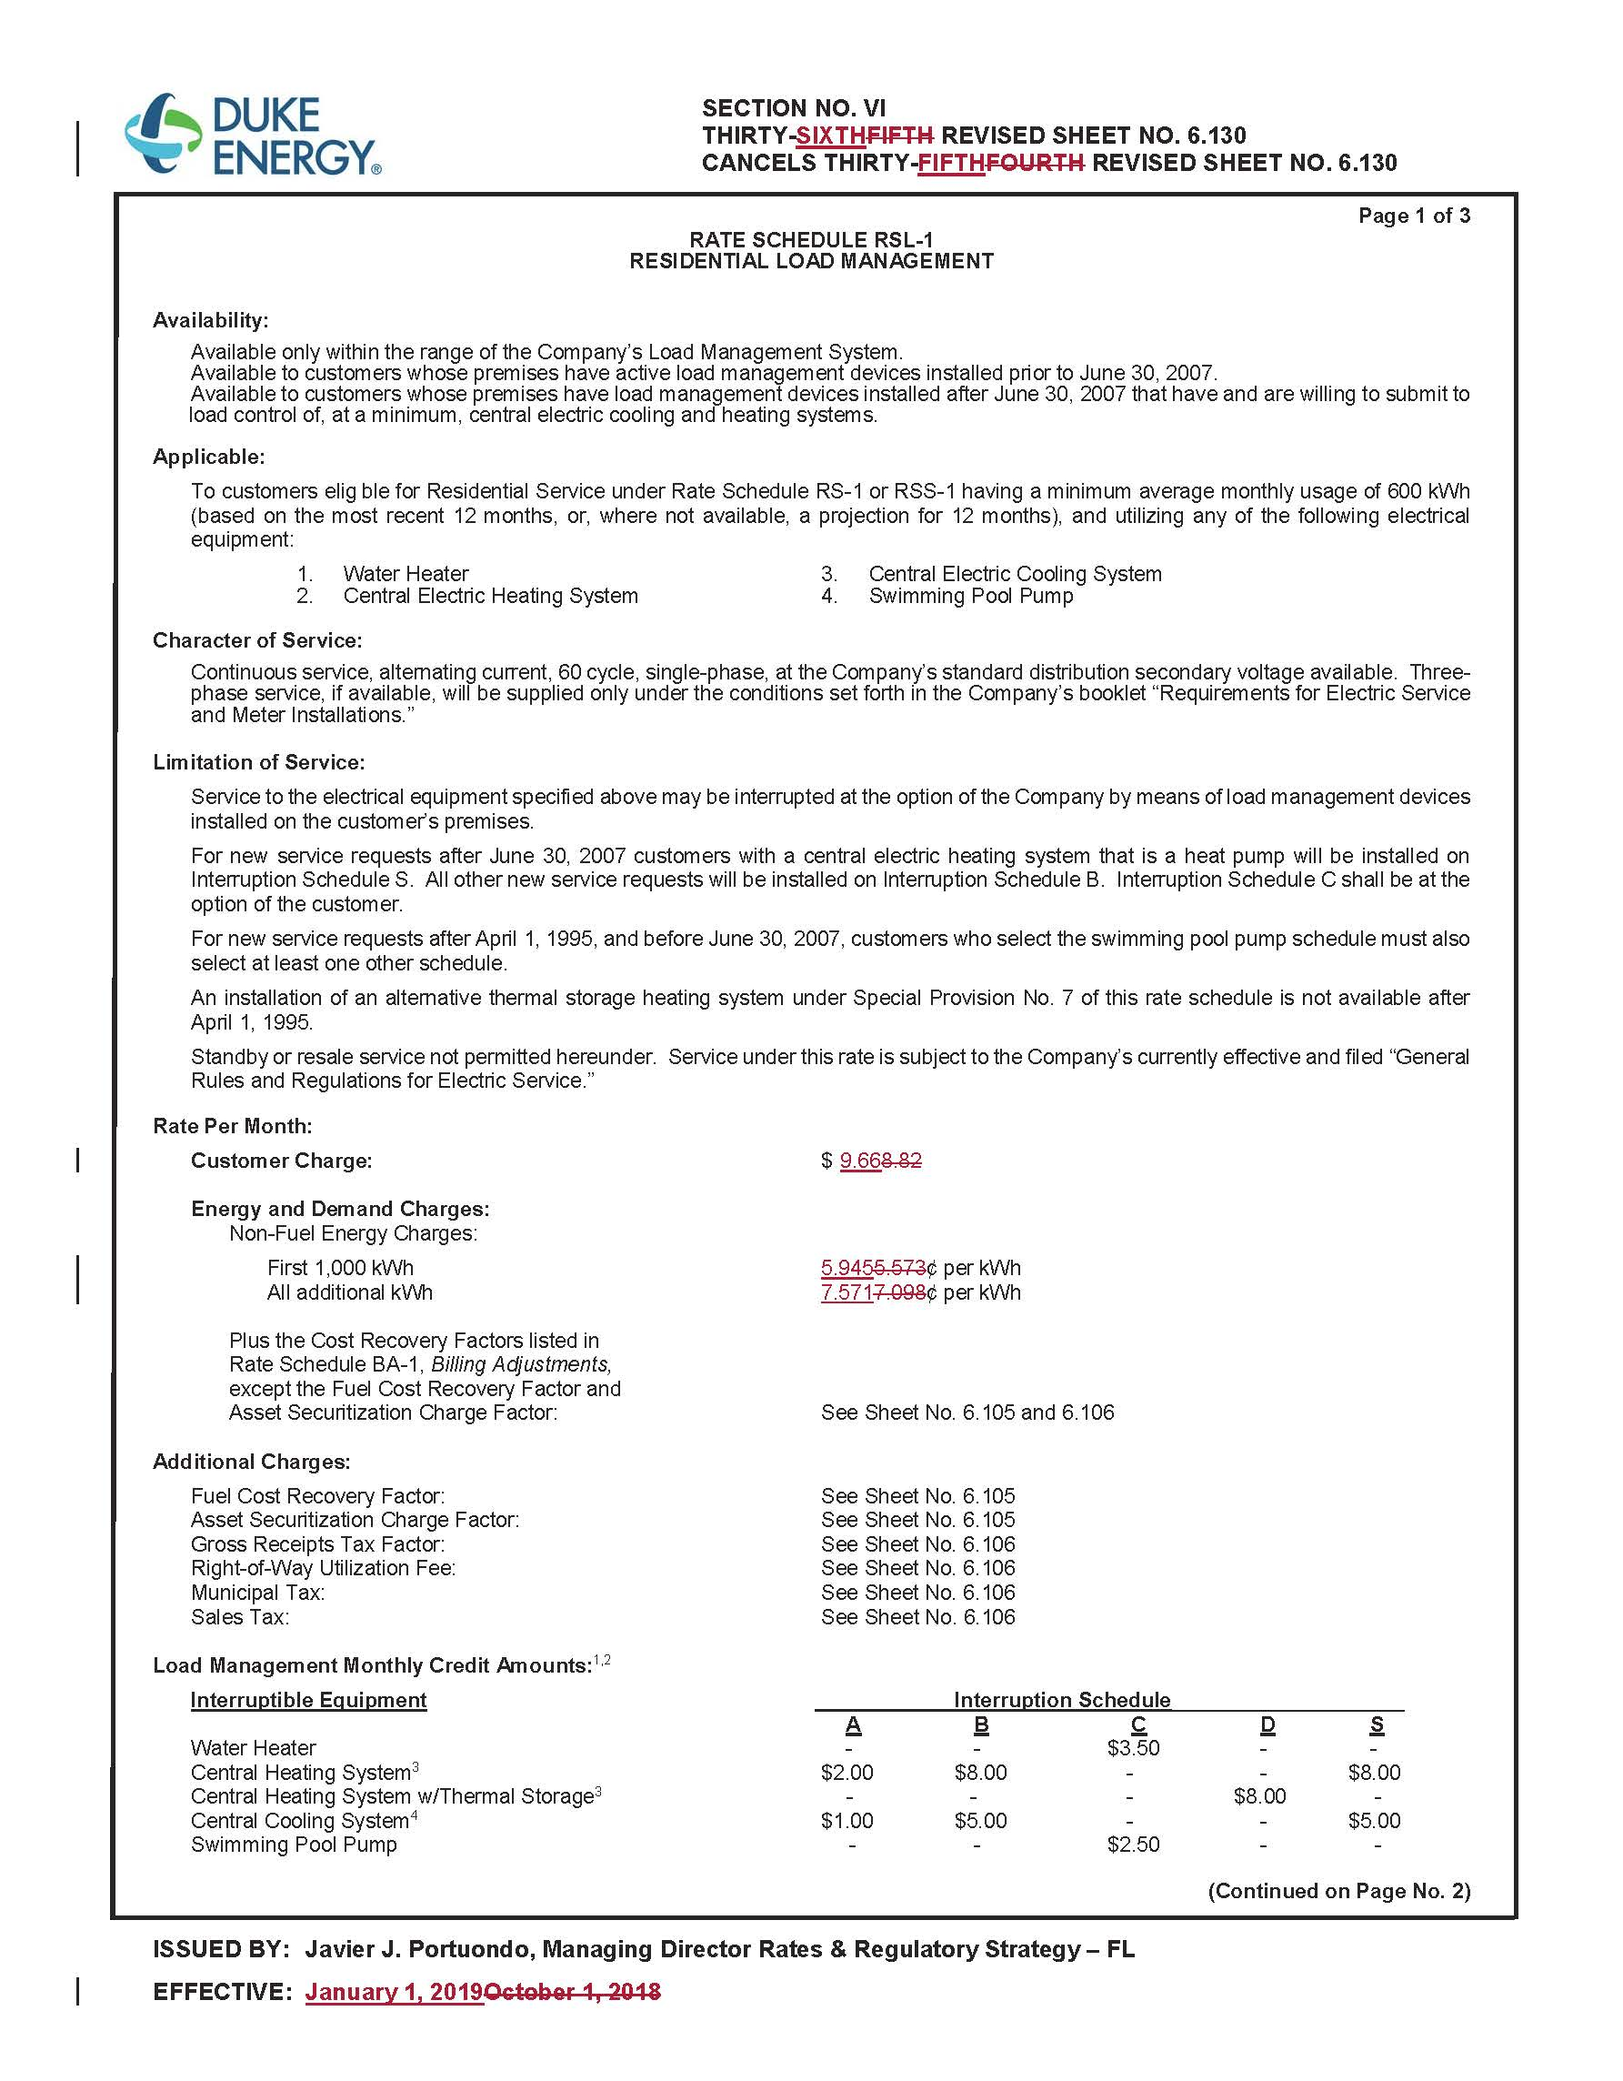
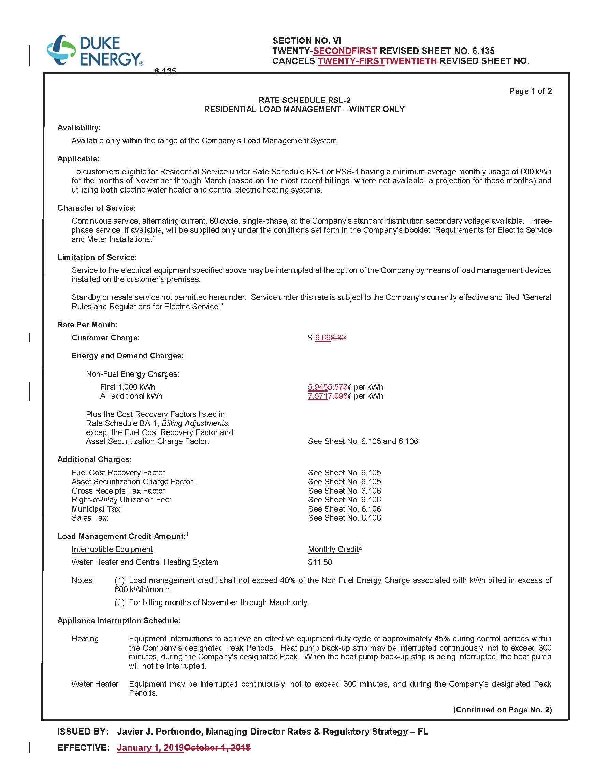
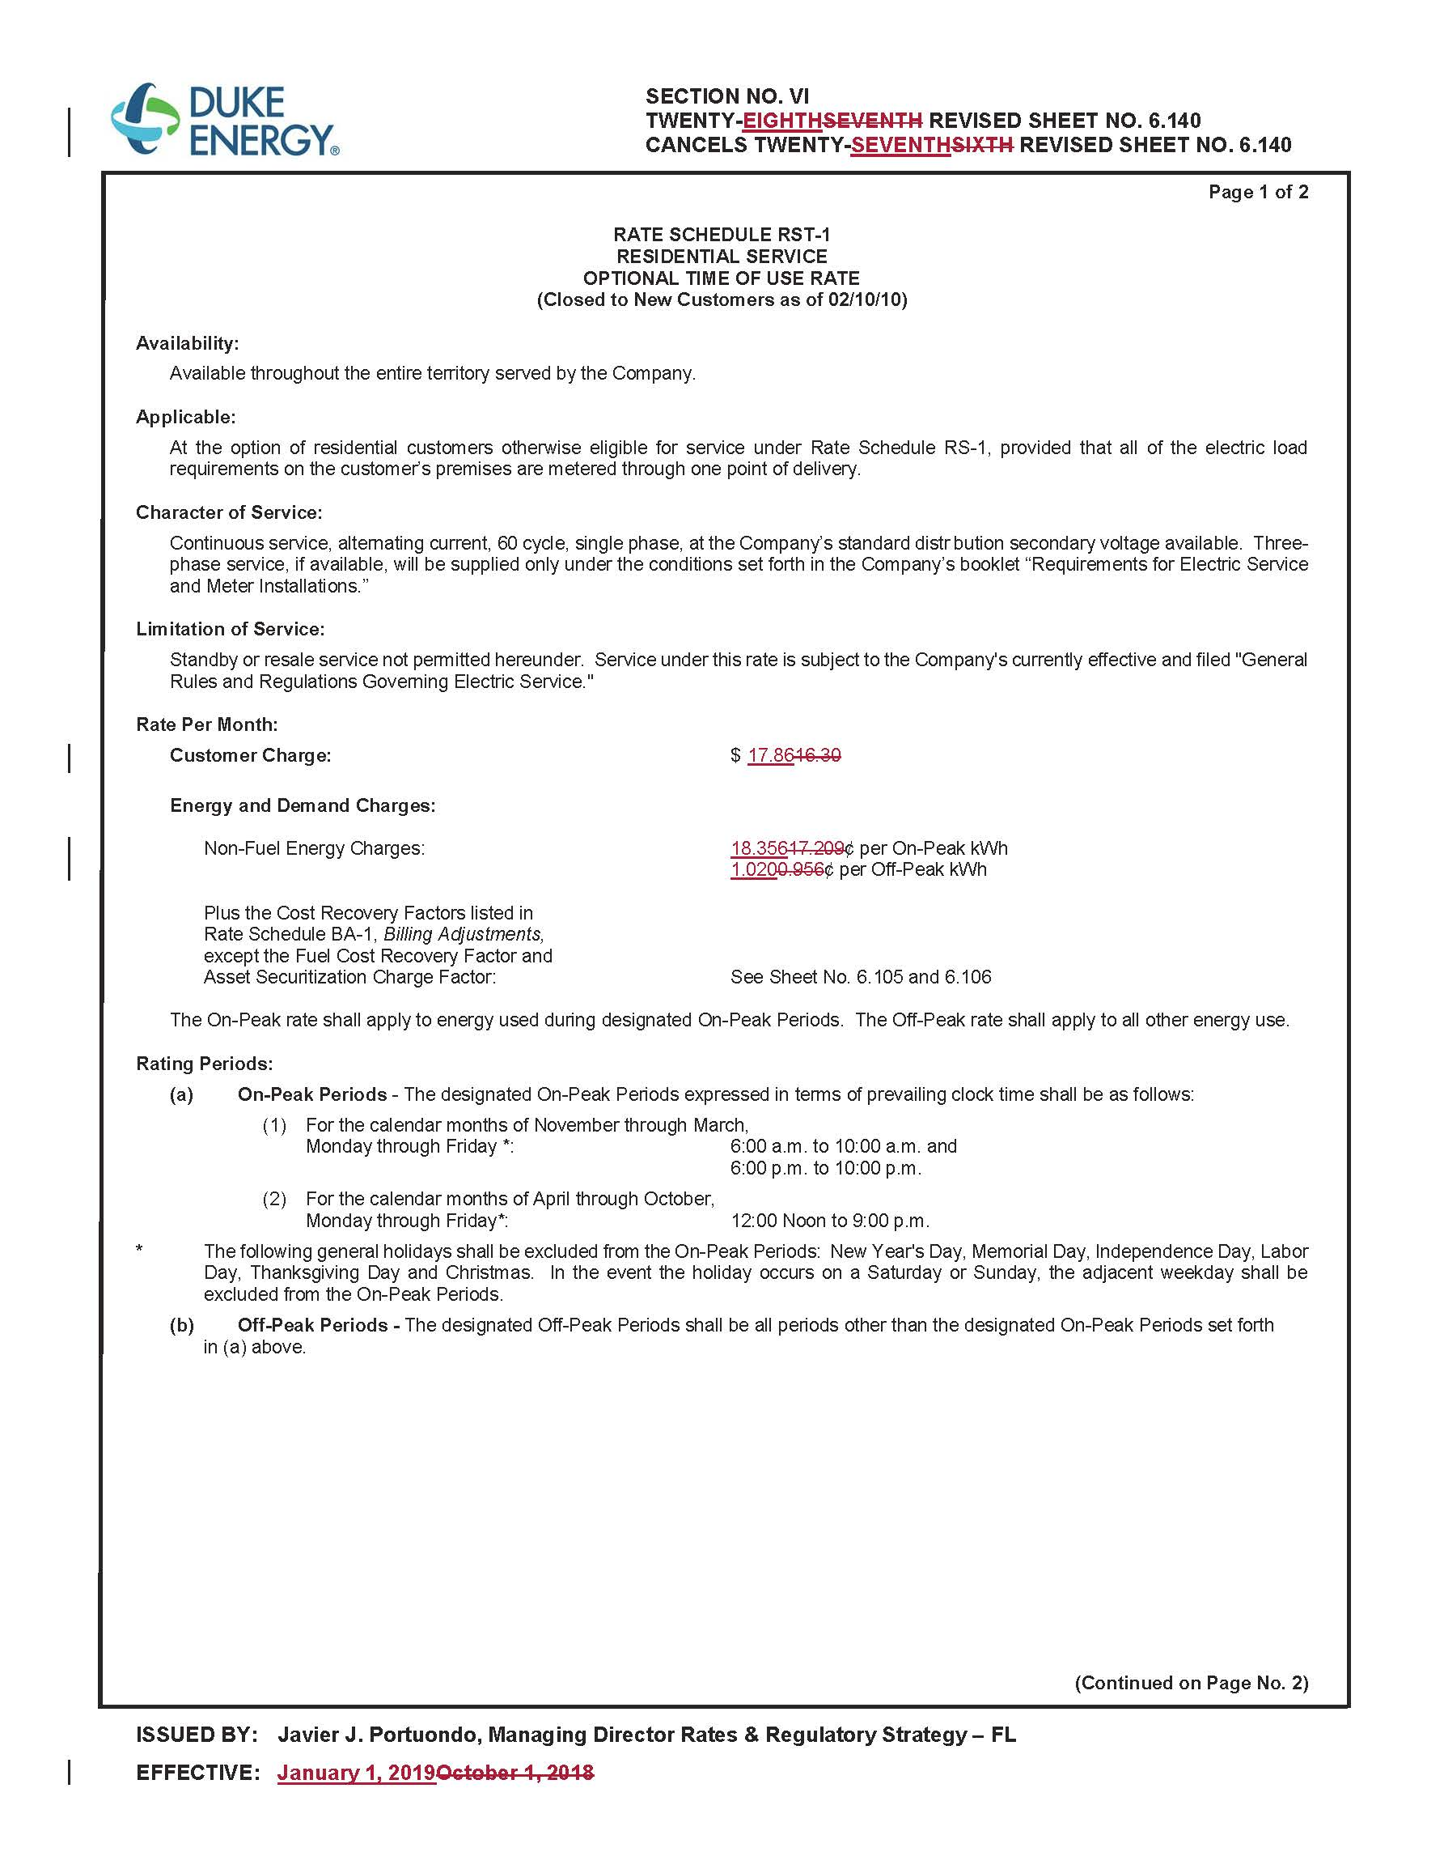
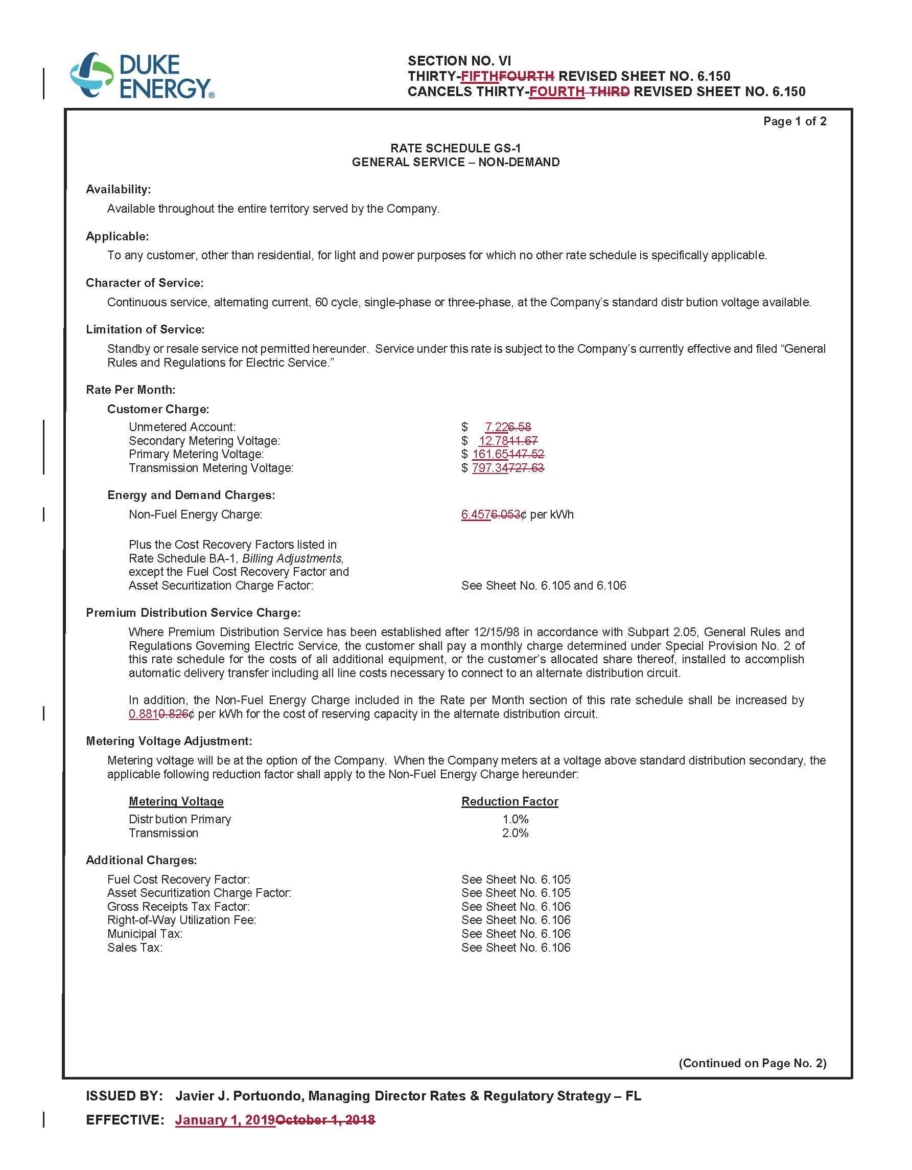
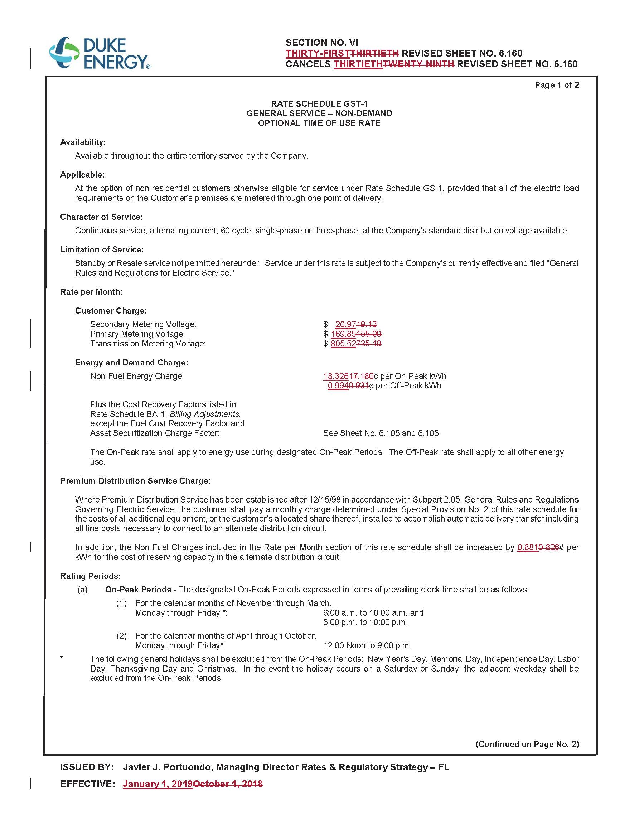
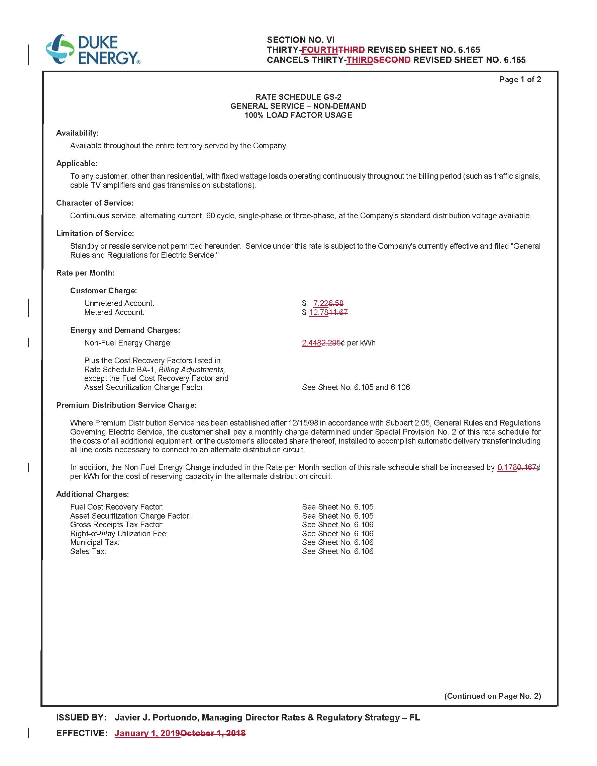
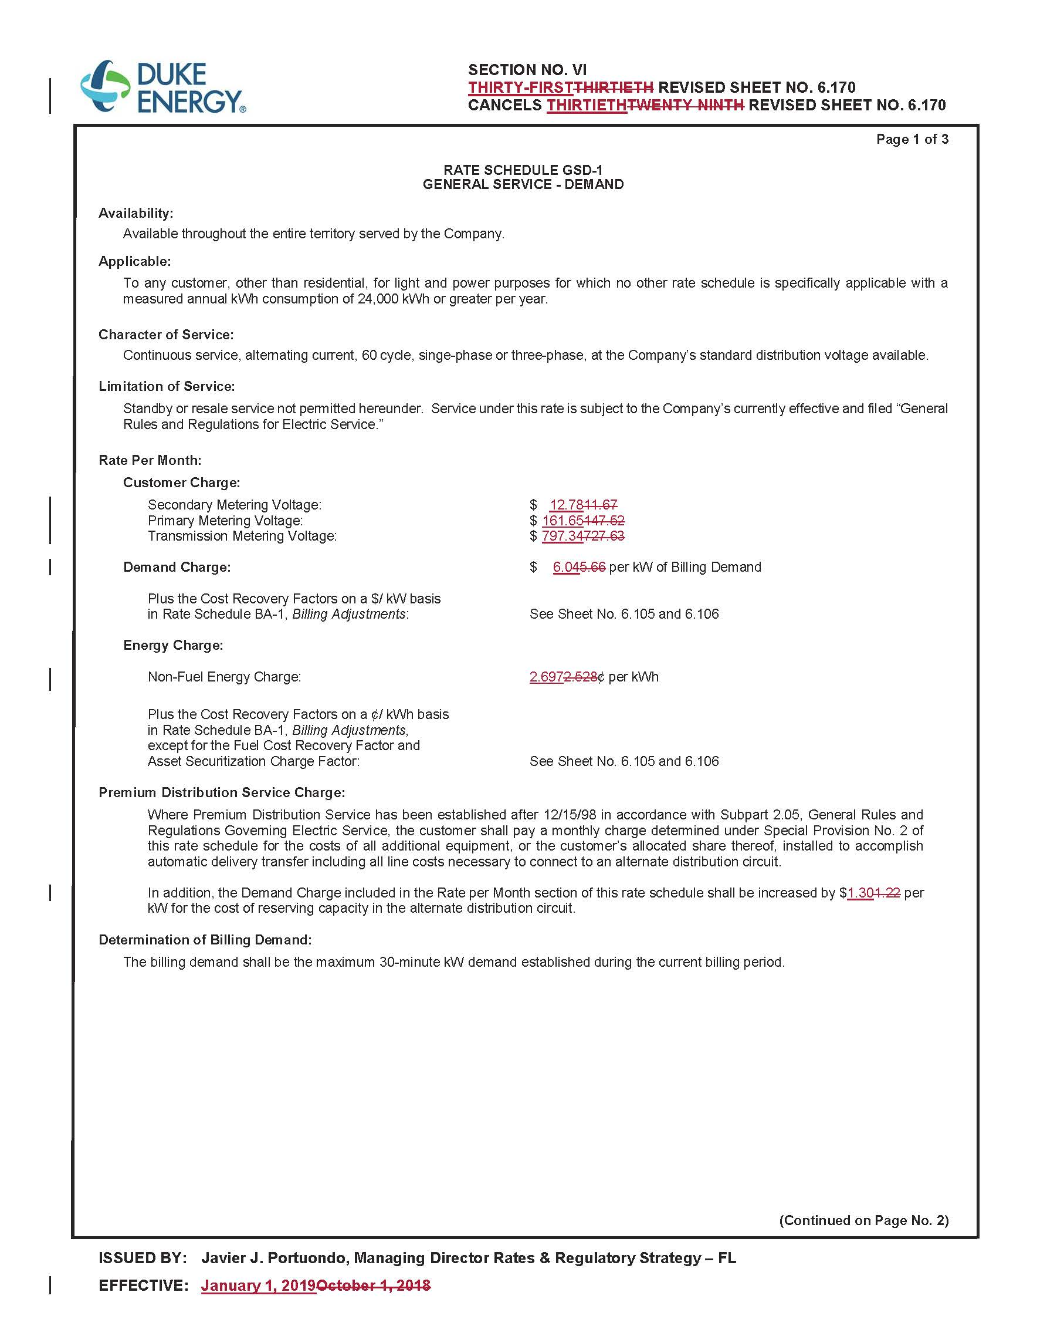
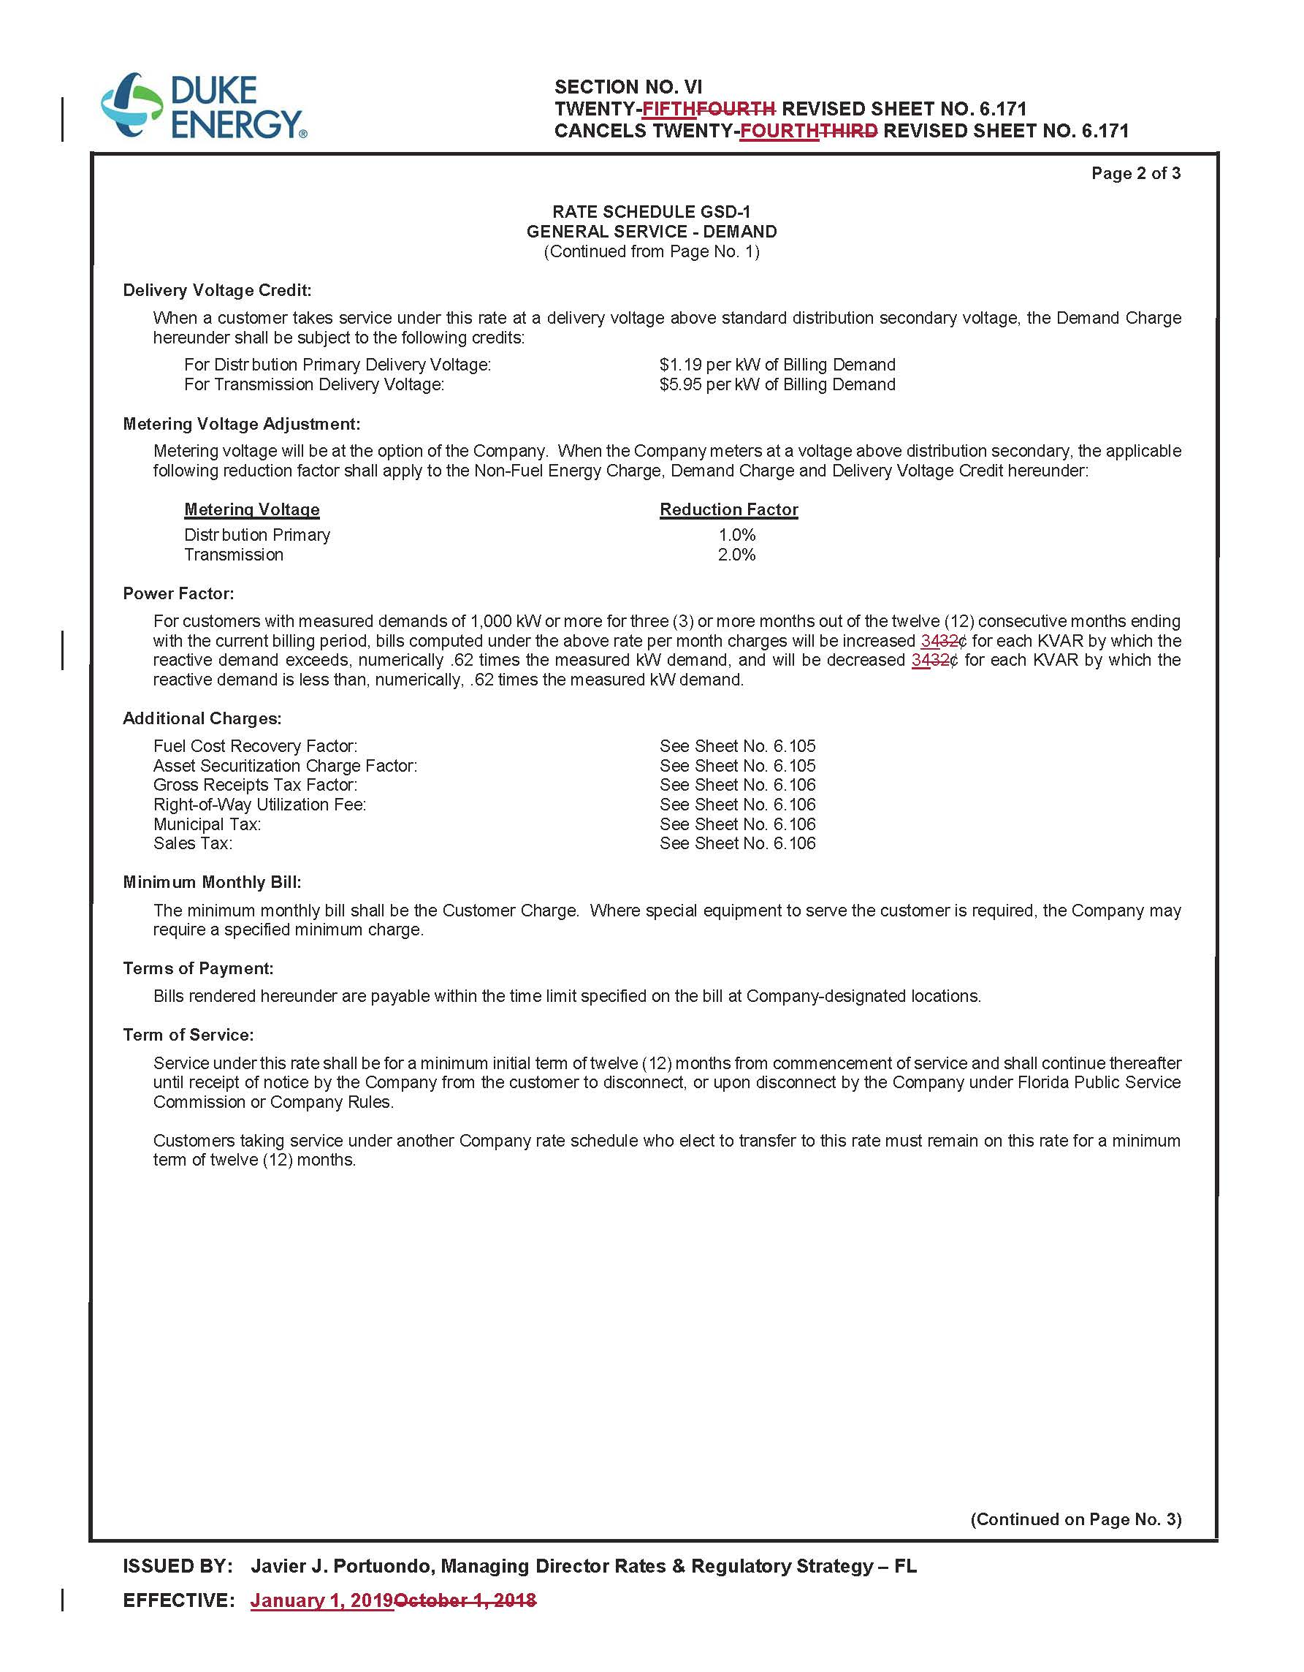
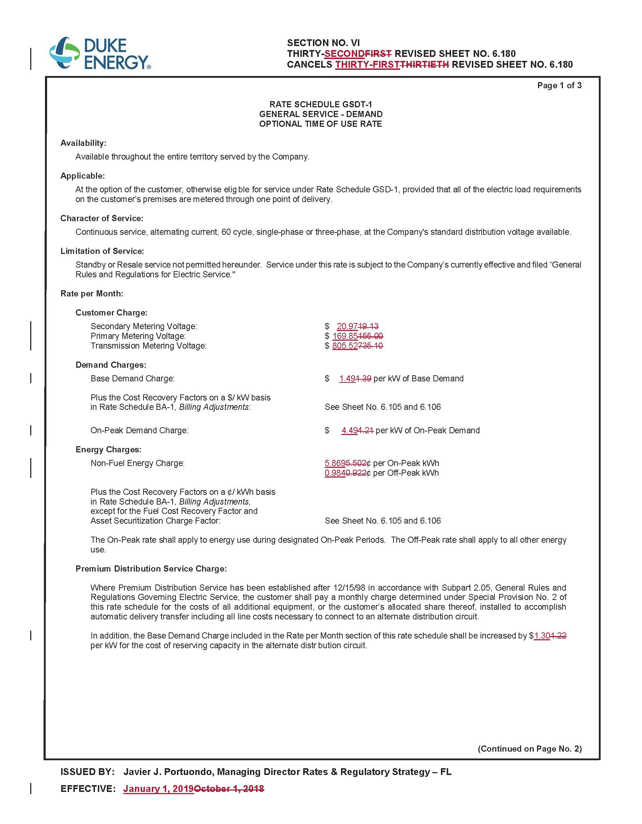
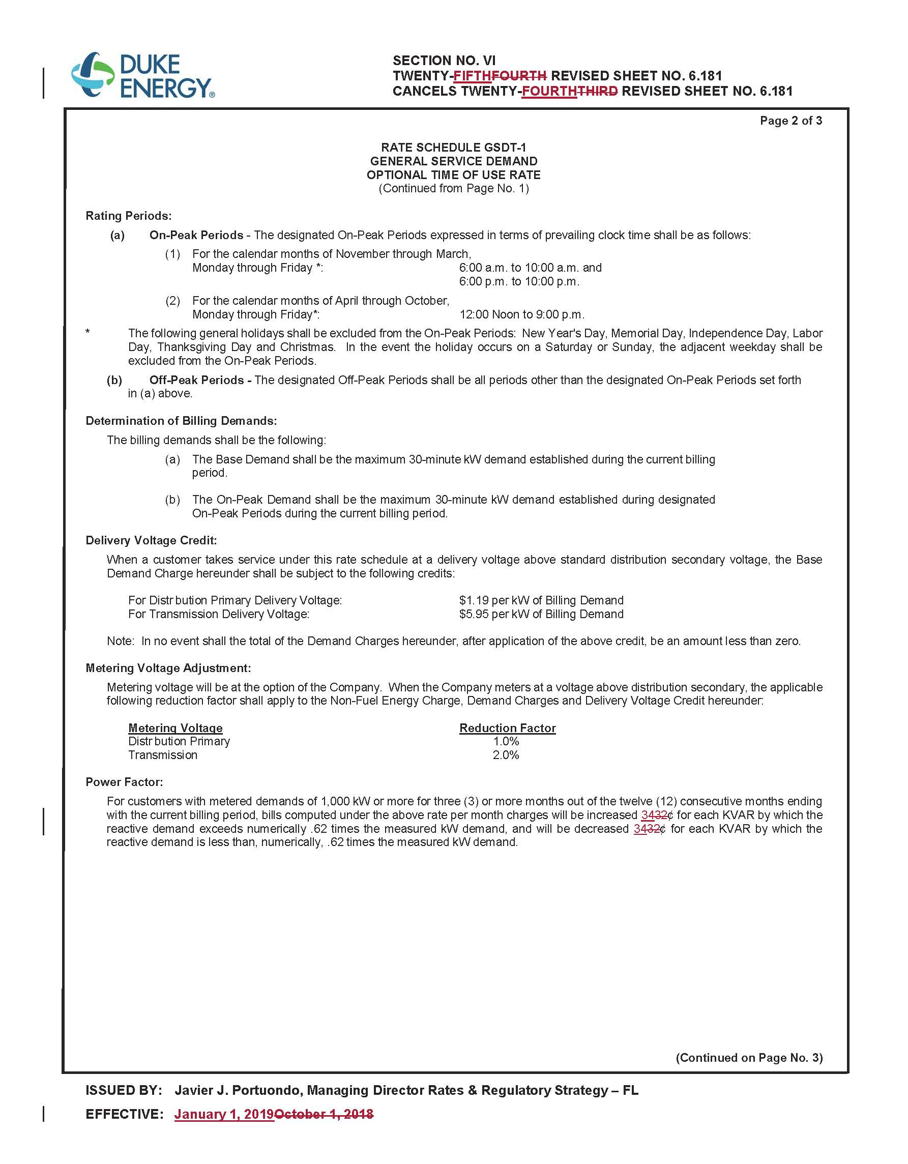
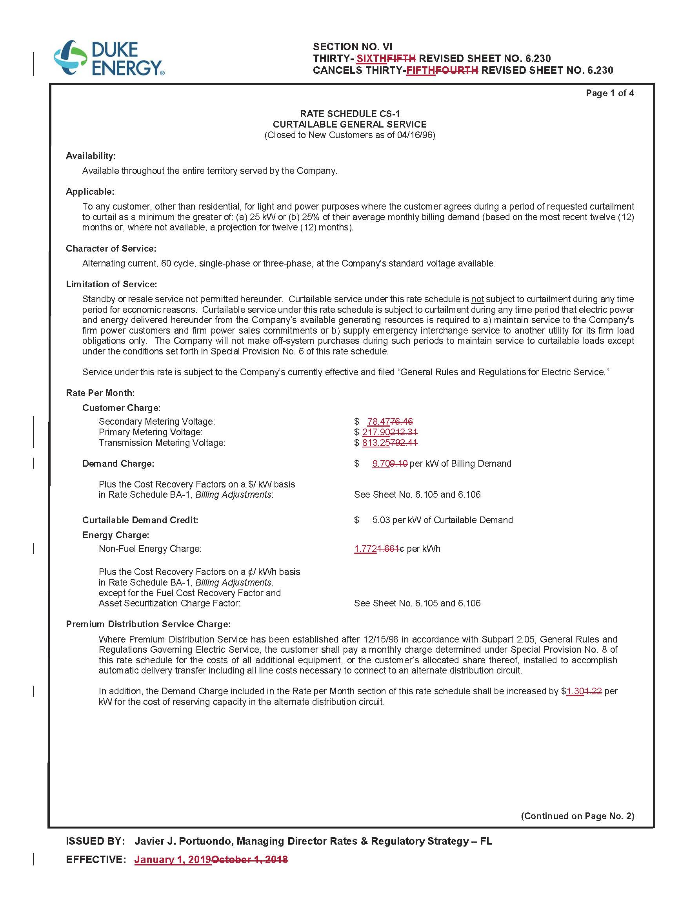
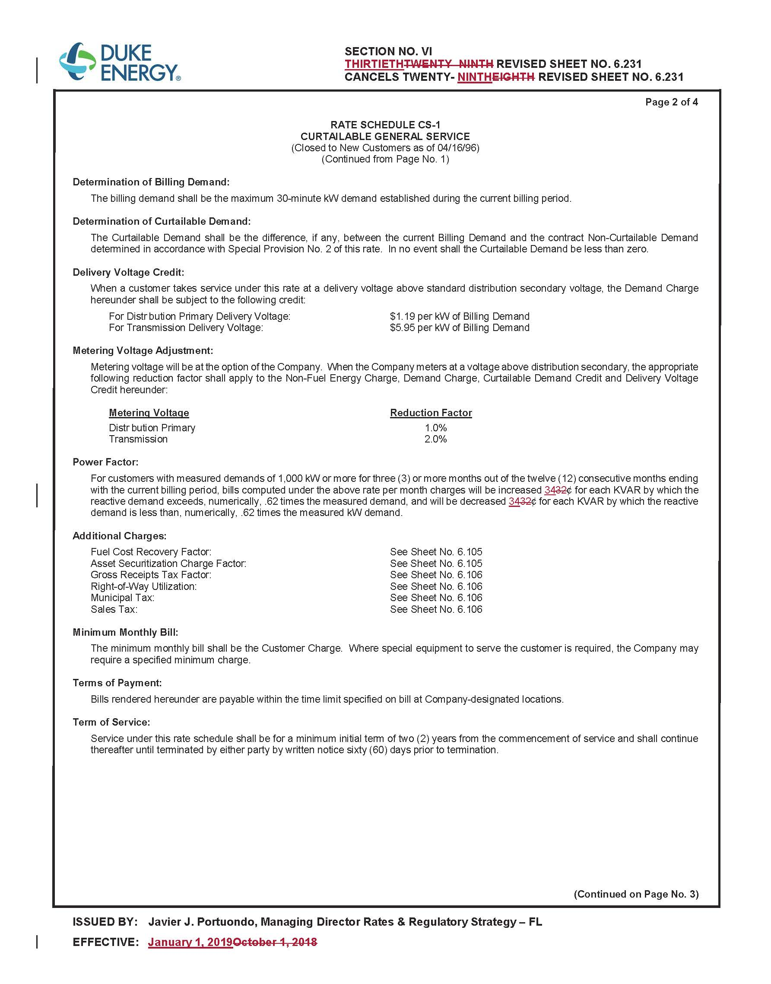
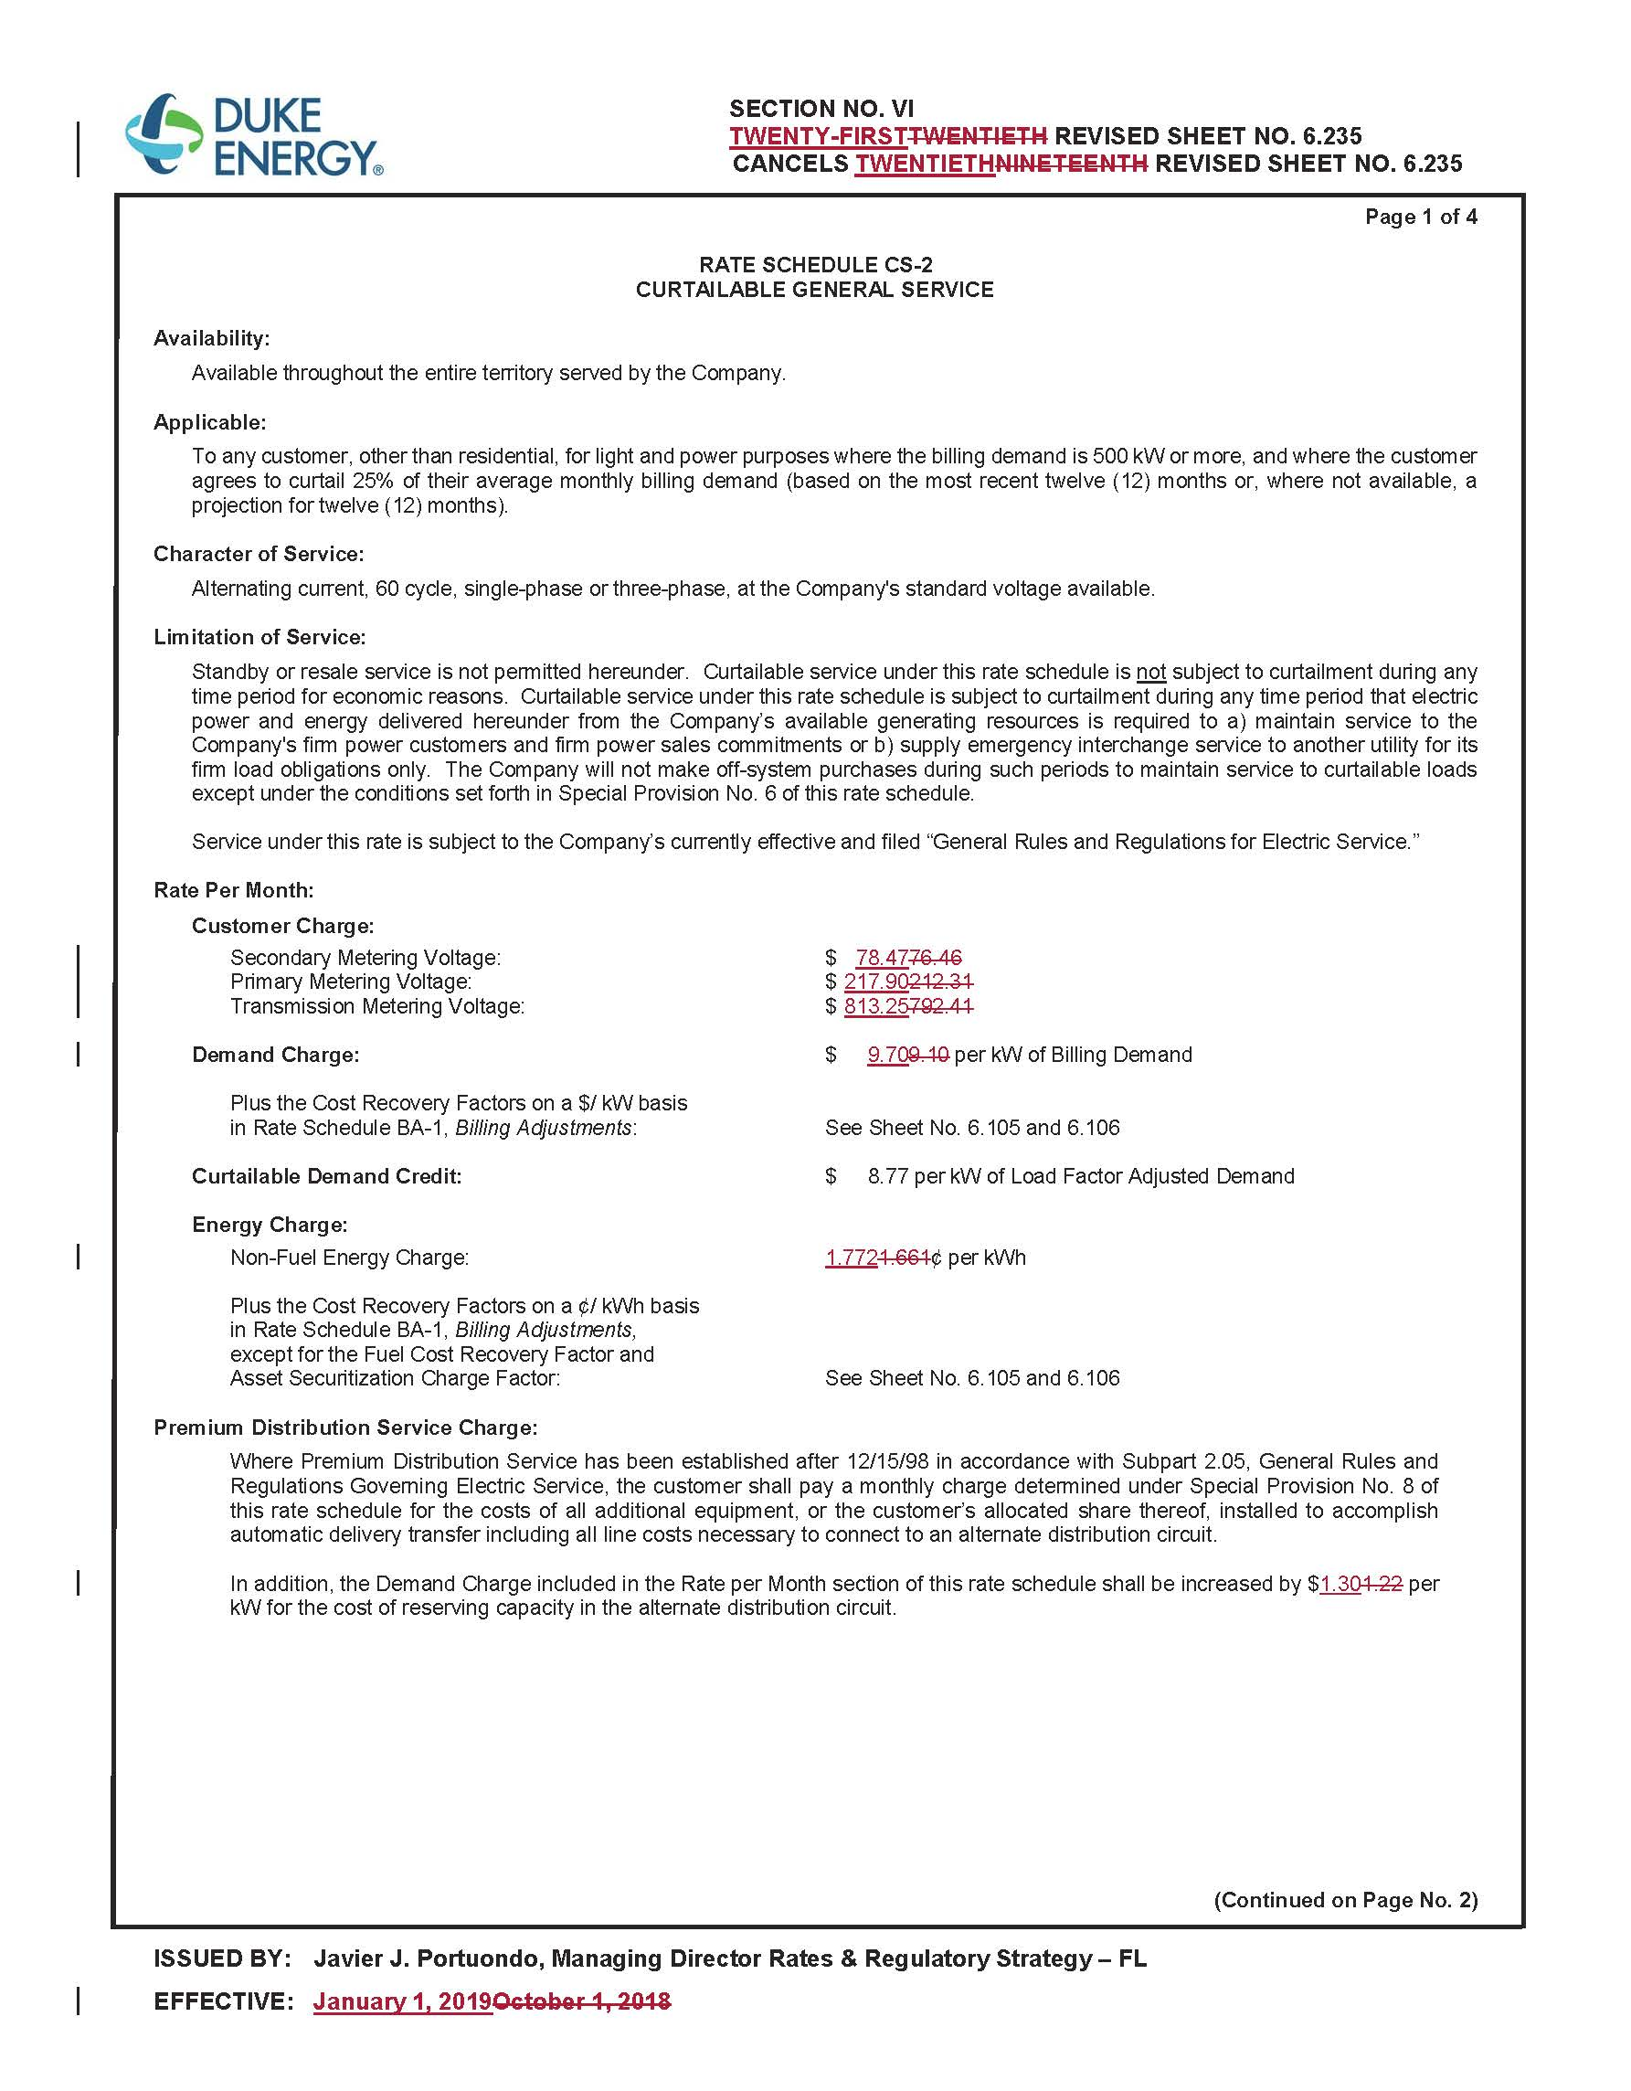
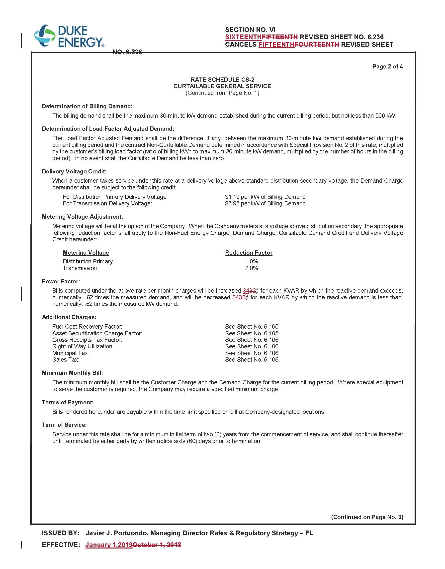
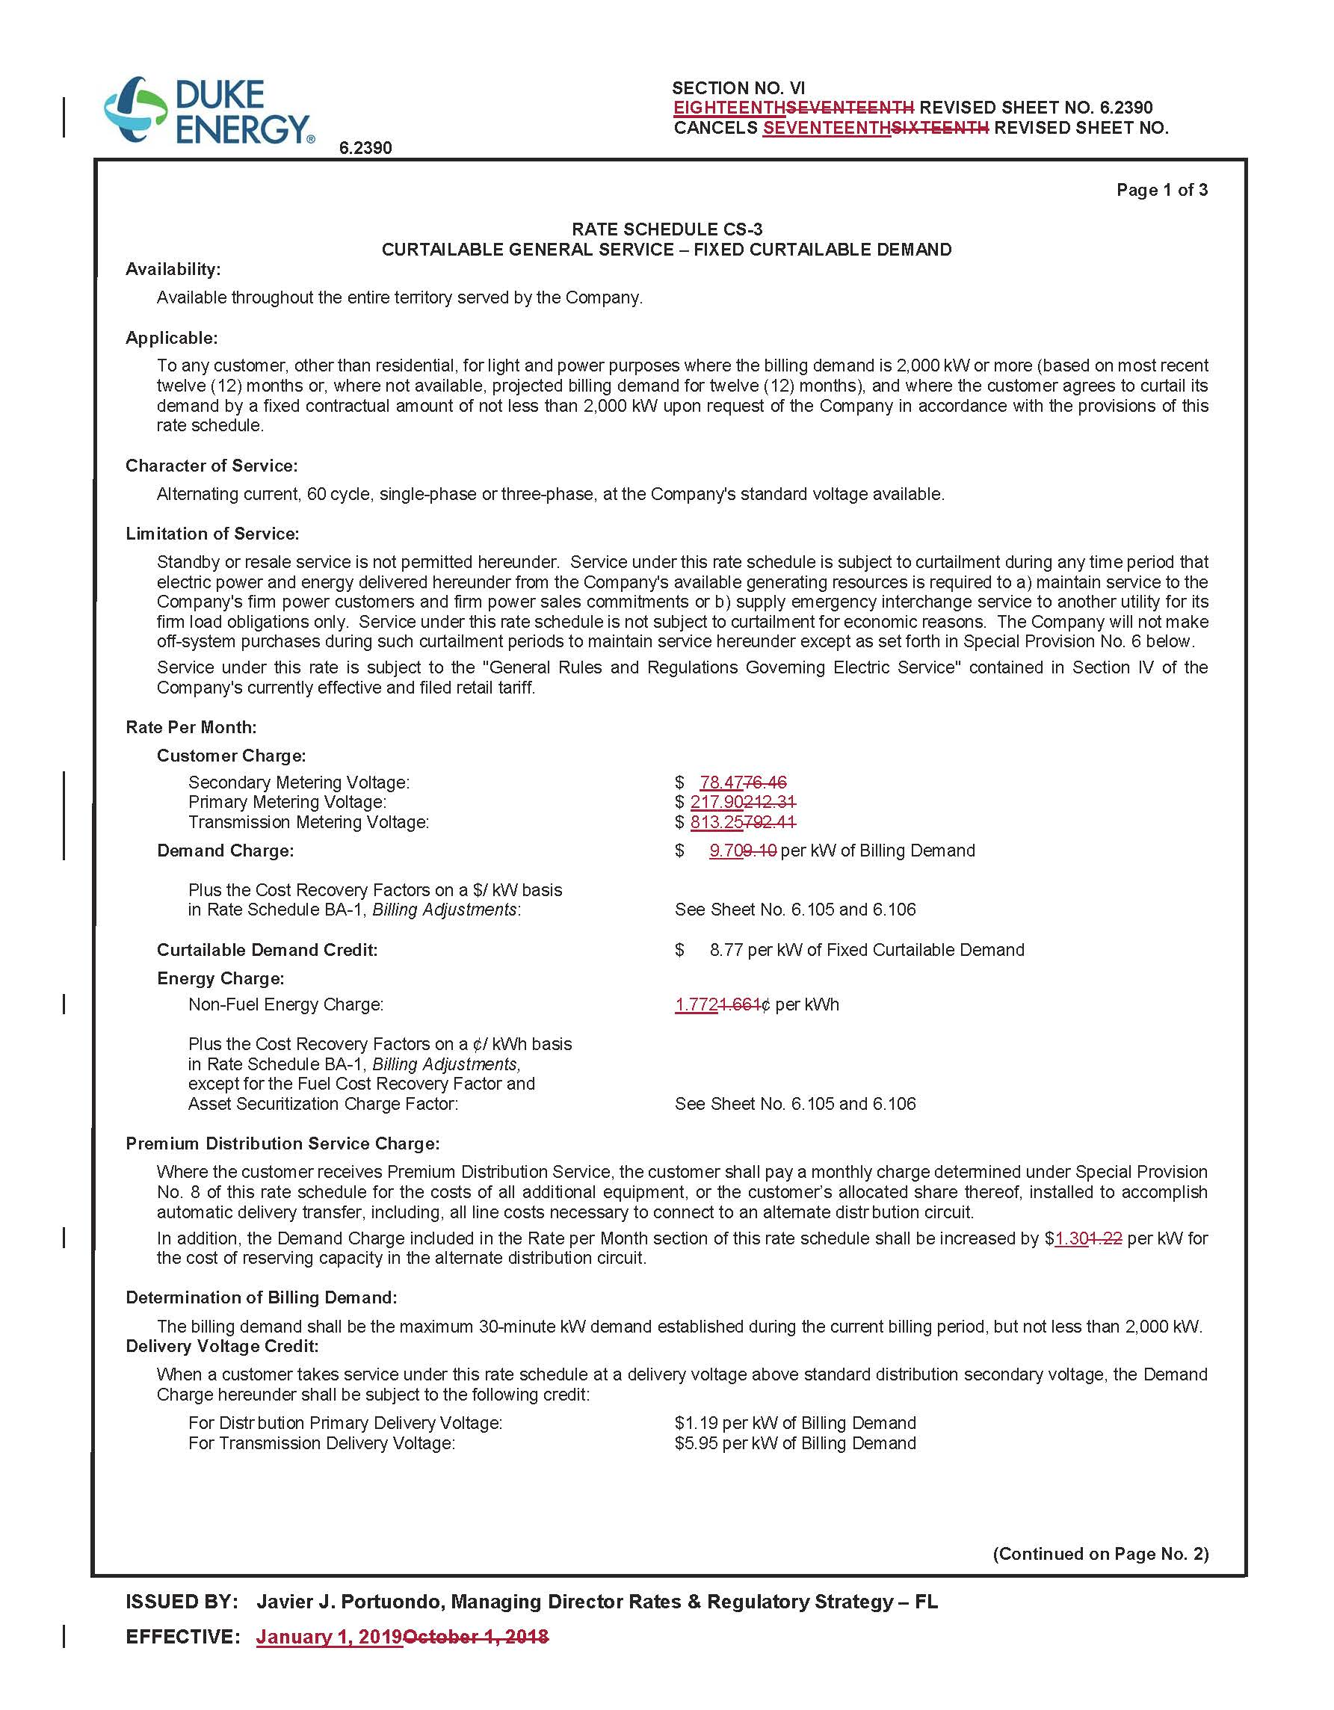
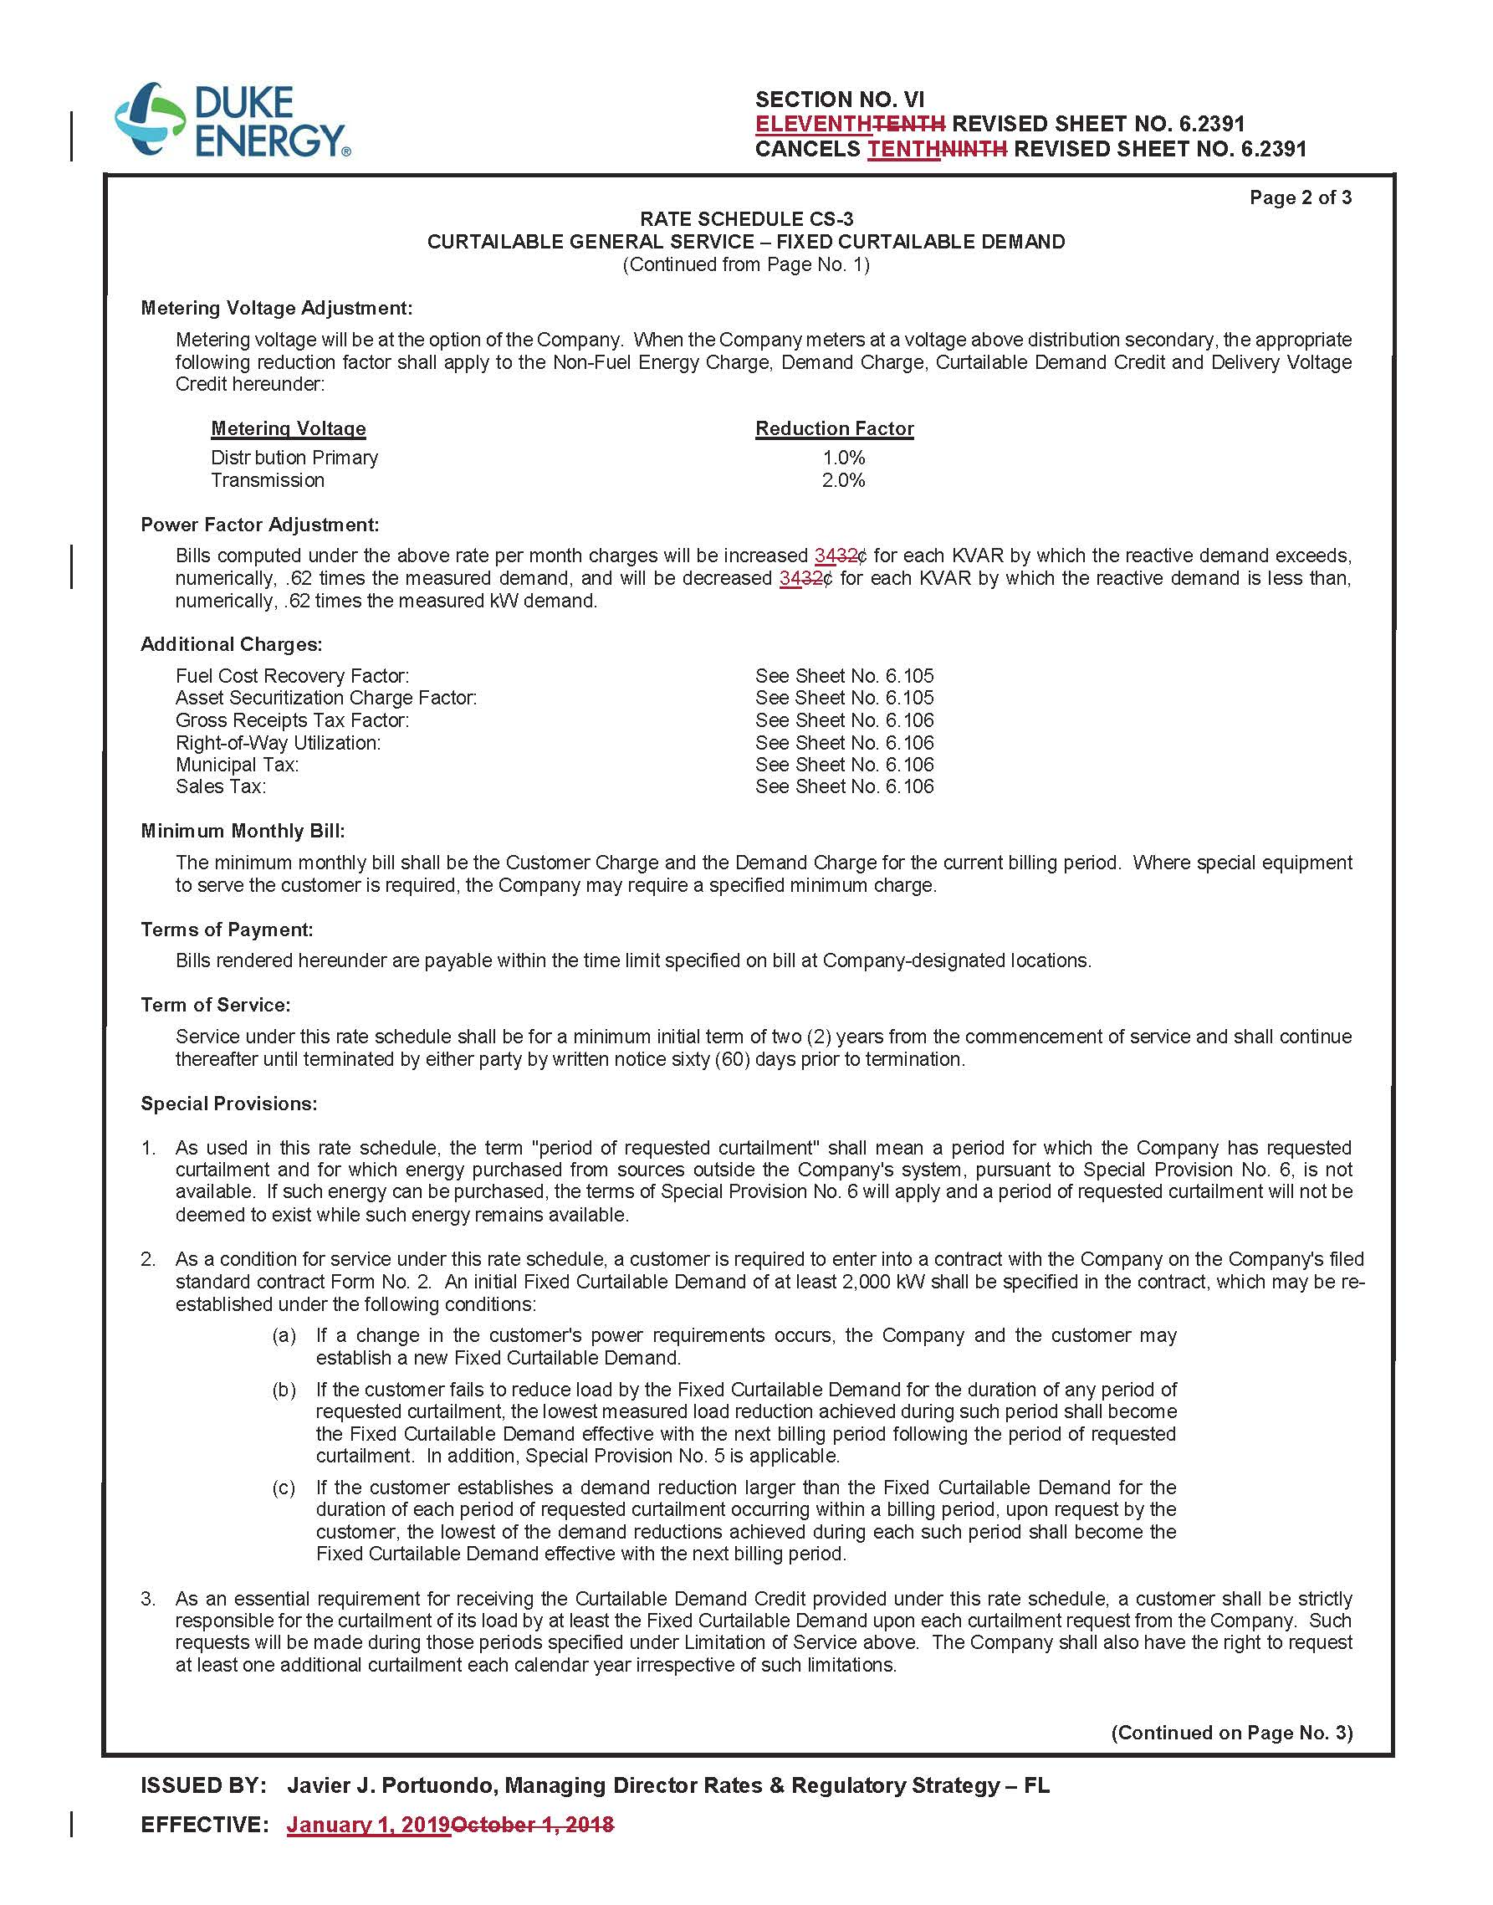
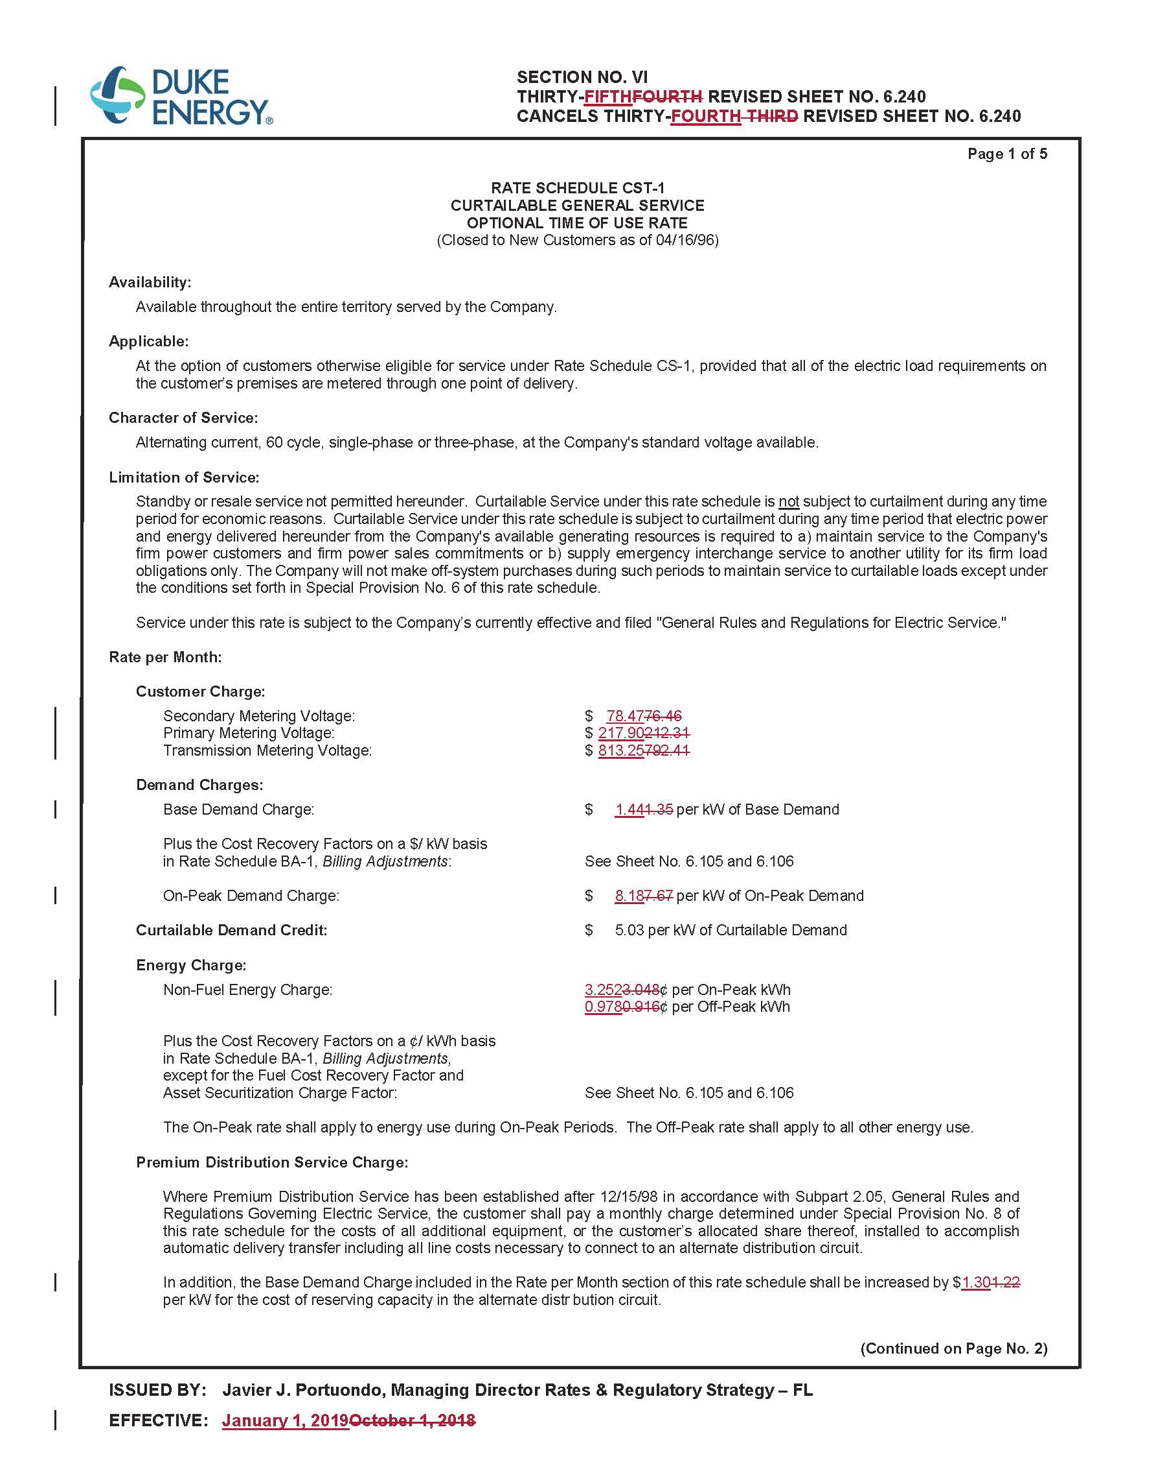
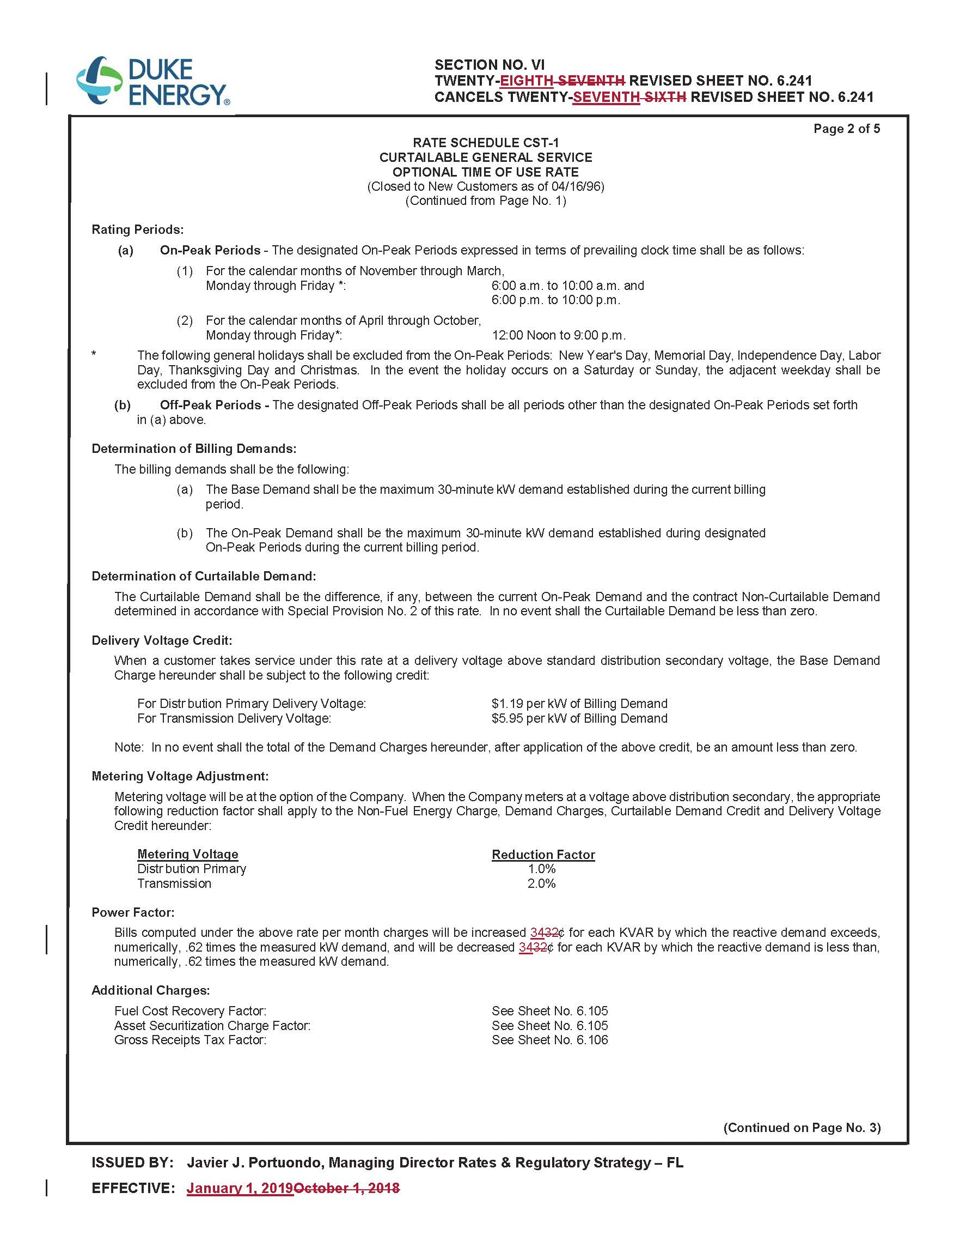
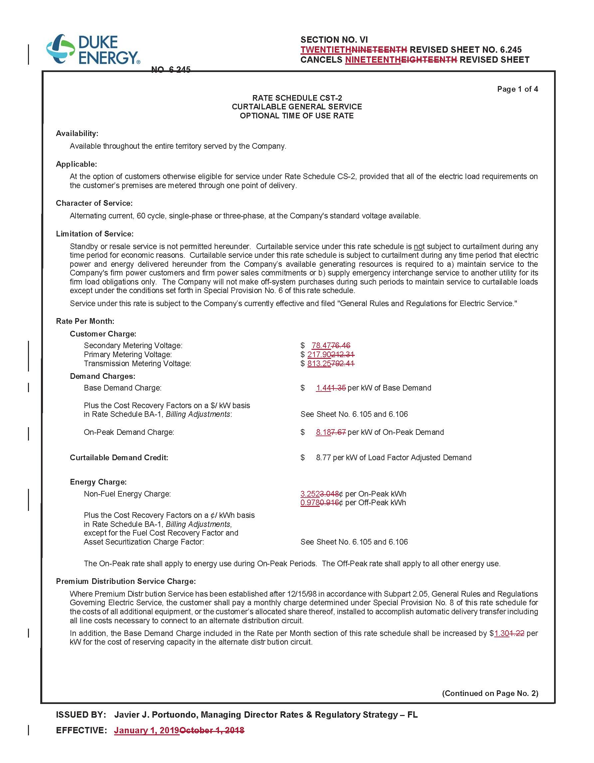
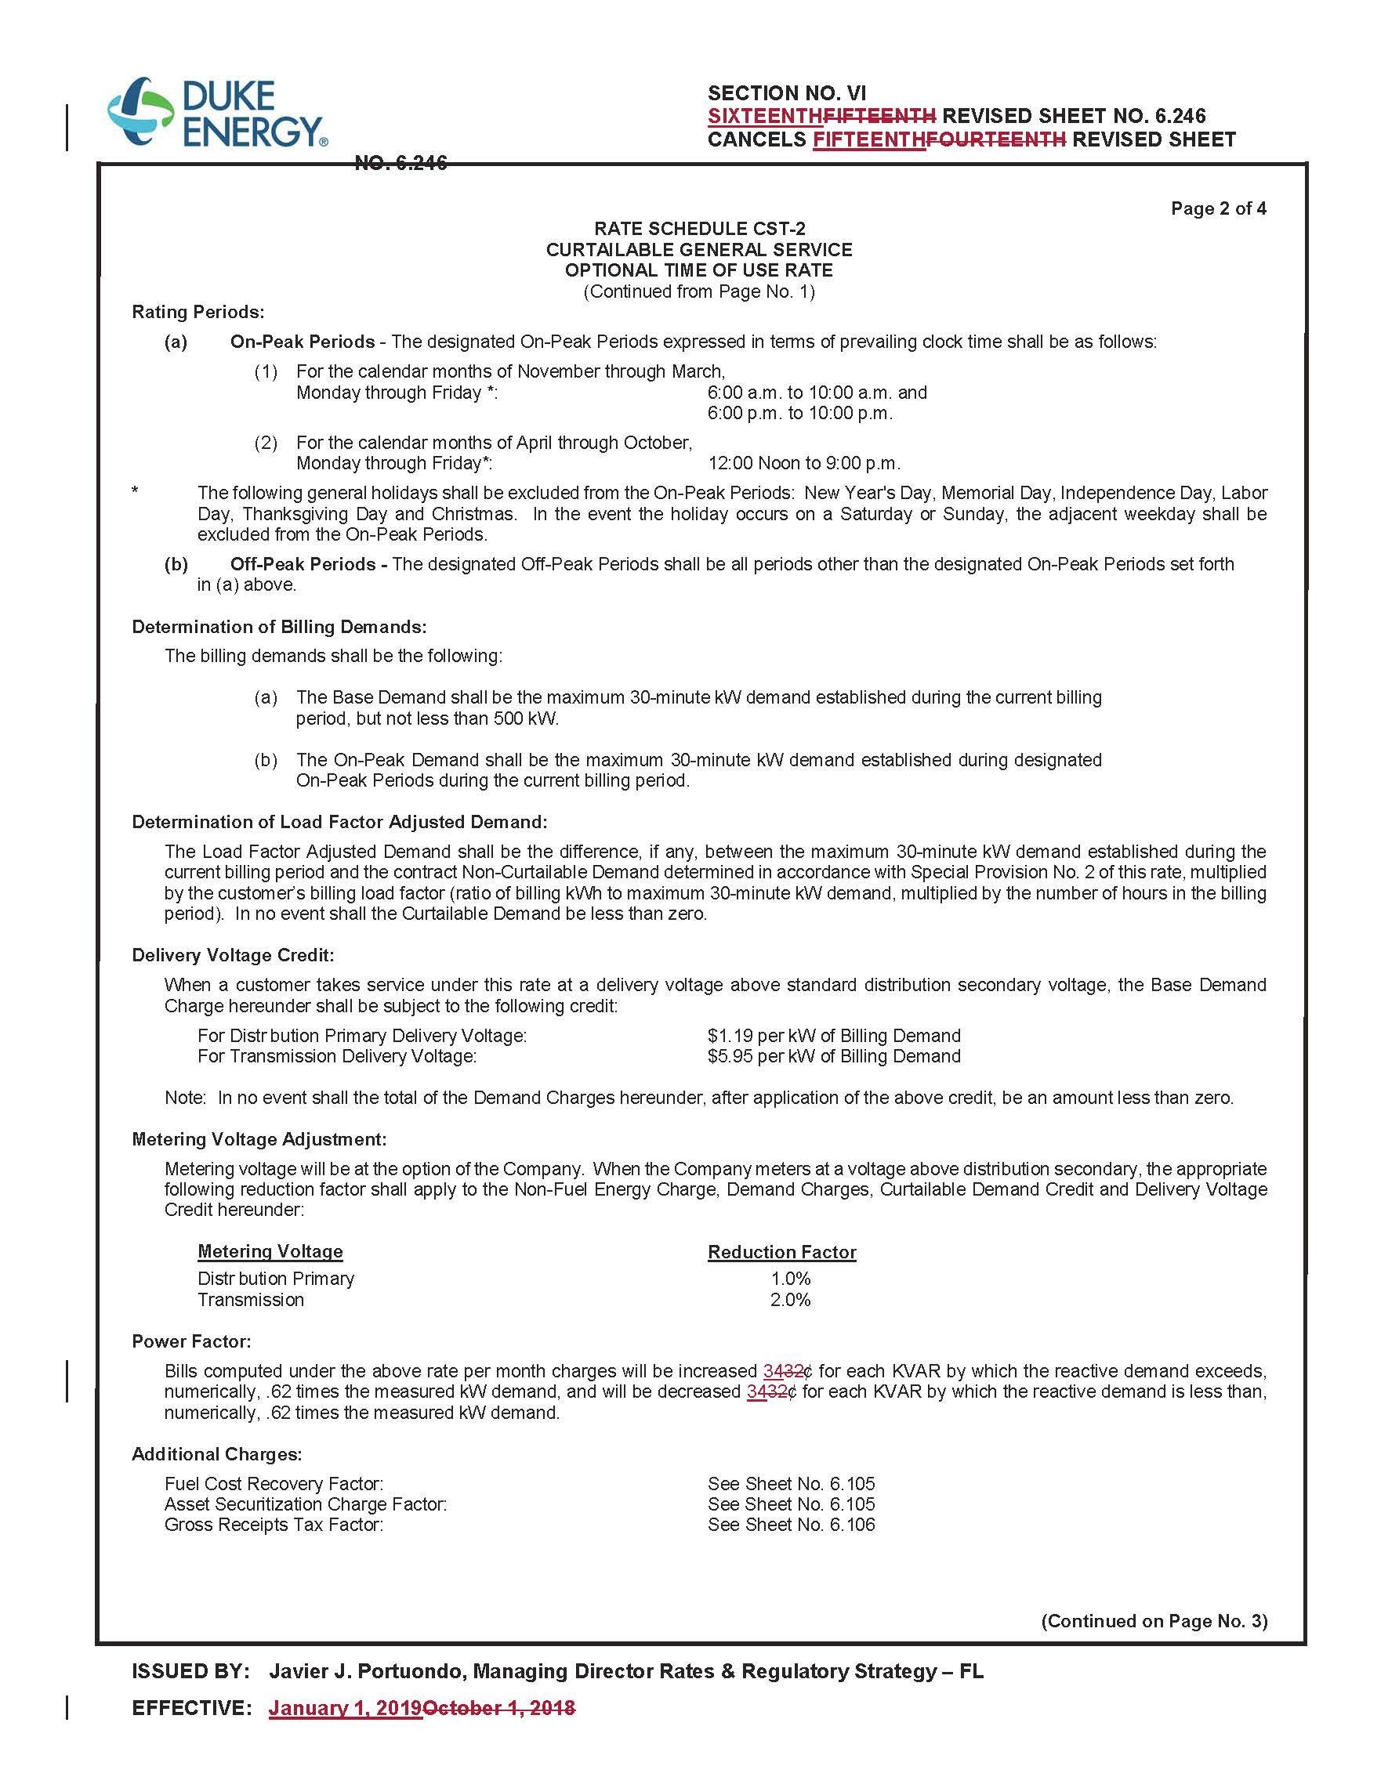
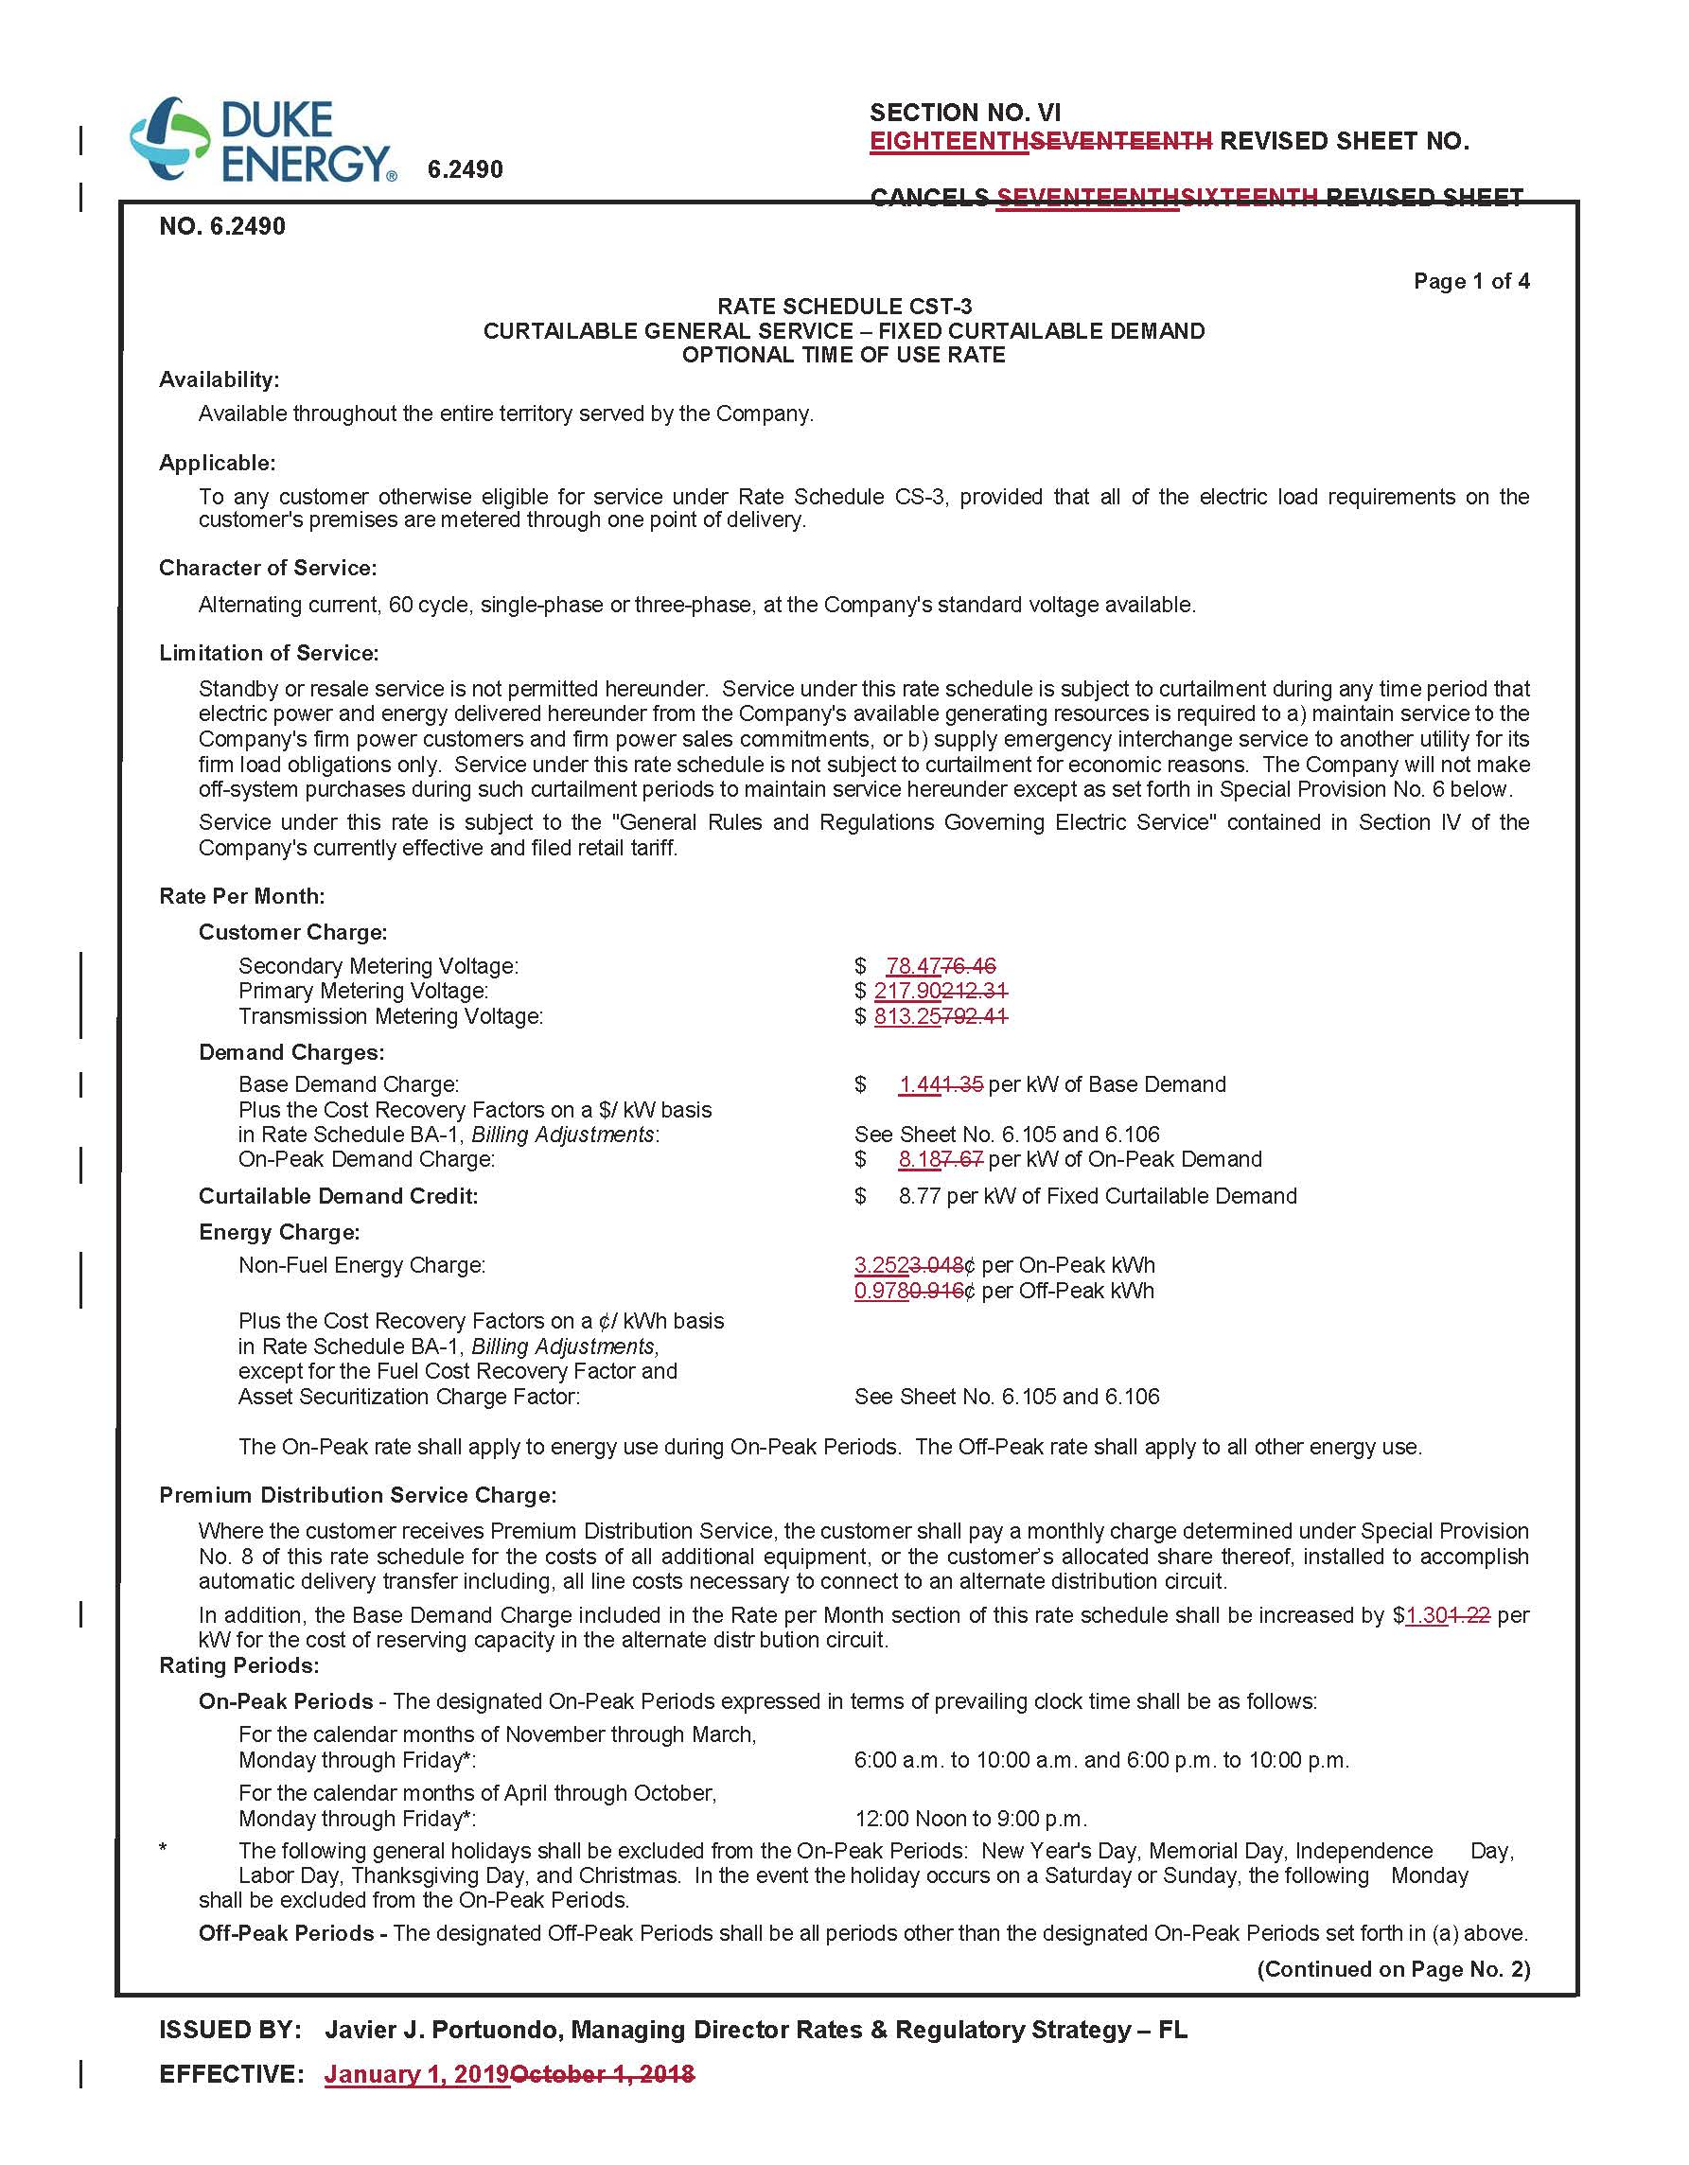
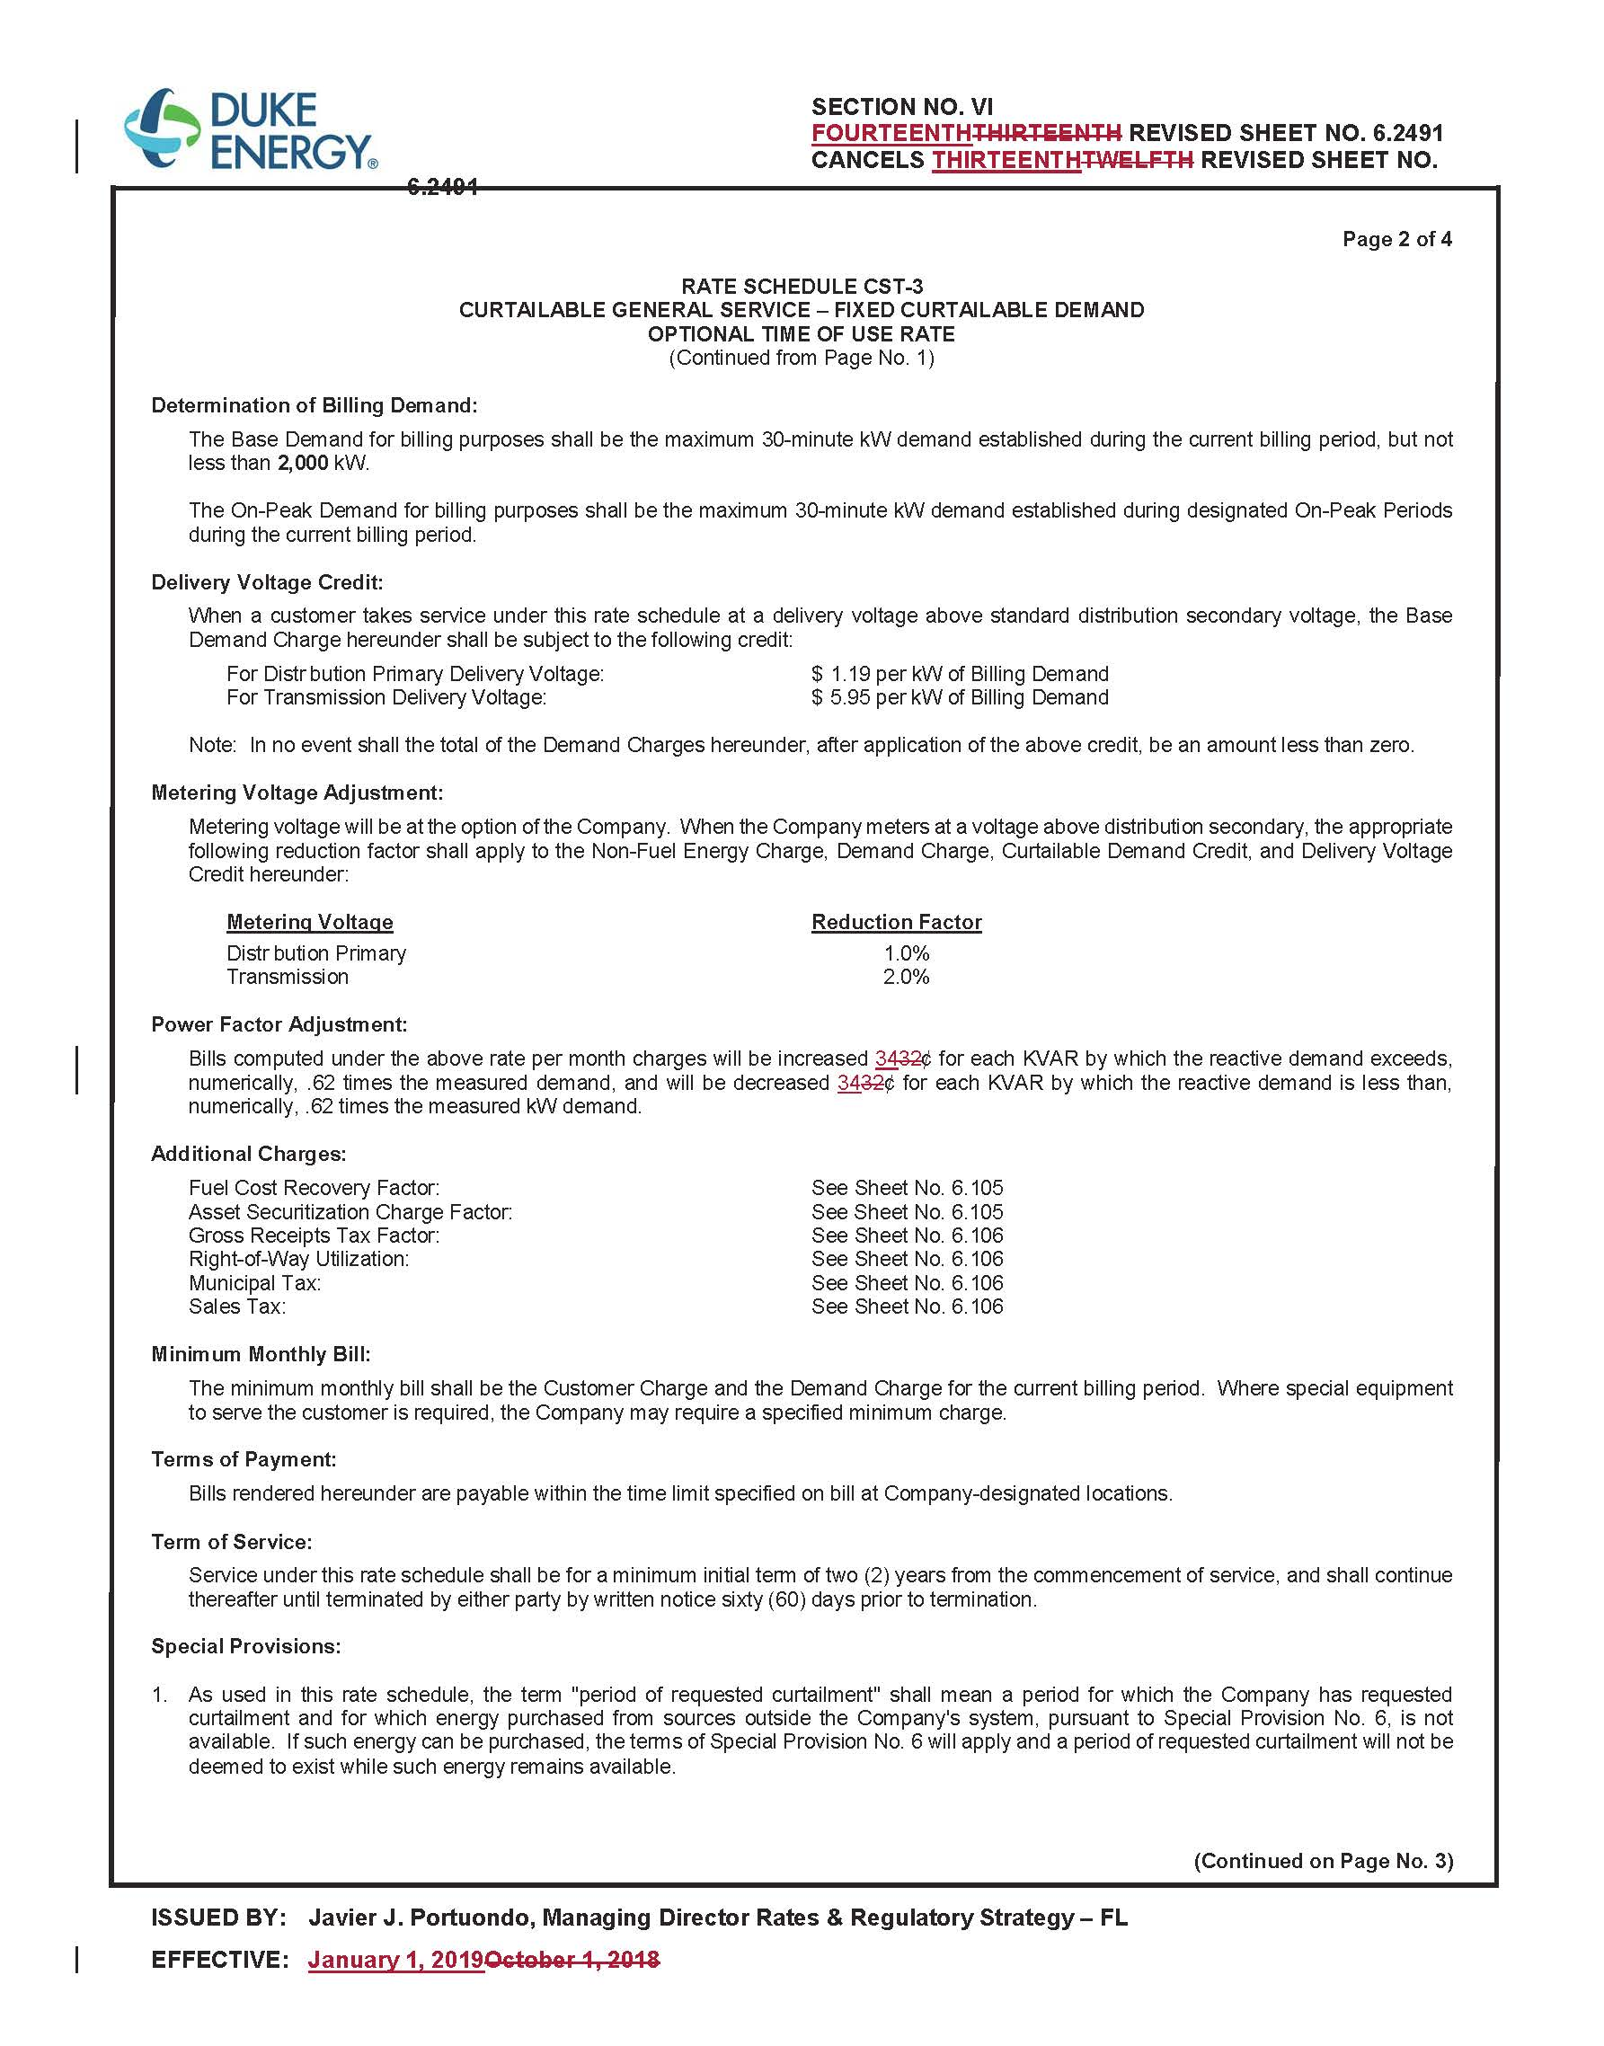
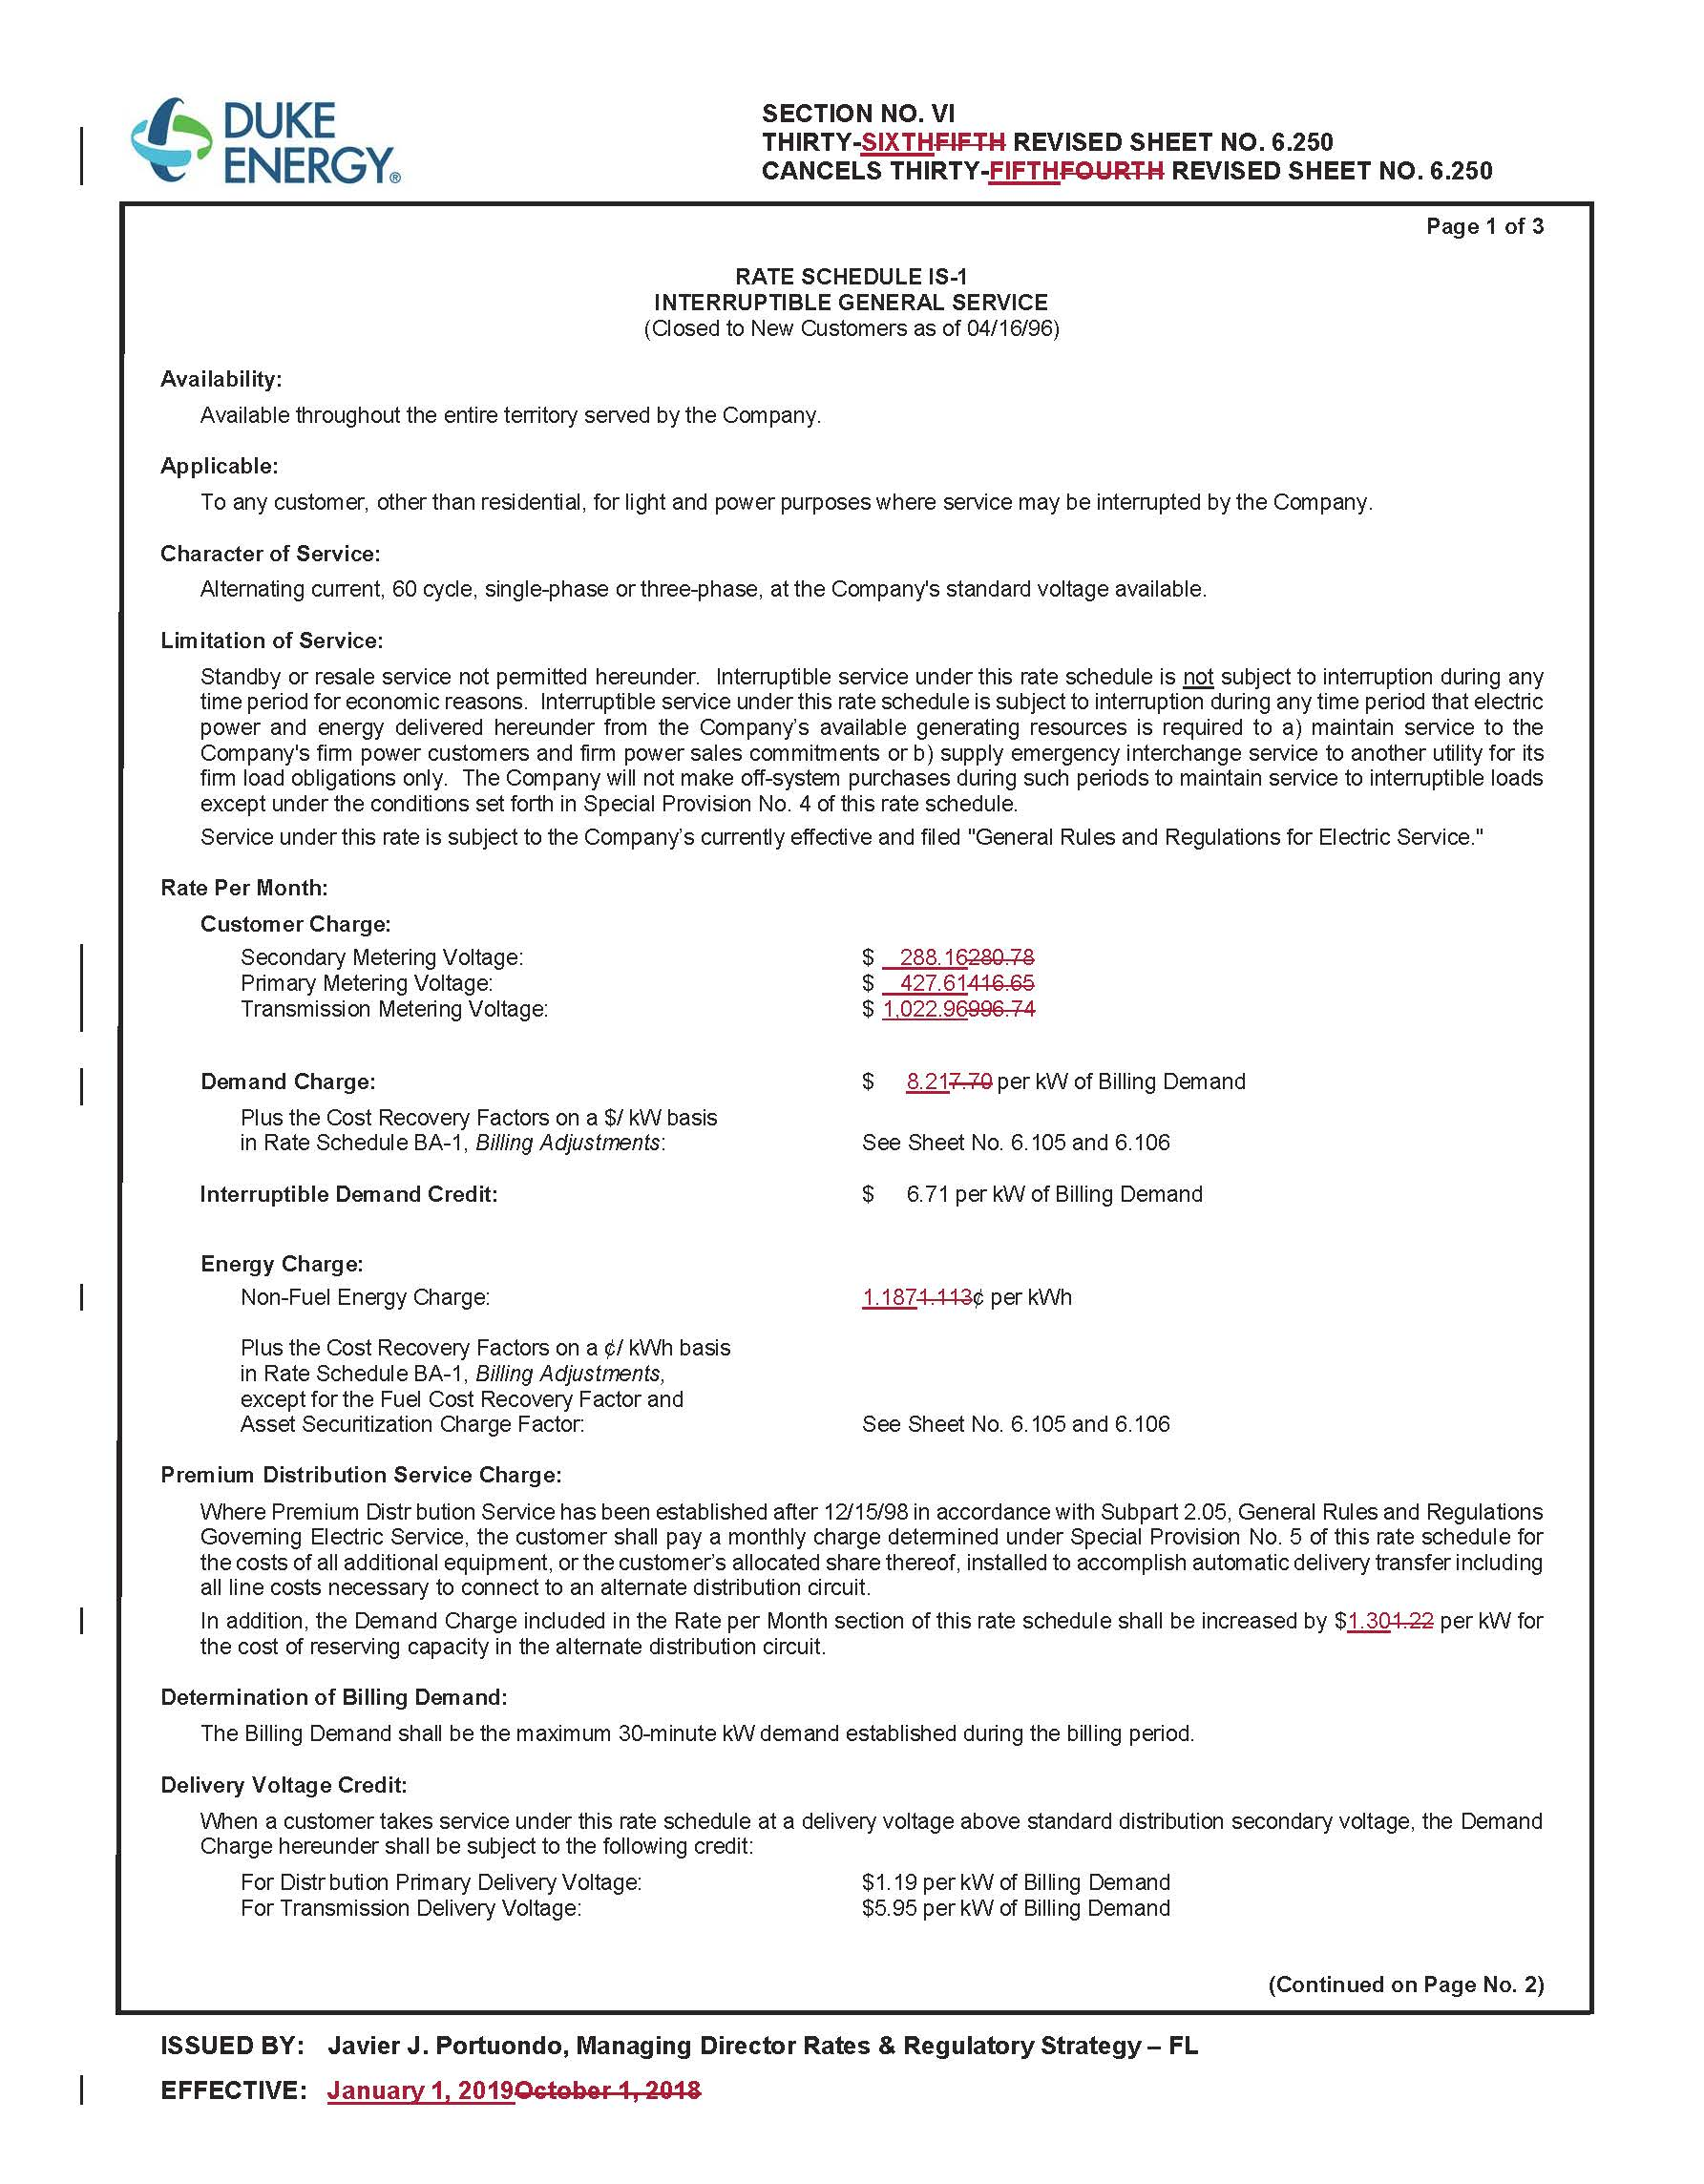
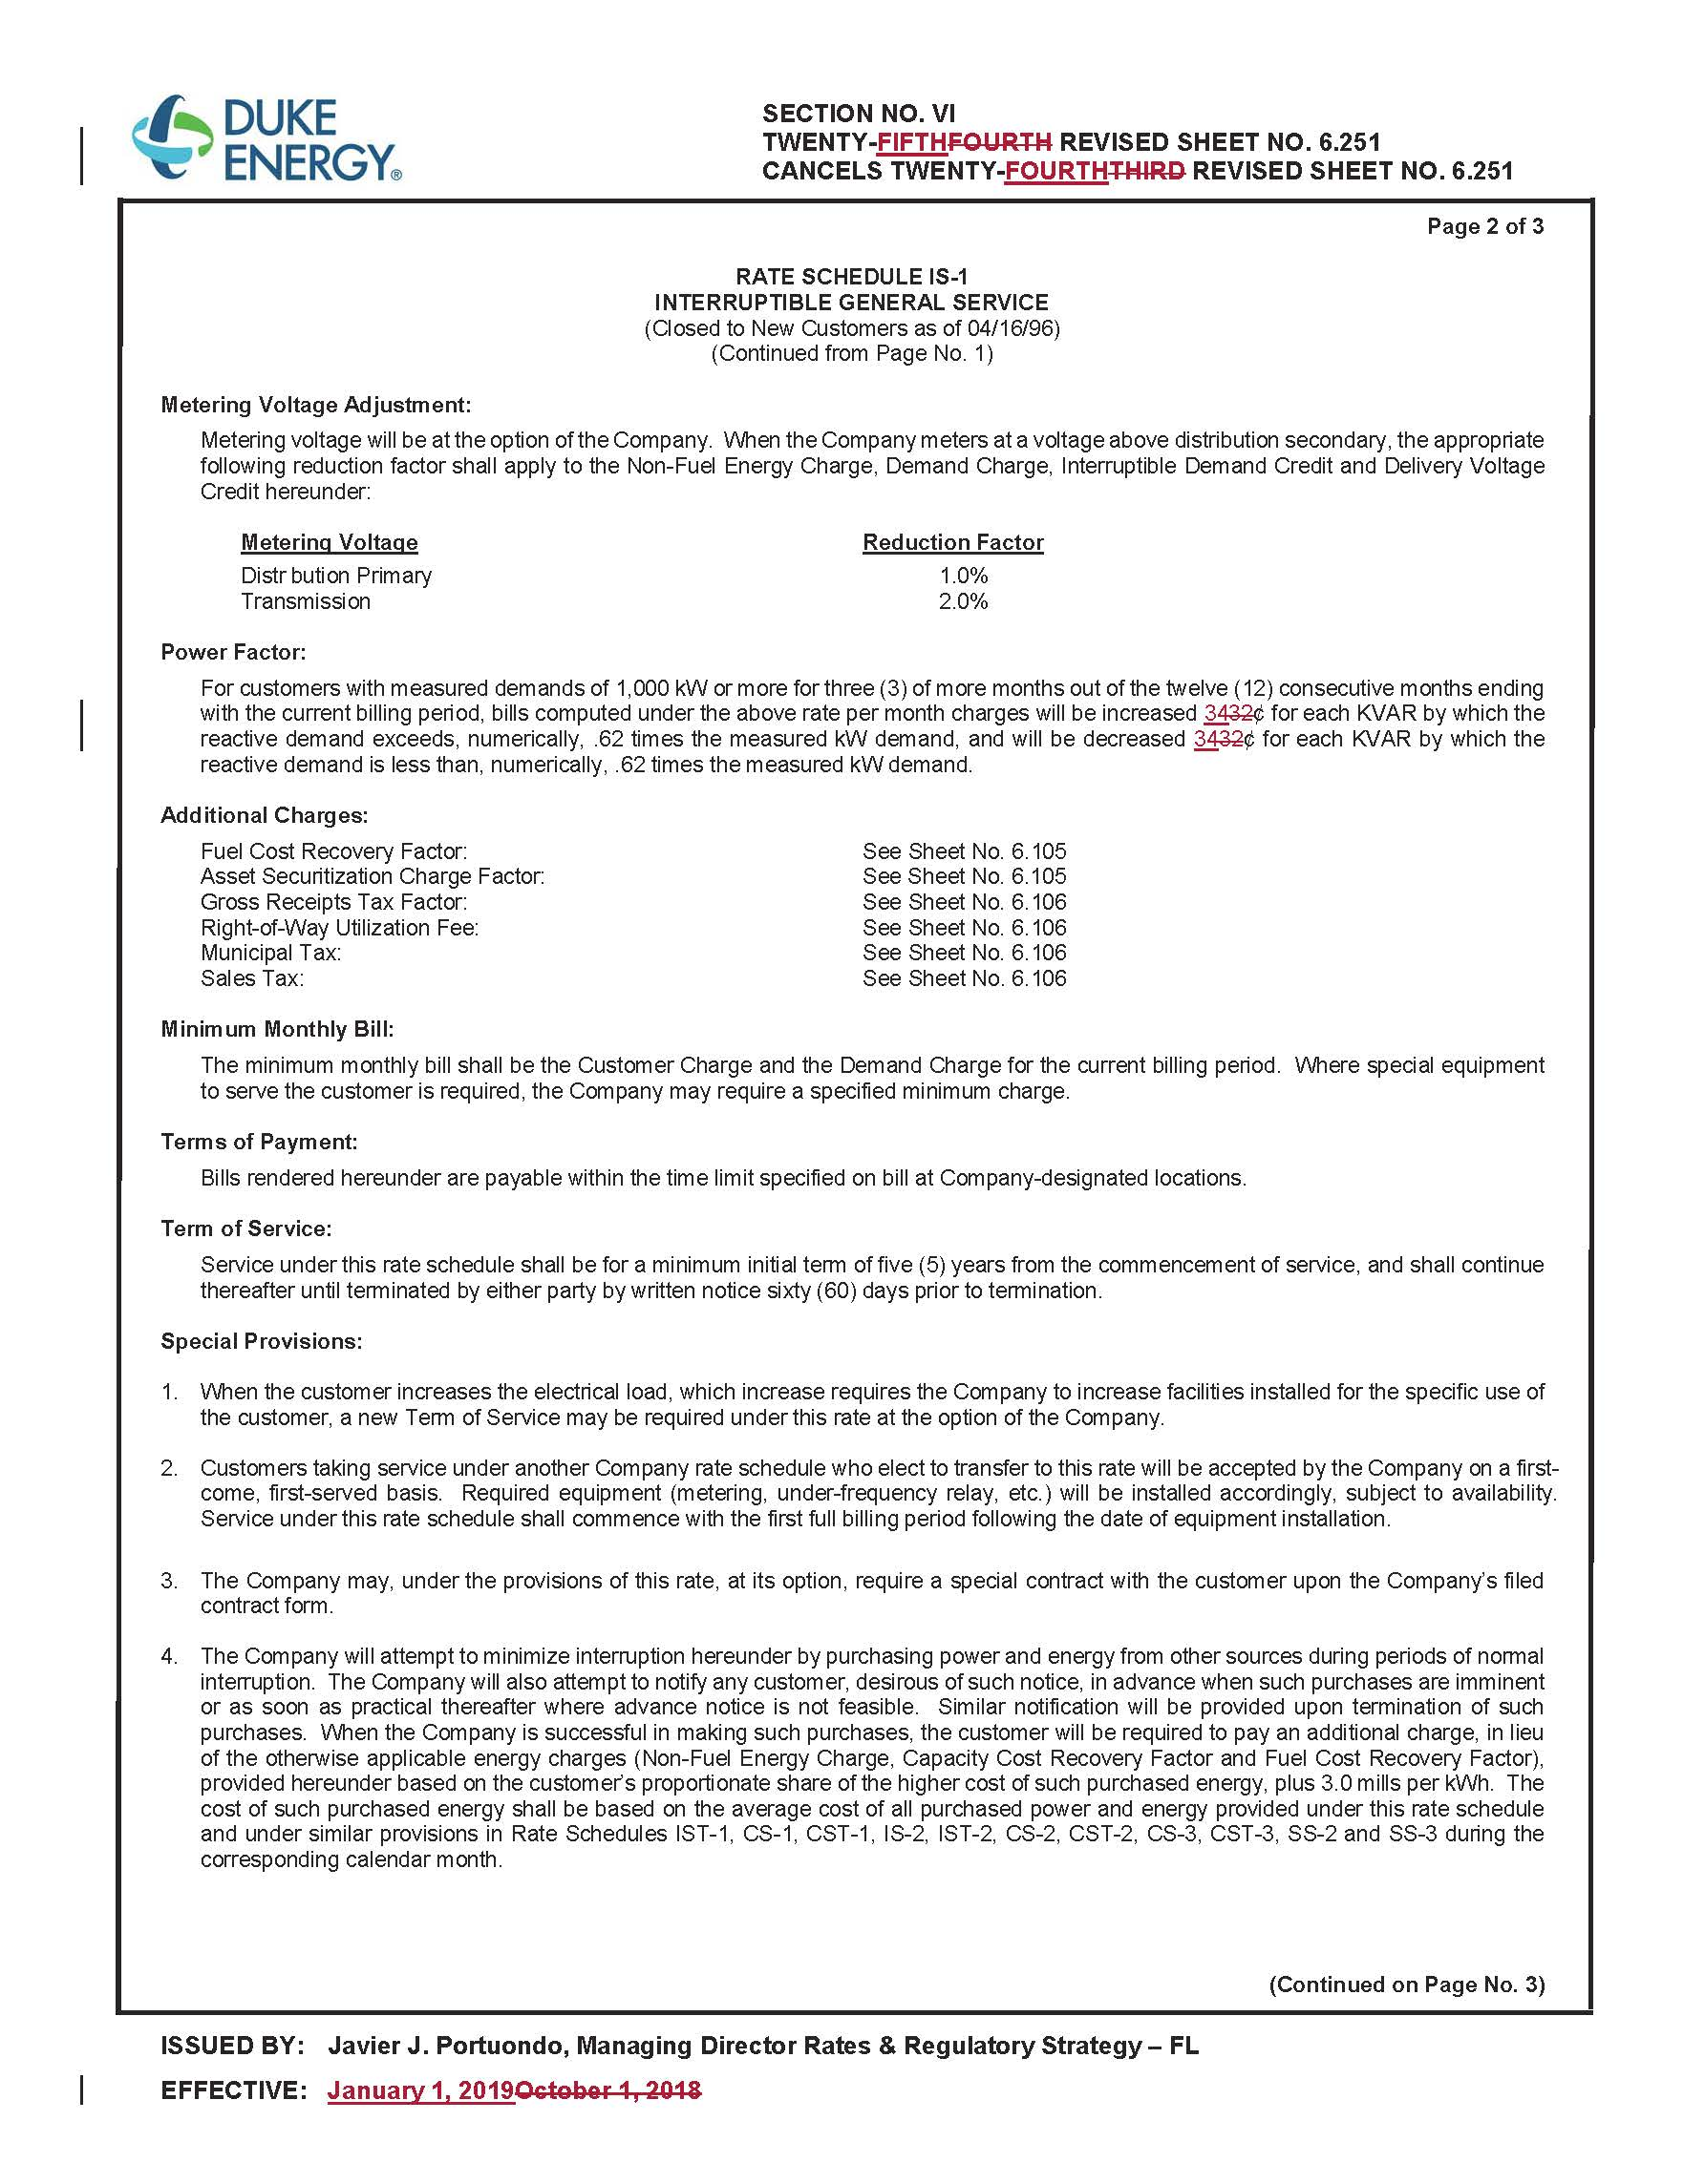
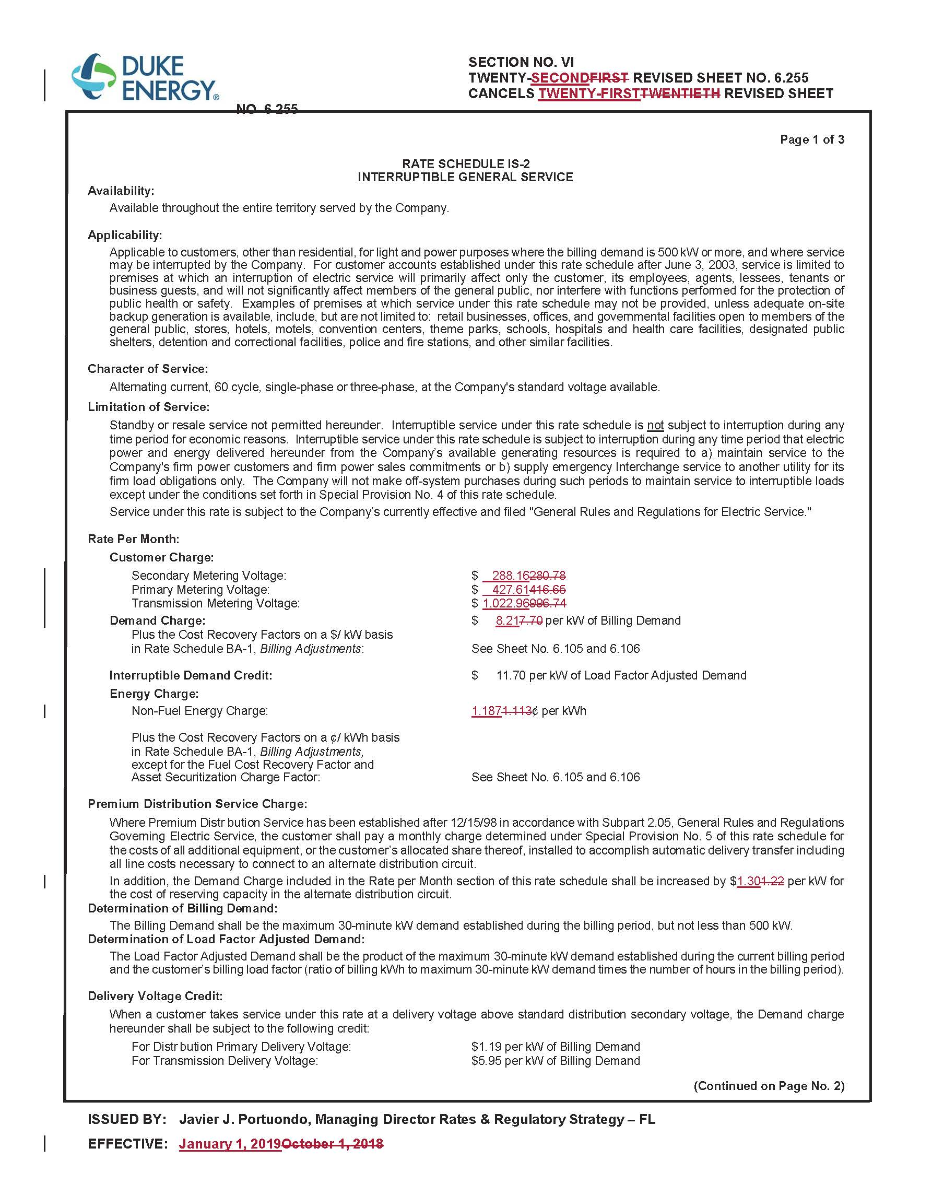
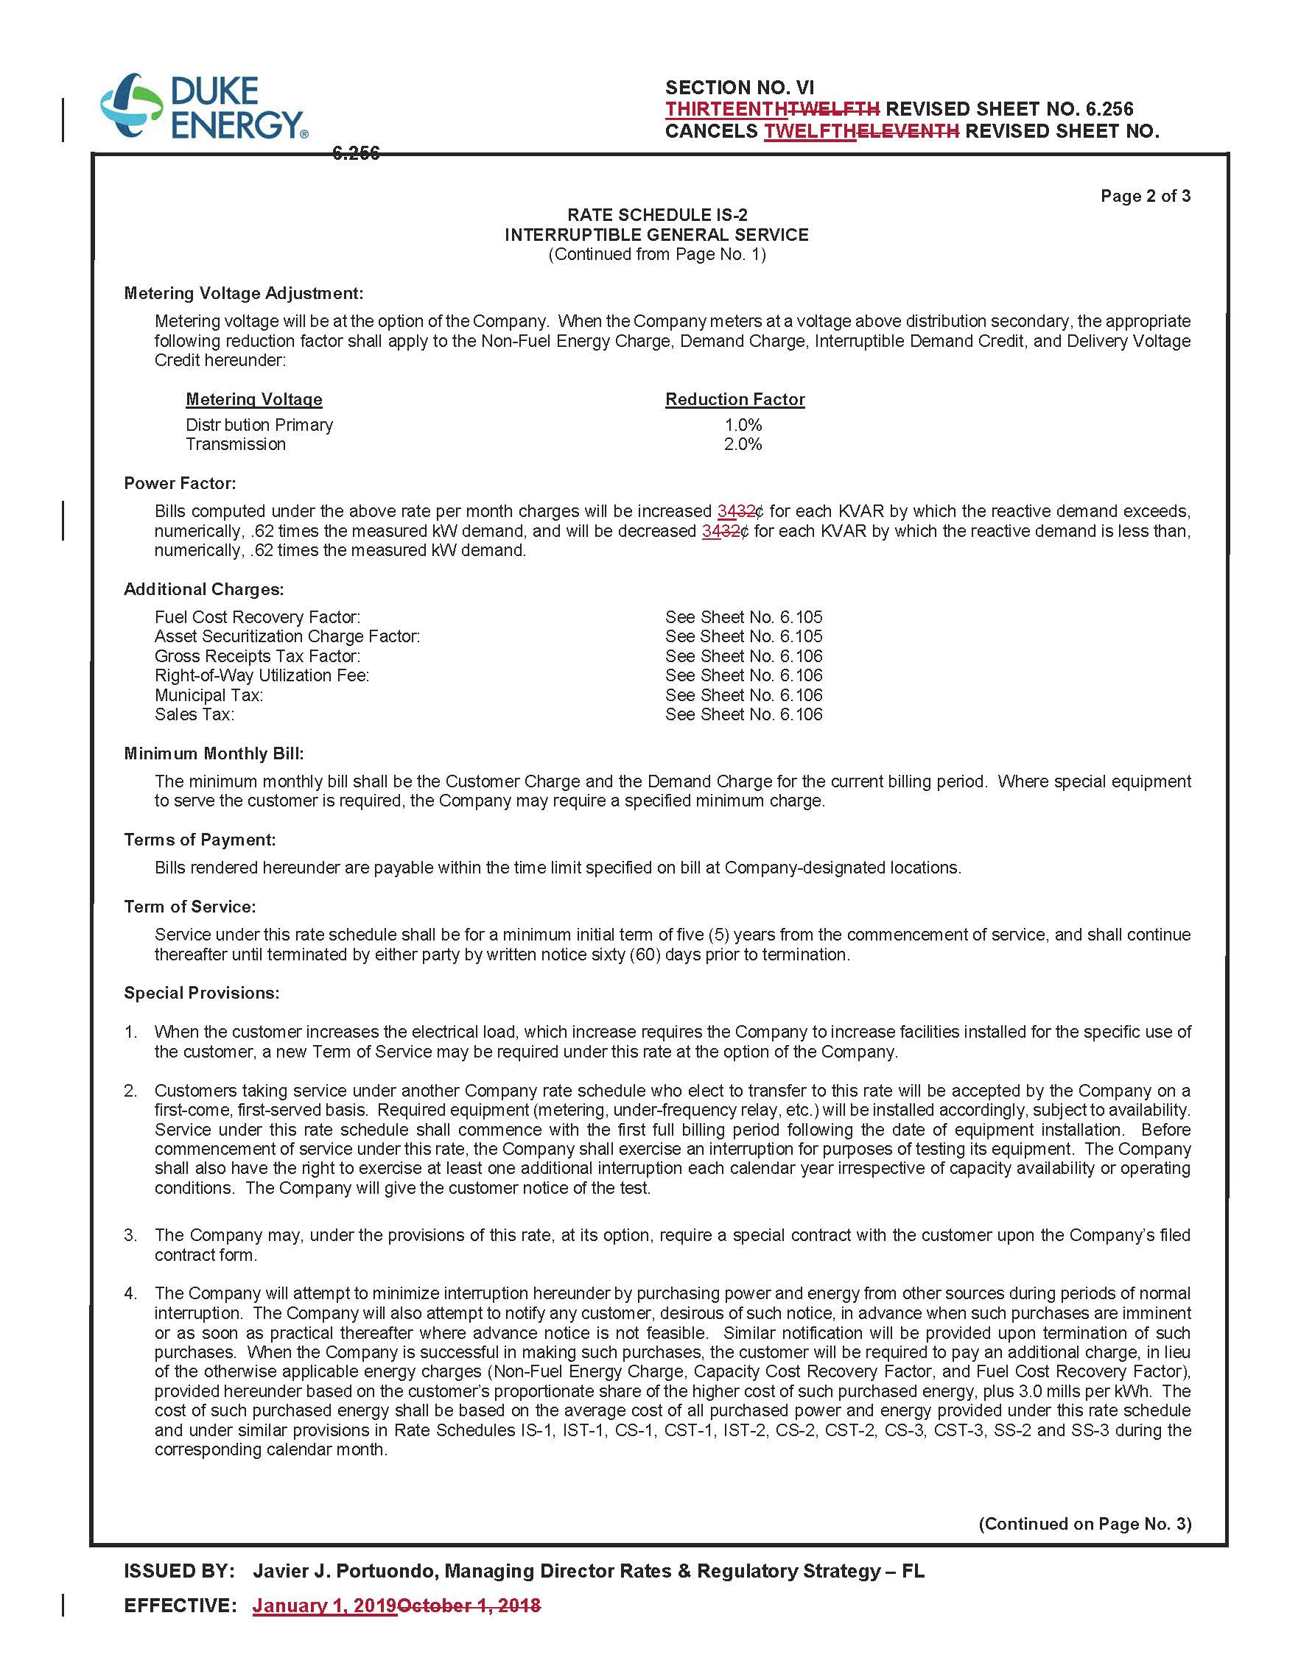
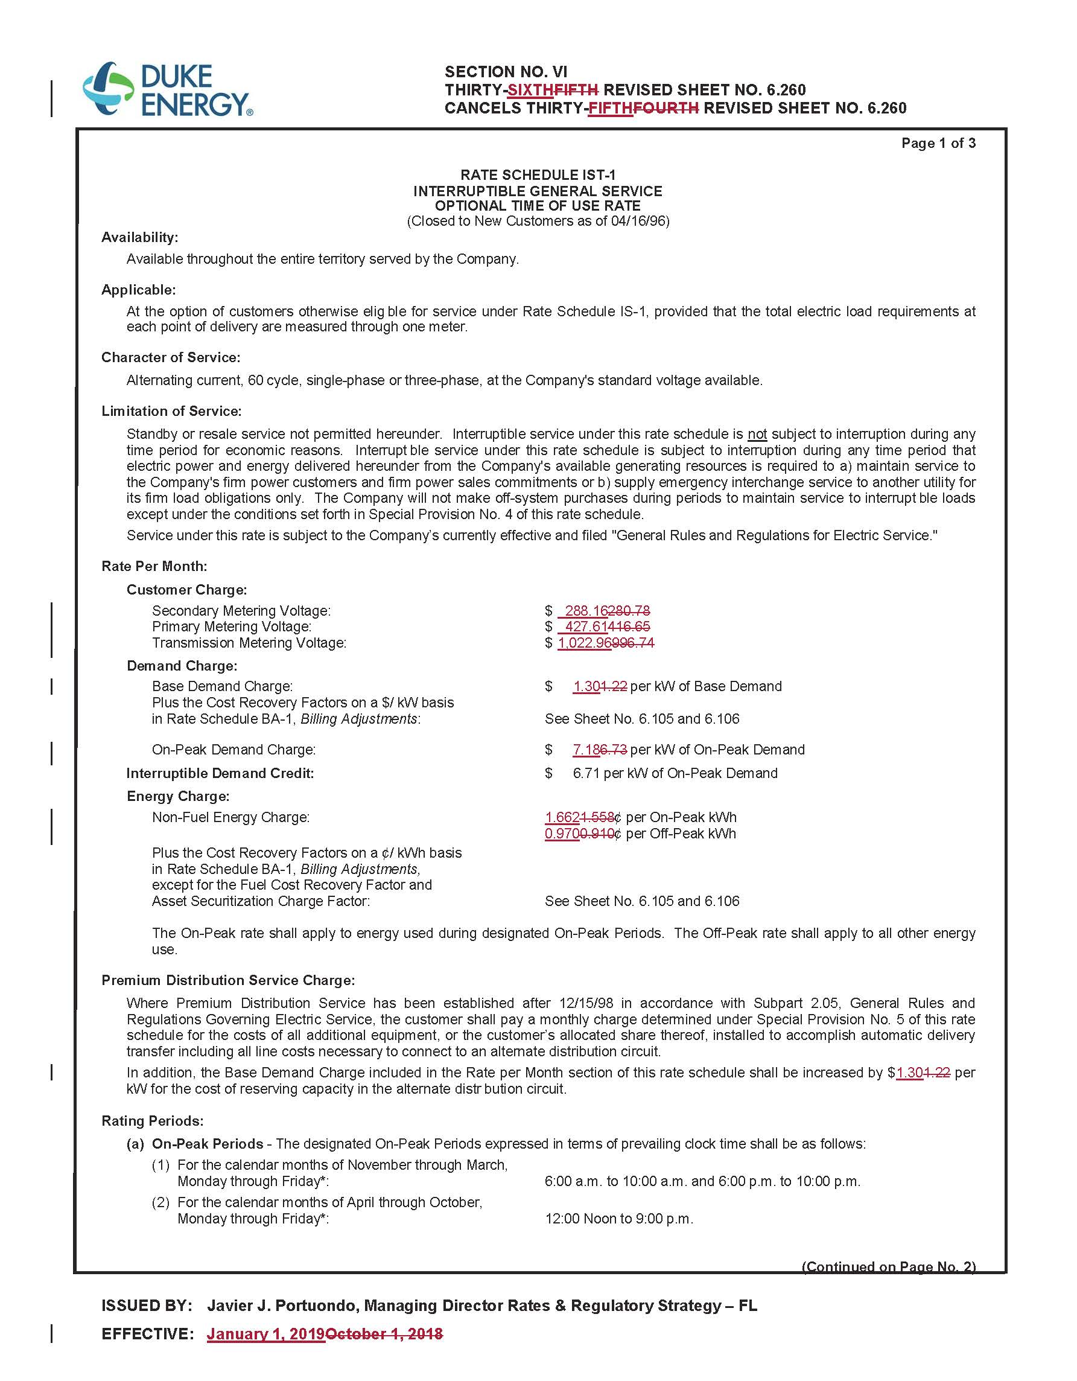
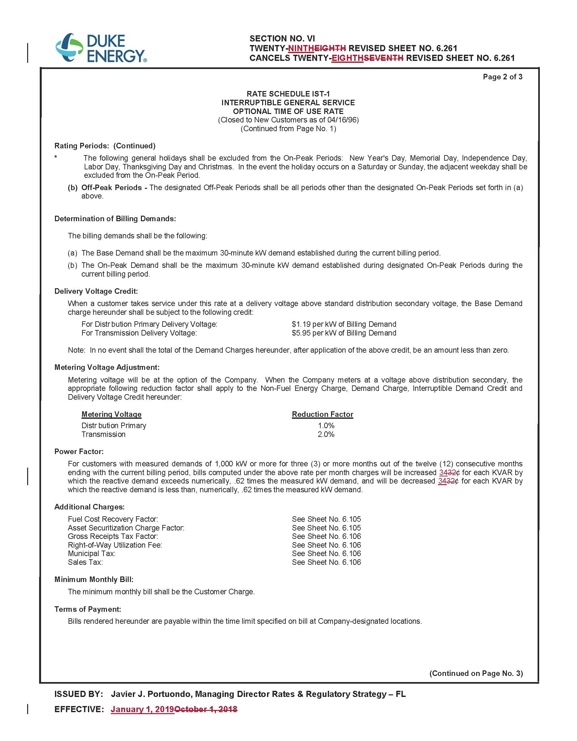
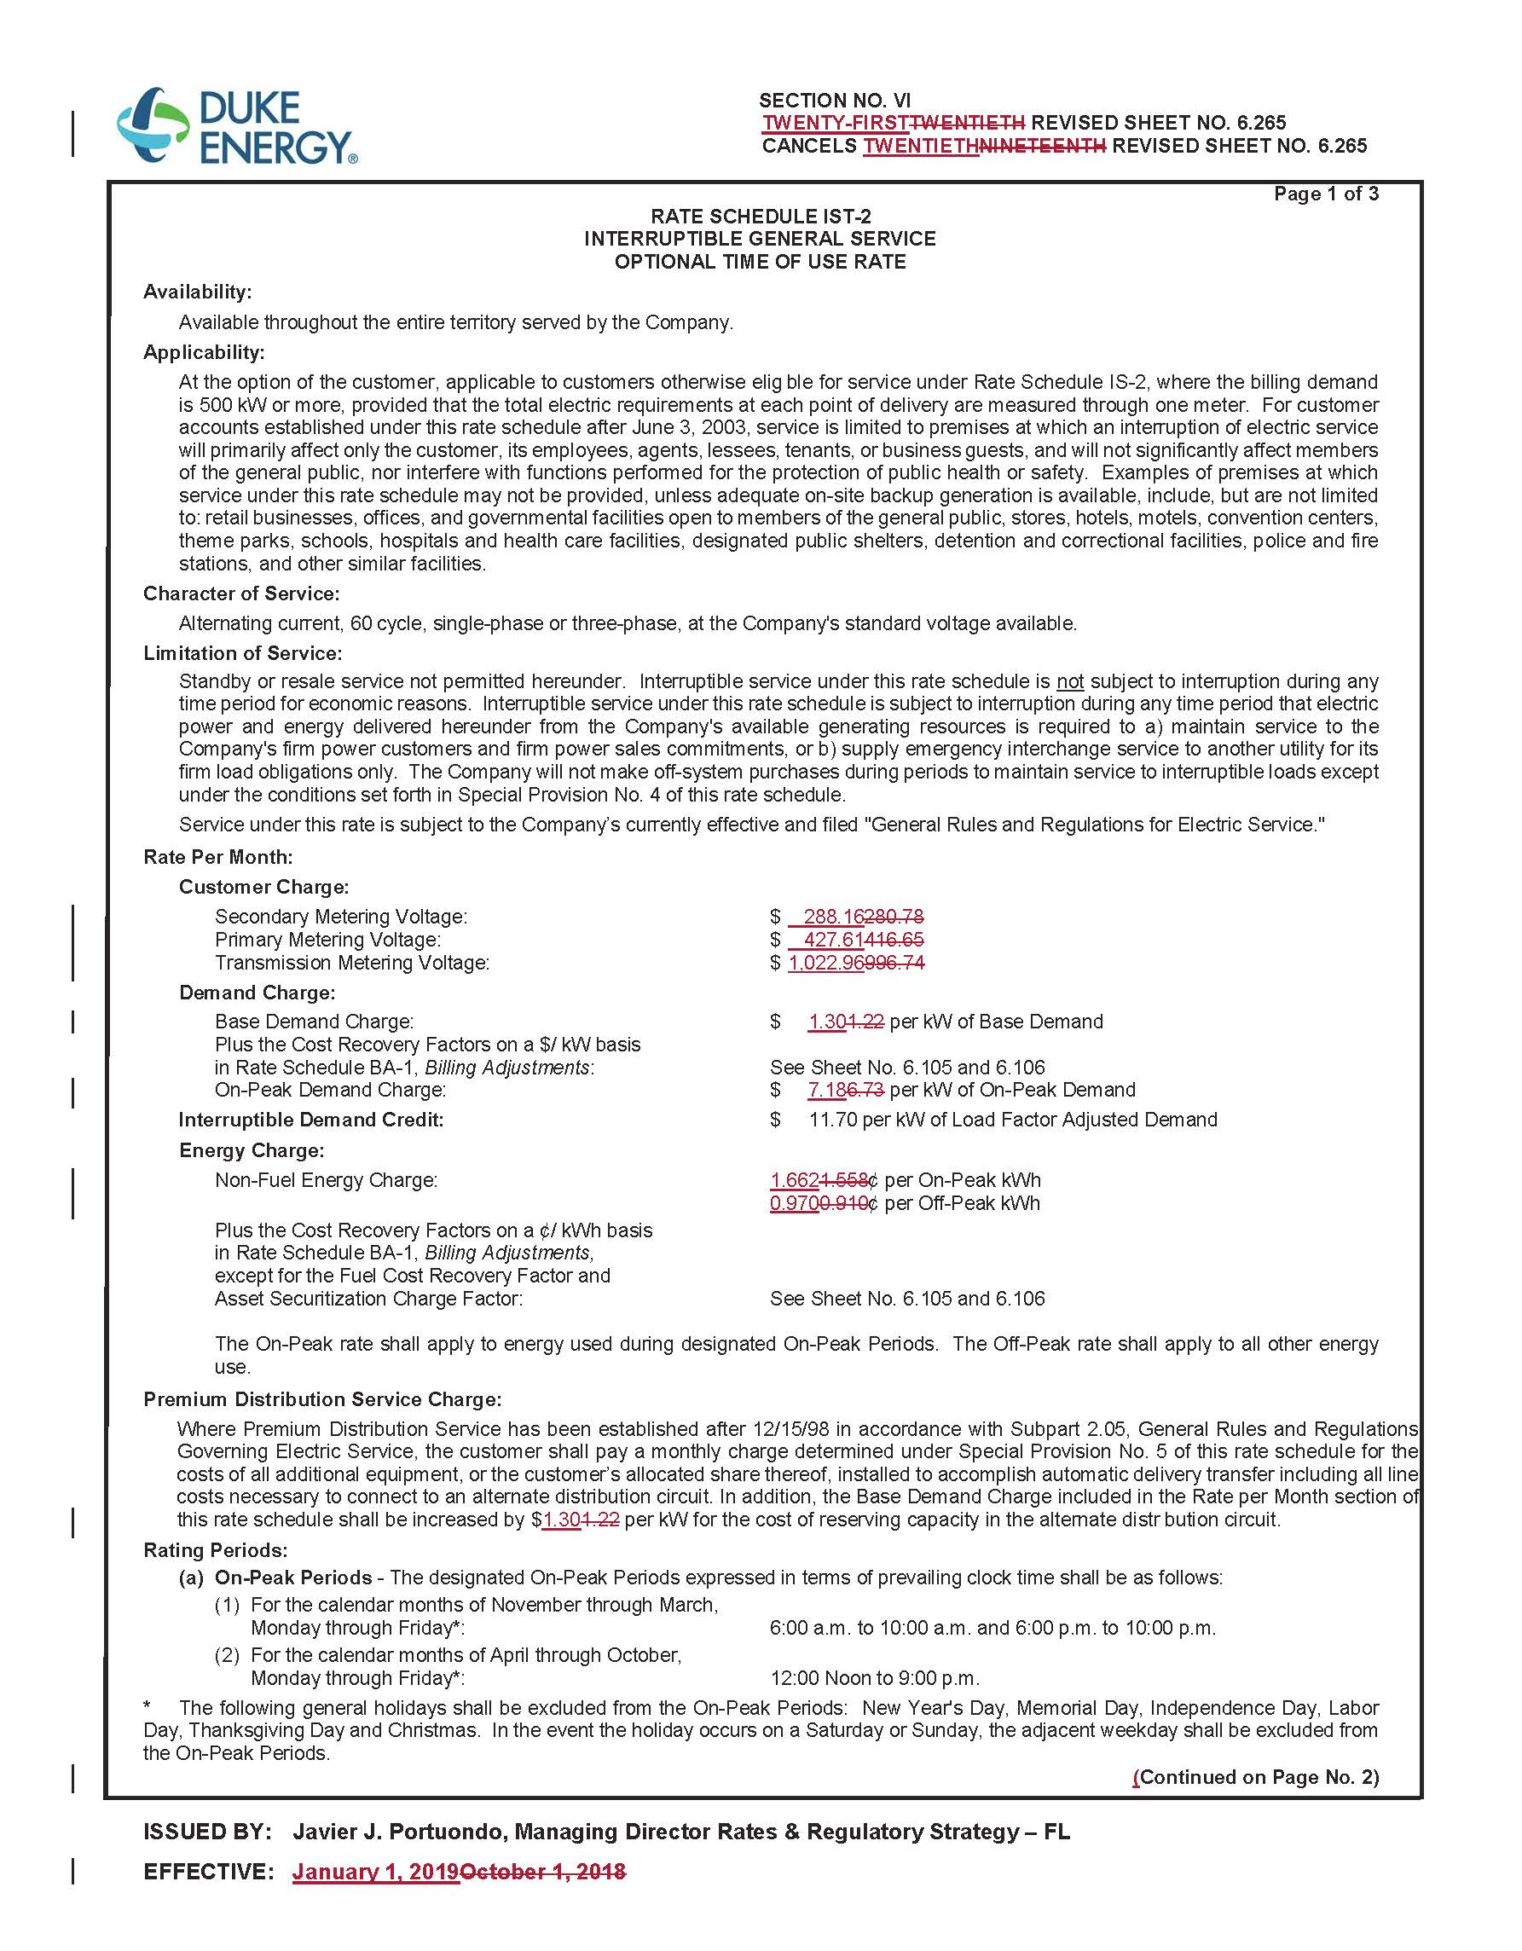
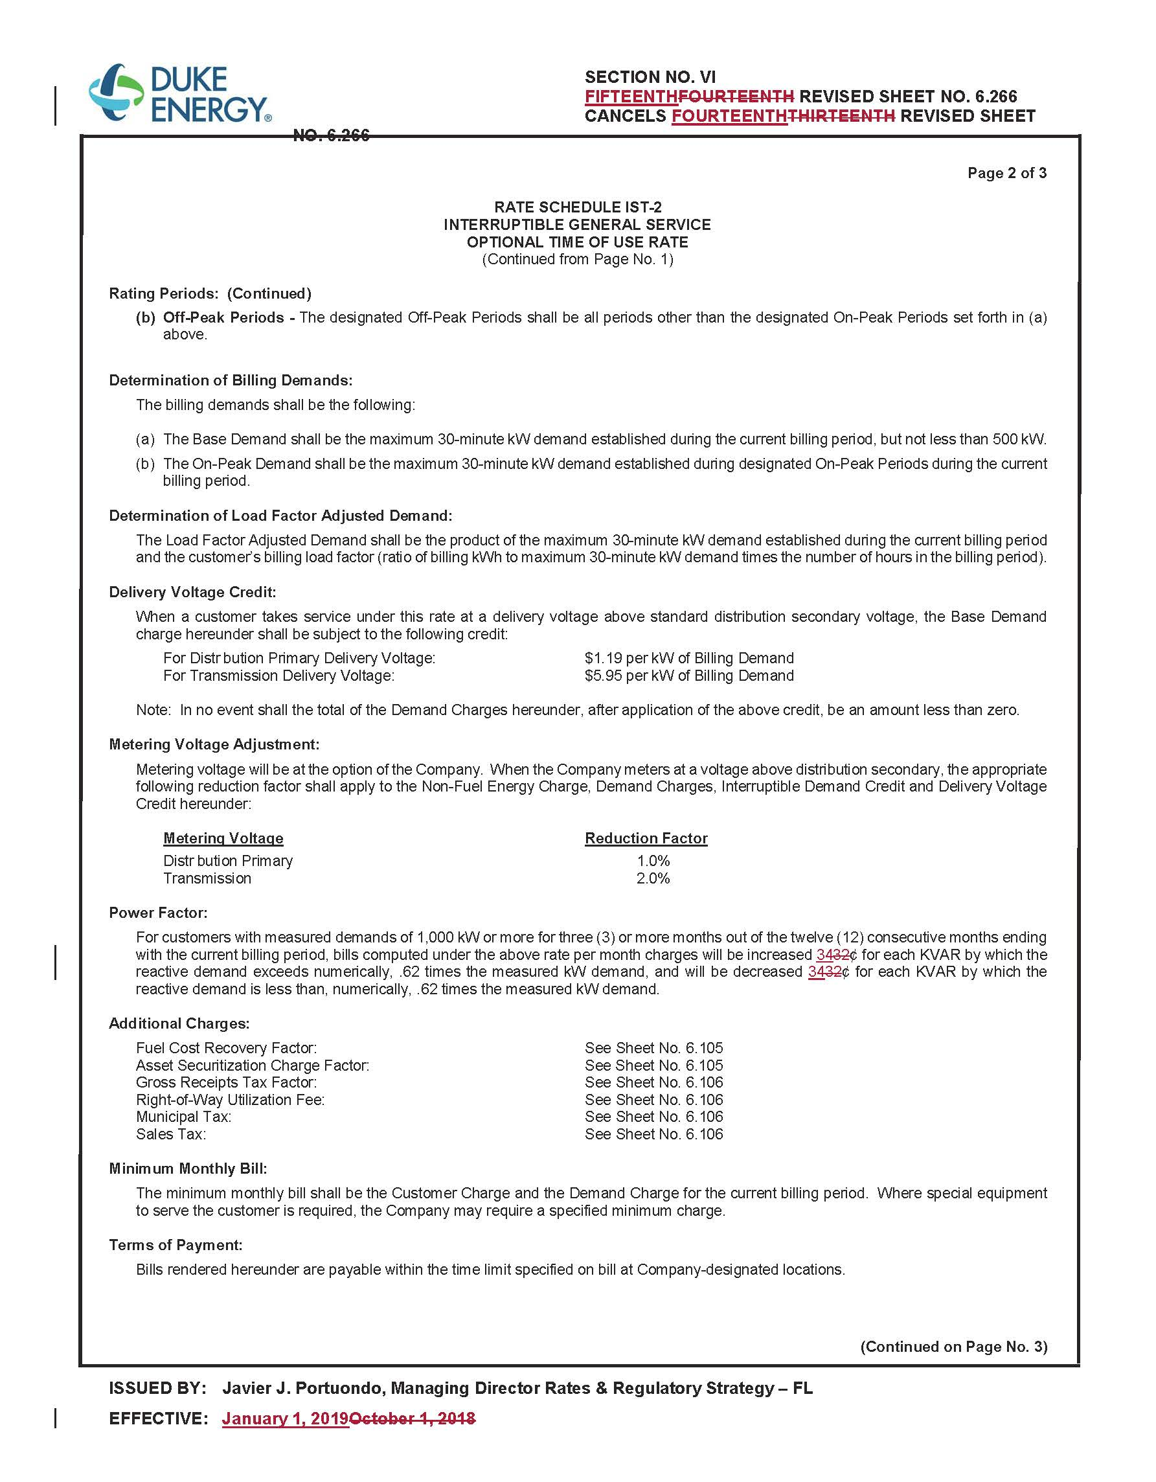
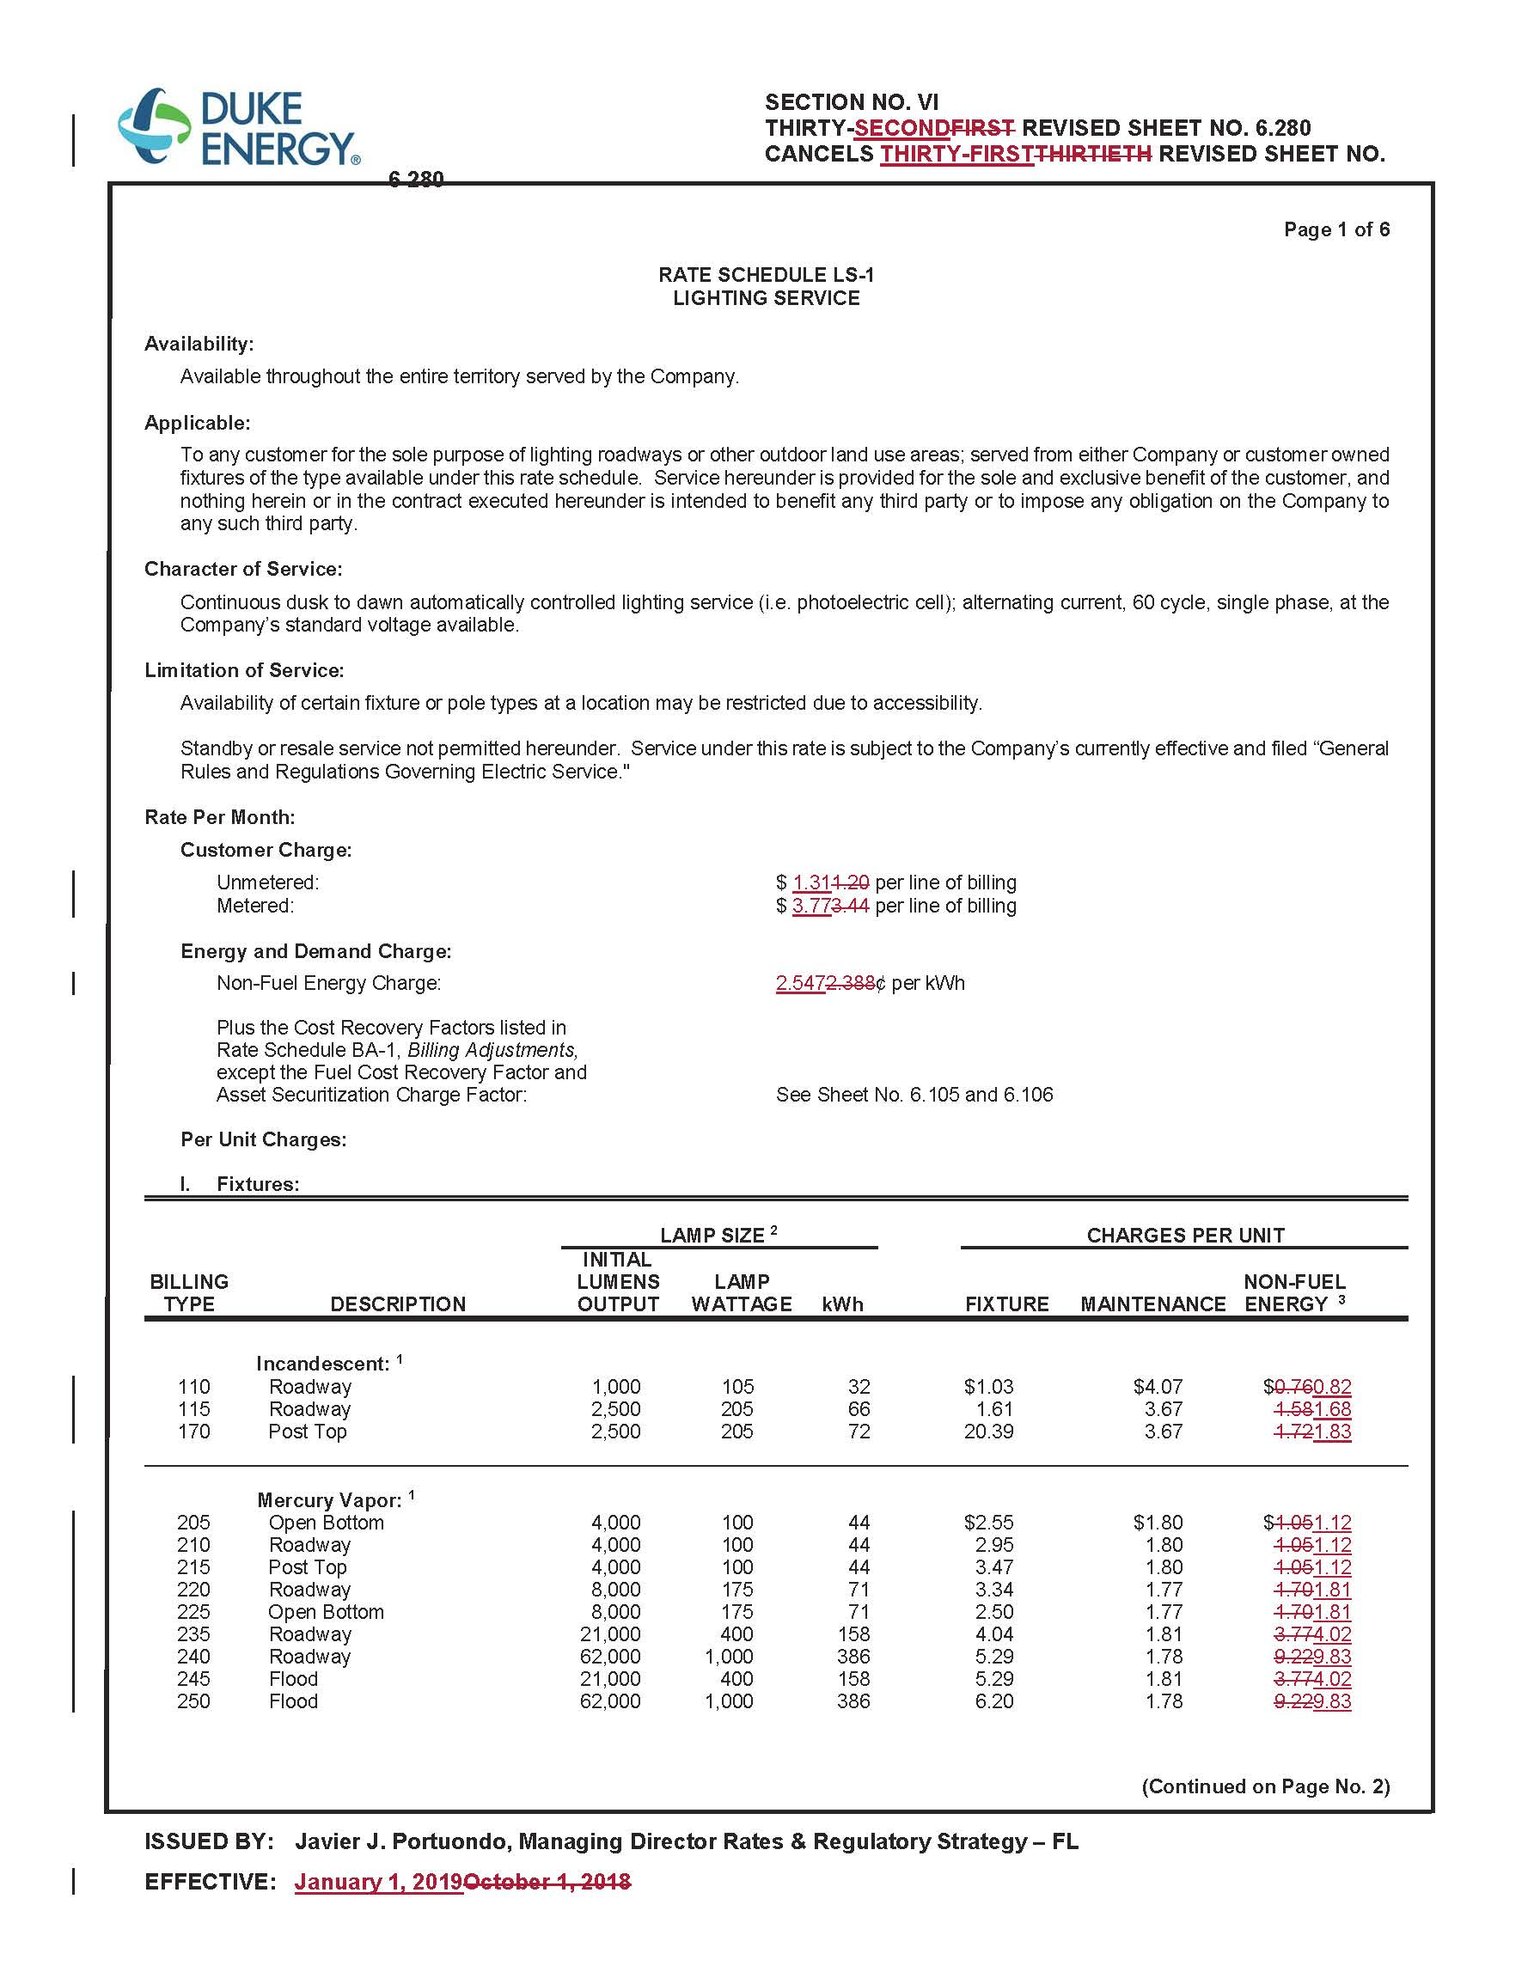
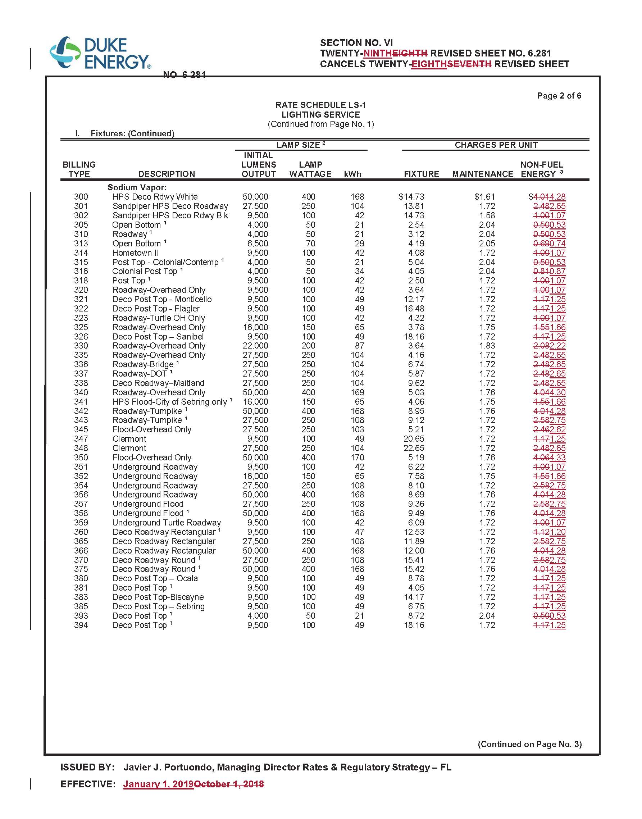
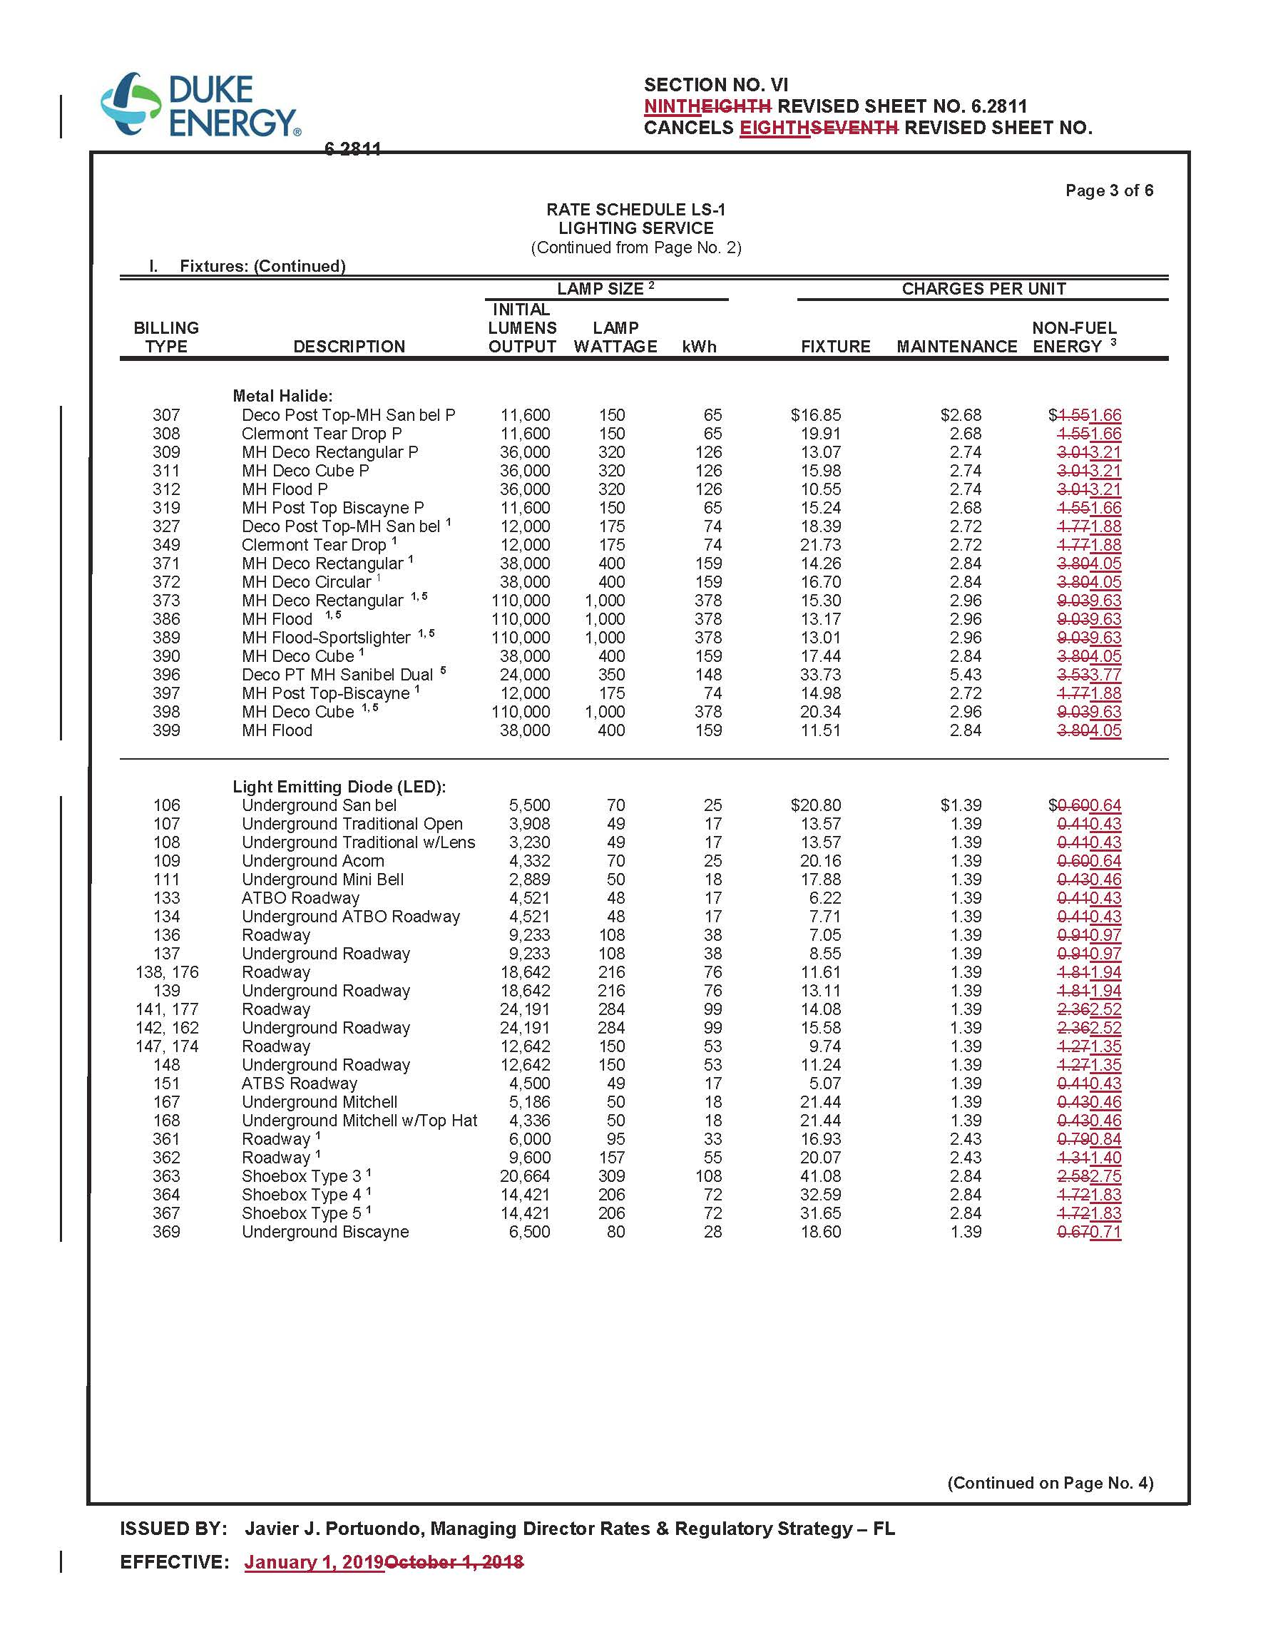
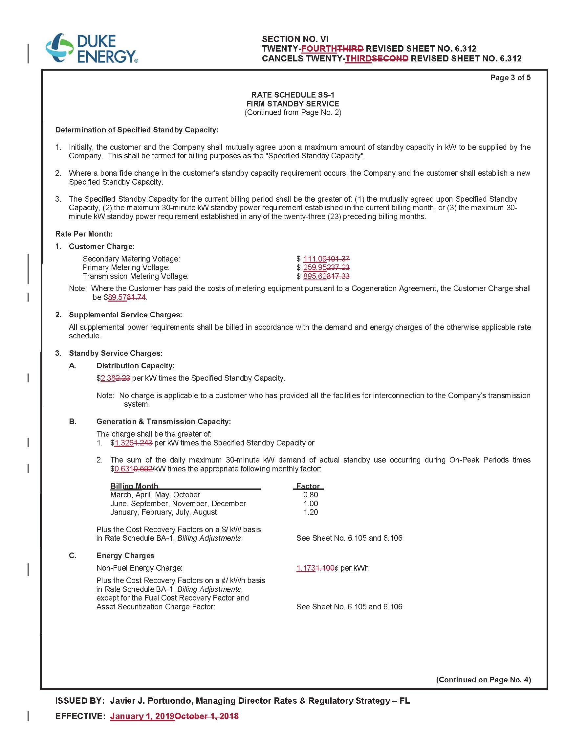
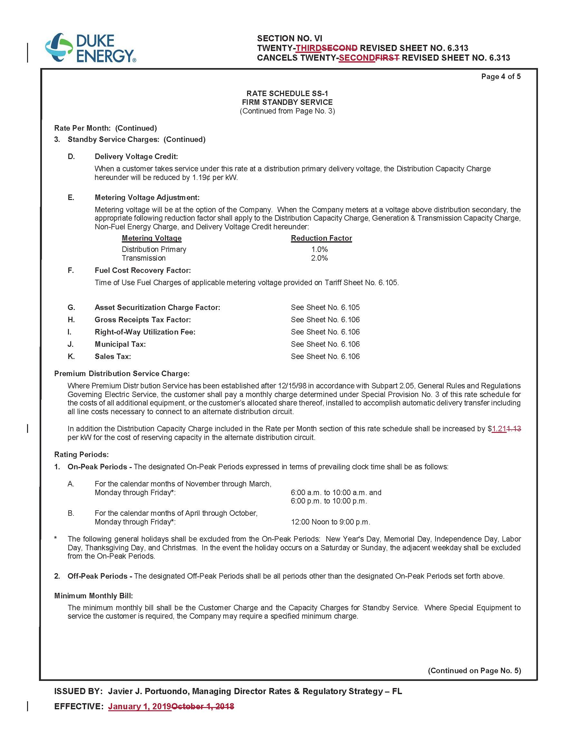
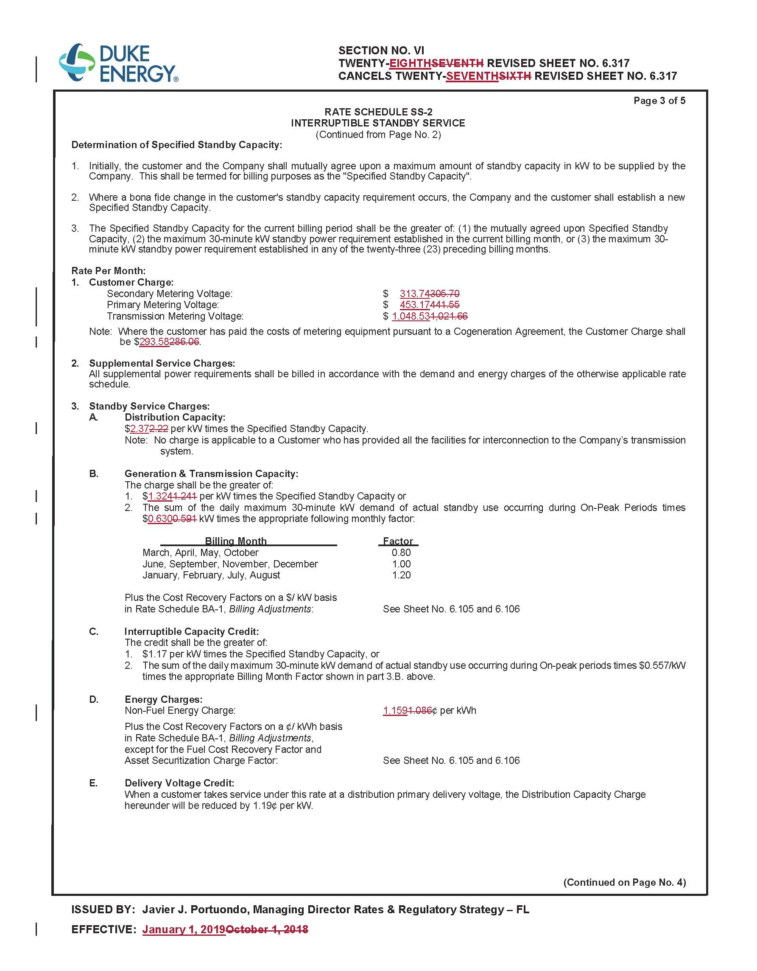
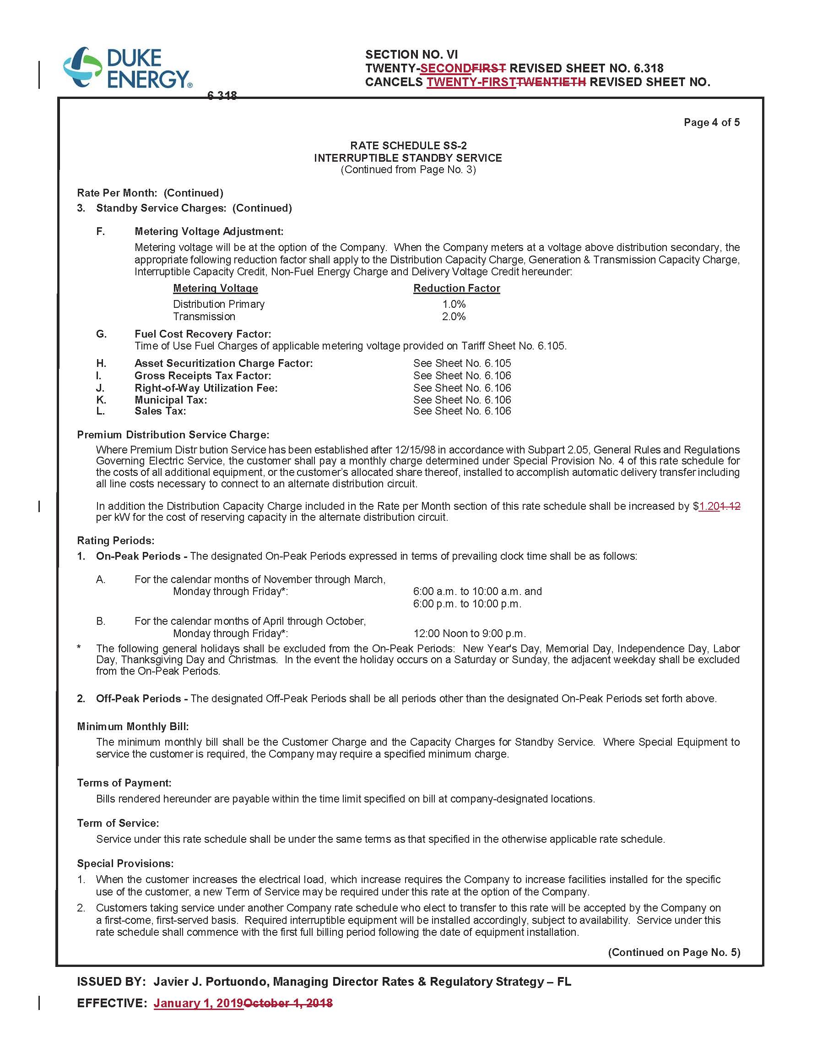
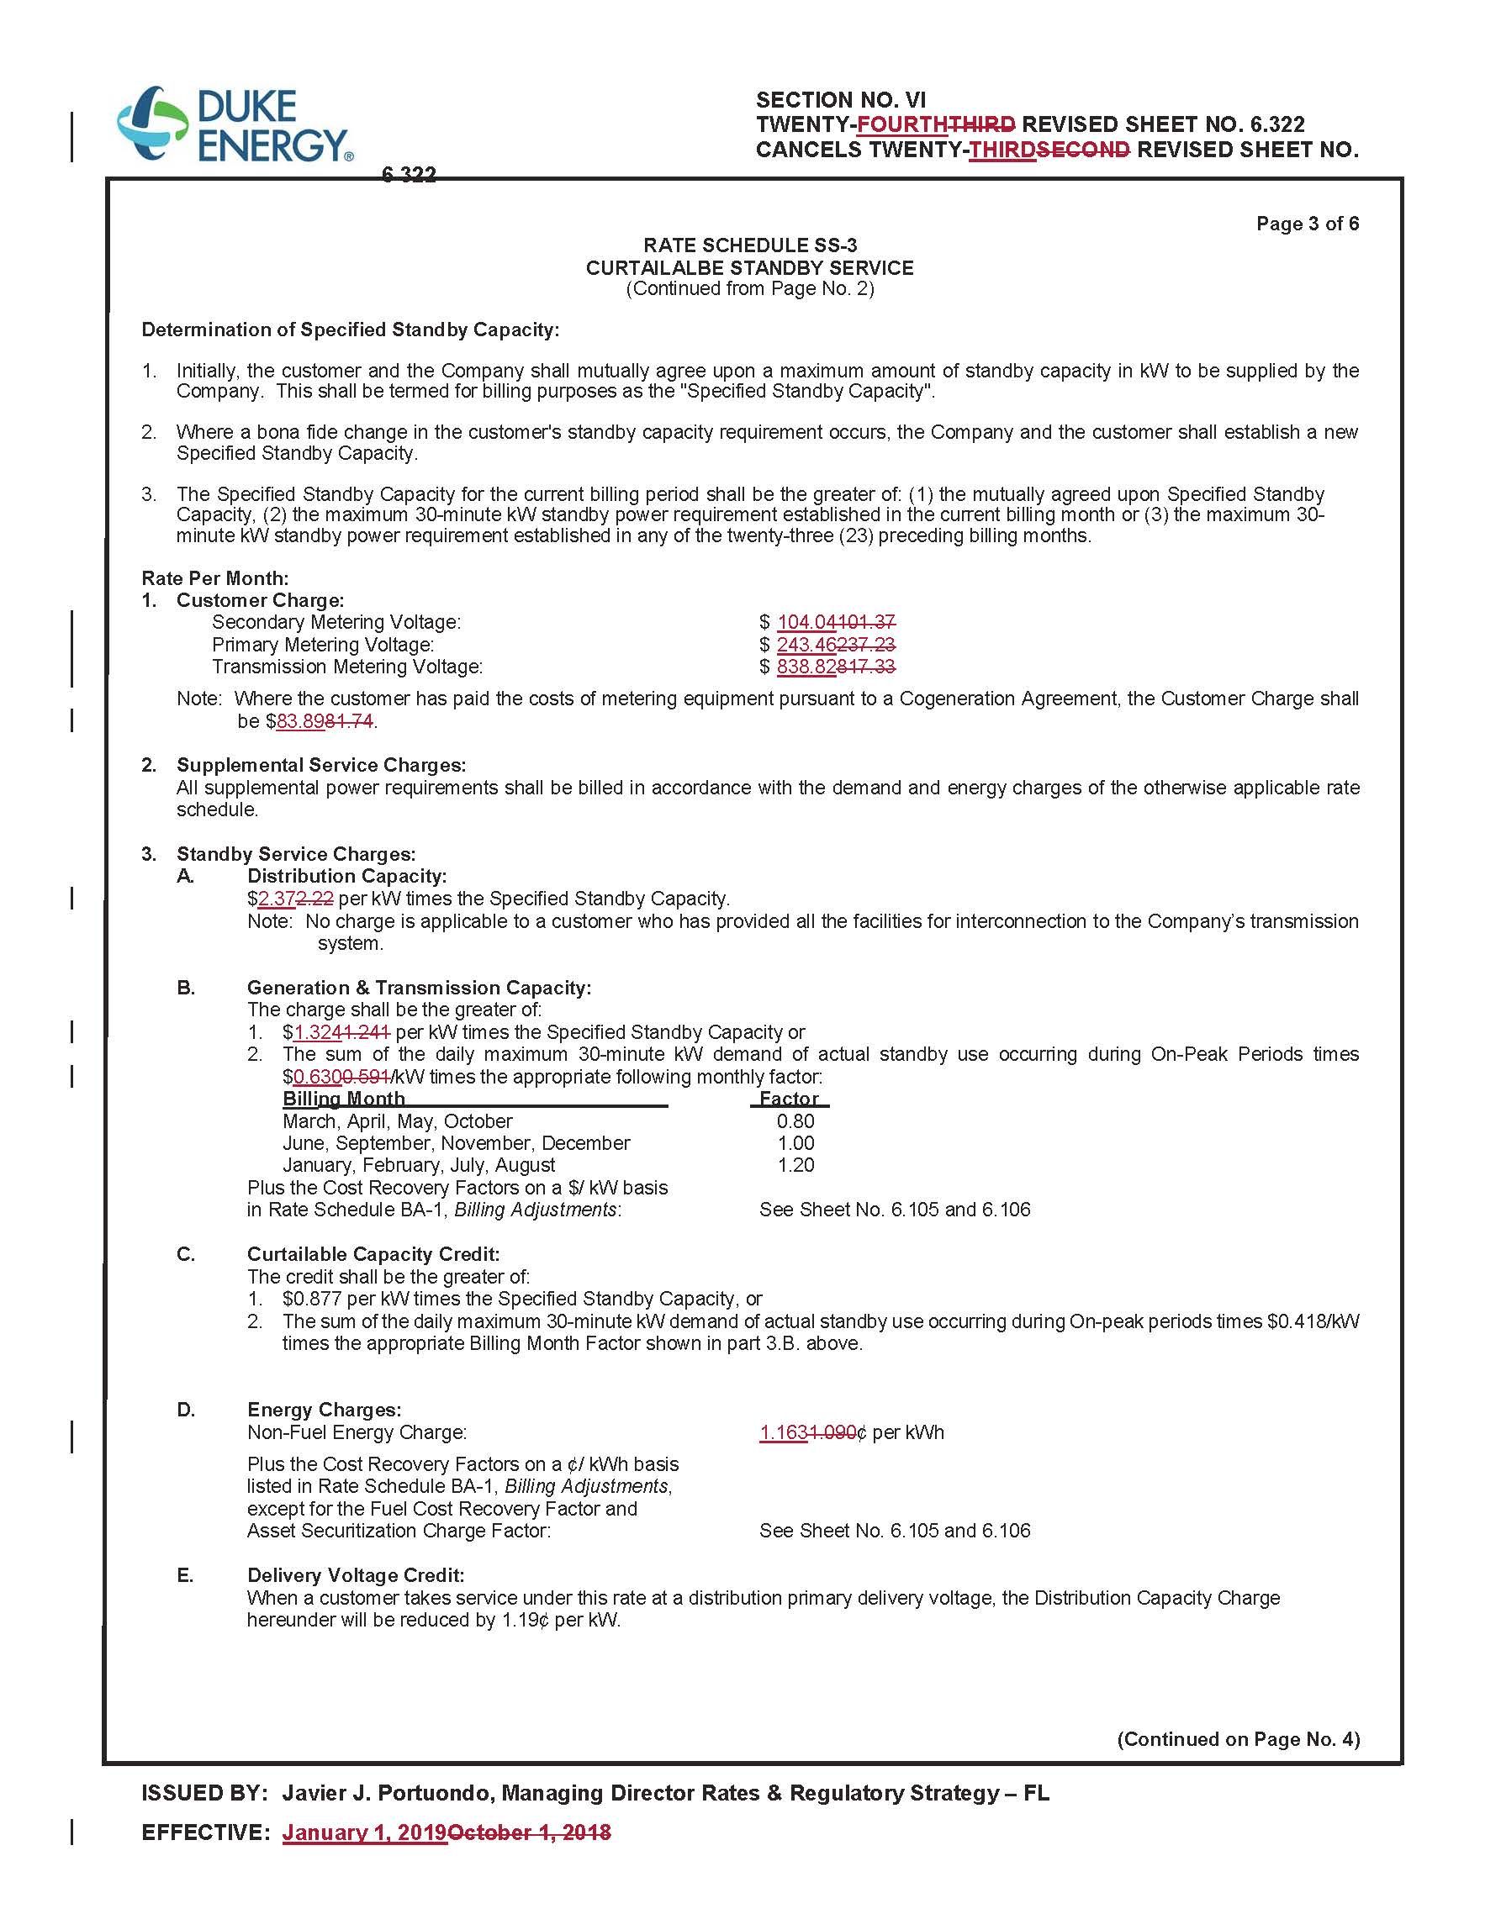
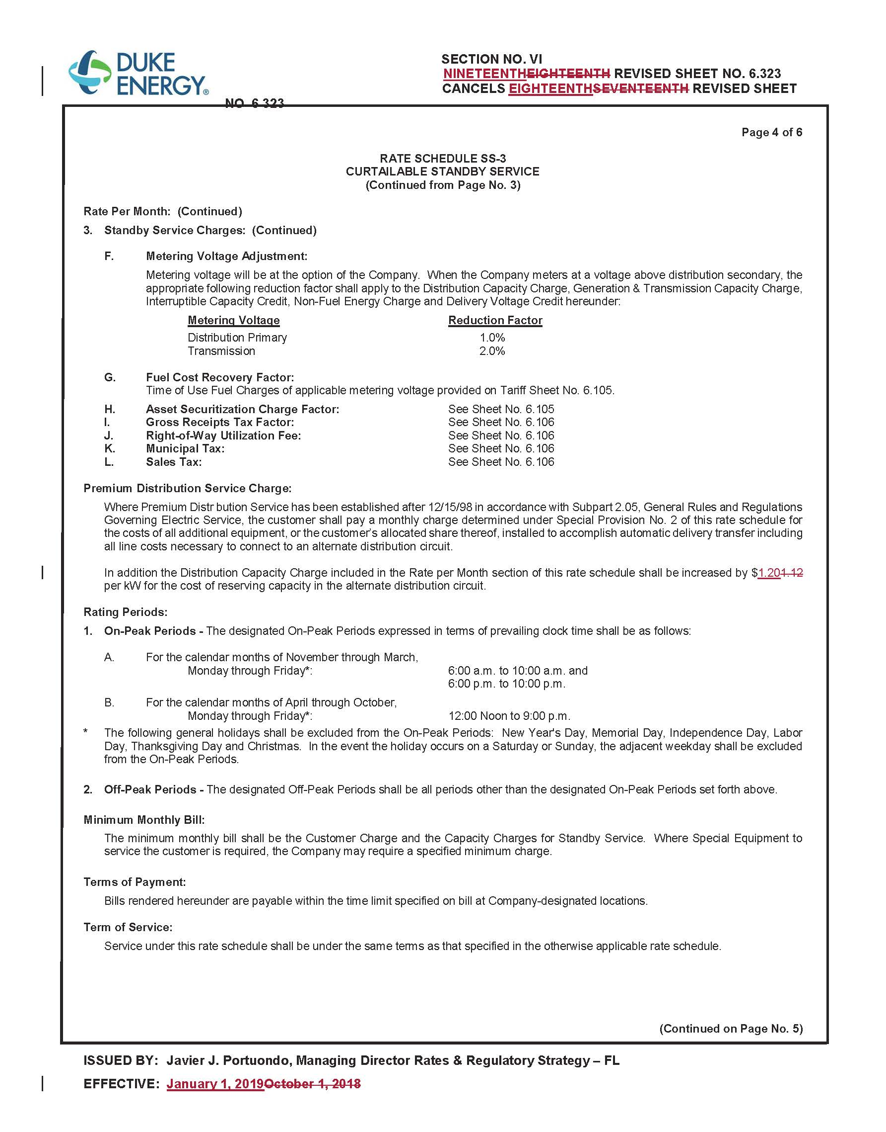

Order No. PSC-2017-0451-AS-EU, issued November 20, 2017, in Docket No. 20170183-EI, In re: Application for limited proceeding to approve 2017 second revised and restated settlement agreement, including certain rate adjustments, by Duke Energy Florida, LLC.
Order No. PSC-2018-0367-TRF-EI, issued July 25, 2018, in Docket No. 20180084-EI, In re: Petition for limited proceeding for approval to include in base rates the revenue requirement for the Citrus combined cycle project, by Duke Energy Florida, LLC.

