BEFORE THE FLORIDA PUBLIC SERVICE COMMISSION

In re: Petition for approval of safety, access, and facility enhancement program true-up and 2019 cost recovery factors, by Florida City Gas. | DOCKET NO. 20180164-GU  ORDER NO. PSC-2018-0545-TRF-GU  ISSUED: November 19, 2018

The following Commissioners participated in the disposition of this matter:

ART GRAHAM, Chairman
JULIE I. BROWN
DONALD J. POLMANN
GARY F. CLARK
ANDREW GILES FAY

TARIFF ORDER

BY THE COMMISSION:

Background
On September 4, 2018, Florida City Gas (City Gas or company) filed a petition for approval of its safety, access, and facility enhancement program (SAFE program) true-up and 2019 cost recovery factors. The SAFE program was originally approved by this Commission in Order No. PSC-15-0390-TRF-GU (2015 order) to recover the cost of relocating on an expedited basis certain existing gas mains and associated facilities from rear lot easements to the street front. In the 2015 order, this Commission found that the relocation of mains and services to the street front provides for more direct access to the facilities and will enhance the level of service provided to all customers through improved safety and reliability. The SAFE factor is a surcharge on customers’ bills. This Commission ordered the company to file an annual petition, beginning in 2016, for review and resetting of the SAFE factors to true-up any prior over- or under-recovery and to set the surcharge for the coming year. The SAFE program is a 10-year program effective from 2015 through 2025.
In City Gas’s 2017 rate case, this Commission approved a Stipulation and Settlement Agreement (settlement) among the parties to the rate case. The settlement included a provision that the $3.5 million SAFE investment at the time of the rate case be moved into rate base and recovered through base rates (instead of being recovered through a separate SAFE surcharge on customers’ bills) and the 2018 SAFE factors were reset to $0 for the period June through December 2018. Since the SAFE program is a 10-year program projected to continue until 2025, City Gas filed the instant petition for SAFE factors effective January 2019. The settlement further required City Gas to use a 21 percent federal tax rate for the six-month January through May 2018 true-up calculation and for the 12-month 2019 calculation. The federal tax rate is included in the SAFE return on investment calculation.
During the review process of the current petition, the Commission issued a data request to the company, for which the responses were received on September 28, 2018. The responses included revised tariff Sheet No. 79 to include a minor correction. The revised tariff is shown in Attachment 2 to this order. On October 12, 2018, the company filed an amended response to question 4 of staff’s first data request regarding notifications to customers. This Commission has jurisdiction over this matter pursuant to Sections 366.03, 366.04, 366.05, 366.06, and 368, Florida Statutes (F.S.).

Decision
Under the SAFE program, City Gas will relocate or replace 254.3 miles of mains and 12,462 associated services from rear property easements to the street front over a 10-year period ending in 2025. City Gas began its mains and services replacements at the end of 2015, as provided for in the 2015 order, and the surcharges have been in effect since January 2016. As of 2018, the company has replaced 82.2 miles of mains and 4,667 services as shown in Attachment 1 to this order.
As stated in City Gas’s response to the Commission’s data request, the company’s current 2018 replacement plans include 10 projects located in Merritt Island in Brevard County, City of Hialeah, City of Miami Gardens, South Miami Heights neighborhood, and Westchester neighborhood in Miami-Dade County. The company’s projected 2019 replacement plans include nine additional projects located in the City of Port Saint Lucie in Saint Lucie County, the City of Miami Gardens, the City of Hialeah, Sierra neighborhood, and Westchester neighborhood in Miami-Dade County.
City Gas stated that its replacement projects are generally prioritized based on the risk assessment model in the company’s Distribution Integrity Management Program. Prioritization factors include, but are not limited to, location of the pipeline, rear lot pipelines with maintenance access complications and customer encroachments, leak incident rate, material of pipe, age of the pipeline, and operating pressure of the pipeline.

True-ups by Year
As required in the 2015 order, City Gas’s calculations for the 2019 revenue requirement and SAFE factors include a final true-up for 2017, an actual/estimated true-up for 2018, and projected costs for 2019. City Gas currently does not include interest on any over- or under-recoveries in its calculations.

Final True-up for 2017
City Gas stated that the revenues collected for 2017 were $2,018,776 compared to a revenue requirement of $2,283,402, resulting in an under-recovery of $264,626. Adding the 2016 final over-recovery of $182,647, and the $264,626 under-recovery of 2017, results in a final 2017 under-recovery of $81,979.

Actual/Estimated 2018 True-up
As stated in the background, the SAFE factor was reset to $0 for the period June through December 2018; therefore, the actual/estimated 2018 true-up only includes actual data for January through May 2018. The company collected $1,450,631 from January to May compared to the revenue requirement of $1,029,927 for the same period, resulting in an over-recovery of $420,704. Adding the final 2017 under-recovery of $81,979 to the 2018 over-recovery of $420,704, the resulting total 2018 true-up is an over-recovery of $338,727.

Projected 2019 Costs
The company’s projected investment for 2019 is $10,530,795 for its nine projects located in Saint Lucie and Miami-Dade Counties. The revenue requirement, which includes a return on investment, depreciation, and taxes, is $629,977. The return on investment calculation includes federal income taxes, regulatory assessment fees, and bad debt. After adding the 2018 over-recovery of $338,727, the total 2019 revenue requirement is $291,250. Table 1 displays the projected 2019 revenue requirement calculation.
Table 0
2019 Revenue Requirement Calculation
2019 Projected Investment | $10,530,795
Return on Investment | $427,027
Depreciation Expense | 152,868
Property Tax Expense | 50,082
2019 Revenue Requirement | $629,977
Less 2018 Over-recovery | -338,727
Total 2019 Revenue Requirement | $291,250
Source: Attachment A of the Petition and Attachment 1 (Excel file) in response to Staff’s First Data Request No. 9.

Proposed 2019 SAFE Factors
The SAFE factors are fixed monthly charges. City Gas’s cost allocation method was approved by this Commission in the 2015 order and was used in the instant filing. The approved methodology allocates the current cost of a 2-inch pipe to all customers on a per customer basis and allocates the incremental cost of replacing a pipe larger than 2 inches to customers who use over 6,000 therms per year. For customers who require 4-inch pipes, the cost takes into account that the minimum pipe is insufficient to serve their demand and, therefore, allocates an incremental per foot cost in addition to the all-customer cost. The resulting allocation factors are applied to the 2019 total revenue requirement to develop the monthly SAFE factors.
The proposed fixed monthly SAFE factor is $0.21 for customers using less than 6,000 therms per year (current factor is $0). The proposed fixed monthly SAFE factor for customers using more than 6,000 therms per year is $0.40 (current factor is $0).

Conclusion
We reviewed City Gas’s filings and supporting documentation and find that the calculations are consistent with the methodology approved in the 2015 order and are reasonable and accurate. We also reviewed City Gas’s calculation of the 2018 true-up and 2019 projected cost calculations and verified that the calculation includes the 21 percent federal tax rate, as required by the settlement. We therefore approve of City Gas’s proposed SAFE factors for the period January through December 2019.

Based on the foregoing, it is

ORDERED by the Florida Public Service Commission that Florida City Gas’s proposed SAFE factors are approved for the period January through December 2019. It is further

ORDERED that if a protest is filed within 21 days of issuance of the Order, the tariff shall remain in effect with any charges held subject to refund pending resolution of the protest. It is further

ORDERED that if no timely protest is filed, this docket shall be closed upon the issuance of a Consummating Order.

By ORDER of the Florida Public Service Commission this 19th day of November, 2018.

/s/ Carlotta S. Stauffer
CARLOTTA S. STAUFFER
Commission Clerk
Florida Public Service Commission
2540 Shumard Oak Boulevard
Tallahassee, Florida 32399
(850) 413-6770
www.floridapsc.com

Copies furnished: A copy of this document is provided to the parties of record at the time of issuance and, if applicable, interested persons.
LD

NOTICE OF FURTHER PROCEEDINGS

The Florida Public Service Commission is required by Section 120.569(1), Florida Statutes, to notify parties of any administrative hearing or judicial review of Commission orders that is available under Sections 120.57 or 120.68, Florida Statutes, as well as the procedures and time limits that apply. This notice should not be construed to mean all requests for an administrative hearing or judicial review will be granted or result in the relief sought.

Mediation may be available on a case-by-case basis. If mediation is conducted, it does not affect a substantially interested person's right to a hearing.

The Commission's decision on this tariff is interim in nature and will become final, unless a person whose substantial interests are affected by the proposed action files a petition for a formal proceeding, in the form provided by Rule 28-106.201, Florida Administrative Code. This petition must be received by the Office of Commission Clerk, 2540 Shumard Oak Boulevard, Tallahassee, Florida 32399-0850, by the close of business on December 10, 2018.

In the absence of such a petition, this Order shall become final and effective upon the issuance of a Consummating Order.

Any objection or protest filed in this docket before the issuance date of this order is considered abandoned unless it satisfies the foregoing conditions and is renewed within the
specified protest period

Table 1
Florida City Gas’s SAFE Program Progress
 | Main Replacements |  | Service Replacement
Year* | Replaced Main (miles) | Total Miles Remaining | Replaced Services (number) | Total Remaining Services
2014 | 0.0 | 254.3 | 0 | 12,462
2015 | 0.0 | 254.3 | 49 | 12,413
2016 | 17.1 | 237.2 | 1,433 | 10,980
2017 | 37.5 | 199.7 | 1,551 | 9,429
2018 | 27.6 | 172.1 | 1,634 | 7,795
2019 | 31.2 | 141.0 | 1,312 | 6,483
2020 | 30.0 | 111.0 | 1,200 | 5,283
2021 | 25.0 | 86.0 | 1,200 | 4,083
2022 | 25.0 | 61.0 | 1,200 | 2,883
2023 | 25.0 | 36.0 | 1,200 | 1,683
2024 | 25.0 | 11.0 | 1,200 | 483
2025 | 11.0 | 0.0 | 483 | 0
Source: FCG Response to Staff’s First Data Request, Response to Question 3.
*Actuals 2014-July 2018. Projections August 2018-2025.

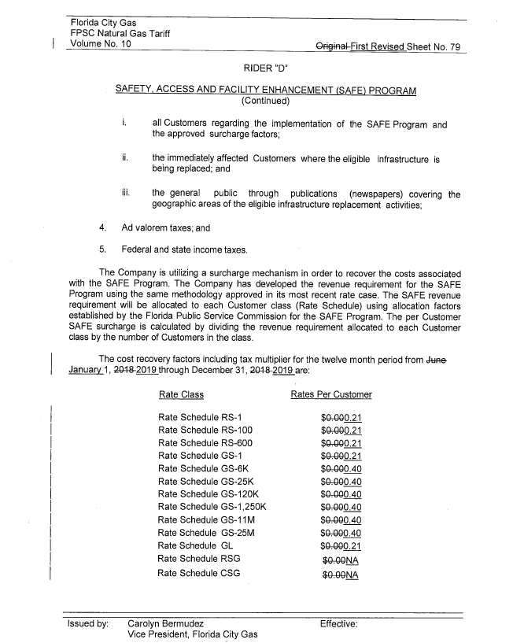

Order No. PSC-15-0390-TRF-GU, issued September 15, 2015, in Docket No. 150116-GU, In re: Petition for approval of safety, access, and facility enhancement program and associated cost recovery methodology, by Florida City Gas.
Order No. PSC-2018-0190-FOF-GU, issued April 20, 2018, in Docket No. 20170179-GU, In re: Petition for rate increase by Florida City Gas.

