BEFORE THE FLORIDA PUBLIC SERVICE COMMISSION

In re: Joint petition for approval of GRIP cost recovery factors, by Florida Public Utilities Company, Florida Public Utilities Company-Fort Meade, and Florida Division of Chesapeake Utilities Corporation. | DOCKET NO. 20180163-GU  ORDER NO. PSC-2018-0547-TRF-GU  ISSUED: November 19, 2018

The following Commissioners participated in the disposition of this matter:

ART GRAHAM, Chairman
JULIE I. BROWN
DONALD J. POLMANN
GARY F. CLARK
ANDREW GILES FAY

TARIFF ORDER

BY THE COMMISSION:

Background
On September 4, 2018, Florida Public Utilities Company (FPUC), Florida Public Utilities Company-Fort Meade (Fort Meade), and Florida Division of Chesapeake Utilities Corporation (Chesapeake), collectively the companies, filed a joint petition for approval of their gas reliability infrastructure program (GRIP or program) cost recovery factors for the period January through December 2019. The GRIP for FPUC and Chesapeake was first approved in Order No. PSC-12-0490-TRF-GU (2012 order) to recover the cost of accelerating the replacement of cast iron and bare steel distribution mains and services, including a return on investment, through a surcharge on customers’ bills. Fort Meade’s GRIP was originally approved in Order No. PSC-15-0578-TRF-GU, and allowed Fort Meade to file its annual petition for GRIP factors concurrently with FPUC and Chesapeake. The current GRIP charges for January through December 2018 were approved in Order No. PSC-2017-0437-TRF-GU.
On September 28, 2018, the companies filed responses to the Commission’s first data request and on October 8, 2018, the companies filed responses to the Commission’s second data request. The Office of Public Counsel intervened in this docket on September 14, 2018, which was acknowledged by Order No. PSC-2018-0502-PCO-GU, issued October 18, 2018. The proposed tariff sheets are contained in Attachment B (FPUC), Attachment C (Chesapeake), and Attachment D (Fort Meade). This Commission has jurisdiction over this matter pursuant to Sections 366.03, 366.04, 366.05, and 366.06, Florida Statutes.

Decision
The GRIP surcharges have been in place since January 2013 for FPUC and Chesapeake, while Fort Meade’s surcharges were first implemented in January 2017. In response to the Commission’s data requests, the companies stated that replacement projects in Winter Haven, Eagle Lake, Lake Wales, West Palm Beach, and Palm Beach were completed in 2018 and additional replacement projects in Winter Haven, Bartow, West Palm Beach, Lake Worth, Haines City, and Fort Meade were projected to continue into 2019. Attachment A provides an update of mains and services replaced and replacement forecasts. The companies stated that they prioritized the potential replacement projects focusing on areas of high consequence and areas more susceptible to corrosion.
This Commission’s 2012 order states that FPUC and Chesapeake agreed to report any operations and maintenance and depreciation expense savings in their annual petitions for the GRIP surcharge. In response to the Commission’s second data request, the companies stated that no depreciation or operations and maintenance expense savings were included as a reduction in expenses. The companies further stated that they had determined that if there were any depreciation expense savings, they would be offset by the change in asset life caused by the increased cost of removal.
The impacts of the Tax Cuts and Jobs Act of 2017 on the companies’ 2018 GRIP calculations are currently being considered in separate dockets that are scheduled to go to hearing November 27-30, 2018. Specifically, in Docket No. 20180051-GU, FPUC proposed to treat the $1,040,141 in 2018 tax savings as an over-recovery in the 2019 GRIP projection. In Docket No. 20180054-GU, Chesapeake proposed to treat the $324,362 in 2018 tax savings as an over-recovery for the 2019 GRIP projection. In Docket No. 20180053-GU, Fort Meade proposed to retain the $2,376 of 2018 tax savings. In response to the Commission’s second data request, the companies suggested that the GRIP factors should be adjusted after we make a final decision in those tax dockets. The 2019 GRIP calculations include the lower federal tax rate.

FPUC’s True-ups by Year
FPUC’s calculation for the 2019 GRIP revenue requirement and surcharges include a final true-up for 2017, an actual/estimated true-up for 2018, and projected costs for 2019. FPUC was authorized to recover $747,727 of annual GRIP expenses in base rates; therefore, the $747,727 is excluded from the GRIP surcharge calculation.

Final True-up for 2017
FPUC stated that the revenues collected through the GRIP surcharges for 2017 were $13,957,004, compared to a revenue requirement of $10,278,434, resulting in an over-recovery of $3,678,570. The 2016 under-recovery of $1,456,443, the 2017 over-recovery of $3,678,570, and interest of $9,137 associated with any over- and under-recoveries results in a final 2017 true-up is an over-recovery of $2,231,264.

Actual/Estimated 2018 True-ups
FPUC provided actual revenues for January through July 2018 and estimated revenues for August through December 2018, totaling $10,141,296, compared to an actual/estimated revenue requirement for 2018 of $11,000,516, resulting in an under-recovery of $859,220. The 2017 over-recovery of $2,231,264, the 2018 under-recovery of $859,220, and interest of $41,848 results in a total 2018 over-recovery of $1,413,891.

Projected 2019 Costs
FPUC expects capital expenditures of $12,000,000 for the replacement of cast iron/bare steel infrastructure in 2019. This compares with final 2017 expenditures of $7,208,720 and actual/estimated 2018 expenditures of $6,133,092. The return on investment (which includes federal income taxes, regulatory assessment fees, and bad debt), depreciation expense, and property tax and customer notification expense associated with that investment are $11,414,481. Subtracting the revenue requirement for bare steel replacement included in base rates results in a 2019 revenue requirement of $10,666,754. After subtracting the total 2018 over-recovery of $1,413,891, the 2019 revenue requirement is $9,252,863. Table 1 shows FPUC’s 2019 revenue requirement calculation.
Table 1
FPUC 2019 Revenue Requirement Calculation
2019 Projected Expenditures |  | $12,000,000
Return on Investment | $7,063,378
Depreciation Expense | 2,589,547
Property Tax and Customer Notice Expense | 1,761,557
2019 Revenue Requirement | $11,414,481
Less Revenue Requirement in Base Rates | -747,727
2019 GRIP Revenue Requirement | $10,666,754
Less 2018 Over-recovery | -1,413,891
2019 Total Revenue Requirement | $9,252,863
Source: Wight testimony page 5 of 5, Schedule C-2 pages 4-5 of 15

Chesapeake’s True-ups by Year
Chesapeake’s calculation for the 2019 GRIP revenue requirement and surcharges include a final true-up for 2017, an actual/estimated true-up for 2018, and projected costs for 2019. Chesapeake does not have a replacement recovery amount embedded in base rates.

Final True-up for 2017
Chesapeake stated that the revenues collected for 2017 were $2,919,064, compared to a revenue requirement of $3,073,570, resulting in an under-recovery of $154,506. The 2016 under-recovery of $9,679, 2017 under-recovery of $154,506, and $12 for interest associated with any over- and under-recoveries results in a final 2017 under-recovery of $164,174.

Actual/Estimated 2018 True-up
Chesapeake provided actual GRIP revenues for January through July 2018 and estimated revenues for August through December 2018, totaling $3,495,194, compared to an actual/estimated revenue requirement of $3,630,319, resulting in an under-recovery of $135,126. The 2017 under-recovery of $164,174, 2018 under-recovery of $135,126, and interest of $2,526 associated with any over- and under-recoveries results in a total 2018 under-recovery of $301,825.

Projected 2019 Costs
Chesapeake projects capital expenditures of $3,000,000 for the replacement of cast iron/bare steel infrastructure in 2019. This compares with final 2017 expenditures of $3,628,451 and actual/estimated 2018 expenditures of $6,799,478. The return on investment, depreciation expense, and property tax and customer notification expense to be recovered in 2019 totals $3,868,130. After adding the total 2018 under-recovery of $301,825, the total 2019 revenue requirement is $4,169,955. Table 2 shows Chesapeake’s 2019 revenue requirement calculation.
Table 2
Chesapeake 2019 Revenue Requirement Calculation
2019 Projected Expenditures | $3,000,000
Return on Investment | $2,353,222
Depreciation Expense | 890,826
Property Tax and Customer Notice Expense | 624,082
2019 Revenue Requirement | $3,868,130
Plus 2018 Under-recovery | 301,825
2019 Total Revenue Requirement | $4,169,955
Source: Wight Testimony Schedule C-2 and D-1

Fort Meade’s True-ups by Year
Fort Meade started its replacement program in 2016 and first implemented GRIP surcharges in January 2017. Unlike FPUC and Chesapeake, only bare steel services (and no mains) require replacement in Fort Meade. Fort Meade’s replacement program was originally scheduled to be completed in 2018. However, the companies explained that as a result of delays in contractor availability and permitting the replacement program will conclude in 2019.

Final True-up for 2017
Fort Meade stated that the revenues collected for 2017 were $32,852, compared to a revenue requirement of $16,822, resulting in an over-recovery of $16,031. Adding the 2016 under-recovery of $2,582, the 2017 over-recovery of $16,031, and $80 for interest associated with any over- and under-recoveries, the final 2017 over-recovery is $13,528.

Actual/Estimated 2018 True-up
Fort Meade provided actual GRIP revenues for January through July 2018 and estimated revenues for August through December 2018 totaling $7,414, compared to an actual/estimated revenue requirement of $27,205, resulting in an under-recovery of $19,792. Adding the 2017 over-recovery of $13,528, the 2018 under-recovery of $19,792, and interest of $85 associated with any over- and under-recoveries, the resulting total 2018 true-up is an under-recovery of $6,178.

Projected 2019 Costs
Fort Meade projects capital expenditures of $20,000 for the replacement of cast iron/bare steel infrastructure in 2019. This compares with 2017 final expenditures of $117,860 and actual/estimated 2018 expenditures of $68,079. The return on investment, depreciation expense, and property tax expense to be recovered in 2019 totals $29,579. After adding the 2018 under-recovery of $6,178, the total 2019 revenue requirement is $35,757. Table 3 shows Fort Meade’s 2019 revenue requirement calculation.
Table 3
Fort Meade 2019 Revenue Requirement Calculation
2019 Projected Expenditures | $20,000
Return on Investment | $17,699
Depreciation Expense | 6,924
Property Tax Expense | 4,956
2019 Revenue Requirement | $29,579
Plus 2018 Under-recovery | 6,178
2019 Total Revenue Requirement | $ 35,757
Source: Wight Testimony Schedules C-1 and D-1

Approved Surcharges for FPUC, Chesapeake, and Fort Meade
As established in the 2012 order approving the GRIP program, the total 2019 revenue requirement is allocated to the rate classes using the same methodology used for the allocation of mains and services in the cost of service study used in the companies’ most recent rate case. The respective percentages were multiplied by the 2019 revenue requirements and divided by each rate class’ projected therm sales to provide the GRIP surcharge for each rate class.
The proposed 2019 GRIP surcharge for FPUC’s residential customers on the RS schedule is $0.21356 per therm (compared to the current surcharge of $0.24395 per therm). The monthly bill impact is $4.27 for a residential customer using 20 therms per month. The approved FPUC tariff page is shown in Attachment B to this order.
The proposed 2019 GRIP surcharge for Chesapeake’s residential customers on the FTS-1 schedule is $0.13593 per therm (compared to the current surcharge of $0.11838). The monthly bill impact is $2.72 for a residential customer using 20 therms per month. The approved Chesapeake tariff pages are contained in Attachment C.
The proposed 2019 GRIP surcharge for Fort Meade’s residential customers on the RS schedule is $0.29382 per therm (compared to the current surcharge of $0.08198). The monthly bill impact is $5.88 for a residential customer using 20 therms per month. The approved Fort Meade tariff pages are contained in Attachment D.

Conclusion
We have reviewed the calculation of the 2019 GRIP surcharge revenue requirement and the proposed GRIP surcharges for FPUC, Chesapeake, and Fort Meade are reasonable and accurate. We therefore approve of FPUC’s, Chesapeake’s, and Fort Meade’s proposed GRIP surcharges for the period January through December 2019.
Based on the foregoing, it is

ORDERED by the Florida Public Service Commission that Florida Public Utilities Company, Florida Public Utilities Company-Fort Meade, and Florida Division of Chesapeake Utilities Corporation’s proposed GRIP surcharges are approved for the period January through December 2019. It is further

ORDERED that if a protest is filed within 21 days of issuance of the Order, the tariff shall remain in effect with any charges held subject to refund pending resolution of the protest. It is further

ORDERED that if no timely protest is filed, this docket shall be closed upon the issuance of a Consummating Order

By ORDER of the Florida Public Service Commission this 19th day of November, 2018.

/s/ Carlotta S. Stauffer
CARLOTTA S. STAUFFER
Commission Clerk
Florida Public Service Commission
2540 Shumard Oak Boulevard
Tallahassee, Florida 32399
(850) 413-6770
www.floridapsc.com

Copies furnished: A copy of this document is provided to the parties of record at the time of issuance and, if applicable, interested persons.
LD

NOTICE OF FURTHER PROCEEDINGS

The Florida Public Service Commission is required by Section 120.569(1), Florida Statutes, to notify parties of any administrative hearing or judicial review of Commission orders that is available under Sections 120.57 or 120.68, Florida Statutes, as well as the procedures and time limits that apply. This notice should not be construed to mean all requests for an administrative hearing or judicial review will be granted or result in the relief sought.

Mediation may be available on a case-by-case basis. If mediation is conducted, it does not affect a substantially interested person's right to a hearing.

The Commission's decision on this tariff is interim in nature and will become final, unless a person whose substantial interests are affected by the proposed action files a petition for a formal proceeding, in the form provided by Rule 28-106.201, Florida Administrative Code. This petition must be received by the Office of Commission Clerk, 2540 Shumard Oak Boulevard, Tallahassee, Florida 32399-0850, by the close of business on December 10, 2018.

In the absence of such a petition, this Order shall become final and effective upon the issuance of a Consummating Order.

Any objection or protest filed in this docket before the issuance date of this order is considered abandoned unless it satisfies the foregoing conditions and is renewed within the specified protest period.

FPUC, Chesapeake, and Fort Meade Pipe Replacement Programs Progress
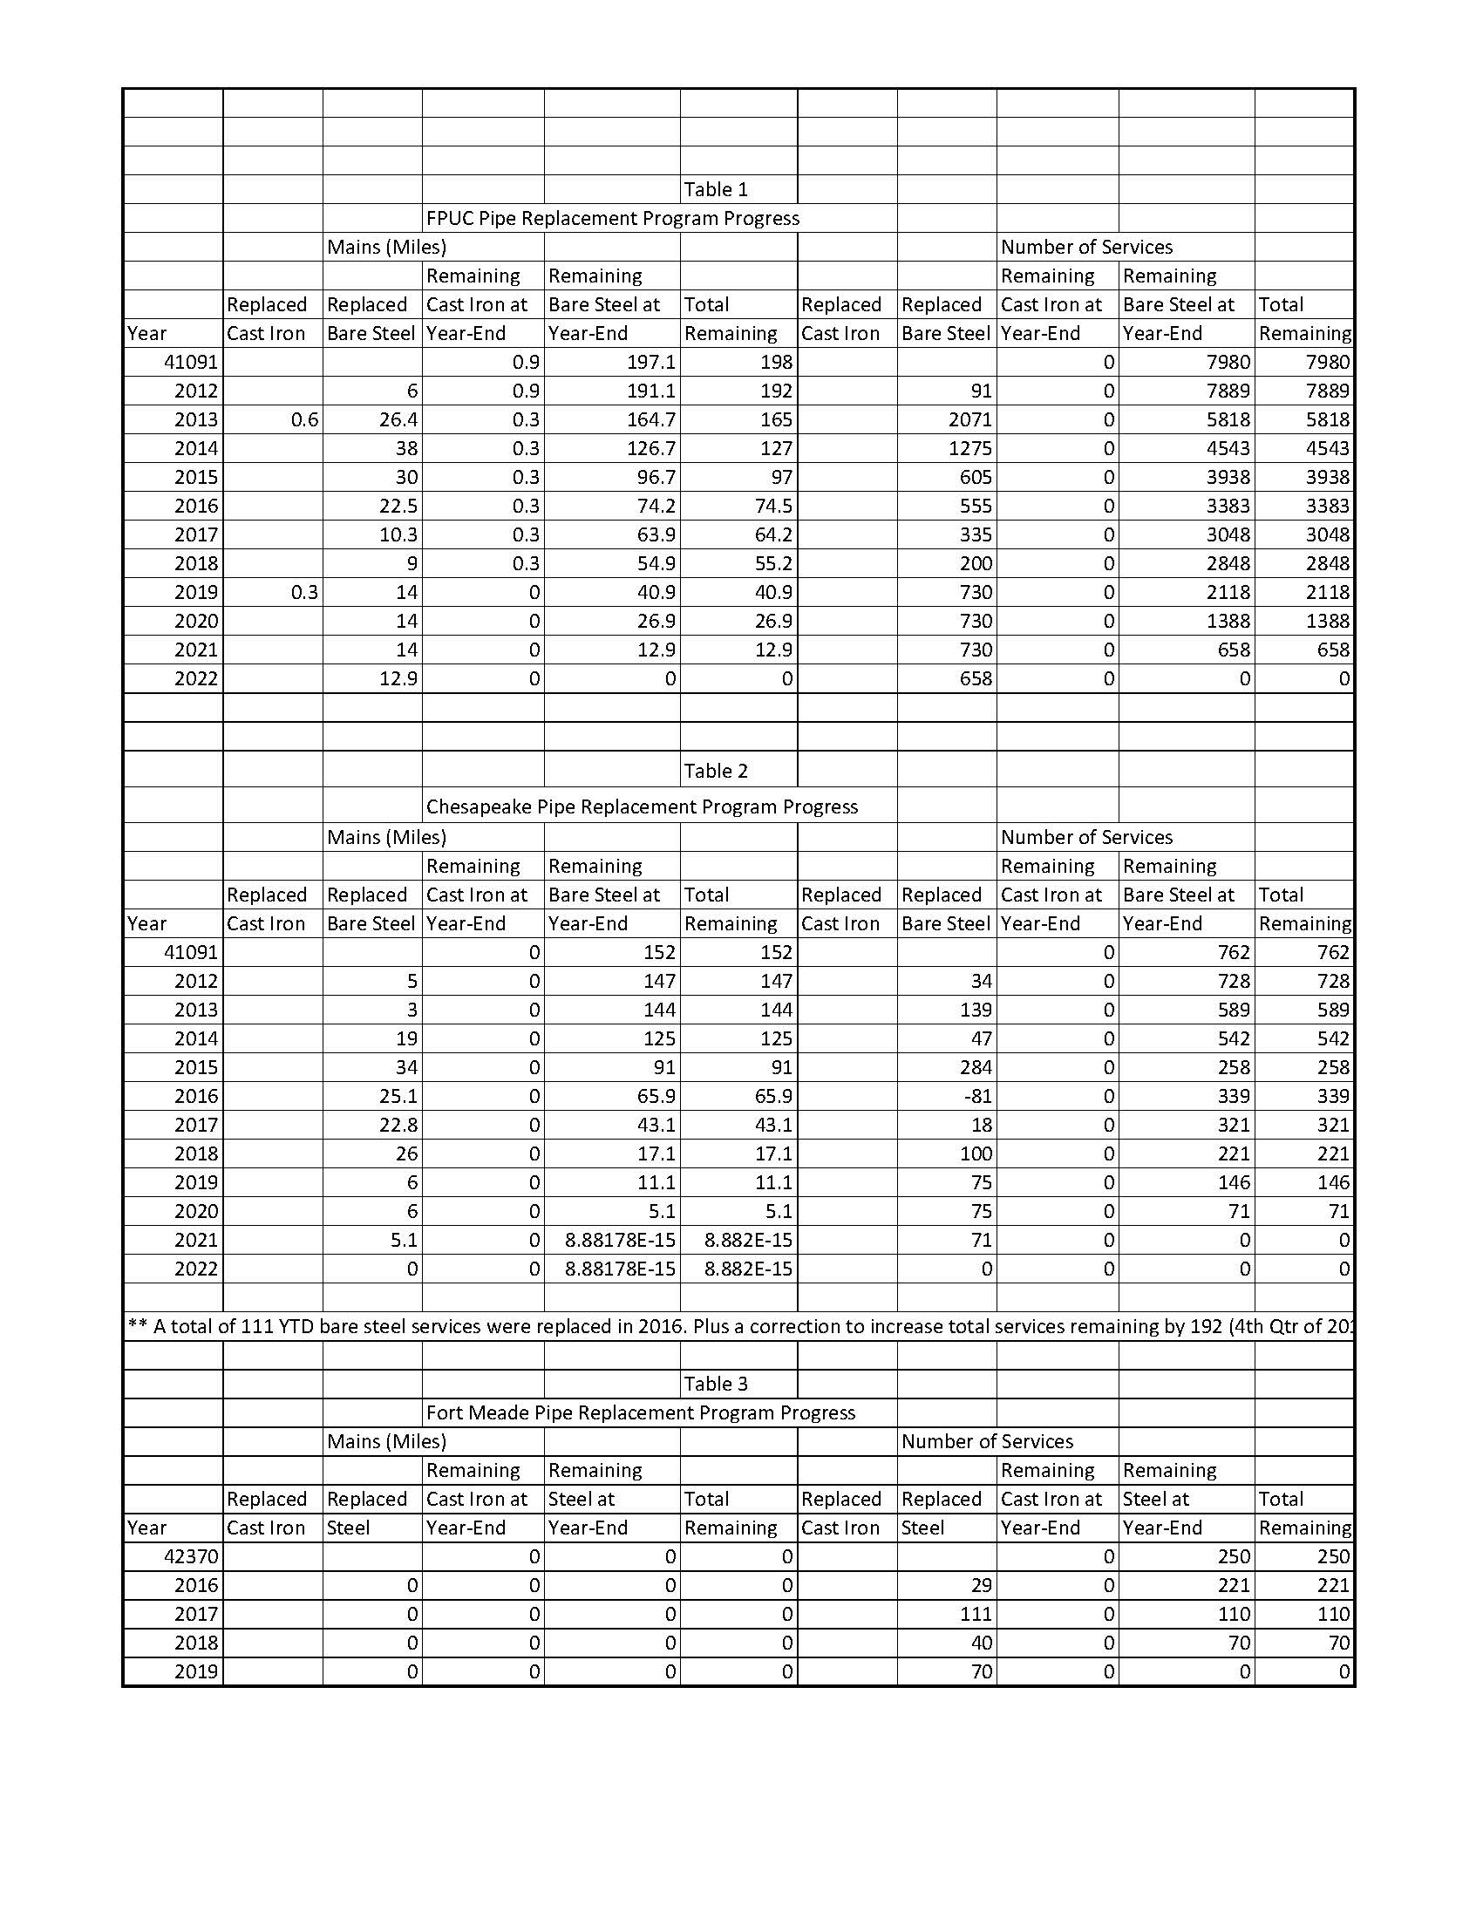
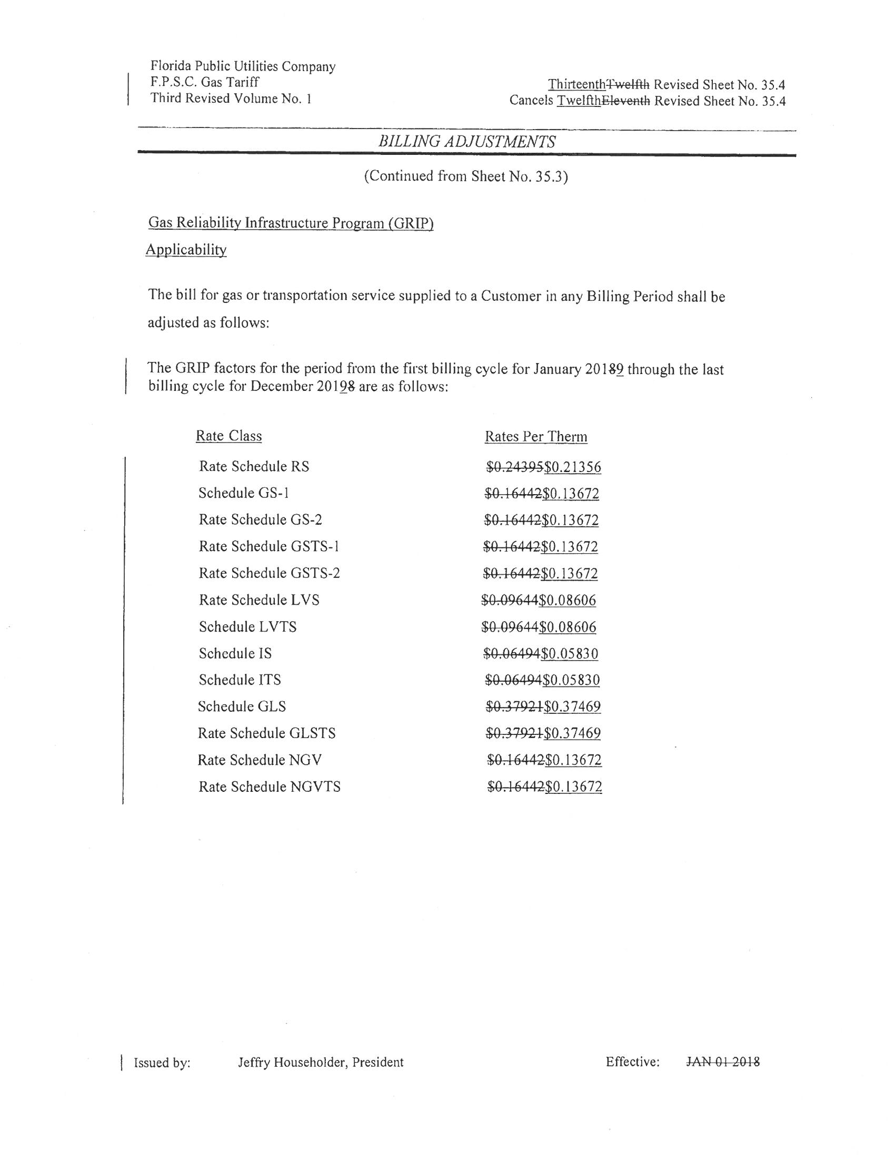

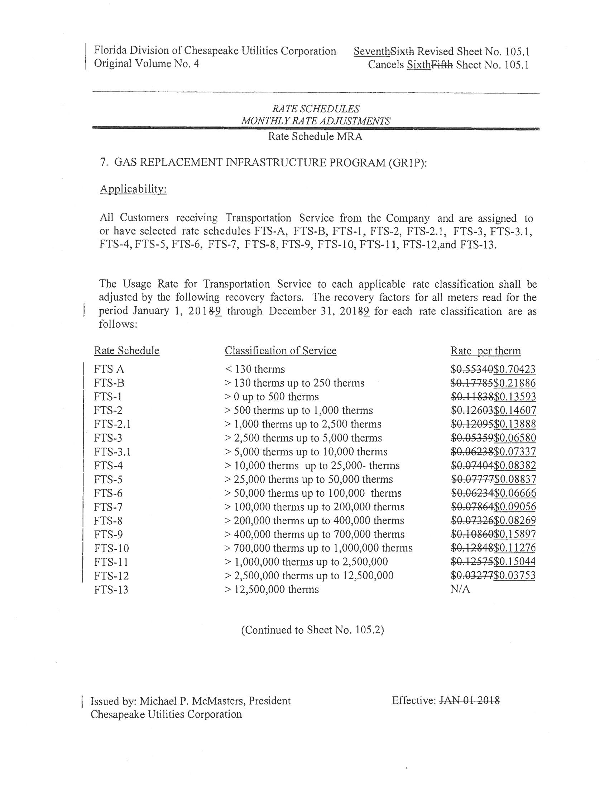

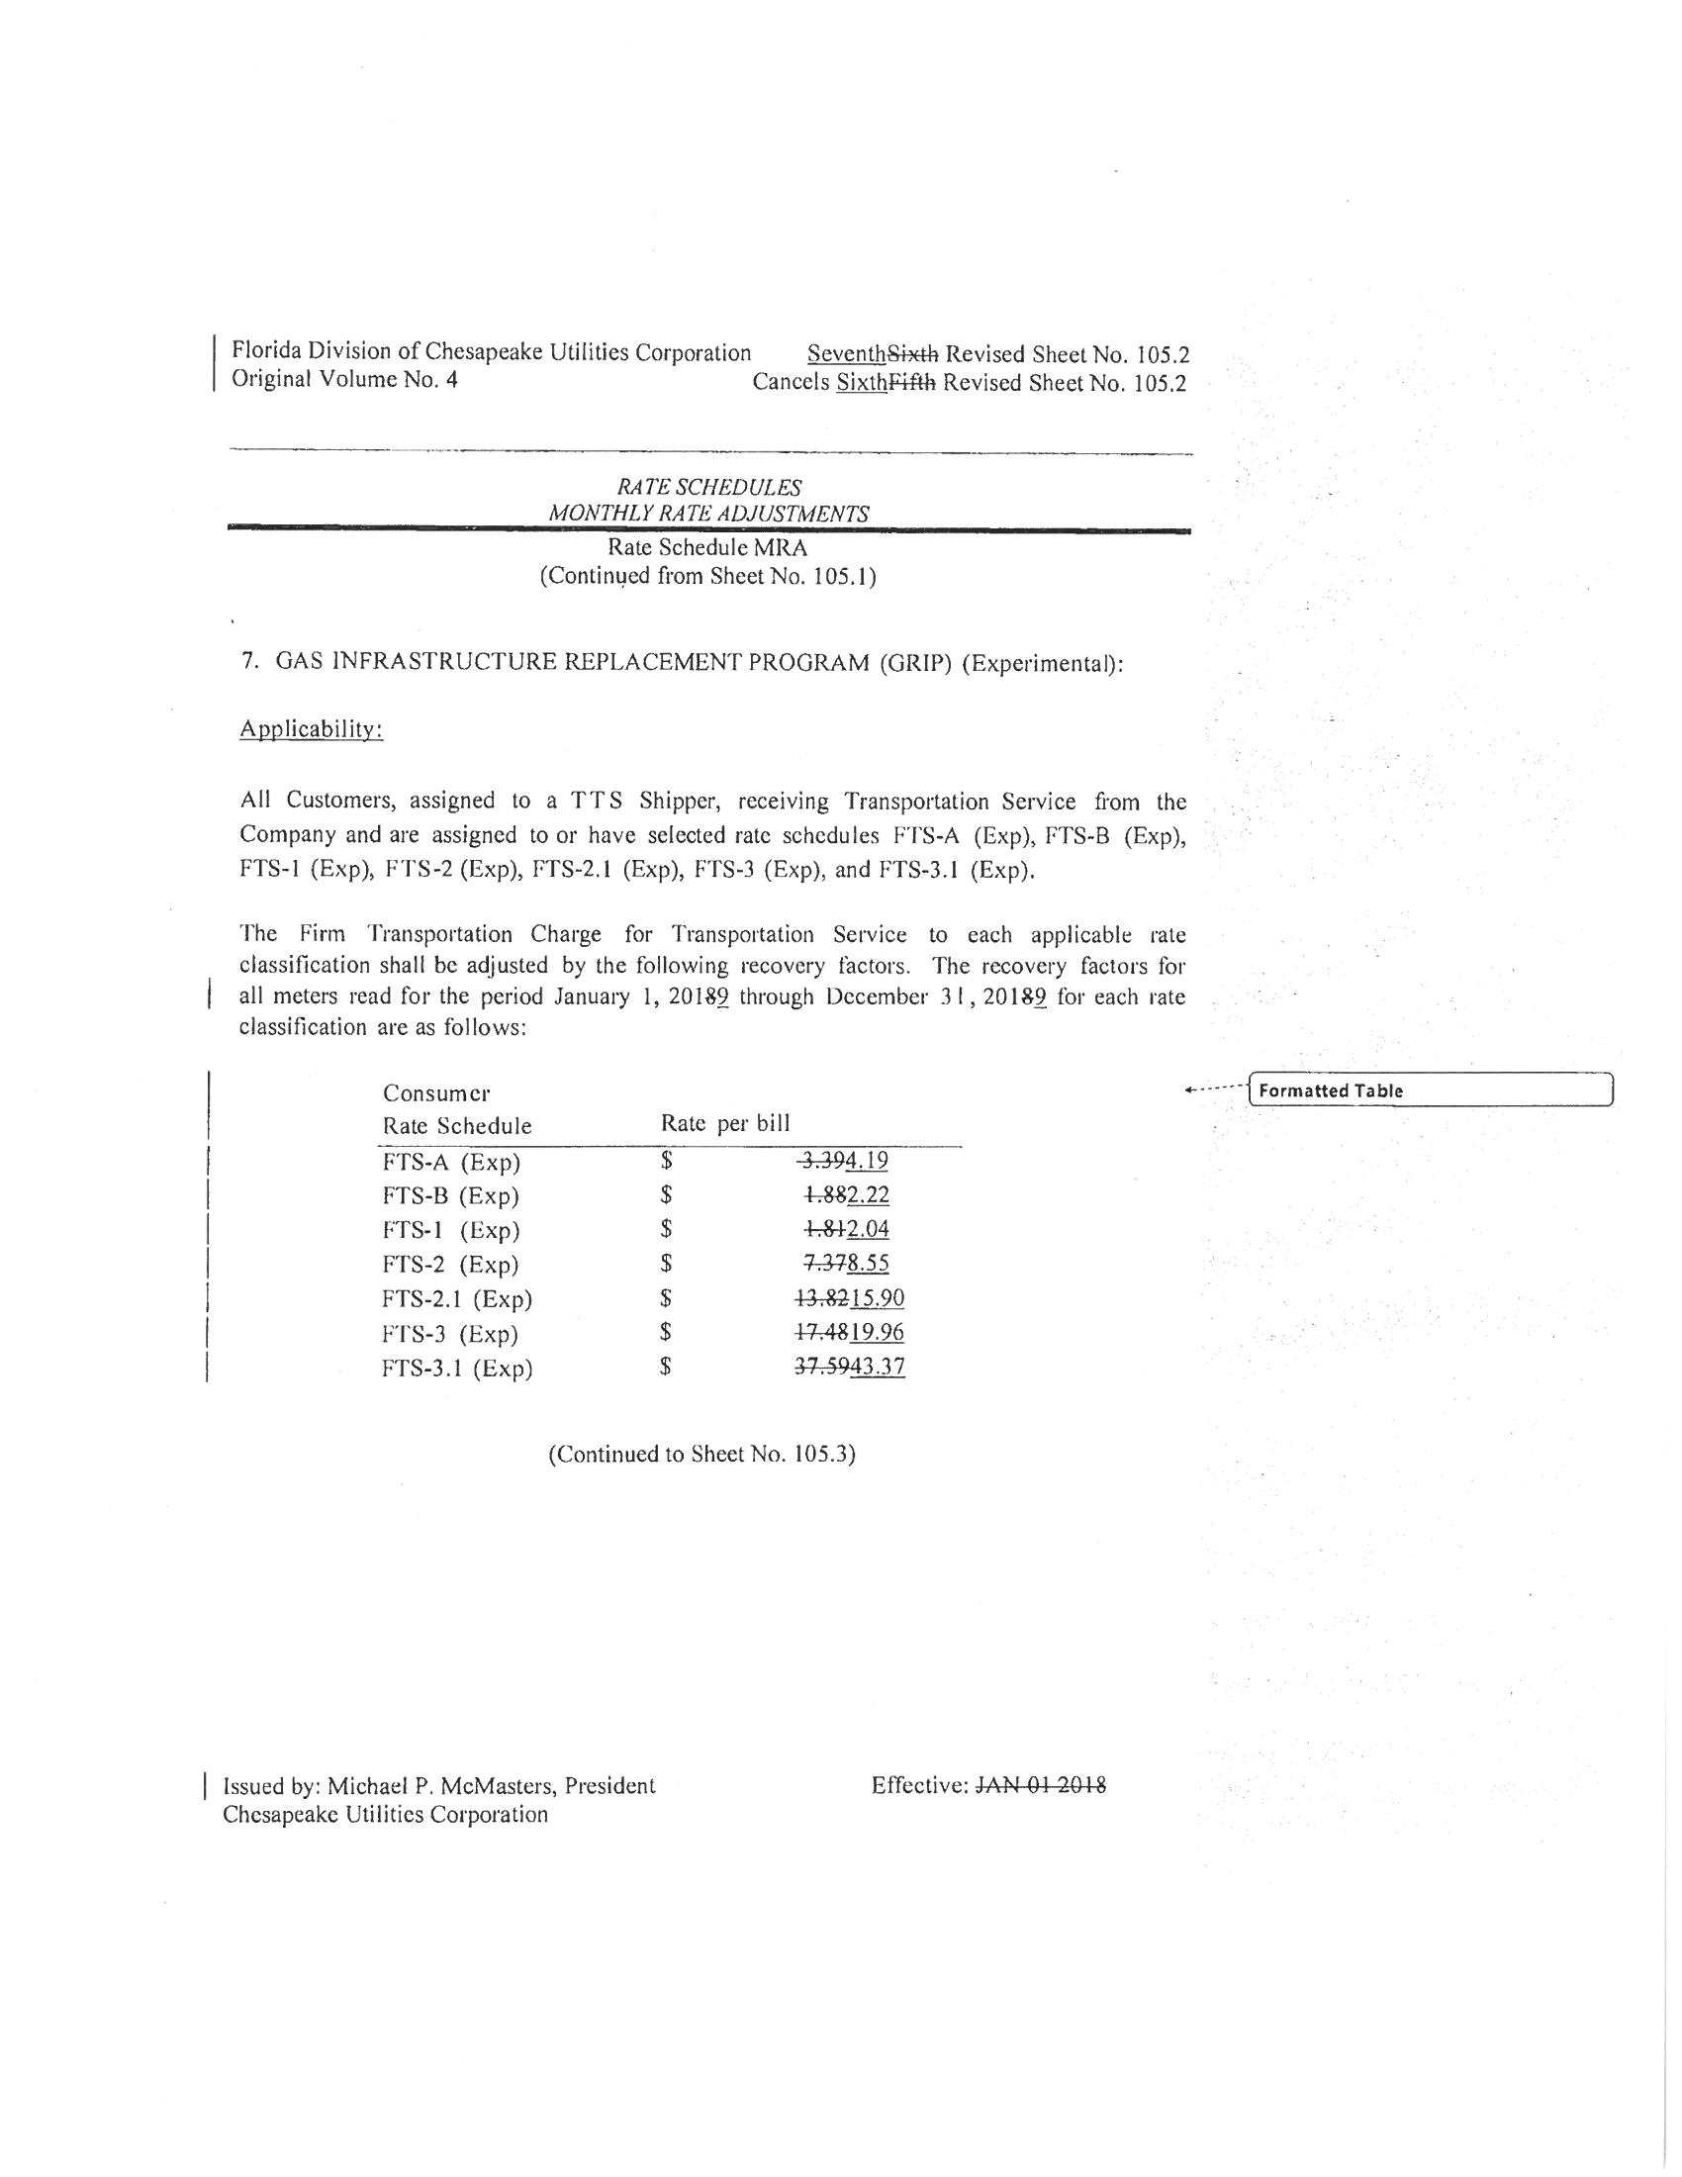

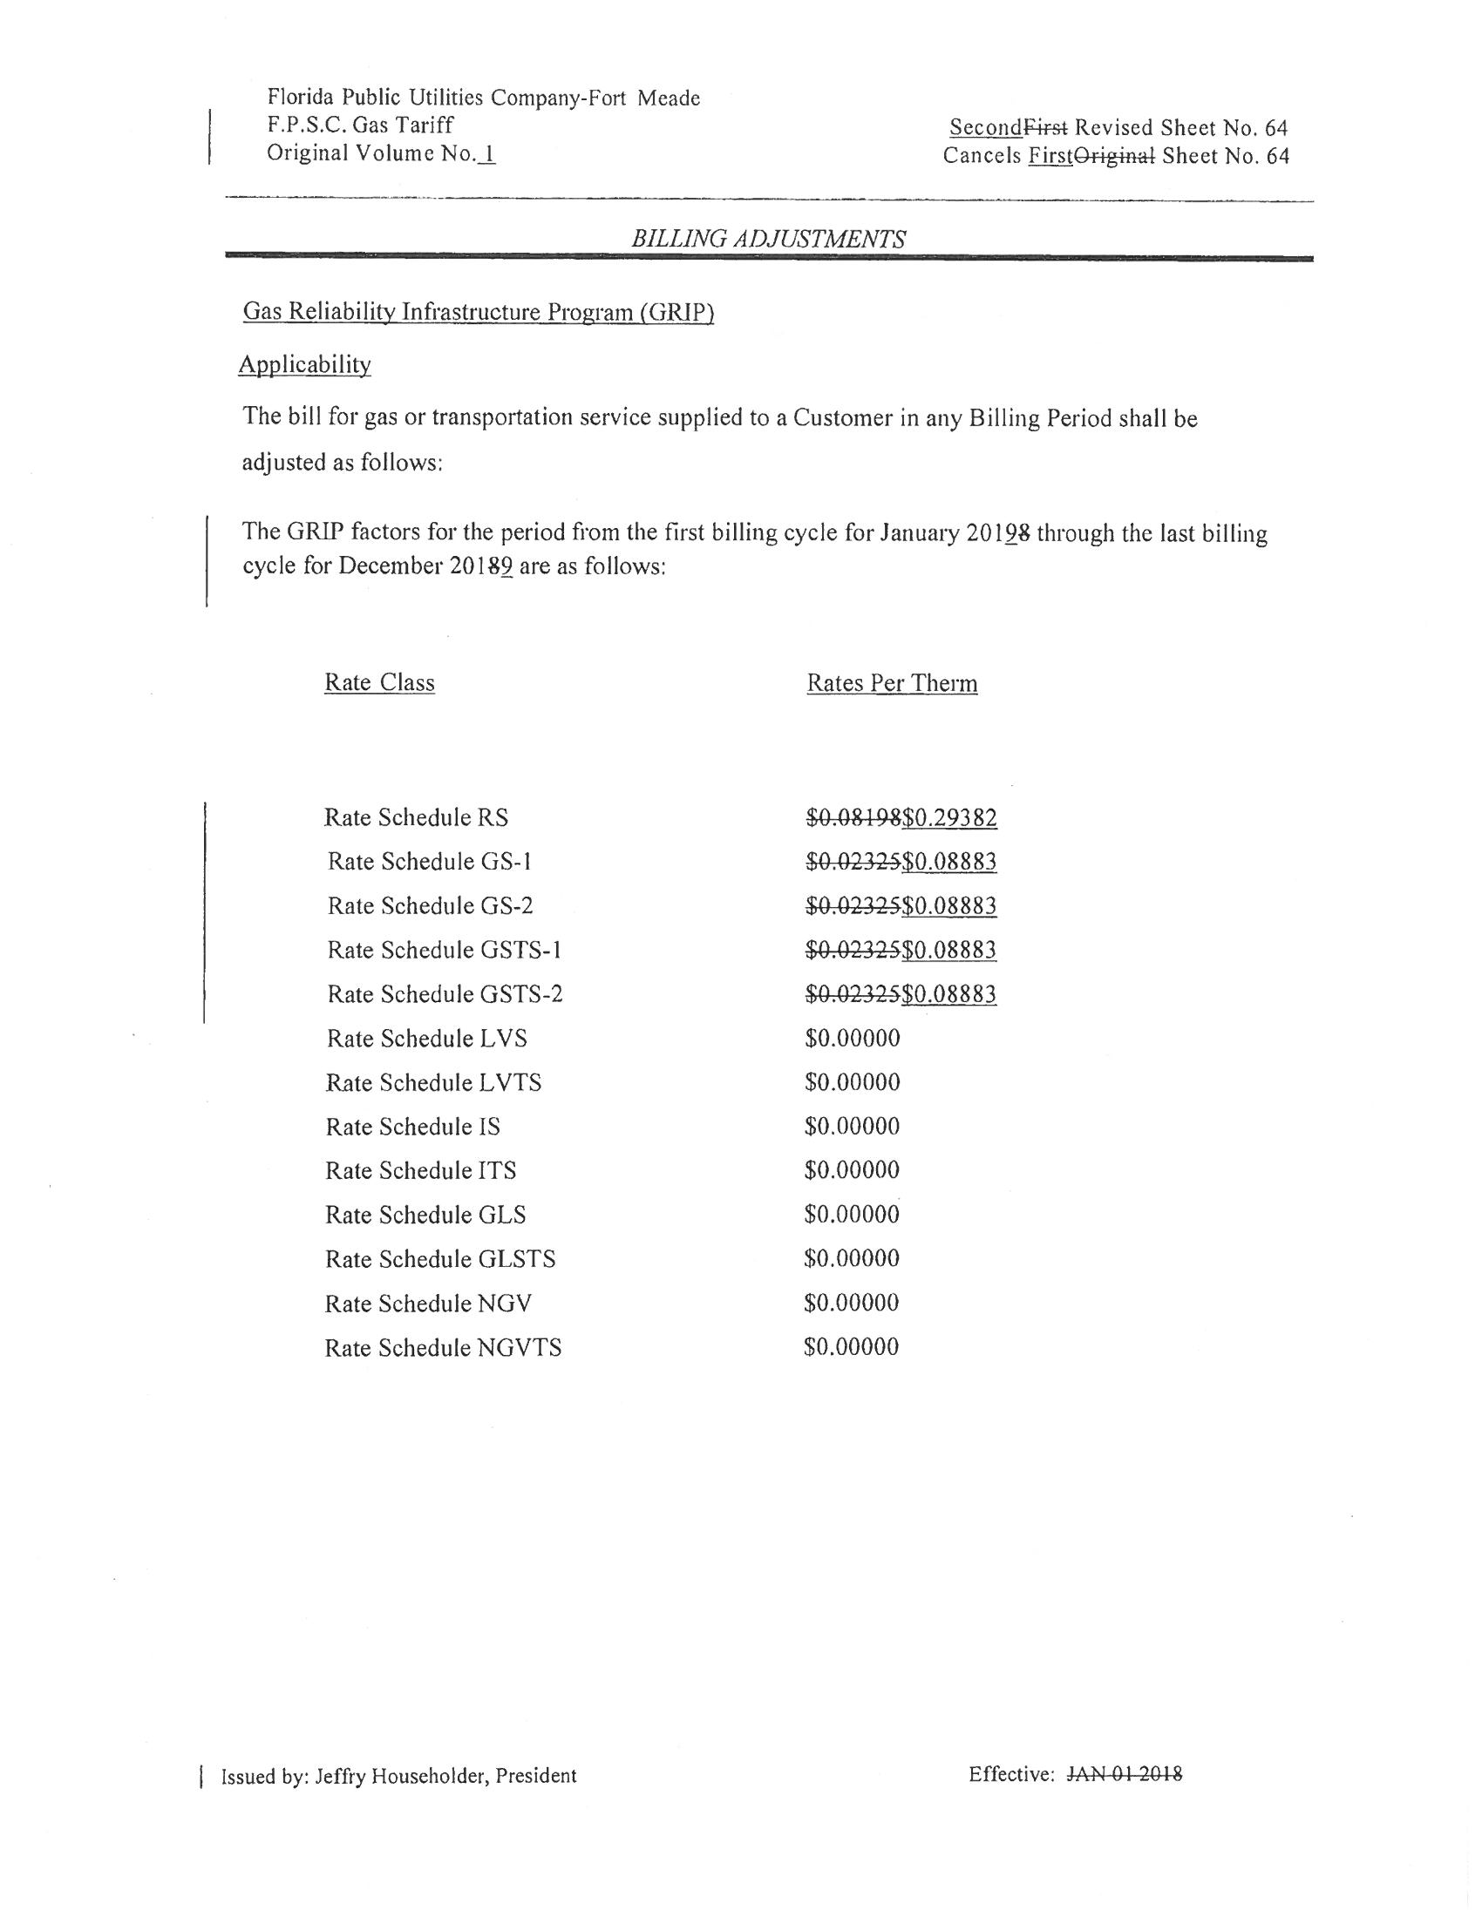

Order No. PSC-12-0490-TRF-GU, issued September 24, 2012, in Docket No. 120036-GU, In re: Joint petition for approval of Gas Reliability Infrastructure Program (GRIP) by Florida Public Utilities Company and the Florida Division of Chesapeake Utilities Corporation.
Order No. PSC-15-0578-TRF-GU, issued December 21, 2015, in Docket No. 150191-GU, In re: Joint petition for approval to implement gas reliability infrastructure program (GRIP) for Florida Public Utilities Company-Fort Meade and for approval of GRIP cost recovery factors by Florida Public Utilities Company, Florida Public Utilities Company-Fort Meade and the Florida Division of Chesapeake Utilities Corporation.
Order No. PSC-17-0437-TRF-GU, issued November 16, 2017, in Docket No. 20170190-GU, In re: Joint petition for approval of gas reliability infrastructure program (GRIP) cost recovery factors by Florida Public Utilities Company, Florida Public Utilities Company-Fort Meade, and Florida Division of Chesapeake Utilities Corporation.

