State of Florida |  | Public Service Commission  Capital Circle Office Center ● 2540 Shumard Oak Boulevard  Tallahassee, Florida 32399-0850  -M-E-M-O-R-A-N-D-U-M-
DATE: | November 29, 2018
TO: | Office of Commission Clerk (Stauffer)
FROM: | Division of Economics (Merryday)  Office of the General Counsel (Brownless)
RE: | Docket No. 20180182-EI – Petition for approval of tariff modification, by Tampa Electric Company.
AGENDA: | 12/11/18 – Regular Agenda – Tariff Filing – Interested Persons May Participate
COMMISSIONERS ASSIGNED: |  |  | All Commissioners
PREHEARING OFFICER: |  |  | Administrative
CRITICAL DATES: |  |  | 60-day suspension date waived by the utility until 12/11/2018
SPECIAL INSTRUCTIONS: |  |  | Place before 20180183-GU on the Agenda

Case Background
On October 2, 2018, Tampa Electric Company (TECO or utility) filed a petition for approval of a tariff modification relating to refusal or discontinuation of service. The proposed tariff modification is designed to protect TECO’s field employees from dangerous situations resulting from customer threats, as numerous incidents have occurred recently. The Commission approved a similar tariff for Florida Power & Light Company (FPL) in 1996. Peoples Gas System, a division of TECO, filed a similar petition in Docket No. 20180183-GU. The utility’s proposed tariff modification is shown in Attachment A to the recommendation. On October 3, 2018, TECO provided a letter waiving the 60-day file and suspend provision of Section 366.06(3), Florida Statutes (F.S.), until the December 11, 2018 Agenda Conference. TECO responded to staff’s data requests on October 26, 2018, and November 6, 2018. The Commission has jurisdiction pursuant to Sections 366.04, 366.05, and 366.06, F.S.

Discussion of Issues

Issue 1:
Should the Commission approve TECO's proposed tariff modification as shown in Attachment A to the recommendation?

Recommendation:
Yes, the Commission should approve TECO’s proposed tariff modification as shown in Attachment A to the recommendation. The proposed tariff modification is consistent with the tariff provision the Commission approved for FPL and is consistent with Rule 25-6.105, Florida Administrative Code (F.A.C.). The proposed tariff modification should become effective on December 11, 2018. (Merryday)

Staff Analysis:
The utility states that its field employees have experienced a number of threats, assaults, and harassments made by customers. In response to staff’s first data request, the utility detailed some of these threats, which ranged from threats against utility property to physical harm of employees.
Utilities currently have the ability to disconnect or refuse service for conditions specified in Rule 25-6.105, F.A.C. Specifically, Rule 25-6.105(5)(f), F.A.C., allows electric utilities to refuse or discontinue service for neglect or refusal to provide safe and reasonable access to the utility provided that written notice be given to the customer. Rule 25-6.105(5)(h), F.A.C., allows the utility to disconnect service without notice in the event of a condition known to the utility to be hazardous.
TECO’s current tariff provides the conditions under which TECO may refuse or discontinue service. As shown in Attachment A to the recommendation, the proposed tariff modification adds subsection (12) to tariff sheet No. 5.150. Subsection (12) states that the utility may refuse or discontinue service:
[f]or actions or threats made by a customer, or anyone on the customer’s premises, which are reasonably perceived by a Company employee as violent or unsafe, after affording the customer reasonable opportunity to cease from any further act of violence or unsafe condition.
As stated in the case background, the Commission approved a similar tariff for FPL in 1996. Like TECO’s proposed tariff, FPL’s approved tariff allows FPL to discontinue service as a result of threats made against employees.
To assure that unwarranted disconnections do not occur, the utility explained that the Corporate Security Department will investigate threat incidents and verify whether the actions or threats made by the customer have created a dangerous condition warranting disconnection. TECO’s head of corporate security will notify the utility’s Customer Service Department of valid incidents and will decide whether or not a disconnection notice will be issued to the customer.
In the instances where a customer’s service is being refused pursuant to the proposed tariff modification, the utility stated it will notify the customer as soon as practicable of the reason for refusal of service. The utility states that in most cases, a disconnection will have already taken place, and the restoration of service is what is being denied. TECO notes that it does not take disconnection of its customers or refusal of service lightly and that disconnecting or refusing service will be considered an extreme event that will follow other efforts to remedy the situation, up to and including law enforcement or security escorts. Once the threatening condition is resolved to the utility’s satisfaction, the utility will reconnect the customer.

Staff has reviewed TECO’s petition and responses to data requests and believes TECO’s proposed tariff modification is warranted. Additionally, the proposed tariff modification is consistent with the tariff provision the Commission approved for FPL and is consistent with Rule 25-6.105, F.A.C. Therefore, staff recommends approval of TECO’s proposed tariff modification. The proposed tariff modification should become effective on December 11, 2018.

Issue 2:
Should this docket be closed?

Recommendation:
Yes. If Issue 1 is approved and a protest is filed within 21 days of the issuance of the order, the tariff should be suspended pending resolution of the protest. If no timely protest is filed, this docket should be closed upon the issuance of a consummating order. (Brownless)

Staff Analysis:
If Issue 1 is approved and a protest is filed within 21 days of the issuance of the order, the tariff should be suspended pending resolution of the protest. If no timely protest is filed, this docket should be closed upon the issuance of a consummating order.
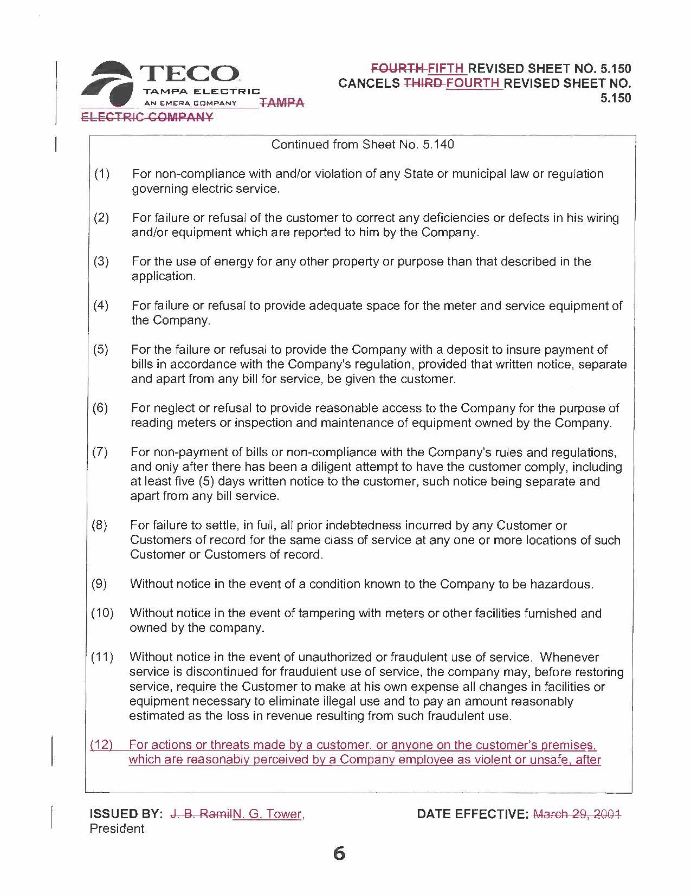
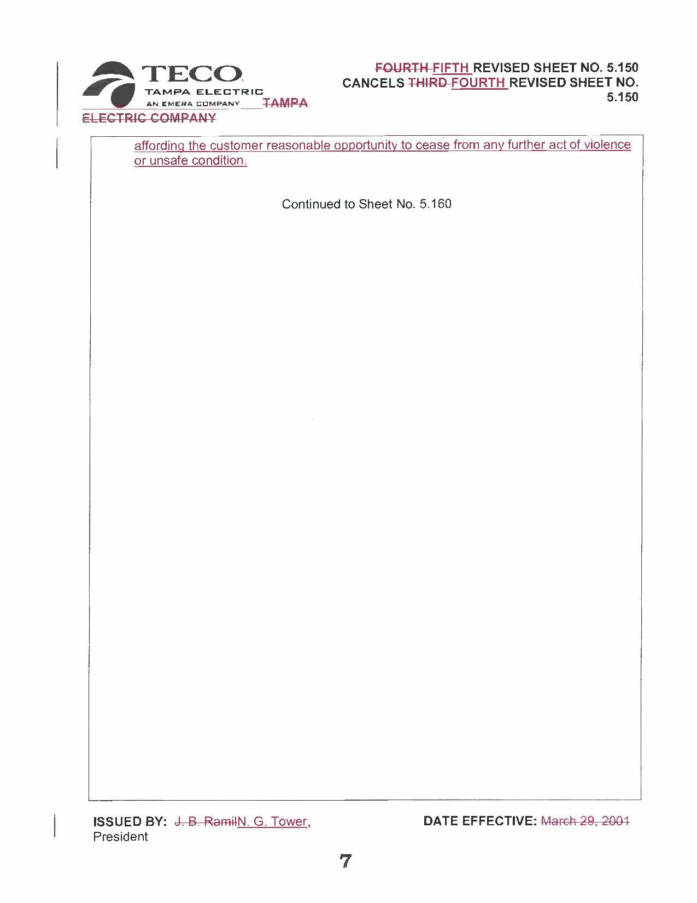

Order No. PSC-96-0585-FOF-EI issued May 6, 1996, in Docket No. 960307-EI, In re: Proposed revision of rules and regulations, pertaining to access portion of tariff, by Florida Power & Light Company.
See FPL tariff sheet No. 6.010, section 1.6 - Discontinuance of Service.

