State of Florida |  | Public Service Commission  Capital Circle Office Center ● 2540 Shumard Oak Boulevard  Tallahassee, Florida 32399-0850  -M-E-M-O-R-A-N-D-U-M-
DATE: | November 29, 2018
TO: | Office of Commission Clerk (Stauffer)
FROM: | Office of Industry Development and Market Analysis (Wooten)  Division of Economics (McCoy)  Office of the General Counsel (Dziechciarz)
RE: | Docket No. 20180205-TX – Bankruptcy compliance cancellation by Florida Public Service Commission of CLEC Certificate No. 8244, issued to Trans National Communications International, Inc., effective December 31, 2018.  Docket No. 20180206-TC – Bankruptcy compliance cancellation by Florida Public Service Commission of PATS Certificate No. 5995, issued to Florida Gaming Centers, Inc., effective December 31, 2018.  Docket No. 20180207-TX – Bankruptcy compliance cancellation by Florida Public Service Commission of CLEC Certificate No. 4847, issued to OneStar Long Distance, Inc., effective December 31, 2018.  Docket No. 20180208-TX – Bankruptcy compliance cancellation by Florida Public Service Commission of CLEC Certificate No. 8382, issued to Baldwin County Internet/DSSI, L.L.C., effective December 31, 2018.  Docket No. 20180209-TX – Bankruptcy compliance cancellation by Florida Public Service Commission of CLEC Certificate No. 8748, issued to iNetworks Group, Inc., effective December 31, 2018.
AGENDA: | 12/11/18 – Regular Agenda – Proposed Agency Action – Interested Persons May Participate
COMMISSIONERS ASSIGNED: |  |  | All Commissioners
PREHEARING OFFICER: |  |  | Administrative
CRITICAL DATES: |  |  | None
SPECIAL INSTRUCTIONS: |  |  | None

Case Background
Pursuant to Section 364.336, Florida Statutes (F.S.), telecommunications companies must pay a minimum annual Regulatory Assessment Fee (RAF) if the company’s certificate was active during any portion of the calendar year. Section 350.113, F.S. provides for penalties and interest on any delinquent amounts. This recommendation addresses telecommunications companies that currently have active certificates, but have entered either Chapter 11 bankruptcy proceedings (addressed in Issue 1) or Chapter 7 bankruptcy proceedings (addressed in Issue 2). In a Chapter 11 bankruptcy proceeding, the daily operations of the company continue while the company works to reorganize its business to become profitable again. In a Chapter 7 bankruptcy proceeding, the company stops all operations and goes completely out of business.

Trans National Communications International, Inc. (Trans National) currently holds competitive local exchange telecommunications company (CLEC) Certificate No. 8244, issued by the Commission on December 4, 2002. Trans National filed for Chapter 11 bankruptcy on October 9, 2011, and the case was terminated on January 26, 2016. Trans National has not paid its RAFs or the penalties and interest assessed for the years 2014, 2015, 2016, 2017, and 2018.

Florida Gaming Centers, Inc. (Florida Gaming) currently holds pay telephone service (PATS) Certificate No. 5995, issued by the Commission on February 16, 1999. Florida Gaming filed for Chapter 11 bankruptcy on August 19, 2013, and the case was terminated on August 22, 2017. Florida Gaming has not paid its RAFs or the penalties and interest assessed for the years 2014, 2015, 2016, 2017, and 2018.

OneStar Long Distance, Inc. (OneStar) currently holds CLEC Certificate No. 4847, issued by the Commission on May 9, 2003. OneStar filed for Chapter 11 bankruptcy on December 31, 2003, but RAFs have not been assessed for OneStar since January 13, 2005, when the company converted to Chapter 7 bankruptcy.

Baldwin County Internet/DSSI Service, L.L.C. (Baldwin County) currently holds CLEC Certificate No. 8382, issued by the Commission on September 17, 2003. Baldwin County filed for Chapter 11 bankruptcy on April 26, 2012. RAFs have not been assessed for Baldwin County since October 15, 2012, when the company converted to Chapter 7 bankruptcy.

iNetworks Group, Inc. (iNetworks) currently holds CLEC Certificate No. 8748, issued by the Commission on March 6, 2009. RAFs have not been assessed on iNetworks since August 11, 2017, when the company filed for Chapter 7 bankruptcy.

The Commission has jurisdiction over these matters pursuant to Section 364.336, F.S.

Discussion of Issues

Issue 1:
Should the Commission, on its own motion, cancel Trans National Communications International, Inc.’s CLEC certificate and Florida Gaming Centers, Inc.’s PATS certificate and service schedules (if any) for failure to pay Regulatory Assessment Fees following discharge from Chapter 11 bankruptcy; change the companies’ status to “cancelled” in the Master Commission Directory effective December 31, 2018; direct the Division of Administrative and Information Technology Services (AIT) to write off any statutory late payment charges, penalties and interest instead of requesting collection services; and require the companies to immediately cease and desist providing telecommunications services in Florida?

Recommendation:
Yes, the Commission, on its own motion, should cancel Trans National Communications International, Inc.’s CLEC certificate and Florida Gaming Centers, Inc.’s PATS certificate and service schedules (if any) for failure to pay Regulatory Assessment Fees following discharge from Chapter 11 bankruptcy. The Commission should change the companies’ status to “cancelled” in the Master Commission Directory, effective December 31, 2018; direct AIT to write off any statutory late payment charges, penalties and interest instead of requesting collection services; and require the companies to immediately cease and desist providing telecommunications services in Florida. (Wooten, McCoy)

Staff Analysis:
Staff searches of the Public Access to Court Electronic Records (PACER) system show that on October 9, 2011, Trans National filed for Chapter 11 bankruptcy in the U.S. Bankruptcy Court for the District of Massachusetts. The bankruptcy case was closed on January, 26, 2016. Trans National has not paid the RAFs, or the late penalties and interest assessed for the years 2014, 2015, 2016, 2017, and 2018.
Trans National has not responded to staff’s requests to update contact information or data requests. Staff reviewed Trans National’s records on the Florida Department of State, Division of Corporations website, which show that the company’s last annual report was filed on April 12, 2013, and that its corporate status was listed as “inactive” as of February 6, 2014. The Federal Communications Commission (FCC) Form 499 Filer Database lists Trans National as no longer active as of April 30, 2013.,
Staff searches of the PACER system show that on August 19, 2013, Florida Gaming filed for Chapter 11 bankruptcy in the U.S. Bankruptcy Court for the Southern District of Florida, and that the bankruptcy case was closed on August 22, 2017. Florida Gaming has not paid the RAFs or the late penalties and interest assessed for the years 2014, 2015, 2016, 2017, and 2018.
Florida Gaming has not responded to staff’s requests to update contact information or data requests. All mail sent by staff has been returned by the U.S. Postal Service marked “not deliverable as addressed,” and the telephone numbers on file for the company are out of service. Staff reviewed Florida Gaming’s records on the Florida Department of State, Division of Corporations website, which show that the company’s last annual report was filed on April 16, 2014, and its corporate status was listed as “inactive.” On September 25, 2015, the company’s status was listed as “administrative dissolution for annual report.” The FCC Form 499 Filer Database has no listing for Florida Gaming.
Pursuant to Chapter 11 U.S. Code §362(a), the filing of a petition for Chapter 11 bankruptcy relief acts as an automatic stay that enjoins a governmental entity from exercising its regulatory authority to collect a pre-petition debt. Additionally, in any bankruptcy liquidation or reorganization, secured creditors are given the highest priority in the distribution and, normally, receive all of the distributed assets. RAFs, late payment charges, and penalties owed by a company to the Commission, as well as monetary settlements of cases resolving issues of failure to pay such fees, are not secured debts and, as a practical matter, are uncollectible. Therefore, this Commission would be prevented from collecting pre-bankruptcy RAFs owed by these companies, and from assessing and collecting a penalty for failure to pay the fees.
While the Commission is enjoined from collecting pre-petition debts, companies in Chapter 11 bankruptcy are required to pay post-petition expenses as incurred. Trans National and Florida Gaming have both exited bankruptcy, but neither has paid any RAFs for any years after declaring and after exiting bankruptcy. Furthermore, as indicated above, it appears that the companies are no longer providing service in Florida.
Pursuant to Section 364.336, F.S., certificate holders must pay a minimum annual RAF if the certificate was active during any portion of the calendar year. Section 350.113, F.S. provides for penalties and interest on for any delinquent amounts.
AIT advised that it appears Trans National and Florida Gaming have failed to comply with Section 364.336, F.S., following their discharge from Chapter 11 bankruptcy. The companies have not paid RAFs or statutory late payment charges as detailed in Attachment A. Therefore, staff recommends that the Commission, on its own motion, cancel Trans National’s CLEC certificate and Florida Gaming’s PATS certificate and service schedules (if any) for failure to pay RAFs following the companies’ discharge from Chapter 11 bankruptcy. Staff recommends that the companies’ status be changed to “cancelled” in the Master Commission Directory, effective December 31, 2018, and that AIT be directed to write off any statutory late payment charges, penalties, and interest instead of requesting collection services. Staff further recommends that the Commission should require the companies to immediately cease and desist providing telecommunications services in Florida.

Issue 2:
Should the Commission, on its own motion, cancel OneStar Long Distance, Inc., Baldwin County Internet/DSSI Service, L.L.C., and iNetworks Group, Inc.’s CLEC certificates and service schedules (if any) because of the companies’ status as Chapter 7 bankruptcy liquidations; change the companies’ status to “cancelled” in the Master Commission Directory effective December 31, 2018; and require the companies to immediately cease and desist providing telecommunications services in Florida?

Recommendation:
Yes, the Commission, on its own motion, should cancel OneStar Long Distance, Inc., Baldwin County Internet/DSSI Service, L.L.C., and iNetworks Group, Inc.’s CLEC certificates and service schedules (if any) because of the companies’ status as Chapter 7 bankruptcy liquidations; change the companies’ status to “cancelled” in the Master Commission Directory effective December 31, 2018; and require the companies to immediately cease and desist providing telecommunications services in Florida (Wooten, McCoy)

Staff Analysis:
Staff searches of the PACER system show that OneStar Long Distance, Inc., Baldwin County Internet/DSSI Service, L.L.C., and iNetworks are currently in Chapter 7 bankruptcy. According to the U.S. Securities and Exchange Commission, “(U)nder Chapter 7, the company stops all operations and goes completely out of business. A trustee is appointed to "liquidate" (sell) the company's assets and the money is used to pay off the debt, which may include debts to creditors and investors.”,
A company undergoing Chapter 7 bankruptcy proceedings will no longer be able to serve its customers or to meet its obligations as the holder of a certificate of authority. Upon notification that a company has initiated a Chapter 7 bankruptcy case, the Commission ceases to bill for RAFs, and does not assess any penalties or interest, because RAFs owed are not secured debts and, as a practical matter, are uncollectible. Therefore, staff recommends that the Commission, on its own motion, should cancel OneStar Long Distance, Inc., Baldwin County Internet/DSSI Service, L.L.C., and iNetworks Group, Inc.’s CLEC certificates and service schedules (if any) because of the companies’ status as Chapter 7 bankruptcy liquidations; change the companies’ status to “cancelled” in the Master Commission Directory effective December 31, 2018; and require the companies to immediately cease and desist providing telecommunications services in Florida.

Issue 3:
Should this docket be closed?

Recommendation:
Yes, if no person whose substantial interests are affected by the proposed agency action files a protest within 21 days of the issuance of the order, these dockets should be closed upon the issuance of a consummating order. If a protest is filed in one docket, the protest should not prevent the action in a separate docket from becoming final. These dockets should then be closed upon issuance of a consummating order. (Dziechciarz)

Staff Analysis:
If no person whose substantial interests are affected by the proposed agency action files a protest within 21 days of the issuance of the order, these dockets should be closed upon the issuance of a consummating order. If a protest is filed in one docket, the protest should not prevent the action in a separate docket from becoming final. These dockets should then be closed upon issuance of a consummating order.

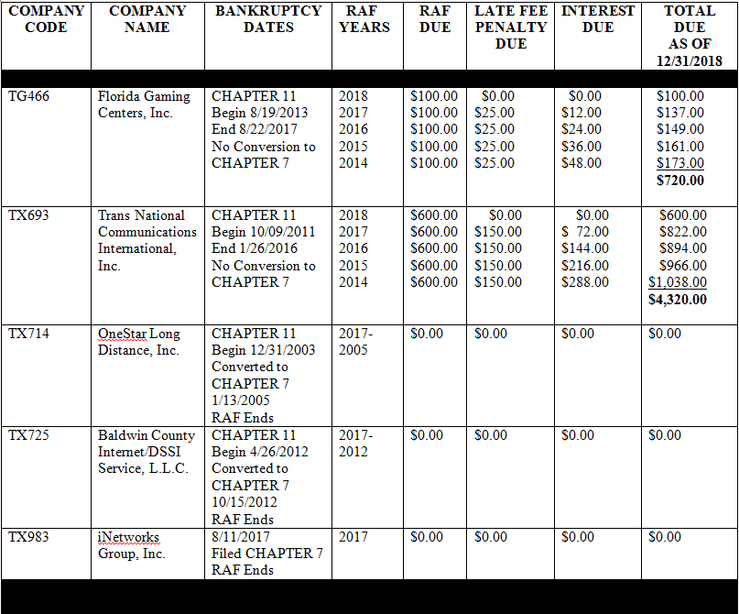

See “Bankruptcy: What Happens When Public Companies Go Bankrupt,” U.S. Securities and Exchange Commission, published February 3, 2009, https://www.sec.gov/reportspubs/investor-publications/investorpubsbankrupthtm.html.
Id.
See http://apps.fcc.gov/cgb/form499/499detail.cfm?FilerNum=817852
FCC Form 499 is used to facilitate the quarterly and annual revenue reporting requirements for telecommunications companies. The FCC Form 499 Filer Database is a compilation of all telecommunications companies that are required to file either Form 499-Q or Form 499-A. It contains company information such as the company’s name, address, designated agent, and jurisdictions in which it provides service.
See 11 U.S. Code §§503 and 721, 28 U.S. Code §959.
See “Bankruptcy: What Happens When Public Companies Go Bankrupt,” U.S. Securities and Exchange Commission, published February 3, 2009, https://www.sec.gov/reportspubs/investor-publications/investorpubsbankrupthtm.html.
See 11 U.S. Code §721.
See Attachment A.

