State of Florida |  | Public Service Commission  Capital Circle Office Center ● 2540 Shumard Oak Boulevard  Tallahassee, Florida 32399-0850  -M-E-M-O-R-A-N-D-U-M-
DATE: | December 27, 2019
TO: | Office of Commission Clerk (Stauffer)
FROM: | Office of the General Counsel (Harper)  Division of Economics (Coston, Guffey)
RE: | Docket No. 20180121-EG – Amendment of Rule 25-17.015, F.A.C., Energy Conservation Cost Recovery Clause.
AGENDA: | 01/08/18 – Regular Agenda – Interested Persons May Participate
COMMISSIONERS ASSIGNED: |  |  | All Commissioners
PREHEARING OFFICER: |  |  | Brown
RULE STATUS: |  |  | Proposal May Be Deferred
SPECIAL INSTRUCTIONS: |  |  | None

Case Background
The Energy Conservation Cost Recovery (ECCR) clause is a mechanism through which utilities recover reasonable and prudent costs related to energy conservation programs. Rule 25-17.015, Florida Administrative Code (F.A.C.), Energy Conservation Cost Recovery, requires all electric and gas utilities that seek to recover conservation program-related costs to file with the Commission ECCR program costs and collected revenue for the prior year (actual and true-up amounts), the current year (actual and estimated amounts), and the future year (projected amounts).
By Order No. PSC-2018-0423-PAA-GU, issued on August 24, 2018, in Docket No. 20180004-GU, the Commission granted a Petition for Waiver of Rule 25-17.015(1)(b), F.A.C, by Peoples Gas System, Florida Public Utilities Company, Florida Division of Chesapeake Utilities Corporation, Florida Public Utilities Company- Fort Meade, Florida Public Utilities Company-Indiantown Division, Florida City Gas, St. Joe Natural Gas Company, and Sebring Gas System (collectively utilities). The utilities asserted that it was a substantial hardship to file eight months of current year actual and four months estimated data reflecting ECCR program costs as required by Rule 25-17.015(1)(b), F.A.C. The utilities asserted that they could provide the Commission with filings based on six months of actual data and six months of projected data, which would allow the utilities to meet the deadline set forth by the Commission’s Order Establishing Procedure (OEP) and which would be a more reasonable means of achieving the purpose of Rule 25-17.015(1)(b), F.A.C.
Accordingly, staff initiated this rulemaking to amend Rule 25-17.015 (1)(b), F.A.C., to remove the provisions that require investor-owned electric and gas utilities to file the current year’s ECCR program costs and collected revenue for eight months actual and four months estimated. Additionally, the rulemaking will remove the requirement that the ECCR proceeding occur in November of each year. The removal of the eight and four month filing and proceeding requirements will allow the Commission flexibility to establish the filing dates for the ECCR proceedings by an OEP.
Staff also recommends that the rule be amended to remove an unnecessary form requirement and to add clarifying language concerning the evaluation of advertising costs associated with ECCR conservation efforts.
The Commission’s Notice of Development of Rulemaking was published in the Florida Administrative Register on March 20, 2018, in Volume 44, No. 55. There were no requests for a rule development workshop, and no workshops were held. No comments from interested parties were received.
This recommendation addresses whether the Commission should propose the amendment of Rule 25-17.015, F.A.C. The Commission has jurisdiction pursuant to Section 120.54, F.S., Section 366.04, F.S., and Section 366.05, F.S.

Discussion of Issues

Issue 1:
Should the Commission propose the amendment of Rule 25-17.015, F.A.C., Energy Conservation Cost Recovery?

Recommendation:
Yes. The Commission should propose the amendment of Rule 25-17.015, F.A.C., as set forth in Attachment A. Staff recommends that the Commission certify amended Rule 25-17.015, F.A.C., as a minor violation rule. (Harper, Coston)

Staff Analysis:
Sections 366.80, 366.81, 366.82, 366.83 and 403.519, F.S., collectively, provide conservation requirements for the utilities. Section 366.82, F.S., requires that the Commission develop rules that establish conservation goals, approve conservation plans, and monitor programs related to the promotion of demand-side renewable energy systems and the conservation of electric energy and natural gas usage. Rule 25-17.015, F.A.C. (ECCR rule), requires utilities to report certain costs and revenues associated with each utility’s conservation programs.

Rule 25-17.015, F.A.C., is the Commission’s only cost recovery clause rule that includes a fixed timeline for the actual and estimated filings and a requirement that ECCR proceedings occur during November of each calendar year. Paragraph (1)(b) requires that the utilities file the current year’s actual and estimated filings with eight months actual and four months estimated actual true-up amounts. The filing deadlines and hearing schedule associated with the other annual cost recovery clauses are dictated by each respective clause’s OEP. Staff is recommending that paragraph (1)(b) be amended to remove the November proceeding requirement and the eight months actual and four months estimated filing provisions to allow the Commission greater flexibility in scheduling the annual ECCR hearing.

Paragraph (1)(e) states that within the 90 days immediately following a utility’s true-up filing, each utility must file a report of the first six-month actual results for the current docket year. The utilities must use Form PSC/ECO/44 (11/97), Energy Conservation Cost Recovery Annual Short Form (Short Form), to provide this information. Staff recommends that Paragraph (1)(e) be removed because the Short Form becomes unnecessary with the proposed change to Paragraph (1)(b). The original purpose of this form was to provide a six month update on the actual costs or true-up, per Section 366.82(11) F.S. If Paragraph (1)(b) of the rule is amended as set forth in Attachment A, the actual/estimated filings will satisfy the requirements set forth in Section 366.82(11), F.S.

Staff is also recommending that Subsection (5) of the ECCR rule be amended to clarify language concerning the evaluation of advertising costs associated with conservation efforts. The current rule language is vague and could potentially limit the Commission’s ability to assess and evaluate the appropriateness of these costs. Staff recommends that Subsection (5) of the rule be amended to refer the Commission to the Order approving the program when evaluating whether advertising costs are directly related to an approved conservation program. This amendment is clarifies that electric and natural gas conservation programs are approved by Commission order.

Minor Violation Rules Certification
Pursuant to Section 120.695, F.S., beginning July 1, 2017, for each rule filed for adoption, the Commission is required to certify whether any part of the rule is designated as a rule the violation of which would be a minor violation. A list of the Commission rules designated as minor violation rules is published on the Commission’s website, as required by Section 120.695(2), F.S. Currently, Rule 25-17.015, F.A.C., is on the Commission’s list of rules designated as minor violations. If the Commission proposes the amendment of Rule 25-17.015, F.A.C., the rule would continue to be considered a minor violation rule. Therefore, for purposes of filing the amended rules for adoption with the Department of State, staff recommends that the Commission certify proposed amended Rule 25-17.015, F.A.C., as a minor violation rule.

Statement of Estimated Regulatory Costs
Pursuant to Section 120.54, F.S., agencies are encouraged to prepare a statement of estimated regulatory costs (SERC) before the adoption, amendment, or repeal of any rule. The SERC is appended as Attachment B to this recommendation. The SERC evaluates whether the rule amendment is likely to have an adverse impact on growth, private sector job creation or employment, or private sector investment in excess of $1 million in the aggregate within five years of implementation of the proposed rule.
The SERC concludes that the rule amendment will not likely directly or indirectly increase regulatory costs in excess of $200,000 in the aggregate in Florida within one year after implementation. Further, the SERC concludes that the rule amendment will not likely have an adverse impact on economic growth, private sector job creation or employment, private sector investment, business competitiveness, productivity, or innovation in excess of $1 million in the aggregate within five years of implementation. Thus, the rule amendment does not require legislative ratification pursuant to Section 120.541(3), F.S. In addition, the SERC states that the rule amendment will not have an adverse impact on small business and will have no impact on small cities or counties. No regulatory alternatives were submitted pursuant to paragraph 120.541(1)(a), F.S. None of the impact/cost criteria established in paragraph 120.541(2)(a), F.S., will be exceeded as a result of the recommended revision.

Conclusion
Based on the foregoing, staff recommends the Commission propose the amendment of Rule 25-17.015, F.A.C., as set forth in Attachment A. Staff recommends that the Commission certify amended Rule 25-17.015, F.A.C., as a minor violation rule.

Issue 2:
Should this docket be closed?

Recommendation:
Yes. If no requests for hearing or comments are filed, the rule may be filed with the Department of State, and this docket should be closed. (Harper)

Staff Analysis:
If no requests for hearing or comments are filed, the rule may be filed with the Department of State, and this docket should be closed.

25-17.015 Energy Conservation Cost Recovery.
(1) The Commission shall conduct annual energy conservation cost recovery (ECCR) proceedings during November of each calendar year. Each utility over which the Commission has ratemaking authority may seek to recover its costs for energy conservation programs. Each utility seeking cost recovery shall file the following at the times directed by the Commission, pursuant to the order establishing procedures in the annual cost recovery proceeding:
(a) An annual final true-up filing showing the actual common costs, individual program costs and revenues, and actual total ECCR revenues for the most recent 12-month historical period from January 1 through December 31 that ends prior to the annual ECCR proceedings. As part of this filing, the utility shall include a summary comparison of the actual total costs and revenues reported to the estimated total costs and revenues previously reported for the same period covered by the filing in paragraph (1)(b). The filing shall also include the final over- or under-recovery of total conservation costs for the final true-up period.
(b) An annual estimated/actual true-up filing showing eight months actual and four months projected common costs, individual program costs, and any revenues collected. Actual costs and revenues should begin January 1 immediately following the period described in paragraph (1)(a). The filing shall also include the estimated/actual over- or under-recovery of total conservation costs for the estimated/actual true-up period.
(c) An annual projection filing showing 12 months projected common costs and program costs for the period beginning January 1 following the annual hearing.
(d) An annual petition setting forth proposed energy conservation cost recovery factors to be effective for the 12-month period beginning January 1 following the annual hearing. The Such proposed cost recovery factors shall take into account the data filed pursuant to paragraphs (1)(a), (b) and (c).
(e) Within the 90 days that immediately follow the first six months of the reporting period in paragraph (1)(a), each utility shall report the actual results for that period on Form PSC/ECO/44 (11/97), entitled, Energy Conservation Cost Recovery Annual Short Form, which is incorporated by reference in this rule, and may be obtained from the Director, Division of Economics, Florida Public Service Commission.
(2) Each utility shall establish separate accounts or subaccounts for each conservation program for purposes of recording the costs incurred for that program. Each utility shall also establish separate subaccounts for any revenues derived from specific customer charges associated with specific programs.
(3) A complete list of all account and subaccount numbers used for conservation cost recovery shall accompany each filing in paragraph (1)(a).
(4) New programs or program modifications must be approved prior to a utility seeking cost recovery. A utility may seek cost recovery for implementation costs associated with new or modified programs incurred prior to Commission approval. Specifically, any incentives or rebates associated with new or modified programs may not be recovered if paid before approval. However, if a utility may not seek cost recovery for any incentives or rebates associated with new or modified programs paid prior to Commission approval incurs prudent implementation costs before a new program or modification has been approved by the Commission, a utility may seek recovery of these expenditures.
(5) Advertising expense recovered through energy conservation cost recovery shall be directly related to an approved conservation program, shall not mention a competing energy source, and shall not be company image enhancing. When the advertisement makes a specific claim of potential energy savings or states appliance efficiency ratings or savings, all data sources and calculations used to substantiate these claims must be included in the filings required by subsection paragraph (1)(a). In determining whether an advertisement is “directly related to an approved conservation program,”, the Commission shall refer to the Order approving the program. In addition, the Commission shall consider, but is not limited to, whether the advertisement or advertising campaign:
(a) Identifies a specific problem;
(b) States how to correct the problem; and
(c) Provides direction concerning how to obtain help to alleviate the problem.
Rulemaking Authority 350.127(2), 366.05(1) FS. Law Implemented 366.04(2)(f), 366.06(1), 366.82 (2), (7)-(11), (3), (5) FS. History–New 1-27-81, Amended 12-30-82, 3-27-86, Formerly 25-17.15, Amended 8-22-90, 11-16-97, 5-4-99,_________.

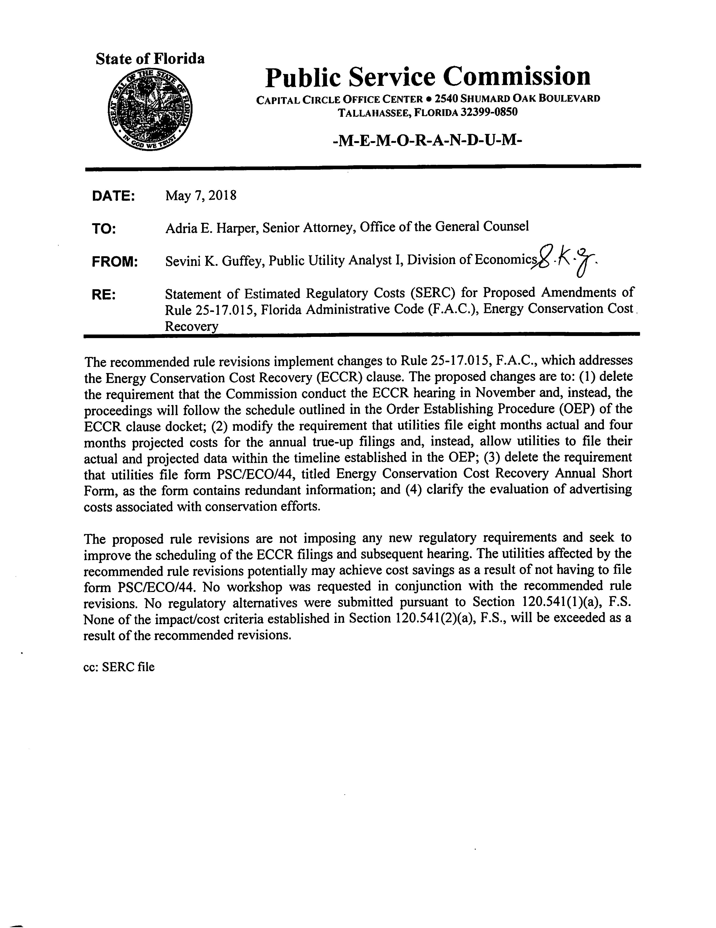
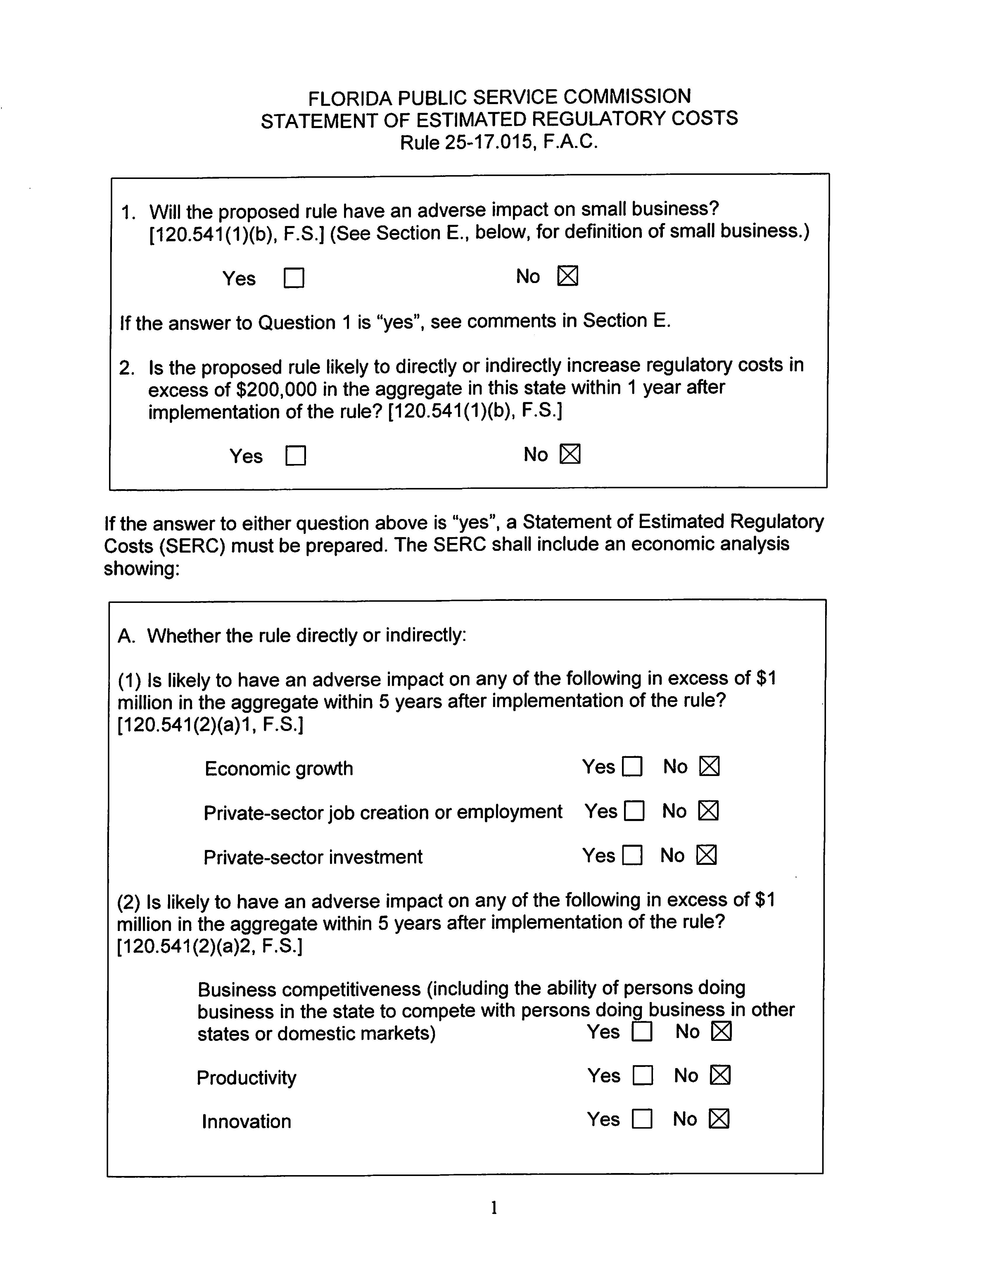
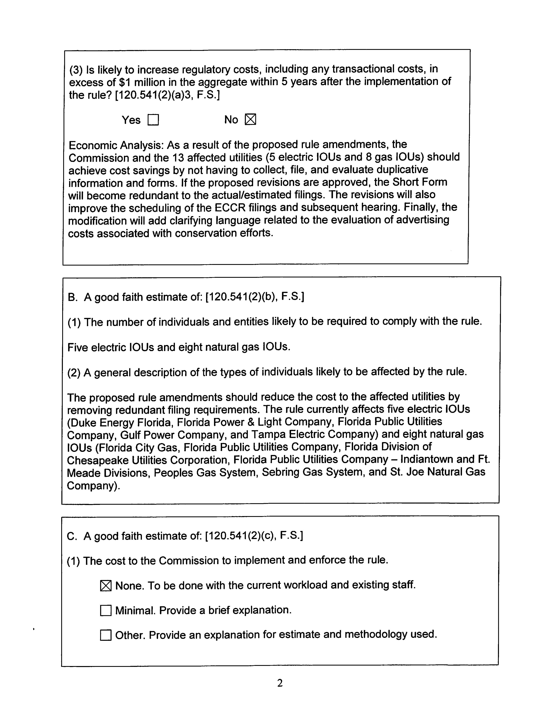
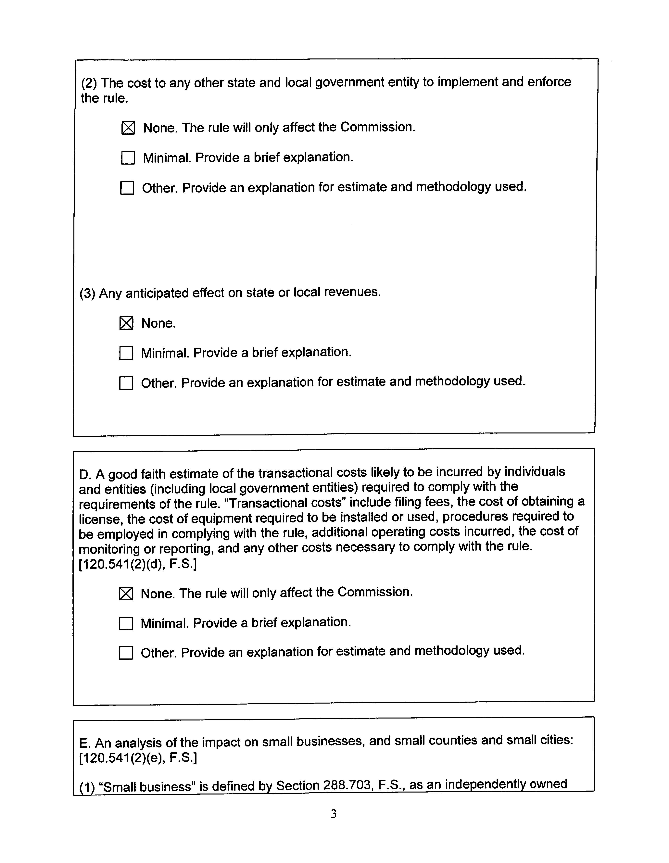
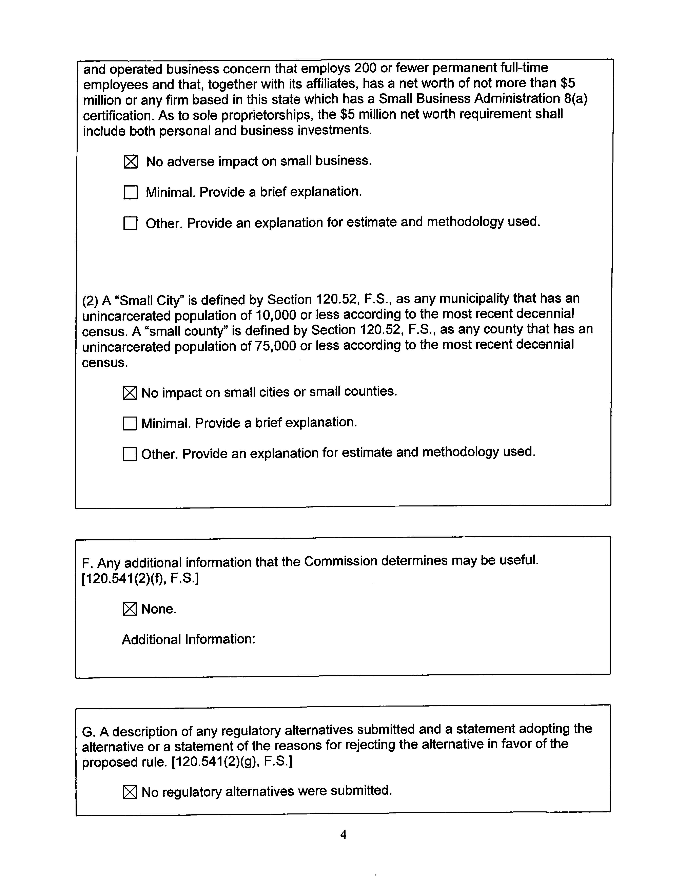
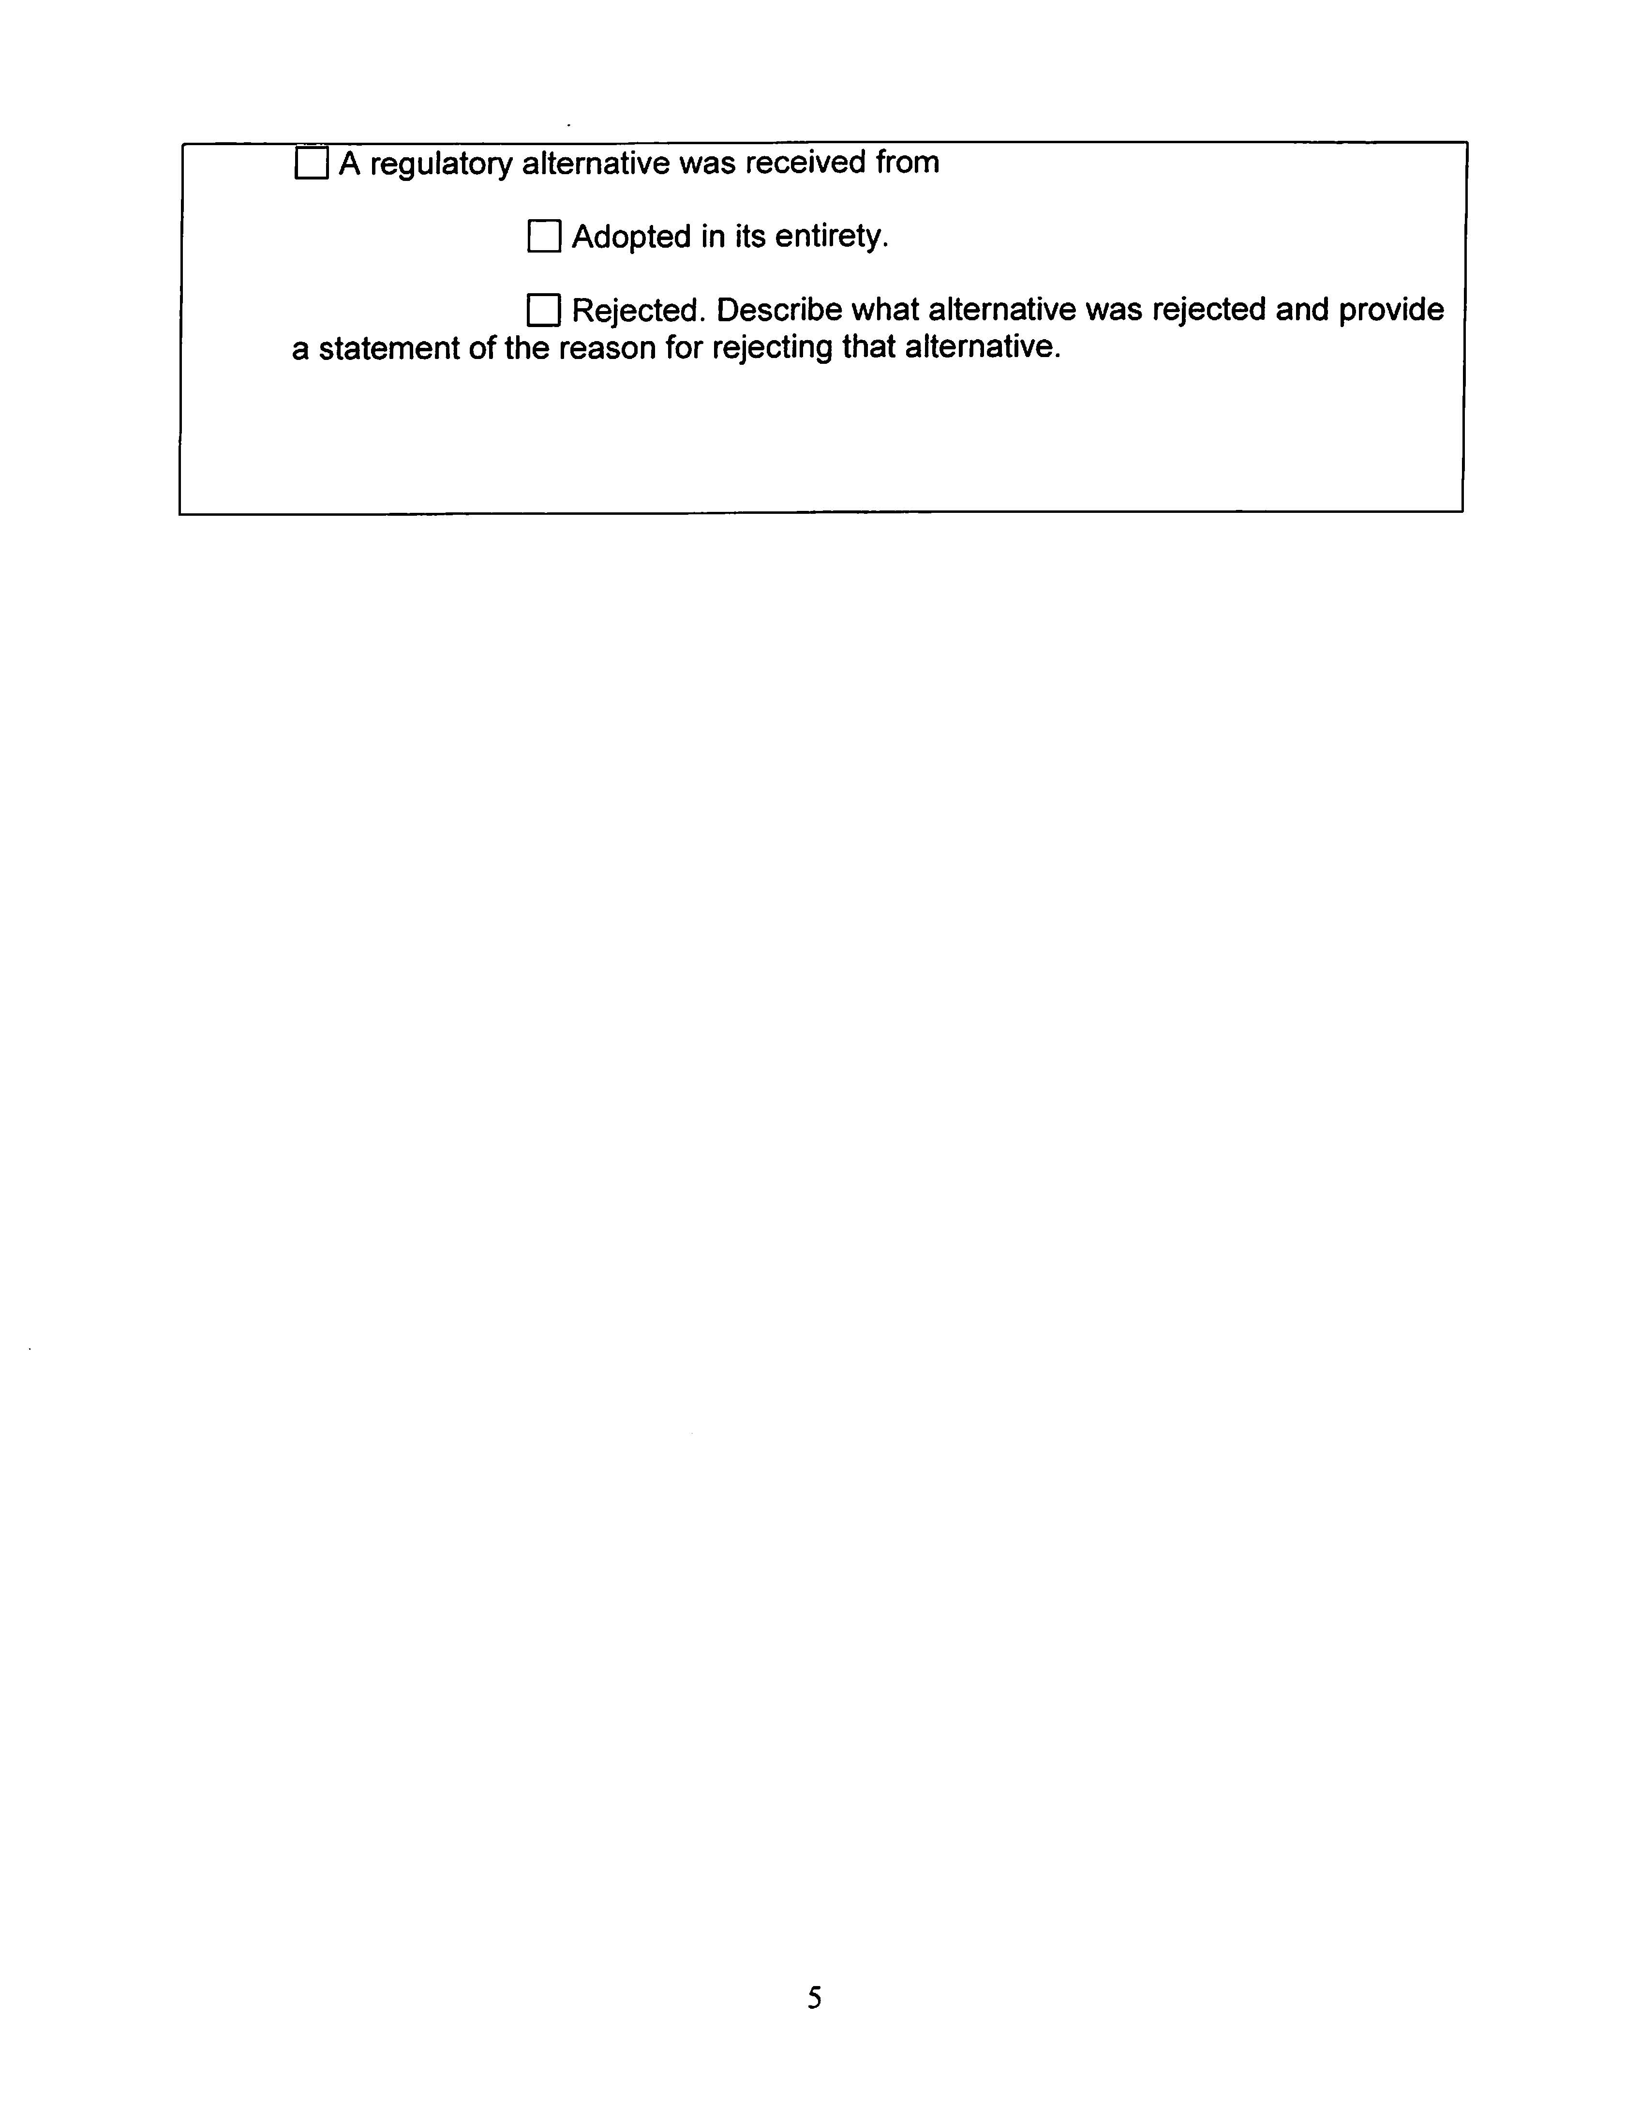

See Order No. PSC-2018-0094-POC-EG, in Docket No. 20180002-EG, where the Commission issued an Order Establishing Procedure for the electric utilities in the ECCR docket, and Order PSC-2018-0115-GU, in Docket No. 20180004-GU, where the Commission issued an Order Establishing Procedure for the gas utilities in the ECCR docket.
See Order No. PSC-2018-0244-PAA-EG, in Docket 20180002-EG, where the Commission granted a joint petition for waiver of Rule 25-17.015(1)(b), F.A.C, by Tampa Electric Company, Florida Power & Light Company, Duke Energy Florida, LLC, and Gulf Power Company, and held that six months of ECCR actual data and six months of ECCR projected data would allow the Commission to determine the utilities’ appropriate recovery of energy conservation costs.
Section 120.541(2), F.S.

