BEFORE THE FLORIDA PUBLIC SERVICE COMMISSION

In re: Consideration of the tax impacts associated with Tax Cuts and Jobs Act of 2017 for Florida Public Utilities Company - Electric. | DOCKET NO. 20180048-EI  ORDER NO. PSC-2019-0010-AS-EI  ISSUED: January 2, 2019

The following Commissioners participated in the disposition of this matter:

ART GRAHAM, Chairman
JULIE I. BROWN
GARY F. CLARK

ORDER APPROVING SETTLEMENT AGREEMENT

BY THE COMMISSION:

Background
The Florida Public Service Commission (Commission) opened Docket No. 20180048-EI on February 21, 2018, to consider the tax impacts affecting Florida Public Utilities Company (FPUC) as a result of the passage of the Tax Cuts and Jobs Act of 2017 (TCJA).

On October 17, 2018, FPUC and the Office of Public Counsel (OPC) filed a Joint Motion with the Commission to suspend the procedural schedule in this Docket (Joint Motion). The Order Granting Joint Motion to Suspend Procedural Schedule, Order No. PSC-2018-0504-PCO-EI, was issued on October 19, 2018. On October 18, 2018, FPUC and OPC (collectively, Parties) filed a Joint Motion for approval of a 2018 Tax Settlement, which is appended to this Order in Attachment A. In their Joint Motion, the Parties asserted that the Commission’s approval of the 2018 Tax Settlement would resolve all issues in this docket and that such approval would obviate the need for further testimony and a full hearing in this docket.

Settlement Agreement

The TCJA results in an annual savings of $638,158 to FPUC’s net operating income (NOI). The 2018 Tax Settlement states that, for calendar year 2018, the annual NOI tax savings would be flowed through to recover incremental fuel costs. Effective January 1, 2019, the Parties agreed that FPUC would apply the annual NOI tax savings of $638,158 as a permanent base rate reduction. The Parties further agreed that the grossed-up, “protected” Excess Accumulated Deferred Income tax (EADIT) balance is a deferred regulatory tax liability in the amount of $7,155,154. The “protected” EADIT for 2018, in the estimated annual amount of $288,230, would be applied to the Company’s existing fuel and purchased power cost recovery balance. As of January 1, 2019, the 2018 Tax Settlement calls for the “protected” EADIT to be applied to the storm reserve along with any additional accrual. Effective January 1, 2021, the Parties agreed that FPUC would apply the “protected” EADIT annual amount of $288,230 as a permanent base rate reduction. Finally, the 2018 Tax Settlement states that the grossed-up “unprotected” EADIT amount of $538,064 would be applied to reduce FPUC’s existing fuel and purchased power cost recovery balance and further reduces FPUC’s fuel cost recovery factors in 2019.

Decision

The standard for approval of a settlement agreement is whether it is in the public interest. A determination of public interest requires a case-specific analysis based on consideration of the proposed settlement taken as a whole.

The Parties, in their Joint Motion, assert that 2018 Tax Settlement “is the result of good faith efforts to address the issues in this proceeding in a manner that will provide regulatory certainty with regard to FPUC's rates and avoid the unnecessary expense and uncertainty associated with further litigation.” The Parties further assert that “the 2018 Tax Settlement is a compromise based on the highly specific circumstances of this case and utility that results in a fair, just, and reasonable disposition of the tax benefits arising from the TCJA to the benefit of FPUC's customers.”

We agree with the Parties and find that the 2018 Tax Settlement allows FPUC’s customers to fairly, justly, and reasonably benefit from the tax savings arising from the TCJA. Based on our review of the 2018 Tax Settlement; the exhibits entered into the record; the support and assertions of the Parties; the testimony provided by FPUC witnesses Michael Cassel, Matthew Dewey, and Michael J. Reno; and the benefits to FPUC customers, we find that the 2018 Tax Settlement, as a whole, is in the public interest. Therefore, the 2018 Tax Settlement is hereby approved.

Based on the foregoing, it is

ORDERED by the Florida Public Service Commission that the attached 2018 Tax Settlement Agreement is approved. It is further

ORDERED that this docket shall be closed.
By ORDER of the Florida Public Service Commission this 2nd day of January, 2019.

/s/ Adam J. Teitzman
ADAM J. TEITZMAN
Commission Clerk
Florida Public Service Commission
2540 Shumard Oak Boulevard
Tallahassee, Florida 32399
(850) 413-6770
www.floridapsc.com

Copies furnished: A copy of this document is provided to the parties of record at the time of issuance and, if applicable, interested persons.

KMS

NOTICE OF FURTHER PROCEEDINGS OR JUDICIAL REVIEW

The Florida Public Service Commission is required by Section 120.569(1), Florida Statutes, to notify parties of any administrative hearing or judicial review of Commission orders that is available under Sections 120.57 or 120.68, Florida Statutes, as well as the procedures and time limits that apply. This notice should not be construed to mean all requests for an administrative hearing or judicial review will be granted or result in the relief sought.

Any party adversely affected by the Commission's final action in this matter may request: 1) reconsideration of the decision by filing a motion for reconsideration with the Office of Commission Clerk, 2540 Shumard Oak Boulevard, Tallahassee, Florida 32399-0850, within fifteen (15) days of the issuance of this order in the form prescribed by Rule 25-22.060, Florida Administrative Code; or 2) judicial review by the Florida Supreme Court in the case of an electric, gas or telephone utility or the First District Court of Appeal in the case of a water and/or wastewater utility by filing a notice of appeal with the Office of Commission Clerk, and filing a copy of the notice of appeal and the filing fee with the appropriate court. This filing must be completed within thirty (30) days after the issuance of this order, pursuant to Rule 9.110, Florida Rules of Appellate Procedure. The notice of appeal must be in the form specified in Rule 9.900(a), Florida Rules of Appellate Procedure.

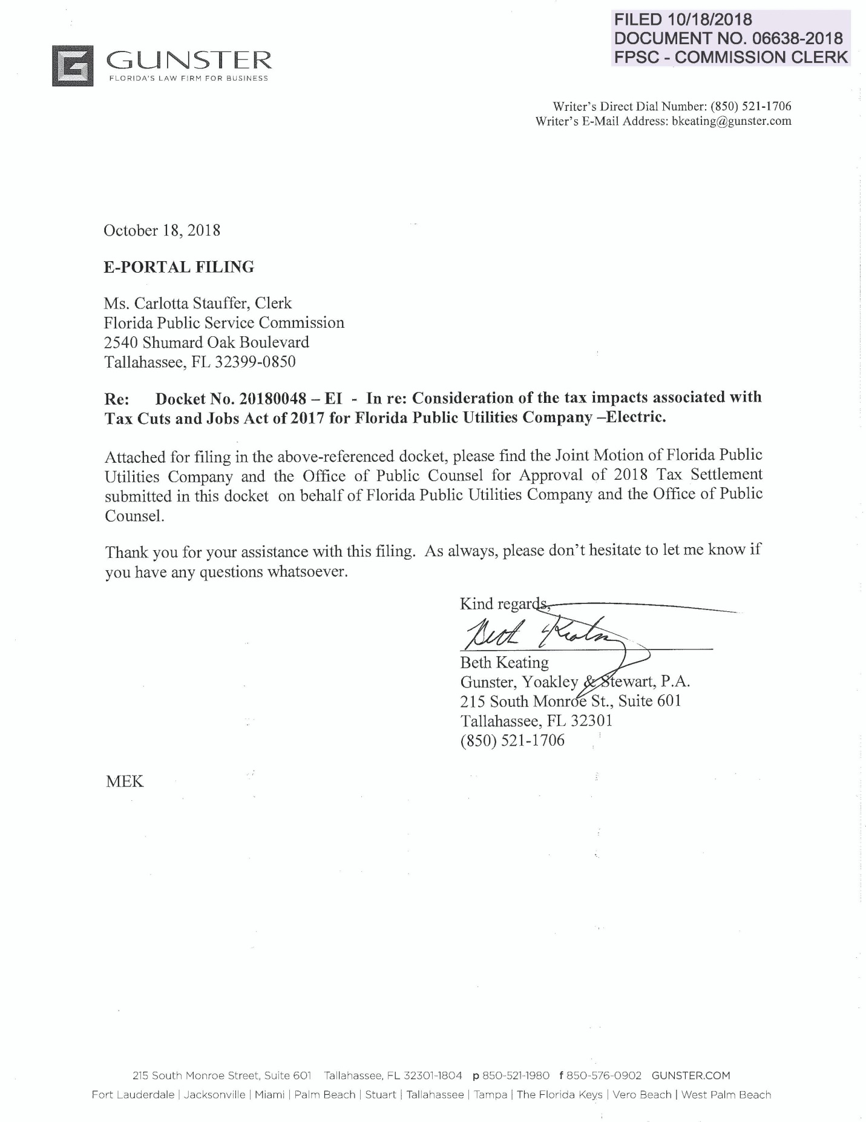
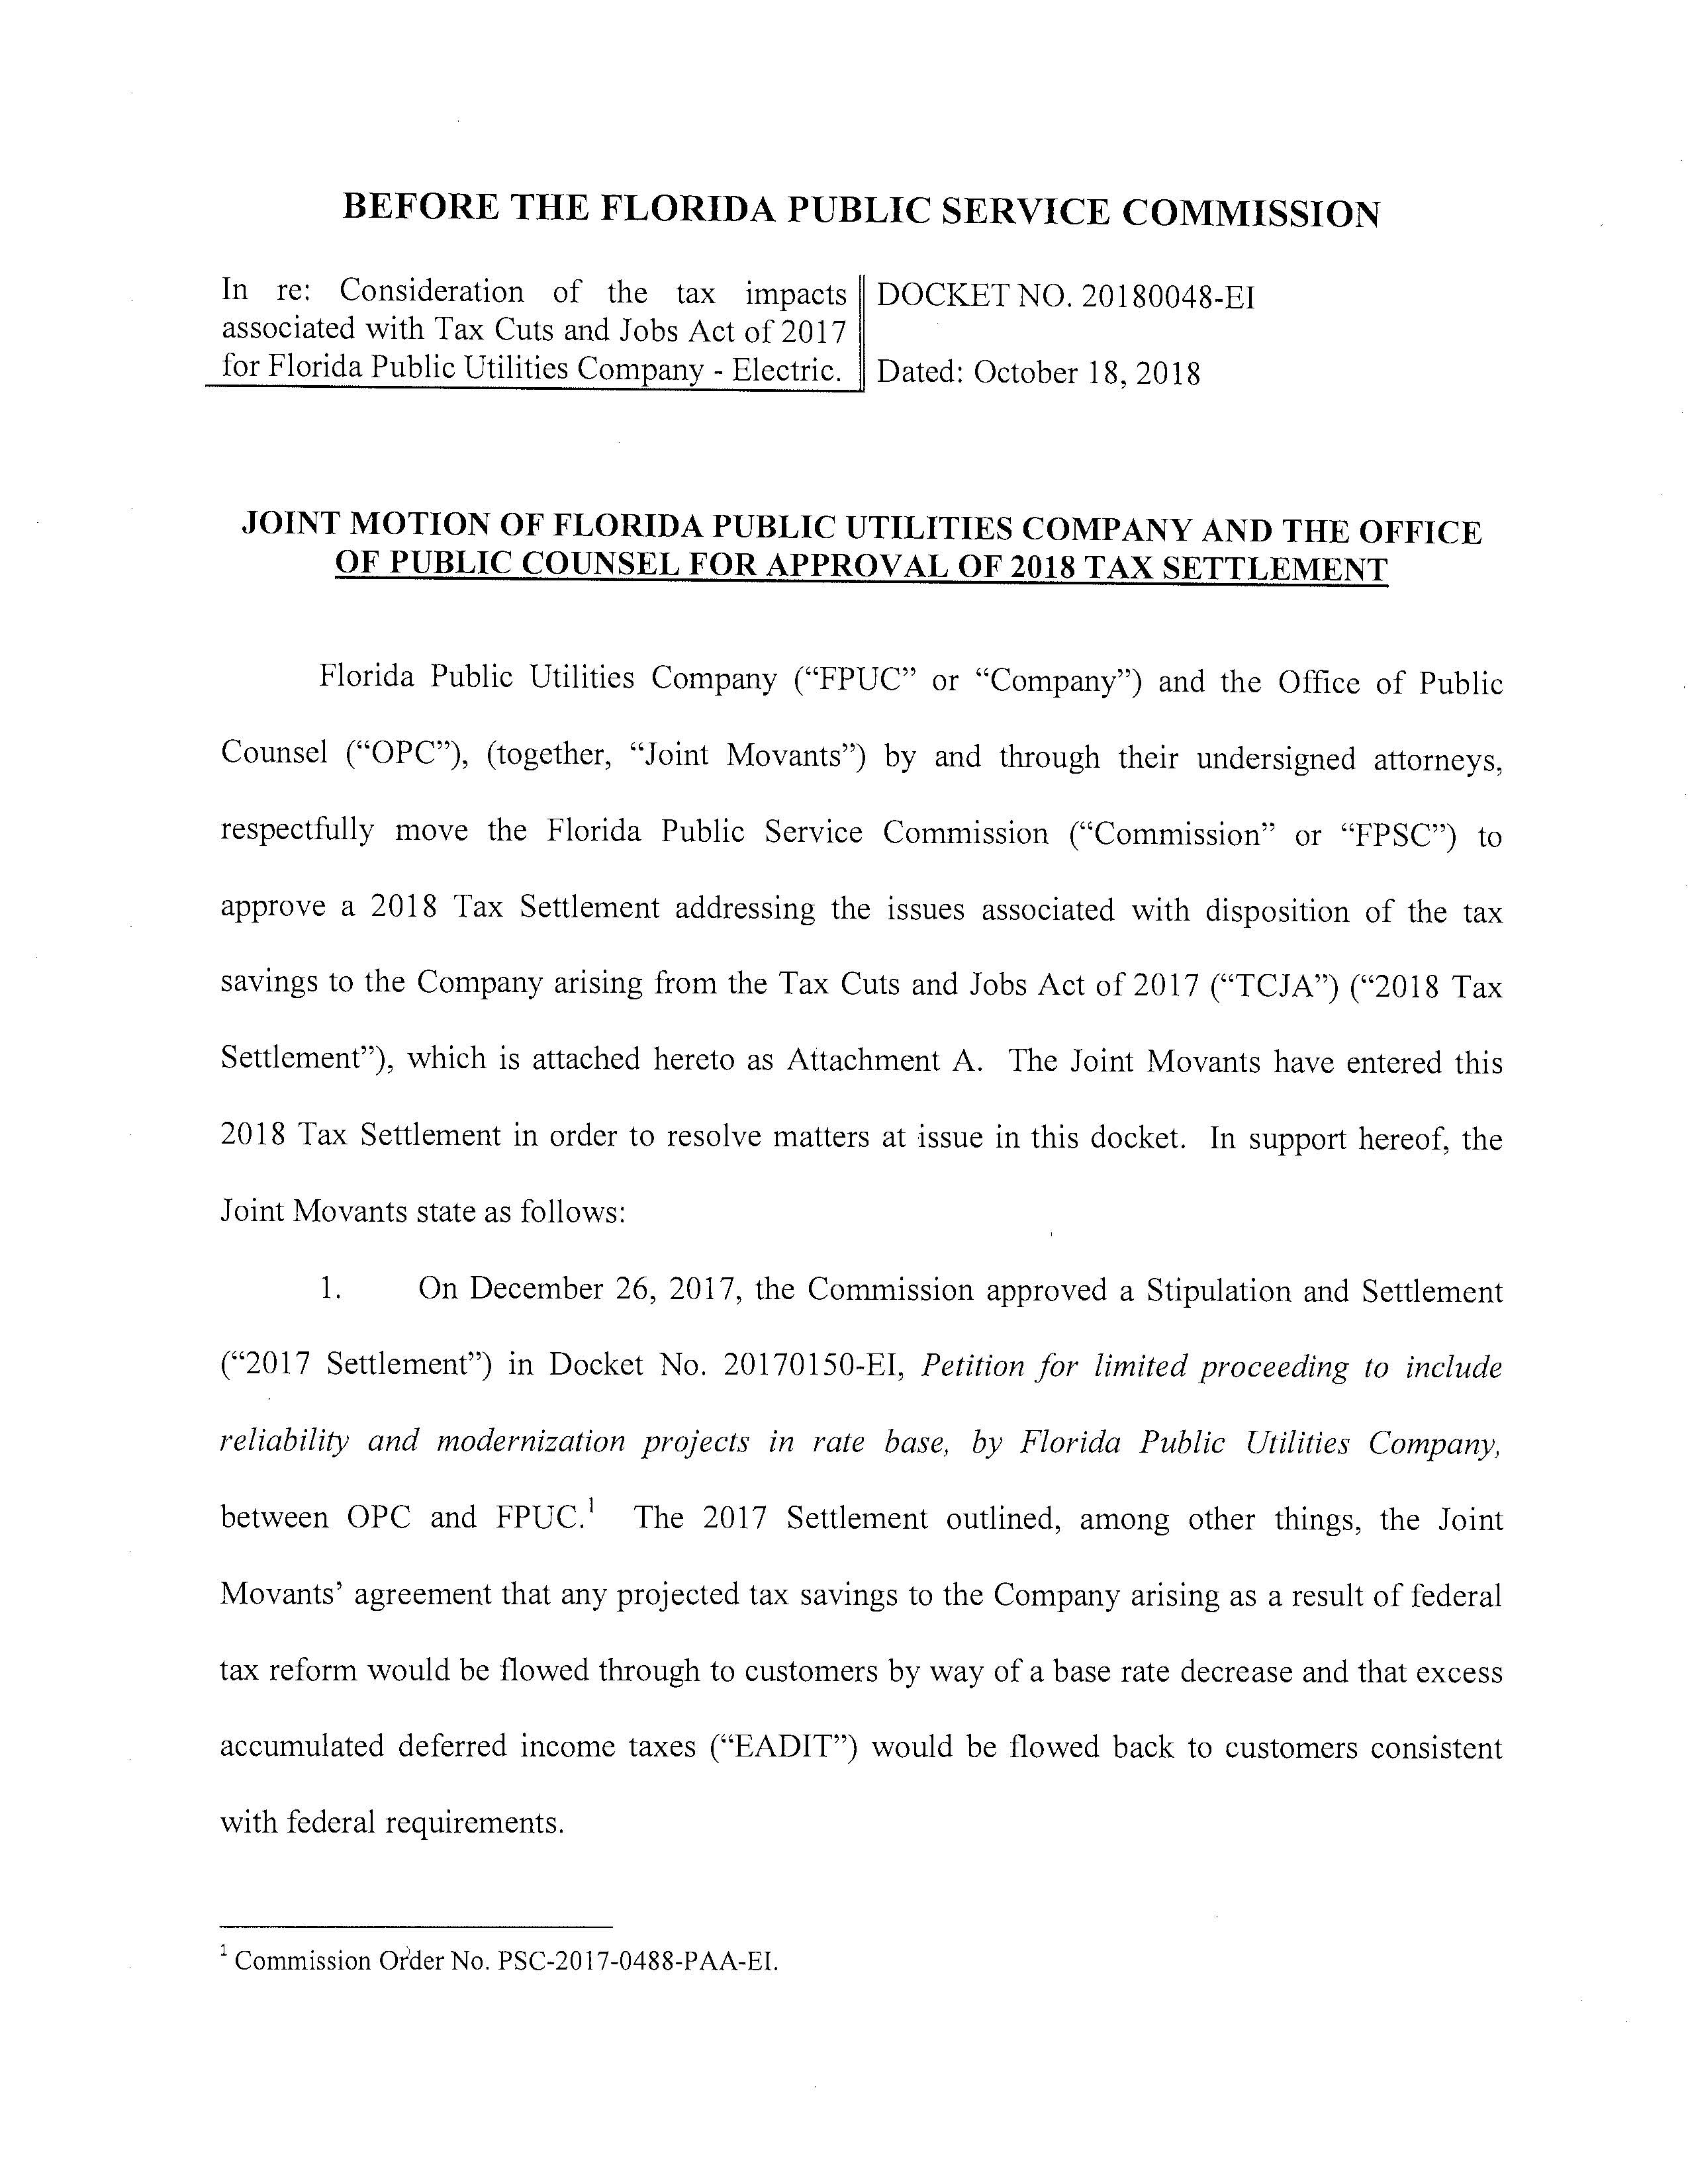

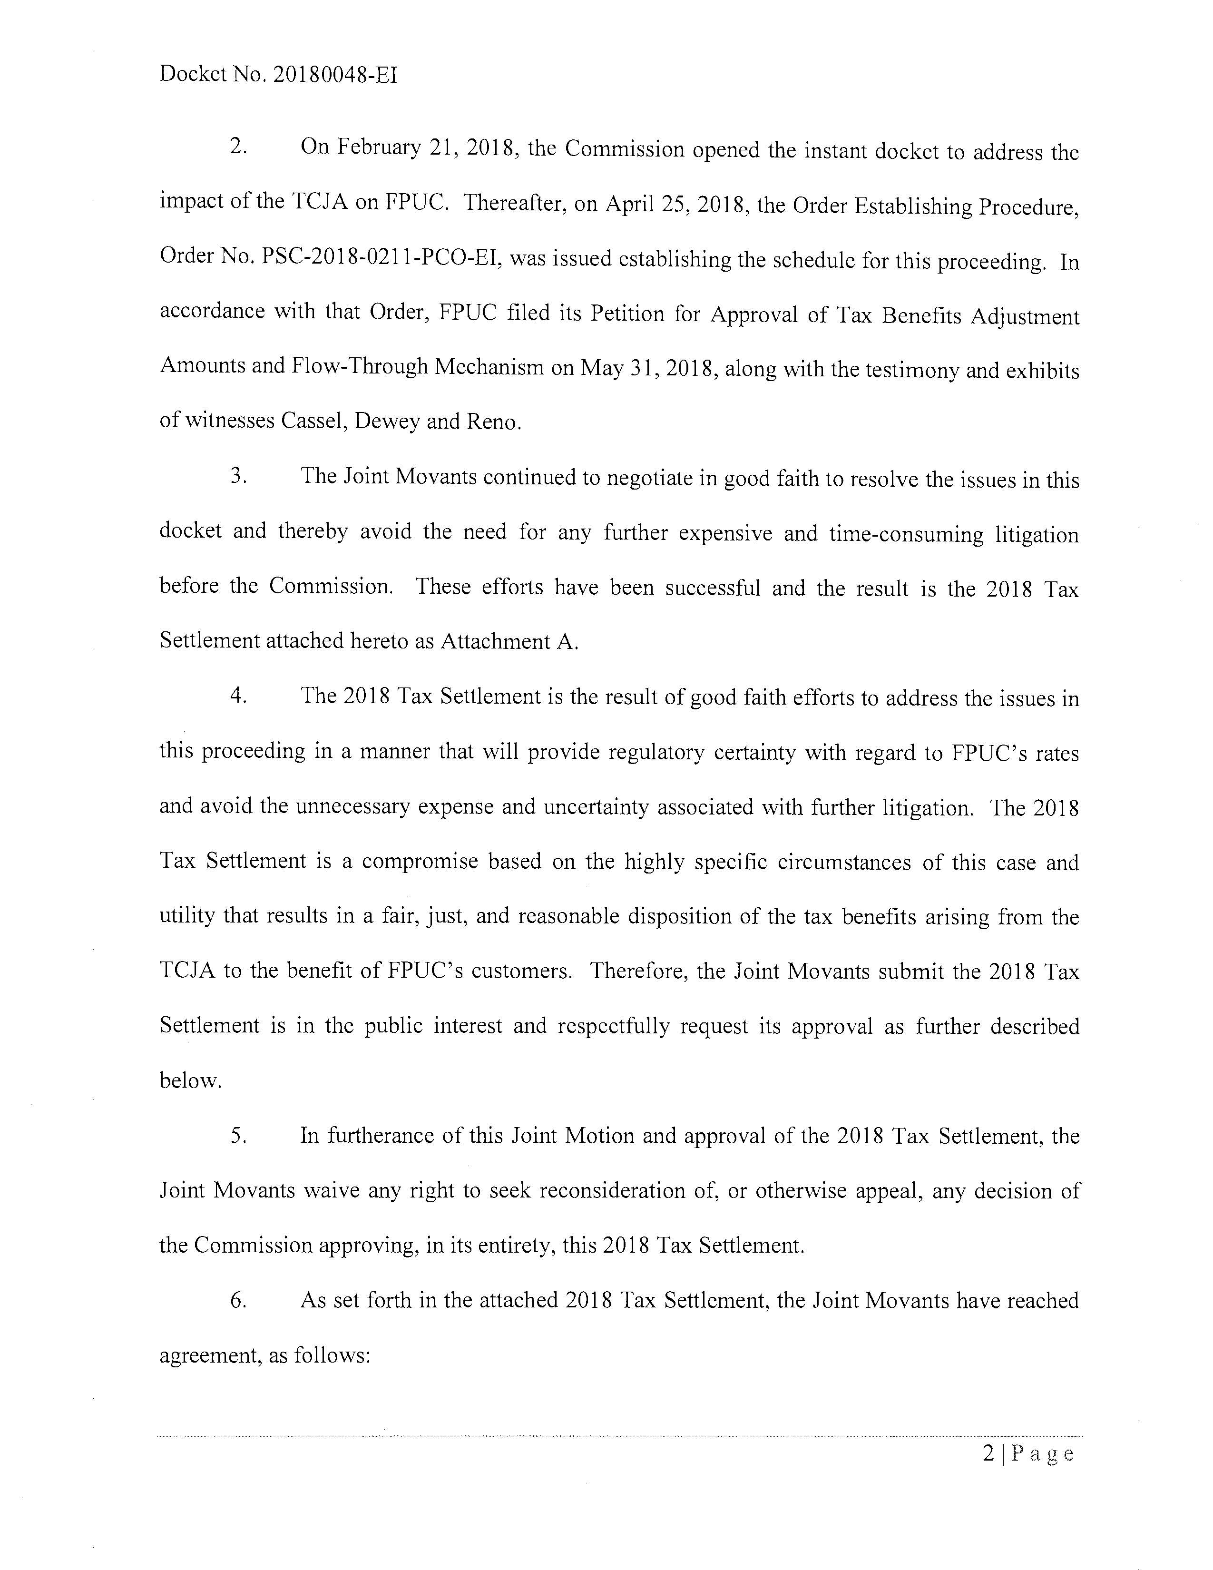

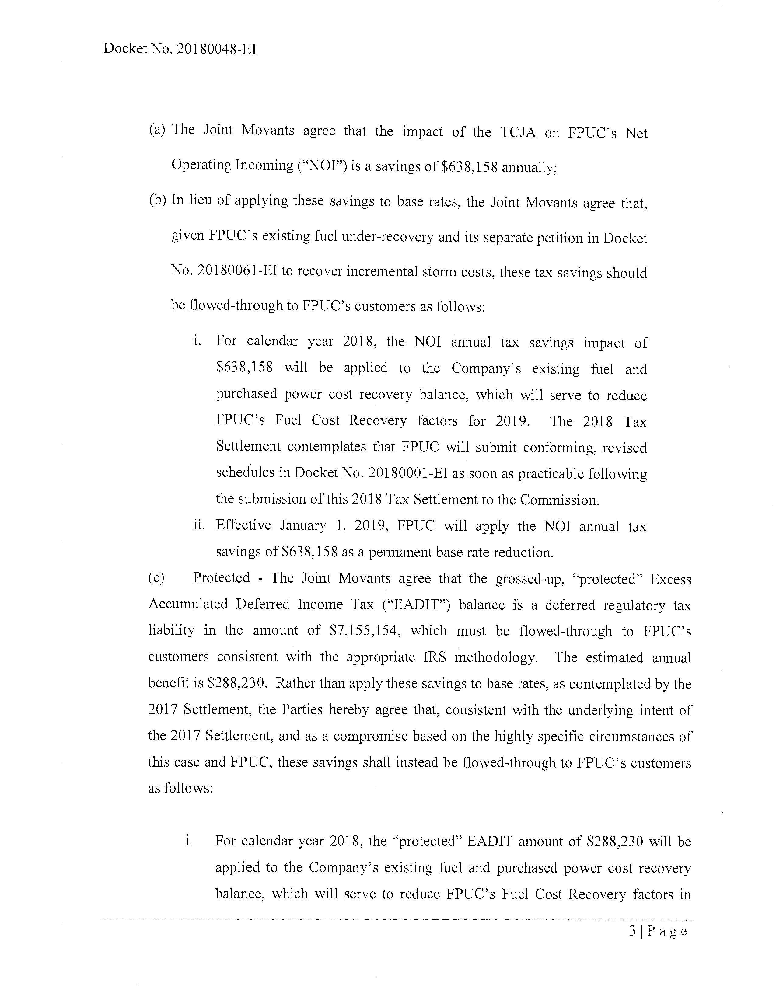

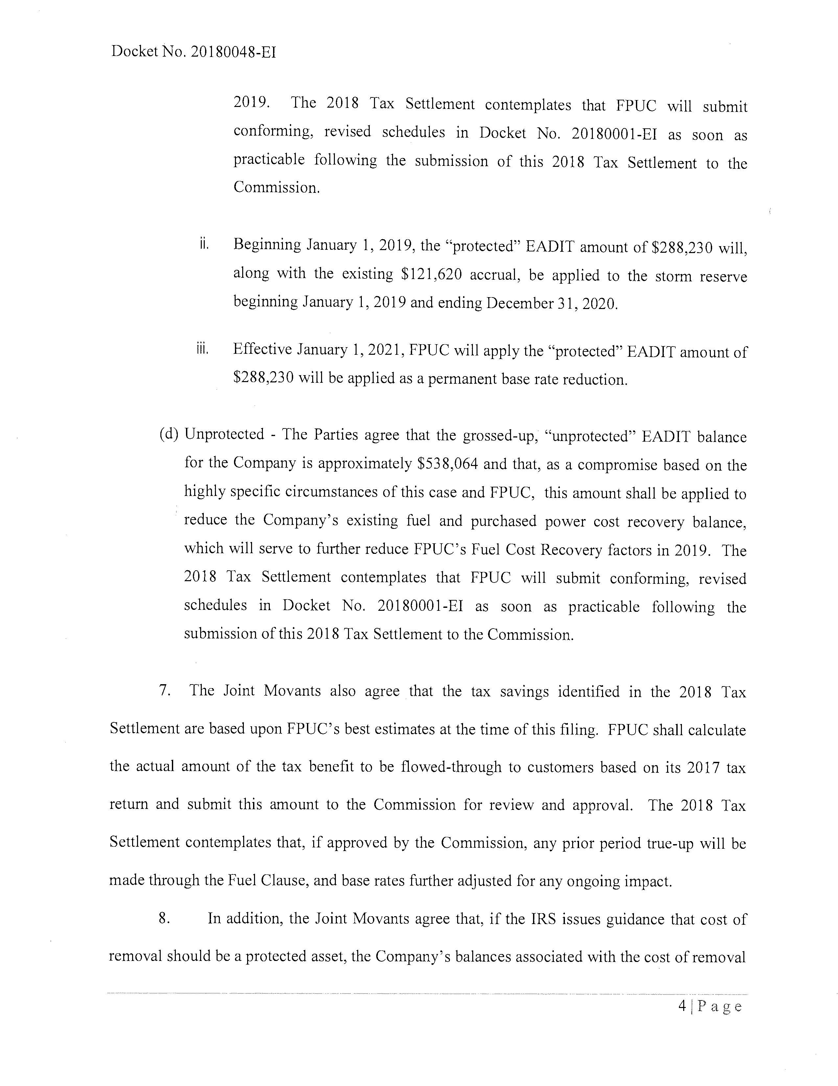

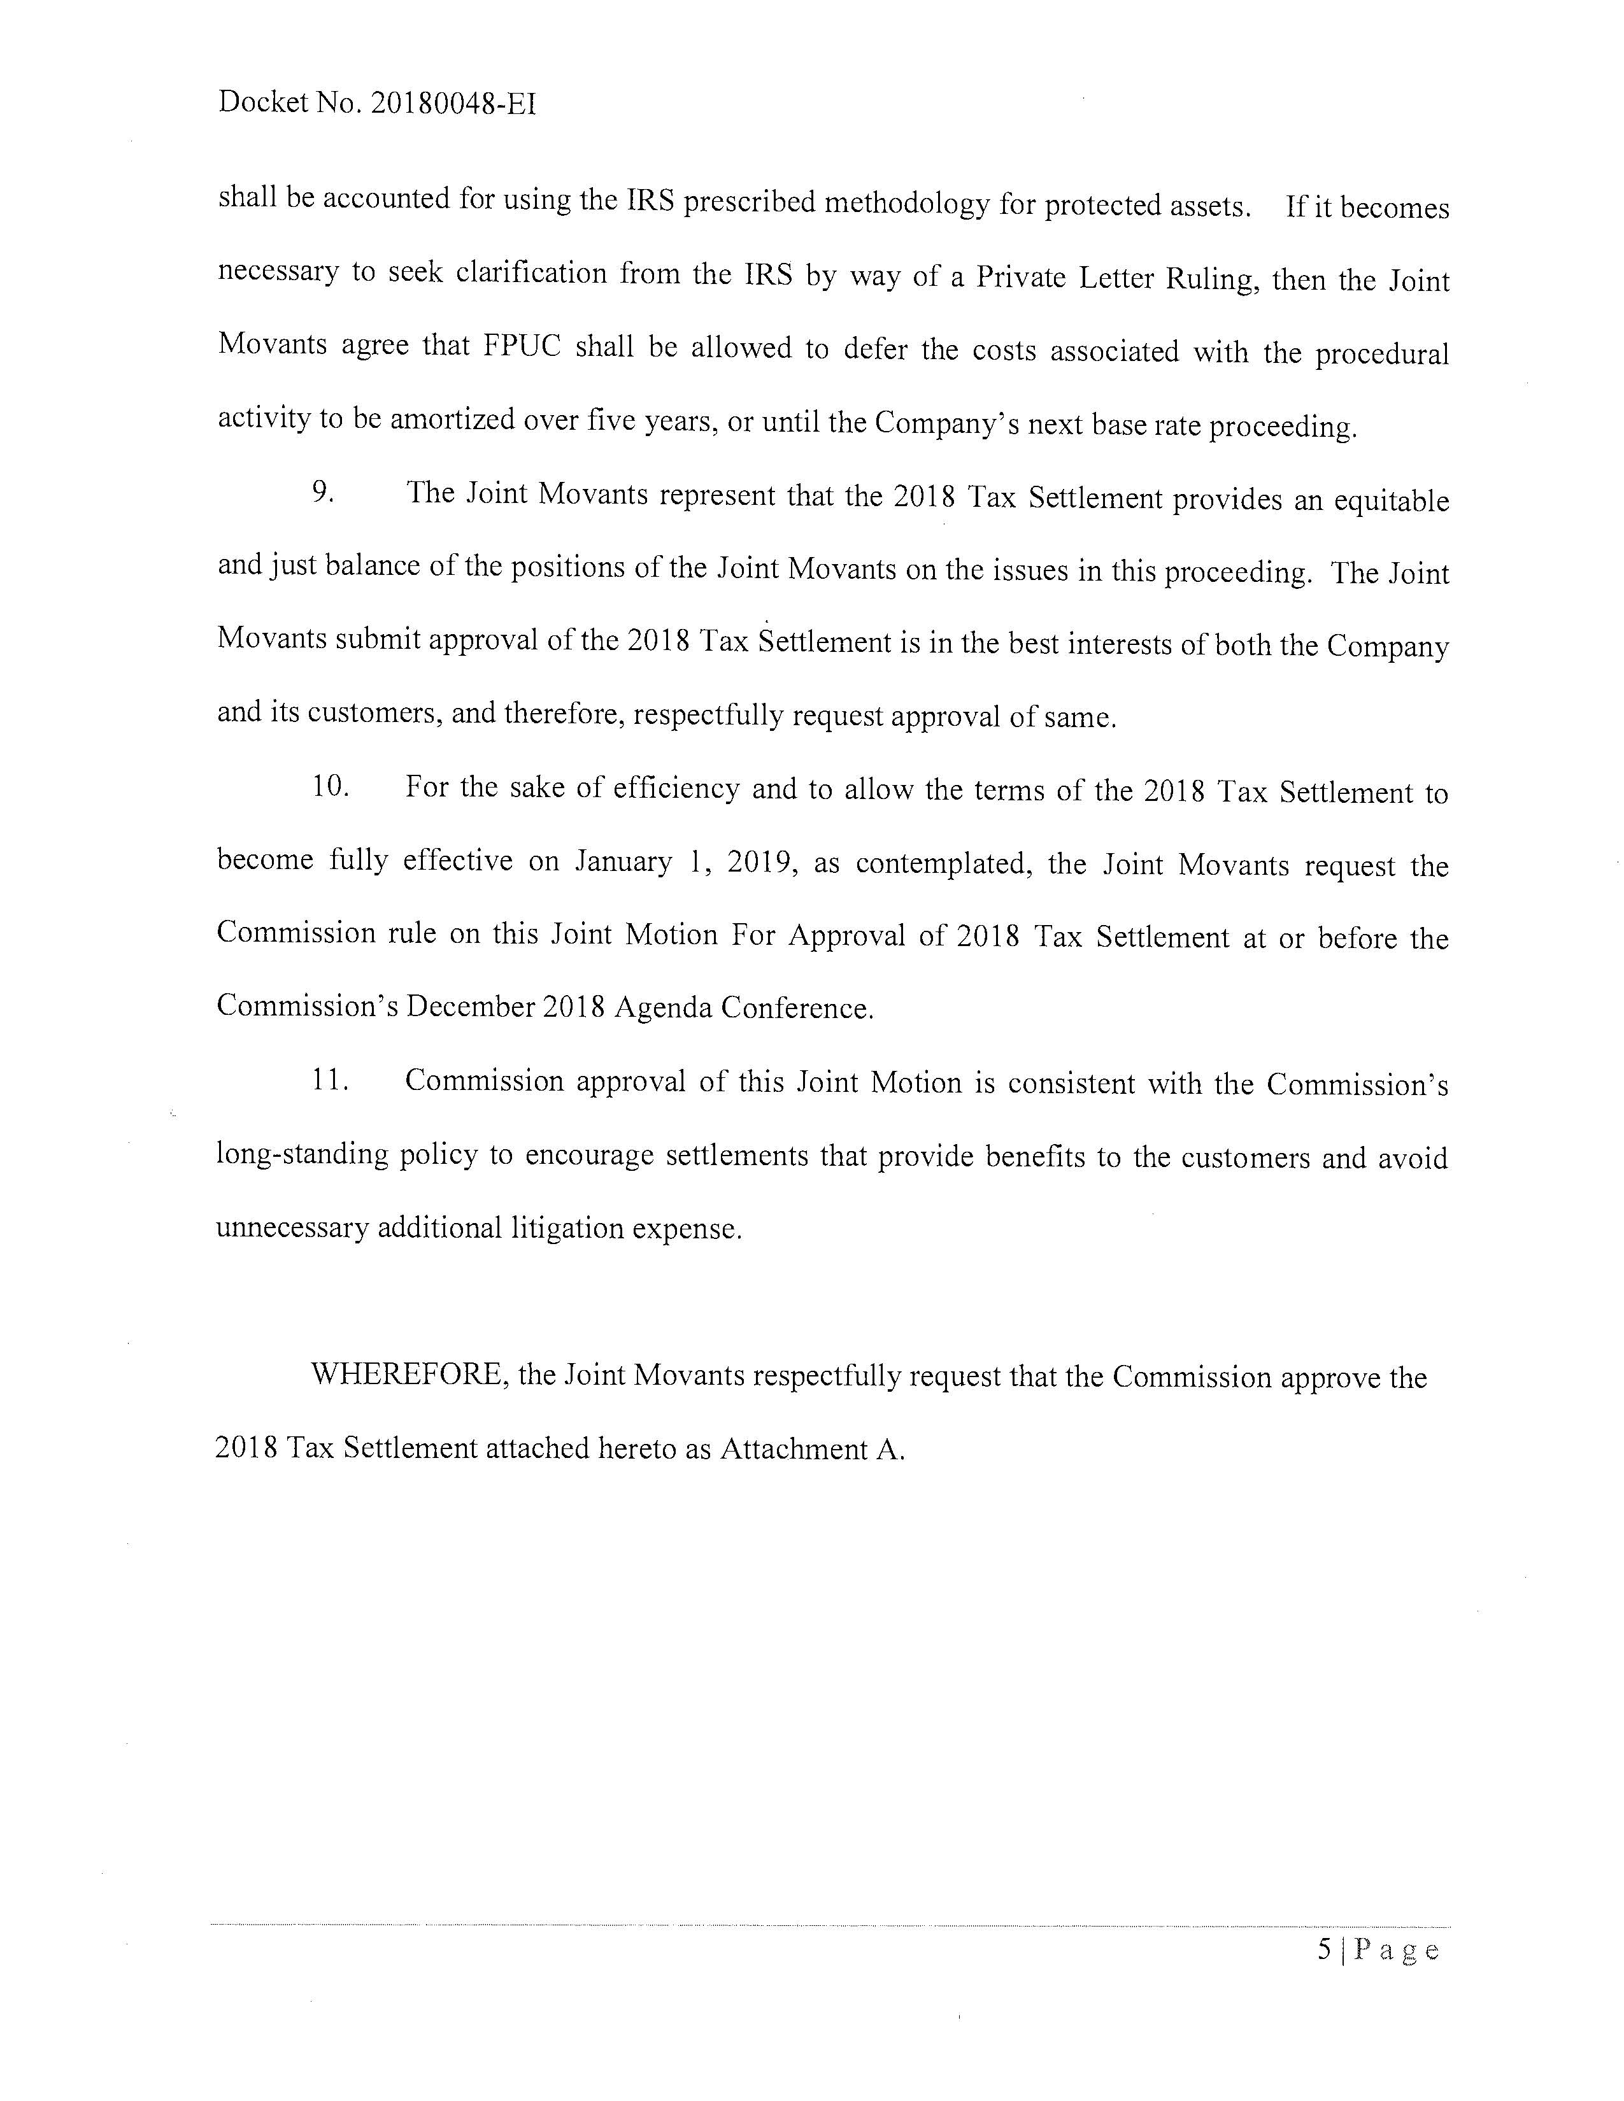

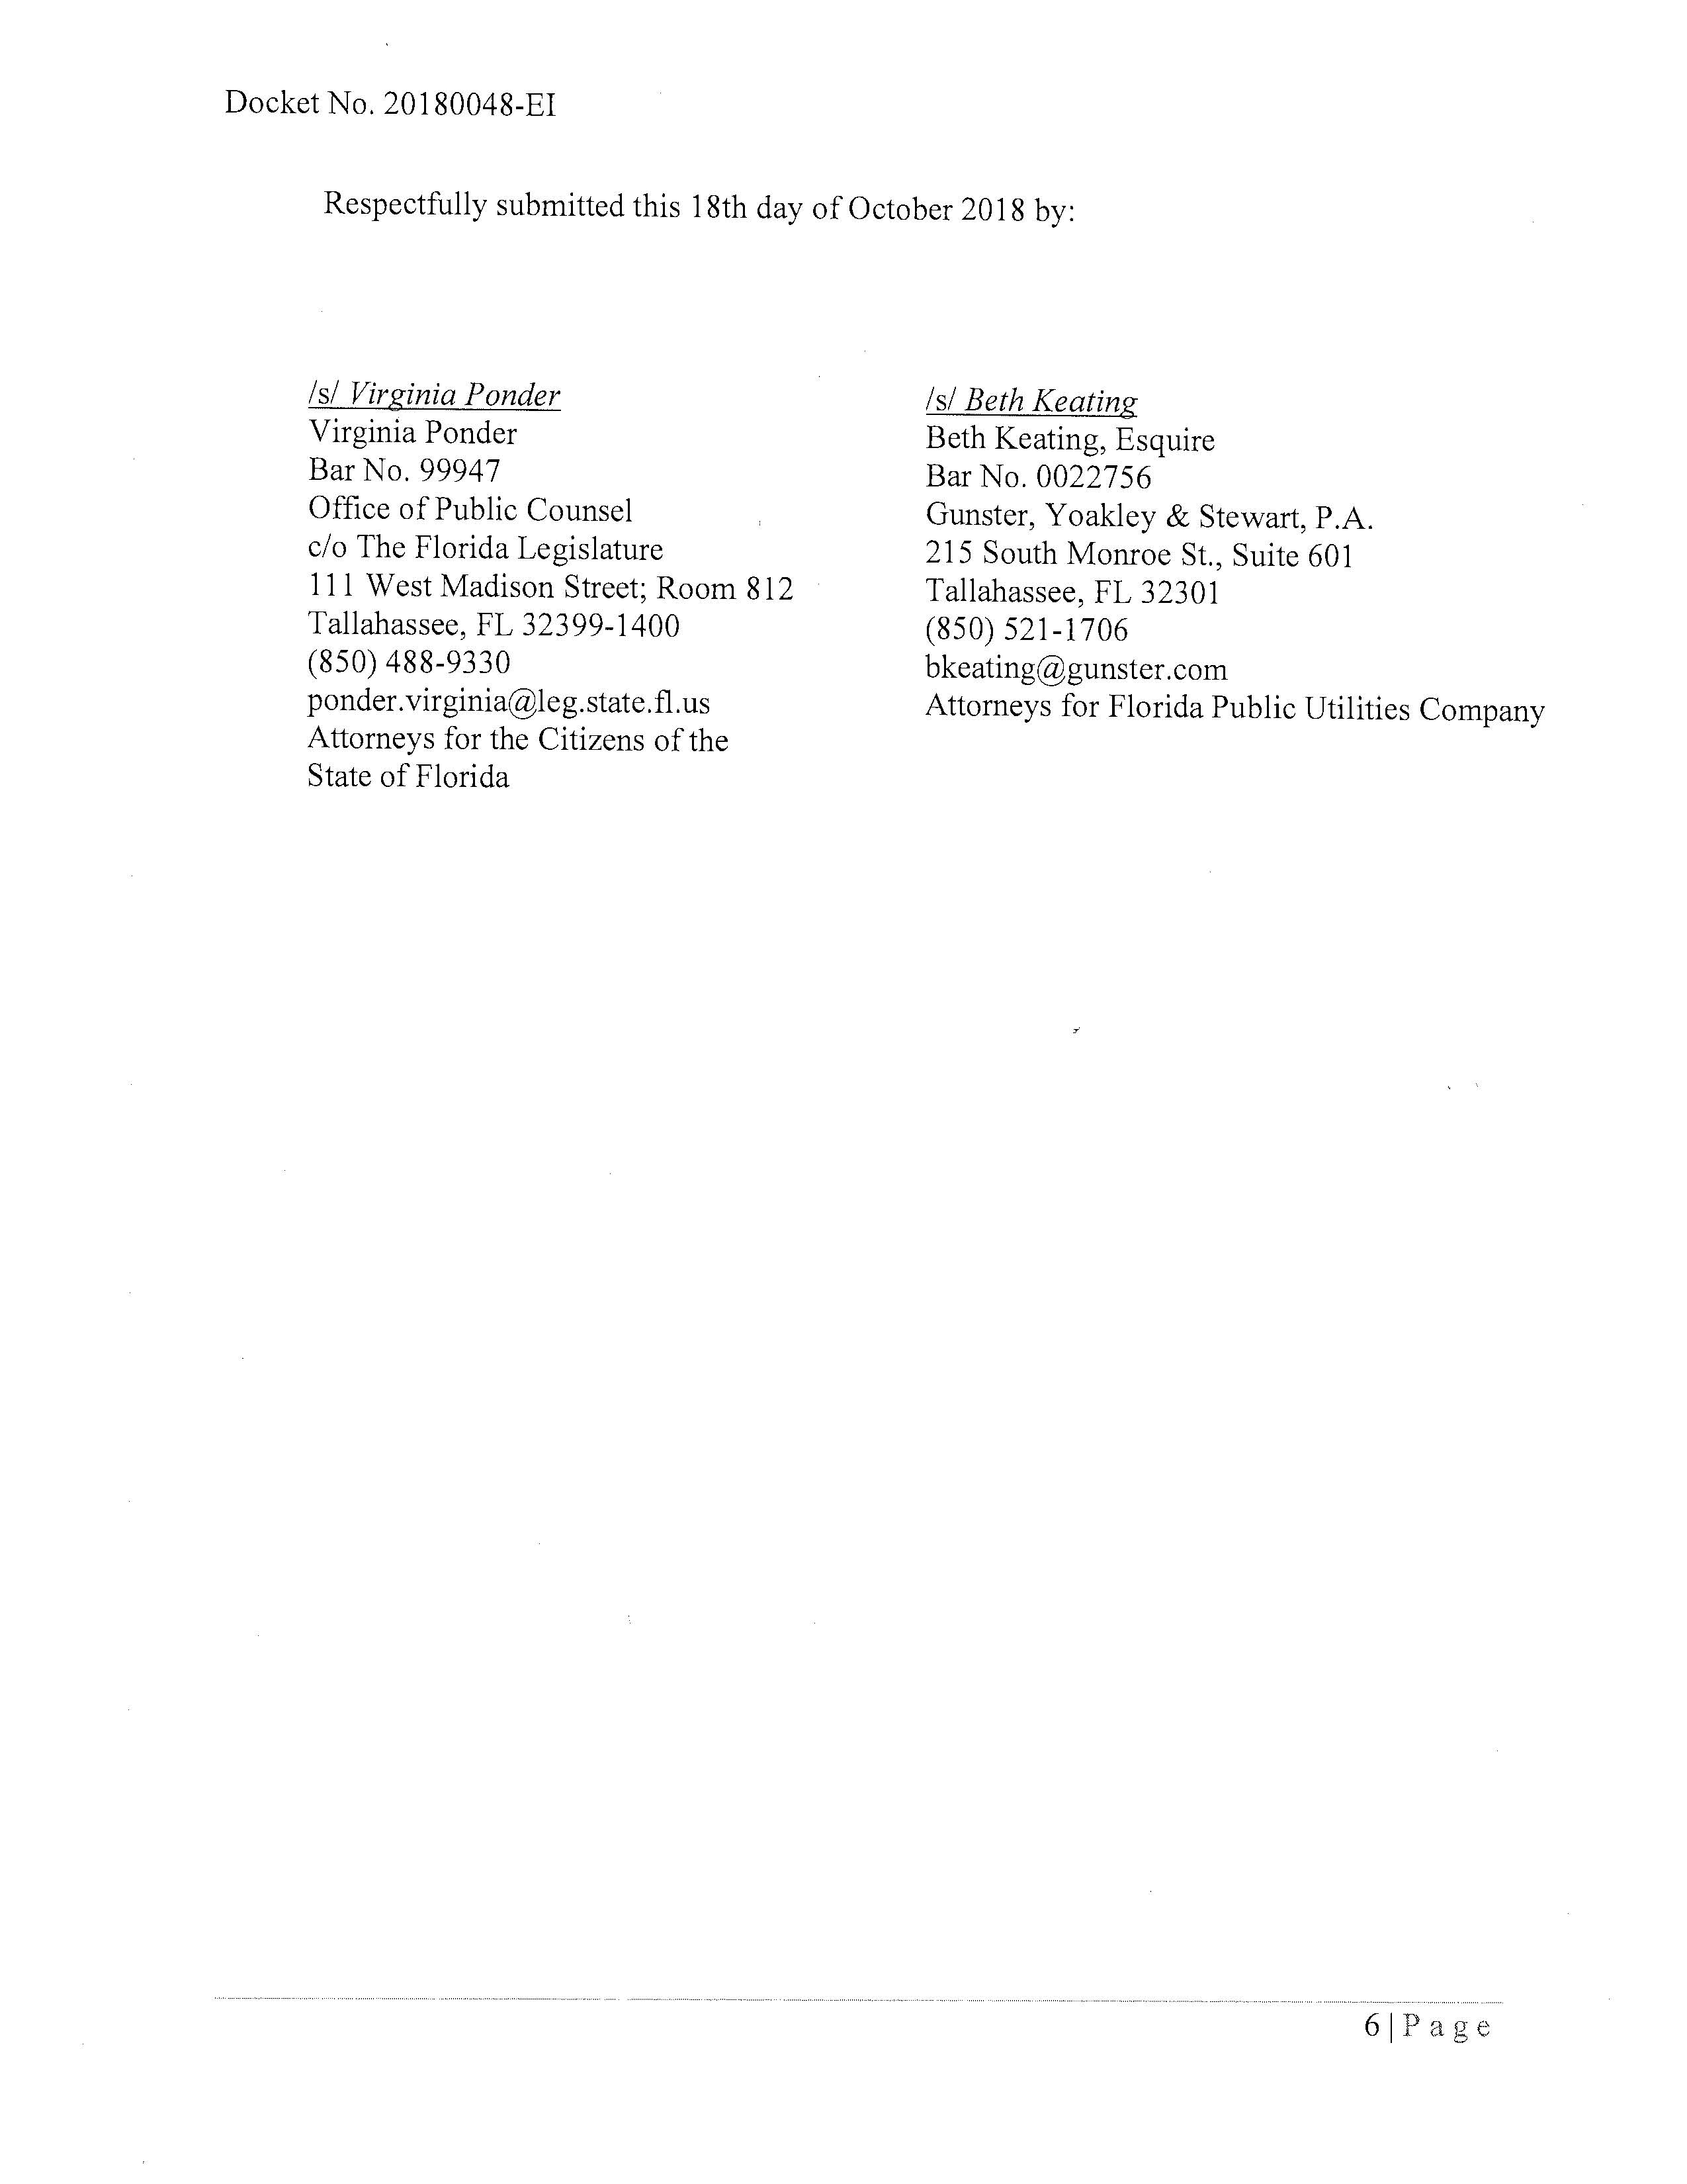

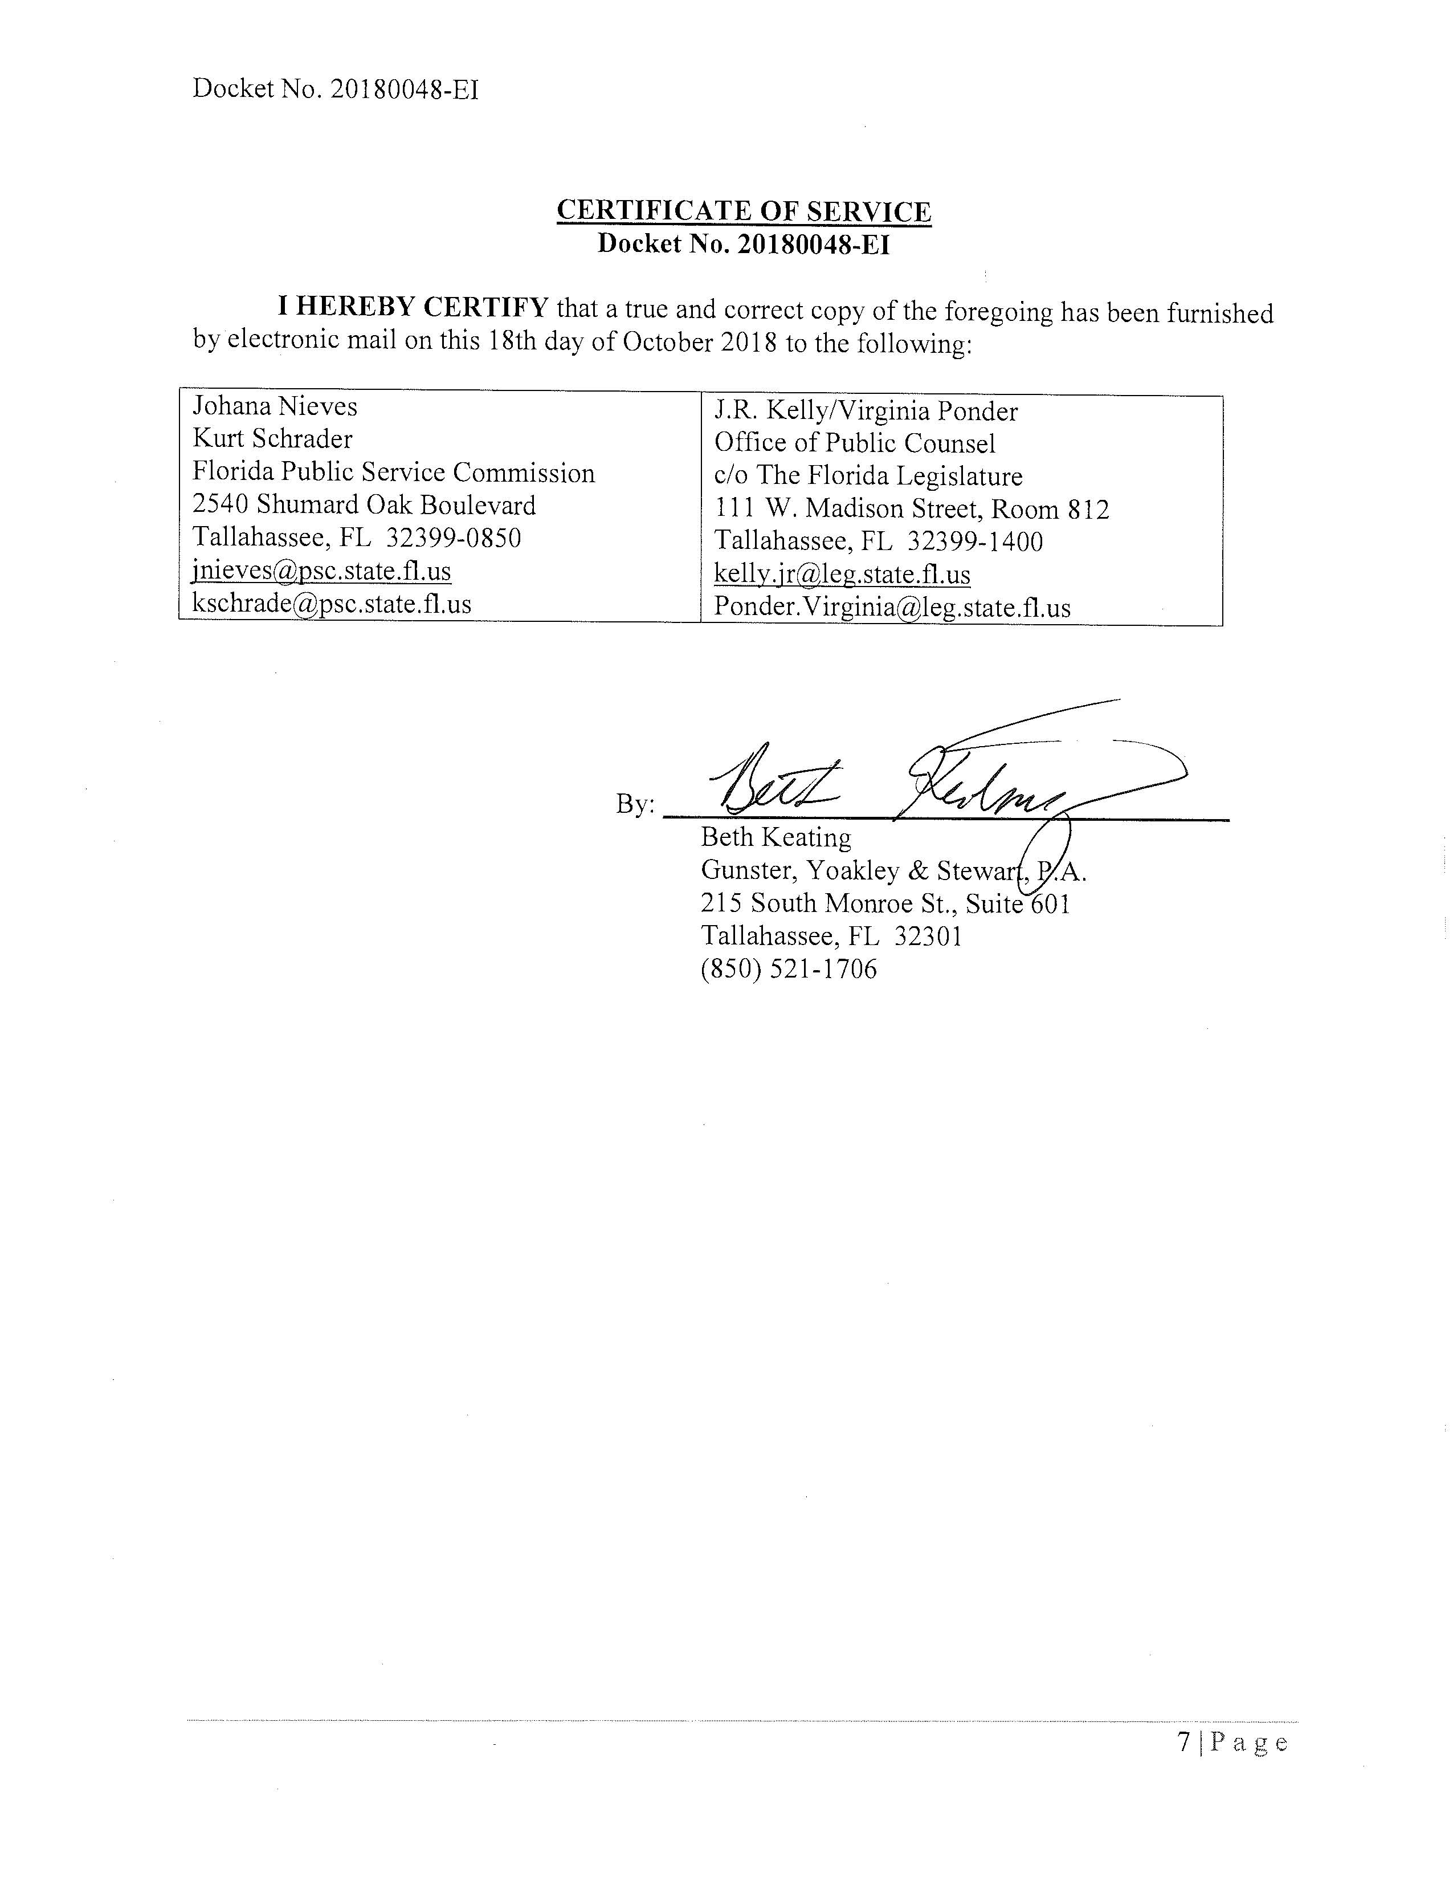

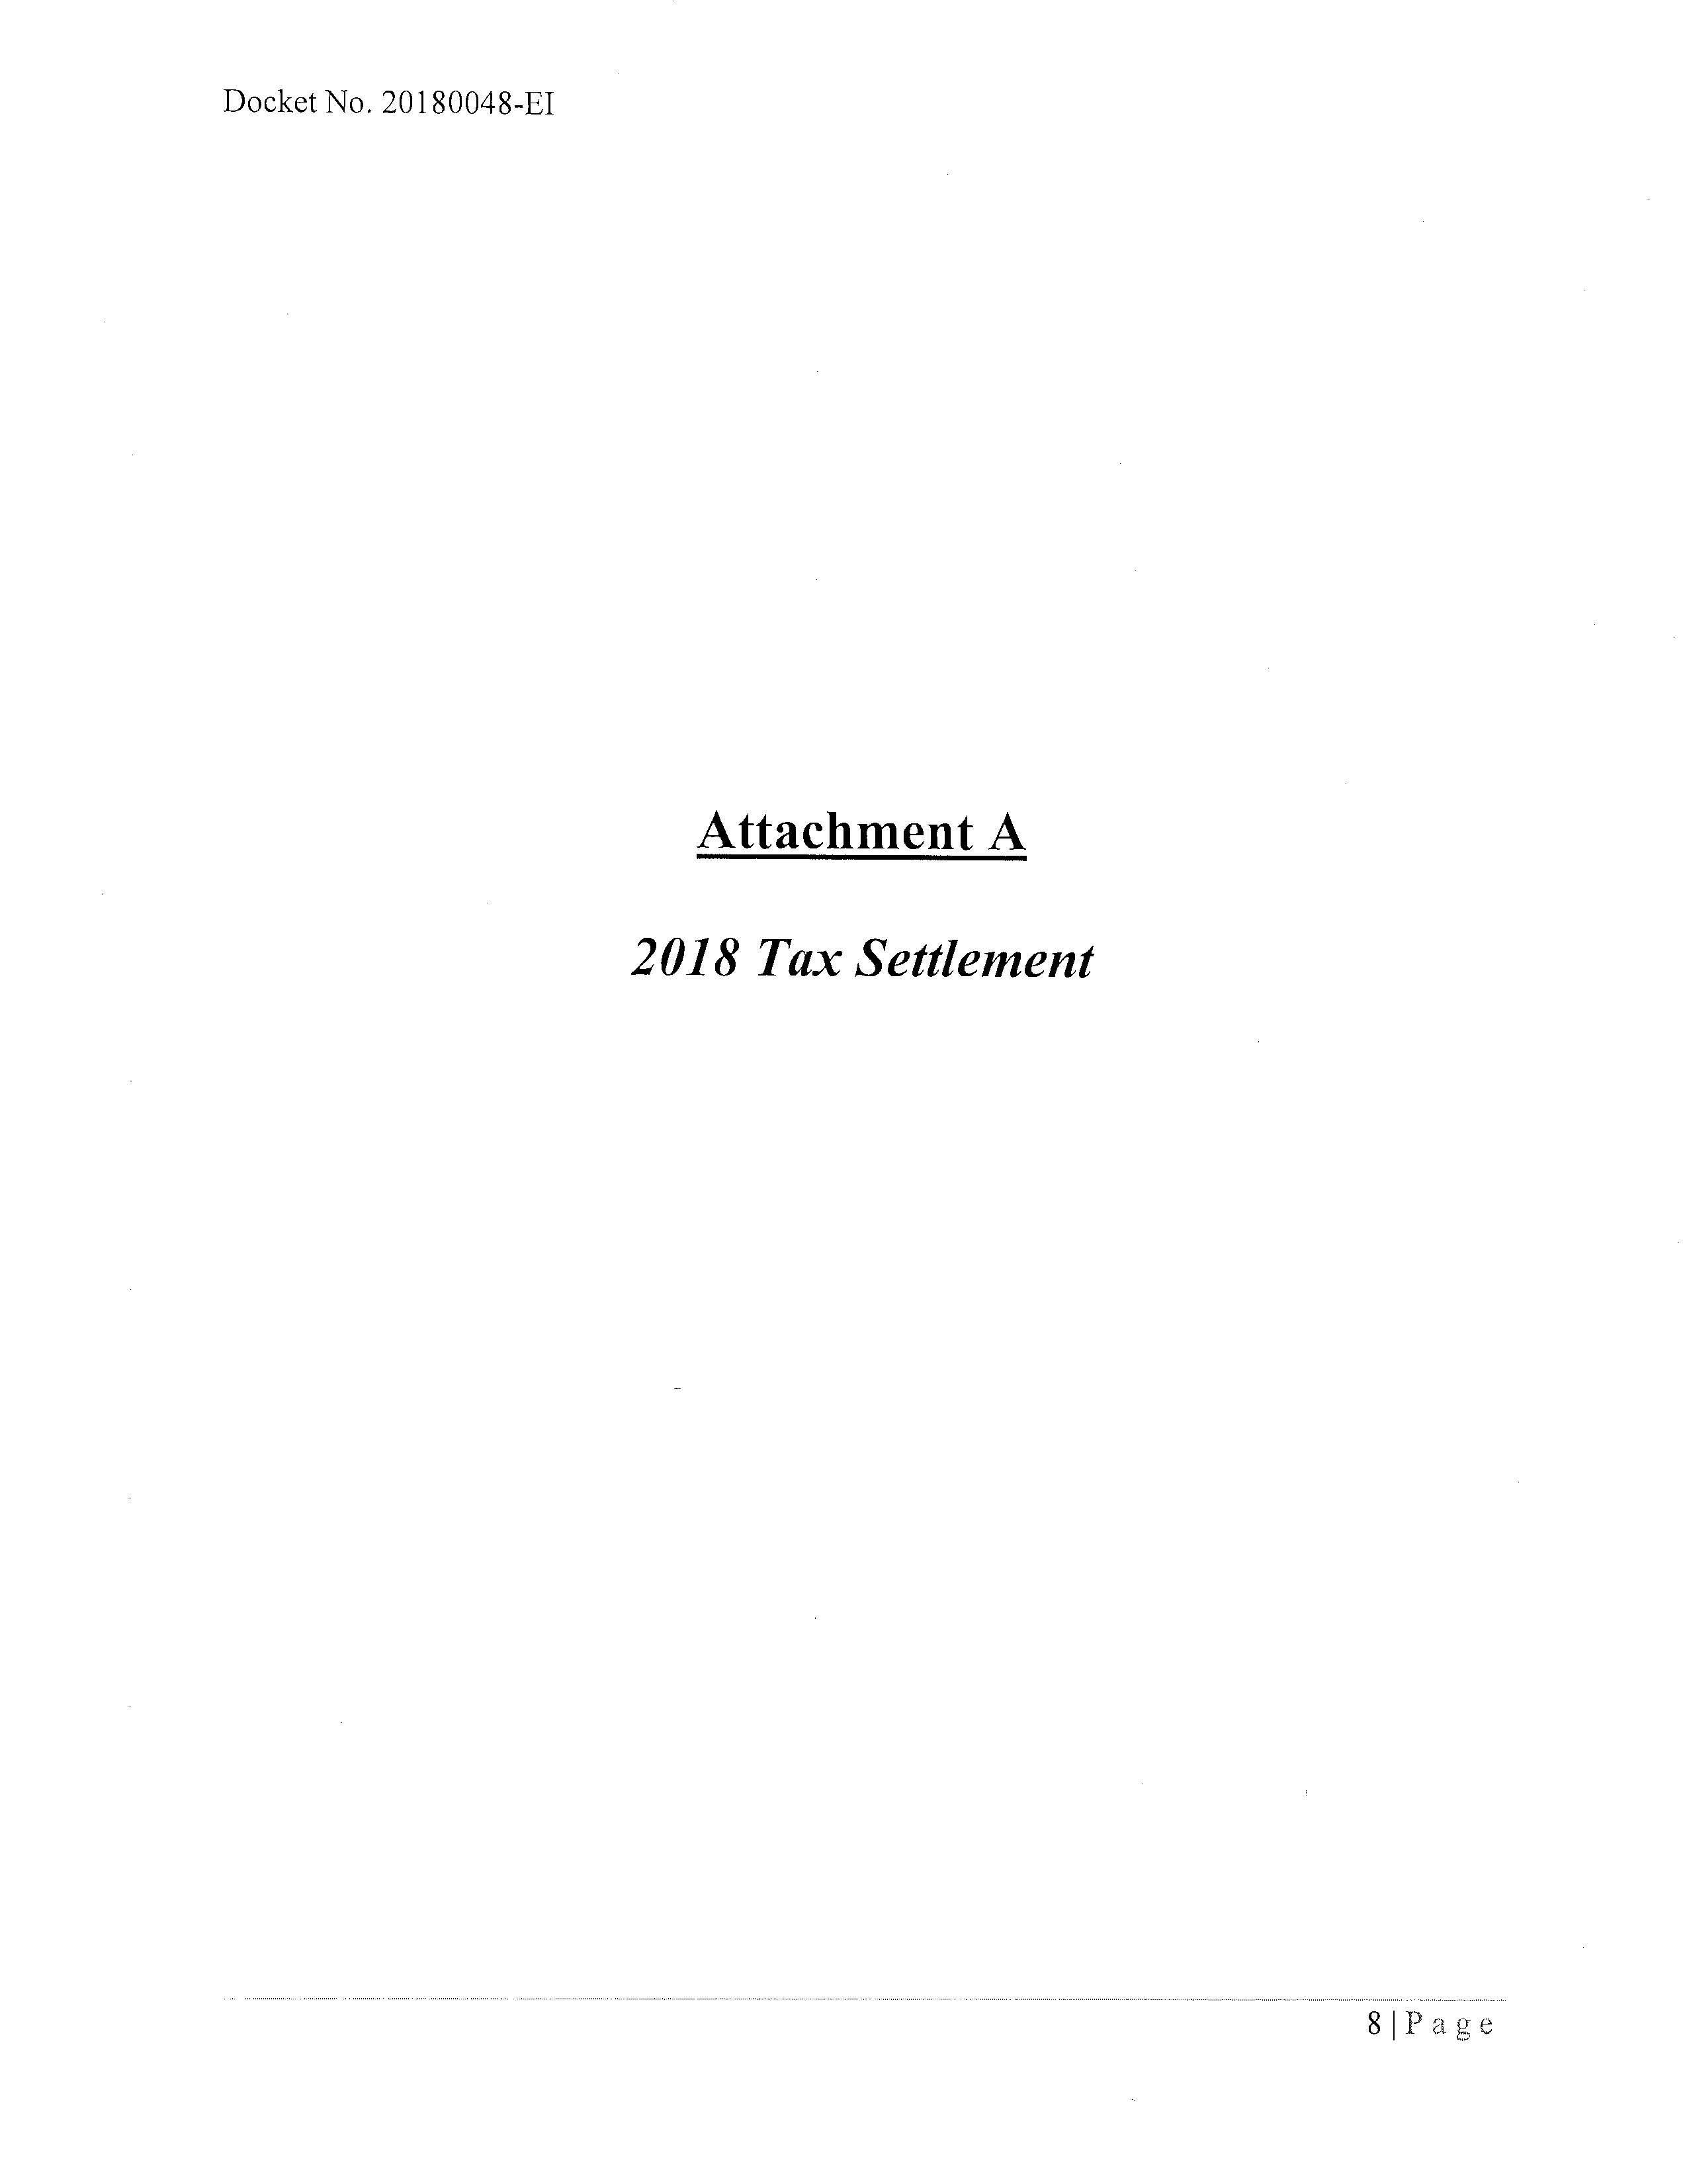

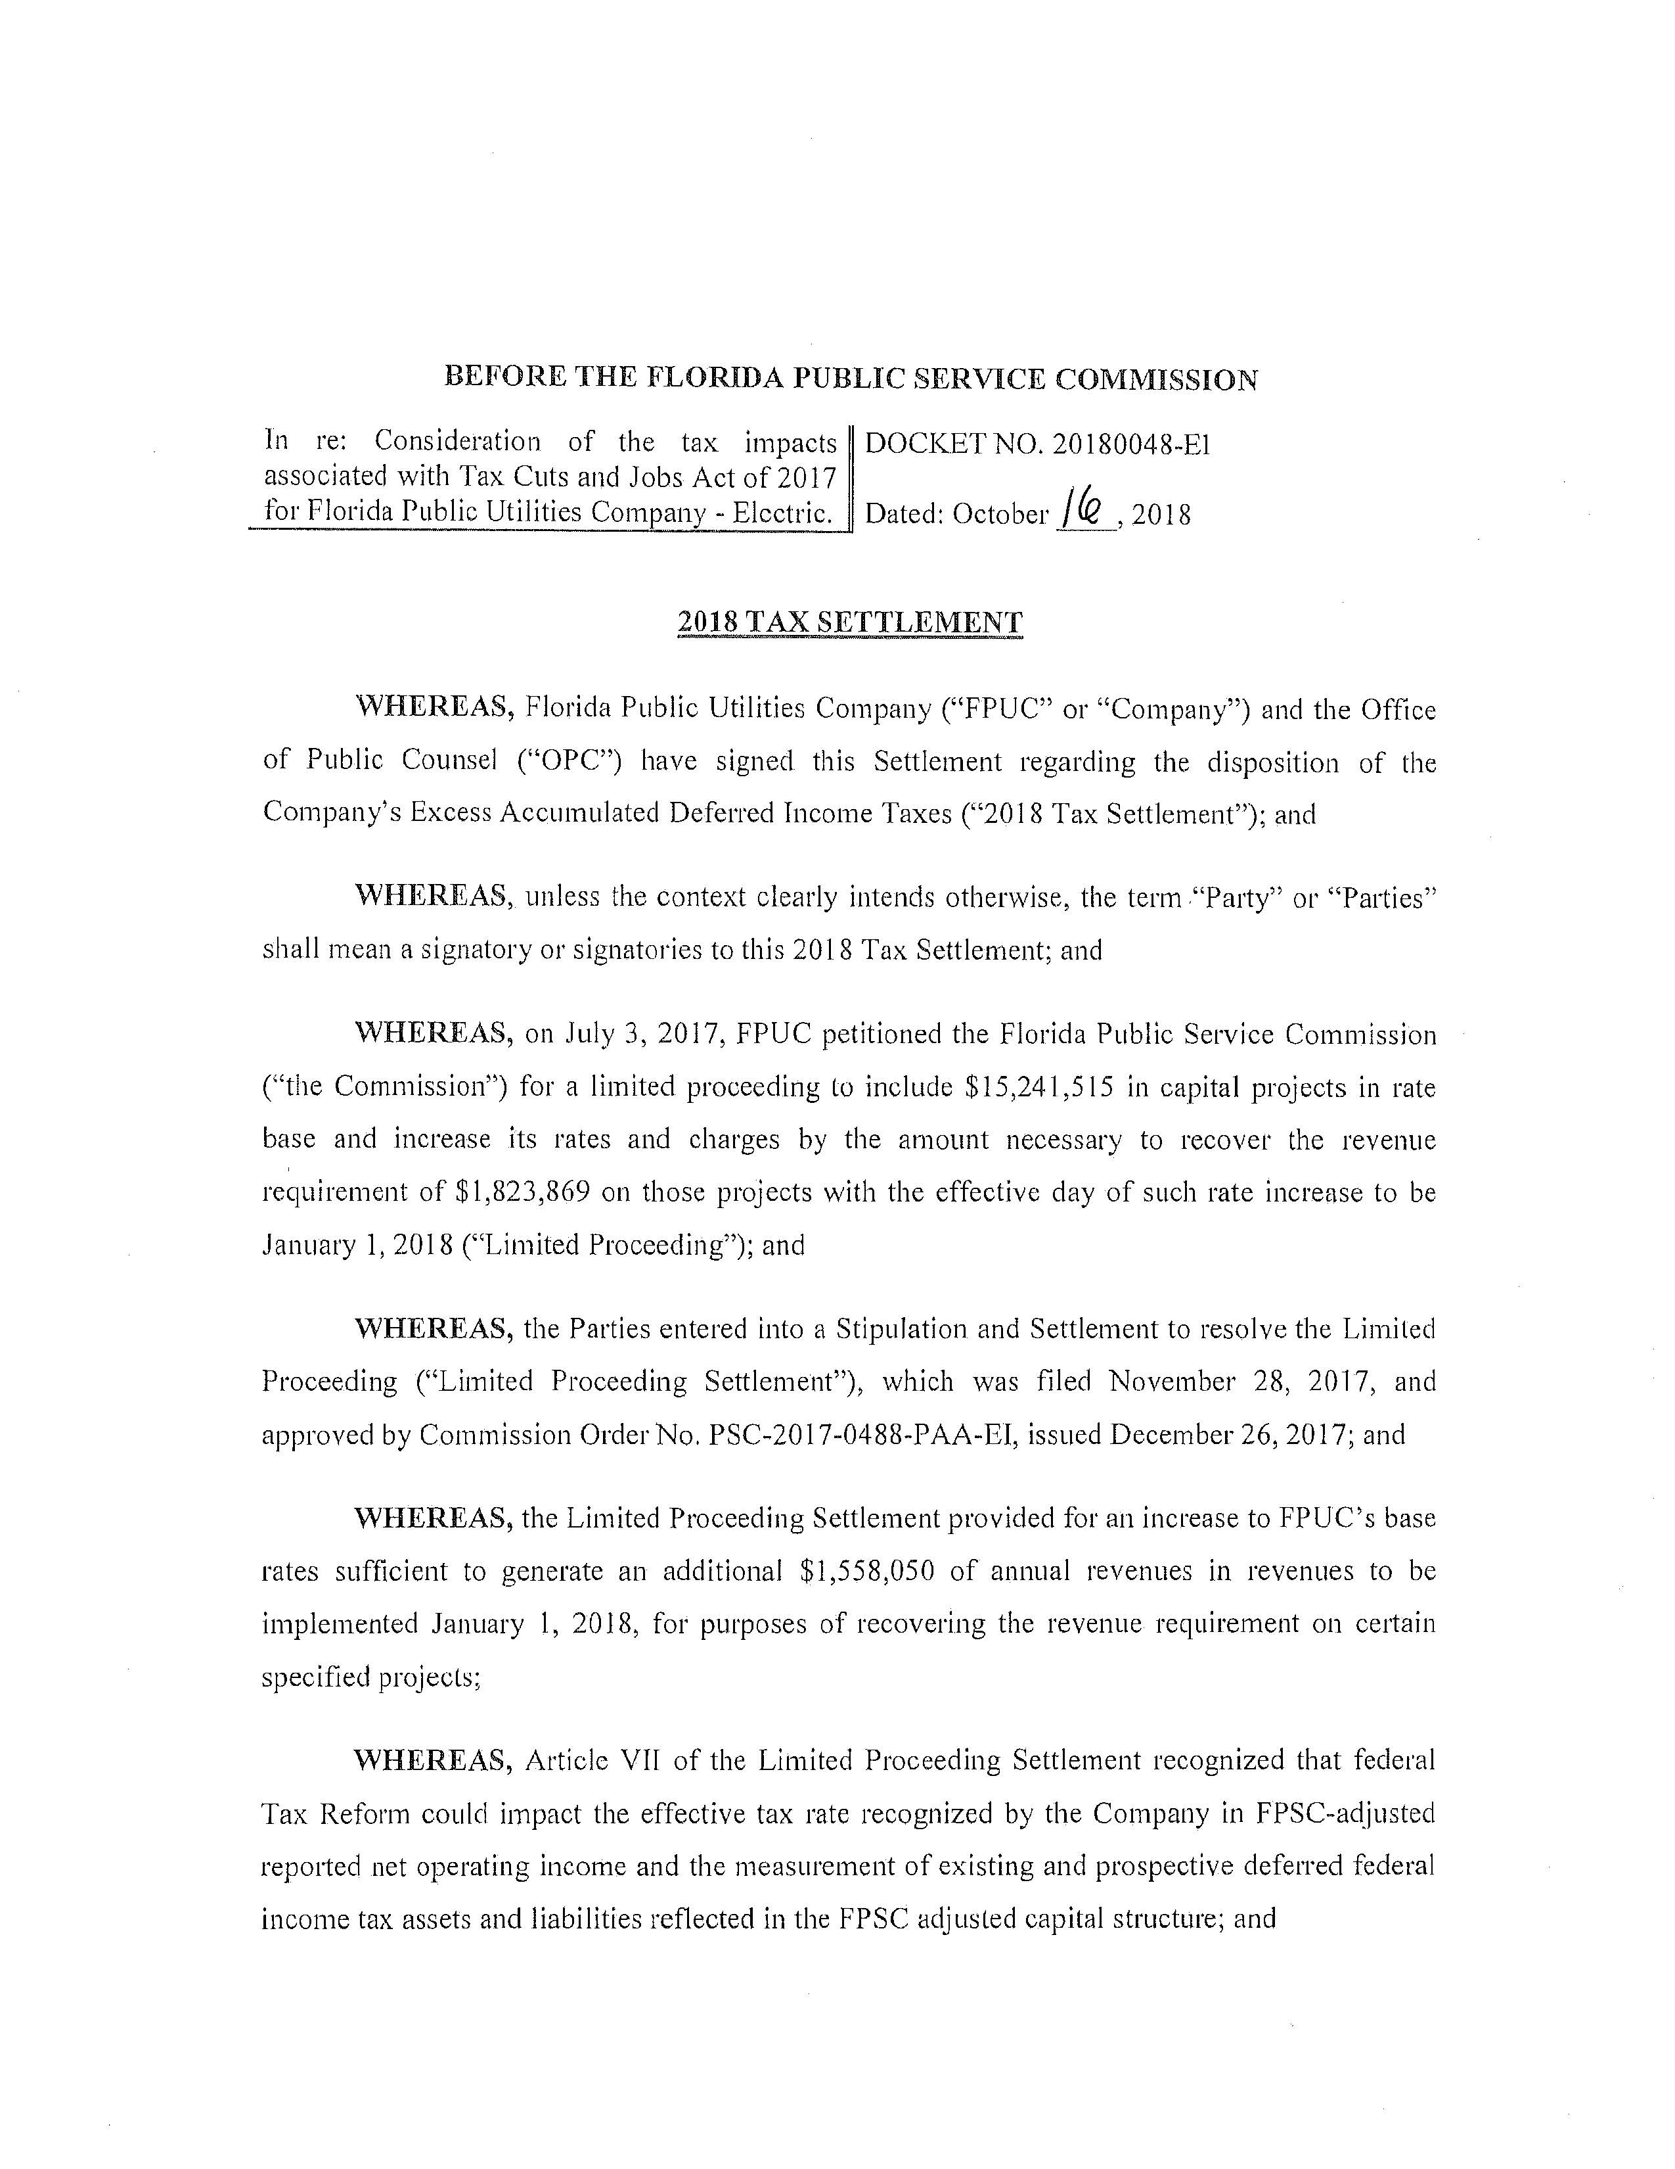

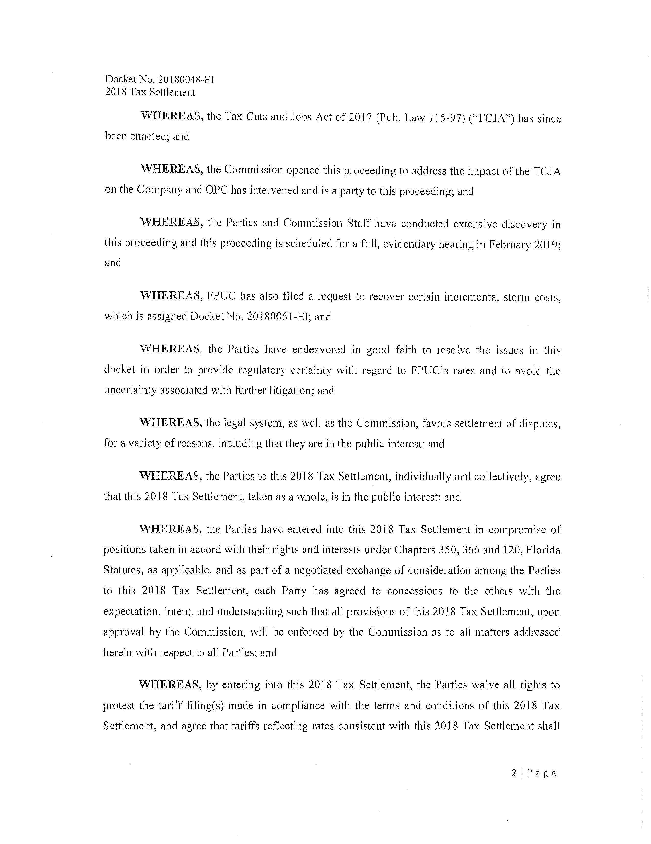

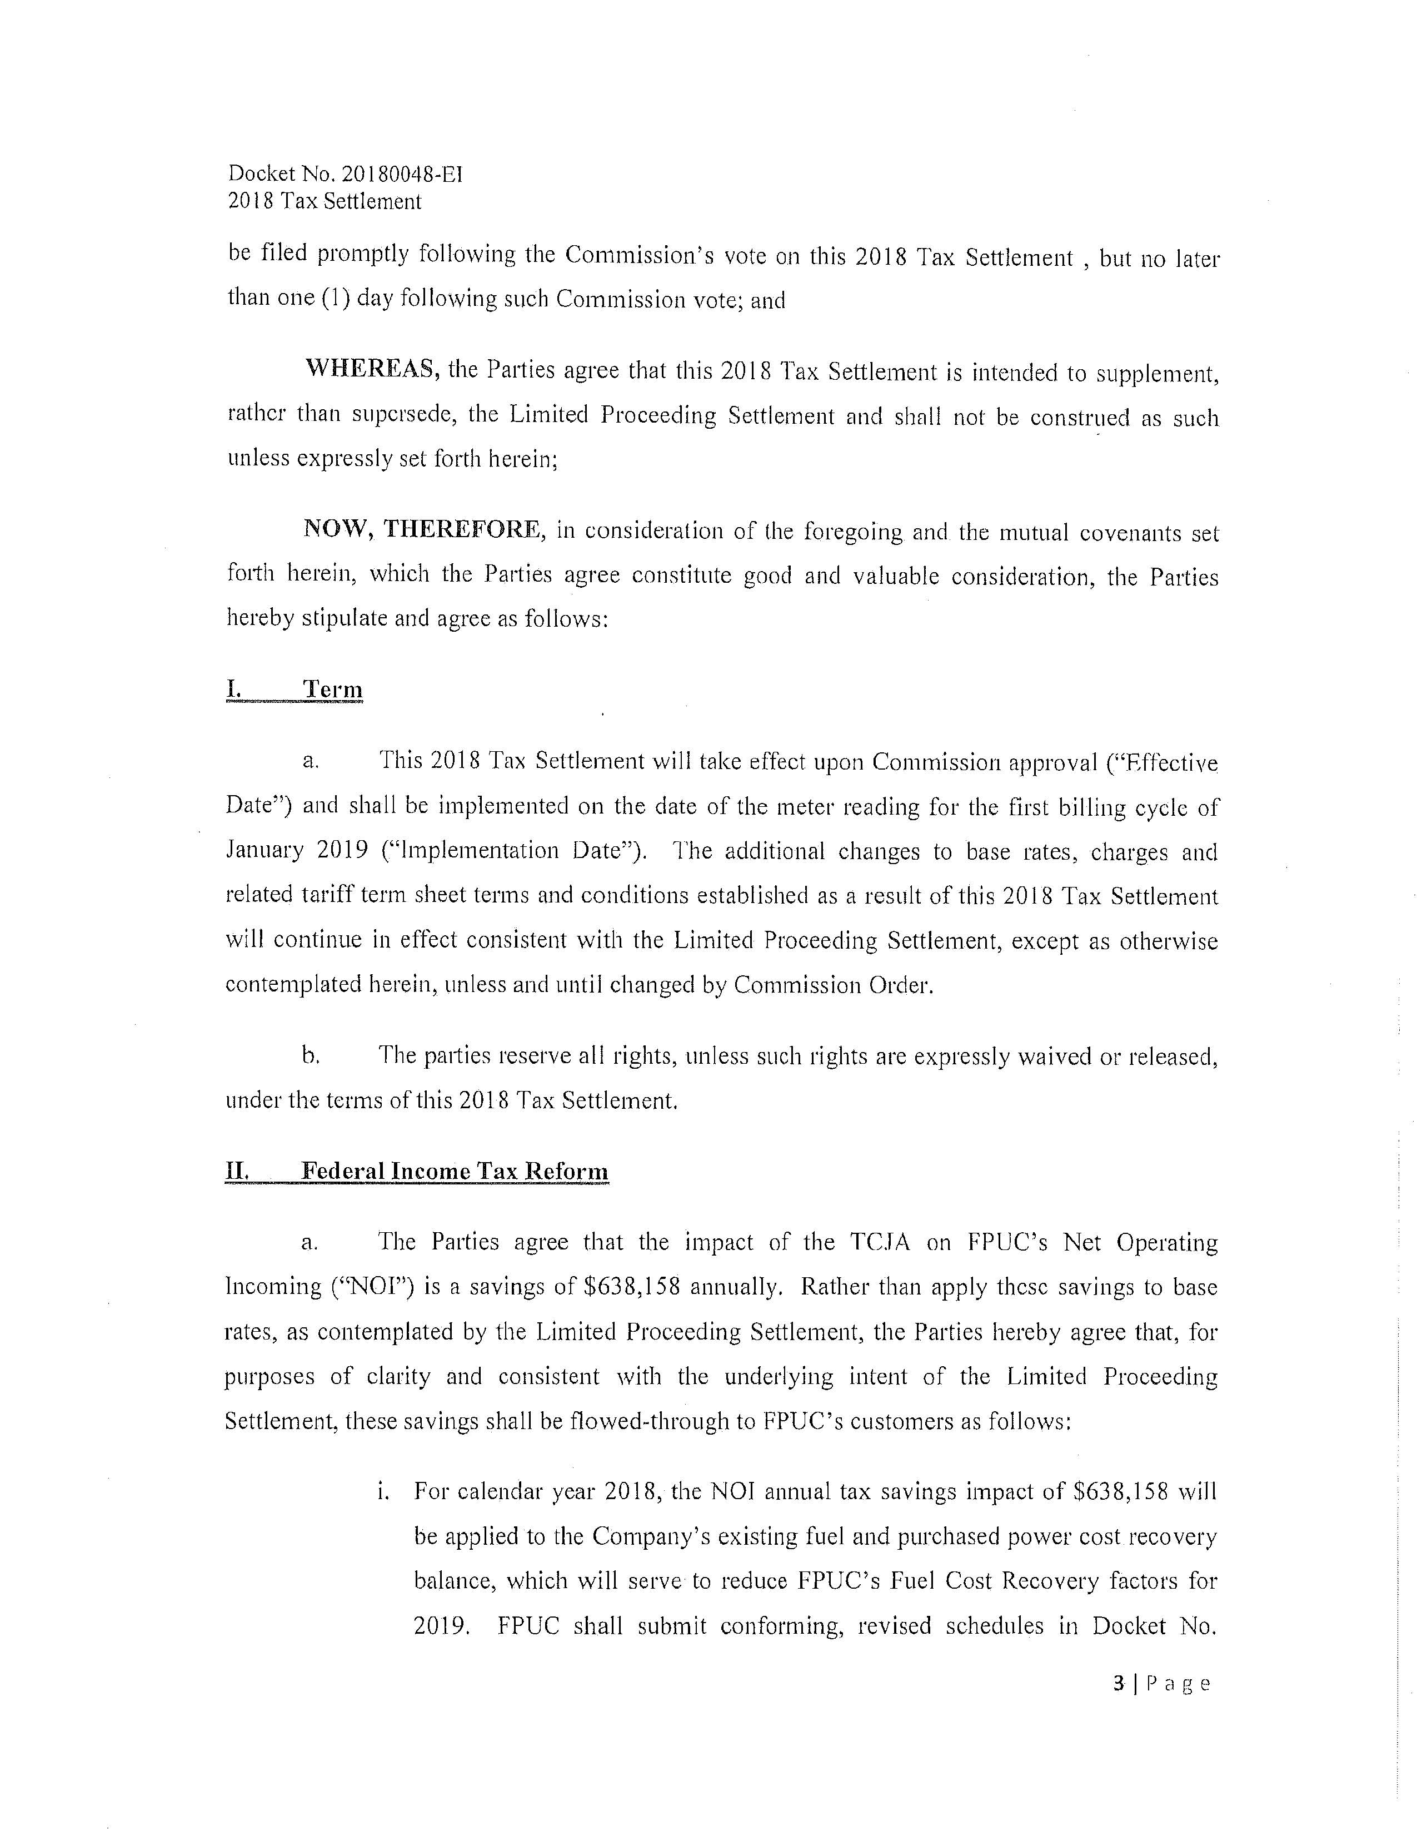

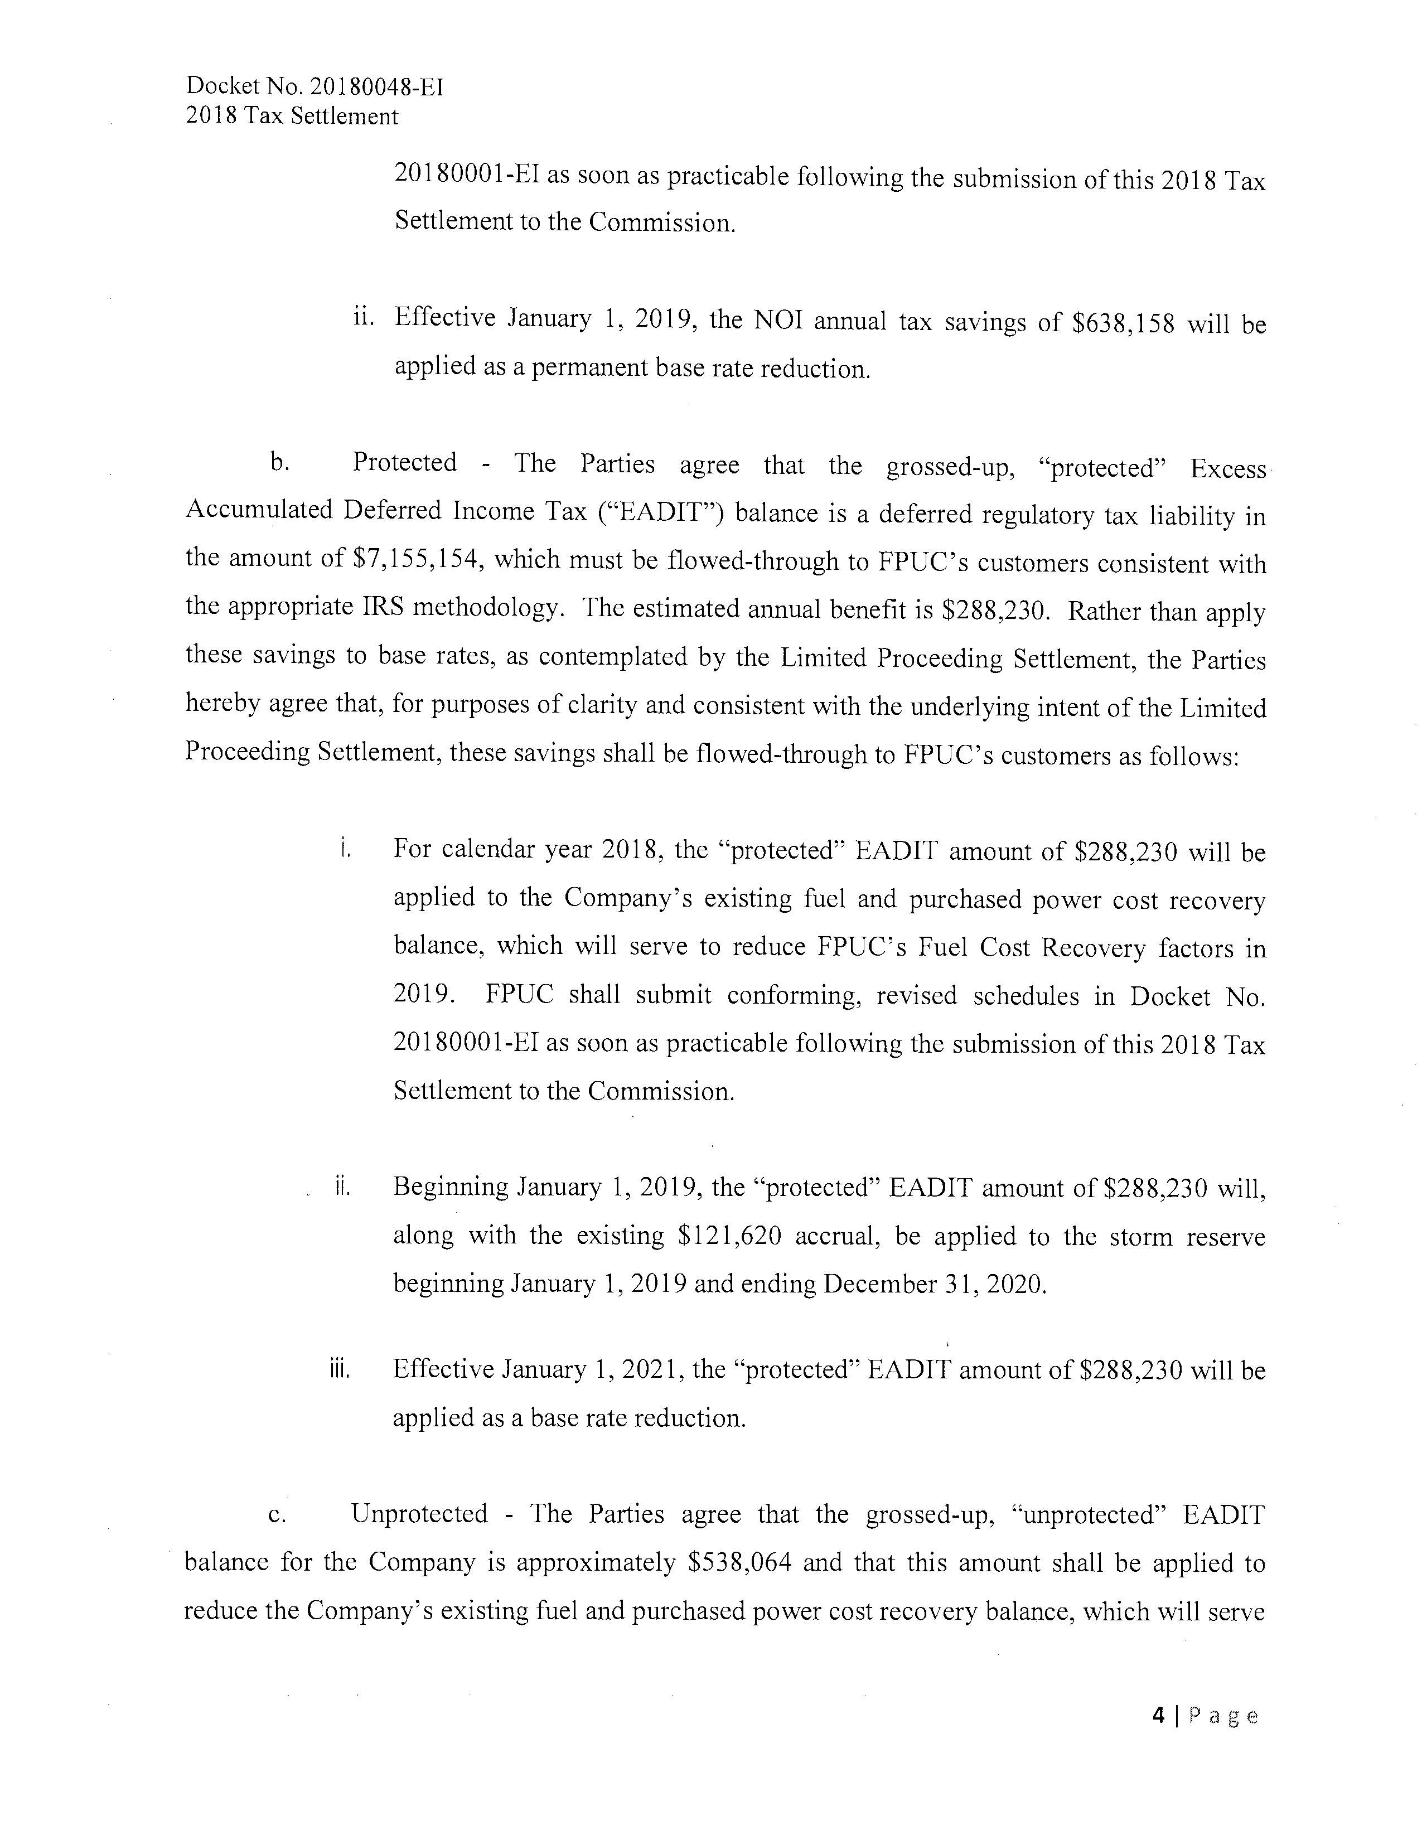

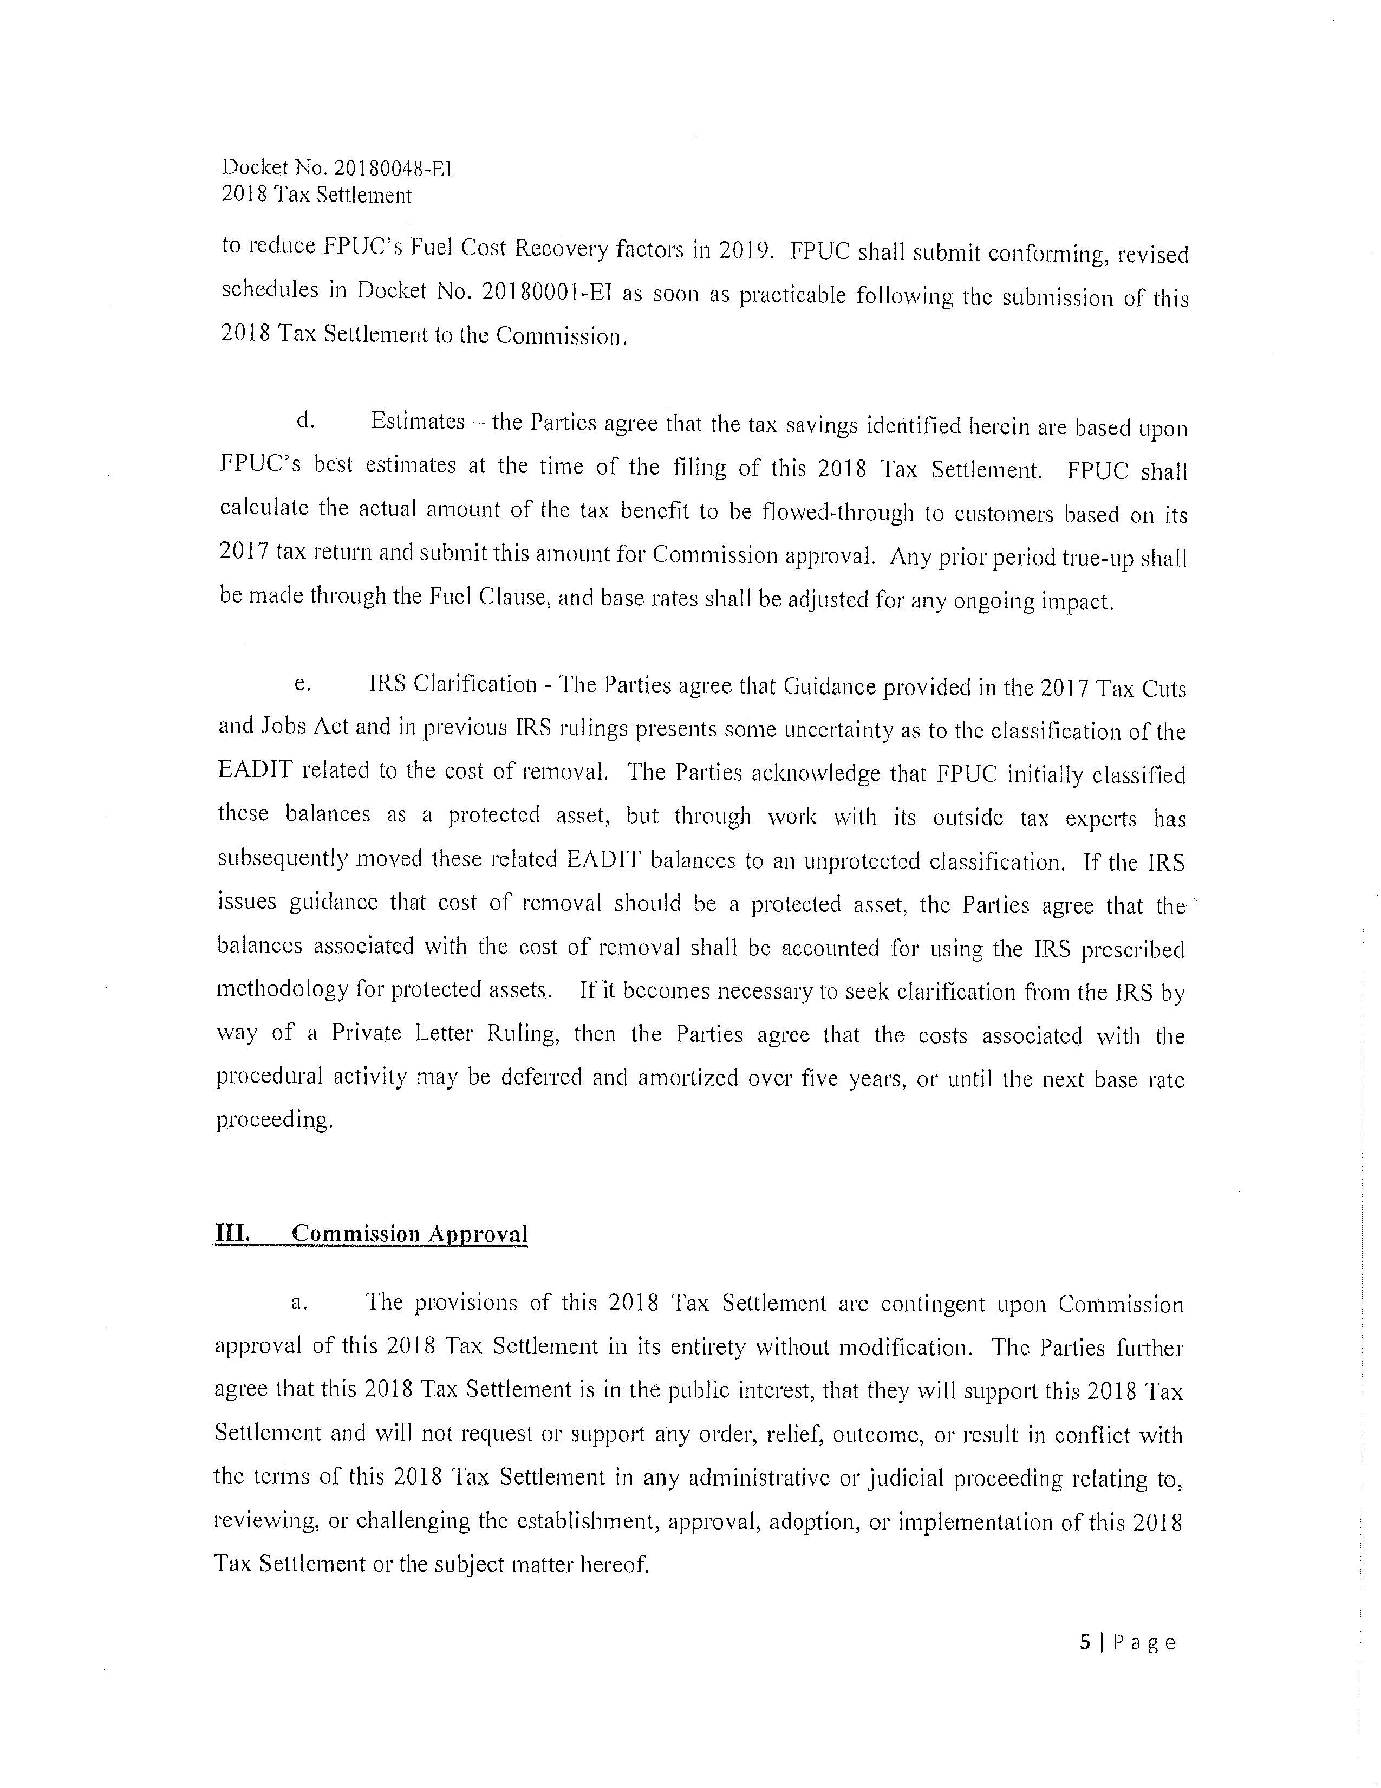

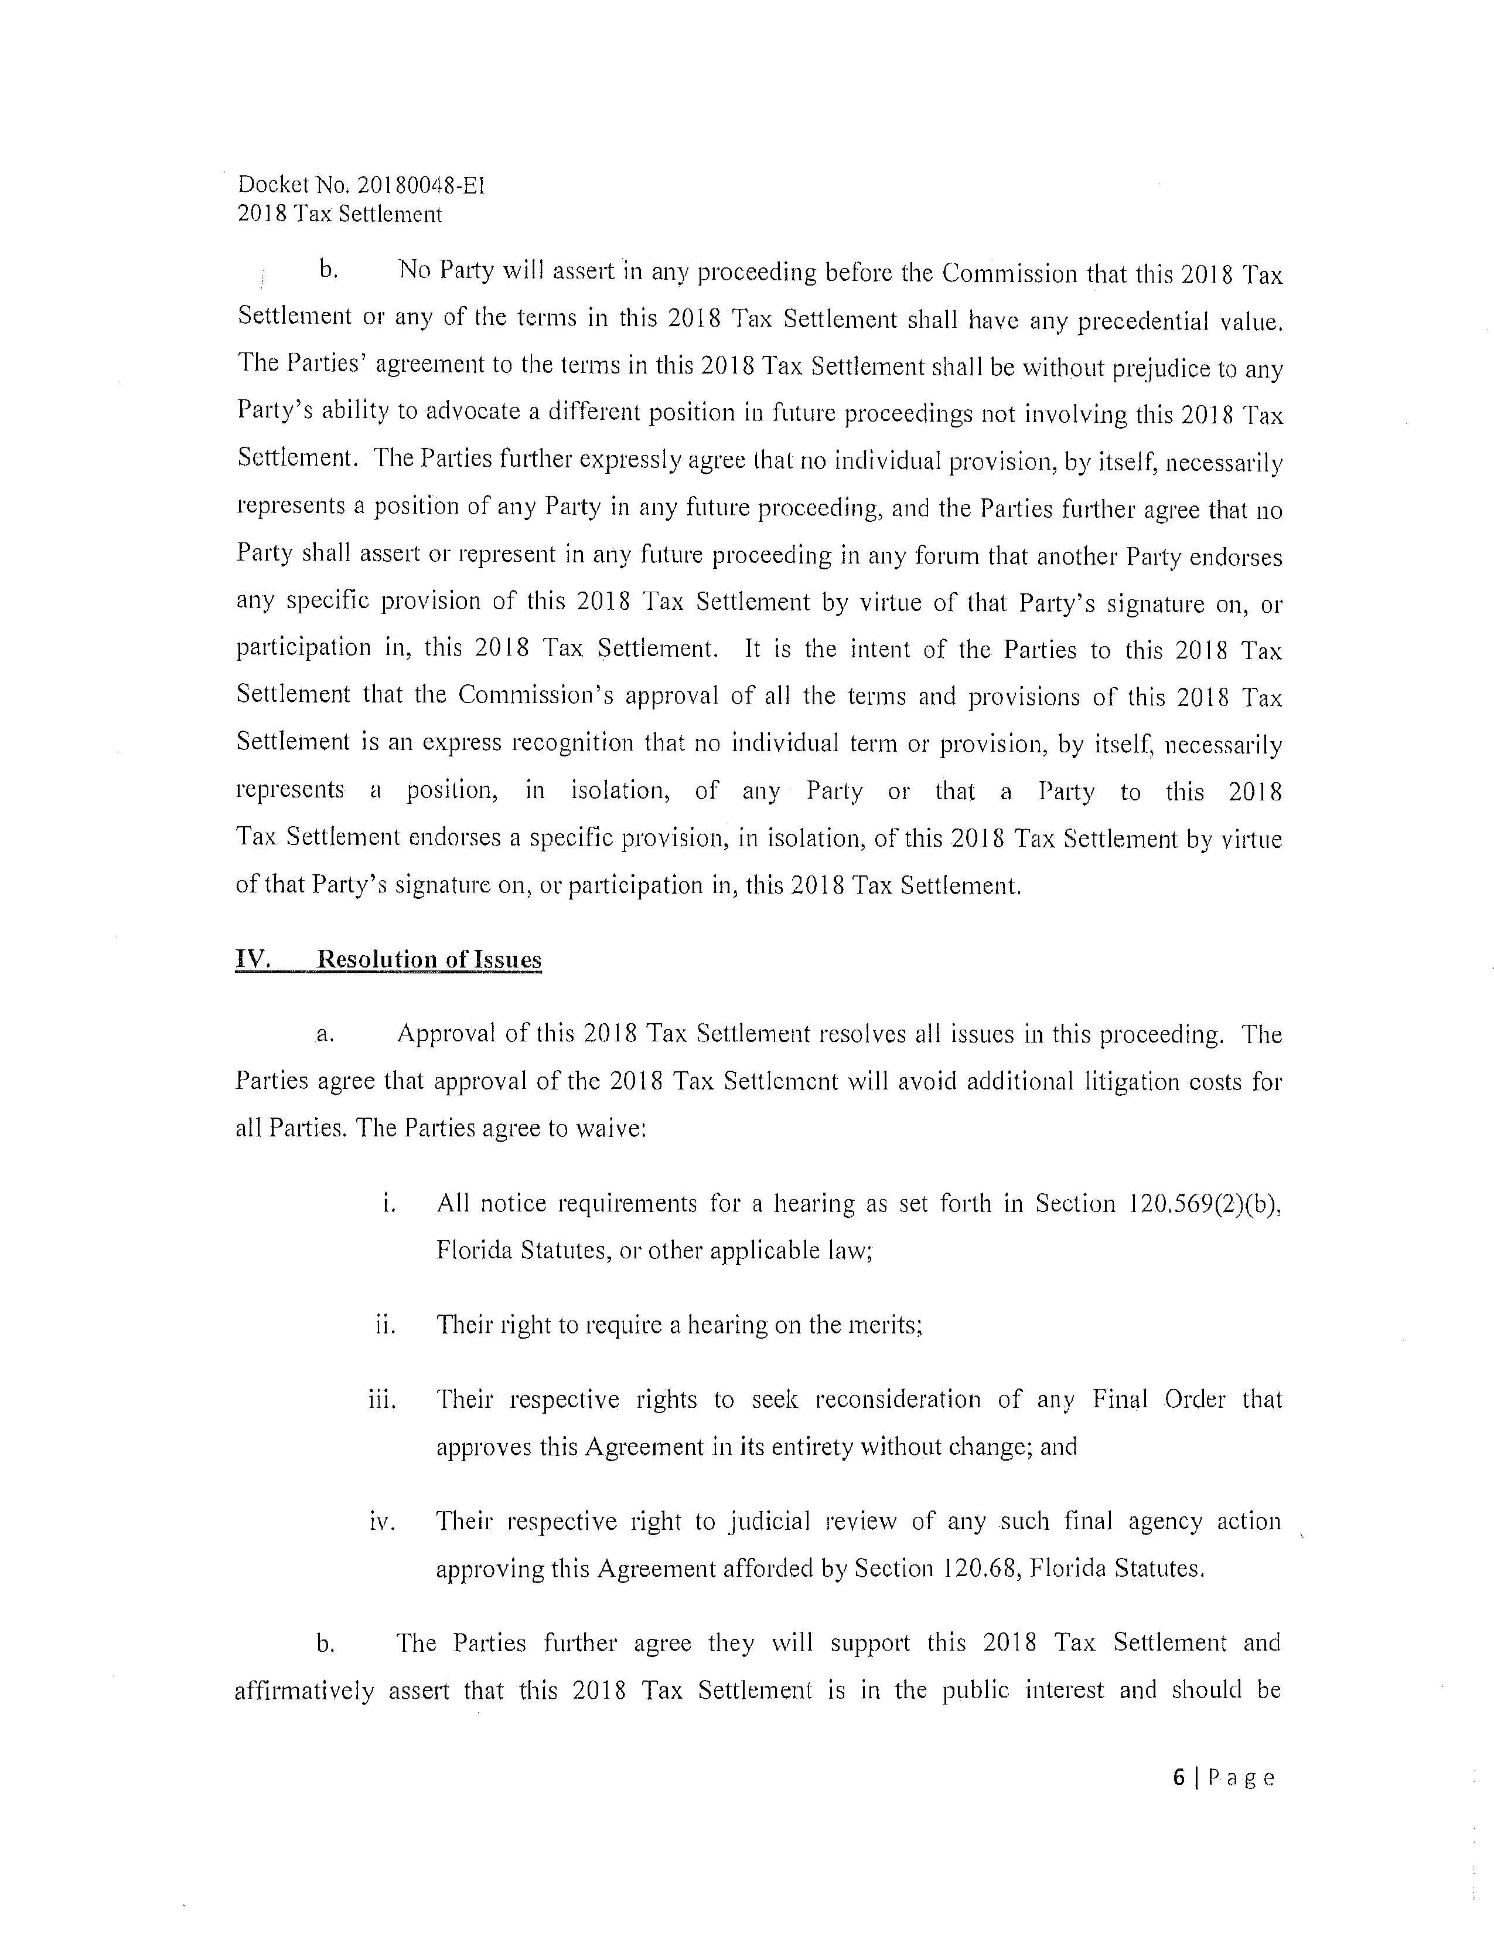

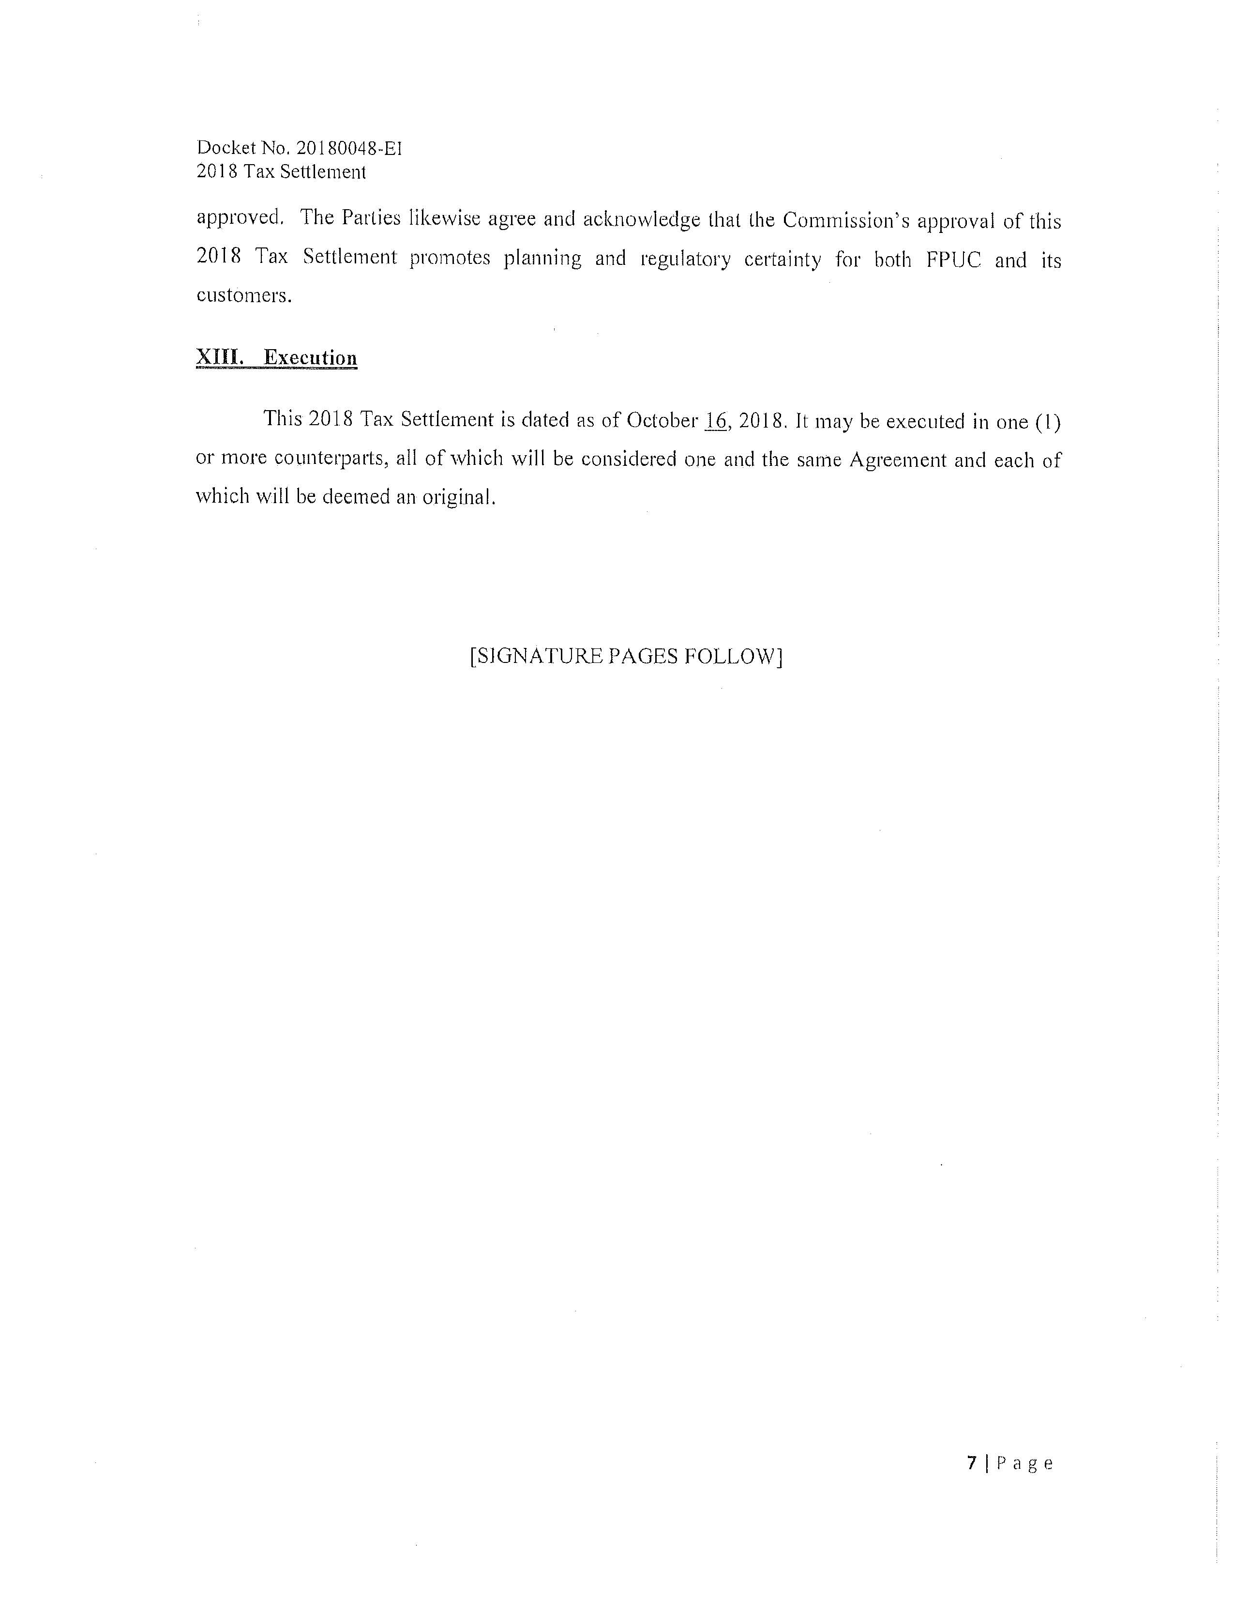

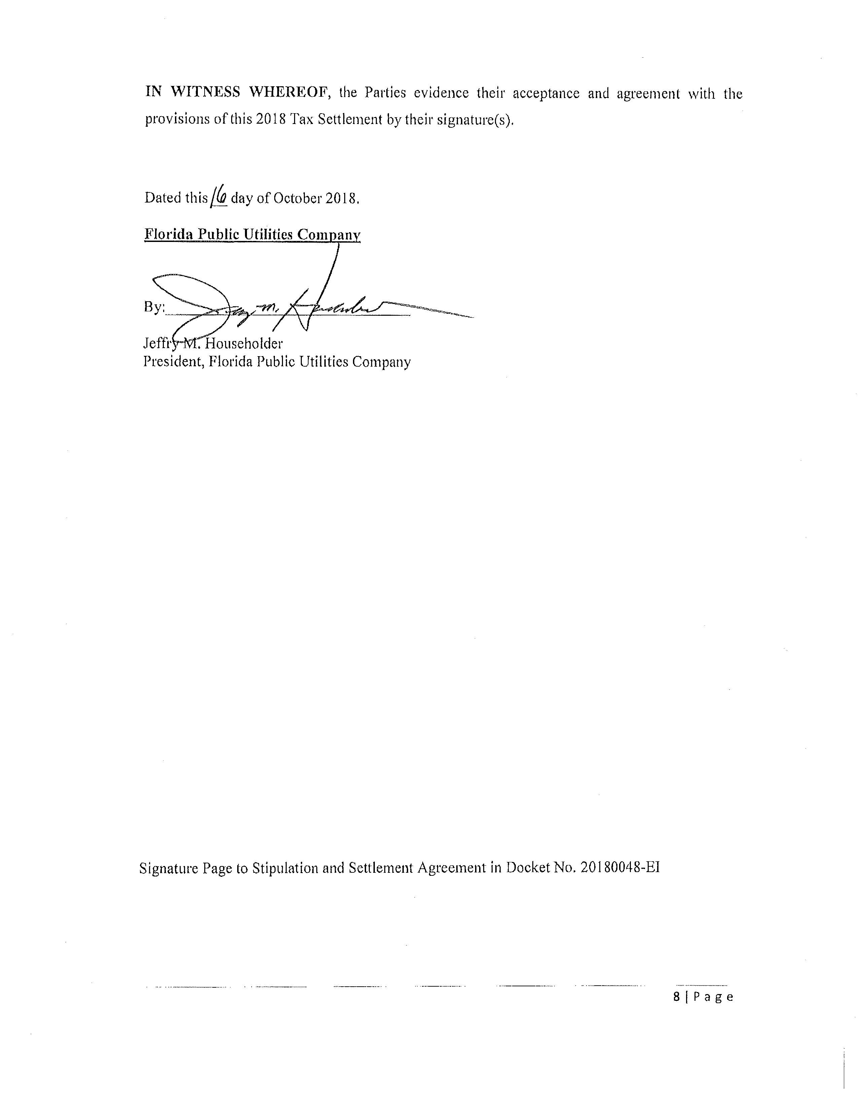

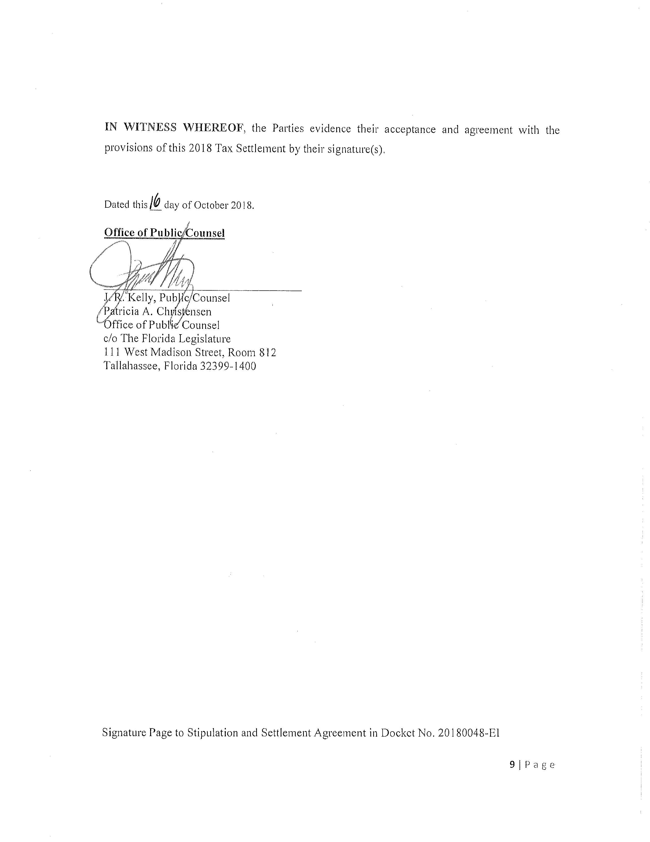

Order No. PSC-13-0023-S-EI, issued January 14, 2013, in Docket No. 120015-EI, In re: Petition for increase in rates by Florida Power & Light Company; Order No. PSC-11-0089-S-EI, issued February 1, 2011, in Docket Nos. 080677 and 090130, In re: Petition for increase in rates by Florida Power & Light Company and In re: 2009 depreciation and dismantlement study by Florida Power & Light Company; Order No. PSC-13-0023-S-EI, issued January 14, 2013, in Docket No. 120015-EI, In re: Petition for increase in rates by Florida Power & Light Company; PSC-10-0398-S-EI, issued June 18, 2010, in Docket Nos. 090079-EI, 090144-EI, 090145-EI, 100136-EI, In re: Petition for increase in rates by Progress Energy Florida, Inc., In re: Petition for limited proceeding to include Bartow repowering project in base rates, by Progress Energy Florida, Inc., In re: Petition for expedited approval of the deferral of pension expenses, authorization to charge storm hardening expenses to the storm damage reserve, and variance from or waiver of Rule 25-6.0143(1)(c), (d), and (f), F.A.C., by Progress Energy Florida, Inc., and In re: Petition for approval of an accounting order to record a depreciation expense credit, by Progress Energy Florida, Inc.; Order No. PSC-05-0945-S-EI, issued September 28, 2005, in Docket No. 050078-EI, In re: Petition for rate increase by Progress Energy Florida, Inc.
Order No. PSC-13-0023-S-EI, at p. 7.

