State of Florida |  | Public Service Commission  Capital Circle Office Center ● 2540 Shumard Oak Boulevard  Tallahassee, Florida 32399-0850  -M-E-M-O-R-A-N-D-U-M-
DATE: | January 24, 2019
TO: | Office of Commission Clerk (Teitzman)
FROM: | Division of Economics (Doherty)  Office of the General Counsel (Simmons)
RE: | Docket No. 20180222-EI – Petition for approval of customer specified lighting tariff by Tampa Electric Company.
AGENDA: | 02/05/19 – Regular Agenda – Tariff Filing – Interested Persons May Participate
COMMISSIONERS ASSIGNED: |  |  | All Commissioners
PREHEARING OFFICER: |  |  | Administrative
CRITICAL DATES: |  |  | 60-day suspension date waived by the utility until 02/05/2019
SPECIAL INSTRUCTIONS: |  |  | None

Case Background
On December 3, 2018, Tampa Electric Company (TECO or utility) filed a petition for approval of a new optional customer specified lighting tariff (LS-2 tariff). TECO proposed the new LS-2 tariff in response to customers requesting special lighting fixtures or poles.
TECO provided a letter waiving the 60-day file and suspend provision of Section 366.06(3), Florida Statutes (F.S.), until the February 5, 2019 Agenda Conference. On January 15, 2019, TECO filed two corrections to the tariffs filed with the petition. First, the correction to tariff sheet No. 6.835 reflects the addition of the LS-2 energy charge, which was inadvertently omitted. Second, TECO revised the cost recovery clause tariff sheet No. 6.020 to include the LS-2 tariff as LS-2 customers will be billed all cost recovery clauses. The proposed tariff sheets in legislative format are shown in Attachment A to this recommendation. The Commission has jurisdiction over this matter pursuant to Sections 366.03, 366.04, 366.05, and 366.06, F.S.

Discussion of Issues

Issue 1:
Should the Commission approve TECO's proposed customer specified lighting tariff as shown in Attachment A?

Recommendation:
Yes. The Commission should approve TECO’s proposed customer specified lighting tariff, as shown in Attachment A, effective February 5, 2019. The LS-2 tariff allows TECO to respond to customer requests for special fixtures or poles in a timely and efficient manner. The general body of ratepayers will be protected as LS-2 customers will be responsible for all costs associated with their request. (Doherty)

Staff Analysis:
Currently, TECO offers lighting service under its Lighting Service-1 (LS-1) tariff. The LS-1 tariff includes specific fixtures and poles a customer can choose from. The LS-1 charges for each fixture are comprised of three components: a fixture charge, a maintenance charge, and an energy charge. Charges for poles include a pole and maintenance charge. Customers taking service under the LS-1 tariff are required to sign the Bright Choices Outdoor Lighting Agreement (agreement) for a minimum of 10 years. After the initial 10-year term, the agreement can be terminated by either party upon providing the other party with 90 days written notice of termination.
TECO explained that, on occasion, customers request a specific fixture or pole that is not offered under the LS-1 tariff. After receiving such a customer request, TECO has the option of seeking Commission approval to add the requested fixture or pole to the LS-1 tariff. In the alternative, customers have the option of choosing lighting facilities that are offered under the LS-1 tariff or installing customer-owned facilities and utilizing TECO’s energy-only rate offering under the LS-1 tariff.
To address customer requests in a timely and efficient manner for special fixtures or poles not offered under the LS-1 tariff, TECO proposed the LS-2 tariff. If the requested lighting facilities meet TECO’s reliability standards, TECO would purchase and install the lighting facilities. TECO stated that customers are seeking lighting poles or fixtures that would be a signature of or attraction for their location. TECO believes that as economic development continues in the Tampa Bay area, the LS-2 tariff will be predominantly used by subdivisions, shopping centers, and other new developments.
TECO explained that the utility will not actively market the LS-2 tariff, but will only apply the LS-2 tariff in response to a special lighting request. The utility stated that it has one current request for lighting service from a subdivision that would be best accommodated under the LS-2 tariff, as the subdivision requested a unique style of pole.
The lighting requests under the LS-2 tariff will be unique to each customer; therefore, TECO proposes that a different rate setting approach be applied. To bill customers for the fixture and maintenance costs, TECO proposes to apply a monthly factor of 1.19 percent to the in-place value of the facilities. The in-place value is determined by TECO’s cost to purchase and install the requested facilities. The Commission-approved monthly factor of 1.19 percent is currently contained in the Facilities Rental Agreement (tariff sheet Nos. 7.760 – 7.775) and was approved in TECO’s last rate case. The monthly factor of 1.19 percent assures recovery of TECO’s lighting facilities investment (depreciation, taxes, maintenance cost, and return). All other Commission-approved street lighting energy charge and cost recovery factors, such as fuel, will apply.
As with the currently available LS-1 tariff, customers will be required to sign the agreement. However, the initial term for LS-2 customers will be 20 years to allow for full cost recovery over the expected life of the facilities. TECO explained that the longer term is justified because the lighting equipment installed is specific to a customer’s request and may not be of value to a subsequent customer at the location or another customer at a different location. To accommodate the 20-year term associated with the proposed LS-2 tariff, TECO modified one page of the agreement (refer to Attachment A, page 6 of 7, of this recommendation).

Conclusion
The Commission approved a similar lighting tariff (Form 4, tariff sheet No. 7.13) for Gulf Power Company (Gulf) in Gulf’s 2001 rate case in response to customers requesting more fixture or pole options. More recently, the Commission approved an optional LT-1 streetlight tariff for Florida Power & Light Company (FPL). The LT-1 tariff allows FPL to offer a wide range of fixtures through a catalogue on the FPL website as opposed to in the tariff itself.
Staff has reviewed TECO’s petition and believes the proposed LS-2 tariff is reasonable and appropriate. The LS-2 tariff allows TECO to respond to customer requests for special fixtures or poles in a timely and efficient manner. The general body of ratepayers will be protected as LS-2 customers will be responsible for all costs associated with their request. Staff recommends that TECO’s proposed customer specified lighting tariff, as shown in Attachment A, be approved effective February 5, 2019.

Issue 2:
Should this docket be closed?

Recommendation:
If Issue 1 is approved and a protest is filed within 21 days of the issuance of the order, the tariff should remain in effect, with any revenues held subject to refund, pending resolution of the protest. If no timely protest is filed, this docket should be closed upon the issuance of a consummating order. (Simmons)

Staff Analysis:
If Issue 1 is approved and a protest is filed within 21 days of the issuance of the order, the tariff should remain in effect, with any revenues held subject to refund, pending resolution of the protest. If no timely protest is filed, this docket should be closed upon the issuance of a consummating order.

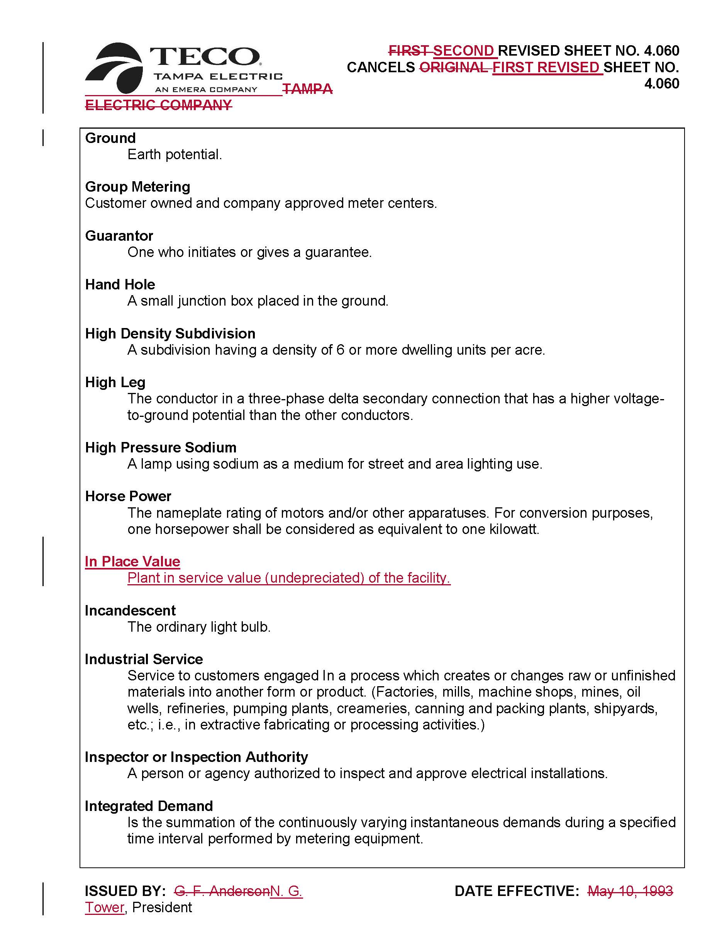

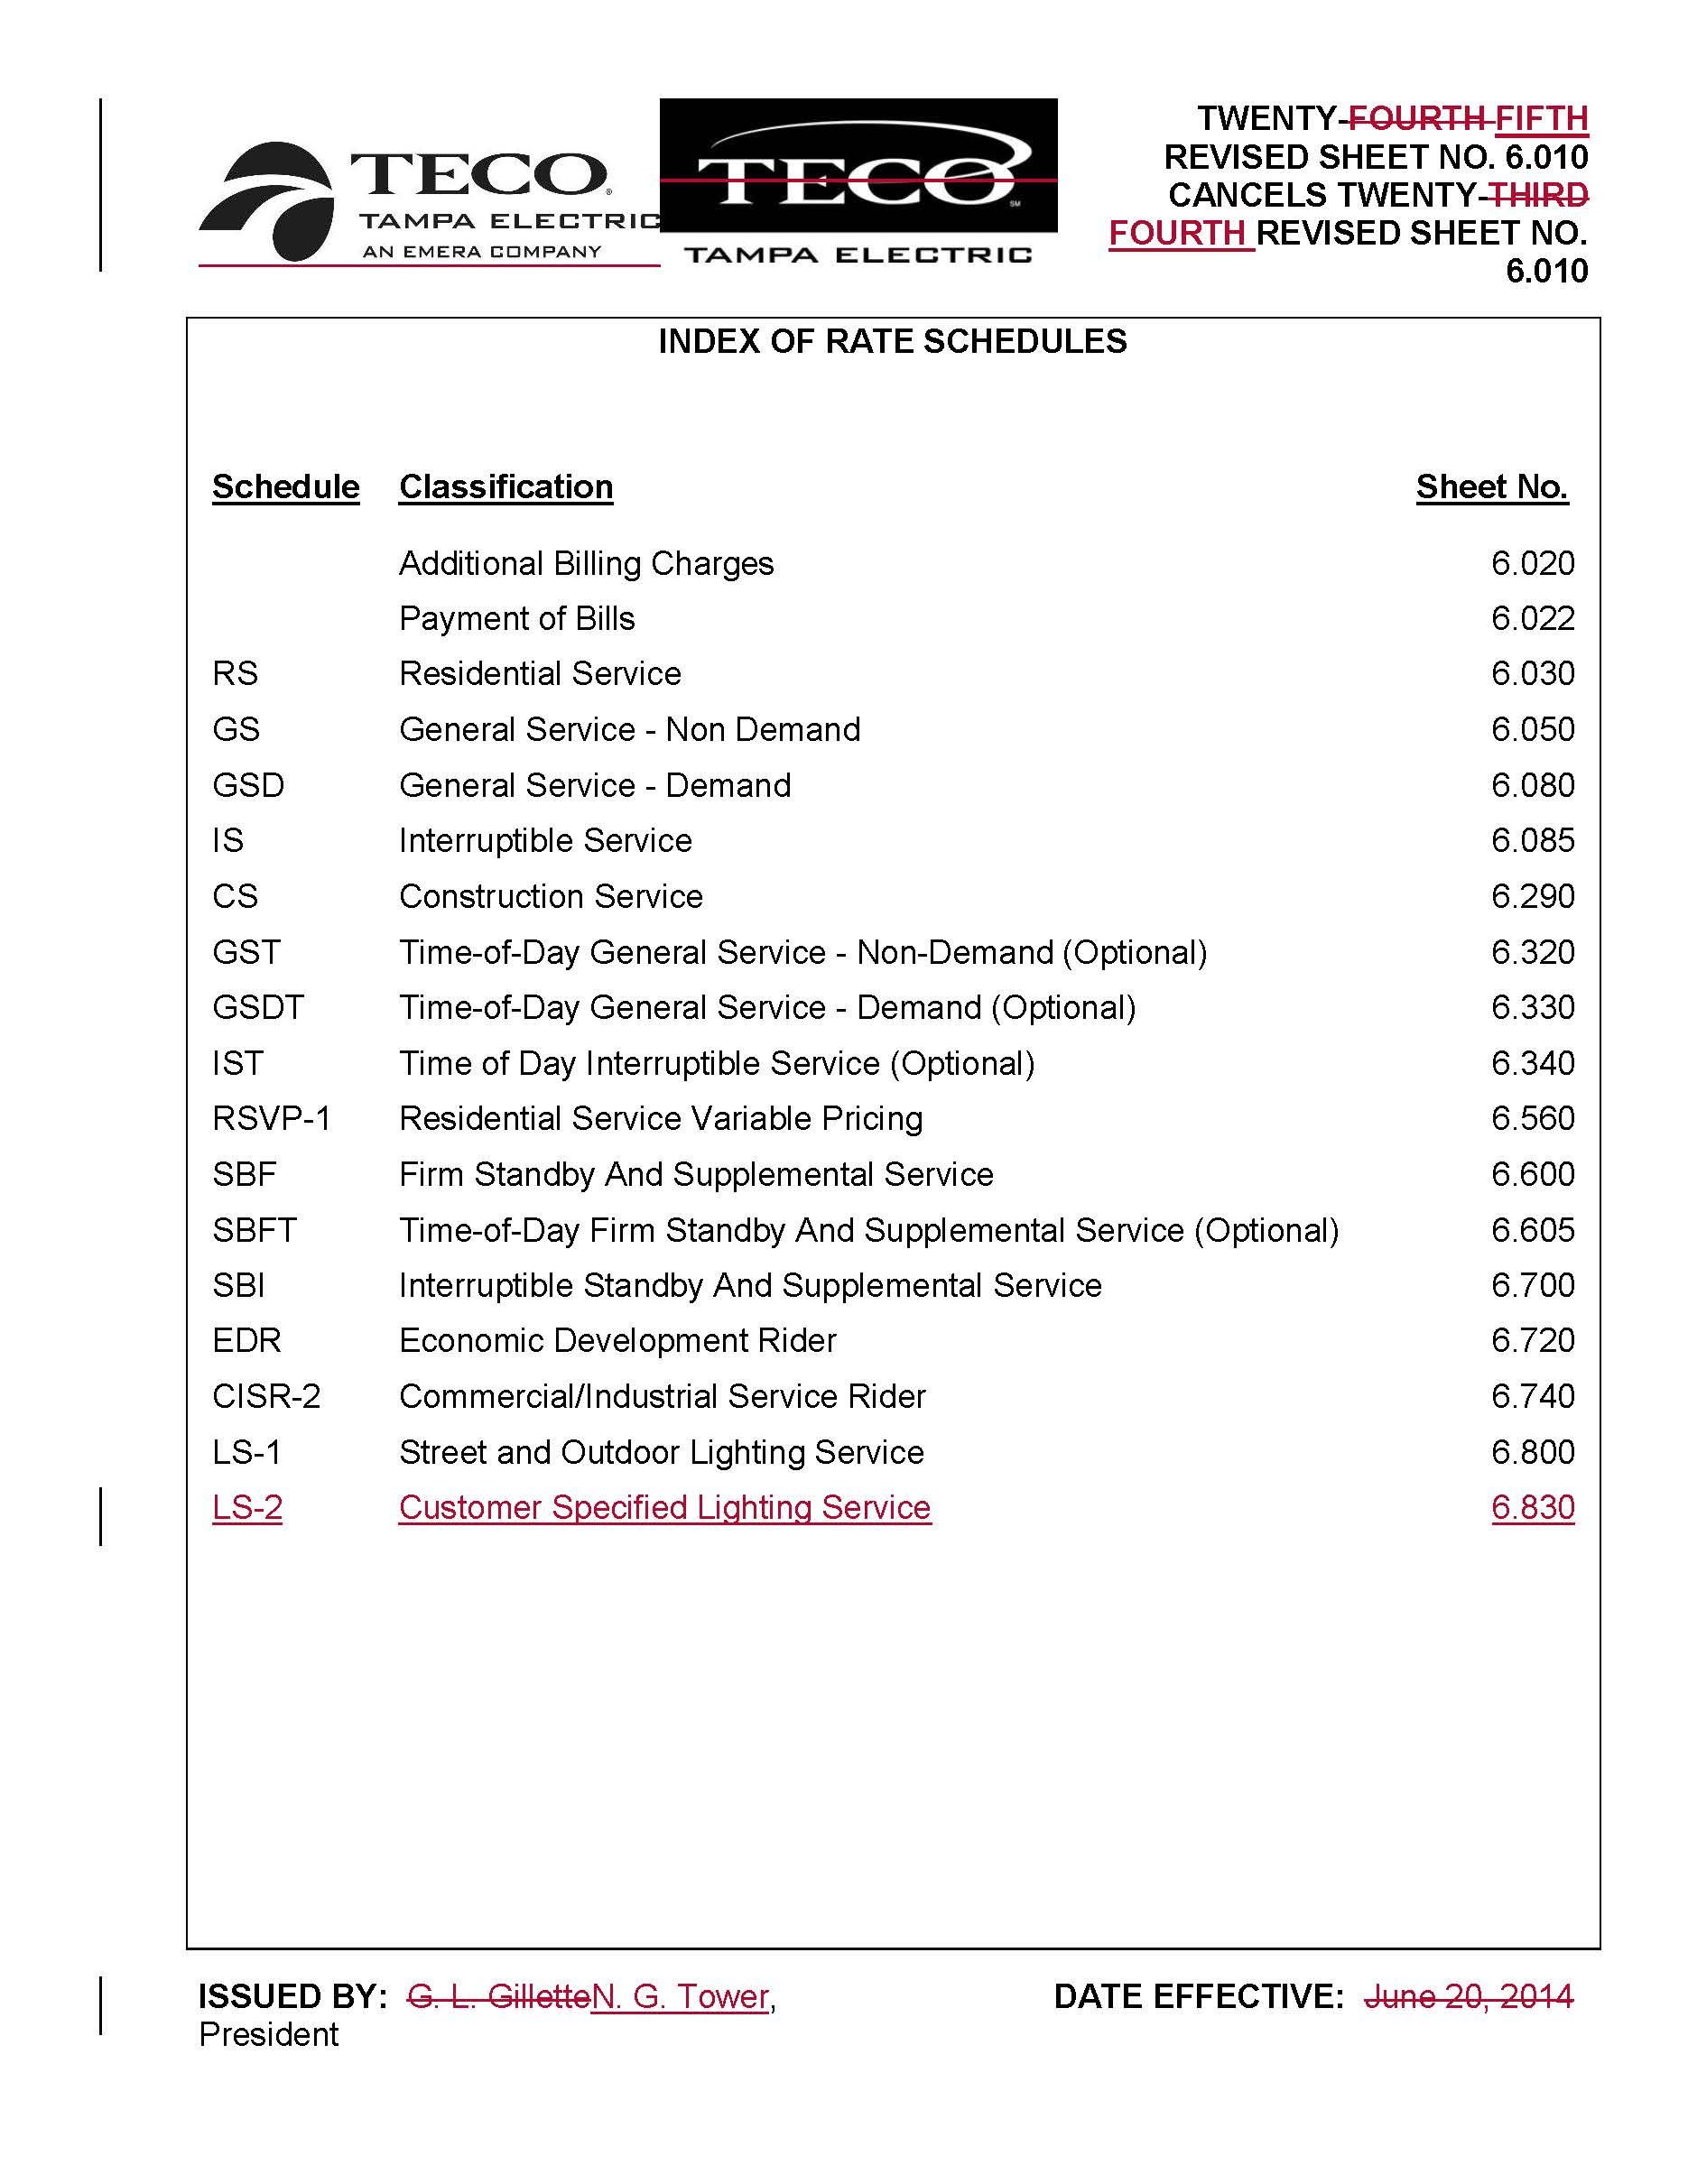

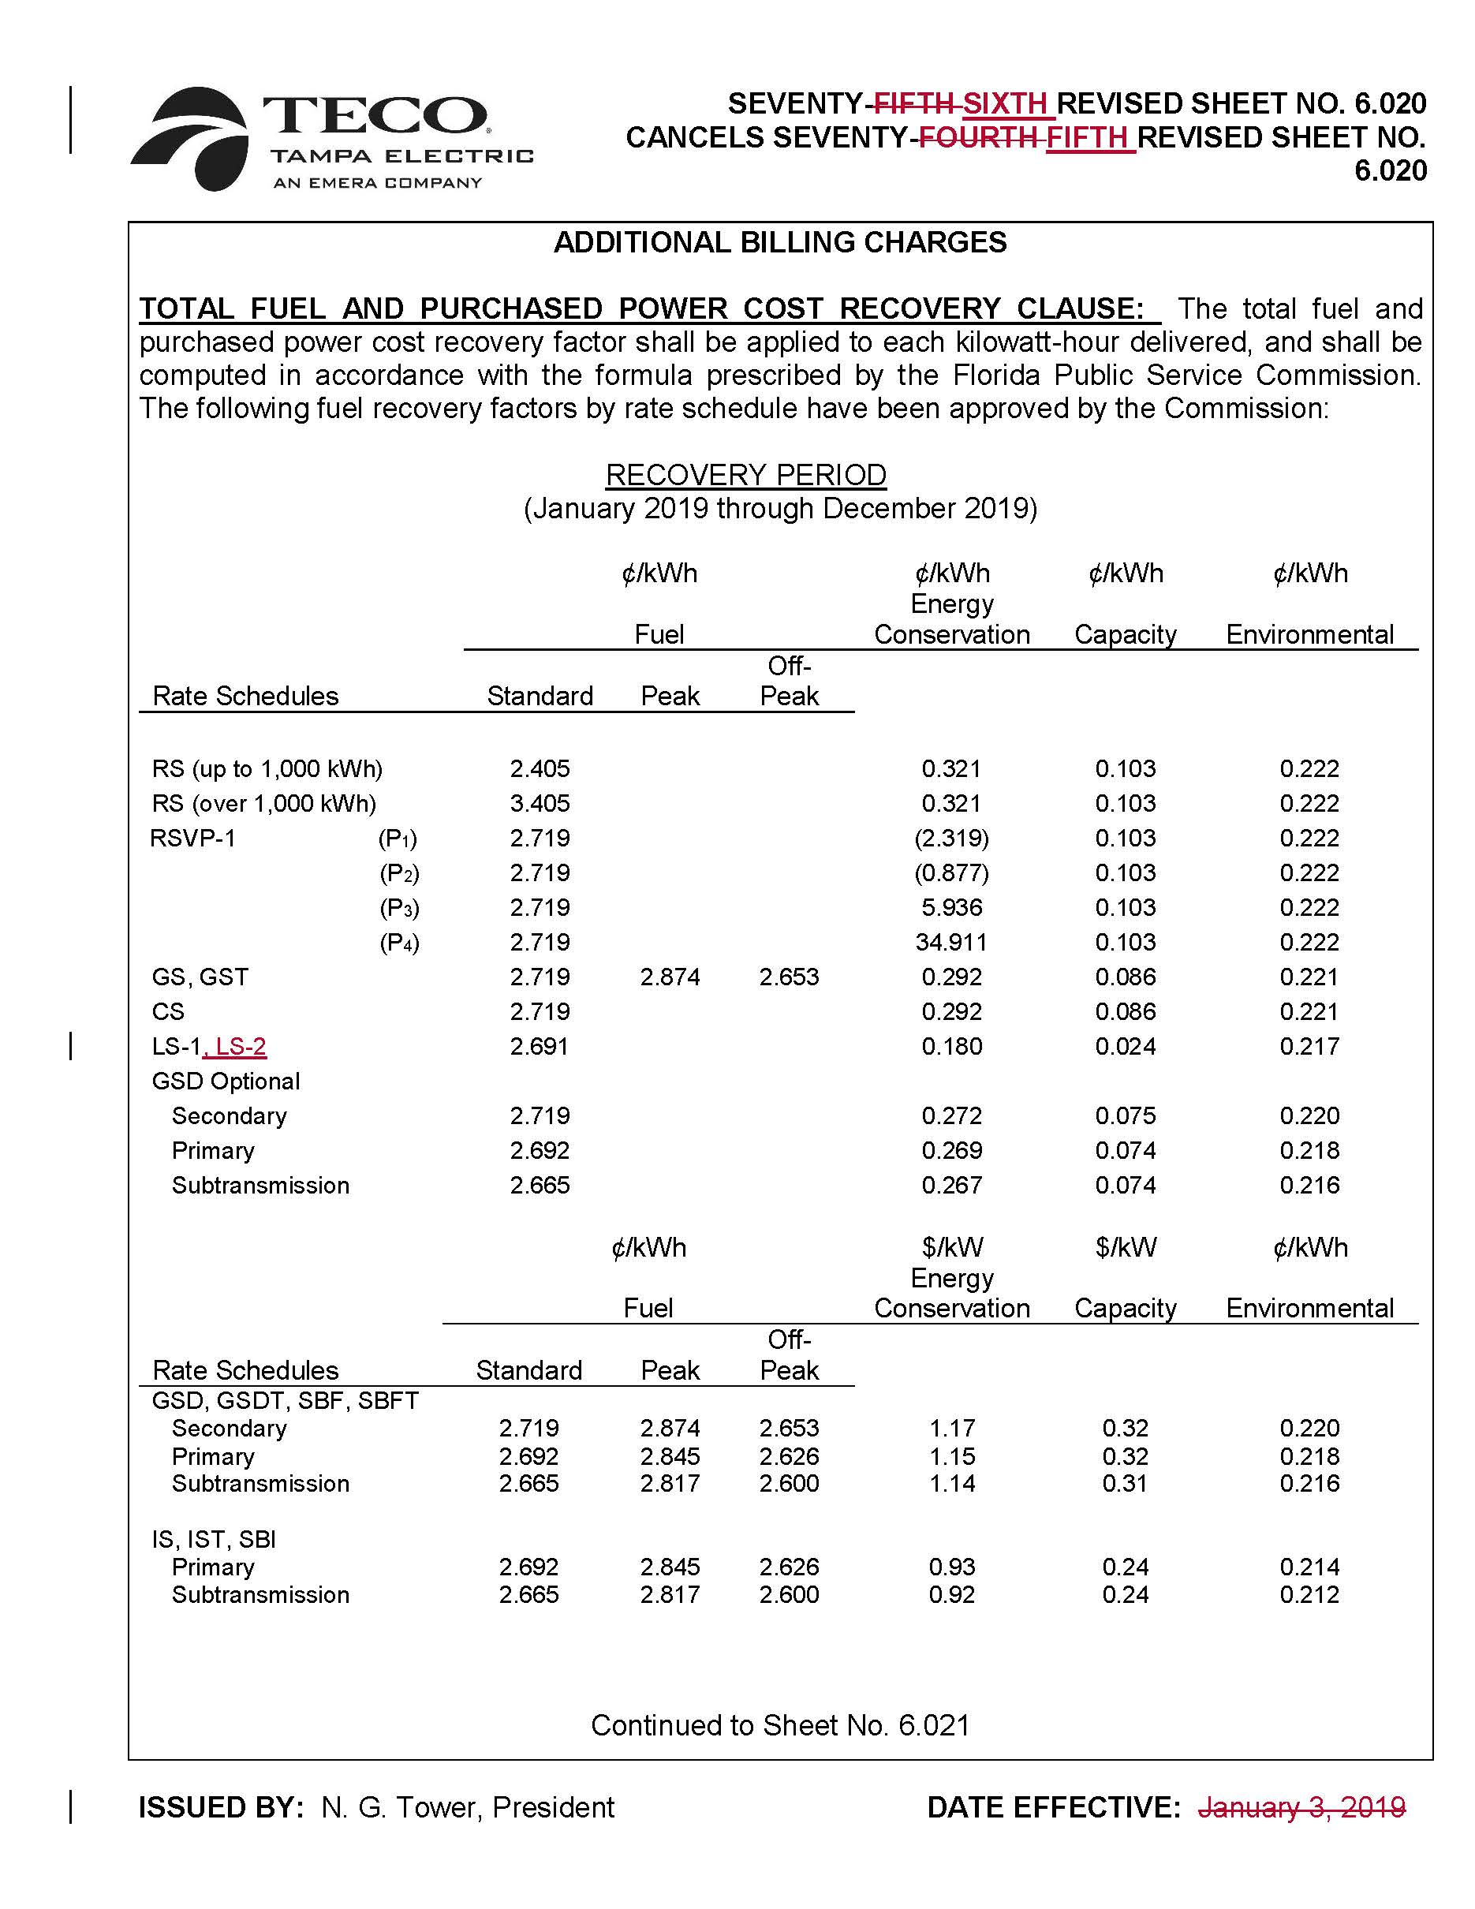

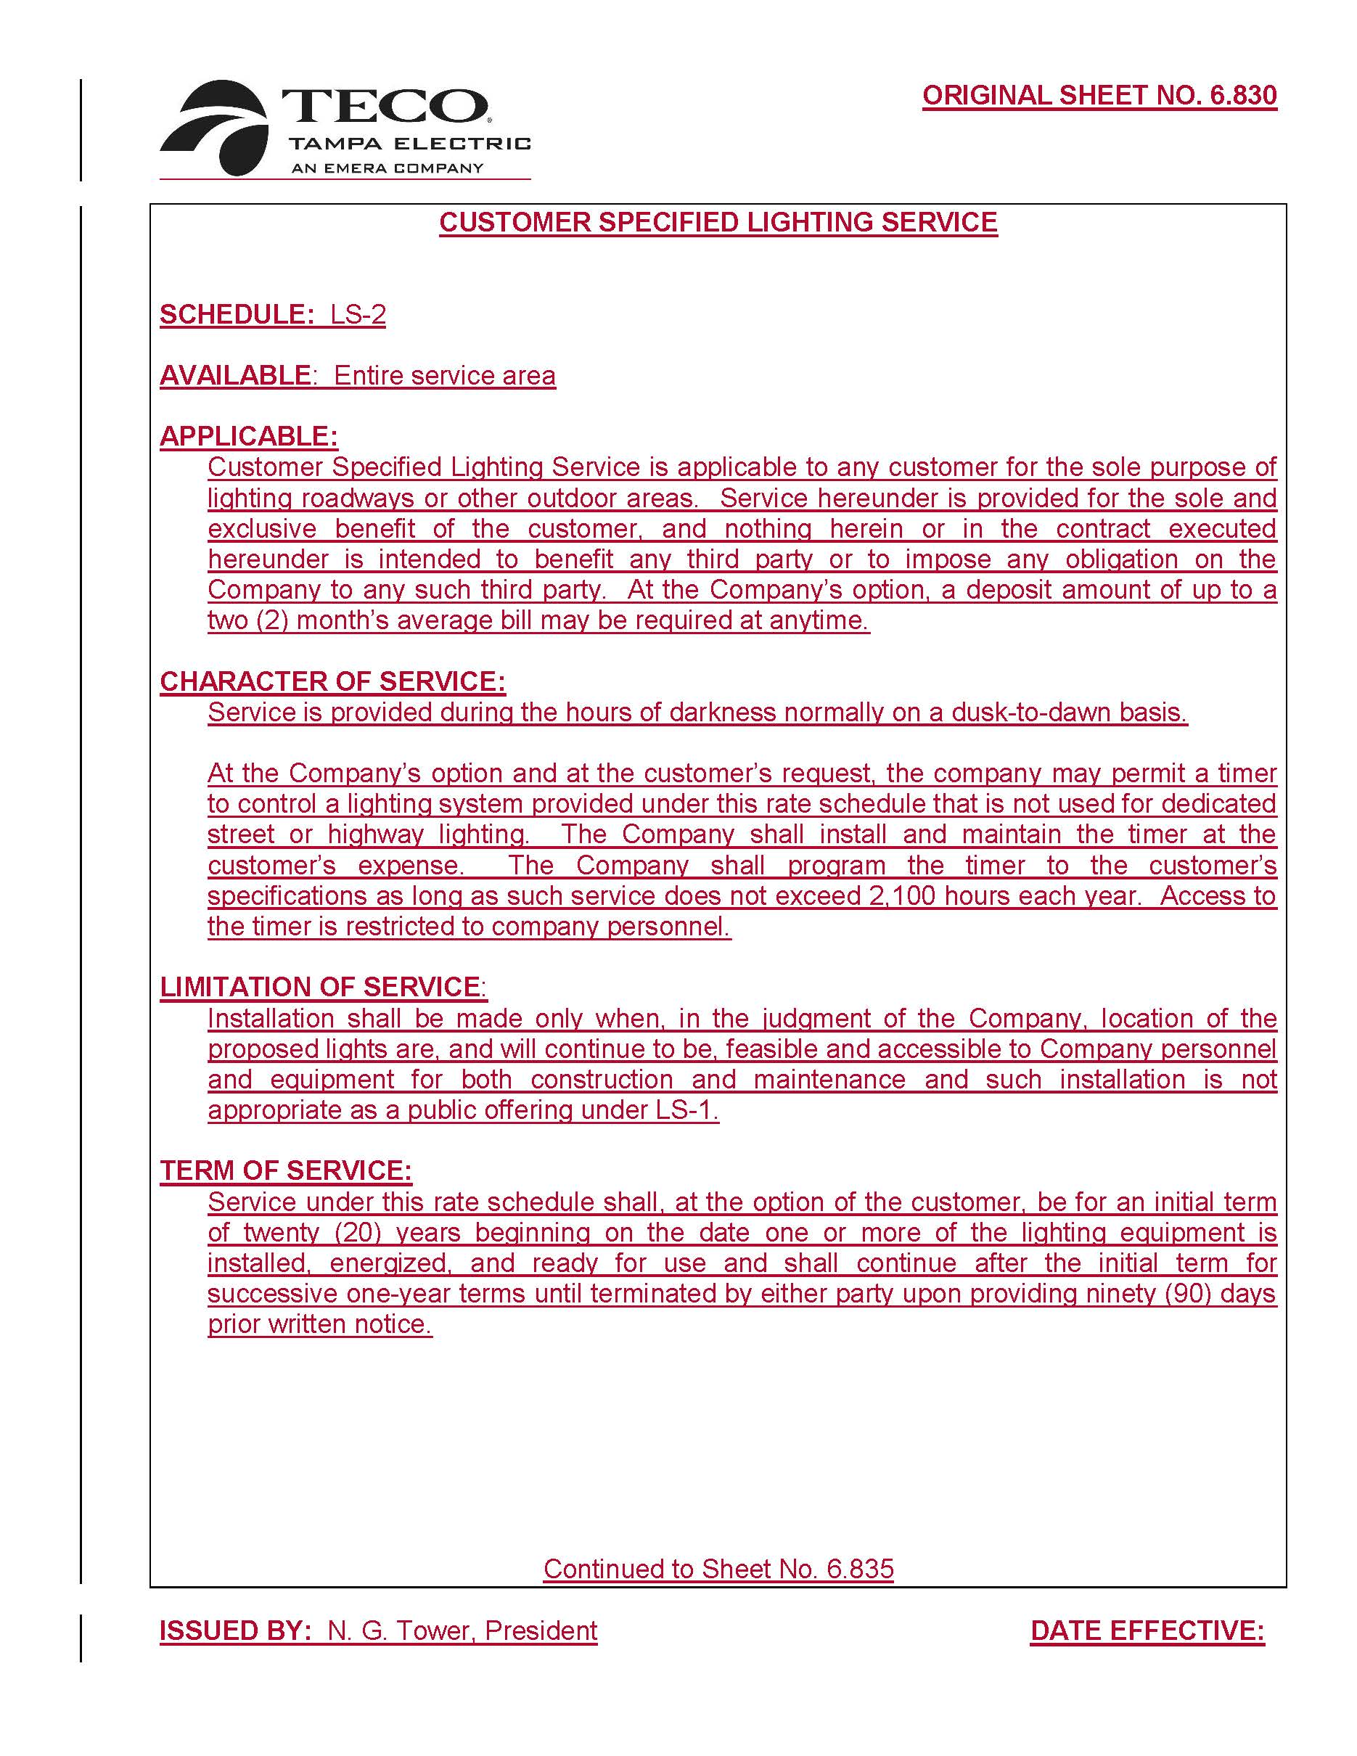

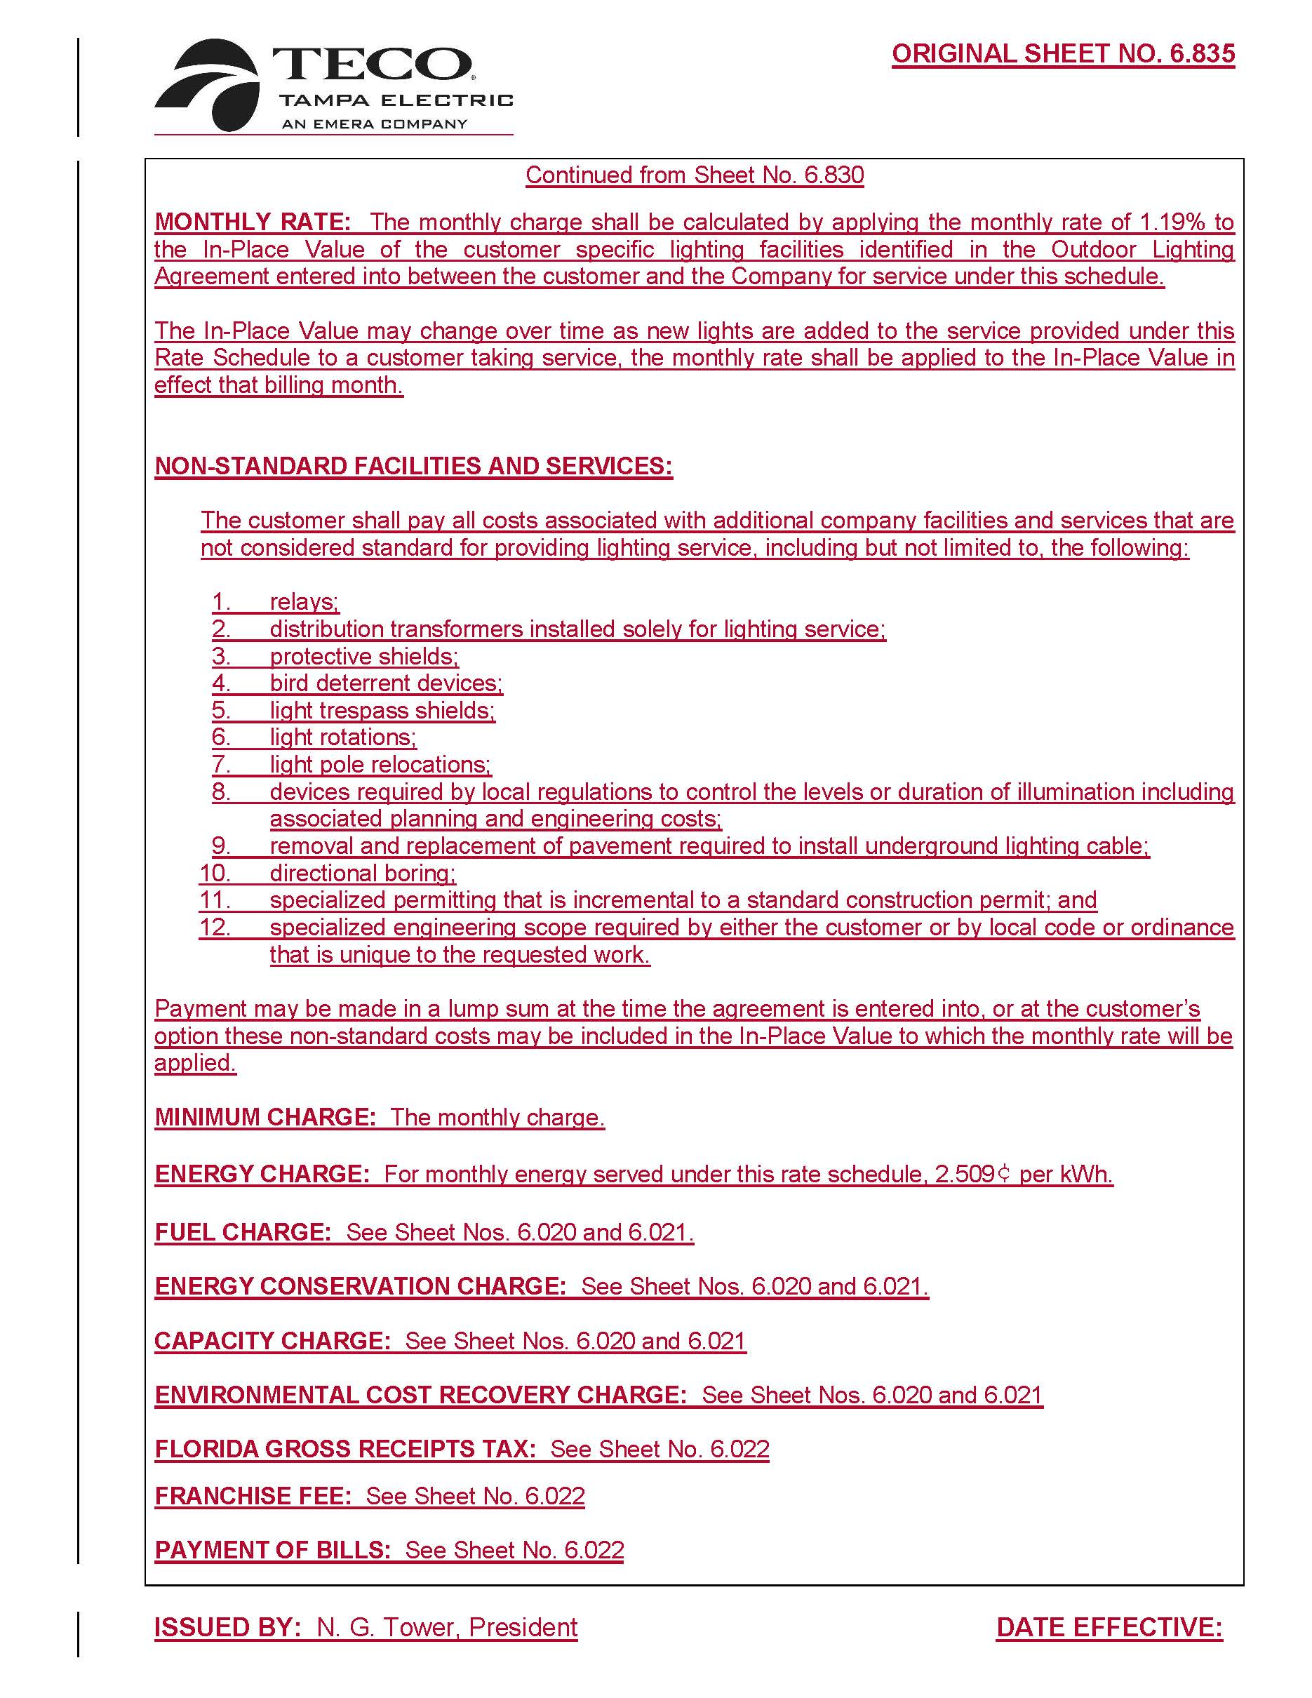

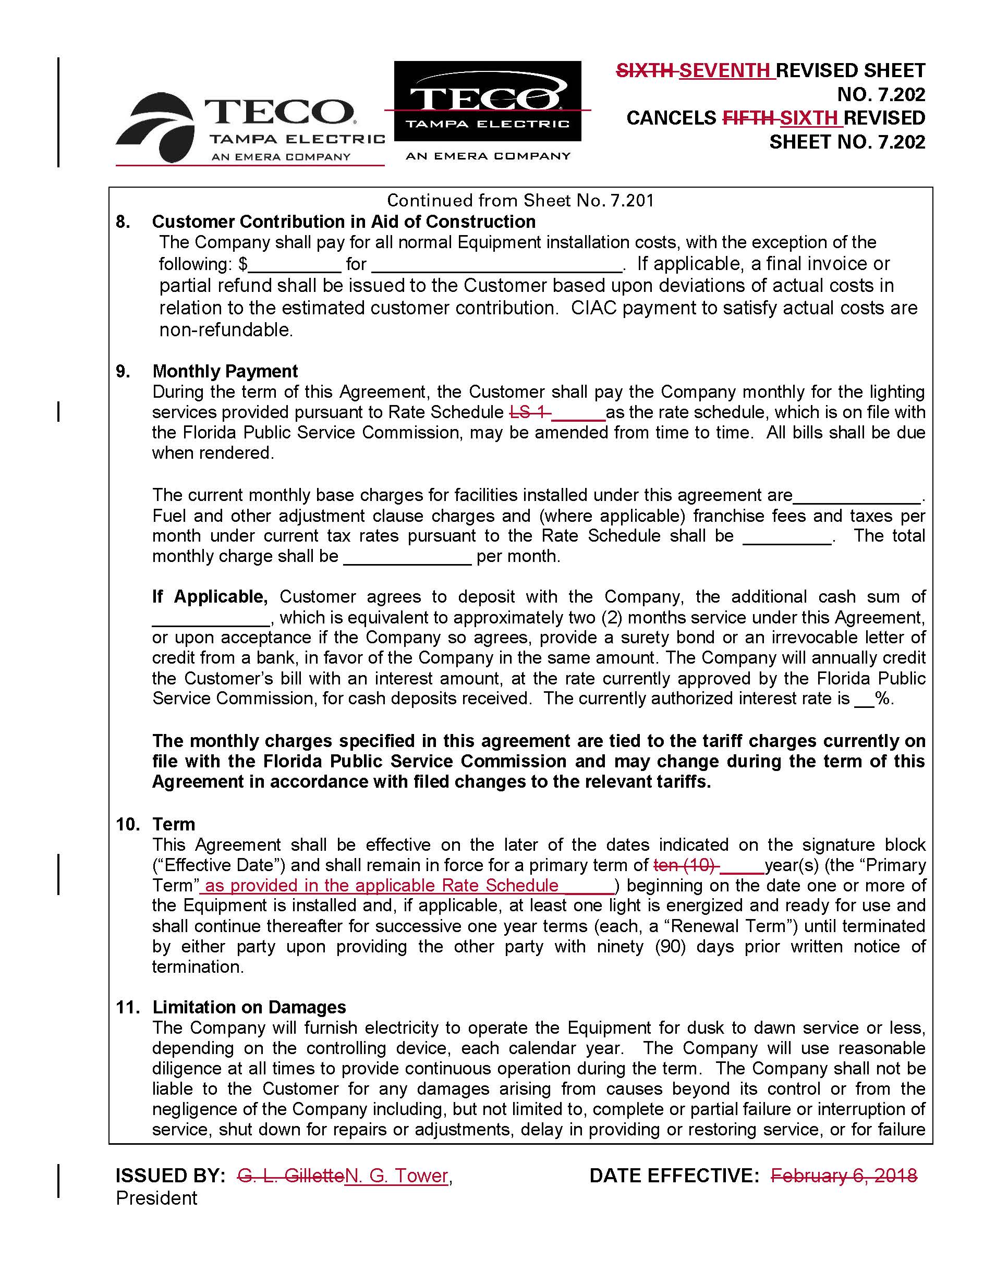

Order No. PSC-13-0443-FOF-EI, issued September 30, 2013, Docket No. 130040-EI, In re: Petition for rate increase by Tampa Electric Company.
Order No. PSC-02-0787-FOF-EI, issued June 10, 2002, Docket No. 010949-EI, In re: Request for rate increase by Gulf Power Company.
Order No. PSC-17-0115-TRF-EI, issued March 28, 2017, Docket No. 160245-EI, In re: Petition for approval of a new optional pilot LED streetlight tariff, by Florida Power & Light Company.

