State of Florida |  | Public Service Commission  Capital Circle Office Center ● 2540 Shumard Oak Boulevard  Tallahassee, Florida 32399-0850  -M-E-M-O-R-A-N-D-U-M-
DATE: | Feburary 21, 2019
TO: | Office of Commission Clerk (Teitzman)
FROM: | Division of Engineering (Wooten, Ellis, Wright)  Office of the General Counsel (Murphy)
RE: | Docket No. 20180073-EQ – Petition for approval of amended standard offer contract (Schedule COG-2) based on a combustion turbine avoided unit, by Duke Energy Florida, LLC.
AGENDA: | 03/05/19 – Regular Agenda – Proposed Agency Action – Interested Persons May Participate
COMMISSIONERS ASSIGNED: |  |  | All Commissioners
PREHEARING OFFICER: |  |  | Administrative
CRITICAL DATES: |  |  | None
SPECIAL INSTRUCTIONS: |  |  | None

Case Background
Section 366.91(3), Florida Statutes (F.S.), requires that each investor-owned utility (IOU) continuously offer to purchase capacity and energy from renewable energy generators and small qualifying facilities. Florida Public Service Commission (Commission) Rules 25-17.200 through 25-17.310, Florida Administrative Code (F.A.C.), implement the statute and require each IOU to file with the Commission, by April 1 of each year, a standard offer contract based on the next avoidable fossil fueled generating unit of each technology type identified in the Utility’s current Ten-Year Site Plan. On March 29, 2018, Duke Energy Florida, LLC (DEF) filed a petition for approval of its amended standard offer contract and rate schedule COG-2 based on its 2018 Ten-Year Site Plan. On June 19, 2018, the Commission issued Order No. PSC-2018-0314-PAA-EQ approving DEF’s petition.
On November 16, 2018, DEF filed a petition for approval to modify the delivery voltage adjustment factors (DVAFs) found on Sheet 9.458 of its standard offer contract. Pursuant to DEF’s standard offer contract, these voltage factors adjust the energy payments made to renewable energy generators and qualifying facilities located within DEF’s service territory to reflect line losses avoided by DEF based on the delivery voltage level at which the facility’s energy is received by DEF. DEF uses a value that is filed with the Federal Energy Regulatory Commission (FERC) every year on May 1 as a component of the DVAFs. On October 31, 2018, a settlement agreement was filed on behalf of DEF that alters DEF’s DVAFs beginning January 1, 2019. On January 28, 2019, the FERC issued a letter order, Duke Energy Fla., LLC, 166 FERC ¶ 61,057 (2019), approving the settlement agreement. DEF is not requesting modification of any other tariff sheets.
The Commission has jurisdiction over this standard offer contract pursuant to Sections 366.04 through 366.06 and 366.91, F.S.

Discussion of Issues

Issue 1:
Should the Commission approve Duke Energy Florida, LLC’s petition to adjust the delivery voltage adjustment factors found on Sheet 9.458 of its standard offer contract?

Recommendation:
Yes. FERC’s approval of DEF’s settlement agreement necessitates modification of two of the three delivery voltage adjustment factors found on Sheet 9.458 of DEF’s standard offer contract. The revised Sheet 9.458 provided by DEF reflects the necessary adjustments and should be approved by the Commission. (Wright)

Staff Analysis:
DEF conducts an annual system line loss study for the prior calendar year to determine delivery efficiencies throughout its transmission and distribution network. The results of this study are used to derive system line loss factors for its transmission, primary distribution, and secondary distribution voltage levels, which are filed with the FERC every year on May 1. These efficiency factors are used in the calculation of the DVAFs found on Sheet 9.458 of DEF’s standard offer contract. The current DVAFs are based on DEF’s 2017 line loss study and are 1.0150 for transmission, 1.0254 for primary distribution, and 1.0627 for secondary distribution.
On October 31, 2018, a settlement agreement was filed on behalf of DEF that alters DEF’s DVAFs beginning January 1, 2019. On January 28, 2019, the FERC approved the settlement agreement through its issuance of a letter order Duke Energy Fla., LLC, 166 FERC ¶ 61,057 (2019), included as Attachment A of this recommendation. In the settlement, DEF agreed to remove facilities owned by Seminole Electric Cooperative, Inc. (Seminole) and its members from the losses calculation, aligning delivery efficiency determination with the Network Integration Service Agreement between Seminole and DEF. The result was an increase in the derived transmission delivery efficiency of 0.01 percent, or a change from 98.52 percent to 98.53 percent. This change necessitates adjustment of two of the three DVAFs found on Sheet 9.458 of DEF’s standard offer contract. The updated DVAFs consist of a transmission DVAF of 1.0149 and a primary distribution DVAF of 1.0253. The revised Sheet 9.458, in type-and-strike format, is included as Attachment B of this recommendation. Staff has reviewed these updated values and recommends approval of DEF’s petition to amend Sheet 9.458 of its standard offer contract.

Issue 2:
Should this docket be closed?

Recommendation:
Yes. This docket should be closed upon issuance of a consummating order, unless a person whose substantial interests are affected by the Commission’s decision files a protest within 21 days of the issuance of the Commission’s Proposed Agency Action Order. Potential signatories should be aware that, if a timely protest is filed, DEF’s standard offer contract may subsequently be revised. (Murphy)

Staff Analysis:
This docket should be closed upon the issuance of a consummating order, unless a person whose substantial interests are affected by the Commission’s decision files a protest within 21 days of the issuance of the Commission’s Proposed Agency Action Order. Potential signatories should be aware that, if a timely protest is filed, DEF’s standard offer contract may subsequently be revised.

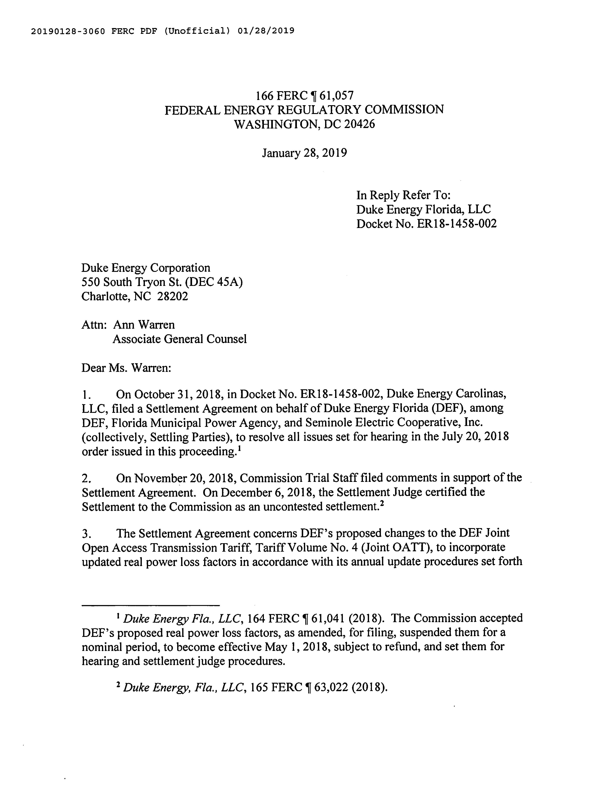
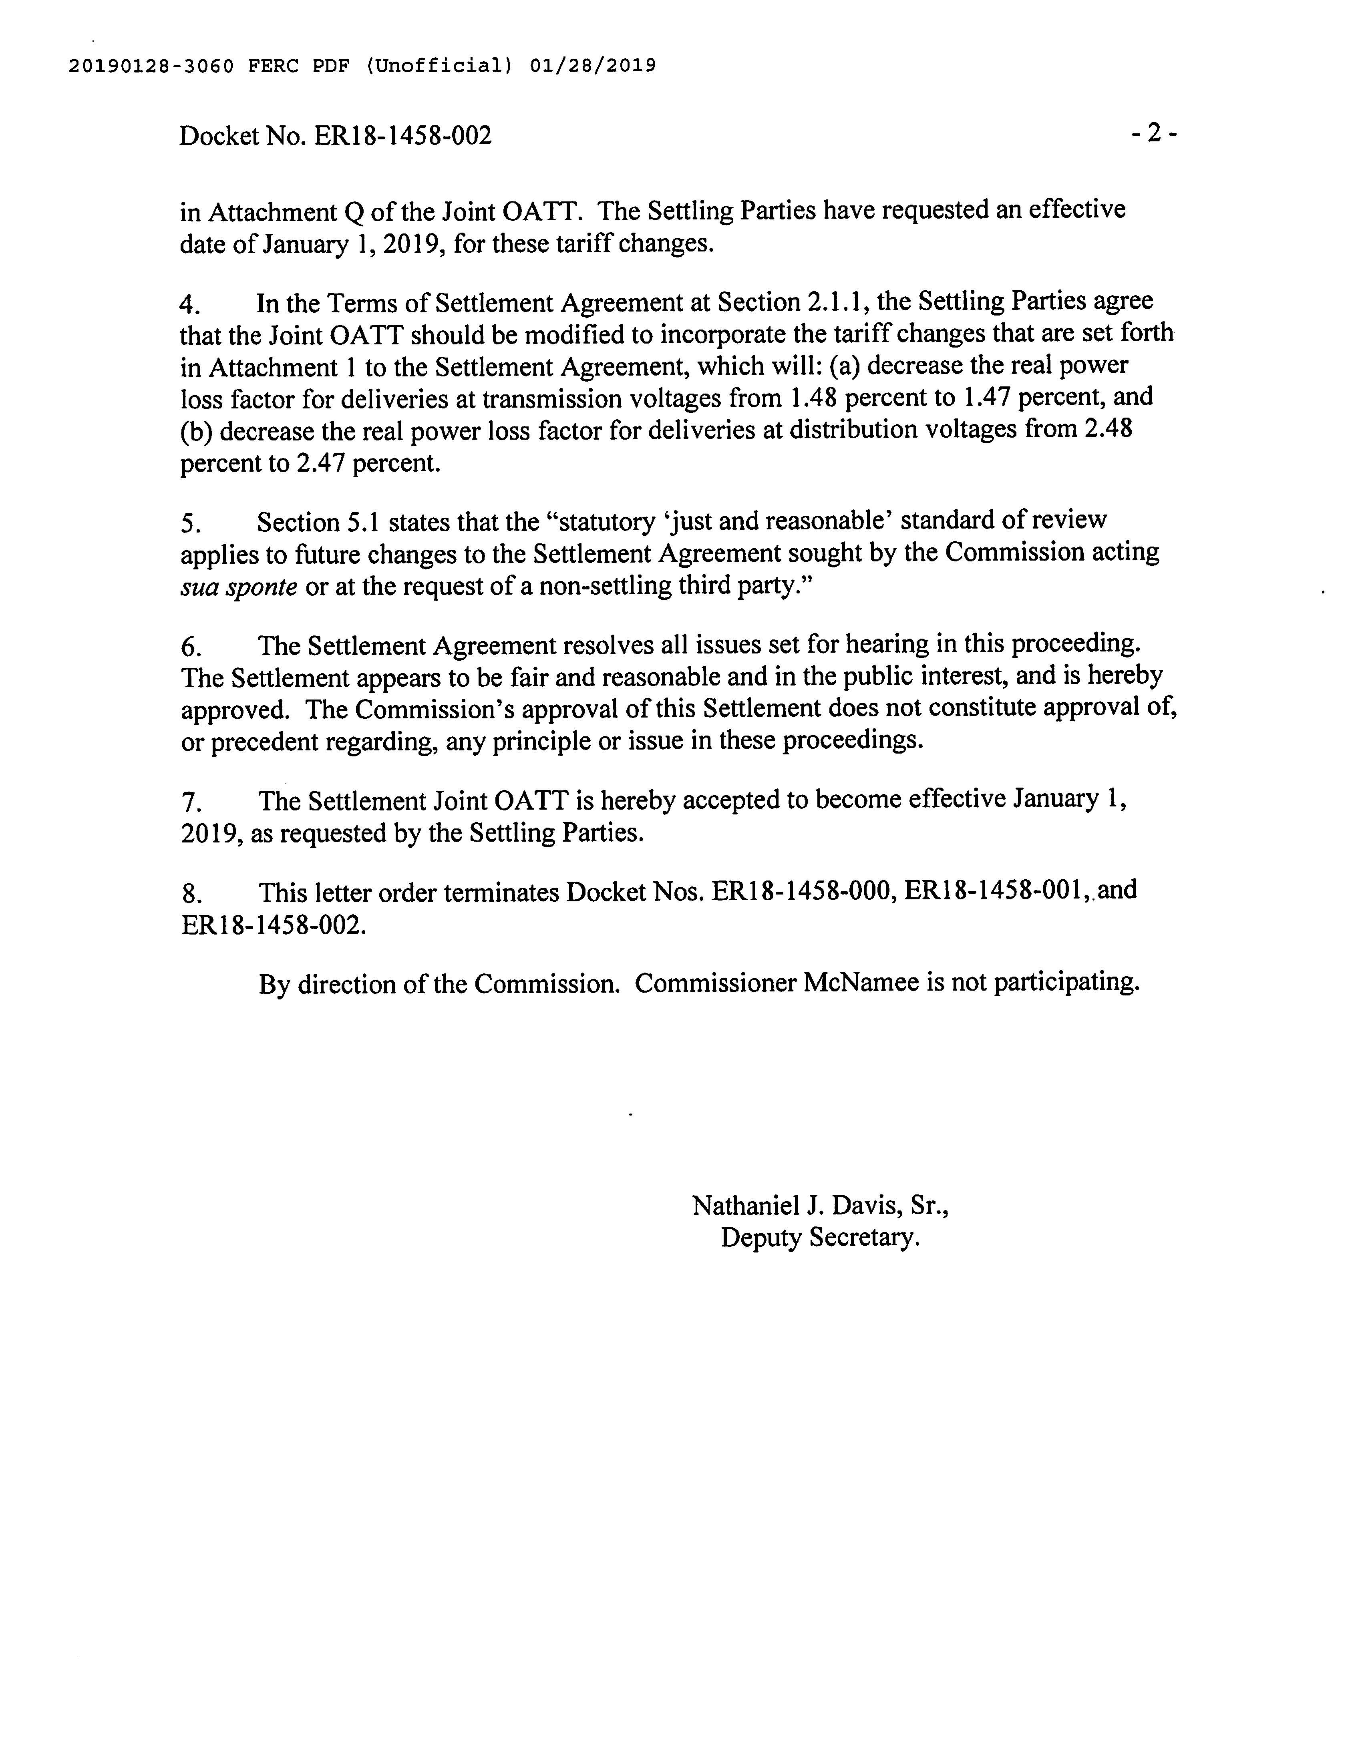
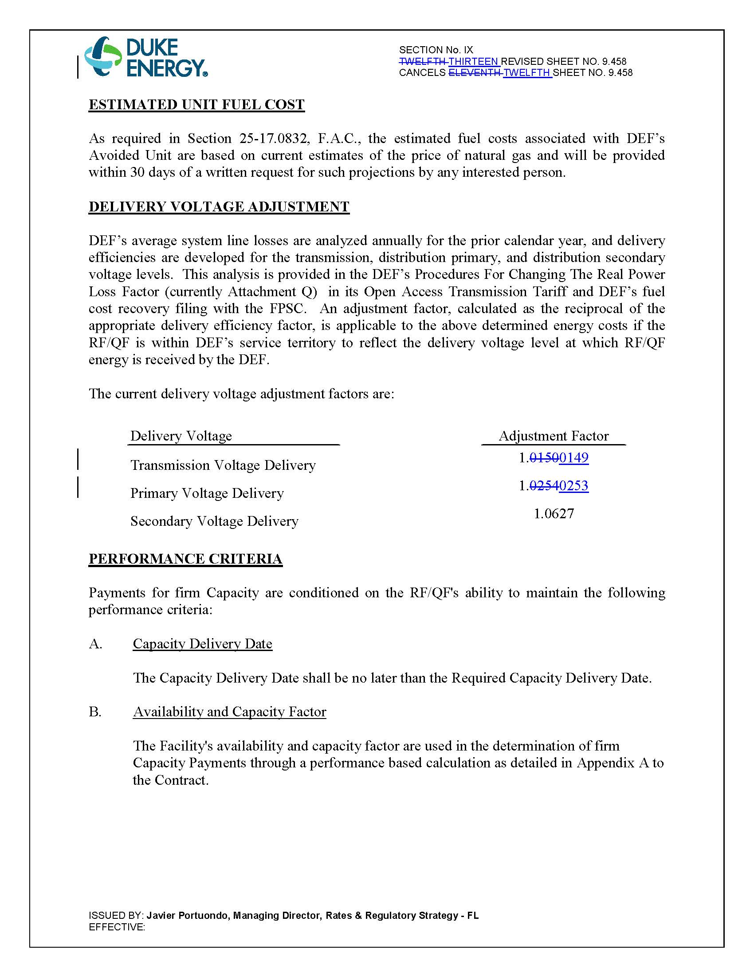

Order No. PSC-2018-0314-PAA-EQ, issued June 19, 2018, in Docket No. 20180073-EQ, In re: Petition for approval of amended standard offer contract (Schedule COG-2) based on a combustion turbine avoided unit, by Duke Energy Florida, LLC.
FERC Docket No. ER18-1458-002.

