State of Florida |  | Public Service Commission  Capital Circle Office Center ● 2540 Shumard Oak Boulevard  Tallahassee, Florida 32399-0850  -M-E-M-O-R-A-N-D-U-M-
DATE: | March 21, 2019
TO: | Office of Commission Clerk (Teitzman)
FROM: | Division of Engineering (Wright, Doehling, Ellis, King, Knoblauch, Wooten)  Division of Economics (Coston, Morgan, Wu)  Office of the General Counsel (DuVal, Dziechciarz)
RE: | Docket No. 20180186-GU – Petition for approval of demand side management goals and residential customer assisted and commercial walk-through energy audit programs, by Peoples Gas System.
AGENDA: | 04/02/19 – Regular Agenda – Proposed Agency Action – Interested Persons May Participate
COMMISSIONERS ASSIGNED: |  |  | All Commissioners
PREHEARING OFFICER: |  |  | Brown
CRITICAL DATES: |  |  | None
SPECIAL INSTRUCTIONS: |  |  | None

Case Background
Sections 366.80 through 366.83, and 403.519, Florida Statutes (F.S.), are known collectively as the Florida Energy Efficiency and Conservation Act (FEECA). Originally enacted in 1980, FEECA emphasizes the utilization of efficient and cost-effective demand-side renewable energy and conservation systems. Pursuant to Section 366.82, F.S., the Florida Public Service Commission (Commission) must review the conservation goals of each utility subject to FEECA at least every five years, and must require that each utility provide energy audit programs to its residential customers. The Commission may extend the audit program requirement to some or all commercial customers. Currently, all five investor-owned electric utilities and two municipal electric utilities are subject to FEECA. Peoples Gas System (PGS or Company) is the only natural gas utility subject to these requirements.
In 1980, the Commission adopted rules that set statewide conservation goals; however, these rules were repealed in 1990, following the sunset provision in FEECA. In 1996, the Commission adopted Rule 25-17.009, Florida Administrative Code (F.A.C.), which establishes a methodology for assessing the cost-effectiveness of demand-side management (DSM) programs for natural gas utilities. However, Rule 25-17.009, F.A.C., does not require goals to be set for natural gas utilities. Since 1981, PGS has offered a variety of conservation programs which have been reviewed by the Commission pursuant to Rule 25-17.015, F.A.C., the Energy Conservation Cost Recovery (ECCR) clause. The Company’s residential and commercial DSM programs were first approved by the Commission in 1990, with several modifications and additions being made since that time.
In October 2015, the State of Florida Auditor General issued Report No. 2016-022, which found the Commission had not fully implemented FEECA requirements for natural gas utilities. The report recommended that the Commission management either fully implement FEECA specifically as it applies to natural gas utilities or seek legislative clarification regarding whether the Commission is required to adopt energy conservation and DSM goals for natural gas utilities and whether natural gas utilities are to offer residential energy audits. Through several meetings both internally and with legislative staff, Commission management determined the best way to comply with the Auditor General’s findings was to request PGS, in a manner similar to that followed by the FEECA electric utilities, develop and file with the Commission annual conservation goals along with residential and commercial energy audit programs.
On October 15, 2018, PGS filed a petition for approval of its natural gas DSM goals for the period 2019-2028, and its residential and commercial energy audit programs. In response to staff-issued data requests, the Company provided updated numeric conservation goals.
The Commission has jurisdiction over this matter pursuant to Sections 366.80 through 366.83, and 403.519, F.S.

Discussion of Issues

Issue 1:
Are the Company’s proposed goals based on an adequate assessment of the full technical potential of all available demand-side and supply-side conservation and efficiency measures, including demand-side renewable energy systems?

Recommendation:
Yes. PGS has analyzed the maximum system-wide therm savings theoretically possible from implementation of DSM measures commercially available in Florida. As such, staff recommends that the updated Technical Potential seen in Table 1-1 is an adequate assessment of the full technical potential, and serves as an acceptable basis for the Company’s annual therm savings goals. (Wright, Doehling, Wu)

Staff Analysis:
Section 366.82(3), F.S., requires the Commission, in developing conservation goals, evaluate the technical potential of all available DSM measures applicable to a utility’s system. To facilitate this evaluation, PGS has provided an analysis of the maximum system-wide therm savings theoretically possible from implementation of DSM measures, regardless of cost and other barriers that may prevent installation or adoption. Staff has evaluated the development of this therm savings analysis, termed the Technical Potential, by reviewing each of its four parts: (1) the identification of the DSM measures to be evaluated; (2) the calculation of the theoretical per-site therm savings for each DSM measure; (3) the calculation of the system-wide therm savings for each DSM measure; and (4) the determination of system-wide therm savings in consideration of measure interactions.

DSM Measure Identification
PGS identified the DSM measures for inclusion in the Technical Potential by first compiling a list of technologies known to the Company to be commercially available in Florida that, when applied in a residential, commercial, or industrial setting, yield reductions in the use of natural gas. The Company then compared this list against other utility, state, and federal technical potential studies and technical reference manuals to identify any missing measures. Those measures found to be missing were filtered by commercial availability in Florida before being added to the list of DSM measures evaluated in PGS’ Technical Potential. Ultimately, 31 residential, 29 commercial, and 22 industrial measures addressing water heating, cooking, HVAC, laundry, and industrial process use-cases were evaluated. Staff recommends that the methodology used to compile the list of DSM measures evaluated in PGS’ Technical Potential is adequate.

Per-Site DSM Measure Savings
PGS calculated theoretical per-site therm savings for each DSM measure. Similar to the methodology used by electric FEECA utilities, only the savings from new, replaced, or retrofitted measures that surpassed those savings based on minimum appliance energy efficiencies in the Florida Building Code or the associated Federal Appliance Efficiency Standards, whichever greater, were counted. Energy consumption parameters used in savings calculations were derived from a combination of state and national industry sources, current building code and appliance standards, and a review of historical DSM program activity. In response to staff-issued data requests, the Company provided updated theoretical per-site therm savings. Staff recommends that the methodology used by PGS in the updated calculations adequately assesses the theoretical per-site therm savings of the DSM measures evaluated.

System-wide DSM Measure Savings
PGS calculated system-wide theoretical therm savings on a per-measure basis by applying the per-site therm savings (which were previously calculated) to modified counts of its sector-specific customer populations (applicable populations). The Company utilized the 2019 residential and small-commercial population projections, discussed in Issue 2, as the basis for both sectors’ applicable population. The basis of the applicable population for industrial DSM measures, however, was a simple count of PGS’ 62 industrial and large commercial customers. PGS then modified the baseline applicable populations for each DSM measure to account for existing measure prevalence and incompatibility with a customer’s premises, as indicated by the Company’s recent residential equipment market survey and a review of the characteristics of its commercial and industrial customer populations. Staff recommends that the methodology used by PGS to calculate system-wide theoretical therm savings on a per-measure basis is adequate.

Consideration of Measure Interactions
To arrive at its final determination of the Technical Potential, PGS took into account measure interactions, overlapping effects, and potential rebound effects when combining the system-wide therm savings of all evaluated DSM measures. The Company approached adjustments for measure interactions by selecting DSM measure input assumptions that would maximize the Technical Potential. Similarly, PGS addressed overlapping effects by including in the final sum only those DSM measures that resulted in the maximum Technical Potential. PGS examined the potential for rebound effects in its development of the Technical Potential, but did not find any supporting evidence. Staff recommends that PGS took adequate consideration of measure interaction, overlapping effects, and potential rebound effects in its final determination of the Technical Potential. Using the updated therm savings calculations, PGS developed the Technical Potential seen in Table 1-1.

Table 1-1
2019 Technical Potential
Sector | Therm Savings
Residential | 60,134,211
Commercial | 150,064,380
Industrial | 246,275,380
Total | 456,473,972
Source: Document No. 03158-2019

Conclusion
PGS has analyzed the maximum system-wide therm savings theoretically possible from implementation of DSM measures commercially available in Florida. As such, staff recommends that the updated Technical Potential seen in Table 1-1 is an adequate assessment of the full technical potential, and serves as an acceptable basis for the Company’s annual therm savings goals.

Issue 2:
What residential and commercial annual therm savings goals should be established for the period 2019-2028?

Recommendation:
Staff recommends that the Commission establish the annual therm savings seen in Table 2-1 as PGS’ annual conservation goals for the period 2019-2028. The Company’s proposed conservation goals adequately address the considerations enumerated in Section 366.82(3), F.S. (Wright, Doehling, Wooten, Wu)

Staff Analysis:
Section 366.82(2), F.S., requires the Commission to adopt appropriate conservation goals to promote energy efficiency and the development of DSM programs. Section 366.82(3), F.S., states that, in establishing these goals, the Commission shall take into consideration: (1) the costs and benefits to customers participating in a program; (2) the costs and benefits to the general body of ratepayers; (3) the need for incentives to promote both customer-owned and utility-owned energy efficiency and demand-side renewable energy systems; and (4) the costs imposed by state and federal regulations on the emission of greenhouse gases.
PGS has proposed annual conservation goals for the years 2019-2028 which focus on achieving overall therm usage reductions at residential and small-commercial end-use sites. The Company has based these goals on achievable therm savings from its portfolio of current Commission-approved DSM programs. The residential DSM programs were approved by the Commission in 2010, and the commercial programs were approved by the Commission in 2014. These programs are comprised of eight residential and ten small-commercial DSM measures, which each implement use-specific energy-saving technology at natural gas points-of-use throughout a customer’s property. Because the Company’s DSM programs serve as the basis for its proposed annual conservation goals, staff first reviewed these programs, taking into consideration those factors enumerated in Section 366.82(3), F.S. Staff then evaluated the development of PGS’ proposed achievable therm savings by reviewing each of its three parts: (1) the projection of DSM measure participation over the years 2019-2028; (2) the calculation of achievable per-site therm savings for each DSM measure; and (3) the projection of achievable annual therm savings over the 2019-2028 period. Staff notes that PGS did not propose conservation goals, nor has incorporated any DSM measures, into its DSM portfolio for large commercial or industrial customers. This is because these customers are entirely either natural gas fired cogenerators or interruptible customers and, per Order No. 23576, these two rate classes are excluded from cost recovery through the ECCR clause.

Benefits and Costs to Participants and the General Body of Ratepayers
Section 366.82(3)(a), F.S., requires the Commission take into consideration the costs and benefits to customers participating in a program. Section 366.82(3)(b), F.S., requires the Commission take into consideration the costs and benefits to the general body of ratepayers as a whole, including utility incentives and participant contributions. Per Rule 25-17.009, F.A.C., utilities seeking cost recovery for an existing, new, or modified demand side management program must file the cost effectiveness test results of the Participants Test and the Rate Impact Measure Test. The Participants Test measures the impact of a program on the participating customers. In 2010 and 2014, all PGS residential and commercial programs passed the Participants Test with scores above 1.0., The Gas Rate Impact Measure (Gas RIM) Test, a modified version of the Rate Impact Measure Test specific to natural gas utilities, is an indirect measure of the program impact on customer rates that addresses utility incentives and participation. In 2010 and 2014, all PGS residential and commercial programs passed the Gas RIM with scores above 1.0., Therefore, staff recommends that both Sections 366.82(3)(a) and (b), F.S., are adequately addressed by the proposed DSM goals.

Need for Incentives
Section 366.82(3)(c), F.S., requires the Commission take into consideration the need for incentives to promote both customer-owned and utility-owned energy efficiency and demand-side renewable energy systems. As stated previously, the proposed DSM goals are based upon PGS’ current Commission approved DSM programs. The current residential DSM programs were approved in 2010, and the Commission found that the cash incentive allowances were cost-effective and did not impose an undue rate impact on PGS customers’ monthly bills. The current commercial DSM programs were approved in 2014, when the Commission also found the incentive levels of these programs appropriate. The design of the incentives for both residential and commercial programs included consideration of free ridership and, thus, balanced incentive effectiveness with the ability of these programs to contribute to the defrayal of the costs associated with the installation of natural gas supply lines, internal piping, venting and equipment. Therefore, staff recommends that Section 366.82(3)(c), F.S., is adequately addressed by the proposed DSM goals.

Greenhouse Gas Emissions
Section 366.82(3)(d), F.S., requires the Commission take into consideration the costs imposed by state and federal regulations on the emission of greenhouse gases. Currently, there are no costs imposed by state and federal regulations on the emissions of greenhouse gases. Pursuant to Section 366.82(6), F.S., the Commission has the authority to change conservation goals for a reasonable cause. Once compliance costs associated with any regulations on the emission of greenhouse gases are established, the Commission may review and, if appropriate, modify goals.

Projection of DSM Measure Participation
PGS began the process of forecasting DSM measure participation by analyzing customer growth rates. Each of the Company’s 14 divisions maintains both a residential and a small-commercial customer model developed using Itron’s MetrixND forecasting tool. These models primarily use population growth as inputs to forecast division-specific customer growth, with additional variables used to adjust for customer seasonality, unexpected events, and other variations. PGS combined the customer growth projections of each of its divisions to derive a total residential and small-commercial customer forecast for the years 2019-2028. Yearly growth rates were derived from the composite projections. Residential customers are projected to grow at an average rate of 2.17 percent per year over the 2019-2028 period, while over the same period, commercial customers are expected to grow at an average yearly rate of 2.48 percent. PGS states that yearly growth rates calculated in this manner have historically approximated the growth in yearly participation rates of the Company’s DSM measures. Accordingly, PGS used these customer growth rates to escalate DSM measure participation through the 2019-2028 period. This method assumes that as the customer population grows, the number of customers enrolled in DSM measures will increase proportionally. After reviewing the information presented, including the major assumptions, key data sources and criteria utilized to develop and evaluate its customer forecast, staff recommends that PGS’ forecasting method and the resulting customer forecast is appropriate for use in DSM goal setting in the instant docket.

Achievable Per-Site DSM Measure Savings
PGS next calculated achievable per-site therm savings for each DSM measure currently found in its DSM program portfolio. Similar to the methodology used in the Technical Potential discussed in Issue 1, only the savings from measure implementation that exceeded those savings based on minimum appliance energy efficiencies in the Florida Building Code or the associated Federal Appliance Efficiency Standards, whichever greater, were counted. Energy consumption parameters used in DSM measure savings calculations were derived from a combination of state and national industry sources, responses to customer surveys, and a review of historical DSM program activity. In response to staff-issued data requests, the Company provided updated achievable per-site therm savings. Staff recommends that the methodology used by PGS in the updated calculations, as well as the incorporation of marketplace forces into the determination of achievable therm savings, result in per-site savings that adequately represent those savings likely to come from real-world implementation of the DSM measures considered.

Achievable Annual Therm Savings
By combining projected yearly DSM measure participation with the updated DSM measure achievable per-site therm savings, PGS derived achievable annual therm savings over the 2019-2028 period. These savings can be seen in Table 2-1, alongside a cumulative count of projected savings, and are the Company’s proposed annual conservation goals for the period 2019-2028. Staff recommends that the Commission establish the annual therm savings seen in Table 2-1 as PGS’ annual conservation goals for the period 2019-2028.

Table 2-1
2019-2028 Achievable Therm Savings For All Current DSM Measures
Year | Residential |  | Small-commercial |  | Combined
 | Yearly | Cumulative | Yearly | Cumulative | Yearly | Cumulative
2019 | 338,439 | 338,439 | 216,155 | 216,155 | 554,594 | 554,594
2020 | 347,108 | 685,548 | 222,062 | 438,217 | 569,170 | 1,123,764
2021 | 355,569 | 1,041,116 | 227,968 | 666,184 | 583,537 | 1,707,301
2022 | 363,728 | 1,404,845 | 233,833 | 900,017 | 597,561 | 2,304,862
2023 | 371,562 | 1,776,406 | 239,661 | 1,139,678 | 611,222 | 2,916,084
2024 | 379,045 | 2,155,451 | 245,457 | 1,385,135 | 624,502 | 3,540,586
2025 | 386,682 | 2,542,133 | 251,338 | 1,636,473 | 638,019 | 4,178,605
2026 | 394,475 | 2,936,608 | 257,304 | 1,893,777 | 651,779 | 4,830,385
2027 | 402,429 | 3,339,037 | 263,357 | 2,157,134 | 665,786 | 5,496,171
2028 | 410,546 | 3,749,583 | 269,500 | 2,426,634 | 680,046 | 6,176,217
Source: Document No. 03158-2019

Other Matters
PGS has indicated that, because these savings are based upon current Commission-approved DSM programs, the net effect of establishing these savings as DSM goals for PGS is zero additional cost to customers, excluding those costs associated with the new Residential Customer Assisted Energy Audit and the Commercial Walk-Through Energy Audit, discussed in Issue 3. The Company intends to review its DSM goals every five years, with the next review to occur in 2023, to align it with the Commission’s periodic conservation goals review as required by Section 366.82(6), F.S. Additionally, PGS will provide annual DSM reports on the achievements of incremental natural gas therm savings by March 1 of each year. Staff intends to monitor these annual reports in an effort to refine the natural gas goal-setting process used in this proceeding.

Conclusion
Staff recommends that the Commission establish the annual therm savings seen in Table 2-1 as PGS’ annual conservation goals for the period 2019-2028. The Company’s proposed conservation goals adequately address the considerations enumerated in Section 366.82(3), F.S.

Issue 3:
Should the Commission approve the Company’s new residential and commercial audit programs?

Recommendation:
Yes. The scope of both the Residential Customer Assisted Energy Audit and the Commercial Walk-Through Energy Audit meet the requirements established by FEECA. Accordingly, PGS should be allowed recovery of reasonable and prudent expenditures associated with these programs through the ECCR clause. (Wright, Doehling)

Staff Analysis:
Pursuant to Section 366.82(11), F.S., the Commission requires FEECA utilities to offer energy audits to its residential customers. The Commission may extend the audit program requirement to some or all commercial customers. PGS has proposed two new audit programs: (1) the Residential Customer Assisted Energy Audit (RA), and (2) the Commercial Walk-Through Energy Audit (CA). Staff has analyzed the scope of these audits and preliminary estimates of their administrative costs on a per-audit basis.

Audit Scope
Both the RA and CA are designed to increase customer awareness of natural gas energy use on their premises, and are offered for free to all existing PGS customers of the appropriate rate class that are located within PGS’ service area. The RA is an online energy audit that combines responses to survey questions with either historical or customer-entered natural gas energy usage to provide personalized conservation recommendations. The CA is a walk-through energy audit conducted by a trained commercial energy auditor who inspects the equipment and systems utilized in a customer’s facility, and recommends a tailored list of energy conservation programs aimed at increasing the customer’s overall efficiency. Both audits facilitate customer participation in PGS’ DSM programs. Program descriptions and standards for both audits can be found in Attachment A of this recommendation.

Audit Costs
Staff performed a preliminary analysis of the administrative costs, on a per-audit basis, of both audit programs and believes them to be reasonably comparable to other utilities’ audit program costs. However, staff notes that the determination of reasonable and prudent expenditures should occur within ECCR clause proceedings, and that this preliminary analysis was performed for informational purposes only. PGS has indicated that, given program approval, audit expenses and participation will be reported to the Commission through its annual FEECA DSM and ECCR filings.

Conclusion
The scope of both the RA and the CA meet the requirements established by FEECA. Accordingly, PGS should be allowed recovery of reasonable and prudent expenditures associated with these programs through the ECCR clause.

Issue 4:
Should this docket be closed?

Recommendation:
Yes. If no person whose substantial interests are affected by the proposed agency action (PAA) files a protest within 21 days of the issuance of the PAA Order, a Consummating Order should be issued and the docket should be closed. If the Commission approves the proposed Residential Customer Assisted Energy Audit and the Commercial Walk-Through Energy Audit programs, those programs should become effective on the date of the Consummating Order. If a protest is filed within 21 days of the issuance of the PAA Order, the programs should not be implemented until after the resolution of the protest. Within 90 days of the issuance of the final order, PGS should file a demand-side management plan designed to meet the Utility’s approved goals. (DuVal, Dziechciarz)

Staff Analysis:
If no person whose substantial interests are affected by the proposed agency action (PAA) files a protest within 21 days of the issuance of the PAA Order, a Consummating Order should be issued and the docket should be closed. If the Commission approves the proposed RA and CA programs, those programs should become effective on the date of the Consummating Order. If a protest is filed within 21 days of the issuance of the PAA Order, the programs should not be implemented until after the resolution of the protest. Within 90 days of the issuance of the final order, PGS should file a demand-side management plan designed to meet the Utility’s approved goals.

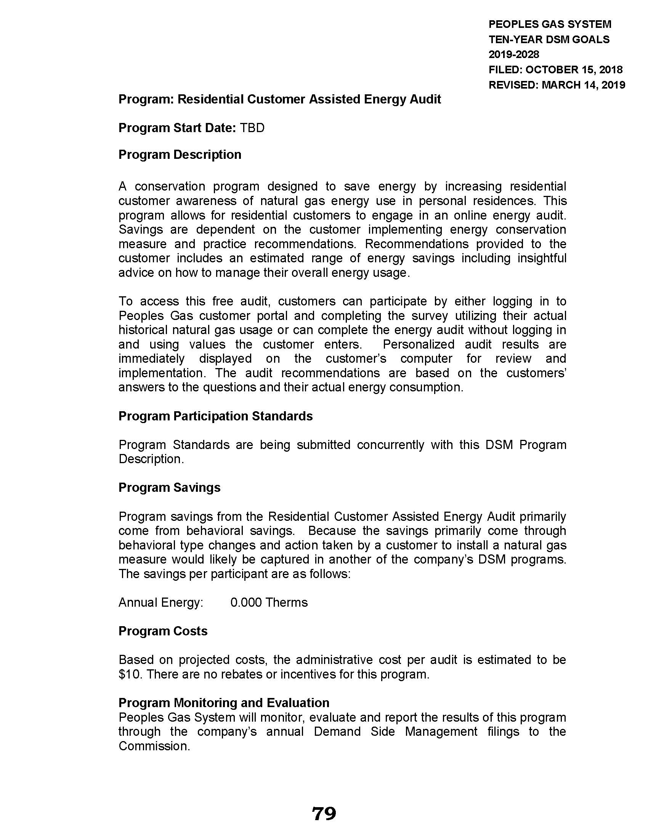

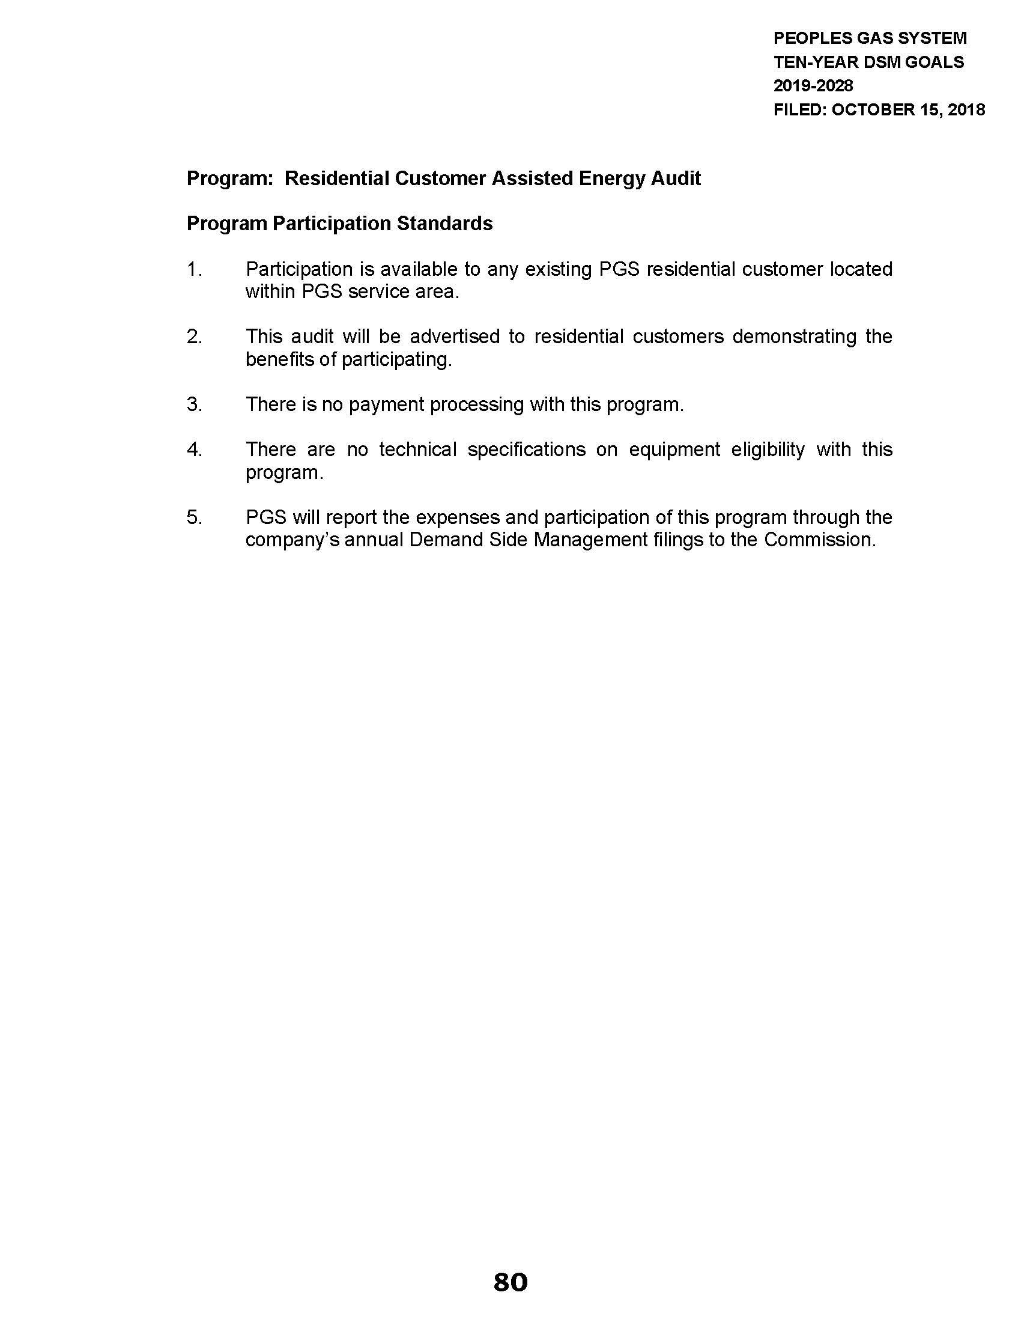

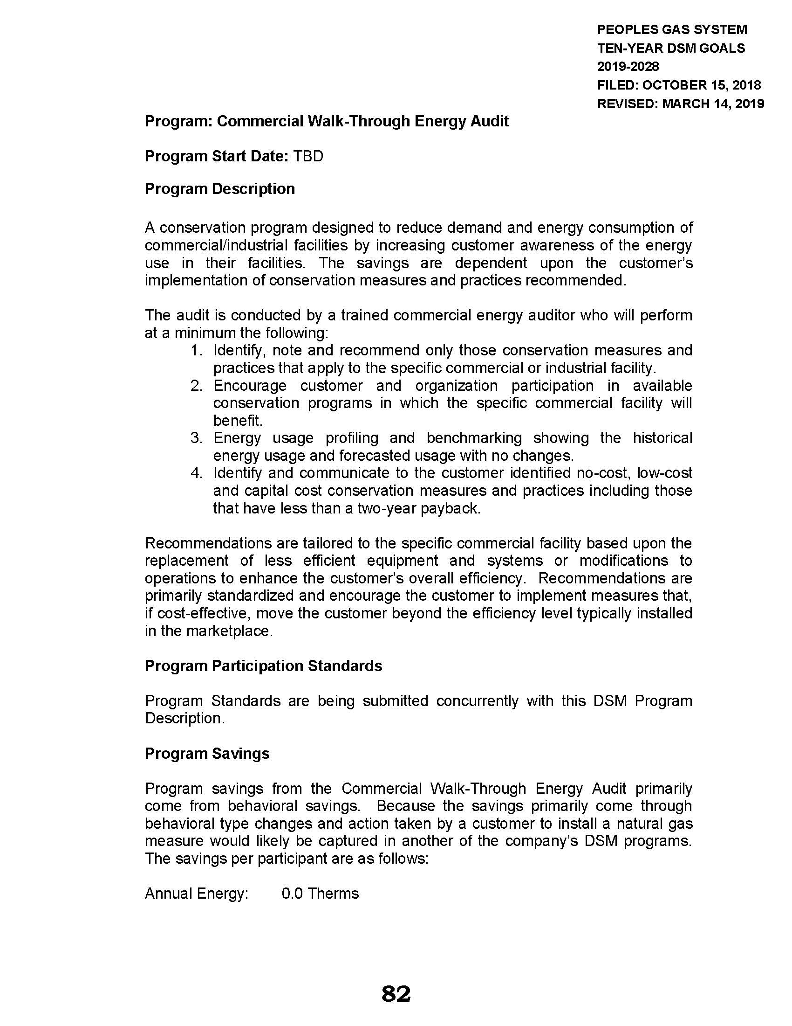

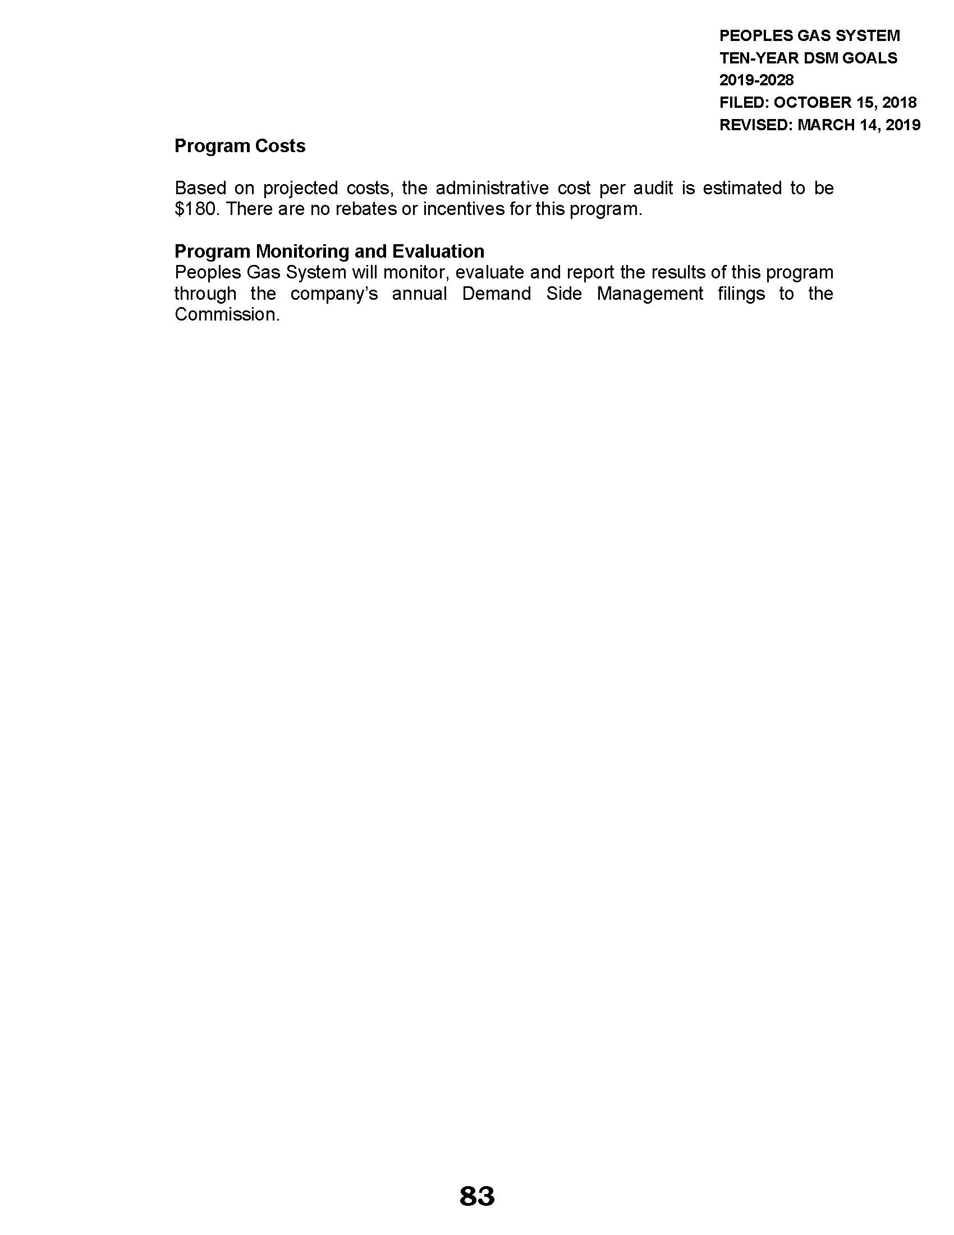

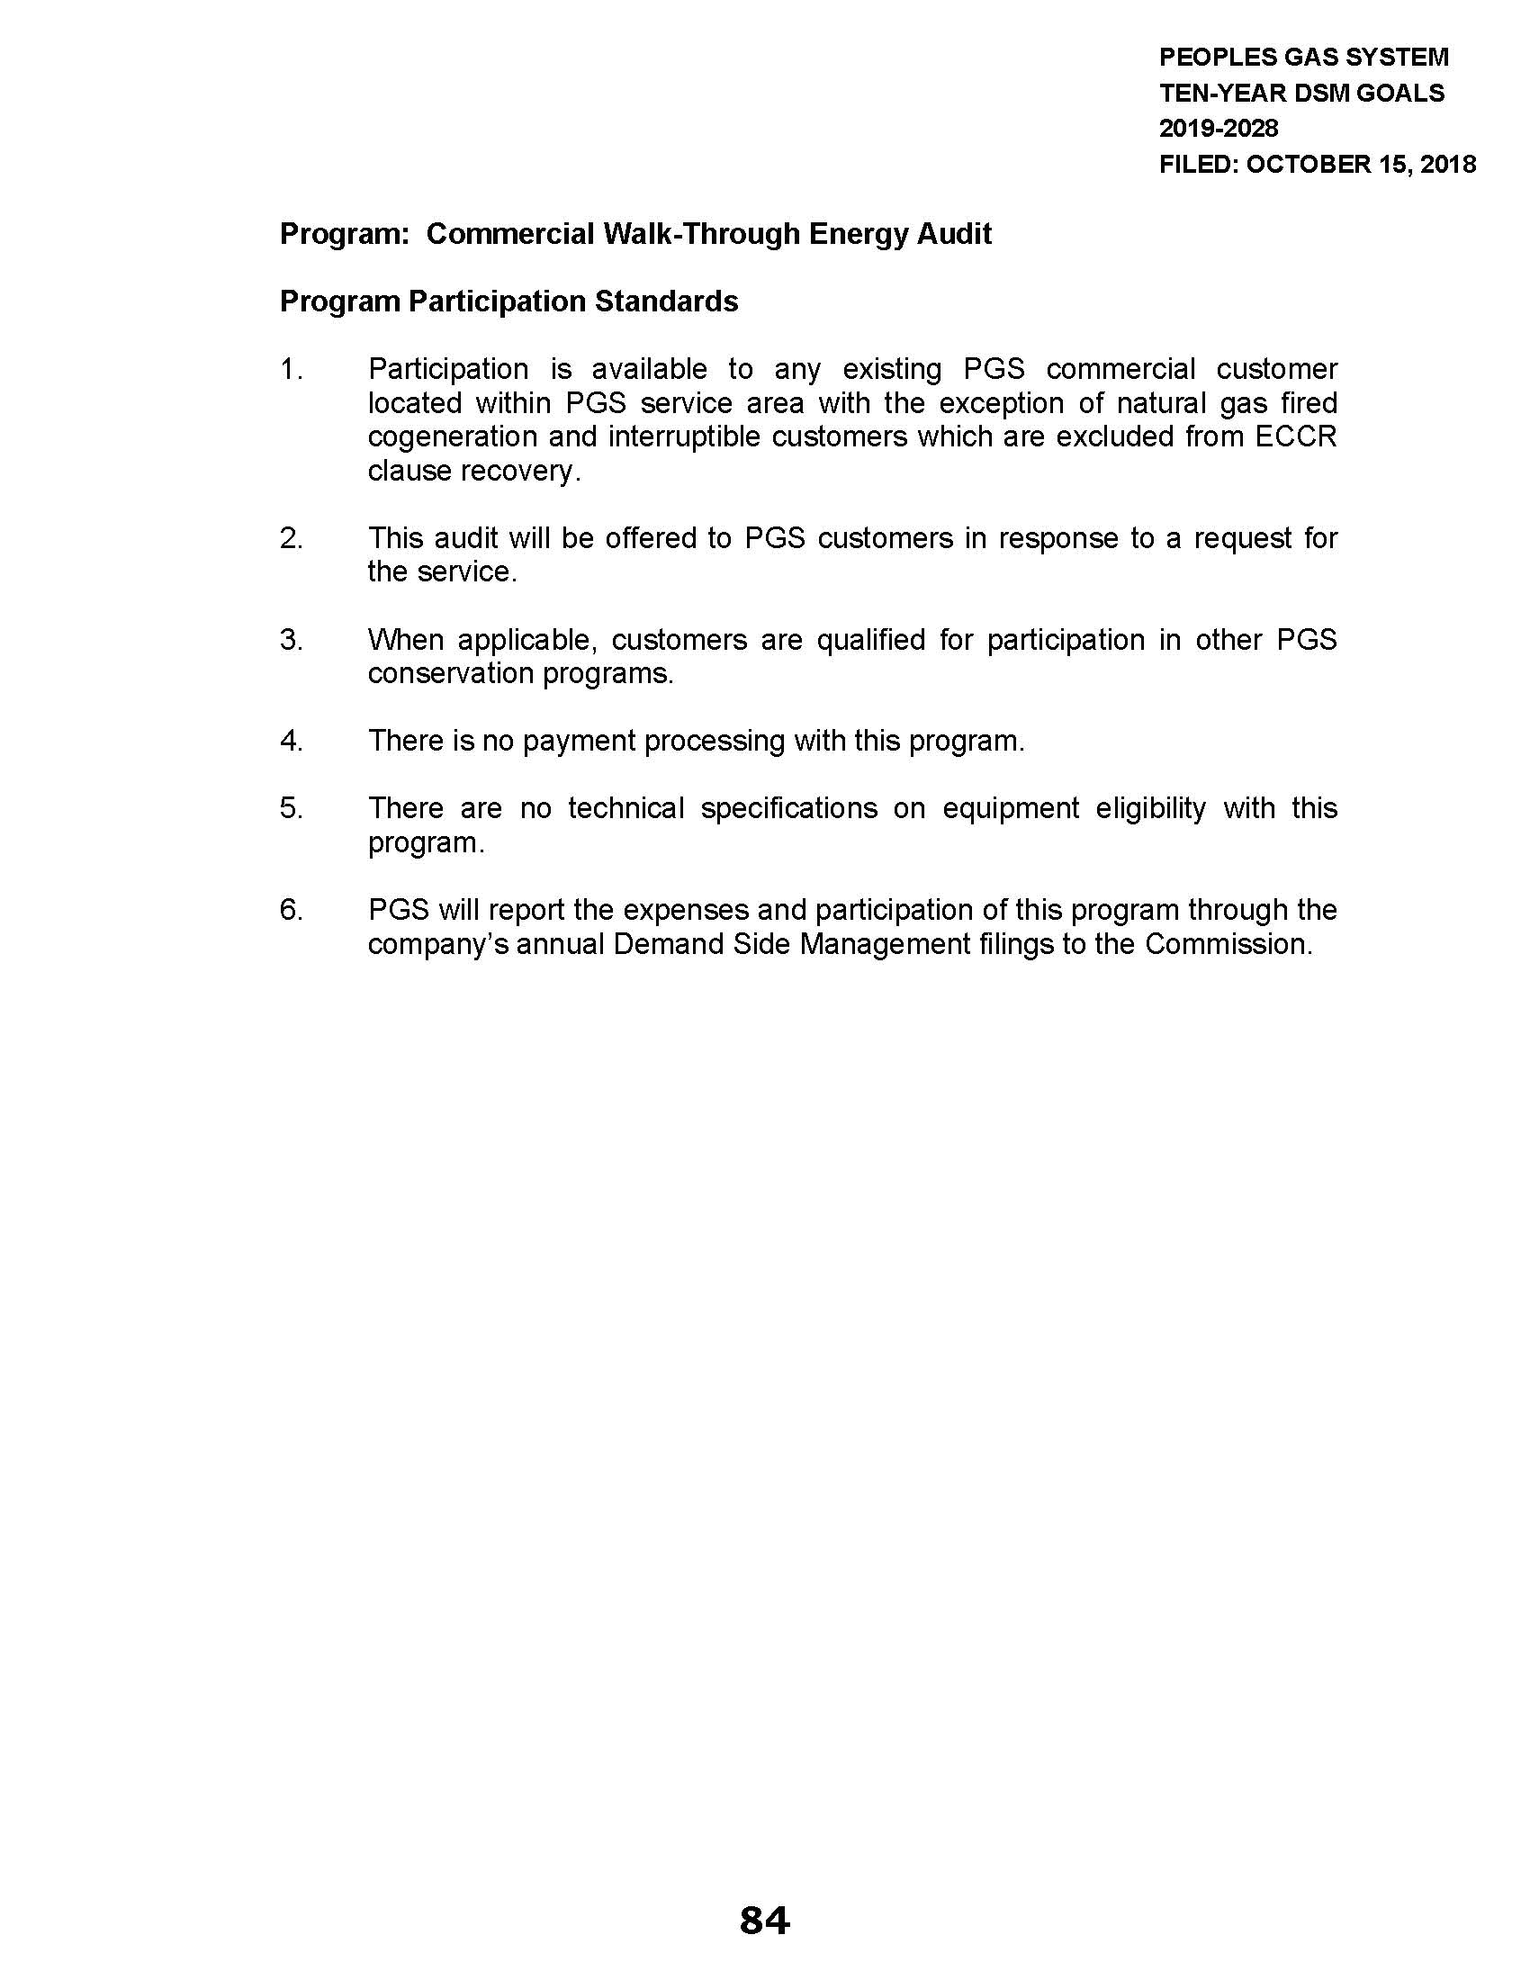

Section 366.82, F.S., provides that a natural gas utility is subject to FEECA requirements if a utility’s annual retail sales volume is equal to or greater than 100 million therms.
Order No. 23462, issued September 11, 1990, in Docket No. 19900089-EG, In re: Request for approval of Energy Conservation Plan by Peoples Gas System, Inc.; Order No. PSC-06-0816-PAA-EG, issued October 4, 2006, in Docket No. 20060478-EG, In re: Petition for approval of modifications to approved energy conservation programs, by Peoples Gas System.; Order No. PSC-10-0113-PAA-EG, issued February 25, 2010, in Docket No. 20090122-EG, In re: Petition for approval of modifications to approved energy conservation programs, by Associated Gas Distributors of Florida.; Order No. PSC-10-0551-PAA-EG, issued September 2, 2010, in Docket No. 20100186-EG, In re: Petition for approval of natural gas residential energy conservation programs, by Associated Gas Distributors of Florida.; Order No. PSC-14-0039-PAA-EG, issued January 14, 2014, in Docket No. 20130167-EG, In re: Petition for approval of natural gas energy conservation programs for commercial customers, by Associated Gas Distributors of Florida.; Order No. PSC-15-0095-PAA-EG, issued February 6, 2015, in Docket No. 20140196-EG, In re: Petition for approval of extension of conservation demonstration and development program, by Associated Gas Distributors of Florida.
Report No. 2016-022, issued October 2015, Public Service Commission Nuclear Power Plant Cost Recovery, Florida Energy Efficiency and Conservation Act, and Selected Administrative Activities.
A list of all DSM measures evaluated in the Technical Potential can be found in Appendix A of Exhibit A on pages 20-22 of PGS’ petition.
Order No. PSC-10-0551-PAA-EG, issued September 2, 2010, in Docket No. 20100186-EG, In re: Petition for approval of natural gas residential energy conservation programs, by Associated Gas Distributors of Florida.
Order No. PSC-14-0039-PAA-EG, issued January 14, 2014, in Docket No. 20130167-EG, In re: Petition for approval of natural gas energy conservation programs for commercial customers, by Associated Gas Distributors of Florida.
Order No. 23576, issued October 3, 1990, in Docket No. 19900002-EG, In re: Conservation Cost Recovery Clause.
Order No. PSC-10-0551-PAA-EG, issued September 2, 2010, in Docket No. 20100186-EG, In re: Petition for approval of natural gas residential energy conservation programs, by Associated Gas Distributors of Florida.
Order No. PSC-14-0039-PAA-EG, issued January 14, 2014, in Docket No. 20130167-EG, In re: Petition for approval of natural gas energy conservation programs for commercial customers, by Associated Gas Distributors of Florida.
Order No. PSC-10-0551-PAA-EG, issued September 2, 2010, in Docket No. 20100186-EG, In re: Petition for approval of natural gas residential energy conservation programs, by Associated Gas Distributors of Florida.
Order No. PSC-14-0039-PAA-EG, issued January 14, 2014, in Docket No. 20130167-EG, In re: Petition for approval of natural gas energy conservation programs for commercial customers, by Associated Gas Distributors of Florida.
This requirement corresponds to Rule 25-17.0021(5), F.A.C., that the FEECA electric utilities operate under regarding annual DSM reports.
The CA is not offered to commercial natural gas-fired cogeneration and interruptible customers because expenses associated with these customers do not qualify for cost recovery under the ECCR clause.

