State of Florida |  | Public Service Commission  Capital Circle Office Center ● 2540 Shumard Oak Boulevard  Tallahassee, Florida 32399-0850  -M-E-M-O-R-A-N-D-U-M-
DATE: | March 21, 2019
TO: | Office of Commission Clerk (Teitzman)
FROM: | Office of the General Counsel (Harper)  Division of Engineering (Moses)
RE: | Docket No. 20190047-GU – Proposed amendment of Rule 25-12.005, F.A.C., Codes and Standards Adopted.
AGENDA: | 04/02/19 – Regular Agenda – Interested Persons May Participate
COMMISSIONERS ASSIGNED: |  |  | All Commissioners
PREHEARING OFFICER: |  |  | Brown
RULE STATUS: |  |  | Proposal May Be Deferred
SPECIAL INSTRUCTIONS: |  |  | None

Case Background
On October 17, 2018, a Notice of Development of Rulemaking was published in the Florida Administrative Weekly for Rule 25-12.005, Florida Administrative Code (F.A.C.). Rule 25-12.005, F.A.C., implements the minimum federal safety standards and reporting requirements for pipeline facilities and transportation of natural gas as prescribed by the Pipeline and Hazardous Materials Safety Administration (PHMSA) regulations. The federal regulations are found in 49 Code of Federal Regulations (C.F.R.) Parts 191, 192, and 199. The purpose of the rule amendment is to incorporate by reference into the rule the February 14, 2019, version of the federal standards (49 CFR Parts 191, 192, and 199) that apply to natural gas pipeline operators under the Commission’s jurisdiction.

This recommendation addresses whether the Commission should propose the amendment of Rule 25-12.005. No requests for a rule development workshop were made, so no workshop was held. The Commission has jurisdiction pursuant to Section 120.54, Florida Statutes (F.S.), and Sections 368.03 and 368.05, F.S.

Discussion of Issues

Issue 1:
Should the Commission propose the amendment of Rule 25-12.005, F.A.C., Codes and Standards Adopted?

Recommendation:
Yes, the Commission should propose the amendment of Rule 25-12.005, F.A.C., as set forth in Attachment A. The Commission should certify that Rule 25-12.005, F.A.C., is not a rule that the violation of which would be a minor violation pursuant to Section 120.695, F.S. (Harper, Moses)

Staff Analysis:
Rule 25-12.005, F.A.C., implements federal reporting requirements and safety standards, including drug and alcohol employee reporting standards and requirements for employees of natural gas pipeline operators and emergency response persons under the direct authority or control of a gas utility or gas pipeline operator. The rule incorporates by reference the federal regulations that apply to natural gas pipeline operators within the Commission’s jurisdiction that are found in 49 C.F.R. Parts 191, 192, and 199. Staff is recommending that Rule 25-12.005, F.A.C., be amended to incorporate by reference the February 14, 2019, version of the C.F.R., as set forth in Attachment A. Specifically, the updated C.F.R. provisions clarify and streamline the standards pertaining to pipeline safety regulations, such as excess flow valves, underground natural gas storage facilities, and accident and incident notification.

Minor Violation Rules Certification
Pursuant to Section 120.695, F.S., beginning July 1, 2017, for each rule filed for adoption the agency head shall certify whether any part of the rule is designated as a rule the violation of which would be a minor violation. Rule 25-12.005, F.A.C., is a not a rule for which a violation would be minor because violation of the rule would result in physical harm to a person and have an adverse effect on the public health, safety, or welfare or create a significant threat of such harm. Thus, staff recommends that the Commission certify that Rule 25-12.005, F.A.C., is not a rule that the violation of which would be a minor violation pursuant to Section 120.695, F.S.

Statement of Estimated Regulatory Costs
Pursuant to Section 120.54, F.S., agencies are encouraged to prepare a statement of estimated regulatory costs (SERC) before the adoption, amendment, or repeal of any rule. The SERC is appended as Attachment C to this recommendation. The SERC analysis also includes whether the rule is likely to have an adverse impact on growth, private sector job creation or employment, or private sector investment in excess of $1 million in the aggregate within five years of implementation.
The SERC concludes that the rule will not likely directly or indirectly increase regulatory costs in excess of $200,000 in the aggregate in Florida within one year after implementation. Further, the SERC concludes that the rule will not likely have an adverse impact on economic growth, private sector job creation or employment, private sector investment, business competitiveness, productivity, or innovation in excess of $1 million in the aggregate within five years of implementation. Thus, the rule does not require legislative ratification pursuant to Section 120.541(3), F.S. In addition, the SERC states that the rule will not have an adverse impact on small business and will have no impact on small cities or counties. No regulatory alternatives were submitted pursuant to paragraph 120.541(1)(a), F.S. None of the impact/cost criteria established in paragraph 120.541(2)(a), F.S., will be exceeded as a result of the recommended amendments.

Conclusion
Based on the foregoing, staff recommends the Commission propose the amendment of Rule 25-12.005, F.A.C., as set forth in Attachment A. In addition, staff recommends that the Commission certify that Rule 25-12.005, F.A.C., is not a rule that the violation of which would be a minor violation pursuant to Section 120.695, F.S.
Issue 2:
Should this docket be closed?

Recommendation:
Yes. If no requests for hearing or comments are filed, the rule may be filed with the Department of State for adoption, and the docket should be closed. (Harper)

Staff Analysis:
If no requests for hearing or comments are filed, the rule may be filed with the Department of State for adoption, and the docket should be closed.

25-12.005 Codes and Standards Adopted.
The Minimum Federal Safety Standards and reporting requirements for pipeline facilities and transportation of gas prescribed by the Pipeline and Hazardous Materials Safety Administration in 49 C.F.R. 191 and 192 (2019) (2017), are adopted and incorporated by reference as part of these rules. 49 C.F.R. 191 (2019) (2017) may be accessed at [insert hyperlink] http://www.flrules.org/Gateway/reference.asp?No=Ref-07920. 49 C.F.R. 192 (2019) (2017) may be accessed at [insert hyperlink] http://www.flrules.org/Gateway/reference.asp?No=Ref-07923. 49 C.F.R. 199 (2019) (2017), “Drug and Alcohol Testing,” is adopted and incorporated by reference to control drug use, by setting standards and requirements to apply to the testing and use of all emergency response personnel under the direct authority or control of a gas utility or pipeline operator, as well as all employees directly or indirectly employed by gas pipeline operators for the purpose of operation and maintenance and all employees directly or indirectly employed by intrastate gas distribution utilities for onsite construction of natural gas transporting pipeline facilities. 49 C.F.R. 199 (2019) (2017) may be accessed at [insert hyperlink] http://www.flrules.org/Gateway/reference.asp?No=Ref-07921. Part 199 also is adopted to prescribe standards for use of employees who do not meet the requirements of the regulations.
Rulemaking Authority 368.03, 368.05(2), 350.127(2) FS. Law Implemented 368.03, 368.05 FS. History–New 11-14-70, Amended 9-24-71, 9-21-74, 10-7-75, 11-30-82, 10-2-84, Formerly 25-12.05, Amended 8-8-89, 1-7-92, 5-13-99, 4-26-01, 12-15-09, 10-11-12, 3-2-17, ________.

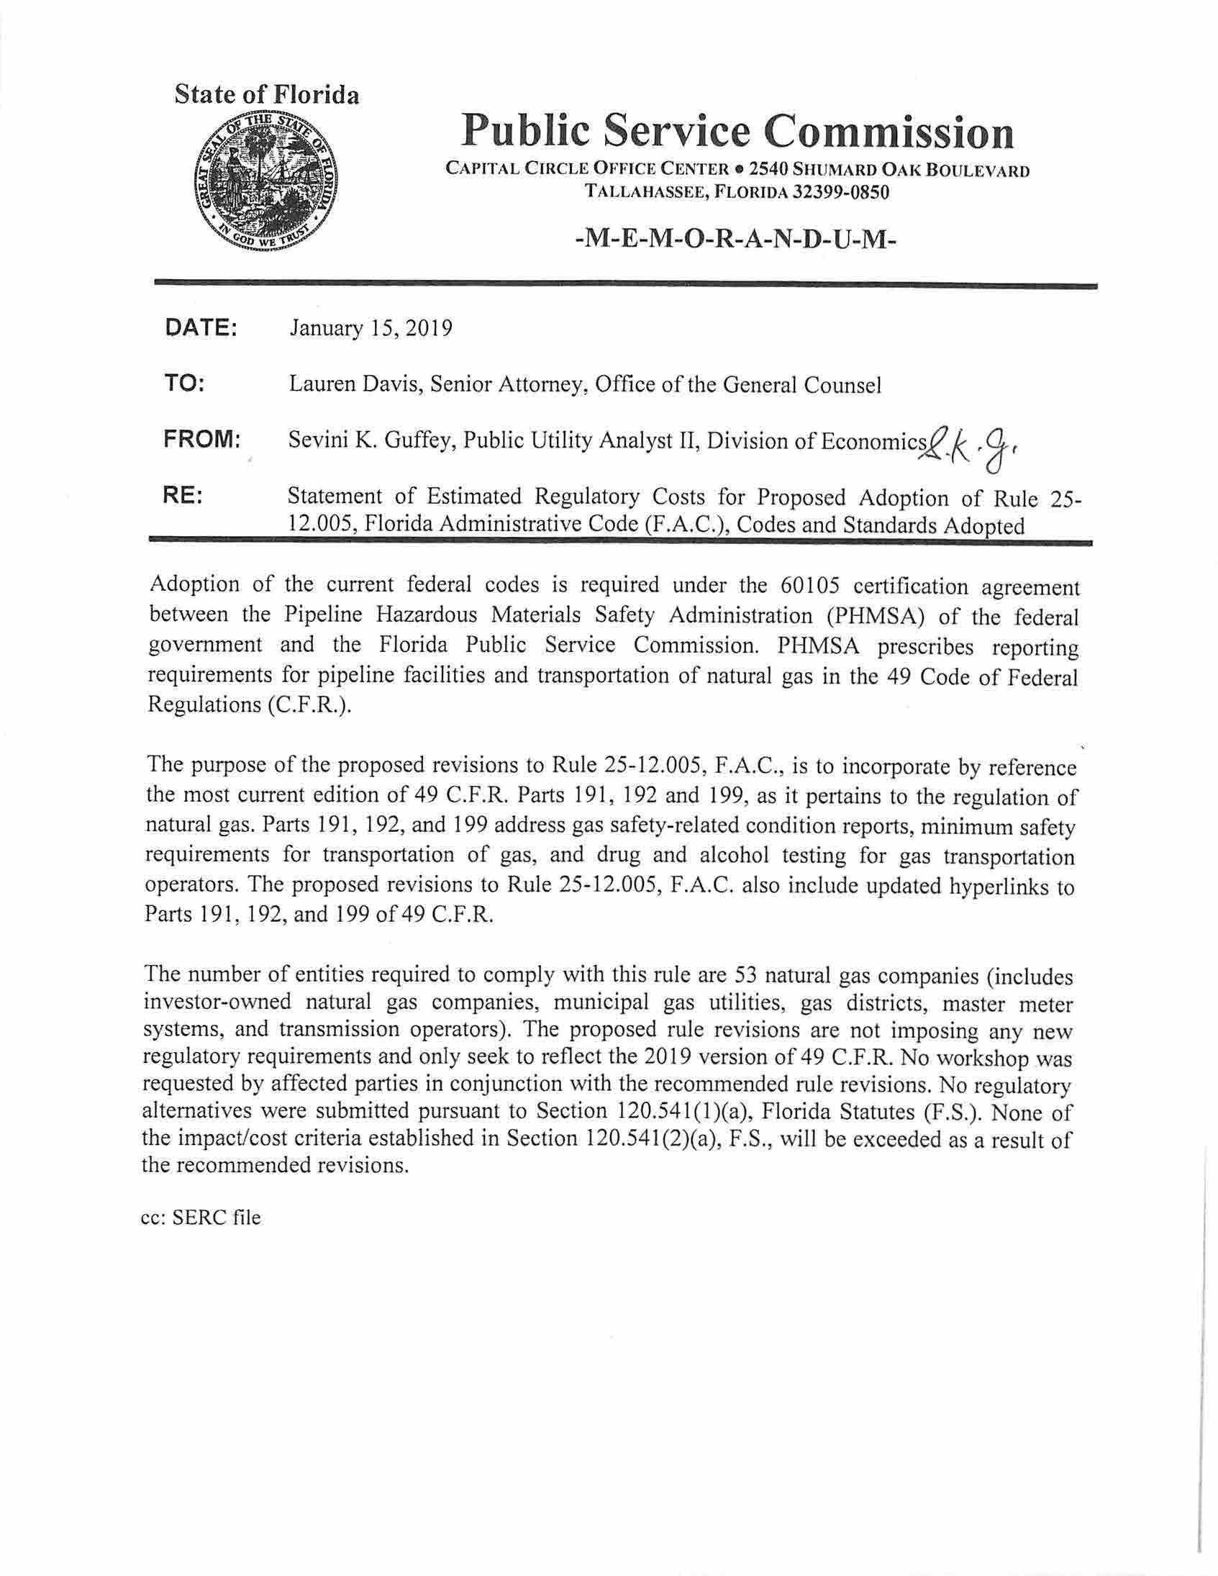

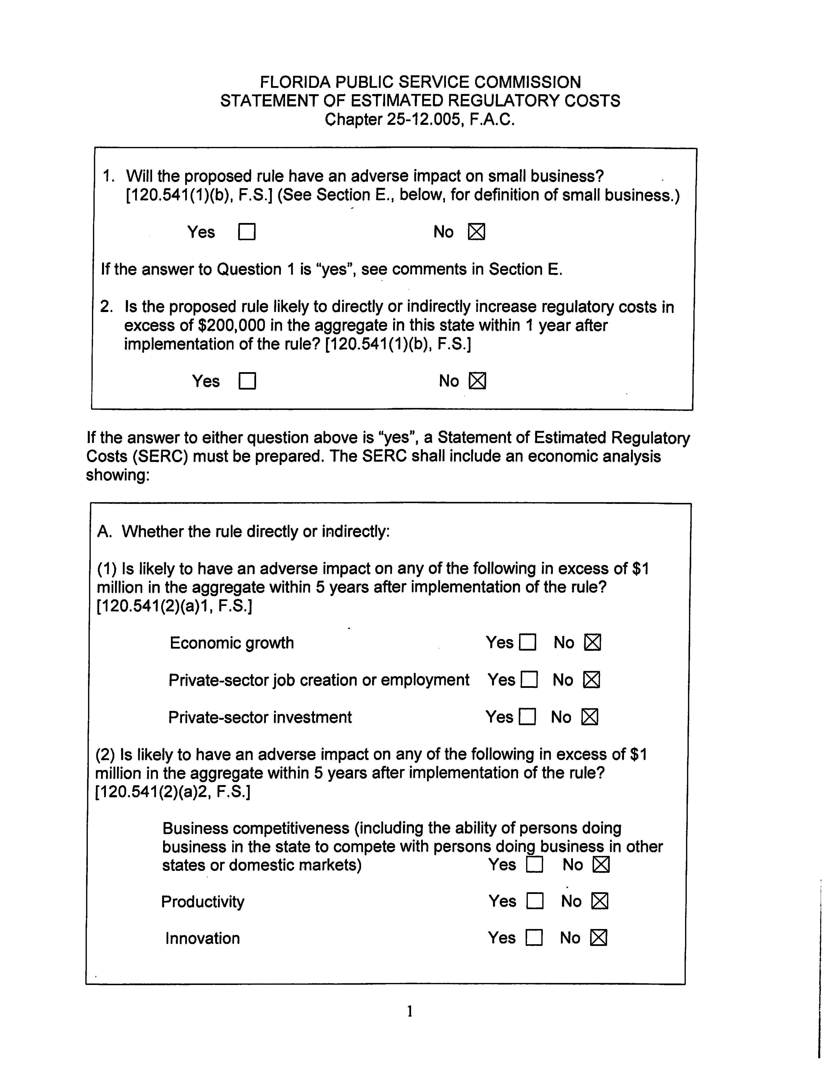

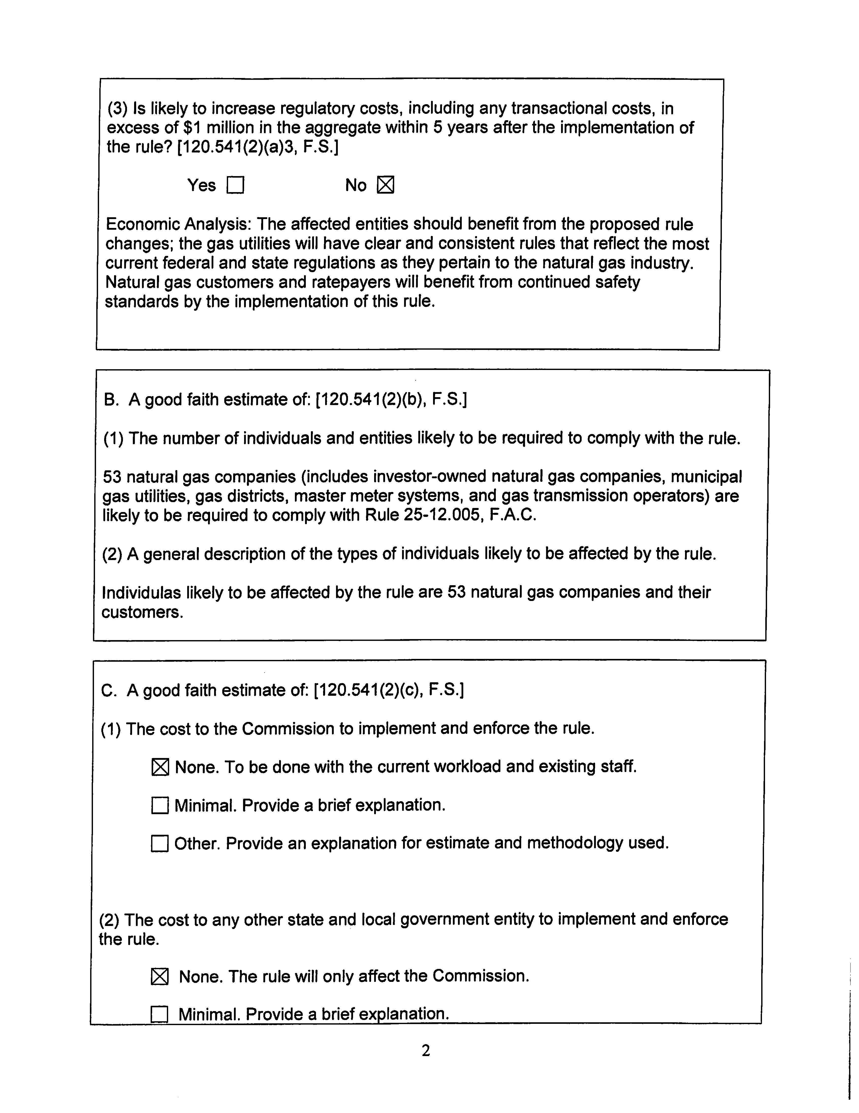

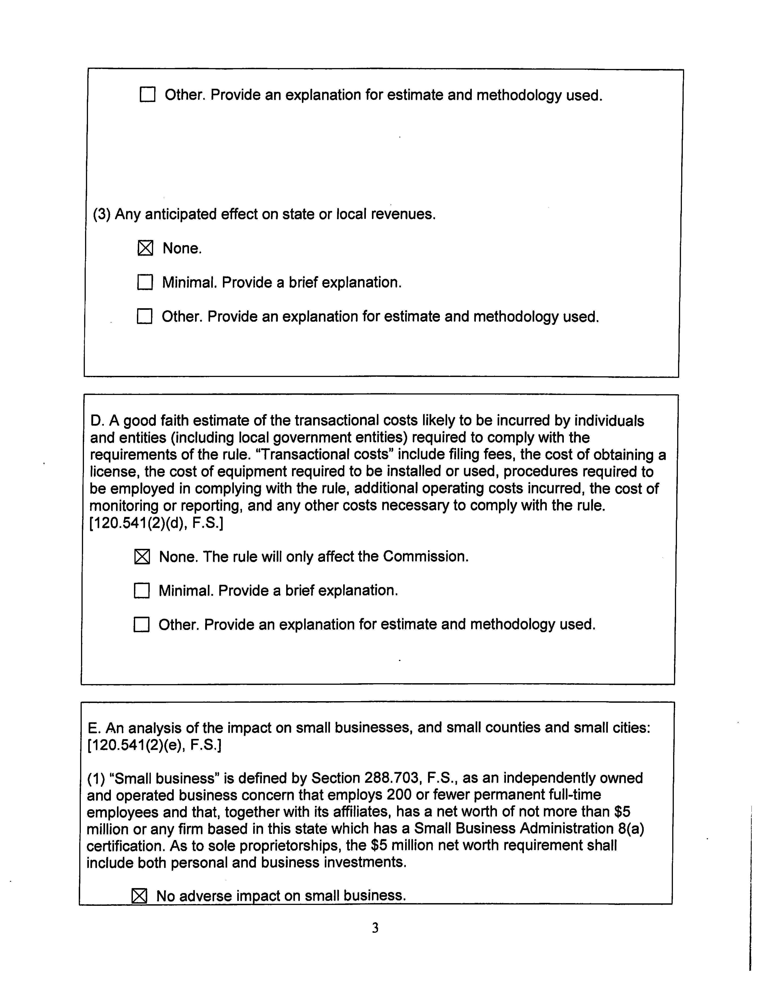

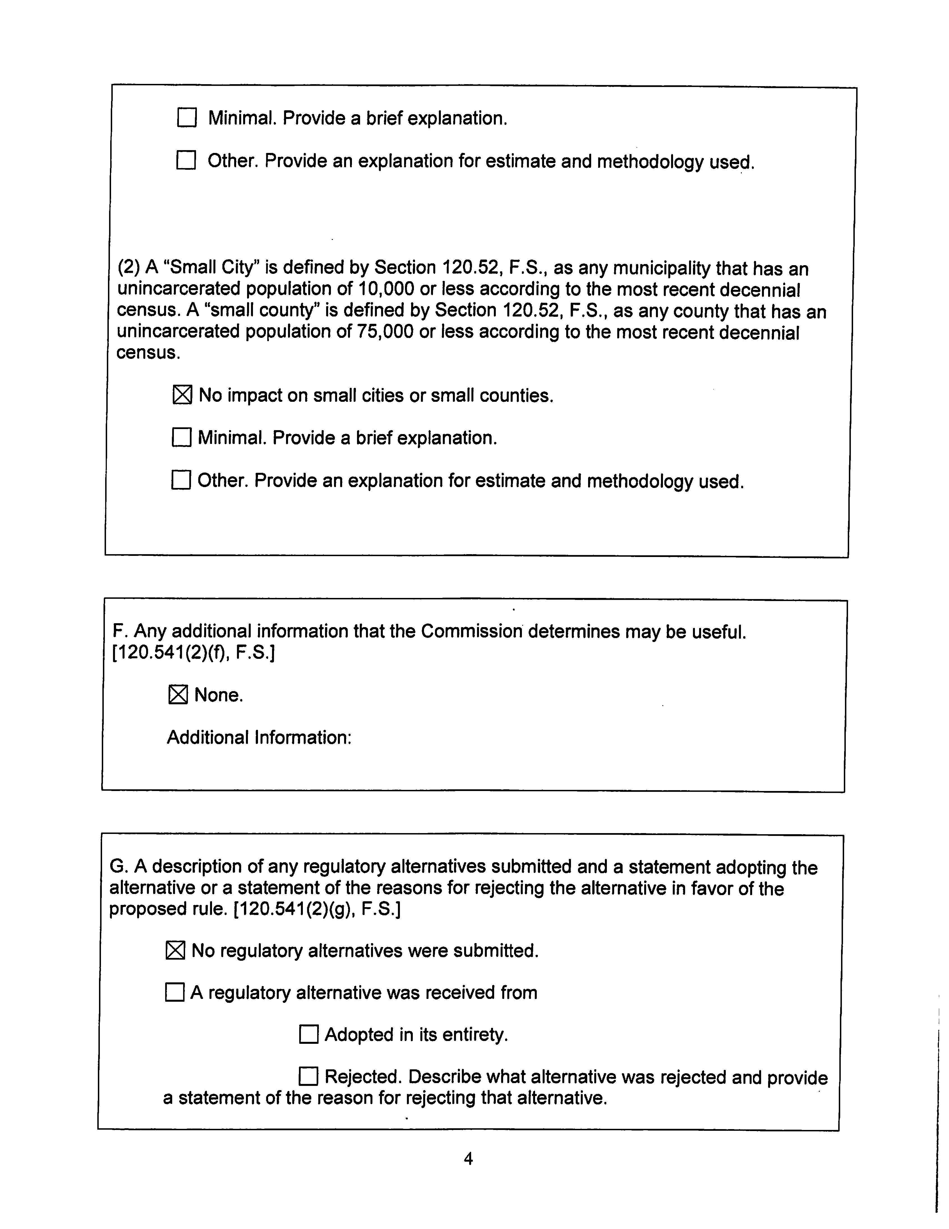

Section 120.541(2), F.S.

