BEFORE THE FLORIDA PUBLIC SERVICE COMMISSION

In re: Fuel and purchased power cost recovery clause with generating performance incentive factor. | DOCKET NO. 20190001-EI  ORDER NO. PSC-2019-0109-PCO-EI  ISSUED: March 22, 2019

The following Commissioners participated in the disposition of this matter:

ART GRAHAM, Chairman
JULIE I. BROWN
DONALD J. POLMANN
GARY F. CLARK
ANDREW GILES FAY

ORDER APPROVING TAMPA ELECTRIC COMPANY’S
PETITION FOR MID-COURSE CORRECTION

BY THE COMMISSION:

BACKGROUND

On January 15, 2019, Tampa Electric Company (TECO or Company) filed a Petition for Mid-Course Correction to its 2019 Fuel and Capacity Cost Recovery Factors (Mid-Course Petition). The revision to its fuel cost recovery factors primarily reflects elevated projected fuel costs and revised capacity cost recovery factors associated with the impact of a canceled capacity transaction. The Mid-Course Petition seeks to change the respective 2019 fuel and capacity cost recovery factors that were approved in Order No. PSC-2018-0610-FOF-EI. On January 30, 2019, TECO filed the tariff sheets incorporating the changes identified in its Mid-Course Petition. (Attachment B)
Mid-course corrections are part of the fuel and purchased power cost recovery clause (fuel clause) proceeding, and such corrections are used by this Commission between fuel clause hearings whenever costs deviate from revenues by a significant margin. Petitions for mid-course corrections to fuel factors are addressed in Rule 25-6.0424, Florida Administrative Code (F.A.C.). Under this rule, a utility must notify this Commission whenever it expects to experience an under-recovery or over-recovery greater than 10 percent. Pursuant to Rule 25-6.0424, F.A.C., the mid-course percentage is the estimated end-of-period total net true-up amount divided by the current period’s total actual and estimated jurisdictional fuel revenue applicable to period amount. Mid-course corrections are considered preliminary procedural decisions, and any over-recoveries or under-recoveries caused by or resulting from our approved adjusted fuel or capacity factors may be included in the following year’s fuel or capacity factors.
This Commission’s jurisdiction to consider fuel clause proceedings derives from our authority to set fair and reasonable rates, found in Section 366.05, Florida Statutes.

DECISION

On an annual basis, TECO and the other four investor-owned electric utilities (IOUs) in Florida participate in a series of technical hearings to evaluate actual and projected costs which have been recorded in cost recovery clauses. The purpose of this evaluation is to calculate cost recovery factors for the next calendar year. Although the specific dates vary from year to year, generally speaking, the annual cost recovery clause hearings are conducted in early November, and the most recent cost recovery clause hearings took place on November 5-6, 2018. The orders issued from the 2018 hearings set forth the cost recovery clause factors that were implemented by all IOUs in Florida. Those revised factors became effective with the first billing cycle of January 2019.

In the 2018 Fuel Order, we approved the fuel and capacity cost recovery factors for TECO that are currently in place. By its Mid-Course Petition, TECO seeks approval to implement adjustments to the fuel and the capacity cost recovery clause factors, effective with the April 2019 billing cycle, as discussed below.

Mid-course Adjustment for Fuel and Capacity Cost Recovery Factors

In the Mid-Course Petition, TECO presents data from two time periods, true up results from 2018, and revised projected information for 2019. A secondary distinction is drawn between fuel cost recovery amounts and capacity cost recovery amounts for each period, resulting in four individual components to evaluate as part of TECO’s Mid-Course Petition:

- Fuel cost recovery amounts from 2018;
- Capacity cost recovery amounts from 2018;
- Projected fuel cost recovery amounts for 2019; and
- Projected capacity cost recovery amounts for 2019.

TECO analyzed its actual and estimated balances using the calculation set forth in Rule 25-6.0424, Florida Administrative Code (F.A.C.), to arrive at two variations for recovering the amounts identified in the Mid-Course Petition.

First, the Company calculated a mid-course adjustment based on the recovery of all aspects of the fuel and capacity cost recovery balances. This calculation yielded a mid-course correction value of 24.9 percent. Although TECO referenced the results of this calculation, the Company did not include supporting schedules for this alternative in its Mid-Course Petition.
TECO also calculated a mid-course adjustment based on the recovery of revised capacity-related costs for 2018 and 2019, and the revised 2019 fuel costs. TECO’s calculation did not include the revised shortfall of its 2018 fuel cost true-up. According to the Company, the mid-course calculation using these balances results in a mid-course correction of 16.0 percent. This alternative aligns with the requested relief, and TECO asserts that it will prepare a petition to request recovery of the final fuel cost amounts for 2018 for consideration at the November 5-7, 2019 hearing.
True-Up Amounts from 2018 (Fuel and Capacity)

On the fuel cost recovery side, TECO states that elevated natural gas prices were the principle driver of the $36,970,912 under-recovery balance for fuel for 2018. In response to a data request, the Company stated that lower than historic average gas storage levels and early season cold weather in the northeast sparked higher market prices in the latter portions of 2018. TECO did not incorporate the under-recovery balance in the calculations to determine the new cost recovery factors that are presented in the Mid-Course Petition. Rather, the Company asserts that this balance will be addressed in the normal hearing cycle planned for the fall of 2019. By forgoing cost recovery of this amount during the remainder of 2019, TECO hopes to mitigate what otherwise would be a significant increase in customer bills. By delaying the recovery of the unrecovered balance, the amount will be included in the calculation of total fuel expenses for 2020, and recovered in factors over a 12-month period, compared to a 9-month period if the balance was included in the requested mid-course correction.

On the capacity cost recovery side, TECO states that the true-up balance for 2018 was a $5,458,886 under-recovery. For context, an under-recovery amount of $2,784,988 was approved for collection in 2019 in the 2018 Fuel Order. In the Mid-Course Petition, the Company included the final true-up adjustment under-recovery amount of $2,673,898 in its calculations of the revised cost recovery factors for April through December, 2019.

Revised Projected Amounts for 2019 (Fuel and Capacity)

As a basis for its Mid-Course Petition, TECO revised its fuel and capacity cost recovery projections for 2019. The original projections for 2019 were filed on August 24, 2018, and evaluated in Docket No. 20180001-EI. The fuel and capacity cost recovery factors that were approved in the 2018 Fuel Order are based, in large part, on the forecasted projections for 2019.

As reflected in Schedule E1, TECO’s original projection for fuel costs in 2019 reflects an estimate of $537,871,753 for its Total Fuel and Net Power Transactions. The Company states that its revised projection for 2019 shows an increase of $75,514,842, reflecting a new amount of $613,386,595. As with the under-recovered fuel cost recovery balance from 2018, TECO attributes the increase to elevated projected natural gas prices for the period. In response to a data request, the Company stated that the concerns over limited supplies of natural gas contributed to higher projected prices for 2019, compared to the prior forecast. As referenced earlier, weather-related concerns impact forward market prices for natural gas.

In the 2018 Fuel Order, we approved $17,124,796 as the projected amount of capacity costs for TECO in 2019. The Company asserts that its original projection for capacity in 2019 was based upon a planned capacity purchase that did not materialize. Because this purchase for 2019 did not materialize, the Company’s revised end-of-period balance for 2019 is an over-recovery of $14,240,130.
Summary of Mid-Course Petition

TECO is requesting mid-course adjustments to fully recover the capacity-related balances (2018 and 2019), and the revised estimate of its 2019 fuel costs. At this time, the Company is not seeking to recover the 2018 true-up under recovery. The revised fuel and capacity cost recovery balances the Company seeks to recover would be recovered between April and December, 2019 through the fuel and capacity cost recovery factors, as shown on Tables 1 and 2 of Attachment A, and the associated tariff sheets presented in Attachment B.
Table 1 below shows that if TECO’s Mid-Course Petition is approved, a residential customer using 1,000 kilowatt hours (kWh) of electricity will see a net increase of $4.05 per month on their bill, with the fuel cost recovery portion of their bill rising by $5.08 per month, partially offset by a reduction on the capacity portion of the bill.

Table 1
Requested Recovery
TECO Typical 1,000-kWh Residential Customer Bill Comparison
for the period January-December, 2019
(1) | (2) | (3) | (4)
Component | Current  (January-December) | Proposed  (April-December) | Bill Impact
Base Charge | $66.53 | $66.53 | $0.00
Fuel Cost Recovery | 24.05 | 29.13 | 5.08
Conservation Cost Recovery | 3.21 | 3.21 | 0.00
Capacity Cost Recovery | 1.03 | (0.10) | (1.13)
Environmental Cost Recovery | 2.22 | 2.22 | 0.00
Subtotal | $97.04 | $100.99 | $3.95
Gross Receipts Tax | 2.49 | 2.59 | 0.10
Totals | $99.53 | $103.58 | $4.05
Source: Mid-Course Correction filing, Schedule E10, Bates Stamped Page 46.

Analysis

As noted above, the currently-approved fuel and capacity cost recovery factors for TECO were developed based, in large part, on the projected fuel and capacity cost amounts for 2019 that were filed in Docket No. 20180001-EI, on August 24, 2018. The Company stated that the main driver for the under-recovery balance for fuel in 2018 was the cost difference between projected and actual prices for natural gas. Because TECO observed these elevated market prices in the final months of 2018, the Company re-examined its 2019 fuel price forecasts and filed its Mid-Course Petition for adjusted cost recovery factors.
Review of the requested relief

TECO prepares fuel forecasts on a regular and routine basis, and filed its Mid-Course Petition in order to respond to market-driven changes to costs the Company incurred for the predominate fuel used in its generating fleet, natural gas. Although capacity-related over-recovered balances are presented, the balances for fuel-related costs are the principle concern that TECO has for requesting new cost recovery factors.

In order to prepare its forward year projection filing, the Company analyzed forecasted fuel price data for 2019 based on a forward natural gas price forecast utilizing the NYMEX natural gas futures contract prices for five consecutive business days in April 2018. For its fuel price projections, a delivered price of $3.82 per MMBtu was calculated for natural gas. In its original projection filing, TECO estimated 16,516,370 megawatt-hours (87.90 percent) of its generation would come from natural gas, while coal would account for 1,249,950 megawatt-hours (6.66 percent). The original and revised forecasts used the same sources for forecasting data, although in response to a data request, the Company acknowledged that slightly modified forecasting assumptions were incorporated in its revised forecast.

On a comparative basis, the revised fuel price forecast used NYMEX futures contract pricing data for natural gas prices for five consecutive business days in early December 2018. A revised delivered price of $4.20 per MMBtu was used for natural gas in the more recent fuel price projection. Based on the revised data, system generation is up slightly, with natural gas generation estimated at 16,822,800 megawatt-hours (86.34 percent), while coal is up slightly to 1,639,120 megawatt-hours (8.41 percent.) In response to a data request, TECO confirmed that no fuel delivery or transportation arrangements changed between the period of time when the original and the revised forecasts were prepared, and emphasized that the primary reason for needing the requested mid-course adjustment to cost recovery factors is the change in the forecasted price of natural gas. The Company stated that the elevated prices that are presented in the most current forecast were likely triggered by storage level concerns. The storage-related concerns and weather-driven demand are both factors in the commodity markets for natural gas that are well outside of TECO’s control, but nevertheless influence the actual costs the Company has, or will, incur when purchasing natural gas.

Customer Notifications

In response to a staff data request, TECO stated that it issued news releases and information on social media concurrent with its filing of the Mid-Course Petition (dated January 15, 2019). The Company will notify customers about this pending matter with on-bill messaging for paper and paperless bills in advance of the rates taking effect. In addition, TECO stated that a website link provides information regarding the proposed rate change effective with the April 2019 billing cycle. The Company stated that it plans a second news release after our vote on its Mid-Course Petition.

TECO’s Mid-Course Petition will result in higher fuel cost recovery factors, and lower capacity cost recovery factors for TECO’s customers, effective with the April 2019 billing cycle. Typically, effective dates are set a minimum of 30 days after our vote modifying the charges as the result of a mid-course correction. This time limit is imposed in order to prevent new rates from being applied to energy consumed before the effective date of our action, i.e., the date of the vote. However, we also have implemented charges in less than 30 days when circumstances warrant. In this instance, the interval between our vote on this matter (March 5, 2019) and the proposed implementation date (April 2019 billing cycle, which begins on April 2, 2019) is 27 days. Although this filing results in a net increase to cost recovery factors, we find that the notification interval is sufficient.

Based on the above, we find that a mid-course adjustment is appropriate and hereby approve TECO's Mid-Course Petition and the associated tariff sheets, effective with the first billing cycle of April 2019. We further approve the revised fuel and capacity cost recovery factors as stated in Attachment A and the associated tariff sheets contained in Attachment B.

Therefore, it is

ORDERED by the Florida Public Service Commission that Tampa Electric Company’s Petition for Mid-Course Correction of its Fuel Cost Recovery Factors and Capacity Cost Recovery Factors for 2019 is hereby approved. It is further
ORDERED that the fuel and capacity cost recovery factors are approved as stated in Attachment A. It is further
ORDERED that the tariff sheets in Attachment B are hereby approved. It is further
ORDERED that the revised fuel and cost recovery factors and the associated tariff sheets shall become effective with the April 2019 billing cycle, which begins on April 2, 2019. It is further
ORDERED that this docket shall remain open.

By ORDER of the Florida Public Service Commission this 22nd day of March, 2019.

/s/ Adam J. Teitzman
ADAM J. TEITZMAN
Commission Clerk
Florida Public Service Commission
2540 Shumard Oak Boulevard
Tallahassee, Florida 32399
(850) 413-6770
www.floridapsc.com

Copies furnished: A copy of this document is provided to the parties of record at the time of issuance and, if applicable, interested persons.

SBr

NOTICE OF FURTHER PROCEEDINGS OR JUDICIAL REVIEW

The Florida Public Service Commission is required by Section 120.569(1), Florida Statutes, to notify parties of any administrative hearing or judicial review of Commission orders that is available under Sections 120.57 or 120.68, Florida Statutes, as well as the procedures and time limits that apply. This notice should not be construed to mean all requests for an administrative hearing or judicial review will be granted or result in the relief sought.

Mediation may be available on a case-by-case basis. If mediation is conducted, it does not affect a substantially interested person's right to a hearing.

Any party adversely affected by this order, which is preliminary, procedural or intermediate in nature, may request: (1) reconsideration within 10 days pursuant to Rule 25-22.0376, Florida Administrative Code; or (2) judicial review by the Florida Supreme Court, in the case of an electric, gas or telephone utility, or the First District Court of Appeal, in the case of a water or wastewater utility. A motion for reconsideration shall be filed with the Office of Commission Clerk, in the form prescribed by Rule 25-22.0376, Florida Administrative Code. Judicial review of a preliminary, procedural or intermediate ruling or order is available if review of the final action will not provide an adequate remedy. Such review may be requested from the appropriate court, as described above, pursuant to Rule 9.100, Florida Rules of Appellate Procedure.

Attachment A – Table 1 (Requested Recovery)
TECO Revised Fuel Cost Recovery Factors for the period April-December, 2019
Metering Voltage Level |  | Fuel Cost Recovery Factors (cents per kWh)
 |  | Levelized Fuel Recovery Factor | First Tier  (Up to 1,000 kWh) | Second Tier  (Over 1,000 kWh)
STANDARD
 | Distribution Secondary (RS only) | -- | 2.913 | 3.913
 | Distribution Secondary | 3.227
 | Distribution Primary | 3.195
 | Transmission | 3.162
 | Lighting Service | 3.194
TIME OF USE
 | Distribution Secondary- On-Peak | 3.411
 | Distribution Secondary- Off-Peak | 3.149
 | Distribution Primary- On-Peak | 3.377
 | Distribution Primary- Off-Peak | 3.118
 | Transmission – On-Peak | 3.343
 | Transmission – Off-Peak | 3.086
Source: Mid-Course Correction filing, Schedule E1-E, Bates Stamped Page 20.

Attachment A - Table 2 (Requested Recovery)
TECO Capacity Cost Recovery Factors for the period April-December, 2019
Rate Class and Metering Voltage | 2019 Capacity Cost Recovery Factors
 | Dollars / kW | Dollars / kWh
RS Secondary |  | -0.00010
GS and CS Secondary |  | -0.00009
GSD, SBF Standard
Secondary | -0.03
Primary | -0.03
Transmission | -0.03
GSD Optional
Secondary |  | -0.00007
Primary |  | -0.00007
Transmission |  | -0.00007
IS, SBI
Primary | -0.03
Transmission | -0.03
LS1 Secondary |  | -0.00002
Source: Mid-Course Correction filing, Exhibit D, Page 4 of 6, Bates Stamped Page 55.

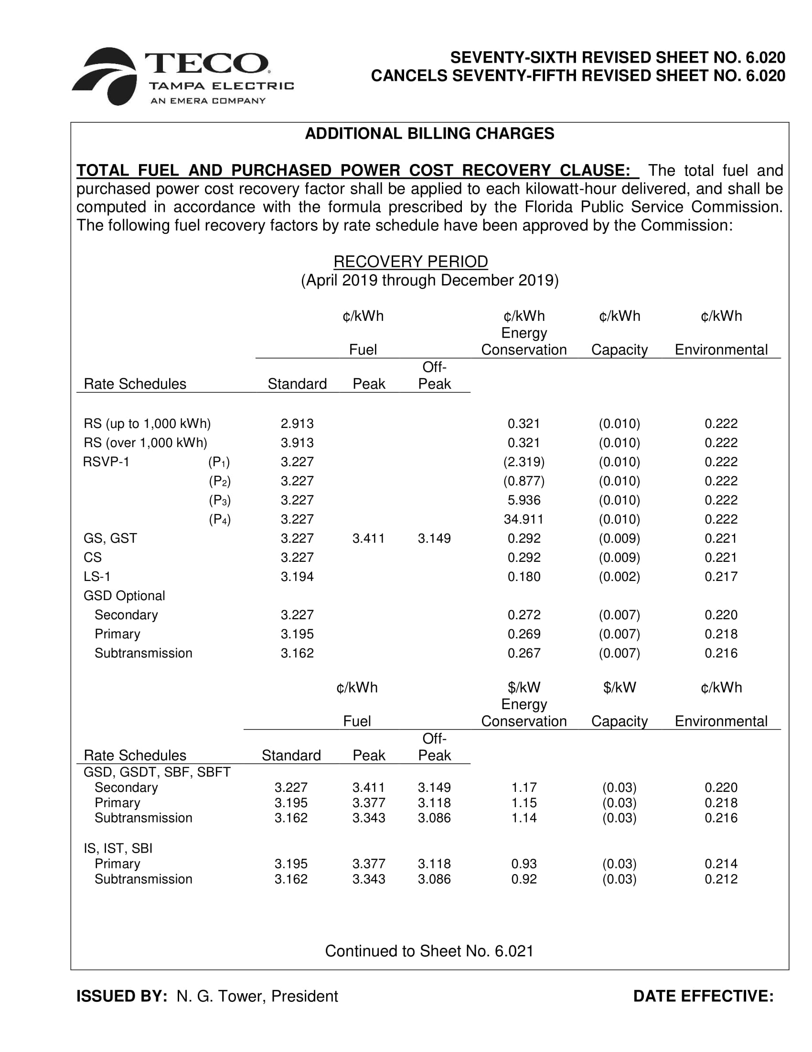
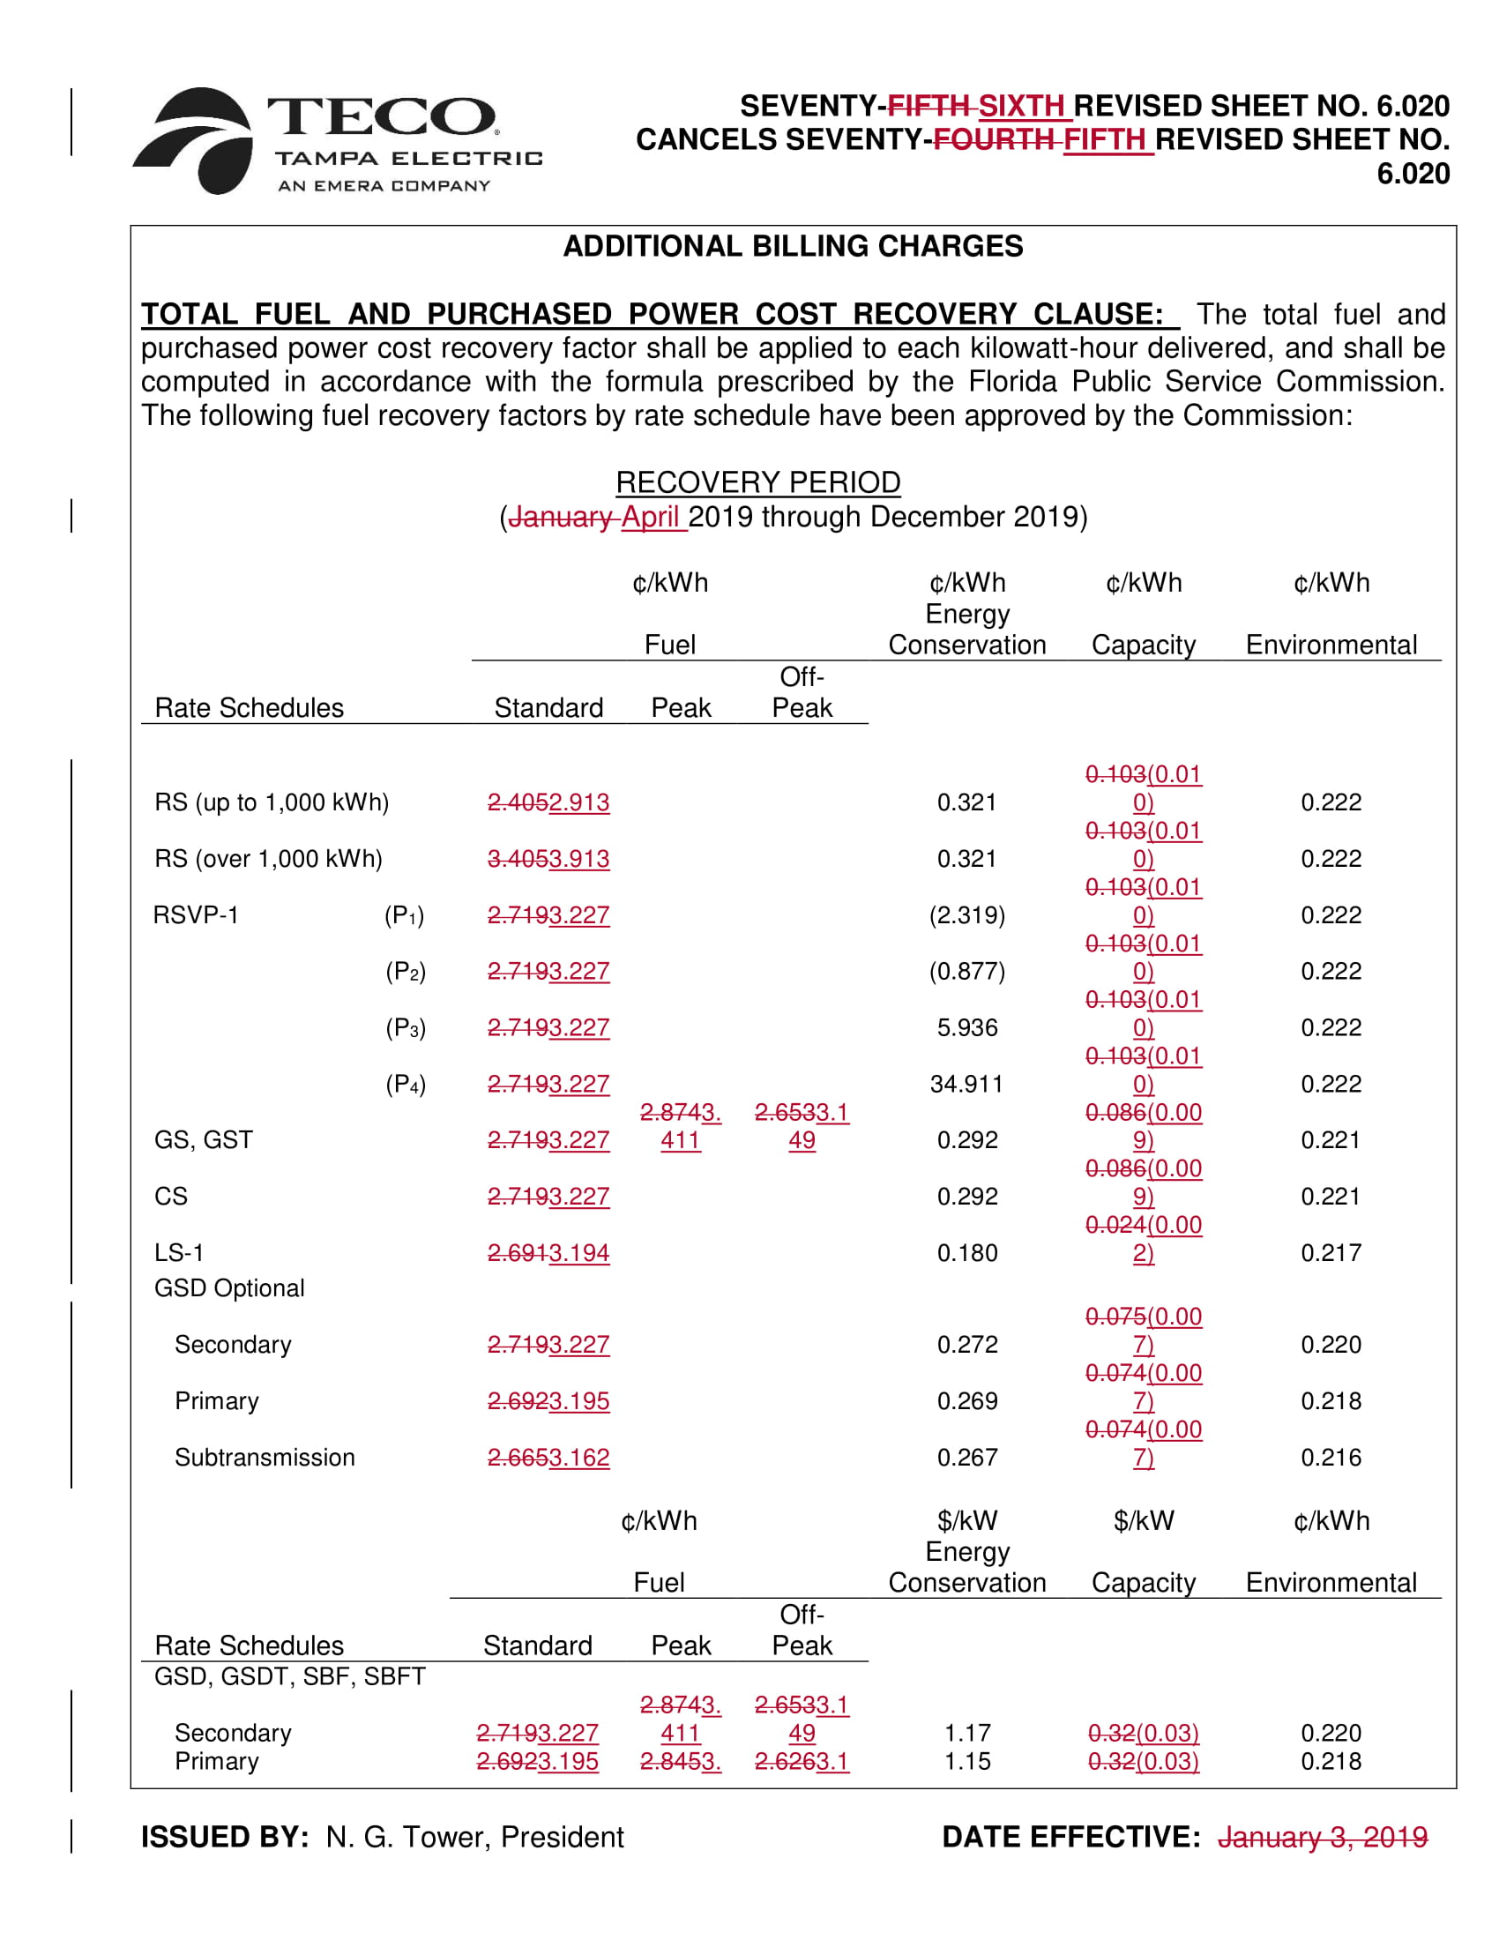

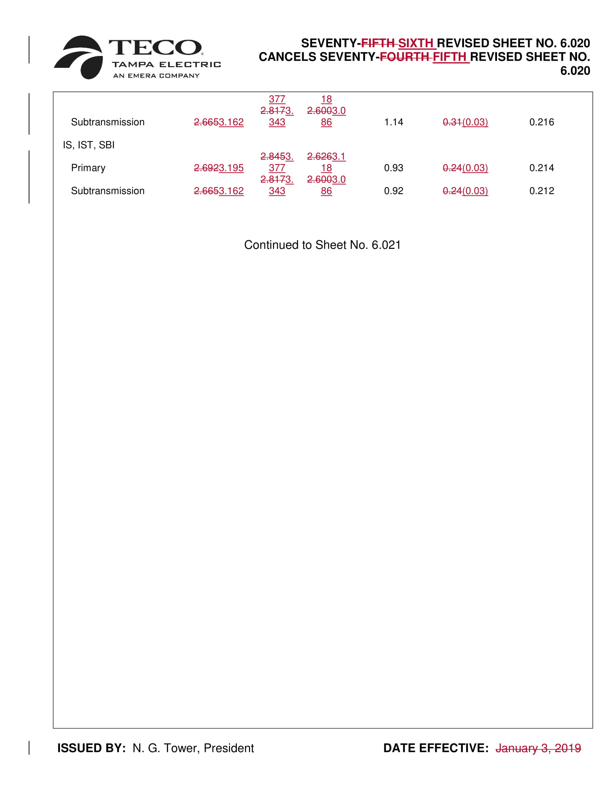

By Order No. PSC-2018-0610-FOF-EI, issued December 26, 2018, in Docket No. 20180001-EI, In re: Fuel and Purchased Power Cost Recovery Clause with Generating Performance Incentive Factor, we approved cost recovery factors for the period January through December, 2019. (2018 Fuel Order)
The negative value shown is due to the timing of this proposed correction. Because the Mid-Course Petition is proposed to become effective with the first billing cycle in April 2019, TECO will over collect on capacity amounts by charging the currently-approved factors for the months of January through March, 2019. As a result, the over-collected amount more than offsets all capacity costs from 2018 and 2019, and the recovery factors that are proposed for April through December 2019 reflect negative values, shown on Table 2 of Attachment A.
The New York Mercantile Exchange (NYMEX) is a commodities futures exchange widely used by the electric industry for pricing natural gas.
MMBTU is an acronym for one million British Thermal Units (BTU). A BTU is a measure of the energy content in fuel, and is used in the power, steam generation, heating and air conditioning industries. One BTU is equivalent to 1.06 Joules.
Schedule E3, Exhibit No. PAR-3, Document No. 2, Page 9 of 30, as filed in Docket No. 20180001-EI, on August 24, 2018.
Along with updated pricing for natural gas, the revised forecast incorporated more current information on planned outages and prices for purchased power.
Schedule E3, Mid-Course Correction filing, Page 12 of 33, as filed in Docket No. 20190001-EI, on January 15, 2019. In response to a data request, the Company stated that it expects coal prices to remain relatively stable for 2019.
Commission staff reviewed the news release information on the Company’s website.
Gulf Power Co. v. Cresse, 410 So. 2d 492 (Fla. 1982); Order No. PSC-96-0907-FOF-EI, issued on July 15, 1996, in Docket No. 19960001-EI, In re: Fuel and purchased power cost recovery clause and generating performance incentive factor; Order No. PSC-1996-0908-FOF-EI, issued July 15, 1996, in Docket No. 19960001-EI, In re: Fuel and purchased power cost recovery clause and generating performance incentive factor; Order No. PSC-1997-0021-FOF-EI, issued on January 6, 1997, in Docket No. 19970001-EI, In re: Fuel and purchased power cost recovery clause and generating performance incentive factor.
Order No. PSC-2001-0963-PCO-EI, issued April 18, 2001, in Docket No. 20010001-EI, In re: Fuel and purchased power cost recovery clause and generating performance incentive factor (allowing recovery of increase in fuel factor in order to decrease the carrying costs and therefore the total amount ratepayers were ultimately required to repay.); Order No. PSC-2000-2383-FOF-GU, issued December 12, 2000, in Docket No. 20000003-GU, In re: Purchased gas adjustment (PGA) true-up (allowing recovery of an increased gas fuel factor due to drastic increases in natural gas prices in winter of 2000-2001.); Order No. PSC-2015-0161-PCO-EI, issued April 30, 2015, in Docket No. 20150001-EI, In re: Fuel and Purchased Power Cost Recovery Clause with Generating Performance Incentive Factor (approving FPL’s petition for a mid-course correction, thereby reducing fuel factors with less than 30 days notice).

