BEFORE THE FLORIDA PUBLIC SERVICE COMMISSION

In re: Petition for approval of a smart meter opt-out tariff, by Tampa Electric Company. | DOCKET NO. 20190024-EI  ORDER NO. PSC-2019-0112-TRF-EI  ISSUED: March 25, 2019

The following Commissioners participated in the disposition of this matter:

ART GRAHAM, Chairman
JULIE I. BROWN
DONALD J. POLMANN
GARY F. CLARK
ANDREW GILES FAY

ORDER GRANTING TAMPA ELECTRIC COMPANY’S
PETITION FOR APPROVAL OF A SMART METER OPT-OUT TARIFF

BY THE COMMISSION:

Background
On January 18, 2019, Tampa Electric Company (TECO or Utility) filed a petition for approval of a smart meter opt-out tariff (opt-out tariff). The tariff, as approved herein, is available to customers who elect to receive a non-communicating meter in lieu of the standard smart meter, or Automated Meter Infrastructure (AMI) smart meter.
On November 16, 2017, we approved TECO’s 2017 Amended and Restated Stipulation and Settlement Agreement (2017 Settlement), which allows TECO to apply existing depreciation rates to AMI meters if they are installed before the Utility’s next depreciation study. Paragraph 12 of the 2017 Settlement allows the Utility to file the proposed opt-out tariff as the tariff and associated charges are optional to customers.
TECO’s current residential meters are Automated Meter Reading (AMR) meters that emit a radio frequency signal. That signal is picked up by a meter reading vehicle driving by the neighborhood. Current commercial customers primarily have digital, non-communicating meters that require monthly meter reading visits. The Utility states that the scope of the AMI project is to upgrade all meters in TECO’s service territory to AMI meters.
The Utility expects that some customers will elect to forego the new AMI meters and request a non-communicating meter; therefore, TECO filed the instant petition and associated opt-out tariff. The opt-out tariff will be applicable to customers that request a non-communicating, i.e., non-standard, meter and includes an initial one-time set-up fee of $96.27 and a monthly surcharge of $20.64. The proposed charges are based on TECO’s incremental costs to provide the opt-out service.
We approved similar opt-out tariffs and charges for Florida Power & Light Company (FPL) in 2015 and Duke Energy Florida, LLC (Duke) in 2018. FPL’s opt-out tariff includes an $89.00 one-time set-up fee with a $13.00 monthly surcharge. Duke’s opt-out tariff includes a $96.34 one-time set-up fee with a $15.60 monthly surcharge. Several municipal electric utilities (City of Lakeland and Orlando Utilities Commission) and rural electric cooperatives (Sumter Electric, Talquin Electric, Tri-County Electric, and Peace River) also provide opt-out tariffs.
On February 8 and 15, 2019, TECO responded to Commission staff data requests. The legislative version of the opt-out tariff sheet No. 3.280 is shown in Attachment A to this order. This Commission has jurisdiction pursuant to Sections 366.03, 366.04, 366.05, and 366.06, Florida Statutes (F.S.).

Decision
TECO began installing AMI meters in January 2017 with the goal of converting all of its existing drive-by AMR meters to AMI meters by 2021. The Utility states that customers are currently being granted the option of not having their meters replaced and are being told that there are currently no charges imposed for taking advantage of this option; however, they are being informed that it is expected that such charges will be authorized and collected in the future. The instant petition seeks to approve the tariff to implement such charges at a later date.
The requested tariff includes two separate fees: a one-time set-up fee of $96.27 (for the non-standard meter installation) and a monthly surcharge of $20.64 (for upfront IT costs and monthly meter readings). The set-up fee must be paid at the time the customer takes service under the opt-out tariff, regardless of the length of time the customer is enrolled; however, customers that have already rejected an AMI meter will not be assessed any opt-out tariff fees until the tariff is effective and a non-standard meter is installed (expected to be sometime in the third quarter of 2019). TECO states that this will allow customers time to elect to either continue or abandon their prior opt-out selection. These charges will be in addition to all other tariffed rates and charges applicable to an opt-out customer.

Customer Participation

TECO anticipates that approximately 0.2 percent – or 1,620 – of its approximate 810,000 customers will elect to opt out. The Utility explained that TECO is experiencing a current opt-out rate of 0.27 percent and anticipates a reduction in participation if the fees in the instant petition are introduced. As of December 31, 2017, FPL had 5,966 customers enrolled in its smart meter opt-out tariff, which represented a 0.12 percent customer participation rate. Duke anticipated 0.15 percent – about 2,700 – of its 1.8 million eligible customers would opt out. The projected number of opt-out customers is used in developing the monthly surcharge.

Set-up Fee

The one-time set-up fee of $96.27 reflects the labor, transportation, and initial IT set-up costs to install each non-standard meter and enroll the customer in the opt-out program. In response to Commission staff’s data request, TECO indicated that it is not creating any new positions to perform the incremental tasks associated with administering the opt-out tariff. Customers will not be required to pay the $96.27 set-up fee if an approved non-communicating meter already exists at customer premises or if customers relocate to premises with an approved non-communicating meter.
The set-up fee is applicable to all opt-out tariff participants regardless of duration of service under the opt-out tariff. The breakdown of the set-up fee components is shown in Table 1 below.

Table 1
Set-up Fee Cost Components
Task | Time Per Customer | Cost Per Customer | Description
Customer Service | 10 minutes | $5.28 | Customer Care Specialist to take calls for opt-out participants, explain tariff details, set up account, and handle initial questions/issues to support re-route.
Perform analysis to re-route meter | 45 minutes | $27.00 | Billing Specialist to analyze and plan approach to re-route meters, move meters to new route, and validate billing is correct.
Planner Dispatcher to reroute meter | 5 minutes | $4.05 | Planner/Dispatcher to move meter into new route upon direction from Billing Specialist.
Meter Field Rep to exchange meter | 40 minutes | $29.15 | Meter Field Rep to travel to customer premise, remove existing meter and replace with opt-out meter, close work orders.
Vehicle to exchange meter | 40 minutes | $2.76 | Use of a vehicle to change out meter.
IT developer to complete initial setup for opt-out customer | n/a | $28.03 | IT development work to prepare for customer sign-up for the opt-out program
Total one-time cost per customer |  | $96.27
Source: Exhibit A to TECO’s petition

TECO explained that the time per customer is based on each of the tasks to be performed. We find the time estimates to be reasonable. The cost per customer is calculated by multiplying the time to complete the task by the hourly rate of the job performer. TECO provided cost support for its hourly rates which includes the confidential annual salary, payroll tax, benefits, pension, and incentives (bonus payments). We reviewed hourly rate information provided by TECO in its 2013 rate case and find the hourly rates included in this docket are reasonable. Furthermore, TECO’s salaries and vehicle rates are comparable to those approved for FPL’s and Duke’s opt-out charges.

Monthly Surcharge

The monthly surcharge to take service under the opt-out tariff is $20.64, which reflects a combination of ongoing IT and meter reading related costs. TECO’s states that its IT costs are predicted to be $407,966. This is the estimated cost to update the customer system to enable and support the opt-out program. TECO used a 5-year recovery period for these IT costs to derive monthly IT related costs of $6.35 per customer, which is the same recovery period we approved for FPL’s and Duke’s opt-out tariff.
After installation of a non-standard meter, the only ongoing costs to the Utility will be the monthly meter readings, which the Utility estimates to be $14.29 per customer. These costs reflect the meter reading position rates and the vehicle rates, both for an estimated 20 minutes per meter reading.

Customer Notice and Deployment

The Utility states that AMI deployment began in January 2017 with the goal of converting all of its existing drive-by AMR meters to AMI meters by 2021. TECO explained that customers are currently being granted the option of not having their AMR meters replaced with an AMI meter and are being told that there are currently no charges for taking advantage of this option. TECO also informed customers that if this Commission approves an opt-out tariff, any approved opt-out charges will apply. TECO states that customers who have opted out during the AMI deployment process will be contacted when the opt-out tariff becomes effective. If the customers continue to desire to opt out, they will be enrolled in the opt-out tariff, receive a non-communicating meter, and be assessed the applicable tariffed charges.
TECO states that the Utility will communicate to customers the deployment logistics of the AMI meters and provide them with facts to help them understand AMI technology. TECO’s communication process includes information on the Utility’s website, door hangers, and mail notifications.

Reporting

Within three months after the AMI meter deployment is completed, TECO shall report to this Commission on the costs of the program, revenues, and actual participation. We find that three months is a reasonable time to allow TECO to prepare and file a report in this docket, which shall happen no later than May 31, 2022. If AMI meter deployment is significantly delayed beyond the Utility’s anticipated completion date, the Utility shall notify us with a filing in this docket.
It is noted that FPL is required to file annual smart meter progress reports. We did not require Duke to file annual smart meter progress reports, but rather submit a filing in that docket three months after the AMI meter deployment is completed. As with Duke, we find that actual participation rates and costs may vary and that a comparison of estimated costs presented in this petition and actual costs incurred is important to ensure the opt-out tariff remains cost-based or else be adjusted through a revised tariff filing.

Conclusion

In the order approving FPL’s opt-out tariff, we noted that “since significant incremental costs would be incurred in providing [an opt-out tariff], it would be discriminatory to require standard meter customers to subsidize that service.” We find that TECO provided sufficient cost support in its petition and responses to Commission staff’s data requests to support its assertion that the proposed tariff is cost-based. Therefore, we hereby approve TECO’s proposed opt-out tariff, as shown in Attachment A. This tariff allows TECO to respond to customer requests for a non-communicating meter. Opt-out customers will be responsible for all costs associated with their request, thus protecting the general body of ratepayers. Additionally, the proposed opt-out tariff is in accordance with previous Commission decisions.
The tariff shall become effective when TECO completes the billing system changes to implement the tariff, which is expected to be in the third quarter of 2019. TECO shall notify Commission staff when the billing system changes are completed. Within three months after the AMI smart meter deployment is completed, TECO shall report to this Commission (with a filing in this docket) on the costs of the program, revenues, and actual participation.
Based on the foregoing, it is

ORDERED by the Florida Public Service Commission that Tampa Electric Company’s petition for approval of a smart meter opt-out tariff is hereby granted, effective when TECO completes the billing system changes to implement the tariff. It is further

ORDERED that TECO shall notify Commission staff when the billing system changes are completed. Within three months after the Automated Meter Infrastructure smart meter deployment is completed, TECO shall file a report within this docket on the costs of the program, revenues, and actual participation. It is further

ORDERED that if a protest is filed within 21 days of issuance of this Order, the tariff shall remain in effect with any charges held subject to refund pending resolution of the protest. It is further

ORDERED that if no timely protest is filed, this docket shall be closed upon the issuance of a Consummating Order.

By ORDER of the Florida Public Service Commission this 25th day of March, 2019.

/s/ Adam J. Teitzman
ADAM J. TEITZMAN
Commission Clerk
Florida Public Service Commission
2540 Shumard Oak Boulevard
Tallahassee, Florida 32399
(850) 413-6770
www.floridapsc.com

Copies furnished: A copy of this document is provided to the parties of record at the time of issuance and, if applicable, interested persons.
JEN

NOTICE OF FURTHER PROCEEDINGS

The Florida Public Service Commission is required by Section 120.569(1), Florida Statutes, to notify parties of any administrative hearing or judicial review of Commission orders that is available under Sections 120.57 or 120.68, Florida Statutes, as well as the procedures and time limits that apply. This notice should not be construed to mean all requests for an administrative hearing or judicial review will be granted or result in the relief sought.

Mediation may be available on a case-by-case basis. If mediation is conducted, it does not affect a substantially interested person's right to a hearing.

The Commission's decision on this tariff is interim in nature and will become final, unless a person whose substantial interests are affected by the proposed action files a petition for a formal proceeding, in the form provided by Rule 28-106.201, Florida Administrative Code. This petition must be received by the Office of Commission Clerk, 2540 Shumard Oak Boulevard, Tallahassee, Florida 32399-0850, by the close of business on April 15, 2019.

In the absence of such a petition, this Order shall become final and effective upon the issuance of a Consummating Order.

Any objection or protest filed in this docket before the issuance date of this order is considered abandoned unless it satisfies the foregoing conditions and is renewed within the specified protest period.

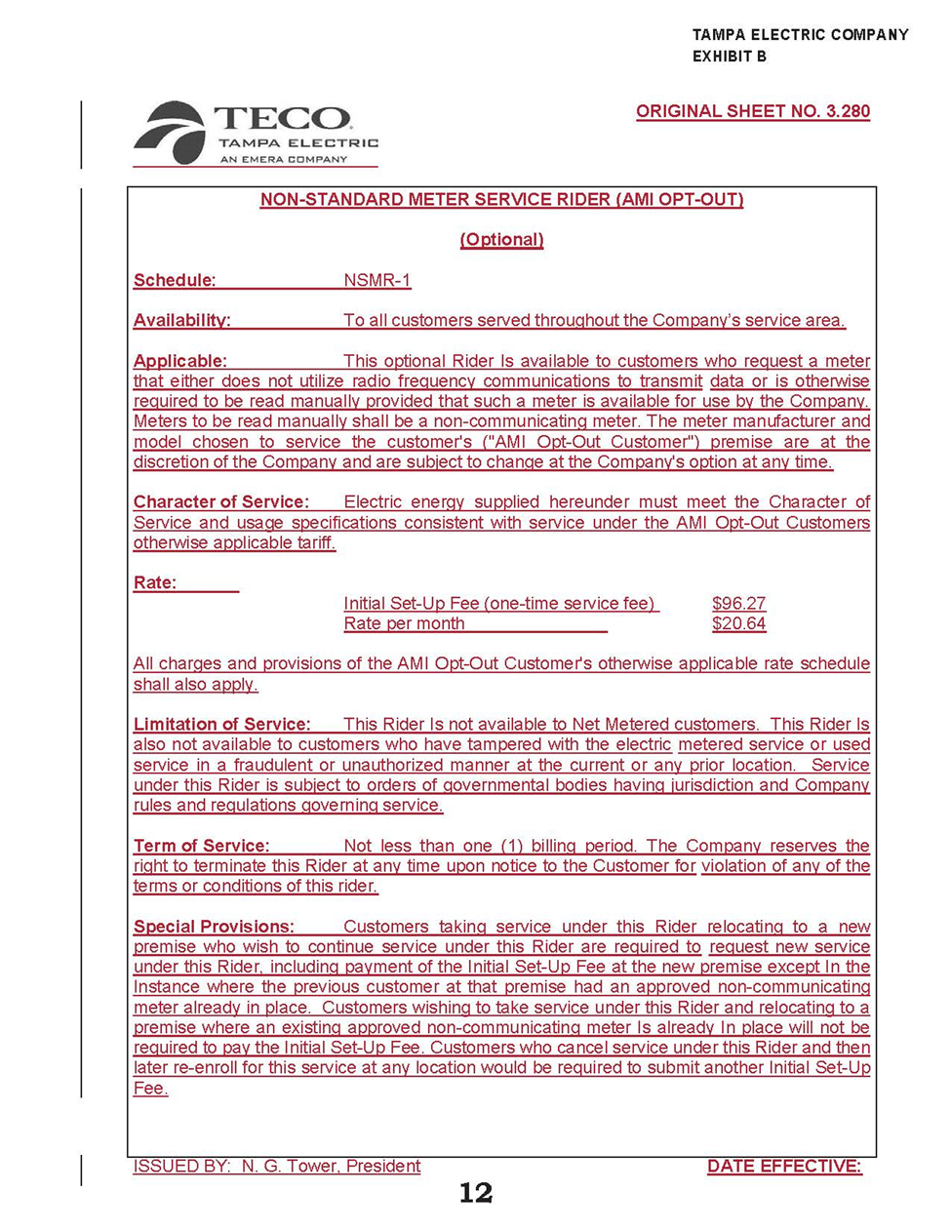

Order No. PSC-2017-0456-S-EI, issued November 27, 2017, in Docket No. 20170210-EI; In re: Petition for limited proceeding to approve 2017 amended and restated stipulation and settlement agreement, by Tampa Electric Company.
Order No. PSC-15-0026-FOF-EI, issued on January 7, 2015, in Docket No. 130223-EI; In re: Petition for approval of optional non-standard meter rider, by Florida Power & Light Company.
Order No. Order PSC-2018-0435-TRF-EI, issued on August 28, 2018, in Docket No. 180088-EI; In re: Petition for limited proceeding for approval of a smart meter opt-out tariff, by Duke Energy Florida, LLC.
TECO’s petition included other non-substantive tariff changes that have not been attached to this order.
TECO requested confidentiality on the negotiated IT contractor information.
Docket No. 130040-EI; In re: Petition for rate increase by Tampa Electric Company.
Order No. PSC-15-0026-FOF-EI, issued on January 7, 2015, in Docket No. 130223-EI; In re: Petition for approval of optional non-standard meter rider, by Florida Power & Light Company.

