BEFORE THE FLORIDA PUBLIC SERVICE COMMISSION

In re: Complaint against Gulf Power Company for expedited enforcement of territorial order, by Gulf Coast Electric Cooperative, Inc. | DOCKET NO. 20180125-EU  ORDER NO. PSC-2019-0134-PAA-EU  ISSUED: April 16, 2019

The following Commissioners participated in the disposition of this matter:

ART GRAHAM, Chairman
DONALD J. POLMANN
ANDREW GILES FAY

NOTICE OF PROPOSED AGENCY ACTION
ORDER APPROVING SETTLEMENT AGREEMENT
AND REVISIONS TO TERRITORIAL AGREEMENT
AND
ORDER VACATING PREVIOUS COMMISSION VOTE

BY THE COMMISSION:

NOTICE is hereby given by the Florida Public Service Commission that the action discussed herein, except for vacating our previous vote, is preliminary in nature and will become final unless a person whose interests are substantially affected files a petition for a formal proceeding, pursuant to Rule 25-22.029, Florida Administrative Code (F.A.C.).

Background
This docket pertains to a territorial dispute between Gulf Coast Electric Cooperative (GCEC) and Gulf Power Company (Gulf Power) over new service to a sewage treatment lift facility (Lift Facility) that was constructed by St. Joe Company. The ultimate customer of the Lift Facility is Bay County, and the Lift Facility was transferred to Bay County after the completion and commissioning of the facility.

To resolve a long-standing dispute between GCEC and Gulf Power regarding electric service in certain areas of Washington and Bay Counties, GCEC and Gulf Power entered into a Territorial Agreement (Territorial Agreement). The Territorial Agreement set out procedures and guidelines by which the parties were to address sub transmission, distribution, and new requests for service. This Commission approved this Territorial Agreement by Order Nos. PSC-01-0891-PAA-EU, issued April 9, 2001, and PSC-01-0891A-PAA-EU, issued March 26, 2002 (collectively referred to herein as the Territorial Order).

The Territorial Agreement does not use a traditional “lines-on-the-ground” territorial boundary. Rather, the Territorial Agreement establishes procedures for the parties to follow upon receiving a request for service from a customer.

On May 23, 2018, GCEC filed a complaint against Gulf Power in the instant docket alleging, in essence, that Gulf Power did not comply with the notice procedures of the Territorial Agreement and seeking expedited enforcement of the Territorial Order in GCEC’s favor to service the new Lift Facility. After filing an answer to GCEC’s complaint, Gulf Power filed a Motion for Summary Final Order on June 6, 2018. At the December 11, 2018 Agenda Conference, we voted to grant Gulf Power’s Motion for Summary Final Order and denied GCEC’s Motion for Summary Final Order as moot. Prior to the issuance of an order on that vote, Commission staff filed a recommendation on February 21, 2019, stating that staff believed it had incorrectly advised us on Gulf Power’s Motion for Summary Final Order and recommended that we vacate our December 11, 2018, votes to grant Gulf Power’s Motion for Summary Final Order and deny GCEC’s Motion for Summary Final Order, and reconsider the parties’ motions. Commission staff’s recommendation, ultimately, was to deny both Gulf Power’s and GCEC’s Motions for Summary Final Order. At the request of the parties, and in order to allow for further discussion of settlement of this matter, we deferred consideration of the Commission staff recommendation until the April 2, 2019, Agenda Conference.

On March 20, 2019, GCEC and Gulf Power filed a Joint Motion to Approve Settlement Agreement and Amendment to Territorial Agreement (Joint Motion) to resolve all matters in this docket and clarify current language in the notice procedure for future application.
We have jurisdiction in this matter pursuant to Section 366.04, Florida Statutes (F.S.).

Decision
The parties’ proposed settlement resolves the question regarding which electric utility will serve the Lift Facility and also proposes to revise the Territorial Agreement. The parties state that the proposed Settlement Agreement and revisions to the Territorial Agreement are null and void unless we approve them in their entirety by “non-appealable” final order.

The proposed Settlement Agreement provides that:

- Gulf Power relinquish service to the Lift Facility to GCEC.
- Gulf Power remove 3,000 linear feet of lines beginning at the Lift Facility and extending west to a demarcation point bisecting the right-of-way on a specified highway.
- GCEC be permitted to extend westerly its lines and facilities 11,000 linear feet, beginning at its existing facilities.
- GCEC agree not to assess any additional charges to the Lift Facility as a result of GCEC taking over service to that facility.
- The parties agree to not further extend lines from a demarcation point along the right-of-way of a specified highway.

The Settlement Agreement also calls for GCEC to withdraw its complaint in this docket if we grant the Joint Motion in its entirety.

The parties state that the proposed revisions to the Territorial Agreement are intended to forestall future disputes regarding interpretation of that Agreement and avoid further uneconomic duplication of facilities. In summary, the proposed revisions:

- Provide that, for certain service requests from a customer, the requested utility must deliver notice of their intent to fulfill such a request to the other utility by certified mail. The proposed revisions also provide the persons to whom such a notice must be sent.
- Define the term “all relevant information” to clarify what information must be provided in the notice to the other utility about a service request from a customer.
- Revise the deadline for the other utility to reply to the notice from the requested utility from five to ten days.
- Require the utility responding to the notice to do so in writing.

The parties’ Settlement Agreement (incorporating the parties’ corrected page 2 of the Settlement Agreement that was filed on March 22, 2019) and the First Amendment to Territorial Agreement are attached as Appendix A.
Pursuant to Section 366.04(2)(d), F.S., and Rule 25-6.0440, F.A.C., we have the jurisdiction to approve territorial agreements between and among rural electric cooperatives, municipal electric utilities, and other electric utilities. Unless we determine that the agreement will cause a detriment to the public interest, the agreement should be approved.
After our review of the Joint Motion and the proposed revisions to the Territorial Agreement, we find that the proposed amendments to the Territorial Agreement are in the public interest and will enable Gulf Power and GCEC to serve their customers in an efficient manner. We also find that the proposed amendments will avoid uneconomic duplication of facilities and will not cause a decrease in the reliability of electric service to the customers. The joint movants state that they have worked together to resolve the issues in this docket and voluntarily have entered into the Settlement Agreement. We agree that the Settlement Agreement fairly and reasonably balances the various positions of the parties regarding the issues in this docket, and it serves the best interests of Gulf Power’s and GCEC’s customers and the public interest in general. As such, Gulf Power and GCEC’s Settlement Agreement (as corrected on March 22, 2019) and proposed revisions to the Territorial Agreement are approved in the public interest.
Upon this Proposed Agency Action becoming a Final Order, the Settlement Agreement provides that GCEC must withdraw its complaint in this matter. Because the Motions for Summary Final Order filed by Gulf Power and GCEC are moot with our approval of the Settlement Agreement, we also vacate our votes from the December 11, 2018, Agenda Conference regarding those Motions.
Based on the foregoing, it is

ORDERED by the Florida Public Service Commission that Gulf Coast Electric Cooperative, Inc. and Gulf Power Company’s Joint Motion to Approve Settlement Agreement and Amendment to Territorial Agreement is granted. It is further,

ORDERED that the Settlement Agreement and the First Amendment to the Territorial Agreement are approved as attached as Appendix A to this Order. It is further,

ORDERED, that our votes from the December 11, 2018, Agenda Conference, regarding the granting of a Motion for Summary Final Order for Gulf Power and denying of a Motion for Summary Final Order for GCEC, are hereby vacated. It is further,

ORDERED that the provisions of this Order, issued as proposed agency action, shall become final and effective upon the issuance of a Consummating Order unless an appropriate petition, in the form provided by Rule 28-106.201, Florida Administrative Code, is received by the Commission Clerk, 2540 Shumard Oak Boulevard, Tallahassee, Florida 32399-0850, by the close of business on the date set forth in the “Notice of Further Proceedings” attached hereto. It is further

ORDERED that if no protest to the proposed agency action is filed by a substantially affected person within 21 days of the date of the issuance of the order, a consummating order shall be issued and the docket shall be closed.
By ORDER of the Florida Public Service Commission this 16th day of April, 2019.

ADAM J. TEITZMAN
Commission Clerk
Florida Public Service Commission
2540 Shumard Oak Boulevard
Tallahassee, Florida 32399
(850) 413-6770
www.floridapsc.com

Copies furnished: A copy of this document is provided to the parties of record at the time of issuance and, if applicable, interested persons.

KMS

NOTICE OF FURTHER PROCEEDINGS OR JUDICIAL REVIEW

The Florida Public Service Commission is required by Section 120.569(1), Florida Statutes, to notify parties of any administrative hearing or judicial review of Commission orders that is available under Sections 120.57 or 120.68, Florida Statutes, as well as the procedures and time limits that apply. This notice should not be construed to mean all requests for an administrative hearing or judicial review will be granted or result in the relief sought.

As identified in the body of this order, our action herein, except for vacating our previous votes, is preliminary in nature. Any person whose substantial interests are affected by the action proposed by this order may file a petition for a formal proceeding, in the form provided by Rule 28-106.201, Florida Administrative Code. This petition must be received by the Office of Commission Clerk, 2540 Shumard Oak Boulevard, Tallahassee, Florida 32399-0850, by the close of business on May 7, 2019. If such a petition is filed, mediation may be available on a case-by-case basis. If mediation is conducted, it does not affect a substantially interested person's right to a hearing. In the absence of such a petition, this order shall become effective and final upon the issuance of a Consummating Order.

Any objection or protest filed in this docket before the issuance date of this order is considered abandoned unless it satisfies the foregoing conditions and is renewed within the specified protest period.

Any party adversely affected by the vacation of the December 11, 2018, Agenda Conference Commission votes, which is procedural or intermediate in nature, may request: (1) reconsideration within 10 days pursuant to Rule 25-22.0376, Florida Administrative Code, if issued by a Prehearing Officer; (2) reconsideration within 15 days pursuant to Rule 25-22.060, Florida Administrative Code, if issued by the Commission; or (3) judicial review by the Florida Supreme Court, in the case of an electric, gas or telephone utility, or the First District Court of Appeal, in the case of a water or wastewater utility. A motion for reconsideration shall be filed with the Office of Commission Clerk, in the form prescribed by Rule 25-22.060, Florida Administrative Code. Judicial review of a preliminary, procedural or intermediate ruling or order is available if review of the final action will not provide an adequate remedy. Such review may be requested from the appropriate court, as described above, pursuant to Rule 9.100, Florida Rules of Appellate Procedure.

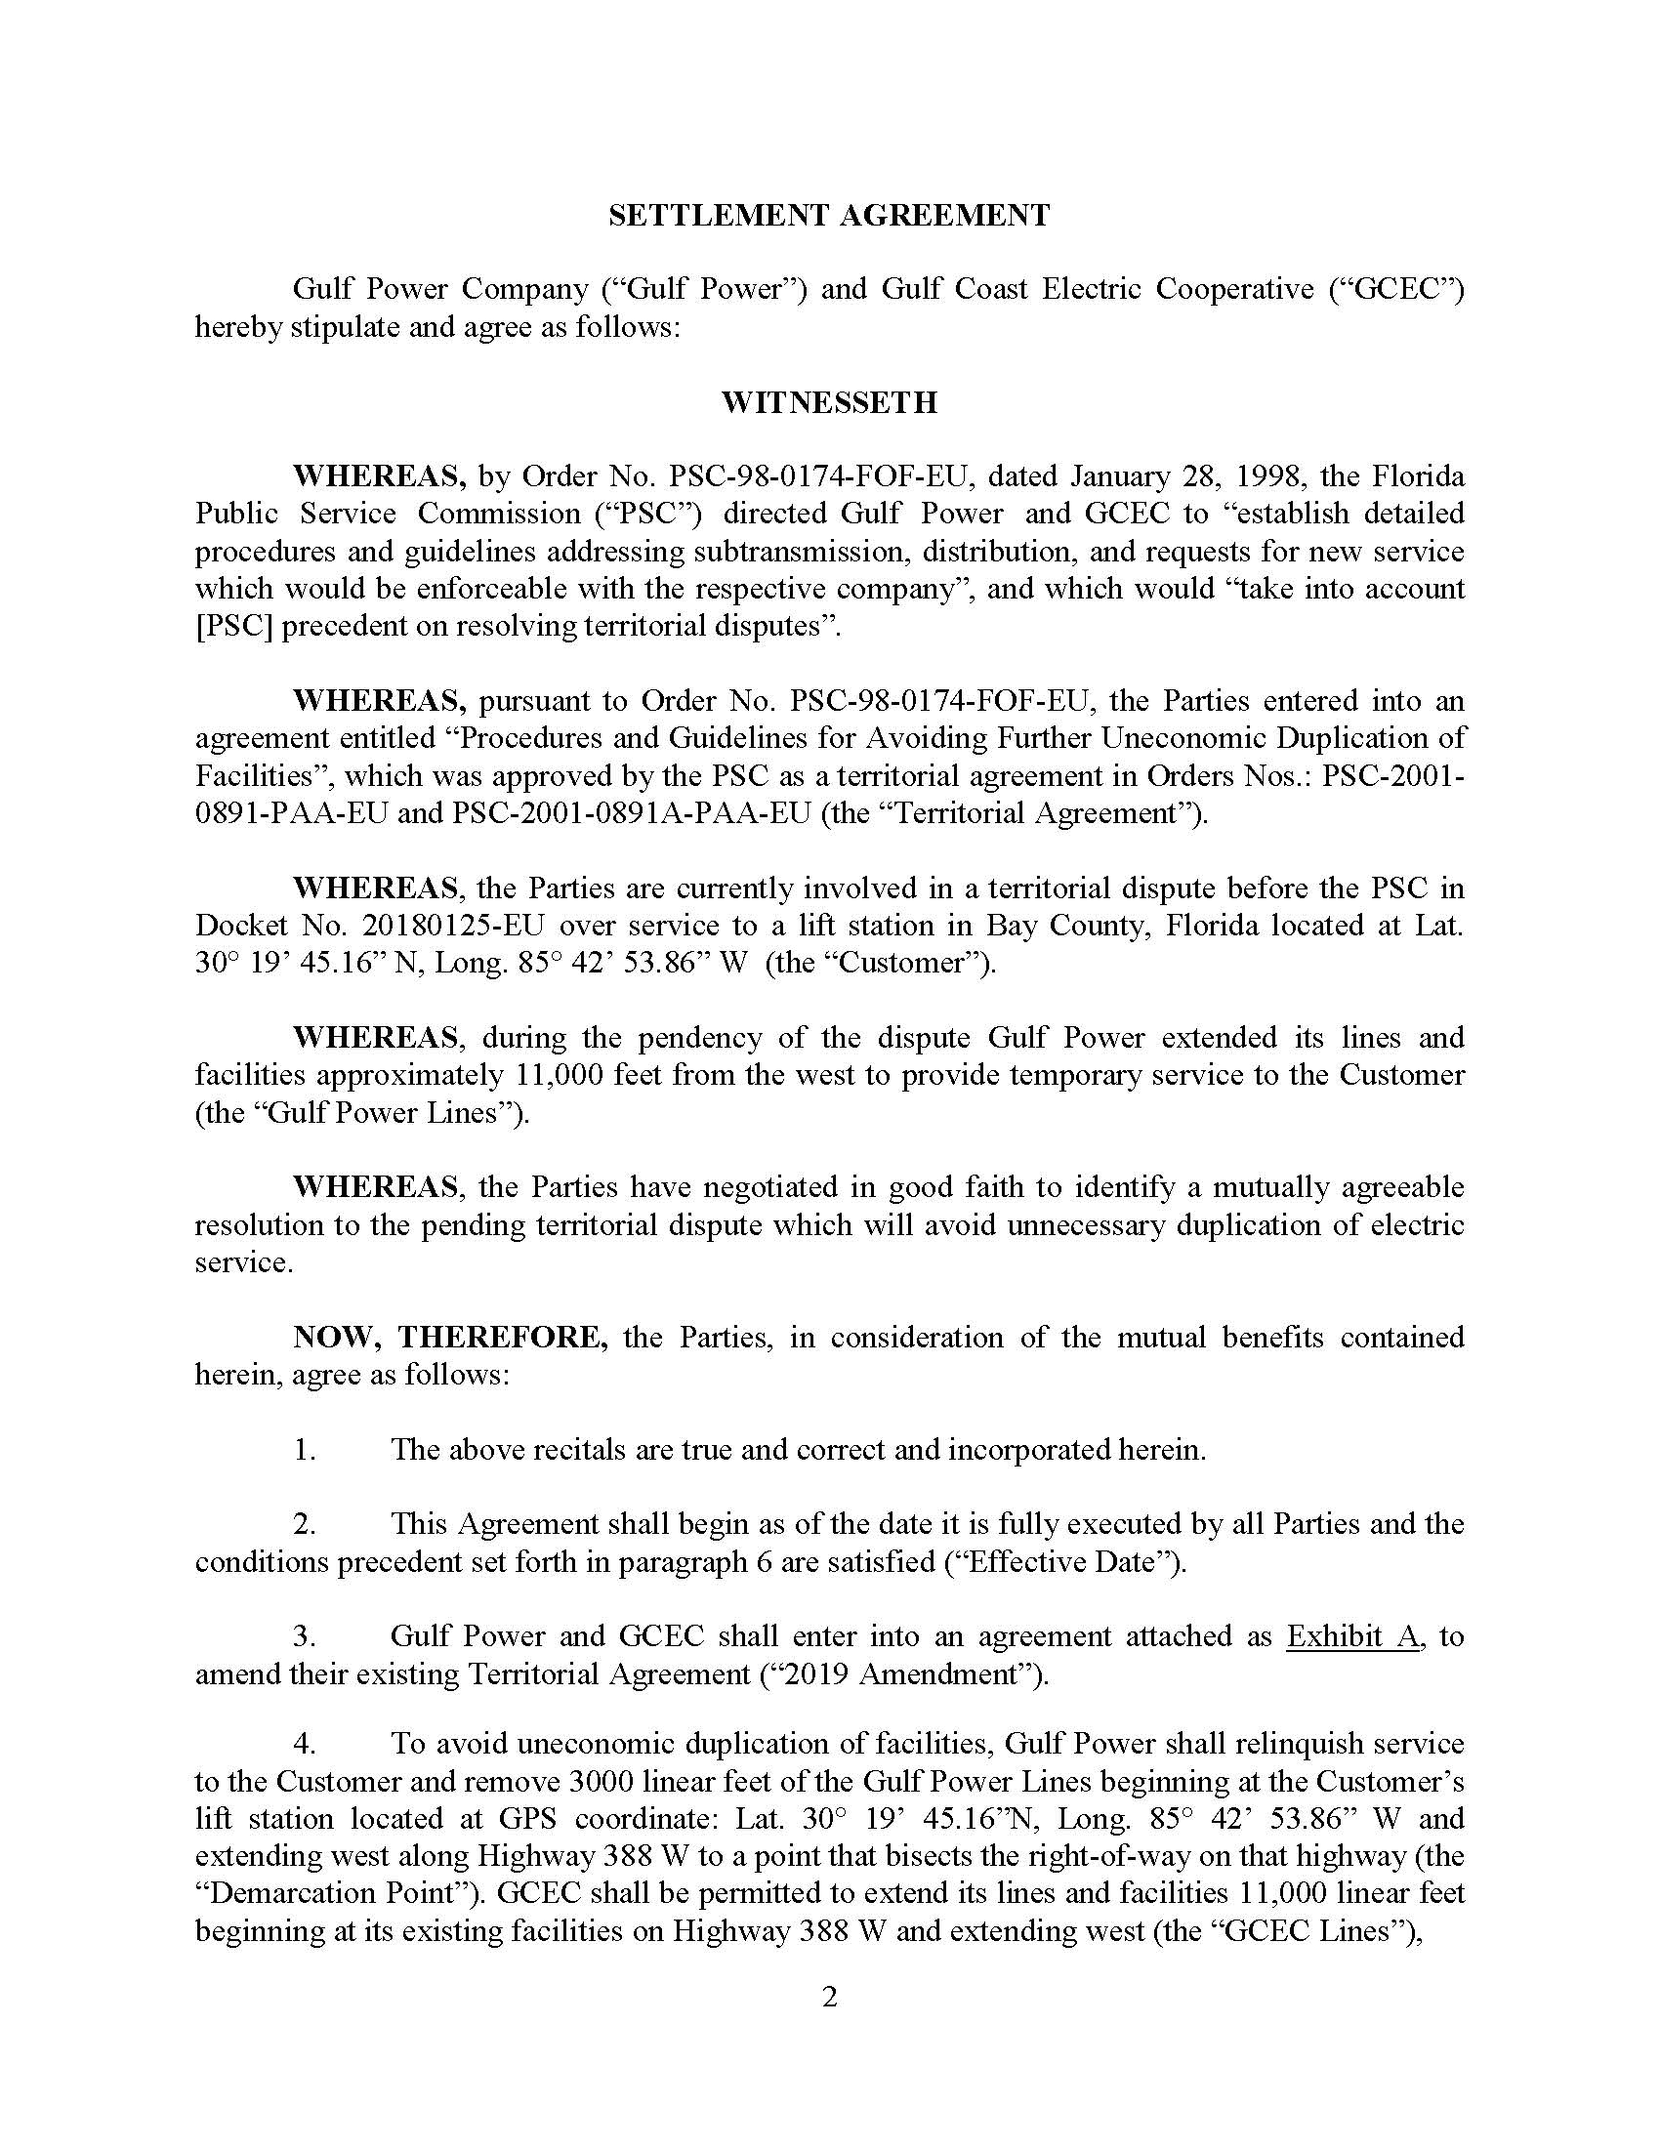

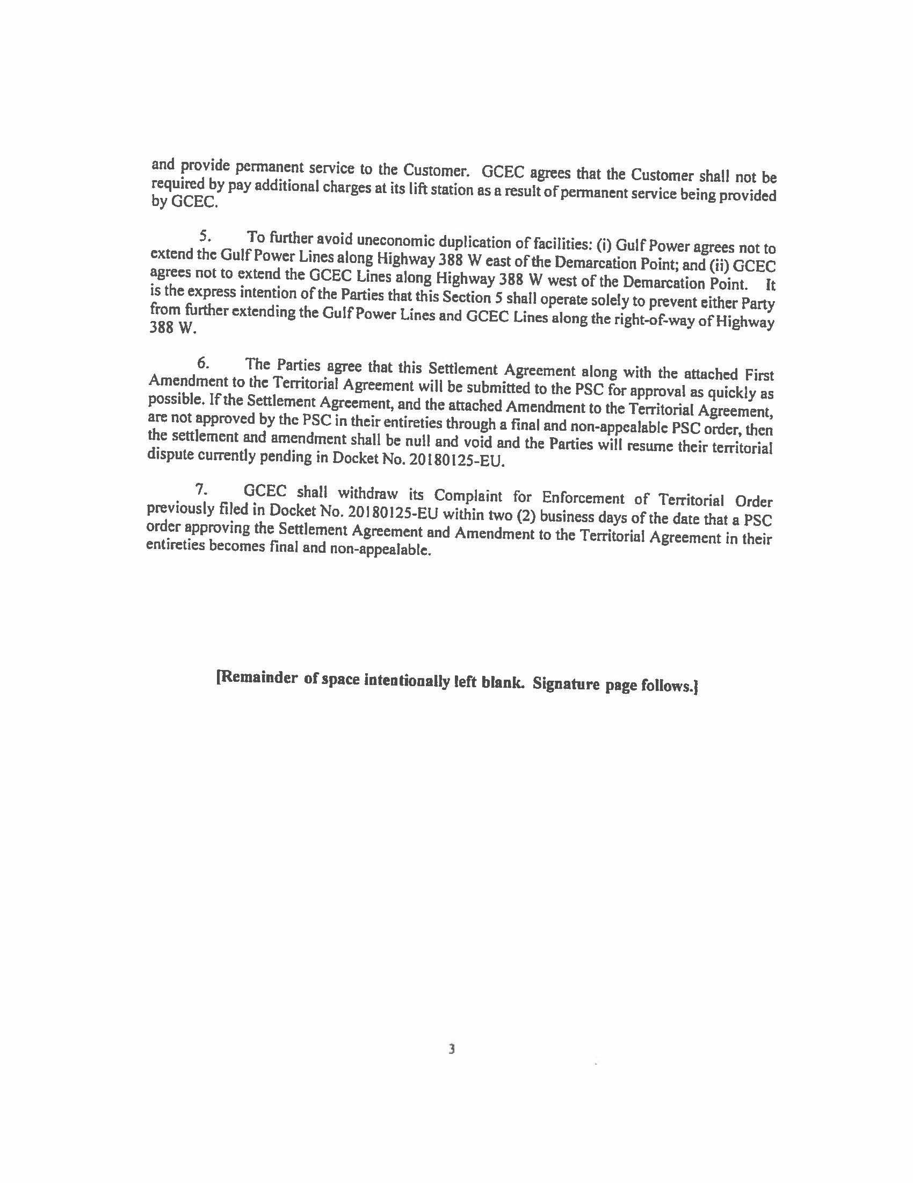

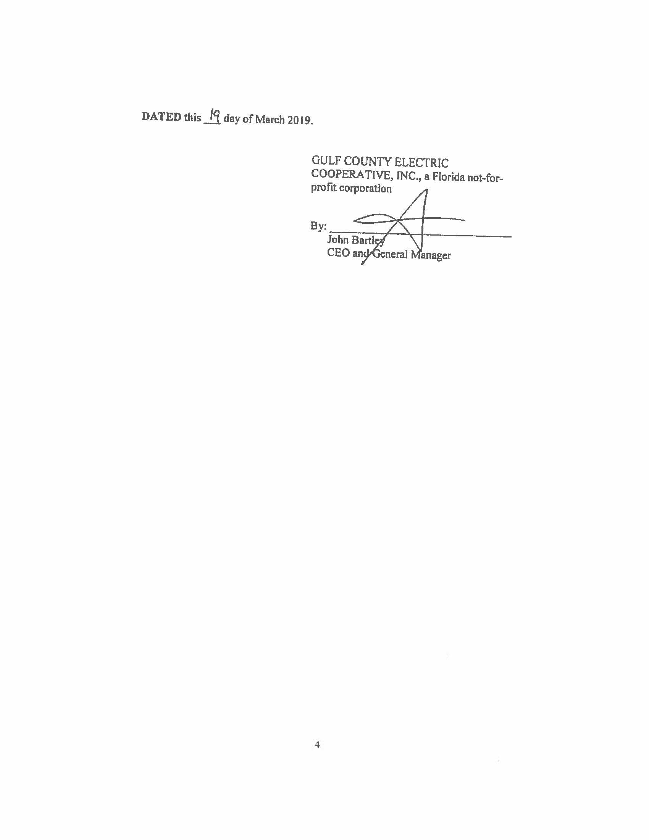

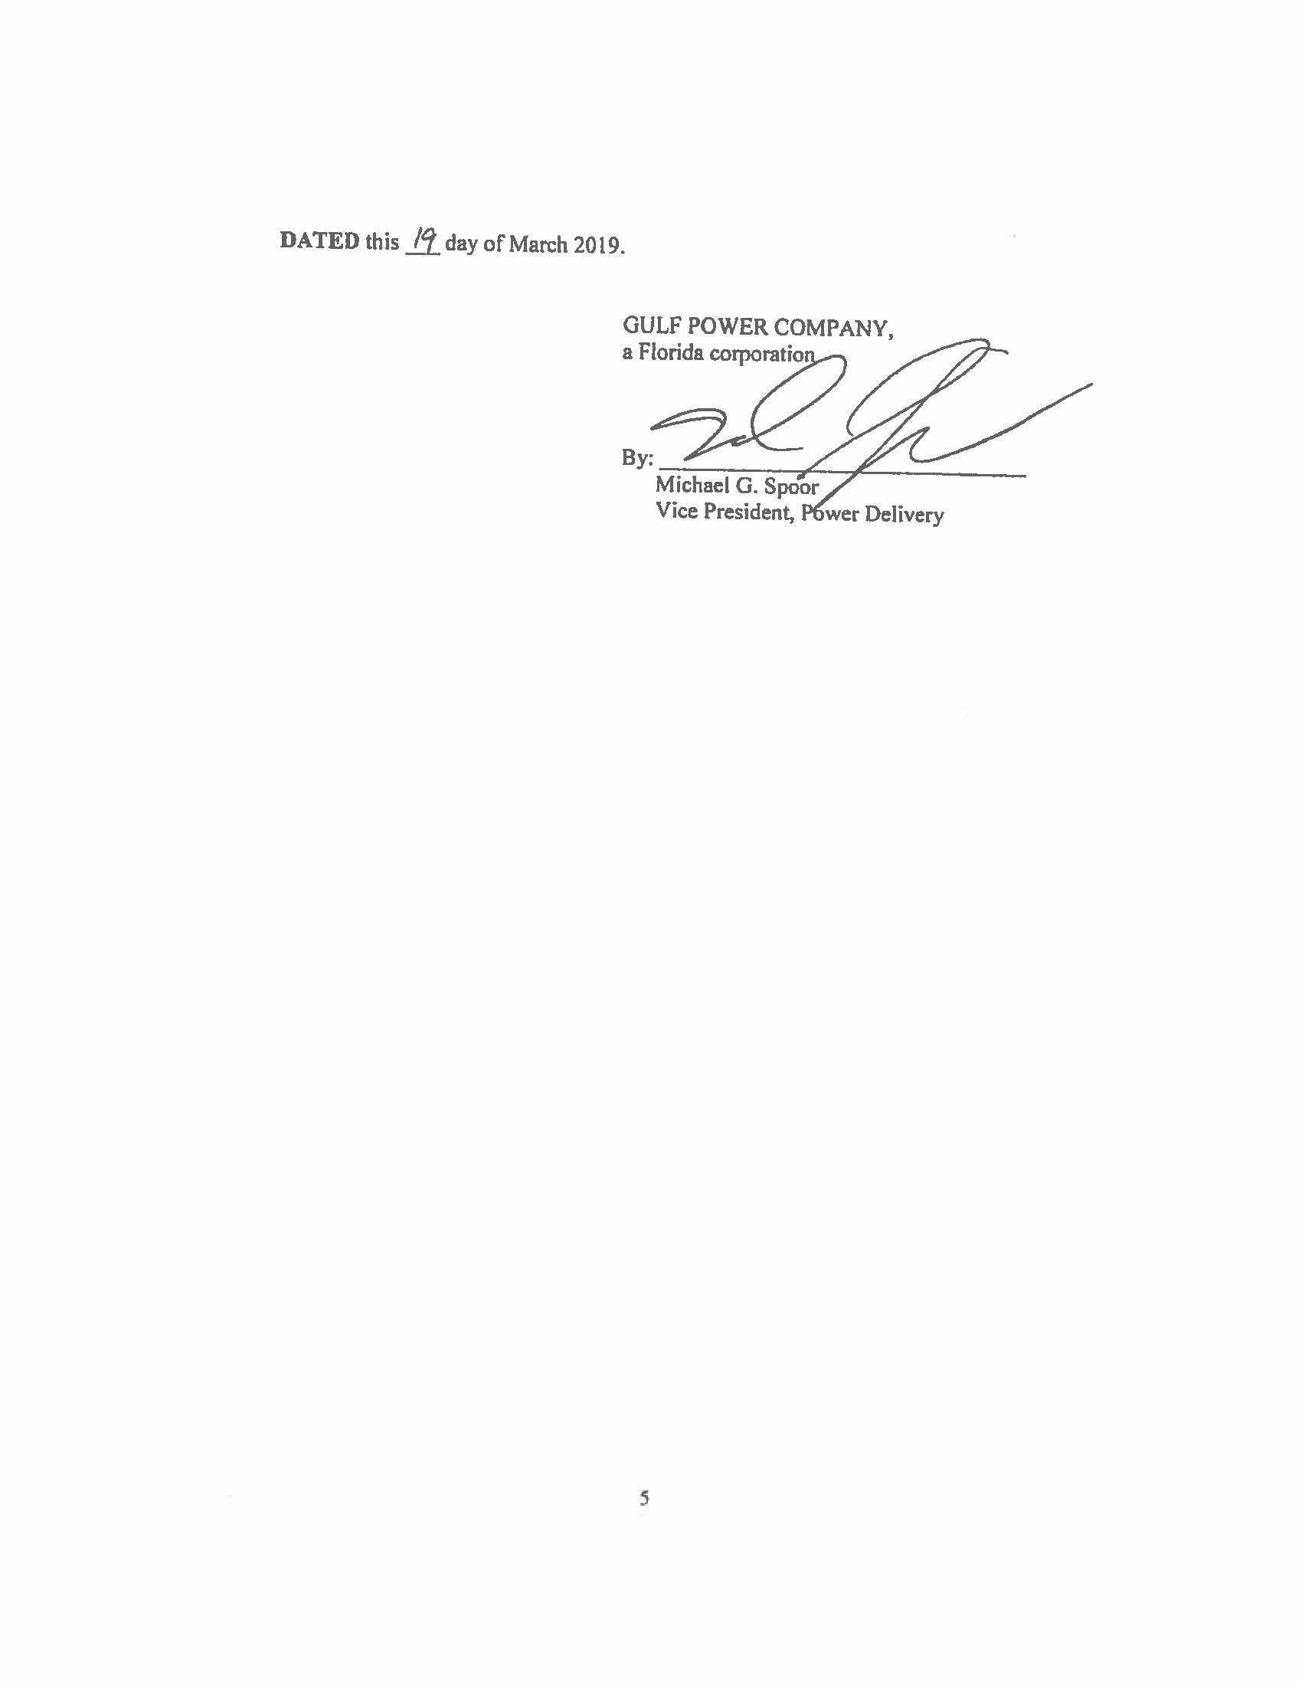

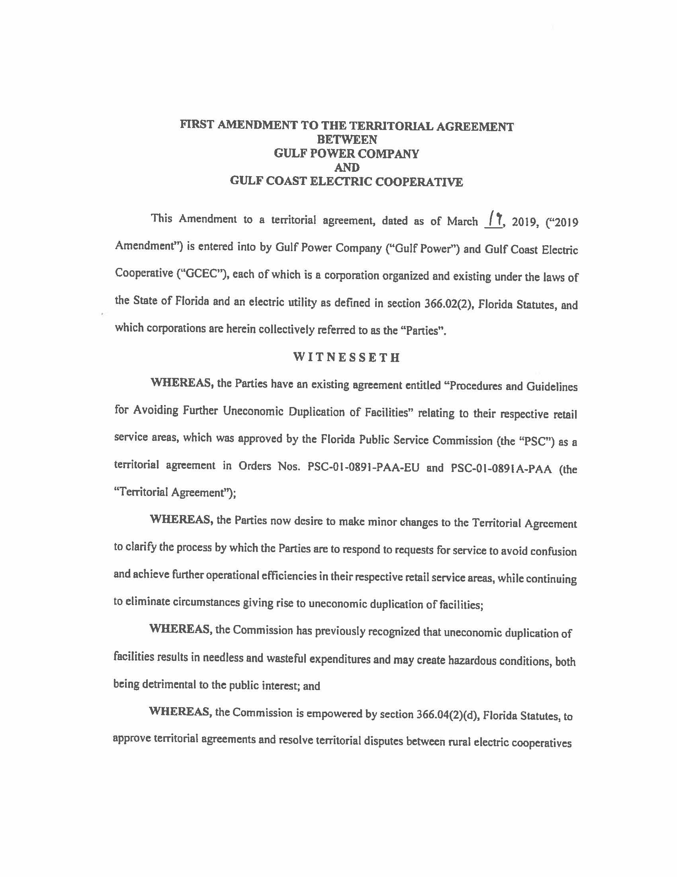

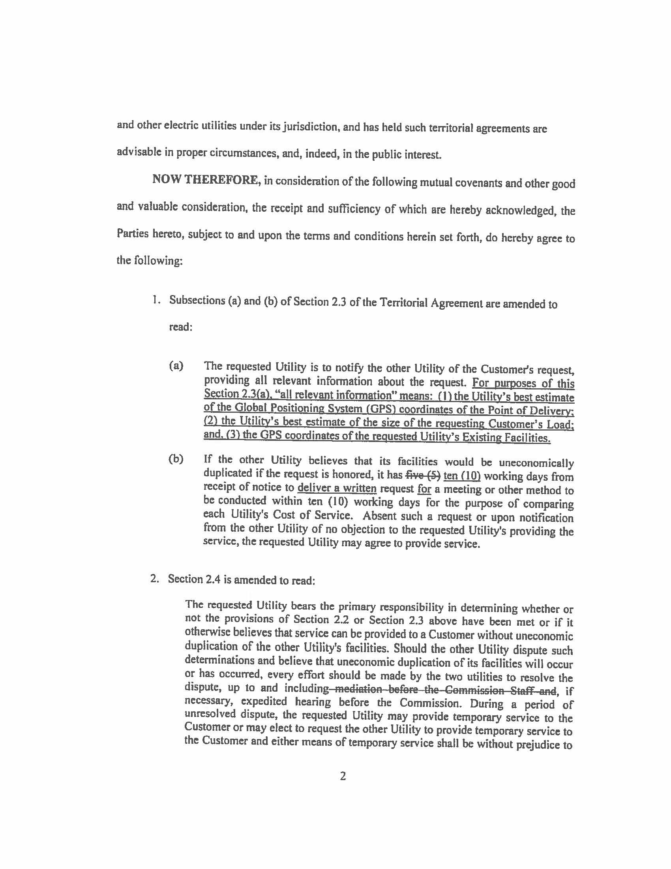

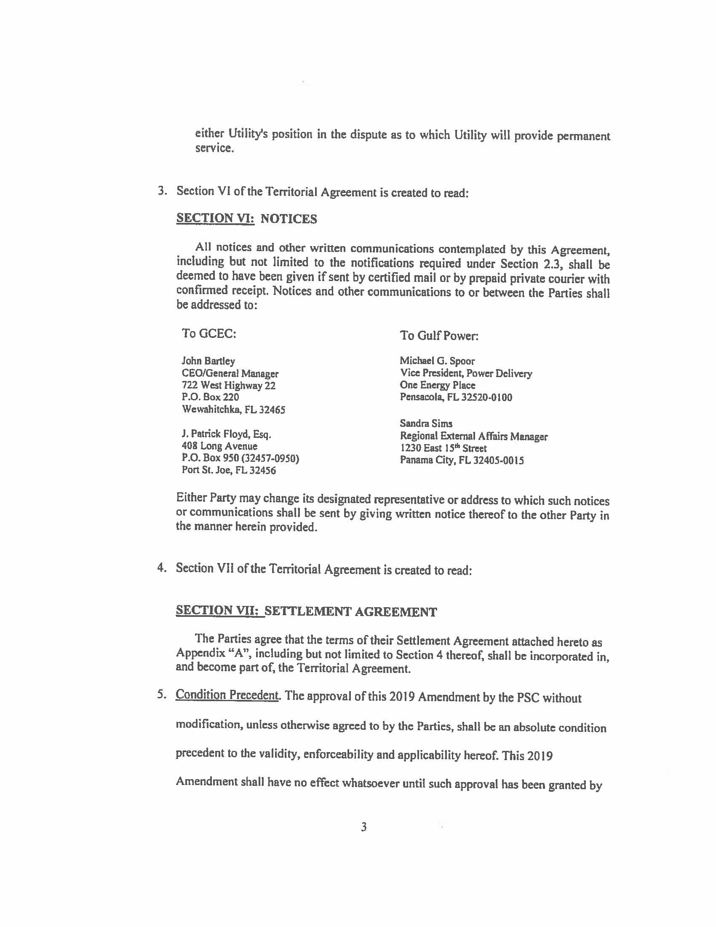
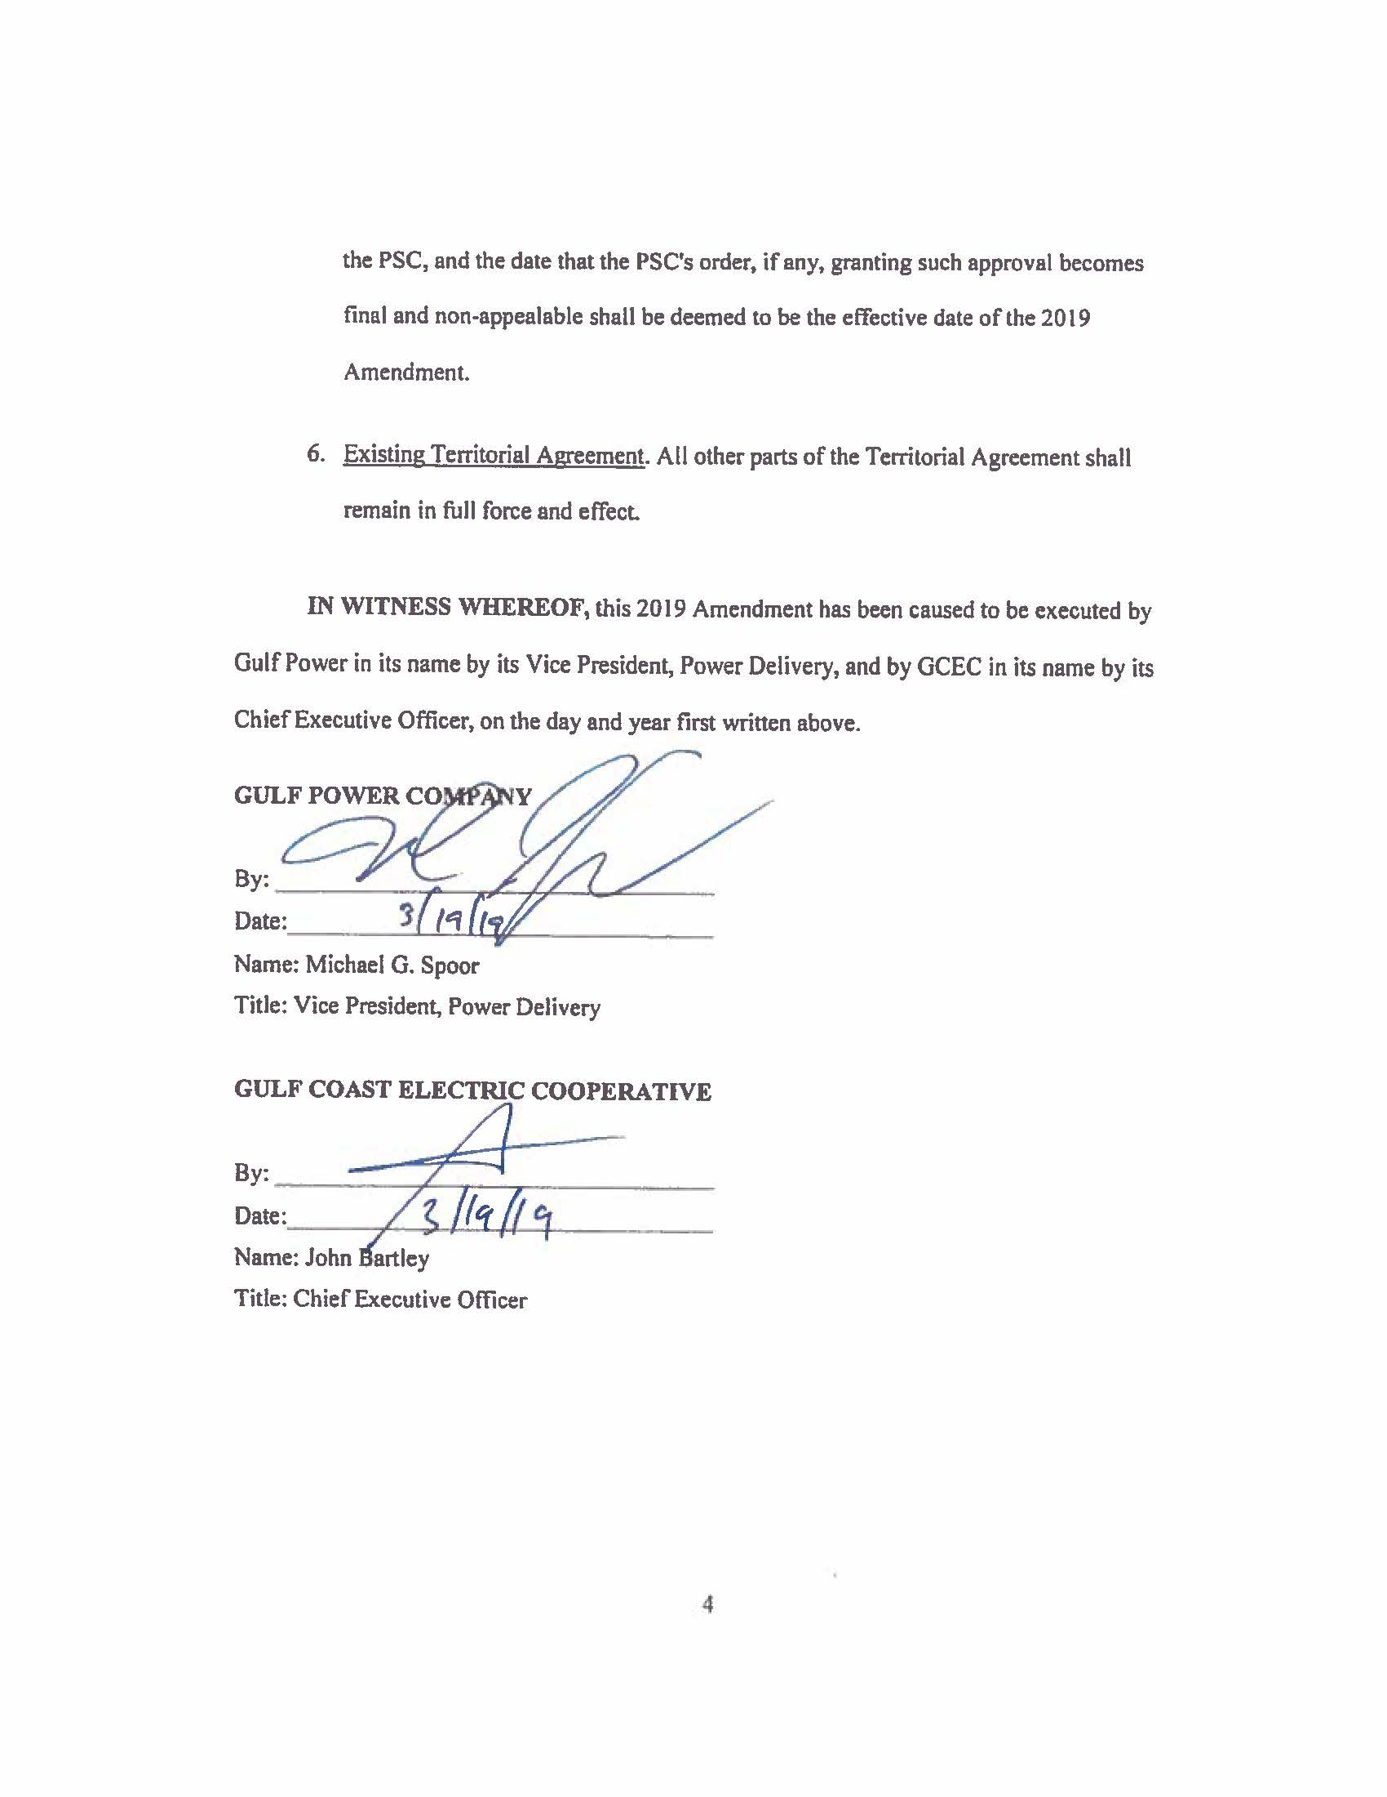

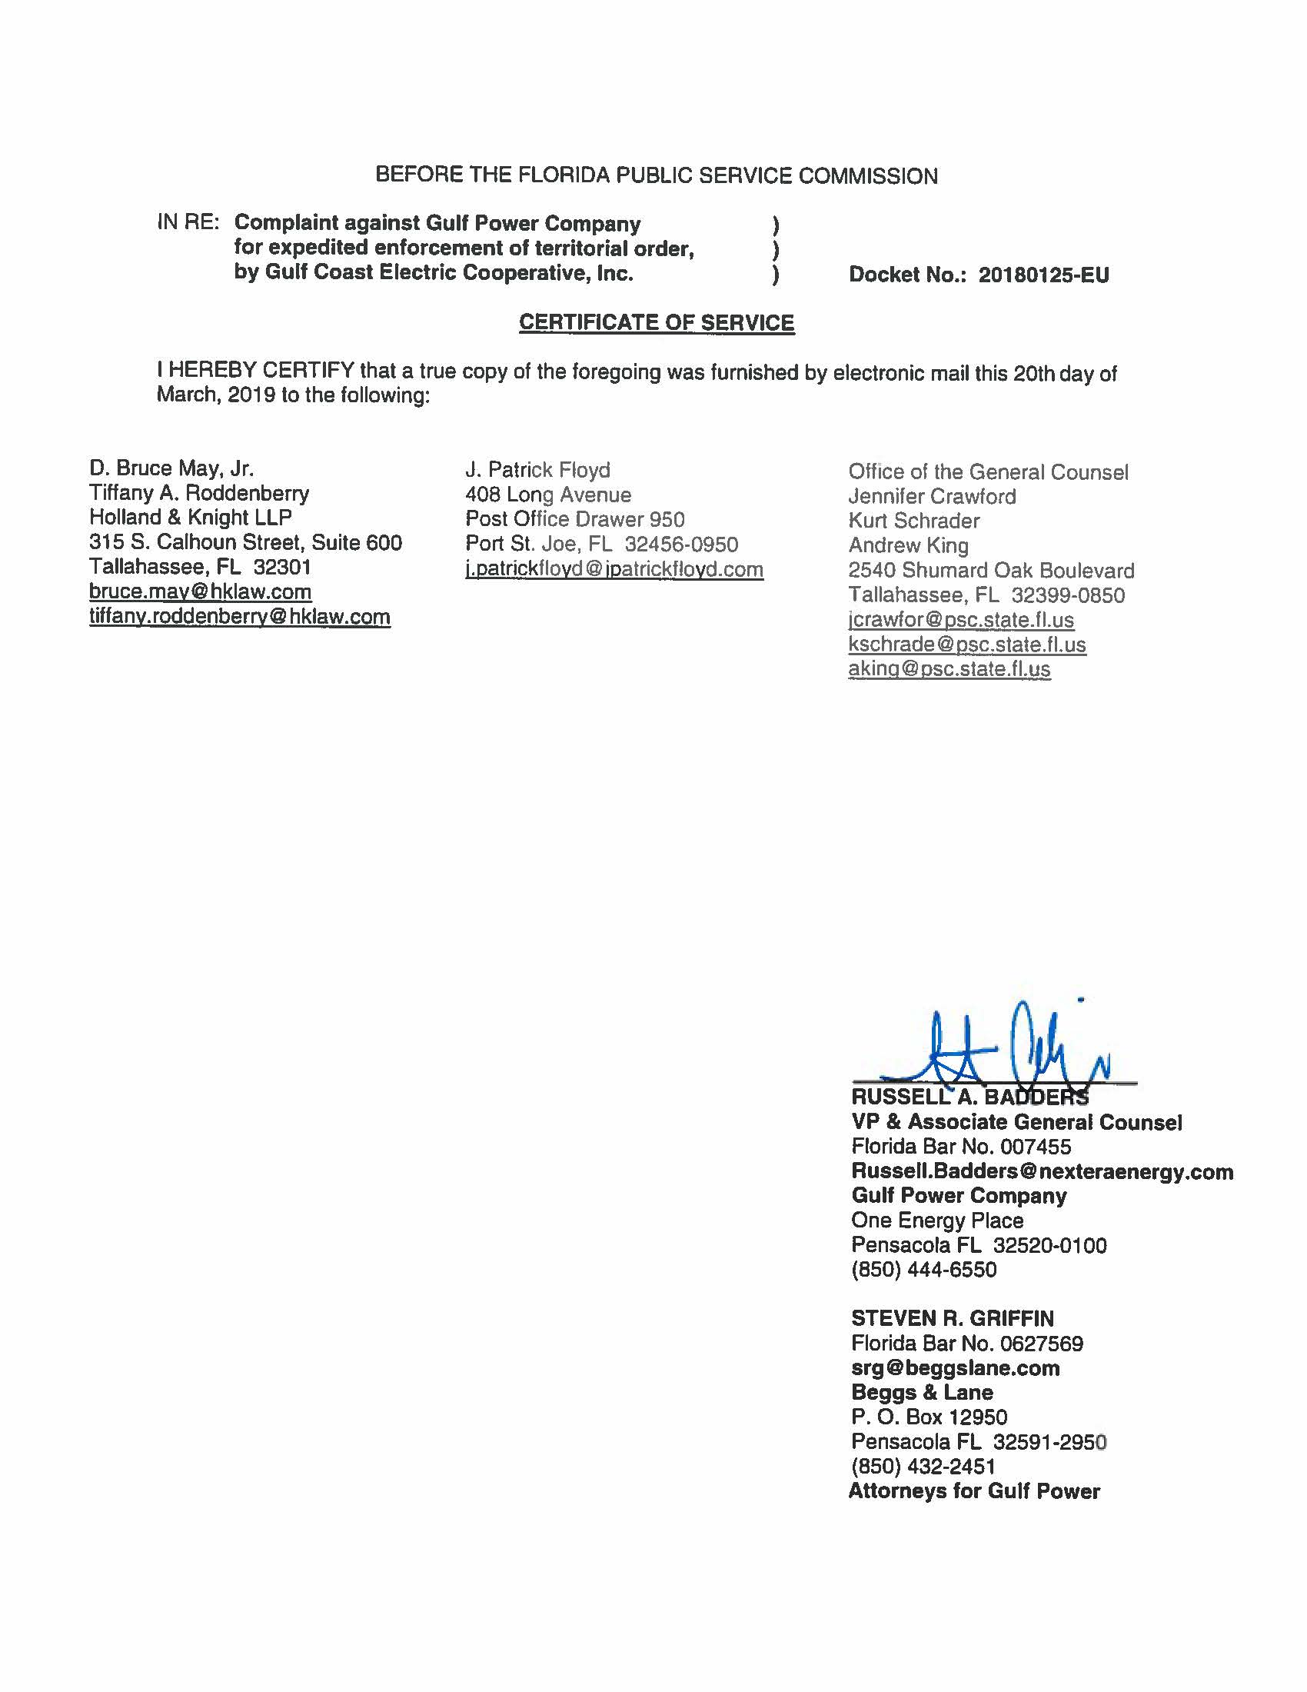

See Order No. PSC-01-0891-PAA-EU, issued April 9, 2001, in Docket No. 930885-EU, In re: Petition to resolve territorial dispute with Gulf Coast Electric Cooperative, Inc. by Gulf Power Company; Order No. PSC-01-0891A-PAA-EU, issued March 26, 2002, in Docket No. 930885-EU, In re: Petition to resolve territorial dispute with Gulf Coast Electric Cooperative, Inc. by Gulf Power Company.
On March 22, 2019, the parties filed a revised page 2 of the Settlement Agreement, correcting an inadvertent typographical error.
The nature of our decision herein is a Proposed Agency Action that will become a final order 21 days after the PAA order is issued, if there is no request for a hearing. We do not have the authority to enter a “non-appealable” final order.
Utils. Comm’n of the City of New Smyrna Beach v. Fla. Pub. Serv. Comm’n, 469 So. 2d 731, 732–33 (Fla. 1985).

