BEFORE THE FLORIDA PUBLIC SERVICE COMMISSION

In re: Petition for authority for approval of revised transportation imbalance tariffs, by Florida Public Utilities Company; Florida Public Utilities Company-Ft. Meade. | DOCKET NO. 20190036-GU  ORDER NO. PSC-2019-0153-TRF-GU  ISSUED: April 24, 2019

The following Commissioners participated in the disposition of this matter:

ART GRAHAM, Chairman
DONALD J. POLMANN
ANDREW GILES FAY

ORDER GRANTING FLORIDA PUBLIC UTILITIES COMPANY’S PETITION FOR APPROVAL OF REVISED TRANSPORTATION IMBALANCE TARIFFS

BY THE COMMISSION:

Background
On February 1, 2019, Florida Public Utilities Company (FPUC) and Florida Public Utilities Company – Fort Meade (FPUC – Fort Meade) (jointly, Companies) filed a petition for approval of revised transportation imbalance tariffs. The imbalance tariffs apply to pool managers who are responsible for purchasing natural gas for the Companies’ transportation customers.
During the review process of the petition, Commission staff issued a data request to the Companies for which the responses were received on March 8, 2019. On March 14, 2019, the Companies filed certain minor corrections to the proposed tariffs. The corrected tariff pages for FPUC are contained in Attachment 1 and the corrected tariff pages for FPUC – Fort Meade are contained in Attachment 2 to this order. The petitioners provided a letter waiving the 60-day file and suspend provision of Section 366.06(3), Florida Statutes (F.S.). We have jurisdiction over this matter pursuant to Sections 366.03, 366.04, 366.05, and 366.06, F.S.

Decision
The Companies proposed to revise their methodology for calculating billing adjustments to pool managers for monthly imbalances. Specifically, the Companies proposed to modify the imbalance cash-out tiers and associated cash-out rates. Imbalances occur when the amount of natural gas delivered by a pool manager and the amount of natural gas consumed by transportation customers varies.

Background
Rule 25-7.0335, Florida Administrative Code, (F.A.C.), requires local distribution companies (LDCs), such as FPUC and FPUC – Fort Meade, to make gas transportation service available to non-residential customers. Transportation service is a voluntary program that allows customers to use a pool manager, or third party marketer or shipper, rather than the LDC to meet their natural gas requirements. In a transportation service environment, the LDC only transports natural gas from the gate station (delivery point at which natural gas is transferred from the interstate pipeline to the LDC’s distribution system) to the transportation customer’s meter. Customers who purchase their natural gas from the LDC are referred to as sales customers.
Both FPUC and FPUC – Fort Meade function as traditional LDCs providing gas service for sales customers and provide optional transportation service as required by Rule 25-7.0335, F.A.C. There are currently 13 pool managers qualified to serve FPUC and FPUC – Fort Meade’s transportation customers in aggregated customer pools. The transportation customers pay the pool manager’s charges for natural gas and are not subject to the Companies’ Commission-approved Purchased Gas Adjustment (PGA) rates, whereas sales customers are subject to PGA rates. We do not approve or review the natural gas prices the pool managers offer.

Current Imbalance Tariffs
Gas is delivered by the pool managers to the LDC’s gate station at a constant level daily even though transportation customers’ daily therm usage varies, creating negative or positive imbalances. At the end of each month, the Companies calculate each pool manager’s imbalance level by aggregating customer usage in their pool and comparing it to the pool manager’s natural gas deliveries.
A negative (short) imbalance results when the gas consumption of a transportation customer pool exceeds what the pool manager delivered that month; therefore, the Companies sell natural gas to the pool manager. A positive (long) imbalance results when more natural gas was delivered than was needed for the transportation customers; therefore, the Companies purchase the excess gas delivered by the pool manager. To calculate invoices to pool managers for a long imbalance or amounts due to the Companies for a short imbalance, the amount (in therms) of the long or short imbalance is multiplied by the applicable imbalance tier. The resulting amount is then multiplied by the PGA rate, i.e., cash-out rate. The proposed revisions to the Companies’ tariff provisions that contain the imbalance tiers and cash-out rates are discussed in detail below.

Proposed Revisions to Imbalance Tariffs

Imbalance Tiers
The Companies explained that the current imbalance tiers are very broad. The imbalance tiers represent the difference, expressed as a percentage, between the natural gas quantity delivered (in therms) by the pool manager and the natural gas consumed (in therms) by the transportation customers. As shown in Table 1 below, the first tier is from zero to 20 percent; therefore, if a pool manager delivers between zero and 20 percent more natural gas than what is consumed, the Companies must pay the pool manager the full PGA rate for the excess gas delivered. The next tier, 20 percent to 40 percent, provides for a payment of a long position at 90 percent of the PGA rate. Similar calculations are used to determine payment amounts to or from pool managers depending on position and tier.
Table 1
Current Imbalance Tiers
Imbalance Tiers |  | Short Factor | Long Factor
Lower | Upper
0% | 20% | 1.00 | 1.00
20% | 40% | 1.10 | 0.90
40% | 60% | 1.20 | 0.80
60% | 80% | 1.30 | 0.70
Greater than 80% |  | 1.40 | 0.60
Source: Docket No. 20190036-GU petition
The Companies requested to revise the imbalance tiers as shown in Table 2 below. As Table 2 demonstrates, the requested imbalance tiers only provide a 100 percent payout for a long position from zero to five percent.
Table 2
Proposed Imbalance Tiers
Imbalance Tiers |  | Short Factor | Long Factor
Lower | Upper
0% | 5% | 1.00 | 1.00
5% | 20% | 1.10 | 0.90
Greater than 20% |  | 1.20 | 0.80
Source: Docket No. 20190036-GU petition

Cash-out Rate for Monthly Imbalance Amounts
The Companies’ second revision is to change the cash-out rate for monthly imbalance amounts as shown in the proposed tariffs. Instead of the PGA rate, the Companies proposed to use market- based natural gas cash-out rates as reported in the Platts Gas Daily and published interstate pipeline capacity charges. The Platts Gas Daily provides natural gas commodity prices in various areas of the US natural gas market.
The Companies assert that proposed cash-out rates are indicative of the natural gas prices in the market. The PGA rate is typically higher than market based natural gas prices as it includes interstate and intrastate pipeline demand charges for all the capacity the Companies need to hold to serve their sales customers and costs related to the Companies’ purchase gas function.
To support their petition, the Companies explained that over the last three years, payments to pool managers have increased. In response to Commission staff’s data request, the Companies provided monthly imbalance quantities. The monthly imbalance quantities (in therms) show that for the period January 2015 through December 2018, the net total of each pool manager’s monthly imbalance was a long imbalance, i.e., the pool managers delivered excess natural gas. Therefore, the Companies made the following annual payments to pool managers for excess natural gas delivered: $2.1M (2015), $2.8M (2016), $4.9M (2017), and $3.5M (2018). These payments to pool managers are included in the calculation of the PGA rate. The Companies assert that the proposed lower cash out rates shall provide a price signal to pool managers to not overschedule natural gas deliveries. A reduction in the payment amounts to pool managers for long imbalances will provide downward pressure on the PGA rate benefitting the sales customers.
The Companies assert that the long positions are an indication that some pool managers may intentionally purchase more natural gas in the market than the amount needed to serve their customer pool in order to sell the excess (long) gas quantity back to the Companies at the PGA rate. The Companies explained that any excess natural gas purchased from the pool managers either is used by the sales customers or sold to an interstate pipeline. Any revenue received from an interstate pipeline is credited to the PGA charge; however, the interstate pipeline’s cash-out rates are typically based on the New York Mercantile Exchange, which is less than the Companies’ PGA rates.

Conclusion
The requested revisions are intended as a deterrent to long monthly imbalances and provide benefits to sales customers. Furthermore, the requested revisions are consistent with Florida Division of Chesapeake Utilities Corporation’s (Chesapeake) current Commission-approved imbalance tariffs. FPUC is a wholly-owned subsidiary of Chesapeake Utilities Corporation which is headquartered in Dover, Delaware. Chesapeake is an operating division of Chesapeake Utilities Corporation. The Companies expressed a desire to have consistent tariff provisions across their Florida business units.
The Companies stated that they have communicated with the pool managers about the requested revisions and that the pool managers have been supportive. In light of the foregoing, we hereby approve FPUC and FPUC – Fort Meade’s tariff modifications, as shown in Attachments 1 and 2 to this Order, effective April 2, 2019.
Based on the foregoing, it is
ORDERED by the Florida Public Service Commission that Florida Public Utilities Company and Florida Public Utilities Company – Fort Meade’s petition for approval of revised transportation imbalance tariffs is hereby approved, effective April 2, 2019. It is further
ORDERED that if a protest is filed within 21 days of issuance of the Order, the tariffs shall remain in effect with any charges held subject to refund pending resolution of the protest. It is further
ORDERED that if no timely protest is filed, this docket shall be closed upon the issuance of a Consummating Order.
By ORDER of the Florida Public Service Commission this 24th day of April, 2019.

/s/ Adam J. Teitzman
ADAM J. TEITZMAN
Commission Clerk
Florida Public Service Commission
2540 Shumard Oak Boulevard
Tallahassee, Florida 32399
(850) 413-6770
www.floridapsc.com

Copies furnished: A copy of this document is provided to the parties of record at the time of issuance and, if applicable, interested persons.
ARJ

NOTICE OF FURTHER PROCEEDINGS

The Florida Public Service Commission is required by Section 120.569(1), Florida Statutes, to notify parties of any administrative hearing or judicial review of Commission orders that is available under Sections 120.57 or 120.68, Florida Statutes, as well as the procedures and time limits that apply. This notice should not be construed to mean all requests for an administrative hearing or judicial review will be granted or result in the relief sought.

Mediation may be available on a case-by-case basis. If mediation is conducted, it does not affect a substantially interested person's right to a hearing.

The Commission's decision on this tariff is interim in nature and will become final, unless a person whose substantial interests are affected by the proposed action files a petition for a formal proceeding, in the form provided by Rule 28-106.201, Florida Administrative Code. This petition must be received by the Office of Commission Clerk, 2540 Shumard Oak Boulevard, Tallahassee, Florida 32399-0850, by the close of business on May 15, 2019.

In the absence of such a petition, this Order shall become final and effective upon the issuance of a Consummating Order.

Any objection or protest filed in this docket before the issuance date of this order is considered abandoned unless it satisfies the foregoing conditions and is renewed within the specified protest period.

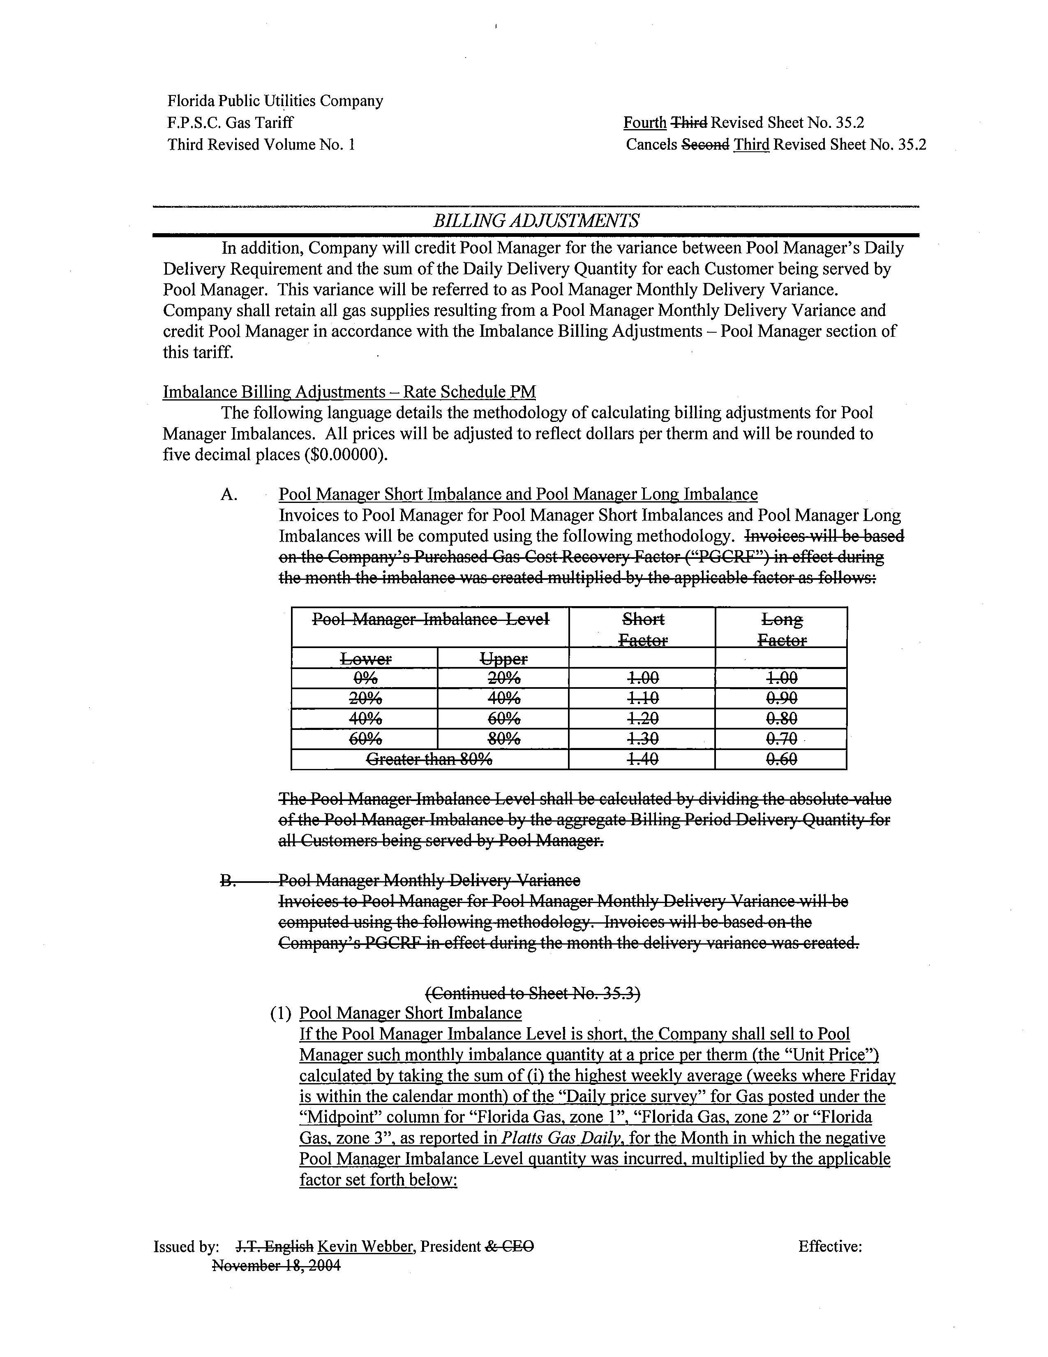

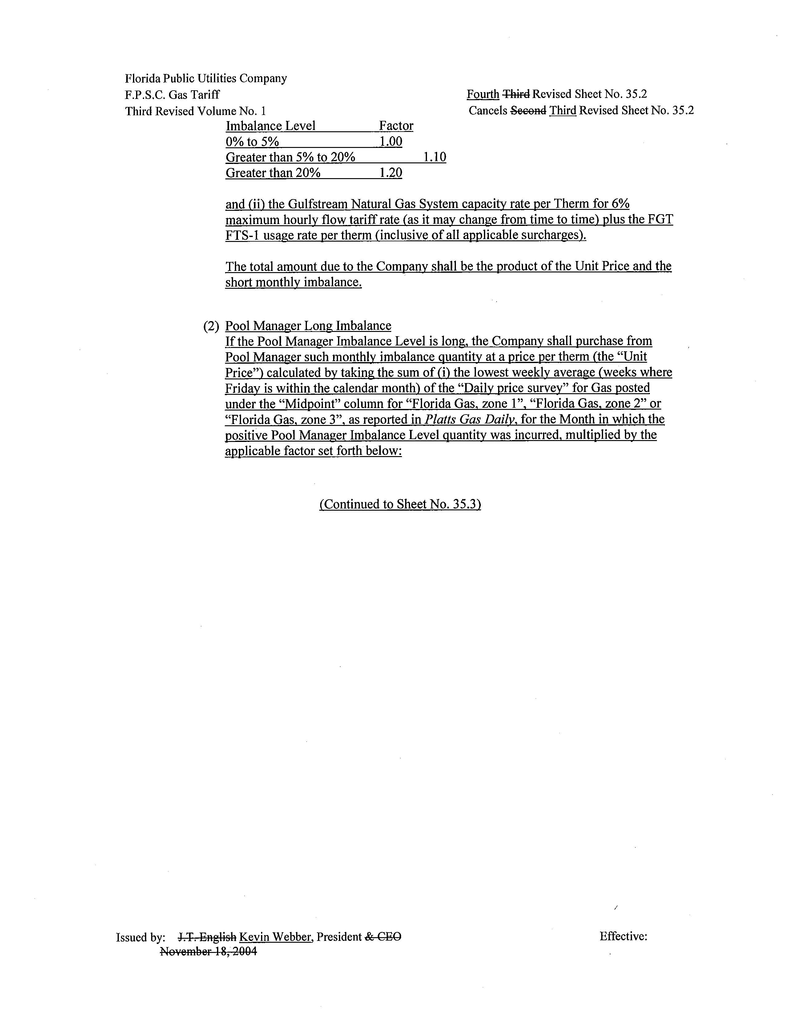
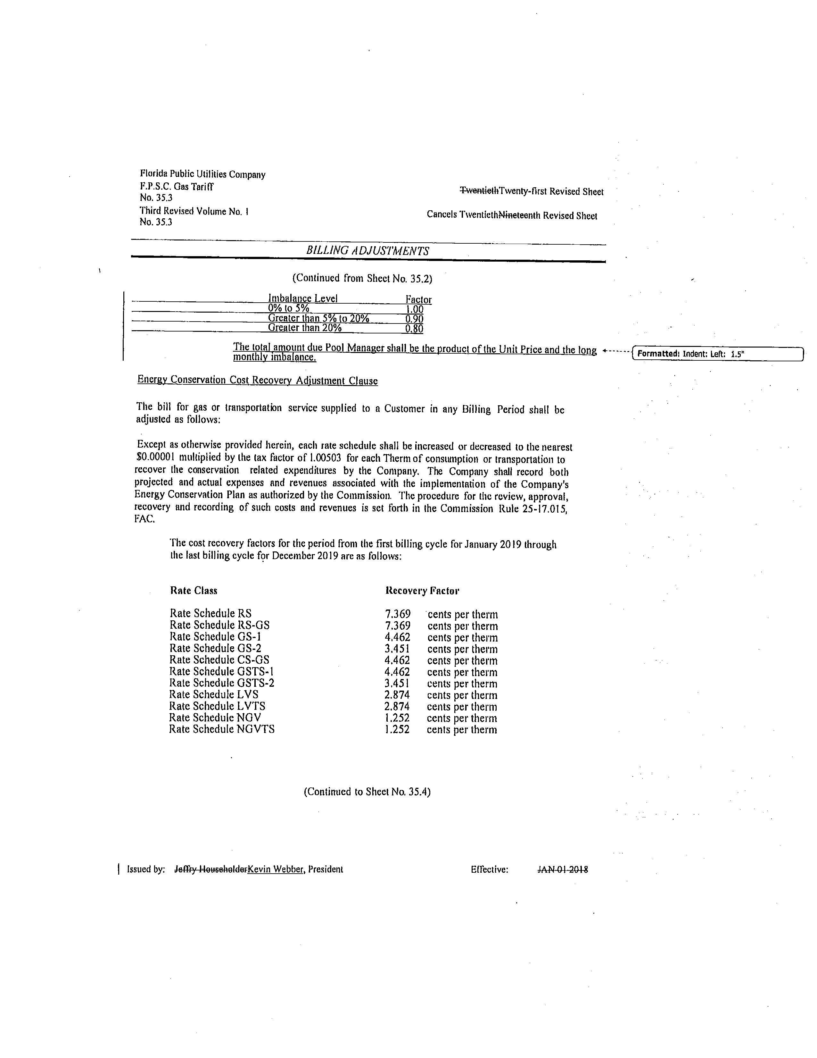

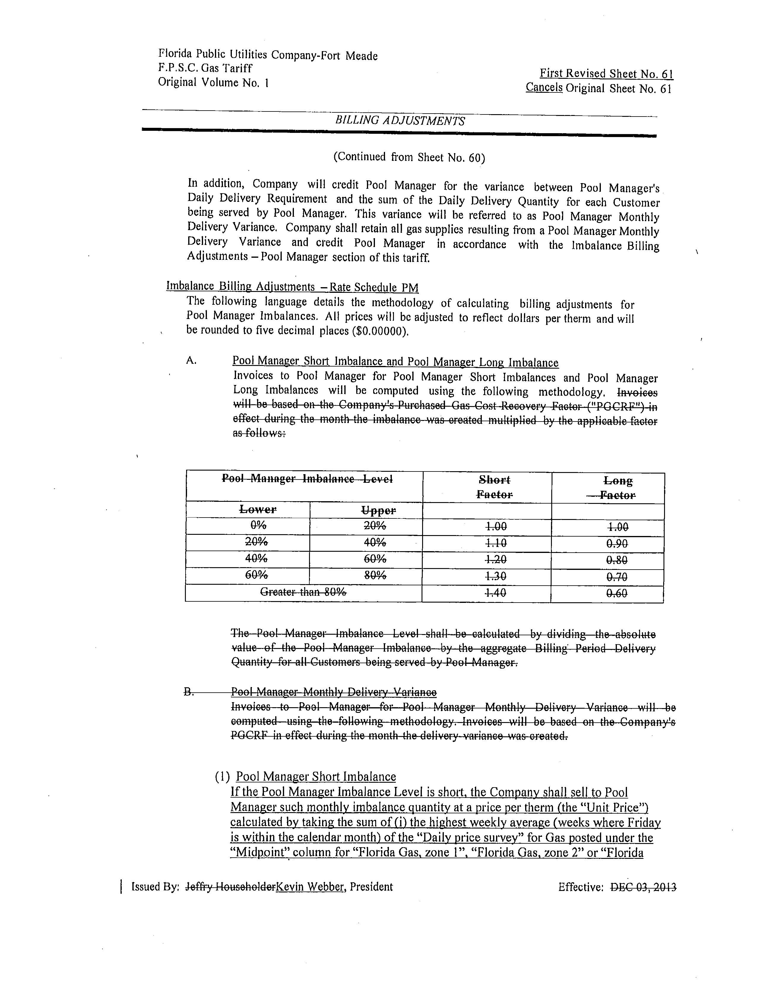
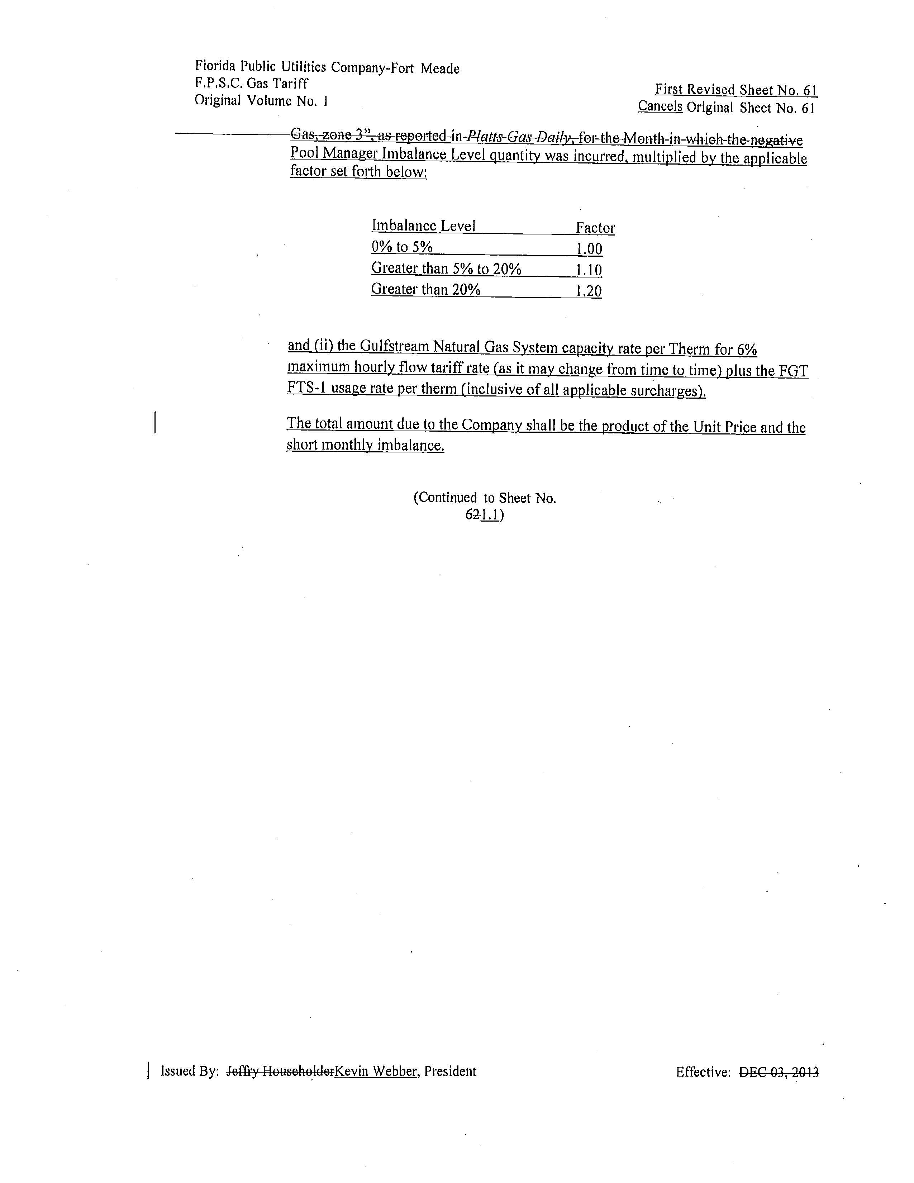

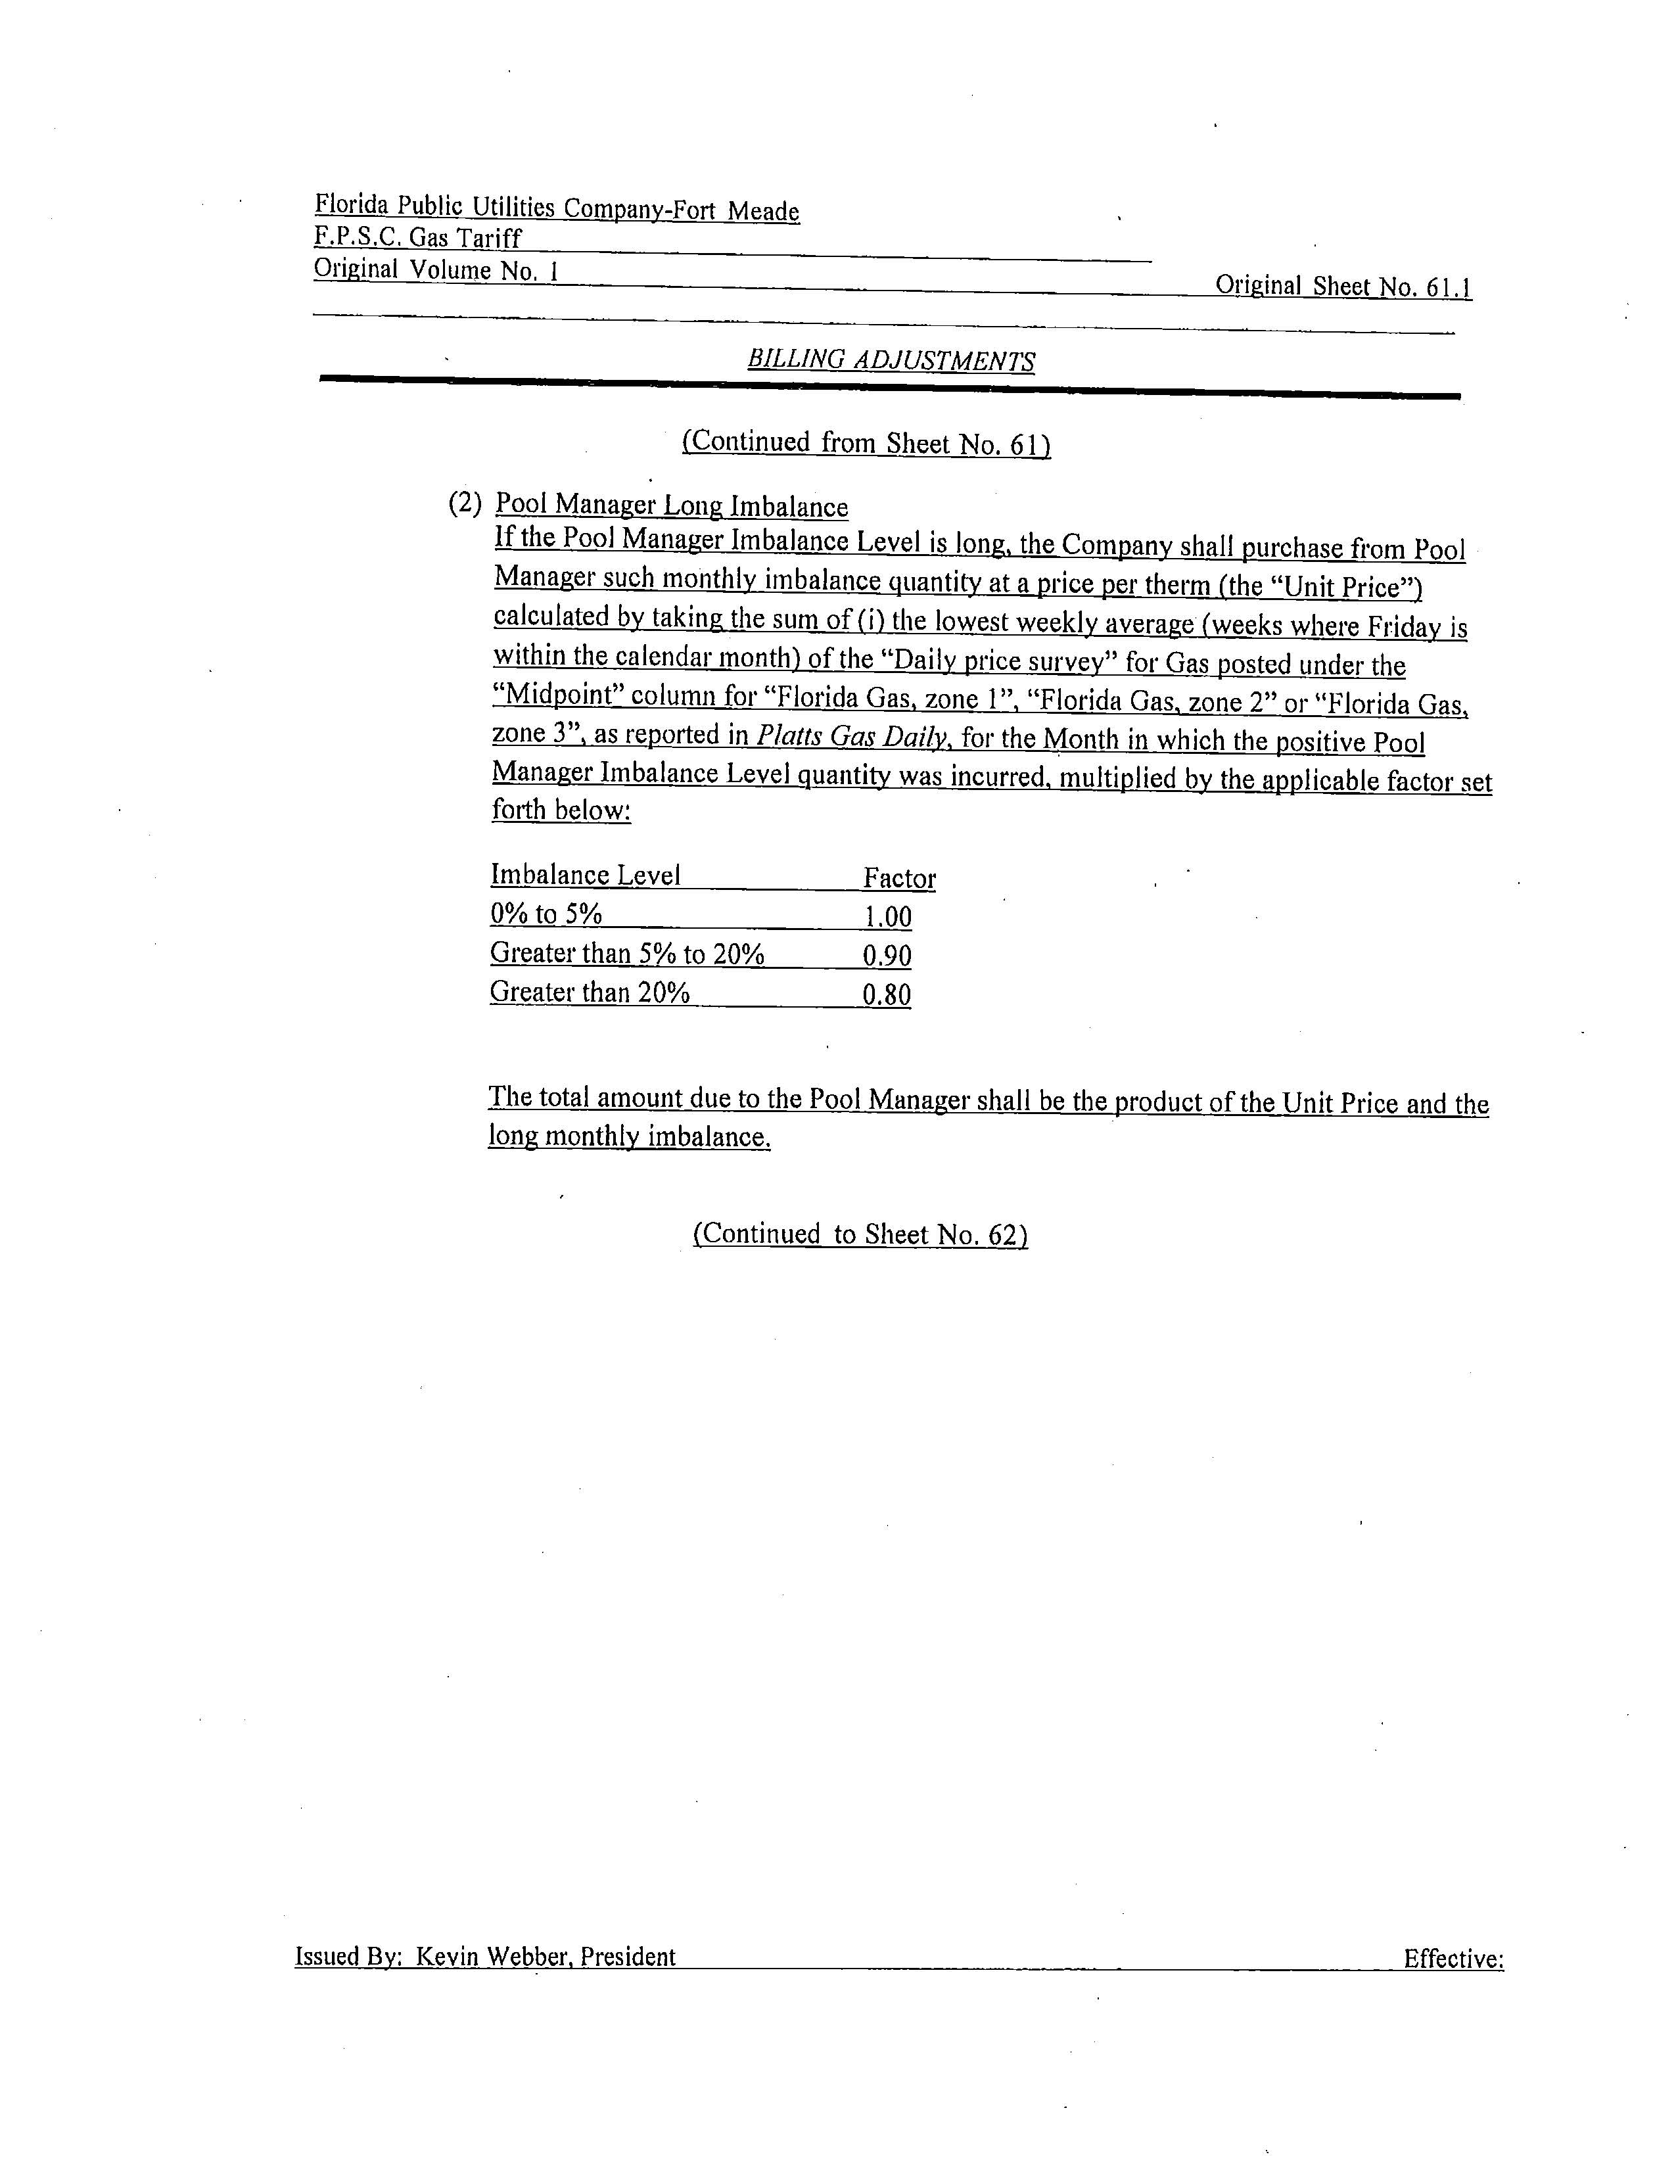

FPUC currently has 2,369 transportation customers and 58,733 sales customers while FPUC-Fort Meade currently has 7 transportation customers and 584 sales customers.

