State of Florida |  | Public Service Commission  Capital Circle Office Center ● 2540 Shumard Oak Boulevard  Tallahassee, Florida 32399-0850  -M-E-M-O-R-A-N-D-U-M-
DATE: | May 2, 2019
TO: | Office of Commission Clerk (Teitzman)
FROM: | Division of Economics (Morgan, Doherty, Higgins, Wu, Coston, McNulty)  Division of Engineering (Thompson, Ellis)  Division of Accounting and Finance (Mouring, Barrett)  Office of the General Counsel (Trierweiler)
RE: | Docket No. 20180204-EI – Petition for approval of shared solar tariff by Tampa Electric Company.
AGENDA: | 5/14/19 – Regular Agenda – Tariff Filing – Interested Persons May Participate
COMMISSIONERS ASSIGNED: |  |  | All Commissioners
PREHEARING OFFICER: |  |  | Administrative
CRITICAL DATES: |  |  | 60-Day Suspension Deadline waived to the May 14, 2019 Agenda Conference
SPECIAL INSTRUCTIONS: |  |  | None

Case Background
On November 2, 2018, Tampa Electric Company (TECO or Company) filed its Petition for Approval of Shared Solar Tariff (Petition), requesting creation of a new, optional shared solar tariff (SSR-1 Tariff or tariff). The proposed SSR-1 Tariff would allow TECO’s customers to purchase energy produced from a TECO-owned solar energy source to replace all or a portion of their monthly energy consumption, which would normally be generated by TECO’s system generating resources. Under the tariff, participants would pay a Shared Solar Charge for energy produced by a 17.5 megawatt (MW) portion of the Lake Hancock solar project (Lake Hancock). Participants would be charged the Shared Solar Charge for all subscribed energy, in addition to the base and energy charges. In order to recognize the renewable nature of the energy source, participants would be exempted from paying the fuel and purchased power charge and the Environmental Cost Recovery Clause (ECRC) charge for all energy purchased under the SSR-1 tariff in the original Petition. On February 8, 2019, TECO amended the tariff to eliminate language excluding SSR-1 Tariff participants from the ECRC after concluding that it would be appropriate for participating customers to be charged the ECRC.
On February 15, 2019, in response to a data request by staff, TECO amended the tariff to clarify language indicating that SSR-1 Tariff participants would pay the fuel charge for any portion of their energy usage not covered under the SSR-1 Tariff. On March 22, 2019, TECO filed an amended Petition, adding language that limits the SSR-1 Tariff to the 17.5 MW portion of Lake Hancock, after staff expressed concerns that the Petition proposed unlimited capacity additions without Commission review. In TECO’s original Petition, the Company states that the total output of the SSR-1 Tariff portion of Lake Hancock was 17.7 MW. In response to Staff’s First Data Request, TECO clarified that the output is now 17.5 MW, based on the expected output of the six inverters assigned to the SSR-1 Tariff.
TECO is currently operating under the Commission-approved 2017 Amended and Restated Stipulation and Settlement Agreement (Settlement). The Settlement restricts any change in base rates for the years 2019 through 2021, other than Solar Base Rate Adjustment (SoBRA) additions. SoBRA has been established as a mechanism for TECO to recover the costs of 600 MW of new solar capacity.
Staff, members of the Office of Public Counsel, and Company representatives attended noticed informal meetings on December 10, 2018, and February 28, 2019, to discuss matters within the docket. On December 12, 2018, TECO waived the 60-day tariff suspension deadline. On March 22, 2019, TECO waived the 60-day tariff suspension deadline once more, to allow this matter to be heard at the May 14, 2019 Agenda Conference. Staff issued five data requests to TECO on this matter. Attachment A of this recommendation provides the proposed tariff pages reflecting all three amendments. The Commission has jurisdiction over this matter pursuant to Sections 366.05 and 366.06, Florida Statutes.

Discussion of Issues

Issue 1:
Should the Commission approve TECO’s petition for approval of a new shared solar tariff?

Recommendation:
Yes, the Commission should approve TECO’s petition for approval of a new shared solar tariff. The tariff should become effective after TECO completes its tariff-related billing systems, which is expected to be in June 2019. TECO should notify Commission staff when this is completed and the effective date of the tariff is known. TECO should file summary reports with the Commission, in this docket, containing prior year results of the SSR-1 Tariff by March 1 of 2020, 2021, and 2022, including SSR-1 participation and waiting list levels, energy sales amounts, costs, and revenues. (Morgan, Ellis)

Staff Analysis:

Description of Proposed Tariff
Under the proposed SSR-1 Tariff, residential (RS) and small commercial (GS) customers would be able to purchase solar energy on a basis of 25, 50, or 100 percent of their monthly energy usage. Large commercial (GSD and IS) customers would be able to purchase energy in 1,000 kilowatt-hour (kWh) blocks; the initial amount cannot exceed their prior 12-month average. Participants who move may retain their SSR-1 Tariff participation at their new address within the TECO service territory, but may not transfer their SSR-1 rate to another customer. TECO states that the program does not reserve any allocation of available energy to a particular customer class.
The Shared Solar Charge would be $0.063 per kWh. The $0.063 charge was designed to recover the costs of the system, operating and maintenance (O&M) costs, and program administrative costs, at full subscription. Customers who join the tariff would pay the $0.063 charge in lieu of the current fuel and purchased power charge for all subscribed energy consumption. The fuel and purchased power charge is comprised of mostly variable costs related to buying and transporting fuel for generation, as well as purchased power. This charge is recovered through the Fuel Cost Recovery Clause (FCRC). Thus, participating customers would be paying toward the recovery of the development and maintenance of the solar project, instead of charges associated with fueling traditional means of generation.
Under the tariff, participating customers would avoid paying FCRC charges only on the percentage of energy subscribed under the SSR-1 Tariff. For example, a customer subscribing to receive 25 percent of their energy under the SSR-1 Tariff would continue to pay the FCRC charges on the remaining 75 percent of their energy usage. Participants in the SSR-1 Tariff would continue to pay all other charges, such as the base service charge and energy charge, for all energy used.
TECO indicates that participation in the tariff would be capped at 95 percent of energy produced by the solar unit. The remaining 5 percent would serve as a buffer against over-subscription. TECO further states that the output of the SSR-1 site and customer energy consumption would be reviewed annually in order to ensure that the usage rate does not exceed the 95 percent cap. In the event that subscribed energy falls below generation levels, a customer waiting list would be available to add participants going forward. If subscriptions approach the cap, TECO would allow customer attrition to limit energy usage before adding new customers.
TECO states that any Renewable Energy Credits (RECs) associated with the tariff would not be eligible for resale by the Company. TECO would retain ownership of, or retire, all RECs. Customers could request to have RECs deposited into a designated account at their own expense. Any charges to the customer would be limited to the administrative expense of establishing the REC transfer.
The Company performed a third-party study to evaluate existing community solar programs and incorporated some of the best practices of those programs into the SSR-1 Tariff. TECO also performed a customer survey among e-bill customers in August 2016, with approximately 25,000 responses, or about 3.4 percent of its customer base. Based on the survey results, the Company estimates the potential participation is about 11 percent of the residential customer base. TECO concluded that there is a market potential of approximately 24,000 residential customers for a shared solar program with an incremental cost of $0.04 per kWh over retail. The SSR-1 Tariff amounts to approximately $0.034 per kWh over the Company’s current retail energy rates. Given the survey results and size of the SSR-1 unit, staff believes it is likely that TECO will be able to achieve full participation in the tariff after an initial ramp-up period. If approved, TECO indicates it would be ready to start accepting participants for the SSR-1 Tariff in June 2019.

The Lake Hancock Site
The Lake Hancock project, located in Polk County, is fully operational as of April 25, 2019. The facility has a total capacity of approximately 49.5 MW, of which 32.0 MW has been approved for cost recovery by the Commission in the Company’s second tranche of SoBRA. The remaining 17.5 MW SSR-1 portion of Lake Hancock was built as additional generation above what the Company was constructing for its second tranche of SoBRA. TECO states that, if approved, the 17.5 MW portion of Lake Hancock that is reserved for the SSR-1 Tariff will not be eligible for SoBRA recovery at any point in time. The panels responsible for the 17.5 MW of capacity are connected to 6 inverters that are reserved for SSR-1 service. The SSR-1 unit will generate enough energy for approximately 2,600 residential customers at the 100 percent subscription level.
TECO has planned 600 MW of solar generation under SoBRA, which is also the cap imposed on SoBRA by the Settlement. The Company states that if the tariff is not approved, the 17.5 MW, reserved for SSR-1 use at Lake Hancock, would be included in a future tranche of TECO’s SoBRA. If the tariff is approved, the Company would construct an additional 17.5 MW of solar capacity to meet the 600 MW capacity cap for SoBRA. Also, any future additions to the SSR-1 Tariff would be built as a result of customer demand and must be approved by the Commission. For those reasons, staff believes that it is appropriate to view the 17.5 MW referenced in this Petition as an incremental addition to TECO’s overall generation.

Subscriber Benefits
TECO states that the main objective of the SSR-1 Tariff is to provide customers who cannot otherwise install rooftop solar with an opportunity to receive some, or all, of their power from a TECO-owned solar energy source. A customer may not be able to install rooftop solar if they rent or lease, cannot afford the upfront costs of rooftop solar, or have roof conditions which are poor for purposes of solar energy production. Customers who participate in the tariff would do so on a month-to-month basis with no commitment beyond the first month. The tariff is designed so that new subscribers could join at any time, assuming unsubscribed energy is available; otherwise, they would be put on a waiting list.
As customer demand exceeds the 17.5 MW output of this site and the waiting list grows, additional solar capacity may be added to the SSR-1 Tariff, after obtaining Commission approval. Therefore, by participating in the SSR-1 Tariff, customers would be paying to encourage the growth of solar generation in Florida.
A future financial incentive may also exist for participants in the tariff. According to TECO’s fuel price forecast, fuel prices are expected to increase to levels above the Shared Solar Charge of $0.063 per kWh. This means that a cross-over point likely exists during the tariff’s span, where an SSR-1 customer may eventually pay a lower rate than a customer under the traditional rate structure.

Levelized Cost Calculation
As discussed in the Company’s Petition, the initial energy charge of $0.063 per kWh is based on the levelized rate for full recovery of the revenue requirements of the 17.5 MW portion of Lake Hancock and the administrative costs of the SSR-1 program at full subscription. Staff reviewed both the revenue requirement and the levelized cost calculation.

Revenue Requirement
In response to staff’s data request, the Company provided a detailed breakdown of the revenue requirement. The Company assumed the same fixed unit price of $1,494 per kilowatt (kW) installed as in TECO’s Second SoBRA proceeding. Fixed O&M expenses are notably lower than in the Second SoBRA, reducing from $7.70/kW-year to $4.03/kW-year, based on an updated O&M agreement TECO reached with a third party. For program administrative costs, TECO assumed higher initial start-up costs, and then escalating administrative costs over the duration of the SSR-1 Tariff. Administrative costs are $156,708 for the first year and $105,048 the second year, with an annual 2.1 percent escalation thereafter. These costs are made up of call center operations, program management, marketing, training, software, and other expenses.

Levelized Cost Rate
To determine the levelized cost rate, TECO used full subscription, such that it would collect the full revenue requirement from only 95 percent of the energy output of the 17.5 MW of Lake Hancock. The Company included the effects of degradation of the unit over time and assumed a capacity factor of 25.8 percent, slightly lower than the 26.3 percent used in the second SoBRA docket. Overall, the Company’s proposed $0.063 per kWh rate appears reasonable based upon Lake Hancock and SSR-1 Tariff program costs.

Recovery of the 17.5 MW Portion of Lake Hancock
TECO has indicated that the 17.5 MW SSR-1 portion of Lake Hancock would become part of the Company’s total cost of service, thereby impacting surveillance reporting, including during the TECO Settlement period. However, all revenue collected under the SSR-1 Tariff would also be included in surveillance reporting, thus offsetting the cost and revenue requirements. While the cost and expense of the 17.5 MW portion of Lake Hancock, and the revenue collected to offset such cost and expense, would be included in surveillance reporting, the actual cost, expense, and revenue are uncertain in amount.
If the tariff is approved, during a future rate proceeding, the 17.5 MW SSR-1 portion of Lake Hancock would be included in the revenue requirements, thus added to base rates. The revenues collected under the tariff would be revenue credited to the revenue requirement as an offset. Since the proposed Shared Solar Charge ($0.063 per kWh) has been shown to cover the costs of the unit and administration of the tariff at full subscription, the revenue credit would allow for a lower rate than if TECO recovered the unit through its SoBRA. While the Company proposes a Shared Solar Charge to completely offset the capacity costs and O&M expenses, both the costs and revenues of the program have the potential to ultimately impact base rates throughout most of the program period (the years after the Settlement period). Overall, the revenue credit can be expected to offset the revenue requirement of the unit to limit any impact on base rates.

Impact of the SSR-1 Tariff on Non-participants
In response to a staff data request, TECO initially indicated that the SSR-1 Tariff has been designed so that, over the life of the shared solar facility, non-participating customers would experience minimal, if any, bill impacts due to the program. At full subscription of the unit, TECO’s initial analysis indicated that non-participants would pay $0.12 more per month for electricity in 2019 due to the impact of an increase in the fuel charge, but that bill impact amount would be reduced to $0.01 more per month by 2048.
TECO later revised its response, stating that its initial response was based on the concept that there would be no change in non-solar generation, wherein the fuel impact reflected the same amount of MW but fewer fuel clause participants. TECO indicated that such an outcome would be a theoretical worst case scenario. The Company reanalyzed the impact to non-participants based on what it described as the most likely scenario, wherein the program’s solar capacity (17.5 MW) would reduce the dispatch of TECO’s total non-solar capacity. At full subscription, TECO indicated that the program should result in no impact to non-participants. The Company also indicated that less than full subscription would benefit non-participants by reducing fuel rates charged through the FCRC.
Staff considered the ways non-participant rates might be impacted if the SSR-1 Tariff is approved. As discussed earlier, staff recognizes that TECO’s proposed Shared Solar Charge is designed to generate sufficient revenue to offset the revenue requirement of the program, and while actual results may vary, the rate, as proposed, appears to be sufficient to protect the general body of ratepayers. This assessment is further supported by the fact that the capacity of this proposed community solar program is limited to 17.5 MW.
Another possible impact on rates will be whether or not the displacement of non-solar generation under the program will be sufficient to fully offset the program’s lost fuel revenue. Lost fuel revenue under the tariff is associated with the participants not paying the fuel charge. The 17.5 MW at Lake Hancock is considered incremental solar capacity, thus allowing for fuel savings that would not otherwise be available to the general body of ratepayers given the 600 MW solar capacity restriction defined in the Settlement and TECO’s stated intention to maximize its SoBRA construction to 600 MW. At full capacity, staff believes the fuel savings associated with the incremental plant would be roughly equivalent to the lost fuel revenue.
Under the special conditions presented in this docket, related to the Settlement, staff agrees with the Company that any future non-participant rate impacts can be expected to be minimal. The avoided fuel costs can be expected to offset the lost fuel revenues. In regard to base rate impacts, the revenue from the Shared Solar Charge can be expected to offset the revenue requirement of the 17.5 MW unit. In sum, staff believes non-participants are not likely to pay higher rates with the implementation of the SSR-1 Tariff.

Compliance with the Settlement
Staff requested that TECO obtain verification from the Settlement signatories to confirm that the SSR-1 Tariff is in accordance with the terms of the Settlement. Paragraph 12 of the Settlement requires that new or revised tariffs requested by TECO must not increase existing base rates or other non-optional charges to customers. The Office of Public Counsel, Florida Retail Federation, Florida Industrial Power Users Group, and Federal Executive Agencies do not believe that the tariff conflicts with the terms of the Settlement. Staff contacted the WCF Hospital Utility Alliance, which stated that it has no position.

Staff reviewed the SSR-1 Tariff proposal in light of the various provisions of the Settlement. As stated previously, neither base rates nor the fuel charge are expected to be impacted during the Settlement period by the proposed tariff. The tariff provides an additional 17.5 MW of solar generation that would not otherwise be available to TECO’s customers, thereby creating fuel savings to counteract the lost fuel revenue associated with the participants’ fuel clause exemption. Staff does not believe that the SSR-1 Tariff violates the Settlement.

Reporting Requirements
Due to the fact that this tariff is a new concept, staff believes the Commission would be able to discern customer acceptance and financial performance going forward by requiring annual reports from TECO in the first three years of the tariff. Staff believes that the tariff’s participation and waiting list levels, energy sales amounts, costs, and revenues would be essential in analyzing the impacts on both participants and non-participants.

Conclusion
Staff believes that the SSR-1 Tariff provides a reasonable alternative to customers who cannot otherwise invest in solar generation. Staff believes that the Shared Solar Charge of $0.063 per kWh reasonably offsets the unit costs and administration of the SSR-1 Tariff. Further, staff believes it is reasonable to expect that the tariff will provide benefits to the participants, while having minimal impact on the general body of ratepayers.
Staff therefore recommends that the Commission approve TECO’s petition for approval of a new shared solar tariff. The tariff should become effective after TECO completes its tariff-related billing systems, which is expected to be in June 2019. TECO should notify Commission staff when this is completed and the effective date of the tariff is known. TECO should be required to file summary reports with the Commission containing prior year results of the SSR-1 Tariff by March 1 of 2020, 2021, and 2022, including SSR-1 participation and waiting list levels, energy sales amounts, costs, and revenues in this docket.
Issue 2: Should this docket be closed?

Recommendation:
If Issue 1 is approved and a protest is filed within 21 days of the issuance of the order, the tariff, if in effect at that time, should remain in effect, with any revenues held subject to refund, pending resolution of the protest. If no timely protest is filed, this docket should be closed upon the issuance of the consummating order. (Trierweiler)

Staff Analysis: If Issue 1 is approved and a protest is filed within 21 days of the issuance of the order, the tariff, if in effect at that time, should remain in effect, with any revenues held subject to refund, pending resolution of the protest. If no timely protest is filed, this docket should be closed upon the issuance of the consummating order.

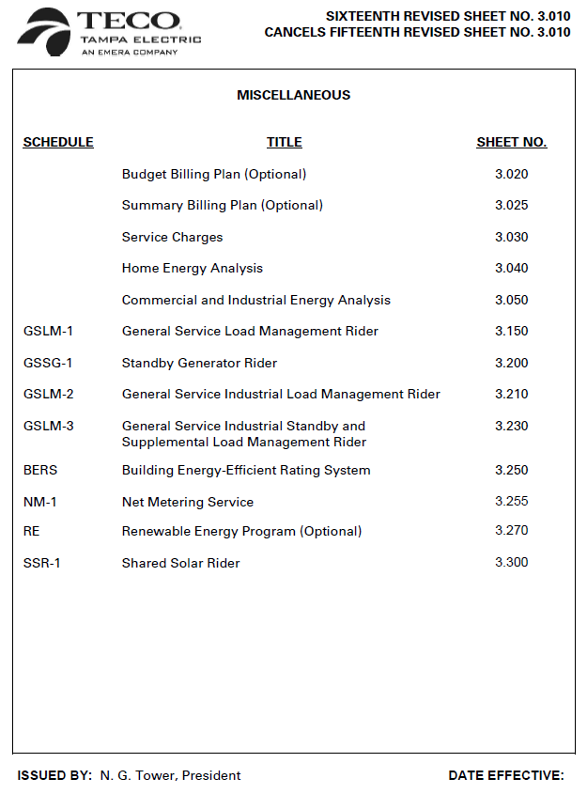
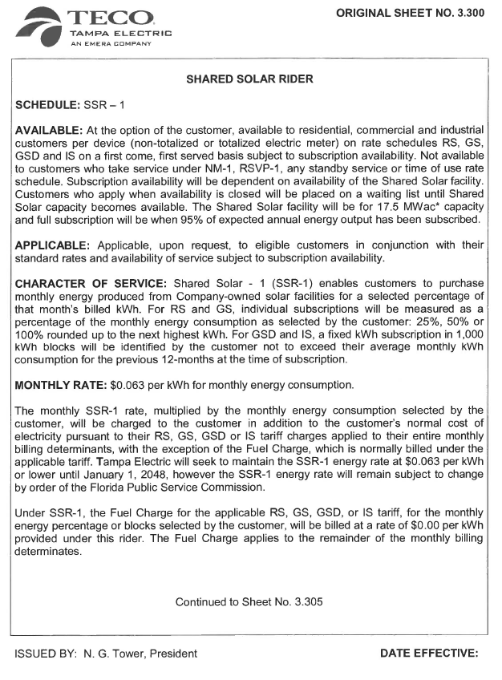
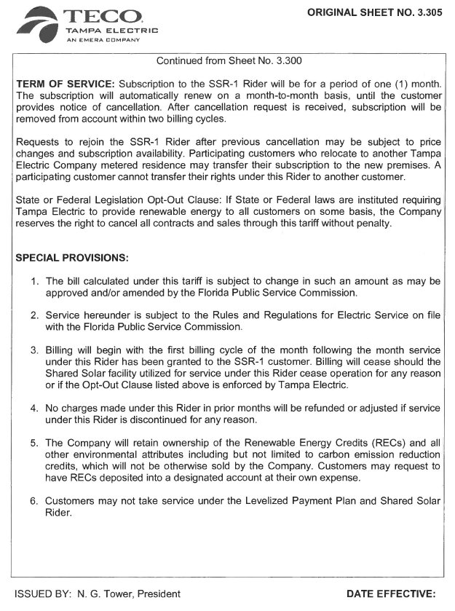

TECO currently offers the Renewable Energy Program (REP) to its customers. In that program, customers pay $5 per 200 kilowatt-hour (kWh) block of renewable energy, produced by photovoltaic arrays, biomass fuel, and other renewable energy sources. TECO states the REP will not be closed or changed at this time.
The originally-proposed tariff required Commission approval for any price change to participating customers.
TECO’s response to staff’s First Data Request, No. 3.
Order No. PSC-2017-0456-S-EI, issued September 27, 2017, in Docket No. 20170210-EI, In re: Petition for limited proceeding to approve 2017 amended and restated stipulation and settlement agreement.
A REC is a tradeable, non-tangible energy commodity that represents the environmental attributes of one megawatt-hour of electricity generated from an eligible renewable energy resource.
TECO’s response to staff’s First Data Request, No. 22A.
The incremental cost over traditional rates of $0.034 was calculated by subtracting TECO’s current FCRC factor for residential customers ($0.02913) from the Shared Solar Charge ($0.063), resulting in a difference of $0.03387.
Order No. PSC-2018-0571-FOF-EI, issued June 29, 2018, in Docket No. 20180133-EI, In re: Petition for limited proceeding to approve second SoBRA.
Staff’s Second Set of Interrogatories, No. 11, filed September 13, 2018, in Docket No. 20180133-EI.
TECO’s response to staff’s Fourth Data Request, No. 5.
TECO’s response to staff’s First Data Request, No. 9.
Order No. PSC-2017-0456-S-EI, issued November 27, 2017, in Docket No. 20170210-EI, In re: Petition for limited proceeding to approve 2017 amended and restated stipulation and settlement agreement.
TECO’s response to staff’s Fourth Data Request, No. 1B.
TECO’s response to staff’s First Data Request, No. 28A.
Full subscription would be equal to 95 percent of the energy produced by the 17.5 MW, reserved for SSR-1 Tariff use, at Lake Hancock.
Order No. PSC-2018-0571-FOF-EI, issued June 29, 2018, in Docket No. 20180133-EI, In re: Petition for limited proceeding to approve second SoBRA.
TECO’s response to staff’s First Data Request, No. 1.
The Settlement restricts any change in base rates through 2021, other than SoBRA additions.
TECO’s response to staff’s First Data Request, No. 7.
TECO’s response to staff’s First Data Request, No. 5.
TECO’s response to staff’s Fourth Data Request, No. 1.
Order No. PSC-2017-0456-S-EI, issued November 27, 2017, in Docket No. 20170210-EI, In re: Petition for limited proceeding to approve 2017 amended and restated stipulation and settlement agreement, Attachment A, Page 10 of 43, and TECO’s Response to Vote Solar’s Motion to Leave to File Amicus Curiae Memorandum, dated March 18, 2019, Paragraph 8.
Order No. PSC-2017-0456-S-EI, issued November 27, 2017, in Docket No. 20170210-EI, In re: Petition for limited proceeding to approve 2017 amended and restated stipulation and settlement agreement, Attachment A, Page 27 of 43,

