State of Florida |  | Public Service Commission  Capital Circle Office Center ● 2540 Shumard Oak Boulevard  Tallahassee, Florida 32399-0850  -M-E-M-O-R-A-N-D-U-M-
DATE: | May 2, 2019
TO: | Office of Commission Clerk (Teitzman)
FROM: | Division of Economics (Doherty, Guffey)  Office of the General Counsel (Crawford)
RE: | Docket No. 20190048-EI – Petition for approval to amend street lighting, outdoor lighting and LED lighting pilot tariffs, by Florida Power & Light Company.
AGENDA: | 05/14/19 – Regular Agenda – Tariff Filing – Interested Persons May Participate
COMMISSIONERS ASSIGNED: |  |  | All Commissioners
PREHEARING OFFICER: |  |  | Administrative
CRITICAL DATES: |  |  | 60-day suspension date waived by the utility until 05/14/2019
SPECIAL INSTRUCTIONS: |  |  | None

Case Background
On February 20, 2019, Florida Power & Light Company (FPL or utility) filed a petition for approval to amend its street lighting (SL-1), outdoor lighting (OL-1), and LED lighting pilot (LT-1) tariffs. The proposed tariff revisions are designed to establish monthly charges for lighting facilities that are not contained in FPL’s lighting tariffs (i.e., non-standard lighting).
With FPL’s acquisition of the City of Vero Beach (COVB) electric utility system, the Commission granted FPL approval to charge its approved rates and charges to the COVB customers upon the closing date of the Asset Sale and Purchase Agreement between FPL and COVB. The Asset Sale and Purchase Agreement closed on December 17, 2018, and FPL started billing the former COVB customers its rates and charges.
FPL conducted an analysis of COVB’s former tariffs and outdoor lighting and determined that 30 percent of the fixtures and poles previously served by COVB constitute non-standard lighting. The non-standard lighting previously served by COVB is made up of 19 fixtures types and three pole types that are not offered under FPL’s lighting tariffs. Therefore, FPL does not have existing rates in its tariff to apply to the former COVB non-standard lighting customers. The remaining 70 percent of the lighting facilities in the former COVB service territory constitute standard lighting and is billed under FPL’s tariffs.
On February 27, 2019, FPL provided a letter waiving the 60-day file and suspend provision on Section 366.06(3), Florida Statutes (F.S.), until the May 14, 2019 Agenda Conference. On March 1, 2019, staff issued its first data request to FPL for which responses were received on March 11, 2019. On April 26, 2019, FPL filed amended tariffs adding language regarding the calculation of the maintenance charges for non-standard lighting and to clarify that for the LT-1 tariff, the proposed new special provision applies to poles only. The proposed tariff sheets in legislative format, as amended on April 26, 2019, are shown in Attachment A to this recommendation. The Commission has jurisdiction over this matter pursuant to Sections 366.03, 366.04, 366.05, and 366.06, F. S.

Discussion of Issues

Issue 1:
Should the Commission approve FPL’s proposed changes to its SL-1, OL-1, and LT-1 tariffs as shown in Attachment A?

Recommendation:
Yes. The Commission should approve the proposed changes to FPL’s SL-1, OL-1 and LT-1 tariffs as shown in Attachment A to this recommendation. The proposed revisions allow FPL to bill the former COVB customers with non-standard lighting and respond to customers’ future requests for special fixtures or poles. The general body of ratepayers will be protected as non-standard lighting customers will be responsible for all costs associated with their lighting facilities. The revised tariffs should become effective on May 14, 2019. (Doherty, Guffey)

Staff Analysis:
Currently, FPL offers lighting service under its SL-1, OL-1, and LT-1 tariffs. The SL-1 and OL-1 tariffs include specific fixtures and poles a customer can choose from. The charges for each fixture are comprised of three components: a fixture charge, a maintenance charge, and an energy charge. The LT-1 tariff provides customers with Light Emitting Diode (LED) fixture options and flexible payment methods; however, the LT-1 tariff contains specific poles a customer can choose from. Pole charges vary by type of pole (e.g., concrete, wood, fiberglass)
FPL proposed to add a special provision to its SL-1, OL-1, and LT-1 tariffs to allow FPL to determine monthly charges for customers with non-standard lighting. Pursuant to the special provision, FPL would apply a facilities charge factor of 1.63 percent to the average installed cost of the lighting facilities to determine the fixture or pole charge. The calculation of the 1.63 facilities charge factor is shown in Exhibit G to the petition and includes a return, depreciation, and property taxes. The facilities charge factor assures recovery of the lighting facilities investment.
FPL explained that it does not know the average installed costs of the former COVB lighting facilities as COVB did not have sufficient records to support such calculation. To determine the average installed cost of the former COVB non-standard lighting facilities, FPL used the current estimated value of the facilities. While the proposed tariff revisions initially apply to the former COVB non-standard lighting customers, FPL stated that the special provision would apply to all customers who request a fixture or pole that is not included in FPL’s existing tariffs. FPL stated that any requested lighting facilities would need to meet FPL’s reliability standards.
To determine the maintenance charges for non-standard lighting fixtures, FPL would use the approved maintenance cost for a fixture with the same wattage. For wattages that fall between two existing wattages, the maintenance charge will be averaged based on the two existing wattages. All other Commission-approved street lighting energy charges and cost recovery factors, such as fuel, will apply.

Former COVB Customer Bill Impacts and Notification
In its response to staff’s data request, FPL stated that 83 former COVB customers are served by non-standard lighting. These customers are comprised of one governmental customer, 81 commercial customers, and one residential customer. Since the Asset Sale and Purchase Agreement closed on December 17, 2018, FPL has been billing these 83 former COVB lighting customers pursuant to the proposed tariff, subject to refund or recovery of the difference pending the outcome of this proceeding. FPL has three lighting tariffs (SL-1, OL-1, and LT-1), while COVB had only one tariff for all lighting customers. By performing field surveys, FPL is able to identify the appropriate FPL tariff for all former COVB lighting customers.
With the proposed tariff revisions, an estimated 63 customers have seen their lighting bill decrease and 20 customers have seen their bill increase. Customer monthly bill decreases range from $0.39 to $326.61 a month, while the increases range from $1.32 to $786 a month. FPL explained that the customer (a condominium association) who saw the $786 increase had a note in COVB’s billing file that referenced an agreement with COVB to pay a non-tariffed rate. FPL explained that when it contacted the customer, the customer was unaware that it was being billed less than the COVB tariffed rate. FPL represented it is working with the customer to reduce its lighting bill.
FPL further explained that other former COVB customers experienced increases in their bills, because COVB charged the customers for an incorrect fixture. FPL has corrected this error from the COVB billing and is charging the lighting customers for the actual fixture provided. FPL stated that all former COVB non-standard lighting customers whose lighting bill increased by more than $8.00 were contacted by phone call or by an in person visit. To date, the commission has not received any customer comments or complaints regarding the requested tariff amendments.
It is incumbent on public utilities to charge only those rates filed with and approved by the Commission, pursuant to Section 366.06, F.S. Staff recognizes the unique circumstances surrounding FPL’s acquisition and provision of service to the COVB customers, and that the majority of customers affected by the proposed tariff will experience a rate decrease. However, FPL should be cautioned to charge only those rates reflected in its Commission-approved tariffs, and that it is authorized to change such rates only after securing the Commission’s approval.

Conclusion
The Commission approved a similar lighting tariff for Gulf Power Company (Gulf) in Gulf’s 2001 rate case in response to customers requesting more fixture or pole options. More recently, the Commission approved Tampa Electric Company’s (TECO) optional customer specified lighting tariff to allow TECO to respond to customer requests for special fixtures or poles in a timely and efficient manner.
Staff has reviewed FPL’s petition and supporting documentation and believes the addition of the Special Provision to the SL-1, OL-1, and LT-1 tariffs is reasonable and appropriate. The Commission should approve the proposed changes to FPL’s SL-1, OL-1, and LT-1 tariffs as shown in Attachment A to this recommendation. The proposed revisions allow FPL to bill the former COVB customers with non-standard lighting and respond to customers’ future requests for special fixtures or poles. The general body of ratepayers will be protected as non-standard lighting customers will be responsible for all costs associated with their lighting facilities. The revised tariffs should become effective on May 14, 2019.

Issue 2:
Should this docket be closed?

Recommendation:
If Issue 1 is approved and a protest is filed within 21 days of the issuance of the order, the tariff should remain in effect, with any revenues held subject to refund, pending resolution of the protest. If no timely protest is filed, this docket should be closed upon the issuance of a consummating order. (Crawford)

Staff Analysis:
If Issue 1 is approved and a protest is filed within 21 days of the issuance of the order, the tariff should remain in effect, with any revenues held subject to refund, pending resolution of the protest. If no timely protest is filed, this docket should be closed upon the issuance of a consummating order.

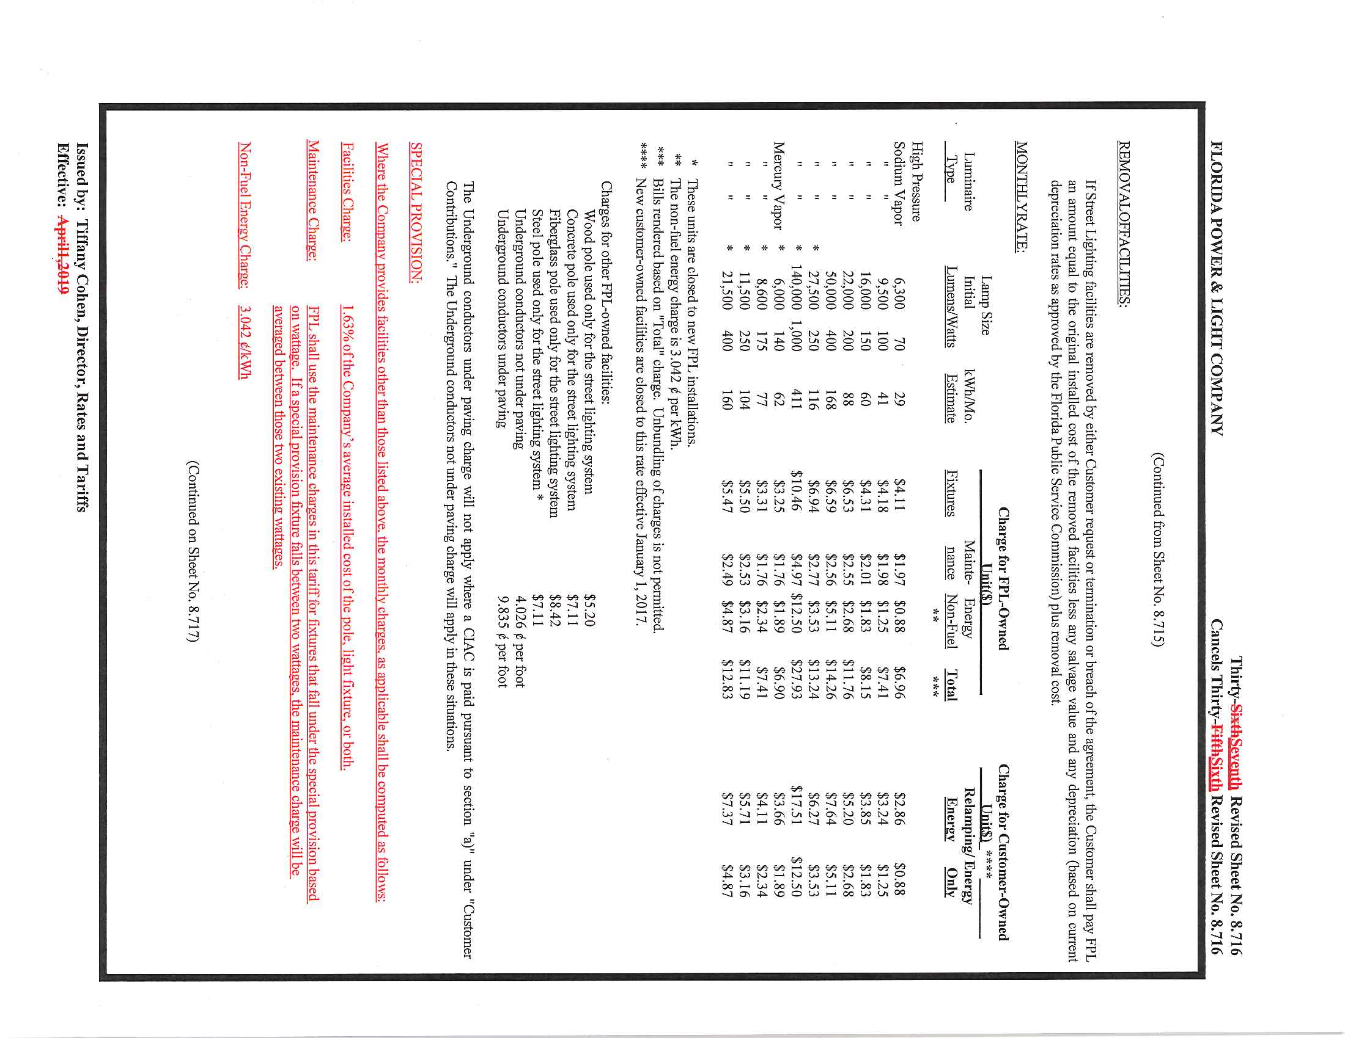

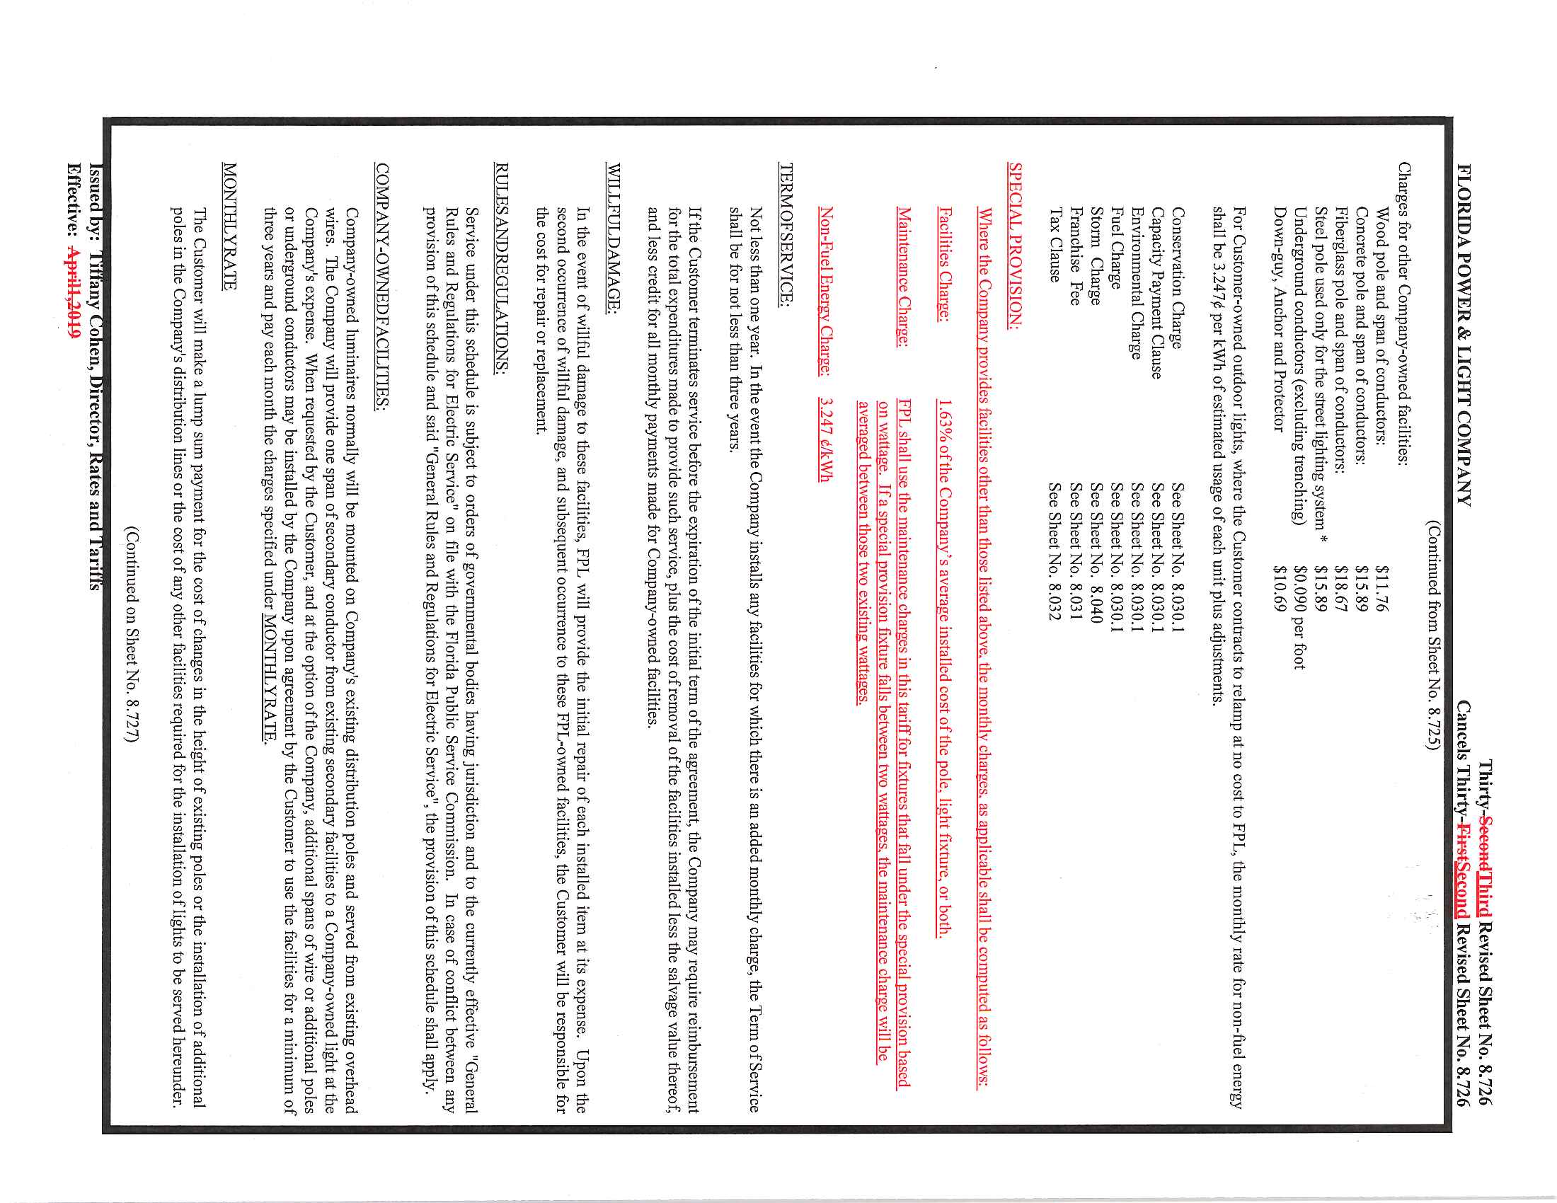

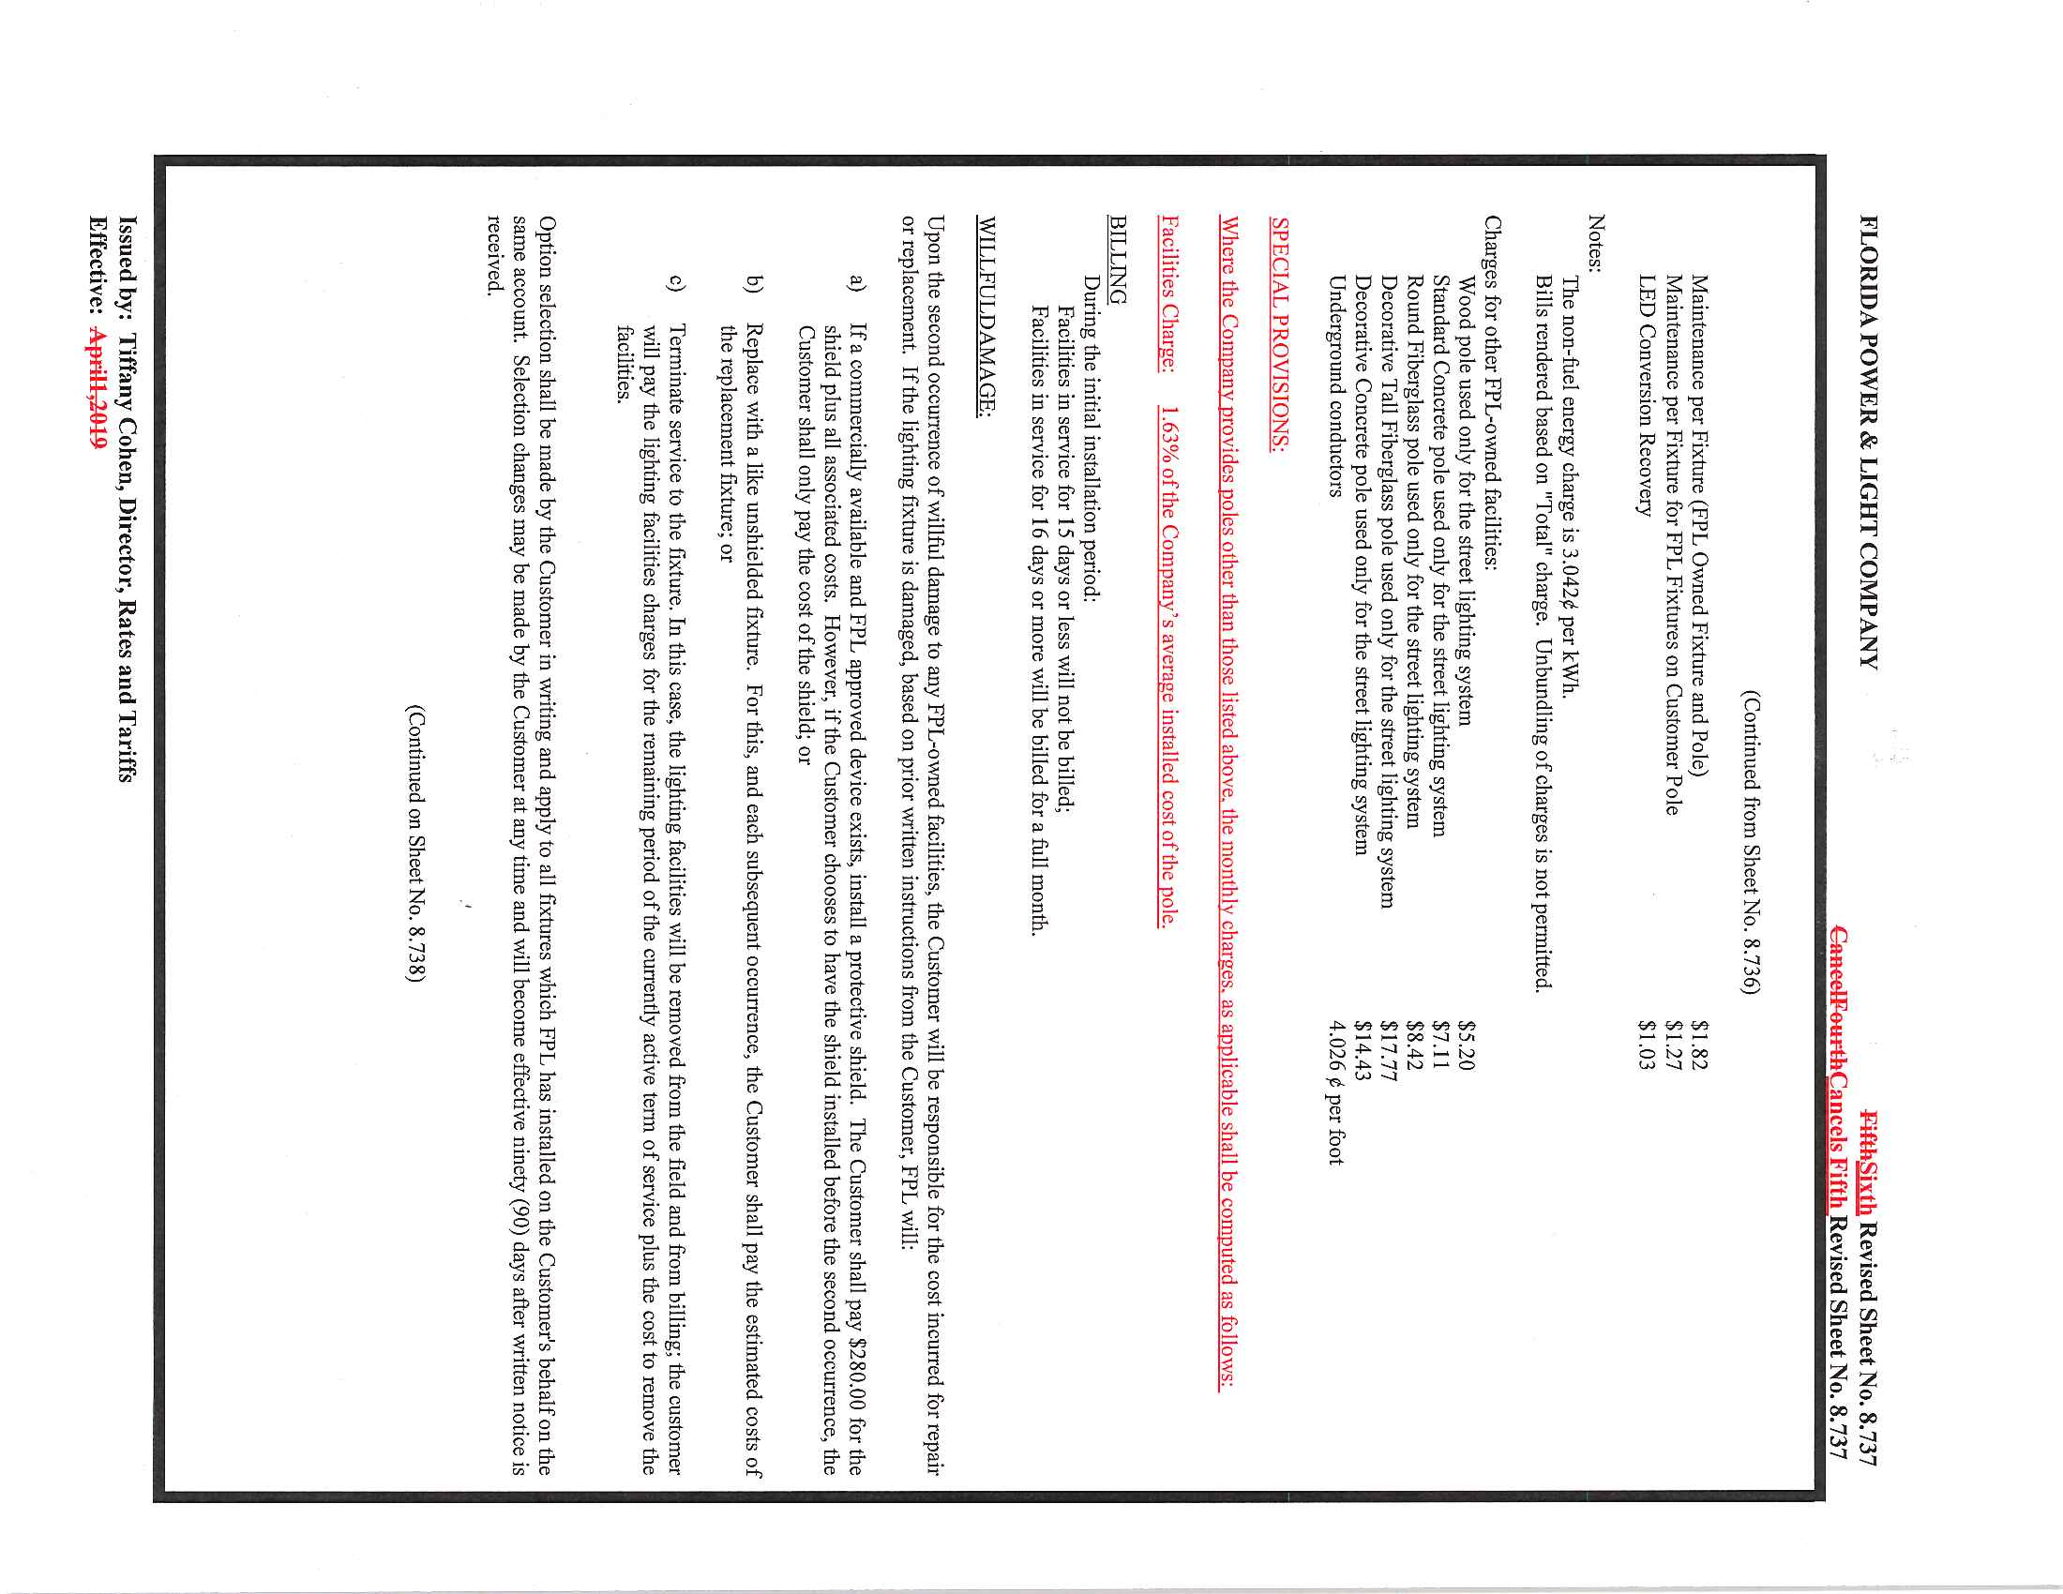

Order No. PSC-2018-0566-FOF-EU, issued on November 30, 2018, in Docket No. 20170235-EI, In re: Petition by Florida Power & Light Company (FPL) for authority to charge FPL rates to former City of Vero Beach customers and for approval of FPL's accounting treatment for City of Vero Beach transaction.
Order No. PSC-17-0115-TRF-EI, issued March 28, 2017, in Docket No. 160245-EI, In re: Petition for approval of a new optional pilot LED streetlight tariff, by Florida Power & Light Company.
Order No. PSC-02-0787-FOF-EI, issued June 10, 2002, in Docket No. 010949-EI, In re: Request for rate increase by Gulf Power Company.
Order No. PSC-2019-0063-TRF-EI, issued February 18, 2019, in Docket No. 20180222-EI, In re: Petition for approval of customer specified lighting tariff by Tampa Electric Company.

