State of Florida | Public Service Commission  Capital Circle Office Center ● 2540 Shumard Oak Boulevard  Tallahassee, Florida 32399-0850  -M-E-M-O-R-A-N-D-U-M-
DATE: | May 2, 2019
TO: | Office of Commission Clerk (Teitzman)
FROM: | Division of Engineering (Thompson, Doehling, Ellis)  Office of the General Counsel (DuVal)
RE: | Docket No. 20190088-EQ – Petition for approval of standard offer for energy purchased from cogenerators and renewable generating facilities and standard offer contract for purchase of firm capacity and energy, by Florida Public Utilities Company.
AGENDA: | 05/14/19 – Consent Agenda – Proposed Agency Action – Interested Persons May Participate
SPECIAL INSTRUCTIONS: |  | None

Please place the following on the consent agenda for approval.

DOCKET NO. | COMPANY NAME | 2019 Standard Offer
20190088-EQ | Florida Public Utilities Company | Attachment A

Section 366.91(3), Florida Statutes (F.S.), requires that each investor-owned utility (IOU) continuously offer to purchase capacity and energy from renewable energy generators and small qualifying facilities. Florida Public Service Commission (Commission) Rules 25-17.200 through 25-17.310, Florida Administrative Code, implement the statute and require each IOU to file with the Commission, by April 1 of each year, a standard offer contract based on the next avoidable fossil fueled generating unit of each technology type identified in the Utility’s current Ten-Year Site Plan. On April 1, 2019, Florida Public Utilities Company (FPUC) filed its standard offer contract. FPUC’s standard offer contract filing does not reflect any changes or revisions from the filing approved by Order No. PSC-2018-0310-PAA-EQ. The Commission has jurisdiction over this matter pursuant to Sections 366.04 through 366.055, and 366.91, F.S.

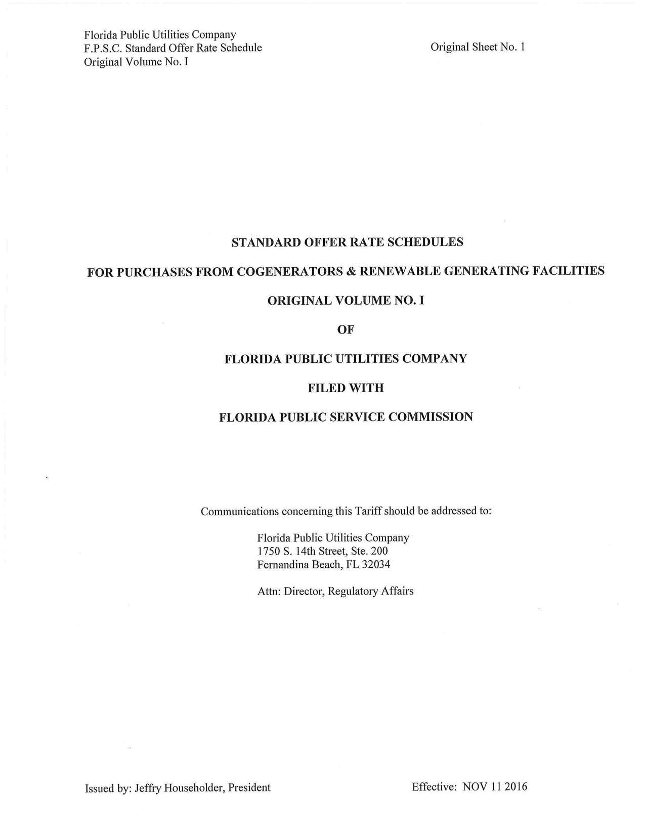

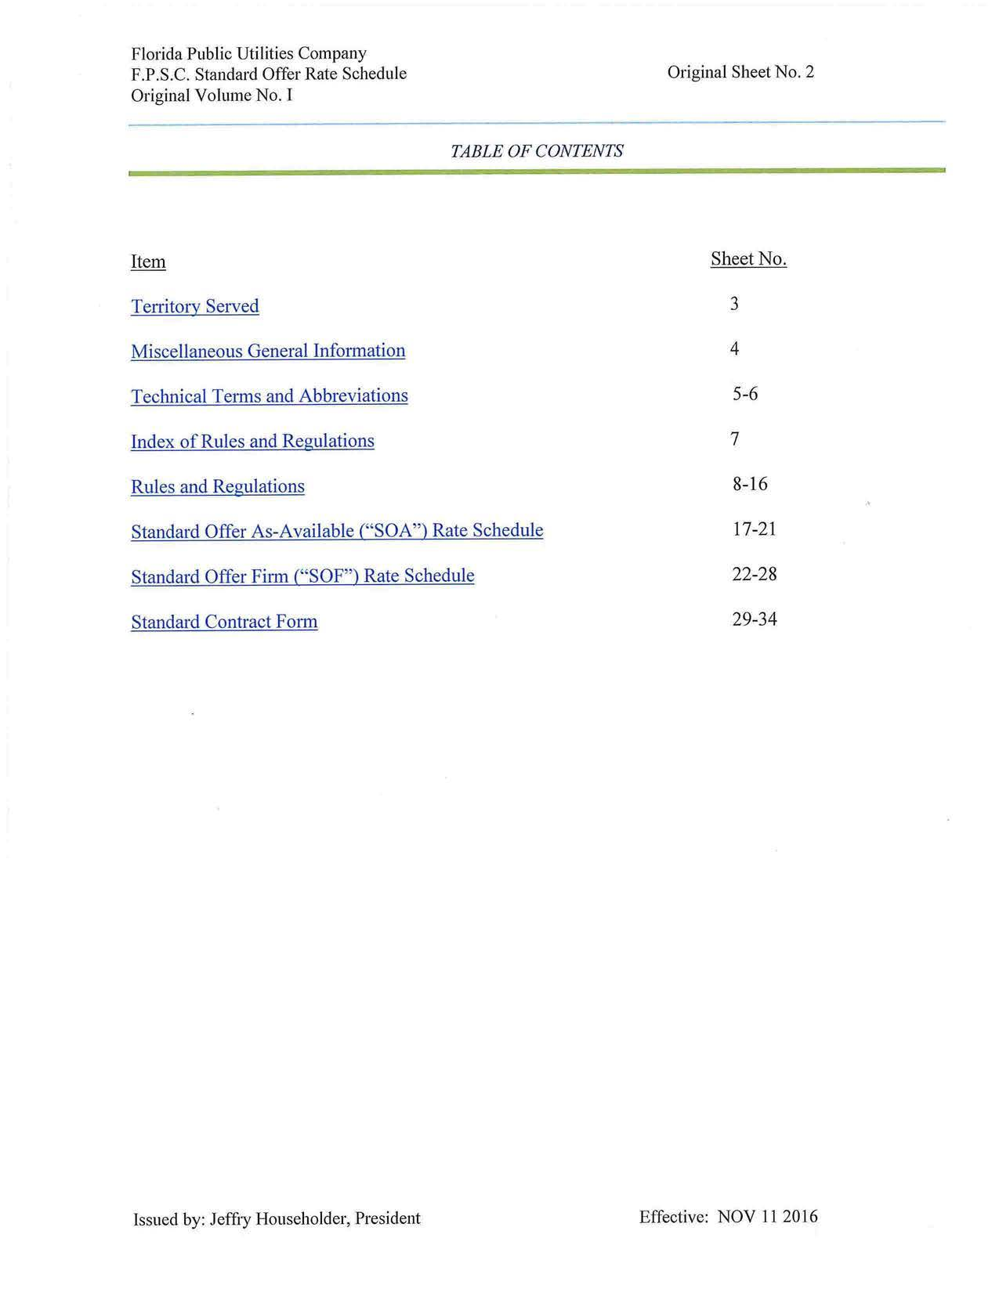

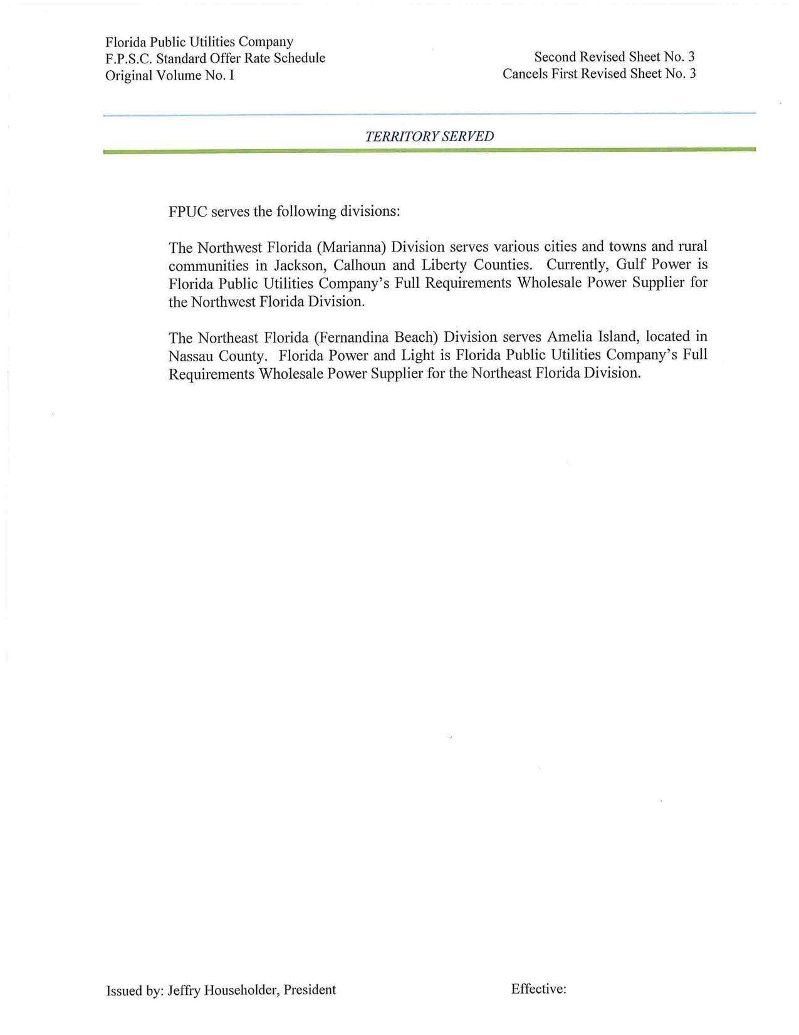

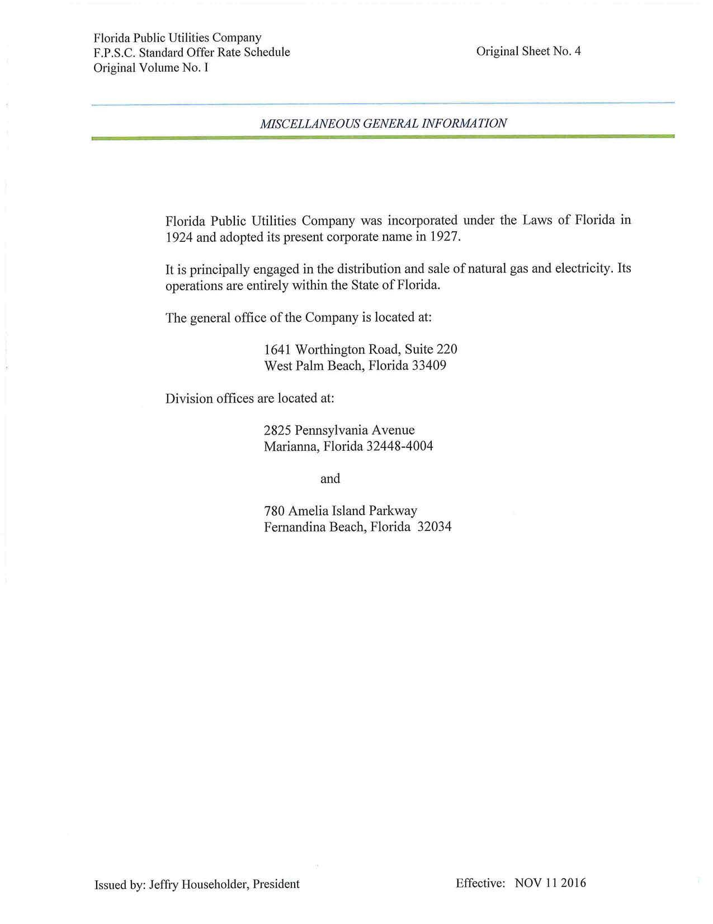

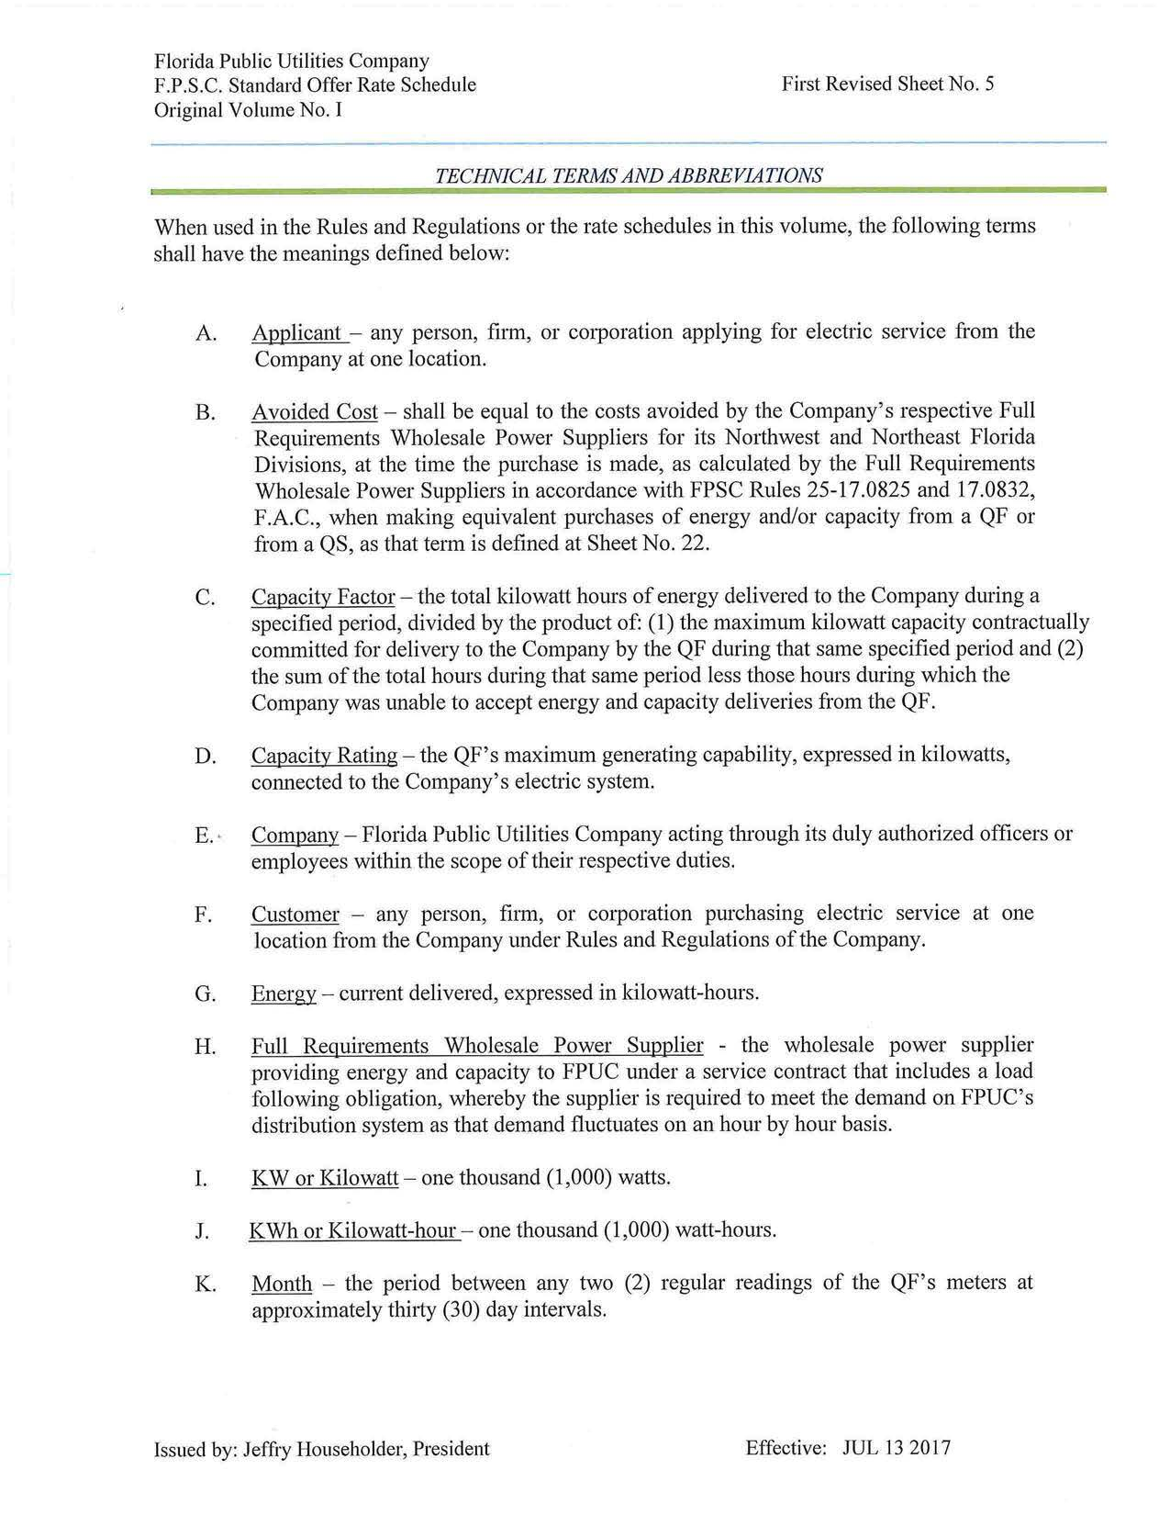

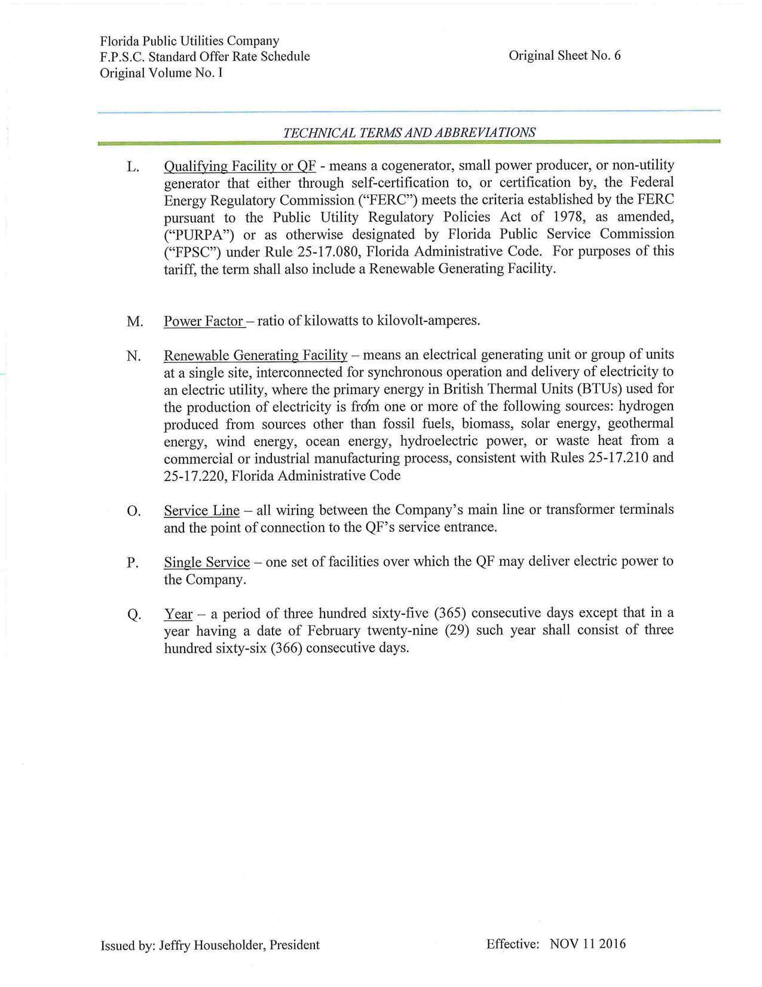

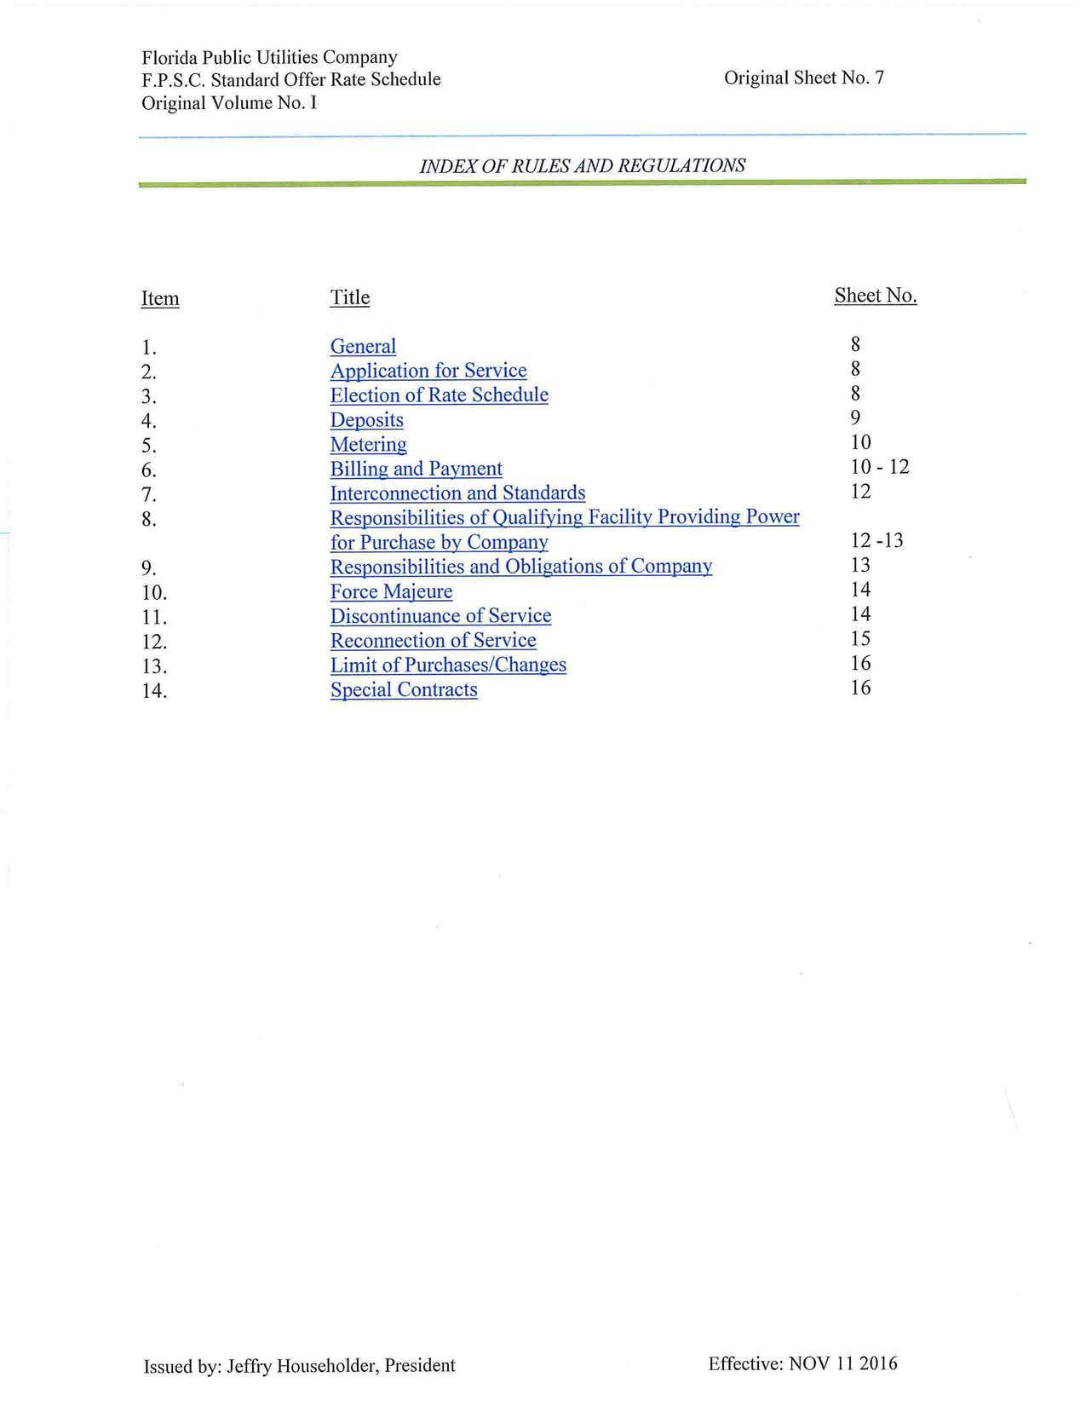

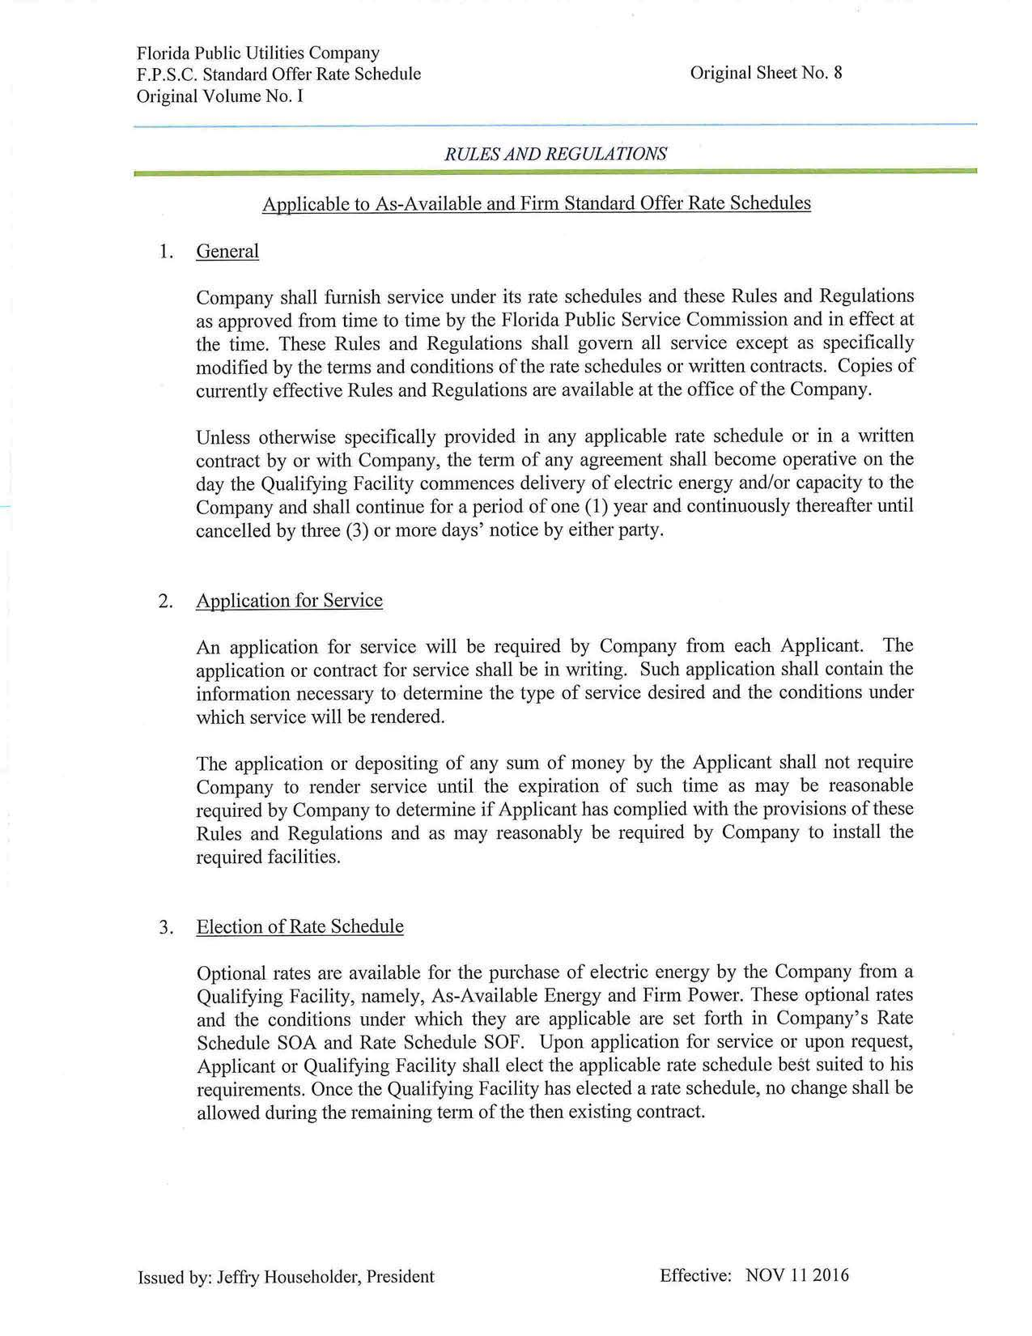

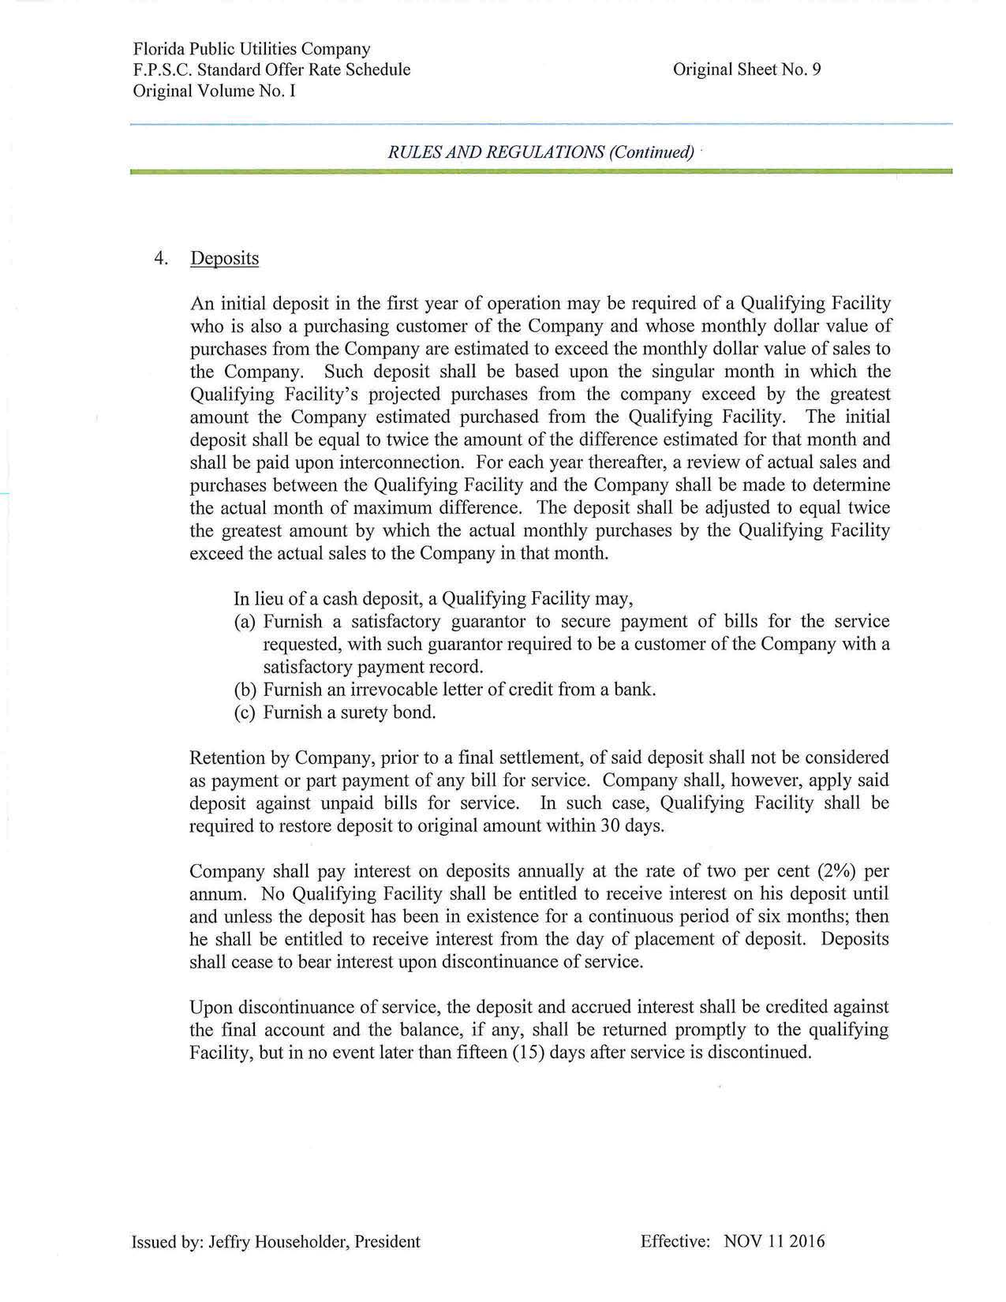

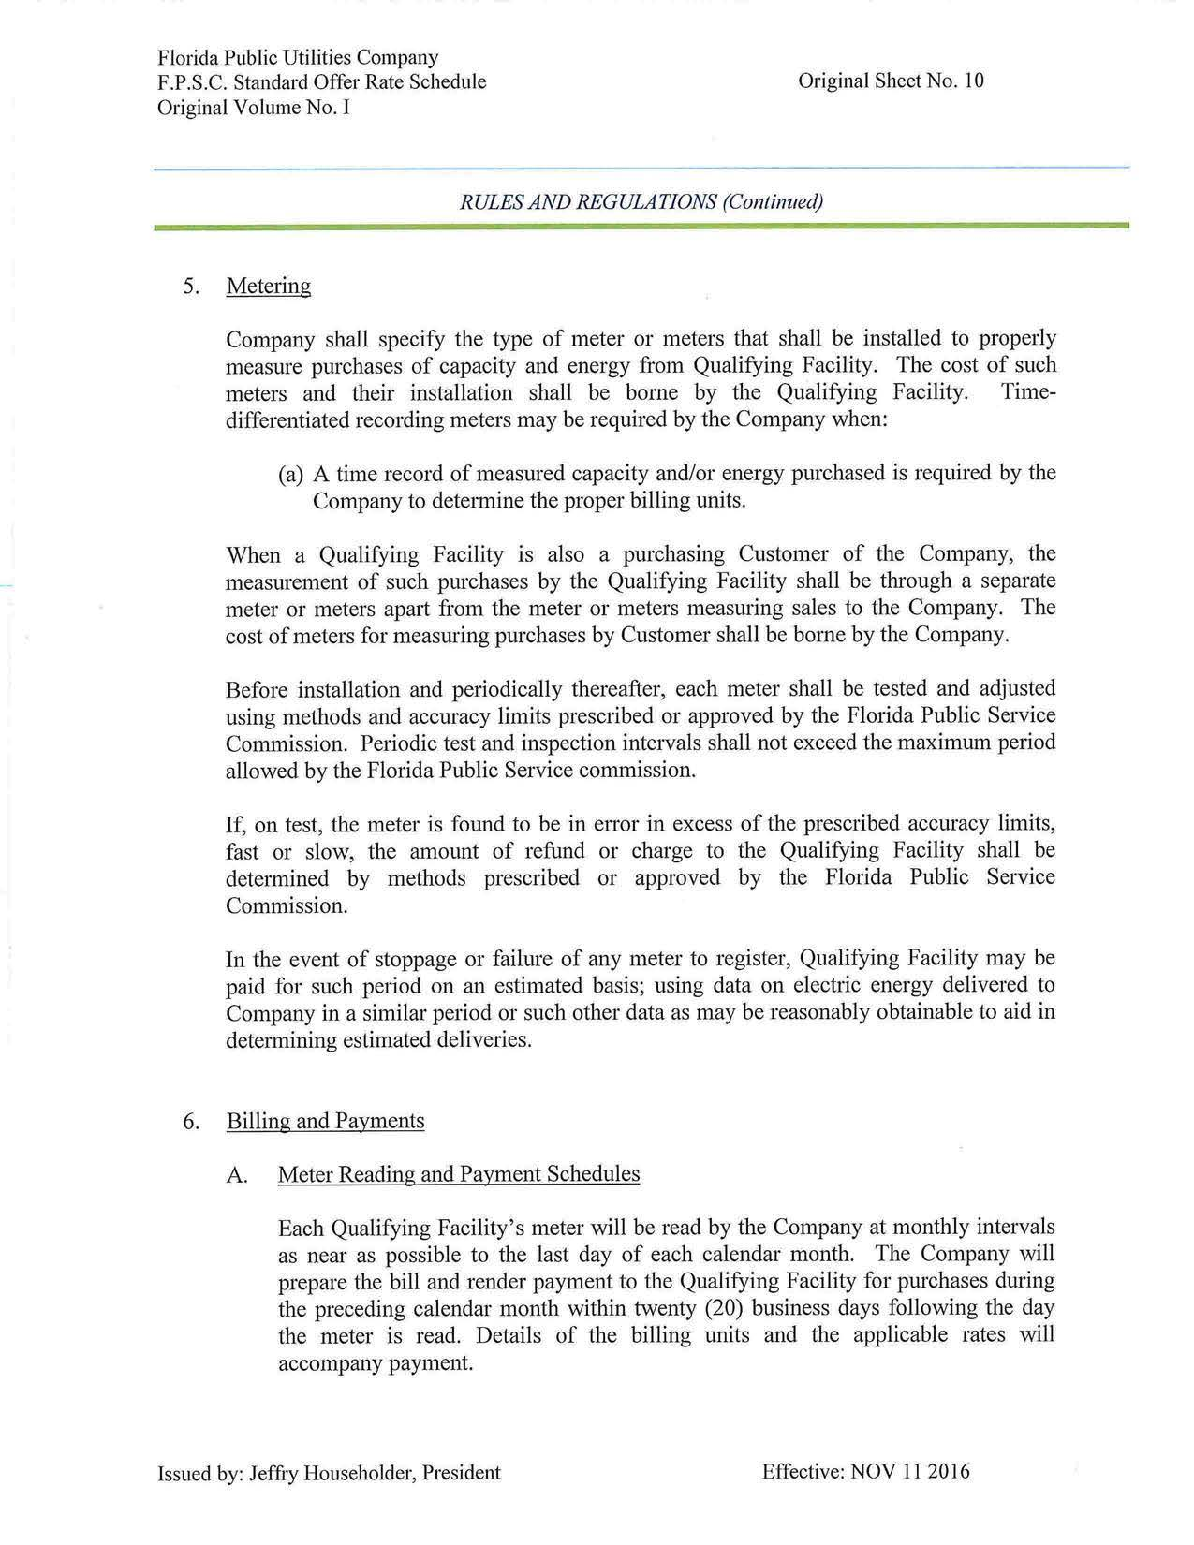

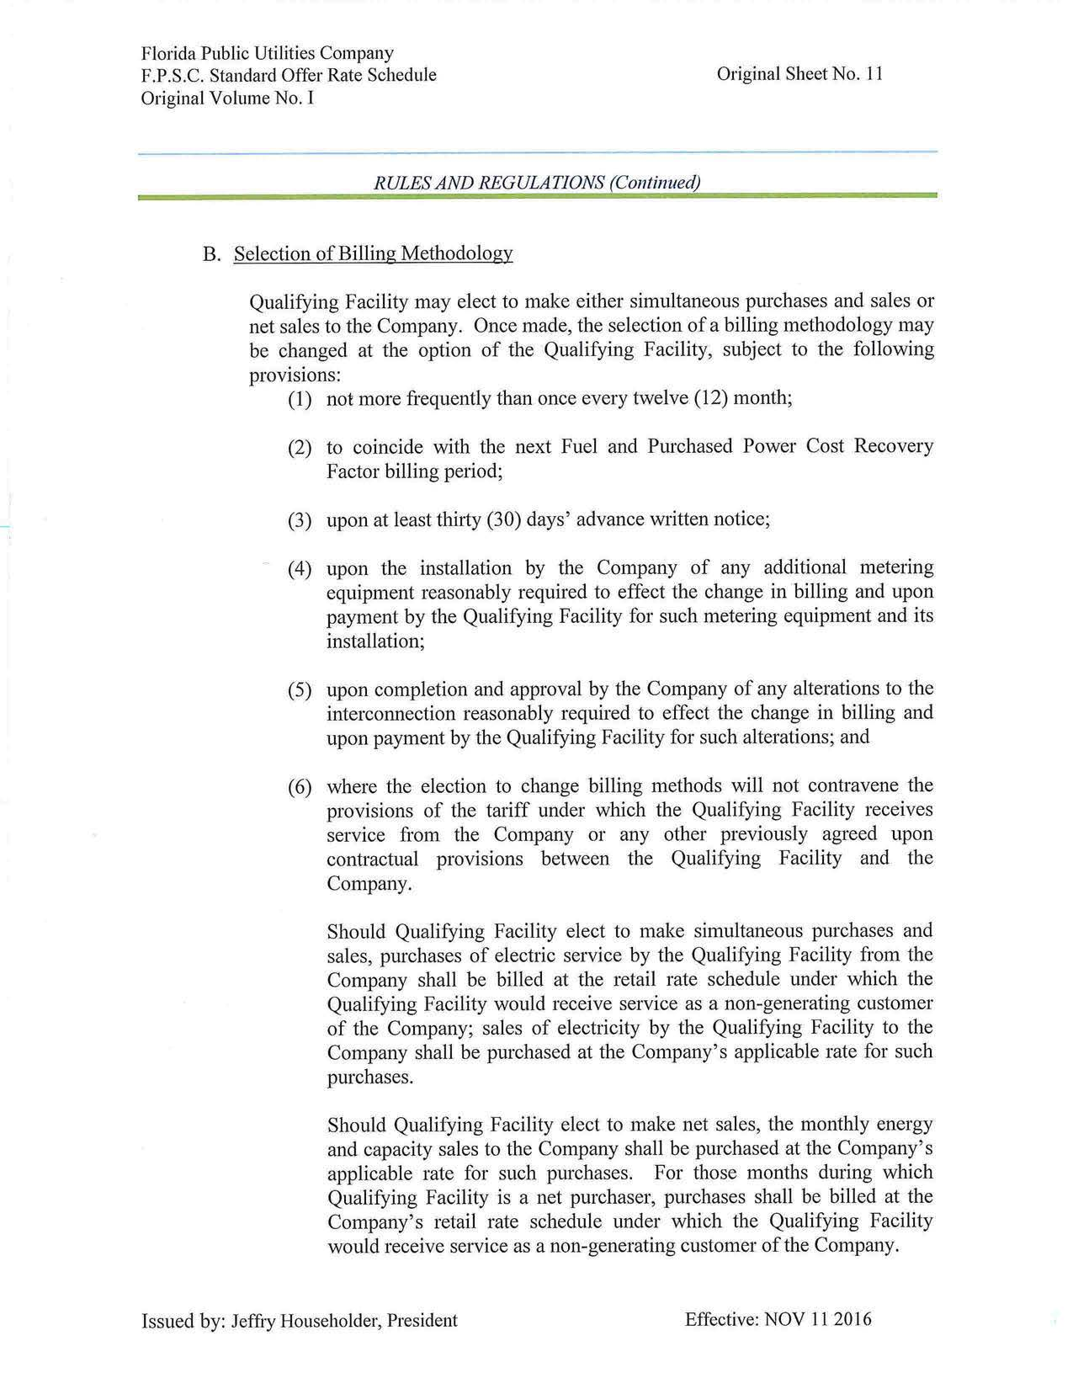

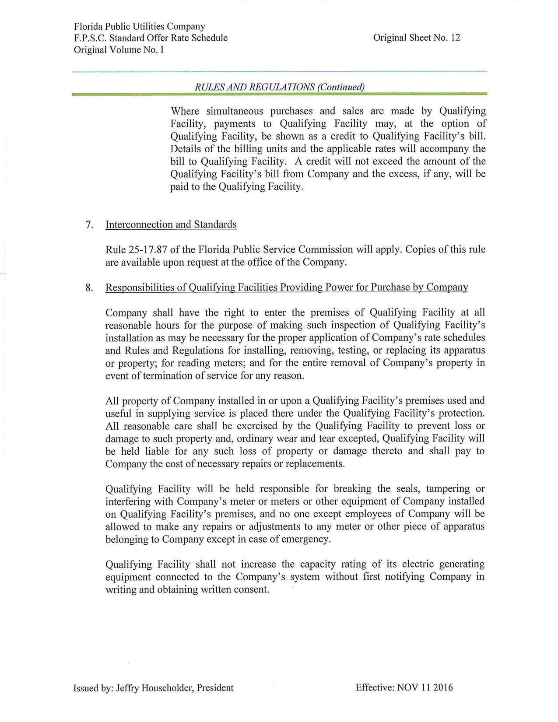

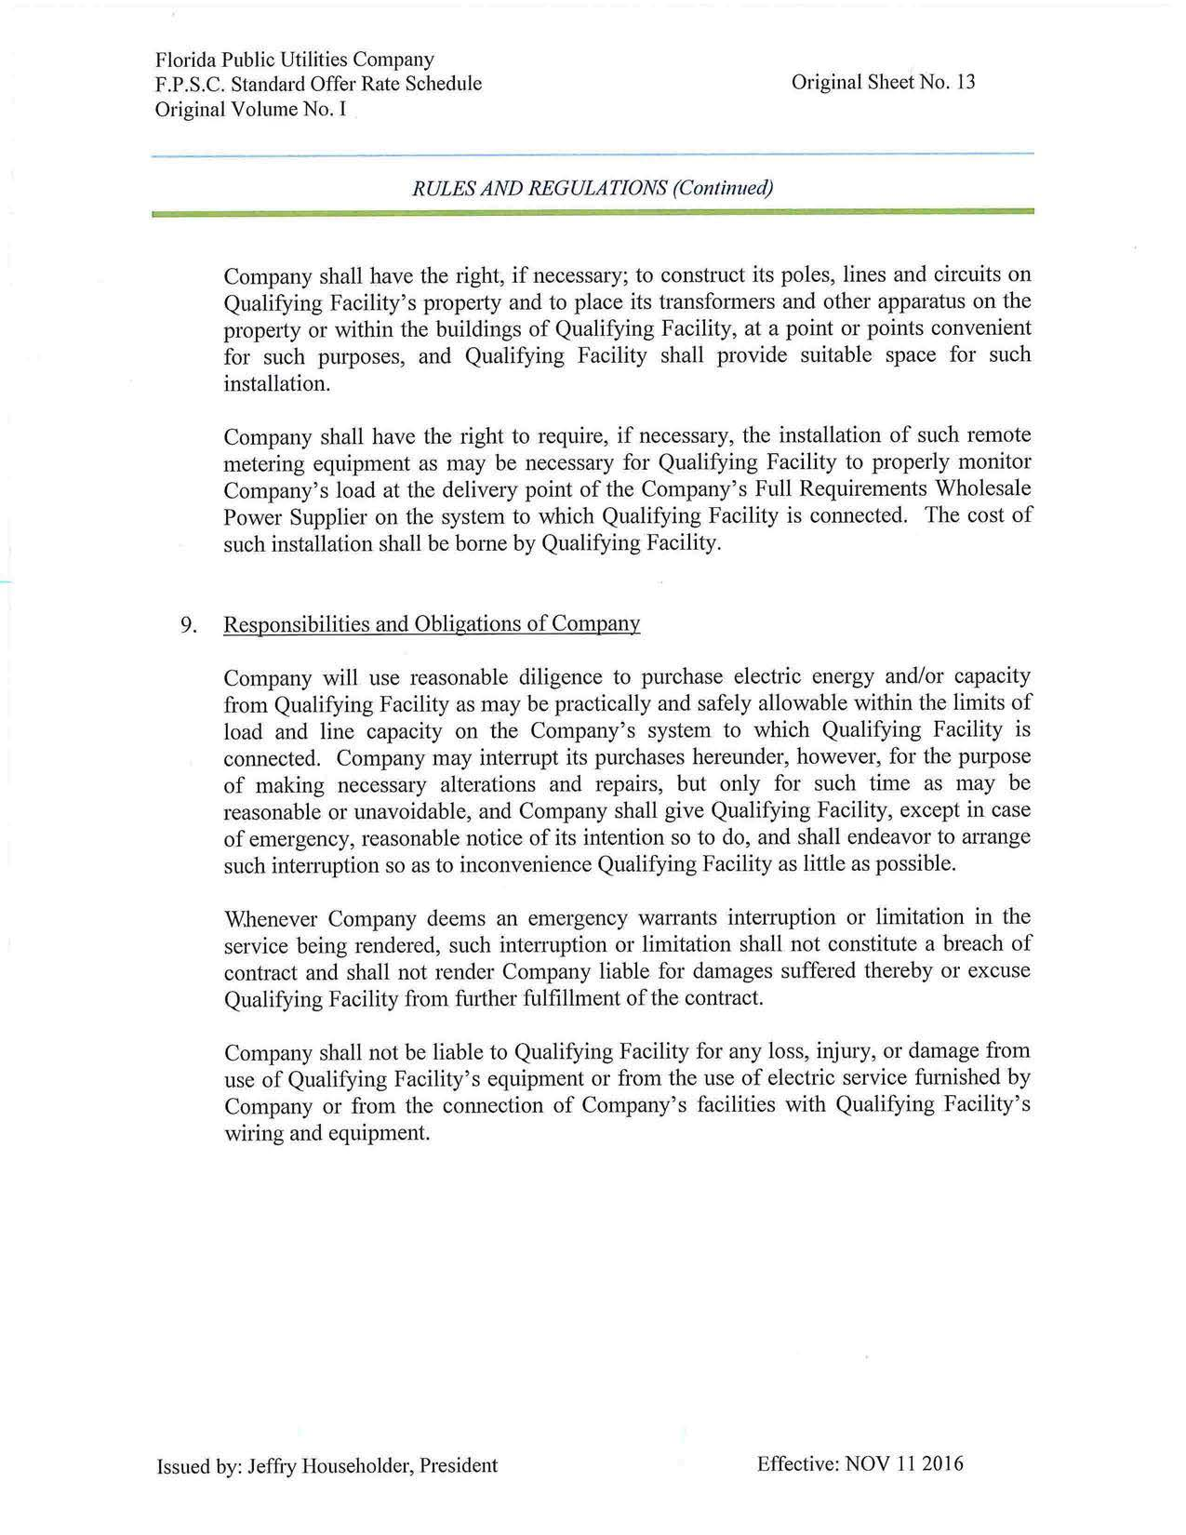

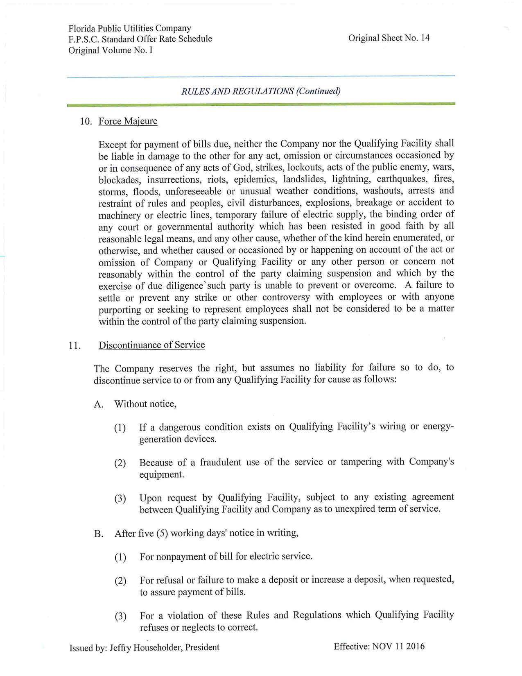

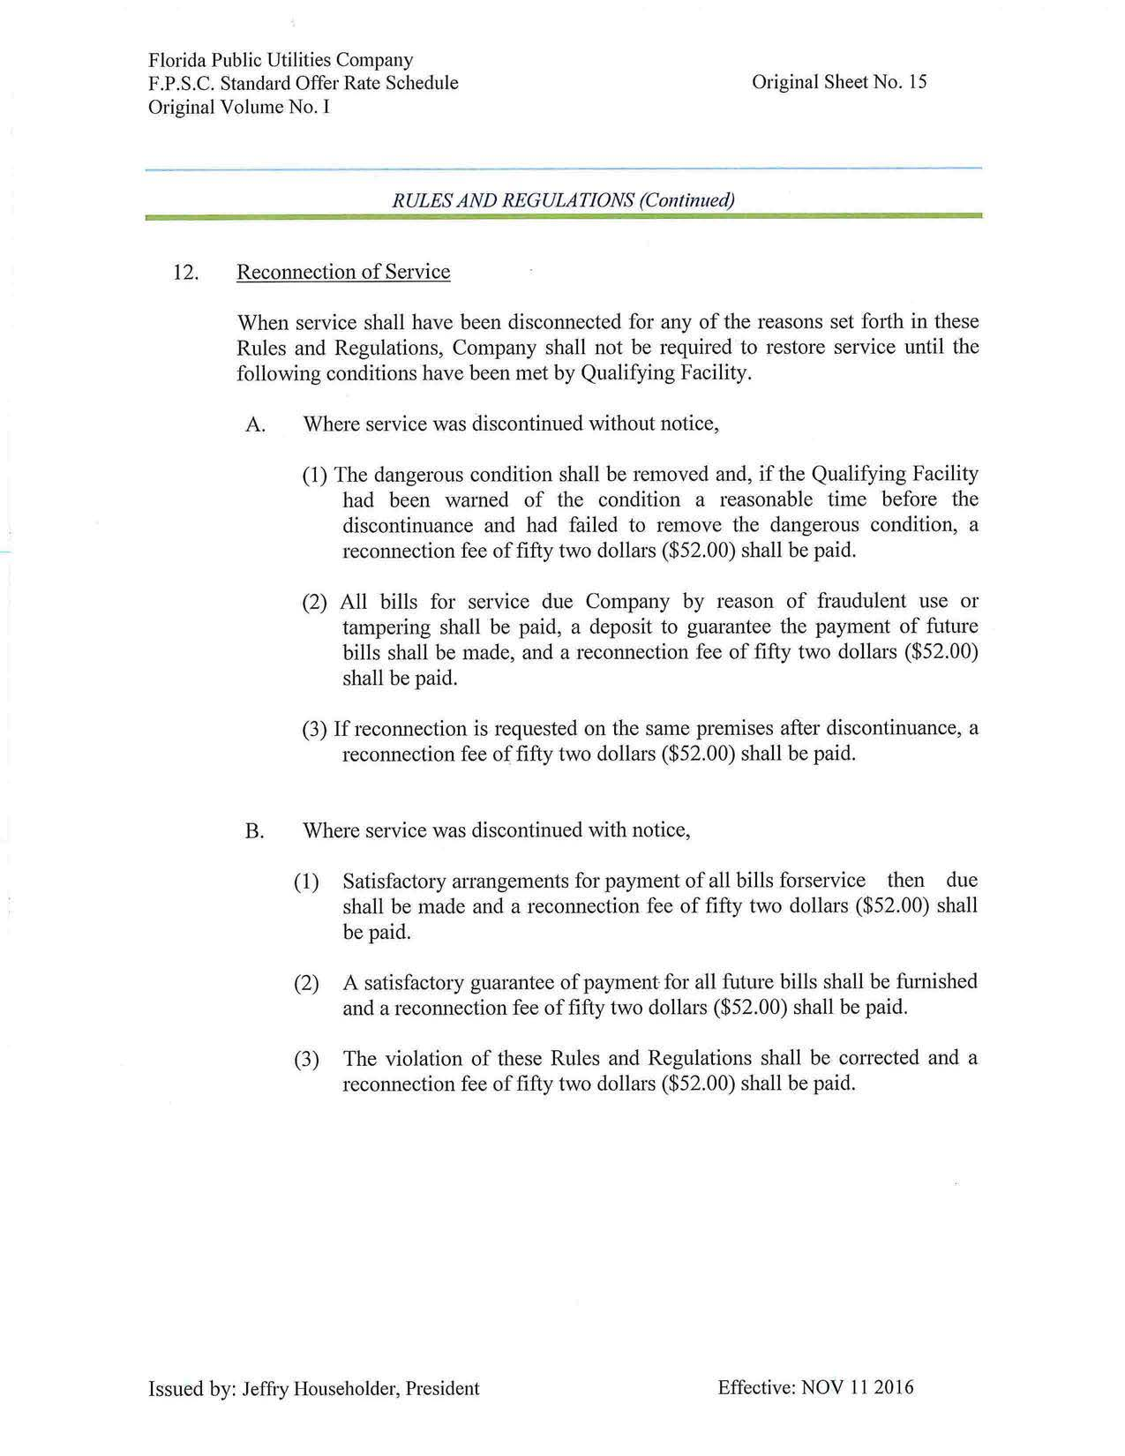

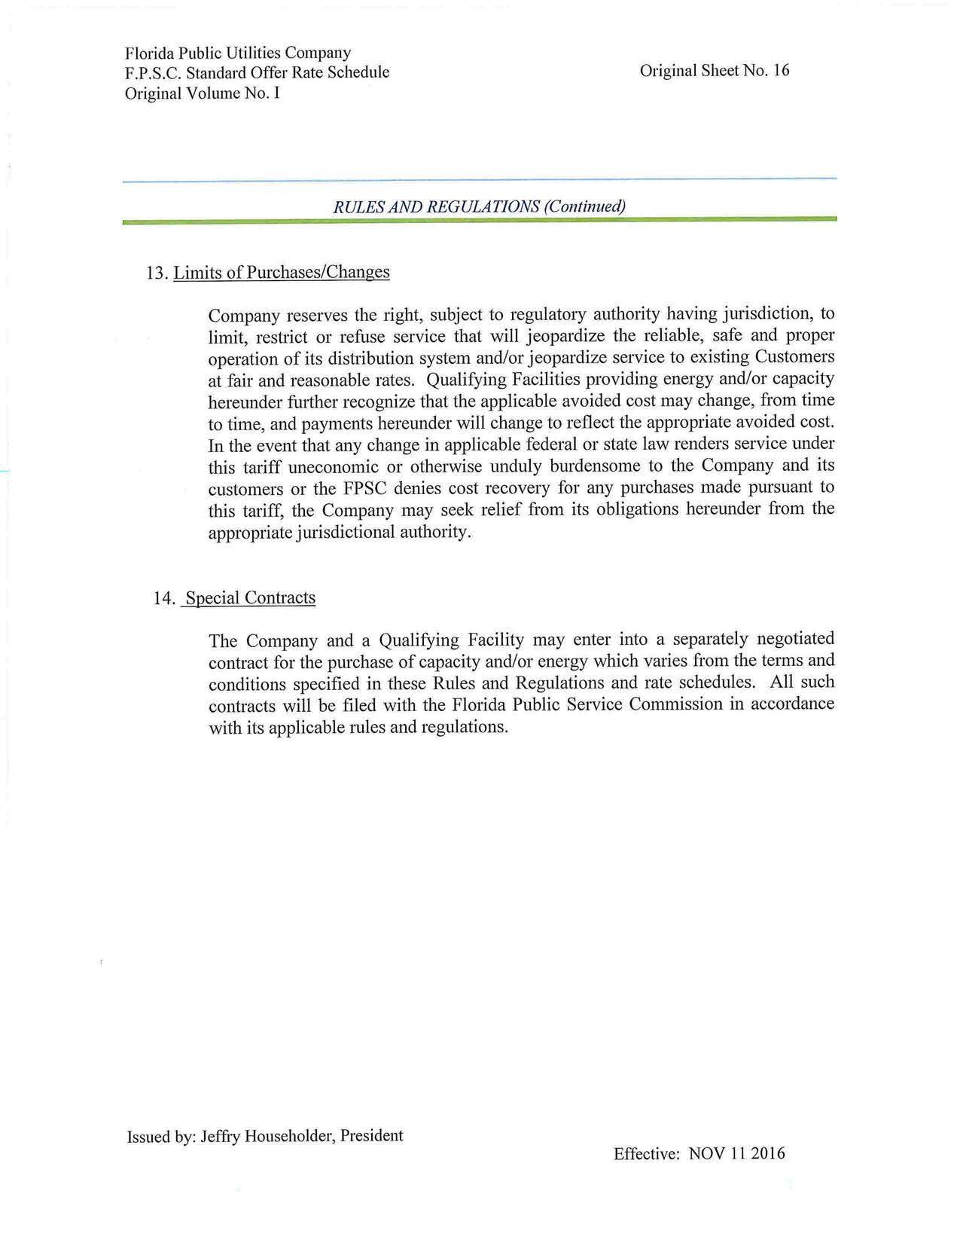

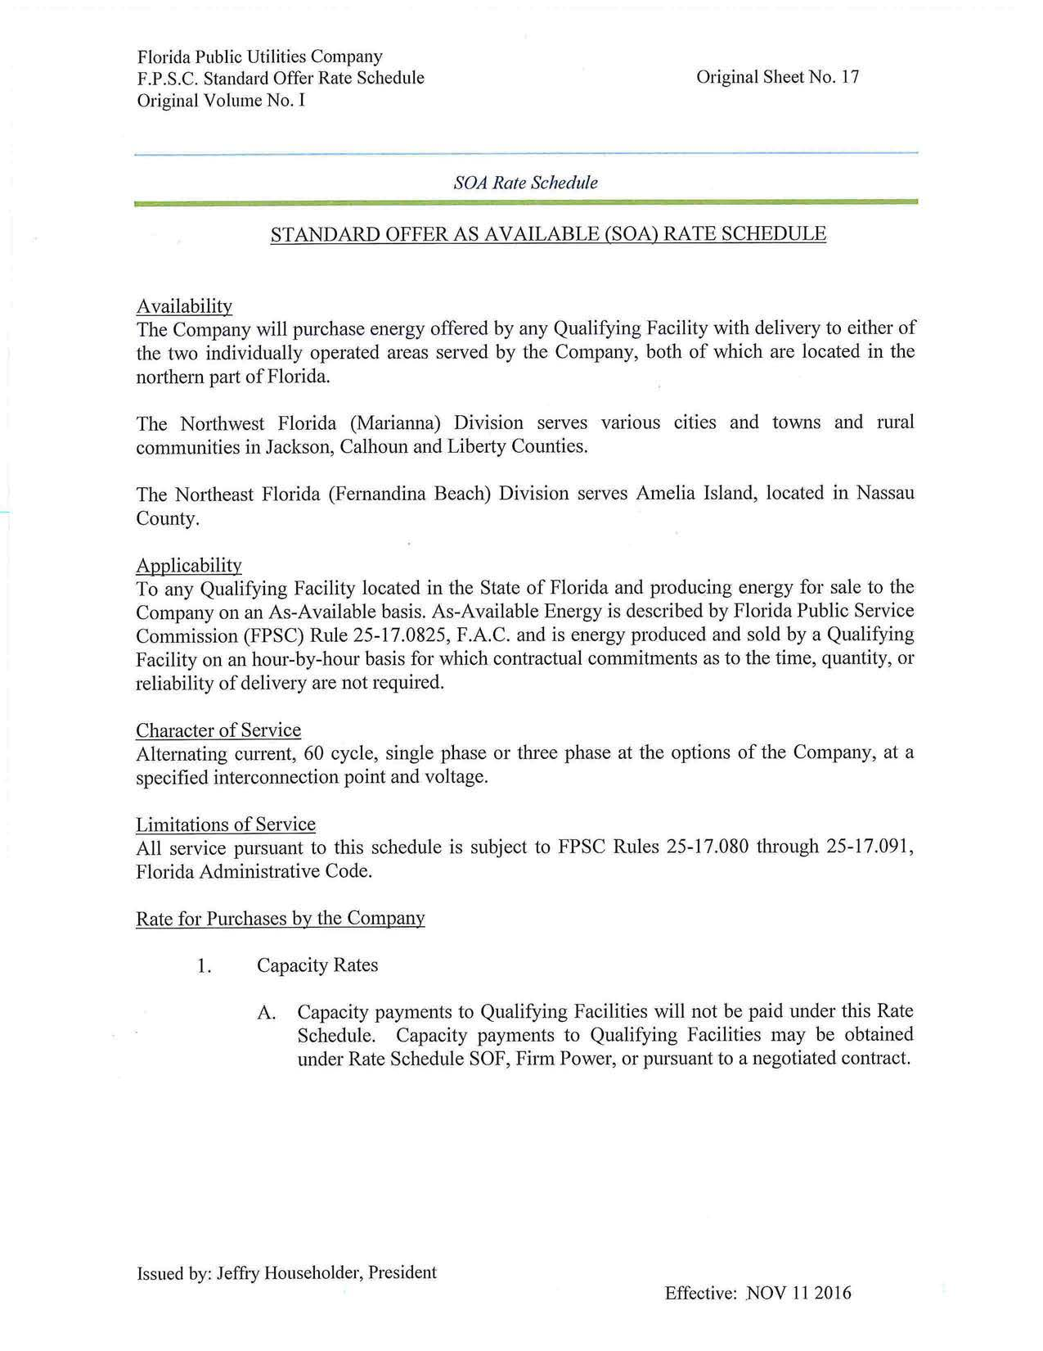

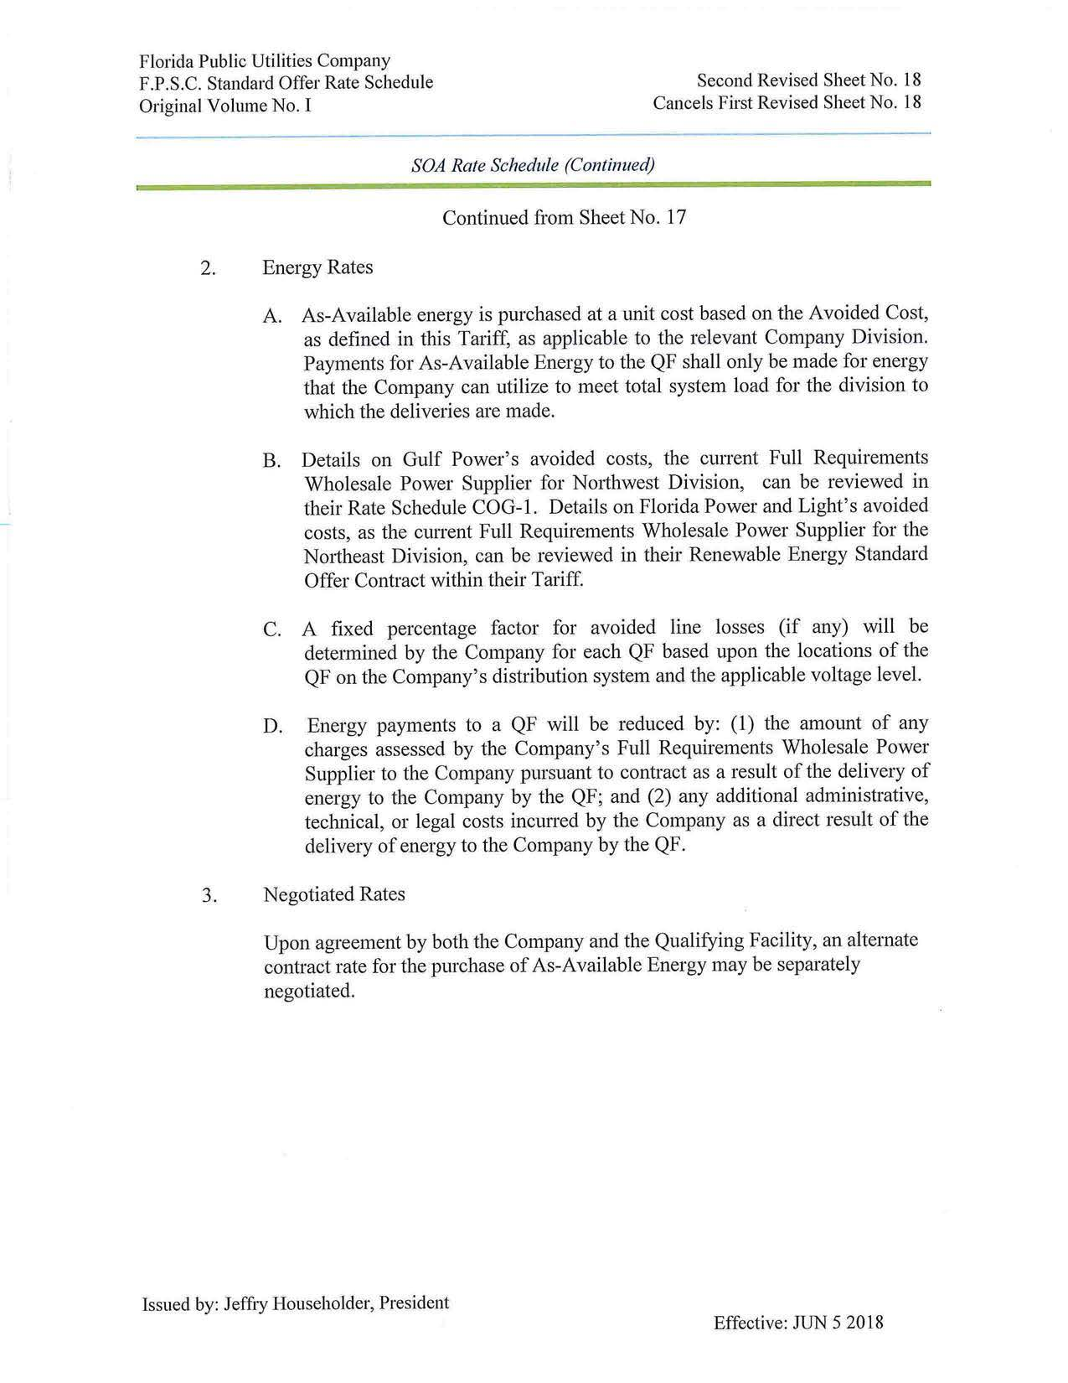

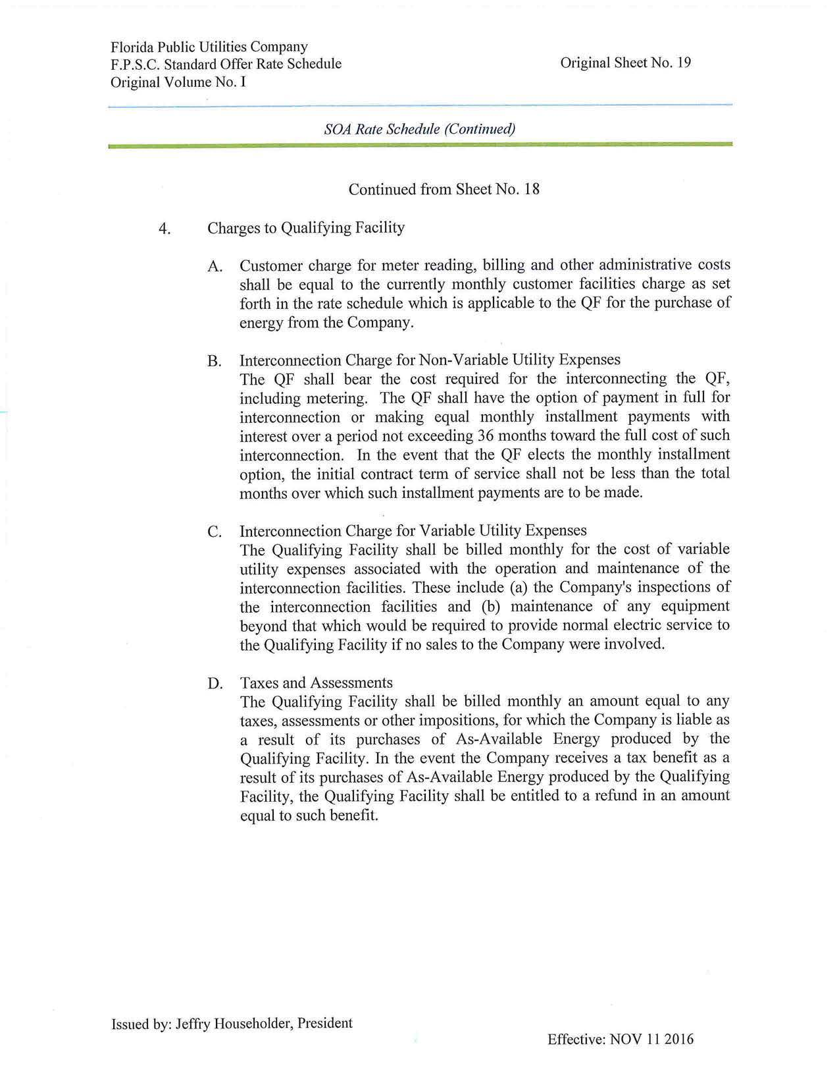

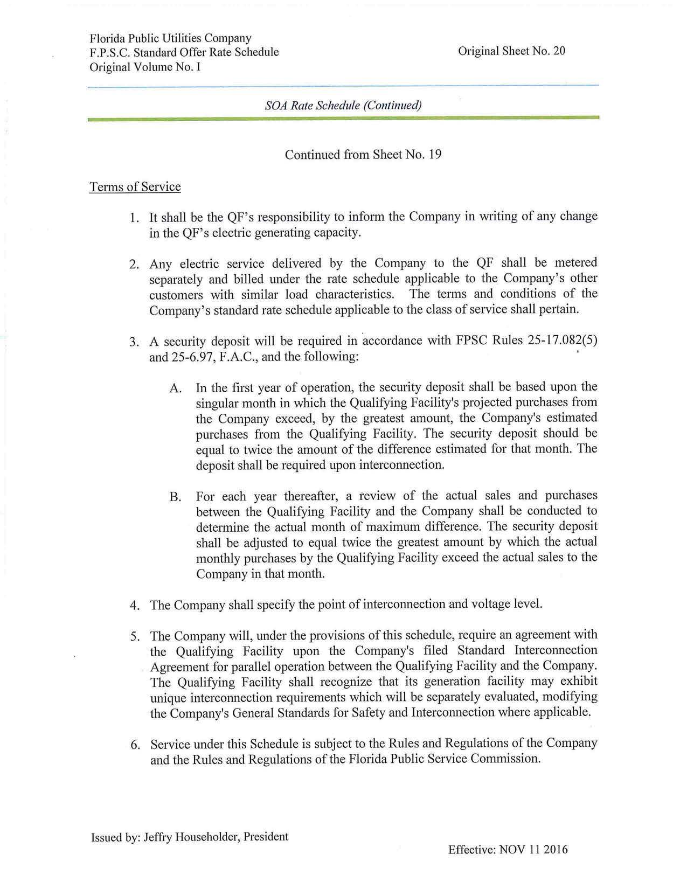

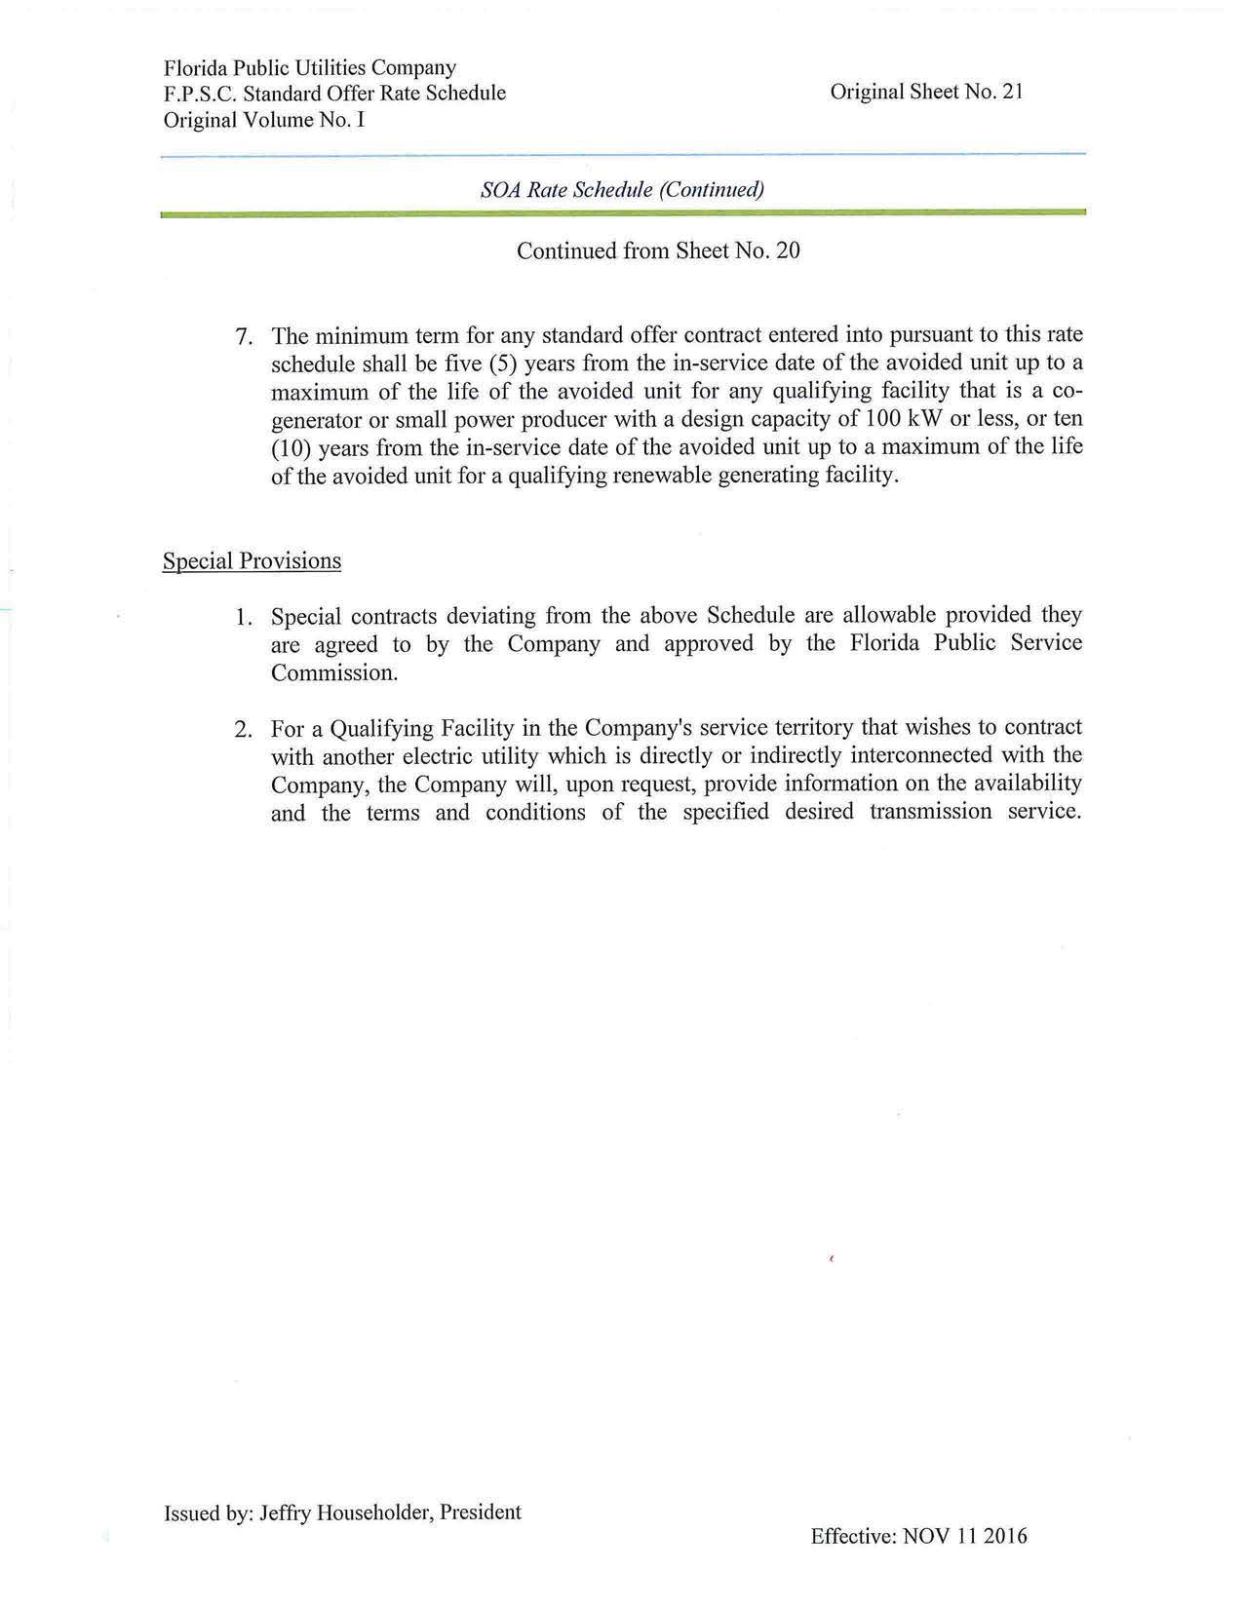

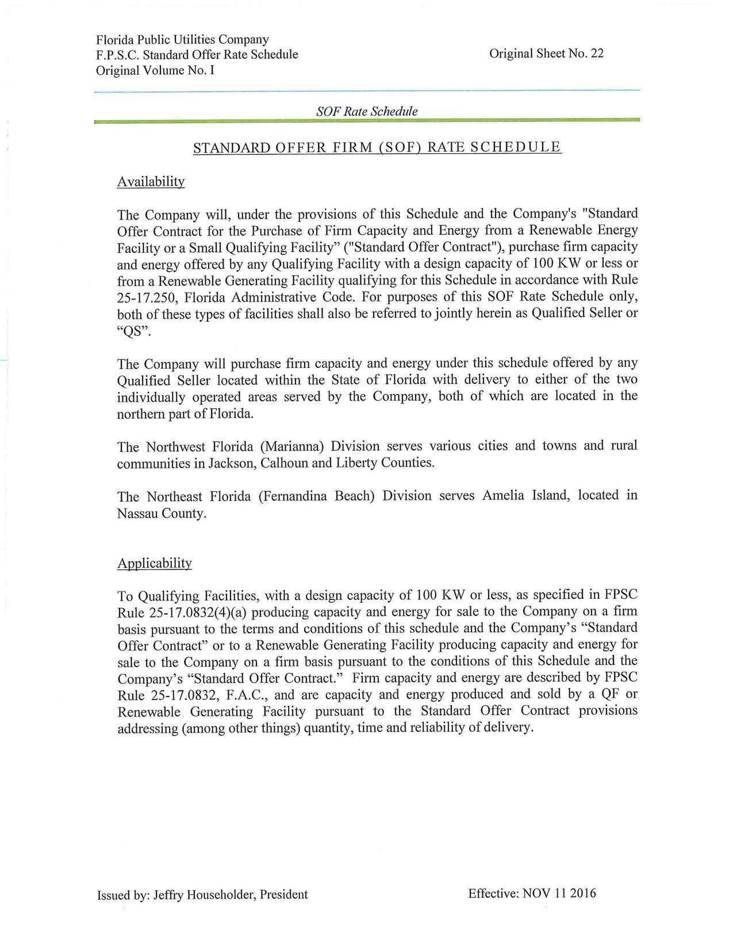

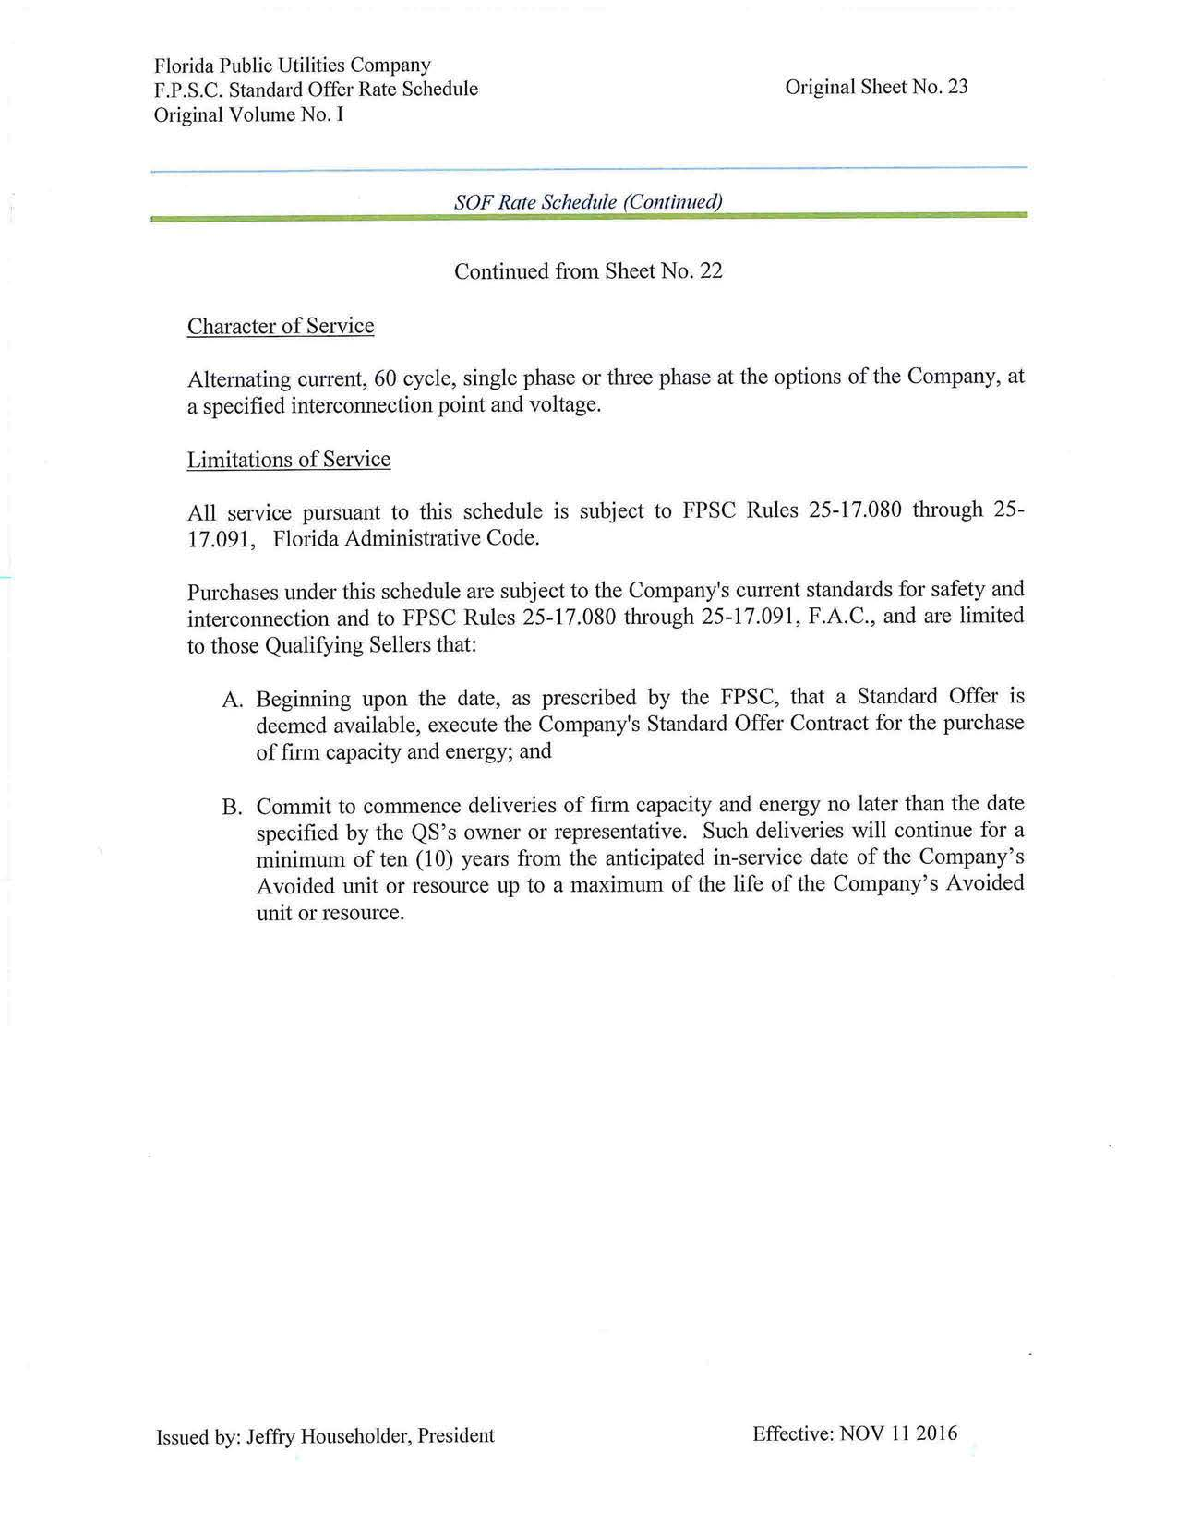

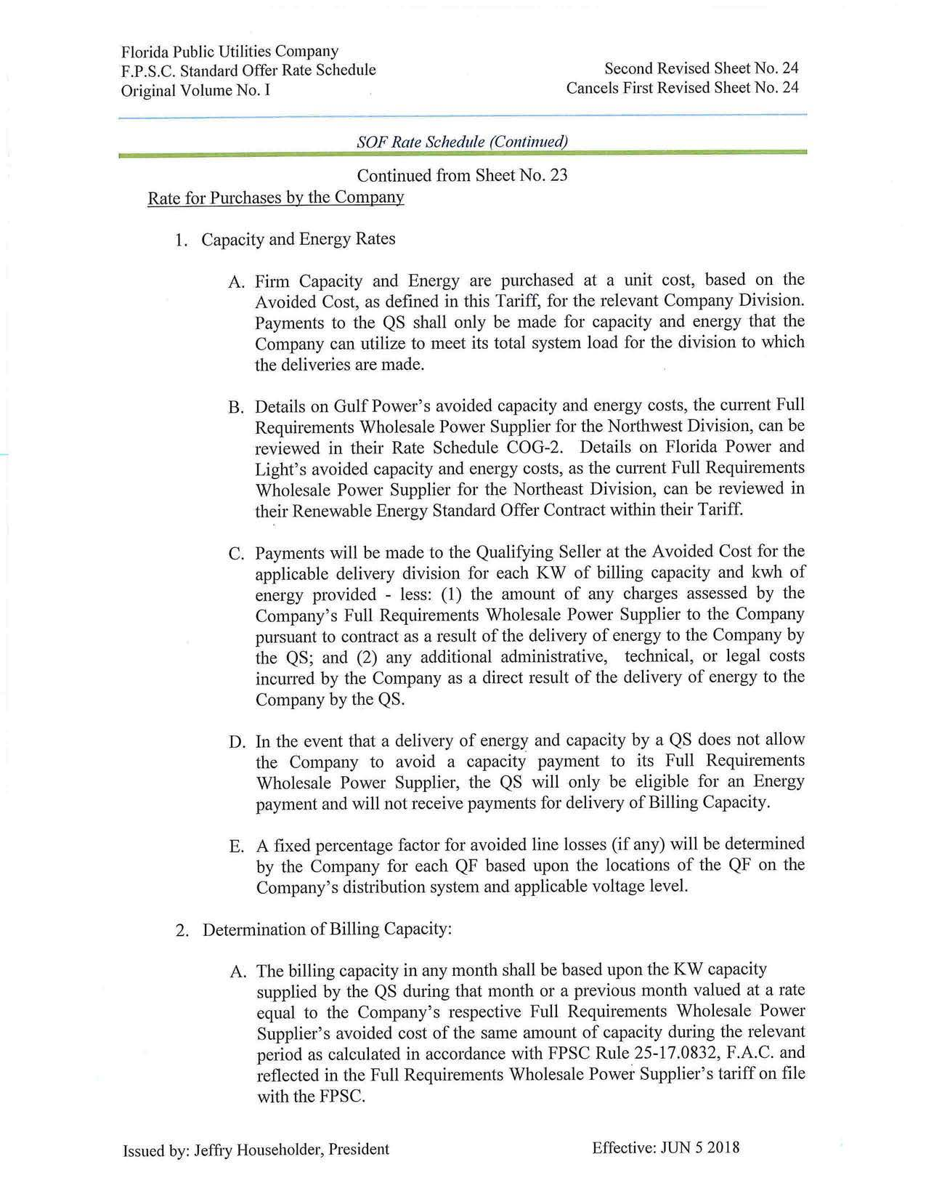

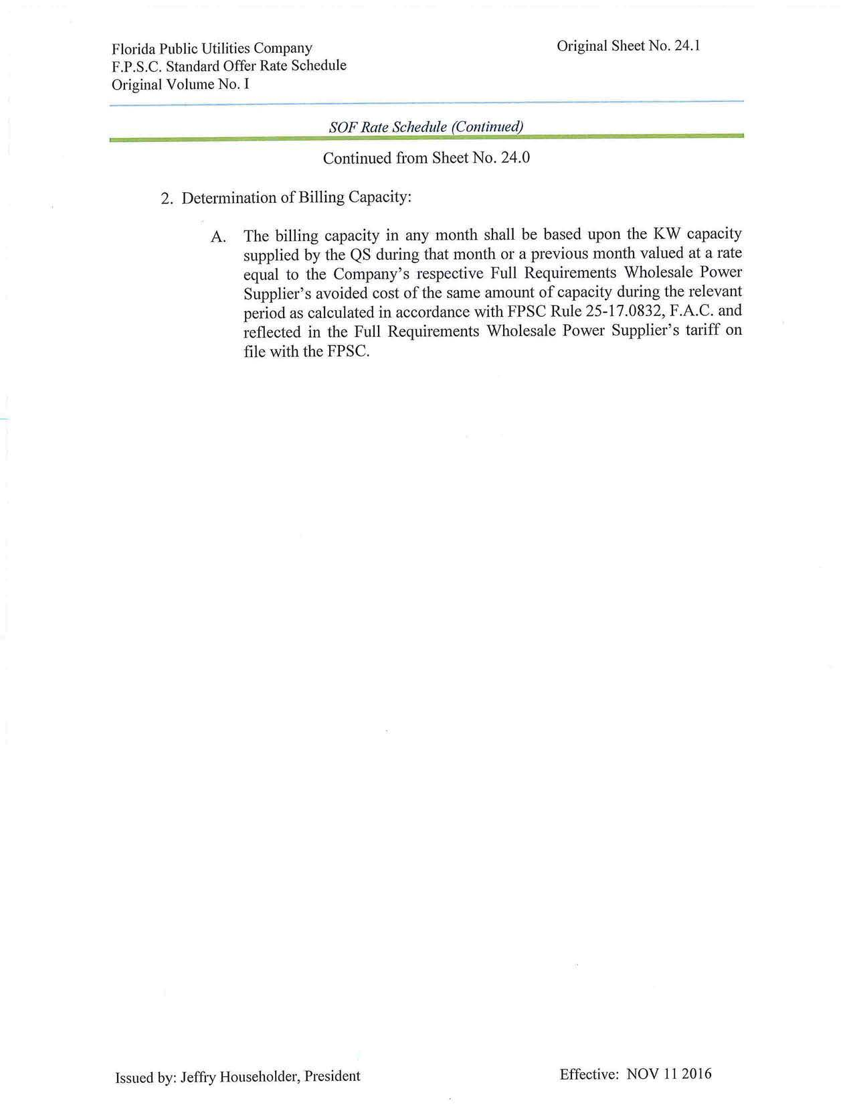

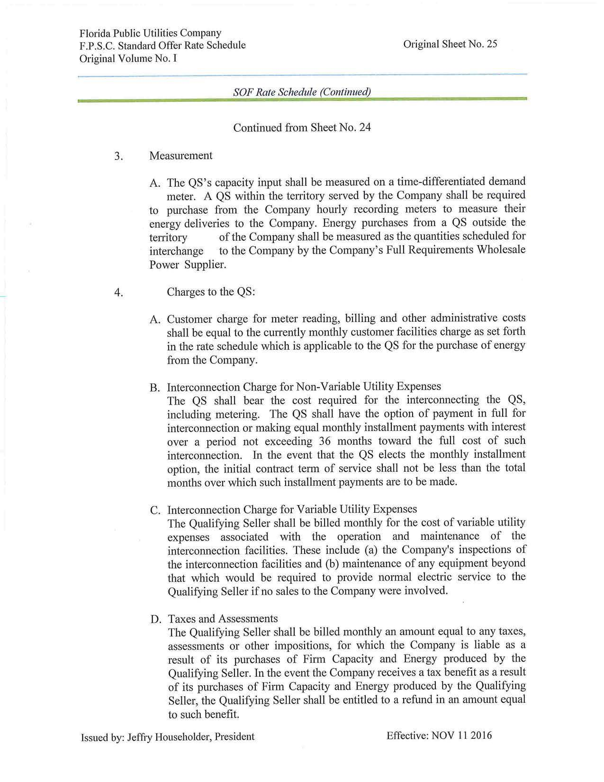

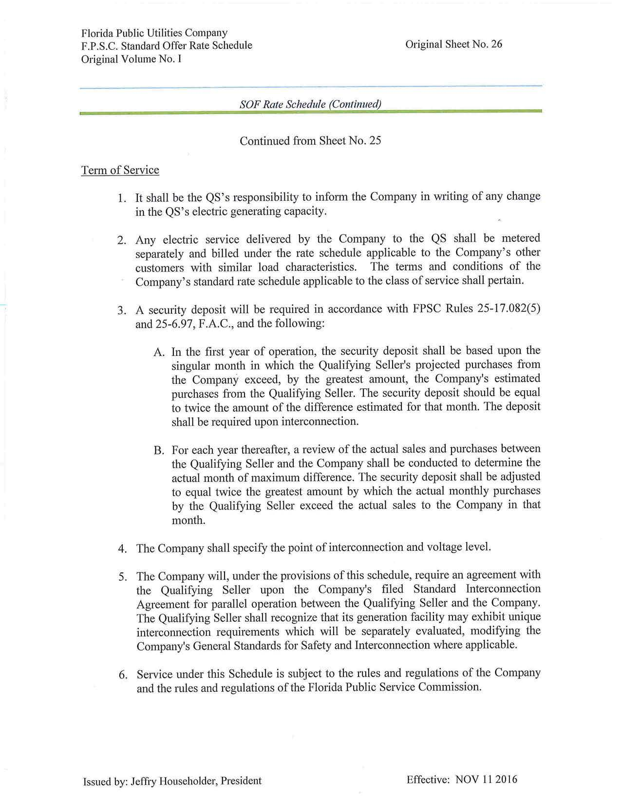

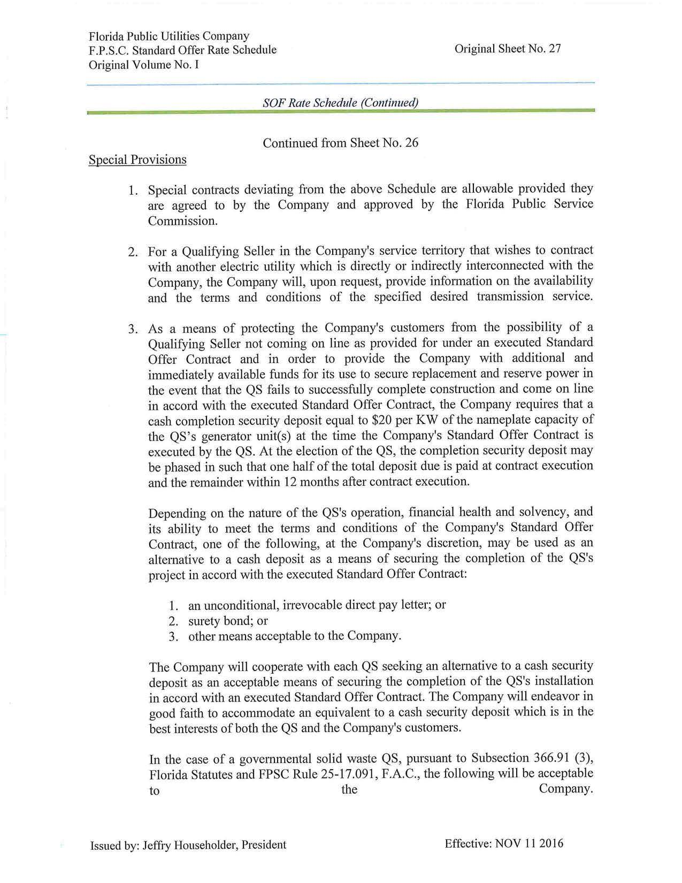

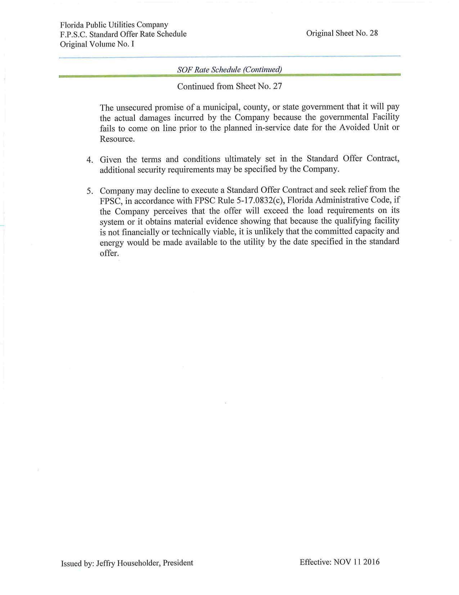

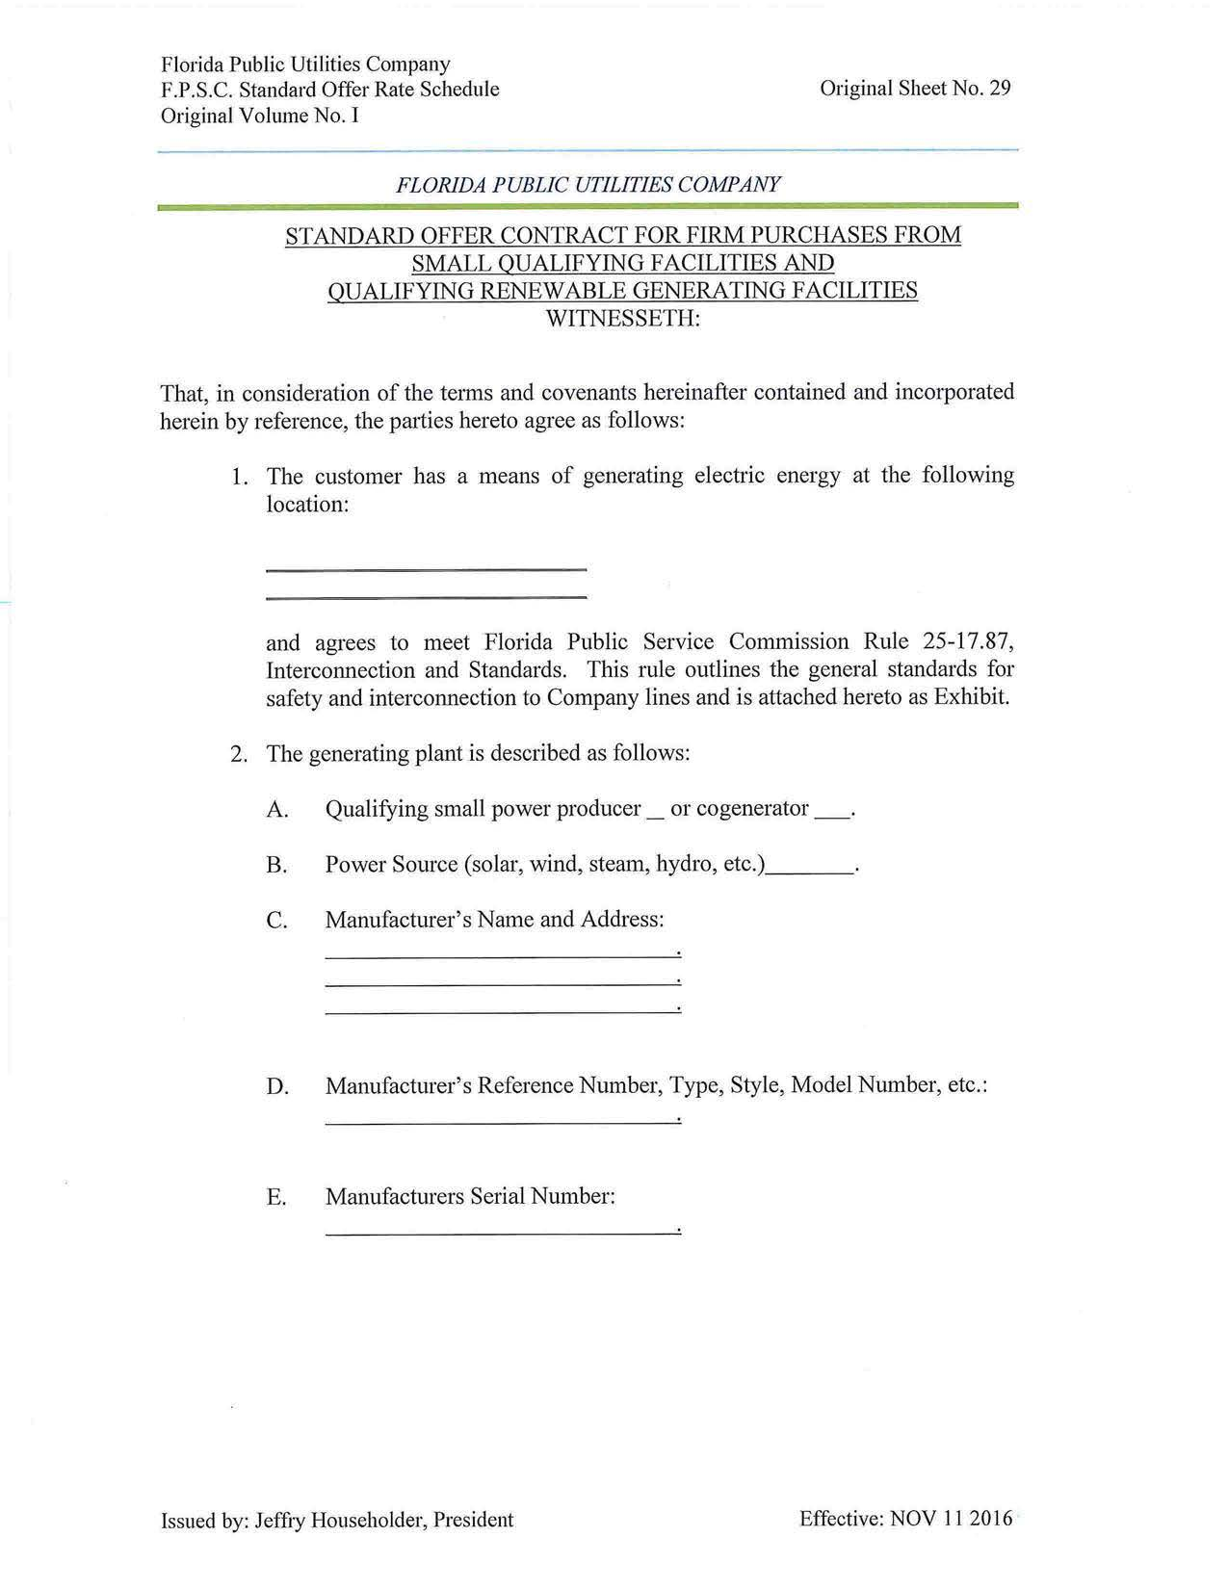

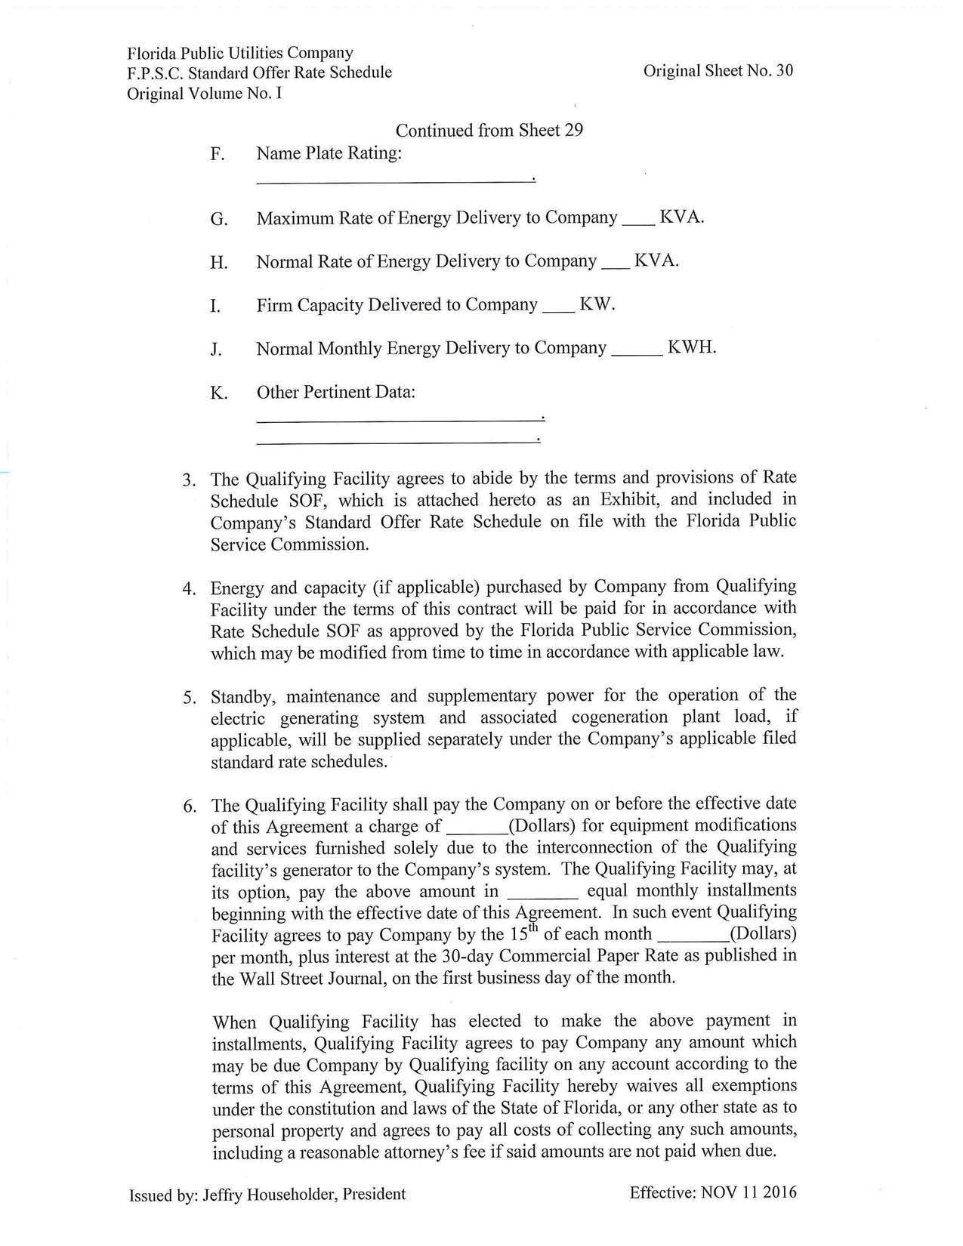

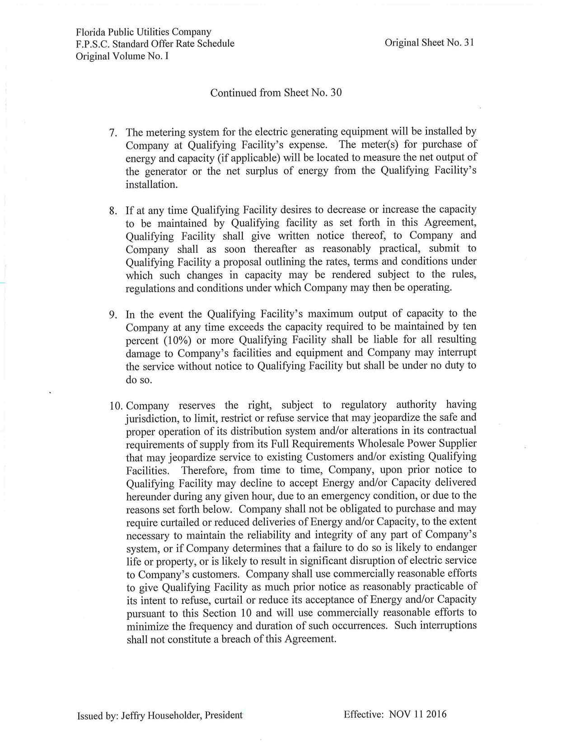

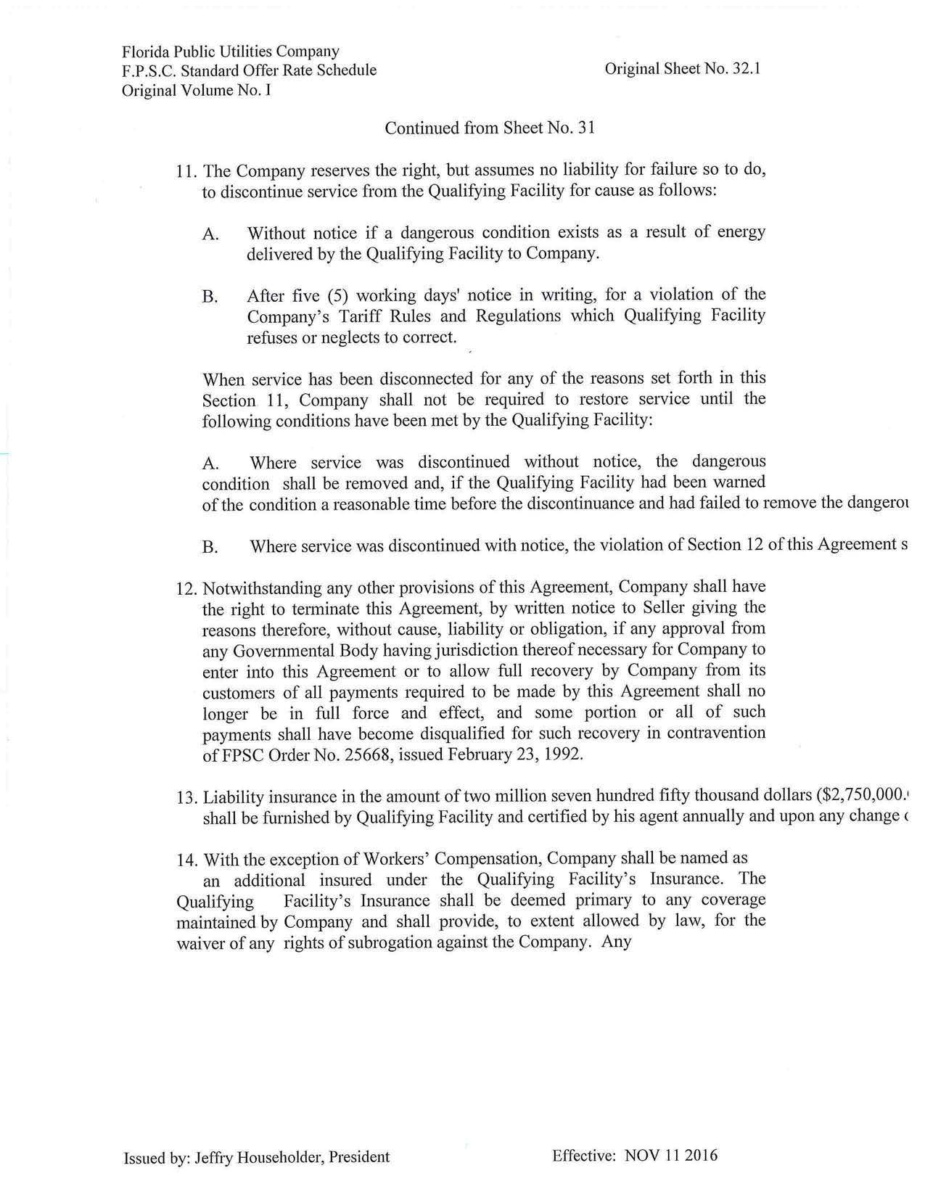

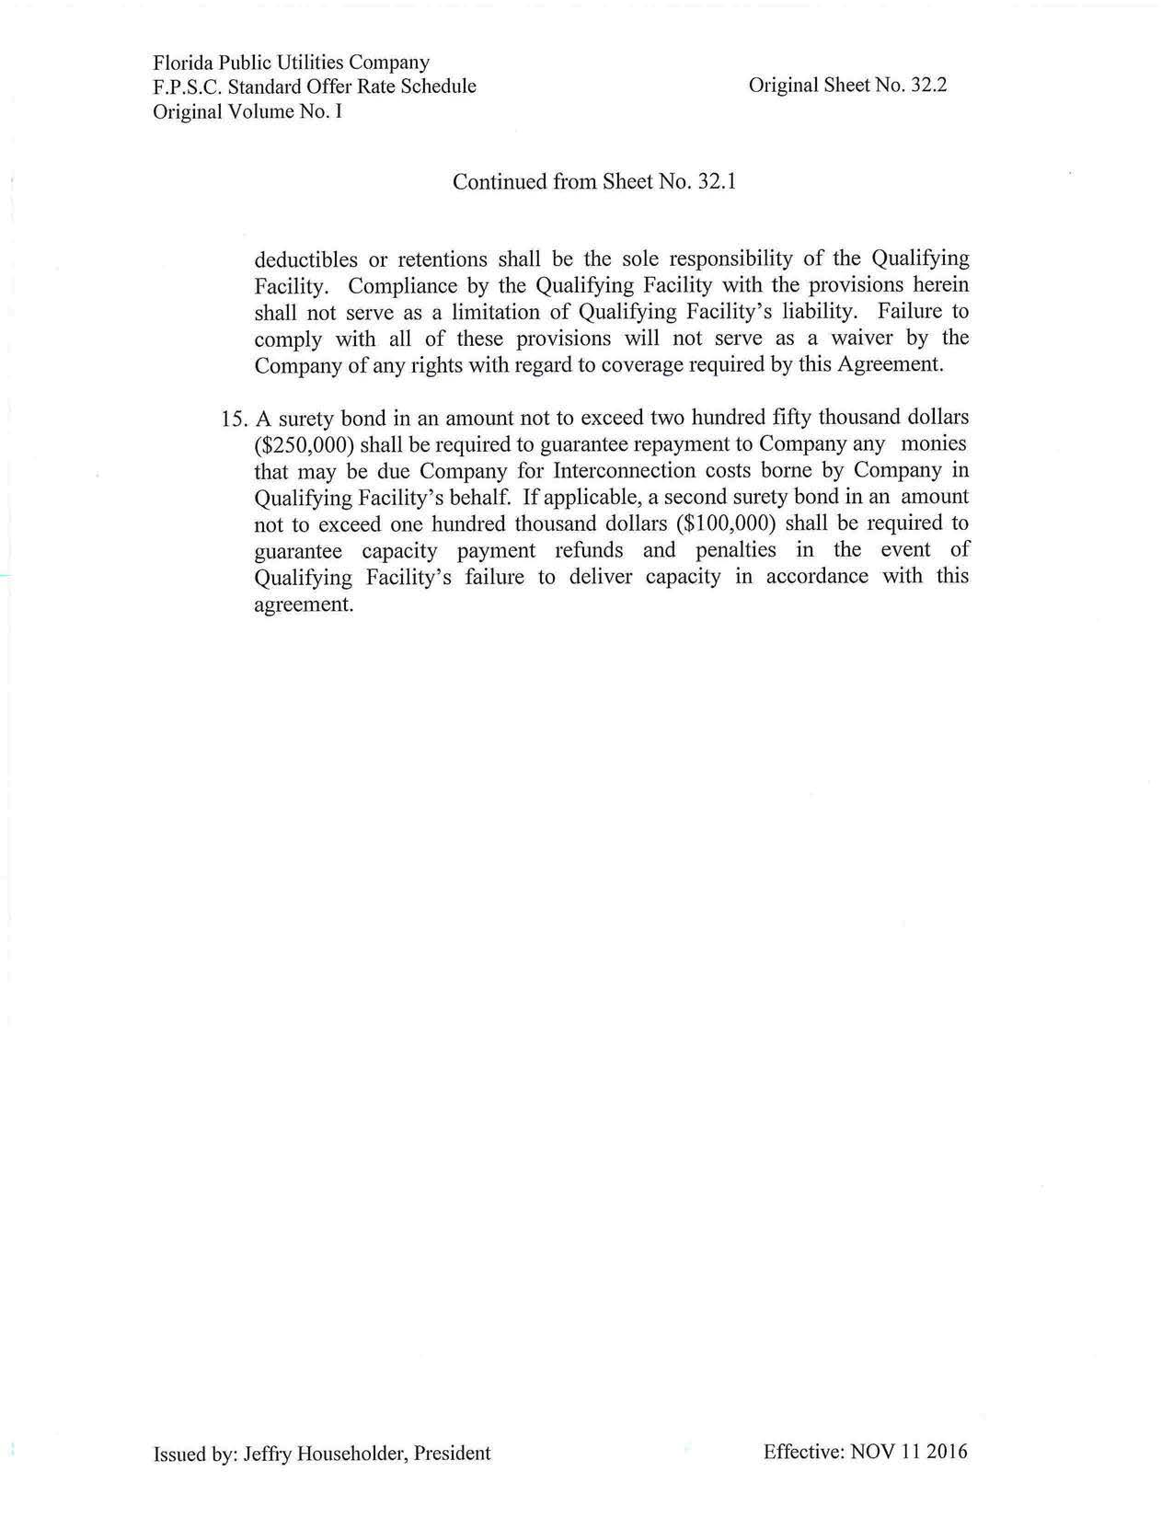

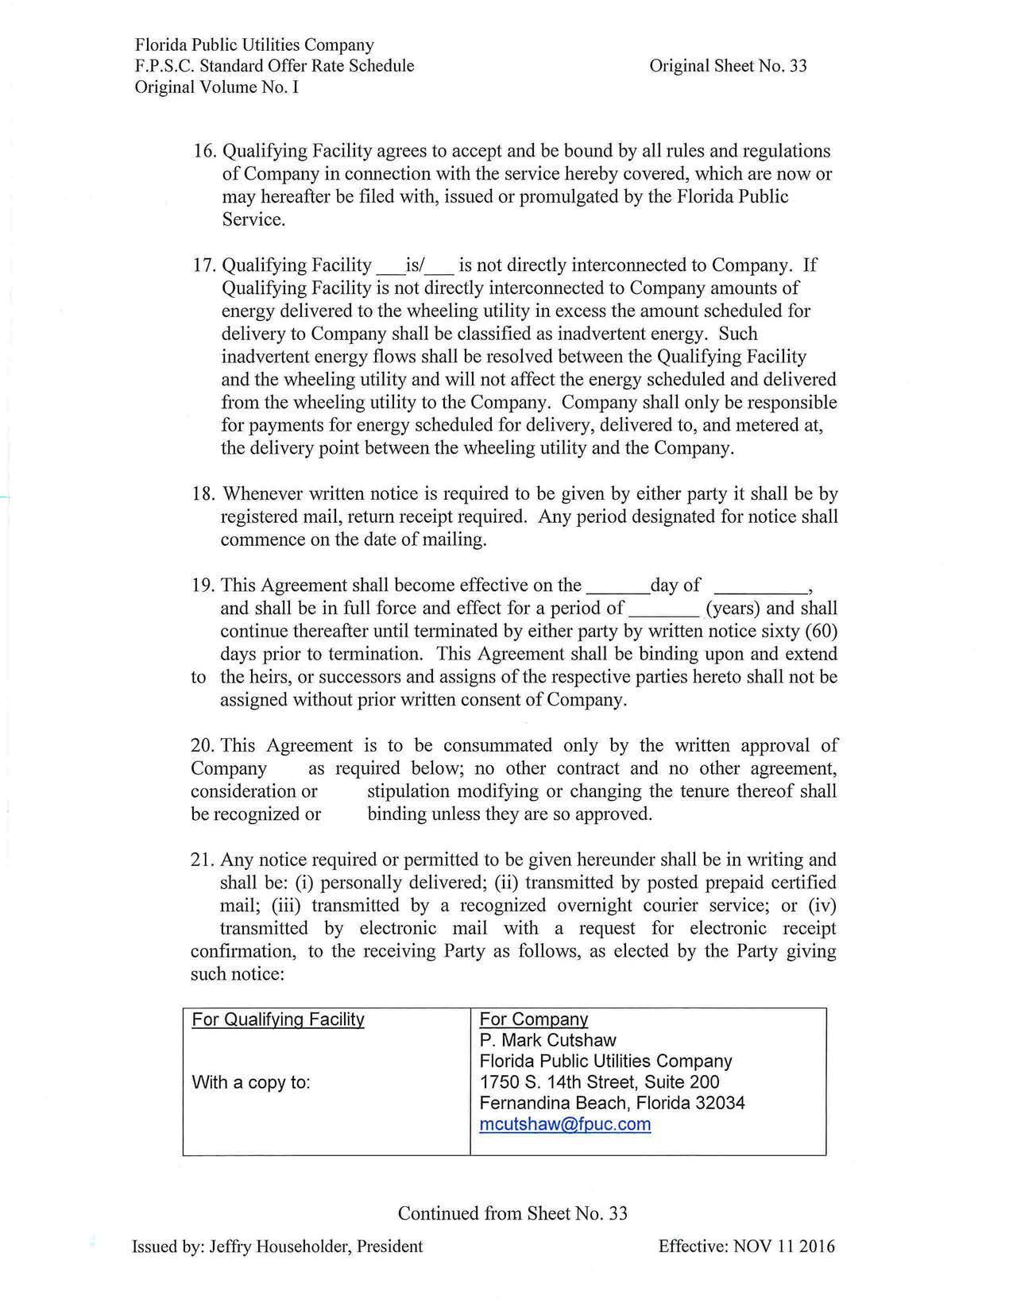

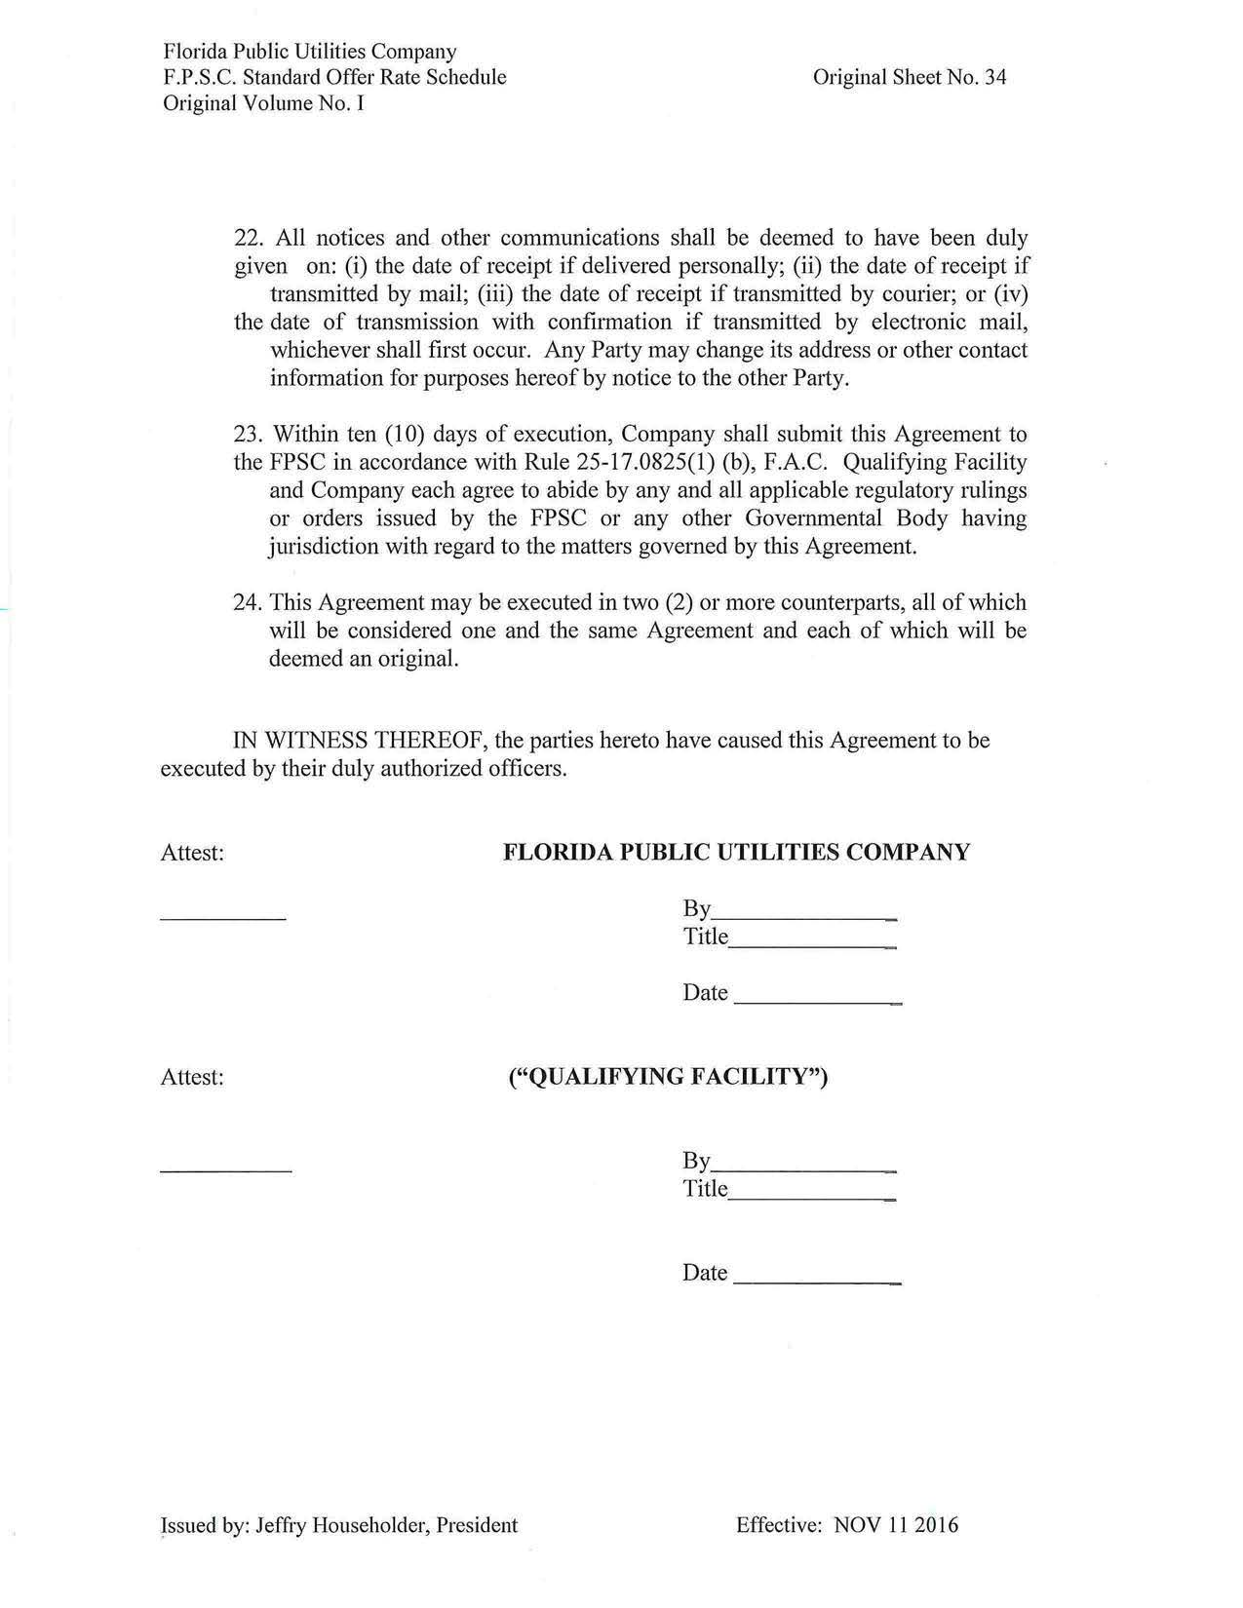

Document No. 03445-2019, filed April 1, 2019, in Docket No. 20190088-EQ.
Order No. PSC-2018-0310-PAA-EQ, issued June 12, 2018, in Docket No. 20180091-EQ, In re: Petition for approval of revisions to standard offer for energy purchased from cogenerators and renewable generating facilities and standard offer contract for purchases of firm capacity and energy, by Florida Public Utilities Company.

