State of Florida |  | Public Service Commission  Capital Circle Office Center ● 2540 Shumard Oak Boulevard  Tallahassee, Florida 32399-0850  -M-E-M-O-R-A-N-D-U-M-
DATE: | May 6, 2019
TO: | Office of Commission Clerk (Teitzman)
FROM: | Division of Accounting and Finance (Cicchetti, Buys, Hightower)  Division of Economics (Merryday)  Division of Engineering (Ellis)  Office of the General Counsel (Brownless)
RE: | Docket No. 20180046-EI – Consideration of the tax impacts associated with Tax Cuts and Jobs Act of 2017 for Florida Power & Light Company.
AGENDA: | 05/14/19 – Regular Agenda – Post-hearing – Participation limited to Commissioners and Commission staff.
COMMISSIONERS ASSIGNED: |  |  | Brown, Polmann, Clark, Fay
PREHEARING OFFICER: |  |  | Brown
CRITICAL DATES: |  |  | None
SPECIAL INSTRUCTIONS: |  |  | None

Case Background
This docket was opened by the Florida Public Service Commission (Commission) on February 21, 2018, to consider the tax impacts affecting Florida Power & Light Company (FPL) as a result of the passage of the Tax Cuts and Jobs Act of 2017 (TCJA). An administrative hearing was held on February 5, 2019, in which Exhibit Nos. 1-22 were admitted into the record. Further, the testimonies of Scott R. Bores and Ralph C. Smith, witnesses for FPL and the Office of Public Counsel (OPC), respectively, were inserted into the record as though read. Issues 1-17 and 20, addressing the quantification of tax savings, were stipulated by the parties and approved by the Commission. At the February 5 hearing, Issues 18 and 19 were reserved with the parties given an opportunity to file Initial and Reply Briefs on these issues on February 22, 2019, and March 8, 2019, respectively. The hearing was then continued until April 16, 2019, at which time parties were given 40 minutes per side for oral argument on Issues 18 and 19. FPL, OPC, Florida Retail Federation (FRF), Florida Executive Agencies (FEA), and Florida Industrial Users Group (FIPUG) filed Initial Briefs on February 22, 2019. FPL, OPC, FRF, and FIPUG filed Reply Briefs on March 8, 2019.
At the April 16, 2019, hearing, OPC, FPL, FEA, FIPUG, and FRF presented oral argument on Issues 18 and 19. The Commission has jurisdiction over this matter based on Chapter 366, Florida Statutes (F.S.).

Discussion of Issues

Issue 18:
Does the 2016 Settlement Agreement allow FPL to credit the Amortization Reserve with the tax savings resulting from the Tax Cuts and Jobs Act of 2017?

Recommendation:
Yes. (Brownless, Cicchetti)
Parties’ Positions

FPL: Yes. The 2016 Settlement Agreement allows FPL to make both credit and debit entries to the Amortization Reserve, so long as it maintains its earned ROE within the authorized range. To the extent FPL’s earnings, taking into account the impact of tax savings and all of the Company’s other costs of doing business, allow FPL to make credit entries to the Amortization Reserve while remaining within the authorized ROE range, then FPL is permitted by the 2016 Settlement Agreement to do so.

OPC: No. FPL exhausted the Reserve Amount and thus there is no ARM available through which to receive credits. The Reserve Amount was created for a special purpose by the Parties. It was not used for that purpose. It was extinguished and the evidence is overwhelming that, had there been as much as $200 million more in the Reserve Amount, it too would have been exhausted. Prior to the public interest determination that the Florida Supreme Court approved in affirming the 2016 Order, FPL had committed to the Commission to using the SCRM that was set forth in the 2016 Settlement for any storm cost recovery. Likewise, FPL also agreed to use the ARM and the Reserve Amount to manage earnings fluctuations while focusing on running its business operations related to “the risk of weather, inflation, rising interest rates, mandated cost increases and other factors affecting FPL’s earnings that largely are beyond the Company’s control.” The Company expressly testified that storm cost recovery was not affected by earnings and was to be accomplished as a pass-through, and the Company also informed investors of this plan. The 2016 Settlement further provided that storm cost recovery must be accomplished without regard to the availability of any amount remaining in the Reserve Amount. The intent of the Parties expressed in the 2016 Settlement was that the ARM and the SCRM had two distinct and wholly separate functions expressly designed to operate independently and without regard to the existence of the other.

FRF: No. The Commission must interpret and construe the 2016 Settlement using the same standard that it applied in reviewing it for approval in 2016, and that the Florida Supreme Court applied in reviewing the 2016 Settlement when it was appealed: the Commission’s decisions must result in “rates that are fair, just, and reasonable” and in an application of the 2016 Settlement to the issues presented here that “is in the public interest.” FPL’s refusal and failure to use the SCRM to recover Hurricane Irma restoration costs and its simultaneous efforts to use the Reserve as a “slush fund” where it can disguise the windfall tax cost reductions and resulting excessive earnings as just another reserve balance not subject to earnings review have resulted and will continue to result in FPL’s rates being unfair, unjust, and unreasonable, because FPL’s costs are dramatically, and unexpectedly, less than the rates in effect when the 2016 Settlement was negotiated and approved. The suggestion that FPL should be allowed to keep all of the TCJA savings for itself and its parent, NextEra, is patently and egregiously contrary to the public interest.

FIPUG: FIPUG did not submit a statement of position on this issue either in its Initial Brief or Reply Brief filed on February 22 and March 8, 2019, respectively.

FEA: FEA agrees with the positions taken by the Office of Public Counsel.

Staff Analysis:

Background

Florida Power & Light Company (FPL), the Office of Public Counsel (OPC), the Florida Retail Federation (FRF), and the South Florida Hospital and Healthcare Association (SFHHA) entered into a settlement agreement (2016 Settlement Agreement) resolving FPL’s 2016 rate case that was approved by the Commission by Order No. PSC-16-0560-AS-EI, issued on December 15, 2016.

Sections 12(a) and (b) of the 2016 Settlement Agreement establish a “Reserve Amount” consisting of the depreciation reserve surplus remaining at the end of 2012 ($104 million), a portion of FPL’s fossil dismantlement reserve ($146 million), and a theoretical depreciation reserve surplus as of January 1, 2017 ($1 billion). (Attachment B) The 2016 Settlement Agreement provides that until FPL’s base rates are set in a general base rate proceeding, FPL may amortize any reserve amount remaining at the end of 2016 up to $1.0 billion of the theoretical depreciation reserve surplus with “amounts to be amortized in each year of the Term left to FPL’s discretion.” FPL’s use of the Reserve Amount is limited in three ways. First, FPL cannot amortize “less than the actual amount of deprecation reserve surplus remaining at the end of 2016.” Second, FPL must amortize at least the amount of the available Reserve Amount necessary to maintain an ROE of at least 9.6 percent. Third, FPL may not amortize the Reserve Amount in an amount that results in an ROE greater than 11.6 percent. FPL is further precluded from initiating a base rate case until it exhausts the Reserve Amount. Finally, FPL may not amortize any remaining Reserve Amount after December 31, 2020, unless it notifies the parties by no later than March 31, 2020, that it does not intend to seek a general rate base increase which becomes effective before January 1, 2022.

Section 6 of the 2016 Settlement Agreement (Attachment A) continues the Storm Cost Recovery Mechanism (SCRM) first found in FPL’s 2013 Stipulation and Settlement (2013 Settlement). Section 6 sets forth the mechanism by which FPL may recover through a storm surcharge up to $4.00/1,000 kWh for a 12 month period for monthly residential bills. Storm costs exceeding $800 million may be recovered with the imposition of a surcharge greater than $4.00/1,000 kWh or extending beyond a 12 month period. Only costs related to a named tropical storm by the National Hurricane Center or its successor may be recovered and Rule 25-6.0143, Florida Administrative Code (F.A.C.), applies. Final storm costs are determined in a limited proceeding docket in which parties may contest the amount of FPL’s claimed storm costs but not the SCRM mechanism itself.

FPL:
It is FPL’s positon that the resolution of this issue turns on the interpretation of Sections 6 and 12 of the 2016 Settlement Agreement. FPL argues that it is not required to use the SCRM to recover the storm costs associated with Hurricane Irma nor is it prohibited from using the Reserve Amount to pay Hurricane Irma costs with those costs replenished by ratepayers from tax savings. It is FPL’s position that as long as it is earning within its authorized range of rate of return (9.6-11.6 percent), it has full discretion to use the tax savings however it wishes without having to consult with the parties to the 2016 Settlement Agreement or ask permission of the Commission. FPL argues that resolution of this issue is based on contract law which requires first an analysis of the plain language of the 2016 Settlement Agreement and if that language is not dispositive, consideration of extrinsic evidence regarding the intent of the parties at the time the 2016 Settlement Agreement was executed. Under FPL’s analysis, it is the understanding of the signatories to the 2016 Settlement Agreement, not the understanding of the Commission at the time of approval, that is dispositive.

Based on the plain language of the 2016 Settlement Agreement, FPL concludes the following:

- That the purpose of the Reserve Amount was to allow FPL to maintain its earnings throughout the 2016 Settlement Agreement’s four-year contract term (Term) within its authorized rate of return range of 9.6-11.6 percent. That being the case, all parties understood that throughout the Term, FPL would be making debits and credits to the Reserve Amount at FPL’s sole discretion. [FPL Initial Brief at 3-5]

- The whole purpose of the Reserve Amount was to allow FPL to respond to unanticipated changed circumstances either in the form of tax savings or Hurricane Irma storm costs. [FPL Reply Brief at 4-5]

- There is no restriction on the types of expenses that can be paid with Reserve Amount funds or the types of revenues that can be placed into the Reserve Amount. Further, there is no provision in the 2016 Settlement Agreement that states that the Reserve Amount is extinguished when it reaches a zero balance. [FPL Initial Brief at 7-8]

- The plain language of Section 6 of the 2016 Settlement Agreement does not require FPL to use SCRM to recover storm costs. Rather, Section 6 of the 2016 Settlement Agreement allows FPL to implement a surcharge under the terms and restrictions listed if FPL wishes to. [FPL Reply Brief at 7] Implicit in this argument is the understanding that it is the language of the 2016 Settlement Agreement, not the language of Order No. PSC-16-0560-AS-EI, that is relevant.

- The 2016 Settlement Agreement does not address the disposition of any savings or losses resulting from the enactment of the Tax Cuts and Jobs Act of 2017 at all. This was intentional as all parties to the 2016 Settlement Agreement were fully aware that a tax savings bill was being widely discussed should Trump win the presidency. [FPL Reply Brief at 15]

- Prior to filing its petition to initiate a rate case for FPL on December 5, 2018, OPC was informed of FPL’s treatment of its tax savings and did not object. Nor did OPC, FRF or FIPUG object when FPL twice informed the Commission of its treatment of its tax savings at the February 6, 2018, Commission agenda conference. Nothing has changed between that time and this. [FPL Initial Brief at 7; FPL Reply Brief at 22]

- Interpretation of the 2016 Settlement Agreement as Intervenors suggest is a de facto request to modify the settlement terms due to changed circumstances (Hurricane Irma, size of tax savings) and not supported by either the plain language of the settlement or the parties’ intent at the time of executing the settlement. [FPL Reply Brief at 12-14]

- If a “public interest” standard or “fair, just, and reasonable rates” standard is applied to modify the terms of the 2016 Settlement Agreement to require an immediate reduction in base rates as FRF suggests, this is tantamount to rewriting the 2016 Settlement Agreement terms resulting in a premature termination of the 2016 Settlement Agreement. [FPL Reply Brief at 17]

- In order to apply a “public interest” or “fair, just, and reasonable rates” standard to support a modification of the 2016 Settlement Agreement, the Commission must place the terms of the Settlement Agreement on the same footing as a decision of the Commission. This ignores the fact that the Settlement Agreement was negotiated between the signatories and was presented to the Commission by the signatories for approval as a whole without modification. Further, if settlement agreement terms can be modified based on these standards, parties will be discouraged from entering into settlement agreements since they will never become completely final even upon Commission approval. This action would be contrary to the Commission’s long-standing policy of encouraging and giving great weight and deference to settlements. [FPL Reply Brief at 17-21]

OPC, FRF, and FIPUG have interpretations of the 2016 Settlement Agreement, as well as Order No. PSC-16-0560-AS-EI, contrary to that of FPL.

OPC:
OPC argues the following:

- Citizens of Florida v. Graham, 213 So. 3d 703,706,713-4, 710 (Fla. 2017), states that by the approval of settlement agreements the Commission “adopts” “the corresponding settlement provisions as Commission policy.” [OPC Initial Brief at 1, 8] Therefore, it is inappropriate to evaluate the 2016 Settlement Agreement under contract law. Here the Commission is construing and applying its own order and policies. (Sierra Club v. Brown, 243 So. 3d 903 (Fla. 2018). [OPC Reply Brief at 5-6] Thus, the Commission should apply administrative law standards for modification of Commission ratemaking orders and policies, e.g., significantly changed circumstances which the parties were unable to predict or control. Here those significantly changed circumstances are the Hurricane Irma storm damage costs and the significant tax savings generated by the Tax Cuts and Jobs Act of 2017. [OPC Initial Brief at 4]

- It is the Commission’s understanding of the terms of the 2016 Settlement Agreement at the time the Commission approved the agreement as memorialized in Order No. PSC-16-0560-AS-EI that is controlling, not the parties’ intent at the time of negotiating the agreement. Thus, the sentence in Order No. PSC-16-0560-AS-EI which states: “This charge [current storm damage cost recovery mechanism] will be used to replace incremental costs associated with the named storm as well as to replenish the storm reserve to the level in effect as of August 31, 2016” mandates the use of the SCRM to recover Hurricane Irma storm costs. [OPC Initial Brief at 4]

- The 2016 Settlement Agreement is silent with regard to unanticipated, material changes in circumstances. [OPC Initial Brief at 4]

- Because the 2016 Settlement Agreement is Commission policy, FPL was required to contact the parties to the agreement as well as request permission from the Commission in order to use the Reserve Amount to pay off Hurricane Irma storm costs. FPL did neither but acted unilaterally without either the parties’ knowledge or the Commission’s approval. [OPC Initial Brief at 2-3] This proceeding is an effort to get post hoc approval of FPL’s illegal actions. [OPC Initial Brief at 3]

- The Reserve Amount cannot be used to pay for storm costs and once extinguished cannot be replenished with tax savings. [OPC Initial Brief at 24-6]

- Because the Reserve Amount cannot be replenished, the $649.6 million annual tax savings in 2018 create immediate overearnings of $540 million which requires that a rate case be immediately initiated as requested in Docket No. 20180224-EI. [OPC Reply Brief at 10]

FEA: FEA agrees with the positions taken by the Office of Public Counsel.

FRF:
FRF generally agrees with OPC with slight differences:

- The 2016 Settlement Agreement and Order No. PSC-16-0560-AS-EI adopting that agreement are a combined statement of Commission policy which must be evaluated using the same standard applied by the Florida Supreme Court when it approved that order on appeal: that the resulting rates “are fair, just, and reasonable” and “in the public interest.” [FRF Initial Brief at 2] FRF argues that in Sierra Club v. Brown, 243 So. 3d 903 (Fla. 2018), the Florida Supreme Court upheld the Commission’s position that settlement agreements are to be approved if in the public interest. Further, noting that the Commission had not clearly defined “public interest,” the Court stated that the items listed in Section 366.06(1), Florida Statutes (F.S.), for the Commission to consider in fixing rates was applicable, e.g., costs, effect on ratepayers, ensuring reliability of service, etc. [FRF Initial Brief at 18-9]

- Because the Reserve Amount has been extinguished and cannot be restored with the $540 million in tax savings generated by the passage of the Tax Cut and Jobs Act of 2017, FPL is currently earning more than 11.6 percent, the top of its equity range set in the 2016 Settlement Agreement, and customers are paying rates that are not cost based and therefore neither fair, just, and reasonable, nor in the public interest. [FRF Initial Brief at 3, 15-17]

- Because FPL is currently overearning, the Commission should immediately move forward with a general base rate case as requested by OPC, FRF, and FIPUG in Docket No. 20180224-EI with a 2019 test year. FRF contends that only a base rate case that evaluates all of FPL’s costs and revenues can determine how much of FPL’s realized tax savings should be flowed back to ratepayers or retained by FPL. [FRF Initial Brief at 13-4, 26-9; FRF Reply Brief at 5]

- FPL unilaterally violated the 2016 Settlement Agreement by failing to use the SCRM as intended by the parties at the time of the execution of the agreement and the Commission at the time of its approval as demonstrated by the history of the Reserve Amount and the SCRM and evidence presented at the 2016 rate case hearing. [FRF Initial Brief at 19-22; FRF Reply Brief at 3,8, 13] FPL never discussed its plan for payment of Hurricane Irma costs with FRF before it made its accounting entries in December 2017 or before either this docket or the Hurricane Irma storm docket, Docket 20180049-EI, were opened. [FRF Reply Brief at 23]

- FPL’s comparison of its treatment of tax savings to that of TECO’s and DEF’s treatment of tax savings is misleading for several reasons. First, both TECO and DEF met with the parties to their rate case settlements prior to taking action. Second, TECO and DEF sought Commission approval of their proposed use of tax savings. Third, both TECO and DEF agreed to reduce base rates when their storm restoration costs were fully paid. [FRF Reply Brief at 20-1]

- Like TECO and DEF, FPL could have recovered its Hurricane Irma costs by amortizing its storm costs over a period of time and using its tax savings to pay for this expense. With this approach, there would be no storm surcharge causing an increase in customers’ rates and after the storm costs were paid off, base rates could have been decreased to reflect the tax savings. [FRF Initial Brief at 25; FRF Reply Brief at 21]

- FRF is not seeking to rewrite the 2016 Settlement Agreement but to enforce the Commission’s decision approving the agreement as stated in Order No. PSC-16-0560-AS-EI which states that the SCRM “will be used” by FPL to recover storm restoration costs. [FRF Reply Brief at 12-8]

- FPL’s argument that its use of the Reserve Amount to recover Hurricane Irma costs have allowed it to maintain rate stability throughout the term of the 2016 Settlement Agreement and possibly one or two years beyond is specious. FRF takes the position that the 2016 Settlement Agreement does not grant FPL the right to extend the agreement or limit the parties’ ability to request a rate case after the minimum term has expired. [FRF Reply Brief at 22]

- Neither FRF nor any of the other parties to the 2016 Settlement Agreement could have known that income tax reform would be passed at the time the agreement was signed. No discussion of tax reform occurred during the negotiations. [FRF Reply Brief at 23]

FIPUG:
FIPUG agrees with the other Intervenors generally but initially took a slightly different tack with regard to the remedy to be imposed on FPL as discussed below:

- FIPUG is not a signatory to the 2016 Settlement Agreement and it is, therefore, not binding on FIPUG. [FIPUG Initial Brief at 4-5]

- The 2016 Settlement Agreement is not binding on the Commission as it has “statutory obligations and responsibilities that cannot be constrained by the contractual settlement agreements of third parties,” i.e., the responsibility to set fair, just, and reasonable rates. Therefore, the Commission has the ability to recognize the substantial change in circumstances caused by the passage of the Tax Cuts and Jobs Act of 2017 and modify the rates set by Order No. PSC-16-0560-AS-EI in the public interest. [FIPUG Initial Brief at 5-6]

- The substantial change in circumstances here is the large tax savings generated by the passage of the Tax Cuts and Jobs Act of 2017. Under such circumstances, the doctrine of administrative finality does not apply and the Commission can make changes to the rates previously approved by Order No. PSC-16-0560-AS-EI in the public interest. [FIPUG Initial Brief at 5-6]

- The most pressing issue in this docket is setting a date certain when ratepayers will receive a base rate reduction to reflect the $772.3 million in tax savings realized by FPL as was done by TECO, Gulf and DEF. In order to implement this decrease in base rates, FPL should be required to submit a plan to the Commission for its review and approval. This approach is consistent with the Commission’s statutory duties under Sections 366.041 and 366.06, F.S. [FIPUG Initial Brief at 1-2]

- In addition to requiring FPL to submit a plan to return the tax savings, the Commission should require FPL to file for a base rate case as requested by FIPUG, FRF and OPC in Docket No. 20180224-EI. [FIPUG Initial Brief at 6]

In its Reply Brief, FIPUG appears to have modified its rationale rejecting a contract interpretation approach, implicit in its arguments above, arguing the following:

- Because the signatories never had a meeting of the minds with regard to the operation of the Reserve Amount, admittedly a crucial and essential part of the 2016 Settlement Agreement, there was no meeting of the minds and therefore, no contract was formed. Goff v. Indian Lake Estates, Inc., 178 So. 2d 910, 912 (Fla. 2d DCA 1965); Perkins v. Simmons, 153 Fla. 595 (Fla. 1943). That being the case, the 2016 Settlement Agreement should be set aside as void ab initio. [FIPUG Reply Brief at 2]

Discussion
Analysis

As discussed above, the parties have divergent theories about how the Commission should review and enforce the 2016 Settlement Agreement to determine the rate impacts, if any, of the TCJA and Hurricane Irma. Having considered the parties arguments, and for reasons discussed below, staff recommends a different approach that both rejects and acknowledges some elements of all arguments. We agree with FPL that a contract law analysis standard is appropriate to resolve this dispute. We disagree to the extent that FPL argues that the “public interest” standard is somehow applied differently to a decision regarding a settlement agreement verses an order of the Commission that establishes “fair, just, and reasonable” rates following an evidentiary hearing in a rate proceeding.

OPC seems to argue that a settlement establishes Commission policy and therefore should be subject to administrative law standards for modification of orders, and applying an administrative law standard allows the Commission to modify an agreement due to changed circumstances to reflect the plain meaning of the agreement under conditions as they exist today. While we agree with OPC that a settlement agreement is evaluated in the public interest, we disagree with OPC to the extent that it argues that the terms of any approved settlement become Commission policy. Settlements have no precedential value beyond the case at hand. As such, a settlement agreement is a binding and enforceable agreement between the signatories.

Under FRF’s theory, the Commission must use the same approach it followed when approving the settlement agreement in the first place – the resulting rates must be “fair, just, and reasonable” and in the “public interest.” FRF’s statement of law is not incorrect, but it does not prohibit the Commission from applying a contract law analysis in order to resolve an issue between the parties regarding the meaning of an approved settlement agreement.

FIPUG, who was not a signatory to the 2016 Settlement Agreement, argues that the Commission always has the ability to unwind settlement agreements and modify rates due to its ongoing statutory obligations to set fair, just, and reasonable rates and based upon any substantial change in circumstances (i.e. TCJA). We agree that the Commission has a continuing obligation to ensure that fair, just and reasonable rates are charged to utility customers, but the Commission must exercise its ability to modify rates with great restraint and only under extraordinary and changed circumstances. Issue 18, as framed, is not whether the TCJA is an extraordinary circumstance necessitating an adjustment to rates. Issue 18, as framed, is whether the 2016 Settlement Agreement provisions allow FPL to credit the Amortization Reserve with the tax savings resulting from the TCJA, including whether the Reserve Amount can be used for storm restoration costs. The answer to these questions is based upon an interpretation of the 2016 Settlement Agreement. Therefore, it is not necessary or appropriate for the Commission to set aside the entire agreement. Furthermore, FIPUG’s argument that there was no meeting of the minds regarding the 2016 Settlement Agreement is unpersuasive given the actions of the parties over the two and one-half years the agreement has been in effect.

The following legal analysis conveys the applicable framework and law for a decision in this matter. As recognized by the Florida Supreme Court, there are:

differences between the functions and orders of courts and those of administrative agencies, particularly those regulatory agencies which exercise a continuing supervisory jurisdiction over the persons and activities regulated. For one thing, although courts seldom, if ever, initiate proceedings on their own motion, regulatory agencies such as the commission often do so. Further, whereas courts usually decide cases on relatively fixed principles of law for the principal purpose of settling the rights of the parties litigant, the actions of administrative agencies are usually concerned with deciding issues according to a public interest that often changes with shifting circumstances and passage of time.

These differences between courts and administrative agencies are not unique to Florida. For instance, in Indiana, the Court of Appeals was asked to review a decision of the Indiana Utility Regulatory Commission (IURC) where the Commission denied the rate treatment sought by the Northern Indiana Public Service Company (NIPSCO). The Indiana Court affirmed the IURC’s decision to deny NIPSCO’s request, because approval would have violated a rate settlement previously approved by the IURC. The Indiana Court stated:

[S]ettlement carries a different connotation in administrative law and practice from the meaning usually ascribed to settlement of civil actions in a court. While trial courts perform a more passive role and allow the litigants to play out the contest, regulatory agencies are charged with a duty to move on their own initiative where and when they deem appropriate. Any agreement that must be filed and approved by an agency loses its status as a strictly private contract and takes on a public interest gloss.

According to the Indiana Court, “regulatory settlements are distinguishable from agreements that are governed purely by contract law.” The IURC has “broad authority to supervise settlement agreements” and “be proactive in protecting the public interest.”

The Florida Commission also has “continuing supervisory jurisdiction” over the utilities it regulates. When reviewing a settlement agreement, the Commission looks to see whether the settlement agreement is in the public interest. As in other tribunals, settlement agreements continue to be favored in the Commission’s jurisprudence. At times, however, all signatories may not agree with the implementation or enforcement of a settlement agreement approved by the Commission. We are in that posture now with respect to the 2016 Settlement Agreement.

The 2016 Settlement Agreement would have no life but for the approval of the Commission. The signatories do not have the ability or authority to set rates or terms of service - only the Commission has such authority under Chapter 366, F.S. When a territorial agreement is approved by the Commission, it takes on two natures. It has characteristics of both a contract and a Commission order. Because a territorial agreement takes on both of these natures, it is subject to both contract law and the law surrounding Commission orders.

In Beard, the Court specifically held that though the law of contracts applies to the interpretation of territorial agreements, the law surrounding Commission orders applies to the modification or termination of those agreements. In Johnson, the Court acknowledged and impliedly approved of the Commission’s use of “well-settled principles of contractual construction” to resolve an ambiguity in a territorial agreement between the City of Homestead and Florida Power & Light Company. Thus, even though territorial agreements become part of the order that approved them, the Commission still applies contract law if it is asked to interpret those agreements. Likewise, the same analysis that applies to territorial agreements should be applied to settlement agreements that resolve ratemaking petitions before the Commission.

When a dispute arises over the terms of a settlement agreement, differences of opinion in interpretation by the parties, or that an ambiguity allegedly exists, the Commission has historically used “well-established principles of contractual construction” to interpret the agreement and resolve any settlement implementation questions. Any settlement agreement, or interpretation thereof, which must be approved by the Commission loses its status as a strictly private contract and takes on a “public interest gloss.” This case is no different, and the Commission’s application of principles of contract construction should be cloaked or viewed through the public interest lens.
When reviewing the 2016 Settlement Agreement using a contract law analysis, one first looks at the plain meaning of the language in the agreement and gives effect to the plain and ordinary meaning of its terms. Further, an interpretation that “gives a reasonable meaning to all provisions of a contract is preferred to one which leaves a part useless or inexplicable.” An unambiguous contract must be enforced as written. A court “may not rewrite contracts, add meaning that is not present, or otherwise reach results contrary to the intentions of the parties.”

If the contract language is ambiguous, extrinsic evidence can be used to determine the intent of the parties at the time of executing the agreement. However, extrinsic evidence cannot be used to vary or change the terms of the contract but only to explain, clarify, or elucidate the ambiguous language, the relation of the parties, and the circumstances surrounding them when they entered into the contract.

The contract law standard is applicable here because the parties are essentially arguing about both the meaning of Sections 6 and 12 of the 2016 Settlement Agreement, as well as how those sections were intended to work together.

The Reserve Amount

Looking at the plain language of Section 12, it is clear that the Reserve Amount was intended to be available for the entire four year term of 2016 Settlement Agreement. Intervenors’ contention that the Reserve Amount was extinguished in December 2017 when the balance fell to zero is not supported by any language in the agreement nor does it make sense when the purpose of the Reserve Amount is considered. The Reserve Amount was intended to allow FPL to maintain earnings within its agreed upon 9.6-11.6 percent range by making debits and credits to the Reserve Amount. The whole idea behind the Reserve Amount was that the ability to debit and credit this reserve would allow FPL to maintain a steady earnings profile, stabilize base rates, and stay out for the four year minimum term and perhaps one or two years more. FPL’s argument that it would have left a dollar in the Reserve Amount if it had any reason to believe the Reserve Amount would be extinguished when it was reduced to a zero balance rings true. [FPL Initial Brief at 13-4]

If the possibility of extinguishing the Reserve Amount prior to the end of the 2016 Settlement Agreement term was intended by the parties there would be specific language in the 2016 Settlement Agreement stating the conditions under which extinguishment would occur. No such language exists. However, there is specific language in the 2016 Settlement Agreement which details what actions are necessary for FPL to extend the Reserve Amount beyond the end of the agreement term. Given the intended purpose of the Reserve Amount and the complete absence of any terms related to terminating the Reserve Amount before the end of the term, staff concludes that the Reserve Amount cannot be extinguished during the term of the agreement.

Upon review of the plain language of Section 12, it is also evident that there are no restrictions on what type of funds can be debited or credited to the Reserve Amount. There are, however, specific provisions stating that FPL must amortize not less than the actual amount of depreciation reserve surplus remaining at the end of 2016 ($250 million) and must amortize at least the amount of available Reserve Amount necessary to maintain a return on equity of at least 9.6 percent and may not amortize any Reserve Amount that pushes its return on equity higher than 11.6 percent. That being the case, staff concludes that there is no language in Section 12 prohibiting FPL from either debiting the Reserve Amount to pay for Hurricane Irma costs or crediting the Reserve Amount with tax savings realized from the passage of the Tax Cuts and Jobs Act of 2017.

The Storm Cost Recovery Mechanism

The Intervenors argue that even if the Reserve Amount cannot be extinguished during the term of the 2016 Settlement Agreement and the language of Section 12 does not prohibit FPL from crediting tax savings to the Reserve Amount, the language of Section 6 prohibits FPL from using the Reserve Amount to pay for Hurricane Irma storm restoration costs. The Intervenors take the position that the SCRM is the exclusive means by which FPL can recover storm restoration costs outside of a base rate case. In order to support this position, Intervenors rely on one sentence in a section of Order No. PSC-16-0560-AS-EI describing the SCRM: “This charge will be used to replace incremental costs associated with the named storm as well as to replenish the storm reserve to the level in effect as of August 31, 2016.” When describing Section 6 of the Settlement in the order, the Commission was simply describing the storm cost recovery mechanism that is available to FPL under the 2016 Settlement. In other words, to the extent that the utility chooses to use the SCRM available under the Settlement Agreement to recover storm costs, it will use the charge as specified in the Settlement Agreement. However, the Settlement Agreement does not appear to limit the available methods for storm recovery.

Further, the actual language of Section 6(a) states that “[n]othing shall preclude FPL from petitioning the Commission to seek recovery of costs associated with any storms.” The SCRM is available regardless of how much money is in the Reserve Amount or FPL’s actual achieved rate of return. Finally, all parties agree that FPL is free to recover storm costs in a base rate proceeding during the term of the agreement, if FPL’s earnings drop below 9.6 percent. When all of these terms are read together, it is clear that FPL’s use of the SCRM is completely discretionary and that the SCRM is not intended to be the only means for recovery of storm restoration costs.

The last contract analysis argument is FIPUG’s contention that because the signatories never had a meeting of the minds with regard to the operation of the Reserve Amount, admittedly a crucial and essential part of the 2016 Settlement Agreement, there was no meeting of the minds and no contract was formed. That being the case, FIPUG argues that the 2016 Settlement Agreement is void ab initio. FIPUG makes this argument as a non-signatory to the 2016 Settlement Agreement. However, alleged and after-the-fact misunderstandings do not invalidate or void an agreement that has been approved by the Commission and has become final. In this case, the dispute over Sections 6 (SCRM) and 12 (Reserve Amount) are but two pieces of a multi-piece agreement that was presented to the Commission for approval as a whole and approved by the Commission as a whole. Indeed the standard for review of settlement agreements is “whether the agreement – as a whole – resolved all the issues, ‘established rates that were just, reasonable, and fair, and that the agreement is in the public interest.’”

Based on the above, the staff concludes, and recommends that the Commission find, that the 2016 Settlement Agreement allows FPL to credit the Amortization Reserve with the tax savings resulting from the Tax Cuts and Jobs Act of 2017.

Issue 19:
How should the savings associated with the Tax Cuts and Jobs Act of 2017 be treated?

Recommendation:
The Commission should find that FPL should retain the amount of tax savings equivalent to the Hurricane Irma storm restoration costs determined in Docket No. 20190049-EI to be reasonable and prudent. Thereafter, FPL should reduce its base rates by the $772.3 million in annual tax savings stipulated to by the parties in Exhibit No. 22. FPL should be required to file tariffs to implement base rate reductions reflecting a $772.3 million decrease in FPL’s adjusted revenue requirement 60 days prior to the date FPL estimates that all reasonable and prudent Hurricane Irma costs have been recouped. Commission staff should be given authority to administratively approve FPL’s new base rate tariffs consistent with the Commission’s vote.

In order to timely track the tax savings realized by FPL, FPL should be required to provide the Commission with a monthly Tax Savings Report which indicates the cumulative difference in revenue requirements with and without the effect of the Tax Cuts and Jobs Act of 2017 from February 6, 2018, through June 30, 2019. The first Tax Savings Report, including data through June 30, 2019, should be filed on August 15, 2019. Subsequent reports updated through the end of each subsequent month should be filed on the 15th of every month thereafter until the base rate reduction associated with the TCJA is implemented. (Cicchetti, Brownless)

Staff Analysis:

Parties’ Positions

FPL: In December 2017, FPL wrote off incremental Hurricane Irma costs that had been initially charged to the storm reserve to O&M expense and then amortized all of the Reserve Amount available at the time. The amortization offset most, but not all, of the incremental Irma costs, resulting in a one-time reduction in FPL’s earnings for 2017. FPL expects that from 2018 through 2020, tax savings under the Tax Act will enable the Company to partially reverse the one-time amortization of all available Reserve Amount, while staying within the authorized ROE range. By combining expected tax savings with the flexible amortization of the Reserve Amount under the 2016 Settlement Agreement, FPL provided customers with a nearly immediate economic benefit by avoiding an interim storm charge due to Hurricane Irma entirely, and it will provide a future benefit by continuing to operate under the Settlement Agreement for at least one year beyond the Minimum Term. FPL’s treatment of the savings associated with the Tax Act already has resulted in a direct benefit to customers. The benefit was experienced nearly immediately, its magnitude was significant, and it was made possible by the flexibility afforded by ARM in the Settlement Agreement. FPL should be authorized to use savings associated with the Tax Act to facilitate credits to the Reserve that will allow it to continue operating under the Agreement for at least one year beyond the Minimum Term.

OPC: The TCJA significantly reduced the corporate tax rate, from 35% to 21%, which for FPL is an annual and ongoing revenue requirement reduction of $649.6 million presuming the inability to make credits to the depreciation reserve after December 31, 2017. There is no question this reduction is a benefit to FPL created entirely by customer overpayments and this benefit should be returned to customers in the form of a $649.6 million credit in the income statement with any earnings above 11.6% disposed of in Docket No. 20180224-EI.

FEA: FEA agrees with the positions taken by the Office of Public Counsel.

FRF: The federal income tax savings realized by FPL as a result of the TCJA should be treated as what they are – a dramatic windfall reduction in FPL’s cost of providing service, with the corresponding recognition of the increase in FPL’s earnings resulting from this dramatic cost decrease. Treated appropriately in this manner, FPL’s earnings exceeded the 11.6 percent ROE ceiling provided in the 2016 Settlement by more than $540 million, thereby triggering the rights of the FRF and the Citizens to seek base rate reductions pursuant to the 2016 Settlement, and the FRF and the Citizens, joined by FIPUG, have thus sought such reductions in the Joint Petition Docket. The Commission should proceed with the general rate case requested in the Joint Petition. Only by the principled examination of FPL’s costs and revenues through these proceedings will the Commission be able to ensure that FPL’s rates are fair, just, and reasonable, as required by the standard that the Commission applied in approving the 2016 Settlement.

FIPUG: FIPUG did not submit a statement of position on this issue either in its Initial Brief or Reply Brief filed on February 22 and March 8, 2019, respectively.

Analysis:

Upon review of the parties’ Initial and Reply Briefs, there appears to be three options advanced by the parties to handle the tax savings generated by the passage of the Tax Cuts and Jobs Act of 2017: 1) allow FPL to continue to replenish the Reserve Amount from tax savings and operate under the 2016 Settlement Agreement within the range of 9.6 to 11.6 percent (FPL); 2) require FPL to file a plan with the Commission detailing when and how much federal tax savings will be flowed back to customers (FIPUG); and 3) record tax savings as a credit to income without transfer to the Reserve Amount and move forward with the petition for base rate case, Docket No. 20180224-EI (OPC, FIPUG, FRF, FEA).

Inherent in Options 2 and 3 is the assumption that if the tax savings are recorded as a credit to income, rather than a credit to the Reserve Amount, FPL will immediately exceed its 11.6 percent rate of return cap. Intervenors’ assumption is based upon FPL’s 2018 Earnings Surveillance Report (2018 ESR) which shows that FPL had revenues of more than $540 million that it booked to the Reserve Amount above the amount necessary to achieve an ROE of 11.6 percent. [FRF Initial Brief at 10]

Once the 11.6 percent rate of return cap is exceeded, or is expected to be exceeded, Intervenors envision two options: proceeding with the rate case petition filed in Docket No. 20180224-EI and/or reducing base rates by the tax savings. Another option discussed in the Intervenors’ Initial and Reply Briefs, but not requested in their requests for relief, is to order a rate reduction of $772.3 million in tax savings after FPL has recouped the storm restoration costs approved by the Commission in Docket No. 20180049-EI. The effect of this treatment would be consistent with that approved for Tampa Electric Company (TECO) in Docket No. 20180045-EI and Duke Energy Florida, LLC (DEF) in Docket No. 20180047-EI. [RFR Reply Brief at 20-1; OPC Initial Brief at 25-6]

Staff recommends a similar approach for the treatment of tax savings for the benefit of FPL’s customers. Staff recommends that FPL retain the amount of tax savings equivalent to Hurricane Irma storm costs determined to be reasonable and prudent in Docket No. 20180049-EI and thereafter reduce customer base rates by $772.3 million in annual tax savings, the amount stipulated to by the parties. This approach balances the interests of all parties and is consistent with the premise of the underlying 2016 Settlement Agreement based upon a significant and material change in federal tax law. Staff’s recommendation gives recognition to FPL for managing its Reserve Amount by using tax savings to pay for Hurricane Irma costs. Staff’s approach also recognizes that federal income taxes were baked into and embedded in base rates when the 2016 Settlement Agreement was approved.

It is uncontested that the rates which were the result of the 2016 Settlement Agreement were based on the fact that FPL was assessed federal corporate income taxes at a rate of 35 percent. The federal income tax expense associated with that 35 percent rate is part and parcel of the revenue requirements and rates agreed to by the parties when the 2016 Settlement Agreement was signed and also when the 2016 Settlement Agreement was approved by the Commission. There is no dispute that the TCJA lowered that corporate federal income tax rate from 35 to 21 percent, a 40 percent decrease. The parties have stipulated in this docket that the effect of that decrease in federal corporate income taxes is $649.6 million without the Reserve Amount credits and $772.3 million with the Reserve Amount credits. [Exhibit 22]

The reason for this difference in the annual amount of tax savings has to do with how the Reserve Amount is employed by FPL to manage its earnings. The Reserve Amount represents a reduction to rate base. When credits are made to replenish, or increase, the Reserve Amount, it results in a reduction to rate base. A lower rate base results in lower net income. The lower net income translates into a lower tax liability and thus greater tax savings. Therefore, with the ability to debit and credit the Reserve Amount over time, the amount of tax savings is greater than if the Reserve Amount were not available to FPL. As discussed in Issue 18, staff has recommended that the 2016 Settlement Agreement allows FPL the opportunity to debit and credit the Reserve Amount as it sees fit. The parties stipulated in Issue 9, and the Commission approved this stipulation at the February 5, 2019 hearing, that if credits to the Reserve Amount are permitted, the annual jurisdictional base revenue requirement decrease due to the enactment of the TCJA is $772.3 million.

Order No. PSC-16-0560-AS-EI not only approved the 2016 Settlement Agreement but also set rates for FPL’s customers. Whether rates are set through the approval of a settlement agreement or as the result of an evidentiary hearing, the standard for approval is the same: whether the rates are fair, just, and reasonable and in the public interest. The tension between administrative finality for Commission orders and the requirement to impose fair, just, and reasonable rates when circumstances change is always present. The Courts have recognized this tension and required that the Commission’s ability to modify or withdraw a final order is justified only after “proper notice and hearing, and upon a specific finding based on adequate proof that such modification or withdrawal of approval is necessary in the public interest because of changed conditions or other circumstances not present in the proceedings which led to the order being modified.”

The Florida Supreme Court also addressed this issue in Reedy Creek Utilities Co. v. Florida Public Service Comm., 418 So. 2d 249 (Fla. 1982). In Reedy Creek, after the passage of the Revenue Act of 1978, which reduced the corporate tax rate from 48 to 46 percent, the Commission issued two orders which stated that if the tax reduction resulted in revenues to the utility exceeding its fair and reasonable return on investment, a refund to its ratepayers would be required. Ultimately, the six investor-owned utilities, of which Reedy Creek was one, signed a stipulation which agreed to a one-time refund limited to the year 1979 and set forth the method for calculating the amount subject to refund. The Commission issued an order approving this stipulation and subsequently approved Reedy Creek’s calculation of a refund in the amount of $47,833. Several months later the Commission issued a supplemental order, Order No. 9456-A, stating that Reedy Creek’s calculation of a $47,833 refund had been done incorrectly and did not include an expansion factor which increased the refund to $93,281. Reedy Creek asked for reconsideration of this order and a full evidentiary hearing was held to resolve the issue of the appropriate amount of refund. The Court found that the record supported the Commission’s conclusion that the refund was to be based on the revenues associated with the reduction in tax liability and that the parties agreed to this in the stipulation. In upholding the Commission’s ability to issue an order revising its original order, the Court stated:

The Commission is charged with the statutory duty of regulating and supervising public utilities with respect to their rates. When the Commission determined that it had erred to the detriment of the using public, it has the inherent power and the statutory duty to amend its order to protect the customer.

The record is clear and uncontested that the federal income tax rate has decreased and that the effect on FPL’s revenue requirements is significant: $772.3 million. It is also clear that this change in federal income tax rate was not in place when the parties negotiated, and the Commission approved, the 2016 Settlement Agreement. The parties have had ample notice of the issue of how to treat the tax savings which resulted from the passage of the TCJA coupled with two days of hearings in which all parties were given the opportunity to file Initial and Reply Briefs on this subject, as well as the ability to present extensive oral argument on the issue.

Given the significant dollar amount involved and its material and substantial effect on FPL’s revenues/rates, coupled with the fact that this is a permanent change in the federal corporate tax expense, not an expense subject to market fluctuations, the Commission should find that there has been a material, substantial change in circumstances that renders the current rates set by the 2016 Settlement Agreement no longer fair, just, and reasonable and in the public interest.

As all parties have recognized, the Commission is not a party to the 2016 Settlement Agreement. The Commission, by its approval of the 2016 Settlement Agreement, determined that when taken as a whole, the 2016 Settlement Agreement was in the public interest. Lowering base rates to reflect a significant change in circumstances, i.e., a change in federal tax law, with a corresponding material revenue impact, is not tantamount to rewriting the 2016 Settlement Agreement. The Commission is not “adding a word here or striking a word there” in the 2016 Settlement Agreement. FPL and the Intervenors are being restored to the same position they were in when the 2016 Settlement Agreement was negotiated. FPL is fully recovering its corporate federal income tax expense based on the current federal corporate income tax rates applicable to the utility. Federal corporate income tax expenses are passed through and always embedded in the base rate. Lowering the federal corporate income tax expense simply matches the costs assessed by the federal government with FPL’s expenses as reported on its annual ESR.

In this case, FPL should be allowed to retain federal income tax savings equal to the amount of all reasonable and prudent Hurricane Irma costs. Then base rates will be decreased to reflect the lower federal corporate income tax rate; all other increases or changes to the base rates negotiated by the parties and reflected in the 2016 Settlement Agreement remain. Further, the base rates set in this docket shall remain in effect until they are addressed in a future proceeding.

Further, reducing base rates after Hurricane Irma costs are recouped does not affect the elements cited by the Commission in Order No. PSC-2016-0560-AS-EI as supporting the determination that the 2016 Settlement Agreement was in the public interest. The Amortization Reserve Mechanism (ARM) created by Section 12 continues to operate and FPL will be able to continue to debit and credit the Reserve Amount as described in the 2016 Settlement Agreement. FPL will have sufficient revenues to continue to keep the new lower base rates in effect throughout the 2016 Settlement Agreement term thereby maintaining rate stability. FPL will have the ability to sustain its current high level of service. Reducing base rates commensurate with the tax savings will not impact the earnings of FPL. Thus, FPL will be able to maintain its earnings within the 9.6 to 11.6 percent rate of return range set by the 2016 Settlement Agreement.

For these reasons, the Commission should find that FPL should retain the amount of tax savings equivalent to the Hurricane Irma storm restoration costs determined in Docket No. 20190049-EI to be reasonable and prudent. Thereafter, FPL should reduce its base rates by the $772.3 million in annual tax savings stipulated to by the parties in Exhibit No. 22. FPL should be required to file tariffs to implement base rate reductions reflecting a $772.3 million decrease in FPL’s adjusted revenue requirement 60 days prior to the date FPL estimates that all reasonable and prudent Hurricane Irma costs have been recouped. Commission staff should be given authority to administratively approve FPL’s new base rate tariffs consistent with the Commission’s vote.

In order to timely track the tax savings realized by FPL, FPL should be required to provide the Commission with a monthly Tax Savings Report which indicates the cumulative difference in revenue requirements with and without the effect of the Tax Cuts and Jobs Act of 2017 from February 6, 2018, through June 30, 2019. The first Tax Savings Report, including data through June 30, 2019, should be filed on August 15, 2019. Subsequent reports updated through the end of each subsequent month should be filed on the 15th of every month thereafter until the base rate reduction associated with the TCJA is implemented.

ATTACHMENT A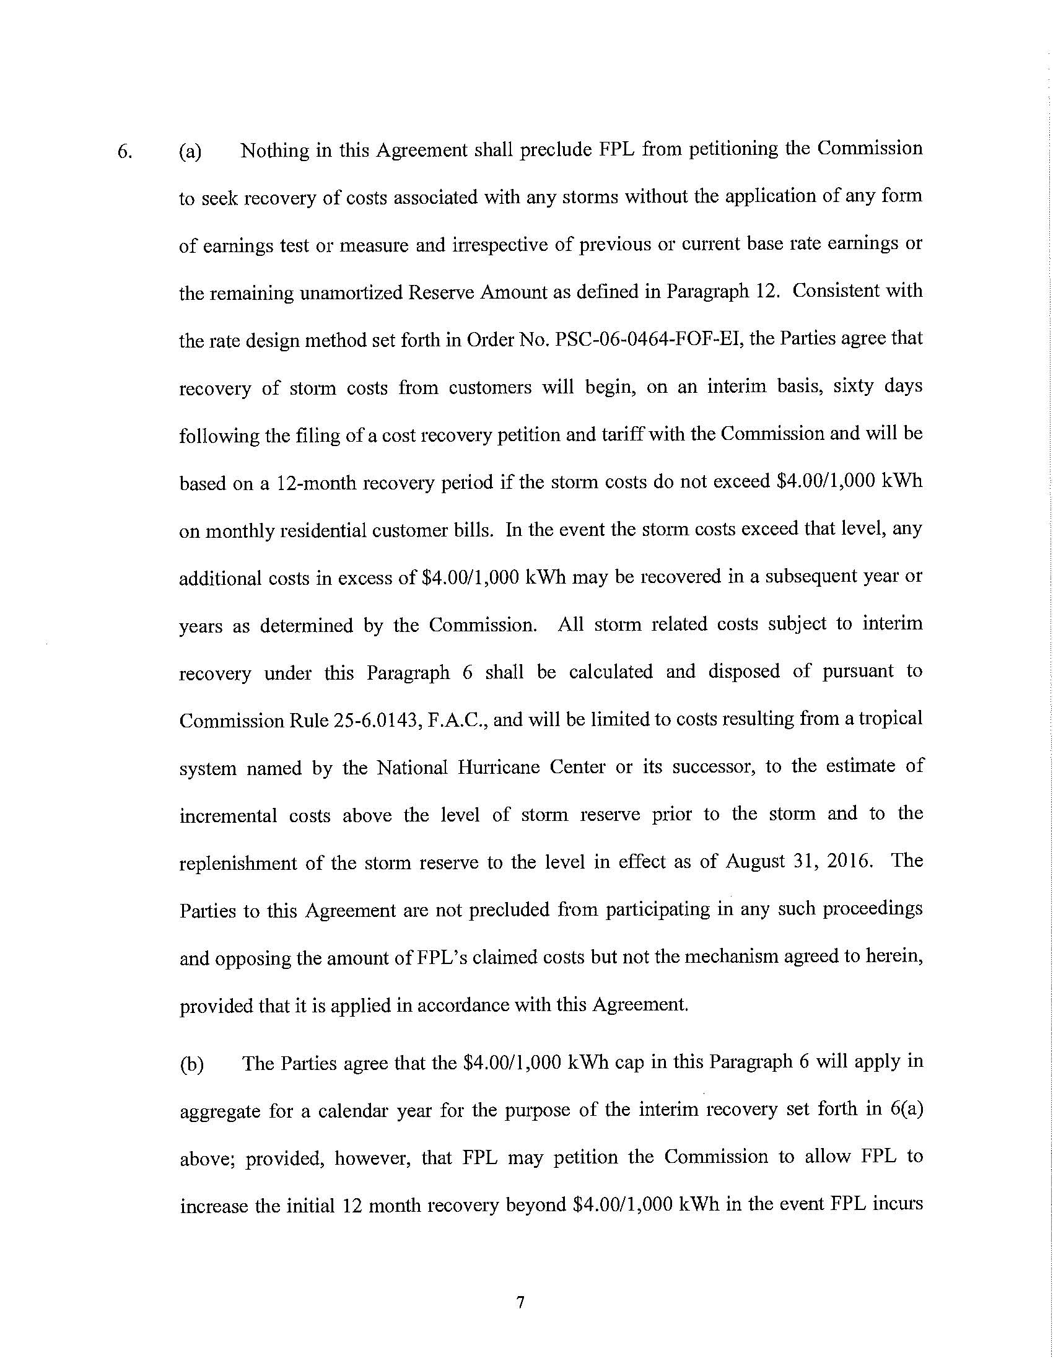
ATTACHMENT A
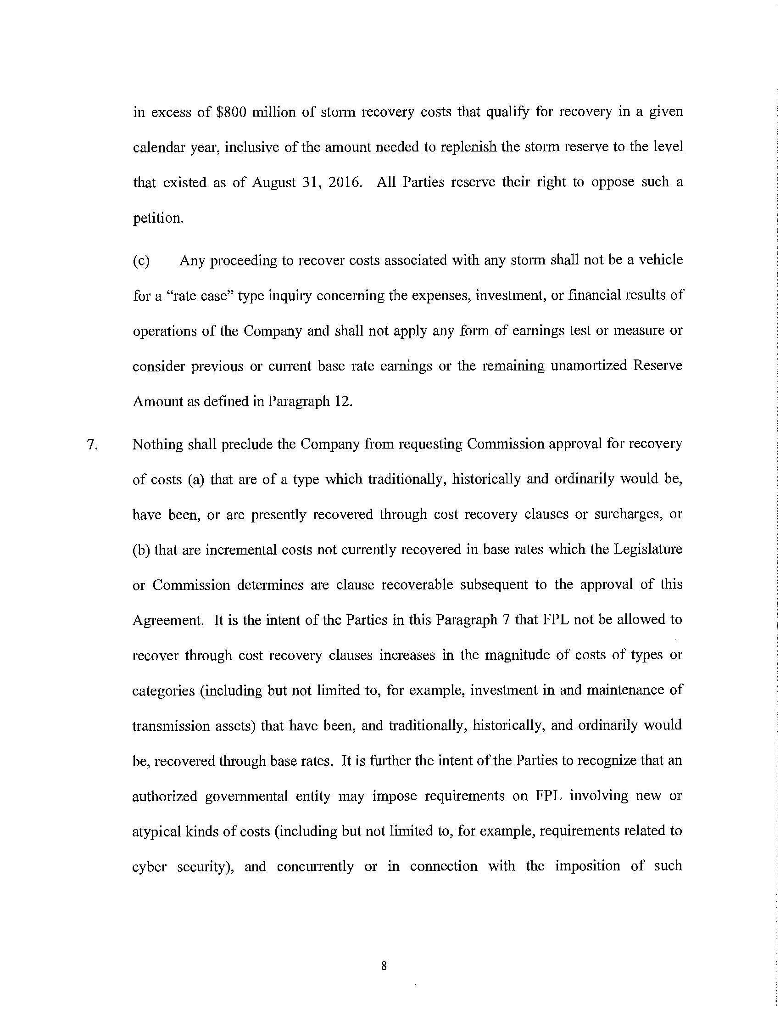

ATTACHMENT B
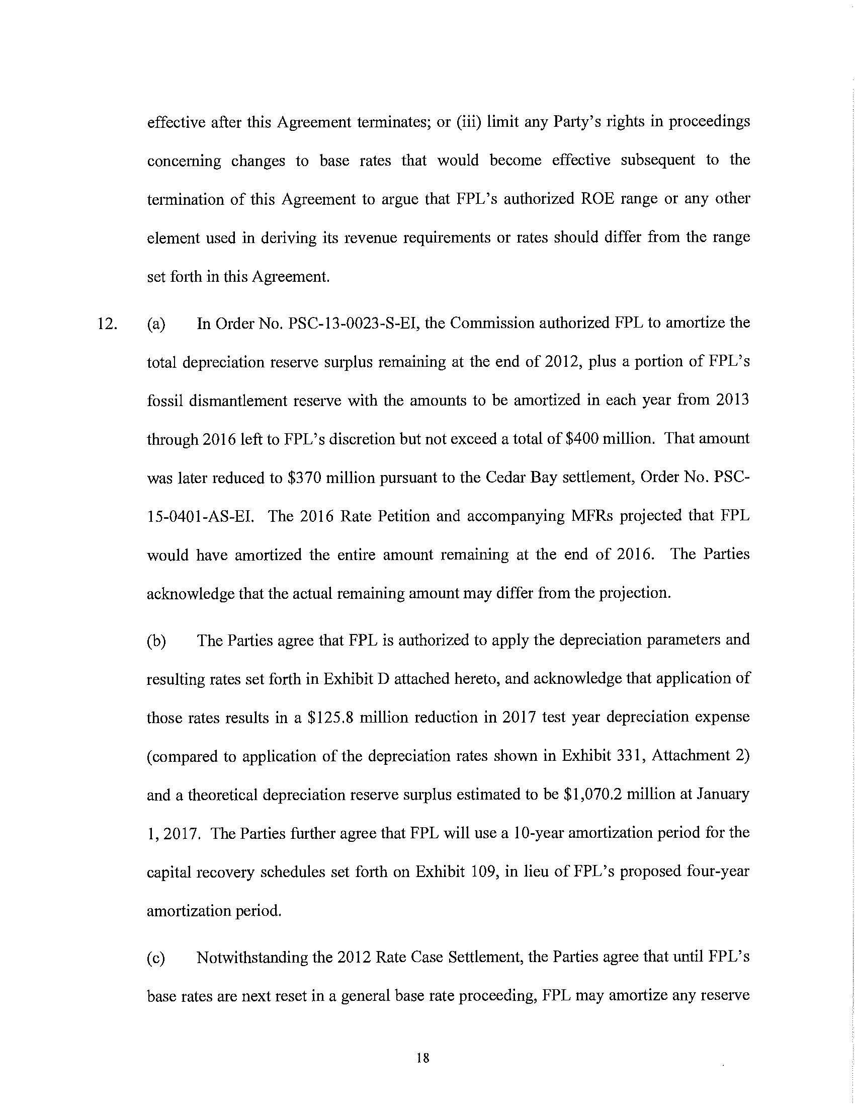

ATTACHMENT B
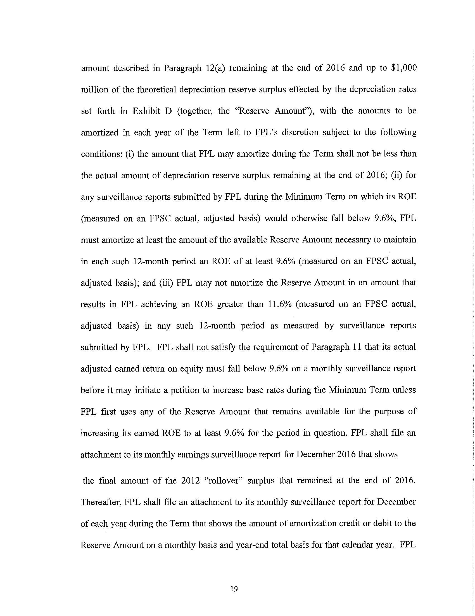

ATTACHMENT B
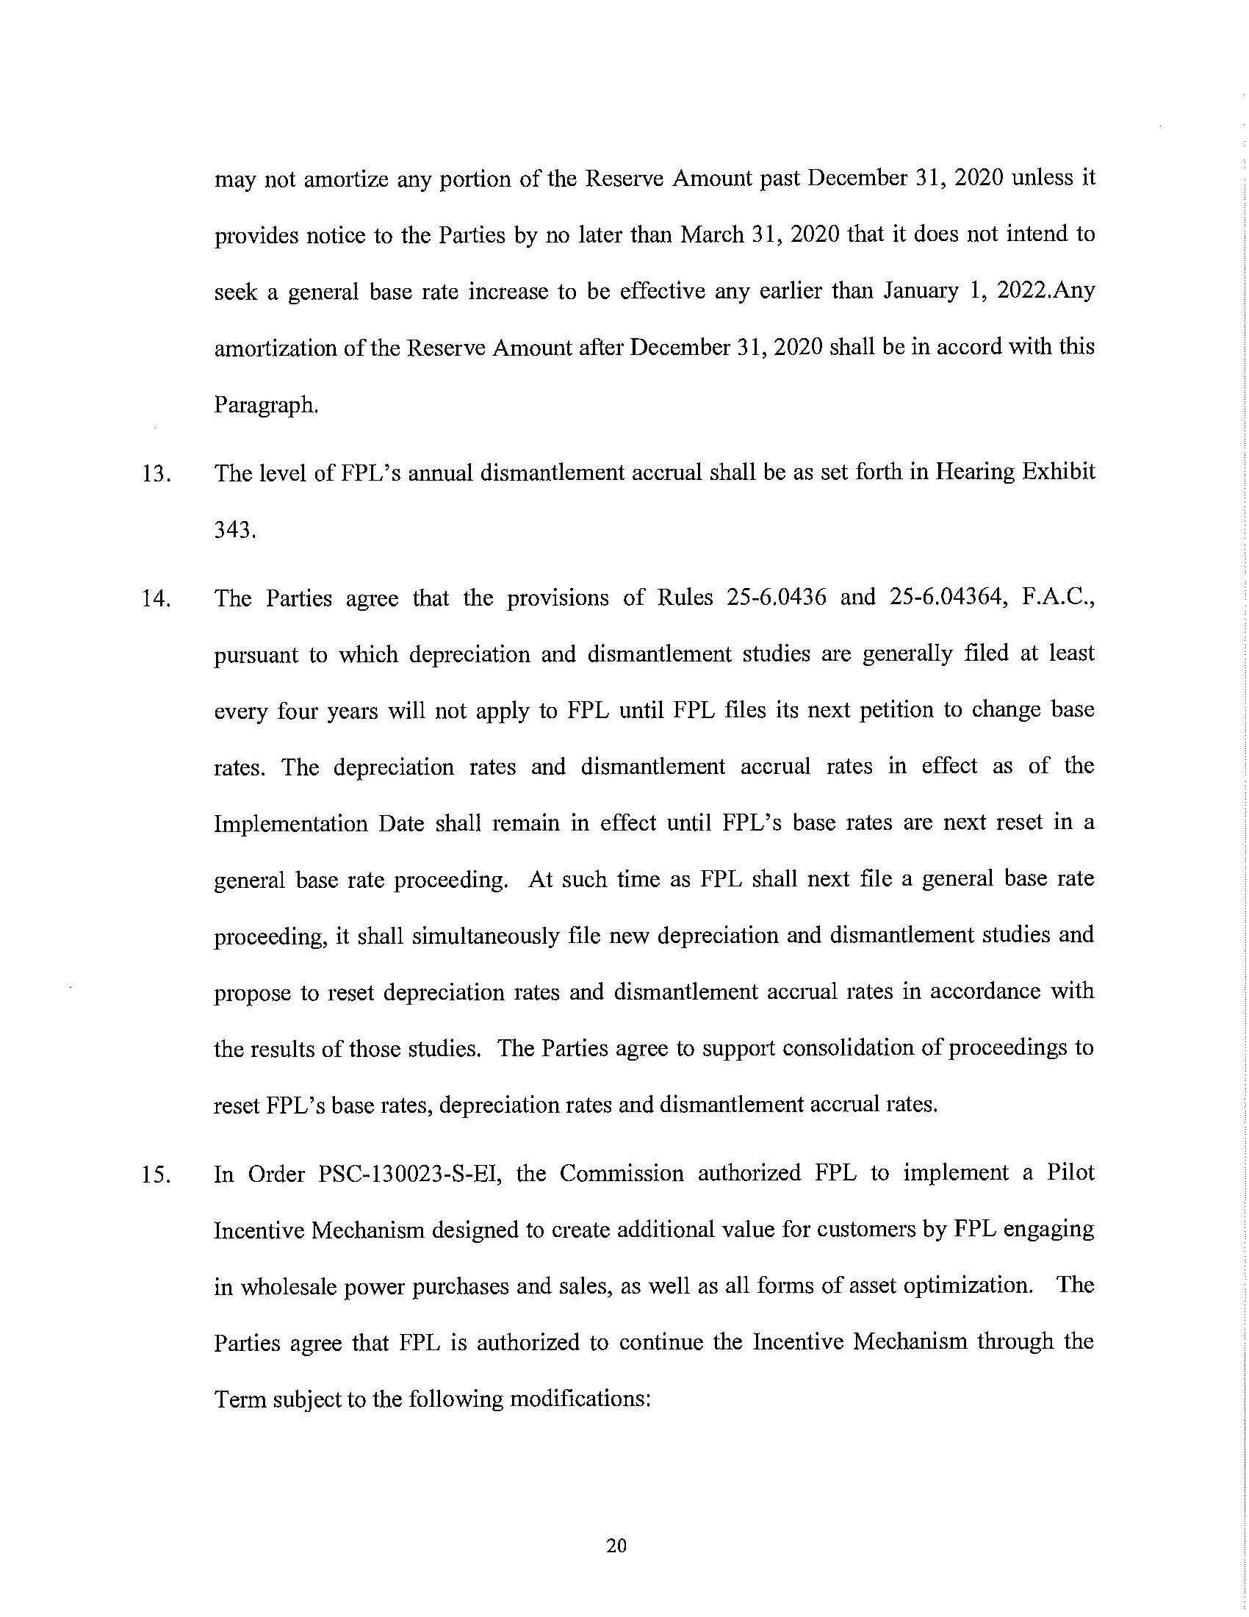

Issue 18: Does the 2016 Settlement Agreement allow FPL to credit the Amortization Reserve with the tax savings resulting from the Tax Cuts and Jobs Act of 2017?; Issue 19: How should the savings associated with the Tax Cuts and Jobs Act of 2017 be treated?
Order No. PSC-16-0560-AS-EI, issued December 15, 2016, in Docket No. 160021-EI, In re: Petition for rate increase by Florida Power & Light Company.
Section 12(c).
Section 12(c).
Id.
Id.
Order No. PSC-13-0023-S-EI, issued January 14, 2013, in Docket No. 120015-EI, In re: Petition for increase in rates by Florida Power & Light Company.
Section 6(a).
Section 6(b).
It is unclear whether OPC is also asking for an immediate base rate reduction of either the $540 million overearnings or the $649.6 million tax savings that it has calculated was realized by FPL in 2018. However, OPC contends that reducing base rates to account for tax savings is consistent with actions taken by Gulf Power Company (Gulf) (Order No. PSC-2018-0180-FOF-EI), Tampa Electric Company (TECO) (Order No. PSC-2018-0457-FOF-EI), and Duke Energy Florida LLC (DEF) (Order No. PSC-2019-0053-FOF-EI). [OPC Initial Brief at 25-26]
PSC Order No. 22353, issued on December 29, 1989, in Docket No. 890216-TL, In re: Petition of Citizens of the State of Florida for a limited proceeding to reduce General Telephone Company of Florida’s authorized rate of return on equity: In re: Investigation into the proper application of Rule 25-14.003, relating to tax savings refunds for 1988 and 1989 for GTE Florida Incorporated.
Peoples Gas System, Inc. v. Mason, 187 So. 2d 335, 339 (Fla. 1966) (Emphasis added).
Northern Indiana Public Service. Co. v. Indiana Office of Utility Consumer Counselor, 826 N.E. 2d 112 (Ind. Ct. App. 2005).
Northern Indiana Public Service. Co. v. Indiana Office of Utility Consumer Counselor, 826 N.E. 2d at 118, citing Citizens Action Coalition of Indiana, Inc. v. Northern Indiana Public Service Co., 796 N.E. 2d 1264, 1267-68 (Ind. Ct. App. 2003), quoting Citizens Action Coalition of Indiana v. PSI Energy, Inc., 664 N.E. 2d 401, 406 (Ind. Ct. App 1996).(Emphasis added.)
Northern Indiana Public Service Co. v. Indiana Office of Utility Consumer Counselor, 826 N.E.2d 112, 118 (Ind. Ct. App. 2005), citing Indiana Bell Telephone Company, Inc. v. Office of Utility Consumer Counselor, 725 N.E.2d 432, 435 (Ind. Ct. App.2000).
Northern Indiana Public Service Co., 826 N.E. 2d at 119.
Peoples, 187 So. 2d at 339.
Sierra Club v. Brown, 243 So. 2d 903, 909 (Fla. 2018).
Id.
City of Homestead v. Beard, 600 So. 2d 450, 453 (Fla. 1992); See: City of Homestead v. Johnson, 760 So. 2d 80, 84 (Fla. 2000).
Beard, 600 So. 2d at 453.
Johnson, 760 So. 2d at 84.
Golf Scoring Systems Unlimited , Inc. v. Remedio,877 So. 2d 827, 829 (Fla. 4th DCA 2004).
Premier Insurance Company v. Adams, 632 So. 2d 1054, 1057 (Fla. 5th DCA 1994).
Harrington v. Citizens Property Insurance Corporation, 54 So. 3d 999, 1002 (Fla. 4th DCA 2010).
Id.
Friedman v. Virginia Metal Products Corporation, 56 So. 2d 515, 517 (Fla. 1952).
Id.
“FPL provides notice to the Parties by no later than March 31, 2020 that it does not intend to seek a general base rate increase to be effective any earlier than January 1, 2022.” Section 12(c).
Section 12(c)(i), (ii) and (ii).
Order No. PSC-16-0560-AS-EI at 3.
Section 6(a).
Sierra Club v. Brown, 243 So. 3d 903, 909 (Fla. 2018).
Docket No. 20180224-EI, In re: Petition for enforcement of 2016 Settlement and permanent base rate reductions against Florida Power & Light Company.
Peoples Gas System, Inc. v. Mason, 187 So. 2d 335, 339 (Fla. 1966)(Emphasis added.)(Court quashed a Commission order which partially abrogated a territorial agreement approved four years before without a finding that the public interest was served by the modification.) See also: Order No. PSC-96-1517-FOF-EG, issued December 13, 1996, in Docket No. 930563-EG, In re: Adoption of numeric conservation goals and consideration of National Energy Policy Act Standards (Section 111) by Talquin Electric Cooperative, Inc.(In 1995 the Commission set conservation goals for electric cooperatives per the requirements of the Florida Energy Efficiency and Conservation Act (FEECA), Sections 366.80-366.85, and 403.519, Florida Statutes (F.S.). Upon passage of Chapter 96-321, Laws of Florida, exempting electric cooperatives from complying with FEECA, the Commission issued Order No. PSC-96-1517-FOF-EI, exempting them from complying with their previously set FEECA goals.).
Reedy Creek, 418 So. 2d at 251.
Id.
Reedy Creek, 418 So. 2d at 252.
Reedy Creek, 418 So. 2d at 253.
Sections 4, 8, 9, and 10.

